

Applies to these Concur solutions:

£ Expense  
£ Professional/Premium edition  
    £ Integrated with Professional/Premium Travel  
    £ Stand-alone  
£ Standard edition  
    £ Integrated with Standard Travel  
    £ Stand-alone  
£ Concurforce

S Travel   
S Professional/Premium edition  
    S Integrated with Professional/Premium Expense  
    S Integrated with Professional/Premium Request  
    S Stand-alone  
£ Standard edition  
    £ Integrated with Standard Expense  
    £ Stand-alone

Travel: Travel System Admin

User Guide

Last Updated: April 19, 2024

Table of Contents

Travel System Admin 1

Section 1: IMPORTANT - About this Guide 1

Section 2: Introduction to Travel System Admin 1

Features Available in Travel System Admin 3

Section 3: Getting Started 4

Procedure: Logging in to Travel System Admin 4

Section 4: Configuring a Company 5

General Information Options 5

Air Connectors 7

Wizard Options 9

Wizard Options – General Options 9

Wizard Options – Transportation Security Administration (TSA) Secure Flight Options 25

Wizard Options – Carbon Model Options for AIR 25

Wizard Options – Class of Service Options 25

Wizard Options – Rule Class Options 26

Wizard Options – Air Search Options 27

Wizard Options – Flex Faring 34

Wizard Options – Amadeus Fare Family Setting 34

Wizard Options – Alternate Fare Finishing Endpoints (Amadeus Only) 37

Wizard Options – Hotel Search Options 39

Wizard Options – Hotel Connectors 41

Wizard Options – Sorting 44

Wizard Options – Rail Connectors 47

Wizard Options – Ground Transportation 47

Wizard Options – Ground Connectors 47

Wizard Options – Airpass Options 48

Wizard Options – Car Search Options 48

Wizard Options – E-Receipts 53

Wizard Options – AirPlus Configuration 53

Wizard Options – Trip Sharing and Cloning 53

Wizard Options – Manifest Clone FOP Options 53

Wizard Options – Comments-to-Agent Warning 54

Wizard Options – DC Configuration 54

System Options 56

GDS PNR Options 59

Email Options 61

Fares Revalidation 64

Approval Email Options 65

Profile Options 66

Custom Attributes Option 69

Invoicing 69

Form of Payment Options 70

Form of Payment Options: Agency Invoice 70

Form of Payment Options: Processing Fees 70

Form of Payment Options: User Custom Property for Default Corporate Credit Card 70

Project Billing 71

PNR Finishing Configuration Options 73

Other Information 74

Refundable Checkbox For Air / Rail 76

Concur TripLink – Agency Assistance 77

Compleat Integration 77

Buttons and Links 78

Sites Using the Global/Divisional View 78

Procedure: Creating a New Company Travel Configuration 79

Procedure: Cloning a Company Travel Configuration 79

Procedure: Editing a Company Travel Configuration 82

Procedure: Deactivating a Company Travel Configuration 82

Section 5: Editing a Company Configuration -- Most Commonly Used Company-Specific Features 83

Overview 83

Discounts 83

Manage Travelfusion B2B Credentials 83

Travel Hubs 83

Procedure: Creating a Travel Hub 84

Procedure: Defining Hub Preferences 85

Procedure: Editing a Travel Hub 86

Procedure: Removing a Travel Hub 86

GDS User Profile Names 86

Procedures: Viewing Users Using GDS User Profile Names 86

Company Information 87

Procedure: Viewing and Editing Company Information 88

Import/Export Hotel Discounts 89

Log Out and Back In As 89

Global/Divisional View 89

Procedure: Logging Out and Back In As 89

Section 6: Editing a Company Configuration – Other Company-Specific Features 89

Manage Segment Fees 89

Procedure: Enabling the Feature 90

Procedure: Adding Fees for the Vendor 90

Manage Non-GDS Hotels 92

Import Travel Arrangers 92

Procedure: Importing Travel Arrangers 92

Manage Lanes 93

Procedure: Adding Lanes 93

Procedure: Editing Lanes 96

Procedure: Removing Lanes 96

Procedure: Importing Lanes 96

Procedure: Exporting Lanes 97

Airpass Configuration 97

Send Account Information 98

Procedure: Sending Account Information 98

View GDS Transaction Logging 100

Procedure: Viewing and Exporting the GDS Transaction Log 100

Import Data 101

Procedure: Importing Data 102

Procedure: Downloading Import Templates 102

Procedure: Adding an Import Task 103

Procedure: Changing Properties 104

Procedure: Deleting a Task 104

Scheduled Tasks Log 104

Procedure: View the Task Log 104

Travel Text Customization 105

Profile Text Customization 105

Manage CIBT Configuration 105

Share Custom Fields 106

Section 7: Appendix A – Find the Travel Service Guides & Fact Sheets 107

Section 8: Appendix B – Agency Configuration 108

Procedure: Create an Agency Configuration 108

Procedure: Modify an Agency Configuration 118

Trip Cancel 119

Alternate Queue Sets 119

Section 9: Appendix C – Module Properties 120

Section 10: Appendix D – Password Management 120

Section 11: Appendix E – Auto-Cancel 120

Section 12: Appendix F – Duplicate Booking Prevention 120

Revision History

| Date | Notes / Comments / Changes | |
| --- | --- | --- |
| April 19, 2024 | Updated *Wizard Options* section with rail violation code information. | |
| March 22, 2024 | Removed yellow highlight throughout. Updated *Wizard Options* section. | |
| October 13, 2023 | Updated *Air Connectors* table with information of new **Travel Configurations** for the new Flight experience. | |
| September 15, 2023 | Updated all instances of **Agency Ticketing Country / Currency** with **Travel Agency Ticketing Country** in the *General Information Options* section | |
| April 26, 2023 | Finalized information on new car experience. | |
| January 30, 2023 | Updated draft to reflect changes for the initial release of the new Car experience. | |
| May 20, 2022 | updated document to remove XML sync information; removed *XML Sync Authorization*, updated *Profile Options* | |
| February 18, 2022 | Added information re: PCC to *Appendix B,* for *Report Error Queue field*, and *Offline Approval Error Queue field.* | |
| January 25, 2022 | Updated *Wizard Options – General Options* topic under *Configuring a Company* section | |
| September 13, 2021 | Updated the *Getting Started* section | |
| June 28, 2021 | Removed Parking Wizard option | |
| May 26, 2021 | Updated Worldspan pricing options in the *Configuring a Company* section | |
| February 16, 2021 | Updated Allow post-ticketing flight changes description under *Configuring a Company* section | |
| December 14, 2020 | Updated *Create and Agency Configuration* procedure under *Appendix B* | |
| July 21, 2020 | Added not under *GDS PNR Options* section | |
| May 8, 2020 | Updated the *Access to Agency Fares* option under the *Configuring a Company* section | |
| May 4, 2020 | In the *Configuring a Company* section, updated the *Approval Email Options* topic | |
| February 14, 2020 | Updated the copyright; updated China terminology to Hong Kong, China | |
| November 25, 2019 | Removed *Wizard Options – Air Canada Direct Connect*, *Air Connectors – Air Canada Direct Connect* sections. Removed reference to Air Canada Direct Connect under *Wizard Options – Air Search Options* section | |
| September 19, 2019 | Updated *IMPORTANT - About this Guide* section with standard text.  Updated *Wizard Options* section, **Augment price results with the schedule info for the time window** option.  Added a note in the *Configuring a Company, Air Connectors* section re: Air Canada Direct Connect retirement. | |
| May 15, 2019 | Removed information about password hint | |
| May 13, 2019 | Removed Amadeus reporting | |
| March 8, 2019 | Clarified Profile Passport Information | |
| February 28, 2019 | Added a note about agency processing fees | |
| November 13, 2018 | Added additional information about queues | |
| November 9, 2018 | Removed references to Sabre Basic Fare Shop JR | |
| July 16, 2018 | Clarified currency in the **Agency Ticketing Country/Currency** field in the *General Information Options* section | |
| June 26, 2018 | Removed **Add New Company**  American Airlines AAirpass changed to AirPass | |
| June 21, 2018 | Clarified definition of the *Force users to choose a credit card* field  Corrected the size of company logo | |
| April 2, 2018 | Modified the description for the **Change logo for this configuration** field | |
| February 18, 2018 | Removed this section; created new Travel Service Guides:   * Wizard Options – Transportation Security Administration (TSA) Secure Flight Options – refer to *Transportation Security Administration (TSA) Requirements**Travel Service Guide* | |
| January 25, 2018 | Small text change about Concur Meeting | |
| January 19, 2018 | Updated to include the changes for the January 2018 release: | |
| **Section** | **Description/Action** |
| Appendix – Agency Configuration | Removed references to Concur Meeting |
| Older revision history has been removed. | | |

# Travel System Admin

## IMPORTANT - About this Guide

Be aware of the following:

* **Infinite variables:** Certain scenarios have an infinite number of variables or extremely unusual circumstances, like rare cancellation or refund situations. So, not all scenarios can be presented in this guide. Also, certain processes may be influenced by third- or fourth-party providers. In some cases, you must contact the provider directly.
* **User interface, fees, rates, schedules:** When other providers change their user interface (for example, web site) or their fees/rates/schedules, they are under no obligation to make SAP Concur aware of those changes. If a screen sample in this guide is outdated because of a change made by a provider, we will update that screen sample when we become aware of the change and at our earliest convenience.
* **Permissions:** A company's admin may or may not have the correct permissions to manage the feature described in this guide. If an admin needs to manage this feature and does not have the proper permissions, they should contact the company's SAP Concur administrator.

Also, the admin should be aware that some of the tasks described in this guide cannot be completed by the company. In this case, the client must contact their TMC (if a TMC provides their support) or SAP Concur (if SAP Concur provides their support).

## Introduction to Travel System Admin

*This guide contains information that describes the new Concur Travel experience for Car, Hotel, and Air. This information will be displayed in notes or indicated with "new experience" as these features are released.*

1. Multiple SAP Concur product versions and UI themes are available, so this content might contain images or procedures that do not precisely match your implementation. For example, when SAP Fiori UI themes are implemented, home page navigation is consolidated under the SAP Concur Home menu.

The Travel System Admin feature allows you to set up and configure new companies and administer company-specific features, such as air and hotel discounts.

Each company has a unique setup in Travel, consisting of:

* One or more agency configurations
* A company
* One or more company travel configurations

For a new site, you must first complete a setup request work order, which is the contract that notifies SAP Concur of your new account.

1. If you need a copy of the work order, contact your SAP Concur account manager.

You will receive a system-generated email that your request was received. SAP Concur's Client Readiness team will then send an email with one of the following items:

* A request for additional information or missing components from your new site request  
    
  – or –
* Instructions on how to create a company and subsequent company travel configurations, as needed

When you create a *company*, you assign a preconfigured *agency configuration*, which the Client Readiness team completes for you from your initial work order. You can create multiple *company travel configurations*, as needed.

1. Refer to your contract with Concur Travel about any costs associated with a new customer site and subsequent configurations.

***NOTE (new Car experience):*** *For the initial release of the new Car experience, only some of the following features are supported. Refer to notes included within the following tables for specific details.*

| Feature | Description / Action |
| --- | --- |
| Agency Configuration | The agency configuration:   * Determines where the request is ticketed, and specific information related to the agency * Contains PCC/SID/Office ID for customer Travel bookings and profiles, GDS, queues, and other agency-related information   If all information is the same, you can share a configuration across multiple company travel configurations.  Only Concur Travel should create the agency configuration, but the travel agency can modify it. The initial setup is created from the setup request work order. |
| Company | The company determines the traveler's individual information, applicable rules related to the travel class, ability to select arrangers, and other options.  We recommend only one company per legal entity. So, typically, multiple countries and divisions should be within the same company. |
| Company Travel Configuration | The company travel configuration determines options in the Travel Wizard, profile synchronization, PNR Finishing templates, and other options detailed in this document. For each company travel configuration, you can associate a different agency configuration.   * **Best Practice:** As an SAP Concur implementation best practice, a company travel configuration is created for each country the legal entity is located in. |

### Features Available in Travel System Admin

To access Travel System Admin, on the menu, click **Administration** **>** **Travel** (on the sub-menu) **>** **Travel System Admin**.

1. If Travel System Admin is your only Travel option, then the commands are **Administration** **>** **Travel System Admin**.

You can access different features using the menu on the left side of the page. Travel System Admin features are divided into four sections:

| Section | Description / Action |
| --- | --- |
| Agency Setup | Allows Concur Travel to create *agency configurations* and allow agencies to modify *agency configurations* |
| Company Travel Setup | Allows you to create and configure new *companies* and *company travel configurations* |
| Company-Specific Configuration | Allows you to configure and view options that are assigned to specific *company travel configurations* |
| Profile & Finishing | Allows you to create and modify Profile and PNR Finishing for a company |

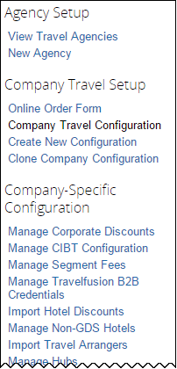 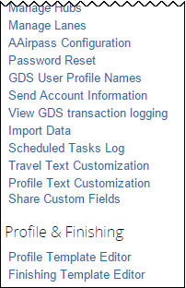

## Getting Started

### Procedure: Logging in to Travel System Admin

1. To log in to Travel System Admin:
2. Access the login page.
3. In the **User Name** field, enter your user name.
4. In the **Password** field, enter your password.
5. Remember the password is case sensitive.
6. Click **Login**.
7. On the menu, click **Administration > Travel** (on the sub-menu) **> Travel System Admin**.
8. If Travel System Admin is your only Travel option, then the commands are **Administration** **>** **Travel System Admin**.
9. (For TMCs migrated to new AWS environments) The Lookup Tool appears. Select a company. This will redirect to the correct data center for the customer’s Travel System Admin screen. Note the following fields:

Search: Allows you to search for a company that you manage. This requires at least one character to be entered in order to perform the search.

Companies: This provides the list of search results. Once a company is selected, you will be redirected to the Travel System Admin screen in the correct datacenter.

## Configuring a Company

Use the main configuration page – referred to as *the travel configuration page* – to define the options that travelers see in the Travel Wizard. To meet the needs of different travelers, you can create several travel configurations for a company. In the User Administration tool, you can choose the travel configuration that applies to each traveler by modifying the traveler's assigned travel rule class.

You can access the travel configuration page in the following ways:

* You are directed to this page when you create a new company.
* You can edit an existing company travel configuration by clicking the name of the company/configuration in the company list.
* You can create a new company travel configuration to assign to an existing company by clicking **Create New Configuration** in the left menu.

### General Information Options

In the general information section, you will specify the fields and options listed in the following table.

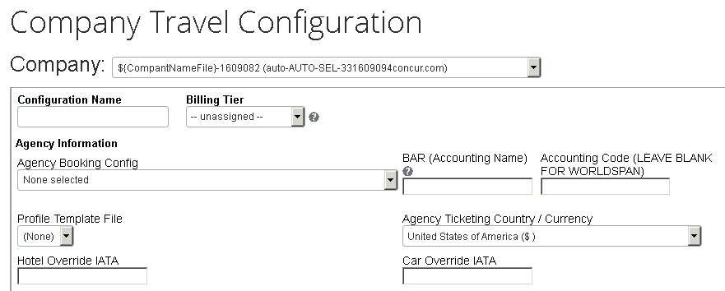

| Option | Description / Action |
| --- | --- |
| Configuration Name | Enter a name for this company travel configuration.  This name should be detailed enough so that it is easily identified in the list of configurations. If this is an alternate configuration for a company, it will automatically appear in the list as the company name/configuration name. |
| Billing Tier | This field is not use but might be required. Select any option. |
| Agency Booking Config | Select the agency configuration for this company from the list.  This should be the agency configuration created when you submitted the setup request work order. If you do not see the correct agency, contact SAP Concur support immediately. |
| BAR (Accounting Name) | You should enter BAR specifications as (optionally) PCC- followed by the BAR/STAR/Worldfile name.   * If you want to move the user-level profile (Apollo -OR- Sabre), put a * in front of the BAR/STAR/Worldfile. * If you want to merge the two, use a ^. * You can specify multiple moves by separating them with commas (except in Worldspan). * If you have a multiple BAR/Level 2 Star/Level 3 Worldfile/ Company Profile, use [ORG_UNIT_NAME]. The multiple levels all must be within the same PCC/SID/Office ID.   Contact your assigned SAP Concur Implementation Manager if you have additional questions. |
| Accounting Code | Leave this field blank if the GDS is Worldspan.  In Sabre, this field is typically referred to as the DK number.  You do not need to fill in this field if the Accounting Code/DK Number is coming from the BAR/level 1 STAR/Company Profile that is being merged into the PNR. |
| Profile Template File | Select a profile synch template file. |
| Travel Agency Ticketing Country | Select the currency that corresponds to your TMC's fulfilment currency for this configuration.  Results in Travel will appear in the currency that the GDS uses.  **NOTE:** The country named here is the default country used in Google Maps when a user searches for a location. |
| Sabre Profiles Template ID  Sabre Profiles Name Field remark  Sabre Profiles Name Format | These fields appear only if Sabre Profiles has been activated using the **Sabre Profiles Enabled** field (**Administration > Travel > Travel System Admin**, and then **View Travel Agencies** in the **Agency Setup** section of the left menu).   * Refer to the *Sabre Profiles Travel Service Guide*. |
| Hotel Override IATA | Enter the IATA number to specify an IATA override for hotel segments.  Some companies have their own IATA number to track and collect their hotel commissions globally instead of through regional agencies. The PNR and flight segments must exist under the travel agency IATA, which requires an override for the hotel segments. |
| Car Override IATA | Enter the IATA number to specify an IATA override for car segments.  Some companies have their own IATA number to track and collect their car commissions globally instead of through regional agencies. The PNR and flight segments must exist under the travel agency IATA, which requires an override for the car segments. |

### Air Connectors

In the **Air Connectors** section, you can:

* Access direct connect participating vendor inventory, which may be considered *Instant Purchase* and require guaranteed ticketing.  
    
  In order to guarantee a ticket price, the purchase is immediately transacted online, either on a GDS (Worldspan, Sabre, or Apollo) or through a direct connection to the airline. For these types of flights, travelers will not be able to hold or obtain approval prior to ticketing and will be informed that, if they reserve the selected flight, they will pay for it immediately.
* Access airline inventory from a secondary GDS, which may or may not be the same as the GDS associated with the initial site
* Access Cross-GDS Rapid Reprice ticket exchange functionality

1. Concur Travel allows the user to book only the alternate GDS airline and not combine with other carriers. All ancillary types would be booked in the native GDS, like car and hotel.

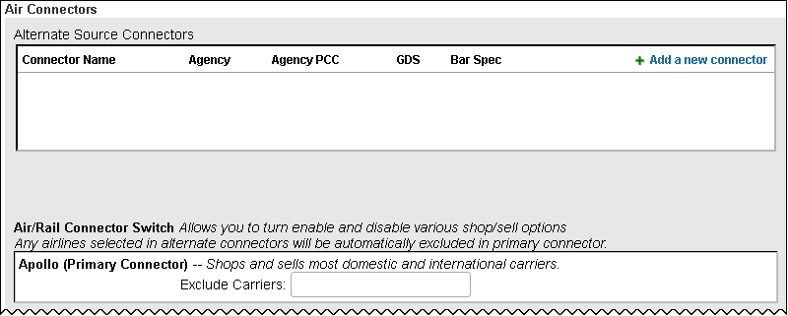

This is the first part of this section. The remainder of this section is described on the following pages.

| Option | Description / Action |
| --- | --- |
| Alternate Source Connectors | Click **Add a new connector** to create a new air connector. When you add a new air connector, it appears in the **Air/Rail Connector Switch** section, and you can enable and disable shop/sell options. You are required to associate an agency configuration.  **NOTES:**   * If this is a new site and you need assistance, contact your assigned SAP Concur Implementation Project Manager. If this is a site currently using Travel, contact SAP Concur support. * You do not need to add a PNR template or a BAR/Level 1 Star/Worldfile/Company ID for a direct connect. You may, however, add a BAR/Level 1 Star/Worldfile/Company ID if you are utilizing the multi-GDS option to access Southwest flights on Sabre. |
| Air/Rail Connector Switch | For each air connector, click **Shop Enabled** or **Sell Enabled**. Once you add connectors, you can choose to enable them.  **NOTE:** The options to enable the connector will not be available until you have saved the company travel configuration. When you return to this section, you will be able to view and select the options, and then save the changes. |
| Sabre NDC Enablement | On the **Travel Configuration** page, select the new **Enable NDC Content** check box.  **NOTE:** This setting is only applicable for Flight searching and booking in the new Concur Travel experience, but the toggle will appear for all Sabre configurations.  **NOTE:** A checkbox is available only on **Travel** **Configurations** where Sabre is the GDS |

Scroll down to the next section.

##### Cleartrip Direct Connect

Refer to the *Cleartrip (Air) Direct Connect Travel Service Guide*.

##### Southwest Airlines Direct Connect

Refer to the *Southwest Direct Connect Travel Service Guide*.

##### Travelfusion Direct Connect

Refer to the *Travelfusion Direct Connect Travel Service Guide*.

##### Volaris

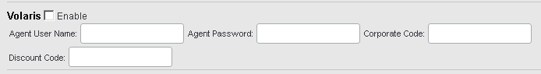

To enable:

| Field | Description |
| --- | --- |
| Enable | Select to enable. |
| Agent User Name | Enter the user name. |
| Agent Password | Enter the password. |
| Corporate Code | Enter the agency IATA. |
| Discount Code | Enter a discount code, if known. |

Then, remember to select from the **Access to Guaranteed Ticketing carriers** list in the **Rule Class Options** section of the travel configuration page.

### Wizard Options

The **Wizard Options** section has many subsections that you will complete. Each is described on the following pages.

#### Wizard Options – General Options

Use the general options (top) section to specify the fields and options listed in the following table.

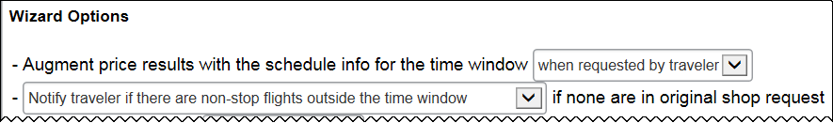

This is the first part of this section. The remainder of this section is described on the following pages.

User interface options:

| Option | Description / Action |
| --- | --- |
| Augment price results with the schedule info for the time window | This option determines what source of data will be used to display fares in the **Shop by Schedule tab** when the **Search** **by** option is set to **Price** and requested **Class** of service is **Economy** in the Air Search Wizard. (This option is ignored when **Search by** is set to **Schedule** or **Class** of service is other than **Economy**).  Choose either:   * **Automatically** – A dedicated request will be made to provide full range of fares available by Schedule. This request may be subject to billing costs. * **When requested by traveler** – No dedicated request is made to obtain fares available by Schedule. The existing data on fares available by Price are decomposed and used to show a limited range of fares available by Schedule instead. In this case, a **Load detailed schedule data** link will appear at the bottom of the Search by Schedule tab. When clicked, this will trigger the dedicated request to load the full range of fares.   P440C4T7#yIS1  **NOTE**: For customers on Sabre or Worldspan using corporate jet service, the option must be set to automatically in order for the user to see the corporate jet results on the Shop by Fares tab.   * Best Practice: Concur Travel recommends that you choose the Automatically option. |
| ...if none are in the original shop request | Use this option to alert the user that non-stop flights are not available during their time window and allow them to expand the window to include a non-stop flight.   * **Best Practice:** This option does not use any additional scans and it is strongly encouraged.   Click either:   * Do not notify traveler if there are non-stop flights outside the time window * Notify traveler if there are non-stop flights outside the time window |

Scroll down to the next section.

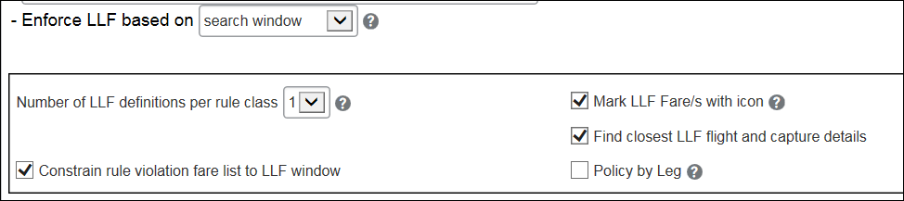

| Option | Description / Action |
| --- | --- |
| Enforce LLF based on  Number of LLF definitions per rule class  Constrain rule violation fare list to LLF window  Mark LLF Fare/s with icon  Find closest LLF flight and capture details  Policy by Leg | * For information about these settings, refer to the *Lowest Logical Fare (LLF) / Benchmark Lowest Airfare Travel Service Guide*. |

Scroll down to the next section.

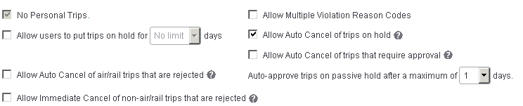

| Option | Description / Action |
| --- | --- |
| No Personal Trips | Select (enable) this check box to prevent users from booking personal trips. |
| Allow users to put trips on hold for x days | Select (enable) this check box to allow users to hold a trip during booking, at the point where the user would normally purchase the trip.  This option reserves the fare and any other options; however, it does not send the flight for ticketing until the traveler chooses to purchase the fare in Travel. It is important to make sure that travelers are aware of rules and limitations for holding fares. |
| Allow Auto Cancel of air/rail trips that are rejected | Select (enable) this check box to allow Travel to automatically cancel trips that were rejected trips during the approval process. The trip is cancelled based on the ticketing time limit or 24 hours prior to departure, whichever comes sooner.  **NOTE:** This feature will not work unless the PNR contains a GDS air segment.   * Refer to the *Auto Cancel Fact Sheet*. |
| Allow Immediate Cancel of non-air/rail trips that are rejected | Select (enable) this check box to allow the immediate cancellation of rejected non-air trips, such as car and hotel-only reservations.  Messaging appears on the approval page and in the approver email. When an approver rejects a non-air trip, Concur Travel places it in queue for cancellation.  **NOTE:** This feature does not apply to offline trips. |
| Allow Multiple Violation Reason Codes | Select (enable) this check box to allow the user to see more the one violation code. If this check box is ***not*** selected, only one reason code is requested of the user - even of the user violates multiple rules.  If the feature is activated and if a user violates a rule, the user sees one violation reason per list assigned to rules violated.   * If one rule is broken, the user sees one list. * If two rules are broken and the rules have the same list assigned, the user sees one list. * If rules with two or more lists assigned are broken, the user sees each list and must choose a value for each one.   Additional steps:   * The administrator creates the rule violation codes using **Administration** **>** **Company** (on the sub-menu) **>** **Company Admin**, and then **Travel Admin** in the **Travel Administration** section of the left menu), and then the **Policy Violation Reasons** tab. * The administrator must update the PNR template to determine how the multiple violation reason codes write to the PNR, using **Administration** **>** **Travel** (on the sub-menu) **>** **Travel System Admin**, and then **Finishing Template Editor** in the **Profile & Finishing** section of the left menu.  **NOTE: *Only*** multiple ***air*** violation codes will be available in the finisher. Writing multiple violation codes in finishing is not available for car, hotel, or itinerary rules.   In the new Concur Travel experience for Rail, If **Allow Multiple Violation Reason Codes** is enabled and multiple travel policy rules are violated, a user may be requested to select multiple violation reasons on the **Review and Book page** if different policy violation reason types are configured for the rules**.**  The user interface displays a list all the policy rules violated, grouped by the rule action. |
| Allow and Display message | Support for additional policy-based messaging set by administrators is available. **Allow** and **Display Message** enforcement levels will behave similarly. When a rule is set up with these levels, the user can book the segment without restrictions. |
| Display per diem rates with individual hotel selections | In the new Concur Travel experience, If the Display per diem rates with individual hotel selections configuration setting is selected, the Search results page will include the per diem lodging limits for the property location together with the dates the per diem rate is applicable. |
| Allow Auto Cancel of trips on hold | Select (enable) this check box to allow Travel to automatically cancel trips that are still on hold after the last ticketing date has passed.  We recommend that you click this option if the **Allow users to put trips on hold** option is active.  When enabled, by default the auto cancel code looks at the ticketing deadline, -1 day. For all non-refundable reservations the fare can be held for 24 hours unless otherwise noted.  If a PNR cancels in:   * **0-20 minutes:** Same day travel and approval is required. * **2-4 hours:** The z_demo permission is enabled and the PNR is never sent to the ticketing queue.  **NOTE:** Instant Purchase Carriers are excluded; this applies ***only*** to GDS Carriers. * **6+ hours:** Orphan trip **NOTE:** Instant Purchase Carriers are excluded; this applies ***only*** to GDS Carriers. * Refer to the *Auto Cancel Fact Sheet*. |
| Allow Auto Cancel of trips that require approval | Select (enable) this check box to allow Travel to automatically cancel trips that require approval if they have not been approved by the last ticketing date.   * **Best Practice:** Concur Travel recommends that you click this option if you use approvals. * Refer to the *Auto Cancel Fact Sheet*. |
| Auto-approve trips on passive hold after a maximum of x day(s) | Select the number of days to indicate the amount of time an approver has to reject the trip before it is automatically approved. |
| Multiple Rail Connectors | * For travel configurations where only rail connectors in the New Concur Travel Experience are enabled, vendor selection by the user is not necessary. * For travel configurations combining current and New Concur Travel Experience rail connectors, the user can select the vendor from a dropdown. |

Scroll down to the next section.

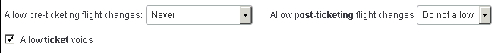

| Option | Description / Action |
| --- | --- |
| Allow pre-ticketing flight changes | Select a preference that allows travelers to change a flight that is reserved but not ticketed.  Depending on your settings, travelers will be able to change the date, time, or carrier for the flight.  The choices to allow pre-ticketing flight changes are:   * **Never:** Traveler can never change flights * **When trip is on hold:** Traveler can change a trip only when it is on hold  **NOTE:** This option allows Eurostar users to make pre-ticket changes. This applies only to Eurostar via the GDS. Eurostar is also available through the SNCF Direct Connect. * **Anytime:** Traveler can change a trip anytime, pre-ticketing |
| Allow **post-ticketing** flight changes | This option appears only if you have completed the Rapid Reprice Post Ticket Change setup process.   * Refer to the *Trip Cancel and Voids Travel Service Guide*.   Click one of the options to:   * Not allow post-ticket change * Allow post-ticket change using the web version of Travel   This is currently available ***only*** for Apollo, Amadeus, Sabre, and Worldspan customers – not Galileo and Abacus. |
| Allow ticket voids | Select (enable) this check box to allow travelers to cancel reservations in Travel after a ticket has been issued. If you enable this check box, Travel will attempt to void the ticket.  Then, designate the following for the agency configuration associated with the company travel configuration:   * Voided ticket queue (when Travel voids a ticket) * Refund request queue (Agency assistance needed with refund) * Refer to the *Trip Cancel and Voids Travel Service Guide*. |

Scroll down to the next section.

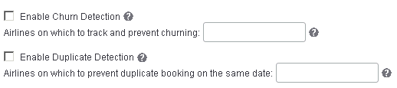

| Option | Description / Action |
| --- | --- |
| Enable Churn Detection  ***- and -***  Airlines on which to track and prevent churning | *Churning* is defined on airline websites as "Canceling and rebooking the same itinerary in the same or different classes of service across one or more PNRs."  Select (enable) the **Enable Churn Detection** check box.  Then, in the **Airlines on which to track and prevent churning** field, enter:   * A comma-separated list of airlines (up to 10; example: AA,BB,CC)  ***– or –*** * "ALL" to enable it for all airlines   Once enabled, Concur Travel evaluates all flights booked for the same user for the past 31 days when making the "churning" determination. Then:   * The ***third*** time the user tries to book the *same* flight in the *same* class of service; Concur Travel warns the user that this is the last opportunity to book it. * The ***fourth*** time the user tries to book the *same* flight in the *same* class of service; Concur Travel prevents the user from doing so. * The ***fourth*** time the user tries to book the *same* flight *regardless* of class of service; Concur Travel warns the user that this is the last opportunity to book it. * The ***fifth*** time the user tries to book the *same* flight *regardless* of class of service; Concur Travel prevents the user from doing so.   **NOTE:** This functionality is not applicable to Instant Purchase Carriers.  Concur Travel shows an error message on-screen if a traveler makes a reservation that would likely lead to a churning debit memo. The text of the message is configurable using (criteria defined in **Administration** **>** **Company** (on the sub-menu) **>** **Company Admin**, and then **Travel Admin** on the left menu, and then the **Custom Text** tab. |
| Enable Duplicate Detection  - and -  Airlines on which to prevent duplicate booking on the same date | Some airlines have complex rules about what defines a *duplicate* booking. Concur Travel has coded to the strictest rules that would result in a debit memo. A duplicate booking is essentially when a trip is booked that the traveler cannot possibly travel on due to a previous booking with the same airline. This can cross dates, city pairs, and times of departure and arrival.  Select (enable) the **Enable Duplicate Detection** check box.  Then, in the Airlines on which to prevent duplicate booking on the same date field, enter:   * A comma-separated list of airlines (up to 10; example: AA,BB,CC)  – or – * "ALL" to enable it for all airlines |

Scroll down to the next section.

P589#yIS1

| Option | Description / Action |
| --- | --- |
| Offline trip approvals are passive | Select (enable) this check box to allow accounts to send offline (traditional agent-booked) PNRs to an approval queue. Travel will import these PNRs and send them to the trip approver for approval, similar to the way it is done for online trips. If you choose to use this feature:   * Administrators must update the agency configuration with a passive approval queue:   P597C4T12#yIS1   * + Refer to *Appendix B: Agency Configuration* in this guide. * To enable passive approval for a given rule, click **Administration** **>** **Company** (on the sub-menu) **>** **Company Admin**, and then **Travel Admin** in the **Travel Administration** section of the left menu: * P600C4T12#yIS1   + Refer to the *Approvals, Rules, and Classes/Policies Travel Service Guide*. |

Scroll down to the next section.

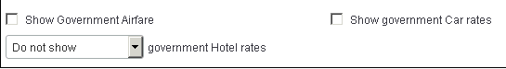

| Option | Description / Action |
| --- | --- |
| Show Government Airfare/Car rates/ Hotel rates | Select (enable) this check box (or select from list) to allow travelers to see and book government airfare, car, or hotel.   * Refer to the *Government Features Travel Service Guide*. |

Scroll down to the next section.

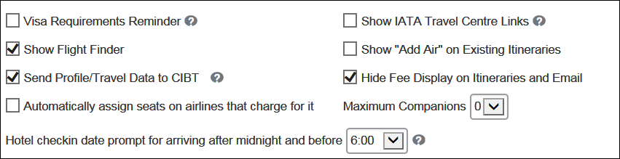

| Option | Description / Action |
| --- | --- |
| Visa Requirements Reminder | Select (enable) this check box to display a reminder to travelers who are booking international travel to check the visa requirements for the countries they are visiting. |
| Show Flight Finder | Select (enable) this check box to allow travelers to search by price or by schedule. |
| Send Profile/Travel Data to CIBT | Select (enable) this check box to enable the CIBT Integration.   * Refer to the *CIBT Visa and Passport Travel Service Guide*. |
| Automatically assign seats on airlines that charge for it | Some airlines charge travelers a fee when Concur Travel automatically pre-assigns seats. If this check box is ***not*** enabled, Concur Travel will ***not*** automatically pre-assign seats for those airlines that charge. This setting has no effect for airlines that do not charge for pre-assigned seats. Currently, this applies only to FlyBe. |
| Hotel check in date prompt for arriving after midnight and before | Use the option to assist late-arriving travelers. This feature targets travel where a user arrives in the early morning hours and would like a room waiting for them when they arrive at their destination.  Set the time as desired.  To disable this feature, change the option to *Midnight*.  **NOTE:** This feature ***only*** applies to hotels requested from the home page search Travel Wizard. It ***does not*** apply when adding a hotel to an existing reservation from the itinerary. |
| Show IATA Travel Centre Links | Select (enable) this check box to allow travelers who are booking international travel to see links on their itinerary to the IATA Travel Centre web site.  The IATA Travel Centre is a service to provide all the travel requirement information needed to successfully complete an international air journey. Essential information offered includes personalized passport, visa, and health advice related to the specific destinations chosen by the user. |
| Show "Add Air" on Existing Itineraries | Select (enable) this check box to allow travelers to add air to existing car or hotel reservations. |
| Hide Fee Display on Itineraries and Email | Do not use. |
| Maximum Companions | ***Not available to Amadeus***  Select the number of companions (who may or may not have profiles in Travel) that you will allow travelers to book travel for.  Companions will be added in the same PNR as the traveler. Within the shared PNR, a reservation will be made in the name of the companion for air bookings and Trainline (UK Rail Direct Connect). Companion details are not sent to hotel/car vendors. |

Scroll down to the next section.

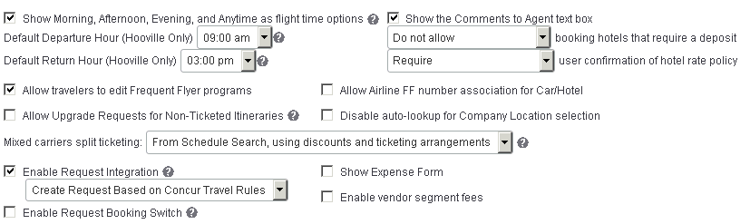

| Option | Description / Action |
| --- | --- |
| Show Morning, Afternoon, Evening, and Anytime as flight time options | Select (enable) this check box to display *Morning*, *Afternoon*, and *Evening* as search options, along with hours in the day.  These options search the following range of times in the specified periods and may not be precise enough for some travelers.   * **Morning:** 6:00 A.M. to 12:00 P.M. * **Afternoon:** 12:00 P.M. to 6:00 P.M. * **Evening:** 6:00 P.M. to 12:00 A.M. * **Anytime:** This option will be available only if the travel configuration has premium search/pricing enabled.   **IMPORTANT:** *Anytime* will be available ***only*** if the following three conditions are met:   1. **Show Morning, Afternoon, Evening, and Anytime as flight time options** is enabled. 2. The **Maximum Window** field in the **Air Search Options** section must be set to *11* or higher. 3. Premium search must be enabled:  * Sabre: * **Use Bargain Finder Max Search** must be enabled. * The **Max Search Results** field must be set to *200*. * Apollo: **Use ePricing Search** must be enabled. * Worldspan: **Use Premium Search** must be enabled. * Amadeus: Master Pricer Expert is required, but is enabled by default for all Amadeus travel configurations. No action required for this step. |
| Default Departure Hour  Default Return Hour | Select the default times for flights.  If your company is in a location where most travel departs late in the day, you could choose 5 P.M. for the default departure time.  If your company wants "the normal business day" to default, then choosing 1 P.M. with a default search window of +/- 4 hours as the default could achieve that goal.  If you have enabled the **Show Morning, Afternoon, Evening, and Anytime** option and if you want the default for departure or return flights to be:   * *Morning* - then set 9 A.M. as the default * *Afternoon* - then set 3 P.M. as the default * *Evening* - then set 9 P.M. as the default   **NOTE:** This setting affects the Travel Wizard on the SAP Concur home page or the Travelhomepage; it does not affect searches when adding air to hotel/car-only reservations. |
| Allow travelers to edit Frequent Flyer programs | Select (enable) this check box to allow users to add, edit, or delete airline frequent flier programs on their personal profile.  **NOTES:**   * The user still has the ability to add, modify, or delete ***car and hotel*** frequent traveler cards, as well as Advantage Programs. * All users with the User Administration permission can edit/add/ delete on behalf of a traveler. * If not selected, users will not be able to edit or delete existing frequent flier programs, nor will they be able to add new ones. All existing frequent traveler numbers will remain.   ***NOTE (for new Car experience):*** *This feature is supported for the new Car experience.* |
| Allow Upgrade Request for Non-Ticketed Itineraries | Select (enable) this check box to allow the upgrade link to appear on the user's itinerary when the ticket has not yet been issued.  This is only applicable with airline carriers AA, DL, and UA.  **NOTE:** UA will send an OSI and always use accrued frequent flyer points.  **IMPORTANT:** With this feature, Concur Travel sends a message to the carrier to upgrade when the user is eligible. This is usually 24, 48, or 72 hours depending on the user's status with the airline. Concur Travel does not recommend enabling this feature because it could upgrade a reservation before the agency has a chance to ticket it (if they make the reservation less than 72 hours out). The user would then lose the saved fare. The agency would have to try to rebook at the original fare and then re-upgrade.  If the GDS is Worldspan, the traveler is automatically added to the upgrade list on Delta and United. The **Request Upgrade** link is displayed only for American flights. |
| Mixed carriers split ticketing | Click one of these:   * From Schedule Search, using discounts and ticketing arrangements: This option means Concur Travel will split only when flights are chosen *from a schedule search*, and: * When the fare has flights that use non-combinable carriers (Concur Travel calls this an imperative split condition) ***– or –*** * If the discount configuration/ticketing arrangements indicate split ticketing should occur * From Schedule and Price Search, when split is cheaper: This option means Concur Travel will split when flights are chosen *from a schedule search*, and: * There are imperative split conditions ***– or –*** * If the discount configuration/ticketing arrangements indicate split ticketing should occur ***– or –*** * If Concur Travel compares the split and non-split fares and finds it is cheaper to split * Additionally, with this option, Concur Travel will split when flights are chosen ***from a price search***, and: * There are imperative split conditions ***– or –*** * If Concur Travel compares the split and non-split fares and finds it is cheaper to split * **IMPORTANT:** Discounts and ticketing arrangements are ***not*** considered when selecting fares from a price search. * **From Schedule Search, price without splitting and use no discounts:** This option means Concur Travel will ignore any discounts and ticketing arrangements when flights are chosen ***from a schedule search*** and will price mixed-carrier itineraries without splitting and without comparing split and non-split fares to find the lower price. The only time a split will occur with this option is if Concur Travel identifies an imperative split condition. |
| Enable Request Integration | ***This check box appears only if Concur Request has been enabled.***  When you click the **Enable Request Integration** check box, a list of options appears:   * **Always Create Request:** A request is always created, regardless of travel rules * **Create Request Based on Concur Travel Rules:** If a rule using the "Require Approval" enforcement level is broken, then a request is required. If no rules using the "Require Approval" enforcement level are broken, then the process of creating a request is bypassed and the trip is sent directly to ticketing.   **NOTE:**  Any rules that are broken that use other levels of enforcement (Require Passive Approval, Notify Manager, etc.) will not redirect the user to a request.   * Require Passive approval rules will behave as Active Approval rule for Request: If a Concur Request was created for a Require Passive approval rule violation and the approval deadline has passed, Concur Travel will not confirm the trip if the Request approver has not taken action. Instead, the trip will be sent for cancellation   **IMPORTANT:** If this option is selected, then **Force Finishing before Approval** ***MUST*** also be selected (**PNR Finishing Configuration** section of the travel configuration page).   * For more information about: * The relationship between Request and Travel approvals, refer to the appendix in the *Approvals, Rules, and Classes/Policies Travel Service Guide*. * Concur Request, refer to the SAP Concur support portal. |
| Enable Request Booking Switch | This check box appears only if Concur Request has been activated.  The booking switch is a decision tool that determines – based on client-defined criteria – if any or all segments are created by the user or an agency.  When enabled, will be evaluated at the Concur Travel Home page and in the Edit search or Search again pages.   * For more information about Concur Request, refer to the SAP Concur support portal. |
| Show the Comments to Agent text box | Select (enable) this check box to show the **Comments to Agent** box on the **Travel Booking Information** page, which allows travelers to enter comments. |
| ...booking hotels that require a deposit | Select a preference to either allow travelers to book hotels that require a deposit (as long as no approval is required) or to never allow travelers to book hotels with deposits.  **Apollo/Galileo Only:**  Send GT, not DPST  **NOTE:** Holiday Inns do not place the deposit information in the same place as other providers, so their property rates will always appear. |
| ...user confirmation of hotel rate policy | Click the appropriate option to control the display of the hotel rate rules/cancellation policy ***check box*** on the **Review and Reserve** page This governs whether the check box appears:   * If the check box appears, the user must check the box in order to proceed, indicating that the user has read and accepts the rate details/cancellation policy information. * If the check box does not appear, the user is not required to take any other action; they passively accept the rate details/cancellation policy information.   The options are:   * **Require:** The check box always appears. * **Skip unless deposit needed:** The check box appears ***only*** if a hotel rate requires a deposit. * **Always skip:** The check box never appears.   **IMPORTANT:** If you click *Always skip*, a warning appears to the user that Concur Travel is absolved of any liability for hotel policy issues. |
| Allow Airline FF number association for Car/Hotel | Select (enable) this check box to allow users to associate an airline frequent flyer number with a car or hotel booking so the user can get credit for Air, Car, and Hotel.  ***NOTE (for new Car experience):*** *This feature is supported for the new Car experience.* |
| Disable auto-lookup for Company Location selection | If this check box is cleared ***and*** there are more than 25 locations in the list, the list then uses auto-complete instead of a long dropdown list.  Select (enable) this check box to prevent auto-complete; regardless of the length of the list, there is no auto-complete. |
| Show Expense Form | ***This field appears only for Travel & Expense clients.***  Select (enable) this check box to allow travelers to auto populate their expense report with expected charges for parking and transportation to/from the airport.  The popup appears at the end of the booking process. |
| Enable vendor segment fees | Select (enable) this check box to allow vendor segment fees.   * For more information, refer to the *Manage Segment Fees* section in this guide. |
| Cancel Trip | When Concur Travel sends a trip for cancelation, the trip may or may not be cancelable. When the trip is not cancelable, Concur Travel will instead auto-complete the trip. |

#### Wizard Options – Transportation Security Administration (TSA) Secure Flight Options

Refer to the *Transportation Security Administration (TSA) Requirements**Travel Service Guide*.

#### Wizard Options – Carbon Model Options for AIR

Refer to the *Green Support Travel Service Guide*.

#### Wizard Options – Class of Service Options

Use the **Class of service options** section to specify the default class of service when a traveler who is authorized for more than one class of service is searching for flights.

Select an option to set the default to the Highest or Lowest available class.

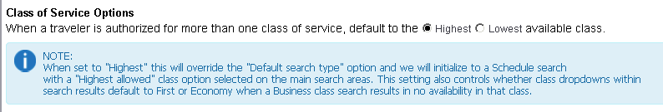

Note the following:

* **Highest Allowed:** If there are multiple classes available and if the **Class of Service Options** option is set to *Highest*, users can select *Highest allowed* in the **Class of service** dropdown in the Travel Wizard.

The **Class of service** dropdown in the Travel Wizard will default to the highest class of service allowed, per the user's policy. If *Highest allowed* is selected, the radio button for the search type will be set to **Schedule**. Users will be taken to the **Shop by Schedule** tab to select their flights after clicking **Search**.

* **Mixed Classes:** The option called *Mixed classes* will also appear in the **Class of service** dropdown options if a traveler is authorized for more than one class of service. The Mixed cla*sses* option is similar to *Highest allowed* and users will select their flights from the **Shop by Schedule** tab.

When taken to the **Shop by Schedule** tab after selecting *Highest Allowed* or *Mixed Cabins*, there will be no price results initially. The user selects the desired flights. The user will then see their flights and the option to price these options. The price results will appear on the **Shop by Fare** tab.

#### Wizard Options – Rule Class Options

Use the **Rule Class Options** section to specify the fields and options listed in the following table.

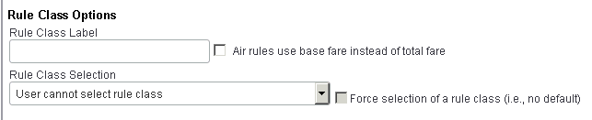

| Option | Description / Action |
| --- | --- |
| Rule Class Label | Enter the rule class label as you want it to appear to the traveler. |
| Air rules use base fare instead of total fare | Select (enable) this check box so that any rules that use the selected airfare will use the base fare, instead of the total fare, which includes taxes and fees. |
| Rule Class Selection | Click one of these:   * User cannot select rule class * User can select from rule classes tied to this configuration * User can select from rule classes tied to this agency |
| Force selection of a rule class | Select (enable) this check box to force the user to select a rule class.  Concur Travel will ***always*** default to the blank option in order to prevent travelers from inadvertently booking with the wrong travel class. If a traveler attempts to book without first selecting a rule class, they will receive an alert message and will be unable to continue the booking process until they select a rule class. |

#### Wizard Options – Air Search Options

Use the **Air Search** **Options** section to specify the fields and options listed in the following table.

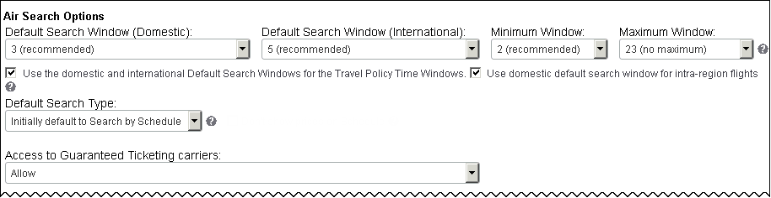

This is the first part of this section. The remainder of this section is described on the following pages.

| Option | Description / Action |
| --- | --- |
| Default Search Window (Domestic), Default Search Window (International), Minimum Window, Maximum Window | Select the default search window for domestic and international travel and select the minimum and maximum window for travelers.  The default window will pre-populate when the traveler selects dates and times on the **Flight Search** (or **Air/Rail Search**) tab. The traveler can change the default window when searching but can never search a smaller time window than the minimum/ maximum set here.  **NOTES:**   * ***For Worldspan only***, the *Anytime* option will appear ***only*** for users if the **Maximum Window** field is set to 12 hours. * ***For Sabre only***, the admin can select an option greater than *9* from the **Maximum Window** list only if Bargain Finder Max is enabled ***and*** if the **Max Search Results** field is set to *200*. |
| Use the domestic and international Default Search Windows for the Travel Policy Time Windows  Travel Policy Time Window (Domestic)  Travel Policy Time Window (International) | Select (enable) this check box to use the settings above to manage both the Lowest Logical Fare (LLF) time window and the default search window for air searches.  Clear this check box to manage the LLF and the default search windows separately. When you clear (disable) this check box, two additional options appear:   * Travel Policy Time Window (Domestic) * Travel Policy Time Window (International)   The selections you make from these two lists define the LLF window. The selections in **Default Search Window (Domestic)** and **Default Search Window (International)** define the search windows.   * For more information about LLF, refer to the *Lowest Logical Fare (LLF) / Benchmark Lowest Airfare Travel Service Guide*. |
| Use domestic search window for intra-region flights | Select to enable.  *Domestic* is defined as within a country, for example, Chicago to New York. *International* is defined as crossing a country border, for example, Paris to Hong Kong, China.  Enabling this feature will cause intra-region itineraries to default to the domestic time window, for example, London to Frankfurt will become *domestic* rather than *international*. |
| Default Search Type | Click one of these:   * Initially default to Search by Price * Initially default to Search by Schedule * Always default to Search by Schedule * Only Search by Schedule: When using the Travel Wizard, users will not have a choice to search by price or schedule. Travelers are automatically directed to the **Shop by Schedule** tab but the **Shop by Fares** tab is available for use.   **NOTE:** If **Show Flight Finder** is not selected under Wizard options, you can only search by price. |
| Access to Guaranteed Ticketing carriers | If you choose to allow guaranteed ticketing carriers, select an option from this list to determine when travelers have access to them. You can choose from:   * Guaranteed Ticketing Carriers not available * Allow if fare violates no rules * Allow unless manager approval is required * Show but don't allow * Allow: This option overrides any broken rules and allows users to book the flights anyway; users will still see any broken rules, but the radio button to choose the flights will ***not*** be disabled. |
| Use Master Pricer Travel Board  (may not be shown in sample above) | ***Applies to Amadeus only***  Options are:   * Never * Always * Travel 7 or more days out * Travel 14 or more days out * Travel 21 or more days out   Master Pricer Travel Board uses a cached search, retrieving recommendations from a high-speed cache for efficiency. Cached searches are less reliable in the short term. Therefore, we have provided the ability for the travel administrator to select the number of days ahead before invoking Master Pricer Travel Board. |

Scroll down to the next section.

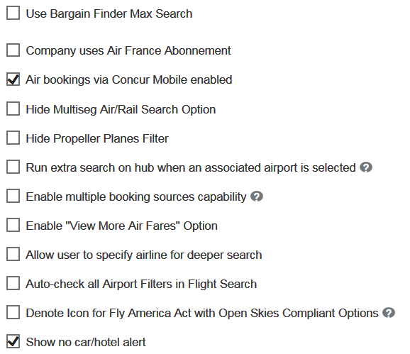

There are several possible options as shown in the following table.

| Option | Description / Action |
| --- | --- |
| Use Bargain Finder Max Search  (may not be shown in sample above) | ***Applies to Sabre only***  Select (enable) the check box and choose the maximum number of results.  **IMPORTANT #1:** This feature must be active in the customer's Sabre pseudo city before turning it on in Travel. To activate the feature, please contact your Sabre account representative.  Sabre's Bargain Finder Max provides up to 200 itinerary options for each low-fare search, carefully mixing the lowest prices with a diverse set of carriers, non-stop and connecting flight options, short flight durations, and the ability to specify arrival and departure times.  **IMPORTANT #2:** Only if Bargain Finder Max is enabled ***and*** if the **Max Search Results** field is set to *200*:   * The admin can select an option greater than *9* from the **Maximum Window** list. * The *Anytime* option appears to users if the **Show Morning, Afternoon, Evening, and Anytime as flight time options** check box is selected.   ***Special situation:***  The **Shop Across Passenger Types** check box appears if:   * Both Bargain Finder Max and SAPT (shop-across-passenger-types) turned on by Sabre for a SWS agency. – and – * The **Allow Shop Across Passenger Types** module property is set to True by SAP Concur support.   **IMPORTANT #3:** Once the configuration is saved, these fields become read-only. |
| Use ePricing Search  (may not be shown in sample above) | ***Applies to Apollo/Galileo only*** |
| Use Premium Search  (may not be shown in sample above) | ***Applies to Worldspan only***  Unlike the other GDSs, the Premium Search for Worldspan only impacts searches for customer-defined hubs – and not the regular search results. Since we already get a good mix of results with Worldspan's basic shop, there was no reason to add the premium shop until now. The Premium Shop (e-pricing) in Worldspan allows us to search for multiple airports in a single request.  **NOTE:** Clients and TMCs should be aware that Travelport may charge the TMC additional fees for use of this command.  **More information:** Travelport e-Pricing allows travel agencies, corporate travel buyers, and online shoppers to shop, price, and book low fares faster and more accurately. It provides these benefits:   * Shop across millions of published, negotiated, web, and advertised fares as well as hundreds of thousands of itinerary options in seconds with just one simple entry. This removes the need to log into different systems or web sites, which ensures customers get the information and choice they expect. * Travelport subscribers have the option of contracting for three (3) different Tier Levels that control the quantity of itineraries returned: * **Tier 1:** Minimum 25 – Maximum 150 * **Tier 2:** Minimum 50 – Maximum 200 * **Tier 3:** Minimum 100 – Maximum 350 * Valuable option to shop for low fares prior to booking an itinerary or shop the lowest available fares worldwide for an existing itinerary * Ensures accuracy on all ticketed low fares, with automatically validated rules on worldwide itinerary pricing, ticketing, and accurate taxes |
| Company uses Air France Abonnement | Select (enable) this check box if your company uses the Air France Abonnement service. |
| Air bookings via Concur Mobile enabled | ***Appears for Sabre only but can be used by all clients***  Sabre clients can clear (disable) this check box to remove air booking capability from the SAP Concur mobile app.  Other clients can use this feature as well but they must contact SAP Concur support for assistance. |
| Hide Multiseg Air/Rail Search Option | Select (enable) this check box to hide the **Multi-Segment** radio button on the **Flight Search** tab and the **Train** **Search** tab to prevent users from booking multi-segment flights and rail trips. |
| Hide Propeller Planes Filter | Select (enable) this check box to display the **Hide Propeller Planes** filter that users can access on the search results page. |
| Run extra search on hub when an associated airport is selected | Select (enable) this check box to allow Travel to run an additional search on the main hub if the user has chosen one of the associated airports. If you require more results than this feature provides, you should create a hub for that region.  **NOTE:** Creating a hub will add additional scans. |
| Enable multiple booking sources capability | ***Flex faring, GDS, and direct connect*** Select (enable) this check box to allow Apollo, Galileo, Sabre, and Amadeus customers who have flex faring to combine a GDS and a direct connect segment in the same booking.  ***GDS and direct connect for Search by Schedule* NOTES:**   * Concur Travel does not support mixed content for pre- or post-ticket change. The links to change the segment/trip will be hidden for both GDS and direct connect vendors. * Southwest has a limitation with the GDS that it cannot be combined with any other carrier. In order to support mixed content for Southwest, we updated the passive segment to note the carrier as XA instead of WN. This will be particularly important to our TMC partners and should be reviewed before turning this feature on.  **Example:** 1 XA 614W 05JUL T BWIDEN YK1 615A 820A * Concur Travel does not support mixing Southwest from the GDS with Southwest from the direct connect. We will continue the current functionality where – if a user chooses a fare class that is serviced from the direct connect on one segment with a fare class that is serviced from the GDS on another segment, then we will purchase both segments from the direct connect. This is how Southwest Direct Connect has worked since its release. * Supported GDS: Sabre, Amadeus, Worldspan, Apollo and Galileo * Current supported direct connects: Southwest; others air direct connects will become available with a future release. * This feature works for users, arrangers, and guest travel bookings. * Trip Cancel and Trip Approval apply to mixed-content bookings. The user experience will depend on the setting configurations. For trip cancel, please verify your trip cancel settings are correct in the Agency Configuration. * This feature is not supported for any rail supplier. |
| Enable "View More Air Fares" Option | Select (enable) this check box to allow a traveler to search multiple cabins, refundable and non-refundable airfares for all GDSs; for Sabre Webservices only.   * Refer to the *View More Air Fares Travel Service Guide*. |
| Allow user to specify airline for deeper search | Select (enable) this check box to allow a user to specify an airline that they would like searched. If selected, the **Search airline** check box appears on the user's Travel Wizard and in the **Change Flight Search** on the left side of the search results page.  P937C24T18#yIS1  When the user selects the check box, a list of carriers appears:   * The first (in yellow) will be their frequent flyer carriers. * The second (in a gray/khaki color) are the most requested airlines. * The remaining airlines are in alphabetical order.   **NOTES:**   * Only one vendor can be searched at a time, and this will override the preferred airline searches normally done for all of the frequent flyer number carriers. * This should, in many cases, result in more results for that airline – although, in reality, the difference may be negligible. * This will add an additional search for the selected carrier; it will not inhibit all other carrier flight options. |
| Auto-check all Airport Filters in Flight Search | Select (enable) this check box to have the system automatically select each of the alternate airport filter check boxes on the air shop. This means users will see all the results with flights to/from those airports. |
| Denote Icon for Fly America Act with Open Skies Compliant Options | Select (enable) this check box so that users will see the US flag icon (on both the **Shop by Schedule** and **Shop by Fares** tabs) for Fly America Act-compliant options.   * Refer to the *Government Features Travel Service Guide*. |
| Exclude Unbundled Economy Fares | ***Applies to Apollo, Galileo, and Worldspan***  This option allows clients using Apollo, Galileo, and Worldspan (provided by Travelport) to exclude these types of fares, like the new Delta unbundled "E" class fares.  If enabled, Concur Travel will send new XD modifier in the fare shop (Powershopper) and the FXD modifier when pricing economy flights. This means Concur Travel will exclude all unbundled economy fares from the results set and, therefore, these will neither be offered to the user nor considered when calculating the LLF (lowest logical fare) for travel policy. |
| Show No Car/Hotel Alert | Select (enable) this check box to have Concur Travel display a reminder to the user to book hotel and car, in those cases where the user booked a flight but not hotel/car. |

#### Wizard Options – Flex Faring

Refer to the *Flex Faring Travel Service Guide*.

#### Wizard Options­ – Amadeus Fare Family Setting

Use the **Amadeus Fare Family Setting** section to show the user all the fare types on the same line instead of having to do multiple searches. For example, you can configure this to show direct connect fares (if applicable), web fares (if applicable), refundable, and non-refundable fares – all in one result.

Note the following:

* This feature is available only for customers using Amadeus Web Services – the **AMADEUS ONLY: Enable all features using Amadeus web services** check box is selected in the **System Options** section of the travel configuration page, as shown on the following page.
* There is a limit of four different fare types.
* This feature is available to all regions and is not limited to Europe.
* Once this option is enabled, it cannot be disabled.

In order for this section of the travel configuration page to appear, follow these steps – in this order:

1. Amadeus Web Service credentials are required for this feature. Amadeus must provide this information. Please work with your TMC partner to acquire this data. Once received, the TMC can add this data to the Agency Configuration.

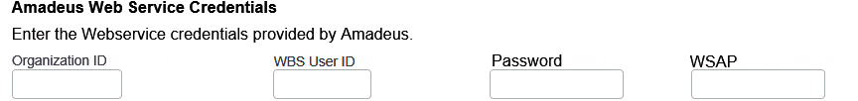

1. Click any option except *Never* from the **Use Master Pricer Travel Board** list, which is under the **Air Search Options** (on the travel configuration page).

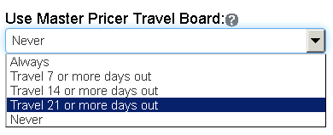

1. In the **System Options** section of the travel configuration page, select (enable) the **AMADEUS ONLY: Enable all features using Amadeus web services** check box.
2. Administrators cannot enable this option until the web service credentials are loaded in the agency configuration. Once this option is enabled, it cannot be disabled.

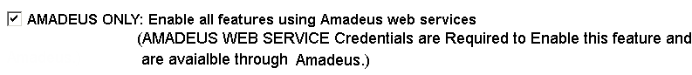

1. In the **Amadeus Fare Family Setting** section (between **Air Search Options** and **Hotel Search Options** on the travel configuration page), select (enable) the **Enable Configurable Fares View** check box. The additional options appear:

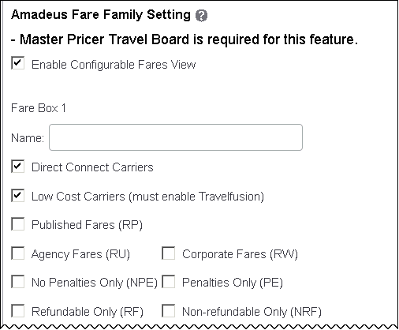

| Fields | Description / Action |
| --- | --- |
| Name (required field) | Each of the four sections includes a **Name** field. Enter an appropriate name, which the user will see if the user hovers the mouse pointer over the help icon in the fare box on the search results page.  Consider:   * Box 1: Direct Connect (includes rail as well) and Low Cost Carriers (Travelfusion web fares) * Box 2: Published fares * Box 3: Refundable fares * Box 4: Corporate and agency fares |
| Direct Connect Carriers  ***(Fare Box 1 only)*** | Select (enable) this check box to search the direct connect carriers (including both air and rail). |
| Low Cost Carriers (must enable Travelfusion ***(Fare Box 1 only)*** | Select (enable) this check box to search the Travelfusion carriers. |
| Published Fares, Agency Fares, Corporate Fares | Select (enable) this check box to search published, agency, and/or corporate fares (respectively). |
| No Penalties Only, Penalties Only | Click one or none; do not click both:   * Select **No Penalties Only (NPE)** to search no-penalties fares only. * Select **Penalties Only (PE)** to search penalties fares only. * Select ***neither of the check boxes*** to search ***both*** no-penalties and penalties fares. |
| Refundable Only, Non-refundable Only | Click one or none; do not click both:   * Select **Refundable Only (RF)** to search refundable fares only. * Select **Non-refundable Only (NRF)** to search non-refundable fares only. * Select ***neither of the check boxes*** to search ***both*** refundable and non-refundable fares. |

Scroll down to the next section.

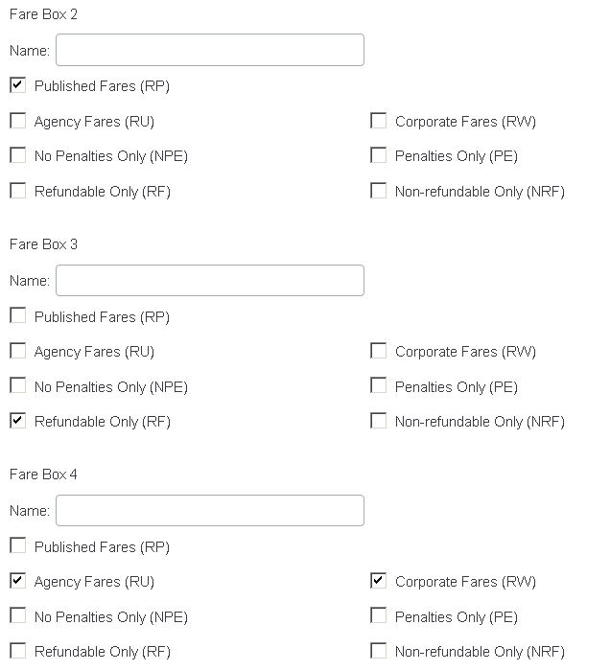

1. Complete the additional sections as described in the table above.

#### Wizard Options­ – Alternate Fare Finishing Endpoints (Amadeus Only)

Use the **Alternate Fare Finishing Endpoints (Amadeus Only)** section to provide additional information for APA and EMEA markets, where cost savings are often calculated based on the difference between the unrestricted fare on the plane or in-cabin and the actual booked fare.

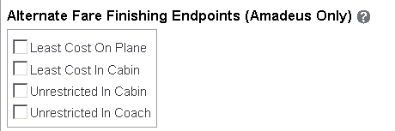

In the **Alternate Fare Finishing Endpoints (Amadeus Only)** section, select the desired options. After enabling, the data will be recorded during the air reservation.

To add this data to the PNR:

1. Click **Administration** **>** **Travel** (in the sub-menu) **Travel System Admin**, and then **Finishing Template Editor** in the **Profile & Finishing** section of the left menu.
2. Locate the template you wish to update and edit. Determine how you want to write this data to the PNR.
3. The recorded data is available in Finishing Template Editor as part of the TripRulesData node under: /PNRFinishData/TripRulesData/AirFareDataAry/AirFareData/AirFareAlternatePrice/AlternateFare

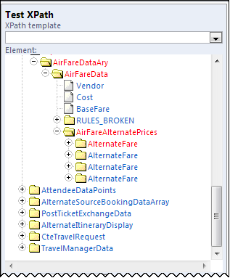 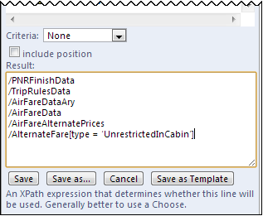

The following text must be added manually to create the required finishing entry:

* Least Cost on Plane = [type = 'LeastCostOnPlane']
* Least Cost in Cabin = [type = 'LeastCostInCabin']
* Unrestricted in Cabin = [type = 'UnrestrictedInCabin']
* Unrestricted in Coach = [type = 'UnrestrictedInCoach']
* **IMPORTANT:** The Finishing Data Endpoints will be available only for Amadeus GDS bookings booked after search by schedule or search by price (one-way or return) and ***not*** for flex faring bookings.

#### Wizard Options – Hotel Search Options

Use the **Hotel Search Options** section to specify the fields and options listed in the following table.

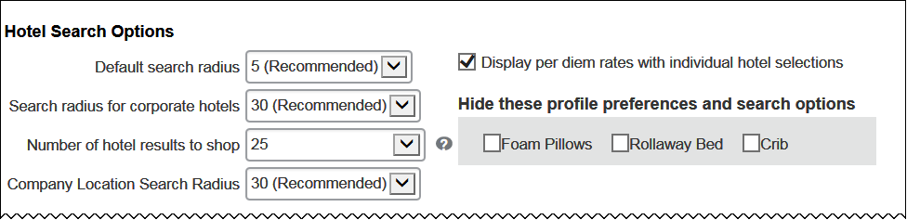

This is the first part of this section. The remainder of this section is described on the following pages.

| Option | Description / Action |
| --- | --- |
| Default search radius | Select the default range for the **Find hotels within** area in the Travel Wizard.  P1042C4T20#yIS1 |
| Search radius for corporate hotels | Select the radius to search for preferred hotel properties.  Regardless of the distance the traveler enters as the search radius when searching for hotels, Travel will search the radius you enter for company-preferred hotels near the location the traveler selects. |
| Number of hotel results to shop | Select the minimum number of hotels to shop. Travel will always show at least this many hotels.  **NOTE:** Concur Travel displays a default of 25 hotel search results on the hotel search results page. Note that there is a difference between *hotel search results* and ***priced*** *hotel search results*. The number of ***priced***hotel search results that return are reflected in this field. For example, if a customer has the value 10 set to hotel shops (in this field), then the hotel search results will show 25 total, 10 of which will have prices fetched for them. |
| Company Location Search radius | Select the radius used to determine the company locations that appear based on the initial airport selected. Widen this range if the company locations are unusually far away from the airports used. |
| Display per diem rates with individual hotel selections | Select (enable) this check box to display per diem rates on the hotel search results page.  **IMPORTANT:** This feature is available ***only*** for integrated Travel & Expense companies (not Travel only) and the users in that company must have Per Diem rates accessible by their ID in order for the display to show on the Hotel Availability screen. |
| Hide these profile preferences and search options | Click any item that you ***do not*** want to appear as an option:   * In the **Hotel Preferences** section of the user's Profile page * In the **Hotel Preferences** section of the search results page in the Travel Wizard   **NOTE:** Because some users can choose from several rule classes prior to booking and because those rule classes could be tied to different configurations, it's important to note the following:   * The display of the preferences on the user's Profile page is controlled by the user's ***default*** travel configuration. * The display of the preferences during booking is controlled by the ***configuration used to book the trip***. |
| HRS (not shown in the screen sample above) | If using HRS, enter the HRS customer number and the HRS-only countries.  **NOTE:** HRS cannot be combined with GDS results for any country. |
| Hilton (not shown in the screen sample above) | If using the Hilton, enter the Hilton rate code, requestor ID, and discount code. |
| HARP (not shown in the screen sample above) | P1075C20T20#y1HARP is a database of hotels maintained by Carlson Wagonlit Travel (CWT). It contains both GDS and non-GDS properties.  **NOTE:** This option appears only if you are from CWT or a CWT affiliate.  If HARP is enabled, hotel search results will include both GDS and HARP-only properties. To do so:   * Enter the HARP company code. * Select (enable) the **Include CWT discounted hotels** check box to include discounted hotels from CWT in the user's hotel search. * **NOTE:** This check box appears only after the HARP company code has been entered. |

Scroll down to the next section.

#### Wizard Options – Hotel Connectors

##### General

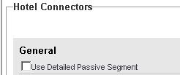

Refer to the *Passive Segments Fact Sheet*.

##### Hilton

P1088#yIS1

To enable:

|  |  |
| --- | --- |
| Option | Description / Action |
| Enable | Select to enable direct connect. |
| Discount Code | Enter the discount code. |

##### Hotel.de

* Refer to the *HOTEL DE Direct Connect Travel Service Guide*.

##### HRS

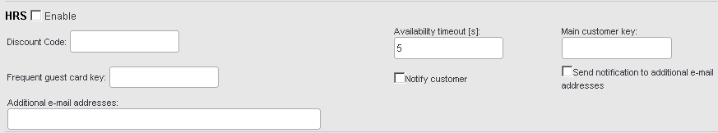

1. HRS and hotel.de cannot both be activated.

To enable:

| Option | Description / Action |
| --- | --- |
| Enable | Select to enable. |
| Discount Code | Enter the discount code. |
| Availability timeout | Leave the setting as 5 (for 5 seconds; default) or enter up to 99 (for 99 seconds)   * **Best Practice:** Increasing the timeout can affect the user experience. Concur Travel recommends 15 seconds or less. |
| Main customer key | Enter the key obtained from HRS.  This field and the **Frequent guest card key** field are used to support loyalty programs. |
| Frequent guest card key | Enter the 3-digit key obtained from HRS. |
| Notify customer | Select (enable) this check box so the user receives email notifications to the email address specified in the user's travel profile. |
| Send notification to additional e-mail addresses  Additional e-mail addresses | To send the same notification to additional email addresses:   * Select (enable) the Send notification to additional e-mail addresses check box. * In the **Additional e-mail addresses** field, enter one or more email addresses (separated by commas).   **NOTE:** The notification is not sent to the email addresses unless the **Send notification to additional e-mail addresses** check box is selected. |

##### Pegasus

P1137#yIS1

Select (enable) this check box to enable the direct connect.

##### AOT

* **IMPORTANT:** AOT is currently available ***only*** for AMEX in Australia.

P1141#yIS1

To enable:

| Option | Description / Action |
| --- | --- |
| Enable | Select to enable. |
| Agent ID | Enter the agent ID. |
| Password | Enter the password. |

In the country section, select *AOT* for Australia.

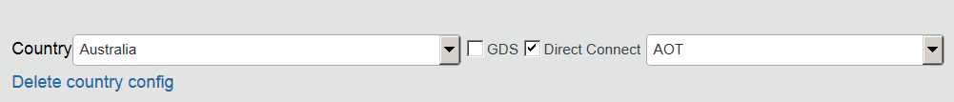

In the **Defaults for Specific Non-GDS Vendors** section of the travel configuration page, indicate whether to write a passive segment.

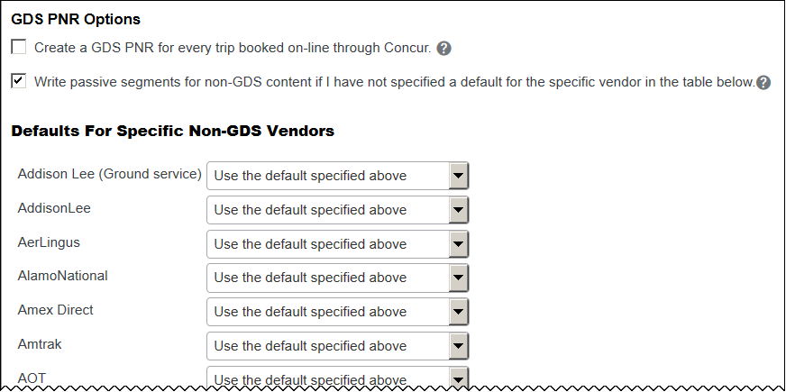

##### Booking.com, CDS, Direct Connect Hotels (Cleartrip Hotels), HCorpo, iAlbatros, Premier Inn, Rakuten Travel, The Hotel Network (THN), The Lido Group

* Refer to the *Hotel Service Content Suppliers Travel Service Guide*.

#### Wizard Options – Sorting

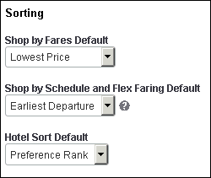Use the **Sorting** section to specify the fields and options listed in the following table.

| Option | | Description / Action |
| --- | --- | --- |
| Shop by Fares Default | Click one of the following:   * **Preference Rank:** All Most Preferred first, then Preferred, Less Preferred, and Non-Preferred * **Lowest Price:** Displays by price, lowest first * **Earliest Departure:** Displays by departure time, earliest first * **Earliest Arrival:** Displays by arrival time, earliest first * **Duration:** Displaysby duration, shortest travel time (including layovers) first * **Company Policy:** * By policy (green = in policy; yellow = log for reports/notify manager; red = passive approval/require approval) * Then by preference (Most Preferred = three stars; Preferred = two stars; Least Preferred = one star) * Then by price * **Fewest Stops:** Displays first all non-stop flights or flights with the fewest stops, then by price * **Emissions:** Displays all flights by emissions, lowest first * **Custom:** Refer to the "custom" information at the end of this table. | |
| Shop by Schedule and Flex Faring Default | Click one of the following:   * **Earliest Departure:** Displays by departure time, earliest first * **Earliest Arrival:** Displays by arrival time, earliest first * **Preference Rank:** All Most Preferred first, then Preferred, Less Preferred, and Non-Preferred * **Lowest Price:** Displays by price, lowest first - available only for Flex Faring. If you select this option, then Flex Faring will default to Lowest Price and Search by Schedule will default to Earliest Departure. * **Vendor Name:** alphabetical order * **Duration:** Displaysby duration, shortest travel time (including layovers) first * **Fewest Stops:** Displays first by stops, then by duration, then by depart time * **Emissions:** Displays all flights by emissions, lowest first * **Custom:** Refer to the "custom" information at the end of this table. | |
| Hotel Sort Default | Click one of the following:   * **Preference Rank:** All Most Preferred first, then Preferred, Less Preferred, and Non-Preferred * **Lowest Price:** Displays by rate, lowest daily rate first * **Star Rating:** Displays by stars, most first * **Distance:** Displays by distance, closest first * Company Policy: * By policy (green = in policy; yellow = log for reports/notify manager; red = passive approval/require approval) * Then by preference (Most Preferred = three stars; Preferred = two stars; Least Preferred = one star; chain contacts = one gray star; then Not Preferred) * Then by price * Then by distance * **NOTE:** If the site does not have rules set up for hotels, then Company Policy will work like Company Prefs. * **Custom:** Refer to the "custom" information at the end of this table. | |

##### Custom Sort Options

If the administrator creates a custom sort ***and*** if the administrator makes it the default sort order, then the shop results – by default – will be sorted by the criteria defined by the administrator. Users are not restricted to that sort order – they can select a different sort from the **Sorted By** dropdown as usual, and they can change it back at will.

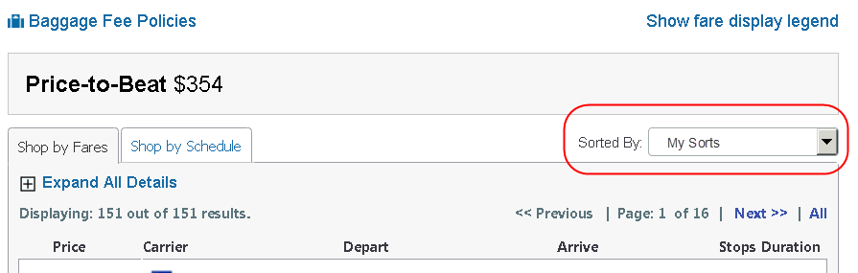

By default, the name of the custom sort is "custom." In this example, the administrator changed the default name to "My Sorts."

* **IMPORTANT:** The custom sort will only appear in **Sorted By** dropdown if the custom sort is made the default, for example, by selecting *Custom* in the **Sort by Fares Default** list.

To use the *Custom* option:

1. Click *Custom* in the desired list. The custom sort options appear:

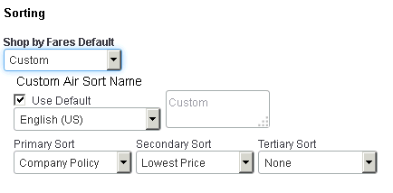

1. Change the custom sort name by clearing (disabling) the **Use Default** check box and adding the new label.
2. Use the **Primary Sort**, **Secondary Sort**, and **Tertiary Sort** lists to define the sort order. The secondary and tertiary sorts are optional; click *None* in the dropdown if no sort is desired.

#### Wizard Options – Rail Connectors

Use the **Rail** **Connectors** section to specify the fields and options listed in the following table.

##### General

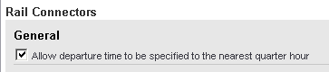

Select (enable) the check box to allow departure time to the nearest quarter hour.

##### BIBE (Bahn Internet Booking Engine)

Refer to the *Deutsche Bahn (BIBE) Direct Connect Travel Service Guide*.

##### SNCF

Refer to the *SNCF Direct Connect Travel Service Guide*.

##### UK Rail (Evolvi)

Refer to the *Evolvi Direct Connect Travel Service Guide*.

##### UK Rail (Trainline)

Refer to the *Trainline Direct Connect Travel Service Guide*.

##### VIA Rail

Refer to the *VIA Rail Direct Connect Travel Service Guide*.

##### AMTRAK (Direct Connect)

Refer to the *Amtrak Direct Connect Travel Service Guide*.

#### Wizard Options – Ground Transportation

* Refer to the *Ground Content Suppliers Travel Service Guide*.

#### Wizard Options – Ground Connectors

* Refer to the *Ground Content Suppliers Travel Service Guide*.

#### Wizard Options – Airpass Options

American Airlines AAirpass was changed to AirPass; however, in some places in Travel, it still appears as AAirpass.

Refer to the *American Airlines AirPass Travel Service Guide*.

#### Wizard Options – Car Search Options

You can choose to allow travelers to automatically reserve cars in Travel. If you activate this option, travelers will see an additional field when choosing a car on the **Flight** tab. Travelers will be able to select a preferred vendor, then select the preferred car type or select among the allowable car types. If availability is located, Travel will automatically add the preferred car to the reservation, bypassing the car results page.

Use the **Car Search Options** section to specify the fields and options listed in the following table.

This is the first part of this section. The remainder of this section is described on the following pages.

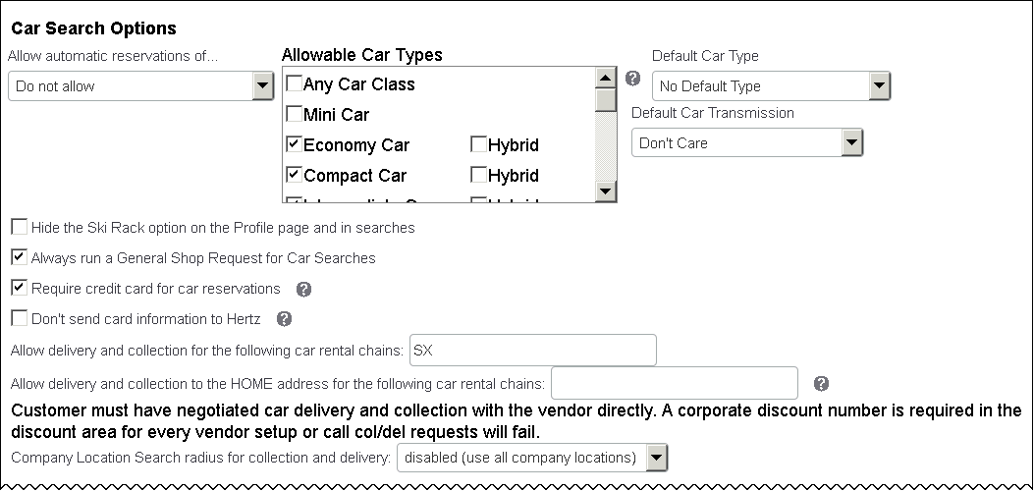

| Option | Description / Action |
| --- | --- |
| Allow automatic reservations of… | Select whether to allow any cars that are in policy, not allow, or allow preferred cars in policy.  Click one of these:   * Do not allow * Cars that are in policy * Preferred cars that are in policy |
| Allowable Car Types | Click the allowable car types.  **NOTE:** Pick-up trucks are not supported at this time.  **Notes about hybrids:**   * Worldspan is not yet supported. * This feature applies ***only*** to car results from the GDS - ***not*** car direct connects.   **Notes about specialized vehicles:**   * This feature applies ***only*** to Sabre GDS, Thrifty, and Hertz. * This feature applies ***only*** to mining-equipped vehicles. |
| Default Car Type | Click to set the default car type when the traveler uses the "Automatically reserve this car" feature in the Travel Wizard. |
| Default Car Transmission | Select the desired option to set the *default* car transmission setting in the profiles of new users.  Click one of these:   * Don't care * Automatic * Manual   The user can change this option in profile; this setting simply sets the default. If a user already has a default set in their profile, this setting will ***not*** override it. |
| Hide Ski Rack option on Profile and in searches | Select (enable) this check box if you ***do not*** want "Ski Rack" to appear as an option:   * In the **Car Rental Preferences** section of the user's Profile * In the **Car booking options** section of the search results page in the Travel Wizard   **NOTE:** Because some users can choose from several rule classes prior to booking and because those rule classes could be tied to different configurations, it's important to note the following:   * The display of the preferences on the user's Profile page is controlled by the user's ***default*** travel configuration. * The display of the preferences during booking is controlled by the ***configuration used to book the trip***. |
| Always run a General Shop Request for Car Searches | Select (enable) this check box to search all rental car vendors when searching for cars, not just preferred vendors. |
| Require credit card for car reservations | Select (enable) this check box to allow travelers to use a credit card other than one stored in their profile to reserve cars.  If you allow travelers to use a ghost card to reserve cars, you should select this option. Otherwise, Concur Travel will send credit card information only when selected by the vendor, which will likely require travelers to present a card when picking up the car.  **NOTE:** This is required for Hertz E-Receipts functionality.  ***NOTE (for new Car experience):*** *This feature is supported for the new Car experience.* |
| Don't send card information to Hertz | Select (enable) this check box to prevent credit card information from being sent to Hertz.  **NOTE:** If your company uses direct bill with Hertz and you use e-receipts or require a card for reservations, you should enable this option. It will stop Concur Travel from sending credit card information to Hertz, which would otherwise happen as a requirement for Hertz e-receipts or because require card for rental car was enabled. You will not receive Hertz e-receipts, but your central bill process will work smoothly. |
| Allow Car Promos | ***Applies to Sabre only***  Select (enable) this check box to allow travelers to enter promo codes when searching for cars. |
| Allow delivery and collection for the following rental car chains | ***Applies to Sabre, Apollo, Galileo, Amadeus, and Sixt Direct Connect***  Enter the car chains (vendor codes) that provide car delivery and collection. For multiple vendors, separate with commas (such as "EP,BD").  **NOTES:**   * The customer must first negotiate with their contract car vendor before using this feature. * There may be additional fees that will apply to the user, depending on the customer contract. * This feature is limited to the locations loaded in **Administration** **>** **Company** (on the sub-menu) **>** **Company Admin**, and then **Company Locations** in the **Company Admin** section of the left menu) that have the **Allow Delivery/Collection of rental cars to this location** check box selected. * Many vendors require a credit card guarantee when using this feature. Depending on your chosen vendors, it may be easier for your travelers if the check box just above **Require a credit card for car reservations** is enabled. However, if the vendor requires a guarantee and one has not been provided, the user will be advised during the booking process and be prompted for a credit card.   ***NOTE (for new Car experience):*** *This feature is supported for the new Car experience.* |
| Allow delivery and collection to the HOME address for the following rental car chains | ***Applies to Apollo, Galileo, Sabre, Abacus, and Amadeus***  Enter the car chains (vendor codes) that provide car delivery and collection. For multiple vendors, separate with commas (such as "EP,BD").  **NOTES:**   * The customer must first negotiate with their contract car vendor before using this feature. * There may be additional fees that will apply to the user, depending on the customer contract. * The user must have a home address populated in their Concur Travel profile. * Many vendors require a credit card guarantee when using this feature. If yours does, select (enable) the **Require credit card for car reservations** check box. However, if the vendor requires a guarantee and the user has not provided one, Concur Travel advises as much during the booking process. |
| Company Location Search radius for collection and delivery | Select the number of miles – starting with 5, increments of 5, up to 100 – to limit the company locations results when a rental car location has been chosen by distance.  Company locations where distances are less than this value are eligible for delivery and collection. |

Scroll down to the next section.

##### Car Connectors

The direct content offers immediate access and full availability to all pricing, where as a GDS booking sometimes suffers from a timing delay. It also grants access to expanded Hertz and Sixt booking capabilities and benefits. This automated system supports all corporate reporting structures and offers improved purchasing and client reservation management.

1. Travel managers must first obtain a corporate discount number by contacting their Hertz and or Sixt account representative. This discount number must be stored under Manage Corporate Discounts.

Refer to the *Discounts Travel Services Guide*.

To enable:

| Option | Description / Action |
| --- | --- |
| For Car Rental direct connects, when displaying daily/ weekly/monthly rates, include a proportional amount of all additional compulsory charges, not just the quoted base rate. | Select (enable) this check box to display additional compulsory charges (required insurance coverage, concession fees, road tax, etc.) or clear (disable) the check box to show only the base rate.  **NOTE:** Be aware that under certain circumstances – in particular when the rental period is exactly a given number of weeks or months with no "extra day" charges – Hertz and Sixt do not provide a daily rate. In this situation, an average rate is calculated. This is indicated in the car search results. |
| Hertz Enable | Select (enable) this check box to display direct content from Hertz. |
| Sixt Enable | Select (enable) this check box to display direct content from Sixt. |
| Allow Sixt notifications to customer | Select this checkbox to let the direct content suppliers send their own confirmation emails to the traveler. |
| Car Connector - Enable | ***NOTE (for new Car experience)****: This feature will be supported with future release for the new Car experience* |
| Hertz | ***NOTE (for new Car experience):*** Select (enable) this checkbox to display Hertz content via the direct connect channel. |
| Sixt | ***NOTE (for new Car experience):*** Select (enable) this checkbox to display Sixt content via the direct connect channel. |
| GDS Fallback | ***NOTE (for new Car experience)****: This feature will be supported with future release for the new Car experience* |

***NOTE (for new Car Experience):*** *The new car experience includes a completely new setting for the activation of direct content.*

##### Hertz

Refer to the *Hertz Direct Connect Travel Service Guide*.  
***NOTE (new Car experience)****: This guide does not apply to the new Car experience.*

1. Discount codes for Hertz Direct Connect are entered in **Manage Corporate Discounts** in either Travel System Admin or Company Admin. Refer to the *Discounts Travel Service Guide*.

##### Sixt

Refer to the *Sixt Direct Connect Travel Service Guide*.  
***NOTE (new Car experience)****: This guide does not apply to the new Car experience.*

1. Discount codes for Sixt Direct Connect are entered in **Manage Corporate Discounts** in either Travel System Admin or Company Admin. Refer to the *Discounts Travel Service Guide*.

Image to be included in a future document update.

#### Wizard Options – E-Receipts

Refer to the *E-Receipts Travel Service Guide*.

#### Wizard Options – AirPlus Configuration

Refer to the *AirPlus Travel Service Guide*.

#### Wizard Options – Trip Sharing and Cloning

Refer to *Clone/Share Trip Travel Service Guide*.

#### Wizard Options – Manifest Clone FOP Options

Use the **Manifest Clone FOP Options** section to select the form of payment option available when creating manifest clones – for travel configurations using Sabre, Apollo, Amadeus, and Galileo as the primary GDS.

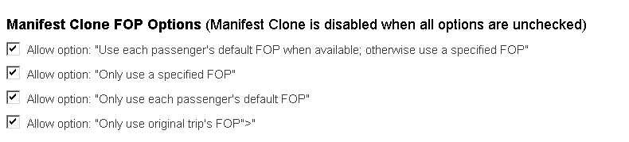

1. A user must have the multi-user clone permission to perform a clone; this section drives which FOP options they can see.

#### Wizard Options – Comments-to-Agent Warning

If you enable this field, when travelers type comments into the **Comments to Agent** field on the **Trip Booking Information** page in the Travel Wizard, a pop-up message will display.

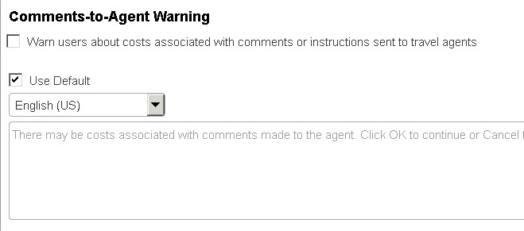

You can:

* Select (enable) the **Use Default** check box to use the default text.  
  – or –
* Clear (disable) the check box, select the desired language, and enter your own text.

#### Wizard Options – DC Configuration

Use the **DC Configuration** section for direct connect vendors that allow trip approval during the booking process. In case of ticketing errors, a notification email can be sent to the customer, approver, or a given list of email addresses.

1. In addition to this notification, Travel will send an email with more specific information to SAP Concur support to assist with troubleshooting.

The fields and options are listed in the following table.

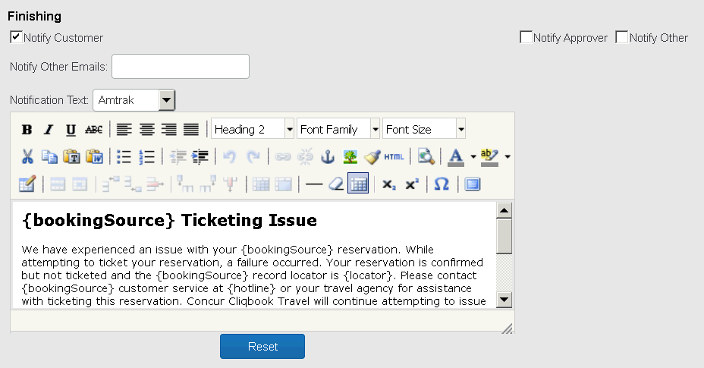

To enable:

| Field | Description / Action |
| --- | --- |
| Notify Customer | Select (enable) this check box to trigger sending an email to the customer (or meeting attendees). |
| Notify Approver | Select (enable) this check box to trigger sending an email to the approver of the trip. |
| Notify Other | Select (enable) this check box to trigger sending an email to the addresses in **Notify Other Emails** field. |
| Notify Other Emails | Enter the list of addresses (separated by comma) to be notified when the **Notify Other** check box is selected. |
| Notification Text | Click either:   * Amtrak * Southwest |
| <message body> | Enter the specific message text to appear to the recipients. You can use following place holders (will be replaced with real content):   * **{locator}** – trip locator * **{hotline}** – vendor hotline (phone number) where the customer may ask for further information * **{bookingSource}** – name of the vendor (i.e. Southwest) * **{errorMessage}** – specific error message returned by the direct connect |

### System Options

Use the **System Options** section to specify the fields and options listed in the following table.

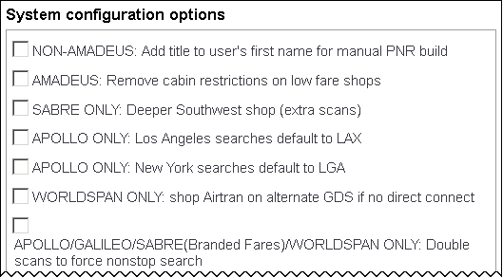

This is the first part of this section. The remainder of this section is described on the following pages.

| Option | Description / Action |
| --- | --- |
| System configuration options | Select (enable) any applicable check boxes. If you have questions, contact SAP Concur support. |

Scroll down to the next section. The options that appear here differ by GDS.

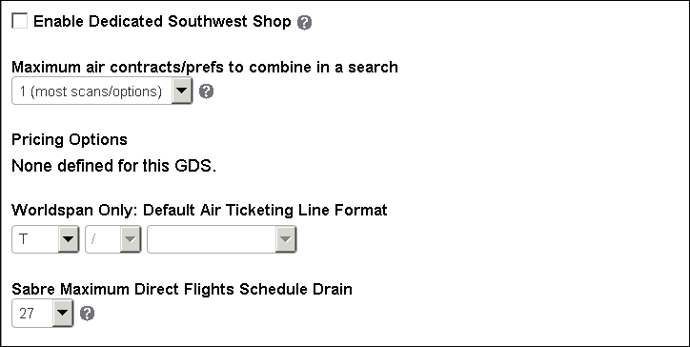

| Option | Description / Action |
| --- | --- |
| SABRE ONLY: Enables All Features Using SABRE Web Services  (may not appear in screen sample above) | Select (enable) this check box to enable Sabre Web Services for all available functions.  **NOTES:**   * As Concur Travel continues to migrate to Sabre Web Services, any new Sabre Web Services functionality and features will become available by enabling this box. Sabre web services credentials are required and must be requested through your Sabre agency representative. * Once an administrator enables Sabre Web Services for a travel configuration, only Concur Travel can disable this feature. |
| SABRE ONLY: Search flex faring fares without specifying public or private modifier  (may not appear in screen sample above) | Based on region, carriers, and contract – certain lowest fares are returned with public or private modifier, while certain lowest fares are returned without public or private modifier while searching for flex faring contents. Generally, it is better allowing public or private modifier. This is the option to skip public or private modifier when Sabre does not return the expected fares.   * **Best Practice:** We recommend customers use the default setting (unselected) unless proper fares are not appearing. |
| AMADEUS ONLY: Enable all features using Amadeus web services  (may not appear in screen sample above) | Select (enable) this check box to enable Amadeus Web Services for all available functions.  Administrators cannot enable this until the web service credentials are loaded in the agency configuration.  P1451C8T29#yIS1 |
| Enable Dedicated Southwest Shop | Select (enable) this check box to enable.  When enabled, Southwest will be shopped on all routes it serves same as if it were set up as a preferred vendor in the normal air discount area. In addition, if the search involves a single airport in a hub and another airport in that hub services southwest to the destination, Southwest on that alternate route will be shopped. This differs from the normal preferred airline behavior. Example: if a traveler searches ORD-PVD and this setting is enabled, then Concur Travel completes a Southwest shop for MDW-PVD. |
| Maximum air contracts/prefs to combine in a search | This field applies to all GDS' supported by Travel.  In Apollo and Sabre, this option controls how many airline contracts or preferences are searched at once in a single shop request.   * **For Sabre:** Select between 1 and 25. 1 returns the most results but there is a penalty in terms of performance and cost. * **For Apollo/Galileo:** Instead of 1 through 3, Apollo/Galileo has 1 through 95 (1 through 9 individually; 10 through 95 in increments of 5, which appears as 1, 2, 3, 4, 5, 6, 7, 8, 9, 10, 15, 20, etc.)   **NOTES:**   * Customers should not change this setting without first discussing with their travel agency. Travel agencies may want to work with their Travelport representative to determine the best setting to use, as shopping algorithm settings may vary from one Apollo/Galileo PCC to the next. * If using flex faring, note that this should not change flex faring search algorithm at all; this should only affect low fare shops. * ePricing is not required in order to use these options and whether it is in use makes no difference.   **IMPORTANT!**  Assume that a flight from Chicago to Dallas has discounts with the same code on United, American, and Midwest so you set this option to 3. Concur Travel will combine those 3 carriers into a single low fare shop request (PowerShopper in Worldspan, FareQuoteSuperBB in Apollo/Galileo, ValuePricer in Amadeus). For most of those GDSs, you will receive a maximum of about 9 fares.  Consider the case where one or two of those carriers fills up the choices with 9 low fares – the third carrier will not return results at all. *That means the traveler will see no results for that discounted carrier.*  The choice of combined carriers is not controlled. In addition, the carriers that will fill up the 9 fare slots *first* is dependent on the fares and capacity that are available at *that* moment in *that* market. So, as a TMC, you have no idea which discount carriers will or will not return. It may be the carrier(s) that the traveler has super-high status on or the one that is strongly preferred carrier for the customer.  **NOTES:**   * **Advantage:** The advantage of 2 or 3 carriers in a shop is that you can cut your scan volume down when you have multiple carriers using the same code. * **Disadvantage:** The disadvantage is that when you have multiple carriers in a single low fare shop request, ***then one or two of them can force the other carriers' results out of the display*** and the traveler will not see any results for some of their discount carriers. * The decision of how to group carriers is not under traveler control and, even if it were, the "smart" decision depends on route and specific fares loaded on any given day. So, you will arbitrarily not see discounted rates on some of your discount carriers when you combine 2 or 3 carriers with same code. |
| Pricing Options | Pricing options available for this GDS will display here.  **Worldspan only:**   * Use #PI on fare quote   **Best Practice:** Should not be used with “Use #TR” option   * Use #TR on fare quote – This qualifier advises WSPAN to create a ticketing record.   **Best Practice:** Should not be used with “Use #PI” option |
| Worldspan only: Default Air Ticketing Line Format | Select the ticketing line format applicable to your agency. |
| Sabre Shop Options | No longer used. |
| Sabre Maximum Direct Flights Schedule Drain | Allows Sabre agencies to configure searches in a way that gives travelers in busy markets better options in the GDS search by schedule  This feature improves performance and reduces scans.  Setting this configuration value to anything other than *ALL* has no effect ***until you search a market and time window where the number of direct flights exceeds the maximum***.In general, this will only happen in markets with a lot of direct flights. Customers in non-hub cities will likely not see any effect, however ***setting the option has no downside in this case***. |
| **Access to Agency Fares** (may not appear in screen sample above) | |
| Passenger Type Code Modifier | * This option is no longer supported and will be removed in a future release.   Allows both the lowest price fare – either Published or Net – during the reservation process; also commonly used for customers to access pseudo city-based agency fares when no other discount (SNAP, passenger type) is available  Enter the appropriate code to enable Net Fare, such as "NEG" for Sabre. |

### GDS PNR Options

Use the **GDS PNR Options** section to specify the fields and options listed in the following table.

1. Addison Lee is no longer supported by Concur Travel. The user interface does not currently reflect this change.

***NOTE*** ***(for new Car experience)****: The* ***Specific Non-GDS Vendors*** *option has been included for Car Connector and is available for the new Car experience only*.

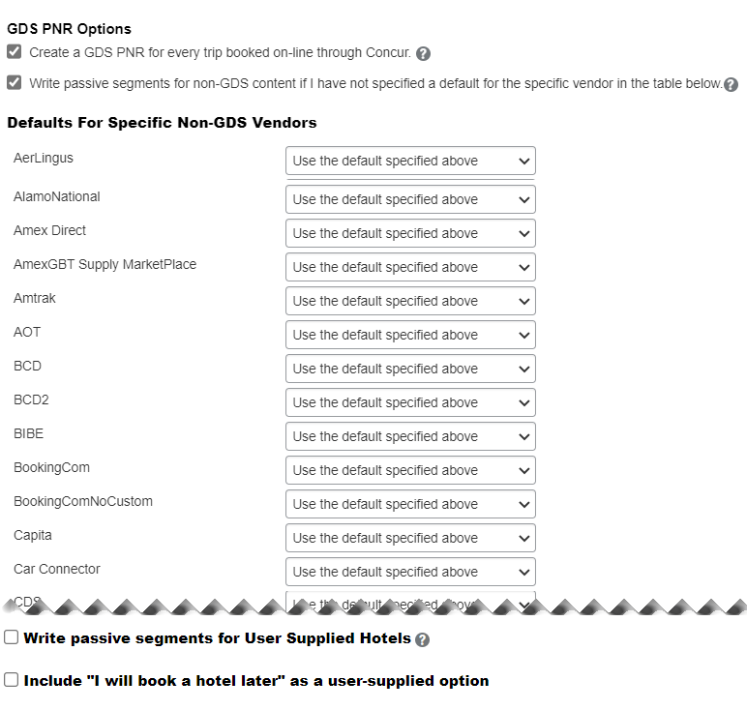

| Option | Description / Action |
| --- | --- |
| Create a GDS PNR for every trip booked on-line through Concur | Select (enable) this check box to instruct Travel to create a GDS PNR for every trip.  Clear (disable) this check box to instruct Travel to create a GDS PNR ***only*** if there is at least one active or passive segment to be written to it. |
| Write passive segments for non-GDS content if I have not specified a default for the specific vendor in the table below | Select (enable) this check box to instruct Travel to write passive segments for non-GDS content unless you have specifically enabled that vendor (listed in **Defaults For Specific Non-GDS Vendors**) to do so. |
| Write passive segments for User Supplied Hotels | Select (enable) this check box to allow Travel to write user-supplied hotels (not booked through Concur Travel) to the PNR as passive hotel segments.   * Refer to the *User Supplied Hotel Travel Service Guide*. |
| Include "I will book a hotel later" as a user-supplied option | Select (enable) this check box to include "I will book a hotel later" as an option when the user books a trip without a hotel. This option appears along with the standard options:   * I will book a hotel now * I will not be staying at a hotel on this trip * I booked a hotel outside of Concur (such as a conference hotel) * Refer to the *User Supplied Hotel Travel Service Guide*. |

### Email Options

Use the **Email Options** section to specify the fields and options listed in the following table.

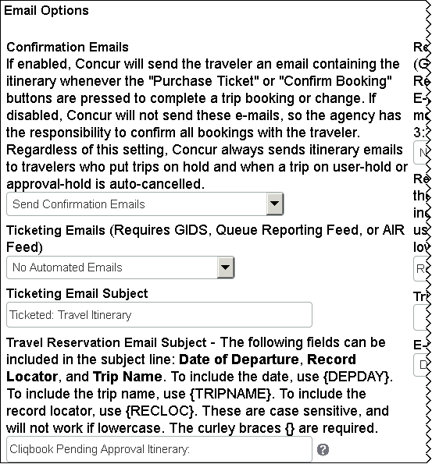

This is the first part of this section. The remainder of this section is described on the following pages.

| Option | Description / Action |
| --- | --- |
| Confirmation Emails | Select whether to send the pre-ticket itinerary confirmation email or to disable the feature. When disabled, an email will still be sent if the reservation is placed on Trip Hold or Approval Hold (based on the travel policy).  **NOTE**: Within the Concur Travel experience, no calendar ics. attachments are available. This feature is planned for a future release. |
| Ticketing Emails | Select whether to send an email to the traveler once the trip has been ticketed.  Turn this feature off if your agents typically send an email, a PDF invoice, or a link to a website when they ticket trips. |
| Ticketing Email Subject | If you enabled the **Ticketing Emails** option, edit the subject line of the email, if desired.  **NOTE:** This field does not support trip-specific tags, so you can edit the text but tags are ***not*** recognized. |
| Travel Reservation Email Subject | Enter the information you would like to appear in the subject line of the email, before the trip name. The date of departure, record locator, and the trip name can be included in the subject line.  The curly braces {} are required and all codes in them are case-sensitive and must be in uppercase. |

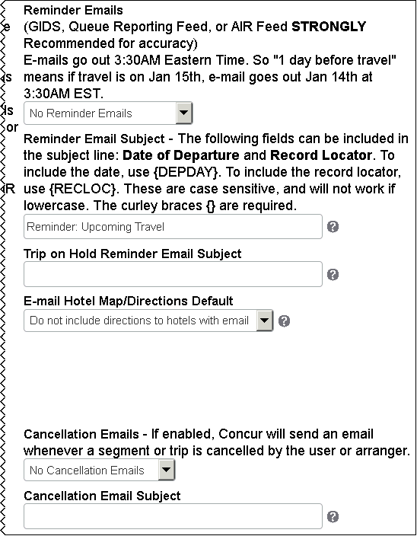

| Option | Description / Action |
| --- | --- |
| Reminder Emails | Select if you want to send the traveler a reminder email, and indicate how many days before travel should the email be sent.  **NOTE:** Emails are sent at 3:30 am Eastern time. |
| Reminder Email Subject | If you enabled the **Reminder Emails** option, edit the subject line of the email, if desired. The date of departure and record locator can be included in the subject line.  The curly braces {} are required and all codes in them are case-sensitive and must be in uppercase. |
| Trip on Hold Reminder Email Subject | Use this option to send out trip-hold expiration reminders to users. This will remind travelers that they need to submit for purchase to confirm their ticket to avoid missing a fare. This will also assist travel managers with keeping ticket costs down and avoiding a phone call to reinstate the fare.  The email will be sent about four hours before the ticketing deadline. If the four-hour lead time occurs *before* 8 AM (agency local time) or *after* 4 PM (agency local time), then the reminder will be sent at approximately 4 PM on the preceding day.  To enable the feature, add the appropriate subject line. The email sent will look exactly like the *trip on hold* email except with the subject line is determined in the configuration. It is, therefore, important to update the subject line accordingly.  **NOTES:**   * Suggested subject line: Trip on Hold Reminder: {DEPDAY} {RECLOC} * All email addresses associated with the user will be copied on the reminder email, including the user's arranger. * Reminder subject line is limited to 50 characters.   You can effectively disable the reminder email by saving a blank email subject. |
| E-mail Hotel Map/ Directions Default | Indicate if you want Concur Travel to include directions and/or maps to the hotel with the itinerary when the user is booking air and hotel trips. Click one of the following:   * Do not include directions to hotels with email * Include directions to hotels * Include directions and maps to hotels |
| Cancellation Emails | Select whether to send cancellation email when a user or arranger actively cancels an entire trip within Concur Travel.  **NOTE:** Cancellations in the GDS by an agent do ***not*** trigger a cancellation email.  Cancellation emails will be generated regardless of the content source (GDS, direct connect, Travelfusion, etc.).  **NOTE:** Cancellation emails are separate from auto-cancel emails, which are sent when Concur Travel cancels a segment or trip when the ticketing time limit is met. |
| Cancellation Email Subject | If sending cancellation emails, leave the text as is or make the desired changes.  **NOTE:** The following fields can be included in the subject line: <strong>Date of Departure</strong>, <strong>Record Locator</strong>, and <strong>Trip Name</strong>. To include the date, use {DEPDAY}. To include the record locator, use {RECLOC}. These are case sensitive, and will not work if lowercase. The curly braces {} are required.' |

### Fares Revalidation

Use the **Fares Revalidation** section to specify the fields and options listed in the following table.

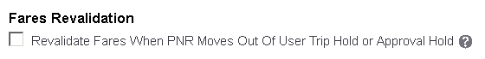

|  |  |
| --- | --- |
| Option | Description / Action |
| Revalidate Fares When PNR Moves Out Of User Trip Hold or Approval Hold | Select (enable) this check box to revalidate the fare.  When selected, a ticket cannot be purchased after held or approved when the fare difference is the greater of 2% or 10 units of currency.  **NOTE:** This is currently not supported on Worldspan and Amadeus. |

### Approval Email Options

Use the **Approver** **Email Options** section to specify the fields and options listed in the following table.

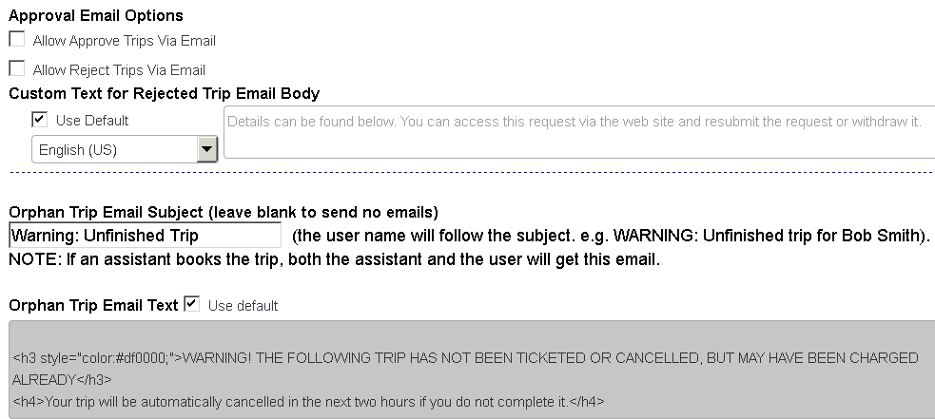

| Option | Description / Action |
| --- | --- |
| Allow Approve Trips Via Email | Select (enable) this check box to allow approvers to approve trips via email.  When using a hand-held device, an approver can write the full word *Approve*. |
| Allow Reject Trips Via Email | Select (enable) this check box to allow approvers to reject trips via email.  When using a hand-held device, an approver can write the full word *Reject*. |
| Custom Text for Rejected Trip Email Body | If you enable the **Allow Reject Trips Via Email** option, you can customize the text sent to the traveler with more specific instructions.   * Select (enable) the **Use Default** check box to use the default text. – or – * Clear (disable) the check box, select the desired language, and enter your own text. |
| Orphan Trip Email Subject | If a traveler creates an orphaned trip either by incorrectly closing the travel booking wizard or loosing internet connection, the PNR will automatically be cancelled 6+ hours after creation.  **NOTE:** An email ***is not*** sent to the traveler when the subject line is empty, but a message is displayed on the **Upcoming Trips** tab until the reservation has been cancelled by the system.  Edit the subject line of the email, if desired. |
| Orphan Trip Email Text | * Select (enable) the **Use Default** check box to use the default test. – or – * Clear (disable) the check box to enter your own text. |

### Profile Options

Use the **Profile Options** section to specify the fields and options listed in the following table.

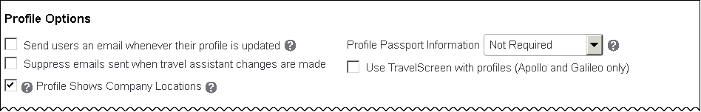

This is the first part of this section. The remainder of this section is described on the following pages.

| Option | Description / Action |
| --- | --- |
| Send users an email whenever their profile is updated | Select (enable) this check box to alert travelers when their profile is changed.  The notification will go to the email addresses specified in the profile. |
| Profile Passport Information | There are three options:   * **Not required:** Default setting; will do nothing * **Warn if incomplete:** Will prompt a traveler when saving their profile or booking a trip * **Required:** Prevents travelers from saving their profiles if the first set of passport fields is incomplete |
| Profile Shows Company Locations | Select (enable) this check box to allow the **Company Locations** dropdown to appear on the user profile page  **NOTES:**   * If the **Company Locations** list appears in Profile, the user can select a location, which will then populate the work address fields. * If the **Company Locations** list does not appear in Profile, users will have to manually fill in the work address fields. |
| Suppress emails sent when travel assistant changes are made | Select (enable) the check box so emails are ***not*** sent when a user's travel assistant has been changed  **NOTE:** The following items will automatically be exempt from receiving an email, regardless of the setting above:   * The user's login ID starts with "admin@" or "neverbooking" * The user's first name is exactly "William" or "william" and the last name is "Never" or "never". * The assistant's/arranger's login name is "William Never". |
| Use TravelScreen with profiles (Apollo and Galileo only) | If you use TravelScreen (Apollo and Galileo only) for profiles, select (enable) this check box to use this information in Travel.  **IMPORTANT:** Verify the Profile Mapping Template is in place and has been tested prior to enabling this feature. |
| Use web service for Sabre profiles  (not shown in the screen sample above) | After the Sabre Web Service Credentials are activated and emulation-tested on the agency configuration, select (enable) this check box to synchronize profiles via Sabre Web Services.  **NOTE:** This feature will become required when Sabre moves everyone over to the Web Services platform. |

Scroll down to the next section.

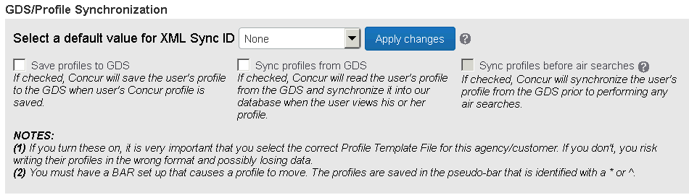

| Option | Description / Action |
| --- | --- |
| Select a default value for XML Sync ID | Click an option to populate the XML Sync ID field for all users in the travel configuration.  **NOTES:**   * If *None* is selected, no default will be applied. The client can use a unique identifier that must be added/updated manually. * If *Login ID* or *Employee ID* are selected, then the profile sync ID will be updated once the **Apply Changes** button is clicked.   Any newly created users will honor the default as well (via HR feed, upload in travel system admin, etc.). If the configuration setting is later changed to *None*, it will not clear existing values of profile sync ID; it simply means that no default value will be added to any newly created users.  **IMPORTANT:** The update does not occur ***unless*** you click **Apply changes**. |
| Save profiles to GDS *(aka format)* | Select (enable) this check box to save profiles to the GDS when a traveler saves their profile in Travel. |
| Sync profiles from GDS *(aka parse)* | Select (enable) this check box to synchronize profiles from the GDS when the traveler views their profile in Travel. |
| Sync profiles before air searches | Select (enable) this check box to synchronize the traveler's profile from the GDS prior to performing any air searches.  **NOTE:** It is important to enable this feature if using profile sync for unused tickets. |

Scroll down to the next section.

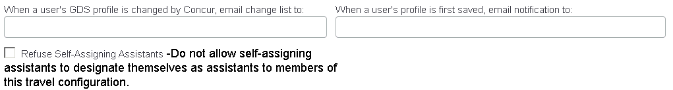

| Option | Description / Action |
| --- | --- |
| When user's GDS profile is changed by Concur, email change list to | Enter an email address to receive the change list when a traveler's GDS profile is updated. It will identify the traveler and the line number changed but will not identify the actual information.  **NOTE:** Several Worldspan agencies use this feature for interactive Worldfile updates. |
| When a user's profile is first saved, email notification to | Enter an email address to receive notification when the traveler's profile is first saved. The specified email address will receive notification the first time each traveler saves their profile.  **NOTE:** Several Worldspan agencies use this feature for interactive Worldfile updates. |
| Refuse Self-Assigning Assistants | Select (enable) this check box to ***not*** allow users with the Self-Assigning Assistant permission to be able to designate themselves as an assistant for any user in this travel configuration. |

### Custom Attributes Option

Use the Custom Fields feature in Company Administration allows you to create custom fields for a trip or for a profile. The custom fields that you create within the site will appear in the **Custom Attributes** section of the **Company Travel Configuration** page. You can select the attributes that apply to each configuration.

Use the **Custom Attributes** section to verify the fields and options listed in the following table.

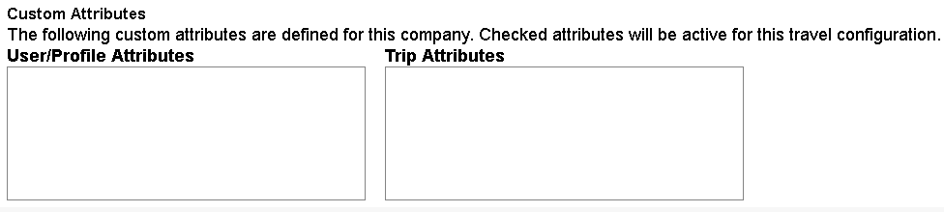

| Option | Description / Action |
| --- | --- |
| User/Profile Attributes | Select (enable) the check boxes for the user/profile attributes that should be active for this travel configuration. |
| Trip Attributes | Select (enable) the check boxes for the trip attributes (also known as PNR finishing custom or Point of Sale fields) that should be active for this travel configuration. |

### Invoicing

If you need to make changes in the **Invoicing** section is read-only, contact SAP Concur support for assistance.

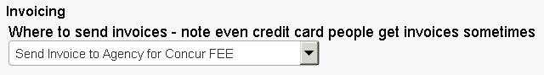

### Form of Payment Options

#### Form of Payment Options: Agency Invoice

Refer to the *Form of Payment Travel Service Guide*.

#### Form of Payment Options: Processing Fees

Refer to the *Form of Payment Travel Service Guide*.

#### Form of Payment Options: User Custom Property for Default Corporate Credit Card

* **IMPORTANT!** This feature should only be used when ***everyone*** on the site is associated to a card. Since the "All" group is used, even individuals who should not receive access will receive access. For a select group of employees, refer to the *Concur Travel: Company Administration User Guide*, in the *Corporate Ghost Cards* section.

1. To map custom Corporate Ghost Card scripting:
2. Create the custom profile field on the customer site.
3. Select the custom profile field from this list.
4. On the customer site, create the Corporate Ghost Card(s) with names that exactly match the values contained in the custom profile field.
5. Associate the 'All' group to have access to the card.

Travelers with matches in the custom profile field will have access to the ghost card. For example, assume that you:

1. Create a custom profile field called **Accounting Unit**.
2. Enter the values 100, 200, and 300 in this field.
3. Select the appropriate custom profile field in the company travel configuration.

You create three Corporate Ghost Cards – 100, 200, and 300 – and associate these with the 'All' group.

Assume that William Never's **Accounting Unit** value is 300. This will be the card that is used when he completes his Travel transactions.

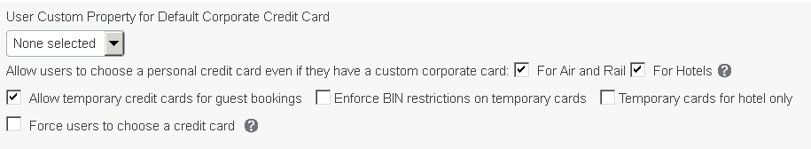

| Option | Description / Action |
| --- | --- |
| Allow users to choose a personal credit card even if they have a custom corporate card: For Air and Rail  For Hotels | Select (enable) this check box to allow the traveler to use an individual card even when a ghost card is set up for airfare and/or hotels. |
| Allow temporary credit cards for guest bookings | Select (enable) this check box to allow the traveler to enter a credit card number at the time of booking.  You combine this option with the Guest Traveler feature. If you do not select this option, either a site-level Company Ghost Card or the credit card of the person making the reservation is applied. |
| Enforce BIN restrictions on temporary cards | Select (enable) this check box to allow configuration-level BIN restrictions to be enforced for temporary credit cards entered for guest bookings.  Users will not be able to go forward from the credit card selection page if they select the option to use a temporary credit card number, if that number does not comply with their configuration's BIN restrictions. |
| Temporary cards for hotel only | Select (enable) this check box to allow limiting the use of temporary credit cards for guest bookings to hotel reservations only. If the booking is not for a hotel, the temporary card fields are not displayed. |
| Force users to choose a credit card | Select (enable) this check box to prevent a card from being selected by default from the credit card list and to force users to actively select a card from the list.  **NOTE:** Be aware that this setting forces the user to ***always*** choose a card – even if the user has only one card. |

### Project Billing

Use the **Project Billing** section to specify the fields and options listed in the following table.

1. These fields are optional and are handled better by using the **Administration** **>** **Company** (on the sub-menu) **>** **Company Admin**, and then **Manage Custom Fields** in the **Company Admin** section of the left menu, in the **Trip Fields** section.

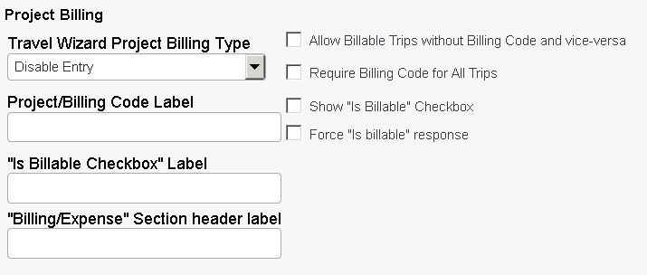

| Option | Description / Action |
| --- | --- |
| Travel Wizard Project Billing Type | Elect to disable this field or select *Type-in Only* to let travelers enter the code. |
| Project/Billing Code Label | Enter the name for the project or billing code field. This should be descriptive enough so travelers know what to enter.  If you choose to ***not*** use this section, ensure this field is blank. |
| "Is Billable Checkbox" Label | Enter a label for this box (typically "Is Billable" or "Travel is Billable").  If you choose to ***not*** use this section, ensure this field is blank. |
| "Billing/Expense" Section header label | Enter a label for the entire billing section that appears on the **Trip Information** page.  If you choose to ***not*** use this section, ensure this field is blank. |
| Allow Billable Trips without Billing Code and vice-versa | Select (enable) this check box to allow travelers to enter billing or project codes even if the trip is not billable or to make the trip billable and not enter a billing or project code. |
| Require Billing Code for All Trips | Select (enable) this check box to prevent travelers from continuing until they enter a code. |
| Show "Is Billable" Checkbox | Select (enable) this check box to allow travelers to make trips billable. |
| Force "Is billable" response | Select (enable) this check box to make the **Is Billable** check box a required field. |

### PNR Finishing Configuration Options

Use the **PNR Finishing Configuration** section to specify the fields and options listed in the following table.

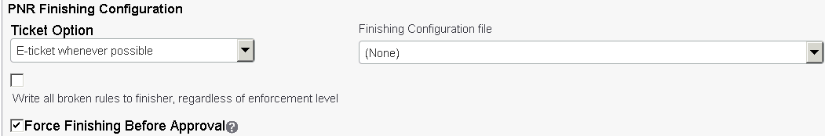

| Option | Description / Action |
| --- | --- |
| Ticket Option | Click an option to determine the type of ticket the traveler can receive. |
| Finishing Configuration file | Click the PNR finishing file to be used for this travel configuration. |
| Write all broken rules to finisher, regardless of enforcement level | Select (enable) this check box to allow all violation rule data to be available to the finisher, regardless of the type or severity of the violation. |
| Force Finishing Before Approval | Select (enable) this check box to force finishing before approval.  If the check box is cleared (disabled), approvers can approve prior to PNR finishing. However, in case the selected finishing configuration file (from the list above) contains any line items with Finishing Mode set to *Approval Hold*, finishing runs despite the disabled option.  This feature is available for those customers experiencing an error message advising that trip approval is not available because PNR finishing has not yet run.  **IMPORTANT:** If **Enable Request Integration** is selected, then this option ***MUST*** also be selected. |

### Other Information

Use the **Other Information** section to specify the fields and options listed in the following table.

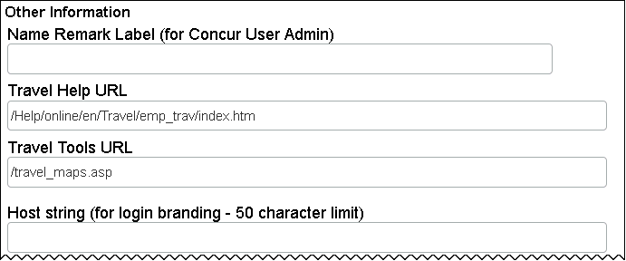

This is the first part of this section. The remainder of this section is described on the following pages.

| Option | Description / Action |
| --- | --- |
| Name Remark Label | Enter a label for this field, which will appear on the **User Details** page in Concur Company Administration/User Administration and will become part of the traveler's SAP Concur record and profile. Contact SAP Concur support for additional information. |
| Wizard Mode | ***Do not modify this box.*** *Prod* should always be selected.  **NOTE:** For Galileo only, click the *Galileo* option. |
| Travel Help URL | Displays the URL for Travel Help |
| Travel Tools URL | Enter the URL for a tools page on your Intranet or elsewhere, or remove the information in this field to remove the tools link entirely. If you have an existing custom tools page, you can enter the URL here. |
| Host String | You can modify the logo that appears at the top-left corner of the Travel page by setting up custom branding. If you have custom branding, you are given a custom login URL that appends ?host= and your host string to the standard Concur Travel URL.  If you do not wish to direct users to log in using this custom URL, you can put the host string value in this field, and direct users to the standard Travel login page. Once logged in, users will see the custom logo at the top-left corner of the page. |

Scroll down to the next section.

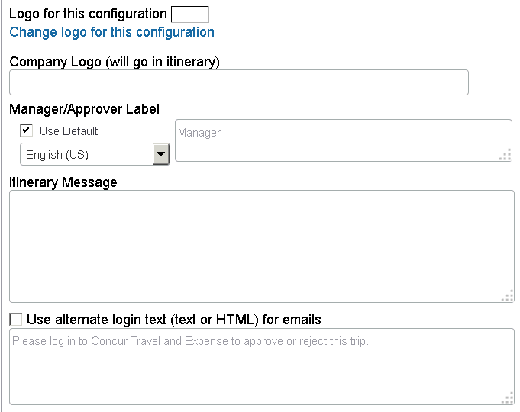

| Option | Description / Action |
| --- | --- |
| Logo for this configuration | Click **Change logo for this configuration** to display a different logo in the top-left corner for this configuration. |
| Company Logo | To display a company logo on emailed itineraries, enter the URL for your logo here. If you do not want the logo to appear in the Travel itinerary, leave this field is blank.  **NOTE:** After loading a company logo on a site, right-click the logo in the upper-right corner of the page. Next, click **Properties**, and copy the URL from the branding to the end. Paste this portion of the URL into the field. |
| Manager/ Approval Label | * Select (enable) the **Use Default** check box to use the default text. – or – * Clear (disable) the check box, select the desired language, and enter your own text. |
| Itinerary Message | Enter a message that appears in the traveler's itinerary that is sent from Travel.  This information appears at the bottom of the itinerary and is in text format, not HTML. To display messages at the top of the itinerary, add data in the GDS Company profile. |
| Use alternate log-in text (text or HTML) for eMails | Select (enable) this check box to send an alternate login URL in an email, which asks the traveler or approver to log in to Travel. |

### Refundable Checkbox For Air / Rail

Use the **Refundable Checkbox For Air** and the **Refundable Checkbox For Rail** and the section to specify the fields and options listed in the following table.

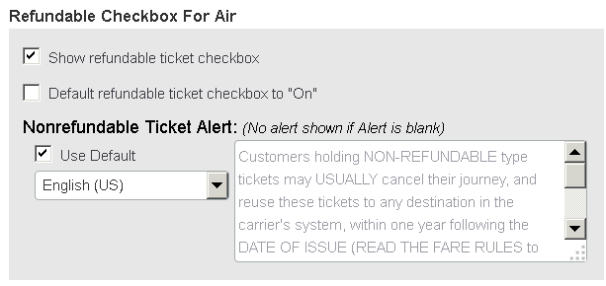

This is the first part of this section. The remainder of this section is described on the following pages.

| Option | Description / Action |
| --- | --- |
| Show refundable ticket checkbox | Select (enable) this check box to let travelers search for refundable tickets. |
| Default refundable ticket checkbox to "On" | Select (enable) this check box to set the Travel refundable check box to "On." Unless travelers clear (disable) this check box, they will always search for refundable tickets. |
| Nonrefundable Ticket Alert | ***Do not use.*** |

Scroll down to the next section.

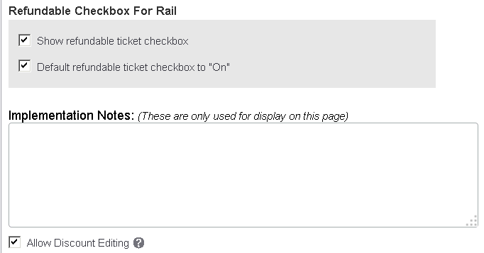

| Option | Description / Action |
| --- | --- |
| Show refundable ticket checkbox | Select (enable) this check box to let travelers search for refundable tickets.  **NOTE:** This is only applicable for SNCF and Deutsche Bahn (DB). With DB, today you will need to unselect the direct connect, save the configuration, then re-enable the direct connect, and this field will appear at the bottom of the screen. |
| Default refundable ticket checkbox to "On" | Select (enable) this check box to set the Travel refundable check box to "On." Unless travelers clear (disable) this check box, they will always search for refundable tickets.  **NOTE:** This is only applicable for SNCF and Deutsche Bahn (DB). With DB, today you will need to unselect the direct connect, save the configuration, then re-enable the direct connect, and this field will appear at the bottom of the screen. |
| Implementation Notes | Enter any additional information you want to make available regarding this company. This information will only be available to individuals with access to the **Company Travel Configuration** page. |
| Allow Discount Editing | Select (enable) this check box to allow administrators within this configuration to modify discounts from the Company Administration section of their Travel site. The Company Discount Editor and Travel Policy Admin User Permissions on the customer site are also required for the person who will be using this feature.   * Additional information about setting up Allow Discount editing is available in the SAP Concur support portal. |

### Concur TripLink – Agency Assistance

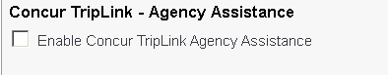

Refer to the TripLink information available on the SAP Concur support portal.

### Compleat Integration

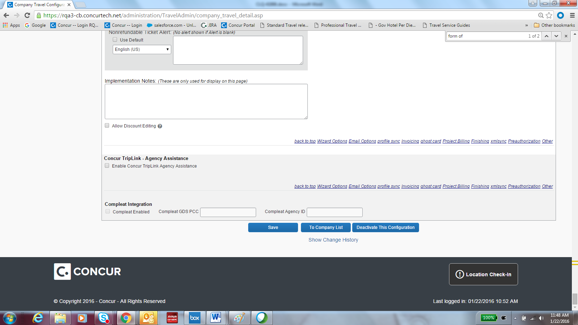

The SAP Concur Compleat team identifies clients who can be integrated with Compleat. Once a customer has been identified as a mutual customer of Compleat/ Concur Travel, the **Compleat Integration** section appears. The check box will be enabled but the entire section will be read only.

### Buttons and Links

| Option | | Description / Action |
| --- | --- | --- |
| Save | Click this button to save all changes made on the entire Company Travel Configuration screen. | |
| To Company List | Click this button to return to the initial Company Travel Configuration list of all your customers. | |
| Deactivate This Configuration | Click this button to deactivate the configuration. If you have travelers associated to this configuration, upon deactivation you will be prompted to change the travel policy the travelers are assigned to.  **WARNING:** ***Before deactivation,*** always make sure you have submitted your deactivation work order or you will continue to be invoiced. | |
| Show Change History | Click this link to see the last ten changes to the travel configuration and name/login for the user who made each change.  P1918C10T46#yIS1 | |

### Sites Using the Global/Divisional View

In order to use the "Log out and back in as" feature (described later in this guide), travel managers must indicate a divisional view administrator for each travel configuration belonging to divisional view companies.

Enter the login ID in the **Divisional View Admin Login** field.

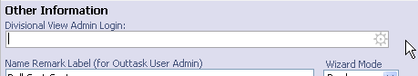

1. This field is only present when editing the configuration of a divisional view company. It is an auto-complete field that is limited to returning the logins of divisional view administrators with access to the travel configuration you are editing.

After selecting the desired administrator name, save the travel configuration. The new login will be used for that travel configuration when using the "Log out and back in as" feature.

### Procedure: Creating a New Company Travel Configuration

1. To create a company travel configuration:
2. On the Travel System Admin page, click **Create New Configuration** in the left menu.
3. In the **Company** list, select the desired company.
4. Complete the fields as described on the previous pages.
5. Click **Save**.

### Procedure: Cloning a Company Travel Configuration

1. To clone a company travel configuration:
2. On the Travel System Admin page, click **Clone Company Configuration** in the left menu. This page appears.

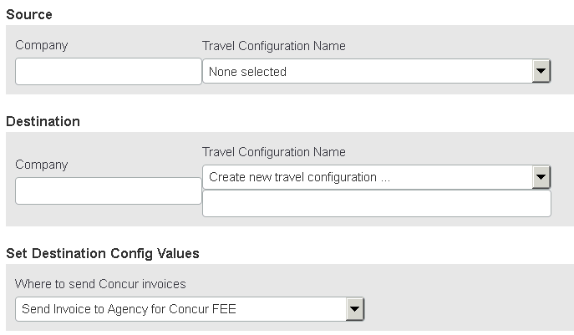

This is the first part of this section. The remainder of this section is described on the following pages.

1. Complete the following fields.

| Field | Description / Action |
| --- | --- |
| **Source** | |
| Company Travel Configuration Name | Select the company and configuration that you want to clone. |
| **Destination** | |
| Company | Enter the name of the site to which you will clone the new configuration.  **IMPORTANT:** The site must already be completed before cloning a configuration. |
| Travel Configuration Name | Verify that *Create New Travel Configuration* is selected. |
| (blank) | Enter the new configuration name. |
| **Set Destination Config Values** | |
| Where to send Concur invoices | Click one of these:   * Send Invoice to Agency for Concur FEE * Send Invoice Directly to Company for Concur FEE |

Scroll down to the next section.

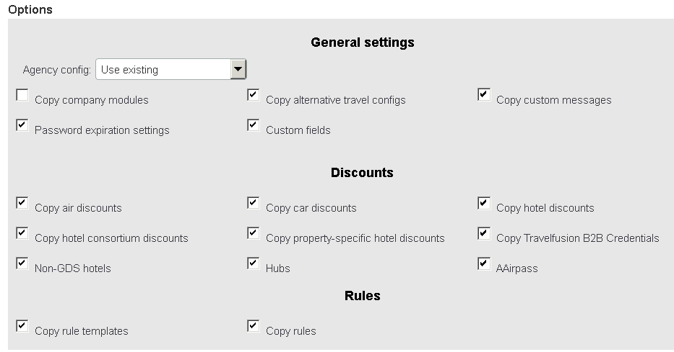

| Field | Description / Action |
| --- | --- |
| **General Settings** | |
| Agency config | * Click *Use existing* if you will use the agency configuration currently associated with the company site to which you are adding the new travel configuration. – or – * Click *Clone existing to* provide a new agency configuration name.   **NOTE:** Regardless of the option you select, the same agency configuration data is copied. You will need to manually change queue and contact information within the new agency configuration. |
| Copy company modules | Do not select (enable) this check box unless you are cloning from your Agency Standards configuration. This is a system setting that only SAP Concur can modify  **NOTE:** If you choose to clone module management properties, it clones everything – self-registration codes, etc. This option is best to leave **cleared** (disabled) if you are cloning one configuration to another configuration on another site. |
| Password expiration settings | Do not select (enable) this check box. This is a system setting that only SAP Concur can modify. |
| Copy alternative travel configs | Select (enable) this check box to copy Alternate GDS configurations. |
| Custom fields | Select (enable) this check box to copy profile and wizard fields. |
| Copy custom messages | Select (enable) this check box to copy custom text. |
| **Discounts** | |
| (all) | Specify the discount information to copy to the new company travel configuration. |
| **Rules** | |
| Copy rule templates | Select (enable) this check box to copy the travel policy rules available by default when a new policy is created.  **NOTES:**   * If you do not select (enable) this option, the site administrator must manually create rules using the Travel Rule Template Builder. * When you copy travel classes, the ***new*** default travel class becomes the default for the entire site. So, if you clone a new Canada configuration from of a US site and there is a Default travel class and a VIP travel class, the new Canada Default travel class becomes the default for the whole site.  *If you copy travel classes, make sure that you verify them thoroughly immediately after cloning*. |
| Copy rules | Select (enable) this check box to copy both the travel policies and the policy violation reason codes. |

1. Click **Clone**.
2. Update the following items within the site after you clone a configuration:

* Websites to search
* Vendors to exclude
* Regional hotel rates

### Procedure: Editing a Company Travel Configuration

1. To edit a company travel configuration:
2. On the Travel System Admin page, access the desired client travel configuration.
3. Edit the fields as necessary. All fields described on the section above about adding a configuration.
4. Click **Save**.

### Procedure: Deactivating a Company Travel Configuration

* **IMPORTANT:** If you are deactivating a company travel configuration, you must also send a request with the termination date to stop billing. If a site is deactivated by mistake, contact SAP Concur support to re-activate. Re-activation can take up to one business day.

1. To deactivate a company travel configuration:
2. On the Travel System Admin page, click **Company Travel Configuration** in the left menu.
3. Click the name (link) of the configuration that you want to deactivate.
4. Scroll to the bottom of the configuration page.
5. Click **Deactivate This Configuration**.

## Editing a Company Configuration -- Most Commonly Used Company-Specific Features

### P2026#y1Overview

Company-specific features allow you to configure and view options that are assigned to specific company travel configurations. Each is described on the following pages.

You access the most commonly used company-specific features from a shortcut menu. Click the P2028#yIS1 next to a company configuration in the company list, and then click a feature from the list.

### Discounts

Refer to the *Discounts Travel Service Guide*.

### Manage Travelfusion B2B Credentials

Refer to the *Travelfusion Direct Connect Travel Service Guide*.

### Travel Hubs

If you need additional hubs that do not already exist in the GDS, use the **Travel Hubs** option to set up hubs for specific companies. For example, if your company does a lot of business in Cincinnati, you might want to add a hub and include the Columbus airport, the Cincinnati airport, the Dayton airport, or any other regional airports to save time when a traveler searches for flights. You can also remove an airport from an existing hub, such as removing Newark from the standard New York City hub.

**Best Practice:** Concur Travel recommends that you include no more than three general airports (no specific carrier selected) in a custom hub. For the fourth airport and above, use the Manage Shops feature to define the airports with assigned carriers. With a custom hub, the combination of flights that Travel returns and the subsequent performance of the search will grow exponentially with each additional airport and carrier that you add. Keep this in mind as you design your custom hub. Also, be sure to test the custom hub flying from or to major markets like Chicago and New York to assess the performance and corresponding results.

1. You can also access this feature by clicking **Manage Hubs** in the Travel System Admin left menu.

#### Procedure: Creating a Travel Hub

* **IMPORTANT!** A hub preference ***must*** be added in conjunction with creating the hub in order for the functionality to work.

1. To create a travel hub:
2. In the company list, click the **P2040L25#yIS1** (in the **Edit** column) for the desired company.
3. Click **Travel Hubs**. This page appears.

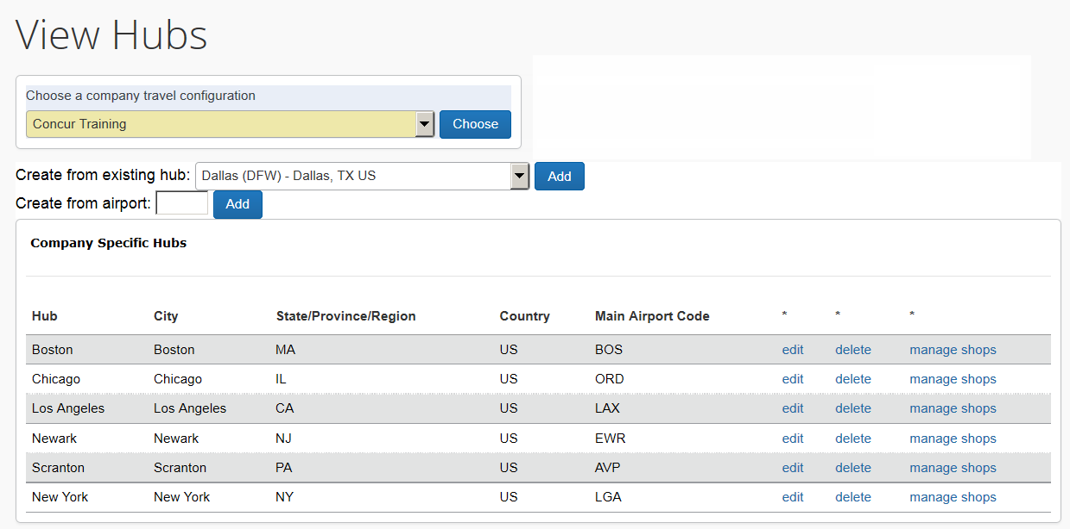

1. On the **Travel Hubs** page, verify that the correct company configuration appears in the **Choose a company travel configuration** field.
2. To create a hub from an existing hub:

* In the **Create from existing hub** field, click a hub name.
* Click **Add**.

The new hub will appear in the **Company Specific Hubs** area and you can edit as needed.

1. Be sure to check the list first for existing hubs. Do not create a hub if it already exists. Instead, edit the existing hub so you can control which airports appear for that city.
2. To create a hub from an airport:

* In the **Create from airport** field, enter the three-character IATA code.
* Click **Add**.

The new hub will appear in the **Company Specific Hubs** area and you can edit as needed.

1. Click **Save**.

#### Procedure: Defining Hub Preferences

You can set the preference for airports within a hub or airlines into or out of those airports.

1. To define hub preferences:
2. To in the **Company Specific Hubs** area, click **manage shops** next to the hub you want to modify. This page appears.

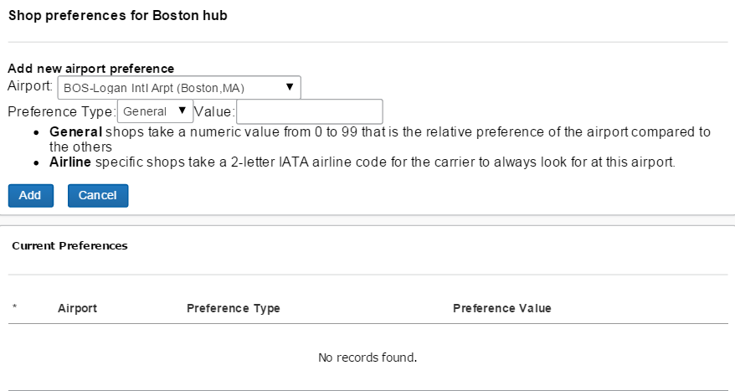

1. For General shops:

* In the **Preference Type** list, click *General*.
* In the **Value** field, enter a number for the airport. Regardless of the number entered, there is no weight structure.

**Best Practice:** It is best practice to enter the same value for all.

1. For Airline shops:

* In the **Preference Type** list, click *Airline*.
* In the **Value** field, enter the IATA code for the airline, indicating Travel should always look for a particular carrier at that airport.

1. Click **Save**.

#### Procedure: Editing a Travel Hub

1. To edit a travel hub:
2. In the **Company Specific Hubs** area, click **edit** next to the hub you want to modify.
3. Update any needed fields.
4. Click **Save**.

#### Procedure: Removing a Travel Hub

1. To remove a travel hub:

In the **Company Specific Hubs** area, click **delete** next to the hub you want to remove.

### GDS User Profile Names

Use the **GDS User Profile Names** option to view a list of users for a particular company and to view travelers' GDS profile names or CRS names. If you want to add or change a GDS profile name, edit the user's profile within the site using Company Admin or Concur XA.

1. You can also access this feature by clicking **GDS User Profile Names** in the Travel System Admin left menu.

#### Procedures: Viewing Users Using GDS User Profile Names

1. To view users:
2. In the company list, click the **P2080L28#yIS1** (in the **Edit** column) for the desired company.
3. Click **GDS User Profile Names**. This page appears.

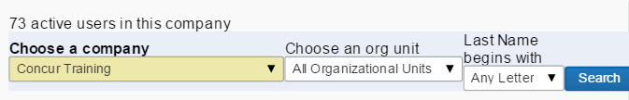

1. Complete the following fields.

| Field | Description / Action |
| --- | --- |
| Choose a company | Verify that the correct company configuration appears. |
| Choose an org unit | Click the desired organizational unit.  Choose *All Organizational Units* to search all units available. |
| Last Name begins with | Click a letter of the user's last name to search for.  Click *Any Letter* to search for all users in the organizational unit that you selected.  **NOTE:** If the site has more than 500 travelers, do not click the *All Users* option. |

1. Click **Search**. This page appears.

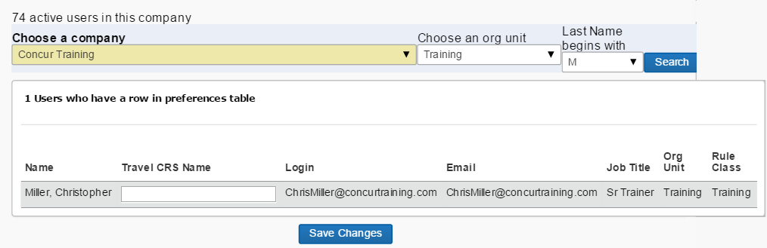

1. In the **Travel CRS Name** field, enter a CRS name for any user you want to update.
2. Click **Save Changes**.

### Company Information

Use the **Company Information** option to modify certain fields, such as address and time zone. Most of the fields are marked with an asterisk (*), which indicates that they are informational only and can be changed by SAP Concur administrators. This feature is only accessible through the shortcut menu.

#### Procedure: Viewing and Editing Company Information

1. To view and edit company information:
2. In the company list, click the **P2107L29#yIS1** (in the **Edit** column) for the desired company.
3. Click **Company Information**. This page appears.

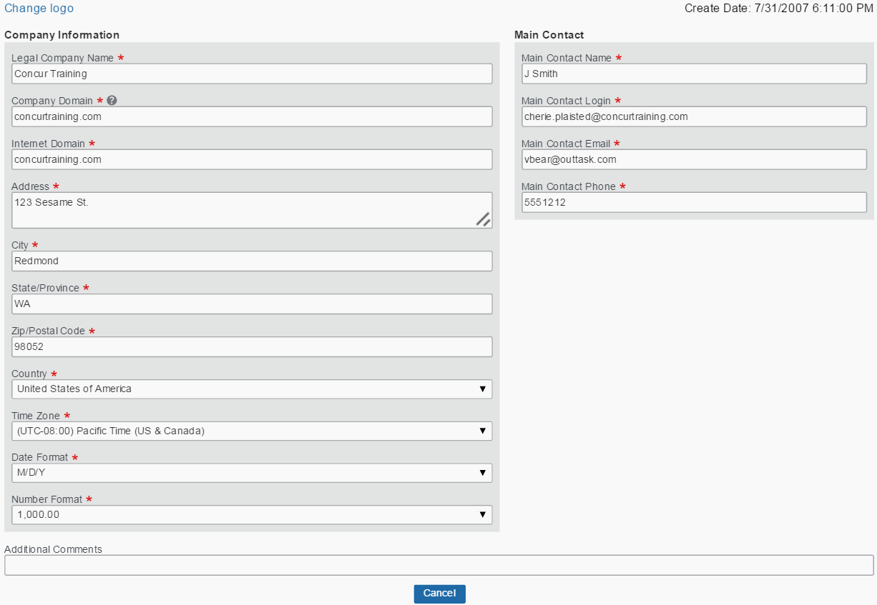

1. On the **Company Information** page, verify that the correct company appears in the **Company Name** field.
2. Modify any fields not marked with an asterisk (*), as needed.

* Refer to the *Create New Company* section of this guide for a description of the **Company Information** fields.

1. Click **Save**.
2. You add a company logo in the **Company Information** section but the link is not visible until the above fields have been completed and saved. The logo must be a .gif or .jpg format and no larger than 200 pixels wide and 55 pixels high. The entire file must not be larger than 100kb.

### Import/Export Hotel Discounts

Refer to the *Discounts Travel Service Guide*.

### Log Out and Back In As

Use the **Log out and back in as** option to log out of Travel System Admin and then log back in to Travel as the main contact for that particular company. This allows you to verify information on the company's site, such as logos and help information, and to search for trips to verify discount and hotel property information.

Refer to the *Add a New Company* section in this guide for more information on the main contact.

#### Global/Divisional View

For sites using the global/ divisional view, travel managers must indicate a divisional view administrator for each travel configuration belonging to divisional view companies.

For more information, refer to the *Other Information* section in this guide.

#### Procedure: Logging Out and Back In As

1. To log out and back in:
2. In the company list, click the **P2125L30#yIS1** (in the **Edit** column) for the desired company.
3. Click **Log out and back in as**.
4. In the confirmation dialog box, click **OK**. You will automatically be logged in as the main contact.

## Editing a Company Configuration – Other Company-Specific Features

Other company-specific features that you might use are described on the following pages.

### Manage Segment Fees

Use **Manage Segment Fees** to manage airline-specific fees that are not included in the fare, such as credit card fees. For example, certain airlines in certain regions charge a fee if the ticket is issued on a credit card. This fee is not shown to the user within Concur Travel because the fee is charged at the time of ticketing, which is done by the fulfillment agency. This feature would allow an administrator to provide messaging specific to that airline and to alert the traveler that this fee will be part of their overall itinerary.

#### Procedure: Enabling the Feature

This process must be completed only once.

1. To enable this feature:
2. Click **Company Travel Configuration** on the left menu and locate the desired configuration.
3. In the **Wizard Options – General Options** section of the page, select (enable) the **Enable vendor segment fees** check box.

#### Procedure: Adding Fees for the Vendor

1. To add the segment fee for the vendor:
2. On the left menu, click **Manage Segment Fees**.
3. Click the appropriate company and agency.

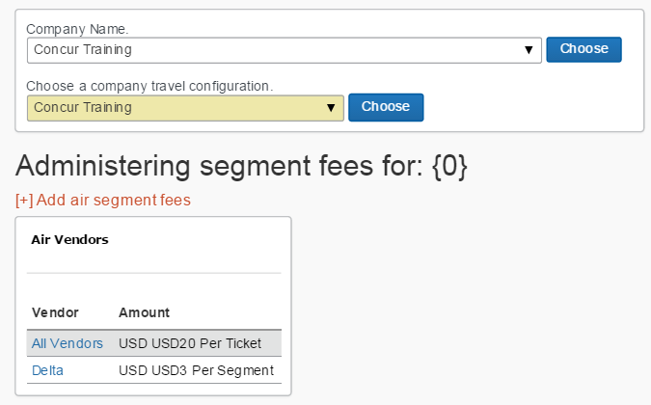

1. Click **Add air segment fees**.
2. Specify the airline or apply to all airlines.

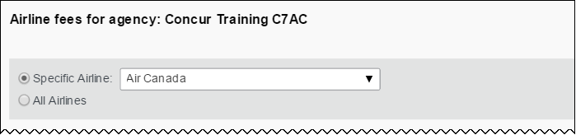

This is the first part of this section. The remainder of this section is described on the following pages.

1. Specify the amount and currency and then indicate if it applies per ticket, per segment, or per segment with a maximum number of one-way and round-trip segments.

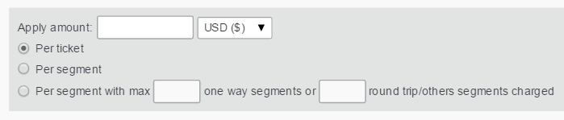

1. Click the fee type.

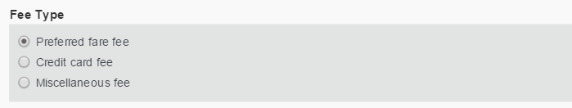

1. Define whether it should appear as a fee, tax, or included in the base fare.

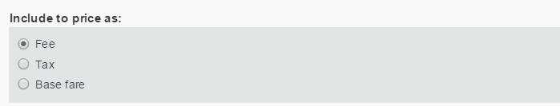

1. Change the itinerary label if desired; the default is Segment Fee.

P2152#yIS1

1. Enter custom text as desired.

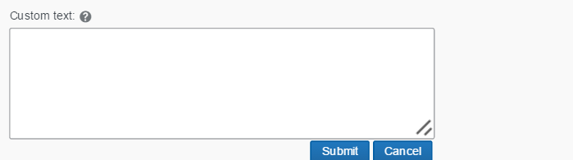

1. Click **Submit**.

### Manage Non-GDS Hotels

Refer to the *Non-GDS Hotels Travel Service Guide*.

### Import Travel Arrangers

Use the **Import Travel Arrangers** option to designate users as travel arrangers "in bulk." This feature imports an Excel spreadsheet or a comma-separate-value (CSV) text file to create the appropriate ties between user records, which then designates assistants who are authorized to book travel for another user.

#### Procedure: Importing Travel Arrangers

1. Between 9 AM – 5 PM (your local time), uploads are limited to 5MB or smaller. If you attempt to upload a file that is larger than that, a message appears. You can often reduce file sizes by changing file formats from .csv to Excel. If changing the format is not an option, you can upload larger files after business hours (9 AM – 5 PM your local time).
2. To import travel arrangers:
3. On the Travel System Admin page, click **Import Travel Arrangers** in the left menu. This page appears.

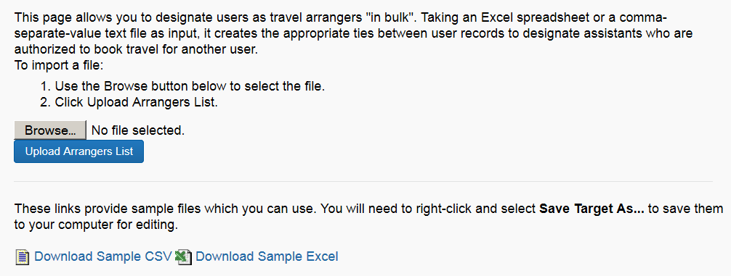

1. Click **Browse** (or **Choose File**, depending on browser) to choose a file to import.
2. Click **Upload Arrangers List**.
3. Use the sample file types to format the data to import.
4. Click **Download Sample CSV** or **Download Sample Excel** to access the sample spreadsheets.
5. Since a login ID is unique across all sites, the company name is not required in this import. The import assumes that everyone on the list has a login ID already created on the customer site.

### Manage Lanes

Use the **Manage Lanes** option to enter custom preferences used with the Travel Policy/Class rules for travel between certain city pairs or airports. You can also import lanes into Travel.

#### Procedure: Adding Lanes

1. To add travel lanes:
2. On the Travel System Admin page, click **Manage Lanes** in the left menu. This page appears.
3. From the **Choose a company travel configuration** list, click the desired configuration.
4. Click **Choose**. This page appears.

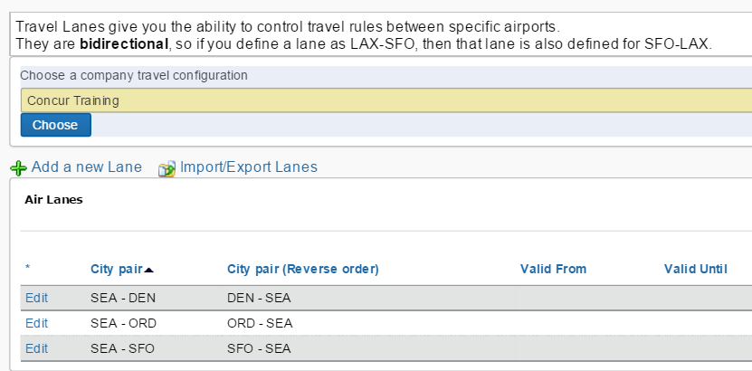

1. Click **Add a new Lane**. This page appears.

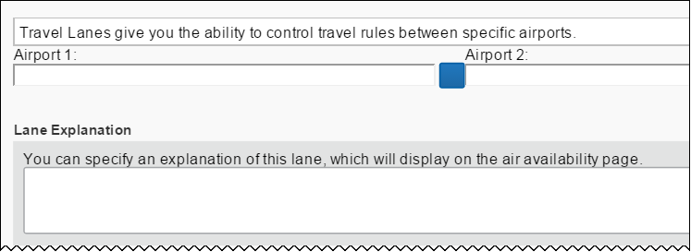

This is the first part of this section. The remainder of this section is described on the following pages.

1. Complete the following fields.

| Field / Section | Description / Action |
| --- | --- |
| Airport 1  Airport 2 | Select the airports. |
| Lane Explanation | Enter the appropriate explanation. |

1. Scroll down to the next section.

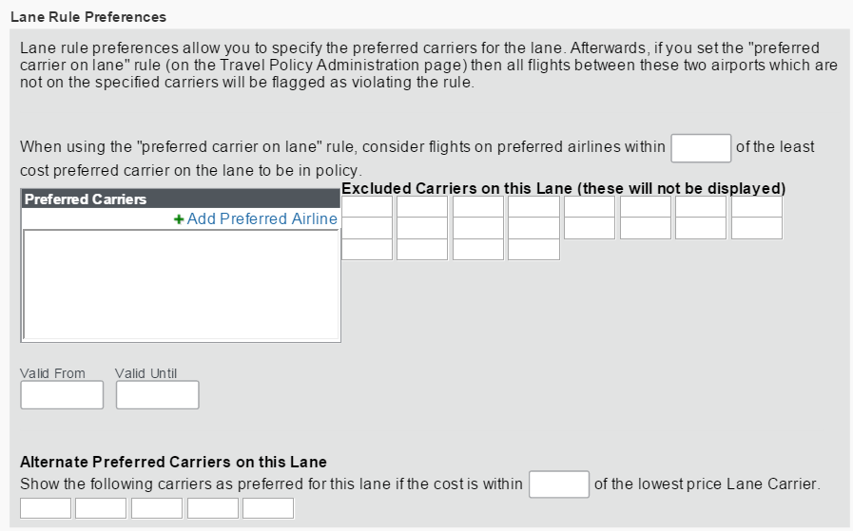

| Field / Section | Description / Action |
| --- | --- |
| Lane Rule Preferences | Complete as appropriate.  To add a preferred airline:   1. Click **Add Preferred Airline**. 2. Click the airline. 3. Click the level of preference.  * **Most preferred:** Travelers are expected to use this vendor whenever possible; displays with 3 diamonds during user booking * **Preferred:**  Travelers are requested to use this vendor whenever possible; displays with 2 diamonds during user booking * **Less Preferred:** Least preferred of preferred vendors; displays with 1 diamond during user booking * **Not Preferred:**  Company has discount with this vendor  1. Click **Save**. |

1. Scroll down to the next section.

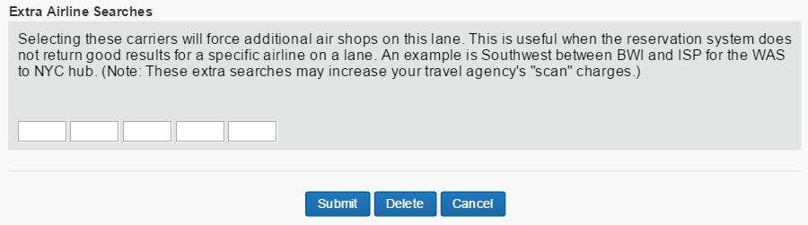

| Field / Section | Description / Action |
| --- | --- |
| Extra Lane Searches | Complete as appropriate. |

1. Click **Submit**.

#### Procedure: Editing Lanes

1. To edit travel lanes:
2. On the Travel System Admin page, click **Manage Lanes** in the left menu.
3. From the **Choose a company travel configuration** list, click the desired configuration.
4. Click **Choose**.
5. Click **Edit** next to a city pair.
6. Make the desired changes.
7. Click **Submit**.

#### Procedure: Removing Lanes

1. To delete travel lanes:
2. On the Travel System Admin page, click **Manage Lanes** in the left menu.
3. From the **Choose a company travel configuration** list, click the desired configuration.
4. Click **Choose**.
5. Click **Edit** next to a city pair.
6. Click **Delete**.

#### Procedure: Importing Lanes

1. Between 9 AM – 5 PM (your local time), uploads are limited to 5MB or smaller. If you attempt to upload a file that is larger than that, a message appears. You can often reduce file sizes by changing file formats from .csv to Excel. If changing the format is not an option, you can upload larger files after business hours (9 AM – 5 PM your local time).
2. To import lanes:
3. On the Travel System Admin page, click **Manage Lanes** in the left menu.
4. From the **Choose a company travel configuration** list, click the desired configuration.
5. Click **Choose**.
6. To import or export lanes, on the **Travel Lanes** page, click **Import/Export Lanes**.
7. Select (enable) the **Delete carriers on existing lanes before updating** check box to replace those carriers.
8. Click **Browse** (or **Choose File**, depending on your browser) to choose a file to import.
9. Click **Upload lanes for this configuration**.
10. Use the sample file types to format the data to import.
11. Click **Download Sample CSV** or **Download Sample Excel** to access the sample spreadsheets.

#### Procedure: Exporting Lanes

1. To export lanes:
2. On the Travel System Admin page, click **Manage Lanes** in the left menu.
3. From the **Choose a company travel configuration** list, click the desired configuration.
4. Click **Choose**.
5. To import or export lanes, on the **Travel Lanes** page, click **Import/Export Lanes**.
6. Click **Export Lanes for this company**. The data appears in an Excel spreadsheet, which you can save and use, as needed.

### Airpass Configuration

American Airlines AAirpass was changed to AirPass; however, in some places in Travel, it still appears as AAirpass.

Refer to the *American Airlines AirPass Travel Service Guide*.

### Send Account Information

Use the **Send Account Information** option to create a welcome message that will be sent to new Travel users to provide login information.

#### Procedure: Sending Account Information

1. To send account information:
2. On the Travel System Admin page, click **Send Account Information** in the left menu. This page appears.

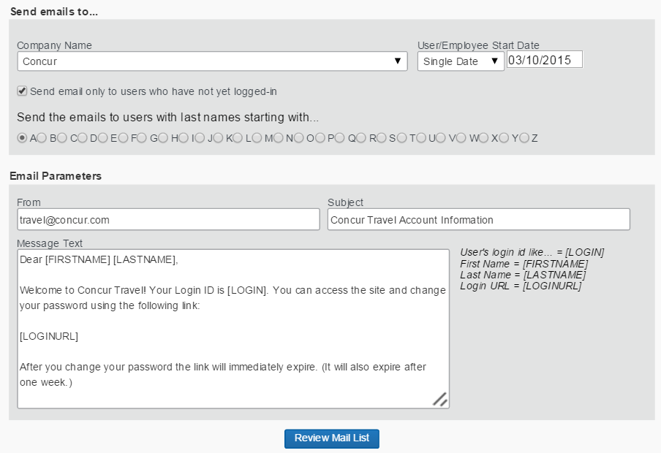

1. Complete the following fields.

| Field | Description / Action |
| --- | --- |
| Company Name | Click the desired company name. |
| User/Employee Start Date | Select the desired range of employee start dates.  **NOTE:** If sending the update to employees created on a single date, you must use the **Date Range** option. Select the day prior to the **Account Activation Date** in the first field and select the actual activation date in the second field. |
| Send email only to users who have not yet logged-in | Select (enable) this check box if you want to send the welcome message only to users who have not yet logged in to Travel. |
| Send the emails to users with last names starting with | Select the desired letter. |
| From | Enter the email address that will appear in the welcome message.  **IMPORTANT:** Be sure to enter another email address – other than the default – so that *bounced* replies will be captured. If the default is left, the bounced messages are sent to an unmonitored address and cannot be sent to you.  Also, when entering a new address, be sure to test that your customer receives the email before generating the message to the larger audience. |
| Subject | Enter the subject for the welcome message. |
| Message Text | Enter the text for the welcome message. You can use the default text that appears in this field or modify the text, as needed. |

1. Click **Review Mail List** to review this list of users that will receive the welcome message.
2. Be sure to take a screen shot or copy-and-paste the results on this page. This information is not stored anywhere else within the site, when you leave this screen.
3. Click **Send Email** to send the welcome message to the list of users.

### View GDS Transaction Logging

Use the **View GDS Transaction Logging** option to view how Travel communicates with the GDS when booking travel. This feature can help pinpoint problems with Travel. You are required to submit this log file with SAP Concur support tickets to ensure faster response time.

#### Procedure: Viewing and Exporting the GDS Transaction Log

1. To view and export the GDS Transaction Log:
2. On the Travel System Admin page, click **View GDS Transaction Logging** in the left menu. This page appears.

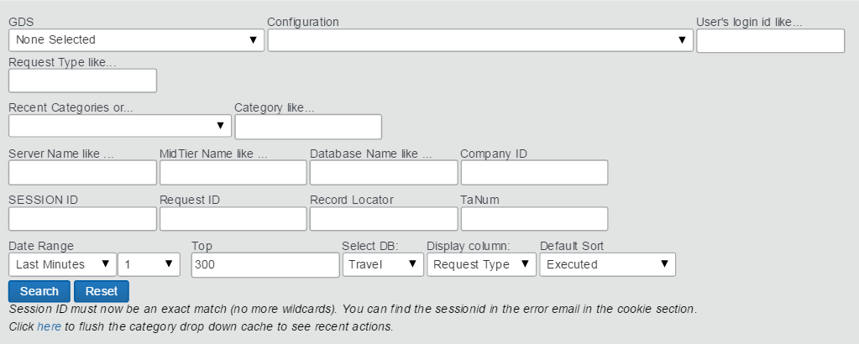

1. In the **Configuration** field, choose the appropriate site and configuration.
2. In the **User's login id like** field, enter the login ID that has received the error or your agency login ID if you have recreated the error onsite.
3. Transaction Logs are stored in the database by the login of the user who booked the trip – regardless of the traveler. For a booking done by a travel admin, the transaction logs are under the assistant's login ID.
4. From the **Date Range** list, click a date/time as close to the error as possible so the exact log is found.
5. The log files are stored for seven days.
6. Click **Search**.
7. In the search results:

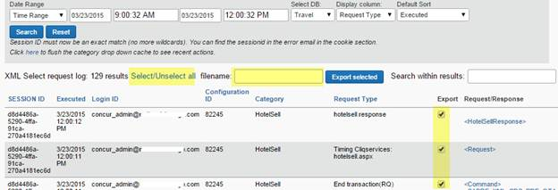

* Click **Select/Unselect All**.
* Enter a file name.
* Click **Export selected**.

1. Save the file to your computer and attach it to your support ticket.

### Import Data

Use the **Import Data** option to view the list of import tasks that have been processed or are scheduled to be processed, and to download import templates.

For more information on importing data, refer to the **Instruction** tab found on each template available for download.

Note the following:

* Many sections in the template will allow you to also remove data.
* For a reward membership program, leave the number field blank and it will be removed from the traveler's Travel profile.
* For the Org. Unit/Division, enter the value <clear>.
* To randomly generate a password for new login IDs, enter the value <random>.

1. Between 9 AM – 5 PM (your local time), uploads are limited to 5MB or smaller. If you attempt to upload a file that is larger than that, a message appears. You can often reduce file sizes by changing file formats from .csv to Excel. If changing the format is not an option, you can upload larger files after business hours (9 AM – 5 PM your local time).

#### Procedure: Importing Data

The tasks that appear depend on the user's login ID. The customer (and SAP Concur internal staff) can see all tasks performed for the associated customer. TMCs, however, can view only the tasks performed by that TMC.

1. To view import tasks:
2. On the Travel System Admin page, click **Import Data** in the left menu. This page appears.

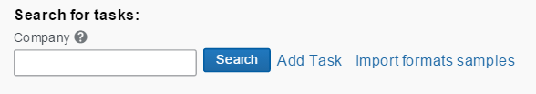

1. In the **Company** field, enter the company name.
2. Click **Search**.

#### Procedure: Downloading Import Templates

1. To download import templates:
2. On the Travel System Admin page, click **Import Data** in the left menu.
3. Click **Import formats samples**. This page appears.

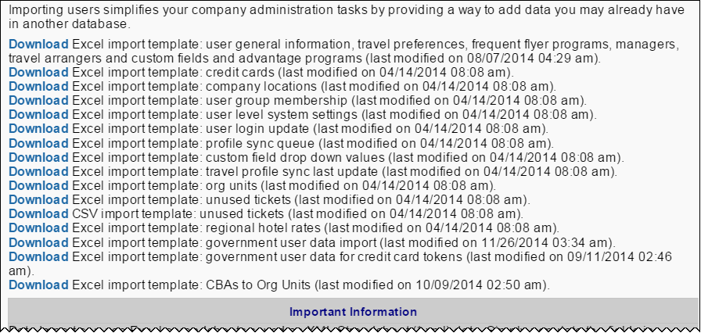

1. Click **Download** for the import template that is relevant for the import task you wish to create.
2. Populate the data in the template, and then save the data as XML Spreadsheet data (*.xml).

#### Procedure: Adding an Import Task

1. To add an import task:
2. On the Travel System Admin page, click **Import Data** in the left menu.
3. In the **Company** field, enter the company name.
4. Click **Search**.
5. Click **+ Add Task**. This page appears.

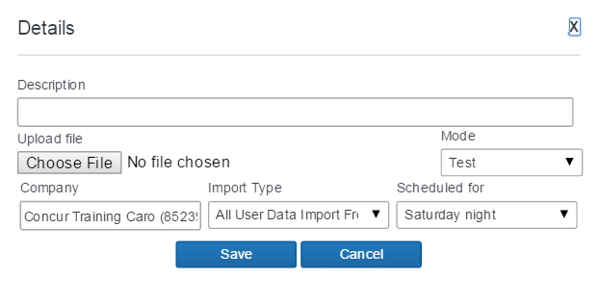

1. Complete the following fields.

| Field | Description / Action |
| --- | --- |
| Description | Enter an accurate description of the import task to be created |
| Upload file | Click **Browse** (or **Choose File**, depending on your browser) and choose the file to upload. |
| Mode | Click **Test** to indicate if the import is a test import.   * **Best Practice:** Concur Travel recommends that you initially run the import task in Test mode. No changes are made to the database when the import task is run in Test mode. However, imports cannot be reversed when run in a non-"test" mode. |
| Company | Verify that the correct company appears. |
| Import Type | Select the import type that matches the import task. |
| Scheduled for | Select the value that is appropriate for the import task you are creating. Selecting *Another task completion…* will allow you to chain this import task to another so that they occur in a specific order. |

1. Click **Save** to save this import task. The import task will appear in the Manage Import Tool Task list.

#### Procedure: Changing Properties

You can edit the task configuration if it has not begun processing or to view details of the completed import.

1. To change properties:
2. On the Travel System Admin page, click **Import Data** in the left menu.
3. In the **Company** field, enter the company name.
4. Click **Search**.
5. Click P2369#yIS1 for the desired task.

#### Procedure: Deleting a Task

1. To delete a task:
2. On the Travel System Admin page, click **Import Data** in the left menu.
3. In the **Company** field, enter the company name.
4. Click **Search**.
5. Click P2375#yIS1 for the desired task.

### Scheduled Tasks Log

Use the **Scheduled Tasks Log** option to verify and check for errors after synchronizing users' profiles.

#### Procedure: View the Task Log

1. To view the task log:
2. On the Travel System Admin page, click **Scheduled Tasks Log** on the left menu. This page appears.

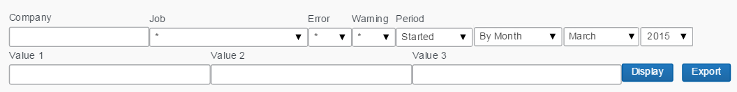

1. Complete the following fields.

| Field | Description / Action |
| --- | --- |
| Company | Click the desired company name. |
| Job | Select the desired job. |
| Error | Click one of the following:   * * * Yes * No |
| Warning | Click one of the following:   * * * Yes * No |
| Period | Click one of the following:   * Started * Completed * Updated   Then, select the time period from the following list. |
| Value 1  Value 2  Value 3 | Enter as appropriate. |

1. Click **Display**.

### Travel Text Customization

Refer to the *Custom Text Travel Service Guide*.

### Profile Text Customization

Refer to the *Custom Text Travel Service Guide*.

### Manage CIBT Configuration

Use the **Manage CIBT Configuration** option to complete the second step in the CIBT configuration. The first step is to select (enable) the **Send Profile/Travel Data to CIBT** check box in the **Wizard Options** section of the travel configuration page.

Refer to the *CIBT Visa and Passport Travel Service Guide*.

### Share Custom Fields

Use the **Share Custom Fields** option to allow the sharing of custom fields with Hotel Service content suppliers. This feature allows Concur Travel to pass custom fields (profile or trip), such as department identifier and cost center, to the hotel vendors.

1. ***Not every vendor supports this feature.***

Refer to the *Hotel Service Content Suppliers Travel Service Guide*.

## Appendix A – Find the Travel Service Guides & Fact Sheets

Travel Service Guides and Fact Sheets are mentioned throughout this guide.

* If you have the proper permissions, you can access them using the SAP Concur support portal.
* If you have ***any*** type of Travel "admin" permission, you can access them through online Help in Travel.

Click **Help** **>** **Travel Administration Help**. Then, click the **Travel Service Guides & Fact Sheets** link.

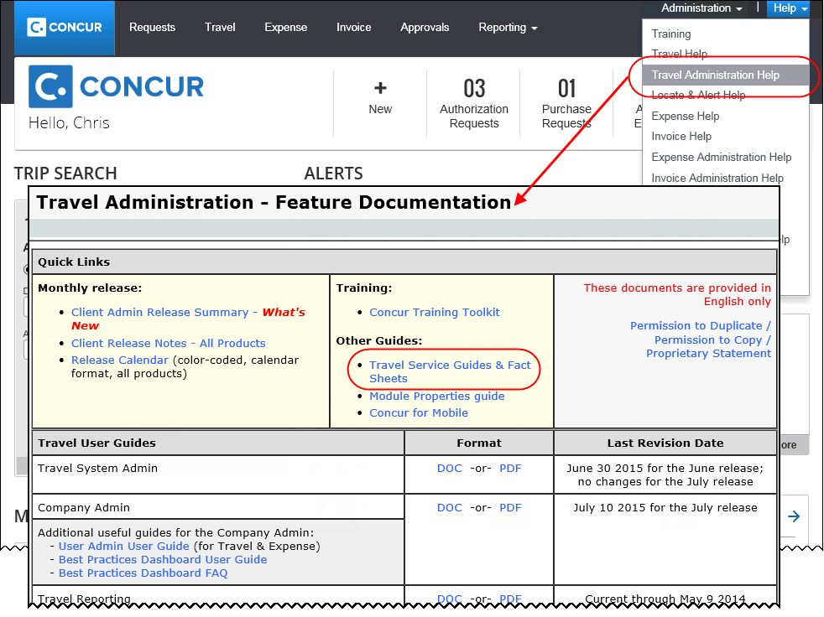

You can find release notes, admin summaries, and other information here, too!

## Appendix B – Agency Configuration

### Procedure: Create an Agency Configuration

1. To create a new agency configuration:
2. On the Travel System Admin page, click **New Agency** in the left menu. This page appears.

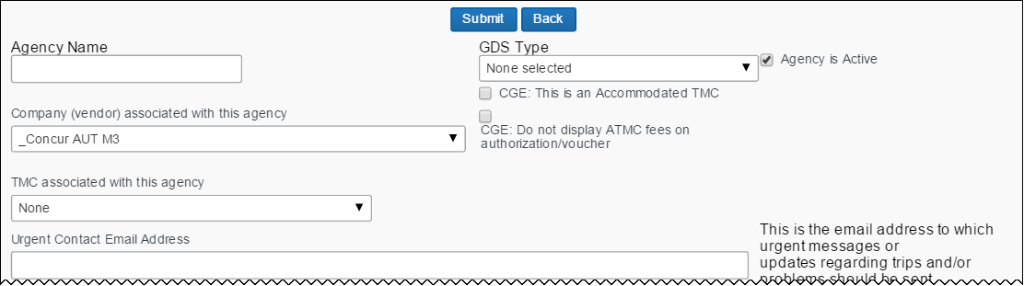

This is the first part of this section. The remainder of this section is described on the following pages.

1. Complete the following fields.

| Field | Description / Action |
| --- | --- |
| Agency Name | Enter the agency name in the format [Travel Agency Name]([Concur Customer Name]) – for example, Travel Agency ABC (Customer XYZ).  Each travel agency configuration should have a unique name. |
| GDS Type | **IMPORTANT:** The GDS type cannot be modified after the travel agency configuration has been created. If the GDS type is incorrect, you must create a new travel agency configuration.  Click one of the following:   * Apollo = Apollo GDS * Galileo = Galileo GDS * Sabre = Sabre GDS * Worldspan = Worldspan GDS * Amadeus = Amadeus GDS * Abacus = Abacus GDS * AirCanada = Direct Connect * DeutscheBahn * SNCF * Rail1 |
| Agency is Active | Select (enable) thischeck box.  **NOTE:** This option ***MUST*** be enabled. |
| Company (vendor) associated with this agency | Select the company. |
| TMC associated with this agency | Select the TMC, if any. |
| Urgent Contact Email Address | Enter an email address to receive notifications when file finishing fails for a PNR. Separate multiple email addresses with semi-colons (;). |

1. Scroll down to the next section.  
     
   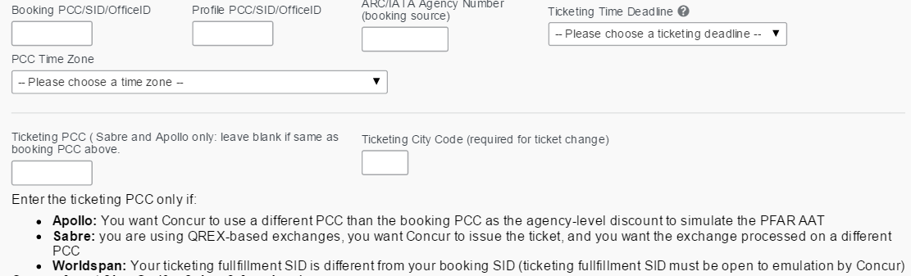

The information in this box differs if using Abacus vs Sabre.

| Field | Description / Action |
| --- | --- |
| Booking PCC/SID/ OfficeID | Enter the booking Sabre/Abacus/Apollo/Galileo Pseudo City Code (PCC), Worldspan Subscriber ID (SID), or Amadeus Office ID. |
| Profile PCC/SID/ OfficeID | Enter the profile Sabre/Abacus/Apollo/Galileo Pseudo City Code (PCC), Worldspan Subscriber ID (SID), or Amadeus Office ID |
| ARC/IATA Agency Number (booking source) | Enter the travel agency's IATA or ARC number.  **NOTE:** You must enter this information for Worldspan GDS. |
| Ticketing Time Deadline | Select a ticketing deadline.  Concur Travel will allow a user to hold a trip until the time specified in this field. |
| PCC Time Zone | Select the time zone for the Sabre/Abacus/Apollo/Galileo Pseudo City Code (PCC), Worldspan Subscriber ID (SID), or Amadeus Office ID. |
| Ticketing PCC | Enter the ticketing PCC only if:   * **Apollo/Galileo:** * If the discount code includes the PCC, then this field is ignored. * If this field contains a Ticketing PCC ***and*** if it matches the Booking PCC, Concur Travel sends the Booking PCC. * If this field contains a Ticketing PCC ***and*** if it does ***not*** match the Booking PCC, Concur Travel sends the Ticketing PCC. * **Sabre/Abacus:** You are using QREX-based exchanges, you want Concur Travel to issue the ticket, and you want the exchange processed on a different PCC |
| Ticketing City Code | Enter the city code.  **NOTE:** This field is required for the ticket change feature. |

1. Scroll down to the next section – appears for Amadeus only.

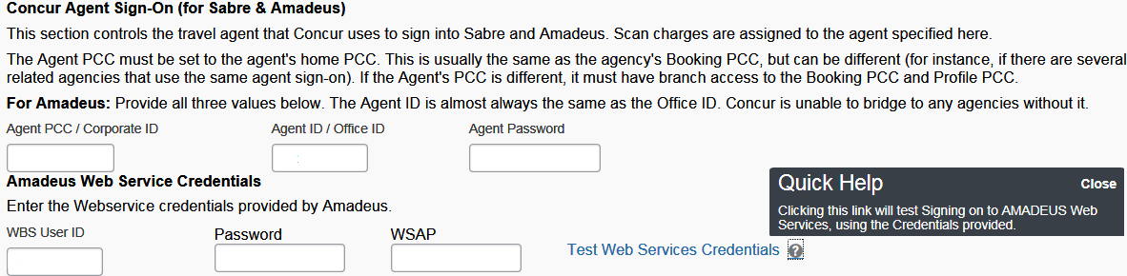

| Field | Description / Action |
| --- | --- |
| WBS User ID | Enter the user ID. |
| Password | Enter a password. |
| WSAP | Enter the access point information. |
| Test Web Services Credentials | Click to test the credentials you just entered.  **NOTE:** If sign-on fails, the agency admin should confirm that the information provided in all three of the credential fields is correct. If this information matches what was provided by Amadeus, then agencies should reach out to their Amadeus representative for further assistance. |

1. This is required for Amadeus if you are going to use the Fare Families functionality.
2. Scroll down to the next section – appears for Sabre only.

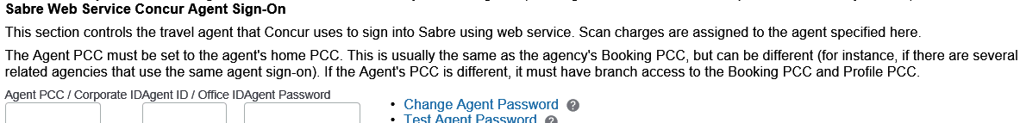

| Field | Description / Action |
| --- | --- |
| Agent PCC / Corporate ID | Enter Sabre Pseudo City Code (PCC). |
| Agent ID / Office ID | Enter Sabre Pseudo City Code (PCC). |
| Agent Password | Enter an agent password. |

1. For Sabre/Abacus GDS, scroll down to the next section.

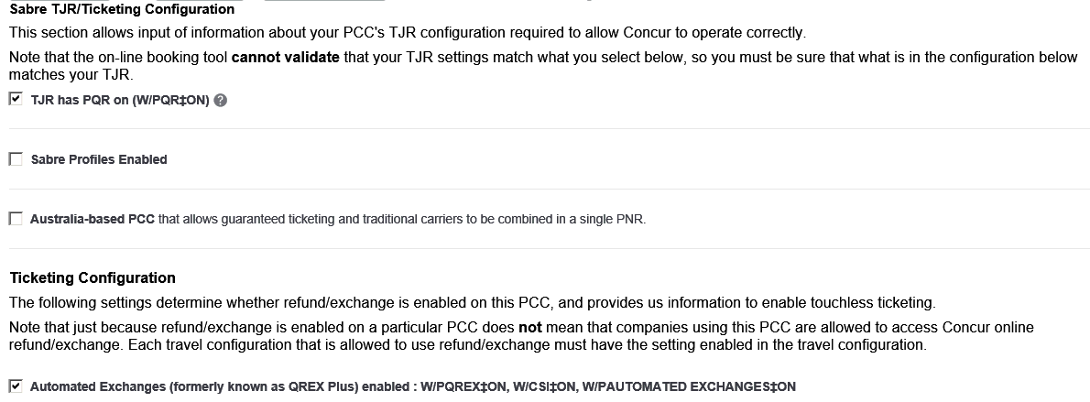

| Field / Section | Description / Action |
| --- | --- |
| TJR has PQR on (W/PQR‡ON) | Select (enable) this check box to activate Price Quote Record functionality (W/PQR‡ON) in Travel.  **NOTE:** This format automatically deactivates the WS Price Retention Alert (WST) indicator. You must be sure that Price Quote Record functionality is activated in the Sabre Travel Journal Record (TJR) security feature options. |
| Sabre Profiles Enabled | Select (enable) this check box to activate Sabre Profiles.   * Refer to the *Sabre Profiles Travel Service Guide*. |
| Australia-based PCC | Select (enable) this check box to allow guaranteed ticketing and traditional carriers to be combined on a single PNR. |
| Automated Exchanges (formerly known as QREX Plus) enabled : W/PQREX‡ON, W/CSI‡ON, W/PAUTOMATED EXCHANGES‡ON | Select (enable) this check box to activate Quick Refunds and Exchanges (QREX) functionality (W/PQREX‡ON) in Travel.  **NOTE:** Price Quote record functionality does not need to be active to use QREX functionality. |

1. Scroll down to the next section – appears for Apollo only.

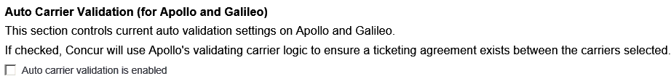

Select (enable) the **Auto carrier validation is enabled** check box so Concur Travel will use Apollo's validating carrier logic to ensure that a ticketing agreement exists between the carriers selected.

1. Do not enable this setting if your agency has not enabled the feature within the Apollo/Galileo host.
2. Scroll down to the next section.

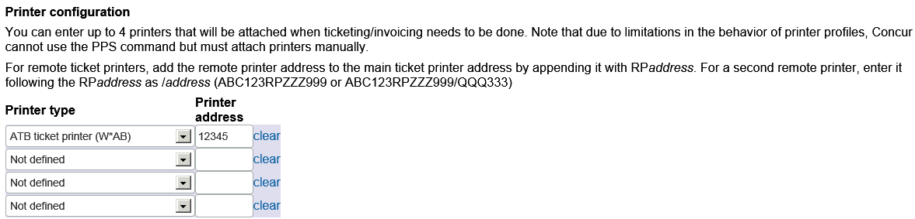

| Field | Description / Action | |
| --- | --- | --- |
| Invoicing options (DIN modifiers) | | ***No longer used.*** |
| Printer type Printer address | | Select the printer function and printer line address for each printer. |

1. Scroll down to the next section.

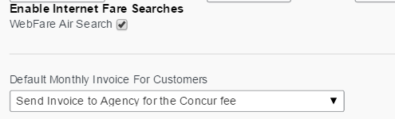

| Field | Description / Action |
| --- | --- |
| WebFare Air Search | ***Do not modify this setting.***  This option should be configured only in the travel configuration. |
| Default Monthly Invoice For Customers | ***Do not modify this setting.***  This option should be configured only in the travel configuration. |

1. Scroll down to the next section.

P2590#yIS1

No functionality at this time.

1. Scroll down to the next section.

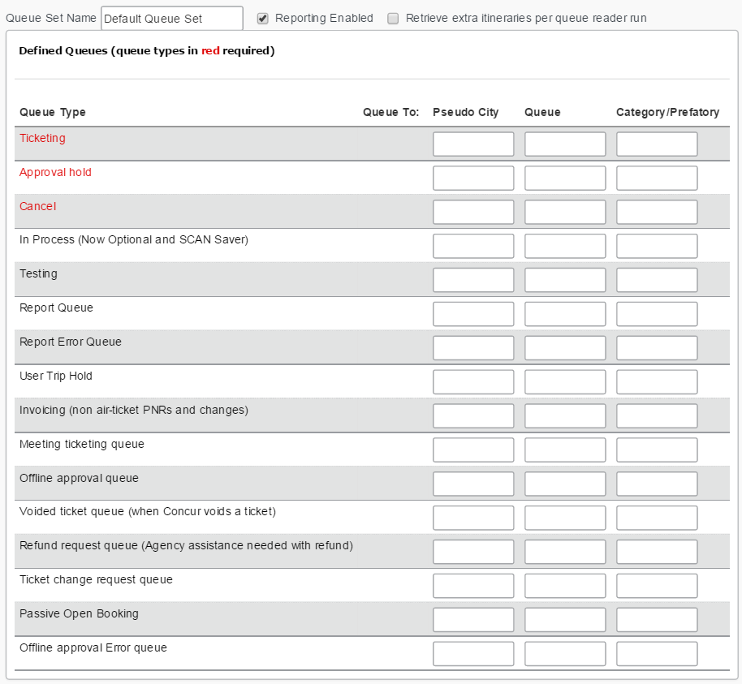

| Field | Description / Action |
| --- | --- |
| Queue Set Name | Enter alternate queue sets, as needed. By default, the name of the initial first queue set is "Default Queue Set." |
| Reporting Enabled | This check box is selected by default. ***Do not make any changes unless otherwise notified by SAP Concur.***  **NOTE:** Reporting cannot be enabled without Amadeus Web Services. |
| Retrieve extra itins per queue reader run | ***Do not select (enable) this check box unless advised by SAP Concur Implementation or SAP Concur support.*** |
| **Defined Queues** | |
| Ticketing | PNRs are placed in this queue to be ticketed by an agent. |
| Approval hold | Unticketed PNRs are placed in this queue when manager or designated approver approval is required. |
| Cancel | Unticketed PNRs are placed in this queue when a user requests to cancel an itinerary. Travel cancels the itinerary and all segments and then sends the PNR to this queue. |
| In Process (Now Optional and SCAN Saver) | All newly created PNRs are placed in this queue prior to user hold, approval hold, or ticketing. |
| Testing | This queue is not currently being used. |
| Report Queue | Sabre, Worldspan, and Amadeus  All traditional and interactive PNRs are placed in this queue to be consolidated into Travel's reports. Configure your setup so that all PNRs are automatically sent to the reporting queue whenever they are ticketed or the reservation changes.  You must verify that the travel agency and Concur Travel have completed all branch access steps before entering the Report Queue Pseudo City and Queue in the travel agency configuration. |
| Report Error Queue | Sabre, Worldspan, and Amadeus  Travel will place PNRs in this queue that cannot be parsed and need to be processed later. This queue must differ from the Report Queue and it requires a prefatory. Nothing should be dropped in this queue by the agency.  You must verify that the travel agency and Concur Travel have completed all branch access steps before entering the Report Error Queue Pseudo City and Queue in the travel agency configuration.  This queue must be on the same PCC as its corresponding report queue.  **NOTE:** If some but not all of the required reporting remarks are not present, then Concur Travel may ingest the trip rather than putting it on the Report Error Queue. If Concur Travel is unable to associate the trip to a user, the trip will appear to Travel Admins in reports but will not appear on a user's trip list. |
| User Trip Hold | PNRs are placed in this queue when the user has placed a reservation on hold. |
| Invoicing (non air-ticket PNRs and changes) | All car/hotel-only bookings, non-air tickets, and car/hotel changes to existing ticketed reservations are placed in this queue to be invoiced by an agent.  **NOTE:** If an Invoice Queue is not defined, all bookings will be sent to the defined Ticketing Queue. |
| Meeting ticketing queue | Meeting PNRs are placed in this queue to be ticketed by an agent. |
| Offline approval queue | All GDSs are supported  Unticketed, agent-booked PNRs are placed in this queue if manager approval is required via Travel.  You must verify that the travel agency and Concur Travel have completed all branch access steps before entering the Offline approval queue Pseudo City and Queue in the travel agency configuration.  **AMADEUS ONLY** – In order to use this feature, you must:   * Switch to queue-based reporting, where a reporting queue and a reporting error queue are in place. * Stop mirroring AIR/IMR records to SAP Concur's office ID DCA1S216O (O as in Oscar not the number 0). |
| Voided ticket queue (when Concur voids a ticket) | Ticketed PNRs within the void window are placed in this queue when a user requests to void a ticket. Concur Travel voids the ticket, cancels the itinerary and all segments, and sends the PNR to this queue. The "Allow ticket voids" option must be enabled in the travel configuration for this functionality.  Concur Travel supports Voiding in Sabre/Abacus for a ticket issues from an alternate PCC. Travel verifies the PCC of ticket generation and emulates to that PCC to void the ticket (as voiding must occur in the ticketed PCC).  **NOTE:** Emulation ***must*** be opened between the booking PCC and the ticketing PCC if accessing via branch sign in. |
| Refund request queue (Agency assistance needed with refund) | Ticketed PNRs that Concur Travel is unable to void are placed in this queue to be cancelled/refunded by the agency.  **NOTE**: In case of a scenario with unusual variables or circumstances, a PNR should not be queued to the refund request queue; it will be available on the cancel queue. |
| Ticket change request queue | Tickets exchanged via Concur Travel are placed in this queue. |
| Passive Open Booking | Assign a queue (all three fields are required) for Passive Open Booking.   * If the PNR created is new, then the PNR is queued to this new queue. * If it is an existing PNR we add the open booking passive segment to, it will go to this queue and the appropriate queue. |
| Offline approval Error queue | Offline approval PNRs that Concur Travel is unable to process, for reasons such as:   * missing required reporting remarks * emulation failures * bad formatting of data * reservation (PNR) has already been ticketed   This allows TMCs to monitor a specific queue for these reservations to ensure they can be approved before the traveler's departure.  This queue must be on the same PCC as its corresponding offline approval queue.  **NOTE:** If some but not all of the required reporting remarks are not present, then Concur Travel may ingest the trip rather than putting it on the Offline Approval Error Queue. If Concur Travel is unable to associate the trip to a user, this might prevent notification to the approver. |

* For more information on adding alternate queue sets, see the *Alternate Queue Sets* section below.

1. Scroll down to the next section.

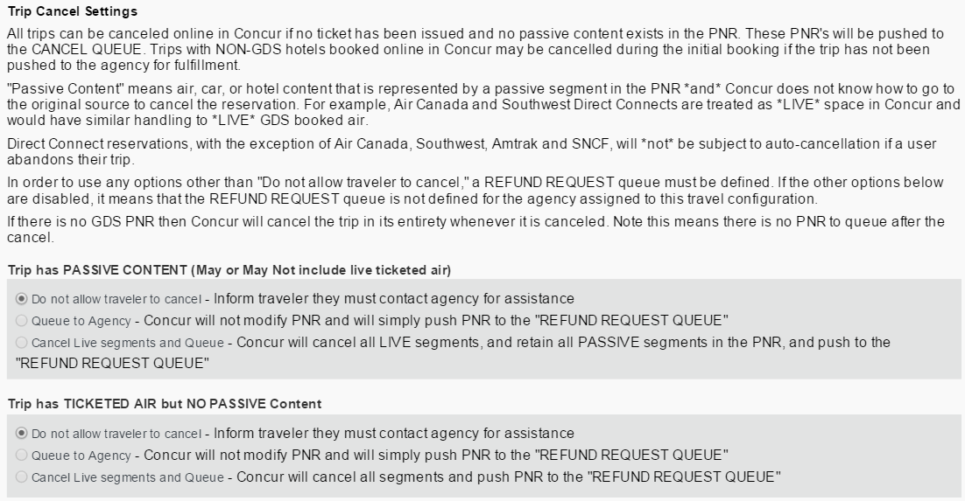

Make the appropriate selections.

* For a complete description, refer to the *Trip Cancel*section below.

1. Scroll down to the next section.  
     
   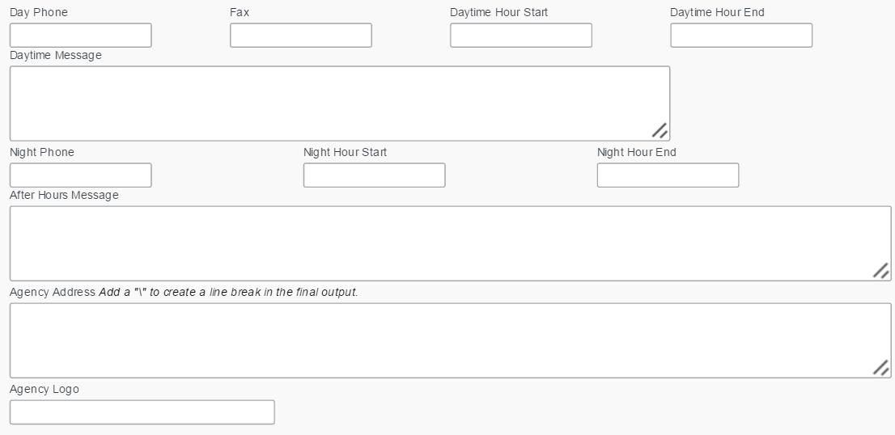

| Field | Description / Action |
| --- | --- |
| (day information) | Enter the appropriate daytime contact information.   * **Best Practice:** Concur Travel recommends leaving the **Day Phone**, **Daytime Hour Start**, and **Daytime Hour End** fields blank and placing all pertinent agency contact information in the **Daytime Message** field. The text entered in the **Daytime Message** field can be in HTML format. ***EXAMPLE****: This is an example that Concur Practice Managers use for Direct Corporate Client Implementations:*  </b><b>Contact An Agent</b><br/> <br/>For questions regarding travel reservations or changes to an itinerary, contact the Travel Department:<br/> <br/><b>Hours:  </b> XXXXXX <br/><b>Phone:  </b> XXX-XXX-XXXX <br/><b>After Hours:  </b> XXX-XXX-XXXX <br/><b>Email:  </b> <a href="mailto:email address here">display name here</A><br/ |
| (night information) | Enter the appropriate nighttime contact information.   * **Best Practice:** Concur Travel recommends leaving the **Night Phone**, **Night Hour Start**, and **Night Hour End** fields blank and placing all pertinent agency contact information in the **After Hours Message** field. The text entered in the **After Hours Message** field can be in HTML format. This information will appear on the Travel Tools page. |
| Agency Address | Enter information that will appear on the travel itinerary. |
| Agency Logo | Enter the logo path in the appropriate format (i.e., /branding/filename or /logos/filename or /images). The agency logo will appear on the travel itinerary.  The specified logo must have previously been uploaded as a site logo, which will place the logo image file on the SAP Concur Web server in the /branding directory.  To determine the path of a logo image file, right-click on the image, click **Properties**, and view the URL field. |

1. Scroll down to the next section.

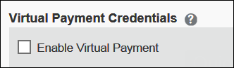

* Refer to the *Virtual Payment (Conferma) Travel Service Guide* for complete instructions.

1. Click **Submit**.

### Procedure: Modify an Agency Configuration

1. To modify an agency configuration:

Do one of these:

* **Process #1:**
* Click **Administration** **> Travel > Travel System Admin** **>** **Company Travel Configuration** (**Company Travel Setup** section of the left menu).

1. If Travel System Admin is your only Travel option, then the commands are **Administration** **>** **Travel System Admin > Company Travel Configuration**.

* Locate the row listing the Company Travel Configuration Name.
* Click the link to the right, which is the name of the Agency Configuration.

- or -

* **Process #2:** Click **Administration** **>** **Travel > Travel System Admin** **>** **View Travel Agencies** (**Agency Setup** section of the left menu). You will see a list of all of the Agency Configurations created for Travel, by your agency.

1. If Travel System Admin is your only Travel option, then the commands are **Administration** **>** **Travel System Admin > View Travel Agencies**.
2. The bottom of the **Agency Configuration** page contains an audit log with a link called **Show Change History**. This area contains the last 10 modifications completed within this configuration and name/login for the user who made each change.   
     
   P2721#yIS1

### Trip Cancel

Refer to the *Trip Cancel and Voids Travel Service Guide*.

### Alternate Queue Sets

If a trip was booked on a different or alternative PCC, an alternate queue set, <Owning PCC>_Alternate, will be used. The Alternate Queue Set feature allows travel agencies to handle instances where offline and online bookings are done in different PCC's. Note:

* Both GIDS Processor and QueueSuckers were modified to look up users by Travel Profile Sync ID if a remark CLIQSYNCID is included in an itinerary and CLIQUSERID is not. Because a GDS does not accept a full ascii character set, some characters need to be substituted in the remark to match stored TRAVEL_PROFILE_SYNC_IDs. These are the same as the CLIQUSER substitutions:
* For QueueSucker, you can replace '@' with '*'. Other special characters will be replaced by the GDS with a space, and spaces will be changed to an underscore ('_').
* For GIDS Processor, you can replace the '@' with '//'. Spaces will be changed to underscores ('_').

To enable this feature, click **Add Alternate Queue Set** in the travel agency configuration.

The **Queue Set Name** field for the alternate queue set must contain the PCC/SID/Office ID used in the defined queue and '_Alternate', for example ABC_Alternate. This feature is limited to a single PCC/SID/Office ID.

1. This feature is primarily used for Travel Reporting, so traditional/agency booked PNRs from another PCC can be fed into a Concur Travel site for reporting.

## Appendix C – Module Properties

Refer to the *Module Properties User Guide*.

## Appendix D – Password Management

Refer to the *Password Management and Defaults Fact Sheet*.

## Appendix E – Auto-Cancel

Refer to the *Auto Cancel Fact Sheet*.

## Appendix F – Duplicate Booking Prevention

Refer to the *Duplicate Booking Prevention Fact Sheet*.

**☼**