SAP Concur Release Notes
Concur Travel
Concur Professional/Premium and Concur Standard
Month | Audience
Release Date: April 2024  Initial post: Friday, April 19 | SAP Concur Client FINAL

** FINAL **
The enhancements and changes described in this document may or may not be included in this release. SAP Concur reserves the right to postpone implementation of – or completely remove – any enhancement/change mentioned here.
The DRAFT and FINAL release notes contain information about Concur Professional/Premium and Concur Standard.
Each note contains a table that which indicates if the enhancement/change applies to Professional and/or Standard.

Contents
Release Notes 1
Administration 1
**Ongoing Changes** New Concur Travel Experience: Allow Users to Choose Rule Class Tied to Same Configuration (Professional Edition Only) 1
Flight 4
New Concur Travel Experience: Mixed Cabin Offers and Product Selection (Professional Edition Only) (Apr 22) 4
New Concur Travel Experience: Persistent Filters and Sort Options (Professional Edition Only) 6
New Concur Travel Experience: Pricing Added to Carrier Filter (Professional Edition Only) 7
Hotel 8
New Concur Travel Experience: Enhanced Filters for Hotel (Professional Edition Only) 8
Hotel, Rail 11
**Ongoing** New Concur Travel Experience: Last Four Digits on Form of Payment Displayed (Professional Edition Only) 11
Miscellaneous 14
New Concur Travel Experience: Trips and Calendar Integration (Professional Edition Only) 14
Travel Profile API 2.0 Gender Diversity Support (Mar 26) 18
New Concur Travel Experience: Market Eligibility Expansion (Professional Edition Only) (Mar 26) 19
**Ongoing** New Concur Travel Experience: Add to Trip Enhancement (Professional Edition Only) 21
**Ongoing** New Concur Travel Experience: Trip History (Professional Edition Only) 25
**Ongoing** New Concur Travel Experience: Skip Search Action (Professional Edition Only) 30
**Ongoing** New Concur Travel Experience: Feature Exclusions, Limitations & Changed Behavior (Professional Edition Only) 32
Rail 33
New Concur Travel Experience: Renfe - Choose Your Rule Class Tied to Same Agency Setting (Professional Edition Only) 33
New Concur Travel Experience: Support of Phone and E-mail on Review and Book Page (Professional Edition Only) 33
New Concur Travel Experience: Renfe - New Supported Rules (Professional Edition Only) (April 8-10) 34
New Concur Travel Experience: Renfe - Auto-Cancel and Standalone Approval Process Enhancement (Professional Travel Only) (April 8-10) 40
New Concur Travel Experience: Renfe + Car, Hotel, Flight - Changes to Approval Deadline Logic (Professional Edition Only) 46
New Concur Travel Experience: Renfe - User Interface Changes to Workflow Pages and E-mails (Professional Edition Only) (April 8-10) 48
New Concur Travel Experience: Renfe - Train Options Turned Down (Professional Edition Only) (April 8-10) 54
New Concur Travel Experience: Renfe - Multiple Violation Reasons (Professional Edition Only) (April 8-10) 56
New Concur Travel Experience: Renfe - Configurable Message Boards (Professional Edition Only) (April 8-10) 58
New Concur Travel Experience: Renfe - Support for Multiple Rail Connectors (Professional Edition Only) (April 8-10) 60
New Concur Travel Experience: Renfe – Allow/Display Message Support (Professional Edition Only) (April 8-10) 61
New Concur Travel Experience: CO2 Emissions Display (Professional Edition Only) 63
New Concur Travel Experience: Trainline - Available on Amadeus, Sabre, Galileo (Professional Edition Only) (April 10) 65
New Concur Travel Experience: Renfe - Least Cost Logical Fare Support (Professional Edition Only) (April 8-10) 75
Travel Operations / Technical Essentials 77
Sabre Enhanced Form of Payment (FOP Wallet) 77
New Concur Travel Experience: TMC Self-Service Report Enhancement for Client Opt Out Status (Professional Edition Only) 80
Planned Changes 81
Flight 81
**Planned Changes** New Concur Travel Experience: New CO2 Filter Added to Flight (Professional Edition Only) 81
**Planned Changes** New Concur Travel Experience: EDIFACT and NDC Content for Amadeus (Professional Edition Only) 83
**Planned Changes** New Concur Travel Experience: Add Vendor Preference and Corporate Rate to Post Booking Flow (Professional Edition Only) 84
Hotel 85
**Planned Changes** New CSL Segment Format for Sabre Hotels 85
**Planned Changes** New Concur Travel Experience: Configuration for Custom Hotel Sourcing (Professional Edition Only) 87
Miscellaneous 90
**Planned Changes** Share a Trip Via Microsoft Teams Integration 90
**Planned Changes** New Fields Available in Online Order Form 93
**Planned Changes** Decommission of Two-Manager Approval Setting (Professional Edition Only) 95
Travel Operations / Technical Essentials 97
**Planned Changes** Decommission of Travel Configuration Agency Processing Fee Form of Payment for Land Only/Non-GDS Reservations Setting 97
**Planned Changes** New Concur Travel Experience: Sabre Car Enhancements – Additional Elements (Professional Edition Only) 99
**Planned Changes** Decommission of Credit Card Datapoints in Profile and PNR Finishing Templates 100
**Planned Changes** New Concur Travel Experience: Sabre’s Price Quote - Enhancement to Provide More Accurate Fare at Booking 105
Additional Release Notes and Other Technical Documentation 107
Online Help 107
SAP Concur Support Portal – Selected Users 107
Legal Disclaimer
The information in this presentation is confidential and proprietary to SAP SE or an SAP affiliate company and may not be disclosed without the permission of SAP SE or the respective SAP affiliate company. This presentation is not subject to your license agreement or any other service or subscription agreement with SAP SE or its affiliated companies. SAP SE and its affiliated companies have no obligation to pursue any course of business outlined in this document or any related presentation, or to develop or release any functionality mentioned therein. This document, or any related presentation and SAP SE or an SAP affiliate company’s strategy and possible future developments, products and or platforms directions and functionality are all subject to change and may be changed by SAP SE and its affiliated companies at any time for any reason without notice. The information in this document is not a commitment, promise or legal obligation to deliver any material, code or functionality. This document is provided without a warranty of any kind, either express or implied, including but not limited to, the implied warranties of merchantability, fitness for a particular purpose, or non-infringement. This document is for informational purposes and may not be incorporated into a contract. SAP SE and its affiliated companies assume no responsibility for errors or omissions in this document, except if such damages were caused by SAP SE or an SAP affiliate company’s willful misconduct or gross negligence.
All forward-looking statements are subject to various risks and uncertainties that could cause actual results to differ materially from expectations. Readers are cautioned not to place undue reliance on these forward-looking statements, which speak only as of their dates, and they should not be relied upon in making purchasing decisions.

Release Notes

Administration

**Ongoing Changes** New Concur Travel Experience: Allow Users to Choose Rule Class Tied to Same Configuration (Professional Edition Only)

Information First Published | Information Last Modified | Feature Target Release Date
February 9, 2024 | April 12, 2024 | March - May 2024
Any changes since the previous monthly release are highlighted in yellow in this release note.

Prof | Stan |   Edition
X |  | On: Impacts end users who use this feature/vendor; no configuration/setup by agency/ admin; cannot be turned OFF (example: new icons or rate display)
 |  | Available for use: No impact to end users unless/until configuration/setup by agency/admin (described below) (example: new rule, new Travelfusion airline)
 |  | Other: Refer to the release note below
 | X | Does not apply to this edition
Source
GDS
Direct Connect
Other
X | EMEA Data Center |  |  | Scan impact
X | North America Data Center |  |  | UI impact
 | China Data Center |  |  | File finishing impact
 | All data centers |  |  | Profile/Profile API/3rd Party XML Sync Impact
Affected Documentation
TSGs |  | Approvals, Rules, and Classes/Policies Travel Service Guide
Fact Sheets
Admin Guides
Other

Overview
Starting in April, administrators can allow users to select a rule class tied to the same configuration or agency. This will allow customers who currently have this setting enabled in their legacy Concur Travel experience to migrate to the new Concur Travel experience.
The Choose Rule Class - Allow Users to Choose Rule Class Tied to Same Configuration setting is currently available to all new Concur Travel experience customers.
The information from the February release note “**Planned Changes** New Concur Travel Experience: Choose Your Rule Class (Professional Edition Only)” has been included here.

Phases
This feature will be released to specific verticals between April and May:

Phase | Date of Release
Phase 1: Renfe Rail  NOTE: For Renfe, all three options under the Rule Class Selection dropdown, (as in, User cannot select rule class, User can select from rule classes tied to this configuration, User can select from rule classes tied to this agency) will be supported. Until this change, only the User cannot select rule class is applied. | April 8 - 10
Phase 2: All other verticals | May 2024, date TBD
In the Rule Class Options section of Travel System Admin, administrators will be able to configure their travel sites to do the following:
- allow users to select from a rule class tied to this travel configuration.
- allow users to select a rule class tied to same agency.
- force users to select a rule when making a reservation.
- display a custom rule class label and
- opt out a rule class from displaying in the dropdown.

User/Customer Benefit
This setting allows users to select which rules are suitable for the trip they are booking.

Administrator Experience
The administrator will be able to:
- enable the options User can select from rule classes tied to this configuration or User can select from rule classes tied to same agency.
- create a custom rule class label.
- select the Force selection of a rule class checkbox.
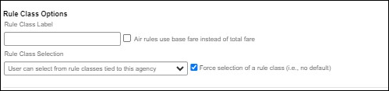
- select the Choose Rule Class Opt Out checkbox to remove the display of a rule class.
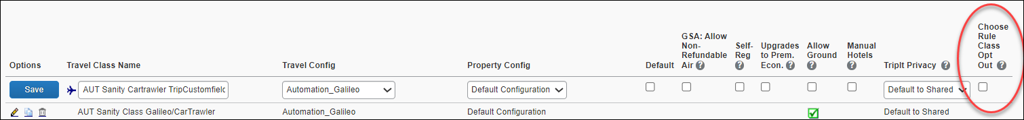
- display a custom message if the user does not select a rule class when required.

End-User Experience
The user will see a dropdown on the home page that contains rule classes associated with their travel configuration, excluding a rule class that has been opted out. If the force rule class is enabled, then users will see a blinking yellow outline that surrounds the dropdown. If the user does not select a rule (when required), they will be prompted to select a rule class.
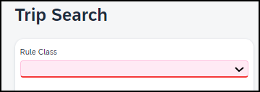

Configuration for Professional Travel
Refer to the Administrator Experience section for set up details. If the setting has been previously enabled, no changes are required.

Flight

New Concur Travel Experience: Mixed Cabin Offers and Product Selection (Professional Edition Only) (Apr 22)

Prof | Stan |   Edition
 |  | On: Impacts end users who use this feature/vendor; no configuration/setup by agency/ admin; cannot be turned OFF (example: new icons or rate display)
 |  | Available for use: No impact to end users unless/until configuration/setup by agency/admin (described below) (example: new rule, new Travelfusion airline)
X |  | Other: Refer to the release note below
 | X | Does not apply to this edition
Source
GDS |  | Sabre EDIFACT
Direct Connect
Other
X | EMEA Data Center |  |  | Scan impact
X | North America Data Center |  | X | UI impact
 | China Data Center |  |  | File finishing impact
 | All data centers |  |  | Profile/Profile API/3rd Party XML Sync Impact
Affected Documentation
TSGs
Fact Sheets
Admin Guides
Other

Overview
On April 22, end users can mix different cabins between outbound and inbound flights, provided the selected itinerary does not have a brand. The initial search results for selected outbound flight options will continue to display roundtrip-based prices, where each offer shows the total cost of outbound and inbound flights in the same cabin.
When selecting any EDIFACT unbranded option on the outbound selection page, the inbound selection page displays mixed cabin options. Every price that is displayed on the inbound selection page is a round trip that includes a previously selected outbound cabin, combined with the inbound cabin displayed on that page.

Limitations
This feature is not currently supported for NDC flight bookings. It applies to non-branded EDIFACT flight bookings only.
If the selected outbound and inbound flights have different fare classes of service, and the selected offer is out-of-policy, the least cost logical fares (LLF) displayed on the policy violation popup is calculated using the outbound flight’s fare class of service.

End-User Experience
With more flight options including mixed cabins, the end-user can shop offers with the best possible value when customizing their trip.
Example: On the outbound selection page, the end-user selects a business cabin:
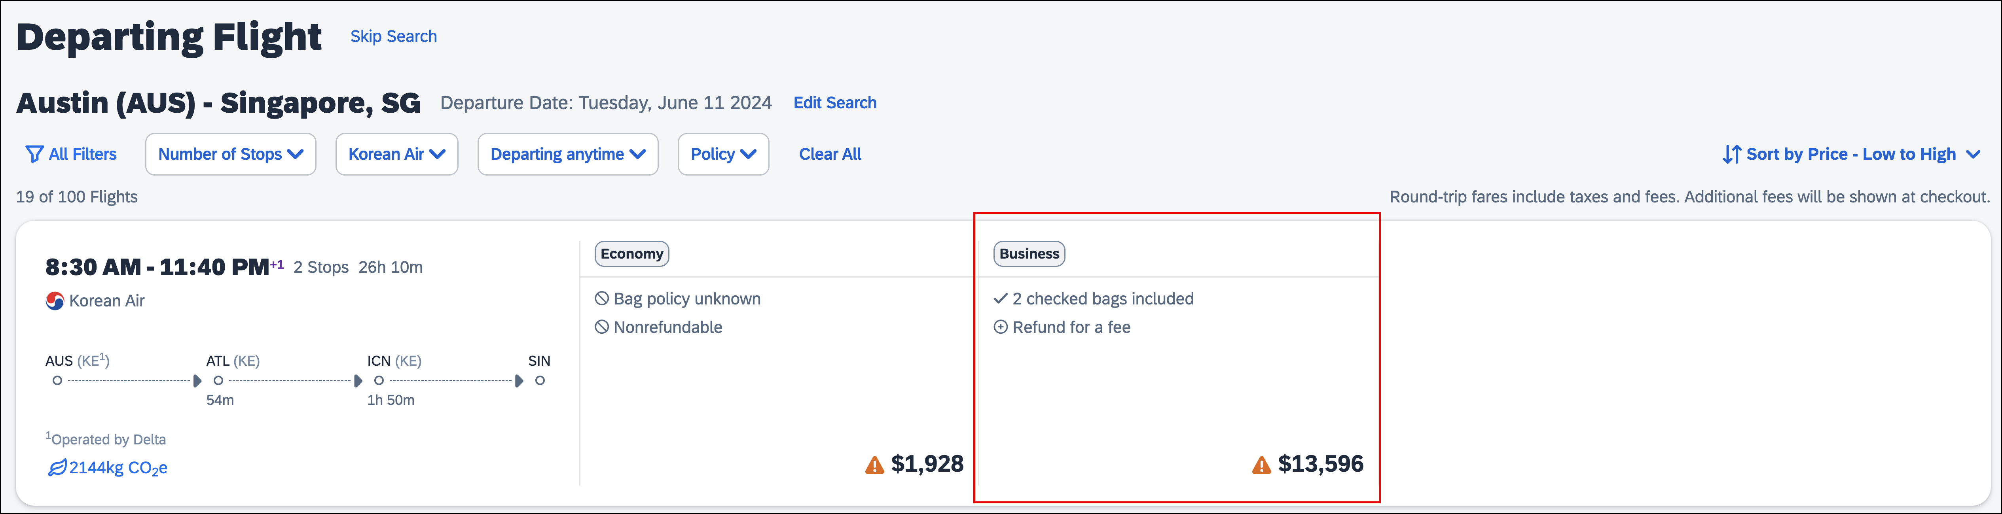
On the inbound selection page, with consideration of the outbound offer, mixed prices are displayed with different cabins. For this example, an Economy cabin is selected.
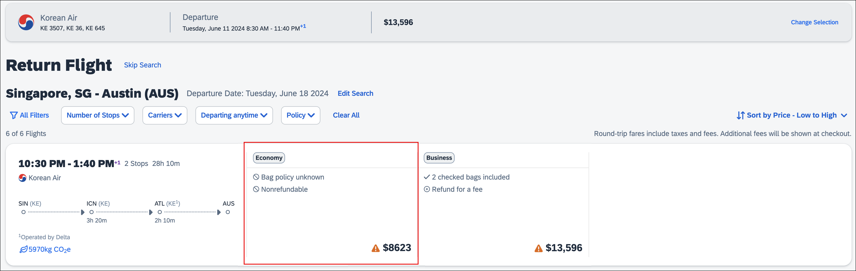
Since no forced upsells or downsells occur, no warning displays. The end-user will be transferred to the Review and Book page to continue with the booking process.

Configuration for Professional Travel
This feature is enabled by default. There are no configuration steps.

New Concur Travel Experience: Persistent Filters and Sort Options (Professional Edition Only)

Prof | Stan |   Edition
 |  | On: Impacts end users who use this feature/vendor; no configuration/setup by agency/ admin; cannot be turned OFF (example: new icons or rate display)
 |  | Available for use: No impact to end users unless/until configuration/setup by agency/admin (described below) (example: new rule, new Travelfusion airline)
X |  | Other: Refer to the release note below
 | X | Does not apply to this edition
Source
GDS
Direct Connect
Other
X | EMEA Data Center |  |  | Scan impact
X | North America Data Center |  | X | UI impact
 | China Data Center |  |  | File finishing impact
 | All data centers |  |  | Profile/Profile API/3rd Party XML Sync Impact
Affected Documentation
TSGs
Fact Sheets
Admin Guides
Other

Overview
Persistent filter and sort options have been added to the new Flight experience. To use filters and sort more efficiently, these options display as the user scrolls up and down the search results page. Additionally, filters remain expanded across the page for easier access.

End-User Experience
When search results are returned, filter and sort options are used to refine these results. With this change, sort options remain visible as the user scrolls through the results and filter options remain expanded, providing easier access to these features.

Configuration for Professional Travel
This feature is enabled by default. There are no configuration steps.

New Concur Travel Experience: Pricing Added to Carrier Filter (Professional Edition Only)

Prof | Stan |   Edition
 |  | On: Impacts end users who use this feature/vendor; no configuration/setup by agency/ admin; cannot be turned OFF (example: new icons or rate display)
 |  | Available for use: No impact to end users unless/until configuration/setup by agency/admin (described below) (example: new rule, new Travelfusion airline)
X |  | Other: Refer to the release note below
 | X | Does not apply to this edition
Source
GDS
Direct Connect
Other
X | EMEA Data Center |  |  | Scan impact
X | North America Data Center |  | X | UI impact
 | China Data Center |  |  | File finishing impact
 | All data centers |  |  | Profile/Profile API/3rd Party XML Sync Impact
Affected Documentation
TSGs
Fact Sheets
Admin Guides
Other

Overview
To provide more transparency during the search workflow, prices have been added to the Carriers filter. Users can now compare airline prices at a glance to see which airline is the best value.

End-User Experience
The shopping experience has been enhanced by including prices beside each carrier, allowing the end user to review this information before they select the options to filter. The returned results will adjust as the user applies different filters.
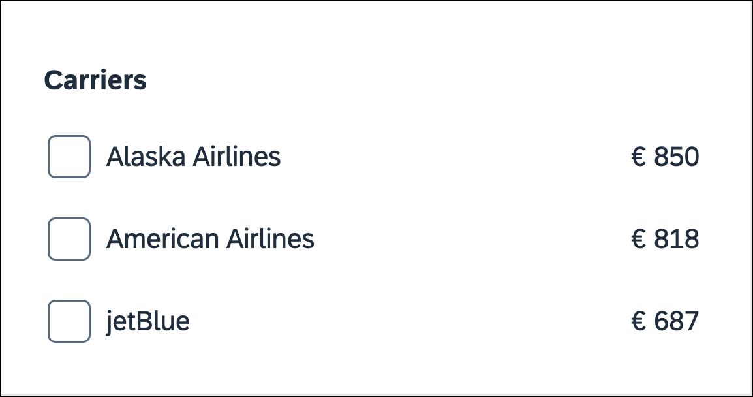

Configuration for Professional Travel
This feature is enabled by default. There are no configuration steps.

Hotel

New Concur Travel Experience: Enhanced Filters for Hotel (Professional Edition Only)

Prof | Stan |   Edition
 |  | On: Impacts end users who use this feature/vendor; no configuration/setup by agency/ admin; cannot be turned OFF (example: new icons or rate display)
 |  | Available for use: No impact to end users unless/until configuration/setup by agency/admin (described below) (example: new rule, new Travelfusion airline)
X |  | Other: Refer to the release note below
 | X | Does not apply to this edition
Source
GDS |  | Sabre
Direct Connect |  | Custom Hotel Source providers (TBD)
Other
 | EMEA Data Center |  |  | Scan impact
 | North America Data Center |  |  | UI impact
 | China Data Center |  |  | File finishing impact
 | All data centers |  |  | Profile/Profile API/3rd Party XML Sync Impact
Affected Documentation
TSGs
Fact Sheets
Admin Guides
Other

Overview
The new Hotel experience now includes additional filters on both the search results and Hotel Details pages. Customers can use the new sustainability filters to narrow their search results to the most sustainable properties, according to their score and/or their emissions.

End-User Experience: Search Results
When the user selects Filters on the search results page, there are two additional filters for Sustainability.
The first is Sustainability score, which allows users to select properties that have a score between 0 and 100 using a sliding scale. The default for this filter is zero.
The second filter is Emissions, which allows users to select properties between the lowest and the highest carbon emissions returned in the results using a sliding scale. The default for this filter is the highest number on the scale.
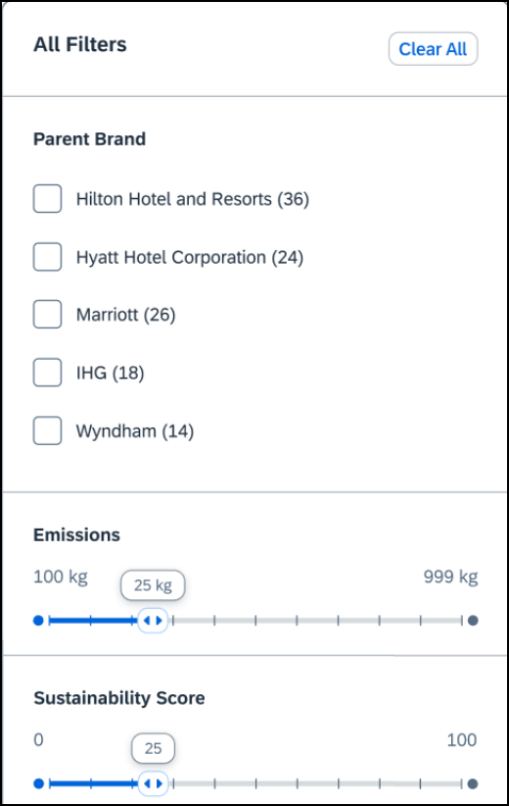

End-User Experience: Hotel Details
The Hotel Details page now includes additional filters for Bed type, Accessible room and Breakfast Included.
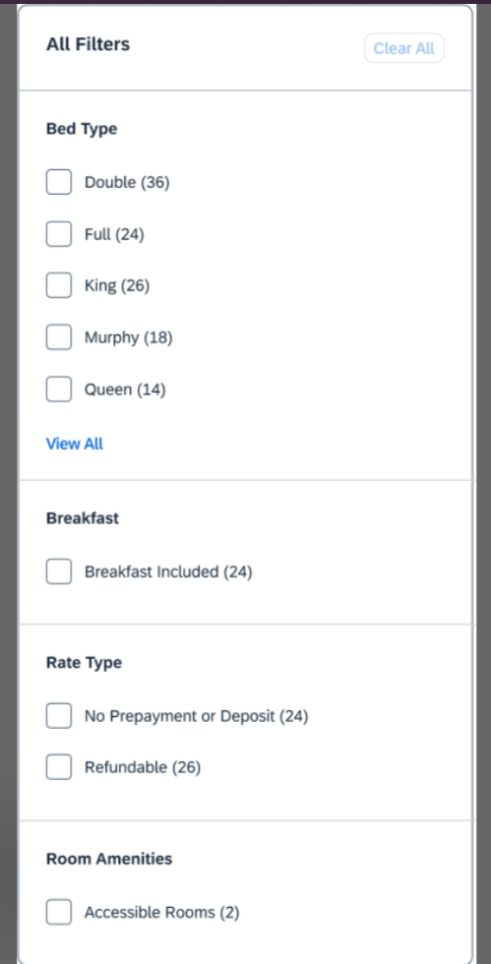
The user can filter on rooms using a specific bed type, whether there is breakfast included in the rate, and whether the room is accessible.

Configuration for Professional Travel
This feature is enabled by default. There are no configuration steps.

Hotel, Rail

**Ongoing** New Concur Travel Experience: Last Four Digits on Form of Payment Displayed (Professional Edition Only)

Information First Published | Information Last Modified | Feature Target Release Date
December 2023 | April 12, 2024 | February to April 2024
Any changes since the previous monthly release are highlighted in yellow in this release note.

Prof | Stan | Å Å Edition
 |  | On: Impacts end users who use this feature/vendor; no configuration/setup by agency/ admin; cannot be turned OFF (example: new icons or rate display, new Amtrak feature)
 |  | Available for use: No impact to end users unless/until configuration/setup by agency/admin (described below) (example: new rule, new Travelfusion airline)
X |  | Other: Refer to the release note below
 | X | Does not apply to this edition
Source / Solution Suggestion
GDS
Direct Connect |  | Trainline, Renfe
Other
X | EMEA Data Center |  |  | Scan impact
X | North America Data Center |  |  | UI impact
 | China Data Center |  |  | File finishing impact
 | All data centers |  |  | Profile/Profile API/3rd Party XML Sync Impact
Affected Documentation
TSGs
Fact Sheets
Admin Guides
Other |  | Travel Services Help

Overview
The last four digits of a traveler’s credit card or other form of payment will display on the Finalize and Trip Overview pages, and Confirmation/Cancellation e-mails. The forms of payment will show for Trainline, Renfe, and all Hotel web-based bookings, and all vertical bookings on mobile.

Phases
This feature will be released to specific verticals, vendors, and data centers between February and April:

Phase | Date of Release
Phase 1: Trainline (existing customers as they migrate to the new travel experience) | February 2024 (completed)
Phase 2: Hotel | April 2024
Phase 3: Renfe Rail customers in US Data Center | April 8, 2024
Phase 4: Renfe Rail customers in EU Data Center | April 10, 2024

User/Customer Benefit
This update is being implemented to improve the customer experience by providing more complete information about each booking.
For Trainline bookings, users are required to provide any valid form of payment to retrieve their tickets, not necessarily the form of payment used to make the booking.

End-User Experience
The last four digits of the user’s credit card will display on different pages during the booking process.
These include:
- Finalize page
- Trip Overview page
- Confirmation E-Mail
- Cancellation E-Mail
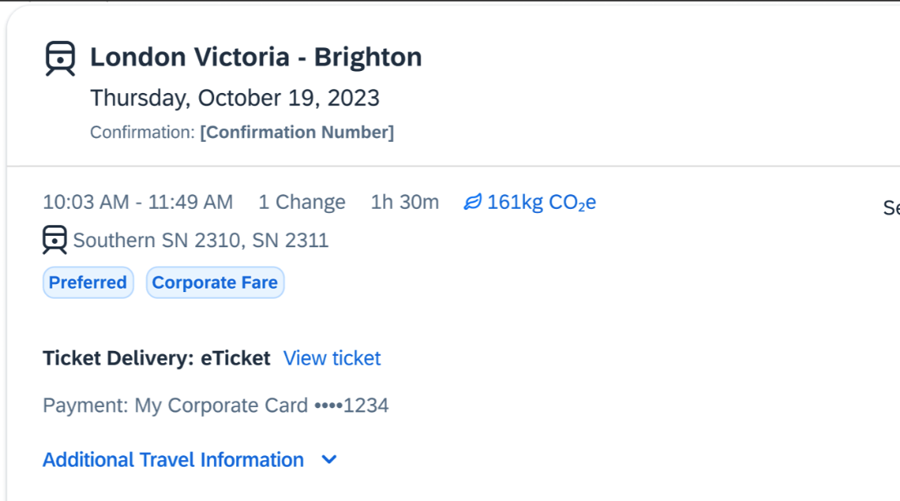
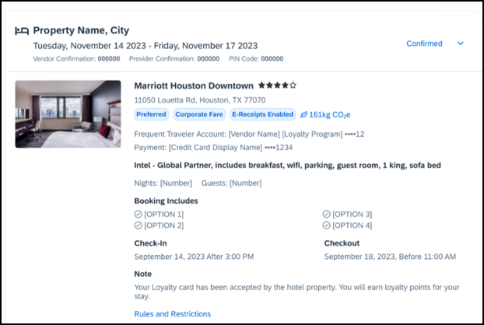

Configuration for Professional Travel
This feature is enabled by default. There are no configuration steps.
- For more information on Renfe and UK Rail (Trainline), refer to the February release updates to the Travel Services Help. To locate, go to the Concur Travel product page in the SAP Help Portal and select the Travel Services Help listed under the Implement > Administration section.

Miscellaneous

New Concur Travel Experience: Trips and Calendar Integration (Professional Edition Only)

Prof | Stan |   Edition
 |  | On: Impacts end users who use this feature/vendor; no configuration/setup by agency/ admin; cannot be turned OFF (example: new icons or rate display)
 |  | Available for use: No impact to end users unless/until configuration/setup by agency/admin (described below) (example: new rule, new Travelfusion airline)
X |  | Other: Refer to the release note below
 | X | Does not apply to this edition
Source
GDS
Direct Connect
Other
X | EMEA Data Center |  |  | Scan impact
X | North America Data Center |  |  | UI impact
 | China Data Center |  |  | File finishing impact
 | All data centers |  |  | Profile/Profile API/3rd Party XML Sync Impact
Affected Documentation
TSGs
Fact Sheets
Admin Guides
Other

Overview
With this feature, users will be able to see calendar events for Microsoft and Google Calendars automatically created for their trips when they receive a Trip Confirmation e-mail. Trips are also automatically removed from calendars when a Trip Cancellation e-mail is received from SAP Concur. Users will automatically have their travel plans available in their preferred calendars without taking any additional actions, including opening their e-mails.

End-User Experience
When a user books a flight, hotel, or car, once the Trip Confirmation e-mail is received, the calendar entries (one per booking) will automatically be created in their Microsoft Outlook Office 365 calendar or their Google calendar. If a user cancels a trip and receives the Trip Cancellation e-mail, the calendar entries will be removed from their calendars automatically. This is accomplished via hidden json code embedded within the e-mail message that follows schema.org JSON markup standard and does not require the user to click on the ICS attachments in the e-mail.
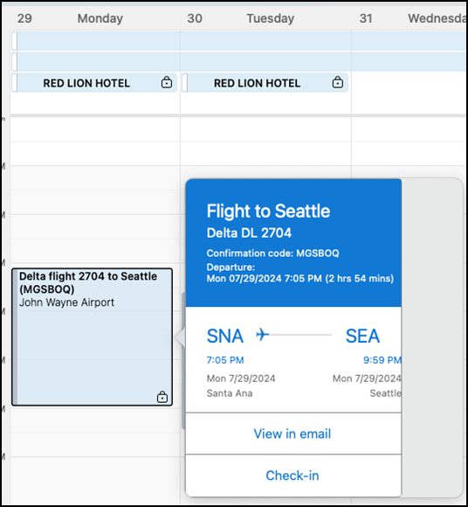
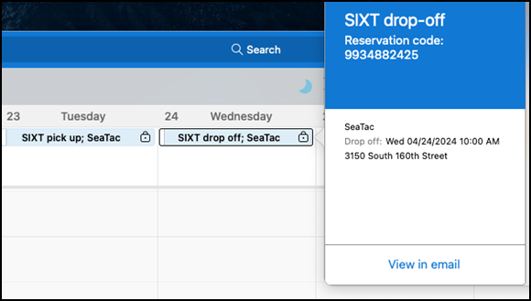
There are specific settings within Microsoft Office 365 and Google that enable or disable this functionality that the user can control.

Google Calendar

Settings
To activate:
- Go to Google calendar settings > Events from Gmail > On Gmail Settings > Smart features and personalization -> On. This setting does not only enable automated calendar event management from e-mails (event creation, modification and deletion), but also other features such as automated filtering and categorization of e-mails, intelligent writing (correction or proposals), intelligent search proposals etc.
- Notifications for all-day calendar events (like Hotel Reservations) can be set on the user level. Go to Google Calendar > Settings for my calendars > Personal Calendar > All-day event notifications.

Allow-Listing
Only allow-listed sender domains are supported for the automated calendar event creation feature. The concursolutions.com domain is on the Google allow-list for e-mail markup as of March 2021.

Restrictions
The schema.org JSON markup for Rail and Rental Car reservations are currently not supported by Google. Even though embedded in the SAP Concur confirmation and cancellation e-mails, they will be ignored and no calendar event will be created.

Outlook Calendar

Settings
To activate:
- Go to https://outlook.office.com/mail/options/calendar/calendarInEmail, go to Calendar > Events from the e-mail to activate flight reservations, hotel reservations and rental car reservations individually.
There is an additional checkbox allowing the user to mark the events as private, so that only the user can see them.

Allow-Listing
Only allow-listed sender domains are supported for the automated calendar event creation feature. The concursolutions.com domain is on the Microsoft allow-list for e-mail markup as of March 2021.

Restrictions
The schema.org JSON markup for Rail reservations is currently not supported by Microsoft. Even though markup may be embedded in the SAP Concur confirmation and cancellation e-mails, it will be ignored and no calendar event will be created.

Important Notes
This feature is released in addition to .ics attachments, not as a replacement for .ics attachments, which the user can click to add events to any calendar application that supports them. Even with this feature enabled, .ics attachments are useful for the following reasons:
- Calendar event creation based on schema.org JSON in an e-mail must be set up on user level in the calendar software. Not all users may want to accept events by any allow-listed sender, but they have no option to restrict event creation to SAP Concur only. They may opt not to activate it and will then need the .ics attachments to create the event semi-manually in their calendar.
- Some customers may block their users from setting up the calendar integration. Those users depend on .ics attachments.
- There may be times where issues prevent the automated calendar event creation based on our e-mail markup. Some of the markup types (for example, Rail) are not currently supported by the calendar provider. .ics attachments offer a useful workaround in these cases.
Confirmation e-mails are sent out to both the traveler and the arranger, if the trip is booked by an arranger.
It is recommended that travel arrangers either don't activate automated event creation in Outlook or Google calendar or opt out of receiving confirmation e-mails from SAP Concur. This will prevent calendar events for reservations the arranger makes on behalf of their assigned travelers.
Not embedding schema.org JSON markup in the e-mail sent to the arranger is not a solution, as the calendar suites will parse e-mails regardless and create calendar events for the reservations they detect; all that schema.org JSON does is improve the accuracy of the created calendar events.

Configuration for Professional Travel
This feature is enabled by default. There are no configuration steps.

Travel Profile API 2.0 Gender Diversity Support (Mar 26)

Prof | Stan |   Edition
 |  | On: Impacts end users who use this feature/vendor; no configuration/setup by agency/ admin; cannot be turned OFF (example: new icons or rate display)
 |  | Available for use: No impact to end users unless/until configuration/setup by agency/admin (described below) (example: new rule, new Travelfusion airline)
X | X | Other: Refer to the release note below
 |  | Does not apply to this edition
Source
GDS
Direct Connect
Other
 | EMEA Data Center |  |  | Scan impact
 | North America Data Center |  |  | UI impact
 | China Data Center |  |  | File finishing impact
 | All data centers |  | X | Profile/Profile API/3rd Party XML Sync Impact
Affected Documentation
TSGs
Fact Sheets
Admin Guides
Other |  | SAP Concur Developer Center

Overview
With the SAP Concur commitment to Gender Diversity initiatives, as of March 26, the Travel Profile API 2.0 now includes support for two new Gender values: Unspecified and Undisclosed.
Partners must update their systems to use the updated API.

Configuration for Professional Travel
This feature is enabled by default. There are no configuration steps.

New Concur Travel Experience: Market Eligibility Expansion (Professional Edition Only) (Mar 26)

Prof | Stan |   Edition
X |  | On: Impacts end users who use this feature/vendor; no configuration/setup by agency/ admin; cannot be turned OFF (example: new icons or rate display)
 |  | Available for use: No impact to end users unless/until configuration/setup by agency/admin (described below) (example: new rule, new Travelfusion airline)
 |  | Other: Refer to the release note below
 | X | Does not apply to this edition
Source
GDS |  | Sabre, Sabre NDC
Direct Connect |  | Car Connector, CHS Hotel Connector, UK Rail via Trainline, Spanish Rail via Renfe
Other
X | EMEA Data Center |  |  | Scan impact
X | North America Data Center |  | X | UI impact
 | China Data Center |  |  | File finishing impact
 | All data centers |  |  | Profile/Profile API/3rd Party XML Sync Impact
Affected Documentation
TSGs
Fact Sheets
Admin Guides
Other

Overview
On March 26, 2024, SAP Concur expanded the new Concur Travel experience to new markets beyond the United States. These markets are determined by the Travel Agency Ticketing Currency. If this is set to Canada, Mexico, UK or Ireland then the configuration is eligible for market expansion.
Configurations set to European Union instead of a specific country are not eligible. To avoid this, while the currency can still be set to Euros, a specific country can also be selected.
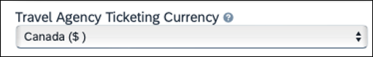
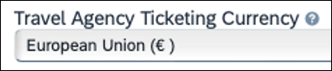

User/Customer Benefit
Customers outside the United States have access to the new Concur Travel experience. While they will still have control over when they choose to enable, the Flight, Car, Hotel and Rail experiences will be available for Sabre and Amadeus GDS based on regional timelines.

End-User Experience
End-users can enable the new Concur Travel experience based on a targeted rollout plan. The planned market expansion schedule is as follows:

North America
- Sabre: Canada and Mexico was enabled on March 26.
- Amadeus: US, Canada, and Mexico will be enabled by June 25.

EMEA
- Sabre: The UK and Ireland was enabled on March 26.
- Amadeus: The UK and Ireland will be enabled by June 25.
- Sabre and Amadeus: France, Germany, Spain, Portugal, Italy, Austria, Switzerland, Belgium, Netherlands, Luxembourg, Norway, Sweden, Denmark, Finland, and Iceland will be enabled by June 25.

Configuration for Professional Travel
Administrators with the Company Admin permission can navigate to the Manage New Concur Travel Experience Preferences page to opt out if they choose not to participate in this round of market expansion. This can be done at the configuration level (country or market) or at the individual Flight, Rental Car, or Hotel level by clicking the configuration under the Company Level Preference section.

**Ongoing** New Concur Travel Experience: Add to Trip Enhancement (Professional Edition Only)

Prof | Stan | Å Å Edition
 |  | On: Impacts end users who use this feature/vendor; no configuration/setup by agency/ admin; cannot be turned OFF (example: new icons or rate display, new Amtrak feature)
 |  | Available for use: No impact to end users unless/until configuration/setup by agency/admin (described below) (example: new rule, new Travelfusion airline)
X |  | Other: Refer to the release note below
 | X | Does not apply to this edition
Source / Solution Suggestion
GDS |  | All Flight and Hotel sources
Direct Connect
Other
X | EMEA Data Center |  |  | Scan impact
X | North America Data Center |  |  | UI impact
 | China Data Center |  |  | File finishing impact
 | All data centers |  |  | Profile/Profile API/3rd Party XML Sync Impact
Affected Documentation
TSGs
Fact Sheets
Admin Guides
Other |  | Concur Travel Professional Edition End User Help

Overview
Concur Travel is enhancing the user experience when adding bookings to an existing trip.
In this release, when adding Hotel to an existing trip, the Your Reservations dropdown is enhanced to contain relevant information from the previously booked Flight, Car, and/or Rail booking. When the trip contains a single booking, Concur Travel pre-selects one of the values from the dropdown. More details about this enhancement are available in the user experience section of this release note.
In upcoming releases, similar enhancements will also be available for Flight and Car, and a new modal will be available when adding a new Concur Travel experience booking to another new Concur Travel experience booking. The user experience will remain the same when adding a new Concur Travel experience booking to a legacy Concur Travel booking.

Phases
This feature will be released in phases:

Phase | Date of Release
Phase 1:  - Enhancements in the “Your reservations” dropdown options and pre-selection of one of the options when adding Hotel to an existing trip.  - No changes to existing user interface. | March 2024
Phase 2:  - Enhancements in the “Your reservations” dropdown options and pre-selection of one of the options when adding Flight and Car to an existing trip.  - New UI modal available when adding New Concur Travel experience Flight, Hotel or Car content to a New Concur Travel experience trip. | June 2024
Phase 3:  - Add Rail to existing Trip. | TBD

User/Customer Benefit
The user sees more helpful details when adding Flight and Hotel to an existing trip.

End-User Experience
When adding Hotel to to an existing trip, the Your Reservations dropdown shows the following options, in chronological order:
Flights: If the trip includes flights, the user sees the following:
- Flight: Closest city to the Destination Airport, Arrival date - When selected, the closest city to the destination airport is added to the Destination field, and the arrival date and departure date of the destination airport is added to the Dates field.
- Flight: Closest city to the final Airport, Arrival date - When selected, the closest city to the final airport is added to the Destination field, and the arrival date of the final airport with a one-night stay is added to the Dates field.
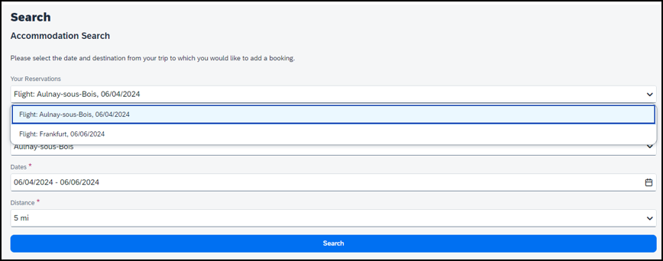
Train: If the trip includes Train, the user sees the following:
- Train: Closest city to the Destination Rail Station, Arrival date - When selected, the closest city to the destination rail station is added to the Destination field, and the arrival date and departure date of the destination rail stations is added to the Dates field.
- Train: Closest city to the final Rail Station, Arrival date - When selected, the closest city to the final rail station is added to the Destination field, and the arrival date of the final Rail Station with a one-night stay is added to the Dates field.
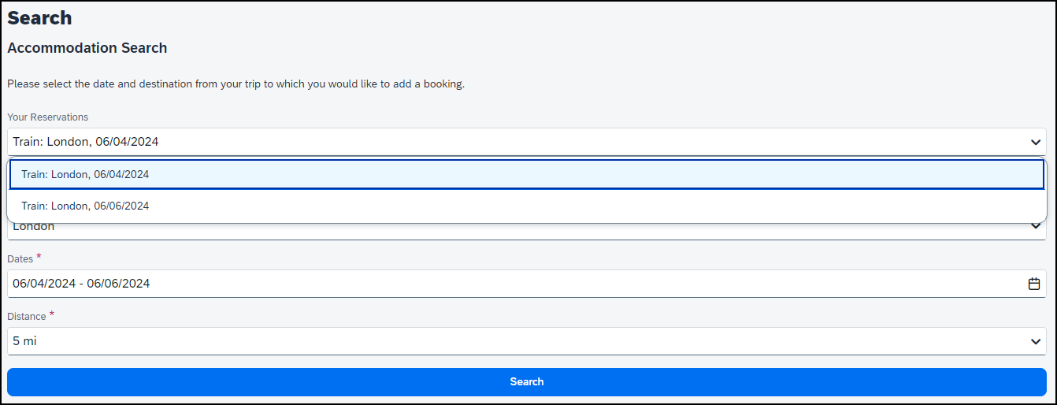
Car: If the trip includes a rental car, the user sees the following:
- Car pick-up (Rental Car: Closest city to the Car Pick Up, Pick up date) - When selected, the closest city to the car pick up is added to the Destination field, and the pick up date and drop off date of the rental car is added to the Dates field.
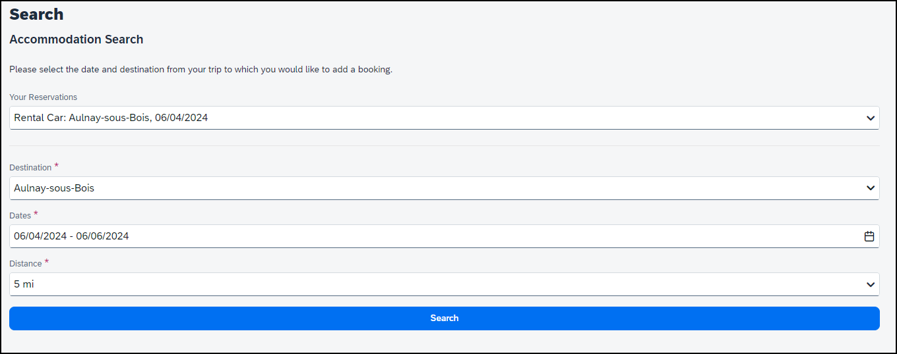
If the trip has only one reservation, when adding Hotel to an existing trip, the following is pre-selected in the Your Reservations pop-up:
- Flight: Arrival to the destination Airport
- Train: Arrival to the destination Rail Station
- Car: Pick-up

Example: New UI Modal (Future Release)
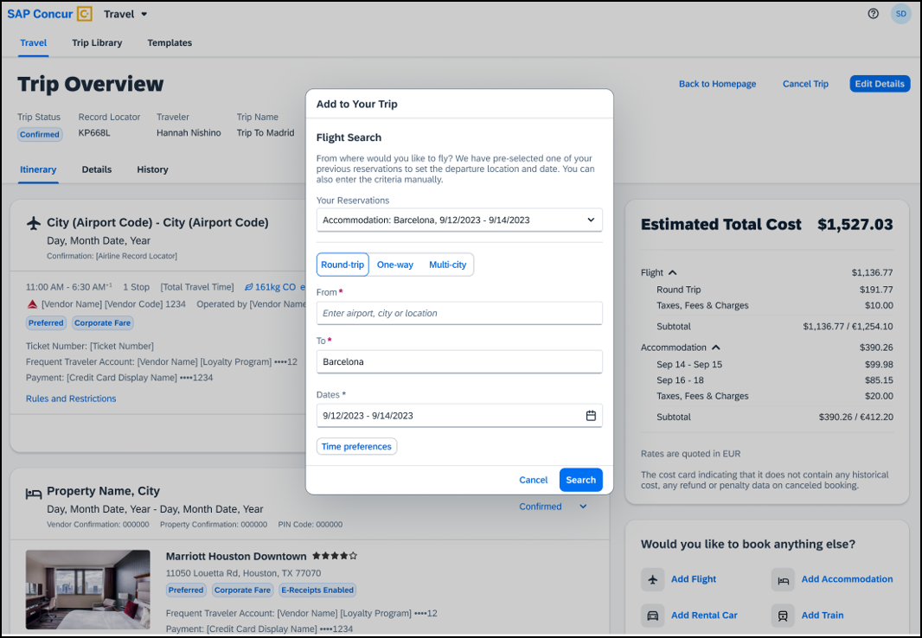

Configuration for Professional Travel
This feature is enabled by default. There are no configuration steps.

**Ongoing** New Concur Travel Experience: Trip History (Professional Edition Only)

Information First Published | Information Last Modified | Feature Target Release Date
December 2023 | April 19, 2024 | March to Sept 2024
Any changes since the previous monthly release are highlighted in yellow in this release note.

Prof | Stan |   Edition
X |  | On: Impacts end users who use this feature/vendor; no configuration/setup by agency/ admin; cannot be turned OFF (example: new icons or rate display)
 |  | Available for use: No impact to end users unless/until configuration/setup by agency/admin (described below) (example: new rule, new Travelfusion airline)
X |  | Other: Refer to the release note below
 | X | Does not apply to this edition
Source
GDS |  | Sabre, Car Connector
Direct Connect
Other
X | EMEA Data Center |  |  | Scan impact
X | North America Data Center |  | X | UI impact
 | China Data Center |  |  | File finishing impact
 | All data centers |  |  | Profile/Profile API/3rd Party XML Sync Impact
Affected Documentation
TSGs
Fact Sheets
Admin Guides
Other |  | Concur Travel Professional Edition End User Help

Overview
Targeted for the March to September 2024 releases, the Trip History feature is available for the new Concur Travel experience. This feature provides access to detailed historical records of all trips associated with an account. Data will be available indefinitely (except for legal, compliance policies such as GDPR “Right to be Forgotten” requests), even if the trip is subsequently cancelled and after the trip has been completed.

Phases
This feature will be released in phases, with the first Trip History events visible starting on March 29:

Phase | Date of Release
Phase 1: New History tab on the Trip Overview Page.  - Trip-level events  - Trip Created  - Trip Cancelled  - Trip Confirmed  - Confirmation E-mail Sent  - Trip Sent to Agency for Processing  - Stand-alone Approvals events  - Trip Submitted for Approval  - Trip Logged for Reporting  - Manager Notified  - Trip Approved  - Trip Rejected  - Approval Deadline Expired | March 29, 2024 (completed)
Phase 2:  - Booking-Specific events (for example, Booking Created, Booking Cancelled, Booking Updated, Booking Failed for Car, Hotel, and Rail Bookings), Booking Failed to Cancel | Q3 2024
Phase 3:  - Approvals via Request Integration  - Additional data included in already available events  - Trip History available in the SAP Concur Mobile App | Specific dates are TBD in 2024 and will be announced in the release notes.
A detailed list of supported events and which information they include with each phase will be provided in the release note for the month they are available.
Trips which include bookings from both the legacy and new Concur Travel experience are included only in the legacy Trip History, on the web application, and show bookings regardless of whether they were booked via the legacy or new Concur Travel experience.
Trips which include bookings from only the new Concur Travel experience are included within the new experience’s Trip History, on both web and mobile applications. For the mobile app, this feature will be availability in April.

User/Customer Benefit
This feature provides greater clarity and confidence in the details of the Concur Travel booking experience, allowing users to search for and reference trip details more quickly and easily. This will allow users to avoid having to request information via a support case.
Users and arrangers can see the Trip History tab on the Trip Overview page. TMCs, Support Agents, and SAP Concur representatives can see the history via Support Tools, which will be included in a future release.

End-User Experience
Historical data includes:
- the original details of the trip and the travel provider, for example, airlines, hotels, locations etc.
- significant edits to a trip
- the identity of the person performing each action taken on the trip
- dates and time stamps
- ticket and confirmation numbers
- approvals and rejections
- policy violations
- detailed trip costs
- specific details of travel providers

Phase I Details:
Event | Data Included | Notes/Additional Information
Trip Created | - Who  - Date | Time | Timezone
Trip Cancelled | - Who  - Date | Time | Timezone
Trip Confirmed | - Who  - Date | Time | Timezone
Confirmation E-mail Sent | - Date | Time | Timezone  - Which user / e-mail address
Trip Sent to Agency for Processing) | - Date | Time | Timezone | For Trips sent to Agency for Finishing and/or Ticketing
Trip Logged for Reporting | - Date | Time | Timezone
Trip Submitted for Approval | - Who submitted the trip for approval  - Date | Time | Timezone  When trip was submitted for approval  - Whose approval is required  - Approval deadline  - E-mail sent to Approver | If a user creates a new booking, with new dates, and this changes the Approval deadline, there will be a second “Trip Submitted for Approval” event with the new details, and new Approval deadline.
Manager Notified | - Date | Time | Timezone Which e-mail address
Trip Approved | - Who Approved  - Date | Time | Timezone  - Approver’s Comments (if any)
Trip Rejected | - Who Rejected  - Date | Time | Timezone Approver’s Comments (if any)
Approval Deadline Expired | - Date | Time | Timezone

To access trip histories:
- On the Trip Overview page, click the Trip History tab.
- The Trip History tab displays all the events that took place for the trip in either ascending or descending chronological sort order, such as Creation, Cancellation, Approval etc.
- To expand the content and see additional details, click the arrow icon next to the event.
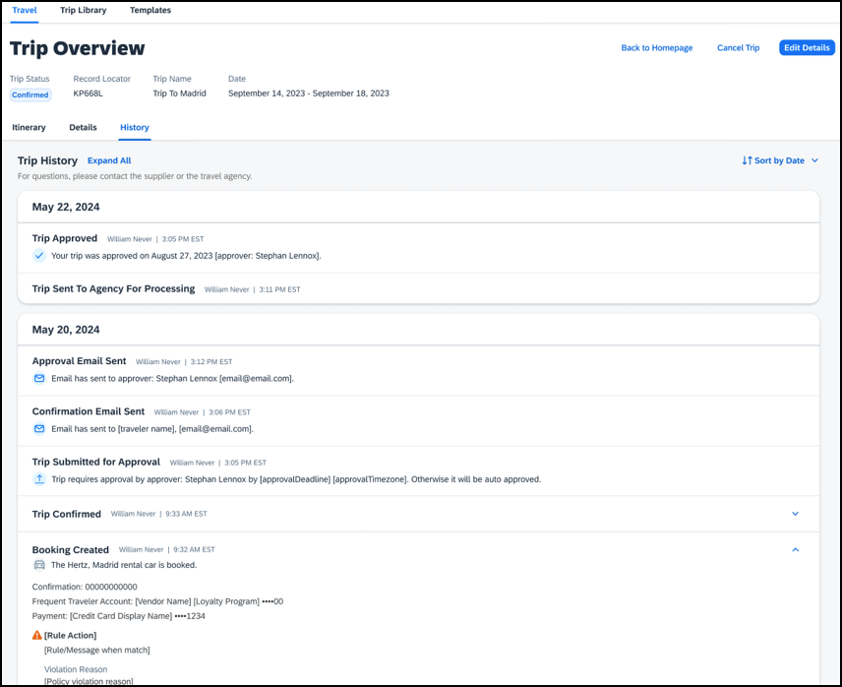
Events will become visible for new trips created after this feature is released and as new events become available with each phase. This means there will be no backfill for older trips or user actions on existing trips. For example, a trip created in April (after the March release) will have the “Trip Created” event available in Trip History, but no “Booking Created” events for any of the bookings. However, if a booking in that trip is subsequently cancelled after the Q3 release, there will be a “Booking Cancelled” event, without the corresponding “Booking Created” event.

Configuration for Professional Travel
This feature is enabled by default. There are no configuration steps.

**Ongoing** New Concur Travel Experience: Skip Search Action (Professional Edition Only)

Information First Published | Information Last Modified | Feature Target Release Date
October 6, 2023 | March 22, 2024 | February to April 2024
Any changes since the previous monthly release are highlighted in yellow in this release note.

Prof | Stan |   Edition
X |  | On: Impacts end users who use this feature/vendor; no configuration/setup by agency/ admin; cannot be turned OFF (example: new icons or rate display)
 |  | Available for use: No impact to end users unless/until configuration/setup by agency/admin (described below) (example: new rule, new Travelfusion airline)
X |  | Other: Refer to the release note below
 | X | Does not apply to this edition
Source
GDS |  | Sabre, Car Connector
Direct Connect
Other
X | EMEA Data Center |  |  | Scan impact
X | North America Data Center |  | X | UI impact
 | China Data Center |  |  | File finishing impact
 | All data centers |  |  | Profile/Profile API/3rd Party XML Sync Impact
Affected Documentation
TSGs
Fact Sheets
Admin Guides
Other |  | Concur Travel Professional Edition End User Help

Overview
In the February to April releases, the Skip Search action will be available for the new Concur Travel experience. This feature allows a user to discard the search workflow for a trip segment and return to one of three UI pages, depending on the previous workflow.

Phases
This feature will be released to specific verticals, vendors, and data centers between February and April:

Phase | Date of Release
Phase 1: Trainline (existing customers with migration to the new travel experience) | February 2024 (completed)
Phase 1: Flight, Car, Hotel | February 2024 (completed)
Phase 3: Renfe Rail customers in US Data Center | April 8, 2024
Phase 4: Renfe Rail customers in EU Data Center | April 10, 2024

User/Customer Benefit
This feature is comparable to existing components in the current Concur Travel shopping experience. It provides the user a one-click method of returning to their trip booking workflow, should they decide not to complete a search and book option.

End-User Experience
The Skip Search link allows a user to discard the search workflow for a trip segment, returning the user to one of three UI pages, depending on the previous workflow.
For example, if a user decides to book a flight reservation, searches for a flight, and then decides NOT to book a flight, they click Skip Search.
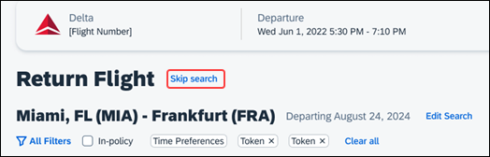
The Skip search option behaves as follows:
- If there is an existing booking for the given trip, but it is not yet finalized, then the user is redirected to the Finalize page.
- If there is an existing booking for the given trip and it was previously finalized, then the user is redirected to the Trip Overview page.
- If there is no existing booking or trip, then the user is redirected to the SAP Concur Travel home page.

Configuration for Professional Travel
This feature is enabled by default. There are no configuration steps.

**Ongoing** New Concur Travel Experience: Feature Exclusions, Limitations & Changed Behavior (Professional Edition Only)

Information First Published | Information Last Modified | Feature Target Release Date
September 15, 2023 | March 15, 2024 | TBD
Any changes since the previous monthly release are highlighted in yellow in this release note.

Overview
SAP Concur is delivering the new Concur Travel experience through phased software releases, while limiting the impact on customers and travelers.
- All customers and travelers can continue to use Concur Travel, which will support all existing capabilities.
- Travelers will continue to use their same URLs, logins, passwords, and mobile application. No specific traveler access change is required.
- The system is designed so that if a traveler were to book something not yet supported, they would be directed to the current booking flow they already know and use. Over time, as those capabilities are added to the new experience, redirects will be less frequent.
For customers that want to see the Q4 2023 release of the new Concur Travel experience:
- The customer’s servicing TMC must have acknowledged support for bookings made through the new Concur Travel experience.
- Customers must be eligible, based on content sources, policies, and configuration settings, as described in the linked document below.
Customers will automatically receive the Q4 2023 release of the new Concur Travel experience unless the customer or their TMC chooses to opt out.

User/Customer Benefit
With all the changes in user experience to address the current industry capabilities and traveler expectations, some policy rules or features may no longer be relevant. These will be decommissioned over time and will be outlined in the linked document below.

End-User Experience
Every company, travel program, and traveler are different, so SAP Concur wants to ensure that you have the information to understand when it’s the right time to implement the new booking experience in your organization.
Continue to check this release note as SAP Concur will update it regularly with additional details as development continues.
- For more information about disclaimers, exclusions, limitations, and more, please refer to the New Concur Travel Experience: Exclusions, Limitations, Redirects & Enhancements document.

Configuration for Professional Travel
For configuration instructions, please refer to individual release notes.

Rail

New Concur Travel Experience: Renfe - Choose Your Rule Class Tied to Same Agency Setting (Professional Edition Only)
- Refer to the **Ongoing Changes** New Concur Travel Experience: Allow Users to Choose Rule Class Tied to Same Configuration (Professional Edition Only) release note in the Release Notes > Administration section of this document.

New Concur Travel Experience: Support of Phone and E-mail on Review and Book Page (Professional Edition Only)

Prof | Stan | Å Å Edition
 |  | On: Impacts end users who use this feature/vendor; no configuration/setup by agency/ admin; cannot be turned OFF (example: new icons or rate display, new Amtrak feature)
X |  | Available for use: No impact to end users unless/until configuration/setup by agency/admin (described below) (example: new rule, new Travelfusion airline)
 |  | Other: Refer to the release note below
 | X | Does not apply to this edition
Source / Solution Suggestion
GDS
Direct Connect |  | Renfe
Other
X | EMEA Data Center |  |  | Scan impact
X | North America Data Center |  |  | UI impact
 | China Data Center |  |  | File finishing impact
 | All data centers |  |  | Profile/Profile API/3rd Party XML Sync Impact
Affected Documentation
TSGs
Fact Sheets
Admin Guides
Other |  | Travel Services Help

Overview
Previously, in the Traveler Information section on the Review and Book page, the customer could only see their default phone number and e-mail address, even if several were configured in their profile. With the April release, users will be able to choose which option they prefer.

End-User Experience
With this change, users can select the e-mail address or phone number that will be used for a booking from a dropdown, when multiple options exist in their profile. The default e-mail or phone number will be automatically populated, but users can change this in the new dropdown. The selected phone number and e-mail address is sent to the rail supplier, where applicable.
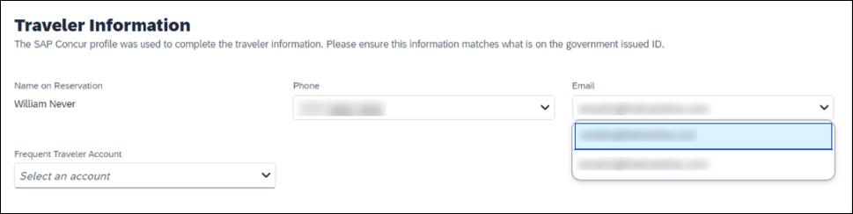

Configuration for Professional Travel
This feature is enabled by default. There are no configuration steps.

New Concur Travel Experience: Renfe - New Supported Rules (Professional Edition Only) (April 8-10)

Prof | Stan | Å Å Edition
 |  | On: Impacts end users who use this feature/vendor; no configuration/setup by agency/ admin; cannot be turned OFF (example: new icons or rate display, new Amtrak feature)
 |  | Available for use: No impact to end users unless/until configuration/setup by agency/admin (described below) (example: new rule, new Travelfusion airline)
X |  | Other: Refer to the release note below
 | X | Does not apply to this edition
Source / Solution Suggestion
GDS
Direct Connect
Other
X | EMEA Data Center |  |  | Scan impact
X | North America Data Center |  |  | UI impact
 | China Data Center |  |  | File finishing impact
 | All data centers |  |  | Profile/Profile API/3rd Party XML Sync Impact
Affected Documentation
TSGs |  | Approvals, Rules, and Classes/Policies Travel Service Guide
Fact Sheets
Admin Guides
Other

Overview
New rules are now supported for Renfe to match the legacy Concur Travel experience. This requires that Renfe clients update their rule class setup.

User/Customer Benefit
To provide a more effective and consistent user experience, the Renfe rules have been updated for the new Concur Travel experience.

End-User Experience
The following rules are supported for Renfe in the new Concur Travel experience.

Flight
- Flight Number [condition] [FlightNumber]
- Flight Number is in the list of [FlightNumber]
- Air Fare is [condition] [currency][money]
- Air Fare is [condition] the least cost logical airfare plus [difference] [currencyOrPercent]
- Air Fare is within [difference] to [difference2] [currencyOrPercent] of the least cost logical airfare
- Air Fare is [difference] [currencyOrPercent] [condition] the least cost fewest stops fare
- Air Fare is [condition] the least cost [numStops]-stop fare [plusMinus] [difference]
- Air Base Fare is [condition] [currency][money]
- One or more fare basis codes contain [FareBasisText]
- One or more fare basis codes do not contain [FareBasisText]
- Any leg departure City is [CityCodeList]
- Any leg departure City is not [CityCodeList]
- Any leg arrival City is [CityCodeList]
- Any leg arrival City is not [CityCodeList]
- First leg departure City is [CityCodeList]
- First leg departure City is not [CityCodeList]
- First leg arrival City is [CityCodeList]
- First leg arrival City is not [CityCodeList]
- Flights connect through airport/city [CityCodeList]
- No flights connect through airport/city [CityCodeList]
- Flight departure or arrival city is [CityCodeList]
- Neither departure nor arrival city is [CityCodeList]
- Flight is between airports [CityCodeList1] and [CityCodeList2]
- Flight is not between airports [CityCodeList1] and [CityCodeList2]
- Flight departure date is [condition] [Date]
- Flight arrival date is [condition] [Date]
- Flight depart time is [condition] [Time]
- Flight arrival time is [condition] [Time]
- Flight depart time is between [Time1] and [Time2]
- Flight arrival time is between [Time1] and [Time2]
- Flight depart time is not between [Time1] and [Time2]
- Flight arrival time is not between [Time1] and [Time2]
- Flight departure date/time is [condition] [Date] at [Time]
- Flight arrival date/time is [condition] [Date] at [Time]
- Flight departure date/time on [leg] leg [condition] [Date] at [Time]
- Flight arrival date/time on [leg] leg [condition] [Date] at [Time]
- Flight departs on [DayOfWeekCodes]
- Flight does not depart on [DayOfWeekCodes]
- Flight is refundable
- Flight is not refundable
- Carrier is not preferred
- Carrier is preferred
- Marketing airline is in [CarrierList]
- Marketing airline is not in [CarrierList]
- Operating airline is in [CarrierList]
- Operating airline is not in [CarrierList]
- Any segment carried by [CarrierList]
- Any segment not carried by [CarrierList]
- Any flight is in region [Region]
- Any flight is not in region [Region]
- All Flights are within the region: [Region]
- All Flights are within the region: Africa
- All Flights are within the region: Asia
- All Flights are within the region: Australia
- All Flights are within the region: Europe + UK
- All Flights are within the region: South America
- All Flights are within the region: North America
- Flight Departure Country/Region is [CountryList]
- Flight Arrival Country/Region is [CountryList]
- Flight connects in country/region [CountryList]
- No flights connect in country/region [CountryList]
- All Flights are within the country/region: [CountryList]
- No Flights are within the country/region: [CountryList]
- Any flight is in country/region [CountryList]
- Any flight not within the country/region [CountryList]
- Flight departs from or arrives at an alternate airport in the region
- User requested Area Airports and flights do not depart from/return to the same airport
- Flight departs from or arrives at the user's chosen airport
- Air Fare is [condition] the least cost air fare into the preferred airport [plusMinus] [difference]
- The least cost logical airfare uses alternate airports
- The least cost logical airfare uses the user's chosen airport
- Flight uses [prefAlt] airport and airport is one of [CityCodeList]
- Flight is booked less than [DaysAdvance] days in advance
- Flight is booked less than [HoursAdvance] hours in advance
- Any leg duration [condition] that of the user's selected flights plus [minutes] minutes, [incExcLayovers] layovers
- Any leg duration [condition] that of the shortest duration for that leg in the inventory plus [minutes] minutes, [incExcLayovers] layovers
- Shortest Flight duration between two most distant airports is [condition] [minutes] minutes, [incExcLayovers] layovers
- Flight duration of all flights in a segment (including layovers) is [condition] [Duration] minutes
- Flight duration of all flights in a segment (excluding layovers) is [condition] [Duration] minutes
- Flight duration for any single flight is [condition] [Duration] minutes
- Fare is from the Reservation System
- Fare is not from the Reservation System
- Fare uses class of service not in [ClassList]
- Fare uses cabin class not in list [CabinList]
- Search results contain one or more of these vendors: [VendorList]
- Search results contain none of these vendors: [VendorList]
- Results contain preferred vendors
- Results do not contain preferred vendors
- Trip duration [condition] [DaysLong] days
- Time spent at destination is [condition] [DaysLong] days
- Flight Number of stops is [condition] [Numstops]
- The least cost logical airfare is on one of [CarrierList]
- The least cost logical airfare is not on one of [CarrierList]
- Layover duration on any segment is [condition] [minutes] minutes
- Number of stops in the least cost logical fare is [condition] [numStops] stops
- Number of stops is [condition] the number of stops in the least cost logical fare
- Contains flights in cabin lower than that requested
- Booking source is [Source]
- Booking source is not [Source]

Rail
- Number of train changes is [condition] [NumTrainChanges] and train carrier is in [CarrierList]
- Rail is [PreferredList]
- Rail is not [PreferredList]
- Trip duration [condition] [DaysLong] days
- Rail fare description contains [DescriptionList]
- Train is from source [Vendor] and Operating Carrier in [CarrierList]
- Train is from source [Vendor] and train type in [TrainTypeList]

View More Fares
These rules are applied during the initial search.
- Fare in cabin classes: [CabinList] is [condition] the least cost logical airfare plus [difference] [currencyOrPercent]
- Refundable fare in cabin classes: [CabinList] is [condition] the least cost logical airfare plus [difference] [currencyOrPercent]
- Refundable fare in cabin classes: [CabinList] is [condition] the cheapest fare in flight plus [difference] [currencyOrPercent]
- Fare in cabin classes: [CabinList] is [condition] the cheapest refundable fare in flight plus [difference] [currencyOrPercent]
- First leg departure City is [CityCodeList]
- First leg departure City is not [CityCodeList]
- First leg arrival City is [CityCodeList]
- First leg arrival City is not [CityCodeList]
- User requested Area Airports and flights do not depart from/return to the same airport
- One or more fare basis codes contain [FareBasisText]
- One or more fare basis codes do not contain [FareBasisText]

Class of Service Group (Unique from Flight Group)
- Cabin classes allowed: [CabinClasses]
- Leg duration [condition] that of the shortest option available plus [minutes] minutes, [incExcLayovers] layovers

Considerations when setting up Flight rules for Rail:
- City code is Rail station code.
- Flight number is a maximum of 4 digits.
The admin interface limit may not be long enough for train number.
- There is no difference between marketing / operating / validating carriers in Rail.
- Rail fare always checks the total cost.
- For LLF definition:
- If “Include rail” option is OFF, LLF will be turned off for Rail.
- Refundability option only applies when this information is available.
- Center time calculation does not support morning, afternoon, evening, or anytime.
- Arrival time is not supported.
- Outbound policy violations will not be called out-of-policy, even if no inbound fares can be combined with the specific outbound fare to yield a policy compliant option. For example, if a rule is set up as "Air Fare greater than $50 - require approval" and cheapest outbound fare is $40 and cheapest inbound fare is $30, then
- The outbound fare will not be marked out-of-policy.
- All inbound fares will be marked out-of-policy.

Configuration for Professional Travel
No additional steps are required by administrators to support this change. However, SAP Concur recommends that clients provide messaging within Concur Travel to inform travelers of the updated rule set.

New Concur Travel Experience: Renfe - Auto-Cancel and Standalone Approval Process Enhancement (Professional Travel Only) (April 8-10)

Prof | Stan | Å Å Edition
 |  | On: Impacts end users who use this feature/vendor; no configuration/setup by agency/ admin; cannot be turned OFF (example: new icons or rate display, new Amtrak feature)
 |  | Available for use: No impact to end users unless/until configuration/setup by agency/admin (described below) (example: new rule, new Travelfusion airline)
X |  | Other: Refer to the release note below
 | X | Does not apply to this edition
Source / Solution Suggestion
GDS |  | Applies to all GDSs
Direct Connect |  | Applies to all Direct Connects
Other
X | EMEA Data Center |  |  | Scan impact
X | North America Data Center |  |  | UI impact
 | China Data Center |  |  | File finishing impact
 | All data centers |  |  | Profile/Profile API/3rd Party XML Sync Impact
Affected Documentation
TSGs
Fact Sheets
Admin Guides
Other

Overview
Starting April 8 -10, SAP Concur will support standalone approvals for Renfe, as it does for all other verticals and rail vendors. Require Approval and Require Passive Approval rules are no longer downgraded.
In the previous Concur Travel booking experience and in cases where a trip was booked using current and new booking experiences together (“mixed trips”), if Require Approval or Require Passive Approval rules were broken, and the approver either rejected or did not take an action on the trip by the approval deadline, the trip was:
- Auto-finalized, allowing for trip fulfilment for certain booking sources where bookings are not fully refundable or cancellation isn’t possible (for trips containing Cleartrip, Travelfusion, Evolvi, Trainline, and Renfe bookings).
- Neither auto-cancelled nor auto-finalized, where the trip is left unactioned in Concur Travel (for trips containing UK Rail, and Deutsch Bahn bookings).
- Auto cancelled, for all other booking sources where bookings are fully refundable and can be cancelled (for example, GDS Air bookings, before ticketing).
In this release, for trips booked entirely on the new Concur Travel experience, if the Require Approval or Require Passive Approval rules are broken, and the approver either rejects or does not action the trip by the trip approval deadline, Concur Travel checks all bookings on the trip for cancel / refund ability, regardless of booking source.
If Require Approval or Require Passive Approval rules are broken, and the approver either rejects or does not take action on the trip by the approval deadline, the trip is:
- Auto-finalized, allowing for trip fulfilment for trips with at least one non-cancelable or not fully refundable booking or where cancellation isn't possible (for example, one trip that includes a Trainline booking, as this content cannot yet be cancelled in Concur Travel).
- Auto-cancelled, for all bookings that are fully refundable and can be cancelled (for example, GDS Air bookings, before ticketing).
For mixed trips containing Renfe as a booking source, Concur Travel auto-finalizes the trip, allowing for trip fulfilment if the trip contains at least one booking non-cancellable or cancellable with a fee. Otherwise, it auto cancels the trip. Mixed trip behavior is unchanged.
For trips booked entirely on the new Concur Travel Experience and for mixed trips, Concur Travel continues to respect the auto cancel settings Allow Auto Cancel of trips that require approval, Allow Auto Cancel of air/rail trips that are rejected, and Allow immediate Cancel of Non-air/rail trips that are rejected. When set to not allow auto-cancellation, Concur Travel does not auto-cancel nor auto-finalize the trip. When set to allow auto-cancellation, Concur Travel no longer leaves trips in an un-actioned state and is auto-finalizing more trips due to improved awareness around ability to cancel and refund.

User/Customer Benefit
To provide a more effective and consistent user experience, the Trainline rules are updated for the new Concur Travel experience. The previous limitation has been removed.

End-User Experience
When the user books a trip that will be auto-finalized, they will see the following:
Example: Trip Confirmation page
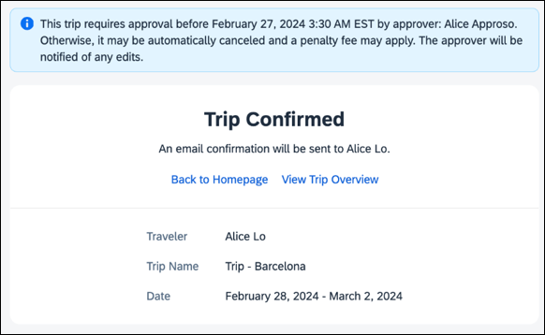
Example: Trip Overview page before the approver rejects the trip
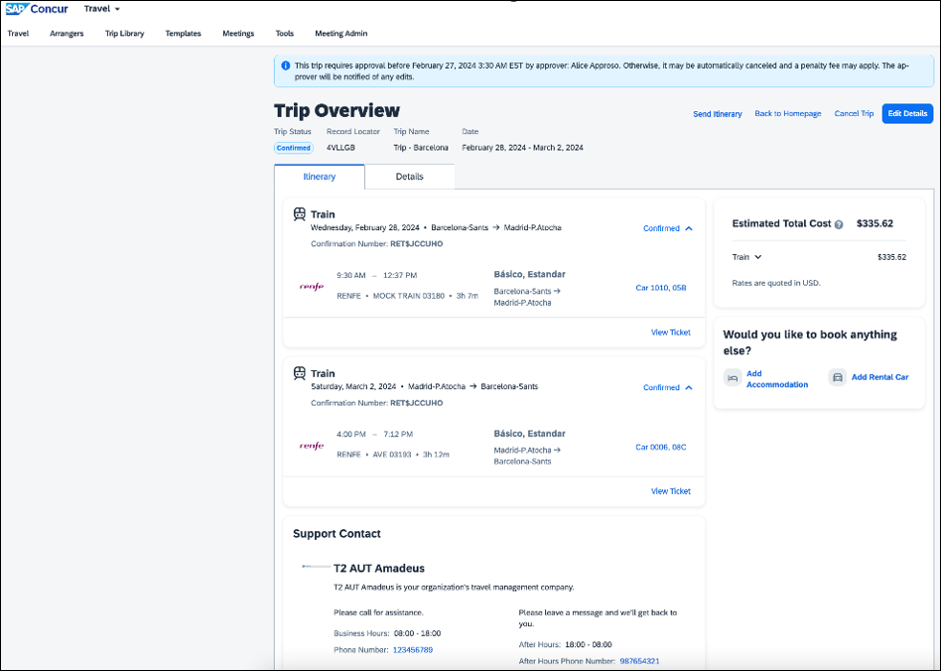
Example: Trip Overview page after the approver rejects and the trip is auto-finalized
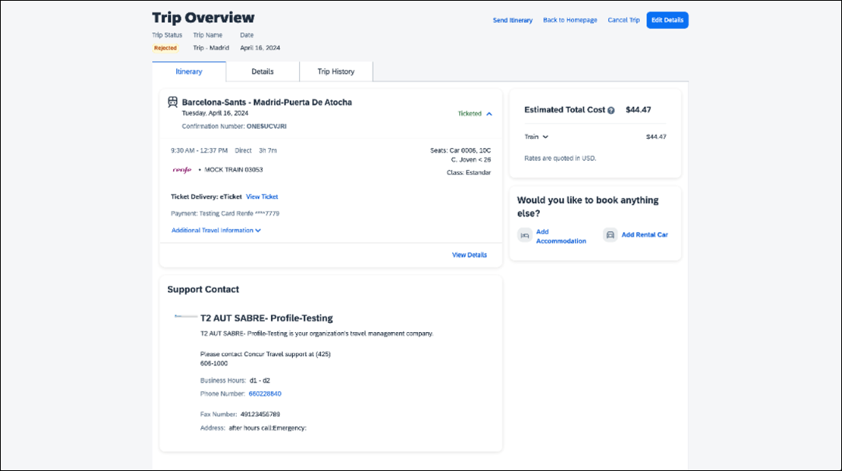
Example: E-mail that the traveler receives after the approver rejects the trip
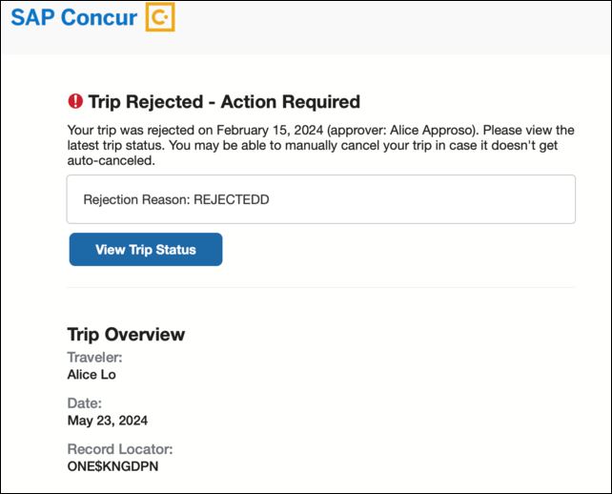
Example: Approver e-mail
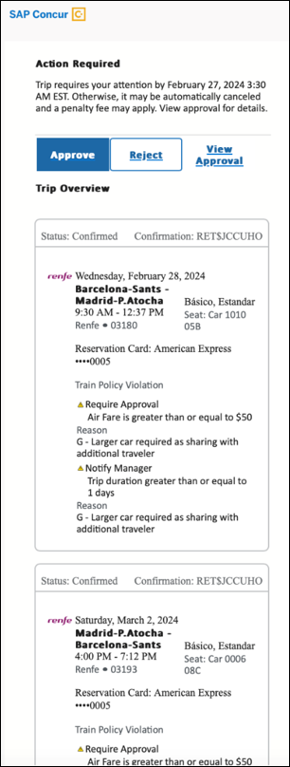
Example: For same day bookings, when approval deadline is in the past at the time of booking - Traveler’s Trip Confirmation e-mail.
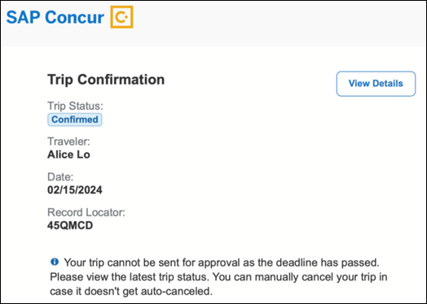
Example: Approver is notified e-mail notification
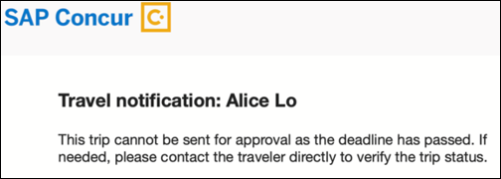

Configuration for Professional Travel
No additional steps are required by administrators to support this change.

New Concur Travel Experience: Renfe + Car, Hotel, Flight - Changes to Approval Deadline Logic (Professional Edition Only)

Prof | Stan | Å Å Edition
 |  | On: Impacts end users who use this feature/vendor; no configuration/setup by agency/ admin; cannot be turned OFF (example: new icons or rate display, new Amtrak feature)
 |  | Available for use: No impact to end users unless/until configuration/setup by agency/admin (described below) (example: new rule, new Travelfusion airline)
X |  | Other: Refer to the release note below
 | X | Does not apply to this edition
Source / Solution Suggestion
GDS
Direct Connect |  | Renfe Direct Connect
Other
X | EMEA Data Center |  |  | Scan impact
X | North America Data Center |  |  | UI impact
 | China Data Center |  |  | File finishing impact
 | All data centers |  |  | Profile/Profile API/3rd Party XML Sync Impact
Affected Documentation
TSGs
Fact Sheets
Admin Guides
Other |  | Concur Travel Professional Edition End User Help

Overview
In this release, the method with which an approval deadline is calculated will change. This will allow for an approver to process a trip. If unprocessed, the trip will attempt to be auto-cancelled.
For customers with Renfe or Trainline enabled, the updated approval deadline logic also currently applies to flight, rental car, and hotel bookings. Targeted for April 19, the approval deadline logic will apply to flight, rental car, and hotel bookings regardless of whether a customer is enabled with Renfe or Trainline.

User/Customer Benefit
This change is being made to provide a more consistent approval deadline behavior between SAP Concur products.

End-User Experience
Currently in the new Concur Travel experience when a booking is either non-refundable, instant purchase, or same day booking, the approval deadline is not calculated. If the approver does not take any action, the trip will remain live in the system and the traveler must contact the travel agency to cancel the booking.
With this update, an approval deadline will be calculated irrespective of the trip content. For a booking with non-refundable or instant purchase content, the approval deadline will be calculated as the booking start date, less one day.
The trip approval deadline will still be the sooner of all the booking's individual booking times. Please refer to the examples below:
Any trip with only one Flight booking, where the booking has a deadline:
- Soonest of either Booking 1 Deadline or Agency Time, less 2 hours.
Any trip with only one booking, where the booking does not have a deadline:
- Trip start, less 1 day.
Any trip with two bookings (one of which is Flight and the other is not), where all the bookings have a deadline:
- The soonest of either Booking 1 Flight Deadline or Agency Time, less 2 hours.
- Booking 2 Deadline, less 2 hours.
- The soonest of either a. or b.
Any trip with two bookings (one of which is Flight, and the other is not), where the first booking has a deadline, and the second booking does not have a deadline:
- The soonest of Booking 1 Deadline, or Agency Time, less 2 hours.
- Trip start, less 1 day.
- The soonest of either a. or b.
For same day bookings, the Trip Start Time less 2 hours will be used. If the approval deadline is in the past, the trip will be automatically cancelled immediately after booking. The traveler will be warned of the cancellation on the Confirmation page.
If the assigned approver does not take action by the approval deadline, the trip will be sent for auto-cancellation. However, if the trip cannot be cancelled or has at least one booking that is not fully refundable, the trip will not be cancelled but sent for finishing instead.

Configuration for Professional Travel
No additional steps are required by administrators to support this change. However, SAP Concur recommends that clients provide messaging within Concur Travel to inform travelers of these changes.

New Concur Travel Experience: Renfe - User Interface Changes to Workflow Pages and E-mails (Professional Edition Only) (April 8-10)

Prof | Stan | Å Å Edition
 |  | On: Impacts end users who use this feature/vendor; no configuration/setup by agency/ admin; cannot be turned OFF (example: new icons or rate display, new Amtrak feature)
 |  | Available for use: No impact to end users unless/until configuration/setup by agency/admin (described below) (example: new rule, new Travelfusion airline)
X |  | Other: Refer to the release note below
 | X | Does not apply to this edition
Source / Solution Suggestion
GDS
Direct Connect |  | Renfe
Other
X | EMEA Data Center |  |  | Scan impact
X | North America Data Center |  |  | UI impact
 | China Data Center |  |  | File finishing impact
 | All data centers |  |  | Profile/Profile API/3rd Party XML Sync Impact
Affected Documentation
TSGs |  | Renfe Direct Connect
Fact Sheets
Admin Guides
Other

Overview
From April 8-10, there are changes to the view of the Renfe user interface. These changes affect Shop and Review and Book pages.

User/Customer Benefit
To provide a more consistent user experience, some Renfe pages are updated to resemble Flight pages.

End-User Experience
These updates apply mostly to the Shop result and Review and Book pages.
Changes to the search results display:
- New horizontal display of the search results: Up to four fares display as the initial search results. All remaining available fare options display upon expanding the itinerary.
- Updated Fare Rules and Restrictions pop-up window.
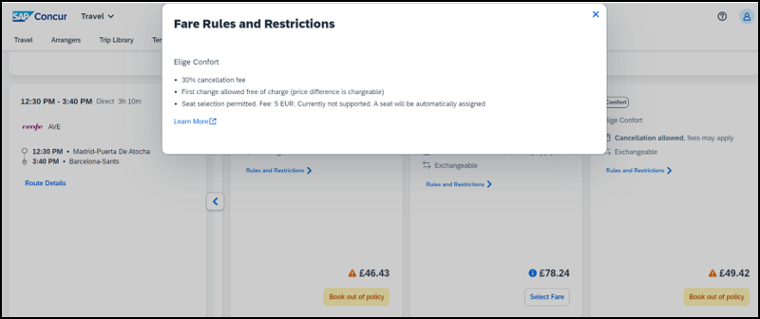
- Updated Filter options.
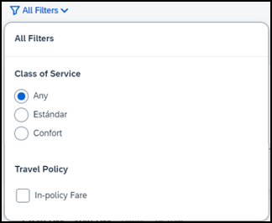
- Updated Sort options.
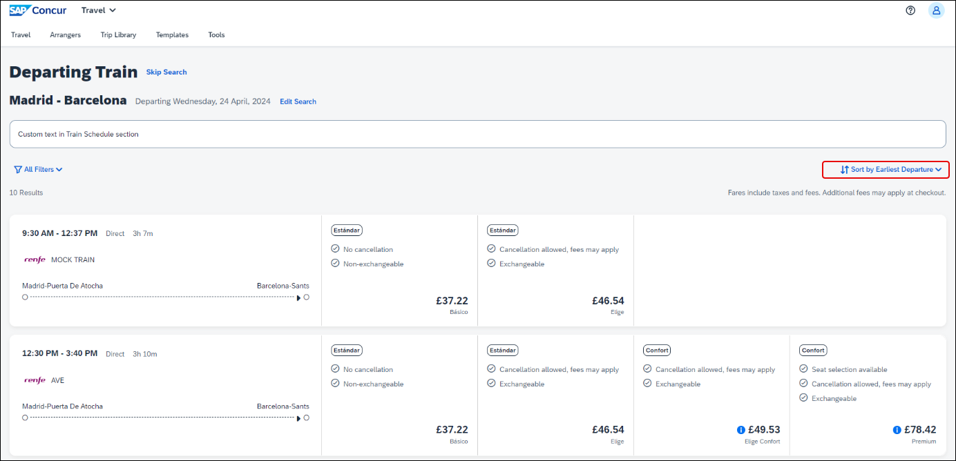
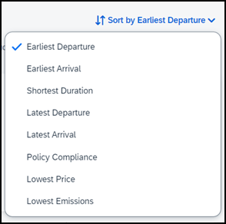
- Support display of Preference label.
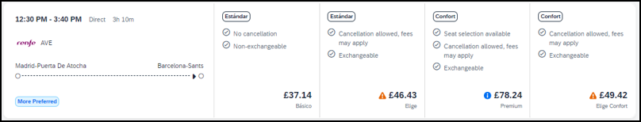
- Display of fares in the configured currency instead of vendor currency.
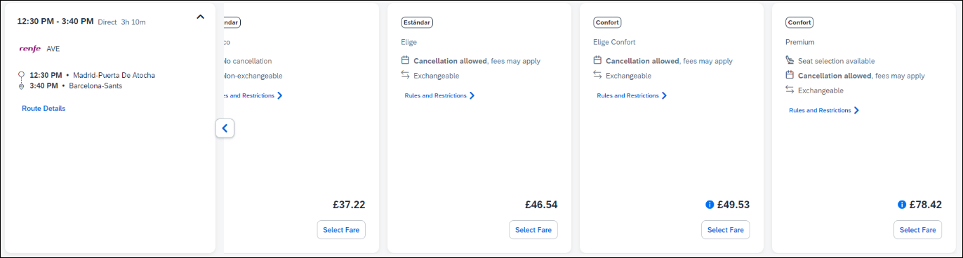
Changes to Review and Book page:
- Updated display of itinerary.
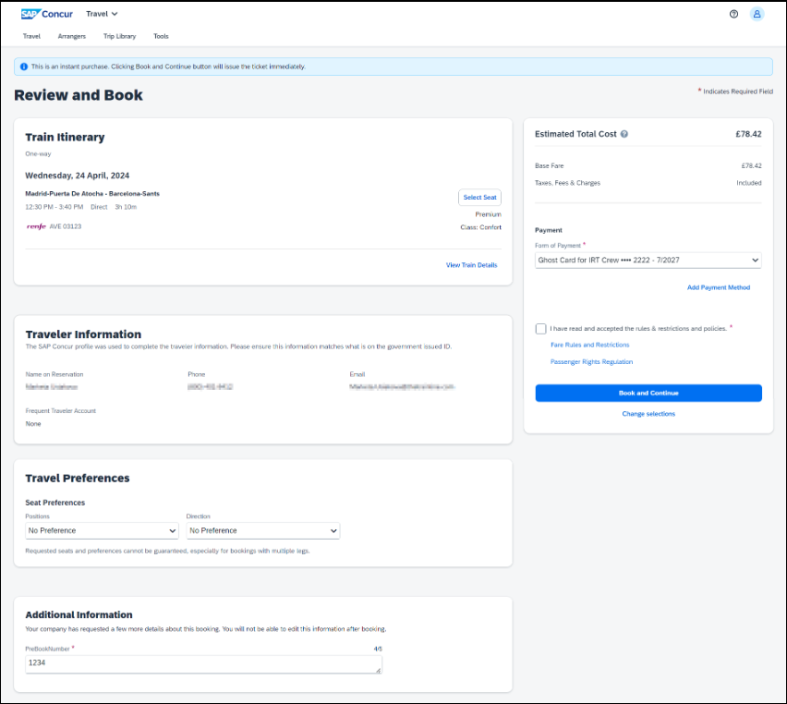
- New display of Total Cost card aligns with the display on following Trip pages and E-mail.
- Updated display of itinerary on Finalize and Trip Overview pages.
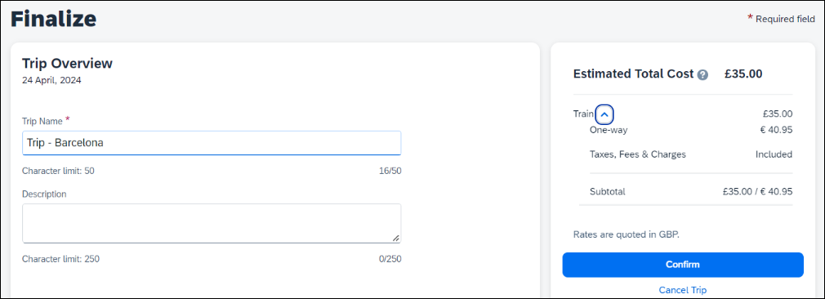
Changes to Confirmation E-mail:
- Updated display of itinerary
- Previously links to download ticket (PDF and Phone Wallet) were displayed in the body of the confirmation e-mail. In the updated confirmation e-mail tickets are attached to the e-mail as attached files.
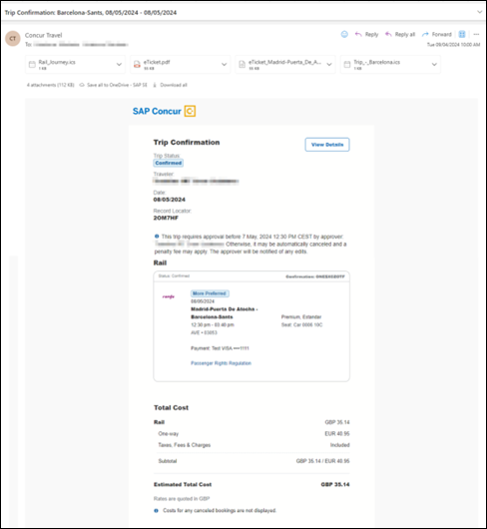
Update to Confirmation e-mail is applicable only to trips booked fully in the new booking experience. For trips combining content booked using the original and new booking experiences together (mixed trips), the e-mail format remains the same as before and tickets can be retrieved via link within the e-mail. If user is not already logged into Concur Travel web where the link for their ticket opens, they will be asked to log in in order to display the ticket.
Changes to Approver e-mail:
- The approver e-mail has a better appearance to match the rest of the product.
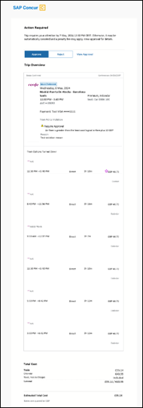

Configuration for Professional Travel
This feature is enabled by default. There are no configuration steps.

New Concur Travel Experience: Renfe - Train Options Turned Down (Professional Edition Only) (April 8-10)

Prof | Stan | Å Å Edition
 |  | On: Impacts end users who use this feature/vendor; no configuration/setup by agency/ admin; cannot be turned OFF (example: new icons or rate display, new Amtrak feature)
X |  | Available for use: No impact to end users unless/until configuration/setup by agency/admin (described below) (example: new rule, new Travelfusion airline)
 |  | Other: Refer to the release note below
 | X | Does not apply to this edition
Source / Solution Suggestion
GDS
Direct Connect |  | Renfe
Other
X | EMEA Data Center |  |  | Scan impact
X | North America Data Center |  |  | UI impact
 | China Data Center |  |  | File finishing impact
 | All data centers |  |  | Profile/Profile API/3rd Party XML Sync Impact
Affected Documentation
TSGs
Fact Sheets
Admin Guides
Other |  | Module Properties, Travel Services Help

Overview
If an out-of-policy fare is chosen by the user when creating a booking, the options not chosen are captured and displayed, both to the user and to the approvers. This allows the approver to view the alternatives that were not selected.

User/Customer Benefit
The updates to the Policy section for Rail provide a more cohesive Concur Travel experience. They allow for the visibility of available fares not chosen when creating out-of-policy bookings.

End-User Experience
When booking out-of-policy, a list of Train Options Turned Down is displayed. This list is available to the user on the Review and Book page within the Travel Policy section. For approvers, the Train Options Turned Down list is available in the approver view and in the approver e-mail.
When Least Cost Logical Fare (LLF) is enabled but not chosen during a booking, the first option in the list is a declined LLF. The other list items are the remaining in-policy offers that have not been chosen.
Example:
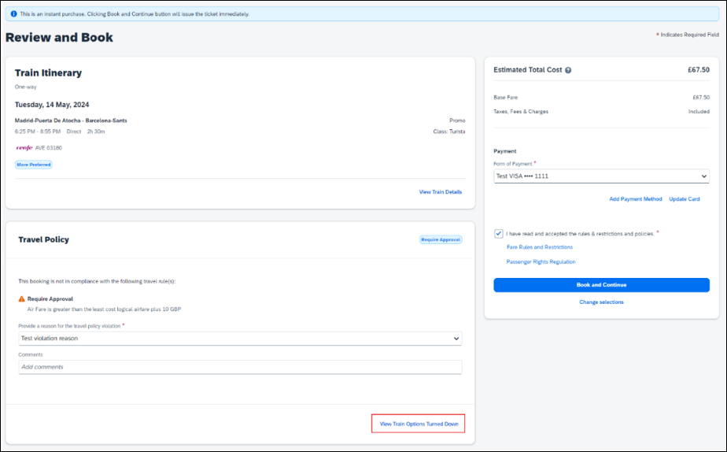
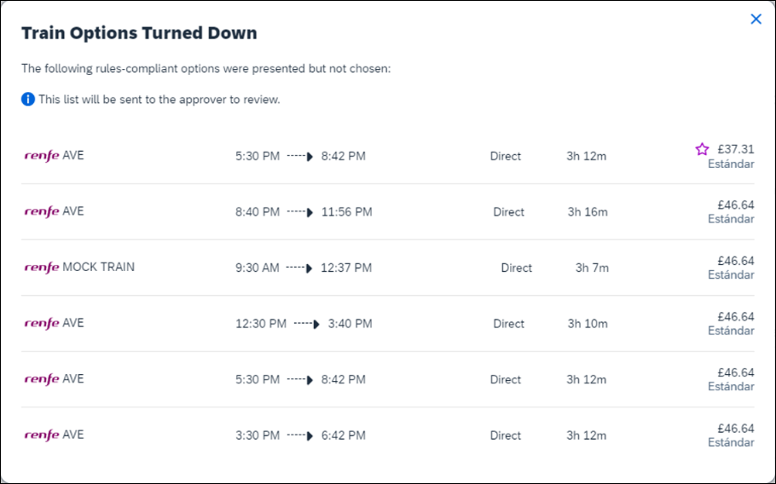
Train Options Turned Down displays only if there are alternative in-policy offers available. If all fares are out-of-policy, no Train Options Turned Down displays.
The maximum number of Train Options Turned Down displayed is limited to ten in the new Concur Travel experience.

Configuration for Professional Travel
This feature is enabled by default. There are no configuration steps.
The default number of options turned down is 10 (depending on fare availability). Administrators can configure the number of displayed fares using the Limit options turned down for Approval module property.
The module property setting is also applicable to Flight bookings. It is not only specific to Rail bookings.

New Concur Travel Experience: Renfe - Multiple Violation Reasons (Professional Edition Only) (April 8-10)

Prof | Stan | Å Å Edition
 |  | On: Impacts end users who use this feature/vendor; no configuration/setup by agency/ admin; cannot be turned OFF (example: new icons or rate display, new Amtrak feature)
X |  | Available for use: No impact to end users unless/until configuration/setup by agency/admin (described below) (example: new rule, new Travelfusion airline)
 |  | Other: Refer to the release note below
 | X | Does not apply to this edition
Source / Solution Suggestion
GDS
Direct Connect |  | Renfe
Other
X | EMEA Data Center |  |  | Scan impact
X | North America Data Center |  |  | UI impact
 | China Data Center |  |  | File finishing impact
 | All data centers |  |  | Profile/Profile API/3rd Party XML Sync Impact
Affected Documentation
TSGs |  | Renfe Direct Connect
Fact Sheets
Admin Guides |  | Travel System Admin Guide
Other

Overview
For bookings of out-of-policy fares, users are required to select a policy violation reason. From April 8 – April 10, Concur Travel introduces support for Allow Multiple Violation Reason Codes for Renfe.

User/Customer Benefit
The updates to the Policy section for rail provides a more cohesive Concur Travel experience. They allow for improved visibility of violated policy rules and the ability to provide multiple violation reasons for rail bookings.

End-User Experience
If Allow Multiple Violation Reason Codes is enabled and multiple travel policy rules are violated, a user may be requested to select multiple violation reasons on the Review and Book page if different policy violation reason types are configured for the rules.
The user interface displays a list of all the policy rules violated, grouped by the rule action.
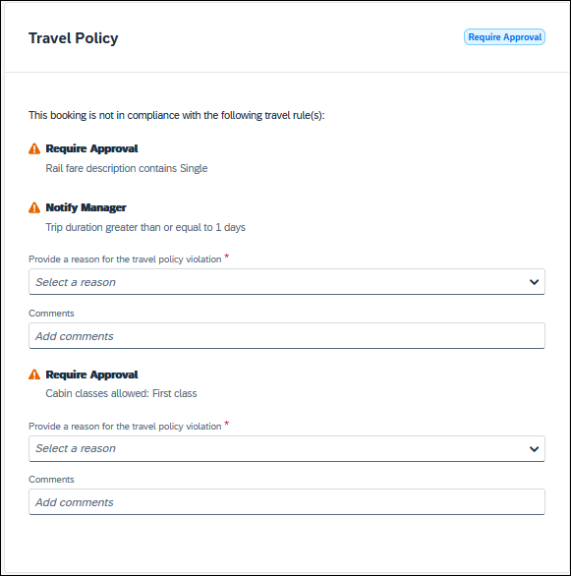

Configuration for Professional Travel
No additional steps are required by administrators to support this change.
Allow Multiple Violation Reason Codes can be enabled on the Company Travel Configuration page.
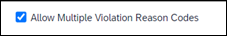
The setting is applicable to all bookings when enabled. It is not specific to Rail bookings.

New Concur Travel Experience: Renfe - Configurable Message Boards (Professional Edition Only) (April 8-10)

Prof | Stan | Å Å Edition
 |  | On: Impacts end users who use this feature/vendor; no configuration/setup by agency/ admin; cannot be turned OFF (example: new icons or rate display, new Amtrak feature)
X |  | Available for use: No impact to end users unless/until configuration/setup by agency/admin (described below) (example: new rule, new Travelfusion airline)
 |  | Other: Refer to the release note below
 | X | Does not apply to this edition
Source / Solution Suggestion
GDS
Direct Connect |  | Renfe
Other
X | EMEA Data Center |  |  | Scan impact
X | North America Data Center |  |  | UI impact
 | China Data Center |  |  | File finishing impact
 | All data centers |  |  | Profile/Profile API/3rd Party XML Sync Impact
Affected Documentation
TSGs |  | Renfe Direct Connect, Configurable Message Boards Travel Service Guide
Fact Sheets
Admin Guides
Other

Overview
The Configurable Message Boards allow clients to influence end user behavior with dynamic, rule based, messaging. The new Concur Travel experience for Renfe Rail supports new placements with the release between April 8 and April 10.

User/Customer Benefit
Configurable Message Boards provide administrators with the opportunity to configure informative custom messaging for specific scenarios based on policy rules to their end users.

End-User Experience
Messages display on the shop page. They can appear inline:
Or in a popup:
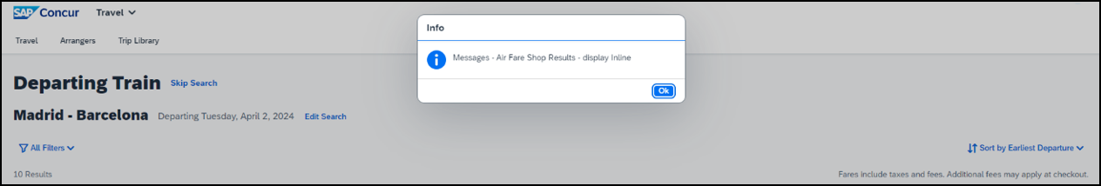

Configuration for Professional Travel
In the Travel Policy Administration section, rules can be configured under Messages - Air Fare Shop Results:
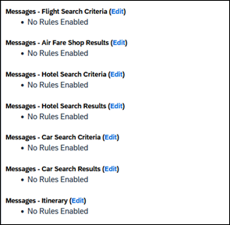
Support for configurable message boards is limited to the web user interface. Rich text including formatting and hyperlinks are supported.
Any message entered manually by an administrator is not localized. If a message is not set up by an administrator, the localized rule displays to the user.
It is not possible to configure configurable message boards separately for Rail and Flight bookings. If configured, messaging displays for both.

New Concur Travel Experience: Renfe - Support for Multiple Rail Connectors (Professional Edition Only) (April 8-10)

Prof | Stan | Å Å Edition
 |  | On: Impacts end users who use this feature/vendor; no configuration/setup by agency/ admin; cannot be turned OFF (example: new icons or rate display, new Amtrak feature)
X |  | Available for use: No impact to end users unless/until configuration/setup by agency/admin (described below) (example: new rule, new Travelfusion airline)
 |  | Other: Refer to the release note below
 | X | Does not apply to this edition
Source / Solution Suggestion
GDS
Direct Connect |  | Renfe
Other
X | EMEA Data Center |  |  | Scan impact
X | North America Data Center |  |  | UI impact
 | China Data Center |  |  | File finishing impact
 | All data centers |  |  | Profile/Profile API/3rd Party XML Sync Impact
Affected Documentation
TSGs |  | Renfe Direct Connect
Fact Sheets
Admin Guides |  | Travel System Admin Guide
Other

Overview
Concur Travel offers multiple rail connectors. From April 8-10, support has been added for any rail connectors offered by Concur Travel to be enabled with Renfe.

User/Customer Benefit
This change provides administrators with the opportunity to enable a wider rail offering to their users on one travel configuration in the new Concur Travel experience.

End-User Experience
End users can book with any of the enabled rail connectors.
For travel configurations where only rail connectors in the New Concur Travel Experience are enabled, vendor selection by the user is not necessary.
For travel configurations combining current and New Concur Travel Experience rail connectors, the user can select the vendor from a dropdown.

Configuration for Professional Travel
No additional steps are required by administrators to support this change.
Any new rail connectors can be added or removed on the Company Travel Configuration page.
Currently when Renfe is enabled alongside any additional rail connector, only Renfe is available to the end users. From April, if any additional rail connector is enabled, it is available to end users. Administrators should check their Company Travel Configuration settings.

New Concur Travel Experience: Renfe – Allow/Display Message Support (Professional Edition Only) (April 8-10)

Prof | Stan | Å Å Edition
 |  | On: Impacts end users who use this feature/vendor; no configuration/setup by agency/ admin; cannot be turned OFF (example: new icons or rate display, new Amtrak feature)
 |  | Available for use: No impact to end users unless/until configuration/setup by agency/admin (described below) (example: new rule, new Travelfusion airline)
X |  | Other: Refer to the release note below
 | X | Does not apply to this edition
Source / Solution Suggestion
GDS
Direct Connect |  | Renfe Direct Connect
Other
X | EMEA Data Center |  |  | Scan impact
X | North America Data Center |  |  | UI impact
 | China Data Center |  |  | File finishing impact
 | All data centers |  |  | Profile/Profile API/3rd Party XML Sync Impact
Affected Documentation
TSGs
Fact Sheets
Admin Guides |  | Travel System Administration Guide
Other

Overview
From April 8 and April 10, support for additional policy-based messaging set by administrators is available. Allow and Display Message enforcement levels will behave similarly. When a rule is set up with these levels, the user can book the segment without restrictions.

User/Customer Benefit
This functionality provides administrators with more options for adding policy-based information for travelers.

End-User Experience
Example: A message displays to customers.
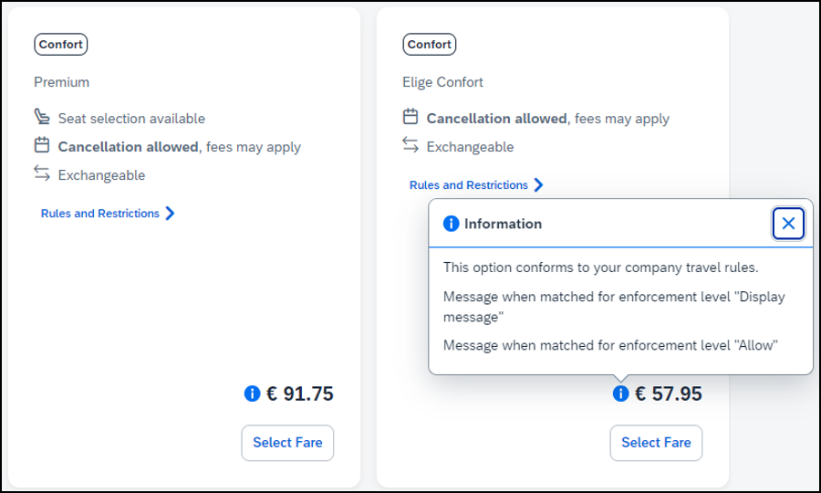

Configuration for Professional Travel
In the Travel Policy Administration section, administrators can set rules with the applicable enforcement level, and configure a message for it when matched.
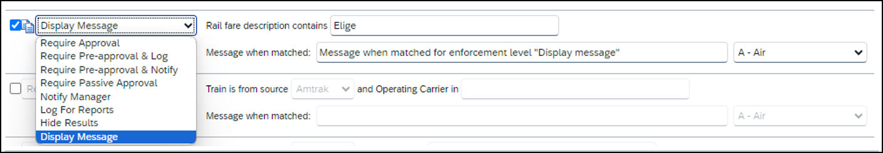
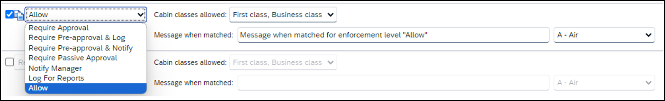
Not all types of rules have both enforcement levels. For example, train rules allow for Display Message, whereas Flight - Class of Service rules allow for Allow.

New Concur Travel Experience: CO2 Emissions Display (Professional Edition Only)

Prof | Stan | Å Å Edition
 |  | On: Impacts end users who use this feature/vendor; no configuration/setup by agency/ admin; cannot be turned OFF (example: new icons or rate display, new Amtrak feature)
 |  | Available for use: No impact to end users unless/until configuration/setup by agency/admin (described below) (example: new rule, new Travelfusion airline)
X |  | Other: Refer to the release note below
 | X | Does not apply to this edition
Source / Solution Suggestion
GDS
Direct Connect |  | Trainline, Renfe
Other
X | EMEA Data Center |  |  | Scan impact
X | North America Data Center |  | X | UI impact
 | China Data Center |  |  | File finishing impact
 | All data centers |  |  | Profile/Profile API/3rd Party XML Sync Impact
Affected Documentation
TSGs
Fact Sheets
Admin Guides
Other

Overview
With this release, the carbon dioxide (CO2) emissions display is updated for UK Rail (Trainline) and is available for Renfe Rail for web. Support for the improved display of CO2 on mobile is planned for a later release.

User/Customer Benefit
When shopping and booking rail, customers now have access to CO2 emissions information applicable to their rail journey. Display of CO2 emissions is supported per journey segment and per class of service. For Renfe, the option to sort by emissions is also available.

End-User Experience
The CO2 emissions is shown to the user on the Shop pages, where it is displayed per class of service. CO2 per segment is available on Train Details modal which is displayed on Review and Book page, Finalize page and Trip Overview page.
On shop pages, the option to sort by emissions is available for Renfe. This sorting is already supported for Trainline.
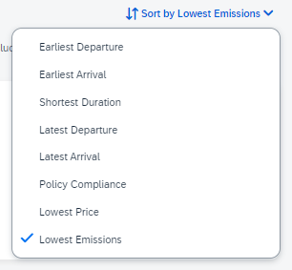
CO2 emissions display with two decimal places. This could cause a discrepancy while displaying the total amount of CO2 for the total journey compared to single segments. The sum of segments might not correspond to the total amount per journey, due to the rounding to two decimal places.
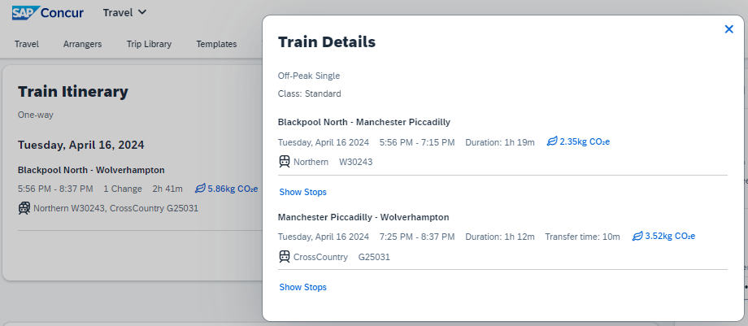

Configuration for Professional Travel
This feature is enabled by default. There are no configuration steps.

New Concur Travel Experience: Trainline - Available on Amadeus, Sabre, Galileo (Professional Edition Only) (April 10)

Prof | Stan | Å Å Edition
 |  | On: Impacts end users who use this feature/vendor; no configuration/setup by agency/ admin; cannot be turned OFF (example: new icons or rate display, new Amtrak feature)
 |  | Available for use: No impact to end users unless/until configuration/setup by agency/admin (described below) (example: new rule, new Travelfusion airline)
X |  | Other: Refer to the release note below
 | X | Does not apply to this edition
Source / Solution Suggestion
GDS
Direct Connect |  | Trainline
Other
X | EMEA Data Center |  |  | Scan impact
X | North America Data Center |  |  | UI impact
 | China Data Center |  |  | File finishing impact
 | All data centers |  |  | Profile/Profile API/3rd Party XML Sync Impact
Affected Documentation
TSGs
Fact Sheets
Admin Guides
Other |  | Travel Services Help

Overview
From April 10, the UK Rail (Trainline) connector has been added to all travel configurations on Amadeus, Sabre and Galileo. New clients can enable the UK Rail (Trainline) connector for Rail content. This announcement is in conjunction with the Trainline migration release note. Customers who have already migrated to Trainline will see the new Trainline connection from the end of February. New clients who are interested in enabling the new Trainline connection and meet the requirements can do so from April 10.

User/Customer Benefit
The new Concur Travel rail booking experience together with the new Trainline connection will bring clients the following benefits:
- New user interface
- Reduced number of steps to complete the booking
- Support for eTicket delivery option
- Support for UK Rail bookings on mobile application

End-User Experience
The booking workflow includes search, book, and itinerary review.

Search
The user clicks the Rail tab and initiates their search for Round Trip or One Way. For the Open Return option, the user enables the Open Return checkbox in the Round Trip option to omit selecting a return date and time.
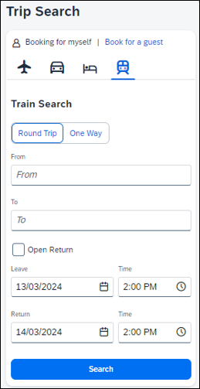

Select a Train
Clicking Search displays the results.
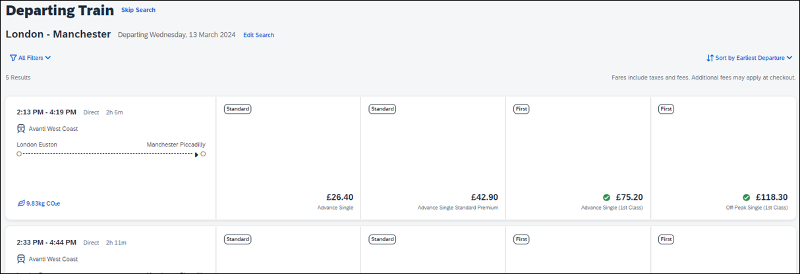
To see all available fares, click on the required train. All fares display with information on the alternative stations and Rules and Restrictions. If Railcard savings are applied, it is visible in the fare. The original and the discounted price are also presented to the user.
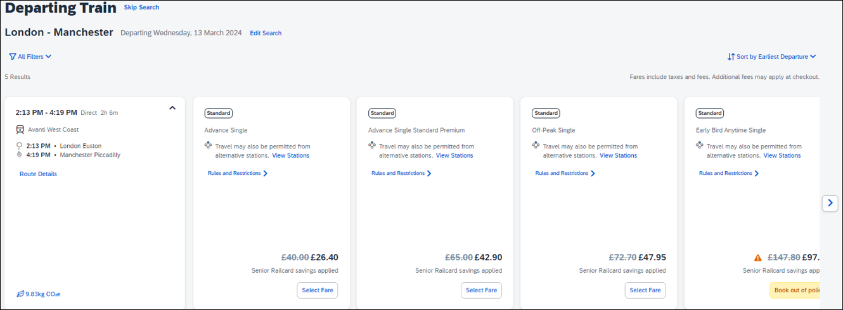
After clicking Select Fare, the user is redirected to the Review and Book page.

Review and Book
The Review and Book page displays all relevant information for the user to review before completing the booking.
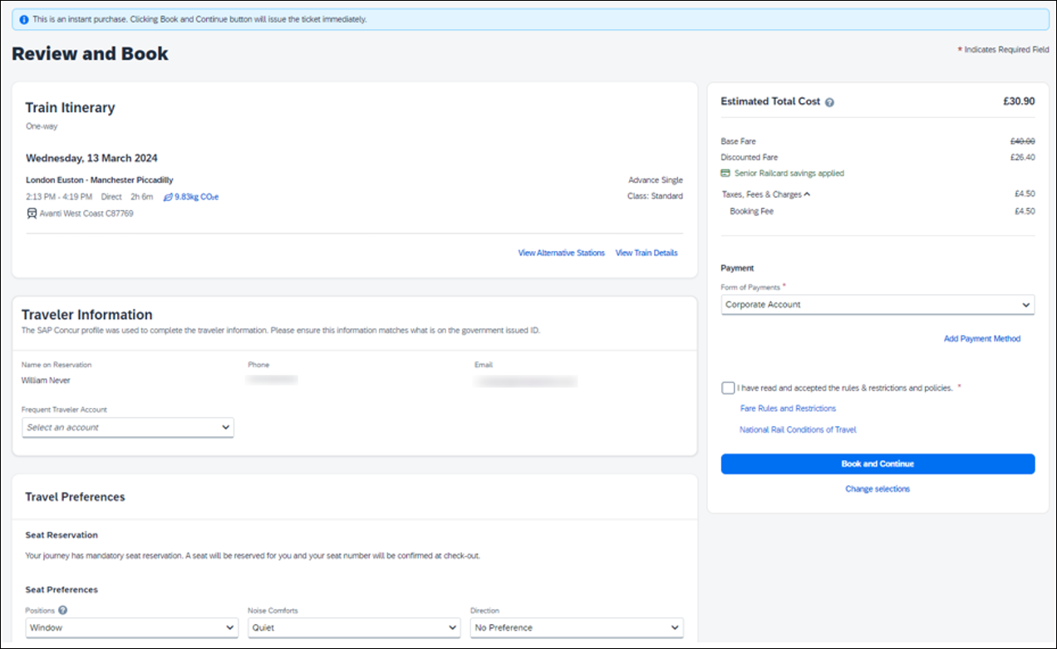
For more information on the Train Itinerary, see View Train Details.
The Form of Payments that displays in the dropdown depend on the agreement between the client, travel agency and Trainline. The Update Card option is available only for personal cards when selected from the dropdown.
The Travel Preferences section contains the Seat Reservation information and Seat Preferences, if applicable. No seat preferences are displayed if the seat reservation is not available. The availability of seat reservation depends on the selected route and carrier.
The Ticket Delivery Preference section offers two ticket delivery options, if applicable: eTicket (free of charge) and Kiosk (with a fee). The eTicket option is preselected if both options are available. Depending on the selected route, the eTicket might not be offered (for example, if a tube is part of the journey).
An eTicket must be enabled with Trainline for the client to see this delivery option. Depending on their contract, the client should contact their travel agency or Trainline if they are interested in the eTicket delivery option.
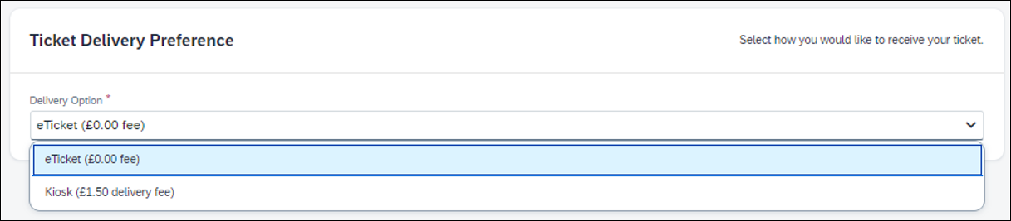
After the user confirms the rules and restrictions and clicks Book and Continue, they are redirected to the Finalize page.

Finalize
The Finalize page allows a user to add accommodation or rental car. It also provides the user with the overview of their UK Rail (Trainline) booking.
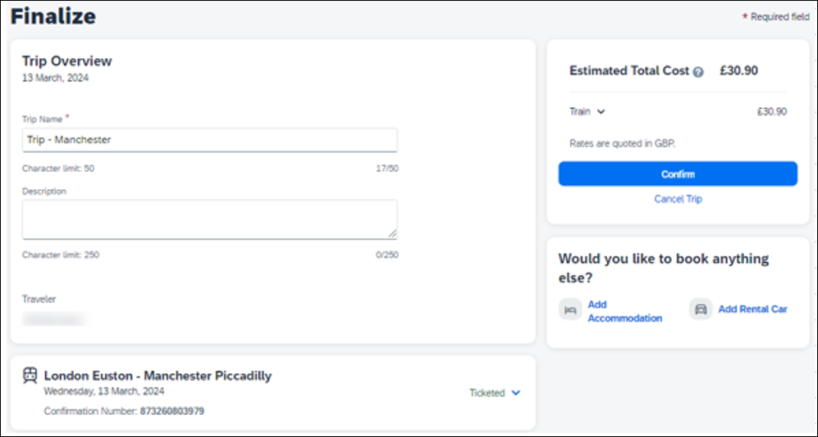
If the user selects the eTicket delivery option on the Review and Book page, the ticket becomes available when they get to the Finalize page, accessible when they click the down arrow icon to Show train details:
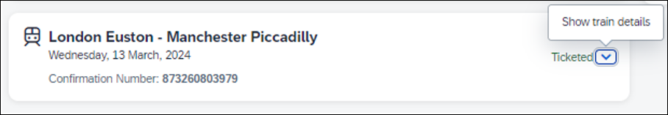
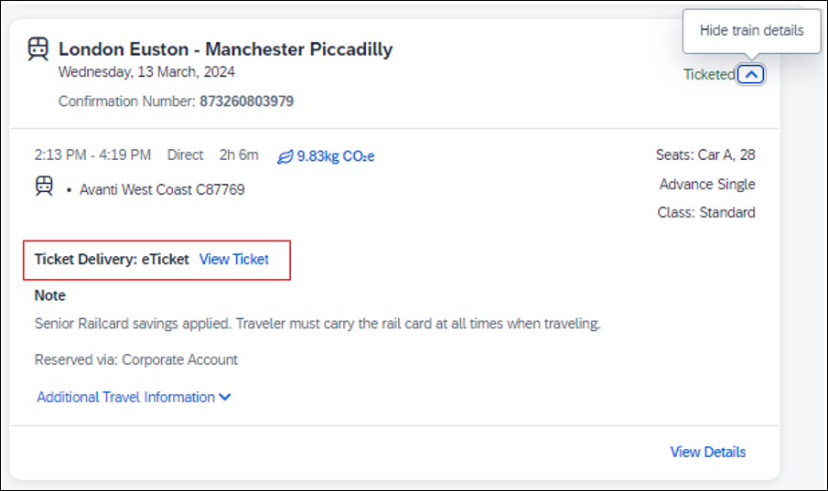

View Ticket
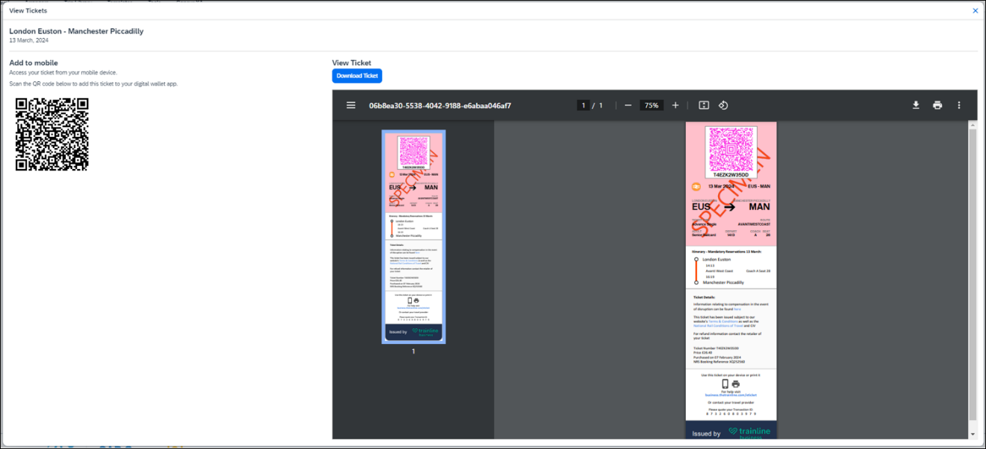
The eTicket issuance might take longer. If the eTicket is not available during the booking process, the e-mail will be sent separately later.
The user clicks Confirm to complete the trip and is redirected to the Trip Confirmed page.
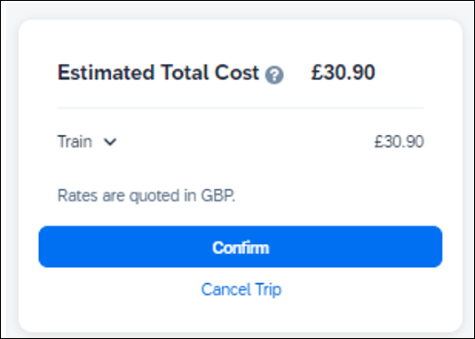
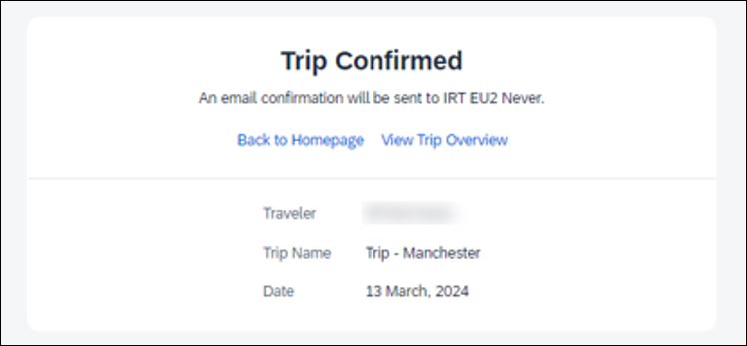
The user can open their trip by clicking on View Trip Overview.

View Trip Overview
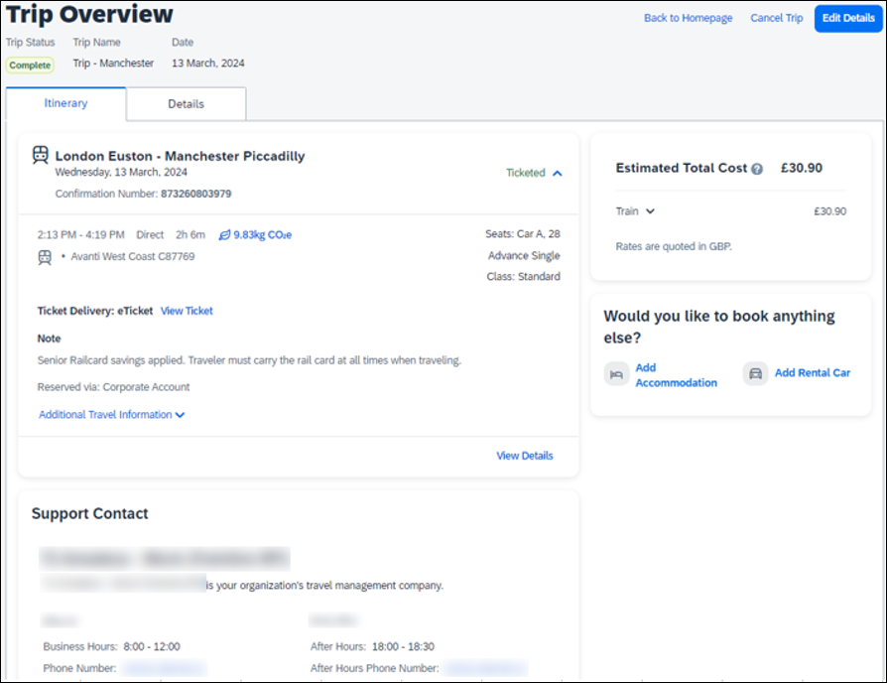
If the client's travel agency has a support contact enabled, it then appears on the itinerary of the Trainline booking.

Cancel Trip
Cancellation of the Trainline booking is not supported. The user sees the following message when attempting to cancel the Trainline booking:
“Cancelation is not available for at least one content provider. Please contact the supplier or your travel agency for assistance.”
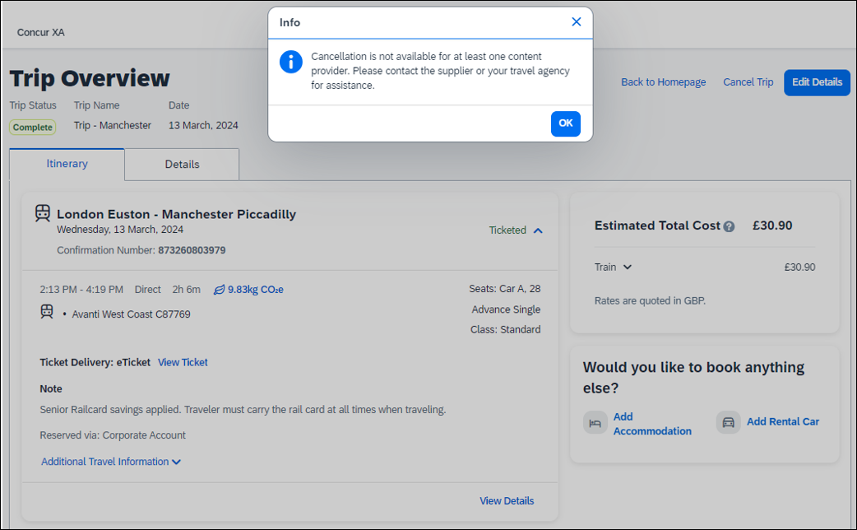

Configuration for Professional Travel
No additional steps are required by administrators to support this change.
The enablement process for the UK Rail (Trainline) connector is described in the following section.

For General Configuration and Activation
- Go to Administration > Travel > Travel System Admin and access the desired client Travel configuration.
Depending on your permissions, the page may appear immediately after you click Administration or Travel.
- In the Rail Connectors section of the travel configuration page, locate UK Rail [Trainline].
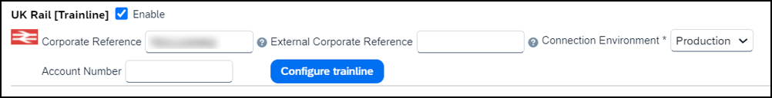
- Complete the appropriate fields.

Field | Required? | Description / Action
Enable | Required | Select this checkbox.
Corporate Reference  OR  External Corporate Reference | Required | New clients should use Corporate Reference field to insert the corporate reference.  Migrated clients will see the corporate reference that they used for the previous connection filled in the External Corporate Reference field.  NOTE: If both values are entered, the Corporate Reference will take precedence.  In case of any update to the Corporate Reference or External Corporate Reference, save your changes and access the travel configuration again to review MI Questions mapping by clicking Configure Trainline.  MI Questions mapping will be lost when the corporate reference is changed and will need to be set up again.
Account Number | Required*  Optional | Clients having one account number should enter it in the Account Number field. The Account Number is sent to Trainline as Account Name.  *For migrated clients who were using the Account Number field with the legacy API, the account number remains required.  NOTE: Clients having more than one account number should create a custom field and map it to the appropriate Trainline question under the Configure Trainline button. If the client using the Account Number value wants to set up a custom field for the Account Name instead, they must delete the Account Number value from the UK Rail (Trainline) configuration settings first and then save changes. Next, to access the travel configuration again, open Trainline MI Questions by clicking Configure Trainline and map the Trainline Account Name to their custom field created for this purpose to complete.
Connection Environment | Required | Select Production. (TEST and MOCK environments are for internal use only)
- Important: Use Configure Trainline to map Concur Travel custom fields to Trainline custom fields. To prevent any issues during the booking flow, make sure that the custom fields’ values set up in Concur Travel correspond to requirements set up with Trainline. Any discrepancy might lead to booking failures for users.

Professional Edition – Client Agreement
Customers based in the UK using a Travel Management Company (TMC) that is also based in the UK, do not need to sign a commercial agreement with Trainline. However, an agreement between Trainline and their TMC is required.
TMCs based in the UK need to have a contract with Trainline to be able to fulfill tickets booked for UK Rail.
TMCs based outside of the UK need to have an international license to fulfill UK Rail tickets. If the TMC does not have an international license and the client would like to book UK Rail from outside of the UK, the client should contact Trainline directly as the direct contract with Trainline would be required in such a case.
A support case must be opened if a TMC does not support Trainline via Concur Travel but plans to in the future. The tenant ID needs to be added by SAP Concur before enabling the UK Rail (Trainline) connector for clients.

New Concur Travel Experience: Renfe - Least Cost Logical Fare Support (Professional Edition Only) (April 8-10)

Prof | Stan | Å Å Edition
 |  | On: Impacts end users who use this feature/vendor; no configuration/setup by agency/ admin; cannot be turned OFF (example: new icons or rate display, new Amtrak feature)
X |  | Available for use: No impact to end users unless/until configuration/setup by agency/admin (described below) (example: new rule, new Travelfusion airline)
 |  | Other: Refer to the release note below
 | X | Does not apply to this edition
Source / Solution Suggestion
GDS
Direct Connect |  | Renfe
Other
X | EMEA Data Center |  |  | Scan impact
X | North America Data Center |  |  | UI impact
 | China Data Center |  |  | File finishing impact
 | All data centers |  |  | Profile/Profile API/3rd Party XML Sync Impact
Affected Documentation
TSGs |  | Renfe Direct Connect Travel Service Guide, Lowest Logical Fare (LLF) / Benchmark Lowest Airfare
Fact Sheets
Admin Guides
Other |  | Travel Services Help

Overview
With the release between April 8 and April 10, Concur Travel introduces the support of the Least Cost Logical Fare (LLF) for Renfe rail bookings in the new Concur Travel experience.

User/Customer Benefit
The calculation of the Least Cost Logical Fare (LLF) is based on criteria and travel policy rules set by the company administrator. These options are highlighted as the best choices for the users to select during the train search.

End-User Experience
If configured, Concur Travel calculates the Least Cost Logical Fare (LLF) based on criteria defined by the customer. LLFs are identified on the Search results page with a star icon. If configured, LLF will display per class of service. The same icon is used for all classes of service.
The LLF is also visible with the same icon in the Train Options Turned Down list to both the user and the approver.

Configuration for Professional Travel
Least Cost Logical Fare is calculated for Rail only if the Include Rail setting in the LLF calculation definition is set to Yes. Administrators can make this change by going to the Travel Policy Administration page and editing Flight travel policy rules.
LLF per fare class of service is a new LLF configuration only applicable to the new Concur Travel experience. The new configuration enables administrators to have a Least Cost Logical Fare per class of service. This is different than the current system where the LLF is always in the lowest class of service that is available in the search results.
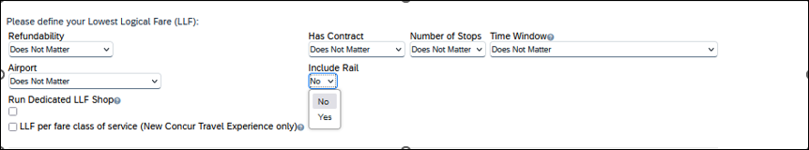

Limitations
Delayed LLF calculation configuration on Company Travel Configuration page:
- Enforce LLF based on user’s chosen fare: Initially, the display of additional screen will not be supported. This functionality may be added later. A banner message will display at the top of the Search Results page that will read: “Additional policy will be calculated based on the time of your selected fare”. Delayed LLF will be calculated after the user has selected their fare (for example, if return fares are chosen after the selection of an inbound fare), and all fares will be evaluated against any delayed LLF based travel policy rules. Users will see all policy rule violations on the Review and Book page for the moment, this may be revised in the future.
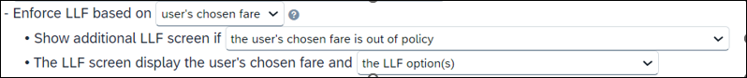
- Enforce LLF based on hybrid: Initially, Hybrid LLF is calculated based on the search window. Additional search options triggering calculation based on a user’s search are not yet supported.
The Run Dedicated LLF Shop LLF configuration option is not supported in the new Concur Travel experience due to changes in the overall search process.
Mark LLF fare/s with icon LLF configuration option is no longer supported in the new Concur Travel experience. The icon will always display.
Travel administrators for configurations where Renfe rail connectors are enabled and who set LLF criteria for Rail should revisit their current LLF related policy rules to ensure rules are configured correctly for their needs.
All configuration settings are applied for both Flight and Rail bookings if LLF is enabled for Rail.

Travel Operations / Technical Essentials

Sabre Enhanced Form of Payment (FOP Wallet)

Prof | Stan |   Edition
X | X | On: Impacts end users who use this feature/vendor; no configuration/setup by agency/ admin; cannot be turned OFF (example: new icons or rate display, new Amtrak feature)
 |  | Available for use: No impact to end users unless/until configuration/setup by agency/admin (described below) (example: new rule, new Travelfusion airline)
 |  | Other: Refer to the release note below
 |  | Does not apply to this edition
Source / Solution Suggestion
GDS |  | Sabre
Direct Connect
Other
X | EMEA Data Center |  |  | Scan impact
X | North America Data Center |  |  | UI impact
 | China Data Center |  |  | File finishing impact
 | All data centers |  |  | Profile/Profile API/3rd Party XML Sync Impact
Affected Documentation
TSGs
Fact Sheets
Admin Guides
Other

Overview
Sabre is decommissioning their legacy 5-Remarks Form of Payment Field (5-*VI444333322221111¥05/26) as of Q3 2024. All Sabre customers are required to migrate to Sabre’s Enhanced Form of Payment also known as FOP Wallet (*FOP). For compliance, Sabre is also anonymizing and removing credit card data from all non-compliant fields in the PNR. They are rolling this anonymization and removal process out in phases, with the final phase to be completed by December 2024. This change will also require a new process for sending credit card data to back-office systems.
Please refer to the following Sabre SAN messages for more details:
- SAN 16643 - Sunset of PNR Form of Payment Field 5-Remarks
- SAN 16331 - Payment Card Anonymization & Removal in PNR Fields
- SAN 17007 - Form of Payment Wallet (FOP) New Use Type for Interface Records
- SAN 17009 - Interface User Record (IUR) - New MX Record for Form of Payment Wallet
Concur Travel will migrate to the FOP Wallet in preparation for this mandate.

User/Customer Benefit
Concur Travel will add the company default or traveler-selected form of payment chosen at the time of booking for every reservation type (Flight, Car, Hotel, and Rail) to the FOP Wallet in the Sabre PNR along with the appropriate Use Type code, for example, UAL=Air, UCR=CAR, UHL=Hotel, and URL=Rail.
During this transition period, Concur Travel will also continue to add the Air and Rail FOP in the legacy format without a Use Type code to support existing mid-office processes. This applies only to PNRs with a live Air and Rail GDS reservation.

End-User Experience
Example: FOP Wallet
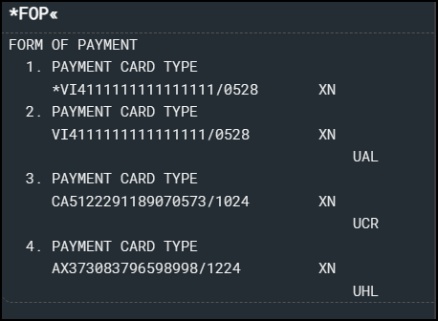

Configuration for Professional and Standard Travel
This feature requires that a default company form of payment be defined, or the form of payment must be selected by the traveler on the Review and Reserve page for every reservation type, in order to be added to the Sabre FOP Wallet.
- For more information on setting FOP requirements, refer to the Form of Payment Travel Service Guide. To locate, refer to Additional Release Notes and Other Technical Documentation in these release notes.
Sabre customers must self-activate Passenger Name Association, which includes the FOP Wallet by using the TJR keyword PNAPNR.
- Once the TJR setting is activated, it cannot be deactivated.
The form of payment updates will automatically be enabled by default in Concur Travel. If a Sabre customer has not yet activated the FOP Wallet, then Concur Travel will automatically revert to the legacy FOP field prior to Sabre’s activation deadline.
- For more information, refer to the Form of Payment Travel Service Guide.
- Refer to the following Sabre SAN notifications:
- SAN 16643 - Sunset of PNR Form of Payment Field 5-Remarks
- SAN 16331 - Payment Card Anonymization & Removal in PNR Fields
- SAN 17007 - Form of Payment Wallet (FOP) New Use Type for Interface Records
- SAN 17009 - Interface User Record (IUR) - New MX Record for Form of Payment Wallet

New Concur Travel Experience: TMC Self-Service Report Enhancement for Client Opt Out Status (Professional Edition Only)

Prof | Stan |   Edition
 |  | On: Impacts end users who use this feature/vendor; no configuration/setup by agency/ admin; cannot be turned OFF (example: new icons or rate display)
 |  | Available for use: No impact to end users unless/until configuration/setup by agency/admin (described below) (example: new rule, new Travelfusion airline)
X |  | Other: Refer to the release note below
 | X | Does not apply to this edition
Source
GDS
Direct Connect
Other
X | EMEA Data Center |  |  | Scan impact
X | North America Data Center |  | X | UI impact
 | China Data Center |  |  | File finishing impact
 | All data centers |  |  | Profile/Profile API/3rd Party XML Sync Impact
Affected Documentation
TSGs
Fact Sheets
Admin Guides
Other

Overview
To accompany the Concur Travel configuration setting that allows administrators to opt out of the new Concur Travel experience, the TMC Self-Service report, “Evolution of Travel Opt Out Report”, was also updated a few months ago to reflect those changes. The client name as well as the travel configuration name are included in the report.

Configuration for Professional Travel
This feature is enabled by default. There are no configuration steps.

Planned Changes
The items in this section are targeted for future releases. SAP Concur solutions reserves the right to postpone implementation of – or completely remove – any enhancement or change mentioned here.
The planned changes listed in this document are specific to this product. For information about planned site-wide or shared changes that might impact your SAP Concur solutions, refer to the Shared Changes Release Notes.

Flight

**Planned Changes** New Concur Travel Experience: New CO2 Filter Added to Flight (Professional Edition Only)

Information First Published | Information Last Modified | Feature Target Release Date
April 19, 2024 | -- | May 2024
Any changes since the previous monthly release are highlighted in yellow in this release note.

Prof | Stan |   Edition
 |  | On: Impacts end users who use this feature/vendor; no configuration/setup by agency/ admin; cannot be turned OFF (example: new icons or rate display)
 |  | Available for use: No impact to end users unless/until configuration/setup by agency/admin (described below) (example: new rule, new Travelfusion airline)
X |  | Other: Refer to the release note below
 | X | Does not apply to this edition
Source
GDS
Direct Connect
Other
X | EMEA Data Center |  |  | Scan impact
X | North America Data Center |  | X | UI impact
 | China Data Center |  |  | File finishing impact
 | All data centers |  |  | Profile/Profile API/3rd Party XML Sync Impact
Affected Documentation
TSGs
Fact Sheets
Admin Guides
Other |  | Concur Travel Professional Edition End User Help

Overview
Targeted for the May release, Concur Travel will add a filter to the Flight experience that sorts results based on CO2 emissions. This allows users to make more sustainable choices.

End-User Experience
When booking flights, the user will be able to filter out results based on CO2 emissions. With a sliding filter, the user can adjust the results based on the emissions that they find acceptable.
When filtering results, the user will adjust the filter under Emissions to return more sustainable flights.
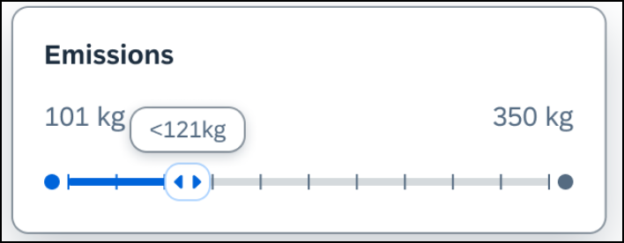

Configuration for Professional Travel
This feature will be enabled by default. There are no configuration steps.

**Planned Changes** New Concur Travel Experience: EDIFACT and NDC Content for Amadeus (Professional Edition Only)

Information First Published | Information Last Modified | Feature Target Release Date
April 12, 2024 | -- | June 21, 2024
Any changes since the previous monthly release are highlighted in yellow in this release note.

Prof | Stan |   Edition
 |  | On: Impacts end users who use this feature/vendor; no configuration/setup by agency/ admin; cannot be turned OFF (example: new icons or rate display)
 |  | Available for use: No impact to end users unless/until configuration/setup by agency/admin (described below) (example: new rule, new Travelfusion airline)
X |  | Other: Refer to the release note below
 | X | Does not apply to this edition
Source
GDS |  | Amadeus
Direct Connect
Other
X | EMEA Data Center |  |  | Scan impact
X | North America Data Center |  | X | UI impact
 | China Data Center |  |  | File finishing impact
 | All data centers |  |  | Profile/Profile API/3rd Party XML Sync Impact
Affected Documentation
TSGs
Fact Sheets
Admin Guides
Other

Overview
In an upcoming release, Amadeus EDIFACT and NDC will be enabled as the content source for Amadeus customers. The following is targeted for inclusion from the following airlines via Amadeus NDC:
- American Airlines
- United Airlines
- Air France
- KLM Royal Dutch Airlines.
Other airlines through Amadeus NDC will be supported in the future releases.

Configuration for Professional Travel
A setting is required so administrators can enable or disable the NDC shopping and booking flow in the new Concur Travel Experience through a GDS. In Amadeus, the Office ID and IATA number must first be activated for an individual airline’s NDC. Then the toggle can be turned on to enable the NDC content source for flight shopping and booking.
This new setting will be added to Amadeus customers' Travel Configuration page, providing the ability to enable NDC content through a GDS. While this setting will only be applicable for Flight searching and booking in the new Concur Travel experience, the toggle will appear for all Amadeus configurations.

**Planned Changes** New Concur Travel Experience: Add Vendor Preference and Corporate Rate to Post Booking Flow (Professional Edition Only)

Information First Published | Information Last Modified | Feature Target Release Date
February 2024 | April 19, 2024 | May 2024
Any changes since the previous monthly release are highlighted in yellow in this release note.

Prof | Stan |   Edition
 |  | On: Impacts end users who use this feature/vendor; no configuration/setup by agency/ admin; cannot be turned OFF (example: new icons or rate display)
 |  | Available for use: No impact to end users unless/until configuration/setup by agency/admin (described below) (example: new rule, new Travelfusion airline)
X |  | Other: Refer to the release note below
 | X | Does not apply to this edition
Source
GDS
Direct Connect
Other
X | EMEA Data Center |  |  | Scan impact
X | North America Data Center |  | X | UI impact
 | China Data Center |  |  | File finishing impact
 | All data centers |  |  | Profile/Profile API/3rd Party XML Sync Impact
Affected Documentation
TSGs
Fact Sheets
Admin Guides
Other |  | Concur Travel Professional Edition End User Help

Overview
Targeted for a future release, Concur Travel plans to display the Corporate Rate label and Preferred Vendor label for Flight. These changes will be visible on the Review and Book, Finalize and Trip Overview pages. These labels will also display on e-mails received once a booking is finalized.

User/Customer Benefit
This change is being made to remind the user which type of rates and vendors were booked, and it will provide a more consistent user experience across the booking process.

End-User Experience
Once the search for flights is completed, the user will then see the Corporate Rate and Preferred Vendor labels on the last pages of the booking flow and in the post booking e-mails received. These labels will appear on the Review and Book, Finalize and Trip Overview pages.

Configuration for Professional Travel
This feature is enabled by default. There are no configuration steps.

Hotel

**Planned Changes** New CSL Segment Format for Sabre Hotels

Information First Published | Information Last Modified | Feature Target Release Date
March 8, 2024 | April 12, 2024 | May 31, 2024
Any changes since the previous monthly release are highlighted in yellow in this release note.

Prof | Stan |   Edition
 |  | On: Impacts end users who use this feature/vendor; no configuration/setup by agency/ admin; cannot be turned OFF (example: new icons or rate display)
 |  | Available for use: No impact to end users unless/until configuration/setup by agency/admin (described below) (example: new rule, new Travelfusion airline)
X | X | Other: Refer to the release note below
 |  | Does not apply to this edition
Source
GDS |  | Sabre
Direct Connect
Other
 | EMEA Data Center |  |  | Scan impact
 | North America Data Center |  |  | UI impact
 | China Data Center |  |  | File finishing impact
X | All data centers |  |  | Profile/Profile API/3rd Party XML Sync Impact
Affected Documentation
TSGs
Fact Sheets
Admin Guides
Other

Overview
SAP Concur completed development to support Sabre’s Content Service for Lodging (CSL) platform in 2021. Since that time Concur has continued to create the legacy segment for Sabre bookings using an indicator in the Enhanced Hotel Book API “bookGDSviaCSL=False”. This is to support those customers whose third-party mid and back-office systems were not yet able to process the CSL HHX segment type that is generated in the Sabre Interface User Record (IUR) file, which supports travel agency back-office functions for Ticketing, Invoicing, and Itinerary type entries.
Sabre’s latest CSL update via SAN 16384 states that Sabre will require all hotel bookings to be created using the new CSL hotel segment as of May 31, 2024. Please refer to Sabre SAN 16384 for complete details.
Concur Travel is ready for this change and will continue to be able to modify and cancel both legacy hotel segments as well as the new CSL hotel segment type from May 31. The API flag “bookGDSviaCSL” will continue to be set to “False” which means that starting March 26, 2024, hotel bookings will be created using the new CSL segment type, but the legacy IUR format will be sent for back-office processing.
Sabre has not indicated when the legacy IUR will be sunset, so whilst some customers will continue to use this for the foreseeable future, other Concur Travel customers may be ready to migrate to the new CSL HHX IUR segment type. As Concur Travel does not have visibility into which customers have migrated, a new Agency Configuration setting is being introduced so clients who want to use the new CSL IUR format can do so. This new configuration setting will be called Create Content Services for Lodging Interface User Record (IUR).
The default for this setting is unchecked which means the legacy IUR will continue to be created.
This setting only applies to users working with the new Concur Travel experience. Customers using the current OBT platform will not be able to use the new IUR.

TMC Experience
TMCs will see the new configuration setting, Create Content Services for Lodging Interface User Record (IUR).
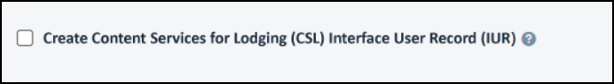
If the customer wants to create a new IUR record, they will need to update the new configuration setting for this.
- For more information, refer to the Concur Travel Client Fact Sheet – Sabre Content Services for Lodging.

**Planned Changes** New Concur Travel Experience: Configuration for Custom Hotel Sourcing (Professional Edition Only)

Information First Published | Information Last Modified | Feature Target Release Date
March 2023 | April 12, 2024 | May 2024
Any changes since the previous monthly release are highlighted in yellow in this release note.

Prof | Stan |   Edition
 |  | On: Impacts end users who use this feature/vendor; no configuration/setup by agency/ admin; cannot be turned OFF (example: new icons or rate display)
 |  | Available for use: No impact to end users unless/until configuration/setup by agency/admin (described below) (example: new rule, new Travelfusion airline)
X |  | Other: Refer to the release note below
 | X | Does not apply to this edition
Source
GDS |  | N/A
Direct Connect |  | Custom Hotel Source providers (TBD)
Other
 | EMEA Data Center |  |  | Scan impact
 | North America Data Center |  |  | UI impact
 | China Data Center |  |  | File finishing impact
 | All data centers |  |  | Profile/Profile API/3rd Party XML Sync Impact
Affected Documentation
TSGs
Fact Sheets
Admin Guides
Other

Overview
Recently, SAP Concur released the new Hotel booking experience for customers connected to Sabre and for customers connected to one of our participating Custom Hotel Source (CHS) providers. With this integration, customers can experience:
- An intuitive and personalized design, with an easy-to-use interface.
- Seamless content normalization, aggregation, and servicing.
- Mobile and web content parity.

User/Customer Benefit
The new Concur Travel Hotel booking experience offers a specific feature set for customers.
- Time Savings: The booking workflow will be streamlined so fewer steps are required.
- Omni search: Once the user enters the first few characters of their search criteria, the system will update to provide a list of suggested options from which the user can select.
- Sustainability: Property information will include the sustainability certifications or programs to which the property belongs, a sustainability score, and carbon emissions data. Additional property filter options will include electric car charging stations and sustainability certifications to help users make more sustainable choices. Users will be able to sort properties based on their sustainability score and emissions.
- Search results with lead rate: The property search results will be presented with one lead rate so the user can quickly compare the lowest rate available at multiple properties.
- Hotel Details: A list of the rates available at a specific property, together with cancellation policy details, room amenities and images, will be available to the user.

Configuration for Professional Travel

Custom Hotel Source Providers
For customers interested in using Custom Hotel Source providers as their source for hotel content, re-enablement is required.
To configure:
- Click Administration > Travel (on the sub-menu) > Travel System Admin and select the desired client travel configuration.
Depending on your permissions, the page may appear immediately after you click Administration or Travel.
There are now two different Hotel Connector sections of the Travel Configuration page. One is to support the new hotel connectors and is called Hotel Connectors – Hotel Service v4. The other is the existing hotel connector section.
- When enabling a new connector, it is essential that any current direct connect remains enabled otherwise customers will not be able to make bookings in the current Concur Travel experience. This means that a current HSv2 configuration needs to remain enabled on HSv2, and on HSv4 once migrated. The HSv2 connection will not allow new bookings but will provide access to previously booked reservations for servicing. Any servicing will continue as it is today using the Online Booking Tool (OBT).
- The administrator will be able to select the default connection type within the new section.
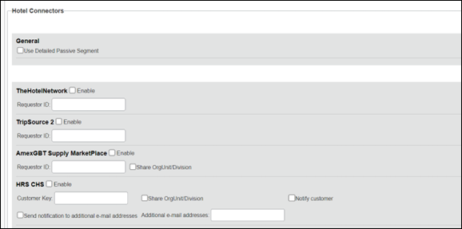
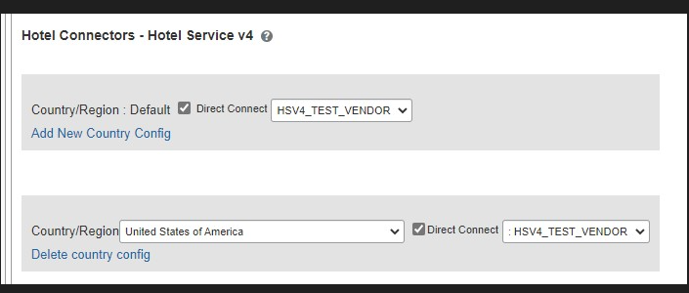

Passive PNR for Direct Content
To configure:
- Go to Administration > Travel (on the sub-menu) > Travel System Admin and select the desired client travel configuration.
Depending on your permissions, the page may appear immediately after you click Administration or Travel.
- On the Travel Configuration page, under GDS PNR Options, go to the activation checkboxes.
- Under Defaults for Specific non-GDS vendors, select the New Custom Hotel Source checkbox. The default for this field is Use the default specified above. Select the Write passive segments for non-GDS content if I have not specified a default for the specific vendor in the table below checkbox.

Travel Arranger Flow
The Travel Arranger feature will be supported for Hotel.
- For more information on how to book a hotel as a Travel Arranger, see the Travel Arranger View Travel Service Guide.
The Travel Arranger Name appears on the new Trip Overview page.

Miscellaneous

**Planned Changes** Share a Trip Via Microsoft Teams Integration

Information First Published | Information Last Modified | Feature Target Release Date
April 12, 2024 | -- | Late April or May, 2024
Any changes since the previous monthly release are highlighted in yellow in this release note.

Prof | Stan | Å Å Edition
 |  | On: Impacts end users who use this feature/vendor; no configuration/setup by agency/ admin; cannot be turned OFF (example: new icons or rate display)
 |  | Available for use: No impact to end users unless/until configuration/setup by agency/admin (described below) (example: new rule, new Travelfusion airline)
X | X | Other: Refer to the release note below
 |  | Does not apply to this edition
Source
GDS |  | All
Direct Connect
Other
X | EMEA Data Center |  |  | Scan impact
X | North America Data Center |  | X | UI impact
 | China Data Center |  |  | File finishing impact
 | All data centers |  |  | Profile/Profile API/3rd Party XML Sync Impact
Affected Documentation
TSGs
Fact Sheets
Admin Guides
Other

Overview
Targeted for late April or May, for the Flight vertical, users will be able to share trips in Microsoft Teams. Once the SAP Concur app is installed by an administrator, users can select the app in their Teams conversation.
To make this feature available in the Microsoft Teams store, it must first be reviewed and approved by Microsoft. After it is approved, an update will be published in next month’s release notes.
When used for the first time or after their session expires, users will be prompted to log in via single sign-on (SSO) or by entering their username and password.
SAP Concur is investigating an issue that occurs when logging in via SSO with a link sent to the user’s inbox.
Trips will then be automatically synced. Teams chat recipient participants can click the Book this trip in SAP Concur button that will re-direct them to Concur Travel where they can book a similar trip. The same trip destination will display, but the departure airport will reflect the one that is specified in their profile.

End-User Experience
Example: Teams Chat window with Concur Travel shared itinerary, trip search, and trip booking functionality
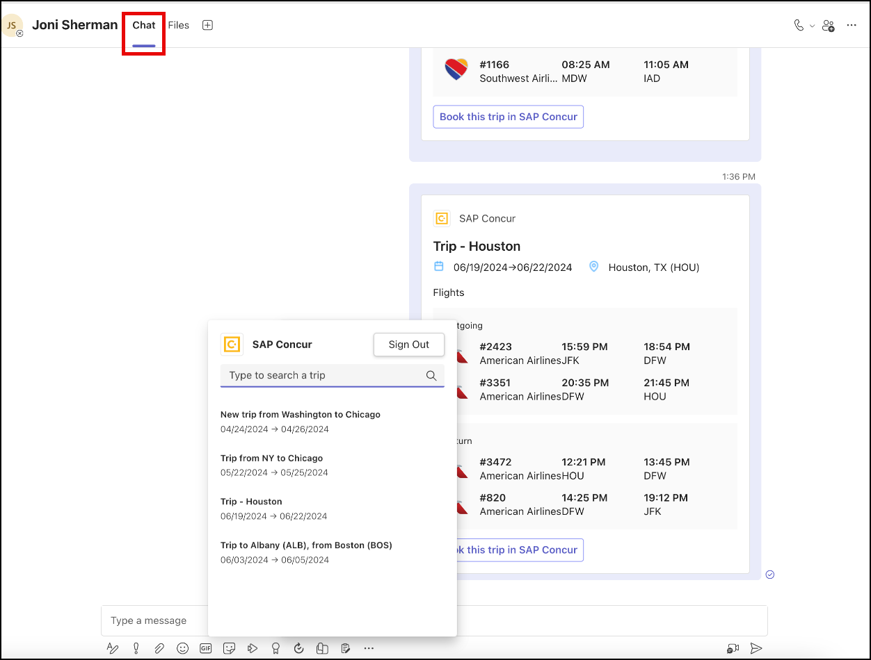
Example: Book this trip in SAP Concur.
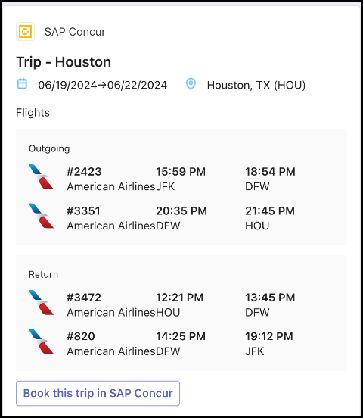

Configuration for Professional Travel
Administrators are required to install the SAP Concur app in the Microsoft Teams tenant to enable the integration. Users will also need to add the app to their Microsoft Teams once it was enabled by their administrators.

**Planned Changes** New Fields Available in Online Order Form

Information First Published | Information Last Modified | Feature Target Release Date
March 15, 2024 | April 19, 2024 | May 17, 2024
Any changes since the previous monthly release are highlighted in yellow in this release note.

Prof | Stan |   Edition
 |  | On: Impacts end users who use this feature/vendor; no configuration/setup by agency/ admin; cannot be turned OFF (example: new icons or rate display)
 |  | Available for use: No impact to end users unless/until configuration/setup by agency/admin (described below) (example: new rule, new Travelfusion airline)
X | X | Other: Refer to the release note below
 |  | Does not apply to this edition
Source
GDS
Direct Connect
Other
 | EMEA Data Center |  |  | Scan impact
 | North America Data Center |  |  | UI impact
 | China Data Center |  |  | File finishing impact
X | All data centers |  |  | Profile/Profile API/3rd Party XML Sync Impact
Affected Documentation
TSGs |  | Online Order Form Travel Service Guide
Fact Sheets
Admin Guides
Other

Overview
Targeted for release May 17, there will be changes to the Online Order Form. New fields will be available, while one is removed.

User/Customer Benefit
This change is being initiated to support options that are billable to the client. It also ensures consistency between the order form and the Reseller Price List.

End-User Experience
The Online Order Form will be adjusted to allow for changes including new fields.
The Enable TripLink checkbox will be removed and will longer be available.
If a user chooses New Professional Client or New Standard Client, the Additional Comments input box will appear and will be retitled to Additional Comments (Include implementation country).
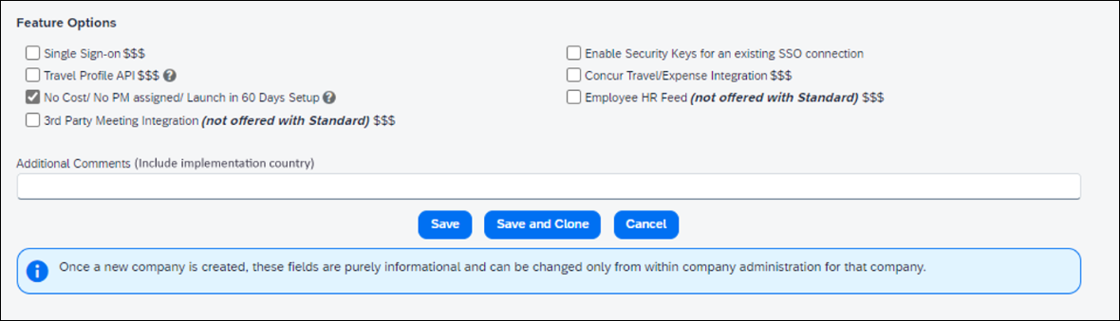
Under Feature Options there will be a new checkbox to enable New Tier2 for Host Agency $$$.
When Modify Existing Client > Agency Conversion – Incoming Agency is selected, a new checkbox appears, titled GDS/PCC Conversion (no agency change) $$$.
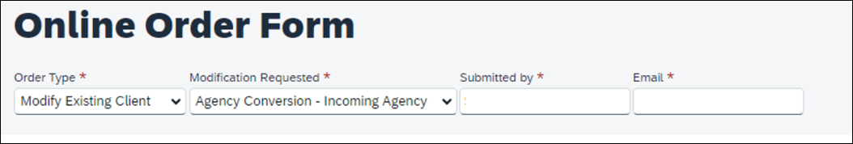
If a user chooses Modify Existing Client > Add Config to Existing Professional Site or Modify Existing Client > Add Config to Existing Standard Site, two new checkboxes will appear. These are:
- New GDS (assumes standard finishing) $$$
- Additional Country $$$ (this checkbox is accompanied by a dropdown list, where a country is selected).

Configuration for Professional Travel
This feature will be enabled by default. There are no configuration steps.

**Planned Changes** Decommission of Two-Manager Approval Setting (Professional Edition Only)

Information First Published | Information Last Modified | Feature Target Release Date
August 11, 2023 | January 19, 2024 | TBD 2024
Any changes since the previous monthly release are highlighted in yellow in this release note.

Prof | Stan |   Edition
X |  | On: Impacts end users who use this feature/vendor; no configuration/setup by agency/ admin; cannot be turned OFF (example: new icons or rate display)
 |  | Available for use: No impact to end users unless/until configuration/setup by agency/admin (described below) (example: new rule, new Travelfusion airline)
 |  | Other: Refer to the release note below
 | X | Does not apply to this edition
Source
GDS
Direct Connect
Other
X | EMEA Data Center |  |  | Scan impact
X | North America Data Center |  | X | UI impact
 | China Data Center |  |  | File finishing impact
 | All data centers |  |  | Profile/Profile API/3rd Party XML Sync Impact
Affected Documentation
TSGs
Fact Sheets
Admin Guides
Other

Overview
Targeted for a future release in the legacy Concur Travel experience, the two-manager approval flow will no longer be supported. In the legacy Concur Travel experience, all clients with a two-manager approval flow will be migrated to a one manager approval flow.

User/Customer Benefit
This change is being initiated to simplify and streamline the approval flow in the legacy Concur Travel experience. It also provides more options when working with Concur Request.

End-User Experience
When choosing an approver, the user will only be able to request the approval flow be directed to one manager and not two.
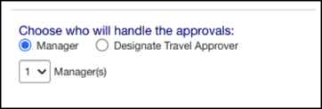

Configuration for Professional Travel
This feature is enabled by default. There are no configuration steps.

Travel Operations / Technical Essentials

**Planned Changes** Decommission of Travel Configuration Agency Processing Fee Form of Payment for Land Only/Non-GDS Reservations Setting

Information First Published | Information Last Modified | Feature Target Release Date
March 8, 2024 | April 12, 2024 | December 2024
Any changes since the previous monthly release are highlighted in yellow in this release note.

Prof | Stan |   Edition
X | X | On: Impacts end users who use this feature/vendor; no configuration/setup by agency/ admin; cannot be turned OFF (example: new icons or rate display)
 |  | Available for use: No impact to end users unless/until configuration/setup by agency/admin (described below) (example: new rule, new Travelfusion airline)
X |  | Other: Refer to the release note below
 |  | Does not apply to this edition
Source
GDS
Direct Connect
Other
X | EMEA Data Center |  |  | Scan impact
X | North America Data Center |  | X | UI impact
 | China Data Center |  |  | File finishing impact
 | All data centers |  |  | Profile/Profile API/3rd Party XML Sync Impact
Affected Documentation
TSGs |  | Travel System Admin Guide
Fact Sheets
Admin Guides
Other

Overview
Concur Travel is removing the Agency Processing Fee Form of Payment for Land Only/Non-GDS Reservations configuration setting from Travel Configurations. Any credit card data that is stored in these fields will be removed.

User/Customer Benefit
The GDS are making changes to the way credit cards are entered into the Passenger Name Record (PNR), resulting in several changes needed within Concur Travel. Form of payment (FOP) will need to be written in a specific format, depending on its use. This means that all FOP features require updating and reformatting. Based on these changes, SAP Concur is recommending that customers and TMCs work together on how to manage TMC service fees outside of the booking process. One benefit to this change is the avoidance of PNR template updates for a process that has no impact to the online booking process.

End-User Experience
The previous setting will be removed from the Travel Configurations page and will no longer be visible. Configurations using the following options will have the setting automatically changed to Always write user selected card (default):
- Always write user selected air/rail card
- Always write air/rail ghost card
- Always write air/rail profiled card
- Always use this card
- None
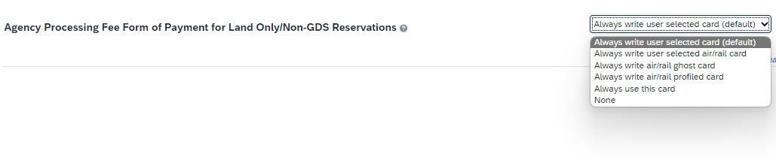
Depending on the customer configuration settings, the user-selected FOP will be added to Amadeus, Apollo, Worldspan, and Travelport+ PNRs. For Sabre bookings, see the **Planned Changes** Sabre Enhanced Form of Payment (FOP Wallet) in this document for Sabre specific FOP handling.

Configuration for Professional Travel
This feature is enabled by default. There are no configuration steps.

**Planned Changes** New Concur Travel Experience: Sabre Car Enhancements – Additional Elements (Professional Edition Only)

Information First Published | Information Last Modified | Feature Target Release Date
March 8, 2024 | March 15, 2024 | July 2024
Any changes since the previous monthly release are highlighted in yellow in this release note.

Prof | Stan |   Edition
 |  | On: Impacts end users who use this feature/vendor; no configuration/setup by agency/ admin; cannot be turned OFF (example: new icons or rate display, new Amtrak feature)
 |  | Available for use: No impact to end users unless/until configuration/setup by agency/admin (described below) (example: new rule, new Travelfusion airline)
X |  | Other: Refer to the release note below
 | X | Does not apply to this edition
Source / Solution Suggestion
GDS |  | Sabre
Direct Connect
Other
X | EMEA Data Center |  |  | Scan impact
X | North America Data Center |  | X | UI impact
 | China Data Center |  |  | File finishing impact
 | All data centers |  |  | Profile/Profile API/3rd Party XML Sync Impact
Affected Documentation
TSGs
Fact Sheets
Admin Guides
Other |  | Travel Services Help

Overview
Targeted for the July release, Concur Travel intends to release additional elements to the Sabre Rental Car experience. The elements that will be added are Flight Information and Loyalty ID.

User/Customer Benefit
SAP Concur wants to enhance the new Concur Travel experience for the end user by adding new elements.

End-User Experience
With the July release, the following will be added:
- Flight Information: This is being added so the traveler’s arrival details can be provided to the rental car partners.
- Loyalty ID: To ensure that loyalty incentives are received, loyalty information will be added to the segment (ID-¤XX). Sabre hides this information.
Example:
CAR ZE 30JAN T HK1 SEA/31JAN/ICAR/ARR-1000 DL1234/ID-¤XX /DCZEXXXX9537/PH-206-277-2300/GVI4111111111111111EXP 08 26-TOBIAS/NM ¤SKYE BLUE/RET-1000/RG¤USD137.75 UNL DY XH46.83 UNL/AP-¤USD189.87 UNL 1DY 0HR 52.12MC/BS-49640150/RC-RCUD1/CF-K6573 775956GOLD-

Configuration for Professional Travel
This feature is enabled by default. There are no configuration steps.

**Planned Changes** Decommission of Credit Card Datapoints in Profile and PNR Finishing Templates

Information First Published | Information Last Modified | Feature Target Release Date
January 12, 2024 | April 12, 2024 | December 2024
Any changes since the previous monthly release are highlighted in yellow in this release note.

Prof | Stan |   Edition
X | X | On: Impacts end users who use this feature/vendor; no configuration/setup by agency/ admin; cannot be turned OFF (example: new icons or rate display, new Amtrak feature)
 |  | Available for use: No impact to end users unless/until configuration/setup by agency/admin (described below) (example: new rule, new Travelfusion airline)
X |  | Other: Refer to the release note below
 |  | Does not apply to this edition
Source / Solution Suggestion
GDS |  | Sabre, Amadeus, Apollo, Worldspan, Travelport+ (Galileo)
Direct Connect
Other
X | EMEA Data Center |  |  | Scan impact
X | North America Data Center |  | X | UI impact
 | China Data Center |  |  | File finishing impact
 | All data centers |  |  | Profile/Profile API/3rd Party XML Sync Impact
Affected Documentation
TSGs
Fact Sheets
Admin Guides
Other

Overview
The GDS systems are changing how credit cards are managed in Passenger Name Records (PNRs), resulting in several changes needed within Concur Travel. One of the GDS-imposed changes is the anonymization and removal of credit card data in all areas of the PNR except for the designated Form of Payment (FOP) field or FOP Wallet. In preparation for this change, Concur Travel will be decommissioning Profile and PNR Finishing Template datapoints for credit card numbers and expiration dates.

Sabre
- Profile Templates are not applicable to Sabre customers. Concur Travel securely synchronizes credit card data from the Concur profile to Sabre Profiles using Sabre Web Services today.
- Concur Travel will be migrating to Sabre’s Enhanced Form of Payment (FOP Wallet) and will be adding the company default or traveler-selected form of payment for each booking type to the FOP Wallet (*FOP) along with the applicable Use Type code. Refer to the **Planned Changes** Sabre Enhanced Form of Payment (FOP Wallet) release note in this document for more information.
- Concur Travel will be decommissioning Sabre PNR Finishing Template datapoints for credit card numbers and expiration dates in December 2024. It is important to note this is the final extension of this feature. SAP Concur will retire this functionality in December 2024.

Amadeus and Travelport
- Concur Travel will continue to transmit the user-selected credit card to the compliant form of payment field already in place in the PNR today.
- Concur Travel will be decommissioning Amadeus, Apollo, Travelport+ and Worldspan Profile Template datapoints for credit card numbers and expiration dates in December 2024. It is important to note this is the final extension of this feature. SAP Concur will retire this functionality in December 2024.Concur Travel will be decommissioning Amadeus, Apollo, Travelport+ and Worldspan PNR Finishing Template datapoints for credit card numbers and expiration dates in December 2024. It is important to note this is the final extension of this feature. SAP Concur will retire this functionality in December 2024.
- Concur Travel strongly recommends using the Travel Profile API for synchronizing Concur profile data with your GDS profiles. For more information, refer to the Travel Profile v2 API documentation in the SAP Concur Developer Center.
- SAP Concur is working closely with our GDS partners to ensure Concur Travel is utilizing the latest and most secure credit card processing for travel reservations.
- Due to the highly customizable nature of PNR Finishing Templates, Concur Travel can only provide general guidance for making updates and cannot ensure that finishing will run successfully if these datapoints are not removed before their retirement.

User/Customer Benefit
SAP Concur sees this as one of the first of many industry-wide efforts to better secure sensitive user data, creating higher confidence in the travel purchasing process and reducing financial risk for users and companies alike.
SAP Concur is recommending that customers and TMCs work together to identify any scenarios where the Profile or PNR Finishing templates are used to transmit credit card data to the GDS systems in non-compliant fields of the GDS profile and/or PNR. Customers who need credit card data transmitted to the IUR/A.I.R./MIR file for back-office processing will need to seek a mid-office solution to address their needs.

End-User Experience
The following datapoint examples should help TMCs and customers determine if changes are needed to their Concur Travel instance.

Profile Template Datapoint Examples
The following is a list of profile template datapoints which include credit card numbers or expiration dates; this list may not be comprehensive. TMCs and customers should review their Profile Templates. If templates are using one of the credit card elements, these should be removed:
- Air_credit_card_number car_credit_card_number
- ghost_air_credit_card_number
- ghost_car_credit_card_number
- ghost_hotel_credit_card_number
- hotel_credit_card_number
- personal_air_credit_card_number
- personal_car_credit_card_number
- personal_hotel_credit_card_number
- car_expiration_date
- ghost_air_expiration_date
- ghost_car_expiration_date
- ghost_card_expiration
- ghost_card_number
- ghost_hotel_expiration_date
- hotel_expiration_date
- personal_air_expiration_date
- personal_car_expiration_date
- personal_hotel_expiration_date
- ycal_ghost_card_expiration
- ycal_ghost_card_number
Example of a Profile Template line configured to transmit a credit card number:
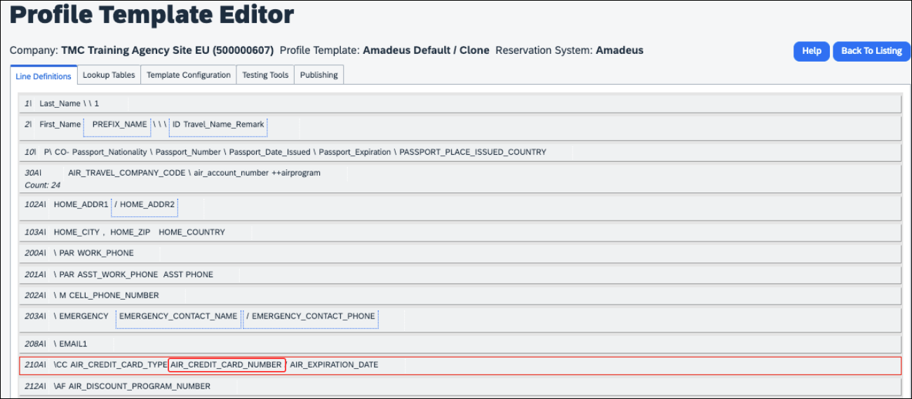

PNR Finishing Template Examples
TMCs or customers should review their PNR Finishing Templates. If templates are using one of the credit card elements, these should be removed.
Credit Card Finishing Template Datapoints:
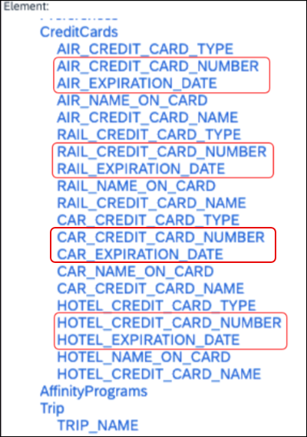
Customers using Conferma Pay for hotel virtual cards should review their PNR Finishing Templates. If templates are using one of the credit card elements, these should be removed:
- Virtual_Hotel_Credit_Card_Number
- Virtual_Hotel_Expiration_Date

Configuration for Professional and Standard Travel
This feature is enabled by default. There are no configuration steps.
- Please refer to the following resources to help you prepare further:
- Sabre SAN 16331 - Payment Card Anonymization & Removal in PNR Fields.
- Amadeus Notification – PNR Core Product: Warning at end of transaction (EOT) time when a credit card is detected in an inappropriate PNR element
- The **Planned Changes** Sabre Enhanced Form of Payment (FOP Wallet) release note in this document.
- The Travel Profile v2 API documentation in the SAP Concur Developer Center.

**Planned Changes** New Concur Travel Experience: Sabre’s Price Quote - Enhancement to Provide More Accurate Fare at Booking

Information First Published | Information Last Modified | Feature Target Release Date
November 3, 2023 | January 12, 2024 | June 30, 2024
Any changes since the previous monthly release are highlighted in yellow in this release note.

Prof | Stan |   Edition
X |  | On: Impacts end users who use this feature/vendor; no configuration/setup by agency/ admin; cannot be turned OFF (example: new icons or rate display)
 |  | Available for use: No impact to end users unless/until configuration/setup by agency/admin (described below) (example: new rule, new Travelfusion airline)
X |  | Other: Refer to the release note below
 | X | Does not apply to this edition
Source
GDS |  | Sabre, Car Connector
Direct Connect
Other
X | EMEA Data Center |  |  | Scan impact
X | North America Data Center |  | X | UI impact
 | China Data Center |  |  | File finishing impact
 | All data centers |  |  | Profile/Profile API/3rd Party XML Sync Impact
Affected Documentation
TSGs
Fact Sheets
Admin Guides
Other

Overview
SAP Concur plans to add Price Quote (PQ) modifiers into the new Concur Travel experience process for accuracy purposes.

User/Customer Benefit
This change will be implemented to enhance accuracy and reduce price jump situations such that the stored price always matches the price offered in the shopping response.

End-User Experience
When storing the price quote, the following qualifiers will be added:
- XO (forced passenger type to avoid shifting to ADT when not using ADT),
- P(passenger type),
- A (validating carrier) and
- ZZ (fare basis)
In addition, SAP Concur will change the SNAP code qualifier from I to AC*.
New Pricing Command Line:
WPAC*GLD03¥S1*BRMAINCABIN*ZZXAVUA0ML¥S2*BRMAINCABIN*ZZXAVNA0ME¥RY/CA¥AUA¥PADT¥XO¥RQ
New PQ Line:
PQ 1 AC*GLD03¥S1*BRMAINCABIN*ZZXAVUA0ML¥S2*BRMAINCABIN*ZZXAVNA0ME¥AUA¥PADT¥XO¥RQ
Current PQ Line:
WPIGLD03¥S1*BRMAINCABIN¥S2*BRMAINCABIN¥RQ

Configuration for Professional Travel
This feature is enabled by default. There are no configuration steps.

Additional Release Notes and Other Technical Documentation

Online Help
You can access release notes, setup guides, user guides, admin summaries, supported configurations, and other resources via the in-product Help menu or directly on the SAP Help Portal.
To access the full set of documentation for your product, use the links in the SAP Concur Help menu, or visit the SAP Concur solutions page.
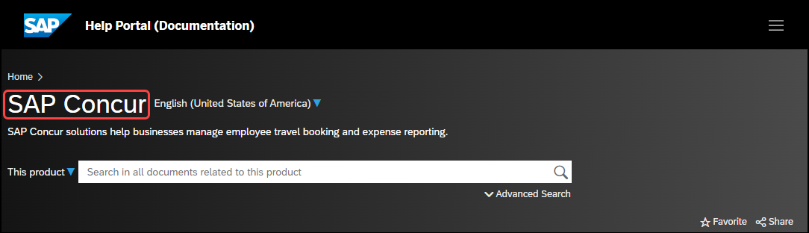

SAP Concur Support Portal – Selected Users
Access release notes, webinars, and other technical documentation on the SAP Concur support portal.
If you have the required permissions, Contact Support is available on the SAP Concur Help menu and in the SAP Concur page footer.
Click Contact Support to access the SAP Concur support portal, then click Resources.
- Click Release/Tech Info for release notes, technical documents, etc.
- Click Webinars for recorded and live webinars.

© 2024 SAP SE or an SAP affiliate company. All rights reserved.
No part of this publication may be reproduced or transmitted in any form or for any purpose without the express permission of SAP SE or an SAP affiliate company.
SAP and other SAP products and services mentioned herein as well as their respective logos are trademarks or registered trademarks of SAP SE (or an SAP affiliate company) in Germany and other countries. Please see http://global12.sap.com/corporate-en/legal/copyright/index.epx for additional trademark information and notices.
Some software products marketed by SAP SE and its distributors contain proprietary software components of other software vendors.
National product specifications may vary.
These materials are provided by SAP SE or an SAP affiliate company for informational purposes only, without representation or warranty of any kind, and SAP SE or its affiliated companies shall not be liable for errors or omissions with respect to the materials. The only warranties for SAP SE or SAP affiliate company products and services are those that are set forth in the express warranty statements accompanying such products and services, if any. Nothing herein should be construed as constituting an additional warranty.
In particular, SAP SE or its affiliated companies have no obligation to pursue any course of business outlined in this document or any related presentation, or to develop or release any functionality mentioned therein. This document, or any related presentation, and SAP SE’s or its affiliated companies’ strategy and possible future developments, products, and/or platform directions and functionality are all subject to change and may be changed by SAP SE or its affiliated companies at any time for any reason without notice. The information in this document is not a commitment, promise, or legal obligation to deliver any material, code, or functionality. All forward-looking statements are subject to various risks and uncertainties that could cause actual results to differ materially from expectations. Readers are cautioned not to place undue reliance on these forward-looking statements, which speak only as of their dates, and they should not be relied upon in making purchasing decisions.

