SAP Concur Release Notes
Concur Travel
Concur Professional/Premium and Concur Standard
Month | Audience
Release Date: March 23, 2024  Initial post: Friday, March 22 | SAP Concur Client FINAL

** FINAL **
The enhancements and changes described in this document may or may not be included in this release. SAP Concur reserves the right to postpone implementation of – or completely remove – any enhancement/change mentioned here.
The DRAFT and FINAL release notes contain information about Concur Professional/Premium and Concur Standard.
Each note contains a table that which indicates if the enhancement/change applies to Professional and/or Standard.

Contents
Release Notes 1
Administration 1
New Concur Travel Experience: Concur Travel and Request Integration Book Then Approve Support (Professional Edition Only) (Mar 22 - 26) 1
New Concur Travel Experience: Out-of-Policy Popup on Shop Pages (Professional Edition Only) (Mar 22) 5
New Concur Travel Experience: Travel Policy Updates on Review & Book and Finalize Pages (Professional Edition Only) (Mar 22) 7
Car 9
New Concur Travel Experience: Sixt and Hertz Direct Connect via Car Connector Available in Eligible Markets (Professional Edition Only) (Mar 22) 9
New Concur Travel Experience: Redesign of Car Search Results Page (Professional Edition Only) (Mar 22) 12
Flight 15
New Concur Travel Experience: Updated Details of Taxes, Fees and Charges (Professional Edition Only) (Mar 22) 15
New Concur Travel Experience: Display Possible Ticketing Fees Information on Review and Book (Professional Edition Only) (Mar 22) 17
New Concur Travel Experience: Mixed Brand Offers and Product Selection (Professional Edition Only) (Mar 22) 19
New Concur Travel Experience: Update to Round Trip Pricing (Professional Edition Only) (Mar 22) 21
New Concur Travel Experience: Include Accommodation Option on the Flight Search Tab (Professional Edition Only) (Mar 22) 22
Hotel 25
New Concur Travel Experience: Hotel Enhancements on Shop Pages (professional Edition Only) (Mar 22) 25
New Concur Travel Experience: Support for Per Diems (Professional Edition Only) (Mar 22) 29
Hotel, Rail 33
**Ongoing** New Concur Travel Experience: Last Four Digits on Form of Payment Displayed (Professional Edition Only) 33
Miscellaneous 35
Profile Enhancement for Gender Inclusivity (Mar 22) 35
Zip Code Updates for Credit Card Form of Payment in Traveler Profile (Mar 22) 40
New Concur Travel Experience: Send Itinerary by Email (Professional Edition Only) (Mar 22) 41
New Concur Travel Experience: Improved Translations for Airport Names (Professional Edition Only) (Mar 22) 46
New Concur Travel Experience: Meeting Match Redirect to Meeting During Booking Workflow (Professional Edition Only) (Mar 22) 47
New Concur Travel Experience: Conflict Detection (Professional Edition Only) (Mar 22) 50
**Ongoing** New Concur Travel Experience: Add to Trip Enhancement (Professional Edition Only) 51
**Ongoing** New Concur Travel Experience: Trip History (Professional Edition Only) 56
**Ongoing** New Concur Travel Experience: Feature Exclusions, Limitations & Changed Behavior (Professional Edition Only) 61
Rail 62
New Concur Travel Experience: Renfe - Choose Your Rule Class Tied to Same Agency Setting (Professional Edition Only) 62
New Concur Travel Experience: Trainline - Book and Approve Request Support (Professional Edition Only) (Feb 19-28) 62
Orphaned Trip Handling Changes for Trainline (Feb 19-28) 63
New Concur Travel Experience: Trainline New Supported Rules (Professional Edition Only) (Feb 19 -28) 65
Trainline Decommission for Apollo and Worldspan Configurations (Feb 29) 70
New Concur Travel Experience: Trainline - Train Options Turned Down (Professional Edition Only) (Feb 19-28) 72
New Concur Travel Experience: Trainline - Configurable Message Boards (Professional Edition Only) (Feb 19-28) 73
New Concur Travel Experience: Trainline - Support for Multiple Rail Connectors (Professional Edition Only) (Feb 19-28) 75
New Concur Travel Experience: Trainline - Multiple Violation Reasons (Professional Edition Only) (Feb 19-28) 76
New Concur Travel Experience: Trainline - Least Cost Logical Fare Support (Professional Edition Only) (Feb 19-28) 78
New Concur Travel Experience: Trainline - Customer Migration (Professional Edition Only) (Feb 19-28) 80
Planned Changes 86
Administration 86
**Ongoing Changes** New Concur Travel Experience: Choose Your Rule Class Tied to Same Agency Setting (Professional Edition Only) 86
Flight 89
**Planned Changes** New Concur Travel Experience: Add Vendor Preference and Corporate Rate to Post Booking Flow (Professional Edition Only) 89
Hotel 90
**Planned Changes** New CSL Segment Format for Sabre Hotels (Mar 26) 90
**Planned Changes** New Concur Travel Experience: Configuration for Custom Hotel Sourcing (Professional Edition Only) 92
Miscellaneous 95
**Planned Changes** New Fields Available in Online Order Form 95
**Planned Changes** Travel Profile API 2.0 Gender Diversity Support 97
**Planned Changes** Decommission of Two-Manager Approval Setting (Professional Edition Only) 98
**Ongoing** New Concur Travel Experience: Market Eligibility Expansion (Professional Edition Only) (Mar 26) 100
**Ongoing** New Concur Travel Experience: Skip Search Action (Professional Edition Only) 102
Rail 104
**Planned Changes** New Concur Travel Experience: CO2 Emissions Display (Professional Edition Only) 104
*Planned Changes** New Concur Travel Experience: Renfe - Auto-Cancel and Standalone Approval Process Enhancement (Professional Travel Only) (April 8-10) 105
**Planned Changes** New Concur Travel Experience: Renfe – Allow/Display Message Support (Professional Edition Only)(April 8-10) 112
**Planned Changes** New Concur Travel Experience: Renfe - Changes to Approval Deadline Logic (Professional Edition Only)(April 8-10) 114
**Planned Changes** New Concur Travel Experience: Renfe - Configurable Message Boards (Professional Edition Only) (April 8-10) 116
**Planned Changes** New Concur Travel Experience: Renfe - Least Cost Logical Fare Support (Professional Edition Only) (April 8-10) 118
**Planned Changes** New Concur Travel Experience: Renfe - Multiple Violation Reasons (Professional Edition Only) (April 8-10) 120
**Planned Changes** New Concur Travel Experience: Renfe - New Supported Rules (Professional Edition Only) (April 8-10) 122
**Planned Changes** New Concur Travel Experience: Renfe - Support for Multiple Rail Connectors (Professional Edition Only) (April 8-10) 128
**Planned Changes** New Concur Travel Experience: Renfe - Train Options Turned Down (Professional Edition Only) (April 8-10) 129
**Planned Changes** New Concur Travel Experience: Renfe - User Interface Changes to Workflow Pages and Emails (Professional Edition Only) (April 8-10) 131
**Planned Changes** New Concur Travel Experience: Trainline - Available on Amadeus, Sabre, Galileo (Professional Edition Only) 136
Travel Operations / Technical Essentials 147
**Planned Changes** New Concur Travel Experience: Sabre Car Enhancements – Additional Elements (Professional Edition Only) 147
**Planned Changes** Decommission of Credit Card Datapoints in Profile and PNR Finishing Templates 148
**Planned Changes** Decommission of Travel Configuration Agency Processing Fee Form of Payment for Land Only/Non-GDS Reservations Setting 153
**Planned Changes** Sabre Enhanced Form of Payment (FOP Wallet) 155
**Planned Changes** New Concur Travel Experience: Sabre’s Price Quote - Enhancement to Provide More Accurate Fare at Booking 157
Client Notifications 159
Accessibility 159
Accessibility Updates 159
Gender Diversity Planned Features and Changes 159
Documentation for New Concur Travel Experience 159
Online Help Updates in the SAP Help Portal 159
In-Product User Assistance 160
Client Customized Content 160
Subprocessors 161
SAP Concur Non-Affiliated Subprocessors 161
Supported Browsers 161
Supported Browsers and Changes to Support 161
Additional Release Notes and Other Technical Documentation 162
Online Help 162
SAP Concur Support Portal – Selected Users 162
Legal Disclaimer
The information in this presentation is confidential and proprietary to SAP SE or an SAP affiliate company and may not be disclosed without the permission of SAP SE or the respective SAP affiliate company. This presentation is not subject to your license agreement or any other service or subscription agreement with SAP SE or its affiliated companies. SAP SE and its affiliated companies have no obligation to pursue any course of business outlined in this document or any related presentation, or to develop or release any functionality mentioned therein. This document, or any related presentation and SAP SE or an SAP affiliate company’s strategy and possible future developments, products and or platforms directions and functionality are all subject to change and may be changed by SAP SE and its affiliated companies at any time for any reason without notice. The information in this document is not a commitment, promise or legal obligation to deliver any material, code or functionality. This document is provided without a warranty of any kind, either express or implied, including but not limited to, the implied warranties of merchantability, fitness for a particular purpose, or non-infringement. This document is for informational purposes and may not be incorporated into a contract. SAP SE and its affiliated companies assume no responsibility for errors or omissions in this document, except if such damages were caused by SAP SE or an SAP affiliate company’s willful misconduct or gross negligence.
All forward-looking statements are subject to various risks and uncertainties that could cause actual results to differ materially from expectations. Readers are cautioned not to place undue reliance on these forward-looking statements, which speak only as of their dates, and they should not be relied upon in making purchasing decisions.

Release Notes

Administration

New Concur Travel Experience: Concur Travel and Request Integration Book Then Approve Support (Professional Edition Only) (Mar 22 - 26)

Prof | Stan | Å Å Edition
 |  | On: Impacts end users who use this feature/vendor; no configuration/setup by agency/ admin; cannot be turned OFF (example: new icons or rate display, new Amtrak feature)
 |  | Available for use: No impact to end users unless/until configuration/setup by agency/admin (described below) (example: new rule, new Travelfusion airline)
X |  | Other: Refer to the release note below
 | X | Does not apply to this edition
Source / Solution Suggestion
GDS
Direct Connect
Other
X | EMEA Data Center (Mar 22) |  |  | Scan impact
X | North America Data Center (Mar 26) |  | X | UI impact
 | China Data Center |  |  | File finishing impact
 | All data centers |  |  | Profile/Profile API/3rd Party XML Sync Impact
Affected Documentation
TSGs
Fact Sheets
Admin Guides |  | Travel System Admin
Other

Overview
There are different integration process flows available between Concur Request and Concur Travel. One of the existing workflows in legacy Concur Travel is the integrated “Travel-to-Request Book then Approve”: The user begins by booking their trip in Concur Travel, the system then places reservations on hold that require ticketing where possible (for example, non-direct ticketing GDS air, SNCF French rail reservations), and then the reserved travel segments populate the segments area of an automatically created request.
There are two setup options for the creation of a request based on a Concur Travel booking:
- Always create Request (for every booking)
- Create Request based on rules (only for bookings that require approval per travel policy setup)
In this release, this functionality will be supported for all verticals in the new Concur Travel experience.
This feature will be available for TMC Preview, from March 18 to March 21. It will be available to all customers, on March 22.
To support feature parity with the legacy Concur Travel experience, the following enhancements will be made:
- Require Passive approval rules will behave as Active Approval rule for Request: If a Concur Request was created for a Require Passive approval rule violation and the approval deadline has passed, Concur Travel will not confirm the trip if the Request approver has not taken action. Instead, the trip will be sent for cancellation.
- When Concur Travel sends a trip for cancelation, the trip may or may not be cancelable. When the trip is not cancelable, Concur Travel will instead auto-complete the trip.
- Booking Switch, when enabled, will be evaluated at the Concur Travel Home page and in the Edit search or Search again pages.
For Renfe Rail customers, Booking Switch will be available with the release of user interface enhancements during April 8-10.
Limitations:
- Enforce Online/Offline will not be supported. The user will be re-directed to the legacy Concur Travel experience. If legacy Concur Travel does not support the vendor, the workflow will not work (for example, Trainline). Clients are requested to not configure this feature, if a return to the legacy Concur Travel experience is not possible.
- Approve then Book will not be supported. The user will be re-directed to the legacy Concur Travel experience where possible.
- Offline PNR update support is limited to the support in new Concur Travel experience.

User/Customer Benefit
Customers will be able to book Concur Travel with associated, actionable Concur Requests.

End-User Experience
Example: Traveler Experience
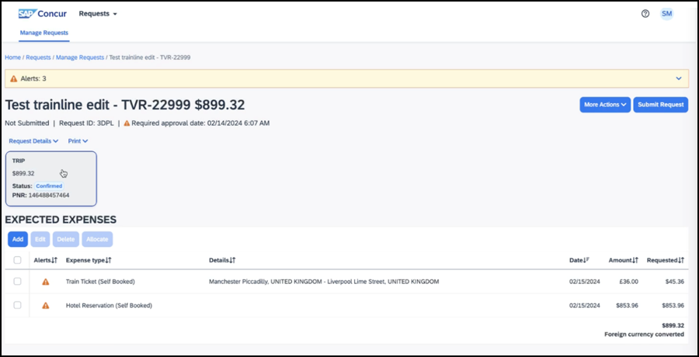
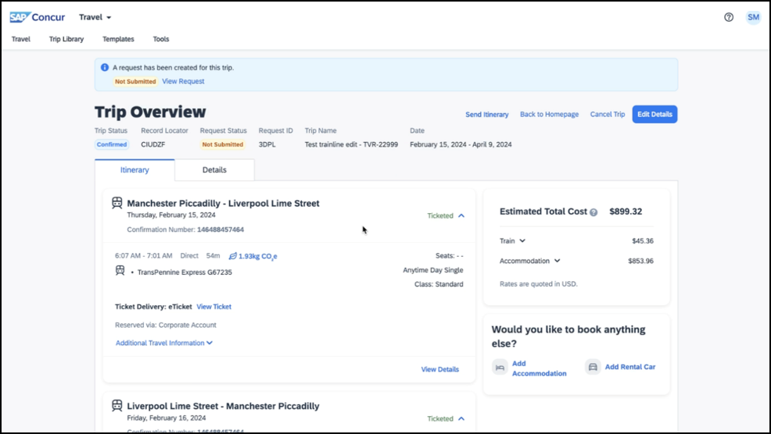
What the approver sees 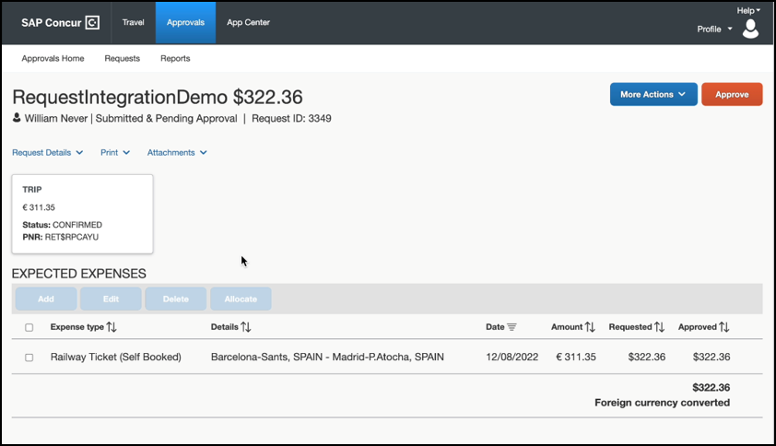
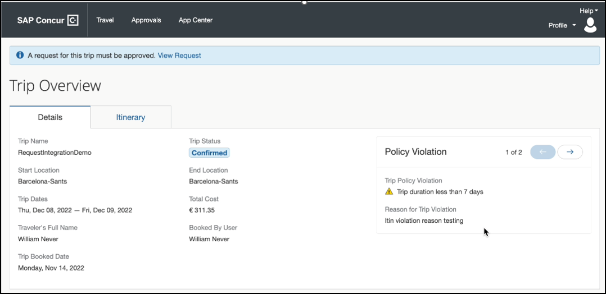

Configuration for Professional Travel
Follow the procedures for accessing the travel configuration page through the Travel System Admin. When you click the Enable Request Integration checkbox, a list of options appears:
- Always Create Request: A request is always created, regardless of travel rules.
- Create Request Based on Concur Travel Rules: If a rule using the "Require Approval" enforcement level is broken, then a request is required. If no rules using the "Require Approval" enforcement level are broken, then the process of creating a request is bypassed and the trip is sent directly to ticketing.
Any rules that are broken that use other levels of enforcement (Require Passive Approval, Notify Manager, etc.) will not redirect the user to a request.
To enable the Concur Request integration, refer to the steps provided in the Concur Travel System Admin Guide. For the relationship between Concur Request and Concur Travel approvals, refer to the appendix in the Approvals, Rules, and Classes/Policies Travel Service Guide. For more information about Concur Request, refer to the SAP Concur support portal.

New Concur Travel Experience: Out-of-Policy Popup on Shop Pages (Professional Edition Only) (Mar 22)

Prof | Stan |   Edition
X |  | On: Impacts end users who use this feature/vendor; no configuration/setup by agency/ admin; cannot be turned OFF (example: new icons or rate display)
 |  | Available for use: No impact to end users unless/until configuration/setup by agency/admin (described below) (example: new rule, new Travelfusion airline)
 |  | Other: Refer to the release note below
 | X | Does not apply to this edition
Source
GDS
Direct Connect
Other
X | EMEA Data Center |  |  | Scan impact
X | North America Data Center |  | X | UI impact
 | China Data Center |  |  | File finishing impact
 | All data centers |  |  | Profile/Profile API/3rd Party XML Sync Impact
Affected Documentation
TSGs
Fact Sheets
Admin Guides
Other |  | Concur Travel Professional Edition End User Help

Overview
In this release, the out-of-policy popup message will consistently display for flight, car, hotel, and rail shop pages.
The Allow, Display Message, and Allow/Display Message options will present a blue information icon. Any other rule actions will display below a yellow warning icon.
If a blue information icon or no icon displays, it means that the option is in-policy. A green checkmark icon will not display.

User/Customer Benefit
The new popup message facilitates a consistent user experience.

End-User Experience
The following images demonstrate popup messages for out-of-policy occurrences.
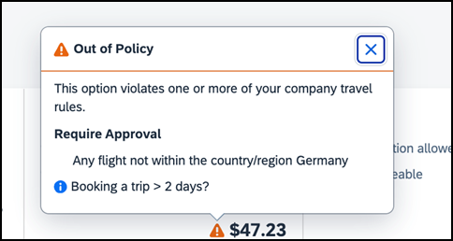
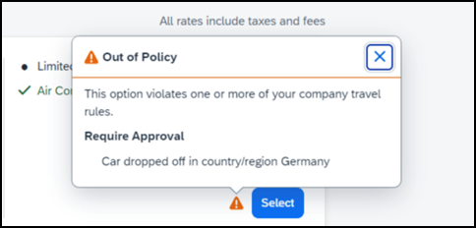
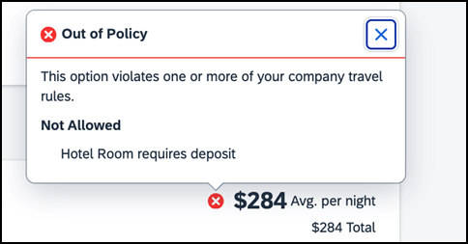

Configuration for Professional Travel
This feature is enabled by default. There are no configuration steps.

New Concur Travel Experience: Travel Policy Updates on Review & Book and Finalize Pages (Professional Edition Only) (Mar 22)

Prof | Stan |   Edition
X |  | On: Impacts end users who use this feature/vendor; no configuration/setup by agency/ admin; cannot be turned OFF (example: new icons or rate display)
 |  | Available for use: No impact to end users unless/until configuration/setup by agency/admin (described below) (example: new rule, new Travelfusion airline)
 |  | Other: Refer to the release note below
 | X | Does not apply to this edition
Source
GDS
Direct Connect
Other
X | EMEA Data Center |  |  | Scan impact
X | North America Data Center |  | X | UI impact
 | China Data Center |  |  | File finishing impact
 | All data centers |  |  | Profile/Profile API/3rd Party XML Sync Impact
Affected Documentation
TSGs
Fact Sheets
Admin Guides
Other |  | Concur Travel Professional Edition End User Help

Overview
The Travel Policy section on the Review and Book and Finalize pages indicates the specific policy that is violated for bookings and trip itinerary, respectively. The following updates are included in this release:
- Removal of existing banner on both pages. This banner is no longer necessary as it does not provide other information than what is already shown in the Travel Policy section.
- A visual indication of the most severe policy violation in the Travel Policy section so that the traveler can quickly identify the rule action for that booking or itinerary.

User/Customer Benefit
The user can work with a simplified user experience with immediately visible warnings or messages that require their attention.

End-User Experience
In the Travel Policy section, the user will see a user interface component resembling a blue pill with text. For example:

Configuration for Professional Travel
This feature is enabled by default. There are no configuration steps.

Car

New Concur Travel Experience: Sixt and Hertz Direct Connect via Car Connector Available in Eligible Markets (Professional Edition Only) (Mar 22)

Prof | Stan |   Edition
 |  | On: Impacts end users who use this feature/vendor; no configuration/setup by agency/ admin; cannot be turned OFF (example: new icons or rate display)
 |  | Available for use: No impact to end users unless/until configuration/setup by agency/admin (described below) (example: new rule, new Travelfusion airline)
X |  | Other: Refer to the release note below
 | X | Does not apply to this edition
Source
GDS |  | Sabre, Amadeus
Direct Connect |  | Car Connector
Other
X | EMEA Data Center |  |  | Scan impact
X | North America Data Center |  |  | UI impact
 | China Data Center |  |  | File finishing impact
 | All data centers |  |  | Profile/Profile API/3rd Party XML Sync Impact
Affected Documentation
TSGs
Fact Sheets
Admin Guides
Other

Overview
Sixt and Hertz direct connect will be offered in the new Concur Travel experience, without any restrictions in the eligible markets, via Car Connector. In the March release, customers that use Sixt or Hertz direct connect for car bookings can enable it either at the company level or at a separate configuration.

User/Customer Benefit
The new Concur Travel Car booking experience via Car Connector offers a feature set for customers open to explore the changes:
- Time Savings: The car booking workflow has fewer required steps to complete a booking.
- Delivery and Collection: Delivery and Collection feature is supported for Car Connector bookings
- Sustainability: Let end users consider the environmental footprint by comparing carbon dioxide (CO2) emissions between offered vehicles. Additional filter options on hybrid and electric cars help promote more sustainable choices. The new sort option Lowest emissions is offered.
- Merged on-airport and off-airport search: No matter where the user requires a rental car, all text entries will be recognized, and location suggestions are provided. All activated rental car companies with negotiated packages will be comparable.
- Location and Rate Details: Location and Rate information is delivered in real-time directly from suppliers via Car Connector.

Configuration for Professional Travel

Hertz and Sixt Direct Content
To configure:
- Click Administration > Travel (on the sub-menu) > Travel System Admin and select the desired client travel configuration.
Depending on your permissions, the page may appear immediately after you click Administration or Travel.
- In the Car Connector section of the travel configuration page, locate the Hertz and Sixt activation checkboxes.
Hertz and Sixt Direct Connect are currently the only direct connects available for the new Concur Travel experience. Europcar Direct Connect is not yet available.
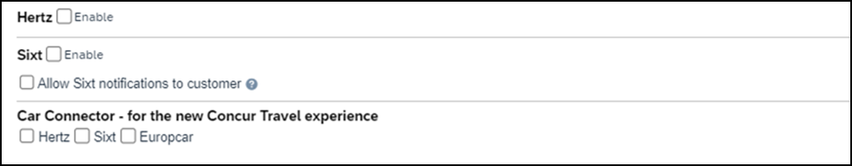

Hertz and Sixt Passive PNR for Direct Content
To configure:
- Click Administration > Travel (on the sub-menu) > Travel System Admin and select the desired client travel configuration.
Depending on your permissions, the page may appear immediately after you click Administration or Travel.
- Under the GDS PNR Options of the travel configuration page, go to the activation checkboxes.
- Under Defaults for Specific non-GDS vendors, select the Car Connector checkbox. The default for this field is Use the default specified above. Select the Write passive segments for non-GDS content if I have not specified a default for the specific vendor in the table below checkbox.

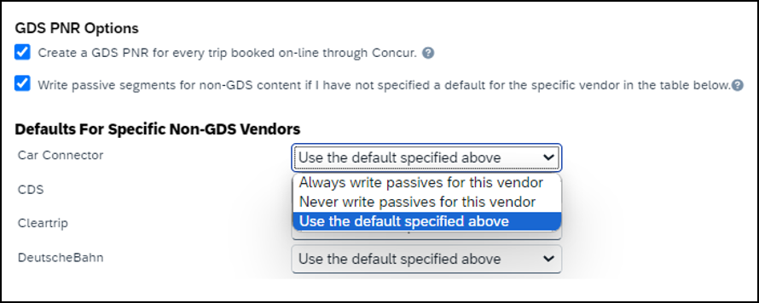
FAQ
Q. Can a customer enable only one of the new vendors available through Car Connector?
A. Yes, Sixt and Hertz via Car Connector partner can either be enabled both or separately.
Q. Can customers enable Car Connector vendors together with the GDS content in the new Concur Travel experience?
A. Yes.
Q. Can customers enable Car Connector on all their travel configurations?
A. The new Car direct connect content via Car Connector can be enabled together with the GDS content only in the markets that are eligible for the new Concur Travel experience.
Q. Can customers combine GDS Car booking from the legacy Concur Travel experience with Car Connector content in the new concur Travel experience?
A. No, car bookings from the legacy concur travel experience cannot be combined with Car Connector bookings. Customers willing to enable both GDS and direct connect content will need to wait until the new concur travel experience is available for their market.
Q. Is Delivery and Collection supported for Car Connector bookings?
A. Yes.

New Concur Travel Experience: Redesign of Car Search Results Page (Professional Edition Only) (Mar 22)

Prof | Stan |   Edition
 |  | On: Impacts end users who use this feature/vendor; no configuration/setup by agency/ admin; cannot be turned OFF (example: new icons or rate display)
 |  | Available for use: No impact to end users unless/until configuration/setup by agency/admin (described below) (example: new rule, new Travelfusion airline)
X |  | Other: Refer to the release note below
 | X | Does not apply to this edition
Source
GDS |  | Sabre, Amadeus
Direct Connect |  | Car Connector
Other
X | EMEA Data Center |  |  | Scan impact
X | North America Data Center |  |  | UI impact
 | China Data Center |  |  | File finishing impact
 | All data centers |  |  | Profile/Profile API/3rd Party XML Sync Impact
Affected Documentation
TSGs
Fact Sheets
Admin Guides
Other

Overview
The Car Search Results page is now updated to provide a seamless design experience between the Car, Air, Hotel and Rail verticals.

User/Customer Benefit
This change is being made to provide a more consistent user experience with Air, Hotel and Rail bookings.

End-User Experience
With this release, the Car Search Results page will be adapted for better usability.
The Edit Search form on the Car Search Results page has been updated.
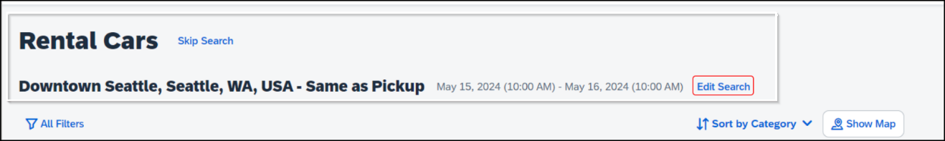
Clicking Edit Search expands the search parameters and new options can be selected.
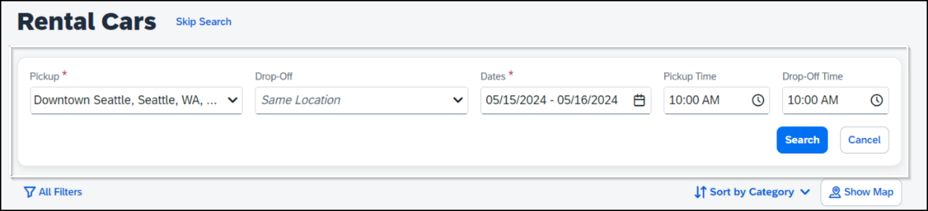

Search Results
Once the search is complete, there are different ways to view the results. The new combined filter allows the user to filter the results by options such as Category, Type, Rental Company and Specifications.
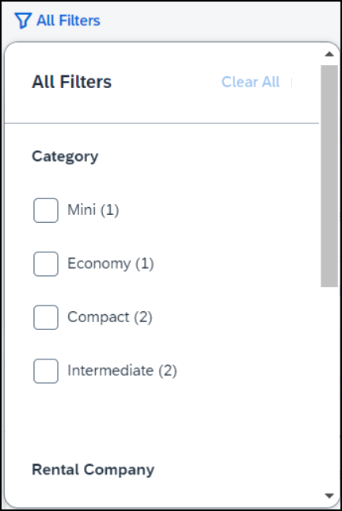
The Sort by Category dropdown has been updated with a new design.
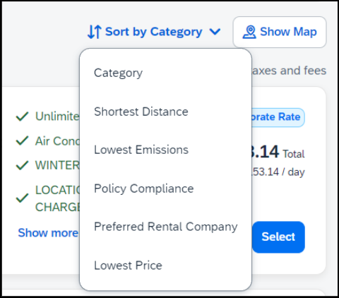

Configuration for Professional Travel
This feature is enabled by default. There are no configuration steps.

Flight

New Concur Travel Experience: Updated Details of Taxes, Fees and Charges (Professional Edition Only) (Mar 22)

Prof | Stan |   Edition
 |  | On: Impacts end users who use this feature/vendor; no configuration/setup by agency/ admin; cannot be turned OFF (example: new icons or rate display)
 |  | Available for use: No impact to end users unless/until configuration/setup by agency/admin (described below) (example: new rule, new Travelfusion airline)
X |  | Other: Refer to the release note below
 | X | Does not apply to this edition
Source
GDS |  | Sabre EDIFACT
Direct Connect |  | Sabre NDC
Other
X | EMEA Data Center |  |  | Scan impact
X | North America Data Center |  | X | UI impact
 | China Data Center |  |  | File finishing impact
 | All data centers |  |  | Profile/Profile API/3rd Party XML Sync Impact
Affected Documentation
TSGs
Fact Sheets
Admin Guides
Other

Overview
With this release, the way that details for taxes, fees and charges appear will change for Flight. A more detailed breakdown of taxes, fees and charges will be available on the Review and Book, Finalize and Trip Overview pages. They will also be visible in the confirmation e-mails.

User/Customer Benefit
This change is being made to provide more transparency to end users during the booking process. Viewing detailed information regarding fees allows the end user to consider alternative routes.

End-User Experience
In the Estimated Total Cost section, expanding the Taxes, fees & charges displays an itemized list of the charges associated with the fare.
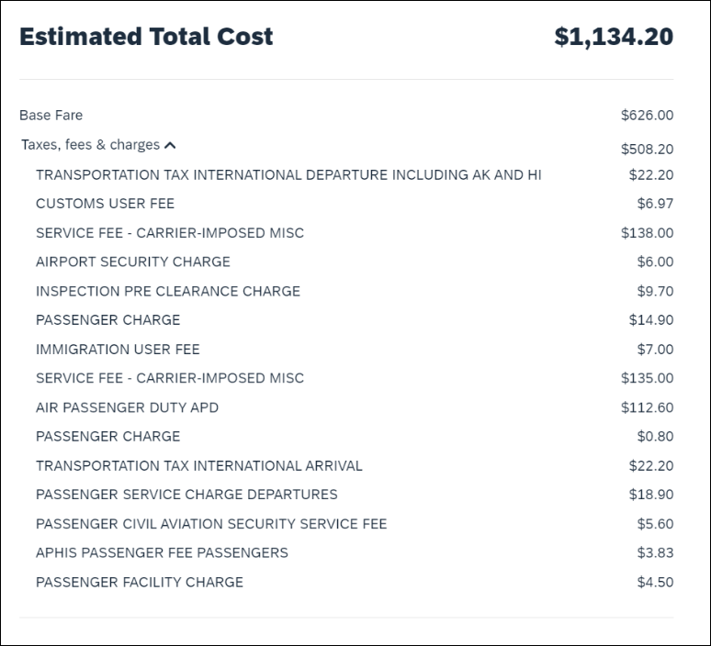
In case of a missing tax description (for example, if not sent by the air booking source), the tax, fee, or charge will show a label of Other Tax, Fee, or Charge along with the amount.
This feature will be available for TMC Preview, from March 18 to March 21. It will be available to all customers, on March 22.

Configuration for Professional Travel
This feature is enabled by default. There are no configuration steps.

New Concur Travel Experience: Display Possible Ticketing Fees Information on Review and Book (Professional Edition Only) (Mar 22)

Prof | Stan |   Edition
 |  | On: Impacts end users who use this feature/vendor; no configuration/setup by agency/ admin; cannot be turned OFF (example: new icons or rate display)
X |  | Available for use: No impact to end users unless/until configuration/setup by agency/admin (described below) (example: new rule, new Travelfusion airline)
X |  | Other: Refer to the release note below
 | X | Does not apply to this edition
Source
GDS |  | Sabre EDIFACT
Direct Connect
Other
X | EMEA Data Center |  |  | Scan impact
X | North America Data Center |  | X | UI impact
 | China Data Center |  |  | File finishing impact
 | All data centers |  |  | Profile/Profile API/3rd Party XML Sync Impact
Affected Documentation
TSGs
Fact Sheets
Admin Guides
Other

Overview
Airlines may charge ticketing fees based on card form of payment. These non-refundable fees are not included in the ticket price and are assessed only at ticketing. A warning message will be provided to alert the traveler to the maximum possible fee on the Review and Book screen. The rules governing these fees vary by country and/or governing body and are not assessed on sales where Agency Invoice is used. The fees have always been in place; however, the way SAP Concur communicates it to the end user has changed. This warning message is only applicable to the users of the new Concur Travel experience.
Previously, customers could provide Vendor Segment Fee information through Concur Travel by pre-determining fees to show as a tax or fee. This required checking the Enable Vendor Segment Fees box in the Company Travel configuration, then managing the segment fees. Now, any customer who has Vendor Segment Fees enabled will see this automated warning whenever the airline has filed fees for a trip.
Not all airlines and routes have form of payment fees so the fee warning is only shown when applicable.
Airlines may charge different fee amounts based on their contracts that control card surcharges. The highest possible fee will be shown in the message but the actual fee will be determined upon ticketing when the exact card used is known.

User/Customer Benefit
This change is being made to provide more transparency to the end user. End users can be prepared for the possibility of additional fees on their invoices.

End-User Experience
When a Flight booking is being completed a warning message will appear to alert users to the possibility of additional fees, based on the use of their chosen card. On the Review and Book page, in the Estimated Total Cost, a warning appears declaring the maximum possible fees that could be charged after booking.
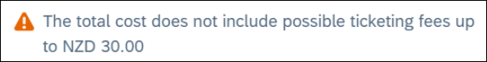
This feature will be available for TMC Preview, from March 18 to March 21. It will be available to all customers, on March 22.

Configuration for Professional Travel
This feature is enabled by default for configurations that already have Vendor Segment Fees enabled. There are no additional configuration steps.

New Concur Travel Experience: Mixed Brand Offers and Product Selection (Professional Edition Only) (Mar 22)

Prof | Stan |   Edition
 |  | On: Impacts end users who use this feature/vendor; no configuration/setup by agency/ admin; cannot be turned OFF (example: new icons or rate display)
 |  | Available for use: No impact to end users unless/until configuration/setup by agency/admin (described below) (example: new rule, new Travelfusion airline)
X |  | Other: Refer to the release note below
 | X | Does not apply to this edition
Source
GDS |  | Sabre EDIFACT
Direct Connect
Other
X | EMEA Data Center |  |  | Scan impact
X | North America Data Center |  | X | UI impact
 | China Data Center |  |  | File finishing impact
 | All data centers |  |  | Profile/Profile API/3rd Party XML Sync Impact
Affected Documentation
TSGs
Fact Sheets
Admin Guides
Other

Overview
In this release, end users can mix different brands between outbound and inbound flights. Initial shopping results to select outbound flight options continue to display all round-trip-based prices, where every offer displays the total cost for flying outbound and inbound with the same brand. There are no actual changes on the outbound selection page.
Upon selecting any EDIFACT-branded option on the outbound selection page, the options displayed on the inbound selection page are going to be mixed. Prices will display in a round-trip fashion, where every price represents the entire price of the trip: exact outbound pricing in the selected brand combined with the inbound pricing for the brand displayed in the user interface.
This feature will be available for TMC Preview, from March 18 to March 21. It will be available to all customers, on March 22.

User/Customer Benefit
Users are offered the flexibility to customize their flights. They can combine different brands, cabins, or products within the same trip.

Limitations
This enhancement is not supported for non-branded EDIFACT or NDC flight bookings.
If the selected inbound and outbound flights have a different fare class of service, and the selected offer is out-of-policy, the least cost logical fares (LLF) displayed on the policy violation pop-up will be calculated using the outbound fare’s class of service.

End-User Experience
Example:
An outbound offer of $566 is selected (Comfort Plus brand):
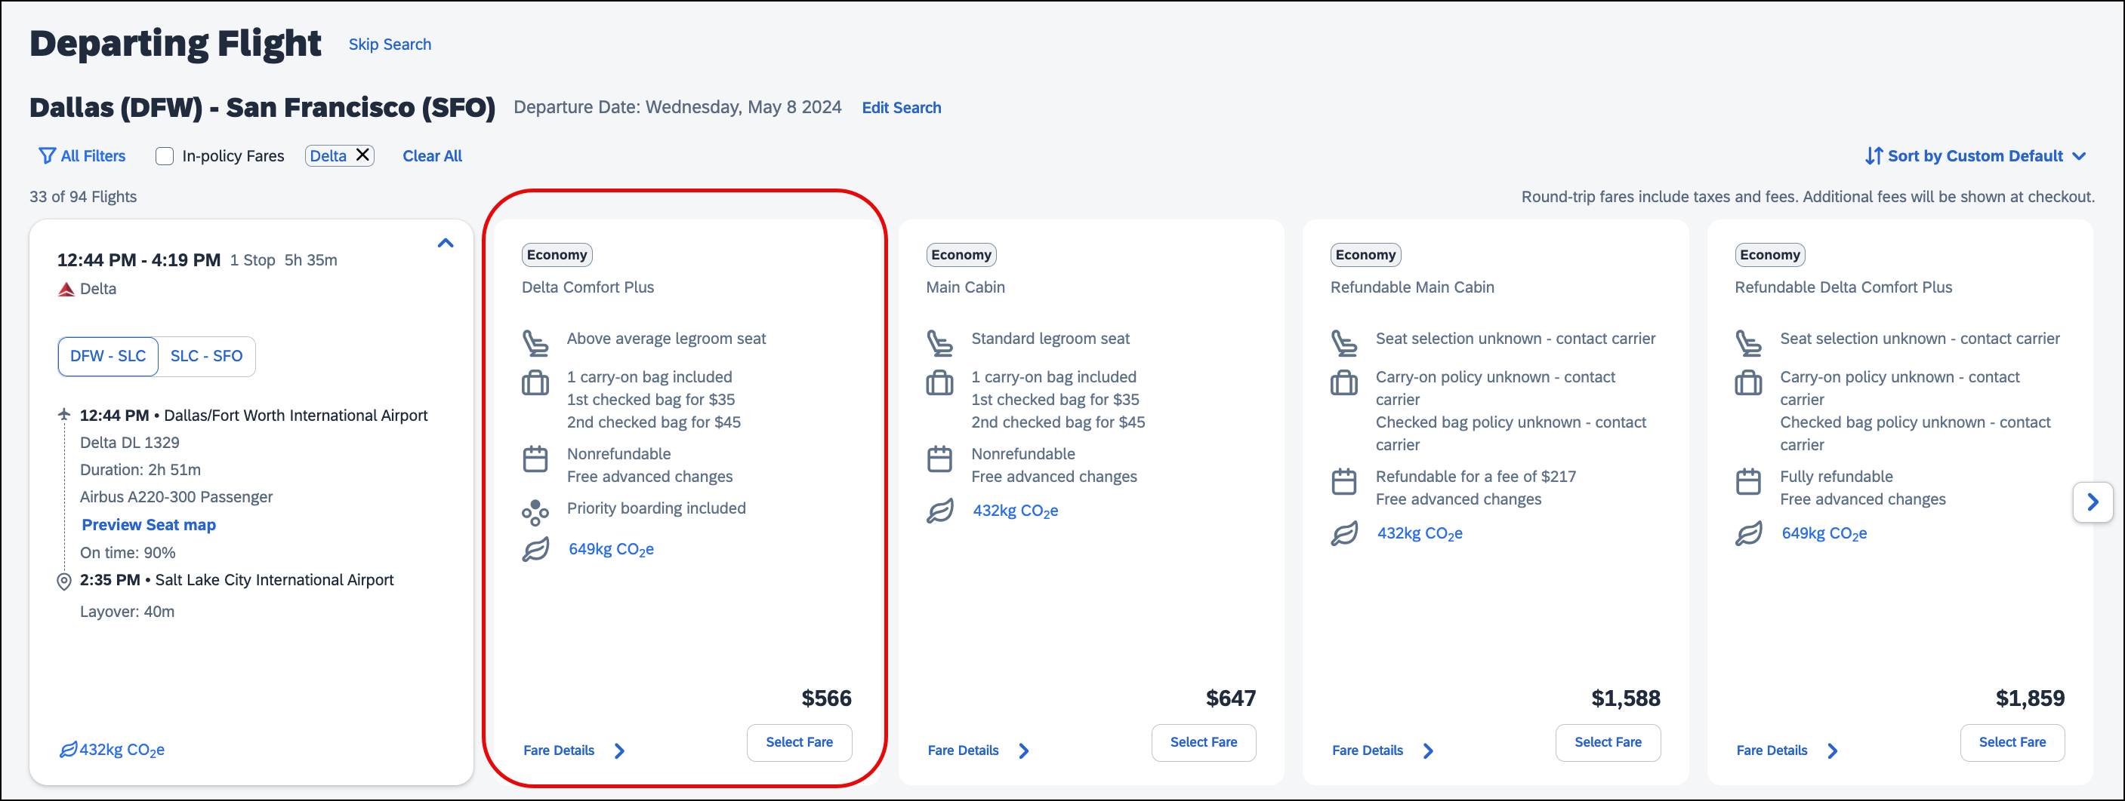
Then, the inbound selection set displays prices that consider the selected, combined with every single possible product, driving mixed prices when using a different brand.
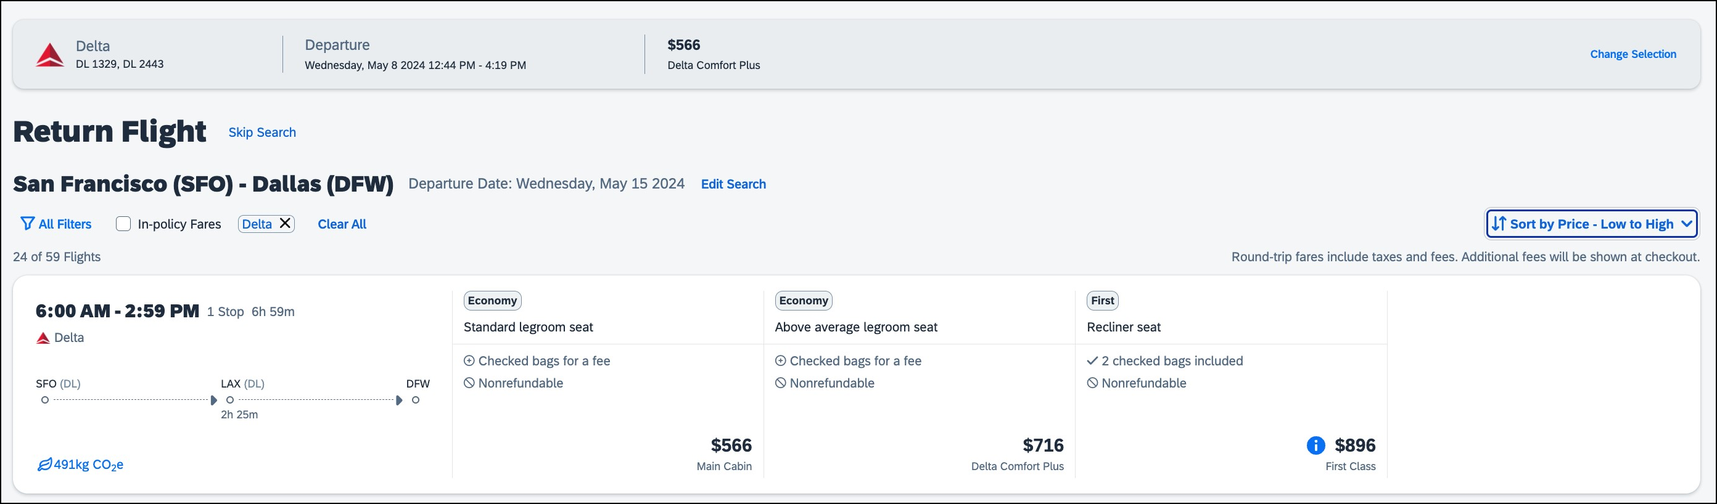
The $566 offer with both outbound and inbound on Comfort Plus is also available. Since no forced upsells nor downsells occur, no warning will display. The end user will be transferred to the Review and Book page to continue with the booking process.

Configuration for Professional Travel
This feature is enabled by default. There are no configuration steps.

New Concur Travel Experience: Update to Round Trip Pricing (Professional Edition Only) (Mar 22)

Prof | Stan |   Edition
 |  | On: Impacts end users who use this feature/vendor; no configuration/setup by agency/ admin; cannot be turned OFF (example: new icons or rate display)
 |  | Available for use: No impact to end users unless/until configuration/setup by agency/admin (described below) (example: new rule, new Travelfusion airline)
X |  | Other: Refer to the release note below
 | X | Does not apply to this edition
Source
GDS
Direct Connect
Other
X | EMEA Data Center |  |  | Scan impact
X | North America Data Center |  | X | UI impact
 | China Data Center |  |  | File finishing impact
 | All data centers |  |  | Profile/Profile API/3rd Party XML Sync Impact
Affected Documentation
TSGs
Fact Sheets
Admin Guides
Other |  | Concur Travel Professional Edition End User Help

Overview
With the March release, Concur Travel will update the way prices for round trips are displayed. Currently, users sometimes see negative pricing when booking a round trip. SAP Concur has adjusted the way these fares are shown to provide a more enhanced user experience.
This feature will be available for TMC Preview, from March 18 to March 21. It will be available to all customers, on March 22.

User/Customer Benefit
This change has been made to eliminate confusion in the round-trip booking process and to avoid any manual calculations for the end user.

End-User Experience
The fares for round trip searches in Flight have changed to show prices as a round trip total on both the outbound and return results. This provides more transparency so customers know exactly what price is being charged for their trip.
Currently, if an inbound trip is more expensive than an outbound trip, the difference in the two fares displays, instead of the price of the fare. If there is no price difference, the price displays as a zero value. If the price is less that, the difference displays as a negative value.
With this change, the total fare is automatically updated to reflect the total fare.

Configuration for Professional Travel
This feature is enabled by default. There are no configuration steps.

New Concur Travel Experience: Include Accommodation Option on the Flight Search Tab (Professional Edition Only) (Mar 22)

Prof | Stan |   Edition
 |  | On: Impacts end users who use this feature/vendor; no configuration/setup by agency/ admin; cannot be turned OFF (example: new icons or rate display)
 |  | Available for use: No impact to end users unless/until configuration/setup by agency/admin (described below) (example: new rule, new Travelfusion airline)
X |  | Other: Refer to the release note below
 | X | Does not apply to this edition
Source
GDS
Direct Connect
Other
X | EMEA Data Center |  |  | Scan impact
X | North America Data Center |  | X | UI impact
 | China Data Center |  |  | File finishing impact
 | All data centers |  |  | Profile/Profile API/3rd Party XML Sync Impact
Affected Documentation
TSGs
Fact Sheets
Admin Guides
Other |  | Concur Travel Professional Edition End User Help

Overview
Users creating a trip itinerary can include flights, hotel, car, and rail reservations, all within the same trip. In this March release, a more streamlined approach will be available. When entering a flight search on the Flight Search tab, they can simultaneously include a search for accommodations.
This feature will be available for TMC Preview, from March 18 to March 21. It will be available to all customers, on March 22.

User/Customer Benefit
Upcoming changes to the Concur Travel user interface will help minimize the number of steps required to complete the trip booking process.

End-User Experience
The Flight Search tab now includes the Include Accommodation option.
Once a user has entered their flight search conditions on the Flight Search tab, the Include Accommodation checkbox is enabled. If clicked, the user interface updates to display accommodations search options.
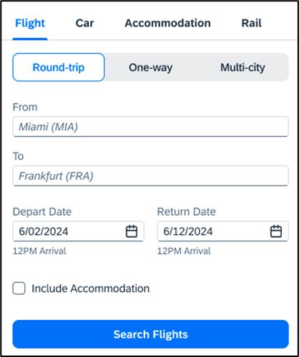
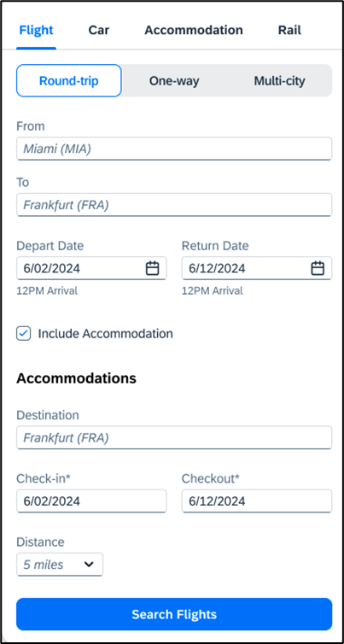
Once a user clicks Search Flights, the user interface updates to display the Flight search results. The user then selects their flight and clicks Book and Continue. Previously, the user was redirected to Finalize page and had the option to Add Accommodation. With this change, after the Book and Continue page, the user interface immediately displays the accommodations results.
The user selects their accommodations and again clicks Book and Continue. The user interface displays the Finalize screen where the user can confirm the trip with both bookings.
If the user edits their flight search query during this process, the results of the original accommodations query will display to the user. This is consistent with legacy Concur Travel behavior.

Configuration for Professional Travel
This feature is enabled by default. There are no configuration steps.
If the Hide Hotel Tab module property is enabled, users will not see the Include Accommodation option and will not be able to add accommodations to their flight search.

Hotel

New Concur Travel Experience: Hotel Enhancements on Shop Pages (professional Edition Only) (Mar 22)

Prof | Stan |   Edition
 |  | On: Impacts end users who use this feature/vendor; no configuration/setup by agency/ admin; cannot be turned OFF (example: new icons or rate display)
 |  | Available for use: No impact to end users unless/until configuration/setup by agency/admin (described below) (example: new rule, new Travelfusion airline)
X |  | Other: Refer to the release note below
 | X | Does not apply to this edition
Source
GDS |  | Sabre
Direct Connect |  | Custom Hotel Source providers (TBD)
Other
 | EMEA Data Center |  |  | Scan impact
 | North America Data Center |  |  | UI impact
 | China Data Center |  |  | File finishing impact
 | All data centers |  |  | Profile/Profile API/3rd Party XML Sync Impact
Affected Documentation
TSGs
Fact Sheets
Admin Guides
Other

Overview
The new Hotel experience now includes the following enhancements for Hotel content:
- Map icons to highlight Preferred and Fedroom properties.
- Sustainable Property tag that replaces the leaf symbol beside the property name.
- Display of costs for amenities where applicable on the Hotel details page (CHS only).

User / Customer Benefit
These enhancements provide additional information for customers when shopping for properties, allowing them to make more informed decisions as they book.

End-User Experience
Example: New map icons
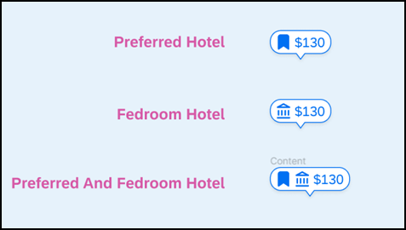
Example: Sustainable Property tag
Example: Amenity costs
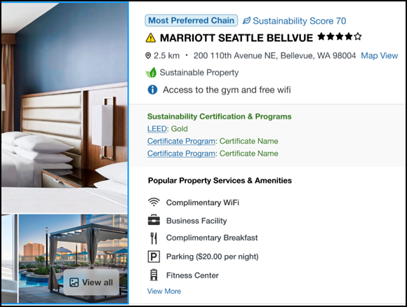
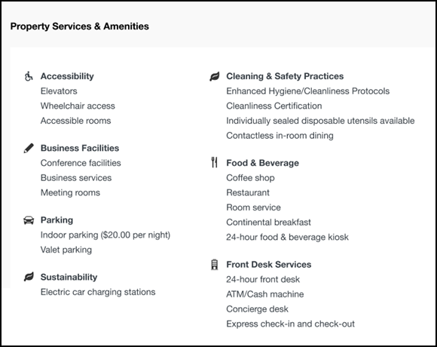

Configuration for Professional Travel
These features are enabled by default. There are no configuration steps.

New Concur Travel Experience: Support for Per Diems (Professional Edition Only) (Mar 22)

Prof | Stan |   Edition
 |  | On: Impacts end users who use this feature/vendor; no configuration/setup by agency/ admin; cannot be turned OFF (example: new icons or rate display)
 |  | Available for use: No impact to end users unless/until configuration/setup by agency/admin (described below) (example: new rule, new Travelfusion airline)
X |  | Other: Refer to the release note below
 | X | Does not apply to this edition
Source
GDS |  | Sabre
Direct Connect |  | Custom Hotel Source providers (TBD)
Other
 | EMEA Data Center |  |  | Scan impact
 | North America Data Center |  |  | UI impact
 | China Data Center |  |  | File finishing impact
 | All data centers |  |  | Profile/Profile API/3rd Party XML Sync Impact
Affected Documentation
TSGs
Fact Sheets
Admin Guides |  | Travel System Admin Guide
Other

Overview
The new Hotel experience includes support for Per Diems, or daily allowances, for both Concur Travel only and Travel and Expense users.
This feature will be available for TMC Preview from March 18 to 21. From March 22, it will be available for all customers.

User/Customer Benefit
Travel managers can use per diems to ensure that their travelers are not spending more than what has been deemed appropriate for a given location. By implementing travel policies based on per diem rates, travel managers can save travel spend by leveraging data the government uses to estimate location-based hotel room rate value.

End-User Experience: Search Results
If the Display per diem rates with individual hotel selections configuration setting is selected, the Search results page will include the per diem lodging limits for the property location together with the dates the per diem rate is applicable.
This configuration setting applies to all users whether they are Concur Travel only or Travel and Expense.
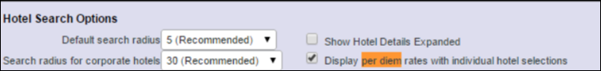
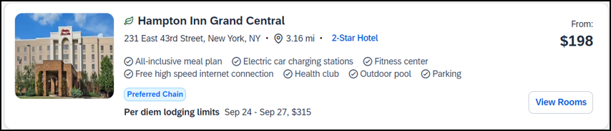

End-User Experience: Hotel Details
The Hotel Details page (as shown next) displays the Per Diem rate plus the Meals and Incidentals rates when applicable, at the top of the page.
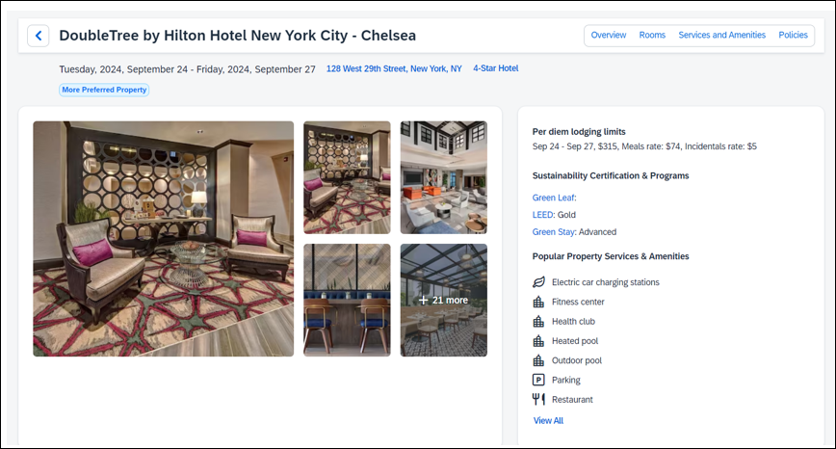

End-User Experience: Review and Book
The Review and Book page displays the Per Diem rate plus the Meals and Incidentals rates when applicable, at the bottom of the Hotel section.
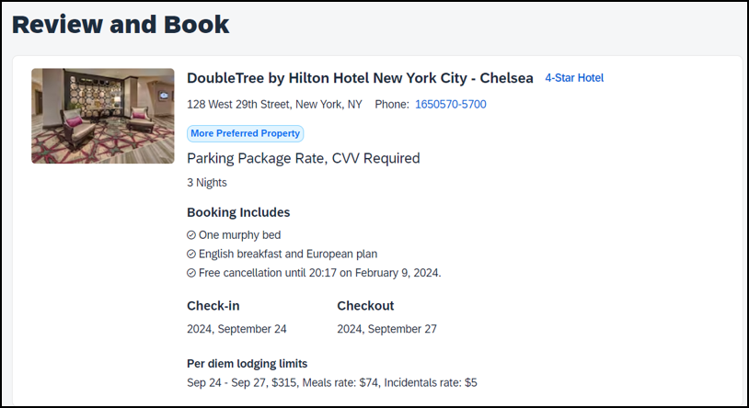

End-User Experience: Trip Overview
The Trip Overview page displays the Per Diem rate plus the Meals and Incidentals rates when applicable, at the bottom of the Hotel section.
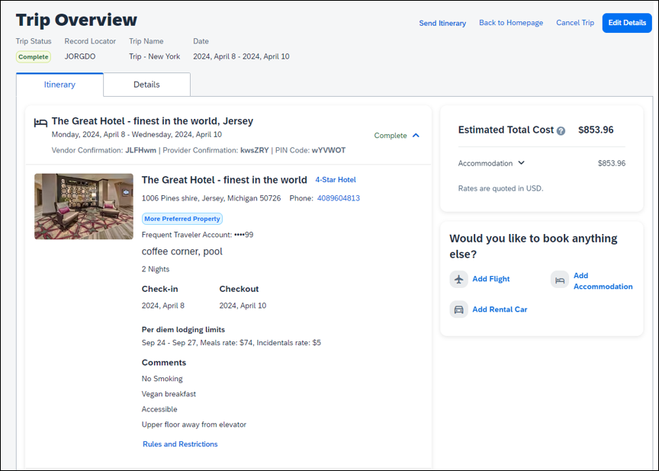

End-User Experience: Per Diem Policy Rules
There are two policy rules that use Per Diems:
- Travel only users:
Hotel Rate is [condition] the government location based per diem rate [plusMinus] [money] [currencyOrPercent]
- Travel and Expense users:
Hotel Rate is [condition] the government hotel level based per diem rate [plusMinus] [money] [currencyOrPercent]
Each hotel rate is marked in or out of policy, depending on how the travel per diem rule has been configured.
The hotel per diem policy rule is enforced on the average nightly rate.
For more information on the per diem rates option, refer to the Configuring a Company section in the Travel System Admin Guide.

Configuration for Professional Travel
These features are enabled by default. There are no configuration steps.

Hotel, Rail

**Ongoing** New Concur Travel Experience: Last Four Digits on Form of Payment Displayed (Professional Edition Only)

Information First Published | Information Last Modified | Feature Target Release Date
December 2023 | March 22, 2024 | February to April 2024
Any changes since the previous monthly release are highlighted in yellow in this release note.

Prof | Stan | Å Å Edition
 |  | On: Impacts end users who use this feature/vendor; no configuration/setup by agency/ admin; cannot be turned OFF (example: new icons or rate display, new Amtrak feature)
 |  | Available for use: No impact to end users unless/until configuration/setup by agency/admin (described below) (example: new rule, new Travelfusion airline)
X |  | Other: Refer to the release note below
 | X | Does not apply to this edition
Source / Solution Suggestion
GDS
Direct Connect |  | Trainline, Renfe
Other
X | EMEA Data Center |  |  | Scan impact
X | North America Data Center |  |  | UI impact
 | China Data Center |  |  | File finishing impact
 | All data centers |  |  | Profile/Profile API/3rd Party XML Sync Impact
Affected Documentation
TSGs
Fact Sheets
Admin Guides
Other |  | Travel Services Help

Overview
The last four digits of a traveler’s credit card or other form of payment will display on the Finalize and Trip Overview pages, and Confirmation/Cancellation emails. The forms of payment will show for Trainline, Renfe, and all Hotel web-based bookings, and all vertical bookings on mobile.

Phases
This feature will be released to specific verticals, vendors, and data centers between February and April:

Phase | Date of Release
Phase 1: Trainline (existing customers as they migrate to the new travel experience) | February 2024
Phase 2: Hotel | April 2024
Phase 3: Renfe Rail customers in US Data Center | April 8, 2024
Phase 4: Renfe Rail customers in EU Data Center | April 10, 2024

User/Customer Benefit
This update is being implemented to improve the customer experience by providing more complete information about each booking.
For Trainline bookings, users are required to provide any valid form of payment to retrieve their tickets, not necessarily the form of payment used to make the booking

End-User Experience
The last four digits of the user’s credit card will display on different pages during the booking process.
These include:
- Finalize page
- Trip Overview page
- Confirmation E-Mail
- Cancellation E-Mail
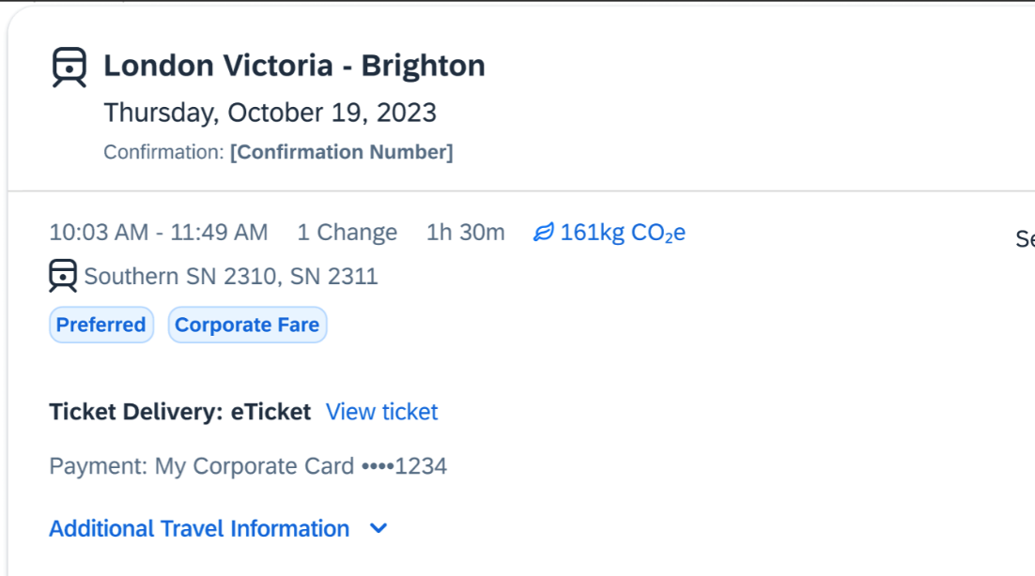

Configuration for Professional Travel
This feature is enabled by default. There are no configuration steps.
For more information on Renfe and UK Rail (Trainline), refer to the February release updates to the Travel Services Help. To locate, go to the Concur Travel product page in the SAP Help Portal and select the Travel Services Help listed under the Implement > Administration section.

Miscellaneous

Profile Enhancement for Gender Inclusivity (Mar 22)

Prof | Stan |   Edition
X | X | On: Impacts end users who use this feature/vendor; no configuration/setup by agency/ admin; cannot be turned OFF (example: new icons or rate display)
 |  | Available for use: No impact to end users unless/until configuration/setup by agency/admin (described below) (example: new rule, new Travelfusion airline)
 |  | Other: Refer to the release note below
 |  | Does not apply to this edition
Source
GDS |  | Amadeus, Apollo, Sabre, Travelport+ Worldspan
Direct Connect |  | Southwest
Other
X | EMEA Data Center |  |  | Scan impact
X | North America Data Center |  |  | UI impact
 | China Data Center |  |  | File finishing impact
 | All data centers |  |  | Profile/Profile API/3rd Party XML Sync Impact
Affected Documentation
TSGs |  | Transportation Security Administration (TSA) Requirements
Fact Sheets
Admin Guides
Other |  | Shared: Employee Import Specification

Overview
In this March release, Concur Travel will enhance the Transportation Security Administration (TSA) Secure Flight section under the Concur Travel Profile page to support two new gender options: Unspecified (X) and Undisclosed (U). With this change, users can now select from four different options in the Concur Travel Profile:
- Male (M)
- Female (F)
- Unspecified (X)
- Undisclosed (U)
This feature will be available for TMC Preview, from March 18 to March 21. It will be available to all customers, on March 22.

User/Customer Benefit
Non-binary travelers will be able to use the two new inclusive gender selections: Unspecified (X) and Undisclosed (U) for profiled travelers. The ability to select Unspecified (X) and Undisclosed (U) gender for guest and companion bookings will be available at a later date.

TMC Experience

Profile Synchronization
Inclusive Gender types Unspecified (X) and Undisclosed (U) will sync between a Concur profile and Sabre Profiles.
Inclusive Gender types Unspecified (X) and Undisclosed (U) will sync between a Concur profile and Apollo, Travelport+, and Worldspan GDS profile by using the new datapoint Gender_Inclusive with Concur Profile Templates. Gender types are not available to sync between the Concur profile and Amadeus profile. Any existing Profile templates using the Gender datapoint will need to be updated to use the new Gender_Inclusive datapoint in order to support all gender types. A lookup table is not needed for the new Gender_Inclusive datapoint.
The new Gender_Inclusive datapoint includes all genders and their corresponding values as follows:
Male = M
Female = F
Unspecified = X
Undisclosed = U

Air Bookings
When an air booking is made in Concur Travel through one of the Global Distribution Systems (GDSs) and the When to send TSA-required data to air carriers setting is set to send TSA data, Concur Travel will now send gender types Unspecified (X) and Undisclosed (U) when sending TSA Secure Flight or Advanced Passenger Information (APIS) to the airline vendor.
For Sabre NDC bookings, some providers may respond with an error when Concur Travel sends an unsupported gender to them. In such cases, Concur Travel will not be able to proceed with the booking and will inform the user of the error with the following message: “We could not complete your booking because the specified gender is not accepted by the provider for the selected airline. Please select a different airline or contact your travel agency for assistance.”
Example:
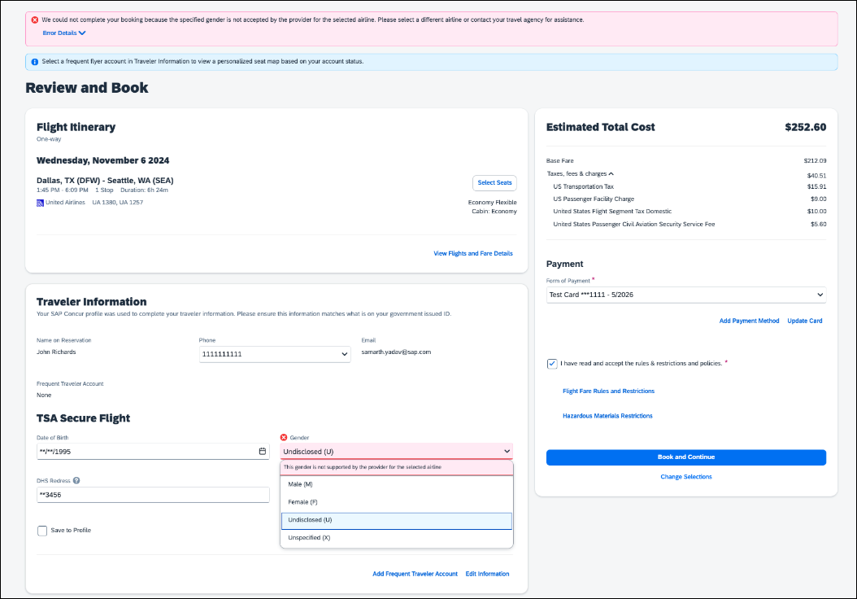
For EDIFACT bookings, all GDS systems will accept the Inclusive Gender types Unspecified (X) and Undisclosed (U) for TSA SSR messages without error, however, no validation is done with the airline being booked. If the airline booked in the PNR does not support Unspecified (X) or Undisclosed (U), the airline is required to reject the SSR message following the IATA Airline Industry Reservations Interline Message (AIRIMP) guidelines. Please refer to IATA for the most updated information regarding these rules and the format in which the airline should respond.
- Concur Travel will not monitor or act on any SSR messages rejected by the airline. Customers will need to seek a mid-office solution if they wish to automate monitoring for these SSR messages.
For more information on displaying, collecting, saving, and sending TSA data, refer to the configuration information section of the Transportation Security Administration (TSA) Requirements Travel Service Guide. To locate, refer to Additional Release Notes and Other Technical Documentation in these release notes.

Hotel, Rail, and Car Bookings
Gender information is not sent to Hotel, Rail, and Car vendors.

Finishing Templates
Inclusive Gender types Unspecified (X) and Undisclosed (U) will be available for use in Finishing Templates with the new Gender_Inclusive datapoint. Any existing templates using the Gender datapoint will need to be updated to use the new Gender_Inclusive datapoint in order to support all gender types. A lookup table is not needed for the new Gender_Inclusive datapoint.
The new Gender_Inclusive datapoint includes all genders and their corresponding values as follows:
Male = M
Female = F
Unspecified = X
Undisclosed = U

Travel Profile API 2.0
The new Gender values Unspecified (X) and Undisclosed (U) are also supported on the Travel Profile API 2.0. For more details, please refer to the Travel Profile API 2.0 Gender Diversity Support release note in this document.

Travel Import Data
The Travel Import Data Tool files will not support the new Gender selections in this March release.

Update to the employee import format
For the Travel Addendum Import (Record Type 350) format, it supports the new Gender values as:
- M: Male
- F: Female
- X: Unspecified
- U: Undisclosed
Refer to the Shared: Employee Import Specification for more information on the Travel Addendum Import format. To locate, refer to Additional Release Notes and Other Technical Documentation in these release notes.

End-User Experience
When the For information required by the TSA for travel to/from the USA field setting is set to show information in Concur Travel Profile, users will be able to select one of the four options from a Gender dropdown:
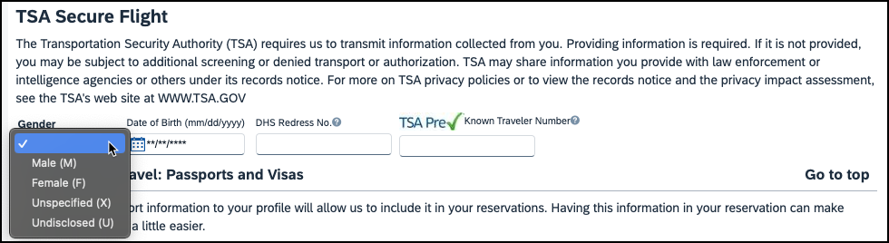
When no information is stored in the Concur Travel Profile, the information will be collected during checkout when required. The TSA Secure Flight text description will be updated to:
“The Transportation Security Authority (TSA) requires us to transmit information collected from you. Providing information is required. If it is not provided, you may be subject to additional screening or denied transport or authorization. Gender requirement for TSA is optional, but it can still be required by your company on this section. The recommendation is for the user to select the Gender that matches the Passport.TSA may share information you provide with law enforcement or intelligence agencies or others under its records notice. For more on TSA privacy policies or to view the records notice and the privacy impact assessment, see the TSA's web site at WWW.TSA.GOV.”

Configuration for Professional and Standard Travel
This feature is enabled by default. There are no configuration steps.

Zip Code Updates for Credit Card Form of Payment in Traveler Profile (Mar 22)

Prof | Stan |   Edition
X | X | On: Impacts end users who use this feature/vendor; no configuration/setup by agency/ admin; cannot be turned OFF (example: new icons or rate display)
 |  | Available for use: No impact to end users unless/until configuration/setup by agency/admin (described below) (example: new rule, new Travelfusion airline)
 |  | Other: Refer to the release note below
 |  | Does not apply to this edition
Source
GDS
Direct Connect
Other
X | EMEA Data Center |  |  | Scan impact
X | North America Data Center |  |  | UI impact
 | China Data Center |  |  | File finishing impact
X | All data centers |  |  | Profile/Profile API/3rd Party XML Sync Impact
Affected Documentation
TSGs |  | Form of Payment
Fact Sheets
Admin Guides
Other

Overview
Users and administrators with corporate credit card programs can now use 11-digit United States Zip Codes when creating or updating Profile Credit Cards. An emerging format used by the United States Postal Service makes use of 11-digit Zip codes, including a Delivery Point designation.

User/Customer Benefit
Previously, the data entry for the credit card details would not accept the expanded US Zip Code format. Now, customers can include the Delivery Point suffix, including up to 11 characters.

End-User Experience
In the traveler profile, when editing credit card details, the user will be able to edit and save the Zip Code with additional support for the delivery point information. If an invalid Zip Code value is entered, an error message displays.
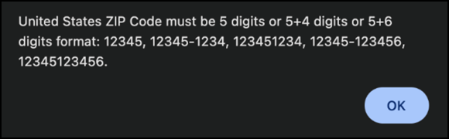

Configuration for Professional and Standard Travel
This feature is enabled by default. There are no configuration steps.

New Concur Travel Experience: Send Itinerary by Email (Professional Edition Only) (Mar 22)

Prof | Stan |   Edition
X |  | On: Impacts end users who use this feature/vendor; no configuration/setup by agency/ admin; cannot be turned OFF (example: new icons or rate display)
 |  | Available for use: No impact to end users unless/until configuration/setup by agency/admin (described below) (example: new rule, new Travelfusion airline)
 |  | Other: Refer to the release note below
 | X | Does not apply to this edition
Source
GDS |  | All
Direct Connect
Other
X | EMEA Data Center |  |  | Scan impact
X | North America Data Center |  | X | UI impact
 | China Data Center |  |  | File finishing impact
 | All data centers |  |  | Profile/Profile API/3rd Party XML Sync Impact
Affected Documentation
TSGs
Fact Sheets
Admin Guides
Other |  | Concur Travel Professional Edition End User Help

Overview
On the Trip Overview page, a Send Itinerary link will allow travelers and travel arrangers to send an itinerary to others inside or outside the organization so that they are aware of travel plans. Recipients of the shared itinerary will see an email containing general details about the trip.
This feature will be available for TMC Preview, from March 18 to March 21. It will be available to all customers, on March 22.

User/Customer Benefit
Users can easily share itineraries with others by email.

End-User Experience
When the user sends the itinerary, the recipient receives an email with general information such as trip status, traveler name, dates, record locator (if applicable), and the itinerary details for flight, hotel, rail, or car.
For data economy reasons, the following information and fields are not included in the email: Corporate Rate/Fare, Vendor preference level, Frequent Traveler Card, Advantage Card, Form of Payment, Cost section, View Details deep link, .ics attachments for calendar integration, and ticket attachments.
The following screenshots demonstrate the end-user experience.
Example: Trip Overview page with Send Itinerary link
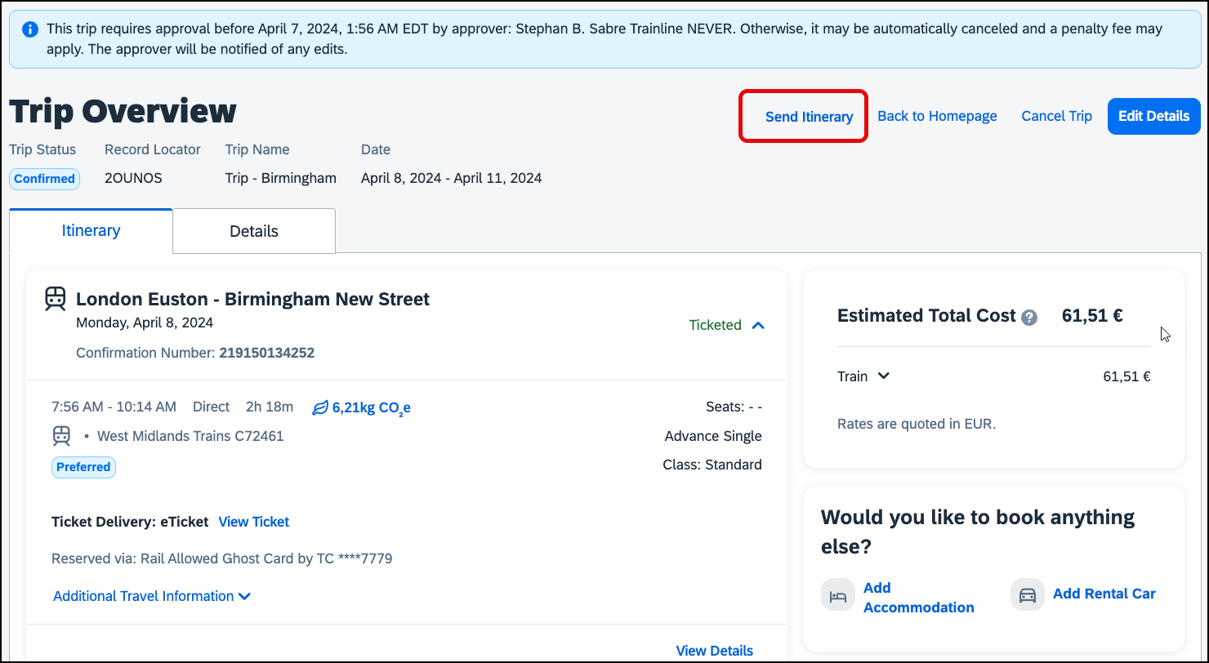
Example: Send Itinerary dialog
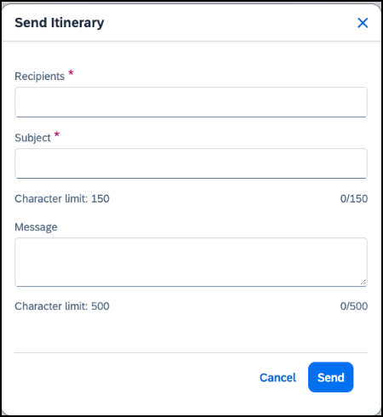
Example: Send Itinerary dialog, with field validation
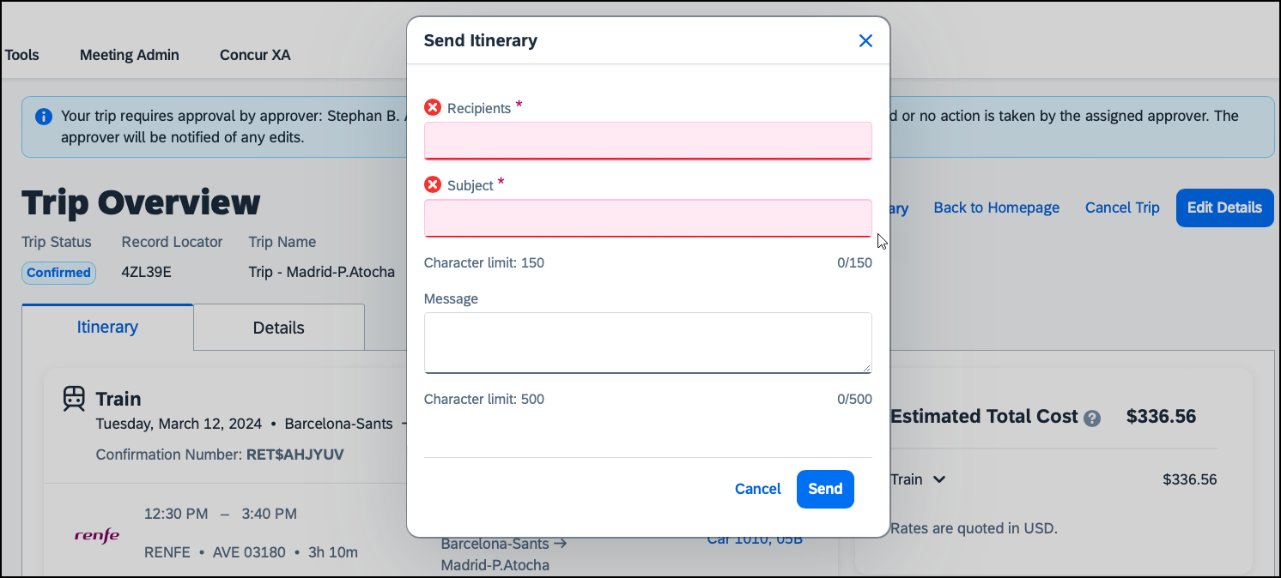
Example: Send Itinerary dialog, with fields filled in before sending
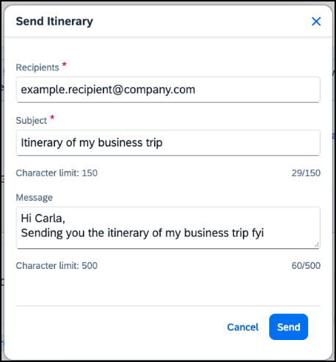
Example: Shared Itinerary Email
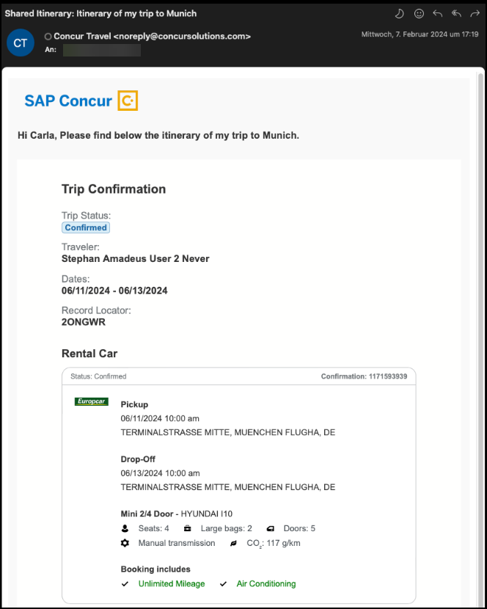

Configuration for Professional Travel
This feature is enabled by default. There are no configuration steps.

New Concur Travel Experience: Improved Translations for Airport Names (Professional Edition Only) (Mar 22)

Prof | Stan |   Edition
X |  | On: Impacts end users who use this feature/vendor; no configuration/setup by agency/ admin; cannot be turned OFF (example: new icons or rate display)
 |  | Available for use: No impact to end users unless/until configuration/setup by agency/admin (described below) (example: new rule, new Travelfusion airline)
 |  | Other: Refer to the release note below
 | X | Does not apply to this edition
Source
GDS
Direct Connect
Other
X | EMEA Data Center |  |  | Scan impact
X | North America Data Center |  | X | UI impact
 | China Data Center |  |  | File finishing impact
 | All data centers |  |  | Profile/Profile API/3rd Party XML Sync Impact
Affected Documentation
TSGs
Fact Sheets
Admin Guides
Other

Overview
In Concur Travel, translations for airport names will use AI programs (LLM – large language model). Users can find airports by searching in their language (as set in their user profile) or in English. Matching search results will display in the user’s support language.

User/Customer Benefit
Currently in Concur Travel, less than 100 airports are translated in some languages. In the March release, users will be able to see more than 5000 airports listed in all supported languages.

Configuration for Professional Travel
This feature is enabled by default. There are no configuration steps.

New Concur Travel Experience: Meeting Match Redirect to Meeting During Booking Workflow (Professional Edition Only) (Mar 22)

Prof | Stan | Å Å Edition
X |  | On: Impacts end users who use this feature/vendor; no configuration/setup by agency/ admin; cannot be turned OFF (example: new icons or rate display)
 |  | Available for use: No impact to end users unless/until configuration/setup by agency/admin (described below) (example: new rule, new Travelfusion airline)
 |  | Other: Refer to the release note below
 | X | Does not apply to this edition
Source
GDS
Direct Connect
Other
X | EMEA Data Center |  |  | Scan impact
X | North America Data Center |  | X | UI impact
 | China Data Center |  |  | File finishing impact
 | All data centers |  |  | Profile/Profile API/3rd Party XML Sync Impact
Affected Documentation
TSGs |  | Third-Party Meeting Registration Travel Service Guide
Fact Sheets
Admin Guides
Other

Overview
The new Concur Travel experience user will be presented with a choice when a meeting match is detected upon search for a flight, rail, hotel, or rental car. They can either confirm that the trip is not applicable to any of the presented meetings and continue with their booking in the new experience or select one of the presented meetings and continue with the redirect to the meeting workflow using the legacy experience of Concur Travel.
The check for meeting matches will occur for new trips only, when created. If the user does any of the following, the check will not be invoked again, and no popup detection messages will be shown:
- searches again (with a rail search)
- edit a flight, rail, hotel, or rental car search or
- add to an existing trip with flight, rail, hotel, or rental car
This feature will be available to all customers, on March 22 together with meeting match and conflict detection. For Renfe Rail customers, this feature will be available with the release of user interface enhancements during April 8 – 10.

User/Customer Benefit
New Concur Travel experience users will be offered the flexibility to use the booking workflow in the new experience and still work with the matching meeting detection feature that is available in the legacy Concur Travel experience. A redirect to the legacy experience will only be necessary if a matching meeting is detected.

End-User Experience
After a user begins the search, if a meeting match is detected based on the location and dates of the search, the user will see a popup message about the detection.
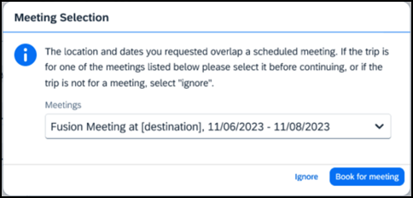
The location that displays next to the meeting name in the dropdown list is the same as the Location Name entered by the administrator in the Group Meeting Creation admin page.
The dates that display for each meeting line item in the dropdown are the same as the Start Date and End Date information entered by the administrator in the Group Meeting Creation admin page. The dates used for the meeting match check are the dates entered in the Matching Start Date and Matching End Date fields on the Group Meeting Creation admin page.

NO Meeting Match
If the user confirms that the presented meetings are not applicable, the popup message will close, and the page will automatically redirect to the next page in the booking workflow within the new experience.

Meeting Match
If the user selects one of the presented meetings from the dropdown list, they can then click Book for meeting. The page will redirect to the meeting workflow, available in the legacy experience for Concur Travel.
Important notes to consider with the redirect and flight search:
- If a round trip flight search matches a meeting, the user will be redirected to the flight results page in the legacy experience.
- If a one-way flight search matches a meeting, the user will be redirected to the Flight Information page in the legacy experience. If the meeting configuration does not allow users to book a one-way flight to the meeting, the user must enter data for the return flight there.
Important note to consider with the redirect and rental car or hotel search:
- If a rental car or hotel search matches a meeting, the user will be redirected from the new experience Search tab to the Flight Information page in the legacy experience and the meeting booking workflow for flight.
Important note to consider with the redirect and rail search:
- If a rail search matches a meeting, the user will be redirected to the Flight Information page in the legacy experience and the meeting booking workflow for flight.
Important note to consider with the redirect and trip custom fields:
- If trip custom fields are configured to display at the beginning of the workflow AND at least one of those custom fields is enabled for meetings, the redirect will be to the trip custom fields page within the meeting workflow in the legacy experience, and next to the flight results page or the Flight Information page.

Conflicting Trip and Matching Meeting
If a conflicting trip AND a matching meeting are detected, two popups in a row will display. The first one displays for conflict detection, then the second for the meeting match.

Configuration for Professional Travel
Meetings and meeting match features can be configured through the Meeting Admin section, available from the Company Admin page or Travel tab. For more information on meeting setup, refer to the Third-Party Meeting Registration Travel Service Guide.

New Concur Travel Experience: Conflict Detection (Professional Edition Only) (Mar 22)

Prof | Stan |   Edition
X |  | On: Impacts end users who use this feature/vendor; no configuration/setup by agency/ admin; cannot be turned OFF (example: new icons or rate display)
 |  | Available for use: No impact to end users unless/until configuration/setup by agency/admin (described below) (example: new rule, new Travelfusion airline)
 |  | Other: Refer to the release note below
 | X | Does not apply to this edition
Source
GDS |  | All
Direct Connect |  | All
Other
X | EMEA Data Center |  |  | Scan impact
X | North America Data Center |  | X | UI impact
 | China Data Center |  |  | File finishing impact
 | All data centers |  |  | Profile/Profile API/3rd Party XML Sync Impact
Affected Documentation
TSGs
Fact Sheets
Admin Guides
Other

Overview
In this release, Concur Travel will detect if users already have a trip booked for the dates that they have entered in the Search tool when editing the search or adding to an existing trip. If a trip is detected, the user will have the option to continue with a new booking or to cancel the search.
The warning This Trip Might Conflict acts as a safeguard against booking errors by providing users with valuable information regarding potential conflicts. By highlighting overlapping trips in advance, users can avoid double bookings, time clashes, or any other scheduling mistakes that may occur when planning and managing their trips.
This feature will be available for TMC Preview, from March 18 to March 21. It will be available to all customers, on March 22. For Renfe Rail customers, this feature will be available with the release of user interface enhancements during April 8 – 10.
For availability in the mobile app, conflict detection is targeted for the April release.

User/Customer Benefit
Users may be unaware that a travel arranger has already booked a trip for them. Concur Travel will provide users with the ability to stay informed when a conflict arises so that they can avoid unnecessary duplicate booking and scheduling conflicts.

End-User Experience
If an overlapping trip is detected, a message prompt will ask the user if they want to proceed. If they click Continue, they can proceed and book the overlapping trip. If they click Cancel, they are returned to the search.

Conflicting Trip and Matching Meeting
If a conflicting trip AND a matching meeting are detected, two popups in a row will display. The first one displays for conflict detection, then the second for the meeting match.

Configuration for Professional Travel
This feature is enabled by default. There are no configuration steps.

**Ongoing** New Concur Travel Experience: Add to Trip Enhancement (Professional Edition Only)

Prof | Stan | Å Å Edition
 |  | On: Impacts end users who use this feature/vendor; no configuration/setup by agency/ admin; cannot be turned OFF (example: new icons or rate display, new Amtrak feature)
 |  | Available for use: No impact to end users unless/until configuration/setup by agency/admin (described below) (example: new rule, new Travelfusion airline)
X |  | Other: Refer to the release note below
 | X | Does not apply to this edition
Source / Solution Suggestion
GDS |  | All Flight and Hotel sources
Direct Connect
Other
X | EMEA Data Center |  |  | Scan impact
X | North America Data Center |  |  | UI impact
 | China Data Center |  |  | File finishing impact
 | All data centers |  |  | Profile/Profile API/3rd Party XML Sync Impact
Affected Documentation
TSGs
Fact Sheets
Admin Guides
Other |  | Concur Travel Professional Edition End User Help

Overview
Concur Travel is enhancing the user experience when adding bookings to an existing trip.
In this release, when adding Hotel to an existing trip, the Your Reservations dropdown will be enhanced to contain relevant information from the previously booked Flight, Car, and/or Rail. When the trip contains a single booking, Concur Travel will pre-select one of the values from the dropdown. More details about this enhancement are available in the user experience section of this release note.
In upcoming releases, similar enhancements will also be available for Flight and Car, and a new modal will be available when adding a new Concur Travel experience booking to another new Concur Travel experience booking. The user experience will remain the same when adding a new Concur Travel experience booking to a legacy Concur Travel booking.

Phases
This feature will be released in phases:

Phase | Date of Release
Phase 1:  - Enhancements in the “Your reservations” dropdown options and pre-selection of one of the options when adding Hotel to an existing trip.  - No changes to existing user interface. | March 2024
Phase 2:  - Enhancements in the “Your reservations” dropdown options and pre-selection of one of the options when adding Flight and Car to an existing trip  - New UI modal available when adding New Concur Travel experience Flight, Hotel or Car content to a New Concur Travel experience trip | June 2024
Phase 3:  - Add Rail to existing Trip | TBD

User/Customer Benefit
The user will see more helpful details when adding Flight and Hotel to an existing trip.

End-User Experience
When adding Hotel to to an existing trip, the Your Reservations dropdown will show the following options in chronological order:
Flights: If the trip includes flights, the user will see the following:
- Flight: Closest city to the Destination Airport, Arrival date - When selected, the closest city to the destination airport will be added to the Destination field, and the arrival date and departure date of the destination airport will be added to the Dates field.
- Flight: Closest city to the final Airport, Arrival date - When selected, the closest city to the final airport will be added to the Destination field, and the arrival date of the final airport with a one-night stay will be added to the Dates field.
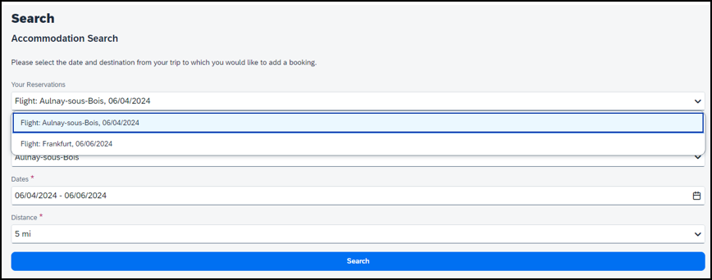
Train: If the trip includes Train, the user will see the following:
- Train: Closest city to the Destination Rail Station, Arrival date - When selected, the closest city to the destination rail station will be added to the Destination field, and the arrival date and departure date of the destination rail stations will be added to the Dates field.
- Train: Closest city to the final Rail Station, Arrival date - When selected, the closest city to the final rail station will be added to the Destination field, and the arrival date of the final Rail Station with a one-night stay will be added to the Dates field.
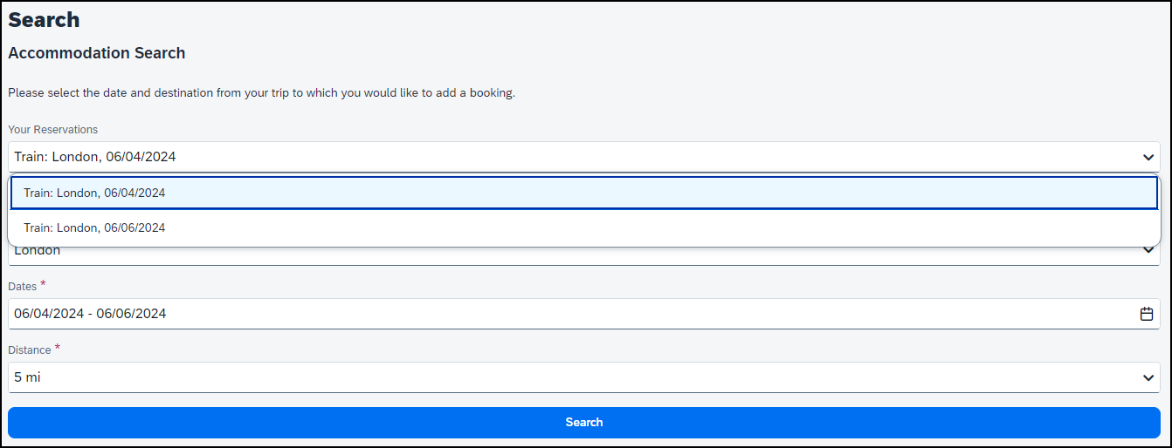
Car: If the trip includes rental car, the user will see the following:
- Car pick-up (Rental Car: Closest city to the Car Pick Up, Pick up date) - When selected, the closest city to the car pick up will be added to the Destination field, and the pick up date and drop off date of the rental car will be added to the Dates field.
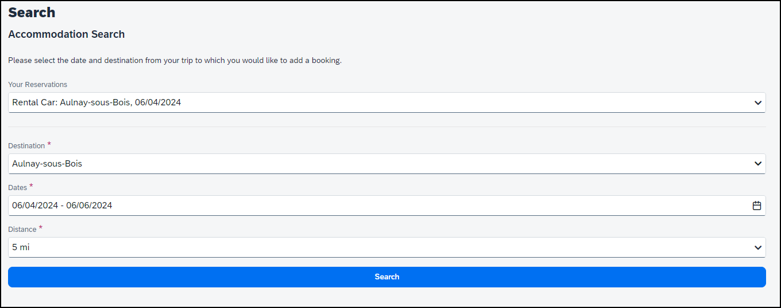
If the trip has only one reservation, When adding Hotel to an existing trip the following will be pre-selected in the Your Reservations pop-up:
- Flight: Arrival to the destination Airport
- Train: Arrival to the destination Rail Station
- Car: Pick-up

Example: New UI Modal (Future Release)
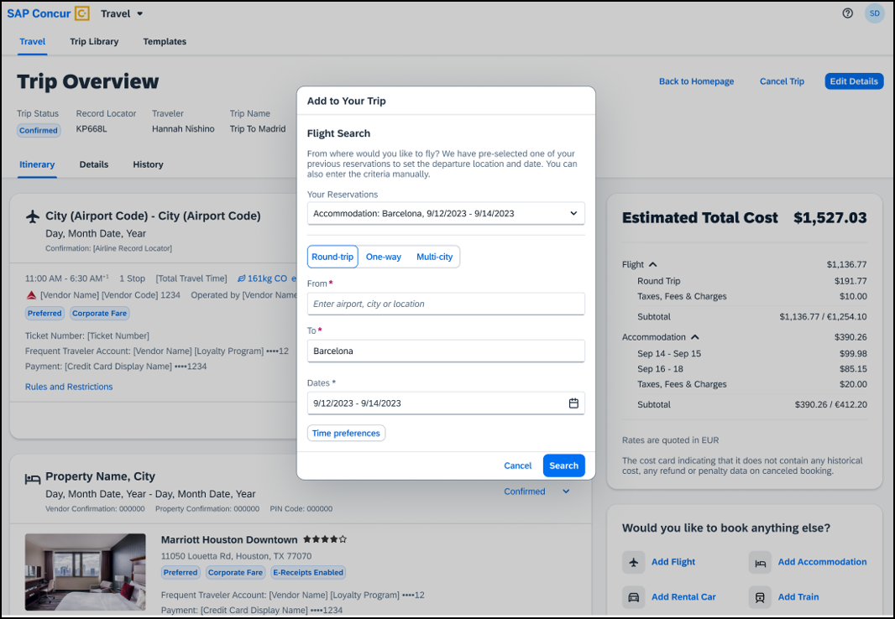

Configuration for Professional Travel
This feature is enabled by default. There are no configuration steps.

**Ongoing** New Concur Travel Experience: Trip History (Professional Edition Only)

Information First Published | Information Last Modified | Feature Target Release Date
December 2023 | March 8, 2024 | March to May 2024
Any changes since the previous monthly release are highlighted in yellow in this release note.

Prof | Stan |   Edition
X |  | On: Impacts end users who use this feature/vendor; no configuration/setup by agency/ admin; cannot be turned OFF (example: new icons or rate display)
 |  | Available for use: No impact to end users unless/until configuration/setup by agency/admin (described below) (example: new rule, new Travelfusion airline)
X |  | Other: Refer to the release note below
 | X | Does not apply to this edition
Source
GDS |  | Sabre, Car Connector
Direct Connect
Other
X | EMEA Data Center |  |  | Scan impact
X | North America Data Center |  | X | UI impact
 | China Data Center |  |  | File finishing impact
 | All data centers |  |  | Profile/Profile API/3rd Party XML Sync Impact
Affected Documentation
TSGs
Fact Sheets
Admin Guides
Other |  | Concur Travel Professional Edition End User Help

Overview
Targeted for the March to May 2024 releases, the Trip History feature will be available for the new Concur Travel experience. This feature will provide all access to detailed historical records of all trips associated with an account. Data will be available indefinitely (except for legal, compliance policies such as GDPR “Right to be Forgotten” requests), even if the trip is subsequently cancelled and after the trip has been completed.

Phases
This feature will be released in phases, with the first Trip History events visible starting on March 29:

Phase | Date of Release
Phase 1: New History tab on the Trip Overview Page.  - Trip-level events  - Trip Created  - Trip Cancelled  - Trip Confirmed  - Confirmation Email Sent  - Trip Sent to Agency for Processing  - Stand-alone Approvals events  - Trip Submitted for Approval  - Trip Logged for Reporting  - Manager Notified  - Trip Approved  - Trip Rejected  - Approval Deadline Expired | March 29, 2024
Phase 2:  - Booking-Specific events (for example, Booking Created, Booking Cancelled, Booking Updated, Booking Failed for Car, Hotel, and Rail Bookings), Booking Failed to Cancel | April 2024
Phase 3:  - Approvals via Request Integration  - Air Booking Cancelled, Air Booking Updated, Air Booking Failed  - Additional events  - Some additional data for already released events | May 2024
A detailed list of supported events and which information they include with each phase will be provided in a future release note.
Trips which include bookings from both the legacy and new Concur Travel experience will be included only in the legacy Trip History, on the web application, and will show bookings regardless of whether they were booked via the legacy or new Concur Travel experience.
Trips which include bookings from only the new Concur Travel experience will be included within the new experience’s Trip History, on both web and mobile applications. For the mobile app, feature availability will be in April.

User/Customer Benefit
This feature will provide greater clarity and confidence in the details of the Concur Travel booking experience, allowing users to search for and reference trip details more quickly and easily. This will allow users to avoid having to request information via a support case.
Users and arrangers will be able to see the Trip History tab on the Trip Overview page. TMCs, Support Agents, and SAP Concur representatives will be able to see the history via Support Tools, which will be included in a future release.

End-User Experience
Historical data will include:
- the original details of the trip and the travel provider, for example, airlines, hotels, locations etc.
- significant edits to a trip
- the identity of the person performing each action taken on the trip
- dates and time stamps
- ticket and confirmation numbers
- approvals and rejections
- policy violations
- detailed trip costs
- specific details of travel providers

Phase I Details:
Event | Data Included | Notes/Additional Information
Trip Created | - Who  - Date | Time | Timezone
Trip Cancelled | - Who  - Date | Time | Timezone
Trip Confirmed | - Who  - Date | Time | Timezone
Confirmation Email Sent | - Date | Time | Timezone  - Which user / email address
Trip Sent to Agency for Processing) | - Date | Time | Timezone | For Trips sent to Agency for Finishing and/or Ticketing
Trip Logged for Reporting | - Date | Time | Timezone
Trip Submitted for Approval | - Who submitted the trip for approval  - Date | Time | Timezone  When trip was submitted for approval  - Whose approval is required  - Approval deadline  - Email sent to Approver | If a user creates a new booking, with new dates, and this changes the Approval deadline, there will be a second “Trip Submitted for Approval” event with the new details, and new Approval deadline.
Manager Notified | - Date | Time | Timezone Which email address
Trip Approved | - Who Approved  - Date | Time | Timezone  - Approver’s Comments (if any)
Trip Rejected | - Who Rejected  - Date | Time | Timezone Approver’s Comments (if any)
Approval Deadline Expired | - Date | Time | Timezone

To access trip histories:
- On the Trip Overview page, click the Trip History tab.
- The Trip History tab will display all the events that took place for the trip in either ascending or descending chronological sort order, such as Creation, Cancellation, Approval etc.
- To expand the content and see additional details, click the arrow icon next to the event.
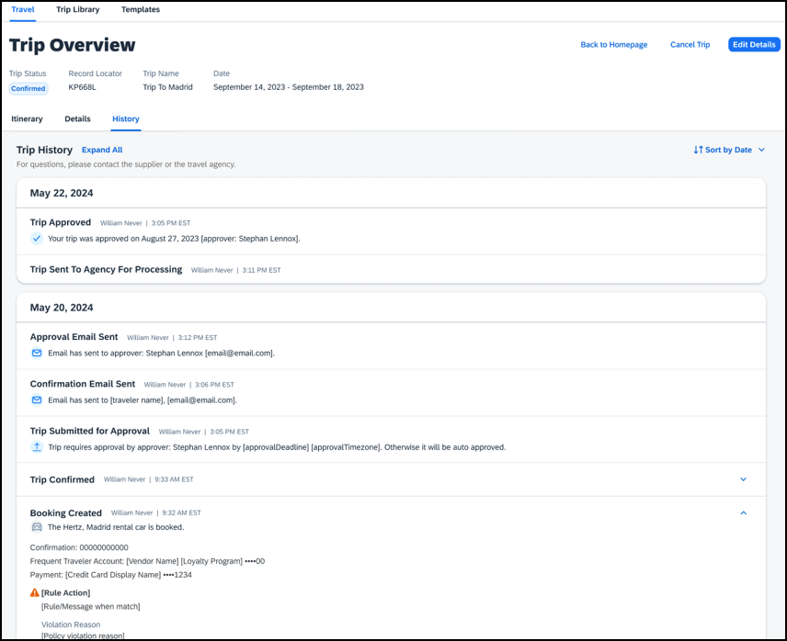
Events will become visible for new trips created after this feature is released and as new events become available with each phase. This means there will be no backfill for older trips or user actions on existing trips. For example, a trip created in April (after the March release) will have the “Trip Created” event available in Trip History, but no “Booking Created” events for any of the bookings. However, if a booking in that trip is subsequently cancelled after the April release, there will be a “Booking Cancelled event, without the corresponding “Booking Created” event.

Configuration for Professional Travel
This feature is enabled by default. There are no configuration steps.

**Ongoing** New Concur Travel Experience: Feature Exclusions, Limitations & Changed Behavior (Professional Edition Only)

Information First Published | Information Last Modified | Feature Target Release Date
September 15, 2023 | March 15, 2024 | TBD
Any changes since the previous monthly release are highlighted in yellow in this release note.

Overview
SAP Concur is delivering the new Concur Travel experience through phased software releases, while limiting the impact on customers and travelers.
- All customers and travelers can continue to use Concur Travel, which will support all existing capabilities.
- Travelers will continue to use their same URLs, logins, passwords, and mobile application. No specific traveler access change is required.
- The system is designed so that if a traveler were to book something not yet supported, they would be directed to the current booking flow they already know and use. Over time, as those capabilities are added to the new experience, redirects will be less frequent.
For customers that want to see the Q4 2023 release of the new Concur Travel experience:
- The customer’s servicing TMC must have acknowledged support for bookings made through the new Concur Travel experience.
- Customers must be eligible, based on content sources, policies, and configuration settings, as described in the linked document below.
Customers will automatically receive the Q4 2023 release of the new Concur Travel experience unless the customer or their TMC chooses to opt out.

User/Customer Benefit
With all the changes in user experience to address the current industry capabilities and traveler expectations, some policy rules or features may no longer be relevant. These will be decommissioned over time and will be outlined in the linked document below.

End-User Experience
Every company, travel program, and traveler are different, so SAP Concur wants to ensure that you have the information to understand when it’s the right time to implement the new booking experience in your organization.
Continue to check this release note as SAP Concur will update it regularly with additional details as development continues.
For more information about disclaimers, exclusions, limitations, and more, please refer to the New Concur Travel Experience: Exclusions, Limitations, Redirects & Enhancements document.

Configuration for Professional Travel
For configuration instructions, please refer to individual release notes.

Rail

New Concur Travel Experience: Renfe - Choose Your Rule Class Tied to Same Agency Setting (Professional Edition Only)
Refer to the **Ongoing Changes** New Concur Travel Experience: Choose Your Rule Class Tied to Same Agency Setting (Professional Edition Only) release note in the Planned Changes > Administration section of this document.

New Concur Travel Experience: Trainline - Book and Approve Request Support (Professional Edition Only) (Feb 19-28)

Prof | Stan | Å Å Edition
 |  | On: Impacts end users who use this feature/vendor; configuration/setup needed by agency/ admin; can be turned OFF (example: new icons or rate display, new Amtrak feature)
 |  | Available for use: No impact to end users unless/until configuration/setup by agency/admin (described below) (example: new rule, new Travelfusion airline)
X |  | Other: Refer to the release note below
 | X | Does not apply to this edition
Source / Solution Suggestion
GDS
Direct Connect |  | Trainline
Other
X | EMEA Data Center |  |  | Scan impact
X | North America Data Center |  | X | UI impact
 | China Data Center |  |  | File finishing impact
 | All data centers |  |  | Profile/Profile API/3rd Party XML Sync Impact
Affected Documentation
TSGs
Fact Sheets
Admin Guides
Other

Overview
As of February 19-28, Concur Travel introduced support for Book then Approve Request integration for Trainline customers.

User/Customer Benefit
This functionality provides a smoother booking process for the customer.

End-User Experience
When booking a Trainline trip, the user is directed to the Request header to confirm the trip and submit the request. The request approver can then approve, reject, or send it back.
This functionality to always create a Request is based on rules and configurations.
Previously, if a client had enabled Request Integration and Trainline, they would not be able to enable any other vertical (Flight, Car, or Hotel) in the new Concur Travel experience. This will be corrected in a subsequent release.
This integration for Request only applies to the new Concur Travel experience and Trainline bookings. If this is combined with any other element of Concur Travel (Flight, Car etc.) this function will not apply.

Configuration for Professional Travel
To enable the Request Booking Switch
- Click Administration > Travel, then, select Travel System Admin.
- Locate the desired company. In the Wizard Options section of the Travel Configuration page, select Enable Travel Request Integration. This must be selected to use the booking switch feature.
- Select Enable Request Booking Switch.

Orphaned Trip Handling Changes for Trainline (Feb 19-28)

Prof | Stan |   Edition
X | X | On: Impacts end users who use this feature/vendor; no configuration/setup by agency/ admin; cannot be turned OFF (example: new icons or rate display)
 |  | Available for use: No impact to end users unless/until configuration/setup by agency/admin (described below) (example: new rule, new Travelfusion airline)
 |  | Other: Refer to the release note below
 |  | Does not apply to this edition
Source
GDS |  | Trainline Direct Connect
Direct Connect
Other
X | EMEA Data Center |  |  | Scan impact
X | North America Data Center |  | X | UI impact
 | China Data Center |  |  | File finishing impact
 | All data centers |  |  | Profile/Profile API/3rd Party XML Sync Impact
Affected Documentation
TSGs
Fact Sheets
Admin Guides
Other |  | Concur Travel Professional Edition End User Help, Travel Services Help

Overview
Previously, for orphaned trips containing Trainline, Concur Travel neither auto-cancelled nor auto-finalized the trip. As of February 19-28, Concur Travel began to auto-finalize the trips containing Trainline, similar to what currently happens with Renfe trips.

User/Customer Benefit
If a trip is not cancelled nor finalized, the necessary changes required for trip fulfillment are not included in the trip (for example, to ticket a flight, such information would be required).

End-User Experience
When the user abandons the trip on the Finalize page:
- The trip is auto-finalized after four hours.
- A warning e-mail is sent at that time, informing the user that the trip was sent through finishing. The e-mail presents the following information: “The following trip was not completed in Concur Travel. Concur has automatically sent your trip through finishing to ensure your travel agency can fulfill your reservation. Your agency has also been notified about this and may be contacting you to obtain any un-captured trip information, such as policy violation justification or questions asked for each trip (custom trip fields). Your agency may charge additional fees for this. To prevent this from occurring in the future, please be sure to complete your reservation in Concur Travel – you can tell you have completed your booking when you see "Finished!" at the top of the page during the booking process.”
- For trips containing bookings made solely in the new Concur Travel experience, users are redirected to the Finalize page where they can update the trip with new trip name, description, custom fields, and itinerary level policy. They can click Confirm to finalize the trip again with the additional details.
The differences in behavior compared to trips containing legacy Concur Travel bookings include:
- If the user opens a trip in Concur, the new Concur Travel Finalize page is displayed (as for an orphaned trip), because the user can update the trip with a new trip name, description, custom fields, itinerary level policy and send it through to finishing once again.
- If approval is required (Request to be created), the user is not prevented from proceeding with these steps.

Configuration for Professional and Standard Travel
This feature is enabled by default. There are no configuration steps.

New Concur Travel Experience: Trainline New Supported Rules (Professional Edition Only) (Feb 19 -28)

Prof | Stan | Å Å Edition
 |  | On: Impacts end users who use this feature/vendor; no configuration/setup by agency/ admin; cannot be turned OFF (example: new icons or rate display, new Amtrak feature)
 |  | Available for use: No impact to end users unless/until configuration/setup by agency/admin (described below) (example: new rule, new Travelfusion airline)
X |  | Other: Refer to the release note below
 | X | Does not apply to this edition
Source / Solution Suggestion
GDS
Direct Connect
Other
X | EMEA Data Center |  |  | Scan impact
X | North America Data Center |  |  | UI impact
 | China Data Center |  |  | File finishing impact
 | All data centers |  |  | Profile/Profile API/3rd Party XML Sync Impact
Affected Documentation
TSGs
Fact Sheets
Admin Guides
Other |  | Travel Services Help

Overview
As of February 19-28, new rules are supported for Trainline to match the legacy Concur Travel experience. This requires Trainline clients to update their rule class setup.

User/Customer Benefit
To provide a more effective and consistent user experience, the Trainline rules have been updated for the new Concur Travel experience.

End-User Experience
The following rules are supported for Trainline in the new Concur Travel experience.

Flight
- Flight Number [condition] [FlightNumber]
- Flight Number is in the list of [FlightNumber]
- Air Fare is [condition] [currency][money]
- Air Fare is [condition] the least cost logical airfare plus [difference] [currencyOrPercent]
- Air Fare is within [difference] to [difference2] [currencyOrPercent] of the least cost logical airfare
- Air Fare is [difference] [currencyOrPercent] [condition] the least cost fewest stops fare
- Air Fare is [condition] the least cost [numStops]-stop fare [plusMinus] [difference]
- Air Base Fare is [condition] [currency][money]
- One or more fare basis codes contain [FareBasisText]
- One or more fare basis codes do not contain [FareBasisText]
- Any leg departure City is [CityCodeList]
- Any leg departure City is not [CityCodeList]
- Any leg arrival City is [CityCodeList]
- Any leg arrival City is not [CityCodeList]
- First leg departure City is [CityCodeList]
- First leg departure City is not [CityCodeList]
- First leg arrival City is [CityCodeList]
- First leg arrival City is not [CityCodeList]
- Flights connect through airport/city [CityCodeList]
- No flights connect through airport/city [CityCodeList]
- Flight departure or arrival city is [CityCodeList]
- Neither departure nor arrival city is [CityCodeList]
- Flight is between airports [CityCodeList1] and [CityCodeList2]
- Flight is not between airports [CityCodeList1] and [CityCodeList2]
- Flight departure date is [condition] [Date]
- Flight arrival date is [condition] [Date]
- Flight depart time is [condition] [Time]
- Flight arrival time is [condition] [Time]
- Flight depart time is between [Time1] and [Time2]
- Flight arrival time is between [Time1] and [Time2]
- Flight depart time is not between [Time1] and [Time2]
- Flight arrival time is not between [Time1] and [Time2]
- Flight departure date/time is [condition] [Date] at [Time]
- Flight arrival date/time is [condition] [Date] at [Time]
- Flight departure date/time on [leg] leg [condition] [Date] at [Time]
- Flight arrival date/time on [leg] leg [condition] [Date] at [Time]
- Flight departs on [DayOfWeekCodes]
- Flight does not depart on [DayOfWeekCodes]
- Flight is refundable
- Flight is not refundable
- Carrier is not preferred
- Carrier is preferred
- Marketing airline is in [CarrierList]
- Marketing airline is not in [CarrierList]
- Operating airline is in [CarrierList]
- Operating airline is not in [CarrierList]
- Any segment carried by [CarrierList]
- Any segment not carried by [CarrierList]
- Any flight is in region [Region]
- Any flight is not in region [Region]
- All Flights are within the region: [Region]
- All Flights are within the region: Africa
- All Flights are within the region: Asia
- All Flights are within the region: Australia
- All Flights are within the region: Europe + UK
- All Flights are within the region: South America
- All Flights are within the region: North America
- Flight Departure Country/Region is [CountryList]
- Flight Arrival Country/Region is [CountryList]
- Flight connects in country/region [CountryList]
- No flights connect in country/region [CountryList]
- All Flights are within the country/region: [CountryList]
- No Flights are within the country/region: [CountryList]
- Any flight is in country/region [CountryList]
- Any flight not within the country/region [CountryList]
- Flight departs from or arrives at an alternate airport in the region
- User requested Area Airports and flights do not depart from/return to the same airport
- Flight departs from or arrives at the user's chosen airport
- Air Fare is [condition] the least cost air fare into the preferred airport [plusMinus] [difference]
- The least cost logical airfare uses alternate airports
- The least cost logical airfare uses the user's chosen airport
- Flight uses [prefAlt] airport and airport is one of [CityCodeList]
- Flight is booked less than [DaysAdvance] days in advance
- Flight is booked less than [HoursAdvance] hours in advance
- Any leg duration [condition] that of the user's selected flights plus [minutes] minutes, [incExcLayovers] layovers
- Any leg duration [condition] that of the shortest duration for that leg in the inventory plus [minutes] minutes, [incExcLayovers] layovers
- Shortest Flight duration between two most distant airports is [condition] [minutes] minutes, [incExcLayovers] layovers
- Flight duration of all flights in a segment (including layovers) is [condition] [Duration] minutes
- Flight duration of all flights in a segment (excluding layovers) is [condition] [Duration] minutes
- Flight duration for any single flight is [condition] [Duration] minutes
- Fare is from the Reservation System
- Fare is not from the Reservation System
- Fare uses class of service not in [ClassList]
- Fare uses cabin class not in list [CabinList]
- Search results contain one or more of these vendors: [VendorList]
- Search results contain none of these vendors: [VendorList]
- Results contain preferred vendors
- Results do not contain preferred vendors
- Trip duration [condition] [DaysLong] days
- Time spent at destination is [condition] [DaysLong] days
- Flight Number of stops is [condition] [Numstops]
- The least cost logical airfare is on one of [CarrierList]
- The least cost logical airfare is not on one of [CarrierList]
- Layover duration on any segment is [condition] [minutes] minutes
- Number of stops in the least cost logical fare is [condition] [numStops] stops
- Number of stops is [condition] the number of stops in the least cost logical fare
- Contains flights in cabin lower than that requested
- Booking source is [Source]
- Booking source is not [Source]

Rail
- Number of train changes is [condition] [NumTrainChanges] and train carrier is in [CarrierList]
- Rail is [PreferredList]
- Rail is not [PreferredList]
- Trip duration [condition] [DaysLong] days
- Rail fare description contains [DescriptionList]
- Train is from source [Vendor] and Operating Carrier in [CarrierList]
- Train is from source [Vendor] and train type in [TrainTypeList]

View More Fares
These rules are applied during the initial search.
- * Fare in cabin classes: [CabinList] is [condition] the least cost logical airfare plus [difference] [currencyOrPercent]
- * Refundable fare in cabin classes: [CabinList] is [condition] the least cost logical airfare plus [difference] [currencyOrPercent]
- * Refundable fare in cabin classes: [CabinList] is [condition] the cheapest fare in flight plus [difference] [currencyOrPercent]
- * Fare in cabin classes: [CabinList] is [condition] the cheapest refundable fare in flight plus [difference] [currencyOrPercent]
- First leg departure City is [CityCodeList]
- First leg departure City is not [CityCodeList]
- First leg arrival City is [CityCodeList]
- First leg arrival City is not [CityCodeList]
- User requested Area Airports and flights do not depart from/return to the same airport
- Airline is [CarrierList] and brand name is [BrandedFareNameList]
- One or more fare basis codes contain [FareBasisText]
- One or more fare basis codes do not contain [FareBasisText]

Class of Service Group (Unique from Flight Group)
- Cabin classes allowed: [CabinClasses]
- Leg duration [condition] that of the shortest option available plus [minutes] minutes, [incExcLayovers] layovers
- Waitlist cabin(s) are available and allowed

Flight Rules for Rail
Considerations when setting up:
- City code is Rail station code.
- Flight number is a maximum of 4 digits.
The admin interface limit may not be long enough for train number.
- There is no difference between marketing / operating / validating carriers in Rail.
- Rail fare always checks the total cost.
- For LLF definition:
- If “Include rail” option is OFF, LLF will be turned off for Rail.
- Refundability option only applies when this information is available.
- Center time calculation does not support morning, afternoon, evening, or anytime.
- Arrival time is not supported.
- Outbound policy violations will not be called out-of-policy, even if no inbound fares can be combined with the specific outbound fare to yield a policy compliant option. For example, if a rule is set up as "Air Fare greater than $50 - require approval" and the cheapest outbound fare is $40 and the cheapest inbound fare is $30, then:
- The outbound fare will not be marked out-of-policy.
- All inbound fares will be marked out-of-policy.

Configuration for Professional Travel
No additional steps are required by administrators to support this change. However, SAP Concur recommends that clients provide messaging within Concur Travel to inform travelers of the updated rule set.
For more information on UK Rail (Trainline), refer to February release updates to the Travel Services Help. To locate, go to the SAP Help Portal and select the Travel Services Help listed under the Implement > Administration section.

Trainline Decommission for Apollo and Worldspan Configurations (Feb 29)

Prof | Stan | Å Å Edition
 |  | On: Impacts end users who use this feature/vendor; no configuration/setup by agency/ admin; cannot be turned OFF (example: new icons or rate display, new Amtrak feature)
 |  | Available for use: No impact to end users unless/until configuration/setup by agency/admin (described below) (example: new rule, new Travelfusion airline)
X | X | Other: Refer to the release note below
 |  | Does not apply to this edition
Source / Solution Suggestion
GDS
Direct Connect |  | UK Rail (Trainline)
Other
X | EMEA Data Center |  |  | Scan impact
X | North America Data Center |  |  | UI impact
 | China Data Center |  |  | File finishing impact
 | All data centers |  |  | Profile/Profile API/3rd Party XML Sync Impact
Affected Documentation
TSGs
Fact Sheets
Admin Guides
Other |  | Travel Services Help

Overview
Concur Travel currently provides travelers the ability to book trains via Trainline for the UK market. The solution is supported for Amadeus, Sabre, and Galileo travel configurations.
Due to changing contractual obligations, SAP Concur and Travelport jointly decided to decommission the direct connection to Concur Travel in February 2024. The UK Rail (Trainline) direct connect has been automatically disabled and no longer visible for any Apollo and Worldspan travel configurations effective February 29.

User/Customer Benefit
Periodically, under-supported third-party features may be removed to ensure usability standards are maintained. This feature is not fully supported and has been decommissioned.

End-User Experience
Existing Rail itineraries will remain visible in Concur Travel under Upcoming Trips. Historical data will also be kept for reporting.
This Trainline decommission is only applicable to Apollo and Worldspan. Amadeus, Sabre, and Galileo are not affected by this change.

Configuration for Professional and Standard Travel
No additional steps are required by administrators to support this change. However, SAP Concur recommends that clients provide messaging within Concur Travel to inform travelers.

New Concur Travel Experience: Trainline - Train Options Turned Down (Professional Edition Only) (Feb 19-28)

Prof | Stan | Å Å Edition
 |  | On: Impacts end users who use this feature/vendor; no configuration/setup by agency/ admin; cannot be turned OFF (example: new icons or rate display, new Amtrak feature)
X |  | Available for use: No impact to end users unless/until configuration/setup by agency/admin (described below) (example: new rule, new Travelfusion airline)
 |  | Other: Refer to the release note below
 | X | Does not apply to this edition
Source / Solution Suggestion
GDS
Direct Connect |  | Trainline
Other
X | EMEA Data Center |  |  | Scan impact
X | North America Data Center |  |  | UI impact
 | China Data Center |  |  | File finishing impact
 | All data centers |  |  | Profile/Profile API/3rd Party XML Sync Impact
Affected Documentation
TSGs
Fact Sheets
Admin Guides
Other |  | Module Properties

Overview
If an out-of-policy fare is chosen by the user when creating a booking, the options not chosen will be captured and displayed, both to the user and to the approvers. This allows the approver to view the alternatives that were not selected.

User/Customer Benefit
The updates to the Policy section for Rail provide a more cohesive Concur Travel experience. This allows for the visibility of available fares not chosen when creating out-of-policy bookings.

End-User Experience
When booking out-of-policy, a list of Train Options Turned Down displays. This list is available to the user on the Review and Book page within the Travel Policy section. For approvers, the Train Options Turned Down are available in the approver view and in the approver e-mail.
When Least Cost Logical Fare (LLF) is enabled but not chosen during a booking, the first option in the list is a declined LLF. The other list items are the remaining in-policy offers that have not been chosen.
Train Options Turned Down displays only if there are alternative in-policy offers available. If all fares are out-of-policy, no Train Options Turned Down display. The maximum number of Train Options Turned Down displayed is limited to ten in the new Concur Travel experience.

Configuration for Professional Travel
This feature will be enabled by default. There are no configuration steps.
The default number of options turned down is 10 (depending on fare availability). Administrators can configure the number of displayed fares using the Limit options turned down for Approval module property.
The module property setting is also applicable to Flight bookings. It is not only specific to Rail bookings.

New Concur Travel Experience: Trainline - Configurable Message Boards (Professional Edition Only) (Feb 19-28)

Prof | Stan | Å Å Edition
 |  | On: Impacts end users who use this feature/vendor; no configuration/setup by agency/ admin; cannot be turned OFF (example: new icons or rate display, new Amtrak feature)
X |  | Available for use: No impact to end users unless/until configuration/setup by agency/admin (described below) (example: new rule, new Travelfusion airline)
 |  | Other: Refer to the release note below
 | X | Does not apply to this edition
Source / Solution Suggestion
GDS
Direct Connect |  | Trainline
Other
X | EMEA Data Center |  |  | Scan impact
X | North America Data Center |  |  | UI impact
 | China Data Center |  |  | File finishing impact
 | All data centers |  |  | Profile/Profile API/3rd Party XML Sync Impact
Affected Documentation
TSGs |  | Configurable Message Boards Travel Service Guide
Fact Sheets
Admin Guides
Other

Overview
Configurable Message Boards allow clients to influence end user interactions with dynamic, rule based, messaging. The new Concur Travel experience for Trainline supports placement to match the legacy Concur Travel experience.

User/Customer Benefit
Configurable Message Boards provide administrators with the opportunity to configure informative custom messaging for specific scenarios based on policy rules to their end users.

End-User Experience
Messages display on the shop page. They can appear inline:
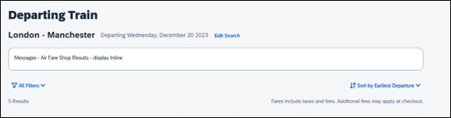
Or in a popup:
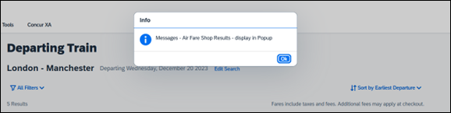

Configuration for Professional Travel
In the Travel Policy Administration section, rules can be configured under Messages - Air Fare Shop Results:
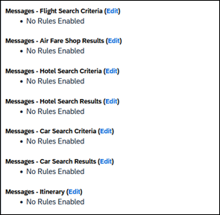
Support for configurable message boards is limited to the web user interface. Rich text including formatting and hyperlinks are supported.
Any message entered manually by an administrator is not localized. If a message is not set up by an administrator, the localized rule displays to the user.
It is not possible to configure configurable message boards separately for Rail and Flight bookings. If configured, messaging will display for both.

New Concur Travel Experience: Trainline - Support for Multiple Rail Connectors (Professional Edition Only) (Feb 19-28)

Prof | Stan | Å Å Edition
 |  | On: Impacts end users who use this feature/vendor; no configuration/setup by agency/ admin; cannot be turned OFF (example: new icons or rate display, new Amtrak feature)
X |  | Available for use: No impact to end users unless/until configuration/setup by agency/admin (described below) (example: new rule, new Travelfusion airline)
 |  | Other: Refer to the release note below
 | X | Does not apply to this edition
Source / Solution Suggestion
GDS
Direct Connect |  | Trainline
Other
X | EMEA Data Center |  |  | Scan impact
X | North America Data Center |  |  | UI impact
 | China Data Center |  |  | File finishing impact
 | All data centers |  |  | Profile/Profile API/3rd Party XML Sync Impact
Affected Documentation
TSGs
Fact Sheets
Admin Guides |  | Travel System Admin Guide
Other

Overview
Concur Travel offers multiple rail connectors. From February 19-28, support has been added for any rail connectors offered by Concur Travel to be enabled with Trainline.

User/Customer Benefit
This change provides administrators with the opportunity to enable a wider rail offering to their users on one travel configuration in the new Concur Travel experience.

End-User Experience
End users can now book with any of the enabled rail connectors.
For travel configurations where only rail connectors in the New Concur Travel Experience are enabled, vendor selection by the user is not necessary.
For travel configurations combining current and New Concur Travel Experience rail connectors, the user can select the vendor from a dropdown.

Configuration for Professional Travel
No additional steps are required by administrators to support this change.
New rail connectors can be added or removed on the Company Travel Configuration page.
Currently when Renfe is enabled alongside any additional rail connector, only Renfe is available to the end users. This limitation will be removed with a future release.

New Concur Travel Experience: Trainline - Multiple Violation Reasons (Professional Edition Only) (Feb 19-28)

Prof | Stan | Å Å Edition
 |  | On: Impacts end users who use this feature/vendor; no configuration/setup by agency/ admin; cannot be turned OFF (example: new icons or rate display, new Amtrak feature)
X |  | Available for use: No impact to end users unless/until configuration/setup by agency/admin (described below) (example: new rule, new Travelfusion airline)
 |  | Other: Refer to the release note below
 | X | Does not apply to this edition
Source / Solution Suggestion
GDS
Direct Connect |  | Trainline
Other
X | EMEA Data Center |  |  | Scan impact
X | North America Data Center |  |  | UI impact
 | China Data Center |  |  | File finishing impact
 | All data centers |  |  | Profile/Profile API/3rd Party XML Sync Impact
Affected Documentation
TSGs
Fact Sheets
Admin Guides |  | Travel System Admin Guide
Other

Overview
For bookings of out-of-policy fares, users are required to select a policy violation reason.

User/Customer Benefit
The updates to the Policy section for rail will provide a more cohesive Concur Travel experience. They allow for improved visibility of violated policy rules and the ability to provide multiple violation reasons for rail bookings.

End-User Experience
If Allow Multiple Violation Reason Codes is enabled and multiple travel policy rules are violated, a user may be requested to select multiple violation reasons on the Review and Book page if different policy violation reason types are configured for the rules.
The user interface displays a list all the policy rules violated, grouped by the rule action.
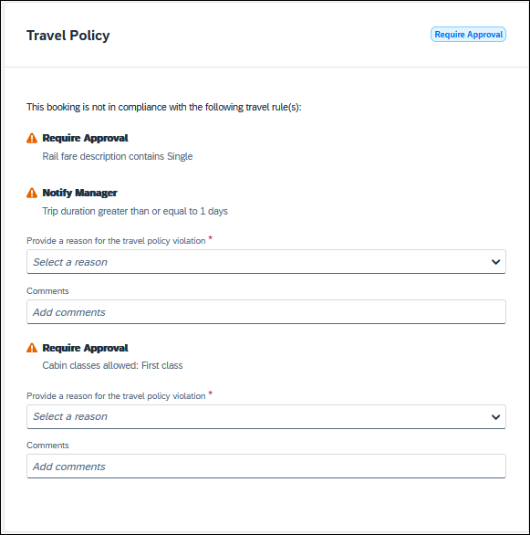

Configuration for Professional Travel
No additional steps are required by administrators to support this change.
Allow Multiple Violation Reason Codes can be enabled on the Company Travel Configuration page.
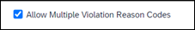
The setting is applicable to all bookings when enabled. It is not specific to rail bookings.

New Concur Travel Experience: Trainline - Least Cost Logical Fare Support (Professional Edition Only) (Feb 19-28)

Prof | Stan | Å Å Edition
 |  | On: Impacts end users who use this feature/vendor; no configuration/setup by agency/ admin; cannot be turned OFF (example: new icons or rate display, new Amtrak feature)
X |  | Available for use: No impact to end users unless/until configuration/setup by agency/admin (described below) (example: new rule, new Travelfusion airline)
 |  | Other: Refer to the release note below
 | X | Does not apply to this edition
Source / Solution Suggestion
GDS
Direct Connect |  | Trainline
Other
X | EMEA Data Center |  |  | Scan impact
X | North America Data Center |  |  | UI impact
 | China Data Center |  |  | File finishing impact
 | All data centers |  |  | Profile/Profile API/3rd Party XML Sync Impact
Affected Documentation
TSGs |  | Lowest Logical Fare (LLF) / Benchmark Lowest Airfare
Fact Sheets
Admin Guides
Other |  | Travel Services Help

Overview
As of February 19-28, Concur Travel introduced the support of the Least Cost Logical Fare (LLF) for Trainline rail bookings in the new Concur Travel experience.

User/Customer Benefit
The calculation of the Least Cost Logical Fare (LLF) is based on criteria and travel policy rules set by the company administrator. These options are highlighted as the best choices for the users to select during the train search.

End-User Experience
If configured, Concur Travel calculates the Least Cost Logical Fare (LLF) based on criteria defined by the customer. LLFs are identified on the Search results page with a star icon. If configured, LLF displays per class of service. The same icon is used for all classes of service.
The LLF is also visible with the same icon in the Train Options Turned Down list to both the user and the approver.

Configuration for Professional Travel
Least Cost Logical Fare is calculated for Rail only if the Include Rail setting in the LLF calculation definition is set to Yes. Administrators can make this change by going to the Travel Policy Administration page and editing Flight travel policy rules.
LLF per fare class of service is a new LLF configuration only applicable to the new Concur Travel experience. The new configuration enables administrators to have a Least Cost Logical Fare per class of service. This is different than the current system where the LLF is always in the lowest class of service that is available in the search results.
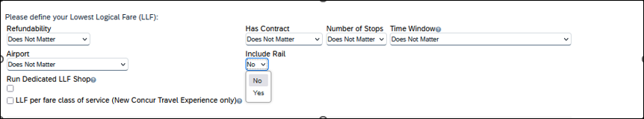

Limitations
Delayed LLF calculation configuration on Company Travel Configuration page:
- Enforce LLF based on user’s chosen fare: Initially, the display of additional screen is not supported. This functionality may be added later. A banner message will display at the top of the Search Results page that will read: “Additional policy will be calculated based on the time of your selected fare”. Delayed LLF will be calculated after the user has selected their fare (for example, if return fares are chosen after the selection of an inbound fare), and all fares will be evaluated against any delayed LLF based travel policy rules. Users will see all policy rule violations on the Review and Book page for the moment, this may be revised in the future.

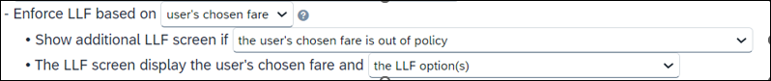
- Enforce LLF based on hybrid: Initially, Hybrid LLF is calculated based on the search window. Additional search options triggering calculation based on a user’s search are not yet supported.
The Run Dedicated LLF Shop LLF configuration option is not supported in the new Concur Travel experience due to changes in the overall search process.
Mark LLF fare/s with icon LLF configuration option is no longer support in the new Concur Travel experience. The icon always displays.
Travel administrators for configurations where Renfe or Trainline rail connectors are enabled and who set LLF criteria for Rail should revisit their current LLF related policy rules to ensure rules are configured correctly for their needs.
All configuration settings are applied for both Flight and Rail bookings if LLF is enabled for Rail.

New Concur Travel Experience: Trainline - Customer Migration (Professional Edition Only) (Feb 19-28)

Prof | Stan | Å Å Edition
 |  | On: Impacts end users who use this feature/vendor; no configuration/setup by agency/ admin; cannot be turned OFF (example: new icons or rate display, new Amtrak feature)
 |  | Available for use: No impact to end users unless/until configuration/setup by agency/admin (described below) (example: new rule, new Travelfusion airline)
X |  | Other: Refer to the release note below
 | X | Does not apply to this edition
Source / Solution Suggestion
GDS
Direct Connect |  | Trainline
Other
X | EMEA Data Center |  |  | Scan impact
X | North America Data Center |  | X | UI impact
 | China Data Center |  |  | File finishing impact
 | All data centers |  |  | Profile/Profile API/3rd Party XML Sync Impact
Affected Documentation
TSGs
Fact Sheets
Admin Guides
Other |  | Travel Services Help

Overview
Concur Travel provides travelers in the UK market with the ability to book trains via Trainline. Trainline plans to decommission their current connection to Concur Travel within the first half of 2024.
SAP Concur has completed work towards supporting Trainline’s new connection. As part of this effort, from February 19 to 28, SAP Concur has migrated Trainline existing customers from the current Concur Travel Experience to the new Concur Travel Experience.

User/Customer Benefit
The new Concur Travel rail booking experience together with the new Trainline connection brings clients the following benefits:
- New user interface
- Reduced number of steps to complete the booking.
- Support for eTicket delivery option.
The availability of eTicket delivery option depends on the selected routing and the carrier. Also, this feature must be enabled by Trainline. Clients interested in seeing the eTicket delivery option for Trainline should contact their travel agency or Trainline, depending on their contract.

End-User Experience
The end-user booking workflow includes search, book, and itinerary review. The release introduces a reduced set of features.

Trainline Migration Differences
As SAP Concur migrates UK Rail (Trainline) to the new Trainline connection and the new Concur Travel experience, users might see some differences in the behavior compared to the current experience.
The following items are not yet supported with the new Rail booking experience. Monitor future release notes for changes relating to these.
- IMPORTANT: As the date of birth is required for the new Trainline connection, SAP Concur recommends that users add their date of birth to their user profile to make sure Trainline returns all the fares that the users are eligible for in the search results. Date of birth can be added under the Passport section or under the TSA Secure Flight section. These sections might be unavailable in the profile or not be editable for the user. Clients should consider giving users permission to update their profiles with the date of birth, if missing.
- If the date of birth is missing in the user’s profile a default arbitrary value will be sent to Trainline. This will enable users to search for the UK Rail content even if they choose not to enter a date of birth in their profile.

Product Area | Feature/Setting | Setting Location | Setting/Feature details | Additional Information
Traveler selection | Guest Traveler bookings | User Permission | Guest traveler bookings are disabled | A guest traveler or sponsored guest booking are not yet supported.  Users will see a message “Rail booking for a guest is not available at this time” in the Rail search widget when accessing Rail tab as a guest.
Content | Air/Rail Tab Search: Mixed Air/Rail | N/A | UK Rail search results are not available via Air/Rail tab | Air/Rail comparison is not yet supported for the new rail booking experience.  Users must use the Rail tab to search for UK Rail (Trainline) content.
Content | Global distribution system  (passive segments/finishing) | Travel Configuration | Global distribution system (GDS) supported for UK Rail: Amadeus, Sabre, Galileo | UK Rail will be unavailable for clients with travel configurations on Apollo and Worldspan
Content | Edition | Company | Standard Edition | UK Rail will be unavailable for clients with Concur Travel Standard edition in the new Rail booking experience.
Rail-specific | Arrive by | Travel Configuration | Search by arrival time | Search by arrival time is not supported for UK Rail in the new Rail booking experience yet.  Users will be able to search by departure time for UK Rail.
Rail-specific | Multi-passenger booking | Travel Configuration | “Max Number of companions” feature | “Max Number of companions” feature will not be supported for UK Rail in the new Rail booking experience.
Rail-specific | Promotional code | N/A | Promotional code in the search widget | Promotional code will not be supported for UK Rail in the new Rail booking experience.
Rail-specific | Custom passive template | Travel System Admin > Passive Template Editor |  | Custom passive template will not be supported for the new Rail booking experience.  Standard passive segments will continue to be supported for UK Rail for Amadeus, Sabre and Galileo.
Profile | Loyalty Card | User Profile |  | Loyalty Cards will not be supported for UK Rail in the new Rail booking experience.  Users with UK Rail loyalty program in their profile will be able to search and book UK Rail content. Their UK Rail frequent traveler program will not be sent to Trainline with the booking.
Integration | Concur Request | Travel Configuration  Request module | Approve then Book flow | “Approve then Book flow” is not yet supported for UK Rail in the new rail booking experience for UK Rail.
Integration | Concur Request | Travel Configuration  Request module | Book then Approve flow | “Book then Approve” flow will be supported with limitations.
Travel Policy | Least Cost Logical Fare | Travel Configuration | Enforce LLF based on hybrid | Hybrid LLF will be calculated based on the search window only with initial release. Additional search options triggering calculation based on user’s search window not supported yet.
Travel Policy | Least Cost Logical Fare | Travel Configuration | Enforce LLF based on user’s chosen fare | Display of additional screen will not yet be supported. Users will see all policy rule violations for delayed LLF on the Review and Book page instead of on a separate screen.
Changes in behavior

Product Area | Feature/Setting | Setting Location | Setting/Feature details | Additional Information
Payments | Ghost Card | Travel Administration > Corporate Ghost Cards |  | Ghost Card payment will not require a security code on the Review and Book page.
Profile | Date of Birth | Profile > International Travel: Passports and Visas  Or TSA Secure Flight | Date of birth is required for UK Rail search. | If the date of birth is missing, users will see a message with the request to update their profile before they can continue with their search.
Rail-specific | View More Fares | N/A | “View More Fares” link is not available for the new Rail details booking experience. | Up to four fares will display directly as the initial search results. All remaining available fare options will display upon expanding the itinerary.
Rail-specific | Class selection | Travel Administration > Travel Policy | Class selection is not available in the search widget for the new Rail booking experience | Users will be able to use filters (if applicable) in the search results.
Rail-specific | Search by price/schedule |  | Search by price/schedule is not available in the search widget for the new Rail booking experience | Users will be able to use filters in the search results in the new Rail booking experience.
Rail-specific | Delivery options | N/A | Delivery options displayed on the Review and Book page | Delivery options supported for UK Rail are limited to eTicket and Kiosk.

Configuration for Professional Travel
SAP Concur is planning to migrate existing customers to Trainline's new connection to ensure continuous support of UK Rail in Concur Travel.
No additional steps are required by administrators to support this change. However, SAP Concur recommends that clients provide messaging within Concur Travel to inform travelers.
Travel Agencies should be aware that station codes in the passive segments for Trainline do not align with IATA codes. The station codes used for the current connection will also apply for the new Trainline connection.
Custom field mapping applicable to Trainline is available under the Configure Trainline button in the UK Rail configuration settings. To prevent any issues during the booking flow, make sure that the custom fields’ values set up in Concur Travel correspond to requirements set up with Trainline. Any discrepancy might lead to booking failures for users.

Planned Changes
The items in this section are targeted for future releases. SAP Concur solutions reserves the right to postpone implementation of – or completely remove – any enhancement or change mentioned here.
The planned changes listed in this document are specific to this product. For information about planned site-wide or shared changes that might impact your SAP Concur solutions, refer to the Shared Changes Release Notes.

Administration

**Ongoing Changes** New Concur Travel Experience: Choose Your Rule Class Tied to Same Agency Setting (Professional Edition Only)

Information First Published | Information Last Modified | Feature Target Release Date
February 9, 2024 | March 8, 2024 | April - May 2024
Any changes since the previous monthly release are highlighted in yellow in this release note.

Prof | Stan |   Edition
X |  | On: Impacts end users who use this feature/vendor; no configuration/setup by agency/ admin; cannot be turned OFF (example: new icons or rate display)
 |  | Available for use: No impact to end users unless/until configuration/setup by agency/admin (described below) (example: new rule, new Travelfusion airline)
 |  | Other: Refer to the release note below
 | X | Does not apply to this edition
Source
GDS
Direct Connect
Other
X | EMEA Data Center |  |  | Scan impact
X | North America Data Center |  |  | UI impact
 | China Data Center |  |  | File finishing impact
 | All data centers |  |  | Profile/Profile API/3rd Party XML Sync Impact
Affected Documentation
TSGs |  | Approvals, Rules, and Classes/Policies Travel Service Guide
Fact Sheets
Admin Guides
Other

Overview
In the upcoming April release, administrators can allow users to select a rule class tied to the same configuration or agency. This will allow customers who currently have this setting enabled in their legacy Concur Travel experience to migrate to the new Concur Travel experience.
The information from the February release note “**Planned Changes** New Concur Travel Experience: Choose Your Rule Class (Professional Edition Only)” has been included here.

Phases
This feature will be released to specific verticals between April and May:

Phase | Date of Release
Phase 1: Renfe Rail  For Renfe, all three options under the Rule Class Selection dropdown, (as in, User cannot select rule class, User can select from rule classes tied to this configuration, User can select from rule classes tied to this agency) will be supported. Until this change, only the User cannot select rule class is applied. | April 8 - 10
Phase 2: All other verticals | May 2024, date TBD
In the Rule Class Options section of Travel System Admin, administrators will be able to configure their travel sites to do the following:
- allow users to select from a rule class tied to this travel configuration.
- allow users to select a rule class tied to same agency.
- force users to select a rule when making a reservation.
- display a custom rule class label and
- opt out a rule class from displaying in the dropdown.

User/Customer Benefit
This setting allows users to select which rules are suitable for the trip they are booking.

Administrator Experience
The administrator will be able to:
- enable the options User can select from rule classes tied to this configuration or User can select from rule classes tied to same agency.
- create a custom rule class label.
- select the Force selection of a rule class checkbox.

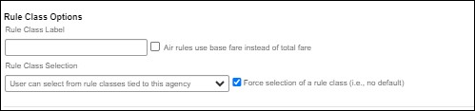
- select the Choose Rule Class Opt Out checkbox to remove the display of a rule class.

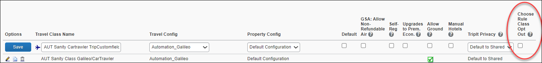
- display a custom message if the user does not select a rule class when required.

End-User Experience
The user will see a dropdown on the home page that contains rule classes associated with their travel configuration, excluding a rule class that has been opted out. If the force rule class is enabled, then users will see a blinking yellow outline that surrounds the dropdown. If the user does not select a rule (when required), they will be prompted to select a rule class.
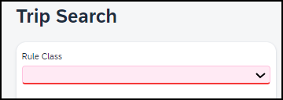

Configuration for Professional Travel
Refer to the Administrator Experience section for set up details. If the setting has been previously enabled, no changes are required.

Flight

**Planned Changes** New Concur Travel Experience: Add Vendor Preference and Corporate Rate to Post Booking Flow (Professional Edition Only)

Information First Published | Information Last Modified | Feature Target Release Date
February 2024 | March 15, 2024 | April 2024
Any changes since the previous monthly release are highlighted in yellow in this release note.

Prof | Stan |   Edition
 |  | On: Impacts end users who use this feature/vendor; no configuration/setup by agency/ admin; cannot be turned OFF (example: new icons or rate display)
 |  | Available for use: No impact to end users unless/until configuration/setup by agency/admin (described below) (example: new rule, new Travelfusion airline)
X |  | Other: Refer to the release note below
 | X | Does not apply to this edition
Source
GDS
Direct Connect
Other
X | EMEA Data Center |  |  | Scan impact
X | North America Data Center |  | X | UI impact
 | China Data Center |  |  | File finishing impact
 | All data centers |  |  | Profile/Profile API/3rd Party XML Sync Impact
Affected Documentation
TSGs
Fact Sheets
Admin Guides
Other |  | Concur Travel Professional Edition End User Help

Overview
Targeted for the April release, Concur Travel plans to display the Corporate Rate label and Preferred Vendor label for Flight. These changes will be visible on the Review and Book, Finalize and Trip Overview pages. These labels will also display on e-mails received once a booking is finalized.

User/Customer Benefit
This change is being made to remind the user which type of rates and vendors were booked, and it will provide a more consistent user experience across the booking process.

End-User Experience
Once the search for flights is completed, the user will then see the Corporate Rate and Preferred Vendor labels on the last pages of the booking flow and in the post booking e-mails received. These labels will appear on the Review and Book, Finalize and Trip Overview pages.

Configuration for Professional Travel
This feature is enabled by default. There are no configuration steps.

Hotel

**Planned Changes** New CSL Segment Format for Sabre Hotels (Mar 26)

Information First Published | Information Last Modified | Feature Target Release Date
March 8, 2024 | -- | March 26, 2024
Any changes since the previous monthly release are highlighted in yellow in this release note.

Prof | Stan |   Edition
 |  | On: Impacts end users who use this feature/vendor; no configuration/setup by agency/ admin; cannot be turned OFF (example: new icons or rate display)
 |  | Available for use: No impact to end users unless/until configuration/setup by agency/admin (described below) (example: new rule, new Travelfusion airline)
X | X | Other: Refer to the release note below
 |  | Does not apply to this edition
Source
GDS |  | Sabre
Direct Connect
Other
 | EMEA Data Center |  |  | Scan impact
 | North America Data Center |  |  | UI impact
 | China Data Center |  |  | File finishing impact
X | All data centers |  |  | Profile/Profile API/3rd Party XML Sync Impact
Affected Documentation
TSGs
Fact Sheets
Admin Guides
Other

Overview
SAP Concur completed development to support Sabre’s Content Service for Lodging (CSL) platform in 2021. Since that time Concur has continued to create the legacy segment for Sabre bookings using an indicator in the Enhanced Hotel Book API “bookGDSviaCSL=False”. This is to support those customers whose third-party mid and back-office systems were not yet able to process the CSL HHX segment type that is generated in the Sabre Interface User Record (IUR) file, which supports travel agency back-office functions for Ticketing, Invoicing, and Itinerary type entries.
Sabre’s latest CSL update via SAN 16384 states that Sabre will require all hotel bookings to be created using the new CSL hotel segment as of March 26, 2024. Please refer to Sabre SAN 16384 for complete details.
Concur Travel is ready for this change and will continue to be able to modify and cancel both legacy hotel segments as well as the new CSL hotel segment type from 26 March. The API flag “bookGDSviaCSL” will continue to be set to “False” which means that starting March 26, 2024, hotel bookings will be created using the new CSL segment type, but the legacy IUR format will be sent for back-office processing.
Sabre has not indicated when the legacy IUR will be sunset, so whilst some customers will continue to use this for the foreseeable future, other Concur Travel customers may be ready to migrate to the new CSL HHX IUR segment type. As Concur Travel does not have visibility into which customers have migrated, a new Agency Configuration setting is being introduced so clients who want to use the new CSL IUR format can do so. This new configuration setting will be called Create Content Services for Lodging Interface User Record (IUR).
The default for this setting is unchecked which means the legacy IUR will continue to be created.
This setting only applies to users working with the new Concur Travel experience. Customers using the current OBT platform will not be able to use the new IUR.

TMC Experience
TMCs will see the new configuration setting, Create Content Services for Lodging Interface User Record (IUR).
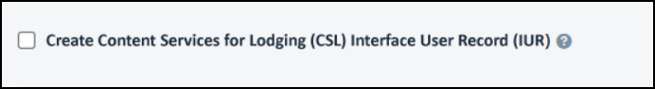
If the customer wants to create a new IUR record, they will need to update the new configuration setting for this.
For more information, refer to the Concur Travel Client Fact Sheet – Sabre Content Services for Lodging.

**Planned Changes** New Concur Travel Experience: Configuration for Custom Hotel Sourcing (Professional Edition Only)

Information First Published | Information Last Modified | Feature Target Release Date
March 2023 | February 9, 2024 | April 2024
Any changes since the previous monthly release are highlighted in yellow in this release note.

Prof | Stan |   Edition
 |  | On: Impacts end users who use this feature/vendor; no configuration/setup by agency/ admin; cannot be turned OFF (example: new icons or rate display)
 |  | Available for use: No impact to end users unless/until configuration/setup by agency/admin (described below) (example: new rule, new Travelfusion airline)
X |  | Other: Refer to the release note below
 | X | Does not apply to this edition
Source
GDS |  | N/A
Direct Connect |  | Custom Hotel Source providers (TBD)
Other
 | EMEA Data Center |  |  | Scan impact
 | North America Data Center |  |  | UI impact
 | China Data Center |  |  | File finishing impact
 | All data centers |  |  | Profile/Profile API/3rd Party XML Sync Impact
Affected Documentation
TSGs
Fact Sheets
Admin Guides
Other

Overview
Recently, SAP Concur released the new Hotel booking experience for customers connected to Sabre and for customers connected to one of our participating Custom Hotel Source (CHS) providers. With this integration, customers can experience:
- An intuitive and personalized design, with an easy-to-use interface.
- Seamless content normalization, aggregation, and servicing.
- Mobile and web content parity.

User/Customer Benefit
The new Concur Travel Hotel booking experience offers a specific feature set for customers.
- Time Savings: The booking workflow will be streamlined so fewer steps are required.
- Omni search: Once the user enters the first few characters of their search criteria, the system will update to provide a list of suggested options from which the user can select.
- Sustainability: Property information will include the sustainability certifications or programs to which the property belongs, a sustainability score, and carbon emissions data. Additional property filter options will include electric car charging stations and sustainability certifications to help users make more sustainable choices. Users will be able to sort properties based on their sustainability score and emissions.
- Search results with lead rate: The property search results will be presented with one lead rate so the user can quickly compare the lowest rate available at multiple properties.
- Hotel Details: A list of the rates available at a specific property, together with cancellation policy details, room amenities and images, will be available to the user.

Configuration for Professional Travel

Custom Hotel Source Providers
For customers interested in using Custom Hotel Source providers as their source for hotel content, re-enablement is required.
To configure:
- Click Administration > Travel (on the sub-menu) > Travel System Admin and select the desired client travel configuration.
Depending on your permissions, the page may appear immediately after you click Administration or Travel.
There are now two different Hotel Connector sections of the Travel Configuration page. One is to support the new hotel connectors and is called Hotel Connectors – Hotel Service v4. The other is the existing hotel connector section.
- When enabling a new connector, it is essential that any current direct connect remains enabled otherwise customers will not be able to make bookings in the current Concur Travel experience. This means that a current HSv2 configuration needs to remain enabled on HSv2, and on HSv4 once migrated. The HSv2 connection will not allow new bookings but will provide access to previously booked reservations for servicing. Any servicing will continue as it is today using the Online Booking Tool (OBT).
- The administrator will be able to select the default connection type within the new section.
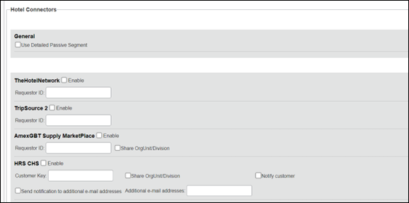
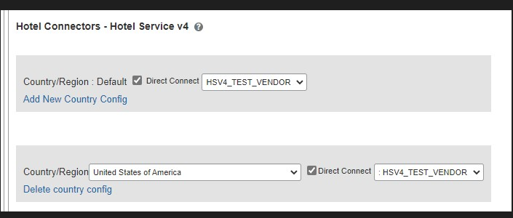

Passive PNR for Direct Content
To configure:
- Go to Administration > Travel (on the sub-menu) > Travel System Admin and select the desired client travel configuration.
Depending on your permissions, the page may appear immediately after you click Administration or Travel.
- On the Travel Configuration page, under GDS PNR Options, go to the activation checkboxes.
- Under Defaults for Specific non-GDS vendors, select the New Custom Hotel Source checkbox. The default for this field is Use the default specified above. Select the Write passive segments for non-GDS content if I have not specified a default for the specific vendor in the table below checkbox.

Travel Arranger Flow
The Travel Arranger feature will be supported for Hotel.
For more information on how to book a hotel as a Travel Arranger, see the Travel Arranger View Travel Service Guide.
The Travel Arranger Name appears on the new Trip Overview page.

Miscellaneous

**Planned Changes** New Fields Available in Online Order Form

Information First Published | Information Last Modified | Feature Target Release Date
March 15, 2024 | -- | April 2024
Any changes since the previous monthly release are highlighted in yellow in this release note.

Prof | Stan |   Edition
 |  | On: Impacts end users who use this feature/vendor; no configuration/setup by agency/ admin; cannot be turned OFF (example: new icons or rate display)
 |  | Available for use: No impact to end users unless/until configuration/setup by agency/admin (described below) (example: new rule, new Travelfusion airline)
X | X | Other: Refer to the release note below
 |  | Does not apply to this edition
Source
GDS
Direct Connect
Other
 | EMEA Data Center |  |  | Scan impact
 | North America Data Center |  |  | UI impact
 | China Data Center |  |  | File finishing impact
X | All data centers |  |  | Profile/Profile API/3rd Party XML Sync Impact
Affected Documentation
TSGs |  | Online Order Form Travel Service Guide
Fact Sheets
Admin Guides
Other

Overview
Targeted for the April release, there will be changes to the Online Order Form. New fields will be available as well as one being removed.

User/Customer Benefit
This change is being initiated to support options that are billable to the client. It also ensures consistency between the order form and the Reseller Price List.

End-User Experience
The Online Order Form will be adjusted to allow for changes including new fields.
The Enable TripLink checkbox will be removed and will no longer be available.
If a user chooses New Professional Client or New Standard Client, the Additional Comments input box will change to Additional Comments (Include implementation country).
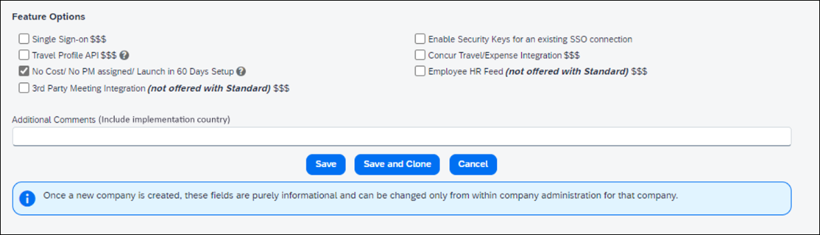
Under Feature Options there will be a new checkbox to enable New Tier2 for Host Agency $$$.
Selecting Modify Existing Client > Agency Conversion – Incoming Agency, a new checkbox will appear titled GDS/PCC Conversion (no agency change) $$$.
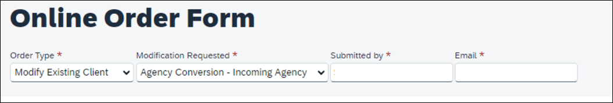
If a user chooses Modify Existing Client > Add Config to Existing Professional Site or Modify Existing Client > Add Config to Existing Standard Site, two new checkboxes shall appear. These are:
- New GDS (assumes standard finishing) $$$
- Additional Country $$$ (This checkbox is accompanied by a dropdown where a country should be selected.

Configuration for Professional Travel
This feature is enabled by default. There are no configuration steps.

**Planned Changes** Travel Profile API 2.0 Gender Diversity Support

Information First Published | Information Last Modified | Feature Target Release Date
September 8, 2023 | March 8, 2024 | End of March 2024
Any changes since the previous monthly release are highlighted in yellow in this release note.

Prof | Stan |   Edition
 |  | On: Impacts end users who use this feature/vendor; no configuration/setup by agency/ admin; cannot be turned OFF (example: new icons or rate display)
 |  | Available for use: No impact to end users unless/until configuration/setup by agency/admin (described below) (example: new rule, new Travelfusion airline)
X | X | Other: Refer to the release note below
 |  | Does not apply to this edition
Source
GDS
Direct Connect
Other
 | EMEA Data Center |  |  | Scan impact
 | North America Data Center |  |  | UI impact
 | China Data Center |  |  | File finishing impact
 | All data centers |  | X | Profile/Profile API/3rd Party XML Sync Impact
Affected Documentation
TSGs
Fact Sheets
Admin Guides
Other |  | SAP Concur Developer Center

Overview
With the SAP Concur commitment to Gender Diversity initiatives, changes are planned for the Travel Profile API 2.0, specifically in adding support for two new Gender values: Unspecified and Undisclosed.
Partners must update their systems to use the updated API.

User/Customer Benefit
This change is being initiated to support partners and customers for the purposes of updating their systems to support the new gender values.

Configuration for Professional Travel
This feature is enabled by default. There are no configuration steps.

**Planned Changes** Decommission of Two-Manager Approval Setting (Professional Edition Only)

Information First Published | Information Last Modified | Feature Target Release Date
August 11, 2023 | January 19, 2024 | TBD 2024
Any changes since the previous monthly release are highlighted in yellow in this release note.

Prof | Stan |   Edition
X |  | On: Impacts end users who use this feature/vendor; no configuration/setup by agency/ admin; cannot be turned OFF (example: new icons or rate display)
 |  | Available for use: No impact to end users unless/until configuration/setup by agency/admin (described below) (example: new rule, new Travelfusion airline)
 |  | Other: Refer to the release note below
 | X | Does not apply to this edition
Source
GDS
Direct Connect
Other
X | EMEA Data Center |  |  | Scan impact
X | North America Data Center |  | X | UI impact
 | China Data Center |  |  | File finishing impact
 | All data centers |  |  | Profile/Profile API/3rd Party XML Sync Impact
Affected Documentation
TSGs
Fact Sheets
Admin Guides
Other

Overview
Targeted for a future release in the legacy Concur Travel experience, the two-manager approval flow will no longer be supported. In the legacy Concur Travel experience, all clients with a two-manager approval flow will be migrated to a one manager approval flow.

User/Customer Benefit
This change is being initiated to simplify and streamline the approval flow in the legacy Concur Travel experience. It also provides more options when working with Concur Request.

End-User Experience
When choosing an approver, the user will only be able to request the approval flow be directed to one manager and not two.
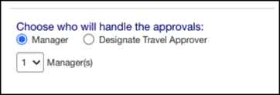

Configuration for Professional Travel
This feature is enabled by default. There are no configuration steps.

**Ongoing** New Concur Travel Experience: Market Eligibility Expansion (Professional Edition Only) (Mar 26)

Information First Published | Information Last Modified | Feature Target Release Date
February 9, 2024 | -- | March 26, 2024
Any changes since the previous monthly release are highlighted in yellow in this release note.

Prof | Stan |   Edition
X |  | On: Impacts end users who use this feature/vendor; no configuration/setup by agency/ admin; cannot be turned OFF (example: new icons or rate display)
 |  | Available for use: No impact to end users unless/until configuration/setup by agency/admin (described below) (example: new rule, new Travelfusion airline)
 |  | Other: Refer to the release note below
 | X | Does not apply to this edition
Source
GDS |  | Sabre, Sabre NDC
Direct Connect |  | Car Connector, CHS Hotel Connector, UK Rail via Trainline, Spanish Rail via Renfe
Other
X | EMEA Data Center |  |  | Scan impact
X | North America Data Center |  | X | UI impact
 | China Data Center |  |  | File finishing impact
 | All data centers |  |  | Profile/Profile API/3rd Party XML Sync Impact
Affected Documentation
TSGs
Fact Sheets
Admin Guides
Other

Overview
Targeted for March 26, 2024, SAP Concur plans to expand the new Concur Travel experience to new markets beyond the United States. These markets are determined by the Travel Agency Ticketing Currency. If this is set to Canada, Mexico, UK or Ireland then the configuration will be eligible for the market expansion.
Configurations set to European Union instead of a specific country will not be eligible. To avoid this, while the currency can still be set to Euros, a specific country can also be selected.
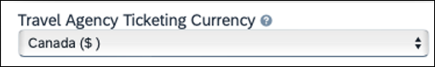
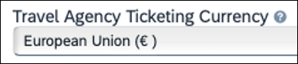

User/Customer Benefit
Customers outside the United States will soon have access to the new Concur Travel experience. While they will still have control over when they choose to enable, the Flight, Car, Hotel and Rail experiences will be available for Sabre and Amadeus GDS based on regional timelines.

End-User Experience
End-users can enable the new Concur Travel experience based on a targeted rollout plan. The planned market expansion schedule is as follows:

North America
- Sabre: Canada and Mexico will be enabled by March 26.
- Amadeus: US, Canada, and Mexico will be enabled by June 25.

EMEA
- Sabre: The UK and Ireland will be enabled by March 26.
- Amadeus: The UK and Ireland will be enabled by June 25.
- Sabre and Amadeus: France, Germany, Spain, Portugal, Italy, Austria, Switzerland, Belgium, Netherlands, and Luxembourg will be enabled by June 25.

Configuration for Professional Travel
Administrators with the Company Admin permission can navigate to the Manage New Concur Travel Experience Preferences page to opt out if they choose not to participate in this round of market expansion. This can be done at the configuration level (country or market) or at the individual Flight, Rental Car, or Hotel level by clicking the configuration under the Company Level Preference section.

**Ongoing** New Concur Travel Experience: Skip Search Action (Professional Edition Only)

Information First Published | Information Last Modified | Feature Target Release Date
October 6, 2023 | March 22, 2024 | February to April 2024
Any changes since the previous monthly release are highlighted in yellow in this release note.

Prof | Stan |   Edition
X |  | On: Impacts end users who use this feature/vendor; no configuration/setup by agency/ admin; cannot be turned OFF (example: new icons or rate display)
 |  | Available for use: No impact to end users unless/until configuration/setup by agency/admin (described below) (example: new rule, new Travelfusion airline)
X |  | Other: Refer to the release note below
 | X | Does not apply to this edition
Source
GDS |  | Sabre, Car Connector
Direct Connect
Other
X | EMEA Data Center |  |  | Scan impact
X | North America Data Center |  | X | UI impact
 | China Data Center |  |  | File finishing impact
 | All data centers |  |  | Profile/Profile API/3rd Party XML Sync Impact
Affected Documentation
TSGs
Fact Sheets
Admin Guides
Other |  | Concur Travel Professional Edition End User Help

Overview
In the February to April releases, the Skip Search action will be available for the new Concur Travel experience. This feature allows a user to discard the search workflow for a trip segment and return to one of three UI pages, depending on the previous workflow.

Phases
This feature will be released to specific verticals, vendors, and data centers between February and April:

Phase | Date of Release
Phase 1: Trainline (existing customers with migration to the new travel experience) | February 2024
Phase 1: Flight, Car, Hotel | February 2024
Phase 3: Renfe Rail customers in US Data Center | April 8, 2024
Phase 4: Renfe Rail customers in EU Data Center | April 10, 2024

User/Customer Benefit
This feature is comparable to existing components in the current Concur Travel shopping experience. It provides the user a one-click method of returning to their trip booking workflow, should they decide not to complete a search and book option.

End-User Experience
The Skip Search link will allow a user to discard the search workflow for a trip segment, returning the user to one of three UI pages, depending on the previous workflow.
For example, if a user decides to book a flight reservation, searches for a flight, and then decides NOT to book a flight, they will click Skip Search.
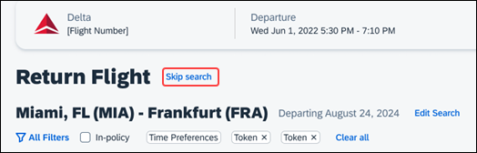
The Skip search option will behave as follows:
- If there is an existing booking for the given trip, but it is not yet finalized, then the user will be redirected to the Finalize page.
- If there is an existing booking for the given trip and it was previously finalized, then the user will be redirected to the Trip Overview page.
- If there is no existing booking or trip, then the user will be redirected to the SAP Concur Travel home page.

Configuration for Professional Travel
This feature is enabled by default. There are no configuration steps.

Rail

**Planned Changes** New Concur Travel Experience: CO2 Emissions Display (Professional Edition Only)

Information First Published | Information Last Modified | Feature Target Release Date
March 8, 2024 | -- | Q2 2024
Any changes since the previous monthly release are highlighted in yellow in this release note.

Prof | Stan | Å Å Edition
 |  | On: Impacts end users who use this feature/vendor; no configuration/setup by agency/ admin; cannot be turned OFF (example: new icons or rate display, new Amtrak feature)
 |  | Available for use: No impact to end users unless/until configuration/setup by agency/admin (described below) (example: new rule, new Travelfusion airline)
X |  | Other: Refer to the release note below
 | X | Does not apply to this edition
Source / Solution Suggestion
GDS
Direct Connect |  | Trainline, Renfe
Other
X | EMEA Data Center |  |  | Scan impact
X | North America Data Center |  | X | UI impact
 | China Data Center |  |  | File finishing impact
 | All data centers |  |  | Profile/Profile API/3rd Party XML Sync Impact
Affected Documentation
TSGs
Fact Sheets
Admin Guides
Other

Overview
In an upcoming release, the carbon dioxide (CO2) emissions display will be updated for UK Rail (Trainline) and will become available for Renfe Rail.

User/Customer Benefit
When shopping and booking rail, customers will have access to CO2 emissions information applicable to their rail journey. Display of CO2 emissions will be supported per journey segment and per class of service. For Renfe the option to sort by emissions will be also available.

End-User Experience
The CO2 emissions will be shown to the user on the Shop pages, where it will be displayed per class of service. CO2 per segment will be available on Train Details modal which is displayed on Review and Book page, Finalize page and Trip Overview page.
On Shop pages the option to Sort by emissions will become available for Renfe. For Trainline this sorting is already supported.
Screenshots to be provided in a future update to the release notes.

Configuration for Professional Travel
This feature is enabled by default. There are no configuration steps.

*Planned Changes** New Concur Travel Experience: Renfe - Auto-Cancel and Standalone Approval Process Enhancement (Professional Travel Only) (April 8-10)

Information First Published | Information Last Modified | Feature Target Release Date
January 2024 | March 22, 2024 | April 8-10, 2024
Any changes since the previous monthly release are highlighted in yellow in this release note.

Prof | Stan | Å Å Edition
 |  | On: Impacts end users who use this feature/vendor; no configuration/setup by agency/ admin; cannot be turned OFF (example: new icons or rate display, new Amtrak feature)
 |  | Available for use: No impact to end users unless/until configuration/setup by agency/admin (described below) (example: new rule, new Travelfusion airline)
X |  | Other: Refer to the release note below
 | X | Does not apply to this edition
Source / Solution Suggestion
GDS |  | Applies to all GDSs
Direct Connect |  | Applies to all Direct Connects
Other
X | EMEA Data Center |  |  | Scan impact
X | North America Data Center |  |  | UI impact
 | China Data Center |  |  | File finishing impact
 | All data centers |  |  | Profile/Profile API/3rd Party XML Sync Impact
Affected Documentation
TSGs
Fact Sheets
Admin Guides
Other

Overview
Targeted for April 2024, SAP Concur will support standalone approvals for Renfe, as it does for all other verticals and rail vendors. Require Approval and Require Passive Approval rules will no longer be downgraded.
In the previous Concur Travel booking experience and in cases where a trip was booked using current and new booking experiences together (“mixed trips”), if Require Approval or Require Passive Approval rules were broken, and the approver either rejected or did not take an action on the trip by the approval deadline, the trip was:
- Auto-finalized, allowing for trip fulfilment for certain booking sources where bookings are not fully refundable or cancellation isn’t possible (for trips containing Cleartrip, Travelfusion, Evolvi, Trainline, and Renfe bookings).
- Neither auto-cancelled nor auto-finalized, where the trip is left unactioned in Concur Travel (for trips containing UK Rail, and Deutsch Bahn bookings).
- Auto cancelled, for all other booking sources where bookings are fully refundable and can be cancelled (for example, GDS Air bookings, before ticketing).
Targeted for the April release, for trips booked entirely on the new Concur Travel experience, if the Require Approval or Require Passive Approval rules are broken, and the approver either rejects or does not action the trip by the trip approval deadline, Concur Travel will check all bookings on the trip for cancel / refund ability, regardless of booking source.
If Require Approval or Require Passive Approval rules are broken, and the approver either rejects or does not take action on the trip by the approval deadline, the trip is:
- Auto-finalized, allowing for trip fulfilment for trips with at least one non-cancelable or not fully refundable booking or where cancellation isn't possible (for example, one trip that includes a Trainline booking, as this content cannot yet be cancelled in Concur Travel).
- Auto-cancelled, for all bookings that are fully refundable and can be cancelled (for example, GDS Air bookings, before ticketing).
For mixed trips containing Renfe as a booking source, Concur Travel auto-finalizes the trip, allowing for trip fulfilment if the trip contains at least one booking non-cancellable or cancellable with a fee. Otherwise, it will auto cancel the trip. Mixed trip behavior is unchanged.
For trips booked entirely on the new Concur Travel Experience and for mixed trips, Concur Travel continues to respect the auto cancel settings Allow Auto Cancel of trips that require approval, Allow Auto Cancel of air/rail trips that are rejected, and Allow immediate Cancel of Non-air/rail trips that are rejected. When set to not allow auto-cancellation, Concur travel does not auto-cancel nor auto-finalize the trip. When set to allow auto-cancellation, Concur Travel no longer leaves trips in an un-actioned state and is auto-finalizing more trips due to improved awareness around ability to cancel and refund.

User/Customer Benefit
To provide a more effective and consistent user experience, the Trainline rules were updated for the new Concur Travel experience. The previous limitation has been removed.

End-User Experience
When the user books a trip that will be auto-finalized, they will see the following:
Example: Trip Confirmation page
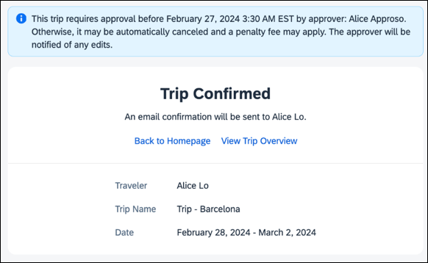
Example: Trip Overview page before the approver rejects the trip
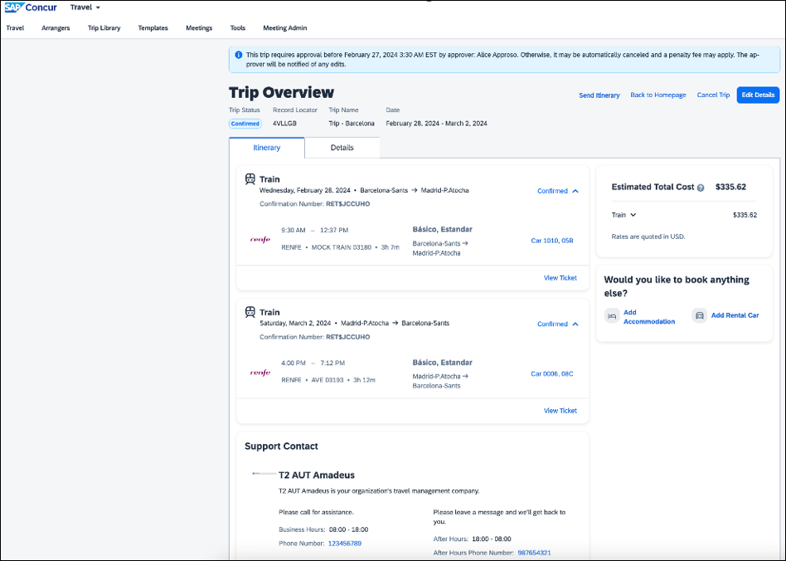
Example: Trip Overview page after the approver rejects and the trip is auto-finalized
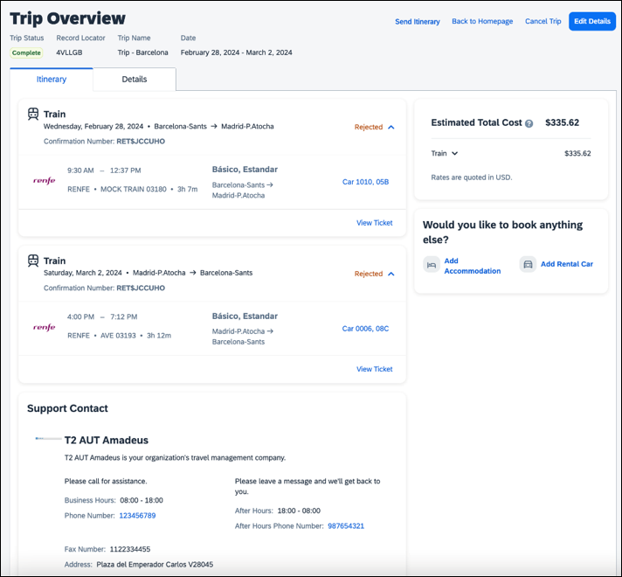
Example: Email that the traveler receives after the approver rejects the trip
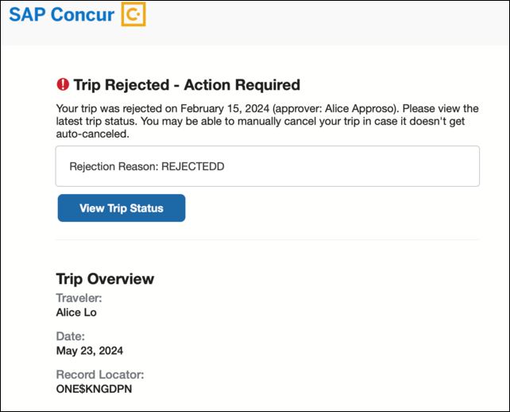
Example: Approver email
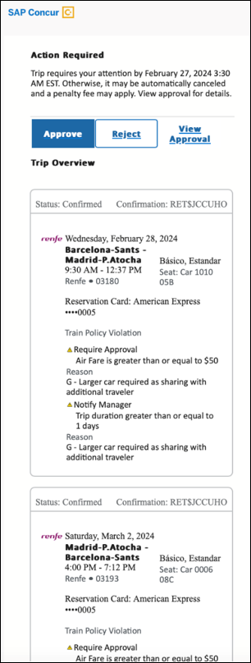
Example: For same day bookings, when approval deadline is in the past at the time of booking - Traveler’s Trip Confirmation email
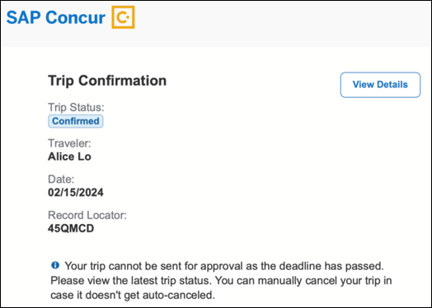
Example: Approver is notified email notification
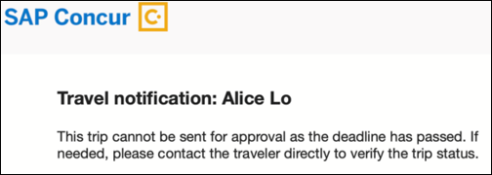

Configuration for Professional Travel
No additional steps are required by administrators to support this change.

**Planned Changes** New Concur Travel Experience: Renfe – Allow/Display Message Support (Professional Edition Only)(April 8-10)

Information First Published | Information Last Modified | Feature Target Release Date
March 8, 2024 | March 22, 2024 | April 8 -10, 2024
Any changes since the previous monthly release are highlighted in yellow in this release note.

Prof | Stan | Å Å Edition
 |  | On: Impacts end users who use this feature/vendor; no configuration/setup by agency/ admin; cannot be turned OFF (example: new icons or rate display, new Amtrak feature)
 |  | Available for use: No impact to end users unless/until configuration/setup by agency/admin (described below) (example: new rule, new Travelfusion airline)
X |  | Other: Refer to the release note below
 | X | Does not apply to this edition
Source / Solution Suggestion
GDS
Direct Connect |  | Renfe Direct Connect
Other
X | EMEA Data Center |  |  | Scan impact
X | North America Data Center |  |  | UI impact
 | China Data Center |  |  | File finishing impact
 | All data centers |  |  | Profile/Profile API/3rd Party XML Sync Impact
Affected Documentation
TSGs
Fact Sheets
Admin Guides |  | Travel System Administration Guide
Other

Overview
Targeted for the April 2024 release, support for additional policy-based messaging set by administrators will be available. Allow and Display Message enforcement levels will behave similarly. When a rule is set up with these levels, the user will be able to book the segment without restrictions.

User/Customer Benefit
This functionality will provide administrators with more options for adding policy-based information for travelers.

End-User Experience
Example: Customers will see a message.
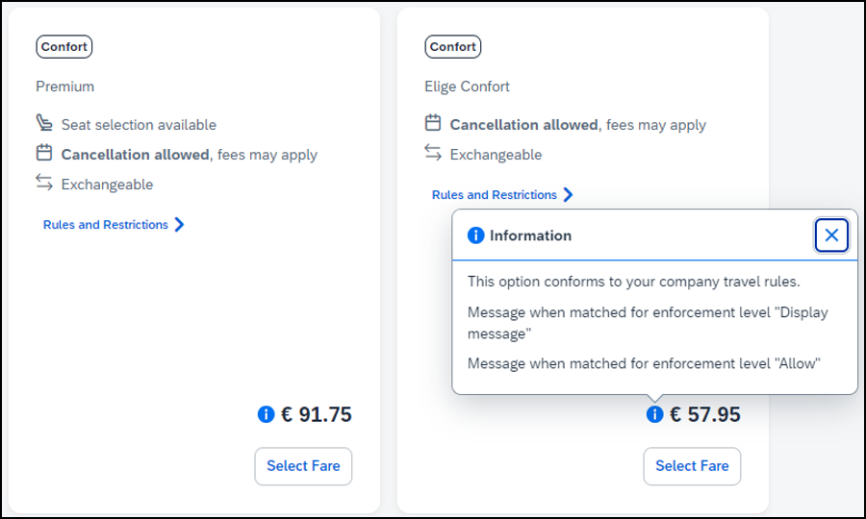

Configuration for Professional Travel
In the Travel Policy Administration section, administrators can set rules with the applicable enforcement level, and configure a message for it when matched.
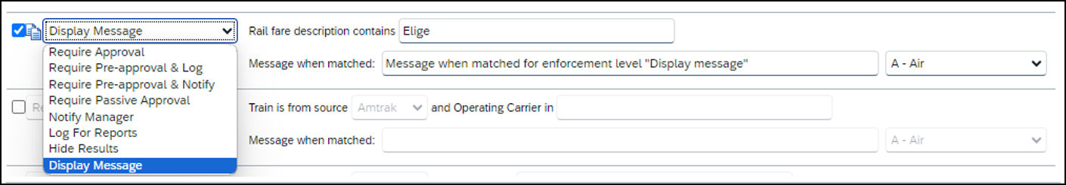
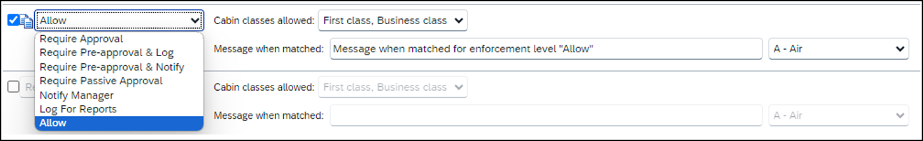
Not all types of rules have both enforcement levels. For example, train rules allow for Display Message, whereas Flight - Class of Service rules allow for Allow.

**Planned Changes** New Concur Travel Experience: Renfe - Changes to Approval Deadline Logic (Professional Edition Only)(April 8-10)

Information First Published | Information Last Modified | Feature Target Release Date
December 2023 | March 22, 2024 | April 8-10, 2024
Any changes since the previous monthly release are highlighted in yellow in this release note.

Prof | Stan | Å Å Edition
 |  | On: Impacts end users who use this feature/vendor; no configuration/setup by agency/ admin; cannot be turned OFF (example: new icons or rate display, new Amtrak feature)
 |  | Available for use: No impact to end users unless/until configuration/setup by agency/admin (described below) (example: new rule, new Travelfusion airline)
X |  | Other: Refer to the release note below
 | X | Does not apply to this edition
Source / Solution Suggestion
GDS
Direct Connect |  | Renfe Direct Connect
Other
X | EMEA Data Center |  |  | Scan impact
X | North America Data Center |  |  | UI impact
 | China Data Center |  |  | File finishing impact
 | All data centers |  |  | Profile/Profile API/3rd Party XML Sync Impact
Affected Documentation
TSGs
Fact Sheets
Admin Guides
Other |  | Concur Travel Professional Edition End User Help

Overview
Targeted for the April 2024 release, the method with which an approval deadline is calculated will change. This will allow for an approver to process a trip. If unprocessed, the trip will attempt to be auto-cancelled.

User/Customer Benefit
This change is being made to provide a more consistent approval deadline behavior between SAP Concur products.

End-User Experience
Currently in the new Concur Travel experience when a booking is either non-refundable, instant purchase, or same day booking, the approval deadline is not calculated. If the approver does not take any action, the trip will remain live in the system and the traveler must contact the travel agency to cancel the booking.
With this update, an approval deadline will be calculated irrespective of the trip content. For a booking with non-refundable or instant purchase content, the approval deadline will be calculated as the booking start date, less one day.
The trip approval deadline will still be the sooner of all the booking's individual booking times. Please refer to the examples below:
Any trip with only one Flight booking, where the booking has a deadline:
- Soonest of either Booking 1 Deadline or Agency Time, less 2 hours.
Any trip with only one booking, where the booking does not have a deadline:
- Trip start, less 1 day.
Any trip with two bookings (one of which is Flight and the other is not), where all the bookings have a deadline:
- The soonest of either Booking 1 Flight Deadline or Agency Time, less 2 hours.
- Booking 2 Deadline, less 2 hours.
- The soonest of either a. or b.
Any trip with two bookings (one of which is Flight, and the other is not), where the first booking has a deadline, and the second booking does not have a deadline:
- The soonest of Booking 1 Deadline, or Agency Time, less 2 hours.
- Trip start, less 1 day.
- The soonest of either a. or b.
For same day bookings, the Trip Start Time less 2 hours will be used. If the approval deadline is in the past, the trip will be automatically cancelled immediately after booking. The traveler will be warned of the cancellation on the Confirmation page.
If the assigned approver does not take action by the approval deadline, the trip will be sent for auto-cancelation. However, if the trip cannot be cancelled or has at least one booking that is not fully refundable, the trip will not be cancelled but sent for finishing instead.

Configuration for Professional Travel
No additional steps are required by administrators to support this change. However, SAP Concur recommends that clients provide messaging within Concur Travel to inform travelers of these changes.

**Planned Changes** New Concur Travel Experience: Renfe - Configurable Message Boards (Professional Edition Only) (April 8-10)

Information First Published | Information Last Modified | Feature Target Release Date
December 2023 | March 22, 2024 | April 8-10, 2024
Any changes since the previous monthly release are highlighted in yellow in this release note.

Prof | Stan | Å Å Edition
 |  | On: Impacts end users who use this feature/vendor; no configuration/setup by agency/ admin; cannot be turned OFF (example: new icons or rate display, new Amtrak feature)
X |  | Available for use: No impact to end users unless/until configuration/setup by agency/admin (described below) (example: new rule, new Travelfusion airline)
 |  | Other: Refer to the release note below
 | X | Does not apply to this edition
Source / Solution Suggestion
GDS
Direct Connect |  | Renfe
Other
X | EMEA Data Center |  |  | Scan impact
X | North America Data Center |  |  | UI impact
 | China Data Center |  |  | File finishing impact
 | All data centers |  |  | Profile/Profile API/3rd Party XML Sync Impact
Affected Documentation
TSGs |  | Renfe Direct Connect, Configurable Message Boards Travel Service Guide
Fact Sheets
Admin Guides
Other

Overview
The Configurable Message Boards allow clients to influence end user behavior with dynamic, rule based, messaging. The new Concur Travel experience for Renfe Rail will support new placements with the April release.

User/Customer Benefit
Configurable Message Boards provide administrators with the opportunity to configure informative custom messaging for specific scenarios based on policy rules to their end users.

End-User Experience
Messages will display on the shop page. They can appear inline:
Or in a popup:
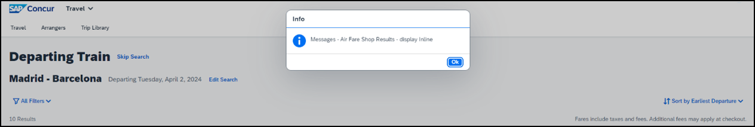

Configuration for Professional Travel
In the Travel Policy Administration section, rules can be configured under Messages - Air Fare Shop Results:
Support for configurable message boards is limited to the web user interface. Rich text including formatting and hyperlinks will be supported.
Any message entered manually by an administrator is not localized. If a message is not set up by an administrator, the localized rule will display to the user.
It is not possible to configure configurable message boards separately for Rail and Flight bookings. If configured, messaging will display for both.

**Planned Changes** New Concur Travel Experience: Renfe - Least Cost Logical Fare Support (Professional Edition Only) (April 8-10)

Information First Published | Information Last Modified | Feature Target Release Date
December 2023 | March 22, 2024 | April 8-10, 2024
Any changes since the previous monthly release are highlighted in yellow in this release note.

Prof | Stan | Å Å Edition
 |  | On: Impacts end users who use this feature/vendor; no configuration/setup by agency/ admin; cannot be turned OFF (example: new icons or rate display, new Amtrak feature)
X |  | Available for use: No impact to end users unless/until configuration/setup by agency/admin (described below) (example: new rule, new Travelfusion airline)
 |  | Other: Refer to the release note below
 | X | Does not apply to this edition
Source / Solution Suggestion
GDS
Direct Connect |  | Renfe
Other
X | EMEA Data Center |  |  | Scan impact
X | North America Data Center |  |  | UI impact
 | China Data Center |  |  | File finishing impact
 | All data centers |  |  | Profile/Profile API/3rd Party XML Sync Impact
Affected Documentation
TSGs |  | Renfe Direct Connect Travel Service Guide, Lowest Logical Fare (LLF) / Benchmark Lowest Airfare
Fact Sheets
Admin Guides
Other |  | Travel Services Help

Overview
Targeted for release in April 2024, Concur Travel plans to introduce the support of the Least Cost Logical Fare (LLF) for Renfe rail bookings in the new Concur Travel experience.

User/Customer Benefit
The calculation of the Least Cost Logical Fare (LLF) is based on criteria and travel policy rules set by the company administrator. These options will be highlighted as the best choices for the users to select during the train search.

End-User Experience
If configured, Concur Travel calculates the Least Cost Logical Fare (LLF) based on criteria defined by the customer. LLFs are identified on the Search results page with a star icon. If configured, LLF will display per class of service. The same icon is used for all classes of service.
The LLF will also be visible with the same icon in the Train Options Turned Down list to both the user and the approver.

Configuration for Professional Travel
Least Cost Logical Fare is calculated for Rail only if the Include Rail setting in the LLF calculation definition is set to Yes. Administrators can make this change by going to the Travel Policy Administration page and editing Flight travel policy rules.
LLF per fare class of service is a new LLF configuration only applicable to the new Concur Travel experience. The new configuration will enable administrators to have a Least Cost Logical Fare per class of service. This is different than the current system where the LLF is always in the lowest class of service that is available in the search results.

Limitations
Delayed LLF calculation configuration on Company Travel Configuration page:
- Enforce LLF based on user’s chosen fare: Initially, the display of additional screen will not be supported. This functionality may be added later. A banner message will display at the top of the Search Results page that will read: “Additional policy will be calculated based on the time of your selected fare”. Delayed LLF will be calculated after the user has selected their fare (for example, if return fares are chosen after the selection of an inbound fare), and all fares will be evaluated against any delayed LLF based travel policy rules. Users will see all policy rule violations on the Review and Book page for the moment, this may be revised in the future.

- Enforce LLF based on hybrid: Initially, Hybrid LLF will be calculated based on the search window. Additional search options triggering calculation based on a user’s search are not yet supported.
The Run Dedicated LLF Shop LLF configuration option is not supported in the new Concur Travel experience due to changes in the overall search process.
Mark LLF fare/s with icon LLF configuration option is no longer support in the new Concur Travel experience. The icon will always display.
Travel administrators for configurations where Renfe rail connectors are enabled and who set LLF criteria for Rail should revisit their current LLF related policy rules to ensure rules are configured correctly for their needs.
All configuration settings are applied for both Flight and Rail bookings if LLF is enabled for Rail.

**Planned Changes** New Concur Travel Experience: Renfe - Multiple Violation Reasons (Professional Edition Only) (April 8-10)

Information First Published | Information Last Modified | Feature Target Release Date
December 2023 | March 22, 2024 | April 8-10, 2024
Any changes since the previous monthly release are highlighted in yellow in this release note.

Prof | Stan | Å Å Edition
 |  | On: Impacts end users who use this feature/vendor; no configuration/setup by agency/ admin; cannot be turned OFF (example: new icons or rate display, new Amtrak feature)
X |  | Available for use: No impact to end users unless/until configuration/setup by agency/admin (described below) (example: new rule, new Travelfusion airline)
 |  | Other: Refer to the release note below
 | X | Does not apply to this edition
Source / Solution Suggestion
GDS
Direct Connect |  | Renfe
Other
X | EMEA Data Center |  |  | Scan impact
X | North America Data Center |  |  | UI impact
 | China Data Center |  |  | File finishing impact
 | All data centers |  |  | Profile/Profile API/3rd Party XML Sync Impact
Affected Documentation
TSGs |  | Renfe Direct Connect
Fact Sheets
Admin Guides |  | Travel System Admin Guide
Other

Overview
For bookings of out-of-policy fares, users are required to select a policy violation reason. An upcoming release will introduce support for Allow Multiple Violation Reason Codes for Renfe.

User/Customer Benefit
The updates to the Policy section for rail will provide a more cohesive Concur Travel experience. They allow for improved visibility of violated policy rules and the ability to provide multiple violation reasons for rail bookings.

End-User Experience
If Allow Multiple Violation Reason Codes is enabled and multiple travel policy rules are violated, a user may be requested to select multiple violation reasons on the Review and Book page if different policy violation reason types are configured for the rules.
The user interface will display a list all the policy rules violated, grouped by the rule action.

Configuration for Professional Travel
No additional steps are required by administrators to support this change.
Allow Multiple Violation Reason Codes can be enabled on the Company Travel Configuration page.
The setting is applicable to all bookings when enabled. It is not specific to rail bookings.

**Planned Changes** New Concur Travel Experience: Renfe - New Supported Rules (Professional Edition Only) (April 8-10)

Information First Published | Information Last Modified | Feature Target Release Date
February 9, 2024 | March 22, 2024 | April 8-10, 2024
Any changes since the previous monthly release are highlighted in yellow in this release note.

Prof | Stan | Å Å Edition
 |  | On: Impacts end users who use this feature/vendor; no configuration/setup by agency/ admin; cannot be turned OFF (example: new icons or rate display, new Amtrak feature)
 |  | Available for use: No impact to end users unless/until configuration/setup by agency/admin (described below) (example: new rule, new Travelfusion airline)
X |  | Other: Refer to the release note below
 | X | Does not apply to this edition
Source / Solution Suggestion
GDS
Direct Connect
Other
X | EMEA Data Center |  |  | Scan impact
X | North America Data Center |  |  | UI impact
 | China Data Center |  |  | File finishing impact
 | All data centers |  |  | Profile/Profile API/3rd Party XML Sync Impact
Affected Documentation
TSGs |  | Approvals, Rules, and Classes/Policies Travel Service Guide
Fact Sheets
Admin Guides
Other

Overview
New rules will be supported for Renfe to match the legacy Concur Travel experience. This will require Renfe clients to update their rule class setup.

User/Customer Benefit
To provide a more effective and consistent user experience, the Renfe rules will be updated for the new Concur Travel experience.

End-User Experience
The following rules are supported for Renfe in the new Concur Travel experience.

Flight
- Flight Number [condition] [FlightNumber]
- Flight Number is in the list of [FlightNumber]
- Air Fare is [condition] [currency][money]
- Air Fare is [condition] the least cost logical airfare plus [difference] [currencyOrPercent]
- Air Fare is within [difference] to [difference2] [currencyOrPercent] of the least cost logical airfare
- Air Fare is [difference] [currencyOrPercent] [condition] the least cost fewest stops fare
- Air Fare is [condition] the least cost [numStops]-stop fare [plusMinus] [difference]
- Air Base Fare is [condition] [currency][money]
- One or more fare basis codes contain [FareBasisText]
- One or more fare basis codes do not contain [FareBasisText]
- Any leg departure City is [CityCodeList]
- Any leg departure City is not [CityCodeList]
- Any leg arrival City is [CityCodeList]
- Any leg arrival City is not [CityCodeList]
- First leg departure City is [CityCodeList]
- First leg departure City is not [CityCodeList]
- First leg arrival City is [CityCodeList]
- First leg arrival City is not [CityCodeList]
- Flights connect through airport/city [CityCodeList]
- No flights connect through airport/city [CityCodeList]
- Flight departure or arrival city is [CityCodeList]
- Neither departure nor arrival city is [CityCodeList]
- Flight is between airports [CityCodeList1] and [CityCodeList2]
- Flight is not between airports [CityCodeList1] and [CityCodeList2]
- Flight departure date is [condition] [Date]
- Flight arrival date is [condition] [Date]
- Flight depart time is [condition] [Time]
- Flight arrival time is [condition] [Time]
- Flight depart time is between [Time1] and [Time2]
- Flight arrival time is between [Time1] and [Time2]
- Flight depart time is not between [Time1] and [Time2]
- Flight arrival time is not between [Time1] and [Time2]
- Flight departure date/time is [condition] [Date] at [Time]
- Flight arrival date/time is [condition] [Date] at [Time]
- Flight departure date/time on [leg] leg [condition] [Date] at [Time]
- Flight arrival date/time on [leg] leg [condition] [Date] at [Time]
- Flight departs on [DayOfWeekCodes]
- Flight does not depart on [DayOfWeekCodes]
- Flight is refundable
- Flight is not refundable
- Carrier is not preferred
- Carrier is preferred
- Marketing airline is in [CarrierList]
- Marketing airline is not in [CarrierList]
- Operating airline is in [CarrierList]
- Operating airline is not in [CarrierList]
- Any segment carried by [CarrierList]
- Any segment not carried by [CarrierList]
- Any flight is in region [Region]
- Any flight is not in region [Region]
- All Flights are within the region: [Region]
- All Flights are within the region: Africa
- All Flights are within the region: Asia
- All Flights are within the region: Australia
- All Flights are within the region: Europe + UK
- All Flights are within the region: South America
- All Flights are within the region: North America
- Flight Departure Country/Region is [CountryList]
- Flight Arrival Country/Region is [CountryList]
- Flight connects in country/region [CountryList]
- No flights connect in country/region [CountryList]
- All Flights are within the country/region: [CountryList]
- No Flights are within the country/region: [CountryList]
- Any flight is in country/region [CountryList]
- Any flight not within the country/region [CountryList]
- Flight departs from or arrives at an alternate airport in the region
- User requested Area Airports and flights do not depart from/return to the same airport
- Flight departs from or arrives at the user's chosen airport
- Air Fare is [condition] the least cost air fare into the preferred airport [plusMinus] [difference]
- The least cost logical airfare uses alternate airports
- The least cost logical airfare uses the user's chosen airport
- Flight uses [prefAlt] airport and airport is one of [CityCodeList]
- Flight is booked less than [DaysAdvance] days in advance
- Flight is booked less than [HoursAdvance] hours in advance
- Any leg duration [condition] that of the user's selected flights plus [minutes] minutes, [incExcLayovers] layovers
- Any leg duration [condition] that of the shortest duration for that leg in the inventory plus [minutes] minutes, [incExcLayovers] layovers
- Shortest Flight duration between two most distant airports is [condition] [minutes] minutes, [incExcLayovers] layovers
- Flight duration of all flights in a segment (including layovers) is [condition] [Duration] minutes
- Flight duration of all flights in a segment (excluding layovers) is [condition] [Duration] minutes
- Flight duration for any single flight is [condition] [Duration] minutes
- Fare is from the Reservation System
- Fare is not from the Reservation System
- Fare uses class of service not in [ClassList]
- Fare uses cabin class not in list [CabinList]
- Search results contain one or more of these vendors: [VendorList]
- Search results contain none of these vendors: [VendorList]
- Results contain preferred vendors
- Results do not contain preferred vendors
- Trip duration [condition] [DaysLong] days
- Time spent at destination is [condition] [DaysLong] days
- Flight Number of stops is [condition] [Numstops]
- The least cost logical airfare is on one of [CarrierList]
- The least cost logical airfare is not on one of [CarrierList]
- Layover duration on any segment is [condition] [minutes] minutes
- Number of stops in the least cost logical fare is [condition] [numStops] stops
- Number of stops is [condition] the number of stops in the least cost logical fare
- Contains flights in cabin lower than that requested
- Booking source is [Source]
- Booking source is not [Source]

Rail
- Number of train changes is [condition] [NumTrainChanges] and train carrier is in [CarrierList]
- Rail is [PreferredList]
- Rail is not [PreferredList]
- Trip duration [condition] [DaysLong] days
- Rail fare description contains [DescriptionList]
- Train is from source [Vendor] and Operating Carrier in [CarrierList]
- Train is from source [Vendor] and train type in [TrainTypeList]

View More Fares
These rules are applied during the initial search.
- Fare in cabin classes: [CabinList] is [condition] the least cost logical airfare plus [difference] [currencyOrPercent]
- Refundable fare in cabin classes: [CabinList] is [condition] the least cost logical airfare plus [difference] [currencyOrPercent]
- Refundable fare in cabin classes: [CabinList] is [condition] the cheapest fare in flight plus [difference] [currencyOrPercent]
- Fare in cabin classes: [CabinList] is [condition] the cheapest refundable fare in flight plus [difference] [currencyOrPercent]
- First leg departure City is [CityCodeList]
- First leg departure City is not [CityCodeList]
- First leg arrival City is [CityCodeList]
- First leg arrival City is not [CityCodeList]
- User requested Area Airports and flights do not depart from/return to the same airport
- One or more fare basis codes contain [FareBasisText]
- One or more fare basis codes do not contain [FareBasisText]

Class of Service Group (Unique from Flight Group)
- Cabin classes allowed: [CabinClasses]
- Leg duration [condition] that of the shortest option available plus [minutes] minutes, [incExcLayovers] layovers

Considerations when setting up Flight rules for Rail:
- City code is Rail station code.
- Flight number is a maximum of 4 digits
The admin interface limit may not be long enough for train number.
- There is no difference between marketing / operating / validating carriers in Rail.
- Rail fare always checks the total cost.
- For LLF definition:
- If “Include rail” option is OFF, LLF will be turned off for Rail.
- Refundability option only applies when this information is available.
- Center time calculation does not support morning, afternoon, evening, or anytime.
- Arrival time is not supported.
- Outbound policy violations will not be called out-of-policy, even if no inbound fares can be combined with the specific outbound fare to yield a policy compliant option. For example, if a rule is set up as "Air Fare greater than $50 - require approval" and cheapest outbound fare is $40 and cheapest inbound fare is $30, then
- The outbound fare will not be marked out-of-policy.
- All inbound fares will be marked out-of-policy.

Configuration for Professional Travel
No additional steps are required by administrators to support this change. However, SAP Concur recommends that clients provide messaging within Concur Travel to inform travelers of the updated rule set.

**Planned Changes** New Concur Travel Experience: Renfe - Support for Multiple Rail Connectors (Professional Edition Only) (April 8-10)

Information First Published | Information Last Modified | Feature Target Release Date
December 2023 | March 22, 2024 | April 8-10, 2024
Any changes since the previous monthly release are highlighted in yellow in this release note.

Prof | Stan | Å Å Edition
 |  | On: Impacts end users who use this feature/vendor; no configuration/setup by agency/ admin; cannot be turned OFF (example: new icons or rate display, new Amtrak feature)
X |  | Available for use: No impact to end users unless/until configuration/setup by agency/admin (described below) (example: new rule, new Travelfusion airline)
 |  | Other: Refer to the release note below
 | X | Does not apply to this edition
Source / Solution Suggestion
GDS
Direct Connect |  | Renfe
Other
X | EMEA Data Center |  |  | Scan impact
X | North America Data Center |  |  | UI impact
 | China Data Center |  |  | File finishing impact
 | All data centers |  |  | Profile/Profile API/3rd Party XML Sync Impact
Affected Documentation
TSGs |  | Renfe Direct Connect
Fact Sheets
Admin Guides |  | Travel System Admin Guide
Other

Overview
Concur Travel offers multiple rail connectors. In an upcoming release, support will be added for any rail connectors offered by Concur Travel to be enabled with Renfe.

User/Customer Benefit
This change will provide administrators with the opportunity to enable a wider rail offering to their users on one travel configuration in the new Concur Travel experience.

End-User Experience
End users will be able to book with any of the enabled rail connectors.
For travel configurations where only rail connectors in the New Concur Travel Experience are enabled, vendor selection by the user will not be necessary.
For travel configurations combining current and New Concur Travel Experience rail connectors, the user can select the vendor from a dropdown.

Configuration for Professional Travel
No additional steps are required by administrators to support this change.
Any new rail connectors can be added or removed on the Company Travel Configuration page.
Currently when Renfe is enabled alongside any additional rail connector, only Renfe is available to the end users. With the upcoming release, if any additional rail connector is enabled, it will become available to end users. Administrators should check their Company Travel Configuration settings.

**Planned Changes** New Concur Travel Experience: Renfe - Train Options Turned Down (Professional Edition Only) (April 8-10)

Information First Published | Information Last Modified | Feature Target Release Date
December 2023 | March 22, 2024 | April 8-10, 2024
Any changes since the previous monthly release are highlighted in yellow in this release note.

Prof | Stan | Å Å Edition
 |  | On: Impacts end users who use this feature/vendor; no configuration/setup by agency/ admin; cannot be turned OFF (example: new icons or rate display, new Amtrak feature)
X |  | Available for use: No impact to end users unless/until configuration/setup by agency/admin (described below) (example: new rule, new Travelfusion airline)
 |  | Other: Refer to the release note below
 | X | Does not apply to this edition
Source / Solution Suggestion
GDS
Direct Connect |  | Renfe
Other
X | EMEA Data Center |  |  | Scan impact
X | North America Data Center |  |  | UI impact
 | China Data Center |  |  | File finishing impact
 | All data centers |  |  | Profile/Profile API/3rd Party XML Sync Impact
Affected Documentation
TSGs
Fact Sheets
Admin Guides
Other |  | Module Properties, Travel Services Help

Overview
If an out-of-policy fare is chosen by the user when creating a booking, the options not chosen will be captured and displayed, both to the user and to the approvers. This allows the approver to view the alternatives that were not selected.

User/Customer Benefit
The updates to the Policy section for Rail provide a more cohesive Concur Travel experience. They will allow for the visibility of available fares not chosen when creating out-of-policy bookings.

End-User Experience
When booking out-of-policy, a list of Train Options Turned Down will display. This list will be available to the user on the Review and Book page within the Travel Policy section. For approvers, the Train Options Turned Down list will be available in the approver view and in the approver e-mail.
When Least Cost Logical Fare (LLF) is enabled but not chosen during a booking, the first option in the list will be a declined LLF. The other list items will be the remaining in-policy offers that have not been chosen.
Train Options Turned Down will display only if there are alternative in-policy offers available. If all fares are out-of-policy, no Train Options Turned Down will display.
The maximum number of Train Options Turned Down displayed is limited to ten in the new Concur Travel experience.

Configuration for Professional Travel
This feature will be enabled by default. There are no configuration steps.
The default number of options turned down is 10 (depending on fare availability). Administrators can configure the number of displayed fares using the Limit options turned down for Approval module property.
The module property setting is also applicable to Flight bookings. It is not only specific to Rail bookings.

**Planned Changes** New Concur Travel Experience: Renfe - User Interface Changes to Workflow Pages and Emails (Professional Edition Only) (April 8-10)

Information First Published | Information Last Modified | Feature Target Release Date
November 2023 | March 22, 2024 | April 8-10, 2024
Any changes since the previous monthly release are highlighted in yellow in this release note.

Prof | Stan | Å Å Edition
 |  | On: Impacts end users who use this feature/vendor; no configuration/setup by agency/ admin; cannot be turned OFF (example: new icons or rate display, new Amtrak feature)
 |  | Available for use: No impact to end users unless/until configuration/setup by agency/admin (described below) (example: new rule, new Travelfusion airline)
X |  | Other: Refer to the release note below
 | X | Does not apply to this edition
Source / Solution Suggestion
GDS
Direct Connect |  | Renfe
Other
X | EMEA Data Center |  |  | Scan impact
X | North America Data Center |  |  | UI impact
 | China Data Center |  |  | File finishing impact
 | All data centers |  |  | Profile/Profile API/3rd Party XML Sync Impact
Affected Documentation
TSGs |  | Renfe Direct Connect
Fact Sheets
Admin Guides
Other

Overview
Targeted for April, there will be changes to the view of the Renfe user interface. These changes will affect Shop and Review and Book pages.

User/Customer Benefit
To provide a more consistent user experience, some Renfe pages will be updated to resemble Flight pages.

End-User Experience
These updates will apply mostly to the Shop result and Review and Book pages.
Changes to the search results display:
- New horizontal display of the search results: Up to four fares will display as the initial search results. All remaining available fare options will display upon expanding the itinerary.
- Updated Fare Rules and Restrictions pop-up window.

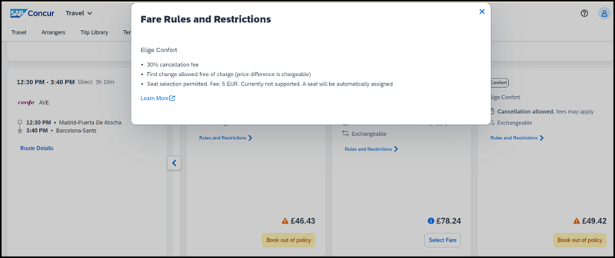
- Updated Filter options.

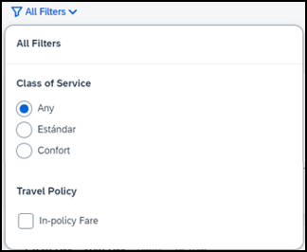
- Updated Sort options.
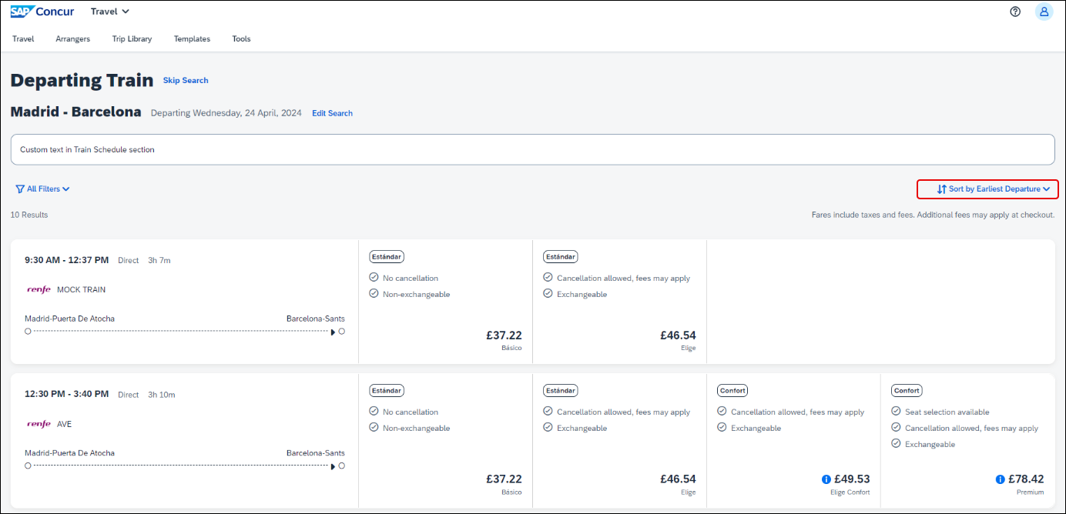

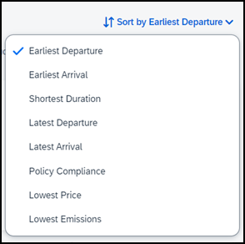
- Support display of Preference label.
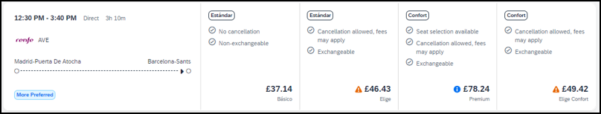
- Display of fares in the configured currency instead of vendor currency.
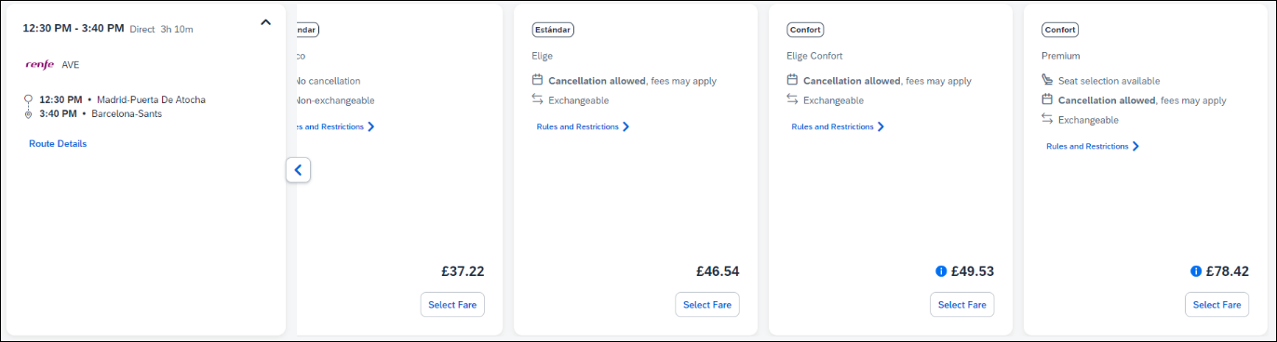
Changes to Review and Book page:
- Updated display of itinerary.
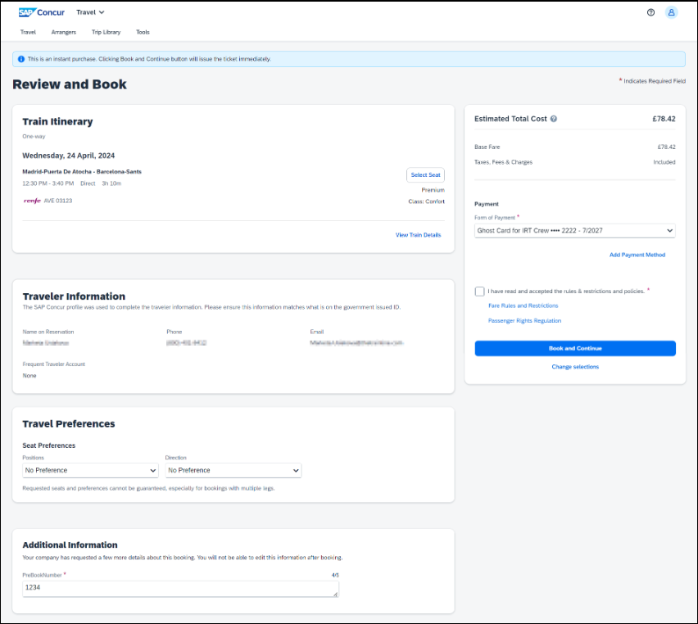
- New display of Total Cost card to align with the display on following Trip pages and Email.
- Updated display of itinerary on Finalize and Trip Overview pages.
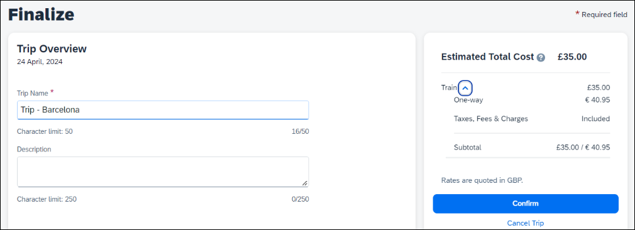
Changes to Confirmation Email:
- Updated display of itinerary
- Previously links to download ticket (PDF and Phone Wallet) was displayed in the body of the confirmation email. In the updated confirmation email tickets will be attached to the email as attached files.
Changes to Approver email:
- The approver email will have a better look and feel to match the rest of the product.
More details will be included in subsequent release notes.

Configuration for Professional Travel
For any features requiring configuration steps by administrators the details will be shared closer to the date. General user interface changes will require no additional enablement.

**Planned Changes** New Concur Travel Experience: Trainline - Available on Amadeus, Sabre, Galileo (Professional Edition Only)

Information First Published | Information Last Modified | Feature Target Release Date
February 9, 2024 | March 8, 2024 | April 2024
Any changes since the previous monthly release are highlighted in yellow in this release note.

Prof | Stan | Å Å Edition
 |  | On: Impacts end users who use this feature/vendor; no configuration/setup by agency/ admin; cannot be turned OFF (example: new icons or rate display, new Amtrak feature)
 |  | Available for use: No impact to end users unless/until configuration/setup by agency/admin (described below) (example: new rule, new Travelfusion airline)
X |  | Other: Refer to the release note below
 | X | Does not apply to this edition
Source / Solution Suggestion
GDS
Direct Connect |  | Trainline
Other
X | EMEA Data Center |  |  | Scan impact
X | North America Data Center |  |  | UI impact
 | China Data Center |  |  | File finishing impact
 | All data centers |  |  | Profile/Profile API/3rd Party XML Sync Impact
Affected Documentation
TSGs
Fact Sheets
Admin Guides
Other |  | Travel Services Help

Overview
Targeted for April 2024, the UK Rail (Trainline) connector is expected to be added to all travel configurations on Amadeus, Sabre and Galileo. New clients will be able to enable the UK Rail (Trainline) connector for Rail content. This announcement is in conjunction with the Trainline migration release note. Customers who have already migrated to Trainline will see the new Trainline connection from the end of February. New clients who are interested in enabling the new Trainline connection and meet the requirements will be able to do so after this planned change for April.

User/Customer Benefit
The new Concur Travel rail booking experience together with the new Trainline connection will bring clients the following benefits:
- New user interface
- Reduced number of steps to complete the booking
- Support for eTicket delivery option
- Support for UK Rail bookings on mobile application
- Support for multiple Advantage Cards (Railcards) in user profile

End-User Experience
The booking workflow will include search, book, and itinerary review.

Search
The user clicks the Rail tab and initiates their search for Round Trip or One Way. For the Open Return option, the user enables the Open Return checkbox in the Round Trip option to omit selecting a return date and time.
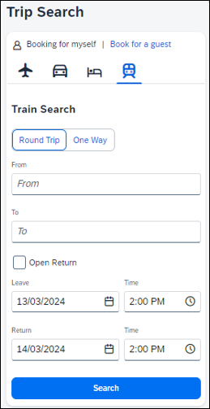

Select a Train
Clicking Search will display the results.
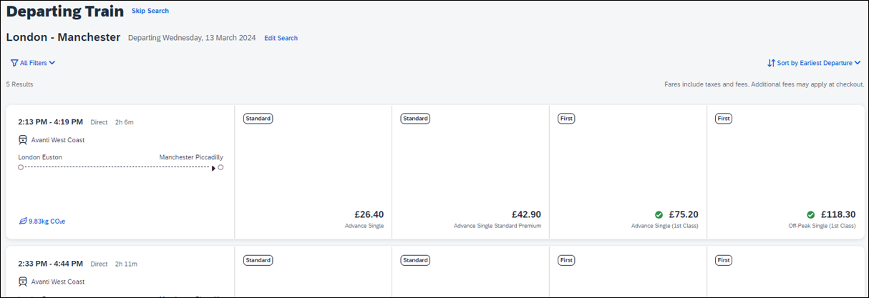
To see all available fares, click on the required train. All fares will display with information on the alternative stations and Rules and Restrictions. If Railcard savings are applied, it will be visible in the fare. The original and the discounted price will also be presented to the user.
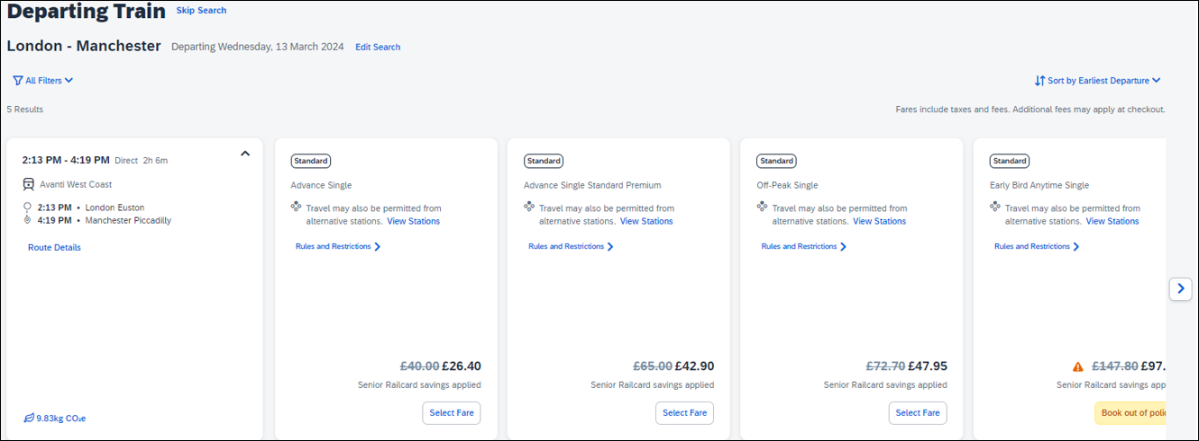
After clicking Select Fare, the user will be redirected to the Review and Book page.

Review and Book
The Review and Book page will display all relevant information for the user to review before completing the booking.
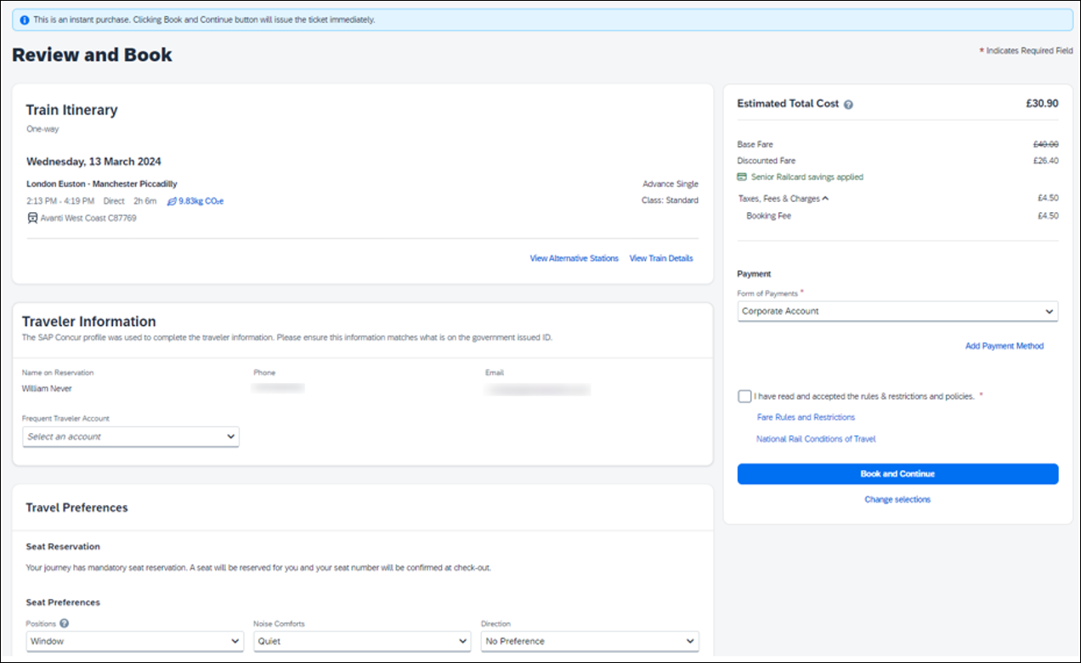
For more information on the Train Itinerary, see View Train Details.
The Form of Payments that will display in the dropdown depend on the agreement between the client, travel agency and Trainline. The Update Card option is available only for personal cards when selected from the dropdown.
The Travel Preferences section contains the Seat Reservation information and Seat Preferences, if applicable. No seat preferences are displayed if the seat reservation is not available. The availability of seat reservation depends on the selected route and carrier.
The Ticket Delivery Preference section offers two ticket delivery options, if applicable: eTicket (free of charge) and Kiosk (with a fee). The eTicket option is preselected if both options are available. Depending on the selected route, the eTicket might not be offered (for example, if a tube is part of the journey).
An eTicket must be enabled with Trainline for the client to see this delivery option. Depending on their contract, the client should contact their travel agency or Trainline if they are interested in the eTicket delivery option.
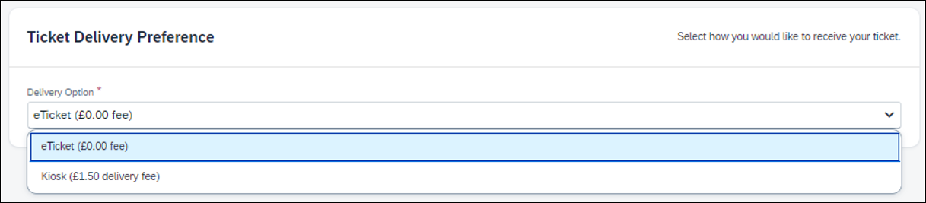
After the user confirms the rules and restrictions and clicks Book and Continue, they will be redirected to the Finalize page.

Finalize
The Finalize page allows a user to add accommodation or rental car. It also provides the user with the overview of their UK Rail (Trainline) booking.
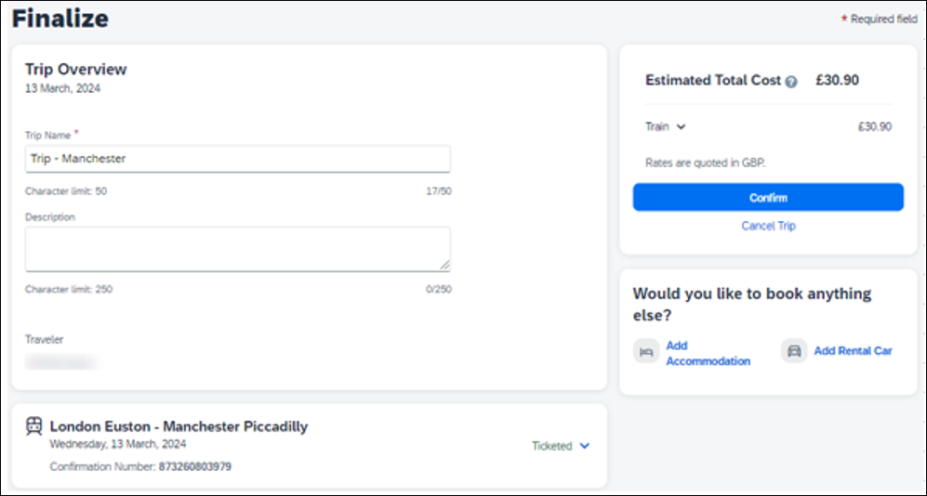
If the user selects the eTicket delivery option on the Review and Book page, the ticket will become available when they get to the Finalize page, accessible when they click the down arrow icon to Show train details:
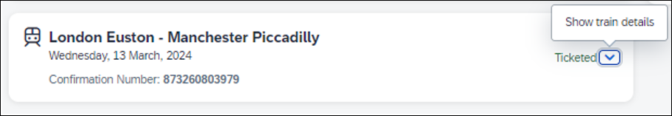
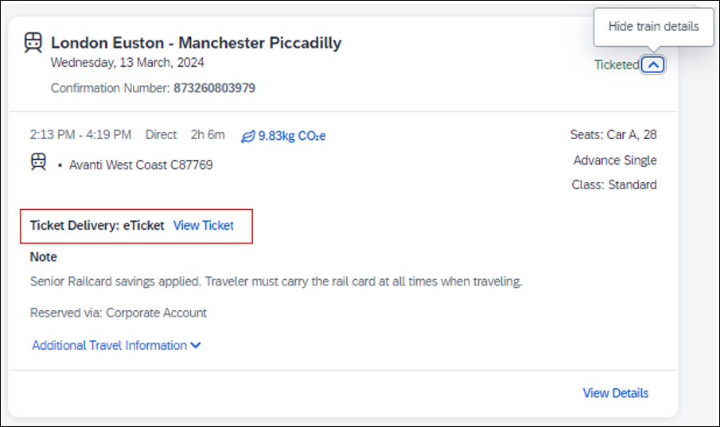

View Ticket
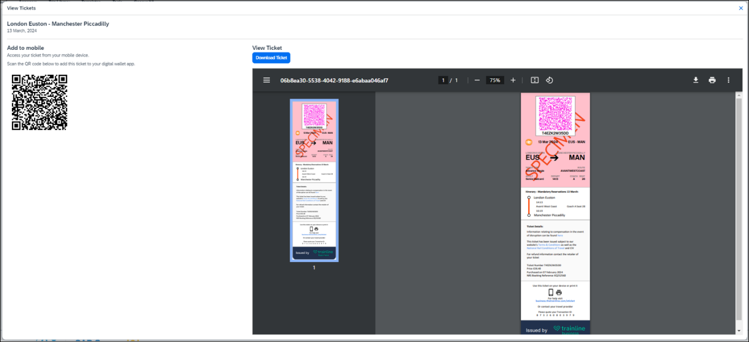
The eTicket issuance might take longer. If the eTicket is not available during the booking process, the email will be sent separately later.
The user clicks Confirm to complete the trip and will be redirected to the Trip Confirmed page.
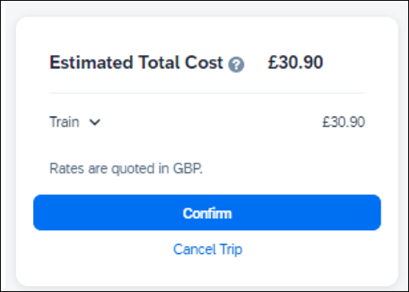
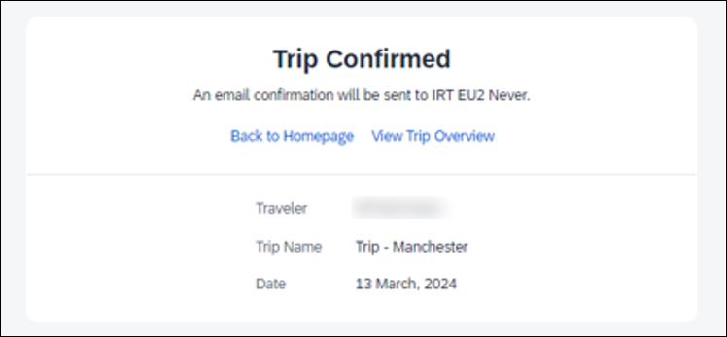
The user can open their trip by clicking on View Trip Overview.

View Trip Overview
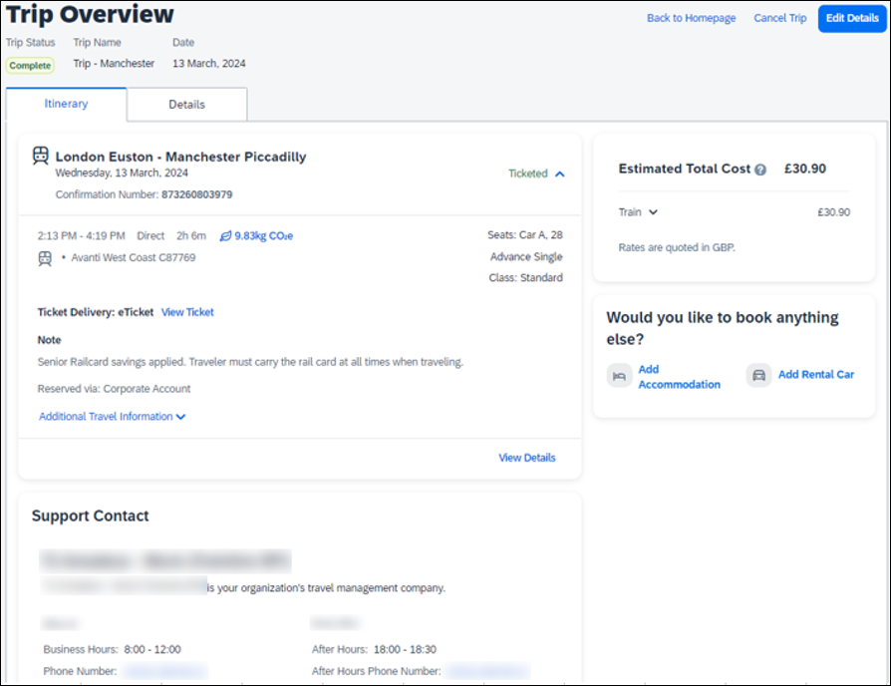
If the client's travel agency has a support contact enabled, it will then appear on the itinerary of the Trainline booking.

Cancel Trip
Cancellation of the Trainline booking is not supported. The user will see the following message when attempting to cancel the Trainline booking:
“Cancelation is not available for at least one content provider. Please contact the supplier or your travel agency for assistance.”
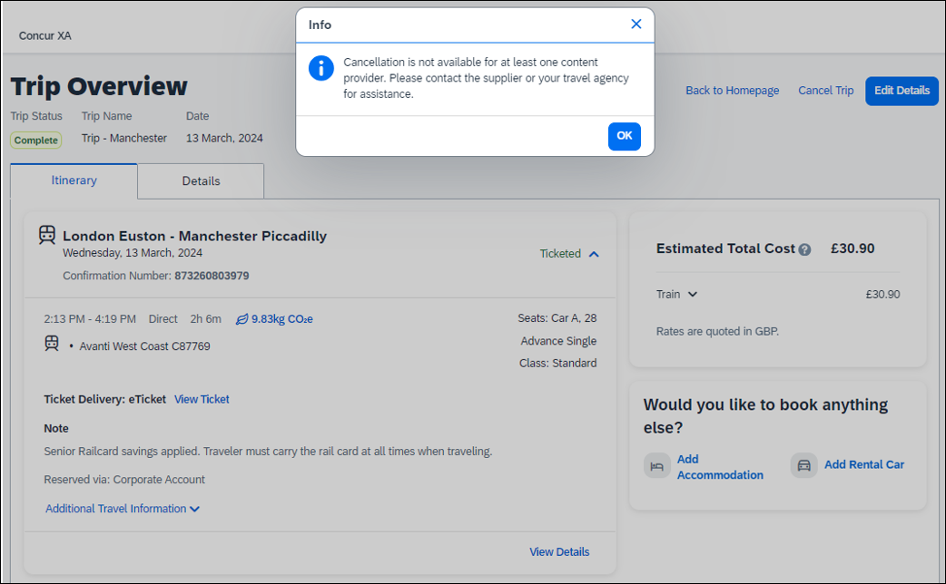

Configuration for Professional Travel
No additional steps are required by administrators to support this change.
The enablement process for the UK Rail (Trainline) connector is described in the following section.

For General Configuration and Activation
- Go to Administration > Travel > Travel System Admin and access the desired client Travel configuration.
Depending on your permissions, the page may appear immediately after you click Administration or Travel.
- In the Rail Connectors section of the travel configuration page, locate UK Rail [Trainline].
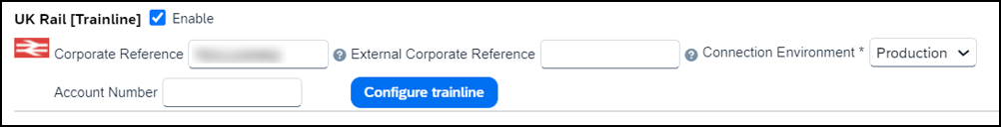
- Complete the appropriate fields.
Field | Required? | Description / Action
Enable | Required | Select this checkbox.
Corporate Reference  OR  External Corporate Reference | Required | New clients will use Corporate Reference field to insert the corporate reference.  Migrated clients will see the corporate reference that they used for the previous connection filled in the External Corporate Reference field.  If both values are entered, the Corporate Reference will take precedence.  In case of any update to the Corporate Reference or External Corporate Reference, save your changes and access the travel configuration again to review MI Questions mapping by clicking Configure Trainline. MI Questions mapping will be lost when the corporate reference is changed and it will need to be set up again.
Account Number | Required*  Optional | Clients having one account number should enter it in the Account Number field. The Account Number is sent to Trainline as Account Name.  *For migrated clients who were using the Account Number field with the legacy API, the account number remains required.  Clients having more than one account number should create a custom field and map it to the appropriate Trainline question under the Configure Trainline button. If the client using the Account Number value wants to set up a custom field for the Account Name instead, they must delete the Account Number value from the UK Rail (Trainline) configuration settings first and then save changes. Next, to access the travel configuration again, open Trainline MI Questions by clicking Configure Trainline and map the Trainline Account Name to their custom field created for this purpose to complete.
Connection Environment | Required | Select Production.  (TEST and MOCK environments are for internal use only)
- Important: Use Configure Trainline to map Concur Travel custom fields to Trainline custom fields. To prevent any issues during the booking flow, make sure that the custom fields’ values set up in Concur Travel correspond to requirements set up with Trainline. Any discrepancy might lead to booking failures for users.

Professional Edition – Client Agreement
Customers based in the UK using a Travel Management Company (TMC) that is also based in the UK, do not need to sign a commercial agreement with Trainline. However, an agreement between Trainline and their TMC is required.
TMCs based in the UK need to have a contract with Trainline to be able to fulfill tickets booked for UK Rail.
TMCs based outside of the UK need to have an international license to fulfill UK Rail tickets. If the TMC does not have an international license and the client would like to book UK Rail from outside of the UK, the client should contact Trainline directly as the direct contract with Trainline would be required in such a case.

Travel Operations / Technical Essentials

**Planned Changes** New Concur Travel Experience: Sabre Car Enhancements – Additional Elements (Professional Edition Only)

Information First Published | Information Last Modified | Feature Target Release Date
March 8, 2024 | March 15, 2024 | July 2024
Any changes since the previous monthly release are highlighted in yellow in this release note.

Prof | Stan |   Edition
 |  | On: Impacts end users who use this feature/vendor; no configuration/setup by agency/ admin; cannot be turned OFF (example: new icons or rate display, new Amtrak feature)
 |  | Available for use: No impact to end users unless/until configuration/setup by agency/admin (described below) (example: new rule, new Travelfusion airline)
X |  | Other: Refer to the release note below
 | X | Does not apply to this edition
Source / Solution Suggestion
GDS |  | Sabre
Direct Connect
Other
X | EMEA Data Center |  |  | Scan impact
X | North America Data Center |  | X | UI impact
 | China Data Center |  |  | File finishing impact
 | All data centers |  |  | Profile/Profile API/3rd Party XML Sync Impact
Affected Documentation
TSGs
Fact Sheets
Admin Guides
Other |  | Travel Services Help

Overview
Targeted for the July release, Concur Travel intends to release additional elements to the Sabre Rental Car experience. The elements that will be added are Flight Information and Loyalty ID.

User/Customer Benefit
SAP Concur wants to enhance the new Concur Travel experience for the end user by adding new elements.

End-User Experience
With the July release, the following will be added:
- Flight Information: This is being added so the traveler’s arrival details can be provided to the rental car partners.
- Loyalty ID: To ensure that loyalty incentives are received, loyalty information will be added to the segment (ID-¤XX). Sabre hides this information.
Example:
CAR ZE 30JAN T HK1 SEA/31JAN/ICAR/ARR-1000 DL1234/ID-¤XX /DCZEXXXX9537/PH-206-277-2300/GVI4111111111111111EXP 08 26-TOBIAS/NM ¤SKYE BLUE/RET-1000/RG¤USD137.75 UNL DY XH46.83 UNL/AP-¤USD189.87 UNL 1DY 0HR 52.12MC/BS-49640150/RC-RCUD1/CF-K6573 775956GOLD-

Configuration for Professional Travel
This feature is enabled by default. There are no configuration steps.

**Planned Changes** Decommission of Credit Card Datapoints in Profile and PNR Finishing Templates

Information First Published | Information Last Modified | Feature Target Release Date
January 12, 2024 | March 15, 2024 | June 2024 (Sabre)  TBD 2024 (all other GDSs)
Any changes since the previous monthly release are highlighted in yellow in this release note.

Prof | Stan |   Edition
X | X | On: Impacts end users who use this feature/vendor; no configuration/setup by agency/ admin; cannot be turned OFF (example: new icons or rate display, new Amtrak feature)
 |  | Available for use: No impact to end users unless/until configuration/setup by agency/admin (described below) (example: new rule, new Travelfusion airline)
X |  | Other: Refer to the release note below
 |  | Does not apply to this edition
Source / Solution Suggestion
GDS |  | Sabre, Amadeus, Apollo, Worldspan, Travelport+ (Galileo)
Direct Connect
Other
X | EMEA Data Center |  |  | Scan impact
X | North America Data Center |  | X | UI impact
 | China Data Center |  |  | File finishing impact
 | All data centers |  |  | Profile/Profile API/3rd Party XML Sync Impact
Affected Documentation
TSGs
Fact Sheets
Admin Guides
Other

Overview
The GDS systems are changing how credit cards are managed in Passenger Name Records (PNRs), resulting in several changes needed within Concur Travel. One of the GDS-imposed changes is the anonymization and removal of credit card data in all areas of the PNR except for the designated Form of Payment (FOP) field or FOP Wallet. In preparation for this change, Concur Travel will be decommissioning Profile and PNR Finishing Template datapoints for credit card numbers and expiration dates.

Sabre
- Profile Templates are not applicable to Sabre customers. Concur Travel securely synchronizes credit card data from the Concur profile to Sabre Profiles using Sabre Web Services today.
- Concur Travel will be migrating to Sabre’s Enhanced Form of Payment (FOP Wallet) and will be adding the traveler-selected form of payment for each booking type to the FOP Wallet (*FOP) along with the applicable Use Type code. Refer to the **Planned Changes** Sabre Enhanced Form of Payment (FOP Wallet) release note in this document for more information.
- Concur Travel will be decommissioning Sabre PNR Finishing Template datapoints for credit card numbers and expiration dates following the release of Sabre Enhanced FOP (FOP Wallet).

Amadeus and Travelport
- Concur Travel will continue to transmit the user-selected credit card to the compliant form of payment field already in place in the PNR today.
- Concur Travel will be decommissioning Amadeus, Apollo, Travelport+ and Worldspan Profile Template datapoints for credit card numbers and expiration dates. A revised timeline is under evaluation and will be shared in a future release note.
- Concur Travel will be decommissioning Amadeus, Apollo, Travelport+ and Worldspan PNR Finishing Template datapoints for credit card numbers and expiration dates. A revised timeline is under evaluation and will be shared in a future release note.
- Concur Travel strongly recommends using the Travel Profile API for synchronizing Concur profile data with your GDS profiles. For more information, refer to the Travel Profile v2 API documentation in the SAP Concur Developer Center.
- SAP Concur is working closely with our GDS partners to ensure Concur Travel is utilizing the latest and most secure credit card processing for travel reservations.
- Due to the highly customizable nature of PNR Finishing Templates, Concur Travel can only provide general guidance for making updates and cannot ensure that finishing will run successfully if these datapoints are not removed before their retirement.

User/Customer Benefit
SAP Concur sees this as one of the first of many industry-wide efforts to better secure sensitive user data, creating higher confidence in the travel purchasing process and reducing financial risk for users and companies alike.
SAP Concur is recommending that customers and TMCs work together to identify any scenarios where the Profile or PNR Finishing templates are used to transmit credit card data to the GDS systems in non-compliant fields of the GDS profile and/or PNR. Customers who need credit card data transmitted to the IUR/A.I.R./MIR file for back-office processing will need to seek a mid-office solution to address their needs.

End-User Experience
The following datapoint examples should help TMCs and customers determine if changes are needed to their Concur Travel instance.

Profile Template Datapoint Examples
The following is a list of profile template datapoints which include credit card numbers or expiration dates; this list may not be comprehensive. TMCs and customers should review their Profile Templates. If templates are using one of the credit card elements, these should be removed:
- Air_credit_card_number car_credit_card_number
- ghost_air_credit_card_number
- ghost_car_credit_card_number
- ghost_hotel_credit_card_number
- hotel_credit_card_number
- personal_air_credit_card_number
- personal_car_credit_card_number
- personal_hotel_credit_card_number
- car_expiration_date
- ghost_air_expiration_date
- ghost_car_expiration_date
- ghost_card_expiration
- ghost_card_number
- ghost_hotel_expiration_date
- hotel_expiration_date
- personal_air_expiration_date
- personal_car_expiration_date
- personal_hotel_expiration_date
- ycal_ghost_card_expiration
- ycal_ghost_card_number
Example of a Profile Template line configured to transmit a credit card number:
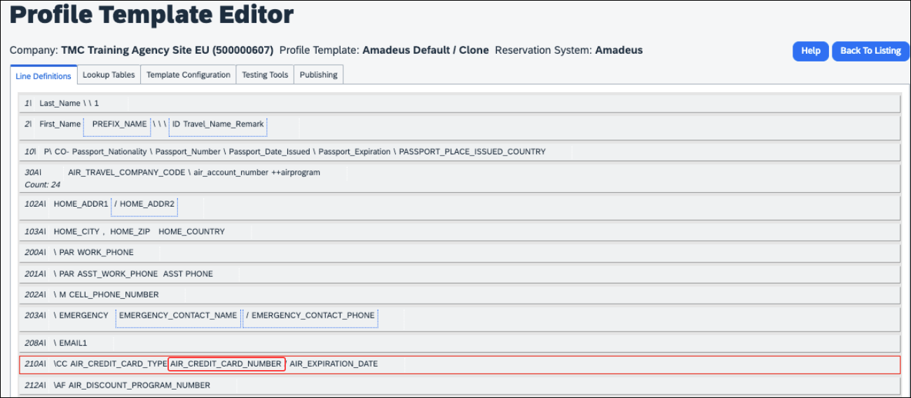

PNR Finishing Template Examples
TMCs or customers should review their PNR Finishing Templates. If templates are using one of the credit card elements, these should be removed.
Credit Card Finishing Template Datapoints:
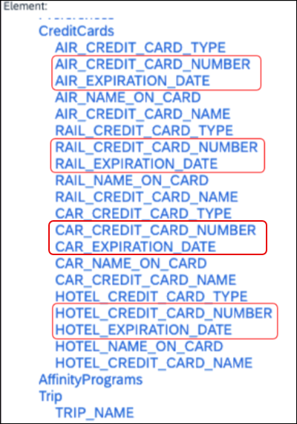
Customers using Conferma Pay for hotel virtual cards should review their PNR Finishing Templates. If templates are using one of the credit card elements, these should be removed:
- Virtual_Hotel_Credit_Card_Number
- Virtual_Hotel_Expiration_Date

Configuration for Professional and Standard Travel
This feature is enabled by default. There are no configuration steps.
Please refer to the following resources to help you prepare further:
- Sabre SAN 16331 - Payment Card Anonymization & Removal in PNR Fields.
- Amadeus Notification – PNR Core Product: Warning at end of transaction (EOT) time when a credit card is detected in an inappropriate PNR element
- The **Planned Changes** Sabre Enhanced Form of Payment (FOP Wallet) release note in this document.
- The Travel Profile v2 API documentation in the SAP Concur Developer Center.

**Planned Changes** Decommission of Travel Configuration Agency Processing Fee Form of Payment for Land Only/Non-GDS Reservations Setting

Information First Published | Information Last Modified | Feature Target Release Date
January 12, 2024 | March 15, 2024 | April 2024
Any changes since the previous monthly release are highlighted in yellow in this release note.

Prof | Stan |   Edition
X | X | On: Impacts end users who use this feature/vendor; no configuration/setup by agency/ admin; cannot be turned OFF (example: new icons or rate display)
 |  | Available for use: No impact to end users unless/until configuration/setup by agency/admin (described below) (example: new rule, new Travelfusion airline)
X |  | Other: Refer to the release note below
 |  | Does not apply to this edition
Source
GDS
Direct Connect
Other
X | EMEA Data Center |  |  | Scan impact
X | North America Data Center |  | X | UI impact
 | China Data Center |  |  | File finishing impact
 | All data centers |  |  | Profile/Profile API/3rd Party XML Sync Impact
Affected Documentation
TSGs |  | Travel System Admin Guide
Fact Sheets
Admin Guides
Other

Overview
Concur Travel is removing the Agency Processing Fee Form of Payment for Land Only/Non-GDS Reservations configuration setting from Travel Configurations. Any credit card data that is currently stored in these fields will be removed.

User/Customer Benefit
The GDS are making changes to the way credit cards are entered into the Passenger Name Record (PNR), resulting in several changes needed within Concur Travel. Form of payment (FOP) will need to be written in a specific format, depending on its use. This means that all FOP features require updating and reformatting. Based on these changes, SAP Concur is recommending that customers and TMCs work together on how to manage TMC service fees outside of the booking process. One benefit to this change is the avoidance of PNR template updates for a process that has no impact to the online booking process.

End-User Experience
The previous setting will be removed from the Travel Configurations page and will no longer be visible. Configurations using the following options will have the setting automatically changed to Always write user selected card (default):
- Always write user selected air/rail card
- Always write air/rail ghost card
- Always write air/rail profiled card
- Always use this card
- None
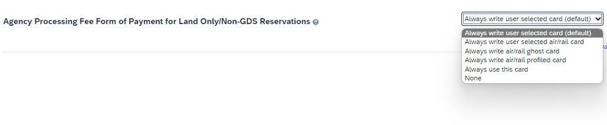
Depending on the customer configuration settings, the user-selected FOP will be added to Amadeus, Apollo, Worldspan, and Travelport+ PNRs. For Sabre bookings, see the **Planned Changes** Sabre Enhanced Form of Payment (FOP Wallet) in this document for Sabre specific FOP handling.

Configuration for Professional Travel
This feature is enabled by default. There are no configuration steps.

**Planned Changes** Sabre Enhanced Form of Payment (FOP Wallet)

Information First Published | Information Last Modified | Feature Target Release Date
January 12, 2024 | March 15, 2024 | April 2024
Any changes since the previous monthly release are highlighted in yellow in this release note.

Prof | Stan |   Edition
X | X | On: Impacts end users who use this feature/vendor; no configuration/setup by agency/ admin; cannot be turned OFF (example: new icons or rate display, new Amtrak feature)
 |  | Available for use: No impact to end users unless/until configuration/setup by agency/admin (described below) (example: new rule, new Travelfusion airline)
 |  | Other: Refer to the release note below
 |  | Does not apply to this edition
Source / Solution Suggestion
GDS |  | Sabre
Direct Connect
Other
X | EMEA Data Center |  |  | Scan impact
X | North America Data Center |  |  | UI impact
 | China Data Center |  |  | File finishing impact
 | All data centers |  |  | Profile/Profile API/3rd Party XML Sync Impact
Affected Documentation
TSGs
Fact Sheets
Admin Guides
Other

Overview
Sabre is decommissioning their legacy 5-Remarks Form of Payment Field (5-*VI444333322221111¥05/26) as of Q3 2024. All Sabre customers are required to migrate to Sabre’s Enhanced Form of Payment also known as FOP Wallet (*FOP). For compliance, Sabre is also anonymizing and removing credit card data from all non-compliant fields in the PNR. They are rolling this anonymization and removal process out in phases, with the final phase to be completed by June 2024. This change will also require a new process for sending credit card data to back-office systems.
Please refer to the following Sabre SAN messages for more details:
- SAN 16643 - Sunset of PNR Form of Payment Field 5-Remarks
- SAN 16331 - Payment Card Anonymization & Removal in PNR Fields
- SAN 17007 - Form of Payment Wallet (FOP) New Use Type for Interface Records
- SAN 17009 - Interface User Record (IUR) - New MX Record for Form of Payment Wallet
Concur Travel will migrate to the FOP Wallet in preparation for this mandate.

User/Customer Benefit
Concur Travel will add the traveler-selected form of payment chosen at the time of booking for every reservation type (Flight, Car, Hotel, and Rail) to the FOP Wallet in the Sabre PNR along with the appropriate Use Type code. (for example, UAL=Air, UCR=CAR, UHL=Hotel, and URL=Rail)
During this transition period, Concur Travel will also continue to add the Air and Rail FOP in the legacy format without a Use Type code to support existing mid-office processes.

End-User Experience
Example: FOP Wallet
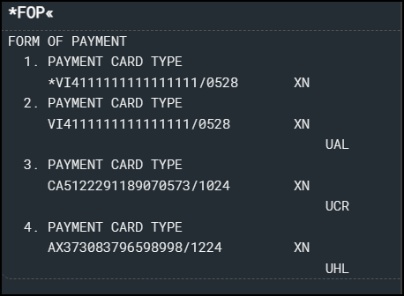

Configuration for Professional and Standard Travel
This feature requires a form of payment to be selected on the Review and Reserve page for every reservation type to be added to the Sabre FOP Wallet.
For more information on setting FOP requirements, refer to the Form of Payment Travel Service Guide. To locate, refer to Additional Release Notes and Other Technical Documentation in these release notes.
Sabre customers must self-activate Passenger Name Association, which includes the FOP Wallet by using the TJR keyword PNAPNR.
- Once the TJR setting is activated, it cannot be deactivated.
The form of payment updates will automatically be enabled by default in Concur Travel. If a Sabre customer has not yet activated the FOP Wallet, then Concur Travel will automatically revert to the legacy FOP field prior to Sabre’s activation deadline.
For more information, refer to the Form of Payment Travel Service Guide.
Refer to the following Sabre SAN notifications:
- SAN 16643 - Sunset of PNR Form of Payment Field 5-Remarks
- SAN 16331 - Payment Card Anonymization & Removal in PNR Fields
- SAN 17007 - Form of Payment Wallet (FOP) New Use Type for Interface Records
- SAN 17009 - Interface User Record (IUR) - New MX Record for Form of Payment Wallet

**Planned Changes** New Concur Travel Experience: Sabre’s Price Quote - Enhancement to Provide More Accurate Fare at Booking

Information First Published | Information Last Modified | Feature Target Release Date
November 3, 2023 | January 12, 2024 | June 30, 2024
Any changes since the previous monthly release are highlighted in yellow in this release note.

Prof | Stan |   Edition
X |  | On: Impacts end users who use this feature/vendor; no configuration/setup by agency/ admin; cannot be turned OFF (example: new icons or rate display)
 |  | Available for use: No impact to end users unless/until configuration/setup by agency/admin (described below) (example: new rule, new Travelfusion airline)
X |  | Other: Refer to the release note below
 | X | Does not apply to this edition
Source
GDS |  | Sabre, Car Connector
Direct Connect
Other
X | EMEA Data Center |  |  | Scan impact
X | North America Data Center |  | X | UI impact
 | China Data Center |  |  | File finishing impact
 | All data centers |  |  | Profile/Profile API/3rd Party XML Sync Impact
Affected Documentation
TSGs
Fact Sheets
Admin Guides
Other

Overview
SAP Concur plans to add Price Quote (PQ) modifiers into the new Concur Travel experience process for accuracy purposes.

User/Customer Benefit
This change will be implemented to enhance accuracy and reduce price jump situations such that the stored price always matches the price offered in the shopping response.

End-User Experience
When storing the price quote, the following qualifiers will be added:
- XO (forced passenger type to avoid shifting to ADT when not using ADT),
- P(passenger type),
- A (validating carrier) and
- ZZ (fare basis)
In addition, SAP Concur will change the SNAP code qualifier from I to AC*.
New Pricing Command Line:
WPAC*GLD03¥S1*BRMAINCABIN*ZZXAVUA0ML¥S2*BRMAINCABIN*ZZXAVNA0ME¥RY/CA¥AUA¥PADT¥XO¥RQ
New PQ Line:
PQ 1 AC*GLD03¥S1*BRMAINCABIN*ZZXAVUA0ML¥S2*BRMAINCABIN*ZZXAVNA0ME¥AUA¥PADT¥XO¥RQ

Current PQ Line:
WPIGLD03¥S1*BRMAINCABIN¥S2*BRMAINCABIN¥RQ

Configuration for Professional Travel
This feature is enabled by default. There are no configuration steps.

Client Notifications

Accessibility

Accessibility Updates
SAP implements changes to better meet current Web Content Accessibility Guidelines (WCAG). Information about accessibility-related changes made to SAP Concur solutions is published on a quarterly basis. You can review the quarterly updates on the Accessibility Updates page.

Gender Diversity Planned Features and Changes
SAP Concur is committed to supporting gender diversity. Over time we plan to implement product changes to help ensure that SAP Concur solutions support gender non-binary users. These changes will include but are not limited to support for preferred names, non-binary gender options in travel preferences, and non-binary titles.
These planned changes reflect SAP's commitment to supporting gender diversity and enable gender non-binary users to enter consistent information when making travel arrangements and entering personal information into SAP Concur solutions.
Timelines and details about these ongoing changes will be provided in the SAP Concur release notes.

Documentation for New Concur Travel Experience

Online Help Updates in the SAP Help Portal

Overview
Online end user help documentation for the new Concur Travel experience, beginning with the Renfe Direct Connect enhancements from the November release, are indicated with “New Workflow” text at the end of topic titles.
Also, on the Implement tab of the Concur Travel product page in the SAP Help Portal, there is a new Travel Services Help. This will become the new home for Travel Service Guides type documentation.

User/Customer Benefit
The “New Workflow” text is intended to help you distinguish between the existing experience and the redesigned experience for Concur Travel.

End-User Experience
When accessing the Concur Travel End User Help, you can see which topics are specific to the Concur Travel experience as they contain the suffix "New Workflow".
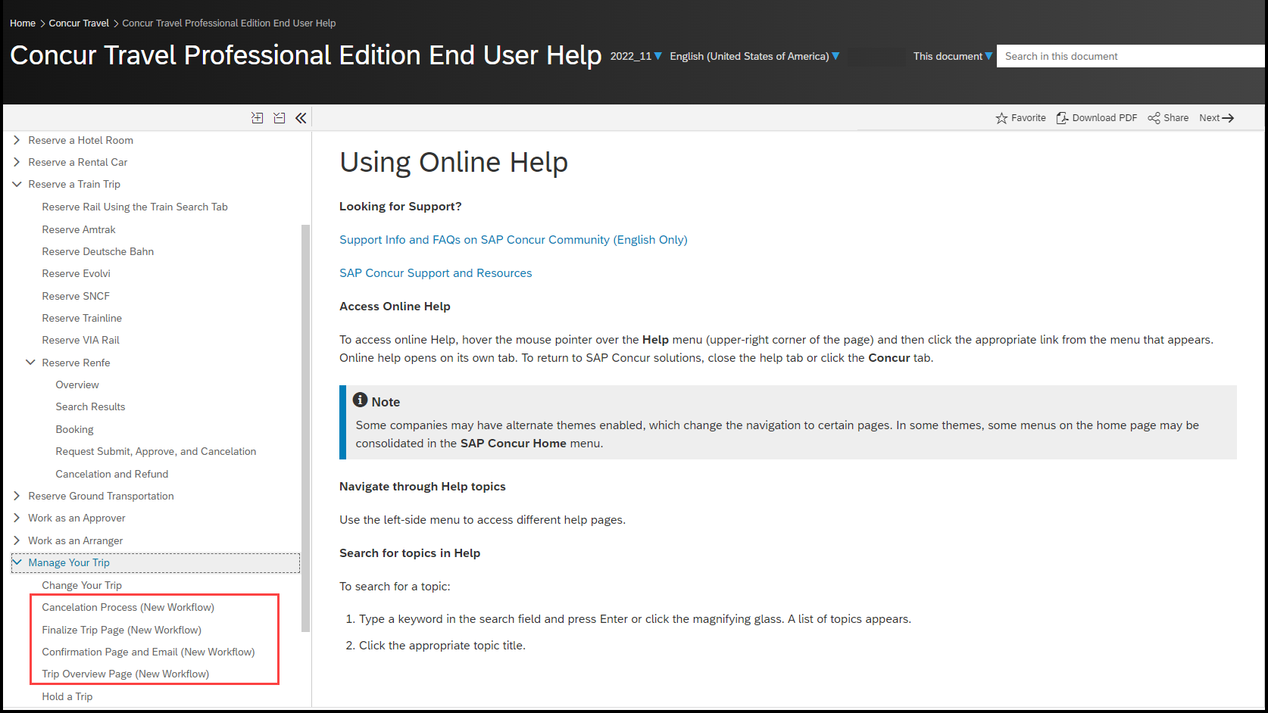

Configuration for Professional and Standard Travel
This feature is enabled by default. There are no configuration steps.

In-Product User Assistance

Client Customized Content
If your company creates customized content for SAP Concur solutions through a user assistance tool such as SAP Enable Now or Concur User Assistant by WalkMe, the changes described in these release notes might affect your customized content. SAP Concur recommends reviewing the monthly release notes for all of your SAP Concur solutions as well as the Shared Changes Release Notes to confirm whether any of the planned or released changes might impact your internal, customized content.
If any changes in a release impact your content, work with your internal teams to update your content accordingly.

Subprocessors

SAP Concur Non-Affiliated Subprocessors
The list of non-affiliated subprocessors is available from the SAP Sub-processors / Data Transfer Factsheets page.
To access the SAP Concur Sub-processors List:
- Click the following link to navigate to the SAP Sub-processors / Data Transfer Factsheets page:
SAP Sub-processors / Data Transfer Factsheets
- Sign in to the SAP Support Portal using your Support User ID (S-user) and password.
SAP customers must sign in to the SAP Support Portal using their Support User ID (S-user) and password. For information about S-User IDs, refer to Your New Support User ID (S-user) and to the Learn All About S-User IDs blog post.
- On the SAP Sub-processors / Data Transfer Factsheets page, type "Concur" in the Search field.
- In the Title column, click SAP Concur Sub-processors List.
If you have questions or comments, please reach out to: Privacy-Request@Concur.com

Supported Browsers

Supported Browsers and Changes to Support
For information about supported browsers and planned changes to supported browsers, refer to the Concur Travel & Expense Supported Configurations guide.
When changes to browser support are planned, information about those changes will also appear in the Shared Changes Release Notes.

Additional Release Notes and Other Technical Documentation

Online Help
You can access release notes, setup guides, user guides, admin summaries, supported configurations, and other resources via the in-product Help menu or directly on the SAP Help Portal.
To access the full set of documentation for your product, use the links in the SAP Concur Help menu, or visit the SAP Concur solutions page.
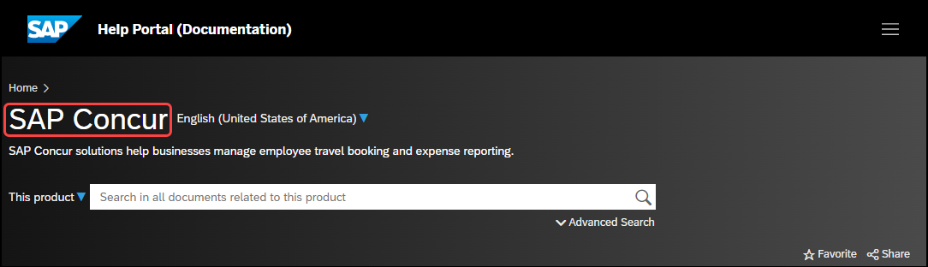

SAP Concur Support Portal – Selected Users
Access release notes, webinars, and other technical documentation on the SAP Concur support portal.
If you have the required permissions, Contact Support is available on the SAP Concur Help menu and in the SAP Concur page footer.
Click Contact Support to access the SAP Concur support portal, then click Resources.
- Click Release/Tech Info for release notes, technical documents, etc.
- Click Webinars for recorded and live webinars.

© 2024 SAP SE or an SAP affiliate company. All rights reserved.
No part of this publication may be reproduced or transmitted in any form or for any purpose without the express permission of SAP SE or an SAP affiliate company.
SAP and other SAP products and services mentioned herein as well as their respective logos are trademarks or registered trademarks of SAP SE (or an SAP affiliate company) in Germany and other countries. Please see http://global12.sap.com/corporate-en/legal/copyright/index.epx for additional trademark information and notices.
Some software products marketed by SAP SE and its distributors contain proprietary software components of other software vendors.
National product specifications may vary.
These materials are provided by SAP SE or an SAP affiliate company for informational purposes only, without representation or warranty of any kind, and SAP SE or its affiliated companies shall not be liable for errors or omissions with respect to the materials. The only warranties for SAP SE or SAP affiliate company products and services are those that are set forth in the express warranty statements accompanying such products and services, if any. Nothing herein should be construed as constituting an additional warranty.
In particular, SAP SE or its affiliated companies have no obligation to pursue any course of business outlined in this document or any related presentation, or to develop or release any functionality mentioned therein. This document, or any related presentation, and SAP SE’s or its affiliated companies’ strategy and possible future developments, products, and/or platform directions and functionality are all subject to change and may be changed by SAP SE or its affiliated companies at any time for any reason without notice. The information in this document is not a commitment, promise, or legal obligation to deliver any material, code, or functionality. All forward-looking statements are subject to various risks and uncertainties that could cause actual results to differ materially from expectations. Readers are cautioned not to place undue reliance on these forward-looking statements, which speak only as of their dates, and they should not be relied upon in making purchasing decisions.

