SAP Concur Release Notes
Concur Travel
Concur Professional/Premium and Concur Standard
Month | Audience
Release Date: August 20, 2022  Update 1: Thursday, August 25 | SAP Concur Client FINAL

** FINAL **
The enhancements and changes described in this document may or may not be included in this release. SAP Concur reserves the right to postpone implementation of – or completely remove – any enhancement/change mentioned here.
The DRAFT and FINAL release notes contain information about Concur Professional/Premium and Concur Standard.
Each note contains a table that which indicates if the enhancement/change applies to Professional and/or Standard.

Contents
Release Notes 4
Administration 4
**Ongoing** AWS Migrations - TMC Information 4
Flight 5
GDS: Southwest – Ticket Credit Policy Update 5
Southwest Direct Connect – Ticket Credit Policy Update 6
Update Flex Faring Airlines – Jetstar (JQ), Virgin Airlines (VA), Qantas (QF) 8
Hotel 9
Support for Sabre’s Content Services for Lodging (CSL) 9
Train 10
Company Code not Required for Renfe Direct Connect 10
Planned Changes 12
Car 12
**Planned Changes** Management of Car Rules 12
Miscellaneous 15
**Planned Changes** Retirement of Calendar Integration Functionality (Professional Edition Only) 15
Client Notifications 17
Accessibility 17
Accessibility Updates 17
Subprocessors 17
SAP Concur Non-Affiliated Subprocessors 17
Supported Browsers 18
Supported Browsers and Changes to Support 18
Additional Release Notes and Other Technical Documentation 19
Online Help 19
SAP Concur Support Portal – Selected Users 19
Legal Disclaimer
The information in this presentation is confidential and proprietary to SAP SE or an SAP affiliate company and may not be disclosed without the permission of SAP SE or the respective SAP affiliate company. This presentation is not subject to your license agreement or any other service or subscription agreement with SAP SE or its affiliated companies. SAP SE and its affiliated companies have no obligation to pursue any course of business outlined in this document or any related presentation, or to develop or release any functionality mentioned therein. This document, or any related presentation and SAP SE or an SAP affiliate company’s strategy and possible future developments, products and or platforms directions and functionality are all subject to change and may be changed by SAP SE and its affiliated companies at any time for any reason without notice. The information in this document is not a commitment, promise or legal obligation to deliver any material, code or functionality. This document is provided without a warranty of any kind, either express or implied, including but not limited to, the implied warranties of merchantability, fitness for a particular purpose, or non-infringement. This document is for informational purposes and may not be incorporated into a contract. SAP SE and its affiliated companies assume no responsibility for errors or omissions in this document, except if such damages were caused by SAP SE or an SAP affiliate company’s willful misconduct or gross negligence.
All forward-looking statements are subject to various risks and uncertainties that could cause actual results to differ materially from expectations. Readers are cautioned not to place undue reliance on these forward-looking statements, which speak only as of their dates, and they should not be relied upon in making purchasing decisions.

Release Notes

Administration

**Ongoing** AWS Migrations - TMC Information

Information First Published | Information Last Modified | Feature Target Release Date
December 2021 | -- | Q3 2022
Any changes since the previous monthly release are highlighted in yellow in this release note.

Prof | Stan | Å Å Edition
X | X | On: Impacts end users who use this feature/vendor; no configuration/setup by agency/ admin; cannot be turned OFF (example: new icons or rate display, new Amtrak feature)
 |  | Available for use: No impact to end users unless/until configuration/setup by agency/admin (described below) (example: new rule, new Travelfusion airline)
 |  | Other: Refer to the release note below
 |  | Does not apply to this edition
Source / Solution Suggestion
GDS
Direct Connect
Solution ID
Other
X | EMEA Data Center |  |  | Scan impact
X | North America Data Center |  |  | UI impact
 | China Data Center |  |  | File finishing impact
 | All data centers |  |  | Profile/Profile API/3rd Party XML Sync Impact
Affected Documentation
TSGs
Fact Sheets |  | Client Fact Sheet - TMC AWS Migration
Admin Guides
Other |  | SAP Concur Cloud Platform Strategy

Overview
SAP Concur is currently migrating TMCs to new Amazon Web Services (AWS) data centers, a process which affects TMC workflows. SAP will first move TMCs to the new data centers, followed over time by their customers. TMCs will therefore experience a period of time where their customer base is split over the current data centers and the new AWS data centers.

User/Customer Benefit
We are migrating from a private platform, where all equipment is owned by SAP Concur solutions, to a third-party cloud platform. This will provide stronger security, improved performance and stability, and faster innovation for our customers.

End-User Experience
End users should see no difference as the migration is carried out, however, TMCs may be required to modify their customer management processes. TMCs should refer to the Client Fact Sheet - TMC AWS Migration for up to date details on changes to their workflows.

Configuration for Professional and Standard Travel
This feature is enabled by default. There are no configuration steps.
For more information, refer to the Client Fact Sheet - TMC AWS Migration and the SAP Concur Cloud Platform Strategy. To locate, refer to Additional Release Notes and Other Technical Documentation in these release notes.

Flight

GDS: Southwest – Ticket Credit Policy Update

Prof | Stan |   Edition
X | X | On: Impacts end users who use this feature/vendor; no configuration/setup by agency/ admin; cannot be turned OFF (example: new icons or rate display, new Amtrak feature)
 |  | Available for use: No impact to end users unless/until configuration/setup by agency/admin (described below) (example: new rule, new Travelfusion airline)
 |  | Other: Refer to the release note below
 |  | Does not apply to this edition
Source / Solution Suggestion
GDS |  | All
Direct Connect
Solution ID
Other
X | EMEA Data Center |  |  | Scan impact
X | North America Data Center |  |  | UI impact
 | China Data Center |  |  | File finishing impact
 | All data centers |  |  | Profile/Profile API/3rd Party XML Sync Impact
Affected Documentation
TSGs |  | Unused Tickets Travel Service Guide
Fact Sheets
Admin Guides
Other

Overview
Ticket credits are credits from canceled flights or downgrades that can be used to purchase future airline ticket.
On 28 July 2022 Southwest Airlines announced the elimination of the expiration dates on all valid Southwest ticket credits with immediate effect. Any ticket credits originally expiring on or after 28 July 2022 can be used at any time without validity date restrictions for future purchases.
Prior to this date Southwest ticket credits were no longer valid one year from the date of original purchase.
Southwest ticket credits expired on or before 27 July 2022 are not affected by the new Southwest policy; they cannot be used for future bookings.
SAP Concur recommends that admins and TMCs reload impacted Southwest ticket credits to Concur Travel with a future expiration date so that travelers or arrangers remain aware of the available ticket credits.
For more details, please visit https://www.southwest.com/help/changes-and-cancellations/flight-credit.

User/Customer Benefit
Travelers can use their unused Southwest ticket credits anytime without validity date restrictions.

Configuration for Professional and Standard Travel
Please refer to the Unused Tickets Travel Service Guide for detailed configuration instructions.

Southwest Direct Connect – Ticket Credit Policy Update

Prof | Stan |   Edition
X | X | On: Impacts end users who use this feature/vendor; no configuration/setup by agency/ admin; cannot be turned OFF (example: new icons or rate display, new Amtrak feature)
 |  | Available for use: No impact to end users unless/until configuration/setup by agency/admin (described below) (example: new rule, new Travelfusion airline)
 |  | Other: Refer to the release note below
 |  | Does not apply to this edition
Source / Solution Suggestion
GDS
Direct Connect |  | Southwest
Solution ID
Other
X | EMEA Data Center |  |  | Scan impact
X | North America Data Center |  |  | UI impact
 | China Data Center |  |  | File finishing impact
 | All data centers |  |  | Profile/Profile API/3rd Party XML Sync Impact
Affected Documentation
TSGs |  | Southwest Direct Connect Travel Service Guide
Fact Sheets
Admin Guides
Other

Overview
Ticket credits are credits from canceled flights or downgrades that can be used to purchase future airline tickets.
On 28 July 2022, Southwest Airlines announced the elimination of the expiration dates on all valid Southwest ticket credits with immediate effect. Any ticket credits originally expiring on or after 28 July 2022 can be used at any time, without validity date restrictions for future purchases.
Prior to this date Southwest ticket credits were no longer valid one year from the date of original purchase.
Southwest ticket credits expired on/before 27 July 2022 are not affected by the new Southwest policy; they cannot be used for future bookings.
SAP Concur has been reviewing the new Southwest policy and preparing to adapt to these changes. In the future, travelers will not be offered to provide an expiration date for manually added Southwest ticket credits. Ticket credits stored in Concur Travel will no longer expire. Delivering the adjustments in the booking tool will take some time; we will update customers about the next steps in upcoming Release Notes.
Until the change is completed, travelers can still use the Southwest ticket credits expiring on or after 28 July for future Southwest Direct Connect bookings in Concur Travel. In cases where a Southwest ticket credit cannot be used because the original expiration date was passed to Concur Travel, travelers can re-add the ticket credit with a future expiration date during the booking process to redeem the credits for new Southwest tickets.
For more details, please visit https://www.southwest.com/help/changes-and-cancellations/flight-credit.

User/Customer Benefit
Travelers can use their Southwest unused ticket credits at any time, without validity date restrictions.

Configuration for Professional and Standard Travel
This feature is enabled by default. There are no configuration steps.
For more information, refer to the Southwest Direct Connect Travel Service Guide. To locate, refer to Additional Release Notes and Other Technical Documentation in these release notes.

Update Flex Faring Airlines – Jetstar (JQ), Virgin Airlines (VA), Qantas (QF)

Prof | Stan |   Edition
X | X | On: Impacts end users who use this feature/vendor; no configuration/setup by agency/ admin; cannot be turned OFF (example: new icons or rate display, new Amtrak feature)
 |  | Available for use: No impact to end users unless/until configuration/setup by agency/admin (described below) (example: new rule, new Travelfusion airline)
 |  | Other: Refer to the release note below
 |  | Does not apply to this edition
Source / Solution Suggestion
GDS |  | All
Direct Connect
Solution ID
Other
X | EMEA Data Center |  |  | Scan impact
X | North America Data Center |  |  | UI impact
 | China Data Center |  |  | File finishing impact
 | All data centers |  |  | Profile/Profile API/3rd Party XML Sync Impact
Affected Documentation
TSGs |  | Flex Faring
Fact Sheets
Admin Guides
Other

Overview

SAP Concur has updated the fare mapping for Jetstar (JQ), Virgin Airlines (VA), Qantas (QF) to align with recent changes made by the airlines.

Configuration for Professional and Standard Travel
This feature is enabled by default. There are no configuration steps.
For more information, refer to the Flex Faring Travel Service Guide. To locate, refer to Additional Release Notes and Other Technical Documentation in these release notes.

Hotel

Support for Sabre’s Content Services for Lodging (CSL)

Information First Published | Information Last Modified | Feature Target Release Date
August 2022 | -- | Q4 2022
Any changes since the previous monthly release are highlighted in yellow in this release note.

Prof | Stan |   Edition
X | X | On: Impacts end users who use this feature/vendor; no configuration/setup by agency/ admin; cannot be turned OFF (example: new icons or rate display, new Amtrak feature)
 |  | Available for use: No impact to end users unless/until configuration/setup by agency/admin (described below) (example: new rule, new Travelfusion airline)
 |  | Other: Refer to the release note below
 |  | Does not apply to this edition
Source / Solution Suggestion
GDS |  | Sabre
Direct Connect
Solution ID
Other
X | EMEA Data Center |  |  | Scan impact
X | North America Data Center |  |  | UI impact
 | China Data Center |  |  | File finishing impact
 | All data centers |  |  | Profile/Profile API/3rd Party XML Sync Impact
Affected Documentation
TSGs
Fact Sheets |  | Sabre Content Services for Lodging
Admin Guides
Other

Overview
SAP Concur has completed development for Sabre’s migration to the Content Service for Lodging (CSL) platform. While the required updates have had no impact on the end user booking experience, future Sabre-mandated changes will impact GDS PNRs and IUR files. Please review the Sabre Content Services for Lodging Fact Sheet in preparation for Sabre mandating the use of true CSL hotel segments. TMCs must ensure mid and back-office systems are prepared for these upcoming changes.

User/Customer Benefit
Sabre’s Content Services for Lodging platform delivers more efficiency and a more consistent shopping experience to travel advisors.

Configuration for Professional and Standard Travel
This feature is enabled by default. There are no configuration steps.
For more information, refer to the Sabre Content Services for Lodging Fact Sheet.

Train

Company Code not Required for Renfe Direct Connect

Prof | Stan | Å Å Edition
 |  | On: Impacts end users who use this feature/vendor; no configuration/setup by agency/ admin; cannot be turned OFF (example: new icons or rate display, new Amtrak feature)
 |  | Available for use: No impact to end users unless/until configuration/setup by agency/admin (described below) (example: new rule, new Travelfusion airline)
X | X | Other: Refer to the release note below
 |  | Does not apply to this edition
Source / Solution Suggestion
GDS
Direct Connect |  | Renfe
Solution ID
Other
X | EMEA Data Center |  |  | Scan impact
X | North America Data Center |  |  | UI impact
 | China Data Center |  |  | File finishing impact
 | All data centers |  |  | Profile/Profile API/3rd Party XML Sync Impact
Affected Documentation
TSGs |  | Renfe Direct Connect Travel Guide
Fact Sheets
Admin Guides
Other

Overview
Until now, Concur Travel required a Company Code for clients to enable the Renfe direct connect.
Renfe no longer requires Concur Travel to send the Company Code in every request and as a result, with the August release, the company code in the travel configuration for Renfe is now optional.
Only public fares will be available to clients who do not have a customer agreement with Renfe.

User/Customer Benefit
This change will allow clients without a customer agreement with Renfe to enable the Renfe direct connect.

End-User Experience
Users will be able to search, book, and cancel with the Renfe direct connect without their company specifying the Company Code in the travel configuration.

Configuration for Professional and Standard Travel
The company code is no longer required for the Renfe direct connect.
For more information, refer to the Renfe Direct Connect Travel Service Guide. To locate, refer to Additional Release Notes and Other Technical Documentation in these release notes.

Planned Changes
The items in this section are targeted for future releases. SAP Concur solutions reserves the right to postpone implementation of – or completely remove – any enhancement or change mentioned here.
The planned changes listed in this document are specific to this product. For information about planned site-wide or shared changes that might impact your SAP Concur solutions, refer to the Shared Changes Release Notes.

Car

**Planned Changes** Management of Car Rules

Information First Published | Information Last Modified | Feature Target Release Date
August 2022 | - | October 2022
Any changes since the previous monthly release are highlighted in yellow in this release note.

Prof | Stan |   Edition
X | X | On: Impacts end users who use this feature/vendor; no configuration/setup by agency/ admin; cannot be turned OFF (example: new icons or rate display, new Amtrak feature)
 |  | Available for use: No impact to end users unless/until configuration/setup by agency/admin (described below) (example: new rule, new Travelfusion airline)
 |  | Other: Refer to the release note below
 |  | Does not apply to this edition
Source / Solution Suggestion
GDS
Direct Connect
Solution ID
Other
X | EMEA Data Center |  |  | Scan impact
X | North America Data Center |  | x | UI impact
 | China Data Center |  |  | File finishing impact
 | All data centers |  |  | Profile/Profile API/3rd Party XML Sync Impact
Affected Documentation
TSGs
Fact Sheets
Admin Guides
Other

Overview
Currently, Concur Travel supports two similar Car rules: CarClass and CarClassList. The CarClass rule enables the user to select from a predefined drop-down of car type combinations. The CarClassList rule opens a popup with the same values as the CarClass dropdown list. The difference between the two is that the selected values in CarClass are not editable after selection, but selected values in CarClassList are editable after selection and can be mapped very closely to ACRISS standards.
The following actions will be taken:
- If a client has the CarClass rule configured, the values will be mapped to the CarClassList rule without any administrative intervention.
- If the client also has a CarClassList rule configured, the CarClass rule values will be appended to the CarClassList rule values.
- The CarClass rule will no longer be configurable.
- The CarClassList rule popup will be disabled.

User/Customer Benefit
These changes will eliminate the ambiguity around the CarClass and CarClassList rules. It will allow administrators to easily configure ACRISS-like codes using the CarClassList rule by directly typing values into a field and removing the need for the popup.

What the Policy Administrator Sees
The Car type is [CarClass] option will no longer removed:
Instead, the Car type is one of [CarClassList] and Car type is not one of [CarClassList] options can be used to configure Car type:
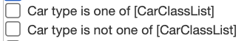
The Choose from… popup will be disabled from CarClassList rule:
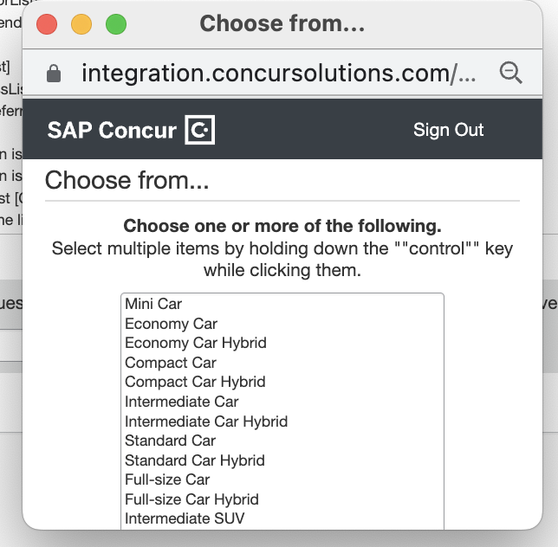
Instead, administrators can enter car types directly into the Car type is one of field:
The Car Type is one of field will accept any car type entry using the ACRISS standard. The asterisks denote a wild card. For example, I* will return all Intermediate cards, I*H will return all Intermediate Hybrid cars, etc.

Configuration for Professional and Standard Travel
This feature is enabled by default. There are no configuration steps.

Miscellaneous

**Planned Changes** Retirement of Calendar Integration Functionality (Professional Edition Only)

Information First Published | Information Last Modified | Feature Target Release Date
July 2022 | July 2022 | September 2022
Any changes since the previous monthly release are highlighted in yellow in this release note.

Prof | Stan |   Edition
X |  | On: Impacts end users who use this feature/vendor; no configuration/setup by agency/ admin; cannot be turned OFF (example: new icons or rate display, new Amtrak feature)
 |  | Available for use: No impact to end users unless/until configuration/setup by agency/admin (described below) (example: new rule, new Travelfusion airline)
 |  | Other: Refer to the release note below
 |  | Does not apply to this edition
Source / Solution Suggestion
GDS
Direct Connect
Solution ID
Other
X | EMEA Data Center |  |  | Scan impact
X | North America Data Center |  | X | UI impact
 | China Data Center |  |  | File finishing impact
 | All data centers |  |  | Profile/Profile API/3rd Party XML Sync Impact
Affected Documentation
TSGs |  | Calendar Integration Travel Service Guide
Fact Sheets
Admin Guides
Other

Overview
The capability of integrating with the Microsoft Exchange Web Services calendar will be retired in 90 days, targeted for September 2022. Existing Google Calendar clients will continue to be supported; however, no new configurations can be enabled.
Concur Travel is retiring the support of Microsoft Exchange Web Services calendar because Microsoft is retiring the Basic Auth mechanism used to populate O365 calendars. The calendar integration feature will be replaced with the capability to include schema.org JSON in confirmation emails, which allows for the creation of events on Microsoft calendars.

End-User Experience
The Calendar Integration Admin page will be removed from the Company Admin Home page.
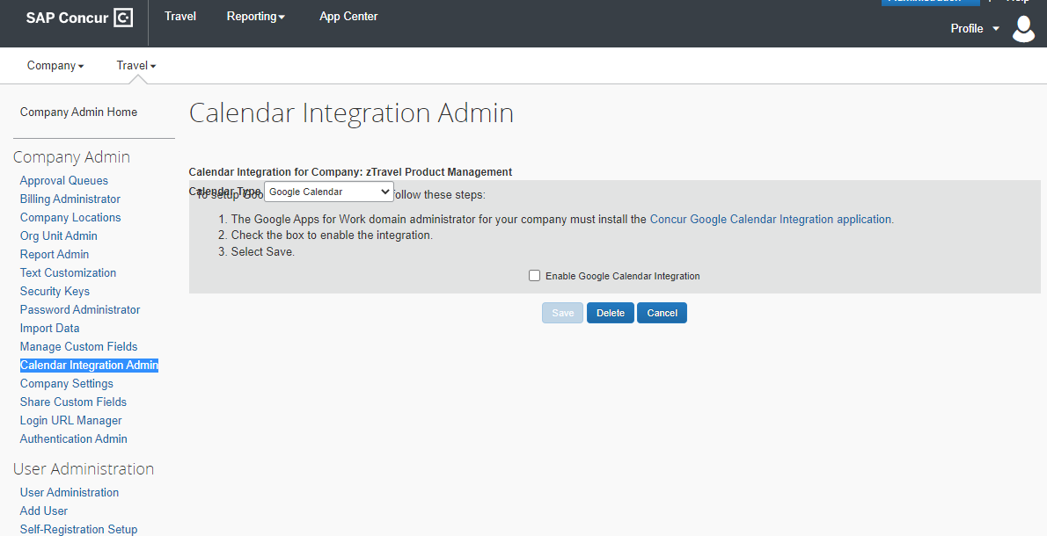

Configuration for Professional Travel
No configuration changes are required.

Client Notifications

Accessibility

Accessibility Updates
SAP implements changes to better meet current Web Content Accessibility Guidelines (WCAG). Information about accessibility-related changes made to SAP Concur solutions is published on a quarterly basis. You can review the quarterly updates on the Accessibility Updates page.

Subprocessors

SAP Concur Non-Affiliated Subprocessors
The list of non-affiliated subprocessors is available from the SAP Sub-processors / Data Transfer Factsheets page.
To access the SAP Concur Sub-processors List:
- Click the following link to navigate to the SAP Sub-processors / Data Transfer Factsheets page:
SAP Sub-processors / Data Transfer Factsheets
- Sign in to the SAP Support Portal using your Support User ID (S-user) and password.
SAP customers must sign in to the SAP Support Portal using their Support User ID (S-user) and password. For information about S-User IDs, refer to Your New Support User ID (S-user).
- On the SAP Sub-processors / Data Transfer Factsheets page, type "Concur" in the Search field.
- In the Title column, click SAP Concur Sub-processors List.
If you have questions or comments, please reach out to: Privacy-Request@Concur.com

Supported Browsers

Supported Browsers and Changes to Support
For information about supported browsers and planned changes to supported browsers, refer to the Concur Travel & Expense Supported Configurations guide.
When changes to browser support are planned, information about those changes will also appear in the Shared Changes Release Notes.

Additional Release Notes and Other Technical Documentation

Online Help
You can access release notes, setup guides, user guides, admin summaries, supported configurations, and other resources via the in-product Help menu or on the SAP Help Portal.
To access the full set of documentation for your product, use the links in the SAP Concur Help menu, or search for your SAP Concur product (Concur Expense, Concur Invoice, Concur Request, or Concur Travel) on the SAP Help Portal (https://help.sap.com).

SAP Concur Support Portal – Selected Users
Access release notes, webinars, and other technical documentation on the SAP Concur support portal.
If you have the required permissions, Contact Support is available on the SAP Concur Help menu and in the SAP Concur page footer.
Click Contact Support to access the SAP Concur support portal, then click Resources.
- Click Release/Tech Info for release notes, technical documents, etc.
- Click Webinars for recorded and live webinars.

© 2022 SAP SE or an SAP affiliate company. All rights reserved.
No part of this publication may be reproduced or transmitted in any form or for any purpose without the express permission of SAP SE or an SAP affiliate company.
SAP and other SAP products and services mentioned herein as well as their respective logos are trademarks or registered trademarks of SAP SE (or an SAP affiliate company) in Germany and other countries. Please see http://global12.sap.com/corporate-en/legal/copyright/index.epx for additional trademark information and notices.
Some software products marketed by SAP SE and its distributors contain proprietary software components of other software vendors.
National product specifications may vary.
These materials are provided by SAP SE or an SAP affiliate company for informational purposes only, without representation or warranty of any kind, and SAP SE or its affiliated companies shall not be liable for errors or omissions with respect to the materials. The only warranties for SAP SE or SAP affiliate company products and services are those that are set forth in the express warranty statements accompanying such products and services, if any. Nothing herein should be construed as constituting an additional warranty.
In particular, SAP SE or its affiliated companies have no obligation to pursue any course of business outlined in this document or any related presentation, or to develop or release any functionality mentioned therein. This document, or any related presentation, and SAP SE’s or its affiliated companies’ strategy and possible future developments, products, and/or platform directions and functionality are all subject to change and may be changed by SAP SE or its affiliated companies at any time for any reason without notice. The information in this document is not a commitment, promise, or legal obligation to deliver any material, code, or functionality. All forward-looking statements are subject to various risks and uncertainties that could cause actual results to differ materially from expectations. Readers are cautioned not to place undue reliance on these forward-looking statements, which speak only as of their dates, and they should not be relied upon in making purchasing decisions.

