SAP Concur Release Notes
Concur Travel
Concur Professional/Premium and Concur Standard
Month | Audience
Release Date: July 16, 2022  Initial post: Friday, July 15 | SAP Concur Client FINAL

** FINAL **
The enhancements and changes described in this document may or may not be included in this release. SAP Concur reserves the right to postpone implementation of – or completely remove – any enhancement/change mentioned here.
The DRAFT and FINAL release notes contain information about Concur Professional/Premium and Concur Standard.
Each note contains a table that which indicates if the enhancement/change applies to Professional and/or Standard.

Contents
Release Notes 1
Administration 1
**Ongoing** AWS Migrations - TMC Information 1
Email Notifications 2
New Email Address For Travel Approvals (AWS Environment) 2
Flight 3
Profile Synchronization Update with Sabre Profiles Official Documents 3
Hotel 4
New Custom Hotel Sourcing Partner: HRS (Professional Edition Only) 4
Planned Changes 6
Miscellaneous 6
**Planned Changes** Retirement of Calendar Integration Functionality (Professional Edition Only) 6
Client Notifications 8
Accessibility 8
Accessibility Updates 8
Subprocessors 8
SAP Concur Non-Affiliated Subprocessors 8
Supported Browsers 9
Supported Browsers and Changes to Support 9
Additional Release Notes and Other Technical Documentation 10
Online Help 10
SAP Concur Support Portal – Selected Users 10
Legal Disclaimer
The information in this presentation is confidential and proprietary to SAP SE or an SAP affiliate company and may not be disclosed without the permission of SAP SE or the respective SAP affiliate company. This presentation is not subject to your license agreement or any other service or subscription agreement with SAP SE or its affiliated companies. SAP SE and its affiliated companies have no obligation to pursue any course of business outlined in this document or any related presentation, or to develop or release any functionality mentioned therein. This document, or any related presentation and SAP SE or an SAP affiliate company’s strategy and possible future developments, products and or platforms directions and functionality are all subject to change and may be changed by SAP SE and its affiliated companies at any time for any reason without notice. The information in this document is not a commitment, promise or legal obligation to deliver any material, code or functionality. This document is provided without a warranty of any kind, either express or implied, including but not limited to, the implied warranties of merchantability, fitness for a particular purpose, or non-infringement. This document is for informational purposes and may not be incorporated into a contract. SAP SE and its affiliated companies assume no responsibility for errors or omissions in this document, except if such damages were caused by SAP SE or an SAP affiliate company’s willful misconduct or gross negligence.
All forward-looking statements are subject to various risks and uncertainties that could cause actual results to differ materially from expectations. Readers are cautioned not to place undue reliance on these forward-looking statements, which speak only as of their dates, and they should not be relied upon in making purchasing decisions.

Release Notes

Administration

**Ongoing** AWS Migrations - TMC Information

Information First Published | Information Last Modified | Feature Target Release Date
December 2021 | -- | Q3 2022
Any changes since the previous monthly release are highlighted in yellow in this release note.

Prof | Stan | Å Å Edition
X | X | On: Impacts end users who use this feature/vendor; no configuration/setup by agency/ admin; cannot be turned OFF (example: new icons or rate display, new Amtrak feature)
 |  | Available for use: No impact to end users unless/until configuration/setup by agency/admin (described below) (example: new rule, new Travelfusion airline)
 |  | Other: Refer to the release note below
 |  | Does not apply to this edition
Source / Solution Suggestion
GDS
Direct Connect
Solution ID
Other
X | EMEA Data Center |  |  | Scan impact
X | North America Data Center |  |  | UI impact
 | China Data Center |  |  | File finishing impact
 | All data centers |  |  | Profile/Profile API/3rd Party XML Sync Impact
Affected Documentation
TSGs
Fact Sheets |  | Client Fact Sheet - TMC AWS Migration
Admin Guides
Other |  | SAP Concur Cloud Platform Strategy

Overview
SAP Concur is currently migrating TMCs to new Amazon Web Services (AWS) data centers, a process which affects TMC workflows. SAP will first move TMCs to the new data centers, followed over time by their customers. TMCs will therefore experience a period of time where their customer base is split over the current data centers and the new AWS data centers.

User/Customer Benefit
We are migrating from a private platform, where all equipment is owned by SAP Concur solutions, to a third-party cloud platform. This will provide stronger security, improved performance and stability, and faster innovation for our customers.

End-User Experience
End users should see no difference as the migration is carried out, however, TMCs may be required to modify their customer management processes. TMCs should refer to the Client Fact Sheet - TMC AWS Migration for up to date details on changes to their workflows.

Configuration for Professional and Standard Travel
This feature is enabled by default. There are no configuration steps.
For more information, refer to the Client Fact Sheet - TMC AWS Migration and the SAP Concur Cloud Platform Strategy. To locate, refer to Additional Release Notes and Other Technical Documentation in these release notes.

Email Notifications

New Email Address For Travel Approvals (AWS Environment)

Overview
The email addresses from which email notifications are sent to Concur Travel approvers has been updated in the AWS environment. Clients who are implemented in or migrated to the AWS environment will receive Concur Travel approval notifications from the following addresses:
US Datacenter:
- TravelWizardApprovalsUS2@concursolutions.com
EU Datacenter:
- TravelWizardApprovalsEU2@concursolutions.com
This change does not impact other email notification types, such as "Reminder of upcoming travel" and "Ticketed confirmation". Those notifications will continue to be sent from TravelWizard@concursolutions.com.
In addition, clients who have not been migrated to the AWS environment will continue to receive approval emails from TravelWizard@concursolutions.com.

User/Customer Benefit
This change makes identifying the source and purpose of the approval email notification easier.

Configuration for Professional and Standard Travel
This change occurred automatically. If your company uses email allow lists to restrict email traffic, this email address might need to be added to your allow list.
- If your company uses email allow lists, SAP recommends adding *.concursolutions.com to your allow list. Adding *.concursolutions.com ensures that all emails coming from the *concursolutions.com domain are allowed and prevents the need for updates if an email username changes or when new email addresses from *.concursolutions.com are added.
For more information about the SAP Concur Migration to Cloud Platform in AWS, refer to the SAP Concur Cloud Platform Strategy FAQ.

Flight

Profile Synchronization Update with Sabre Profiles Official Documents

Prof | Stan |   Edition
X | X | On: Impacts end users who use this feature/vendor; no configuration/setup by agency/ admin; cannot be turned OFF (example: new icons or rate display, new Amtrak feature)
 |  | Available for use: No impact to end users unless/until configuration/setup by agency/admin (described below) (example: new rule, new Travelfusion airline)
 |  | Other: Refer to the release note below
 |  | Does not apply to this edition
Source / Solution Suggestion
GDS |  | Sabre
Direct Connect
Solution ID
Other
X | EMEA Data Center |  |  | Scan impact
X | North America Data Center |  |  | UI impact
 | China Data Center |  |  | File finishing impact
 | All data centers |  |  | Profile/Profile API/3rd Party XML Sync Impact
Affected Documentation
TSGs |  | Travel: Sabre Profiles Travel Service Guide
Fact Sheets
Admin Guides
Other

Overview
To preserve all data within the Official Documents section of Sabre Profiles, Concur Travel now copies and sends back any data not supported by Concur profiles during profile synchronization.

TMC Benefit
This change will enable TMCs to store additional Official Documents data, such as additional Known Traveler and Redress numbers.

Configuration for Professional and Standard Travel
This feature is enabled by default. There are no configuration steps.
For more information, refer to the Travel: Sabre Profiles Travel Service Guide. To locate, refer to Additional Release Notes and Other Technical Documentation in these release notes.

Hotel

New Custom Hotel Sourcing Partner: HRS (Professional Edition Only)

Prof | Stan |   Edition
 |  | On: Impacts end users who use this feature/vendor; no configuration/setup by agency/ admin; cannot be turned OFF (example: new icons or rate display, new Amtrak feature)
 |  | Available for use: No impact to end users unless/until configuration/setup by agency/admin (described below) (example: new rule, new Travelfusion airline)
X |  | Other: Refer to the release note below
 | X | Does not apply to this edition
Source / Solution Suggestion
GDS
Direct Connect |  | HRS CHS
Solution ID
Other
X | EMEA Data Center |  |  | Scan impact
X | North America Data Center |  |  | UI impact
 | China Data Center |  |  | File finishing impact
 | All data centers |  |  | Profile/Profile API/3rd Party XML Sync Impact
Affected Documentation
TSGs |  | Custom Hotel Sourcing Travel Service Guide
Fact Sheets
Admin Guides
Other

Overview
As of June 13, Concur Travel has certified HRS as an authorized Custom Hotel Sourcing (CHS) provider. This provider can manage all hotel content in the Concur Travel online booking tool for designated Concur Travel configurations. Specifically, the HRS CHS hotel connector has been verified and found to meet Concur Travel’s standards for custom hotel sourcing.

User/Customer Benefit
Customers can access curated content from HRS with hotel rate discounts from many sources, including vendors, third-party aggregators, and GDSs. Travelers are able to shop and book hotel inventory and access supplemental services.
By managing all hotel content, HRS is better able to customize the display and sort order of specific properties and rates.
For further information about CHS features, please refer to the Custom Hotel Sourcing Travel Service Guide.

Configuration for Professional Travel
HRS is available for Professional Travel only. Please contact Support for more details.
For more information, refer to the Custom Hotel Sourcing Travel Service Guide. To locate, refer to Additional Release Notes and Other Technical Documentation in these release notes.

Planned Changes
The items in this section are targeted for future releases. SAP Concur solutions reserves the right to postpone implementation of – or completely remove – any enhancement or change mentioned here.
The planned changes listed in this document are specific to this product. For information about planned site-wide or shared changes that might impact your SAP Concur solutions, refer to the Shared Changes Release Notes.

Miscellaneous

**Planned Changes** Retirement of Calendar Integration Functionality (Professional Edition Only)

Information First Published | Information Last Modified | Feature Target Release Date
July 2022 | July 2022 | September 2022
Any changes since the previous monthly release are highlighted in yellow in this release note.

Prof | Stan |   Edition
X |  | On: Impacts end users who use this feature/vendor; no configuration/setup by agency/ admin; cannot be turned OFF (example: new icons or rate display, new Amtrak feature)
 |  | Available for use: No impact to end users unless/until configuration/setup by agency/admin (described below) (example: new rule, new Travelfusion airline)
 |  | Other: Refer to the release note below
 |  | Does not apply to this edition
Source / Solution Suggestion
GDS
Direct Connect
Solution ID
Other
X | EMEA Data Center |  |  | Scan impact
X | North America Data Center |  | X | UI impact
 | China Data Center |  |  | File finishing impact
 | All data centers |  |  | Profile/Profile API/3rd Party XML Sync Impact
Affected Documentation
TSGs |  | Calendar Integration Travel Service Guide
Fact Sheets
Admin Guides
Other

Overview
The capability of integrating with the Microsoft Exchange Web Services calendar will be retired in 90 days, targeted for September 2022. Existing Google Calendar clients will continue to be supported; however, no new configurations can be enabled.
Concur Travel is retiring the support of Microsoft Exchange Web Services calendar because Microsoft is retiring the Basic Auth mechanism used to populate O365 calendars. The calendar integration feature will be replaced with the capability to include schema.org JSON in confirmation emails, which allows for the creation of events on Microsoft calendars.

End-User Experience
The Calendar Integration Admin page will be removed from the Company Admin Home page.
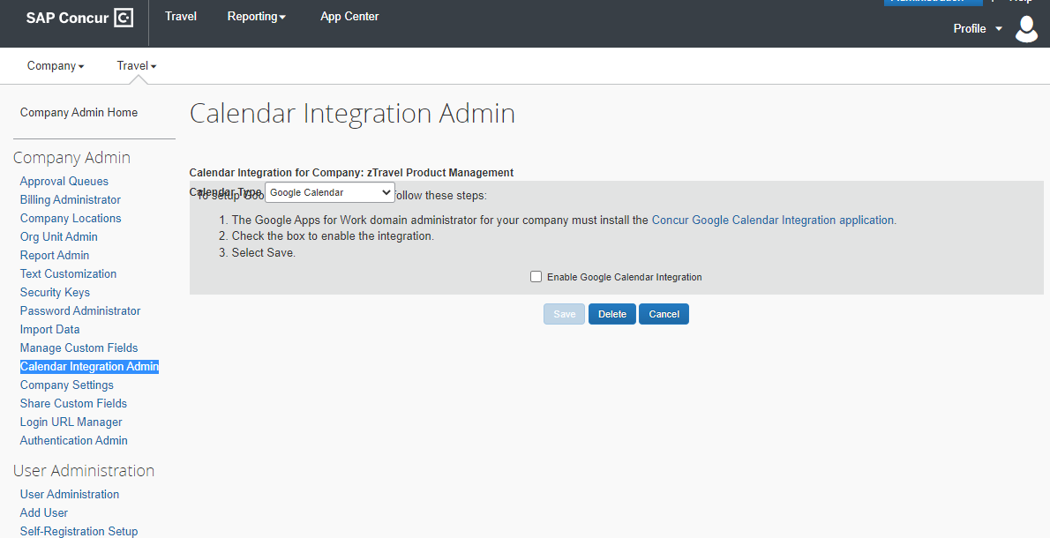

Configuration for Professional Travel
No configuration changes are required.

Client Notifications

Accessibility

Accessibility Updates
SAP implements changes to better meet current Web Content Accessibility Guidelines (WCAG). Information about accessibility-related changes made to SAP Concur solutions is published on a quarterly basis. You can review the quarterly updates on the Accessibility Updates page.

Subprocessors

SAP Concur Non-Affiliated Subprocessors
The list of non-affiliated subprocessors is available from the SAP Sub-processors / Data Transfer Factsheets page.
To access the SAP Concur Sub-processors List:
- Click the following link to navigate to the SAP Sub-processors / Data Transfer Factsheets page:
SAP Sub-processors / Data Transfer Factsheets
- Sign in to the SAP Support Portal using your Support User ID (S-user) and password.
SAP customers must sign in to the SAP Support Portal using their Support User ID (S-user) and password. For information about S-User IDs, refer to Your New Support User ID (S-user).
- On the SAP Sub-processors / Data Transfer Factsheets page, type "Concur" in the Search field.
- In the Title column, click SAP Concur Sub-processors List.
If you have questions or comments, please reach out to: Privacy-Request@Concur.com

Supported Browsers

Supported Browsers and Changes to Support
For information about supported browsers and planned changes to supported browsers, refer to the Concur Travel & Expense Supported Configurations guide.
When changes to browser support are planned, information about those changes will also appear in the Shared Changes Release Notes.

Additional Release Notes and Other Technical Documentation

Online Help
Any user can access release notes, setup guides, user guides, admin summaries, monthly browser certifications, supported configurations, and other resources via online Help or directly on the SAP Help Portal.
Use the links in the Help menu in the app, or search for your SAP Concur product (Concur Expense, Concur Invoice, Concur Request, or Concur Travel) on the SAP Help Portal (https://help.sap.com) to view the full set of documentation for your product.

SAP Concur Support Portal – Selected Users
Access release notes, webinars, and other technical documentation on the SAP Concur support portal.
If you have the proper permissions, the Contact Support appears on the Help menu. Click to access the SAP Concur support portal, then click Resources.
- Click Release/Tech Info for release notes, technical documents, etc.
- Click Webinars for recorded and live webinars.
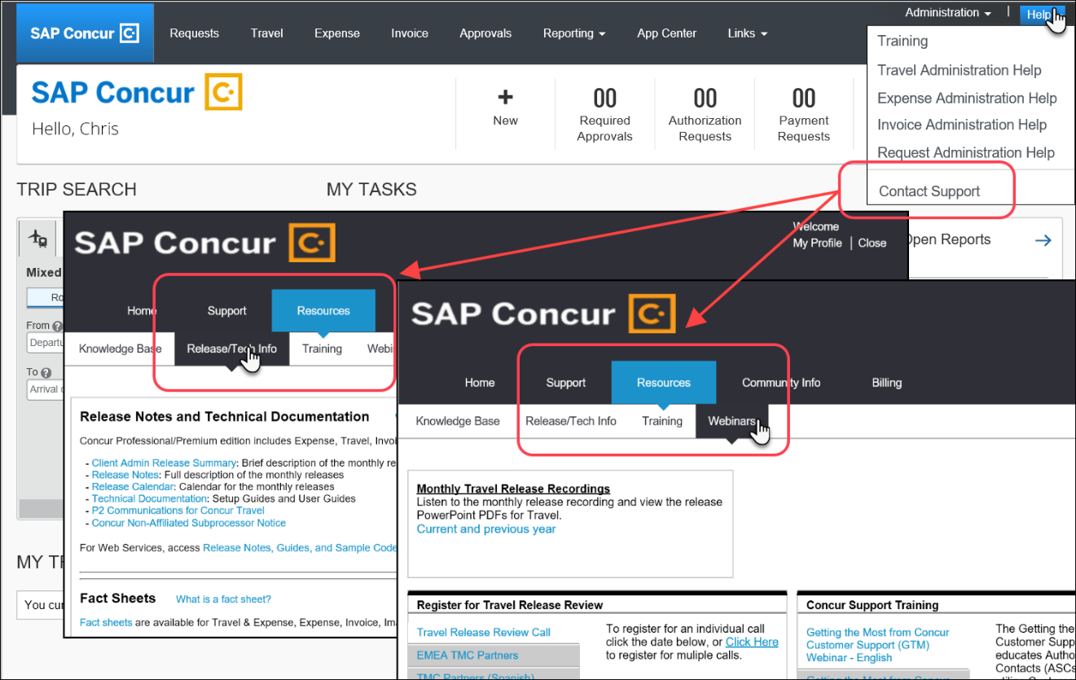

© 2022 SAP SE or an SAP affiliate company. All rights reserved.
No part of this publication may be reproduced or transmitted in any form or for any purpose without the express permission of SAP SE or an SAP affiliate company.
SAP and other SAP products and services mentioned herein as well as their respective logos are trademarks or registered trademarks of SAP SE (or an SAP affiliate company) in Germany and other countries. Please see http://global12.sap.com/corporate-en/legal/copyright/index.epx for additional trademark information and notices.
Some software products marketed by SAP SE and its distributors contain proprietary software components of other software vendors.
National product specifications may vary.
These materials are provided by SAP SE or an SAP affiliate company for informational purposes only, without representation or warranty of any kind, and SAP SE or its affiliated companies shall not be liable for errors or omissions with respect to the materials. The only warranties for SAP SE or SAP affiliate company products and services are those that are set forth in the express warranty statements accompanying such products and services, if any. Nothing herein should be construed as constituting an additional warranty.
In particular, SAP SE or its affiliated companies have no obligation to pursue any course of business outlined in this document or any related presentation, or to develop or release any functionality mentioned therein. This document, or any related presentation, and SAP SE’s or its affiliated companies’ strategy and possible future developments, products, and/or platform directions and functionality are all subject to change and may be changed by SAP SE or its affiliated companies at any time for any reason without notice. The information in this document is not a commitment, promise, or legal obligation to deliver any material, code, or functionality. All forward-looking statements are subject to various risks and uncertainties that could cause actual results to differ materially from expectations. Readers are cautioned not to place undue reliance on these forward-looking statements, which speak only as of their dates, and they should not be relied upon in making purchasing decisions.

