SAP Concur Release Notes
Concur Travel
Concur Professional/Premium and Concur Standard
Month | Audience
Release Date: May 21, 2022  Update 1: Tuesday, May 24 | SAP Concur Client FINAL

** FINAL **
The enhancements and changes described in this document may or may not be included in this release. SAP Concur reserves the right to postpone implementation of – or completely remove – any enhancement/change mentioned here.
The DRAFT and FINAL release notes contain information about Concur Professional/Premium and Concur Standard.
Each note contains a table that which indicates if the enhancement/change applies to Professional and/or Standard.

Contents
Release Notes 1
Administration 1
**Ongoing** AWS Migrations - TMC Information 1
Flight 2
Galileo Post-Ticket Exchange Capability (Professional Edition Only) 2
JetBlue Seat Maps Change 3
Planned Changes 7
Administration 7
**Planned Changes** XML Sync Settings Removed from Company Travel Configuration 7
Client Notifications 9
Accessibility 9
Accessibility Updates 9
Subprocessors 9
SAP Concur Non-Affiliated Subprocessors 9
Supported Browsers 10
Supported Browsers and Changes to Support 10
Additional Release Notes and Other Technical Documentation 11
Online Help 11
SAP Concur Support Portal – Selected Users 11
Legal Disclaimer
The information in this presentation is confidential and proprietary to SAP SE or an SAP affiliate company and may not be disclosed without the permission of SAP SE or the respective SAP affiliate company. This presentation is not subject to your license agreement or any other service or subscription agreement with SAP SE or its affiliated companies. SAP SE and its affiliated companies have no obligation to pursue any course of business outlined in this document or any related presentation, or to develop or release any functionality mentioned therein. This document, or any related presentation and SAP SE or an SAP affiliate company’s strategy and possible future developments, products and or platforms directions and functionality are all subject to change and may be changed by SAP SE and its affiliated companies at any time for any reason without notice. The information in this document is not a commitment, promise or legal obligation to deliver any material, code or functionality. This document is provided without a warranty of any kind, either express or implied, including but not limited to, the implied warranties of merchantability, fitness for a particular purpose, or non-infringement. This document is for informational purposes and may not be incorporated into a contract. SAP SE and its affiliated companies assume no responsibility for errors or omissions in this document, except if such damages were caused by SAP SE or an SAP affiliate company’s willful misconduct or gross negligence.
All forward-looking statements are subject to various risks and uncertainties that could cause actual results to differ materially from expectations. Readers are cautioned not to place undue reliance on these forward-looking statements, which speak only as of their dates, and they should not be relied upon in making purchasing decisions.

Release Notes

Administration

**Ongoing** AWS Migrations - TMC Information

Information First Published | Information Last Modified | Feature Target Release Date
December 2021 | -- | Q3 2022
Any changes since the previous monthly release are highlighted in yellow in this release note.

Prof | Stan | Å Å Edition
X | X | On: Impacts end users who use this feature/vendor; no configuration/setup by agency/ admin; cannot be turned OFF (example: new icons or rate display, new Amtrak feature)
 |  | Available for use: No impact to end users unless/until configuration/setup by agency/admin (described below) (example: new rule, new Travelfusion airline)
 |  | Other: Refer to the release note below
 |  | Does not apply to this edition
Source / Solution Suggestion
GDS
Direct Connect
Solution ID
Other
X | EMEA Data Center |  |  | Scan impact
X | North America Data Center |  |  | UI impact
 | China Data Center |  |  | File finishing impact
 | All data centers |  |  | Profile/Profile API/3rd Party XML Sync Impact
Affected Documentation
TSGs
Fact Sheets |  | Client Fact Sheet - TMC AWS Migration
Admin Guides
Other |  | SAP Concur Cloud Platform Strategy

Overview
SAP Concur is currently migrating TMCs to new Amazon Web Services (AWS) data centers, a process which affects TMC workflows. SAP will first move TMCs to the new data centers, followed over time by their customers. TMCs will therefore experience a period of time where their customer base is split over the current data centers and the new AWS data centers.

User/Customer Benefit
We are migrating from a private platform, where all equipment is owned by SAP Concur solutions, to a third-party cloud platform. This will provide stronger security, improved performance and stability, and faster innovation for our customers.

User Experience
End users should see no difference as the migration is carried out, however, TMCs may be required to modify their customer management processes. TMCs should refer to the Client Fact Sheet - TMC AWS Migration for up to date details on changes to their workflows.

Configuration for Professional and Standard Travel
This feature is enabled by default. There are no configuration steps.
For more information, refer to the Client Fact Sheet - TMC AWS Migration and the SAP Concur Cloud Platform Strategy. To locate, refer to Additional Release Notes and Other Technical Documentation in these release notes.

Flight

Galileo Post-Ticket Exchange Capability (Professional Edition Only)

Prof | Stan | Å Å Edition
X |  | On: Impacts end users who use this feature/vendor; no configuration/setup by agency/ admin; cannot be turned OFF (example: new icons or rate display, new Amtrak feature)
 |  | Available for use: No impact to end users unless/until configuration/setup by agency/admin (described below) (example: new rule, new Travelfusion airline)
 |  | Other: Refer to the release note below
 | X | Does not apply to this edition
Source / Solution Suggestion
GDS |  | Galileo
Direct Connect
Solution ID
Other
X | EMEA Data Center |  |  | Scan impact
X | North America Data Center |  | X | UI impact
 | China Data Center |  |  | File finishing impact
 | All data centers |  |  | Profile/Profile API/3rd Party XML Sync Impact
Affected Documentation
TSGs |  | Post Ticket Change / Rapid Reprice (Apollo and Galileo) Travel Service Guide
Fact Sheets
Admin Guides
Other

Overview
Users are now able to make flight changes via Travelport Galileo after a ticket has been issued. Post-ticket exchange functionality is available for Travelport Galileo customers with the Post Ticket Change feature enabled.

User/Customer Benefit
This change allows users to change Travelport Galileo airline flights through Concur Travel after a ticket has been issued.

Configuration for Professional and Standard Travel
The Galileo Post Ticket Change feature must be enabled in your company’s Concur Travel configuration settings.
For more information and known limitations, please refer to the Post Ticket Change / Rapid Reprice (Apollo and Galileo) Travel Service Guide. To locate, refer to Additional Release Notes and Other Technical Documentation in these release notes.

JetBlue Seat Maps Change

Prof | Stan |   Edition
X | X | On: Impacts end users who use this feature/vendor; no configuration/setup by agency/ admin; cannot be turned OFF (example: new icons or rate display, new Amtrak feature)
 |  | Available for use: No impact to end users unless/until configuration/setup by agency/admin (described below) (example: new rule, new Travelfusion airline)
 |  | Other: Refer to the release note below
 |  | Does not apply to this edition
Source / Solution Suggestion
GDS |  | All
Direct Connect |  | N/A
Solution ID
Other
X | EMEA Data Center |  |  | Scan impact
X | North America Data Center |  | X | UI impact
 | China Data Center |  |  | File finishing impact
 | All data centers |  |  | Profile/Profile API/3rd Party XML Sync Impact
Affected Documentation
TSGs
Fact Sheets |  | Seat Maps Fact Sheet
Admin Guides
Other

Overview
As announced in the Release Notes of December 2021, JetBlue Airways opted to file all seats for all fare products as “chargeable”, in all GDSs. For some fare products, seats were listed with a charge of zero dollars, effectively providing the seat allocation free of charge. For other fare products, a fee was required.
This change led to a number of confusing scenarios, such as:
- A seat map display that implied a fee would be charged for a seat, when in fact it was free of charge for most of the fare products.
- Some GDSs failing to confirm the user’s seat selection.
- Some GDSs displaying a message to users that indicated a seat would automatically be reserved when, in fact, no seat had been reserved.
Because of this change, as of the December 2021 release, Concur Travel opted to no longer provide seat information for JetBlue. Instead, Concur Travel informed users that they had the option to reserve seats directly at JetBlue’s website.
As of May 15, JetBlue has reversed their decision and changed their seat map logic back to the original settings to resolve the above-mentioned problems caused by the previous change.
As of May 25, based on the changes from JetBlue, Concur Travel will again display the full seat map. This will apply to the entire booking flow, including the Search results page.
The seat map displayed on the Search results page may differ from subsequent pages, depending on the selected fare product. On the Search results page, the seats are shown at the flight level, not the fare level. On subsequent pages, the seat map reflects the seats availability for the chosen fare product.
If a specific seat has not been selected by the user, Concur Travel sends a generic seat request to the GDS. This is done to minimize scenarios of denied boarding in cases where the airline has oversold the flight. Concur Travel will continue to do this for all airlines. Customers may wish to consult with their travel management company to confirm seat reservation handling in case a seat charge may be applicable.

User/Customer Benefit
This change provides users full visibility of available seats, allowing them to select seats while booking a flight in Concur Travel.

User Experience
No changes have been made to the way Concur Travel displays seat maps in flight search results.
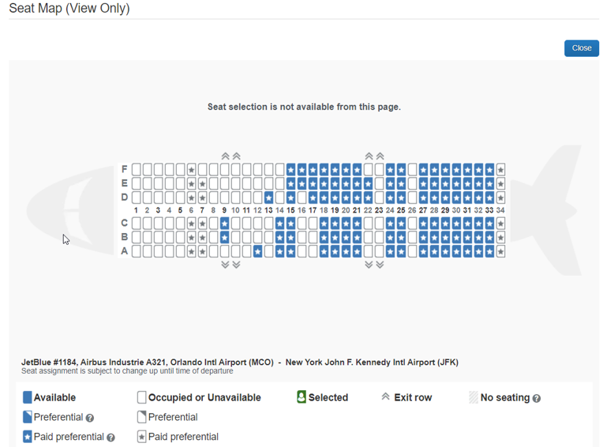
On the Review and Reserve and Travel Details pages, or after reserving a flight on the Itinerary Details page, users will be presented with the seat map corresponding to the chosen fare product. Depending on the GDS, user are able to select seats from either the Review and Reserve page, or from the Confirmation page after flights are reserved.
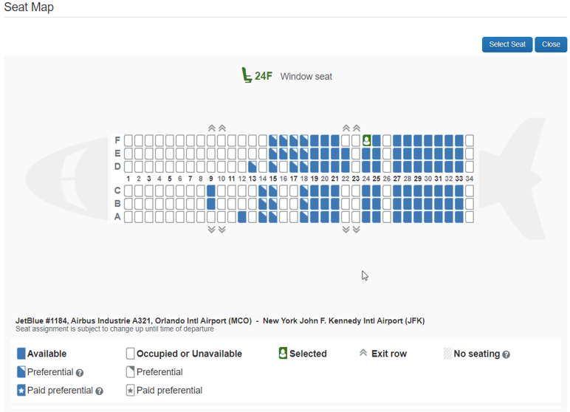

Configuration for Professional and Standard Travel
This feature is enabled by default. There are no configuration steps.
For more information, refer to the Seat Maps Fact Sheet. To locate, refer to Additional Release Notes and Other Technical Documentation in these release notes.

Planned Changes
The items in this section are targeted for future releases. SAP Concur solutions reserves the right to postpone implementation of – or completely remove – any enhancement or change mentioned here.
The planned changes listed in this document are specific to this product. For information about planned site-wide or shared changes that might impact your SAP Concur solutions, refer to the Shared Changes Release Notes.

Administration

**Planned Changes** XML Sync Settings Removed from Company Travel Configuration

Information First Published | Information Last Modified | Feature Target Release Date
May 2022 | -- | June 2022
Any changes since the previous monthly release are highlighted in yellow in this release note.

Prof | Stan |   Edition
X | X | On: Impacts end users who use this feature/vendor; no configuration/setup by agency/ admin; cannot be turned OFF (example: new icons or rate display, new Amtrak feature)
 |  | Available for use: No impact to end users unless/until configuration/setup by agency/admin (described below) (example: new rule, new Travelfusion airline)
 |  | Other: Refer to the release note below
 |  | Does not apply to this edition
Source / Solution Suggestion
GDS
Direct Connect
Solution ID
Other
X | EMEA Data Center |  |  | Scan impact
X | North America Data Center |  |  | UI impact
 | China Data Center |  |  | File finishing impact
 | All data centers |  | X | Profile/Profile API/3rd Party XML Sync Impact
Affected Documentation
TSGs |  | Travel System Admin User Guide
Fact Sheets
Admin Guides
Other

Overview
The XML Profile Sync, which is used to synchronize Concur Travel profile data with TMC partners, will no longer be available after June 2022. Settings related to XML Profile Sync are being removed from Company Travel configuration.

User/Customer Benefit
Users will no longer see these settings in the Company Travel configuration, as the XML synchronization is no longer available.

User Experience
The following UI sections will be removed:
- XML Sync Authorization
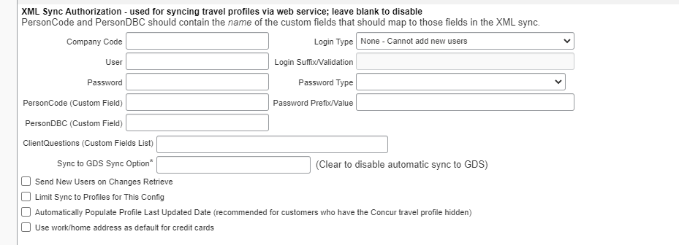
- TripSource: ProfileManager
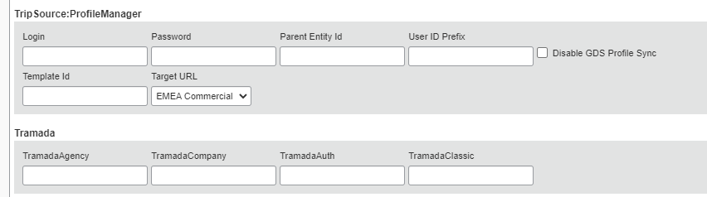
- Tramada

Configuration for Professional and Standard Travel
The feature is enabled by default. There are no configuration steps.

Client Notifications

Accessibility

Accessibility Updates
SAP implements changes to better meet current Web Content Accessibility Guidelines (WCAG). Information about accessibility-related changes made to SAP Concur solutions is published on a quarterly basis. You can review the quarterly updates on the Accessibility Updates page.

Subprocessors

SAP Concur Non-Affiliated Subprocessors
The list of non-affiliated subprocessors is available from the SAP Sub-processors / Data Transfer Factsheets page.
To access the SAP Concur Sub-processors List:
- Click the following link to navigate to the SAP Sub-processors / Data Transfer Factsheets page:
SAP Sub-processors / Data Transfer Factsheets
- Sign in to the SAP Support Portal using your Support User ID (S-user) and password.
SAP customers must sign in to the SAP Support Portal using their Support User ID (S-user) and password. For information about S-User IDs, refer to Your New Support User ID (S-user).
- On the SAP Sub-processors / Data Transfer Factsheets page, type "Concur" in the Search field.
- In the Title column, click SAP Concur Sub-processors List.
If you have questions or comments, please reach out to: Privacy-Request@Concur.com

Supported Browsers

Supported Browsers and Changes to Support
For information about supported browsers and planned changes to supported browsers, refer to the Concur Travel & Expense Supported Configurations guide.
When changes to browser support are planned, information about those changes will also appear in the Shared Changes Release Notes.

Additional Release Notes and Other Technical Documentation

Online Help
Any user can access release notes, setup guides, user guides, admin summaries, monthly browser certifications, supported configurations, and other resources via online Help or directly on the SAP Help Portal.
Use the links in the Help menu in the app, or search for your SAP Concur product (Concur Expense, Concur Invoice, Concur Request, or Concur Travel) on the SAP Help Portal (https://help.sap.com) to view the full set of documentation for your product.

SAP Concur Support Portal – Selected Users
Access release notes, webinars, and other technical documentation on the SAP Concur support portal.
If you have the proper permissions, the Contact Support appears on the Help menu. Click to access the SAP Concur support portal, then click Resources.
- Click Release/Tech Info for release notes, technical documents, etc.
- Click Webinars for recorded and live webinars.
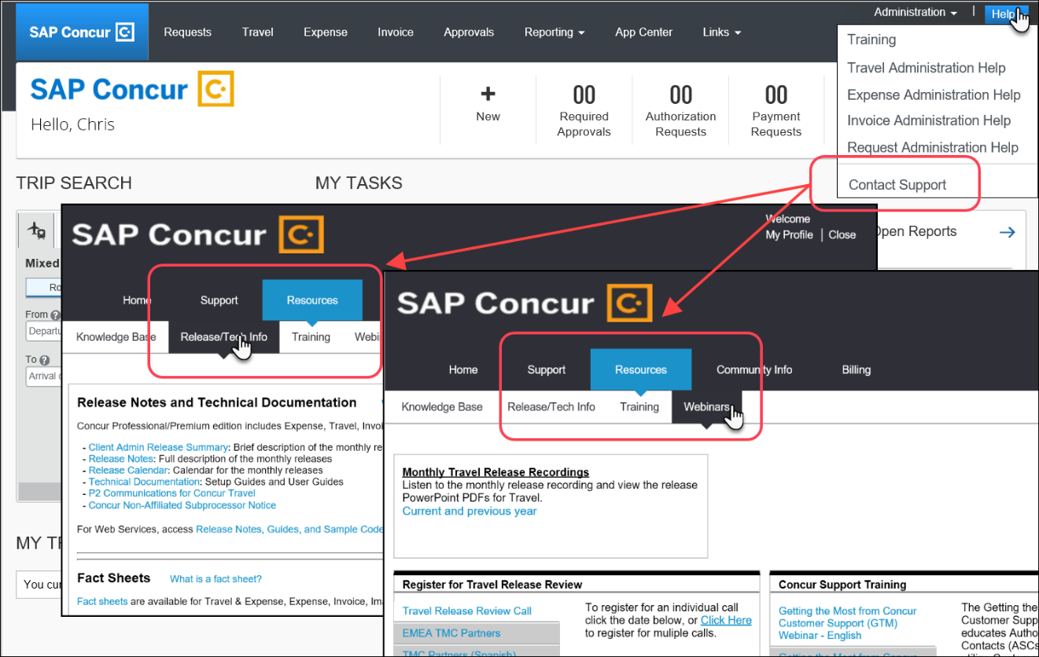

© 2022 SAP SE or an SAP affiliate company. All rights reserved.
No part of this publication may be reproduced or transmitted in any form or for any purpose without the express permission of SAP SE or an SAP affiliate company.
SAP and other SAP products and services mentioned herein as well as their respective logos are trademarks or registered trademarks of SAP SE (or an SAP affiliate company) in Germany and other countries. Please see http://global12.sap.com/corporate-en/legal/copyright/index.epx for additional trademark information and notices.
Some software products marketed by SAP SE and its distributors contain proprietary software components of other software vendors.
National product specifications may vary.
These materials are provided by SAP SE or an SAP affiliate company for informational purposes only, without representation or warranty of any kind, and SAP SE or its affiliated companies shall not be liable for errors or omissions with respect to the materials. The only warranties for SAP SE or SAP affiliate company products and services are those that are set forth in the express warranty statements accompanying such products and services, if any. Nothing herein should be construed as constituting an additional warranty.
In particular, SAP SE or its affiliated companies have no obligation to pursue any course of business outlined in this document or any related presentation, or to develop or release any functionality mentioned therein. This document, or any related presentation, and SAP SE’s or its affiliated companies’ strategy and possible future developments, products, and/or platform directions and functionality are all subject to change and may be changed by SAP SE or its affiliated companies at any time for any reason without notice. The information in this document is not a commitment, promise, or legal obligation to deliver any material, code, or functionality. All forward-looking statements are subject to various risks and uncertainties that could cause actual results to differ materially from expectations. Readers are cautioned not to place undue reliance on these forward-looking statements, which speak only as of their dates, and they should not be relied upon in making purchasing decisions.

