SAP Concur Release Notes
Concur Travel
Concur Professional/Premium and Concur Standard
Month | Audience
Release Date: January 22, 2022  Update 1: February 01 | SAP Concur Client FINAL

** FINAL **
The enhancements and changes described in this document may or may not be included in this release. SAP Concur reserves the right to postpone implementation of – or completely remove – any enhancement/change mentioned here.
The DRAFT and FINAL release notes contain information about Concur Professional/Premium and Concur Standard.
Each note contains a table that which indicates if the enhancement/change applies to Professional and/or Standard.

Contents
Release Notes 1
Administration 1
**Ongoing** AWS Migrations - TMC Information 1
Flight 2
American Airlines NDC Content 2
Ground 7
SummitQwest Decommission 7
Talixo Decommission 8
Release Notes 10
Shared Planned Changes Moving to New Shared Changes Release Notes 10
Travel Operations / Technical Essentials 12
Travel Implementation Process Change 12
Miscellaneous 13
**Ongoing** Rotating PGP Key Available for File Transfers 13
**Ongoing** SAP Concur Homepage Changes 13
**Ongoing** SAP Concur Legacy File Move Migration 13
Profile Menu Functional Changes Under Fiori Light Theme (Professional Edition Only) 13
Planned Changes 14
Flight 14
**Planned Changes** Galileo Post-Ticket Exchange Capability 14
Hotel 15
**Planned Changes** Airbnb Decommission 15
Profile 17
**Planned Changes** Removing Connected Apps Page 17
**Planned Changes** XML Profile Sync No Longer Available as of March 31, 2022 19
Client Notifications 20
Accessibility 20
Accessibility Updates 20
Subprocessors 20
SAP Concur Non-Affiliated Subprocessors 20
Supported Browsers 20
Supported Browsers and Changes to Support 20
Additional Release Notes and Other Technical Documentation 21
Online Help 21
SAP Concur Support Portal – Selected Users 21
Legal Disclaimer
The information in this presentation is confidential and proprietary to SAP SE or an SAP affiliate company and may not be disclosed without the permission of SAP SE or the respective SAP affiliate company. This presentation is not subject to your license agreement or any other service or subscription agreement with SAP SE or its affiliated companies. SAP SE and its affiliated companies have no obligation to pursue any course of business outlined in this document or any related presentation, or to develop or release any functionality mentioned therein. This document, or any related presentation and SAP SE or an SAP affiliate company’s strategy and possible future developments, products and or platforms directions and functionality are all subject to change and may be changed by SAP SE and its affiliated companies at any time for any reason without notice. The information in this document is not a commitment, promise or legal obligation to deliver any material, code or functionality. This document is provided without a warranty of any kind, either express or implied, including but not limited to, the implied warranties of merchantability, fitness for a particular purpose, or non-infringement. This document is for informational purposes and may not be incorporated into a contract. SAP SE and its affiliated companies assume no responsibility for errors or omissions in this document, except if such damages were caused by SAP SE or an SAP affiliate company’s willful misconduct or gross negligence.
All forward-looking statements are subject to various risks and uncertainties that could cause actual results to differ materially from expectations. Readers are cautioned not to place undue reliance on these forward-looking statements, which speak only as of their dates, and they should not be relied upon in making purchasing decisions.

Release Notes
This document contains the release notes for Concur Travel for Professional and Standard editions.
Features and changes that apply to SAP Concur site-wide or to multiple products/services are documented in the Shared Changes Release Notes. For information about site-wide or shared changes in this release that might impact your SAP Concur solutions, refer to the Shared Changes Release Notes.

Administration

**Ongoing** AWS Migrations - TMC Information

Information First Published | Information Last Modified | Feature Target Release Date
December 2021 | -- | Q3 2022
Any changes since the previous monthly release are highlighted in yellow in this release note.

Prof | Stan | Å Å Edition
X | X | On: Impacts end users who use this feature/vendor; no configuration/setup by agency/ admin; cannot be turned OFF (example: new icons or rate display, new Amtrak feature)
 |  | Available for use: No impact to end users unless/until configuration/setup by agency/admin (described below) (example: new rule, new Travelfusion airline)
 |  | Other: Refer to the release note below
 |  | Does not apply to this edition
Source / Solution Suggestion
GDS
Direct Connect
Solution ID
Other
X | EMEA Data Center |  |  | Scan impact
X | North America Data Center |  |  | UI impact
 | China Data Center |  |  | File finishing impact
 | All data centers |  |  | Profile/Profile API/3rd Party XML Sync Impact
Affected Documentation
TSGs
Fact Sheets |  | Client Fact Sheet - TMC AWS Migration
Admin Guides
Other |  | SAP Concur Cloud Platform Strategy

Overview
SAP Concur is currently migrating TMCs to new Amazon Web Services (AWS) data centers, a process which affects TMC workflows. SAP will first move TMCs to the new data centers, followed over time by their customers. TMCs will therefore experience a period of time where their customer base is split over the current data centers and the new AWS data centers.

User/Customer Benefit
We are migrating from a private platform, where all equipment is owned by SAP Concur solutions, to a third-party cloud platform. This will provide stronger security, improved performance and stability, and faster innovation for our customers.

What the User Sees
End users should see no difference as the migration is carried out, however, TMCs may be required to modify their customer management processes. TMCs should refer to the Client Fact Sheet - TMC AWS Migration for up to date details on changes to their workflows.

Configuration for Professional and Standard Travel
This feature is enabled by default. There are no configuration steps.
For more information, refer to the Client Fact Sheet - TMC AWS Migration and the SAP Concur Cloud Platform Strategy. To locate, refer to Additional Release Notes and Other Technical Documentation in these release notes.

Flight

American Airlines NDC Content

Prof | Stan |   Edition
 |  | On: Impacts end users who use this feature/vendor; no configuration/setup by agency/ admin; cannot be turned OFF (example: new icons or rate display, new Amtrak feature)
X | X | Available for use: No impact to end users unless/until configuration/setup by agency/admin (described below) (example: new rule, new Travelfusion airline)
 |  | Other: Refer to the release note below
 |  | Does not apply to this edition
Source / Solution Suggestion
GDS
Direct Connect |  | Travelfusion
Solution ID
Other
X | EMEA Data Center |  |  | Scan impact
X | North America Data Center |  | X | UI impact
 | China Data Center |  | X | File finishing impact
 | All data centers |  |  | Profile/Profile API/3rd Party XML Sync Impact
Affected Documentation
TSGs |  | Travelfusion / New Distribution Capability (NDC) Travel Service Guide  Travelfusion Travel Service Guide
Fact Sheets
Admin Guides
Other

Overview
Airlines are increasingly utilizing the IATA New Distribution Capability (NDC) standard to offer products that may not currently be available in Global Distribution Systems (GDS).
To ensure clients have access to all relevant content, including NDC-sourced content, we are pleased to announce the Select Access program will now include an option for sourcing NDC content via Travelfusion.
As part of our continuous effort to add NDC content, as of January 25, American Airlines will become available via Travelfusion in Concur Travel.
Industry-wide efforts to develop NDC at-scale for use with business travel are in the early stages. As a result, TMC and corporate flexibility are required to use NDC content in its current state via Travelfusion, while airline and GDS development efforts with NDC remain ongoing to fully meet end to end business travel needs.
To provide travelers with an optimal user experience when booking air travel, SAP Concur prohibits mixing an airline’s content from a GDS and Travelfusion in a Concur Travel air shopping display. Customers who currently want access to NDC-sourced fares for a particular airline in Concur Travel should access all the fares from those carriers through Travelfusion.
For detailed information on this capability, refer to the Travelfusion/New Distribution Capability Travel Service Guide. To locate, refer to Additional Release Notes and Other Technical Documentation in these release notes.
For detailed information about the functional integration of Travelfusion Direct Connect, refer to the Travelfusion Direct Connect Travel Service Guide. To locate, refer to Additional Release Notes and Other Technical Documentation in these release notes.

User/Customer Benefit
In some markets, airlines provide new content (for example, brands, bundles, ancillaries) that is not available in the GDS.
Customers can now access the relevant content using Select Access to ensure users can book the right type of product depending on the travel scenario. For example, American Airlines’ Main Plus fares are normally only available through the NDC channel. Select Access allows clients to book those fares when it meets their needs, such as short-haul day trips or within strict cost management programs.

What the User Sees

Shop by Fares
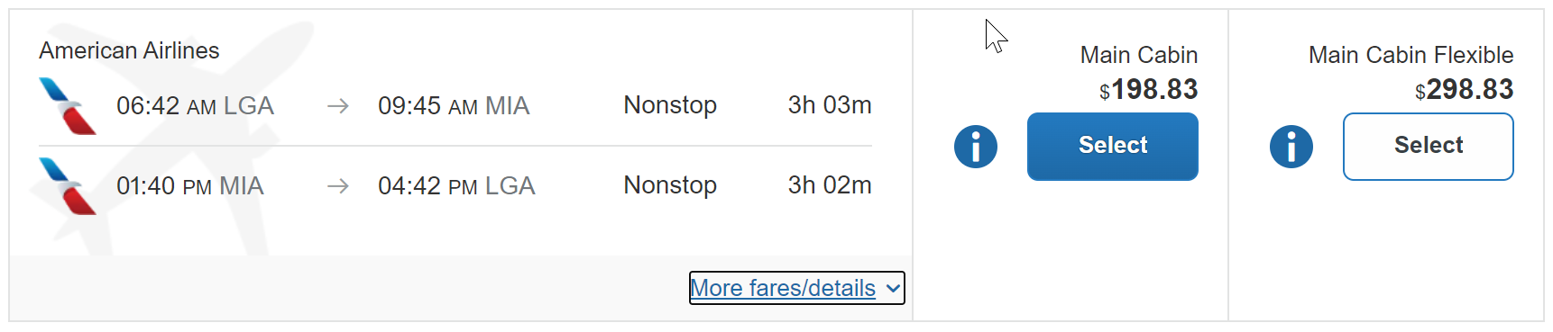

Expanded Display
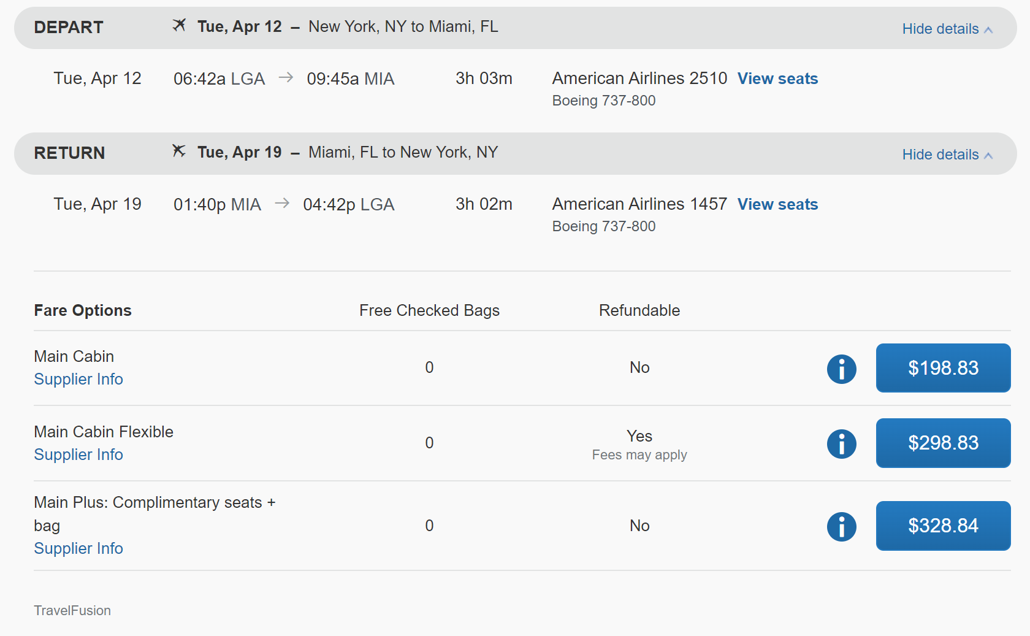

Flight Options
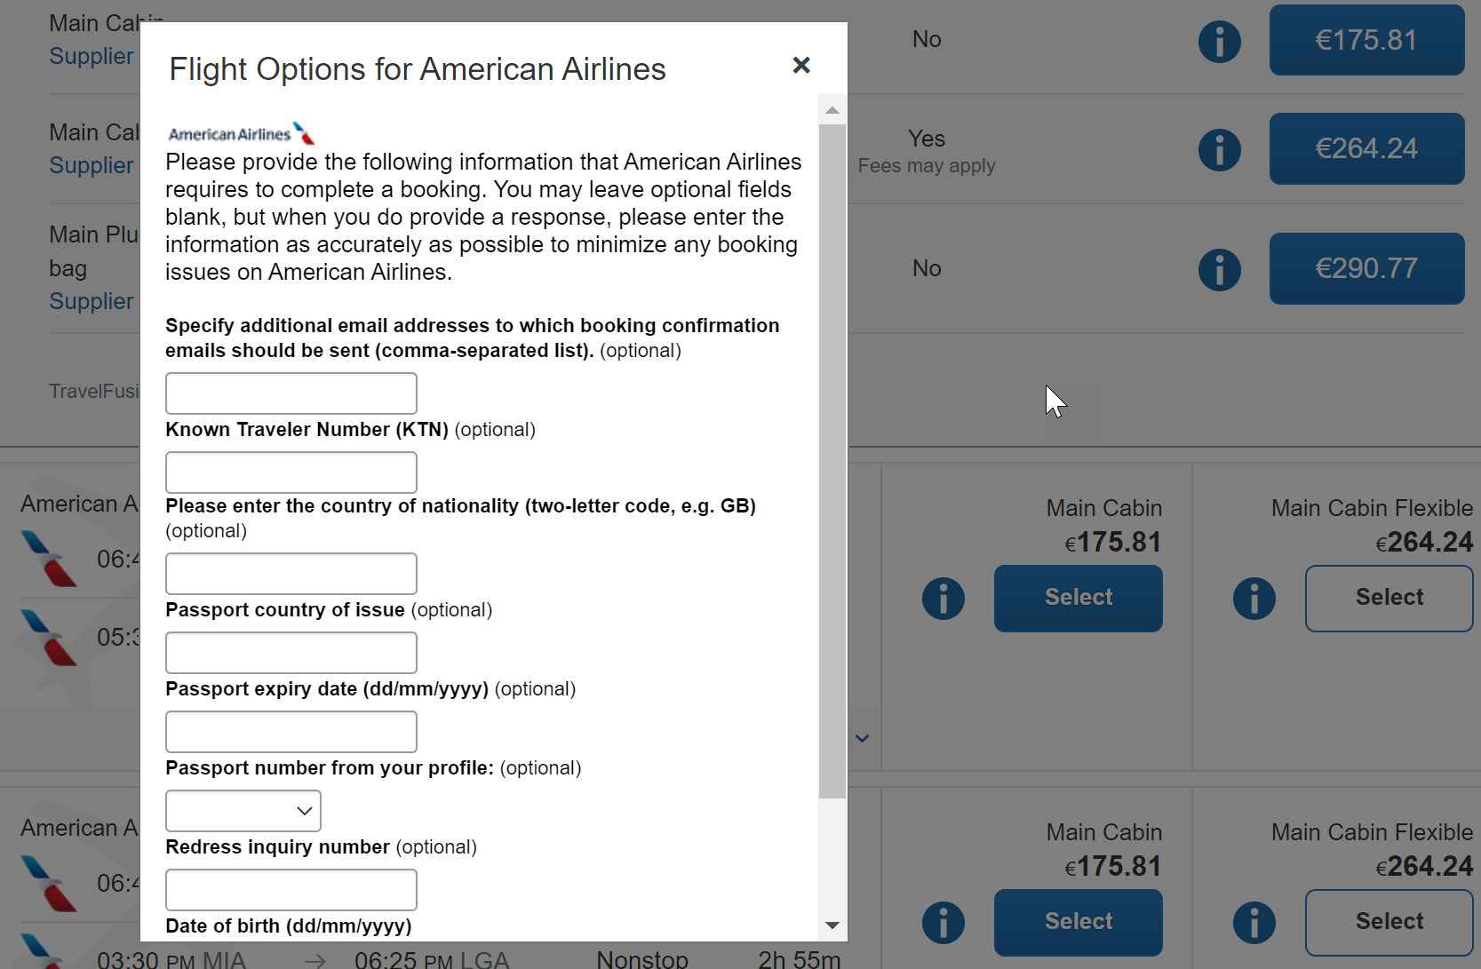

Configuration for Professional and Standard Travel
To proceed with American Airlines bookings via Travelfusion, American Airlines must be enabled in the Concur Travel configuration. For a successful implementation, please follow the instructions on Travelfusion general configuration and administrative settings and on the specifically desired airline content carefully.
For more information, refer to the Travelfusion Direct Connect Travel Service Guide and Travelfusion/New Distribution Capability Travel Service Guide. To locate, refer to Additional Release Notes and Other Technical Documentation in these release notes.
For additional reference, review SAP Concur’s blog regarding NDC.
These steps are covered in detail in Travelfusion Direct Connect Travel Service Guide and Travelfusion/New Distribution Capability Travel Service Guide:
- Enabling Travelfusion by TMC/Client.
- Inhibiting the airline content in the GDS response (required).
- Adding required and optional credentials (for example, IATA #, PCC, etc.) to receive airline content via Travelfusion.
- Enabling the airline as a supplier to be searched in Travelfusion.
- PNR finishing.
- Application of Travel Policy rules (for more information, see Approvals, Rules, and Classes/Policies Travel Services Guide).

Known Limitations
Please note the following:
- Travelers will receive notifications and updates directly from the airline in case of schedule changes. The Concur Travel itinerary will not receive airline updates after the initial booking is posted to the itinerary.
- Travelers will receive booking confirmation from the airline.
- Multi-segment shop and book is not supported.
- Airline is responsible for ticketing, although they may allow TMC ticketing and servicing with third party automation.
- Solution supports credit card and ghost card forms of payment only.

Ground

SummitQwest Decommission

Prof | Stan | Å Å Edition
 |  | On: Impacts end users who use this feature/vendor; no configuration/setup by agency/ admin; cannot be turned OFF (example: new icons or rate display, new Amtrak feature)
 |  | Available for use: No impact to end users unless/until configuration/setup by agency/admin (described below) (example: new rule, new Travelfusion airline)
X | X | Other: Refer to the release note below
 |  | Does not apply to this edition
Source / Solution Suggestion
GDS
Direct Connect
Solution ID
Other
 | EMEA Data Center |  |  | Scan impact
X | North America Data Center |  |  | UI impact
 | China Data Center |  |  | File finishing impact
 | All data centers |  |  | Profile/Profile API/3rd Party XML Sync Impact
Affected Documentation
TSGs |  | Ground Content Suppliers Travel Service Guide
Fact Sheets
Admin Guides
Other

Overview
Concur Travel currently provides travelers the ability to book ground transportation via SummitQwest. SummitQwest is focused on ground transport solutions for New York City but also provide global ground transport solutions (www.hqtravel.com).
Due to its pre-pandemic reduced usage and associated costs of maintenance, SAP Concur decided to decommission the support of SummitQwest in Concur Travel with the January 2022 release.
SAP Concur recognizes that some users may still require ground transportation booking capabilities; it is recommended that users switch to the remaining supplier Groundspan.

User/Customer Benefit
Periodically, under-utilized features or pages must be removed to improve usability. This is a rarely used feature and no longer supports Concur Travel users.

What the User Sees
Existing transfer itineraries will remain visible in Concur Travel under My Trips. Also, the historical data will be kept for reporting.
The option to cancel/modify a Ground booking will continued to be displayed after the January 2022 release but this action will run into an error message. For all required changes to a booking the traveler is advised to contact the ground supplier that is mentioned on the Trip Itinerary overview.

Configuration for Professional and Standard Travel
Targeted for the January 2022 release, SummitQwest will automatically be disabled and will no longer be visible on any travel configurations.
No additional action is required by administrators to support this change. However, SAP Concur recommends that clients provide messaging within Concur Travel to inform travelers.
For more information, refer to the Ground Content Suppliers Travel Service Guide. To locate, refer to Additional Release Notes and Other Technical Documentation in these release notes.

Talixo Decommission

Prof | Stan | Å Å Edition
 |  | On: Impacts end users who use this feature/vendor; no configuration/setup by agency/ admin; cannot be turned OFF (example: new icons or rate display, new Amtrak feature)
 |  | Available for use: No impact to end users unless/until configuration/setup by agency/admin (described below) (example: new rule, new Travelfusion airline)
X | X | Other: Refer to the release note below
 |  | Does not apply to this edition
Source / Solution Suggestion
GDS
Direct Connect
Solution ID
Other
X | EMEA Data Center |  |  | Scan impact
X | North America Data Center |  |  | UI impact
 | China Data Center |  |  | File finishing impact
 | All data centers |  |  | Profile/Profile API/3rd Party XML Sync Impact
Affected Documentation
TSGs |  | Ground Content Suppliers Travel Service Guide
Fact Sheets
Admin Guides
Other

Overview
Concur Travel currently provides travelers the ability to book ground transportation via Talixo. Talixo is an online platform for booking taxis, minicabs and limousines in Germany (www.talixo.de).
Due to its pre-pandemic reduced usage and associated costs of maintenance, SAP Concur decided to decommission the support of Talixo in Concur Travel with the January 2022 release.
SAP Concur recognizes that some users may still require ground transportation booking capabilities; it is recommended that users switch to the remaining supplier Groundspan.

User/Customer Benefit
Periodically, under-supported third-party features may be removed to ensure usability standards are maintained.

What the User Sees
Existing transfer itineraries will remain visible in Concur Travel under My Trips. Also, the historical data will be kept for reporting.
The option to cancel/modify a Ground booking will continued to be displayed after the January 2022 release but this action will run into an error message. For all required changes to a booking the traveler is advised to either contact Talixo directly or to use the self-service portal www.talixo.de/self-service/login.

Configuration for Professional and Standard Travel
Targeted for the January 2022 release, Talixo will automatically be disabled and will no longer be visible on any travel configurations.
No additional action is required by administrators to support this change. However, SAP Concur recommends that clients provide messaging within Concur Travel to inform travelers.
For more information, refer to the Ground Content Suppliers Travel Service Guide. To locate, refer to Additional Release Notes and Other Technical Documentation in these release notes.

Release Notes

Shared Planned Changes Moving to New Shared Changes Release Notes

Applies to: | Expense | Invoice | Request | Travel | Other
Edition(s) | Professional  Standard  CSBE | Professional  Standard  CSBE | Professional  Standard  CSBE | Professional  Standard  CSBE | All Concur products and services
Information First Published |  | Information Last Modified |  | Feature Target Release Date
December 3, 2021 |  | January 14, 2022 |  | January 14, 2022
Any changes since the previous monthly release are highlighted in yellow in this release note.

Overview
Beginning with the January 2022 draft release notes, shared (SAP Concur cross-product) changes, shared planned changes, and changes to SAP Concur core technologies are published in a new document, Shared Changes Release Notes. This document replaces the current Shared Planned Changes Release Notes.
Shared and core technology features and changes include, but are not limited to:
- Security-related changes—for example, annual security certificate renewals, changes to support for security ciphers, changes in support for security protocols, and changes to username and password requirements.
- UI design changes that impact all products—for example, changes to the functionality or appearance of the SAP Concur home page, the addition or removal of links from the site header or footer, changes to the user profile. page, and theme changes that impact the overall look and feel of the SAP Concur site.
- Sign-in process changes—for example, the addition or removal of sign-in features, URL changes, domain-name changes, and changes to verified email.
- Changes to production or test environments.
- Changes that impact site-wide settings, changes to global settings, and changes to pages for configuring site-wide or global settings—for example, changes to the User Administration page, changes to Product Settings for Standard Edition, and the introduction of new administration tools.
Previous Process
SAP Concur User Assistance published the Shared Planned Changes Release Notes in coordination with each monthly release. This document included shared and core features and changes that SAP Concur plans to implement in the future. When those changes were officially released, the release or implementation of the change was distributed and documented in the product-specific release notes—for example, the Concur Expense, Concur Invoice, Concur Request, or Concur Travel release notes.
New Process
Beginning in January 2022, the implementation of shared and core features, and changes to existing shared and core features are now documented in the new Shared Changes Release Notes. This applies both when the features and changes are planned changes and when they are officially released. The shared/core release notes will no longer be distributed to product-specific release notes.
Changes that are specific to one product and that impact that product's functionality or UI for admins or for end users will continue to be documented in that product's release notes.

User/Customer Benefit
This change reduces duplication of information, ensures that the product-specific release notes contain product-specific information, and provides a single source for SAP Concur shared changes and changes to core technologies.

Configuration for Professional and Standard Travel
This process change occurred automatically.
For more information and for information about the implementation of shared and core features, changes to existing shared and core features, and planned changes to shared and core features, refer to the SAP Concur Shared Changes Release Notes.

Travel Operations / Technical Essentials

Travel Implementation Process Change

Information First Published | Information Last Modified | Feature Target Release Date
January 2022 | -- | TBD
Any changes since the previous monthly release are highlighted in yellow in this release note.

Prof | Stan | Å Å Edition
 |  | On: Impacts end users who use this feature/vendor; no configuration/setup by agency/ admin; cannot be turned OFF (example: new icons or rate display, new Amtrak feature)
 |  | Available for use: No impact to end users unless/until configuration/setup by agency/admin (described below) (example: new rule, new Travelfusion airline)
X | X | Other: Refer to the release note below
 |  | Does not apply to this edition
Source / Solution Suggestion
GDS |  | N/A
Direct Connect |  | N/A
Solution ID
Other
X | EMEA Data Center |  |  | Scan impact
X | North America Data Center |  |  | UI impact
 | China Data Center |  |  | File finishing impact
 | All data centers |  |  | Profile/Profile API/3rd Party XML Sync Impact
Affected Documentation
TSGs
Fact Sheets
Admin Guides |  | Travel System Admin User Guide
Other

Overview
When implementing new indirect customers on SAP Concur products, TMCs have previously had different options for creating a new company configuration. They could:
- manually create a new configuration,
- clone an existing configuration, or
- complete the Online Order Form that generates a request for a new configuration to be created.
SAP Concur is making billing system updates, targeted for a future release. TMCs will now be required to complete and submit the Online Order Form for all configuration creations, includes test configurations. Cloned and manually created configurations will not be enabled until the Online Order Form is completed and submitted.

User/Customer Benefit
This feature change has no impact to Concur Travel users.

Configuration for Professional and Standard Travel
This feature is enabled by default. There are no configuration steps.
- For more information, refer to the Travel System Admin User Guide. To locate, refer to Additional Release Notes and Other Technical Documentation in these release notes.

Miscellaneous

**Ongoing** Rotating PGP Key Available for File Transfers

This feature is now documented in the Shared Changes Release Notes.
For more information, refer to Shared Planned Changes Moving to New Shared Changes Release Notes in this document.

**Ongoing** SAP Concur Homepage Changes

This feature is now documented in the Shared Changes Release Notes.
For more information, refer to Shared Planned Changes Moving to New Shared Changes Release Notes in this document.

**Ongoing** SAP Concur Legacy File Move Migration

This feature is now documented in the Shared Changes Release Notes.
For more information, refer to Shared Planned Changes Moving to New Shared Changes Release Notes in this document.

Profile Menu Functional Changes Under Fiori Light Theme (Professional Edition Only)

This feature is now documented in the Shared Changes Release Notes.
For more information, refer to Shared Planned Changes Moving to New Shared Changes Release Notes in this document.

Planned Changes
The items in this section are targeted for future releases. SAP Concur solutions reserves the right to postpone implementation of – or completely remove – any enhancement or change mentioned here.
The planned changes listed in this document are specific to this product. For information about planned site-wide or shared changes that might impact your SAP Concur solutions, refer to the Shared Changes Release Notes.

Flight

**Planned Changes** Galileo Post-Ticket Exchange Capability

Information First Published | Information Last Modified | Feature Target Release Date
January 2022 | -- | February 2022
Any changes since the previous monthly release are highlighted in yellow in this release note.

Prof | Stan | Å Å Edition
X | X | On: Impacts end users who use this feature/vendor; no configuration/setup by agency/ admin; cannot be turned OFF (example: new icons or rate display, new Amtrak feature)
 |  | Available for use: No impact to end users unless/until configuration/setup by agency/admin (described below) (example: new rule, new Travelfusion airline)
 |  | Other: Refer to the release note below
 |  | Does not apply to this edition
Source / Solution Suggestion
GDS |  | Galileo
Direct Connect
Solution ID
Other
X | EMEA Data Center |  |  | Scan impact
X | North America Data Center |  | X | UI impact
 | China Data Center |  |  | File finishing impact
 | All data centers |  |  | Profile/Profile API/3rd Party XML Sync Impact
Affected Documentation
TSGs |  | Post Ticket Change / Rapid Reprice (Apollo and Galileo) Travel Service Guide
Fact Sheets
Admin Guides
Other

Overview
Currently, users are not able to make flight changes via Travelport Galileo after a ticket has been issued. As of this release, post-ticket exchange functionality will be available for Travelport Galileo customers with the Post Ticket Change feature enabled.

User/Customer Benefit
This change will allow users to change Travelport Galileo airline flights through Concur Travel after a ticket has been issued.

Configuration for Professional and Standard Travel
The Galileo Post Ticket Change feature must be enabled in your company’s Concur Travel configuration settings.
For more information and known limitations, please refer to the Post Ticket Change / Rapid Reprice (Apollo and Galileo) Travel Service Guide. To locate, refer to Additional Release Notes and Other Technical Documentation in these release notes.

Hotel

**Planned Changes** Airbnb Decommission

Information First Published | Information Last Modified | Feature Target Release Date
December 2021 | -- | February 2022
Any changes since the previous monthly release are highlighted in yellow in this release note.

Prof | Stan | Å Å Edition
 |  | On: Impacts end users who use this feature/vendor; no configuration/setup by agency/ admin; cannot be turned OFF (example: new icons or rate display, new Amtrak feature)
 |  | Available for use: No impact to end users unless/until configuration/setup by agency/admin (described below) (example: new rule, new Travelfusion airline)
X | X | Other: Refer to the release note below
 |  | Does not apply to this edition
Source / Solution Suggestion
GDS
Direct Connect |  | Airbnb Direct Connect
Solution ID
Other
X | EMEA Data Center |  |  | Scan impact
X | North America Data Center |  |  | UI impact
 | China Data Center |  |  | File finishing impact
 | All data centers |  |  | Profile/Profile API/3rd Party XML Sync Impact
Affected Documentation
TSGs |  | Hotel Service Travel Service Guide
Fact Sheets
Admin Guides
Other

Overview
Targeted for February 2022, by mutual agreement, Airbnb and Concur Travel will disable the Airbnb Direct Connect as a source of content in Concur Travel and decommission the unique punch-out booking experience within the Concur Online Booking Tool. Existing connections will be removed; no new connections to Airbnb will be made.
Affected clients may work with Airbnb, their TMC, and their administrator to arrange Airbnb bookings via alternate channels, and/or to enable alternative hotel content connectors in Concur Travel.
Existing Airbnb itineraries will remain visible in Concur Travel under My Trips.

User/Customer Benefit
Periodically, under-supported third party features may be removed to ensure usability standards are maintained. This feature is not fully supported and will therefore be removed.

Configuration for Professional Travel
SAP Concur will automatically disable this feature for all travel configurations.
For more information, refer to the Hotel Service Travel Service Guide. To locate, refer to Additional Release Notes and Other Technical Documentation in these release notes.

Profile

**Planned Changes** Removing Connected Apps Page

Information First Published | Information Last Modified | Feature Target Release Date
December 2021 | -- | Q1 2022
Any changes since the previous monthly release are highlighted in yellow in this release note.

Prof | Stan | Å Å Edition
X | X | On: Impacts end users who use this feature/vendor; no configuration/setup by agency/ admin; cannot be turned OFF (example: new icons or rate display, new Amtrak feature)
 |  | Available for use: No impact to end users unless/until configuration/setup by agency/admin (described below) (example: new rule, new Travelfusion airline)
 |  | Other: Refer to the release note below
 |  | Does not apply to this edition
Source / Solution Suggestion
GDS
Direct Connect
Solution ID
Other
X | EMEA Data Center |  |  | Scan impact
X | North America Data Center |  |  | UI impact
 | China Data Center |  |  | File finishing impact
 | All data centers |  |  | Profile/Profile API/3rd Party XML Sync Impact
Affected Documentation
TSGs
Fact Sheets
Admin Guides
Other

Overview
SAP Concur will remove the Connected Apps page, https://www.concursolutions.com/profile/ProfileUserOauth.asp, from the Concur Travel and Expense user interface.
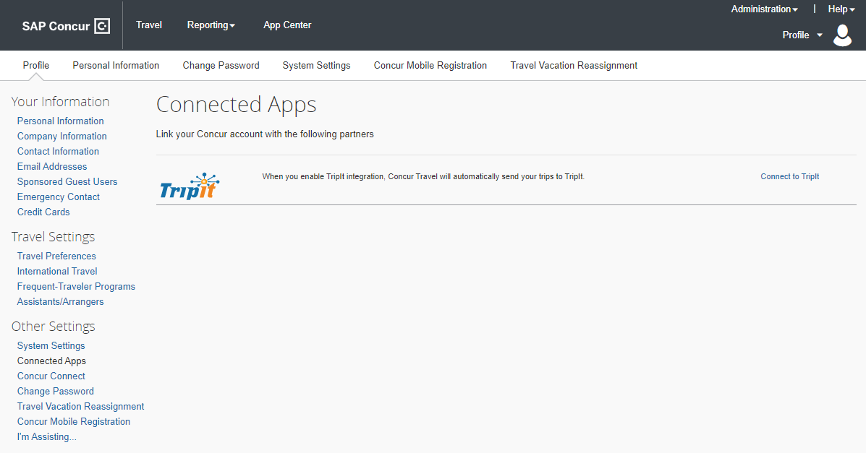

User/Customer Benefit
Periodically, under-utilized features or pages must be removed to improve usability. This is a rarely used page; it no longer meets its purpose of driving partner application usage.

Configuration for Professional and Standard Travel
This feature is enabled by default. There are no configuration steps.

**Planned Changes** XML Profile Sync No Longer Available as of March 31, 2022

Information First Published | Information Last Modified | Feature Target Release Date
March 2021 | -- | March 31, 2022
Any changes since the previous monthly release are highlighted in yellow in this release note.

Prof | Stan |   Edition
 |  | On: Impacts end users who use this feature/vendor; no configuration/setup by agency/ admin; cannot be turned OFF (example: new icons or rate display, new Amtrak feature)
 |  | Available for use: No impact to end users unless/until configuration/setup by agency/admin (described below) (example: new rule, new Travelfusion airline)
X | X | Other: Refer to the release note below
 |  | Does not apply to this edition
Source / Solution Suggestion
GDS
Direct Connect
Solution ID
Other
X | EMEA Data Center |  |  | Scan impact
X | North America Data Center |  |  | UI impact
 | China Data Center |  |  | File finishing impact
 | All data centers |  | X | Profile/Profile API/3rd Party XML Sync Impact
Affected Documentation
TSGs |  | Travel Profile API Travel Service Guide
Fact Sheets
Admin Guides
Other

Overview
The XML Profile Sync, which is used to synchronize Concur Travel user profile data with TMC partners, will no longer be available, targeted for Q1 2022. We advise all partners to engage with SAP Concur representatives to adopt the Travel Profile v2 API for managing Concur Travel user profiles.

User/Customer Benefit
The XML Profile Sync was officially decommissioned in 2016 due to instability and other issues. The Travel Profile v2 API was built to replace this legacy synchronization process. It has now reached a level of stability and maturity that there is no longer any reason to maintain multiple profile sync options.

Configuration for Professional and Standard Travel
This feature is enabled by default. There are no configuration steps.
For more information, refer to the Travel Profile API Travel Service Guide and to the SAP Concur Developer Center, Travel Profile v2 - Resource. To locate, refer to Additional Release Notes and Other Technical Documentation in these release notes.

Client Notifications

Accessibility

Accessibility Updates
SAP implements changes to better meet current Web Content Accessibility Guidelines (WCAG). Information about accessibility-related changes made to SAP Concur solutions is published on a quarterly basis. You can review the quarterly updates on the Accessibility Updates page.

Subprocessors

SAP Concur Non-Affiliated Subprocessors
The list of non-affiliated subprocessors is available here: SAP Concur list of Subprocessors
If you have questions or comments, please reach out to: Privacy-Request@Concur.com

Supported Browsers

Supported Browsers and Changes to Support
For information about supported browsers and planned changes to supported browsers, refer to the Concur Travel & Expense Supported Configurations guide.
When changes to browser support are planned, information about those changes will also appear in the Shared Changes release notes.

Additional Release Notes and Other Technical Documentation

Online Help
Any user can access release notes, setup guides, user guides, admin summaries, monthly browser certifications, supported configurations, and other resources via online Help or directly on the SAP Help Portal.
Use the links in the Help menu in the app, or search for your SAP Concur product (Concur Expense, Concur Invoice, Concur Request, or Concur Travel) on the SAP Help Portal (https://help.sap.com) to view the full set of documentation for your product.

SAP Concur Support Portal – Selected Users
Access release notes, webinars, and other technical documentation on the SAP Concur support portal.
If you have the proper permissions, the Contact Support appears on the Help menu. Click to access the SAP Concur support portal, then click Resources.
- Click Release/Tech Info for release notes, technical documents, etc.
- Click Webinars for recorded and live webinars.
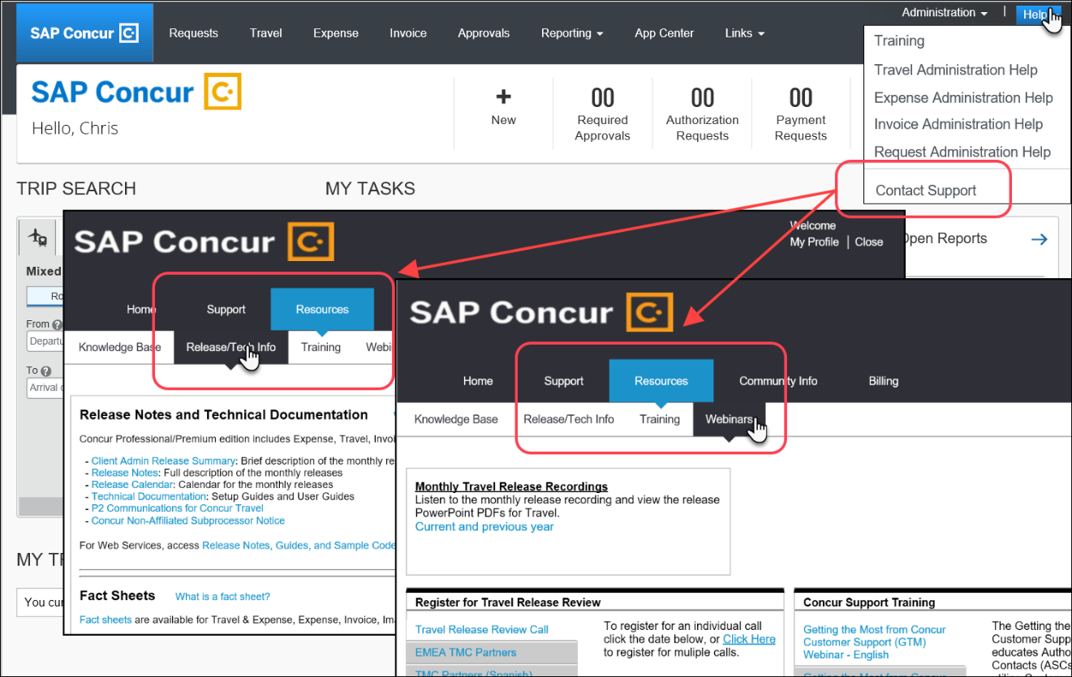

© 2022 SAP SE or an SAP affiliate company. All rights reserved.
No part of this publication may be reproduced or transmitted in any form or for any purpose without the express permission of SAP SE or an SAP affiliate company.
SAP and other SAP products and services mentioned herein as well as their respective logos are trademarks or registered trademarks of SAP SE (or an SAP affiliate company) in Germany and other countries. Please see http://global12.sap.com/corporate-en/legal/copyright/index.epx for additional trademark information and notices.
Some software products marketed by SAP SE and its distributors contain proprietary software components of other software vendors.
National product specifications may vary.
These materials are provided by SAP SE or an SAP affiliate company for informational purposes only, without representation or warranty of any kind, and SAP SE or its affiliated companies shall not be liable for errors or omissions with respect to the materials. The only warranties for SAP SE or SAP affiliate company products and services are those that are set forth in the express warranty statements accompanying such products and services, if any. Nothing herein should be construed as constituting an additional warranty.
In particular, SAP SE or its affiliated companies have no obligation to pursue any course of business outlined in this document or any related presentation, or to develop or release any functionality mentioned therein. This document, or any related presentation, and SAP SE’s or its affiliated companies’ strategy and possible future developments, products, and/or platform directions and functionality are all subject to change and may be changed by SAP SE or its affiliated companies at any time for any reason without notice. The information in this document is not a commitment, promise, or legal obligation to deliver any material, code, or functionality. All forward-looking statements are subject to various risks and uncertainties that could cause actual results to differ materially from expectations. Readers are cautioned not to place undue reliance on these forward-looking statements, which speak only as of their dates, and they should not be relied upon in making purchasing decisions.

