SAP Concur Release Notes
Concur Request Professional/Premium
Month | Audience
Release Date: June 18, 2022  Initial Post: Friday, June 17, 2022 | Client – FINAL

Contents
Release Notes 1
NextGen UI for Concur Request 1
**Ongoing** Updated User Interface (UI) for Concur Request End Users 1
SAP Concur Platform 3
**Ongoing** Retirement and Decommission of Existing Concur Request APIs (v1.0, v3.0, v3.1) (November 30, 2021) 3
UI Changes 4
Expected Expense Details Page Format Updated 4
Expected Expenses Page Format Updated 7
Remaining Amount Added to the Reports Tile 9
Requests Approvals Page Format Updated 12
Planned Changes 15
Workflow 15
**Planned Changes** New Setting: Automatically Assign Authorized Approvers 15
Client Notifications 18
Accessibility 18
Accessibility Updates 18
Subprocessors 18
SAP Concur Non-Affiliated Subprocessors 18
Supported Browsers 19
Supported Browsers and Changes to Support 19
Additional Release Notes and Other Technical Documentation 20
Online Help 20
SAP Concur Support Portal – Selected Users 20
Cases 21
Check Support Case Status 21

Legal Disclaimer
The information in this presentation is confidential and proprietary to SAP SE or an SAP affiliate company and may not be disclosed without the permission of SAP SE or the respective SAP affiliate company. This presentation is not subject to your license agreement or any other service or subscription agreement with SAP SE or its affiliated companies. SAP SE and its affiliated companies have no obligation to pursue any course of business outlined in this document or any related presentation, or to develop or release any functionality mentioned therein. This document, or any related presentation and SAP SE or an SAP affiliate company’s strategy and possible future developments, products and or platforms directions and functionality are all subject to change and may be changed by SAP SE and its affiliated companies at any time for any reason without notice. The information in this document is not a commitment, promise or legal obligation to deliver any material, code or functionality. This document is provided without a warranty of any kind, either express or implied, including but not limited to, the implied warranties of merchantability, fitness for a particular purpose, or non-infringement. This document is for informational purposes and may not be incorporated into a contract. SAP SE and its affiliated companies assume no responsibility for errors or omissions in this document, except if such damages were caused by SAP SE or an SAP affiliate company’s willful misconduct or gross negligence.
All forward-looking statements are subject to various risks and uncertainties that could cause actual results to differ materially from expectations. Readers are cautioned not to place undue reliance on these forward-looking statements, which speak only as of their dates, and they should not be relied upon in making purchasing decisions.

Release Notes
This document contains the release notes for Concur Request Professional edition.
Features and changes that apply to SAP Concur site-wide or to multiple products/services are documented in the Shared Changes Release Notes. For information about site-wide or shared changes in this release that might impact your SAP Concur solutions, refer to the Shared Changes Release Notes.

NextGen UI for Concur Request

**Ongoing** Updated User Interface (UI) for Concur Request End Users

Information First Published | Information Last Modified | Feature Target Release Date
November 2019 | April 22, 2022 | October 1, 2022
Any changes since the previous monthly release are highlighted in yellow in this release note.

Overview
The continued evolution of the Concur Request solution user interface experience is the result of thoughtful design and research that provides a modern, intuitive, and streamlined experience for the request process.
Concur Request customers are now strongly encouraged to preview and then move to the NextGen UI well before the automatic transition date of October 1, 2022.

Business Purpose / Client Benefit
The result is the next generation of the Concur Request user interface designed to provide a modern, consistent, and streamlined user experience. This technology not only provides an enhanced user interface, but also allows us to react more quickly to customer requests to meet changing needs as they happen.

Products and Users Affected
To take advantage of these improvements, Concur Request customers who do not move before October 1, 2022 will be automatically transitioned to the NextGen UI for Concur Request. The following provides information about the timeline and resources available to ensure this process is smooth and efficient for all users.
These UI changes will apply to:
- Concur Request (Professional/Premium and Standard) end users
There are no changes for admins.

IMPORTANT! Timeline and Milestones
There are three important milestones for Concur Request customers as they transition from the existing UI to the NextGen UI:
- Opt-In Period: July 2020 – September 2021
This milestone is marked by the delivery of most planned features as well as further overall quality and stability.
Customers should use this period to plan their transition and move to the NextGen UI for Concur Request when it is right for your business priorities. Some remaining features will become available throughout this period, so customers should plan their roll out accordingly.
- IMPORTANT: When the NextGen UI is enabled, it will automatically enable the NextGen UI for both Concur Expense and Concur Request.
- Active Move Period: October 2021 – September 2022
This is the 12-month notice period we committed to for customers to complete the transition before the automatic transition date.
Customers are strongly encouraged to complete the tasks necessary to ensure a smooth transition for their organization and then transition during the Active Move Period.
- Automatic Transition Date: October 1, 2022
All customers will be automatically transitioned to the NextGen UI. This ensures that we continue to offer a consistent user experience for all customers and allows for superior product innovation and support.

Transition Materials – Guides and Other Resources
We offer several guides, an FAQ, release notes, and other resources to aid in the transition. All the information that an organization needs to get started is available here:
- Professional Edition
- Standard Edition
The links above provide access to the following:
- Admin guides, FAQ, transition resources: The admin guide provides information about accessing the NextGen UI and the roles/permissions required.
Along with the admin guides, FAQ, and other resources, there is a list of features that are not yet available in the NextGen UI for Concur Request. All of these can be used to help customers prepare their users.
To help with training needs, customers can use the admin guide and end-user guide "as is" or they can use any part of them to create training materials. Customers can cut, copy, paste, delete, or otherwise edit either guide at will.
- End-User guide: This guide compares the existing UI to the NextGen UI for Concur Request to help users become comfortable with the new experience. This guide will be updated as needed during the Opt-In Period for NextGen UI as the UI is being enhanced. Admins should review the guide often.
Like the admin guide, the organization can cut, copy, paste, delete, or otherwise edit this guide at will.
- Release information: During the Active Move Period, the release of the enhancements will not be on the regular release schedule. Instead, we will provide special information about features and enhancements that are nearing release.
As of the May 2022 release, release notes for the NextGen UI can be found within this release note document. The statement These changes are part of the NextGen UI experience is displayed at the beginning of each NextGen UI release note.

Get Started
Customers are encouraged to use the transition materials described above and develop a plan for the transition.

SAP Concur Platform

**Ongoing** Retirement and Decommission of Existing Concur Request APIs (v1.0, v3.0, v3.1) (November 30, 2021)

Information First Published | Information Last Modified | Feature Target Release Date
June 2020 | December 3, 2021 | June 1, 2021
Any changes since the previous monthly release will be highlighted in yellow in this release note.

Overview
As of May 31, 2021, the existing Concur Request APIs (v1.0, v3.0 and v3.1) are deprecated. On June 1, 2021, SAP began retiring these APIs in accordance with the SAP Concur API Lifecycle & Deprecation Policy. These APIs are replaced by the Concur Request v4 APIs. SAP will no longer support these APIs after retirement.
As of November 30, 2021, the retirement phase for the existing Concur Request APIs (v1.0, v3.0 and v3.1) is completed.
Decommissioning of the v1.0, v3.0, and v3.1 APIs will start three months after retiring the APIs. The specific dates for decommissioning are dependent on the individual client's API migration.
API Timeline for v1.0, v3.0, v3.1:
- Deprecation – March 1, 2020 – May 31, 2021
- Retirement – June 1, 2021 – November 30, 2021
- Decommission – starts after 3 months of inactivity at the retired state

Business Purpose / Client Benefit
The Concur Request APIs v1.0, v3.0 and v3.1 only support the previous authentication method, which is not best security practice and does not meet the Oauth2 standards. In addition, the previous versions of the Concur Request APIs provided limited possibilities for moving a Request through the approval workflow, as well as managing custom simple & connected list fields. These issues are resolved with the new Concur Request v4 APIs.
In addition, SAP has run a backward compatibility project between the current Concur Request APIs and the new Concur Request v4 APIs (not iso-compatibility) in order to have the vast majority of use cases managed in the previous versions also be managed in the Concur Request v4 APIs.

UI Changes

Expected Expense Details Page Format Updated
This change is part of the NextGen UI experience.

Overview
The formatting of the expected expense details page in Concur Request is updated to match the formatting for the expense details page in Concur Expense.

Business Purpose / Client Benefit
This change provides feature consistency between Concur Request and Concur Expense in the NextGen UI.

End-User Experience
On the expected expense details page, the following updates were made:
- The left and right navigation buttons are moved to align with the top of the request name.
- If the request only contains one expected expense and no segments, the left and right navigation buttons are now displayed but not active. Before this update, the navigation buttons were not displayed on the page if the request only contained one expected expense or segment.
- The request date is now located below the left and right navigation buttons. Before this update the date was located below the request name.
- The Save and Cancel buttons on the bottom of the page are moved from the right side of the page to the left side of the page.

Before:
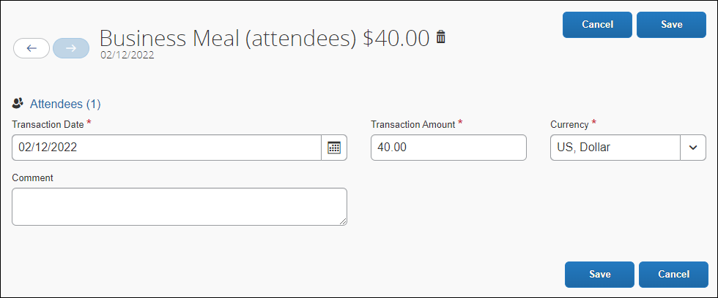

After:
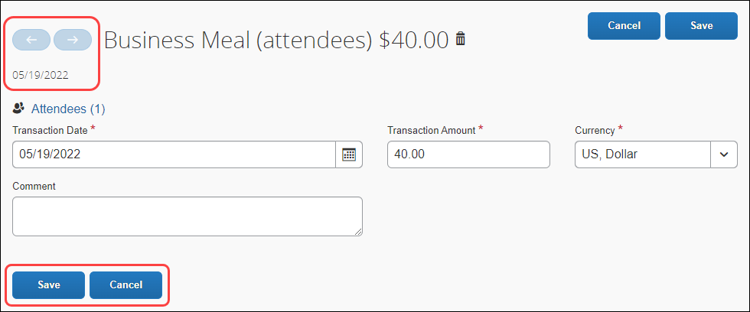
Here is an example of the expense details page in Concur Expense:
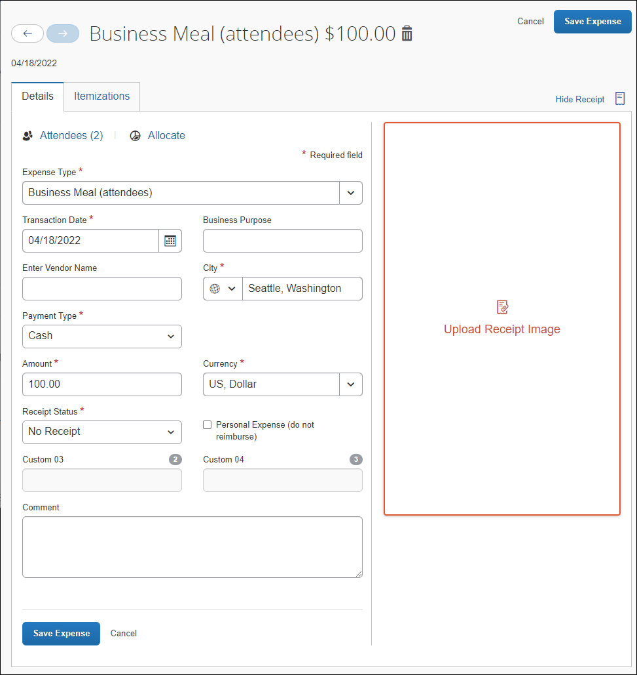

Configuration / Feature Activation
This change is automatically available; there are no configuration or activation steps.

Expected Expenses Page Format Updated
This change is part of the NextGen UI experience.

Overview
The formatting of the Expected Expenses page is updated to match the formatting used for the expense report page in Concur Expense.

Business Purpose / Client Benefit
This change provides feature consistency between Concur Request and Concur Expense in the NextGen UI.

End-User Experience
On the Expected Expenses page, the following updates were made:
- The request name and amount text is now bolded.
- The Copy Request link is now a button instead of a link, like the Copy Report button on the expense report page.
- The Delete and Allocate buttons in the Expected Expenses section of the page are moved so that the Delete button is now displayed between the Edit and Allocate button instead of after the Allocate button.
- The Estimated Total: text is no longer displayed before the request total amount.

Before:
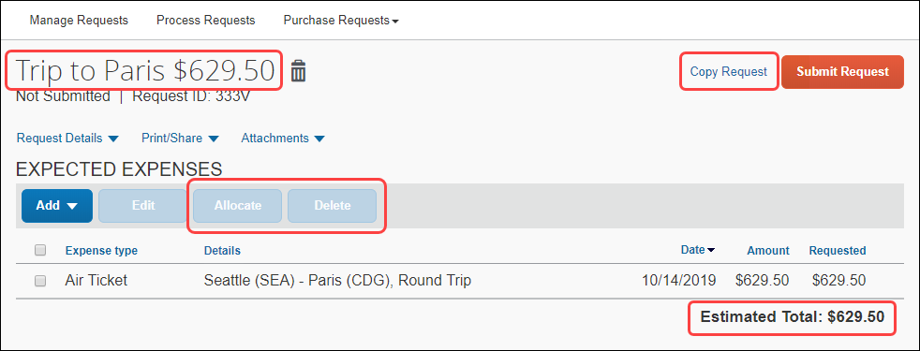

After:
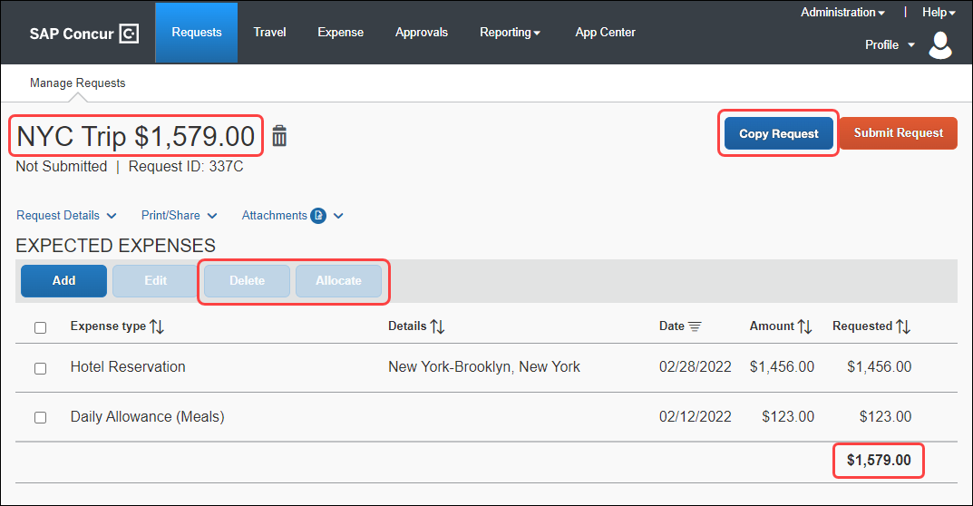
Here is an example of the expense report page in Concur Expense:
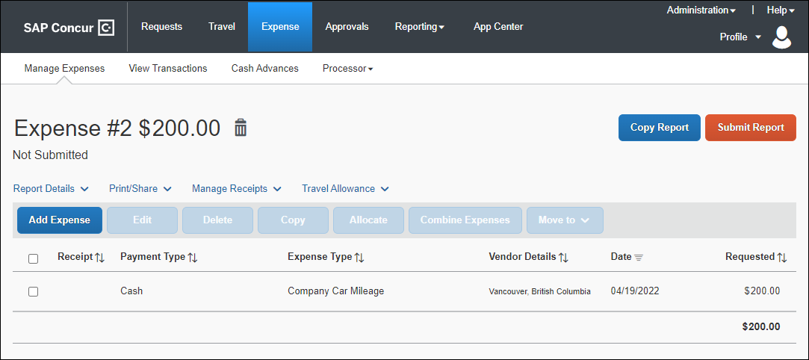

Configuration / Feature Activation
This change is automatically available; there are no configuration or activation steps.

Remaining Amount Added to the Reports Tile
This change is part of the NextGen UI experience.

Overview
The remaining amount information is added to the REPORTS tile on the Expected Expenses page to match the remaining amount formatting used for similar tiles, like the CASH ADVANCE tile on the expense report page in Concur Expense.

Business Purpose / Client Benefit
This change provides feature consistency between Concur Request and Concur Expense in the NextGen UI.

End-User Experience
On the Expected Expenses page, when there are one or more expense reports associated with the request, the REPORTS tile is displayed with the total amount of the expense report(s).

Before:
The REPORTS tile only displayed the expense report amounts.
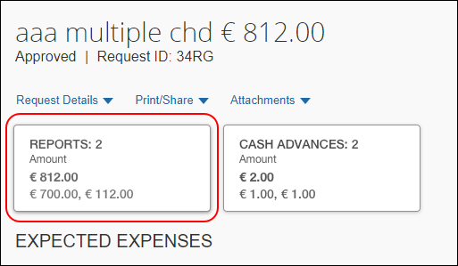

After:
If a user is allowed to see both the total amount of the expense report(s) associated with the request, as well as the remaining amount of the expense report(s), the REPORTS tile will display both the total amount under Amount and the remaining amount under Remaining.
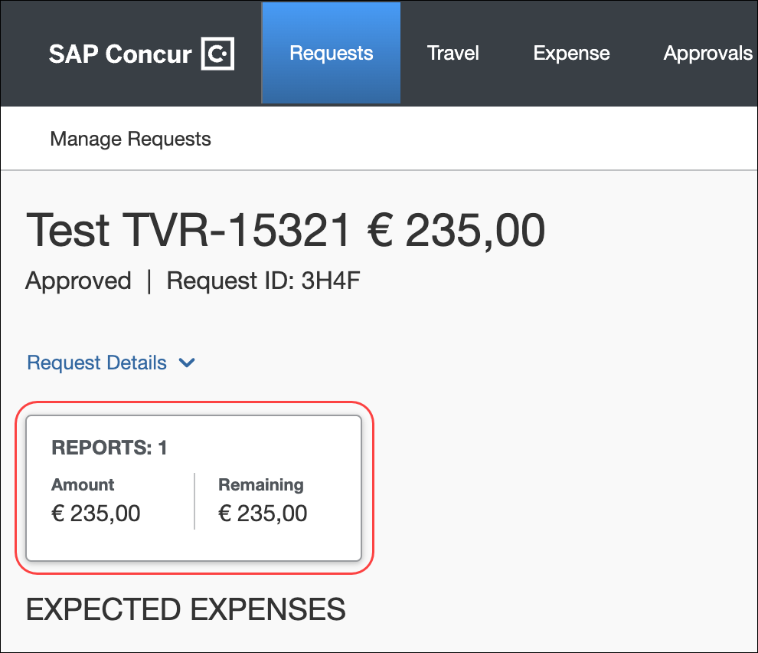
If a user is only allowed to see the remaining amount of the expense report(s) associated with the request, the REPORTS tile only displays the remaining amount under Remaining.
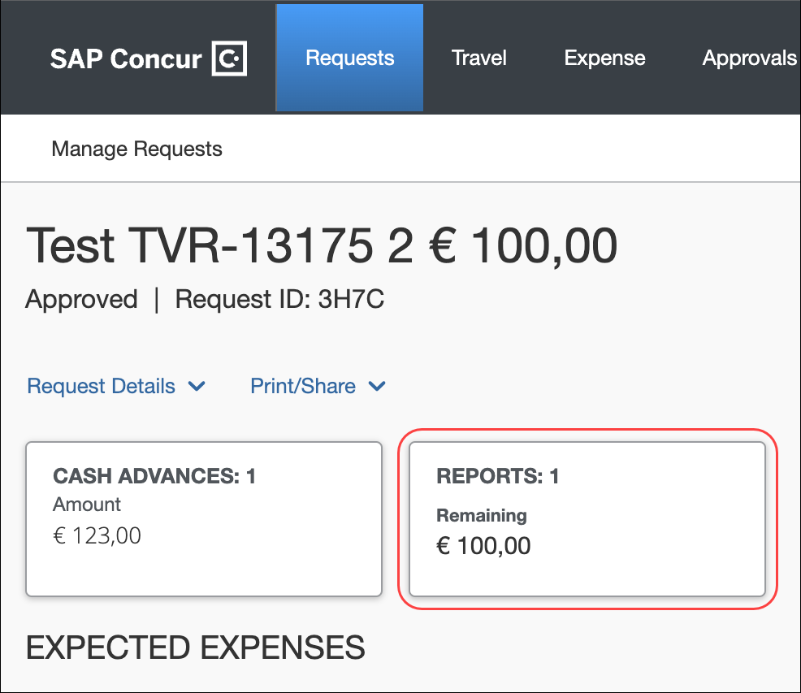
Here is an example of the remaining amount information on the CASH ADVANCE tile on the expense report page in Concur Expense:
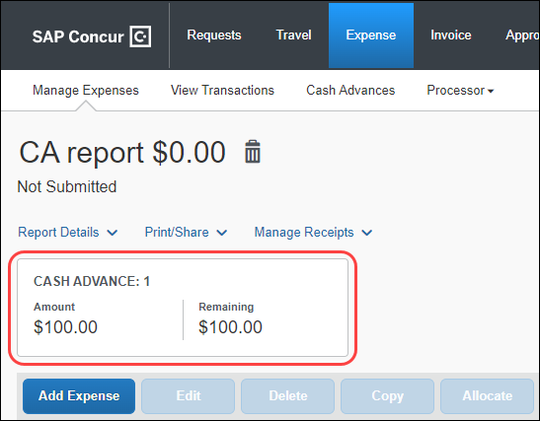

Configuration / Feature Activation
This change is automatically available; there are no configuration or activation steps.

Requests Approvals Page Format Updated
This change is part of the NextGen UI experience.

Overview
The formatting of the Requests page in Approvals is updated to match the formatting planned for the Expense Reports page in Approvals.

Business Purpose / Client Benefit
This change will provide feature consistency between Concur Request and Concur Expense in the NextGen UI.

End-User Experience
On the Requests page in Approvals, the following updates were made:
- The title, Requests, is added at the top of the page.
- The View list is renamed to Limit results to.
- What you select from the Limit results to list is displayed above the request list on the page.
- The request name and request ID are now displayed in two separate columns, Name and ID. Before this update the request ID was displayed below the request name in the Request Name column.

Before:
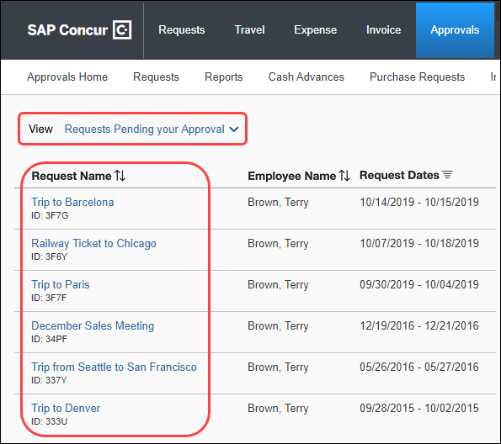

After:
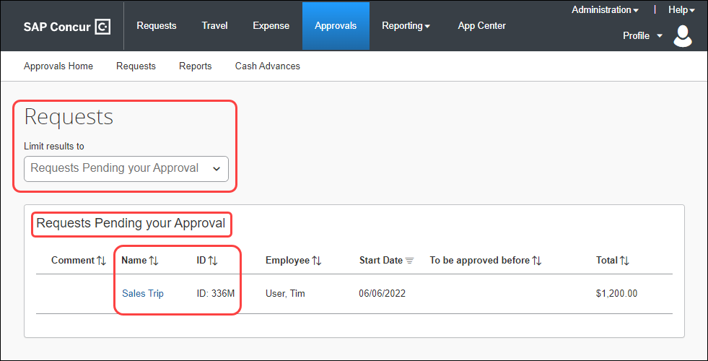

Configuration / Feature Activation
This change is automatically available; there are no configuration or activation steps.

Planned Changes
The items in this section are targeted for future releases. SAP Concur reserves the right to postpone implementation of – or completely remove – any enhancement/change mentioned here.
The planned changes listed in this document are specific to this product. For information about planned site-wide or shared changes that might impact your SAP Concur solutions, refer to the Shared Changes Release Notes.

Workflow

**Planned Changes** New Setting: Automatically Assign Authorized Approvers

Information First Published | Information Last Modified | Feature Target Release Date
June 10, 2022 | -- | TBD
Any changes since the previous monthly release are highlighted in yellow in this release note.

Overview
A new setting, Automatically assign authorized approvers, will be added to the Workflows tab in Workflows (Administration > Request > Workflows). When enabled, the setting ensures that all Authorized Approval steps in the workflow are pre-populated with an assigned authorized approver.
Without the Automatically assign authorized approvers setting, when there are multiple authorized approvers to choose from, the user is required to select the name of an approver before the request can proceed to the next workflow step.
The user can still review the approval flow and elect to edit the step to select another approver from the list of authorized approvers.

Business Purpose / Client Benefit
Use of this setting ensures that all authorized approval steps have an assigned approver for the request, without user action. For most organizations, there is typically one choice per workflow step or only a small number of possible approvers to choose from.
The functionality of the Automatically assign authorized approvers setting for requests in Concur Request matches the functionality of the existing Automatically assign authorized approvers setting for expense reports in Concur Expense.

Administrator Experience
A new setting, Automatically assign authorized approvers, will display on the Workflows tab of the Workflows page. By default, the setting will not be selected (enabled).
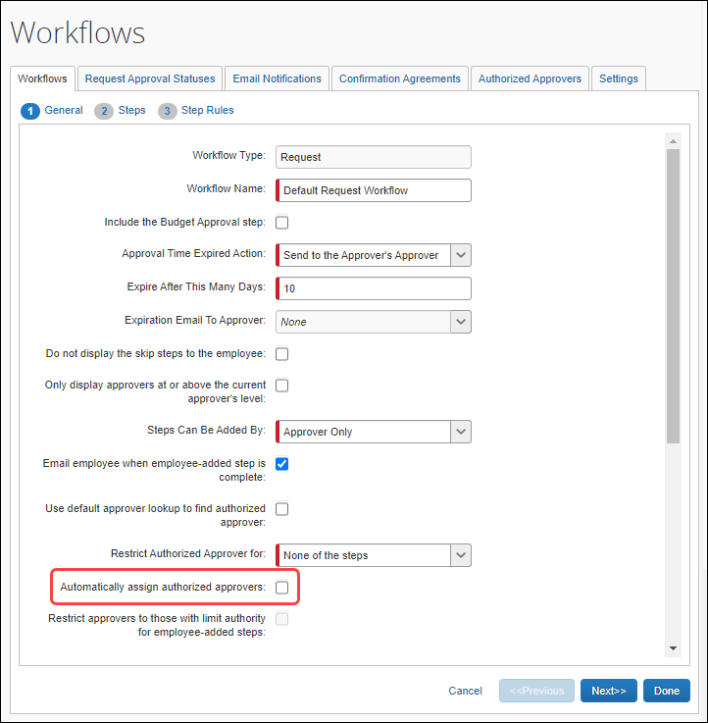
After this setting becomes available and after reviewing the following considerations, to enable this new setting, contact SAP Concur support.
Important considerations before enabling this setting:
- If there are multiple possible Authorized Approvers that could be assigned to a specific Authorized Approver workflow step, the system will order the choices alphabetically by last name, followed by first name (if there is more than one person with the same last name) and then select the first choice from the alphabetized list.
- Enabling this setting is not recommended when there might be large numbers of possible approvers for some workflow steps. In this situation, the user needs to select the appropriate approver for the request rather than sending all reports to the alphabetically-first approver.
- The individual Request Preferences page setting, Prompt for approver when a request is submitted, will display the approval flow to the user for review during the submit process when checked. This can encourage the user to verify that the appropriate approver is assigned to each step prior to submitting the request.
- Use of this feature is optimized by configuring the workflow to allow users to edit approvers, so this is strongly recommended. Refer to the Approver Editable By setting in the Add Workflow Step dialog.
- Clients who currently use the Use default approver lookup to find authorized approver setting on the General page (Workflows tab > General page), should choose to either retain that setting or use the new Automatically assign authorized approvers setting instead. We recommend that these two settings are not enabled and used at the same time.
- For more information, you will be able to refer to the Concur Request: Workflow – General Information Setup Guide and the Concur Request: Workflow – Authorized Approvers Setup Guide.

Client Notifications

Accessibility

Accessibility Updates
SAP implements changes to better meet current Web Content Accessibility Guidelines (WCAG). Information about accessibility-related changes made to SAP Concur solutions is published on a quarterly basis. You can review the quarterly updates on the Accessibility Updates page.

Subprocessors

SAP Concur Non-Affiliated Subprocessors
The list of non-affiliated subprocessors is available here: SAP Concur list of Subprocessors
To access the SAP Concur Sub-processors List:
- Click the following link to navigate to the SAP Sub-processors / Data Transfer Factsheets page:
SAP Sub-processors / Data Transfer Factsheets
- Sign in to the SAP Support Portal using your Support User ID (S-user) and password.
SAP customers must sign in to the SAP Support Portal using their Support User ID (S-user) and password. For information about S-User IDs, refer to Your New Support User ID (S-user).
- On the SAP Sub-processors / Data Transfer Factsheets page, type "Concur" in the Search field.
- In the Title column, click SAP Concur Sub-processors List.
If you have questions or comments, please reach out to: Privacy-Request@Concur.com

Supported Browsers

Supported Browsers and Changes to Support
For information about supported browsers and planned changes to supported browsers, refer to the Concur Travel & Expense Supported Configurations guide.
When changes to browser support are planned, information about those changes will also appear in the Shared Changes Release Notes.

Additional Release Notes and Other Technical Documentation

Online Help
Any user can access release notes, setup guides, user guides, admin summaries, monthly browser certifications, supported configurations, and other resources via online Help or directly on the SAP Help Portal.
Use the links in the Help menu in the app, or search for your SAP Concur product (Concur Expense, Concur Invoice, Concur Request, or Concur Travel) on the SAP Help Portal (https://help.sap.com) to view the full set of documentation for your product.

SAP Concur Support Portal – Selected Users
Access release notes, webinars, and other technical documentation on the SAP Concur support portal.
If you have the proper permissions, Contact Support appears on the Help menu. Click to access the SAP Concur support portal, then click Resources.
- Click Release/Tech Info for release notes, technical documents, etc.
- Click Webinars for recorded and live webinars.
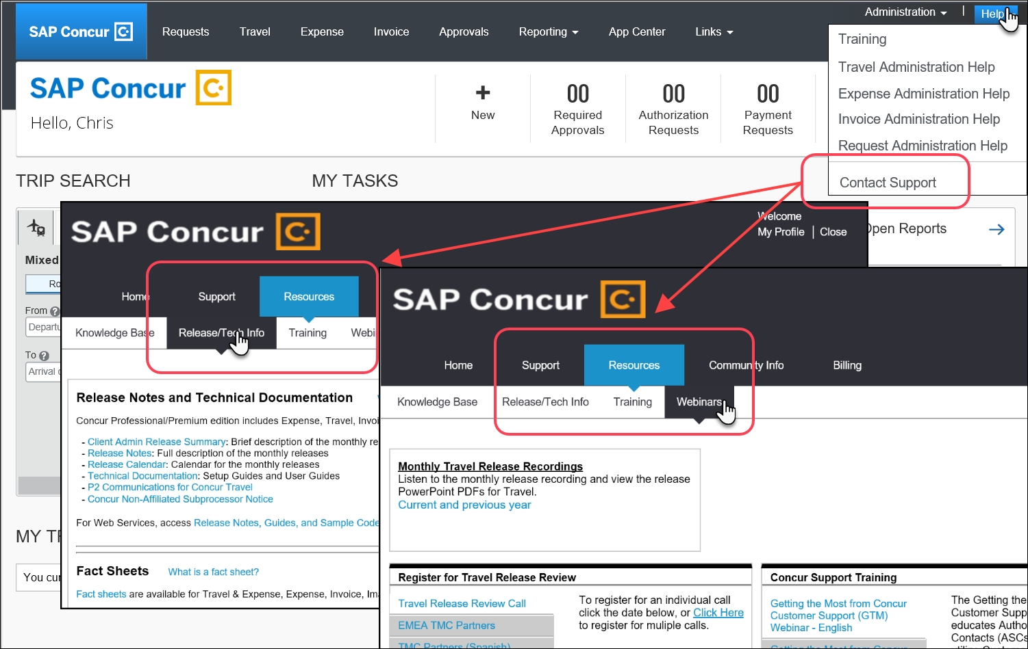

Cases

Check Support Case Status
The steps in this procedure provide instructions for checking whether a case is resolved.
To check the status of a submitted case
- Log on to https://concursolutions.com/portal.asp.
- Click Help > Contact Support.

If you do not have the option to contact SAP Concur support under the Help menu, then your company has chosen to support the SAP Concur service internally. Please contact your internal support desk for assistance.
- Click Support > View Cases.

- In the table, view the desired type of cases based on the View list selection. Search results are limited to each company's own cases.


© 2022 SAP SE or an SAP affiliate company. All rights reserved.
No part of this publication may be reproduced or transmitted in any form or for any purpose without the express permission of SAP SE or an SAP affiliate company.
SAP and other SAP products and services mentioned herein as well as their respective logos are trademarks or registered trademarks of SAP SE (or an SAP affiliate company) in Germany and other countries. Please see http://global12.sap.com/corporate-en/legal/copyright/index.epx for additional trademark information and notices.
Some software products marketed by SAP SE and its distributors contain proprietary software components of other software vendors.
National product specifications may vary.
These materials are provided by SAP SE or an SAP affiliate company for informational purposes only, without representation or warranty of any kind, and SAP SE or its affiliated companies shall not be liable for errors or omissions with respect to the materials. The only warranties for SAP SE or SAP affiliate company products and services are those that are set forth in the express warranty statements accompanying such products and services, if any. Nothing herein should be construed as constituting an additional warranty.
In particular, SAP SE or its affiliated companies have no obligation to pursue any course of business outlined in this document or any related presentation, or to develop or release any functionality mentioned therein. This document, or any related presentation, and SAP SE’s or its affiliated companies’ strategy and possible future developments, products, and/or platform directions and functionality are all subject to change and may be changed by SAP SE or its affiliated companies at any time for any reason without notice. The information in this document is not a commitment, promise, or legal obligation to deliver any material, code, or functionality. All forward-looking statements are subject to various risks and uncertainties that could cause actual results to differ materially from expectations. Readers are cautioned not to place undue reliance on these forward-looking statements, which speak only as of their dates, and they should not be relied upon in making purchasing decisions.

