SAP Concur Release Notes
Concur Request Professional/Premium
Month | Audience
Release Date: March 19, 2022  Initial Post: Tuesday, March 29, 2022 | Client – FINAL

Contents
Release Notes 1
NextGen UI for Concur Request 1
**Ongoing** Updated User Interface (UI) for Concur Request End Users 1
Mileage 3
Mileage Expense Types and Mileage Calculator for Mileage Service 3
SAP Concur Platform 10
**Ongoing** Retirement and Decommission of Existing Concur Request APIs (v1.0, v3.0, v3.1) (November 30, 2021) 10
Planned Changes 12
Request Policies 12
New Setting for Travel Allowance Options in Request 12
Client Notifications 15
Accessibility 15
Accessibility Updates 15
Subprocessors 15
SAP Concur Non-Affiliated Subprocessors 15
Supported Browsers 15
Supported Browsers and Changes to Support 15
Additional Release Notes and Other Technical Documentation 16
Online Help 16
SAP Concur Support Portal – Selected Users 16
Cases 17
Steps for Getting a Status 17
Resolved Cases 18

Legal Disclaimer
The information in this presentation is confidential and proprietary to SAP SE or an SAP affiliate company and may not be disclosed without the permission of SAP SE or the respective SAP affiliate company. This presentation is not subject to your license agreement or any other service or subscription agreement with SAP SE or its affiliated companies. SAP SE and its affiliated companies have no obligation to pursue any course of business outlined in this document or any related presentation, or to develop or release any functionality mentioned therein. This document, or any related presentation and SAP SE or an SAP affiliate company’s strategy and possible future developments, products and or platforms directions and functionality are all subject to change and may be changed by SAP SE and its affiliated companies at any time for any reason without notice. The information in this document is not a commitment, promise or legal obligation to deliver any material, code or functionality. This document is provided without a warranty of any kind, either express or implied, including but not limited to, the implied warranties of merchantability, fitness for a particular purpose, or non-infringement. This document is for informational purposes and may not be incorporated into a contract. SAP SE and its affiliated companies assume no responsibility for errors or omissions in this document, except if such damages were caused by SAP SE or an SAP affiliate company’s willful misconduct or gross negligence.
All forward-looking statements are subject to various risks and uncertainties that could cause actual results to differ materially from expectations. Readers are cautioned not to place undue reliance on these forward-looking statements, which speak only as of their dates, and they should not be relied upon in making purchasing decisions.

Release Notes
This document contains the release notes for Concur Request Professional edition.
Features and changes that apply to SAP Concur site-wide or to multiple products/services are documented in the Shared Changes Release Notes. For information about site-wide or shared changes in this release that might impact your SAP Concur solutions, refer to the Shared Changes Release Notes.

NextGen UI for Concur Request

**Ongoing** Updated User Interface (UI) for Concur Request End Users

Information First Published | Information Last Modified | Feature Target Release Date
November 2019 | September 17, 2021 | October 1, 2022
Any changes since the previous monthly release are highlighted in yellow in this release note.

Overview
The continued evolution of the Concur Request solution user interface experience is the result of thoughtful design and research that provides a modern, intuitive, and streamlined experience for the request process.
Concur Request customers are now strongly encouraged to preview and then move to the NextGen UI well before the automatic transition date of October 1, 2022.

Business Purpose / Client Benefit
The result is the next generation of the Concur Request user interface designed to provide a modern, consistent, and streamlined user experience. This technology not only provides an enhanced user interface, but also allows us to react more quickly to customer requests to meet changing needs as they happen.

Products and Users Affected
To take advantage of these improvements, Concur Request customers who do not move before October 1, 2022 will be automatically transitioned to the NextGen UI for Concur Request. The following provides information about the timeline and resources available to ensure this process is smooth and efficient for all users.
These UI changes will apply to:
- Concur Request (Professional/Premium and Standard) end users
There are no changes for admins.

IMPORTANT! Timeline and Milestones
There are three important milestones for Concur Request customers as they transition from the existing UI to the NextGen UI:
- Opt-In Period: July 2020 – September 2021
This milestone is marked by the delivery of most planned features as well as further overall quality and stability.
Customers should use this period to plan their transition and move to the NextGen UI for Concur Request when it is right for your business priorities. Some remaining features will become available throughout this period, so customers should plan their roll out accordingly.
- IMPORTANT: When the NextGen UI is enabled, it will automatically enable the NextGen UI for both Concur Expense and Concur Request.
- Active Move Period: October 2021 – September 2022
This is the 12-month notice period we committed to for customers to complete the transition before the automatic transition date.
Customers are strongly encouraged to complete the tasks necessary to ensure a smooth transition for their organization and then transition during the Active Move Period.
- Automatic Transition Date: October 1, 2022
All customers will be automatically transitioned to the NextGen UI. This ensures that we continue to offer a consistent user experience for all customers and allows for superior product innovation and support.

Transition Materials – Guides and Other Resources
We offer several guides, an FAQ, release notes, and other resources to aid in the transition. All the information that an organization needs to get started is available here:
- Professional Edition
- Standard Edition
The links above provide access to the following:
- Admin guides, FAQ, transition resources: The admin guide provides information about accessing the NextGen UI and the roles/permissions required.
Along with the admin guides, FAQ, and other resources, there is a list of features that are not yet available in the NextGen UI for Concur Request. All of these can be used to help customers prepare their users.
To help with training needs, customers can use the admin guide and end-user guide "as is" or they can use any part of them to create training materials. Customers can cut, copy, paste, delete, or otherwise edit either guide at will.
- End-User guide: This guide compares the existing UI to the NextGen UI for Concur Request to help users become comfortable with the new experience. This guide will be updated as needed during the Opt-In Period for NextGen UI as the UI is being enhanced. Admins should review the guide often.
Like the admin guide, the organization can cut, copy, paste, delete, or otherwise edit this guide at will.
- Release information: During the Active Move Period, the release of the enhancements will not be on the regular release schedule. Instead, we will provide special release notes and information about features and enhancements that are nearing release.

Get Started
Customers are encouraged to use the transition materials described above and develop a plan for the transition.

Mileage

Mileage Expense Types and Mileage Calculator for Mileage Service
These changes are part of the NextGen UI experience.

Overview
For net new clients using the new Mileage Service, there are mileage-related functionality and UI updates now available in the NextGen UI for Concur Request.
Currently, when the NextGen UI for Concur Request is enabled, there are mileage-related expense types available in Concur Request for creating expected expenses for mileage, and when the new Mileage Service is enabled in the NextGen UI, the Mileage Calculator feature is now available for calculating mileage for a mileage expected expense.
- IMPORTANT: The Mileage Service functionality is only available to new Mileage Service clients using the Professional edition of Concur Request.
- IMPORTANT: The NextGen UI for Concur Request is required in order to use the new Mileage Service functionality in Concur Request.

Business Purpose / Client Benefit
These updates provide clients with automatic best practice government mileage rates, support for mileage-expected expenses, mileage calculator integration with Concur Request, and improved user interfaces and end-to-end user experience.

What the User Sees
When the NextGen UI for Concur Request is enabled, there are expense types associated with the mileage spend categories available on the Expected Expenses page in the NextGen UI for Concur Request.
If your organization is using custom mileage rates, before a user can create an expected expense for mileage, the user must have the vehicle associated with the mileage configured on the Vehicle Configuration page in Profile (Profile > Profile Settings > Expense Settings > Vehicle Configuration).
For countries with fixed mileage rates, if there is no vehicle associated with the user, a vehicle will automatically be created for the user when the first mileage expected expense is created by the user.
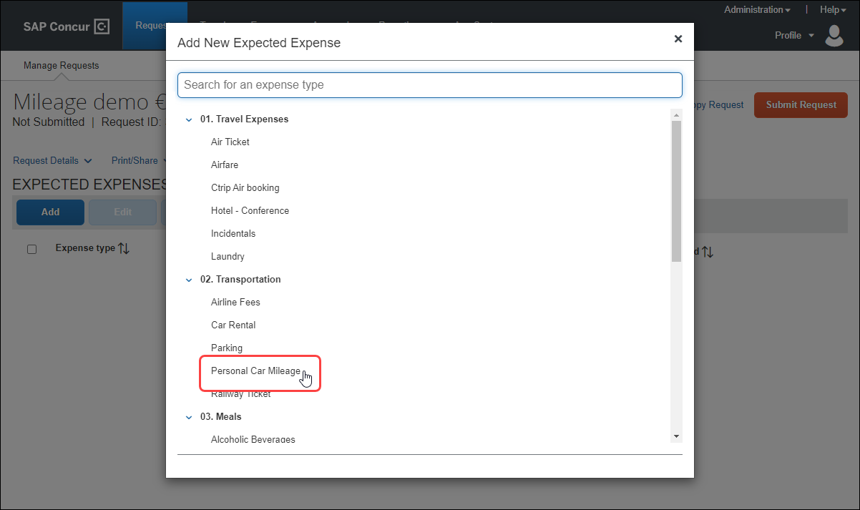
If the new Mileage Service is enabled and the user has configured the vehicle associated with their mileage expenses in Profile, when the user selects one of the mileage expense types, the New Expense page opens for the new mileage expected expense, and the mileage form fields appear on the page.
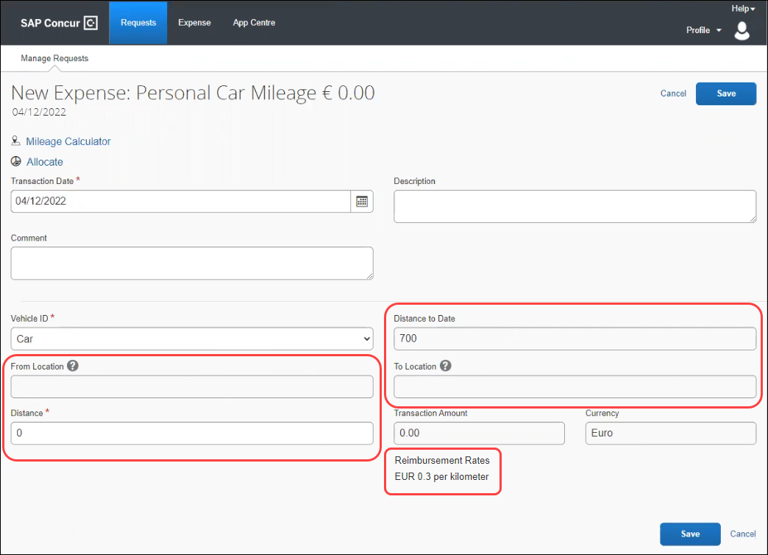
The Distance to Date, From Location, To Location, Transaction Amount, and Currency fields are read-only. The From Location, To Location, and Distance fields will be populated by the Mileage Calculator.
If there is only one mileage reimbursement rate available, such as a fixed mileage rate, the current mileage reimbursement rate is listed at the bottom of the New Expense page.
If there are multiple mileage reimbursement rates available, the View all reimbursement rates link is displayed at the bottom of the New Expense page.
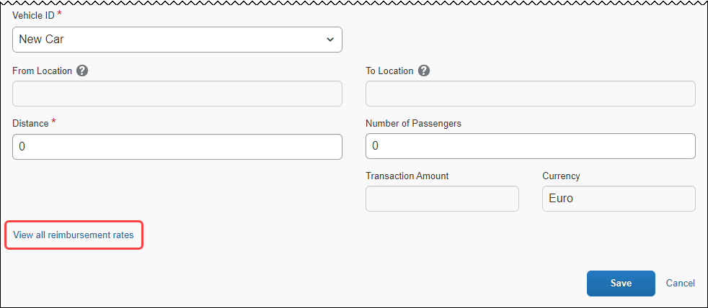
Clicking the View all reimbursement rates link opens the Reimbursement Rates dialog. The available reimbursement rates are listed in the Reimbursement Rates dialog.
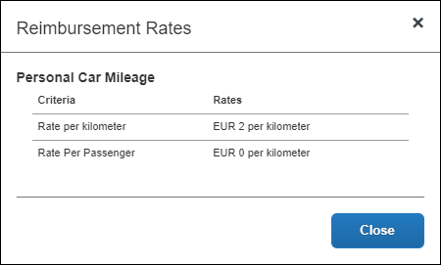
Click the Mileage Calculator link to open the Mileage Calculator page.
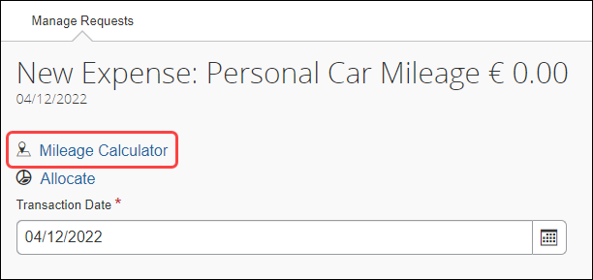
In the Waypoints section, enter the to and from location information to calculate the mileage, and then click the Add Mileage to Expense button to add the mileage information to the expected expense.
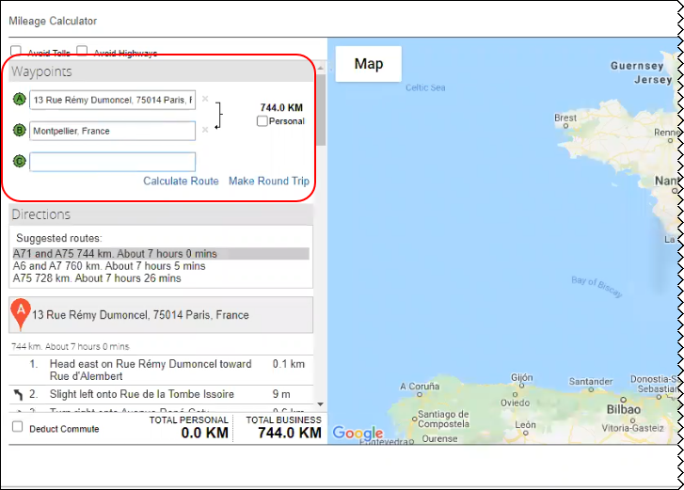
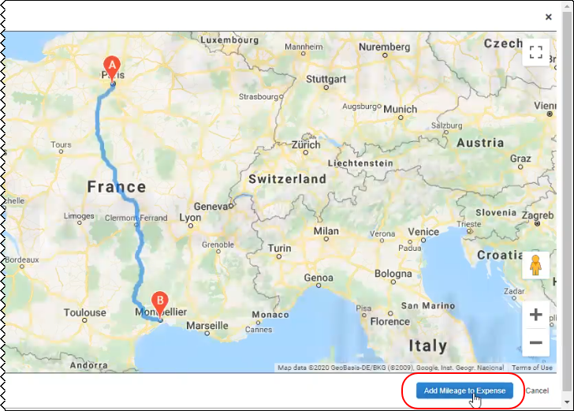
Clicking the Add Mileage to Expense button closes the Mileage Calculator. On the New Expense page, the From Location and To Location fields are populated with the to and from locations you entered in the Mileage Calculator, and the Distance field is populated with the mileage calculated by the Mileage Calculator. The Transaction Amount field is automatically calculated by multiplying the mileage in the Distance field by the applicable mileage rates.
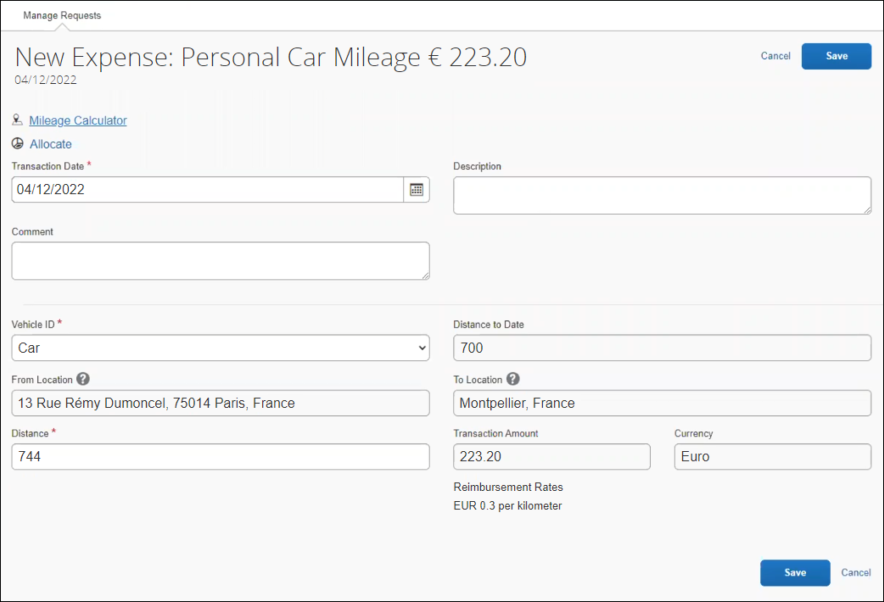
Click Save. The new mileage expected expense is added to the Expected Expenses page.
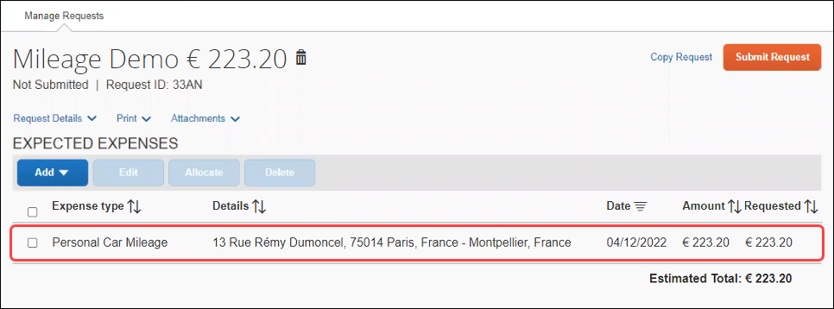
Both the request submitter and the request approver can access the Mileage Calculator link for a mileage expected expense. The request approver can click the Mileage Calculator link to view the mileage details in the Mileage Calculator.

Configuration / Feature Activation
Use of the new Mileage Service feature requires support and implementation resources.
The new Mileage Service is available for both personal car and company car.
If you are using the new Mileage Service, for request-based expense reports, the mileage journey and the mileage expected expenses are automatically added to the expense report.
- For more information about the new Mileage Service, refer to the Mileage | New Mileage Service Features release note in the March 2022 Concur Expense Professional Release Notes.

SAP Concur Platform

**Ongoing** Retirement and Decommission of Existing Concur Request APIs (v1.0, v3.0, v3.1) (November 30, 2021)

Information First Published | Information Last Modified | Feature Target Release Date
June 2020 | December 3, 2021 | June 1, 2021
Any changes since the previous monthly release will be highlighted in yellow in this release note.

Overview
As of May 31, 2021, the existing Concur Request APIs (v1.0, v3.0 and v3.1) are deprecated. On June 1, 2021, SAP began retiring these APIs in accordance with the SAP Concur API Lifecycle & Deprecation Policy. These APIs are replaced by the Concur Request v4 APIs. SAP will no longer support these APIs after retirement.
As of November 30, 2021, the retirement phase for the existing Concur Request APIs (v1.0, v3.0 and v3.1) is completed.
Decommissioning of the v1.0, v3.0, and v3.1 APIs will start three months after retiring the APIs. The specific dates for decommissioning are dependent on the individual client's API migration.
API Timeline for v1.0, v3.0, v3.1:
- Deprecation – March 1, 2020 – May 31, 2021
- Retirement – June 1, 2021 – November 30, 2021
- Decommission – starts after 3 months of inactivity at the retired state

Business Purpose / Client Benefit
The Concur Request APIs v1.0, v3.0 and v3.1 only support the previous authentication method, which is not best security practice and does not meet the Oauth2 standards. In addition, the previous versions of the Concur Request APIs provided limited possibilities for moving a Request through the approval workflow, as well as managing custom simple & connected list fields. These issues are resolved with the new Concur Request v4 APIs.
In addition, SAP has run a backward compatibility project between the current Concur Request APIs and the new Concur Request v4 APIs (not iso-compatibility) in order to have the vast majority of use cases managed in the previous versions also be managed in the Concur Request v4 APIs.

Planned Changes
The items in this section are targeted for future releases. SAP Concur reserves the right to postpone implementation of – or completely remove – any enhancement/change mentioned here.
The planned changes listed in this document are specific to this product. For information about planned site-wide or shared changes that might impact your SAP Concur solutions, refer to the Shared Changes Release Notes.

Request Policies

New Setting for Travel Allowance Options in Request
This change is part of the NextGen UI experience for Professional edition clients.

Overview
For clients using the NextGen UI, a new policy setting, Disable Travel Allowance, will be available.

Business Purpose / Client Benefit
This change will give admins the ability to configure each policy to prompt or not prompt the user for travel allowances.

What the Concur Admin Sees
The new policy setting, Disable Travel Allowance, will appear on the General step of the Modify Request Policy and New Request Policy pages in Request Policies (Administration > Request > Request Policies).
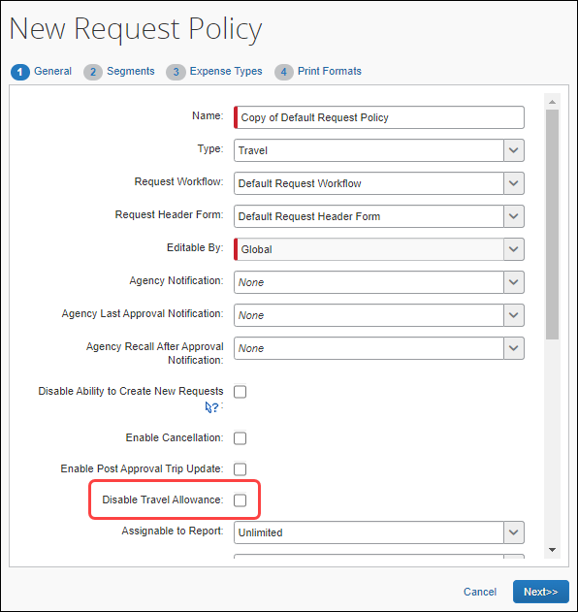

What the User Does Not See
When this new setting is selected, users will not see the Manage Travel Allowance menu on the Expected Expenses page.
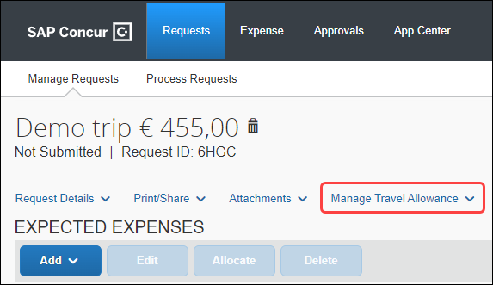

Configuration / Feature Activation
The new setting will automatically be available; there are no configuration or activation steps. For help editing your policies, contact SAP Concur support.
- For more information, such as how to edit an existing policy, refer to the Concur Request: Policies and Groups Setup Guide.

Client Notifications

Accessibility

Accessibility Updates
SAP implements changes to better meet current Web Content Accessibility Guidelines (WCAG). Information about accessibility-related changes made to SAP Concur solutions is published on a quarterly basis. You can review the quarterly updates on the Accessibility Updates page.

Subprocessors

SAP Concur Non-Affiliated Subprocessors
The list of non-affiliated subprocessors is available here: SAP Concur list of Subprocessors
If you have questions or comments, please reach out to: Privacy-Request@Concur.com

Supported Browsers

Supported Browsers and Changes to Support
For information about supported browsers and planned changes to supported browsers, refer to the Concur Travel & Expense Supported Configurations guide.
When changes to browser support are planned, information about those changes will also appear in the Shared Changes Release Notes.

Additional Release Notes and Other Technical Documentation

Online Help
Any user can access release notes, setup guides, user guides, admin summaries, monthly browser certifications, supported configurations, and other resources via online Help or directly on the SAP Help Portal.
Use the links in the Help menu in the app, or search for your SAP Concur product (Concur Expense, Concur Invoice, Concur Request, or Concur Travel) on the SAP Help Portal (https://help.sap.com) to view the full set of documentation for your product.

SAP Concur Support Portal – Selected Users
Access release notes, webinars, and other technical documentation on the SAP Concur support portal.
If you have the proper permissions, Contact Support appears on the Help menu. Click to access the SAP Concur support portal, then click Resources.
- Click Release/Tech Info for release notes, technical documents, etc.
- Click Webinars for recorded and live webinars.
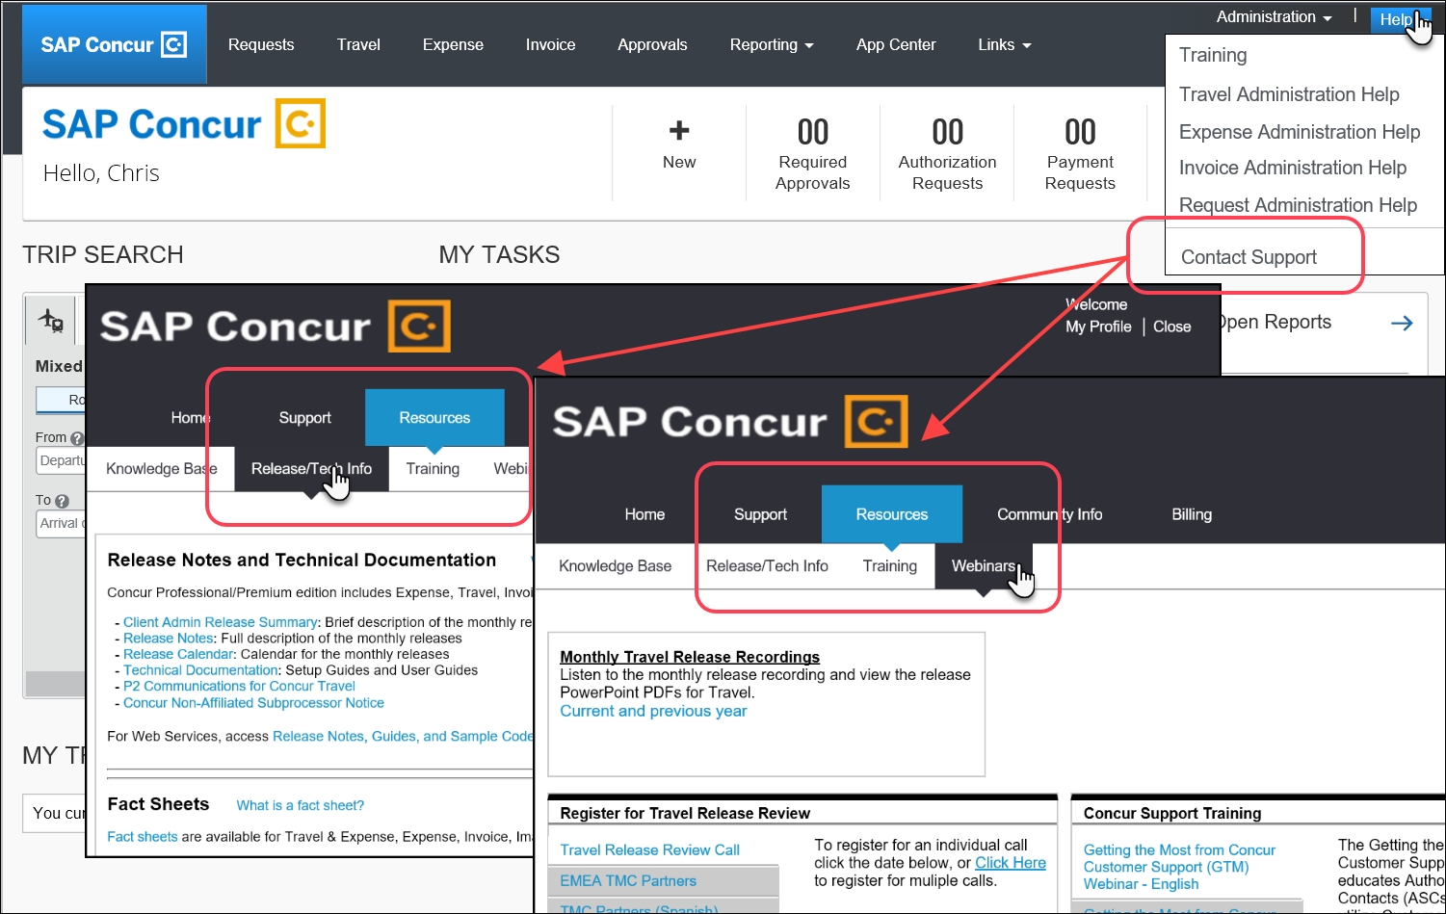

Cases

Steps for Getting a Status
Each service release contains case resolutions.
How to check the status of a submitted case
- Log on to https://concursolutions.com/portal.asp.
- Click Help > Contact Support.

If you do not have the option to contact SAP Concur support under the Help menu, then your company has chosen to support the SAP Concur service internally. Please contact your internal support desk for assistance.
- Click Support > View Cases.

- In the table, view the desired type of cases based on the View list selection. Search results are limited to each company's own cases.


Resolved Cases

Case ID | Description
No resolved cases for the March 2022 release

© 2022 SAP SE or an SAP affiliate company. All rights reserved.
No part of this publication may be reproduced or transmitted in any form or for any purpose without the express permission of SAP SE or an SAP affiliate company.
SAP and other SAP products and services mentioned herein as well as their respective logos are trademarks or registered trademarks of SAP SE (or an SAP affiliate company) in Germany and other countries. Please see http://global12.sap.com/corporate-en/legal/copyright/index.epx for additional trademark information and notices.
Some software products marketed by SAP SE and its distributors contain proprietary software components of other software vendors.
National product specifications may vary.
These materials are provided by SAP SE or an SAP affiliate company for informational purposes only, without representation or warranty of any kind, and SAP SE or its affiliated companies shall not be liable for errors or omissions with respect to the materials. The only warranties for SAP SE or SAP affiliate company products and services are those that are set forth in the express warranty statements accompanying such products and services, if any. Nothing herein should be construed as constituting an additional warranty.
In particular, SAP SE or its affiliated companies have no obligation to pursue any course of business outlined in this document or any related presentation, or to develop or release any functionality mentioned therein. This document, or any related presentation, and SAP SE’s or its affiliated companies’ strategy and possible future developments, products, and/or platform directions and functionality are all subject to change and may be changed by SAP SE or its affiliated companies at any time for any reason without notice. The information in this document is not a commitment, promise, or legal obligation to deliver any material, code, or functionality. All forward-looking statements are subject to various risks and uncertainties that could cause actual results to differ materially from expectations. Readers are cautioned not to place undue reliance on these forward-looking statements, which speak only as of their dates, and they should not be relied upon in making purchasing decisions.

