SAP Concur Release Notes
Shared Changes
Includes cross-product and site-wide changes for:
Professional Edition, Standard Edition, and Small Business Edition
Month | Audience
Release Date: March 23, 2024  Initial Post: Friday, March 22, 2024 | Client FINAL
Contents
Release Notes 1
Data Retention 2
**Ongoing** Pause and Resume Data Retention Site-Wide 2
All Products | All Editions 2
File Transfer 3
**Ongoing** New IP Addresses for DNS Endpoints 3
All Products | All Editions 3
Financial Integration 4
Drop-down List in Employee ID Field 4
Travel w/Spend, Expense, Invoice | Standard Edition 4
Manually Synchronize List Items Between SAP Concur and Sage Intacct 5
Expense, Invoice | Standard Edition 5
Help Menu 6
Contact Support Link in Help Menu 6
All Products | All Editions 6
Home Page 7
**Ongoing ** SAP Concur Homepage Changes 7
All Products | All Editions 7
Import/Extract 9
Add Test User Account Through Employee Import Record 305 9
Expense, Invoice, Request | Professional Edition 9
User Data Extract Feature 11
Travel w/Expense, Expense, Invoice, Request | Professional & Standard 11
Profile Settings / Security 12
**Ongoing** Temporary Security Changes to User Profile 12
Travel, Expense, Invoice, Request | Professional & Standard 12
SAP Concur User Assistance 14
**Ongoing** Links From the SAP Concur Solutions UI to Product Documentation Removed 14
All Products | All Editions 14
SAP Fiori Themes 15
**Ongoing** SAP Fiori Horizon Themes for Concur Mobile and Web 15
All Products | All Editions 15
Planned Changes 20
Authentication 20
**Planned Changes** HMAC Authentication to be Decommissioned 20
All Products | All Editions 20
**Planned Changes** Legacy Authentication Retirement 21
All Products | All Editions 21
**Planned Changes** Sign In To SAP Concur Without a Password 21
All Products | All Editions 21
**Planned Changes** Two-Factor Authentication Enhancements 22
All Products | All Editions 22
Data Retention 23
**Planned Changes** New Year-End Time Basis Option 23
All Products | All Editions 23
File Transfer 25
**Planned Changes** Cipher Security Policy Change for Clients and Vendors 25
All Products | All Editions 25
SAP Concur 26
**Planned Changes** New SAP Concur Outbound IP Addresses to be Added 26
All Products | All Editions 26
SAP Concur User Assistance 27
**Planned Changes** SAP Concur Product Documentation Moving to the SAP Help Portal 27
All Products | All Editions 27
Client Notifications 30
Accessibility 30
Accessibility Enhancements 30
Gender Diversity 30
Gender Diversity Planned Features and Changes 30
In-Product User Assistance 30
Client Customized Content 30
Subprocessors 31
SAP Concur Non-Affiliated Subprocessors 31
Supported Browsers 31
Supported Browsers and Changes to Support 31
Additional Release Notes and Other Technical Documentation 32
Online Help 32
SAP Concur Support Portal – Selected Users 32
Legal Disclaimer
The information in this presentation is confidential and proprietary to SAP SE or an SAP affiliate company and may not be disclosed without the permission of SAP SE or the respective SAP affiliate company. This presentation is not subject to your license agreement or any other service or subscription agreement with SAP SE or its affiliated companies. SAP SE and its affiliated companies have no obligation to pursue any course of business outlined in this document or any related presentation, or to develop or release any functionality mentioned therein. This document, or any related presentation and SAP SE or an SAP affiliate company’s strategy and possible future developments, products and or platforms directions and functionality are all subject to change and may be changed by SAP SE and its affiliated companies at any time for any reason without notice. The information in this document is not a commitment, promise or legal obligation to deliver any material, code or functionality. This document is provided without a warranty of any kind, either express or implied, including but not limited to, the implied warranties of merchantability, fitness for a particular purpose, or non-infringement. This document is for informational purposes and may not be incorporated into a contract. SAP SE and its affiliated companies assume no responsibility for errors or omissions in this document, except if such damages were caused by SAP SE or an SAP affiliate company’s willful misconduct or gross negligence.
All forward-looking statements are subject to various risks and uncertainties that could cause actual results to differ materially from expectations. Readers are cautioned not to place undue reliance on these forward-looking statements, which speak only as of their dates, and they should not be relied upon in making purchasing decisions.

Release Notes
This document contains shared release notes and planned changes. Shared release notes and planned changes document features and changes that apply to SAP Concur solutions site-wide or to multiple SAP Concur products and services. They include but are not limited to:
- Security-related features and changes such as annual security certificate renewals and changes in support for security ciphers and protocols.
- Site-wide UI features and changes such as changes to the home page, changes to the site header or footer, or the implementation of new site-wide UI themes.
- Sign-in process features and changes such as the addition or removal of sign-in features, URL changes, and domain name changes.
- Production and test environment features and changes.
- Global settings or administration page features and changes such as the addition of new site-wide settings or changes to the design of the administration pages.
- Changes to processes such as where and when release notes are published.
For New Features and Changes that apply to a single product and/or service see the release notes for that product or service. Links to the product and service-specific release notes can be found on the following pages:
- Professional Edition
- Standard Edition

Data Retention

**Ongoing** Pause and Resume Data Retention Site-Wide

Information First Published | Information Last Modified | Feature Target Release Date
March 18, 2024 | March 22, 2024 | March 31, 2024
Any changes since the previous monthly release are highlighted in yellow in this release note.
Applies to:

All Products | All Editions

Overview
On March 31, 2024, SAP Concur plans to implement the Data Retention pause and resume feature. This feature enables data retention administrators to pause and resume data retention activity site wide.

Business Purpose / Client Benefit
This change provides the data retention administrator more flexibility and control over the SAP Concur data retention feature.

Admin Experience
After they have configured the data retention feature for their site, the data retention administrator can pause and resume the SAP Concur Data Retention feature. This option pauses data retention activity for the entire site.
Before pausing or resuming data retention:
- Administrators from different parts of the client’s business should coordinate with each other.
- Client administrators should consider the impact of pausing or resuming data retention on policies with different timeframes.
- IMPORTANT: To avoid non-compliance with internal or external Data Protection and Privacy requirements, Data Retention should not be paused for periods of time longer than is necessary. The client administrator is responsible for pausing and resuming their data retention activity.
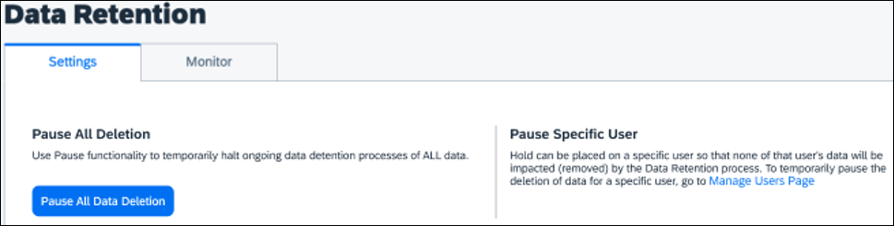
The Data Retention pause and resume feature is only intended for short term use. When applicable, the Hold User feature, which pauses data retention for a specific user, should be used.

Configuration / Feature Activation
After they have configured SAP Concur data retention, this option is automatically available to the data retention administrator.

File Transfer

**Ongoing** New IP Addresses for DNS Endpoints

Information First Published | Information Last Modified | Feature Target Release Date
February 23, 2024 | -- | February 17 and April 27, 2024
Any changes since the previous monthly release are highlighted in yellow in this release note.
Applies to:

All Products | All Editions

Overview
On February 17, 2024, the DNS Endpoint IP addresses assigned to EU2 (mft-eu2.concursolutions.com) were changed to the following:
- 35.158.86.168
- 52.57.240.84
- 3.78.40.190
On April 27, 2024, the DNS Endpoint IP addresses assigned to US2 (mft-us2.concursolutions.com) will be changed to the following:
- 54.218.238.142
- 35.81.128.239
- 44.240.39.69
Because IP addresses are subject to change, for clients who allow list incoming network traffic, SAP Concur recommends allow-listing the DNS endpoint rather than the associated IP addresses.

Business Purpose / Client Benefit
This change helps to improve the security of SAP Concur solutions.

Admin Experience
This change is transparent to most clients.
Clients who allow-list IP addresses, must update their allow lists.

Configuration / Feature Activation
This change occurs automatically.
If your company uses allow lists and you have allow-listed the previous IP addresses, you must update your allow list. SAP Concur recommends allow-listing the file transfer DNS endpoint (mft-eu2.concursolutions.com or mft-us2.concursolutions.com) rather than allow-listing the associated IP addresses.

Financial Integration

Drop-down List in Employee ID Field

Information First Published | Information Last Modified | Feature Target Release Date
March 22, 2024 | -- | March 15, 2024
Any changes since the previous monthly release are highlighted in yellow in this release note.
Applies to:

Travel w/Spend, Expense, Invoice | Standard Edition

Overview
For some clients with Standard Edition who are connected to QuickBooks, Xero, or Sage Intacct, the Employee ID field on the Travel user account page is now a drop-down list field.
This change impacts clients with Expense or Invoice Standard edition combined with Travel Professional edition who are also integrated with QuickBooks Online, Xero, or Sage Intacct.

Business Purpose / Client Benefit
This change supports a future feature targeted for Q3 of 2024.
More information about the planned feature will be included in future release notes.

Manually Synchronize List Items Between SAP Concur and Sage Intacct

Information First Published | Information Last Modified | Feature Target Release Date
March 8, 2024 | -- | March 8, 2024
Any changes since the previous monthly release are highlighted in yellow in this release note.
Applies to:

Expense, Invoice | Standard Edition

Overview
Beginning on March 8, 2024, clients with the Sage Intacct integration will be able to manually import list items from Sage Intacct into their SAP Concur solutions.

Business Purpose / Client Benefit
This change enables clients to synchronize list items between Sage Intacct and SAP Concur solutions.

Admin Experience
A new List Item Import section is available on the Accounting page.
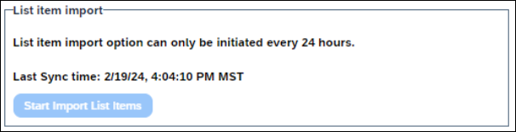
In the List Item Import section, the administrator can click Start Import List Items to synchronize list items between Sage Intacct and SAP Concur solutions.
The list items can only be synchronized once every 24 hours.

Configuration / Feature Activation
The new option is automatically available to clients with the Sage Intacct integration.

Help Menu

Contact Support Link in Help Menu

Information First Published | Information Last Modified | Feature Target Release Date
March 8, 2024 | -- | Late February 2024
Any changes since the previous monthly release are highlighted in yellow in this release note.
Applies to:

All Products | All Editions

Overview
In late February 2024, SAP Concur updated the Contact Support link so that when it is available, it is available in the SAP Concur solutions Help menu. Prior to this change, the Contact Support link was sometimes available from the Home menu.
The Contact Support link is only available to users with the SAP Concur ASC role.
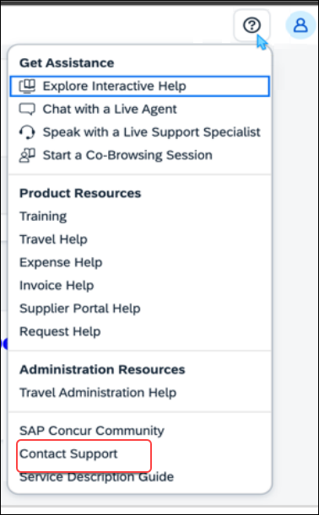

Business Purpose / Client Benefit
This change helps to ensure a consistent user experience when accessing the Contact Support link.

Configuration / Feature Activation
This change occurred automatically.

Home Page

**Ongoing ** SAP Concur Homepage Changes

Information First Published | Information Last Modified | Feature Target Release Date
December 4, 2020 | January 19, 2024 | Q4 2021 – January/February 2024
Any changes since the previous monthly release are highlighted in yellow in this release note.
Applies to:

All Products | All Editions

Overview
In Q4, 2021, SAP Concur began redirecting clients to a new homepage. The appearance of the new homepage is identical to the previous SAP Concur homepage. The new homepage has enhanced functionality when services become temporarily unavailable.
The roll out of the new homepage is phased:
Phase 1: In October of 2021, SAP Concur began redirecting Concur Expense, Concur Invoice, and Concur Request clients in the US Datacenter to the new homepage.
Phase 2: In December 2021, SAP Concur began redirecting Concur Expense, Concur Invoice, and Concur Request clients in the EU Datacenter to the new homepage.
Phase 3: In late January/early February 2024, SAP Concur will begin redirecting the remaining clients in the US and EU datacenters to the new homepage. The remaining clients include those with Concur Travel standalone or Concur Travel with Expense, Invoice, and/or Request.

Business Purpose / Client Benefit
This change ensures that the SAP Concur homepage is available even when some services are unavailable and improves the consistency of the sign in experience.

What the User Sees
With the old homepage, when a user signs into their SAP Concur products, they see their homepage.
The appearance of the homepage varies depending on which products and services are enabled for the client and the permissions assigned to the user.
Example Home Page
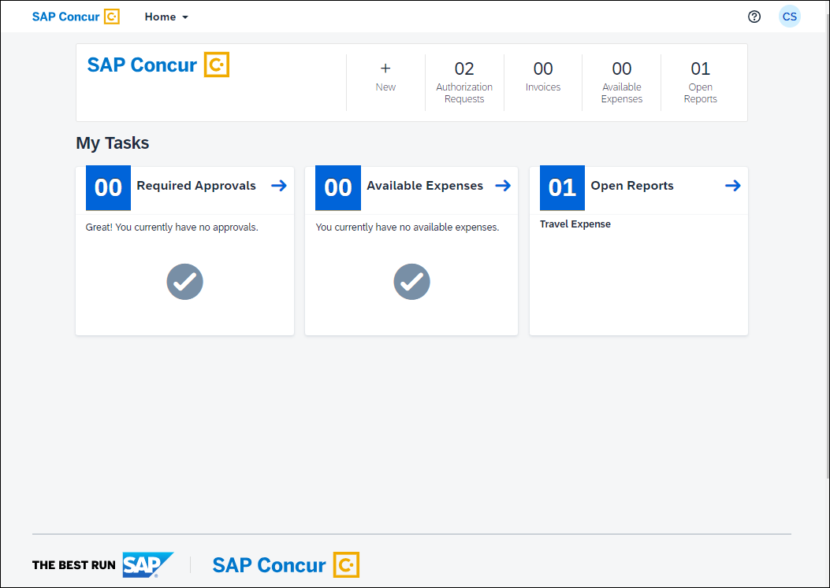
If some products or services are unavailable while other products and services are up and running, a modified version of the user’s homepage similar to the following appears:
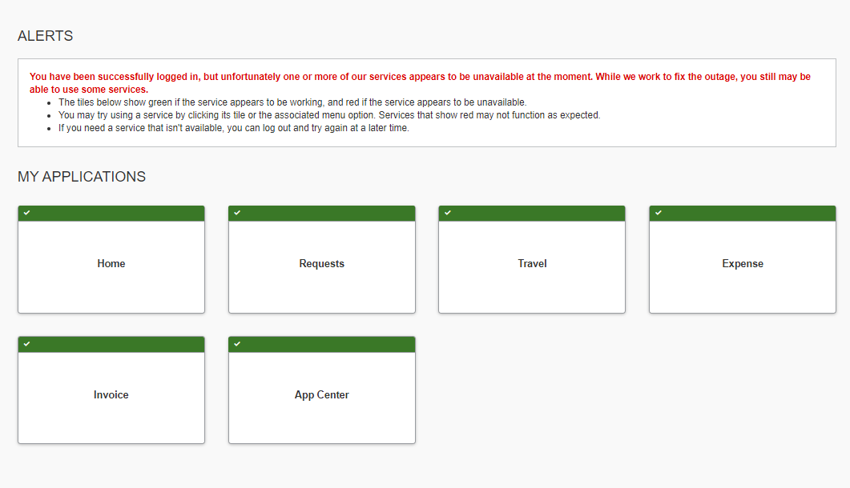
After a client is migrated to the new homepage, if one or more services are unavailable, when a user signs in to their SAP Concur products, they see the usual homepage, but if the user navigates to a page for a service that is unavailable, they will see a page similar to the following:
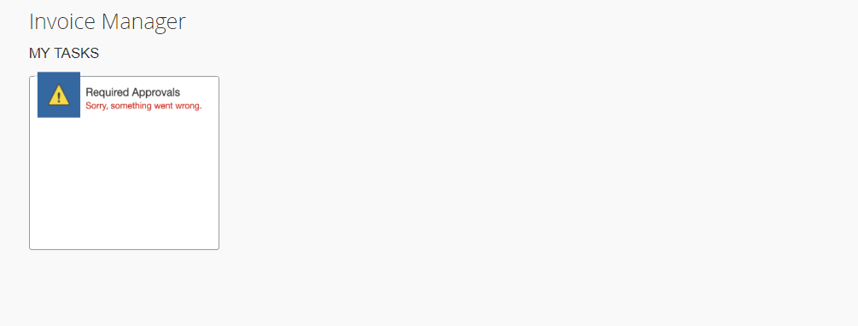
After migration to the new homepage, if all services are available, this change is transparent to the user and they see a homepage that is identical to the pre-migration homepage.

Configuration / Feature Activation
This change occurs automatically; there are no configuration or activation steps.

Import/Extract

Add Test User Account Through Employee Import Record 305

Information First Published | Information Last Modified | Feature Target Release Date
February 23, 2024 | -- | Late February / Early March
Any changes since the previous monthly release are highlighted in yellow in this release note.
Applies to:

Expense, Invoice, Request | Professional Edition

Overview
In late February/early March, SAP Concur plans to add an Is Test User field to Employee Import record type 305.
For information about Employee Import record type 305, refer to Shared: Employee Import Specification.
The Is Test User field enables admins to create test user accounts through the Employee Import feature.
For more information about test user accounts, refer to the Shared: Test User Setup Guide.
A test user can only be configured when the user account is created.

Business Purpose / Client Benefit
This change enables admins to create test users through the Employee Import feature.
Previously, test users could be created manually by selecting the Is a Test User option during user account creation and via the User Provisioning Service (UPS) API.
For information about manually creating a test user, refer to the Shared: Test User Setup Guide. For information about the UPS API, refer to User Provisioning Service on the SAP Concur developer portal.

Admin Experience
When formatting the employee import file, position number 99 (Is Test User) of the 305 record type can be set to Y. When set to Y the relevant user account is set to Is Test User.
The Is Test User field has the following characteristics:
- If the field is set to Y, the new user account is a test user account.
- If the field is set to N, the new user account is not a test user.
- If the field is left blank, the new user account is not a test user.
- The Is Test User field can only be set to Y when the user account is created.
- An existing user account cannot be converted to a test user account.
- A test user account cannot be converted to a user account.
After the account is imported, the Is a Test User field on the user account page in SAP Concur is checked (enabled).
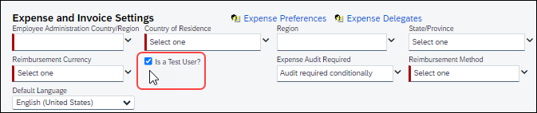

Configuration / Feature Activation
This change occurs automatically.

User Data Extract Feature

Information First Published | Information Last Modified | Feature Target Release Date
January 19, 2024 | -- | March 16, 2024
Any changes since the previous monthly release are highlighted in yellow in this release note.
Applies to:

Travel w/Expense, Expense, Invoice, Request | Professional & Standard

Overview
On March 16, 2024, SAP Concur plans to implement a feature that enables a company administrator with either the Import/Extract Administrator or Import/Extract Monitor role to download extracted user data. The user data extract feature will be available from the User Data Extracts tab on the Import/Extract Monitor and Import/Extract Administrator pages.

Business Purpose / Client Benefit
The user data extract feature enables client administrators to download extracted user data after the data is made available on the User Data Extracts tab.
This feature requires that a request for user data be submitted by a client’s Authorized Support Contact (ASC). This data is typically requested with relation to GDPR requirements. This feature is not intended for general use.

Admin Experience
An admin with the required role can access the User Data Extracts tab on the Import/Extract Monitor or Import/Extract Administrator page.
User data will not appear on the User Data Extracts page until a client ASC has requested the data and the request has been processed by SAP Concur internal staff.
To access the User Data Extracts page and download available user data:
- Under Administration click Tools and then click Import/Extract Monitor or Import/Extract Administrator.
- On the Import/Extract Monitor or Import/Extract Administrator page, click the User Data Extracts tab.
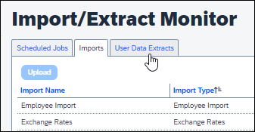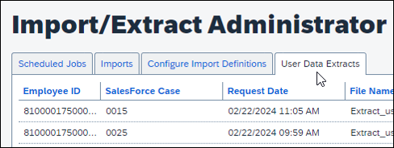
- In the Download File column, in the row for the data you want to download, click Download.
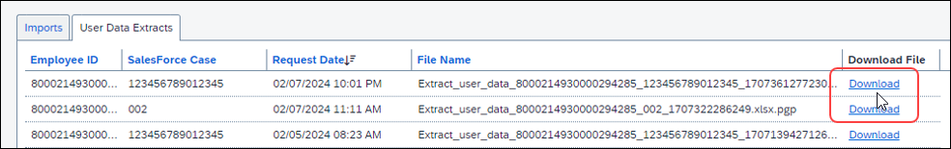
After downloading the extracted user data, you are responsible for appropriate handling of the user’s data and delivery of the data to the user.

Configuration / Feature Activation
This change occurs automatically; The feature is only visible to client administrators with the required roles.

Profile Settings / Security

**Ongoing** Temporary Security Changes to User Profile

Information First Published | Information Last Modified | Feature Target Release Date
July 6, 2023 | December 8, 2023 | June 28, 2023
Any changes since the previous monthly release are highlighted in yellow in this release note.
Applies to:

Travel, Expense, Invoice, Request | Professional & Standard

Overview
The evolving cybersecurity landscape requires that SAP Concur temporarily adopt the following security measures when editing the following profile options for an end-user:

End User Experience
Email 1
- If an end user changes an email address in the Email Addresses section of the My Profile - Personal Information page, a confirmation email is sent to both the old and updated email addresses. For example, if a user changes the email address associated with Email 1, a confirmation email is sent to both the previous (changed) and new Email 1 addresses. And if the Email 2 email address is changed, a confirmation email is sent to both the old and new Email 2 email addresses.
- Existing profile settings that prevent the email change notification from being sent are ignored and the emails are sent to the end-user as stated in the previous bullet.
Last Name
- End users who sign in via SSO: End users who sign in to SAP Concur Solutions via SSO can update the Last Name field on the My Profile - Personal Information page.
- End users who sign in using a username and password: The system prevents users who sign in using a username and password from updating the Last Name field on the My Profile - Personal Information page. An administrator can change the information in the Last Name field through the User Administration page.

Administrator Experience
- Administrators can still change the Last Name field of a user’s profile through the User Administration page.
- Administrators can also continue to update the Last Name field of a user’s profile through the Concur API, import file, and feed options.

Business Purpose / Client Benefit
These changes help to ensure the integrity of SAP Concur client data.

Accounts Disabled by SAP Concur
During routine monitoring activities, SAP Concur may notice abnormal changes to user profiles including name, primary email address, secondary email address, and potentially fraudulent travel bookings. The accounts within your environment that may be linked to fraudulent activity may be disabled. To reenable these accounts, please work directly with your account administrator, or SAP Concur Support. We encourage all clients to adhere to strong password security measures and configurations. For further information, please visit the Password Security article on the SAP Help Portal Password Security | SAP Help Portal.

Configuration / Feature Activation
This security change is enforced by default for all applicable products. No change to this behavior is available to the client at this time and the client will be notified of any changes they may need to make in a future release.
- IMPORTANT: These changes are temporary and will be reversed in the future: clients will be informed of these changes in a subsequent release.

SAP Concur User Assistance

**Ongoing** Links From the SAP Concur Solutions UI to Product Documentation Removed

Information First Published | Information Last Modified | Feature Target Release Date
May 12, 2023 | March 09, 2024 | End of March 2024
Any changes since the previous monthly release are highlighted in yellow in this release note.
Applies to:

All Products | All Editions

Overview
Some pages in the SAP Concur solutions UI included links to product documentation or other content. To better align with SAP best practices, in June 2023, SAP Concur began removing direct links from the SAP Concur solutions UI that point to product documentation on concurtraining.com. This process will be completed at the end of March 2024.
The SAP Help Portal is the central source for all product documentation, release notes, and other content. SAP Concur clients can use the SAP Concur page on the SAP Help Portal to find the complete library of SAP Concur solutions documentation.

Business Purpose / Client Benefit
This change is being made for the following reasons:
- This change better aligns with SAP best practices.
- Links to product documentation from the SAP Concur solutions UI point to English-only content. This experience is not optimal for users that view the UI in languages other than English.
- Direct links to a single document prevent the user from viewing and navigating the entire content library.
- SAP Concur plans to move its product documentation from concursolutions.com to the SAP Help Portal.
- For more information, refer to the **Planned Changes** SAP Concur Product Documentation Moving to the SAP Help Portal release note in this document.

Admin and End-User Experience
Links to product documentation on concursolutions.com—for example, links to SAP Concur user and setup guides—will be removed from SAP Concur solutions UI pages.
Example
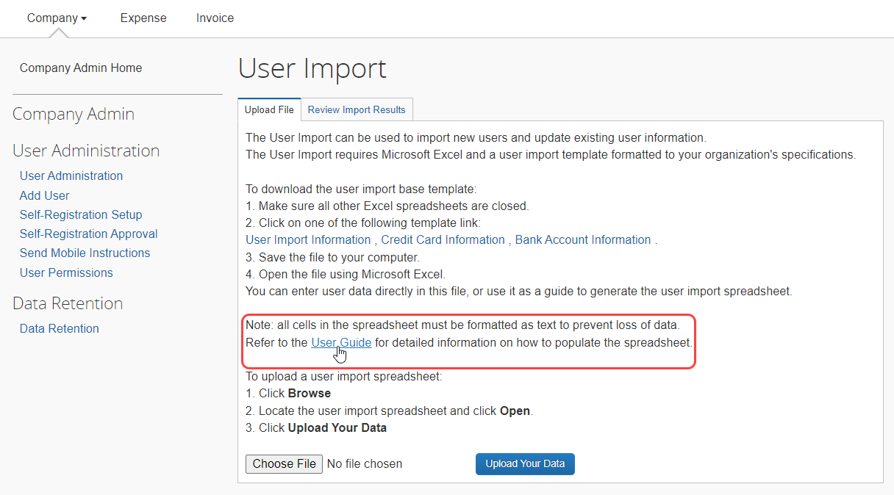

Configuration / Feature Activation
This change was made in phases, starting in 2023. The process of removing the links will be completed at the end of March 2024.

SAP Fiori Themes

**Ongoing** SAP Fiori Horizon Themes for Concur Mobile and Web

Information First Published | Information Last Modified | Feature Target Release Date
February 10, 2023 | January 19, 2024 | Phased release: May 2023 through April 10, 2024
Any changes since the previous monthly release are highlighted in yellow in this release note.
Applies to:

All Products | All Editions

Overview
SAP Concur has adopted the SAP Fiori with Horizon visual design theme family as the default appearance for SAP Concur solutions.
Implementation of the SAP Fiori with Horizon visual design theme impacts the look and feel of SAP Concur solutions by updating fonts, font sizes, icons, colors, and shapes. In addition, in both the SAP Concur mobile and web UI, navigation from the home page is slightly modified.
Introduction of the new design themes has been phased beginning on May 20, 2023. SAP Concur plans to fully implement the new themes, decommissioning the current, legacy (Gateway) theme, on April 10, 2024.
The legacy (Gateway) theme is not available to new clients. New clients automatically default to the Fiori for Horizon Morning Horizon theme.

Business Purpose / Client Benefit
These changes improve the overall user experience, better support accessibility features, and help provide a consistent user experience across all SAP products.

Admin Experience

Mobile
SAP Concur has implemented SAP Fiori with Horizon in the Mobile app.

Web UI
SAP Concur began implementing SAP Fiori with Horizon themes in phases beginning in May 2023:
Phase 1 – May 20, 2023, and June 22, 2023: On May 20, 2023, SAP Concur implemented Theme Settings for SAP Concur Professional edition clients and for most Standard edition clients. On June 22, 2023, Theme Settings were enabled for the remaining Standard edition clients.
During phase 1, admins with the required permissions accessed Theme Settings to choose between the following options:
- Legacy Concur UI: End users only see the legacy Concur Gateway theme.
- Legacy Concur UI and Fiori Horizon: End users see the legacy Concur Gateway theme by default. On the Profile Settings > System Settings page, they can choose between the Concur Gateway theme, Morning Horizon, Evening Horizon, and high contrast themes.
- Fiori Horizon: End users see Morning Horizon by default. On the Profile Settings > System Settings page they can choose between the Morning Horizon, Evening Horizon, and high contrast themes.
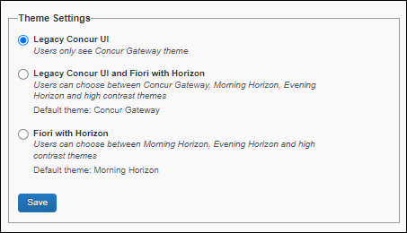
Phase 2 – Beginning October 2, 2023: On October 2, 2023, SAP Concur began setting Morning Horizon as the default SAP Concur UI theme for most clients.
Clients in the China Datacenter entered Phase 2 on January 8, 2024. As of January 8, 2024, these clients will proceed to Phase 3 on April 10, 2024, as documented in the sections that follow.
New clients automatically default to the Morning Horizon theme. Existing SAP Concur client admins have access to Theme Settings and can revert to the legacy Concur Gateway theme.
Admins for preexisting Concur entities can choose either the legacy Concur Gateway theme or SAP Horizon for Fiori themes. A hybrid option that enables both sets of themes is not available.
Phase 3 – April 10, 2024: SAP Concur plans to decommission the legacy Concur Gateway theme. When it is decommissioned, Morning Horizon will become the default theme and end users will be able to choose between Morning Horizon, Evening Horizon, and high contrast themes. The Gateway theme and Theme Settings will no longer be available. Users who have not yet enabled Horizon for Fiori themes will automatically be switch to Morning Horizon.
Clients with SAP Fiori Quartz themes: On October 2, 2023, SAP Concur will decommission the SAP Fiori 3 Quartz themes and clients with SAP Fiori 3 Quartz themes will automatically default to the SAP Fiori with Horizon visual themes.

Implementation Schedule for Clients with Concur Budget
Currently, some screens in Budget are not fully compatible with Horizon for Fiori themes.
This does not impact SAP Concur mobile app. Budget clients already have access to the new theme on the mobile app.
To address this issue, clients with Budget will be migrated to the new themes on the following schedule:
Phase 1 – October 2023: During phase 1, Budget clients can opt in to the Horizon for Fiori themes. The opt-in phase will last approximately 90 days.
Phase 2 – January 8, 2024: on January 8, 2024, Morning Horizon will become the default SAP Concur UI theme for clients with Budget. The process of updating all existing SAP Concur clients to the new default setting might take some time.
New clients with Budget will automatically default to the Morning Horizon theme. The legacy (Gateway) theme is not available to new clients.
When Morning Horizon becomes the default UI theme for clients with Budget in January, existing SAP Concur client admins will have access to Theme Settings and will be able to revert to the legacy Concur Gateway theme.
As of January 8, when Morning Horizon becomes the default UI theme for clients with Budget, there will no longer be a hybrid option in Theme Settings. Client must configure either the legacy (Gateway) theme or the default Horizon for Fiori themes.
Phase 3 – April 10, 2024: On April 10, 2024, SAP Concur plans to decommission the legacy Concur Gateway theme for all clients, including clients with Budget. When it is decommissioned, Morning Horizon will become the default theme and end users will be able to choose between Morning Horizon, Evening Horizon, and high contrast themes.

TMC Experience
The Theme Settings page is available in Global View.

End User Experience
With the SAP Fiori with Horizon visual design themes, the overall look of SAP Concur solutions is updated with new fonts, icons, colors, and shape design.

Legacy Page Design Example
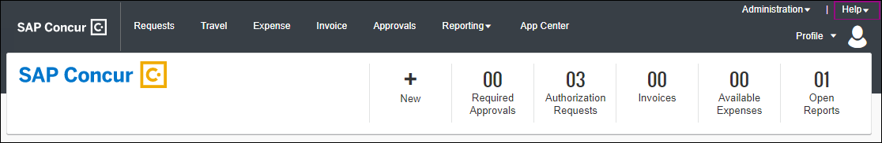

SAP Fiori With Horizon Design Example
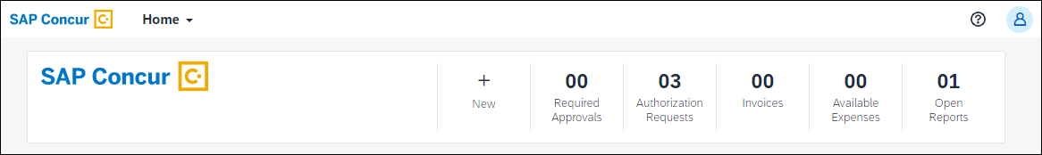
Navigation from the SAP Concur home page is also slightly modified so that it is simpler and more consistent with other SAP products.

Legacy Home Page Navigation
With the legacy theme, navigation from the home page relies on product tabs and the Administration menu.

SAP Fiori With Horizon Home Page Navigation
With the SAP Fiori with Horizon visual design theme, navigation from the Concur home page to Concur product and administration pages is consolidated in the Home menu.
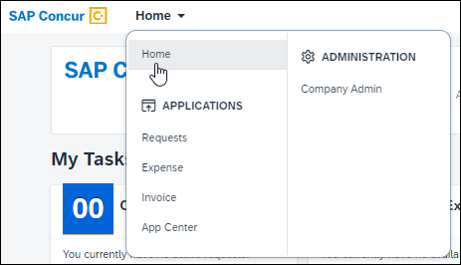

Configuration / Feature Activation
SAP Concur is implementing these changes through a phased approach that began in May 2023 and is targeted to be completed in April 2024.

Planned Changes
The following features and changes are targeted for future releases. SAP Concur solutions reserves the right to postpone implementation of – or completely remove – any enhancement/change mentioned here.

Authentication

**Planned Changes** HMAC Authentication to be Decommissioned

Information First Published | Information Last Modified | Feature Target Release Date
December 1, 2023 | -- | Q3 2024
Any changes since the previous monthly release are highlighted in yellow in this release note.
Applies to:

All Products | All Editions

Overview
SAP Concur support for Hash-Based Message Authentication Code (HMAC) was deprecated in July 2021. In Q3 of 2024 the HMAC service will be decommissioned and authentication to SAP Concur solutions through HMAC will no longer work.
SAP Concur provides a Single Sign-On self-service option that enables client admins to setup their SAML v2 connections without involving an SAP Concur support representative. SAML v2 supports the use of multiple identity providers.
For more information about the Single Sign-On self-service option, refer to the Shared: Single Sign-On Overview and the Shared: Single Sign-On Setup Guide.

Action Required
If you are already using SSO or another supported authentication method other than HMAC, you do not need to take any action.
If you are using only HMAC to access SAP Concur solutions, to avoid disruption of service, you must update your authentication method before HMAC is decommissioned in Q3 of 2024.
If users attempt to authenticate to SAP Concur solutions through HMAC after the HMAC service is decommissioned in Q3 of 2024, they will be denied access.

Business Purpose / Client Benefit
This change provides better security and improved support for users logging in to SAP Concur products and services.

Configuration / Feature Activation
This change will occur automatically.
More information about this change will be provided in future release notes.

**Planned Changes** Legacy Authentication Retirement

Information First Published | Information Last Modified | Feature Target Release Date
March 18, 2024 | -- | July 11, 2024
Any changes since the previous monthly release are highlighted in yellow in this release note.
Applies to:

All Products | All Editions

Overview
Legacy Authentication was deprecated on February 4, 2017:
Pre-2017 Authorization Deprecated
SAP Concur plans to discontinue all support for this authentication method on July 11, 2024. To avoid disruption of service, clients who currently use Legacy Authentication should take immediate action to transition to JSON Web Token (JWT) authentication.

Business Purpose / Client Benefit
This change improves the security of SAP Concur solutions.

Configuration / Feature Activation
This change will occur automatically.

**Planned Changes** Sign In To SAP Concur Without a Password

Information First Published | Information Last Modified | Feature Target Release Date
February 9, 2024 | -- | Q2 2024
Any changes since the previous monthly release are highlighted in yellow in this release note.
Applies to:

All Products | All Editions

Overview
In Q2 2024, SAP Concur plans to enable users who sign in to SAP Concur solutions with a username and password to sign in without a password. When the feature is enabled, a user who does not want to enter a password during sign in will have the option to send a one-time link to the email address associated with their SAP Concur personal profile.

Business Purpose / Client Benefit
For users who do not want to enter a password during sign in, this feature enables the user to sign in quickly and efficiently through a one-time link.

End-User Experience
During the sign-in process, users will have the option to send a sign-in link to the Email 1 and/or Email 2 email address configured in the Email Addresses section of the My Profile – Personal Information page in SAP Concur solutions.
Users who do not have access to the Email Addresses section of the My Profile – Personal Information page—for example, invoice-only users—must have a valid email address associated with their user account. The email address associated with their account can be confirmed by their company’s Concur user administrator.

Configuration / Feature Activation
This change will occur automatically.

**Planned Changes** Two-Factor Authentication Enhancements

Information First Published | Information Last Modified | Feature Target Release Date
March 22, 2024 | -- | Q2 2024
Any changes since the previous monthly release are highlighted in yellow in this release note.
Applies to:

All Products | All Editions

Overview
In Q2 2024, SAP Concur plans to implement enhancements to the instruction for the Two-Factor Authentication setup process.

Business Purpose / Client Benefit
These changes improve the on-screen instructions when setting up Two-Factor Authentication.

End-User Experience
Users will be presented with more clear and concise instructions when setting up Two-Factor Authentication. For example, the setup screen will be updated to provide step-by-step instructions.
Before Example After Example
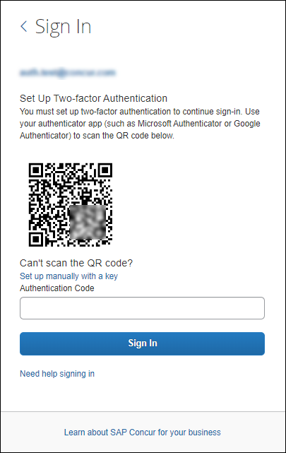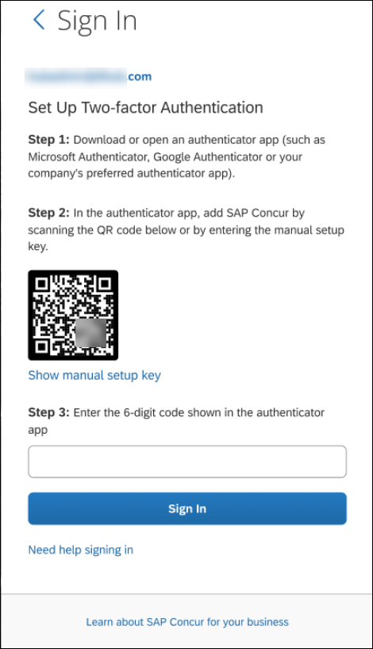

Configuration / Feature Activation
This change will occur automatically.
More information about these changes will be included in future release notes.

Data Retention

**Planned Changes** New Year-End Time Basis Option

Information First Published | Information Last Modified | Feature Target Release Date
March 18, 2024 | -- | Q2 2024
Any changes since the previous monthly release are highlighted in yellow in this release note.
Applies to:

All Products | All Editions

Overview
In Q2 of 2024, SAP Concur plans to add a new site-wide data retention time basis option, Year-end Date. This option enables the client administrator to specify that the data retention period for their site begins at the end of the year in which data is received.
Prior to this change, there was only one time basis for data retention, Record Anniversary Date (RAD). The RAD time-basis is based on each record’s actual Anchor Date, not the end of the year in which the Anchor Date occurred. RAD is the default setting.
There can only be one time basis selected for the entire SAP Concur entity.

Business Purpose / Client Benefit
This change enables clients to align their data retention with regulations that stipulate that data retention periods begin at the end of the year data is received.

Admin Experience
When configuring the data retention feature, the administrator will choose which time basis to apply to their site. This setting can be changed but is always site wide.
If the admin chooses Year-end Date, they are prompted to set the month and day for the year-end retention time basis. The year end month and date can be set per retention policy in the same way that different retention timeframes can be set per policy.
- IMPORTANT: If their retention configuration uses the Year-end time basis with different values per policy for the year-end month and date, client administrators should coordinate with each other when using the Data Retention pause and resume feature.
To avoid non-compliance with internal or external Data Protection and Privacy requirements, data retention should not be paused for periods of time longer than is necessary.
The client administrator is responsible for pausing and resuming their Data Retention activity.

Configuration / Feature Activation
The new option will automatically be available to the Data Retention administrator.

File Transfer

**Planned Changes** Cipher Security Policy Change for Clients and Vendors

Information First Published | Information Last Modified | Feature Target Release Date
February 9, 2024 | -- | April 16, 2024
Any changes since the previous monthly release are highlighted in yellow in this release note.
Applies to:

All Products | All Editions

Overview
This release note is intended for technical staff responsible for file transmissions with SAP Concur solutions. For our clients and vendors participating in data exchange through SFTP, SAP Concur plans to make changes that provide greater security for those file transfers.
On April 16, 2024, SAP Concur plans to update its file transfer security policy from TransferSecurityPolicy-2020-06 to TransferSecurityPolicy-2022-03.
This release note pertains to the following file transfer DNS endpoints:
- EU2 AWS Transfer Site: mft-eu2.concursolutions.com
- US2 AWS Transfer Site: mft-us2.concursolutions.com
- IMPORTANT: If you are using client software that does not support TransferSecurityPolicy-2022-03, you must move to supported SFTP client software before April 16, 2024.
For more information about transfer security policies, including a list of supported cryptographic algorithms, refer to Security polices for AWS Transfer Family and Cryptographic Algorithms on the AWS documentation web site.

Business Purpose / Client Benefit
This change provides greater security for file transfers.

Configuration / Feature Activation
This change occurs automatically.
For more information about SAP Concur file transfers, refer to Shared: AWS File Transfer for Clients and Vendors.

SAP Concur

**Planned Changes** New SAP Concur Outbound IP Addresses to be Added

Information First Published | Information Last Modified | Feature Target Release Date
February 9, 2024 | March 22, 2024 | Q3 2024
Any changes since the previous monthly release are highlighted in yellow in this release note.
Applies to:

All Products | All Editions

Overview
In Q3 2024, SAP Concur plans to increase the outbound IP addresses used to transfer data from SAP Concur to clients.
Most clients will not need to take any action when this change is made. However, clients who use IP address allow lists to restrict inbound traffic from SAP Concur solutions, will need to add the new IP addresses to their allow lists.

Business Purpose / Client Benefit
These changes help to ensure the stability, reliability, and availability of SAP Concur solutions.

Configuration / Feature Activation
This change will occur automatically. Most clients do not need to take an action. Clients who use allow lists must add the new IP Addresses to their allow lists.
More information about this change, including information about how to get the new IP addresses, will be included in future release notes.

SAP Concur User Assistance

**Planned Changes** SAP Concur Product Documentation Moving to the SAP Help Portal

Information First Published | Information Last Modified | Feature Target Release Date
June 9, 2023 | September 15, 2023 | Q3 2024
Any changes since the previous monthly release are highlighted in yellow in this release note.
Applies to:

All Products | All Editions

Overview
Currently, most SAP Concur product documentation is published to concurtraining.com. SAP Concur User Assistance is targeting the third quarter of 2024 to publish all product documentation (such as setup and user guides) to the SAP Help Portal.
Some SAP Concur product documentation, such as the monthly admin summaries and end user help topics, is already published to the SAP Help Portal. The SAP Help Portal also provides links to the product documentation published to concurtraining.com so clients are encouraged to bookmark and start using the SAP Help Portal now to access product documentation.
- IMPORTANT: In 2024, after the product documentation is moved to the SAP Help Portal, links and bookmarks that point to the tech_pubs folder on concurtraining.com will stop working. Please update your links and bookmarks to the SAP Help Portal (https://help.sap.com/docs/SAP_CONCUR).

Business Purpose / Client Benefit
The SAP Help Portal has improved search capabilities and there is a mechanism for clients to provide feedback. This change also aligns with SAP best practices for the publication of product documentation and prepares the content for future user assistance innovations.

Admin Experience
The SAP Concur solutions setup guides, user guides, and fact sheets will continue to be available from the concurtraining.com landing pages until the product documentation is moved to the SAP Help Portal.
Admins can find links to the full SAP Concur product documentation library from the SAP Help Portal.
Please be aware that during this transition there will be procedures and images that do not precisely match your implementation. For example, when SAP Fiori UI themes are implemented, home page navigation is consolidated under the SAP Concur Home menu.
For more information, refer to the SAP Fiori with Horizon Visual Theme for SAP Concur Solutions FAQ.

Action Item
Ensure that you update any custom configuration that you may have that references the tech_pubs folder on concurtraining.com (https://www.concurtraining.com/customers/tech_pubs/*) to point to the SAP Help Portal (https://help.sap.com/docs/SAP_CONCUR) instead. Custom configuration that may be impacted by this change can come from several sources such as Training Admin, Company Info, and the new travel experience Configurable Message Boards.

End-User Experience
End users who access help topics from within SAP Concur solutions will not experience any changes because those help topics are already available from the SAP Help Portal through links provided in the products.

Downloading PDFs
Content available from the SAP Help Portal can be selected and downloaded as a custom PDF file. From the SAP Help Portal, click Download PDF > Create Custom PDF, select the desired topics from the left navigation pane, and click Create PDF.
For a video that includes these clicks, refer to the Using Online Help topic available from the SAP Help Portal.

Example
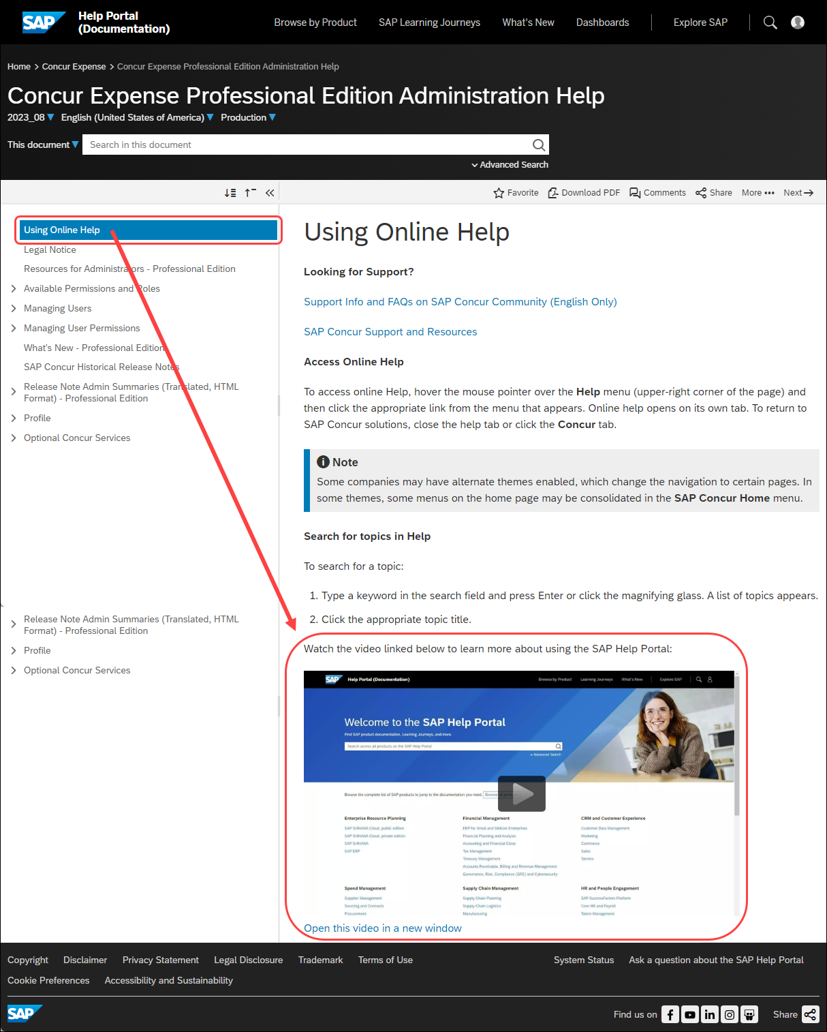

Configuration / Feature Activation
The location change will happen automatically; there are no configuration or activation steps.
The exact date that the product documentation will be available from the SAP Help Portal will be provided in future release notes.

Client Notifications

Accessibility

Accessibility Enhancements
SAP implements changes to better meet current Web Content Accessibility Guidelines (WCAG). Information about accessibility-related changes made to SAP Concur solutions is published on a quarterly basis. You can review the quarterly updates on the Accessibility Updates page.

Gender Diversity

Gender Diversity Planned Features and Changes
SAP Concur is committed to supporting gender diversity. Over time we plan to implement product changes to help ensure that SAP Concur solutions support gender non-binary users. These changes will include but are not limited to support for preferred names, non-binary gender options in travel preferences, and non-binary titles.
These planned changes reflect SAP's commitment to supporting gender diversity and enable gender non-binary users to enter consistent information when making travel arrangements and entering personal information into SAP Concur solutions.
Timelines and details about these ongoing changes will be provided in the SAP Concur release notes.

In-Product User Assistance

Client Customized Content
If your company creates customized content for SAP Concur solutions through a user assistance tool such as SAP Enable Now or Concur User Assistant by WalkMe, the changes described in these release notes might affect your customized content. SAP Concur recommends reviewing the monthly release notes for all of your SAP Concur solutions as well as the Shared Changes Release Notes to confirm whether any of the planned or released changes might impact your internal, customized content.
If any changes in a release impact your content, work with your internal teams to update your content accordingly.

Subprocessors

SAP Concur Non-Affiliated Subprocessors
The list of non-affiliated subprocessors is available from the SAP Sub-processors / Data Transfer Factsheets page.
To access the SAP Concur Sub-processors List:
- Click the following link to navigate to the SAP Sub-processors / Data Transfer Factsheets page:
SAP Sub-processors / Data Transfer Factsheets
- Sign in to the SAP Support Portal using your Support User ID (S-user) and password.
SAP customers must sign in to the SAP Support Portal using their Support User ID (S-user) and password. For information about S-User IDs, Your New Support User ID (S-user) and to the Learn All About S-User IDs blog post.
- On the SAP Sub-processors / Data Transfer Factsheets page, type "Concur" in the Search field.
- In the Title column, click SAP Concur Sub-processors List.
If you have questions or comments, please reach out to: Privacy-Request@Concur.com

Supported Browsers

Supported Browsers and Changes to Support
When changes to browser support are planned, information about those changes will also appear in the Shared Planned Changes release notes.
For information about supported browsers and planned changes to supported browsers, refer to the Concur Travel & Expense Supported Configurations guide.

Additional Release Notes and Other Technical Documentation

Online Help
You can access release notes, setup guides, user guides, admin summaries, supported configurations, and other resources via the in-product Help menu or directly on the SAP Help Portal.
To access the full set of documentation for your product, use the links in the SAP Concur Help menu, or visit the SAP Concur solutions page.
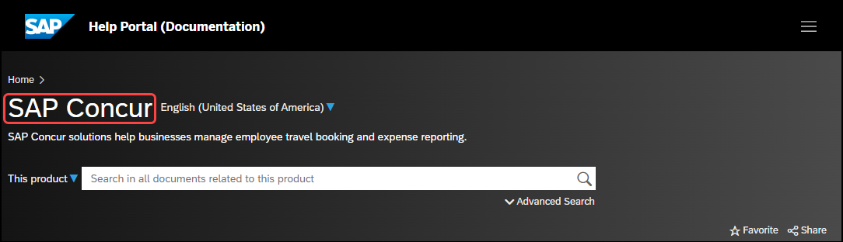

SAP Concur Support Portal – Selected Users
Access release notes, webinars, and other technical documentation on the SAP Concur support portal.
If you have the required permissions, Contact Support is available on the SAP Concur Help menu and in the SAP Concur page footer.
Click Contact Support to access the SAP Concur support portal, then click Resources.
- Click Release/Tech Info for release notes, technical documents, etc.
- Click Webinars for recorded and live webinars.
© 2024 SAP SE or an SAP affiliate company. All rights reserved.
No part of this publication may be reproduced or transmitted in any form or for any purpose without the express permission of SAP SE or an SAP affiliate company.
SAP and other SAP products and services mentioned herein as well as their respective logos are trademarks or registered trademarks of SAP SE (or an SAP affiliate company) in Germany and other countries. Please see http://global12.sap.com/corporate-en/legal/copyright/index.epx for additional trademark information and notices.
Some software products marketed by SAP SE and its distributors contain proprietary software components of other software vendors.
National product specifications may vary.
These materials are provided by SAP SE or an SAP affiliate company for informational purposes only, without representation or warranty of any kind, and SAP SE or its affiliated companies shall not be liable for errors or omissions with respect to the materials. The only warranties for SAP SE or SAP affiliate company products and services are those that are set forth in the express warranty statements accompanying such products and services, if any. Nothing herein should be construed as constituting an additional warranty.
In particular, SAP SE or its affiliated companies have no obligation to pursue any course of business outlined in this document or any related presentation, or to develop or release any functionality mentioned therein. This document, or any related presentation, and SAP SE’s or its affiliated companies’ strategy and possible future developments, products, and/or platform directions and functionality are all subject to change and may be changed by SAP SE or its affiliated companies at any time for any reason without notice. The information in this document is not a commitment, promise, or legal obligation to deliver any material, code, or functionality. All forward-looking statements are subject to various risks and uncertainties that could cause actual results to differ materially from expectations. Readers are cautioned not to place undue reliance on these forward-looking statements, which speak only as of their dates, and they should not be relied upon in making purchasing decisions.

