|  |  |
| --- | --- |
| SAP Concur Release Notes  Shared Changes  Includes cross-product and site-wide changes for:  Professional Edition, Standard Edition, and Small Business Edition | |
| **Month** | **Audience** |
| Release Date: April 22, 2023  Update #1: Thursday, April 27, 2023 | Client FINAL |

Contents

Release Notes 1

Concur Open 2

Subscribe to Maintenance Notices in Personalized Concur Open 2

All Products | All Editions 2

Data Retention 4

**Ongoing** Data Retention Feature Enhancements 4

All Products | All Editions 4

File Transfer Updates 8

New File Transfer Endpoints After Migration to AWS 8

All Products | Professional & Standard 8

**Ongoing** Rotating PGP Key for File Transfers 11

Travel, Expense, Invoice, Request, Intelligence | Professional & Standard 11

Home Page 13

**Ongoing ** SAP Concur Homepage Changes 13

All Products | All Editions 13

Profile Menu 16

Enhancements to “Act As” Section of the Profile Menu 16

All Products | All Editions 16

SAP Concur User Assistance 18

New SAP Concur Page on the SAP Help Portal 18

All Products | All Editions 18

SAP Fiori Themes 20

Preview Horizon for Fiori Themes in SAP Concur 20

All Products | All Editions 20

Security 24

New Security Recommendations Regarding Phishing 24

All Products | All Editions 24

Some TLSv1.2 Ciphers No Longer Supported (Mar 30) 25

Travel, Expense, Invoice, Request | Professional & Standard 25

Addition of ECDSA Encryption and Cipher Retirement 30

Travel, Expense, Invoice, Request | All Editions 30

Admin Tasks – SSL Certificate Update 33

User Export and Import 37

User Export and Import Improvements 37

Expense, Invoice, Request | Standard Edition 37

Planned Changes 41

SAP Concur Support 41

**Planned Changes** Case Types to be Updated 41

All Products | All Editions 41

SAP Fiori Themes 44

**Planned Changes** SAP Fiori Horizon Themes for Concur Mobile and Web 44

All Products | All Editions 44

Client Notifications 47

Accessibility 47

Accessibility Enhancements 47

Subprocessors 47

SAP Concur Non-Affiliated Subprocessors 47

Supported Browsers 48

Supported Browsers and Changes to Support 48

Additional Release Notes and Other Technical Documentation 49

Online Help 49

SAP Concur Support Portal – Selected Users 49

Legal Disclaimer

The information in this presentation is confidential and proprietary to SAP SE or an SAP affiliate company and may not be disclosed without the permission of SAP SE or the respective SAP affiliate company. This presentation is not subject to your license agreement or any other service or subscription agreement with SAP SE or its affiliated companies. SAP SE and its affiliated companies have no obligation to pursue any course of business outlined in this document or any related presentation, or to develop or release any functionality mentioned therein. This document, or any related presentation and SAP SE or an SAP affiliate company’s strategy and possible future developments, products and or platforms directions and functionality are all subject to change and may be changed by SAP SE and its affiliated companies at any time for any reason without notice. The information in this document is not a commitment, promise or legal obligation to deliver any material, code or functionality. This document is provided without a warranty of any kind, either express or implied, including but not limited to, the implied warranties of merchantability, fitness for a particular purpose, or non-infringement. This document is for informational purposes and may not be incorporated into a contract. SAP SE and its affiliated companies assume no responsibility for errors or omissions in this document, except if such damages were caused by SAP SE or an SAP affiliate company’s willful misconduct or gross negligence.

All forward-looking statements are subject to various risks and uncertainties that could cause actual results to differ materially from expectations. Readers are cautioned not to place undue reliance on these forward-looking statements, which speak only as of their dates, and they should not be relied upon in making purchasing decisions.

# Release Notes

This document contains shared release notes and planned changes. Shared release notes and planned changes document features and changes that apply to SAP Concur solutions site-wide or to multiple SAP Concur products and services. They include but are not limited to:

* Security-related features and changes such as annual security certificate renewals and changes in support for security ciphers and protocols
* Site-wide UI features and changes such as changes to the home page, changes to the site header or footer, or the implementation of new site-wide UI themes
* Sign-in process features and changes such as the addition or removal of sign-in features, URL changes, and domain name changes
* Production and test environment features and changes
* Global settings or administration page features and changes such as the addition of new site-wide settings or changes to the design of the administration pages
* Changes to processes such as where and when release notes are published

For New Features and Changes that apply to a single product and/or service see the release notes for that product or service. Links to the product and service-specific release notes can be found on the following pages:

* [Professional Edition](https://www.concurtraining.com/customers/tech_pubs/_RN_CCC.htm)
* [Standard Edition](https://www.concurtraining.com/customers/tech_pubs/_Docs_CCC_CPS.htm)
* [Small Business Edition](http://www.concurtraining.com/customers/tech_pubs/Docs/Breeze/RN/WhatsNew.htm)

## Concur Open

### Subscribe to Maintenance Notices in Personalized Concur Open

|  |  |  |
| --- | --- | --- |
| Information First Published | Information Last Modified | Feature Target Release Date |
| March 17, 2023 | -- | April 3, 2023 |
| Any changes since the previous monthly release are highlighted in yellow in this release note. | | |

**Applies to:**

All Products | All Editions

#### Overview

On April 3, 2023, SAP Concur plans to provide ASCs and other users with the option to subscribe to receive advance notices about upcoming SAP Concur maintenance events.

##### Business Purpose / Client Benefit

This change centralizes subscription to service and maintenance notifications in one location and helps clients to prepare for SAP Concur maintenance events.

#### End-User and Admin Experience

##### ASCs

With this change, ASCs will no longer subscribe to maintenance notifications through the **My Profile** menu on the support portal. Maintenance and service event notifications will be centralized on the **SAP Personalized Concur Open** pages.

To continue receiving maintenance notifications, ASCs must subscribe through the **SAP Personalized Concur Open > Set Notification Preferences** page.

##### SAP Personalized Concur Open Users Including ASCs

After signing in to Personalized Concur Open, new options are available to users on the **Set Notification Preferences** page. In the new **Maintenance Events** section, the user can choose which notifications to receive:

* Maintenance Announcement
* Maintenance Update
* Maintenance Complete
* Maintenance Cancelled

##### Set Notification Preferences

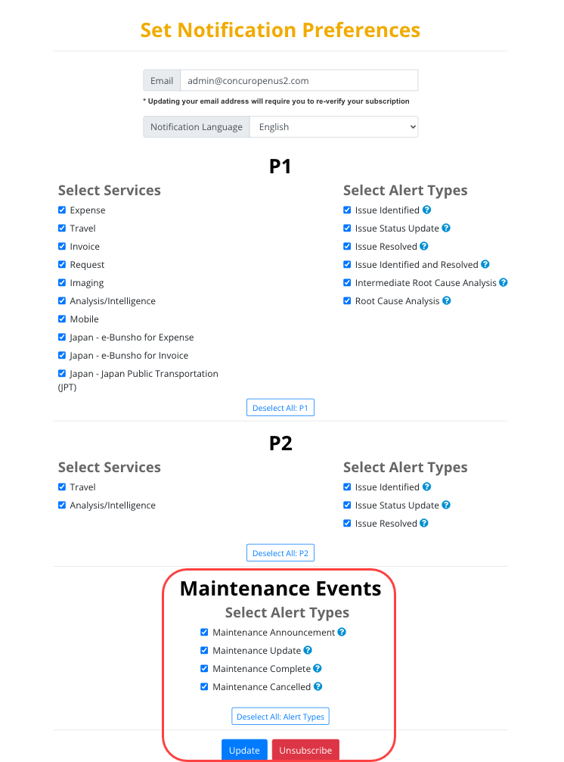

#### Configuration / Feature Activation

These options are automatically available on the **Set Notification Preferences** page.

## Data Retention

### **Ongoing** Data Retention Feature Enhancements

|  |  |  |
| --- | --- | --- |
| Information First Published | Information Last Modified | Feature Target Release Date |
| January 20, 2023 | March 17, 2023 | February 21, 2023 and future release |
| Any changes since the previous monthly release are highlighted in yellow in this release note. | | |

**Applies to:**

All Products | All Editions

#### Overview

On February 21, 2023, SAP Concur renamed the **Sensitive Data Retention Periods** page to **Profile Data Retention Periods**.

In a future release, SAP Concur plans to remove the **Purge User** button.

1. In a previous version of the release notes, we stated that the **Type {name} to confirm settings** field was planned to be removed.  
     
   SAP Concur does not plan to remove this field.

##### Business Purpose / Client Benefit

These changes help clients configure SAP Concur solutions to better support regional data protection regulations.

#### Data Retention Admin Experience

On the **Data Retention** page, the admin sees **Profile Data** instead of **Sensitive Data**.

**Before**

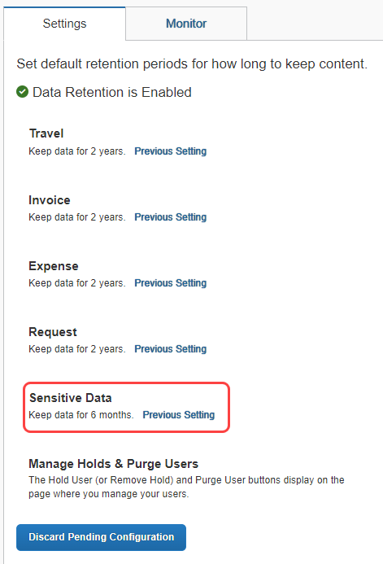

**After**

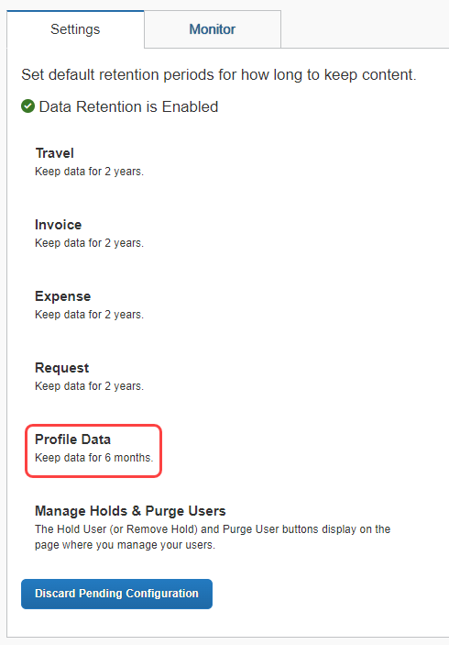

The **Sensitive Data Retention Periods** page had been renamed to **Profile Data Retention Periods**.

**Before**

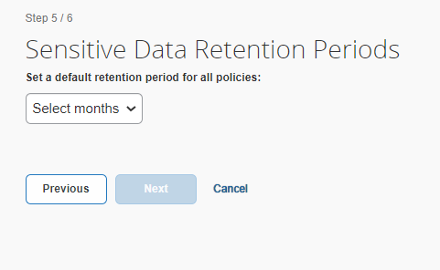

**After**

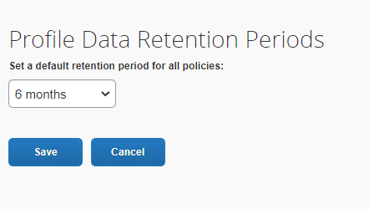

#### Changes to the Purge User Button (Future Release)

In a future release, SAP Concur plans to make changes to the **Purge User** button.

##### Current Behavior

When data retention is enabled, the **Purge User** button is automatically available on the user account page for each user, and an administrator with the required permissions can click the **Purge User** button on an individual user’s account page to purge that user’s data, including transaction data.

* **IMPORTANT:** Clicking **Purge User** purges the user’s data immediately and irreversibly.

When the data retention feature is enabled, the **Purge User** button is available regardless of whether a data retention policy is configured and, if data retention policies are configured, clicking **Purge User** supersedes configured data retention policies and will remove data that could be needed for review, audit, and legal obligations at a future date.

##### Planned Changes

To help ensure that user data is retained and/or removed within the correct timeframe as required by regional data protection regulations, SAP Concur plans to remove the **Purge User** button.

More details about this change will be published in future release notes.

#### Configuration / Feature Activation

The **Sensitive Data Retention Periods** page was renamed to **Profile Data Retention Periods** automatically.

In a future release, the **Purge Users** button will be removed.

For more information about the Data Retention feature, refer to the [*Shared: Data Retention Setup Guide*](https://www.concurtraining.com/customers/tech_pubs/Docs/_Current/SG_Shr/Shr_SG_Data_Retention.pdf) (Professional edition) or the [*Shared: Data Retention Setup Guide for Concur Standard Edition*](https://www.concurtraining.com/customers/tech_pubs/Docs/ConcurPremier/SG_Shr/SG_Shr_Data_Retention.pdf).

## File Transfer Updates

### New File Transfer Endpoints After Migration to AWS

|  |  |  |
| --- | --- | --- |
| Information First Published | Information Last Modified | Feature Target Release Date |
| June 10, 2022 | January 20, 2023 | January 31, 2023 |
| Any changes since the previous monthly release are highlighted in yellow in this release note. | | |

**Applies to:**

All Products | Professional & Standard

#### Overview

The SAP Concur migration to Cloud Platform in AWS is complete. With the migration, new endpoints were implemented for file transfers and notification of these changes was sent to clients impacted by these changes.

The legacy file transfer service will be shut down on February 1, 2023. If these changes apply to your company, you have until January 31, 2023, to switch from the old endpoint(s) to the new AWS Transfer endpoint(s).

If you’ve already completed the update, no further action is required.

1. This change applies to both production and Production Sandbox Environment (PSE) entities.

This announcement pertains to the following file transfer DNS endpoints:

* st.concursolutions.com
* mft-us.concursolutions.com
* vs.concursolutions.com
* st-eu.concursolutions.com
* mft-eu.concursolutions.com

##### Business Purpose / Client Benefit

The SAP Concur migration to Cloud Platform in AWS provides a stronger security posture, improved performance and stability, and faster innovation for our clients.

For more information about the migration, refer to the [*SAP Concur Cloud Platform Strategy FAQ*](http://assets.concur.com/concurtraining/cte/en-us/FAQ_Cloud_Hosting_Strategy.pdf).

#### Configuration / Feature Activation

The legacy file transfer service will be shut down on February 1, 2023. You must update your systems to point to the new AWS Transfer endpoints by January 31, 2023.

You can perform the following steps to verify your entity has been migrated and then update your AWS transfer endpoints.

##### Before Switching to the AWS SFTP Endpoints

* **Required:** Review the [AWS Transfer for SFTP Migration FAQ](https://go.concur.com/rs/013-GAX-394/images/Final%20IFMFAQ.pdf).
* The *Operational Guidance for Executing Required Change* section is critical to review.
* **Recommended:** Review the user guide, [*Transferring files using a client*](https://docs.aws.amazon.com/transfer/latest/userguide/transfer-file.html)*,* available from Amazon’s document repository. Follow the steps in the guide that apply to any SFTP applications your organization uses.

##### Confirm your entities have been migrated to AWS

1. Navigate to SAP Concur solutions, sign in, and then scroll to the bottom of the page.
2. At the bottom of the page, locate the phrase “Service Status.”

If your entity has been migrated, **(US2)** or **(EU2)** follows “Service Status.”

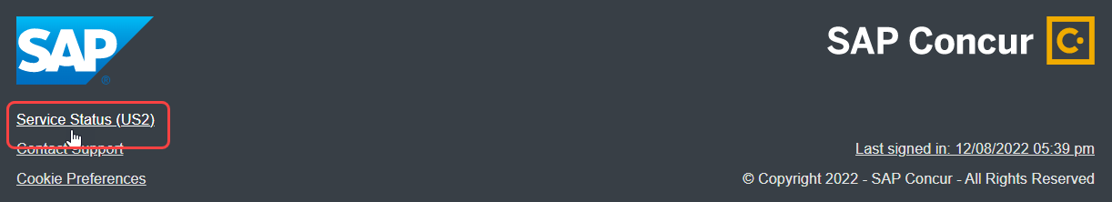

If your entity has not been migrated, **(North America) or (EMEA)** follows “Service Status.”

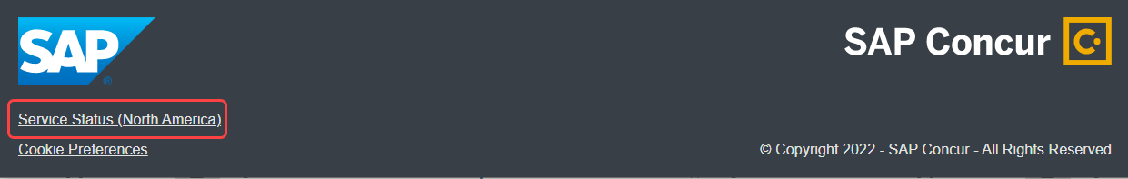

1. **Clients with Cognos (ReportNet) files:** Clients with Cognos files will continue to download their files from the legacy data center until further notice.

If your organization uses any of the endpoints in the table that follows for file transmissions with SAP Concur solutions, you must switch to the corresponding AWS endpoint by January 31, 2023. If you do not update your endpoints by that date, your file transfer account will be disabled on the legacy data center and you will not be able to connect to SAP Concur solutions for file transmissions. This applies to both primary production and PSE entities.

**Use the following table to determine which AWS transfer endpoint to connect to:**

|  |  |  |  |  |  |
| --- | --- | --- | --- | --- | --- |
| **Environment** | **Current Endpoint (Legacy DC)** | **Current IP (Legacy DC)** | **AWS Transfer Endpoint** | **AWS Transfer IPs** | **AWS Transfer SSH Server Fingerprint** |
| North America DC | st.concursolutions.com | 12.129.29.5 | mft-us2.concursolutions.com | 34.216.251.54, 35.83.74.180, 35.81.194.197 | SHA256:A+6pVvfQpGaSZfwvDenRBatqA9GE5YAbFOiKJASC7wI |
| North America DC | mft-us.concursolutions.com | 12.129.29.138 | mft-us2.concursolutions.com | 34.216.251.54, 35.83.74.180, 35.81.194.197 | SHA256:A+6pVvfQpGaSZfwvDenRBatqA9GE5YAbFOiKJASC7wI |
| EMEA DC | st-eu.concursolutions.com | 46.243.56.11 | mft-eu2.concursolutions.com | 3.64.91.253, 3.125.188.25, 18.198.91.237 | SHA256:VL9jvUNfc7lDX1pFaEVN2/UC7y/chtLdT63E3qJVbyk |
| EMEA DC | mft-eu.concursolutions.com | 46.243.56.21 | mft-eu2.concursolutions.com | 3.64.91.253, 3.125.188.25, 18.198.91.237 | SHA256:VL9jvUNfc7lDX1pFaEVN2/UC7y/chtLdT63E3qJVbyk |

* **IMPORTANT:** Confirm that your entities have been migrated before changing to the new endpoints. If you change the endpoint for file transfer accounts that are not yet migrated, your uploaded files will not be processed.

For questions regarding this change, please speak with your IT or networking teams. For support from SAP Concur on making this update, review the [*AWS Migration FAQ*](https://go.concur.com/rs/013-GAX-394/images/Final%20IFMFAQ.pdf), visit the support portal, and submit a support case by choosing “Topic: Expense”> “Case Type: Jobs Data Transfer/Transmission”.

### **Ongoing** Rotating PGP Key for File Transfers

|  |  |  |
| --- | --- | --- |
| Information First Published | Information Last Modified | Feature Target Release Date |
| February 2021 | February 23, 2023 | January 15, 2021, October 11, 2022, and June 15, 2023 |
| Any changes since the previous monthly release are highlighted in yellow in this release note. | | |

**Applies to:**

Travel, Expense, Invoice, Request, Intelligence | Professional & Standard

#### Overview

Files transferred to SAP Concur products must be encrypted with the SAP Concur public PGP key, concursolutionsrotate.asc.

* **IMPORTANT!  
    
  PGP key changes:**• The legacy (non-rotating) key, key ID D4D727C0, was deprecated on October 11, 2022.  
    
  • The previous rotating key, key ID 40AC5D35, expired on September 4, 2022. • The current rotating key, key ID 9AFF10B5, is available in the client's root folder.

**Current rotating PGP key details:**

* Key ID: 9AFF10B5
* Filename: concursolutionsrotate.asc
* The filename for the rotating PGP key does not change when the key is rotated.
* RSA 4096-bit signing and encryption subkey
* The current key expires on September 4, 2024.
* A new key will be available 90 days before the September 4, 2024, expiration date.
* Clients are responsible for replacing the rotating key before it expires.

**Legacy (non-rotating) PGP key details:**

* Key ID: D4D727C0
* The SAP Concur legacy (non-rotating) PGP key was deprecated on October 11, 2022.
* Cognos (ReportNet) files are signed with our legacy key for the US endpoints that follow. Cognos files will no longer be signed as of June 15, 2023:
* st.concursolutions.com
* mft-us.concursolutions.com
* AWS transfer endpoints

This announcement pertains to the following file transfer DNS endpoints:

* st.concursolutions.com
* mft-us.concursolutions.com
* vs.concursolutions.com
* st-eu.concursolutions.com
* mft-eu.concursolutions.com
* AWS transfer endpoints (when they are communicated to you)

##### Business Purpose / Client Benefit

The rotating public PGP key provides greater security for file transfers.

#### Admin Experience

An administrator with the required file transfer credentials can log into the file transfer site to retrieve the rotating public PGP key, concursolutionsrotate.asc, from the root directory.

#### Configuration / Feature Activation

Your internal file transfer administrator can add the current rotating key to their PGP keyring and start using it to encrypt files being transferred to SAP Concur.

If you require assistance, please contact SAP Concur support.

For more information, refer to the [*Shared: File Transfer for Customers and Vendors User Guide*](http://www.concurtraining.com/customers/tech_pubs/Docs/ConcurPremier/UG_Shr/Shr_UG_FileTransfer.pdf).

## Home Page

### **Ongoing ** SAP Concur Homepage Changes

|  |  |  |
| --- | --- | --- |
| Information First Published | Information Last Modified | Feature Target Release Date |
| December 4, 2020 | May 13, 2022 | Q4 2021 – Future Release |
| Any changes since the previous monthly release are highlighted in yellow in this release note. | | |

**Applies to:**

All Products | All Editions

#### Overview

In Q4, 2021, SAP Concur began redirecting clients to a new homepage. The appearance of the new homepage is identical to the previous SAP Concur homepage. The new homepage has enhanced functionality when services become temporarily unavailable.

The roll out of the new homepage is phased:

**Phase 1:** In October of 2021, SAP Concur began redirecting Concur Expense, Concur Invoice, and Concur Request clients in the US Datacenter to the new homepage.

**Phase 2:** In December 2021, SAP Concur began redirecting Concur Expense, Concur Invoice, and Concur Request clients in the EU Datacenter to the new homepage.

**Phase 3:** At a date to be determined, SAP Concur will begin redirecting the remaining clients in the US and EU datacenters to the new homepage. The remaining clients include those with Concur Travel standalone or Concur Travel with Expense, Invoice, and/or Request.

##### Business Purpose / Client Benefit

This change ensures that the SAP Concur homepage is available even when some services are unavailable and improves the consistency of the sign in experience.

#### End-User Experience

With the old homepage, when a user signs into their SAP Concur products, they see their homepage.

1. The appearance of the homepage varies depending on which products and services are enabled for the client and the permissions assigned to the user.

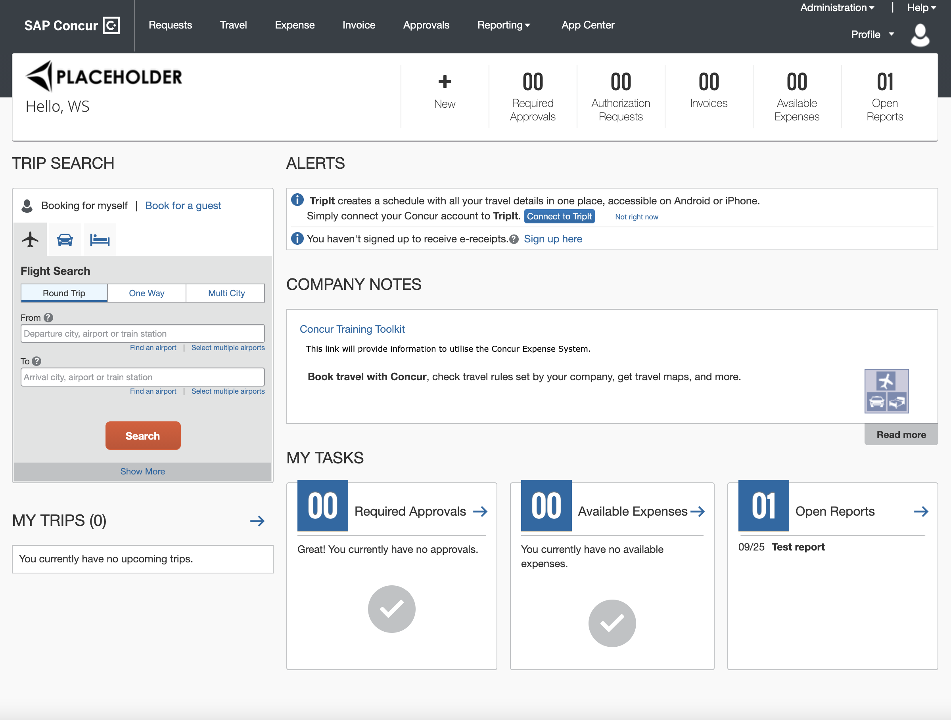

If some products or services are unavailable while other products and services are up and running, a modified version of the user’s homepage similar to the following appears:

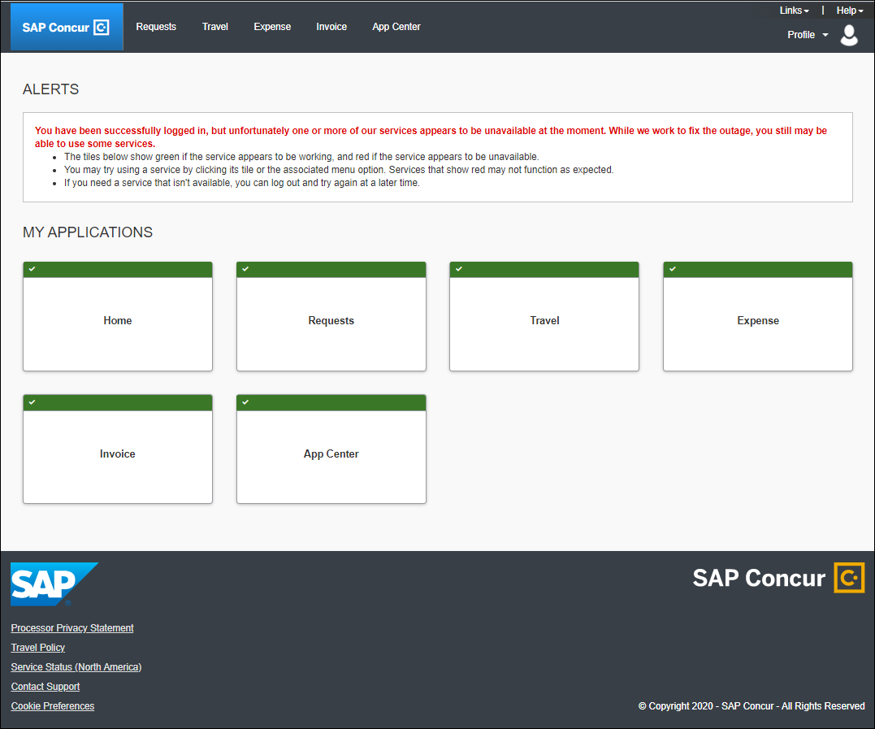

After a client is migrated to the new homepage, if one or more services are unavailable, when a user signs in to their SAP Concur products, they will see the usual homepage, but if the user navigates to a page for a service that is unavailable, they will see a page similar to the following:

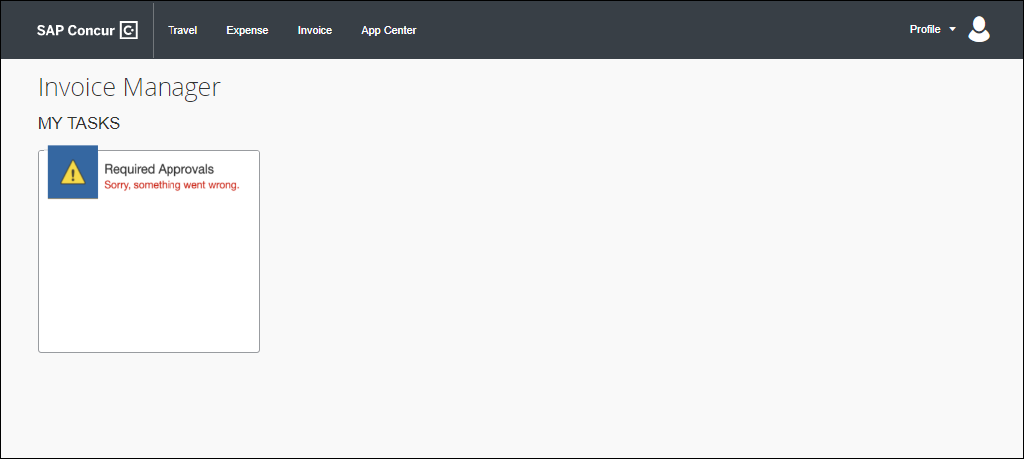

After migration to the new homepage, if all services are available, this change is transparent to the user and they see a homepage that is identical to the pre-migration homepage.

**Example Homepage**

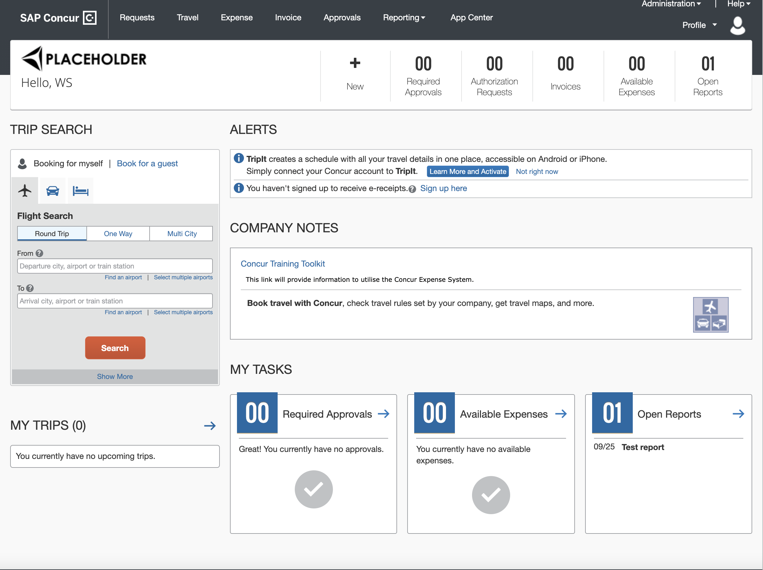

#### Configuration / Feature Activation

This change occurs automatically; there are no configuration or activation steps.

## Profile Menu

### Enhancements to “Act As” Section of the Profile Menu

|  |  |  |
| --- | --- | --- |
| Information First Published | Information Last Modified | Feature Target Release Date |
| March 10, 2023 | March 24, 2023 | March 24, 2023 |
| Any changes since the previous monthly release are highlighted in yellow in this release note. | | |

**Applies to:**

All Products | All Editions

#### Overview

SAP Concur has improved the “Act As” section of the **Profile** menu in the legacy SAP Concur theme.

1. These changes are already present in SAP Concur Fiori themes. For more information about SAP Concur Fiori themes, refer to the [*SAP Concur Fiori Themes*](https://www.concurtraining.com/customers/tech_pubs/Docs/FactSheets/SAP_Fiori_Themes_FS.pdf) fact sheet.

##### Business Purpose / Client Benefit

This change improves the ease of user of the **Profile** menu.

#### End-User Experience

When an end-user opens the **Profile** menu, the new layout and updated text are available.

**Before**

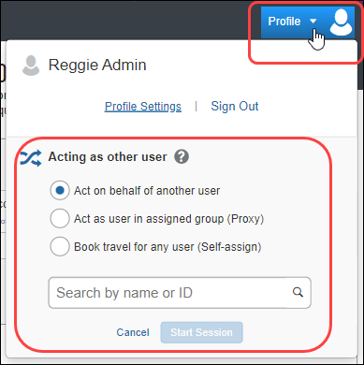

**After**

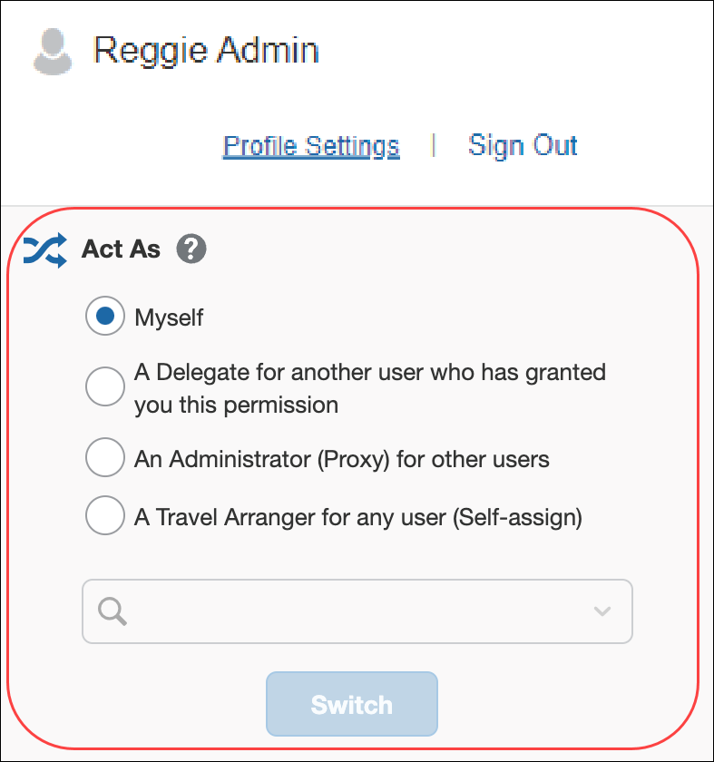

To act as another user or revert to acting on their own behalf, the user selects the desired option or persona, and then clicks **Switch**.

#### Configuration / Feature Activation

The changes to the **Act As** section of the **Profile** menu occur automatically.

## SAP Concur User Assistance

### New SAP Concur Page on the SAP Help Portal

|  |  |  |
| --- | --- | --- |
| Information First Published | Information Last Modified | Feature Target Release Date |
| April 14, 2023 | April 21, 2023 | April 24, 2023 |
| Any changes since the previous monthly release are highlighted in yellow in this release note. | | |

**Applies to:**

All Products | All Editions

#### Overview

On April 24, 2023, a new solutions page titled "SAP Concur" will be available on the SAP Help Portal.

For more information, refer to “Online Help” in the *Additional Release Notes and Other Technical Documentation* section included in all sets of release notes.

##### Business Purpose / Client Benefit

This page provides a single access point on the SAP Help Portal for all SAP Concur product documentation including documentation that is available outside of the portal.

#### Admin Experience

The admin can use this page as a starting point to access all SAP Concur technical documentation for all products and all editions.

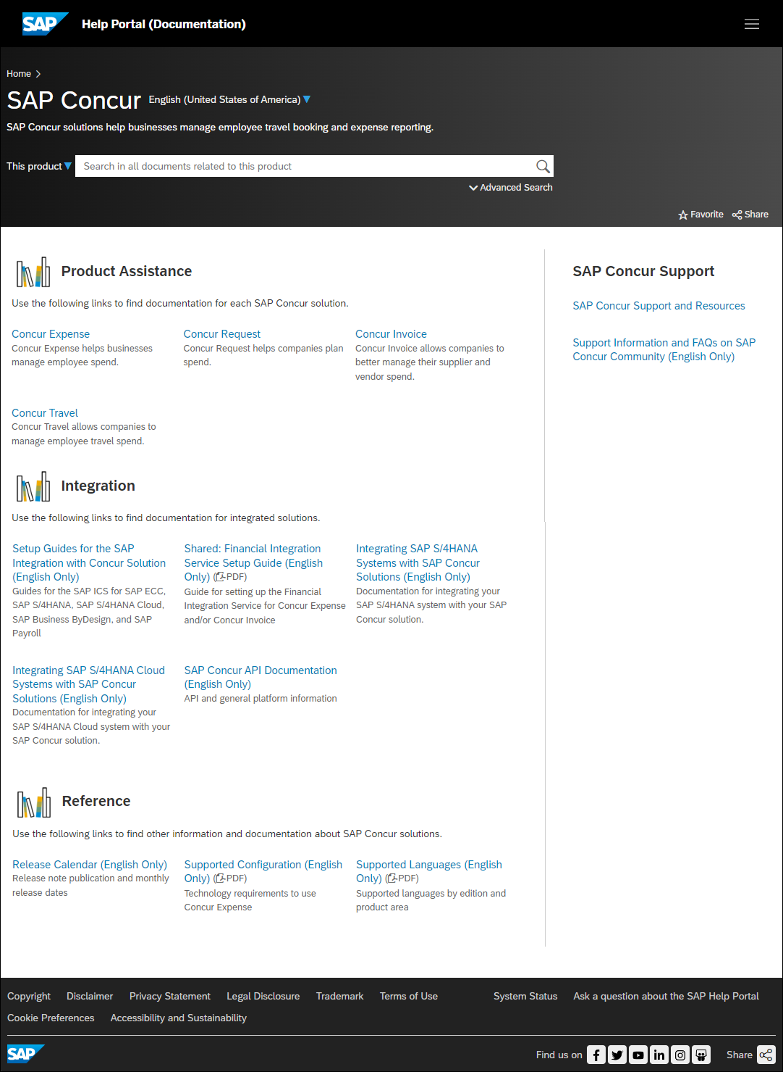

#### Configuration / Feature Activation

This page is scheduled to be available on the SAP Help Portal on April 24, 2023.

## SAP Fiori Themes

### Preview Horizon for Fiori Themes in SAP Concur

|  |  |  |
| --- | --- | --- |
| Information First Published | Information Last Modified | Feature Target Release Date |
| April 3, 2023 | April 4, 2023 | April 3, 2023 |
| Any changes since the previous monthly release are highlighted in yellow in this release note. | | |

**Applies to:**

All Products | All Editions

#### Overview

SAP Fiori with Horizon is a visual design theme family from SAP that is being adopted across SAP Concur solutions. With SAP Fiori with Horizon, clients benefit from a refreshed, modern look and feel, improved consistency across the solutions, and more inclusive and accessible design.

To enable clients to preview Horizon for Fiori themes in SAP Concur solutions before the themes are fully implemented, after signing in to SAP Concur solutions, Concur admins can navigate to the **Appearance Settings** page by adding the following to the SAP Concur solutions URL:

/Profile/AppearanceSettings.asp

1. The full SAP Concur solutions URL differs depending on the datacenter in which your SAP Concur entity is located.
2. Your method of sign in depends on your configuration. For example, your company might require SSO sign in.

For more information about the implementation of Horizon for Fiori themes for SAP Concur solutions, refer to the *\*\*Planned Changes** Fiori Horizon Themes for Concur Mobile and Web* release note in this document.

##### Business Purpose / Client Benefit

The preview enables clients to preview future changes to the appearance of the SAP Concur UI so they can prepare for the implementation of the new themes in the future.

#### Admin and End-User Experience

An admin or end user can navigate to the **Appearance Settings** page by adding the following to the base URL:

…/Profile/AppearanceSettings.asp

For example, if your entity is located in the US (North America) datacenter, after signing in to SAP Concur solutions, the URL you use to navigate to the **Appearance Settings** page is:

https://us2.concursolutions.com/Profile/AppearanceSettings.asp

If your entity is located in the EU (EMEA) datacenter, after signing in to SAP Concur solutions, the URL you use to navigate to the **Appearance Settings** page is:

https://eu2.concursolutions.com/Profile/AppearanceSettings.asp

1. You must be signed in to SAP Concur Solutions before navigating to the **Appearance Settings** page.
2. To Preview Horizon for Fiori Themes
3. After navigating to **Appearance Settings**, click **Enable Theme Preview** to move the switch to the right position (enabled) and enable access to the themes.

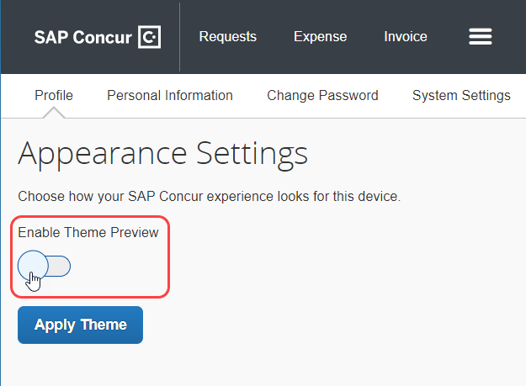

1. Select the desired theme and then click **Apply Theme**.

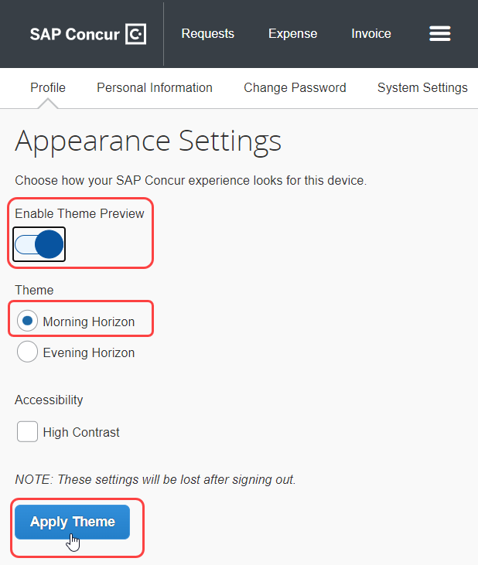

The available themes are as follows:

* Morning Horizon
* Evening Horizon

In addition to the Horizon themes, you can enable **High Contrast** mode.

After clicking **Apply Theme**, the chosen theme is applied to the SAP Concur User interface until you sign out of SAP Concur solutions or until the theme is manually disabled.

1. To return to the legacy theme without signing out of SAP Concur solutions
2. Click the **Enable Theme Preview** switch to move the switch to the left position (disabled).
3. Click **Apply Theme**.

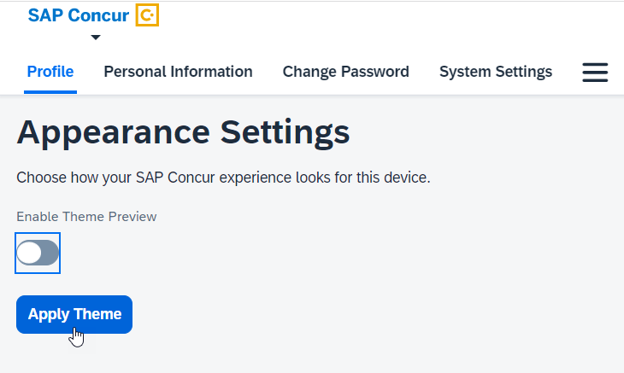

After clicking **Apply Theme**, the legacy theme is reapplied to SAP Concur solutions.

#### Configuration / Feature Activation

While you are signed in to SAP Concur solutions, the **Appearance Settings** page is automatically available when you navigate to <your datacenter URL>/Profile/AppearanceSettings.asp.

For more information about the release of Horizon for Fiori themes for SAP Concur solutions, refer to the *\*\*Planned Changes** Fiori Horizon Themes for Concur Mobile and Web* release note in this document.

## Security

### New Security Recommendations Regarding Phishing

|  |  |  |
| --- | --- | --- |
| Information First Published | Information Last Modified | Feature Target Release Date |
| April 14, 2023 | -- | April 2023 |
| Any changes since the previous monthly release are highlighted in yellow in this release note. | | |

**Applies to:**

All Products | All Editions

#### Overview

SAP has added new security recommendations aimed at helping our clients understand what we are doing, as well as what clients can do, to prevent phishing attacks. The new security recommendations are available on the SAP Concur Security Recommendations page on the SAP Help Portal:

[SAP Concur Security Recommendations](https://help.sap.com/docs/SAP_CONCUR/481708a2290b492f8d105dcd55f9c0bd/80a4fbd48e7d4337ad80171f0ca52cf9.html?)

The new security recommendations detail tools that SAP uses to support email security, including:

* Sender Policy Framework (SPF)
* DomainKeys Identified Mail (DKIM)
* Domain-based Message Authentication, Reporting & Conformance (DMARC)

In addition, we’ve provided some general guidelines to help harden your company against phishing attacks.

##### Business Purpose / Client Benefit

The SAP Concur security recommendations provide information to clients about the email security tools used and supported by SAP. These recommendations are intended to help our clients to prepare for phishing attacks.

#### Configuration / Feature Activation

The security guidelines are available to all clients using the SAP Concur Security Recommendations page:

[SAP Concur Security Recommendations](https://help.sap.com/docs/SAP_CONCUR/481708a2290b492f8d105dcd55f9c0bd/80a4fbd48e7d4337ad80171f0ca52cf9.html?)

Contact your IT department to discuss implementing these recommendations at your company.

### Some TLSv1.2 Ciphers No Longer Supported (Mar 30)

|  |  |  |
| --- | --- | --- |
| Information First Published | Information Last Modified | Feature Target Release Date |
| February 10, 2023 | March 10, 2023 | March 30, 2023 |
| Any changes since the previous monthly release are highlighted in yellow in this release note. | | |

**Applies to:**

Travel, Expense, Invoice, Request | Professional & Standard

#### Overview

Beginning on March 30, 2023 at 10PM GMT+8, China CTE Websites (*.concurcdc.cn) will no longer support connections using the following TLSv1.2 ciphers:

|  |  |
| --- | --- |
| Akamai/OpenSSL cipher name | IANA cipher name |
| AES128-SHA | TLS_RSA_WITH_AES_128_CBC_SHA |
| AES256-SHA | TLS_RSA_WITH_AES_256_CBC_SHA |
| AES128-SHA256 | TLS_RSA_WITH_AES_128_CBC_SHA256 |
| AES256-SHA256 | TLS_RSA_WITH_AES_256_CBC_SHA256 |
| AES256-GCM-SHA384 | TLS_RSA_WITH_AES_256_GCM_SHA384 |
| AES128-GCM-SHA256 | TLS_RSA_WITH_AES_128_GCM_SHA256 |
| ECDHE-RSA-AES256-SHA | TLS_ECDHE_RSA_WITH_AES_256_CBC_SHA |
| ECDHE-RSA-AES128-SHA | TLS_ECDHE_RSA_WITH_AES_128_CBC_SHA |
| ECDHE-RSA-AES256-SHA384 | TLS_ECDHE_RSA_WITH_AES_256_CBC_SHA384 |
| ECDHE-RSA-AES128-SHA256 | TLS_ECDHE_RSA_WITH_AES_128_CBC_SHA256 |

To ensure that connections to *.concurcdc.cn are not disrupted, clients and partners who connect to *.concurcdc.cn through an application that uses a retired cipher must update the application to a supported cipher before March 30, 2023 at 10PM GMT+8.

1. **Most connections already use a supported cipher.**

##### Business Purpose / Client Benefit

This update provides ongoing security for SAP Concur products and services.

#### Confirming Supported Ciphers

The following ciphers included in the **ak-akamai-2020q1** cipher profile are supported:

|  |  |
| --- | --- |
| Akamai/OpenSSL cipher name | IANA cipher name |
| TLS-AES-256-GCM-SHA384 | TLS_AES_256_GCM_SHA384 |
| TLS-CHACHA20-POLY1305-SHA256 | TLS_CHACHA20_POLY1305_SHA256 |
| TLS-AES-128-GCM-SHA256 | TLS_AES_128_GCM_SHA256 |
| ECDHE-ECDSA-AES256-GCM-SHA384 | TLS_ECDHE_ECDSA_WITH_AES_256_GCM_SHA384 |
| ECDHE-ECDSA-AES128-GCM-SHA256 | TLS_ECDHE_ECDSA_WITH_AES_128_GCM_SHA256 |
| ECDHE-RSA-AES256-GCM-SHA384 | TLS_ECDHE_RSA_WITH_AES_256_GCM_SHA384 |
| ECDHE-RSA-AES128-GCM-SHA256 | TLS_ECDHE_RSA_WITH_AES_128_GCM_SHA256 |
| ECDHE-ECDSA-CHACHA20-POLY1305 | TLS_ECDHE_ECDSA_WITH_CHACHA20_POLY1305_SHA256 |
| ECDHE-RSA-CHACHA20-POLY1305 | TLS_ECDHE_RSA_WITH_CHACHA20_POLY1305_SHA256 |

1. If your cipher suite includes both supported and unsupported ciphers, connections to *.concurcdc.cn through a web browser will not be disrupted. During the process of establishing the connection, the *.concurcdc.cn server will choose the most secure cipher in your cipher suite. **Most connections already use a supported cipher.**

You can confirm that your cipher suite includes a supported cipher by cross-referencing the Akamai/OpenSSL cipher name with the IANA cipher name in the **ak-akamai-2020q1 (default)** column in the following table.

Supported ciphers are indicated with a check mark.

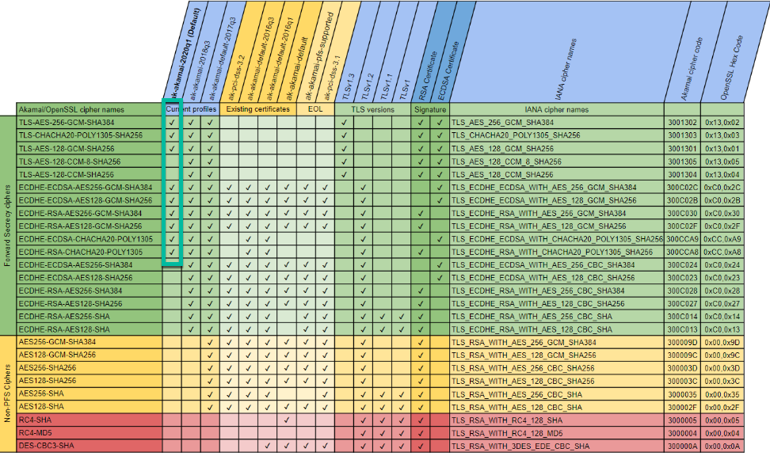

#### Testing Ciphers

The following procedure is intended for use by system administrators who want to test whether their cipher suite configuration will work correctly when connecting to SAP Concur solutions after support for the ciphers listed above has been removed.

This procedure configures the system admin's local machine to connect to an akamai staging environment where support for the listed ciphers has already been removed.

Summary of the procedure:

* Retrieve the IP address of the akamai staging environment.
* Redirect navigation to *www.concurcdc.cn* to the akamai staging environment by editing the local *Hosts* file.
* Test a connection to www.concurcdc.cn.

##### Confirm Your Cipher Suite is Working Correctly

1. Retrieve the IP address of the akamai staging environment

In the **Command Prompt** or **Terminal** window, ping e2806.b.akamaiedge-staging.net.

**Example Ping command**

Ping e2806.b.akamaiedge-staging.net

**Example response**

PING e2806.b.akamaiedge-staging.net (104.81.203.87): 56 data bytes

64 bytes from 104.81.203.87: icmp_seq=0 ttl=52 time=75.033 ms

64 bytes from 104.81.203.87: icmp_seq=1 ttl=52 time=105.865 ms

64 bytes from 104.81.203.87: icmp_seq=2 ttl=52 time=166.914 ms

64 bytes from 104.81.203.87: icmp_seq=3 ttl=52 time=200.904 ms

Copy the highlighted IP address in the response.

**Example IP address**

104.81.203.87

1. Update the Local Hosts File

**MAC:**

1. Open Terminal
2. Type “sudo nano /private/etc/hosts” and then press **Enter**.

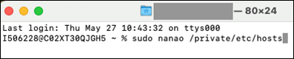

1. If prompted, enter your administrator password.
2. After the comments at the beginning of the file, add the IP address you copied in step 4, followed by “www.concurcdc.cn”.
3. Comments are preceded with a hashtag (#). Your entry should not include the hashtag.
4. **Example entry**
5. 104.81.203.87 [www.concurcdc.cn](http://www.concurcdc.cn)
6. Save the file (Ctrl-x) then “Y” for yes and “Enter” to close.

**Windows:**

1. Launch Notepad as administrator by typing “Notepad” into the Windows search bar, right-clicking Notepad in the search results, and then clicking **Run as administrator**.

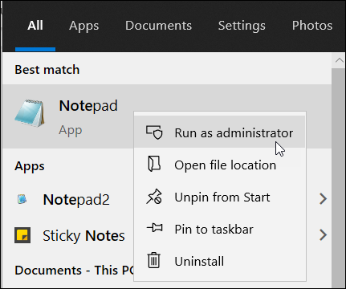

1. If prompted, click **Yes** in the **User Account Control** window.
2. In Notepad, click **File** and then click **Open**.
3. Navigate to *C:\\Windows\System32\drivers\etc* and then, to the right of the **File name** field, choose **All Files (*.*)** from the menu.

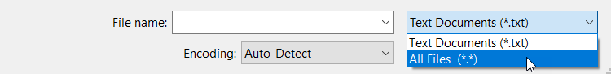

1. Open the *hosts* file.
2. After the comments at the beginning of the file, add the IP address you copied in step 4, followed by “www.concurcdc.cn”.
3. Comments are preceded with a hashtag (#). Your entry should not include the hashtag.
4. **Example entry**
5. 104.81.203.87 www.concurcdc.cn

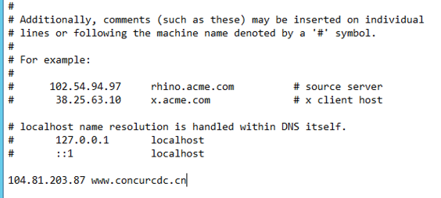

1. In the **File** menu, click **Save**.
2. Connect to www.concurcdc.cn from the Local Machine

After configuring your local *hosts* file to direct connections to www.concurcdc.cn to the akamai staging environment, connect to www.concurcdc.cn from the local machine through the method you need to test.

1. Your system administrator might need to test connections to www.concurcdc.cn made via an API call, connected application, or by navigating to the sign-in page through a web browser and signing in as an SAP Concur user.

#### Configuration / Feature Activation

This change occurs automatically.

### Addition of ECDSA Encryption and Cipher Retirement

|  |  |  |
| --- | --- | --- |
| Information First Published | Information Last Modified | Feature Target Release Date |
| September 30, 2022 | March 17, 2023 | March 16, 2023 |
| Any changes since the previous monthly release are highlighted in yellow in this release note. | | |

**Applies to:**

Travel, Expense, Invoice, Request | All Editions

#### Overview

To provide ongoing security for our products, SAP Concur removed support for the following cipher on March 16, 2023, at 5 PM PST:

|  |  |
| --- | --- |
| Akamai/OpenSSL cipher name | IANA cipher name |
| ECDHE-RSA-AES256-SHA384 | TLS_ECDHE_RSA_WITH_AES_256_CBC_SHA384 |

To better support clients using Windows Server 2012 who relied on this cipher, and to improve security, SAP Concur enabled ECDSA encryption for *concursolutions.com and *api.concursolutions.com. SAP Concur now supports both RSA and ECDSA encryption.

To add support for ECDSA encryption, SAP Concur issued a new security certificate.

With support for ECDSA encryption, support for the following ciphers was also added:

|  |  |
| --- | --- |
| Akamai/OpenSSL cipher name | IANA cipher name |
| ECDHE-ECDSA-AES256-GCM-SHA384 | TLS_ECDHE_ECDSA_WITH_AES_256_GCM_SHA384 |
| ECDHE-ECDSA-AES128-GCM-SHA256 | TLS_ECDHE_ECDSA_WITH_AES_128_GCM_SHA256 |
| ECDHE-ECDSA-CHACHA20-POLY1305 | TLS_ECDHE_ECDSA_WITH_CHACHA20_POLY1305_SHA256 |

##### Business Purpose / Client Benefit

These changes provide ongoing security for our products.

ECDSA encryption provides the following benefits:

* **Stronger Encryption Keys**  
  Small ECC keys have the equivalent strength of larger RSA keys because of the algorithm used to generate them. For example, a 256-bit ECC key is equivalent to a 3072-bit RSA key and a 384-bit ECC key is equivalent to a 7680-bit RSA key. These strong, small keys allow encryption to stay ahead of computing power without having to create longer keys.
* **Smaller Certificate Size**Because of the smaller key size of an ECC certificate, less data is transmitted from the server to the client during the SSL handshake. ECC certificates also require less memory and CPU to process, potentially reducing the impact on network performance and on high-volume or high-traffic sites that larger certificates can have.

#### SAP Concur Supported Ciphers

With the addition of support for ECDSA encryption, the following ciphers included in the **ak-akamai-2020q1** cipher profile are supported:

|  |  |  |
| --- | --- | --- |
| Akamai/OpenSSL cipher name | IANA cipher name | Details |
| TLS-AES-256-GCM-SHA384 | TLS_AES_256_GCM_SHA384 | Supported |
| TLS-CHACHA20-POLY1305-SHA256 | TLS_CHACHA20_POLY1305_SHA256 | Supported |
| TLS-AES-128-GCM-SHA256 | TLS_AES_128_GCM_SHA256 | Supported |
| ECDHE-ECDSA-AES256-GCM-SHA384 | TLS_ECDHE_ECDSA_WITH_AES_256_GCM_SHA384 | Supported with ECDSA encryption, supported by Windows server 2012 |
| ECDHE-ECDSA-AES128-GCM-SHA256 | TLS_ECDHE_ECDSA_WITH_AES_128_GCM_SHA256 | Supported with ECDSA encryption, supported by Windows server 2012 |
| ECDHE-RSA-AES256-GCM-SHA384 | TLS_ECDHE_RSA_WITH_AES_256_GCM_SHA384 | Supported |
| ECDHE-RSA-AES128-GCM-SHA256 | TLS_ECDHE_RSA_WITH_AES_128_GCM_SHA256 | Supported |
| ECDHE-ECDSA-CHACHA20-POLY1305 | TLS_ECDHE_ECDSA_WITH_CHACHA20_POLY1305_SHA256 | Supported with ECDSA encryption |
| ECDHE-RSA-CHACHA20-POLY1305 | TLS_ECDHE_RSA_WITH_CHACHA20_POLY1305_SHA256 | Supported |

1. If your cipher suite includes both supported and unsupported ciphers, connections to *concursolutions.com through a web browser will not be disrupted. During the process of establishing the connection, the *concursolutions.com server will choose the most secure cipher in your cipher suite.

You can confirm that your cipher suite includes a supported cipher by cross-referencing the Akamai/OpenSSL cipher name with the IANA cipher name in the **ak-akamai-2020q1 (default)** column in the following table. Supported ciphers in are indicated with a check mark in the **ak-akamai-2020q1 (default)** column:

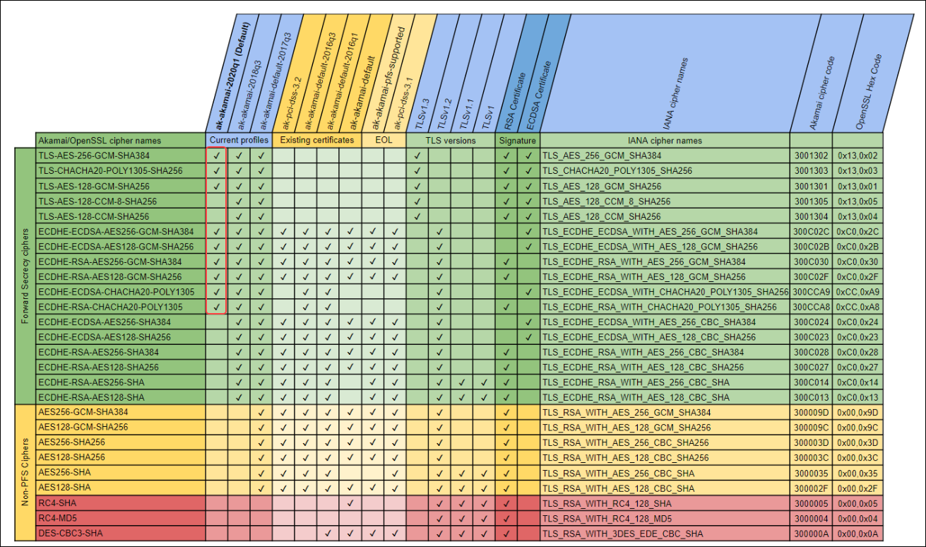

### Admin Tasks – SSL Certificate Update

* **IMPORTANT!** SSL certificates are renewed on a regular basis to ensure the security of our products; because security certificates change periodically, pinning them is not recommended.

#### Clients Who Do Not Pin Security Certificates

Clients who do not pin their security certificates do not need to take any action. Their system will automatically choose the best cipher, RSA or ECDSA, for communication with SAP Concur solutions.

1. Most clients do not pin their certificates.

#### Clients Who Pin Security Certificates

To avoid disruption of service, clients who pin their security certificates must pin both the RSA and ECDSA certificates. The new certificates can be accessed from the following web pages:

**\*.api.concursolutions.com**

<https://assets.concur.com/concurtraining/cte/en-us/api-concursolutions-com-chain_ECDSA.pem>

<https://assets.concur.com/concurtraining/cte/en-us/api-concursolutions-com-chain_RSA.pem>

**\*.concursolutions.com**

<https://assets.concur.com/concurtraining/cte/en-us/concursolutions-com-chain_ECDSA.pem>

<https://assets.concur.com/concurtraining/cte/en-us/concursolutions-com-chain_RSA.pem>

The new certificates must be added before 5:00 PM PST on February 16, 2023.

##### Testing Connections to *concursolutions.com

You can use the SAP Concur test environment, implementation.concursolutions.com, to test the new encryption certificates.

1. To test the new certificates:

* **Windows**

Launch Windows PowerShell and run the following command:

Invoke-WebRequest -Uri https://integration.concursolutions.com

**Expected result:** StatusCode : 200

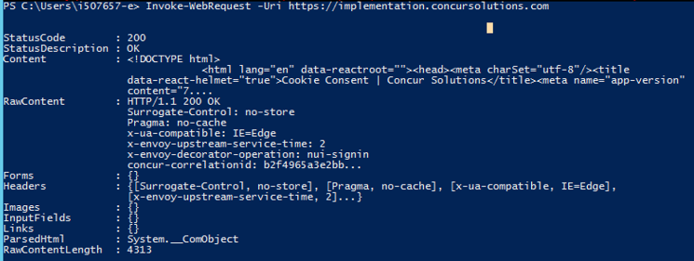

* **Mac**

Open Terminal and run the following command:

curl -vvv https://integration.concursolutions.com

**Expected result:** HTTP/2 200

**Example:**

* Trying 23.204.40.178:443...

* Connected to integration.concursolutions.com (23.52.185.142) port 443 (#0)

* ALPN: offers h2

* ALPN: offers http/1.1

* CAfile: /etc/ssl/cert.pem

* CApath: none

* (304) (OUT), TLS handshake, Client hello (1):

* (304) (IN), TLS handshake, Server hello (2):

* (304) (IN), TLS handshake, Unknown (8):

* (304) (IN), TLS handshake, Certificate (11):

* (304) (IN), TLS handshake, CERT verify (15):

* (304) (IN), TLS handshake, Finished (20):

* (304) (OUT), TLS handshake, Finished (20):

* SSL connection using TLSv1.3 / AEAD-AES256-GCM-SHA384

* ALPN: server accepted h2

* Server certificate:

* subject: C=US; ST=Washington; L=Bellevue; O=Concur Technologies Inc.; CN=*.concursolutions.com

* start date: Sep 29 00:00:00 2022 GMT

* expire date: Sep 29 23:59:59 2023 GMT

* subjectAltName: host "integration.concursolutions.com" matched cert's "*.concursolutions.com"

* issuer: C=US; O=DigiCert Inc; CN=DigiCert TLS RSA SHA256 2020 CA1

* SSL certificate verify ok.

* Using HTTP2, server supports multiplexing

* Copying HTTP/2 data in stream buffer to connection buffer after upgrade: len=0

* h2h3 [:method: GET]

* h2h3 [:path: /]

* h2h3 [:scheme: https]

* h2h3 [:authority: integration.concursolutions.com]

* h2h3 [user-agent: curl/7.86.0]

* h2h3 [accept: */*]

* Using Stream ID: 1 (easy handle 0x7ff438010a00)

> GET / HTTP/2

> Host: integration.concursolutions.com

> user-agent: curl/7.86.0

> accept: */*

< HTTP/2 200

< content-type: text/html; Charset=utf-8

< server: uigw-a8d1c885d0f64e3203d5079dcac82f8e

< surrogate-control: no-store

< cache-control: no-store, no-cache

< pragma: no-cache

##### Testing Connections to *api.concursolutions.com

* **Windows**

**EMEA:**  
Launch Windows PowerShell and run the following command:

Invoke-WebRequest -Uri <https://emea-impl.api.concursolutions.com>

**Expected result:** Invoke-WebRequest : 404 Not Found

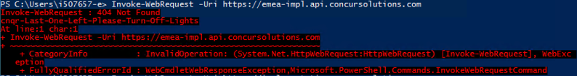

**US:**

Launch Windows PowerShell and run the following command:

Invoke-WebRequest -Uri <https://us-impl.api.concursolutions.com>

**Expected result:** Invoke-WebRequest : 404 Not Found

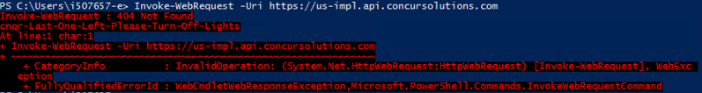

* **Mac**

**EMEA:**

Open Terminal and run the following command:

curl -vvv <https://emea-impl.api.concursolutions.com>

**Expected result:** 404 Not Found

**Example:**

* Trying 104.105.16.162:443...

* Connected to emea-impl.api.concursolutions.com (104.105.16.162) port 443 (#0)

* ALPN: offers h2

* ALPN: offers http/1.1

* CAfile: /etc/ssl/cert.pem

* CApath: none

* (304) (OUT), TLS handshake, Client hello (1):

* (304) (IN), TLS handshake, Server hello (2):

* (304) (IN), TLS handshake, Unknown (8):

* (304) (IN), TLS handshake, Request CERT (13):

* (304) (IN), TLS handshake, Certificate (11):

* (304) (IN), TLS handshake, CERT verify (15):

* (304) (IN), TLS handshake, Finished (20):

* (304) (OUT), TLS handshake, Certificate (11):

* (304) (OUT), TLS handshake, Finished (20):

* SSL connection using TLSv1.3 / AEAD-AES256-GCM-SHA384

* ALPN: server accepted h2...

🡨------ output omitted-----🡪

<html>

<head><title>404 Not Found</title></head>

<body>

<center><h1>404 Not Found</h1></center>

<hr><center>cnqr-Last-One-Left-Please-Turn-Off-Lights</center>

</body>

</html>

* Connection #0 to host emea-impl.api.concursolutions.com left intact

**US:**

Open Terminal and run the following command:

curl -vvv <https://us-impl.api.concursolutions.com>

**Expected result:** 404 Not Found

**Example:**

* Trying 104.105.16.162:443...

* Connected to us-impl.api.concursolutions.com (104.105.16.162) port 443 (#0)

* ALPN: offers h2

* ALPN: offers http/1.1

* CAfile: /etc/ssl/cert.pem

* CApath: none

* (304) (OUT), TLS handshake, Client hello (1):

* (304) (IN), TLS handshake, Server hello (2):

* (304) (IN), TLS handshake, Unknown (8):

* (304) (IN), TLS handshake, Request CERT (13):

* (304) (IN), TLS handshake, Certificate (11):

* (304) (IN), TLS handshake, CERT verify (15):

* (304) (IN), TLS handshake, Finished (20):

* (304) (OUT), TLS handshake, Certificate (11):

* (304) (OUT), TLS handshake, Finished (20):

* SSL connection using TLSv1.3 / AEAD-AES256-GCM-SHA384

...

🡨------ output omitted-----🡪

<html>

<head><title>404 Not Found</title></head>

<body>

<center><h1>404 Not Found</h1></center>

<hr><center>cnqr-Last-One-Left-Please-Turn-Off-Lights</center>

</body>

</html>

* Connection #0 to host us-impl.api.concursolutions.com left intact

#### Configuration / Feature Activation

Clients who do not pin their security certificates do not need to take any action.

For clients who must pin their security certificates, pin both the RSA and ECDSA certificates.

## User Export and Import

### User Export and Import Improvements

|  |  |  |
| --- | --- | --- |
| Information First Published | Information Last Modified | Feature Target Release Date |
| April 22, 2022 | February 10, 2022 | July 21, 2022 – April 6, 2023 |
| Any changes since the previous monthly release are highlighted in yellow in this release note. | | |

**Applies to:**

Expense, Invoice, Request | Standard Edition

#### Overview

SAP Concur has implemented improvements to the user export and import processes.

Improvements include, but are not limited to:

* Improvements to the downloadable user data template including tooltips and drop-down lists
* Removal of the 1000 user maximum for imports and exports of user data
* The addition of a new **Manage Users via a Spreadsheet** page

These improvements were implemented on July 21, 2022, as part of an opt-in experience including a survey for providing feedback on the new experience.

As of August 25, the new experience became the default experience. User admins can still choose to switch back to the old experience and can provide feedback via the survey.

On April 6, 2023, the survey will be removed from the **Users** page and the ability to switch back to the old experience will no longer be available.

##### Business Purpose / Client Benefit

These improvements increase the ease of use and experience of the user import and export processes.

#### Admin Experience

Prior to April 6, 2023, on the **Users** page in Product Settings, a banner with the following message is available at the top of the page:

"Click here to try out the new Manage User via a Spreadsheet experience, and provide your early feedback."

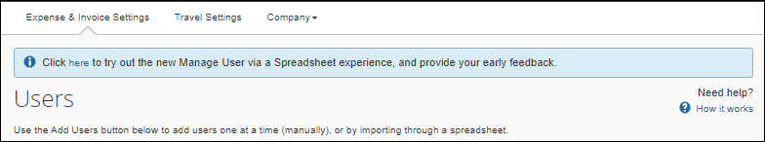

The admin can click the word "here" to opt-in to the experience.

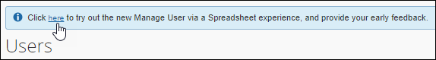

After they click **here**, the banner message text changes to the following:

"Welcome to the new Manage User via a Spreadsheet experience. In addition to the new UI, we have also updated the spreadsheet template to include user-friendly header rows, drop-down menus, and tooltips for your reference. Click here to provide your feedback on the new experience. If you like, you can change back to the existing experience."

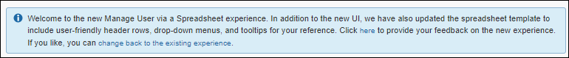

In the new message, the admin can click the word "here" to provide feedback on the experience through a brief survey.

The admin can also click the phrase "change back to the existing experience" to opt out of the new spreadsheet experience.

1. On April 6, 2023, SAP Concur will fully implement the new experience and the ability to switch back to the previous experience will no longer be available.

After opting in to the experience, on the **Users** page in Product Settings, when the admin clicks **Add Users > From Spreadsheet**, the admin sees the new **Manage Users via a Spreadsheet** page.

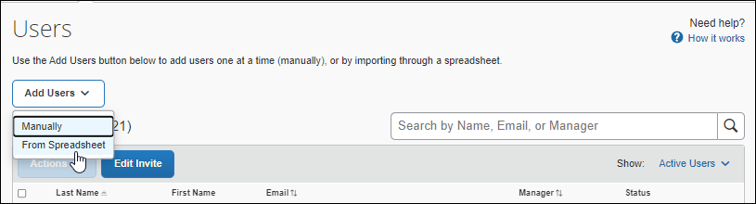

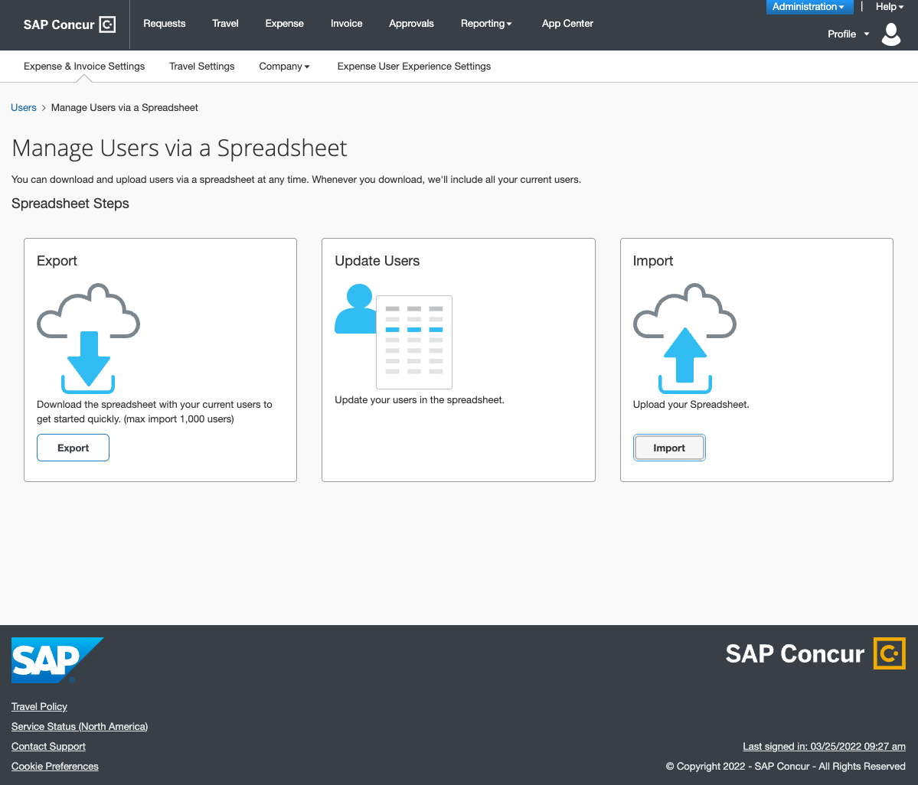

On the **Manage Users via a Spreadsheet** page, the admin can export, update, and import user data. When they export the spreadsheet, they will see new tooltips and, where applicable, drop-down lists in the spreadsheet. In addition, they will no longer be limited to downloading 1000 rows of user data.

**Tooltip Example**

Tooltips appear when you hover over a column header in the spreadsheet.

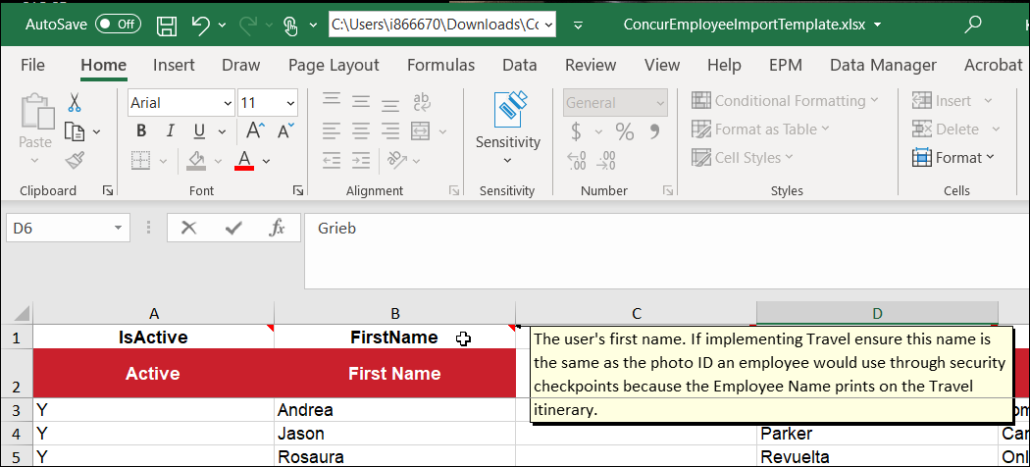

**Drop-down List Example**

Drop-down lists are available for columns where applicable.

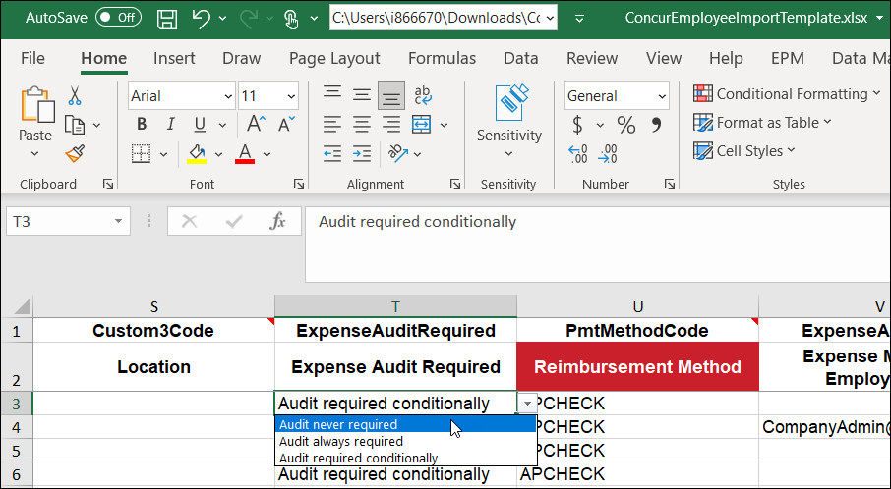

#### Configuration / Feature Activation

After the opt-in/opt-out period ends on April 6, 2023, the new user export/import experience will be automatically available. There are no configuration steps.

# Planned Changes

The following features and changes are targeted for future releases. SAP Concur solutions reserves the right to postpone implementation of – or completely remove – any enhancement/change mentioned here.

## SAP Concur Support

### **Planned Changes** Case Types to be Updated

|  |  |  |
| --- | --- | --- |
| Information First Published | Information Last Modified | Feature Target Release Date |
| April 21, 2023 | -- | Future Release |
| Any changes since the previous monthly release are highlighted in yellow in this release note. | | |

**Applies to:**

All Products | All Editions

#### Overview

In a future release, SAP Concur plans to update the **Case Type** field on the form where an ASC (Authorized Support Contact) creates support cases.

##### Business Purpose / Client Benefit

These changes help SAP Concur more accurately evaluate issues and identify opportunities for product improvement.

#### ASC Experience

The following changes will be made to the case creation form:

* New list items will be added.
* Some list items will be removed.
* Some list items will be renamed.

1. The list of case types that appear in the **Case Type** field when you create a new case depends on the product selected in the **Topic** field.

##### Case Type Field

##### 

##### New Case Types

| Concur Travel | Concur Expense | Concur Invoice | Concur Request |
| --- | --- | --- | --- |
| Accessibility | Accessibility | Accessibility | Accessibility |
| Concur Support Portal | Audit Rules | Audit Rules | Agency Proposals |
| Database Update | Concur Support Portal | Concur Support Portal | Book outside of Concur Travel |
| Security / Fraud | Data Retention | Invoice Administration | Booking with Concur Travel |
| Travel Administration | Delegate | Jobs Data Transfer / Transmission | Concur Support Portal |
| User Assistant / Tools | Expense Administration | Jobs Import | Event Request |
| Vendor / Supplier | Report Creation / Returned | Mobile - Invoice | Request Administration |
| --- | Localization | Process Invoices | Risk Management |
| --- | Mobile – Login / Authentication | Purchase Request | Security / Fraud |
| --- | Permissions | Security / Fraud | Standard Request Abstract |
| --- | Security / Fraud | User Assistant / Tools | Travel Allowance / Mileage |
| --- | User Assistant / Tools | --- | User Assistant / Tools |
| --- | Workflow | --- | --- |

##### Removed Case Types

| Concur Travel | Concur Expense | Concur Invoice | Concur Request |
| --- | --- | --- | --- |
| Data Transfer | E-Mail – Expense | Audit Rules – Exception Messages | Authorization Request – Legacy Feature |
| Permissions | Unspecified – Expense | Error or Warning Message on Request | Booking / Trip Creation |
| TMC Messaging | Workflow / Audit Rules | File Transfer – Core Product | C-Trip |
| Unspecified- Travel | --- | Forms and Fields | Jobs Data Transfer / Transmission |
| Verify | --- | Group Configurations | Missing Segment |
| --- | --- | Invoice Settings | Mobile – Request |
| --- | --- | Jobs | Offline |
| --- | --- | List Management | Permissions |
| --- | --- | Payment Processor | Pre-Travel Authorization – Legacy Feature |
| --- | --- | Policy | Segments Not Updating |
| --- | --- | Printed Invoice / Fax | Unspecified |

##### Renamed Case Types

| Concur Expense | Concur Invoice | Concur Request |
| --- | --- | --- |
| Company Info / Logo | Integration – Extract Services / Custom Extract | Adding Request to an Expense Report |
| Processor | Jobs Export / Extract (Not Analytic Reporting) | Integration – Extract Services / Custom Extract |
| Integration – Extract Services / Custom Extract | Purchase Order | --- |
| Jobs Export / Extract (Not Analytic Reporting) | --- | --- |

#### Configuration / Feature Activation

This change occurs automatically.

## SAP Fiori Themes

### **Planned Changes** SAP Fiori Horizon Themes for Concur Mobile and Web

|  |  |  |
| --- | --- | --- |
| Information First Published | Information Last Modified | Feature Target Release Date |
| February 10, 2023 | April 27, 2023 | May 20, 2023 – Early 2024 |
| Any changes since the previous monthly release are highlighted in yellow in this release note. | | |

**Applies to:**

All Products | All Editions

#### Overview

SAP Concur plans to adopt the SAP Fiori with Horizon visual design theme family for all SAP Concur solutions on both the mobile app and the web.

Implementation of the SAP Fiori with Horizon visual design theme impacts the look and feel of SAP Concur solutions by updating fonts, font sizes, icons, colors, and shapes. In addition, in both the SAP Concur mobile and web UI, navigation from the home page is slightly modified.

Introduction of the new design themes will be phased beginning on May 20, 2023. SAP Concur plans to fully implement the new theme, decommissioning the current, legacy theme, in 2024.

##### Business Purpose / Client Benefit

These changes improve the overall user experience, better support accessibility features, and help to provide a consistent user experience across all SAP products.

#### Admin Experience

##### Mobile

SAP Concur plans to implement SAP Fiori with Horizon in the Mobile app over time starting on June 5, 2023.

##### Web UI

SAP Fiori with Horizon Theme Implementation Phases:

**Current:** SAP Concur client admins can currently preview the SAP Fiori for Horizon themes through a designated URL.

* For more information about previewing SAP Fiori for Horizon themes via the URL, refer to the *Preview Horizon for Fiori Themes in SAP Concur* release note in the *Release Notes* section of this document.

**Phase 1 – May 20, 2023**: SAP Concur plans to provide clients with access to the **Appearance Admin** page.

On the **Appearance Admin** page, an admin can choose between the following options:

* **Legacy Concur UI:** End users only see the legacy Concur Gateway theme.
* **Legacy Concur UI and Fiori Horizon:** End users see the legacy Concur Gateway theme by default. On the **Profile Settings > System Settings** page, they can choose between the Concur Gateway theme, Morning Horizon, Evening Horizon, and high contrast themes.
* **Fiori Horizon:** End users see Morning Horizon by default. On the **Profile Settings > System Settings** page they can choose between the Morning Horizon, Evening Horizon, and high contrast themes.

**Phase 2 – October 2023:** Morning Horizon becomes the default theme for all clients. SAP Concur client admins have access to the **Appearance Admin** page and can revert to the legacy Concur Gateway theme if needed.

**Phase 3 – Early 2024:** SAP Concur plans to decommission the legacy Concur Gateway theme. When it is decommissioned, Morning Horizon will become the default theme and end users will be able to choose between Morning Horizon, Evening Horizon, and high contrast themes.

1. **Clients with SAP Fiori Quartz themes**: On October 2, 2023, SAP Concur will retire the SAP Fiori 3 Quartz themes and clients with SAP Fiori 3 Quartz themes will automatically default to the SAP Fiori with Horizon visual themes.

#### End User Experience

With the SAP Fiori with Horizon visual design themes, the overall look of SAP Concur solutions is updated with new fonts, icons, colors, and shape design.

##### Legacy Page Design Example

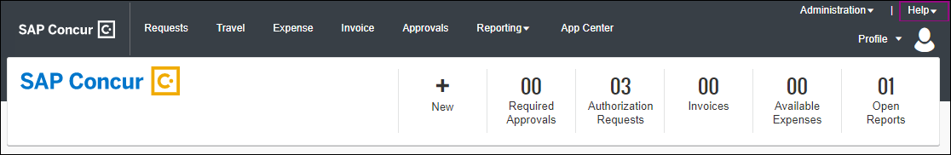

##### SAP Fiori With Horizon Design Example

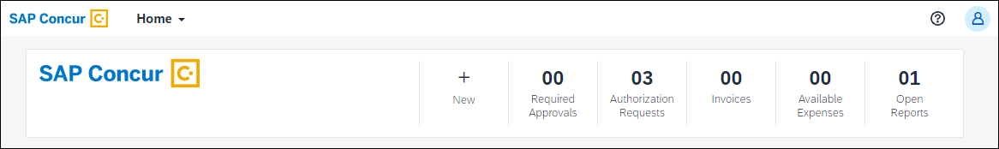

Navigation from the SAP Concur home page is also slightly modified so that it is simpler and more consistent with other SAP products.

##### Legacy Home Page Navigation

With the legacy theme, navigation from the home page relies on product tabs and the **Administration** menu.



##### SAP Fiori With Horizon Home Page Navigation

With the SAP Fiori with Horizon visual design theme, navigation from the Concur home page to Concur product and administration pages is consolidated in the **Home** menu.

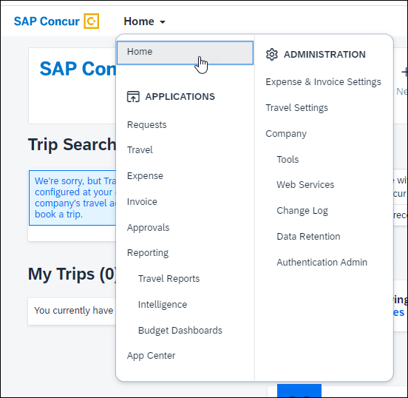

#### Configuration / Feature Activation

SAP Concur plans to implement these changes over time through a phased approach starting on May 20, 2023.

# Client Notifications

## Accessibility

### Accessibility Enhancements

SAP implements changes to better meet current Web Content Accessibility Guidelines (WCAG). Information about accessibility-related changes made to SAP Concur solutions is published on a quarterly basis. You can review the quarterly updates on the [Accessibility Updates](https://help.sap.com/docs/SAP_CONCUR/caf7d7289796414a91e130a5169d8e71/84234e2c0e844ca09e7a91213e6c8646.html) page.

## Subprocessors

### SAP Concur Non-Affiliated Subprocessors

The list of non-affiliated subprocessors is available from the *SAP Sub-processors / Data Transfer Factsheets* page.

1. To access the SAP Concur Sub-processors List:
2. Click the following link to navigate to the *SAP Sub-processors / Data Transfer Factsheets* page:  
   [*SAP Sub-processors / Data Transfer Factsheets*](https://support.sap.com/en/my-support/trust-center/subprocessors.html)
3. Sign in to the SAP Support Portal using your Support User ID (S-user) and password.
4. SAP customers must sign in to the SAP Support Portal using their Support User ID (S-user) and password. For information about S-User IDs, refer to [*Your New Support User ID (S-user)*](https://support.sap.com/en/my-support/users/welcome.html) and to the [*Learn All About S-User IDs*](https://blogs.sap.com/2021/03/09/learn-all-about-s-user-ids/) blog post.
5. On the *SAP Sub-processors / Data Transfer Factsheets* page, type "Concur" in the **Search** field.
6. In the **Title** column, click **SAP Concur Sub-processors List**.

If you have questions or comments, please reach out to: [Privacy-Request@Concur.com](mailto:Privacy-Request@Concur.com)

## Supported Browsers

### Supported Browsers and Changes to Support

For information about supported browsers and planned changes to supported browsers, the [*Concur Travel & Expense Supported Configurations*](http://www.concurtraining.com/customers/tech_pubs/Docs/Z_SuppConfig/Supported_Configurations_for_Concur_Travel_and_Expense.pdf) guide.

When changes to browser support are planned, information about those changes will also appear in the [*Shared Planned Changes*](https://www.concurtraining.com/customers/tech_pubs/RN_shared_planned/_client_shared_RN_all.htm) release notes.

# Additional Release Notes and Other Technical Documentation

## Online Help

You can access release notes, setup guides, user guides, admin summaries, supported configurations, and other resources via the in-product Help menu or directly on the SAP Help Portal.

To access the full set of documentation for your product, use the links in the SAP Concur **Help** menu, or visit the [SAP Concur solutions page](https://help.sap.com/docs/SAP_CONCUR).

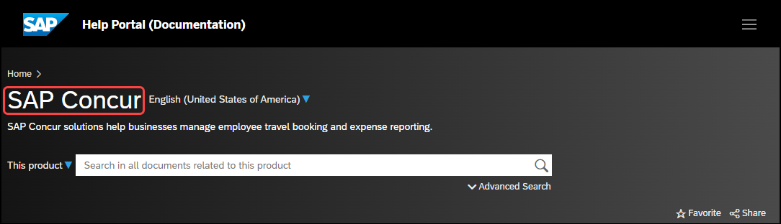

## SAP Concur Support Portal – Selected Users

Access release notes, webinars, and other technical documentation on the SAP Concur support portal.

If you have the required permissions, **Contact** **Support** is available on the SAP Concur **Help** menu and in the SAP Concur page footer.

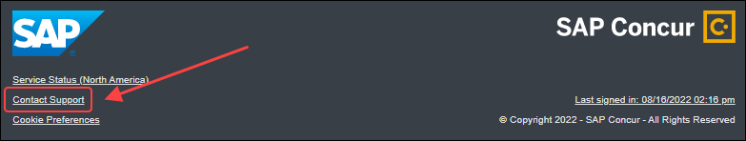

Click **Contact Support** to access the SAP Concur support portal, then click **Resources**.

* Click **Release/Tech Info** for release notes, technical documents, etc.
* Click **Webinars** for recorded and live webinars.

© 2023 SAP SE or an SAP affiliate company. All rights reserved.

No part of this publication may be reproduced or transmitted in any form or for any purpose without the express permission of SAP SE or an SAP affiliate company.

SAP and other SAP products and services mentioned herein as well as their respective logos are trademarks or registered trademarks of SAP SE (or an SAP affiliate company) in Germany and other countries. Please see http://global12.sap.com/corporate-en/legal/copyright/index.epx for additional trademark information and notices.

Some software products marketed by SAP SE and its distributors contain proprietary software components of other software vendors.

National product specifications may vary.

These materials are provided by SAP SE or an SAP affiliate company for informational purposes only, without representation or warranty of any kind, and SAP SE or its affiliated companies shall not be liable for errors or omissions with respect to the materials. The only warranties for SAP SE or SAP affiliate company products and services are those that are set forth in the express warranty statements accompanying such products and services, if any. Nothing herein should be construed as constituting an additional warranty.

In particular, SAP SE or its affiliated companies have no obligation to pursue any course of business outlined in this document or any related presentation, or to develop or release any functionality mentioned therein. This document, or any related presentation, and SAP SE’s or its affiliated companies’ strategy and possible future developments, products, and/or platform directions and functionality are all subject to change and may be changed by SAP SE or its affiliated companies at any time for any reason without notice. The information in this document is not a commitment, promise, or legal obligation to deliver any material, code, or functionality. All forward-looking statements are subject to various risks and uncertainties that could cause actual results to differ materially from expectations. Readers are cautioned not to place undue reliance on these forward-looking statements, which speak only as of their dates, and they should not be relied upon in making purchasing decisions.