|  |  |
| --- | --- |
| SAP Concur Release Notes  Shared Changes  Includes cross-product and site-wide changes for:  Professional Edition, Standard Edition, and Small Business Edition | |
| **Month** | **Audience** |
| Release Date: January 21, 2023  Initial Post: Friday, January 20, 2023 | Client FINAL |

Contents

Release Notes 1

Currencies 2

Euro Replaces Kuna as the Official Currency of Croatia 2

Expense, Invoice, Request, Mobile | Professional & Standard 2

Financial Integration 4

Reconnect to ERP Without Disconnecting 4

Expense, Invoice | Standard Edition 4

File Transfer Updates 6

New File Transfer Endpoints After Migration to AWS 6

All Products | Professional & Standard 6

**Ongoing** Rotating PGP Key for File Transfers 9

Travel, Expense, Invoice, Request, Intelligence | Professional & Standard 9

Home Page 11

**Ongoing ** SAP Concur Homepage Changes 11

All Products | All Editions 11

Imaging 14

Imaging Database System Maintenance 14

Expense, Invoice, Request, Budget, Mobile | Professional & Standard 14

Miscellaneous 15

New IP Address Range for Callouts (EMEA, US) 15

Expense, Request | Professional & Standard 15

SAP Concur Migration to Cloud Platform in AWS 16

All Products | All Editions 16

Test Entities | Production Sandbox Environment 18

Most Recently Used Lists Not Migrated 18

Expense, Invoice, Request | Professional 18

Production Sandbox Environment Login Updates 20

Expense, Invoice, Request | Professional 20

Unique Address Required for PSE Email Verification 25

Expense, Invoice, Request | Professional 25

User Export and Import 27

**Ongoing** User Export and Import Improvements 27

Expense, Invoice, Request | Standard Edition 27

Planned Changes 31

Data Retention 31

**Planned Changes** Data Retention Feature Enhancements 31

All Products | All Editions 31

Fapiao 32

**Planned Changes** Fapiao Capture Support for EMEA and US Datacenters 32

Travel, Expense, Invoice, Request, Mobile | Professional Edition 32

Financial Integration 34

**Planned Changes** Microsoft Dynamics 365 Business Central Integration 34

Expense, Invoice | Professional & Standard 34

Security 36

**Planned Changes** Addition of ECDSA Encryption and Cipher Retirement 36

Travel, Expense, Invoice, Request | All Editions 36

Admin Tasks – SSL Certificate Update 39

**Planned Changes** New *.concursolutions.com and *api.concursolutions.com SSL certificates (Feb 16) 43

All | All 43

User Assistance 45

**Planned Changes** How It Works Links To Be Decommissioned 45

Expense, Invoice, Request, Budget| Standard Edition 45

Client Notifications 47

Accessibility 47

Accessibility Enhancements 47

Subprocessors 47

SAP Concur Non-Affiliated Subprocessors 47

Supported Browsers 48

Supported Browsers and Changes to Support 48

Additional Release Notes and Other Technical Documentation 49

Online Help 49

SAP Concur Support Portal – Selected Users 49

Legal Disclaimer

The information in this presentation is confidential and proprietary to SAP SE or an SAP affiliate company and may not be disclosed without the permission of SAP SE or the respective SAP affiliate company. This presentation is not subject to your license agreement or any other service or subscription agreement with SAP SE or its affiliated companies. SAP SE and its affiliated companies have no obligation to pursue any course of business outlined in this document or any related presentation, or to develop or release any functionality mentioned therein. This document, or any related presentation and SAP SE or an SAP affiliate company’s strategy and possible future developments, products and or platforms directions and functionality are all subject to change and may be changed by SAP SE and its affiliated companies at any time for any reason without notice. The information in this document is not a commitment, promise or legal obligation to deliver any material, code or functionality. This document is provided without a warranty of any kind, either express or implied, including but not limited to, the implied warranties of merchantability, fitness for a particular purpose, or non-infringement. This document is for informational purposes and may not be incorporated into a contract. SAP SE and its affiliated companies assume no responsibility for errors or omissions in this document, except if such damages were caused by SAP SE or an SAP affiliate company’s willful misconduct or gross negligence.

All forward-looking statements are subject to various risks and uncertainties that could cause actual results to differ materially from expectations. Readers are cautioned not to place undue reliance on these forward-looking statements, which speak only as of their dates, and they should not be relied upon in making purchasing decisions.

# Release Notes

This document contains shared release notes and planned changes. Shared release notes and planned changes document features and changes that apply to SAP Concur solutions site-wide or to multiple SAP Concur products and services. They include but are not limited to:

* Security-related features and changes such as annual security certificate renewals and changes in support for security ciphers and protocols
* Site-wide UI features and changes such as changes to the home page, changes to the site header or footer, or the implementation of new site-wide UI themes
* Sign-in process features and changes such as the addition or removal of sign-in features, URL changes, and domain name changes
* Production and test environment features and changes
* Global settings or administration page features and changes such as the addition of new site-wide settings or changes to the design of the administration pages
* Changes to processes such as where and when release notes are published

For New Features and Changes that apply to a single product and/or service see the release notes for that product or service. Links to the product and service-specific release notes can be found on the following pages:

* [Professional Edition](https://www.concurtraining.com/customers/tech_pubs/_RN_CCC.htm)
* [Standard Edition](https://www.concurtraining.com/customers/tech_pubs/_Docs_CCC_CPS.htm)
* [Small Business Edition](http://www.concurtraining.com/customers/tech_pubs/Docs/Breeze/RN/WhatsNew.htm)

## Currencies

### Euro Replaces Kuna as the Official Currency of Croatia

|  |  |  |
| --- | --- | --- |
| Information First Published | Information Last Modified | Feature Target Release Date |
| December 9, 2022 | -- | December 7, 2022, and January 31, 2023 |
| Any changes since the previous monthly release are highlighted in yellow in this release note. | | |

**Applies to:**

Expense, Invoice, Request, Mobile | Professional & Standard

#### Overview

On January 1, 2023, the Euro (EUR) will replace the Kuna (HRK) as the official currency of Croatia. To support this change, on December 7, 2022, SAP Concur solutions will begin defaulting to EUR as the default currency for new, manually created transactions that are configured with Croatian currency.

1. Imported transactions—for example, credit card transactions—will continue to use the currency designated in the transaction. SAP Concur solutions will not change the designated currency for imported transactions.

Between December 7, 2022, and January 31, 2023, users will be able to reset the currency from EUR to HRK manually. Beginning on January 31, 2023, users will no longer be able to create new transactions set to HRK. All Croatian transactions will be set to EUR.

1. Transactions that were created prior to January 31, 2023, with HRK as the configured currency will not be impacted by this change and will be processed with the configured (HRK) currency.

##### Business Purpose / Client Benefit

This change ensures that SAP Concur solutions support the correct currency for Croatia.

#### End-User Experience

In flight transactions created before January 31, 2023—for example, expenses, invoices, and requests—will continue to be processed with the originally configured currency.

As of December 7, 2022, when a user manually creates a new transaction with Croatian currency, the currency will default to EUR. Users will be able to reset the currency to HRK through January 31, 2023.

As of January 31, 2023, all new transactions located within Croatia will be set to EUR and users cannot change them to HRK.

#### Admin Experience

Depending on the client’s configuration, an SAP Concur admin might need to update custom configurations such as audit rules, mileage rates, and vendor information.

* **IMPORTANT:** Clients with mileage rates set to HRK must deactivate/delete the old configuration and replace it with a configuration set to EUR. For information on configuring mileage rates, refer to *the* [*Concur Expense: Mileage Service Setup Guide for Concur Professional Edition*](https://www.concurtraining.com/customers/tech_pubs/Docs/_Current/SG_Exp/Exp_SG_Mileage_Service.pdf) or the [*Concur Expense: Mileage Service Setup Guide for Concur Standard Edition*](https://www.concurtraining.com/customers/tech_pubs/Docs/ConcurPremier/SG_Exp/SG_Exp_Mileage_Service.pdf).

#### Configuration / Feature Activation

This change occurs automatically. Some administrative changes might need to be made—for example, audit rules related to spending limits and configured mileage rates might need to be updated to reflect EUR values.

* **IMPORTANT:  
  Concur Expense and Concur Request:** This change does not impact the reimbursement currency assigned to users. This change is tightly coupled with the internal timing of client financial systems, and it must be executed via an employee update initiated by the individual client. In most cases, employee updates are made through an automated feed/import from an HR system.  
    
  Mileage reimbursement configurations for Croatia that are set to HRK must be replaced with new mileage reimbursement configurations set to EUR. This change must be coordinated with the timing of the change for user reimbursement currency.  
    
  **Concur Invoice:** This change does not impact the payment currency assigned to vendors. This change should be coupled with the internal timing for client Accounts Payable systems. It must be implemented through a vendor master update initiated by the individual client.

## Financial Integration

### Reconnect to ERP Without Disconnecting

|  |  |  |
| --- | --- | --- |
| Information First Published | Information Last Modified | Feature Target Release Date |
| January 20, 2023 | -- | January 21, 2023 |
| Any changes since the previous monthly release are highlighted in yellow in this release note. | | |

**Applies to:**

Expense, Invoice | Standard Edition

#### Overview

With this release, clients can reconnect to their company entity in Concur Expense or Concur Invoice without disconnecting from their financial integration system. On the **Accounting** page in Product Settings, a new **Reconnect with Financial System** button enables administrators to refresh the connection with the existing connected company.

With this update:

* Clients with in-flight reports can reconnect to their company entity without disconnecting from their financial system integration.
* Administrators can change log in credentials when they click the Disconnect from Financial System button and then click the Reconnect **with Financial System** button.

This update applies to the following financial system integrations:

* QuickBooks Desktop
* QuickBooks Online
* Xero Accounting
* Sage Intacct Accounting

##### Business Purpose / Client Benefit

This update ensures that clients can refresh their ERP connection without disrupting the connection to their financial system.

#### Admin Experience

After signing in to a company entity and connecting with a financial integration system, the **Reconnect with Financial System** button is now available on the **Accounting** page in Product Settings.

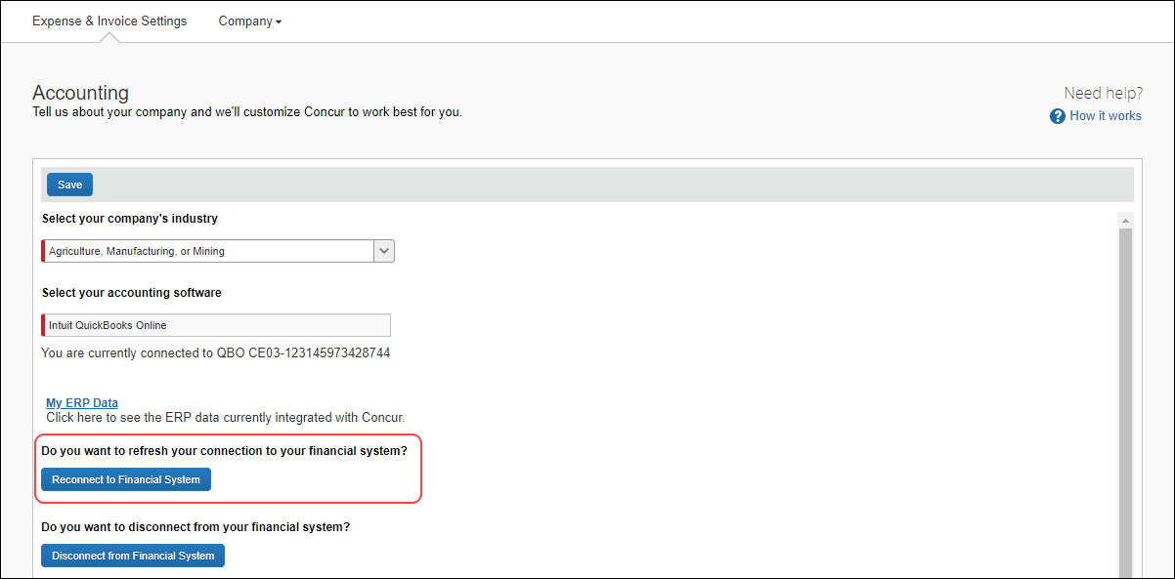

Admins can click the **Reconnect with Financial System** button to refresh the connection with their existing connected company entity.

A warning message displays confirming whether to refresh the connection.

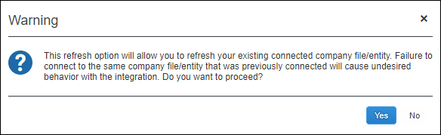

Admins can click **Yes** to refresh the connection.

Clicking **No** cancels the action and closes the dialog box.

* **IMPORTANT NOTE:** Failure to connect to the same company file/entity that was previously connected will cause undesired behavior with the integration.

After successfully authenticating to the financial integration system, admins will be directed back to the **Accounting** page in Product Settings. Admins will see they are connected and which company is currently connected.

On the **Accounting** page, admins should see data when clicking the **My ERP Data** link.

##### QuickBooks Desktop Experience

When an admin clicks the **Reconnect with Financial System** button, they see a new password and new QWC file generated. With the new file and password, admins should be able to connect with QuickBooks Desktop and sync data for any in-flight reports.

#### Configuration / Feature Activation

This change occurs automatically.

## File Transfer Updates

### New File Transfer Endpoints After Migration to AWS

|  |  |  |
| --- | --- | --- |
| Information First Published | Information Last Modified | Feature Target Release Date |
| June 10, 2022 | January 20, 2023 | January 31, 2023 |
| Any changes since the previous monthly release are highlighted in yellow in this release note. | | |

**Applies to:**

All Products | Professional & Standard

#### Overview

The SAP Concur migration to Cloud Platform in AWS is complete. With the migration, new endpoints were implemented for file transfers and notification of these changes was sent to clients impacted by these changes.

The legacy file transfer service will be shut down on February 1, 2023. If these changes apply to your company, you have until January 31, 2023, to switch from the old endpoint(s) to the new AWS Transfer endpoint(s).

If you’ve already completed the update, no further action is required.

1. This change applies to both production and Production Sandbox Environment (PSE) entities.

This announcement pertains to the following file transfer DNS endpoints:

* st.concursolutions.com
* mft-us.concursolutions.com
* vs.concursolutions.com
* st-eu.concursolutions.com
* mft-eu.concursolutions.com

##### Business Purpose / Client Benefit

The SAP Concur migration to Cloud Platform in AWS provides a stronger security posture, improved performance and stability, and faster innovation for our clients.

For more information about the migration, refer to the [*SAP Concur Cloud Platform Strategy FAQ*](http://assets.concur.com/concurtraining/cte/en-us/FAQ_Cloud_Hosting_Strategy.pdf).

#### Configuration / Feature Activation

The legacy file transfer service will be shut down on February 1, 2023. You must update your systems to point to the new AWS Transfer endpoints by January 31, 2023.

You can perform the following steps to verify your entity has been migrated and then update your AWS transfer endpoints.

##### Before Switching to the AWS SFTP Endpoints

* **Required:** Review the [AWS Transfer for SFTP Migration FAQ](https://go.concur.com/rs/013-GAX-394/images/Final%20IFMFAQ.pdf).
* The *Operational Guidance for Executing Required Change* section is critical to review.
* **Recommended:** Review the user guide, [*Transferring files using a client*](https://docs.aws.amazon.com/transfer/latest/userguide/transfer-file.html)*,* available from Amazon’s document repository. Follow the steps in the guide that apply to any SFTP applications your organization uses.

##### Confirm your entities have been migrated to AWS

1. Navigate to SAP Concur solutions, sign in, and then scroll to the bottom of the page.
2. At the bottom of the page, locate the phrase “Service Status.”

If your entity has been migrated, **(US2)** or **(EU2)** follows “Service Status.”

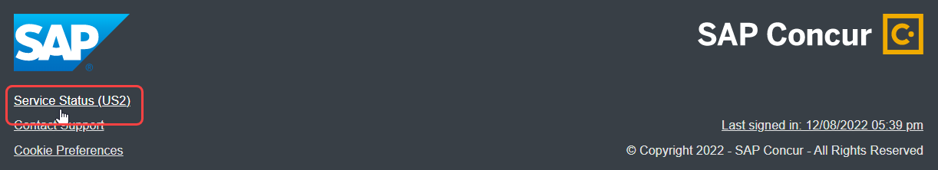

If your entity has not been migrated, **(North America) or (EMEA)** follows “Service Status.”

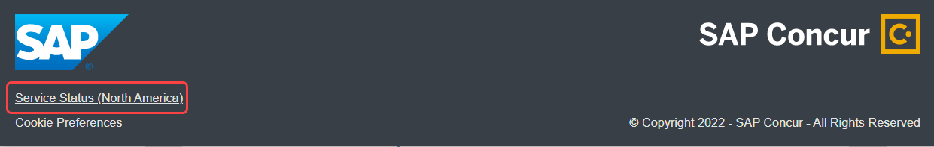

1. **Clients with Cognos (ReportNet) files:** Clients with Cognos files will continue to download their files from the legacy data center until further notice.

If your organization uses any of the endpoints in the table that follows for file transmissions with SAP Concur solutions, you must switch to the corresponding AWS endpoint by January 31, 2023. If you do not update your endpoints by that date, your file transfer account will be disabled on the legacy data center and you will not be able to connect to SAP Concur solutions for file transmissions. This applies to both primary production and PSE entities.

**Use the following table to determine which AWS transfer endpoint to connect to:**

|  |  |  |  |  |  |
| --- | --- | --- | --- | --- | --- |
| **Environment** | **Current Endpoint (Legacy DC)** | **Current IP (Legacy DC)** | **AWS Transfer Endpoint** | **AWS Transfer IPs** | **AWS Transfer SSH Server Fingerprint** |
| North America DC | st.concursolutions.com | 12.129.29.5 | mft-us2.concursolutions.com | 34.216.251.54, 35.83.74.180, 35.81.194.197 | SHA256:A+6pVvfQpGaSZfwvDenRBatqA9GE5YAbFOiKJASC7wI |
| North America DC | mft-us.concursolutions.com | 12.129.29.138 | mft-us2.concursolutions.com | 34.216.251.54, 35.83.74.180, 35.81.194.197 | SHA256:A+6pVvfQpGaSZfwvDenRBatqA9GE5YAbFOiKJASC7wI |
| EMEA DC | st-eu.concursolutions.com | 46.243.56.11 | mft-eu2.concursolutions.com | 3.64.91.253, 3.125.188.25, 18.198.91.237 | SHA256:VL9jvUNfc7lDX1pFaEVN2/UC7y/chtLdT63E3qJVbyk |
| EMEA DC | mft-eu.concursolutions.com | 46.243.56.21 | mft-eu2.concursolutions.com | 3.64.91.253, 3.125.188.25, 18.198.91.237 | SHA256:VL9jvUNfc7lDX1pFaEVN2/UC7y/chtLdT63E3qJVbyk |

* **IMPORTANT:** Confirm that your entities have been migrated before changing to the new endpoints. If you change the endpoint for file transfer accounts that are not yet migrated, your uploaded files will not be processed.

For questions regarding this change, please speak with your IT or networking teams. For support from SAP Concur on making this update, review the [*AWS Migration FAQ*](https://go.concur.com/rs/013-GAX-394/images/Final%20IFMFAQ.pdf), visit the support portal, and submit a support case by choosing “Topic: Expense”> “Case Type: Jobs Data Transfer/Transmission”.

### **Ongoing** Rotating PGP Key for File Transfers

|  |  |  |
| --- | --- | --- |
| Information First Published | Information Last Modified | Feature Target Release Date |
| February 2021 | October 14, 2022 | January 15, 2021, and October 11, 2022 |
| Any changes since the previous monthly release are highlighted in yellow in this release note. | | |

**Applies to:**

Travel, Expense, Invoice, Request, Intelligence | Professional & Standard

#### Overview

Files transferred to SAP Concur products must be encrypted with the SAP Concur public PGP key, concursolutionsrotate.asc.

* **IMPORTANT!  
    
  PGP key changes:**• The legacy (non-rotating) key, key ID D4D727C0, was deprecated on October 11, 2022.  
    
  • The previous rotating key, key ID 40AC5D35, expired on September 4, 2022. • The current rotating key, key ID 9AFF10B5, is available in the client's root folder.

**Current rotating PGP key details:**

* Key ID: 9AFF10B5
* Filename: concursolutionsrotate.asc
* The filename for the rotating PGP key does not change when the key is rotated.
* RSA 4096-bit signing and encryption subkey
* The current key expires on September 4, 2024.
* A new key will be available 90 days before the September 4, 2024, expiration date.
* Clients are responsible for replacing the rotating key before it expires.

**Legacy (non-rotating) PGP key details:**

* Key ID: D4D727C0
* The SAP Concur legacy (non-rotating) PGP key was deprecated on October 11, 2022.
* Cognos (ReportNet) files are signed with our legacy key for the US endpoints that follow. Cognos files will no longer be signed as of March 14, 2023:
* st.concursolutions.com
* mft-us.concursolutions.com
* AWS transfer endpoints

This announcement pertains to the following file transfer DNS endpoints:

* st.concursolutions.com
* mft-us.concursolutions.com
* vs.concursolutions.com
* st-eu.concursolutions.com
* mft-eu.concursolutions.com
* AWS transfer endpoints (when they are communicated to you)

##### Business Purpose / Client Benefit

The rotating public PGP key provides greater security for file transfers.

#### Admin Experience

An administrator with the required file transfer credentials can log into the file transfer site to retrieve the rotating public PGP key, concursolutionsrotate.asc, from the root directory.

#### Configuration / Feature Activation

Your internal file transfer administrator can add the current rotating key to their PGP keyring and start using it to encrypt files being transferred to SAP Concur.

If you require assistance, please contact SAP Concur support.

For more information, refer to the [*Shared: File Transfer for Customers and Vendors User Guide*](http://www.concurtraining.com/customers/tech_pubs/Docs/ConcurPremier/UG_Shr/Shr_UG_FileTransfer.pdf).

## Home Page

### **Ongoing ** SAP Concur Homepage Changes

|  |  |  |
| --- | --- | --- |
| Information First Published | Information Last Modified | Feature Target Release Date |
| December 4, 2020 | May 13, 2022 | Q4 2021 – Future Release |
| Any changes since the previous monthly release are highlighted in yellow in this release note. | | |

**Applies to:**

All Products | All Editions

#### Overview

In Q4, 2021, SAP Concur began redirecting clients to a new homepage. The appearance of the new homepage is identical to the previous SAP Concur homepage. The new homepage has enhanced functionality when services become temporarily unavailable.

The roll out of the new homepage is phased:

**Phase 1:** In October of 2021, SAP Concur began redirecting Concur Expense, Concur Invoice, and Concur Request clients in the US Datacenter to the new homepage.

**Phase 2:** In December 2021, SAP Concur began redirecting Concur Expense, Concur Invoice, and Concur Request clients in the EU Datacenter to the new homepage.

**Phase 3:** At a date to be determined, SAP Concur will begin redirecting the remaining clients in the US and EU datacenters to the new homepage. The remaining clients include those with Concur Travel standalone or Concur Travel with Expense, Invoice, and/or Request.

##### Business Purpose / Client Benefit

This change ensures that the SAP Concur homepage is available even when some services are unavailable and improves the consistency of the sign in experience.

#### End-User Experience

With the old homepage, when a user signs into their SAP Concur products, they see their homepage.

1. The appearance of the homepage varies depending on which products and services are enabled for the client and the permissions assigned to the user.

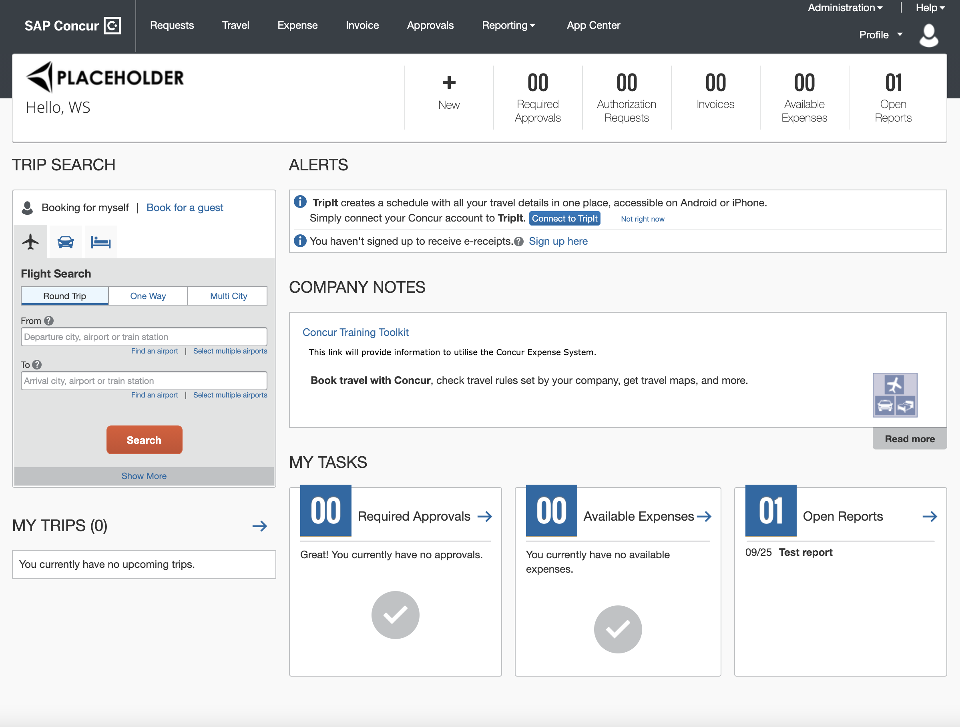

If some products or services are unavailable while other products and services are up and running, a modified version of the user’s homepage similar to the following appears:

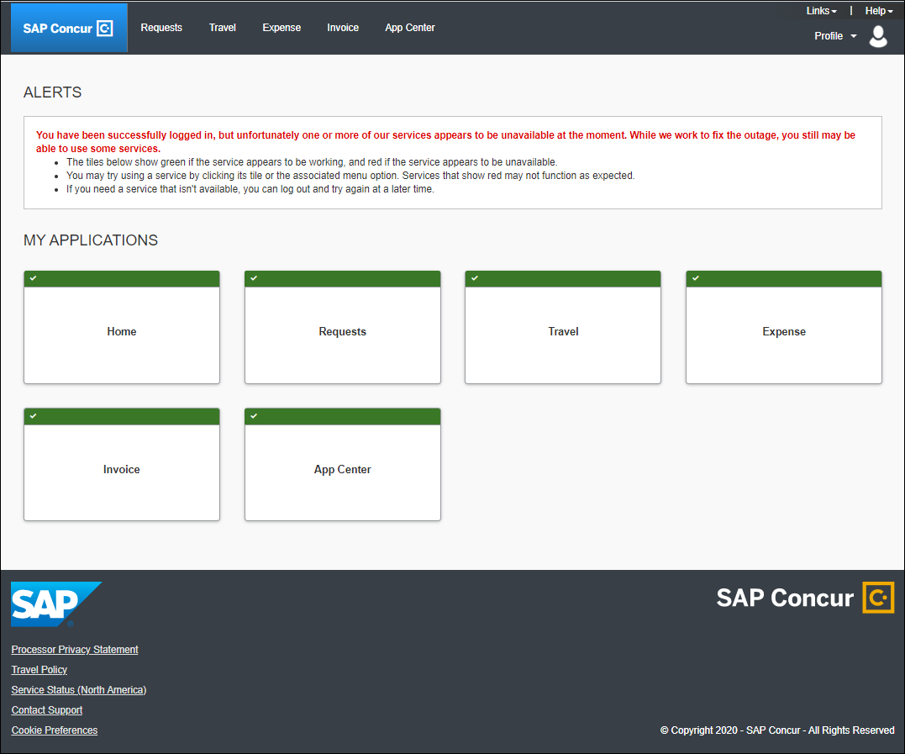

After a client is migrated to the new homepage, if one or more services are unavailable, when a user signs in to their SAP Concur products, they will see the usual homepage, but if the user navigates to a page for a service that is unavailable, they will see a page similar to the following:

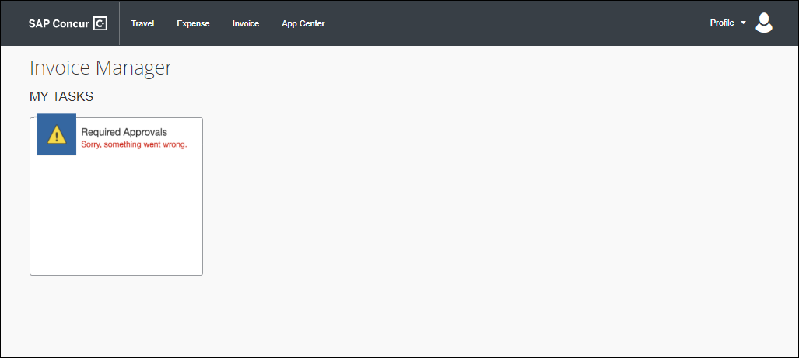

After migration to the new homepage, if all services are available, this change is transparent to the user and they see a homepage that is identical to the pre-migration homepage.

**Example Homepage**

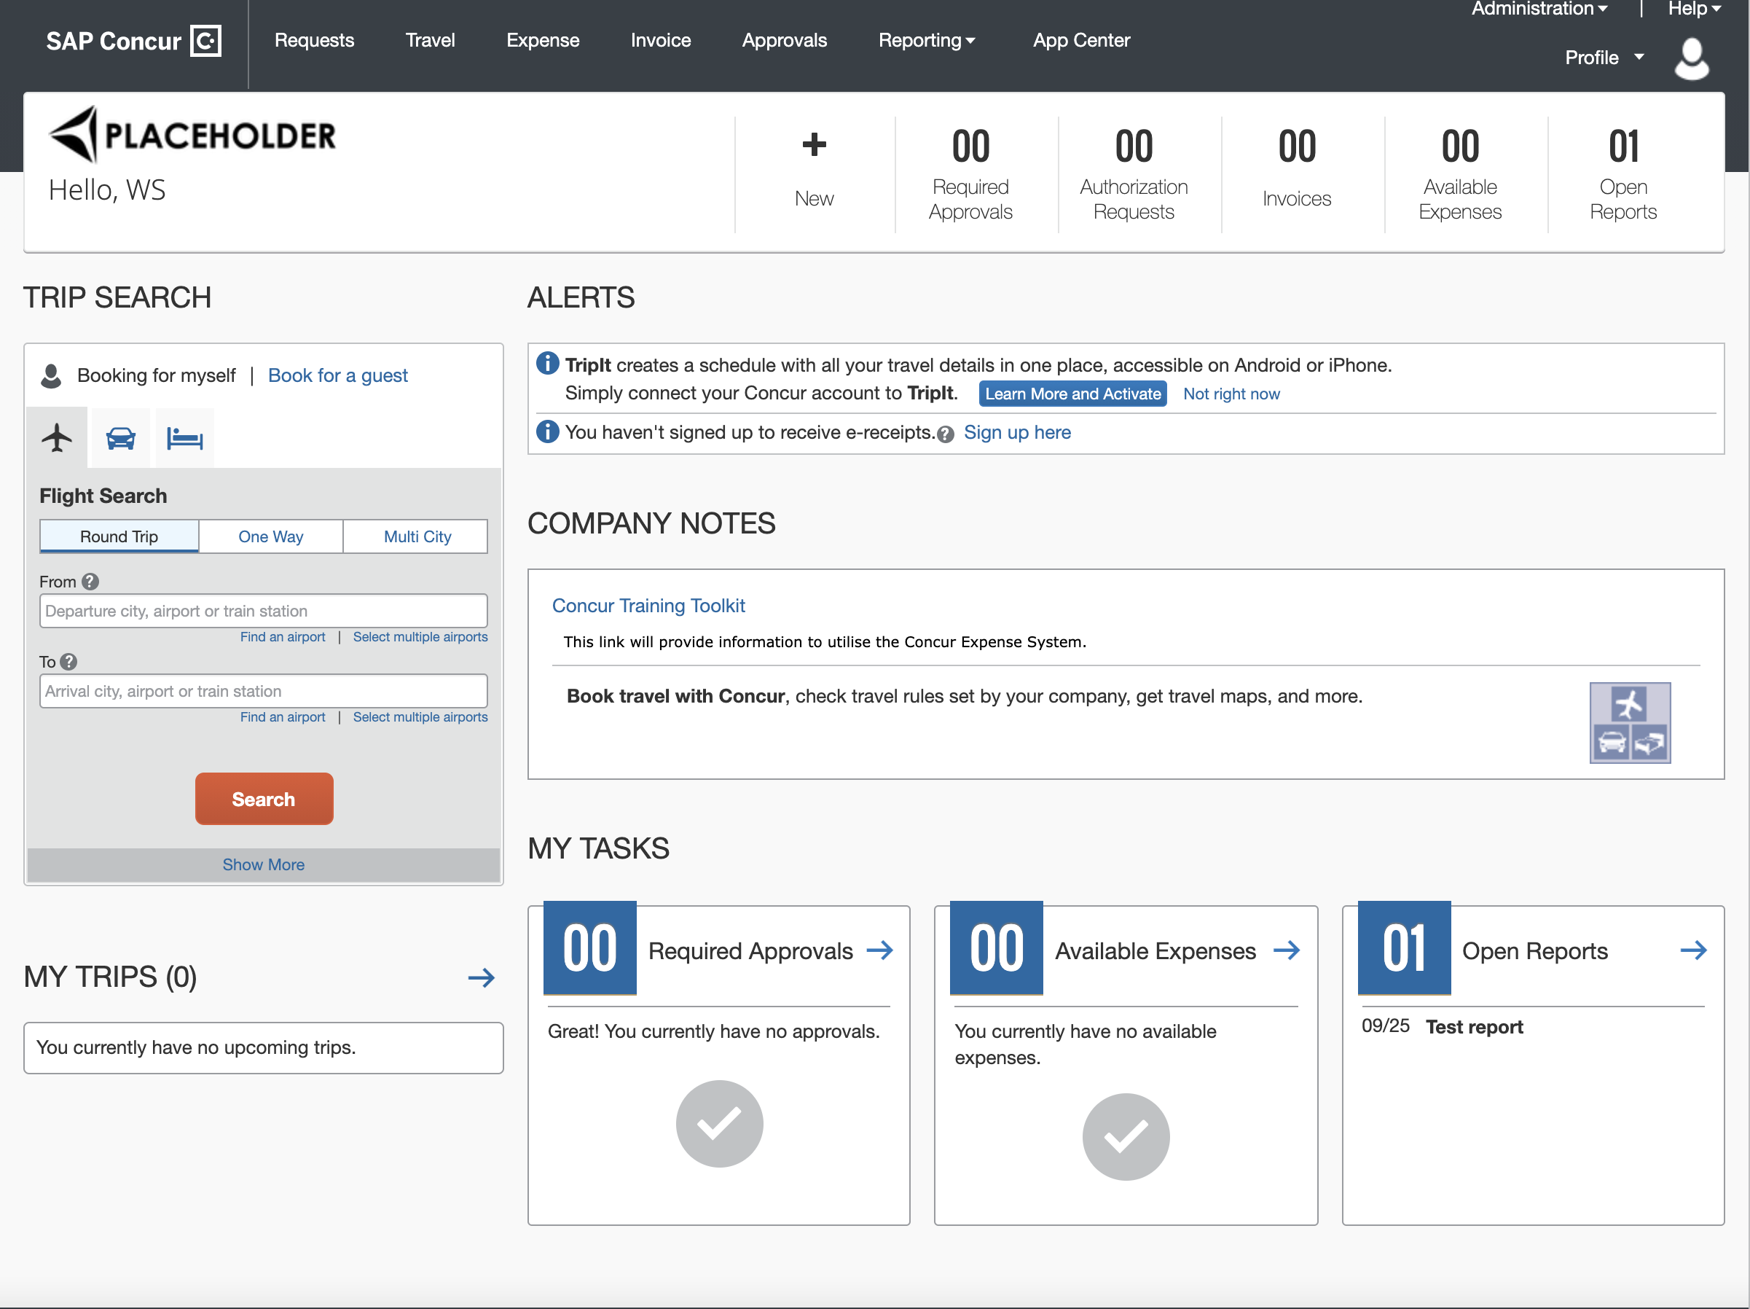

#### Configuration / Feature Activation

This change occurs automatically; there are no configuration or activation steps.

## Imaging

### Imaging Database System Maintenance

|  |  |  |
| --- | --- | --- |
| Information First Published | Information Last Modified | Feature Target Release Date |
| August 5, 2022 | November 11, 2022 | November ’22 – January ‘23 |
| Any changes since the previous monthly release are highlighted in yellow in this release note. | | |

**Applies to:**

Expense, Invoice, Request, Budget, Mobile | Professional & Standard

#### Overview

SAP Concur plans to perform system maintenance on the Concur Expense and Concur Invoice imaging databases. The system maintenance will be performed in phases, beginning in November 2022, and ending in January 2023.

What clients can expect:

* To avoid working hours, maintenance operations will take place on Saturday in the region where the maintenance is taking place.
* With a few exceptions noted as follows, maintenance operations impact all clients.

1. PSCC clients and clients in the China datacenter are not impacted by this image database migration.

* The maintenance tasks can take 2 to 4 hours.

##### Business Purpose / Client Benefit

This maintenance operation increases the stability of the imaging feature and better supports document compliance for tax authorities.

#### End-User Experience

While the system maintenance is in progress, users will not be able to attach, view, or modify images in Concur Expense, Concur Invoice, or Concur Request, nor through web services or mobile applications.

1. The Concur Invoice product will be unusable during the maintenance period since viewing invoice images is a core feature of the product.

Users might also receive one of the following messages:

* Invoice Image:

Concur Imaging Service Not Available

* E-Receipt:

Retrieving Images from Image Server. Please wait…

* Mobile:

We’re unable to attach your receipt. Please try again.

* Attach to Report:

Alert! The following files failed to upload: <filename>

Or

No file chosen

#### Configuration / Feature Activation

Clients do not need to take any action to facilitate the system maintenance.

## Miscellaneous

### New IP Address Range for Callouts (EMEA, US)

|  |  |  |
| --- | --- | --- |
| Information First Published | Information Last Modified | Feature Target Release Date |
| August 12, 2022 | January 20, 2023 | August – December 2022 |
| Any changes since the previous monthly release are highlighted in yellow in this release note. | | |

**Applies to:**

Expense, Request | Professional & Standard

#### Overview

Beginning in August 2022 and continuing through the end of 2022, servers that support SAP Concur callouts in the US & EMEA datacenters were upgraded. This maintenance included migration of some services to new servers. When migration occurred, the IP addresses associated with these services changed.

These servers support the following functionality:

* Fetch Attendee Data Callout
* Fetch List Item Callout
* Event Notification Callout
* Launch External URL Callout
* Concur Salesforce Connector
* **IMPORTANT**: With this change, clients who use allow lists or otherwise restrict SAP Concur IP addresses might need to update their lists to avoid disruption of some functionality. SAP recommends adding *concursolutions.com to your allow lists rather than specific IP addresses.

##### Business Purpose / Client Benefit

This migration improves the stability and reliability of connections that pass these servers.

#### Configuration / Feature Activation

With this change, clients who use allow lists or otherwise restrict SAP Concur IP addresses might need to add the new IP addresses to their lists to avoid disruption of some functionality.

1. SAP recommends adding *concursolutions.com to allow lists rather than specific IP addresses. If your company requires specific IP addresses, contact SAP Concur support or your SAP Concur representative for assistance.

### SAP Concur Migration to Cloud Platform in AWS

|  |  |  |
| --- | --- | --- |
| Information First Published | Information Last Modified | Feature Target Release Date |
| February 18, 2022 | December 16, 2022 | December 2022 |
| Any changes since the previous monthly release are highlighted in yellow in this release note. | | |

**Applies to:**

All Products | All Editions

#### Overview

SAP Concur has completed the North America and EMEA datacenter migrations to a cloud platform. While this process started in 2017, the final phase of the migration was completed in early-December 2022.

##### Business Purpose / Client Benefit

This change provides a stronger security posture, improved performance and stability, and faster innovation for our clients.

#### Admin Experience

##### Review Network and API Connections

* For clients who use allow lists to manage connections to their SAP Concur solutions including API connections, SAP recommends you add *.concursolutions.com to your allow list.
* **IMPORTANT:** If you allow specific URLs or IP addresses, review the *Updated Naming Convention for Sub-URLs* and *Updated IP Addresses* sections that follow.
* Always store the geolocation and the refresh token as they may have changed. On subsequent calls, use the last received geolocation and refresh token.
* For detailed information, refer to the documentation on the SAP Concur Developer Center:  
  [Base URIs](https://developer.concur.com/api-reference/authentication/apidoc.html#base-uris-)

##### Updated Naming Convention for Sub-URLs

In June 2021, SAP Concur implemented a more consistent naming convention for the URLs used to connect to SAP Concur solutions, based on data center. Users who navigate to www.concursolutions.com will be automatically routed to the correct URL or single sign-on (SSO) as part of their sign-in process.

1. In rare cases, clients who restrict or filter access from their corporate network to specific URLs might need to update their configuration to enable users to connect to the new URLs.   
     
   In rare cases, direct URLs pointing to web pages on concursolutions.com might need to be updated—for example, if you use direct URLs in your training materials.

The URLs that were implemented in June 2021 are as follows:

* **us.concursolutions.com**  
  This URL is functionality identical to the existing www.concursolutions.com.
* **eu.concursolutions.com**  
  This URL is functionally identical to the existing eu1.concursolutions.com
* **us2.concursolutions.com** and **eu2.concursolutions.com**  
  These are the URLs for data centers in AWS

It is not a best practice to only allow specific URLs. If restricted access is a requirement, SAP recommends allowing *.concursolutions.com to avoid having to make these adjustments in the future.

For more information, view the June 2021 Release Notes for your product: [Standard](https://www.concurtraining.com/customers/tech_pubs/_RN_CCC_CPS.htm) | [Professional](https://www.concurtraining.com/customers/tech_pubs/_RN_CCC.htm).

##### Updated IP Addresses

Similar to the new sub-URLs, each new data center has a new set of IP addresses.

We do not anticipate any interruption in functionality; however, clients who use allow lists or otherwise restrict SAP Concur IP addresses might need to update their lists to avoid disruption.

In addition, the IP addresses associated with SAP Concur services have changed—for example, Callout connectors, the Salesforce connector, or an internal firewall. If your solution makes use of these capabilities, contact SAP Concur support or your SAP Concur representative for assistance.

1. SAP Concur does not recommend allow-listing IP addresses. The recommendation and best practice is to add *.concursolutions.com to your allow lists rather than specific IP addresses.

#### Configuration / Feature Activation

These changes occurred automatically.

For more information, refer to the [*SAP Concur Cloud Platform Strategy FAQ*](http://assets.concur.com/concurtraining/cte/en-us/FAQ_Cloud_Hosting_Strategy.pdf).

## Test Entities | Production Sandbox Environment

### Most Recently Used Lists Not Migrated

|  |  |  |
| --- | --- | --- |
| Information First Published | Information Last Modified | Feature Target Release Date |
| September 2021 | January 16, 2023 | October 1, 2021 - Q4 2022 |
| Any changes since the previous monthly release are highlighted in yellow in this release note. | | |

**Applies to:**

Expense, Invoice, Request | Professional

#### Overview

Some SAP Concur users use Product Sandbox Environment (PSE) entities to set up, test, and train on new configurations prior to deploying them to their live production entity. As part of our move to Amazon Web Services (AWS), SAP Concur has migrated PSEs to the AWS environment.

For more information, refer to the [*SAP Concur Cloud Platform Strategy FAQ*](http://assets.concur.com/concurtraining/cte/en-us/FAQ_Cloud_Hosting_Strategy.pdf).

Due to the architectural changes that SAP Concur made to support this move, some Most Recently Used (MRU) list items within the PSE were not migrated.

1. MRU lists consist of recent selections made by the user. These lists are generated overtime as users interact with various menus and other defined lists and they will be regenerated in the new environment.
2. These changes apply to PSEs that were moved or created in the AWS environment.

##### Business Purpose / Client Benefit

In AWS, PSEs benefit from the same stability, monitoring capabilities, and level of performance as production entities.

#### What the User Sees

Some MRU lists that were generated prior to the migration are empty. These lists will be regenerated automatically through the normal use of the PSE.

The following screenshots show some examples of MRU lists that were impacted by the migration:

**Create New Expense in Concur Expense**

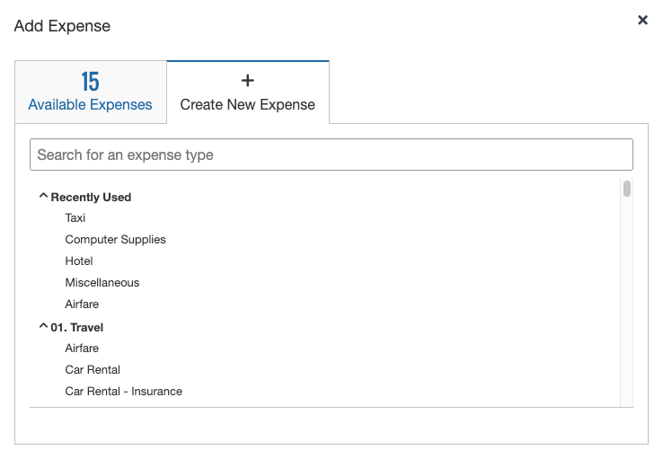

**New Segment in Concur Request**

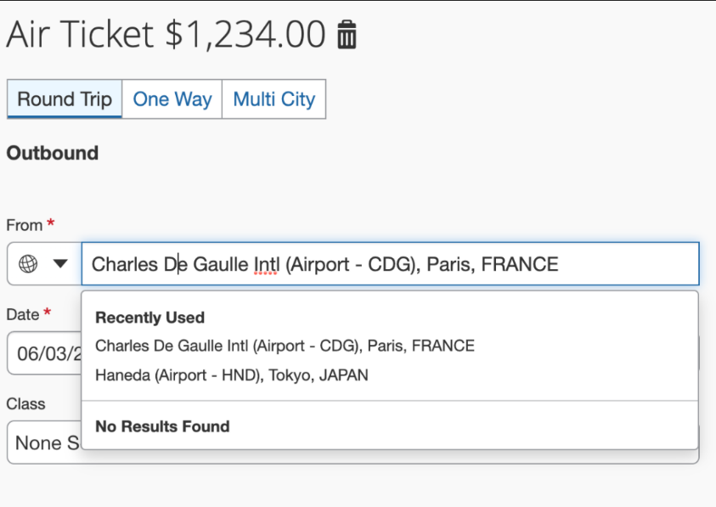

#### Configuration / Feature Activation

This change occurred when PSEs were migrated to the new AWS environment; there are no configuration or activation steps. The MRU lists will be regenerated with normal user of the entity.

### Production Sandbox Environment Login Updates

|  |  |  |
| --- | --- | --- |
| Information First Published | Information Last Modified | Feature Target Release Date |
| August 2021 | January 16, 2023 | October 1, 2021 - Q4 2022 |
| Any changes since the previous monthly release are highlighted in yellow in this release note. | | |

**Applies to:**

Expense, Invoice, Request | Professional

#### Overview

Some SAP Concur users use Product Sandbox Environment (PSE) entities to set up, test, and train on new configurations prior to deploying them to their live production entity. As part of our move to Amazon Web Services (AWS), SAP Concur has migrated PSEs to the AWS environment.

For more information, refer to the [*SAP Concur Cloud Platform Strategy FAQ*](http://assets.concur.com/concurtraining/cte/en-us/FAQ_Cloud_Hosting_Strategy.pdf).

Before migration to AWS, users could have the same login ID for their test and production entities because the entities were in separate environments. With AWS, test and production entities reside in the same environment and user ID’s must be unique to each entity.

To support the requirement for unique user IDs, during migration, SAP Concur appended all PSE login IDs with a ".uat” domain. And appends, during user creation, SAP concur appends “.uat” to user IDs ensure the IDs are unique and do not conflict with any existing production login ID. For example, in PSEs, johnsmith@123.com becomes johnsmith@123.com.uat.

While there is no action required for most clients regarding this update, we want to ensure clients are aware of it because the change will be visible in certain areas of PSEs.

##### Business Purpose / Client Benefit

In the AWS environment, PSEs benefit from the same stability, monitoring capabilities, and level of performance as production entities.

#### End-User Experience

This process occurred in the background during migration to the AWS environment and occurs in the background during the user creation processes. Because SAP Concur manages this process, users will **NOT** have to make any changes to their login ID.

Migrated users use the same implementation URL and login ID they used prior to the AWS migration.

New clients use the AWS production URL–<https://us2.concursolutions.com> or <https://eu2.concursolutions.com> with the appended login ID, which includes the appended domain. For example, [johnsmith@123.com.uat](mailto:johnsmith@123.com.uat).

**Example:**

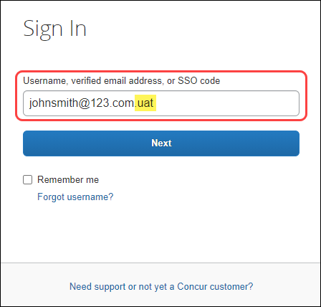

**User Creation:** To ensure there are no conflicts with production login IDs, when new users are created via import or API, SAP Concur automatically appends the .uat domain to each login ID.  This means clients can use the same employee import files in PSEs that they use in production.  When an admin creates a new user manually via the UI, if the .uat domain is not already appended to the login ID, the admin will be prompted to add the .uat domain to the login ID.

**Extracts**: When generating accounting extracts or financial integration documents, SAP Concur automatically removes the .uat domain from login IDs that were appended during user creation. This helps generate realistic extracts without requiring any action from the client.

1. These changes apply to PSEs that were moved or created in the AWS environment.

#### SAP ICS With Legacy Authentication to Concur PSE

With the migration to AWS, clients who use SAP Integration with Concur Solutions (SAP ICS) with legacy authentication (username and password) to their Concur PSE will encounter an “invalid user” error when attempting to connect to the PSE.

To resolve the error, the username must be updated. Users can do this by appending the .uat domain to the username.

* **IMPORTANT:** This change does NOT impact the following:   
    
  • SAP ICS in the production environment  
  • S/4HANA Cloud, public edition customers  
  • Clients who use the new gateway authentication

For more information about the new gateway authentication, refer to the following:  
 • Section 8 of SAP knowledge base article [2914977 - FAQ: Concur Certificates,  
 Authentication, and Connectivity](https://launchpad.support.sap.com/?sap-outbound-id=FA963A83ABEA4728FE572E88DC763A438E368ABA#/notes/2914977)   
 • The “**Ongoing** SAP Integration with Concur Solutions (ICS) for SAP ECC   
 and SAP S/4HANA On-Premise Required Authentication Update” release note   
 in the November 2022 [Concur Expense Professional Edition Release Notes](https://www.concurtraining.com/customers/tech_pubs/Docs/_ReleaseNotes/_RN_CCC_CTE.htm)

1. To update the username in the SAP System:
2. In the SAP system, start the CTE_SETUP transaction, “Setting Up the Integration with SAP Concur”.

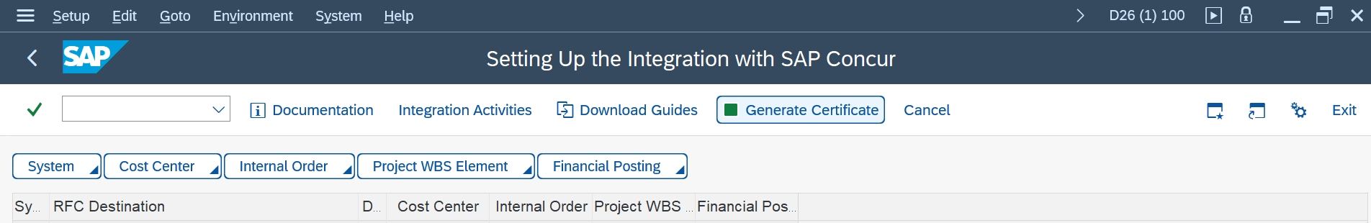

1. Click **System**, and then click **Change Connection**.

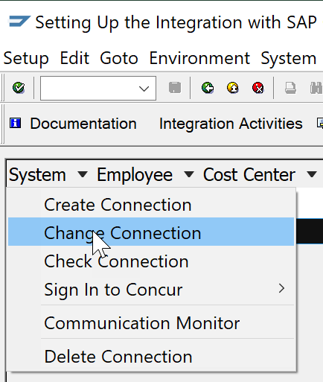

1. On the **Setting Up the System Connection** page, click **Continue** until you reach the **Assign Access Token** step.

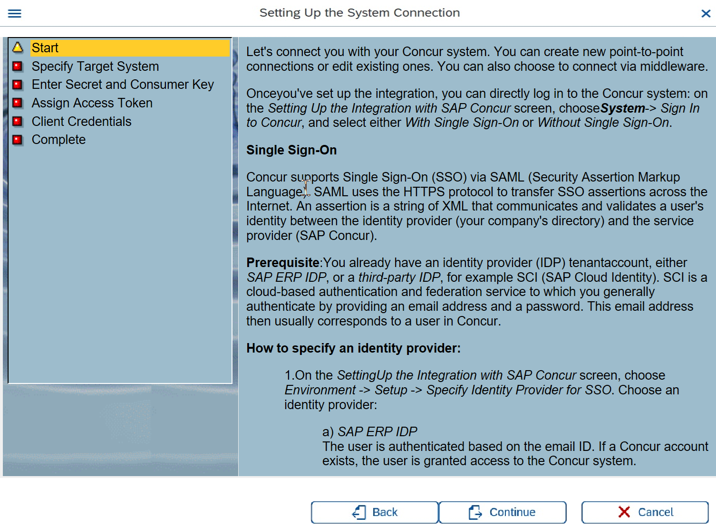

1. In the **User** field, append .uat to the username. (For example, johnsmith@123.com becomes johnsmith@123.com.uat.)

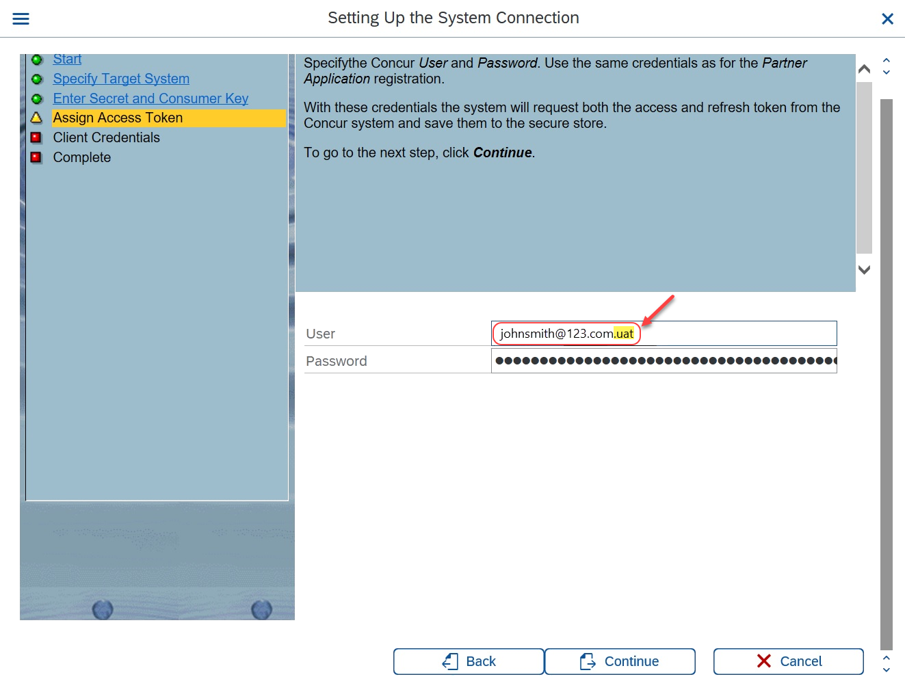

1. Click **Continue** until you reach the **Complete** step, and then click **Complete**.

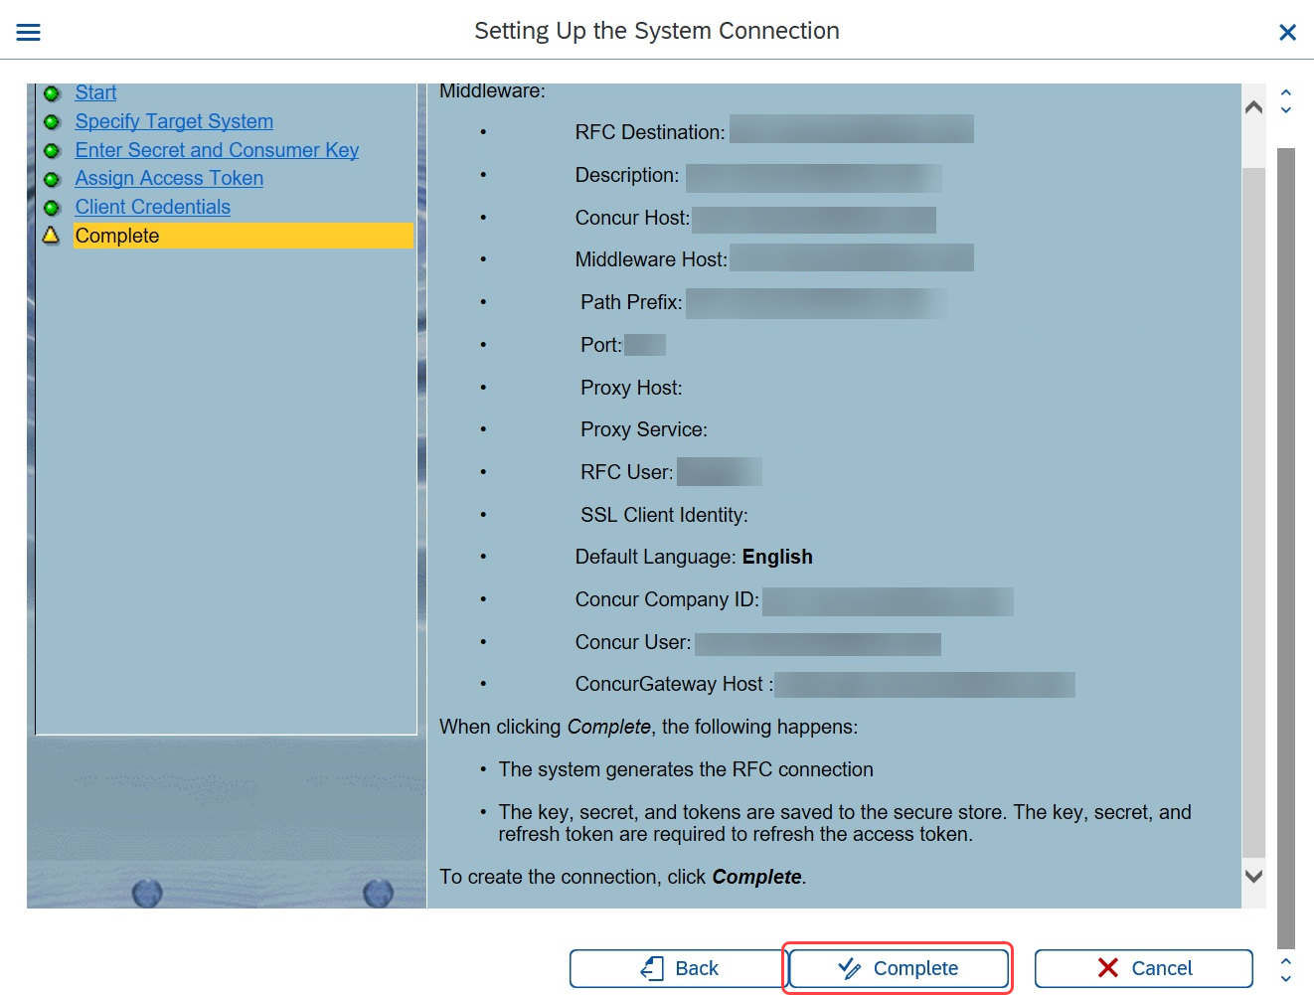

A message similar to the following is presented:

“RFC Destination <Destination> was updated successfully.”



#### Configuration / Feature Activation

These changes occurred automatically; in most cases, no additional configuration or activation steps were needed.

Clients who connect to SAP Concur solutions via SAP ICS and who use legacy authentication (username and password) must update the username in the **Assign Access Token** step in the SAP system by appending the .uat doman to the username.

### Unique Address Required for PSE Email Verification

|  |  |  |
| --- | --- | --- |
| Information First Published | Information Last Modified | Feature Target Release Date |
| August 2021 | January 16, 2023 | October 1, 2021 - Q4 2022 |
| Any changes since the previous monthly release are highlighted in yellow in this release note. | | |

**Applies to:**

Expense, Invoice, Request | Professional

#### Overview

Some SAP Concur users use Product Sandbox Environment (PSE) entities to set up, test, and train on new configurations prior to deploying them to their live production entity. As part of our move to Amazon Web Services (AWS), SAP Concur has migrated PSEs to the AWS environment.

For more information, refer to the [*SAP Concur Cloud Platform Strategy FAQ*](http://assets.concur.com/concurtraining/cte/en-us/FAQ_Cloud_Hosting_Strategy.pdf).

##### When PSEs were migrated to the AWS production environment, verified emails from the existing PSE did not carry over to the new PSE. As a result, when users test verified email functionality in a future PSE, it is recommended that they use an email that is different from the email configured in their production entity. This process is required as the email in the existing PSE was most likely already verified in production and, therefore, cannot be verified in another entity.

With respect to user email addresses, the Receipt Recognition service validates user email addresses and as such, only one instance of an email address can be associated with a user account. To test in production, clients will be required to utilize alternate email addresses that are not currently associated with any production user account. If a client attempts to set up a test account in production using an email address already associated with a corresponding user profile, it will fail the validation process.

1. These changes apply to PSEs that were migrated to or created in the AWS environment.

##### Business Purpose / Client Benefit

In AWS, PSEs benefit from the same stability, monitoring capabilities, and level of performance as production entities.

#### What the Admin Sees

##### BEFORE – Existing Email in Existing PSE

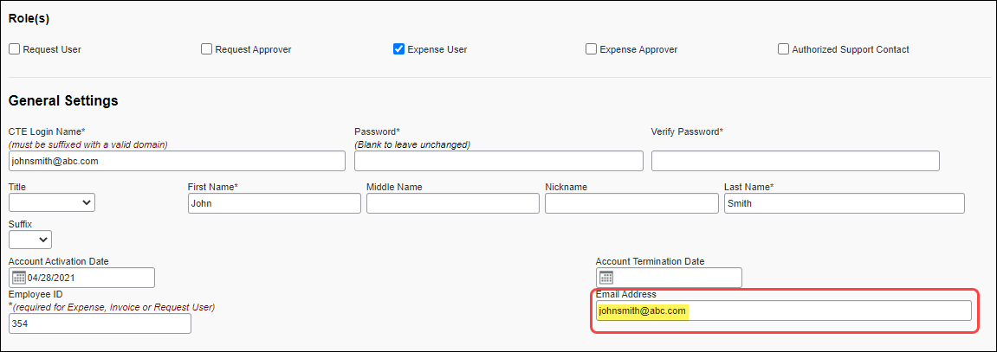

##### AFTER – New Email in New/Future PSE

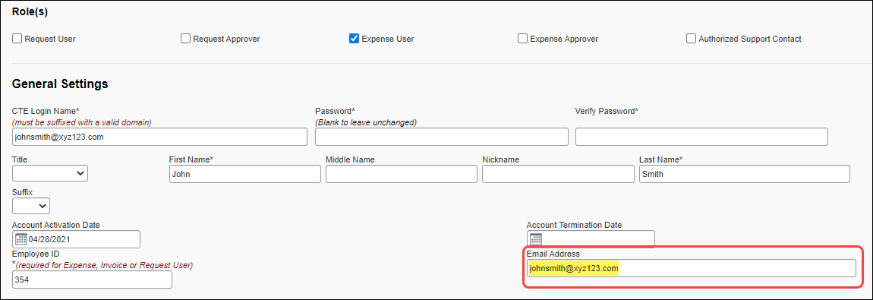

#### Configuration / Feature Activation

These changes occurred automatically.

## User Export and Import

### **Ongoing** User Export and Import Improvements

|  |  |  |
| --- | --- | --- |
| Information First Published | Information Last Modified | Feature Target Release Date |
| April 22, 2022 | September 16, 2022 | July 21, 2022 – Future Release |
| Any changes since the previous monthly release are highlighted in yellow in this release note. | | |

**Applies to:**

Expense, Invoice, Request | Standard Edition

#### Overview

SAP Concur has implemented improvements to the user export and import processes.

Improvements include, but are not limited to:

* Improvements to the downloadable user data template including tooltips and drop-down lists
* Removal of the 1000 user maximum for imports and exports of user data
* The addition of a new **Manage Users via a Spreadsheet** page

These improvements were implemented on July 21, 2022, as part of an opt-in experience including a survey for providing feedback on the new experience.

As of August 25, the new experience became the default experience. User admins can still choose to switch back to the old experience and can provide feedback via the survey.

In a future release, the ability to switch back to the old experience and the survey will be removed from the **Users** page.

##### Business Purpose / Client Benefit

These improvements increase the ease of use and experience of the user import and export processes.

#### Admin Experience

On the **Users** page in Product Settings, a banner with the following message is available at the top of the page:

"Click here to try out the new Manage User via a Spreadsheet experience, and provide your early feedback."

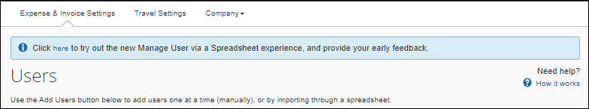

The admin can click the word "here" to opt-in to the experience.

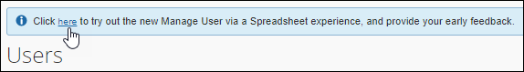

After they click **here**, the banner message text changes to the following:

"Welcome to the new Manage User via a Spreadsheet experience. In addition to the new UI, we have also updated the spreadsheet template to include user-friendly header rows, drop-down menus, and tooltips for your reference. Click here to provide your feedback on the new experience. If you like, you can change back to the existing experience."

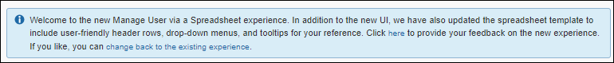

In the new message, the admin can click the word "here" to provide feedback on the experience through a brief survey.

The admin can also click the phrase "change back to the existing experience" to opt out of the new spreadsheet experience.

After opting in to the experience, on the **Users** page in Product Settings, when the admin clicks **Add Users > From Spreadsheet**, the admin sees the new **Manage Users via a Spreadsheet** page.

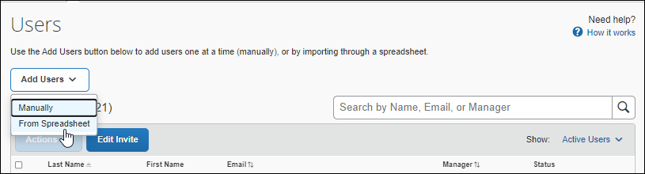

On the **Manage Users via a Spreadsheet** page, the admin can export, update, and import user data.

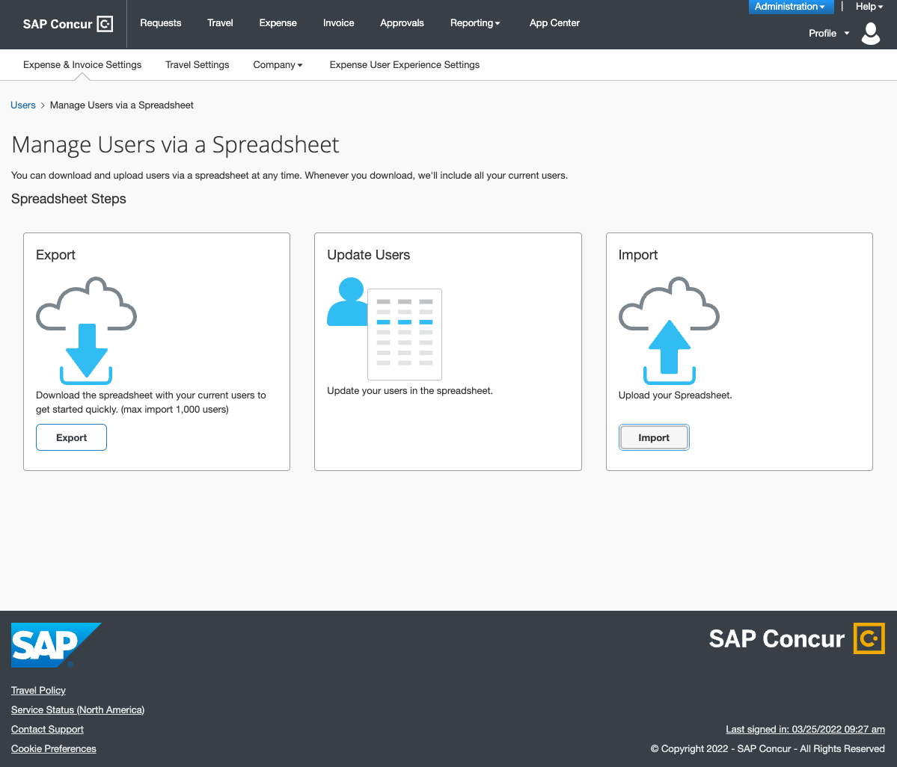

When they export the spreadsheet, they will see new tooltips and, where applicable, drop-down lists in the spreadsheet. In addition, they will no longer be limited to downloading 1000 rows of user data.

**Tooltip Example**

Tooltips appear when you hover over a column header in the spreadsheet.

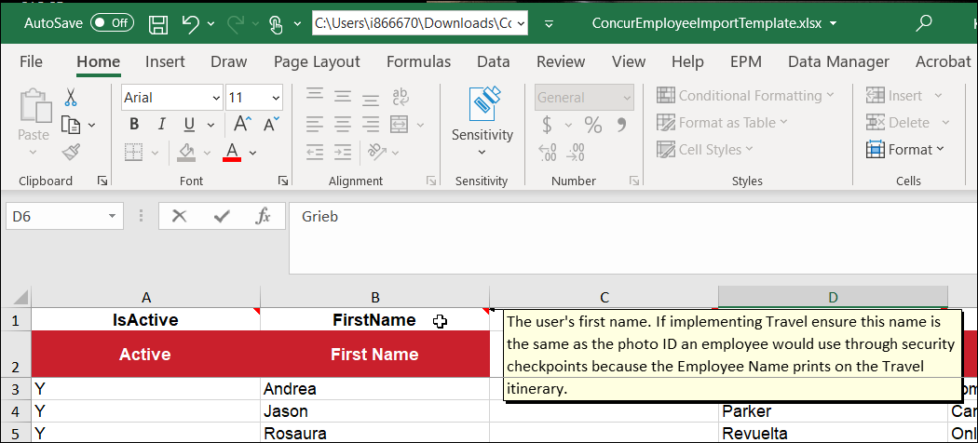

**Drop-down List Example**

Drop-down lists are available for columns where applicable.

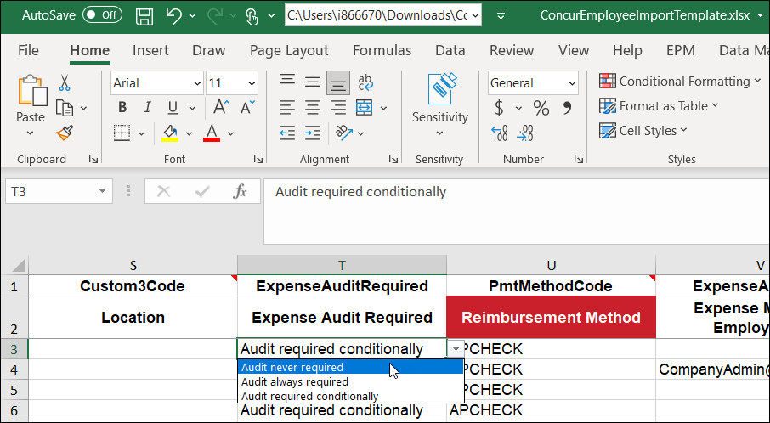

#### Configuration / Feature Activation

After the opt-in period has ended, the new user export/import experience will be automatically available.

# Planned Changes

The following features and changes are targeted for future releases. SAP Concur solutions reserves the right to postpone implementation of – or completely remove – any enhancement/change mentioned here.

## Data Retention

### **Planned Changes** Data Retention Feature Enhancements

|  |  |  |
| --- | --- | --- |
| Information First Published | Information Last Modified | Feature Target Release Date |
| January 20, 2023 | -- | Future Release |
| Any changes since the previous monthly release are highlighted in yellow in this release note. | | |

**Applies to:**

All Products | All Editions

#### Overview

SAP Concur plans to implement the following enhancements to the Data Retention feature:

* The **Sensitive Data Retention Periods** page will be renamed to **Profile Data Retention Periods**.
* The **Type {name} to confirm settings** field will be removed.
* The **Purge User** button will be removed.

##### Business Purpose / Client Benefit

These changes help clients configure SAP Concur solutions to better support regional data protection regulations.

#### Configuration / Feature Activation

These changes will occur automatically. There are no configuration or activation steps to have these changes reflected in your site.

For more information about the Data Retention feature, refer to the [*Shared: Data Retention Setup Guide*](https://www.concurtraining.com/customers/tech_pubs/Docs/_Current/SG_Shr/Shr_SG_Data_Retention.pdf) (Professional edition) or the [*Shared: Data Retention Setup Guide for Concur Standard Edition*](https://www.concurtraining.com/customers/tech_pubs/Docs/ConcurPremier/SG_Shr/SG_Shr_Data_Retention.pdf).

## Fapiao

### **Planned Changes** Fapiao Capture Support for EMEA and US Datacenters

|  |  |  |
| --- | --- | --- |
| Information First Published | Information Last Modified | Feature Target Release Date |
| November 4, 2022 | -- | Future Release |
| Any changes since the previous monthly release are highlighted in yellow in this release note. | | |

**Applies to:**

Travel, Expense, Invoice, Request, Mobile | Professional Edition

#### Overview

The ability to capture and upload fapiao into Concur Expense will be extended in an upcoming release to include US and EMEA datacenters in addition to China.

1. This feature applies to all clients who must conform to Chinese regulations for receipt requirements as per the Chinese government regulations.

##### Background

The ability to manage fapiao using Concur Expense supports the requirement to capture and upload fapiao to an expense according to Chinese regulatory or government authorities.

A fapiao is a legal receipt required for business transactions, employee reimbursement and VAT deduction. A fapiao is issued by the State Taxation Administration of the People's Republic of China but provided by the merchant.

The feature is available to clients based in China and while originally deployed only to the China datacenter, will now expand to include the US and EMEA datacenters.

For more information, refer to the [State Taxation Administration of the People's Republic of China](http://www.chinatax.gov.cn/eng/).

##### Business Purpose / Client Benefit

This feature extends the ability to provide a paperless receipt option that adheres to requirements and regulations for China for paper into electronic tax receipt processing and compliance to additional datacenters.

#### End-User Experience

Those using US and EMEA datacenters can sign into the WeChat mini app to process fapiao and send them to Concur Expense. You can sign in via password or, if you do not know your password, via email passcode.

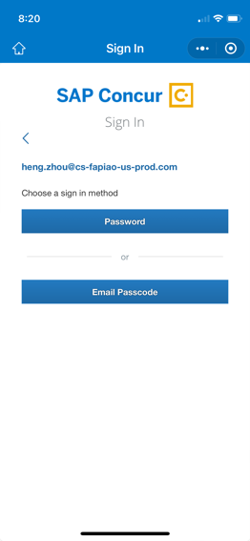

#### Configuration / Feature Activation

This change is automatically available; there are no configuration or activation steps.

For more information, refer to the Mobile App User Guide SAP Concur Fapiao Capture.

## Financial Integration

### **Planned Changes** Microsoft Dynamics 365 Business Central Integration

|  |  |  |
| --- | --- | --- |
| Information First Published | Information Last Modified | Feature Target Release Date |
| January 16, 2023 | -- | Q1 2023 |
| Any changes since the previous monthly release are highlighted in yellow in this release note. | | |

**Applies to:**

Expense, Invoice | Professional & Standard

#### Overview

SAP Concur and Pivot Payables have partnered to make sharing accounting information between Microsoft Dynamics® 365 Business Central or “Business Central” and SAP Concur products easier. This partnership includes an integration that delivers bidirectional data flows between Concur Expense or Concur Invoice and Business Central. This integration uses APIs from the SAP Concur platform and from the Pivot Payables Business Central extension ensuring fully automatic, near real-time data sharing.

This integration is targeted for Q1 2023.

The Business Central Accounting integration allows clients to:

* Send employee (supplier) data from Business Central Accounting to Concur Expense and/or Concur Invoice, keeping the system up to date with the latest employee information.
* Send expense reports and invoices using their Business Central Accounting financial system without needing to send a batch file to Business Central Accounting.
* Send data from Concur Expense and/or Concur Invoice to Business Central Accounting and receive feedback from Business Central Accounting.
* View Business Central Accounting posting status in Concur Expense and/or Concur Invoice, including posting document numbers and, if a posting failed, a description of why that posting failed. This information appears in the audit trail of the expense report or invoice. Transactions will post as a Purchase Journal in Business Central.

##### Business Purpose / Client Benefit

This integration provides a more responsive system by adding the financial posting to the report and invoice workflow so that any problems with posting appear in Concur Expense and Concur Invoice, where they can be identified and corrected.

#### Integration Considerations

The Business Central Accounting integration works with Concur Expense and Concur Invoice.

The following functionality is supported by the integration:

* Expense Pay
* Invoice Pay (Only Check and ACH)
* Client Remittance of IBCP

The following functionality is not supported by the Sage Intacct Accounting Integration:

* Payment Types with Offsets: Company Paid, IBCP with Offsets, CBCP with Offsets

1. The Business Central integration does support multicurrency transactions. The integration also does not support VAT/GST at this time.

#### Supported Versions and Editions

##### Supported Versions of Business Central

* On-Premise: version 14 or more recent version
* Cloud: most recent version

##### Supported Editions of Business Central Accounting

* US version only

#### Business Central Prerequisites and Exclusions

##### Prerequisites

The following prerequisites will prepare you to successfully connect your existing Business Central service with your SAP Concur service.

Have the following prepared:

* **Employees set up as Vendors**:for creating Concur Expense users, ExpenseBusiness Central sends employee specific information to SAP Concur as “employee vendors”. Employees must be set up as vendors in Business Central with first name, last name, and email address. Vendors without an email address will not be considered an employee vendor.
* **Deploy and Configure the PivotNexus for Microsoft Dynamics 365 Business Central Extension**:
* Please contact your SAP Concur representative for a copy of the *PivotNexus Business Central Extension Deployment and Setup Guide for the SAP Concur Financial Integration Program*.

##### Exclusions

The following extensions are excluded:

* You may not have extensions that customize any of the master data that the Business Central integrations loads into SAP Concur.
* You may not have extensions that customize any of the financial documents the integrations posts into Business Central.

#### Configuration / Feature Activation

To have Business Central Accounting Integration enabled for your company, contact SAP Concur support for more information.

For more information, refer to the *Shared: Microsoft 365 Business Central Setup Guide*.

## Security

### **Planned Changes** Addition of ECDSA Encryption and Cipher Retirement

|  |  |  |
| --- | --- | --- |
| Information First Published | Information Last Modified | Feature Target Release Date |
| September 30, 2022 | December 16, 2022 | February 16, 2022 |
| Any changes since the previous monthly release are highlighted in yellow in this release note. | | |

**Applies to:**

Travel, Expense, Invoice, Request | All Editions

#### Overview

To provide ongoing security for our products, SAP Concur plans to remove support for the following cipher on February 16, 2023, at 5 PM PST:

|  |  |
| --- | --- |
| Akamai/OpenSSL cipher name | IANA cipher name |
| ECDHE-RSA-AES256-SHA384 | TLS_ECDHE_RSA_WITH_AES_256_CBC_SHA384 |

To better support clients using Windows Server 2012 who relied on this cipher, and to improve security, SAP Concur plans to enable ECDSA encryption for *concursolutions.com and *api.concursolutions.com. SAP Concur will support both RSA and ECDSA encryption.

To add support for ECDSA encryption, SAP Concur will issue a new security certificate.

When support for ECDSA encryption is added, support for the following ciphers will also be added:

|  |  |
| --- | --- |
| Akamai/OpenSSL cipher name | IANA cipher name |
| ECDHE-ECDSA-AES256-GCM-SHA384 | TLS_ECDHE_ECDSA_WITH_AES_256_GCM_SHA384 |
| ECDHE-ECDSA-AES128-GCM-SHA256 | TLS_ECDHE_ECDSA_WITH_AES_128_GCM_SHA256 |
| ECDHE-ECDSA-CHACHA20-POLY1305 | TLS_ECDHE_ECDSA_WITH_CHACHA20_POLY1305_SHA256 |

##### Business Purpose / Client Benefit

These changes provide ongoing security for our products.

ECDSA encryption provides the following benefits:

* **Stronger Encryption Keys**  
  Small ECC keys have the equivalent strength of larger RSA keys because of the algorithm used to generate them. For example, a 256-bit ECC key is equivalent to a 3072-bit RSA key and a 384-bit ECC key is equivalent to a 7680-bit RSA key. These strong, small keys allow encryption to stay ahead of computing power without having to create longer keys.
* **Smaller Certificate Size**Because of the smaller key size of an ECC certificate, less data is transmitted from the server to the client during the SSL handshake. ECC certificates also require less memory and CPU to process, potentially reducing the impact on network performance and on high-volume or high-traffic sites that larger certificates can have.

#### SAP Concur Supported Ciphers

With the addition of support for ECDSA encryption, the following ciphers included in the **ak-akamai-2020q1** cipher profile will be supported:

|  |  |  |
| --- | --- | --- |
| Akamai/OpenSSL cipher name | IANA cipher name | Details |
| TLS-AES-256-GCM-SHA384 | TLS_AES_256_GCM_SHA384 | Currently supported |
| TLS-CHACHA20-POLY1305-SHA256 | TLS_CHACHA20_POLY1305_SHA256 | Currently supported |
| TLS-AES-128-GCM-SHA256 | TLS_AES_128_GCM_SHA256 | Currently supported |
| ECDHE-ECDSA-AES256-GCM-SHA384 | TLS_ECDHE_ECDSA_WITH_AES_256_GCM_SHA384 | Supported with ECDSA encryption, supported by Windows server 2012 |
| ECDHE-ECDSA-AES128-GCM-SHA256 | TLS_ECDHE_ECDSA_WITH_AES_128_GCM_SHA256 | Supported with ECDSA encryption, supported by Windows server 2012 |
| ECDHE-RSA-AES256-GCM-SHA384 | TLS_ECDHE_RSA_WITH_AES_256_GCM_SHA384 | Currently supported |
| ECDHE-RSA-AES128-GCM-SHA256 | TLS_ECDHE_RSA_WITH_AES_128_GCM_SHA256 | Currently supported |
| ECDHE-ECDSA-CHACHA20-POLY1305 | TLS_ECDHE_ECDSA_WITH_CHACHA20_POLY1305_SHA256 | Supported with ECDSA encryption |
| ECDHE-RSA-CHACHA20-POLY1305 | TLS_ECDHE_RSA_WITH_CHACHA20_POLY1305_SHA256 | Currently supported |

1. If your cipher suite includes both supported and unsupported ciphers, connections to *concursolutions.com through a web browser will not be disrupted. During the process of establishing the connection, the *concursolutions.com server will choose the most secure cipher in your cipher suite.

You can confirm that your cipher suite includes a supported cipher by cross-referencing the Akamai/OpenSSL cipher name with the IANA cipher name in the **ak-akamai-2021 (default)** column in the following table. Supported ciphers in are indicated with a check mark in the **ak-akamai-2021 (default)** column:

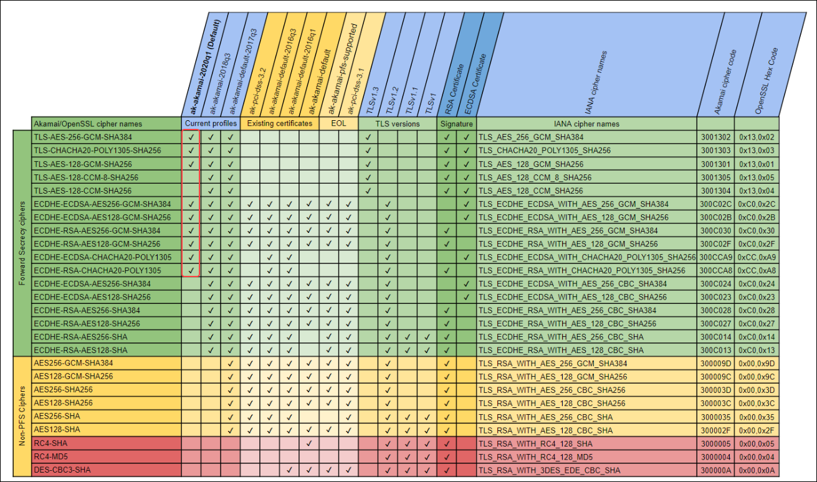

### Admin Tasks – SSL Certificate Update

* **IMPORTANT!** SSL certificates are renewed on a regular basis to ensure the security of our products; because security certificates change periodically, pinning them is not recommended.

#### Clients Who Do Not Pin Security Certificates

Clients who do not pin their security certificates do not need to take any action. Their system will automatically choose the best cipher, RSA or ECDSA, for communication with SAP Concur solutions.

1. Most clients do not pin their certificates.

#### Clients Who Pin Security Certificates

To avoid disruption of service, clients who pin their security certificates must pin both the RSA and ECDSA certificates. The new certificates can be accessed from the following web pages:

**\*.api.concursolutions.com**

<https://assets.concur.com/concurtraining/cte/en-us/api-concursolutions-com-chain_ECDSA.pem>

<https://assets.concur.com/concurtraining/cte/en-us/api-concursolutions-com-chain_RSA.pem>

**\*.concursolutions.com**

<https://assets.concur.com/concurtraining/cte/en-us/concursolutions-com-chain_ECDSA.pem>

<https://assets.concur.com/concurtraining/cte/en-us/concursolutions-com-chain_RSA.pem>

The new certificates must be added before 5:00 PM PST on February 16, 2023.

##### Testing Connections to *concursolutions.com

Between now and December 31, 2022, you can use the SAP Concur test environment, implementation.concursolutions.com, to test the new encryption certificates.

1. To test the new certificates:

* **Windows**

Launch Windows PowerShell and run the following command:

Invoke-WebRequest -Uri https://implementation.concursolutions.com

**Expected result:** StatusCode : 200

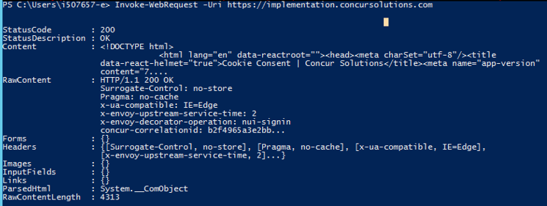

* **Mac**

Open Terminal and run the following command:

curl -vvv https://implementation.concursolutions.com

**Expected result:** HTTP/2 200

**Example:**

* Trying 23.204.40.178:443...

* Connected to implementation.concursolutions.com (23.204.40.178) port 443 (#0)

* ALPN: offers h2

* ALPN: offers http/1.1

* CAfile: /etc/ssl/cert.pem

* CApath: none

* (304) (OUT), TLS handshake, Client hello (1):

* (304) (IN), TLS handshake, Server hello (2):

* (304) (IN), TLS handshake, Unknown (8):

* (304) (IN), TLS handshake, Certificate (11):

* (304) (IN), TLS handshake, CERT verify (15):

* (304) (IN), TLS handshake, Finished (20):

* (304) (OUT), TLS handshake, Finished (20):

* SSL connection using TLSv1.3 / AEAD-AES256-GCM-SHA384

* ALPN: server accepted h2

* Server certificate:

* subject: C=US; ST=Washington; L=Bellevue; O=Concur Technologies Inc.; CN=*.concursolutions.com

* start date: Sep 29 00:00:00 2022 GMT

* expire date: Sep 29 23:59:59 2023 GMT

* subjectAltName: host "implementation.concursolutions.com" matched cert's "*.concursolutions.com"

* issuer: C=US; O=DigiCert Inc; CN=DigiCert TLS RSA SHA256 2020 CA1

* SSL certificate verify ok.

* Using HTTP2, server supports multiplexing

* Copying HTTP/2 data in stream buffer to connection buffer after upgrade: len=0

* h2h3 [:method: GET]

* h2h3 [:path: /]

* h2h3 [:scheme: https]

* h2h3 [:authority: implementation.concursolutions.com]

* h2h3 [user-agent: curl/7.84.0]

* h2h3 [accept: */*]

* Using Stream ID: 1 (easy handle 0x7f807e00e800)

> GET / HTTP/2

> Host: implementation.concursolutions.com

> user-agent: curl/7.84.0

> accept: */*

< HTTP/2 200

< content-type: text/html; Charset=utf-8

< surrogate-control: no-store

< cache-control: no-store, no-cache

< pragma: no-cache

##### Testing Connections to *api.concursolutions.com

* **Windows**

**EMEA:**  
Launch Windows PowerShell and run the following command:

Invoke-WebRequest -Uri <https://emea-impl.api.concursolutions.com>

**Expected result:** Invoke-WebRequest : 404 Not Found

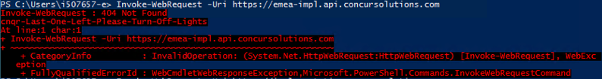

**US:**

Launch Windows PowerShell and run the following command:

Invoke-WebRequest -Uri <https://us-impl.api.concursolutions.com>

**Expected result:** Invoke-WebRequest : 404 Not Found

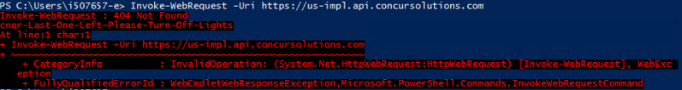

* **Mac**

**EMEA:**

Open Terminal and run the following command:

curl -vvv <https://emea-impl.api.concursolutions.com>

**Expected result:** 404 Not Found

**Example:**

* Trying 104.105.16.162:443...

* Connected to emea-impl.api.concursolutions.com (104.105.16.162) port 443 (#0)

* ALPN: offers h2

* ALPN: offers http/1.1

* CAfile: /etc/ssl/cert.pem

* CApath: none

* (304) (OUT), TLS handshake, Client hello (1):

* (304) (IN), TLS handshake, Server hello (2):

* (304) (IN), TLS handshake, Unknown (8):

* (304) (IN), TLS handshake, Request CERT (13):

* (304) (IN), TLS handshake, Certificate (11):

* (304) (IN), TLS handshake, CERT verify (15):

* (304) (IN), TLS handshake, Finished (20):

* (304) (OUT), TLS handshake, Certificate (11):

* (304) (OUT), TLS handshake, Finished (20):

* SSL connection using TLSv1.3 / AEAD-AES256-GCM-SHA384

* ALPN: server accepted h2...

🡨------ output omitted-----🡪

<html>

<head><title>404 Not Found</title></head>

<body>

<center><h1>404 Not Found</h1></center>

<hr><center>cnqr-Last-One-Left-Please-Turn-Off-Lights</center>

</body>

</html>

* Connection #0 to host emea-impl.api.concursolutions.com left intact

**US:**

Open Terminal and run the following command:

curl -vvv <https://us-impl.api.concursolutions.com>

**Expected result:** 404 Not Found

**Example:**

* Trying 104.105.16.162:443...

* Connected to us-impl.api.concursolutions.com (104.105.16.162) port 443 (#0)

* ALPN: offers h2

* ALPN: offers http/1.1

* CAfile: /etc/ssl/cert.pem

* CApath: none

* (304) (OUT), TLS handshake, Client hello (1):

* (304) (IN), TLS handshake, Server hello (2):

* (304) (IN), TLS handshake, Unknown (8):

* (304) (IN), TLS handshake, Request CERT (13):

* (304) (IN), TLS handshake, Certificate (11):

* (304) (IN), TLS handshake, CERT verify (15):

* (304) (IN), TLS handshake, Finished (20):

* (304) (OUT), TLS handshake, Certificate (11):

* (304) (OUT), TLS handshake, Finished (20):

* SSL connection using TLSv1.3 / AEAD-AES256-GCM-SHA384

...

🡨------ output omitted-----🡪

<html>

<head><title>404 Not Found</title></head>

<body>

<center><h1>404 Not Found</h1></center>

<hr><center>cnqr-Last-One-Left-Please-Turn-Off-Lights</center>

</body>

</html>

* Connection #0 to host us-impl.api.concursolutions.com left intact

#### Configuration / Feature Activation

Clients who do not pin their security certificates do not need to take any action.

For clients who must pin their security certificates, pin both the RSA and ECDSA certificates.

### **Planned Changes** New *.concursolutions.com and *api.concursolutions.com SSL certificates (Feb 16)

|  |  |  |
| --- | --- | --- |
| Information First Published | Information Last Modified | Feature Target Release Date |
| January 20, 2023 | -- | February 16, 2023 |
| Any changes since the previous monthly release are highlighted in yellow in this release note. | | |

**Applies to:**

All | All

#### Overview

As part of the weak cipher removal project, SAP Concur will issue new SSL certificates for concursolutions.com and api.concursolutions.com at 5 PM PST on February 16, 2023.

* **IMPORTANT:** Clients who pin these certificates must update to the new certificates by 5 PM PST on February 16, 2023.

For more information about the weak cipher removal project, refer to the *\*\*Planned Changes** Addition of ECDSA Encryption and Cipher Retirement* release note.

1. Because these certificates are being changed to support the weak cipher removal project, and are not part of the annual renewal process, the date of change might not correspond to the expiration date within the security certificate.

##### Business Purpose / Client Benefit

These changes provide ongoing security for SAP Concur solutions.

#### Configuration / Feature Activation

Clients who have not pinned these certificates do not need to take any action as their certificate will be automatically replaced. ***Most clients do not pin the certificate.***

To avoid possible disruption of service with SAP Concur solutions, clients who have pinned the concursolutions.com or api.concursolutions.com certificates must update to the new certificates before they are replaced.

The new SSL certificates can be accessed through the following URLs:

* Intermediate: [DigiCert TLS RSA SHA256 2020 CA1](https://cacerts.digicert.com/DigiCertTLSRSASHA2562020CA1-1.crt.pem)
* Root: [DigiCert Global Root CA](https://cacerts.digicert.com/DigiCertGlobalRootCA.crt.pem)

The full certificate chain (end, intermediate, and root) can be access from the following URLs:

**\*.api.concursolutions.com**

<https://assets.concur.com/concurtraining/cte/en-us/api-concursolutions-com-chain_ECDSA.pem>

<https://assets.concur.com/concurtraining/cte/en-us/api-concursolutions-com-chain_RSA.pem>

**\*.concursolutions.com**

<https://assets.concur.com/concurtraining/cte/en-us/concursolutions-com-chain_ECDSA.pem>

<https://assets.concur.com/concurtraining/cte/en-us/concursolutions-com-chain_RSA.pem>

1. If you pin the End certificate you must pin both the ECDSA and RSA certificates.

If you are not sure whether your concursolutions.com or api.concursolutions.com certificate is pinned, consult with your IT department.

## User Assistance

### **Planned Changes** How It Works Links To Be Decommissioned

|  |  |  |
| --- | --- | --- |
| Information First Published | Information Last Modified | Feature Target Release Date |
| December 9, 2022 | -- | February 2023 |
| Any changes since the previous monthly release are highlighted in yellow in this release note. | | |

**Applies to:**

Expense, Invoice, Request, Budget| Standard Edition

#### Overview

In February 2023, Sap Concur plans to decommission the **How it works** links that appear on some administration pages in Concur Standard Edition.

##### Business Purpose / Client Benefit

Over time, SAP Concur has implemented changes to the administration pages in Concur Standard Edition to improve the administrator experience, improve the onboarding experience, and to make the pages more user friendly. With these improvements, the **How it works** content is no longer needed.

#### Admin Experience

Client administrators will no longer see the **How it works** links on the administration pages.

**Before the Change**

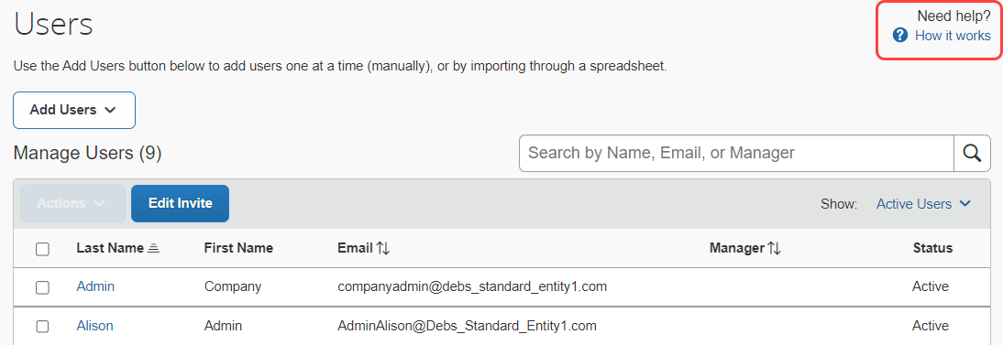

**After the Change**

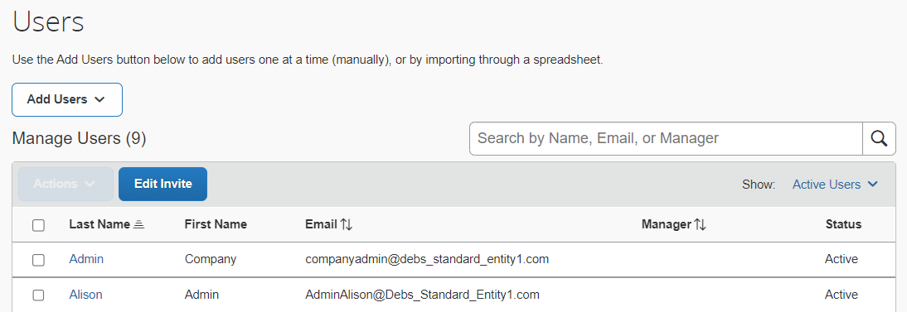

#### Configuration / Feature Activation

This change occurs automatically.

# Client Notifications

## Accessibility

### Accessibility Enhancements

SAP implements changes to better meet current Web Content Accessibility Guidelines (WCAG). Information about accessibility-related changes made to SAP Concur solutions is published on a quarterly basis. You can review the quarterly updates on the [Accessibility Updates](https://www.concurtraining.com/customers/tech_pubs/RN-monthly-Access/_RN_access_client.htm) (English Only) page.

## Subprocessors

### SAP Concur Non-Affiliated Subprocessors

The list of non-affiliated subprocessors is available from the *SAP Sub-processors / Data Transfer Factsheets* page.

1. To access the SAP Concur Sub-processors List:
2. Click the following link to navigate to the *SAP Sub-processors / Data Transfer Factsheets* page:  
   [*SAP Sub-processors / Data Transfer Factsheets*](https://support.sap.com/en/my-support/trust-center/subprocessors.html)
3. Sign in to the SAP Support Portal using your Support User ID (S-user) and password.
4. SAP customers must sign in to the SAP Support Portal using their Support User ID (S-user) and password. For information about S-User IDs, refer to [*Your New Support User ID (S-user)*](https://support.sap.com/en/my-support/users/welcome.html) and to the [*Learn All About S-User IDs*](https://blogs.sap.com/2021/03/09/learn-all-about-s-user-ids/) blog post.
5. On the *SAP Sub-processors / Data Transfer Factsheets* page, type "Concur" in the **Search** field.
6. In the **Title** column, click **SAP Concur Sub-processors List**.

If you have questions or comments, please reach out to: [Privacy-Request@Concur.com](mailto:Privacy-Request@Concur.com)

## Supported Browsers

### Supported Browsers and Changes to Support

For information about supported browsers and planned changes to supported browsers, the [*Concur Travel & Expense Supported Configurations*](http://www.concurtraining.com/customers/tech_pubs/Docs/Z_SuppConfig/Supported_Configurations_for_Concur_Travel_and_Expense.pdf) guide.

When changes to browser support are planned, information about those changes will also appear in the [*Shared Planned Changes*](https://www.concurtraining.com/customers/tech_pubs/RN_shared_planned/_client_shared_RN_all.htm) release notes.

# Additional Release Notes and Other Technical Documentation

## Online Help

You can access release notes, setup guides, user guides, admin summaries, supported configurations, and other resources via the in-product **Help** menu or on the SAP Help Portal.

To access the full set of documentation for your product, use the links in the SAP Concur **Help** menu, or search for your SAP Concur product (Concur Expense, Concur Invoice, Concur Request, or Concur Travel) on the SAP Help Portal (https://help.sap.com).

## SAP Concur Support Portal – Selected Users

Access release notes, webinars, and other technical documentation on the SAP Concur support portal.

If you have the required permissions, **Contact** **Support** is available on the SAP Concur **Help** menu and in the SAP Concur page footer.

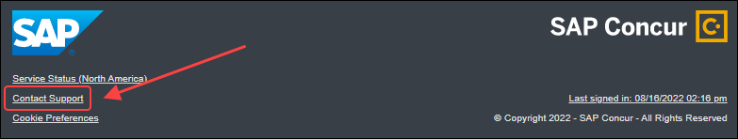

Click **Contact Support** to access the SAP Concur support portal, then click **Resources**.

* Click **Release/Tech Info** for release notes, technical documents, etc.
* Click **Webinars** for recorded and live webinars.

© 2023 SAP SE or an SAP affiliate company. All rights reserved.

No part of this publication may be reproduced or transmitted in any form or for any purpose without the express permission of SAP SE or an SAP affiliate company.

SAP and other SAP products and services mentioned herein as well as their respective logos are trademarks or registered trademarks of SAP SE (or an SAP affiliate company) in Germany and other countries. Please see http://global12.sap.com/corporate-en/legal/copyright/index.epx for additional trademark information and notices.

Some software products marketed by SAP SE and its distributors contain proprietary software components of other software vendors.

National product specifications may vary.

These materials are provided by SAP SE or an SAP affiliate company for informational purposes only, without representation or warranty of any kind, and SAP SE or its affiliated companies shall not be liable for errors or omissions with respect to the materials. The only warranties for SAP SE or SAP affiliate company products and services are those that are set forth in the express warranty statements accompanying such products and services, if any. Nothing herein should be construed as constituting an additional warranty.

In particular, SAP SE or its affiliated companies have no obligation to pursue any course of business outlined in this document or any related presentation, or to develop or release any functionality mentioned therein. This document, or any related presentation, and SAP SE’s or its affiliated companies’ strategy and possible future developments, products, and/or platform directions and functionality are all subject to change and may be changed by SAP SE or its affiliated companies at any time for any reason without notice. The information in this document is not a commitment, promise, or legal obligation to deliver any material, code, or functionality. All forward-looking statements are subject to various risks and uncertainties that could cause actual results to differ materially from expectations. Readers are cautioned not to place undue reliance on these forward-looking statements, which speak only as of their dates, and they should not be relied upon in making purchasing decisions.