|  |  |
| --- | --- |
| SAP Concur Release Notes  Shared Changes  Includes cross-product and site-wide changes for:  Professional Edition, Standard Edition, and Small Business Edition | |
| **Month** | **Audience** |
| Release Date: August 20, 2022  Initial Post: Friday, August 19, 2022 | Client FINAL |

Contents

Release Notes 1

Employee Import 2

SAP Global Identification Import Added as 315-Level Record Set 2

Travel, Expense, Invoice, Request | Professional & Standard 2

File Transfer Updates 3

**Ongoing** Rotating PGP Key for File Transfers 3

Travel, Expense, Invoice, Request, Intelligence | Professional & Standard 3

Help Menu 5

**Ongoing** Consolidation of Resources Under Help Menu 5

All Products | All Editions 5

Home Page 7

**Ongoing ** SAP Concur Homepage Changes 7

All Products | All Editions 7

Miscellaneous 10

**Ongoing** New IP Address Range for Callouts (EMEA, US) 10

Expense, Request | Professional & Standard 10

**Ongoing** SAP Concur Migration to Cloud Platform in AWS 11

All Products | All Editions 11

Profile Settings 13

**Ongoing** Changes to My Profile, Home Page, and Profile Menu 13

Travel, Expense, Invoice, Request, Mobile | Professional & Standard 13

Security 19

Some TLSv1.2 Ciphers No Longer Supported 19

Travel, Expense, Invoice, Request | All Editions 19

Test Entities | Production Sandbox Environment 24

**Ongoing** Most Recently Used Lists Not Migrated 24

Expense, Invoice, Request | Professional 24

**Ongoing** Production Sandbox Environment Login Updates 26

Expense, Invoice, Request | Professional 26

**Ongoing** Unique Address Required for PSE Email Verification 28

Expense, Invoice, Request | Professional 28

User Administration 29

**Ongoing** Standalone White Spaces No Longer Valid in First and Last Name Fields 29

Travel, Expense, Invoice, Request | Professional & Standard 30

User Import and Export 31

User Export and Import Improvements 31

Expense, Invoice, Request | Standard Edition 31

Planned Changes 35

Exchange Rates 35

**Planned Changes** Automatic Provisioning of Central Bank Exchange Rates for Selected Countries 35

Expense, Invoice, Request | Professional & Standard 35

Fax Feature 36

**Planned Changes** Fax Feature to be Decommissioned 36

Expense, Invoice | Professional & Standard 36

File Transfer Updates 37

**Planned Changes** New File Transfer Endpoints After Migration to AWS 37

All Products | Professional & Standard 37

Imaging 38

**Planned Changes** Imaging Database System Maintenance 38

Expense, Invoice, Request, Travel, Budget, Mobile | Professional & Standard 38

User Assistance 39

**Planned Changes** Concur User Assistance by WalkMe to be Enabled 39

All Products | All Editions 39

Client Notifications 45

Accessibility 45

Accessibility Enhancements 45

Subprocessors 45

SAP Concur Non-Affiliated Subprocessors 45

Supported Browsers 46

Supported Browsers and Changes to Support 46

Additional Release Notes and Other Technical Documentation 47

Online Help 47

SAP Concur Support Portal – Selected Users 47

Legal Disclaimer

The information in this presentation is confidential and proprietary to SAP SE or an SAP affiliate company and may not be disclosed without the permission of SAP SE or the respective SAP affiliate company. This presentation is not subject to your license agreement or any other service or subscription agreement with SAP SE or its affiliated companies. SAP SE and its affiliated companies have no obligation to pursue any course of business outlined in this document or any related presentation, or to develop or release any functionality mentioned therein. This document, or any related presentation and SAP SE or an SAP affiliate company’s strategy and possible future developments, products and or platforms directions and functionality are all subject to change and may be changed by SAP SE and its affiliated companies at any time for any reason without notice. The information in this document is not a commitment, promise or legal obligation to deliver any material, code or functionality. This document is provided without a warranty of any kind, either express or implied, including but not limited to, the implied warranties of merchantability, fitness for a particular purpose, or non-infringement. This document is for informational purposes and may not be incorporated into a contract. SAP SE and its affiliated companies assume no responsibility for errors or omissions in this document, except if such damages were caused by SAP SE or an SAP affiliate company’s willful misconduct or gross negligence.

All forward-looking statements are subject to various risks and uncertainties that could cause actual results to differ materially from expectations. Readers are cautioned not to place undue reliance on these forward-looking statements, which speak only as of their dates, and they should not be relied upon in making purchasing decisions.

# Release Notes

This document contains shared release notes and planned changes. Shared release notes and planned changes document features and changes that apply to SAP Concur solutions site-wide or to multiple SAP Concur products and services. They include but are not limited to:

* Security-related features and changes such as annual security certificate renewals and changes in support for security ciphers and protocols
* Site-wide UI features and changes such as changes to the home page, changes to the site header or footer, or the implementation of new site-wide UI themes
* Sign-in process features and changes such as the addition or removal of sign-in features, URL changes, and domain name changes
* Production and test environment features and changes
* Global settings or administration page features and changes such as the addition of new site-wide settings or changes to the design of the administration pages
* Changes to processes such as where and when release notes are published

For New Features and Changes that apply to a single product and/or service see the release notes for that product or service. Links to the product and service-specific release notes can be found on the following pages:

* [Professional Edition](https://www.concurtraining.com/customers/tech_pubs/_RN_CCC.htm)
* [Standard Edition](https://www.concurtraining.com/customers/tech_pubs/_Docs_CCC_CPS.htm)
* [Small Business Edition](http://www.concurtraining.com/customers/tech_pubs/Docs/Breeze/RN/WhatsNew.htm)

## Employee Import

### SAP Global Identification Import Added as 315-Level Record Set

|  |  |  |
| --- | --- | --- |
| Information First Published | Information Last Modified | Feature Target Release Date |
| August 5, 2022 | -- | August 20, 2022 |
| Any changes since the previous monthly release are highlighted in yellow in this release note. | | |

**Applies to:**

Travel, Expense, Invoice, Request | Professional & Standard

#### Overview

A new employee import record set, *SAP Global Identification*, is now added to the employee import job at the 315-record level. The purpose of this new feature is to support end-to-end access to the [SAP Intelligent Enterprise suite](https://www.sap.com/products/intelligent-enterprise.html) through a common identification attribute assigned to the user through this import.

The following fields are added through the 315-level import:

* **Field 1:** *Transaction Type*  
  This is a static numeric value always equal to 315. It indicates the Record Type.
* **Field 2:** *Employee ID*  
  The Employee ID value that is being used for the employee at this time.
* **Field 3:** *SAP Global ID*  
  The SAP Global ID value that is being used for the employee at this time.
* **Field 4 - 13:** *Future Use 1 – 10*  
  Reserved for future use.

##### Business Purpose / Client Benefit

This feature supports seamless access across products included in the [SAP Intelligent Enterprise suite](https://www.sap.com/products/intelligent-enterprise.html).

#### Configuration / Feature Activation

The feature is automatically available; however, implementing this feature may require consultation with your Concur Expense product administrator.

For more information, refer to the *Shared: Employee Import Specification* guide.

## File Transfer Updates

### **Ongoing** Rotating PGP Key for File Transfers

|  |  |  |
| --- | --- | --- |
| Information First Published | Information Last Modified | Feature Target Release Date |
| February 2021 | June 10, 2022 | January 15, 2021 and October 11, 2022 |
| Any changes since the previous monthly release are highlighted in yellow in this release note. | | |

**Applies to:**

Travel, Expense, Invoice, Request, Intelligence | Professional & Standard

#### Overview

Files transferred to SAP Concur products must be encrypted with the SAP Concur public PGP key, concursolutionsrotate.asc.

* **IMPORTANT!  
    
  Upcoming PGP key changes:**• The legacy (non-rotating) key, key ID D4D727C0, will be deprecated on October 11, 2022.  
    
  • The current rotating key, key ID 40AC5D35, will expire on September 4, 2022. • A new rotating key, key ID 9AFF10B5, is available in the client's root folder.

**New rotating PGP key details:**

* Key ID: 9AFF10B5
* Filename: concursolutionsrotate.asc
* The filename for the rotating PGP key does not change when the key is rotated.
* As of June 4, 2022, the new rotating public PGP key is available in the client’s root folder.
* RSA 4096-bit signing and encryption subkey.
* This key expires on September 4, 2024.
* Clients are responsible for replacing the rotating key before it expires.
* A new key will be provided 90 days before the September 4, 2024 expiration date.

**Expiring rotating PGP key details:**

* Key ID: 40AC5D35
* Filename: concursolutionsrotate.asc
* This key will expire on September 4, 2022.

**Legacy (non-rotating) PGP key details:**

* Key ID: D4D727C0
* The SAP Concur legacy (non-rotating) PGP key will be deprecated on October 11, 2022.

This announcement pertains to the following file transfer DNS endpoints:

* st.concursolutions.com
* mft-us.concursolutions.com
* vs.concursolutions.com
* st-eu.concursolutions.com
* mft-eu.concursolutions.com
* AWS transfer endpoints (when they are communicated to you)

##### Business Purpose / Client Benefit

The rotating public PGP key provides greater security for file transfers.

#### Admin Experience

An administrator with the required file transfer credentials can log into the file transfer site to retrieve the rotating public PGP key, concursolutionsrotate.asc, from the root directory.

#### Configuration / Feature Activation

Your internal file transfer administrator can add the new rotating key to their PGP keyring and start using it to encrypt files being transferred to SAP Concur any time prior to September 4, 2022.

If you require assistance, please contact SAP Concur support.

For more information, refer to the [*Shared: File Transfer for Customers and Vendors User Guide*](http://www.concurtraining.com/customers/tech_pubs/Docs/ConcurPremier/UG_Shr/Shr_UG_FileTransfer.pdf).

## Help Menu

### **Ongoing** Consolidation of Resources Under Help Menu

|  |  |  |
| --- | --- | --- |
| Information First Published | Information Last Modified | Feature Target Release Date |
| February 18, 2022 | July 8, 2022 | July 6, 2022 and Future release |
| Any changes since the previous monthly release are highlighted in yellow in this release note. | | |

**Applies to:**

All Products | All Editions

#### Overview

On July 6, SAP began consolidating SAP Concur help resources under the **Help** menu in SAP Concur solutions. The changes will occur in two phases:

* **Phase 1 -July 6, 2022**: The **Help** menu was updated. Updates include changes to the overall appearance and organization of the menu. In addition, for clients with SAP Enable Now content, users can access SAP Enable Now content from the **Help** menu.
* For more information about support for SAP Enable Now, refer to the *Support for SAP Enable Now* release note in this document.
* **Phase 2 – Targeted for a future release:**
* User assistance for admins and end users (OEM WalkMe), video tutorials, and tools for contacting support will be accessed from the consolidated **Help** menu.
* The **Get Assistance** icon (?) that is currently used to access those items will be removed from the UI.
* On SAP Concur Standard edition, if user assistance is enabled and a client is in the implementation phase or trying the free trial version, a new chat icon will be available.
* For more information about user assistance for admins and end users, refer to the [*User Assistance for Admins and End Users*](https://www.concurtraining.com/customers/tech_pubs/Docs/FactSheets/User%20Assistance%20for%20Admins%20and%20End%20Users.pdf)fact sheet.

##### Business Purpose / Client Benefit

These changes improve ease of use and simplify the SAP Concur user interface by providing a single point of access to help resources.

#### End-User Experience

As of July 6, 2022, when an admin or end user clicks **Help**, they see the redesigned **Help** menu, and, if SAP Enable Now content is available to them, they will see the **Explore Interactive Content** item in the menu.

**Previous Menu Example**

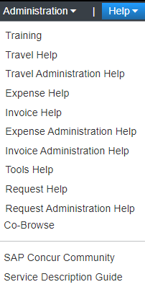

**Current Menu Example**

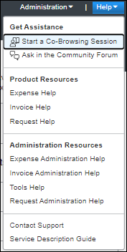

1. The list of items in the **Help** menu depends on a user's roles and permissions and on the configuration of the client's site. For example, only users with administrator privileges have access to **Administrative Resources**.

When all of the changes have been implemented, new options will be available in the **Help** menu—for example, if User Assistance for End Users is enabled, a link to access those resources will appear in the **Help** menu. In addition, the **Get Assistance** icons that currently provide access to those features will be removed from the user interface.

**Current Get Assistance Icons**

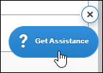

In addition, on SAP Concur Standard edition entities that are in the implementation phase or are a free trial instance, a chat icon will be available on pages in the UI.

**Future Chat Icon**

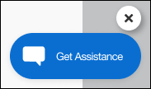

#### Configuration / Feature Activation

These changes will be implemented automatically.

## Home Page

### **Ongoing ** SAP Concur Homepage Changes

|  |  |  |
| --- | --- | --- |
| Information First Published | Information Last Modified | Feature Target Release Date |
| December 4, 2020 | May 13, 2022 | Q4 2021 – Future Release |
| Any changes since the previous monthly release are highlighted in yellow in this release note. | | |

**Applies to:**

All Products | All Editions

#### Overview

In Q4, 2021, SAP Concur began redirecting clients to a new homepage. The appearance of the new homepage is identical to the previous SAP Concur homepage. The new homepage has enhanced functionality when services become temporarily unavailable.

The roll out of the new homepage is phased:

**Phase 1:** In October of 2021, SAP Concur began redirecting Concur Expense, Concur Invoice, and Concur Request clients in the US Datacenter to the new homepage.

**Phase 2:** In December 2021, SAP Concur began redirecting Concur Expense, Concur Invoice, and Concur Request clients in the EU Datacenter to the new homepage.

**Phase 3:** At a date to be determined, SAP Concur will begin redirecting the remaining clients in the US and EU datacenters to the new homepage. The remaining clients include those with Concur Travel standalone or Concur Travel with Expense, Invoice, and/or Request.

##### Business Purpose / Client Benefit

This change ensures that the SAP Concur homepage is available even when some services are unavailable and improves the consistency of the sign in experience.

#### End-User Experience

With the old homepage, when a user signs into their SAP Concur products, they see their homepage.

1. The appearance of the homepage varies depending on which products and services are enabled for the client and the permissions assigned to the user.

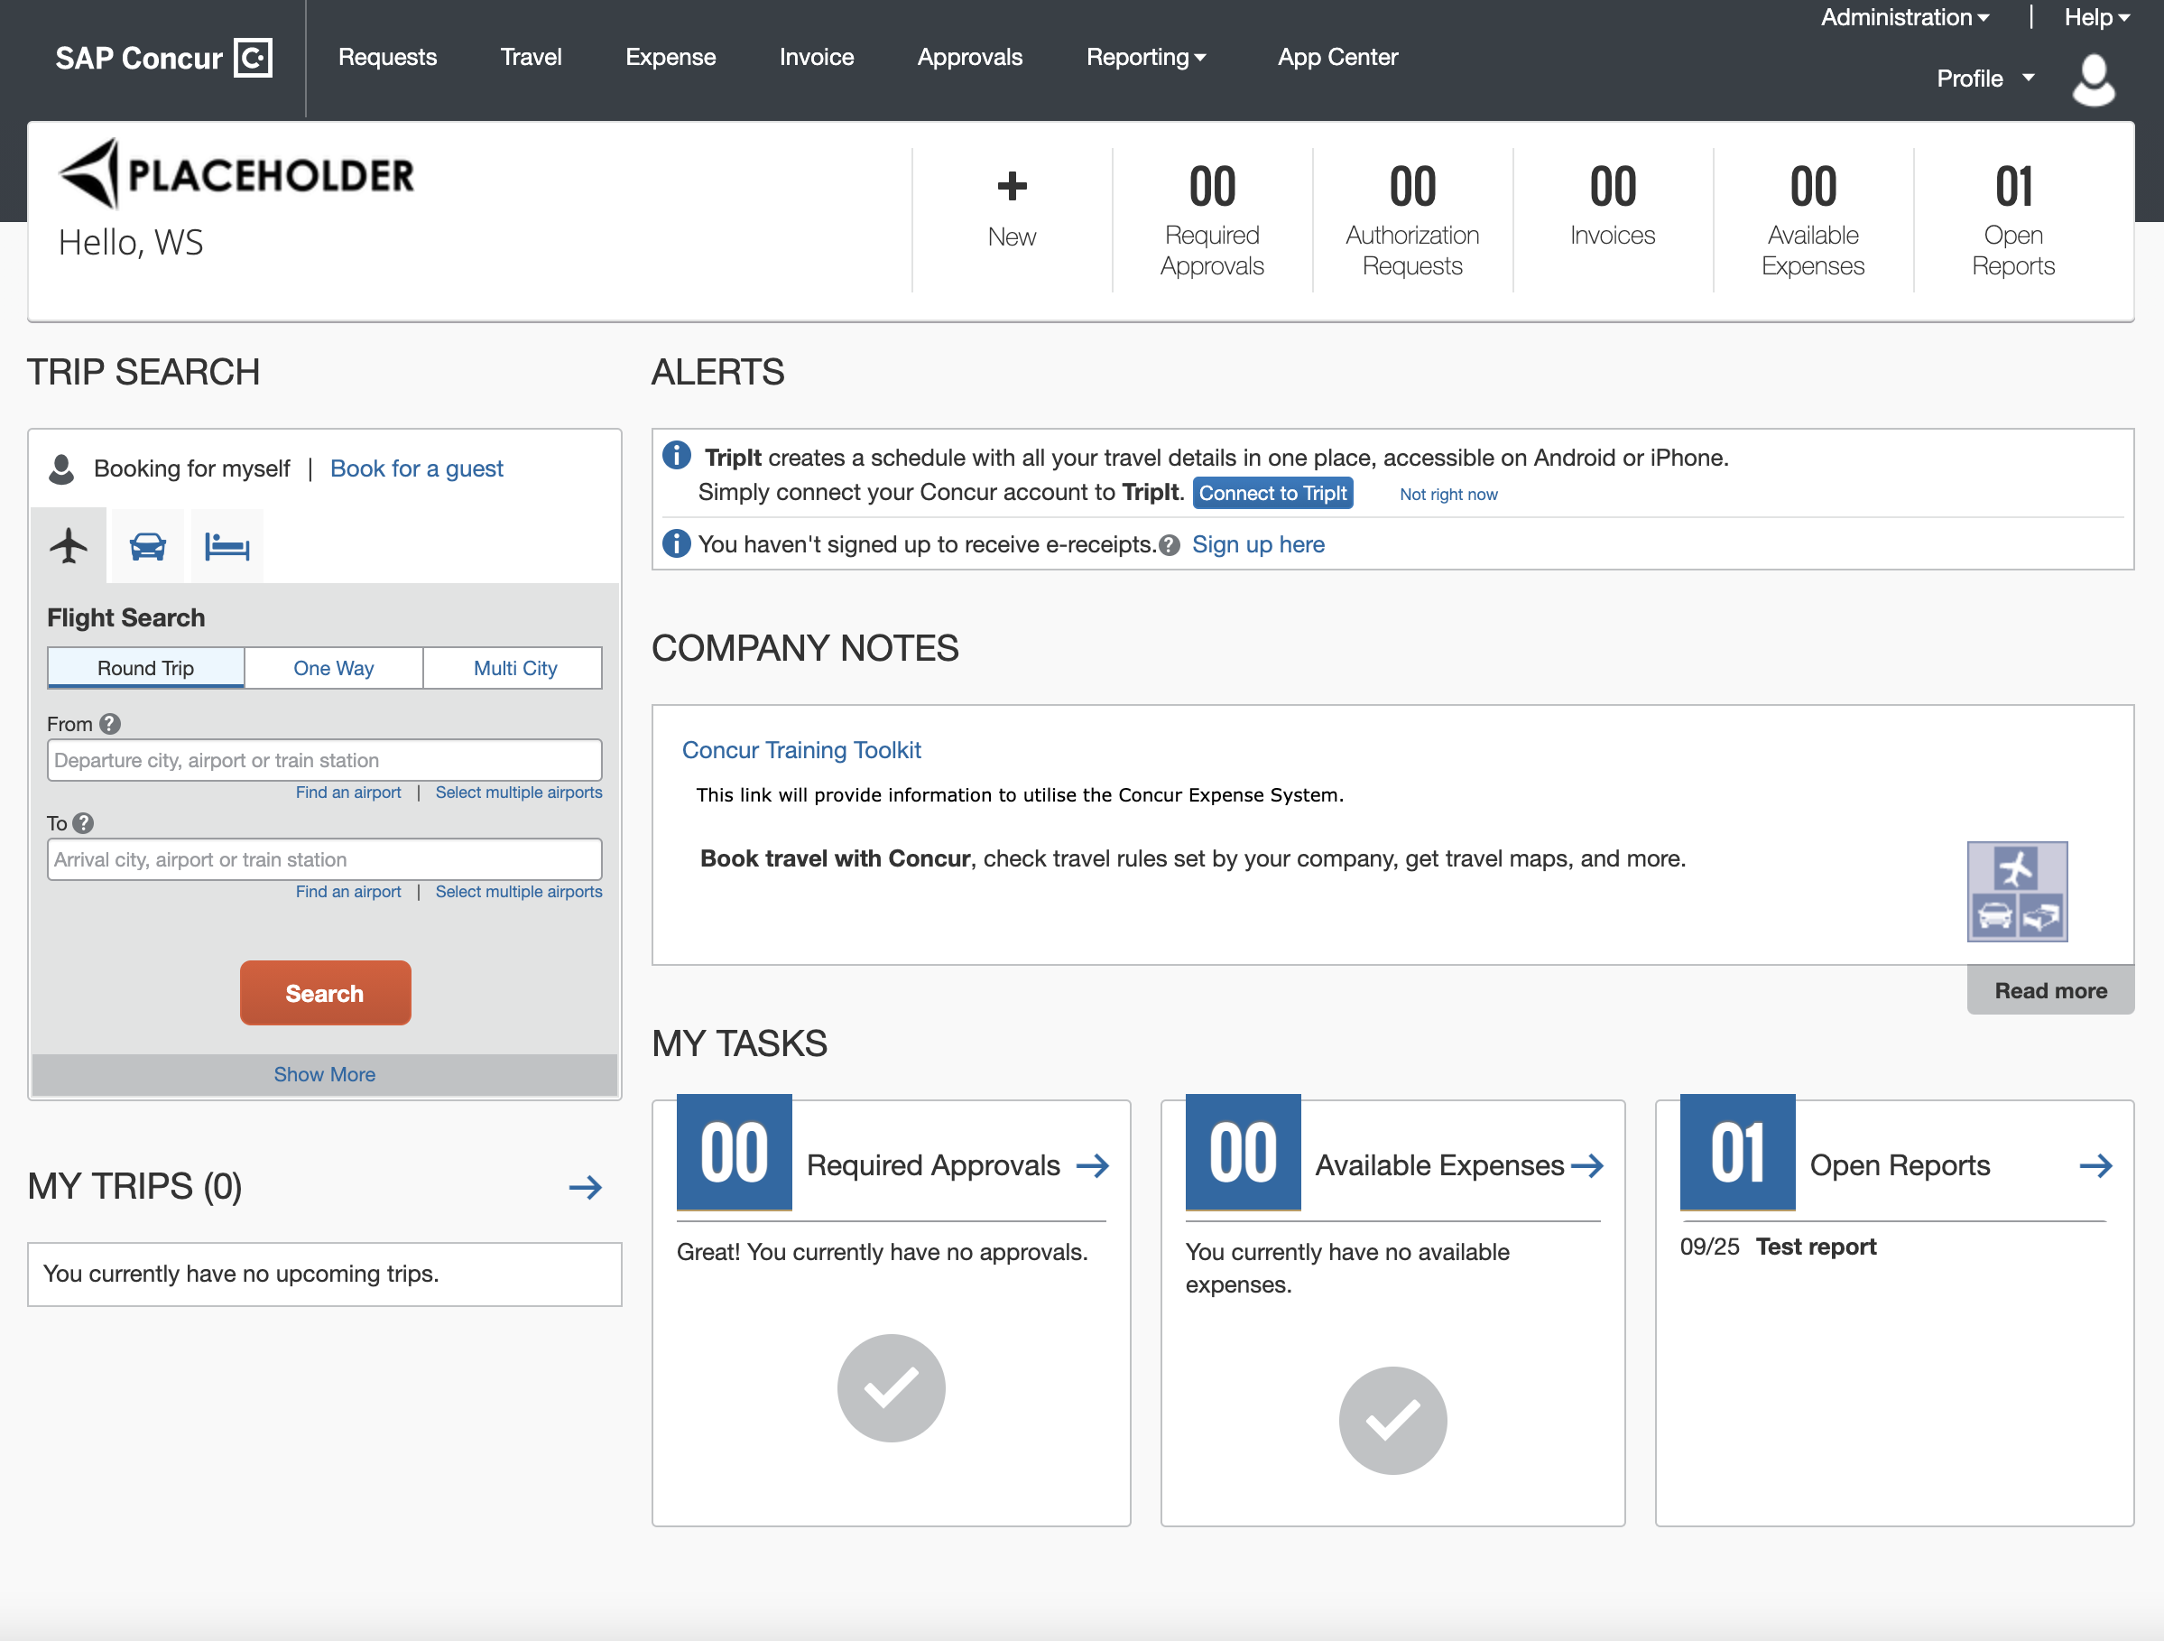

If some products or services are unavailable while other products and services are up and running, a modified version of the user’s homepage similar to the following appears:

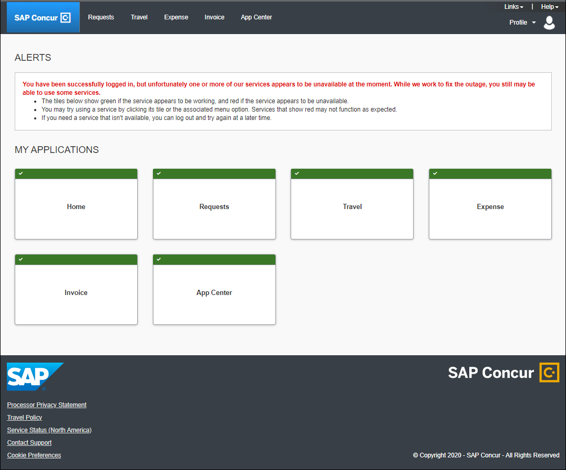

After a client is migrated to the new homepage, if one or more services are unavailable, when a user signs in to their SAP Concur products, they will see the usual homepage, but if the user navigates to a page for a service that is unavailable, they will see a page similar to the following:

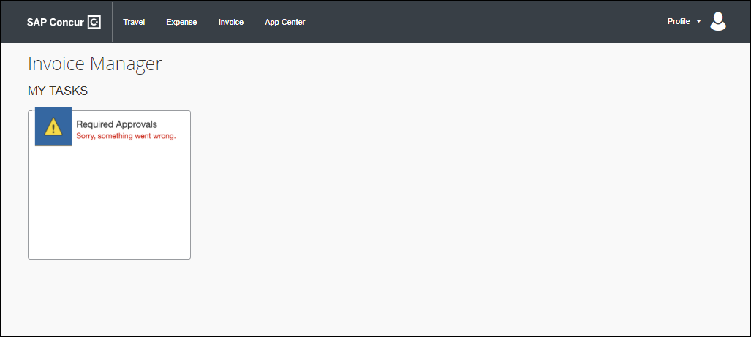

After migration to the new homepage, if all services are available, this change is transparent to the user and they see a homepage that is identical to the pre-migration homepage.

**Example Homepage**

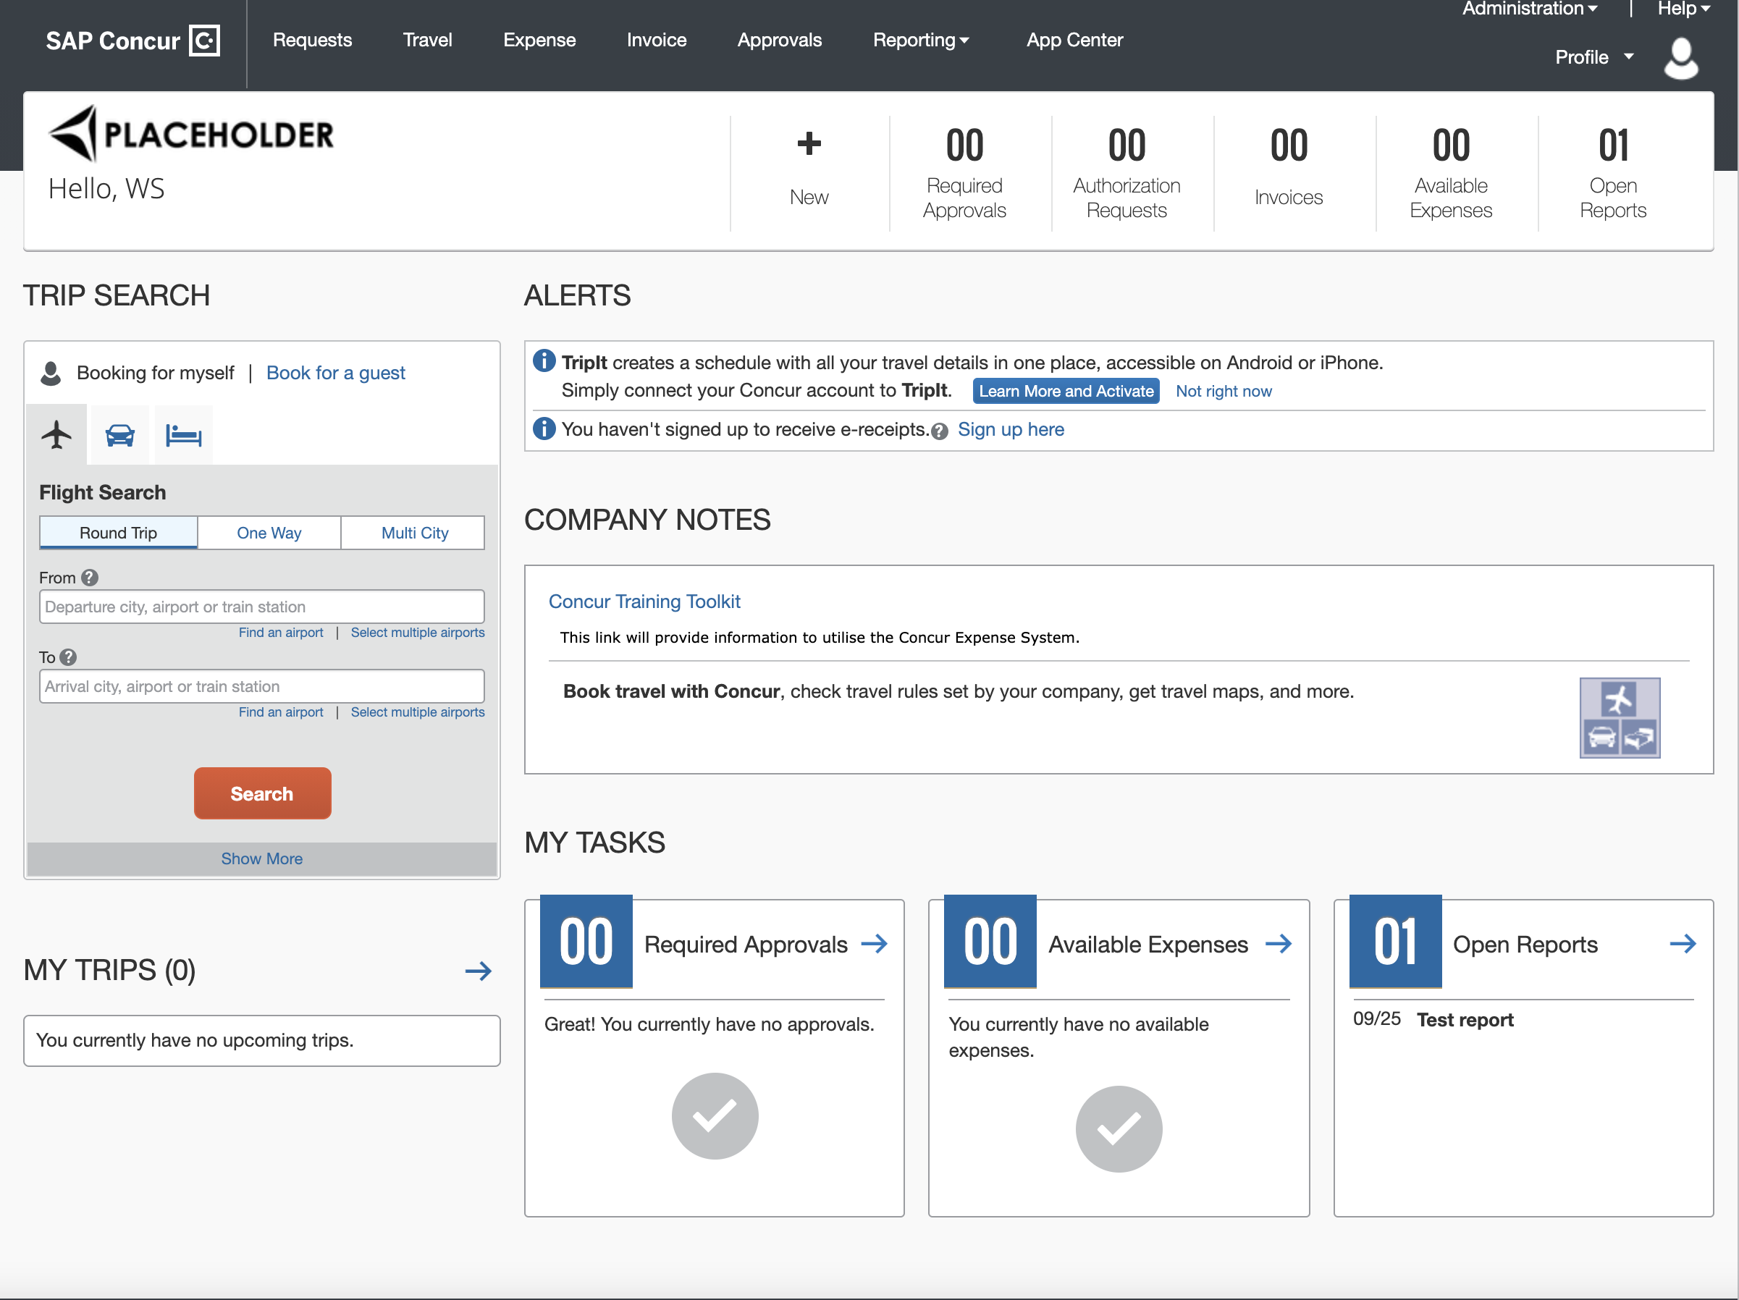

#### Configuration / Feature Activation

This change occurs automatically; there are no configuration or activation steps.

## Miscellaneous

### **Ongoing** New IP Address Range for Callouts (EMEA, US)

|  |  |  |
| --- | --- | --- |
| Information First Published | Information Last Modified | Feature Target Release Date |
| August 12, 2022 | -- | August – December 2022 |
| Any changes since the previous monthly release are highlighted in yellow in this release note. | | |

**Applies to:**

Expense, Request | Professional & Standard

#### Overview

Beginning in August and continuing through the end of 2022, servers that support SAP Concur callouts in the US & EMEA datacenters will be upgraded. This maintenance includes migration of some services to new servers. This means that clients should anticipate that, when the migration occurs, the IP addresses associated with these services will change.

These servers support the following functionality:

* Fetch Attendee Data Callout
* Fetch List Item Callout
* Event Notification Callout
* Launch External URL Callout
* Concur Salesforce Connector
* **IMPORTANT**: We do not anticipate any interruption in functionality for clients who use SAP Concur callout; however, clients who use allow lists or otherwise restrict SAP Concur IP addresses might need to update their lists to avoid disruption of some functionality. SAP recommends adding *concursolutions.com to your allow lists rather than specific IP addresses.

##### Business Purpose / Client Benefit

This migration improves the stability and reliability of connections that pass these servers.

#### Configuration / Feature Activation

We do not anticipate any interruption in functionality for clients who use SAP Concur callout; however, clients who use allow lists or otherwise restrict SAP Concur IP addresses may need to add the new IP addresses to their lists to avoid disruption of some functionality.

1. SAP recommends adding *concursolutions.com to your allow lists rather than specific IP addresses. If your company requires specific IP addresses, contact SAP Concur support or your SAP Concur representative for assistance.

### **Ongoing** SAP Concur Migration to Cloud Platform in AWS

|  |  |  |
| --- | --- | --- |
| Information First Published | Information Last Modified | Feature Target Release Date |
| February 18, 2022 | March 18, 2022 | Ongoing in 2022 |
| Any changes since the previous monthly release are highlighted in yellow in this release note. | | |

**Applies to:**

All Products | All Editions

#### Overview

SAP Concur plans to migrate from a pure private cloud operation, where all equipment is owned by SAP Concur, to a cloud platform. We plan to close our own private data centers in favor of a cloud platform implemented in Amazon Web Services (AWS). While this process started in 2017, we are focused on the final phase of the migration in 2022 for the North American and EMEA data centers.

##### Business Purpose / Client Benefit

This change provides a stronger security posture, improved performance and stability, and faster innovation for our clients.

#### End-User Experience During Migration

While a company is being migrated from an SAP Concur private data center to the cloud platform, their SAP Concur solutions might not be available to end users.

If an end user tries to sign in to SAP Concur solutions during the migration process, they might not be able to sign in and they might receive the following message:

"SAP Concur solutions is undergoing scheduled maintenance. Please try again later"

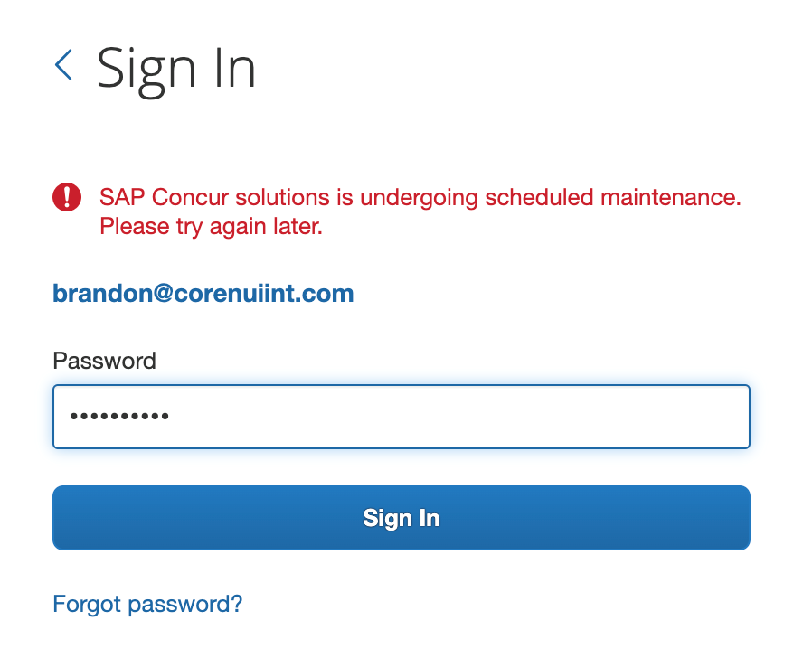

If an end user is working in SAP Concur solutions when their company is migrated, they might be returned to the sign in page.

1. SAP plans to implement migrations on weekends and after business hours.

#### Configuration / Feature Activation

This change will occur automatically.

For details, refer to the [*SAP Concur Cloud Platform Strategy FAQ*](http://assets.concur.com/concurtraining/cte/en-us/FAQ_Cloud_Hosting_Strategy.pdf).

## Profile Settings

### **Ongoing** Changes to My Profile, Home Page, and Profile Menu

|  |  |  |
| --- | --- | --- |
| Information First Published | Information Last Modified | Feature Target Release Date |
| January 21, 2022 | June 10, 2022 | Ongoing beginning in April 2022 |
| Any changes since the previous monthly release are highlighted in yellow in this release note. | | |

**Applies to:**

Travel, Expense, Invoice, Request, Mobile | Professional & Standard

#### Overview

SAP Concur has implemented or plans to implement changes to several pages in the UI. The changes will be implemented over time beginning in April of 2022 and continuing throughout 2022.

These changes reflect [SAP's commitment to supporting gender diversity](https://www.sap.com/about/company/diversity.html) by enabling gender non-binary users to enter consistent information when making travel arrangements and entering information in SAP Concur solutions. Changes include but are not limited to the following:

**April 2022 Release**

* The greeting on the SAP Concur Home page was removed. In addition, first and last name were removed from the menu in the SAP Concur mobile app.
* If a user adds their preferred name on the **My Profile – Personal Information** page in **Profile Settings**, their preferred name and last name is displayed in the SAP Concur **Profile** menu.

**May 2022 Release**

* The **Nickname** field on the **My Profile – Personal Information** page was changed from **Nickname** to **Preferred Name**.
* The **Nickname** field in the **Employee Travel Addendum Import 350** file was changed from **Nick Name** to **Preferred Name**.
* The **Nickname** field in the **Employee Import** file was changed from **Nickname** to **Preferred Name**.

**June 2022 Release**

* The **Nickname** field on the user details page in **User Administration** was changed from **Nickname** to **Preferred Name**.

**Future Releases**

* A new option, Mx, will be added to the **Title** list on the **My Profile – Personal Information** page.
* New options will be added to enable users to select a non-binary gender in the **TSA Secure Flight** section of **Travel Preferences**.
* New options will be added to the gender field in the Travel Profile 2.0 API. This change will enable callers, such as TMCs and App Center partners, to provision (write) and receive (read) the new non-binary gender values.

##### Business Purpose / Client Benefit

These changes:

* Enable users to enter information into SAP Concur solutions that is consistent with their identity.
* Enable SAP Concur solutions to address a user by their preferred name.
* Ensure that information in SAP Concur solutions matches a user's government-issued identification.
* Ensure that travel documents such as airplane tickets purchased through SAP Concur solutions display information that is consistent with other required documents.

Implemented and Planned Changes

SAP Concur has implemented or plans to implement the following changes overtime beginning in April 2022 and continuing throughout 2022.

#### April 2022 Release

##### Web UI Page Header

The greeting on the Concur home page, "Hello <First Name>" was removed in April. The greeting included the name from the **First Name** field in the end user's user account.

**Previously**

The greeting "Hello, <First Name>" was included on the SAP Concur homepage.

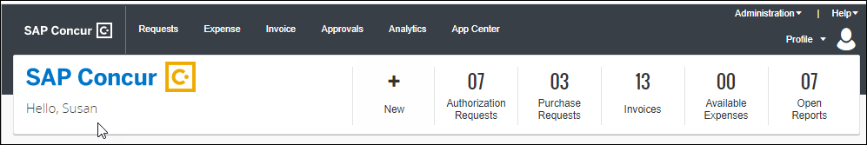

**With the April 2022 Release**

The greeting is no longer included.

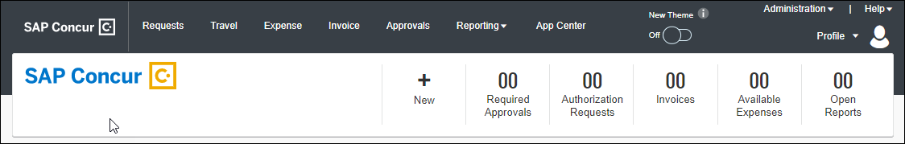

##### Mobile App

**Previously**

Prior to the April 2022 release, the menu in the Mobile app included the first and last names from the respective fields in the user's user account.

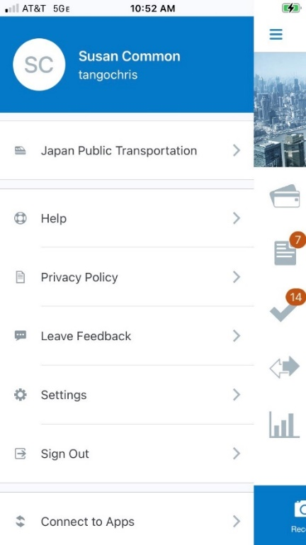

**With the April 2022 Release**

With the April 2022 release, no name is included at the top of the Mobile app menu.

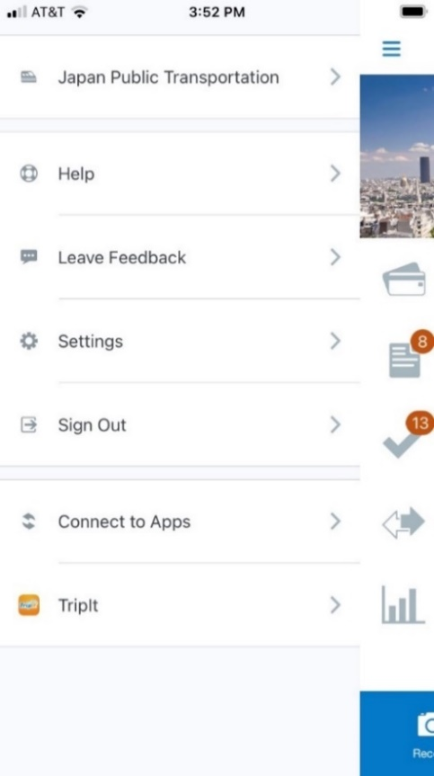

##### Web UI Profile Menu

Beginning with the April release, if a user specifies a preferred name on the **Profile – Personal Information** page in **Profile Settings**, when they click on **Profile** in the web version of SAP Concur solutions, their preferred name and last name is displayed.

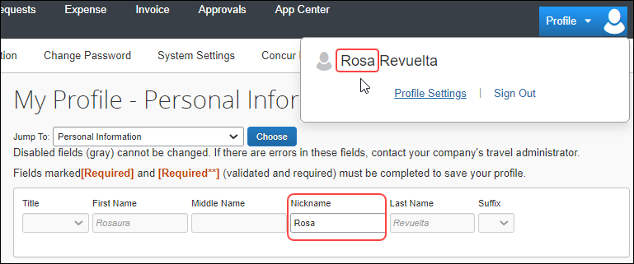

1. If the user has not specified a preferred name, their first and last names from their user account information will be displayed.

#### May 2022 Release

##### My Profile - Personal Information – Preferred Name

**Preferred Name Field**

Prior to the May 2022 release, a **Nickname** field was included on the **My Profile – Personal Information** page. With the May 2022 release, this field will be replaced by the **Preferred Name** field.

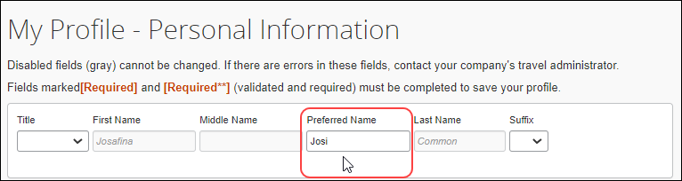

##### Preferred Name in Import and Extract Files

With the May 2022 release, the Nickname fields in import and extract files will be renamed to Preferred name.

**Employee Travel Addendum Import 350**

The **Preferred Name** field will replace the **Nick Name** field in Employee Travel Addendum Import 350.

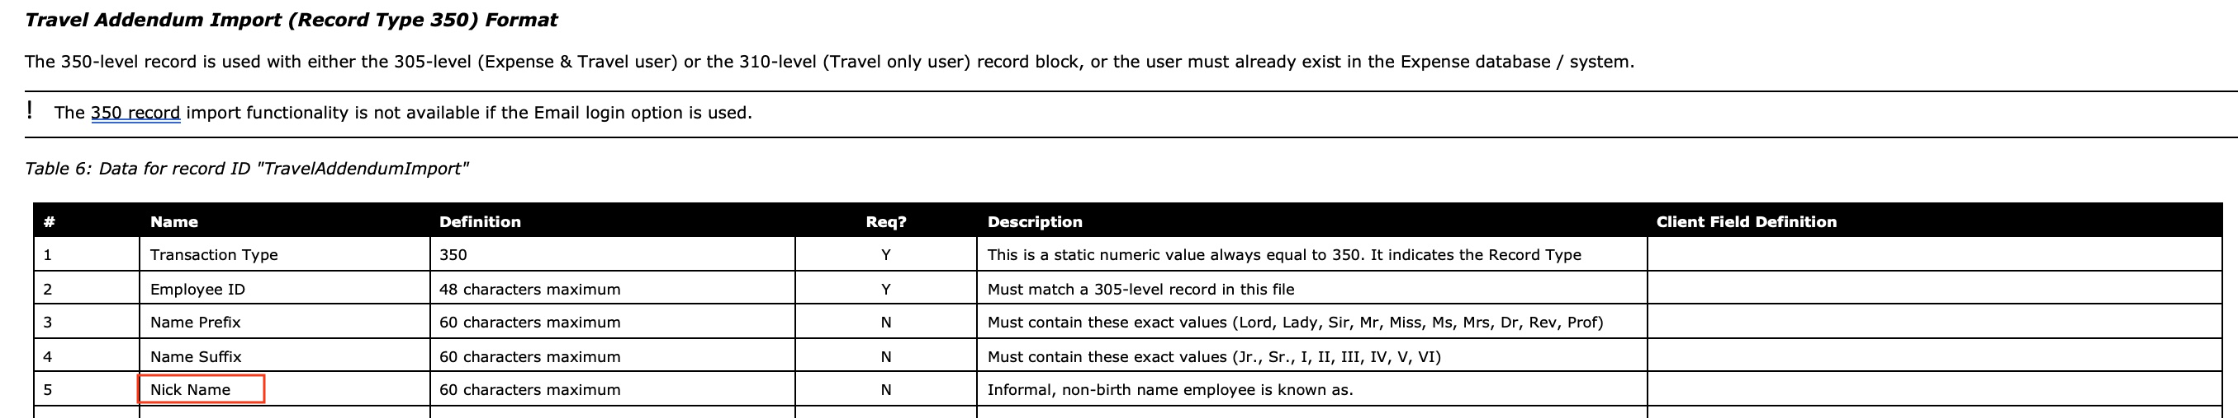

**User Import**

The **Preferred Name** field will replace the **Nickname** field in User Import.



**Import Data**

The **Preferred Name** field will replace the **Nickname** field in the user general information template.

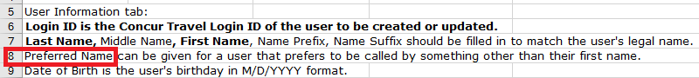

1. Previously downloaded templates containing the Nickname field will continue to be processed.

#### June 2022 Release

On the user detail pages in **User Administration**, in the **General Settings** section, the **Nickname** field will be changed from **Nickname** to **Preferred Name**.

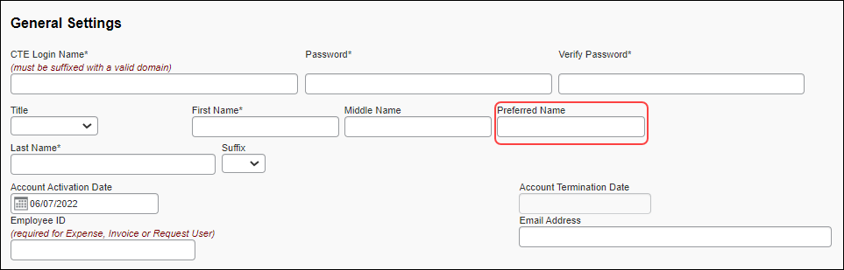

#### Future Releases

##### Title List

In a future release, a new gender non-binary option, **Mx** (pronounced "Mix"), will be added to the list in the **Title** list.

##### Travel Preferences TSA Secure Flight

Currently, users see two options under **Gender** in the **TSA Secure Flight** section of **Travel Preferences**.

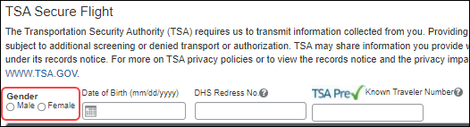

In a future release, users will have two additionaloptions under **Gender**: undisclosed (x) and unspecified (u).

1. When selecting a gender option, users should choose the option that matches the government-issued ID they use when travelling.

##### Web UI Profile Menu

When users with permission to act on behalf of another user—for example, Travel Arrangers and Delegates—search for and act as another user, they will see the preferred name of the user they are acting on behalf of in the search field and at the top of the **Profile** menu.

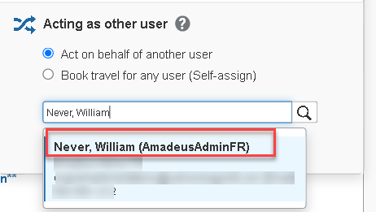 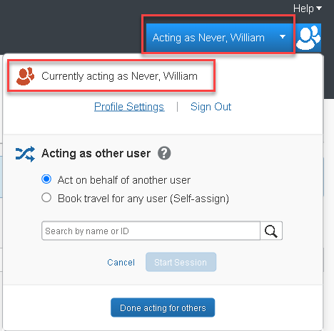

#### Configuration / Feature Activation

These changes will occur automatically over time. Users might need to update the information on the **My Profile – Personal Information** page after the changes are implemented.

For more information, refer to the [*Preferred Name and Nonbinary Gender Options*](https://www.concurtraining.com/customers/tech_pubs/Docs/FactSheets/Preferred%20Name_Nonbinary%20Gender%20Options_FS.pdf) fact sheet.

## Security

### Some TLSv1.2 Ciphers No Longer Supported

|  |  |  |
| --- | --- | --- |
| Information First Published | Information Last Modified | Feature Target Release Date |
| August 13, 2021 | July 8, 2022 | February 1, 2022 & Nov/Dec 2022 |
| Any changes since the previous monthly release are highlighted in yellow in this release note. | | |

**Applies to:**

Travel, Expense, Invoice, Request | All Editions

#### Overview

SAP Concur no longer supports connections to *.concursolutions.com and * api.concursolutions.com that use the following TLSv1.2 ciphers:

|  |  |
| --- | --- |
| Akamai/OpenSSL cipher name | IANA cipher name |
| AES256-GCM-SHA384 | TLS_RSA_WITH_AES_256_GCM_SHA384 |
| AES128-GCM-SHA256 | TLS_RSA_WITH_AES_128_GCM_SHA256 |
| ECDHE-RSA-AES128-SHA256 | TLS_ECDHE_RSA_WITH_AES_128_CBC_SHA256 |
| ECDHE-RSA-AES256-SHA | TLS_ECDHE_RSA_WITH_AES_256_CBC_SHA |
| ECDHE-RSA-AES128-SHA | TLS_ECDHE_RSA_WITH_AES_128_CBC_SHA |

To ensure that connections to *.concursolutions.com and * api.concursolutions.com are not disrupted, clients and partners who connect to *.concursolutions.com and *api.concursolutions.com through an application that uses a retired cipher must update the application to a supported cipher.

Because some SAP Concur clients use an operating system that does not yet support any of the SAP Concur supported ciphers, removal of support for the following cipher has been postponed:

|  |  |
| --- | --- |
| Akamai/OpenSSL cipher name | IANA cipher name |
| ECDHE-RSA-AES256-SHA384 | TLS_ECDHE_RSA_WITH_AES_256_CBC_SHA384 |

##### Business Purpose / Client Benefit

This update provides ongoing security for our products and services.

#### Confirming Supported Ciphers

The following ciphers included in the **ak-akamai-2020q1** cipher profile are supported:

|  |  |
| --- | --- |
| Akamai/OpenSSL cipher name | IANA cipher name |
| TLS-AES-256-GCM-SHA384 | TLS_AES_256_GCM_SHA384 |
| TLS-CHACHA20-POLY1305-SHA256 | TLS_CHACHA20_POLY1305_SHA256 |
| TLS-AES-128-GCM-SHA256 | TLS_AES_128_GCM_SHA256 |
| ECDHE-RSA-AES256-GCM-SHA384 | TLS_ECDHE_RSA_WITH_AES_256_GCM_SHA384 |
| ECDHE-RSA-AES128-GCM-SHA256 | TLS_ECDHE_RSA_WITH_AES_128_GCM_SHA256 |
| ECDHE-RSA-CHACHA20-POLY1305 | TLS_ECDHE_RSA_WITH_CHACHA20_POLY1305_SHA256 |

1. If your cipher suite includes both supported and unsupported ciphers, connections to *concursolutions.com through a web browser will not be disrupted. During the process of establishing the connection, the *concursolutions.com server will choose the most secure cipher in your cipher suite.

You can confirm that your cipher suite includes a supported cipher by cross-referencing the Akamai/OpenSSL cipher name with the IANA cipher name in the **ak-akamai-2021 (default)** column in the following table.

Supported ciphers are indicated with a check mark.

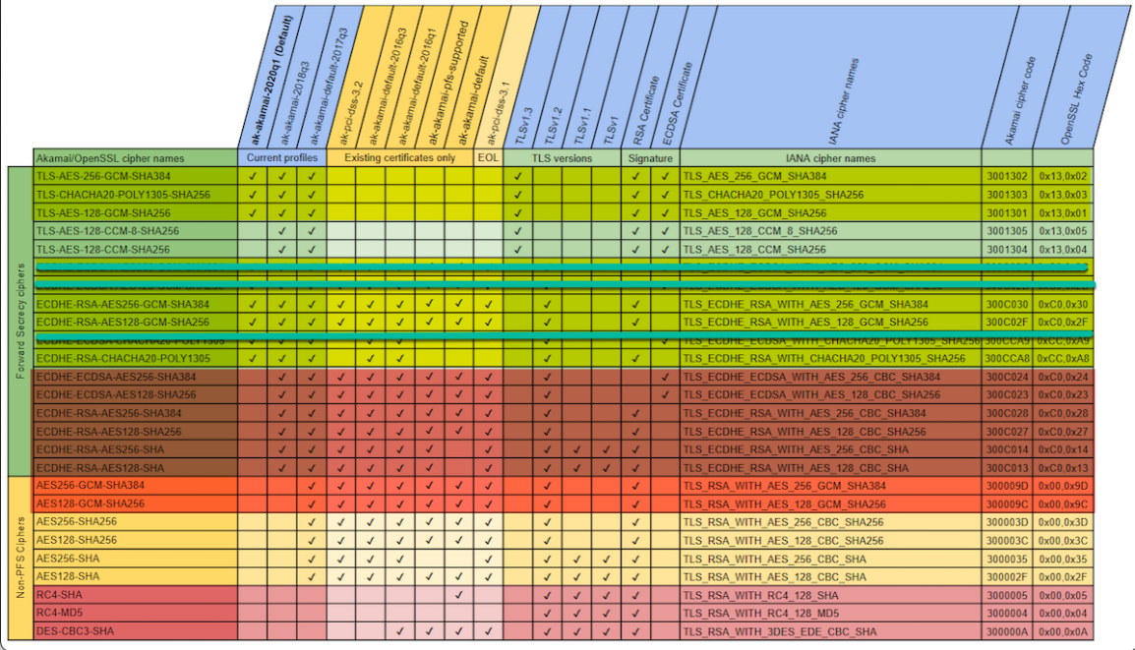

#### Testing Ciphers

The following procedure is intended for use by system administrators who want to test whether their cipher suite configuration will work correctly when connecting to SAP Concur solutions after support for the ciphers listed above has been removed.

This procedure configures the system admin's local machine to connect to an akamai staging environment where support for the listed ciphers has already been removed.

Summary of the procedure:

* Retrieve the IP address of the akamai production environment.
* Retrieve the IP address of the akamai staging environment.
* Redirect navigation to concursolutions.com to the akamai staging environment by editing the local *Hosts* file.
* Test a connection to concursolutions.com.

##### Confirm Your Cipher Suite is Working Correctly

1. Retrieve the IP Address of the Akamai Production Environment
2. Ping www.concursolutions.com

* Windows: Open a **Command Prompt** window, type “Ping www.concursolutions.com” and then press **Enter**.
* Mac: Open Terminal, type “Ping www.concursolutions.com” and then press **Enter.**

**Example response**

Pinging e7868.b.akamaiedge.net (23.46.104.197): 56 data bytes  
64 bytes from 23.46.104.197: icmp_seq=0 ttl=50 time=125.070 ms  
64 bytes from 23.46.104.197: icmp_seq=1 ttl=50 time=111.866 ms  
64 bytes from 23.46.104.197: icmp_seq=2 ttl=50 time=111.967 ms  
64 bytes from 23.46.104.197: icmp_seq=3 ttl=50 time=112.435 ms

1. Copy the highlighted address in the response.

**Example address**

e7868.b.akamaiedge.net

1. Retrieve the IP address of the akamai staging environment
2. In the **Command Prompt** or **Terminal** window, ping the copied address, but with “-staging” appended to “akamaiedge”.

**Example Ping command**

Ping e7868.b.akamaiedge-staging.net

**Example response**

Pinging e7868.b.akamaiedge-staging.net (104.76.225.252): 56 data bytes  
64 bytes from 104.76.225.252: icmp_seq=0 ttl=50 time=118.809 ms  
64 bytes from 104.76.225.252: icmp_seq=1 ttl=50 time=242.459 ms  
64 bytes from 104.76.225.252: icmp_seq=2 ttl=50 time=112.145 ms  
64 bytes from 104.76.225.252: icmp_seq=3 ttl=50 time=114.994 ms

1. Copy the highlighted IP address in the response.

**Example IP address**

104.76.225.252

1. Update the Local Hosts File

**MAC:**

1. Open Terminal
2. Type “sudo nano /private/etc/hosts” and then press **Enter**.

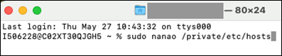

If prompted, enter your administrator password.

1. After the comments at the beginning of the file, add the IP address you copied in step 4, followed by “www.concursolutions.com”.
2. Comments are preceded with a hashtag (#). Your entry should not include the hashtag.

**Example entry**

104.76.225.252 [www.concursolutions.com](http://www.concursolutions.com)

1. Save the file (Ctrl-o) and close Terminal (Ctrl-x).

**Windows:**

1. Launch Notepad as administrator by typing “Notepad” into the Windows search bar, right-clicking Notepad in the search results, and then clicking **Run as administrator**.

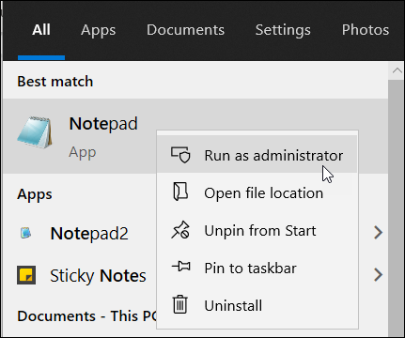

If prompted, click **Yes** in the **User Account Control** window.

1. In Notepad, click **File** and then click **Open**.
2. Navigate to *C:\\Windows\System32\drivers\etc* and then, to the right of the **File name** field, choose **All Files (*.*)** from the menu.

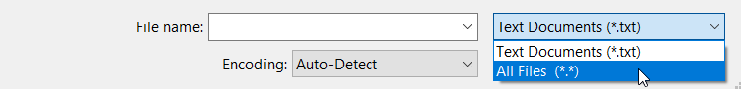

1. Open the *hosts* file.
2. After the comments at the beginning of the file, add the IP address you copied in step 4, followed by “www.concursolutions.com”.
3. Comments are preceded with a hashtag (#). Your entry should not include the hashtag.

**Example entry**

104.76.225.252 www.concursolutions.com

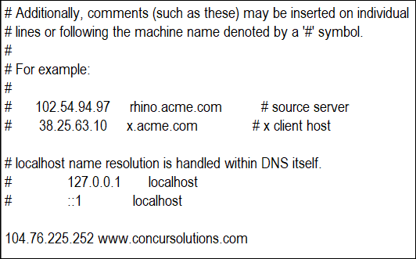

1. In the **File** menu, click **Save**.
2. Connect to *concursolutions.com from the Local Machine

After configuring your local *hosts* file to direct connections to *concursolutions.com to the akamai staging environment, connect to *concursolutions.com from the local machine through the method you need to test.

1. Your system administrator might need to test connections to *concursolutions.com made via an API call, connected application, or by navigating to the sign-in page through a web browser and signing in as an SAP Concur user.

#### Configuration / Feature Activation

To ensure that connections to *.concursolutions.com and * api.concursolutions.com are not disrupted, any applications that use an unsupported cipher must be updated to use a supported cipher.

1. If your cipher suite includes both supported and unsupported ciphers, connections to *concursolutions.com through a web browser will not be disrupted. During the process of establishing the connection, the *concursolutions.com server will choose the most secure cipher in your cipher suite.

## Test Entities | Production Sandbox Environment

### **Ongoing** Most Recently Used Lists Not Migrated

|  |  |  |
| --- | --- | --- |
| Information First Published | Information Last Modified | Feature Target Release Date |
| September 2021 | January 21, 2022 | October 1, 2021 through mid-2022 |
| Any changes since the previous monthly release are highlighted in yellow in this release note. | | |

**Applies to:**

Expense, Invoice, Request | Professional

#### Overview

Some SAP Concur users use Production Sandbox Environment (PSE) entities to set up, test, and train on new configurations prior to deploying them to their live production entity. SAP Concur plans to migrate PSEs as part of our move to Amazon Web Services (AWS).

For more information, refer to the [*SAP Concur Cloud Platform Strategy FAQ*](http://assets.concur.com/concurtraining/cte/en-us/FAQ_Cloud_Hosting_Strategy.pdf).

Due to the architectural changes that SAP Concur must make to support this move, when PSEs are migrated to the new environment, some Most Recently Used (MRU) list items within the PSE will not be migrated.

1. MRU lists consist of recent selections made by the user. These lists are generated overtime as users interact with various menus and other defined lists and they will be regenerated after the PSE is migrated to the new environment.
2. These changes apply to PSEs once they are moved or created in the AWS environment, which will occur at a future date.

##### Business Purpose / Client Benefit

Once in AWS, PSEs benefit from the same stability, monitoring capabilities, and level of performance as production entities.

#### End-User Experience

After the migration, some MRU lists that were generated prior to the migration will be empty. These lists will be regenerated automatically through the normal use of the PSE.

The following screenshots show some examples of MRU lists that will be impacted by the migration:

**Create New Expense in Concur Expense**

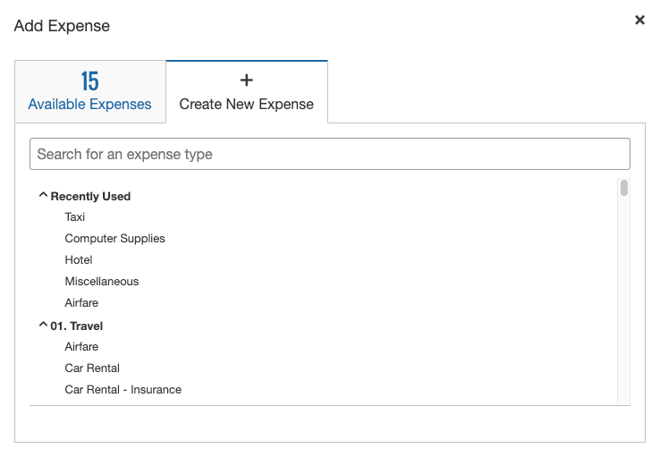

**New Segment in Concur Request**

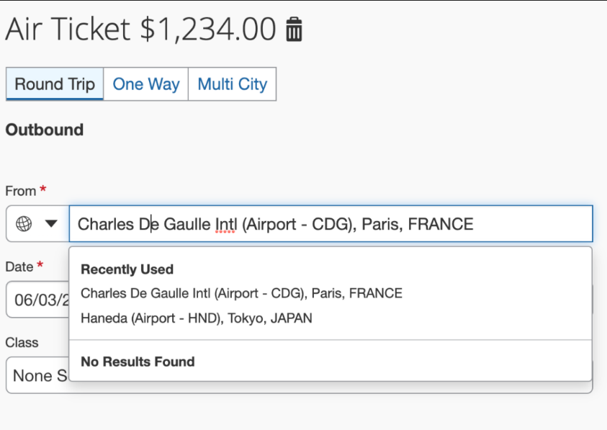

#### Configuration / Feature Activation

This change occurs when a PSE is migrated to the new AWS environment; there are no configuration or activation steps. The MRU lists will be regenerated with normal user of the entity.

### **Ongoing** Production Sandbox Environment Login Updates

|  |  |  |
| --- | --- | --- |
| Information First Published | Information Last Modified | Feature Target Release Date |
| August 2021 | January 21, 2022 | October 1, 2021 through mid-2022 |
| Any changes since the previous monthly release are highlighted in yellow in this release note. | | |

**Applies to:**

Expense, Invoice, Request | Professional

#### Overview

Some SAP Concur users use Production Sandbox Environment (PSE) entities to set up, test, and train on new configurations prior to deploying them to their live production entity. SAP Concur plans to migrate PSEs as part of our move to Amazon Web Services (AWS).

For more information, refer to the [*SAP Concur Cloud Platform Strategy FAQ*](http://assets.concur.com/concurtraining/cte/en-us/FAQ_Cloud_Hosting_Strategy.pdf).

Today, a user can maintain the same login ID for their test and production entities because they are in separate environments. With the plan to migrate both test and production entities to the same AWS production environment in the future, this will no longer be possible since each login ID must be unique.

While there is no action required for clients regarding this update, we want to ensure clients are aware of it because the change will be visible in certain areas of PSEs. To account for this change, SAP Concur will append all PSE login IDs with a ".uat” domain during both migration and user creation to ensure they are unique and do not conflict with any existing production login ID. For example, [johnsmith@123.com](mailto:johnsmith@123.com) will become [johnsmith@123.com.uat](mailto:johnsmith@123.com.uat).

* **IMPORTANT**: No changes will made to the login IDs in the current implementation environment in our private data centers.  
    
  This process will occur in the background during both the migration and user creation processes. Because SAP Concur will manage this process, users will **NOT** have to make any changes to their login ID.   
    
  Migrated users will still use the same implementation URL and login ID they used prior to the AWS migration.   
    
  New clients will use the production URL with the appended login ID, which will include the appended domain (for example, [johnsmith@123.com.uat](mailto:johnsmith@123.com.uat)).

This change will help to safeguard against any conflicts with production login IDs.

**User Creation:** Additionally, clients can use the exact same employee import files as they would in production. The uat domain will also be applied to all aspects of user creation: FTP import, Excel import, entity restore, and more.

**Extracts**: When generating accounting extracts or financial integration documents, SAP Concur will automatically remove the uat domain from login IDs that were appended during user creation. This will help to generate realistic extracts without requiring any actions from the clients, such as removing the appended domain.

1. These changes apply to PSEs once they are moved or created in the AWS environment, which will occur at a future date.

##### Business Purpose / Client Benefit

Once in AWS, PSEs will benefit from the same stability, monitoring capabilities, and level of performance as production entities.

#### Configuration / Feature Activation

These changes occur automatically; there are no additional configuration or activation steps.

### **Ongoing** Unique Address Required for PSE Email Verification

|  |  |  |
| --- | --- | --- |
| Information First Published | Information Last Modified | Feature Target Release Date |
| August 2021 | January 21, 2021 | October 1, 2021 through mid-2022 |
| Any changes since the previous monthly release are highlighted in yellow in this release note. | | |

**Applies to:**

Expense, Invoice, Request | Professional

#### Overview

Some SAP Concur users use Production Sandbox Environment (PSE) entities to set up, test, and train on new configurations prior to deploying them to their live production entity. SAP Concur plans to migrate PSEs as part of our move to Amazon Web Services (AWS).

For more information, refer to the [*SAP Concur Cloud Platform Strategy FAQ*](http://assets.concur.com/concurtraining/cte/en-us/FAQ_Cloud_Hosting_Strategy.pdf).

##### When PSEs are migrated to the AWS production environment, verified emails from the existing PSE will not carry over to the new PSE. As a result, when users test verified email functionality in a future PSE, it is recommended that the employee uses an email that is different from the email configured in their production entity. This process is required as the email in the existing PSE was most likely already verified in production and, therefore, cannot be verified in another entity.

With respect to user email addresses, the Receipt Recognition service validates user email addresses and as such, only one instance of an email address can be associated with a user account. To test in production, clients will be required to utilize alternate email addresses that are not currently associated with any production user account. If a client attempts to set up a test account in production using an email address already associated with a corresponding user profile, it will fail the validation process.

1. These changes apply to PSEs once they are moved or created in the AWS environment, which will occur at a future date.

##### Business Purpose / Client Benefit

Once in AWS, PSEs will benefit from the same stability, monitoring capabilities, and level of performance as production entities.

#### Admin Experience

##### BEFORE – Existing Email in Existing PSE

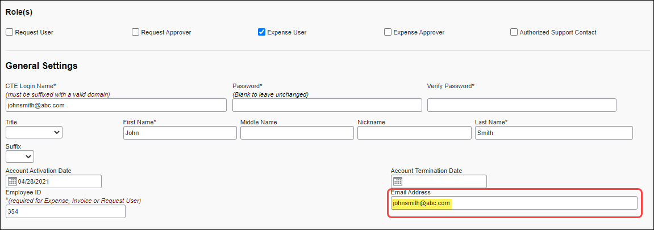

##### AFTER – New Email in New/Future PSE

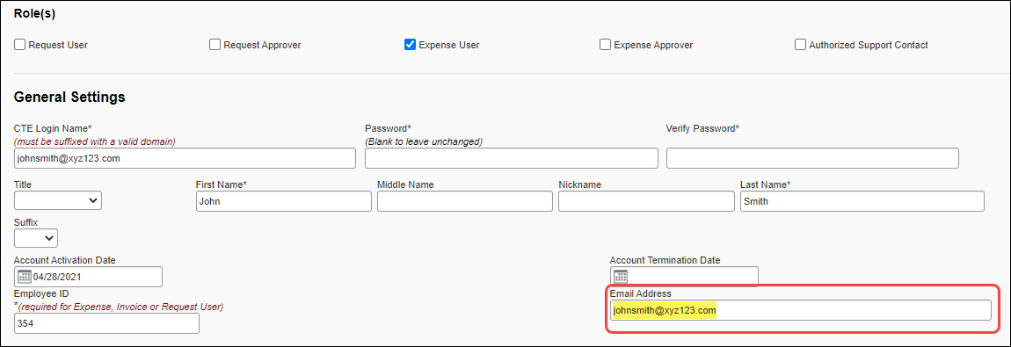

#### Configuration / Feature Activation

These changes occur automatically; there are no additional configuration or activation steps.

## User Administration

### **Ongoing** Standalone White Spaces No Longer Valid in First and Last Name Fields

|  |  |  |
| --- | --- | --- |
| Information First Published | Information Last Modified | Feature Target Release Date |
| June 17, 2022 | August 5, 2022 | July 26, 2022 – Future releases |
| Any changes since the previous monthly release are highlighted in yellow in this release note. | | |

**Applies to:**

Travel, Expense, Invoice, Request | Professional & Standard

#### Overview

SAP Concur plans to apply validation that prevents the use of standalone white space characters in first and last name fields. This validation will be implemented in phases, beginning on July 26, 2022.

Changes implemented on July 26, 2022:

* If a name field is populated with only white space characters via the profile v4 API, an error message is returned and the entries are not accepted.

Changes planned for a future release:

* Standalone white space characters will no longer be accepted as a valid entry in name fields in user accounts.

1. White space characters that are part of a valid name will be accepted.

* Standalone white space characters will no longer be accepted as a valid entry in name fields on the **My Profile – Personal Information** page.

1. White space characters that are part of a valid name will be accepted.

* If a name field is populated with only white space characters via the employee import file or through manual entry, a message or error will be returned and the entries will not be accepted.

1. The type of response received when entering an invalid name depends on the method of entry.

##### Business Purpose / Client Benefit

Ensuring that valid names are entered into the name fields in SAP Concur solutions can prevent errors when the data is exported to external systems that do not support or cannot process standalone white space characters in name fields.

#### Admin Experience

If an admin attempts to enter only white spaces in a name field on the **User Details** page, through an API call, through the employee import process, or through manual entry, the entry or entries will not be accepted and a message or error will be returned. On the user accounts page, the user account will not be saved.

1. White space characters that are part of a valid name—for example, "Mary Ann"—are valid and will continue to be accepted.

#### Configuration / Feature Activation

This validation will be added automatically.

## User Import and Export

### User Export and Import Improvements

|  |  |  |
| --- | --- | --- |
| Information First Published | Information Last Modified | Feature Target Release Date |
| April 22, 2022 | August 5, 2022 | August 25, 2022 |
| Any changes since the previous monthly release are highlighted in yellow in this release note. | | |

**Applies to:**

Expense, Invoice, Request | Standard Edition

#### Overview

On August 25, 2022 SAP Concur plans to implement improvements to the user export/import experience.

As of July 21, when an admin navigates to the **Users** page in Product Settings, they have the option to try out the improvements through a banner that is available at the top of the page.

Improvements include, but are not limited to:

* Improvements to the downloadable user data template including tooltips and drop-down lists
* Removal of the 1000 user maximum for imports and exports of user data
* The addition of a new **Manage Users via a Spreadsheet** page

##### Business Purpose / Client Benefit

These improvements increase the ease of use and experience of the user import and export processes.

#### Admin Experience

On the **Users** page in Product Settings, a banner with the following message is available at the top of the page:

"Click here to try out the new Manage User via a Spreadsheet experience, and provide your early feedback."

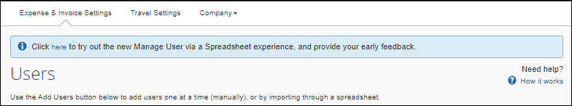

The admin can click the word "here" to opt-in to the experience.

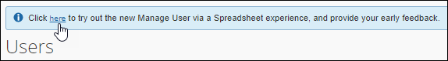

After they click **here**, the banner message text changes to the following:

"Welcome to the new Manage User via a Spreadsheet experience. In addition to the new UI, we have also updated the spreadsheet template to include user-friendly header rows, drop-down menus, and tooltips for your reference. Click here to provide your feedback on the new experience. If you like, you can change back to the existing experience."

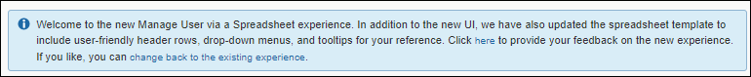

In the new message, the admin can click the word "here" to provide feedback on the experience through a brief survey.

The admin can also click the phrase "change back to the existing experience" to opt out of the new spreadsheet experience.

After opting in to the experience, on the **Users** page in Product Settings, when the admin clicks **Add Users > From Spreadsheet**, the admin sees the new **Manage Users via a Spreadsheet** page.

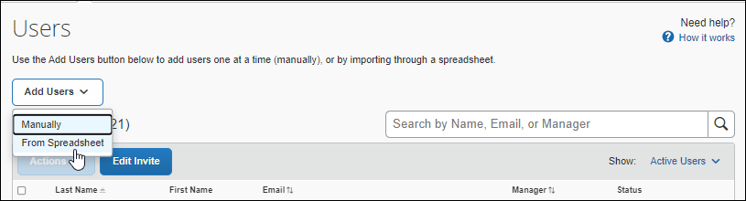

On the **Manage Users via a Spreadsheet** page, the admin can export, update, and import user data.

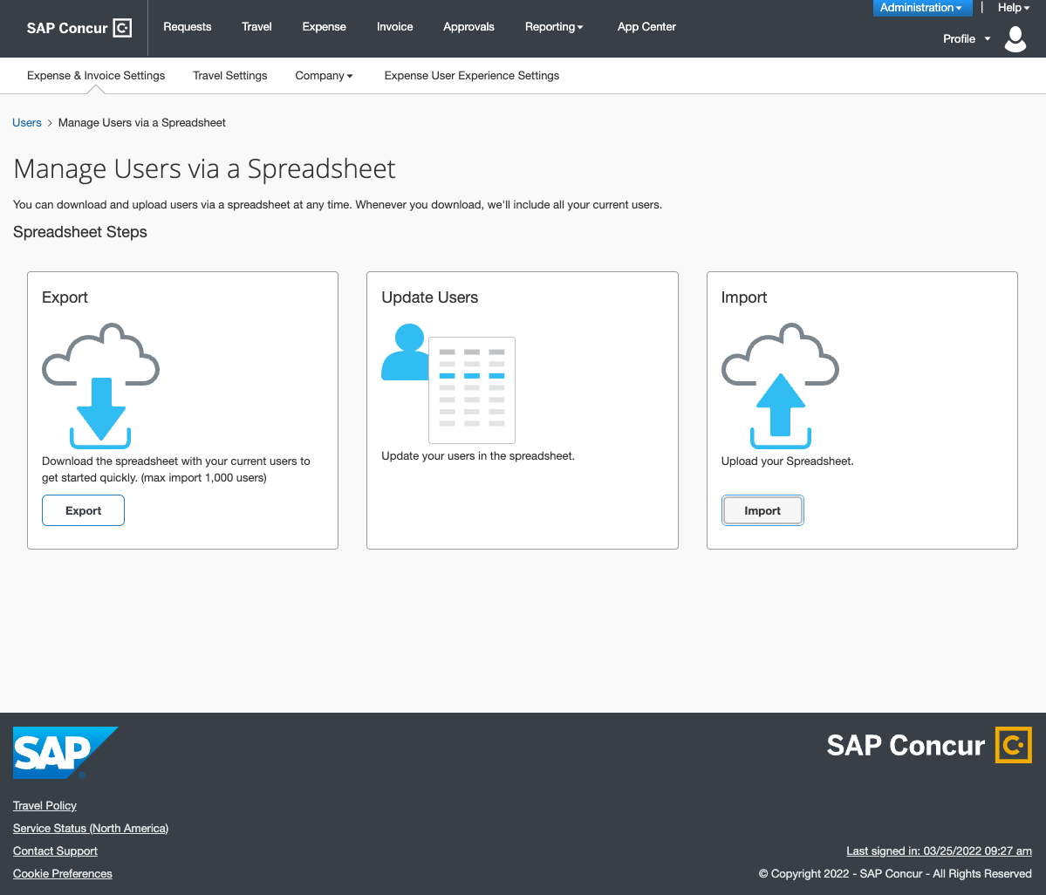

When they export the spreadsheet, they will see new tooltips and, where applicable, drop-down lists in the spreadsheet. In addition, they will no longer be limited to downloading 1000 rows of user data.

**Tooltip Example**

Tooltips appear when you hover over a column header in the spreadsheet.

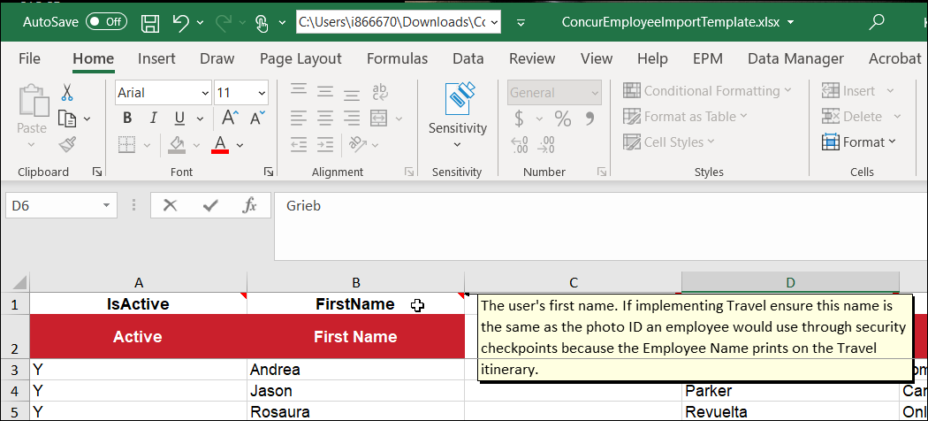

**Drop-down List Example**

Drop-down lists are available for columns where applicable.

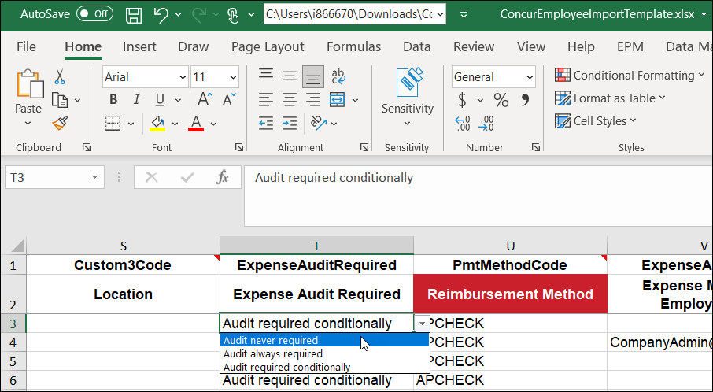

#### Configuration / Feature Activation

After the opt-in period has ended, the new user export/import experience will be automatically available.

# Planned Changes

The following features and changes are targeted for future releases. SAP Concur solutions reserves the right to postpone implementation of – or completely remove – any enhancement/change mentioned here.

## Exchange Rates

### **Planned Changes** Automatic Provisioning of Central Bank Exchange Rates for Selected Countries

|  |  |  |
| --- | --- | --- |
| Information First Published | Information Last Modified | Feature Target Release Date |
| August 5, 2022 | -- | Q4 2022 |
| Any changes since the previous monthly release are highlighted in yellow in this release note. | | |

**Applies to:**

Expense, Invoice, Request | Professional & Standard

#### Overview

In a future release, SAP Concur plans to provide foreign exchange rates from the central bank for the following countries:

* Czechia
* Poland
* The Russian Federation
* Türkiye (Turkey)

##### Business Purpose / Client Benefit

This change helps SAP Concur achieve regulatory compliance with local country rules for exchange rates.

#### Admin Experience

For clients who are using SAP Concur-provided exchange rates, the exchange rates for users who are reimbursed in the official currency of the specified countries will automatically employ central bank rates.

#### Configuration / Feature Activation

This change occurs automatically. For clients who are using SAP Concur-provided exchange rates, no configuration is required.

For clients who import custom exchange rates for these countries, additional information will be provided about how to transition to the SAP Concur-provided rates.

## Fax Feature

### **Planned Changes** Fax Feature to be Decommissioned

|  |  |  |
| --- | --- | --- |
| Information First Published | Information Last Modified | Feature Target Release Date |
| November 2021 | January 14, 2022 | October 1, 2022 |
| Any changes since the previous monthly release are highlighted in yellow in this release note. | | |

**Applies to:**

Expense, Invoice | Professional & Standard

#### Overview

On October 1, 2022, the Concur Fax Feature will be decommissioned.

1. The Fax feature was retired in 2020. Clients onboarded after July 15, 2020 do not have access to this feature. Among clients with access, very few use the feature regularly and, among those that use it, use has declined steadily.

##### Business Purpose / Client Benefit

Removal of the Fax feature improves the security, performance, and scalability of SAP Concur solutions.

In addition, The Concur Fax Feature attaches files only at the header level of expenses and invoices. As a result, clients who use the Fax Feature cannot take advantage of recent innovations that apply only to images and attachments at the line-item level.

#### End-User Experience

Users will no longer have the option to print Fax cover pages from within Concur Expense or Concur Invoice and they will no longer have the ability to fax images to SAP Concur for attachment to expenses or invoices.

#### Configuration / Feature Activation

This change occurs automatically; there are no configuration steps. Additional information about this change will be made available over the coming months.

## File Transfer Updates

### **Planned Changes** New File Transfer Endpoints After Migration to AWS

|  |  |  |
| --- | --- | --- |
| Information First Published | Information Last Modified | Feature Target Release Date |
| June 10, 2022 | June 17, 2022 | Future Release |
| Any changes since the previous monthly release are highlighted in yellow in this release note. | | |

**Applies to:**

All Products | Professional & Standard

#### Overview

With the SAP Concur migration to Cloud Platform in AWS, new endpoints will be implemented for file transfers. After your entity is migrated to the new platform, you will receive notification about the migration including the new endpoints. After you receive notification, you will have 30 days to switch from the old endpoint(s) to the new AWS Transfer endpoint(s).

* **IMPORTANT!** Do not switch endpoints until you have been notified. Doing so will have unpredictable results.

This announcement pertains to the following file transfer DNS endpoints:

* st.concursolutions.com
* mft-us.concursolutions.com
* vs.concursolutions.com
* st-eu.concursolutions.com
* mft-eu.concursolutions.com

##### Business Purpose / Client Benefit

The SAP Concur migration to Cloud Platform in AWS provides a stronger security posture, improved performance and stability, and faster innovation for our clients.

For more information, refer to the [*SAP Concur Cloud Platform Strategy FAQ*](http://assets.concur.com/concurtraining/cte/en-us/FAQ_Cloud_Hosting_Strategy.pdf).

#### Configuration / Feature Activation

After you receive notification that your entity has been migrated to AWS, you will have 30 days to update your systems to point to the new AWS Transfer endpoints.

* **IMPORTANT!** Do not switch endpoints until you have been notified. Doing so will have unpredictable results.

## Imaging

### **Planned Changes** Imaging Database System Maintenance

|  |  |  |
| --- | --- | --- |
| Information First Published | Information Last Modified | Feature Target Release Date |
| August 5, 2022 | -- | September - November |
| Any changes since the previous monthly release are highlighted in yellow in this release note. | | |

**Applies to:**

Expense, Invoice, Request, Travel, Budget, Mobile | Professional & Standard

#### Overview

SAP Concur plans to perform system maintenance on the Concur Expense and Concur Invoice imaging databases. The system maintenance will be performed in phases, beginning in September 2022, and ending in November 2022.

What clients can expect:

* To avoid working hours, maintenance operations will take place on Saturday in the region where the maintenance is taking place.
* With a few exceptions noted as follows, maintenance operations impact all clients.

1. PSCC clients and clients in the China datacenter are not impacted by this image database migration.

* The maintenance tasks can take 2 to 4 hours.

##### Business Purpose / Client Benefit

This maintenance operation increases the stability of the imaging feature and better supports document compliance for tax authorities.

#### End-User Experience

While the system maintenance is in progress, users will not be able to attach, view, or modify images in Concur Expense, Concur Invoice, or Concur Request, nor through web services or mobile applications.

1. The Concur Invoice product will be unusable during the maintenance period since viewing invoice images is a core feature of the product.

Users might also receive one of the following messages:

* Invoice Image:

Concur Imaging Service Not Available

* E-Receipt:

Retrieving Images from Image Server. Please wait…

* Mobile:

We’re unable to attach your receipt. Please try again.

* Attach to Report:

Alert! The following files failed to upload: <filename>

Or

No file chosen

#### Configuration / Feature Activation

Clients do not need to take any action to facilitate the system maintenance.

## User Assistance

### **Planned Changes** Concur User Assistance by WalkMe to be Enabled

|  |  |  |
| --- | --- | --- |
| Information First Published | Information Last Modified | Feature Target Release Date |
| July 15, 2022 | -- | October 2022 |
| Any changes since the previous monthly release are highlighted in yellow in this release note. | | |

**Applies to:**

All Products | All Editions

#### Overview

On October 1, 2022, SAP Concur plans to enable **Concur User Assistance by WalkMe** on client sites with Concur Expense and/or Concur Invoice. **User Assistance by WalkMe** helps administrators and end users complete tasks by providing guided help while they are using SAP Concur solutions.

1. This change does not impact the following clients:  
   - Clients with Concur Travel only  
   - Clients with SAP Enable Now for Concur

##### Business Purpose / Client Benefit

This feature helps users learn new tasks more quickly and efficiently, driving user adoption, increasing efficiency, improving the user experience, and improving user satisfaction with SAP Concur solutions.

#### Admin Experience

##### User Assistance Settings Page

After User Assistance by WalkMe is enabled for all clients on October 1, 2022, the administrator will be able to access the **User Assistance Settings Page** to enable and disable User Assistance by WalkMe for their end users.

**Professional Edition**

After the feature is enabled by SAP Concur internal staff, a client admin with the Company Administrator role can access the **User Assistance Settings** page from the **Company Administration** page.

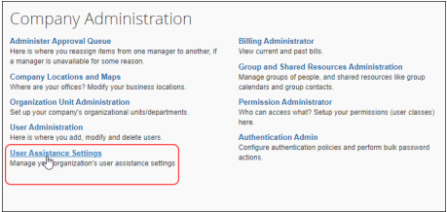

For more information about roles, refer to the [*Shared: User Administration Guide*](https://www.concurtraining.com/customers/tech_pubs/Docs/_Current/UG_Shr/Shr_UG_User_Admin.pdf).

**Standard Edition**

After the feature is enabled by SAP Concur internal staff, a client admin with the Can Administer permission can access the **User Assistance Settings** page from the **Administration > Company > Tools** page.

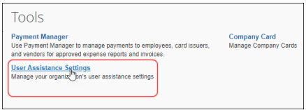

For more information about Concur Standard Edition permissions, refer to the [*Shared: Users Setup Guide for Concur Standard Edition*](https://www.concurtraining.com/customers/tech_pubs/Docs/ConcurPremier/SG_Shr/SG_Shr_Users.pdf).

##### Enabling/Disabling User Assistance for End Users

On the **User Assistance Settings** page, the administrator can enable and disable user assistance for end users globally. They can also enable and disable user assistance for end users based on a user’s assigned country or region.

When the administrator selects a country/region on the **User Assistance Settings** page, the feature is enabled for all end users assigned to that country/region.

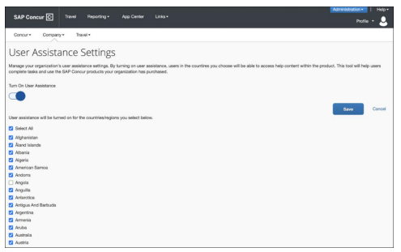

1. Enabling or disabling user assistance for end users does not impact user assistance for admins. User assistance for admins is enabled and disabled by SAP Concur internal staff.

#### End-User Experience

After the feature is enabled on October 1, 2022, User Assistance by WalkMe content can be accessed through the SAP Concur **Help** menu by clicking **Explore Interactive Help**.

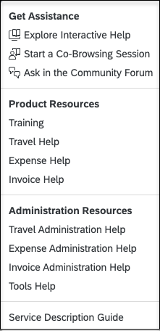

1. The list of items in the **Help** menu depends on a user's roles and permissions and on the configuration of the client's site. For example, only users with administrator privileges have access to **Administrative Resources**.

When the user clicks **Explore Interactive Walkthroughs**, the **Get Assistance** panel opens. The **Get Assistance** panel provides access to a list of resources including guided tours, video tutorials, and documents such as user guides.

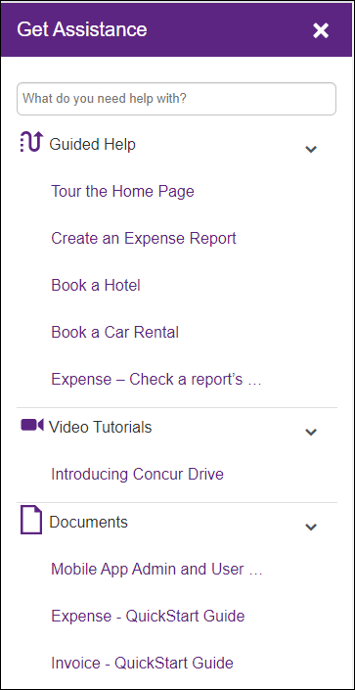

The guided tours that are available in the **Get Assistance** panel are relevant to the page the user is on. For example, when the user is on the **Manage Expenses** page, the guided tours in the **Get Assistance** panel reflect tasks that can be performed on that page, such as creating an expense report and viewing expense details.

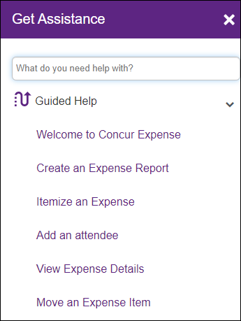

If a user clicks on a guided tour, they are guided through the selected task by a series of messages.

**Example Guided Tour: Create an Expense Report**

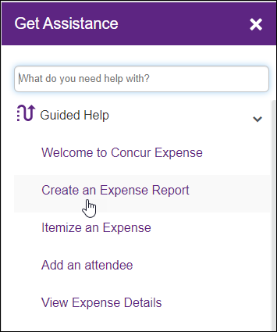

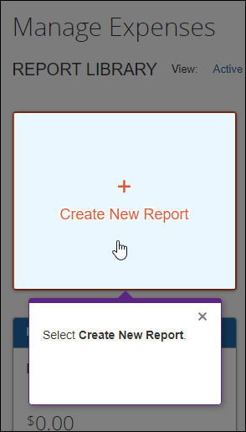

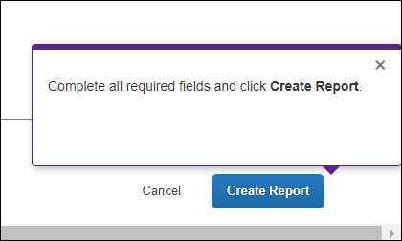

#### Configuration / Feature Activation

SAP plans to enable User Assistance by WalkMe on October 1, 2022. After the feature is enabled on October 1, 2022, clients who do not wish to have User Assistance by WalkMe enabled can open an SAP Concur support ticket to disable the feature.

1. This change does not impact the following clients:  
   - Clients with Concur Travel only  
   - Clients with SAP Enable Now for Concur

# Client Notifications

## Accessibility

### Accessibility Enhancements

SAP implements changes to better meet current Web Content Accessibility Guidelines (WCAG). Information about accessibility-related changes made to SAP Concur solutions is published on a quarterly basis. You can review the quarterly updates on the [Accessibility Updates](https://www.concurtraining.com/customers/tech_pubs/RN-monthly-Access/_RN_access_client.htm) (English Only) page.

## Subprocessors

### SAP Concur Non-Affiliated Subprocessors

The list of non-affiliated subprocessors is available from the *SAP Sub-processors / Data Transfer Factsheets* page.

1. To access the SAP Concur Sub-processors List:
2. Click the following link to navigate to the *SAP Sub-processors / Data Transfer Factsheets* page:  
   [*SAP Sub-processors / Data Transfer Factsheets*](https://support.sap.com/en/my-support/trust-center/subprocessors.html)
3. Sign in to the SAP Support Portal using your Support User ID (S-user) and password.
4. SAP customers must sign in to the SAP Support Portal using their Support User ID (S-user) and password. For information about S-User IDs, refer to [*Your New Support User ID (S-user)*](https://support.sap.com/en/my-support/users/welcome.html).
5. On the *SAP Sub-processors / Data Transfer Factsheets* page, type "Concur" in the **Search** field.
6. In the **Title** column, click **SAP Concur Sub-processors List**.

If you have questions or comments, please reach out to: [Privacy-Request@Concur.com](mailto:Privacy-Request@Concur.com)

## Supported Browsers

### Supported Browsers and Changes to Support

For information about supported browsers and planned changes to supported browsers, refer to the [*Concur Travel & Expense Supported Configurations*](http://www.concurtraining.com/customers/tech_pubs/Docs/Z_SuppConfig/Supported_Configurations_for_Concur_Travel_and_Expense.pdf) guide.

When changes to browser support are planned, information about those changes will also appear in the [*Shared Planned Changes*](https://www.concurtraining.com/customers/tech_pubs/RN_shared_planned/_client_shared_RN_all.htm) release notes.

# Additional Release Notes and Other Technical Documentation

## Online Help

You can access release notes, setup guides, user guides, admin summaries, supported configurations, and other resources via the in-product **Help** menu or on the SAP Help Portal.

To access the full set of documentation for your product, use the links in the SAP Concur **Help** menu, or search for your SAP Concur product (Concur Expense, Concur Invoice, Concur Request, or Concur Travel) on the SAP Help Portal (https://help.sap.com).

## SAP Concur Support Portal – Selected Users

Access release notes, webinars, and other technical documentation on the SAP Concur support portal.

If you have the required permissions, **Contact** **Support** is available on the SAP Concur **Help** menu and in the SAP Concur page footer.

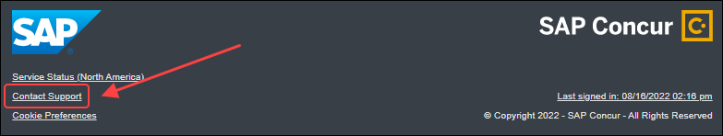

Click **Contact Support** to access the SAP Concur support portal, then click **Resources**.

* Click **Release/Tech Info** for release notes, technical documents, etc.
* Click **Webinars** for recorded and live webinars.

© 2022 SAP SE or an SAP affiliate company. All rights reserved.

No part of this publication may be reproduced or transmitted in any form or for any purpose without the express permission of SAP SE or an SAP affiliate company.

SAP and other SAP products and services mentioned herein as well as their respective logos are trademarks or registered trademarks of SAP SE (or an SAP affiliate company) in Germany and other countries. Please see http://global12.sap.com/corporate-en/legal/copyright/index.epx for additional trademark information and notices.

Some software products marketed by SAP SE and its distributors contain proprietary software components of other software vendors.

National product specifications may vary.

These materials are provided by SAP SE or an SAP affiliate company for informational purposes only, without representation or warranty of any kind, and SAP SE or its affiliated companies shall not be liable for errors or omissions with respect to the materials. The only warranties for SAP SE or SAP affiliate company products and services are those that are set forth in the express warranty statements accompanying such products and services, if any. Nothing herein should be construed as constituting an additional warranty.

In particular, SAP SE or its affiliated companies have no obligation to pursue any course of business outlined in this document or any related presentation, or to develop or release any functionality mentioned therein. This document, or any related presentation, and SAP SE’s or its affiliated companies’ strategy and possible future developments, products, and/or platform directions and functionality are all subject to change and may be changed by SAP SE or its affiliated companies at any time for any reason without notice. The information in this document is not a commitment, promise, or legal obligation to deliver any material, code, or functionality. All forward-looking statements are subject to various risks and uncertainties that could cause actual results to differ materially from expectations. Readers are cautioned not to place undue reliance on these forward-looking statements, which speak only as of their dates, and they should not be relied upon in making purchasing decisions.