|  |  |
| --- | --- |
| SAP Concur Release Notes  Shared Changes  Includes cross-product and site-wide changes for:  Professional Edition, Standard Edition, and Small Business Edition | |
| **Month** | **Audience** |
| Release Date: May 21, 2022  Initial Post: Friday, May 20, 2022 | Client FINAL |

Contents

Release Notes 1

Concur Invoice Vendor Management 2

Vendor Page Custom Fields and Invoice Copy-Down Options 2

Invoice | Standard 2

Custom Fields 6

Two 'How It Works' Links Removed 6

Expense, Invoice, Request | Standard 6

File Transfer Updates 8

**Ongoing** Rotating PGP Key for File Transfers 8

Travel, Expense, Invoice, Request, Intelligence | Professional & Standard 8

Home Page 9

**Ongoing ** SAP Concur Homepage Changes 9

All Products | All Editions 9

Miscellaneous 13

**Ongoing** SAP Concur Migration to Cloud Platform in AWS 13

All Products | All Editions 13

Profile Settings 14

**Ongoing** Accessibility Improvements to My Profile – Personal Information Page 14

Travel, Expense | Professional & Standard 14

**Ongoing** Changes to My Profile, Home Page, and Profile Menu 15

Travel, Expense, Invoice, Request, Mobile | Professional & Standard 15

Implemented and Planned Changes 17

SAP Concur Support 21

Suggested Solutions Migration 21

All Products | All Editions 21

Security 23

Some TLSv1.2 Ciphers No Longer Supported (Feb 1, 2022) 23

Travel, Expense, Invoice, Request | All Editions 23

Test Entities | Production Sandbox Environment 28

**Ongoing** Most Recently Used Lists Not Migrated 28

Expense, Invoice, Request | Professional 28

**Ongoing** Production Sandbox Environment Login Updates 30

Expense, Invoice, Request | Professional 30

**Ongoing** Unique Address Required for PSE Email Verification 31

Expense, Invoice, Request | Professional 31

Planned Changes 34

Concur Open 34

**Planned Changes** Japanese Translation Available (Jun 2) 34

All Products | Professional & Standard 34

Fax Feature 36

**Planned Changes** Fax Feature to be Decommissioned 36

Expense, Invoice | Professional & Standard 36

Financial Integration 37

**Planned Changes** Sage Accounting to be Retired 37

Expense, Invoice | Standard Edition 37

Help Menu 37

**Planned Change** Consolidation of Resources Under Help Menu 37

All Products | All Editions 37

SSO Management 38

**Planned Changes** New Checkbox to Hide SSO Sign-In Option 38

Travel, Expense, Invoice, Request | Professional & Standard 38

**Planned Changes** Option to Provide URL to IdP Metadata to be Removed 39

Travel, Expense, Invoice, Request | Professional & Standard 39

User Assistance 40

**Planned Changes** Support for SAP Enable Now 40

Travel, Expense, Invoice, Request | Professional & Standard 40

User Export and Import 41

**Planned Changes** User Export and Import Improvements 41

Expense, Invoice, Request | Standard Edition 41

Client Notifications 43

Accessibility 43

Accessibility Enhancements 43

Subprocessors 43

SAP Concur Non-Affiliated Subprocessors 43

Supported Browsers 44

Supported Browsers and Changes to Support 44

Additional Release Notes and Other Technical Documentation 45

Online Help 45

SAP Concur Support Portal – Selected Users 45

Legal Disclaimer

The information in this presentation is confidential and proprietary to SAP SE or an SAP affiliate company and may not be disclosed without the permission of SAP SE or the respective SAP affiliate company. This presentation is not subject to your license agreement or any other service or subscription agreement with SAP SE or its affiliated companies. SAP SE and its affiliated companies have no obligation to pursue any course of business outlined in this document or any related presentation, or to develop or release any functionality mentioned therein. This document, or any related presentation and SAP SE or an SAP affiliate company’s strategy and possible future developments, products and or platforms directions and functionality are all subject to change and may be changed by SAP SE and its affiliated companies at any time for any reason without notice. The information in this document is not a commitment, promise or legal obligation to deliver any material, code or functionality. This document is provided without a warranty of any kind, either express or implied, including but not limited to, the implied warranties of merchantability, fitness for a particular purpose, or non-infringement. This document is for informational purposes and may not be incorporated into a contract. SAP SE and its affiliated companies assume no responsibility for errors or omissions in this document, except if such damages were caused by SAP SE or an SAP affiliate company’s willful misconduct or gross negligence.

All forward-looking statements are subject to various risks and uncertainties that could cause actual results to differ materially from expectations. Readers are cautioned not to place undue reliance on these forward-looking statements, which speak only as of their dates, and they should not be relied upon in making purchasing decisions.

# Release Notes

This document contains shared release notes and planned changes. Shared release notes and planned changes document features and changes that apply to SAP Concur solutions site-wide or to multiple SAP Concur products and services. They include but are not limited to:

* Security-related features and changes such as annual security certificate renewals and changes in support for security ciphers and protocols
* Site-wide UI features and changes such as changes to the home page, changes to the site header or footer, or the implementation of new site-wide UI themes
* Sign-in process features and changes such as the addition or removal of sign-in features, URL changes, and domain name changes
* Production and test environment features and changes
* Global settings or administration page features and changes such as the addition of new site-wide settings or changes to the design of the administration pages
* Changes to processes such as where and when release notes are published

For New Features and Changes that apply to a single product and/or service see the release notes for that product or service. Links to the product and service-specific release notes can be found on the following pages:

* [Professional Edition](https://www.concurtraining.com/customers/tech_pubs/_RN_CCC.htm)
* [Standard Edition](https://www.concurtraining.com/customers/tech_pubs/_Docs_CCC_CPS.htm)
* [Small Business Edition](http://www.concurtraining.com/customers/tech_pubs/Docs/Breeze/RN/WhatsNew.htm)

## Concur Invoice Vendor Management

### Vendor Page Custom Fields and Invoice Copy-Down Options

|  |  |  |
| --- | --- | --- |
| Information First Published | Information Last Modified | Feature Target Release Date |
| April 15, 2022 | May 13, 2021 | May 19, 2022 |
| Any changes since the previous monthly release are highlighted in yellow in this release note. | | |

**Applies to:**

Invoice | Standard

#### Overview

When custom fields are created, they are added to the following pages:

* **User Profile:** On the user profile page
* **Concur Expense**: On the expense report header, line, and allocation pages
* **Concur Invoice**: On the invoicepage header, line, and allocation pages
* **Concur Request**: On the request header and allocation pages

With the May release, new custom fields are also added to the following pages:

* Concur Invoice **New Vendor** page
* Concur Invoice **Vendor** pages

In addition, a new **Invoice Copy-Down** option has been added to the **Custom Fields** page. This option enables admins to change the copy-down source for custom fields on invoices enabling them to choose whether custom fields should copy from the user profile to the Invoice Header or from the vendor record to the Invoice Header.

##### Business Purpose / Client Benefit

This change enables admins to add custom fields to **Concur Invoice** vendor pages and specify the copy-down source for custom fields in **Concur Invoice**.

#### Admin Experience

After this change is implemented, when a client admin adds a custom field through the **Custom Fields** page in Product Settings, the field is added to the **New Vendor** page when a vendor manager or end user creates new vendors, and on the vendor information page for existing vendors.

1. To add a custom field:
2. Click **Administration > Invoice Settings > Custom Fields**.

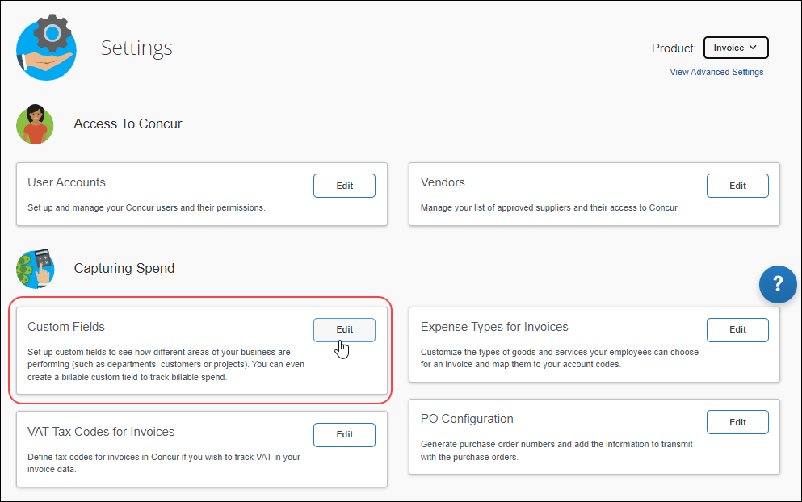

1. Click **Add Custom Field**.

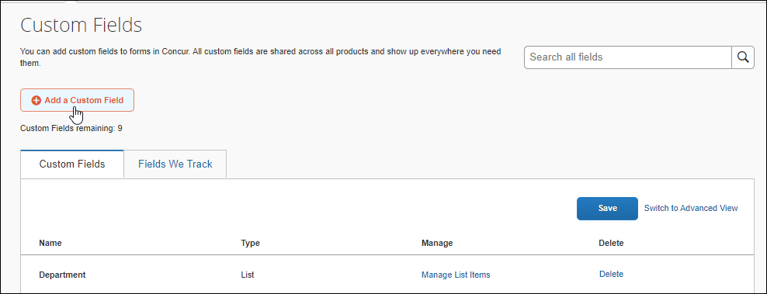

1. Select a field type, select or enter a field name, and then click **Add**.

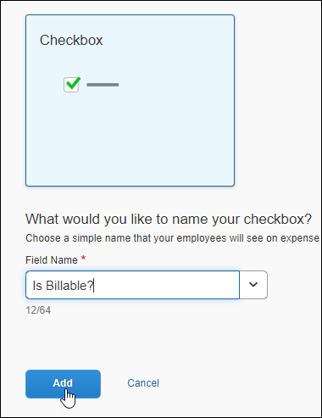

1. The visibility and access attributes (required, optional, and read-only) for custom fields on the User, Concur Expense, Concur Invoice, and Concur Request pages is configurable. Custom fields on the vendor pages are set to **Optional** by default and this attribute cannot be changed.

Depending on the type of field you create, there may be additional steps required to complete creation of the field. For detailed steps, refer to [*Shared: Custom Fields Setup Guide for Concur Standard Edition*](https://www.concurtraining.com/customers/tech_pubs/Docs/ConcurPremier/SG_Shr/SG_Shr_Custom_Fields.pdf).

1. Set the copy-down behavior for the new field:
2. On the **Custom Fields** page, click **Switch to Advanced View**.

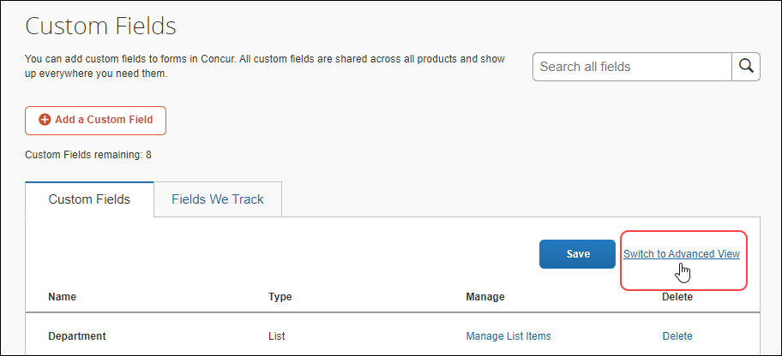

1. In the **Invoice Copy-Down** list, select the desired copy-down source.

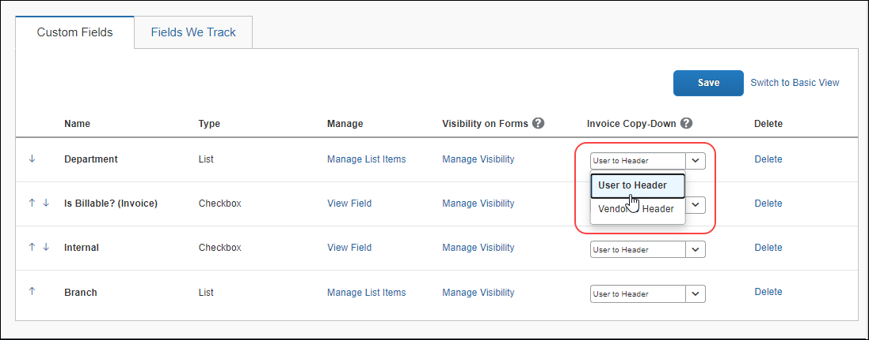

If you change the copy-down source of a custom field, the following informational message appears at the top of the **Custom Fields** page:

"Any invoices created after the Invoice Copy-Down setting is changed will inherit the new copy-down source. Any previously created invoices will not be impacted."

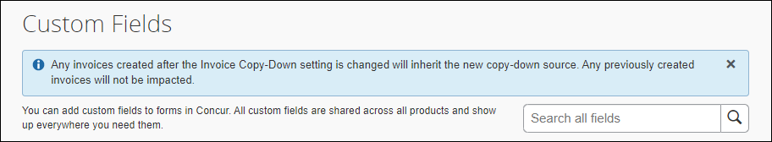

The message can be closed by clicking the "x" in the upper right corner of the banner.

1. Click **Save**.

If an admin changes the copy-down source for a field to a new custom field on the vendor page, only invoices created after the new custom field is added will copy-down from the new custom field. Invoices created before the new custom field was added will continue to copy-down data from the previously targeted field.

1. To view the custom field on the New Vendor page:
2. Click **Invoice > Vendor Manager**.

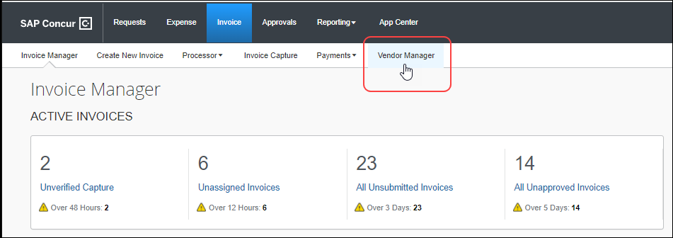

1. Click **Open Vendor > Request New Vendor.**

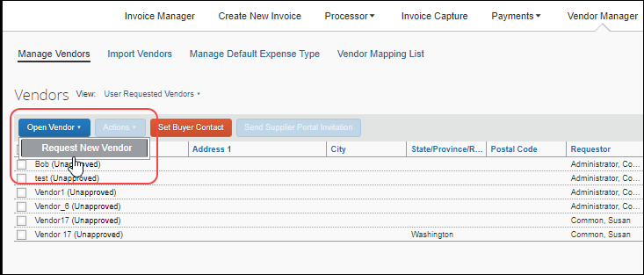

The custom field is included on the **New Vendor** page.

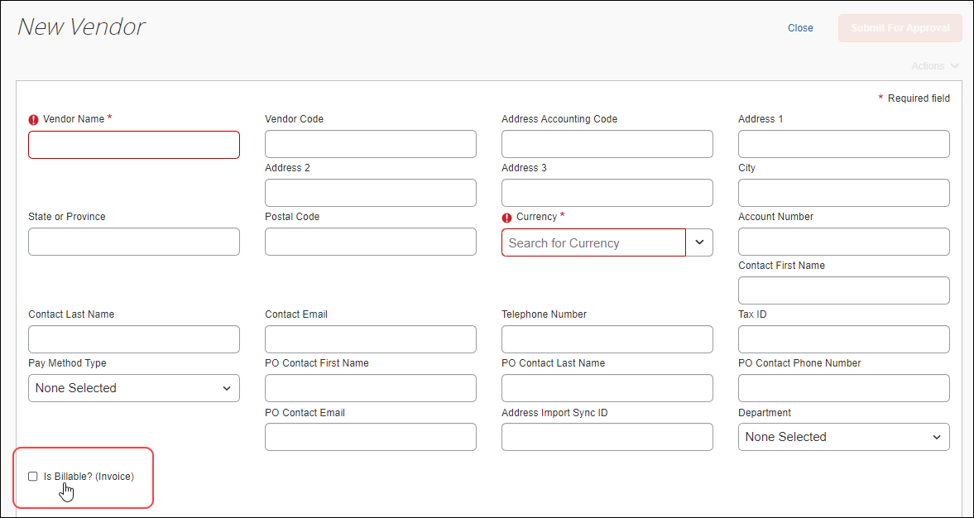

The custom field is also included on the page for existing vendors.

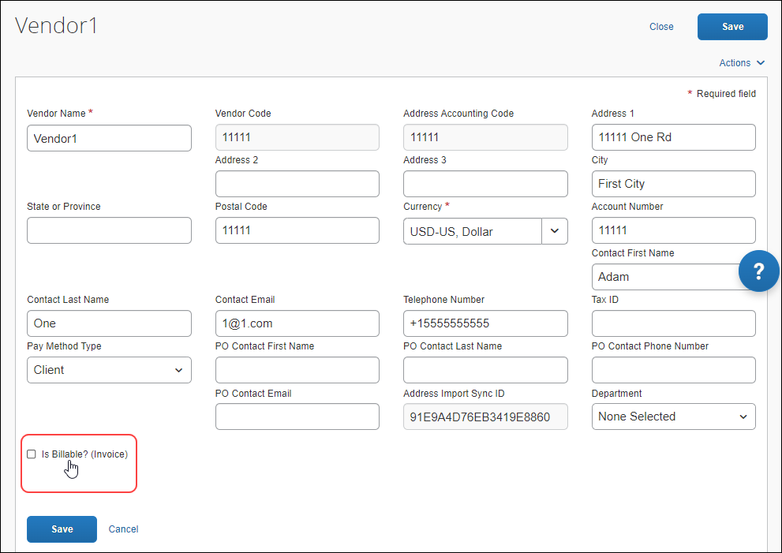

##### Custom Fields Created before the feature was implemented

Custom fields created before this change is implemented will not automatically be added to the vendor page. The admin must first visit the **Administration > Invoice Settings > Custom Fields** page. Visiting the **Custom Fields** page prompts the system to add the preexisting custom fields to the vendor page.

#### Configuration / Feature Activation

This change occurs automatically.

## Custom Fields

### Two 'How It Works' Links Removed

|  |  |  |
| --- | --- | --- |
| Information First Published | Information Last Modified | Feature Target Release Date |
| May 13, 2022 | -- | May 21, 2022 |
| Any changes since the previous monthly release are highlighted in yellow in this release note. | | |

**Applies to:**

Expense, Invoice, Request | Standard

#### Overview

With the May release, in preparation for future improvements, the **How It Works** links on the **Custom Fields > Add New Field** and **Custom Fields > Edit List** pages will be removed.

##### Business Purpose / Client Benefit

Removal of the **How It Works** links and the related content are a first step toward implementing more functional improvements to the **Custom Fields** pages in Product Settings.

#### Admin Experience

The **How It Works** links will no longer be available on the following pages:

##### Add New Field

**Before**

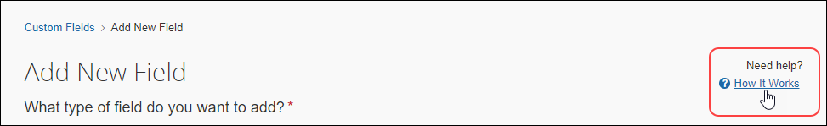

**After**

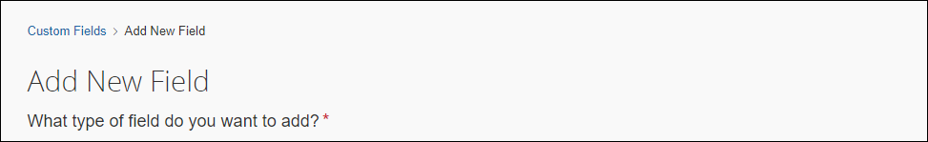

##### Edit List

**Before**

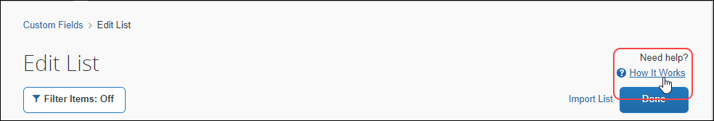

**After**

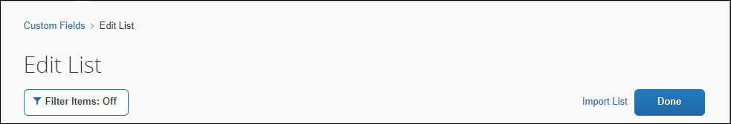

#### Configuration / Feature Activation

This change occurs automatically.

## File Transfer Updates

### **Ongoing** Rotating PGP Key for File Transfers

|  |  |  |
| --- | --- | --- |
| Information First Published | Information Last Modified | Feature Target Release Date |
| February 2021 | May 13, 2022 | January 15, 2021 and October 11, 2022 |
| Any changes since the previous monthly release are highlighted in yellow in this release note. | | |

**Applies to:**

Travel, Expense, Invoice, Request, Intelligence | Professional & Standard

#### Overview

Files transferred to SAP Concur products must be encrypted with the SAP Concur public PGP key, concursolutionsrotate.asc.

concursolutionsrotate.asc

* Key file is available in client’s root folder
* Key ID 40AC5D35
* RSA 4096-bit signing and encryption subkey
* Key expires every 2 years
* Client is responsible for replacing the key before it expires
* Next expiry date: September 4, 2022
* The new rotating public PGP key (concursolutionsrotate.asc) will be available in the client’s root folder on June 4, 2022.

The SAP Concur legacy PGP key (key ID D4D727C0) will be decommissioned on October 11, 2022. You must switch to using the rotating PGP key before that date. Files encrypted with the legacy PGP key will not be processed after October 10, 2022.

This announcement pertains to the following file transfer DNS endpoints:

* st.concursolutions.com
* mft-us.concursolutions.com
* vs.concursolutions.com
* st-eu.concursolutions.com
* mft-eu.concursolutions.com
* AWS transfer endpoints (when they are communicated to you)

##### Business Purpose / Client Benefit

The rotating public PGP key provides greater security for file transfers.

#### Admin Experience

An administrator with the required file transfer credentials can log into the file transfer site to retrieve the rotating public PGP key, concursolutionsrotate.asc, from the root directory.

#### Configuration / Feature Activation

Your internal file transfer administrator can add the key to their PGP keyring and start using it to encrypt any files being transferred to SAP Concur.

If assistance is required, please contact SAP Concur support.

For more information, refer to the [*Shared: File Transfer for Customers and Vendors User Guide*](http://www.concurtraining.com/customers/tech_pubs/Docs/ConcurPremier/UG_Shr/Shr_UG_FileTransfer.pdf).

## Home Page

### **Ongoing ** SAP Concur Homepage Changes

|  |  |  |
| --- | --- | --- |
| Information First Published | Information Last Modified | Feature Target Release Date |
| December 4, 2020 | May 13, 2022 | Q4 2021 – Future Release |
| Any changes since the previous monthly release are highlighted in yellow in this release note. | | |

**Applies to:**

All Products | All Editions

#### Overview

In Q4, 2021, SAP Concur began redirecting clients to a new homepage. The appearance of the new homepage is identical to the previous SAP Concur homepage. The new homepage has enhanced functionality when services become temporarily unavailable.

The roll out of the new homepage is phased:

**Phase 1:** In October of 2021, SAP Concur began redirecting Concur Expense, Concur Invoice, and Concur Request clients in the US Datacenter to the new homepage.

**Phase 2:** In December 2021, SAP Concur began redirecting Concur Expense, Concur Invoice, and Concur Request clients in the EU Datacenter to the new homepage.

**Phase 3:** At a date to be determined, SAP Concur will begin redirecting the remaining clients in the US and EU datacenters to the new homepage. The remaining clients include those with Concur Travel standalone or Concur Travel with Expense, Invoice, and/or Request.

##### Business Purpose / Client Benefit

This change ensures that the SAP Concur homepage is available even when some services are unavailable and improves the consistency of the sign in experience.

#### End-User Experience

With the old homepage, when a user signs into their SAP Concur products, they see their homepage.

1. The appearance of the homepage varies depending on which products and services are enabled for the client and the permissions assigned to the user.

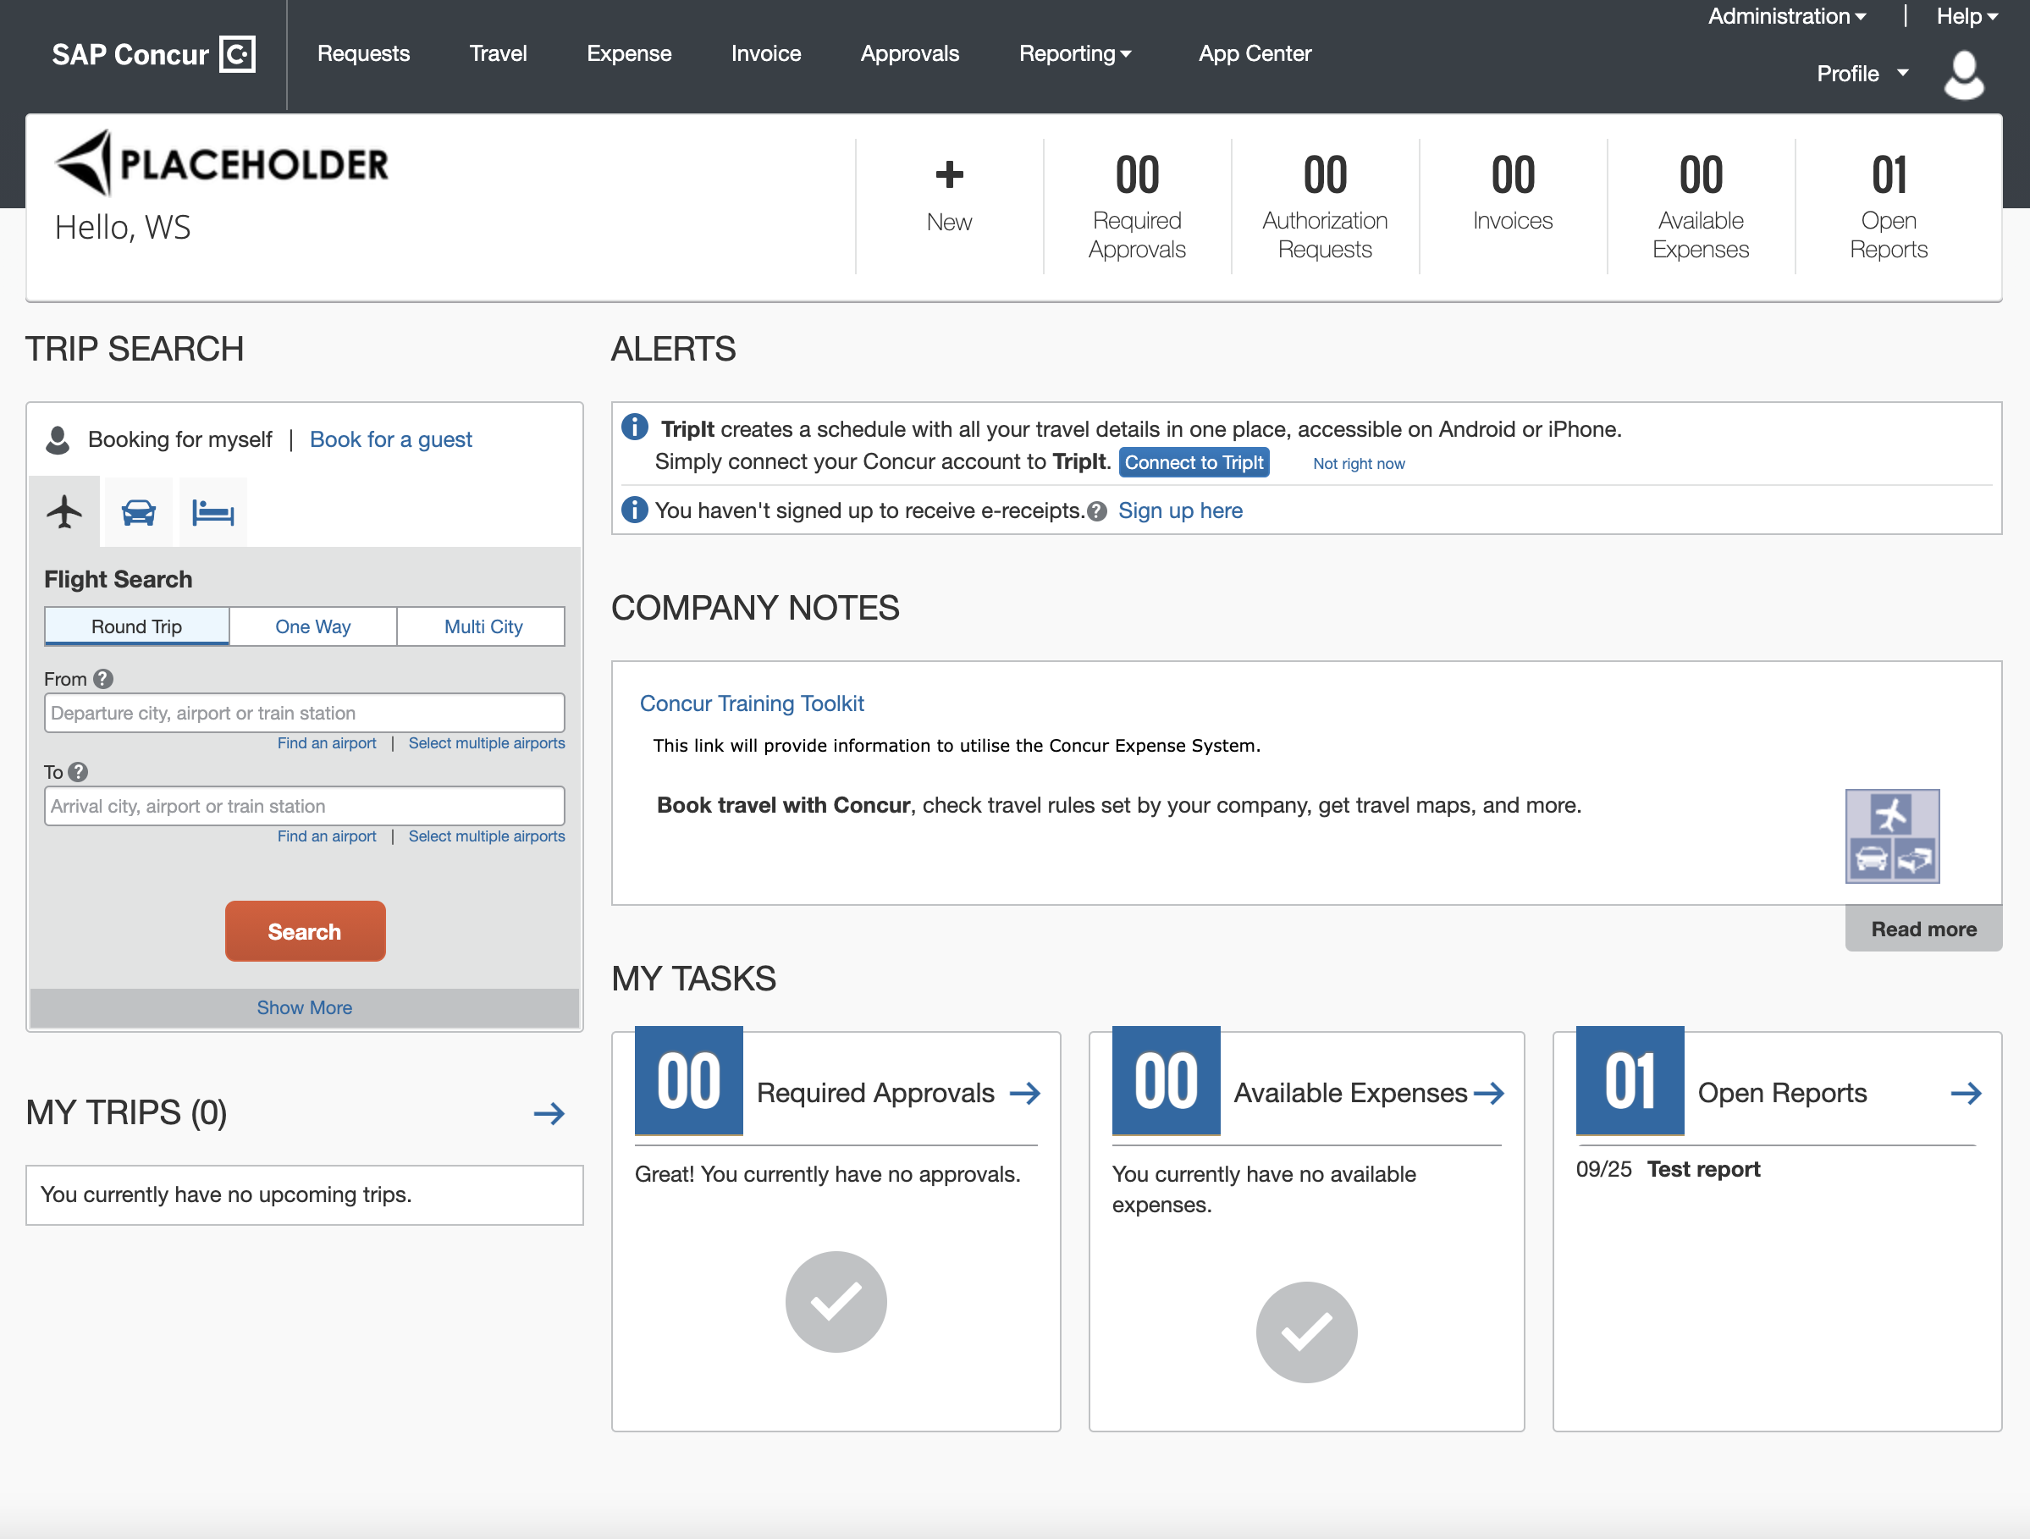

If some products or services are unavailable while other products and services are up and running, a modified version of the user’s homepage similar to the following appears:

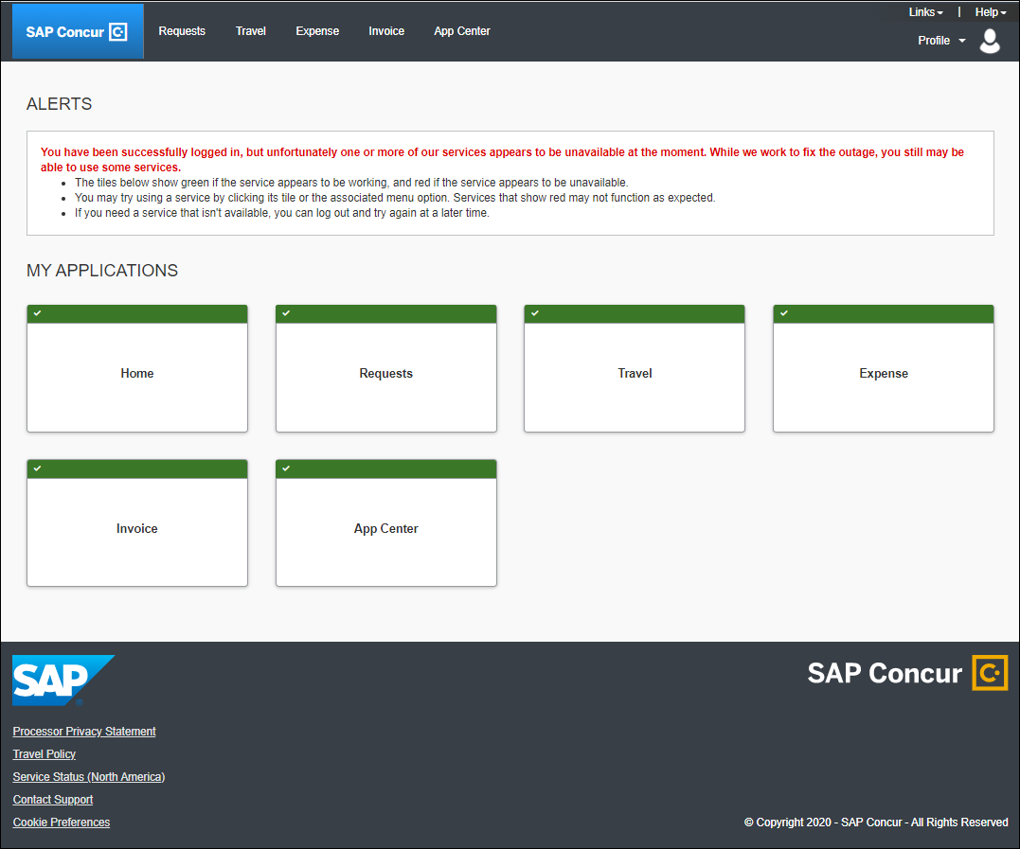

After a client is migrated to the new homepage, if one or more services are unavailable, when a user signs in to their SAP Concur products, they will see the usual homepage, but if the user navigates to a page for a service that is unavailable, they will see a page similar to the following:

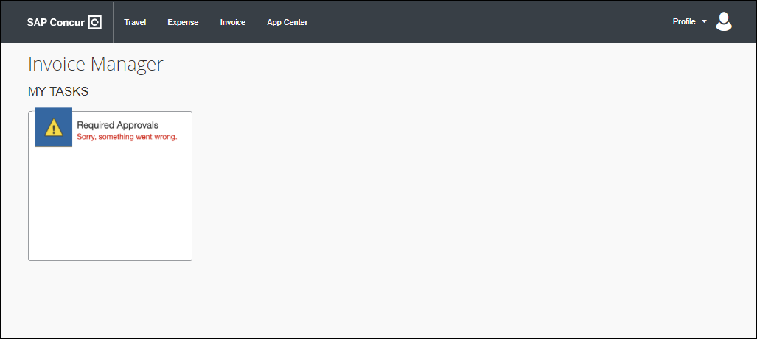

After migration to the new homepage, if all services are available, this change is transparent to the user and they see a homepage that is identical to the pre-migration homepage.

**Example Homepage**

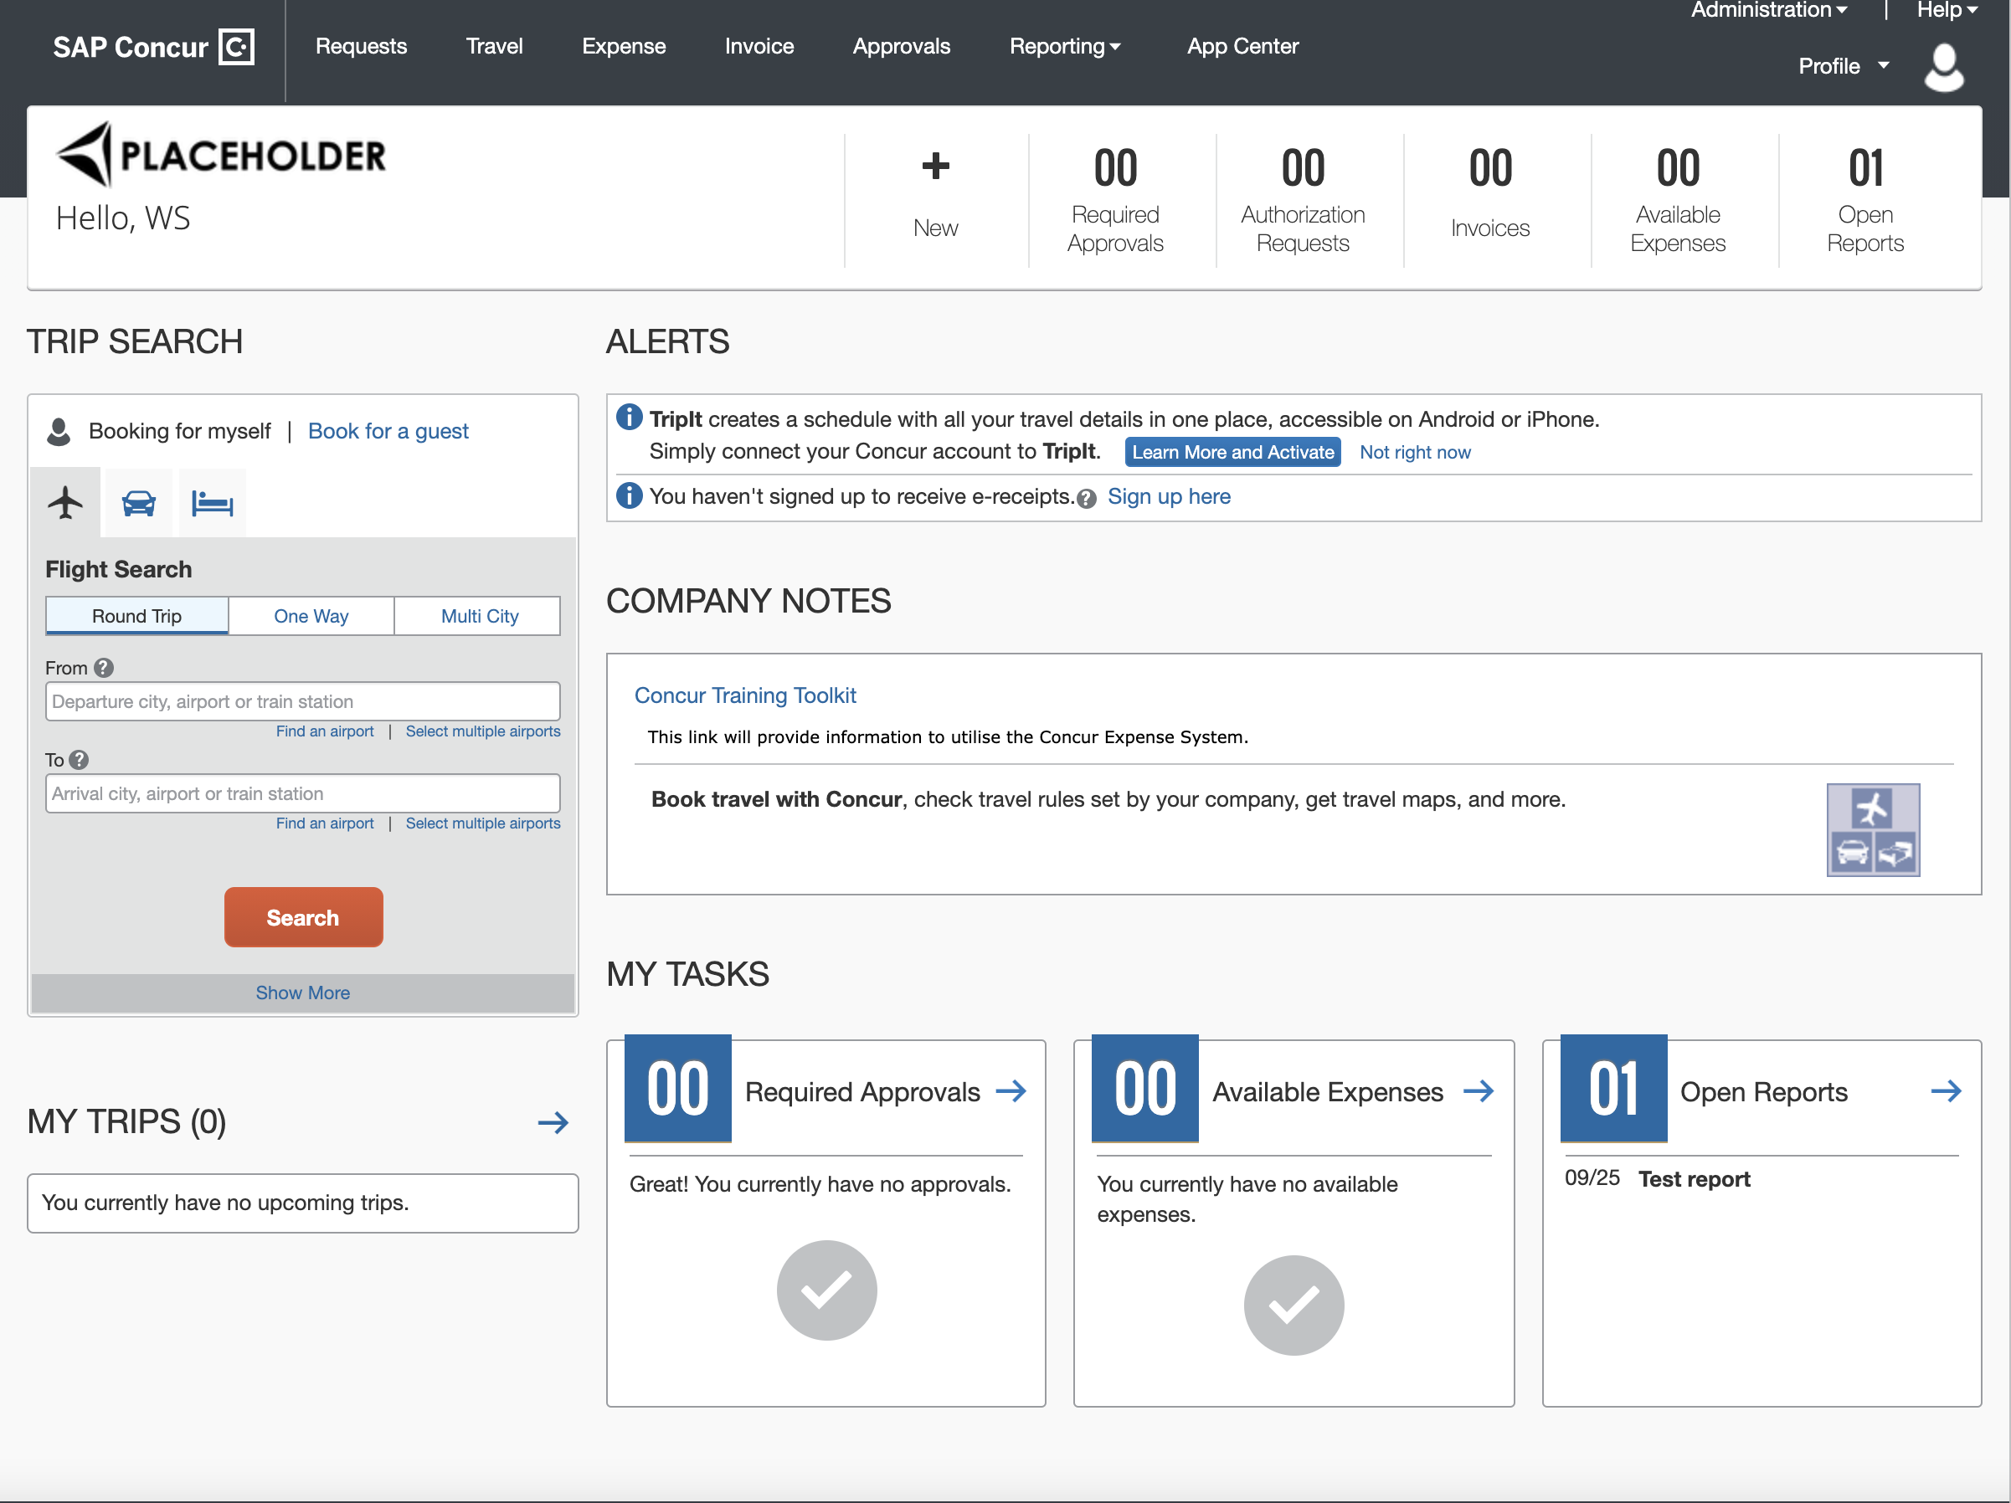

#### Configuration / Feature Activation

This change occurs automatically; there are no configuration or activation steps.

## Miscellaneous

### **Ongoing** SAP Concur Migration to Cloud Platform in AWS

|  |  |  |
| --- | --- | --- |
| Information First Published | Information Last Modified | Feature Target Release Date |
| February 18, 2022 | March 18, 2022 | Ongoing in 2022 |
| Any changes since the previous monthly release are highlighted in yellow in this release note. | | |

**Applies to:**

All Products | All Editions

#### Overview

SAP Concur plans to migrate from a pure private cloud operation, where all equipment is owned by SAP Concur, to a cloud platform. We plan to close our own private data centers in favor of a cloud platform implemented in Amazon Web Services (AWS). While this process started in 2017, we are focused on the final phase of the migration in 2022 for the North American and EMEA data centers.

##### Business Purpose / Client Benefit

This change provides a stronger security posture, improved performance and stability, and faster innovation for our clients.

#### End-User Experience During Migration

While a company is being migrated from an SAP Concur private data center to the cloud platform, their SAP Concur solutions might not be available to end users.

If an end user attempts to sign in to SAP Concur solutions during the active migration process, they might not be able to sign in and they might see the following message:

"SAP Concur solutions is undergoing scheduled maintenance. Please try again later"

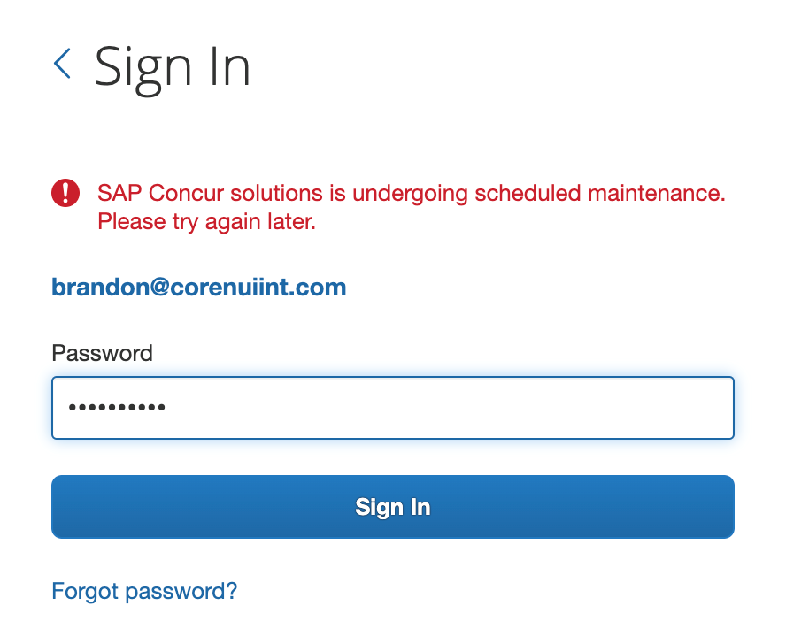

If an end user is working in SAP Concur solutions when their company is migrated, they might be returned to the sign in page.

1. SAP plans to implement migrations on weekends and after business hours.

#### Configuration / Feature Activation

This change will occur automatically.

For details, refer to the [*SAP Concur Cloud Platform Strategy FAQ*](http://assets.concur.com/concurtraining/cte/en-us/FAQ_Cloud_Hosting_Strategy.pdf).

## Profile Settings

### **Ongoing** Accessibility Improvements to My Profile – Personal Information Page

|  |  |  |
| --- | --- | --- |
| Information First Published | Information Last Modified | Feature Target Release Date |
| April 22, 2022 | May 13, 2022 | Q2 2022 |
| Any changes since the previous monthly release are highlighted in yellow in this release note. | | |

**Applies to:**

Travel, Expense | Professional & Standard

#### Overview

To make the **My Profile – Personal Information** page in **Profile Settings** more accessible to users, SAP Concur is making changes to the page. Implementation of the changes began with the April 2022 release and will continue over time.

With the May release, the following changes are being implemented in the **Assistance and Travel Arrangers** section of the **My Profile – Personal Information** page:

* Table headers will be added to the display table.
* Tags, labels, and captions will be added to support the user of screen readers.
* Minor changes will be made to facilitate tabbing between elements.

With the April release, the following changes were implemented in the **Credit Cards** section of the **My Profile – Personal Information** page:

* Table headers were added to the display table.
* Tags and captions were implemented to support the use of screen readers.
* Minor changes were made to facilitate tabbing between elements.

##### Business Purpose / Client Benefit

SAP Concur is committed to making our products accessible to as many users as possible. With that goal in mind, we plan to make changes to the **My Profile – Personal Information** page that will improve the user experience for users who don’t use a mouse and for users who use screen readers.

#### End-User Experience

With the May release, the **Assistants and Travel Arrangers** section now includes the following column headers:

* **Assistant**
* **Can Book Travel?**
* **Update/Delete**

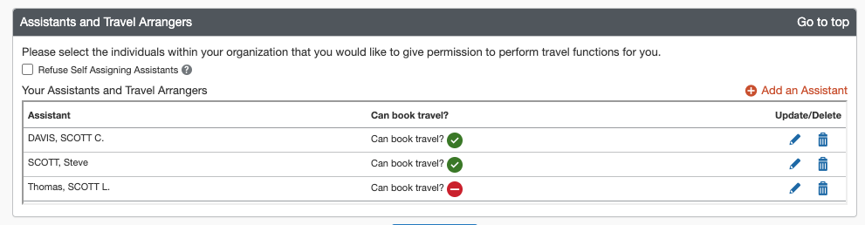

#### Configuration / Feature Activation

The changes are implemented automatically.

For more information about accessibility improvements, refer to [*Accessibility Updates*](https://www.concurtraining.com/customers/tech_pubs/RN-monthly-Access/_RN_access_client.htm).

### **Ongoing** Changes to My Profile, Home Page, and Profile Menu

|  |  |  |
| --- | --- | --- |
| Information First Published | Information Last Modified | Feature Target Release Date |
| January 21, 2022 | May 21, 2022 | Ongoing beginning in April 2022 |
| Any changes since the previous monthly release are highlighted in yellow in this release note. | | |

**Applies to:**

Travel, Expense, Invoice, Request, Mobile | Professional & Standard

#### Overview

SAP Concur has implemented or plans to implement changes to several pages in the UI. The changes will be implemented over time beginning in April of 2022 and continuing throughout 2022.

These changes reflect [SAP's commitment to supporting gender diversity](https://www.sap.com/about/company/diversity.html) by enabling gender non-binary users to enter consistent information when making travel arrangements and entering information in SAP Concur solutions. Changes include but are not limited to the following:

**April 2022 Release**

* The greeting on the SAP Concur Home page was removed. In addition, first and last name were removed from the menu in the SAP Concur mobile app.
* If a user adds their preferred name on the **My Profile – Personal Information** page in **Profile Settings**, their preferred name and last name is displayed in the SAP Concur **Profile** menu.

**May 2022 Release**

* The **Nickname** field on the **My Profile – Personal Information** page will be changed from **Nickname** to **Preferred Name**.
* The **Nickname** field in the **Employee Travel Addendum Import 350** file will be changed from **Nick Name** to **Preferred Name**.
* The **Nickname** field in the **Employee Import** file will be changed from **Nickname** to **Preferred Name**.

**Future Releases**

* The **Nickname** field on the **User Administration – User Details** page will be changed from **Nickname** to **Preferred Name**.
* A new option, Mx, will be added to the **Title** list on the **My Profile – Personal Information** page.
* New options will be added to enable users to select a non-binary gender in the **TSA Secure Flight** section of **Travel Preferences**.
* New options will be added to the gender field in the Travel Profile 2.0 API. This change will enable callers, such as TMCs and App Center partners, to provision (write) and receive (read) the new non-binary gender values.

##### Business Purpose / Client Benefit

These changes:

* Enable users to enter information into SAP Concur solutions that is consistent with their identity.
* Enable SAP Concur solutions to address a user by their preferred name.
* Ensure that information in SAP Concur solutions matches a user's government-issued identification.
* Ensure that travel documents such as airplane tickets purchased through SAP Concur solutions display information that is consistent with other required documents.

### Implemented and Planned Changes

SAP Concur has implemented or plans to implement the following changes overtime beginning in April 2022 and continuing throughout 2022.

#### April 2022 Release

##### Web UI Page Header

The greeting on the Concur home page, "Hello <First Name>" was removed in April. The greeting included the name from the **First Name** field in the end user's user account.

**Previously**

The greeting "Hello, <First Name>" was included on the SAP Concur homepage.

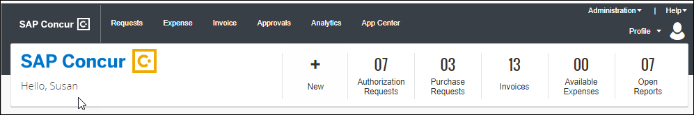

**With the April 2022 Release**

The greeting is no longer included.

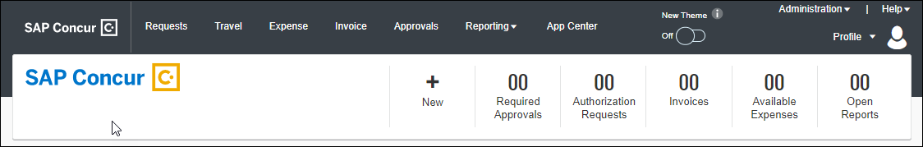

##### Mobile App

**Previously**

Prior to the April 2022 release, the menu in the Mobile app included the first and last names from the respective fields in the user's user account.

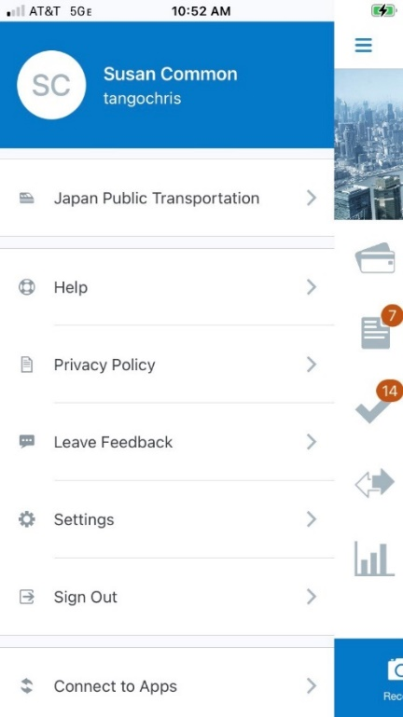

**With the April 2022 Release**

With the April 2022 release, no name is included at the top of the Mobile app menu.

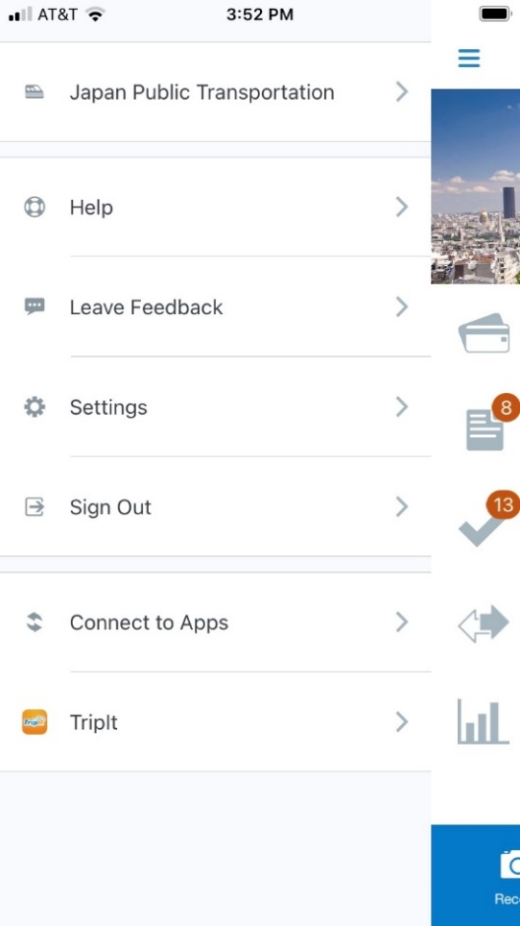

##### Web UI Profile Menu

Beginning with the April release, if a user specifies a preferred name on the **Profile – Personal Information** page in **Profile Settings**, when they click on **Profile** in the web version of SAP Concur solutions, their preferred name and last name is displayed.

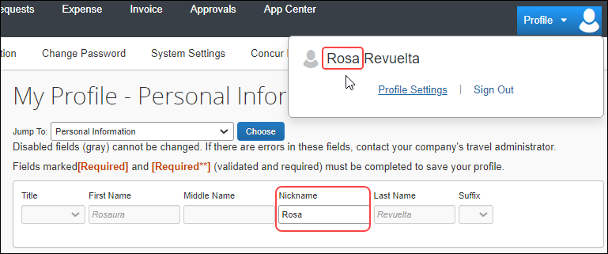

1. If the user has not specified a preferred name, their first and last names from their user account information will be displayed.

#### May 2022 Release

##### My Profile - Personal Information – Preferred Name

**Preferred Name Field**

Prior to the May 2022 release, a **Nickname** field was included on the **My Profile – Personal Information** page. With the May 2022 release, this field will be replaced by the **Preferred Name** field.

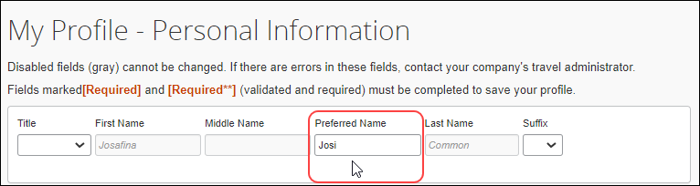

##### Preferred Name in Import and Extract Files

With the May 2022 release, the Nickname fields in import and extract files will be renamed to Preferred name.

**Employee Travel Addendum Import 350**

The **Preferred Name** field will replace the **Nick Name** field in Employee Travel Addendum Import 350.  
  
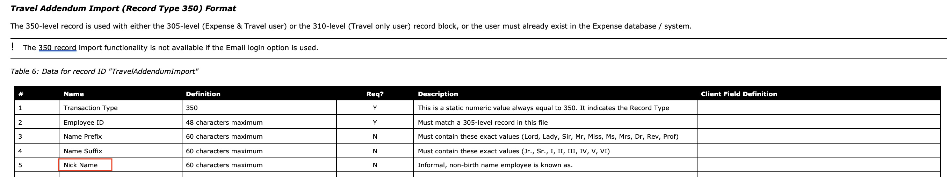

**User Import**

The **Preferred Name** field will replace the **Nickname** field in User Import.



**Import Data**

The **Preferred Name** field will replace the **Nickname** field in the user general information template.

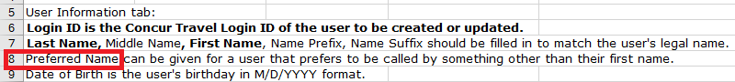

1. Previously downloaded templates containing the Nickname field will continue to be processed.

#### Future Releases

##### Title List

In a future release, a new gender non-binary option, **Mx** (pronounced "Mix"), will be added to the list in the **Title** list.

##### Travel Preferences TSA Secure Flight

Currently, users see two options under **Gender** in the **TSA Secure Flight** section of **Travel Preferences**.

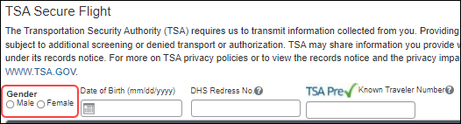

In a future release, users will have two additionaloptions under **Gender**: undisclosed (x) and unspecified (u).

1. When selecting a gender option, users should choose the option that matches the government-issued ID they use when travelling.

##### Web UI Profile Menu

When users with permission to act on behalf of another user—for example, Travel Arrangers and Delegates—search for and act as another user, they will see the preferred name of the user they are acting on behalf of in the search field and at the top of the **Profile** menu.

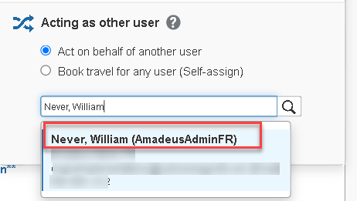 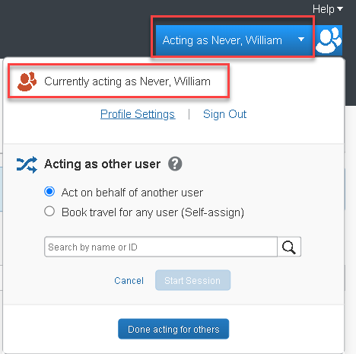

#### Configuration / Feature Activation

These changes will occur automatically over time. Users might need to update the information on the **My Profile – Personal Information** page after the changes are implemented.

For more information, refer to the [*Preferred Name and Nonbinary Gender Options*](https://www.concurtraining.com/customers/tech_pubs/Docs/FactSheets/Preferred%20Name_Nonbinary%20Gender%20Options_FS.pdf) fact sheet.

## SAP Concur Support

### Suggested Solutions Migration

|  |  |  |
| --- | --- | --- |
| Information First Published | Information Last Modified | Feature Target Release Date |
| November 5, 2021 | May 13, 2022 | March 10, 2022 |
| Any changes since the previous monthly release are highlighted in yellow in this release note. | | |

**Applies to:**

All Products | All Editions

#### Overview

On March 10, 2022, SAP Concur solutions replaced the Solution Suggestions platform with the SAP Continuous Influence – Improvement Requests program.

This change provides a better user experience and a single place for Authorized Support Contact (ASC) users to engage with all SAP Concur Customer Influence programs.

1. ConcurGov customers will no longer see the Solution Suggestions section on the Support Portal. Customers can contact their Account Manager for more information.

For more information about this new program, refer to [*SAP* *Continuous Influence Sessions*](https://www.concurtraining.com/cnqr/continuous-influence-sessions).

##### Business Purpose / Client Benefit

In addition to offering a better tool with more functionality, SAP Concur solutions has enhanced the entire process of how improvement requests are reviewed, considered, and prioritized.

#### End-User Experience

**Before Update**

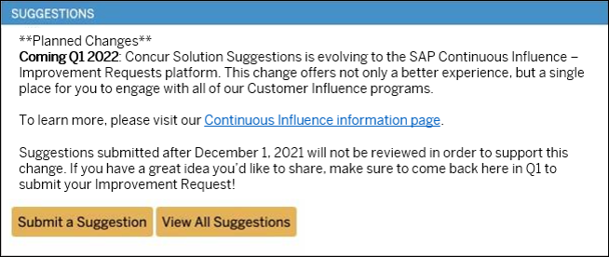

**After Update**

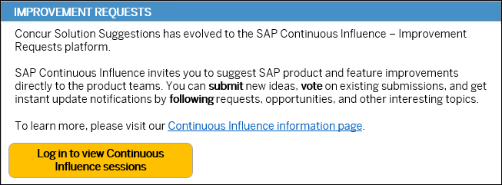

#### Configuration / Feature Activation

The change occurred automatically; there are no additional configuration or activation steps.

## Security

### Some TLSv1.2 Ciphers No Longer Supported (Feb 1, 2022)

|  |  |  |
| --- | --- | --- |
| Information First Published | Information Last Modified | Feature Target Release Date |
| August 13, 2021 | January 14, 2022 | February 1, 2022 |
| Any changes since the previous monthly release are highlighted in yellow in this release note. | | |

**Applies to:**

Travel, Expense, Invoice, Request | All Editions

#### Overview

Beginning on February 1, 2022, SAP Concur solutions will no longer support connections to *.concursolutions.com and * api.concursolutions.com that use the following TLSv1.2 ciphers:

|  |  |
| --- | --- |
| Akamai/OpenSSL cipher name | IANA cipher name |
| AES256-GCM-SHA384 | TLS_RSA_WITH_AES_256_GCM_SHA384 |
| AES128-GCM-SHA256 | TLS_RSA_WITH_AES_128_GCM_SHA256 |
| ECDHE-RSA-AES256-SHA384 | TLS_ECDHE_RSA_WITH_AES_256_CBC_SHA384 |
| ECDHE-RSA-AES128-SHA256 | TLS_ECDHE_RSA_WITH_AES_128_CBC_SHA256 |
| ECDHE-RSA-AES256-SHA | TLS_ECDHE_RSA_WITH_AES_256_CBC_SHA |
| ECDHE-RSA-AES128-SHA | TLS_ECDHE_RSA_WITH_AES_128_CBC_SHA |

To ensure that connections to *.concursolutions.com and * api.concursolutions.com are not disrupted, clients and partners who connect to *.concursolutions.com and *api.concursolutions.com through an application that uses a retired cipher must update the application to a supported cipher before February 1, 2022.

##### Business Purpose / Client Benefit

This update provides ongoing security for our products and services.

#### Confirming Supported Ciphers

The following ciphers included in the **ak-akamai-2020q1** cipher profile are supported:

|  |  |
| --- | --- |
| Akamai/OpenSSL cipher name | IANA cipher name |
| TLS-AES-256-GCM-SHA384 | TLS_AES_256_GCM_SHA384 |
| TLS-CHACHA20-POLY1305-SHA256 | TLS_CHACHA20_POLY1305_SHA256 |
| TLS-AES-128-GCM-SHA256 | TLS_AES_128_GCM_SHA256 |
| ECDHE-RSA-AES256-GCM-SHA384 | TLS_ECDHE_RSA_WITH_AES_256_GCM_SHA384 |
| ECDHE-RSA-AES128-GCM-SHA256 | TLS_ECDHE_RSA_WITH_AES_128_GCM_SHA256 |
| ECDHE-RSA-CHACHA20-POLY1305 | TLS_ECDHE_RSA_WITH_CHACHA20_POLY1305_SHA256 |

1. If your cipher suite includes both supported and unsupported ciphers, connections to *concursolutions.com through a web browser will not be disrupted. During the process of establishing the connection, the *concursolutions.com server will choose the most secure cipher in your cipher suite.

You can confirm that your cipher suite includes a supported cipher by cross-referencing the Akamai/OpenSSL cipher name with the IANA cipher name in the **ak-akamai-2021 (default)** column in the following table.

Supported ciphers are indicated with a check mark.

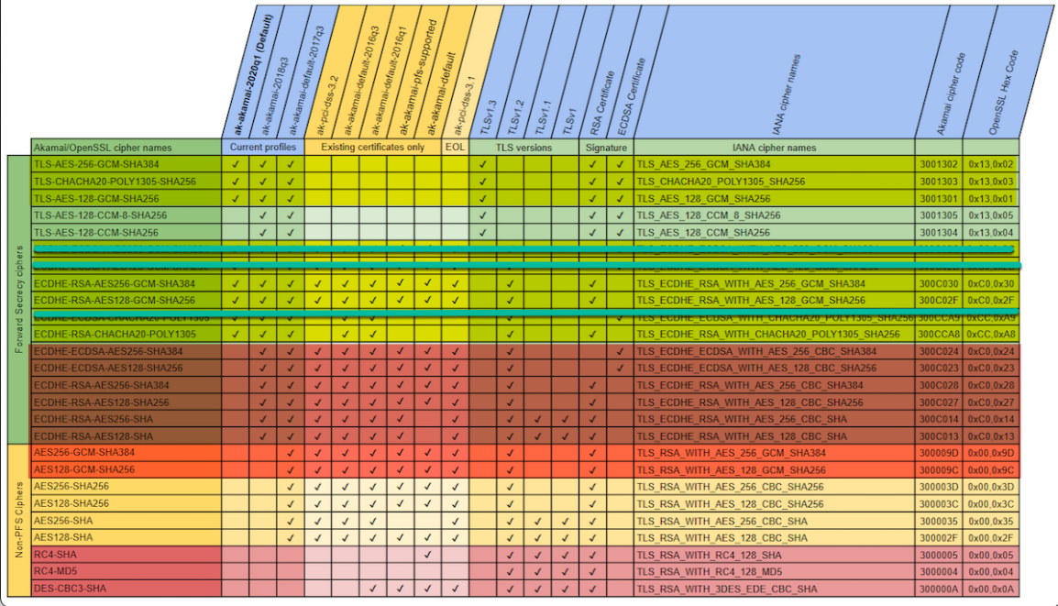

#### Testing Ciphers

The following procedure is intended for use by system administrators who want to test whether their cipher suite configuration will work correctly when connecting to SAP Concur solutions after support for the ciphers listed above has been removed.

This procedure configures the system admin's local machine to connect to an akamai staging environment where support for the listed ciphers has already been removed.

Summary of the procedure:

* Retrieve the IP address of the akamai production environment.
* Retrieve the IP address of the akamai staging environment.
* Redirect navigation to concursolutions.com to the akamai staging environment by editing the local *Hosts* file.
* Test a connection to concursolutions.com.

##### Confirm Your Cipher Suite is Working Correctly

1. Retrieve the IP Address of the Akamai Production Environment
2. Ping www.concursolutions.com

* Windows: Open a **Command Prompt** window, type “Ping www.concursolutions.com” and then press **Enter**.
* Mac: Open Terminal, type “Ping www.concursolutions.com” and then press **Enter.**

**Example response**

Pinging e7868.b.akamaiedge.net (23.46.104.197): 56 data bytes  
64 bytes from 23.46.104.197: icmp_seq=0 ttl=50 time=125.070 ms  
64 bytes from 23.46.104.197: icmp_seq=1 ttl=50 time=111.866 ms  
64 bytes from 23.46.104.197: icmp_seq=2 ttl=50 time=111.967 ms  
64 bytes from 23.46.104.197: icmp_seq=3 ttl=50 time=112.435 ms

1. Copy the highlighted address in the response.

**Example address**

e7868.b.akamaiedge.net

1. Retrieve the IP address of the akamai staging environment
2. In the **Command Prompt** or **Terminal** window, ping the copied address, but with “-staging” appended to “akamaiedge”.

**Example Ping command**

Ping e7868.b.akamaiedge-staging.net

**Example response**

Pinging e7868.b.akamaiedge-staging.net (104.76.225.252): 56 data bytes  
64 bytes from 104.76.225.252: icmp_seq=0 ttl=50 time=118.809 ms  
64 bytes from 104.76.225.252: icmp_seq=1 ttl=50 time=242.459 ms  
64 bytes from 104.76.225.252: icmp_seq=2 ttl=50 time=112.145 ms  
64 bytes from 104.76.225.252: icmp_seq=3 ttl=50 time=114.994 ms

1. Copy the highlighted IP address in the response.

**Example IP address**

104.76.225.252

1. Update the Local Hosts File

**MAC:**

1. Open Terminal
2. Type “sudo nano /private/etc/hosts” and then press **Enter**.

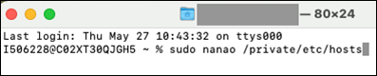

If prompted, enter your administrator password.

1. After the comments at the beginning of the file, add the IP address you copied in step 4, followed by “www.concursolutions.com”.
2. Comments are preceded with a hashtag (#). Your entry should not include the hashtag.

**Example entry**

104.76.225.252 [www.concursolutions.com](http://www.concursolutions.com)

1. Save the file (Ctrl-o) and close Terminal (Ctrl-x).

**Windows:**

1. Launch Notepad as administrator by typing “Notepad” into the Windows search bar, right-clicking Notepad in the search results, and then clicking **Run as administrator**.

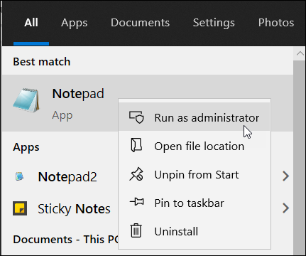

If prompted, click **Yes** in the **User Account Control** window.

1. In Notepad, click **File** and then click **Open**.
2. Navigate to *C:\\Windows\System32\drivers\etc* and then, to the right of the **File name** field, choose **All Files (*.*)** from the menu.

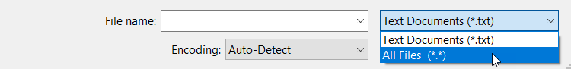

1. Open the *hosts* file.
2. After the comments at the beginning of the file, add the IP address you copied in step 4, followed by “www.concursolutions.com”.
3. Comments are preceded with a hashtag (#). Your entry should not include the hashtag.

**Example entry**

104.76.225.252 www.concursolutions.com

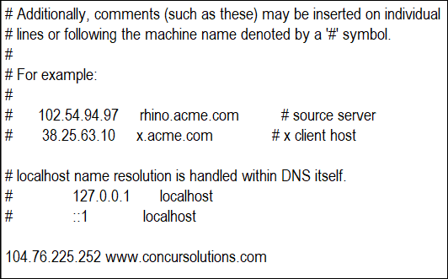

1. In the **File** menu, click **Save**.
2. Connect to *concursolutions.com from the Local Machine

After configuring your local *hosts* file to direct connections to *concursolutions.com to the akamai staging environment, connect to *concursolutions.com from the local machine through the method you need to test.

1. Your system administrator might need to test connections to *concursolutions.com made via an API call, connected application, or by navigating to the sign-in page through a web browser and signing in as an SAP Concur user.

#### Configuration / Feature Activation

To ensure that connections to *.concursolutions.com and * api.concursolutions.com are not disrupted, any applications that use an unsupported cipher must be updated to use a supported cipher before February 1, 2022.

1. If your cipher suite includes both supported and unsupported ciphers, connections to *concursolutions.com through a web browser will not be disrupted. During the process of establishing the connection, the *concursolutions.com server will choose the most secure cipher in your cipher suite.

## Test Entities | Production Sandbox Environment

### **Ongoing** Most Recently Used Lists Not Migrated

|  |  |  |
| --- | --- | --- |
| Information First Published | Information Last Modified | Feature Target Release Date |
| September 2021 | January 21, 2022 | October 1, 2021 through mid-2022 |
| Any changes since the previous monthly release are highlighted in yellow in this release note. | | |

**Applies to:**

Expense, Invoice, Request | Professional

#### Overview

Some SAP Concur users use Production Sandbox Environment (PSE) entities to set up, test, and train on new configurations prior to deploying them to their live production entity. SAP Concur plans to migrate PSEs as part of our move to Amazon Web Services (AWS).

For more information, refer to the [*SAP Concur Cloud Platform Strategy FAQ*](http://assets.concur.com/concurtraining/cte/en-us/FAQ_Cloud_Hosting_Strategy.pdf).

Due to the architectural changes that SAP Concur must make to support this move, when PSEs are migrated to the new environment, some Most Recently Used (MRU) list items within the PSE will not be migrated.

1. MRU lists consist of recent selections made by the user. These lists are generated overtime as users interact with various menus and other defined lists and they will be regenerated after the PSE is migrated to the new environment.
2. These changes apply to PSEs once they are moved or created in the AWS environment, which will occur at a future date.

##### Business Purpose / Client Benefit

Once in AWS, PSEs benefit from the same stability, monitoring capabilities, and level of performance as production entities.

#### End-User Experience

After the migration, some MRU lists that were generated prior to the migration will be empty. These lists will be regenerated automatically through the normal use of the PSE.

The following screenshots show some examples of MRU lists that will be impacted by the migration:

**Create New Expense in Concur Expense**

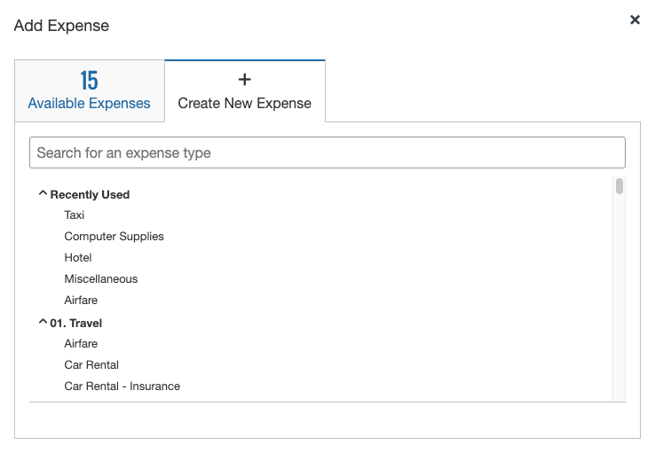

**New Segment in Concur Request**

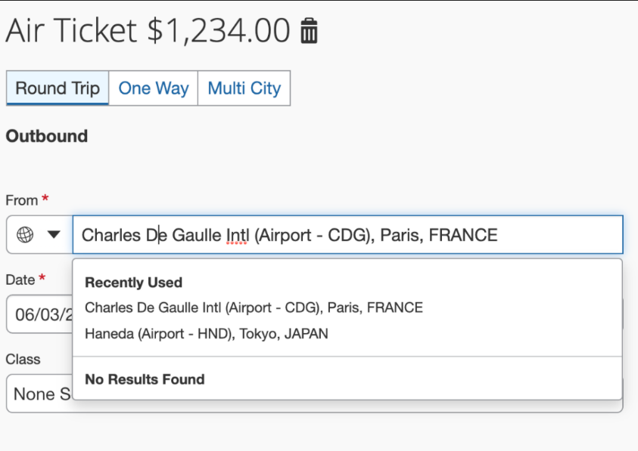

#### Configuration / Feature Activation

This change occurs when a PSE is migrated to the new AWS environment; there are no configuration or activation steps. The MRU lists will be regenerated with normal user of the entity.

### **Ongoing** Production Sandbox Environment Login Updates

|  |  |  |
| --- | --- | --- |
| Information First Published | Information Last Modified | Feature Target Release Date |
| August 2021 | January 21, 2022 | October 1, 2021 through mid-2022 |
| Any changes since the previous monthly release are highlighted in yellow in this release note. | | |

**Applies to:**

Expense, Invoice, Request | Professional

#### Overview

Some SAP Concur users use Production Sandbox Environment (PSE) entities to set up, test, and train on new configurations prior to deploying them to their live production entity. SAP Concur plans to migrate PSEs as part of our move to Amazon Web Services (AWS).

For more information, refer to the [*SAP Concur Cloud Platform Strategy FAQ*](http://assets.concur.com/concurtraining/cte/en-us/FAQ_Cloud_Hosting_Strategy.pdf).

Today, a user can maintain the same login ID for their test and production entities because they are in separate environments. With the plan to migrate both test and production entities to the same AWS production environment in the future, this will no longer be possible since each login ID must be unique.

While there is no action required for clients regarding this update, we want to ensure clients are aware of it because the change will be visible in certain areas of PSEs. To account for this change, SAP Concur will append all PSE login IDs with a ".uat” domain during both migration and user creation to ensure they are unique and do not conflict with any existing production login ID. For example, [johnsmith@123.com](mailto:johnsmith@123.com) will become [johnsmith@123.com.uat](mailto:johnsmith@123.com.uat).

* **IMPORTANT**: No changes will made to the login IDs in the current implementation environment in our private data centers.  
    
  This process will occur in the background during both the migration and user creation processes. Because SAP Concur will manage this process, users will **NOT** have to make any changes to their login ID.   
    
  Migrated users will still use the same implementation URL and login ID they used prior to the AWS migration.   
    
  New clients will use the production URL with the appended login ID, which will include the appended domain (for example, [johnsmith@123.com.uat](mailto:johnsmith@123.com.uat)).

This change will help to safeguard against any conflicts with production login IDs.

**User Creation:** Additionally, clients can use the exact same employee import files as they would in production. The uat domain will also be applied to all aspects of user creation: FTP import, Excel import, entity restore, and more.

**Extracts**: When generating accounting extracts or financial integration documents, SAP Concur will automatically remove the uat domain from login IDs that were appended during user creation. This will help to generate realistic extracts without requiring any actions from the clients, such as removing the appended domain.

1. These changes apply to PSEs once they are moved or created in the AWS environment, which will occur at a future date.

##### Business Purpose / Client Benefit

Once in AWS, PSEs will benefit from the same stability, monitoring capabilities, and level of performance as production entities.

#### Configuration / Feature Activation

These changes occur automatically; there are no additional configuration or activation steps.

### **Ongoing** Unique Address Required for PSE Email Verification

|  |  |  |
| --- | --- | --- |
| Information First Published | Information Last Modified | Feature Target Release Date |
| August 2021 | January 21, 2021 | October 1, 2021 through mid-2022 |
| Any changes since the previous monthly release are highlighted in yellow in this release note. | | |

**Applies to:**

Expense, Invoice, Request | Professional

#### Overview

Some SAP Concur users use Production Sandbox Environment (PSE) entities to set up, test, and train on new configurations prior to deploying them to their live production entity. SAP Concur plans to migrate PSEs as part of our move to Amazon Web Services (AWS).

For more information, refer to the [*SAP Concur Cloud Platform Strategy FAQ*](http://assets.concur.com/concurtraining/cte/en-us/FAQ_Cloud_Hosting_Strategy.pdf).

##### When PSEs are migrated to the AWS production environment, verified emails from the existing PSE will not carry over to the new PSE. As a result, when users test verified email functionality in a future PSE, it is recommended that the employee uses an email that is different from the email configured in their production entity. This process is required as the email in the existing PSE was most likely already verified in production and, therefore, cannot be verified in another entity.

With respect to user email addresses, the Receipt Recognition service validates user email addresses and as such, only one instance of an email address can be associated with a user account. To test in production, clients will be required to utilize alternate email addresses that are not currently associated with any production user account. If a client attempts to set up a test account in production using an email address already associated with a corresponding user profile, it will fail the validation process.

1. These changes apply to PSEs once they are moved or created in the AWS environment, which will occur at a future date.

##### Business Purpose / Client Benefit

Once in AWS, PSEs will benefit from the same stability, monitoring capabilities, and level of performance as production entities.

#### Admin Experience

##### BEFORE – Existing Email in Existing PSE

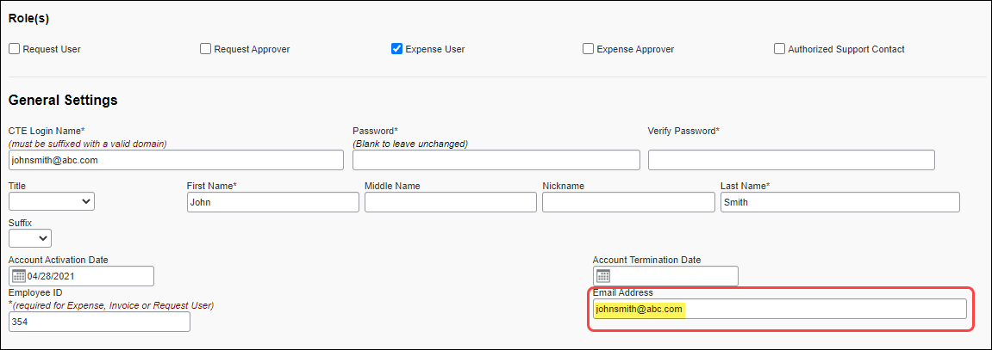

##### AFTER – New Email in New/Future PSE

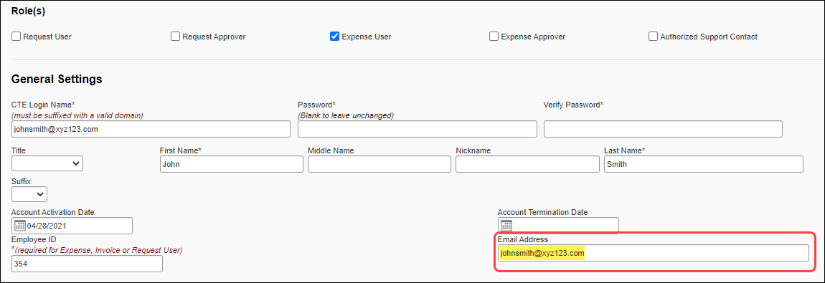

#### Configuration / Feature Activation

These changes occur automatically; there are no additional configuration or activation steps.

# Planned Changes

The following features and changes are targeted for future releases. SAP Concur solutions reserves the right to postpone implementation of – or completely remove – any enhancement/change mentioned here.

## Concur Open

### **Planned Changes** Japanese Translation Available (Jun 2)

|  |  |  |
| --- | --- | --- |
| Information First Published | Information Last Modified | Feature Target Release Date |
| May 13, 2022 | -- | June 2, 2022 |
| Any changes since the previous monthly release are highlighted in yellow in this release note. | | |

**Applies to:**

All Products | Professional & Standard

#### Overview

Beginning June 2, 2022, the ability to switch between English and Japanese will be added to the **SAP Concur Open** and **SAP Personalized Concur Open** pages.

In addition, you will be able to set English or Japanese as your preferred language on the **Set Notification Preferences** page.

##### Business Purpose / Client Benefit

This change eliminates the current manual translation process and improves the customer experience.

#### End-User Experience

When an end user navigates to the **SAP Concur Open** page by clicking the link to **Service Status** in the concursolutions.com page footer, a new language icon is available to the left of the **SAP** logo in the upper right corner of the **SAP Concur Open** page.

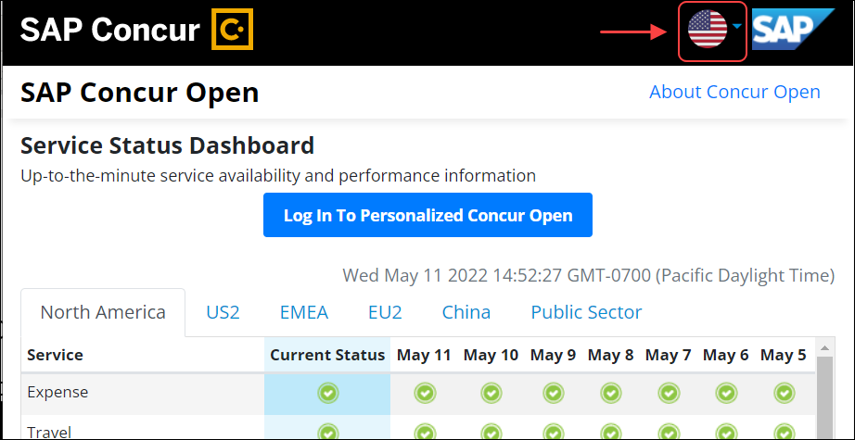

The new icon also appears on the **SAP Personalized Concur Open** page.

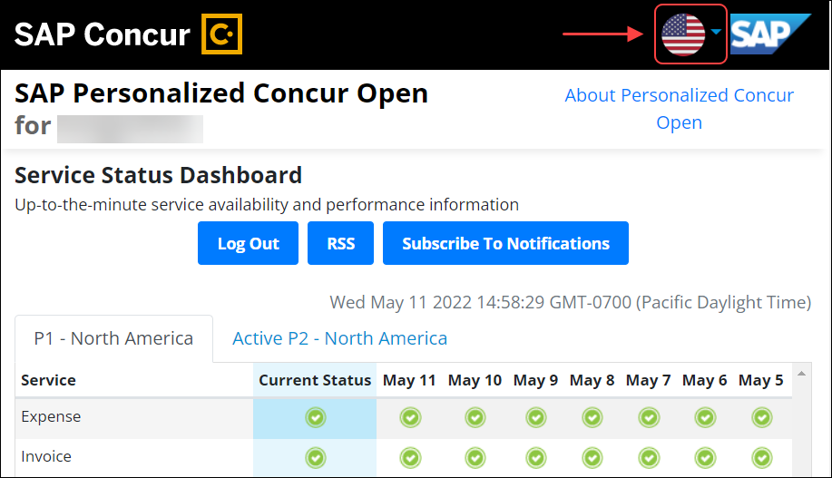

When the user clicks on the icon, they can choose to set the page language to either English or Japanese.

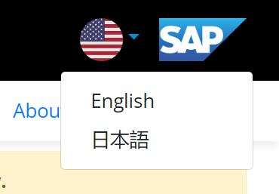

In addition, on the **SAP Personalized Concur Open** page, after clicking **Subscribe to Notifications**, they can set their preferred notification language to English or Japanese.

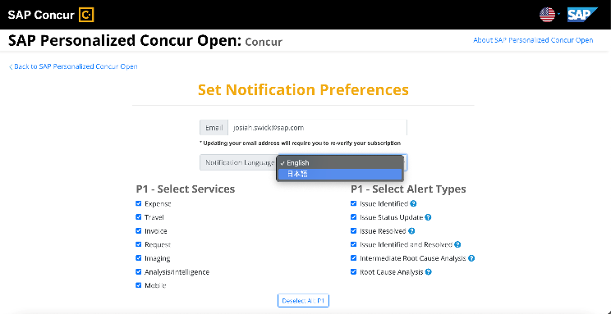

#### Configuration / Feature Activation

This change occurs automatically.

## Fax Feature

### **Planned Changes** Fax Feature to be Decommissioned

|  |  |  |
| --- | --- | --- |
| Information First Published | Information Last Modified | Feature Target Release Date |
| November 2021 | January 14, 2022 | October 1, 2022 |
| Any changes since the previous monthly release are highlighted in yellow in this release note. | | |

**Applies to:**

Expense, Invoice | Professional & Standard

#### Overview

On October 1, 2022, the Concur Fax Feature will be decommissioned.

1. The Fax feature was retired in 2020. Clients onboarded after July 15, 2020 do not have access to this feature. Among clients with access, very few use the feature regularly and, among those that use it, use has declined steadily.

##### Business Purpose / Client Benefit

Removal of the Fax feature improves the security, performance, and scalability of SAP Concur solutions.

In addition, The Concur Fax Feature attaches files only at the header level of expenses and invoices. As a result, clients who use the Fax Feature cannot take advantage of recent innovations that apply only to images and attachments at the line-item level.

#### End-User Experience

Users will no longer have the option to print Fax cover pages from within Concur Expense or Concur Invoice and they will no longer have the ability to fax images to SAP Concur for attachment to expenses or invoices.

#### Configuration / Feature Activation

This change occurs automatically; there are no configuration steps.

Additional information about this change will be made available over the coming months.

## Financial Integration

### **Planned Changes** Sage Accounting to be Retired

|  |  |  |
| --- | --- | --- |
| Information First Published | Information Last Modified | Feature Target Release Date |
| April 15, 2022 | -- | July 2022 |
| Any changes since the previous monthly release are highlighted in yellow in this release note. | | |

**Applies to:**

Expense, Invoice | Standard Edition

#### Overview

In July 2022, SAP Concur solutions plans to retire the Sage Accounting integration with Concur Expense and Concur Invoice.

1. This change does not impact the Sage Intacct integration.

##### Business Purpose / Client Benefit

This integration offering has not been adopted by any SAP Concur clients.

#### Configuration / Feature Activation

This retirement will occur automatically.

## Help Menu

### **Planned Change** Consolidation of Resources Under Help Menu

|  |  |  |
| --- | --- | --- |
| Information First Published | Information Last Modified | Feature Target Release Date |
| February 18, 2022 | May 13, 2022 | June 30, 2022 and Future release |
| Any changes since the previous monthly release are highlighted in yellow in this release note. | | |

**Applies to:**

All Products | All Editions

#### Overview

In June 2022, SAP plans to begin consolidating SAP Concur help resources under the **Help** menu in SAP Concur solutions. These changes will occur in two phases:

* **Phase 1 -Targeted for June 30, 2022**: In addition to the help content that is currently available from the **Help** menu, SAP Enable Now will be accessed from the **Help** menu.
* For more information about support for SAP Enable Now, refer to the *\*\*Planned Changes** Support for SAP Enable Now* release note in this document.
* **Phase 2 – Targeted for a future release:** The question mark icon (?) that currently provides access to user assistance, video tutorials, and tools for contacting support will be removed and those items will be accessed from the consolidated **Help** menu.
* For more information about user assistance for admins and end users, refer to the [*User Assistance for Admins and End Users*](https://www.concurtraining.com/customers/tech_pubs/Docs/FactSheets/User%20Assistance%20for%20Admins%20and%20End%20Users.pdf)fact sheet.

##### Business Purpose / Client Benefit

These changes will improve ease of use and simplify the SAP Concur user interface by providing a single point of access to help resources.

#### User Experience

When all changes have been implemented, new options will be available in the **Help** menu—for example, if User Assistance for End Users or SAP Enable Now are enabled, a link to access those resources will appear in the **Help** menu.

#### Configuration / Feature Activation

These changes will be implemented automatically.

## SSO Management

### **Planned Changes** New Checkbox to Hide SSO Sign-In Option

|  |  |  |
| --- | --- | --- |
| Information First Published | Information Last Modified | Feature Target Release Date |
| February 11, 2022 | May 13, 2022 | June 2022 |
| Any changes since the previous monthly release are highlighted in yellow in this release note. | | |

**Applies to:**

Travel, Expense, Invoice, Request | Professional & Standard

#### Overview

SAP Concur plans to add a checkbox to the **Add IdP Metadata** and **Edit IdP Configuration** dialogs. The checkbox will enable an SSO administrator to prevent a specified SSO sign-in method from being presented to users as a sign-in option on the concursolutions.com sign-in page.

In addition, SAP Concur plans to add a column to the table in the **IdP Metadata** section of the **Manage Single Sign-On** page that will indicate whether the checkbox to hide the SSO sign-in option is enabled (checked) or disabled (unchecked) for each configured sign-in method.

1. Users will still be able to sign-in via the method through other navigation paths as outlined by their company.

##### Business Purpose / Client Benefit

The addition of this checkbox gives the SSO administrator greater control over how end-users sign in to their SAP Concur solutions.

#### SSO Admin Experience

When the admin navigates to the **Manage Single Sign-On** page, if SSO sign-in methods are configured, the new column indicates whether the method is available to end users or hidden from them.

When an admin clicks **Add** or **Edit** in the **IdP Metadata** section, the new checkbox is available at the bottom of the **Add IdP Metadata** or the **Edit IdP Configuration** dialog.

1. The SSO sign-in option can be enabled (checked) and disabled (unchecked) in the **Edit IdP Configuration** dialog.

#### Configuration / Feature Activation

The checkbox will be added to the **Add IdP Metadata** and **Edit IdP Configuration** pages automatically.

### **Planned Changes** Option to Provide URL to IdP Metadata to be Removed

|  |  |  |
| --- | --- | --- |
| Information First Published | Information Last Modified | Feature Target Release Date |
| February 11, 2022 | February 18, 2022 | Q2 2022 |
| Any changes since the previous monthly release are highlighted in yellow in this release note. | | |

**Applies to:**

Travel, Expense, Invoice, Request | Professional & Standard

#### Overview

In a future release, SAP Concur plans to remove the **Provide link to your IdP's metadata** field from the **Add IdP Metadata** dialog.

##### Business Purpose / Client Benefit

In order to use the **Provide link to your IdP's metadata** field, clients must first open a support ticket to have the URL added to the SAP Concur allow list. These additional steps do not support the goal of making the SSO management process self-service for our clients.

#### SSO Admin Experience

When the admin navigates to the **Manage Single Sign-On** page and then clicks **Add** in the **IdP Metadata** section, they will no longer see the **Provide link to your IdP's metadata** field in the **Add IdP Metadata** dialog.

1. The admin will still have the ability to upload IdP metadata by clicking **Upload XML File**.

#### Configuration / Feature Activation

The field will be removed from the **Add IdP Metadata** page automatically.

1. More information about this change will be included in future release notes.

## User Assistance

### **Planned Changes** Support for SAP Enable Now

|  |  |  |
| --- | --- | --- |
| Information First Published | Information Last Modified | Feature Target Release Date |
| February 11, 2022 | May 13, 2022 | June 2022 |
| Any changes since the previous monthly release are highlighted in yellow in this release note. | | |

**Applies to:**

Travel, Expense, Invoice, Request | Professional & Standard

#### Overview

In late June, SAP plans to add support for SAP Enable Now with SAP Concur solutions.

##### Business Purpose / Client Benefit

This change will enable clients to use SAP Enable Now to create user assistance content to improve user adoption and increase efficiency with SAP Concur solutions.

#### Configuration / Feature Activation

After support for SAP Enable Now has been added to SAP Concur solutions, clients who have User Assistance enabled for their SAP Concur solutions will be able to enable and disable SAP Enable Now on the SAP Concur **User Assistance** page.

1. More detailed information about this feature will be included in a future release note.

## User Export and Import

### **Planned Changes** User Export and Import Improvements

|  |  |  |
| --- | --- | --- |
| Information First Published | Information Last Modified | Feature Target Release Date |
| April 22, 2022 | -- | Q3 2022 |
| Any changes since the previous monthly release are highlighted in yellow in this release note. | | |

**Applies to:**

Expense, Invoice, Request | Standard Edition

#### Overview

SAP Concur plans to implement improvements to the user export/import experience. Improvements include, but are not limited to:

* Improvements to the downloadable user data template including tooltips and dropdown lists
* Removal of the 1000 user maximum for imports and exports of user data
* The addition of a new **Manage Users via a Spreadsheet** page

##### Business Purpose / Client Benefit

These improvements increase the ease of use and experience of the user import and export processes.

#### Admin Experience

On the **Users** page in Product Settings, when the admin clicks **Add Users > From Spreadsheet**, the admin sees the new **Manage Users via a Spreadsheet** page.

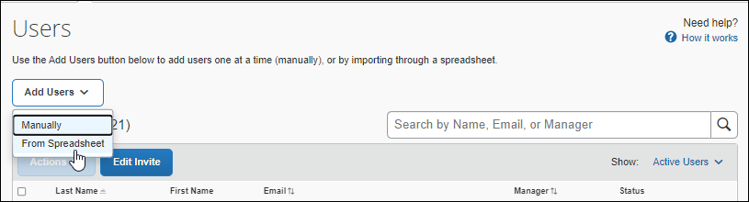

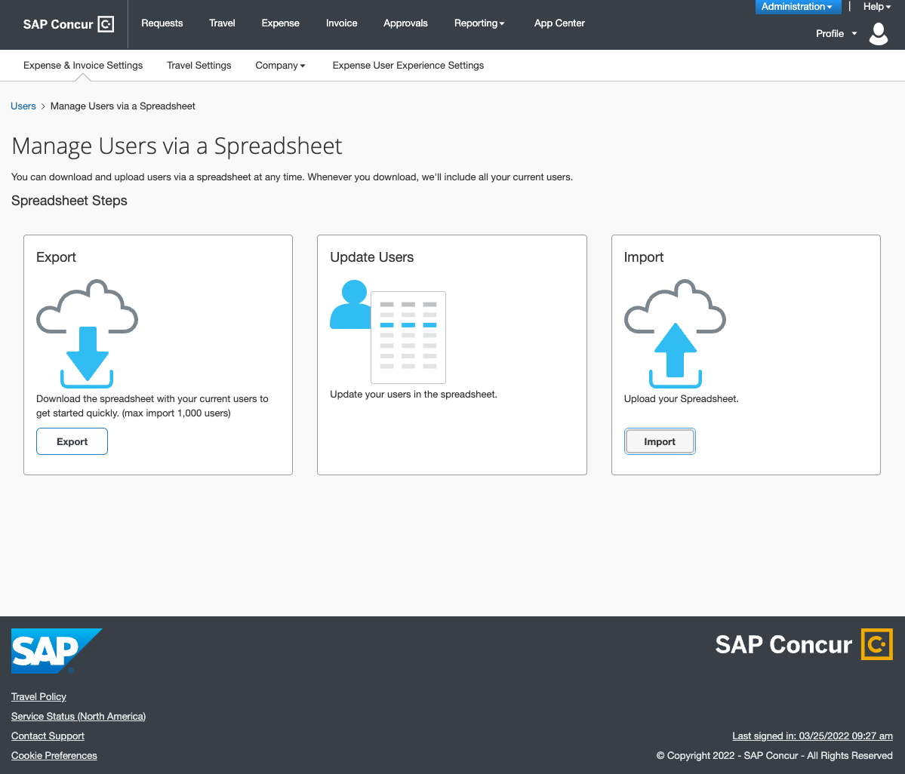

On the **Manage Users via a Spreadsheet** page, the admin can export, update, and import user data. When they export the spreadsheet, they will see new tooltips and, where applicable, dropdown lists in the spreadsheet. In addition, they will no longer be limited to downloading 1000 rows of user data.

##### Initial Release Opt-In Phase and Survey

During the initial release phase, clients will be able to opt-in to the new experience and will have the option to provide feedback on the experience through a survey.

#### Configuration / Feature Activation

This new user export/import experience will be automatically available. During the initial release phase, clients will be able to opt-in to the new experience.

# Client Notifications

## Accessibility

### Accessibility Enhancements

SAP implements changes to better meet current Web Content Accessibility Guidelines (WCAG). Information about accessibility-related changes made to SAP Concur solutions is published on a quarterly basis. You can review the quarterly updates on the [Accessibility Updates](https://www.concurtraining.com/customers/tech_pubs/RN-monthly-Access/_RN_access_client.htm) (English Only) page.

## Subprocessors

### SAP Concur Non-Affiliated Subprocessors

The list of non-affiliated subprocessors is available from the *SAP Sub-processors / Data Transfer Factsheets* page.

1. To access the SAP Concur Sub-processors List:
2. Click the following link to navigate to the *SAP Sub-processors / Data Transfer Factsheets* page:  
   [*SAP Sub-processors / Data Transfer Factsheets*](https://support.sap.com/en/my-support/trust-center/subprocessors.html)
3. Sign in to the SAP Support Portal using your Support User ID (S-user) and password.
4. SAP customers must sign in to the SAP Support Portal using their Support User ID (S-user) and password. For information about S-User IDs, refer to [*Your New Support User ID (S-user)*](https://support.sap.com/en/my-support/users/welcome.html).
5. On the *SAP Sub-processors / Data Transfer Factsheets* page, type "Concur" in the **Search** field.
6. In the **Title** column, click **SAP Concur Sub-processors List**.

If you have questions or comments, please reach out to: [Privacy-Request@Concur.com](mailto:Privacy-Request@Concur.com)

## Supported Browsers

### Supported Browsers and Changes to Support

For information about supported browsers and planned changes to supported browsers, refer to the [*Concur Travel & Expense Supported Configurations*](http://www.concurtraining.com/customers/tech_pubs/Docs/Z_SuppConfig/Supported_Configurations_for_Concur_Travel_and_Expense.pdf) guide.

When changes to browser support are planned, information about those changes will also appear in the [*Shared Planned Changes*](https://www.concurtraining.com/customers/tech_pubs/RN_shared_planned/_client_shared_RN_all.htm) release notes.

# Additional Release Notes and Other Technical Documentation

## Online Help

Any user can access release notes, setup guides, user guides, admin summaries, monthly browser certifications, supported configurations, and other resources via online Help or directly on the SAP Help Portal.

Use the links in the **Help** menu in the app, or search for your SAP Concur product (Concur Expense, Concur Invoice, Concur Request, or Concur Travel) on the SAP Help Portal (https://help.sap.com) to view the full set of documentation for your product.

## SAP Concur Support Portal – Selected Users

Access release notes, webinars, and other technical documentation on the SAP Concur support portal.

If you have the proper permissions, **Contact** **Support** appears on the **Help** menu. Click to access the SAP Concur support portal, then click **Resources**.

* Click **Release/Tech Info** for release notes, technical documents, etc.
* Click **Webinars** for recorded and live webinars.

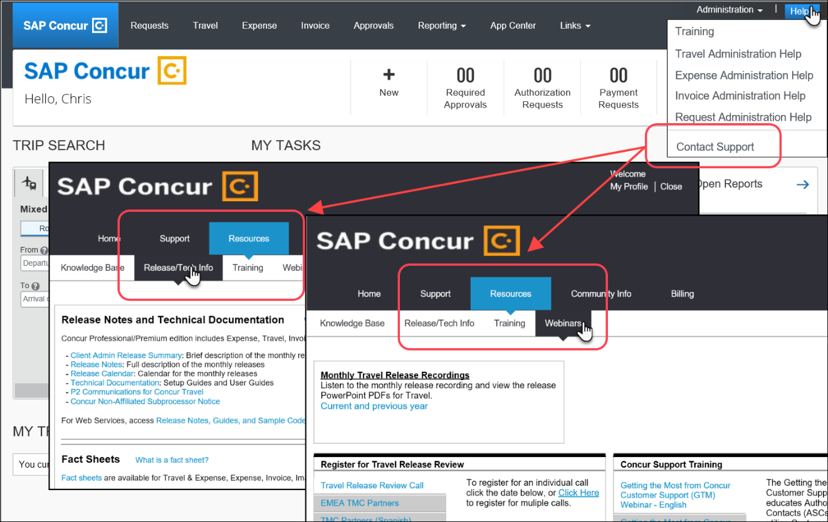

© 2022 SAP SE or an SAP affiliate company. All rights reserved.

No part of this publication may be reproduced or transmitted in any form or for any purpose without the express permission of SAP SE or an SAP affiliate company.

SAP and other SAP products and services mentioned herein as well as their respective logos are trademarks or registered trademarks of SAP SE (or an SAP affiliate company) in Germany and other countries. Please see http://global12.sap.com/corporate-en/legal/copyright/index.epx for additional trademark information and notices.

Some software products marketed by SAP SE and its distributors contain proprietary software components of other software vendors.

National product specifications may vary.

These materials are provided by SAP SE or an SAP affiliate company for informational purposes only, without representation or warranty of any kind, and SAP SE or its affiliated companies shall not be liable for errors or omissions with respect to the materials. The only warranties for SAP SE or SAP affiliate company products and services are those that are set forth in the express warranty statements accompanying such products and services, if any. Nothing herein should be construed as constituting an additional warranty.

In particular, SAP SE or its affiliated companies have no obligation to pursue any course of business outlined in this document or any related presentation, or to develop or release any functionality mentioned therein. This document, or any related presentation, and SAP SE’s or its affiliated companies’ strategy and possible future developments, products, and/or platform directions and functionality are all subject to change and may be changed by SAP SE or its affiliated companies at any time for any reason without notice. The information in this document is not a commitment, promise, or legal obligation to deliver any material, code, or functionality. All forward-looking statements are subject to various risks and uncertainties that could cause actual results to differ materially from expectations. Readers are cautioned not to place undue reliance on these forward-looking statements, which speak only as of their dates, and they should not be relied upon in making purchasing decisions.