|  |  |
| --- | --- |
| SAP Concur Release Notes  Shared Changes  Includes cross-product and site-wide changes for:  Professional Edition, Standard Edition, and Small Business Edition | |
| **Month** | **Audience** |
| Release Date: February 19, 2022  Initial Post: Friday, February 18, 2022 | Client FINAL |

Contents

Release Notes 1

File Transfer Updates 2

**Ongoing** Rotating PGP Key for File Transfers 2

Travel, Expense, Invoice, Request, Intelligence | Professional & Standard 2

Invoice Capture and Expense Receipt Handling 3

CFDi Version 4.0 Now Supported (Mexico) 3

Expense, Invoice | Professional & Standard 3

Miscellaneous 4

**Ongoing ** SAP Concur Homepage Changes 4

Travel, Expense, Invoice, Request | Professional & Standard 4

**Ongoing** SAP Concur Migration to Cloud Platform in AWS 7

All Products | All Editions 7

Product Settings 8

Product Settings Page Enhancements 8

Expense, Invoice, Request | Standard 8

Profile Settings 10

Removal of the Connected Apps Page 10

Travel, Expense, Invoice, Request | Professional & Standard 10

SAP Fiori Themes 11

Profile Menu Functional Changes Under Fiori Light Theme 11

Travel, Expense, Invoice, Request | Professional 11

SAP Concur User Assistance 14

Notice Regarding Stale Documentation 14

All Products | All Editions 14

Security 16

Some TLSv1.2 Ciphers No Longer Supported (Feb 1, 2022) 16

Travel, Expense, Invoice, Request | All Editions 16

Supported Configurations 21

Change in Support for Internet Explorer 11 21

Travel, Expense, Invoice, Request, Analysis/Intelligence | All Editions 21

Test Entities | Production Sandbox Environment 23

**Ongoing** Most Recently Used Lists Not Migrated 23

Expense, Invoice, Request | Professional 23

**Ongoing** Production Sandbox Environment Login Updates 25

Expense, Invoice, Request | Professional 25

**Ongoing** Unique Address Required for PSE Email Verification 26

Expense, Invoice, Request | Professional 26

User Assistance for End Users 28

Countries Added to User Assistance List 28

All Products | Professional & Standard 28

Web Services Administration 30

**Ongoing** Application Connector Username and Password Length Requirements Updated 30

Expense, Request, Web Services | Professional & Standard 30

Planned Changes 33

Fax Feature 33

**Planned Changes** Fax Feature to be Decommissioned 33

Expense, Invoice | Professional & Standard 33

Help Menu 34

**Planned Changes** Consolidation of Resources Under Help Menu 34

All Products | All Editions 34

Product Settings 35

**Planned Changes** Advanced and Basic Views Added to Product Settings 35

Expense, Invoice, Request | Standard 35

Profile Settings 36

**Planned Changes** Changes to My Profile, Home Page, and Profile Menu 36

Travel, Expense, Invoice, Request, Mobile | Professional & Standard 36

SAP Concur Support 40

**Planned Changes** Suggested Solutions Migration 40

All Products & Services | Professional & Standard 40

SSO Management 42

**Planned Changes** Checkbox to Hide SSO Sign-In Option 42

Travel, Expense, Invoice, Request | Professional & Standard 42

**Planned Changes** Option to Provide URL to IdP Metadata to be Removed 43

Travel, Expense, Invoice, Request | Professional & Standard 43

User Assistance 44

**Planned Changes** Support for SAP Enable Now 44

Travel, Expense, Invoice, Request | Professional & Standard 44

Client Notifications 45

Accessibility 45

Accessibility Enhancements 45

Subprocessors 45

SAP Concur Non-Affiliated Subprocessors 45

Supported Browsers 45

Supported Browsers and Changes to Support 45

Additional Release Notes and Other Technical Documentation 46

Online Help 46

SAP Concur Support Portal – Selected Users 46

Legal Disclaimer

The information in this presentation is confidential and proprietary to SAP SE or an SAP affiliate company and may not be disclosed without the permission of SAP SE or the respective SAP affiliate company. This presentation is not subject to your license agreement or any other service or subscription agreement with SAP SE or its affiliated companies. SAP SE and its affiliated companies have no obligation to pursue any course of business outlined in this document or any related presentation, or to develop or release any functionality mentioned therein. This document, or any related presentation and SAP SE or an SAP affiliate company’s strategy and possible future developments, products and or platforms directions and functionality are all subject to change and may be changed by SAP SE and its affiliated companies at any time for any reason without notice. The information in this document is not a commitment, promise or legal obligation to deliver any material, code or functionality. This document is provided without a warranty of any kind, either express or implied, including but not limited to, the implied warranties of merchantability, fitness for a particular purpose, or non-infringement. This document is for informational purposes and may not be incorporated into a contract. SAP SE and its affiliated companies assume no responsibility for errors or omissions in this document, except if such damages were caused by SAP SE or an SAP affiliate company’s willful misconduct or gross negligence.

All forward-looking statements are subject to various risks and uncertainties that could cause actual results to differ materially from expectations. Readers are cautioned not to place undue reliance on these forward-looking statements, which speak only as of their dates, and they should not be relied upon in making purchasing decisions.

# Release Notes

This document contains shared release notes and planned changes. Shared release notes and planned changes document features and changes that apply to SAP Concur solutions site-wide or to multiple SAP Concur products and services. They include but are not limited to:

* Security-related features and changes such as annual security certificate renewals and changes in support for security ciphers and protocols
* Site-wide UI features and changes such as changes to the home page, changes to the site header or footer, or the implementation of new site-wide UI themes
* Sign-in process features and changes such as the addition or removal of sign-in features, URL changes, and domain name changes
* Production and test environment features and changes
* Global settings or administration page features and changes such as the addition of new site-wide settings or changes to the design of the administration pages
* Changes to processes such as where and when release notes are published

For New Features and Changes that apply to a single product and/or service see the release notes for that product or service. Links to the product and service-specific release notes can be found on the following pages:

* [Professional Edition](https://www.concurtraining.com/customers/tech_pubs/_RN_CCC.htm)
* [Standard Edition](https://www.concurtraining.com/customers/tech_pubs/_Docs_CCC_CPS.htm)
* [Small Business Edition](http://www.concurtraining.com/customers/tech_pubs/Docs/Breeze/RN/WhatsNew.htm)

## File Transfer Updates

### **Ongoing** Rotating PGP Key for File Transfers

|  |  |  |
| --- | --- | --- |
| Information First Published | Information Last Modified | Feature Target Release Date |
| February 2021 | January 21, 2022 | January 15, 2021 and October 11, 2022 |
| Any changes since the previous monthly release are highlighted in yellow in this release note. | | |

**Applies to:**

Travel, Expense, Invoice, Request, Intelligence | Professional & Standard

#### Overview

Files transferred to SAP Concur products must be encrypted with the SAP Concur public PGP key, concursolutionsrotate.asc.

concursolutionsrotate.asc

* Key file is available in client’s root folder
* Key ID 40AC5D35
* RSA 4096-bit signing and encryption subkey
* Key expires every 2 years
* Client is responsible for replacing the key before it expires
* Next expiry date: September 4, 2022
* SAP Concur plans to replace the current rotating public PGP key in the client’s root folder 90 days before the expiration date

The SAP Concur legacy PGP key (key ID D4D727C0) will be decommissioned on October 11, 2022. You must switch to using the rotating PGP key before that date. Files encrypted with the legacy PGP key will not be processed after October 10, 2022.

This announcement pertains to the following file transfer DNS endpoints:

* st.concursolutions.com
* mft-us.concursolutions.com
* vs.concursolutions.com
* st-eu.concursolutions.com
* mft-eu.concursolutions.com

##### Business Purpose / Client Benefit

The rotating public PGP key provides greater security for file transfers.

#### What the Administrator Sees

An administrator with the required file transfer credentials can log into the file transfer site to retrieve the rotating public PGP key, concursolutionsrotate.asc, from the root directory.

#### Configuration / Feature Activation

Your internal file transfer administrator can add the key to their PGP keyring and start using it to encrypt any files being transferred to SAP Concur.

If assistance is required, please contact SAP Concur support.

For more information, refer to the [*Shared: File Transfer for Customers and Vendors User Guide*](http://www.concurtraining.com/customers/tech_pubs/Docs/ConcurPremier/UG_Shr/Shr_UG_FileTransfer.pdf).

## Invoice Capture and Expense Receipt Handling

### CFDi Version 4.0 Now Supported (Mexico)

|  |  |  |
| --- | --- | --- |
| Information First Published | Information Last Modified | Feature Target Release Date |
| February 11, 2022 | -- | February 11, 2022 |
| Any changes since the previous monthly release are highlighted in yellow in this release note. | | |

**Applies to:**

Expense, Invoice | Professional & Standard

#### Overview

With the January 22, 2022 release, Concur Invoice and Concur Expense support the new Comprobante Fiscal Digital por Internet (CFDi) version 4.0 format provided by Mexican tax authorities. This format will be the mandatory format beginning May 1, 2022. Regulations in Mexico require that a CFDi document in XML format be attached to every submitted invoice and reimbursable expense.

Clients have the option to send tax documentation using either CFDi version 3.3 or 4.0 until April 30, 2022 when version 3.3 will be deprecated.

With the availability of the new CFDi format, users reporting to Mexican tax authorities and submitting invoices and reimbursable expenses with CFDi attachments will be in compliance with current Mexican tax regulations.

##### Business Purpose / Client Benefit

This update supports users reporting to Mexican tax authorities who need their invoice or receipt and attached CFDi tax document submitted as a single invoice in Concur Invoice or reimbursable expense in Concur Expense.

#### Configuration / Feature Activation

Administrators can enable users to upload CFDi attachments in Group Configurations.

This update is automatically available; there are no additional configuration or activation steps.

For general information about this functionality, refer to the [*Concur Invoice: Capture Processing (Client-Managed) Setup Guide*](https://www.concurtraining.com/customers/tech_pubs/Docs/_Current/SG_Shr/Shr_SG_Budget.pdf), the [*Concur Invoice: Capture Processing (Client-Managed) User Guide*](https://www.concurtraining.com/customers/tech_pubs/Docs/_Current/UG_Inv/Inv_UG_Capture_Processing_Managed.pdf), the [*Concur Expense: Receipt Handling – Digital Tax Invoice Setup Guide*](https://www.concurtraining.com/customers/tech_pubs/Docs/_Current/SG_Exp/Exp_SG_Rec_Hand_Digital_Tax.pdf), and the [*Concur Expense: Receipt Handling – Digital Receipts Setup Guide*](https://www.concurtraining.com/customers/tech_pubs/Docs/_Current/SG_Exp/Exp_SG_Rec_Hand_Digital_Receipts.pdf).

## Miscellaneous

### **Ongoing ** SAP Concur Homepage Changes

|  |  |  |
| --- | --- | --- |
| Information First Published | Information Last Modified | Feature Target Release Date |
| October 8, 2021 | January 14, 2022 | Q4 2021 – Q2 2022 |
| Any changes since the previous monthly release are highlighted in yellow in this release note. | | |

**Applies to:**

Travel, Expense, Invoice, Request | Professional & Standard

#### Overview

In Q4, 2021, SAP Concur began redirecting clients to a new homepage. The appearance of the new homepage is identical to the previous SAP Concur homepage. The new homepage has enhanced functionality when services become temporarily unavailable.

The roll out of the new homepage is phased:

**Phase 1:** At the beginning of Q4, SAP Concur began redirecting Concur Expense, Concur Invoice, and Concur Request clients in the US Datacenter to the new homepage.

**Phase 2:** In December 2021, SAP Concur will begin redirecting Concur Expense, Concur Invoice, and Concur Request clients in the EU Datacenter to the new homepage.

**Phase 3:** In Q2 of 2022, SAP Concur will begin redirecting the remaining clients in the US and EU datacenters to the new homepage. The remaining clients include those with Concur Travel standalone or Concur Travel with Expense, Invoice, and/or Request.

##### Business Purpose / Client Benefit

This change ensures that the SAP Concur homepage is available even when some services are unavailable and improves the consistency of the sign in experience.

#### What the User Sees

With the old homepage, when a user signs into their SAP Concur products, they see their homepage.

1. The appearance of the homepage varies depending on which products and services are enabled for the client and the permissions assigned to the user.

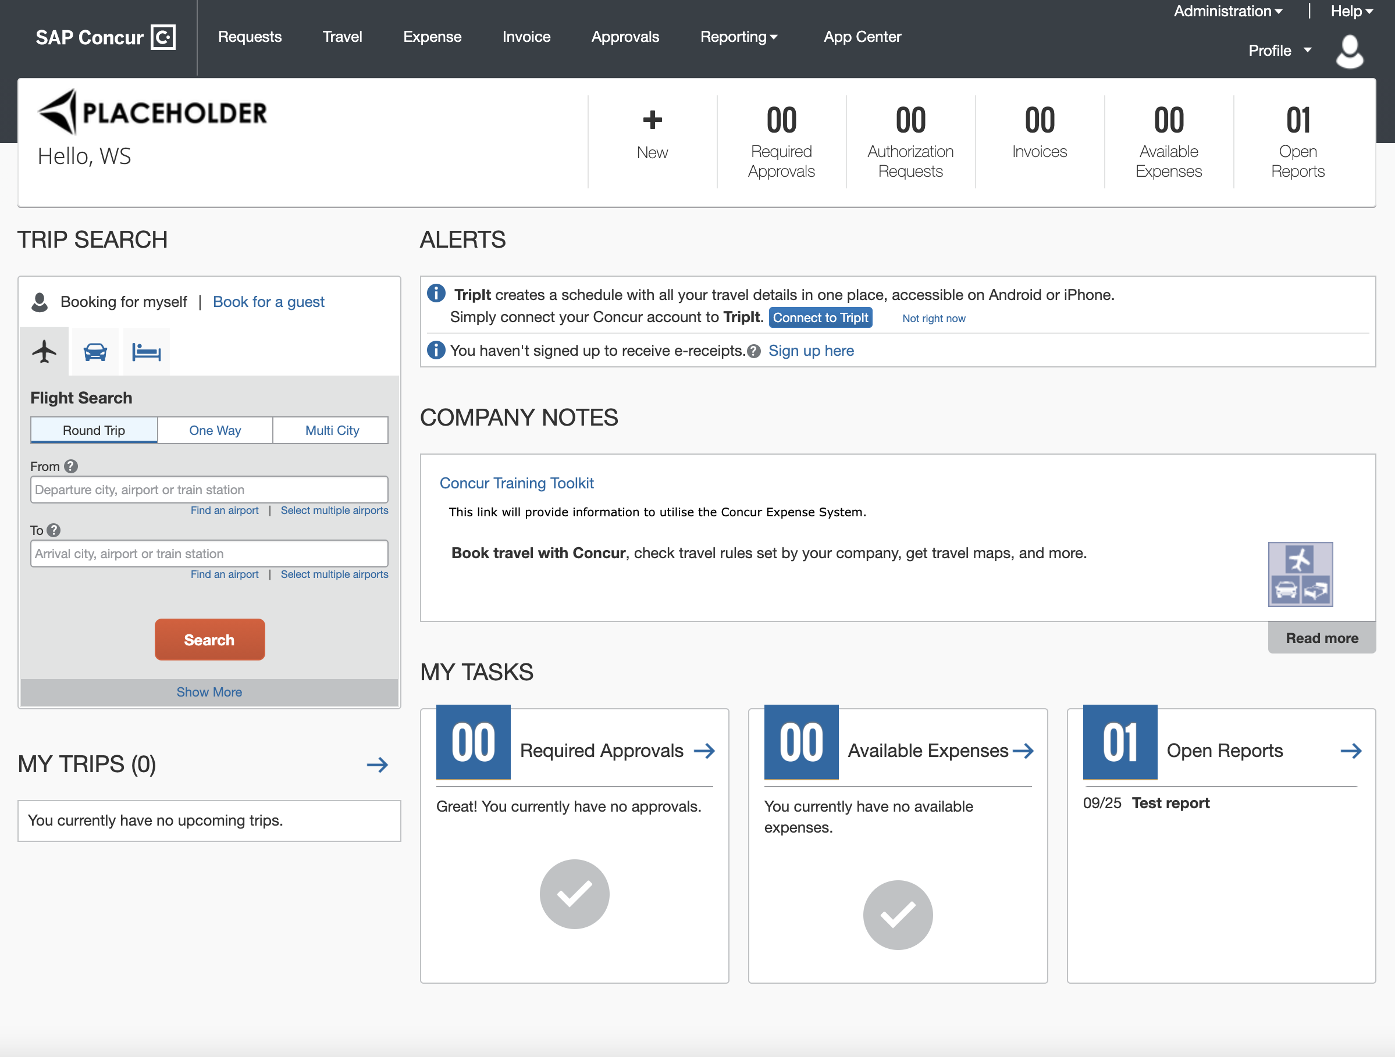

If some products or services are unavailable while other products and services are up and running, a modified version of the user’s homepage similar to the following appears:

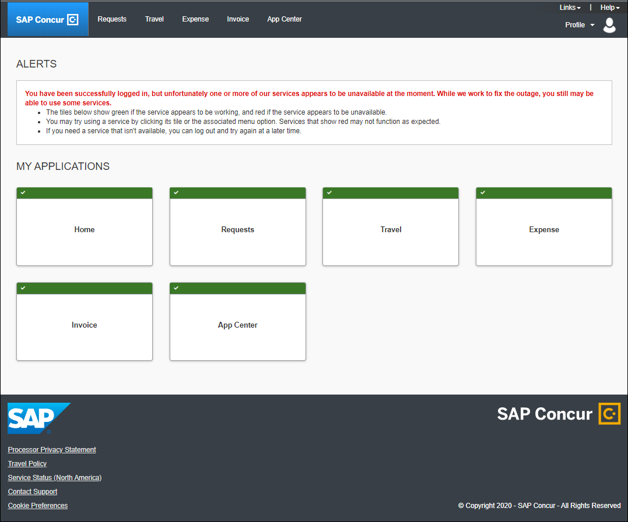

After a client is migrated to the new homepage, if one or more services are unavailable, when a user signs in to their SAP Concur products, they will see the usual homepage, but if the user navigates to a page for a service that is unavailable, they will see a page similar to the following:

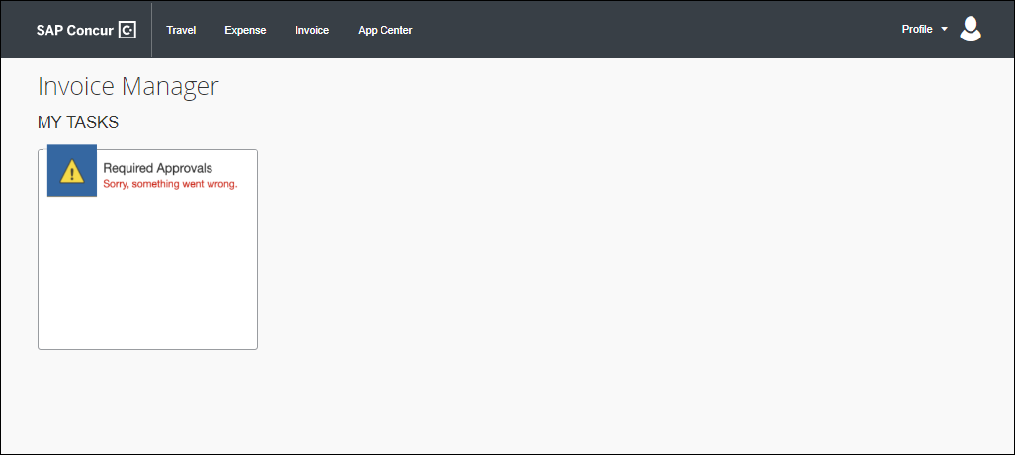

After migration to the new homepage, if all services are available, this change is transparent to the user and they see a homepage that is identical to the pre-migration homepage.

**Example Homepage**

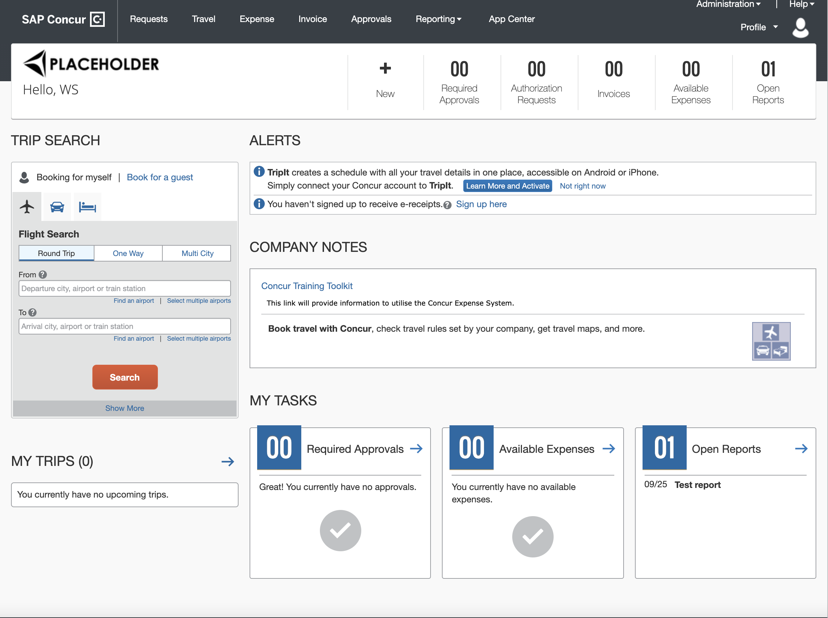

#### Configuration / Feature Activation

This change occurs automatically; there are no configuration or activation steps.

### **Ongoing** SAP Concur Migration to Cloud Platform in AWS

|  |  |  |
| --- | --- | --- |
| Information First Published | Information Last Modified | Feature Target Release Date |
| February 18, 2022 | -- | Ongoing in 2022 |
| Any changes since the previous monthly release are highlighted in yellow in this release note. | | |

**Applies to:**

All Products | All Editions

#### Overview

SAP Concur plans to migrate from a pure private cloud operation, where all equipment is owned by SAP Concur, to a cloud platform. We plan to close our own private data centers in favor of a cloud platform implemented in Amazon Web Services (AWS). While this process started in 2017, we are focused on the final phase of the migration in 2022 for the North American and EMEA data centers.

##### Business Purpose / Client Benefit

This change provides a stronger security posture, improved performance and stability, and faster innovation for our clients.

#### Configuration / Feature Activation

This change will occur automatically.

For details, refer to the [*SAP Concur Cloud Platform Strategy FAQ*](http://assets.concur.com/concurtraining/cte/en-us/FAQ_Cloud_Hosting_Strategy.pdf).

## Product Settings

### Product Settings Page Enhancements

|  |  |  |
| --- | --- | --- |
| Information First Published | Information Last Modified | Feature Target Release Date |
| August 13, 2021 | January 14, 2022 | January 27, 2022 |
| Any changes since the previous monthly release are highlighted in yellow in this release note. | | |

**Applies to:**

Expense, Invoice, Request | Standard

#### Overview

The **Product Settings** page in Concur Standard Edition has been enhanced.

##### Business Purpose / Client Benefit

These changes improve the functionality of the **Product Settings** page.

#### What the Admin Sees

A user with the required administration permissions sees the following enhancements:

* If any required information is missing from the **Accounting**, **Expense Types for Expenses**, **Employee Reimbursements**, **Expense Approvals, Payment Types, User Accounts,** or **VAT** settings pages, an alert banner appears at the top of the **Product Settings** page.

**Alerts Example**



The admin can click the down arrow in the banner to view more details about the alert(s).

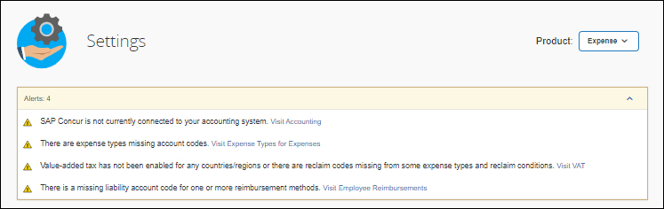

Clicking the "Visit" link at the end of an alert, opens the configuration page for the setting that requires attention.

* If any required information is missing from the **Accounting**, **Expense Types for Expenses**, **Employee Reimbursements**, **Expense Approvals, Payment Types, User Accounts,** or **VAT** settings pages, an alert appears on the tile for the affected setting and the **Edit** button becomes a **Fix** button.

For example, if Expense Types have not yet been mapped to Account Codes on the **Expense Types for Expenses** page, an alert appears on the **Expense Types for Expenses** tile and the button on the tile is labeled **Fix**.

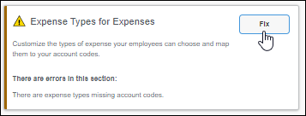

* If required information is missing from a settings page, an alert appears at the top of the affected settings page.

For example, if VAT configurations have not yet been completed, an alert appears at the top of the **Taxation – VAT Tracking** page.

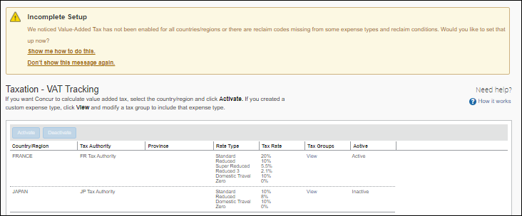

1. If User Assistance for Admins is enabled for the entity and a guided tour for the feature exists, the admin can click **Show me how to do this** to launch a tutorial with information about how to complete the configuration.

#### Configuration / Feature Activation

These enhancements are automatically available.

## Profile Settings

### Removal of the Connected Apps Page

|  |  |  |
| --- | --- | --- |
| Information First Published | Information Last Modified | Feature Target Release Date |
| January 14, 2022 | February 11, 2022 | February 2022 |
| Any changes since the previous monthly release are highlighted in yellow in this release note. | | |

**Applies to:**

Travel, Expense, Invoice, Request | Professional & Standard

#### Overview

SAP Concur plans to remove the **Connected Apps** page in **Profile Settings**.

##### Business Purpose / Client Benefit

Periodically, under-utilized features or pages are removed to improve usability. This is a rarely used page; it no longer meets its purpose of driving partner application usage.

#### What the User Sees

When a user navigates to **Profile > Profile Settings**, they no longer see the **Connected Apps** link under **Other Settings.**

**Before**

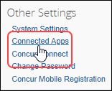

**After**

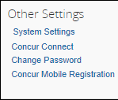

The user no longer has access to the **Connected Apps** page.

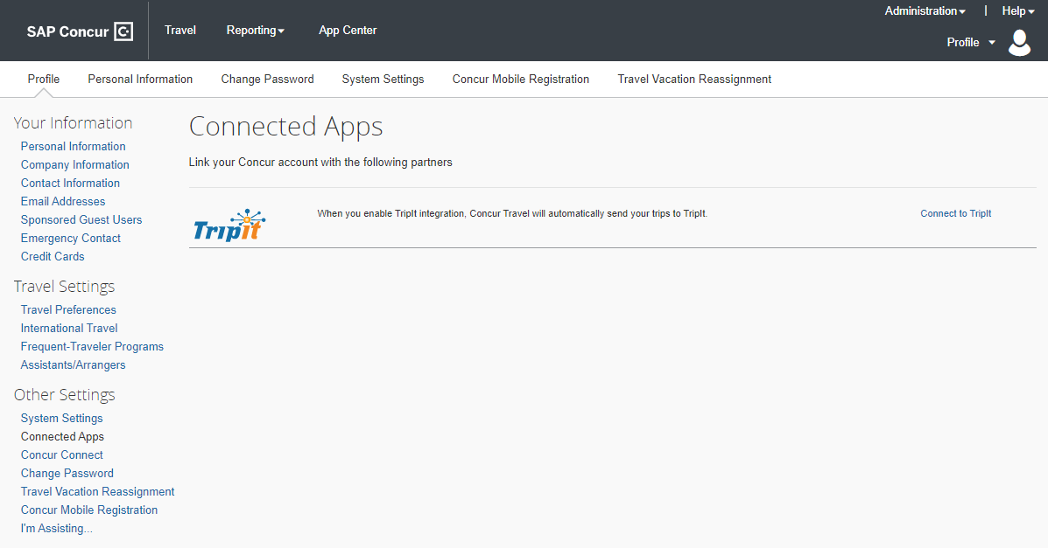

1. Users can continue to connect to available apps through the **App Center**. A link to the **App Center** is available in the SAP Concur page header.  
     
   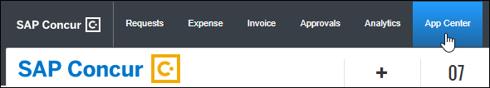

#### Configuration / Feature Activation

This change occurs automatically; there are no configuration or activation steps.

## SAP Fiori Themes

### Profile Menu Functional Changes Under Fiori Light Theme

|  |  |  |
| --- | --- | --- |
| Information First Published | Information Last Modified | Feature Target Release Date |
| December 10, 2021 | January 14, 2022 | January 14, 2022 |
| Any changes since the previous monthly release are highlighted in yellow in this release note. | | |

**Applies to:**

Travel, Expense, Invoice, Request | Professional

#### Overview

With the January release, the **Profile** menu within the SAP Fiori theme has been updated. This update includes changes to the layout of the menu items and some changes in functionality.

##### Business Purpose / Client Benefit

The **Profile** menu within the SAP Fiori theme is now functionally more efficient and easier to use.

1. The SAP Fiori theme harmonizes the look and feel of the SAP Concur offerings with those of other SAP products, providing a more consistent user experience.

#### What User Sees

With the new theme enabled, most users (users without rights to work on behalf of another) see options to access their personal profile settings and to log out of the product. The layout and appearance are changed, but the functionality remains the same.

| Current Theme | SAP Fiori Light Theme |
| --- | --- |
|  |  |

#### What the User with "Act as Another" Rights Sees

In addition to the **Profile Settings** and **Sign Out** option, users granted rights to work on behalf of another see the **Act as Another User** option.

| Current Theme | SAP Fiori Light Theme |
| --- | --- |
|  | Clicking the arrow reveals the option to act on behalf of another user: |

Functional changes to the **Profile** menu under the new theme include the following:

* **Myself:** This option serves two functions, it provides visual identification and confirmation that the user is working on their own behalf and enables the user to return to working on their own behalf after acting as another user.
* **Switch:** This button toggles the user between working for a user and working on their own behalf.

##### Switching Between Acting for Another User and Acting for Yourself

There are minor functionality differences including the following functional changes:

* **Text:** The wording on the Fiori interface is updated to better explain the action being taken.
* **User Selection and Switch button:** The actions of selecting a user and switching to act on their behalf are ordered on a single line and the **Cancel** button has been removed.

| Current Theme | SAP Fiori Light Theme |
| --- | --- |
|  |  |

With the Fiori theme active, a user enters the name of the user they want to act for and, after selecting the user's name, clicks the **Switch** button to begin acting as the specified user. When acting as another user, the name of the user currently being acted for appears above the **Profile** menu.

| Current Theme | SAP Fiori Light Theme |
| --- | --- |
|  |  |

The user resumes acting on their own behalf by selecting the **Myself** option and clicking **Switch**.

#### Configuration / Feature Activation

There are no configuration or activation steps; the **Profile** menu in the SAP Concur Fiori Light Theme is automatically updated with the January 2022 release.

1. Clients who opt-in to preview the SAP Fiori theme and who want to provide feedback, can register on the following page to participate in the SAP Continuous Influence program: [SAP Customer Influence](https://influence.sap.com/sap/ino/)  
     
   After registering or logging in, clients can request to participate in the **Hands-on system Approach of Consistent User Experience based on SAP IE Scenario Travel-to-Reimburse** opportunity.  
     
   Registration for this SAP Customer Influence opportunity is limited and may close.

For more information about acting as another user refer to [*Shared: Delegate Configuration Setup Guide*](https://www.concurtraining.com/customers/tech_pubs/Docs/_Current/SG_Shr/Shr_SG_Delegate_Config.pdf) and the Expense or the Invoice version of the *Proxy Logon User Guide*. For more information about the SAP Fiori theme see *New Permission to Enable Preview of Fiori Light Theme* in the December 2021 release notes.

## SAP Concur User Assistance

### Notice Regarding Stale Documentation

|  |  |  |
| --- | --- | --- |
| Information First Published | Information Last Modified | Feature Target Release Date |
| January 14, 2022 | February 11, 2022 | Q1 2022 |
| Any changes since the previous monthly release are highlighted in yellow in this release note. | | |

**Applies to:**

All Products | All Editions

#### Overview

SAP Concur User Assistance will archive and eventually delete documents as needed to maintain accurate, relevant, and concise information for all supported audiences including end users, client administrators, SAP Concur support, and implementation colleagues.

Archiving activities performed by SAP Concur User Assistance will comply with data retention best practices and adhere to legal compliance requirements.

The initial exercising of this notice will apply to the archiving of ***stale*** ([example](https://help.sap.com/viewer/85f3db6f3c5945fe8414a08fc5f9e3fc/LATEST/en-US/7885ede95c714a5887debc7b237cbdad.html)) online help documents currently available on the concurtraining.com server. All current online help documents are now located on the SAP Help Portal.

For more information, refer to the *Help Menu Directed to SAP Help Portal* release note in the November 2021 product release notes.

* **IMPORTANT:** SAP Concur User Assistance considers this notice sufficient to cover the ***future archiving*** of documents not specifically mentioned here at such time as we deem them stale. Further notices are ***not planned***.

##### Business Purpose / Client Benefit

This notice serves to expedite the appropriate archiving of stale documentation.

#### Configuration / Feature Activation

Archiving will occur automatically; there are no configuration steps or actions required. Bookmarks to the archived content will no longer work. Refer to the SAP Help Portal for the current links to deliverables:

Concur Expense:   
<https://help.sap.com/viewer/product/CONCUR_EXPENSE/LATEST/en-US>

Concur Invoice:   
<https://help.sap.com/viewer/product/CONCUR_INVOICE/LATEST/en-US>

Concur Request:   
<https://help.sap.com/viewer/product/CONCUR_REQUEST/LATEST/en-US>

Concur Travel:   
<https://help.sap.com/viewer/product/CONCUR_TRAVEL/LATEST/en-US>

## Security

### Some TLSv1.2 Ciphers No Longer Supported (Feb 1, 2022)

|  |  |  |
| --- | --- | --- |
| Information First Published | Information Last Modified | Feature Target Release Date |
| August 13, 2021 | January 14, 2022 | February 1, 2022 |
| Any changes since the previous monthly release are highlighted in yellow in this release note. | | |

**Applies to:**

Travel, Expense, Invoice, Request | All Editions

#### Overview

Beginning on February 1, 2022, SAP Concur solutions will no longer support connections to *.concursolutions.com and * api.concursolutions.com that use the following TLSv1.2 ciphers:

|  |  |
| --- | --- |
| Akamai/OpenSSL cipher name | IANA cipher name |
| AES256-GCM-SHA384 | TLS_RSA_WITH_AES_256_GCM_SHA384 |
| AES128-GCM-SHA256 | TLS_RSA_WITH_AES_128_GCM_SHA256 |
| ECDHE-RSA-AES256-SHA384 | TLS_ECDHE_RSA_WITH_AES_256_CBC_SHA384 |
| ECDHE-RSA-AES128-SHA256 | TLS_ECDHE_RSA_WITH_AES_128_CBC_SHA256 |
| ECDHE-RSA-AES256-SHA | TLS_ECDHE_RSA_WITH_AES_256_CBC_SHA |
| ECDHE-RSA-AES128-SHA | TLS_ECDHE_RSA_WITH_AES_128_CBC_SHA |

To ensure that connections to *.concursolutions.com and * api.concursolutions.com are not disrupted, clients and partners who connect to *.concursolutions.com and *api.concursolutions.com through an application that uses a retired cipher must update the application to a supported cipher before February 1, 2022.

##### Business Purpose / Client Benefit

This update provides ongoing security for our products and services.

#### Confirming Supported Ciphers

The following ciphers included in the **ak-akamai-2020q1** cipher profile are supported:

|  |  |
| --- | --- |
| Akamai/OpenSSL cipher name | IANA cipher name |
| TLS-AES-256-GCM-SHA384 | TLS_AES_256_GCM_SHA384 |
| TLS-CHACHA20-POLY1305-SHA256 | TLS_CHACHA20_POLY1305_SHA256 |
| TLS-AES-128-GCM-SHA256 | TLS_AES_128_GCM_SHA256 |
| ECDHE-RSA-AES256-GCM-SHA384 | TLS_ECDHE_RSA_WITH_AES_256_GCM_SHA384 |
| ECDHE-RSA-AES128-GCM-SHA256 | TLS_ECDHE_RSA_WITH_AES_128_GCM_SHA256 |
| ECDHE-RSA-CHACHA20-POLY1305 | TLS_ECDHE_RSA_WITH_CHACHA20_POLY1305_SHA256 |

1. If your cipher suite includes both supported and unsupported ciphers, connections to *concursolutions.com through a web browser will not be disrupted. During the process of establishing the connection, the *concursolutions.com server will choose the most secure cipher in your cipher suite.

You can confirm that your cipher suite includes a supported cipher by cross-referencing the Akamai/OpenSSL cipher name with the IANA cipher name in the **ak-akamai-2021 (default)** column in the following table.

Supported ciphers are indicated with a check mark.

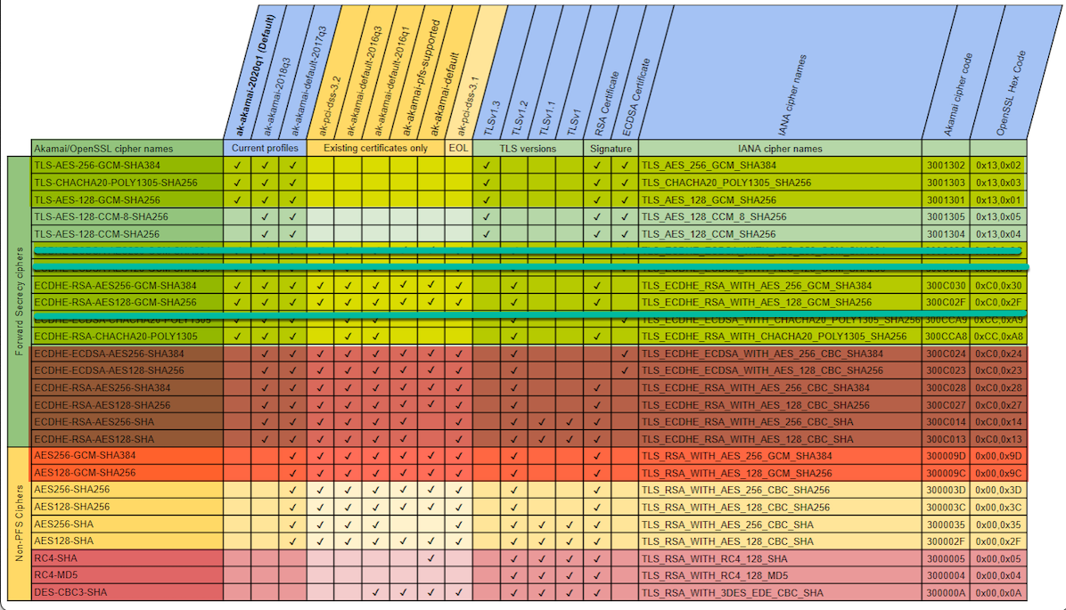

#### Testing Ciphers

The following procedure is intended for use by system administrators who want to test whether their cipher suite configuration will work correctly when connecting to SAP Concur solutions after support for the ciphers listed above has been removed.

This procedure configures the system admin's local machine to connect to an akamai staging environment where support for the listed ciphers has already been removed.

Summary of the procedure:

* Retrieve the IP address of the akamai production environment.
* Retrieve the IP address of the akamai staging environment.
* Redirect navigation to concursolutions.com to the akamai staging environment by editing the local *Hosts* file.
* Test a connection to concursolutions.com.

##### Confirm Your Cipher Suite is Working Correctly

1. Retrieve the IP Address of the Akamai Production Environment
2. Ping www.concursolutions.com

* Windows: Open a **Command Prompt** window, type “Ping www.concursolutions.com” and then press **Enter**.
* Mac: Open Terminal, type “Ping www.concursolutions.com” and then press **Enter.**

**Example response**

Pinging e7868.b.akamaiedge.net (23.46.104.197): 56 data bytes  
64 bytes from 23.46.104.197: icmp_seq=0 ttl=50 time=125.070 ms  
64 bytes from 23.46.104.197: icmp_seq=1 ttl=50 time=111.866 ms  
64 bytes from 23.46.104.197: icmp_seq=2 ttl=50 time=111.967 ms  
64 bytes from 23.46.104.197: icmp_seq=3 ttl=50 time=112.435 ms

1. Copy the highlighted address in the response.

**Example address**

e7868.b.akamaiedge.net

1. Retrieve the IP address of the akamai staging environment
2. In the **Command Prompt** or **Terminal** window, ping the copied address, but with “-staging” appended to “akamaiedge”.

**Example Ping command**

Ping e7868.b.akamaiedge-staging.net

**Example response**

Pinging e7868.b.akamaiedge-staging.net (104.76.225.252): 56 data bytes  
64 bytes from 104.76.225.252: icmp_seq=0 ttl=50 time=118.809 ms  
64 bytes from 104.76.225.252: icmp_seq=1 ttl=50 time=242.459 ms  
64 bytes from 104.76.225.252: icmp_seq=2 ttl=50 time=112.145 ms  
64 bytes from 104.76.225.252: icmp_seq=3 ttl=50 time=114.994 ms

1. Copy the highlighted IP address in the response.

**Example IP address**

104.76.225.252

1. Update the Local Hosts File

**MAC:**

1. Open Terminal
2. Type “sudo nano /private/etc/hosts” and then press **Enter**.

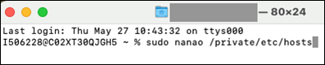

If prompted, enter your administrator password.

1. After the comments at the beginning of the file, add the IP address you copied in step 4, followed by “www.concursolutions.com”.
2. Comments are preceded with a hashtag (#). Your entry should not include the hashtag.

**Example entry**

104.76.225.252 [www.concursolutions.com](http://www.concursolutions.com)

1. Save the file (Ctrl-o) and close Terminal (Ctrl-x).

**Windows:**

1. Launch Notepad as administrator by typing “Notepad” into the Windows search bar, right-clicking Notepad in the search results, and then clicking **Run as administrator**.

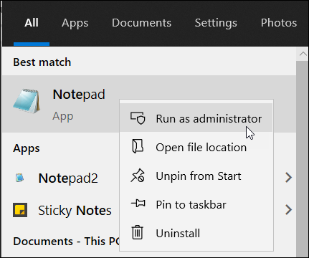

If prompted, click **Yes** in the **User Account Control** window.

1. In Notepad, click **File** and then click **Open**.
2. Navigate to *C:\\Windows\System32\drivers\etc* and then, to the right of the **File name** field, choose **All Files (*.*)** from the menu.

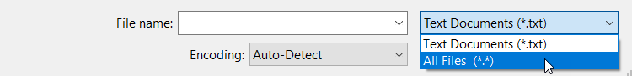

1. Open the *hosts* file.
2. After the comments at the beginning of the file, add the IP address you copied in step 4, followed by “www.concursolutions.com”.
3. Comments are preceded with a hashtag (#). Your entry should not include the hashtag.

**Example entry**

104.76.225.252 www.concursolutions.com

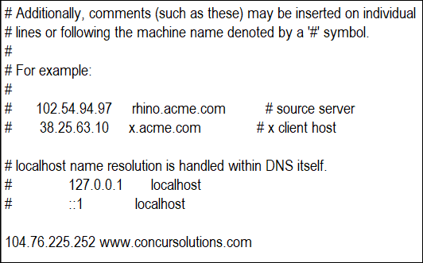

1. In the **File** menu, click **Save**.
2. Connect to *concursolutions.com from the Local Machine

After configuring your local *hosts* file to direct connections to *concursolutions.com to the akamai staging environment, connect to *concursolutions.com from the local machine through the method you need to test.

1. Your system administrator might need to test connections to *concursolutions.com made via an API call, connected application, or by navigating to the sign-in page through a web browser and signing in as an SAP Concur user.

#### Configuration / Feature Activation

To ensure that connections to *.concursolutions.com and * api.concursolutions.com are not disrupted, any applications that use an unsupported cipher must be updated to use a supported cipher before February 1, 2022.

1. If your cipher suite includes both supported and unsupported ciphers, connections to *concursolutions.com through a web browser will not be disrupted. During the process of establishing the connection, the *concursolutions.com server will choose the most secure cipher in your cipher suite.

## Supported Configurations

### Change in Support for Internet Explorer 11

|  |  |  |
| --- | --- | --- |
| Information First Published | Information Last Modified | Feature Target Release Date |
| June 11, 2021 | February 18, 2022 | January 14, 2022 |
| Any changes since the previous monthly release are highlighted in yellow in this release note. | | |

**Applies to:**

Travel, Expense, Invoice, Request, Analysis/Intelligence | All Editions

#### Overview

On January 1, 2022, SAP Concur began transitioning away from support for Internet Explorer 11 (IE 11). This change is in line with other SAP solutions, industry best practices, and Microsoft’s lifecycle policy for IE 11.

1. Until Cognos 11 has been rolled out for all Analysis and Intelligence clients, we will provide support and allow exceptions for investigation to issues related to Cognos 10 and IE 11. For more information, refer to the [*Cognos 11 User Interface Update FAQ*](https://assets.concur.com/concurtraining/cte/en-us/FAQ_Cognos_11_UI_Update.pdf).

After January 1, 2022, SAP Concur development teams will not design new features, user interface enhancements, or security or bug fixes with IE 11 in mind. Over time, new functionality and existing functionality might not work properly on IE 11.

SAP Concur users are not blocked from access when using IE 11. They can still sign in to their SAP Concur solutions. However, to ensure their users can continue to work successfully and securely with SAP Concur solutions, SAP recommends that clients move away from allowing the use of SAP Concur solutions on IE 11 and move to a more modern, supported browser.

##### Business Purpose / Client Benefit

This change enables SAP to speed up adoption of the latest browser innovations and provide a stronger security posture.

#### What the User Sees

Users who navigate to concursolutions.com using Internet Explorer 11 will see a banner with the following message:

"You are using Internet Explorer. Beginning January 1, 2022, SAP Concur began transitioning away from support for Internet Explorer 11. For details, refer to the SAP concur Internet Explorer 11 Support Policy Change FAQ. [View FAQ](https://assets.concur.com/concurtraining/cte/en-us/FAQ_IE_11_Support_Policy_Change.pdf)"

The message can be temporarily dismissed by clicking the **X** in the upper right corner of the banner.



1. Users who have chosen not to accept concursolutions.com functional cookies will not see the **X** and will not be able to dismiss the message. To dismiss the message, these users can temporarily enable functional cookies, refresh the web page, dismiss the message, and then disable functional cookies.  
     
   For information about how to enable and disable functional cookies, refer to the [*Cookie Preferences and User Consent*](https://www.concurtraining.com/customers/tech_pubs/Docs/FactSheets/Cookie_Prefs.pdf)fact sheet.

#### Configuration / Feature Activation

There are no configuration steps; these changes occur automatically.

For more information, refer to the [*Internet Explorer 11 Support Policy Change FAQ*](https://assets.concur.com/concurtraining/cte/en-us/FAQ_IE_11_Support_Policy_Change.pdf).

## Test Entities | Production Sandbox Environment

### **Ongoing** Most Recently Used Lists Not Migrated

|  |  |  |
| --- | --- | --- |
| Information First Published | Information Last Modified | Feature Target Release Date |
| September 2021 | January 21, 2022 | October 1, 2021 through mid-2022 |
| Any changes since the previous monthly release are highlighted in yellow in this release note. | | |

**Applies to:**

Expense, Invoice, Request | Professional

#### Overview

Some SAP Concur users use Production Sandbox Environment (PSE) entities to set up, test, and train on new configurations prior to deploying them to their live production entity. SAP Concur plans to migrate PSEs as part of our move to Amazon Web Services (AWS).

For more information, refer to the [*SAP Concur Cloud Platform Strategy FAQ*](http://assets.concur.com/concurtraining/cte/en-us/FAQ_Cloud_Hosting_Strategy.pdf).

Due to the architectural changes that SAP Concur must make to support this move, when PSEs are migrated to the new environment, some Most Recently Used (MRU) list items within the PSE will not be migrated.

1. MRU lists consist of recent selections made by the user. These lists are generated overtime as users interact with various menus and other defined lists and they will be regenerated after the PSE is migrated to the new environment.
2. These changes apply to PSEs once they are moved or created in the AWS environment, which will occur at a future date.

##### Business Purpose / Client Benefit

Once in AWS, PSEs benefit from the same stability, monitoring capabilities, and level of performance as production entities.

#### What the User Sees

After the migration, some MRU lists that were generated prior to the migration will be empty. These lists will be regenerated automatically through the normal use of the PSE.

The following screenshots show some examples of MRU lists that will be impacted by the migration:

**Create New Expense in Concur Expense**

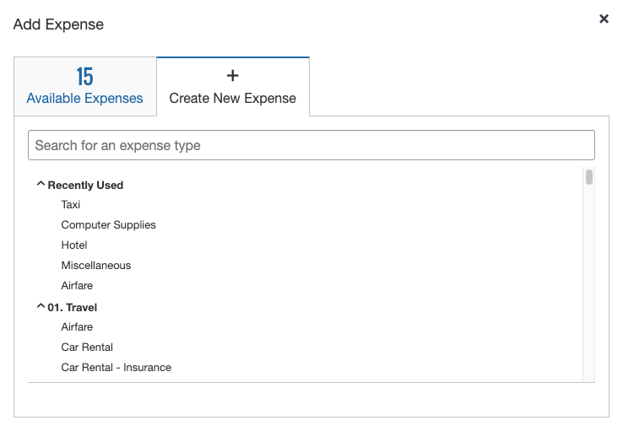

**New Segment in Concur Request**

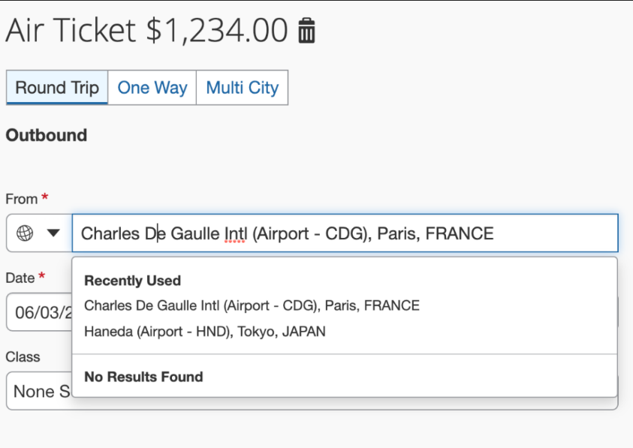

#### Configuration / Feature Activation

This change occurs when a PSE is migrated to the new AWS environment; there are no configuration or activation steps. The MRU lists will be regenerated with normal user of the entity.

### **Ongoing** Production Sandbox Environment Login Updates

|  |  |  |
| --- | --- | --- |
| Information First Published | Information Last Modified | Feature Target Release Date |
| August 2021 | January 21, 2022 | October 1, 2021 through mid-2022 |
| Any changes since the previous monthly release are highlighted in yellow in this release note. | | |

**Applies to:**

Expense, Invoice, Request | Professional

#### Overview

Some SAP Concur users use Production Sandbox Environment (PSE) entities to set up, test, and train on new configurations prior to deploying them to their live production entity. SAP Concur plans to migrate PSEs as part of our move to Amazon Web Services (AWS).

For more information, refer to the [*SAP Concur Cloud Platform Strategy FAQ*](http://assets.concur.com/concurtraining/cte/en-us/FAQ_Cloud_Hosting_Strategy.pdf).

Today, a user can maintain the same login ID for their test and production entities because they are in separate environments. With the plan to migrate both test and production entities to the same AWS production environment in the future, this will no longer be possible since each login ID must be unique.

While there is no action required for clients regarding this update, we want to ensure clients are aware of it because the change will be visible in certain areas of PSEs. To account for this change, SAP Concur will append all PSE login IDs with a ".uat” domain during both migration and user creation to ensure they are unique and do not conflict with any existing production login ID. For example, [johnsmith@123.com](mailto:johnsmith@123.com) will become [johnsmith@123.com.uat](mailto:johnsmith@123.com.uat).

* **IMPORTANT**: No changes will made to the login IDs in the current implementation environment in our private data centers.  
    
  This process will occur in the background during both the migration and user creation processes. Because SAP Concur will manage this process, users will **NOT** have to make any changes to their login ID.   
    
  Migrated users will still use the same implementation URL and login ID they used prior to the AWS migration.   
    
  New clients will use the production URL with the appended login ID, which will include the appended domain (for example, [johnsmith@123.com.uat](mailto:johnsmith@123.com.uat)).

This change will help to safeguard against any conflicts with production login IDs.

**User Creation:** Additionally, clients can use the exact same employee import files as they would in production. The uat domain will also be applied to all aspects of user creation: FTP import, Excel import, entity restore, and more.

**Extracts**: When generating accounting extracts or financial integration documents, SAP Concur will automatically remove the uat domain from login IDs that were appended during user creation. This will help to generate realistic extracts without requiring any actions from the clients, such as removing the appended domain.

1. These changes apply to PSEs once they are moved or created in the AWS environment, which will occur at a future date.

##### Business Purpose / Client Benefit

Once in AWS, PSEs will benefit from the same stability, monitoring capabilities, and level of performance as production entities.

#### Configuration / Feature Activation

These changes occur automatically; there are no additional configuration or activation steps.

### **Ongoing** Unique Address Required for PSE Email Verification

|  |  |  |
| --- | --- | --- |
| Information First Published | Information Last Modified | Feature Target Release Date |
| August 2021 | January 21, 2021 | October 1, 2021 through mid-2022 |
| Any changes since the previous monthly release are highlighted in yellow in this release note. | | |

**Applies to:**

Expense, Invoice, Request | Professional

#### Overview

Some SAP Concur users use Production Sandbox Environment (PSE) entities to set up, test, and train on new configurations prior to deploying them to their live production entity. SAP Concur plans to migrate PSEs as part of our move to Amazon Web Services (AWS).

For more information, refer to the [*SAP Concur Cloud Platform Strategy FAQ*](http://assets.concur.com/concurtraining/cte/en-us/FAQ_Cloud_Hosting_Strategy.pdf).

##### When PSEs are migrated to the AWS production environment, verified emails from the existing PSE will not carry over to the new PSE. As a result, when users test verified email functionality in a future PSE, it is recommended that the employee uses an email that is different from the email configured in their production entity. This process is required as the email in the existing PSE was most likely already verified in production and, therefore, cannot be verified in another entity.

With respect to user email addresses, the Receipt Recognition service validates user email addresses and as such, only one instance of an email address can be associated with a user account. To test in production, clients will be required to utilize alternate email addresses that are not currently associated with any production user account. If a client attempts to set up a test account in production using an email address already associated with a corresponding user profile, it will fail the validation process.

1. These changes apply to PSEs once they are moved or created in the AWS environment, which will occur at a future date.

##### Business Purpose / Client Benefit

Once in AWS, PSEs will benefit from the same stability, monitoring capabilities, and level of performance as production entities.

#### What the Admin Sees

##### BEFORE – Existing Email in Existing PSE

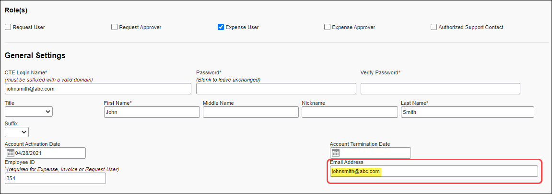

##### AFTER – New Email in New/Future PSE

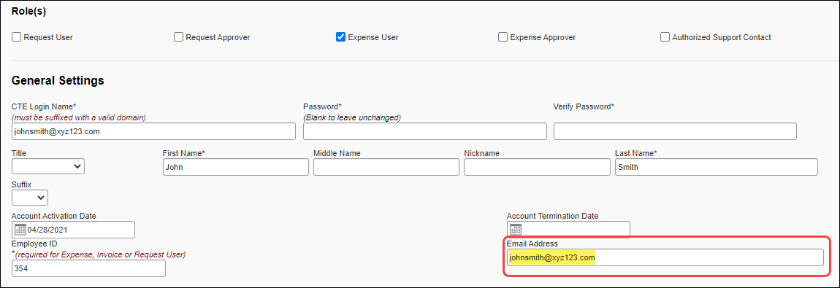

#### Configuration / Feature Activation

These changes occur automatically; there are no additional configuration or activation steps.

## User Assistance for End Users

### Countries Added to User Assistance List

|  |  |  |
| --- | --- | --- |
| Information First Published | Information Last Modified | Feature Target Release Date |
| February 11, 2022 | -- | February 11, 2022 |
| Any changes since the previous monthly release are highlighted in yellow in this release note. | | |

**Applies to:**

All Products | Professional & Standard

#### Overview

On February 11, 2022, SAP Concur added four new countries/regions to the list of countries/regions on the **User Assistance** page. The following countries/regions were added to the list:

* Denmark
* Djibouti
* Dominica
* Dominican Republic

##### Business Purpose / Client Benefit

This change enables clients to enable and disable user assistance for these additional countries/regions.

#### What the Admin Sees

On entities where User Assistance for End Users is enabled, client admins will see the additional countries/regions on the list on the **User Assistance** page.

The **User Assistance** page enables client admins to enable and disable User Assistance for End Users for their SAP Concur Users. User Assistance for End Users can be enabled and disabled based on a user's designated country of residence.

1. Concur Expense is required to access User Assistance for End Users.

On entities running SAP Concur Professional edition, User Assistance for End Users is enabled based on the **Country of Residence** assigned to a user in the **Expense Settings** section of their user account.  
  
On entities running SAP Concur Standard edition, User Assistance for End Users is enabled based on the **Country/Region of Residence** assigned to a user in the **User Information­** section of their user account.

The four added countries/regions are enabled by default. Client admins who do not want the countries/regions to be enabled must disable them.

1. To disable countries/regions on the User Assistance page:
2. Navigate to the **User Assistance** page.

**Professional Edition:**Click **Administration > Company > Company Admin**.

**Standard Edition:**Click **Administration > Company > Tools**.

1. Scroll through the list to the countries/regions you want to disable.

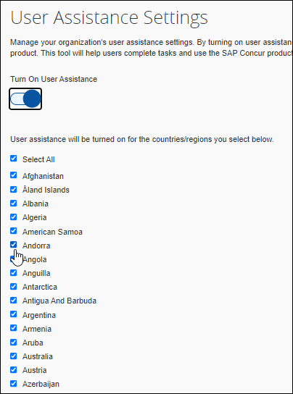

1. Uncheck (disable) the box next to the desired country/region, and then click **Save**.

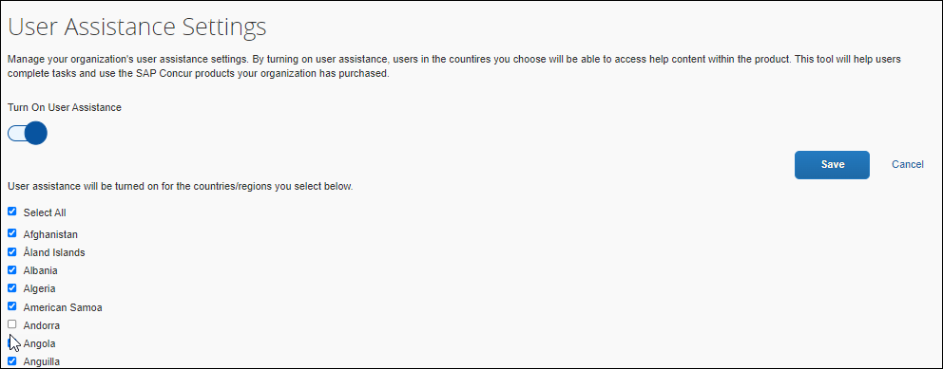

#### Configuration / Feature Activation

The four countries/regions are added automatically. By default, the added countries/regions are enabled. Client admins who do not want these countries/regions enabled must disable them on the **User Assistance** page.

## Web Services Administration

### **Ongoing** Application Connector Username and Password Length Requirements Updated

|  |  |  |
| --- | --- | --- |
| Information First Published | Information Last Modified | Feature Target Release Date |
| January 14, 2022 | January 14, 2022 | February 28, 2022 |
| Any changes since the previous monthly release are highlighted in yellow in this release note. | | |

**Applies to:**

Expense, Request, Web Services | Professional & Standard

*These changes are part of the SAP Concur continued commitment to maintaining secure authentication.*

#### Overview

To meet new security requirements, the length of the username and password associated with an application connector on the **Application Connectors** page must be at least 10 characters long and not more than 50 characters long.

Some clients currently have usernames and passwords configured that do not meet these parameters.

On February 28, 2022, the 10-character minimum and 50-character maximum will be enforced. If the usernames and passwords are not updated prior to this change, some aspects of SAP Concur solutions might stop working. For example, workflow steps will not complete if using notifications, LEU windows will not open, and there will be no results in fields using fetch lists.

To avoid disruption of callouts through application connections and subsequent disruption of some end-user tasks, SAP recommends updating your application connector username(s) and password(s) as soon as possible.

Application connection usernames and passwords can be updated by an administrator with the Company Administrator or Web Services Administrator role.

1. For admins working with Standard entities, a user with the Concur Expense **Can Administer** permission has the **Web Services Administrator** role.

##### Business Purpose / Client Benefit

Enforcing password and username length restrictions improves the security standards for callouts made through the application connector.

#### Configuration / Feature Activation

Usernames and passwords for application connectors are configured on the **Manage Application Connectors** page.

1. To change the username and password for an application connector:
2. Click **Administration > Company > Web Services**.

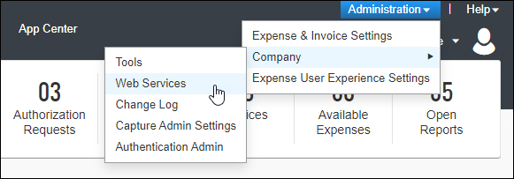

1. Click **Manage Application Connectors**.

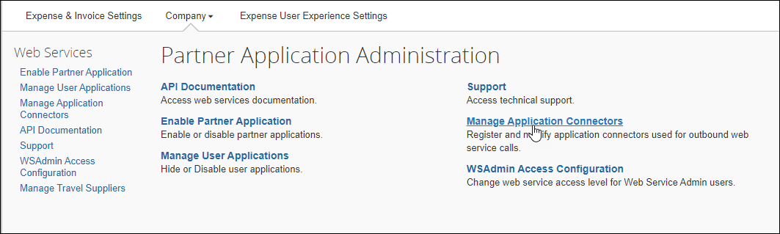

1. Choose the application connector you want to update and then click **Modify**.

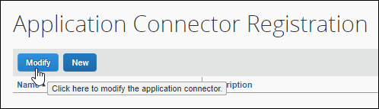

1. Enter the new username and password and then click **Test Connection**.

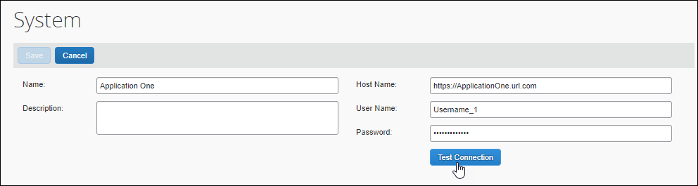

1. Click **Save**.
2. After you update the username and password for an application connector, you must click **Test Connection** to verify the changes before the application connector can be used for any of the callout services.

For more information, refer to [*Callouts and Application Connectors*](https://developer.concur.com/api-reference/callouts/callouts-application-connectors.html#modifying-app-connector-reg) on the SAP Concur Developer Center.

# Planned Changes

The following features and changes are targeted for future releases. SAP Concur solutions reserves the right to postpone implementation of – or completely remove – any enhancement/change mentioned here.

## Fax Feature

### **Planned Changes** Fax Feature to be Decommissioned

|  |  |  |
| --- | --- | --- |
| Information First Published | Information Last Modified | Feature Target Release Date |
| November 2021 | January 14, 2022 | October 1, 2022 |
| Any changes since the previous monthly release are highlighted in yellow in this release note. | | |

**Applies to:**

Expense, Invoice | Professional & Standard

#### Overview

On October 1, 2022 the Concur Fax Feature will be decommissioned.

1. The Fax feature was retired in 2020. Clients onboarded after July 15, 2020 do not have access to this feature. Among clients with access, very few use the feature regularly and, among those that use it, use has declined steadily.

##### Business Purpose / Client Benefit

Removal of the Fax feature improves the security, performance, and scalability of SAP Concur solutions.

In addition, The Concur Fax Feature attaches files only at the header level of expenses and invoices. As a result, clients who use the Fax Feature cannot take advantage of recent innovations that apply only to images and attachments at the line-item level.

#### What the User Sees

Users will no longer have the option to print Fax cover pages from within Concur Expense or Concur Invoice and they will no longer have the ability to fax images to SAP Concur for attachment to expenses or invoices.

#### Configuration / Feature Activation

This change occurs automatically; there are no configuration steps.

Additional information about this change will be made available over the coming months.

## 

## Help Menu

### **Planned Changes** Consolidation of Resources Under Help Menu

|  |  |  |
| --- | --- | --- |
| Information First Published | Information Last Modified | Feature Target Release Date |
| February 18, 2022 | -- | May 2022 |
| Any changes since the previous monthly release are highlighted in yellow in this release note. | | |

**Applies to:**

All Products | All Editions

#### Overview

In May, SAP plans to update the **Help** menu in SAP Concur Solutions to consolidate access to help resources in a single location.

##### Business Purpose / Client Benefit

This change will improve ease of use and simplify the SAP Concur user interface by providing a single point of access to help resources.

#### What the User Sees

The user will see new options in the **Help** menu, for example, if User Assistance for End Users is enabled, the user will see a link to access User Assistance for End User content in the **Help** menu.

#### Configuration / Feature Activation

This change occurs automatically.

## Product Settings

### **Planned Changes** Advanced and Basic Views Added to Product Settings

|  |  |  |
| --- | --- | --- |
| Information First Published | Information Last Modified | Feature Target Release Date |
| January 21, 2022 | -- | February 2022 |
| Any changes since the previous monthly release are highlighted in yellow in this release note. | | |

**Applies to:**

Expense, Invoice, Request | Standard

#### Overview

SAP Concur plans to add the ability to switch between basic and advanced views in Product Settings.

Prior to this change, changing the view between basic and advanced settings in Product Settings required the assistance of an SAP Concur internal administrator.

##### Business Purpose / Client Benefit

This change enables client admins to view or hide their advanced settings as needed without assistance from SAP Concur personnel.

#### What the Admin Sees

By default, only the basic tiles appear on the **Product Settings** page. When an admin navigates to Product Settings, they see the basic tiles and they see the **View Advanced Settings** link under the **Product** menu in Product Settings.

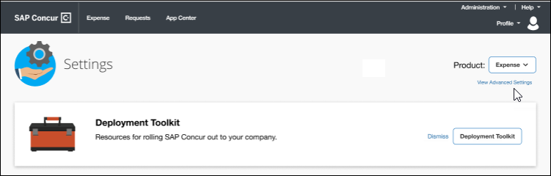

When the admin clicks **View Advanced Settings**, the advanced tiles appear on the **Product Settings** page, and the link under the **Product** menu changes to **View Basic Settings**.

1. The settings tiles that appear in advanced view vary depending on your configuration.

When an admin switches to advanced view, the view persists only for the current session. If the admin signs out of their SAP Concur product, when they sign back in, the view will be reset to the basic (default) view.

#### Configuration / Feature Activation

This change occurs automatically; there are no configuration or activation steps.

## Profile Settings

### **Planned Changes** Changes to My Profile, Home Page, and Profile Menu

|  |  |  |
| --- | --- | --- |
| Information First Published | Information Last Modified | Feature Target Release Date |
| January 21, 2022 | February 18, 2022 | Ongoing beginning in 2022 |
| Any changes since the previous monthly release are highlighted in yellow in this release note. | | |

**Applies to:**

Travel, Expense, Invoice, Request, Mobile | Professional & Standard

#### Overview

SAP Concur plans to implement changes to several pages in the UI. The changes will be implemented over time beginning in Q2 of 2022.

These changes reflect [SAP's commitment to supporting gender diversity](https://www.sap.com/about/company/diversity.html) by enabling gender non-binary users to enter consistent information when making travel arrangements and entering information in SAP Concur solutions. Changes include but are not limited to the following:

* The greeting on the SAP Concur Home page will be removed.
* The **Nickname** field on the **My Profile – Personal Information** page will be changed from **Nickname** to **Preferred Name**.
* A new option, Mx, will be added to the **Title** list on the **My Profile – Personal Information** page.
* If a user adds their preferred name on the **My Profile – Personal Information** page in **Profile Settings**, their preferred name and last name will be displayed in the SAP Concur **Profile** menu and in the menu in the Mobile app.
* New options will be added to enable users to select a non-binary gender in the **TSA Secure Flight** section of **Travel Preferences**.
* The **Nickname** field in the **Employee Travel Addendum Import 350** file will be changed from **Nick Name** to **Preferred Name**.
* The **Nickname** field in the **Employee Import** file will be changed from **Nickname** to **Preferred Name**.

##### Business Purpose / Client Benefit

These changes:

* Enable users to enter information into SAP Concur solutions that is consistent with their identity.
* Enable SAP Concur solutions to address a user by their preferred name.
* Ensure that information in SAP Concur solutions matches a user's government-issued identification.
* Ensure that travel documents such as airplane tickets purchased through SAP Concur solutions display information that is consistent with other required documents.

#### What the User Sees

SAP Concur plans to implement these changes overtime beginning in Q2 of 2022. When they are implemented, users will see the following changes.

##### Web UI Page Header

After signing in to SAP Concur, users currently see a greeting on the Concur home page, "Hello <first name>". The greeting includes the name from the **First Name** field in their user account.

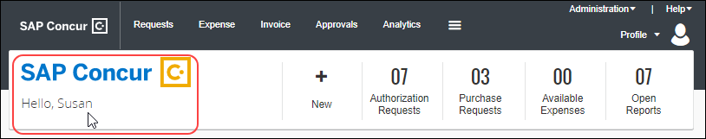

After these changes are implemented, users will no longer see this greeting.

##### Current View My Profile - Personal Information

Currently, users see the **Nickname** field and a list of name prefixes in the **Title** field.

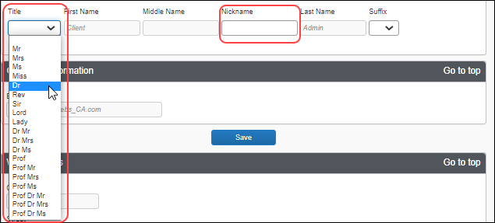

When these changes are implemented, users will see the **Preferred Name** field instead of the **Nickname** field.

In addition, a new gender non-binary option, **Mx** (pronounced "Mix"), will be added to the list in the **Title** field.

##### Current View Travel Preferences TSA Secure Flight

Currently, users see two options under **Gender** in the **TSA Secure Flight** section of **Travel Preferences**.

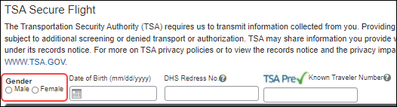

After the changes are implemented, users will have two additionaloptions under **Gender**: undisclosed (x) and unspecified (u).

##### Current View Web UI Profile Menu

Today, when a user clicks on **Profile**, they see the first and last names from the respective fields in their user account.

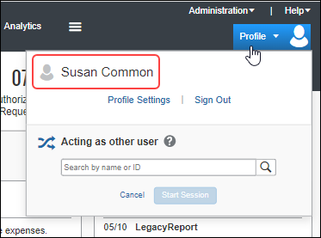

After these changes are implemented, if the user has specified a preferred name on the **Profile – Personal Information** page in **Profile Settings**, when they click on **Profile** in the web version of SAP Concur solutions, their preferred name and last name will be displayed.

1. If the user has not specified a preferred name, their first and last names from their user account information will be displayed.

In addition, when users with permission to act on behalf of another user—for example, Travel Arrangers and Delegates—search for and act as another user, they will see the preferred name of the user they are acting on behalf of in the search field and at the top of the **Profile** menu.

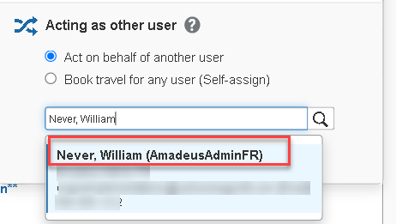 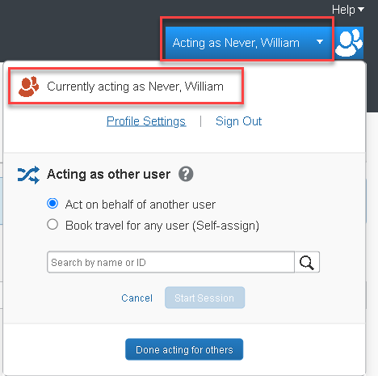

##### Current View – Mobile App

The menu in the Mobile app currently displays the first and last names from the respective fields in the user's user account.

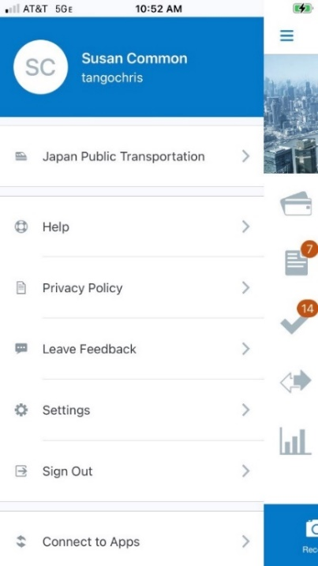

After these changes are implemented, no name will be displayed at the top of the Mobile app menu.

#### What the Admin Sees

Admins will see changes to the Nickname fields in import and extract files.

##### Employee Travel Addendum Import 350

Administrators currently see **Nick Name** in field 5.

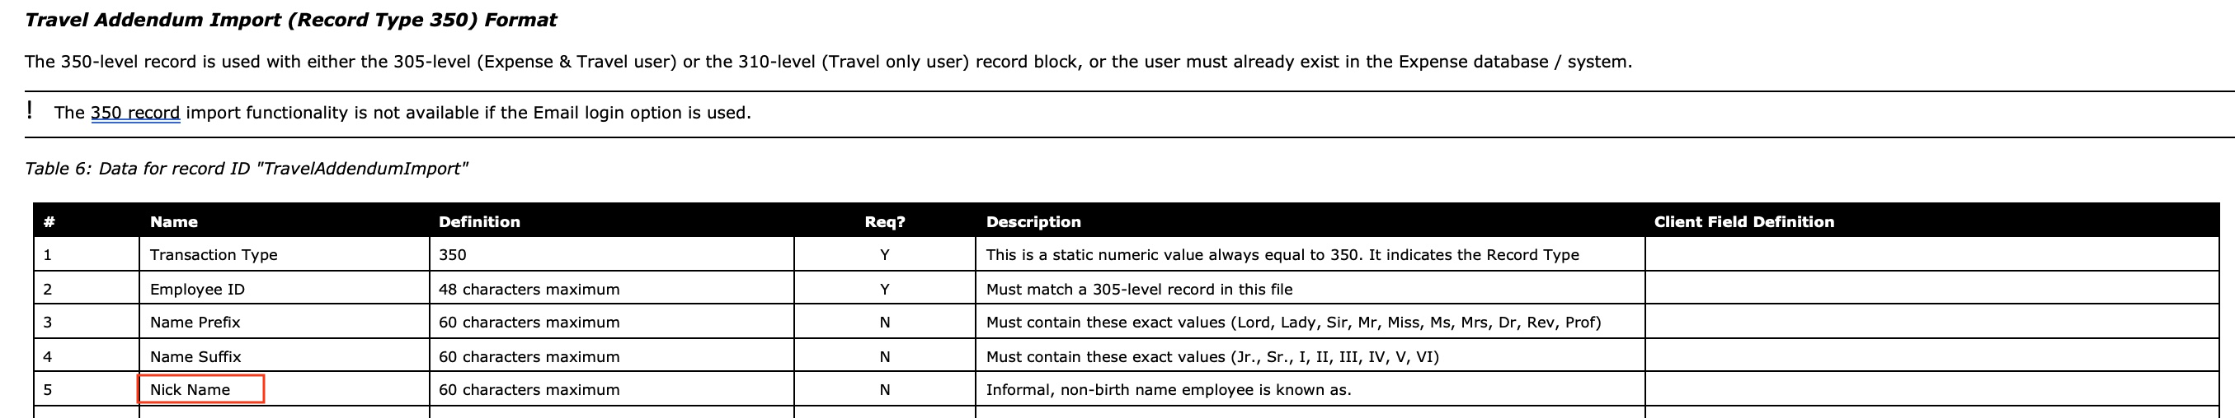

When these changes are implemented, they will see **Preferred Name** in field 5.

##### User Import

Currently, administrator see **Nickname**.



When these changes are implemented, they will see **Preferred Name**.

#### Configuration / Feature Activation

These changes will occur automatically. Users might need to update the information on the **My Profile – Personal Information** page after the new options are added.

More information about these changes will be included in future release notes.

## SAP Concur Support

### **Planned Changes** Suggested Solutions Migration

|  |  |  |
| --- | --- | --- |
| Information First Published | Information Last Modified | Feature Target Release Date |
| November 5, 2021 | January 14, 2022 | Q1 2022 |
| Any changes since the previous monthly release are highlighted in yellow in this release note. | | |

**Applies to:**

All Products & Services | Professional & Standard

#### Overview

Targeted for Q1 2022, the Solution Suggestions platform that SAP Concur provides will be migrated into the SAP Continuous Influence – Improvement Requests program.

This change will provide a better user experience and a single place for Authorized Support Contact (ASC) users to engage with all SAP Concur Customer Influence programs.

1. Tool usage for ConcurGov and Concur Cloud for Public Sector clients is still being evaluated. Additional information for these impacted client groups will be shared in the near future.

For more information, refer to [*SAP* *Continuous Influence Sessions*](https://www.concurtraining.com/cnqr/continuous-influence-sessions).

##### Business Purpose / Client Benefit

In addition to offering a better tool with more functionality, SAP Concur is enhancing the process of how improvement requests will be reviewed, considered, and prioritized.

#### What the User Sees

Beginning with the November release, Authorized Support Contact users saw an updated **Suggestions** section on the **Contact Support** page.

1. Depending on the user’s Support access level, the **Suggestions** section may or may not appear.

**Before Update**

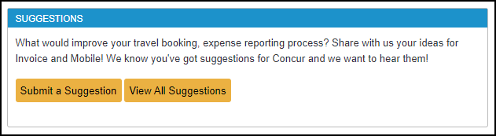

**After Update**

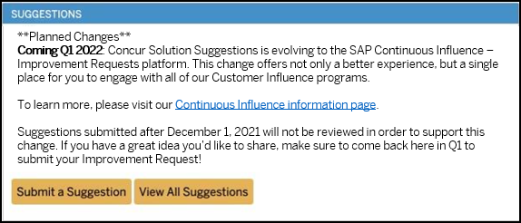

#### Configuration / Feature Activation

The change will occur automatically; there are no additional configuration or activation steps.

## SSO Management

### **Planned Changes** Checkbox to Hide SSO Sign-In Option

|  |  |  |
| --- | --- | --- |
| Information First Published | Information Last Modified | Feature Target Release Date |
| February 11, 2022 | -- | Q2 2022 |
| Any changes since the previous monthly release are highlighted in yellow in this release note. | | |

**Applies to:**

Travel, Expense, Invoice, Request | Professional & Standard

#### Overview

In a future release, SAP Concur plans to add a checkbox to the **Add IdP Metadata** dialog. The checkbox will enable the SSO administrator to prevent the specified SSO sign-in method from appearing to users as a sign-in option on the concursolutions.com sign-in page.

1. User will still be able to sign-in via the method through other navigation paths as outlined by their company.

##### Business Purpose / Client Benefit

The addition of this checkbox gives the SSO administrator greater control over how end-users sign in to SAP Concur solutions.

#### What the SSO Admin Sees

When the admin navigates to the **Manage Single Sign-On** page and then clicks **Add** in the **IdP Metadata** section, they will see the new checkbox at the bottom of the **Add IdP Metadata** dialog.

#### Configuration / Feature Activation

The checkbox will be added to the **Add IdP Metadata** page automatically.

1. More information about this change will be included in future release notes.

### **Planned Changes** Option to Provide URL to IdP Metadata to be Removed

|  |  |  |
| --- | --- | --- |
| Information First Published | Information Last Modified | Feature Target Release Date |
| February 11, 2022 | February 18, 2022 | Q2 2022 |
| Any changes since the previous monthly release are highlighted in yellow in this release note. | | |

**Applies to:**

Travel, Expense, Invoice, Request | Professional & Standard

#### Overview

In a future release, SAP Concur plans to remove the **Provide link to your IdP's metadata** field from the **Add IdP Metadata** dialog.

##### Business Purpose / Client Benefit

In order to use the **Provide link to your IdP's metadata** field, clients must first open a support ticket to have the URL added to SAP Concur's allow list. These additional steps do not support the goal of making the SSO management process self-service for our clients.

#### What the SSO Admin Sees

When the admin navigates to the **Manage Single Sign-On** page and then clicks **Add** in the **IdP Metadata** section, they will no longer see the **Provide link to your IdP's metadata** field in the **Add IdP Metadata** dialog.

1. The admin will still have the ability to upload IdP metadata by clicking **Upload XML File**.

#### Configuration / Feature Activation

The field will be removed from the **Add IdP Metadata** page automatically.

1. More information about this change will be included in future release notes.

## User Assistance

### **Planned Changes** Support for SAP Enable Now

|  |  |  |
| --- | --- | --- |
| Information First Published | Information Last Modified | Feature Target Release Date |
| February 11, 2022 | -- | Future Release |
| Any changes since the previous monthly release are highlighted in yellow in this release note. | | |

**Applies to:**

Travel, Expense, Invoice, Request | Professional & Standard

#### Overview

In a future release, SAP plans to add support for SAP Enable Now with SAP Concur solutions.

##### Business Purpose / Client Benefit

This change will enable clients to use SAP Enable Now to create user assistance content to improve user adoption and increase efficiency with SAP Concur solutions.

#### Configuration / Feature Activation

After support for SAP Enable Now has been added to SAP Concur solutions, clients who have User Assistance enabled for their SAP Concur solutions will be able to enable and disable SAP Enable Now on the SAP Concur **User Assistance** page.

1. More detailed information about this feature will be included in a future release note.

# Client Notifications

## Accessibility

### Accessibility Enhancements

SAP implements changes to better meet current Web Content Accessibility Guidelines (WCAG). Information about accessibility-related changes made to SAP Concur solutions is published on a quarterly basis. You can review the quarterly updates on the [Accessibility Updates](https://www.concurtraining.com/customers/tech_pubs/RN-monthly-Access/_RN_access_client.htm) (English Only) page.

## Subprocessors

### SAP Concur Non-Affiliated Subprocessors

The list of non-affiliated subprocessors is available here: [SAP Concur list of Subprocessors](https://support.sap.com/content/dam/support/en_us/library/ssp/my-support/trust-center/sap-tc-04-0011.pdf)

If you have questions or comments, please reach out to: [Privacy-Request@Concur.com](mailto:Privacy-Request@Concur.com)

## Supported Browsers

### Supported Browsers and Changes to Support

For information about supported browsers and planned changes to supported browsers, refer to the [*Concur Travel & Expense Supported Configurations*](http://www.concurtraining.com/customers/tech_pubs/Docs/Z_SuppConfig/Supported_Configurations_for_Concur_Travel_and_Expense.pdf) guide.

When changes to browser support are planned, information about those changes will also appear in the [*Shared Planned Changes*](https://www.concurtraining.com/customers/tech_pubs/RN_shared_planned/_client_shared_RN_all.htm) release notes.

# Additional Release Notes and Other Technical Documentation

## Online Help

Any user can access release notes, setup guides, user guides, admin summaries, monthly browser certifications, supported configurations, and other resources via online Help or directly on the SAP Help Portal.

Use the links in the **Help** menu in the app, or search for your SAP Concur product (Concur Expense, Concur Invoice, Concur Request, or Concur Travel) on the SAP Help Portal (https://help.sap.com) to view the full set of documentation for your product.

## SAP Concur Support Portal – Selected Users

Access release notes, webinars, and other technical documentation on the SAP Concur support portal.

If you have the proper permissions, **Contact** **Support** appears on the **Help** menu. Click to access the SAP Concur support portal, then click **Resources**.

* Click **Release/Tech Info** for release notes, technical documents, etc.
* Click **Webinars** for recorded and live webinars.

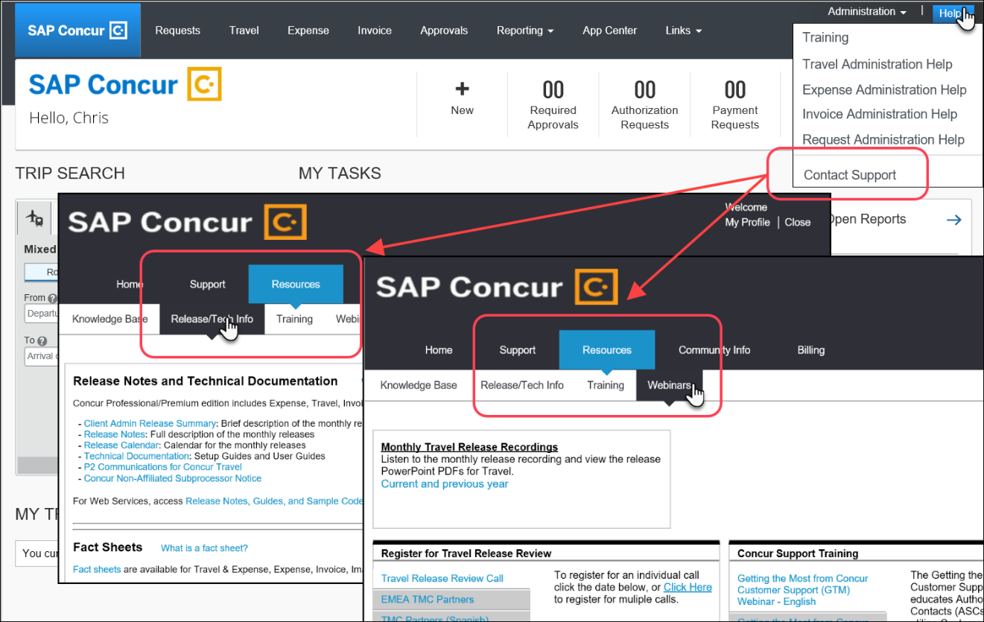

© 2022 SAP SE or an SAP affiliate company. All rights reserved.

No part of this publication may be reproduced or transmitted in any form or for any purpose without the express permission of SAP SE or an SAP affiliate company.

SAP and other SAP products and services mentioned herein as well as their respective logos are trademarks or registered trademarks of SAP SE (or an SAP affiliate company) in Germany and other countries. Please see http://global12.sap.com/corporate-en/legal/copyright/index.epx for additional trademark information and notices.

Some software products marketed by SAP SE and its distributors contain proprietary software components of other software vendors.

National product specifications may vary.

These materials are provided by SAP SE or an SAP affiliate company for informational purposes only, without representation or warranty of any kind, and SAP SE or its affiliated companies shall not be liable for errors or omissions with respect to the materials. The only warranties for SAP SE or SAP affiliate company products and services are those that are set forth in the express warranty statements accompanying such products and services, if any. Nothing herein should be construed as constituting an additional warranty.

In particular, SAP SE or its affiliated companies have no obligation to pursue any course of business outlined in this document or any related presentation, or to develop or release any functionality mentioned therein. This document, or any related presentation, and SAP SE’s or its affiliated companies’ strategy and possible future developments, products, and/or platform directions and functionality are all subject to change and may be changed by SAP SE or its affiliated companies at any time for any reason without notice. The information in this document is not a commitment, promise, or legal obligation to deliver any material, code, or functionality. All forward-looking statements are subject to various risks and uncertainties that could cause actual results to differ materially from expectations. Readers are cautioned not to place undue reliance on these forward-looking statements, which speak only as of their dates, and they should not be relied upon in making purchasing decisions.