|  |  |
| --- | --- |
| SAP Concur Release Notes  Shared Changes  Includes cross-product and site-wide changes for:  Professional Edition, Standard Edition, and Small Business Edition | |
| **Month** | **Audience** |
| Release Date: January 22, 2022  Initial Post: Friday, January 21, 2022 | Client Final |

Contents

Release Notes 1

File Transfer Updates 2

**Ongoing** Rotating PGP Key for File Transfers 2

Travel, Expense, Invoice, Request, Intelligence | Professional & Standard 2

**Ongoing** SAP Concur Legacy File Move Migration 3

Travel, Expense, Invoice, Request, Intelligence | Professional & Standard 3

Miscellaneous 4

**Ongoing ** SAP Concur Homepage Changes 4

Travel, Expense, Invoice, Request | Professional & Standard 4

**Ongoing** Changes to Page Header and Profile Menu 7

Travel, Expense, Invoice, Request | Professional & Standard 7

Product Settings 8

Product Settings Page Enhancements 8

Expense, Invoice, Request | Standard 8

SAP Concur User Assistance 9

Shared Planned Changes Moved to New Shared Changes Release Notes 9

All Products and Services | All Editions 9

SAP Fiori Themes 10

New SAP Fiori Themes Available for Preview 10

Travel, Expense, Invoice, Request | Professional 10

Profile Menu Functional Changes Under Fiori Light Theme 13

Travel, Expense, Invoice, Request | Professional 13

Security 16

Some TLSv1.2 Ciphers No Longer Supported (Feb 1, 2022) 16

Travel, Expense, Invoice, Request | All Editions 16

Supported Configurations 22

Change in Support for Internet Explorer 11 22

Travel, Expense, Invoice, Request, Analysis/Intelligence | All Editions 22

Test Entities | Production Sandbox Environment 23

Permanent Test Entity Renamed to Production Sandbox Environment 23

Expense, Invoice, Request, Intelligence | Professional 23

Test Entity (PSE) Data Maintenance and Entity Deletion (Dec 6) 24

Expense, Invoice, Request, Intelligence | Professional 24

**Ongoing** Most Recently Used Lists Not Migrated 25

Expense, Invoice, Request | Professional 25

**Ongoing** Product Sandbox Environment Login Updates 27

Expense, Invoice, Request | Professional 27

**Ongoing** Unique Address Required for PSE Email Verification 28

Expense, Invoice, Request | Professional 28

User Assistance for End Users 30

New Tours Added to User Assistance for End Users and Admins (US, EMEA) 30

Travel, Expense, Request, Budget | Professional & Standard 30

Web Services Administration 31

**Ongoing** Application Connector Username and Password Length Requirements Updated 31

Expense, Request, Web Services | Professional & Standard 31

Planned Changes 34

Fax Feature 34

**Planned Changes** Fax Feature to be Decommissioned 34

Expense, Invoice | Professional & Standard 34

Product Settings 35

**Planned Changes** Advanced and Basic Views Added to Product Settings 35

Expense, Invoice, Request | Standard 35

Profile Settings 36

**Planned Changes** Removing Connected Apps Page 36

Travel, Expense, Invoice, Request | Professional & Standard 36

SAP Concur Support 37

**Planned Changes** Suggested Solutions Migration 37

All Products & Services | Professional & Standard 37

SAP Concur User Assistance 39

**Planned Changes** Notice Regarding Stale Documentation 39

All Products & Services | All Editions 39

Client Notifications 41

Accessibility 41

Accessibility Enhancements 41

Subprocessors 41

SAP Concur Non-Affiliated Subprocessors 41

Supported Browsers 41

Supported Browsers and Changes to Support 41

Additional Release Notes and Other Technical Documentation 42

Online Help 42

SAP Concur Support Portal – Selected Users 42

Legal Disclaimer

The information in this presentation is confidential and proprietary to SAP SE or an SAP affiliate company and may not be disclosed without the permission of SAP SE or the respective SAP affiliate company. This presentation is not subject to your license agreement or any other service or subscription agreement with SAP SE or its affiliated companies. SAP SE and its affiliated companies have no obligation to pursue any course of business outlined in this document or any related presentation, or to develop or release any functionality mentioned therein. This document, or any related presentation and SAP SE or an SAP affiliate company’s strategy and possible future developments, products and or platforms directions and functionality are all subject to change and may be changed by SAP SE and its affiliated companies at any time for any reason without notice. The information in this document is not a commitment, promise or legal obligation to deliver any material, code or functionality. This document is provided without a warranty of any kind, either express or implied, including but not limited to, the implied warranties of merchantability, fitness for a particular purpose, or non-infringement. This document is for informational purposes and may not be incorporated into a contract. SAP SE and its affiliated companies assume no responsibility for errors or omissions in this document, except if such damages were caused by SAP SE or an SAP affiliate company’s willful misconduct or gross negligence.

All forward-looking statements are subject to various risks and uncertainties that could cause actual results to differ materially from expectations. Readers are cautioned not to place undue reliance on these forward-looking statements, which speak only as of their dates, and they should not be relied upon in making purchasing decisions.

# Release Notes

This document contains shared release notes and planned changes. Shared release notes and planned changes document features and changes that apply to SAP Concur solutions site-wide or to multiple SAP Concur products and services. They include but are not limited to:

* Security-related features and changes such as annual security certificate renewals and changes in support for security ciphers and protocols
* Site-wide UI features and changes such as changes to the home page, changes to the site header or footer, or the implementation of new site-wide UI themes
* Sign-in process features and changes such as the addition or removal of sign-in features, URL changes, and domain name changes
* Production and test environment features and changes
* Global settings or administration page features and changes such as the addition of new site-wide settings or changes to the design of the administration pages
* Changes to processes such as where and when release notes are published

For New Features and Changes that apply to a single product and/or service see the release notes for that product or service. Links to the product and service-specific release notes can be found on the following pages:

* [Professional Edition](https://www.concurtraining.com/customers/tech_pubs/_RN_CCC.htm)
* [Standard Edition](https://www.concurtraining.com/customers/tech_pubs/_Docs_CCC_CPS.htm)
* [Small Business Edition](http://www.concurtraining.com/customers/tech_pubs/Docs/Breeze/RN/WhatsNew.htm)

## File Transfer Updates

### **Ongoing** Rotating PGP Key for File Transfers

|  |  |  |
| --- | --- | --- |
| Information First Published | Information Last Modified | Feature Target Release Date |
| February 2021 | January 21, 2022 | January 15, 2021 and October 11, 2022 |
| Any changes since the previous monthly release are highlighted in yellow in this release note. | | |

**Applies to:**

Travel, Expense, Invoice, Request, Intelligence | Professional & Standard

#### Overview

Files transferred to SAP Concur products must be encrypted with the SAP Concur public PGP key, concursolutionsrotate.asc.

concursolutionsrotate.asc

* Key file is available in client’s root folder
* Key ID 40AC5D35
* RSA 4096-bit signing and encryption subkey
* Key expires every 2 years
* Client is responsible for replacing the key before it expires
* Next expiry date: September 4, 2022
* SAP Concur plans to replace the current rotating public PGP key in the client’s root folder 90 days before the expiration date

The SAP Concur legacy PGP key (key ID D4D727C0) will be decommissioned on October 11, 2022. You must switch to using the rotating PGP key before that date. Files encrypted with the legacy PGP key will not be processed after October 10, 2022.

This announcement pertains to the following file transfer DNS endpoints:

* st.concursolutions.com
* mft-us.concursolutions.com
* vs.concursolutions.com
* st-eu.concursolutions.com
* mft-eu.concursolutions.com

##### Business Purpose / Client Benefit

The rotating public PGP key provides greater security for file transfers.

#### What the Administrator Sees

An administrator with the required file transfer credentials can log into the file transfer site to retrieve the rotating public PGP key, concursolutionsrotate.asc, from the root directory.

#### Configuration / Feature Activation

Your internal file transfer administrator can add the key to their PGP keyring and start using it to encrypt any files being transferred to SAP Concur.

If assistance is required, please contact SAP Concur support.

For more information, refer to the [*Shared: File Transfer for Customers and Vendors User Guide*](http://www.concurtraining.com/customers/tech_pubs/Docs/ConcurPremier/UG_Shr/Shr_UG_FileTransfer.pdf).

### **Ongoing** SAP Concur Legacy File Move Migration

|  |  |  |
| --- | --- | --- |
| Information First Published | Information Last Modified | Feature Target Release Date |
| March 6, 2021 | January 14, 2022 | January 24, 2022 |
| Any changes since the previous monthly release are highlighted in yellow in this release note. | | |

**Applies to:**

Travel, Expense, Invoice, Request, Intelligence | Professional & Standard

#### Overview

This release note is intended for the technical staff responsible for file transmissions with SAP Concur. For our clients and vendors participating in data exchange, SAP Concur is maintaining our file transfer subsystem to provide greater security for those file transfers.

SAP Concur is in the process of migrating entities that currently use a legacy process for moving files to a more efficient and secure file routing process that relies on APIs.

Clients whose entities are currently configured to use the legacy process will be migrated to the more efficient process sometime between now and January 24, 2022. After they are migrated to the more efficient process, clients will see the following improvement:

* With the legacy process, clients had to wait for the file move schedule to run at a specified time. With the more efficient and secure API-based process, extracts and other outbound files from SAP Concur will be available within the existing overnight processing period shortly after the files are created.

This announcement pertains to the following file transfer DNS endpoints:

* st.concursolutions.com

##### Business Purpose / Client Benefit

These changes provide greater security and efficiency for file transfers.

#### Configuration / Feature Activation

If assistance is required, please contact SAP Concur support.

For more information, refer to the [*Shared: File Transfer for Customers and Vendors User Guide*](https://www.concurtraining.com/customers/tech_pubs/Docs/ConcurPremier/UG_Shr/Shr_UG_FileTransfer.pdf).

## Miscellaneous

### **Ongoing ** SAP Concur Homepage Changes

|  |  |  |
| --- | --- | --- |
| Information First Published | Information Last Modified | Feature Target Release Date |
| October 8, 2021 | January 14, 2022 | Q4 2021 – Q2 2022 |
| Any changes since the previous monthly release are highlighted in yellow in this release note. | | |

**Applies to:**

Travel, Expense, Invoice, Request | Professional & Standard

#### Overview

In Q4, 2021, SAP Concur began redirecting clients to a new homepage. The appearance of the new homepage is identical to the previous SAP Concur homepage. The new homepage has enhanced functionality when services become temporarily unavailable.

The roll out of the new homepage is phased:

**Phase 1:** At the beginning of Q4, SAP Concur began redirecting Concur Expense, Concur Invoice, and Concur Request clients in the US Datacenter to the new homepage.

**Phase 2:** In December 2021, SAP Concur will begin redirecting Concur Expense, Concur Invoice, and Concur Request clients in the EU Datacenter to the new homepage.

**Phase 3:** In Q2 of 2022, SAP Concur will begin redirecting the remaining clients in the US and EU datacenters to the new homepage. The remaining clients include those with Concur Travel standalone or Concur Travel with Expense, Invoice, and/or Request.

##### Business Purpose / Client Benefit

This change ensures that the SAP Concur homepage is available even when some services are unavailable and improves the consistency of the sign in experience.

#### What the User Sees

With the old homepage, when a user signs into their SAP Concur products, they see their homepage.

1. The appearance of the homepage varies depending on which products and services are enabled for the client and the permissions assigned to the user.

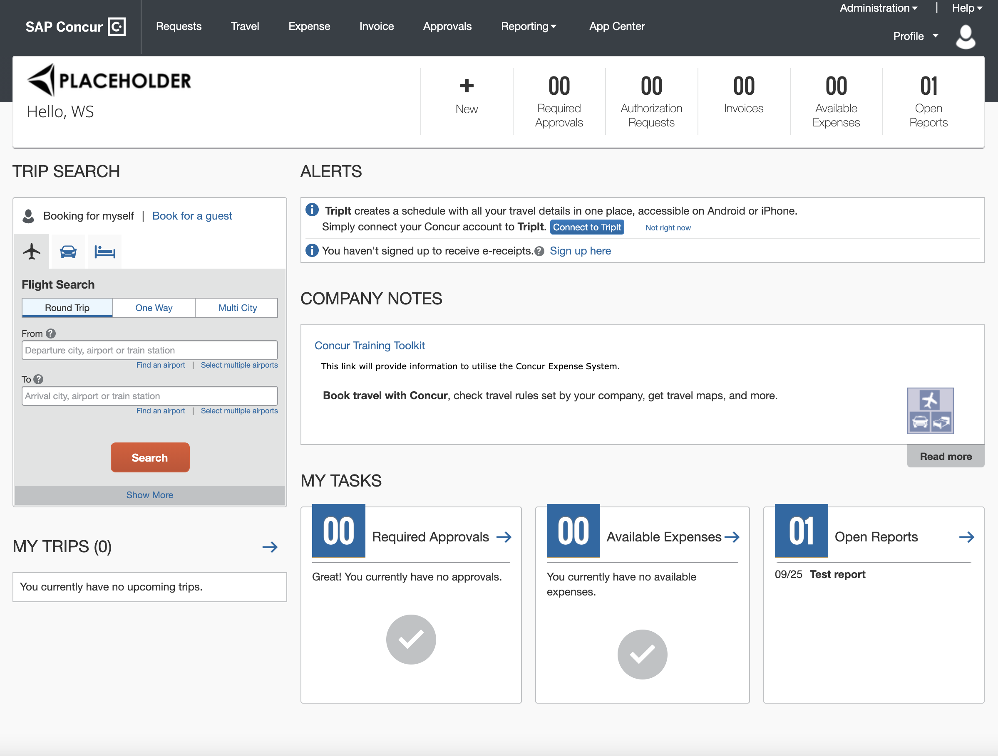

If some products or services are unavailable while other products and services are up and running, a modified version of the user’s homepage similar to the following appears:

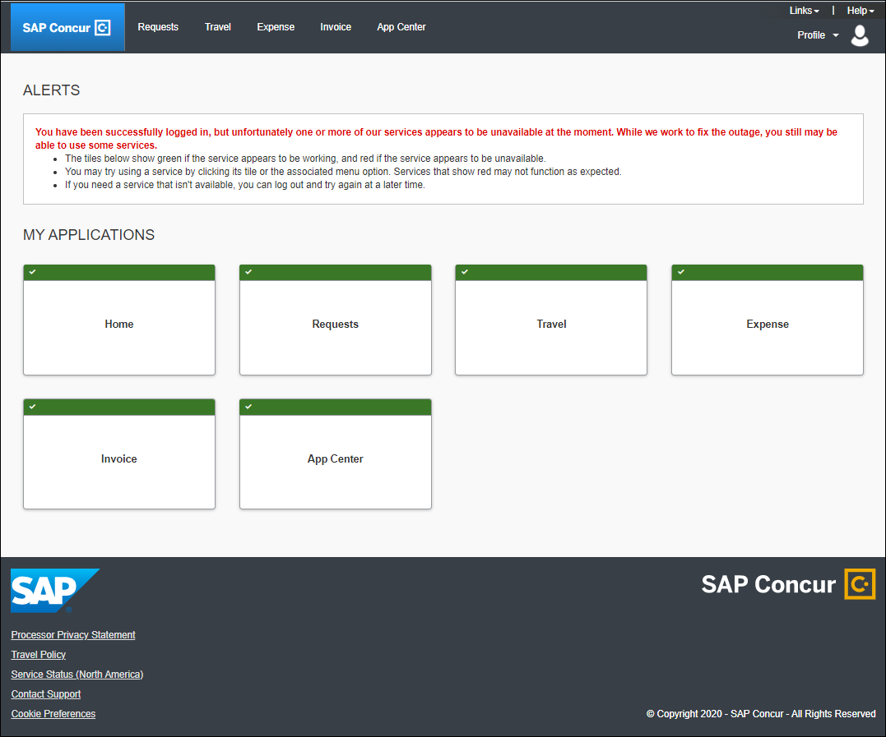

After a client is migrated to the new homepage, if one or more services are unavailable, when a user signs in to their SAP Concur products, they will see the usual homepage, but if the user navigates to a page for a service that is unavailable, they will see a page similar to the following:

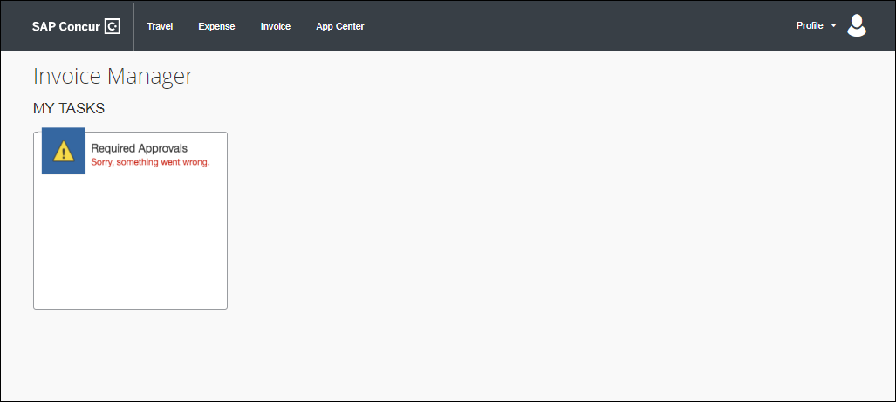

After migration to the new homepage, if all services are available, this change is transparent to the user and they see a homepage that is identical to the pre-migration homepage.

**Example Homepage**

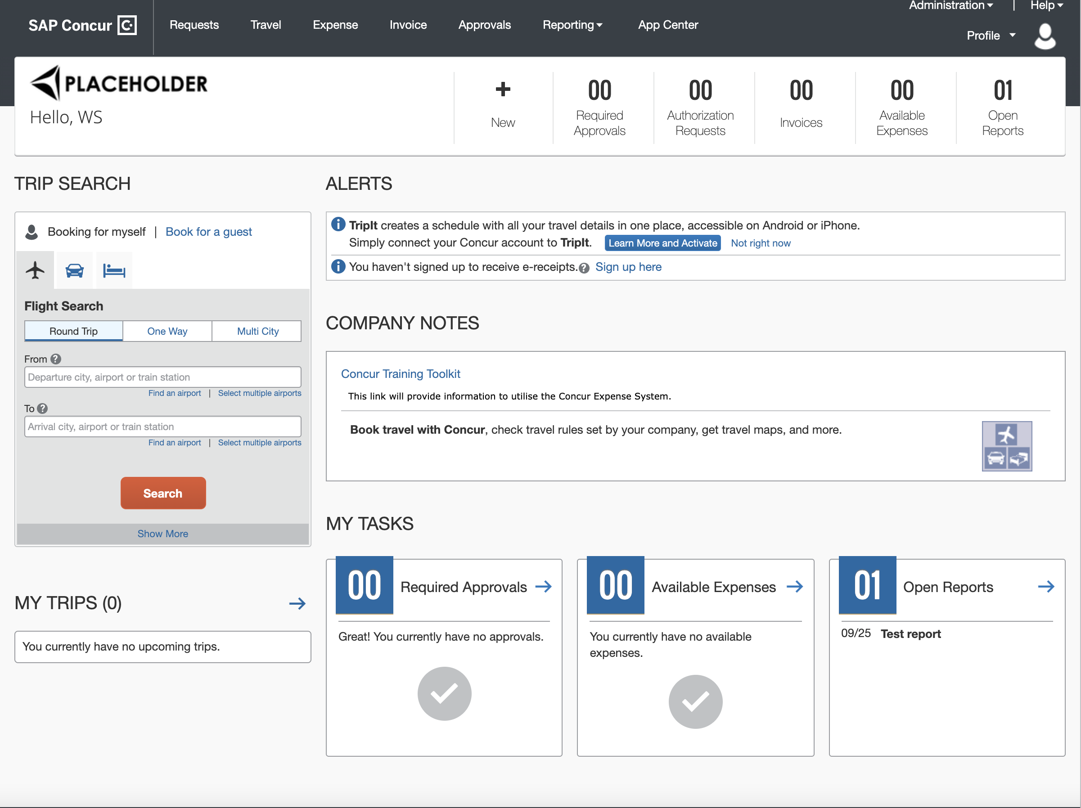

#### Configuration / Feature Activation

This change occurs automatically; there are no configuration or activation steps.

### **Ongoing** Changes to Page Header and Profile Menu

|  |  |  |
| --- | --- | --- |
| Information First Published | Information Last Modified | Feature Target Release Date |
| January 21, 2022 | -- | Q1 – Q2 2022 |
| Any changes since the previous monthly release are highlighted in yellow in this release note. | | |

**Applies to:**

Travel, Expense, Invoice, Request | Professional & Standard

#### Overview

Beginning in Q1 2022, the following changes will be made:

* The greeting on the SAP Concur Homepage will be removed
* If a user has entered a nickname/preferred name on the **Profile – Personal Information** page in **Profile Settings**, their nickname/preferred name will be displayed in the **Profile** menu.

##### Business Purpose / Client Benefit

This change reflects the users preferred name in the user interface.

#### What the User Sees

When the user signs in to their SAP Concur solutions, they will no longer see the phrase "Hello, <firstname>" on the home page.

**Current View**

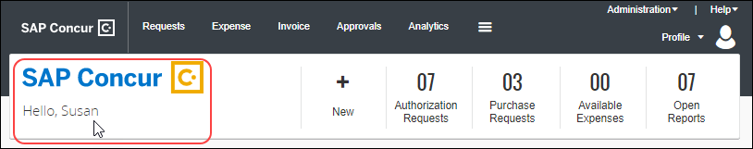

Currently, when a user clicks on **Profile**, their full name is displayed.

**Current View**

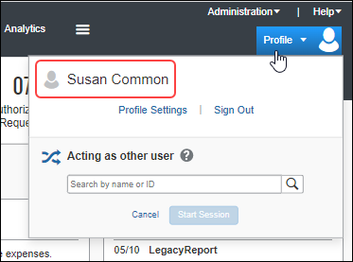

After these changes have been implemented, if the user has specified a nickname/preferred name on the **Profile – Personal Information** page in **Profile Settings**, when they click on **Profile**, their nickname/preferred name will be displayed.

If the user has not specified a nickname/preferred name, when they click on **Profile**, their first name will be displayed.

#### Configuration / Feature Activation

This change occurs automatically; however, this change will be implanted in the new homepage which is being rolled out in phases.

For information about the release timeline for the new homepage, refer to the *\*\*Ongoing ** SAP Concur Homepage Changes* release note in this document.

## Product Settings

### Product Settings Page Enhancements

|  |  |  |
| --- | --- | --- |
| Information First Published | Information Last Modified | Feature Target Release Date |
| August 13, 2021 | January 14, 2022 | January 27, 2022 |
| Any changes since the previous monthly release are highlighted in yellow in this release note. | | |

**Applies to:**

Expense, Invoice, Request | Standard

#### Overview

The **Product Settings** page in Concur Standard Edition has been enhanced.

##### Business Purpose / Client Benefit

These changes improve the functionality of the **Product Settings** page.

#### What the Admin Sees

A user with the required administration permissions sees the following enhancements:

* If any required information is missing from the **Accounting**, **Expense Types for Expenses**, **Employee Reimbursements**, **Expense Approvals, Payment Types, User Accounts,** or **VAT** settings pages, an alert appears at the top of the **Product Settings** page and on the tile for the affected setting.
* For example, if Expense Types have not yet been mapped to Account Codes on the **Expense Types for Expenses** page, an alert appears at the top of the **Product Settings** page and on the **Expense Types for Expenses** tile.
* If required information is missing from a settings page, an alert appears at the top of the affected settings page.
* For example, if VAT configurations have not yet been set up, an alert appears at the top of the **Taxation – VAT Tracking** page.

#### Configuration / Feature Activation

These enhancements are implemented automatically; there are no configuration or activation steps.

## SAP Concur User Assistance

### Shared Planned Changes Moved to New Shared Changes Release Notes

|  |  |  |
| --- | --- | --- |
| Information First Published | Information Last Modified | Feature Target Release Date |
| December 3, 2021 | January 14, 2022 | January 14, 2022 |
| Any changes since the previous monthly release are highlighted in yellow in this release note. | | |

**Applies to:**

All Products and Services | All Editions

#### Overview

Beginning with the January 2022 draft release notes, shared (SAP Concur cross-product) changes, shared planned changes, and changes to SAP Concur core technologies are published in a new document, *Shared Changes Release Notes*. This document replaces the current *Shared Planned Changes Release Notes****.***

Shared and core technology features and changes include, but are not limited to:

* Security-related changes—for example, annual security certificate renewals, changes to support for security ciphers, changes in support for security protocols, and changes to username and password requirements.
* UI design changes that impact all products—for example, changes to the functionality or appearance of the SAP Concur home page, the addition or removal of links from the site header or footer, changes to the user profile. page, and theme changes that impact the overall look and feel of the SAP Concur site.
* Sign-in process changes—for example, the addition or removal of sign-in features, URL changes, domain-name changes, and changes to verified email.
* Changes to production or test environments.
* Changes that impact site-wide settings, changes to global settings, and changes to pages for configuring site-wide or global settings—for example, changes to the User Administration page, changes to Product Settings for Standard Edition, and the introduction of new administration tools.

**Previous Process**

SAP Concur User Assistance published the *Shared Planned Changes Release Notes* in coordination with each monthly release. This document included shared and core features and changes that SAP Concur plans to implement in the future. When those changes were officially released, the release or implementation of the change was distributed and documented in the product-specific release notes—for example, the Concur Expense, Concur Invoice, Concur Request, or Concur Travel release notes.

**New Process**

Beginning in January 2022, the implementation of shared and core features, and changes to existing shared and core features are now documented in the new *Shared Changes Release Notes*. This applies both when the features and changes are planned changes and when they are officially released. The shared/core release notes will no longer be distributed to product-specific release notes.

Changes that are specific to one product and that impact that product's functionality or UI for admins or for end users will continue to be documented in that product's release notes.

##### Business Purpose / Client Benefit

This change reduces duplication of information, ensures that the product-specific release notes contain product-specific information, and provides a single source for SAP Concur shared changes and changes to core technologies.

#### Configuration / Feature Activation

This process change occurred automatically.

## SAP Fiori Themes

### New SAP Fiori Themes Available for Preview

|  |  |  |
| --- | --- | --- |
| Information First Published | Information Last Modified | Feature Target Release Date |
| January 14, 2022 | -- | January 22, 2022 |
| Any changes since the previous monthly release are highlighted in yellow in this release note. | | |

**Applies to:**

Travel, Expense, Invoice, Request | Professional

#### Overview

On September 20, 2021, a new permission, **SAP Fiori Theme Preview**, was added to the list of permissions in Concur Travel Professional edition. The **SAP Fiori Theme Preview** permission enables an SAP Concur client admin to allow users to preview and test the SAP UI themes in their SAP Concur site.

Initially, only the SAP Quartz Light theme was available. With the January 2022 release, a new list field, **Appearance Settings,** has been added to the **Profile Settings > System Settings** page, and users who have been assigned the **SAP Fiori Theme Preview** permission can choose from the following list of SAP themes:

* SAP Quartz Light
* SAP Quartz Dark
* High Contrast White
* High Contrast Black

##### Business Purpose / Client Benefit

SAP themes harmonize the look and feel of the SAP Concur UI with the look and feel of other SAP products, providing a more consistent user experience. Some themes also better support high contrast requirements and low light environments.

#### What the User Sees

By default, when the **New Theme** switch is toggled to **On**, the SAP Concur UI is set to the **SAP Quartz Light** theme. The user can then choose from a list of available themes by navigating to **Profile Settings > System Settings**.

1. To Switch SAP Themes
2. Toggle the **New Theme** switch to the **On** position.

The switch is toggled to the On position.

1. On the **Changing Theme Requires Page Refresh** screen, click **Continue**.

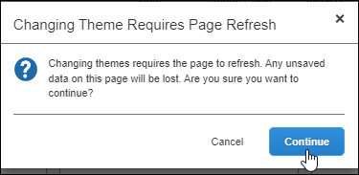

1. Click the Profile icon in the upper left corner of the header bar.

The Profile icon is clicked.

1. Click **Profile Settings**.

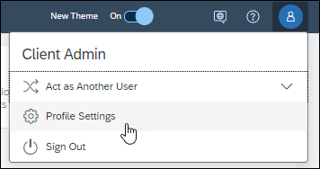

1. On the Profile Options page, click System Settings.

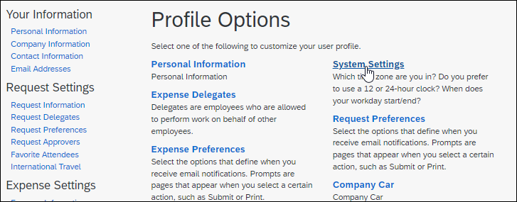

1. On the **System Settings** page, in the **Available Settings** list, select the theme you want to use.

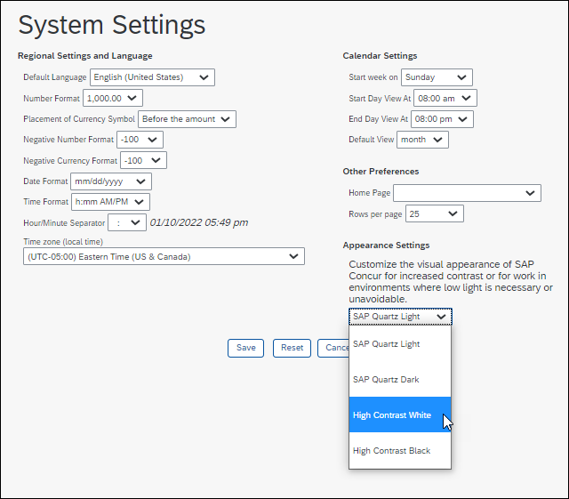

1. Click **Save**. The screen refreshes and the SAP Concur UI is set to the selected theme.

#### Configuration / Feature Activation

The **Appearance Settings** list is added to the **System Settings** page when a user with the **SAP Fiori Theme Preview** permission toggles the **New Theme** switch to the **On** position.

### Profile Menu Functional Changes Under Fiori Light Theme

|  |  |  |
| --- | --- | --- |
| Information First Published | Information Last Modified | Feature Target Release Date |
| December 10, 2021 | January 14, 2022 | January 14, 2022 |
| Any changes since the previous monthly release are highlighted in yellow in this release note. | | |

**Applies to:**

Travel, Expense, Invoice, Request | Professional

#### Overview

With the January release, the **Profile** menu within the SAP Fiori theme has been updated. This update includes changes to the layout of the menu items and some changes in functionality.

##### Business Purpose / Client Benefit

The **Profile** menu within the SAP Fiori theme is now functionally more efficient and easier to use.

1. The SAP Fiori theme harmonizes the look and feel of the SAP Concur offerings with those of other SAP products, providing a more consistent user experience.

#### What User Sees

With the new theme enabled, most users (users without rights to work on behalf of another) see options to access their personal profile settings and to log out of the product. The layout and appearance are changed, but the functionality remains the same.

| Current Theme | SAP Fiori Light Theme |
| --- | --- |
|  |  |

#### What the User with "Act as Another" Rights Sees

In addition to the **Profile Settings** and **Sign Out** option, users granted rights to work on behalf of another see the **Act as Another User** option.

| Current Theme | SAP Fiori Light Theme |
| --- | --- |
|  | Clicking the arrow reveals the option to act on behalf of another user: |

Functional changes to the **Profile** menu under the new theme include the following:

* **Myself:** This option serves two functions, the first to allow visual identification and confirmation that the user is working on their own behalf and the second, to enable the user to return to working on their own behalf after acting as another user.
* **Switch:** This button toggles the user between working for a user and working on their own behalf.

##### Switching Between Acting for Another User and Acting for Yourself

The function of acting for another user is almost identical between the current theme and the SAP Fiori Light Theme.

| Current Theme | SAP Fiori Light Theme |
| --- | --- |
|  |  |

There are minor differences including the following functional changes:

* **Text:** The wording on the Fiori interface is updated to better explain the action being taken.
* **User Selection and Switch button:** Here the actions of selecting a user and switching to act on their behalf are ordered on a single line and the **Cancel** button removed entirely.

With the Fiori theme active, a user enters the name of the user they want to act for and, after selecting the user's name, clicks the **Switch** button to begin acting as the specified user. When acting as another user, the name of the user currently being acted for appears above the **Profile** menu.

| Current Theme | SAP Fiori Light Theme |
| --- | --- |
|  |  |

The user resumes acting on their own behalf by selecting the **Myself** option and clicking **Switch**.

#### Configuration / Feature Activation

There are no configuration or activation steps; the **Profile** menu in the SAP Concur Fiori Light Theme is automatically updated with the January 2022 release.

1. Clients who opt-in to preview the SAP Fiori theme and who want to provide feedback, can register on the following page to participate in the SAP Continuous Influence program: [SAP Customer Influence](https://influence.sap.com/sap/ino/)  
     
   After registering or logging in, clients can request to participate in the **Hands-on system Approach of Consistent User Experience based on SAP IE Scenario Travel-to-Reimburse** opportunity.  
     
   Registration for this SAP Customer Influence opportunity is limited and may close.

For more information about acting as another user refer to [*Shared: Delegate Configuration Setup Guide*](https://www.concurtraining.com/customers/tech_pubs/Docs/_Current/SG_Shr/Shr_SG_Delegate_Config.pdf) and the Expense or the Invoice version of the *Proxy Logon User Guide*. For more information about the SAP Fiori theme see *New Permission to Enable Preview of Fiori Light Theme* in the December 2021 release notes.

## Security

### Some TLSv1.2 Ciphers No Longer Supported (Feb 1, 2022)

|  |  |  |
| --- | --- | --- |
| Information First Published | Information Last Modified | Feature Target Release Date |
| August 13, 2021 | January 14, 2022 | February 1, 2022 |
| Any changes since the previous monthly release are highlighted in yellow in this release note. | | |

**Applies to:**

Travel, Expense, Invoice, Request | All Editions

#### Overview

Beginning on February 1, 2022, SAP Concur solutions will no longer support connections to *.concursolutions.com and * api.concursolutions.com that use the following TLSv1.2 ciphers:

|  |  |
| --- | --- |
| Akamai/OpenSSL cipher name | IANA cipher name |
| AES256-GCM-SHA384 | TLS_RSA_WITH_AES_256_GCM_SHA384 |
| AES128-GCM-SHA256 | TLS_RSA_WITH_AES_128_GCM_SHA256 |
| ECDHE-RSA-AES256-SHA384 | TLS_ECDHE_RSA_WITH_AES_256_CBC_SHA384 |
| ECDHE-RSA-AES128-SHA256 | TLS_ECDHE_RSA_WITH_AES_128_CBC_SHA256 |
| ECDHE-RSA-AES256-SHA | TLS_ECDHE_RSA_WITH_AES_256_CBC_SHA |
| ECDHE-RSA-AES128-SHA | TLS_ECDHE_RSA_WITH_AES_128_CBC_SHA |

To ensure that connections to *.concursolutions.com and * api.concursolutions.com are not disrupted, clients and partners who connect to *.concursolutions.com and *api.concursolutions.com through an application that uses a retired cipher must update the application to a supported cipher before February 1, 2022.

##### Business Purpose / Client Benefit

This update provides ongoing security for our products and services.

#### Confirming Supported Ciphers

The following ciphers included in the **ak-akamai-2020q1** cipher profile are supported:

|  |  |
| --- | --- |
| Akamai/OpenSSL cipher name | IANA cipher name |
| TLS-AES-256-GCM-SHA384 | TLS_AES_256_GCM_SHA384 |
| TLS-CHACHA20-POLY1305-SHA256 | TLS_CHACHA20_POLY1305_SHA256 |
| TLS-AES-128-GCM-SHA256 | TLS_AES_128_GCM_SHA256 |
| ECDHE-RSA-AES256-GCM-SHA384 | TLS_ECDHE_RSA_WITH_AES_256_GCM_SHA384 |
| ECDHE-RSA-AES128-GCM-SHA256 | TLS_ECDHE_RSA_WITH_AES_128_GCM_SHA256 |
| ECDHE-RSA-CHACHA20-POLY1305 | TLS_ECDHE_RSA_WITH_CHACHA20_POLY1305_SHA256 |

1. If your cipher suite includes both supported and unsupported ciphers, connections to *concursolutions.com through a web browser will not be disrupted. During the process of establishing the connection, the *concursolutions.com server will choose the most secure cipher in your cipher suite.

You can confirm that your cipher suite includes a supported cipher by cross-referencing the Akamai/OpenSSL cipher name with the IANA cipher name in the **ak-akamai-2021 (default)** column in the following table.

Supported ciphers are indicated with a check mark.

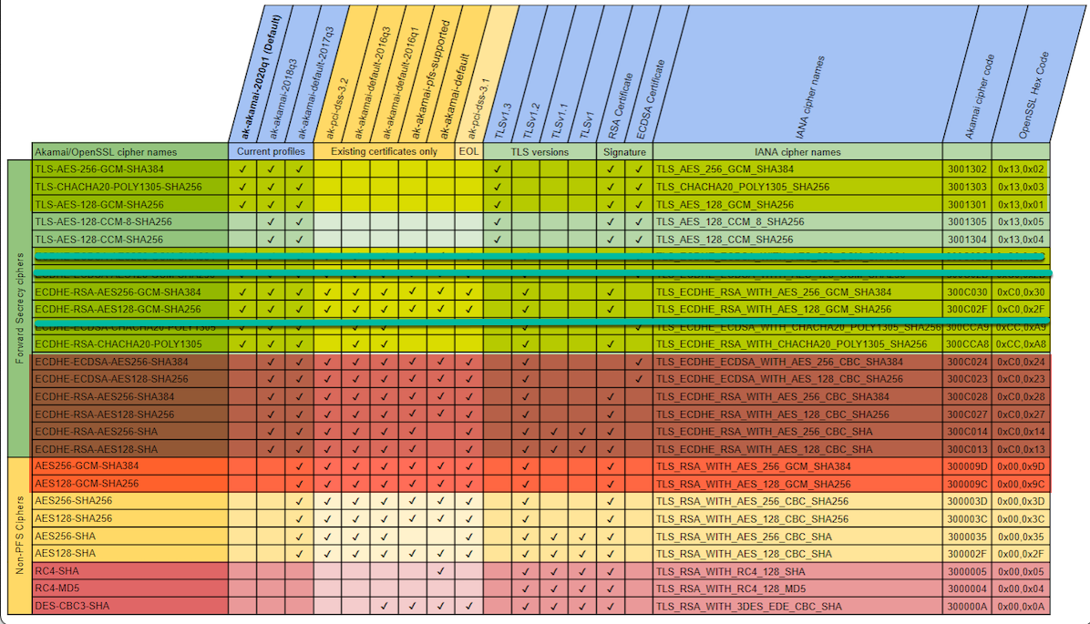

#### Testing Ciphers

The following procedure is intended for use by system administrators who want to test whether their cipher suite configuration will work correctly when connecting to SAP Concur solutions after support for the ciphers listed above has been removed.

This procedure configures the system admin's local machine to connect to an akamai staging environment where support for the listed ciphers has already been removed.

Summary of the procedure:

* Retrieve the IP address of the akamai production environment.
* Retrieve the IP address of the akamai staging environment.
* Redirect navigation to concursolutions.com to the akamai staging environment by editing the local *Hosts* file.
* Test a connection to concursolutions.com.

##### Confirm Your Cipher Suite is Working Correctly

1. Retrieve the IP Address of the Akamai Production Environment
2. Ping www.concursolutions.com

* Windows: Open a **Command Prompt** window, type “Ping www.concursolutions.com” and then press **Enter**.
* Mac: Open Terminal, type “Ping www.concursolutions.com” and then press **Enter.**

**Example response**

Pinging e7868.b.akamaiedge.net (23.46.104.197): 56 data bytes  
64 bytes from 23.46.104.197: icmp_seq=0 ttl=50 time=125.070 ms  
64 bytes from 23.46.104.197: icmp_seq=1 ttl=50 time=111.866 ms  
64 bytes from 23.46.104.197: icmp_seq=2 ttl=50 time=111.967 ms  
64 bytes from 23.46.104.197: icmp_seq=3 ttl=50 time=112.435 ms

1. Copy the highlighted address in the response.

**Example address**

e7868.b.akamaiedge.net

1. Retrieve the IP address of the akamai staging environment
2. In the **Command Prompt** or **Terminal** window, ping the copied address, but with “-staging” appended to “akamaiedge”.

**Example Ping command**

Ping e7868.b.akamaiedge-staging.net

**Example response**

Pinging e7868.b.akamaiedge-staging.net (104.76.225.252): 56 data bytes  
64 bytes from 104.76.225.252: icmp_seq=0 ttl=50 time=118.809 ms  
64 bytes from 104.76.225.252: icmp_seq=1 ttl=50 time=242.459 ms  
64 bytes from 104.76.225.252: icmp_seq=2 ttl=50 time=112.145 ms  
64 bytes from 104.76.225.252: icmp_seq=3 ttl=50 time=114.994 ms

1. Copy the highlighted IP address in the response.

**Example IP address**

104.76.225.252

1. Update the Local Hosts File

**MAC:**

1. Open Terminal
2. Type “sudo nano /private/etc/hosts” and then press **Enter**.

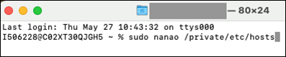

If prompted, enter your administrator password.

1. After the comments at the beginning of the file, add the IP address you copied in step 4, followed by “www.concursolutions.com”.
2. Comments are preceded with a hashtag (#). Your entry should not include the hashtag.

**Example entry**

104.76.225.252 [www.concursolutions.com](http://www.concursolutions.com)

1. Save the file (Ctrl-o) and close Terminal (Ctrl-x).

**Windows:**

1. Launch Notepad as administrator by typing “Notepad” into the Windows search bar, right-clicking Notepad in the search results, and then clicking **Run as administrator**.

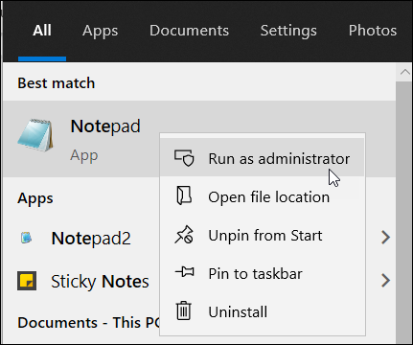

If prompted, click **Yes** in the **User Account Control** window.

1. In Notepad, click **File** and then click **Open**.
2. Navigate to *C:\\Windows\System32\drivers\etc* and then, to the right of the **File name** field, choose **All Files (*.*)** from the menu.

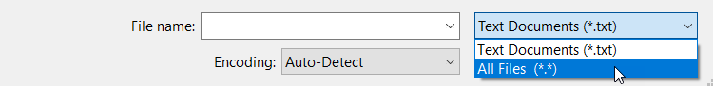

1. Open the *hosts* file.
2. After the comments at the beginning of the file, add the IP address you copied in step 4, followed by “www.concursolutions.com”.
3. Comments are preceded with a hashtag (#). Your entry should not include the hashtag.

**Example entry**

104.76.225.252 www.concursolutions.com

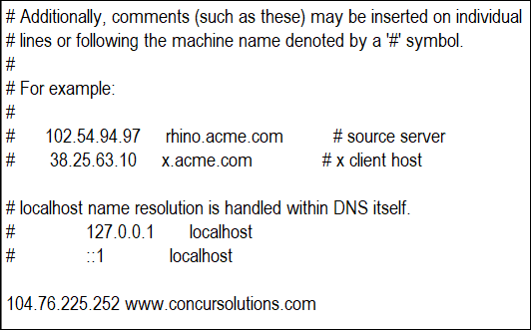

1. In the **File** menu, click **Save**.
2. Connect to *concursolutions.com from the Local Machine

After configuring your local *hosts* file to direct connections to *concursolutions.com to the akamai staging environment, connect to *concursolutions.com from the local machine through the method you need to test.

1. Your system administrator might need to test connections to *concursolutions.com made via an API call, connected application, or by navigating to the sign-in page through a web browser and signing in as an SAP Concur user.

#### Configuration / Feature Activation

To ensure that connections to *.concursolutions.com and * api.concursolutions.com are not disrupted, any applications that use an unsupported cipher must be updated to use a supported cipher before February 1, 2022.

1. If your cipher suite includes both supported and unsupported ciphers, connections to *concursolutions.com through a web browser will not be disrupted. During the process of establishing the connection, the *concursolutions.com server will choose the most secure cipher in your cipher suite.

## Supported Configurations

### Change in Support for Internet Explorer 11

|  |  |  |
| --- | --- | --- |
| Information First Published | Information Last Modified | Feature Target Release Date |
| June 11, 2021 | January 14, 2022 | January 14, 2022 |
| Any changes since the previous monthly release are highlighted in yellow in this release note. | | |

**Applies to:**

Travel, Expense, Invoice, Request, Analysis/Intelligence | All Editions

#### Overview

On January 1, 2022, SAP Concur began transitioning away from support for Internet Explorer 11 (IE 11). This change is in line with other SAP solutions, industry best practices, and Microsoft’s lifecycle policy for IE 11.

1. Until Cognos 11 has been rolled out for all Analysis and Intelligence clients, we will provide support and allow exceptions for investigation to issues related to Cognos 10 and IE 11. For more information, refer to the [*Cognos 11 User Interface Update FAQ*](https://assets.concur.com/concurtraining/cte/en-us/FAQ_Cognos_11_UI_Update.pdf).

After January 1, 2022, SAP Concur development teams will not design new features, user interface enhancements, or security or bug fixes with IE 11 in mind. Over time, new functionality and existing functionality might not work properly on IE 11.

SAP Concur users are not blocked from access when using IE 11. They can still sign in to their SAP Concur solutions. However, to ensure their users can continue to work successfully and securely with SAP Concur solutions, SAP recommends that clients move away from allowing the use of SAP Concur solutions on IE 11 and move to a more modern, supported browser.

##### Business Purpose / Client Benefit

This change enables SAP to speed up adoption of the latest browser innovations and provide a stronger security posture.

#### Configuration / Feature Activation

There are no configuration steps; these changes occur automatically.

For more information, refer to the [*Internet Explorer 11 Support Policy Change FAQ*](https://assets.concur.com/concurtraining/cte/en-us/FAQ_IE_11_Support_Policy_Change.pdf).

## Test Entities | Production Sandbox Environment

### Permanent Test Entity Renamed to Production Sandbox Environment

|  |  |  |
| --- | --- | --- |
| Information First Published | Information Last Modified | Feature Target Release Date |
| January 21, 2022 | -- | Released |
| Any changes since the previous monthly release are highlighted in yellow in this release note. | | |

**Applies to:**

Expense, Invoice, Request, Intelligence | Professional

#### Overview

SAP Concur has renamed the Permanent Test Entity (PTE) service to Production Sandbox Environment (PSE).

A PSE is a copy of a client's SAP Concur production entity. Clients can use the PSE to set up and test new products, features, and services before introducing them into the production environment. The PSE can also be used to train users on SAP Concur products, features, and services.

PSEs support the following:

* Testing of features and functionality in an environment that is similar to their production environment
* Cognos reporting including custom reports
* The ability to refresh the customer data in the PSE with data from their production entity
* Clients must open a support case to request a data refresh.
* Clients can request up to four data refreshes during the annual period defined by their subscription term.

PSEs do not support the following:

* Contract Services
* Active monitoring/reporting of issues on Concur Open
* Additional support for configuration and testing of features
* Receipt images
* Travel system configuration or data
* Travel Profile v2, Request v4, and Identity v4 APIs

##### Business Purpose / Client Benefit

The Production Sandbox Environment enables clients to test and train on features and functionality without impacting their production environment.

#### Configuration / Feature Activation

The terminology change occurred automatically. For more information about setting up a PSE, contact your SAP Concur client account manager.

### Test Entity (PSE) Data Maintenance and Entity Deletion (Dec 6)

|  |  |  |
| --- | --- | --- |
| Information First Published | Information Last Modified | Feature Target Release Date |
| December 3, 2021 | January 21, 2022 | Ongoing |
| Any changes since the previous monthly release are highlighted in yellow in this release note. | | |

**Applies to:**

Expense, Invoice, Request, Intelligence | Professional

#### Overview

As part of SAP Concur routine data maintenance and operations, we will begin deleting stagnant data in SAP Concur Production Sandbox Environments (PSEs).

Beginning December 6, PSEs that have not been signed in to within 180 days will be deleted. For example, if a PSE has not been logged into between June 9, 2021 and December 6, 2021, it will be deleted on December 6, 2021.

As of January 2022, as part of this ongoing routine data maintenance, PSEs that have not been signed in to within 180 days will also be deleted on a regular basis as such data is considered to be stagnant in accordance with applicable law. Any customizations to the PSEs will not be recoverable in the event of deletion.

1. The deletion of data or entities in the production sandbox environment has no impact on live production entities.

##### Business Purpose / Client Benefit

This maintenance activity supports SAP and client data compliance requirements by minimizing the retention of personal data outside of the live production environment.

#### Configuration / Feature Activation

These changes will occur automatically. For customers who are entitled to use the product sandbox environment, SAP Concur support can assist clients with a normal refresh of their current production data in their PSEs.

### **Ongoing** Most Recently Used Lists Not Migrated

|  |  |  |
| --- | --- | --- |
| Information First Published | Information Last Modified | Feature Target Release Date |
| September 2021 | January 21, 2022 | October 1, 2021 through mid-2022 |
| Any changes since the previous monthly release are highlighted in yellow in this release note. | | |

**Applies to:**

Expense, Invoice, Request | Professional

#### Overview

Some SAP Concur users use Product Sandbox Environment (PSE) entities to set up, test, and train on new configurations prior to deploying them to their live production entity. SAP Concur plans to migrate PSEs as part of our move to Amazon Web Services (AWS).

For more information, refer to the [*SAP Concur Cloud Platform Strategy FAQ*](http://assets.concur.com/concurtraining/cte/en-us/FAQ_Cloud_Hosting_Strategy.pdf).

Due to the architectural changes that SAP Concur must make to support this move, when PSEs are migrated to the new environment, some Most Recently Used (MRU) list items within the PSE will not be migrated.

1. MRU lists consist of recent selections made by the user. These lists are generated overtime as users interact with various menus and other defined lists and they will be regenerated after the PSE is migrated to the new environment.
2. These changes apply to PSEs once they are moved or created in the AWS environment, which will occur at a future date.

##### Business Purpose / Client Benefit

Once in AWS, PSEs benefit from the same stability, monitoring capabilities, and level of performance as production entities.

#### What the User Sees

After the migration, some MRU lists that were generated prior to the migration will be empty. These lists will be regenerated automatically through the normal use of the PSE.

The following screenshots show some examples of MRU lists that will be impacted by the migration:

**Create New Expense in Concur Expense**

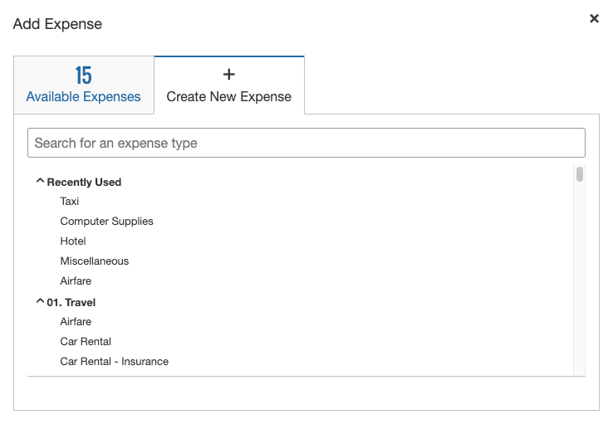

**New Segment in Concur Request**

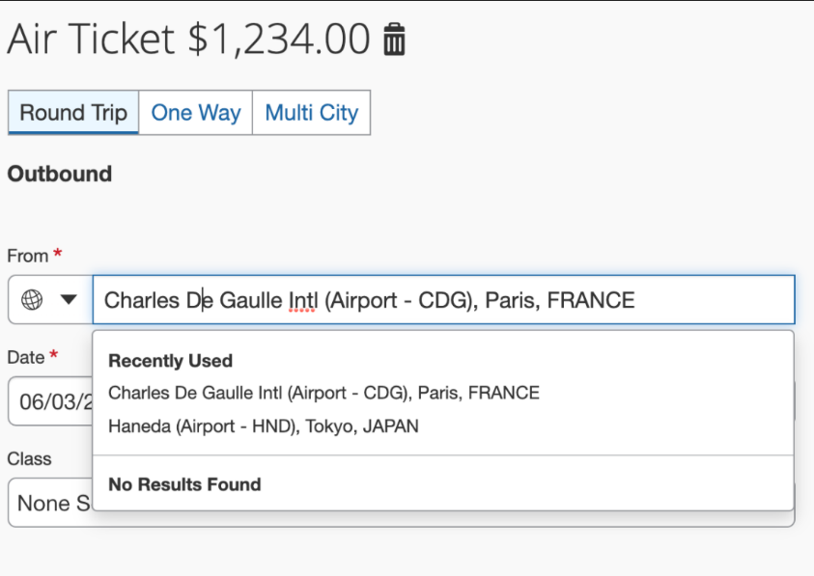

#### Configuration / Feature Activation

This change occurs when a PSE is migrated to the new AWS environment; there are no configuration or activation steps. The MRU lists will be regenerated with normal user of the entity.

### **Ongoing** Product Sandbox Environment Login Updates

|  |  |  |
| --- | --- | --- |
| Information First Published | Information Last Modified | Feature Target Release Date |
| August 2021 | January 21, 2022 | October 1, 2021 through mid-2022 |
| Any changes since the previous monthly release are highlighted in yellow in this release note. | | |

**Applies to:**

Expense, Invoice, Request | Professional

#### Overview

Some SAP Concur users use Product Sandbox Environment (PSE) entities to set up, test, and train on new configurations prior to deploying them to their live production entity. SAP Concur plans to migrate PSEs as part of our move to Amazon Web Services (AWS).

For more information, refer to the [*SAP Concur Cloud Platform Strategy FAQ*](http://assets.concur.com/concurtraining/cte/en-us/FAQ_Cloud_Hosting_Strategy.pdf).

Today, a user can maintain the same login ID for their test and production entities because they are in separate environments. With the plan to migrate both test and production entities to the same AWS production environment in the future, this will no longer be possible since each login ID must be unique.

While there is no action required for customers regarding this update, we want to ensure customers are aware of it because the change will be visible in certain areas of PSEs. To account for this change, SAP Concur will append all PSE login IDs with a ".uat” domain during both migration and user creation to ensure they are unique and do not conflict with any existing production login ID. For example, [johnsmith@123.com](mailto:johnsmith@123.com) will become [johnsmith@123.com.uat](mailto:johnsmith@123.com.uat).

* **IMPORTANT**: No changes will made to the login IDs in the current implementation environment in our private data centers.  
    
  This process will occur in the background during both the migration and user creation processes. Because SAP Concur will manage this process, users will **NOT** have to make any changes to their login ID.   
    
  Migrated users will still use the same implementation URL and login ID they used prior to the AWS migration.   
    
  New customers will use the production URL with the appended login ID, which will include the appended domain (for example, [johnsmith@123.com.uat](mailto:johnsmith@123.com.uat)).

This change will help to safeguard against any conflicts with production login IDs.

**User Creation:** Additionally, clients can use the exact same employee import files as they would in production. The uat domain will also be applied to all aspects of user creation: FTP import, Excel import, entity restore, and more.

**Extracts**: When generating accounting extracts or financial integration documents, SAP Concur will automatically remove the uat domain from login IDs that were appended during user creation. This will help to generate realistic extracts without requiring any actions from the clients, such as removing the appended domain.

1. These changes apply to PSEs once they are moved or created in the AWS environment, which will occur at a future date.

##### Business Purpose / Client Benefit

Once in AWS, PSEs will benefit from the same stability, monitoring capabilities, and level of performance as production entities.

#### Configuration / Feature Activation

These changes occur automatically; there are no additional configuration or activation steps.

### **Ongoing** Unique Address Required for PSE Email Verification

|  |  |  |
| --- | --- | --- |
| Information First Published | Information Last Modified | Feature Target Release Date |
| August 2021 | January 21, 2021 | October 1, 2021 through mid-2022 |
| Any changes since the previous monthly release are highlighted in yellow in this release note. | | |

**Applies to:**

Expense, Invoice, Request | Professional

#### Overview

Some SAP Concur users use Production Sandbox Environment (PSE) entities to set up, test, and train on new configurations prior to deploying them to their live production entity. SAP Concur plans to migrate PSEs as part of our move to Amazon Web Services (AWS).

For more information, refer to the [*SAP Concur Cloud Platform Strategy FAQ*](http://assets.concur.com/concurtraining/cte/en-us/FAQ_Cloud_Hosting_Strategy.pdf).

##### When PSEs are migrated to the AWS production environment, verified emails from the existing PSE will not carry over to the new PSE. As a result, when users test verified email functionality in a future PSE, it is recommended that the employee uses an email that is different from the email configured in their production entity. This process is required as the email in the existing PSE was most likely already verified in production and, therefore, cannot be verified in another entity.

With respect to user email addresses, the Receipt Recognition service validates user email addresses and as such, only one instance of an email address can be associated with a user account. To test in production, clients will be required to utilize alternate email addresses that are not currently associated with any production user account. If a client attempts to set up a test account in production using an email address already associated with a corresponding user profile, it will fail the validation process.

1. These changes apply to PSEs once they are moved or created in the AWS environment, which will occur at a future date.

##### Business Purpose / Client Benefit

Once in AWS, PSEs will benefit from the same stability, monitoring capabilities, and level of performance as production entities.

#### What the Admin Sees

##### BEFORE – Existing Email in Existing PSE

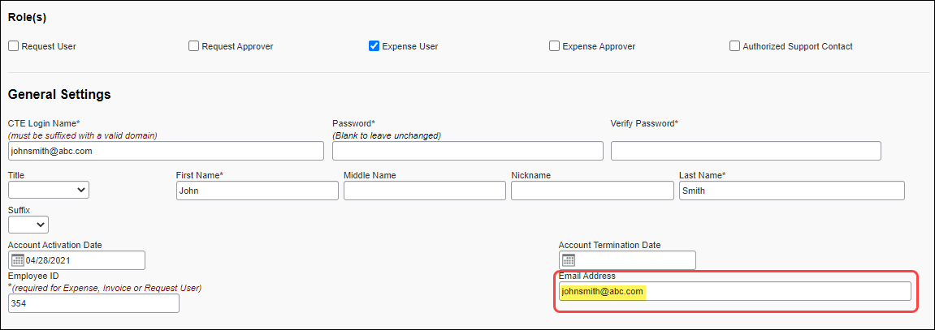

##### AFTER – New Email in New/Future PSE

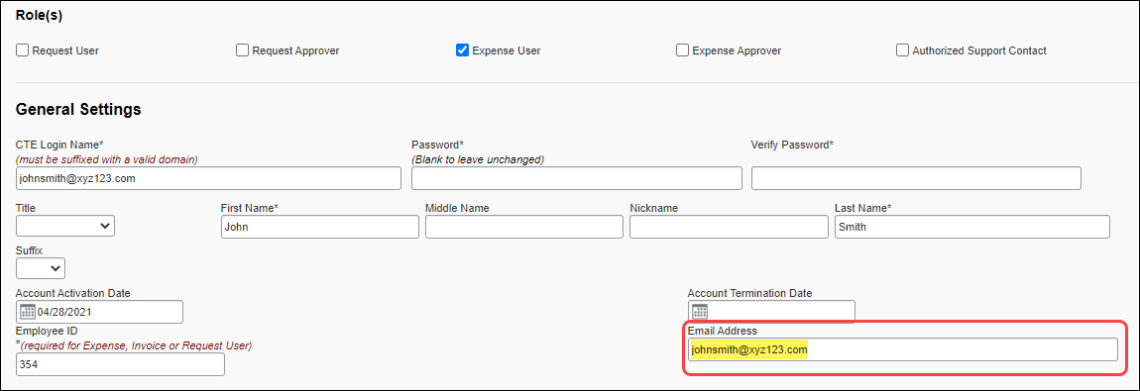

#### Configuration / Feature Activation

These changes occur automatically; there are no additional configuration or activation steps.

## User Assistance for End Users

### New Tours Added to User Assistance for End Users and Admins (US, EMEA)

|  |  |  |
| --- | --- | --- |
| Information First Published | Information Last Modified | Feature Target Release Date |
| January 14, 2022 | -- | January 22, 2022 |
| Any changes since the previous monthly release are highlighted in yellow in this release note. | | |

**Applies to:**

Travel, Expense, Request, Budget | Professional & Standard

#### Overview

The SAP Concur January release includes new User Assistance content (tours). The new tours expand the scope of information provided by User Assistance for End Users and Admins.

The following new tours are included in the January release:

* Concur Travel
* How do I book a hotel?
* Concur Expense
* View Expense Details
* Move Items
* Delete an expense
* Combine expenses
* Edit multiple expenses
* Concur Request
* View audit trail and Request timeline
* Submit a cash advance
* Add attendees to expected expenses
* Concur Budget
* Create a team budget
* Make an adjustment to a team budget

##### Business Purpose / Client Benefit

User Assistance for End Users and Admins assists users and admins to learn new tasks more quickly and efficiently by providing guided tours with step-by-step instructions for completing a task. Enabling users to learn and complete tasks more easily drives user adoption, increases efficiency, improves user experience, and improves user satisfaction with SAP Concur solutions.

#### Configuration / Feature Activation

On entities with User Assistance for Admins enabled, user assistance for end users can be enabled and disabled by country/region or globally on the **User Assistance Settings** page.

**Standard Edition**

Admins with the necessary permissions can navigate to the **User Assistance** page by clicking **Administration > Company > Tools > User Assistance**.

**Professional Edition**

Admins with the necessary permissions can navigate to the **User Assistance** page by clicking **Administration > Company > Company Admin > User Assistance**.

1. SAP Concur clients who do not have User Assistance for Admins enabled can open a service ticket to enable the feature. Once User Assistance for Admins is enabled, the client admin can also enable and disable User Assistance for End Users.

## Web Services Administration

### **Ongoing** Application Connector Username and Password Length Requirements Updated

|  |  |  |  |  |  |
| --- | --- | --- | --- | --- | --- |
| Applies to: | Expense | Invoice | Request | Travel | Other |
| Edition(s) | Professional  Standard | -- | Professional  Standard | -- | Web Services |
| Information First Published | | Information Last Modified | | Feature Target Release Date | |
| January 14, 2022 | | January 14, 2022 | | February 28, 2022 | |
| Any changes since the previous monthly release are highlighted in yellow in this release note. | | | | | |

**Applies to:**

Expense, Request, Web Services | Professional & Standard

*These changes are part of the SAP Concur continued commitment to maintaining secure authentication.*

#### Overview

To meet new security requirements, the length of the username and password associated with an application connector on the **Application Connectors** page must be at least 10 characters long and not more than 50 characters long.

Some clients currently have usernames and passwords configured that do not meet these parameters.

On February 28, 2022, the 10-character minimum and 50-character maximum will be enforced. If the usernames and passwords are not updated prior to this change, some aspects of SAP Concur solutions might stop working. For example, workflow steps will not complete if using notifications, LEU windows will not open, and there will be no results in fields using fetch lists.

To avoid disruption of callouts through application connections and subsequent disruption of some end-user tasks, SAP recommends updating your application connector username(s) and password(s) as soon as possible.

Application connection usernames and passwords can be updated by an administrator with the Company Administrator or Web Services Administrator role.

1. For admins working with Standard entities, a user with the Concur Expense **Can Administer** permission has the **Web Services Administrator** role.

##### Business Purpose / Client Benefit

Enforcing password and username length restrictions improves the security standards for callouts made through the application connector.

#### Configuration / Feature Activation

Usernames and passwords for application connectors are configured on the **Manage Application Connectors** page.

1. To change the username and password for an application connector:
2. Click **Administration > Company > Web Services**.

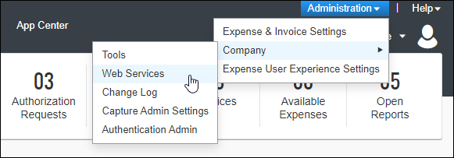

1. Click **Manage Application Connectors**.

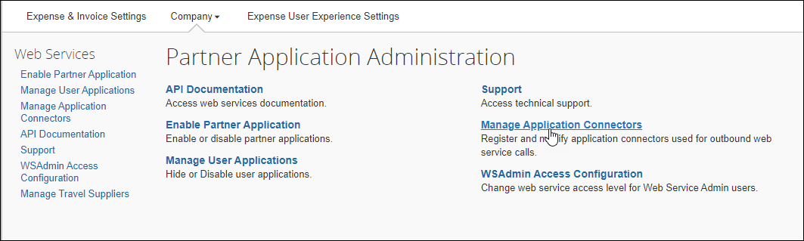

1. Choose the application connector you want to update and then click **Modify**.

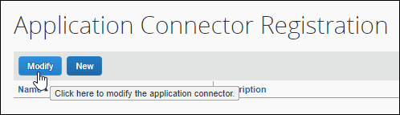

1. Enter the new username and password and then click **Test Connection**.

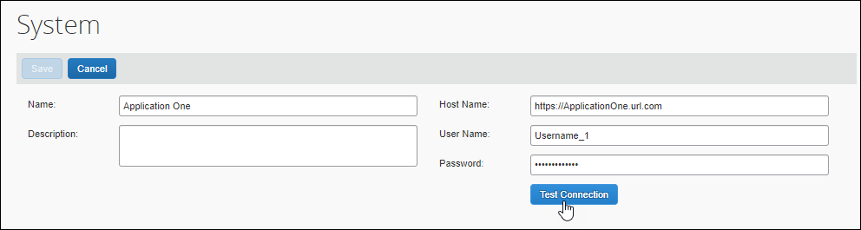

1. Click **Save**.
2. After you update the username and password for an application connector, you must click **Test Connection** to verify the changes before the application connector can be used for any of the callout services.

For more information, refer to [*Callouts and Application Connectors*](https://developer.concur.com/api-reference/callouts/callouts-application-connectors.html#modifying-app-connector-reg) on the SAP Concur Developer Center.

# Planned Changes

The following features and changes are targeted for future releases. SAP Concur solutions reserves the right to postpone implementation of – or completely remove – any enhancement/change mentioned here.

## Fax Feature

### **Planned Changes** Fax Feature to be Decommissioned

|  |  |  |
| --- | --- | --- |
| Information First Published | Information Last Modified | Feature Target Release Date |
| November 2021 | January 14, 2022 | October 1, 2022 |
| Any changes since the previous monthly release are highlighted in yellow in this release note. | | |

**Applies to:**

Expense, Invoice | Professional & Standard

#### Overview

On October 1, 2022 the Concur Fax Feature will be decommissioned.

1. The Fax feature was retired in 2020. Clients onboarded after July 15, 2020 do not have access to this feature. Among clients with access, very few use the feature regularly and, among those that use it, use has declined steadily.

##### Business Purpose / Client Benefit

Removal of the Fax feature improves the security, performance, and scalability of SAP Concur solutions.

In addition, The Concur Fax Feature attaches files only at the header level of expenses and invoices. As a result, clients who use the Fax Feature cannot take advantage of recent innovations that apply only to images and attachments at the line-item level.

#### What the User Sees

Users will no longer have the option to print Fax cover pages from within Concur Expense or Concur Invoice and they will no longer have the ability to fax images to SAP Concur for attachment to expenses or invoices.

#### Configuration / Feature Activation

This change occurs automatically; there are no configuration steps.

Additional information about this change will be made available over the coming months.

## Product Settings

### **Planned Changes** Advanced and Basic Views Added to Product Settings

|  |  |  |
| --- | --- | --- |
| Information First Published | Information Last Modified | Feature Target Release Date |
| January 21, 2022 | -- | February 2022 |
| Any changes since the previous monthly release are highlighted in yellow in this release note. | | |

**Applies to:**

Expense, Invoice, Request | Standard

#### Overview

SAP Concur plans to add the ability to switch between basic and advanced views in Product Settings.

Prior to this change, changing the view between basic and advanced settings in Product Settings required the assistance of an SAP Concur internal administrator.

##### Business Purpose / Client Benefit

This change enables client admins to view or hide their advanced settings as needed without assistance from SAP Concur personnel.

#### What the Admin Sees

By default, only the basic tiles appear on the **Product Settings** page. When an admin navigates to Product Settings, they see the basic tiles and they see the **View Advanced Settings** link under the **Product** menu in Product Settings.

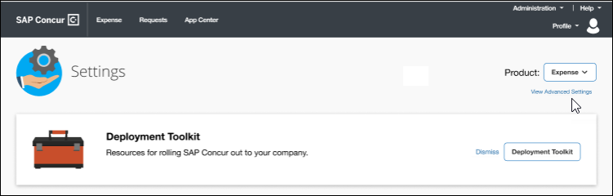

When the admin clicks **View Advanced Settings**, the advanced tiles appear on the **Product Settings** page, and the link under the **Product** menu changes to **View Basic Settings**.

1. The settings tiles that appear in advanced view vary depending on your configuration.

When an admin switches to advanced view, the view persists only for the current session. If the admin signs out of their SAP Concur product, when they sign back in, the view will be reset to the basic (default) view.

#### Configuration / Feature Activation

This change occurs automatically; there are no configuration or activation steps.

## Profile Settings

### **Planned Changes** Removing Connected Apps Page

|  |  |  |
| --- | --- | --- |
| Information First Published | Information Last Modified | Feature Target Release Date |
| January 14, 2022 | -- | Q1 2022 |
| Any changes since the previous monthly release are highlighted in yellow in this release note. | | |

**Applies to:**

Travel, Expense, Invoice, Request | Professional & Standard

#### Overview

SAP Concur plans to remove the **Connected Apps** page in **Profile Settings**.

##### Business Purpose / Client Benefit

Periodically, under-utilized features or pages are removed to improve usability. This is a rarely used page; it no longer meets its purpose of driving partner application usage.

#### What the User Sees

When a user navigates to **Profile > Profile Settings**, they will no longer see the **Connected Apps** link under **Other Settings.**

**Before**

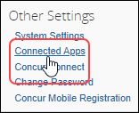

**After**

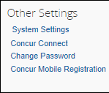

The user will no longer have access to the **Connected Apps** page.

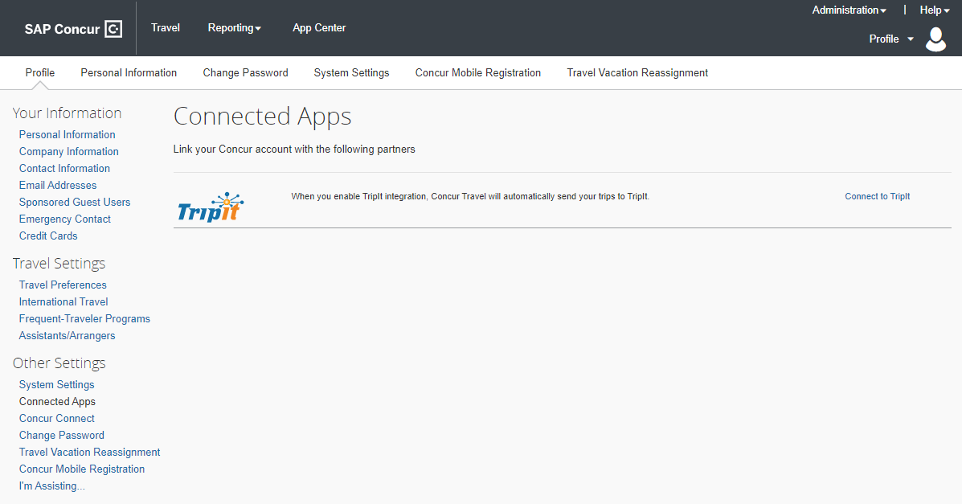

1. Users can continue to connect to available apps through the **App Center**. A link to the **App Center** is available in the SAP Concur page header.  
     
     
   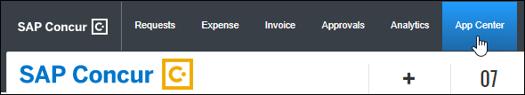

#### Configuration / Feature Activation

This change occurs automatically; there are no configuration or activation steps.

## SAP Concur Support

### **Planned Changes** Suggested Solutions Migration

|  |  |  |
| --- | --- | --- |
| Information First Published | Information Last Modified | Feature Target Release Date |
| November 5, 2021 | January 14, 2022 | Q1 2022 |
| Any changes since the previous monthly release are highlighted in yellow in this release note. | | |

**Applies to:**

All Products & Services | Professional & Standard

#### Overview

Targeted for Q1 2022, the Solution Suggestions platform that SAP Concur provides will be migrated into the SAP Continuous Influence – Improvement Requests program.

This change will provide a better user experience and a single place for Authorized Support Contact (ASC) users to engage with all SAP Concur Customer Influence programs.

1. Tool usage for ConcurGov and Concur Cloud for Public Sector clients is still being evaluated. Additional information for these impacted client groups will be shared in the near future.

For more information, refer to [*SAP* *Continuous Influence Sessions*](https://www.concurtraining.com/cnqr/continuous-influence-sessions).

##### Business Purpose / Client Benefit

In addition to offering a better tool with more functionality, SAP Concur is enhancing the process of how improvement requests will be reviewed, considered, and prioritized.

#### What the User Sees

Beginning with the November release, Authorized Support Contact users saw an updated **Suggestions** section on the **Contact Support** page.

1. Depending on the user’s Support access level, the **Suggestions** section may or may not appear.

**Before Update**

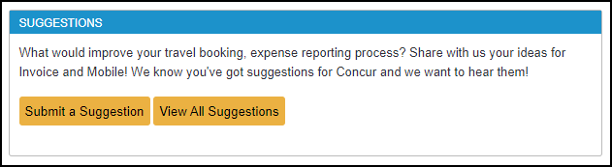

**After Update**

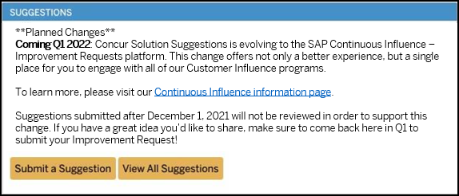

#### Configuration / Feature Activation

The change will occur automatically; there are no additional configuration or activation steps.

## SAP Concur User Assistance

### **Planned Changes** Notice Regarding Stale Documentation

|  |  |  |
| --- | --- | --- |
| Information First Published | Information Last Modified | Feature Target Release Date |
| January 14, 2022 | — | Q1 2022 |
| Any changes since the previous monthly release are highlighted in yellow in this release note. | | |

**Applies to:**

All Products & Services | All Editions

#### Overview

SAP Concur User Assistance will archive and eventually delete documents as needed to maintain accurate, relevant, and concise information for all supported audiences including end users and their administrators, along with SAP Concur support and implementation colleagues.

Archiving activities performed by SAP Concur User Assistance will comply with data retention best practices and adhere to legal compliance requirements.

The initial exercising of this notice will apply to the archiving of ***stale*** ([example](https://help.sap.com/viewer/85f3db6f3c5945fe8414a08fc5f9e3fc/LATEST/en-US/7885ede95c714a5887debc7b237cbdad.html)) online help documents currently available on the concurtraining.com server. All current online help documents are now located on the SAP Help Portal.

For more information, refer to the *Help Menu Directed to SAP Help Portal* release note in the November 2021 product release notes.

* **IMPORTANT:** SAP Concur User Assistance considers this notice sufficient to cover the ***future archiving*** of documents not specifically mentioned here at such time as we deemed them stale. Further notices are ***not planned***.

##### Business Purpose / Client Benefit

This notice serves to expedite the appropriate archiving of stale documentation.

#### Configuration / Feature Activation

Archiving will occur automatically; there will be no configuration or actions required. Bookmarks to the archived content will no longer work. Refer to the SAP Help Portal for the current links to deliverables:

Concur Expense:   
<https://help.sap.com/viewer/product/CONCUR_EXPENSE/LATEST/en-US>

Concur Invoice:   
<https://help.sap.com/viewer/product/CONCUR_INVOICE/LATEST/en-US>

Concur Request:   
<https://help.sap.com/viewer/product/CONCUR_REQUEST/LATEST/en-US>

Concur Travel:   
<https://help.sap.com/viewer/product/CONCUR_TRAVEL/LATEST/en-US>

# Client Notifications

## Accessibility

### Accessibility Enhancements

SAP implements changes to better meet current Web Content Accessibility Guidelines (WCAG). Information about accessibility-related changes made to SAP Concur solutions is published on a quarterly basis. You can review the quarterly updates on the [Accessibility Updates](https://www.concurtraining.com/customers/tech_pubs/RN-monthly-Access/_RN_access_client.htm) (English Only) page.

## Subprocessors

### SAP Concur Non-Affiliated Subprocessors

The list of non-affiliated subprocessors is available here: [SAP Concur list of Subprocessors](https://support.sap.com/content/dam/support/en_us/library/ssp/my-support/trust-center/sap-tc-04-0011.pdf)

If you have questions or comments, please reach out to: [Privacy-Request@Concur.com](mailto:Privacy-Request@Concur.com)

## Supported Browsers

### Supported Browsers and Changes to Support

For information about supported browsers and planned changes to supported browsers, refer to the [*Concur Travel & Expense Supported Configurations*](http://www.concurtraining.com/customers/tech_pubs/Docs/Z_SuppConfig/Supported_Configurations_for_Concur_Travel_and_Expense.pdf) guide.

When changes to browser support are planned, information about those changes will also appear in the [*Shared Planned Changes*](https://www.concurtraining.com/customers/tech_pubs/RN_shared_planned/_client_shared_RN_all.htm) release notes.

# Additional Release Notes and Other Technical Documentation

## Online Help

Any user can access release notes, setup guides, user guides, admin summaries, monthly browser certifications, supported configurations, and other resources via online Help or directly on the SAP Help Portal.

Use the links in the **Help** menu in the app, or search for your SAP Concur product (Concur Expense, Concur Invoice, Concur Request, or Concur Travel) on the SAP Help Portal (https://help.sap.com) to view the full set of documentation for your product.

## SAP Concur Support Portal – Selected Users

Access release notes, webinars, and other technical documentation on the SAP Concur support portal.

If you have the proper permissions, **Contact** **Support** appears on the **Help** menu. Click to access the SAP Concur support portal, then click **Resources**.

* Click **Release/Tech Info** for release notes, technical documents, etc.
* Click **Webinars** for recorded and live webinars.

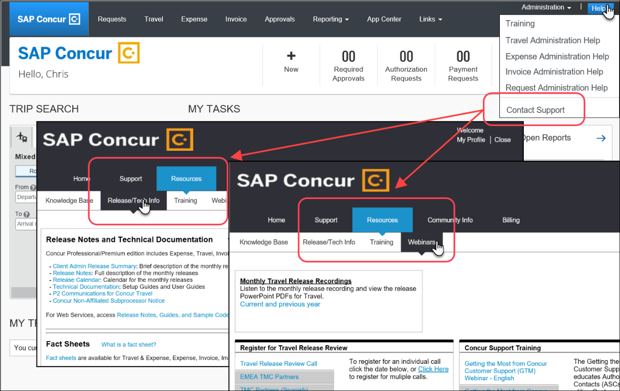

© 2022 SAP SE or an SAP affiliate company. All rights reserved.

No part of this publication may be reproduced or transmitted in any form or for any purpose without the express permission of SAP SE or an SAP affiliate company.

SAP and other SAP products and services mentioned herein as well as their respective logos are trademarks or registered trademarks of SAP SE (or an SAP affiliate company) in Germany and other countries. Please see http://global12.sap.com/corporate-en/legal/copyright/index.epx for additional trademark information and notices.

Some software products marketed by SAP SE and its distributors contain proprietary software components of other software vendors.

National product specifications may vary.

These materials are provided by SAP SE or an SAP affiliate company for informational purposes only, without representation or warranty of any kind, and SAP SE or its affiliated companies shall not be liable for errors or omissions with respect to the materials. The only warranties for SAP SE or SAP affiliate company products and services are those that are set forth in the express warranty statements accompanying such products and services, if any. Nothing herein should be construed as constituting an additional warranty.

In particular, SAP SE or its affiliated companies have no obligation to pursue any course of business outlined in this document or any related presentation, or to develop or release any functionality mentioned therein. This document, or any related presentation, and SAP SE’s or its affiliated companies’ strategy and possible future developments, products, and/or platform directions and functionality are all subject to change and may be changed by SAP SE or its affiliated companies at any time for any reason without notice. The information in this document is not a commitment, promise, or legal obligation to deliver any material, code, or functionality. All forward-looking statements are subject to various risks and uncertainties that could cause actual results to differ materially from expectations. Readers are cautioned not to place undue reliance on these forward-looking statements, which speak only as of their dates, and they should not be relied upon in making purchasing decisions.