SAP Concur Release Notes
SAP Concur mobile app
Month | Audience
Version 10.9 - Associated web release: March 2024  Initial Post: Wednesday, March 27, 2024 | SAP Concur Client FINAL

Contents
Version Information 4
Supported Phone OS 4
Supported Mobile Versions 4
Concur Mobile Version Status for Android and iOS 5
Latest Supported Mobile Versions 5
Bug Fixes 7
Additions 7
There are no new additions with this release. 7
Release Notes 1
Expense 1
eReceipts for Delegates 1
Flight 1
New Concur Experience: Update to Round Trip Pricing 1
New Concur Travel Experience: Include Accommodation Option on the Flight Search Tab (Professional Edition Only) 2
Hotel, Rail 5
**Ongoing** New Concur Travel Experience: Last Four Digits on Form of Payment Displayed (Professional Edition Only) 5
**Rail 7
New Rail Experience: UK Rail (Trainline) on Mobile (March 6) 7
Planned Changes 20
**Planned Changes** Supported Mobile Versions 20
**Planned Changes** Decommission of iOS 15 20
**Planned Changes** Hotel 20
**Planned Changes** New Hotel Experience: Configuration for Custom Hotel Sourcing 20
**Planned Changes** Flight 22
**Planned Changes** New Flight Experience: Add Vendor Preference and Corporate Rate to Post Booking Flow 22
**Planned Changes** Miscellaneous 23
*Planned Changes** New Concur Travel Experience: Trip History (Professional Edition Only) 23
**Planned Changes** Rail 26
**Planned Changes** New Concur Travel Experience: Renfe - User Interface Changes to Workflow Pages and Functionality Enhancements (Professional Edition Only) (April 8-10) 26
Legal Disclaimer
The information in this presentation is confidential and proprietary to SAP SE or an SAP affiliate company and may not be disclosed without the permission of SAP SE or the respective SAP affiliate company. This presentation is not subject to your license agreement or any other service or subscription agreement with SAP SE or its affiliated companies. SAP SE and its affiliated companies have no obligation to pursue any course of business outlined in this document or any related presentation, or to develop or release any functionality mentioned therein. This document, or any related presentation and SAP SE or an SAP affiliate company’s strategy and possible future developments, products and or platforms directions and functionality are all subject to change and may be changed by SAP SE and its affiliated companies at any time for any reason without notice. The information in this document is not a commitment, promise or legal obligation to deliver any material, code or functionality. This document is provided without a warranty of any kind, either express or implied, including but not limited to, the implied warranties of merchantability, fitness for a particular purpose, or non-infringement. This document is for informational purposes and may not be incorporated into a contract. SAP SE and its affiliated companies assume no responsibility for errors or omissions in this document, except if such damages were caused by SAP SE or an SAP affiliate company’s willful misconduct or gross negligence.
All forward-looking statements are subject to various risks and uncertainties that could cause actual results to differ materially from expectations. Readers are cautioned not to place undue reliance on these forward-looking statements, which speak only as of their dates, and they should not be relied upon in making purchasing decisions.

Version Information

Supported Phone OS
Device | Operating System
iOS (iPhone, iPad) | Version 15.0 or greater – users will be able to upgrade to the current version
Google Android | Version 8.0 or greater – users will be able to upgrade to the current version

Supported Mobile Versions
Note the following:
Applicable for 10.4 and newer: If the current mobile app on your mobile device is older than the two latest versions, you will be notified - through a Message Center message and push notifications – that you should update the app to the latest version.
If you have a version of the app older than the last 2 versions on your mobile device, you will see an upgrade notice on the login page. If you have a version of the app older that the last 3 versions you will no longer be able to access the SAP Concur mobile app on your device and will need to update to login.
The SAP Concur mobile app will not be removed from mobile devices that have a version of the app older than the last 3 versions.
For more information on the retention policy, refer to this FAQ.

Concur Mobile Version Status for Android and iOS
Version | Status | Action
10.4 | Disabled | Update via App Store or Google Play
10.5 | Disabled | Update via App Store or Google Play
10.6 | Deprecated | Update via App Store or Google Play
10.7 | Supported | Update via App Store or Google Play
10.8 | Supported
10.9 | Supported

Latest Supported Mobile Versions
Platform | Latest Version | Available | How to Update
iPhone/iPad | 10.9 | Wednesday, March 27 | Update via App Store
Android | 10.9 | Wednesday, March 27 | Update via Google Play

Locate Version Information on the iPhone
To check the version number on the iPhone:
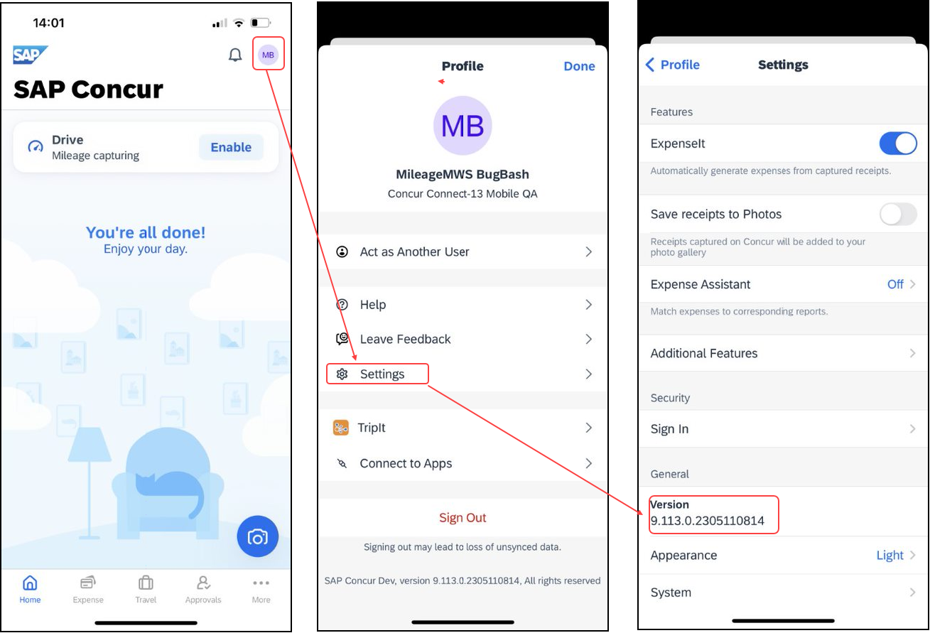

Locate Version Information on the Android
To check the version number on the Android:
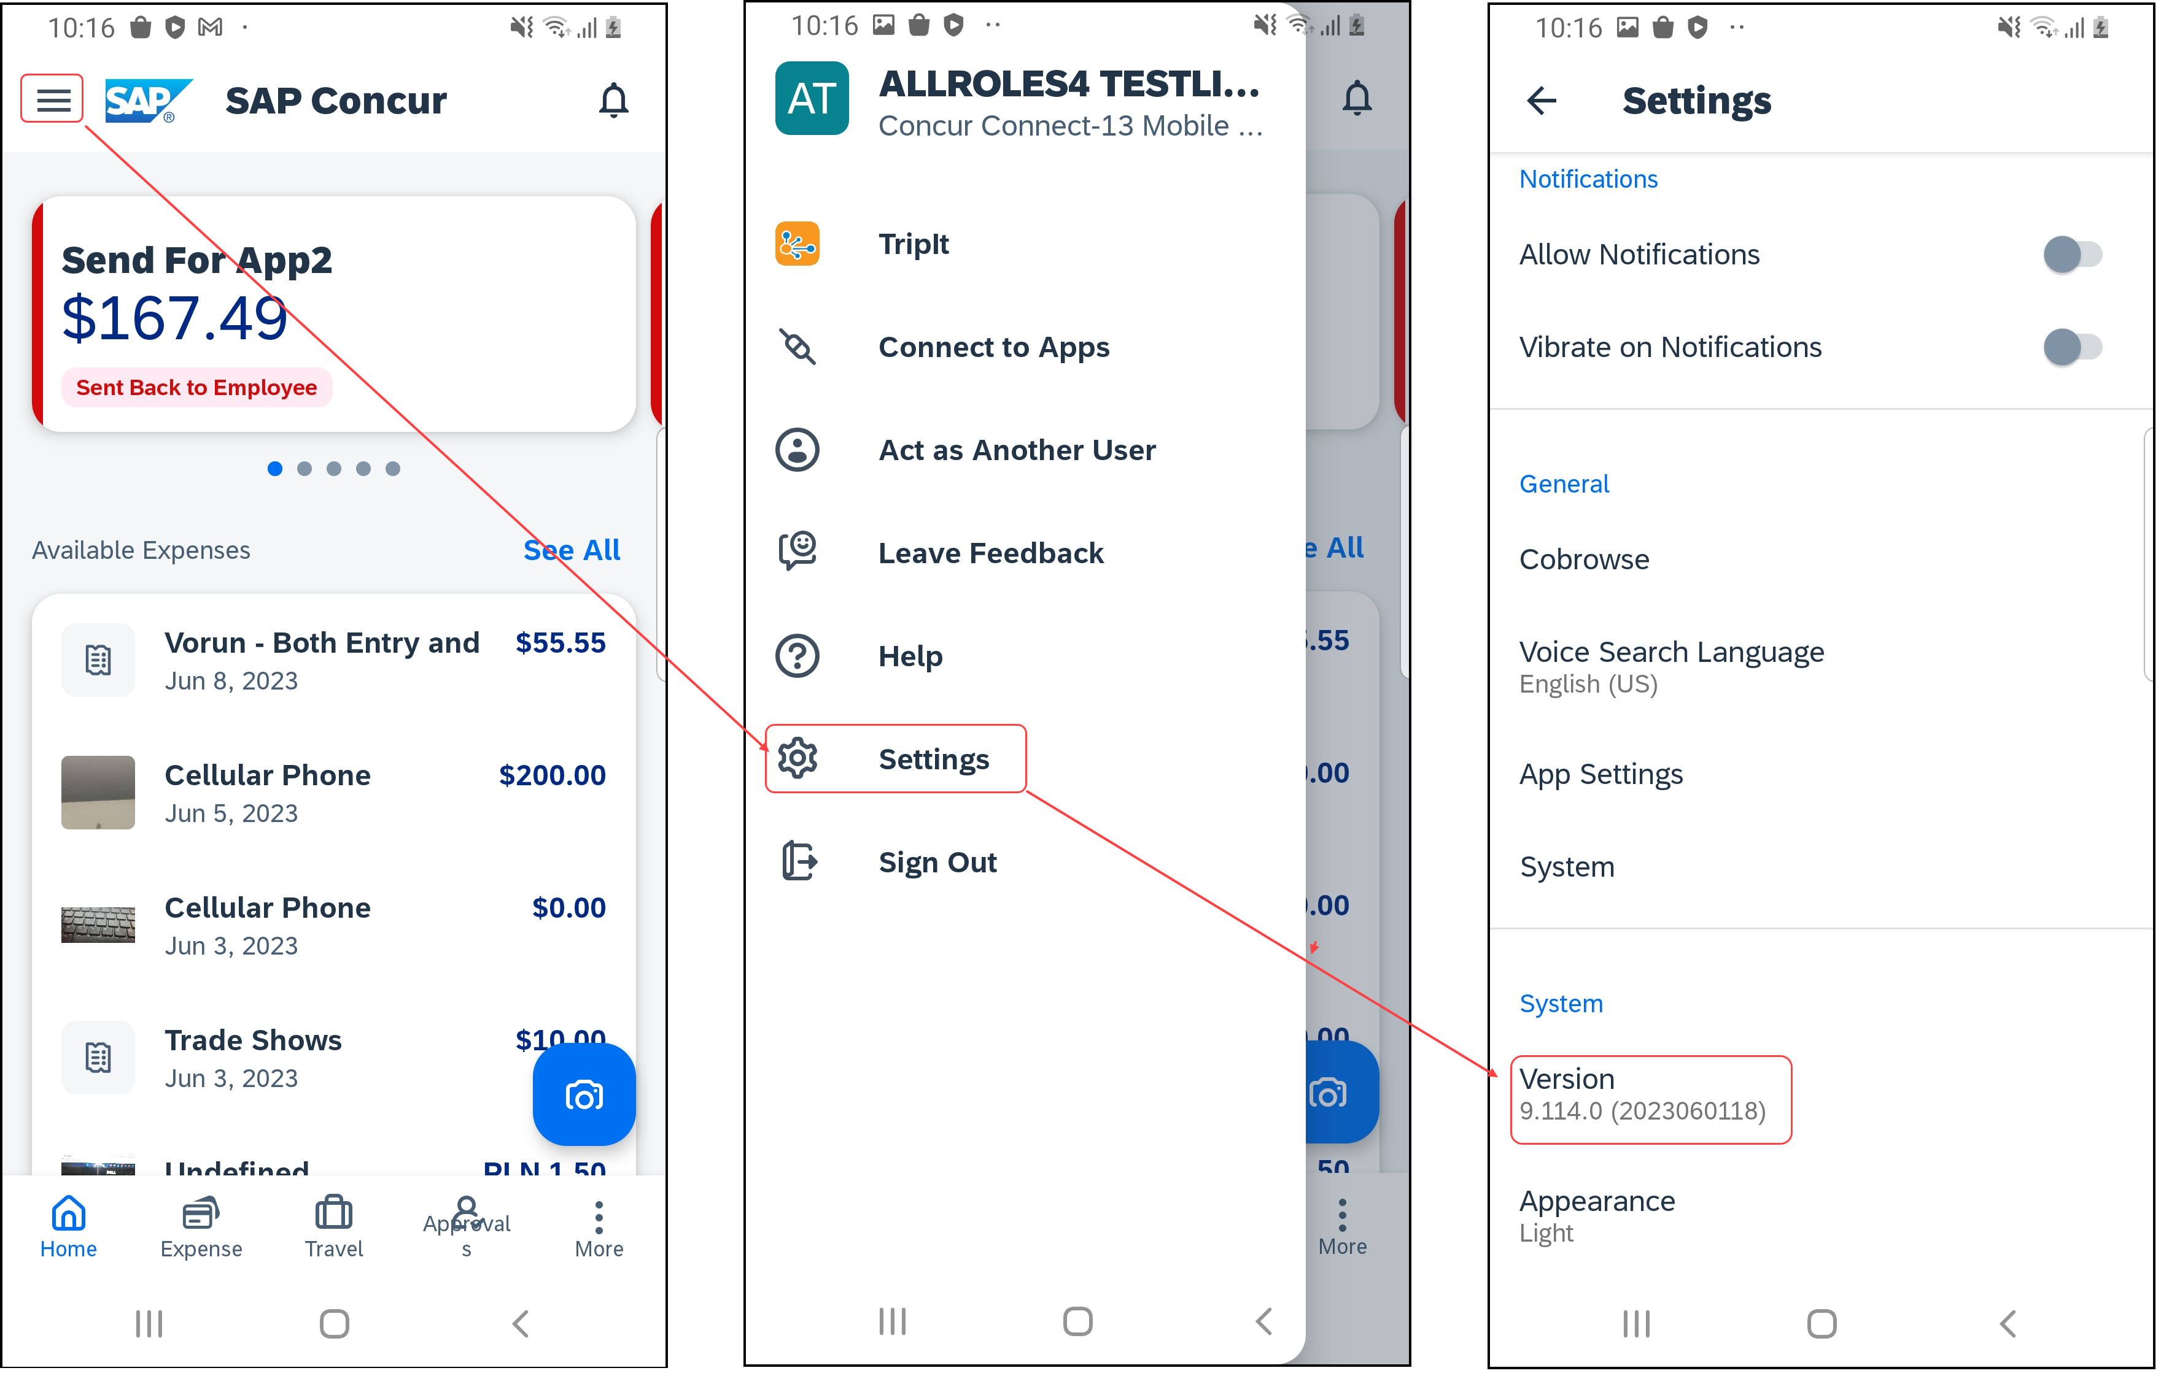

Bug Fixes

Platform | OS | Highlights

Additions

There are no new additions with this release.

Release Notes

Expense

eReceipts for Delegates

Overview
With this release, the ability to work with eReceipts will now be available when acting on behalf of another user.

User/Customer Benefit
This change is being made to allow delegates to be able to work with eReceipts.

End-User Experience
With this change, delegates will now be able to work with eReceipts on behalf of another user. This allows delegates the ability to be able to complete more tasks.
Delegates will now be able see eReceipts and move them to reports from both lists and expense details.
Delegates will not be able to edit eReceipts. With this change, they will only be able to see and move eReceipts.

Configuration for Professional Travel
There are no new configuration steps. The feature is available by default.

Flight

New Concur Experience: Update to Round Trip Pricing

Overview
With the March release, Concur Travel will update the way prices for round trips are displayed. Currently users sometimes see negative pricing when booking a round trip. SAP Concur will adjust the way these fares are shown to provide a more enhanced user experience.

User/Customer Benefit
This change is being made to eliminate confusion in the round-trip booking process and to avoid any manual calculations for the end user.

End-User Experience
The current fares for round trip searches in Flight will change to show prices more accurately. This will provide more transparency so customers will know exactly what price is being charged for their trip.
Currently, if an inbound trip is more expensive than an outbound trip, the difference in the two fares displays, instead of the price of the fare. If there is no price difference, the price displays as a zero value. If the price is less that, the difference displays as a negative value.
With this change, the total fare will automatically be updated to reflect both the inbound and outbound fares.

Configuration for Professional Travel
There are no new configuration steps. The feature is available by default.

New Concur Travel Experience: Include Accommodation Option on the Flight Search Tab (Professional Edition Only)

Overview
Users creating a trip itinerary can include flights, hotel, car and rail reservations, all within the same trip. With this release, a more streamlined approach is now available for trips with Air and Hotel bookings. When entering a flight search on the Flight Search tab, users can simultaneously include a search for accommodations.

User/Customer Benefit
These changes to the Concur Travel user interface help minimize the number of steps required to complete the trip booking process on Mobile.

End-User Experience
The Flight Search tab now includes the Include Accommodation option.
Once a user has entered their flight search conditions on the Flight Search tab, the Include Accommodation checkbox is enabled. If clicked, the user interface will update to display accommodations search options.
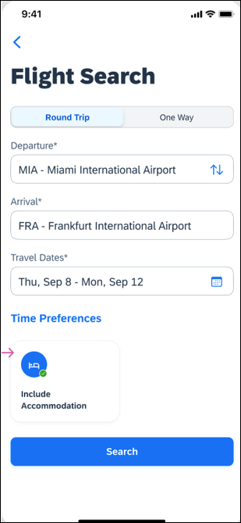
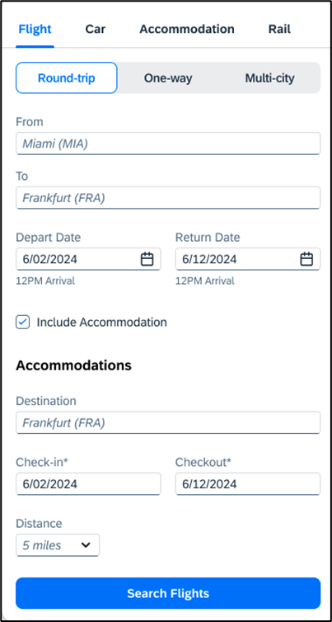
Once a user clicks Search Flights, the user interface updates to display the Flight search results. The user then selects their flight and clicks Book and Continue. Previously, the user was redirected to Finalize page and had the option to Add Accommodation. With this change, after the Book and Continue page, the user interface immediately displays the accommodations results.
The user selects their accommodations and again click Book and Continue. The user interface displays the Finalize screen where the user can confirm the trip with both bookings.
If the user edits their flight search query during this process, the results of the original accommodations query displays to the user. This is consistent with legacy Concur Travel behavior.

Configuration for Professional Travel
This feature is enabled by default. There are no configuration steps.

If the Hide Hotel Tab module property is enabled, users will not see the Include Accommodation option and will not be able to add accommodations to their flight search.

Hotel, Rail

**Ongoing** New Concur Travel Experience: Last Four Digits on Form of Payment Displayed (Professional Edition Only)

Information First Published | Information Last Modified | Feature Target Release Date
February 2024 | -- | February to April 2024
Any changes since the previous monthly release are highlighted in yellow in this release note.

Overview
The last four digits of a traveler’s credit card used to reserve a booking will display in the mobile app This feature will be applied to all Hotel, Rail, and Air bookings made in the mobile app.

Phases
This feature will be released to specific verticals, vendors, and data centers between February and April:

Phase | Date of Release
Phase 1: Trainline (existing customers as they migrate to the new travel experience) and Air | February 2024 (released)
Phase 2: Hotel | April 2024 (target date)
Phase 3: Renfe Rail customers in US Data Center | April 8, 2024
Phase 4: Renfe Rail customers in EU Data Center | April 10, 2024

Display of credit card information for Car bookings will come in a later release.

User/Customer Benefit
This update is being implemented to improve the customer experience and provide more complete information about their bookings.

End-User Experience
The last four digits of the user’s credit card will display on the vertical View Details screen for each booking.
. 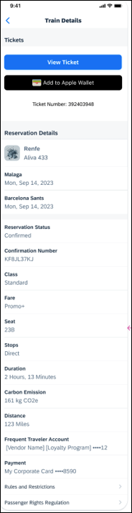 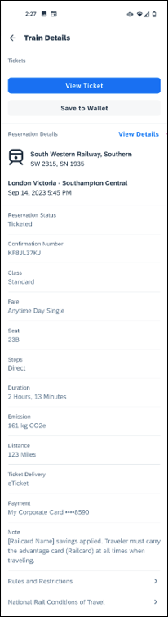
For Trainline bookings, users are required to provide any valid form of payment in order to retrieve their tickets from a kiosk.

Configuration for Professional and Standard Travel
This feature is enabled by default. There are no configuration steps.

**Rail

New Rail Experience: UK Rail (Trainline) on Mobile (March 6)

Overview
With this release, Concur Travel is introducing UK Rail (Trainline) on Mobile. This will first start with migrated clients in Q1 and in Q2, it will expand to eligible clients.

User/Customer Benefit
This change is being made to synchronize the web and mobile experience for users. Customers will be able to not only make Trainline bookings on web, but also on the Concur mobile app.

End-User Experience
The booking workflow includes search, book, and itinerary review.
Search
The user taps Book a Trip and selects Train. On the Train Search the options for Round Trip or One Way can be selected.. Enabling the Open Return option with Round Trip means that a specific return date and time does not need to be selected.
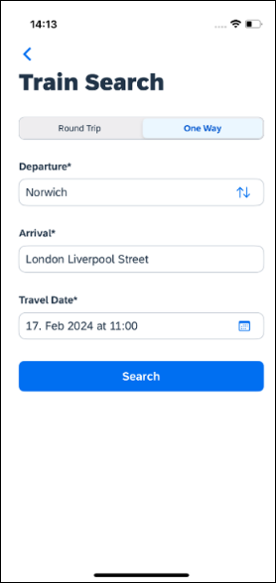
Clicking Search will display the results.
Select a Train
To see all available fares, click on the required train. All fares will display with information on the alternative stations and Rules and Restrictions. If Railcard savings are applied, it will be visible in the fare. The original and the discounted price will also display.
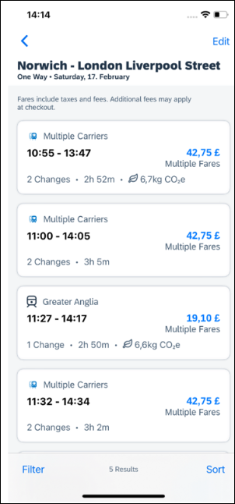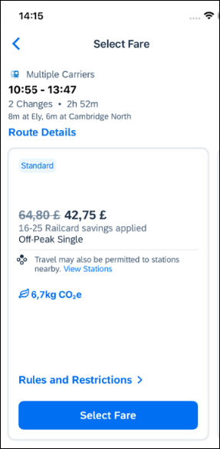
Clicking Select Fare, redirects to the Review and Book page.
Review and Book
The Review and Book page displays all relevant information to be reviewed before the booking is completed.
For more information on the Train Itinerary, see View Train Details. The Train Preferences section contains the Seat Reservation information and Seat Preferences, if applicable. No seat preferences are displayed if the seat reservation is not available. The availability of seat reservation depends on the selected route and carrier.
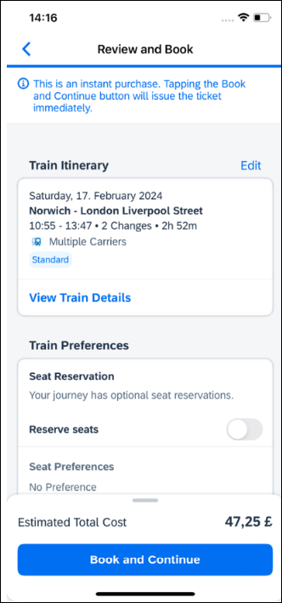
The Ticket Delivery Preference section offers two ticket delivery options, if applicable: eTicket (free of charge) and Kiosk (with a fee). The eTicket option is preselected if both options are available. Depending on the selected route, the eTicket might not be offered (for example, if a tube is part of the journey).
An eTicket must be enabled with Trainline for the client to see this delivery option. Depending on their contract, the client should contact their travel agency or Trainline if they are interested in the eTicket delivery option.
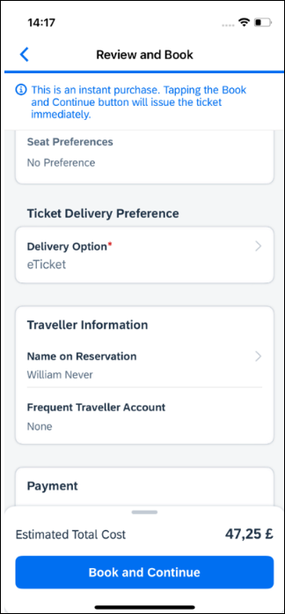
The Form of Payments that will display in the dropdown depend on the agreement between the client, travel agency and Trainline.
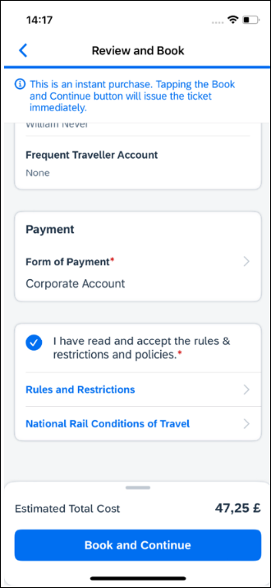
After the user confirms the rules and restrictions and clicks Book and Continue, they will be redirected to the Finalize page.
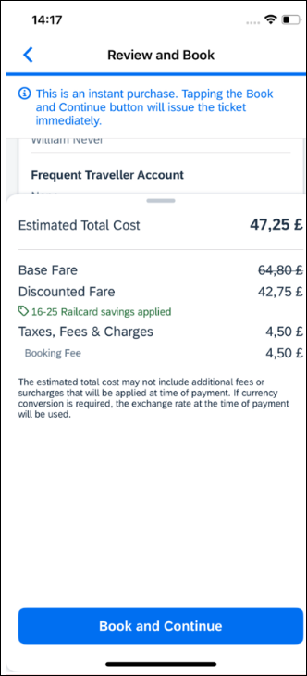
Finalise
The Finalise page allows a user to update Trip Name or Description. It also provides the user with the overview of their UK Rail (Trainline) booking.
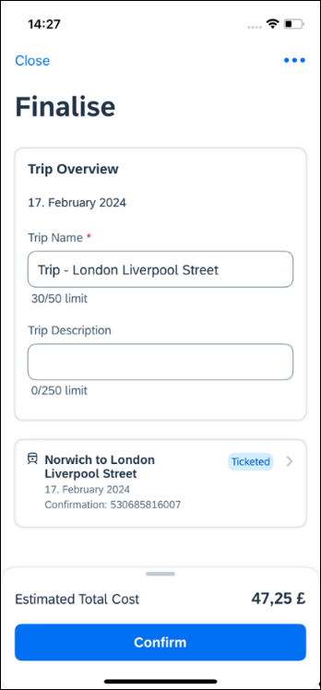
If the user selects the eTicket delivery option on the Review and Book page, the ticket will be available on the Finalise page. It can be accessed by clicking the arrow icon to show Train Details:
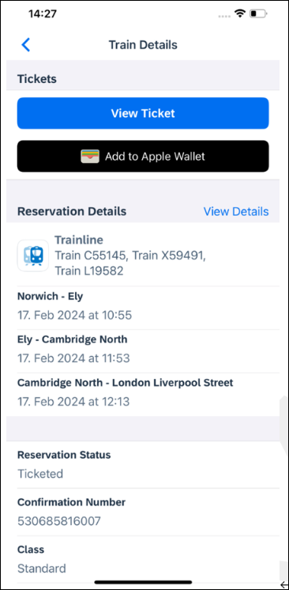
View Ticket
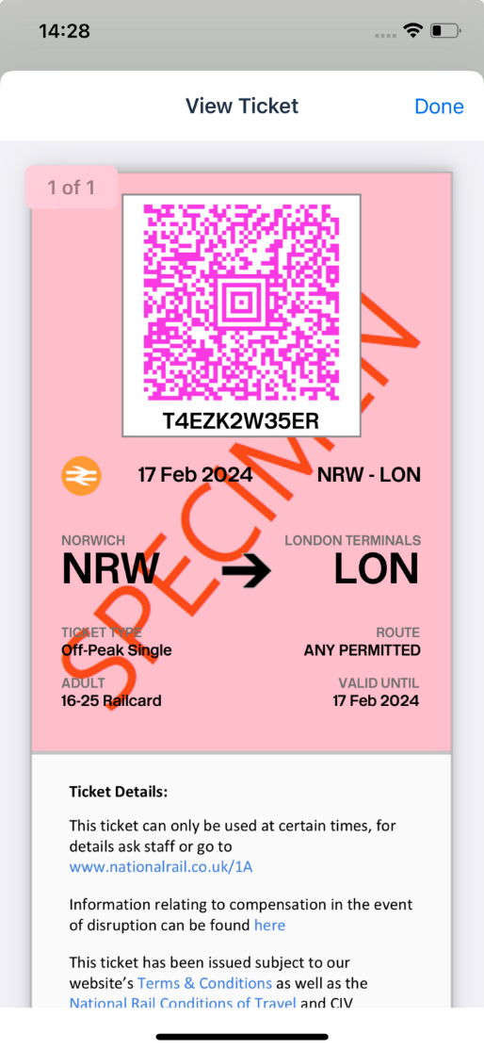
The user clicks Confirm to complete the trip and will be redirected to the Trip Confirmed page.
The eTicket may not be issued immediately. If the eTicket is not available during the booking process, an e-mail will be sent separately later, containing the eTicket.
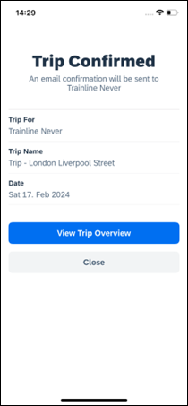
The user can open their trip by clicking on View Trip Overview.
View Trip Overview
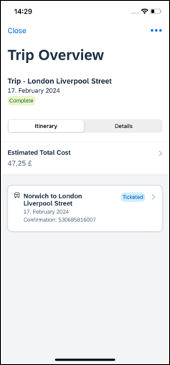
Cancel Trip

Cancellation of the UK Rail (Trainline) booking is not supported. The user will see the following message when attempting to cancel the Trainline booking:
“Cancelation is not available for this content Provider. Please contact the supplier or your travel agency for assistance.
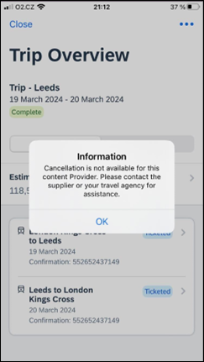

Configuration for Professional Travel
There are no new configuration steps to enable UK Rail (Trainline) on mobile. The feature is available by default.

Planned Changes

**Planned Changes** Supported Mobile Versions

**Planned Changes** Decommission of iOS 15

Information First Published | Information Last Modified | Feature Target Release Date
March 2024 | -- | April 2024
Any changes since the previous monthly release are highlighted in yellow in this release note.

Overview
Targeted for the April Mobile release (version 10.10), SAP Concur will remove support for iOS 15. This change will affect iPhone and iPad users.
SAP Concur solutions updates the minimum operating system regularly to ensure the best possible experience for mobile users. With the April release, SAP Concur solutions will update the minimum operating system to iOS 16.
The March (10.9) Mobile release was the final release for version 15 of the iPhone / iPad operating system. Please ensure that the operating system on all user devices have been updated to at least iOS 16. Be aware that users will not be forced to upgrade their device’s operating system, but users on older operating systems will not be able to install versions of the SAP Concur mobile app with the release of 10.11.
For SAP Concur solutions – and all other mobile apps – encourage your users to keep their operating system (And devices, if possible) current.

**Planned Changes** Hotel

**Planned Changes** New Hotel Experience: Configuration for Custom Hotel Sourcing

Information First Published | Information Last Modified | Feature Target Release Date
March 2023 | October 6, 2023 | April 2024
Any changes since the previous monthly release are highlighted in yellow in this release note.

Configuration for Professional Travel

Custom Hotel Source Providers
Hotel content will only be available from Custom Hotel Source providers. This requires re-enablement for customers who are interested in using these channels.
To configure:
- Click Administration > Travel (on the sub-menu) > Travel System Admin and select the desired client travel configuration.
Depending on your permissions, the page may appear immediately after you click Administration or Travel.
- There are now two different Hotel Connector sections of the travel configuration page. One is to support the new hotel connectors and is called Hotel Connectors – Hotel Service v4. The other is the existing hotel connector section.
- When enabling a new connector in the new Concur Travel experience, it is essential that any current direct connect remains enabled otherwise customers will not be able to service bookings made in the current Travel experience. This means that a current HSv2 config needs to remain enabled on HSv2 and also on HSv4 once migrated. The HSv2 connection will not allow new bookings but will only provide access to previously booked reservations for servicing. Any servicing will be carried out as it is today using the OBT.
- The administrator can select the default connection type within the new section. Although GDS is presented as an option, there is no GDS content available with this Release so checking this box will have no effect.
Example:
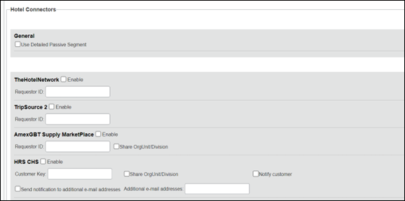
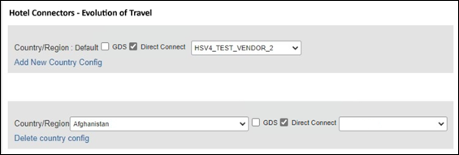

Passive PNR for Direct Content
To configure:
- Go to Administration > Travel (on the sub-menu) > Travel System Admin and select the desired client travel configuration.
Depending on your permissions, the page may appear immediately after you click Administration or Travel.
- Under GDS PNR Options of the travel configuration page, go to the activation checkboxes.
- Select New Custom Hotel Source in the list under Defaults for Specific non-GDS vendors. This defaults to Use the default specified above. Select Write passive segments for non-GDS content if I have not specified a default for the specific vendor in the table below.

Travel Arranger Flow
The Travel Arranger flow will be supported for Hotel. Full details of how to book a hotel as a Travel Arranger are in Travel Arranger View Travel Service Guide.
The Travel Arranger Name appears on the new Trip Overview.
Image to be included in subsequent update.

**Planned Changes** Flight

**Planned Changes** New Flight Experience: Add Vendor Preference and Corporate Rate to Post Booking Flow

Information First Published | Information Last Modified | Feature Target Release Date
February 2024 | -- | April 2024
Any changes since the previous monthly release are highlighted in yellow in this release note.

Overview
Targeted for the March release, Concur Travel plans to display the Corporate Rate label and Preferred Vendor label for Flight. These changes will be visible on the Review and Book, Finalize and Trip Overview pages. These labels will also display on e-mails received once a booking is finalized.

User/Customer Benefit
This change is being made to inform the user which rates and vendors will be available, and it will provide a more consistent user experience across the booking process.

End-User Experience
Once the search for flights is completed, the user will then see the Corporate Rate and Preferred Vendor labels on the last pages of the booking flow and also in the post booking e-mails received. These labels will appear on the Review and Book, Finalize and Trip Overview pages.

Configuration for Professional Travel
There are no new configuration steps. The feature is available by default.

**Planned Changes** Miscellaneous

*Planned Changes** New Concur Travel Experience: Trip History (Professional Edition Only)

Information First Published | Information Last Modified | Feature Target Release Date
February 2024 | -- | April to May 2024
Any changes since the previous monthly release are highlighted in yellow in this release note.

Overview
Targeted for the April 2024 release, the Trip History feature will be available for the new Concur Travel experience. This feature will provide all access to detailed historical records of all trips associated with an account.

Phases
This feature will be released in phases:

Phase | Date of Release
Phase 1: New History tab on the Trip Overview Page.  - Trip-level events (for example, Trip Created, Trip Cancelled, Trip Confirmed)  - Stand-alone Approvals events (for example, Trip Approved, Trip Rejected) | April 2024
Phase 2:  - Booking-Specific events (for example, Booking Created, Booking Cancelled, Booking Updated) | April 2024
Phase 3:  - Approvals via Request Integration  - Additional events | May 2024
There will be a detailed list of supported events and which information they include in next month’s release note.
Trips which included bookings from both the legacy and new Concur Travel experience will be included only in the legacy Trip History, on the web application.
Trips which included bookings from only the new Concur Travel experience will be included within the new experience Trip History, on both web and mobile applications.

User/Customer Benefit
This feature will provide greater clarity and confidence in the details of the Concur Travel booking experience, allowing users to search for and reference trip details more quickly and easily. This will allow users to avoid having to request information via a support case.
Users and arrangers will be able to see the Trip History tab on the Trip Overview screen.

End-User Experience
Historical data will include:
- the original details of the trip and the travel provider, for example, airlines, hotels, locations etc.
- all edits to a trip
- the identity of the person performing each action taken on the trip
- dates and time stamps
- ticket and confirmation numbers
- approvals and rejections
- policy violations
- detailed trip costs
- specific details of travel providers
To access trip histories:
- On the Trip Overview screen, click the Trip History tab.
- The Trip History tab will display all the events that took place for the trip in either ascending or descending chronological sort order, such as Creation, Cancellation, Approval etc.
- To expand the content and see additional details, click the arrow icon next to the event.
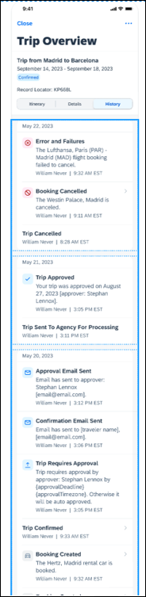

Configuration for Professional Travel
This feature is enabled by default. There are no configuration steps.

**Planned Changes** Rail

**Planned Changes** New Concur Travel Experience: Renfe - User Interface Changes to Workflow Pages and Functionality Enhancements (Professional Edition Only) (April 8-10)

Information First Published | Information Last Modified | Feature Target Release Date
March 2024 | -- | 08-10 April 2024
Any changes since the previous monthly release are highlighted in yellow in this release note.

Overview
Targeted for April, there will be changes to the view of the Renfe user interface and travel policy behavior in alignment with enhancements introduced on web. These changes will affect the entire Renfe rail booking flow - Shop, Review and Book, Finalize and Trip Overview pages.

User/Customer Benefit
To provide a more consistent user experience, some Renfe pages will be updated to resemble Flight pages. Additional functionality related to policy and auto-cancellation will provide a consistent New Concur Travel experience to users and administrators. For details on the functionality changes, please review the release notes for web, where all details have been shared for each feature.

End-User Experience
These updates will apply mostly to the search result and Review and Book pages, and the policy flows and functionality.
Changes to the search results display:

New display of the search results: Fares selection will display fares horizontally.
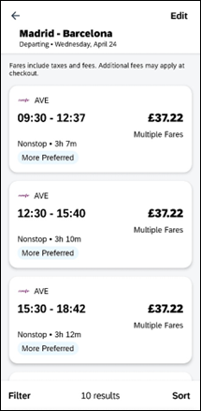
Select Fare:
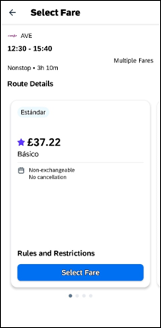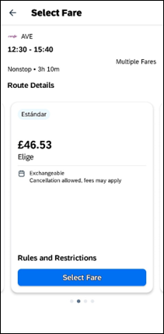
Updated Filter options.
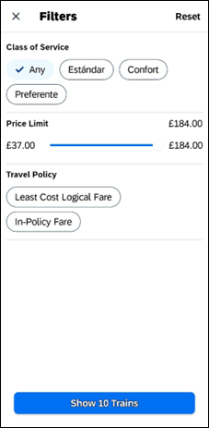
Updated Sort options.
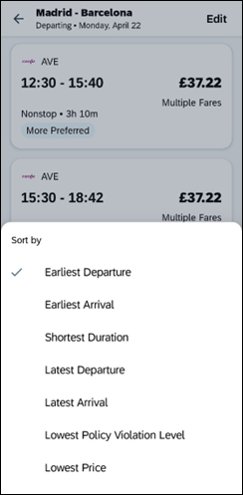
Support the display of following (if configured by administrators):
- Preference label
- Least Cost Logical Fare icon
Display of fares in the configured currency instead of vendor currency on the search result and Review and Book pages, subsequent pages will include both the configured currency and the vendor currency.
Changes to Review and Book page:
Updated display of itinerary:
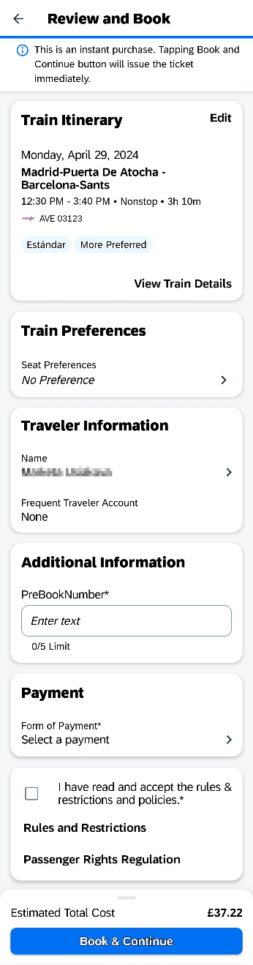
New display of Estimated Total Cost card to align with the display on following Trip pages and e-mail:
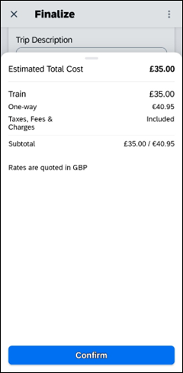
Updated display of itinerary on Finalize and Trip Overview pages.
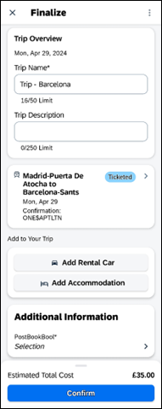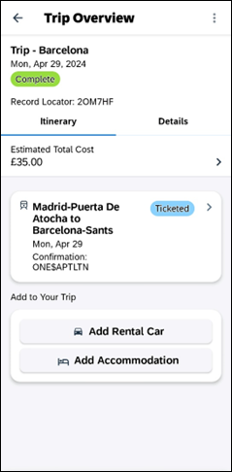
For more information on changes to Travel Policy, refer to the Concur Travel release notes.

Update will include feature parity with web release of new policy features and processes such as:
- Auto-cancel process
- approval process changes:
- Standalone approval process (full support for Require Approval, Require Passive Approval type rules)
- Approval deadline logic implementation
- New supported rules
- Train options turned down
- Multiple violation reasons
- Least Cost Logical Fare for Rail
Of the new features available on web in April 2024, the following features will not be supported in the mobile application at the moment:
- Configurable message boards
- Rule Class Selection

Configuration for Professional Travel
For any features requiring configuration steps by administrators the are shared in the web release notes with each feature. General user interface changes will require no additional enablement.
- With the release of the enhanced experience for Renfe Rail on mobile, users must update the app to the latest version.
© 2024 SAP SE or an SAP affiliate company. All rights reserved.
No part of this publication may be reproduced or transmitted in any form or for any purpose without the express permission of SAP SE or an SAP affiliate company.
SAP and other SAP products and services mentioned herein as well as their respective logos are trademarks or registered trademarks of SAP SE (or an SAP affiliate company) in Germany and other countries. Please see http://global12.sap.com/corporate-en/legal/copyright/index.epx for additional trademark information and notices.
Some software products marketed by SAP SE and its distributors contain proprietary software components of other software vendors.
National product specifications may vary.
These materials are provided by SAP SE or an SAP affiliate company for informational purposes only, without representation or warranty of any kind, and SAP SE or its affiliated companies shall not be liable for errors or omissions with respect to the materials. The only warranties for SAP SE or SAP affiliate company products and services are those that are set forth in the express warranty statements accompanying such products and services, if any. Nothing herein should be construed as constituting an additional warranty.
In particular, SAP SE or its affiliated companies have no obligation to pursue any course of business outlined in this document or any related presentation, or to develop or release any functionality mentioned therein. This document, or any related presentation, and SAP SE’s or its affiliated companies’ strategy and possible future developments, products, and/or platform directions and functionality are all subject to change and may be changed by SAP SE or its affiliated companies at any time for any reason without notice. The information in this document is not a commitment, promise, or legal obligation to deliver any material, code, or functionality. All forward-looking statements are subject to various risks and uncertainties that could cause actual results to differ materially from expectations. Readers are cautioned not to place undue reliance on these forward-looking statements, which speak only as of their dates, and they should not be relied upon in making purchasing decisions.

