SAP Concur Release Notes
SAP Concur mobile app
Month | Audience
Version 10.7 - Associated web release: January 2024  Initial Post: Monday, January 29, 2024 | SAP Concur Client FINAL

Contents
Version Information 3
Supported Phone OS 3
Supported Mobile Versions 3
Concur Mobile Version Status for Android and iOS 4
Latest Supported Mobile Versions 4
Bug Fixes 6
Additions 6
There are no new additions with this release. 6
Release Notes 1
New Flight Experience: Preferred Airport Configuration 1
Planned Changes 3
**Planned Changes** New Hotel Experience 3
**Planned Changes** New Hotel Experience: Configuration for Custom Hotel Sourcing 3
Legal Disclaimer
The information in this presentation is confidential and proprietary to SAP SE or an SAP affiliate company and may not be disclosed without the permission of SAP SE or the respective SAP affiliate company. This presentation is not subject to your license agreement or any other service or subscription agreement with SAP SE or its affiliated companies. SAP SE and its affiliated companies have no obligation to pursue any course of business outlined in this document or any related presentation, or to develop or release any functionality mentioned therein. This document, or any related presentation and SAP SE or an SAP affiliate company’s strategy and possible future developments, products and or platforms directions and functionality are all subject to change and may be changed by SAP SE and its affiliated companies at any time for any reason without notice. The information in this document is not a commitment, promise or legal obligation to deliver any material, code or functionality. This document is provided without a warranty of any kind, either express or implied, including but not limited to, the implied warranties of merchantability, fitness for a particular purpose, or non-infringement. This document is for informational purposes and may not be incorporated into a contract. SAP SE and its affiliated companies assume no responsibility for errors or omissions in this document, except if such damages were caused by SAP SE or an SAP affiliate company’s willful misconduct or gross negligence.
All forward-looking statements are subject to various risks and uncertainties that could cause actual results to differ materially from expectations. Readers are cautioned not to place undue reliance on these forward-looking statements, which speak only as of their dates, and they should not be relied upon in making purchasing decisions.

Version Information

Supported Phone OS
Device | Operating System
iOS (iPhone, iPad) | Version 15.0 or greater – users will be able to upgrade to the current version
Google Android | Version 8.0 or greater – users will be able to upgrade to the current version

Supported Mobile Versions
Note the following:
- Applicable for 10.2 and newer: If the current mobile app on your mobile device is older than the two latest versions, you will be notified - through a Message Center message and push notifications – that you should update the app to the latest version.
- If you have a version of the app older than the last 2 versions on your mobile device, you will see an upgrade notice on the login page. If you have a version of the app older that the last 3 versions you will no longer be able to access the SAP Concur mobile app on your device and will need to update to login.
The SAP Concur mobile app will not be removed from mobile devices that have a version of the app older than the last 3 versions.
For more information on the retention policy, refer to this FAQ.

Concur Mobile Version Status for Android and iOS
Version | Status | Action
10.2 | Disabled | Update via App Store or Google Play
10.3 | Disabled | Update via App Store or Google Play
10.4 | Disabled | Update via App Store or Google Play
10.5 | Deprecated | Update via App Store or Google Play
10.6 | Supported
10.7 | Supported

Latest Supported Mobile Versions
Platform | Latest Version | Available | How to Update
iPhone/iPad | 10.7 | Monday, January 29 | Update via App Store
Android | 10.7 | Monday, January 29 | Update via Google Play

Locate Version Information on the iPhone
To check the version number on the iPhone:
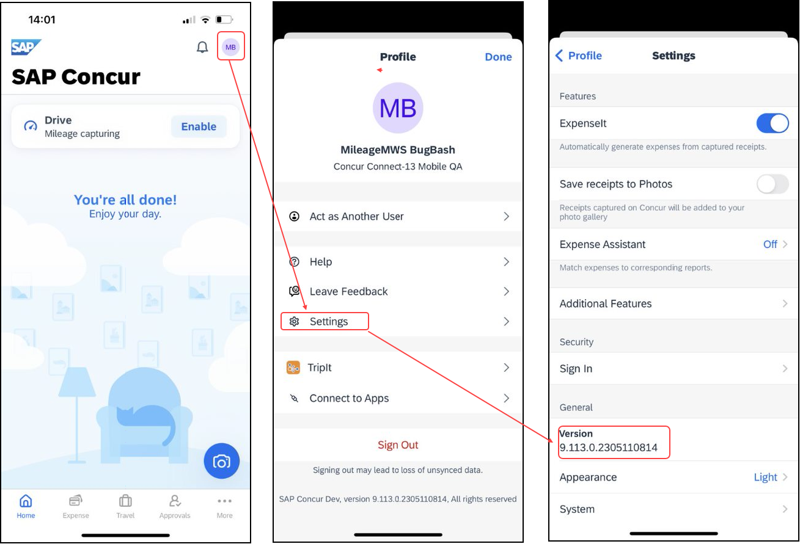

Locate Version Information on the Android
To check the version number on the Android:
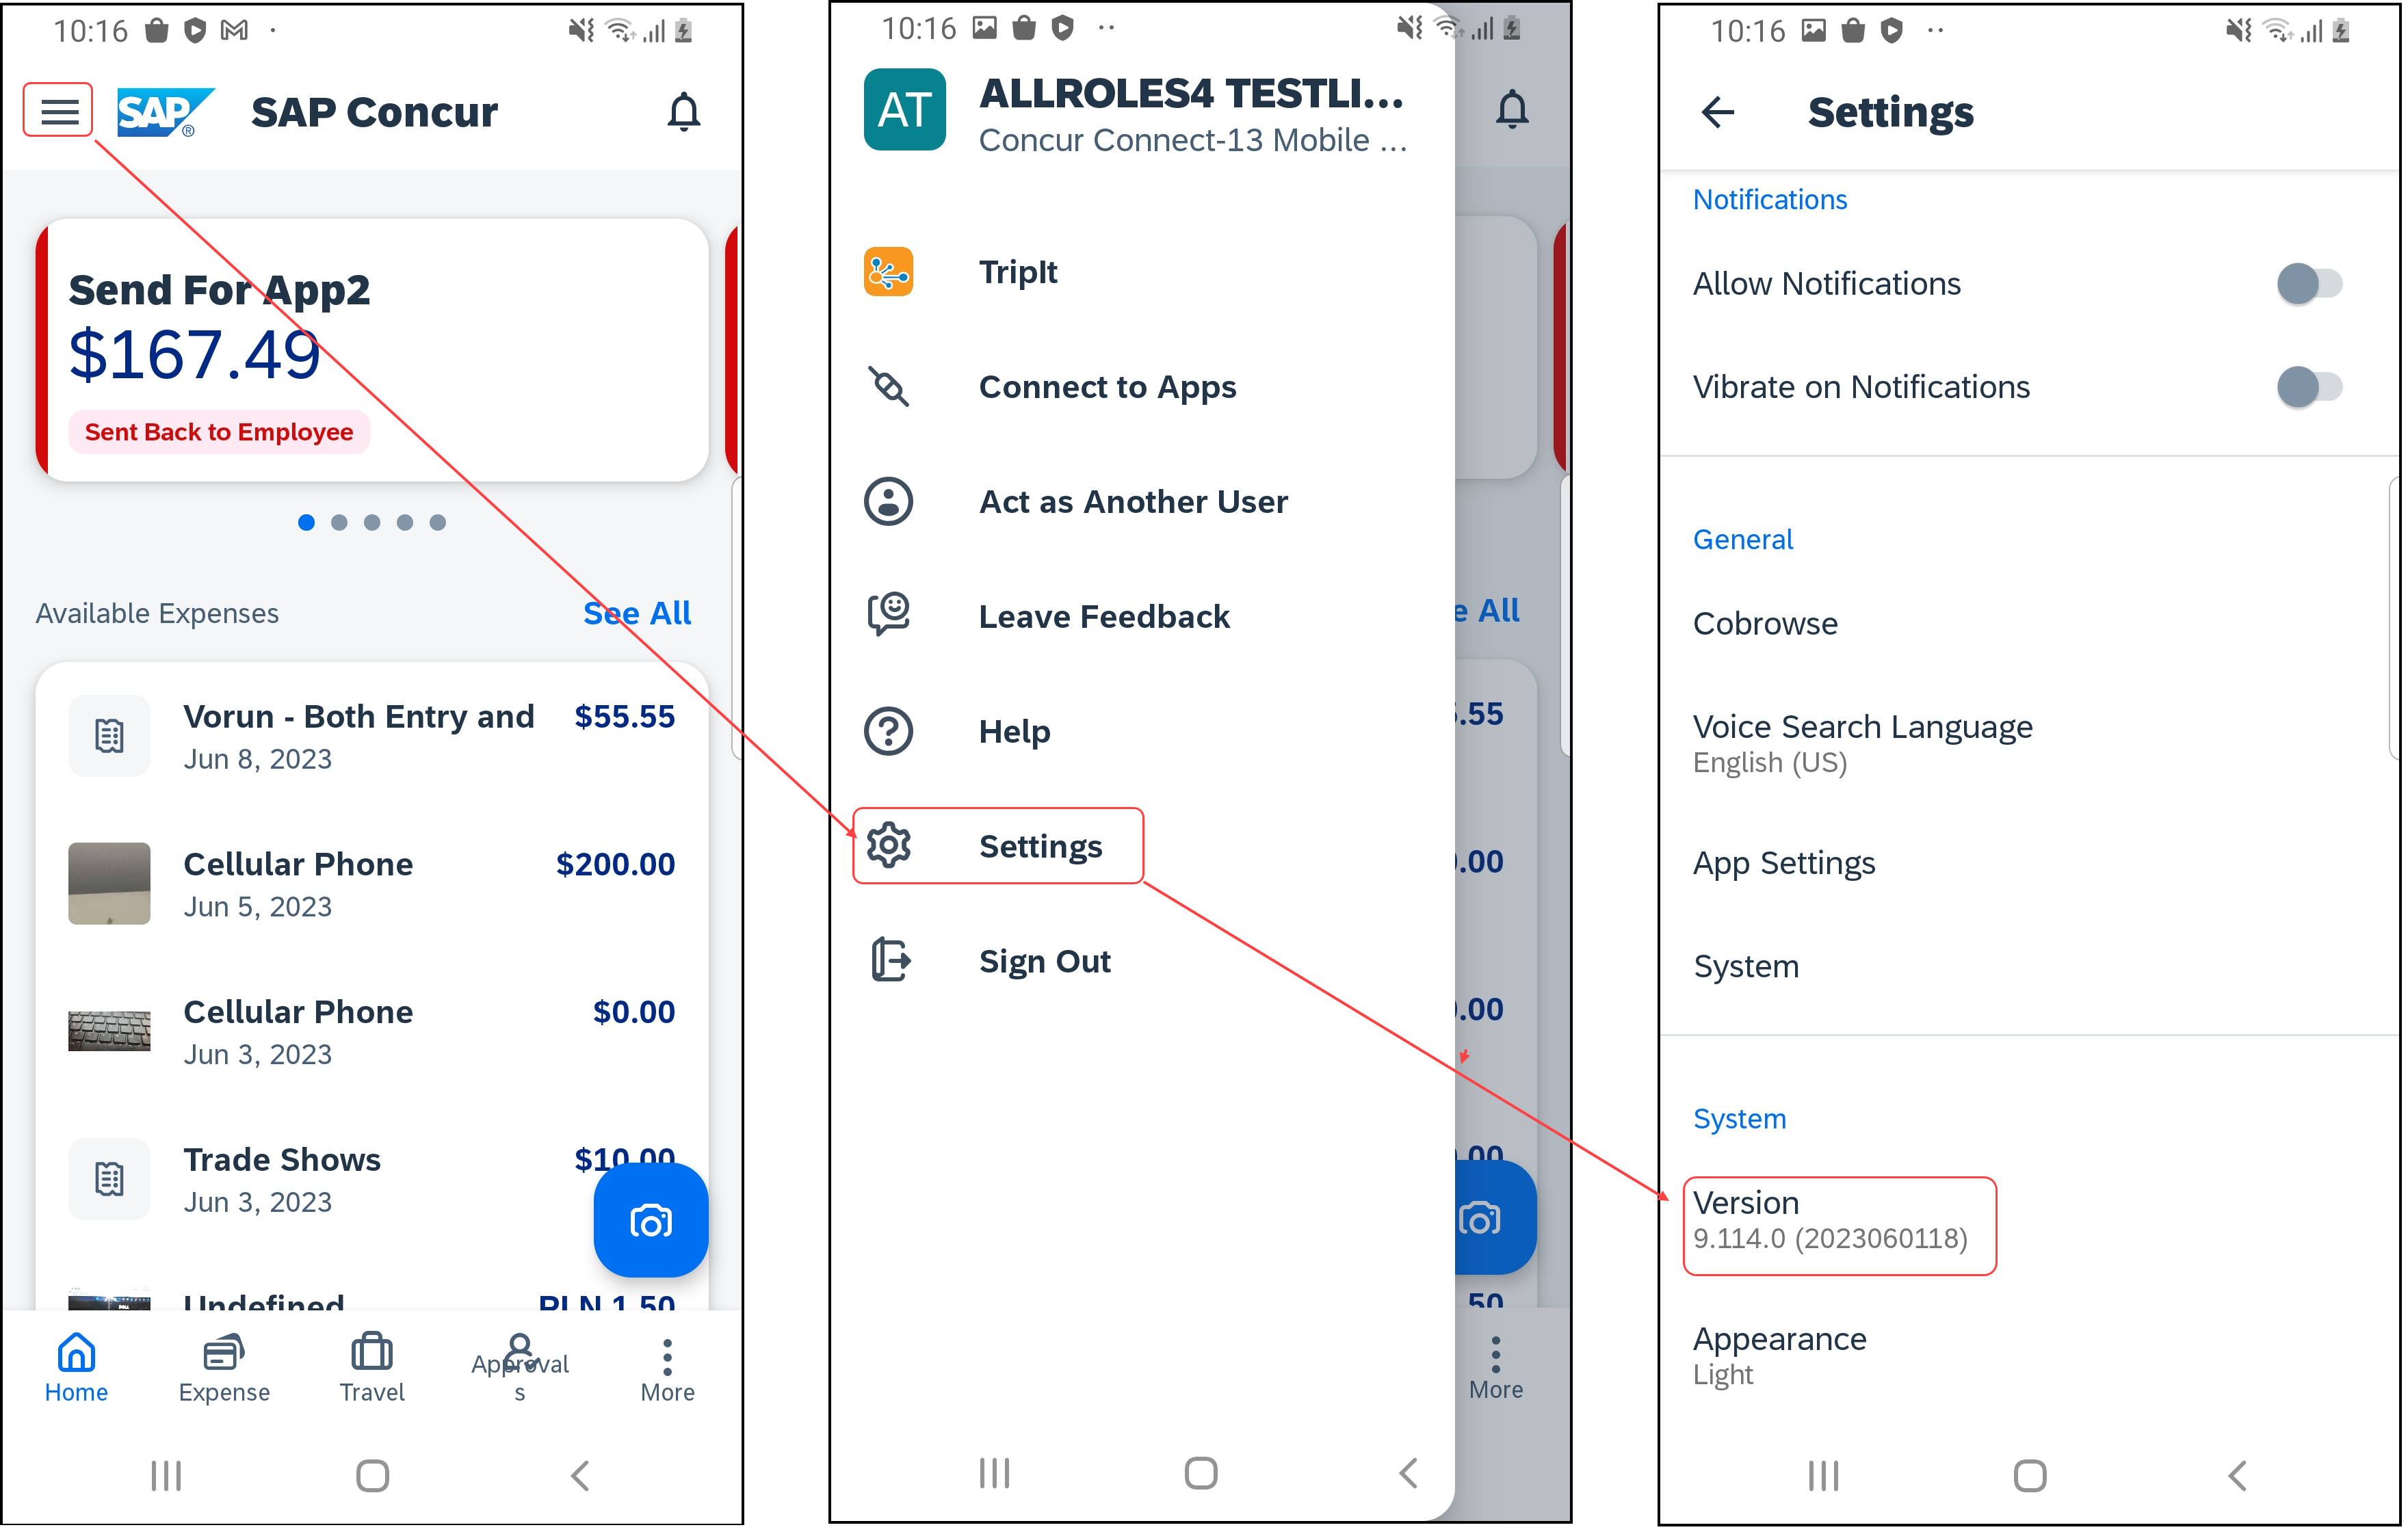

Bug Fixes

Platform | OS | Highlights

Additions

There are no new additions with this release.

Release Notes

New Flight Experience: Preferred Airport Configuration

Overview
To provide an enhanced user experience in the Online Booking Tool, Concur Travel has introduced a new function that allows the user to set their preferred airport in their user profile. This is available on both mobile and web experiences.

User/Customer Benefit
This is being introduced to promote feature parity between the new Concur Travel experience and the original Concur Travel experience.

End-User Experience
Once the user has selected a preferred airport, this airport will be auto filled in the Departure field while searching for flights.
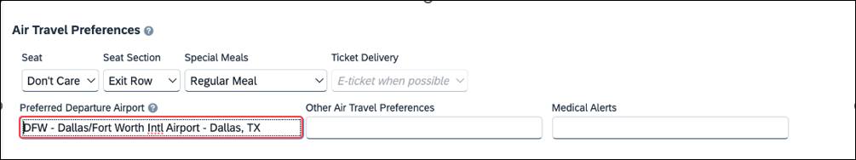
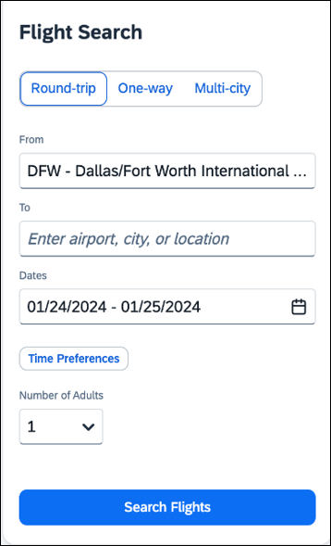
To set the preferred airport in the user profile:
- Select Profile
- Navigate to Travel Profile Options
- Select a Preferred Airport

Configuration for Professional Travel
There are no new configuration steps. The feature is available by default.

Planned Changes

**Planned Changes** New Hotel Experience

Information First Published | Information Last Modified | Feature Target Release Date
March 2023 | October 6, 2023 | January 2024
Any changes since the previous monthly release are highlighted in yellow in this release note.

**Planned Changes** New Hotel Experience: Configuration for Custom Hotel Sourcing

Configuration for Professional Travel

Custom Hotel Source Providers
Hotel content will only be available from Custom Hotel Source providers. This requires re-enablement for customers who are interested in using these channels.
To configure:
- Click Administration > Travel (on the sub-menu) > Travel System Admin and select the desired client travel configuration.
Depending on your permissions, the page may appear immediately after you click Administration or Travel.
- There are now two different Hotel Connector sections of the travel configuration page. One is to support the new hotel connectors and is called Hotel Connectors – Hotel Service v4. The other is the existing hotel connector section.
- When enabling a new connector in the new Concur Travel experience, it is essential that any current direct connect remains enabled otherwise customers will not be able to service bookings made in the current Travel experience. This means that a current HSv2 config needs to remain enabled on HSv2 and also on HSv4 once migrated. The HSv2 connection will not allow new bookings but will only provide access to previously booked reservations for servicing. Any servicing will be carried out as it is today using the OBT.
- The administrator can select the default connection type within the new section. Although GDS is presented as an option, there is no GDS content available with this Release so checking this box will have no effect.
Example:
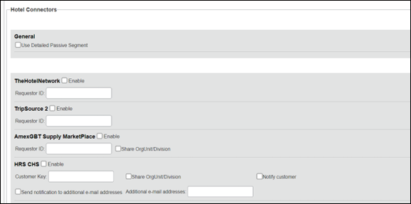
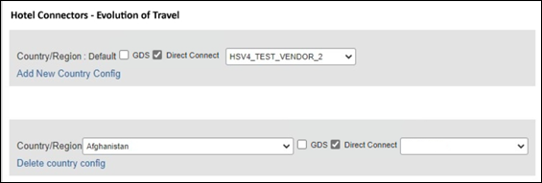

Passive PNR for Direct Content
To configure:
- Go to Administration > Travel (on the sub-menu) > Travel System Admin and select the desired client travel configuration.
Depending on your permissions, the page may appear immediately after you click Administration or Travel.
- Under GDS PNR Options of the travel configuration page, go to the activation checkboxes.
- Select New Custom Hotel Source in the list under Defaults for Specific non-GDS vendors. This defaults to Use the default specified above. Select Write passive segments for non-GDS content if I have not specified a default for the specific vendor in the table below.

Travel Arranger Flow
The Travel Arranger flow will be supported for Hotel. Full details of how to book a hotel as a Travel Arranger are in Travel Arranger View Travel Service Guide.
The Travel Arranger Name appears on the new Trip Overview.
Image to be included in subsequent update.
© 2023 SAP SE or an SAP affiliate company. All rights reserved.
No part of this publication may be reproduced or transmitted in any form or for any purpose without the express permission of SAP SE or an SAP affiliate company.
SAP and other SAP products and services mentioned herein as well as their respective logos are trademarks or registered trademarks of SAP SE (or an SAP affiliate company) in Germany and other countries. Please see http://global12.sap.com/corporate-en/legal/copyright/index.epx for additional trademark information and notices.
Some software products marketed by SAP SE and its distributors contain proprietary software components of other software vendors.
National product specifications may vary.
These materials are provided by SAP SE or an SAP affiliate company for informational purposes only, without representation or warranty of any kind, and SAP SE or its affiliated companies shall not be liable for errors or omissions with respect to the materials. The only warranties for SAP SE or SAP affiliate company products and services are those that are set forth in the express warranty statements accompanying such products and services, if any. Nothing herein should be construed as constituting an additional warranty.
In particular, SAP SE or its affiliated companies have no obligation to pursue any course of business outlined in this document or any related presentation, or to develop or release any functionality mentioned therein. This document, or any related presentation, and SAP SE’s or its affiliated companies’ strategy and possible future developments, products, and/or platform directions and functionality are all subject to change and may be changed by SAP SE or its affiliated companies at any time for any reason without notice. The information in this document is not a commitment, promise, or legal obligation to deliver any material, code, or functionality. All forward-looking statements are subject to various risks and uncertainties that could cause actual results to differ materially from expectations. Readers are cautioned not to place undue reliance on these forward-looking statements, which speak only as of their dates, and they should not be relied upon in making purchasing decisions.

