SAP Concur Release Notes
SAP Concur's mobile app
Month | Audience
Version 9.103 - Associated web release: June 2022  Initial Post: Monday, July 11 | Client – FINAL

Contents
Version Information 3
Supported Phone OS 3
Supported Mobile Versions 3
Deprecating Mobile Versions 3
Latest Supported Mobile Versions 3
Bug Fixes 5
Release Notes 6
iPhone / iPad – iOS Version 13 No Longer Supported 6
Overview 6
Android / iPhone / iPad – New Upload File Button Supports Upload of Receipts From Shared File Repository 6
Planned Changes 10
There are no planned changes this month. 10

Legal Disclaimer
The information in this presentation is confidential and proprietary to SAP SE or an SAP affiliate company and may not be disclosed without the permission of SAP SE or the respective SAP affiliate company. This presentation is not subject to your license agreement or any other service or subscription agreement with SAP SE or its affiliated companies. SAP SE and its affiliated companies have no obligation to pursue any course of business outlined in this document or any related presentation, or to develop or release any functionality mentioned therein. This document, or any related presentation and SAP SE or an SAP affiliate company’s strategy and possible future developments, products and or platforms directions and functionality are all subject to change and may be changed by SAP SE and its affiliated companies at any time for any reason without notice. The information in this document is not a commitment, promise or legal obligation to deliver any material, code or functionality. This document is provided without a warranty of any kind, either express or implied, including but not limited to, the implied warranties of merchantability, fitness for a particular purpose, or non-infringement. This document is for informational purposes and may not be incorporated into a contract. SAP SE and its affiliated companies assume no responsibility for errors or omissions in this document, except if such damages were caused by SAP SE or an SAP affiliate company’s willful misconduct or gross negligence.
All forward-looking statements are subject to various risks and uncertainties that could cause actual results to differ materially from expectations. Readers are cautioned not to place undue reliance on these forward-looking statements, which speak only as of their dates, and they should not be relied upon in making purchasing decisions.

Version Information

Supported Phone OS
Device | Operating System
Apple iPhone | Version 14.0 or greater – users will be able to upgrade to the current version
Apple iPad | Version 14.0 or greater – users will be able to upgrade to the current version
Google Android | Version 8.0 or greater – users will be able to upgrade to the current version

Supported Mobile Versions
Note the following:
- Applicable for 9.101 and newer: If the current mobile app on your mobile device is older than the two latest versions, you will be notified - through a Message Center message and push notifications – that you should update the app to the latest version.
- If you have a version of the app older than the last three versions on your mobile device, you will see an upgrade notice on the login page and will need to update the app to the latest version or you will no longer be able to access the SAP Concur mobile app on your device.
The SAP Concur mobile app will not be removed from mobile devices that have a version of the app older than the last three versions.
- For more information on the retention policy, refer to this FAQ.

Deprecating Mobile Versions
Platform | Deprecating Version
iPhone/iPad | 9.98, 9.99, 9.100
Android | 9.98, 9.99, 9.100

Latest Supported Mobile Versions
Platform | Latest Version | Available | How to Update
iPhone/iPad | 9.103.1 | Thursday, July 7 | Update via App Store
Android | 9.103.1 | Thursday, July 7 | Update via Google Play

Locate Version Information on the iPhone
To check the version number on the iPhone:
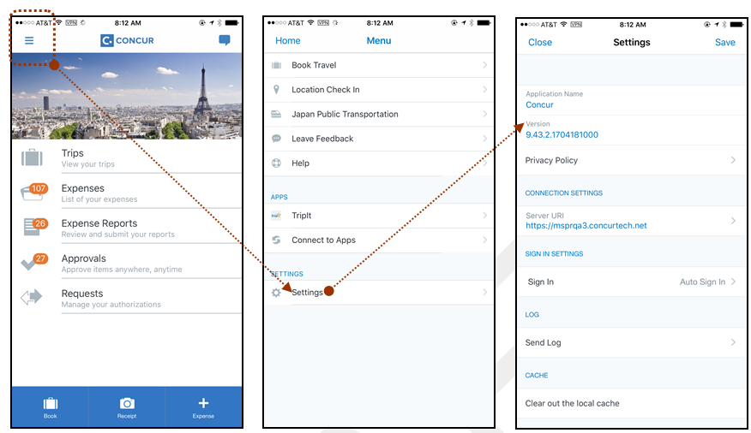

Locate Version Information on the Android
To check the version number on the Android:
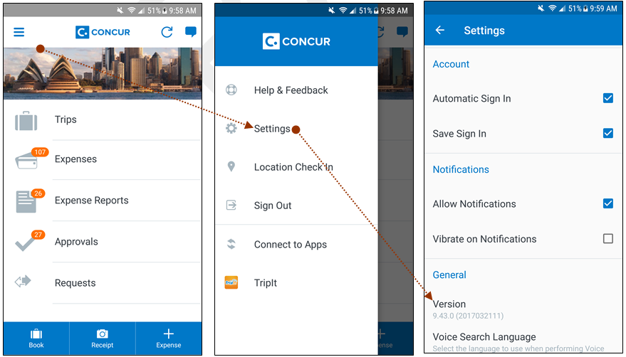

Bug Fixes

Platform | OS | Highlights

Release Notes

iPhone / iPad – iOS Version 13 No Longer Supported

Overview

Information First Published | Information Last Modified | Feature Target Release Date
June 8, 2022 | July 11, 2022 | June 2022 (9.103.1)
SAP Concur solutions updates the minimum operating system regularly to ensure the best possible experience for mobile users. With this release, SAP Concur solutions will update the minimum operating system to iOS 14.
The May (9.102) Mobile release was the final release for version 13 of the iPhone / iPad operating system. Please ensure that the operating system on all user devices have been updated to at least iOS 14. Be aware that users will not be forced to upgrade their device’s operating system, but users on older operating systems will not be able to install versions of the SAP Concur mobile app with the release of 9.103.1.
For SAP Concur solutions – and all other mobile apps – encourage your users to keep their operating systems (and devices, if possible) current.

Configuration / Feature Activation
The change occurs automatically; there are no additional configuration or activation steps.

Android / iPhone / iPad – New Upload File Button Supports Upload of Receipts From Shared File Repository

Overview
With this release, the SAP Concur Mobile app supports uploading a receipt image (such as a PDF) using a new Upload File button, available when working with an expense at the report, details, or list levels.
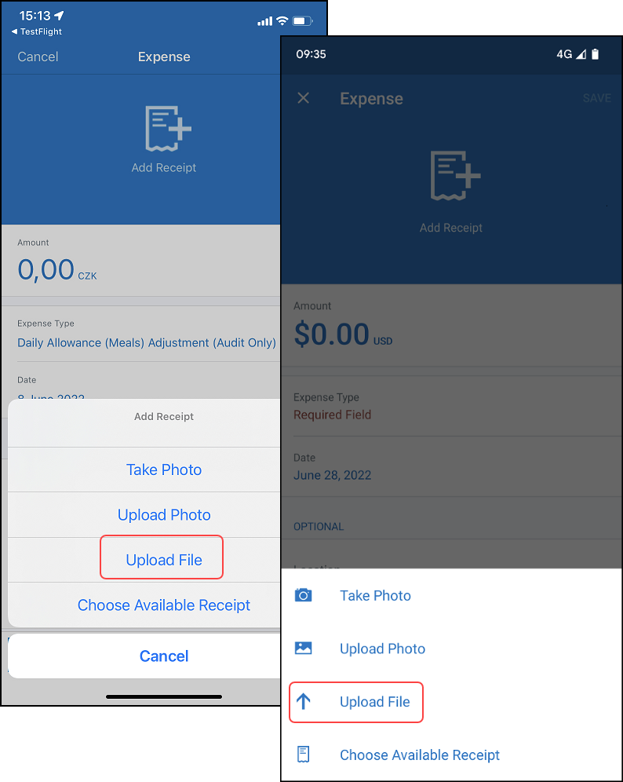
This means that a receipt shared to a phone’s common file repository from any other app (Gmail; Slack; etc.) may be uploaded directly from the repository to an expense using this new button functionality.

Conditions
Note the following when using this functionality:
- The size of the PDF:
- Cannot exceed 10 MB for most users
- Cannot exceed 45 MB for GRDC and eBunsho users
- GRDC users:
- Will always see a message indicating that the receipt cannot be certified
- Can only upload the PDF file to a Single Expense List view
- Offline mode is supported for all scenarios

How it Works
The receipt is shared from the source app to the Recent file repository shared by all the phone’s apps (Slack’s Upload file shown below).
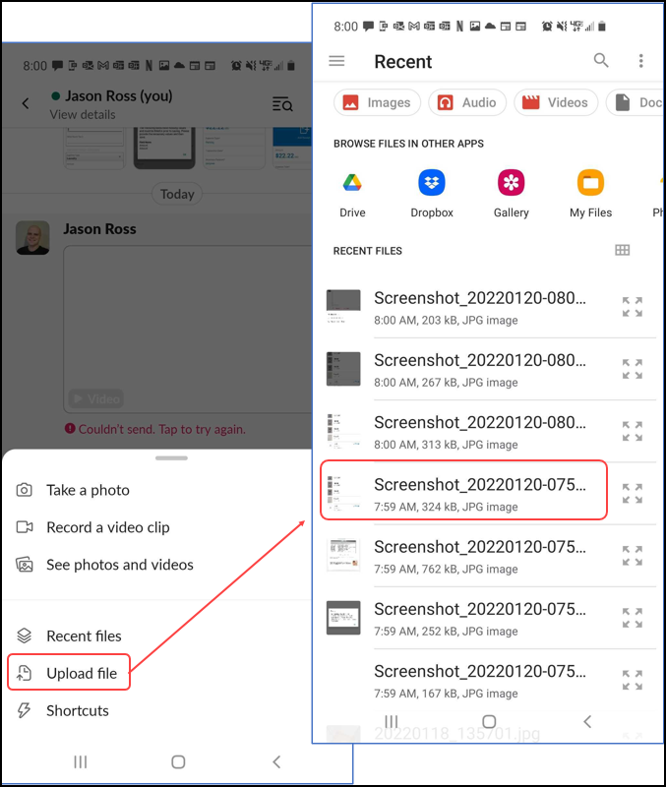
The Mobile user may then attach the receipt using the Upload File button.
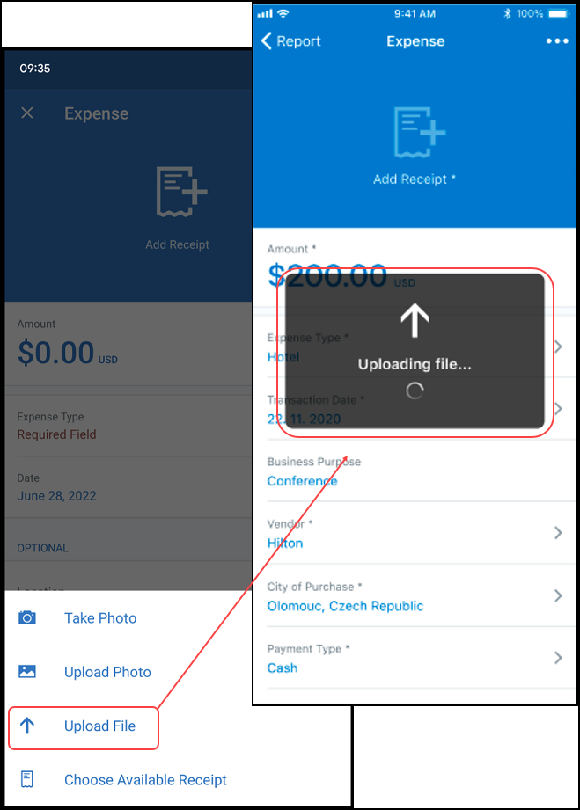
Any of the following methods are available depending on the preferred navigation for attachment (List; Details; Report) and any restrictions:
- Single Expense List: Tap + > Add Receipts > Upload File
NOTE: This is the only method supported for GRDC users.
- Expense Details: Tap Add Receipt > Upload File
- Expense Report: Tap View Receipt > Append Receipt > Upload File

Configuration / Feature Activation
The change occurs automatically; there are no additional configuration or activation steps.
- For more information, see the Mobile App User Guide – Receipts guide.

Planned Changes

There are no planned changes this month.
© 2022 SAP SE or an SAP affiliate company. All rights reserved.
No part of this publication may be reproduced or transmitted in any form or for any purpose without the express permission of SAP SE or an SAP affiliate company.
SAP and other SAP products and services mentioned herein as well as their respective logos are trademarks or registered trademarks of SAP SE (or an SAP affiliate company) in Germany and other countries. Please see http://global12.sap.com/corporate-en/legal/copyright/index.epx for additional trademark information and notices.
Some software products marketed by SAP SE and its distributors contain proprietary software components of other software vendors.
National product specifications may vary.
These materials are provided by SAP SE or an SAP affiliate company for informational purposes only, without representation or warranty of any kind, and SAP SE or its affiliated companies shall not be liable for errors or omissions with respect to the materials. The only warranties for SAP SE or SAP affiliate company products and services are those that are set forth in the express warranty statements accompanying such products and services, if any. Nothing herein should be construed as constituting an additional warranty.
In particular, SAP SE or its affiliated companies have no obligation to pursue any course of business outlined in this document or any related presentation, or to develop or release any functionality mentioned therein. This document, or any related presentation, and SAP SE’s or its affiliated companies’ strategy and possible future developments, products, and/or platform directions and functionality are all subject to change and may be changed by SAP SE or its affiliated companies at any time for any reason without notice. The information in this document is not a commitment, promise, or legal obligation to deliver any material, code, or functionality. All forward-looking statements are subject to various risks and uncertainties that could cause actual results to differ materially from expectations. Readers are cautioned not to place undue reliance on these forward-looking statements, which speak only as of their dates, and they should not be relied upon in making purchasing decisions.

