SAP Concur Release Notes
SAP Concur's mobile app
Month | Audience
Version 9.65 - Associated web release: January 2019  Initial Post: Wednesday, February 6, 8:30 AM PT | Client – FINAL
Contents
Summary 2
Android 2
iPhone / iPad 2
Version Information 3
Supported Phone OS 3
Mobile Version 3
Release Notes 5
iPhone / iPad – Operating System Update 5
Android – Operating System Update 5
**Reminder** Android / iPhone / iPad – ExpenseIt: On-Device Receipt Recognition 5
On-Device Receipt Recognition - iPhone 6
On-Device Receipt Recognition - Android 7
**Reminder** Android / iPhone / iPad – Multipage Receipt Capture in ExpenseIt 8
Capture Multipage Receipts on Your iPhone Device 9
Capture Multipage Receipts on Your Android Device 10
Android ONLY – New Create Report Process and Report Details Screen 11
Overview 11
Enable/Disable for Changes 13

Legal Disclaimer
The information in this presentation is confidential and proprietary to SAP SE or an SAP affiliate company and may not be disclosed without the permission of SAP SE or the respective SAP affiliate company. This presentation is not subject to your license agreement or any other service or subscription agreement with SAP SE or its affiliated companies. SAP SE and its affiliated companies have no obligation to pursue any course of business outlined in this document or any related presentation, or to develop or release any functionality mentioned therein. This document, or any related presentation and SAP SE or an SAP affiliate company’s strategy and possible future developments, products and or platforms directions and functionality are all subject to change and may be changed by SAP SE and its affiliated companies at any time for any reason without notice. The information in this document is not a commitment, promise or legal obligation to deliver any material, code or functionality. This document is provided without a warranty of any kind, either express or implied, including but not limited to, the implied warranties of merchantability, fitness for a particular purpose, or non-infringement. This document is for informational purposes and may not be incorporated into a contract. SAP SE and its affiliated companies assume no responsibility for errors or omissions in this document, except if such damages were caused by SAP SE or an SAP affiliate company’s willful misconduct or gross negligence.
All forward-looking statements are subject to various risks and uncertainties that could cause actual results to differ materially from expectations. Readers are cautioned not to place undue reliance on these forward-looking statements, which speak only as of their dates, and they should not be relied upon in making purchasing decisions.

Summary

Android
- Android – Operating System Update
- Android ONLY – New Create Report Process and Report Details Screen
- **Reminder** Android / iPhone / iPad – ExpenseIt: On-Device Receipt Recognition
- **Reminder** Android / iPhone / iPad – Multipage Receipt Capture in ExpenseIt
- Minor issue fixes

iPhone / iPad
- iPhone / iPad – Operating System Update
- **Reminder** Android / iPhone / iPad – ExpenseIt: On-Device Receipt Recognition
- **Reminder** Android / iPhone / iPad – Multipage Receipt Capture in ExpenseIt
- Minor issue fixes

Version Information

Supported Phone OS
Device | Operating System
Apple iPhone | Version 10.0 – users can continue to use SAP Concur version 9.64  Version 11.0 or greater – users will be able to upgrade to the current version
Apple iPad | Version 10.0 – users can continue to use SAP Concur version 9.64  Version 11.0 or greater – users will be able to upgrade to the current version
Google Android | Version 5.1 – users can continue to use SAP Concur version 9.64  Version 6.0 or greater – users will be able to upgrade to the current version

Mobile Version
Platform | Latest version | Available | How to update
iPhone/iPad | 9.65.0 | February 5, 2019 | Update via App Store
Android | 9.65.1 | February 5, 2019 | Update via Google Play

Locate Version Information on the iPhone
To check the version number on the iPhone:
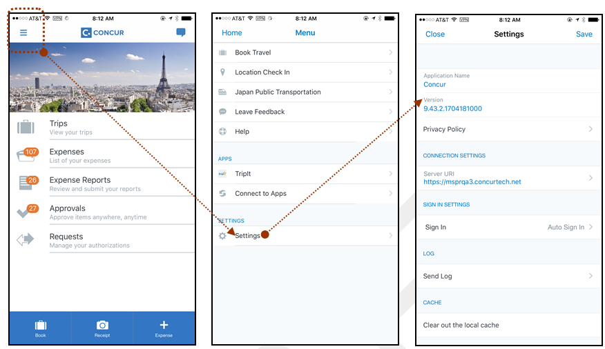

Locate Version Information on the Android
To check the version number on the Android:
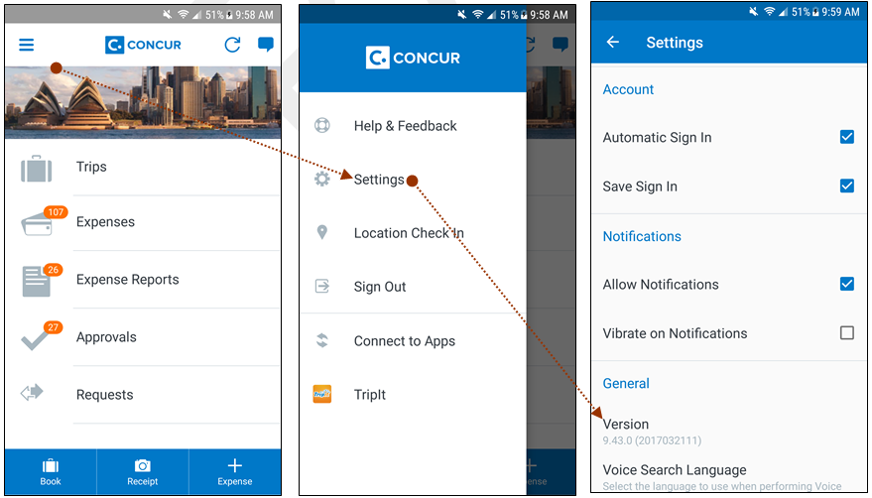

Release Notes

iPhone / iPad – Operating System Update
SAP Concur updates the minimum operating system regularly in order to ensure the best possible experience for mobile users. With this release, SAP Concur will update the minimum operating system to iOS 11.
The December release (9.64) was the final release for version 10 of the iPhone / iPad operating system.
Please ensure that the operating system on all user devices has been updated to at least iOS 11.
Be aware that users will not be forced to upgrade their device’s operating system, but users on older operating systems will not be able to install versions of the SAP Concur mobile app after v9.64.
For SAP Concur – and all other mobile apps – encourage your users to keep their operating systems (and devices, if possible) current.

Android – Operating System Update
SAP Concur updates the minimum operating system regularly in order to ensure the best possible experience for mobile users. With this release, SAP Concur will update the minimum operating system to API 23 (v6.0).
The December release (9.64) will be the final release for versions v5.0, 5.1 (Android Lollipop API 22 & 23) of the Android operating system.
Please ensure that the operating system on all user devices has been updated to at least API 23 (v6.0).
Be aware that users will not be forced to upgrade their device’s operating system, but users on older operating systems will not be able to install versions of the SAP Concur mobile app after v9.64.
For SAP Concur – and all other mobile apps – encourage your users to keep their operating systems (and devices, if possible) current.

**Reminder** Android / iPhone / iPad – ExpenseIt: On-Device Receipt Recognition
This feature was implemented after the December (9.64) release and this release note is a reminder that this feature is now fully implemented and ready to use.
With this release, ExpenseIt users now have access to the new ExpenseIt on-device receipt recognition feature - within the SAP Concur mobile app. Adding this technology enables users to process certain receipt information directly from the SAP Concur mobile app, instead of that information being processed in a server.
On-device processing will increase both speed and accuracy as well as allow SAP Concur to support an offline experience.
When the user captures a receipt in ExpenseIt the on-device receipt recognition feature will pick the top amount found on the receipt and propose it for use. If the amount is not found or incorrect, the user can enter it manually.

On-Device Receipt Recognition - iPhone

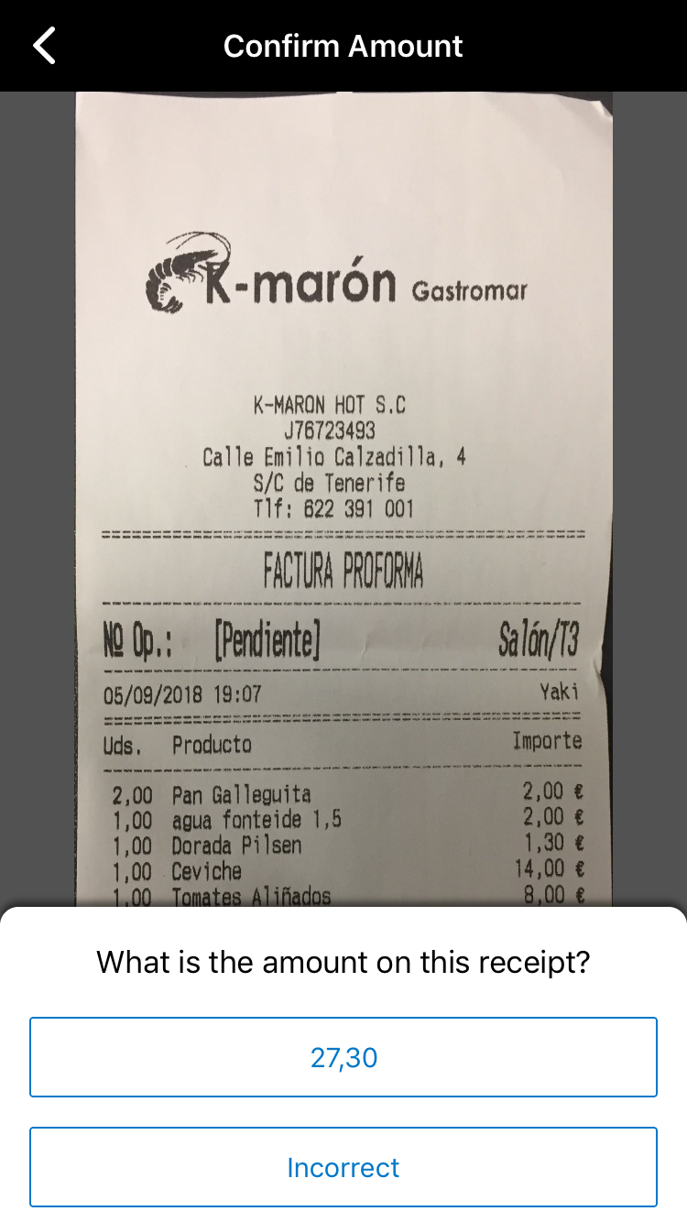
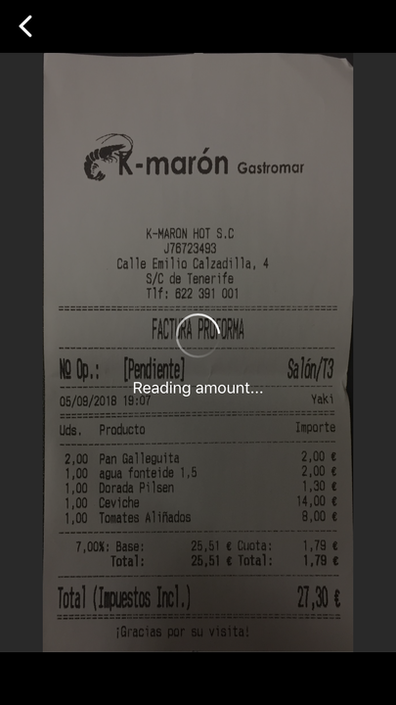
Automatically Detect Receipt Amount
To convert a receipt amount automatically in ExpenseIt:
1) On the home screen, tap ExpenseIt.
2) On the Confirm Amount screen, either:
Tap the amount.
-or-
Tap Incorrect to enter an appropriate amount.

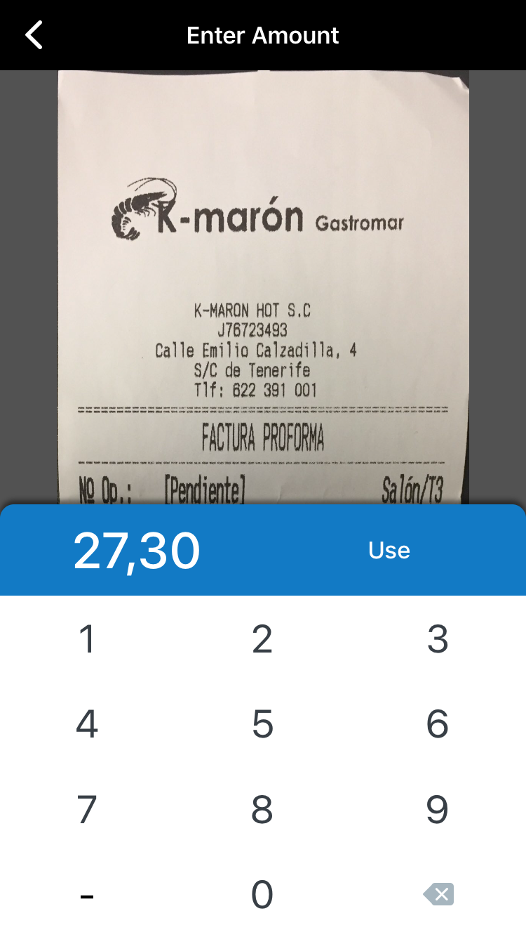
Manually Enter the Correct Receipt Amount
To manually enter the correct receipt amount:
1) On the Confirm Amount screen, tap Incorrect.
2) On the Enter Amount screen, enter the appropriate amount and tap Use when finished.
3) On the Finalise screen, either:
Tap Next receipt to go to the next receipt.
-or-
Tap Done to finish.

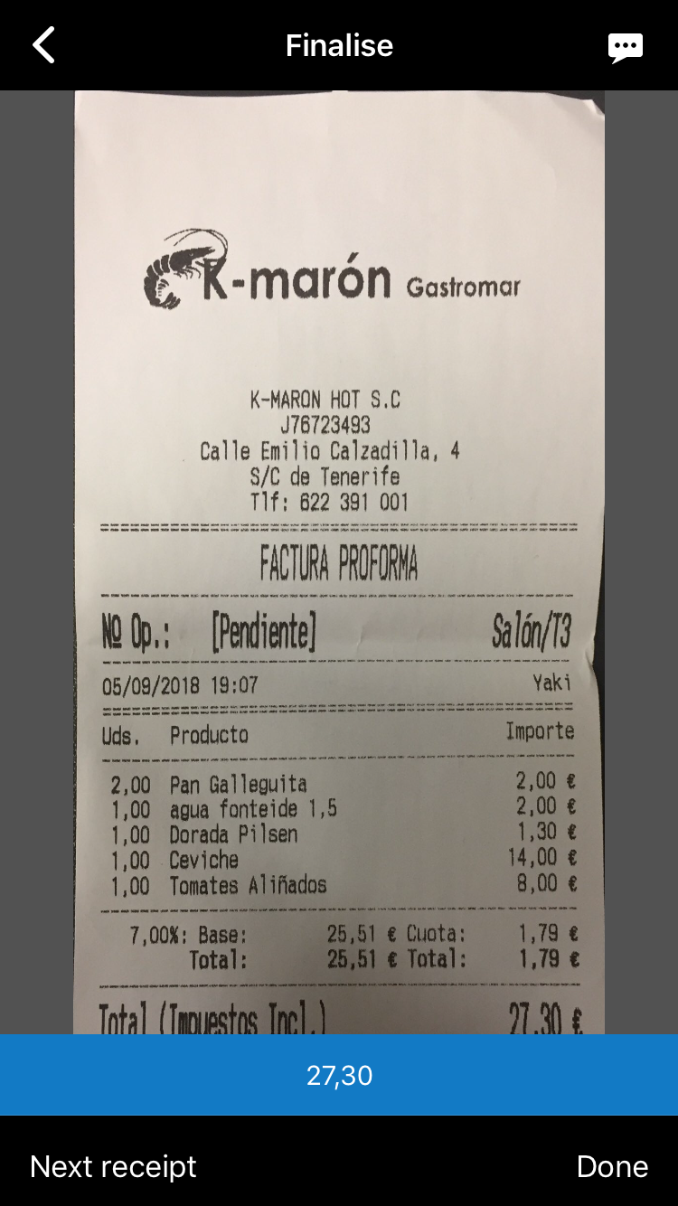

On-Device Receipt Recognition - Android


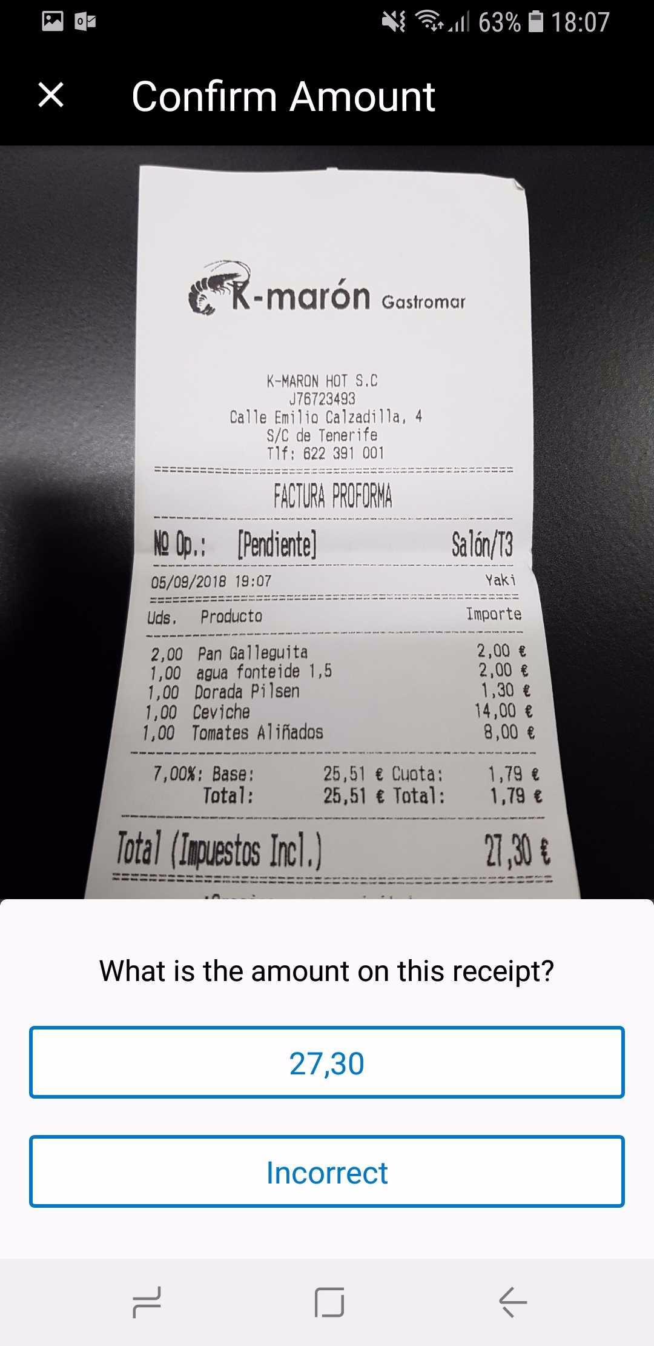
Automatically Detect Receipt Amount
To convert a receipt amount automatically in ExpenseIt:
1) On the home screen, tap ExpenseIt.
2) On the Confirm Amount screen, either:
Tap the amount.
-or-
Tap Incorrect to enter an appropriate amount.

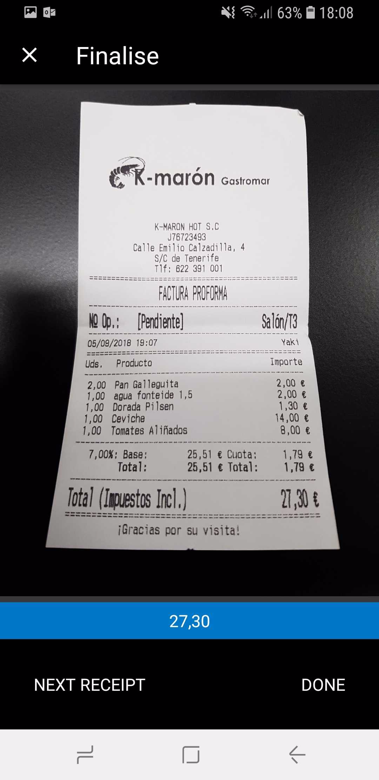
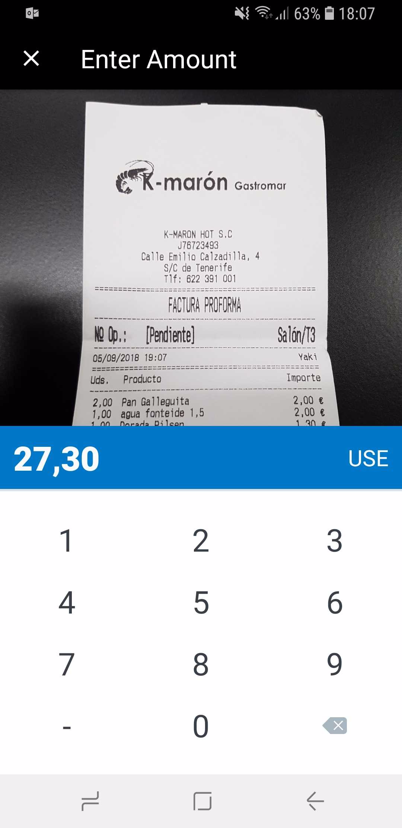
Manually Enter the Correct Receipt Amount
To manually enter the correct receipt amount:
1) On the Confirm Amount screen, tap Incorrect.
2) On the Enter Amount screen, enter the appropriate amount and tap Use when finished.
3) On the Finalise screen, either:
Tap Next receipt to go to the next receipt.
-or-
Tap Done to finish.

**Reminder** Android / iPhone / iPad – Multipage Receipt Capture in ExpenseIt
This feature was implemented after the December (9.64) release and this release note is a reminder that this feature is now fully implemented and ready to use.
With this release, SAP Concur announces that the new multipage capture feature will be available to ExpenseIt users in the SAP Concur mobile app. This feature enhances the user experience and will be available to ExpenseIt users over a period of time.
This feature enables users to capture their receipts with multiple pages (for example hotel invoices or phone bills) directly into the SAP Concur mobile app, instead of sending an email or by other means.

Capture Multipage Receipts on Your iPhone Device

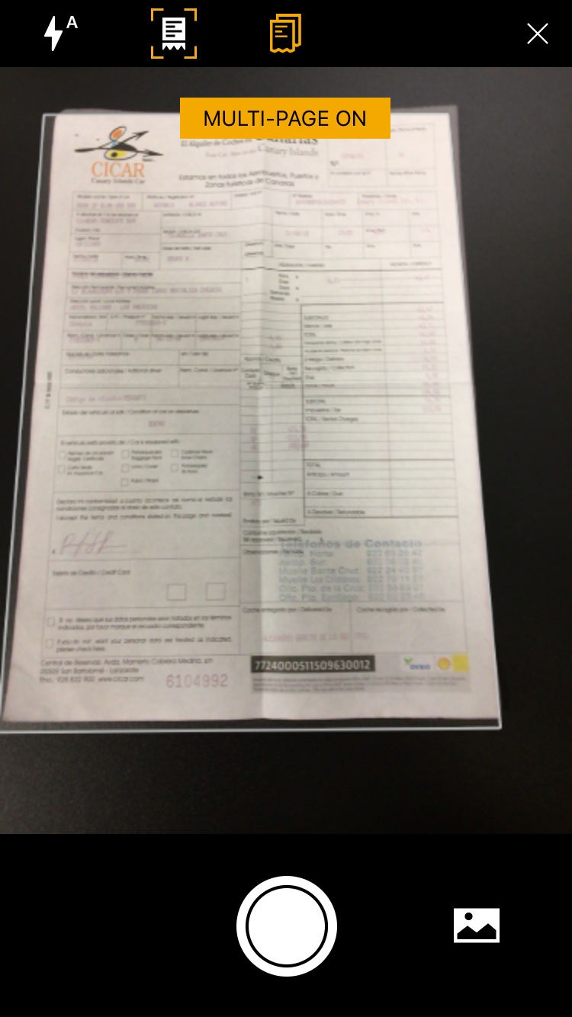
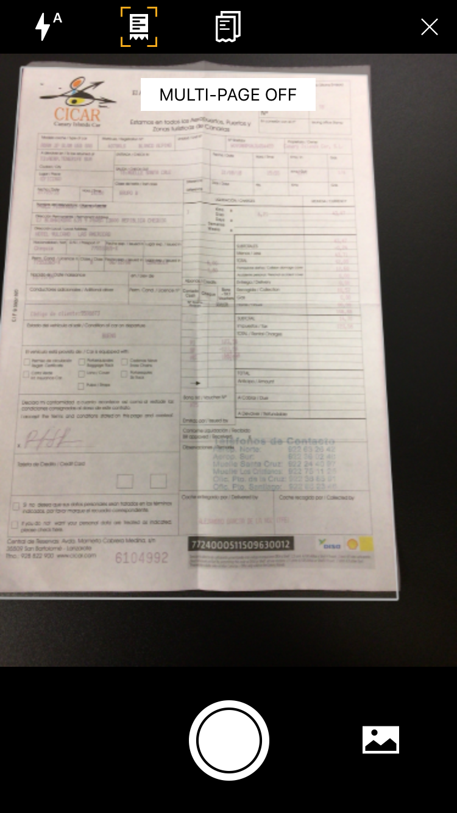
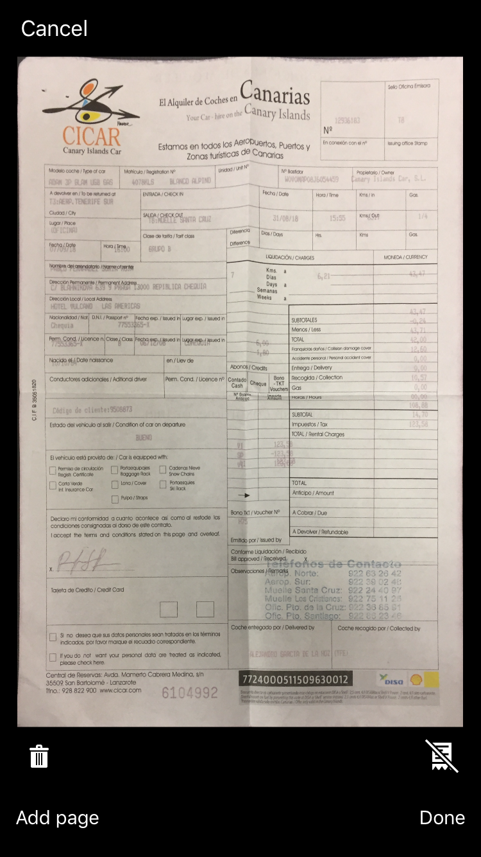
iPhone
To capture multipage receipts:
1) On the home screen, tap ExpenseIt.
2) On the camera screen, tap
.
3) On the next camera screen, tap
.
4) On the next camera screen, tap either:
Add page
– or –
Done
– or –
Cancel
– or –
(Delete)

This number indicates how many receipts have already been captured. Tap to view previously captured receipts.

Capture Multipage Receipts on Your Android Device

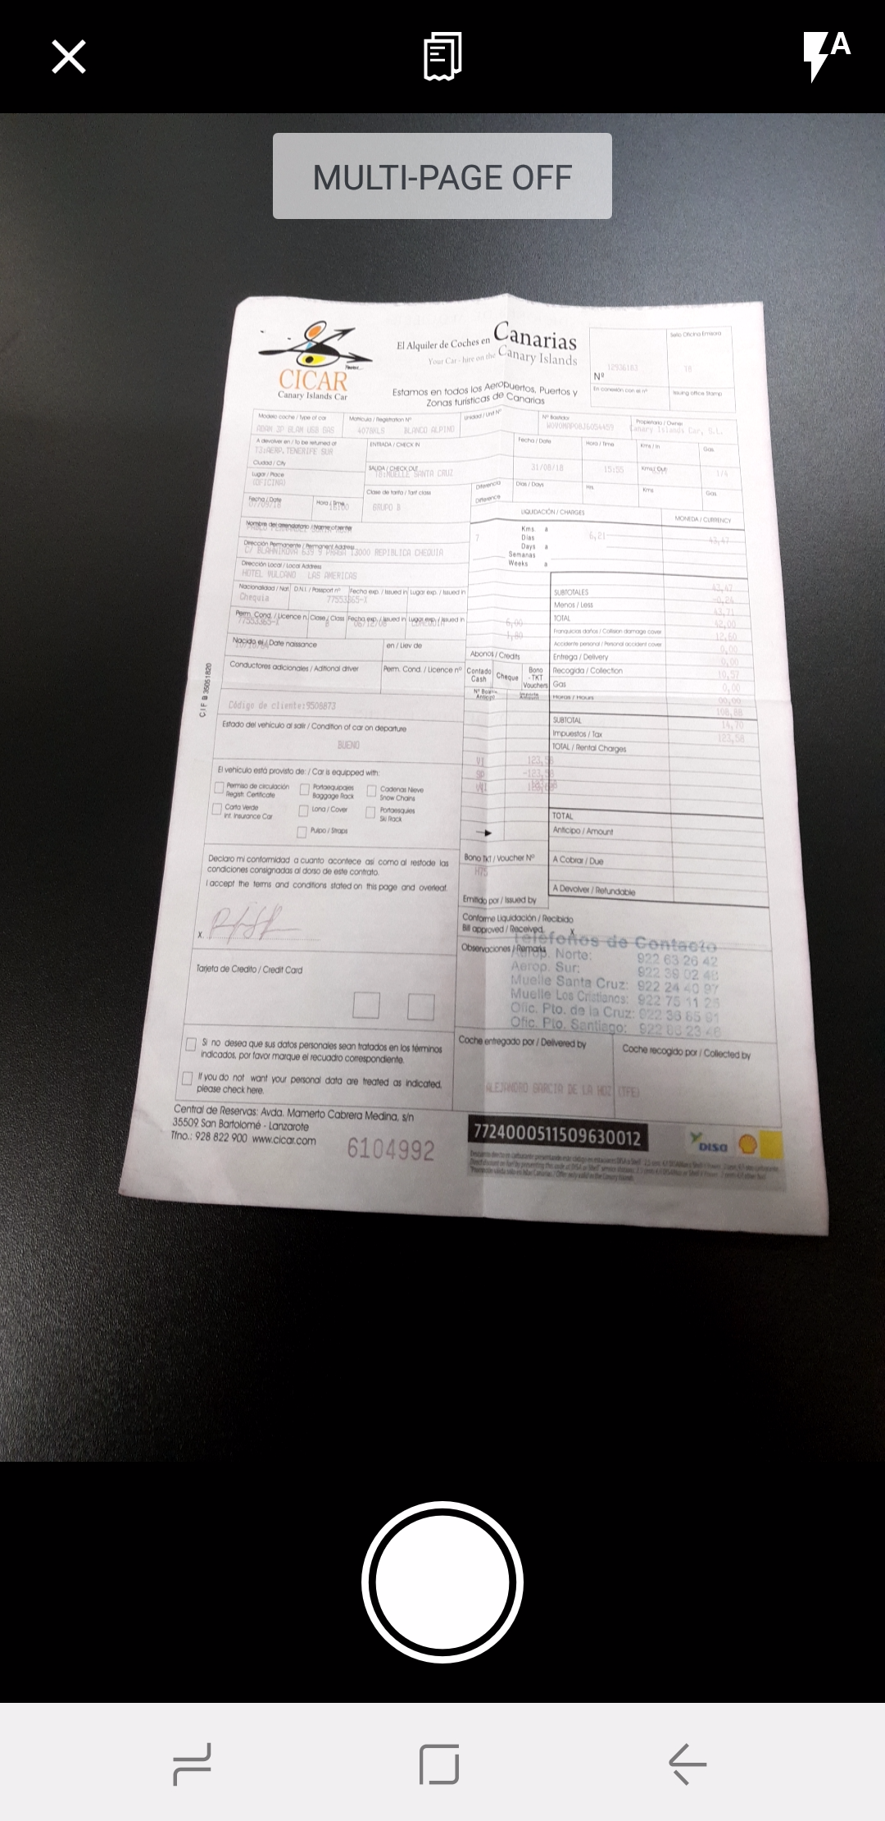
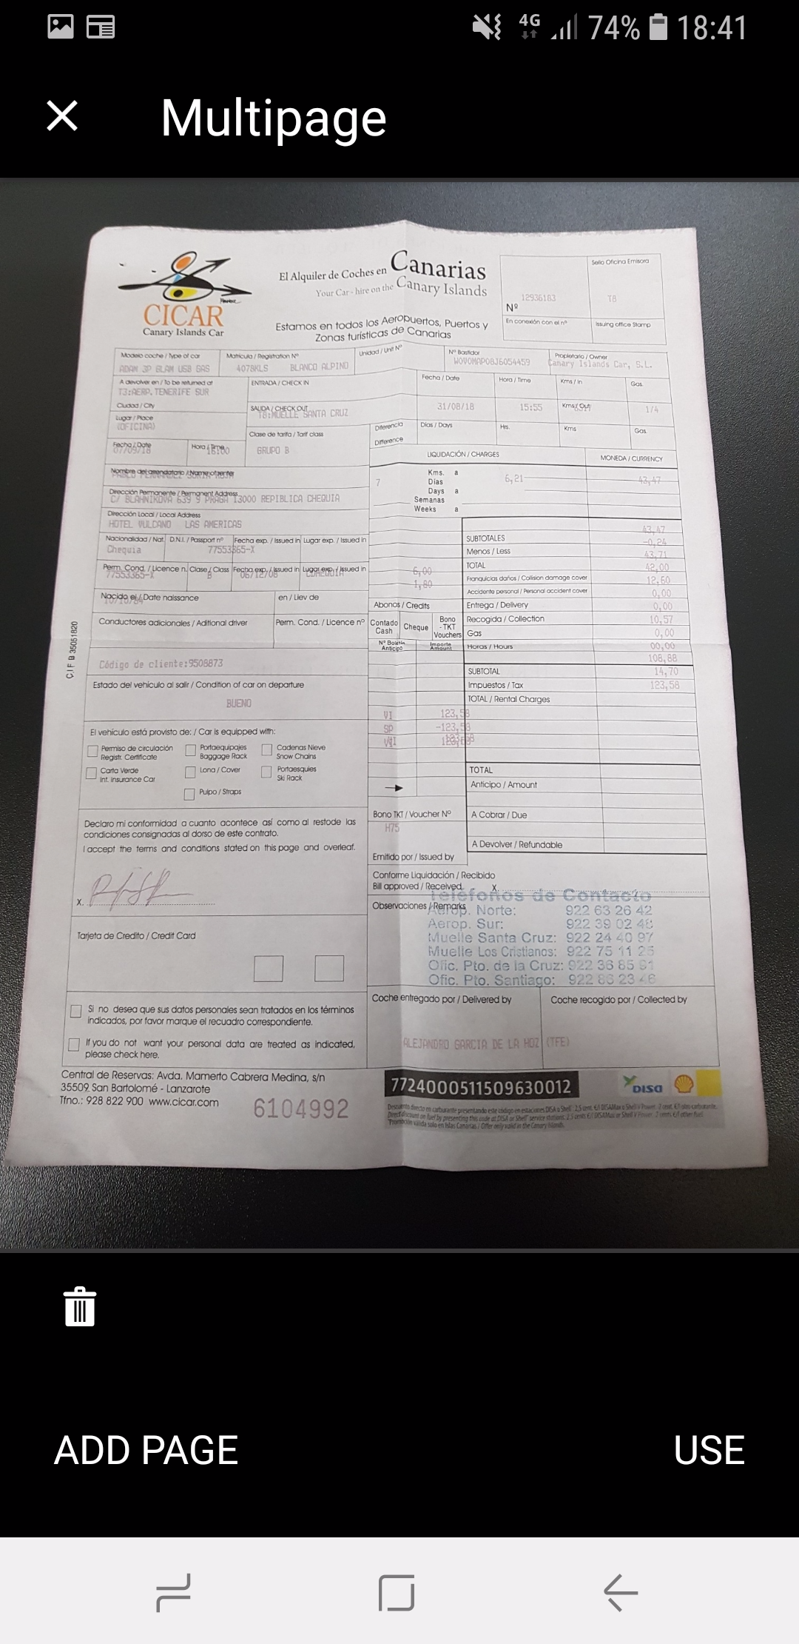
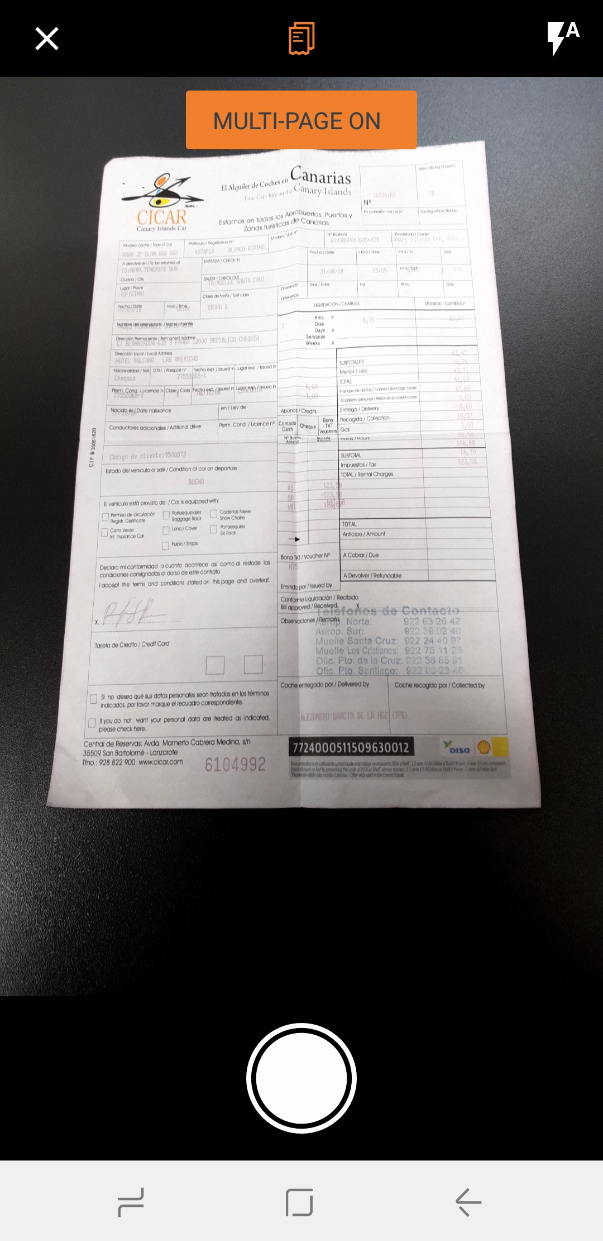
Android
To capture multipage receipts:
1) On the home screen, tap ExpenseIt.
2) On the camera screen, tap
.
3) On the next camera screen, tap
.
4) On the next camera screen, tap either:
Add page
– or –
Use
– or –
(Exit)
– or –
(Delete)

Android ONLY – New Create Report Process and Report Details Screen

Overview
Earlier this year, the new Report List screen was launched on iOS with the Active and History tabs, allowing users to more easily view their active and prior reports. With this release, SAP Concur is excited to introduce improvements to this experience - for Android users only - by creating a new report and viewing the report screen with in the SAP Concur mobile app.
The new screens are designed to bring a more consistent, clean, and easy-to-use experience for users. For report creation, we have focused on better utilizing in-page editing and how users are able to select from lists, calendars, etc.
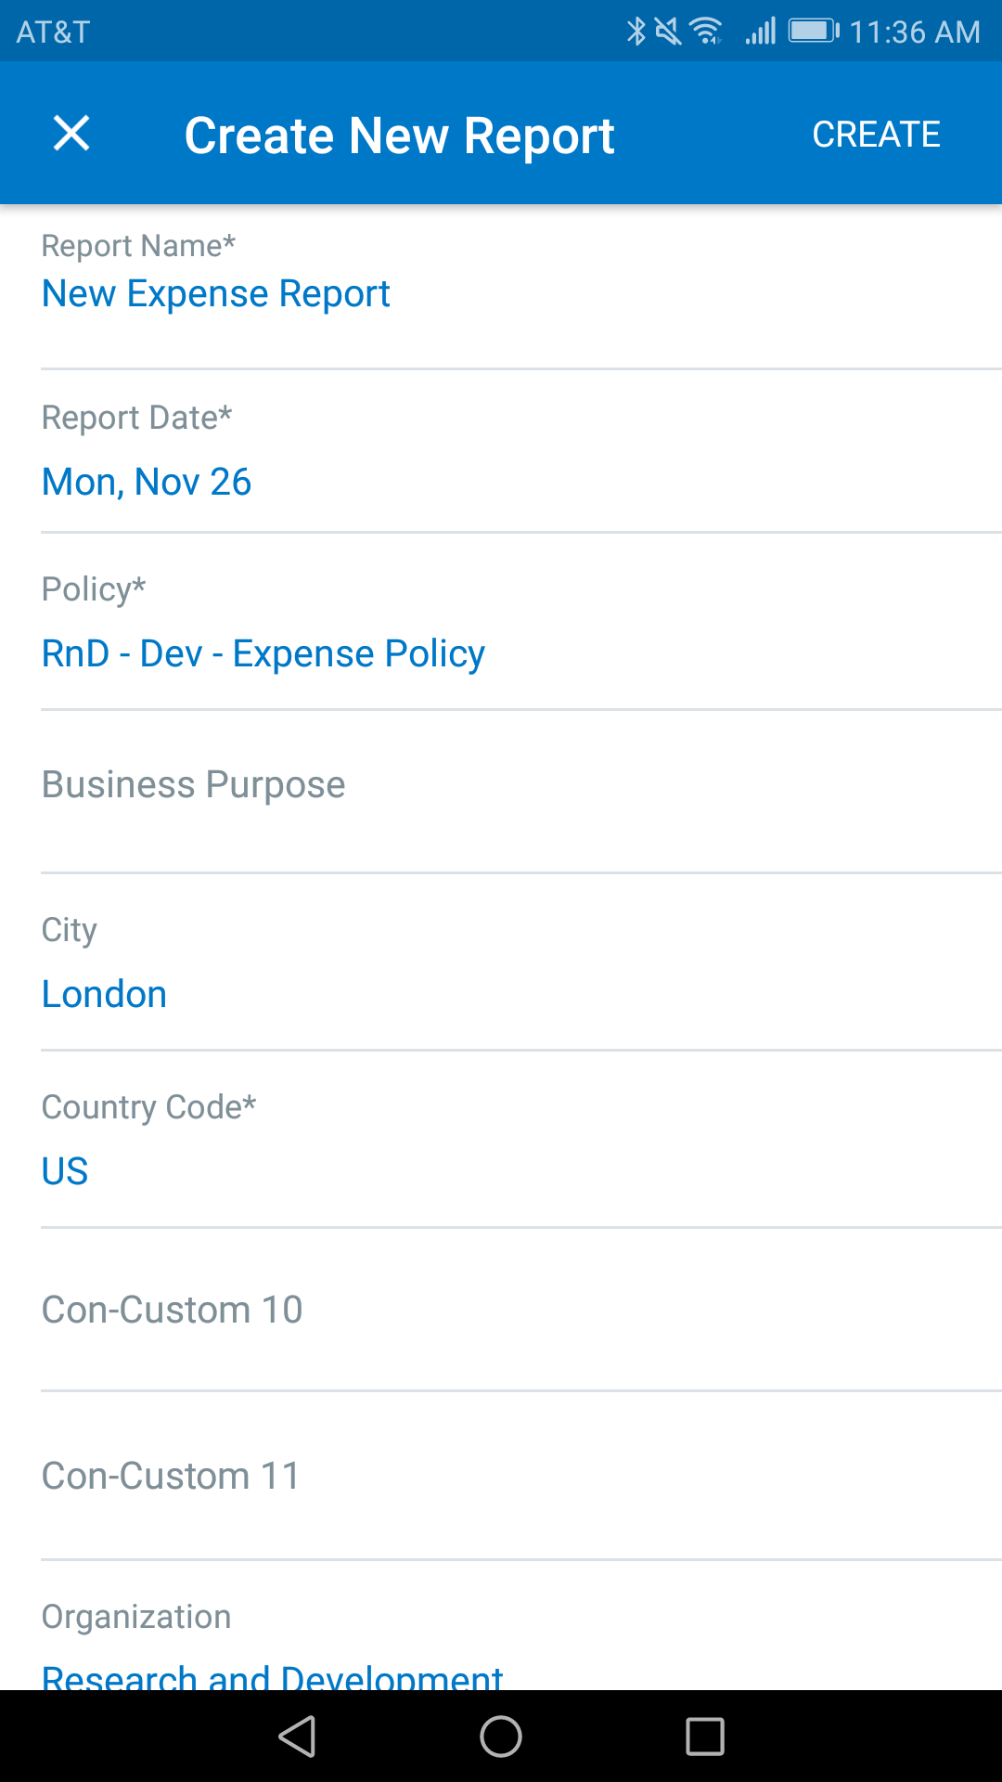
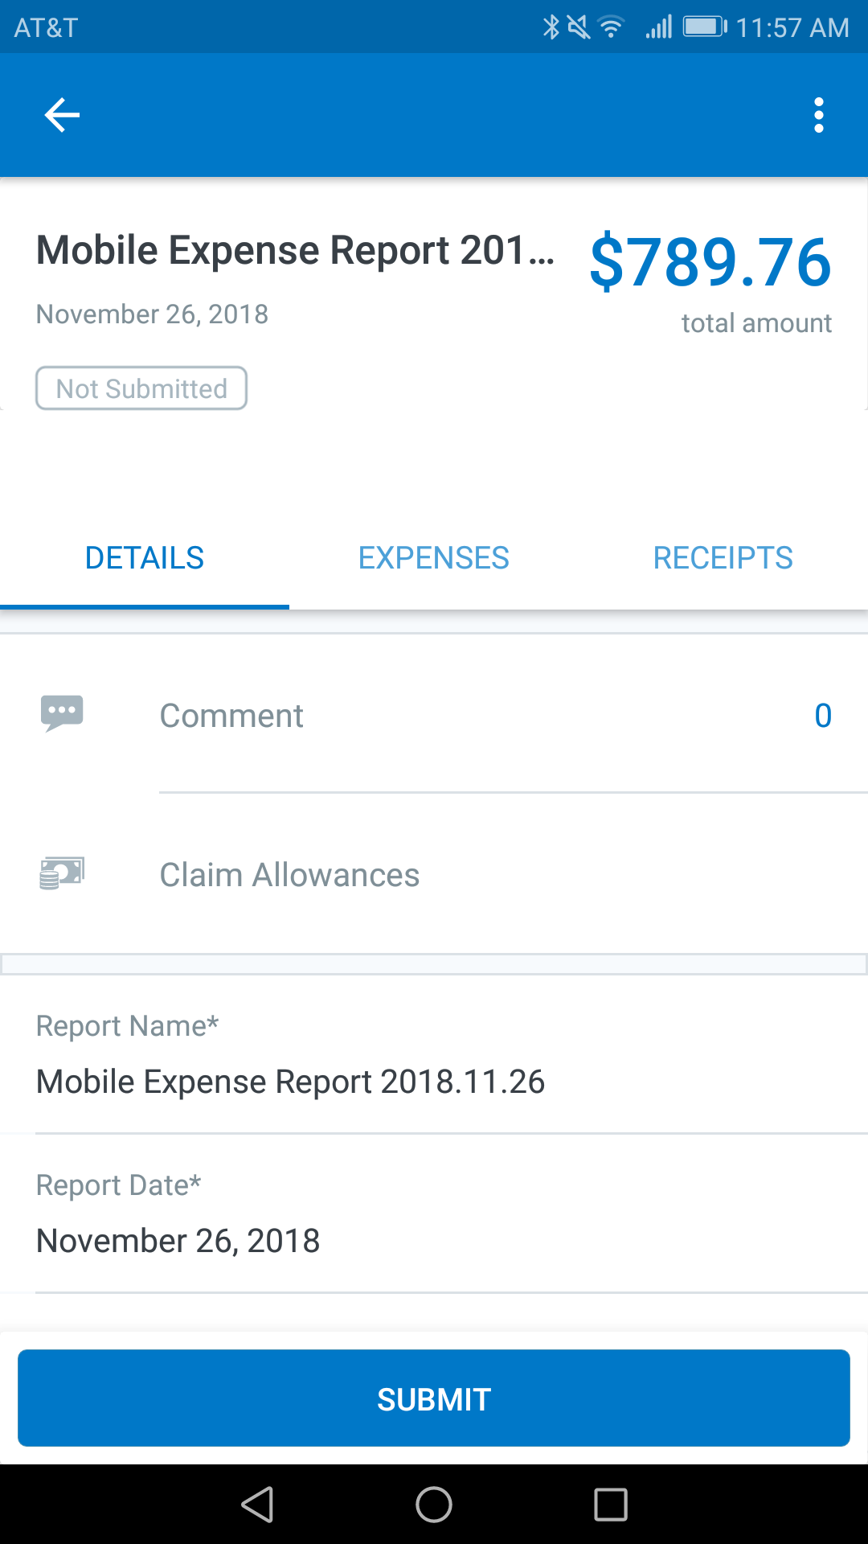
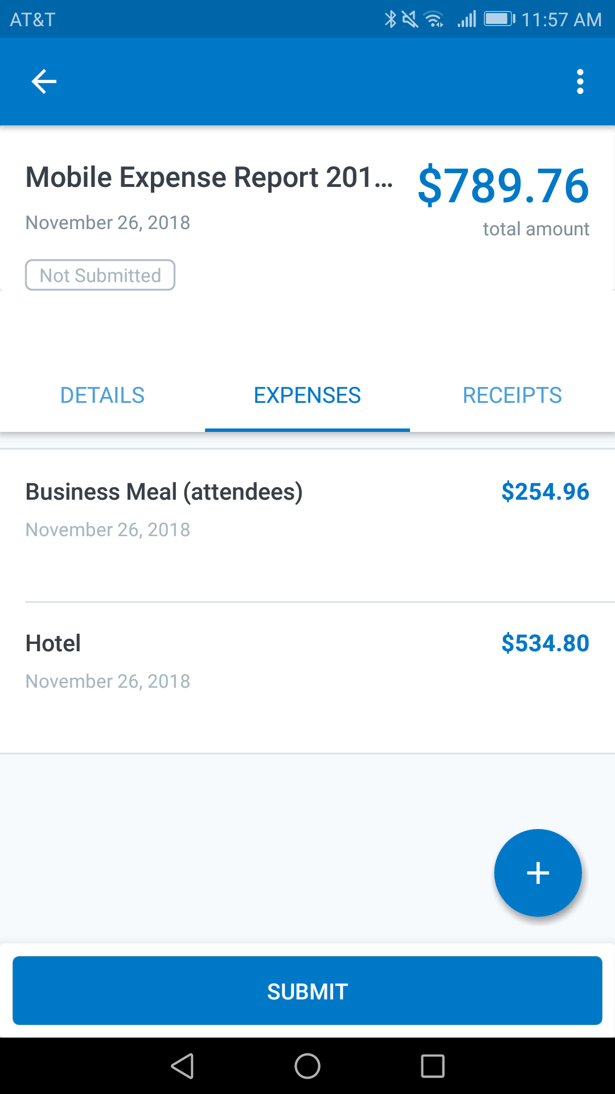
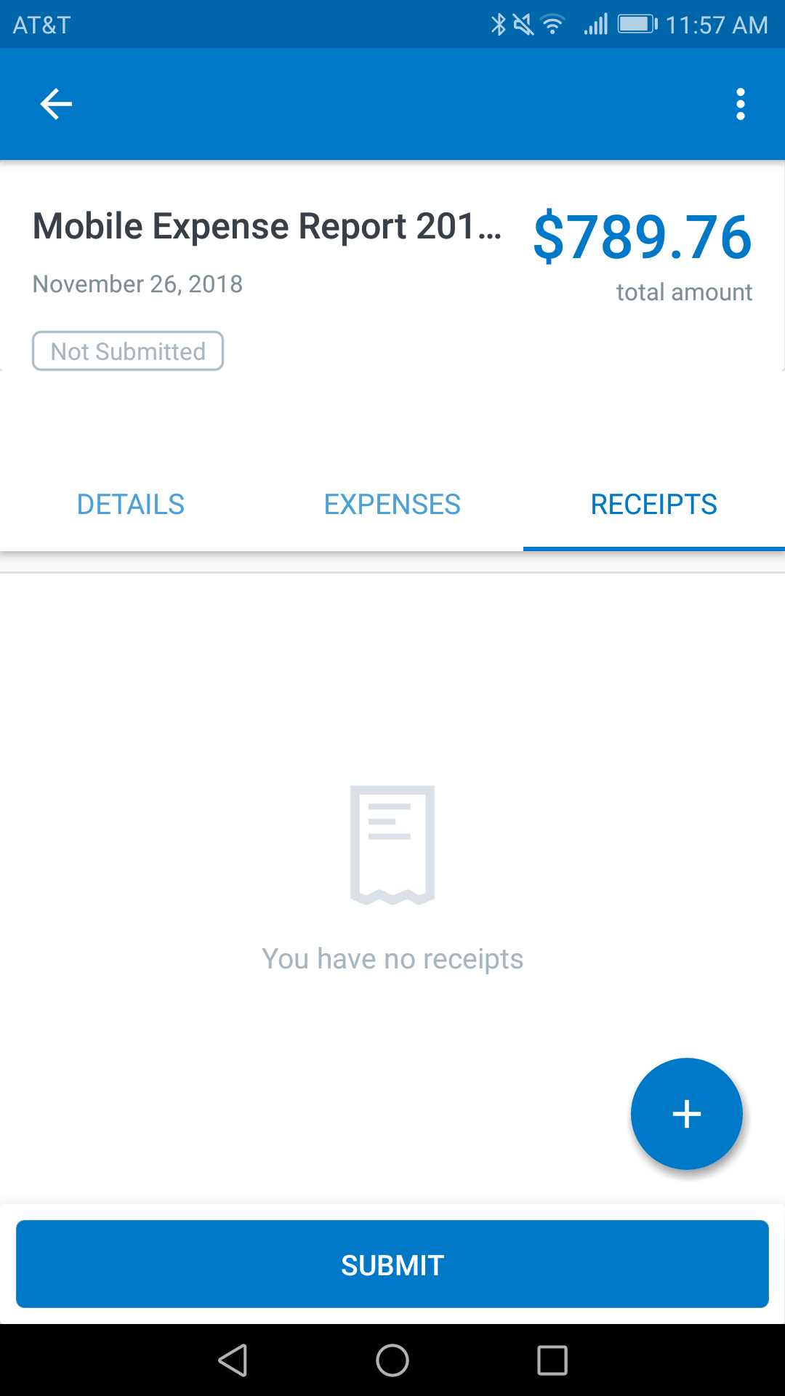
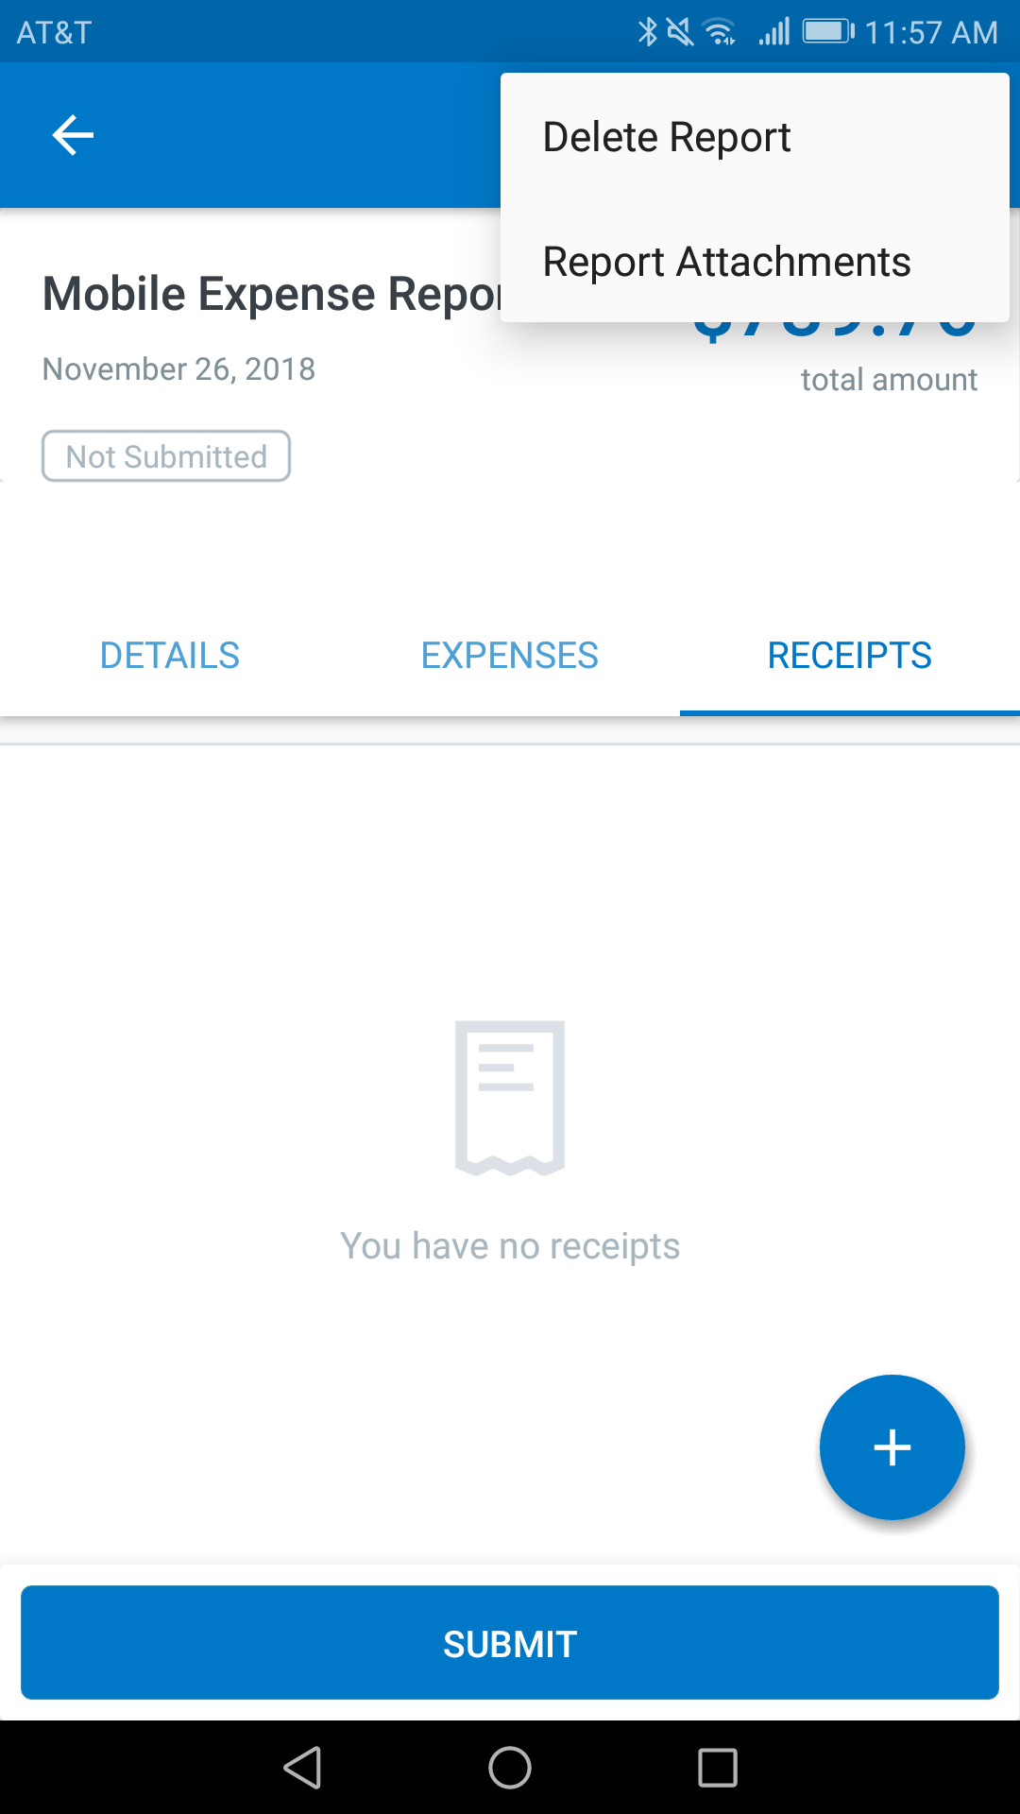
The new report screen continues this streamlined experience by allowing users to more easily toggle between their report header information, the list of available expenses, and any receipts that are presently attached to the report. With this improved view, users will be able to glean more information about their expense report in a shorter period of time, expediting expense report creation and submission.

Enable/Disable for Changes
This new experience can be enabled/disabled via the Report Detail Experience toggle, which the user can find by navigating from the side-menu on the home screen to Concur Settings > Beta Features. This option can be utilized if a user encounters a blocking issue and they need to continue working in the legacy version of the Report Details screen.
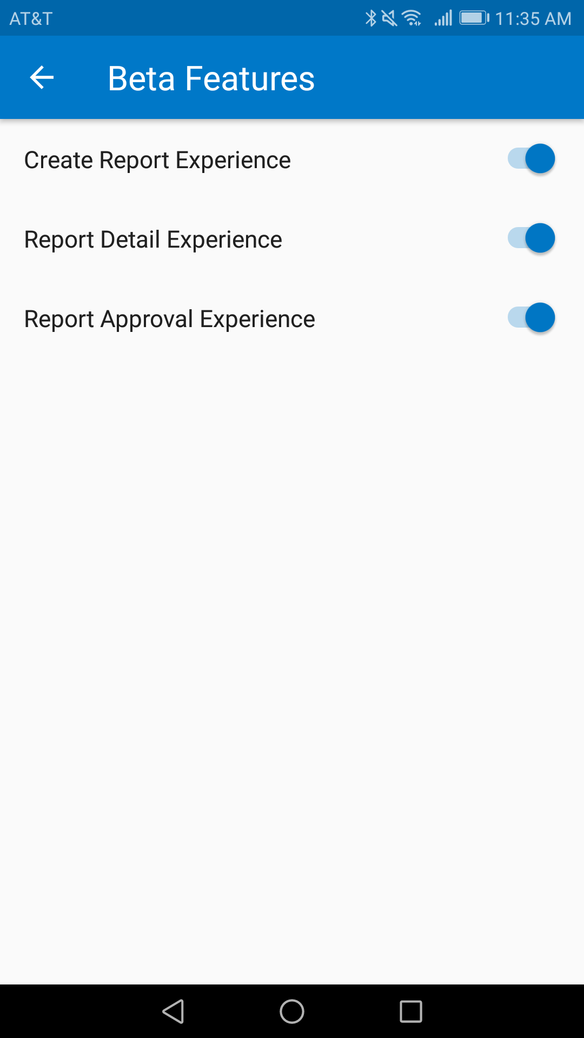
© 2019 SAP SE or an SAP affiliate company. All rights reserved.
No part of this publication may be reproduced or transmitted in any form or for any purpose without the express permission of SAP SE or an SAP affiliate company.
SAP and other SAP products and services mentioned herein as well as their respective logos are trademarks or registered trademarks of SAP SE (or an SAP affiliate company) in Germany and other countries. Please see http://global12.sap.com/corporate-en/legal/copyright/index.epx for additional trademark information and notices.
Some software products marketed by SAP SE and its distributors contain proprietary software components of other software vendors.
National product specifications may vary.
These materials are provided by SAP SE or an SAP affiliate company for informational purposes only, without representation or warranty of any kind, and SAP SE or its affiliated companies shall not be liable for errors or omissions with respect to the materials. The only warranties for SAP SE or SAP affiliate company products and services are those that are set forth in the express warranty statements accompanying such products and services, if any. Nothing herein should be construed as constituting an additional warranty.
In particular, SAP SE or its affiliated companies have no obligation to pursue any course of business outlined in this document or any related presentation, or to develop or release any functionality mentioned therein. This document, or any related presentation, and SAP SE’s or its affiliated companies’ strategy and possible future developments, products, and/or platform directions and functionality are all subject to change and may be changed by SAP SE or its affiliated companies at any time for any reason without notice. The information in this document is not a commitment, promise, or legal obligation to deliver any material, code, or functionality. All forward-looking statements are subject to various risks and uncertainties that could cause actual results to differ materially from expectations. Readers are cautioned not to place undue reliance on these forward-looking statements, which speak only as of their dates, and they should not be relied upon in making purchasing decisions.

