 | Mobile App User Guide  Concur Travel  Last Revised: June 14, 2021 | This guide describes the current version, which is shown on the "Introduction" guide. |  | Applies to these mobile devices:  No: iPhone  Yes: iPad  No: Android
 | IMPORTANT: Be aware that your company's configuration may not allow for all of the features described here. Generally, if a feature is not available in your configuration of the web version of SAP Concur, then it is not available in the mobile app.
Concur Travel simplifies the corporate travel booking experience by bringing the entire booking process and travel data into one place. Travelers see and manage travel their itineraries in SAP Concur’s online travel booking tool.  Concur Travel users can:  - Access content from multiple global distribution systems, negotiated and published prices, direct connects, and web-only fares |  |  | Concur Travel 2  View an Itinerary 2  Additional Flight Information 3  Book a Flight 4  Book a Hotel 9  Book Amtrak Direct Connect 11  Cancel a Hotel or Rental Car Reservation 13  View Travel Agency 14  View TripIt Itinerary 15  Approval 16  Approve a Trip 16
- Use the SAP Concur mobile app to streamline business travel planning, itinerary management, and expense reporting
- Take pictures of receipts and assign them to line items in expense reports.
Use Concur® TripLink to capture and manage invisible travel bookings.
Please Note:
- The SAP Concur app for iOS and Android supports universal links, i.e. links that navigate directly to the app if it is installed or to the website if not.
- Such links are included in notification emails from SAP Concur related to the expense report changes.
- Universal link support for customers own use is currently not supported.
- Some security solutions may block the links embedded into email from opening the app directly. The proper exceptions for the security policy should be configured for SAP Concur universal link URLs (pattern to match: https://*.concursolutions.com/*). Known cases are:
- MDM/MAM policy that prescribes to open any link tapped in Outlook mobile app only in specified browser.
- Outlook mail server phishing protection that wraps all link embedded into e-mails to open the safety check service first.

Concur Travel

View an Itinerary
If you have any trips, a counter is displayed in the Trips section of the home screen.
Screen(s) | Description/Action
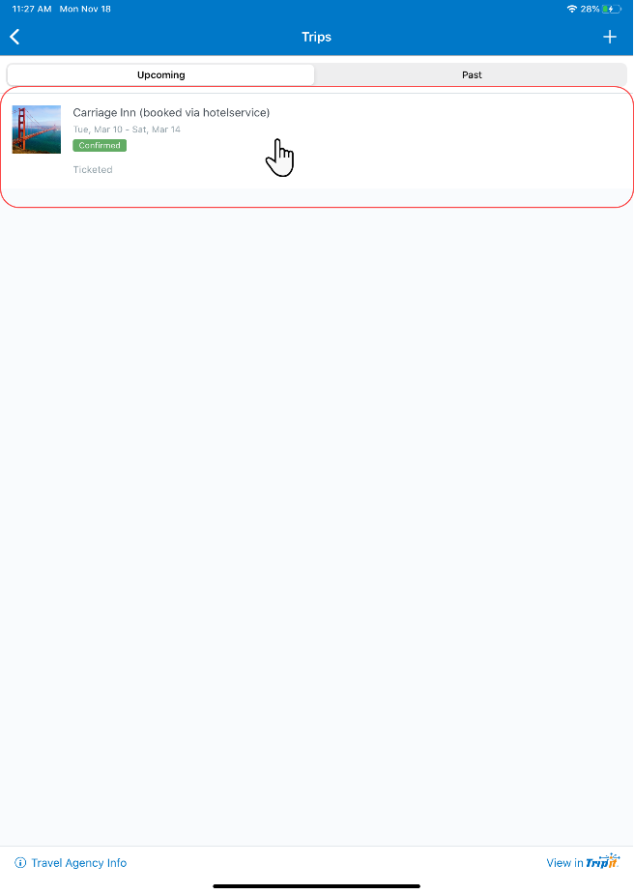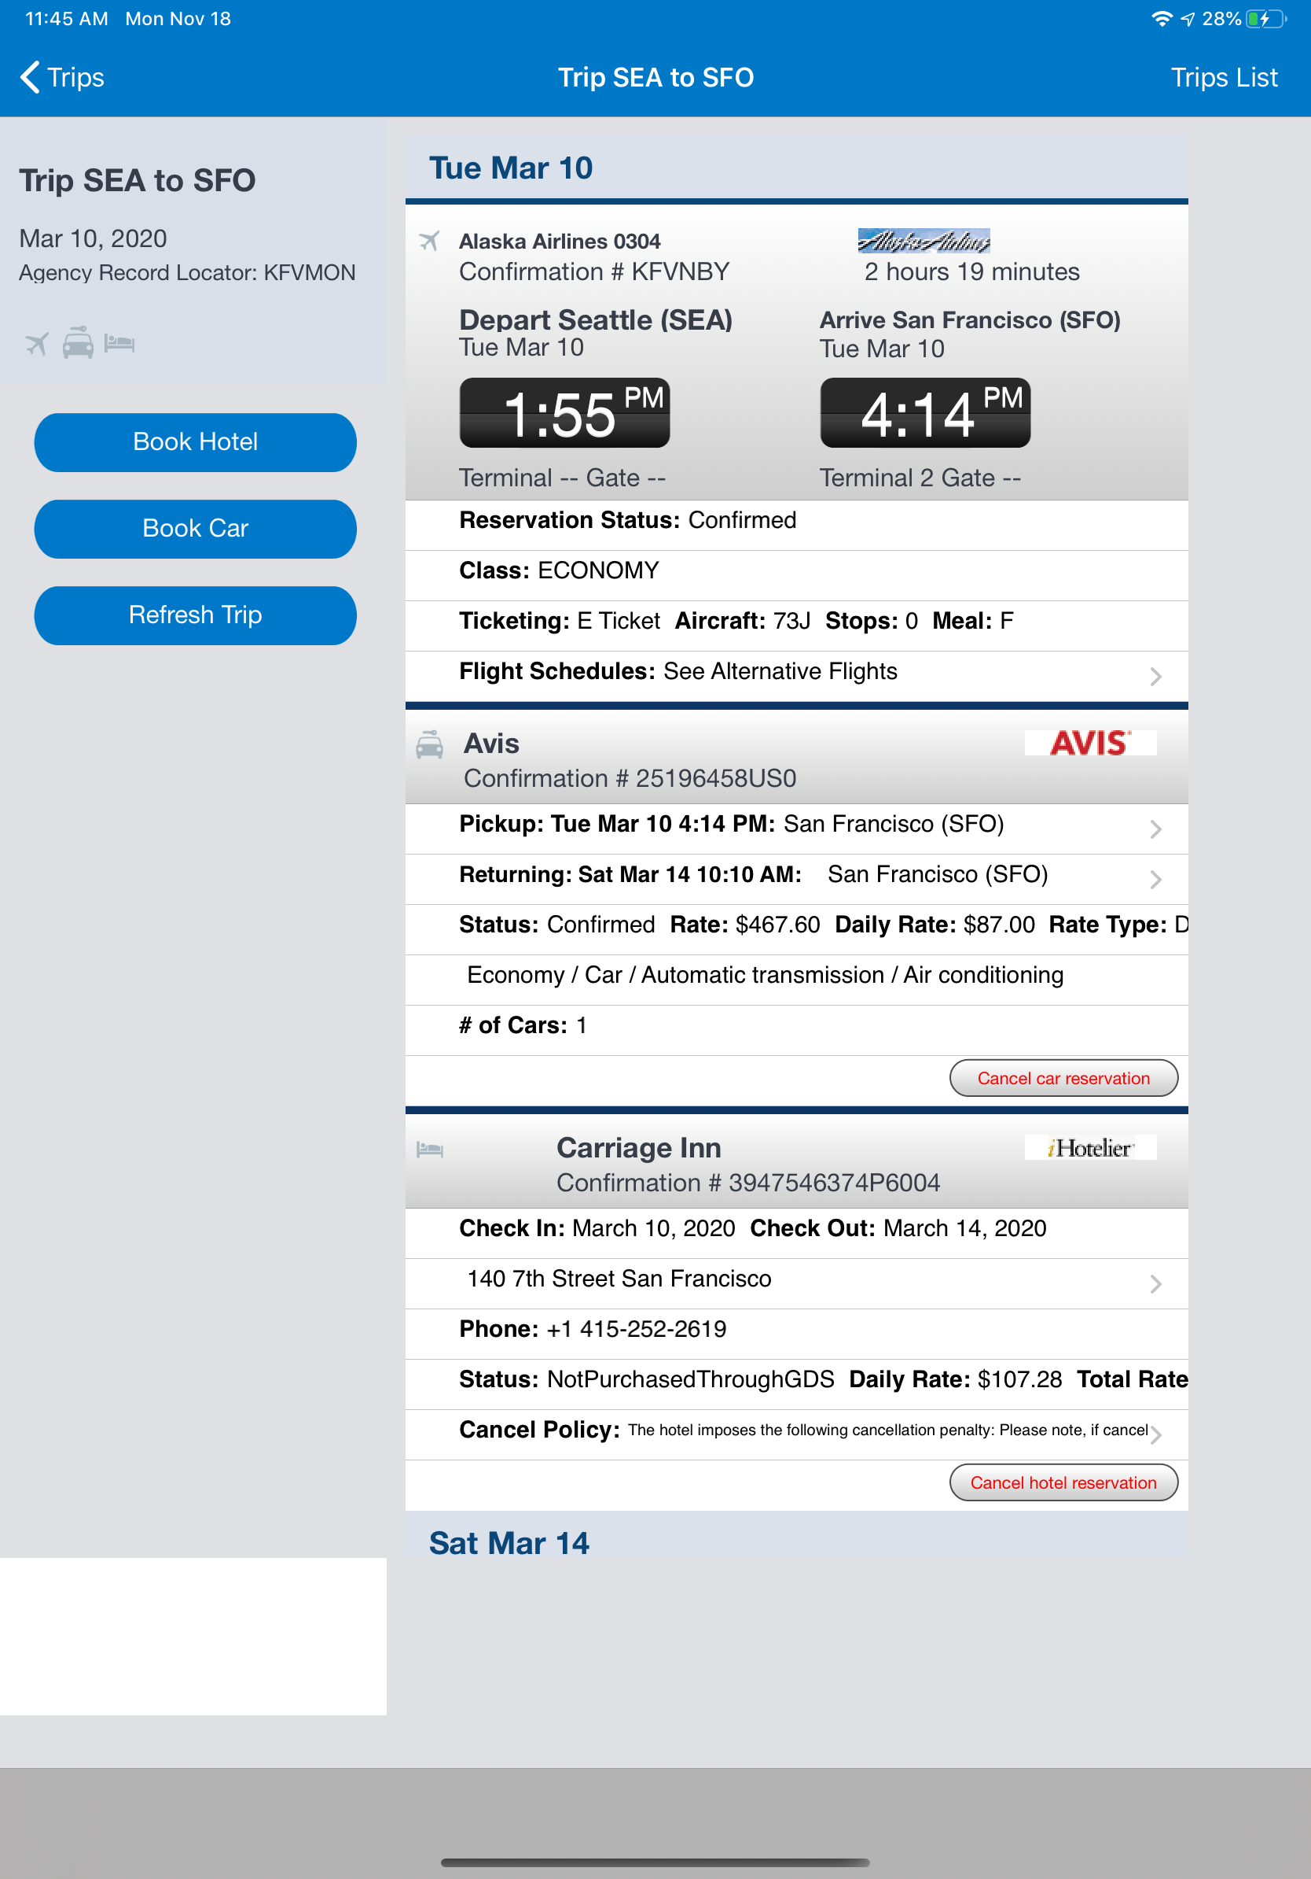 | To view your itinerary:  1) On the home screen, tap Trips.  2) On the Trips screen, tap to open the desired trip.  3) Scroll to view all segments of the itinerary.

Additional Flight Information
Screen(s) | Description/Action
Flight Information:  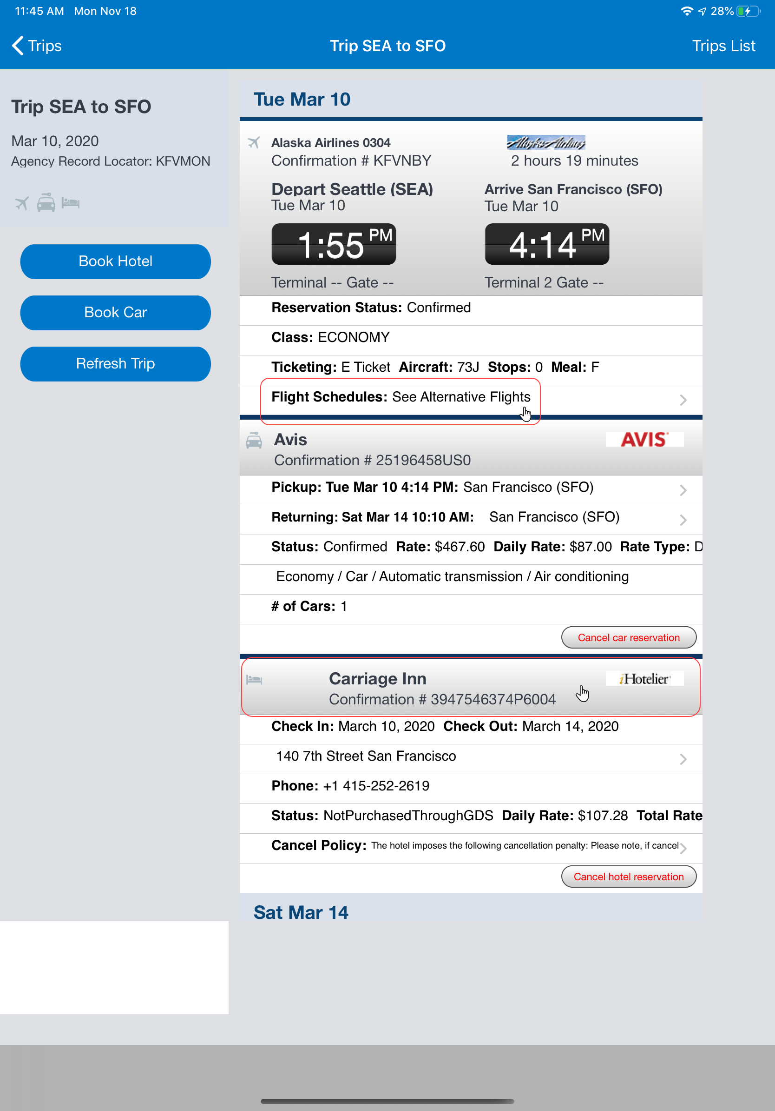 | Flight Tracker:  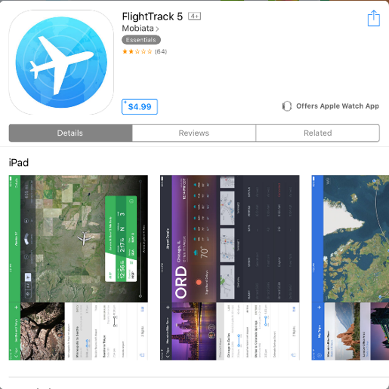  Flight Schedule: Hotel Information:  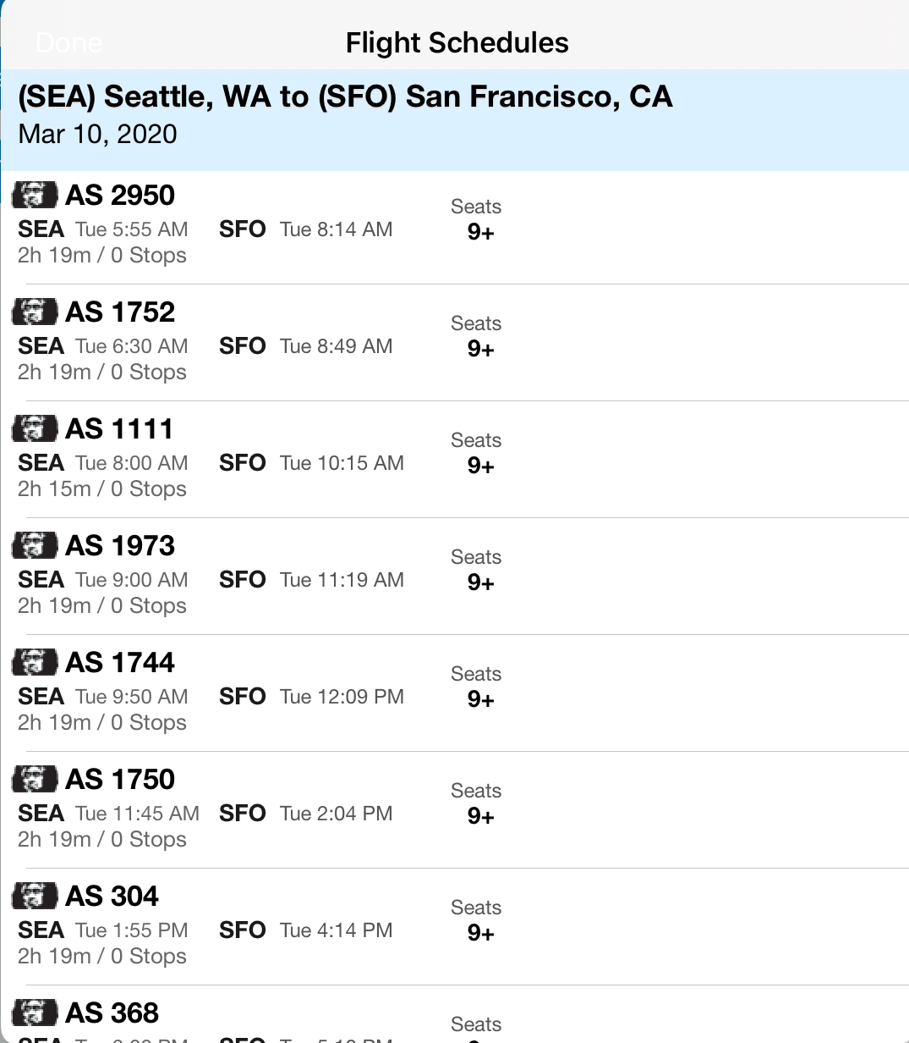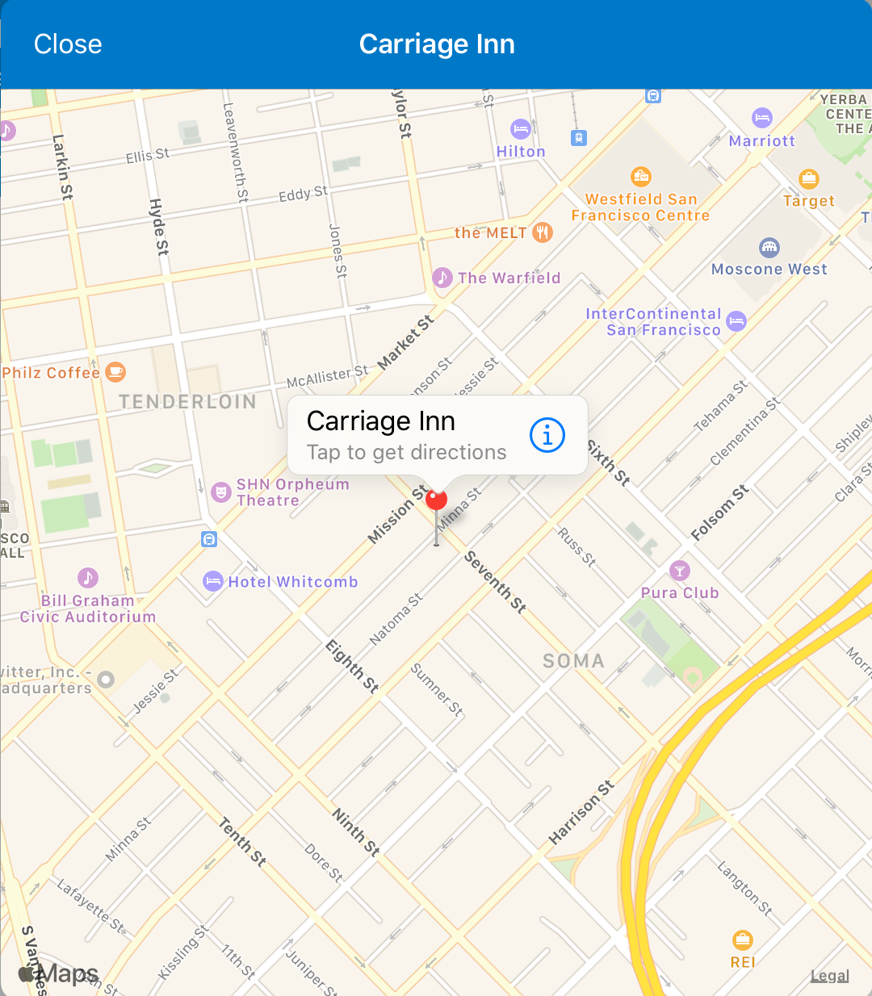

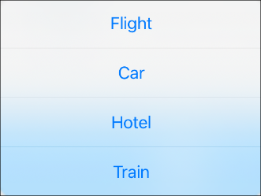
Book a Flight
To access the Book Air menu option:
- On the home screen, tap (lower-left corner) and then tap Travel
– or –
- On the home screen, tap Trips. On the Trips screen, tap (upper-right corner) and then tap Travel
Screen(s) | Description/Action
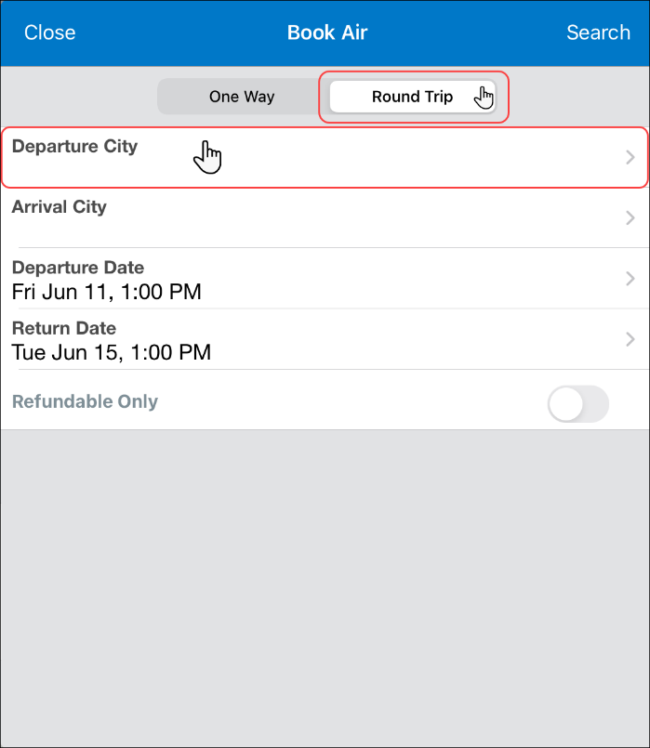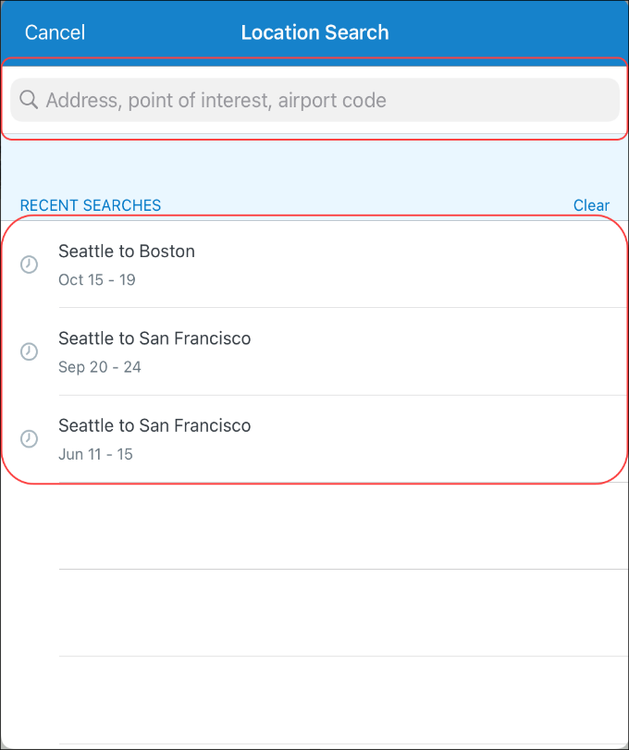 | To book a flight:  1) On the Book Air screen, tap One Way or Round Trip.  2) On the Location Search screen, either:  - Enter the search criteria in the search field and then tap the desired search results.  -or-  - Tap a recent flight search in the Recent Searches list.  NOTE: When you initially enter your flight information on the Book Air screen and then tap Search, the system saves a new recent search item in the Recent Search list on the location search screen.  When you tap on a recent search item in the Recent Searches list, your previous search criteria is now automatically populated on the Book Air screen. This also includes custom fields, which you can change as needed.  This feature only saves and displays the ten most recent searches in the Recent Searches list on the location search screen.
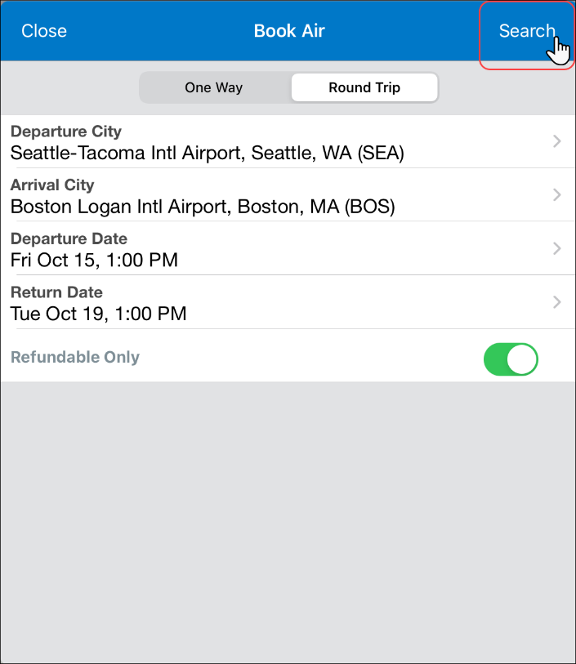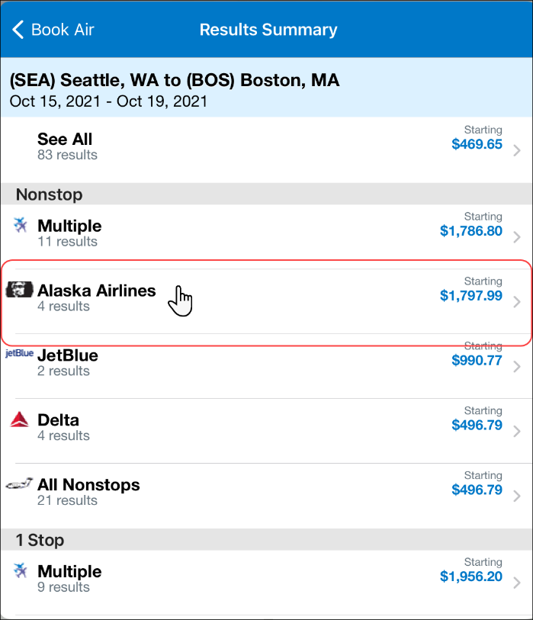 | 3) On the Book Air screen:  - Fill in the fields and make the desired selections.  NOTE: By default, the system automatically populates the Return Date field on the Book Air screen and in the flight details, in the Recent Searches list on the location search screen, with a date three days into the future for roundtrips.  - Tap Search (upper-right corner).  4) On the Results Summary screen, tap the desired carrier.
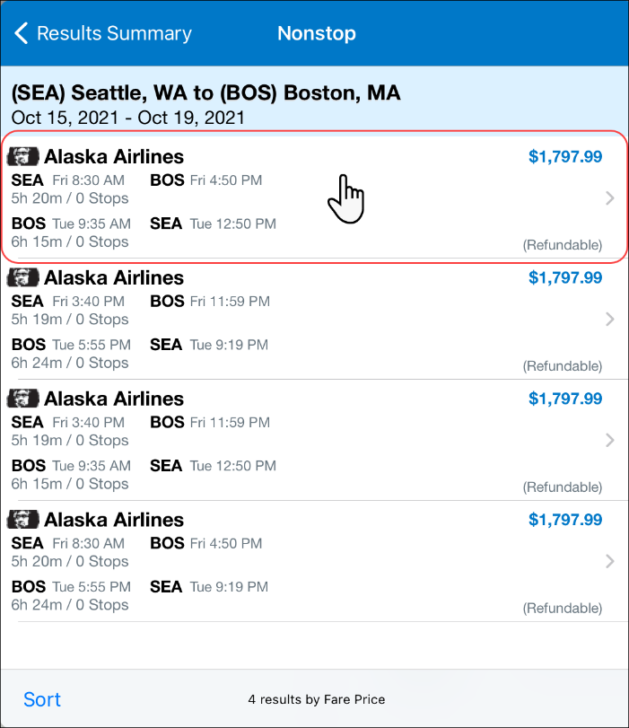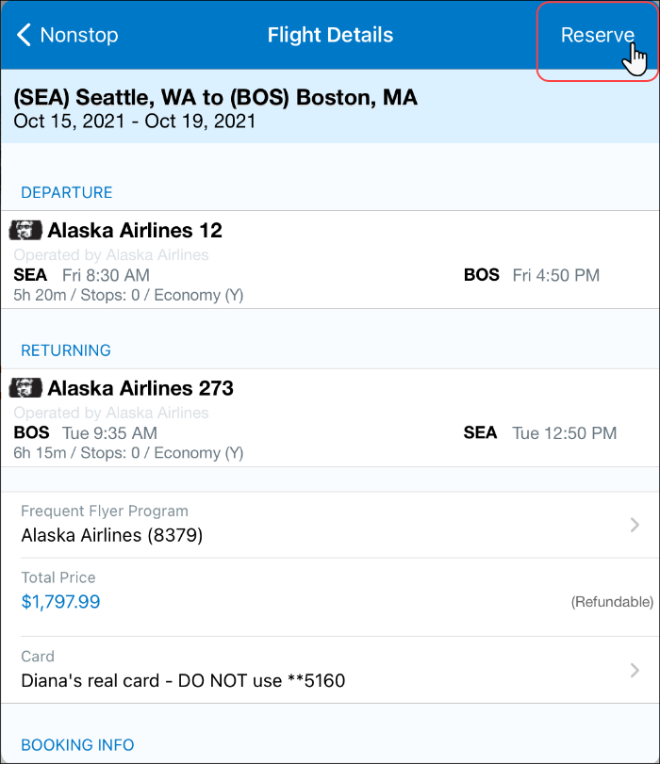 | 5) On the Select Flight screen, tap the desired flight.  6) On the Flight Details screen:  - Review for accuracy.  - Fill in the fields and make the desired selections.  - Tap Reserve (upper-right corner).

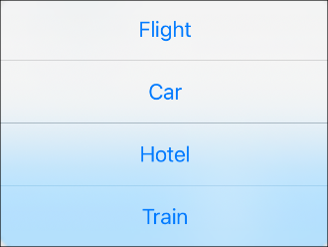
Book a Rental Car
To access the Car Rental screen:
- On the home screen, tap (lower-left corner) and then tap Car
– or –
- On the home screen, tap Trips. On the Trips screen, (upper-right corner) and then tap Car
– or –
To add a car to an existing itinerary, with the itinerary open, tap (upper-right corner) and then tap Car.
NOTE: If you add from the itinerary, the airport and pick-up/drop-off dates are pre-populated.

Screen(s) | Description/Action
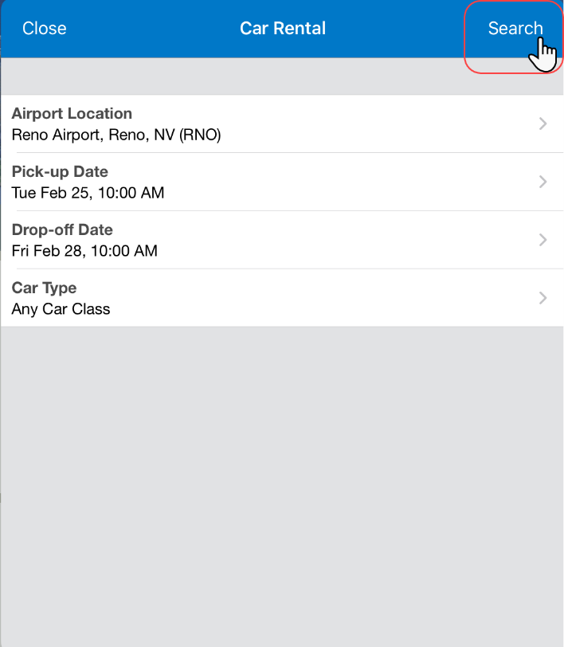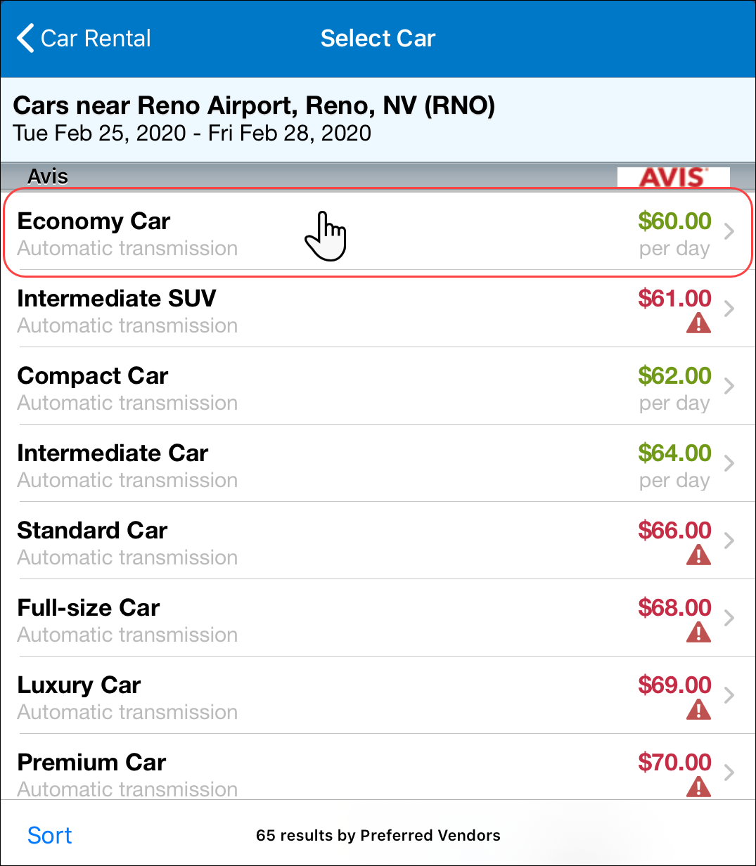 | To book a rental car:  1) On the Car Rental screen:  - Enter the search criteria.  - Tap Search (upper-right corner).  2) On the Select Car screen, tap the desired car.
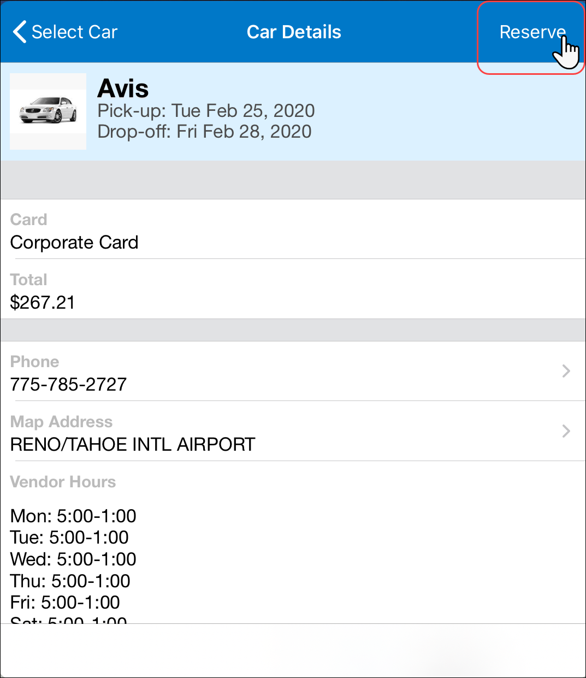 | 3) On the Car Details screen:  - Review for accuracy.  - Fill in the fields (if any) and make the desired selections.  - Tap Reserve (upper-right corner).
Book a Hotel
To access the Hotels screen:
- On the home screen, tap (lower-left corner) and then tap Hotel
– or –
- On the home screen, tap Trips. On the Trips screen, tap (upper-right corner) and then tap Hotel
– or –
To add a hotel to an existing itinerary, with the itinerary open, tap (upper-right corner) and then tap Hotel.
NOTE: If you add from the itinerary, the airport and pick-up/drop-off dates are pre-populated.
Screen(s) | Description/Action
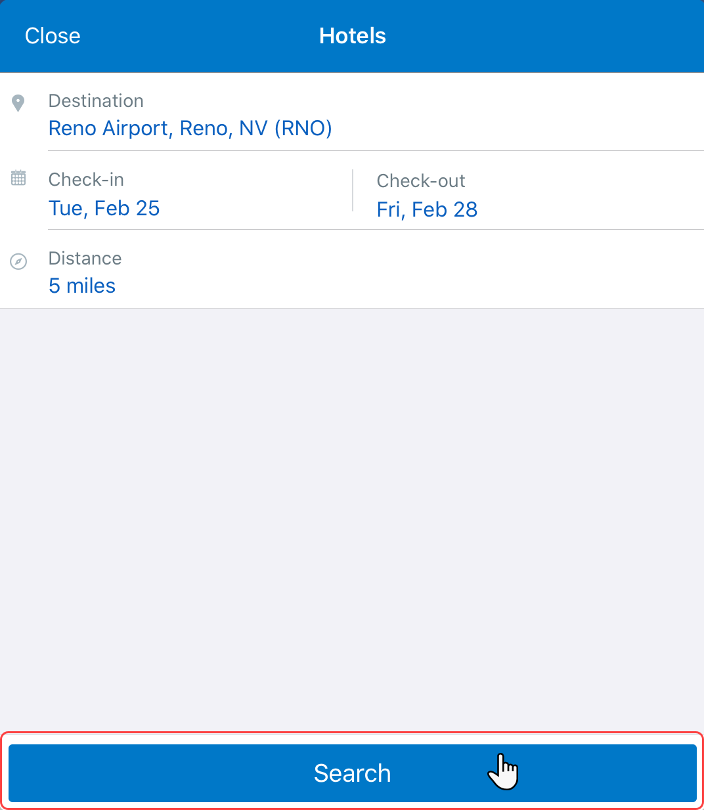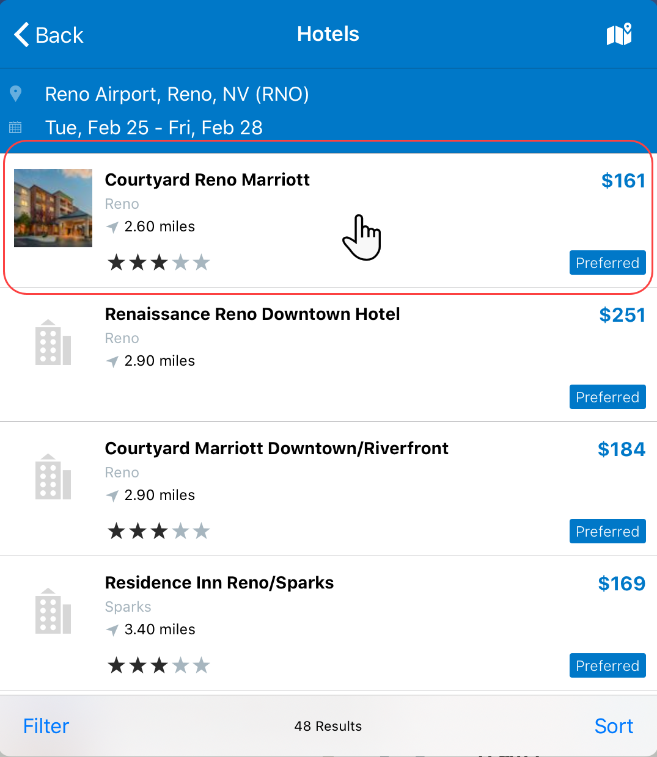 | To book a hotel:  1) On the Hotels screen:  - Enter the search criteria.  - Tap Search.  2) On the Hotels screen, tap the desired hotel.
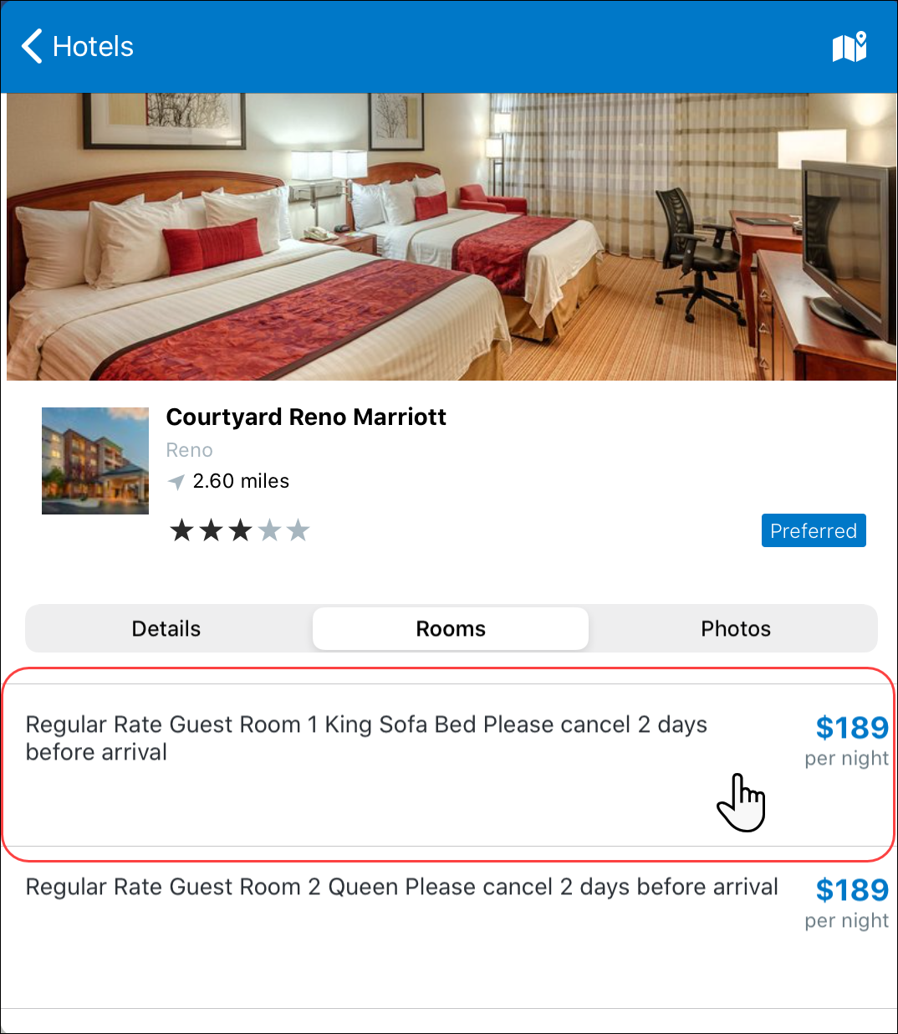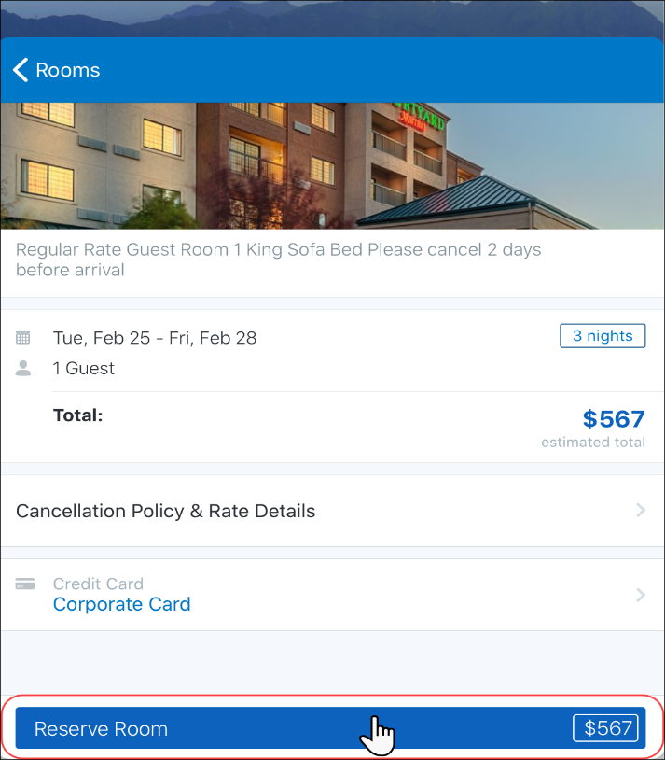 | 3) On the next screen, tap the desired room.  4) On the next screen:  - Review for accuracy.  - Fill in the fields (if any) and make the desired selections.  - Tap Reserve Room.

Book Amtrak Direct Connect
You can book a train if your company is configured to use Amtrak Direct Connect. 1
To access the Train screen:
- On the home screen, tap (lower-left corner) and then tap Train
– or –
- On the home screen, tap Trips. On the Trips screen, tap (upper-right corner) and then tap Train
Screen(s) | Description/Action
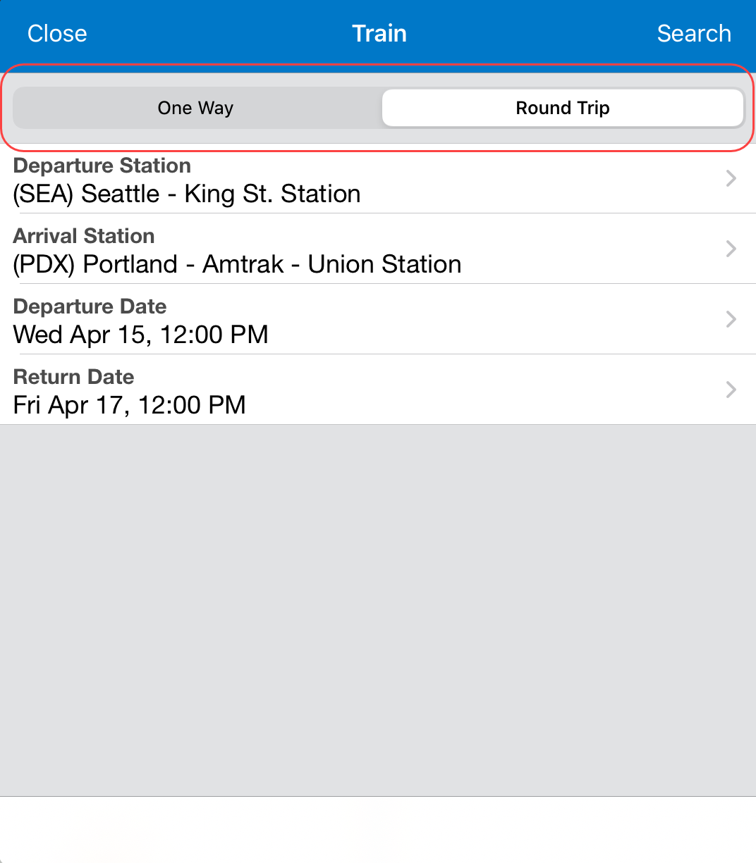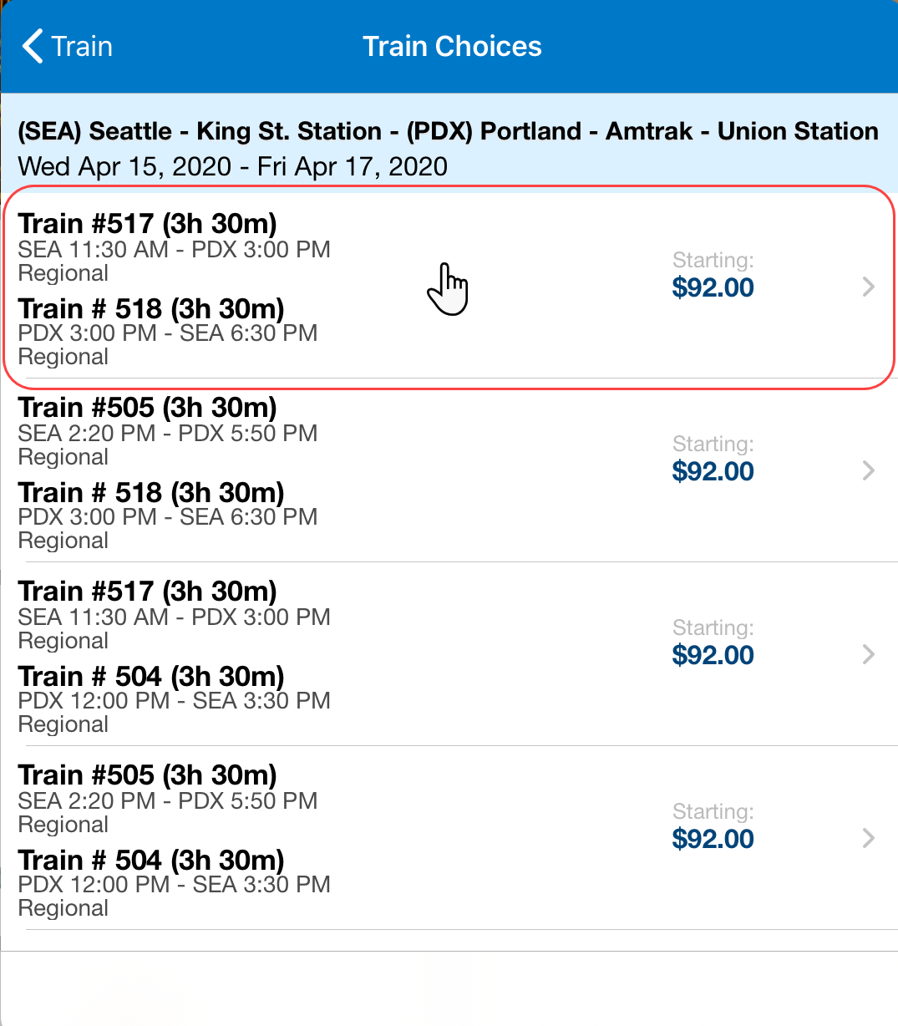 | To book a train:  1) On the Train screen:  - Tap One Way or Round Trip.  - Enter the search criteria.  - Tap Search (upper-right corner).  2) On the Train Choices screen, tap the desired trip.
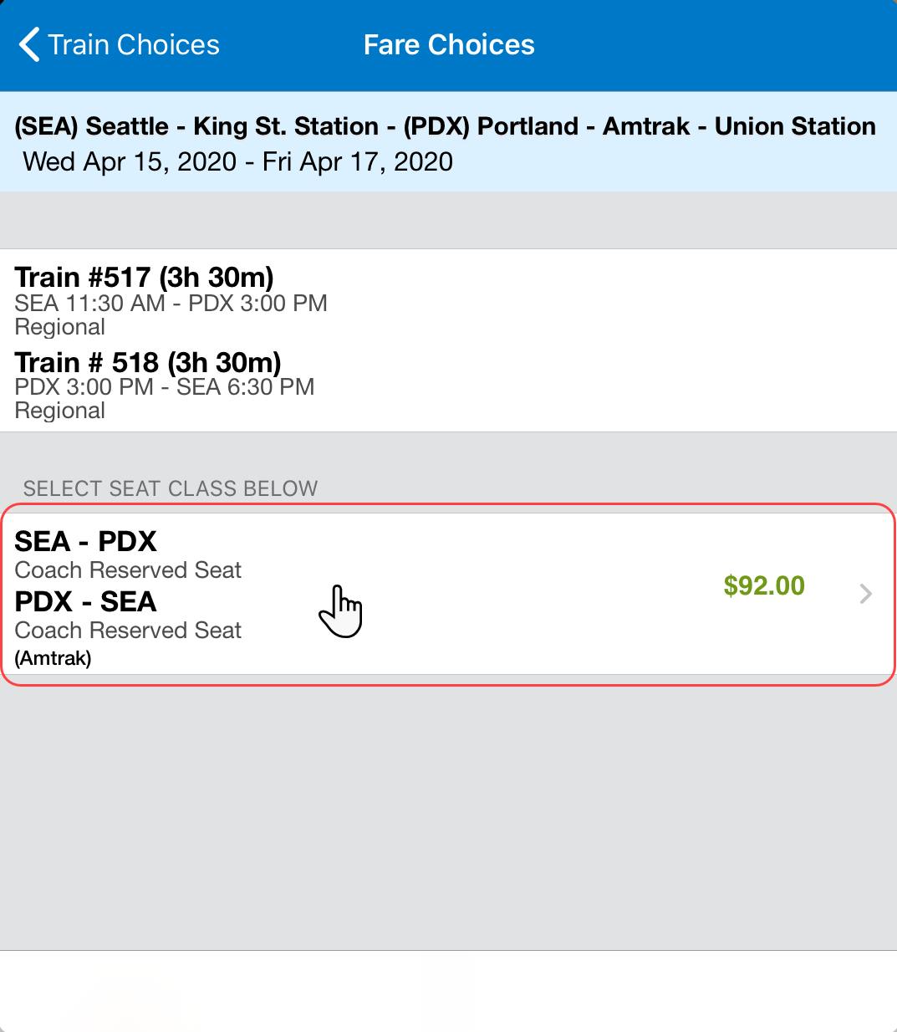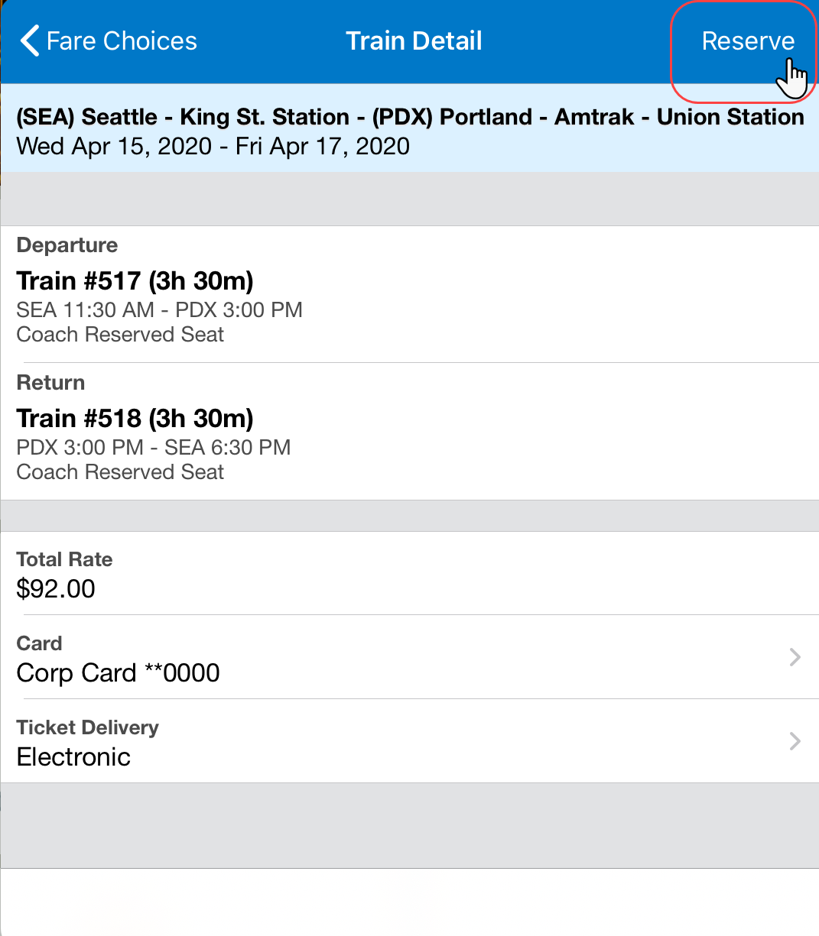 | 3) On the Fare Choices screen, tap the desired fare.  4) On the Train Detail screen:  - Review for accuracy.  - Fill in the fields (if any) and make the desired selections.  - Tap Reserve (upper-right corner).

Cancel a Hotel or Rental Car Reservation
Screen(s) | Description/Action
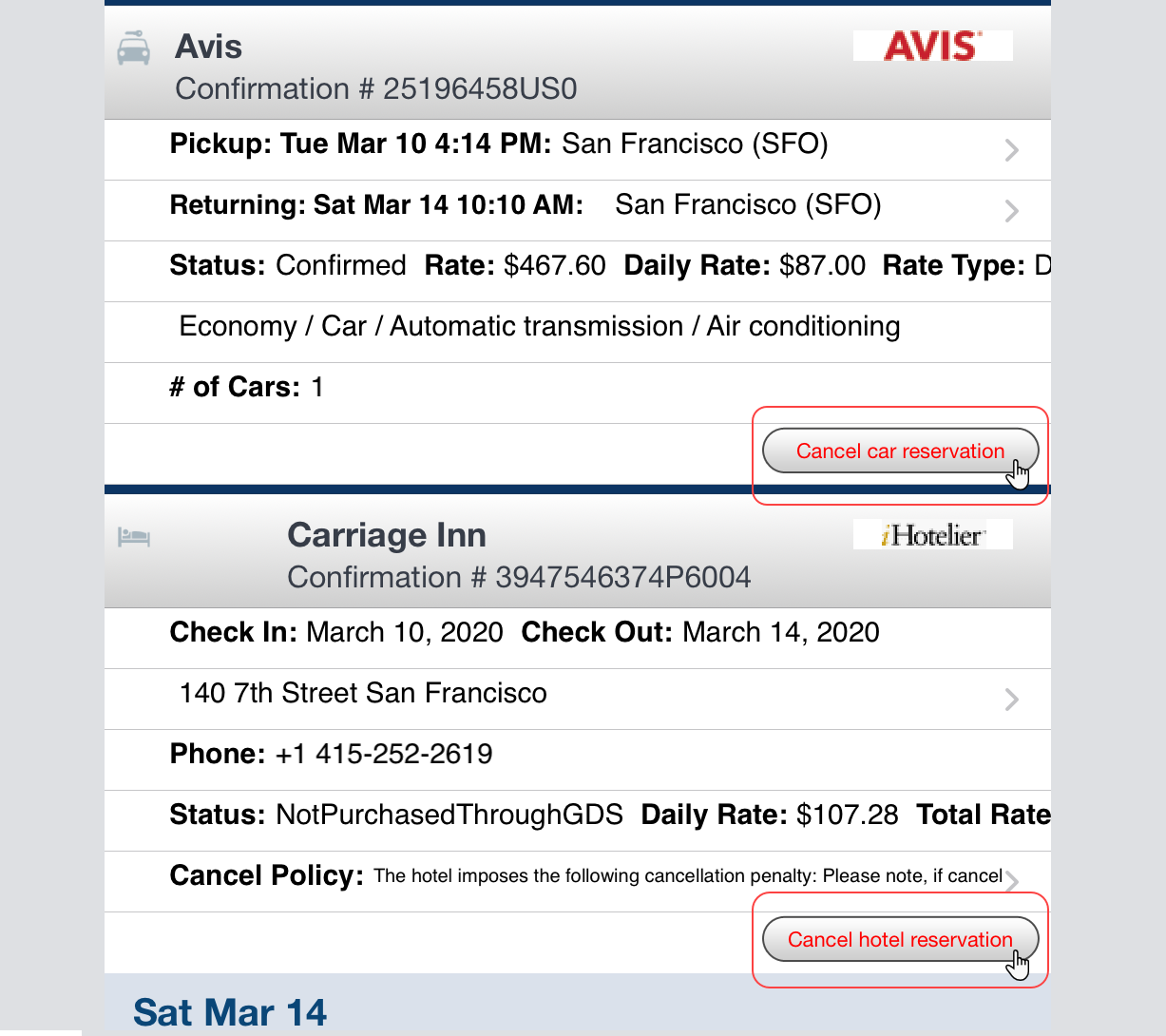 |  | To cancel a hotel or rental car reservation:  1) On the home screen, tap Trips.  2) On the Trips screen, tap to open the desired itinerary.  3) On the next screen, tap Cancel hotel reservation or Cancel car reservation whichever applies.

View Travel Agency
You can access your agency information from the Trips screen.
Screen(s) | Description/Action
To access your agency information:
1) On the home screen, tap Trips.
2) On the Trips screen, tap Travel Agency Info (lower-left corner).

View TripIt Itinerary
Screen(s) | Description/Action
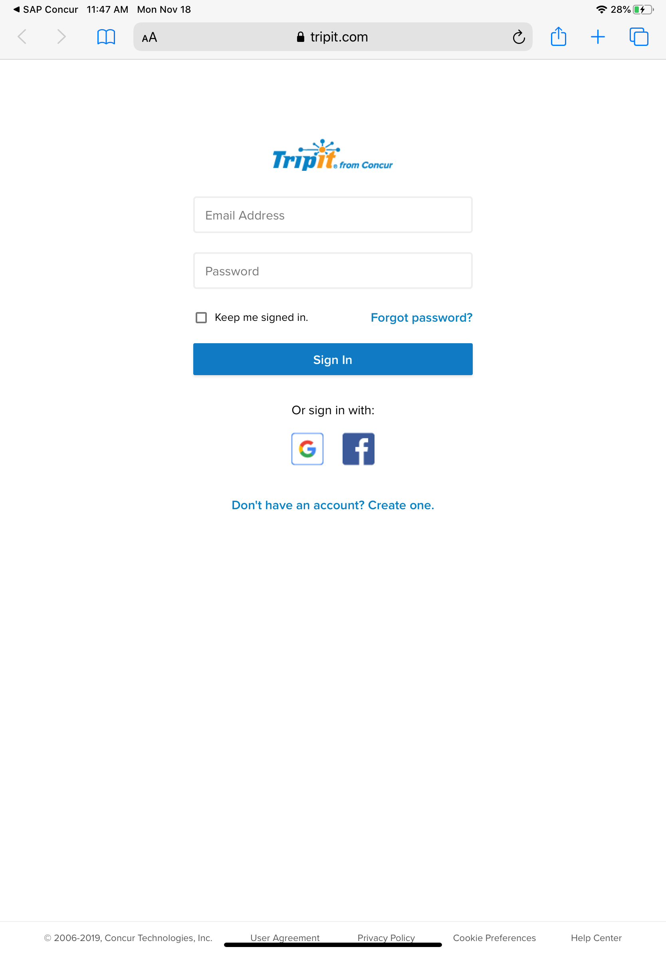 | To access your agency information:  1) On the home screen, tap Trips.  2) On the Trips screen, tap View in TripIt (lower-right corner).

Approval

Approve a Trip
If you are a trip approver, you can access the trips that require your approval.
Screen(s) |  | Description/Action
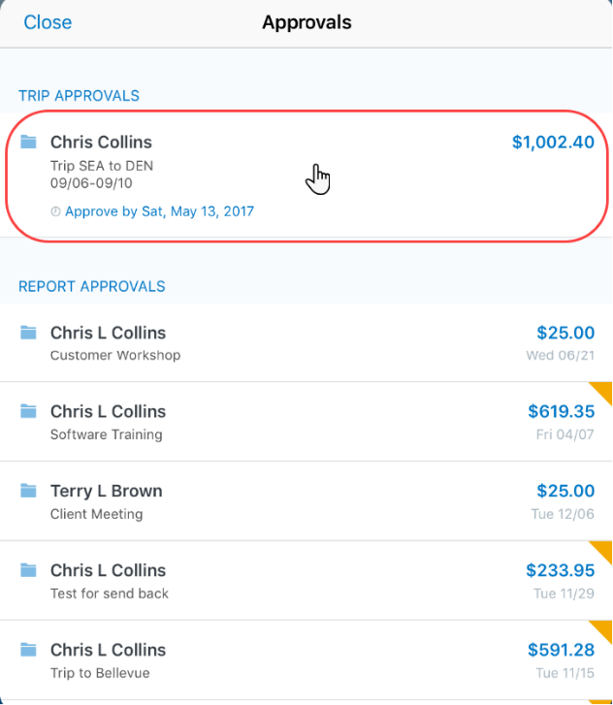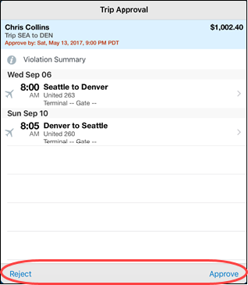 | To approve a trip:  1) On the home screen, tap Approvals.  2) On the Approvals screen, tap to open the desired trip.  3) On the Trip Approval screen:  - Tap to view the report details (segments, violations, etc.).  - Tap Approve or Reject.  NOTE: In the Report Approvals and Trip Approvals sections indicates that there are exceptions.  If the approval type does not have any approvals, then that type does not appear on the Approvals screen. For example, if there are no trips to approve, then Trip Approvals does not appear.

☼

