Mobile App User Guide  Concur Request  Last Revised: July 5, 2021 | This guide describes the current version, which is shown on the "Introduction" guide. |  | Applies to these mobile devices:  Yes: iPhone  No: iPad  No: Android
IMPORTANT: Be aware that your company's configuration may not allow for all of the features described here. Generally, if a feature is not available in your configuration of the web version of SAP Concur, then it is not available in the mobile app.
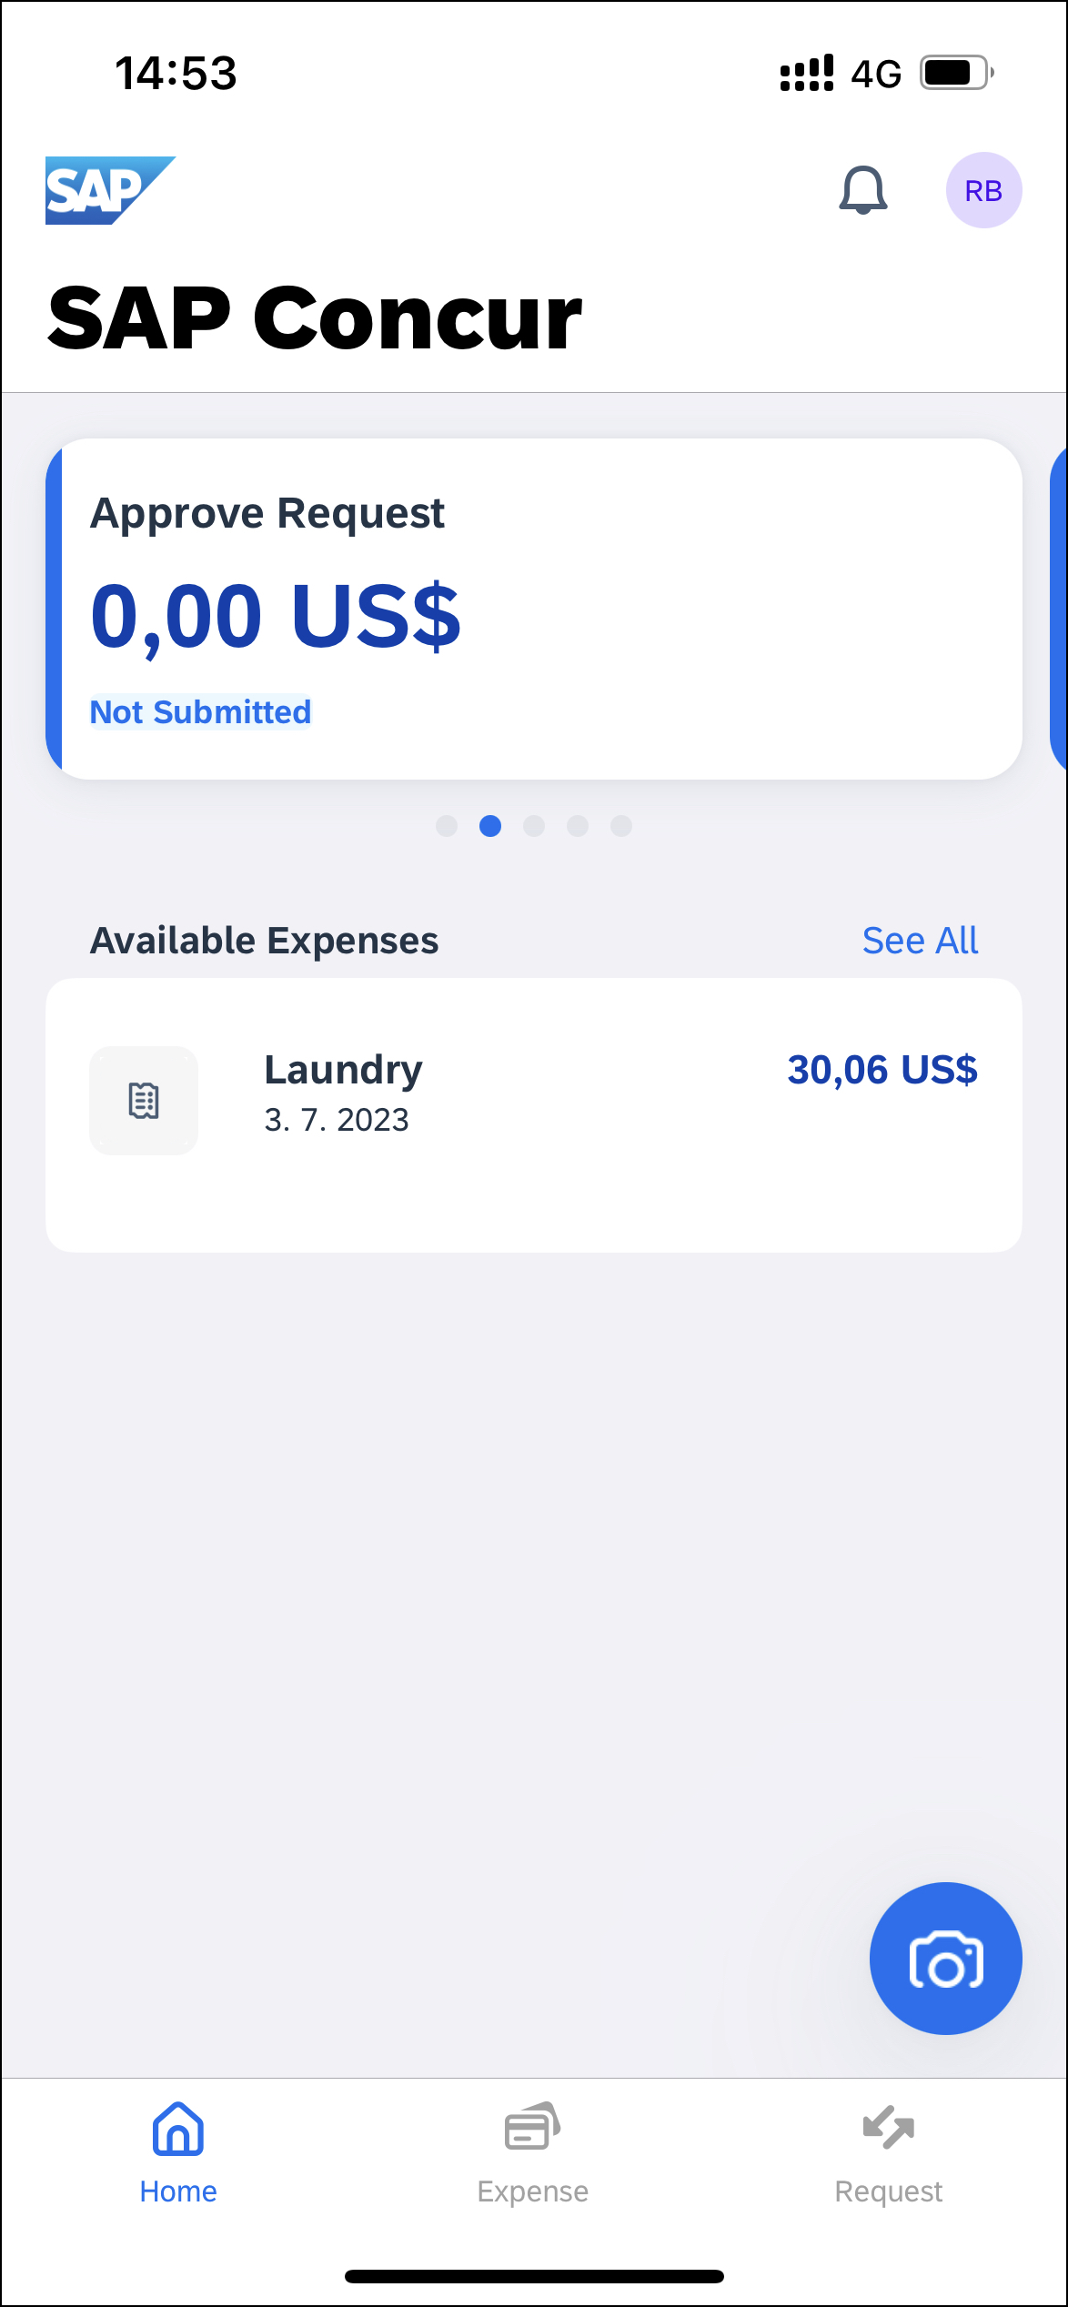 |  | Concur Request 2  Initial Feature Set and Options 2  Create a New Request 3  Create a New Cash Advance 4  Delete a Cash Advance Within a Request 5  Add Segments / Expense Types to a Request 6  Attach an Attachment to a Travel Request 7  Modify an Attachment on the Attachments Screen 8  Delete an Attachment From a Travel Request 8  Delete a Segment / Expense Type From an Open Unsubmitted Request 9  Delete an Unsubmitted Request on in an Open Request 10  Delete an Unsubmitted Request on the Request Screen 11  Submit a Request From an Open Request 12  Submit a Request on the Request Screen 13  Recall a Request 13  Approve a Request 14  Create a New Expense Claim From an Approved Request 15  Cancel an Approved Request From an Open Request 16  Cancel an Approved Request on the Request Screen 17  Close an Approved Request From an Open Request 18  Close an Approved Request on the Request Screen 19
Concur Request streamlines requisition and travel booking processes for travelers, approvers, and finance teams.
Concur Request users can:
- Make strategic decisions about spending before it happens
- Simplify cash advances
- Replace tedious email and manual requests into a single system
- See the entire audit trail of each request, from submission to approval
Please Note:
- The SAP Concur app for iOS and Android supports universal links, i.e. links that navigate directly to the app if it is installed or to the website if not.
- Such links are included in notification emails from SAP Concur related to the expense report changes.
- Universal link support for customers own use is currently not supported.
- Some security solutions may block the links embedded into email from opening the app directly. The proper exceptions for the security policy should be configured for SAP Concur universal link URLs (pattern to match: https://*.concursolutions.com/*). Known cases are:
- MDM/MAM policy that prescribes to open any link tapped in Outlook mobile app only in specified browser.
- Outlook mail server phishing protection that wraps all link embedded into e-mails to open the safety check service first.

Concur Request

Initial Feature Set and Options
Multiple policies per user: The multiple policies per user feature is available to SAP Concur mobile users whose company allows them to select from multiple policies.
NOTE: If a user can select a different policy while creating a request on the web version of SAP Concur, they can do the same within the mobile app.
Header form: The user can select from different policies, which will provide different header forms. Segment form: Following are the available default segment forms:
Air  Hotel  Car Rental  Rail  Dining | Event  Limo  Parking  Taxi  Miscellaneous
Segment / Expense types: All default segment types, expected expenses, and custom segments with their form and layout are supported.
Workflow: Only ”Create," "View," "Cancel," "Delete," "Attach," "Close," "Submit," and "Recall" actions are supported.
NOTE: For the "Submit" action, in those cases where the client allows the user to select their own approver on submit in the web version of SAP Concur, be aware that this option is not available in the mobile app. The request user's default approver must appear in the user's profile.
Not yet available: These options are not available in the mobile app:
Allocations  Travel Allowances | Request & Travel integration  Car Mileage

Create a New Request
Screen(s) | Description/Action
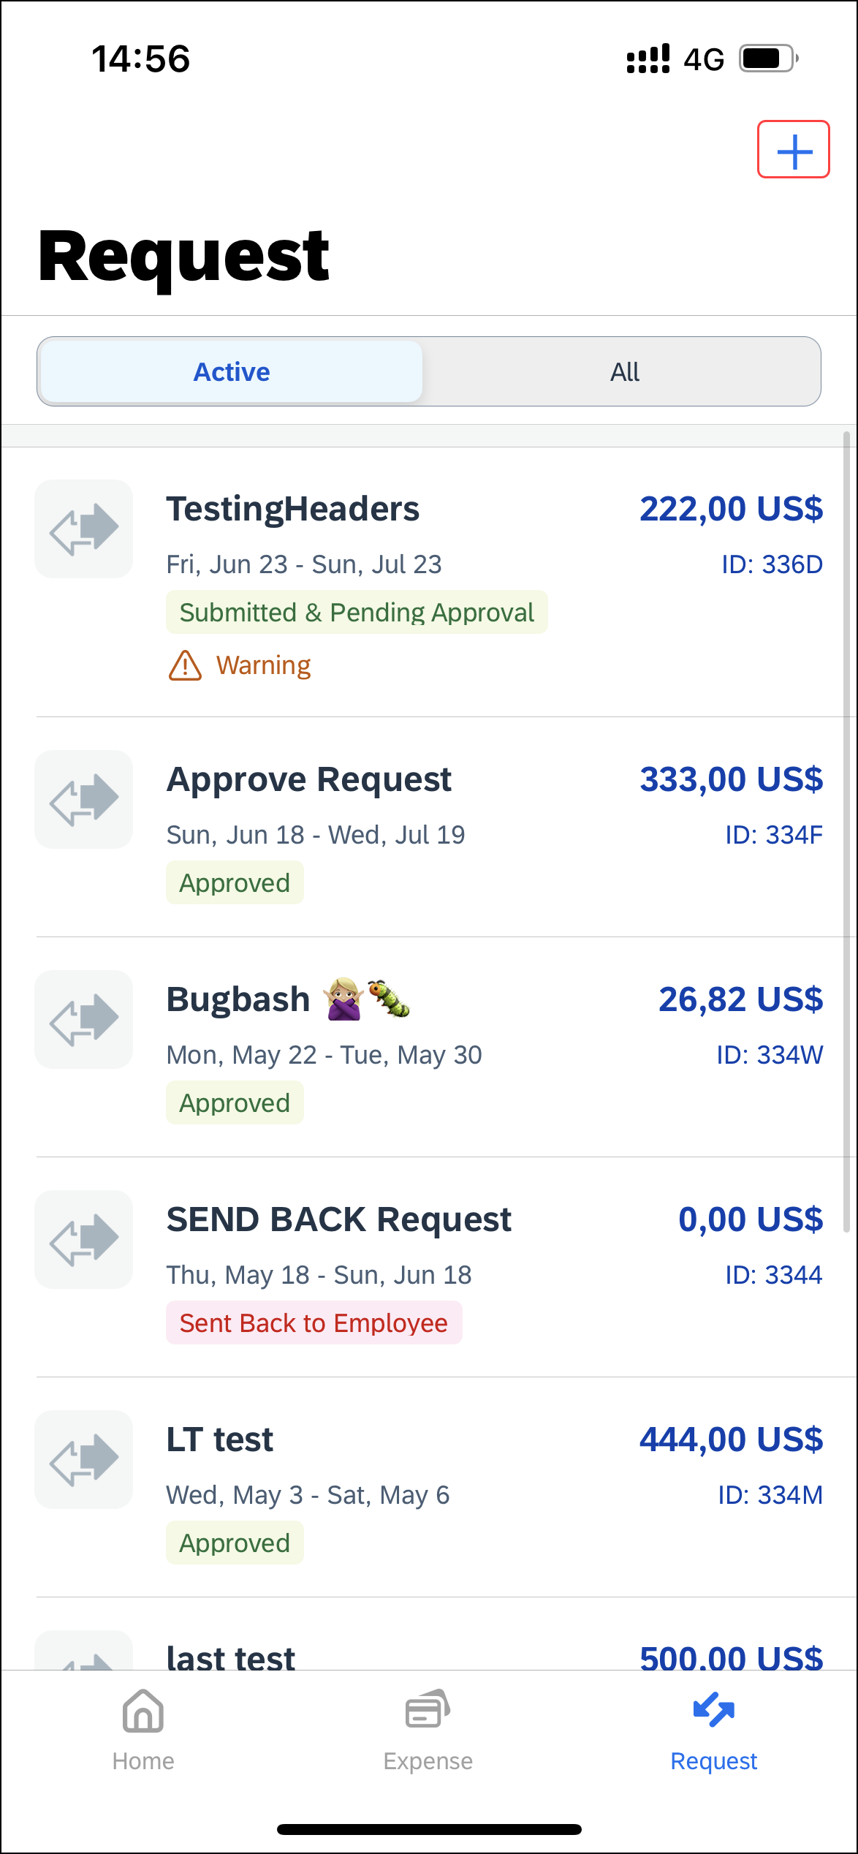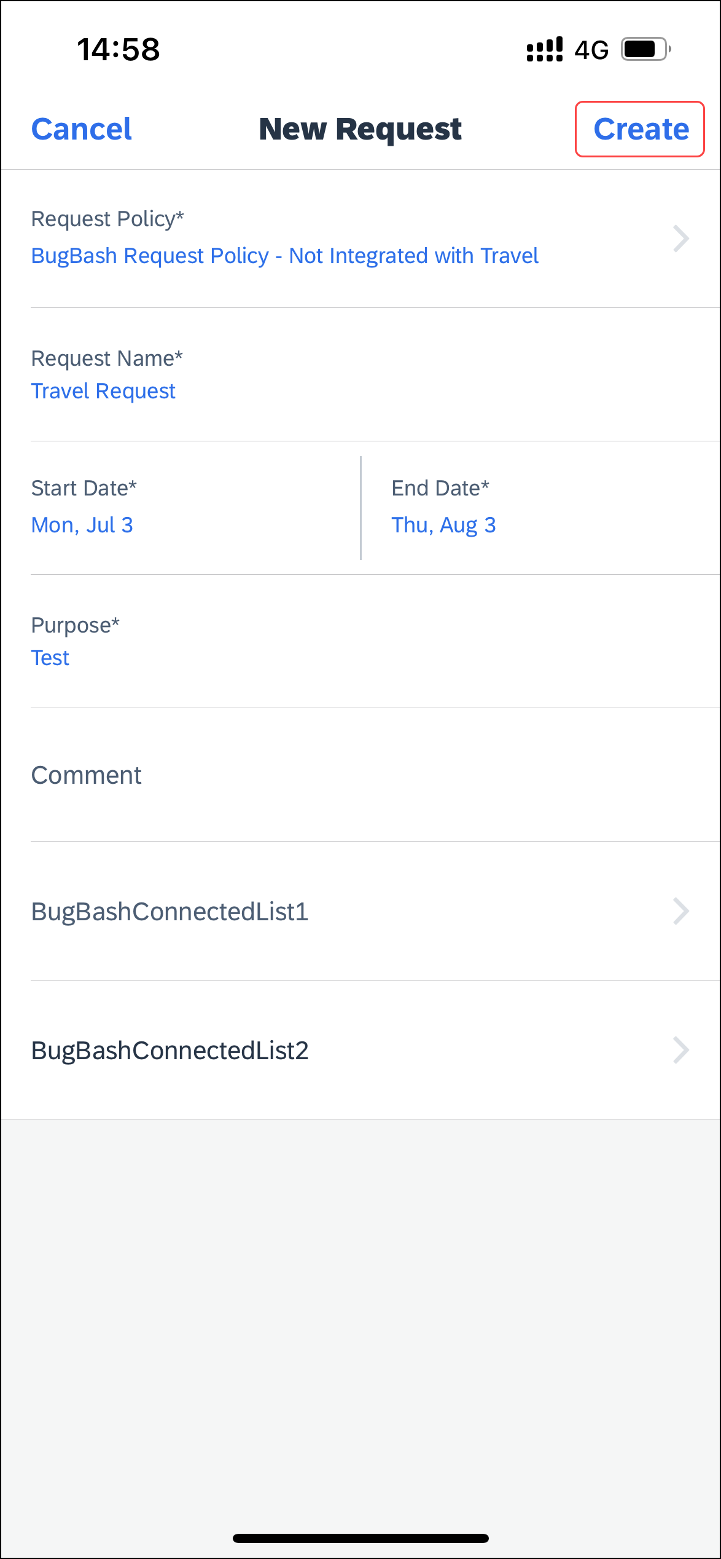 | To create a new request:  1) On the home screen, tap Request.  2) On the Request screen, tap (upper-right corner).  3) On the New Request screen, fill in the location and date fields. When done, tap Create (upper-right corner).
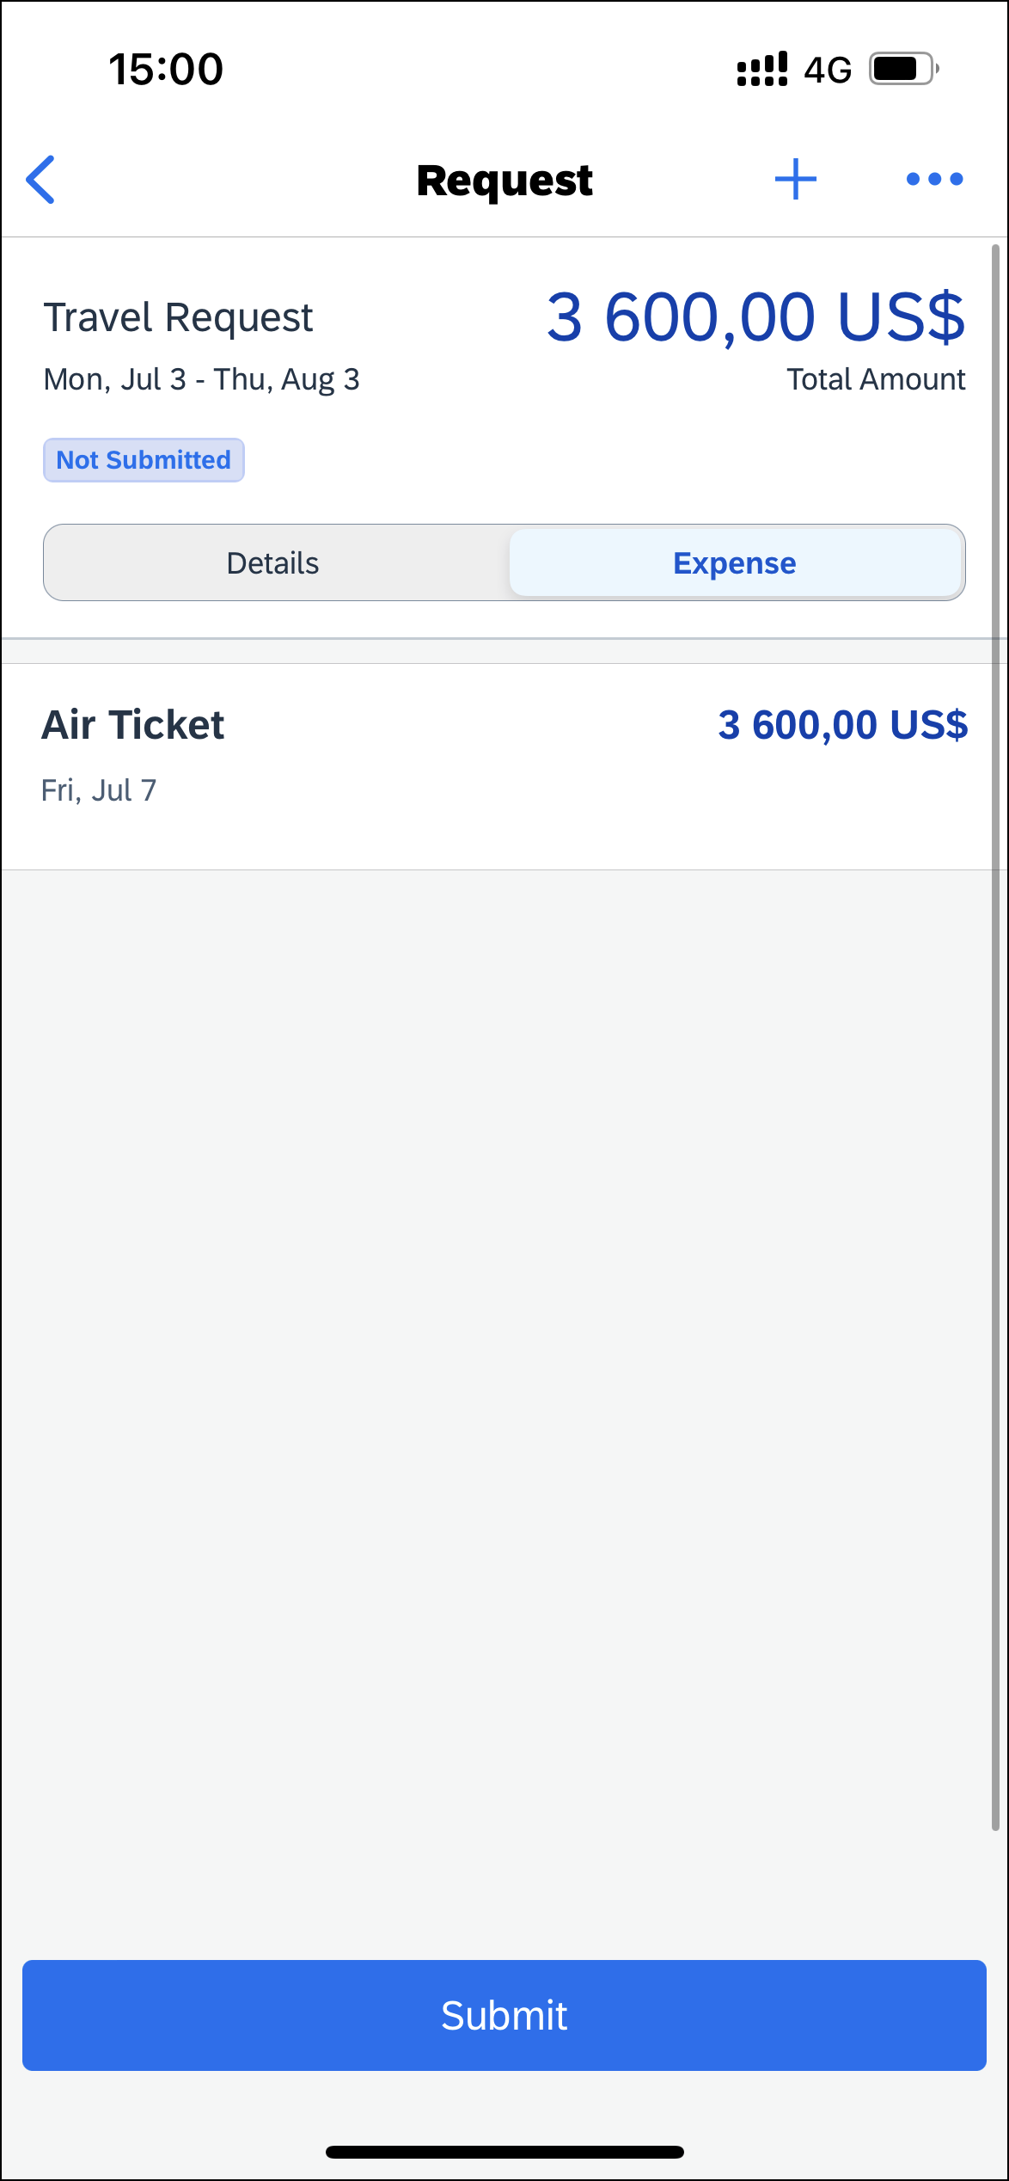 | The request screen appears with the request details appearing on the Details tab.

Create a New Cash Advance
Screen(s) | Description/Action
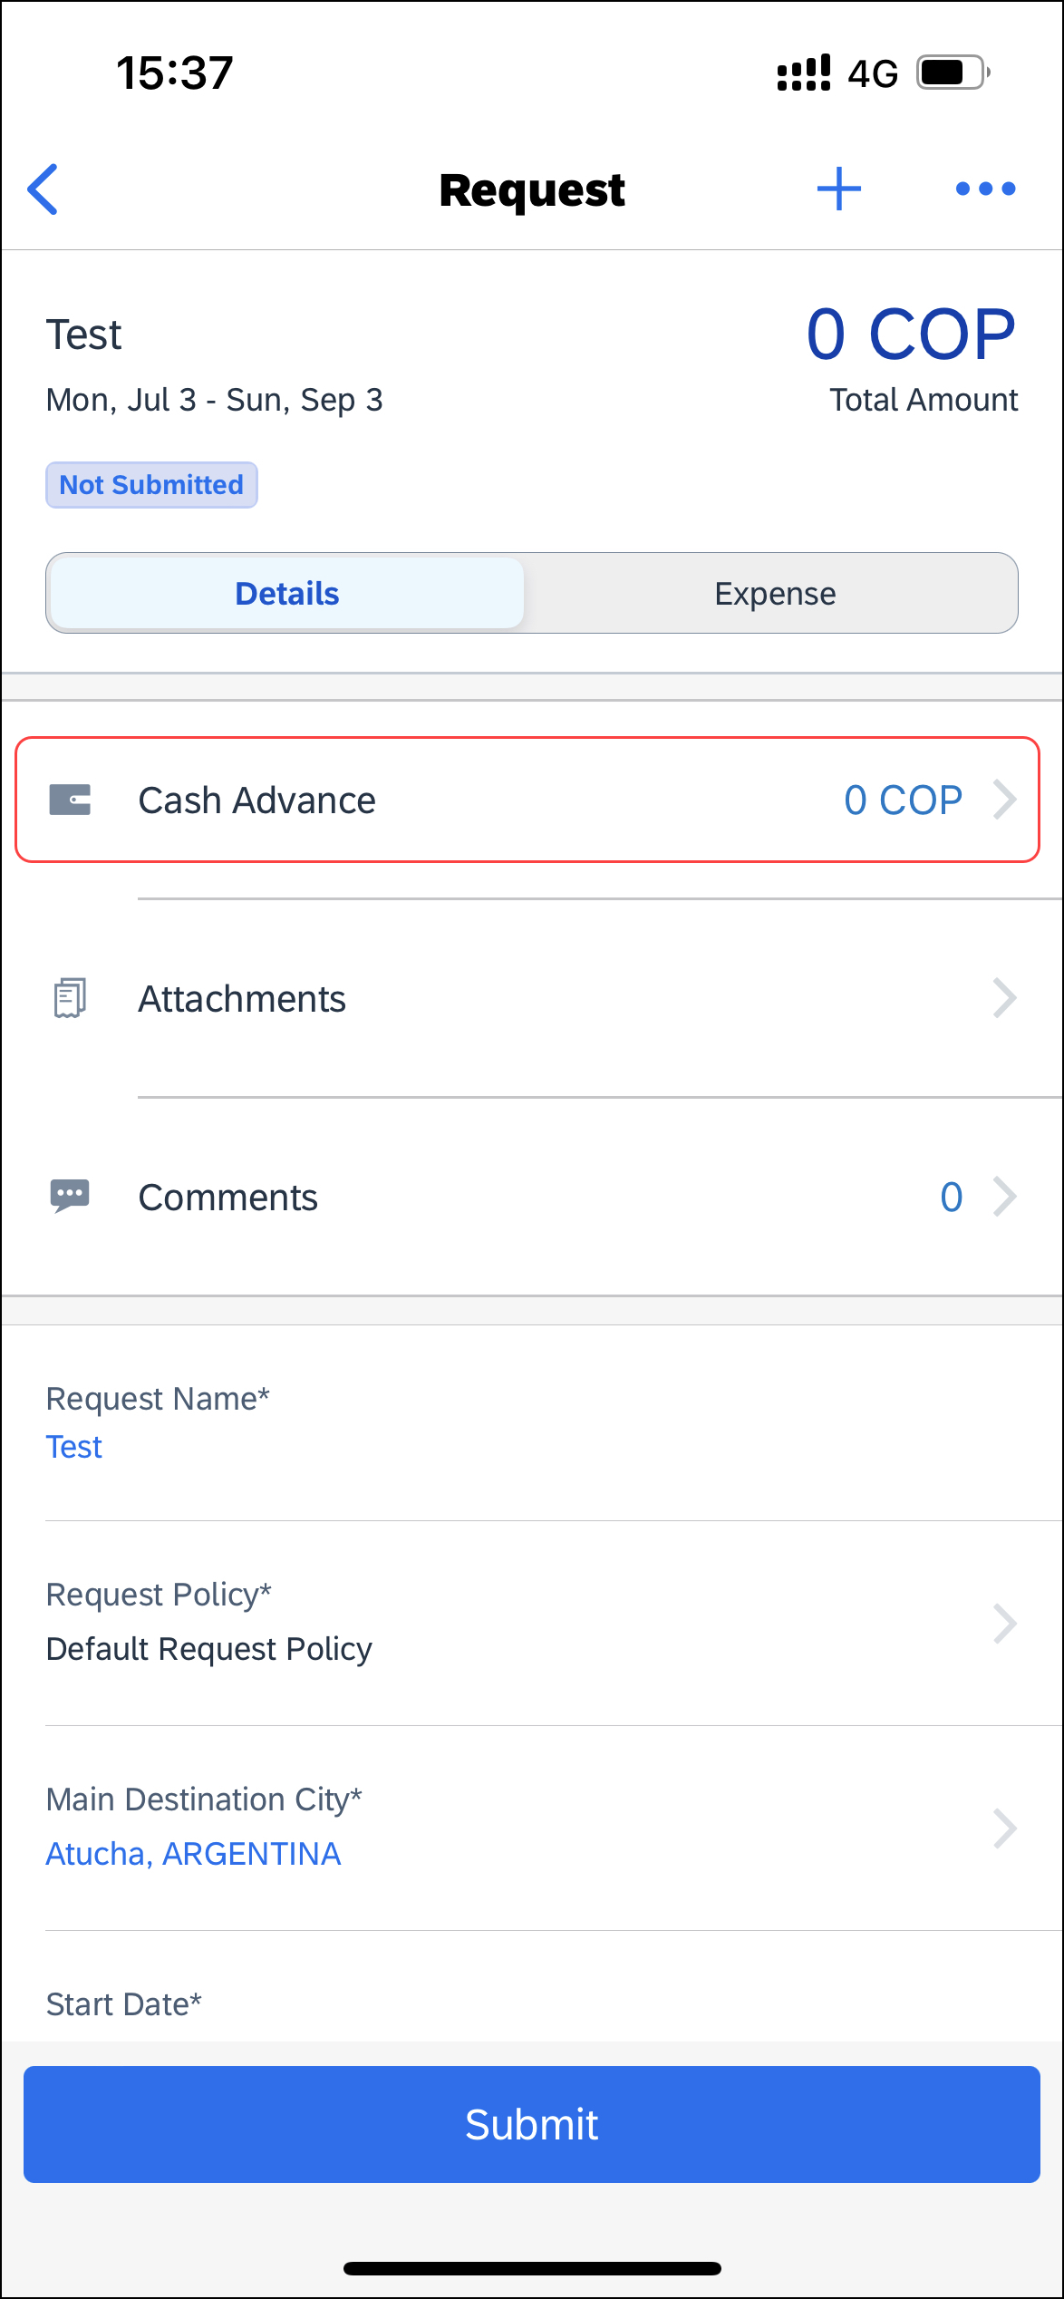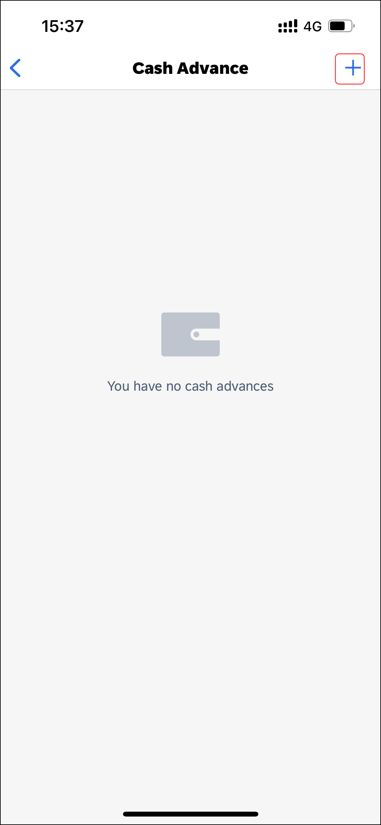 | To create a new cash advance:  1) On the home screen, tap Request.  2) On the Request screen, tap the Active tab.  3) On the Active tab, tap the desired request.  4) On the request screen, tap the Details tab.  5)On the Details tab, tap Cash Advance.  6) On the Cash Advance screen, tap (upper-right corner).
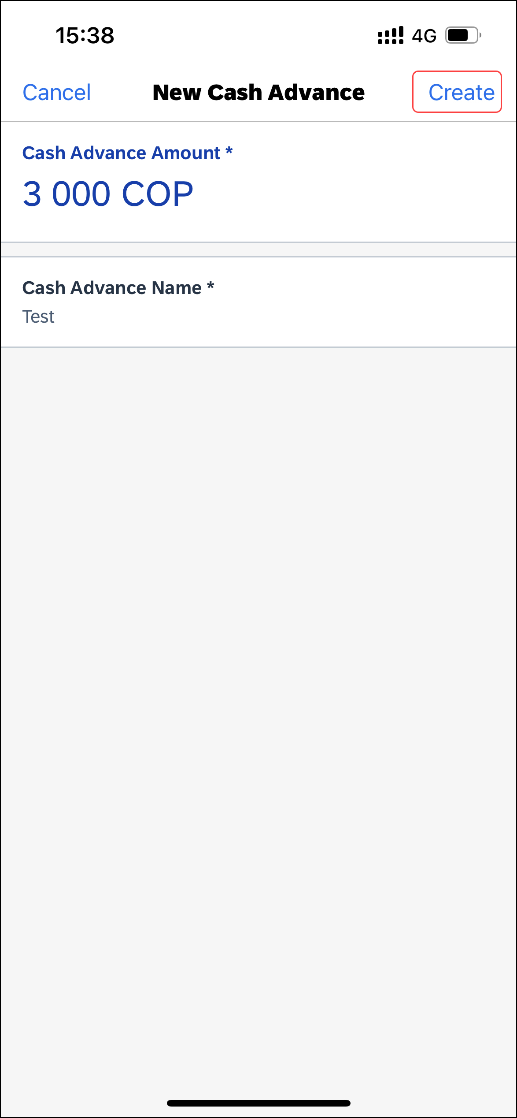 | 7) On the Cash Advance screen, tap Create (upper-right corner).  The cash advance appears on the Cash Advance screen.

Delete a Cash Advance Within a Request
Screen(s) | Description/Action
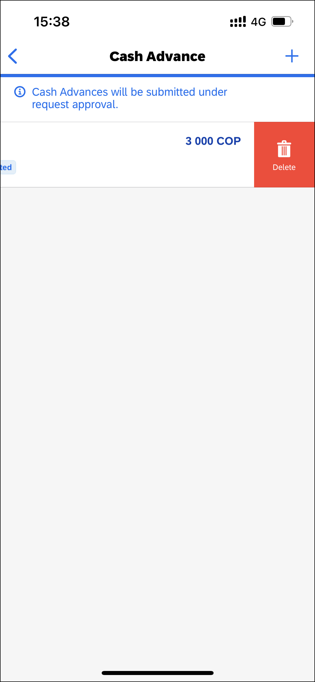 | To delete a cash advance within a request:  1) On the home screen, tap Request.  2) On the Request screen, tap the Active tab.  3) On the Active tab, tap the desired request.  4) On the request screen, tap the Details tab.  5)On the Details tab, tap Cash Advance.  6) On the Cash Advance screen, swipe the desired cash advance to the left.  7) Tap Delete.
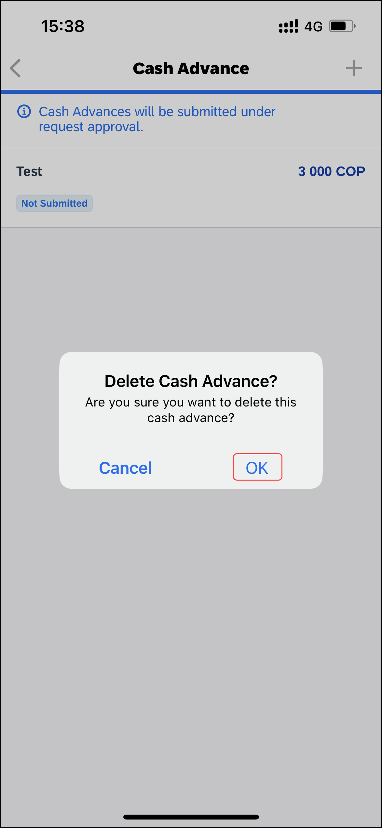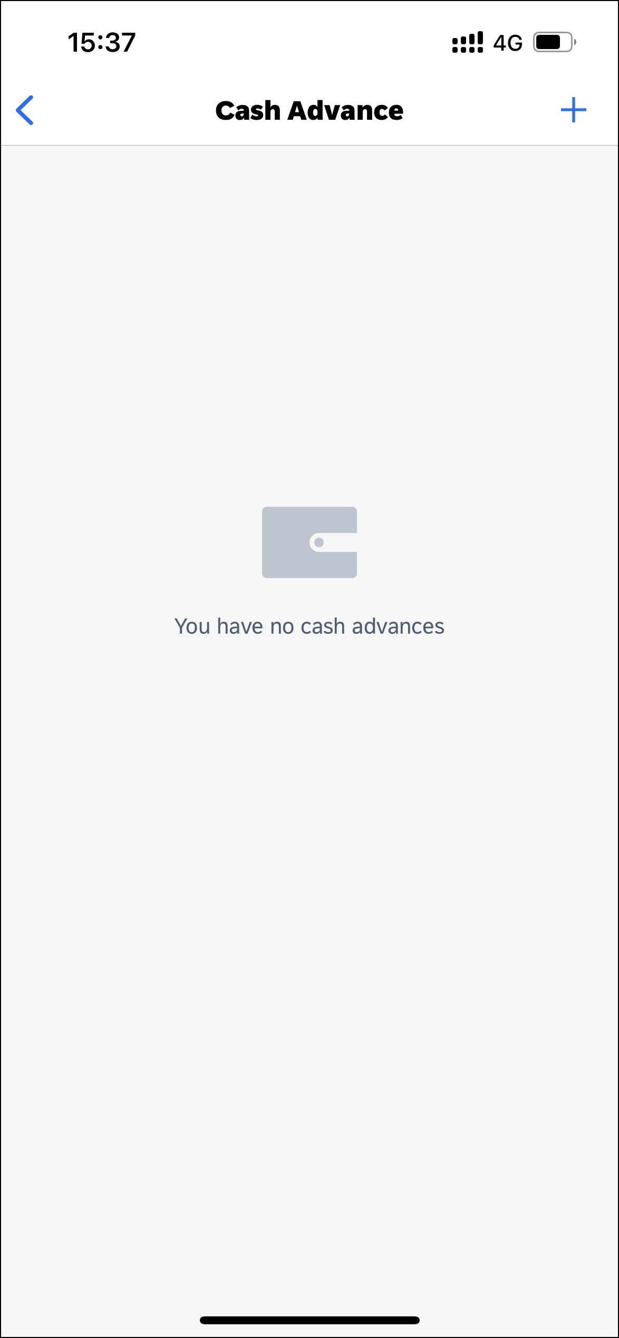 | 8) On the Delete Cash Advance window, tap OK.  The cash advance no longer appears on the Cash Advance screen.

Add Segments / Expense Types to a Request
Screen(s) | Description/Action
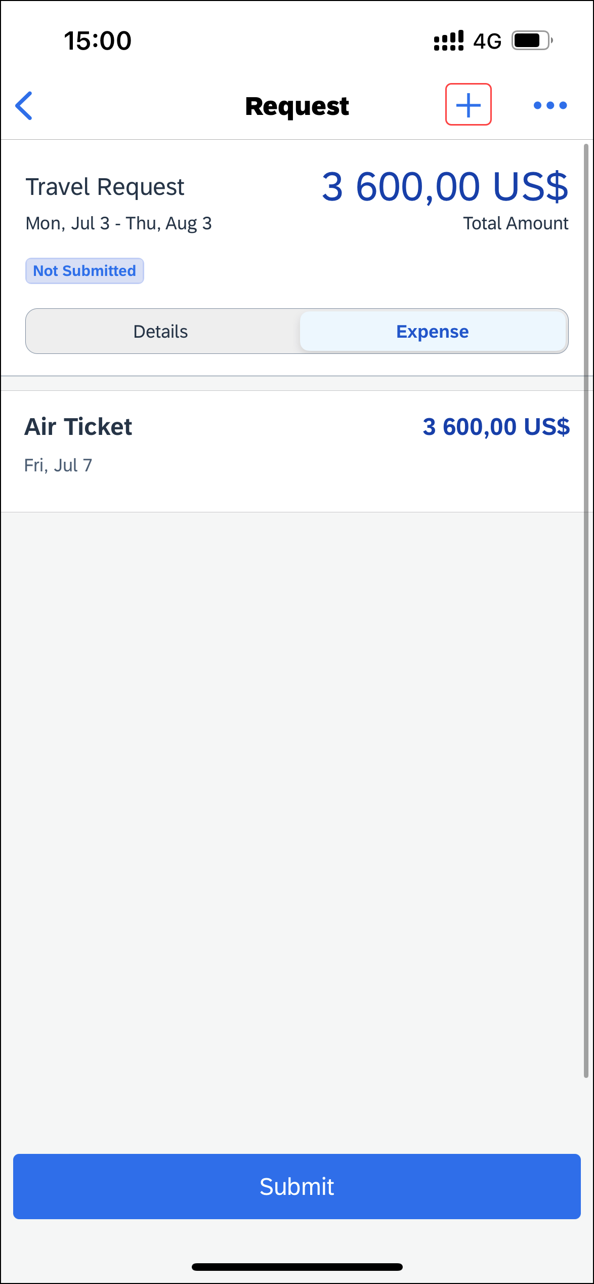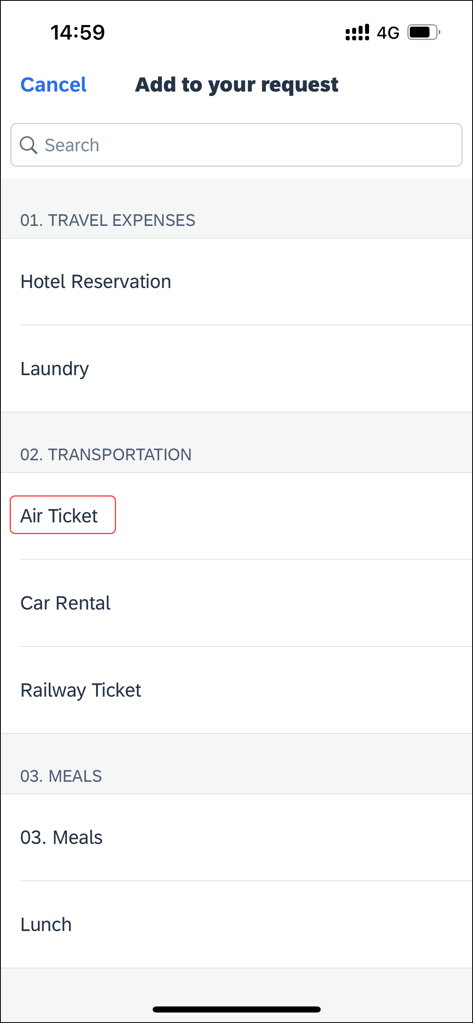 | To add segments / expense types to a request:  1) On the request screen, tap (upper-right corner).  2) On the Add to your request screen, (in this case Air Ticket), fill in the details and make the desired selections.
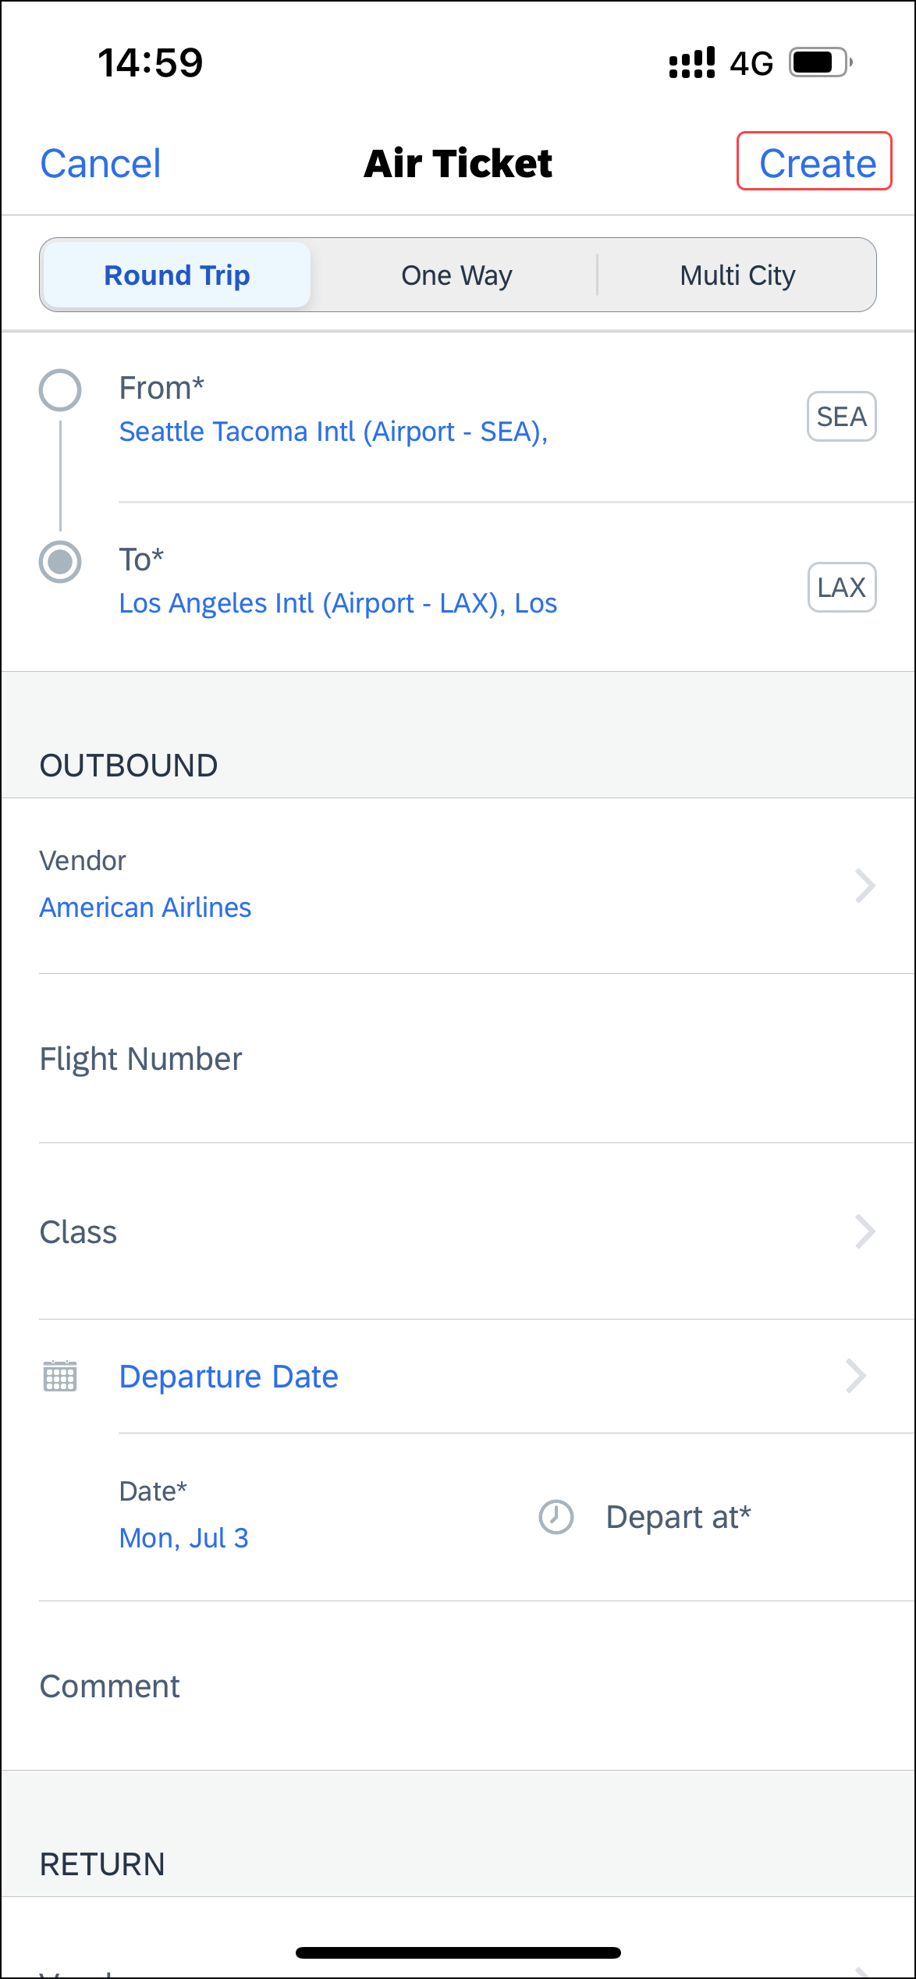 | 3) When done, on the segment / expense type screen, tap Create (upper-right corner) to return to the request screen.  4) On the request screen, add other segments / expense types as desired.

Attach an Attachment to a Travel Request
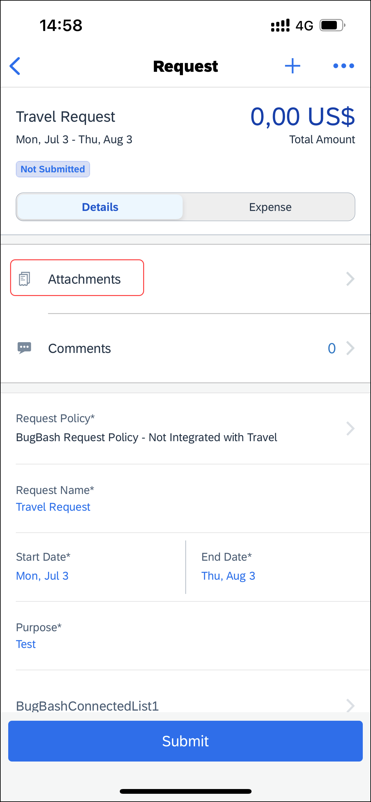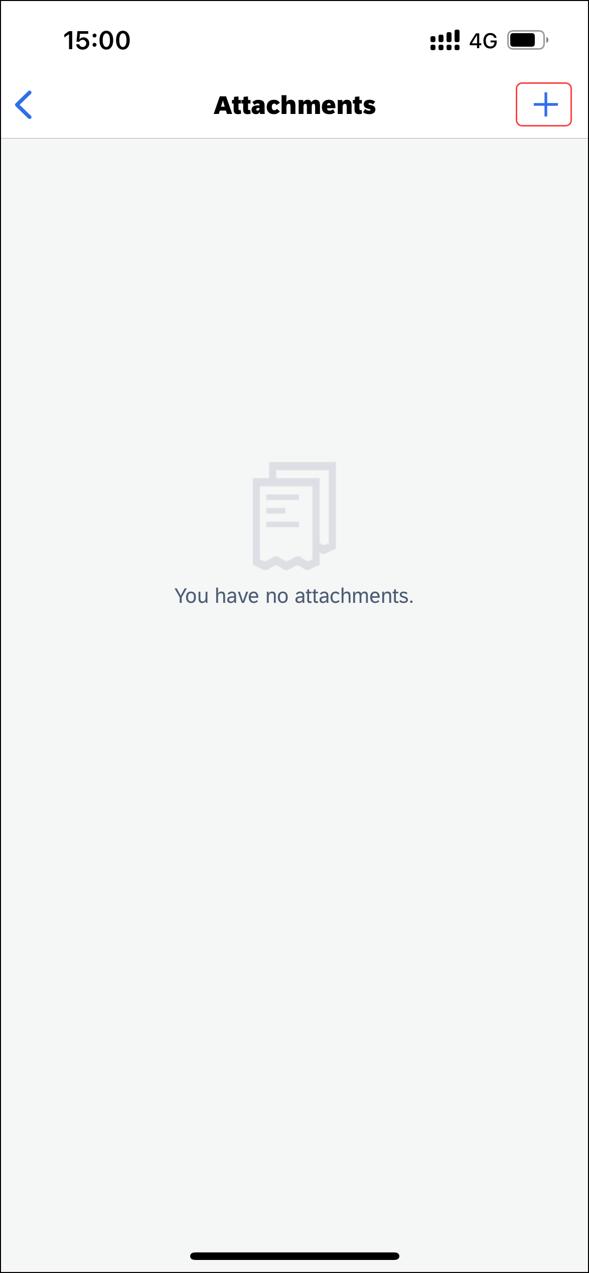 | To attach an attachment to a travel request:  1) On the home screen, tap Request.  2) On the Request screen, tap the Active tab.  3) On the Active tab, tap the desired request.  4) On the Request screen, tap the Details tab.  5) On the Details tab, tap Attachments.  6) On the Attachments screen, you can do the following:  - Tap the desired attachment.  - or -  - If there are no attachments available, tap (upper-right corner) to attach an attachment.
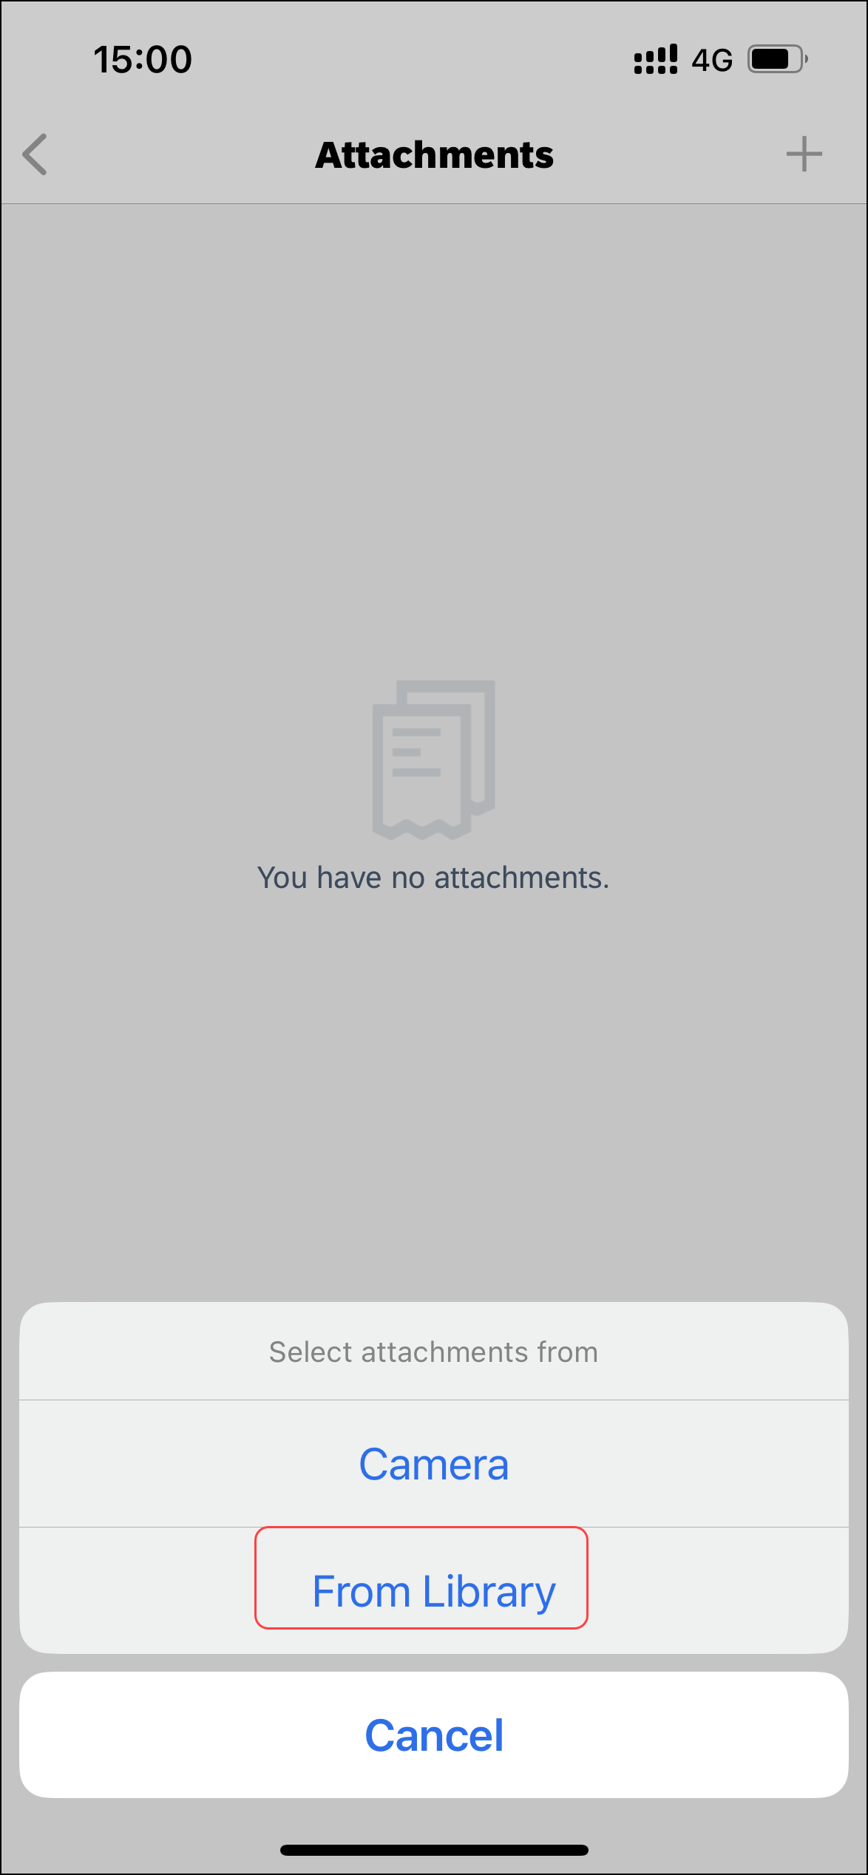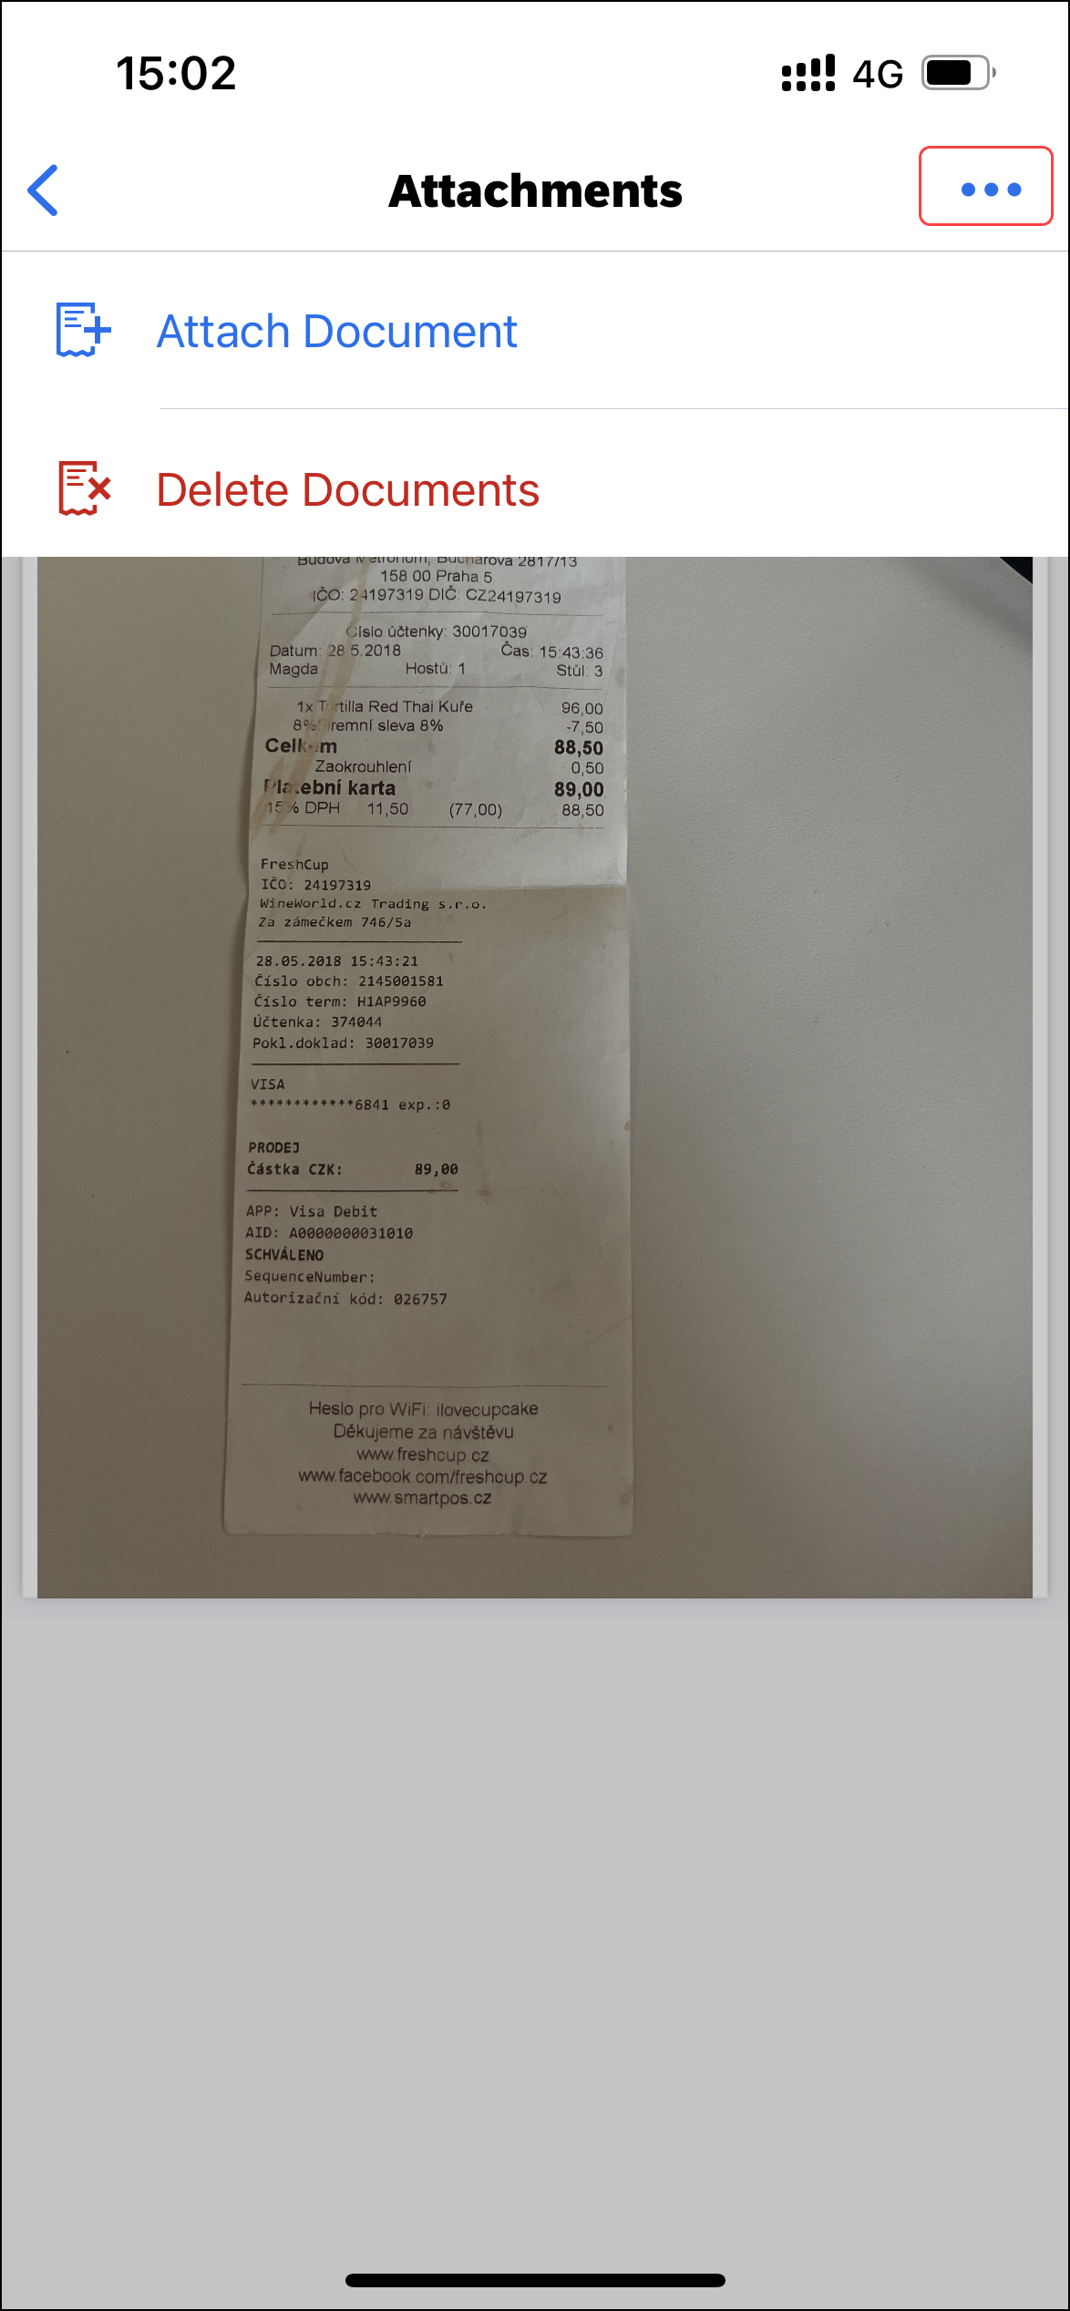 | 7) On the Select attachments from menu, you can do the following:  - Camera: Tap Camera to capture and attach an attachment.  - From Library: Tap From Library to select and attach an attachment.  - Cancel: Tap Cancel to exit the menu.  8) On the Recents screen, tap the desired attachment.  NOTE: The image size is limited to 5 megabytes.  After the desired attachment is uploaded, it appears on the Attachments screen.  NOTE: You can also add attachments by tapping (upper-right corner) on the Attachments screen and then tapping Attach Document on the menu.

Modify an Attachment on the Attachments Screen
Screen(s) | Description/Action
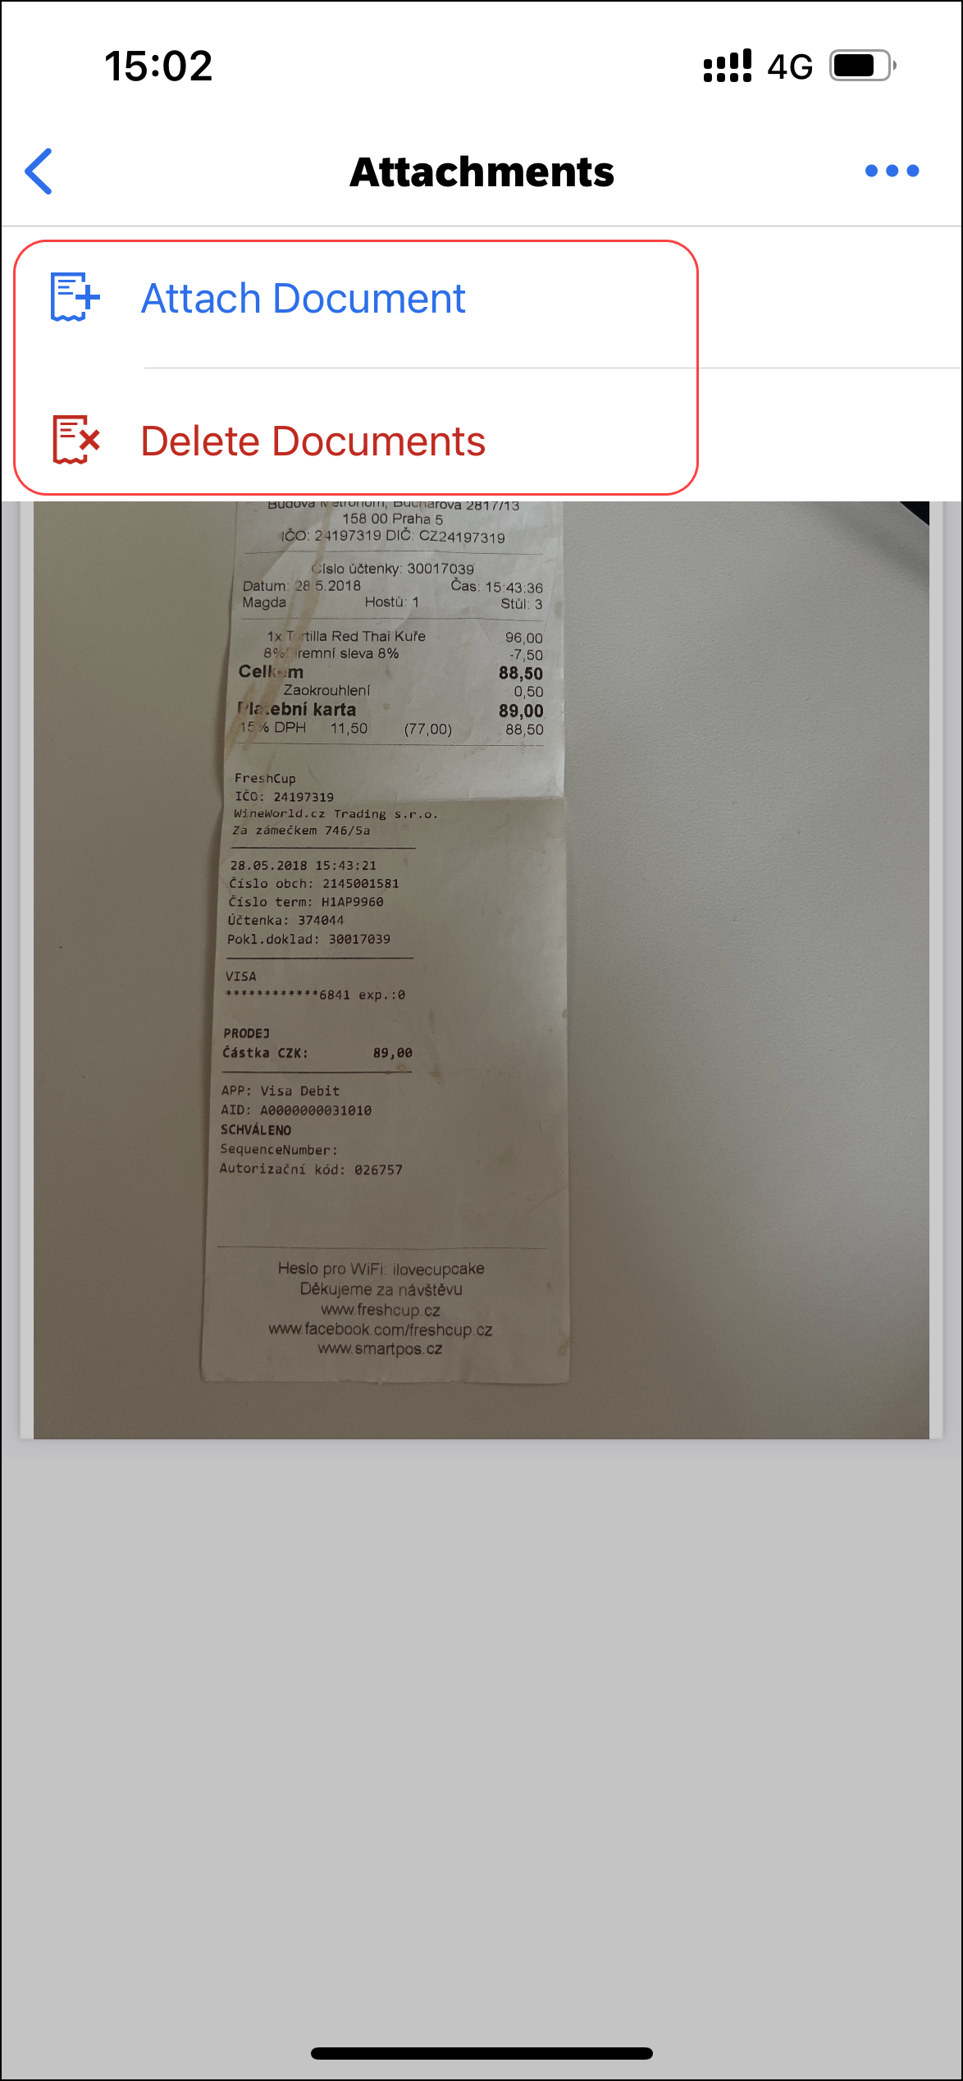 | To modify an attachment on the Attachments screen:  1) On the home screen, tap Request.  2) On the Request screen, tap the Active tab.  3) On the Active tab, tap the desired request.  4) On the Request screen, tap the Details tab.  5) On the Details tab, tap Attachments.  6) On the Attachments screen, tap (upper-right corner).  7) On the menu, you can either tap:  - Attach Document  - or -  - Delete Documents

Delete an Attachment From a Travel Request
Screen(s) | Description/Action
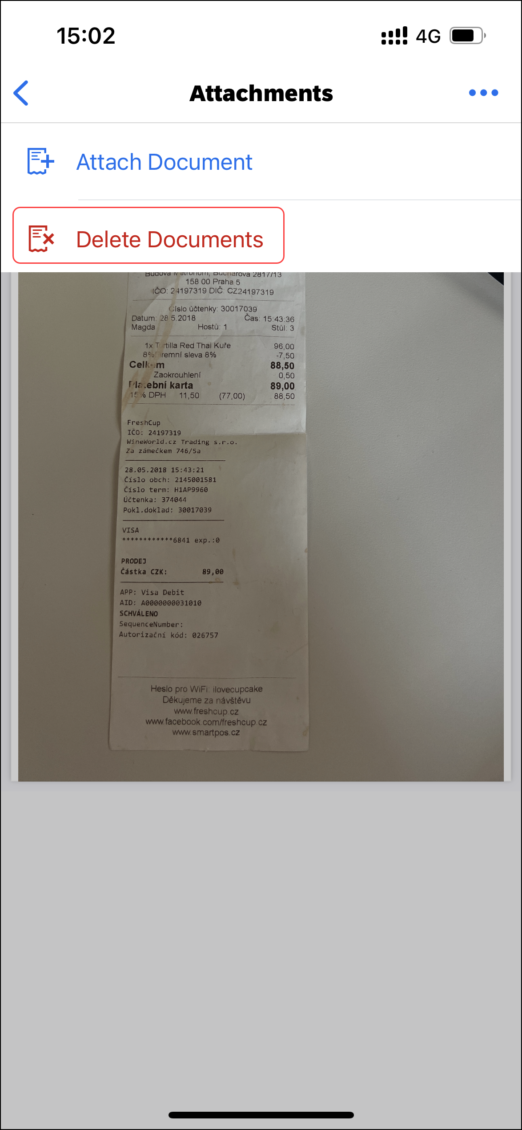 | To delete an attachment from a travel request:  1) On the home screen, tap Request.  2) On the Request screen, tap the Active tab.  3) On the Active tab, tap the desired request.  4) On the Request screen, tap the Details tab.  5) On the Details tab, tap Attachments.  6) On the Attachments screen, tap (upper-right corner).  7) On the menu, tap Delete Documents.
8) On the Delete Documents widow, tap Delete.
After the desired attachment is deleted, it no longer appears on the Attachments screen.

Delete a Segment / Expense Type From an Open Unsubmitted Request
Screen(s) | Description/Action
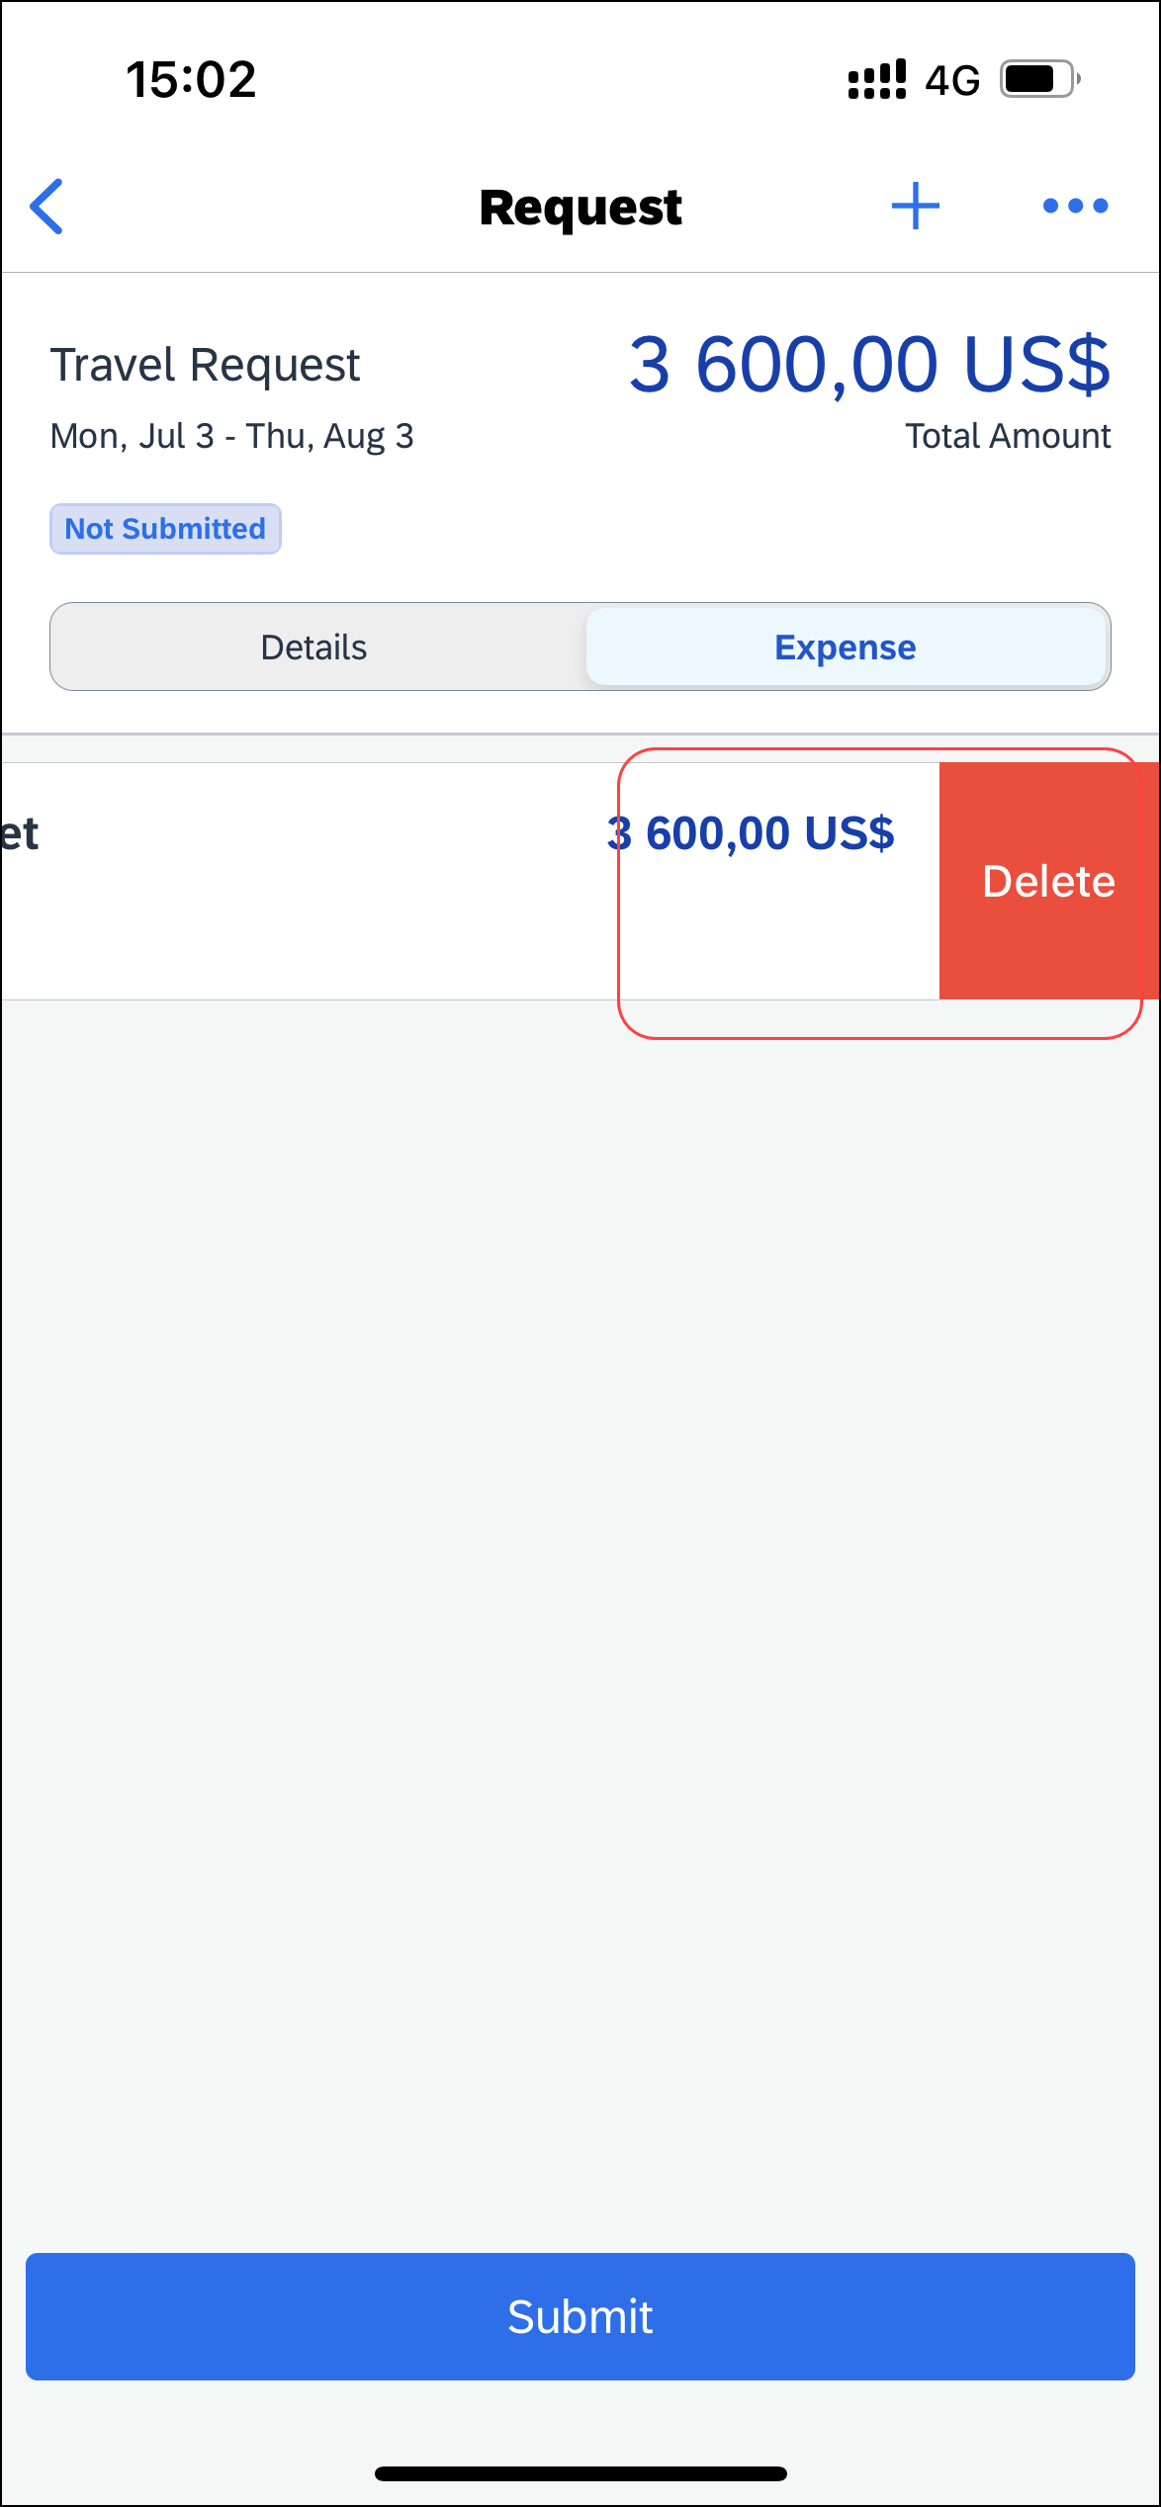 | To delete a segment/expense type from an open unsubmitted request:  1) With the request open, tap the Expense tab,  2) On the Expense tab, swipe the desired segment / expense type to the left.  3) Tap Delete.
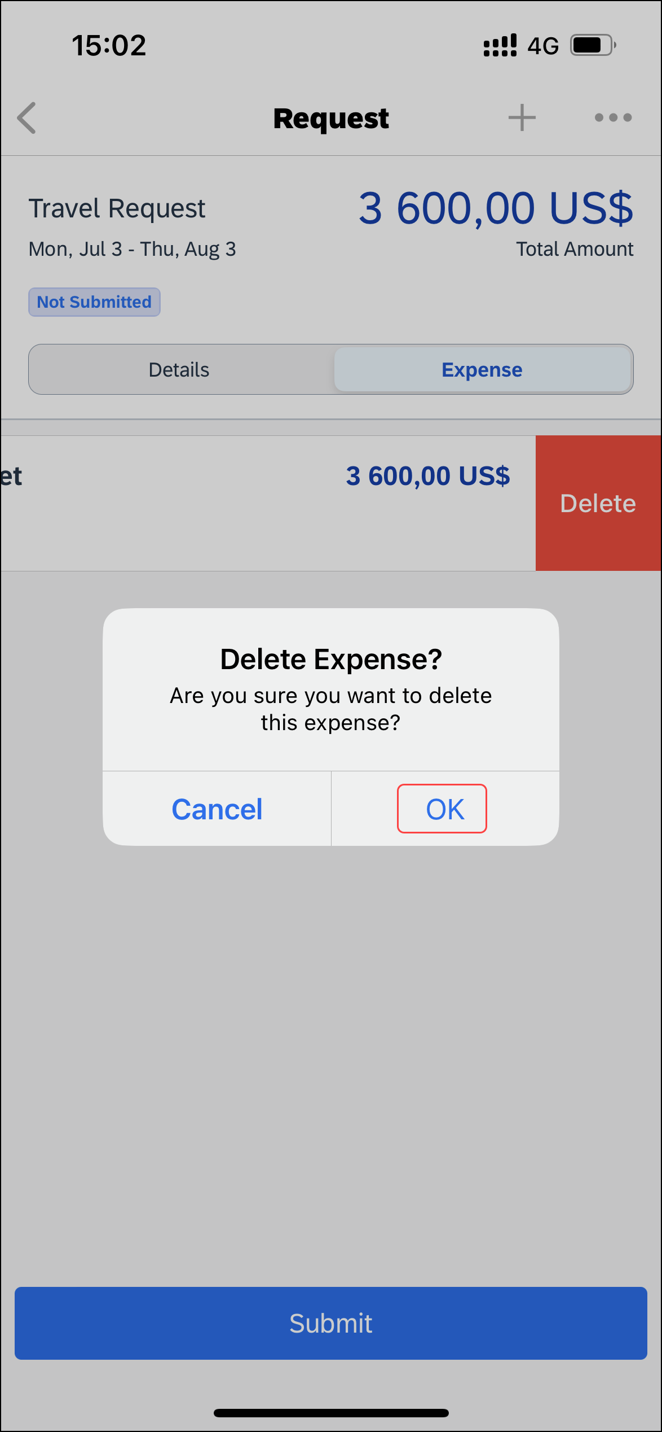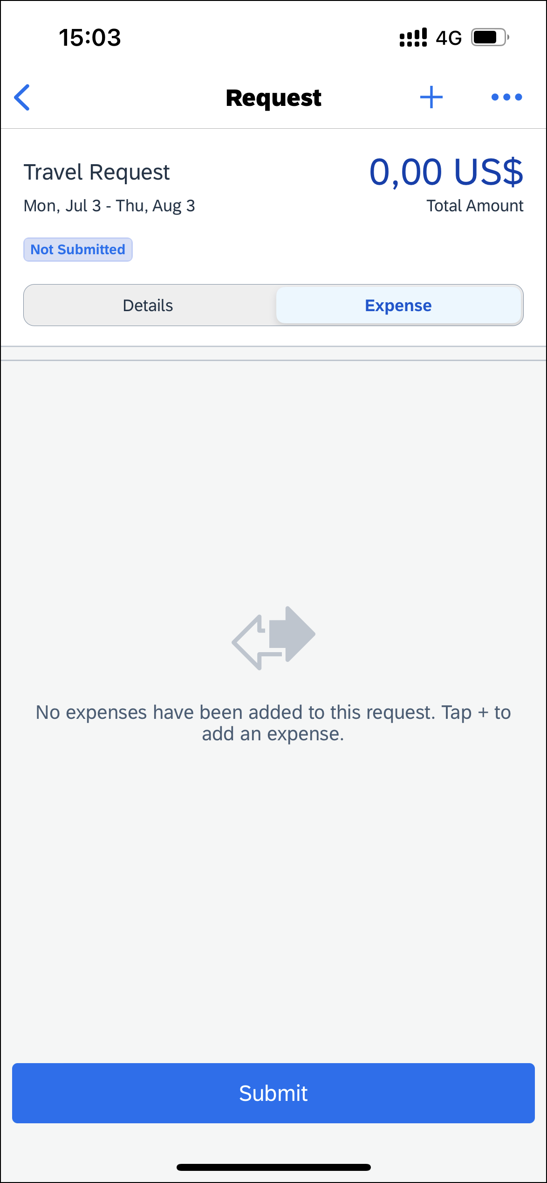 | 4) On the Delete Expense? menu, tap OK.  The segment / expense type no longer appears on the Request screen.  NOTE: You can also delete a segment / expense type from a request by clicking (upper-right corner) and then clicking Delete.

Delete an Unsubmitted Request on in an Open Request
Screen(s) | Description/Action
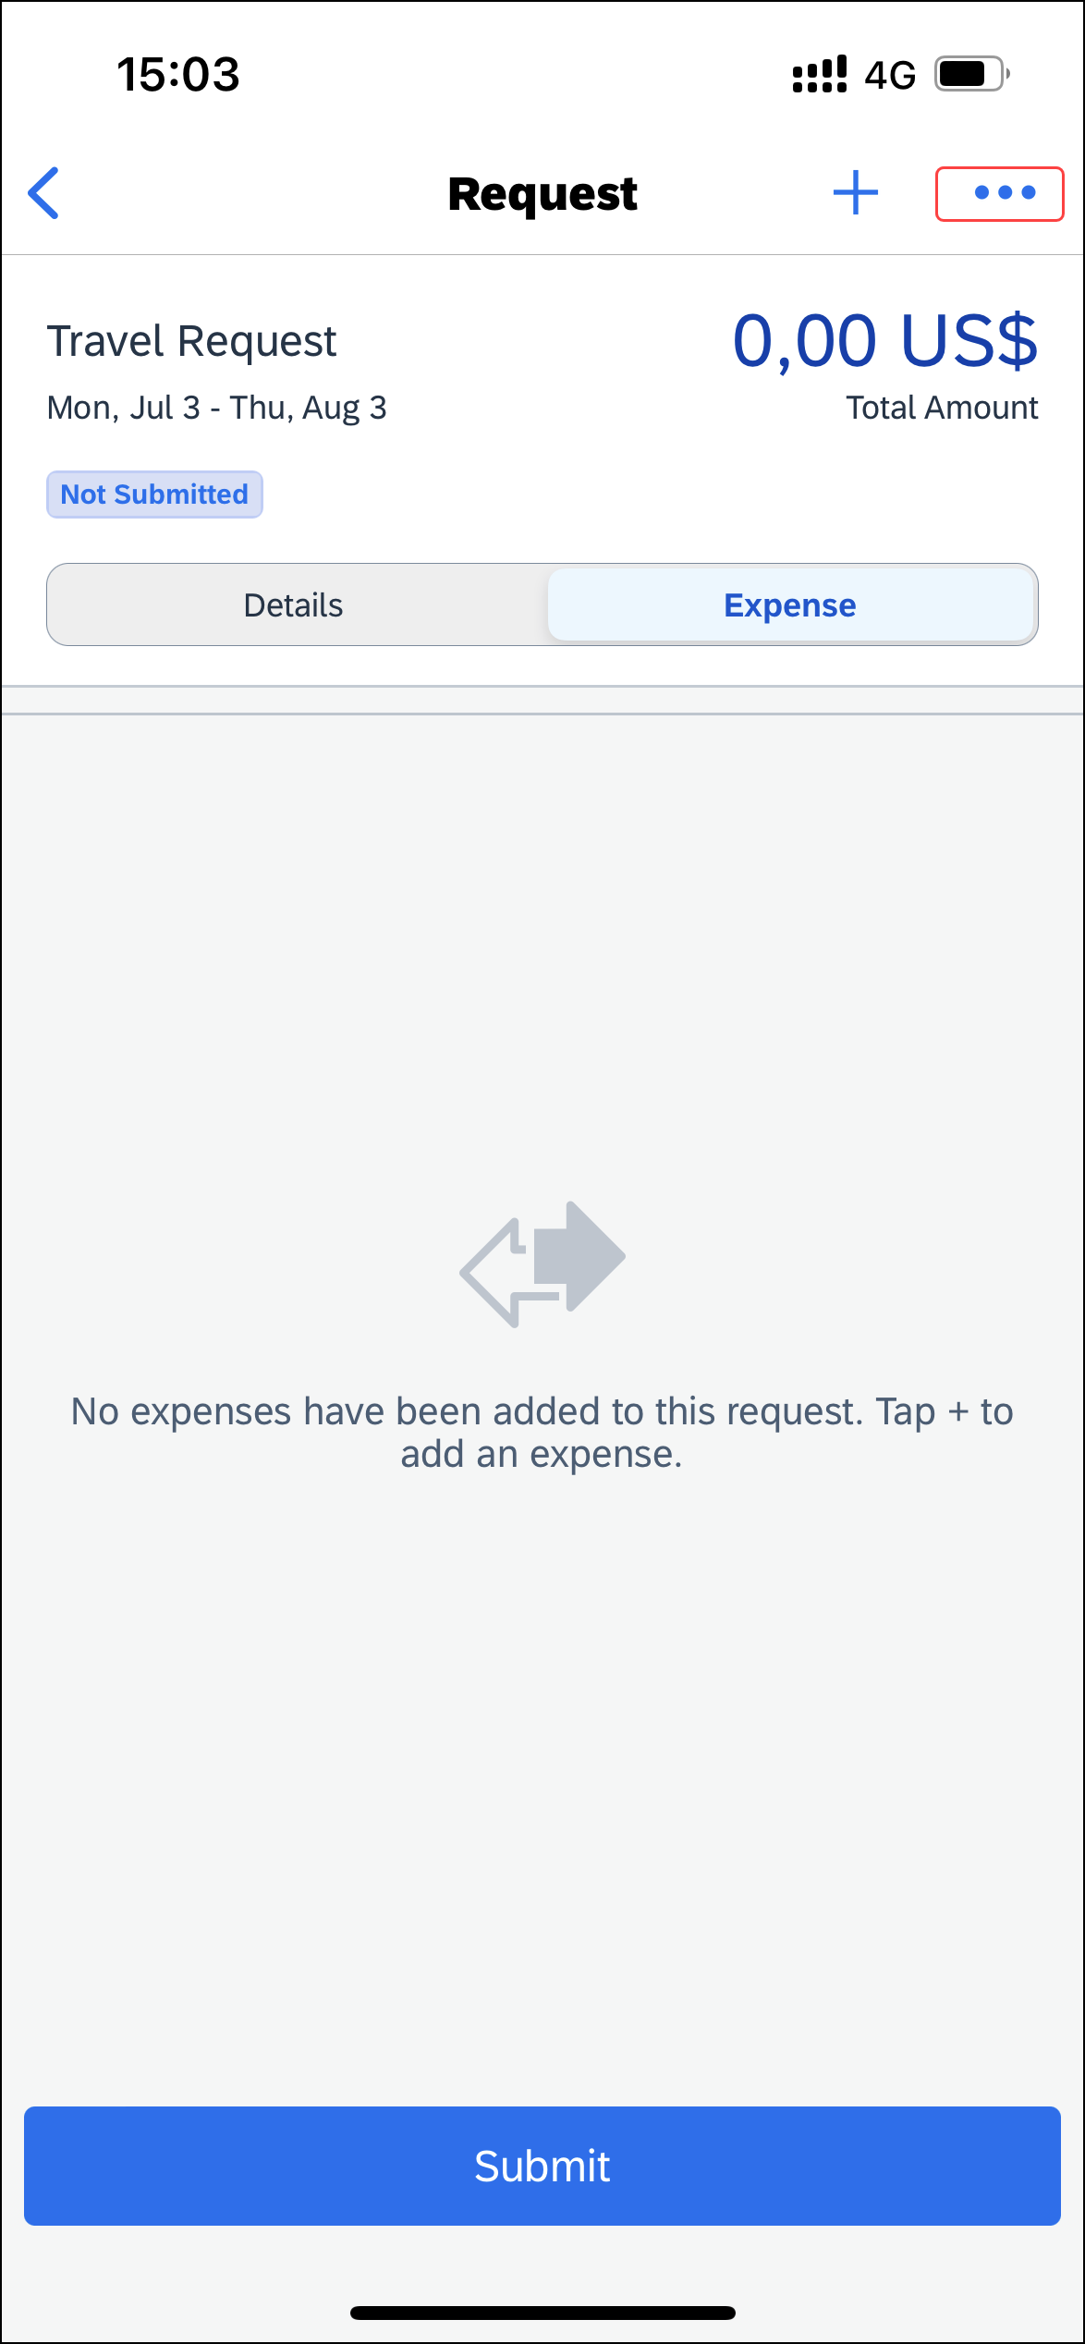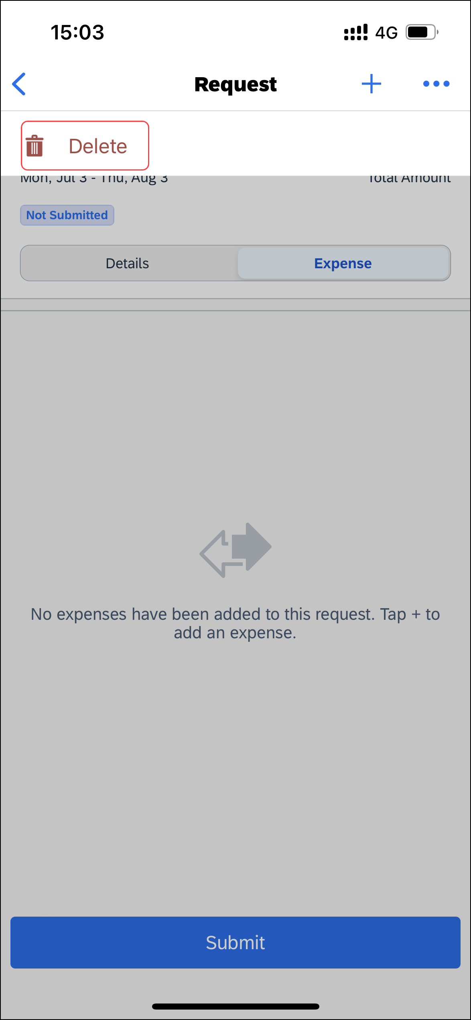 | To delete an unsubmitted request in an open request:  1) With the request open, tap (upper-right corner).  2) On the menu, tap Delete.
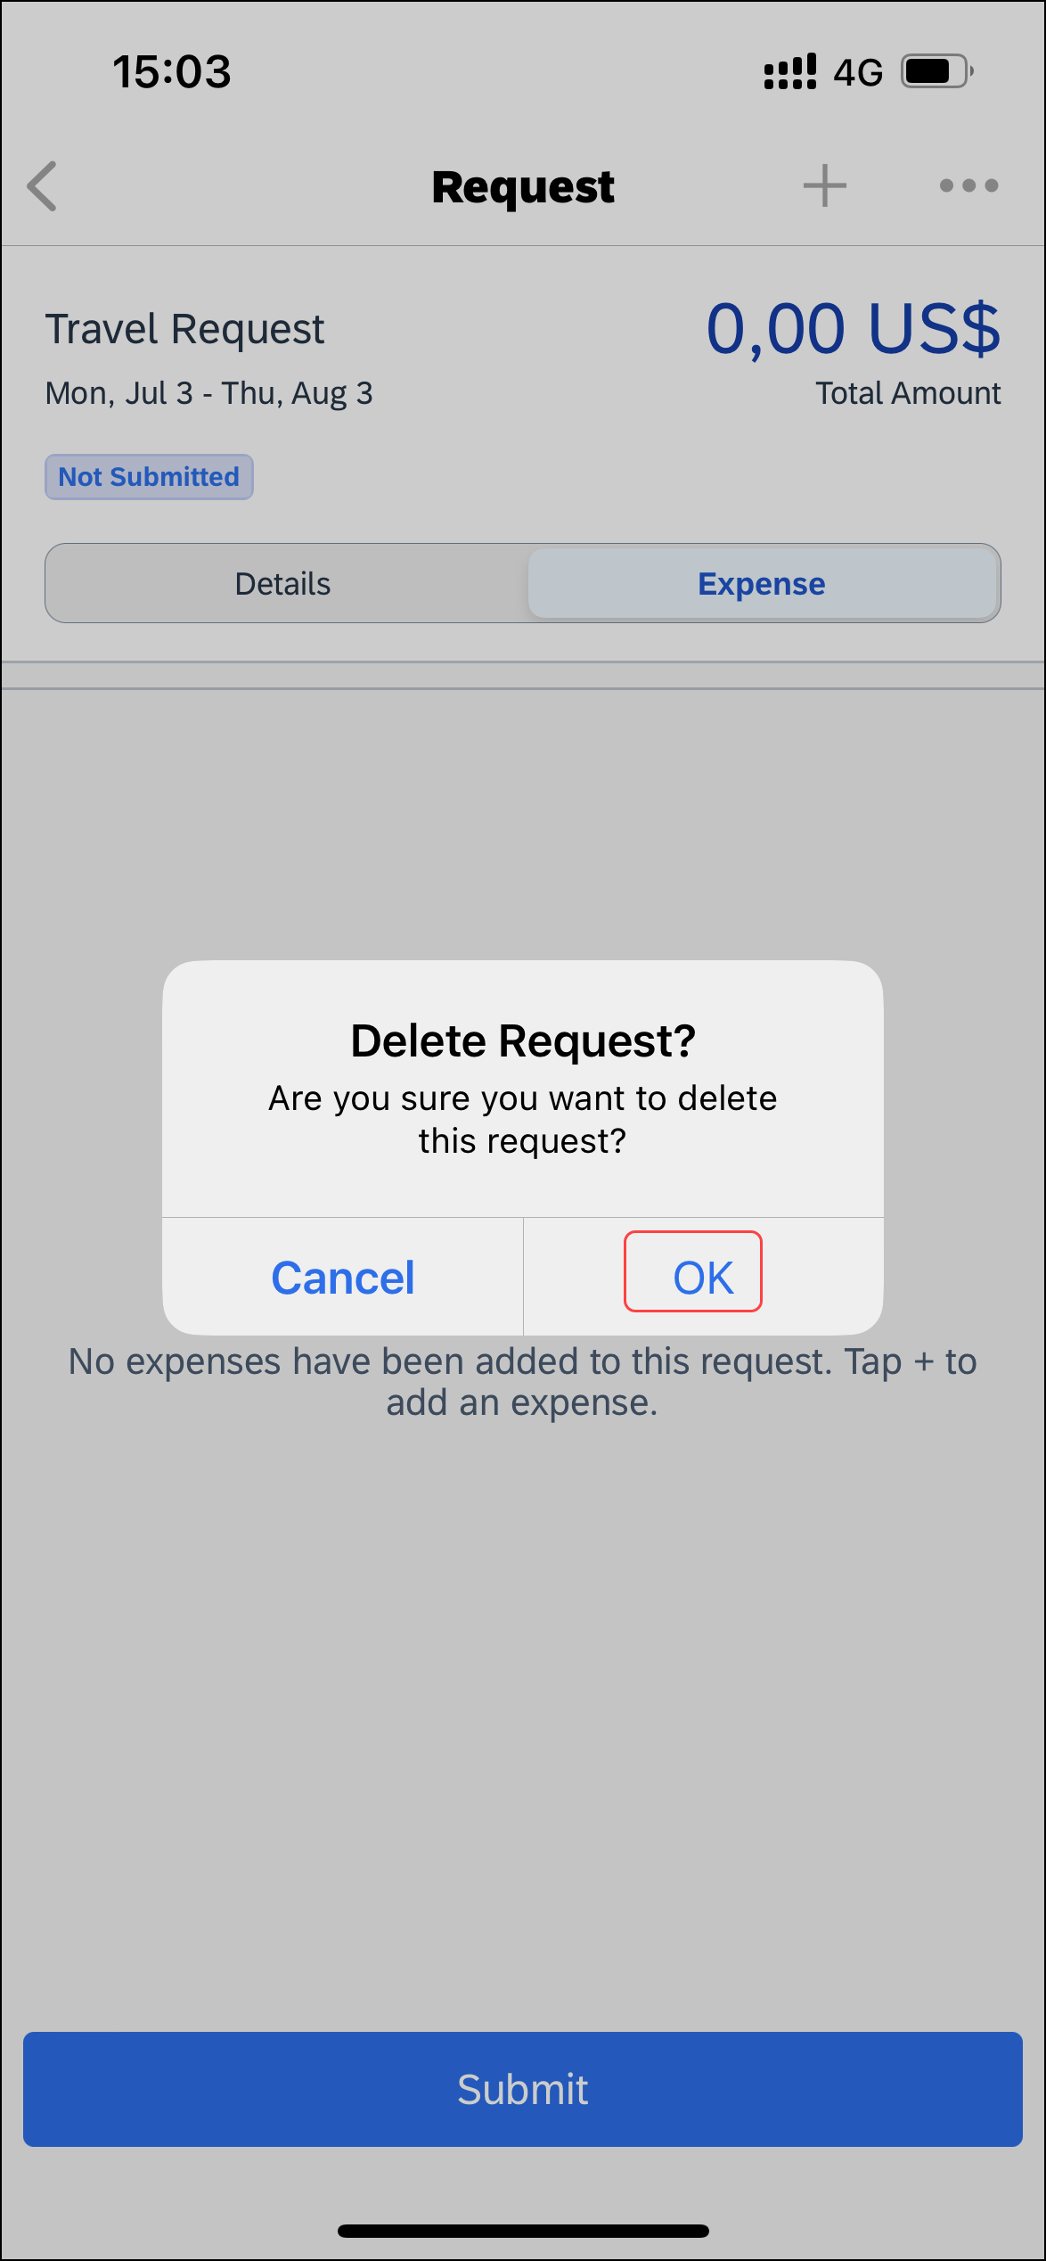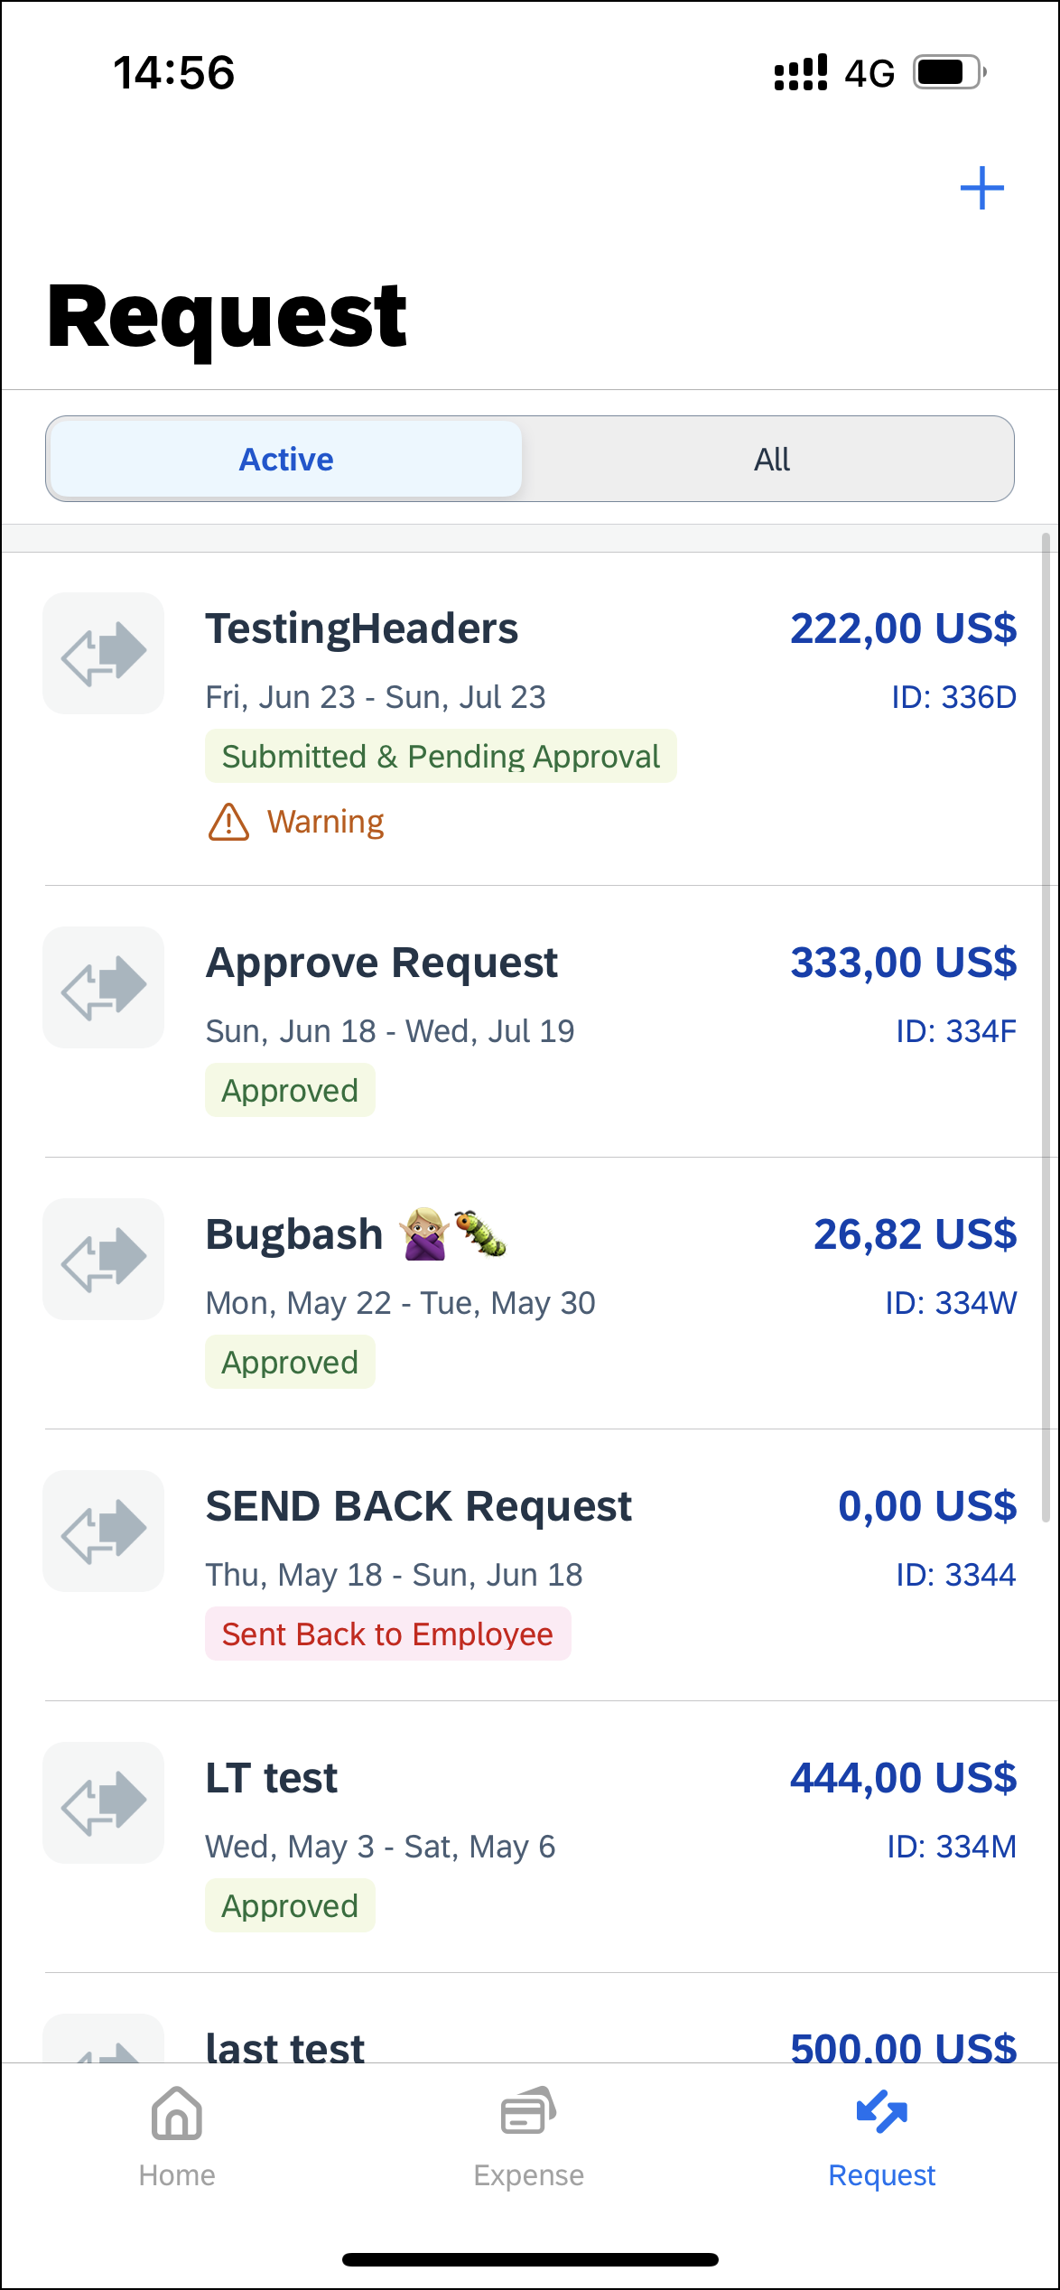 | 3) On the Delete Request? window, tap OK.  The request no longer appears on the Request screen.

Delete an Unsubmitted Request on the Request Screen
Screen(s) | Description/Action
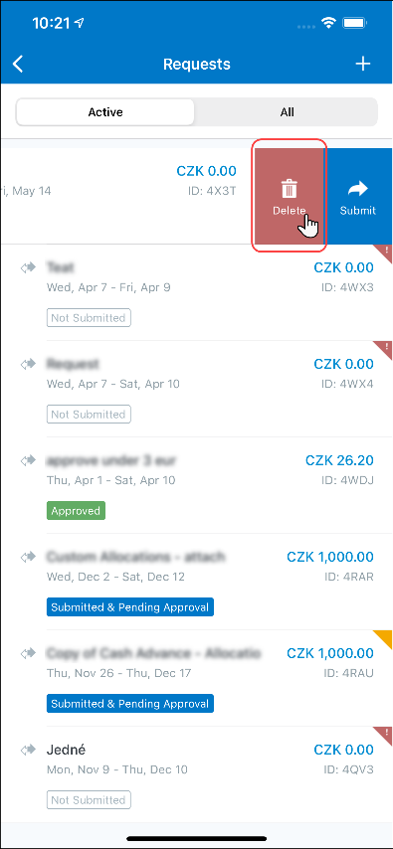 | To delete an unsubmitted request on the Request screen:  1) On the home screen, tap Request.  2) On the Request screen, tap the Active tab.  3) On the Request screen, tap the Active tab.  4) On the Active tab, swipe the desired request to the left.  5) Tap Delete.
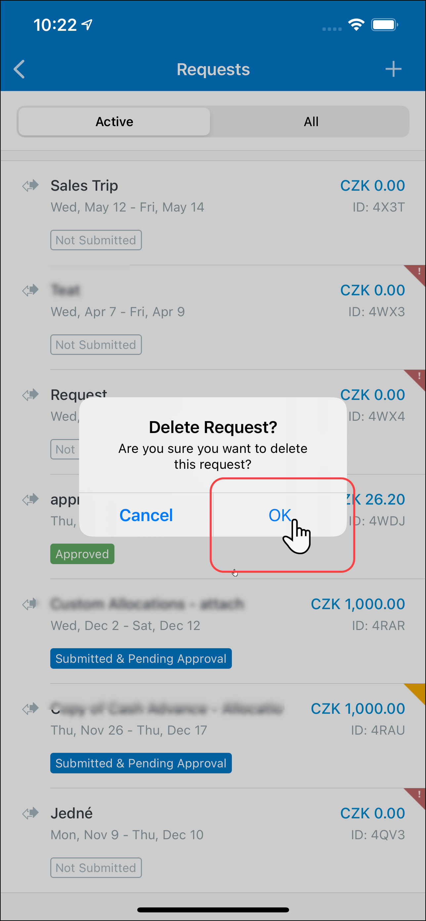 | 6) On the Delete Request? window, tap OK.  The request no longer appears on the Request screen.

Submit a Request From an Open Request
Screen(s) | Description/Action
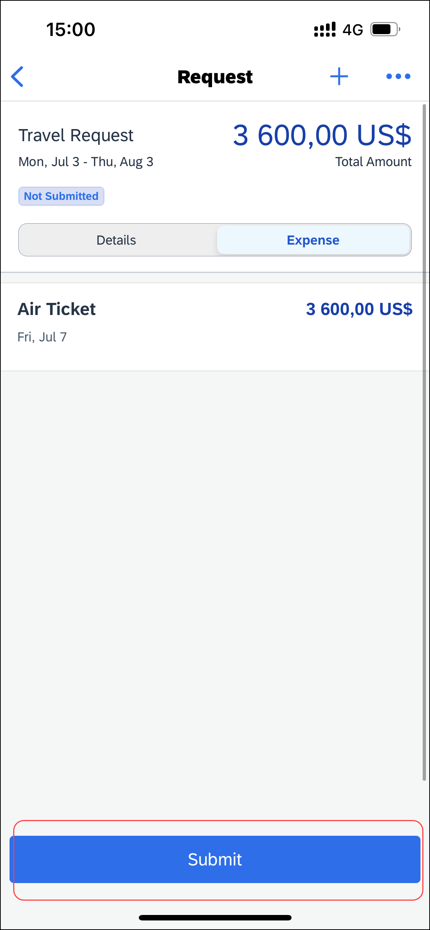 | To submit a request from an open request:  - With the request open, tap Submit.

Submit a Request on the Request Screen
Screen(s) | Description/Action
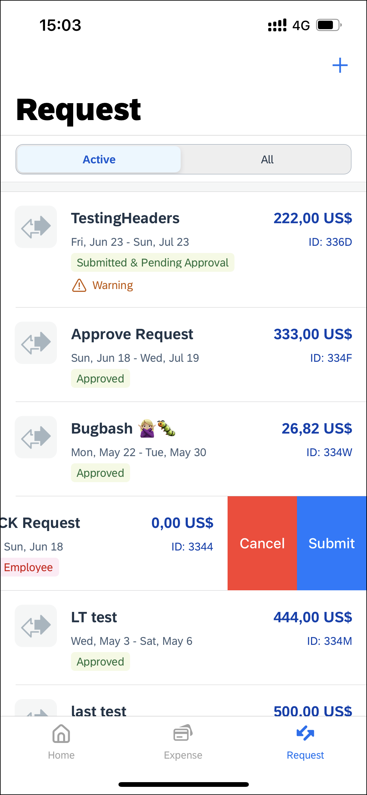 | To submit a request on the Request screen:  1) On the home screen, tap Request.  2) On the Request screen, tap the Active tab.  3) On the Active tab, swipe the desired request to the left.  4)Tap Submit.

Recall a Request
Screen(s) | Description/Action
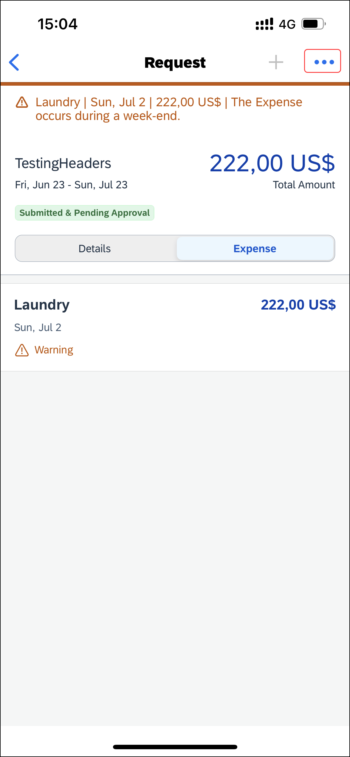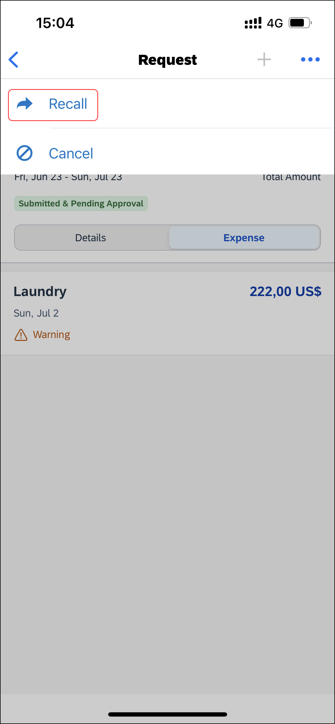 | To recall a submitted request:  1) On the request screen, tap (upper-right corner).  2) On the menu, tap Recall.
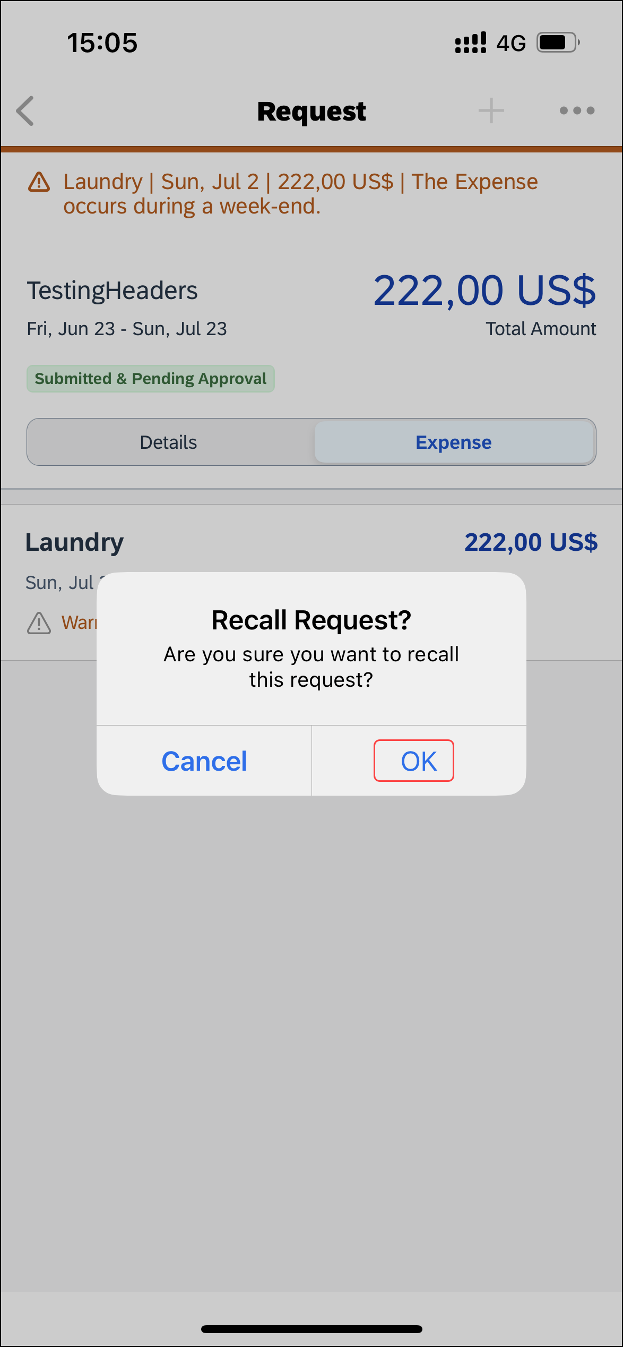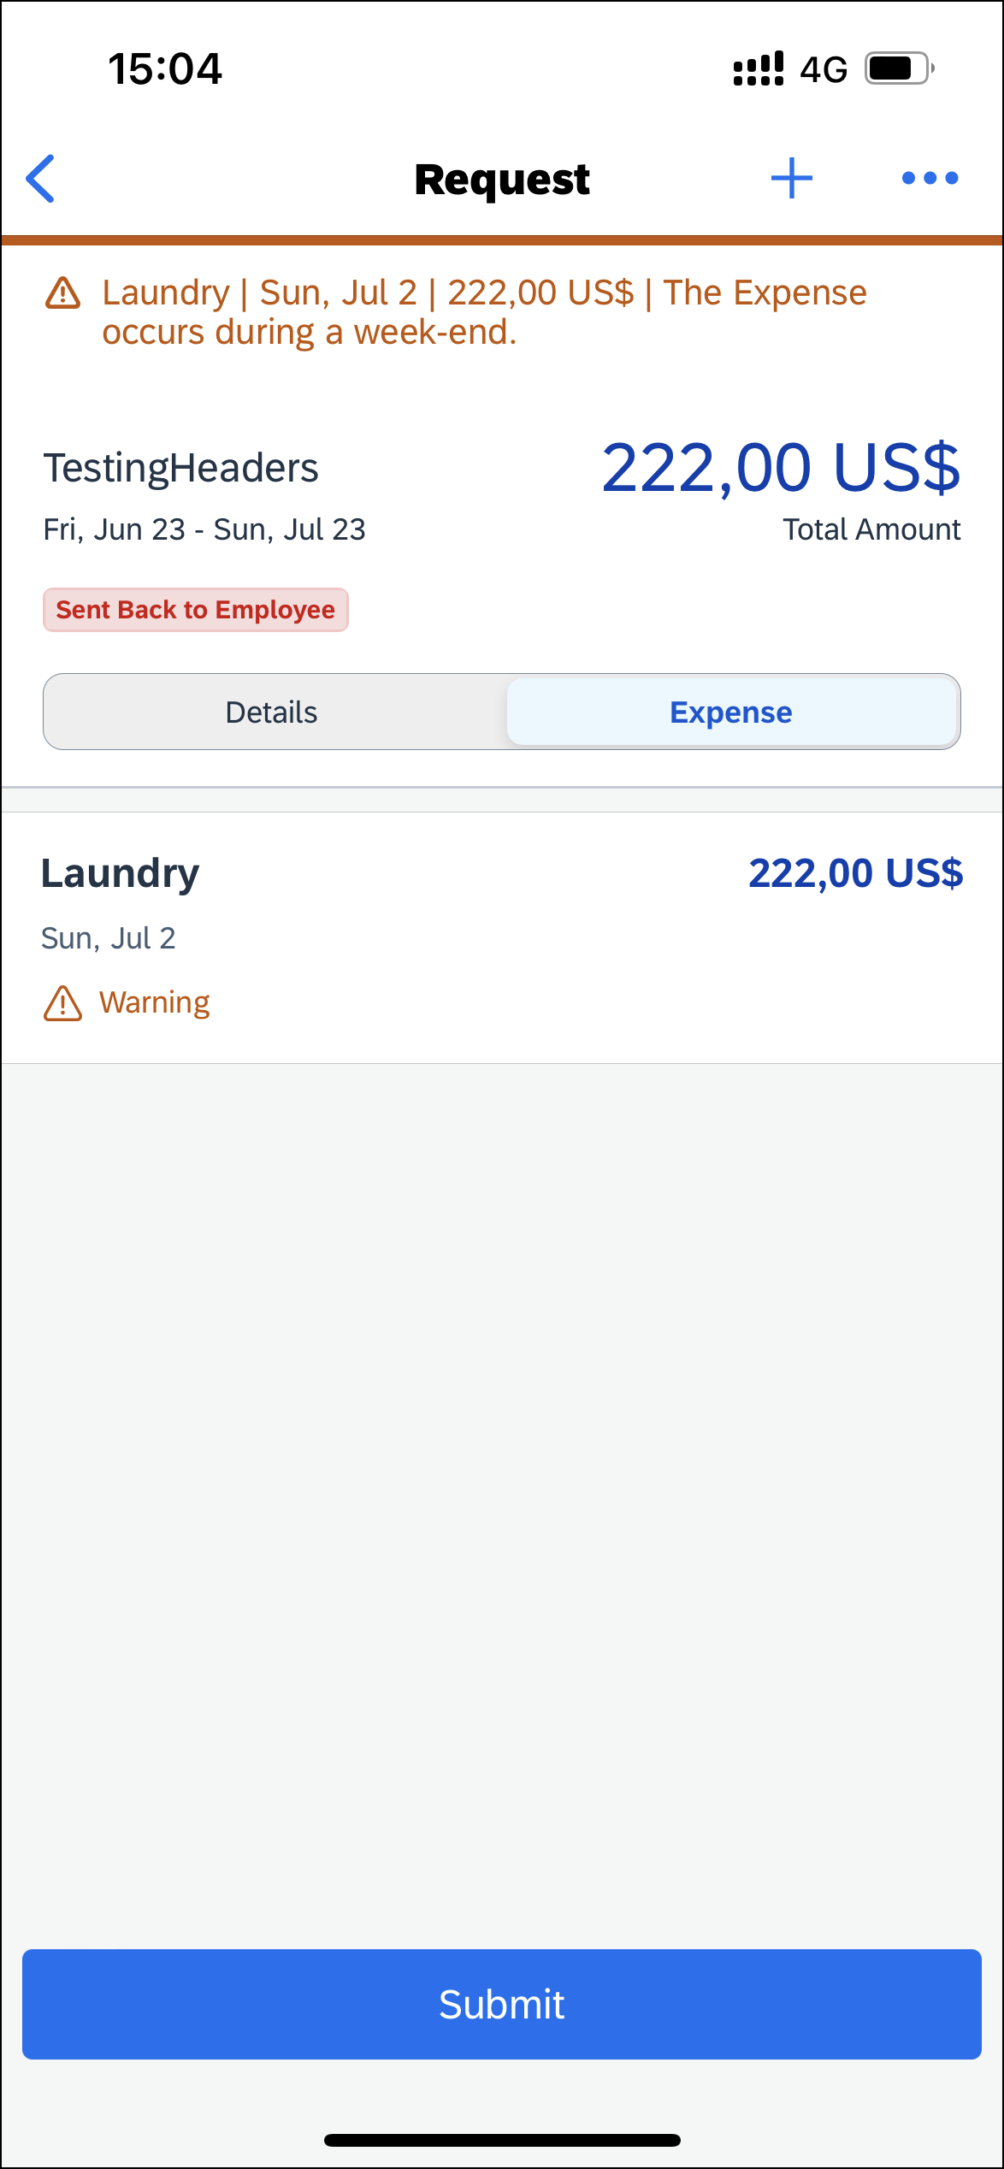 | 3) On the Recall Request? window, tap OK.  The request has been recalled and the Send Back to Employee message appears on the request screen.

Approve a Request
Screen(s) | Description/Action
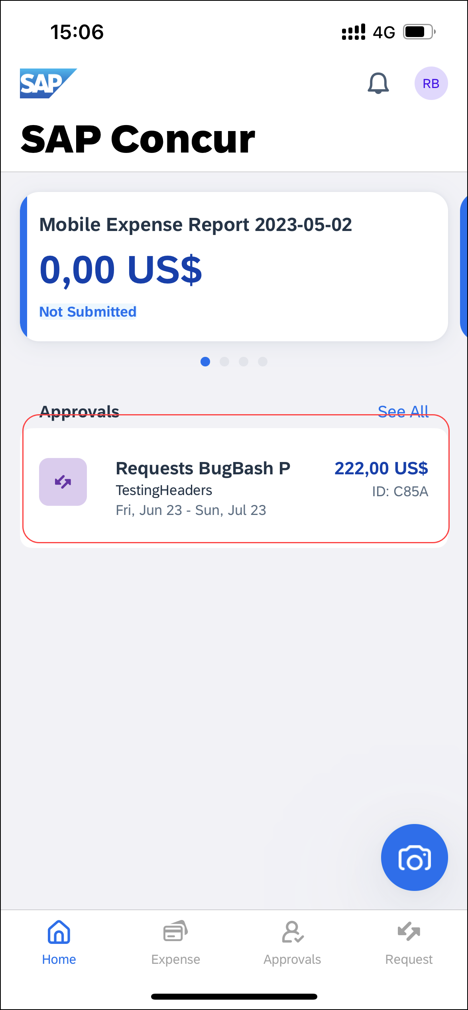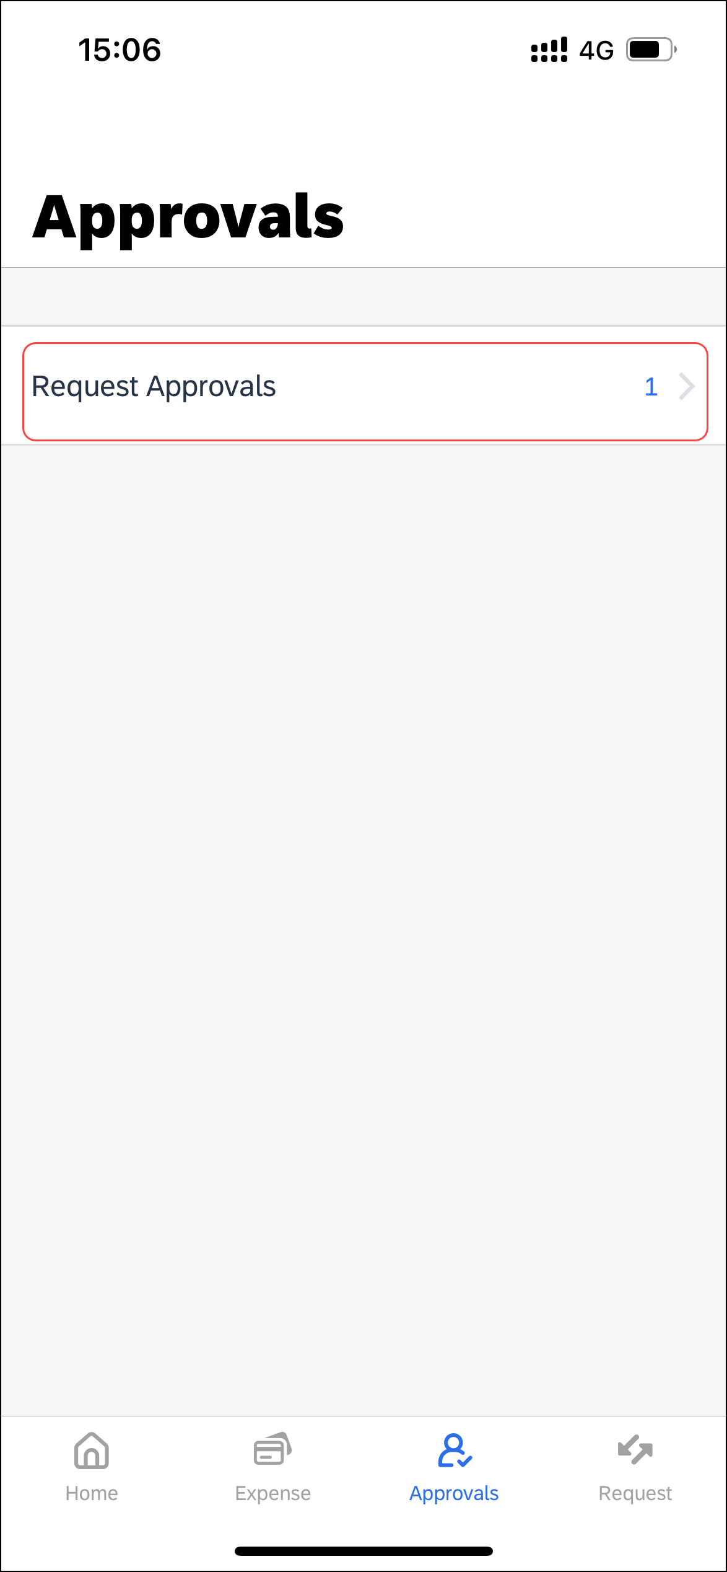 | To approve a request:  1) On the home screen, tap Approvals.  2) On the Approvals screen, tap Request Approvals.
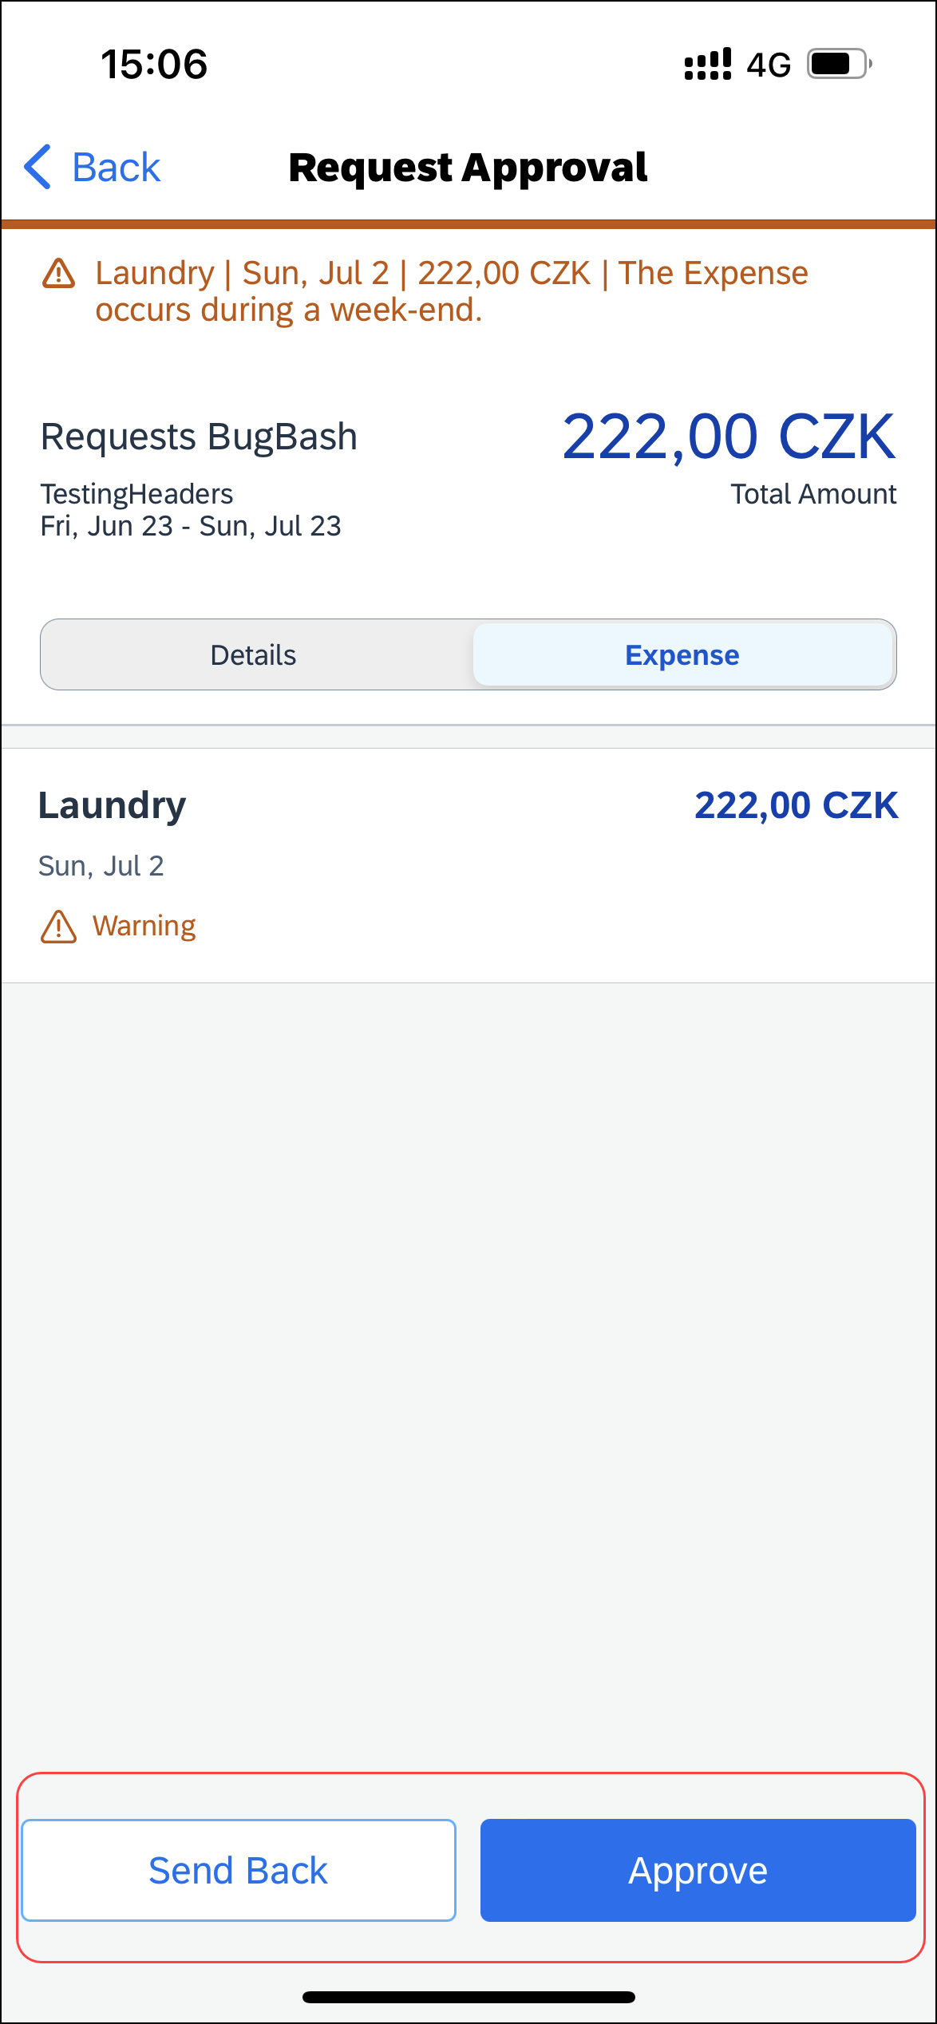 | 3) On the Request screen, tap to open the desired request.  4) On the Request Approval screen, you can:  - Tap the Details tab to view the request details (comments, cash advances, allocations, and attachments).  - Tap the Expense tab to view expected expenses.  - Tap Approve or Send Back.  NOTE: If you send back a request, you must provide a comment.

Create a New Expense Claim From an Approved Request
Screen(s) | Description/Action
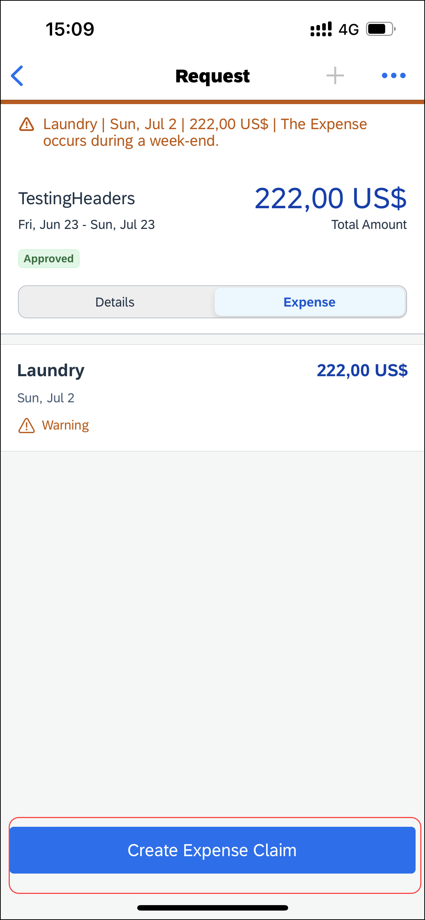 | To create an expense report from an approved request:  1) On the home screen, tap Request  2) On the Request screen, tap the Active tab.  3) On the Active tab, tap the desired approved request.  4) On the approved request screen, you can either tap the:  - Expense tab  -or-  - Details tab  5) On the Expense or Details tab, tap Create Expense Claim.

Cancel an Approved Request From an Open Request
Screen(s) | Description/Action
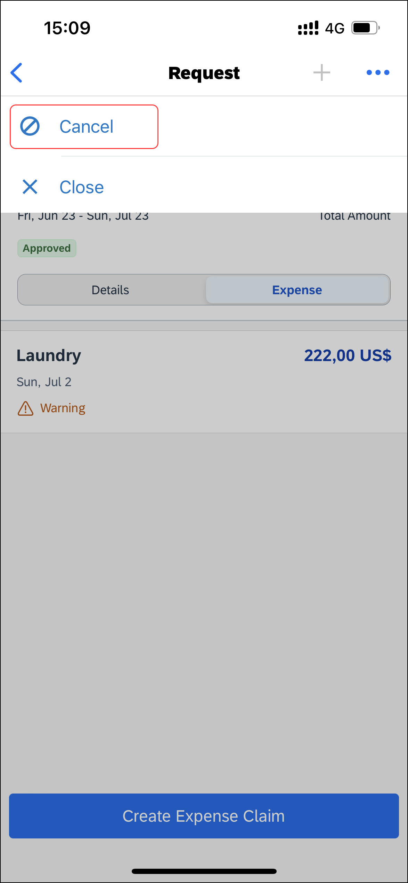 | To cancel an approved request from an open request:  1) With the desired request open, tap (upper-right corner).  2) On the menu, tap Cancel.
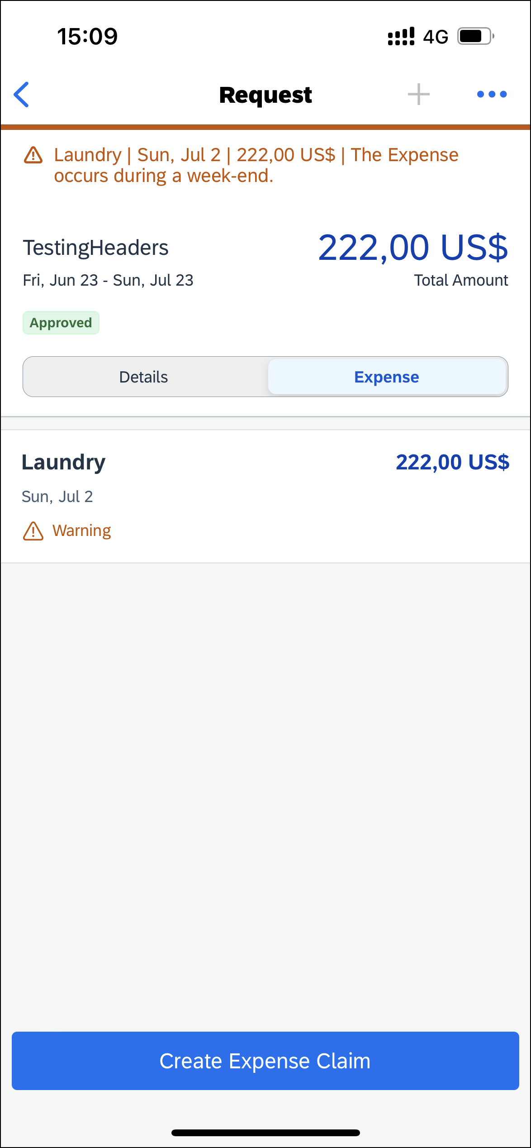 | 3) On the Cancel Request? window, tap OK.  The request no longer appears on the Request screen.

Cancel an Approved Request on the Request Screen
Screen(s) | Description/Action
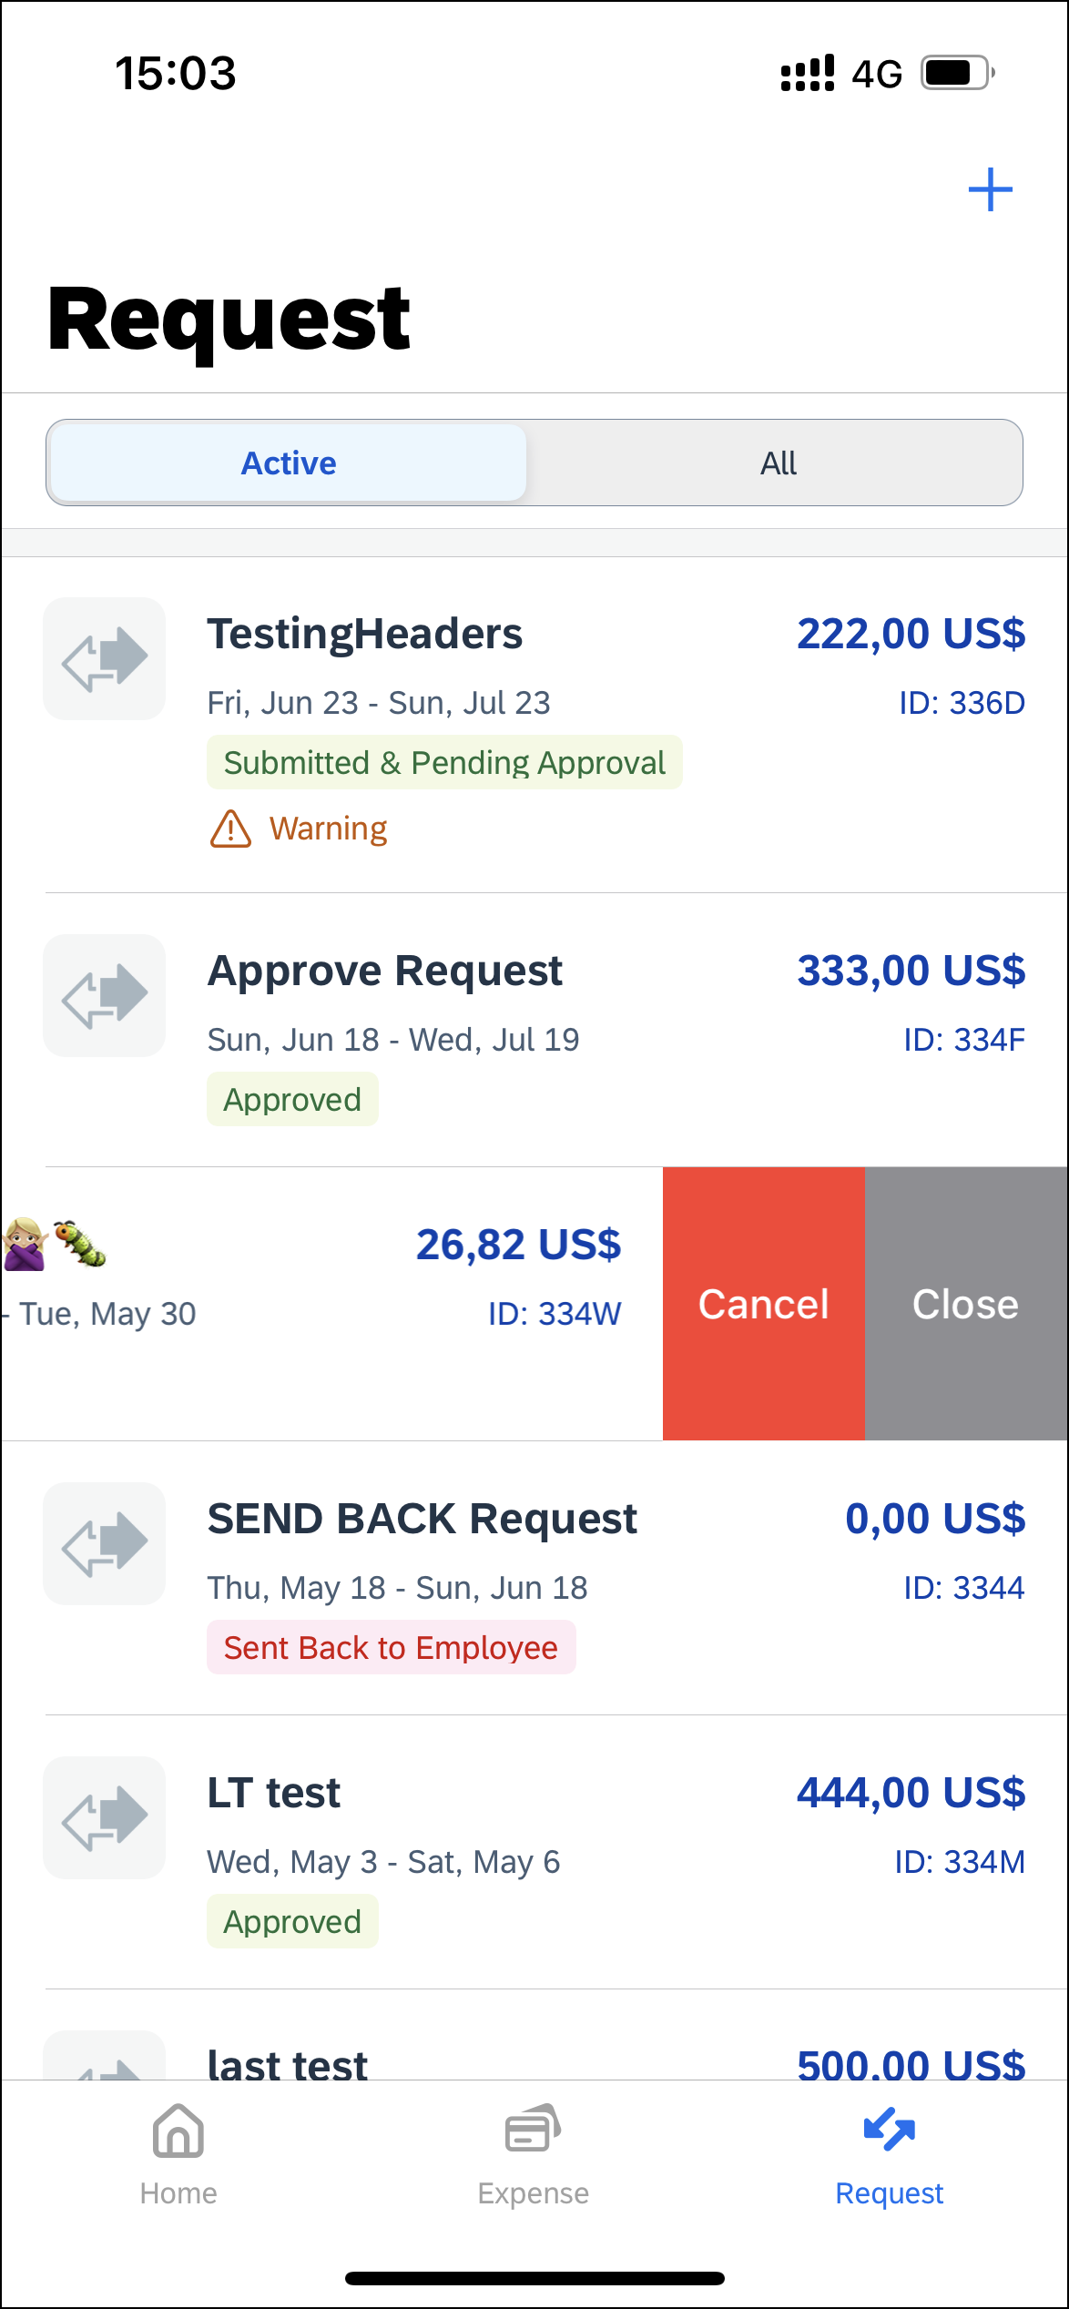 | To cancel an approved request on the Request screen:  1) On the Request screen, tap the Active tab.  2) On the Active tab, swipe the desired request to the left.  3) Tap Cancel.
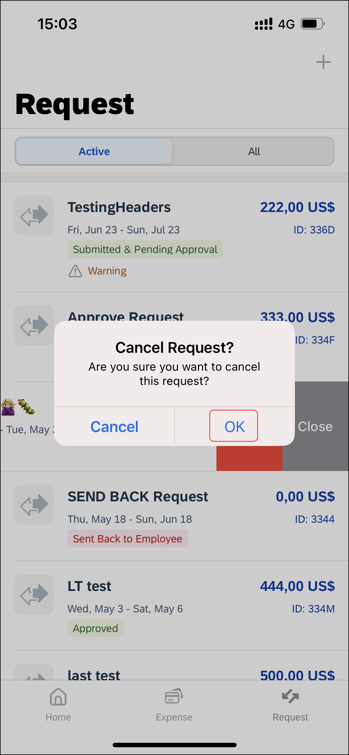 | 4) On the Cancel Request? window, tap OK.  The request no longer appears on the Request screen.

Close an Approved Request From an Open Request
Screen(s) | Description/Action
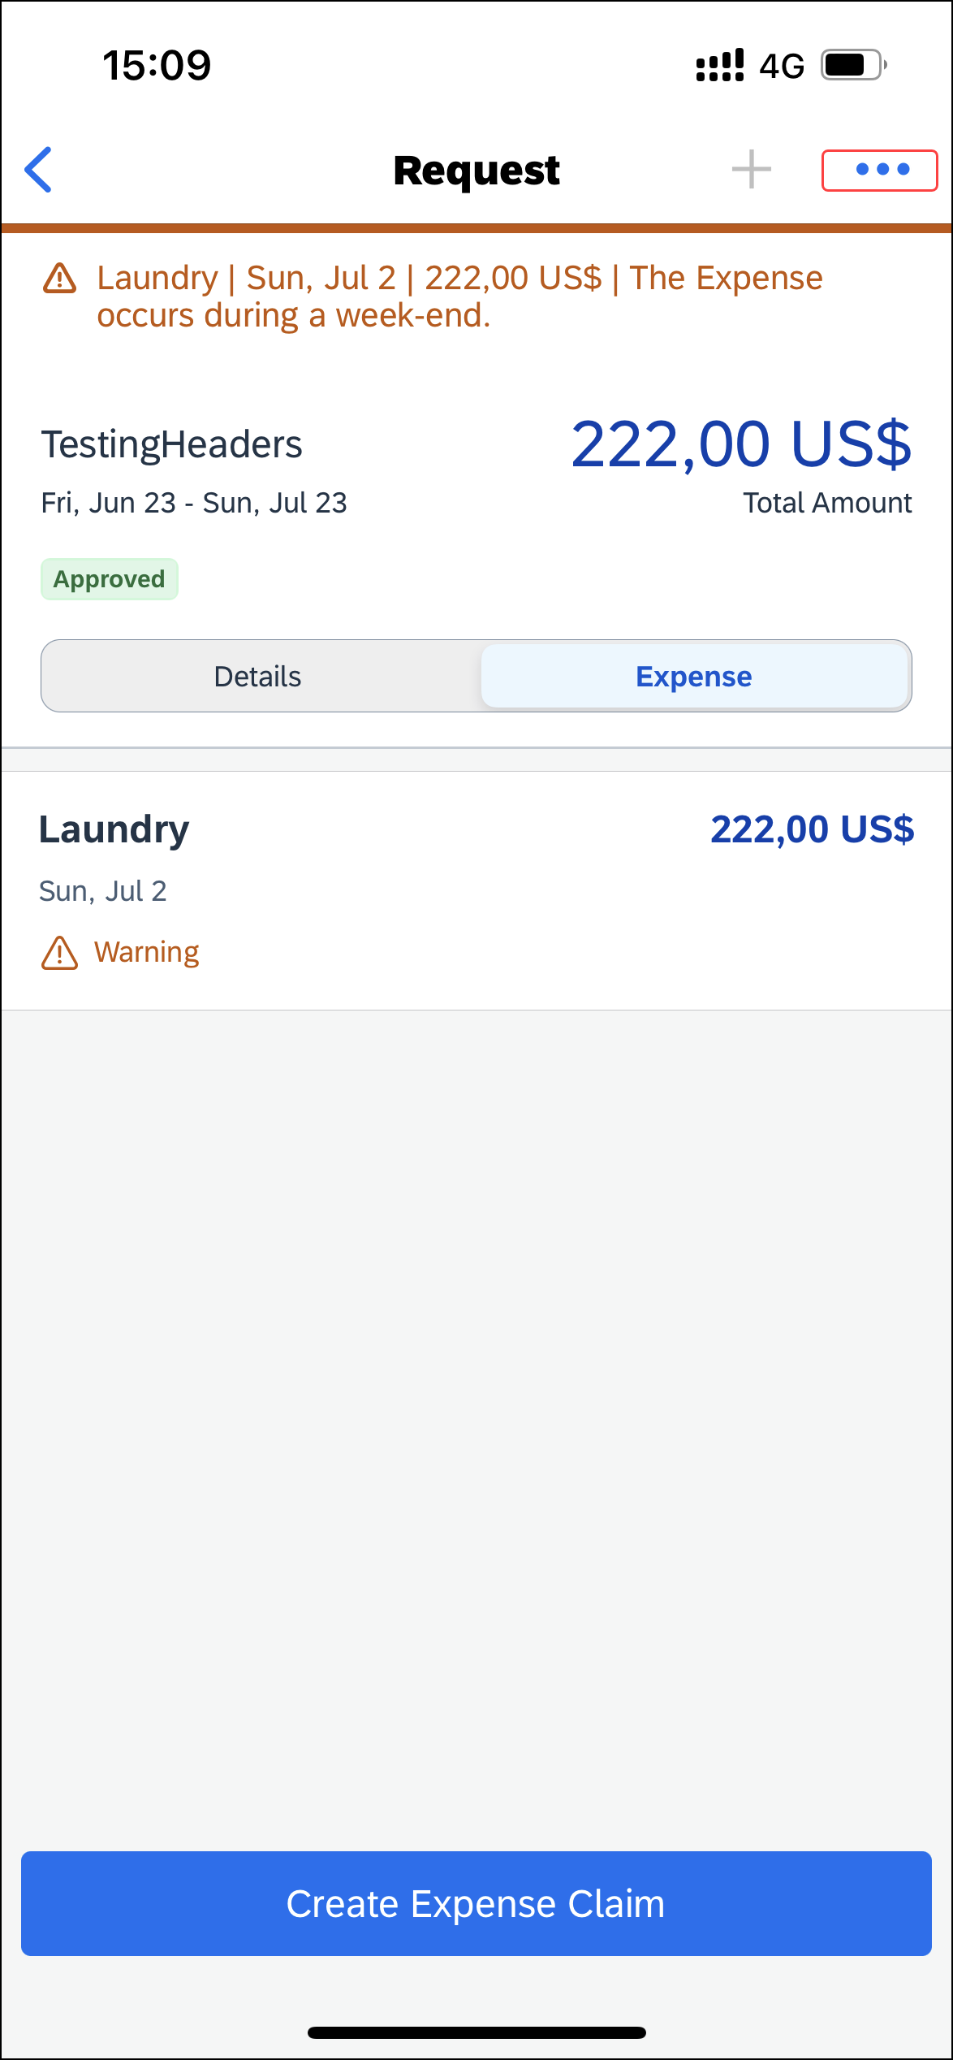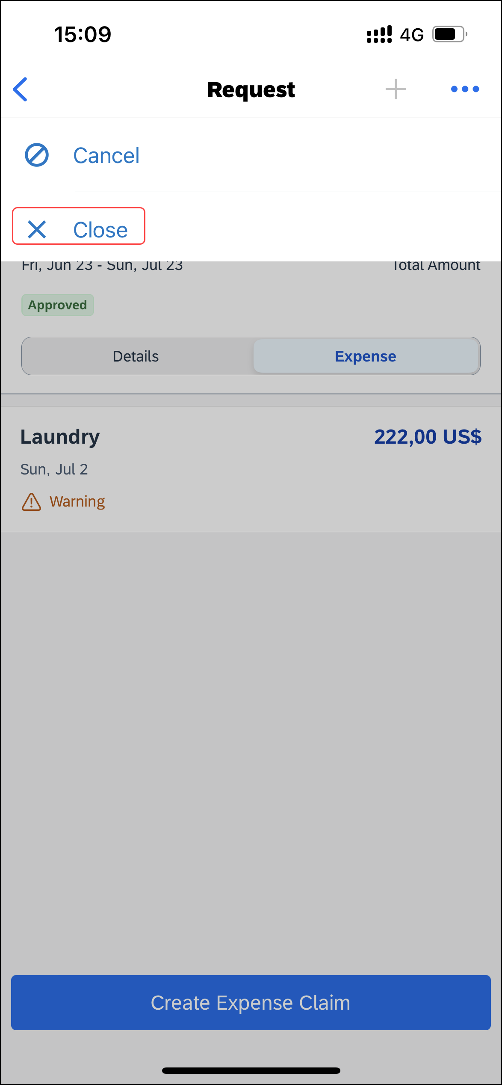 | To close an approved request from an open request:  1) With the desired request open, tap (upper-right corner).  2) On the menu, tap Close.
3) On the Close Request? window, tap OK.
The request no longer appears on the Request screen.

Close an Approved Request on the Request Screen
Screen(s) | Description/Action
To close an approved request on the Request screen:
1) On the Request screen, tap the Active tab.
2) On the Active tab, swipe the desired request to the left.
3) Tap Close.
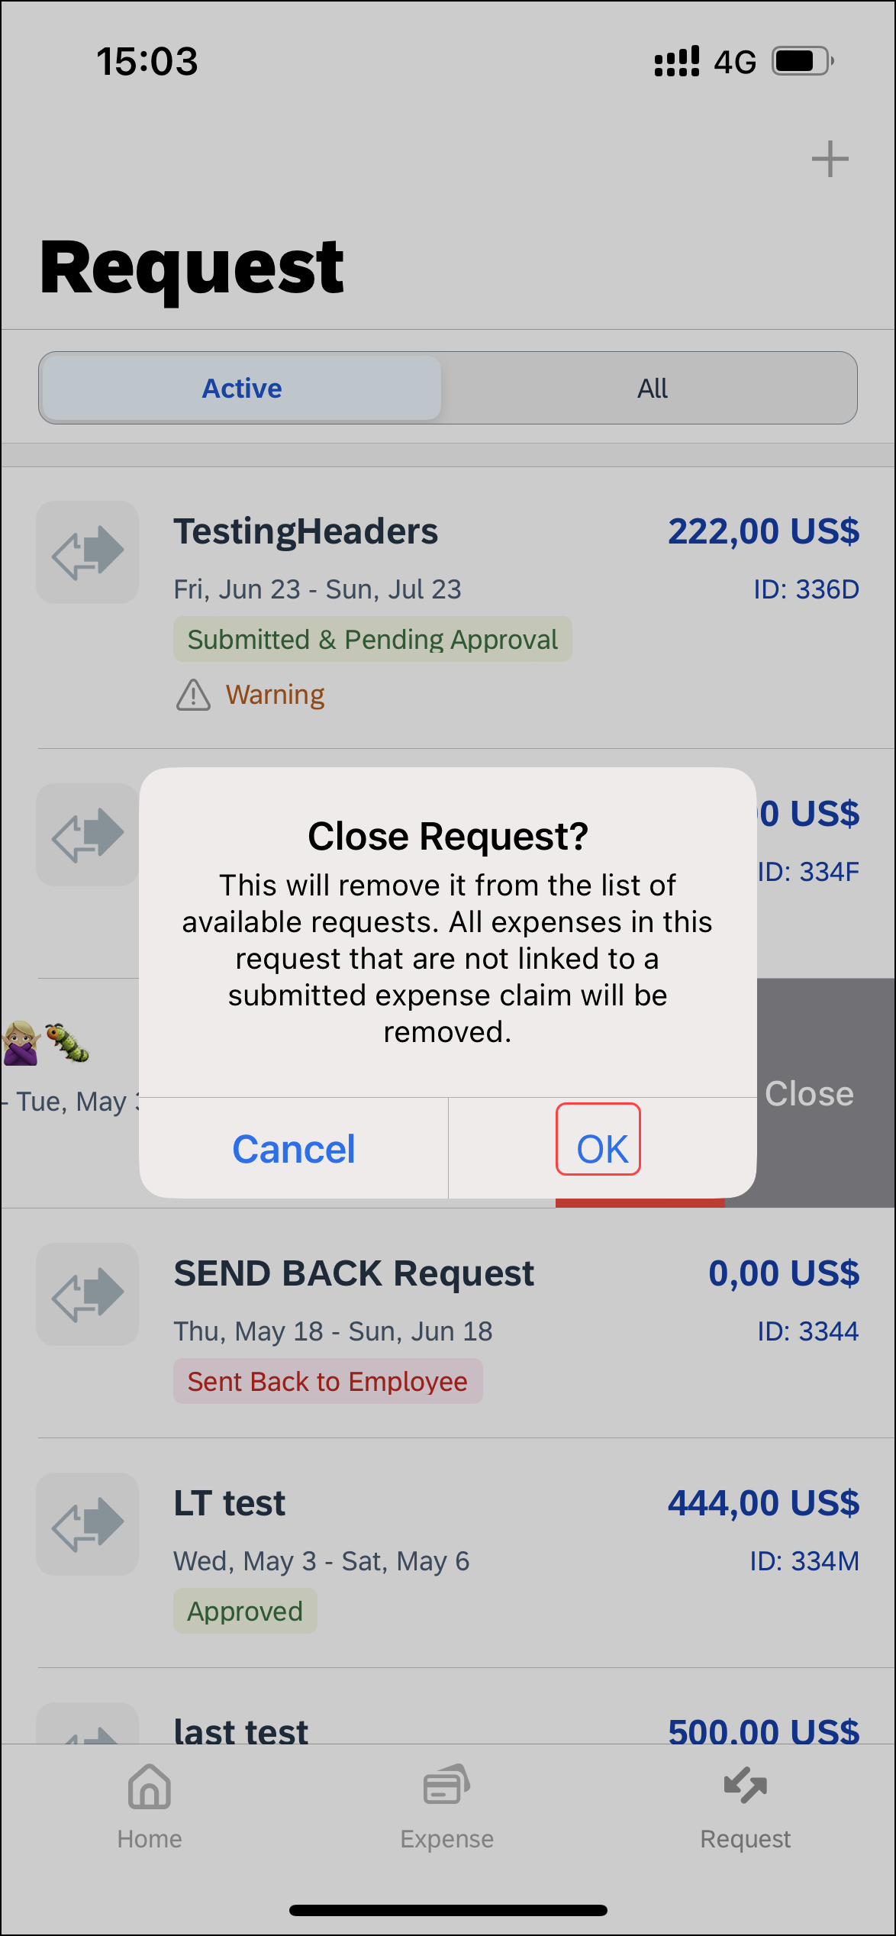 | 4) On the Close Request? window, tap OK.  The request no longer appears on the Request screen.

☼

