Mobile App User Guide  Concur Request  Last Revised: July 5, 2023 | This guide describes the current version, which is shown on the "Introduction" guide. |  | Applies to these mobile devices:  No: iPhone  Yes: iPad  No: Android
IMPORTANT: Be aware that your company's configuration may not allow for all of the features described here. Generally, if a feature is not available in your configuration of the web version of SAP Concur, then it is not available in the mobile app.
Concur Request streamlines requisition and travel booking processes for travelers, approvers, and finance teams. 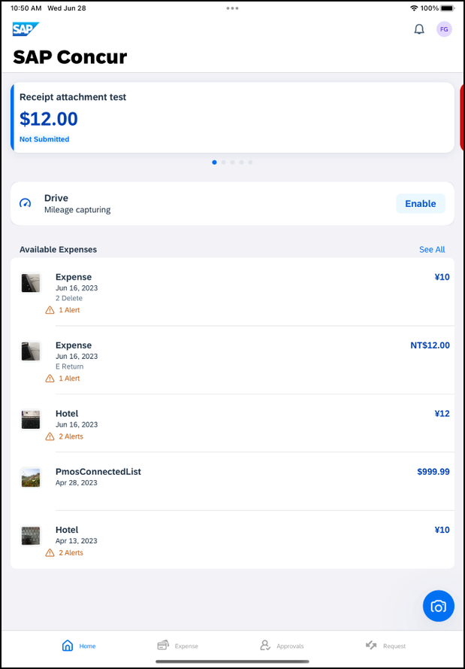 |  | Concur Request 2  Initial Feature Set and Options 2  Create a New Request 3  Create a New Cash Advance 4  Delete a Cash Advance Within a Request 6  Add Segments / Expense Types to a Request 7  Add Multi – City Segments to a Request 9  Delete a Segment / Expense Type From an Open Unsubmitted Request 11  Delete an Unsubmitted Request in an Open Request 12  Delete an Unsubmitted Request on the Request Screen 14  Submit a Request From an Open Request 16  Submit a Request on the Request Screen 17  Recall a Submitted Request 17  Approve a Request 19  Create a New Expense Claim From an Approved Request 21  Cancel an Approved Request From an Open Request 21  Cancel an Approved Request on the Request Screen 23  Close an Approved Request From an Open Request 24  Close an Approved Request on the Request Screen 26
Concur Request users can:
- Make strategic decisions about spending before it happens
- Simplify cash advances Replace tedious email and manual requests into a single system
- See the entire audit trail of each request, from submission to approval
Please Note:
- The SAP Concur app for iOS and Android supports universal links, i.e. links that navigate directly to the app if it is installed or to the website if not.
- Such links are included in notification emails from SAP Concur related to the expense report changes.
- Universal link support for customers own use is currently not supported.
- Some security solutions may block the links embedded into email from opening the app directly. The proper exceptions for the security policy should be configured for SAP Concur universal link URLs (pattern to match: https://*.concursolutions.com/*). Known cases are:
- MDM/MAM policy that prescribes to open any link tapped in Outlook mobile app only in specified browser.
- Outlook mail server phishing protection that wraps all link embedded into e-mails to open the safety check service first.

Concur Request

Initial Feature Set and Options
Multiple policies per user: The multiple policies per user feature is available to SAP Concur mobile users whose company allows them to select from multiple policies.
NOTE: If a user can select a different policy while creating a request on the web version of SAP Concur, they can do the same within the mobile app.
Header form: The user can select from different policies, which will provide different header forms. Segment form: Following are the available default segment forms:
Air  Hotel  Car Rental  Rail  Dining | Event  Limo  Parking  Taxi  Miscellaneous
Segment / Expense types: All default segment types, expected expenses, and custom segments with their form and layout are supported.
Workflow: Only ”Create," "View," "Cancel," "Delete," "Close," "Submit," and "Recall" actions are supported.
NOTE: For the "Submit" action, in those cases where the client allows the user to select their own approver on submit in the web version of SAP Concur, be aware that this option is not available in the mobile app. The request user's default approver must appear in the user's profile.
Not available: These options are not available in the mobile app:
Allocations  Travel Allowances | Request & Travel integration  Car Mileage

Create a New Request
Screen(s) | Description/Action
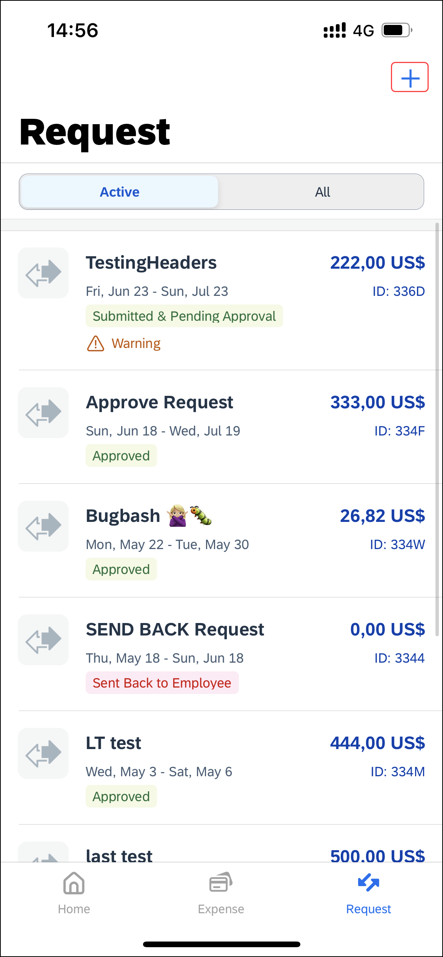 | To create a new request:  1) On the home screen, tap Request.  2) On the Request screen, tap (upper-right corner).
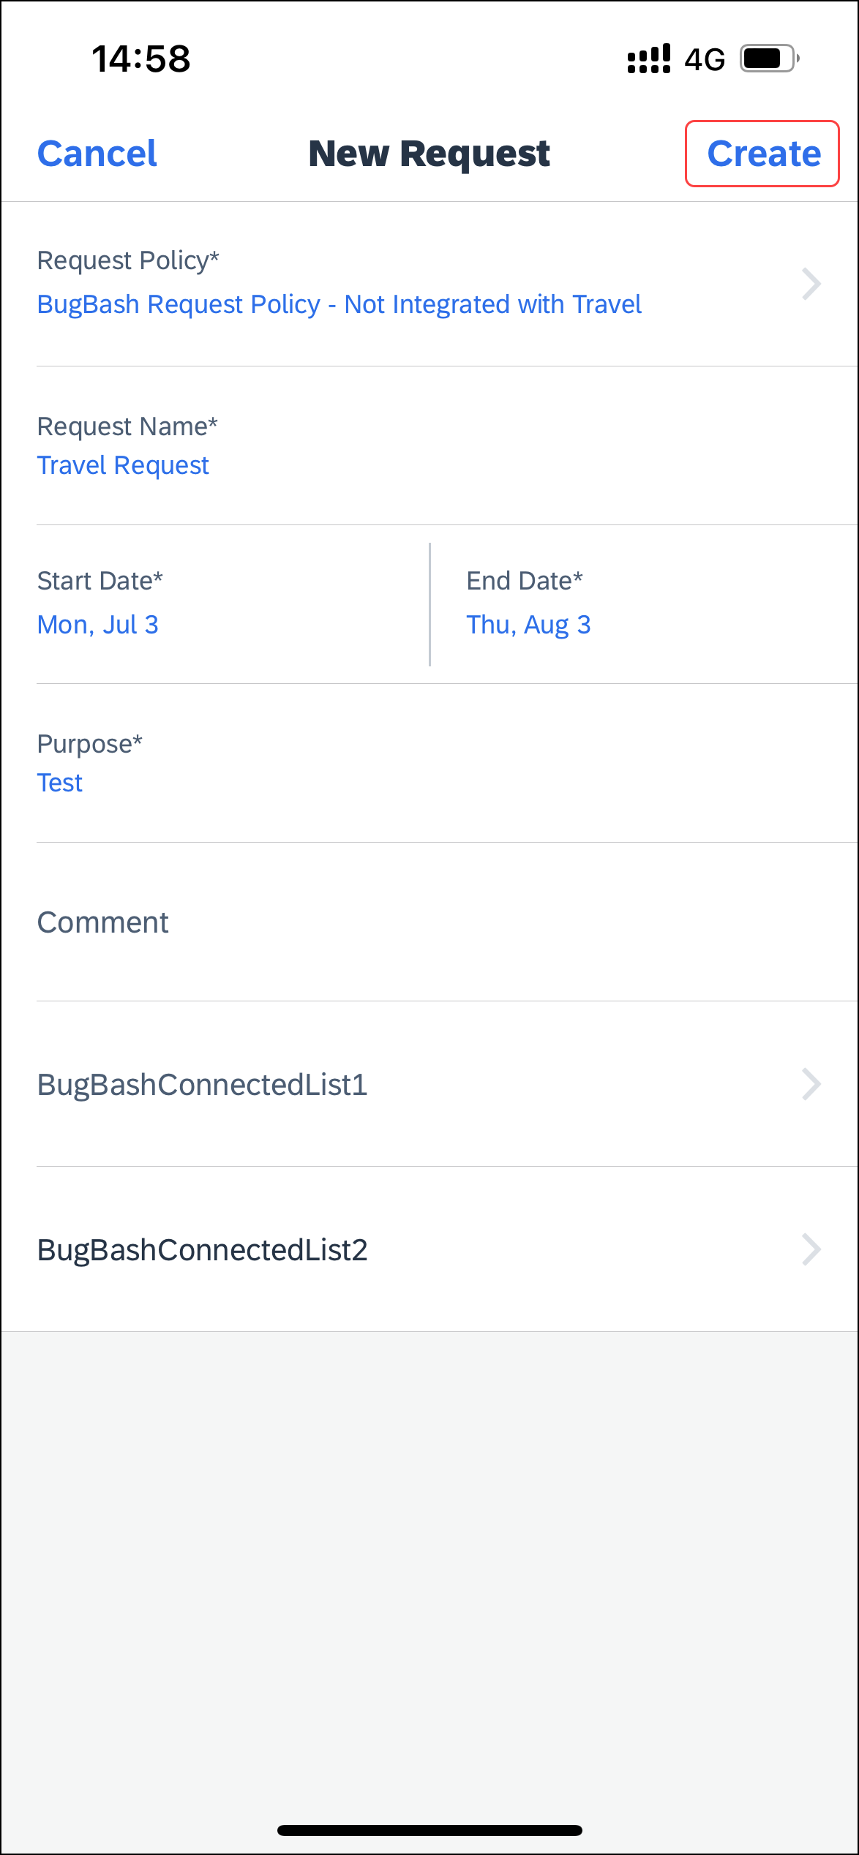 | 3) On the New Request screen, fill in required fields. When done, tap Create (upper-right corner).  The Request screen appears with the request details appearing on the Details tab.

Create a New Cash Advance
Screen(s) | Description/Action
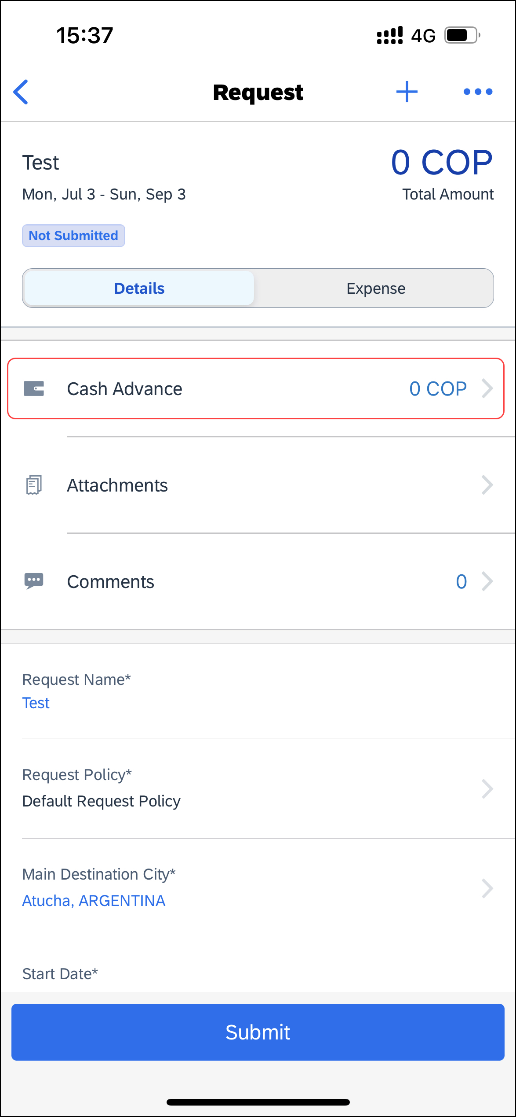 | To create a new cash advance:  1) On the home screen, tap Request.  2) On the Request screen, tap the Active tab.  3) On the Active tab, tap the desired request.  4) On the Request screen, tap the Details tab.  5) On the Details tab, tap Cash Advance.
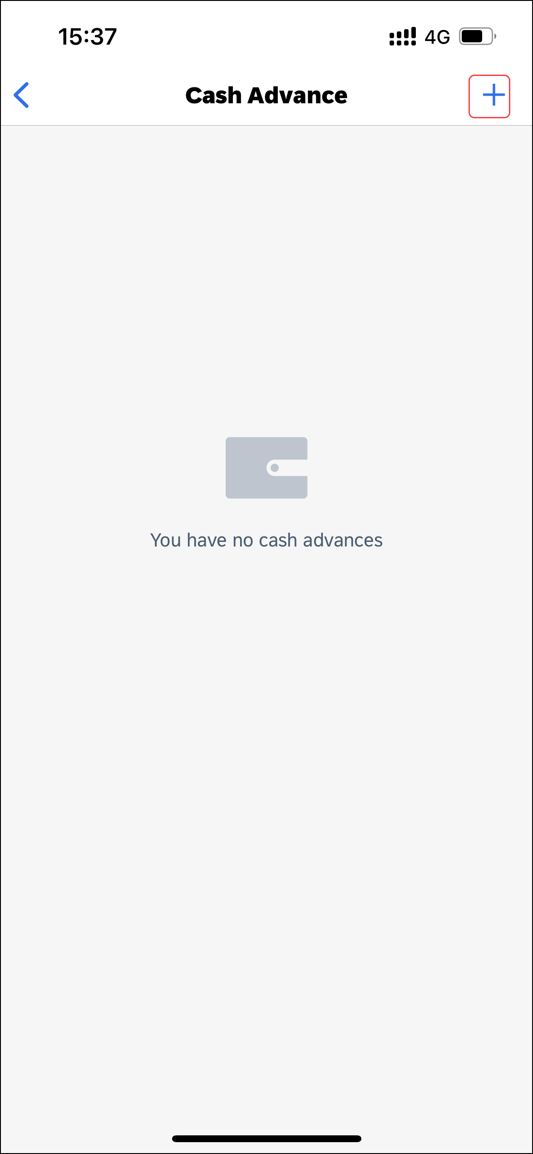 | 6) On the Cash Advance screen, tap (upper-right corner).
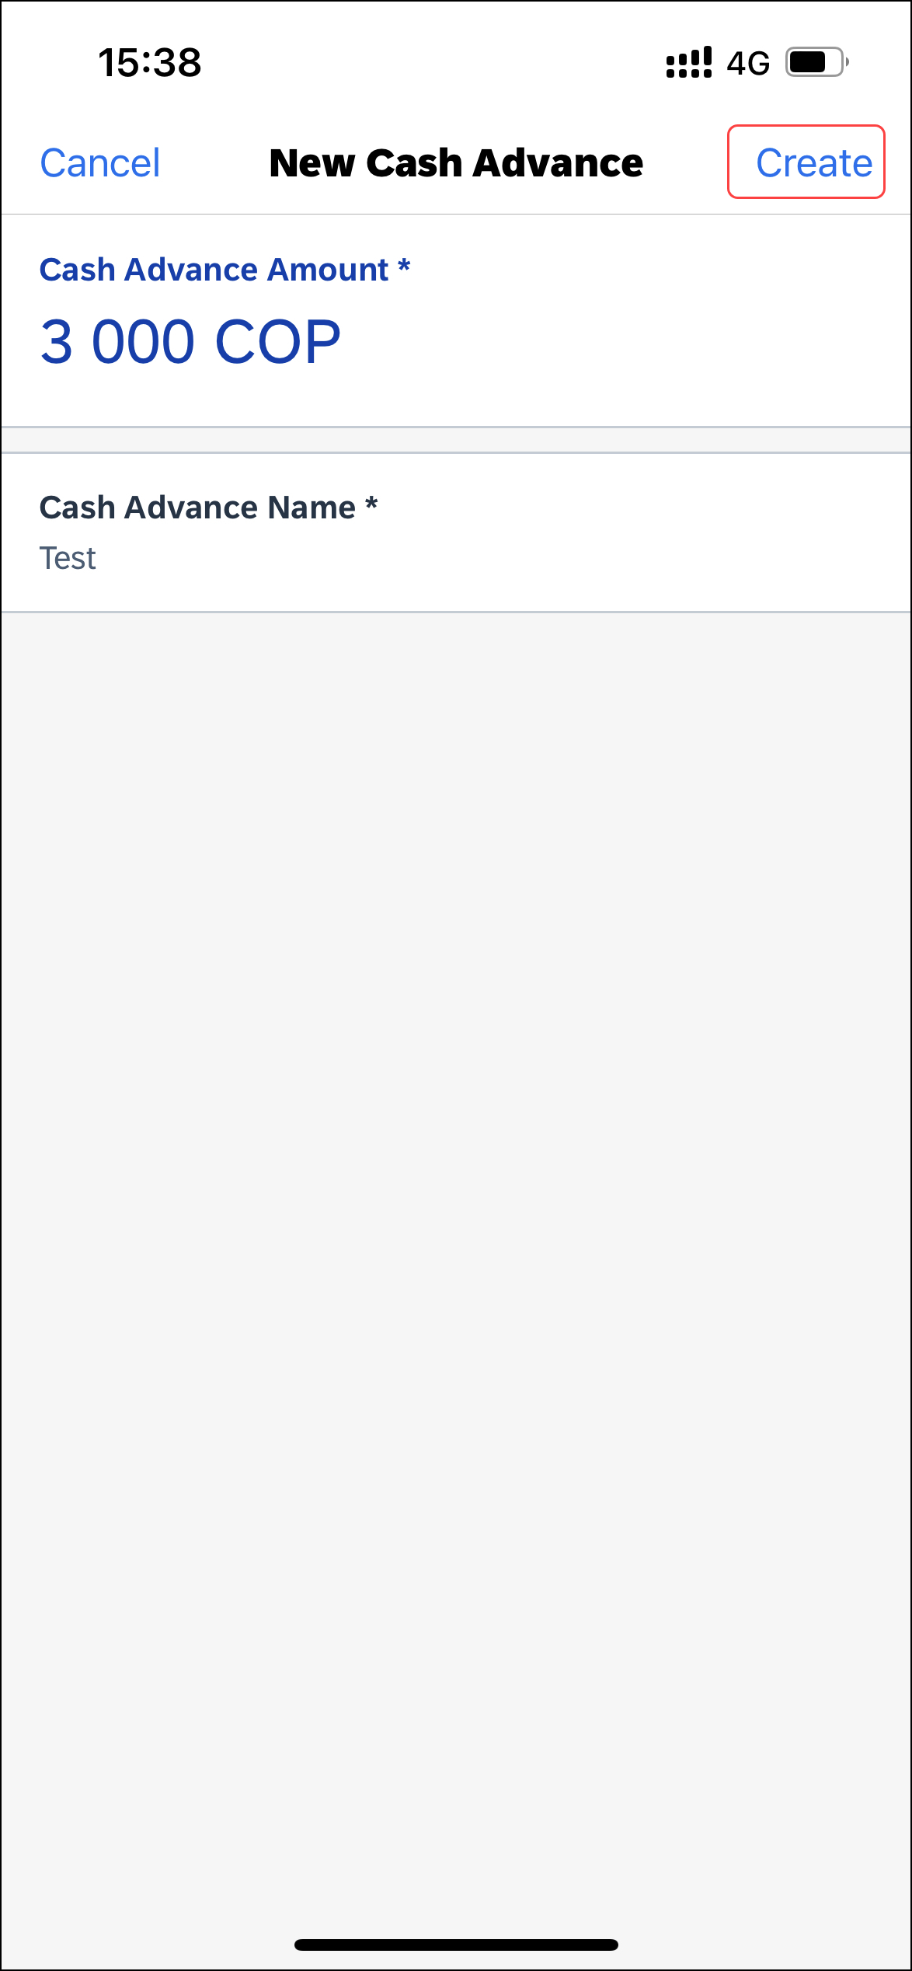 | 7) On the New Cash Advance screen, enter the desired amount and then tap Create (upper-right corner).
 | The cash advance appears on the Cash Advance screen.

Delete a Cash Advance Within a Request
Screen(s) | Description/Action
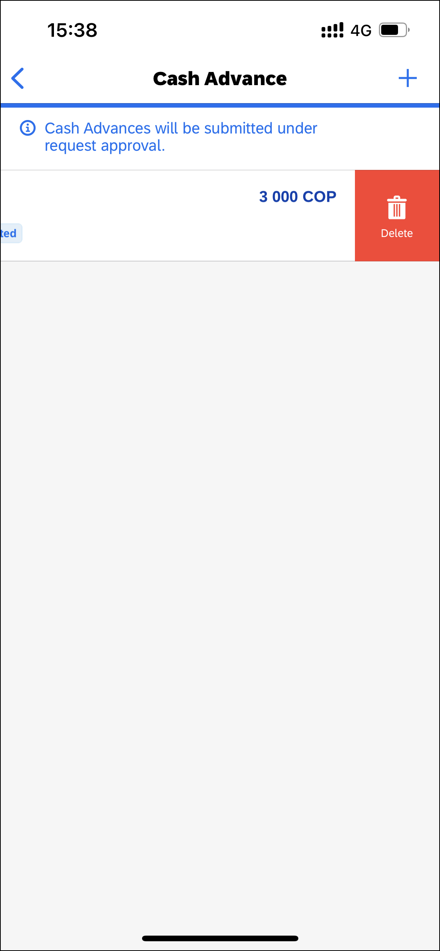 | To delete a cash advance within a request:  1) On the home screen, tap Request.  2) On the Request screen, tap the Active tab.  3) On the Active tab, tap the desired request.  4) On the Request screen, tap the Details tab.  5)On the Details tab, tap Cash Advance.  6) On the Cash Advance screen, swipe the desired cash advance to the left.  7) Tap Delete.
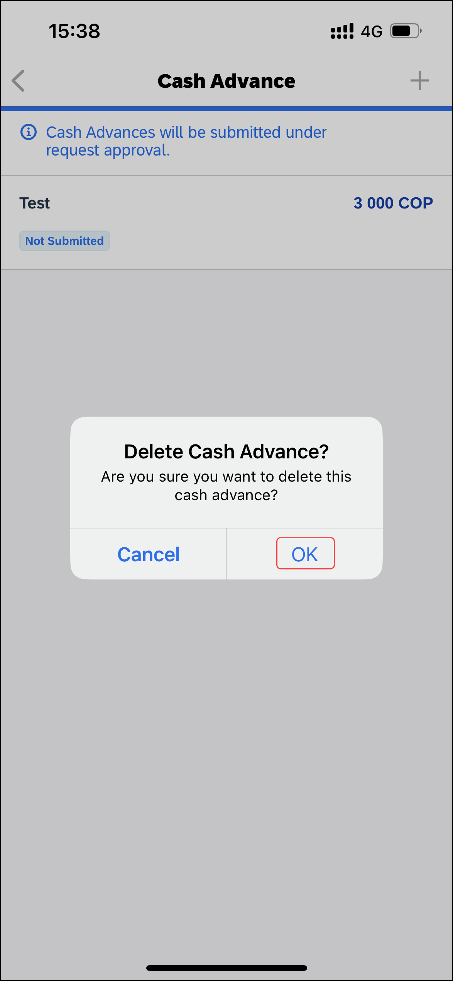 | 8) On the Delete Cash Advance? window, tap OK.
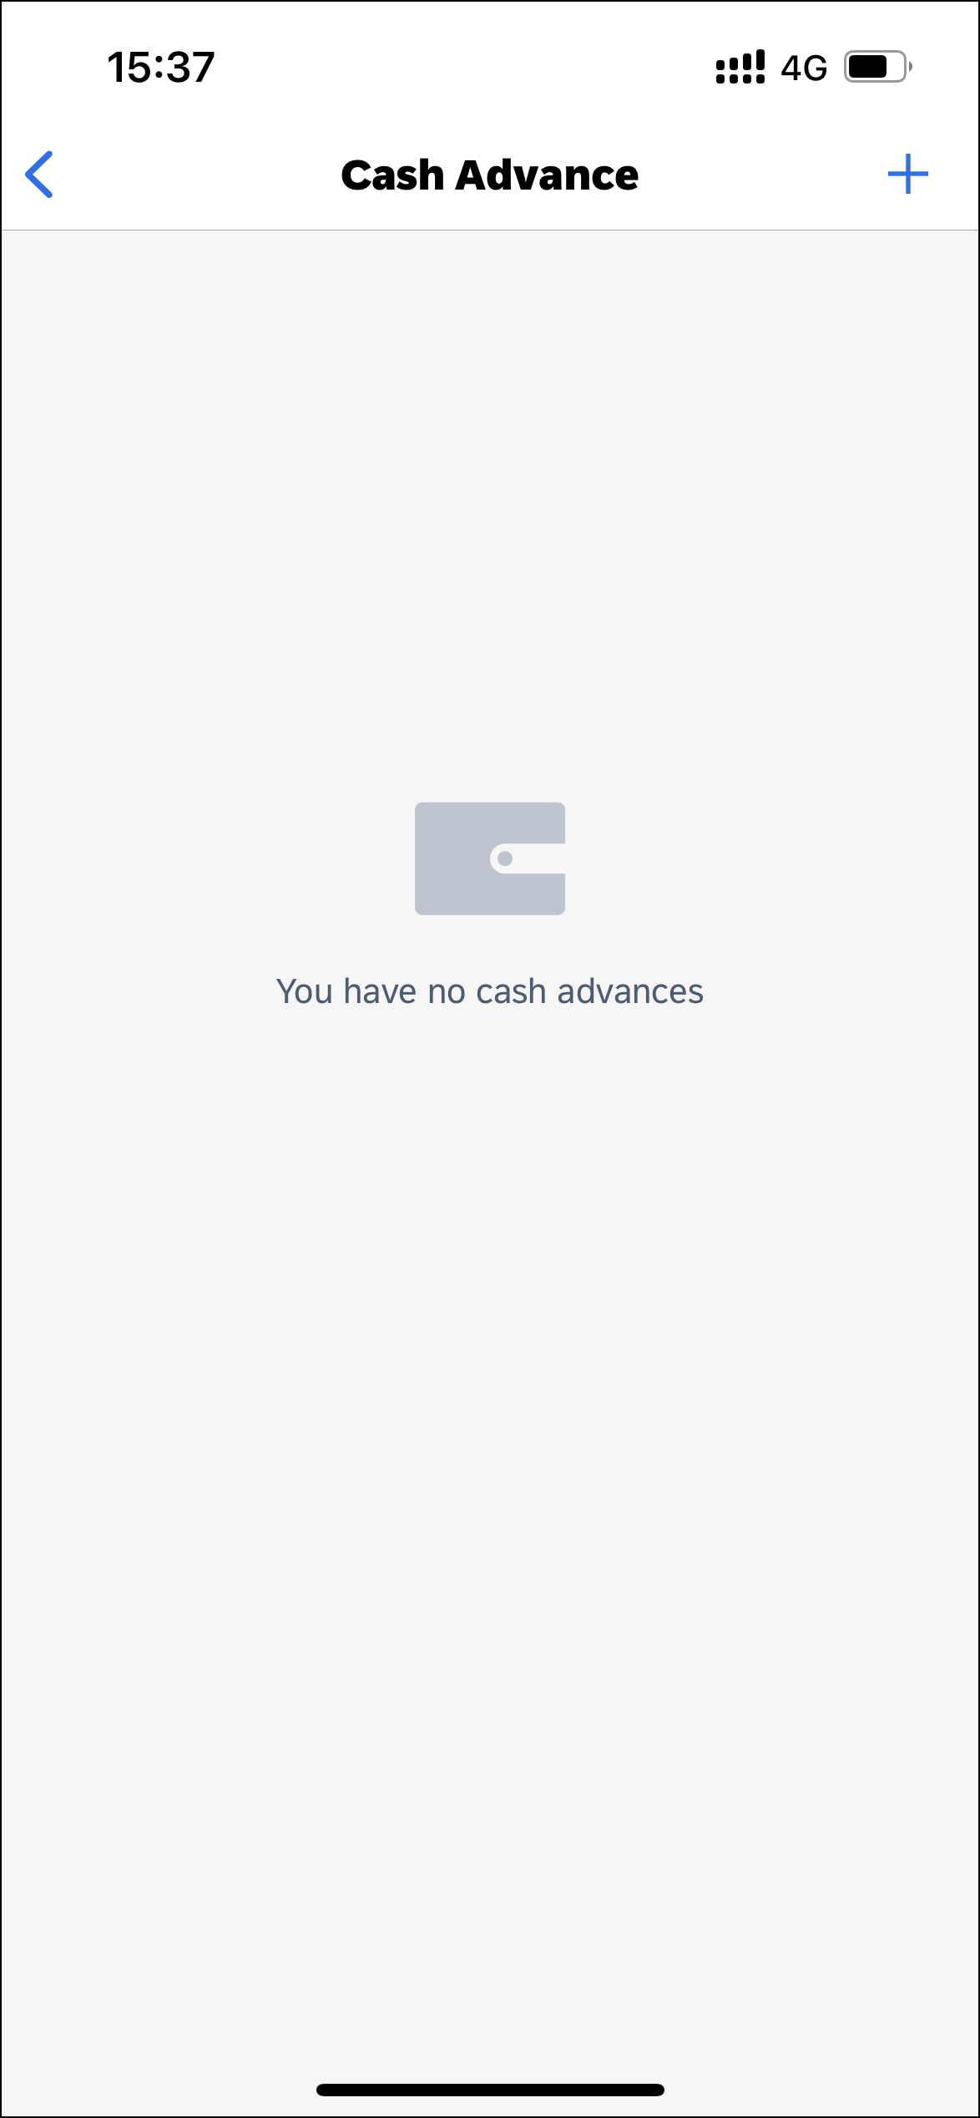 | The cash advance no longer appears on the Cash Advance screen.

Add Segments / Expense Types to a Request
Screen(s) | Description/Action
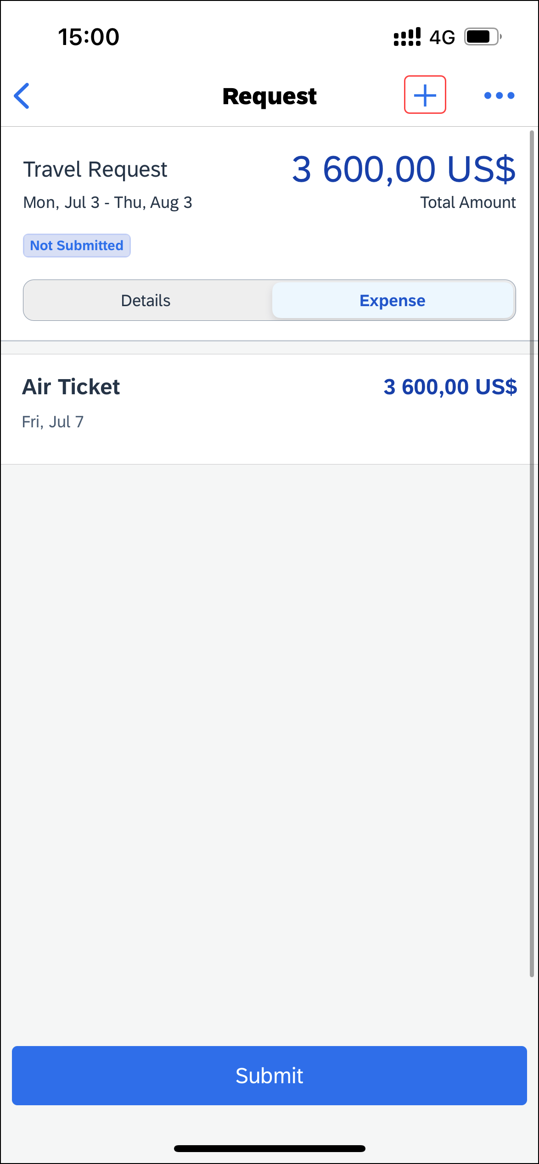 | To add segments / expense types to a request:  1) With the request open, tap (upper-right corner).
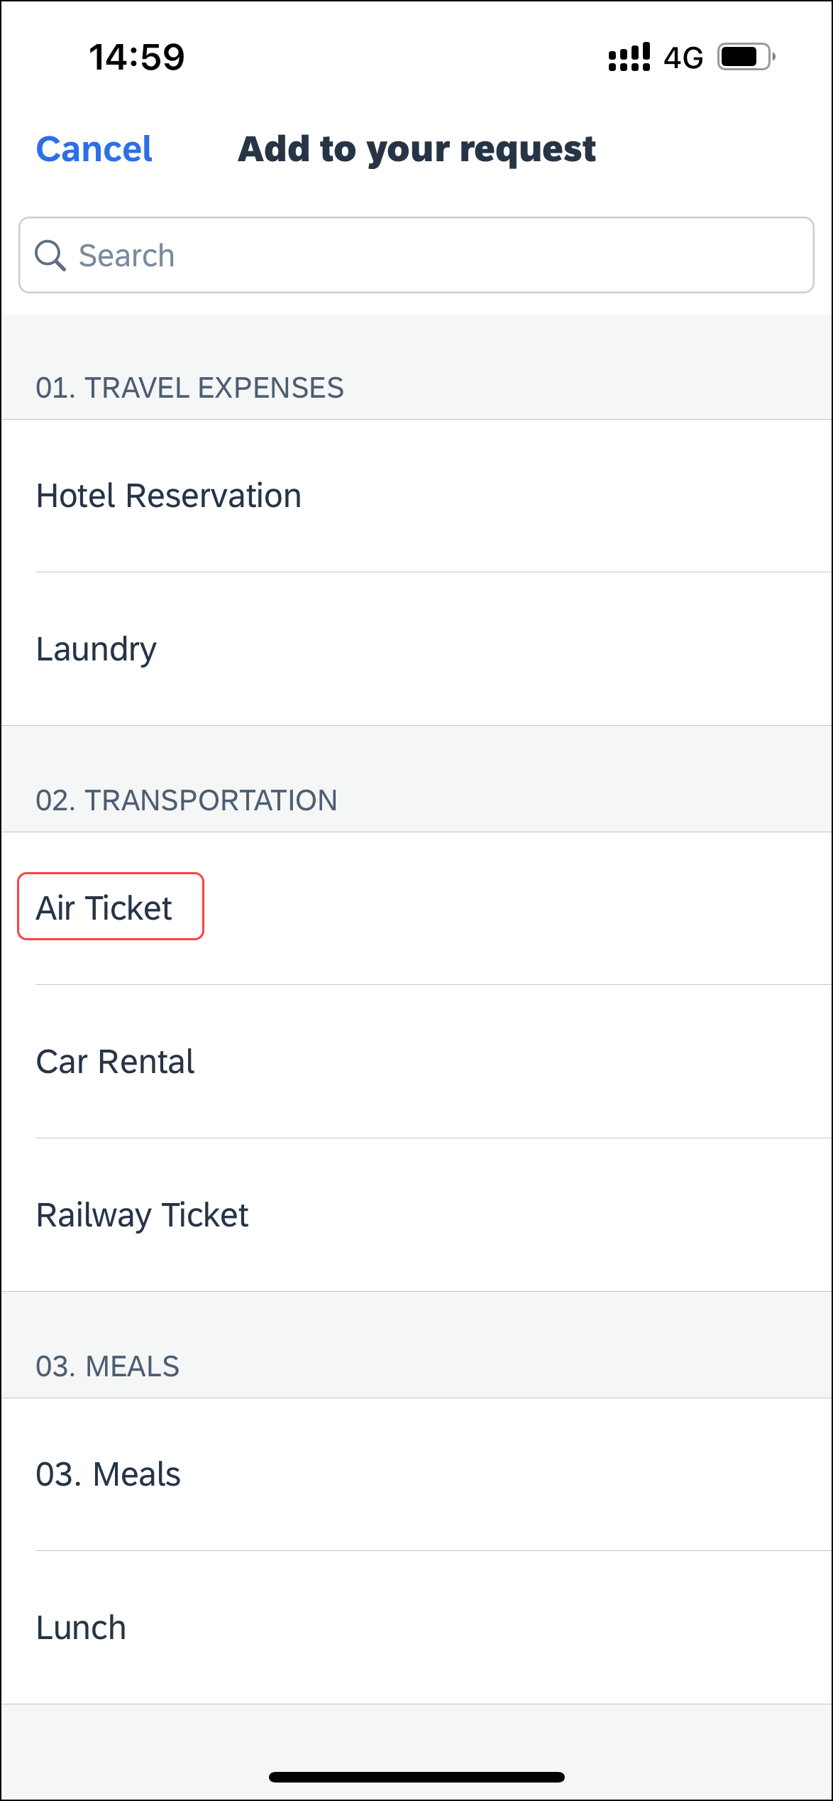 | 2) On the Add to your request screen, (in this case Air Ticket), fill in the details and make the desired selections.
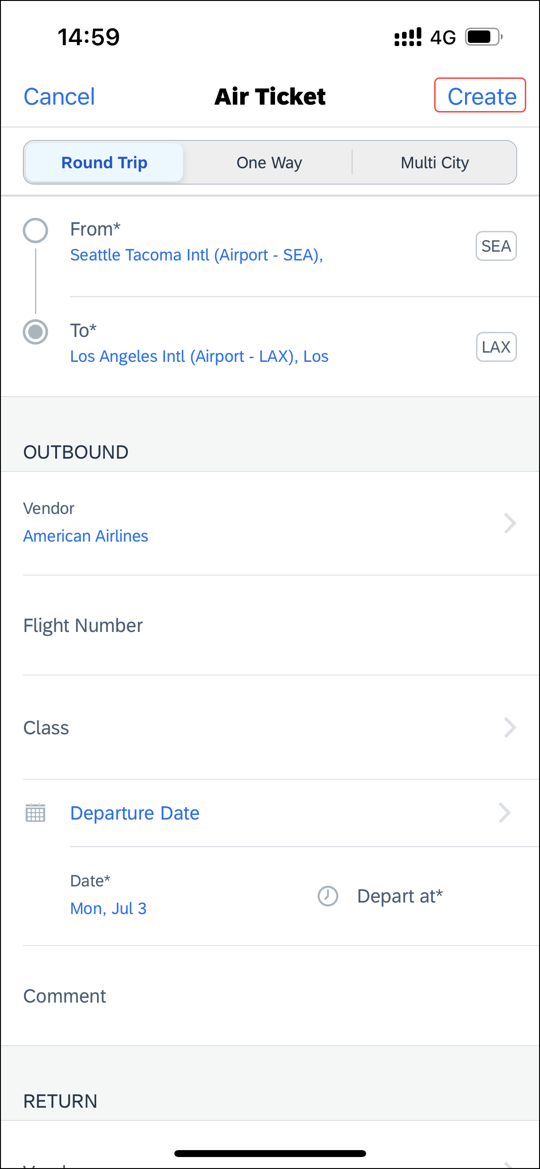 | 3) When done, on the segment / expense type screen, tap Create (upper-right corner) to return to the Request screen.
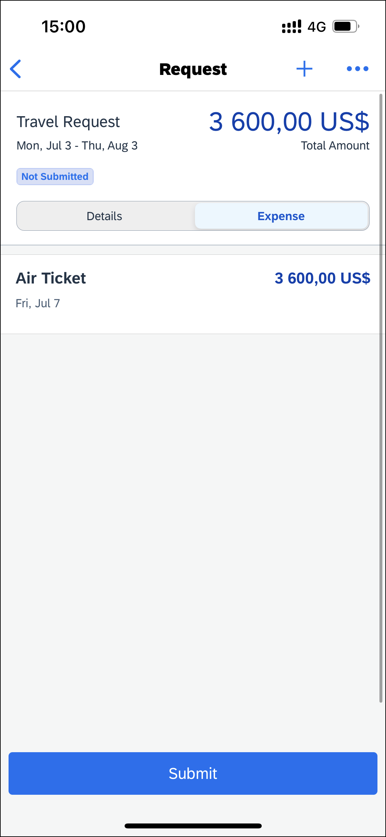 | 4) On the Request screen, add other segments / expense types as desired.

Add Multi – City Segments to a Request
Screen(s) | Description/Action
To add multi – city segments to a request:
1) On the Request screen, tap (upper-right corner).

2) On the Add to your request screen, select the desired segment (in this case Air Ticket).
3) On the segment (in this case Air Ticket) screen, tap the Multi City tab.
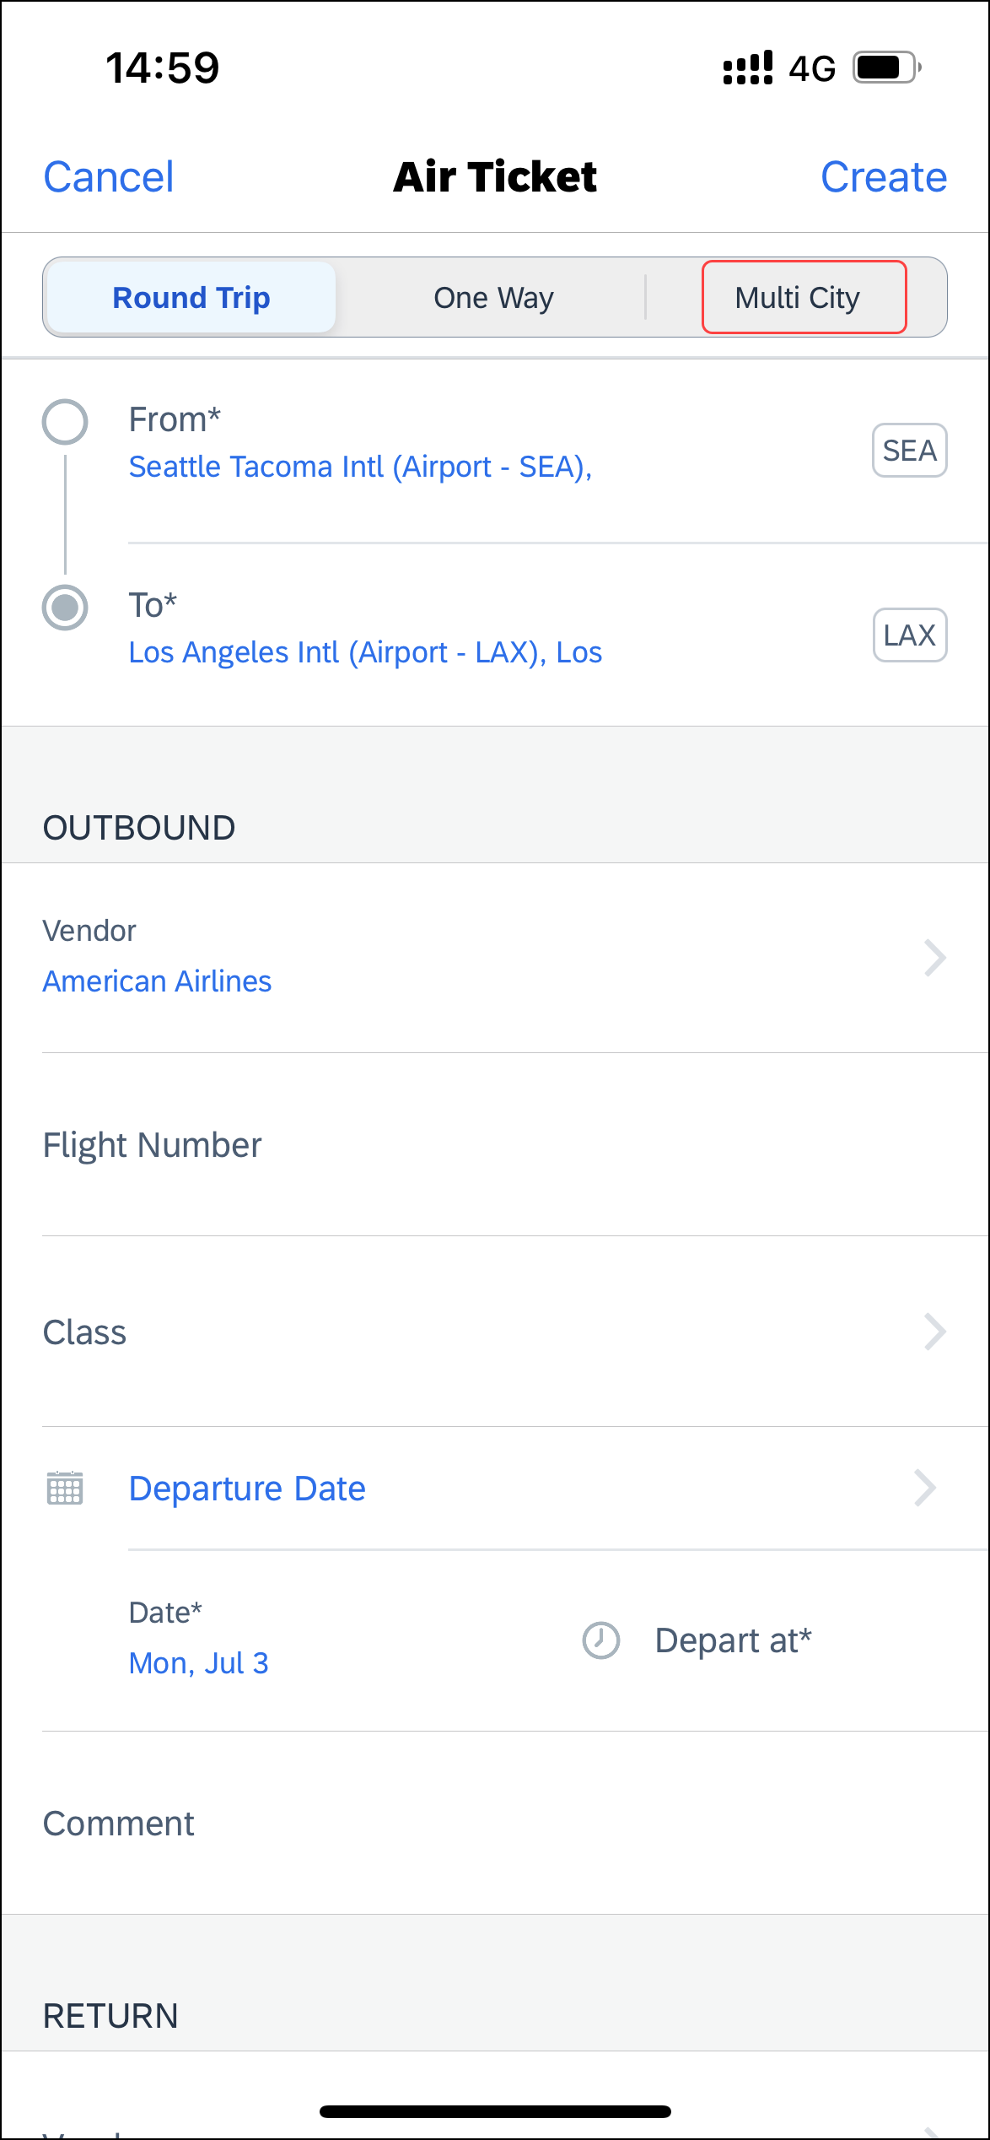 | 4) On the Multi City tab, fill in the details and make the desired selections.  5) When done, tap Create (upper-right corner) to return to the Request screen.  6) Add other segments as desired.

Delete a Segment / Expense Type From an Open Unsubmitted Request
Screen(s) | Description/Action
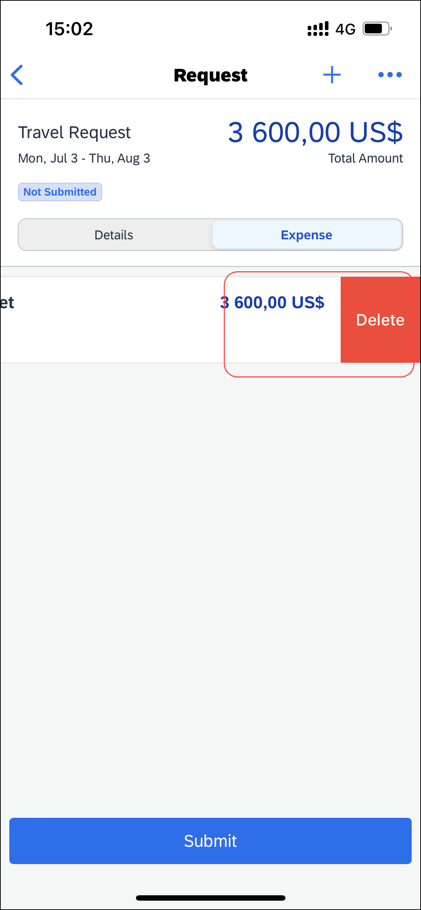 | To delete a segment/expense type from an open unsubmitted request:  1) With the request open, tap the Expense tab,  2) On the Expense tab, swipe the desired segment / expense type to the left.  3) Tap Delete.
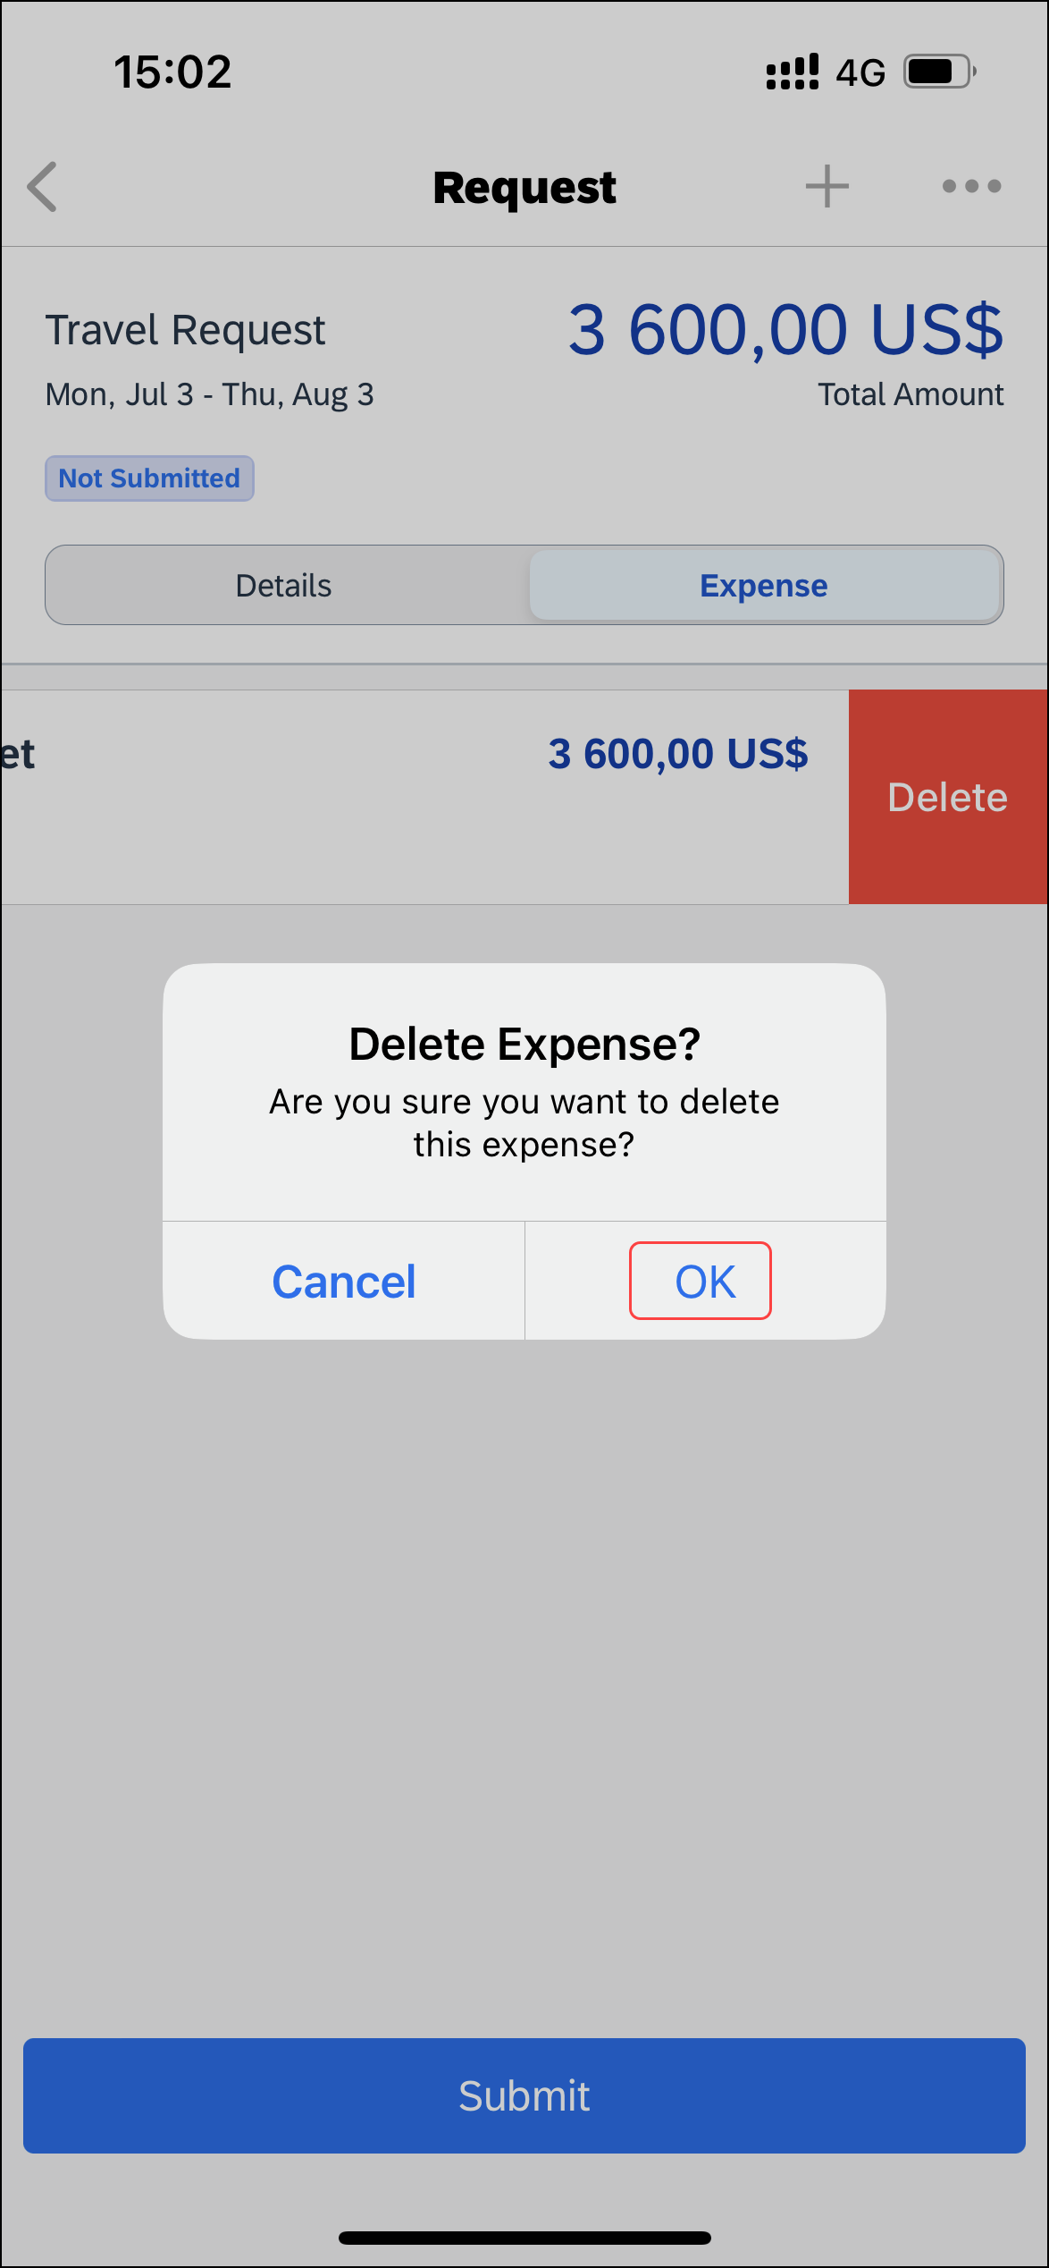 | 4) On the Delete Expense? window, tap OK.
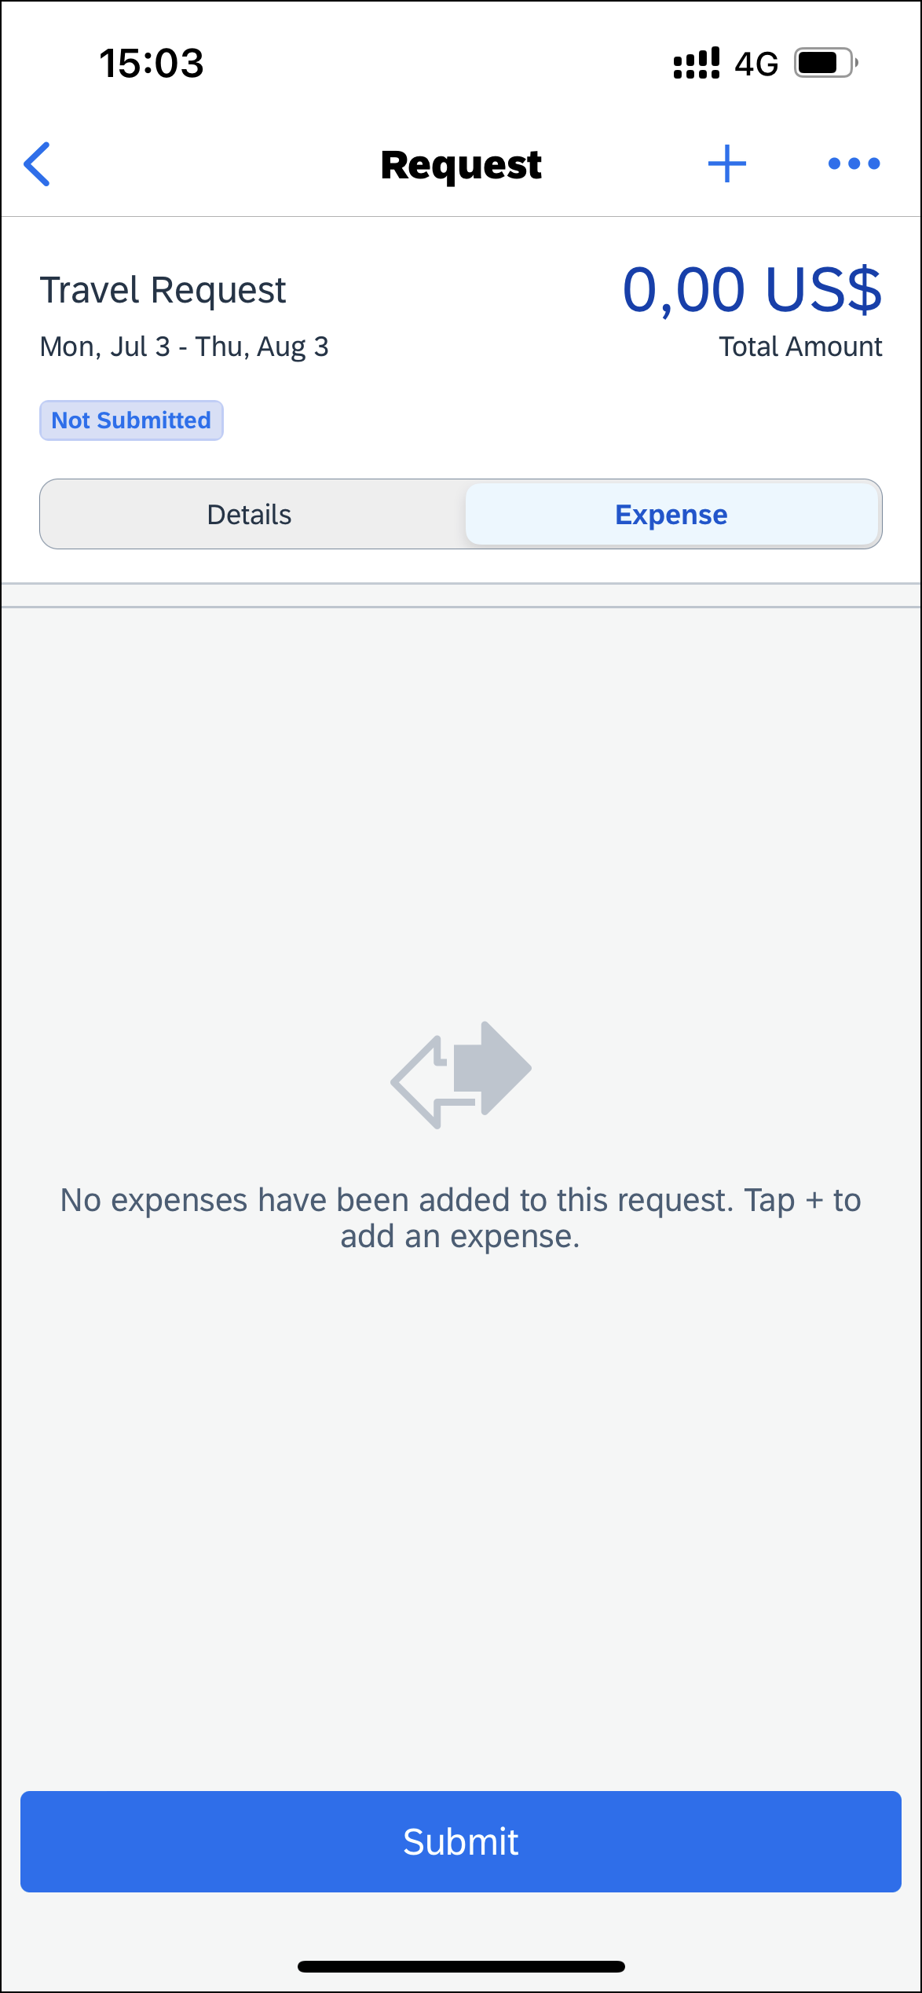 | The segment / expense type no longer appears on the Request screen.  NOTE: You can also delete a segment / expense type from a request by tapping (upper-right corner) and then tapping Delete.

Delete an Unsubmitted Request in an Open Request
Screen(s) | Description/Action
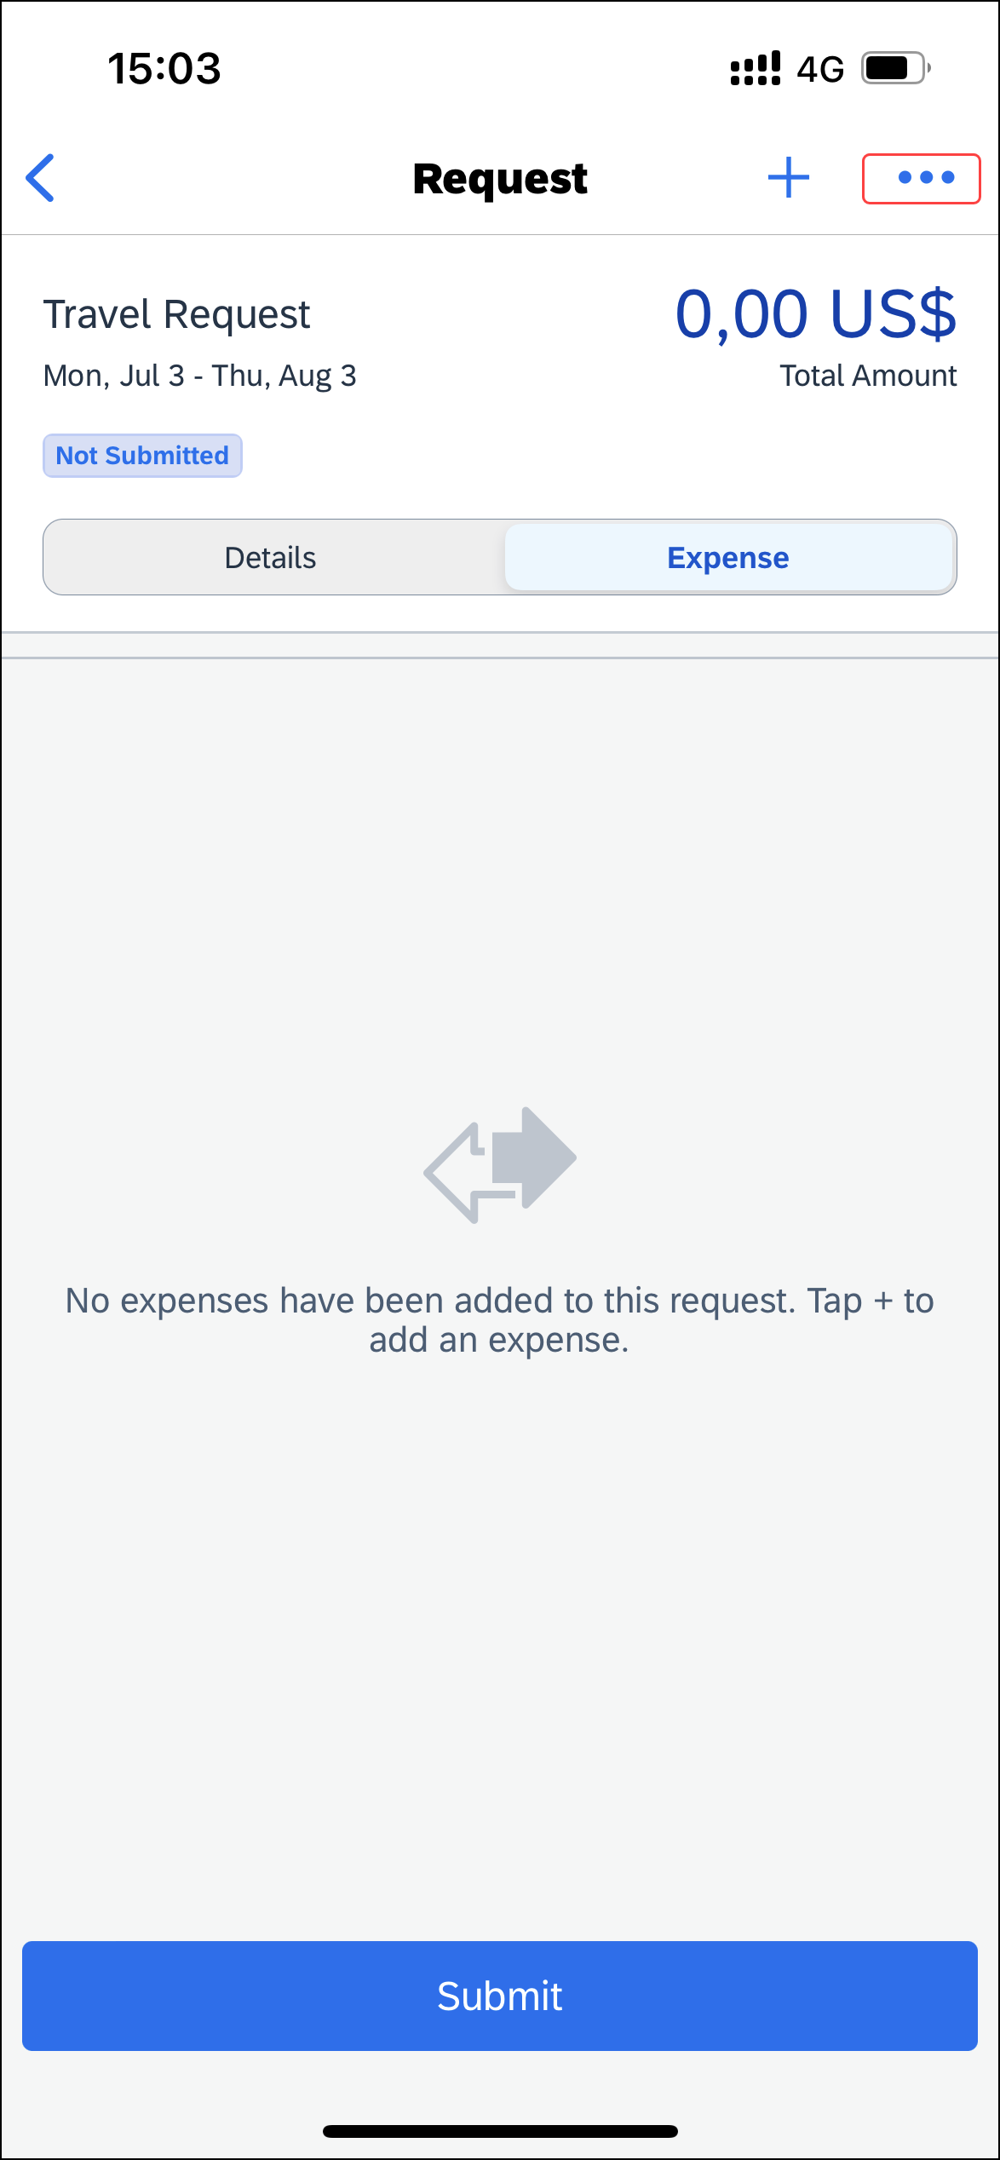 | To delete an unsubmitted request in an open request:  1) With the request open, tap (upper-right corner).
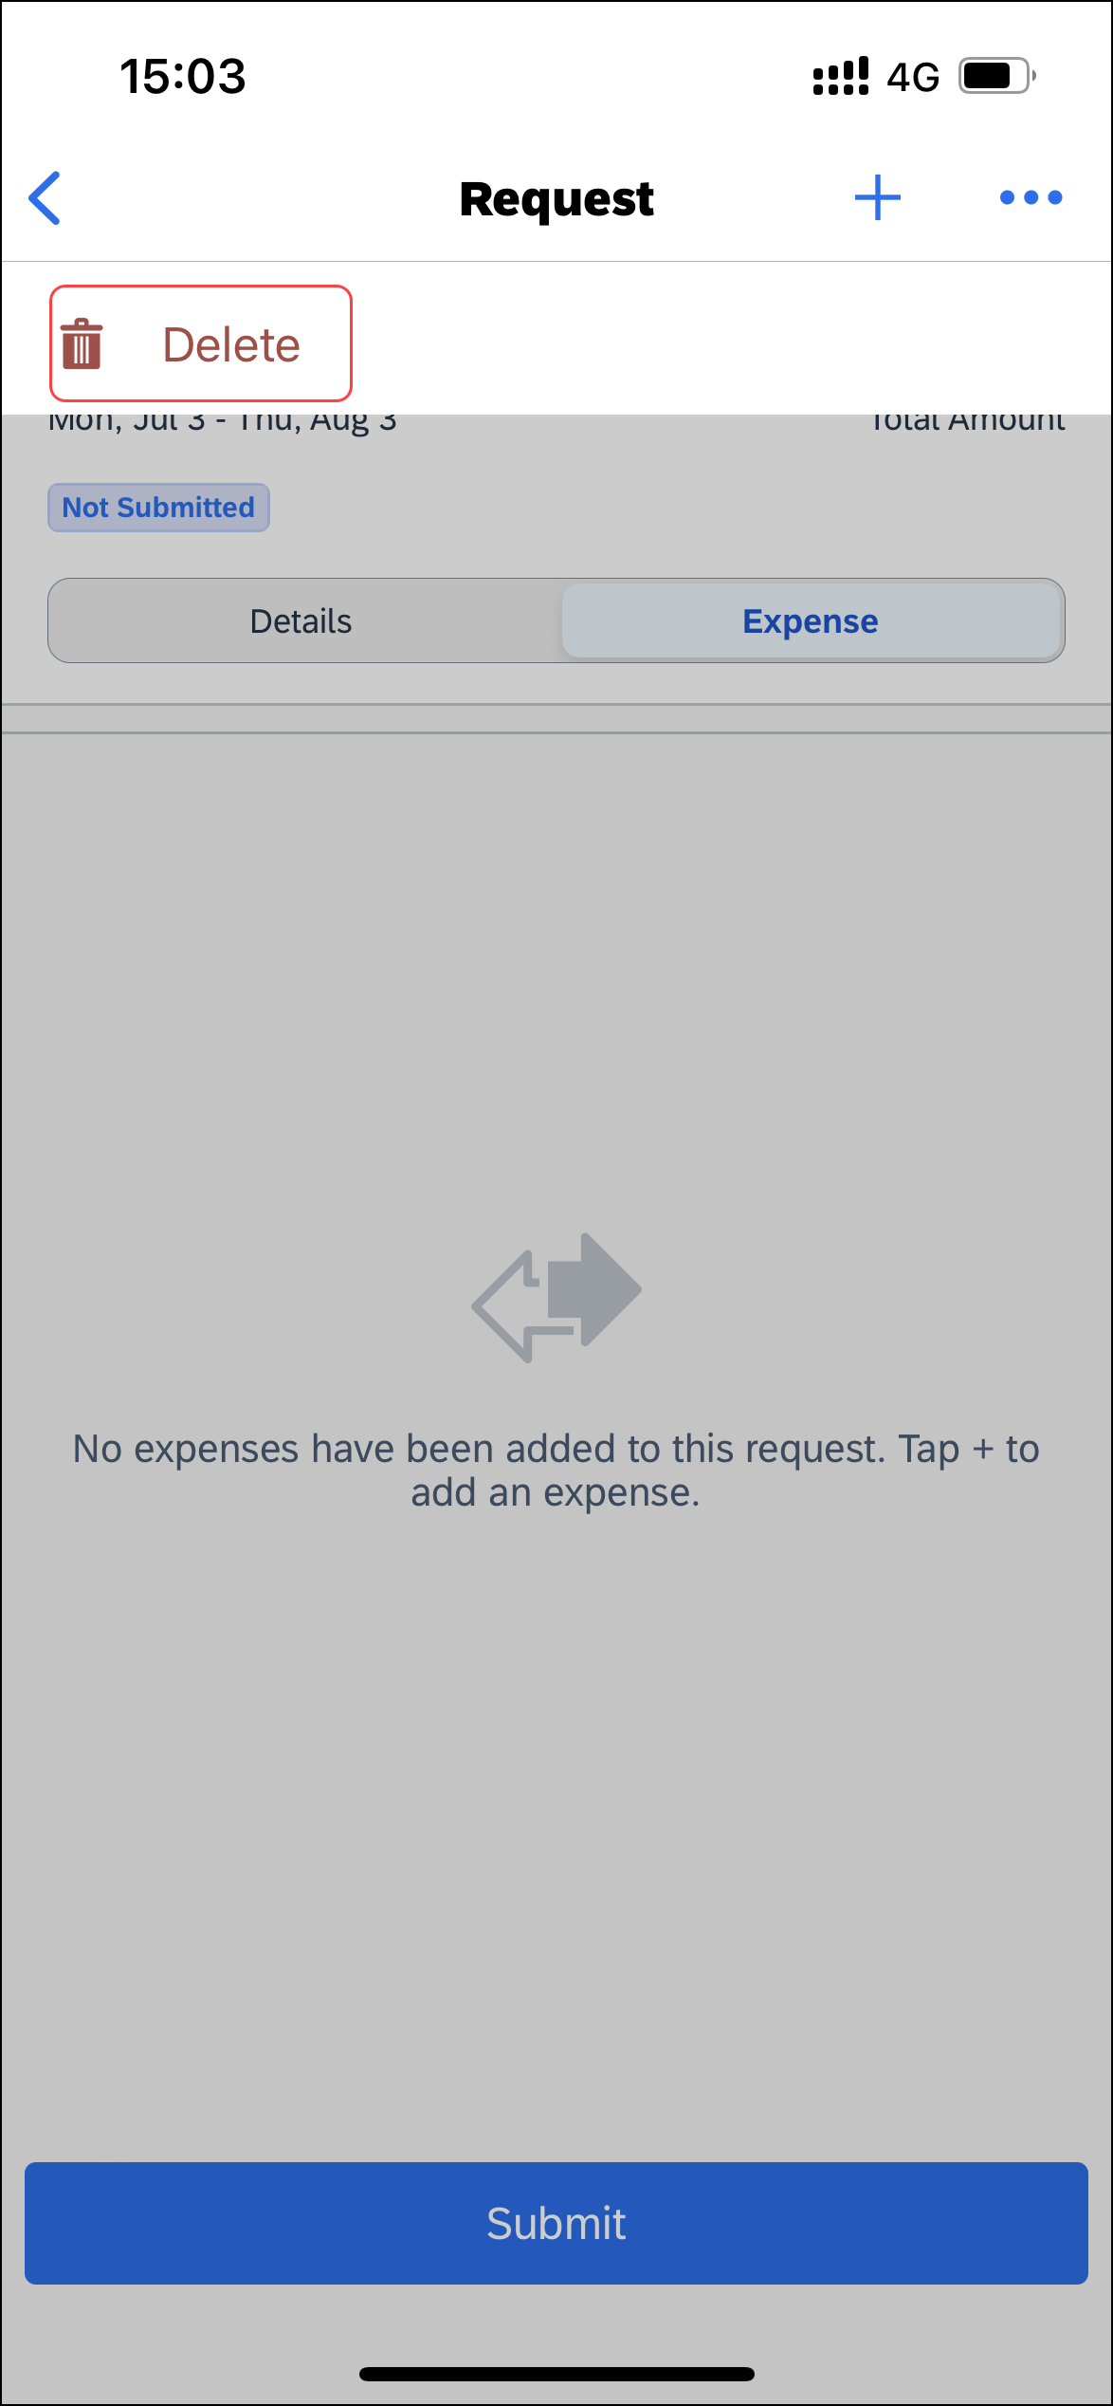 | 2) On the menu, tap Delete.
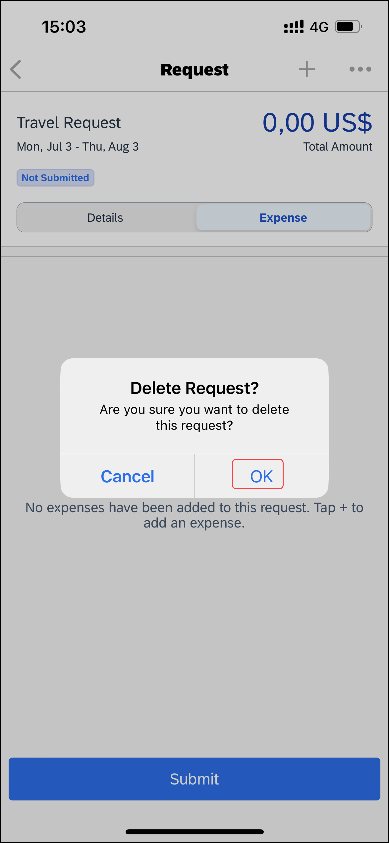 | 3) On the Delete Request? window, tap OK.
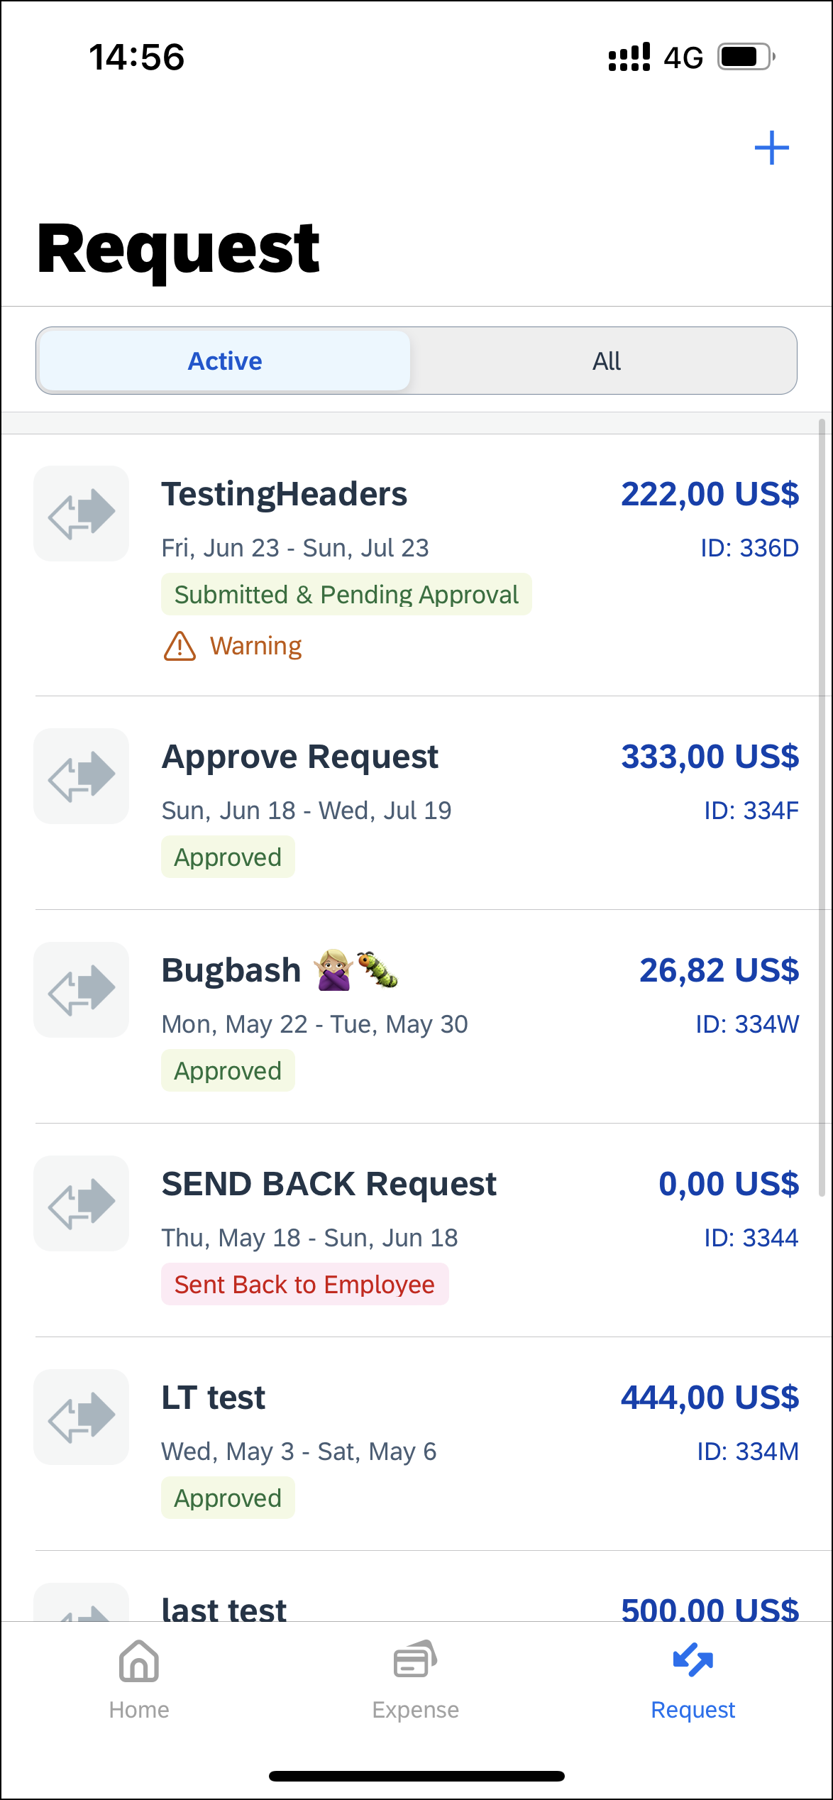 | The request no longer appears on the Request screen.

Delete an Unsubmitted Request on the Request Screen
Screen(s) | Description/Action
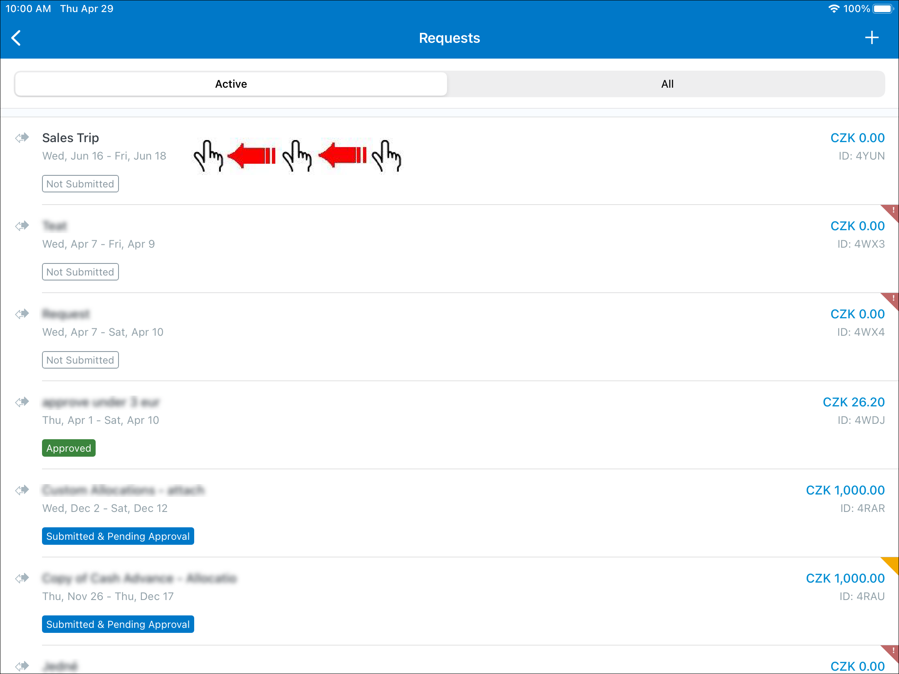 | To delete an unsubmitted request on the Request screen:  1) On the home screen, tap Request.  2) On the Request screen, tap the Active tab.  3) On the Active tab, swipe the desired request to the left.
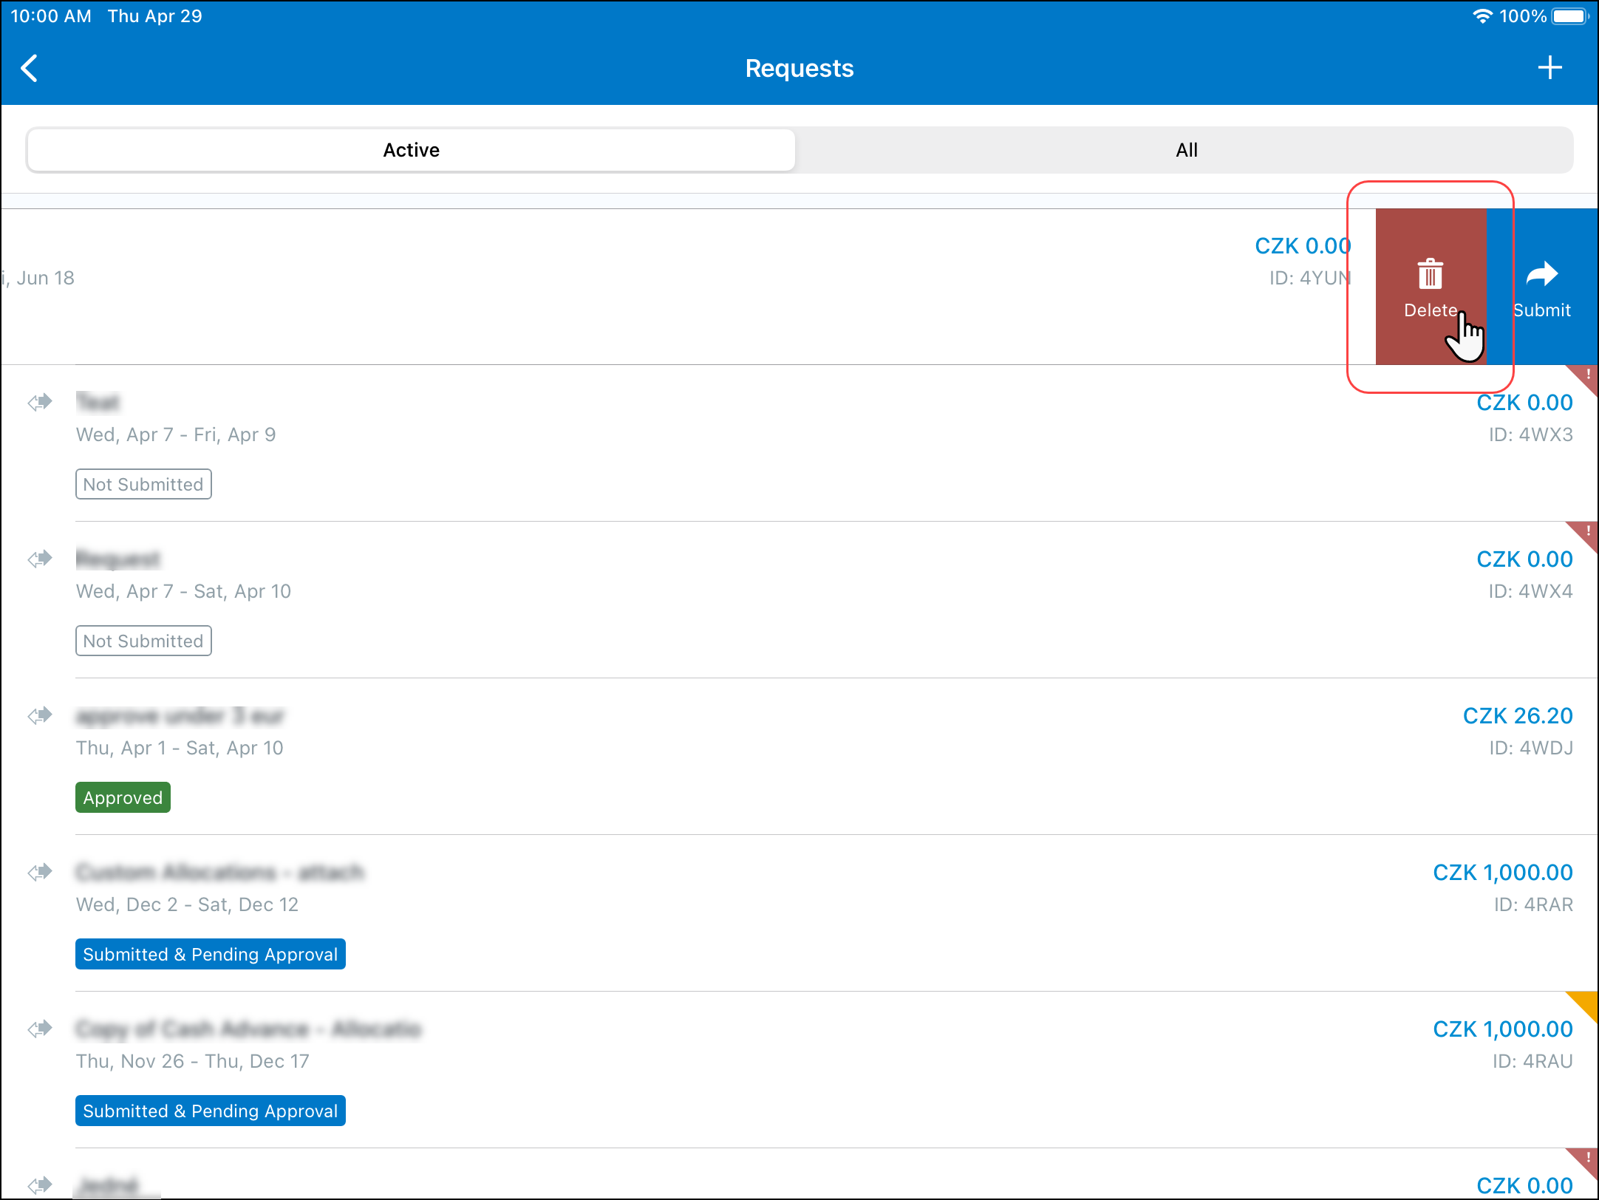 | 4) Tap Delete.
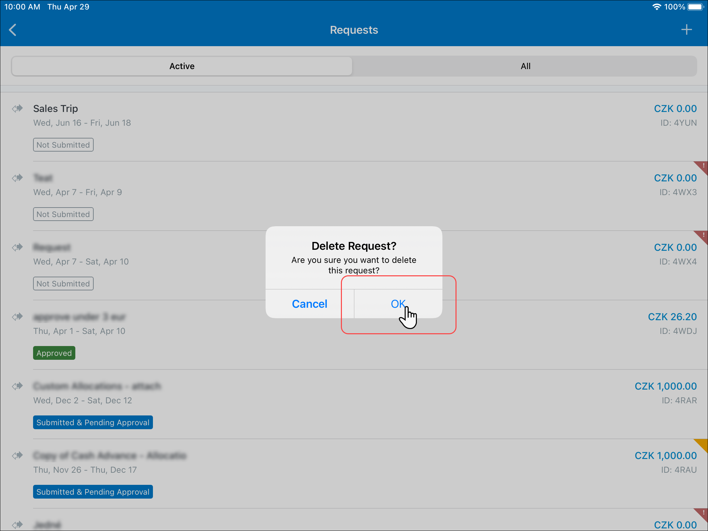 | 5) On the Delete Request? window, tap OK.
 | The request no longer appears on the Request screen.

Submit a Request From an Open Request
Screen(s) | Description/Action
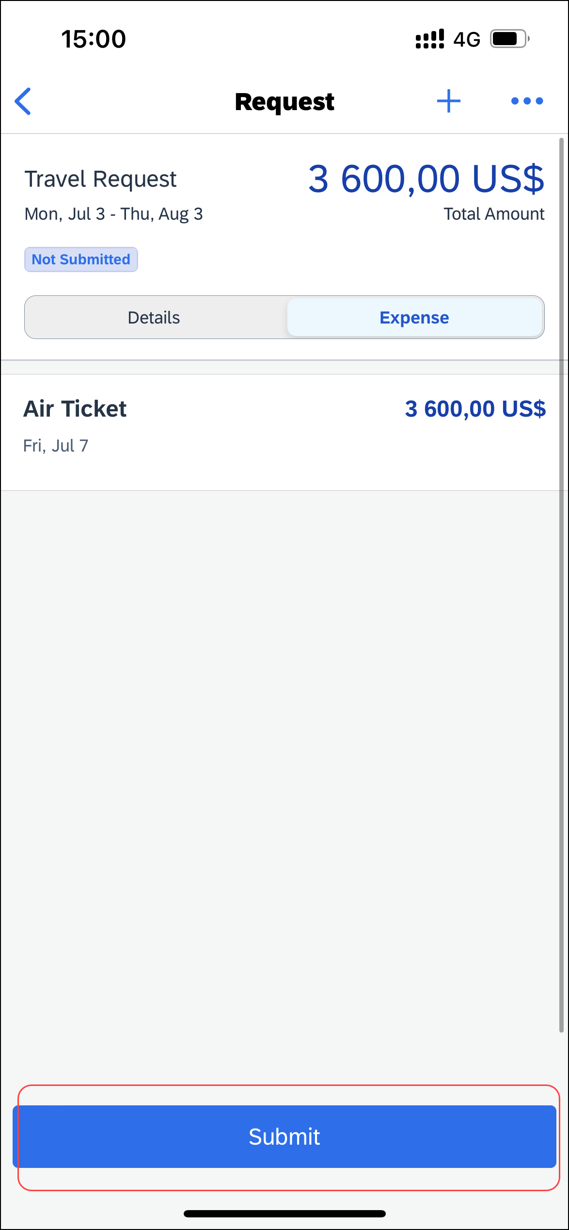 | To submit a request from an open request:  - With the request open, tap Submit.

Submit a Request on the Request Screen
Screen(s) | Description/Action
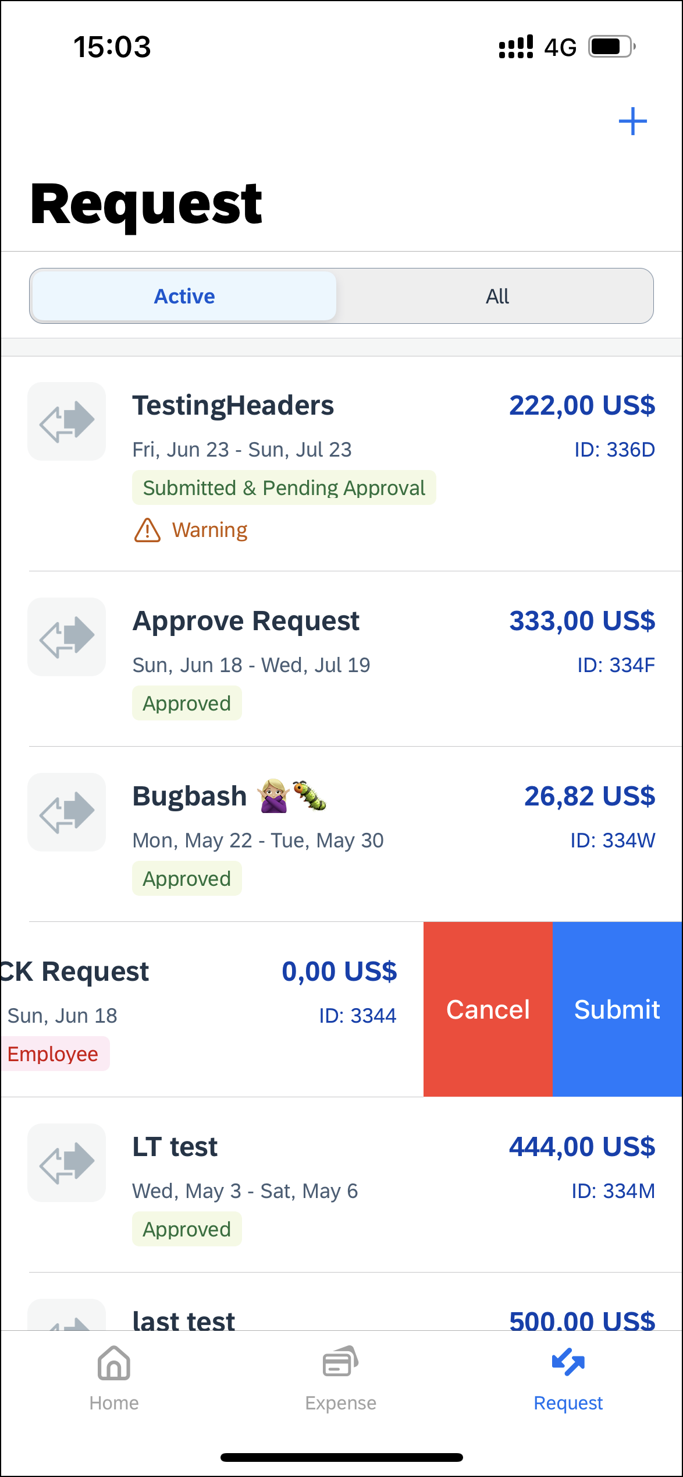 | To submit a request on the Request screen:  1) On the home screen, tap Request.  2) On the Request screen, tap the Active tab.  3) On the Active tab, swipe the desired request to the left.  4) Tap Submit.

Recall a Submitted Request
Screen(s) | Description/Action
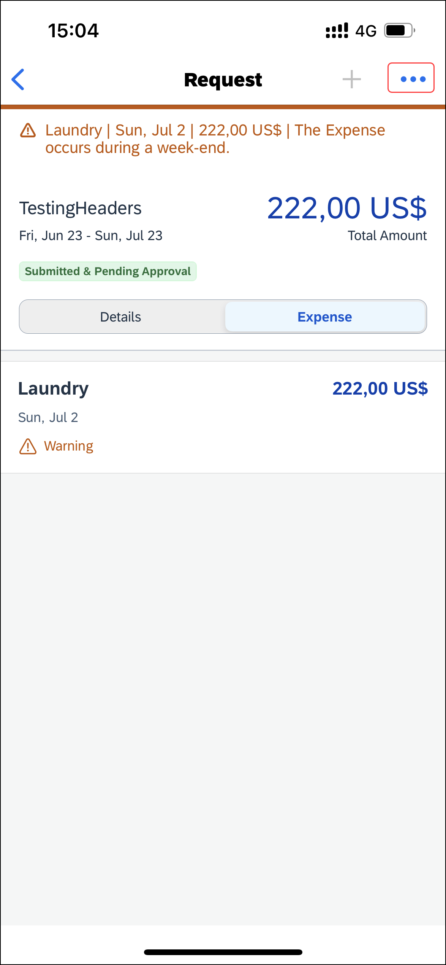 | To recall a submitted request:  1) On the Request screen, tap (upper-right corner).
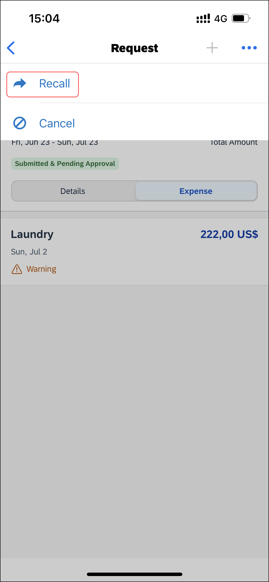 | 2) On the menu, tap Recall.
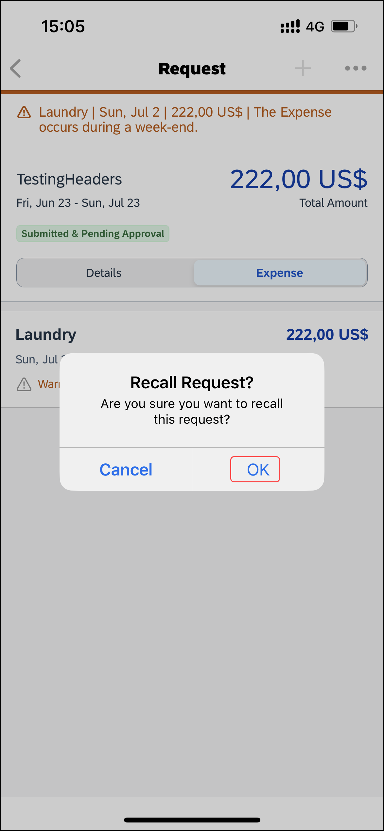 | 3) On the Recall Request? window, tap OK.
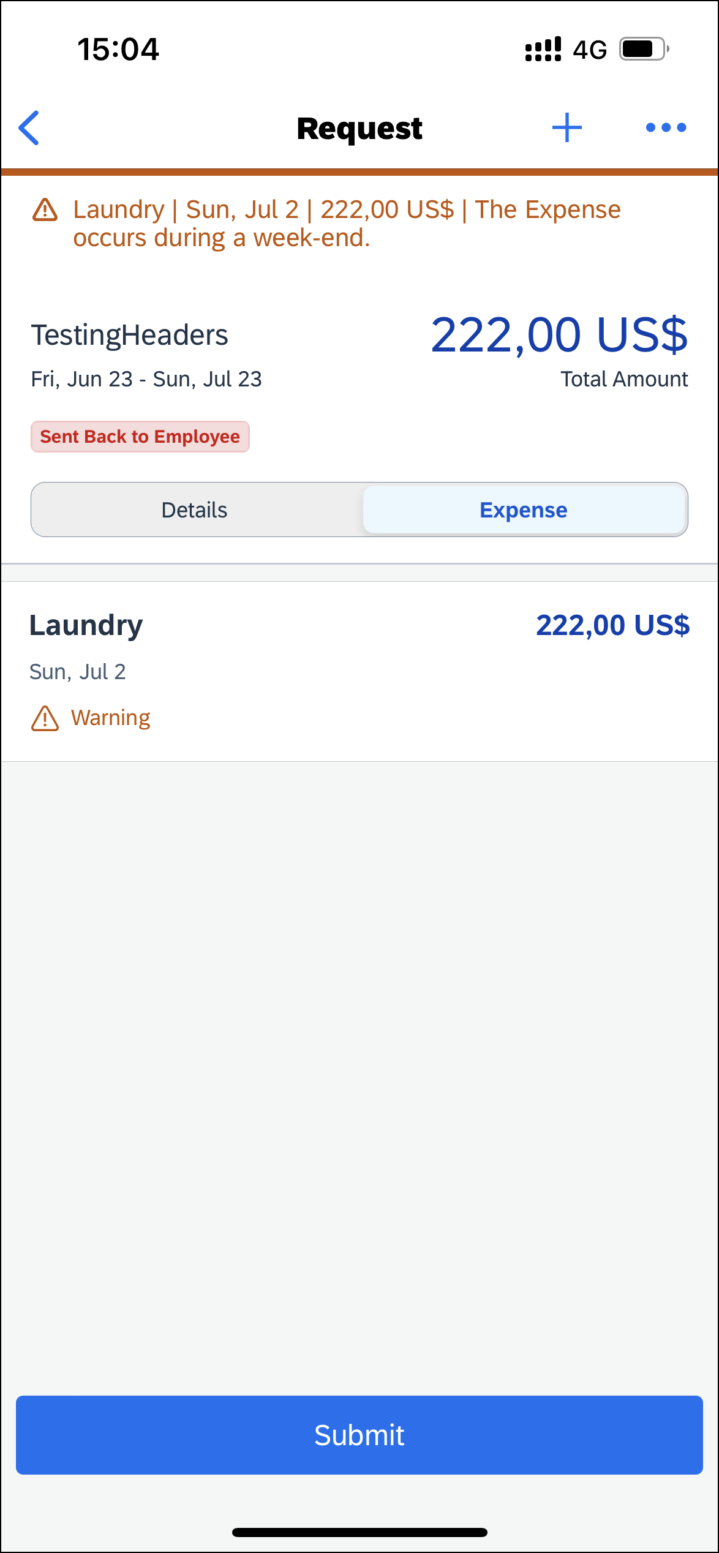 | The request has been recalled and the Send Back to Employee message appears on the Request screen.

Approve a Request
Screen(s) | Description/Action
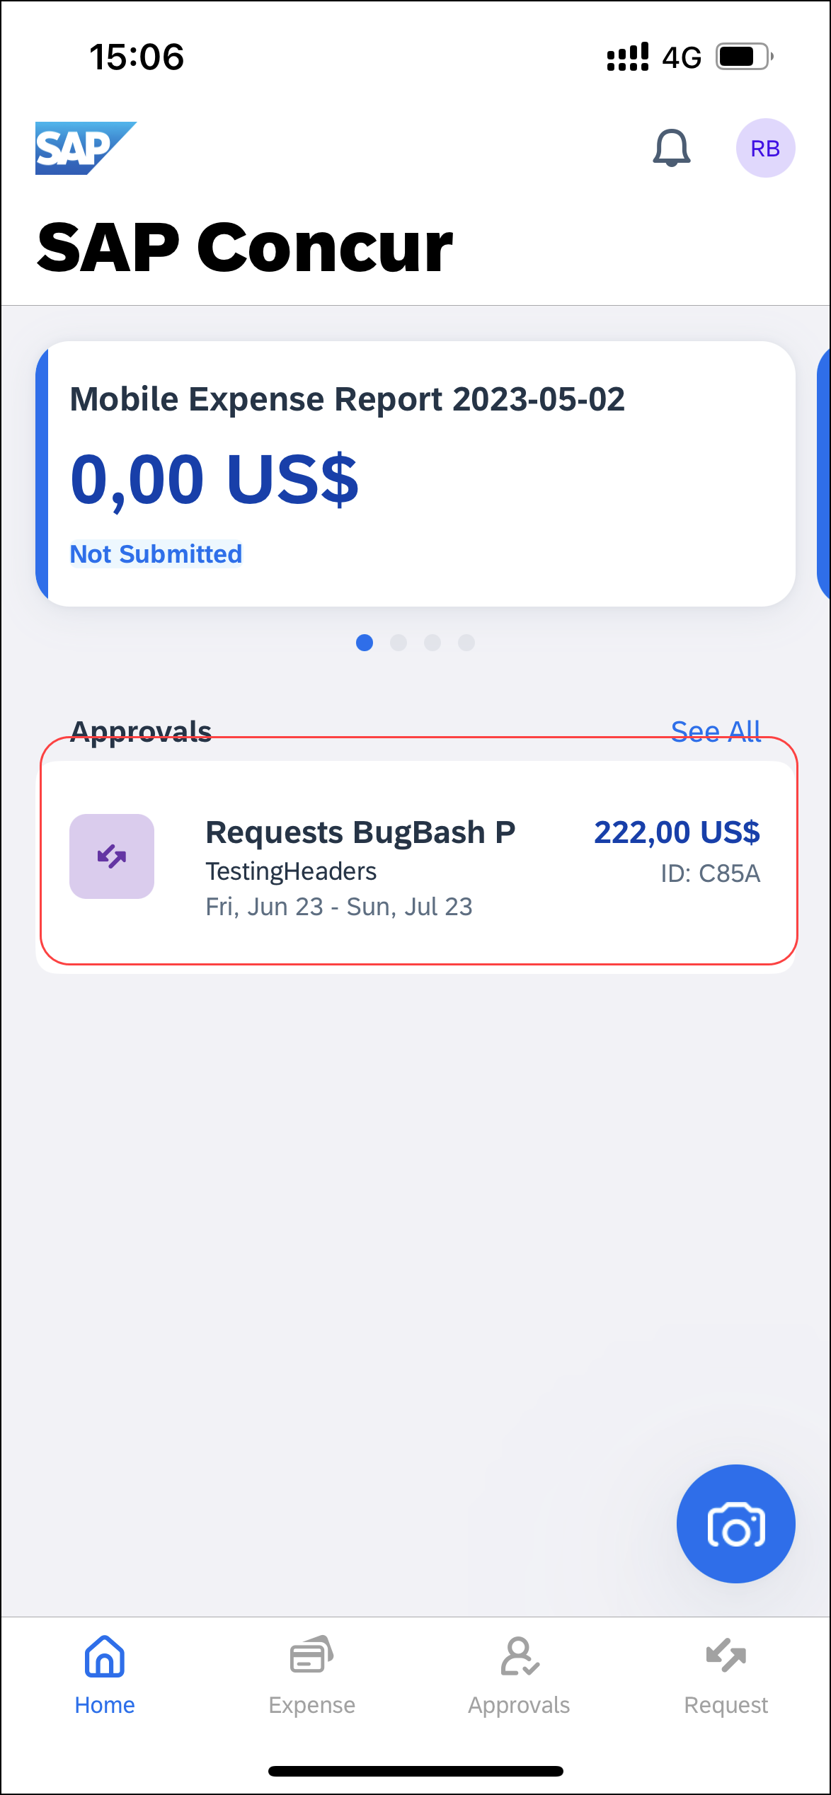 | To approve a request:  1) On the home screen, tap Approvals.
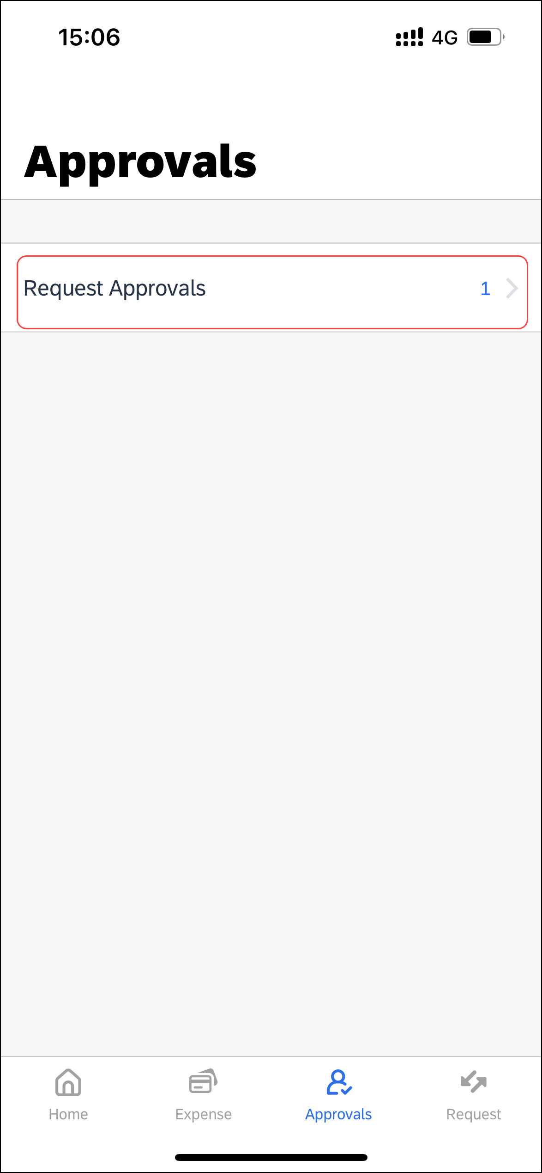 | 2) On the Approvals screen, tap Request Approvals.
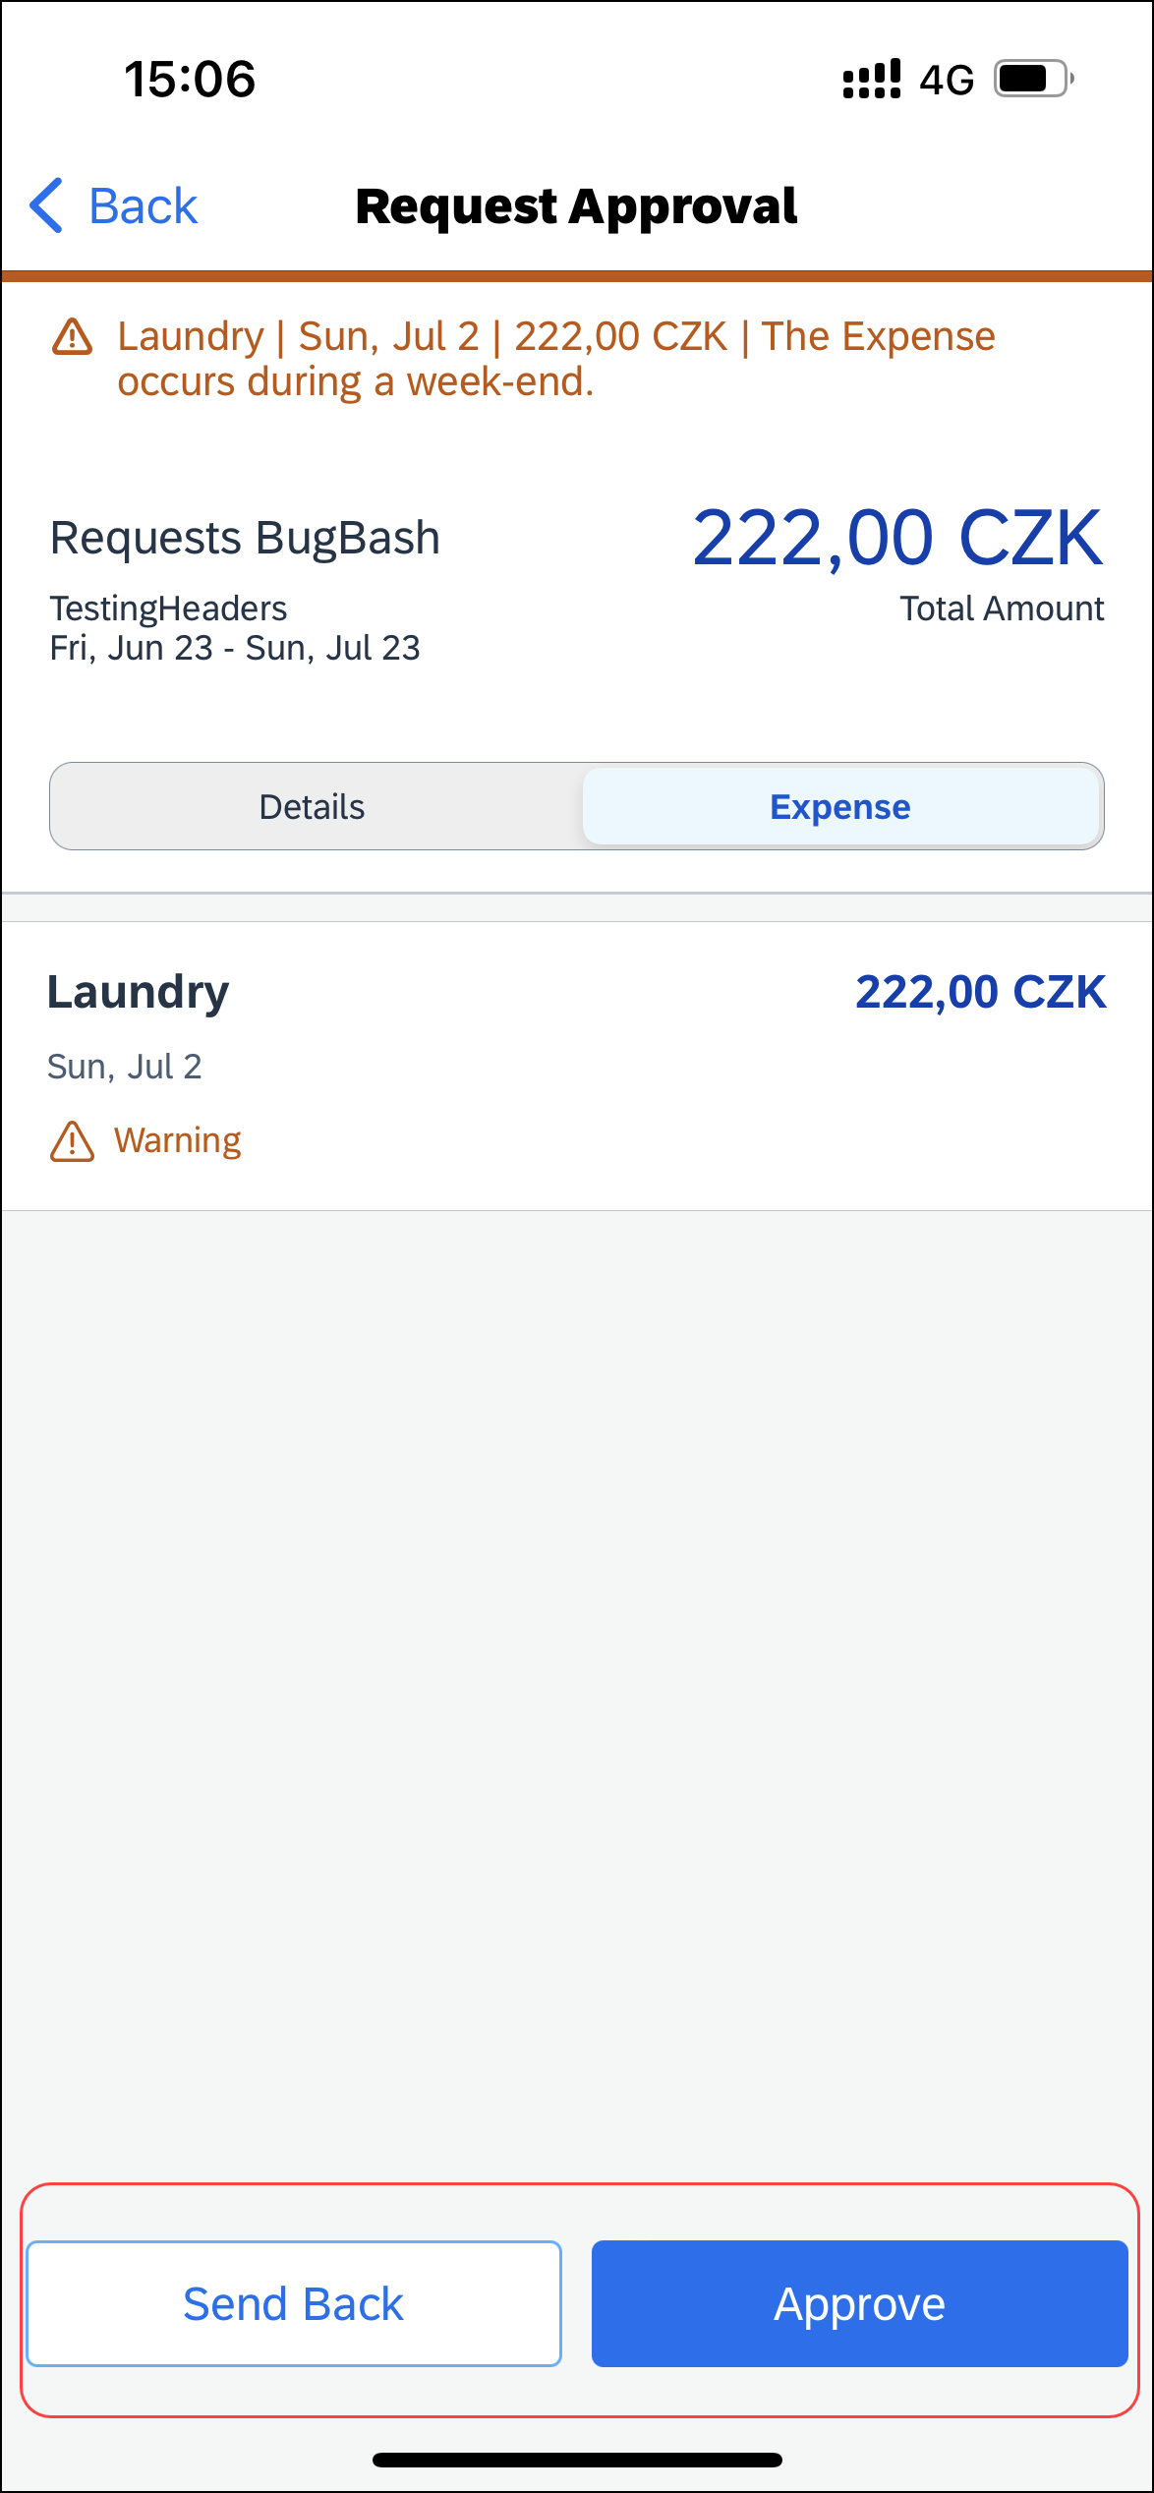 | 3) On the Request screen, tap to open the desired request.  4) On the Request Approval screen, you can do the following:  - Tap the Details tab to view the request details (comments, cash advances, allocations, and attachments).  - Tap the Expense tab to view expected expenses.  - Tap Approve or Send Back.  NOTE: If you send back a request, you must provide a comment.

Create a New Expense Claim From an Approved Request
Screen(s) | Description/Action
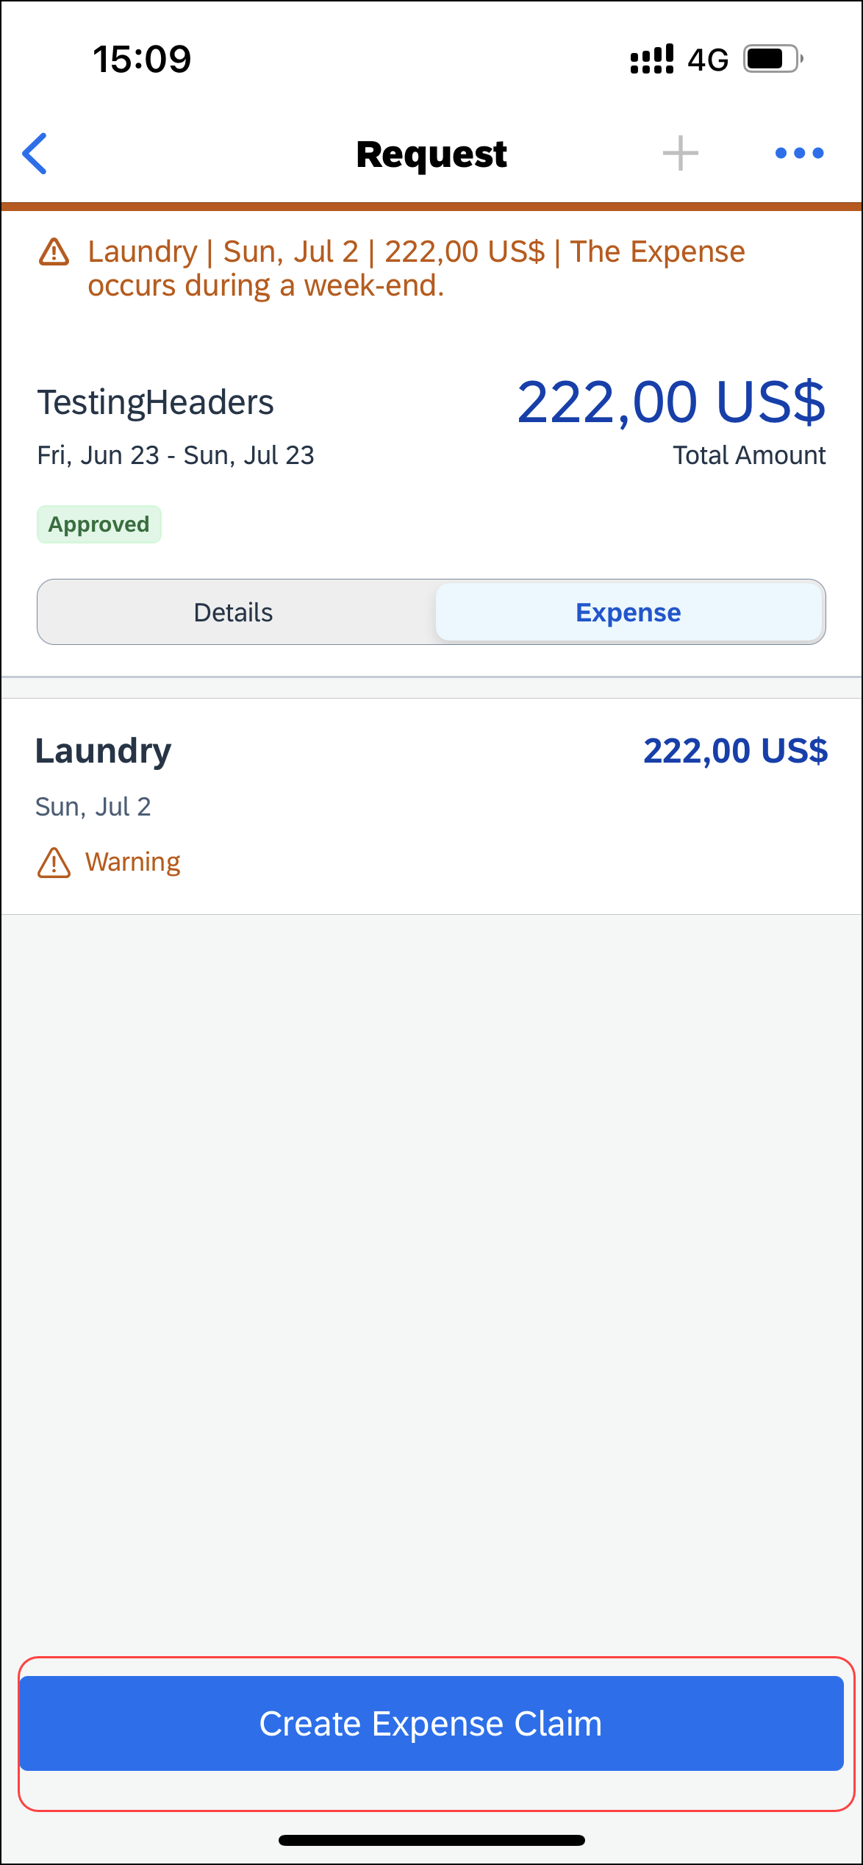 | To create an expense report from an approved request:  1) On the home screen, tap Request.  2) On the Request screen, tap the Active tab.  3) On the Active tab, tap the desired approved request.  4) On the Request screen, you can review details by either tapping:  - Expense tab  -or-  - Details tab  5) Once done, tap Create Expense Claim.

Cancel an Approved Request From an Open Request
Screen(s) | Description/Action
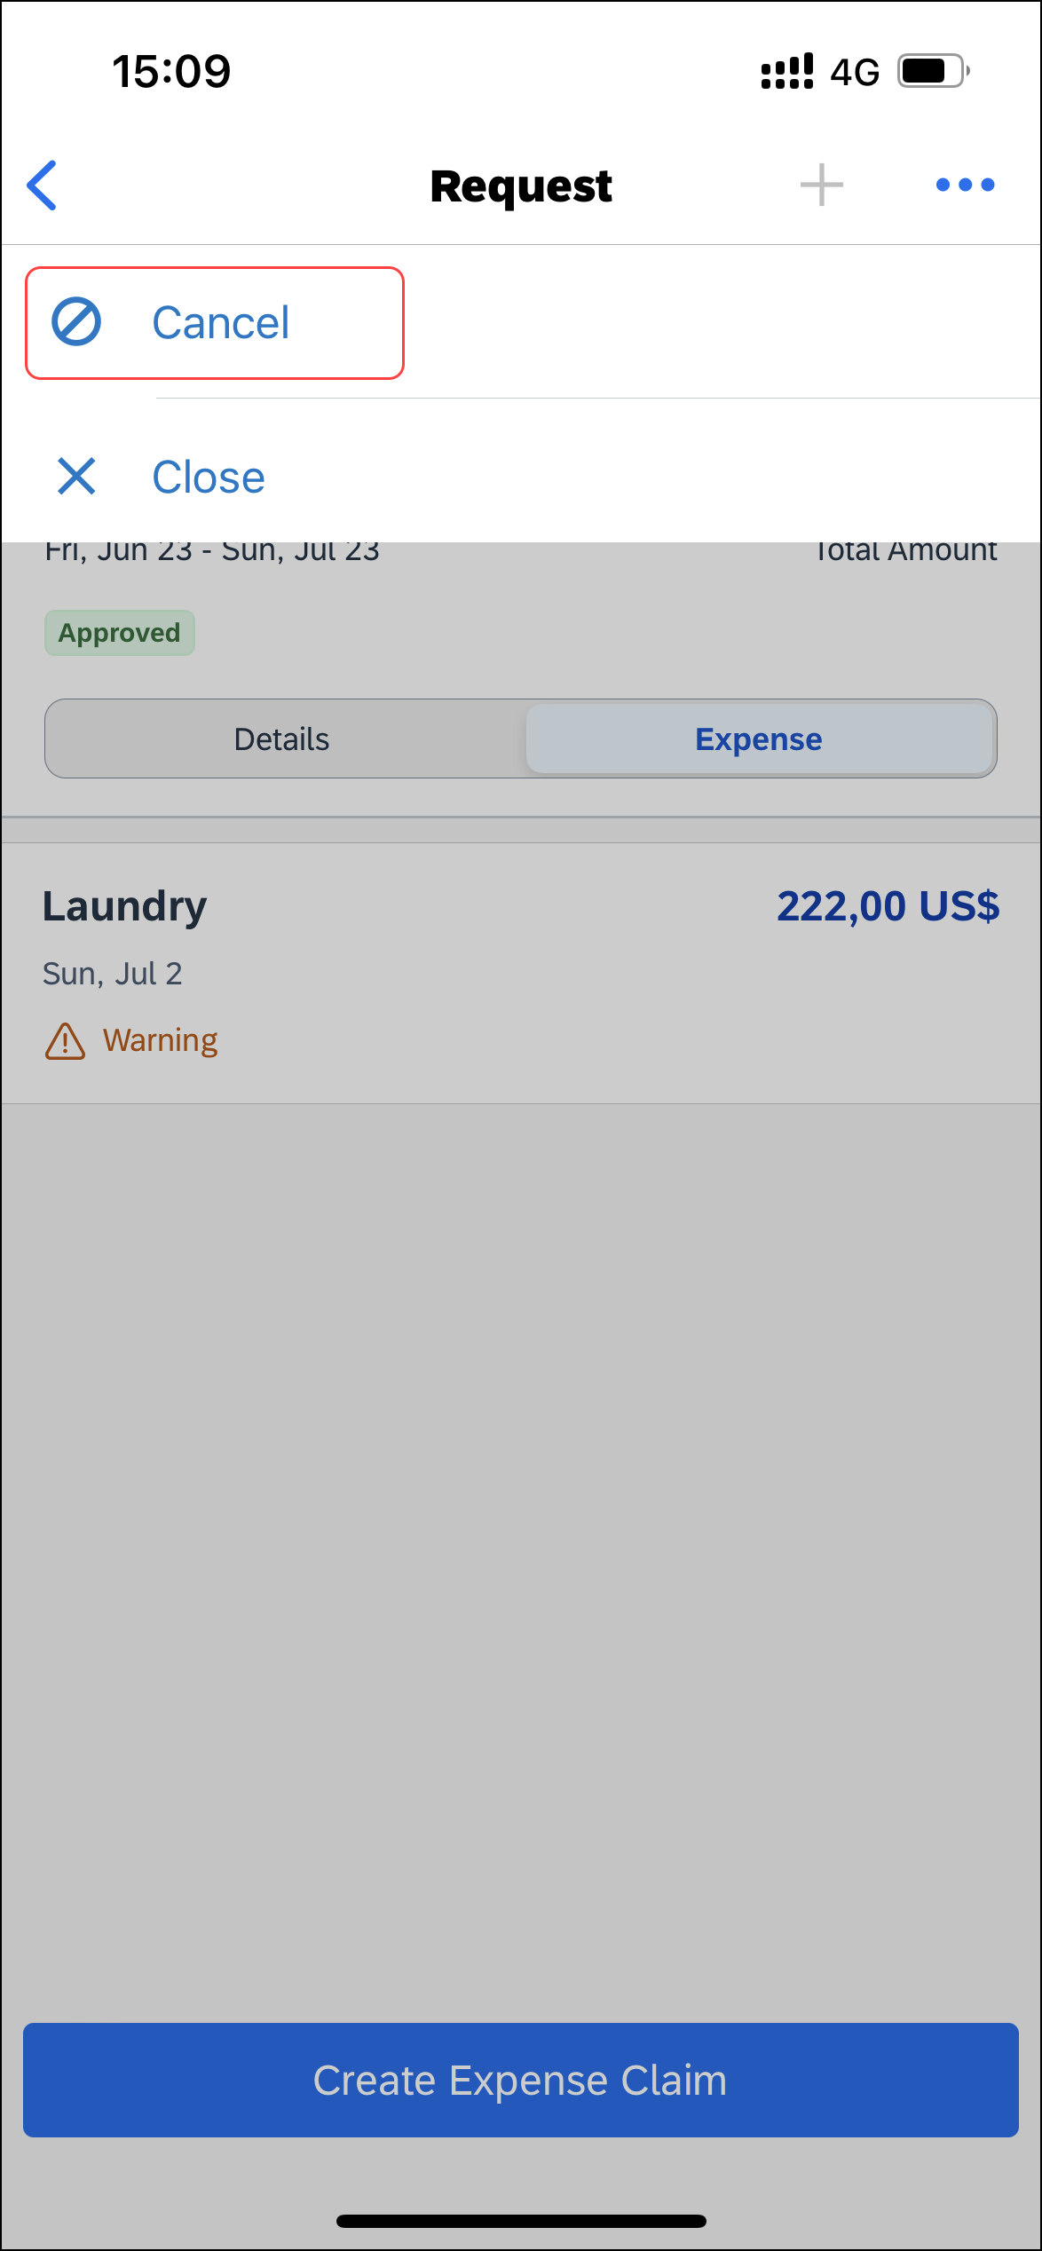 | To cancel an approved request from an open request:  1) With the desired request open, tap (upper-right corner).  2) On the menu, tap Cancel.
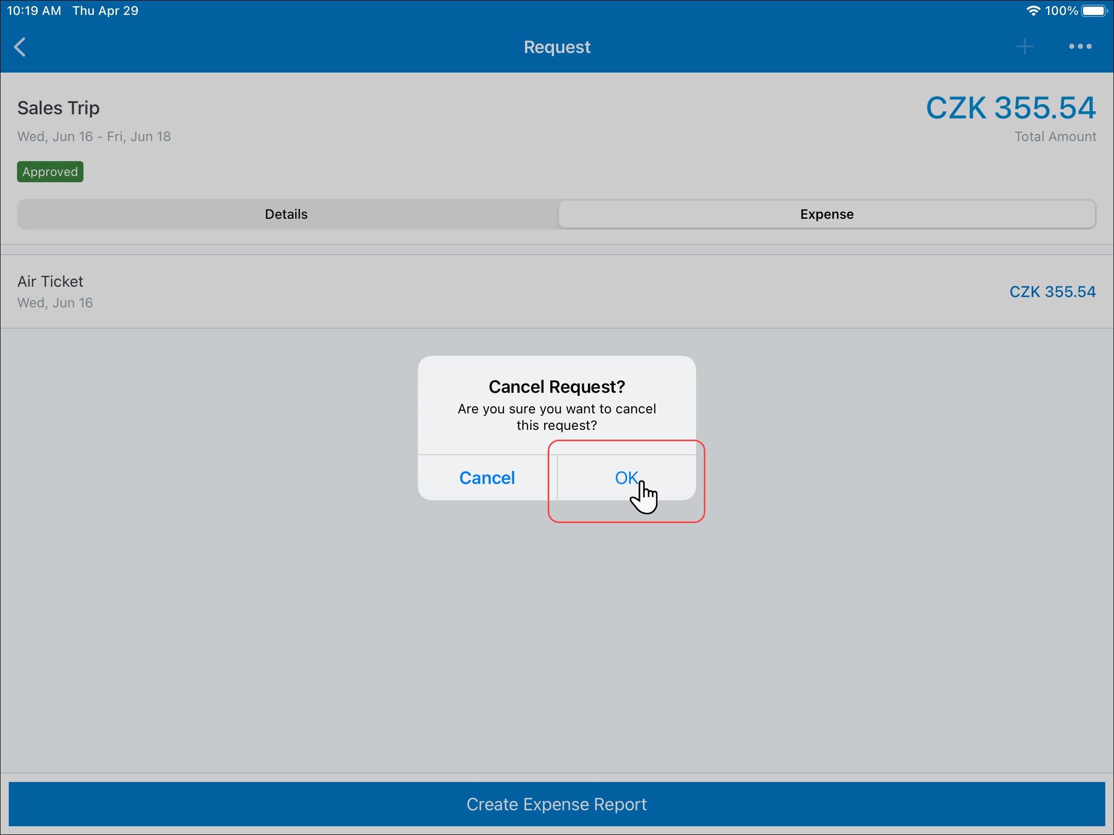 | 3) On the Cancel Request? window, tap OK.
 | The request no longer appears on the Request screen.

Cancel an Approved Request on the Request Screen
Screen(s) | Description/Action
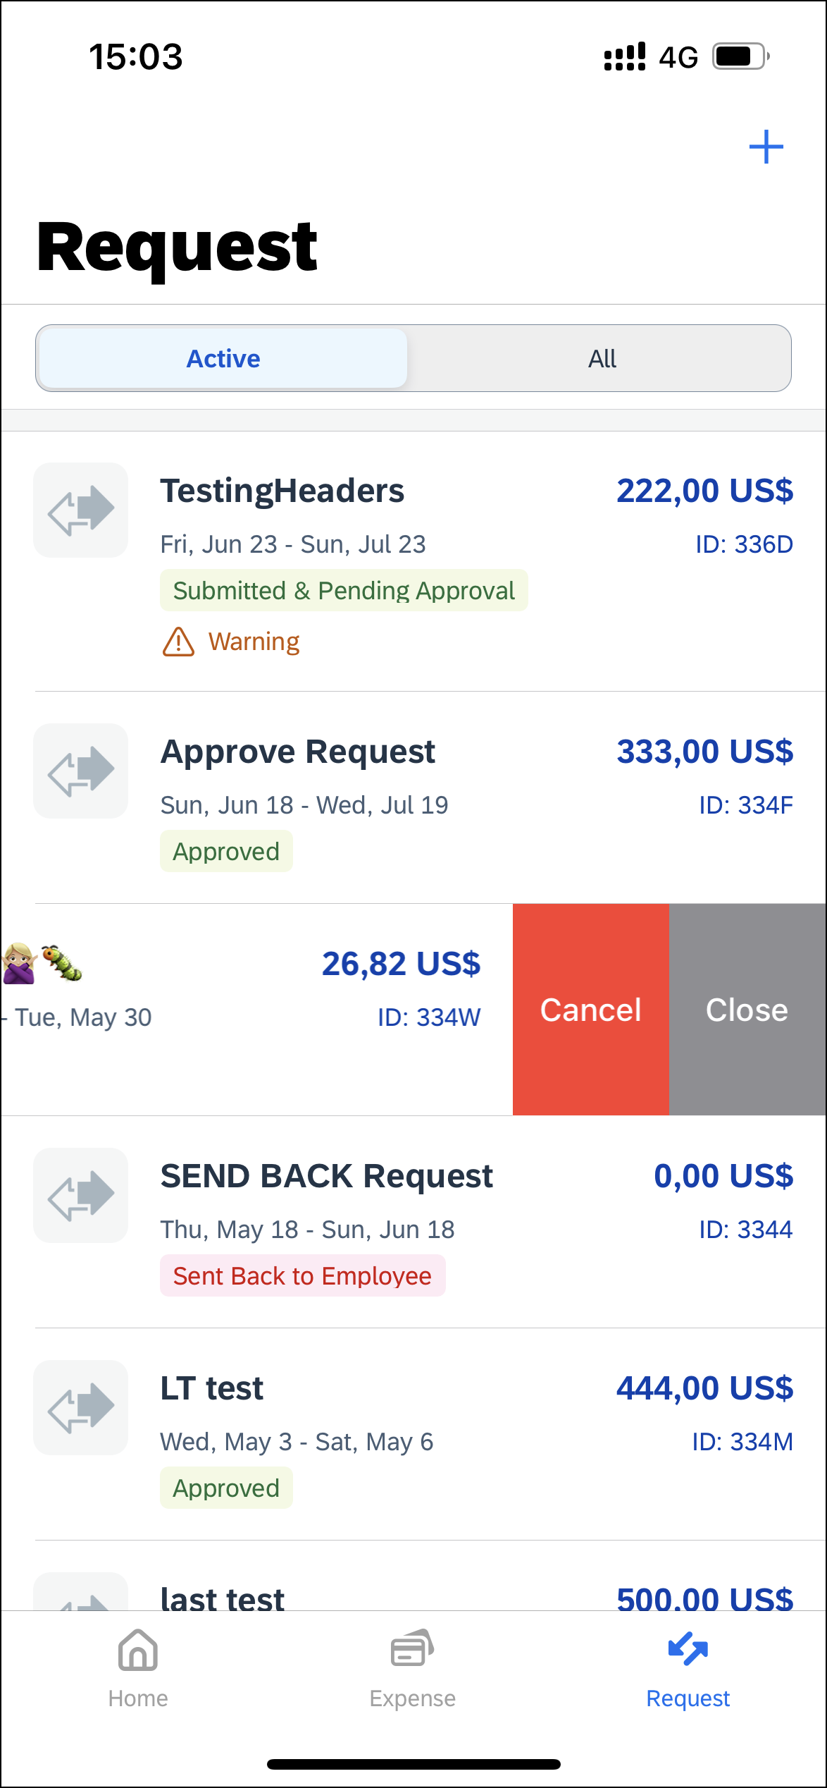 | To cancel an approved request on the Request screen:  1) On the Request screen, tap the Active tab.  2) On the Active tab, swipe the desired request to the left.  3) Tap Cancel.
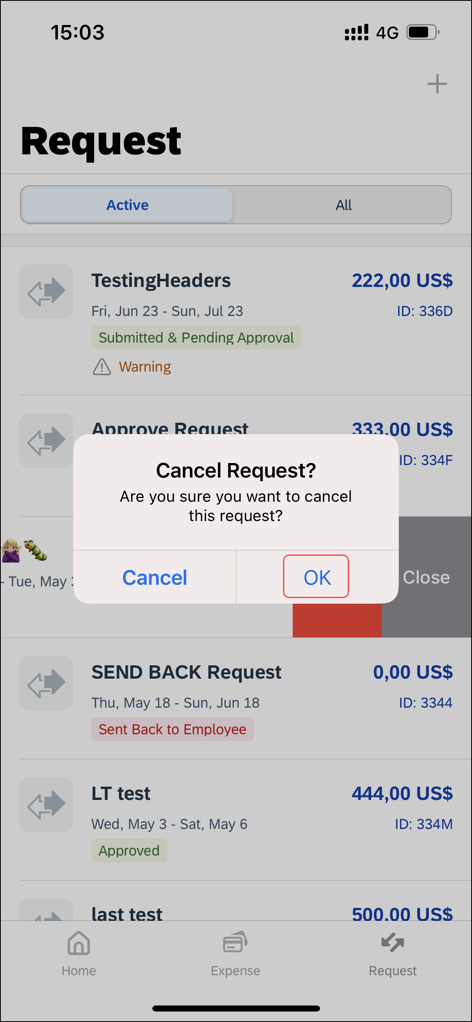 | 4) On the Cancel Request? window, tap OK.
 | The request no longer appears on the Request screen.

Close an Approved Request From an Open Request
Screen(s) | Description/Action
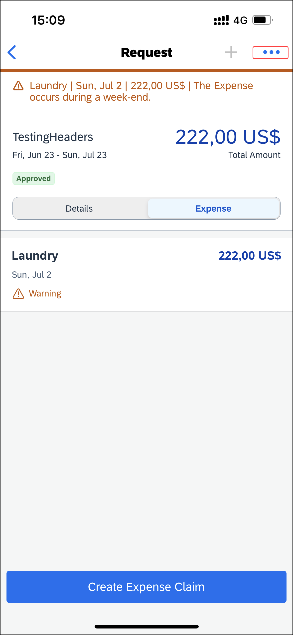 | To close an approved request from an open request:  1) With the desired request open, tap (upper-right corner).
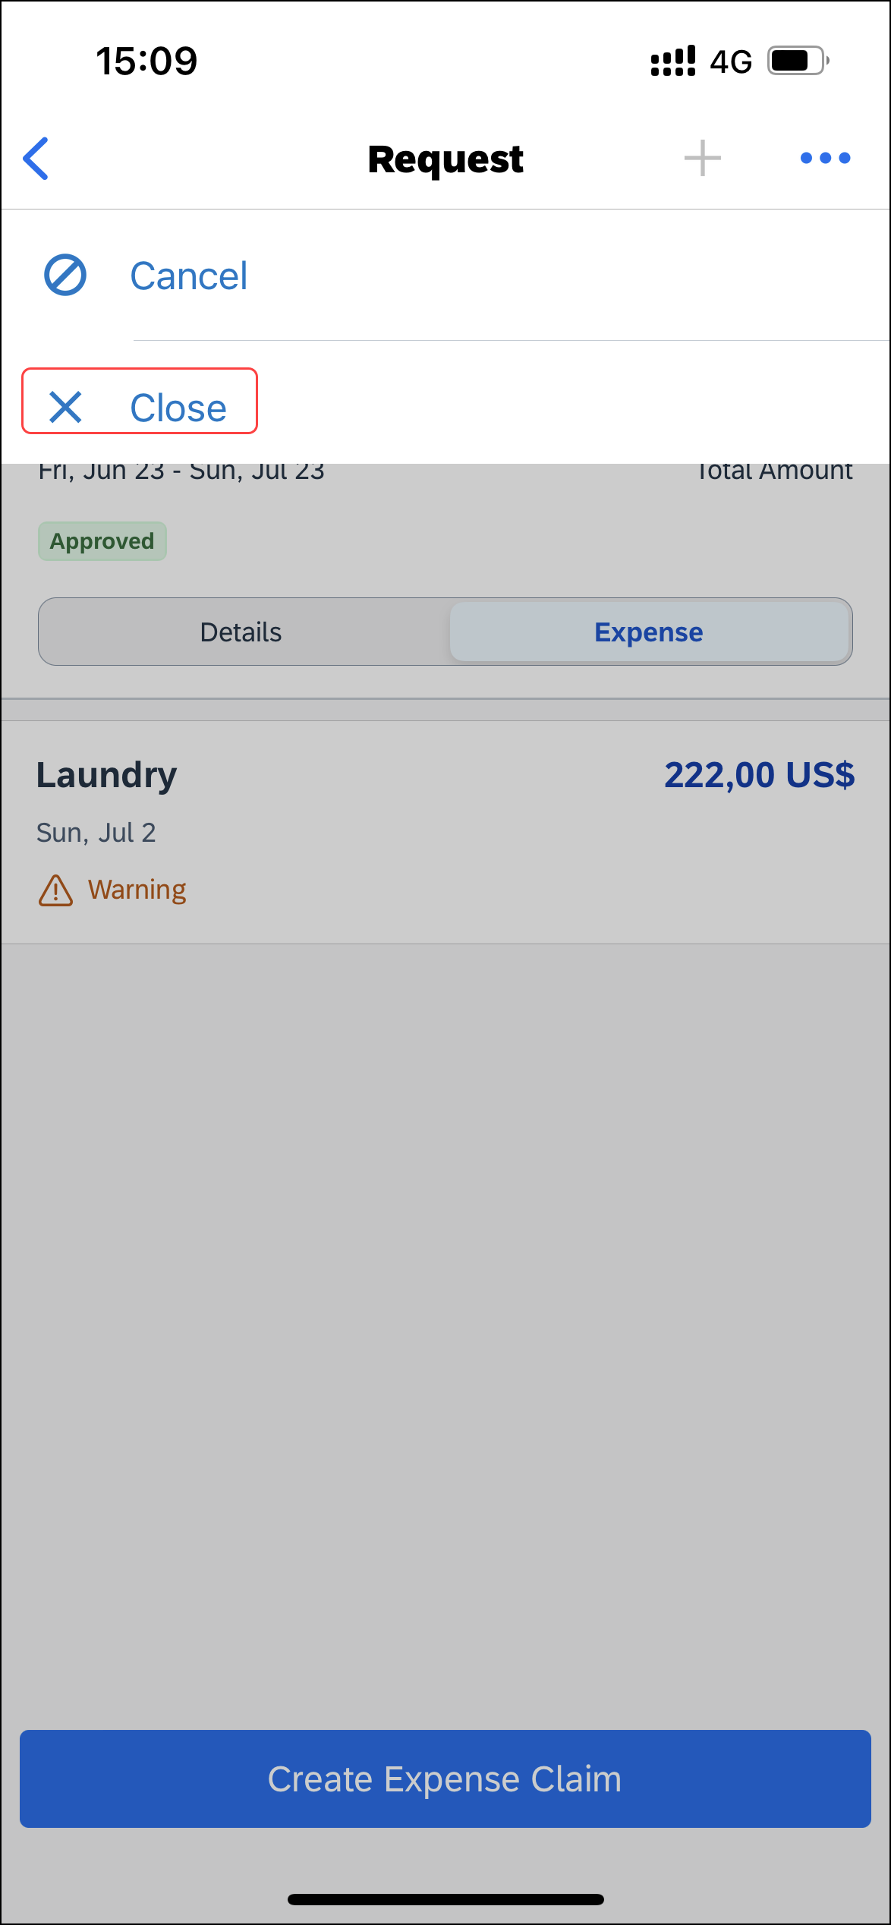 | 2) On the menu, tap Close.
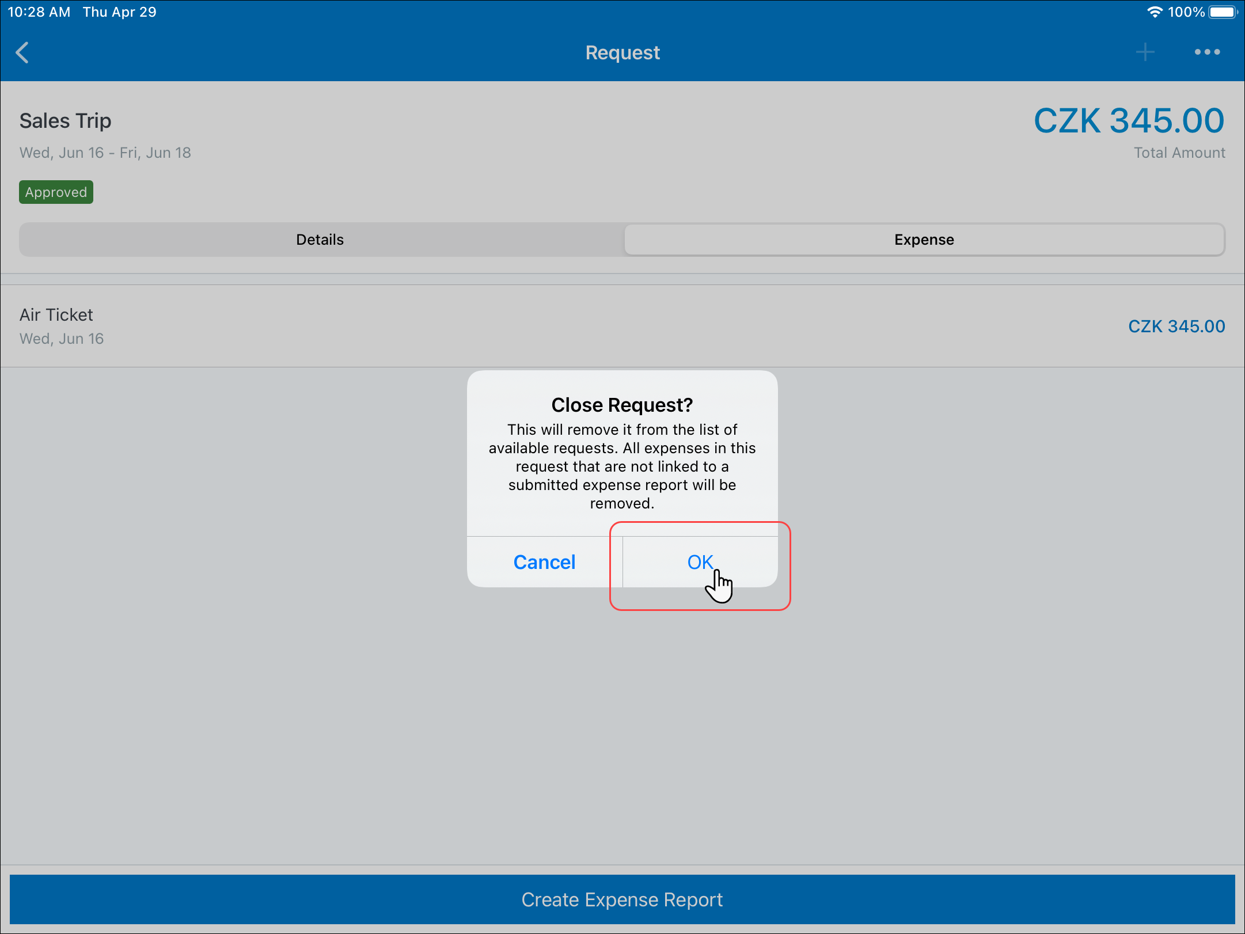 | 3) On the Close Request? window, tap OK.
 | The request no longer appears on the Request screen.

Close an Approved Request on the Request Screen
Screen(s) |  | Description/Action
To close an approved request on the Request screen:
1) On the Request screen, tap the Active tab.
2) On the Active tab, swipe the desired request to the left.
3) Tap Close.
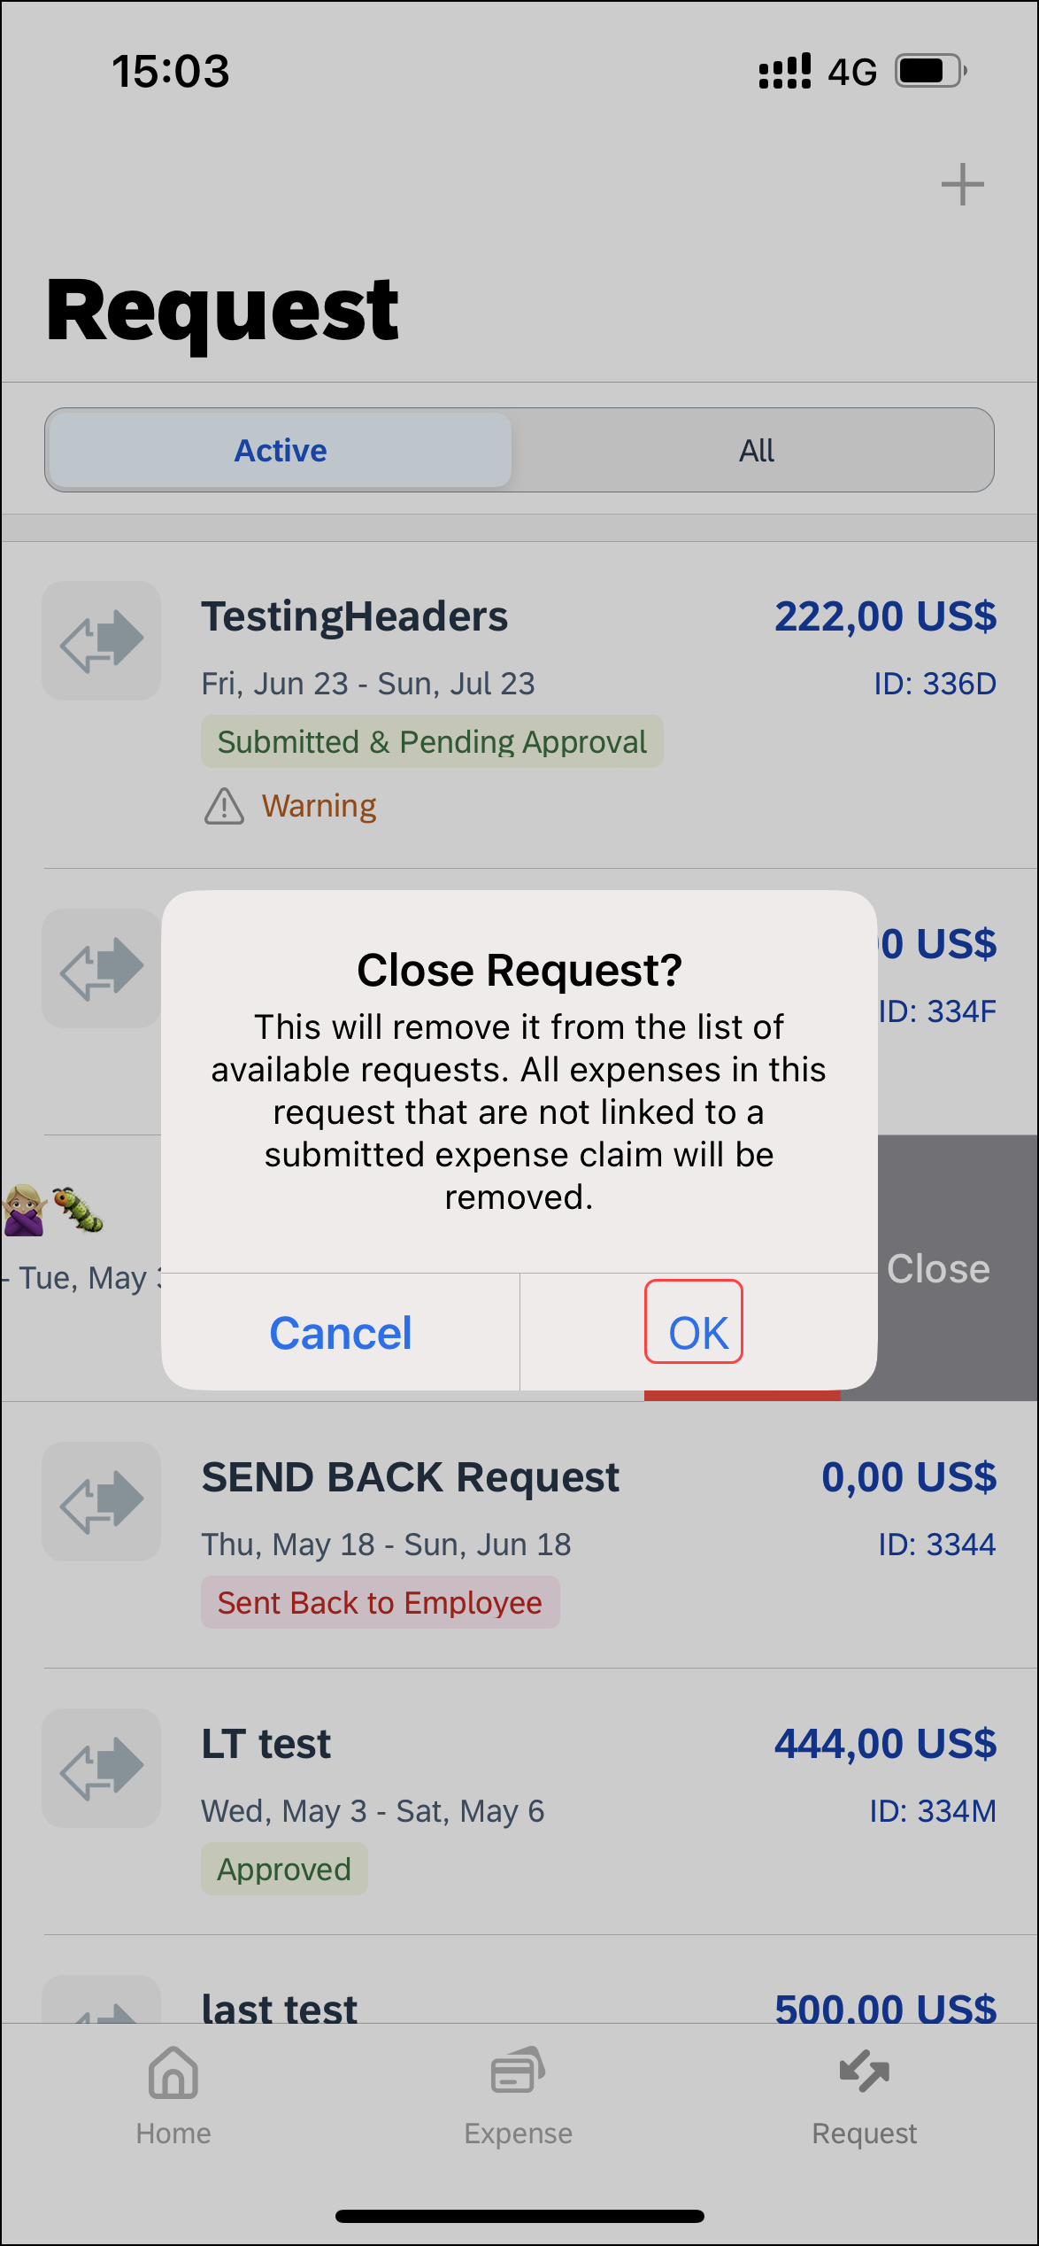 | 4) On the Close Request? window, tap OK.
 |  | The request no longer appears on the Request screen.

☼

