Mobile App User Guide  Concur Invoice  Last Revised: October 3, 2018 | This guide describes the current version, which is shown on the "Introduction" guide. |  | Applies to these mobile devices:  Yes: iPhone  No: iPad  No: Android
IMPORTANT: Be aware that your company's configuration may not allow for all of the features described here. Generally, if a feature is not available in your configuration of the web version of SAP Concur, then it is not available in the mobile app.
With Concur Invoice, users can automate invoice processing with speed and efficiency and a new way to monitor and manage spending to maximize your profitability.  Concur Invoice features include:  - Capture invoices using machine learning  - Stay on top of spending |  | Invoice Approvals 1  Payment Requests 2  Review and Approve a Payment Request 2  View and Submit Payment Requests 4  Submit One or More Payment Requests 5  Purchase Requests 6  Review and Approve a Purchase Request 6
- Eliminate late payments and manage cash outlays
- Streamline purchase requests and automate approvals

Please Note:
- The SAP Concur app for iOS and Android supports universal links, i.e. links that navigate directly to the app if it is installed or to the website if not.
- Such links are included in notification emails from SAP Concur related to the expense report changes.
- Universal link support for customers own use is currently not supported.
- Some security solutions may block the links embedded into email from opening the app directly. The proper exceptions for the security policy should be configured for SAP Concur universal link URLs (pattern to match: https://*.concursolutions.com/*). Known cases are:
- MDM/MAM policy that prescribes to open any link tapped in Outlook mobile app only in specified browser.
- Outlook mail server phishing protection that wraps all link embedded into e-mails to open the safety check service first.

Invoice Approvals

Payment Requests
Use Approvals on the home screen to approve payment requests (if you are an approver).
NOTE: This also includes Cost Object Approvals and Authorized Approvals

Review and Approve a Payment Request
Screen(s) | Description/Action
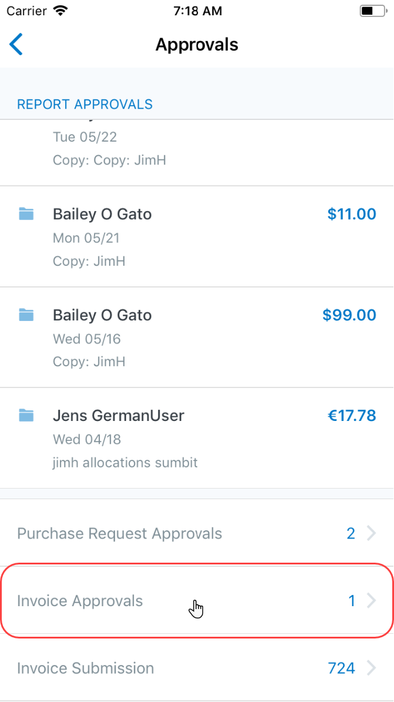 | To review and approve a payment request:  1) On the home screen, tap Approvals.  2) On the Approvals screen, tap Invoice Approvals.
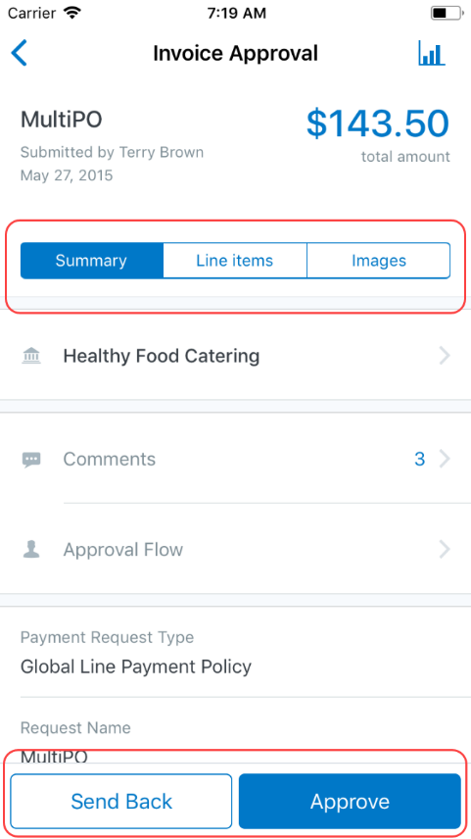 | 3) On the Invoice Approvals screen, tap (to open) the desired invoice.  4) On the Invoice Approval screen, on the Summary tab:  - Tap Comments to review or add comments.  - Tap Approval Flow for the approval information.  - Tap the vendor name for vendor details.  5) On the Invoice Approval screen, on the Line Items tab, tap the desired line item.  6) On the Item Detail screen:  - Review the quantity, price, image, etc.  - Tap Distributions to view the percentages.  7) On the Invoice Approval screen, on the Images tab, view the invoice image.  8) When ready, tap Approve or Send Back.

View and Submit Payment Requests
Screen(s) | Description/Action
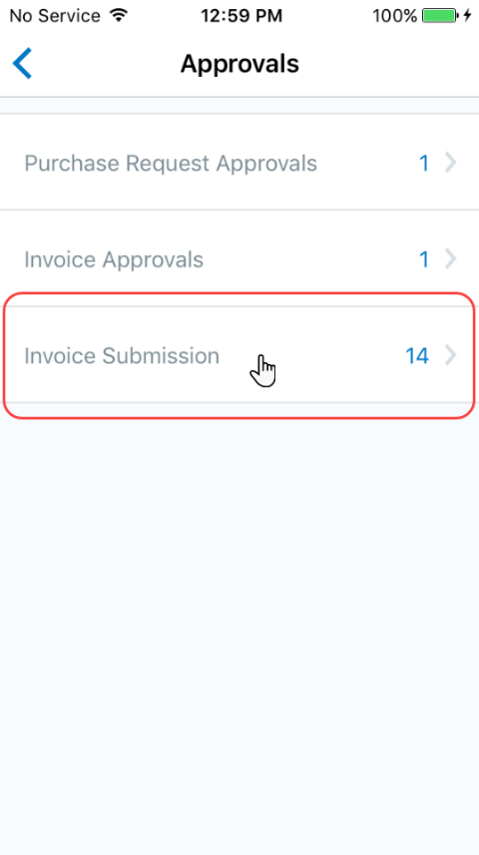 | To view and submit a payment request:  1) On the home screen, tap Approvals.  2) On the Approvals screen, tap Invoice Submission.
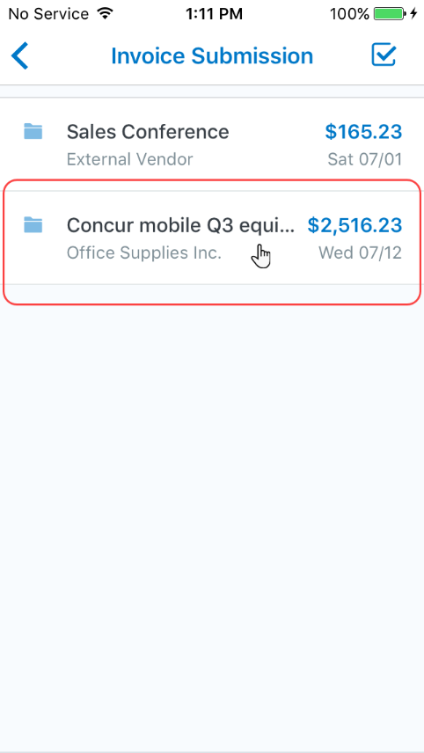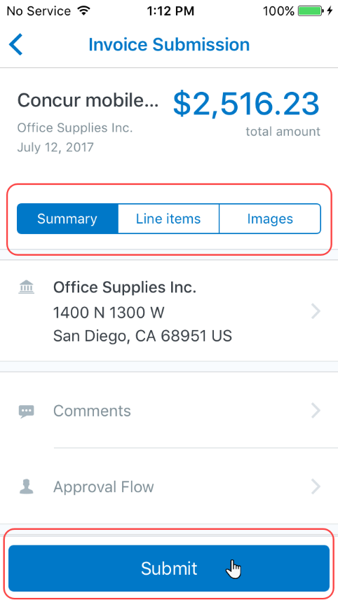 | 3) On the Invoice Submission screen, tap to open the desired payment request.  4) On the Invoice Submission screen, tap the Summary, Line Items, and Images tabs to access and review all information.  5) When done, tap Submit.

Submit One or More Payment Requests
Screen(s) | Description/Action
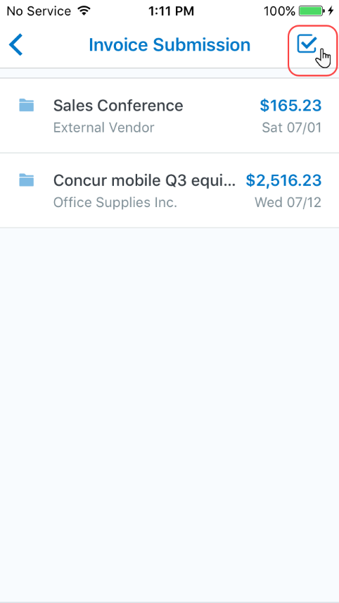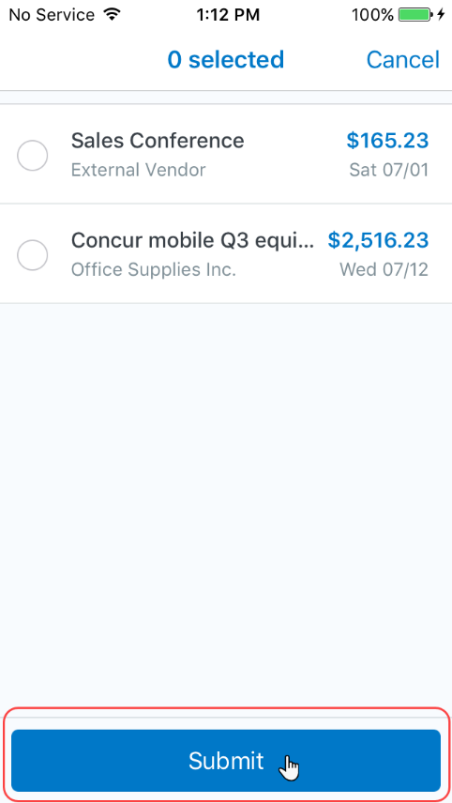 | To submit one or more payment requests:  1) On the Invoice Submission screen, tap (upper-right corner). A selection circle appears to the left of each payment request.  2) Tap the desired selection circles.  3) Tap Submit.

Purchase Requests
Use Approvals on the home screen to approve purchase requests (if you are an approver).
NOTE: This also includes Cost Object Approvals and Authorized Approvals.

Review and Approve a Purchase Request
Screen(s) | Description/Action
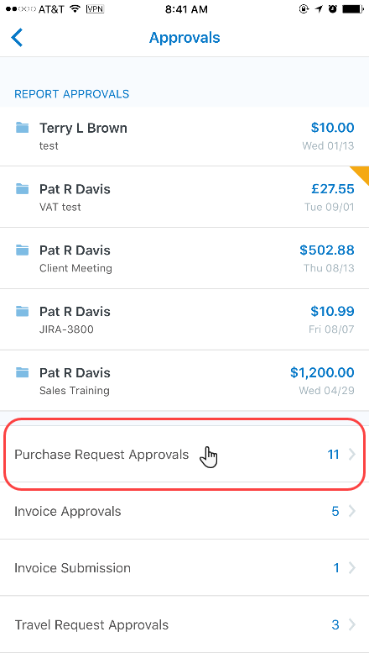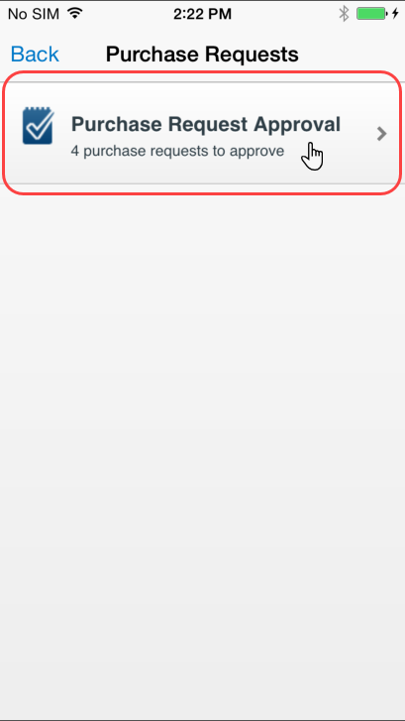 | To review and submit purchase requests:  1) On the home screen, tap Approvals.  2) On the Approvals screen, tap Purchase Request Approvals.  3) On the Purchase Requests screen, tap Purchase Request Approval.
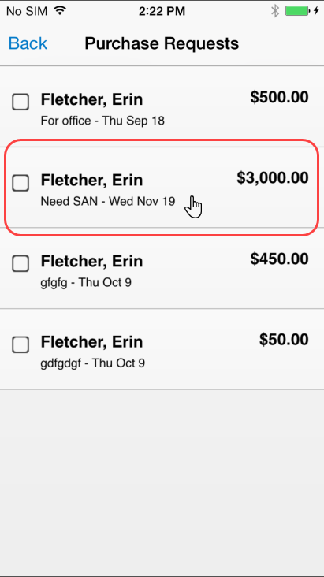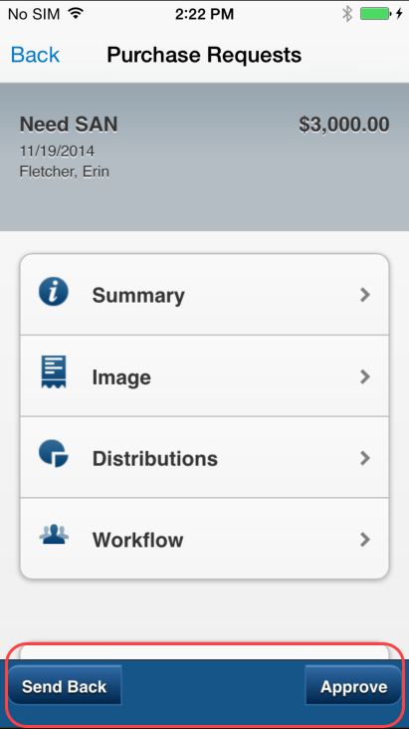 | 4) On the next screen, tap to open the desired payment request.  5) On the Purchase Requests screen:  - View the request details (summary, images, distributions, etc.).  - Tap Approve or Send Back.  NOTE: If you send back a request, you must provide a comment.

☼

