Mobile App User Guide  Concur Invoice  Last Revised: October 3, 2018 | This guide describes the current version, which is shown on the "Introduction" guide. |  | Applies to these mobile devices:  No: iPhone  No: iPad  Yes: Android
IMPORTANT: Be aware that your company's configuration may not allow for all of the features described here. Generally, if a feature is not available in your configuration of the web version of SAP Concur, then it is not available in the mobile app.
With Concur Invoice, users can automate invoice processing with speed and efficiency and a new way to monitor and manage spending to maximize your profitability.  Concur Invoice features include:  - Capture invoices using machine learning  - Stay on top of spending |  | Invoice Approvals 1  Payment Requests 2  Review and Approve a Payment Request 2  Approve / Return one or More Payment Requests 3  Purchase Requests 4  Review and Approve a Purchase Request 4
- Eliminate late payments and manage cash outlays
- Streamline purchase requests and automate approvals
Please Note:
- The SAP Concur app for iOS and Android supports universal links, i.e. links that navigate directly to the app if it is installed or to the website if not.
- Such links are included in notification emails from SAP Concur related to the expense report changes.
- Universal link support for customers own use is currently not supported.
- Some security solutions may block the links embedded into email from opening the app directly. The proper exceptions for the security policy should be configured for SAP Concur universal link URLs (pattern to match: https://*.concursolutions.com/*). Known cases are:
- MDM/MAM policy that prescribes to open any link tapped in Outlook mobile app only in specified browser.
- Outlook mail server phishing protection that wraps all link embedded into e-mails to open the safety check service first.

Invoice Approvals

Payment Requests
Use Approvals on the home screen to view and approve payment requests (if you are an approver).
NOTE: This also includes Cost Object Approvals and Authorized Approvals.

Review and Approve a Payment Request
Screen(s) | Description/Action
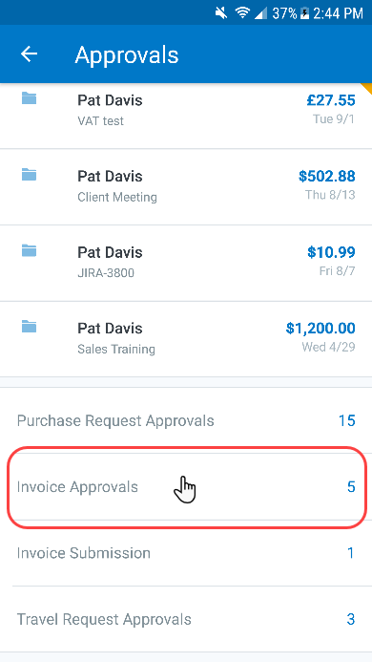 | To review and approve a payment request:  1) On the home screen, tap Approvals.  2) On the Approvals screen, tap Invoice Approvals. The Invoice Approvals screen appears.
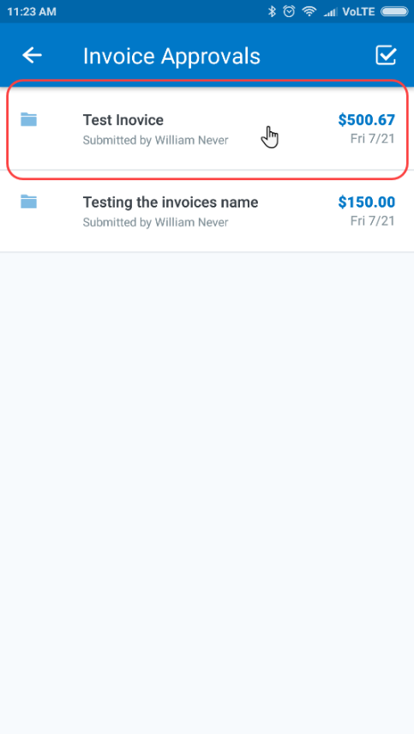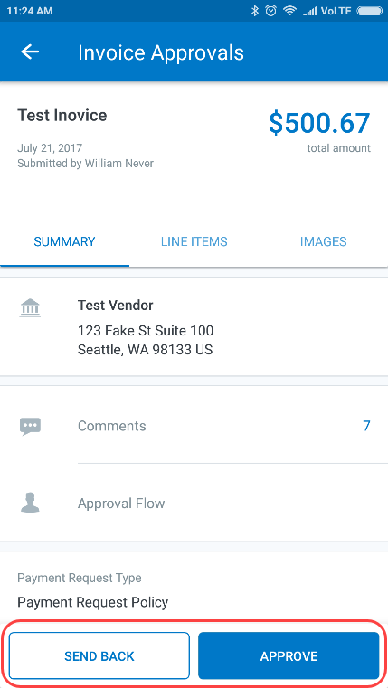 | 3) On the Invoice Approvals screen, tap to open the desired payment request.  4) Tap the Summary, Line Items, and Images tabs to access and review all information.  5) When done, tap Send Back or Approve.

Approve / Return one or More Payment Requests
Screen(s) | Description/Action
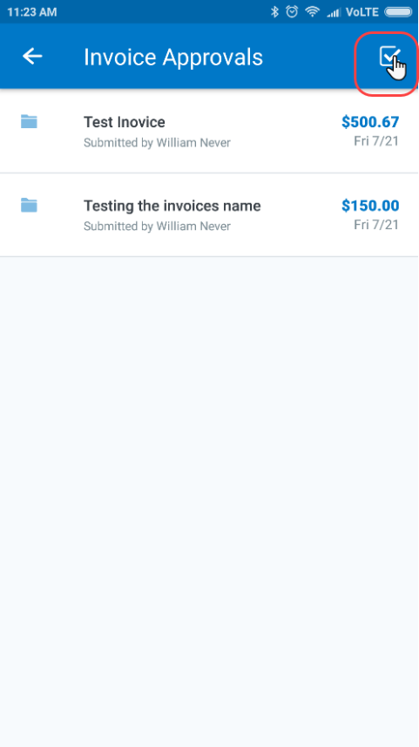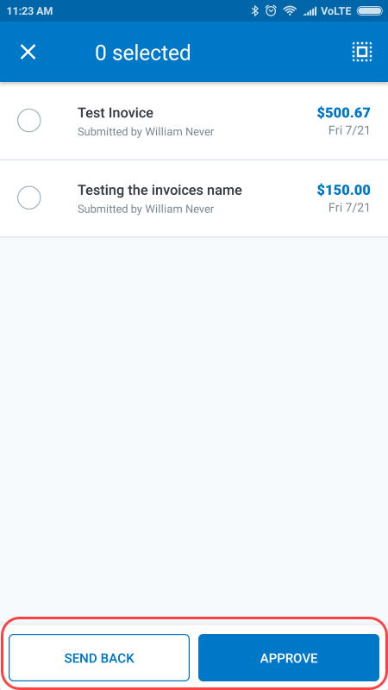 | To approve/return one or more payment request approvals:  1) On the Invoice Approvals screen, tap (upper-right corner). A selection circle appears to the left of each payment request.  2) Tap the desired selected circles.  3) Tap Send Back or Approve.

Purchase Requests
Use Approvals on the home screen to view and approve purchase requests (if you are an approver).
NOTE: This also includes Cost Object Approvals and Authorized Approvals.

Review and Approve a Purchase Request
Screen(s) | Description/Action
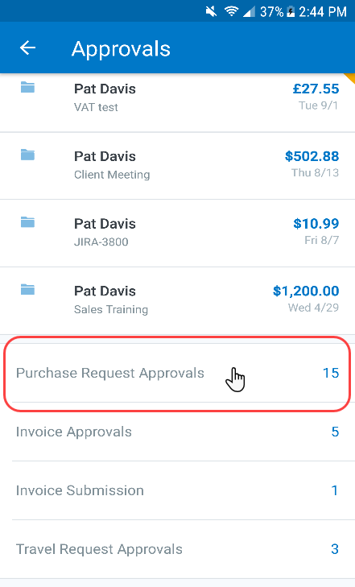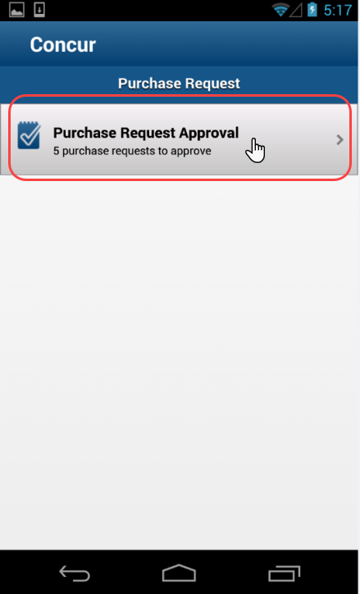 | To review and approve a purchase request:  1) On the home screen, tap Approvals.  2) On the Approvals screen, tap Purchase Request Approvals.
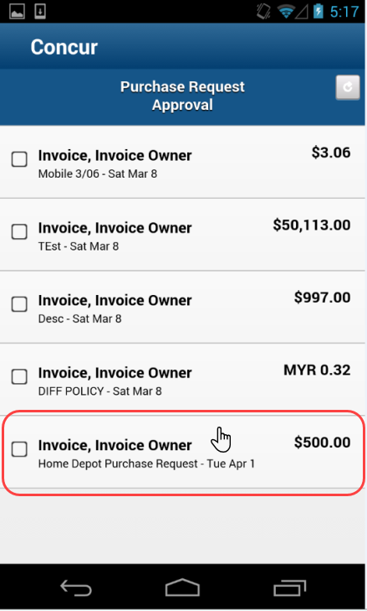 | 3) On the Purchase Request Approval screen, tap to open the desired request.
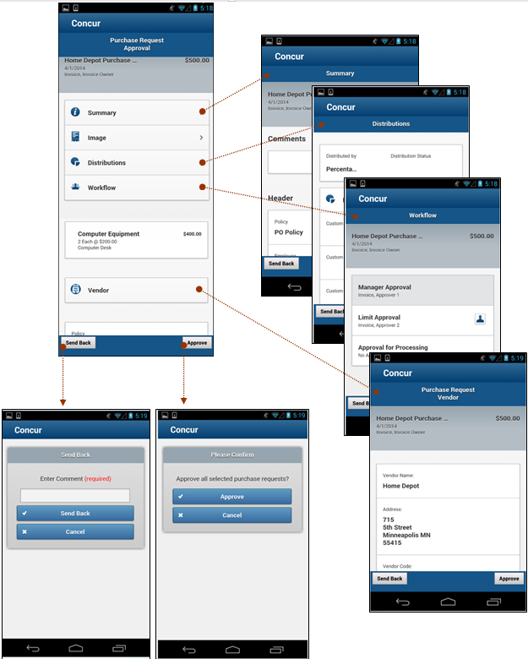 | With the purchase request open:  1) View the request details (summary, images, vendor info, etc.).  2) Tap Approve or Send Back.  NOTE: If you send back a request, you must provide a comment.

☼

