Mobile App User Guide  Concur Expense  Last Revised: March 27, 2024 | This guide describes the current version, which is shown on the "Introduction" guide. |  | Applies to these mobile devices:  No: iPhone  Yes: iPad  No: Android
IMPORTANT: Be aware that your company's configuration may not allow for all of the features described here. Generally, if a feature is not available in your configuration of the web version of SAP Concur, then it is not available in the mobile app.
Concur Expense simplifies creating expense reports. For example, creating expense reports is simplified when charges from credit cards, select suppliers, and receipt photos pre-populate in Concur Expense.  Concur Expense provides the following services:  - Automatically categorizes and map expenses based on receipt.  - Streamlines expense management.  - Enforces policy compliance.  - Reimburse employees faster.  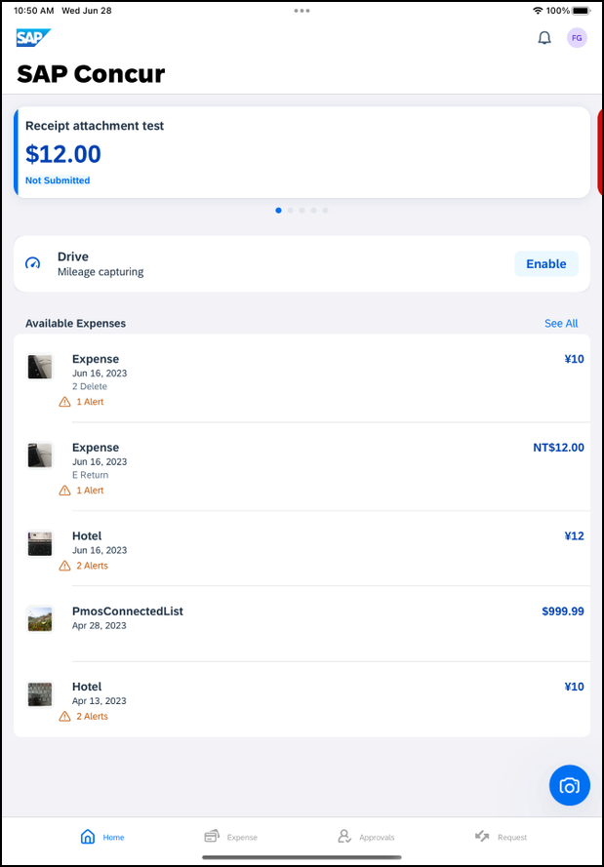 |  | Concur Expense 4  Expense List (Expenses Screen) 4  Expense Report Lists 5  Create a Mobile Expense 7  Add Receipt Functionality 8  Delete a Single Mobile Expense 10  Using Delegate Function to 11  Using Delegate Function to Create an Expense 11  Using Delegate Function to Edit Expenses 14  Using Delegate Function to Move Expenses 15  Create a New Expense Report 17  Create an Expense Within an Open Expense Report 20  Move Expenses From the Expenses Screen to an Expense Report 22  Move a Single Mobile Expense, E-Receipt, or Credit Card Charge to a New or Existing Report UI 25  Edit an Expense on an Expense Report 26  Add a Car Mileage (or Km) Expense–Manually 28  Add a Car Mileage (or Km) Expense–Mileage Calculator 33  Add/Edit/Delete an Itemization 37  Add/Edit/Delete Attendees 45  Remove an Expense From an Expense Report 50  Edit Report Header Information 51  Submit an Expense Report 53  Submit an Expense Report With the Approval Flow Screen 54  Recall an Expense Report 60  Refresh Data 62  Delete an Unsubmitted Expense Report 64  View/Add/Edit/Delete Allocations 65  View Report-Level Allocations 65  View Expense-Level Allocations 66  View Itemization-Level Allocations 68  Add/Edit/Delete Allocations 71  Create Itemization-Level Allocations 74  Icon 75  Copy a Report From Existing Report 76  Edit Report Header Information 78  Capture Multipage Receipts 79  Create a Mobile Expense From a Receipt 84  Delete Receipts 86  Attach a Missing Receipt Declaration to an Expense 87  Work With Fixed Travel Allowances 88  Fixed vs Reimbursable Travel Allowances 88  Restrictions 88  Create Fixed Allowances 90  Edit a Fixed Travel Allowance Itinerary 107  Edit a Fixed Travel Allowance Itinerary on the Travel Allowance Screen 109  Resolve an Alert in a New Travel Allowance 111  Delete Travel Allowances 113  Expense Approvals 118  Approve an Expense Report 118

Please Note:
- The SAP Concur app for iOS and Android supports universal links, i.e. links that navigate directly to the app if it is installed or to the website if not.
- Such links are included in notification emails from SAP Concur related to the expense report changes.
- Universal link support for customers own use is currently not supported.
- Some security solutions may block the links embedded into email from opening the app directly. The proper exceptions for the security policy should be configured for SAP Concur universal link URLs (pattern to match: https://*.concursolutions.com/*). Known cases are:
- MDM/MAM policy that prescribes to open any link tapped in Outlook mobile app only in specified browser.
- Outlook mail server phishing protection that wraps all link embedded into e-mails to open the safety check service first.

Concur Expense

Expense List (Expenses Screen)
Screen(s) | Description/Action
On the home screen, tap Expense and toggle to Expenses to access your list of expenses. Use the All Expenses screen to:
- Add, view, edit, and delete mobile expenses. Mobile expenses are designed to be quick and easy.
- To make more extensive features like itemizations and attendees, either:
- Add the mobile expense to an expense report by selecting Move To Report then edit.
- Create the expense on an open expense report and then edit.
- For car mileage/kilometers expenses, tap Expenses on the home screen. An option will appear Create a Mileage Expense.
- View and make minimal edits to card transactions, which appear with the icon.
- To make more extensive edits, add the card transaction to an expense report then edit.
- To delete a card transaction, use the web version of Expense, if your company allows you to delete card transactions.
- View e-receipts, which can be edited once attached to a report.
Attach expenses – mobile expenses, e-receipts, and card transactions – to a new or existing expense report.

Expense Report Lists
Screen(s) | Description/Action
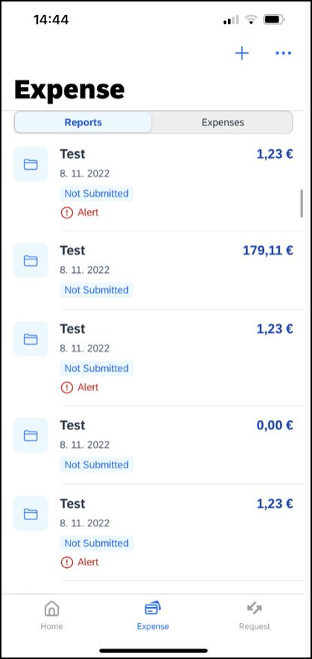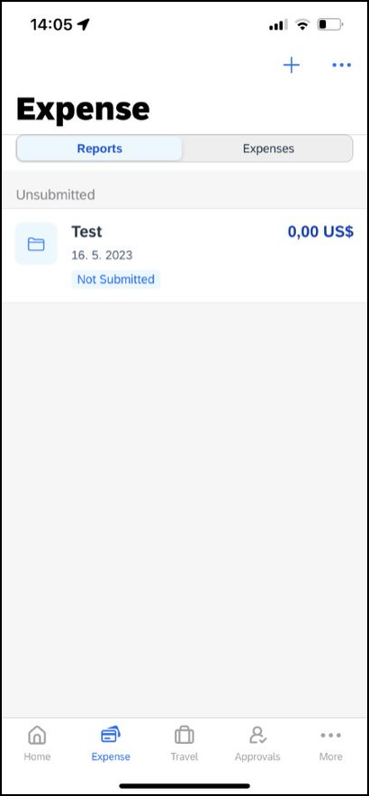 | On the home screen, tap Expense to access the list of expenses and toggle to Reports. On the Reports screen, you can view up to 100 expense reports in each of the Reports main screen or History tabs. On the Reports screen, you can:  - View unsubmitted, submitted, and returned reports  - Create a new report  - Copy reports  - Delete unsubmitted reports  - View red Alert and yellow Warning signs on reports flagged for exceptions  - View the name, status, date and amount of each report  NOTE: All active reports are separated into Unsubmitted, Submitted, and Other sections. Within each category, the reports are sorted by report date.

Screen(s) | Description/Action
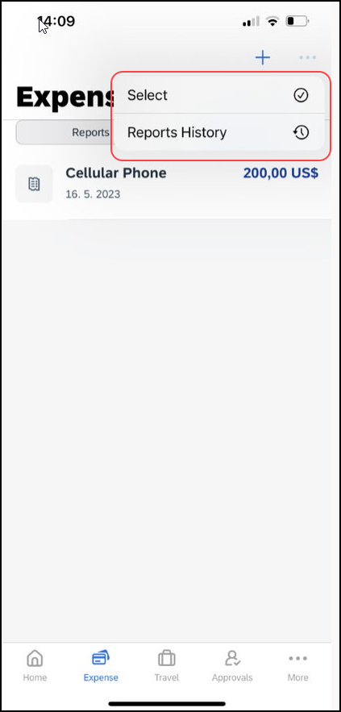 | You can open an existing expense report and:  - View and edit the report summary (report header)  - View and attach receipt images  - View, add, import, match, edit (add attendees and itemizations), and remove expenses  - Submit your report  To access the Reports History tab, tap the icon at the top right hand corner:  - View reports that have been approved and sent for payment  - View red Alert and yellow Warning signs on reports flagged for exceptions  - Copy reports

Create a Mobile Expense
Screen(s) | Description/Action
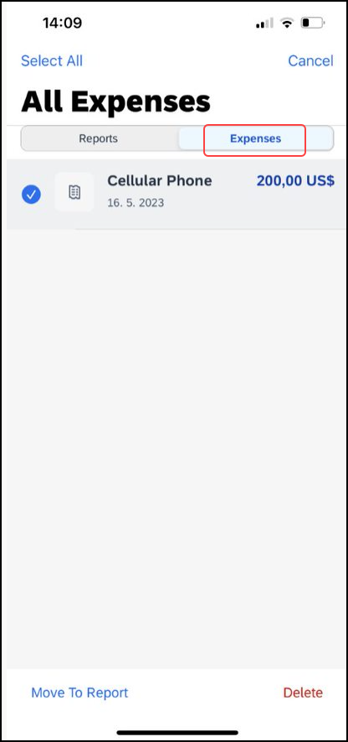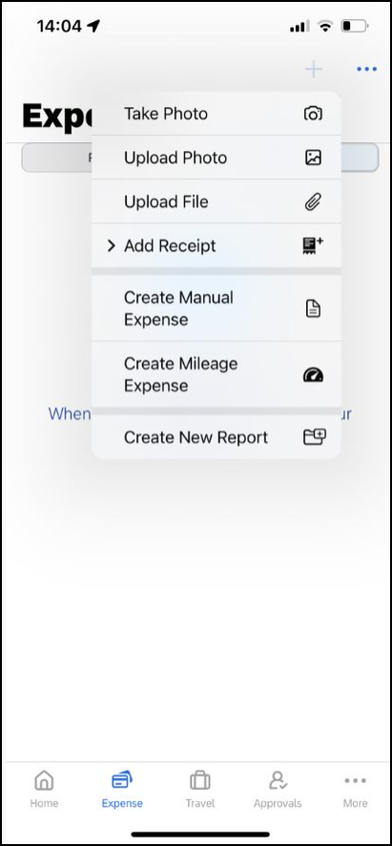  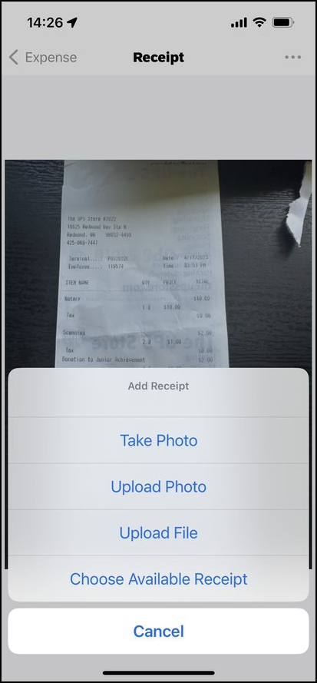 | To create a mobile expense:  - On the home screen, tap Expense on the bottom bar. This will redirect to the Expense screen.  - Then, toggle to Expenses.  This will display the All Expenses screen. Tap and select the expense type to create a Manual Expense.  Then:  1) On the Expense screen, fill in the fields and make the desired selections.  2) Tap the receipt icon.  3) Take a picture of the receipt or grab an existing image from Upload Photo, Upload File or Choose Available Receipt.  4) Tap Save.  NOTE: For more information on how to work with receipts, refer to the Receipt user guide.  NOTE: You cannot create a Japan Public Transportation expense outside of an expense report.

Add Receipt Functionality
Screen(s) | Description/Action
To see the full functionality for creating expenses, the Add Receipt can be dropped down to reveal more options.
To access this:
- On the home screen, tap Expense on the bottom bar. This will redirect to the Expense screen.
- Then, toggle to Expenses.
This will display the All Expenses screen. Tap and select the expense type to create a Manual Expense.

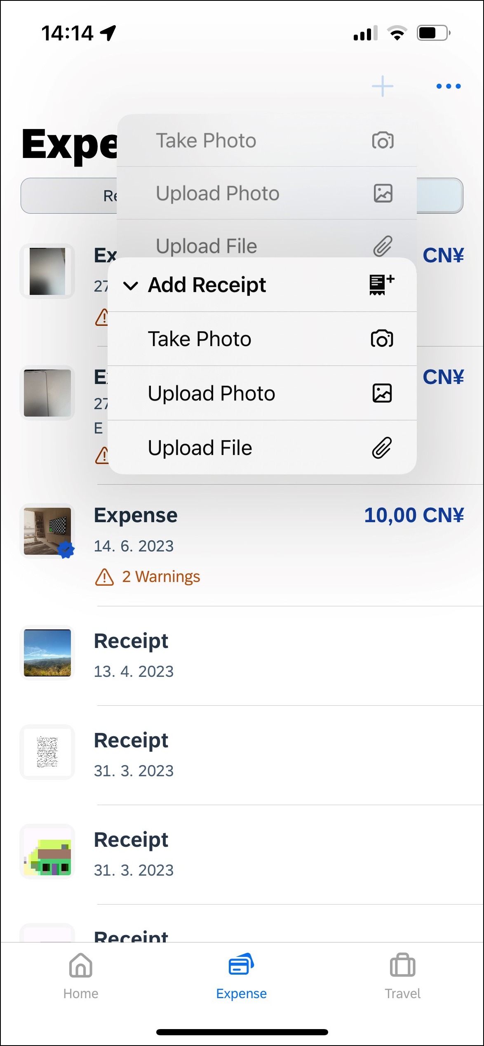 | A drop down will reveal more options:  - Take Photo opens the camera to take a photo of a receipt directly.  - Upload Photo opens the photo gallery on your device to upload a photo of a saved receipt.  Upload File allows you to select a file on the mobile device.

Delete a Single Mobile Expense
Screen(s) | Description/Action
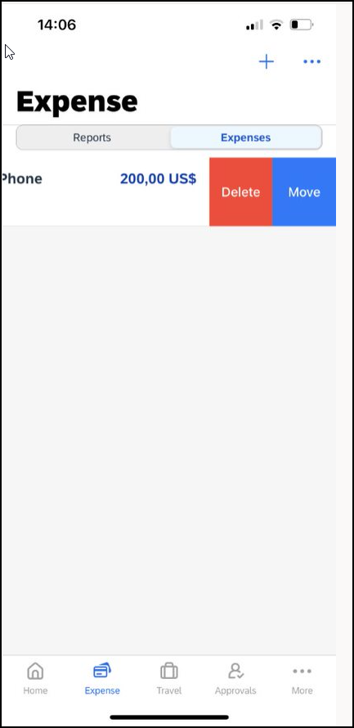 | To delete one or more mobile expenses from the Expenses screen:  1) On the Expense screen, swipe the desired expense to the left.  2) Tap Delete.  NOTE: You can also delete a mobile expense in the web version of SAP Concur.  NOTE: To delete a card transaction, use the web version of Concur Expense - if your company allows you to delete card transactions.

Using Delegate Function to

Using Delegate Function to Create an Expense
Screen(s) | Description/Action
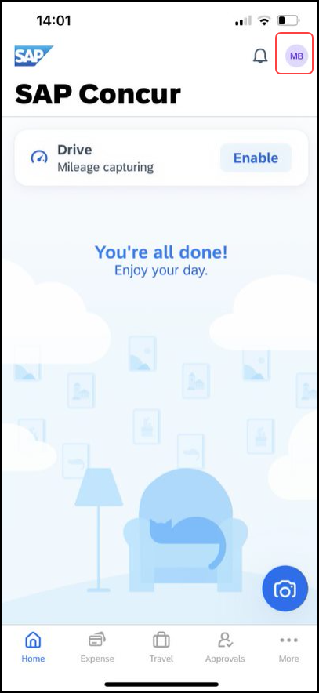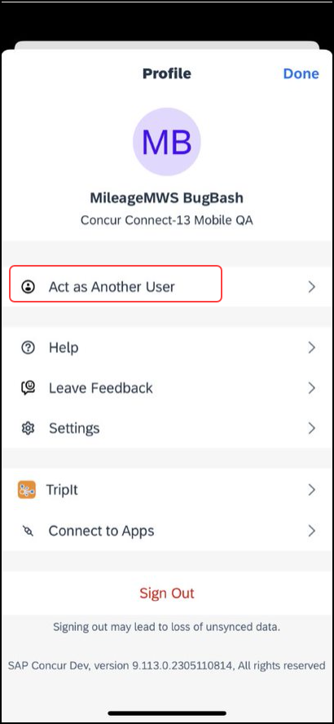 | To Create an Expense While Using the Delegate Function:  1) Tap the initials in the top right corner, to open the Profile page. Then tap Act as Another User.
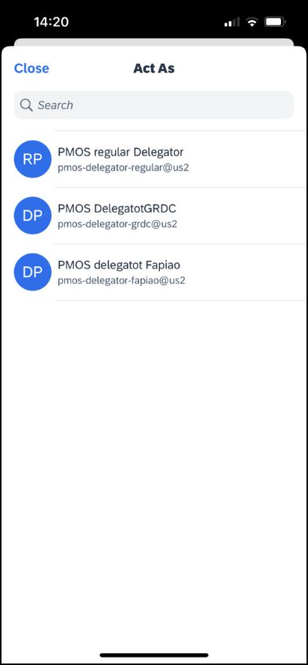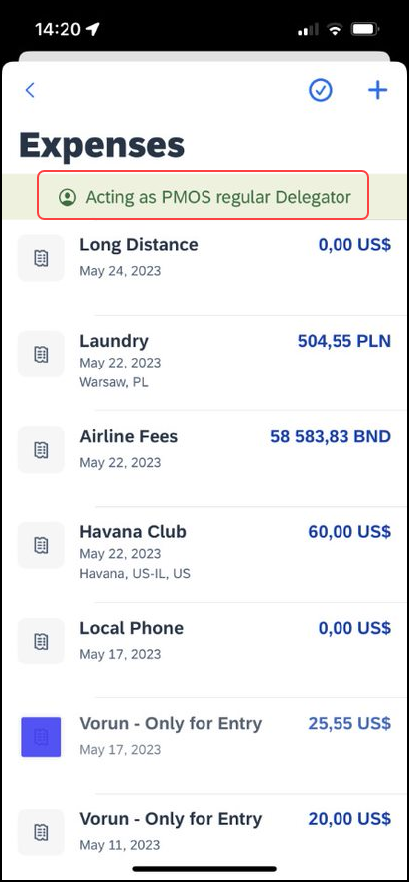 | A list of potential delegates will appear. Once the user you wish to act on behalf of is selected, it will be indicated by a green banner. You will also be directed to the Expenses Screen.
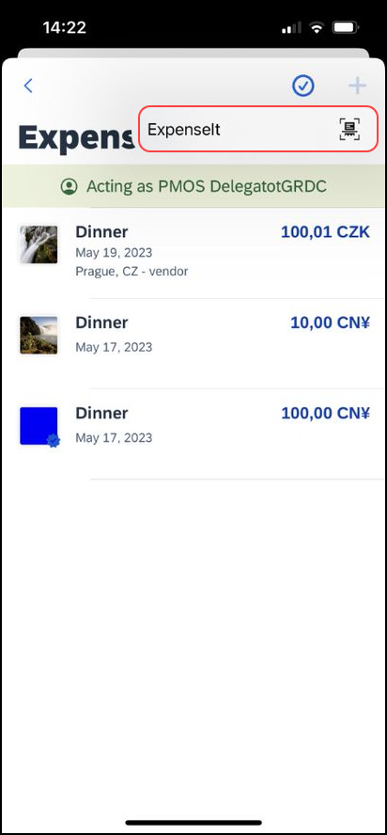 | 2) Tap the plus button and the ExpenseIt option will appear. Tap this option and you will be able to select the receipt to be added as an expense. Once added, the selected receipt appears in the Expenses screen.
GRDC users with ExpenseIt, can still act on behalf of another user in ExpenseIt, but will not be able to create, edit or delete manual expenses.

Using Delegate Function to Edit Expenses
Screen(s) | Description/Action
To Edit an Expense While Using the Delegate Function:
1) Tap the Menu button and then tap Act as Another User. Once the user you wish to act on behalf of is selected, it will be indicated by a green banner. You will also be directed to the Expenses Screen.

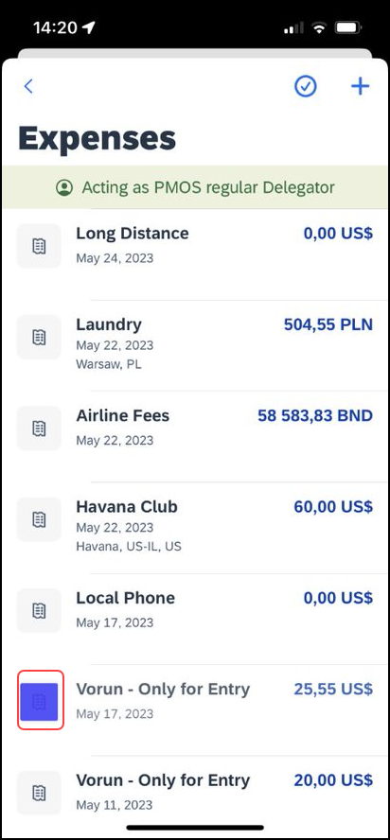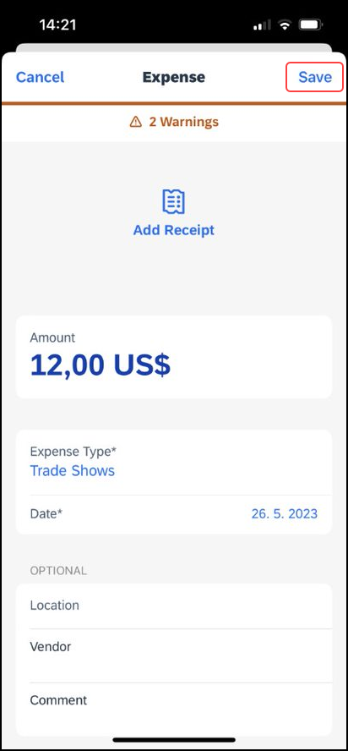 | 2) Once on the Expenses page, select the Expense that needs to be edited and this will direct you to the details of this expense. Tap on the areas that need to be edited. Once the edits are made, tap Save for the edits to be reflected.

Using Delegate Function to Move Expenses
Screen(s) | Description/Action
To Edit an Expense While Using the Delegate Function:
1) Tap the Menu button and then tap Act as Another User. Once the user you wish to act on behalf of is selected, it will be indicated by a green banner. You will also be directed to the Expenses Screen.
NOTE: Delegates can view and move eReceipts but cannot edit them.
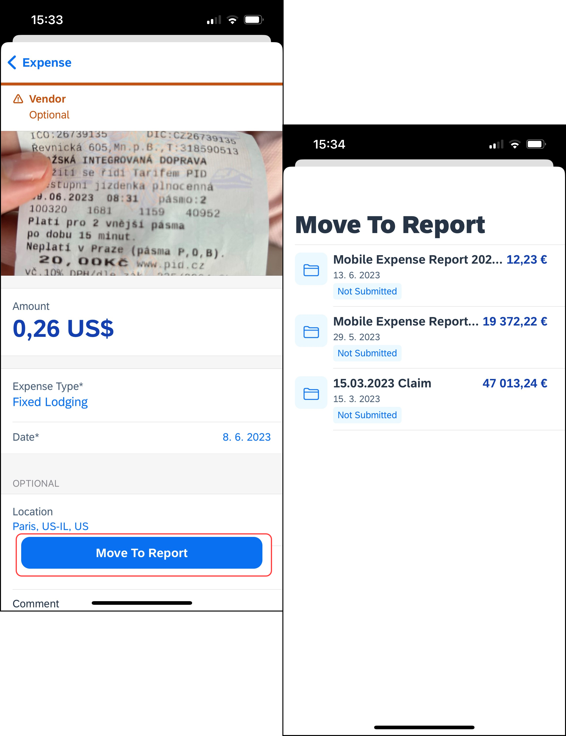 | 2) To move an expense to a report, select the desired expense. Once the expense opens, at the bottom of the screen there is a prompt Move to Report. This opens the list of reports and from there you can select the report that you want to move the expense to.  Once the expense has been moved to the desired report, it w ill no longer appear in the list of expenses.

Create a New Expense Report
You can create a new report:
- From the Reports screen (shown here).
- While adding expenses from the Expense screen (described on the following pages).
- While creating a car mileage expense (described on the following pages).
Screen(s) | Description/Action
You can create a new report:
- From the home screen tap Expense,you will be redirected to the Expense page. From there, you can toggle to Reports.
- While adding expenses from the Expenses screen (described on the following pages)
To create a new report:
1) On the home screen, tap Expense. On the Expense screen, tap Reports.
2) On the Reports screen, tap (upper-right corner).
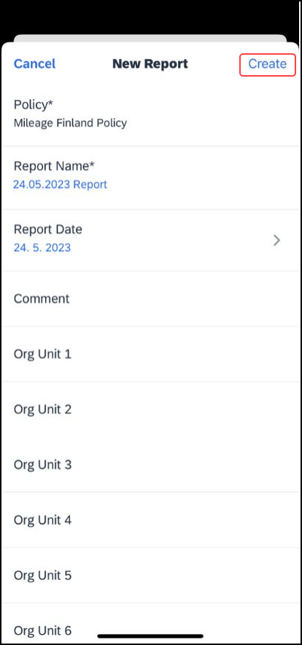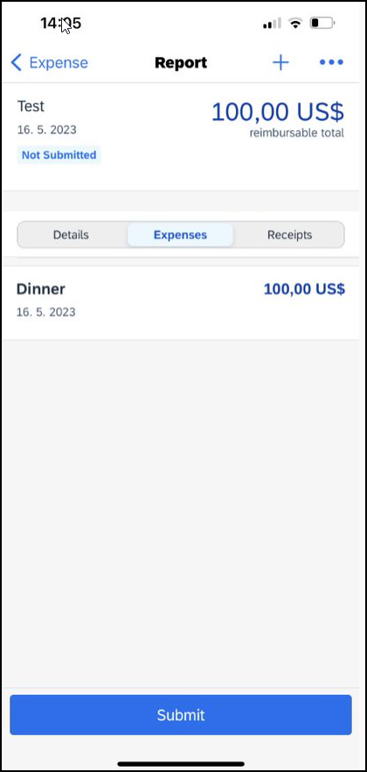 | 3) On the New Report screen:  - SAP Concur provides a report name. Change it if desired.  - Fill in the fields and make the desired selections.  - Tap Create (upper-right corner).  - 4) On the Report screen, enter your expenses, attach receipts, etc. (described on the following pages).

Create an Expense Within an Open Expense Report
Screen(s) | Description/Action
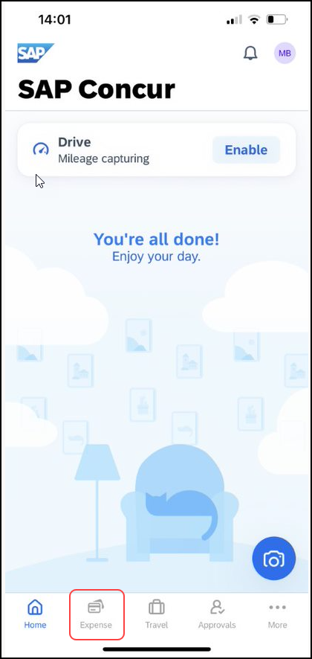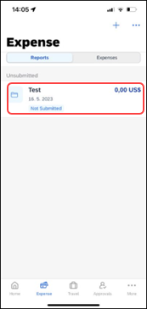 | To create an expense within an open expense report:  1) On the home screen, tap Expense Reports.  2) On the Reports screen, tap the desired report to open it.
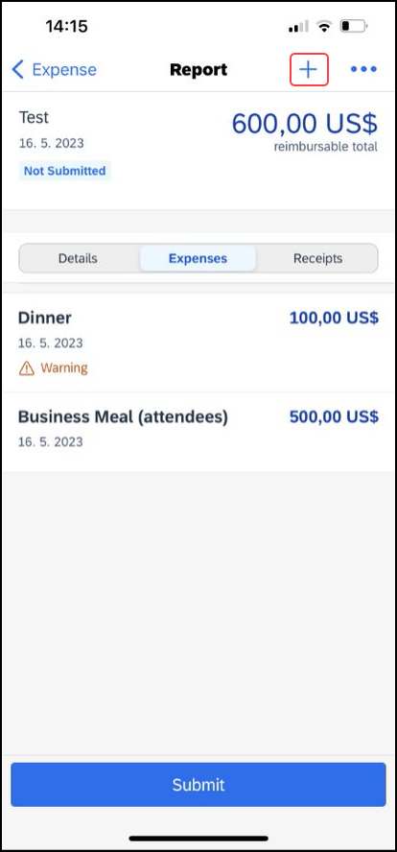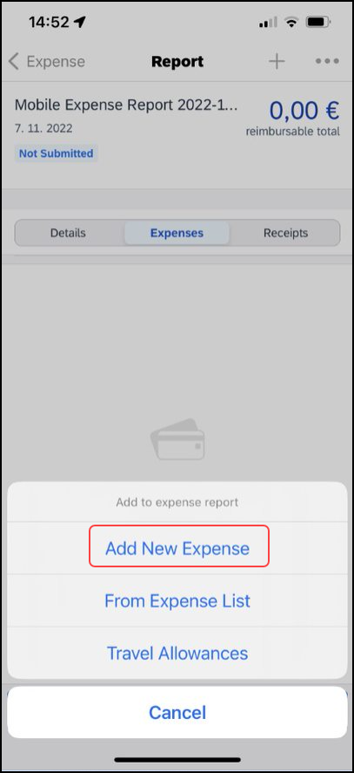 | 3) On the Report screen, tap (upper-right corner) to create a new expense.  4) On the Add to expense report menu, tap Add New Expense.
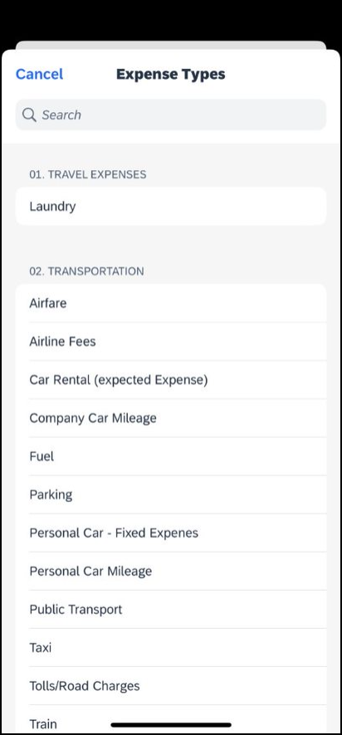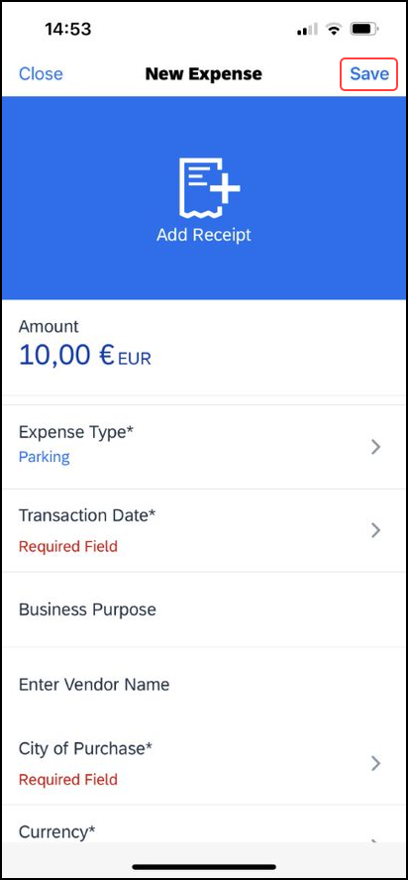 | 5) On the Expense Types screen, select the desired expense type.  6) On the New Expense screen:  - Fill in the fields and make the desired selections.  - Tap Save (upper-right corner).  NOTE: The new report entry experience will not appear, if:  - You add the Personal Car Mileage, Company Car Mileage, or Japan Public Transport expense types.  - You open expenses created via itineraries.  - You are geographically located in China.  You are under a restrictive Mobile Device Management (MDM) or Virtual Private Network (VPN).

Move Expenses From the Expenses Screen to an Expense Report
You can move one or more expenses to an existing expense report or use them to create a new expense report.
Screen(s) | Description/Action
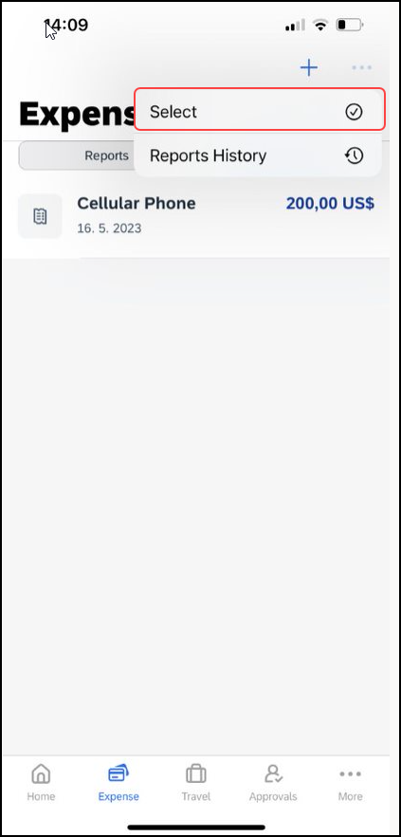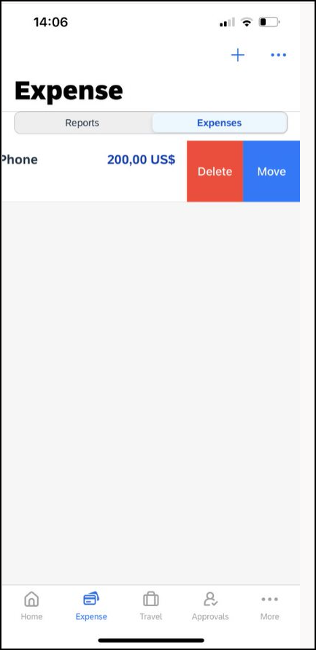 | To move expenses from the Expenses screen to an expense report:  1) On the Expense screen tap and choose Select.This will allow you to select multiple expenses to move. Then, slide to the left to display the Delete and Move options.  2) Select Move.  3) The Move to… screen will appear.  4) Select the report that you wish to move the expense to.
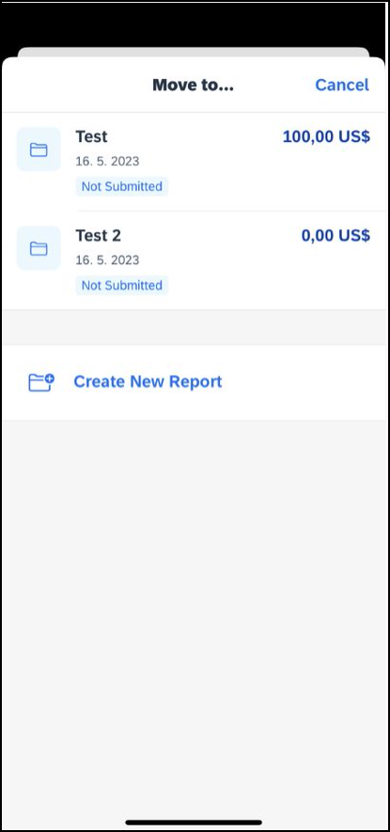

Move a Single Mobile Expense, E-Receipt, or Credit Card Charge to a New or Existing Report UI
Screen(s) | Description/Action
To move a single mobile expense, e-receipt, or credit card charge to a new or existing report:
1) On the expense that you want to move, slide to the left to display the Delete and Move options.
2) Select Move.
3) The Move to… screen will appear.
4) Select the report that you wish to move the expense to.

Edit an Expense on an Expense Report
If an expense is attached to an unsubmitted expense report, you can edit almost every field.
Screen(s) | Description/Action
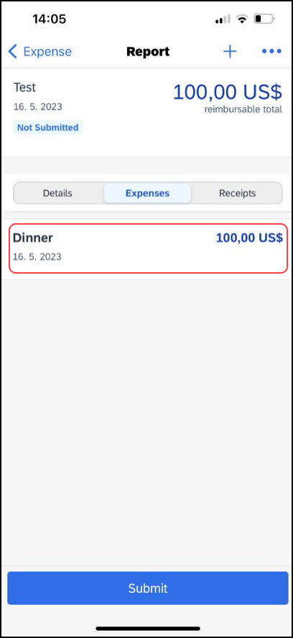 | 1) On the Reports screen, tap the desired report.  2) On the Report screen, tap to open the desired expense.
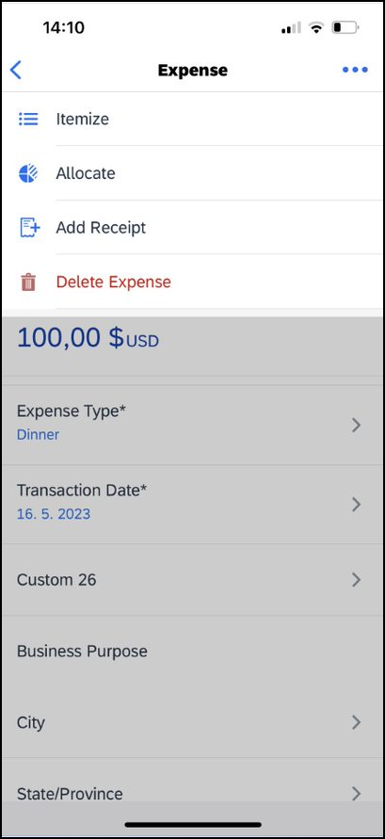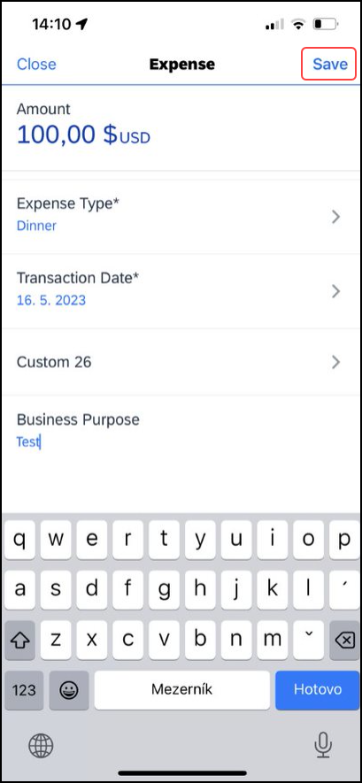 | 3) On the Expense screen:  - Make the desired changes.  - Tap (upper-right corner), to view the more options menu.  4) On the menu, you can tap to view the following options:  - Itemize  - Allocate  - Add Receipt  5) Tap Save in the upper right corner.

Add a Car Mileage (or Km) Expense–Manually
Screen(s) | Description/Action
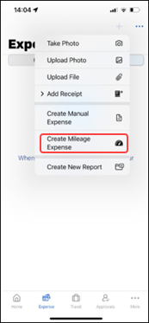  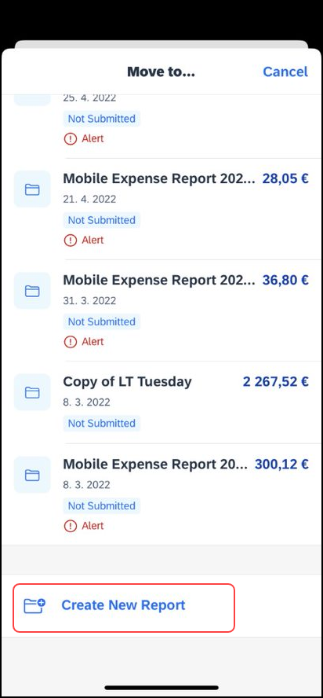 | To manually add a car mileage (or Km) expense:  1) On the home screen, Expense.  2) Tap and select Create Mileage Expense.  NOTE: The Create Mileage Expense icon only appears if your company has the Personal Car Mileage feature activated and when you have registered a personal car on the Profile > Profile Settings > Personal Car page. This icon does not appear for company cars.  3) On the Move to.. screen, either tap the desired expense report or tap Create New Report to create a new report.
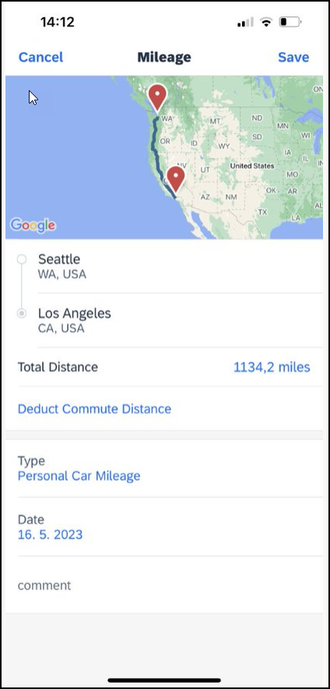 | 4) On the New Report screen:  - Fill in the fields and make the desired selections.  - Tap Create (upper-right corner).  5) On the Add Car Mileage screen:  - Fill in the fields and make the desired selections.  NOTE: SAP Concur calculates the amount based on the distance and the company's mileage rate.  - Tap Save (upper-right corner).

Add a Car Mileage (or Km) Expense–Mileage Calculator
The Mileage Calculator can be used for both personal and company car mileage. The example below shows personal mileage, using the Expense function , accessed through the bottom of home screen. For company car mileage, the user creates an expense as usual and selects the Company Car Mileage (or something similar) expense type. After that, both types work the same way – as shown below.
Screen(s) | Description/Action
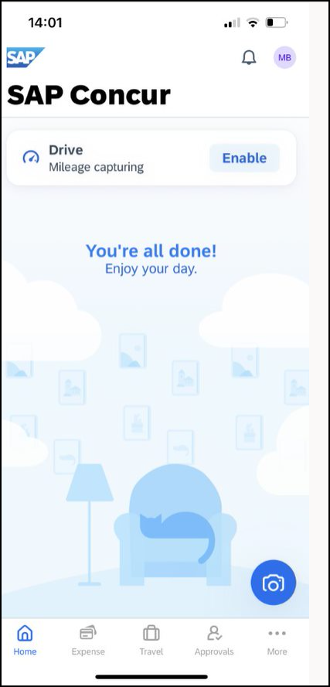 | To add a car mileage (or Km) expense using the Mileage Calculator:  1) On the home screen, tap the Expense button at the bottom of the home screen. Once in the Expense screen, tap the plus icon and then select Create Mileage Expense.  2) On the Move to… screen, either:  - Add to an existing report by selecting the report.  – or –  - Tap Create New Report to create a new report. Complete the steps to create the new report.
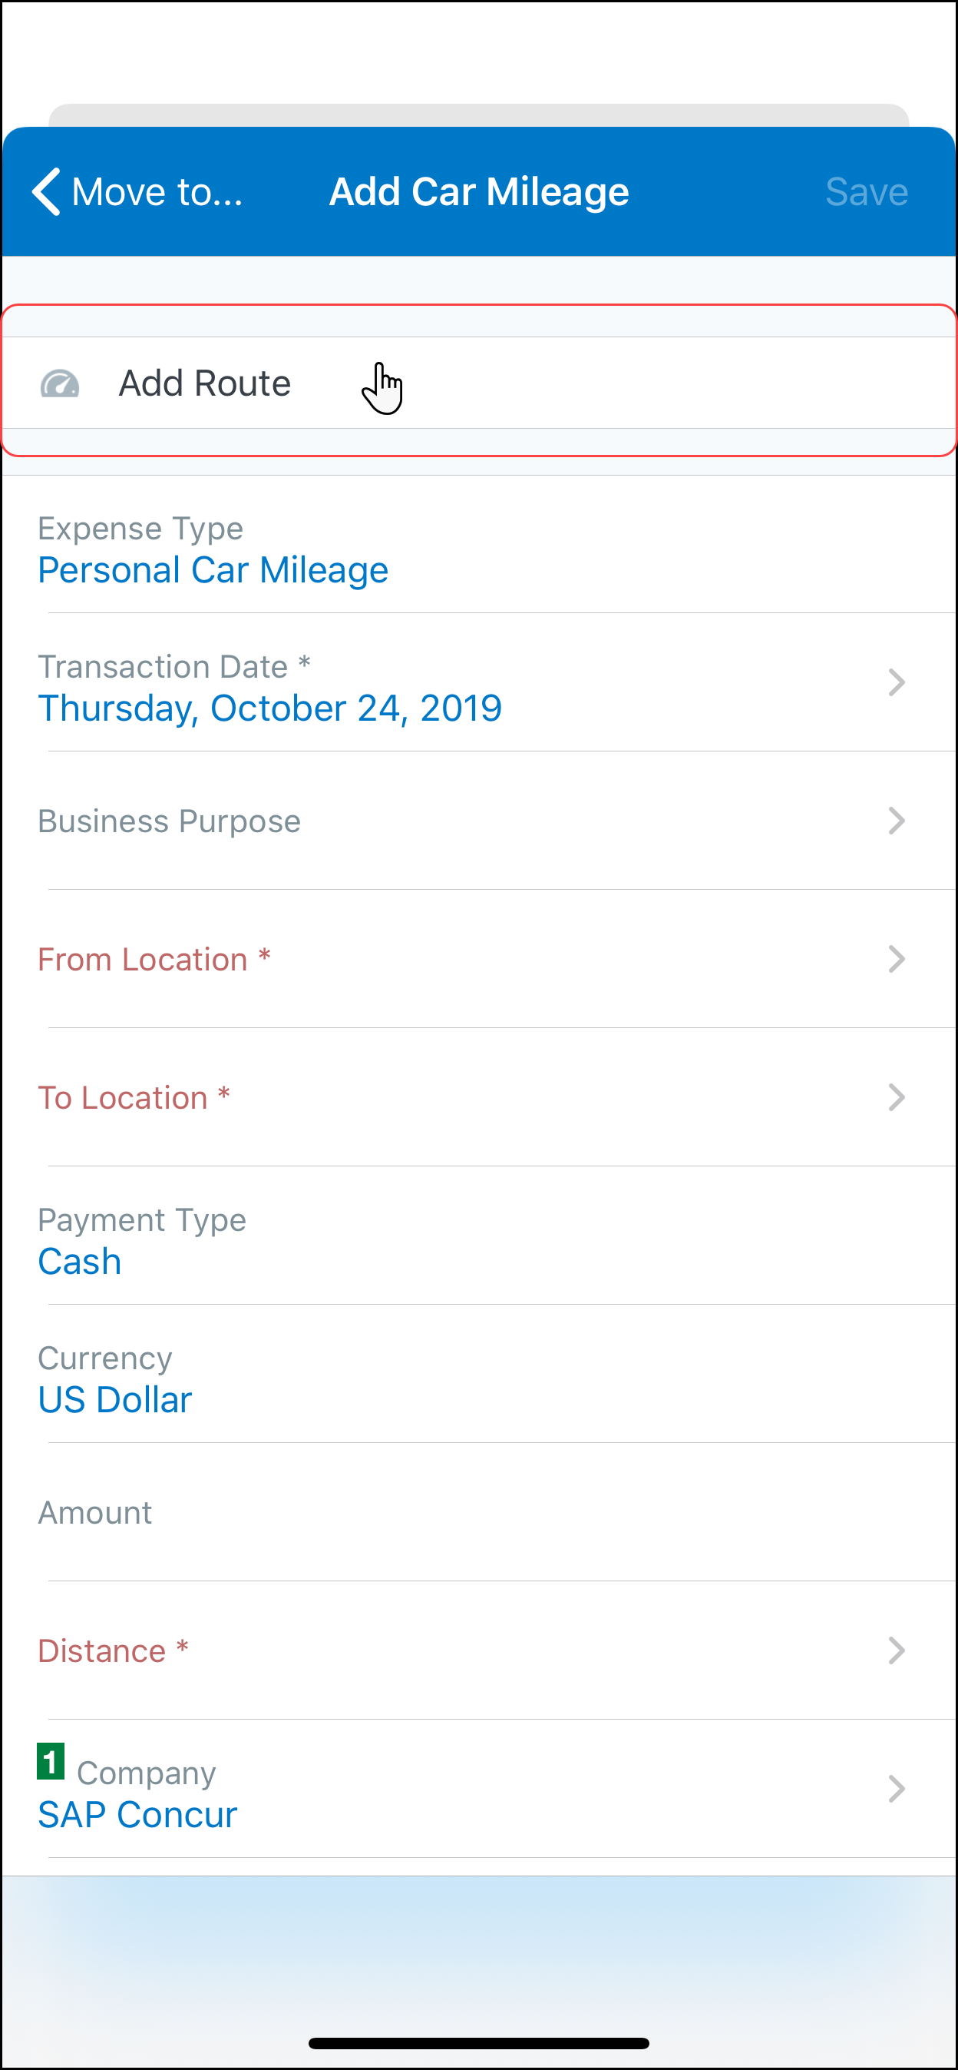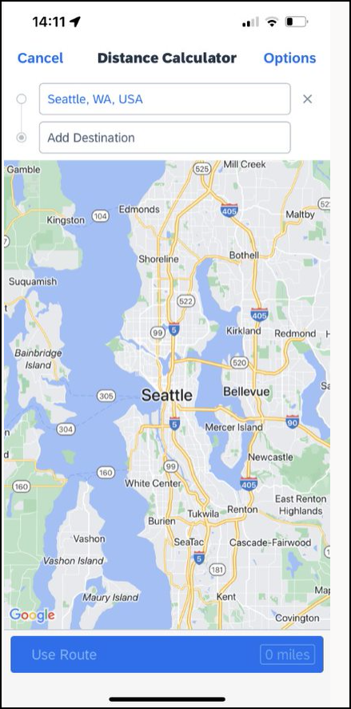 | 3) On the Add Car Mileage screen, tap Add Route.  4)On the Distance Calculator. On this screen, in the Add Destination field, start typing the initial location.
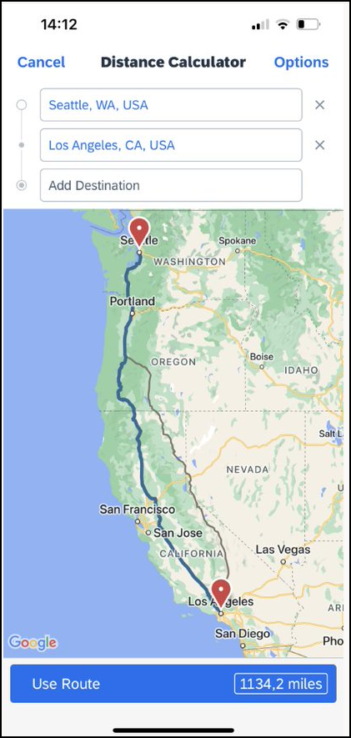 | 5) On the Location screen, select from the list of locations. The selected location appears on the map.  6) On the Distance Calculator screen, in the Add Destination field, start typing the ending location.  7) On the Location screen, select from the list of locations. The selected location appears on the map along with the mileage (lower-right corner).
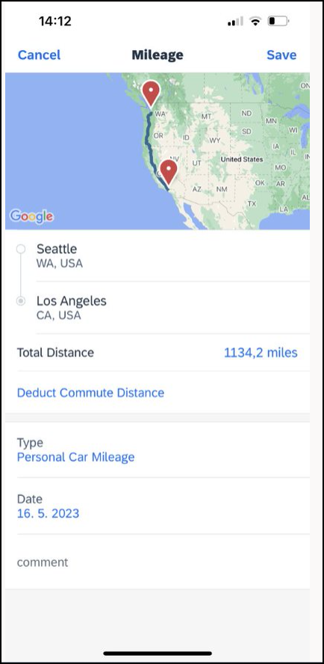 | 8) On the Distance Calculator screen, you have several additional options:  - Tap Add Destination to add another destination.  - Tap Options (upper-right corner) to choose to avoid tolls or highways.  - If an alternate route is available (shown as a gray line), you can select that route.  9) When done, tap Use Route. The mileage and the reimbursement amount appear on the Add Car Mileage screen.

Add/Edit/Delete an Itemization
After an expense has been added to a report, you can itemize the expense.
Screen(s) | Description/Action
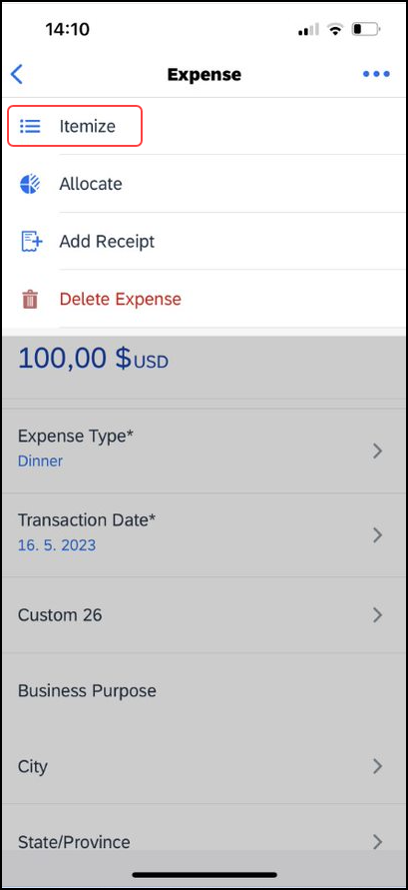 | To add, edit, or delete an itemization:  1) On the Report screen, tap to open the desired expense.  2) On the Expense screen, tap (upper-right corner).  3) On the menu, tap Itemize*.
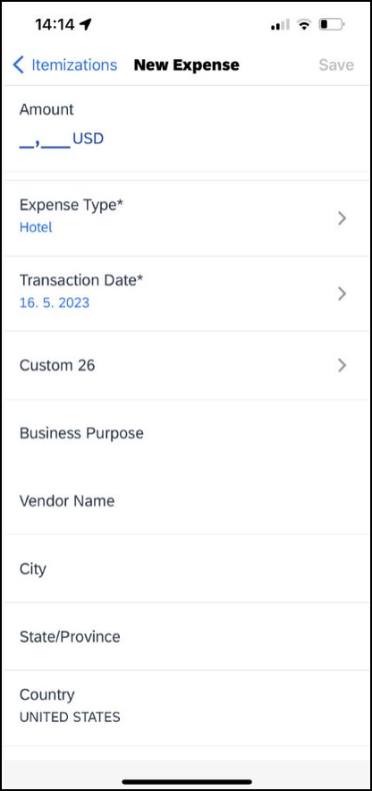 | 4) On the Hotel Itemization Wizard screen:  - Enter the daily room rate and daily tax rate.  - Tap Save (upper-right corner). The itemizations appear.
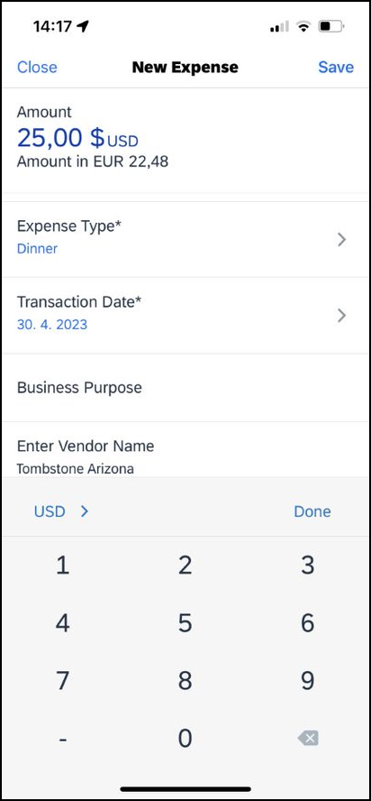 | If there is a remaining balance, tap (upper-right corner) on the Itemizations screen and create the remaining expenses, to bring the remaining balance to zero.  NOTE: To edit an itemization, tap the desired itemization and then make the desired changes.  To delete an itemization, swipe the desired itemization to the left.
 | The remaining balance is brought to zero.

Make Adjustments
Screen(s) | Description/Action
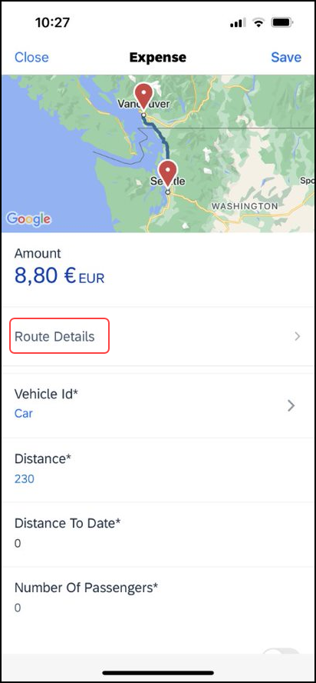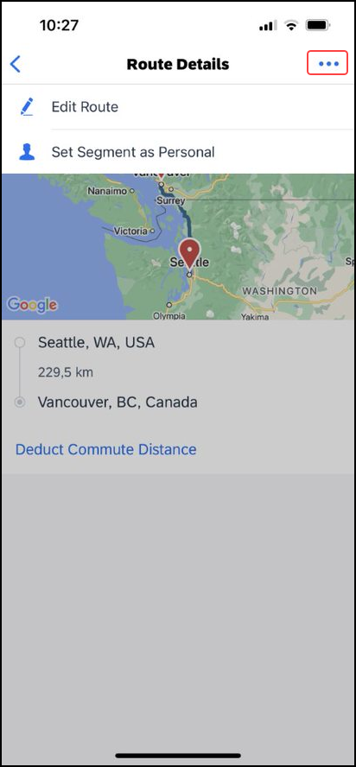 | To make additional adjustments to your car mileage:  1) On the mileage expense screen, tap Route Details.  2) On the Route Details screen, tap (upper-right corner) to access the menu. Using the menu, you can:  - Edit any portion of the trip  – or –  - Designate part of the trip as personal
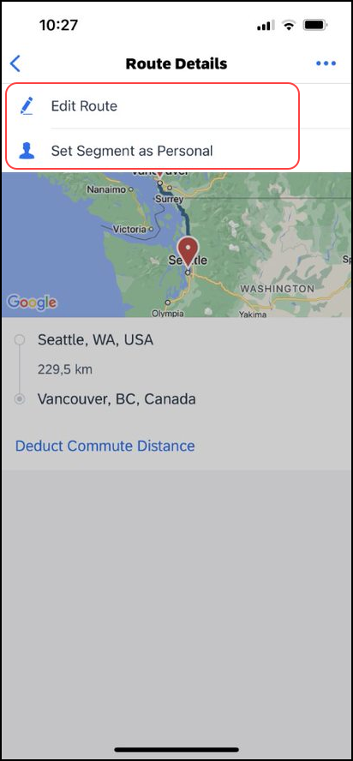 | 3) To edit a route:  - On the menu, tap Edit Route.  - Make the desired changes, using the same steps as when you created the route.  4) To designate part of the trip as personal:  - On the menu, tap Set Segment as Personal.  - On the Set Personal screen, select the segment that is personal.  - Tap Done. On the Route Details screen, the personal distance shows at the top of the screen and the personal segment shows.
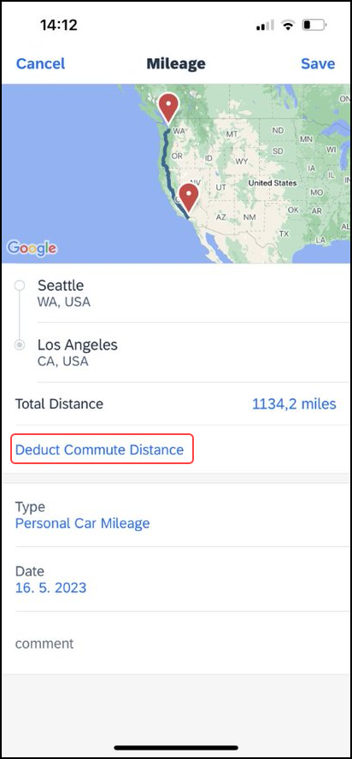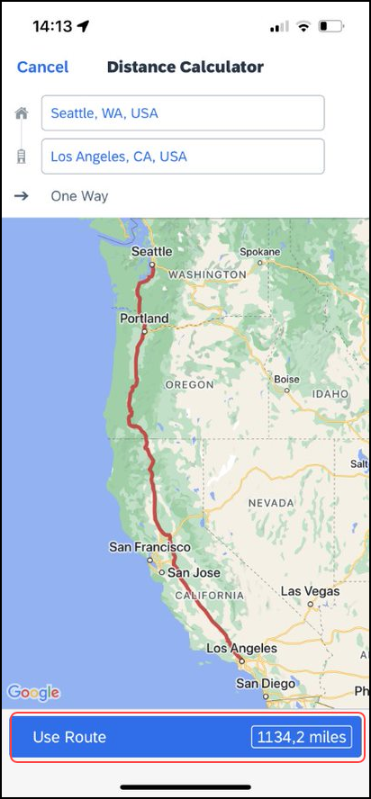 | 5) To deduct commute mileage:  - On the Route Details screen, tap Deduct Commute Distance.  - Define the starting and ending points using the map.  - Select whether the commute is one way or round trip.  - When done, tap Use Route. The Route Details screen appears.
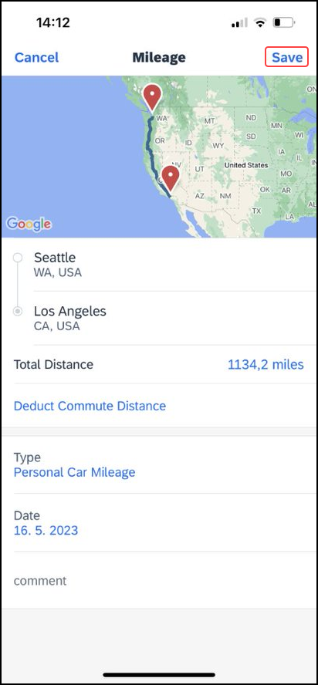 | 6) The overview of the route will appear. Tap Save. The expense is saved to the expense report.

Add/Edit/Delete Attendees
After an expense has been added to a report, you can add attendees to the expense.
Screen(s) | Description/Action
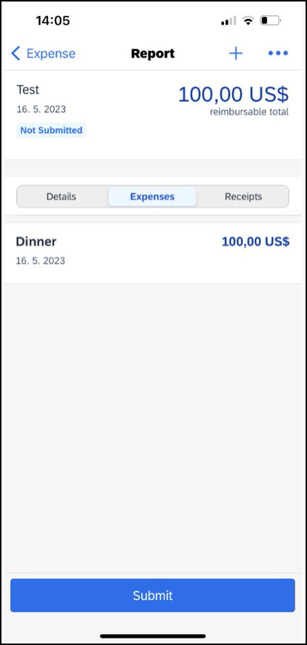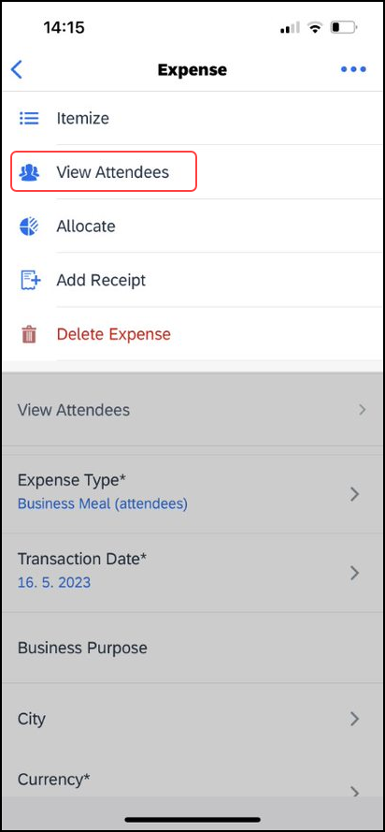 | To add, edit, or delete attendees:  1) On the Report screen, tap to open the desired expense.  2) On the Expense screen, tap View Attendees.
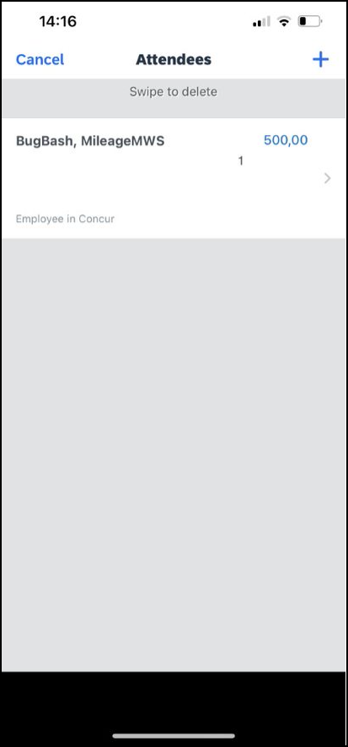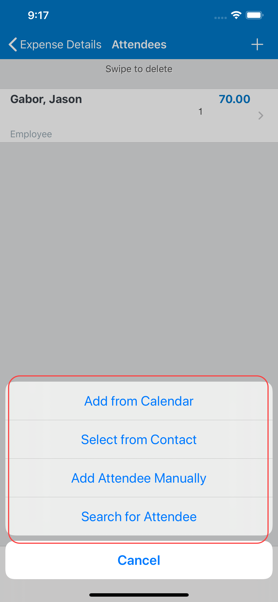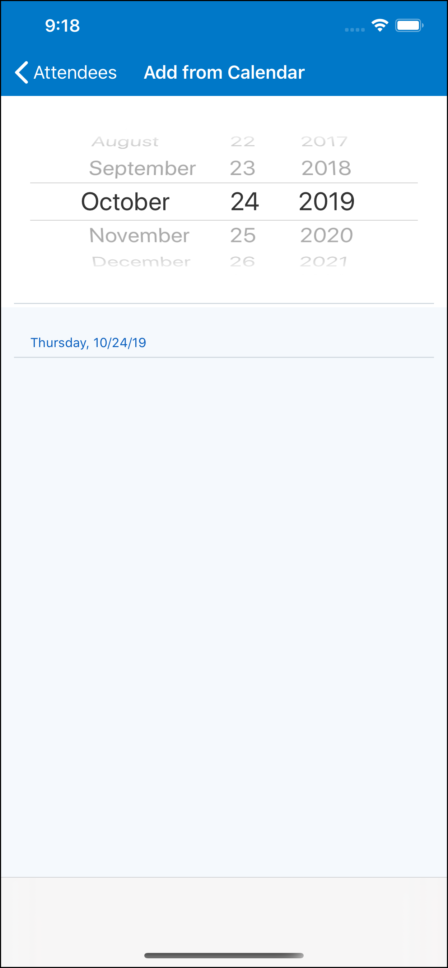 | 3) On the Attendees screen, tap plus sign (upper-right corner) to add an attendee.  4) On the menu, tap one of the following:  - Add from Calendar to import attendees from your calendar
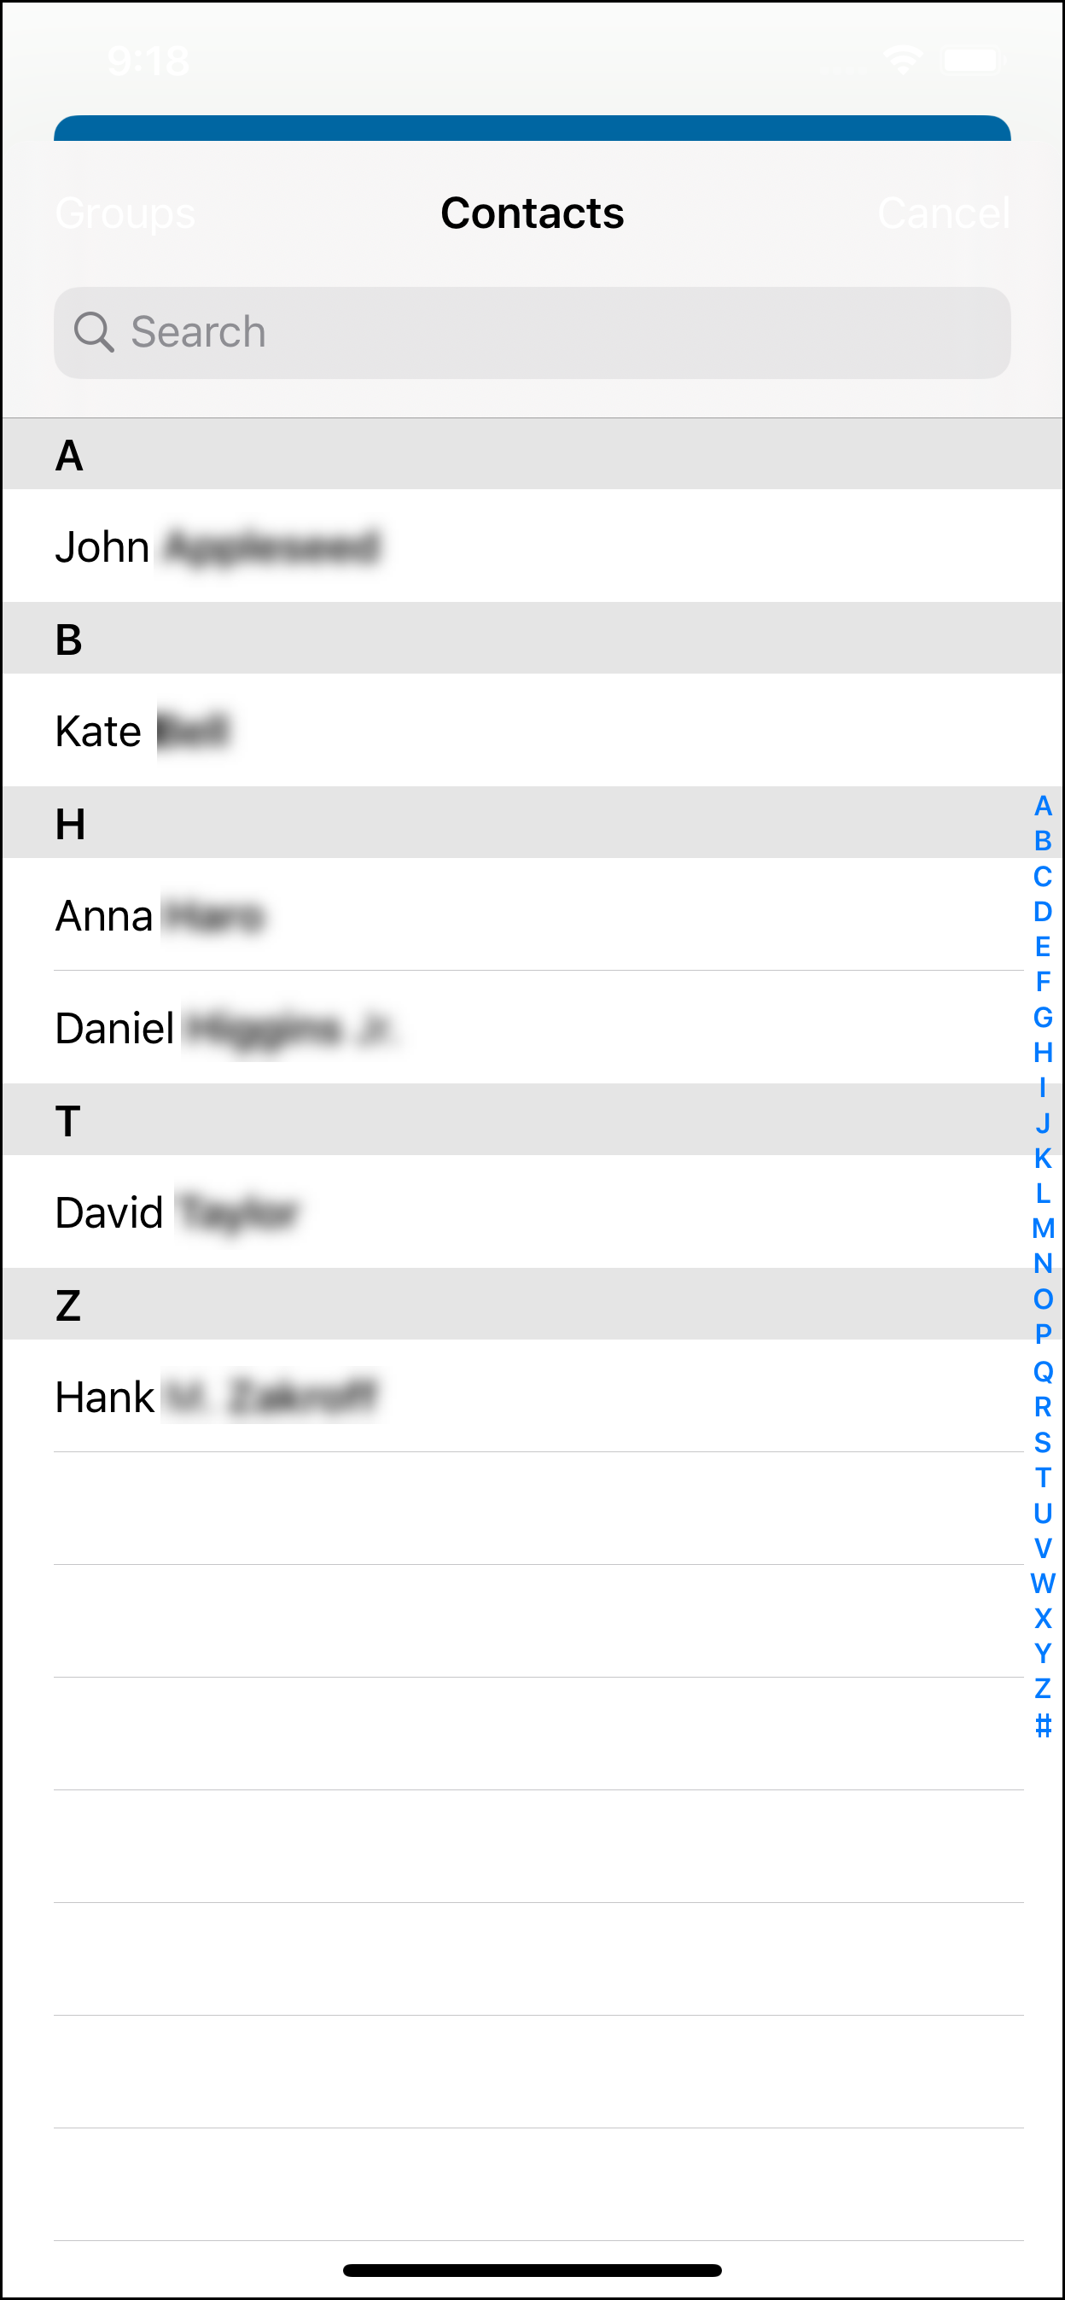 | - Search from Contact to select from your smartphone contact list  - Search for Attendee > Quick Search to search your Favorite Attendees  - Search for Attendee > Advanced Search to search your company's list of attendees or from an external source (like Salesforce)
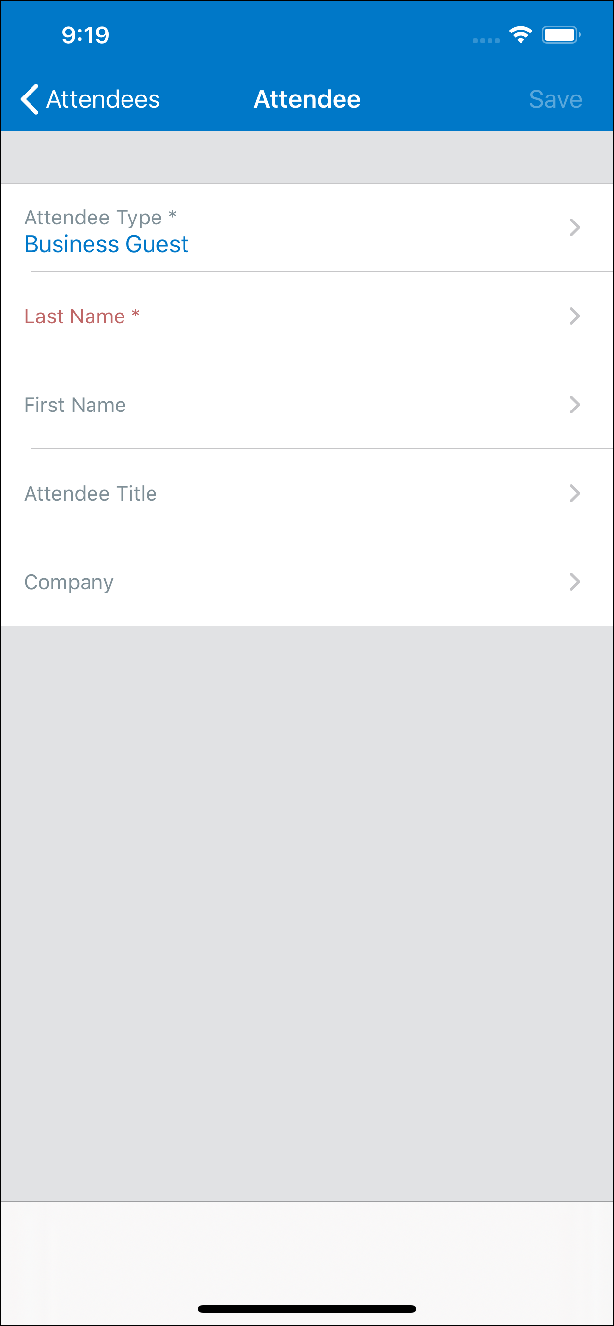 | - Attendee to manually add the attendee  NOTE: To edit an attendee, tap the desired attendee name and then make the desired changes.  To delete an attendee, swipe the desired attendee to the left and then tap Delete.
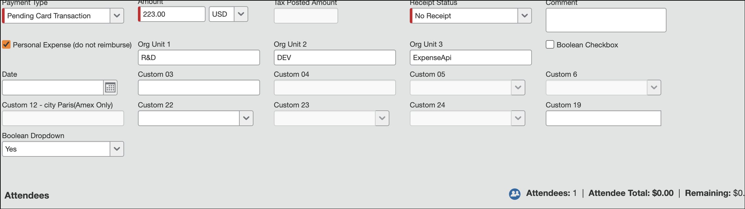 | To add attendees to personal expenses:  1) Create expense.  2) Complete expense.  3) Add attendees.  4) Add itemization:  - Set the amount of the itemization to the total amount of the expense.  - Set the itemization as a personal expense.  - Save the itemization.  - 5) Save the expense.

Remove an Expense From an Expense Report
You can remove an expense from an unsubmitted expense report.
Screen(s) | Description/Action
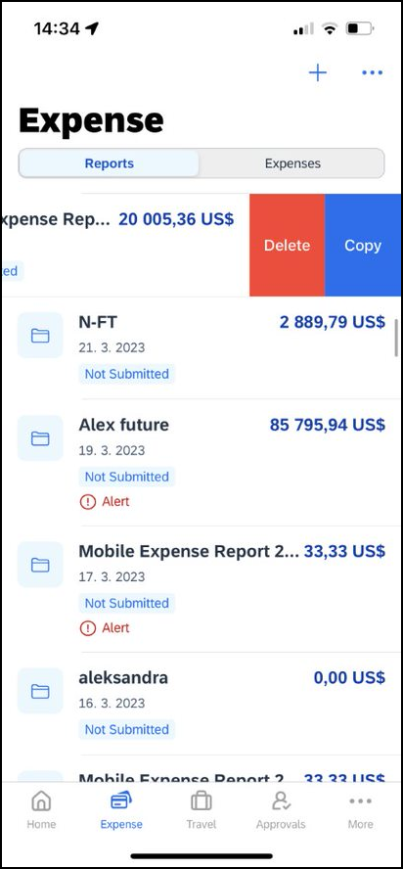 | To remove an expense from an expense report:  1) On the expense report, swipe the desired expense to the left. The Remove button appears.  2) Tap Remove.  NOTE: If you delete a mobile expense or an expense created from a card transaction, it is not really deleted; it is moved back to the "pool" of expenses on the Expenses screen.  If you delete any other type of expense from an expense report, it is truly deleted. (This is consistent with the web version of Expense.)

Edit Report Header Information
You can edit the report name, date, and other company-defined fields on an unsubmitted report.
Screen(s) | Description/Action
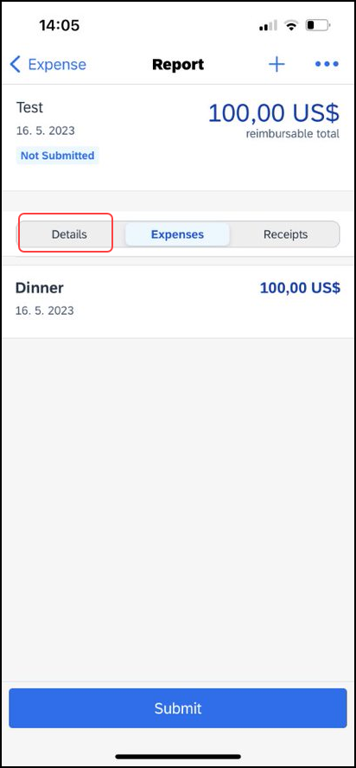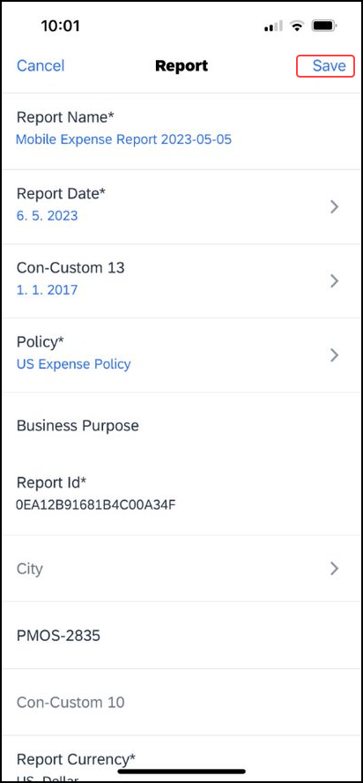 | To edit report header information:  1) On the Report screen, tap the Details tab.  2) On the Details tab, make the desired changes.  3) Tap Save (upper-right corner).
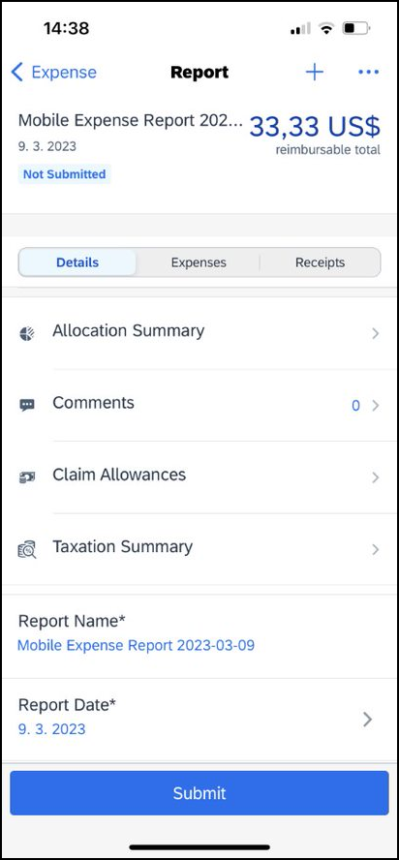 | The updated details appear on the Report screen.

Submit an Expense Report
Screen(s) | Description/Action
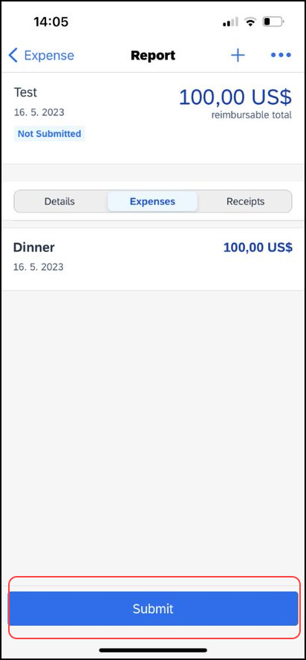 | To submit an expense report, on the Report screen, tap Submit at the bottom of the screen.

Submit an Expense Report With the Approval Flow Screen
Screen(s) | Description/Action
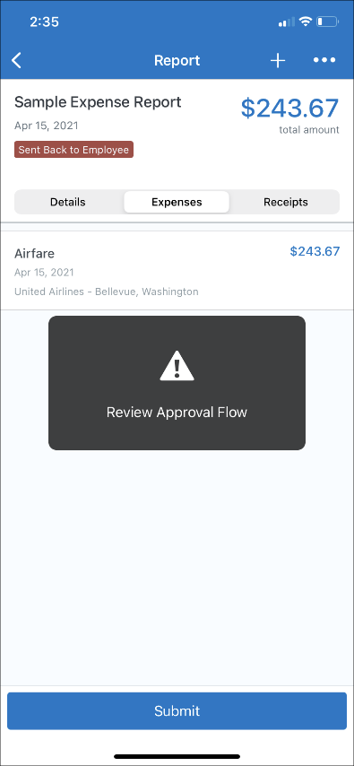 | To submit an expense report with the Approval Flow screen:  1) With the report open, tap Submit.  The Approval Flow screen appears.  NOTE: Your company will need to set the necessary configurations for the Approval Flow screen to appear and to allow you to modify the approval flow.  2) On the Approval Flow screen, tap the plus sign (upper-right corner) to add an approval step.  NOTE: When you first access the Approval Flow screen, a message appears indicating that you can tap (upper-right corner) to select and delete approval steps.
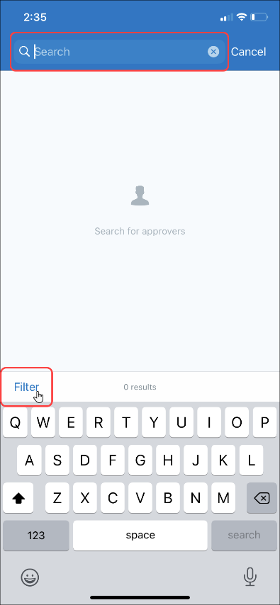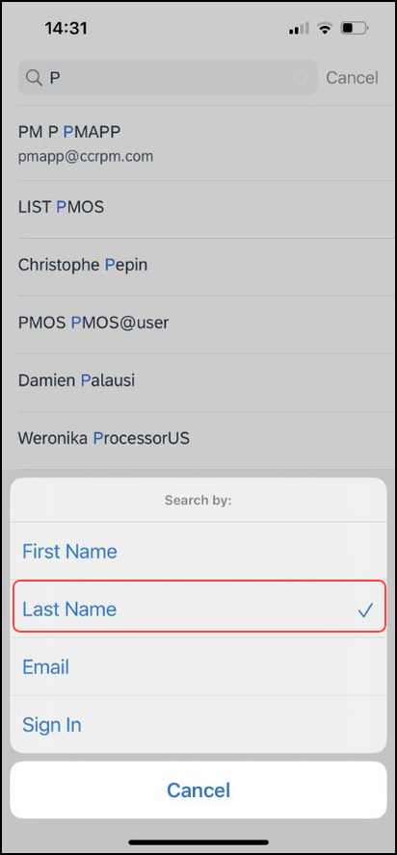 | 3) On the approvers search screen, enter search criteria in the search field.  NOTE: While entering the search criteria, a list of approvers appears on the approvers search screen.  4) Tap the Filter link to change the filter.  5) On the Search by window, select the desired filter to search approvers by.  NOTE: By default, the system searches for approvers via the Last Name filter.  6) On the approvers search screen, tap the desired approver.
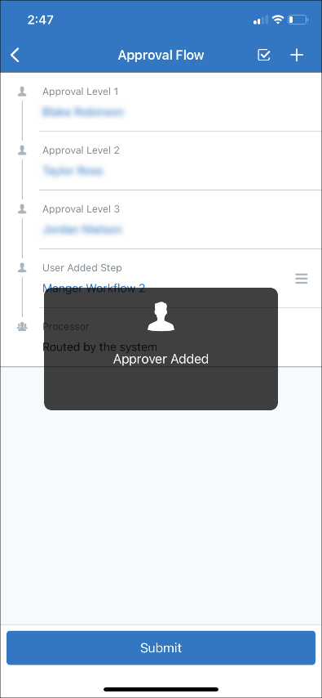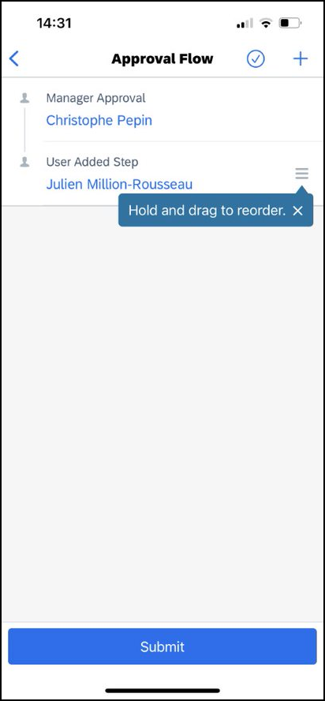 | The selected approver appears as a user added step on the Approval Flow screen.  NOTE: When you first add a user added step, a message will appear indicating that you can hold and drag a user added approval step to reorder it.
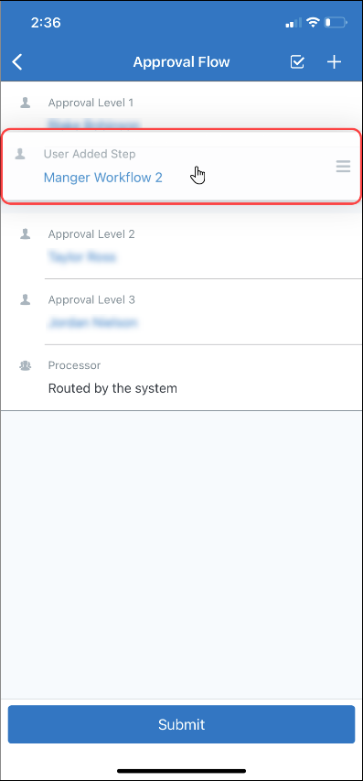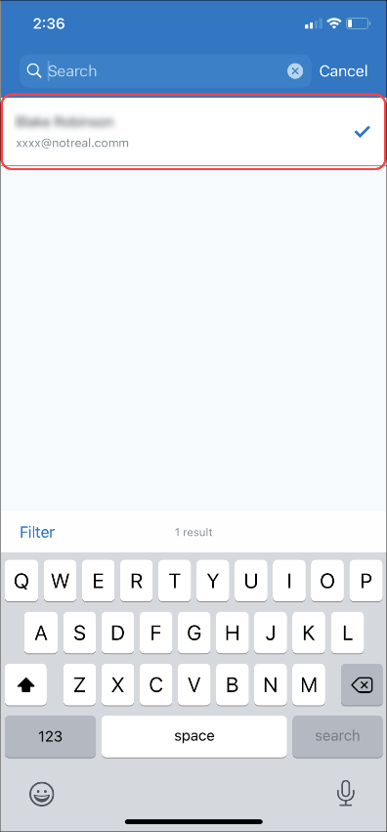 | 7) On the Approval Flow screen, tap and hold the desired approval step and then drag the step upward or downward to reorder it.  When you tap on an existing approval step, the approvers search screen appears.  The currently selected approver appears at the top of the screen with a checkmark.  NOTE: For the Authorized Approver steps, all authorized approvers appear by default (without searching), and you can search within those results if desired.
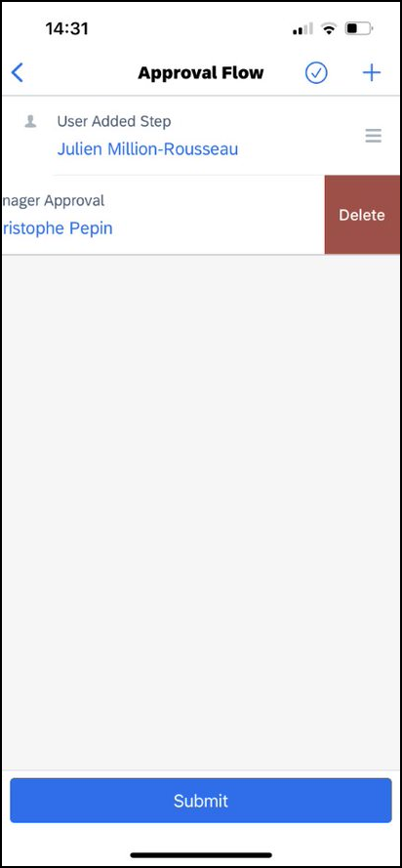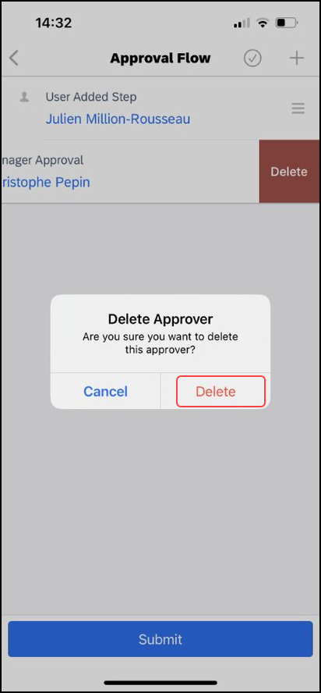 | You can delete an approval step on the Approval Flow screen. To delete an approval step on the Approval Flow screen, you can either:  - Swipe the desired approval step to the left and then tap Delete on the Delete Approver window to delete it.  -or-
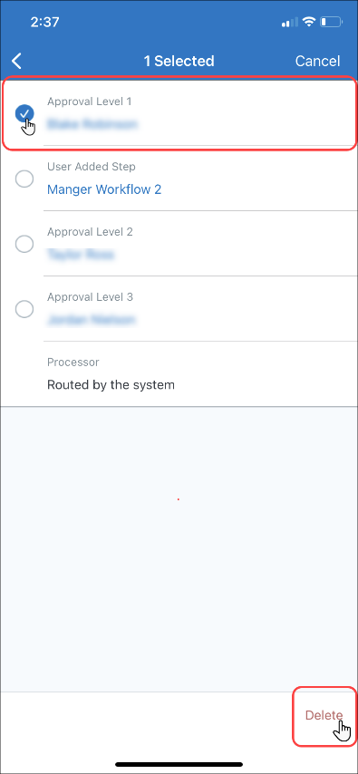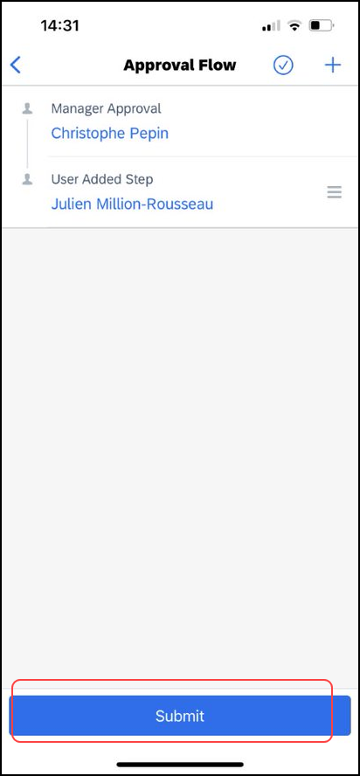 | - Tap (upper-right corner), tap the desired approval step, then tap Delete (lower-left corner), and then tap Delete on the Delete Approver window that appears.  8) Once done reviewing and adjusting the approval flow on the Approval Flow screen, tap Submit.

Recall an Expense Report
Screen(s) | Description/Action
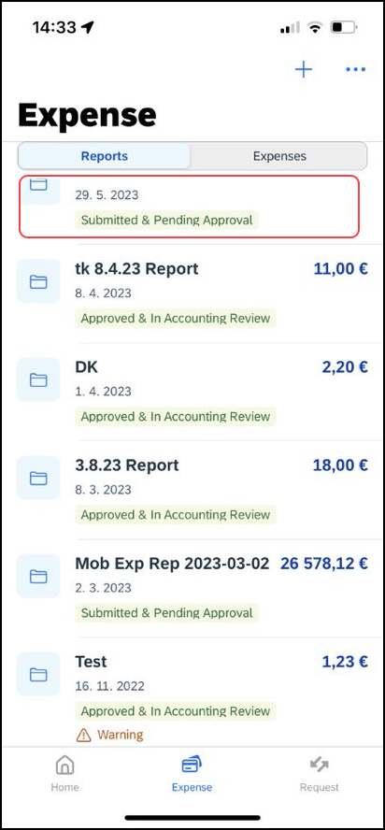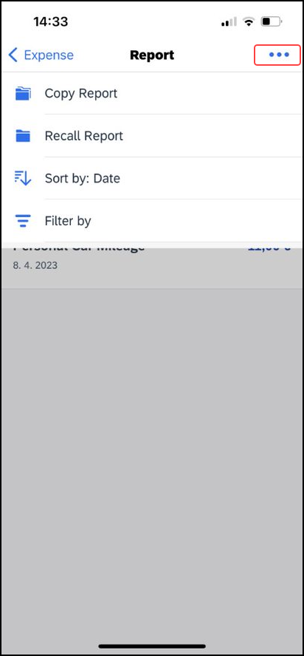 | To recall a report:  1) On the home screen, tap Expense Reports.  2) On the Reports screen, from the Active tab, tap the desired submitted report.  3) On the Report screen, tap (upper-right corner).
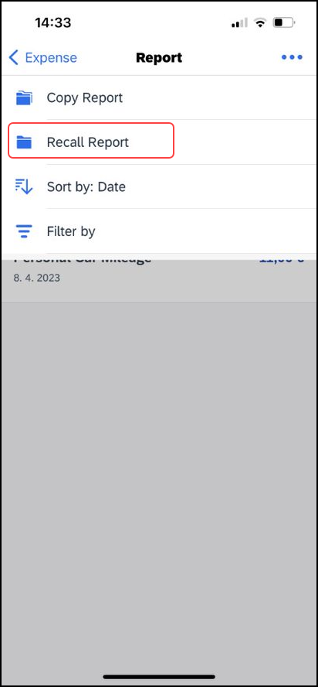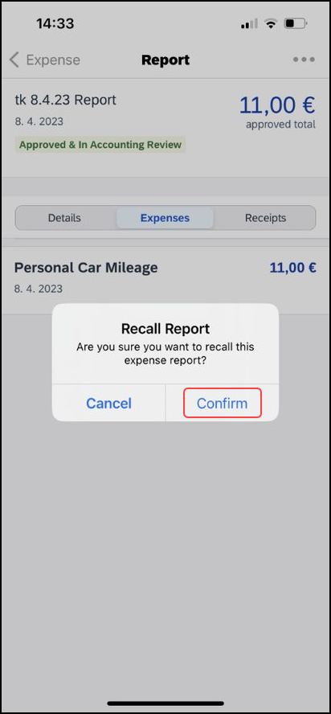 | 4) On the menu, tap Recall Report.  5) On the Recall Report window, tap Confirm.  6) The report has been sent back to the employee.

Refresh Data
Screen(s) | Description/Action
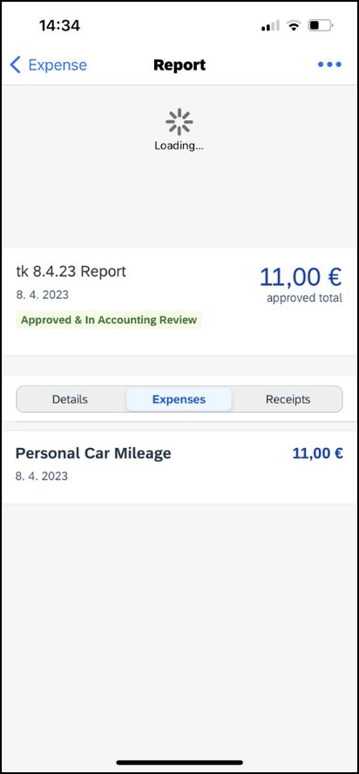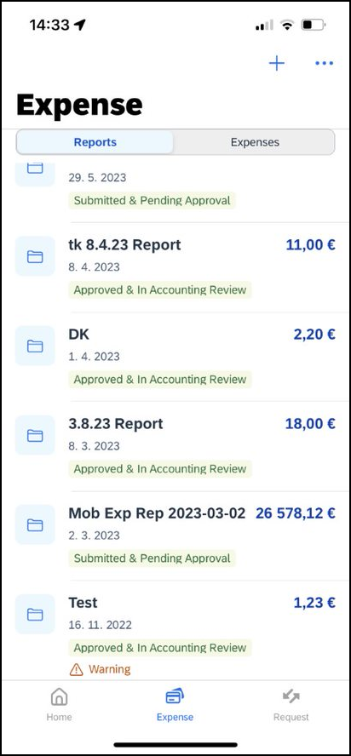 | To refresh report data – for example, expenses and reports – pull down from the top.
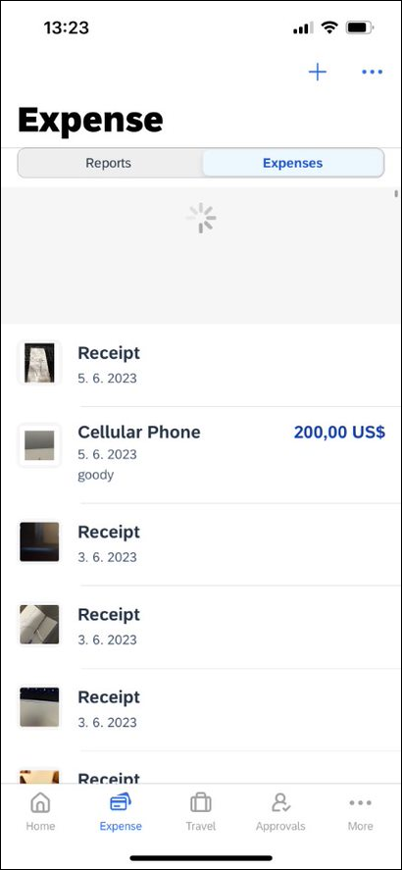 | To refresh expense data – for example, expenses and reports – pull down from the top. Once the refresh icon is cleated, the Expense screen will be refreshed.

Delete an Unsubmitted Expense Report
Screen(s) | Description/Action
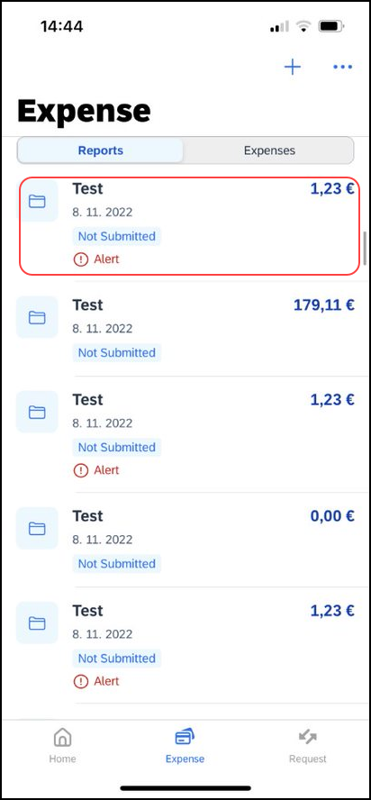 | To delete an unsubmitted expense report:  1) On the Reports screen, tap the Active tab and then swipe the desired report to the left. The Delete button appears.  2) Tap Delete.  NOTE: Expenses on the report that are related to card transactions are not really deleted – they are returned to the "pool" of card transactions. Cash transactions are truly deleted.

View/Add/Edit/Delete Allocations
You can view report-level allocations, expense-level allocations, and itemization-level allocations.

View Report-Level Allocations
The Allocation Summary screen shows that the expenses are allocated to two cost centers (R&D and Marketing at 50% each). Each equals $565.88 with a total of $1,131.76. ($1,131.76 = the airfare and hotel expense on the report.)
Screen(s) | Description/Action
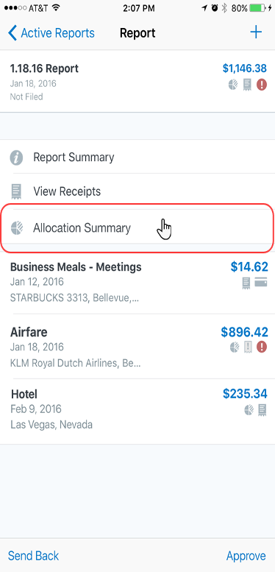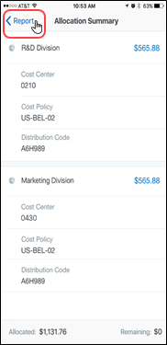 | To view report-level allocations:  1) On the Report screen, tap Allocation Summary.  2) On the Allocation Summary screen:  - Review the information.  - Tap Report (upper-left corner) to return to the report.

View Expense-Level Allocations
Screen(s) | Description/Action
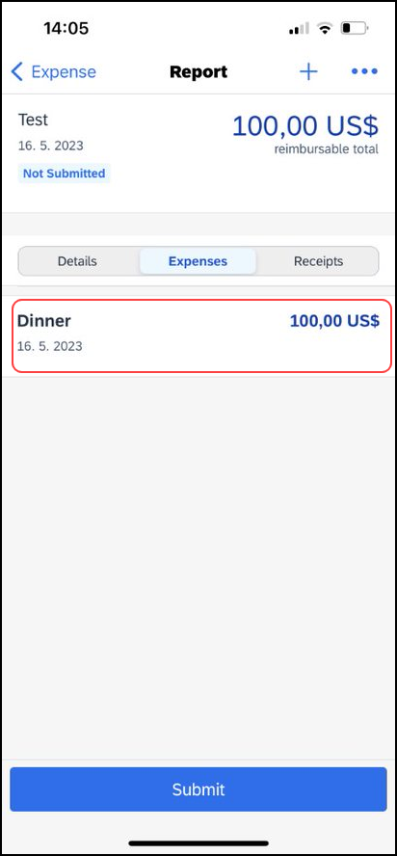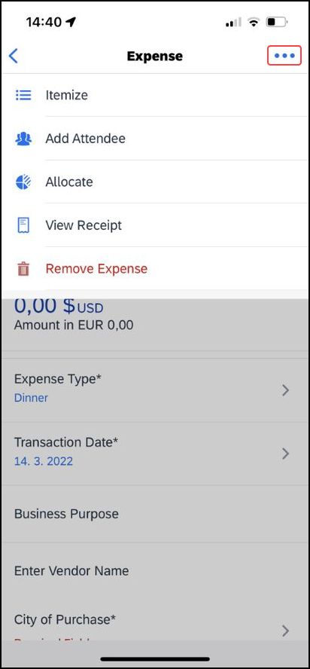 | To view expense-level allocations:  1) On the Report screen, tap the desired expense.  2) On the Expense screen, tap (upper-right corner).
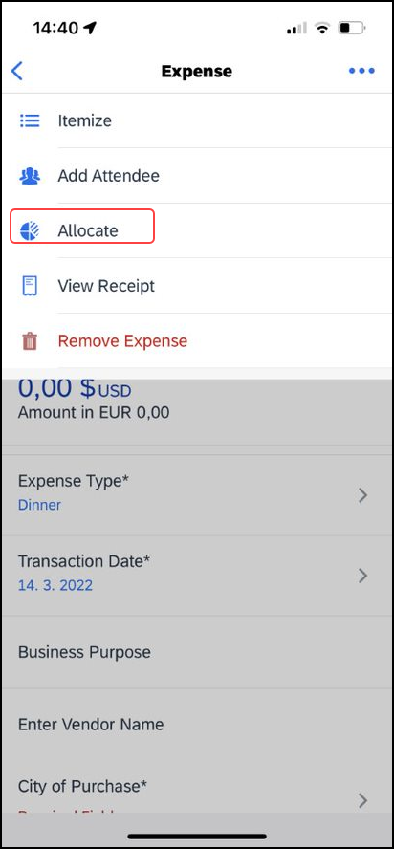 | 3) On the menu, tap Allocate.  4) On the Allocations screen:  - Tap on the desired allocation to view more details.  - Tap (upper-left corner) to return to the Report screen.

View Itemization-Level Allocations
Screen(s) | Description/Action
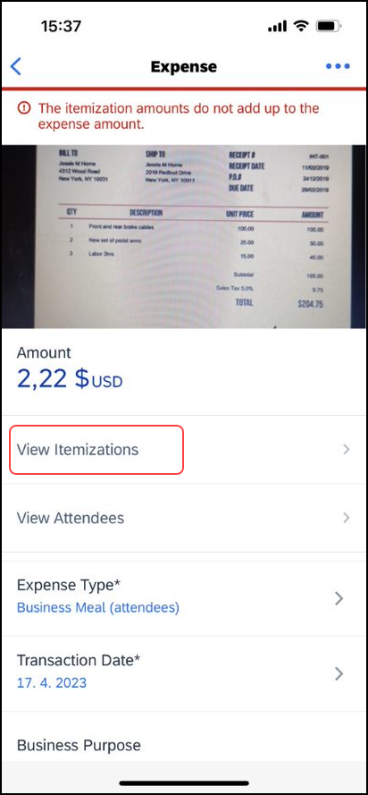 | To view itemization-level allocations:  1) On the Report screen, tap the desired expense.  2) On the Expense screen, tap View Itemizations*.
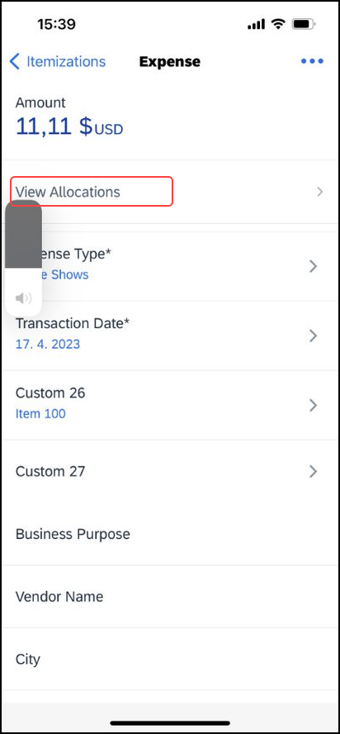 | 3) On the Itemizations screen, tap the desired itemization.  4) On the Expense screen, tap View Allocations.
5) On the Allocations screen:
- Tap on the desired allocation to view more details.
- Tap (upper-left corner) to return to the Report screen.

Add/Edit/Delete Allocations
Screen(s) | Description/Action
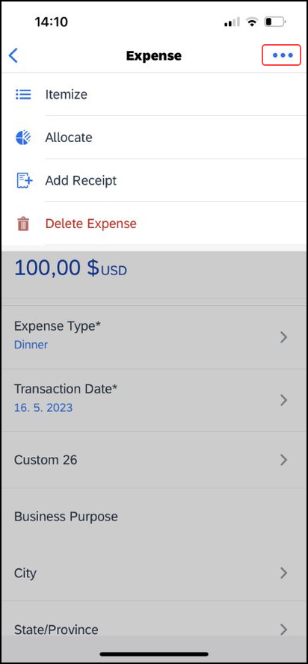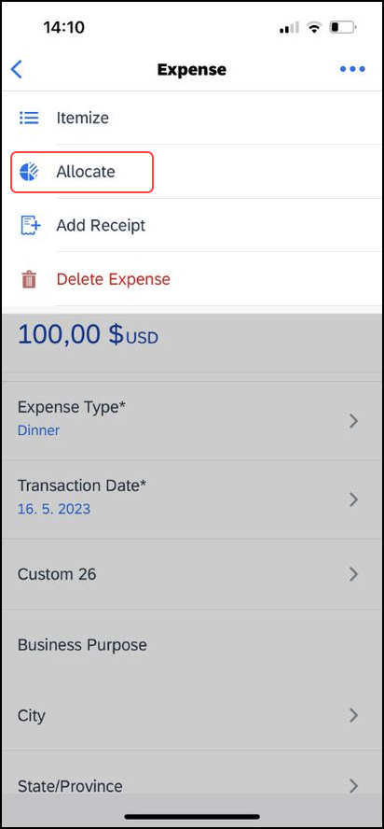 | To add, edit, or delete allocations:  1) To add allocations, on the Expense screen:  - Tap (upper-right corner).  - On the menu, tap Allocate.
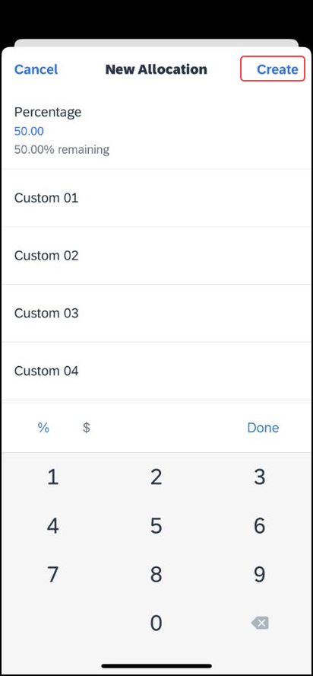 | - On the Allocations screen, tap the plus icon (upper-right corner) to add additional allocations.  - On the New Allocation screen, you can:  - Fill in the fields (if any) and make the desired selections.  - Tap Create (upper-right corner).  2) To edit an allocation, on the Allocations screen:  - Tap the desired allocation to open it.  - Make the desired changes.
3) To delete an allocation, on the Allocations screen:
- Swipe the desired allocation to the left and then tap Remove.
- Tap (upper-right corner) on the selection screen.
- Tap the desired selection circles.
- Tap Delete (lower-right corner) to delete the selected allocations from an expense.
4) At the bottom of the Allocations screen, review the Allocated and Remaining percentages.

Create Itemization-Level Allocations
Screen(s) | Description/Action
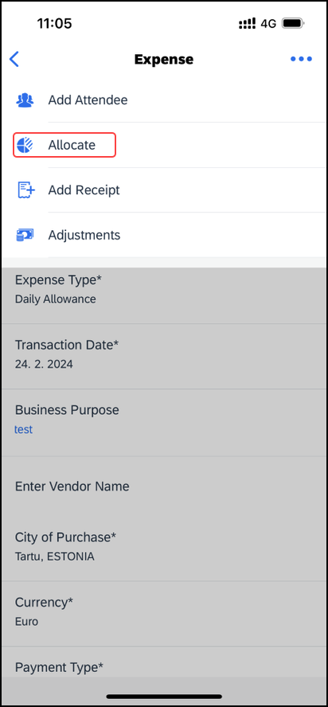 | To create itemization-level allocations:  1) On the Expense screen, tap Allocate  2) On the Allocations screen:  - Tap the plus icon in the upper-right corner.  - Fill in the fields (if any) and make the desired selections.  - Tap the plus icon in the upper-right corner to add additional allocations.

Icon
Screen(s) | Description/Action
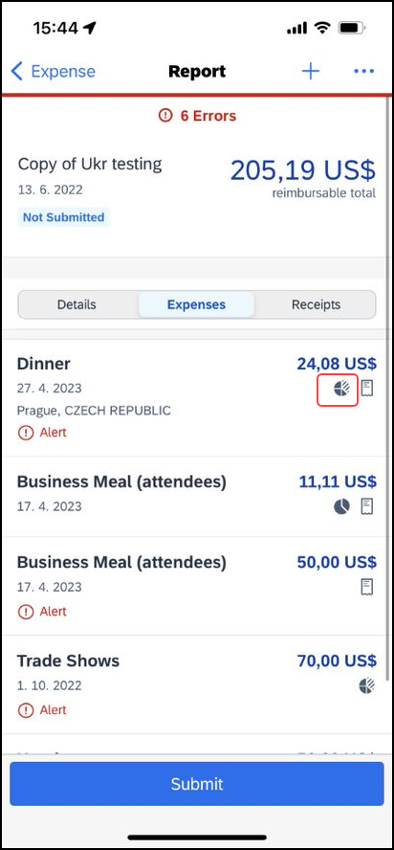 | Once items are allocated, an Allocation icon appears next to the expense and at the report level.

Copy a Report From Existing Report
Screen(s) | Description/Action
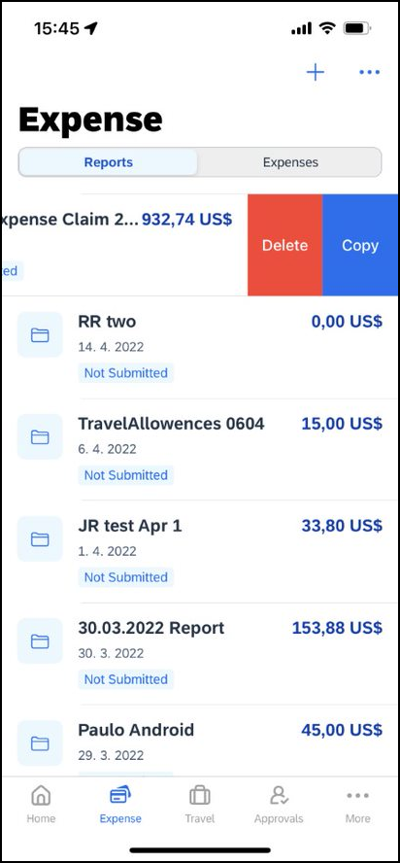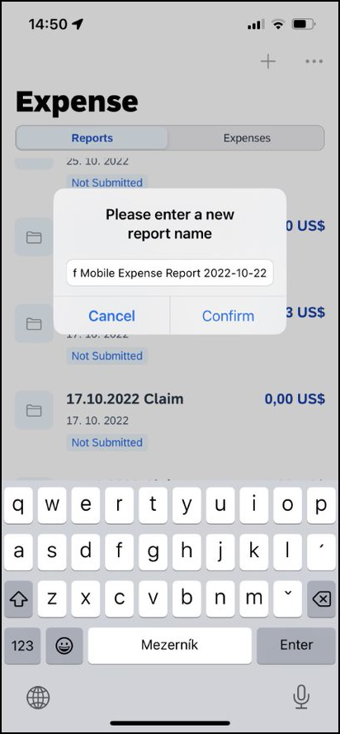 | To copy a report from an existing report:  1) On the Reports screen, swipe the desired report to the left. The Copy option appears.  2) Tap Copy. A box appears (with the existing report name), requesting a new report name.
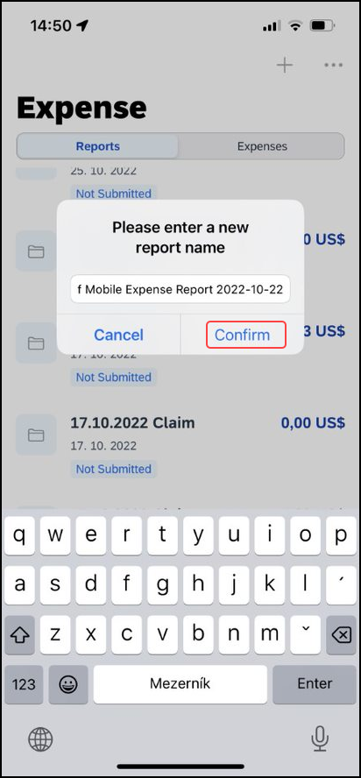 | 3) Enter the new name and tap Confirm. The copied report appears.  4) Make the desired changes, attach receipt images, etc.  5) Save or submit as usual.  The copied report appears on the Reports screen.

Edit Report Header Information
You can view and edit the report header information.
Screen(s) | Description/Action
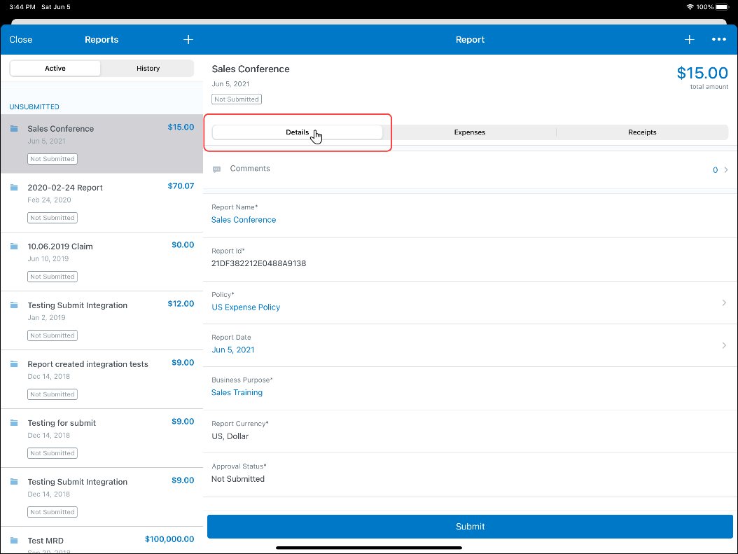 | To edit the report header information:  1) On the Report screen, tap the Details tab.  2) On the Details tab, make the desired changes.  3) Tap Save (upper-right corner).

Capture Multipage Receipts
You can use the multipage receipts feature to capture multipage receipts. For example, you can use this feature to capture standalone receipts to create quick expenses or to capture receipts for ExpenseIt (if your company uses ExpenseIt) to process within the SAP Concur mobile app.
Screen(s) | Description/Action
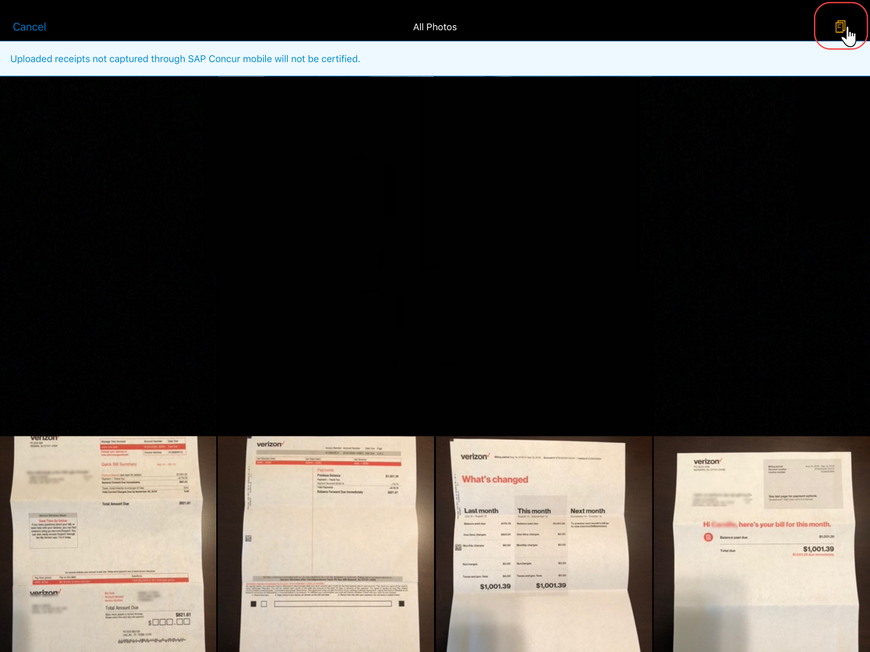 | To capture multipage receipts:  1) On the home screen, tap ExpenseIt.
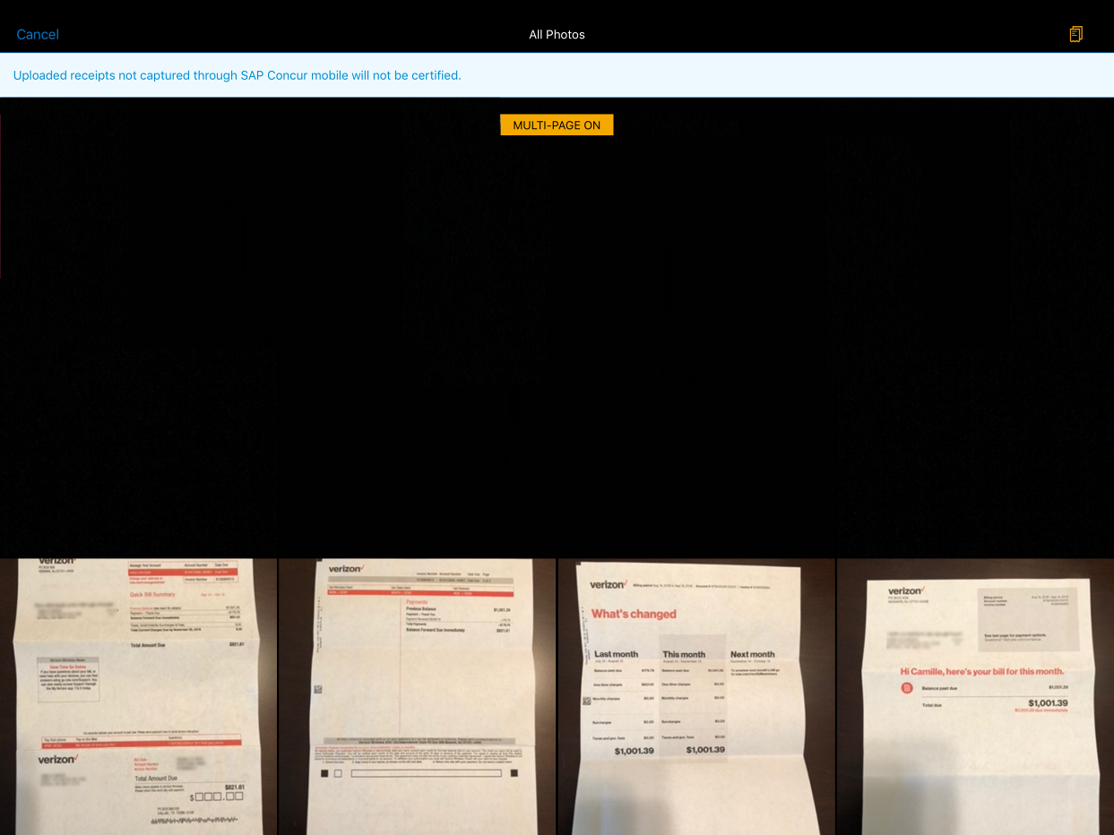 | 2) On the camera screen, tap (upper-right corner).  The multipage feature is now activated.  NOTE: SAP Concur does not certify uploaded receipts that have not been captured in in the SAP Concur mobile app.
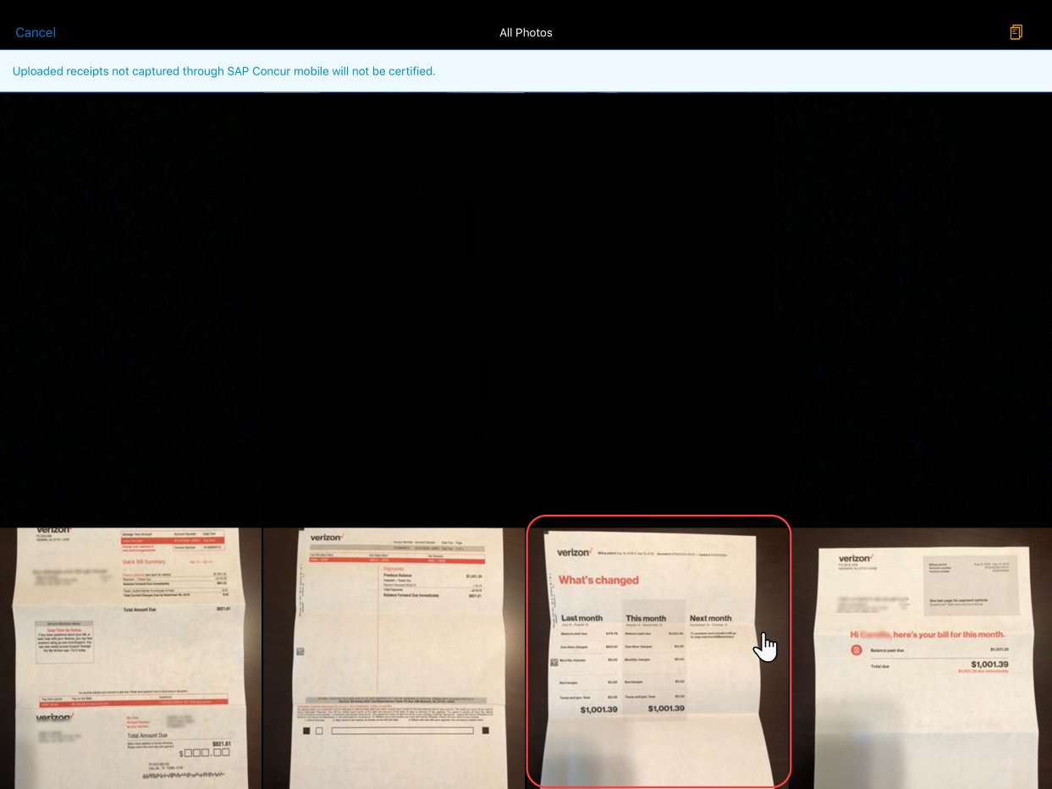 | 3) On the next camera screen, tap the desired receipt to capture
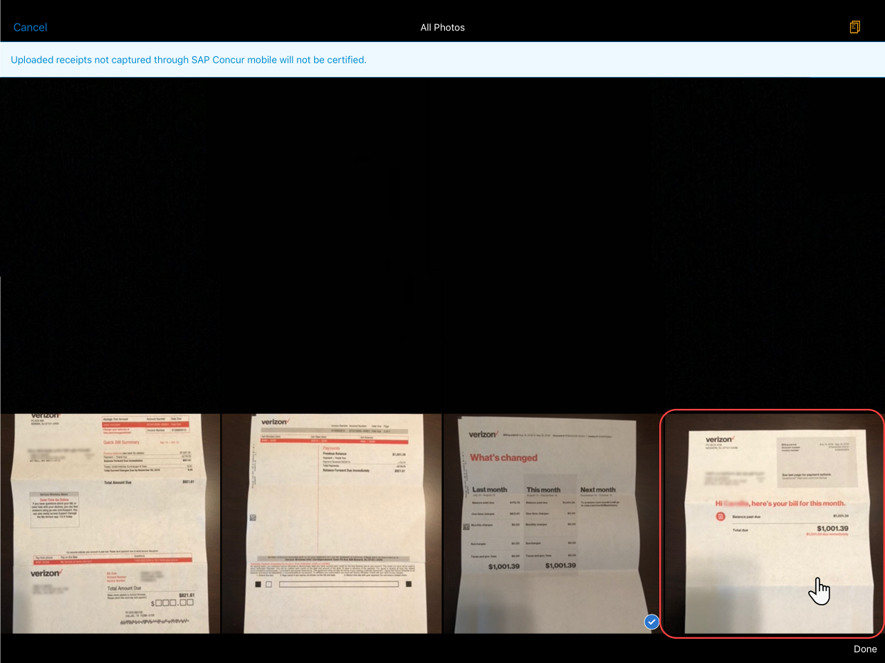
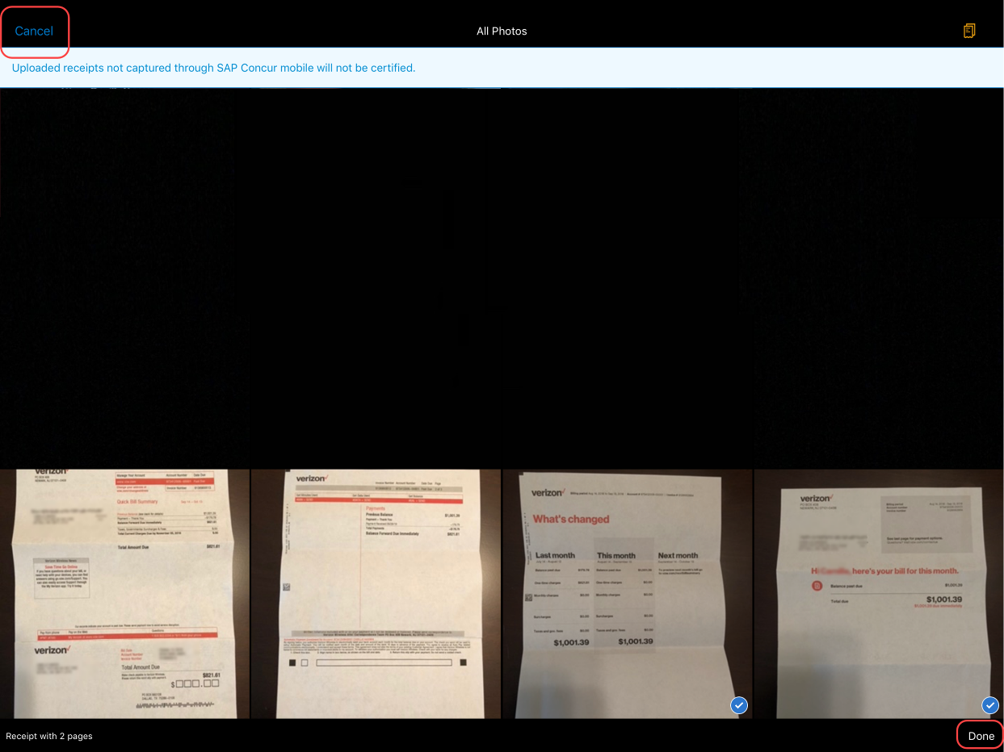 | 4) Repeat this process to capture the desired receipts.  5) After capturing all the appropriate receipts, tap either:  - Done  – or –  - Cancel

Create a Mobile Expense From a Receipt
Screen(s) | Description/Action
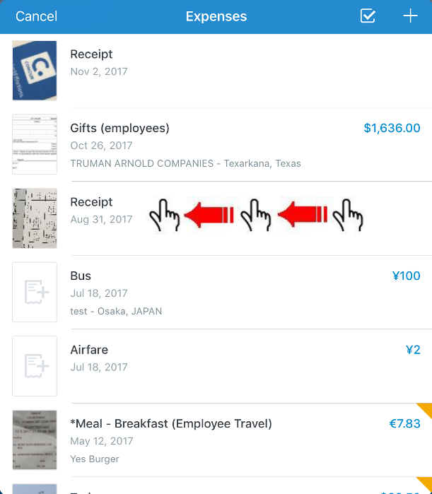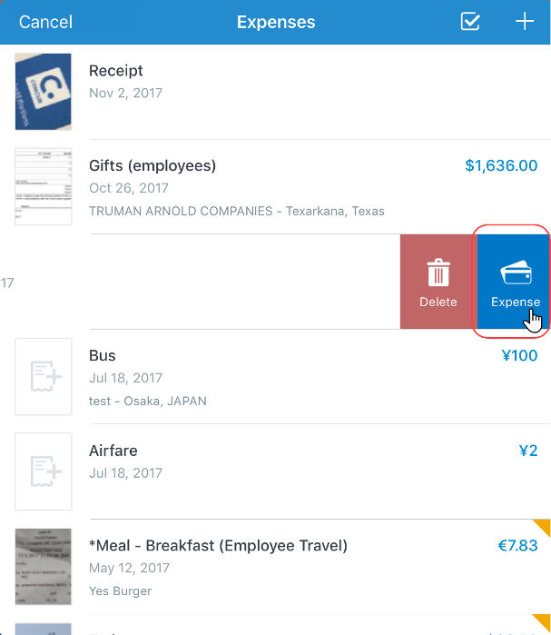 | To create a mobile receipt from an expense:  1) On the Expenses screen, swipe the desired receipt to the left.  2) Tap Expense.
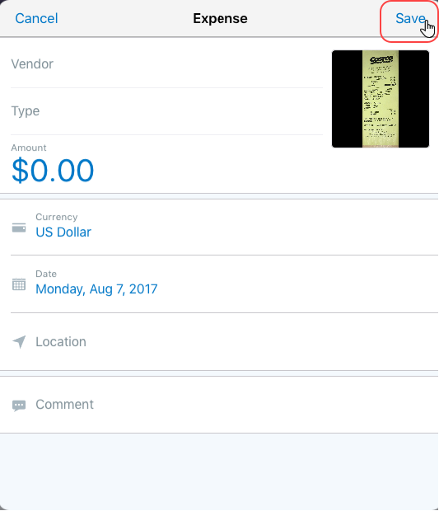 | 3) On the Expense screen, fill in the fields (if any) and make the desired selections.  4) Tap Save.

Delete Receipts
Screen(s) | Description/Action
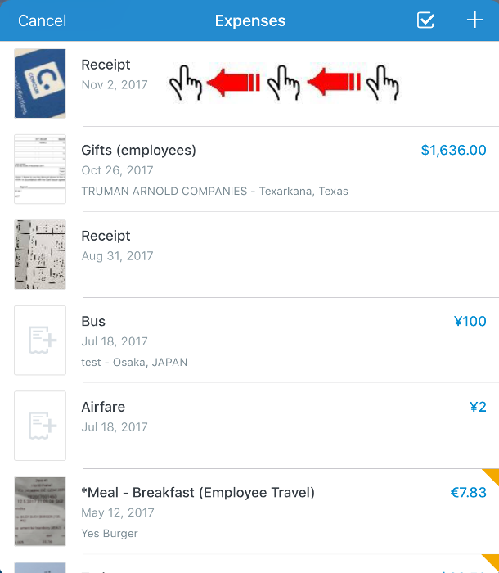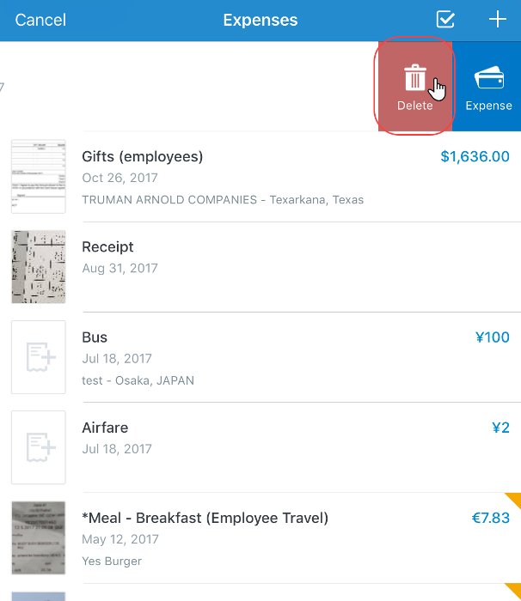 | To delete receipts:  1) On the Expenses screen, swipe the desired receipt to the left.  2) Tap Delete.

Attach a Missing Receipt Declaration to an Expense
Attach a missing receipt declaration to an expense.
Screen(s) | Description/Action
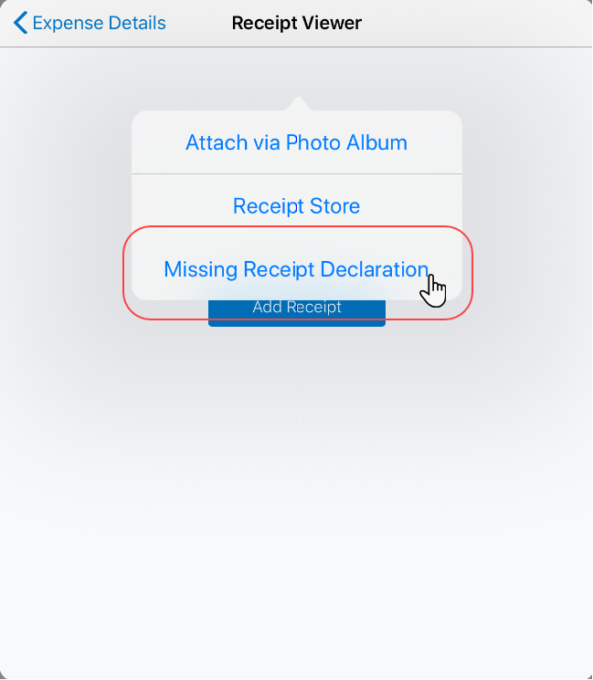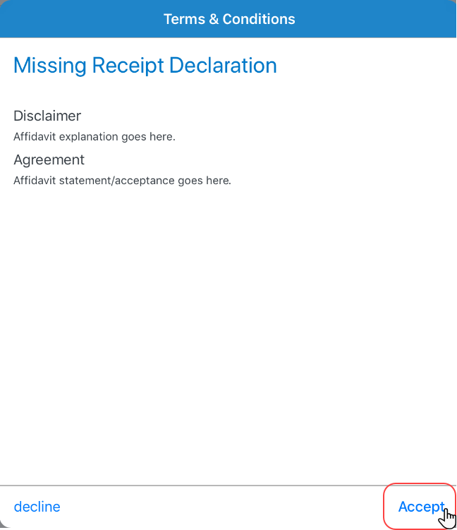 | To create attach a missing receipt declaration to an expense:  1) On the Reports screen, tap to create a new expense.  2) Fill in the fields and make the desired selections.  3) Tap Save.  4) Tap the desired expense.  5) On the Receipt Viewer screen, tap Add Receipt.  6) From the list, select Missing Receipt Declaration.  7) On the Terms & Conditions screen, tap Accept.
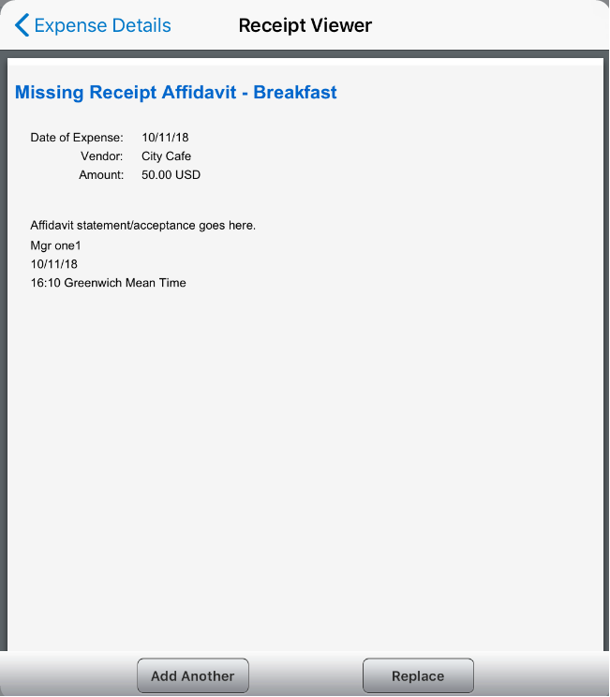 | The Missing Receipt Declaration appears on the Receipt Viewer screen.

Work With Fixed Travel Allowances
The copied report appears.
4) Make the desired changes, attach receipt images, etc.
5) Save or submit as usual.
The copied report appears on the Active tab of the Reports screen.

Users can now claim their fixed meals and fixed lodging travel allowances in the SAP Concur mobile app.

Fixed vs Reimbursable Travel Allowances
Fixed travel allowances – often referred to as per diems – provide a defined daily amount regardless of the actual amount spent by the user
Reimbursable travel allowances generally provide reimbursement for the actual amount of the expense. The ability to create and manage reimbursable travel allowances is not yet available in the SAP Concur mobile app

Restrictions
For the most part, fixed travel allowances work the same way in the mobile app as on the web version of SAP Concur – with some exceptions. These configuration options are not available in the mobile app:
Users cannot define/select:  - Trip length  - "Short distance"  - "Extended trips"  - "Use Percent Rule"  - Location "within municipality" | - Users cannot enter:  - Actual meal amounts  - Rate location  - The mobile version of SAP Concur does not combine meals and lodging rates nor does it display base rates, company rates, government rates, etc.
If the user's configuration uses any of the options listed above, the user should manage their travel allowances using the web version of SAP Concur.

Create Fixed Allowances

Create A New Fixed Travel Allowance in an Expense Report
Screen(s) | Description/Action
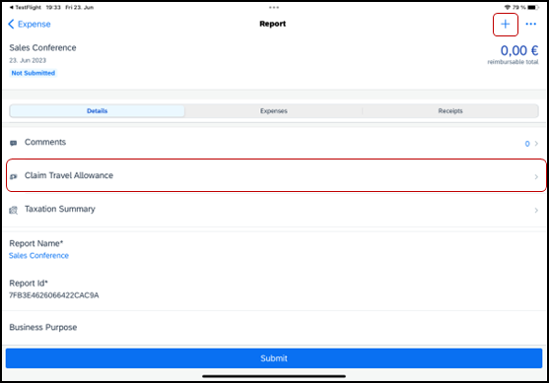  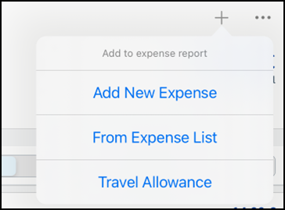 | To create a new fixed travel allowance in an expense report:  1) With a report open, on the Details tab, tap Claim Travel Allowance (or tap the plus icon and select Travel Allowance).
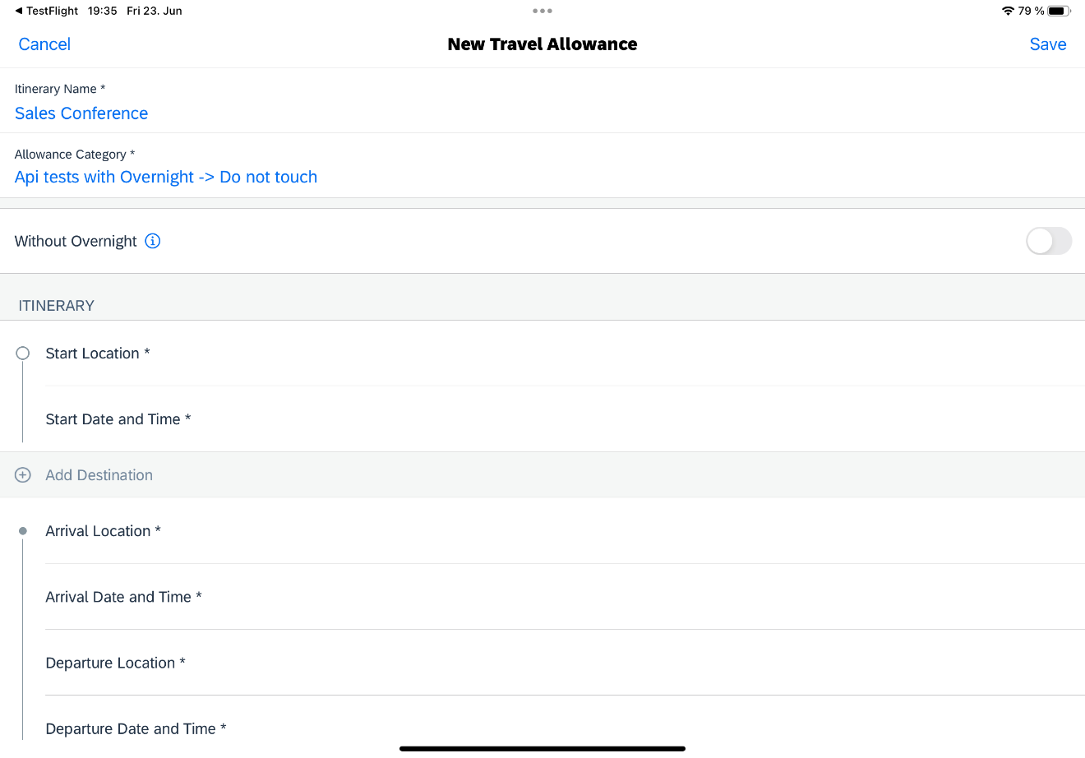 | 2) On the New Travel Allowance screen:  - Enter the itinerary name.  - Select the Allowance Category.  NOTE: If you select an allowance category - which supports the border crossing feature - an additional input field will appear in trip segments, where a border crossing situation is detected.  - Select the Trip Type.  - Swipe Without Overnight to the right, if there was no overnight stay during the trip.  - Swipe Detailed Itinerary to the right, to view all itinerary fields. (In this example, the Detailed Itinerary option is enabled.)  NOTE: Depending on which allowance category you select, you may have the option to choose between the simple or detailed itinerary mode.  If you enable the Detailed Itinerary toggle while in simple mode your detailed changes will be lost. The system will then replace your information with defaulted values.  If you switch from the simple mode back to the detailed mode, you will need to re-enter your details in the additional fields again.
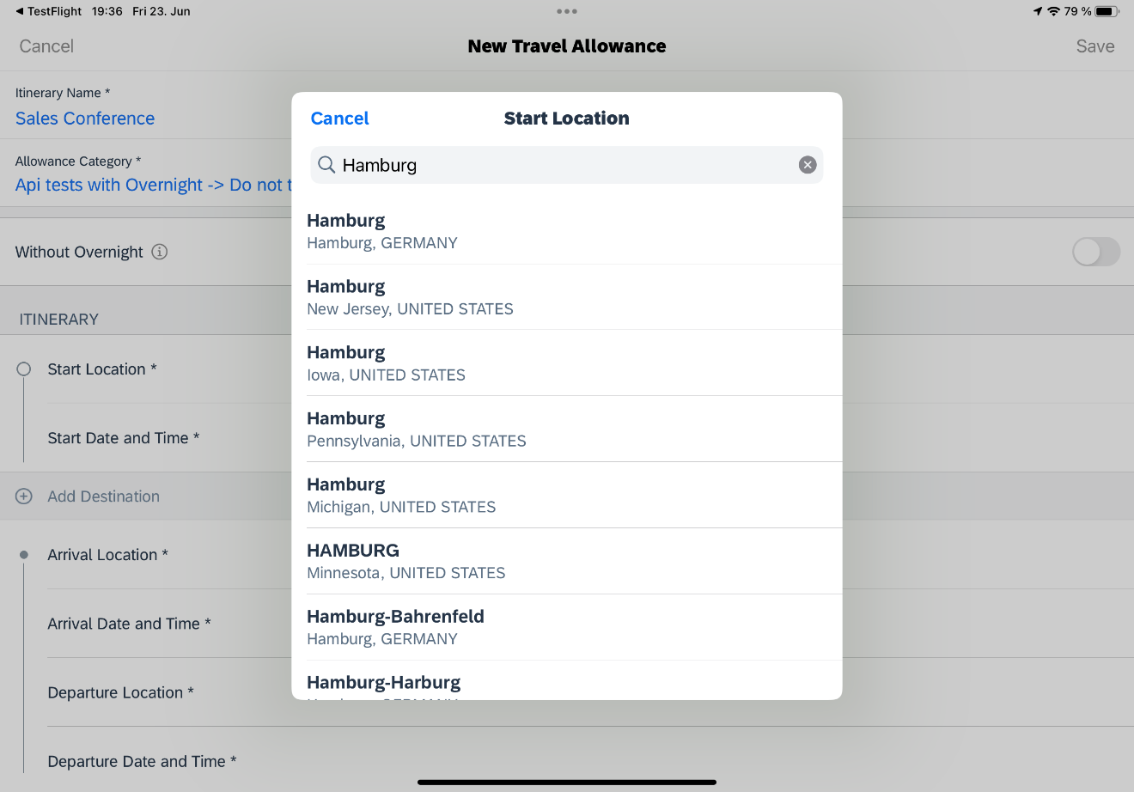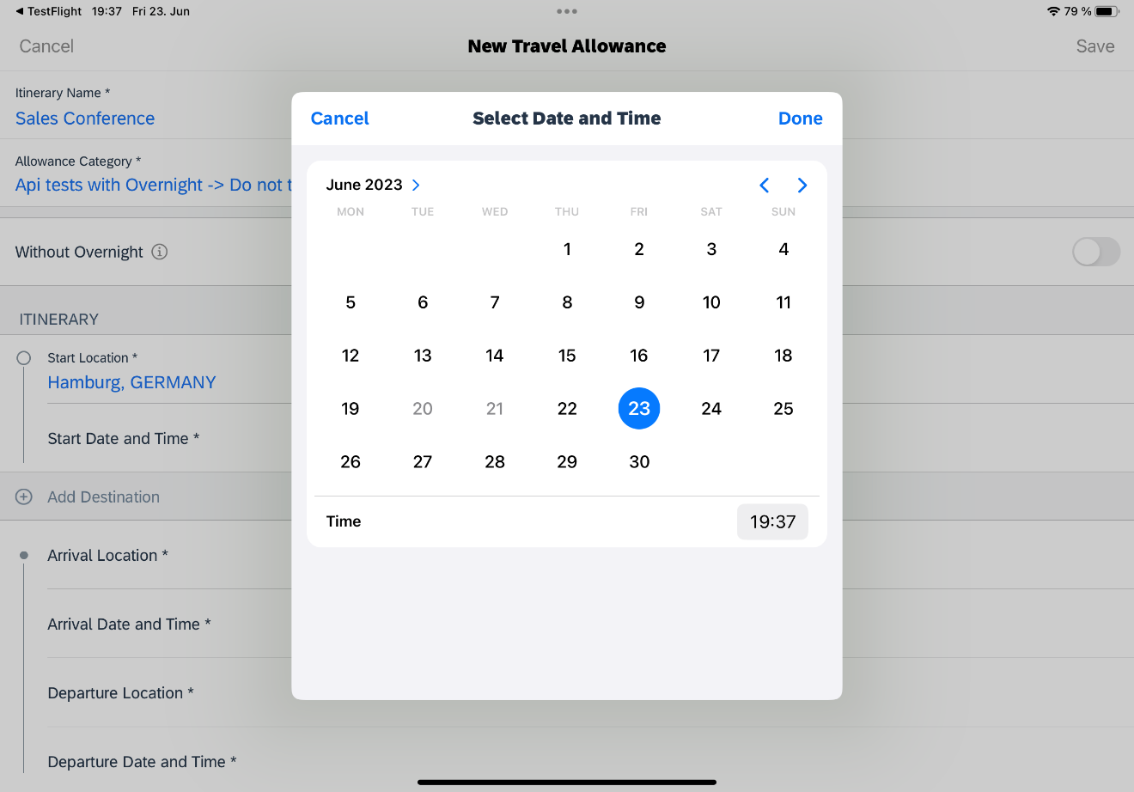 | - On the Location screen, enter and tap on the desired start and arrival locations.  NOTE: When you select an allowance category with the German 3-month-rule configuration, the Arrival Location field will require the full address to be filled out. Without this configuration enabled, you only need to fill out the destination city field and the full address is not required.  - On the Select Date and Time screen, tap the desired date, select the desired time, and tap Done (upper-right corner).
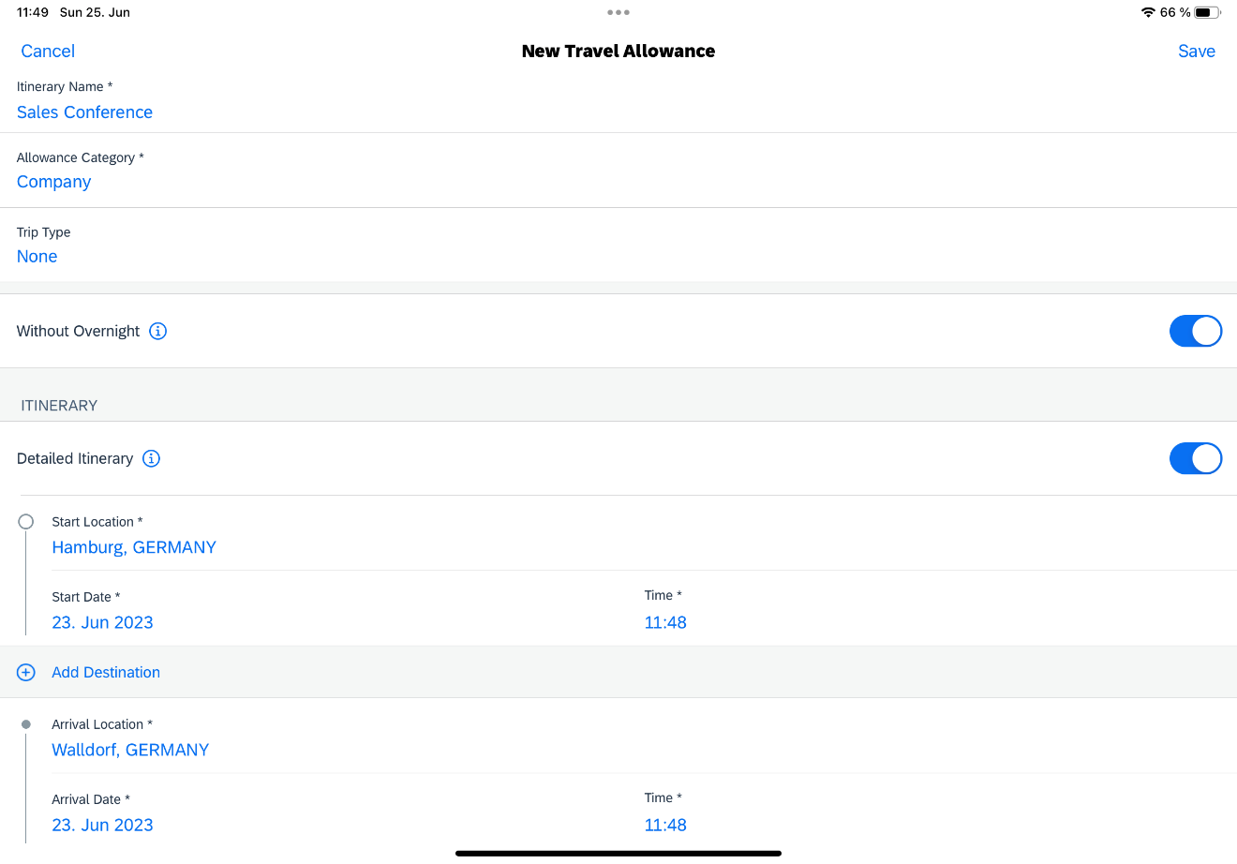 | - Enter the return trip information.  NOTE: The Add Destination option is only for trips with more than one destination.  - Repeat for each leg of the trip, entering the exact "arrival" address if necessary.  - Review the itinerary for accuracy.  3) When done, tap Save (upper-right corner).
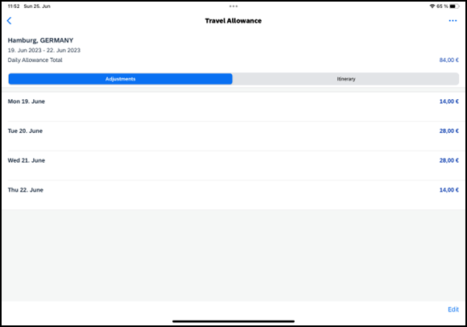 | 4) On the Adjustments tab on the Travel Allowance screen, tap the desired daily allowance that requires adjustment.
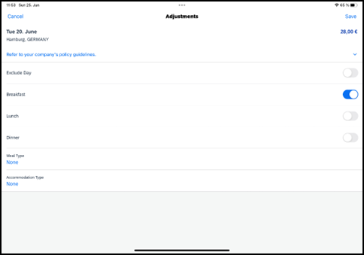 | 6) On the Daily Allowance screen:  - Make the desired adjustments.  NOTE: If the web version of SAP Concur provides a list of options instead of Yes/No, then the list appears here as well.  - When done, tap Save (upper-right corner).
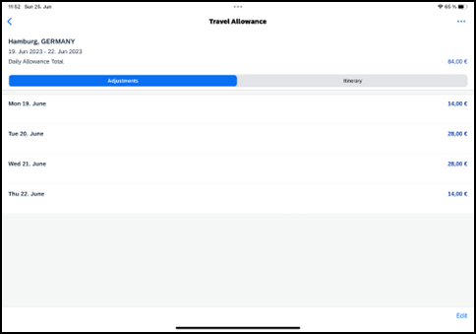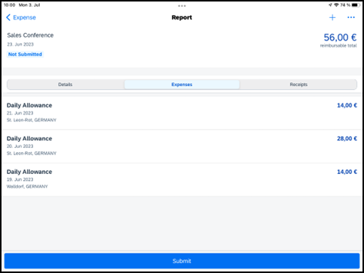 | 7) On the Travel Allowance screen:  - Make any other required adjustments.  - Tap (upper-left corner) to return to the Report screen.  8) On the Report screen:  - Review for accuracy.  - From the Details tab, tap Travel Allowance Itineraries & Adjustments if changes are necessary.  - Finish adding expenses, receipts, etc. Submit when ready.

Create a New Fixed Travel Allowance With Multiple Destinations in an Expense Report
Screen(s) | Description/Action
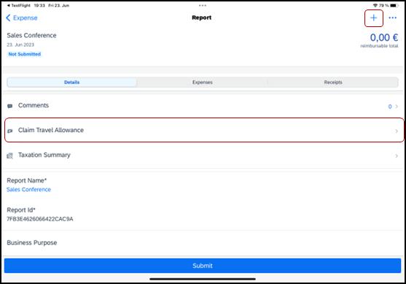 | To create a new fixed travel allowance with multiple destinations in an expense report:  1) With a report open, on the Details tab, tap Claim Travel Allowance (or tap the plus icon and select Travel Allowance).
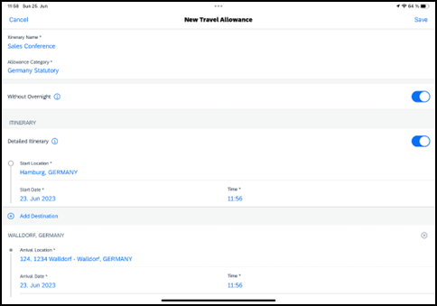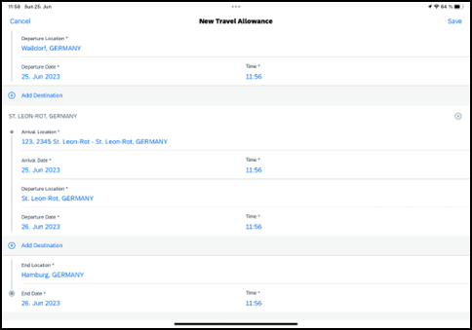 | 2) On the New Travel Allowance screen:  - Fill in the fields and make the desired selections.  - Tap Add Destination to create multiple destinations.  3) When done, tap Save (upper-right corner).
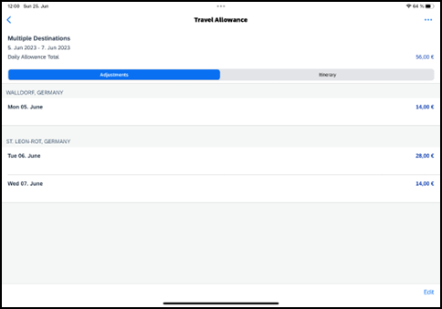 | The multiple destinations appear on the Travel Allowance screen.  NOTE: If your company has opted out of the multiple itineraries on one expense report feature, the option to add more itineraries will not appear.

Create a New Fixed Travel Allowance Itinerary Without Overnight in an Expense Report
Screen(s) | Description/Action
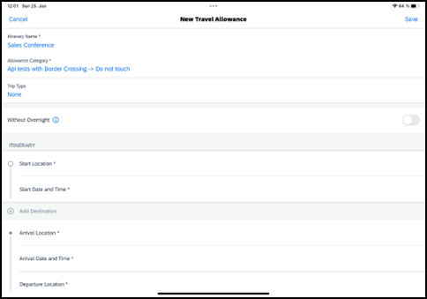 | To create a new fixed travel allowance itinerary without overnight in an expense report:  1) With a report open, on the Details tab, tap Claim Travel Allowance (or tap the plus icon and select Travel Allowance).
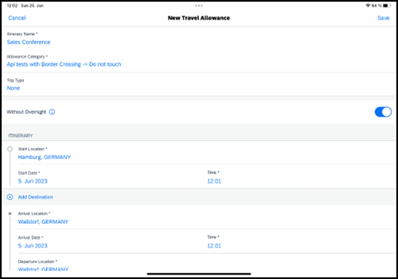 | 2) On the New Travel Allowance screen:  - Fill in the fields and make the desired selections.  - Swipe the Without Overnight toggle to right.  - Tap Save (upper-right corner).  NOTE: Depending on which category is in the Allowance Category field, the user can adjust the itinerary details.
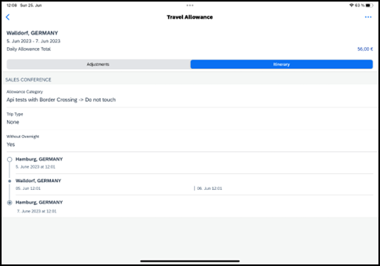 | The itinerary without overnight appears on the Travel Allowance screen.  NOTE: With the Without Overnight toggle enabled, the first itinerary in the list will display the daily allowances in accordance with the 24-hour rule showing 0.00€ for the second day.  Also, the Lodging Type field on the Daily Allowance screen will appear again.

Create a New Fixed Travel Allowance With a Border Crossing in an Expense Report
Screen(s) | Description/Action
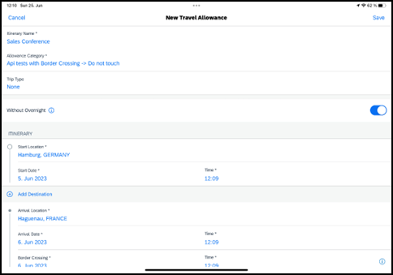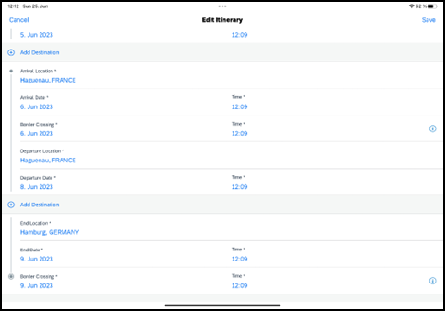 | To create a new fixed travel allowance with a border crossing in an expense report:  1) With a report open, on the Details tab, tap Claim Travel Allowance (or tap the plus icon and select Travel Allowance).  2) On the New Travel Allowance screen:  - Select an allowance category that supports the border crossing feature.  - Fill in the fields and make the desired selections.  - Tap Save (upper-right corner).
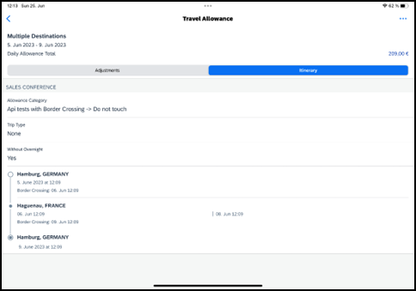 | The border crossing itinerary appears on the Itinerary tab on the Travel Allowance screen.  NOTE: This field will not appear - on the Itinerary tab – if you have not traveled to another country during your trip.

Select a Different Address in a New Travel Allowance
Screen(s) | Description/Action
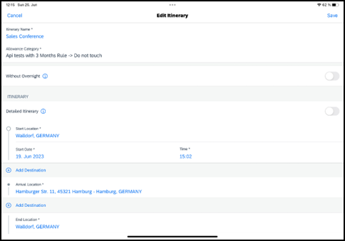 | To select a different address in a new fixed travel allowance:  1) With a report open, on the Details tab, tap Claim Travel Allowance (or tap the plus icon and select Travel Allowance).  2) On the New Travel Allowance screen, tap the Arrival Location field.
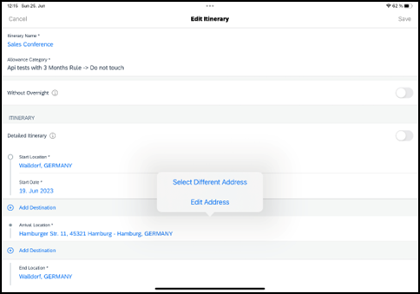 | 3) From the menu, tap Select Different Address (upper-left corner).
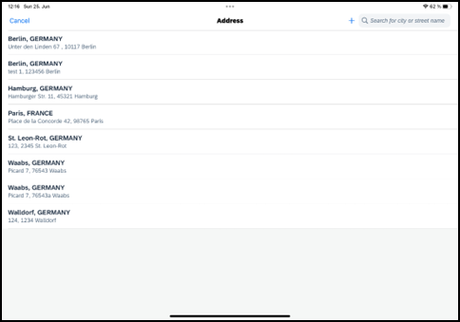 | 4) On the Address screen, tap the desired address.
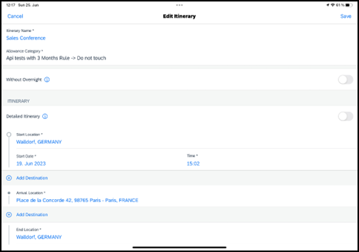 | The changed address appears on the New Travel Allowance screen.

Edit a Fixed Travel Allowance Itinerary
Screen(s) | Description/Action
To edit a fixed travel allowance:
1) 2) With a report open, on the Details tab, tap Travel Allowance Itineraries & Adjustments.
3) From the Travel Allowance screen, on the Itinerary tab, tap the desired itinerary.
4) On the Travel Allowance screen, tap (upper-right corner).
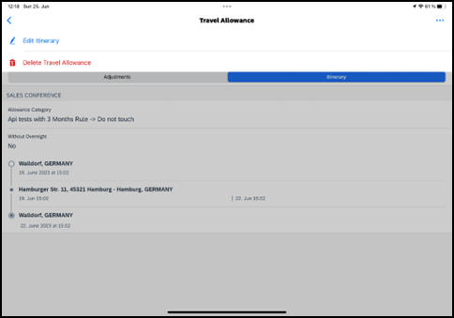 | 5) On the menu, tap Edit Itinerary.
6) On the Edit Itinerary screen:
- Edit the fields
- Make the desired selections
7) When done, tap Save (upper-right corner).
NOTE: Depending on which category is in the Allowance Category field, the user can adjust the itinerary details.

Edit a Fixed Travel Allowance Itinerary on the Travel Allowance Screen
Screen(s) | Description/Action
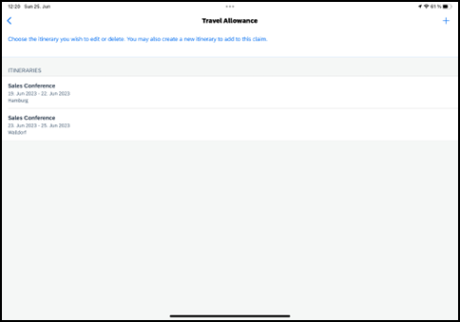 | To edit a fixed travel allowance on the Travel Allowance screen:  1) On home screen, tap Expense Reports.  2) On the Reports screen, tap the desired expense report.  3) On the Report screen, tap the Details tab.  4) On the Details tab, tap Travel Allowance Itineraries & Adjustments.  5) On the Travel Allowance screen, swipe the desired itinerary to the left.  NOTE: This screen will only appear if there is more than one itinerary attached to a report.
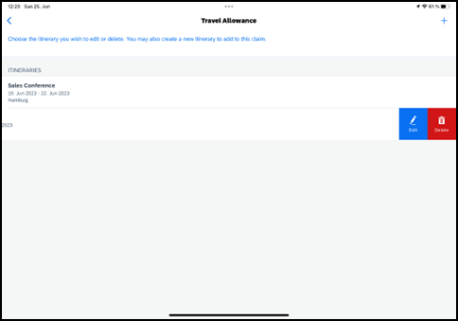 | 6) On the Edit Itinerary screen:  - Edit the fields  - Make the desired selections
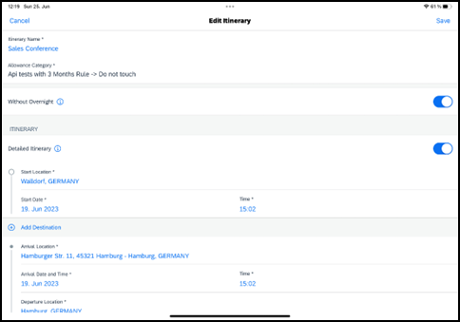 | 7) When done, tap Save (upper-right corner).  NOTE: Depending on which category is in the Allowance Category field, the user can adjust the itinerary details.

Resolve an Alert in a New Travel Allowance
Screen(s) | Description/Action
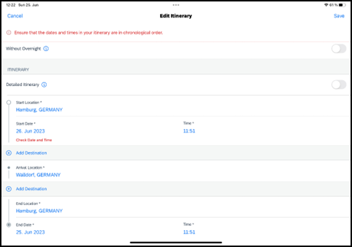 | To resolve an alert in a new fixed travel allowance:  1) On the New Travel Allowance screen:  - Fill in the fields and make the desired selections.  - Tap Save (upper-right corner).  After the system attempts to save the travel allowance, an alert appears at the top of the New Travel Allowance screen.  2) Scroll to the affected field.  NOTE: Additionally, a red alert text will appear next to the affected field giving you further instructions on how to resolve the issue.  3) Tap the desired field to correct.
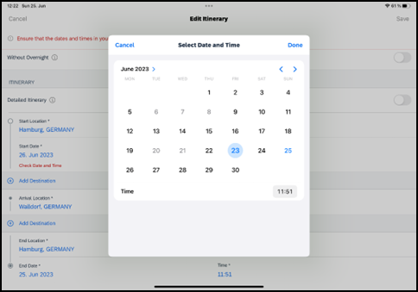 | 4) On the Select Date and Time screen, tap the desired date, select the desired time, and then tap Done (upper-right corner).
 | 5) When done, tap Save (upper-right corner).

Delete Travel Allowances

Delete a Travel Allowance From an Expense Report With multiple Itineraries
Screen(s) | Description/Action
To delete a fixed travel allowance from an expense report:
1) On the Report screen, tap the Details tab.
2) On the Details tab, tap Travel Allowance Itineraries & Adjustments.
3) On the Travel Allowance screen, in the Itineraries section, swipe the desired itinerary to the left.
 | 5) Tap Delete.
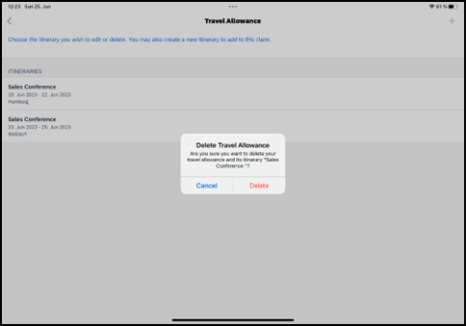 | 6) On the Delete Travel Allowance window, tap Delete.
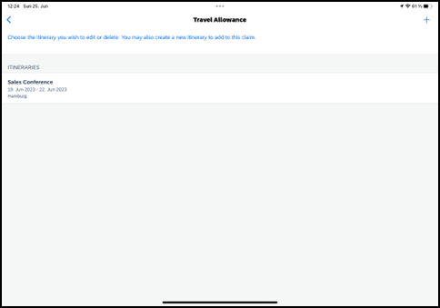 | The itinerary no longer appears in the Itineraries section of the Travel Allowance screen.

Delete a Travel Allowance From The Travel Allowance Screen
Screen(s) | Description/Action
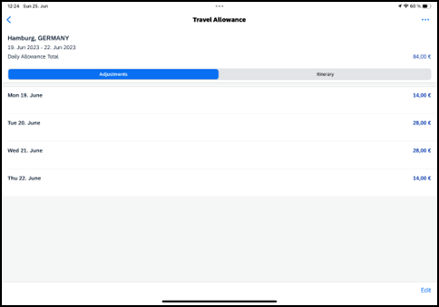 | To delete a fixed travel allowance from the Travel Allowance screen:  1) On the home screen, tap Expense Reports.  2) On Reports screen, tap the desired expense report.  3) On the Report screen, tap the Details tab.  4) On the Details tab, tap Travel Allowance Itineraries & Adjustments.  5) On the Travel Allowance screen, tap (upper-right corner).
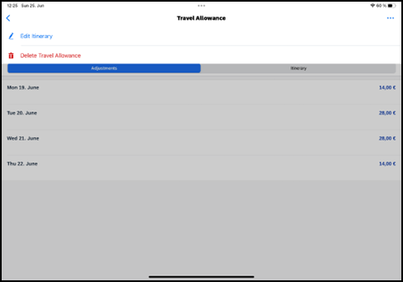 | 6) On the menu, tap Delete Travel Allowance.
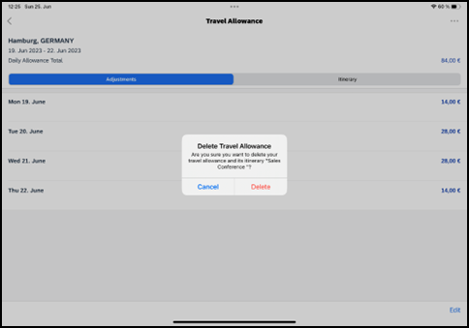 | 7) On the Delete Travel Allowance window, tap Delete.
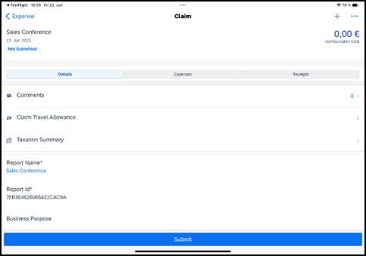 | On the Report screen all travel allowance expenses are gone and the button on the Details tab is called Claim Travel Allowance again.

Expense Approvals
Use Approvals on the home screen to view and approve expense reports (if you are a report approver or a cost objects approver).

Approve an Expense Report
Screen(s) | Description/Action
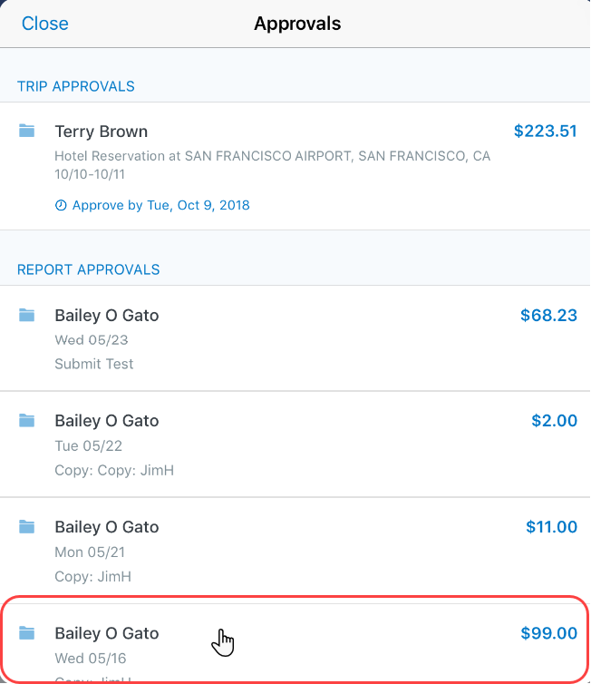 | To approve an expense report:  1) On the home screen, tap Approvals.  2) On the Approvals screen, tap to open the desired expense report.
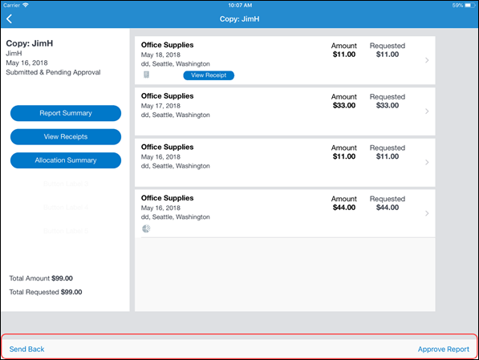 | 3) On the Report screen:  - Tap to view the report details (receipts, expenses, summary, etc.).  - Tap Approve Report or Send Back.  NOTE: If you tap Send Back, you must provide a comment.  NOTE: Depending on your configuration, you may be able to bypass any remaining approvers and send the expense report directly to Accounting Review. If so, when you select Approve, another menu appears.  Select one of these:  - Select Additional approver required to approve the report and send the report to the next approver in the workflow.  - Select Approve report to approve the report and send it directly to Accounting Review.

☼

