Mobile App User Guide  Concur Expense  Last Revised: March 27, 2024 |  | This guide describes the current version, which is shown on the "Introduction" guide. | Applies to these mobile devices:  No: iPhone  No: iPad  Yes: Android
IMPORTANT: Be aware that your company's configuration may not allow for all of the features described here. Generally, if a feature is not available in your configuration of the web version of SAP Concur, then it is not available in the mobile app.
Concur Expense simplifies creating expense reports. For example, creating expense reports is simplified when charges from credit cards, select suppliers, and receipt photos pre-populate in Concur Expense.  Concur Expense provides the following services:  - Automatically categorizes and maps expenses based on receipt.  - Streamlines expense management.  - Enforces policy compliance.  - Reimburses employees faster.  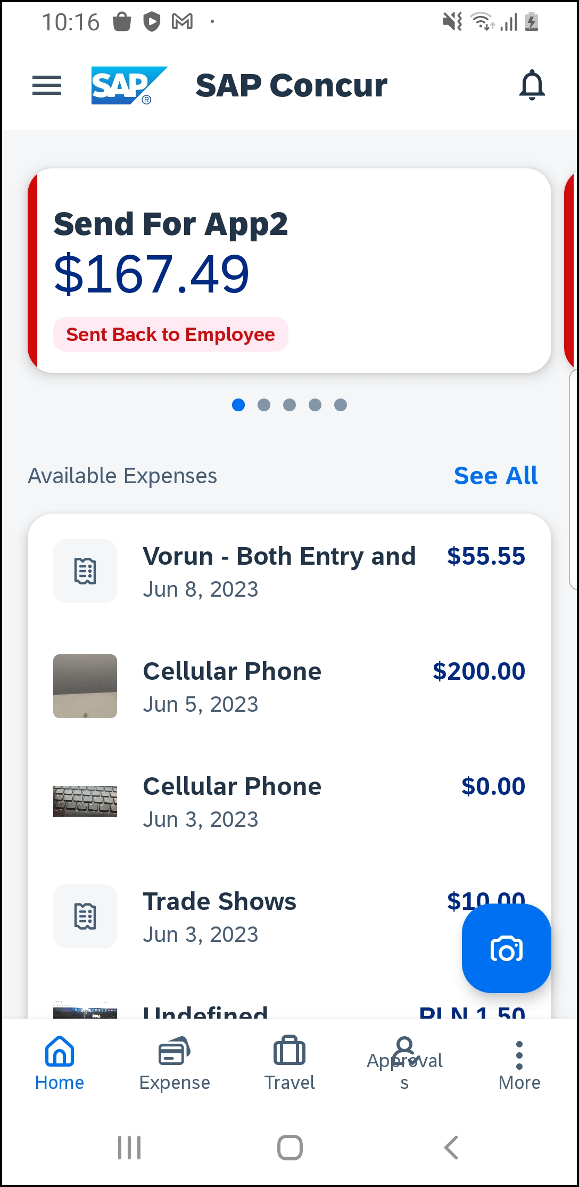 | Concur Expense 3  Expense List (Expenses Screen) 3  Expense Report Lists 4  Create a Mobile Expense 5  Add Receipt Functionality 6  Delete an Expense from the Expenses Screen 7  Using Delegate Function to Add and Delete Expenses 7  Using Delegate Function to Edit Expenses 10  Using Delegate Function to Move Expenses 12  Create a New Expense Report 14  Move Expenses from the Expenses Screen to an Expense Report 15  Manage Multiple Items on the Expenses Screen 16  Create an Expense Within an Open Expense Report 17  Edit an Expense on an Expense Report 19  Sort Expenses in an Expense Report 20  Filter Expenses in an Expense Report 21  Add a Car Mileage (or Km) Expense 23  Add a Car Mileage (or Km) Expense – Mileage Calculator 24  Make Adjustments 26  Reimbursement Rates 29  Add/Edit/Delete Itemizations 29  Add/Edit/Delete Attendees 31  View/Add/Edit/Delete Allocations 33  View Report-Level Allocations 33  View Expense-Level Allocations 34  View Itemization-Level Allocations 35  Add/Edit/Delete Expense-Level Allocations 36  Add Itemization-Level Allocations 38  Icon 39  Remove an Expense From an Expense Report 40  Edit Report Header Information 40  Submit an Expense Report 41  Submit an Expense Report With the Approval Flow Screen 42  Recall an Expense Report 45  Delete an Expense Report 46  Copy an Unsubmitted Expense Report 46  Access the Taxation Summary Screen 47  Work with Fixed Travel Allowances with Fiori UI 49  Fixed vs Reimbursable Travel Allowances 49  Restrictions 49  Create and Edit Fixed Travel Allowances 50  Edit a Fixed Travel Allowance Itinerary 62  Resolve an Alert in a New Travel Allowance 63  Delete Travel Allowances 64  Expense Approvals 69  Approve an Expense Report 69  Send Back an Expense Report 70  Review and Approve an Expense Report as a Cost Object Approver 70  Review and Approve an Expense Report with a Travel Allowance 71
Please Note:
- The SAP Concur app for iOS and Android supports universal links, i.e. links that navigate directly to the app if it is installed or to the website if not.
- Such links are included in notification emails from SAP Concur related to the expense report changes.
- Universal link support for customers own use is currently not supported.
- Some security solutions may block the links embedded into email from opening the app directly. The proper exceptions for the security policy should be configured for SAP Concur universal link URLs (pattern to match: https://*.concursolutions.com/*). Known cases are:
- MDM/MAM policy that prescribes to open any link tapped in Outlook mobile app only in specified browser.
- Outlook mail server phishing protection that wraps all link embedded into e-mails to open the safety check service first.

Concur Expense

Expense List (Expenses Screen)
Screen(s) | Description/Action
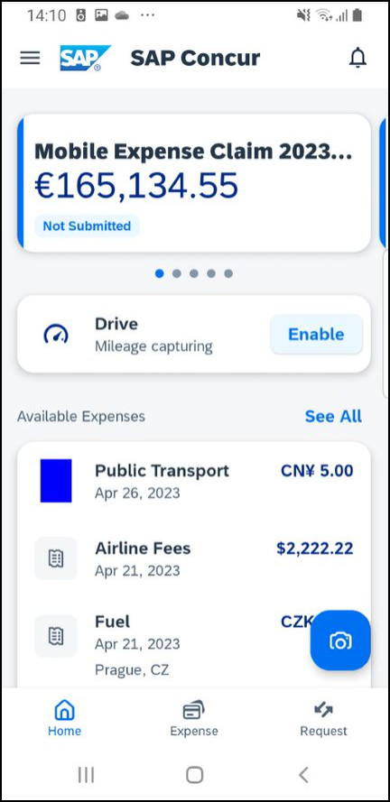 | On the home screen, tap Expense to access your list of expenses. Use the Expense screen to:  - Add, view, edit, and delete mobile expenses. Mobile expenses are designed to be quick and easy.  - To make more extensive features like itemizations and attendees, either:  - Add the mobile expense to an expense report and then edit.  - Create the expense on an open expense report and then edit.  - For car mileage/kilometers expenses, tap Expenses on the home screen. An option will appear Create a Mileage Expense.  - View and make minimal edits to card transactions, which appear with the icon.  - To make more extensive edits, add the card transaction to an expense report then edit.  - To delete a card transaction, use the web version of Expense, if your company allows you to delete card transactions.  - View e-receipts, which can be edited once attached to a report.  - Attach expenses – mobile expenses, e-receipts, and card transactions – to a new or existing expense report.

Expense Report Lists
Screen(s) | Description/Action
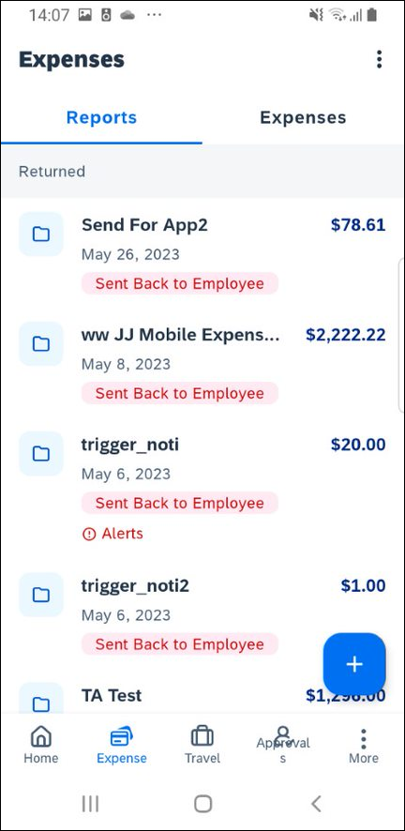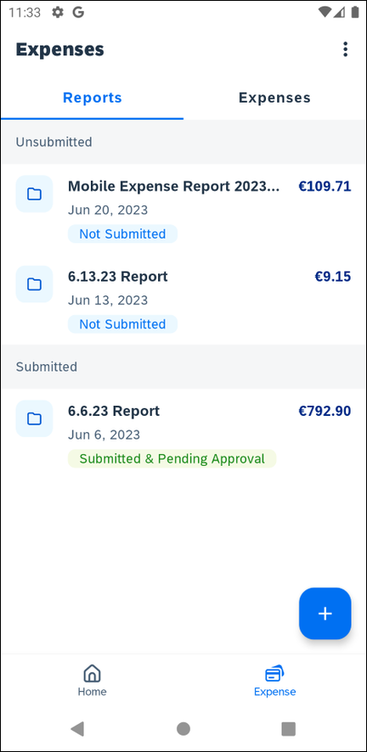 | On the home screen, tap Expense to access the list of expenses and toggle to Reports. On the Reports screen, you can view up to 100 expense reports in each of the Reports main screen or History tabs. On the Reports screen, you can:  - View unsubmitted, submitted, and returned reports  - Create a new report  - Copy reports  - Delete unsubmitted reports  - View red Alert and yellow Warning signs on reports flagged for exceptions  - View the name, status, date and amount of each report  NOTE: All active reports are separated into Unsubmitted, Submitted, and Other sections. Within each category, the reports are sorted by report date.
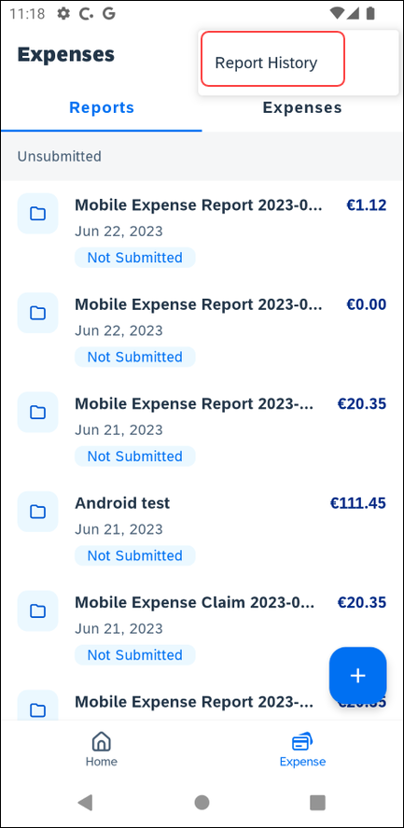 | You can open an existing expense report and:  - View and edit the report summary (report header)  - View and attach receipt images  - View, add, import, match, edit (add attendees and itemizations), and remove expenses  - Submit your report  To access the Reports History tab, tap the icon at the top right hand corner:  - View reports that have been approved and sent for payment  - View red Alert and yellow Warning signs on reports flagged for exceptions  - Copy reports

Create a Mobile Expense
Screen(s) | Description/Action
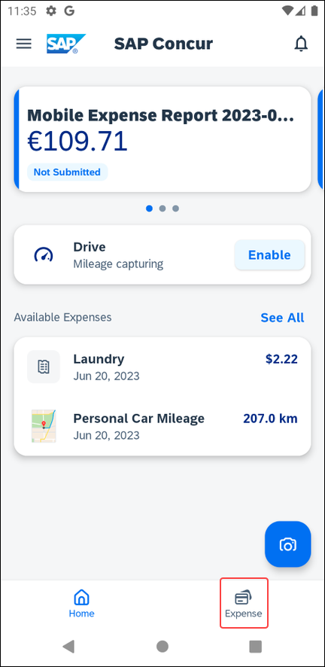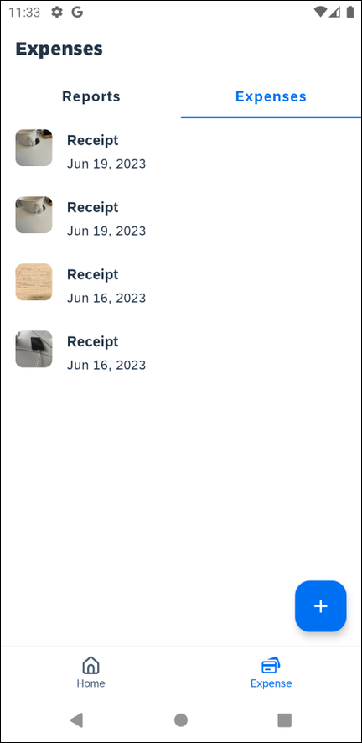 | To create a mobile expense:  - On the home screen, tap  Expense.  - On the Expenses screen, toggle to Expenses and tap the icon.
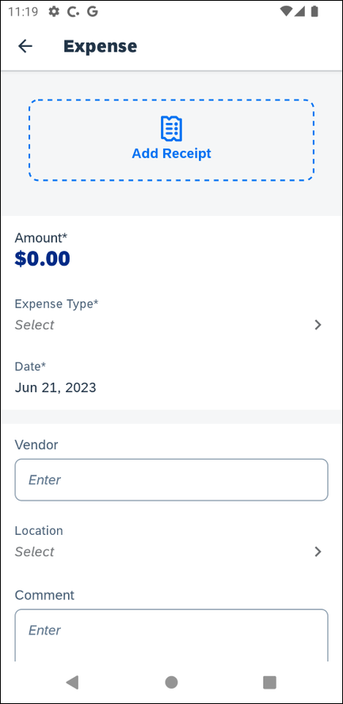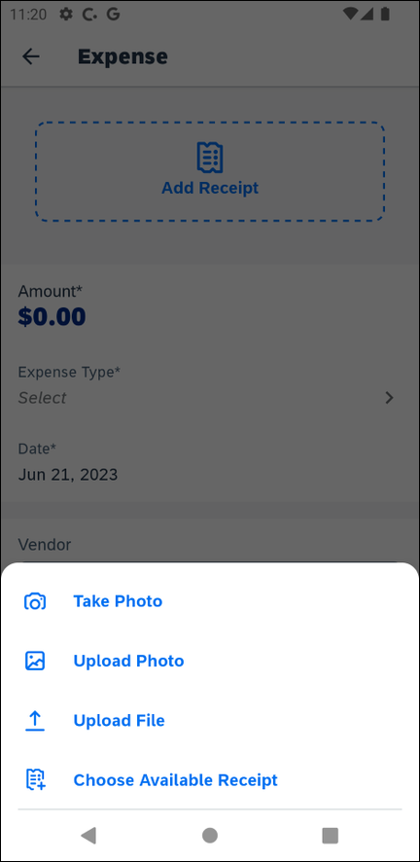 | 1) On the Expense screen, fill in the fields and make the desired selections.  2) Tap Add Receipt to take a picture of the receipt, if required.  3) Tap Save (upper-right corner) to save.  NOTE: You cannot create a Japan Public Transportation expense outside of an expense report.

Add Receipt Functionality
Screen(s) | Description/Action
To create a mobile expense:
- On the home screen, tap
Expense.
- On the Expenses screen, toggle to Expenses and tap the icon.
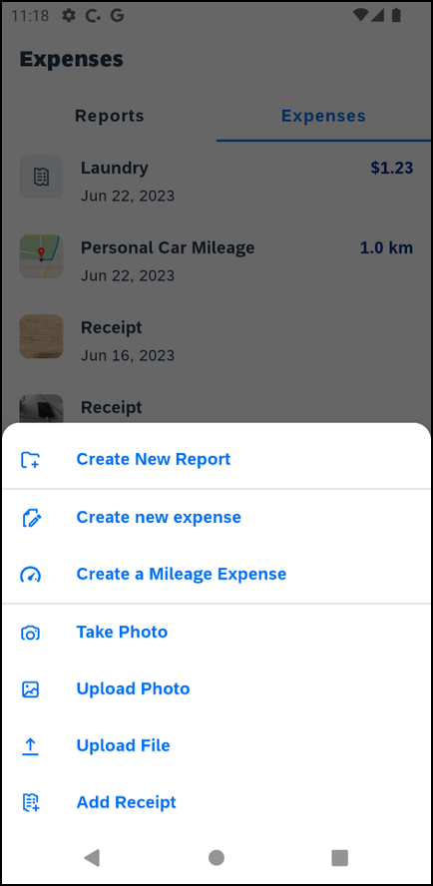 | Tapping the plus icon, displays the types of expenses.  Tapping Add Receipt displays the following:  - Take Photo opens the camera to take a photo of a receipt directly.  - Upload Pholo opens the photo gallery on your device to upload a photo of a saved receipt.  - Upload File allows you to select a file on the mobile device.

Delete an Expense from the Expenses Screen
Screen(s) | Description/Action
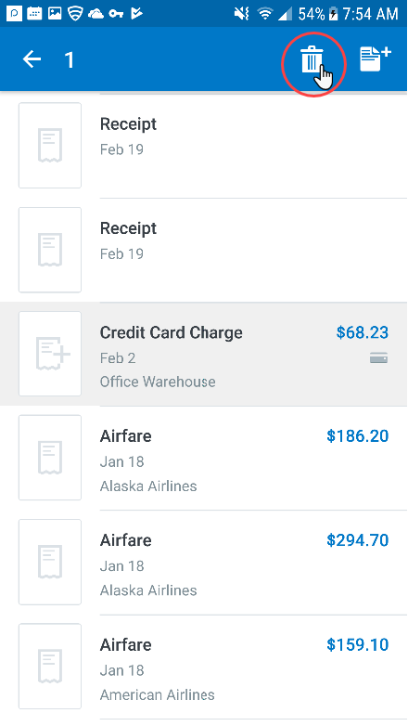 | To delete a mobile expense from the Expenses screen, you can:  - Long press the desired expense  -or-  - Swipe the desired expense to the left  NOTE: You can also delete a mobile expense in the web version of SAP Concur.  To delete a mobile expense by long pressing the desired expense:  1) On the Expenses screen, long press the desired expense (or multiple expenses). The icon appears.  2) Tap to delete the expense.  NOTE: To delete a card transaction, use the web version of Expense - if your company allows you to delete card transactions.
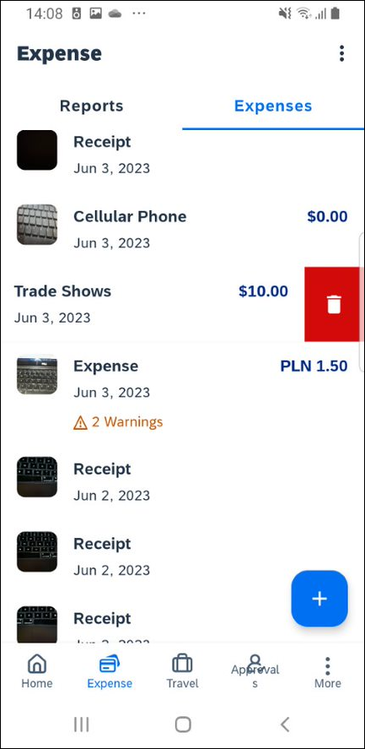 | To delete a mobile expense by swiping the desired expense to the left:  1) On the Expenses screen, swipe the desired expense (or multiple expenses) to the left.  2) Tap Delete.  NOTE: To delete a card transaction, use the web version of Expense - if your company allows you to delete card transactions.

Using Delegate Function to Add and Delete Expenses
GRDC users with ExpenseIt, can still act on behalf of another user in ExpenseIt, but will not be able to create, edit or delete manual expenses.

Screen(s) | Description/Action
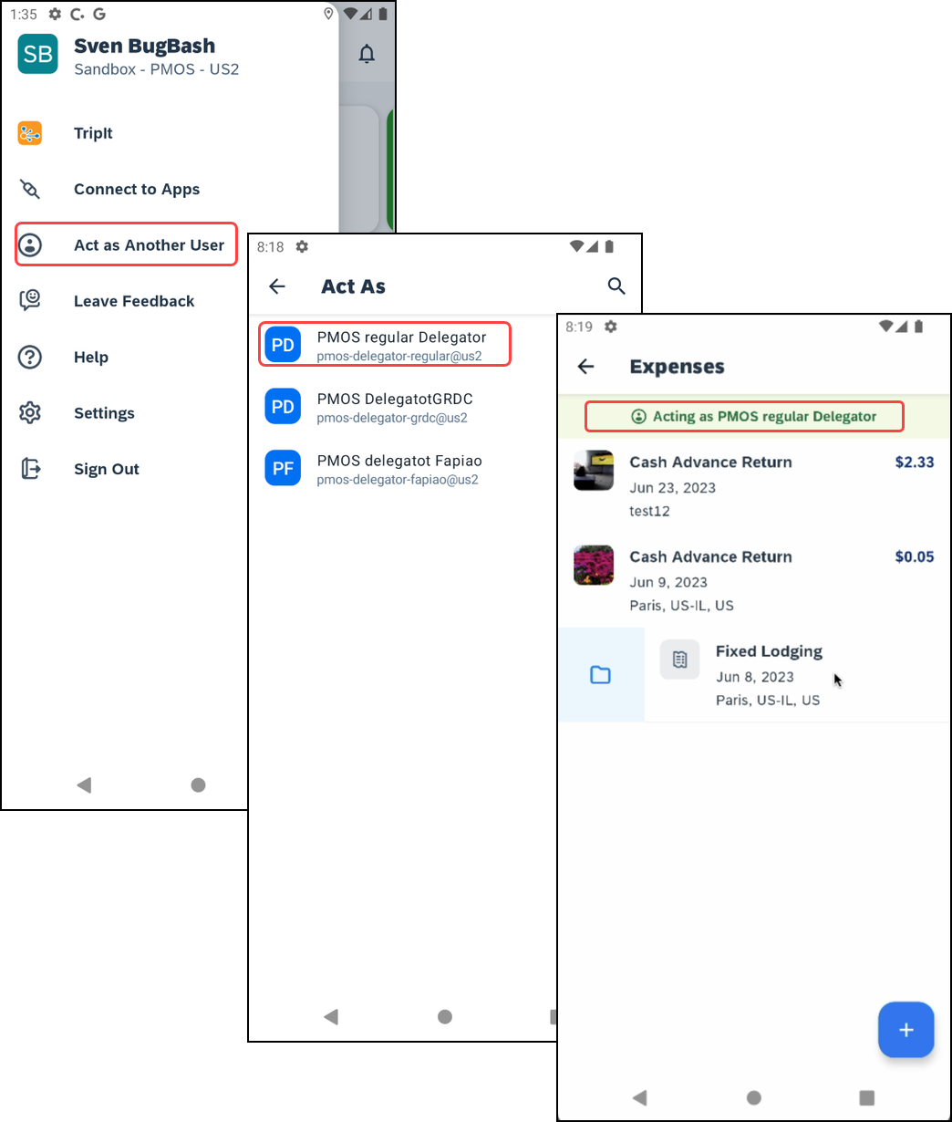 | To Create an Expense While Using the Delegate Function:  1) Tap the Menu button and then tap Act as Another User. Once the user you wish to act on behalf of is selected, it will be indicated by a green banner. You will also be directed to the Expenses Screen.
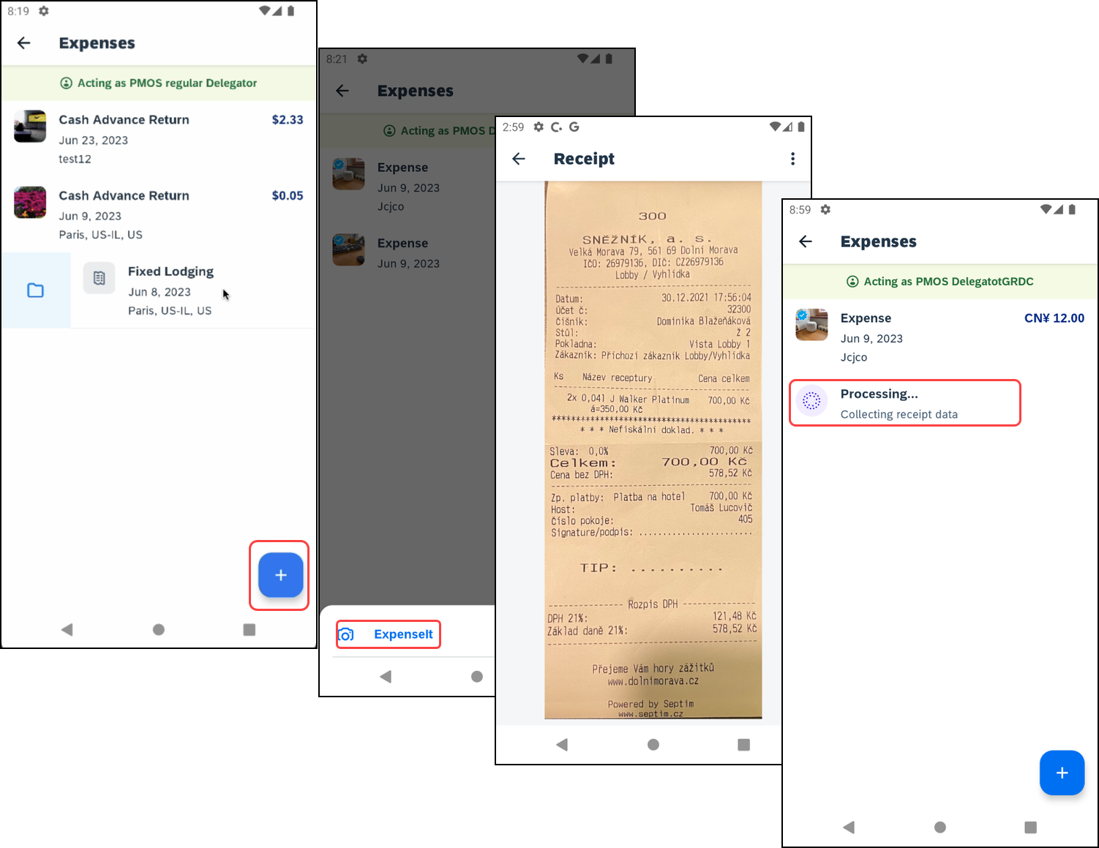 | 2) Tap the Add button and the ExpenseIt option will appear. Tap this option and you will be able to select the receipt to be added as an expense. Once selected, you will be redirected to the Receipt to confirm it. It will then appear in your Expenses List.
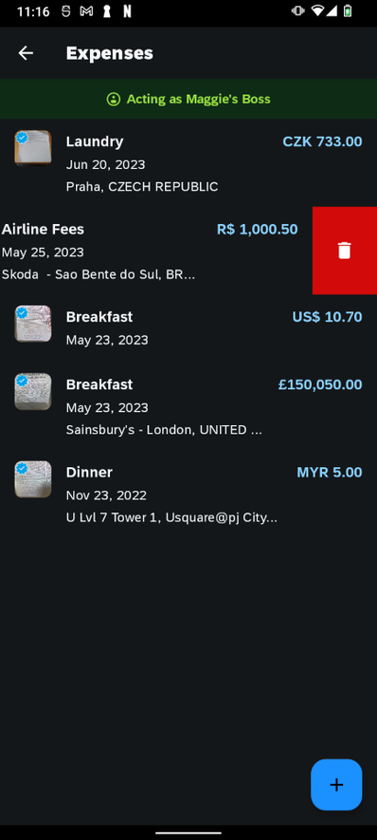 | 3) To Delete an Expense, swipe on the Expense you want to Delete from the list. Tap the Trash Can icon to delete.

Using Delegate Function to Edit Expenses
Screen(s) | Description/Action
To Edit an Expense While Using the Delegate Function:
1) Tap the Menu button and then tap Act as Another User. Once the user you wish to act on behalf of is selected, it will be indicated by a green banner. You will also be directed to the Expenses Screen.
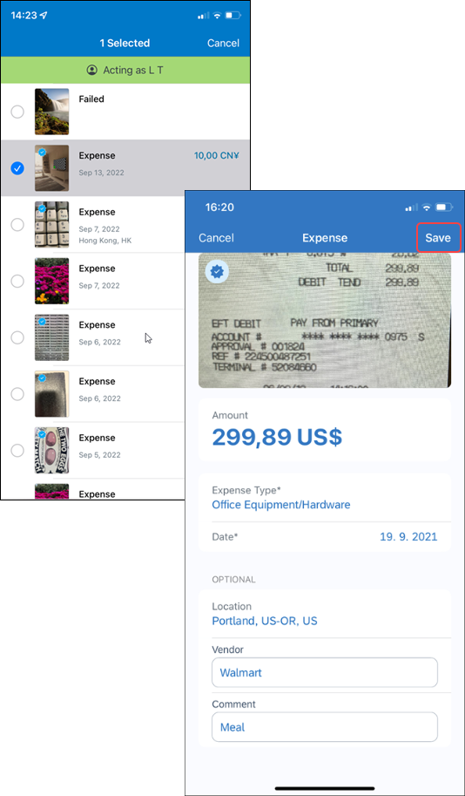 | 2) Once on the Expenses page, select the Expense that needs to be edited and this will direct you to the details of this expense. Tap on the areas that need to be edited. Once the edits are made, tap Usefor the edits to be reflected.

Using Delegate Function to Move Expenses
Screen(s) | Description/Action
To Edit an Expense While Using the Delegate Function:
1) Tap the Menu button and then tap Act as Another User. Once the user you wish to act on behalf of is selected, it will be indicated by a green banner. You will also be directed to the Expenses Screen.
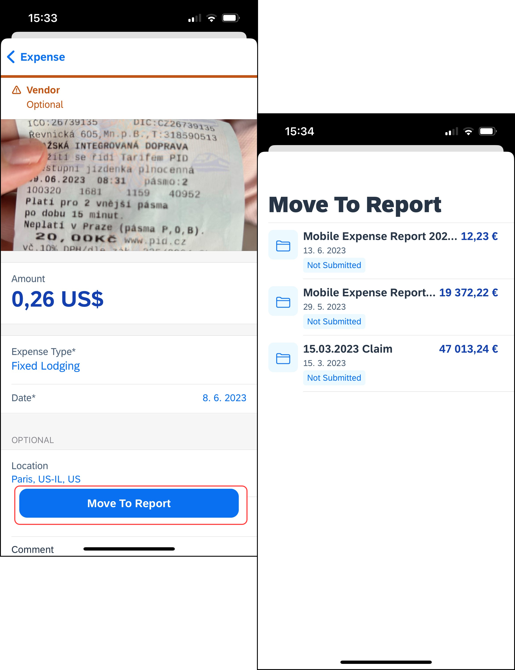 | 2) Once on the Expenses page, select the Expense that needs to be moved and then select Move To Report.  NOTE: Delegates can view and move eReceipts but cannot edit them.

Create a New Expense Report
You can create a new report:
- From the Reports screen (shown here)
- While adding expenses from the Expenses tab (described on the following pages)
- While creating a car mileage expense (described on the following pages)
Screen(s) | Description/Action
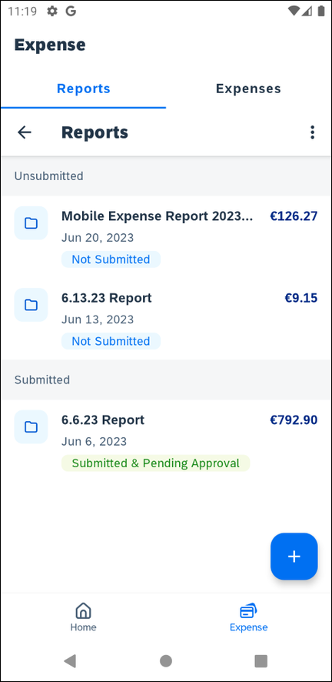 | You can create a new report:  - From the home screen tap Expense,you will be redirected to the Expense page. From there, you can toggle to Reports.  - While adding expenses from the Expenses screen (described on the following pages)  To create a new report:  1) On the home screen, tap Expense. On the Expense screen, tap Reports.  2) On the Reports screen, tap and select Create New Report.
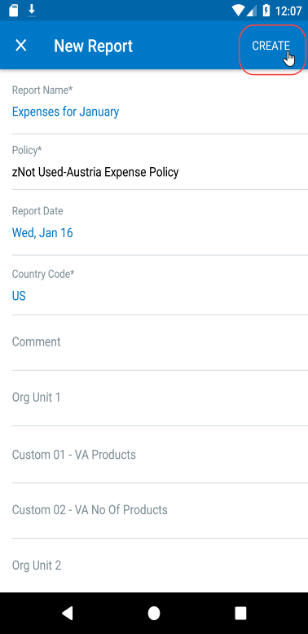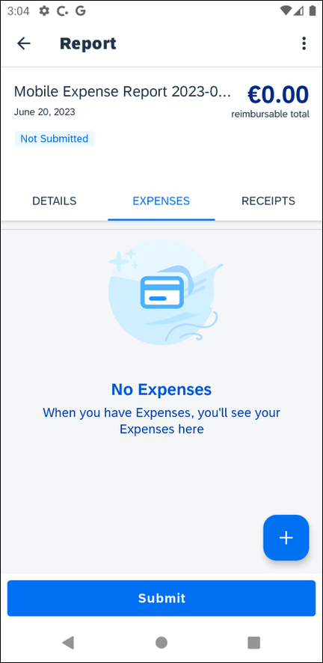 | 3) On the New Report screen:  - SAP Concur provides a report name.  - Change it if desired.  - Fill in the fields and make the desired selections.  - Tap Create.  4) On the report screen, enter your expenses, attach receipts, etc. (described on the following pages).

Move Expenses from the Expenses Screen to an Expense Report
Screen(s) | Description/Action
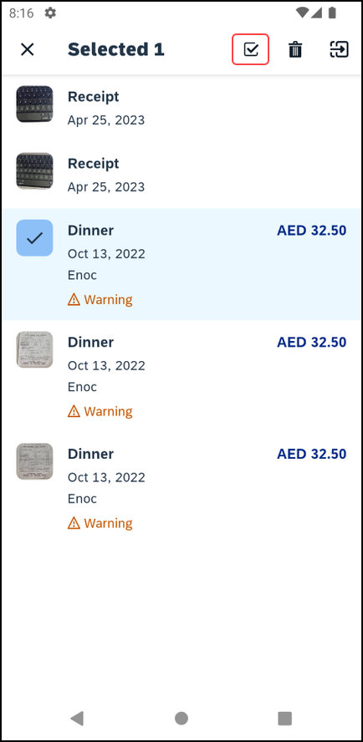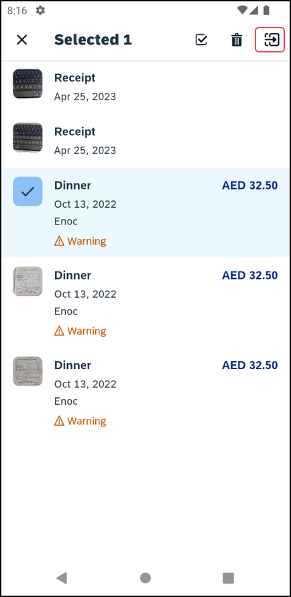 | To move expenses to a new expense report or an existing expense report, you can:  - Long press the desired expense  -or-  - Swipe the desired expense to the left  To move an expense by long pressing:  1) On the Expenses screen, long press the desired expense, or multiple expenses.  2) Tap (upper-right corner) to add an expense to an expense report.  3) On the Move to… screen, tap the desired expense report.  - or -  Tap to manually create a new expense report.
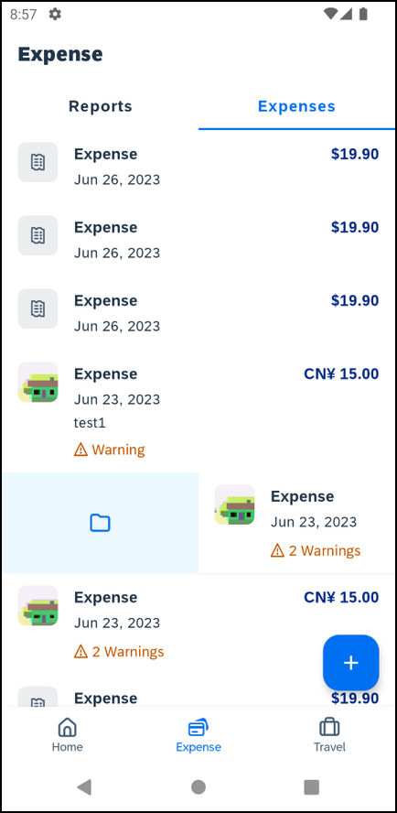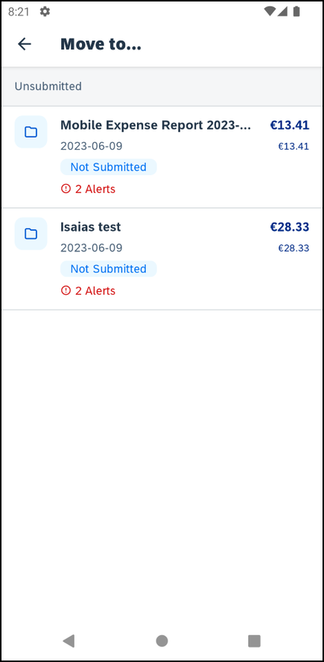 | To move an expense by swiping:  1) On the Expenses screen, swipe the desired expense to the left.  2) Tap the folder icon.  3) On the Move to… screen, tap the desired expense report.
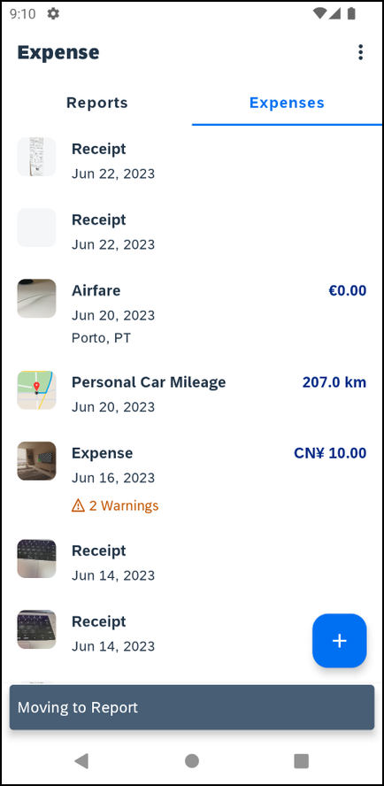 | 4) An alert will appear at the bottom of the screen Moving to Report and you will be redirected to the Expenses screen.  - or -  Tap to manually create a new expense report.

Manage Multiple Items on the Expenses Screen
You can delete multiple expenses or move them to an expense report on the Expenses screen.
Screen(s) | Description/Action
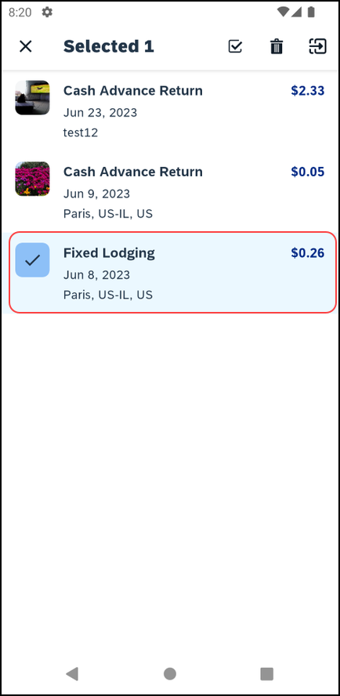 | To manage multiple expenses or move them to an expense report:  1) On the Expenses screen, long press a desired item to activate multi-selection mode.  2) To add additional items to the selection, single-tap them.  3) To remove items from the selection, single-tap them.  NOTE: You can select all expenses by tapping and then tapping Select All.
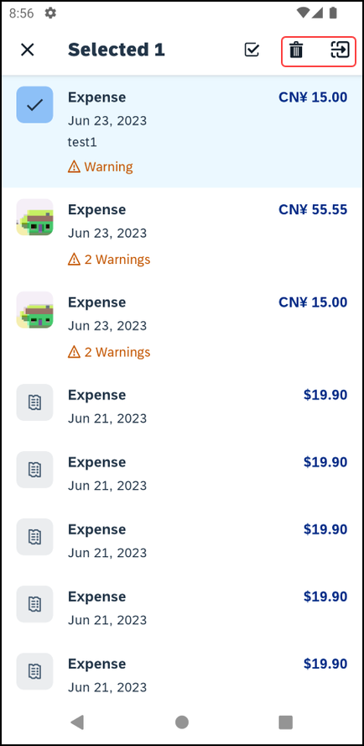 | 4) After selecting the desired items, you can:  - Tap to delete the selected itemes.  - Tap to add the selected items to a report.

Create an Expense Within an Open Expense Report
Screen(s) | Description/Action
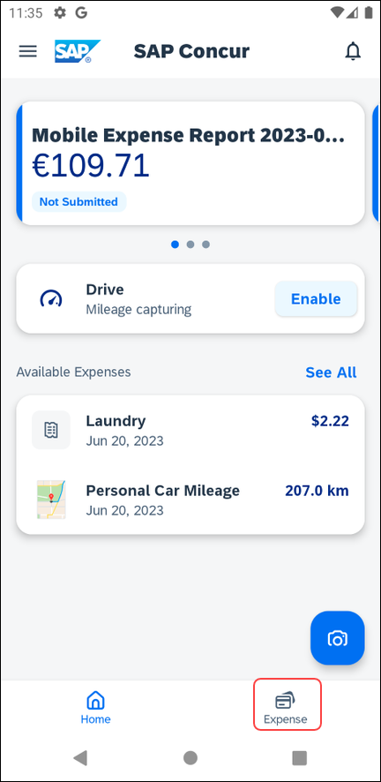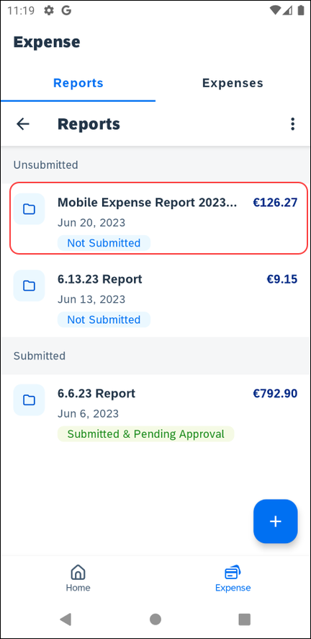 | To create an expense within an open expense report:  1) On the home screen, tap Expense.  2) On the Expense screen, toggle to Reports and open the desired report.
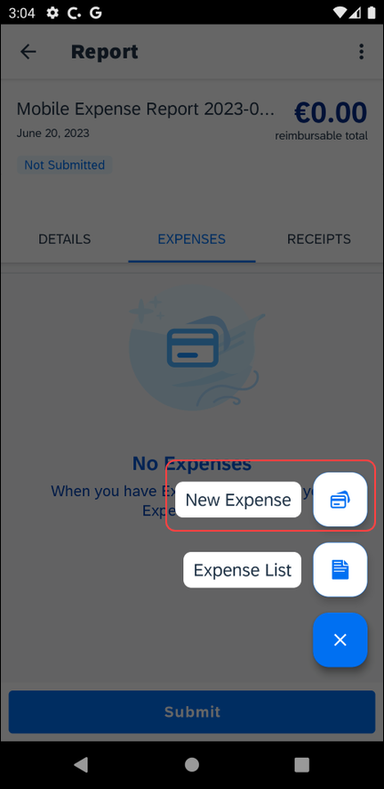 | 3) On the report screen, tap the Expenses tab.  4) On the Expenses tab, tap to create a new expense.  5) On the next screen, tap New Expense.
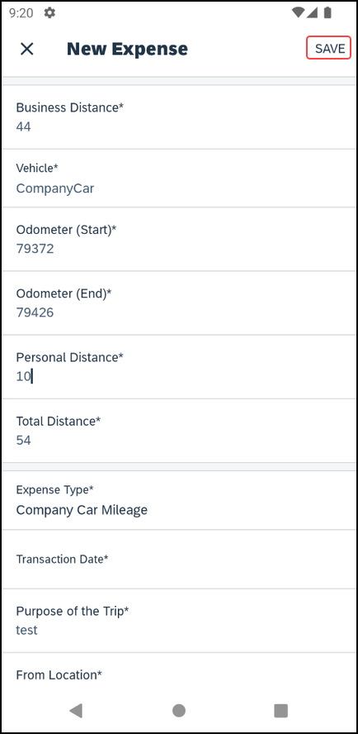 | 6) On the New Expense screen:  - Choose the desired expense type.  - Fill in the fields and make the desired selections.  - Tap Save (upper-right corner).  NOTE: The new report entry experience will not appear, if:  - You add the Personal Car Mileage, Company Car Mileage, or the Japan Public Transport expense types.  - You open expenses created via itineraries.  - You are geographically located in China.  - You are under a restrictive Mobile Device Management (MDM) or Virtual Private Network (VPN).

Edit an Expense on an Expense Report
If an expense is attached to an unsubmitted expense report, you can edit almost every field.
Screen(s) | Description/Action
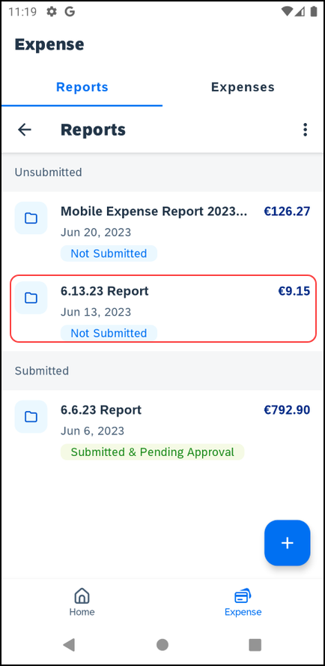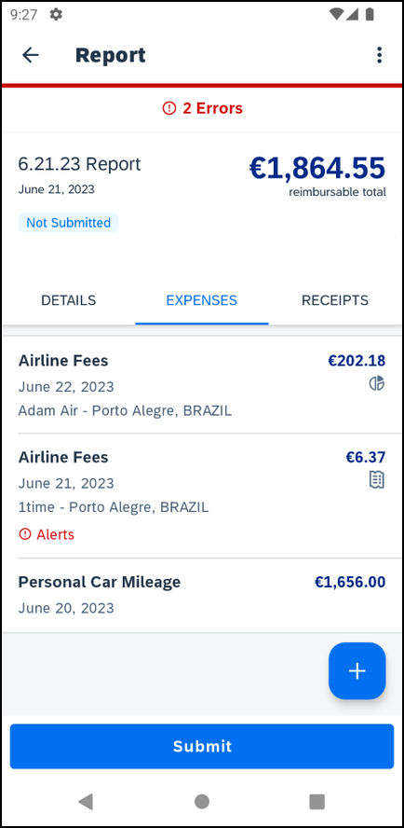 | To edit an expense in an expense report:  1) On the Reports screen, tap to open the desired report.  2) On the report screen, tap the Expenses tab.
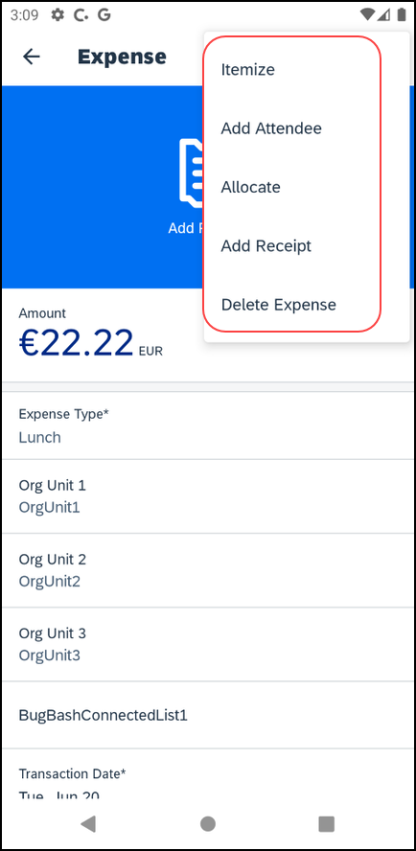 | 3) On the Expenses tab, tap to open the desired expense.  4) On the Expense screen:  - Make the desired changes.  - Tap (upper-right corner), to view the more options menu.  - On the menu, you can tap on the following options:  - Itemize  - Add Attendee  - Allocate  - Add Receipt  - Delete Expense
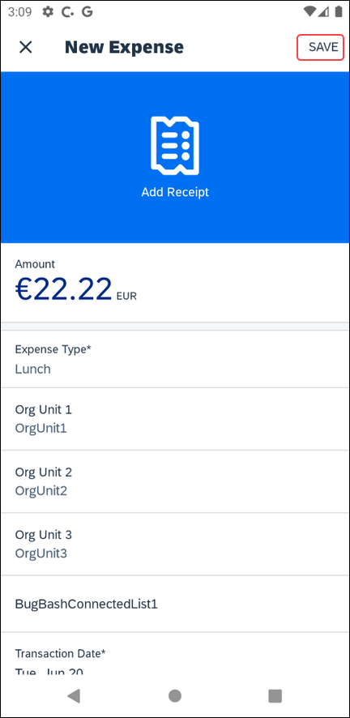 | - Tap Save (upper-right corner) to save.

Sort Expenses in an Expense Report
Screen(s) | Description/Action
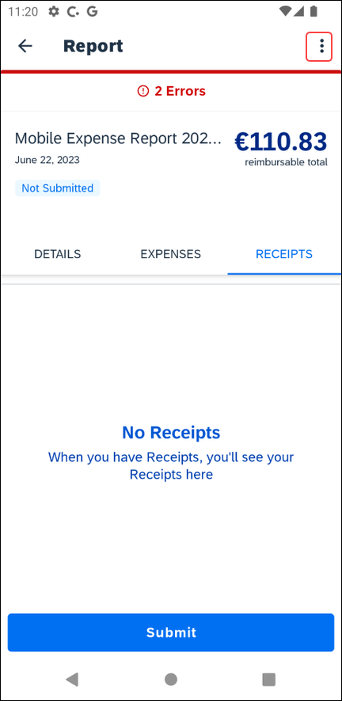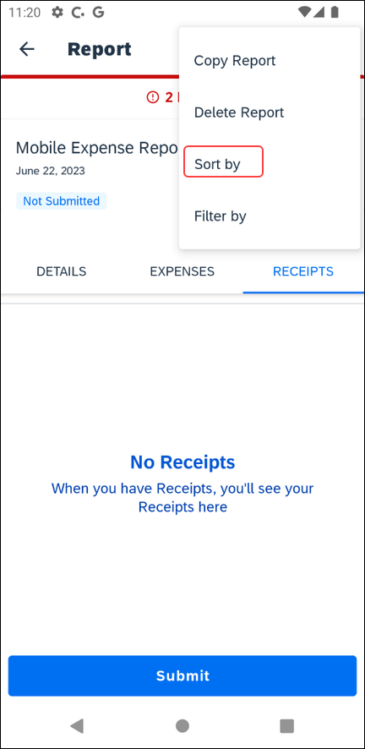 | To sort expenses in an expense report:  1) With the report, tap (right-upper corner).  2) On the menu, tap Sort by.
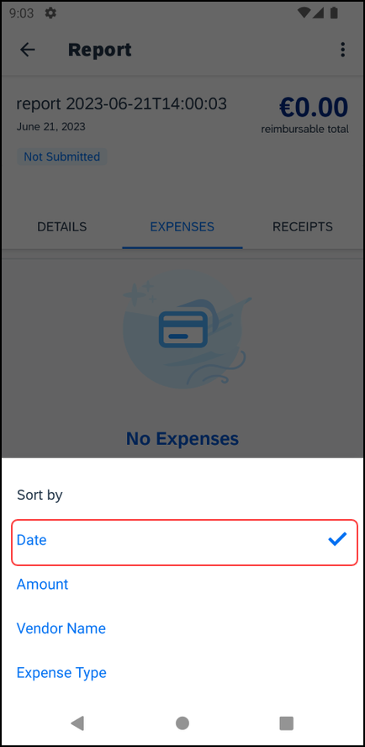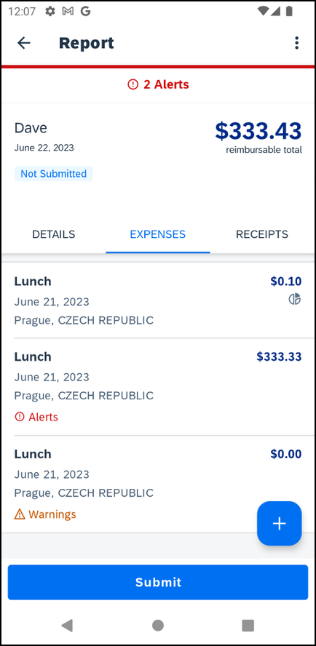 | 3) On the next menu, tap the desired category to sort the expenses by (in this example, the expenses are sorted by date).  The expenses - now sorted by date – appear on the Expense tab on the expense report screen.

Filter Expenses in an Expense Report
Screen(s) | Description/Action
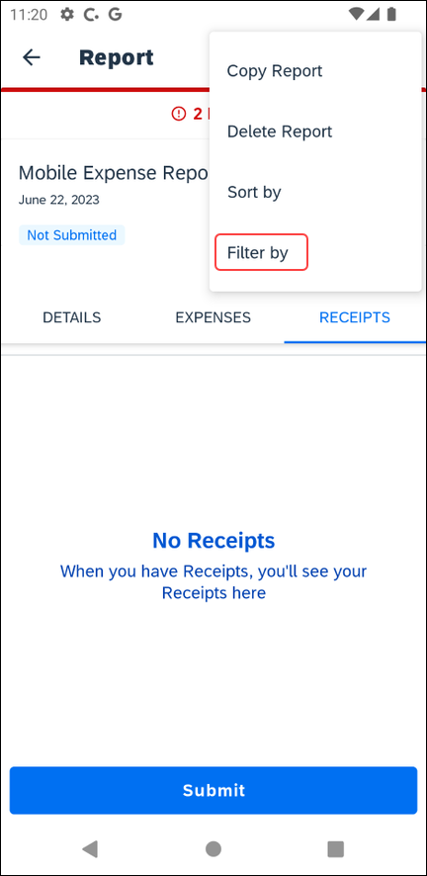 | To filter expenses in an expense report:  1) With the report, tap (right-upper corner).  2) On the menu, tap Filter by.
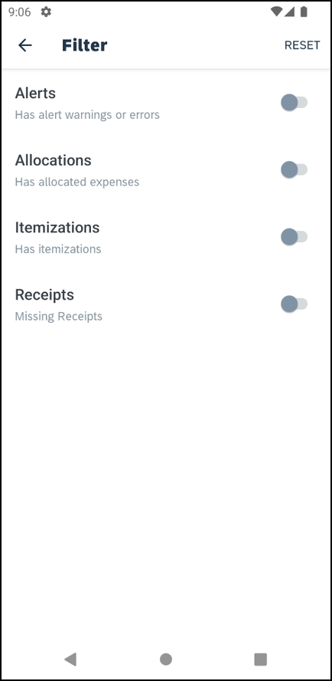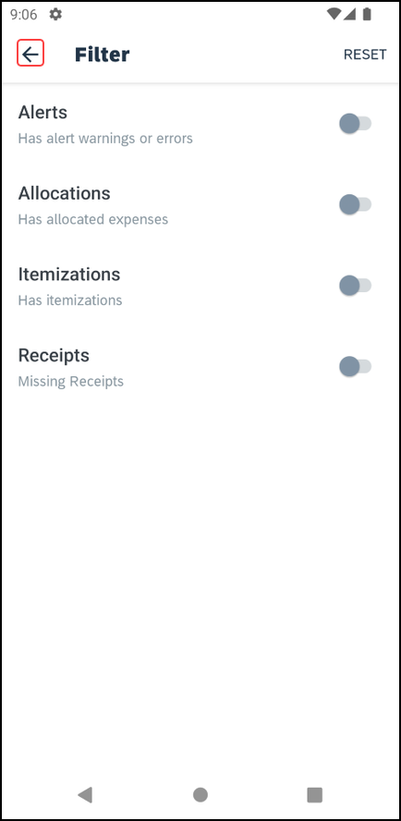 | 3) On the Filter screen, you can choose to filter the expenses by enabling the following categories:  - Alerts  - Allocations  - Itemizations or  - Receipts  Swipe the desired filter toggle to the right to enable it (in this example, the Receipts filter is enabled).  4) On the Filter screen, tap (upper-left corner) to return to the expense report screen.  NOTE: You can tap Reset (upper -right corner), to disable all the filters.
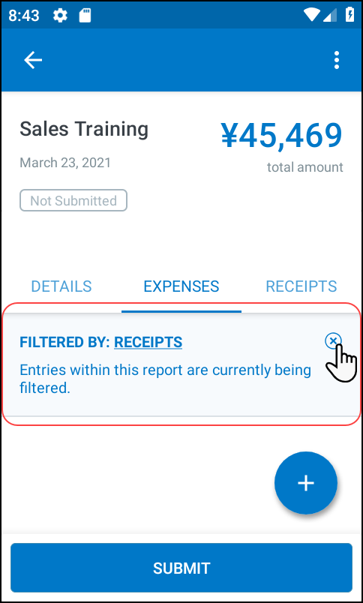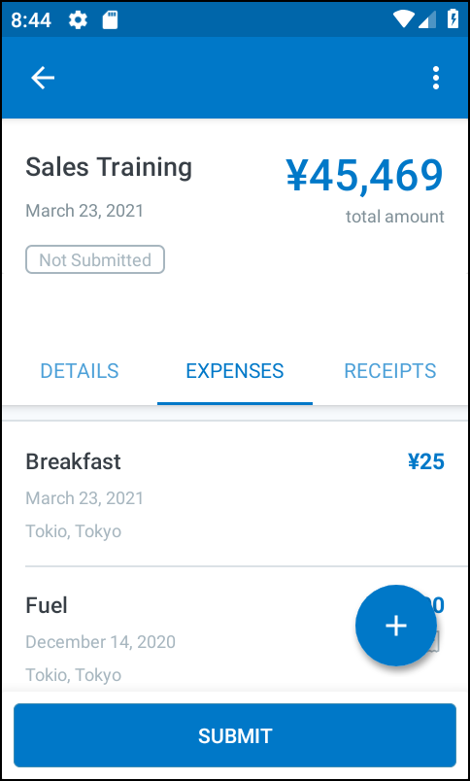 | A message appears on the Expenses tab, indicating that the expenses list is now sorted by the previously enabled category.  5) On the expense report screen, tap to view the expenses list on the Expenses tab on the expense report screen.  The expenses - filtered by receipts - appear on the Expenses tab on the expense report screen.

Add a Car Mileage (or Km) Expense
Screen(s) | Description/Action
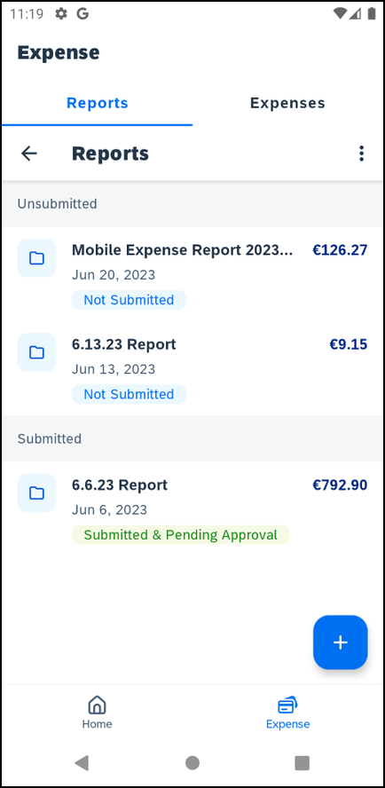 | To add a car mileage (or kilometer) expense:  1) On the home screen, tap Expense. Once on the Expense screen, toggle to Reports.  2) On the Reports screen either select  - Tap to Create New Report. Then, complete the steps to create the new report.  – or –  - Add to an existing report by tapping the report.
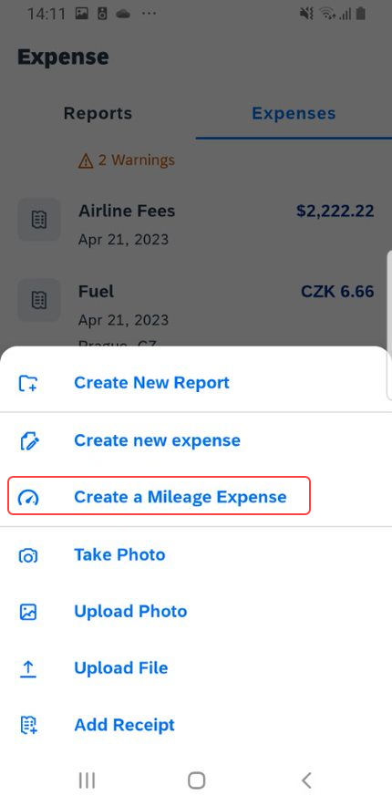 | 3) On the Expenses screen, tap and then select Create a Mileage Expense. Then:  - Fill in the fields and make the desired selections.  NOTE: SAP Concur calculates the amount based on the distance and the company's mileage rate.

Add a Car Mileage (or Km) Expense – Mileage Calculator
The Mileage Calculator can be used for both personal and company car mileage. The example below shows personal mileage, using the Drive on the home screen. For company car mileage, the user creates an expense as usual and selects the Company Car Mileage (or something similar) expense type. After that, both types work the same way – as shown below.
Screen(s) | Description/Action
1) On the home screen, tap Expense. Once on the Expense screen, toggle to Reports.
2) On the Reports screen either select
- Tap to Create New Report. Then, complete the steps to create the new report.
– or –
- Add to an existing report by tapping the report.
3) On the Mileage Expense screen, tap Distance Calculator.
4) On the Distance Calculator screen, in the Start Location field, start typing the initial location.
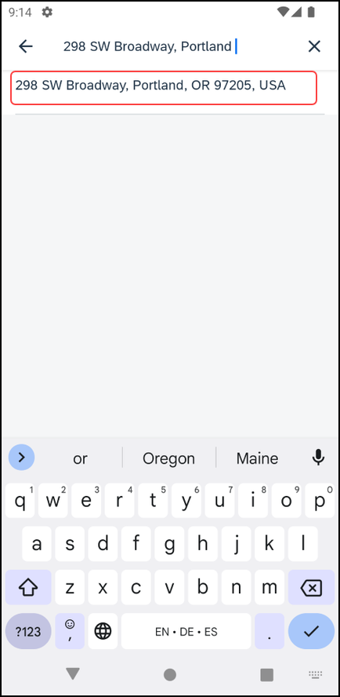 | 5) Select from the list of locations. The selected location appears on the map.
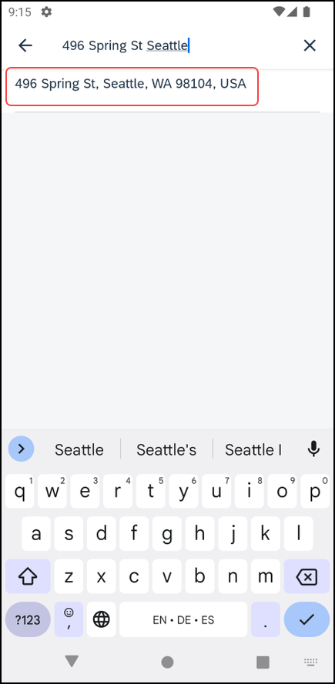 | 6) On the Distance Calculator screen, in the Add Destination field, start typing the ending location.  7) Select from the list of locations. The selected location appears on the map along with the mileage (lower-right corner).
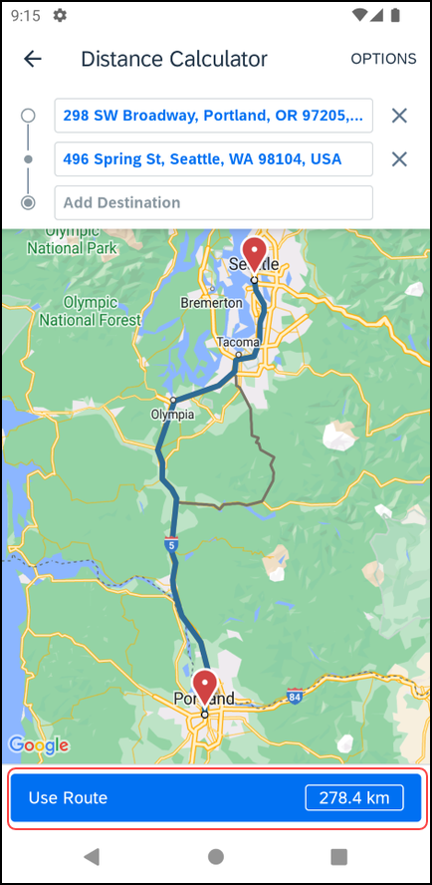 | 8) On the Distance Calculator screen, you have several additional options:  - Tap Add Destination to add another destination.  - Tap Options (upper-right corner) to choose to avoid tolls or highways.  - If an alternate route is available (shown as a gray line), you can select that route.  9) When done, tap Use Route. The mileage and the reimbursement amount appear on the Mileage Expense screen.

Make Adjustments
Screen(s) | Description/Action
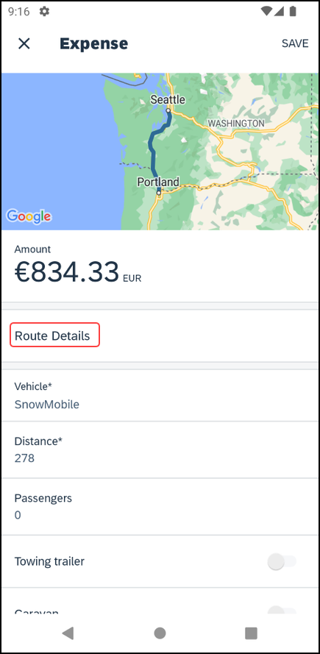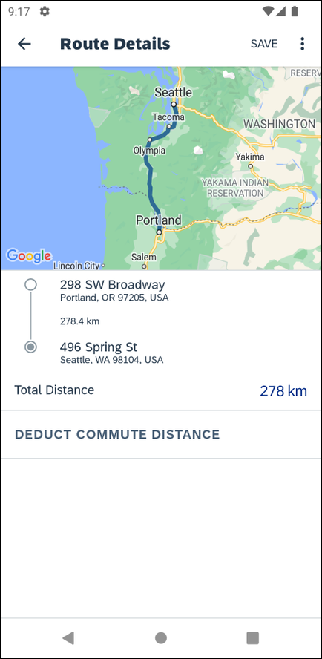 | To make additional adjustments:  1)On the Expense screen, tap Route Details.  2) On the Route Details screen, tap (upper-right corner) to access the menu. Using the menu, you can:  - Edit any portion of the trip  – or –  - Designate part of the trip as personal
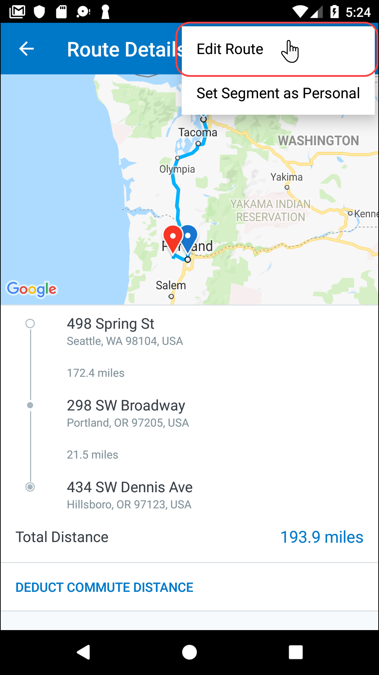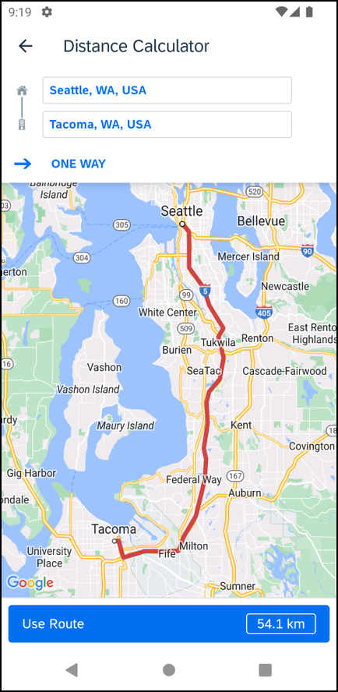 | To edit a route:  1) On the menu of the Route Details screen, tap (upper-right corner).  2) Tap Edit Route.  3) On the Distance Calculator screen, make the desired changes, using the same steps as when you created the route.
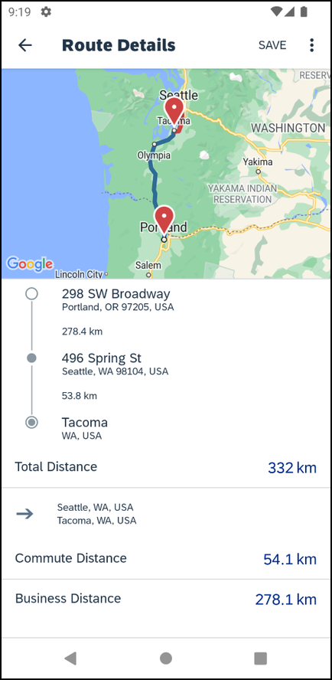 | To designate part of the trip as personal:  1) On the menu of the Route Details screen, tap (upper-right corner).  2) Tap Set Segment as Personal.  3) On the Set Personal screen, select the segment that is personal and then tap (upper-right corner).  4) On the Route Details screen, the personal and business distance amounts appear at the bottom of the screen.
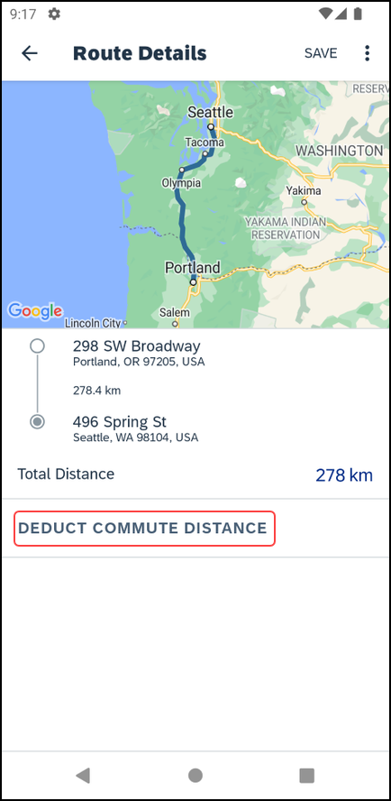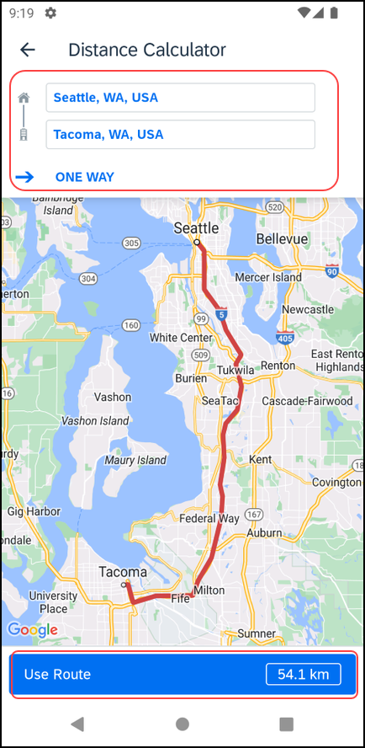 | To deduct commute mileage:  1) On the Route Details screen, tap Deduct Commute Distance.  2) On the Distance Calculator screen, define the starting and ending points using the map.  3) Select whether the commute is one way or round trip.  4) When done, tap Use Route. The Route Details screen appears.
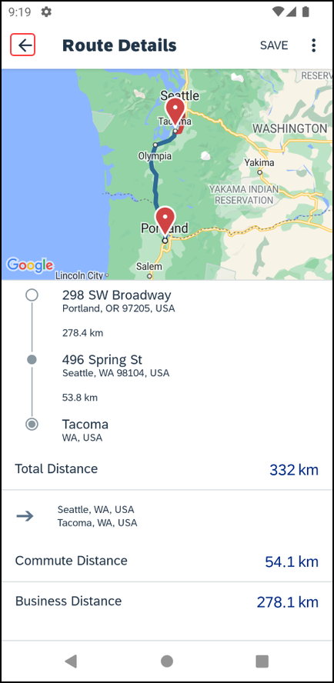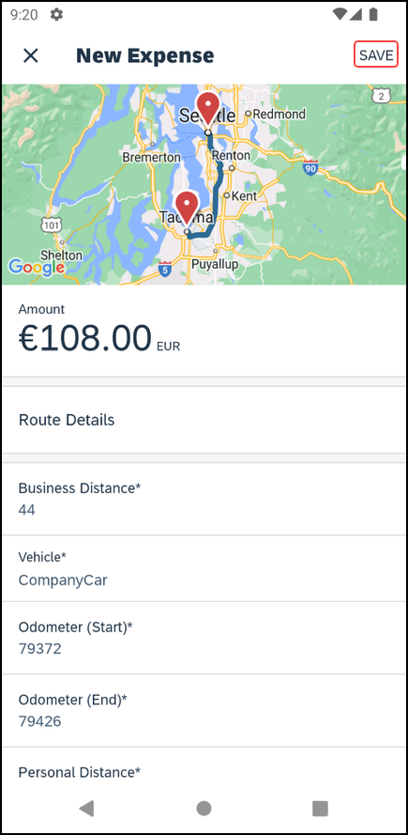 | 5) On the Route Details screen, tap (upper-left corner) to return to the Mileage Expense screen, where the adjusted distance and amount appear.  6) Tap Save (upper-right corner). The expense is saved to the expense report.

Reimbursement Rates
Screen(s) | Description/Action
To add reimbursement rates:
1)On the Expense screen, tap Route Details.
2) On the Route Details screen, tap (upper-right corner) to access the menu. Using the menu, you can:
- Edit any portion of the trip
– or –
- Designate part of the trip as personal

Add/Edit/Delete Itemizations
After an expense has been added to a report, you can itemize the expense.
Screen(s) | Description/Action
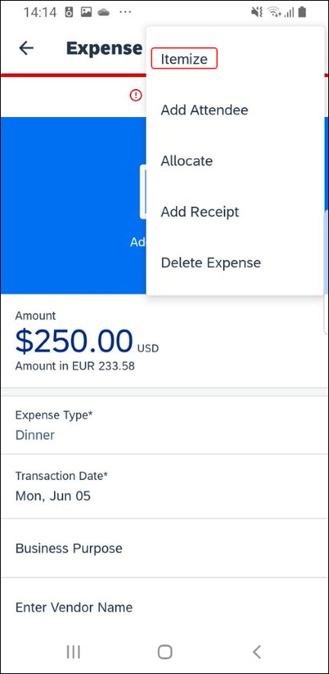 | To itemize an expense:  1) On the report screen, tap the Expenses tab.  2) On the Expenses tab, tap to open the desired expense.  3) On the Expense screen, tap (right-upper corner) and select Itemize.
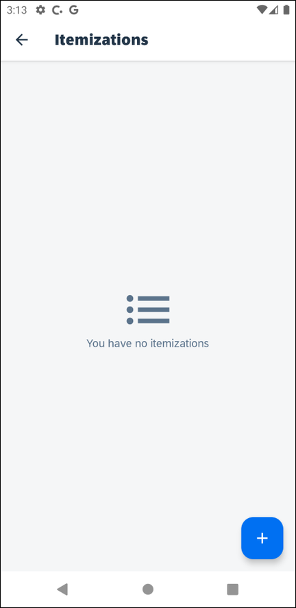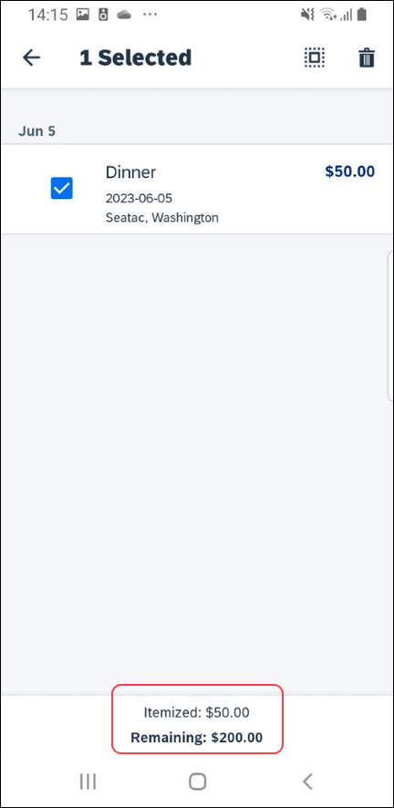 | 4) On the Itemization screen, enter the itemizations.  If there is a remaining balance, select the expense again and tap (lower-right corner) and repeat these steps (including Save) until the remaining amount balance is zero.
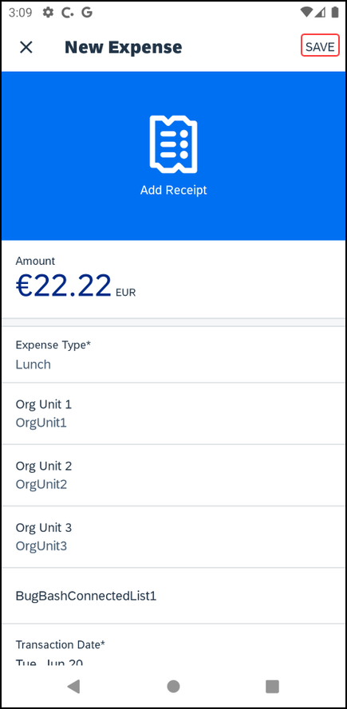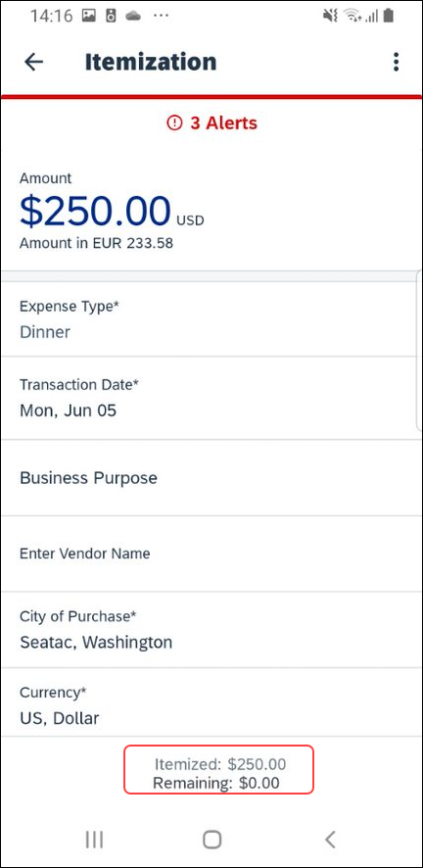 | To edit an itemization:  Tap the desired itemization and then make the desired changes.  To remove an itemization:  Long-press the desired itemization and then tap (upper-right corner).  The remaining amount appears at the bottom of the Itemizations screen.

Add/Edit/Delete Attendees
After an expense has been added to a report, you can add attendees to the expense.
Screen(s) | Description/Action
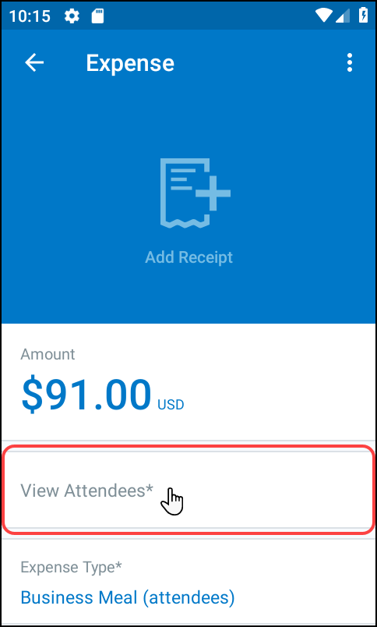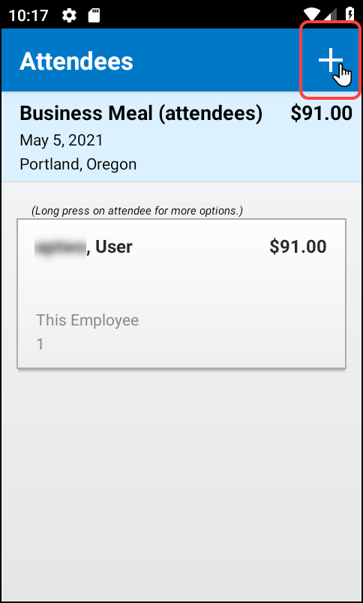 | To add, edit, or delete attendees:  1) On the report screen, tap the Expenses tab.  2) On the Expenses tab, tap to open the desired expense.  3) On the Expense screen, tap View Attendees.  4) On the Attendees screen, tap (upper-right corner) to add an attendee.
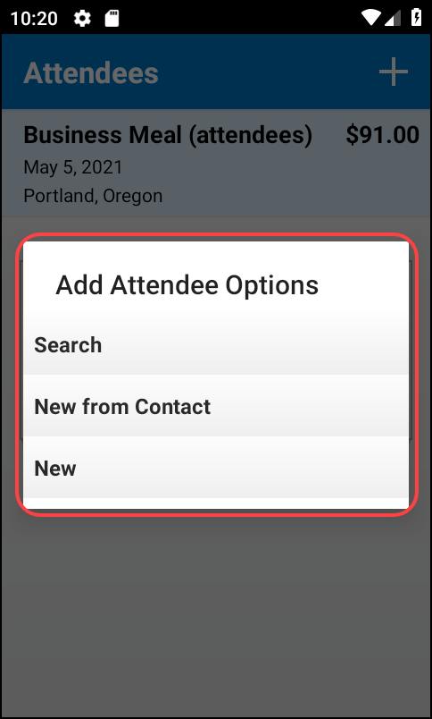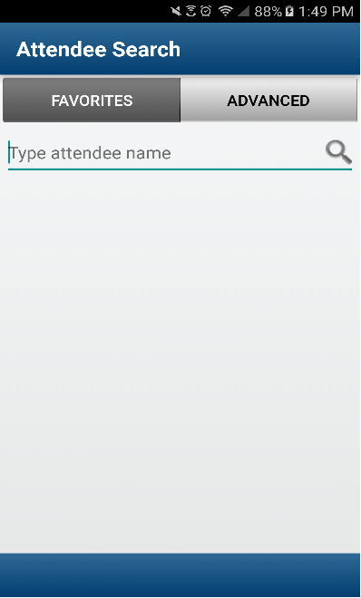 | 5) On the Add Attendee Options menu, tap one of the following:  - Search > Favorites to search your Favorite Attendees
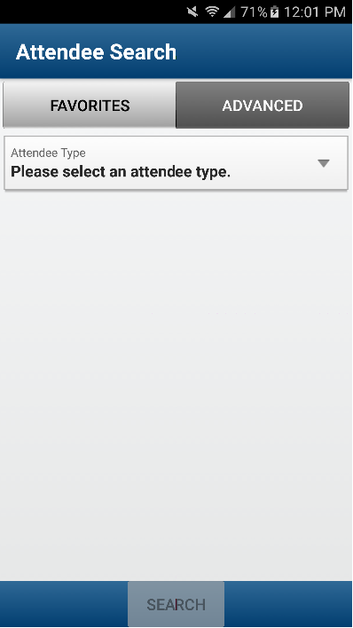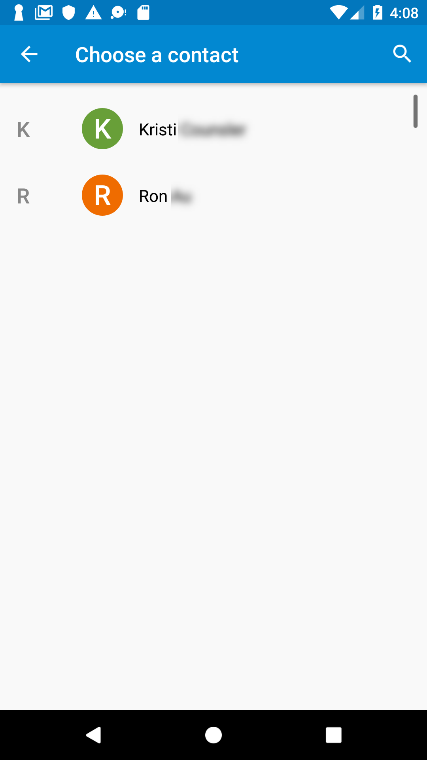 | - Search > Advanced to search your company's list of attendees or from an external source (like Salesforce)  - New from Contact to select from your smartphone contact list
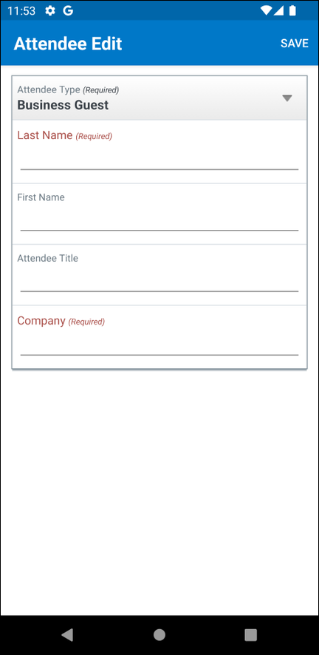 | To edit an attendee:  Tap the desired attendee name and then make the desired changes.  To delete an attendee:  Long-press the desired attendee name and then tap Remove.
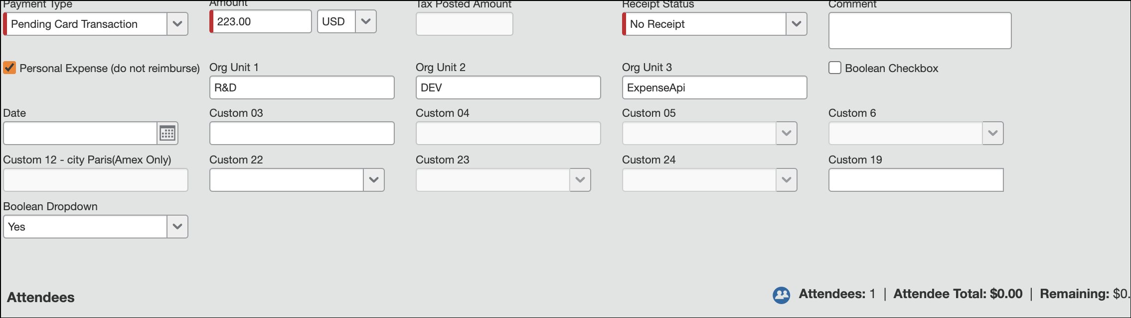 | To add attendees to personal expenses:  1) Create expense.  2) Complete expense.  3) Add attendees.  4) Add itemization:  - Set the amount of the itemization to the total amount of the expense.  - Set the itemization as a personal expense.  - Save the itemization.  5) Save the expense.

View/Add/Edit/Delete Allocations
You can view report-level allocations, expense-level allocations, and itemization-level allocations.

View Report-Level Allocations
The Allocation Summary screen shows that the expense is allocated to the Marketing cost center with a total of $115.00.
Screen(s) | Description/Action
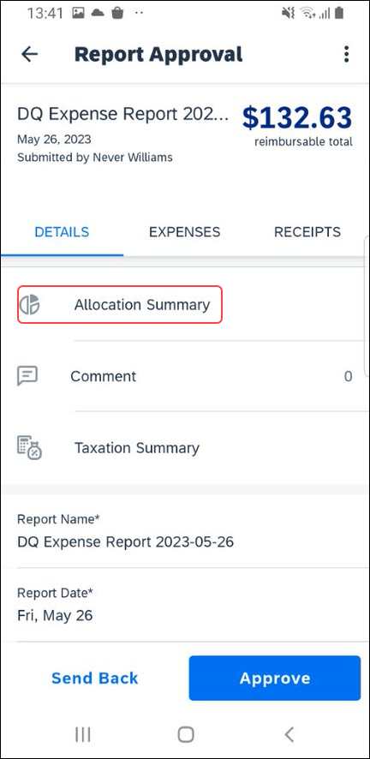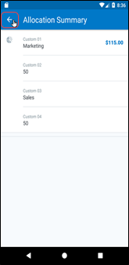 | To view report-level allocations:  1) On the report screen, tap Details.  2) On the Details tab, tap Allocation Summary.  3) On the Allocation Summary screen:  - Review the information.  - Tap (upper-left corner) to return to the report.

View Expense-Level Allocations
Screen(s) | Description/Action
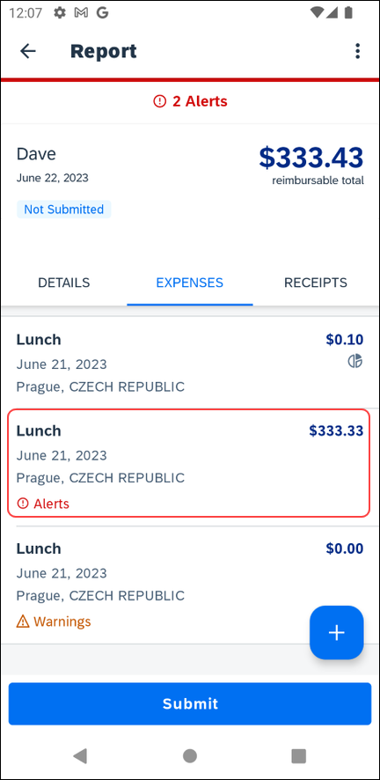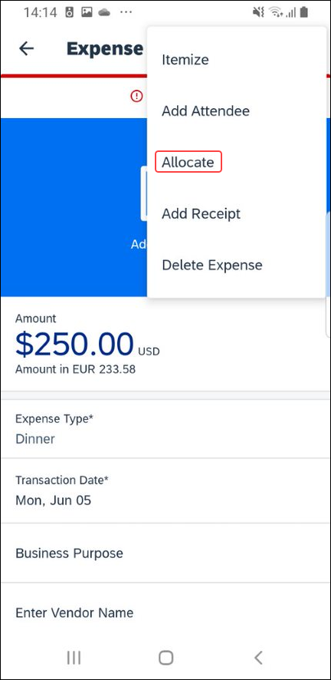 | To view expense-level allocations:  1) On the report screen, tap the Expenses tab.  2) On the Expenses tab, tap the desired expense.  3) On the Expense screen, tap (upper-right corner).  4) On the menu, tap Allocate.
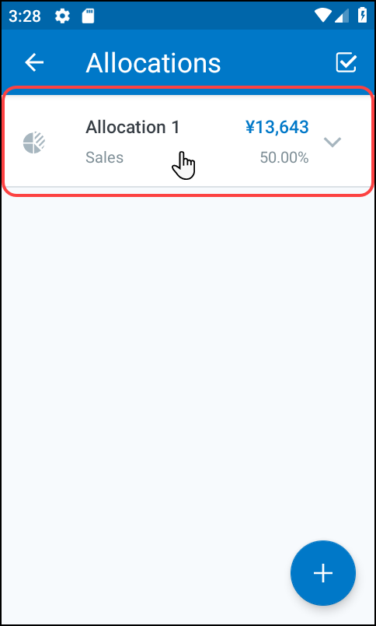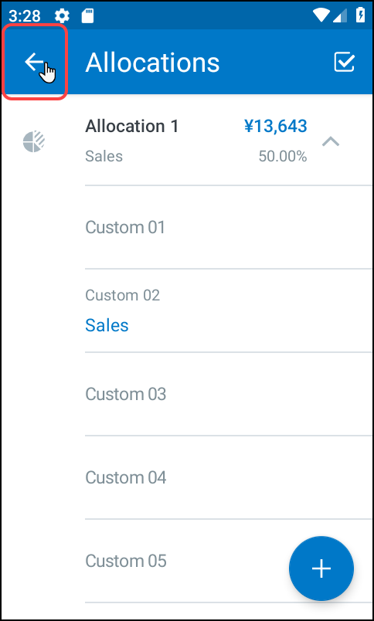 | 5) On the Allocations screen, tap the desired allocation.  6) On the Allocations screen:  - Review the information.  - Tap (upper-left corner) to return to the report.

View Itemization-Level Allocations
Screen(s) | Description/Action
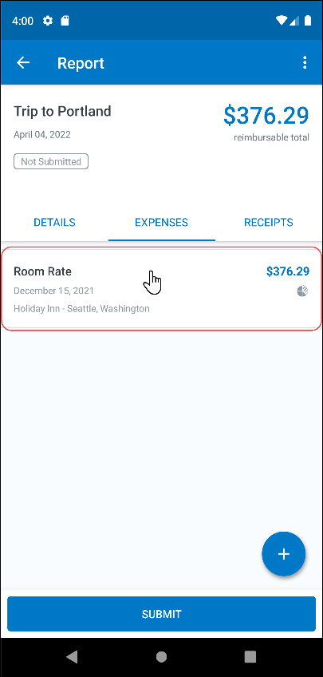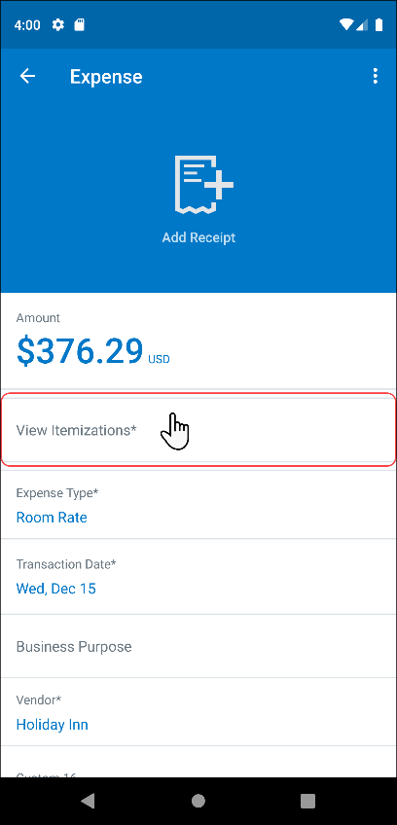 | To view itemization-level allocations:  1) On the Report screen, tap the Expenses tab.  2) On the Expenses tab, tap the desired expense.  3) On the Expense screen, tap View Itemizations.
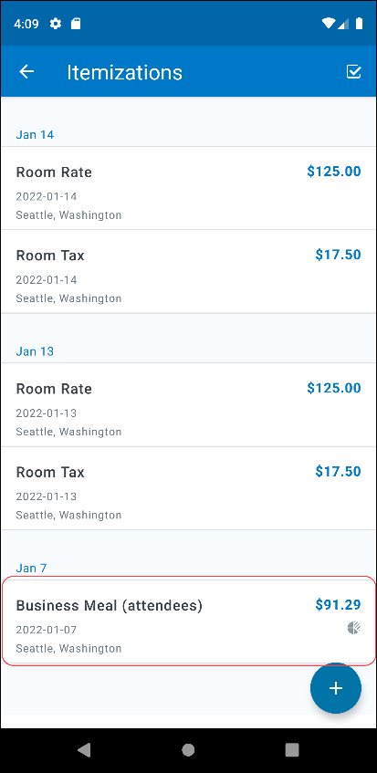 | 4) On the Itemizations screen, tap the desired itemization.

Add/Edit/Delete Expense-Level Allocations
Screen(s) | Description/Action
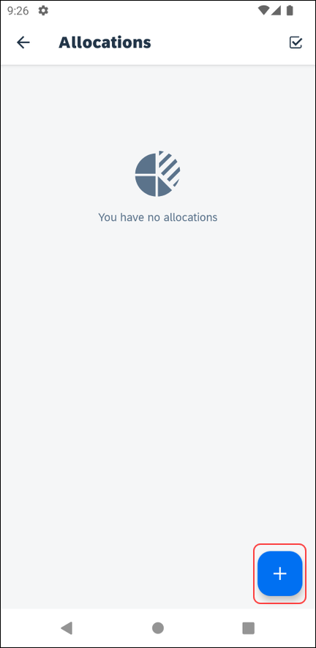 | To add, edit, or delete expense-level allocations:  1) To add allocations, on the Expense screen:  - Tap (upper-right corner).  - Tap Allocate.  - On the Allocations screen, tap (lower-right corner).
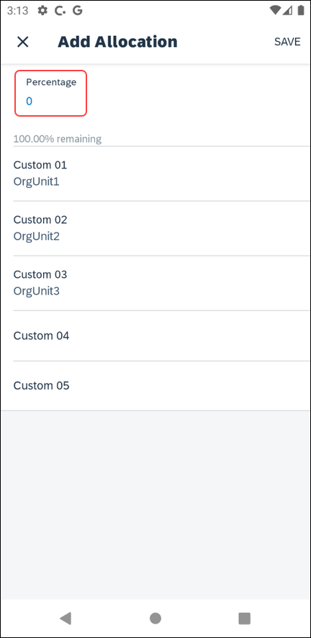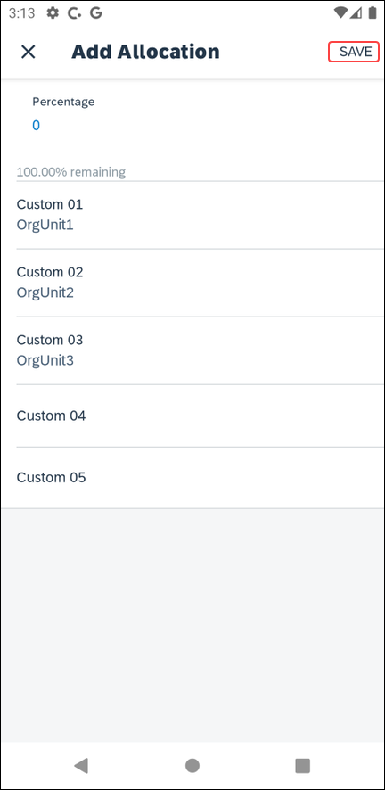 | 2) On the Add Allocation screen, you can:  - Fill in the desired percentage.  - Tap Save.  - Fill in the fields (if any) and make the desired selections.  - Tap Save.
3) To edit an allocation, on the Allocations screen, tap the desired allocation to open it and then make the desired changes and then tap Save.
4) To delete an allocation, on the Allocations screen, tap (upper-right corner).
- Tap the desired selection circles.
 | - Tap (upper-right corner) to delete the selected allocations from an expense.

Add Itemization-Level Allocations
Screen(s) | Description/Action
To add allocations, on the Itemization screen:
1) On the Itemization screen, tap View Allocations.
2) On the Allocations screen, tap (lower-right corner).
3) On the Add Allocation screen,
- Fill in the desired percentage.
- Tap Done.
- Fill in the fields (if any) and make the desired selections.
- Tap Save (upper-right corner).
4) On the Allocations screen, tap (lower-right corner) to add additional allocations.
5) To edit an allocation, on the Allocations screen:
- Tap the desired allocation to open it.
- Make the desired changes.
- Tap Save.

Icon
Screen(s) | Description/Action
 | Once items are allocated, an Allocation icon appears next to the expense and at the report level.

Remove an Expense From an Expense Report
You can remove an expense from an expense report, if the report has not been submitted.
Screen(s) | Description/Action
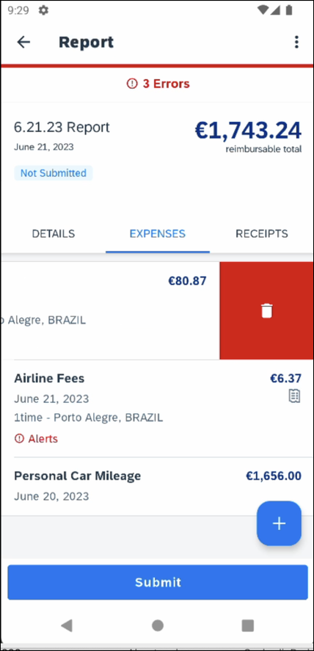 | To remove an expense from an unsubmitted expense report by swiping:  1) Swipe the desired expense to the left.  2) Tap Delete.  NOTE: If you delete a mobile expense or an expense created from a card transaction, it is not really deleted; it is moved back to the "pool" of expenses on the Expenses screen.  If you delete any other type of expense from an expense report, it is truly deleted. (This is consistent with the web version of Expense.)

Edit Report Header Information
You can edit the report name, date, and other company-defined fields on an unsubmitted report.
Screen(s) | Description/Action
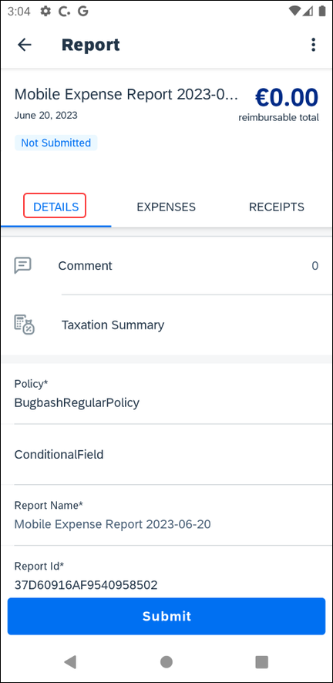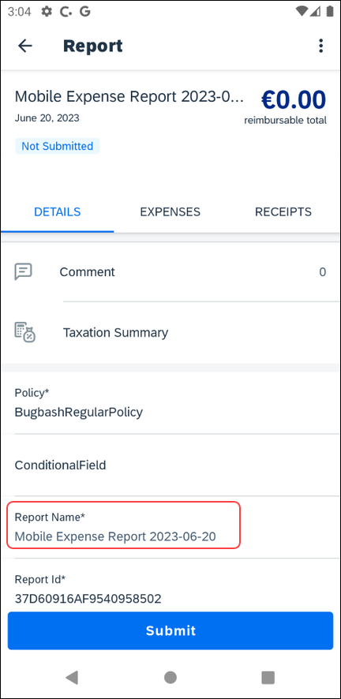 | To edit report header information:  1) On the report screen, tap Details.  2) On the Details tab, tap the appropriate field to make the desired changes.
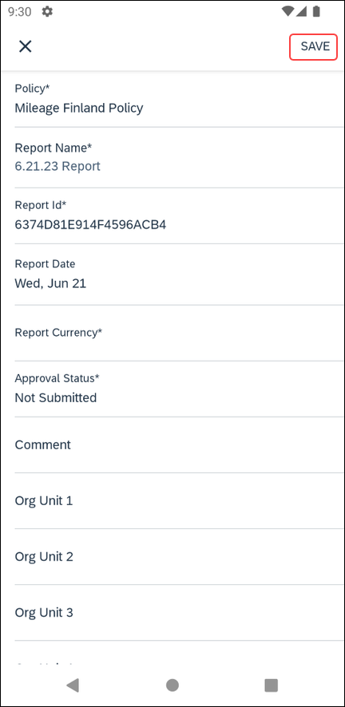 | 3) Tap Save (upper-right corner).

Submit an Expense Report
Screen(s) | Description/Action
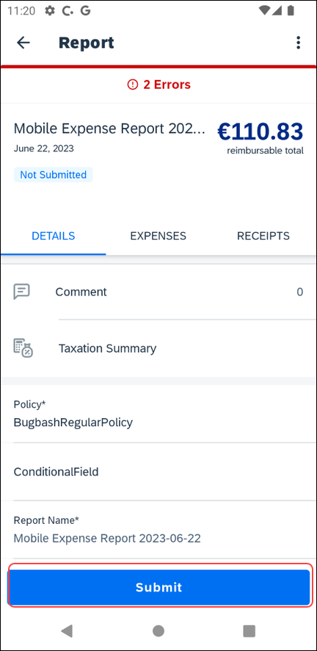 | To submit an expense report:  On the report screen, tap Submit.

Submit an Expense Report With the Approval Flow Screen
Screen(s) | Description/Action
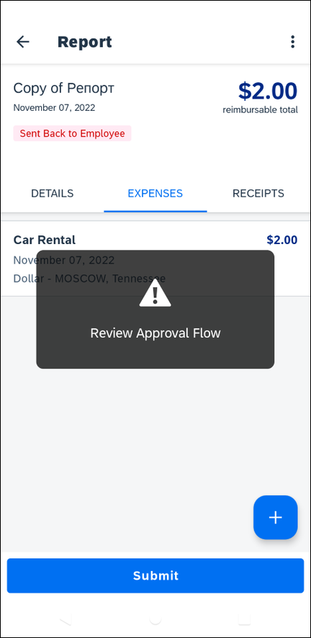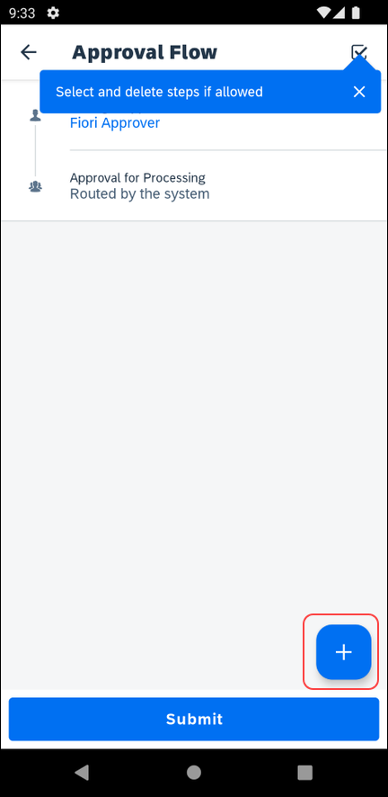 | To submit an expense report with the Approval Flow screen:  1) With the report open, tap Submit.  The Approval Flow screen appears.  NOTE: Your company will need to set the necessary configurations for the Approval Flow screen to appear and to allow you to modify the approval flow.  2) On the Approval Flow screen, tap (lower-right corner) to add an approval step.  NOTE: When you first access the Approval Flow screen, a message appears indicating that you can tap (upper-right corner) to select and delete approval steps.
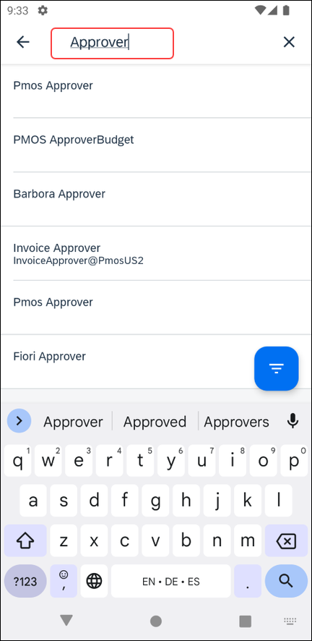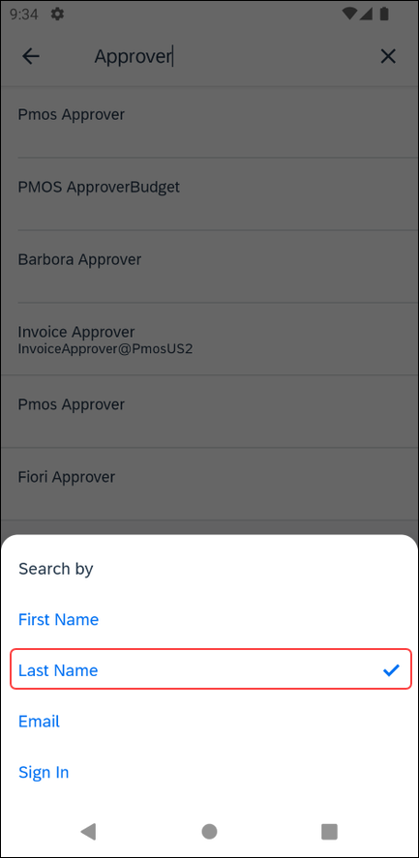 | 3) On the approvers search screen, enter search criteria in the search field.  NOTE: While entering the search criteria, a list of approvers appears on the approvers search screen.  4) Tap to change the filter.  5) On the Search by window, select the desired filter to search approvers by.  NOTE: By default, the system searches for approvers via the Last Name filter.  6) On the approvers search screen, tap the desired approver.
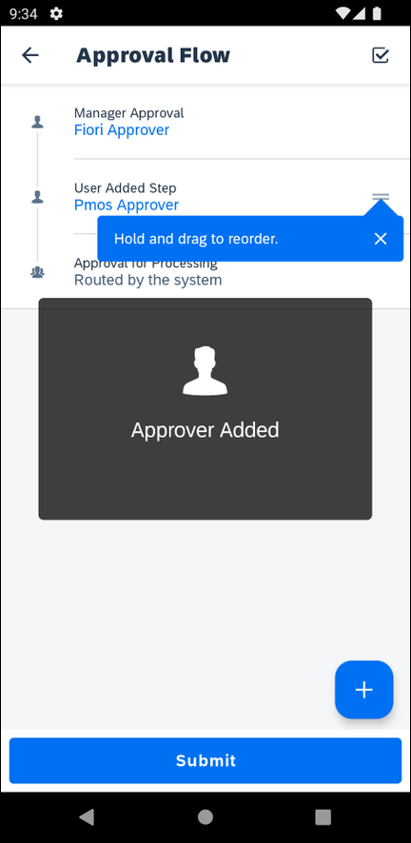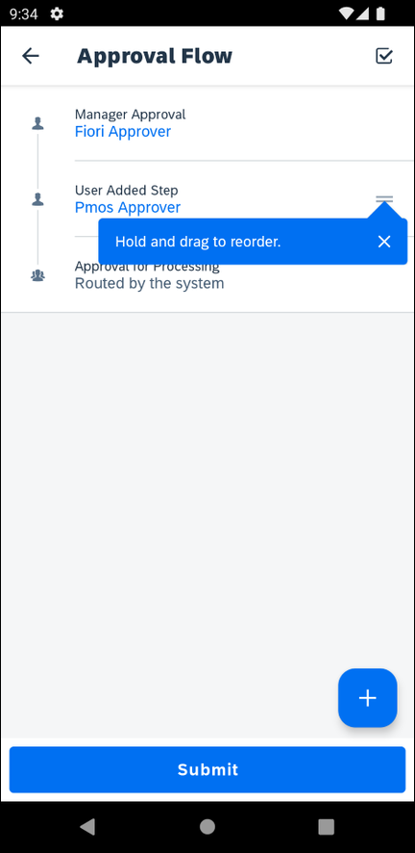 | The selected approver appears as a user added step on the Approval Flow screen.  NOTE: When you first add a user added step, a message will appear indicating that you can hold and drag a user added approval step to reorder it.
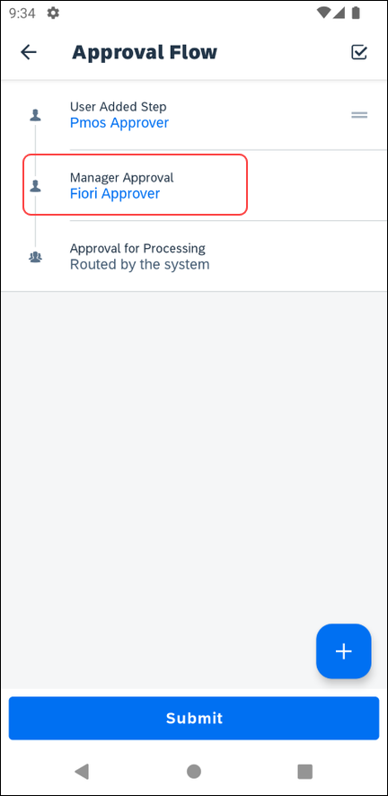 | 7) On the Approval Flow screen, tap and hold the desired approval step and then drag the step upward or downward to reorder it.  When you tap on an existing approval step, the approvers search screen appears.  The currently selected approver appears at the top of the screen with a checkmark.  NOTE: For the Authorized Approver steps, all authorized approvers appear by default (without searching), and you can search within those results if desired.
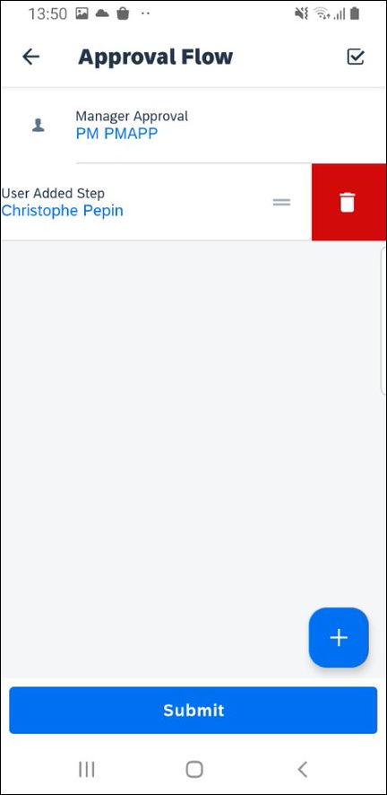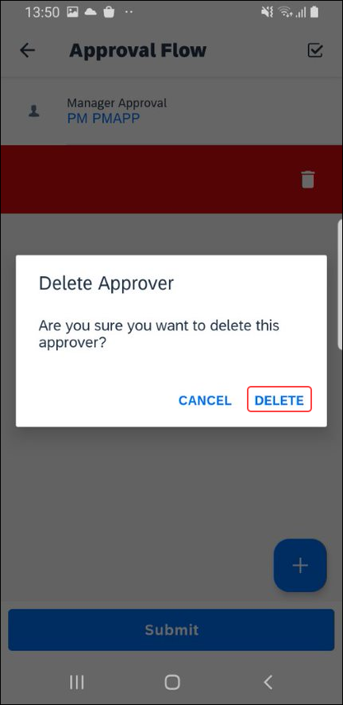 | You can delete an approval step on the Approval Flow screen. To delete an approval step on the Approval Flow screen, you can either:  - Swipe the desired approval step to the left and then tap Delete on the Delete Approver window to delete it.  -or-
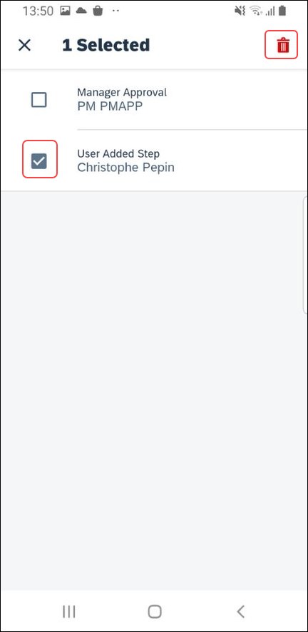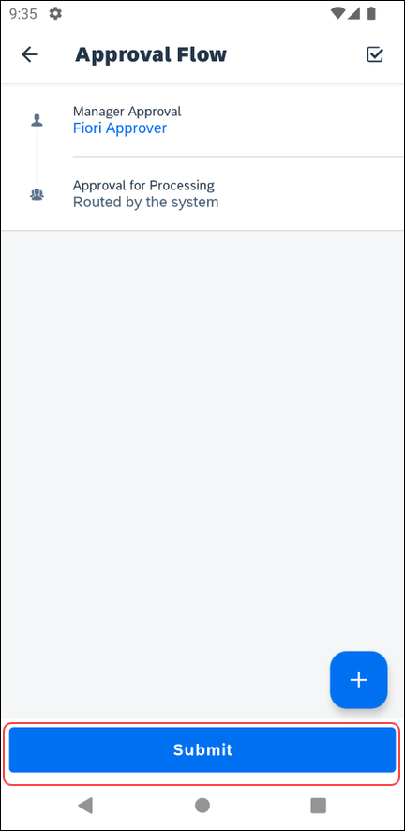 | - Tap (upper-right corner), tap the desired approval step, and then tap (upper-right corner) to delete it.  8) Once done reviewing and adjusting the approval flow on the Approval Flow screen, tap Submit.

Recall an Expense Report
Screen(s) | Description/Action
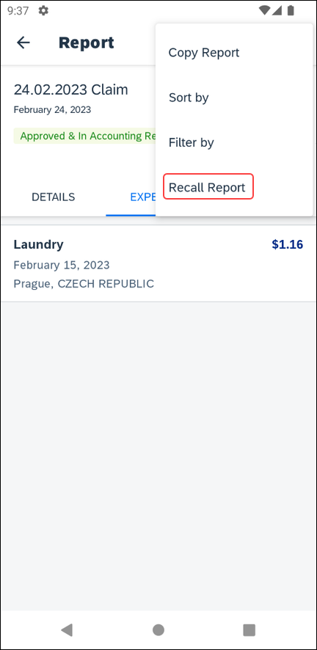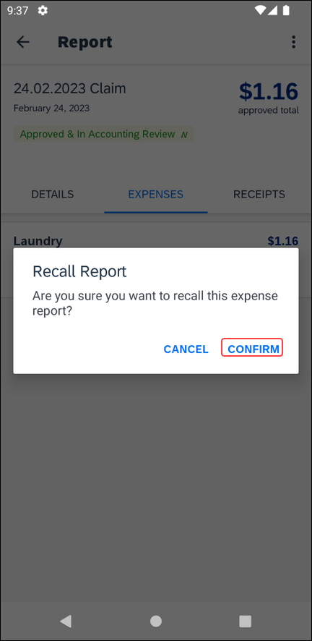 | To recall a report:  1) On the home screen, tap Expense and toggle to Reports.  2) On the Reports screen, tap the desired submitted report.  3) On the report screen, tap (upper-right corner).  4) On the menu, tap Recall Report.  5) On the message screen that appears, select Confirm.
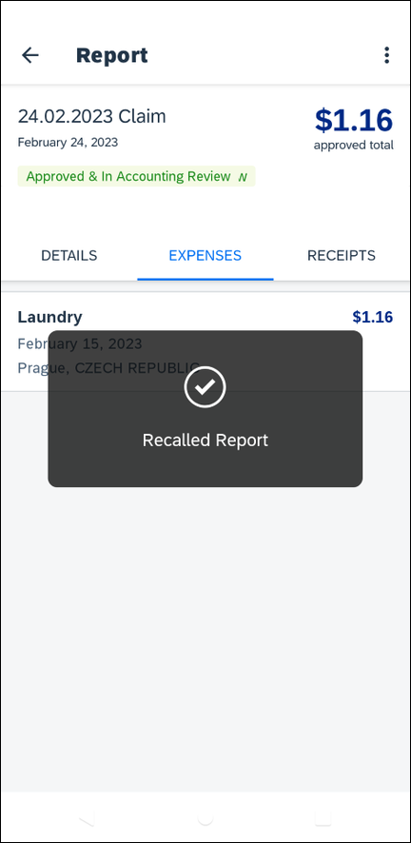 | 6) A message will appear to confirm the report has been recalled.

Delete an Expense Report
Screen(s) | Description/Action
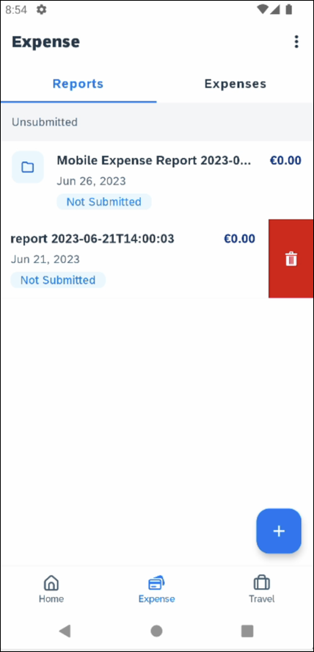 | To delete an expense report:  1) On the Reports screen, swipe the desired report to the right.  2) Tap Delete.  NOTE: Expenses on the report that are related to card transactions are not really deleted – they are returned to the "pool" of card transactions. Cash transactions are truly deleted.

Copy an Unsubmitted Expense Report
Screen(s) | Description/Action
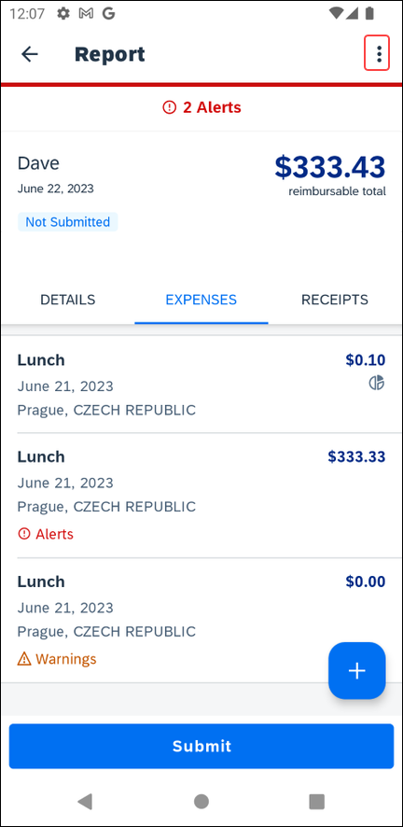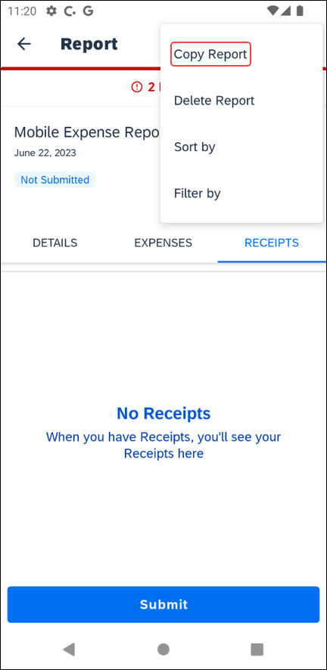 | To copy an unsubmitted expense report:  1) On the Reports screen,tap desired report.  2) Tap the icon in the top right corner.  3) Tap Copy Report.
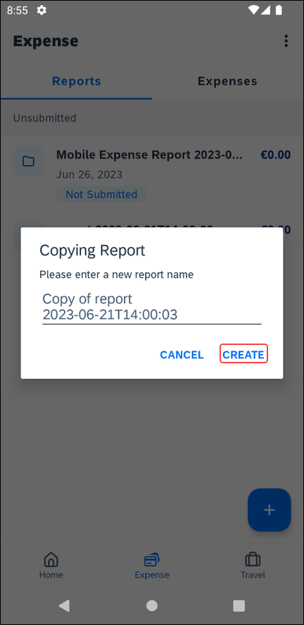 | 4) Enter the desired report name.  5) Tap Create.  The copied expense report appears.

Access the Taxation Summary Screen
Screen(s) | Description/Action
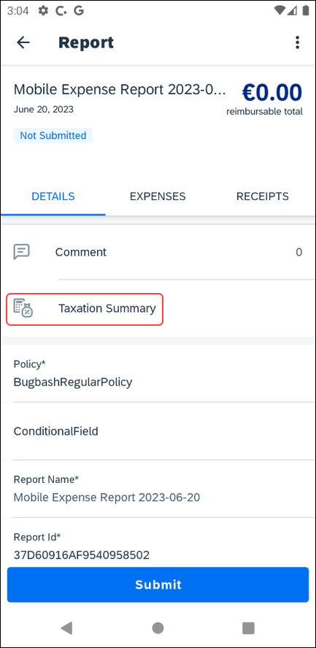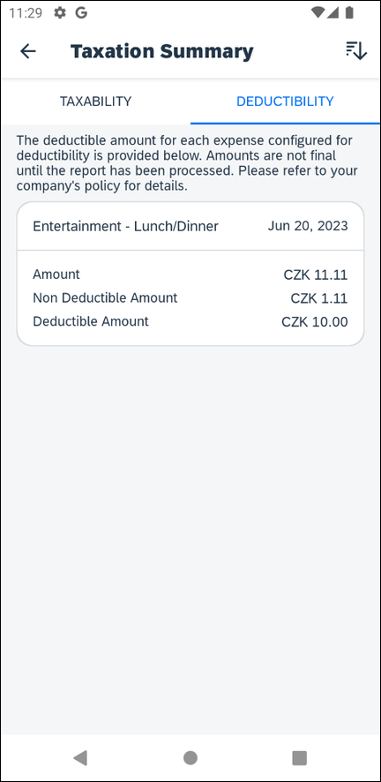 | To access the Taxation Summary screen:  1) From the Report screen, on the Details tab, tap Taxation Summary.  2) On the Taxation Summary screen, tap (upper-right corner) to view the sort options.
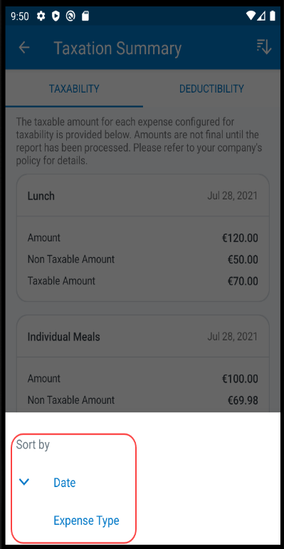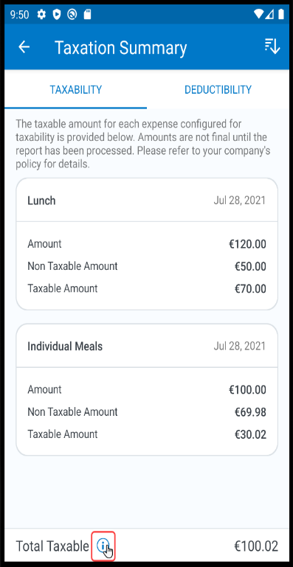 | The Sort by window appears with the following options:  - Date  - Expense Type  3) From the Taxation Summary screen, on the Taxability tab, tap (lower-left corner) to view the taxability amounts.
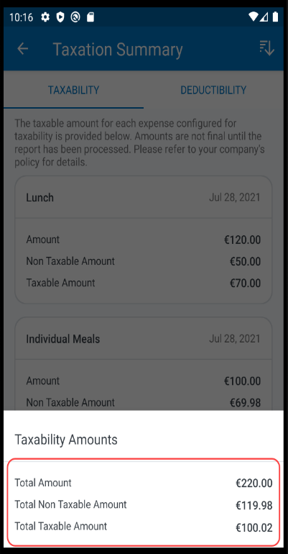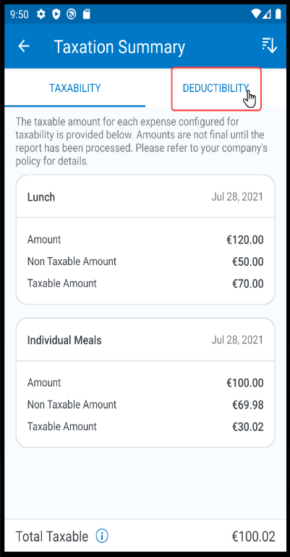 | The Taxability Amounts window appears with the total taxability amounts.  4) On the Taxation Summary screen, tap the Deductibility tab.
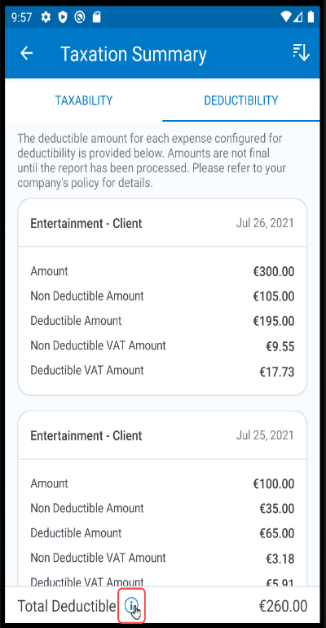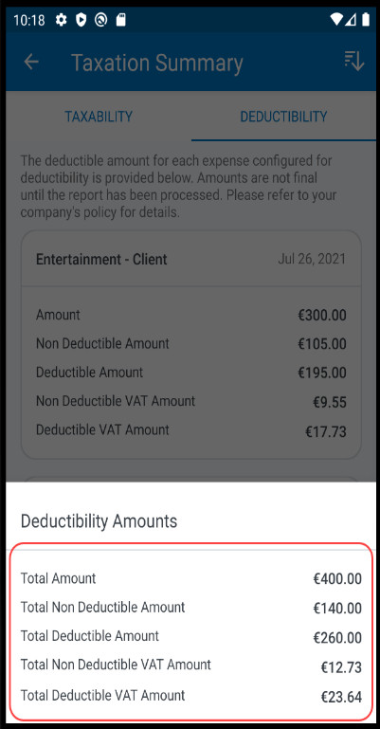 | 5) On the Deductibility tab, tap (lower-left corner) to view the deductibility amounts.  The Deductibility Amounts window appears with the total deductibility amounts.

Work with Fixed Travel Allowances with Fiori UI
Users can claim their fixed meals and fixed lodging travel allowances in the SAP Concur mobile app.

Fixed vs Reimbursable Travel Allowances
- Fixed travel allowances – often referred to as per diems – provide a defined daily amount regardless of the actual amount spent by the user.
- Reimbursable travel allowances generally provide reimbursement for the actual amount of the expense. The ability to create and manage reimbursable travel allowances is not available in the mobile app.

Restrictions
For the most part, fixed travel allowances work the same way in the mobile app as on the web version of SAP Concur – with some exceptions. These configuration options are not available in the mobile app:
- Users cannot define/select:  - Trip length  - "Short distance"  - "Extended trips"  - "Use Percent Rule"  - Location "within municipality" | - Users cannot enter:  - Actual meal amounts  - Rate location  - The mobile version of SAP Concur does not combine meals and lodging rates nor does it display base rates, company rates, government rates, etc.
If the user's configuration uses any of the options listed above, the user should manage their travel allowances using the web version of SAP Concur.

Create and Edit Fixed Travel Allowances

Create A New Fixed Travel Allowance in an Expense Report
Screen(s) | Description/Action
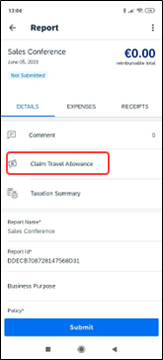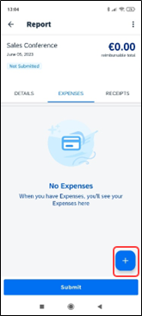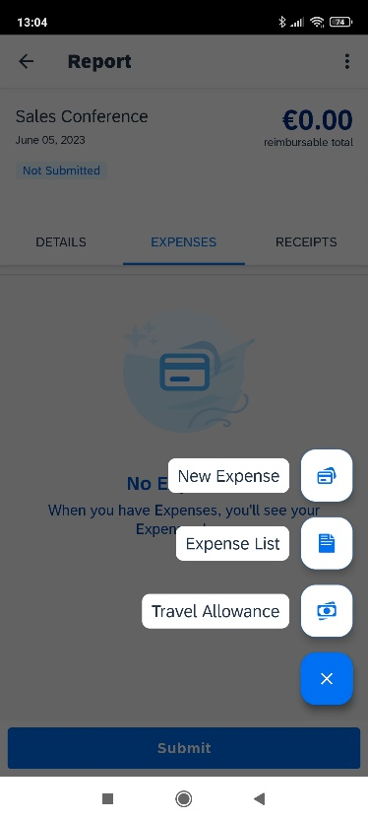 | To create a new fixed travel allowance in an expense report:  1) With a report open:  On the Details tab, tap Claim Travel Allowance.  - or -  On the Expenses tab , tap (lower-right corner) and then select Travel Allowance from the options that appear.
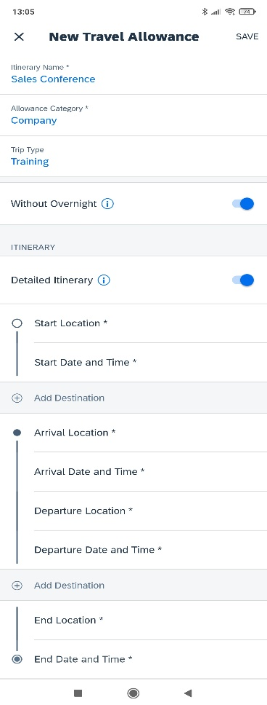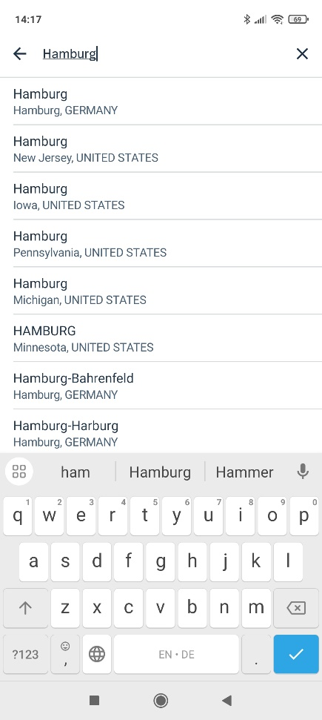 | 3) On the New Travel Allowance screen:  - Enter the itinerary name.  - Select the Allowance Category.  NOTE: If you select an allowance category - which supports the border crossing feature - an additional input field will appear in trip segments, where a border crossing situation is detected.  - Select the Trip Type.  - Swipe Without Overnight to the right, if there was no overnight stay during the trip.  - Swipe Detailed Itinerary to the right, to view all itinerary fields. (In this example, the Detailed Itinerary option is enabled.)  NOTE: Depending on which allowance category you select, you may have the option to choose between the simple or detailed itinerary mode.  If you enable the Detailed Itinerary toggle - while in simple mode - your detailed changes will be lost. The system will then replace your information with defaulted values.  If you switch - from the simple mode - back to the detailed mode, you will need to re-enter your details in the additional fields again.  - Enter the start and arrival locations.  NOTE: When you select an allowance category with the German 3-month-rule configuration, the Arrival Location field will require the full address to be filled out. Without this configuration enabled, you only need to fill out the destination city field and the full address is not required.
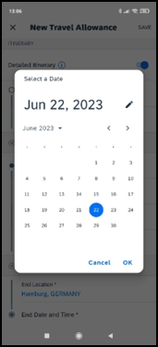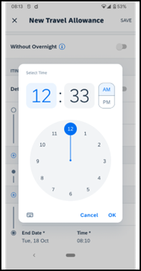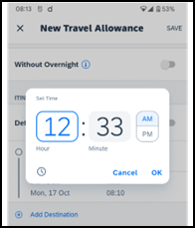 | - Select the date and then tap OK (lower-right corner).  - Select the time and then tap OK (lower-right corner).  NOTE: You can tap to access the Set time window. To go back to the default time window, tap (lower-left corner).
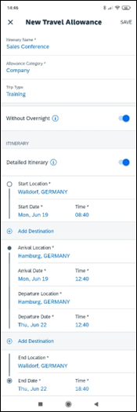 | - Tap Add Destination to access the return trip fields.  NOTE: The Start Location and Arrival Location fields must be filled out before the user can access the Add destination option.  - Enter the return trip information.  - Repeat for each leg of the trip, entering the exact "arrival" address if necessary.  - Review the itinerary for accuracy.  4) When done, tap Save (upper-right corner).
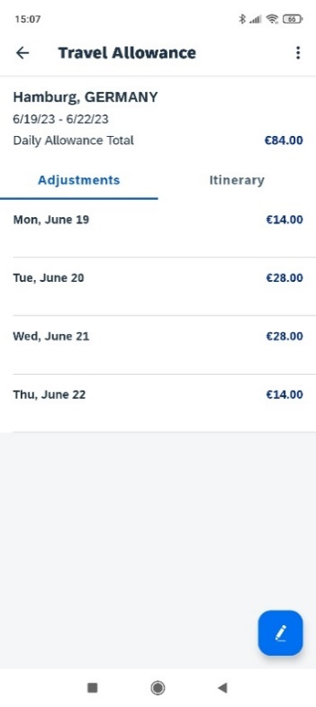 | 5) If adjustments are necessary (for example, to deduct for provided meals), tap the Adjustments tab on the Travel Allowance screen.  6) Tap the desired daily allowance that requires adjustment.
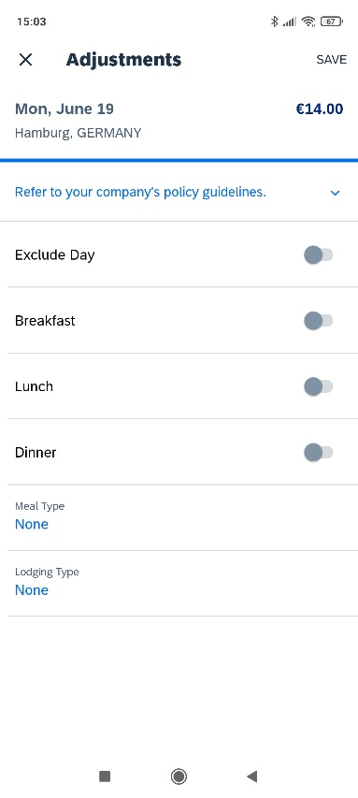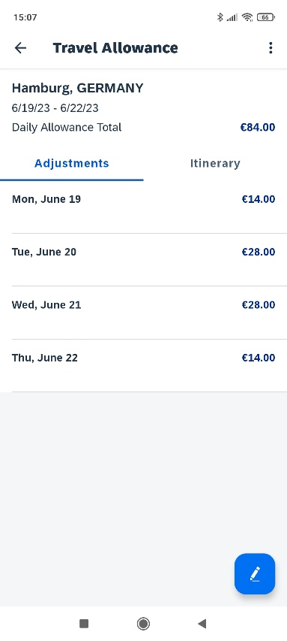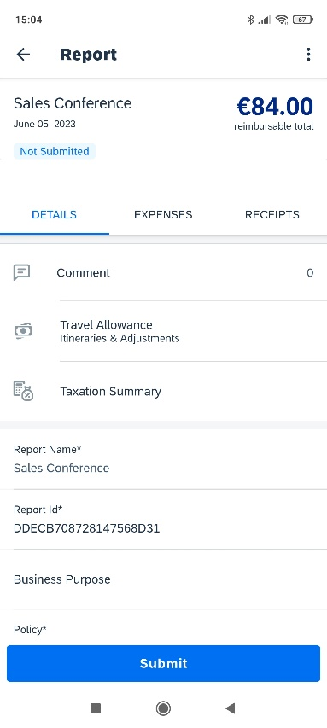 | 7) On the Adjustments screen:  - Make the desired adjustments.  NOTE: If the web version of SAP Concur provides a list of options instead of Yes/No, then the list appears here as well.  - When done, tap Save (upper-right corner).  8) On the Travel Allowance screen:  - Make any other required adjustments.  - Tap (upper-left corner) to return to the expense report.  9) On the report screen:  - Review for accuracy.  - From the Details tab, tap Travel Allowance Itineraries & Adjustments if changes are necessary.  - Finish adding expenses, receipts, etc. Submit when ready.

Create a New Fixed Travel Allowance With Multiple Destinations in an Expense Report
Screen(s) | Description/Action
To create a new fixed travel allowance with multiple destinations in an expense report:

1) With a report open,
- On the Details tab, tap Claim Travel Allowance.
- or -
- On the Expenses tab, tap (lower-right corner) and then select Travel Allowance from the options that appear.
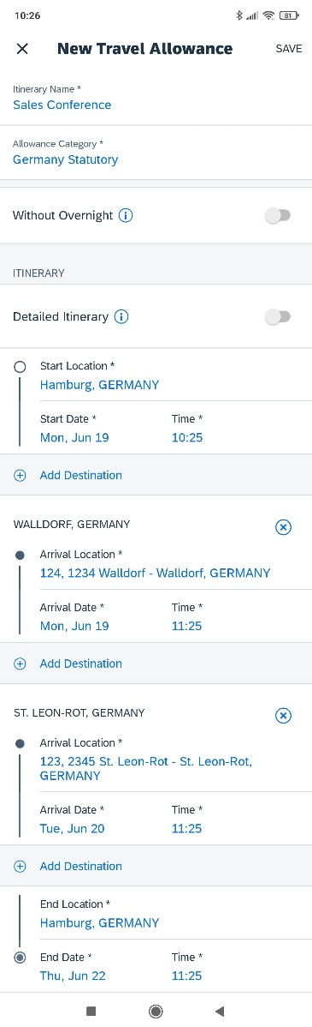 | 2) On the New Travel Allowance screen.  - Fill in the fields and make the desired selections.  - Tap Add Destination to create multiple destinations.  3) When done, tap Save (upper-right corner).
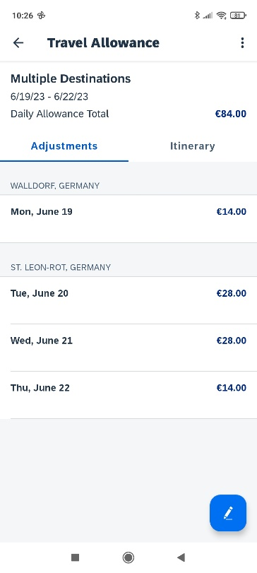 | The multiple destinations appear on the Travel Allowance screen.  NOTE: If your company has opted out of the multiple itineraries on one expense report feature, the option to add more itineraries will not appear.

Create a New Fixed Travel Allowance Itinerary Without Overnight in an Expense Report
Screen(s) | Description/Action
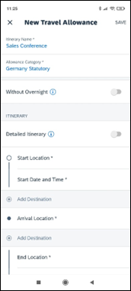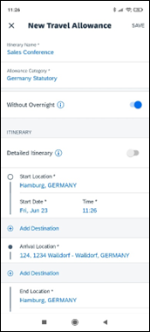 | To create a new fixed travel allowance itinerary without overnight in an expense report:  1) With a report open,  - On the Details tab, tap Claim Travel Allowance.  - or -  - On the Expenses tab, tap (lower-right corner) and then select Travel Allowance from the options that appear.  2) On the New Travel Allowance screen:  - Fill in the fields and make the desired selections.  - Swipe the Without Overnight toggle to right.  - Tap Save (upper-right corner).  NOTE: Depending on which category is in the Allowance Category field, the user can adjust the itinerary details.
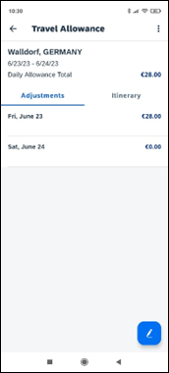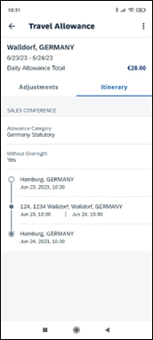 | The itinerary without overnight appears on the Travel Allowance screen.  NOTE: With the Without Overnight toggle enabled, the first itinerary in the list will display the daily allowances in accordance with the 24-hour rule showing 0.00€ for the second day.  Also, the Lodging Type field on the Daily Allowance screen will appear again.

Create a New Fixed Travel Allowance With a Border Crossing in an Expense Report
Screen(s) | Description/Action
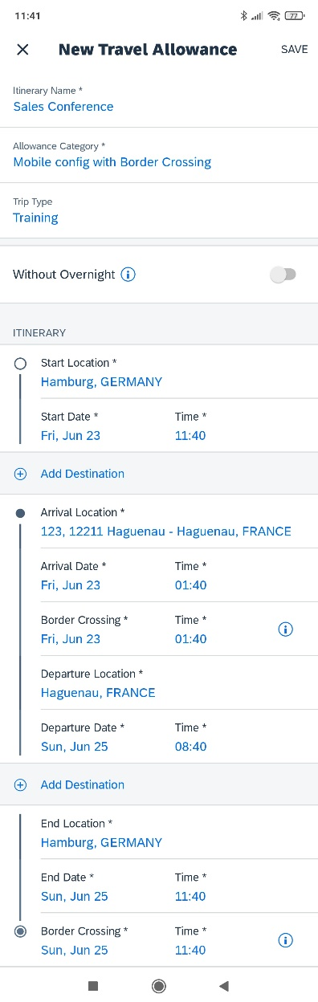 | To create a new fixed travel allowance with a border crossing in an expense report:  1) With a report open,  - On the Details tab, tap Claim Travel Allowance.  - or -  - On the Expenses tab, tap (lower-right corner) and then select Travel Allowance from the options that appear.  2) On the New Travel Allowance screen:  - Select an allowance category that supports the border crossing feature.  - Fill in the fields and make the desired selections.  - Tap Save (upper-right corner).
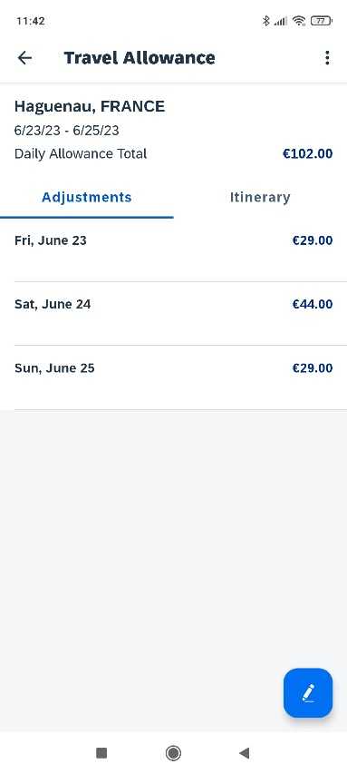 | 3) On the Travel Allowance screen, tap the Itinerary tab.
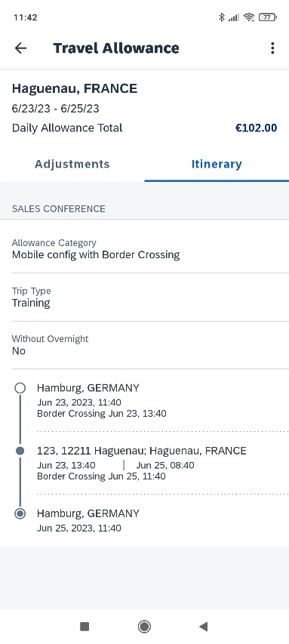 | The border crossing itinerary appears on the on the Itinerary tab on the Travel Allowance screen.  NOTE: This field will not appear - on the Itinerary tab – if you have not traveled to another country during your trip.

Select a Different Address in a New Travel Allowance
Screen(s) | Description/Action
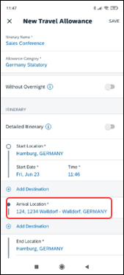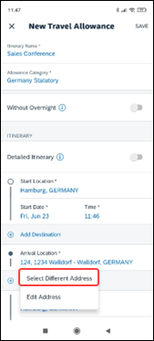 | To select a different address in a new fixed travel allowance:  1) With a report open,  - On the Details tab, tap Claim Travel Allowance.  - or -  - On the Expenses tab, tap (lower-right corner) and then select Travel Allowance from the options that appear.  2) On the New Travel Allowance screen, tap the Arrival Location field.  3) On the menu, tap Select Different Address.
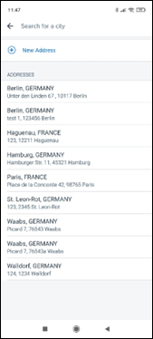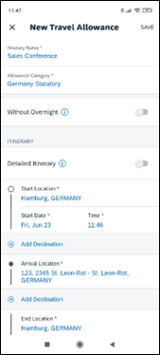 | 4) On the locations screen, tap the desired address.  The new address appears on the New Travel Allowance screen.

Edit a Fixed Travel Allowance Itinerary
Screen(s) | Description/Action
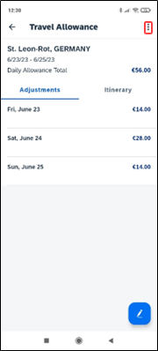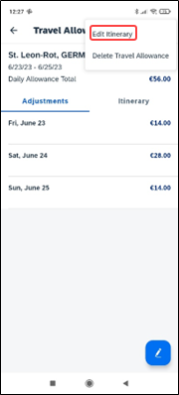 | To edit a fixed travel allowance:  1) On home screen, tap Expense .  2) On the Expenses screen, tap the desired expense report.  3) On the expense report screen, tap the Details tab.  4) On the Details tab, tap Travel Allowance Itineraries & Adjustments.  5) On the Travel Allowance screen, tap (upper-right corner).  6) On the menu, tap Edit Itinerary.
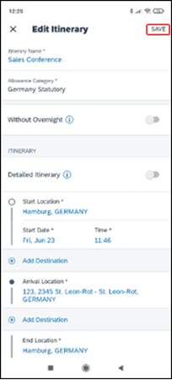 | 7) On the Edit Itinerary screen:  - Edit the fields  - Make the desired selections  8) When done, tap Save (upper-right corner).  NOTE: Depending on which category is in the Allowance Category field, the user can adjust the itinerary details.

Resolve an Alert in a New Travel Allowance
Screen(s) | Description/Action
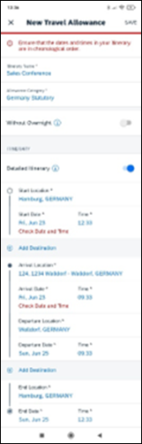 | To resolve an alert in a new fixed travel allowance:  1) On the New Travel Allowance screen:  - Fill in the fields and make the desired selections.  - Tap Save (upper-right corner).  After the system attempts to save the travel allowance and an alert appears at the top of the New Travel Allowance screen.
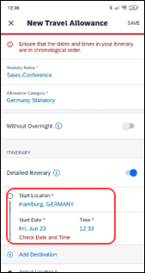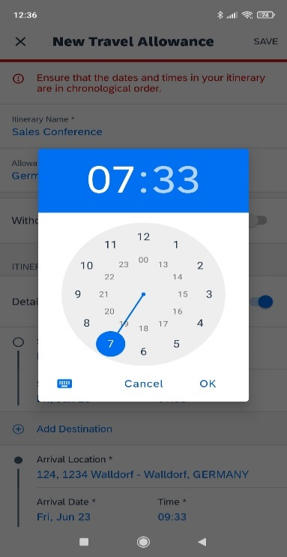 | 2) Scroll to the affected field.  NOTE: Additionally, a red alert text will appear next to the affected field giving you further instructions on how to resolve the issue.  3) Tap the desired field to correct.  4) On the time window, make the desired adjustments and then tap OK.
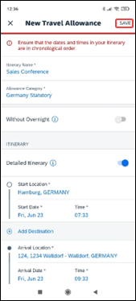 | The red alert text on the field will no longer appear. If necessary, repeat these steps in the next affected section.  5) When done, tap Save (upper-right corner).

Delete Travel Allowances

Delete a Travel Allowance From an Expense Report
Screen(s) | Description/Action
To delete a fixed travel allowance from an expense report:
1) With the report open, tap the Details tab.
2) On the Details tab, tap Travel Allowance Itineraries & Adjustments.
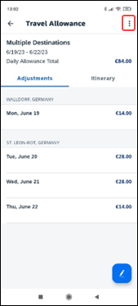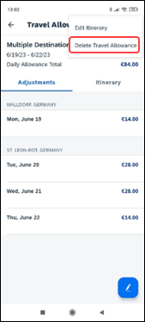 | 3) On the Travel Allowance screen, tap (upper-right corner).  4) Tap Delete Travel Allowance.
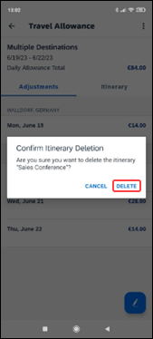 | 5) On the Confirm Itinerary Deletion window, tap Delete.
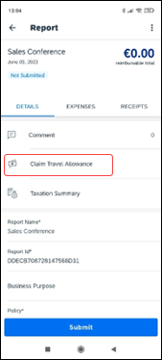 | On the Report screen all travel allowance expenses are gone and the button on the Details tab is called Claim Travel Allowance again.

Delete a Travel Allowance with multiple itineraries
Screen(s) | Description/Action
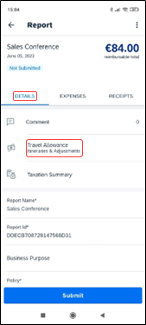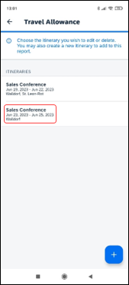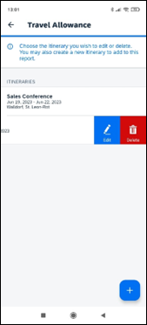 | To delete a fixed travel allowance with multiple itineraries:  1) With the report open, tap the Details tab.  2) On the Details tab, tap Travel Allowance Itineraries & Adjustments.  3) On the Travel Allowance screen, in the Itineraries section, swipe the desired itinerary to the left.  NOTE: The Travel Allowance Itineraries screen only appears when there are multiple itineraries attached to the report.
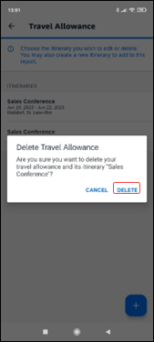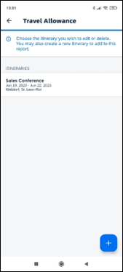 | 7) On the Delete Travel Allowance window, tap Delete.  The travel allowance no longer appears in the Itineraries section of the Travel Allowance screen.

Expense Approvals
Use Approvals on the home screen to view, approve, or send back expense reports (if you are a report approver or a cost object approver).

Approve an Expense Report
Screen(s) | Description/Action
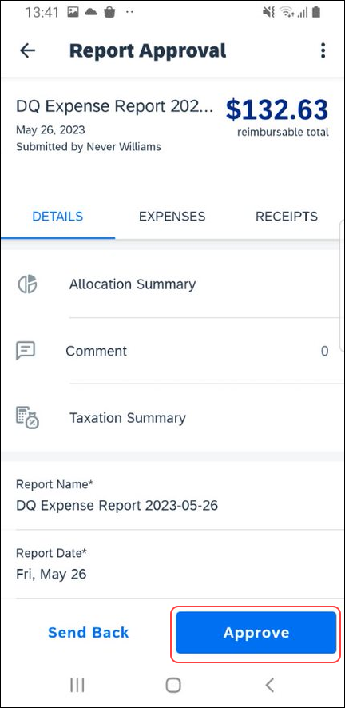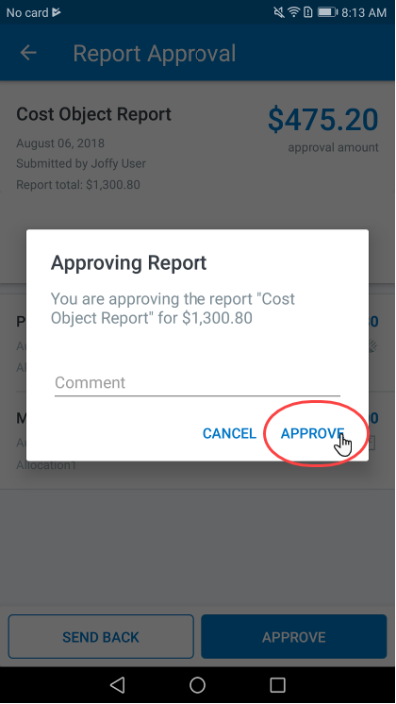 | To approve an expense report:  1) On the home screen, tap Approvals.  2) On the Approvals screen, tap the desired expense report.  3) On the Report Approval screen, tap Approve.  4) On the Report Approval screen, enter the desired comment.  5) Tap Approve.

Send Back an Expense Report
Screen(s) | Description/Action
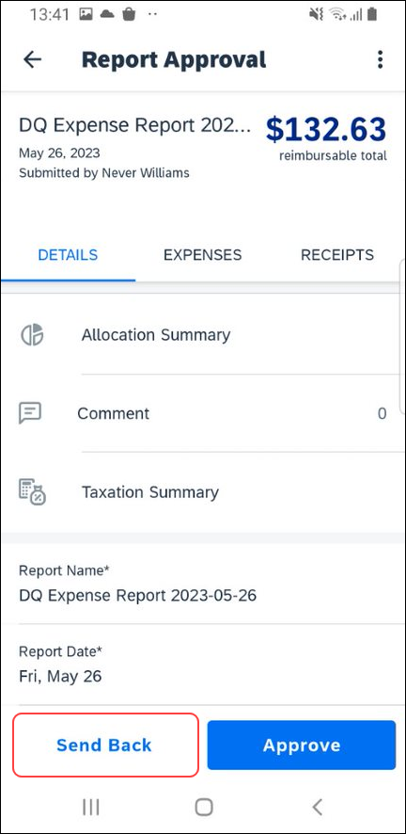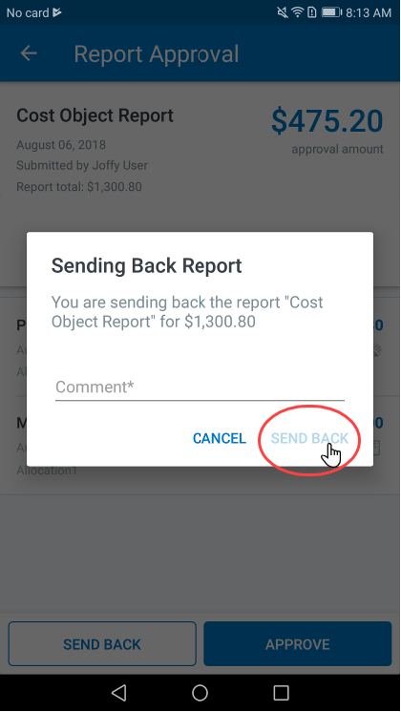 | To send back an expense report:  1) On the home screen, tap Approvals.  2) On the Approvals screen, tap the desired expense report.  3) On the Report Approval screen, tap Send Back.  4) On the Sending Back Report screen, enter the desired comment.  5) Tap Send Back.

Review and Approve an Expense Report as a Cost Object Approver
Screen(s) | Description/Action
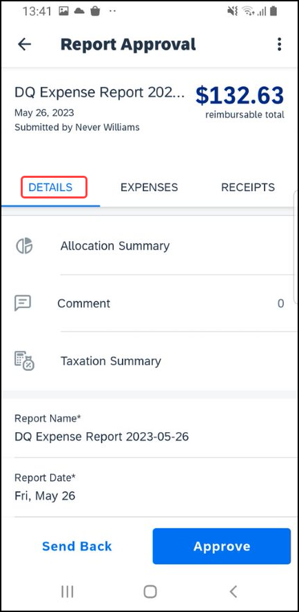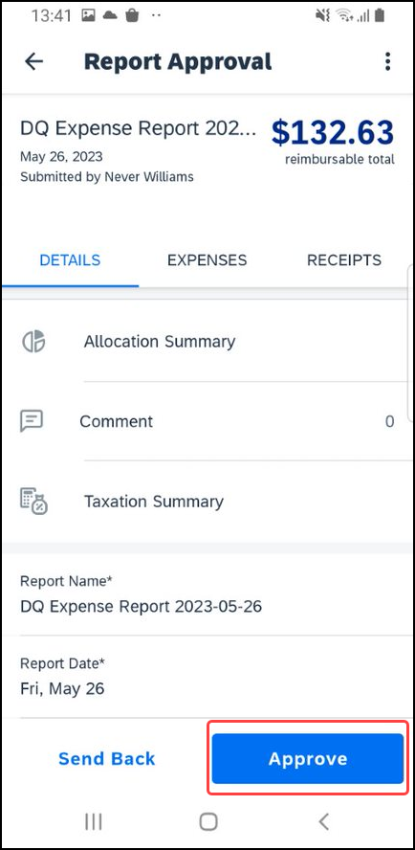 | To review and approve an expense report as a cost object approver:  1) On the home screen, tap Approvals.  2) On the Approvals screen, tap the desired expense report.  3) On the Report Approval screen, review the report details.  4) When ready to approve the expense report, tap Approve.

Review and Approve an Expense Report with a Travel Allowance
Screen(s) | Description/Action
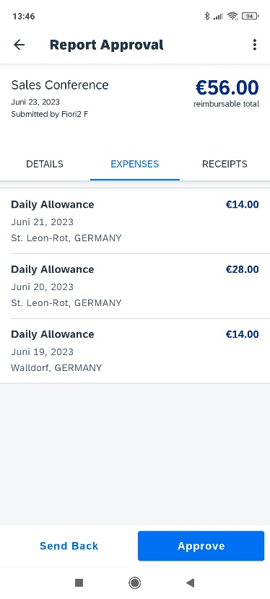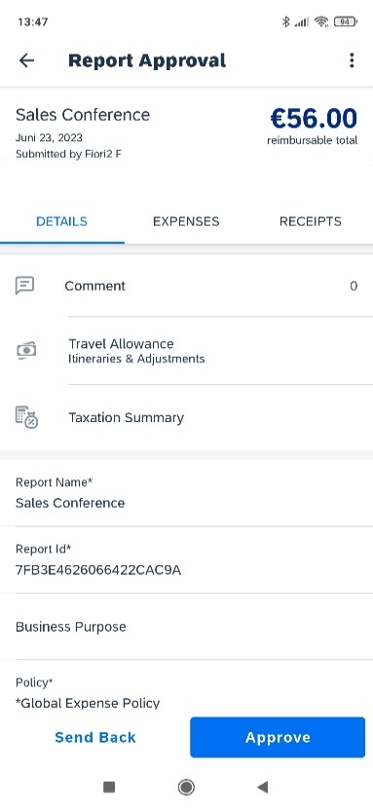 | To review and approve an expense report with a travel allowance:  1) On the home screen, tap Approvals.  2) On the Approvals screen, tap the desired expense report.3) On the Report Approval screen, from the Expense tab you can review the daily allowance details.  4) Once done reviewing the daily allowance details, tap the Details tab.  On the Details tab, you can review the expense report details, comments, and travel allowances.  5) Once done reviewing the expense report details and comments, tap Travel Allowance Itineraries & Adjustments.
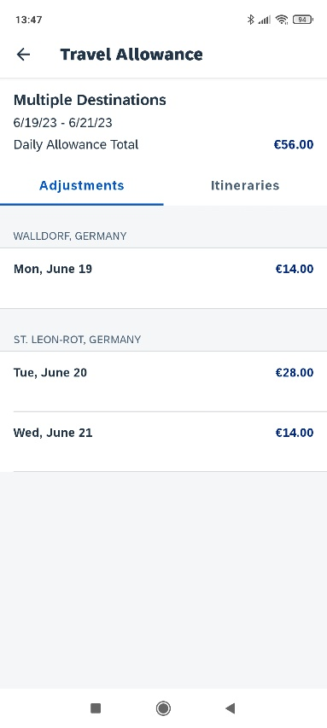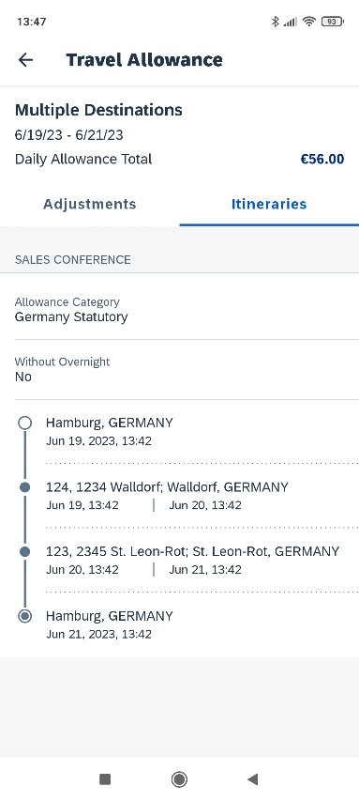 | 6) On the Travel Allowance screen, you can review the adjustment details.  7) Once done reviewing the adjustment details, tap the Itineraries tab.  8) From the Itineraries tab, on the Travel Allowance screen, review the itineraries details.  9) Once done reviewing the itinerary details, tap (upper-left corner) to return to the Report Approval screen.
 | 10) On the Report Approval screen, tap Approve.

☼

