 | Mobile App User Guide  Concur ExpenseIt  Last Revised: August 17, 2023 | This guide describes the current version, which is shown on the "Introduction" guide. |  | Applies to these mobile devices:  Yes: iPhone  Yes: iPad  Yes: Android
 | IMPORTANT: Be aware that your company's configuration may not allow for all of the features described here. Generally, if a feature is not available in your configuration of the web version of SAP Concur, then it is not available in the mobile app.
Concur ExpenseIt, in the SAP Concur mobile app, is a value-added service that turns receipts into expense line items and sends them directly into Concur Expense. It makes submitting receipts, creating expense reports, and getting reimbursed quicker and easier by doing a lot of the work for the user.  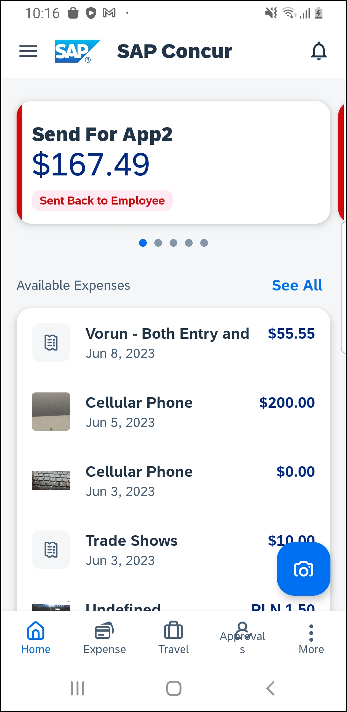 |  |  | Concur ExpenseIt 2  iPhone 2  Convert Receipts into Expenses 2  On-Device Receipt Recognition 5  Use of Delegate Function to Add Expenses 6  Android 10  Convert Receipts into Expenses 10  On-Device Receipt Recognition 11  Use of Delegate Function to Add Expenses 13  iPad 16  Convert Receipts into Expenses 16  On-Device Receipt Recognition 20  Use of Delegate Function to Add Expenses 22
Please Note:
- The SAP Concur app for iOS and Android supports universal links, i.e. links that navigate directly to the app if it is installed or to the website if not.
- Such links are included in notification emails from SAP Concur related to the expense report changes.
- Universal link support for customers own use is currently not supported.
- Some security solutions may block the links embedded into email from opening the app directly. The proper exceptions for the security policy should be configured for SAP Concur universal link URLs (pattern to match: https://*.concursolutions.com/*). Known cases are:
- MDM/MAM policy that prescribes to open any link tapped in Outlook mobile app only in specified browser.
- Outlook mail server phishing protection that wraps all link embedded into e-mails to open the safety check service first.

Concur ExpenseIt
If a user's company uses ExpenseIt, they can manage their expenses start to finish. The SAP Concur mobile app will turn their receipts into expense entries and then send them directly into Concur Expense.

iPhone

Convert Receipts into Expenses
Screen(s) | Description/Action
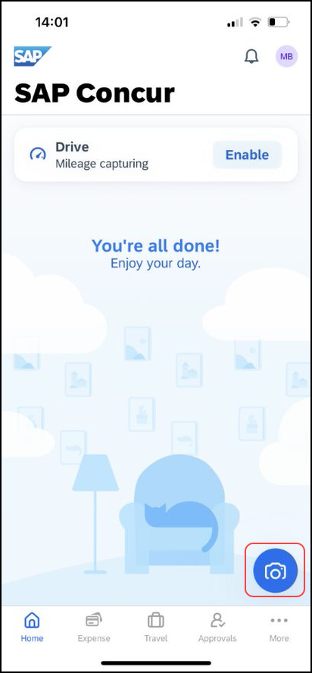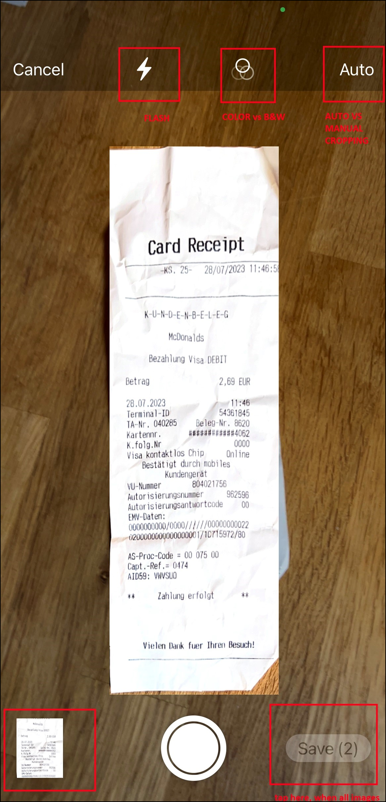 | To turn your receipts into expenses:  1) Tap the camera icon to capture a receipt when ExpenseIt is enabled.  2) Take a picture of the receipt. SAP Concur analyzes the receipt information.  3) The bottom left shows the already created receipts. The bottom right shows how many receipts are waiting to be saved.  4) If Auto is enabled, images will be captured automatically.
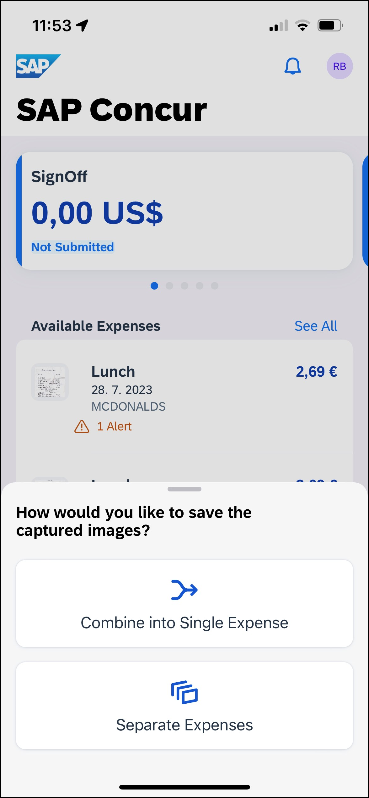 | 5) When taking several images in a row, select Combine into Single Expense or Separate Expenses.
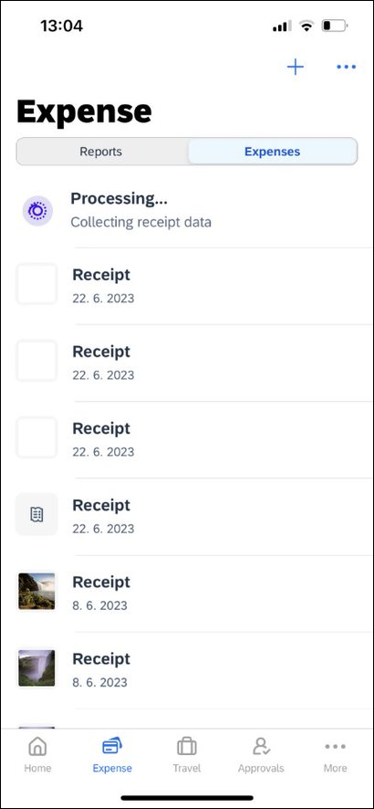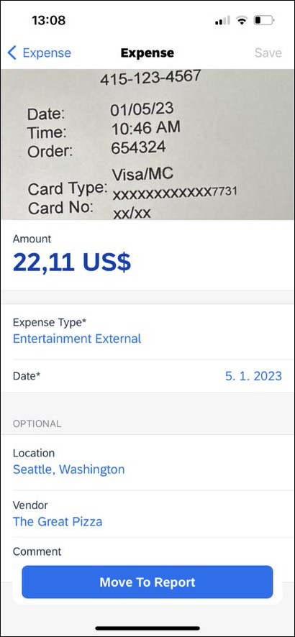 | 6) When the analysis is complete, open the receipt, attach to a report, edit as necessary, etc.  7) When done, tap Move To Report.
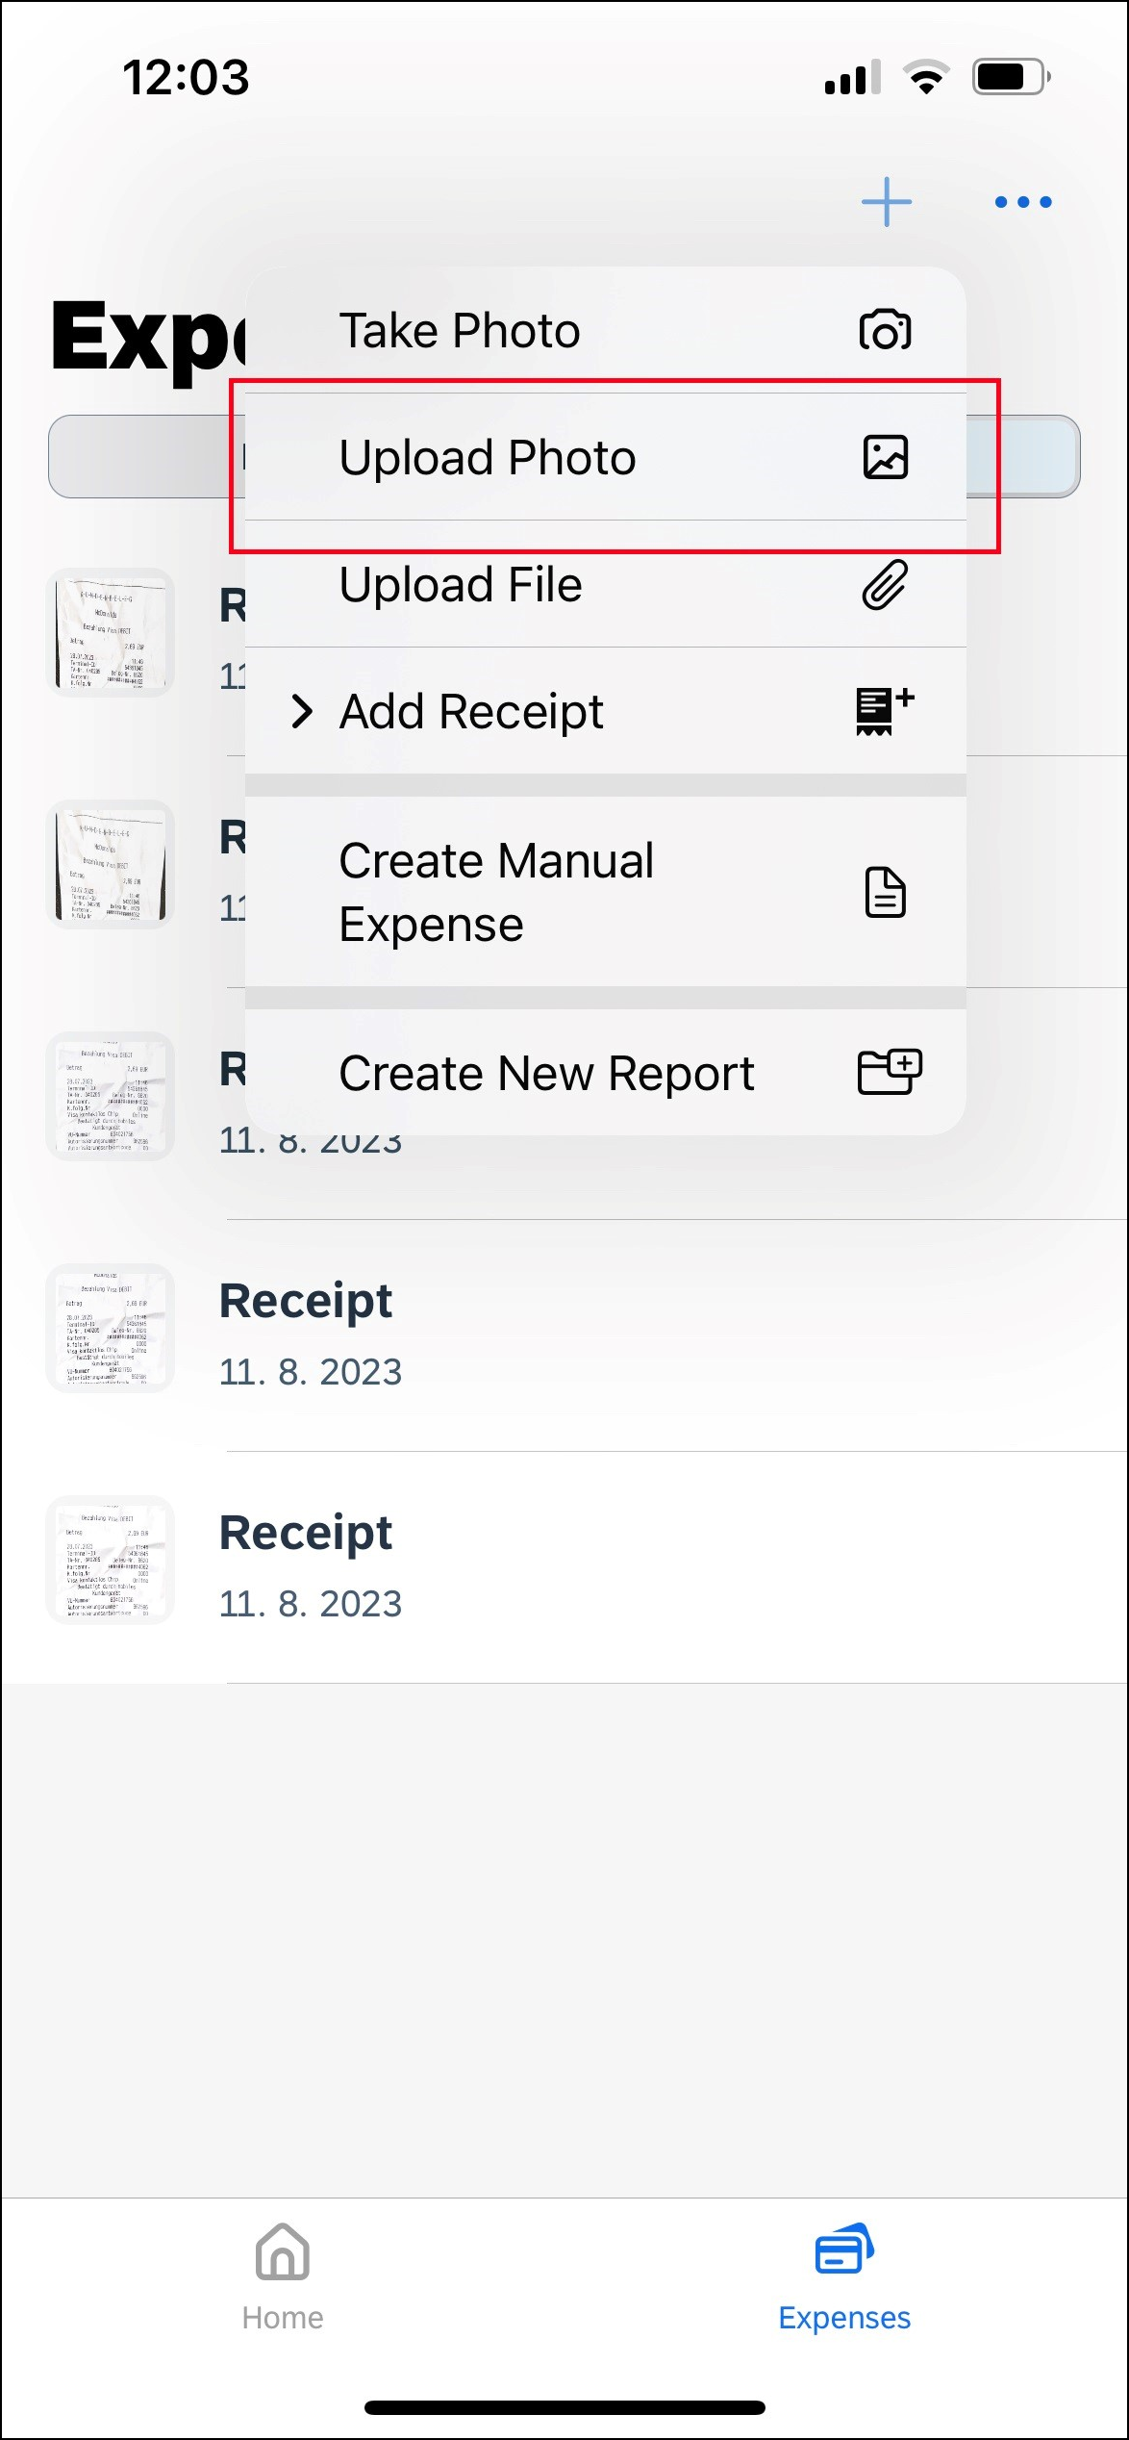 | 8) Saved receipts must be uploaded through the Expense tab on the home screen and then by tapping and selecting Upload Photo.

On-Device Receipt Recognition

Automatically Detect Receipt Amount
Screen(s) | Description/Action
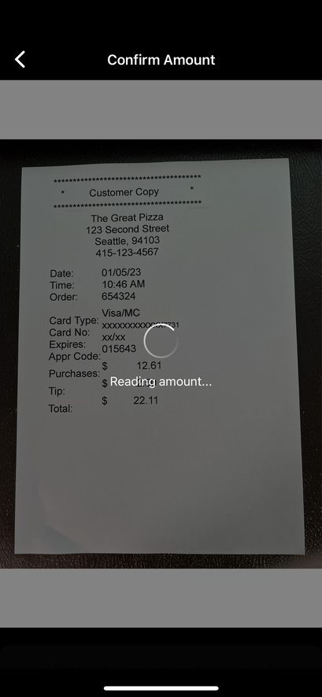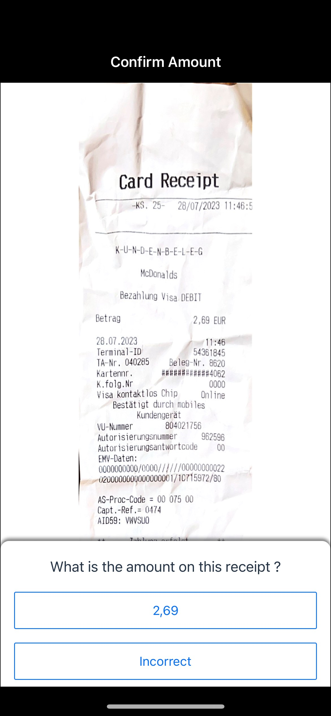 | To convert a receipt amount automatically in ExpenseIt:  1) On the home screen, tap ExpenseIt.  2) On the Confirm Amount screen, either:  - Tap the amount.  -or-  - Tap Incorrect, to enter an appropriate amount.

Manually Enter the Correct Receipt Amount
Screen(s) | Description/Action
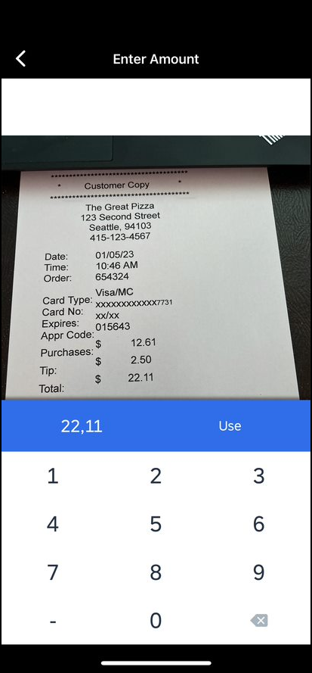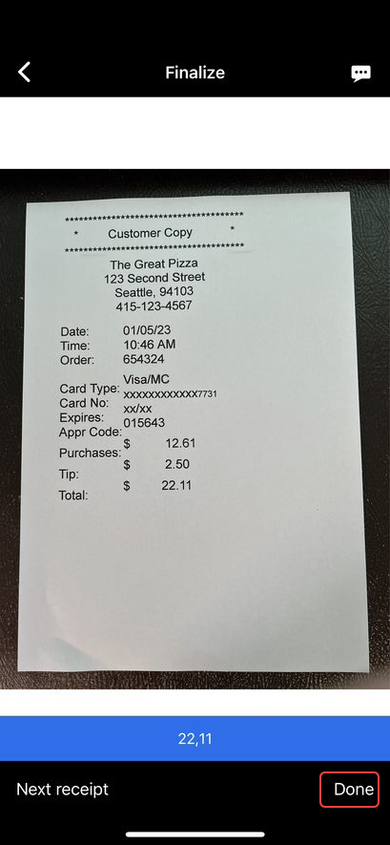 | To manually enter the correct receipt amount:  1) On the Confirm Amount screen, tap Incorrect.  2) On the Enter Amount screen, enter the appropriate amount and tap Use when finished.  3) On the Finalise screen, either:  - Tap Next receipt to go to the next receipt.  -or-  - Tap Done to finish.

Use of Delegate Function to Add Expenses
Screen(s) | Description/Action
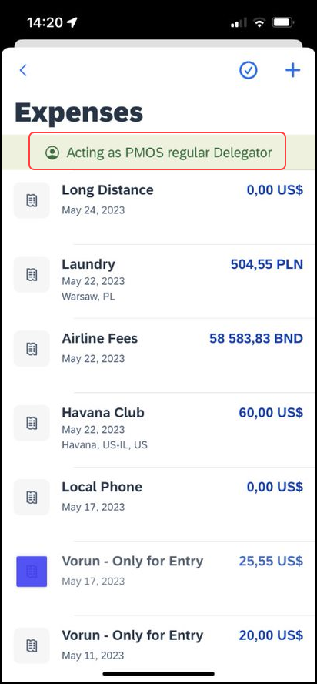 | To add expenses on behalf of another user:  1) Ensure that you are acting as another user. This is indicated by the green banner at the top of the screen. Once enabled, you will automatically be directed to the Expenses screen.
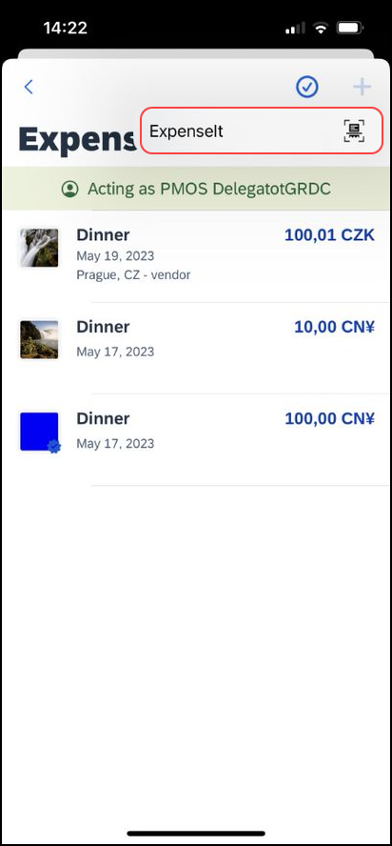 | 2) Click the plus icon and the ExpenseIt option will appear. Tap this option and you will be able to select the receipt to be added as an expense. By tapping Done, you will be re-directed to to the Expenses list where you will see the uploaded receipt being processed.

Stop Using Delegate Function
Screen(s) | Description/Action
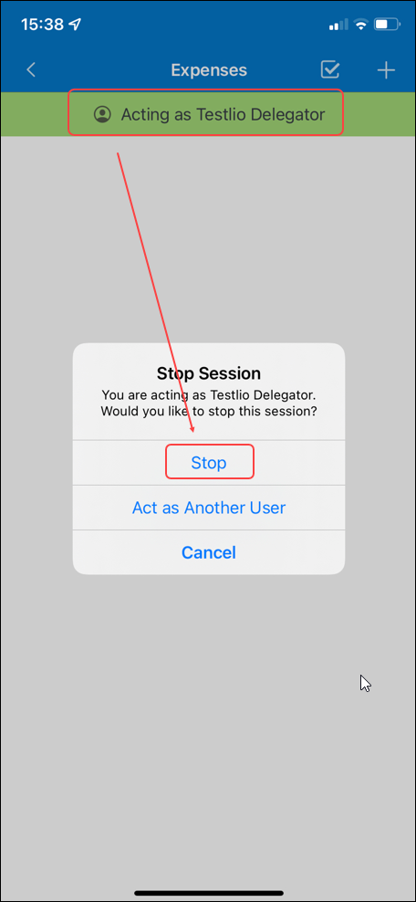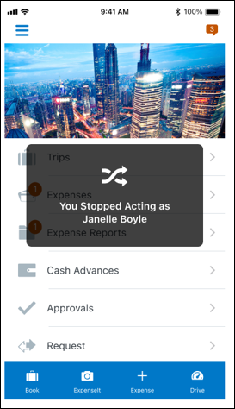 | To stop acting on behalf another user:  1) To stop acting on behalf of another user, tap the green banner where it is visible that you are acting as another user. In the pop up that appears, select Stop.  2) Once you tap Stop this message is automatically dismissed and the green banner also disappears. You now regains access to the usual features.
Note: The Delegate Function is currently only available for GRDC users who are ExpenseIt enabled. Once uploaded, expenses cannot be edited within the Mobile App. Only deleted and re-uploaded. Or, the user or delegate can edit the expense on the web.

Using Delegate Function to Edit Expenses
Screen(s) | Description/Action
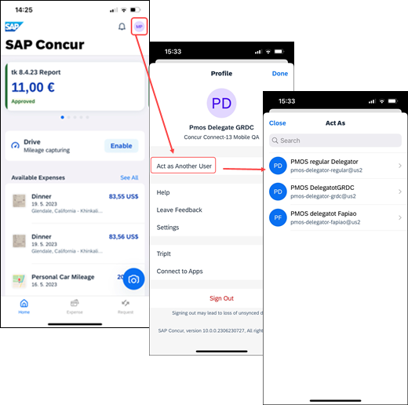 | To Edit an Expense While Using the Delegate Function:  1) Tap the Menu button and then tap Act as Another User. Once the user you wish to act on behalf of is selected, it will be indicated by a green banner. You will also be directed to the Expenses Screen.
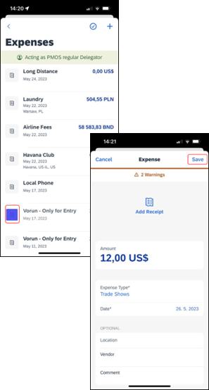 | 2) Once on the Expenses page, select the Expense that needs to be edited and this will direct you to the details of this expense. Tap on the areas that need to be edited. Once the edits are made, tap Save for the edits to be reflected.

Android

Convert Receipts into Expenses
Screen(s) | Description/Action
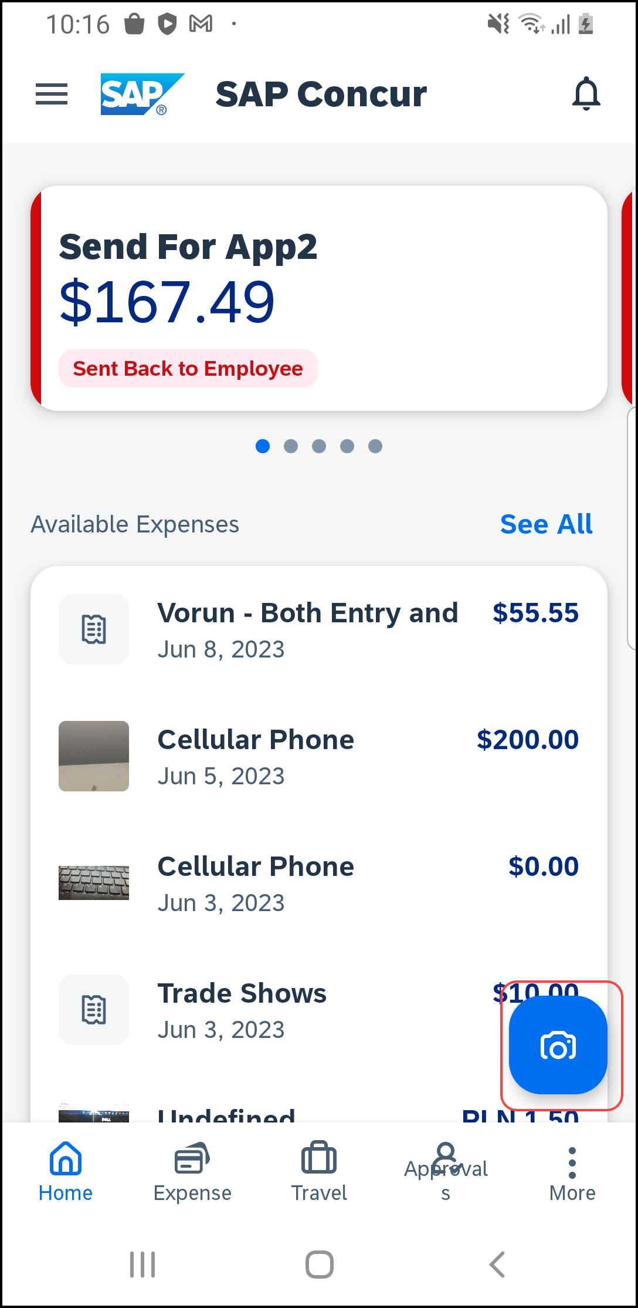 | To turn your receipts into expenses:  1) Tap the camera icon to launch ExpenseIt.
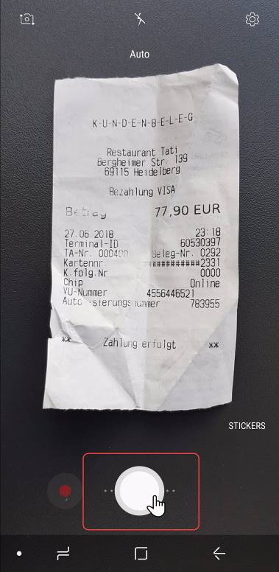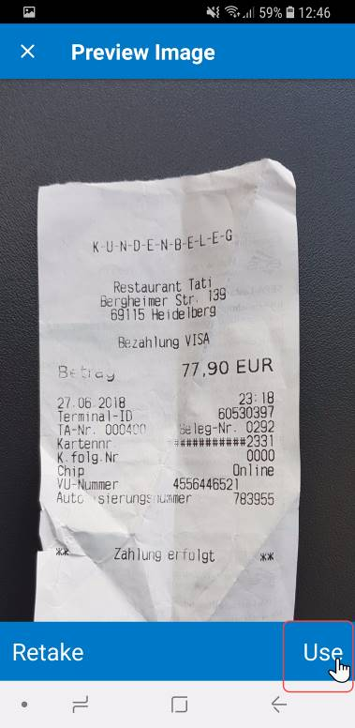 | 2) Take a picture of the receipt. SAP Concur analyzes the receipt information.
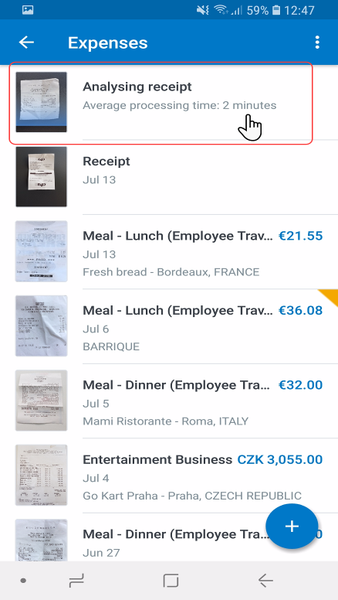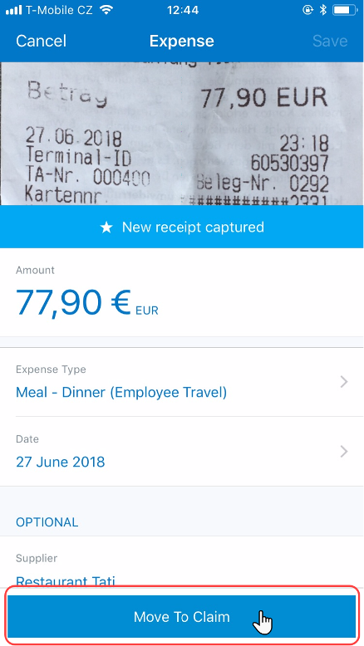 | 3) When the analysis is complete, open the receipt, attach to a report, edit as necessary, etc.  4) When done, tap Move To Claim.

On-Device Receipt Recognition

Automatically Detect Receipt Amount
Screen(s) | Description/Action
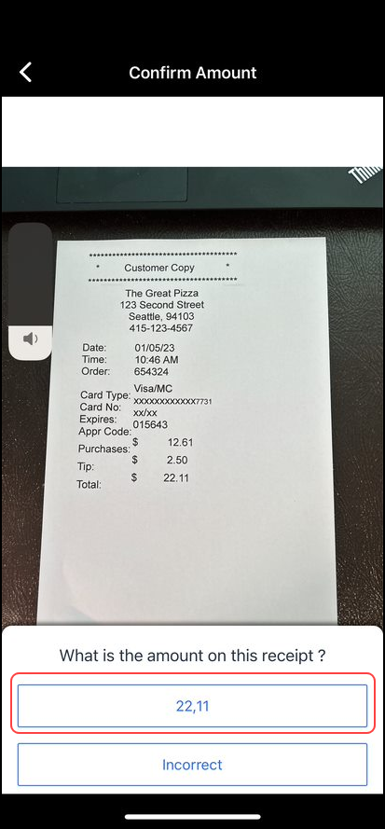 | To convert a receipt amount automatically in ExpenseIt:  1) On the home screen, tap ExpenseIt.  2) On the Confirm Amount screen, either:  - Tap the amount.  -or-  - Tap Incorrect, to enter an appropriate amount.

Manually Enter the Correct Receipt Amount
Screen(s) | Description/Action
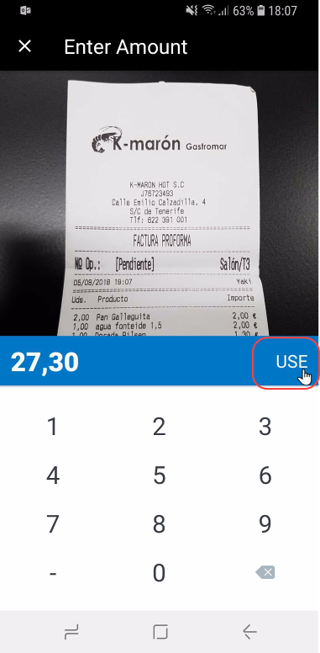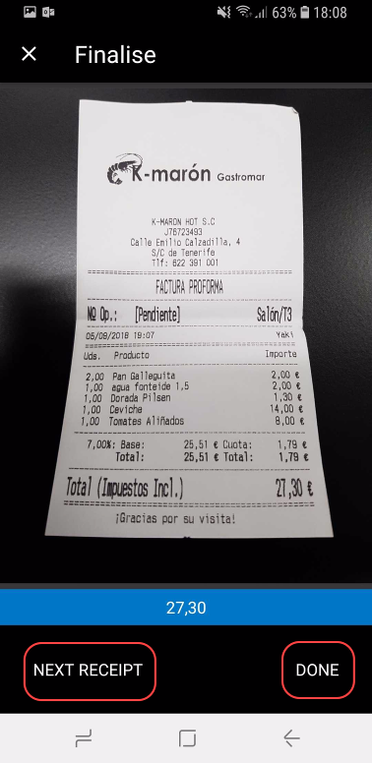 | To manually enter the correct receipt amount:  1) On the Confirm Amount screen, tap Incorrect.  2) On the Enter Amount screen, enter the appropriate amount and tap Use when finished.  3) On the Finalise screen, either:  - Tap Next Receipt to go to the next receipt.  -or-  - Tap Done to finish.

Use of Delegate Function to Add Expenses
Screen(s) | Description/Action
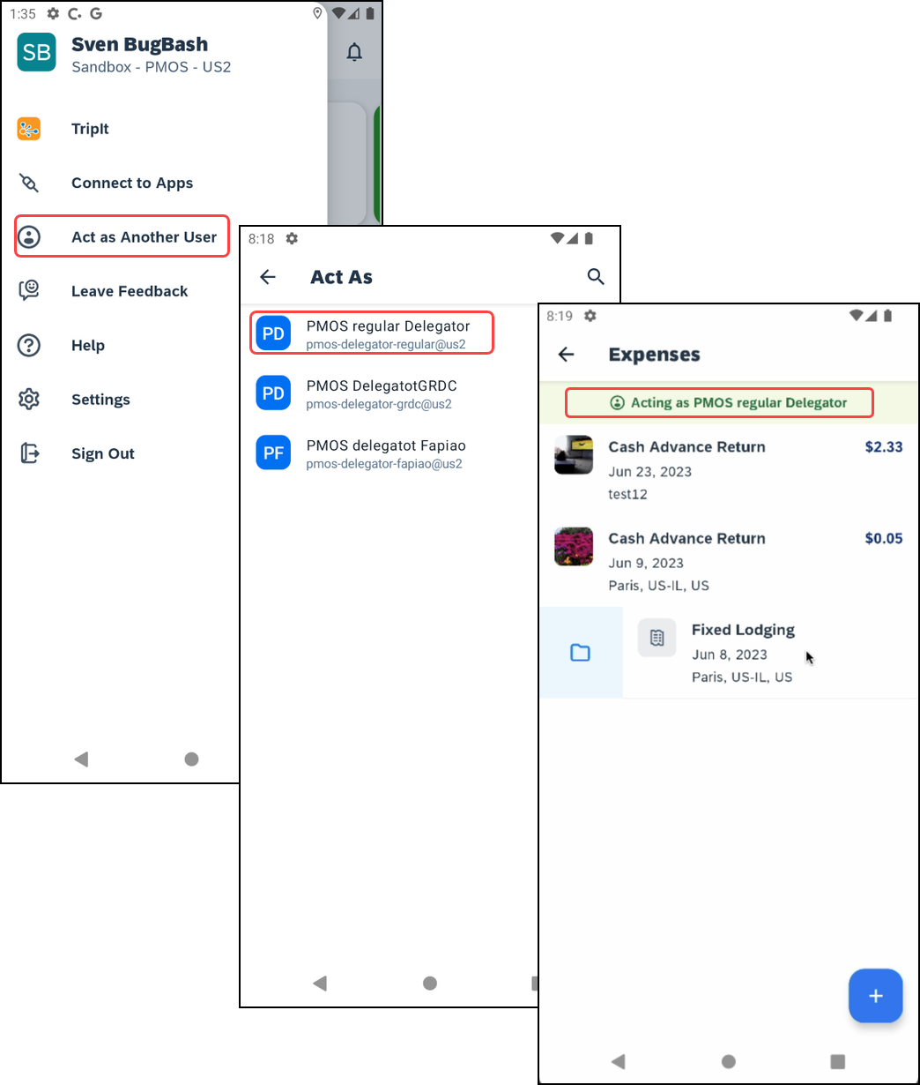 | To add expenses on behalf of another user:  1) Tap the Menu button and then tap Act as Another User. Once the user you wish to act on behalf of is selected, it will be indicated by a green banner. You will also be directed to the Expenses Screen.
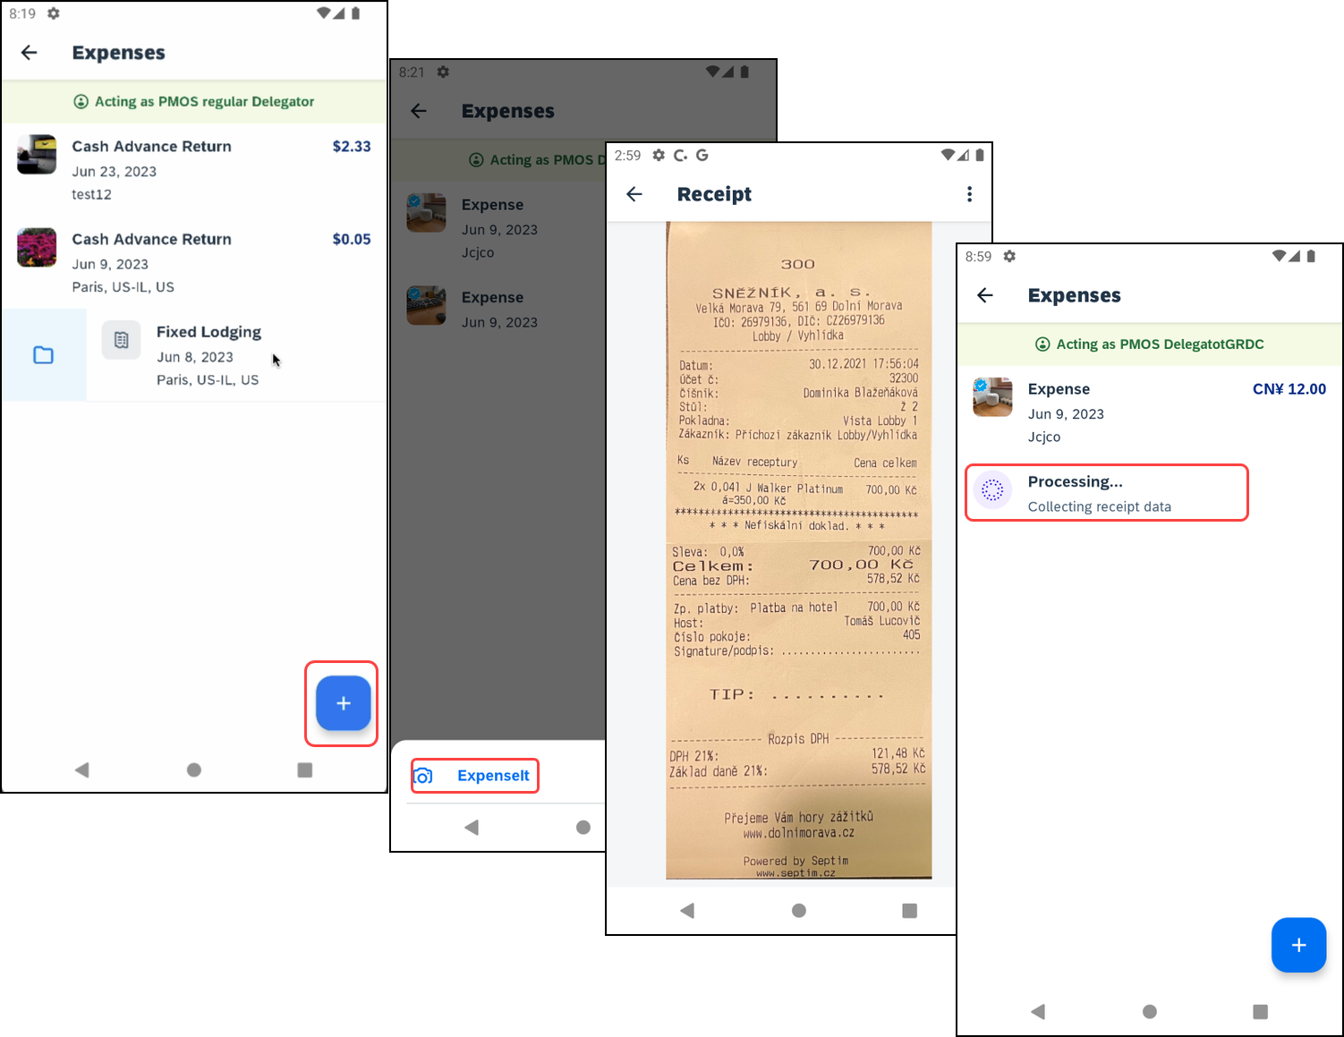 | 2) Tap the Add button and the ExpenseIt option will appear. Tap this option and you will be able to select the receipt to be added as an expense. Once selected, you will be redirected to the Receipt to confirm it. It will then appear in your Expenses List.
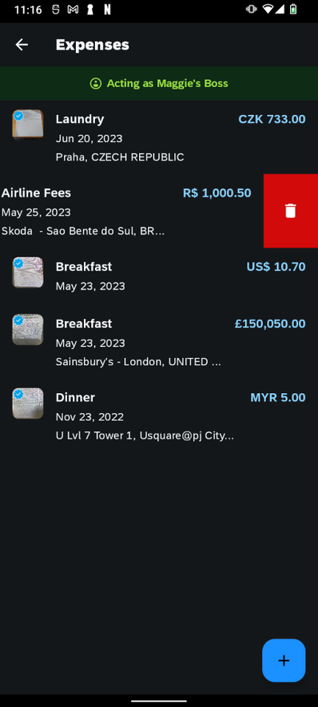 | 3) To Delete an Expense, swipe on the Expense you want to Delete from the list. Tap the Trash Can Icon. A message will appear at the bottom of the screen to confirm the selected is now deleted.

Stop Using Delegate Function
Screen(s) | Description/Action
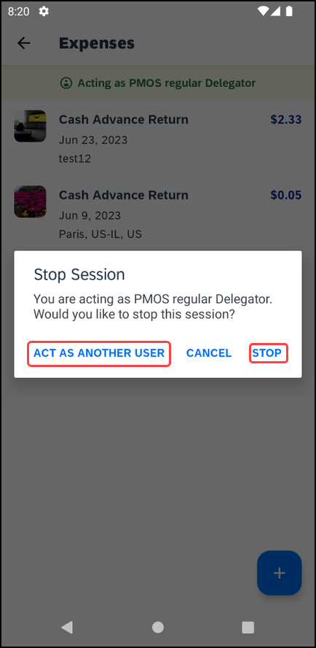 | To stop acting on behalf another user:  1) Tap the green banner, where it is displayed who you are acting on behalf of. From here, you can stop acting on behalf of this user, or, change the user you are acting on behalf of.  2) Once you tap Stop this message is automatically dismissed and the green banner also disappears. You now regains access to the usual features.  3) From here, you can also choose to Act As Another User.
Note: The Delegate Function is currently only available for GRDC users who are ExpenseIt enabled. Once uploaded, expenses cannot be edited within the Mobile App. Only deleted and re-uploaded. Or, the user or delegate can edit the expense on the web.

iPad

Convert Receipts into Expenses
Screen(s) | Description/Action
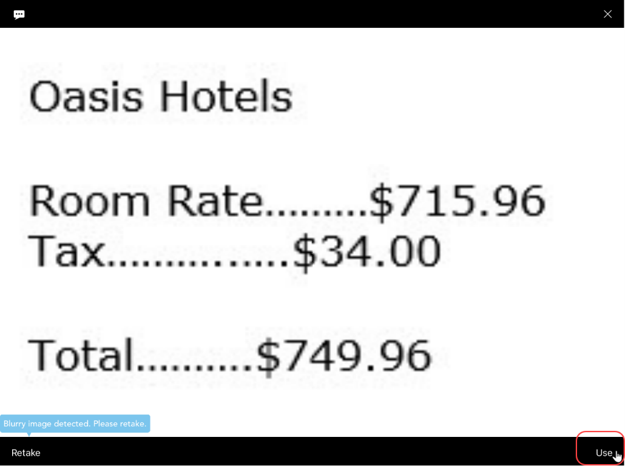 | To turn your receipts into expenses:  1) On the home screen, tap ExpenseIt.  2) Take a picture of the receipt. SAP Concur analyzes the receipt information.
 | 3) When the analysis is complete, open the receipt, attach to a report, edit as necessary, etc.
 | 4) When done, tap Move To Report.
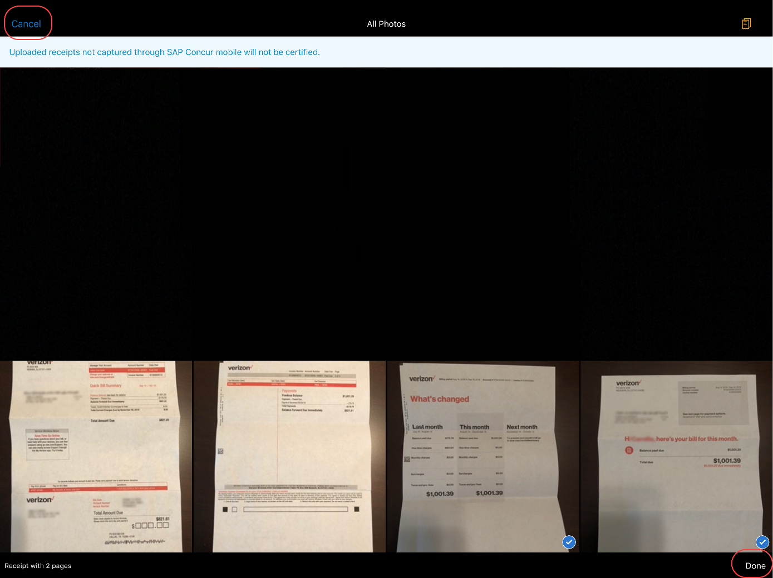 | 5) After capturing all the appropriate receipts, tap either:  - Done  – or –  - Cancel

On-Device Receipt Recognition

Automatically Detect Receipt Amount
Screen(s) | Description/Action
To convert a receipt amount automatically in ExpenseIt:
1) On the home screen, tap ExpenseIt.
2) On the Confirm Amount screen either:
- Tap the amount.
-or-
- Tap Incorrect to enter an appropriate amount.

Manually Enter the Correct Receipt Amount
Screen(s) | Description/Action
To manually enter the correct receipt amount:
1) On the Confirm Amount screen, tap Incorrect.
2) On the Enter Amount screen, enter the appropriate amount and tap Use when finished.
3) On the Finalise screen, either:
- Tap Next receipt, to go to the next receipt.
-or-
- Tap Done, to finish.

Use of Delegate Function to Add Expenses
Screen(s) | Description/Action
To add expenses on behalf of another user:
1) Ensure that you are acting as another user. This is indicated by the green banner at the top of the screen. Once enabled, you will automatically be directed to the Expenses screen.
 | 2) Click the Add button and the ExpenseIt option will appear. Tap this option and you will be able to select the receipt to be added as an expense. By tapping Done, you will be re-directed to to the Expenses list where you will see the uploaded receipt being processed.

Stop Using Delegate Function
Screen(s) | Description/Action
To stop acting on behalf another user:
1) To stop acting on behalf of another user, tap the green banner where it is visible that you are acting as another user. In the pop up that appears, select Stop.

2) Once you tap Stop this message is automatically dismissed and the green banner also disappears. You now regains access to the usual features.

Using Delegate Function to Edit Expenses
Screen(s) | Description/Action
To Edit an Expense While Using the Delegate Function:
1) Tap the Menu button and then tap Act as Another User. Once the user you wish to act on behalf of is selected, it will be indicated by a green banner. You will also be directed to the Expenses Screen.

 | 2) Once on the Expenses page, select the Expense that needs to be edited and this will direct you to the details of this expense. Tap on the areas that need to be edited. Once the edits are made, tap Save for the edits to be reflected.

☼

