Mobile App User Guide  Budget  Last Revised: July 5, 2023 | This guide describes the current version, which is shown on the "Introduction" guide. |  | Applies to these mobile devices:  Yes: iPhone  No: iPad  Yes: Android
IMPORTANT: Be aware that your company's configuration may not allow for all of the features described here. Generally, if a feature is not available in your configuration of the web version of SAP Concur, then it is not available in the mobile app.
Budget provides users with the budget management tools - with actionable insights - that helps them to prevent overspend.  With Budget, users can:  - Capture and consolidate data for a holistic view of spending across their organization  - Control and adjust their budget to changing business needs  - Improve the accuracy and timeliness of their spend |  | Budget 1  iPhone 3  View Your Budget 3  View an Unapproved Invoice Details in Budget 5  Android 6  View Your Budget 6  View an Unapproved Invoice Details in Budget 7
Please Note:
- The SAP Concur app for iOS and Android supports universal links, i.e. links that navigate directly to the app if it is installed or to the website if not.
- Such links are included in notification emails from SAP Concur related to the expense report changes.
- Universal link support for customers own use is currently not supported.
- Some security solutions may block the links embedded into email from opening the app directly. The proper exceptions for the security policy should be configured for SAP Concur universal link URLs (pattern to match: https://*.concursolutions.com/*). Known cases are:
- MDM/MAM policy that prescribes to open any link tapped in Outlook mobile app only in specified browser.
- Outlook mail server phishing protection that wraps all link embedded into e-mails to open the safety check service first.

Budget
On the home screen, tap the and select Budgets to see your budget in a yearly, quarterly, and monthly view.
You can toggle between budgets and approvals to see – in real time – if there is enough budget remaining to allow approval of an expense.
NOTE: You will be sent push notifications if your budget is approaching its limit or is over limit.
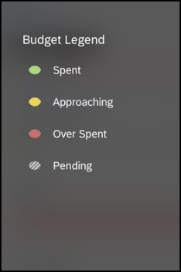
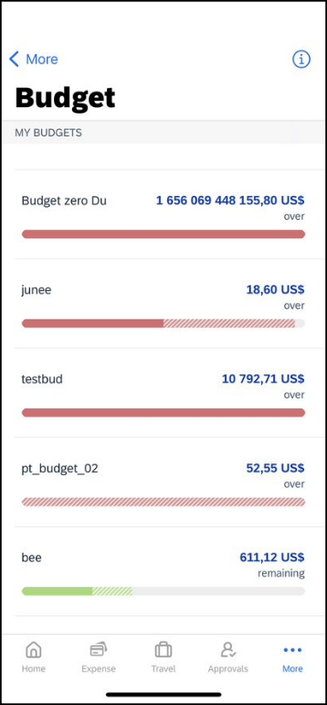
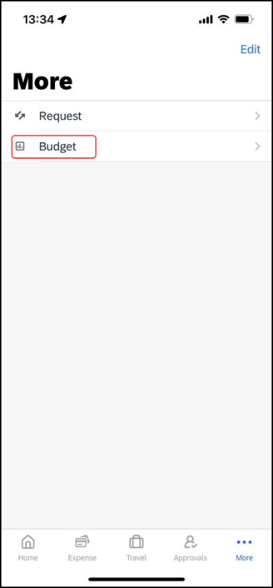
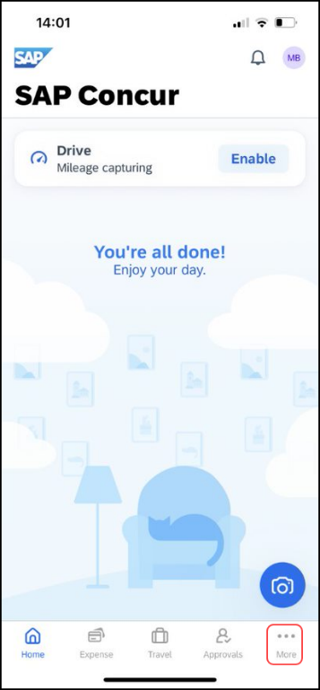

iPhone

View Your Budget
Screen(s) | Description/Action
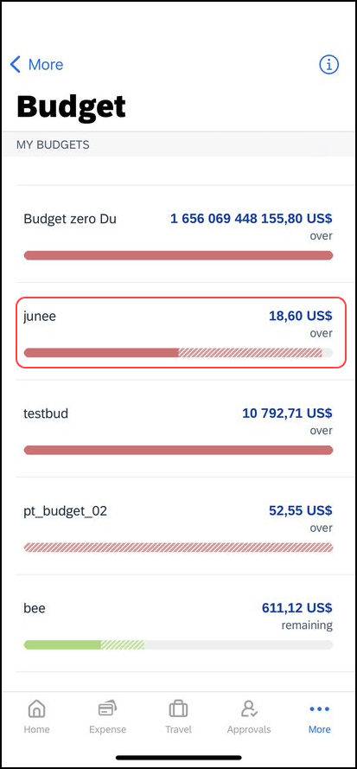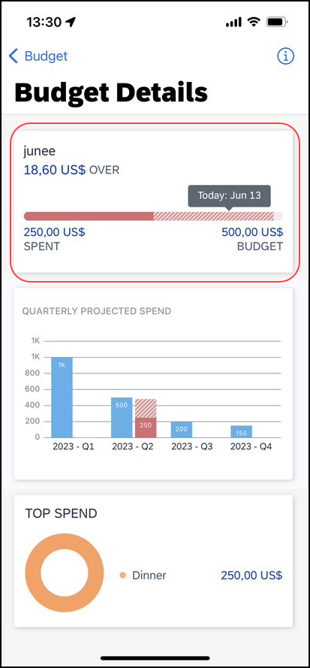 | To view your budget:  1) On the home screen, tap the More icon and then select Budget.  NOTE: The "striped" section of the colored bar indicates pending spend.  2) On the Budgets screen, tap the desired budget.  NOTE: The date represents where "today" is in relation to the budget start and end date.  3) On the Budget Details screen, tap the budget section.
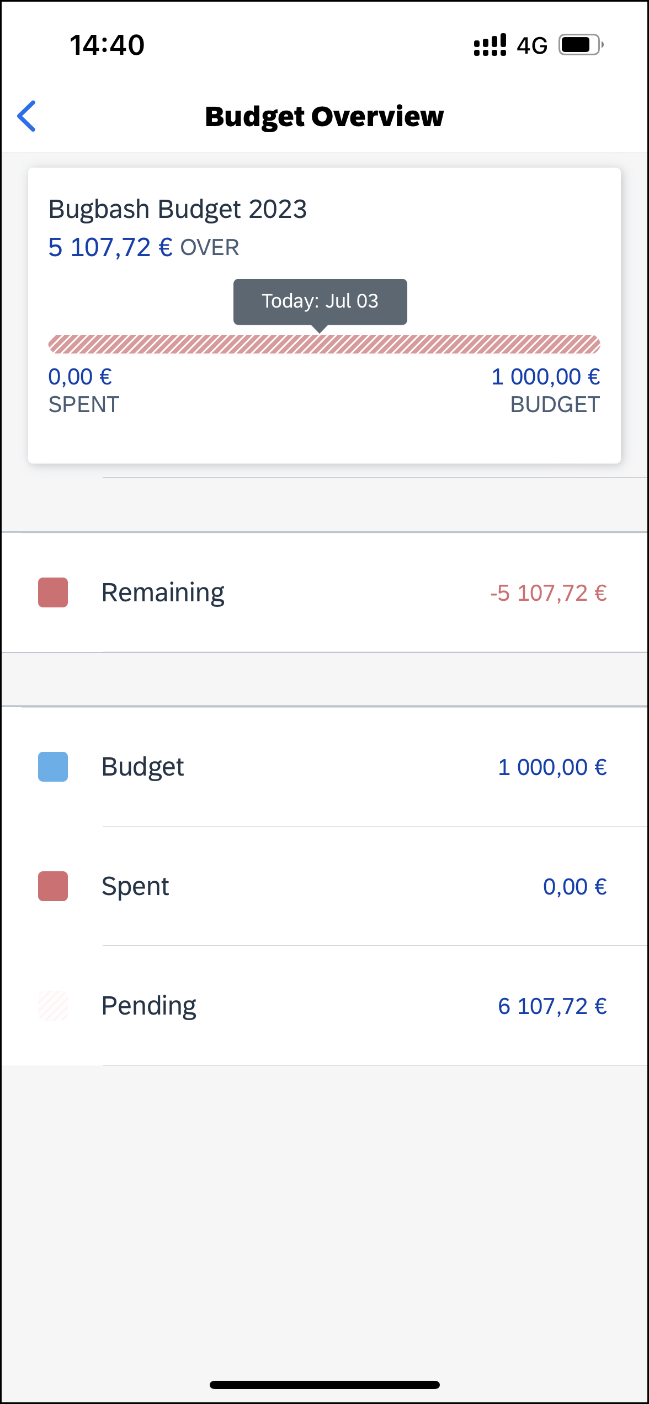 | The Budget Overview screen appears.  NOTE: The Top Spend chart reflects the overall totals for all products associated with the budget.

View an Unapproved Expense Details in Budget
Screen(s) | Description/Action
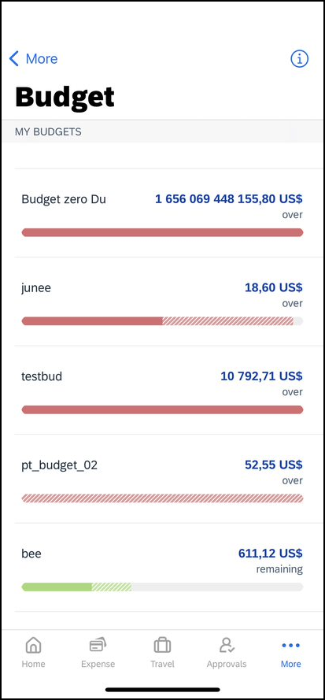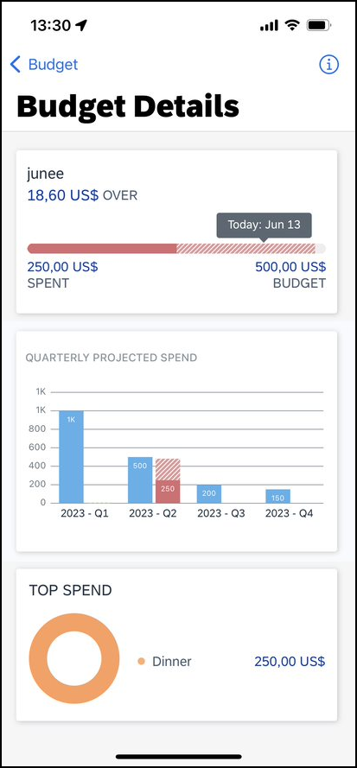 | To view an unapproved expense details in a budget:  1) On the home screen, tap Approvals.  2) On the Report Approvals screen, tap the desired expense report.  3) On the Report Approval screen, tap the screen to view the unapproved expense report details in Budget.  4) On the Budgets screen, tap the budget associated with the expense report.  The Budget Details screen appears.  NOTE: The budget icon will appear in the upper-right corner of the Report Approval screen, if there is a budget associated with the expense report.

View an Unapproved Invoice Details in Budget
Screen(s) | Description/Action
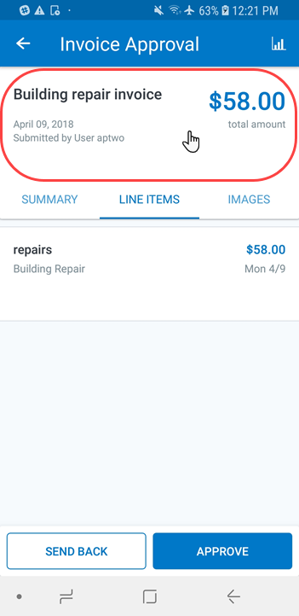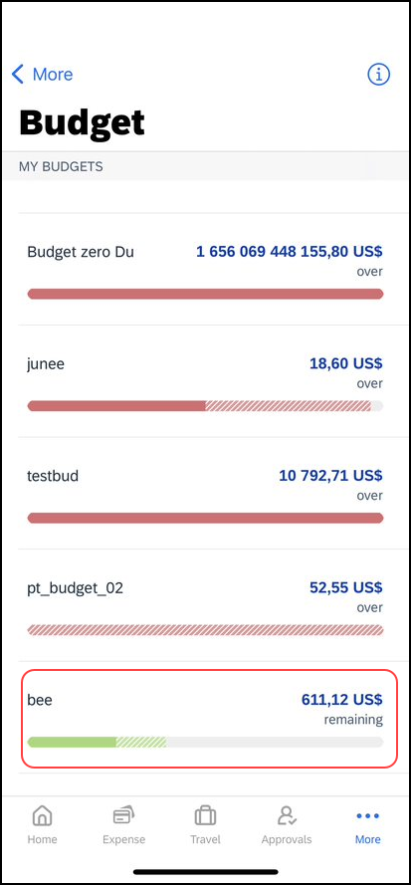 | To view an unapproved invoice details in a budget:  1) On the home screen, tap Approvals.  2) On the Approvals screen, tap Invoice Approvals.  3) On the Invoice Approvals screen, tap the desired payment request.  4) On the Invoice Approval screen, tap the screen to view the unapproved payment request details in Budget.  5) On the Budgets screen, tap the budget associated with the invoice.
The Budget Overview screen appears.
NOTE: The budget icon will appear in the upper-right corner of the Invoice Approval screen, if there is a budget associated with the payment request.

Android

View Your Budget
Screen(s) | Description/Action
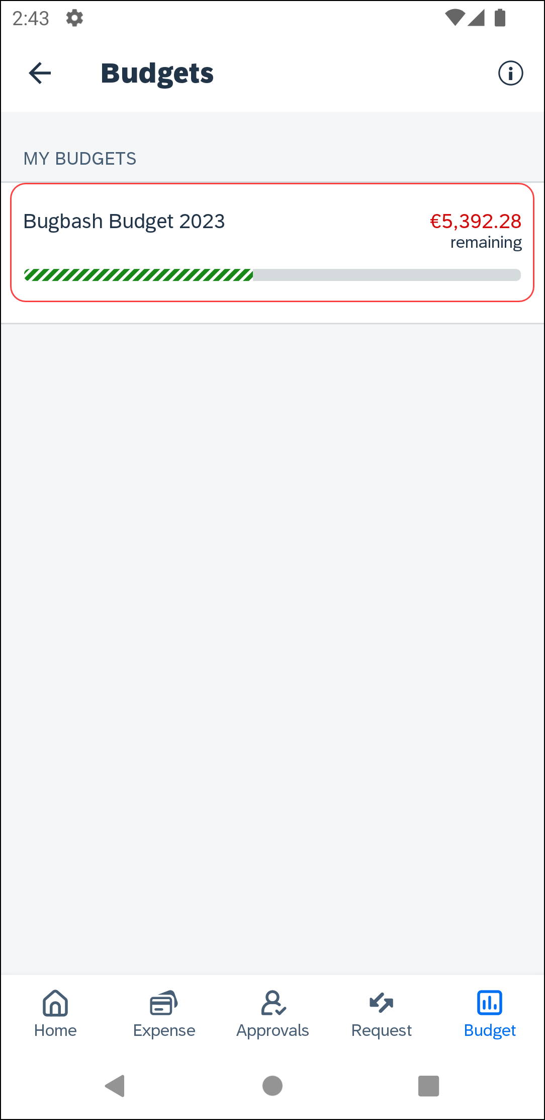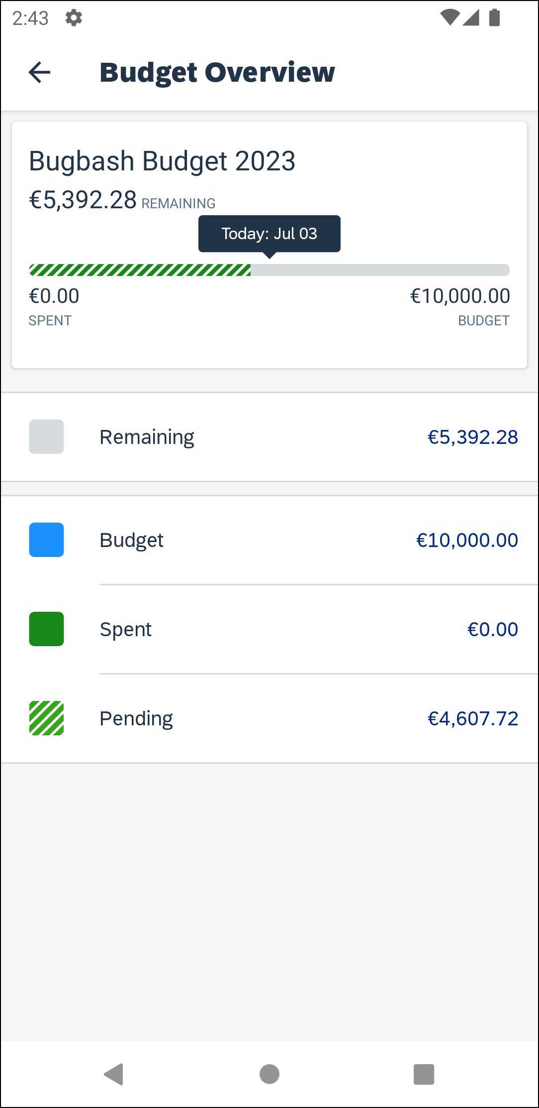 | To view your budget:  1) On the home screen, tap Budgets.  NOTE: The "striped" section of the colored bar indicates pending spend.  2) On the Budgets screen, tap the desired budget.  NOTE: The date represents where "today" is in relation to the budget start and end date.  3) On the Budget Overview screen, tap the budget section.
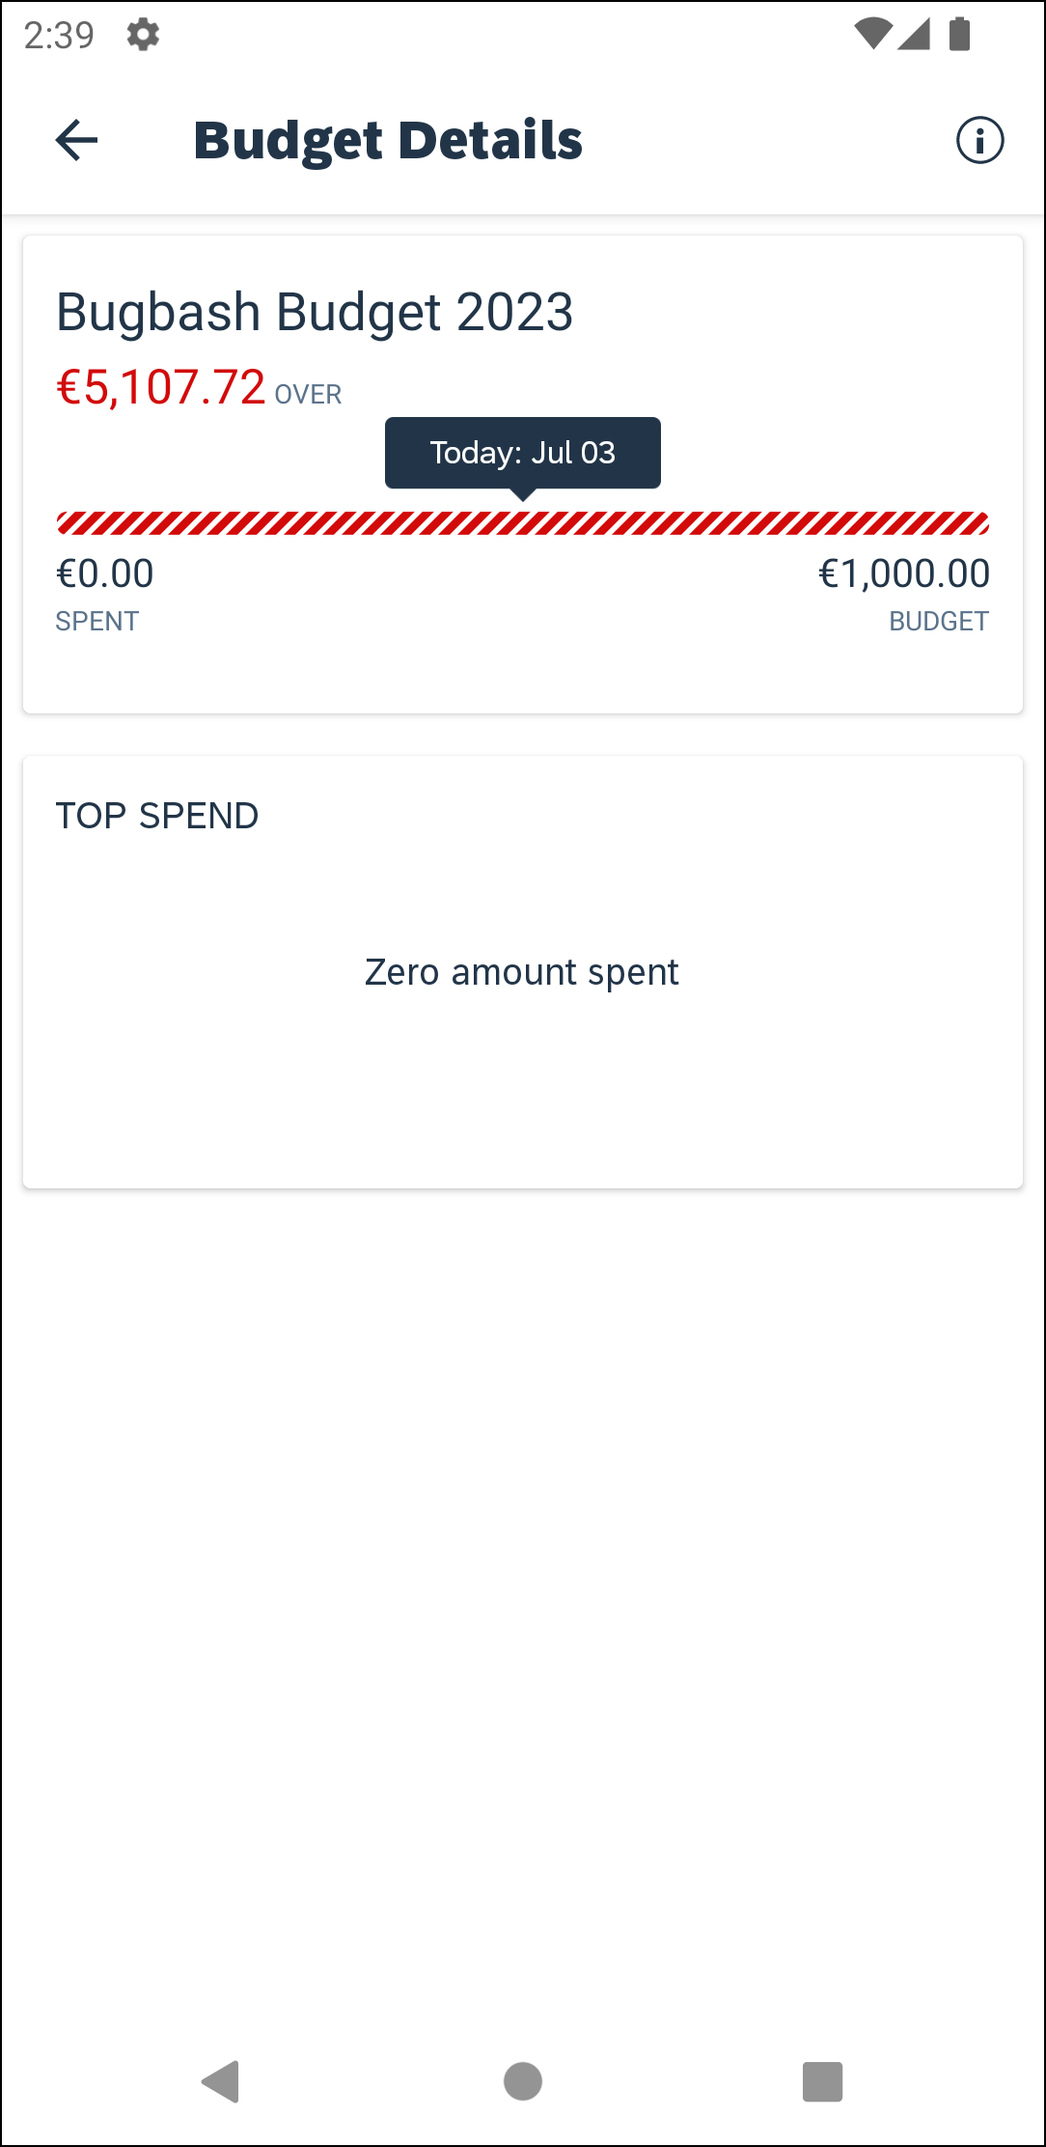 | The Budget Details screen appears.  NOTE: The resulting chart reflects the overall totals for all products associated with the budget.

View an Unapproved Expense Details in Budget
Screen(s) |  | Description/Action
To view an unapproved expense details in a budget:
1) On the home screen, tap Approvals.
2) On the Report Approvals screen, tap the desired expense report.
3) On the Report Approval screen, tap the screen to view the unapproved expense report details in Budget.
4) On the Budgets screen, tap the budget associated with the expense report.
The Budget Details screen appears.
NOTE: The budget icon will appear in the upper-right corner of the Report Approval screen, if there is a budget associated with the expense report.

View an Unapproved Invoice Details in Budget
Screen(s) | Description/Action
To view an unapproved invoice details in a budget:
1) On the home screen, tap Approvals.
2) On the Approvals screen, tap Invoice Approvals.
3) On the Invoice Approvals screen, tap the desired payment request.
4) On the Invoice Approvals screen, tap the screen to view the unapproved payment request details in Budget.
5) On the Budgets screen, tap the budget associated with the invoice. The Budget Overview screen appears.
NOTE: The budget icon will appear in the upper-right corner of the Invoice Approvals screen, if there is a budget associated with the payment request.

☼

