 | Mobile App User Guide  Receipts  Last Revised: March 27, 2024 | This guide describes the current version, which is shown on the "Introduction" guide. |  | Applies to these mobile devices:  Yes: iPhone  No: iPad  No: Android
 | IMPORTANT: Be aware that your company's configuration may not allow for all of the features described here. Generally, if a feature is not available in your configuration of the web version of SAP Concur, then it is not available in the mobile app.
You can work with receipts in the following ways:  - Attach receipts to an expense or report  - Capture receipts with the capture receipt feature  - Capture multipage receipts  - Create a mobile expense from a receipt  - View Receipts  - Delete Receipts Attach a missing receipt declaration to an Expense |  |  | Work With Receipts 2  Using Camera to Create Receipts 2  Attach Receipts 4  Activating Quick-Scan Camera 5  Using Quick-Scan Camera Features 6  Upload File From Shared Repository 8  Capture Multipage Receipts 10  Create a Mobile Expense From a Receipt 11  View Receipts 12  Delete Receipts 13  Using Delegate Function to Upload a Receipt 14  Attach a Missing Receipt Declaration to an Expense 16  Receipt Digitalization 17  Capture the Image While Creating an Expense 18  Capture the Image Using ExpenseIt 21  Troubleshooting 23
Please Note:
- The SAP Concur app for iOS and Android supports universal links, i.e. links that navigate directly to the app if it is installed or to the website if not.
- Such links are included in notification emails from SAP Concur related to the expense report changes.
- Universal link support for customers own use is currently not supported.
- Some security solutions may block the links embedded into email from opening the app directly. The proper exceptions for the security policy should be configured for SAP Concur universal link URLs (pattern to match:https://*.concursolutions.com/*). Known cases are:
- MDM/MAM policy that prescribes to open any link tapped in Outlook mobile app only in specified browser.
- Outlook mail server phishing protection that wraps all link embedded into e-mails to open the safety check service first.

Work With Receipts

Using Camera to Create Receipts

Screen(s) | Description/Action
- 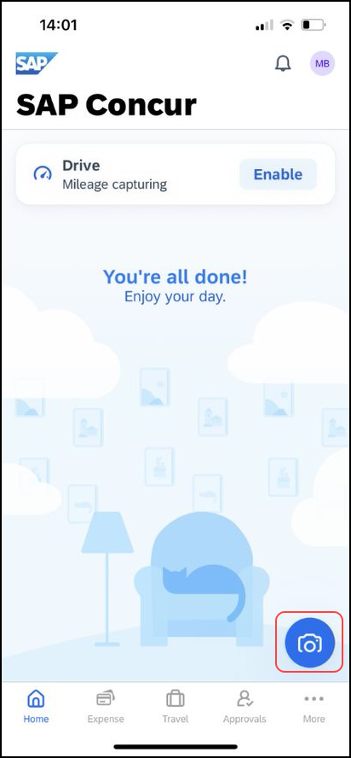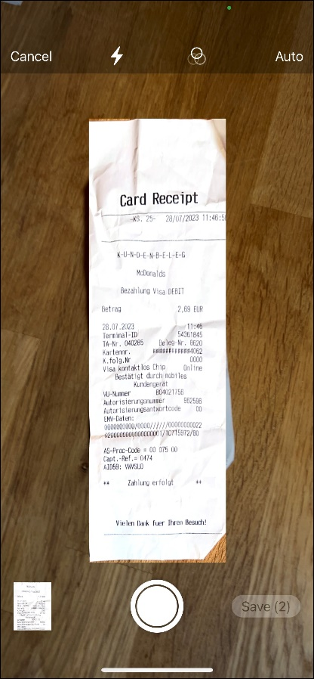 | 1) On the home screen tap the camera icon to take a photo or multiple photos of receipts.  2) The bottom left shows the already created receipts. The bottom right shows how many receipts are waiting to be saved.  3) If Auto is enabled, images will be captured automatically.
- 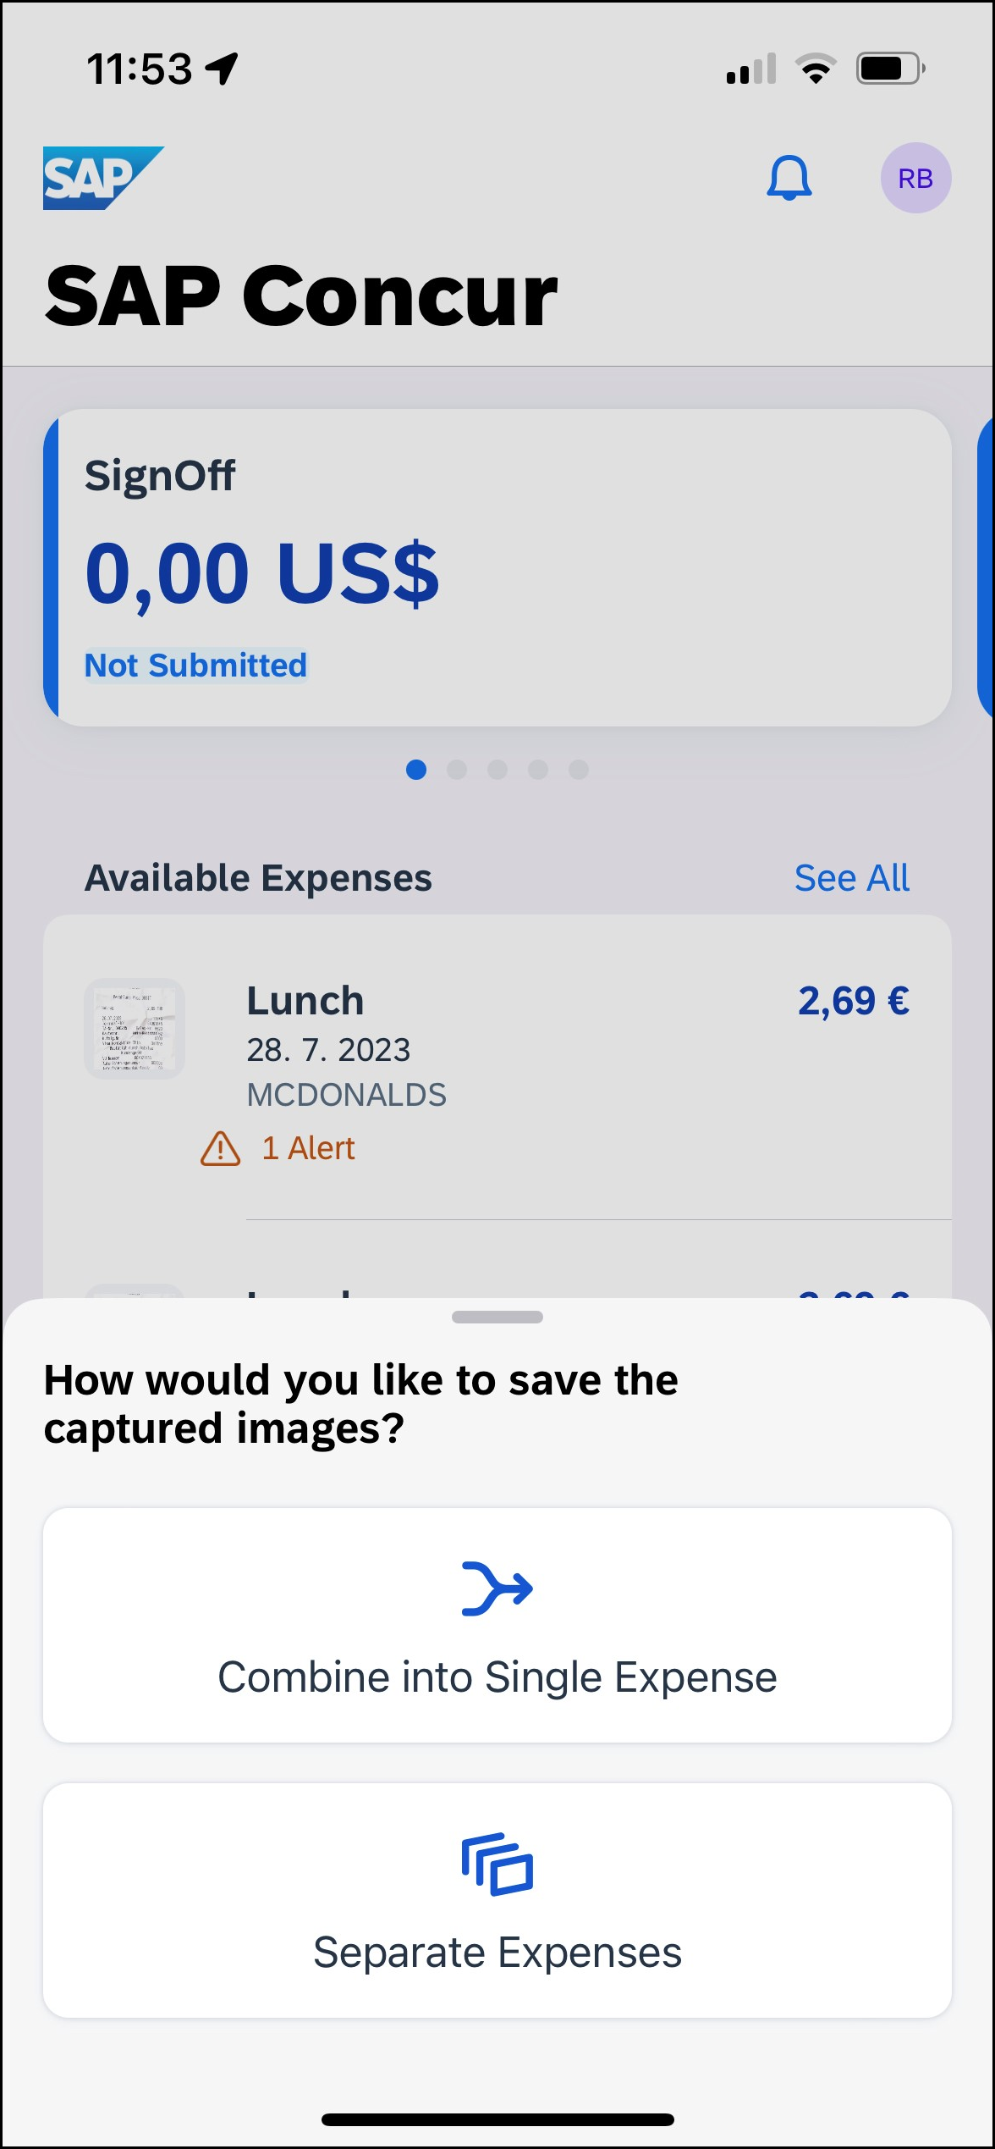 | 4) When taking several images in a row, select Combine into Single Expense or Separate Expenses.
- 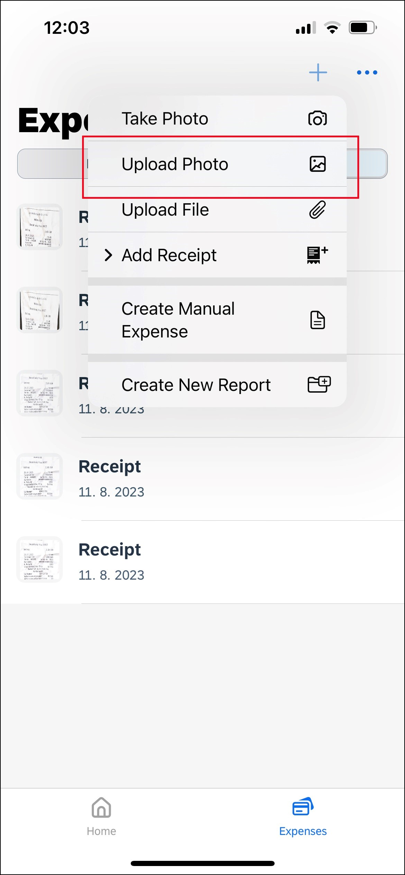 | 5) Saved receipts must be uploaded through the Expense tab on the home screen and then by tapping and selecting Upload Photo.

Attach Receipts
Attach a receipt to a report or to an individual expense, whichever the situation requires.
Screen(s) | Description/Action
- 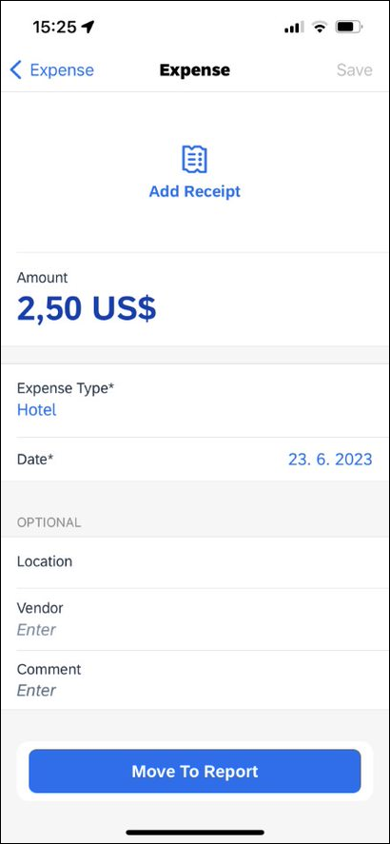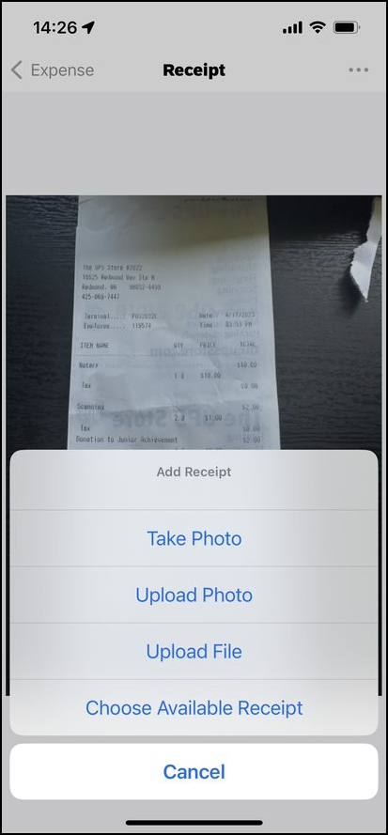 | To attach a receipt:  1) On the Expense screen, tap the desired expense.  2) Tap Add Receipt to view the options for attaching a receipt.  - Take Photo to use your device camera  - Upload Photo to select an image in your device photos  - Upload File to upload a file from your device.  - Choose Available Receipt to select an image in your Concur Receipt Store  NOTE: Turn the device horizontally or upside down to correctly adjust the camera screen.

Activating Quick-Scan Camera
For iOS, there is the option to activate an Quick-Scan Camera The Quick-Scan Camera can streamline the receipt capture process.

Screen(s) | Description/Action
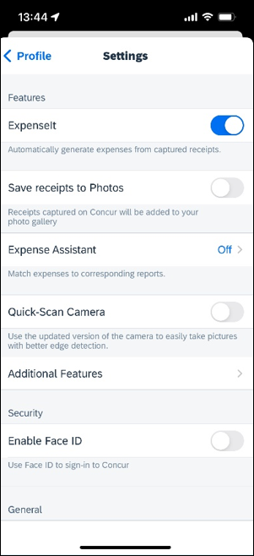 | To enable the Quick Scan Camera:  1) Navigate to the Settings, which can be found in the user profile.  2) Once on the Settings screen, toggle the Quick-Scan Camera so that it is enabled.

Using Quick-Scan Camera Features
The following describes the features of the Quick-Scan Camera. Users can toggle between the original default camera or this camera for iOS.

Screen(s) | Description/Action
- 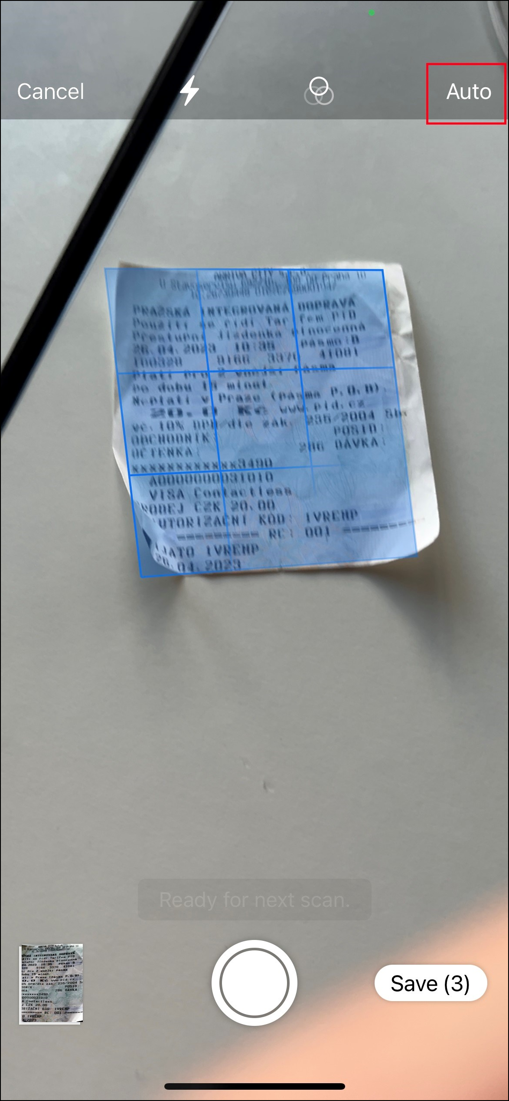 | If configured, images are captured automatically when the camera believes it has detected the receipt correctly.
 | Multiple images can be taken in a row and the user can decide if they are separate receipts or if only one expense is to be created.
 | There is no longer a gallery button on the camera screen when using the Quick-Scan Camera If the user wants to upload a receipt that is already saved, they must do so in the expenses section.

Upload File From Shared Repository
You can upload a file, such as a PDF using the Upload File button. The receipt is shared from the source app to the Recent file repository shared by all the phone’s apps.
Screen(s) | Description/Action
- 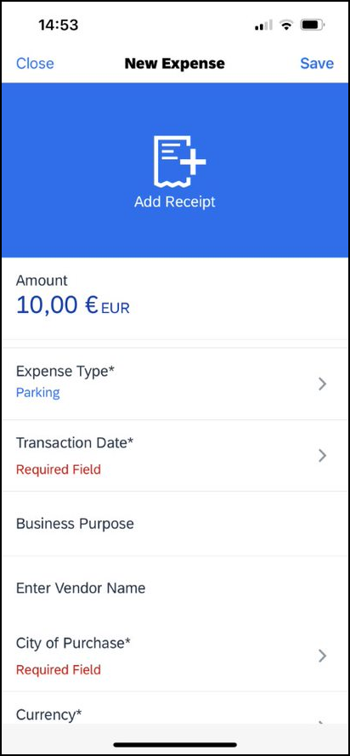 | To upload File:  1) From the Expense tap the Add Receipt icon.  2) Tapping on Add Receipt calls up another menu where the Upload File option is visible.
- 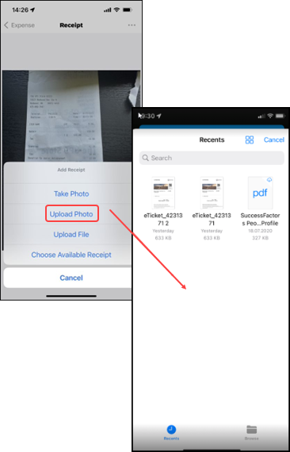 | 3) Tapping on Upload File displays a recent repository where you can select a file, including a PDF.  4) PDF's follow the below:  - Cannot exceed 10 MB for most users  - Cannot exceed 45 MB for GRDC and eBunsho users  5) GRDC users  - Will always see a message indicating that the receipt cannot be certified  - Can only upload the PDF file to a Single Expense List view

Capture Multipage Receipts
You can use the multipage receipts feature to capture multipage receipts. For example, you can use this feature to capture standalone receipts to create quick expenses or to capture receipts for ExpenseIt (if your company uses ExpenseIt) to process within the SAP Concur mobile app.
Screen(s) | Description/Action
- 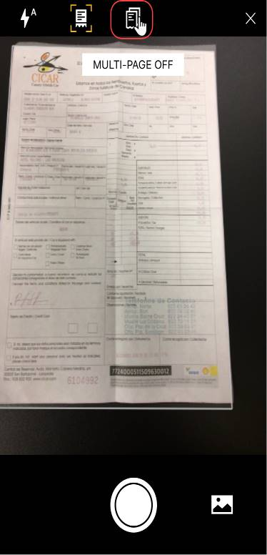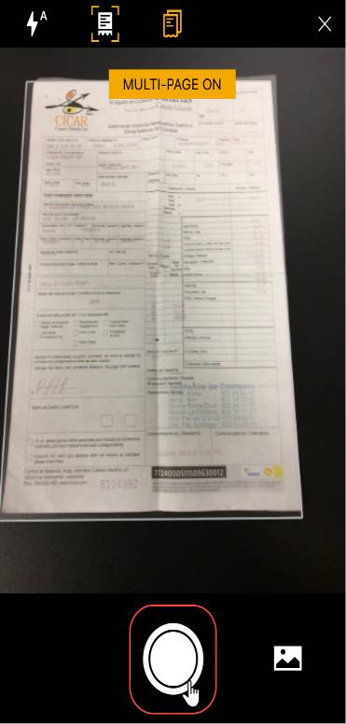 | To capture multipage receipts:  1) On the home screen, tap ExpenseIt.  2) On the camera screen, tap .  3) On the next camera screen, tap .
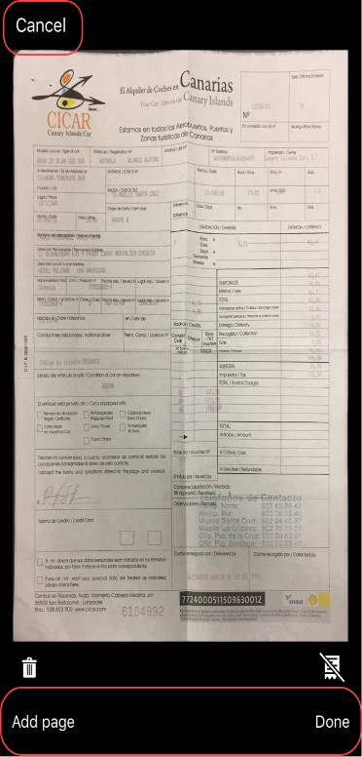 | 4) On the next camera screen, tap either:  - Add page  – or –  - Done  – or –  - Cancel  – or –  - Delete  NOTE: SAP Concur does not certify uploaded receipts that have not been captured in in the SAP Concur mobile app.  NOTE: Users - requiring an e-Bunsho timestamp on their receipts - have the capability to have the timestamp applied to multipage receipt images they have captured in the mobile app.

Create a Mobile Expense From a Receipt
Screen(s) | Description/Action
- 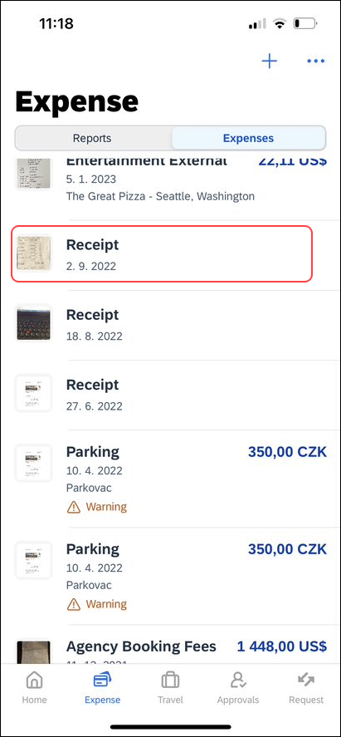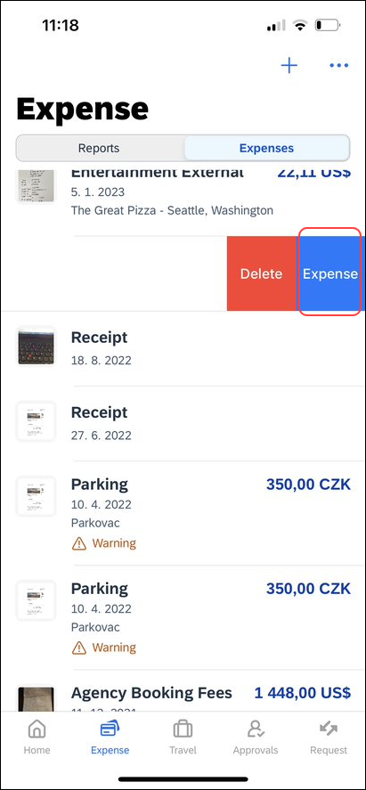 | To create a mobile expense from a receipt:  1) On the Expenses screen, swipe the desired receipt to the left.  2) Tap Expense.
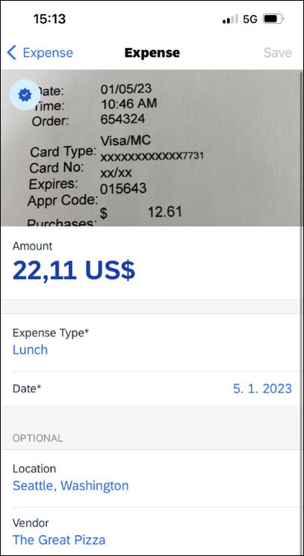 | 3) On the Expense screen, fill in the fields (if any) and make the desired selections.  4) Tap Save (upper-right corner).

View Receipts
Screen(s) | Description/Action
- 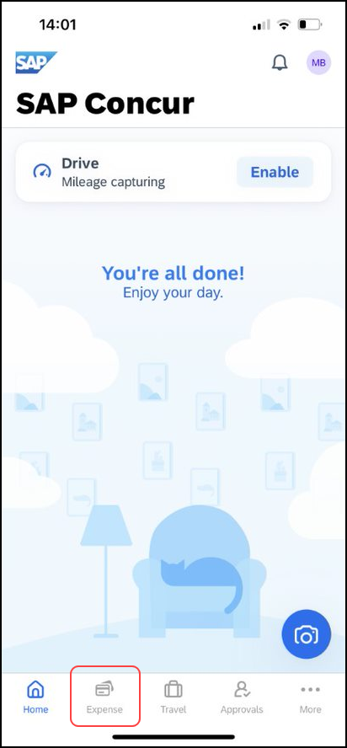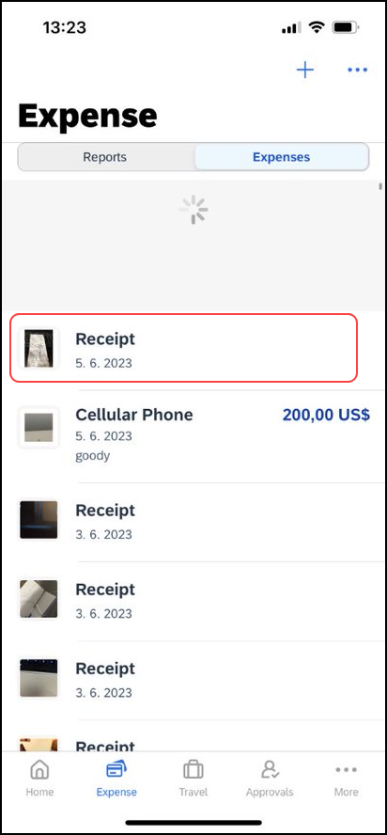 | To view a receipt:  1) On the home screen, tap Expense.  2) On the next page:  - Toggle to the Expenses view.  - Tap the desired receipt.
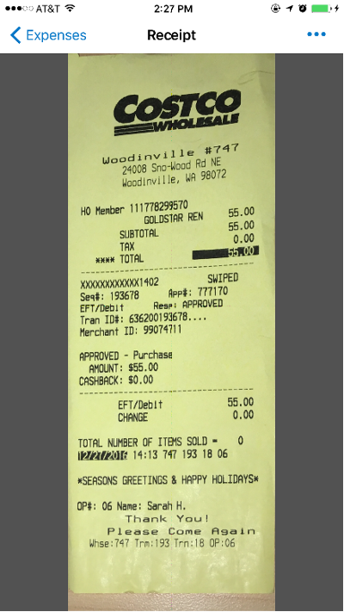 | - Tap to open the desired image.

Delete Receipts
Screen(s) | Description/Action
- 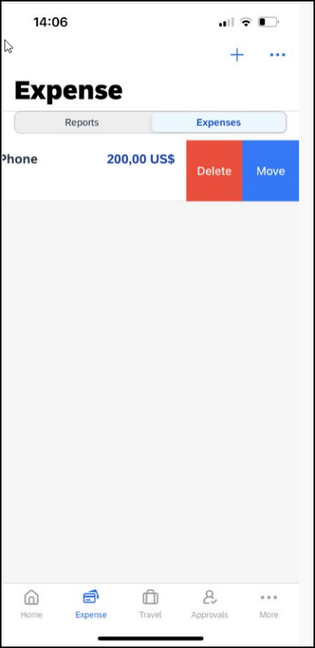 | To delete a receipt:  1) On the Expenses screen, swipe the desired receipt to the left.  2) Tap Delete.

Using Delegate Function to Upload a Receipt
Screen(s) | Description/Action
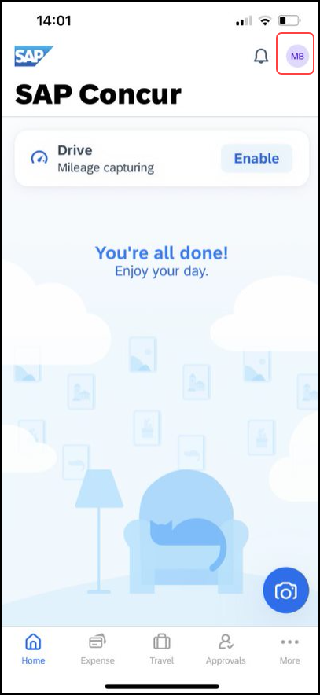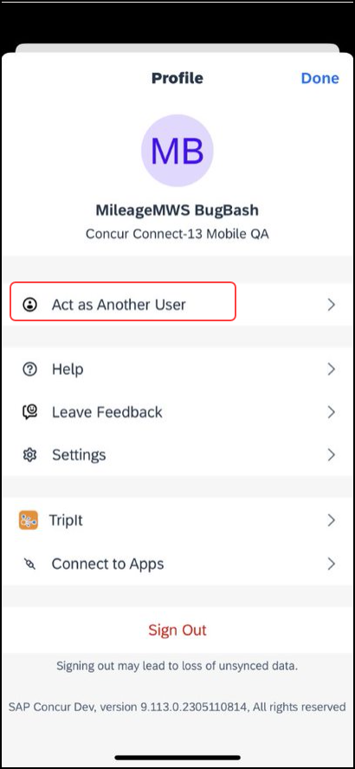  - 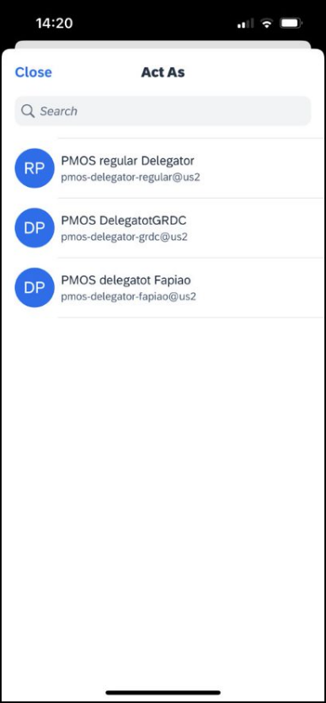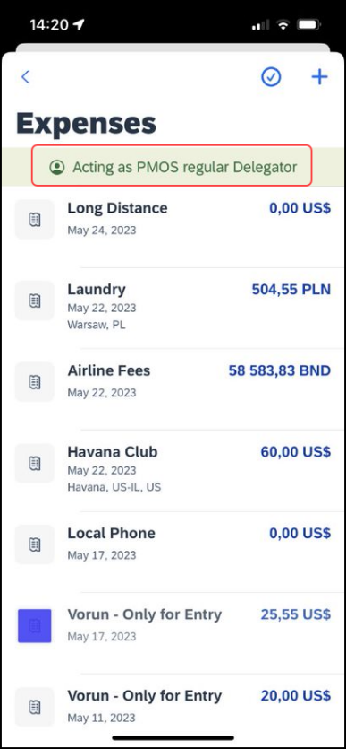 | To use the Delegate Function to upload a Receipt:  1) 1) Tap the initials in the top right corner, to open the Profile page. Then tap Act as Another User. A list of potential delegates will appear. Once the user you wish to act on behalf of is selected, it will be indicated by a green banner. You will also be directed to the Expenses Screen.
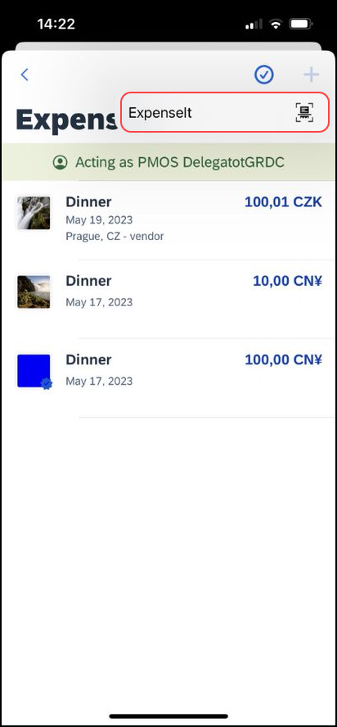 | 2) To add a Receipt, tap the Add button at the top of the screen. A pop up with ExpenseIt will appear. Tap ExpenseIt and then you will be brought to your receipts. Once the correct receipt is identified, tap Done at the bottom of the page. You will be directed back to the Expense List where you will see your receipt Processing.  NOTE: Delegates can view and move eReceipts but cannot edit them.
Note: The Delegate Function is currently only available for GRDC users who are ExpenseIt enabled.

Attach a Missing Receipt Declaration to an Expense
Attach a missing receipt declaration to an expense.
Screen(s) | Description/Action
- 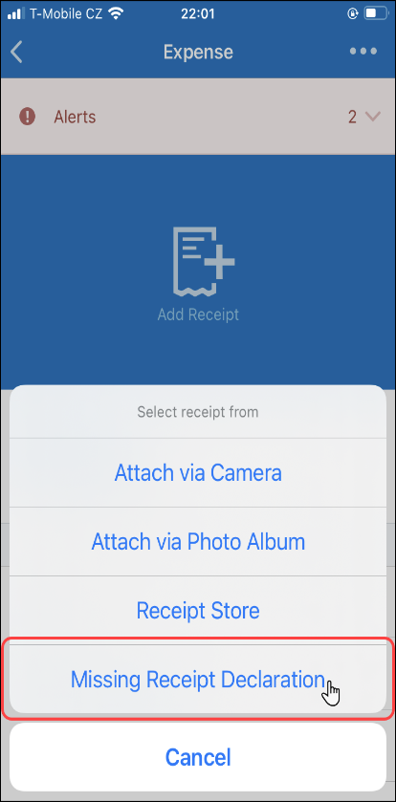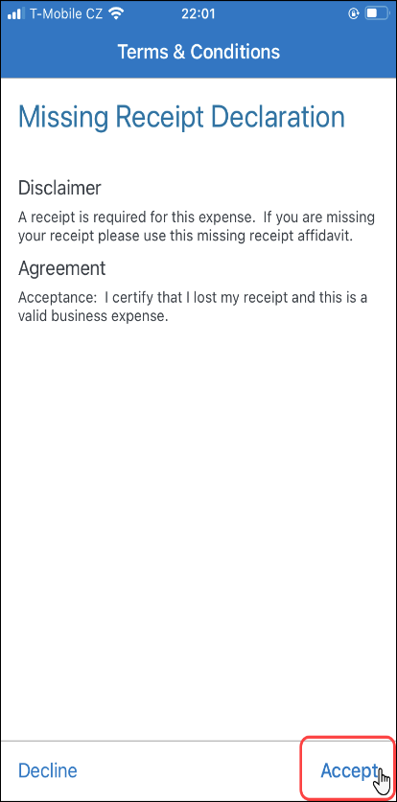 | To attach a missing receipt declaration to an expense:  1) On the Report screen, tap to create a new expense.  2) Fill in the fields and make the desired selections.  3) Tap Save.  4) Tap the desired expense.  5) On the expense screen, tap Add Receipt.  6) On the Select receipt from menu, tap Missing Receipt Declaration.  7) On the Terms & Conditions screen, tap Accept (lower-right corner).
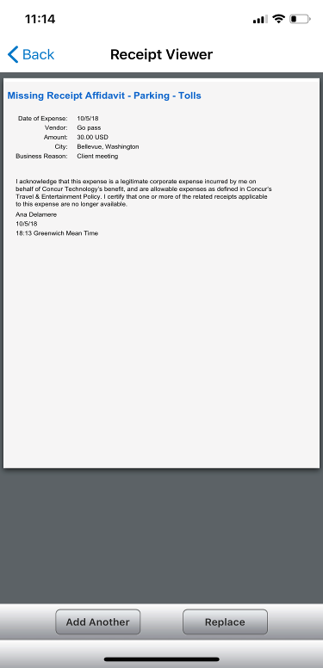 | The Missing Receipt Declaration appears on the Receipt Viewer screen.

Receipt Digitalization
Initially, to capture applicable receipt images, clients must use the SAP Concur mobile app. Users obtain images using the camera in the mobile app. Users can also use ExpenseIt, though ExpenseIt is not required.
Once the image is taken, the digitalization process is applied to the image and the certification icon appears. Then, the user can move the certified receipt image to an expense report.
To comply with regulations related to the use of digital copies of original paper receipts, SAP Concur has provided users with the Receipt Digitalization feature. The feature allows Concur Expense users to convert a paper receipt into a legal digital copy according to their country's regulatory or government authorities.
Important:
- This feature is currently available for Professional and Standard editions for France and Spain.
- Whether a customer is using the existing UI or NextGen Expense, the certified icon appears in the mobile app. However, the certified icon appears only in the web version of NextGen Expense; it does not appear in the existing UI. In order to take full advantage of this feature, customers must use NextGen Expense.
- For Professional edition, this feature is available automatically. For Standard edition, the customer can contact SAP Concur support for assistance.

Capture the Image While Creating an Expense
You can capture an image while creating or editing a mobile expense.
Screen(s) | Description/Action
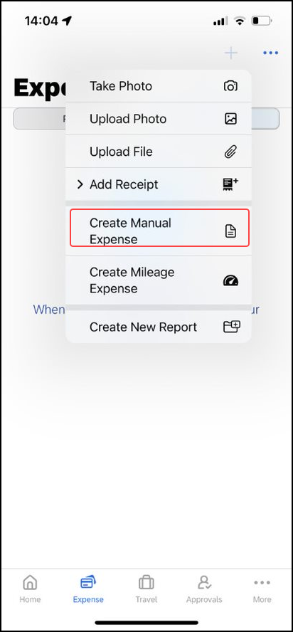 | To add an image while creating a mobile expense:  1) On the home screen, tap Expense.  2) Tap the plus buttom at the top of the page and then select Create Manual Expense.  3) Tap Add Receipt.
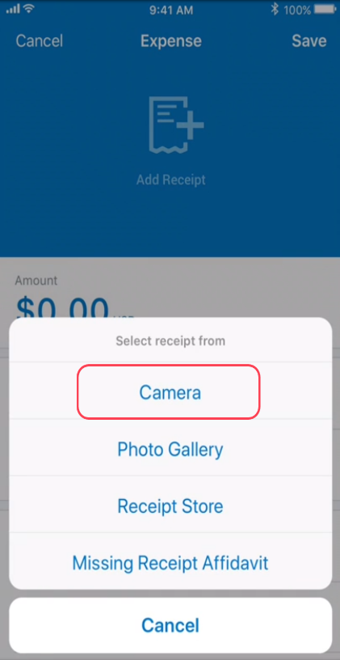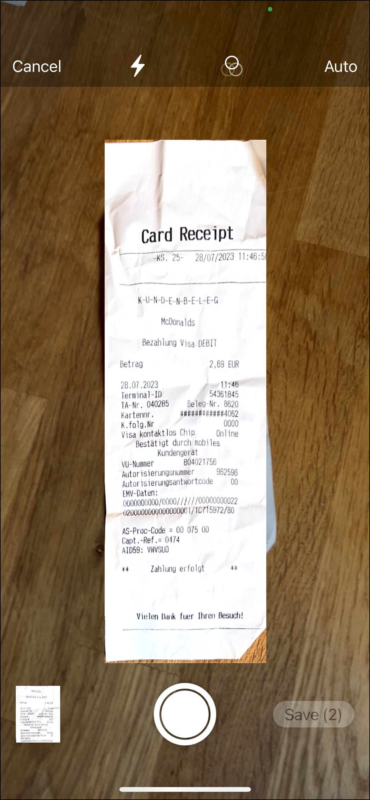 | 3) On the menu that appears, tap Camera.  4) Take a picture of the receipt.
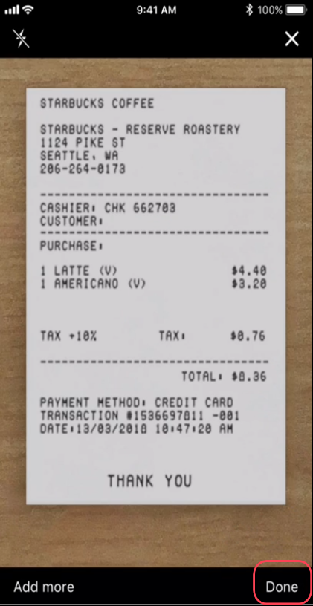 | 5) Tap Done. The image then appears on the Expense screen with the "certified" icon.  6) Complete the remaining fields on the mobile expense as usual.  7) Tap Save (upper-right corner).
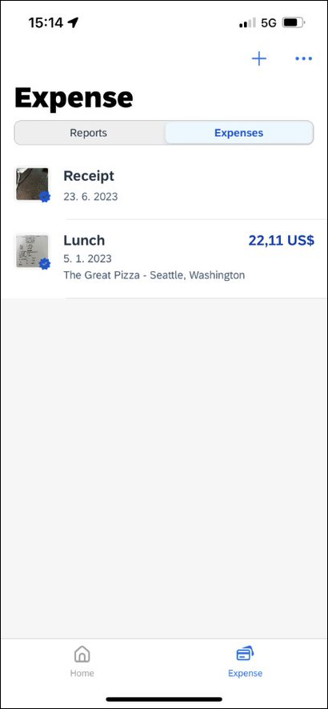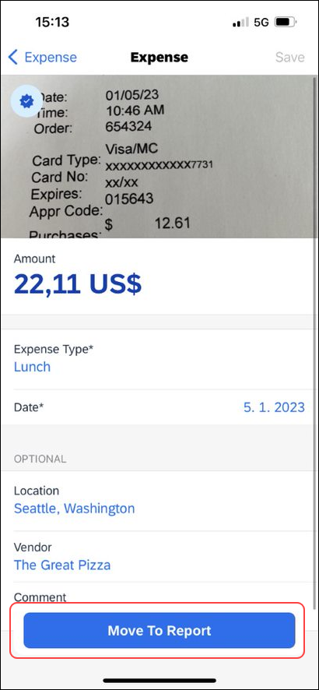 | The expense then appears on the Expenses screen, with the "certified" icon.  8) When ready, open the expense and tap Move to Report to move the expense from the Expenses list to a report.

Capture the Image Using ExpenseIt
You can obtain a certified receipt image using ExpenseIt.
Screen(s) | Description/Action
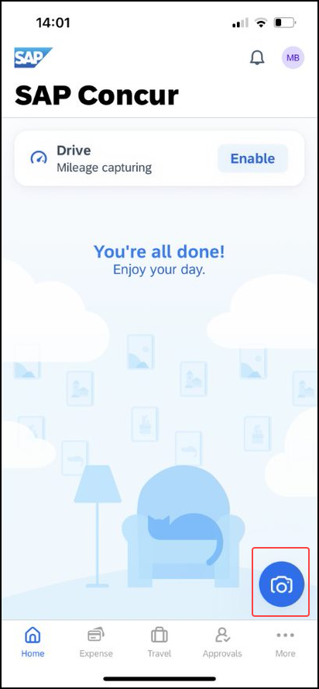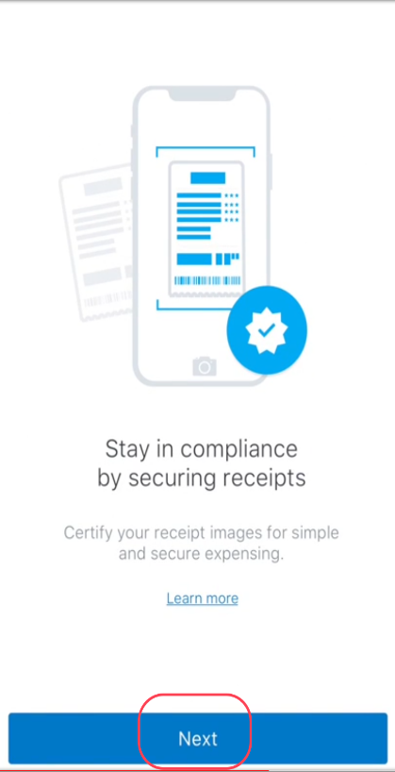 | To add an image when ExpenseIt is enabled:  1) On the home screen, tap the camera icon to be redirected to capture images directly through ExpenseIt.
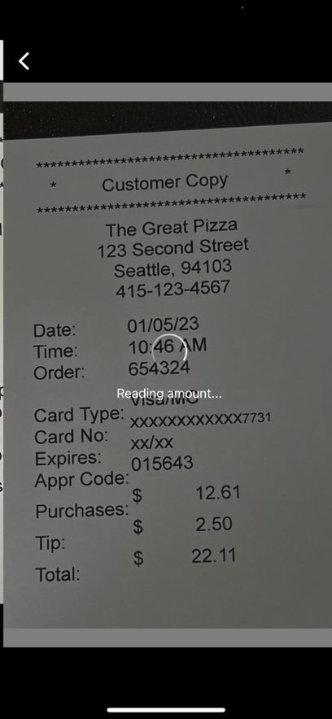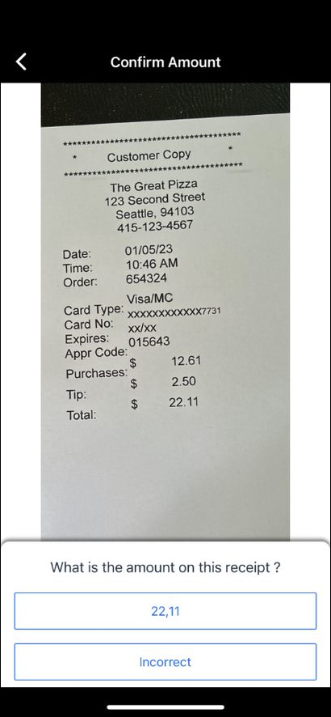 | ExpenseIt reads the image and provides the amount on the screen.  3) Tap Done (lower-right corner).
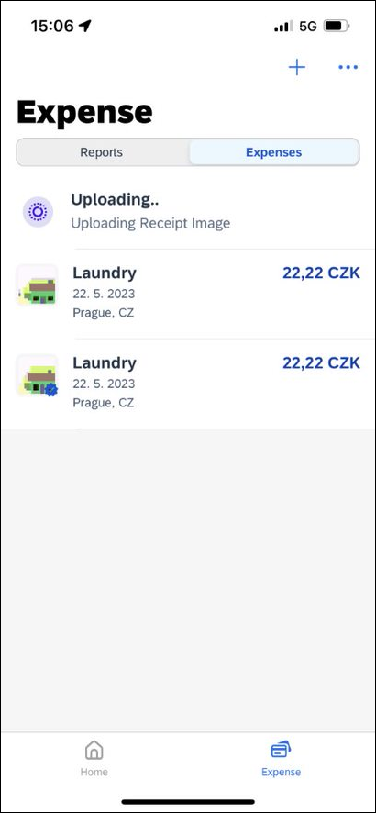 | ExpenseIt continues to analyze the image and creates the expense entry.  When done, the expense appears with the "certified" icon.
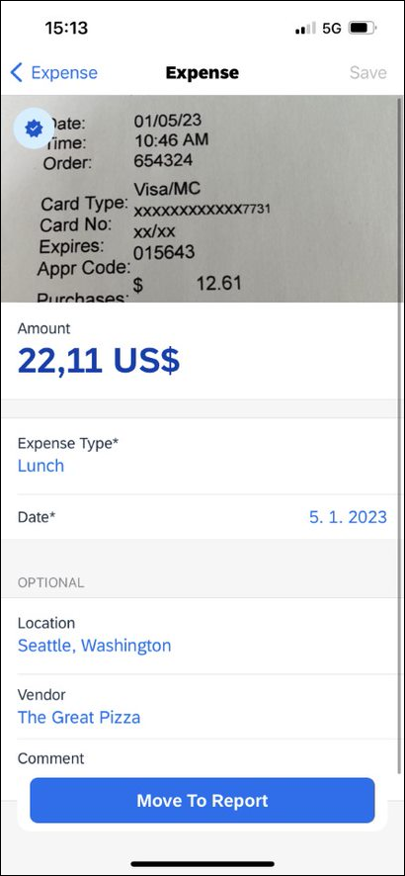 | 4) Open the expense and edit the expense as necessary.  5) When ready, tap Move to Report to move the expense from the Expenses list to a report.  NOTE: Users - requiring an e-Bunsho timestamp on their receipts - have the capability to have the timestamp applied their receipt images they have captured with ExpenseIt in the mobile app.

Troubleshooting
If an image does not certify properly, it appears on the Expenses page but does not have the "certified" icon. Instead, there is a warning indicator in the upper-right corner of the expense entry.
Screen(s) | Description/Action
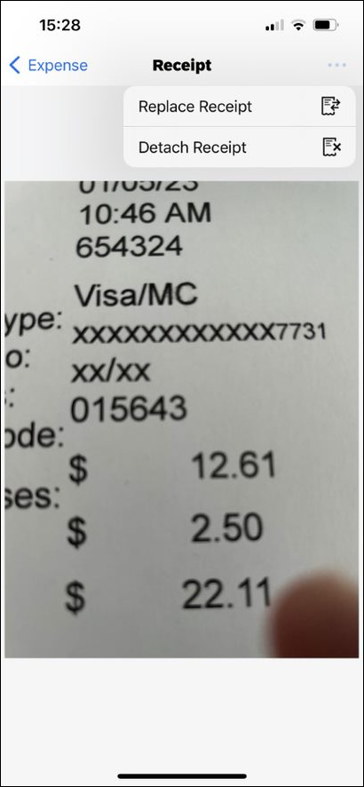 | To recapture an image that did not certify properly:  1) Tap the expense to open. The message then appears at the top of the Expense screen.  2) Tap the "Not Certified" message to see the options.  3) Choose either Replease Receipt to access the camera.
4) Take the picture again.
The mobile app will again attempt to certify the image.
The certification is indicated by the blue tick icon.

☼

