 | Mobile App User Guide  Receipts  Last Revised: March 27, 2024 | This guide describes the current version, which is shown on the "Introduction" guide. |  | Applies to these mobile devices:  No: iPhone  No: iPad  Yes: Android
 | IMPORTANT: Be aware that your company's configuration may not allow for all of the features described here. Generally, if a feature is not available in your configuration of the web version of SAP Concur, then it is not available in the mobile app.
You can work with receipts in the following ways:  - Attach receipts to an expense or report  - Capture multipage receipts  - Create a mobile expense from a receipt  - View Receipts  - Delete Receipts Attach a missing receipt declaration to an Expense |  |  | Work With Receipts 2  Attach Receipts 2  Upload File From Shared Repository 3  Using Delegate Function to Upload a Receipt 4  Capture Multipage Receipts 6  Create a Mobile Expense From a Receipt 7  Attach a Missing Receipt Declaration to an Expense 7  Camera Options 8  Camera Aide 8  Integrated Gallery 9  Receipt Digitalization 10  Capture the Image While Creating an Expense 11  Capture the Image Using ExpenseIt 13
Please Note:
- The SAP Concur app for iOS and Android supports universal links, i.e. links that navigate directly to the app if it is installed or to the website if not.
- Such links are included in notification emails from SAP Concur related to the expense report changes.
- Universal link support for customers own use is currently not supported.
- Some security solutions may block the links embedded into email from opening the app directly. The proper exceptions for the security policy should be configured for SAP Concur universal link URLs (pattern to match: https://*.concursolutions.com/*). Known cases are:
- MDM/MAM policy that prescribes to open any link tapped in Outlook mobile app only in specified browser.
- Outlook mail server phishing protection that wraps all link embedded into e-mails to open the safety check service first.

Work With Receipts

Attach Receipts
Attach a receipt to a report or to an individual expense, whichever the situation requires
Screen(s) | Description/Action
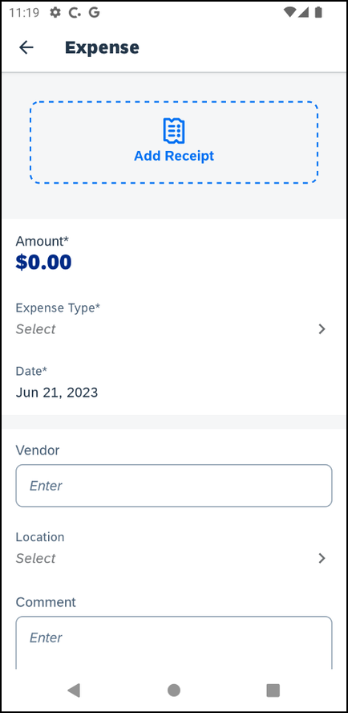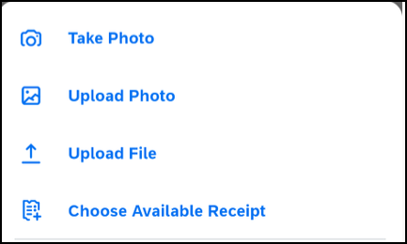 | To attach a receipt to a report or an individual expense, you can either:  - On Expense screen, tap Add Receipt. The Select receipt from menu appers.  - or –  - On the Report screen, tap the Receipts tab and then tap (lower-right corner). A menu appears.  1) To attach a receipt on the Select receipt from menu, tap:  - Take Photo to use your device camera  - Upload Photo to select an image in your device gallery  - Upload File to select a file from your device.  - Choose Available Receipt to select an image in your Concur Receipt Store (Available Receipts Library in the web version of SAP Concur)
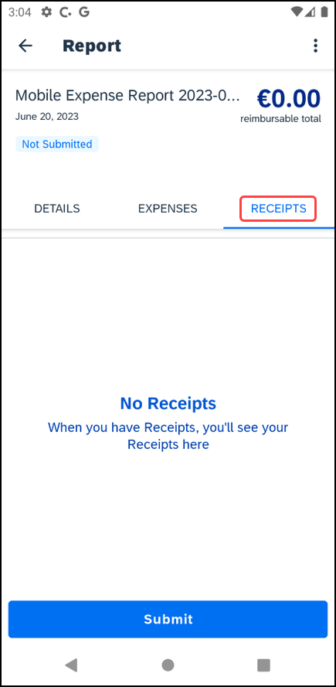 | 2) To attach a receipt on the menu, tap:  - Take Photo to use your device camera  - Upload Photo to select an image in your device gallery  - Upload File to select a file from your device.  Choose Available Receipt to select an image in your Concur Receipt Store (Available Receipts Library in the web version of SAP Concur)To capture receipts with your mobile device:  1) On the Expense screen, click .  2) On the menu, click Add Receipt.

Upload File From Shared Repository
You can upload a file, such as a PDF using the Upload File button. The receipt is shared from the source app to the Recent file repository shared by all the phone’s apps.
Screen(s) | Description/Action
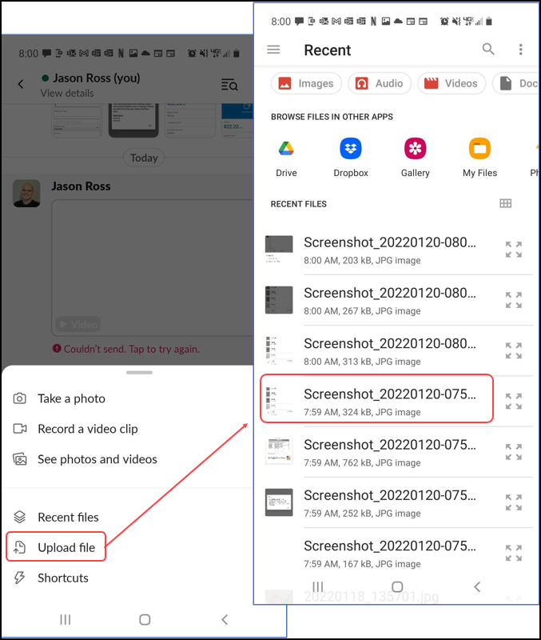 | To Upload File:  1) Go To Expense List and tap the Add button  - Menu appears with Upload File button.  - Tapping on the Upload File button, opens a recent repository.  - From here the required file can be uploaded.  2) PDF's follow the below:  - Cannot exceed 10 MB for most users  - Cannot exceed 45 MB for GRDC and eBunsho users  3) GRDC users  - Will always see a message indicating that the receipt cannot be certified  - Can only upload the PDF file to a Single Expense List view

Using Delegate Function to Upload a Receipt
Screen(s) | Description/Action
- 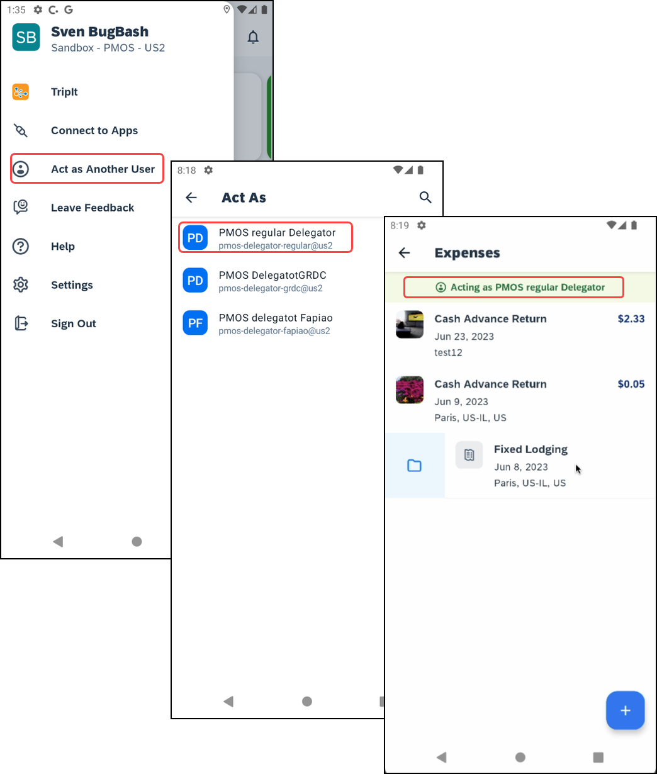 | To use the Delegate Function to upload a Receipt:  1) Ensure you are acting on behalf of another user. To enable this, tap the Menu and then Act as Another User. You will see a green banner once you have selected who you want to act on behalf of and be re-directed to the Expense List.
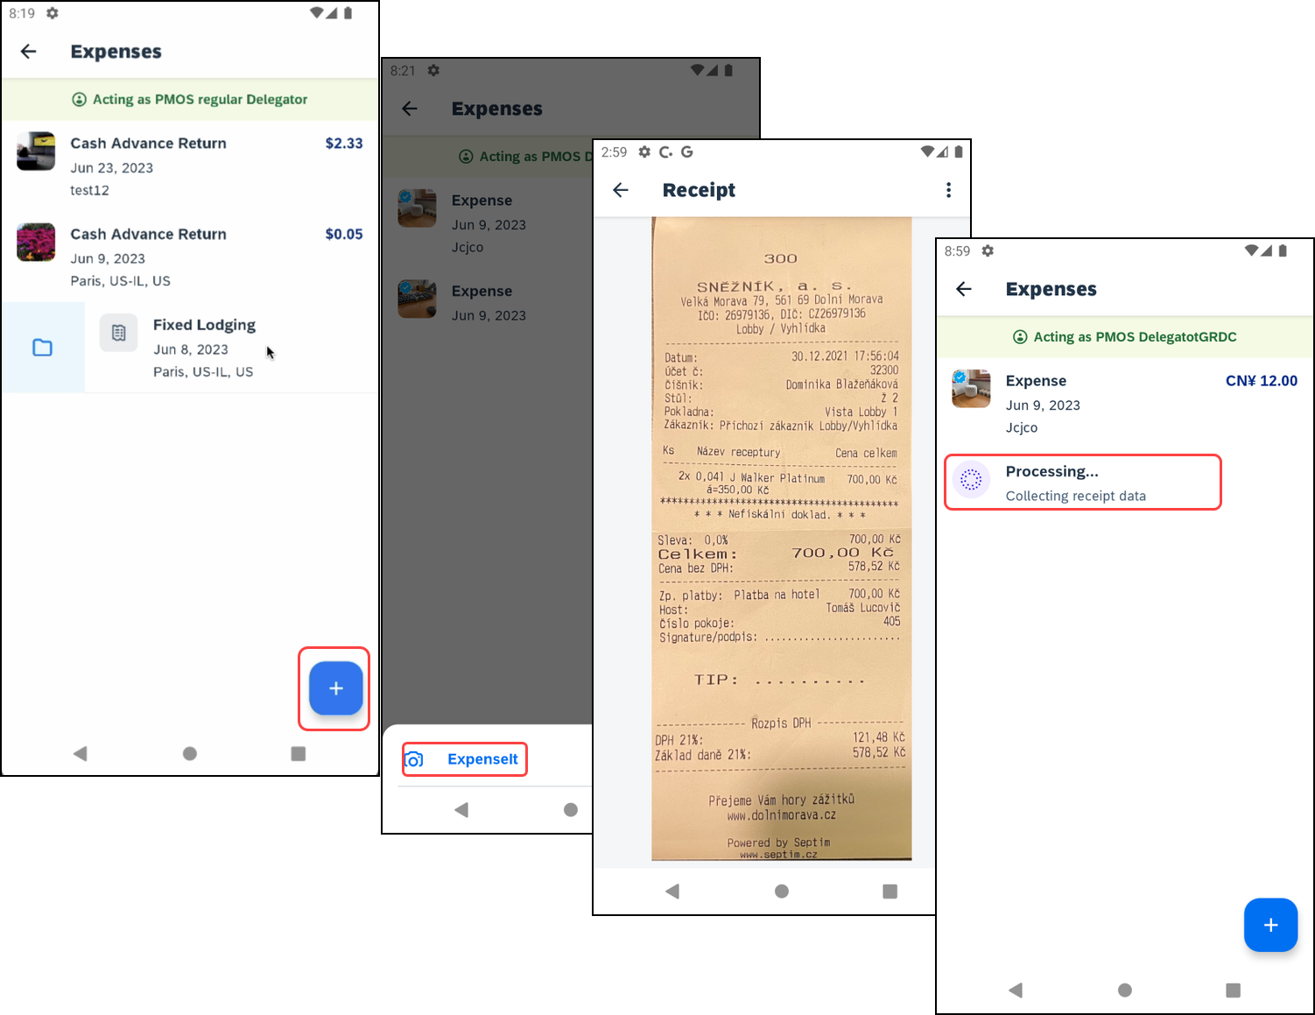 | 2) To add a Receipt, tap the Add button at the top of the screen. A pop up with ExpenseIt will appear. Tap ExpenseIt and then you will be brought to your receipts. Once the correct receipt is identified, tap Done at the bottom of the page. You will be directed back to the Expense List where you will see your selected receipt.  NOTE: Delegates can view and move eReceipts but cannot edit them.
Note: The Delegate Function is currently only available for GRDC users who are ExpenseIt enabled.

Capture Multipage Receipts
You can use the multipage receipts feature to capture multipage receipts. For example, you can use this feature to capture standalone receipts to create quick expenses or to capture receipts for ExpenseIt (if your company uses ExpenseIt) to process within the SAP Concur mobile app.
Screen(s) | Description/Action
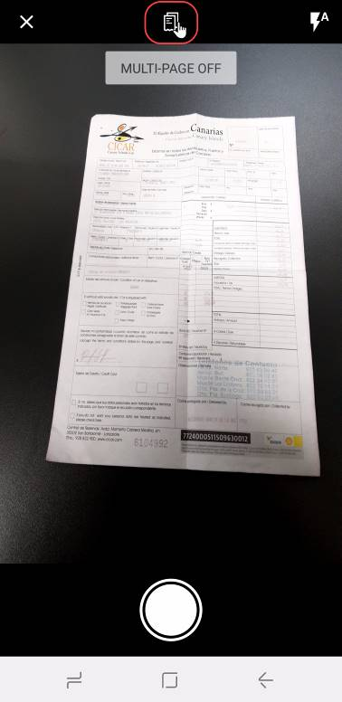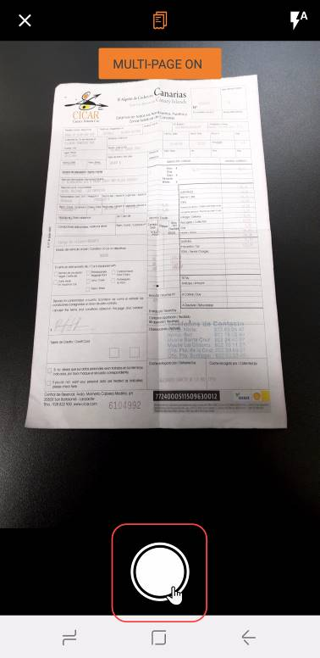 | To capture multipage receipts:  1) On the home screen, tap ExpenseIt.  2) On the camera screen, tap .  3) On the next camera screen, tap .
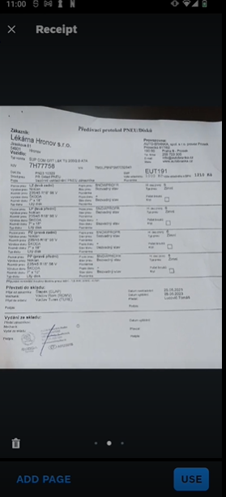 | 4) On the next camera screen, tap either:  - Add Page  – or –  - Use  – or –  - (Exit)  – or –  - (Delete)  NOTE: SAP Concur does not certify uploaded receipts that have not been captured in in the SAP Concur mobile app.  NOTE: Users - requiring an e-Bunsho timestamp on their receipts - have the capability to have the timestamp applied to multipage receipt images they have captured in the mobile app.

Create a Mobile Expense From a Receipt
Screen(s) | Description/Action
- 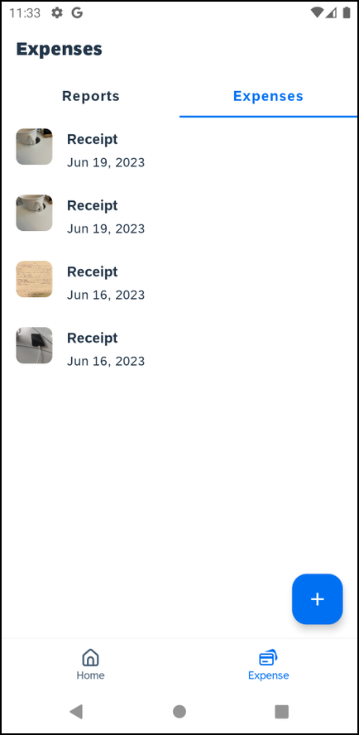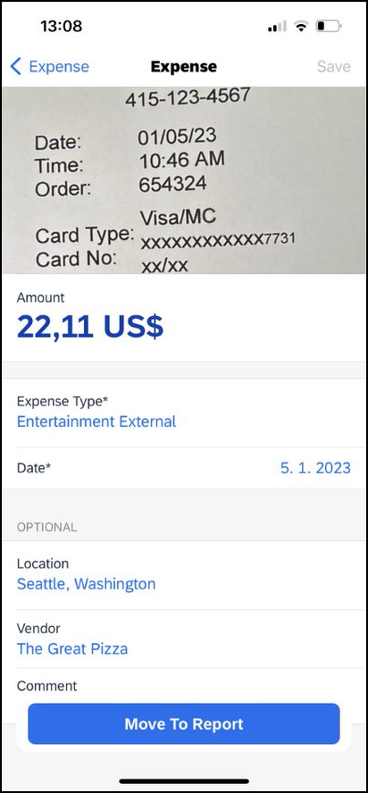 | To create a mobile expense from a receipt:  1) On the Expenses screen, swipe the desired receipt to the left.  2) Tap Expense.  3) On the Expense screen, fill in the fields (if any) and make the desired selections.  4) Tap Save (upper-right corner).

Attach a Missing Receipt Declaration to an Expense
Screen(s) | Description/Action
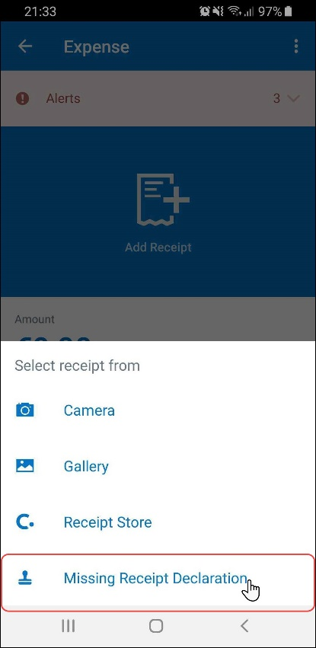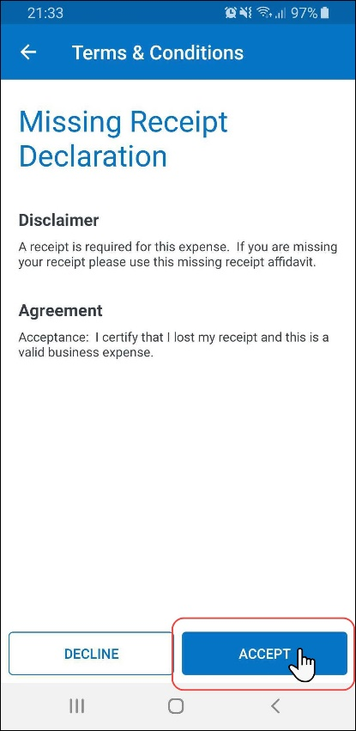 | To attach a missing receipt declaration to an expense:  1) On the Report screen, tap Expenses  2) On the Expenses tab, tap to create a new expense.  3) Fill in the fields and make the desired selections.  4) Tap Save.  5) Tap the desired expense.  6) On the expense screen, tap Add Receipt.  7) On the Select receipt from menu, select Missing Receipt Declaration.  8) On the Terms & Conditions screen, tap Accept (lower-right corner).
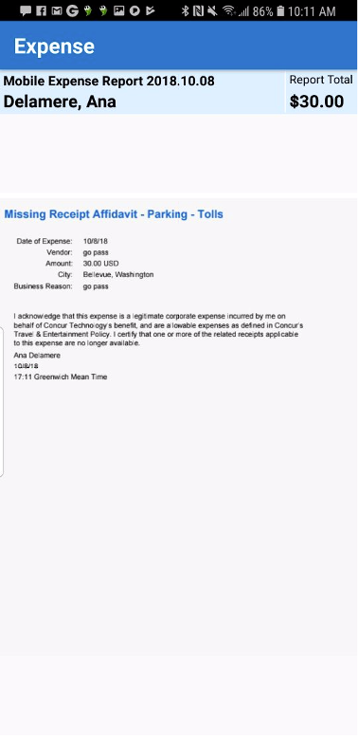 | The Missing Receipt Declaration appears on the receipt viewer screen.

Camera Options

Camera Aide
If your company has the camera aide feature enabled, you can see hints at the bottom of the camera screen detailing how to capture better images. If the receipt is well positioned, this tool will also crop out the areas without text.
Screen(s) | Description/Action
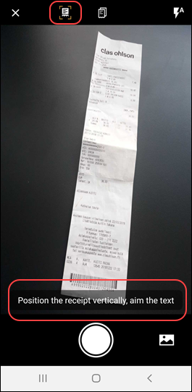 | To see hints on how to capture better images:  1) On the home screen, tap Receipt.  2) Take a picture of the desired image.  The hint appears at the bottom of the camera screen.  Note: If your company has enabled the camera aide feature, you can see the camera aide icon on the upper-left corner of the camera screen.

Integrated Gallery
With the built-in gallery option you can select images captured from your mobile device without leaving the SAP Concur mobile app.
Screen(s) | Description/Action
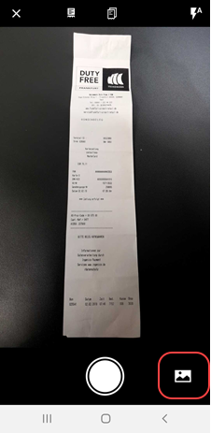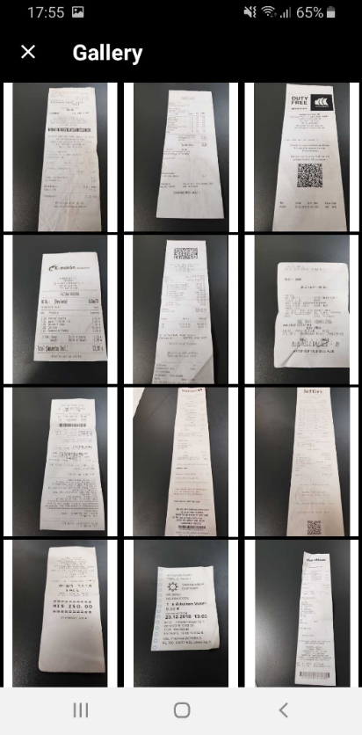 | To view your images in the built-in gallery:  1) On the home screen, tap Receipt.  2) Tap (lower-right corner) on the camera screen.  The Gallery screen appears.

Receipt Digitalization
Initially, to capture applicable receipt images, clients must use the SAP Concur mobile app. Users obtain images using the camera in the mobile app. Users can also use ExpenseIt, though ExpenseIt is not required.
Once the image is taken, the digitalization process is applied to the image and the certification icon appears. Then, the user can move the certified receipt image to an expense report.
To comply with regulations related to the use of digital copies of original paper receipts, SAP Concur has provided users with the Receipt Digitalization feature. The feature allows Concur Expense users to convert a paper receipt into a legal digital copy according to their country's regulatory or government authorities.
Important:
- This feature is currently available for Professional and Standard editions for France and Spain.
- Whether a customer is using the existing UI or NextGen Expense, the certified icon appears in the mobile app. However, the certified icon appears only in the web version of NextGen Expense; it does not appear in the existing UI. In order to take full advantage of this feature, customers must use NextGen Expense.
- For Professional edition, this feature is available automatically. For Standard edition, the customer can contact SAP Concur support for assistance.

Capture the Image While Creating an Expense
You can capture an image while creating or editing a mobile expense.
Screen(s) | Description/Action
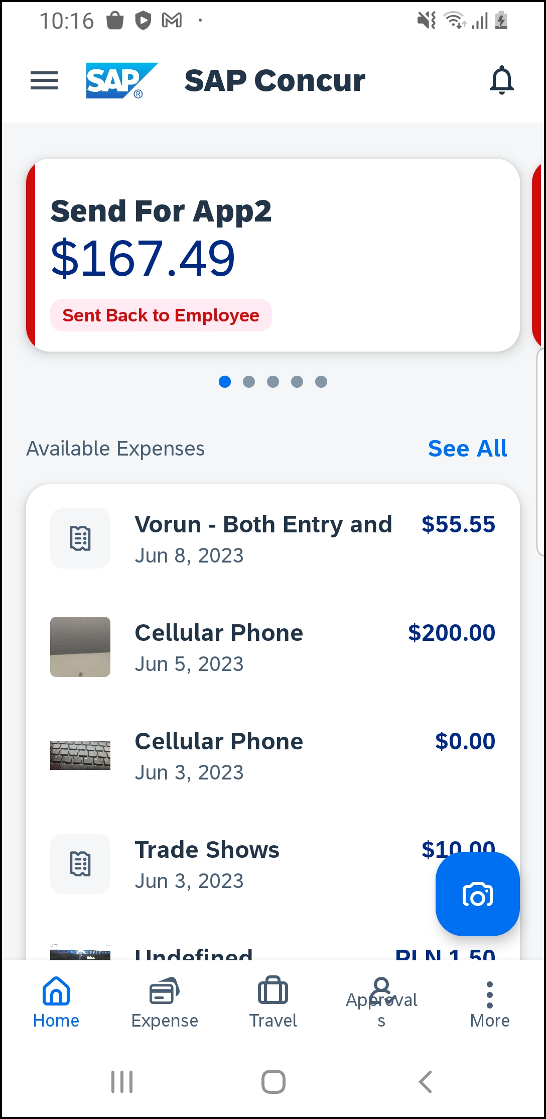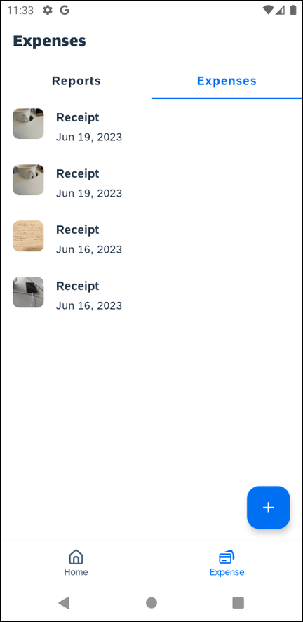  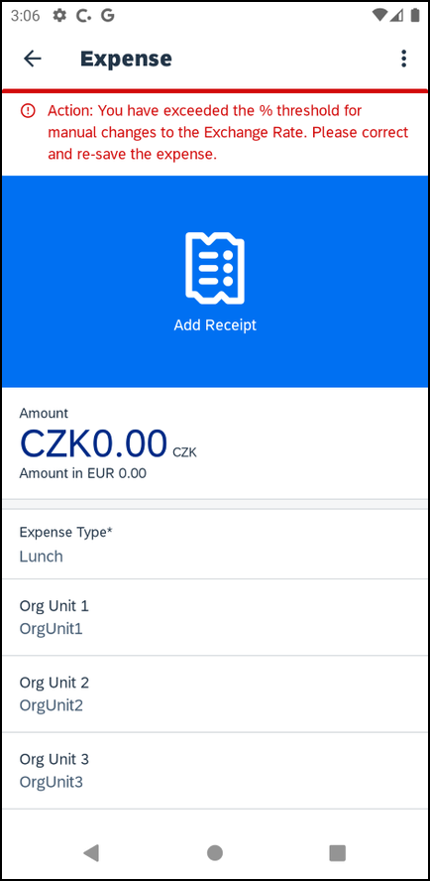 | To add an image while creating a mobile expense:  1) On the home screen, tap Expense.  2) On the Expenses screen, toggle to Expenses and tap the icon.  3) Tap Add Receipt.
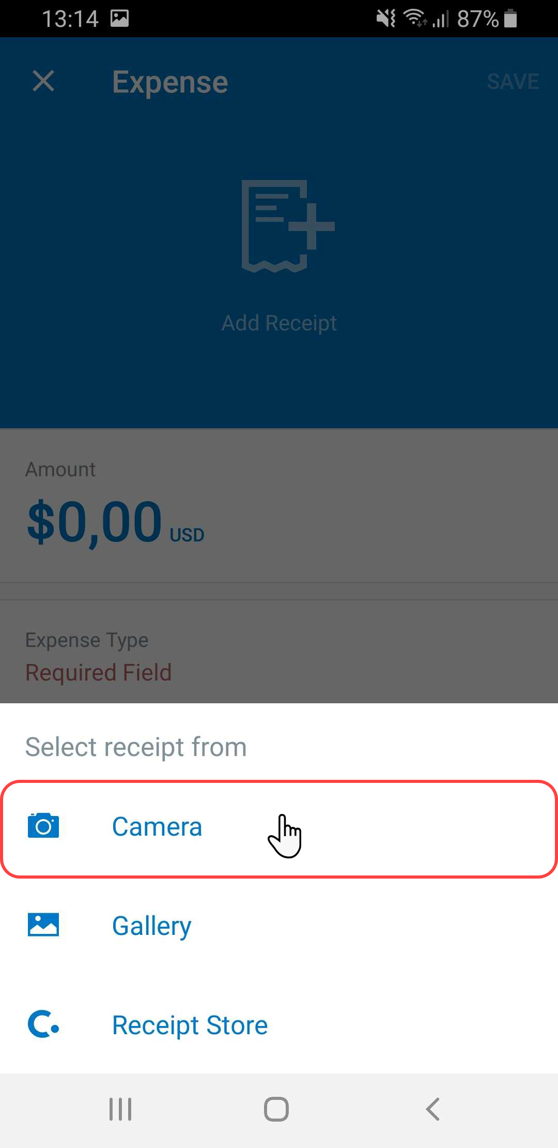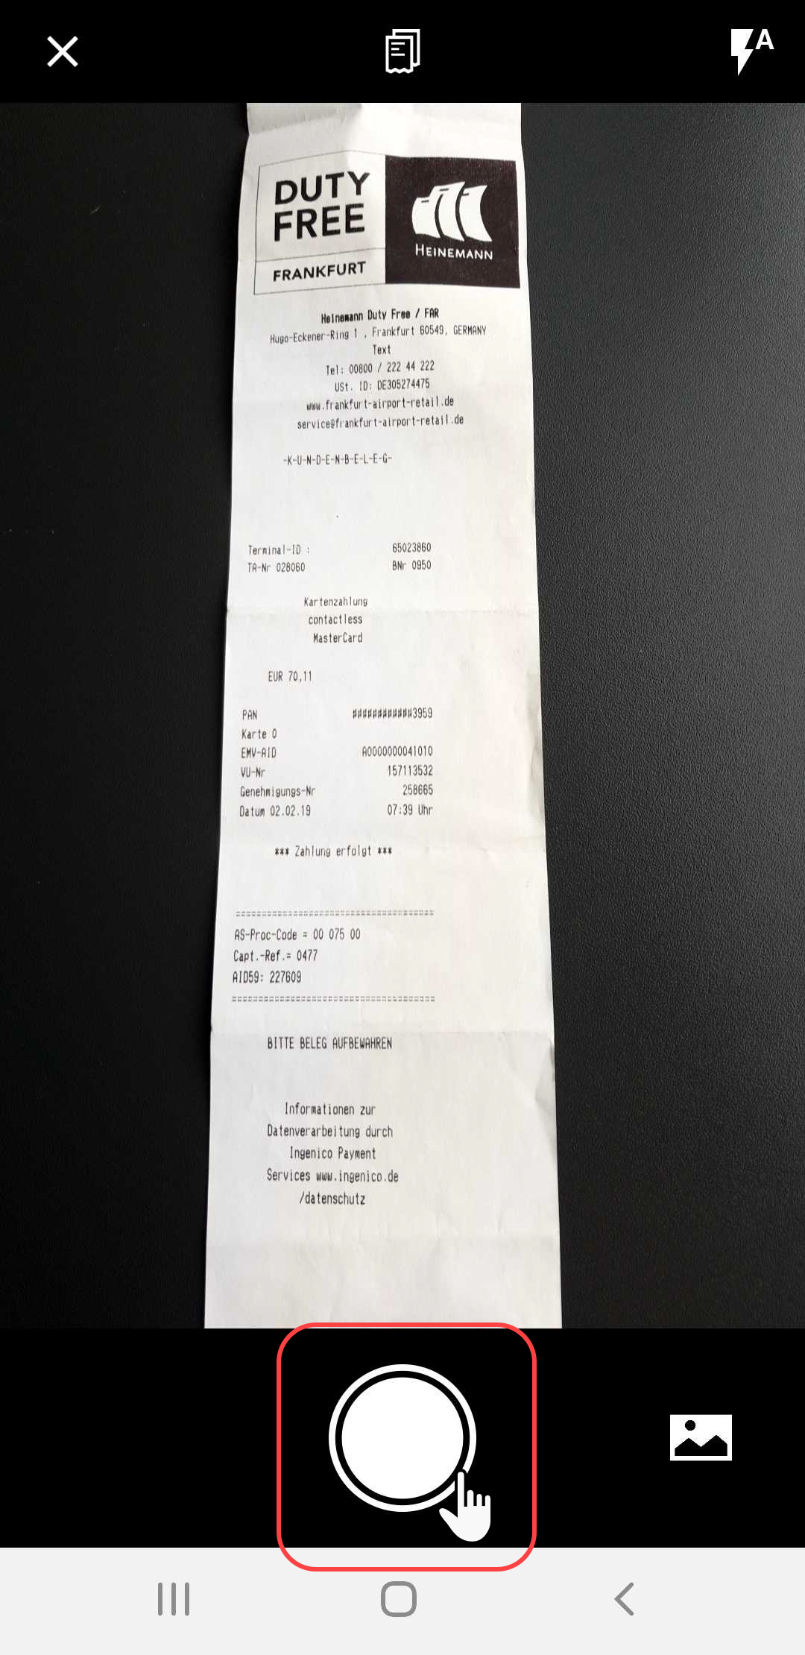 | 3) On the menu that appears, tap Camera.  4) Take a picture of the receipt.
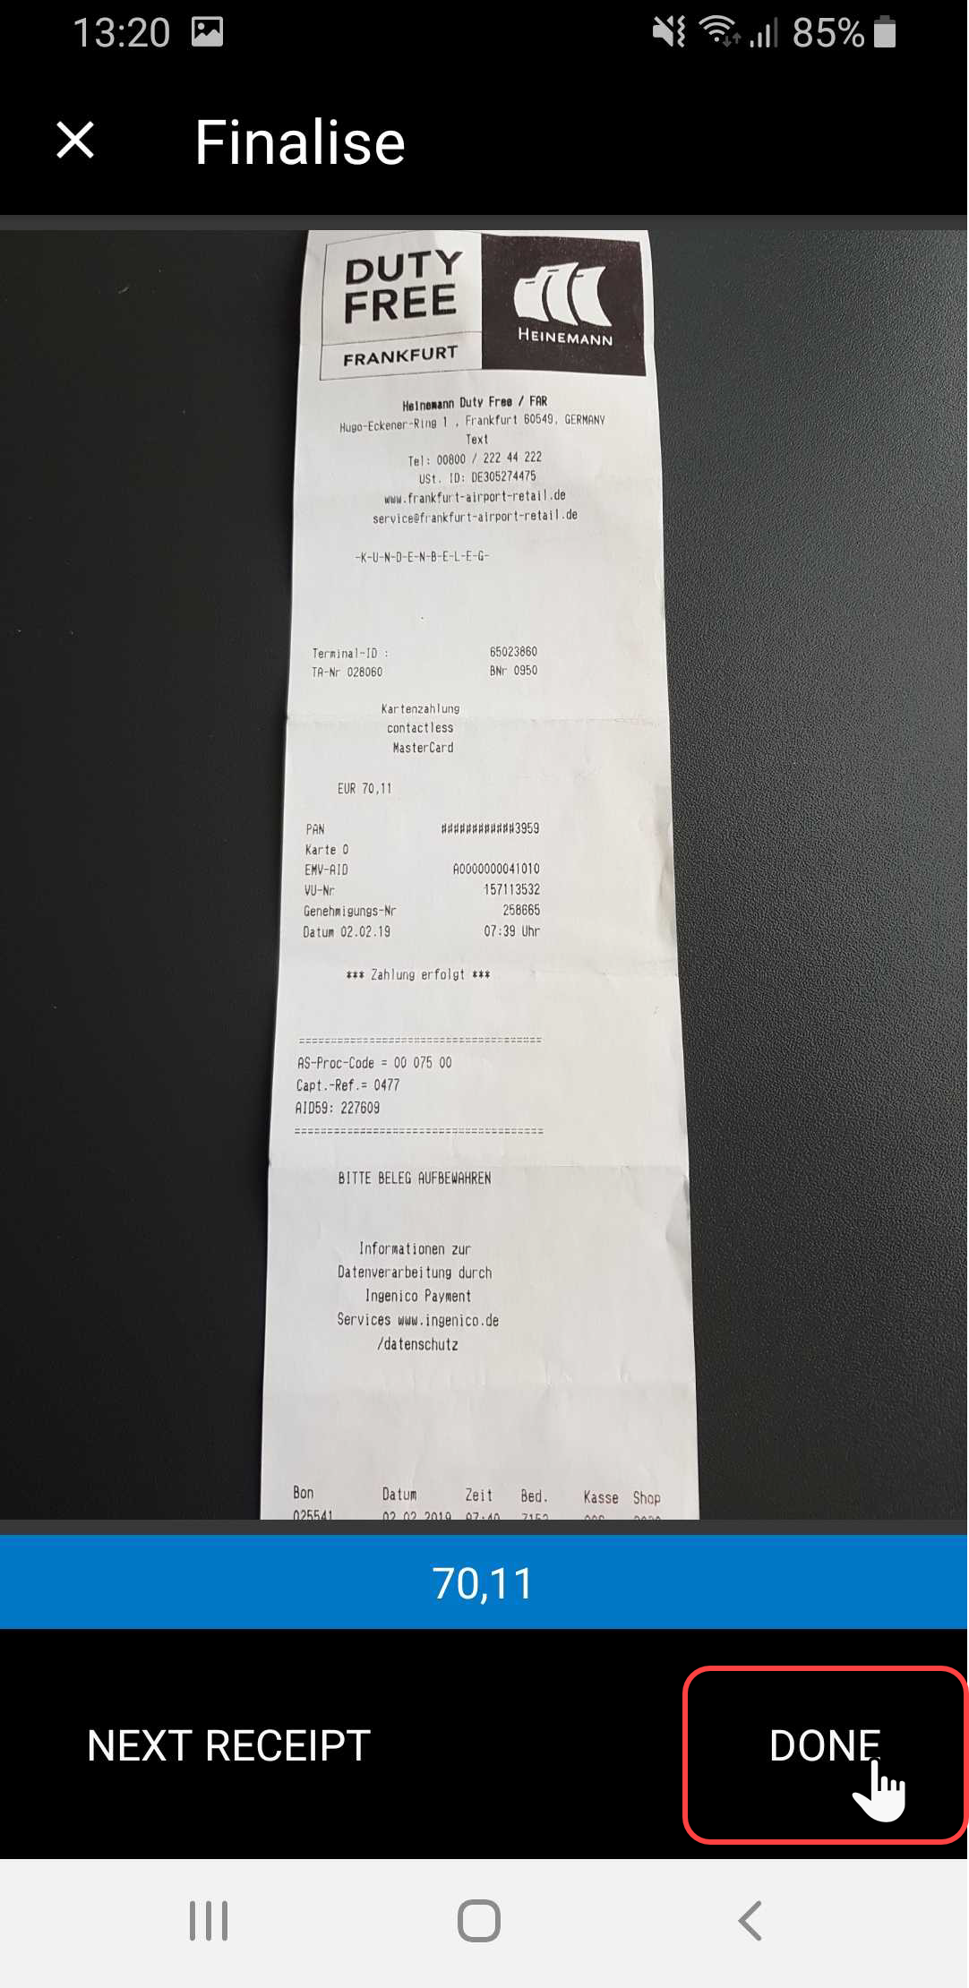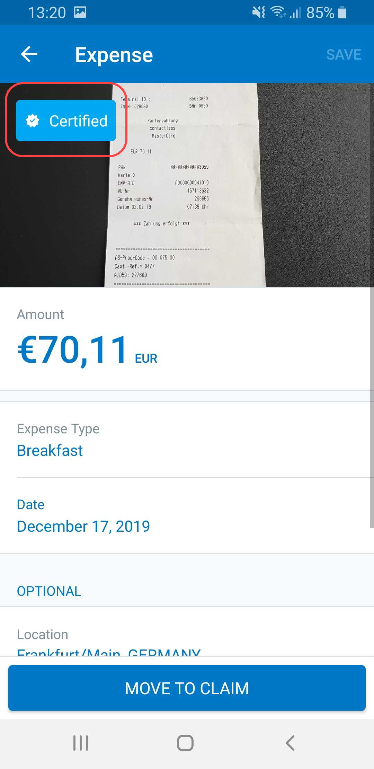 | 5) On the next camera screen, tap Done. The image then appears on the Expense screen with the "certified" icon.  6) Complete the remaining fields on the mobile expense as usual.  7) Tap Save (upper-right corner).
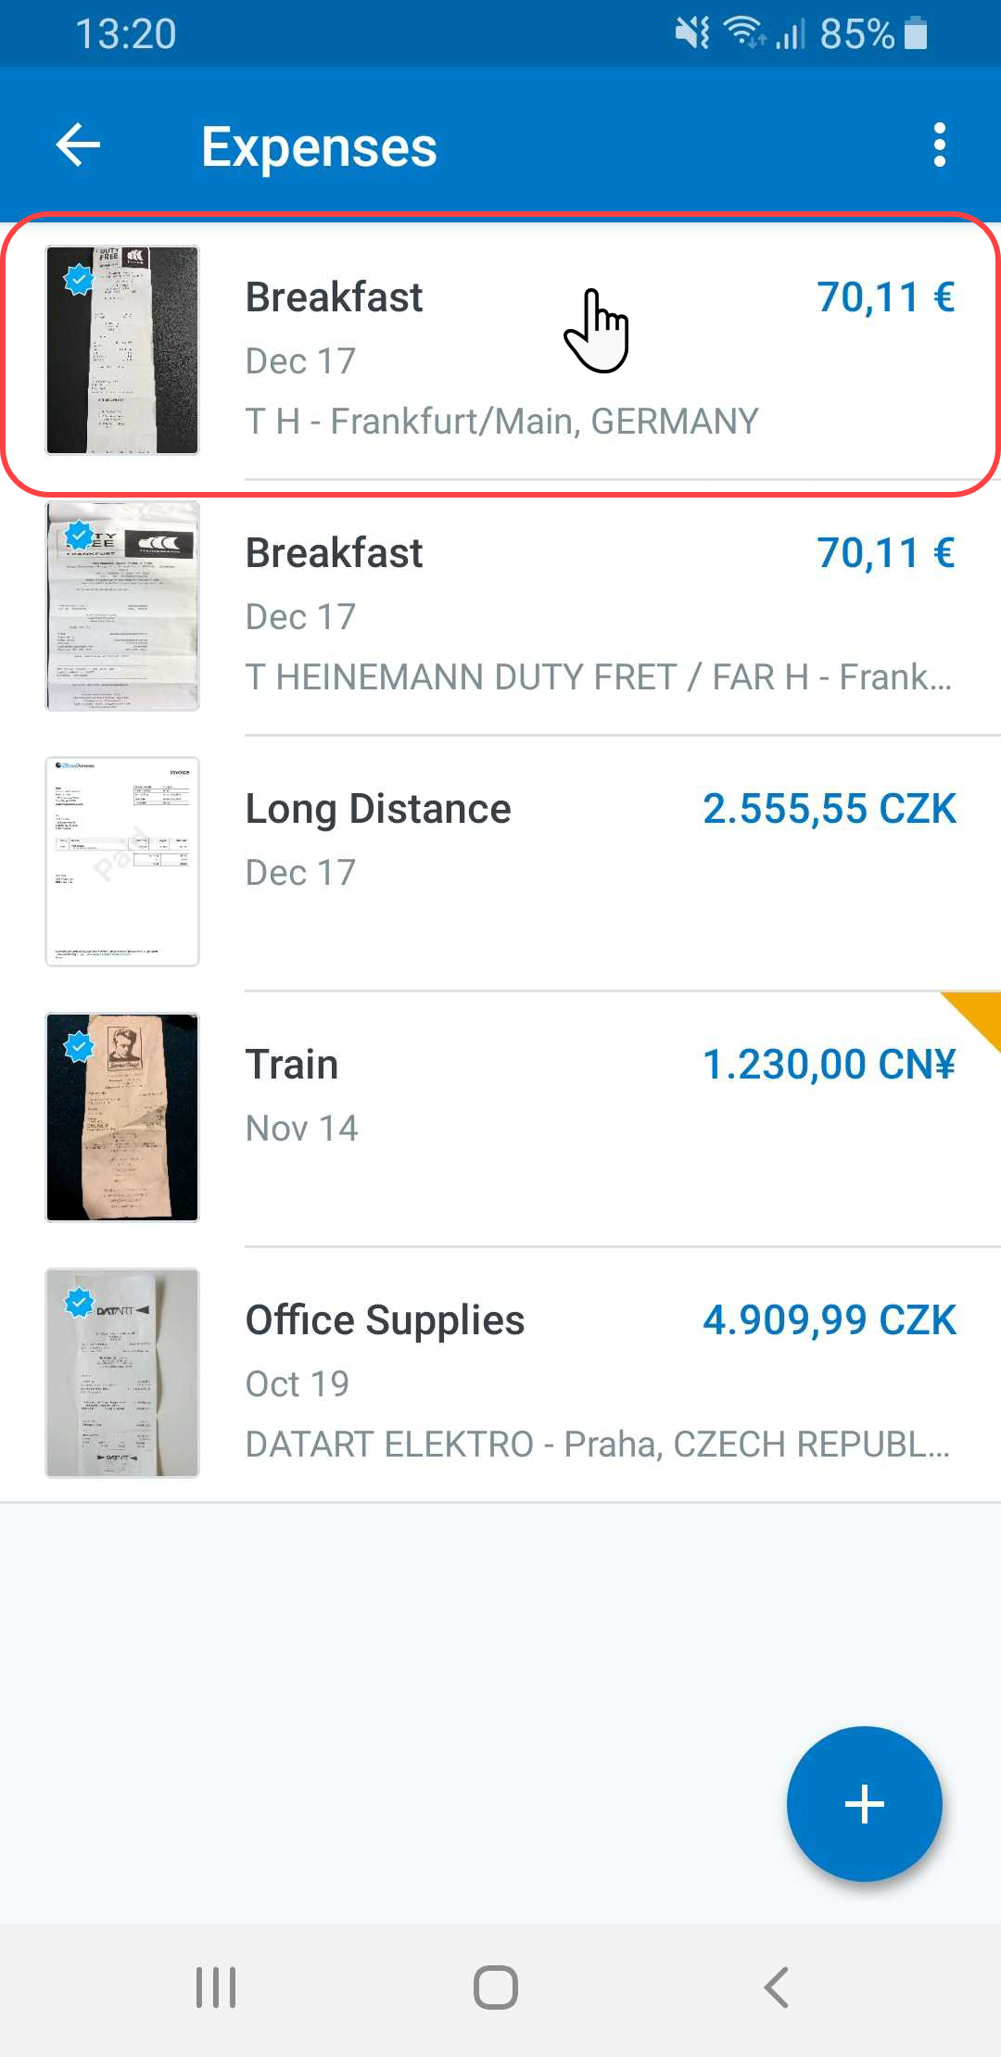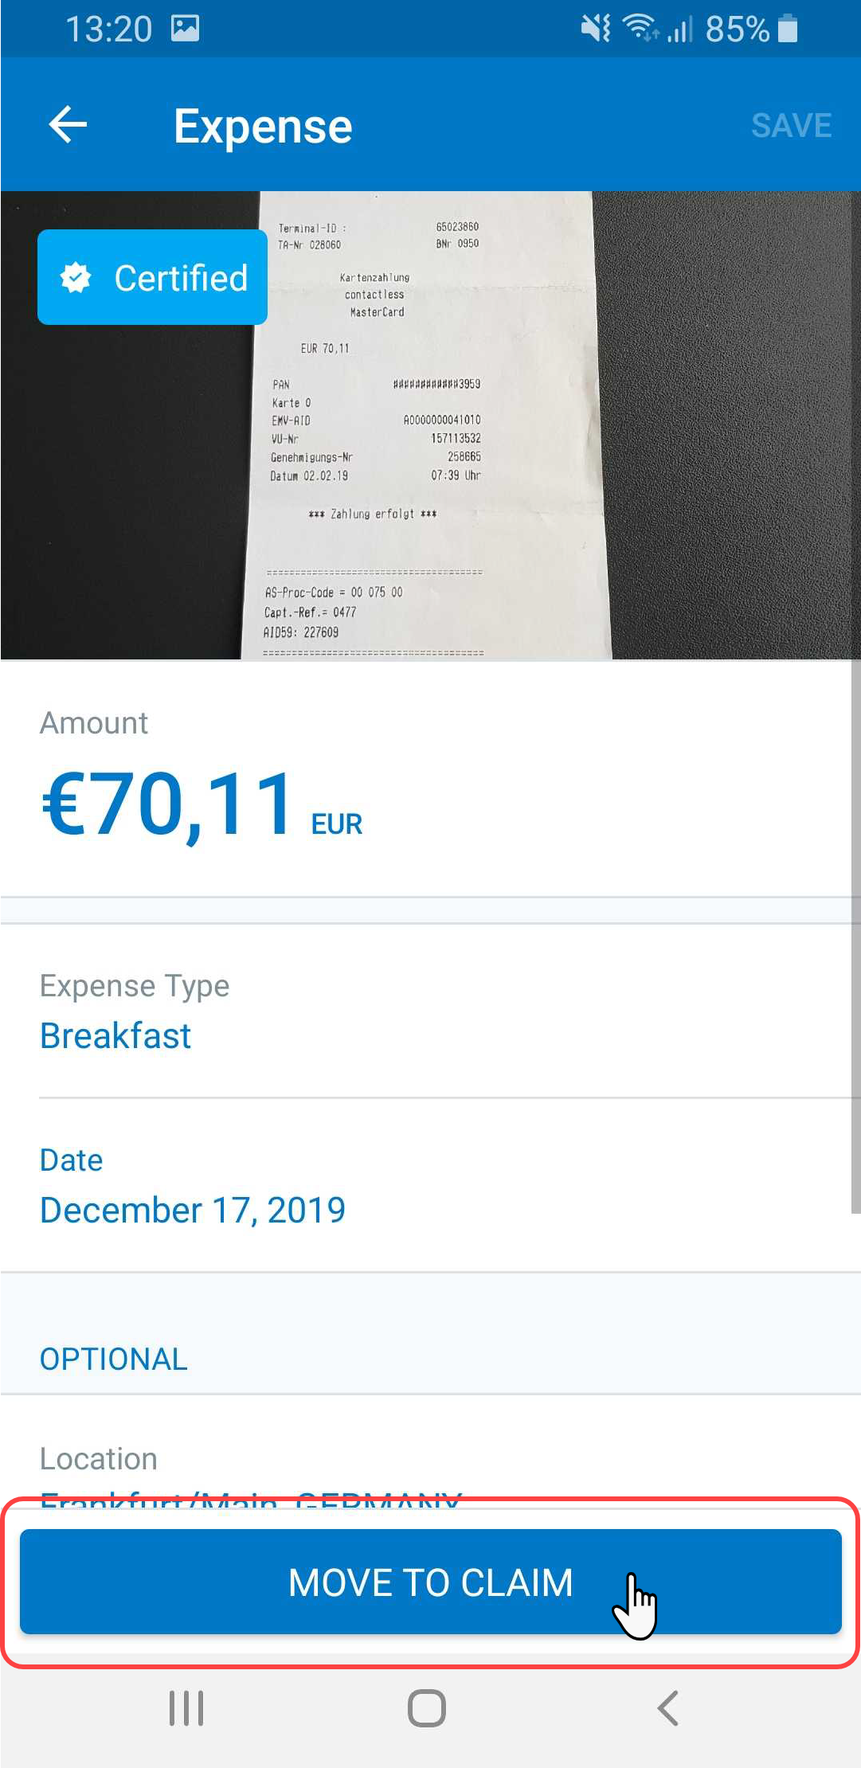 | The expense then appears on the Expenses screen, with the "certified" icon.  8) When ready, open the expense and tap Move to Claim to move the expense from the Expenses list to a report.

Capture the Image Using ExpenseIt
You can obtain a certified receipt image using ExpenseIt.
Screen(s) | Description/Action
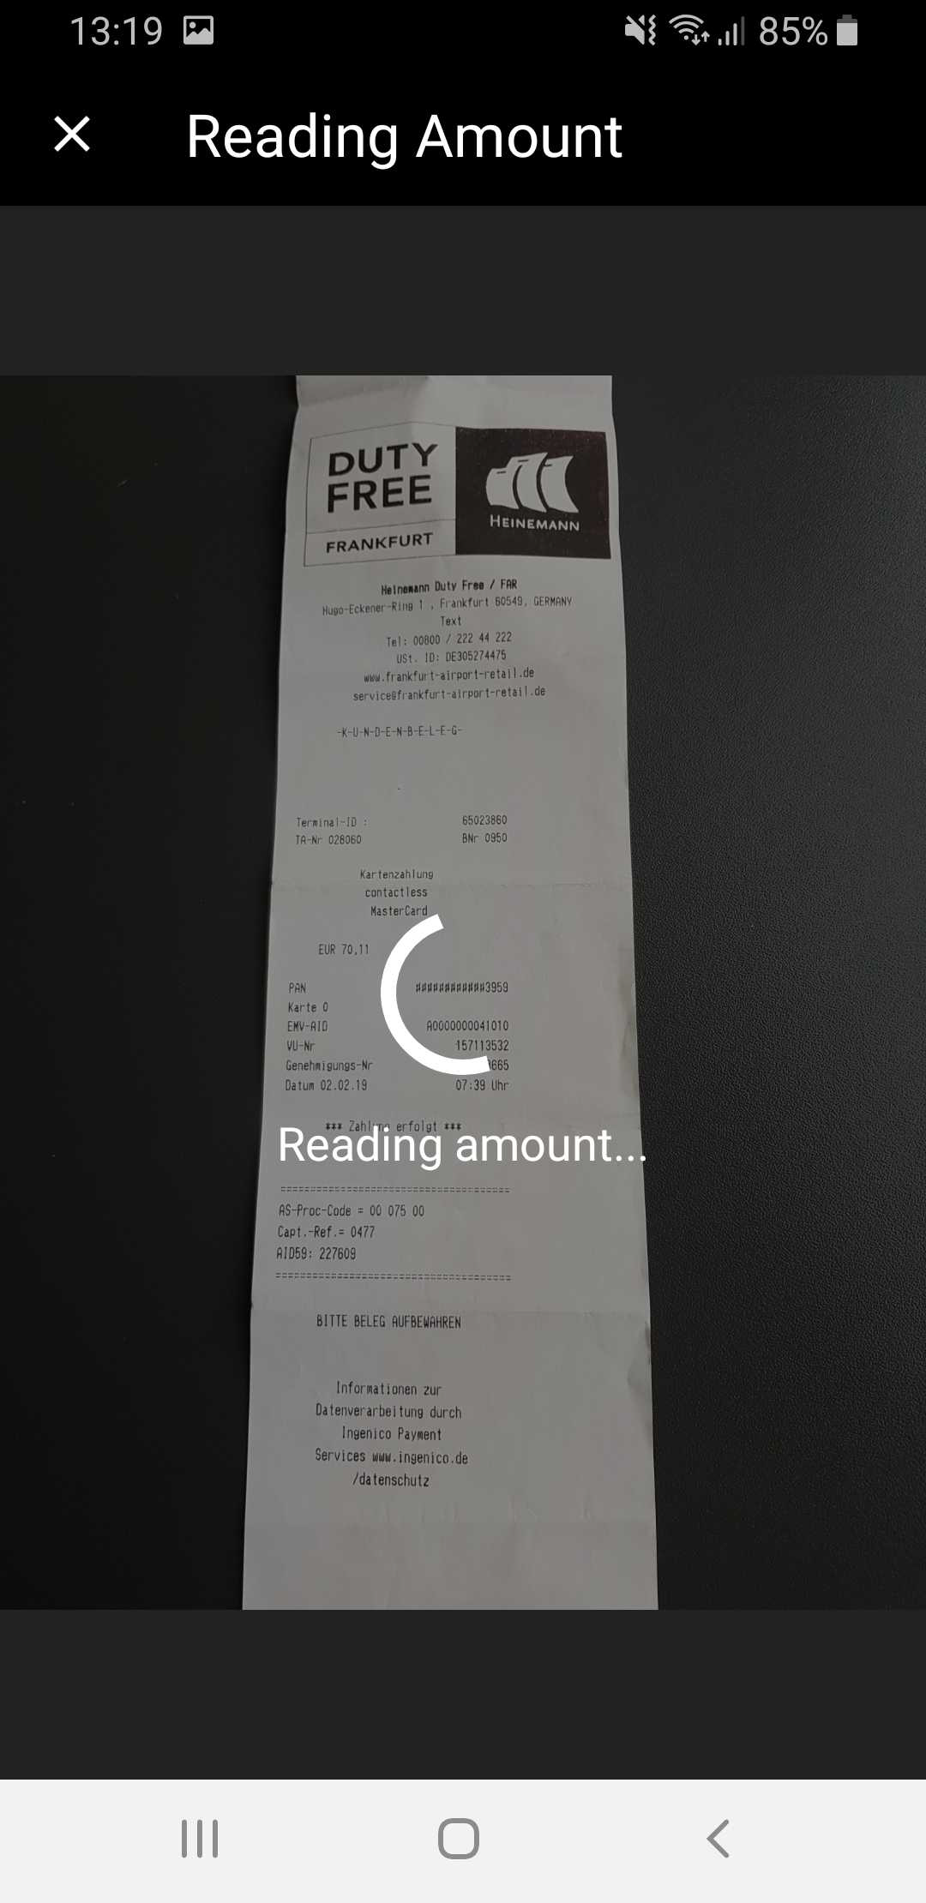 | To add an image while using ExpenseIt:  1) On the home screen, tap ExpenseIt.  2) Tap Next.  ExpenseIt reads the image and provides the amount on the screen.  3) Tap Done (lower-right corner).
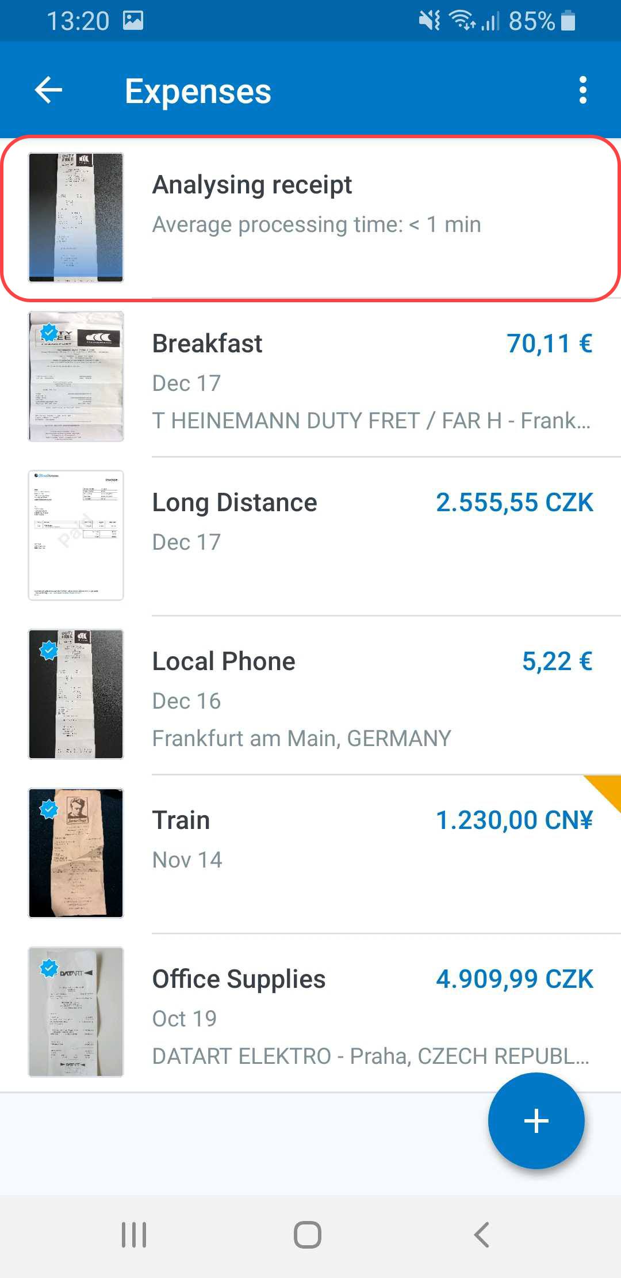 | ExpenseIt continues to analyze the image and creates the expense entry.  When done, the expense appears with the "certified" icon.
4) Open the expense and edit the expense as necessary.
5) When ready, tap Move to Claim to move the expense from the Expenses list to a report.
NOTE: Users - requiring an e-Bunsho timestamp on their receipts - have the capability to have the timestamp applied their receipt images they have captured with ExpenseIt in the mobile app.

☼

