Applies to these SAP Concur solutions:
Expense
Professional/Premium edition
Standard edition
Travel
Professional/Premium edition
Standard edition
Invoice
Professional/Premium edition
Standard edition
Request
Professional/Premium edition
Standard edition

Shared: Funds and Grants Integration with Concur Solutions
Setup Guide for Professional Edition
Last Revised: April 20, 2024

Table of Contents
1 Permissions 1
2 Overview 1
2.1 Features 2
2.1.1 Workflow Example 3
2.2 Exclusions 4
2.3 Definitions 4
2.4 Available Documentation 6
2.4.1 Concur Expense Professional Edition 6
2.4.2 Concur Request Professional Edition 6
2.4.3 SAP Concur Integration Documentation 6
2.4.4 Funds and Grants Integration API 6
3 End-User Experience 6
3.1 Request Page 7
3.2 Report Page 7
3.3 Request/Report Audit Trail 7
4 Admin Experience 8
4.1 Integration Manager Roles 11
4.2 Monitoring the Funds and Grants Integration with Concur Solutions 12
4.2.1 Navigating the Manage Integration Page 12
4.2.2 Searching for Obligation Document Integrations 12
4.2.3 Viewing Obligation Documents 13
4.2.4 Managing Obligation Document Integrations 14
5 Prerequisites 15
5.1 SAP Concur Prerequisites 15
6 Configuration 15
6.1 Overview 15
6.2 Intention-Based Configuration Recommendations 16
6.3 Enabling the Integration for Your Organization 17
6.4 Enabling the Integration for Groups 17
6.5 Adding Workflow Steps for Funds Check and Funds Reservation 18
6.6 Assigning the Integration Manager Roles 20
6.7 (Optional) Managing the Funds and Grants Integration Configuration 20
6.7.1 Modifying the Default Configuration 20
6.7.2 Modifying the Response Handing for a Configuration 22
6.7.3 Creating a New Configuration 26
6.7.4 Managing Allocation Mappings 27

Revision History
Date | Notes/Comments/Changes
April 20, 2024 | Made the following updates:  - Added information about allocation mapping and the new Allocation Mapping tab.  - Renamed the Configure page references to the Funds and Grants Integration page.  - Added references to the new Financial Services tab on the Funds and Grants Integration page.  - Added the 6.7.4 Managing Allocation Mappings section.
February 24, 2024 | Made the following updates:  - In the 2. Overview and 5.1 SAP Concur Prerequisites sections, added S/4HANA Cloud Public Edition  - In the 2. Overview and 5.1 SAP Concur Prerequisites sections, renamed SAP S/4HANA Cloud, private edition to S/4HANA Cloud Private Edition
October 14, 2023 | New document.

Funds and Grants Integration with Concur Solutions
NOTE: Multiple SAP Concur product versions and UI themes are available, so this content might contain images or procedures that do not precisely match your implementation. For example, when SAP Fiori UI themes are implemented, home page navigation is consolidated under the SAP Concur Home menu.

Permissions
A company administrator may or may not have the correct permissions to use this feature. The administrator may have limited permissions, for example, they can affect only certain groups and/or use only certain options (view but not create or edit).
If a company administrator needs to use this feature and does not have the proper permissions, they should contact the company's SAP Concur administrator.
Also, the administrator should be aware that some of the tasks described in this guide can be completed only by SAP Concur internal staff. In this case, the client must initiate a service request with SAP Concur Client Support.

Overview
The Funds and Grants Integration with Concur Solutions connects Concur Expense and Concur Request with SAP S/4HANA Budget Integration with Public Sector Management. The Funds and Grants Integration with Concur Solutions helps simplify cost control by allowing organizations to check and reserve funds for anticipated spend. This ensures that:
- Spend is properly allocated to the rights funds, grants, or budgets within SAP
- Spend is reserved before it is reimbursed
- SAP keeps track of funds availability in consideration of anticipated spend
- Funds are released appropriately when spend is complete
The integration is supported by the following SAP Concur solutions:
- Concur Expense, Professional/Premium Edition
- Concur Request, Professional/Premium Edition
The integration supports the following SAP ERPs:
- SAP S/4HANA 2023 with Public Sector Management
- SAP S/4HANA Cloud Private Edition 2023 with Public Sector Management
- S/4HANA Cloud Public Edition
Customers who are not integrating with SAP can still use the Funds and Grants Integration API.
For more information, refer to the Available Documentation > Funds and Grants Integration API section in this guide.

Features
The integration allows clients to:
- Perform funds checks at various points in the report/request workflow
- Create funds reservations at various points in the report/request workflow
- Automatically release funds when spend concludes
- Monitor and manage the integration using the Administration > Tools > Monitor Integrations and Configuration pages
- Route unsuccessful obligation documents to the Integration Manager for resolution
The integration introduces:
- Three new group-aware user roles that support the integration:
  - Integration Manager
  - Integration Manager Advanced
  - Integration Manager View Only
- A new workflow role, Native Integration
- Two new workflow steps associated with the new Native Integration workflow role
  - Funds Check
  - Funds Reservation
- A new Monitor Integration page for monitoring and managing the integration.
- A new Funds and Grants Integration page for configuring the Funds and Grants Integration with Concur Solutions, including response handling, which determines how unsuccessful integrations are routed and resolved, and allocation mapping, which ensures the cost objects for allocations are mapped to the correct custom fields used for funds reservations in Concur Request and Concur Expense.
When an organization uses the Funds and Grants Integration with Concur Solutions, while there is no visible impact to the approver experience, this integration can:
- Eliminate approval steps by automating the Funds Check and Funds Reservation process
- For organizations that reserve funds before the approver step, the integration can provide assurance to approvers that an expense report or request does not reach them unless the funds were successfully reserved

Workflow Example
A sample company has configured their request workflow to include a Funds Check after Submit, a Manager Approval step, then a Funds Reservation.
- An employee is planning to travel for 2 weeks and submits a request with estimated expenses.
- A Funds Check is sent to SAP to determine if there are funds available for the trip.
  - If there are funds available, the request proceeds to Step 3
  - If funds are not available, the request is returned to the employee
    - The employee can make changes and resubmit (back to Step 1), or
    - They can close the request because they are not permitted to travel
- Because the Funds Check was successful, the request is sent to the manager for approval, and the trip is approved.
- A Funds Reservation is sent to SAP to ensure the funds are reserved for this trip.
  - If the Funds Reservation is successful, the request proceeds to Step 5
  - If the Funds Reservation fails, the request is sent to an Integration Manager to review and determine what needs to be done
    - The Integration Manager can take actions that enable the Funds Reservation to succeed, or
    - They can send the request back to the employee for modifications or with a comment that travel is not permitted
- Because the Funds Reservation was successful, the request is now approved.
- The employee travels and tracks their expenses in their expense report, which they submit upon return.
- A Funds Check is sent to SAP to ensure that the actual spend is within the tolerance levels of the Funds Reservation.
  - If the Funds Check is successful, the expense report proceeds to Step 8
  - If the Funds Check fails, the expense report is returned to the employee
    - The employee can make changes and resubmit (back to Step 6)
- The Funds Check was within the tolerance levels of the Funds Reservation, and the expense report is approved for payment.
- When the expense report is paid, the payment is drawn from the Funds Reservation made in Step 4. Any additional funds in the reservation remain.
- The employee is reimbursed, and the request is automatically or manually closed.
- Because all linked expense reports are paid, a Funds Release is sent to SAP.
- SAP releases any funds remaining in the Funds Reservation, and it is closed.
This concludes the end-to-end flow example. However, most of the components are configurable and accommodate many scenarios. A few of which are:
- Request with multiple linked expense reports
- Request with parent expenses
- Expense report with Funds Reservations in the workflow
- Expense report not linked to a request

Exclusions
This feature cannot be used concurrently with Concur Budget. When deciding whether to use the Funds and Grants Integration with Concur Solutions, clients should weigh the following differences:
- The Funds and Grants Integration with Concur Solutions enables automatic funds check and funds reservation against funds, grants, and budgets maintained within SAP. This integration scales accommodate many daily transactions. Master Data Integration can be leveraged for synchronizing cost objects.
- Concur Budget enables funds checks against manually managed budgets within Concur. Because it’s designed to serve small companies, there are scaling limitations for large companies with many daily transactions.

Definitions
Obligation Document: In the Funds and Grants Integration with Concur Solutions, the SAP Concur expense reports and requests are converted into obligation documents. Each obligation documents represents a single report or request. Each obligation document is assigned a Document Identifier (ID), which is used to identify the document in the SAP financial system and returned in the integration response.
Response Handling: Response handling is a feature of the Funds and Grants Integration with Concur Solutions that determines how unsuccessful integrations are routed and resolved. Response handling is managed from the Response Handling tab in Configuration (Administration > Tools> Configuration)
When the SAP Concur solution communicates with the SAP financial system, the SAP financial system sends a response.
Response handling configuration allows organizations to:
- Choose who needs to take action for each response – the employee or the Integration Manager
- Choose what message is displayed to the employee
- Decide if the message from the financial system should be displayed to the employee
- Choose how to handle responses that have not been seen or configured yet
- Add response handling for responses that are coming from their customized SAP financial system.
The response handling configuration can manage the different response types:
- Default Response: Default responses are pre-configured responses designed to handle any unexpected or unmapped responses from the financial system. Default responses handle all unknown messages the same way to ensure that the message from the financial system is captured and shown.
- SAP-Managed Response: Customers integrating with an SAP financial system will receive certain known responses. SAP-managed responses can be edited and deactivated, if needed, but SAP-managed responses cannot be deleted.
- Custom Response: Custom responses can be created by an organization when additional messages and routing are needed.
Transaction Types: The integration sends a series of transactions to the financial system so that they can be applied to the correct cost objects and ledgers. In the Funds and Grants Integration with Concur Solutions, there are two transaction types: Funds Check and Funds Reservation. These transactions are added to the request and/or expense report workflows so that they occur at the right point in the spend lifecycle.
- Funds Check: Funds Check is a simple funds availability check against the SAP Financial System. A Funds Check is a point-in-time check that does not result in any financial transaction within the SAP financial system. If the SAP financial system responds that funds are available, then the request or report proceeds to the next step in the workflow. If the SAP financial system responds that funds are not available, then the request or expense report is sent back to the employee or requires action from an Integration Manager (however the response handling is configured).
- Funds Reservation: Funds Reservation checks for funds availability, then if funds are available, it reserves the funds. These transactions are known globally as encumbrances, commitments, and obligations.
If the funds are not available or the Funds Reservation cannot be completed, the SAP financial system responds that funds are not available, and the request or expense report is returned to the employee or requires action from an Integration Manager (however the response handling is configured).

Available Documentation

Concur Expense Professional Edition
For Concur Expense Professional Edition setup and user guides, refer to the documentation here:
Concur Expense Product Page

Concur Request Professional Edition
For Concur Request Professional Edition setup and user guides, refer to the documentation here:
Concur Request Product Page

SAP Concur Integration Documentation
For more information about the Funds and Grants Integration with Concur Solutions and the SAP Integration with Concur Solutions (ICS), refer to the documentation here:
SAP Concur Integration User Guides

Funds and Grants Integration API
Customers integrating into non-SAP systems or building a custom integration can use our Funds and Grants Integration API offered through Web Services.
Although much of the content in this guide applies to customers integrating though API, transforming the API payload into financial transactions in their financial system is required and may result in behavior that differs from expected outcomes described in this guide.
For more information about the Funds and Grants Integration API and how to use and integrate with Funds and Grants Integration with Concur Solutions, refer to the API documentation here:
SAP Concur Developer Center

End-User Experience
When an expense report or request reaches a workflow step with the integration enabled, the expense report or request status is updated, and the integration-related actions are displayed in the Audit Trail.

Request Page
In Concur Request, when a Funds Check or Funds Reservation is in process for a request, the user will see the status, Pending External Validation, on the request.

Report Page
In Concur Expense, when a Funds Check or Funds Reservation is in process for an expense report, the user will see the status, Pending Funds Check or Pending Funds Reservation, on the expense report.

Request/Report Audit Trail
The Funds Check or Funds Reservation actions are displayed in the Audit Trail for an expense report or request.
This example shows a successful Funds Reservation and Funds Check action in the audit trail for a request.
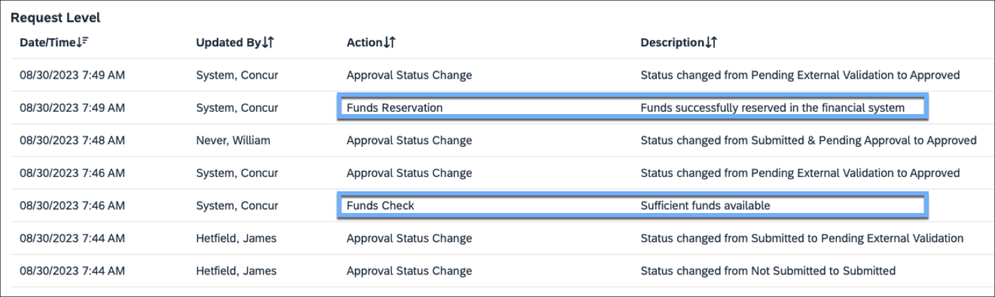
This example shows an unsuccessful Funds Check action in the audit trail for a request.
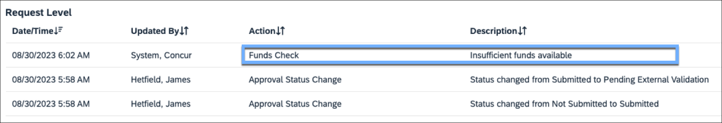

Admin Experience
In Tools (Administration > Tools), the Funds and Grants Integration section contains the Monitor Integrations and Funds and Grants Integration pages.
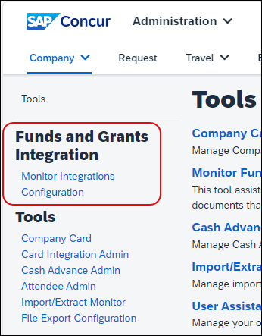
The Funds and Grants Integration page contains two tabs, Financial Systems and Allocation Mapping. On the Financial Systems tab, the administrator can assign different integration configurations to the various Expense Groups. You can also use this page to create new configurations or modify the default configuration for the Funds and Grants Integration with SAP Concur Solutions. All groups are initially assigned to the default configuration.
Response handling configuration is also managed from the Financial Systems tab.
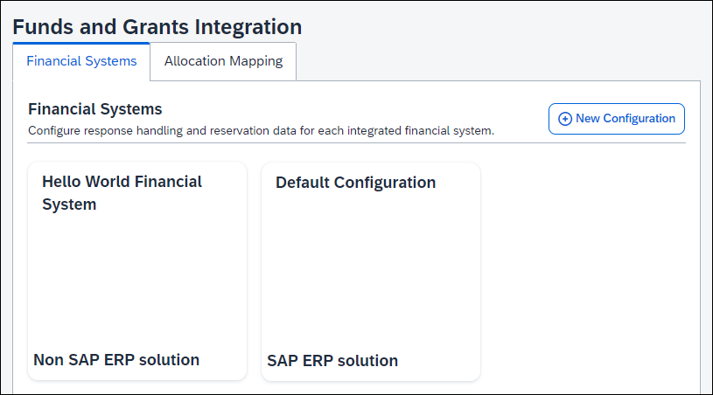
For more information about modifying the default configuration for the Funds and Grants Integration with Concur Solutions, refer to Configuring the Funds and Grants Integration with Concur Solutions (Optional) section in this guide.
When the Funds and Grants Integration with Concur Solutions creates an obligation, the funds in the SAP financial system are reserved at the allocation level. Allocation mapping ensures the cost objects for allocations are mapped to the correct custom fields used for funds reservations in Concur Request and Concur Expense, so that data flows correctly from Concur Request to Concur Expense to the SAP financial system to properly create funds reservations.
Sometimes the allocation forms and information collected in Concur Expense and Concur Request are not an exact match. Allocation fields are not always relevant to the funds reservations. On the Allocation Mapping tab, the administrator can define elements that are relevant to the funds reservation, and then map these definitions to the custom fields on allocation forms.
If allocation mappings are not defined across more than one cost object, the system will allocate 100 percent of the expenses to the default cost object.
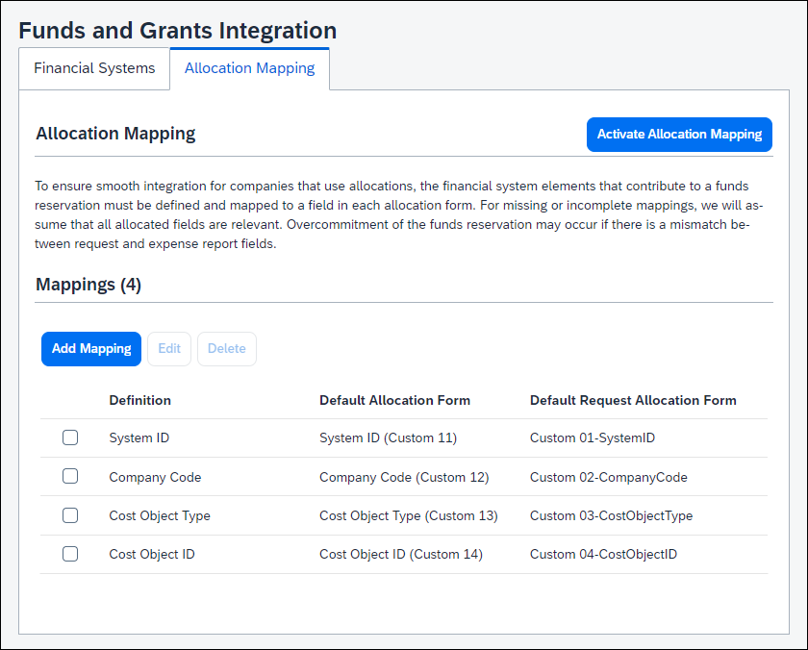
For more information about allocation mapping for the Funds and Grants Integration with Concur Solutions, refer to the Configuring the Funds and Grants Integration with Concur Solutions (Optional) section in this guide.
Users assigned the applicable integration manager role can use the Monitor Integrations page to track and manage the obligation documents for the employee groups to which they have access. When needed, an Integration Manager can also use the Monitor Integrations page to assist with resolving funding or administrative issues.
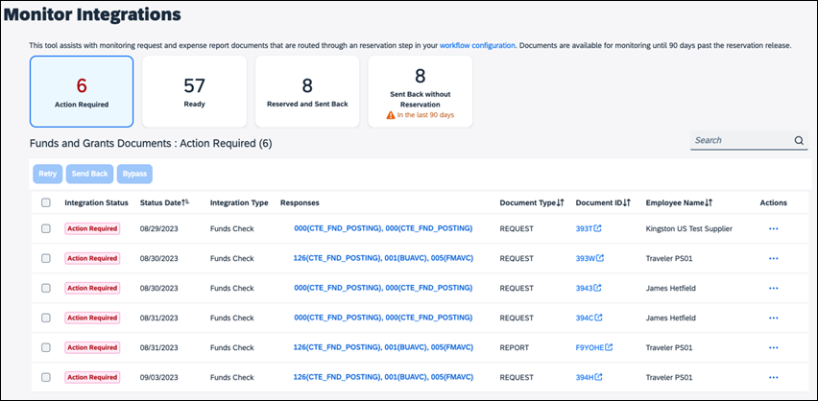

Integration Manager Roles
The Funds and Grants Integration with Concur Solutions uses Integration Manager roles that govern the Monitor Integrations page.
- Integration Manager View Only grants access to the Monitor Integrations page and the ability to browse and search obligation documents, but they may not take any actions.
- Integration Manager grants access to the Monitor Integrations page, the ability to browse and search obligation documents, and permission to Retry or Send Back obligation documents.
- Integration Manager Advanced grants access to the Monitor Integrations page and the ability to browse and search obligation documents, and permission to Retry, Send Back, or Bypass obligation documents.
- For more information, refer to the Managing Obligation Document Integrations section of this guide.

Monitoring the Funds and Grants Integration with Concur Solutions

Navigating the Manage Integration Page
On the Manage Integrations page, there are four views. An Integration Manager can access the views by clicking one of view cards at the top of the page.
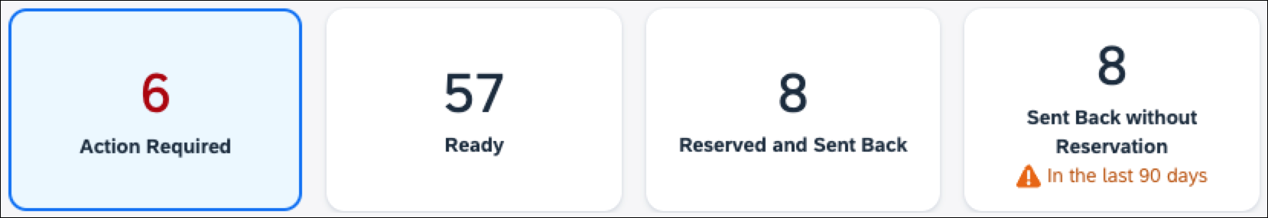
- Clicking the Action Required card displays all obligation documents that must have an action taken by the Integration Manager. The response handling configuration determines when an obligation document is assigned the Action Required status.
- Clicking the Ready card displays all obligation documents that are ready for integration and are waiting to be picked up by SAP at the scheduled interval (typically every 10 minutes).
- Clicking the Reserved and Sent Back card displays which obligation documents have an active Funds Reservation, but are not approved and are awaiting an employee action. It is important to monitor this view to ensure stale obligation documents do not continue to hold funds reservations. If a document stays in this state for a long time, it is likely the spend is no longer going to occur.
- Clicking the Sent Back without Reservation card displays the obligation documents that have been through integration but do not have a Funds Reservation associated with it, and the obligation documents are awaiting employee action.

Searching for Obligation Document Integrations
Use the Search field to search for obligation document integrations either by the obligation document ID or employee name. By default, a search is limited to the obligation documents contained in the selected view. However, the search can be expanded to search all obligation document integrations.

Viewing Obligation Documents
On the Manage Integrations page, the list of obligation documents is the list of obligation documents for the currently selected view. The list can be sorted by the Status Date, Document Type, Document ID, or Employee Name columns.
The table provides the column names and descriptions for the obligation document list on the Monitor Integrations page.
Column | Description
Integration Status | Displays the status of the obligation document’s most recent integration.  The status can be:  - Action Required – the obligation document is awaiting action from an Integration Manager.  - Ready –the obligation document is in the queue waiting to be requested by SAP.  - Sent Back – the obligation document has been either automatically or manually sent back to the employee because the integration was unsuccessful.  - Success –the most recent Funds Check or Funds Reservation was successful and the obligation document progressed to the next step in the workflow.  - Processing –an integration is in process or a manual action is being processed. This is an interim status that obligation documents are in very briefly.
Status Date | Current integration status date
Integration Type | Indicates whether the integration type is Funds Check or Funds Reservation
Responses | Displays the result of the current integration. Clicking the link will open the full response from SAP.
Document Type | Indicates whether the integration was for a request (REQUEST) or an expense report (REPORT)
Document ID | Displays the expense report or request ID associated with the obligation document. Clicking the link opens the expense report or request if the user has permission to access it.
Employee Name | The name of the employee associated with the obligation document that SAP needs to process the transactions
Actions | Clicking the ellipses opens the list of actions available for the obligation document

Managing Obligation Document Integrations
On the Manage Integrations page above the list of obligation documents, are three buttons, Retry, Send Back, and Bypass. When an obligation document is selected in the obligation document list, if the action associated with a button is available for the obligation document, the button will be enabled.
- Retry –the transactions will be rebuilt and sent to SAP. This is helpful when cost objects, allocations, or amounts are changed.
- Send Back –the Integration Manager can provide a comment and the obligation document is sent back to the employee.
- Bypass – the obligation document skips the integration entirely. This option should be considered if there are issues with the obligation document that cannot be resolved.
The Retry, Send Back, and Bypass actions can only be performed on obligation documents that have the Action Required status.
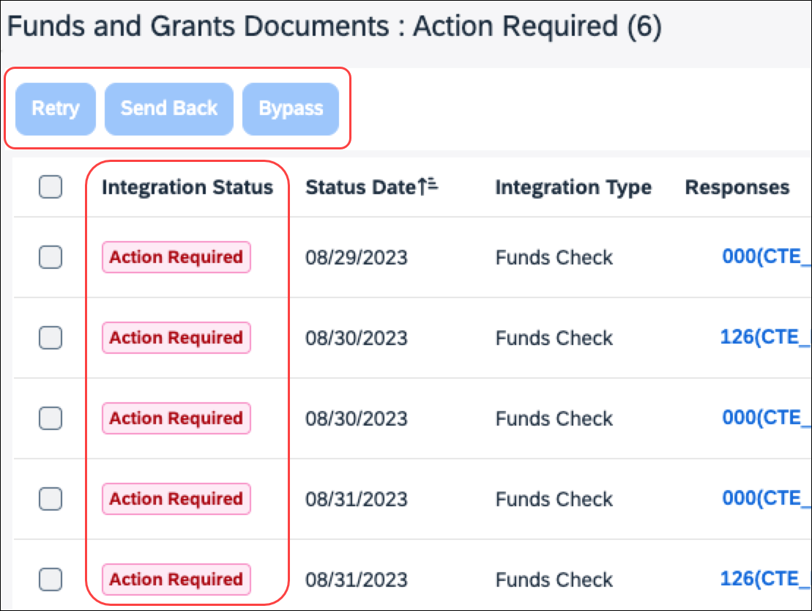

Prerequisites

SAP Concur Prerequisites
The following prerequisites are required to use the Funds and Grants Integration with Concur Solutions:
- Be a new or existing SAP Concur client, with Concur Expense Professional/Premium Edition and (Optional) Concur Request Professional/Premium Edition (if your organization wants to use pre-spend reservations of funds)
- Be an existing SAP client, using SAP Integration with Concur Solutions (ICS) for Financial Integration
If clients are not already using ICS for Financial Integration, they can enable it for this integration. This is required to complete the end-to-end lifecycle of Funds and Grants Integration including release of unused funds.
- Be an existing SAP client, with SAP S/4HANA 2023 with Public Sector Management, SAP S/4HANA Private Cloud 2023 with Public Sector Management, or SAP S/4HANA Cloud Public Edition
The Funds and Grants integration with Concur Solutions cannot be used concurrently with Concur Budget.

Configuration

Overview
One of the many benefits of pairing SAP S/4HANA and SAP Concur is that we have eliminated many of the integration tasks through this native integration. Configuration involves deciding how and when to integrate, and the rest is taken care of. This section covers those steps.
To configure the Funds and Grants Integration with Concur Solutions:
- The Funds and Grants Integration with Concur Solutions is enabled for your organization by SAP Concur.
- Enable the integration for groups in the SAP Concur solution that will use the integration.
- Add workflow steps for the Funds Check and/or Funds Reservation transactions.
- Assign the Integration Manager roles.
- (Optional) Create a new configuration for the integration.
- (Optional) Add allocation mappings for the integration.

Intention-Based Configuration Recommendations
Due to the flexibility of the Funds and Grants Integration with Concur Solutions, the following decision tree can help your organization define a configuration that matches your organization's needs.

Question | Answer | Configuration and Next Step
- Who at your company is allowed to reserve funds for anticipated spend? | Employee (when they plan to travel) | Add a Funds Reservation step right after Submit in the request workflow.  Proceed to Question 3
 | Approver (only after they have approved) | Add a Funds Reservation step after the first authorized manager approval step in the request workflow.  Proceed to Question 2
 | No one | Proceed to Question 2
- Are employees permitted to travel if funds are not available? | Yes | Proceed to Question 3
 | No | Add a Funds Check step right after Submit in the request workflow.  Proceed to Question 3
- Is administrative action required when there are insufficient funds? | Yes | Assign the Integration Manager role to the person(s) who will take the administrative actions.  Set the recipient for responses that require administrative action to the Integration Manager.  Proceed to Question 4
 | No | Proceed to Question 4
- If the approved amount is less than the Reserved amount, do you want to reduce the funds reservation to the approved amount? | Yes | Add a Funds Reservation step as the last step in the request workflow.  Proceed to Question 5
 | No | Proceed to Question 5
- When a costs on a linked expense report exceed the Funds Reservation, should the reservation be increased by the additional amount? | Yes | Add a Funds Reservation after Submit on the expense report workflow.
 | No | No additional configuration recommended.

Enabling the Integration for Your Organization
If your organization is interested in using the Funds and Grants Integration with Concur Solutions, please contact your SAP Concur account team to enable the integration.
Once the Funds and Grants Integration with Concur Solutions is enabled, the rest of integration configuration steps in the SAP Concur solution can be completed.

Enabling the Integration for Groups
Determine which Expense groups will use the Funds and Grants Integration with Concur Solutions, and then enable the Enable Funds and Grants Integration setting for the applicable groups in Group Configuration (Administration > Expense > Group Configuration).
The Enable Financial Integration setting must be enabled before you can enable the Funds and Grants Integration setting in Group Configuration.
The Funds and Grants Integration with Concur Solutions is not inherited from parent groups. For example, if you want to enable the Funds and Grants Integration with Concur Solutions for all groups, each group will need to have this setting enabled in Group Configuration.
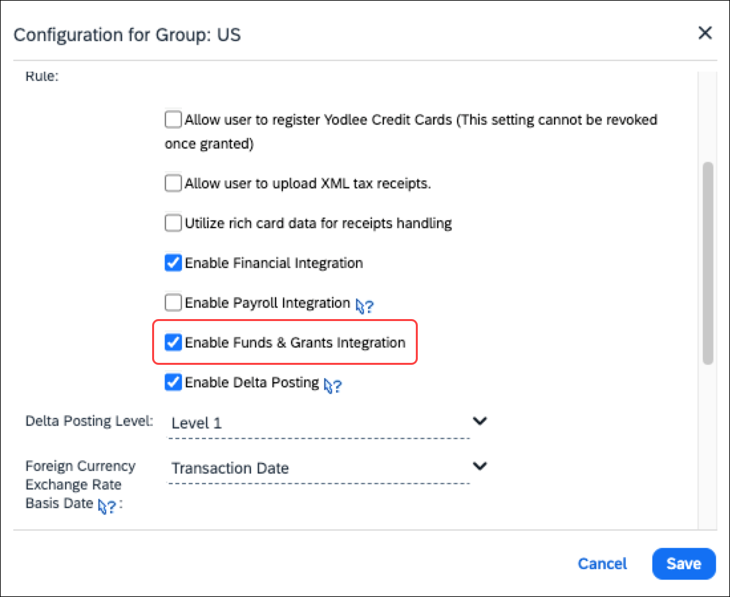
For more information, refer to the Concur Expense: Group Configurations for Expense Setup Guide.

Adding Workflow Steps for Funds Check and Funds Reservation
Before configuring workflow steps for the Funds and Grants Integration with SAP Concur, there are some best practices to consider:
- It is best practice not to configure back-to-back integration steps. It will work, but it is unnecessary.
For example, if you want a Funds Reservation to immediately follow a Funds Check when funds are available, just add the Funds Reservation step. The Funds Reservation step automatically does a Funds Check and will not reserve funds if the Funds Check is unsuccessful.
- It is best practice to ensure an approver is assigned to the approval steps when using the Funds and Grants Integration with Concur Solutions. If there is an approval step without a defined approver after a Funds Check or Funds Reservation workflow step, the obligation document will not progress through the workflow because there is no one to approve the next step.
Determine which integration-related transactions (Funds Check or Funds Reservation) your organization wants to add to your workflows, and then add the applicable integration workflow step to your workflows in Workflows (Administration > Expense or Request > Workflows).
To add an integration step to your workflows, in the Add Workflow Step dialog, select Native Integration from the Role list, and then select one of the following from the Integration Type list:
- Funds Check
- Funds Reservation
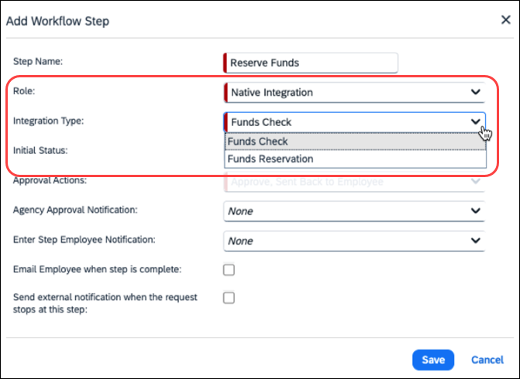
For more information, refer to the Concur Expense: Workflow – General Information Setup Guide and Concur Request: Workflow – General Information Setup Guide.

Assigning the Integration Manager Roles
To access and use the Manage Integrations page in Tools, Integration Managers need to be assigned to the applicable Integration Manager user role.
For more information about each of the Integration Manager roles, refer to the Integration Manager Roles section in this guide.
In User Administration (Administration > Company > Company Admin > User Administration), assign the applicable Integration Manager roles to your organization's Integration Managers.
For more information, refer to the Shared: User Administration User Guide.

(Optional) Managing the Funds and Grants Integration Configuration
By default, Funds and Grants Integration with Concur Solutions is automatically configured to work without additional configuration needed. Unless you want to modify the default configuration, create a new configuration, or you want to add allocation mappings, no additional configuration is needed for the integration.
The default configuration cannot be deleted, and the only things that can be edited on the default configuration are the groups assigned to the configuration and the response handling.
If your organization wants to modify the default integration configuration or add a new configuration, you can modify or add a configuration on the Financial Systems tab on the Funds and Grants Integration page (Administration > Tools > Configuration).
When the Funds and Grants Integration with Concur Solutions is enabled for a group, the group is automatically assigned to the default configuration on the Financial Systems tab.
If your organization wants to configure allocation mappings, you can add, edit, delete, and activate allocation mappings on the Allocation Mapping tab on the Funds and Grants Integration page.

Modifying the Default Configuration
The only thing that can be modified on the default configuration are the groups assigned to the default configuration and the response handling.
Groups cannot be removed from the default configuration manually. In order to remove a group from the default configuration, the group must be assigned to another configuration. Once the group is assigned to another configuration, the group will automatically be removed from the default configuration.
To add a group to the default configuration:
- Open the Funds and Grants Integration page (Administration > Tools > Configuration) and then click the Financial Systems tab.
- On the Financial Systems tab, click the Default Configuration card.
- Click Edit.
The Edit Configuration dialog opens.
- In the Assign Groups list, select the groups you want to add to the configuration.
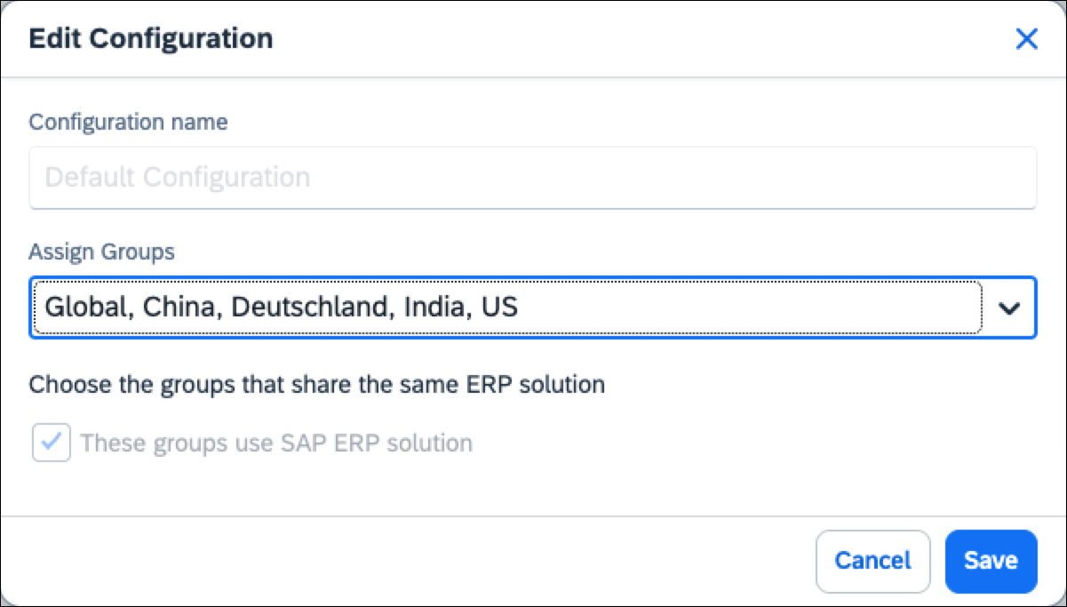
- Click Save.

Modifying the Response Handing for a Configuration
Response handling is managed separately for each configuration from the Configuration page.
Default responses and SAP-managed responses are pre-configured in configurations for the Funds and Grants Integration with Concur Solutions, and may be edited. In addition to the default responses and SAP-managed responses, you can create custom responses for a configuration.
Default and SAP-Managed responses cannot be deleted, but SAP-Managed responses can be deactivated, if needed.
To edit an existing response:
- On the Financial Systems tab, click the configuration containing the responses you want to edit.
- Click Edit.
- On the Response Handling tab, click the ellipses (…) for the response you want to edit in the Actions column.
- Click Edit.
The Edit Response dialog opens.
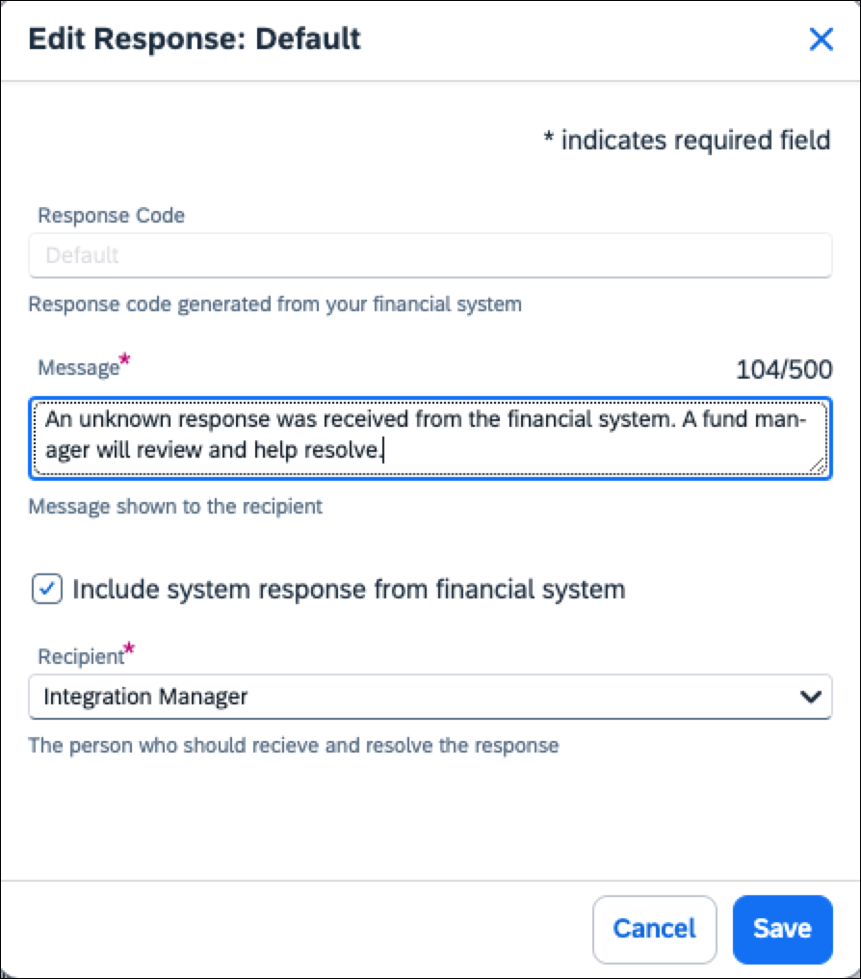
In the Edit Response dialog you can edit the following:
Field | Description
Message | This message is displayed in the audit trail of the obligation document
Include system response from financial system | When selected, the full system message is displayed in the audit trail of the obligation document.
Recipient | If set to Employee, the obligation document will be sent back to the employee.  If set to Integration Manager, the obligation document will be assigned the Action Required integration status on the Monitor Integrations page.
- Click Save.
To deactivate an SAP-managed response:
While SAP-managed responses can be deactivated, it is an uncommon scenario.
- On the Response Handling tab, click the ellipses (…) for the response you want to deactivate in the Actions column.
- Click Deactivate.
Clicking Deactivate changes the response's status to Inactive.
To activate a response:
- On the Response Handling tab, click the ellipses (…) for the response you want to activate in the Actions column.
- Click Activate.
Clicking Activate changes the response's status to Active.
To create a new custom response:
- On the Response Handling tab, click the New Custom Response button.
The Create New Custom Response dialog opens.
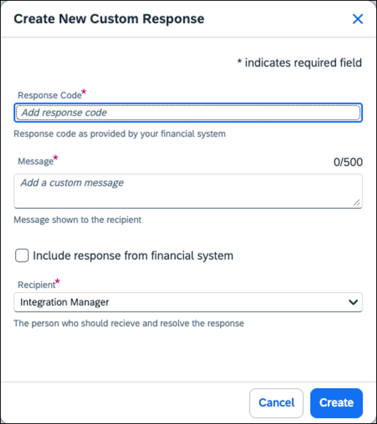
- In the Response Code field, enter the response code.
For SAP integrations, the response code is the message code followed by the message class in parentheses. For example, [message code]([message class]) = 991(FMAVC)
- In the Message field, enter the message to be displayed in the audit trail for the obligation document.
- Select the Include response from financial system check box if you want the full system message to be displayed in the audit trail of the obligation document.
- In the Recipient list, click Employee if the obligation document should be sent back to the employee, or click Integration Manager if the obligation document should be assigned the Action Required integration status on the Monitor Integrations page.
- Click Create.
The custom response is added to the responses list.

Creating a New Configuration
A new configuration can be created for the Funds and Grants Integration with Concur Solutions if the response codes and handling are different for some groups in your organization.
To create a new configuration
- On the Financial Systems tab, click the New Configuration button.
The New Configuration dialog opens.
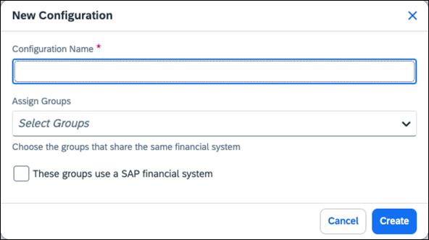
- In the Configuration Name field, enter the configuration name.
- In the Assign Groups list, select the groups you want to assign to the configuration.
- Select These groups use a SAP financial system check box, if applicable.
- Click Create.

Managing Allocation Mappings
On the Allocation Mapping tab, you can add, edit, delete, and activate allocation mappings.
Each allocation form must have allocation mappings defined for the cost objects and Concur Expense and Concur Request custom fields associated with the funds reservations.
Once the allocation mappings for the integration are activated, you cannot add, edit, or delete allocation mappings.
To add a new allocation mapping:
- Open the Funds and Grants Integration page (Administration > Tools > Configuration) and then click the Allocation Mapping tab.
- Click the Add Mapping button.
Clicking the Add Mapping button opens the Create New Mappings dialog.
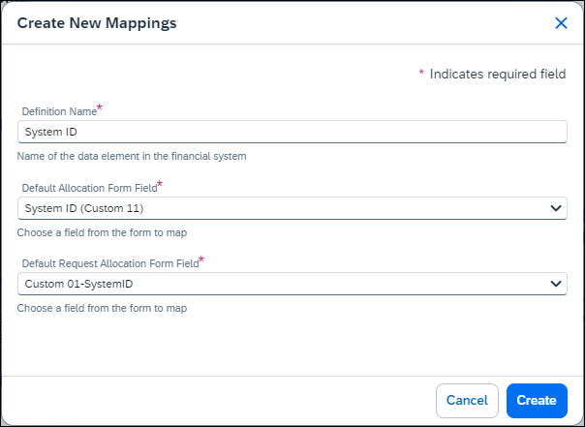
- In the Definition Name field, enter the cost object name.
- In the Default Allocation Form Field list, select the Concur Expense custom field associated with the selected cost object and funds reservations.
- In the Default Request Allocation Form Field list, select the Concur Request custom field associated with the selected cost object and funds reservations.
Most organizations just have one allocation form for Concur Request and one allocation form for Concur Expense. If your organization has more than one allocation form for Concur Request and Concur Expense, additional allocation form fields will be displayed in the Create New Mappings and Edit Mappings dialogs for the additional allocation forms.
- Click Create.
Clicking Create adds the allocation mapping to the Mappings list on the Allocation Mappings page.
To edit an allocation mapping:
- On the Allocation Mapping tab, select the check box for the allocation mapping you want to edit, and then click Edit.
Clicking Edit opens the Edit Mappings dialog.
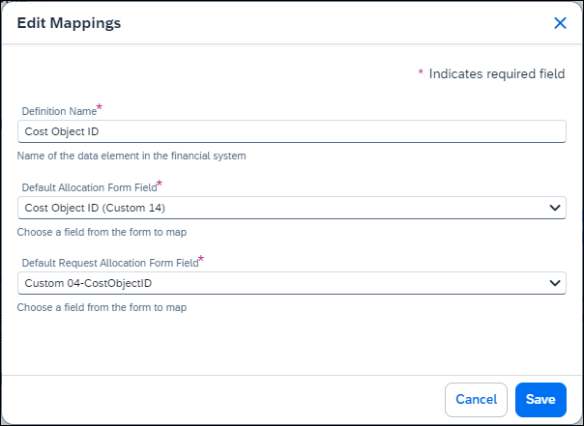
- Make the applicable edits and then click Save.
To delete an allocation mapping:
- On the Allocation Mapping tab, select the check box for the allocation mapping you want to delete, and then click Delete.
Clicking Delete opens The selected field mapping will be deleted. message.
- Click Delete.
The allocation mapping is deleted from the Mappings list on the Allocation Mapping tab.
To activate allocation mappings:
Allocation mappings are not applied to cost objects until they are activated. Once an allocation mapping is activated, it cannot be changed. Clicking the Activate Allocation Mapping button on the Allocation Mapping tab will activate all the allocation mappings listed in the Mappings section.
- Once the allocation mappings are configured for the integration, click the Activate Allocation Mapping button.
- Clicking the Activate Allocation Mapping button opens the Confirm Activation message.
- Click Activate.
All of the allocation mappings listed in the Mappings section of the Allocation Mapping tab are activated and applied to the applicable cost objects.
Once allocation mappings are activated, allocation mappings can be viewed on the Allocation Mapping tab, but allocation mappings cannot be added, edited, or deleted.
☼

