SAP Concur Release Notes
Concur Expense Professional / Premium
Month | Audience
Release Date: April 2024  Initial Post: April 19, 2024 | Client FINAL

Contents
Release Notes 1
Custom Fields 1
Next Generation: Check Box Data Value is Now False and not Null 1
Expense Pay 1
Enhanced User Interface in Expense Payment Manager 1
Updates to the Payment Status Timeline 4
Localization 5
Removal of Expense Types Descriptions 5
Mileage Service 7
Update - Administrator Delegating for a User May Reset Initial Distance Mileage for Personal Car 7
Miscellaneous 7
Keyboard Shortcuts for Expense Screens 7
Travel Allowance 9
New Features: Create a New Rate Bundle from a Statutory Base Rate Bundle and Enhanced Preview Mode 9
Planned Changes 13
Company Card 13
**Planned Changes** Enhancements to the Manage Transactions Screen 13
Receipts – ExpenseIt for Web 16
**Planned Changes** Single Combined Option to Select ExpenseIt for Email and Web Now Two Separate Options 16
Reports 16
**Planned Changes** Enhancements to the Report Timeline 16
**Planned Changes** Preferred Name for Expense Submitter 18
User Interface Changes 19
**Planned Changes** Update to the Report Status Indicator 19
Client Notifications 20
Accessibility 20
Accessibility Updates 20
Gender Diversity 20
Gender Diversity Planned Features and Changes 20
In-Product User Assistance 20
Client Customized Content 20
Subprocessors 21
SAP Concur Non-Affiliated Subprocessors 21
Supported Browsers 21
Supported Browsers and Changes to Support 21
Additional Release Notes and Other Technical Documentation 22
Online Help 22
SAP Concur Support Portal – Selected Users 22
Cases 23
Check Support Case Status 23

Legal Disclaimer
The information in this presentation is confidential and proprietary to SAP SE or an SAP affiliate company and may not be disclosed without the permission of SAP SE or the respective SAP affiliate company. This presentation is not subject to your license agreement or any other service or subscription agreement with SAP SE or its affiliated companies. SAP SE and its affiliated companies have no obligation to pursue any course of business outlined in this document or any related presentation, or to develop or release any functionality mentioned therein. This document, or any related presentation and SAP SE or an SAP affiliate company’s strategy and possible future developments, products and or platforms directions and functionality are all subject to change and may be changed by SAP SE and its affiliated companies at any time for any reason without notice. The information in this document is not a commitment, promise or legal obligation to deliver any material, code or functionality. This document is provided without a warranty of any kind, either express or implied, including but not limited to, the implied warranties of merchantability, fitness for a particular purpose, or non-infringement. This document is for informational purposes and may not be incorporated into a contract. SAP SE and its affiliated companies assume no responsibility for errors or omissions in this document, except if such damages were caused by SAP SE or an SAP affiliate company’s willful misconduct or gross negligence.
All forward-looking statements are subject to various risks and uncertainties that could cause actual results to differ materially from expectations. Readers are cautioned not to place undue reliance on these forward-looking statements, which speak only as of their dates, and they should not be relied upon in making purchasing decisions.

Release Notes
This document contains the release notes for Concur Expense professional edition.
Features and changes that apply to SAP Concur site-wide or to multiple products/services are documented in the Shared Changes Release Notes. For information about site-wide or shared changes in this release that might impact your SAP Concur solutions, refer to the Shared Changes Release Notes.

Custom Fields

Next Generation: Check Box Data Value is Now False and not Null

Overview
On April 9th, a change to the behavior under the Next Generation (NextGen) user interface is applied to check boxes created using the custom fields feature. Now, for an unselected check box, the system will always send a value of False instead of a value of Null to match the behavior of the previous user interface.
This feature standardizes the behavior of the NextGen and prior user interfaces so that a value of False is the default value sent by NextGen to Expense and this same value will appear on data extraction.

Administrator Experience
The administrator tasked with data extraction will no longer see a value of Null when working with an unselected check box under the NextGen user interface but will instead see a value of False just as they did under the earlier user interface.

Configuration / Feature Activation
The change will occur automatically; there are no additional configuration steps.

Expense Pay

Enhanced User Interface in Expense Payment Manager

Overview
As of April 18th, 2024, SAP Concur has enhanced the Funding Accounts and View Funding, and Batch Definitions screens to provide easier access to relevant information and to remove outdated elements from the user interface.
This update provides faster access to relevant information on screen in a simplified manner and reduces the number of clicks required to view the necessary information.

Administrator Experience
Navigate to the Payment Manager > Configure Batches > Funding Account screen to see the following updates:
- The Bank ID column displays the term Provider Account instead of Global Account when using Convera as the payment provider.
- The Account Number column is populated with the term Provider Account. In the future, this will be used to display the provider account ID you setup with your payment provider.
- Removed the following columns: Pay Cycle, Funding Type, On Hold, Active Date, and Test as they are no longer in use or don't provide useful information.
- Added a new column labeled Provider which displays the term Provider. In the future, this will be used to display the payment provider’s name you setup the account with.
- The Funding Accounts screen now displays a full page of funding accounts for the user when searching for the required funding account with multiple pages of accounts. Previously, only 10 records displayed when user clicked the next page icon.
Example:
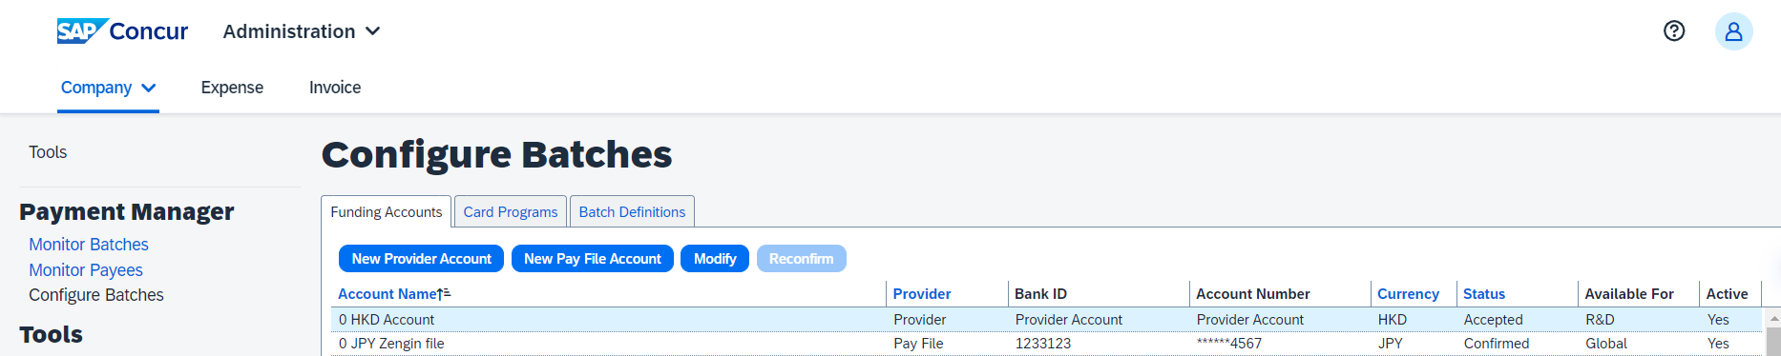
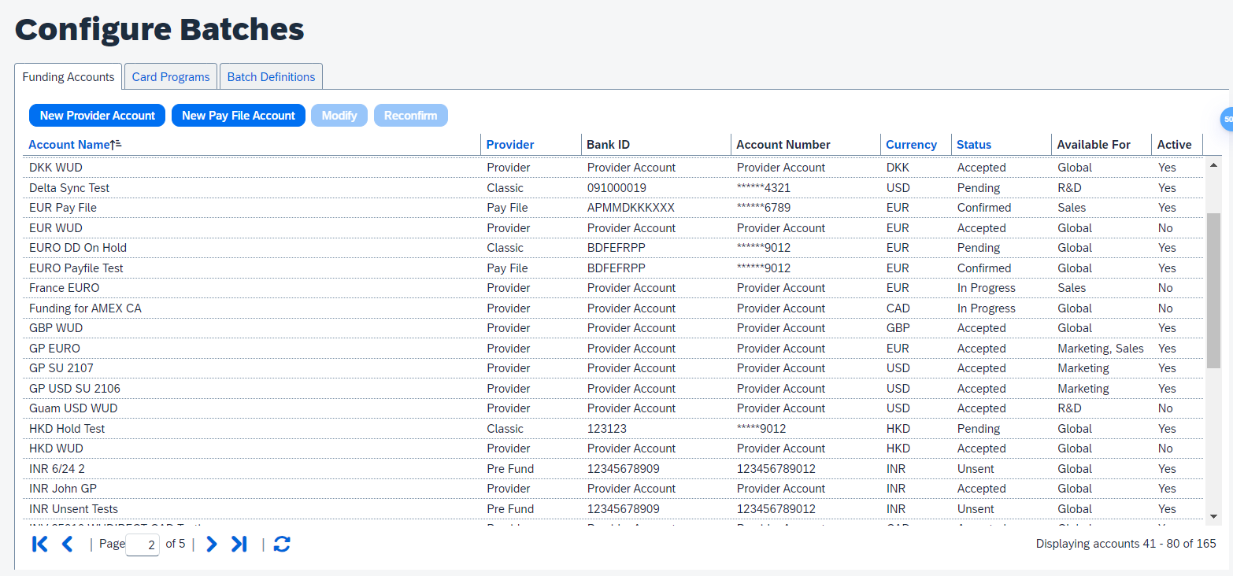
When you add a new card batch in the Batch Defnitions screen, selecting or changing the card program automatically displays a filtered list of funding accounts based on the currency used for the card program.
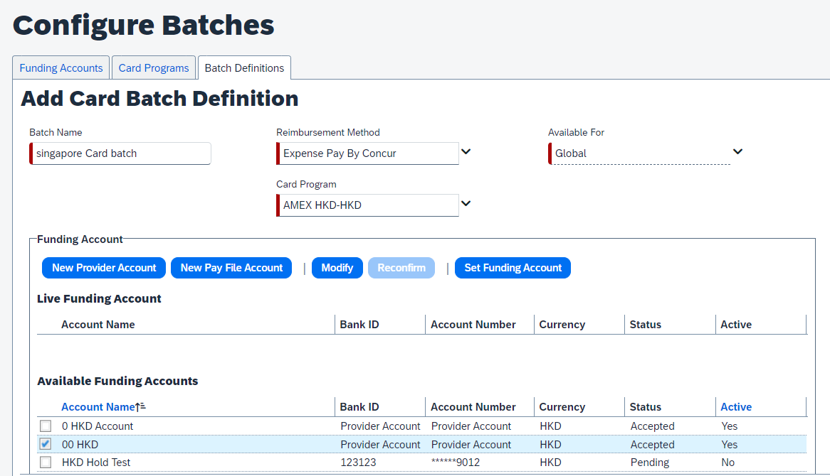
Navigate to the Payment Manager > Monitor Batches > View Funding screen to see the following updates:
- Rearranged the Global Funding tab to be placed first as it contains more relevant information. The other two tabs Direct Debit and Pre Fund is no longer be in use and hence, they are removed from the UI.
- The Global Funding tab is renamed to Provider Funding Amounts.
- The Bank Statements tab is removed as it is no longer relevant.
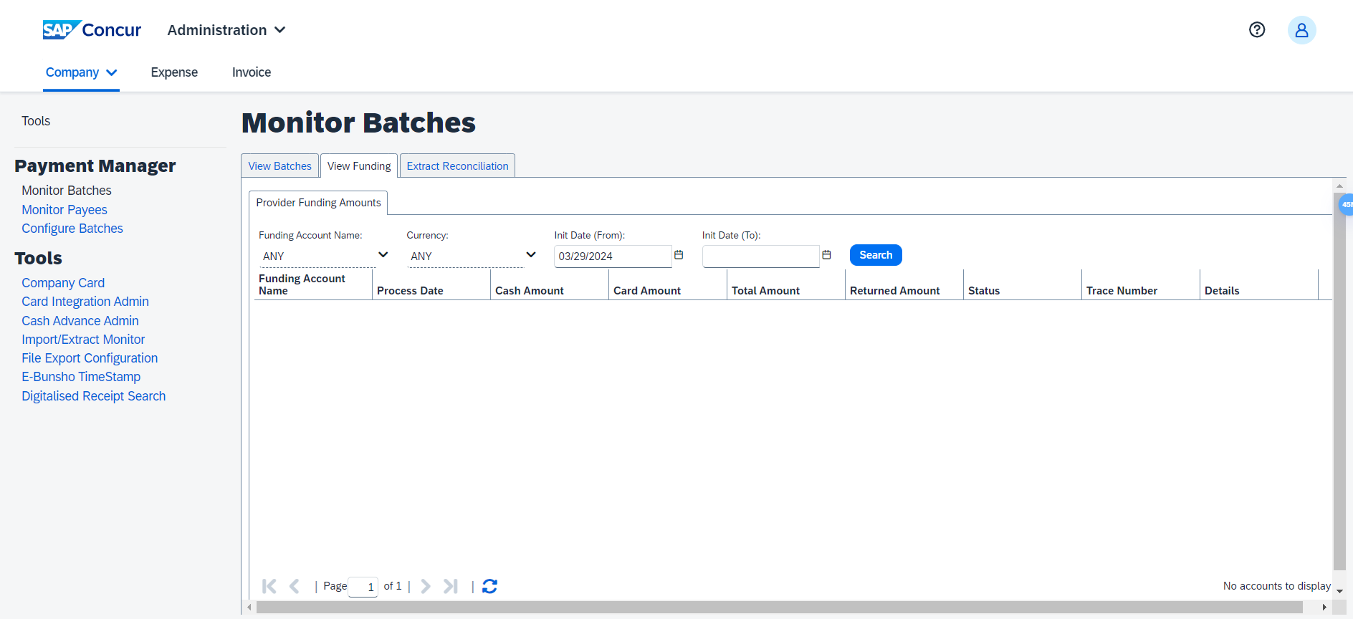

Configuration / Feature Activation
The change occurs automatically; there are no additional configuration steps.

Updates to the Payment Status Timeline

Overview
A new payment status timeline button is added to the Expense Payment Manager, as a part of the Monitor Payees screen, to aid in understanding the status and the history related to a payment.
This update helps provide more meaningful information to the administrator when tracking a payment and help answering employee inquiries about their payments. It also provides faster access to more relevant information in a centralized and simplified display.

Administrator Experience
Navigate to the Payment Manager > Monitor payees > Report Payees screen to access the new View Payment History button. The button is disabled until a payment is selected.
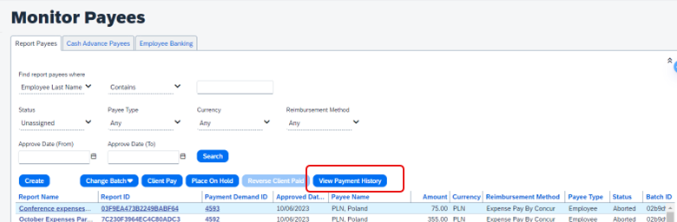
Select a payment and click the View Payment History button to display a timeline view for the payments, including their batches and the various statuses as the payment progressed.
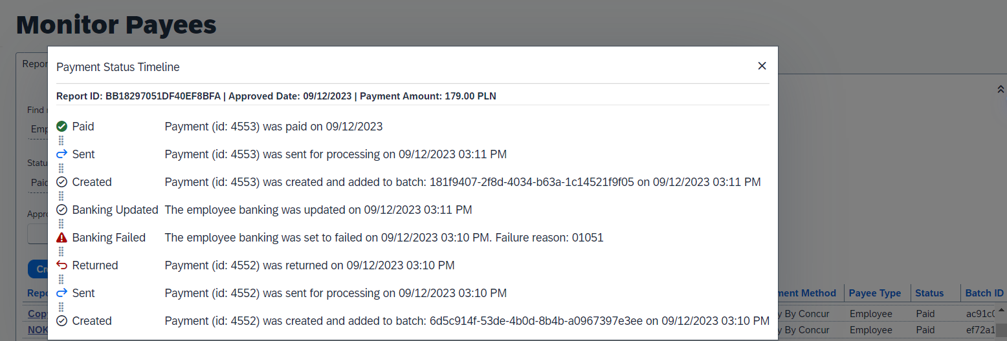

Configuration / Feature Activation
The change occurs automatically; there are no additional configuration steps.

Localization

Removal of Expense Types Descriptions

Overview
As of April 12th, 2024, SAP Concur has deprecated the descriptions for expense types. Currently, there is no possibility to set the descriptions for expense types in the Concur user interface or APIs, but these descriptions do display in the Localization tab in Concur Expense settings.
However, the localized text is not used anywhere within SAP Concur.
This feature prepares the client who uses the localization area for expense types for future feature enhancements.

Administrator Experience
In the Administration > Expense > Expense Admin > Localization tab, administrators can no longer see the contents in the Description and Source Value columns. All default descriptions (and any translated values) are removed.
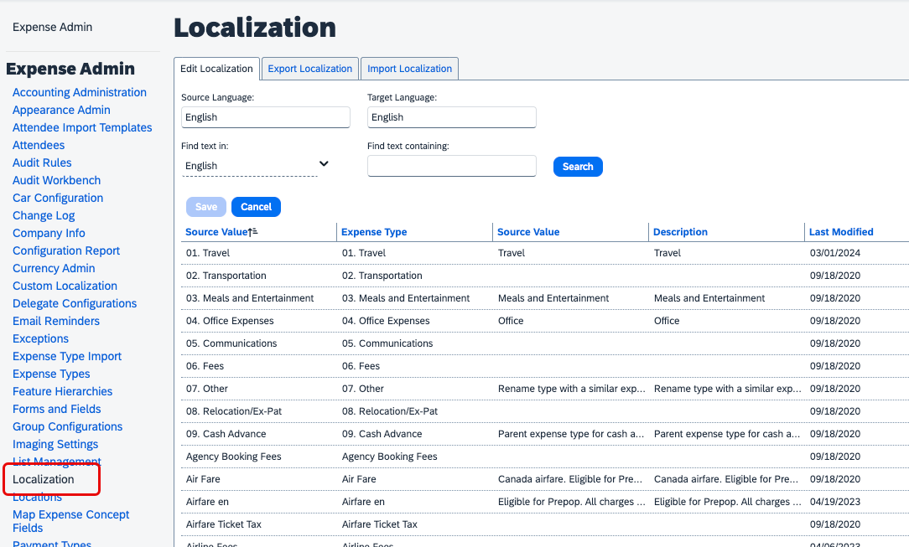
Administrators must save any custom translations or texts that was used in the localization area for expense types.

Configuration / Feature Activation
The change occurs automatically; there are no additional configuration steps.

Mileage Service

Update - Administrator Delegating for a User May Reset Initial Distance Mileage for Personal Car

Overview
In the February release notes it was stated that the administrator for Expense Professional or Standard edition, while delegating for a user, could now reset the initial distance of the user’s personal car. With this release, the Can Administer role in Standard and the Expense Configuration administrator (Restricted) role in Professional may now perform this task for their users.
This feature change lets the client assign the role and complete this task at their site, providing flexibility and is a result of feedback from our client base.

Configuration / Feature Activation
The change will occur automatically; there are no additional configuration steps.
For more information refer to the Concur Expense: Car Configuration Setup
Guide, the Concur Expense: Mileage Service Setup Guide, and the Concur Expense: Mileage Service Setup Guide for Concur Standard Edition.

Miscellaneous

Keyboard Shortcuts for Expense Screens

Overview
SAP Concur has enabled convenient keyboard shortcuts in selective Concur Expense screens such as Expense Home, Report Page, and Expense Entry Page. This update offers users a more convenient way to navigate the expense application faster, ultimately improving productivity, efficiency, and user satisfaction.
This feature will currently be available in English only.

End-User Experience
On selective Expense screens such as Expense Home, Report Page, and Expense Entry Page, press SHIFT + / to view the available shortcuts and to toggle the keyboard shortcuts ON or OFF.
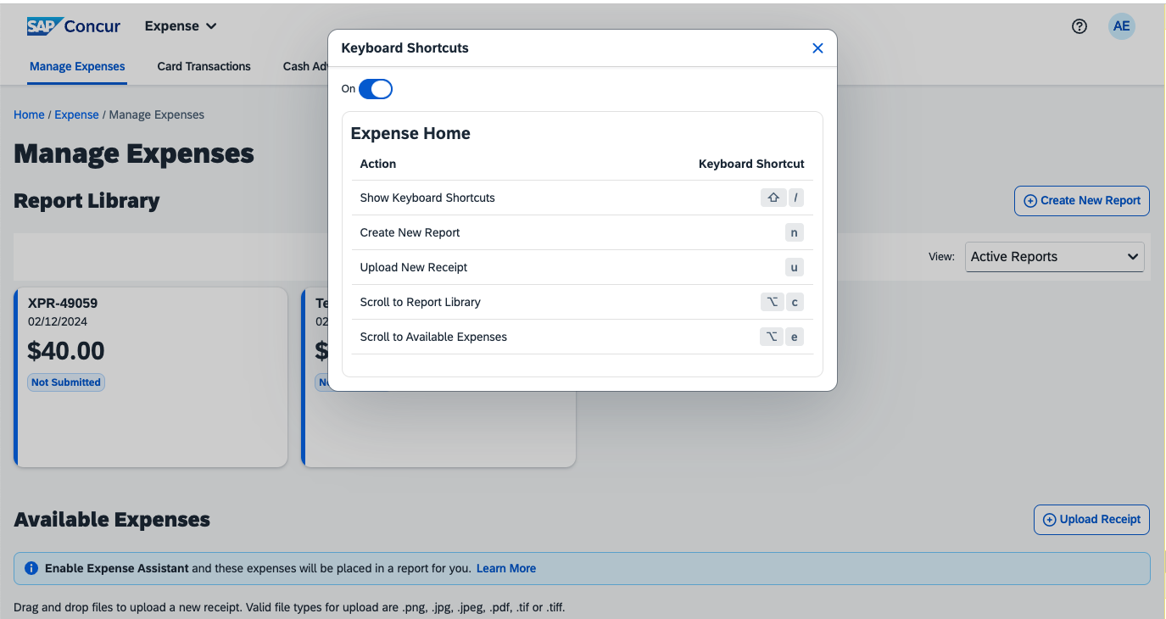
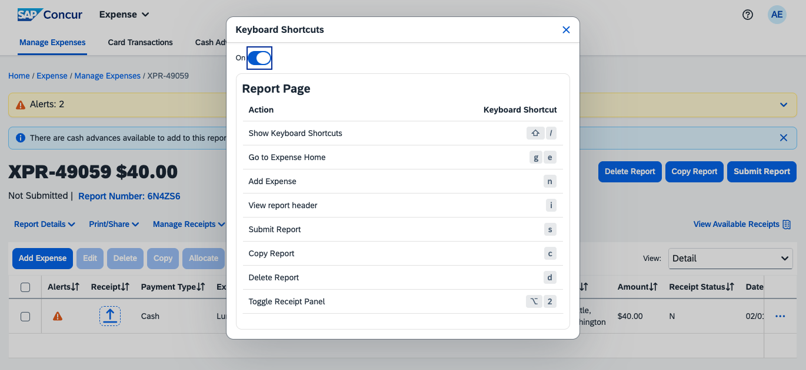
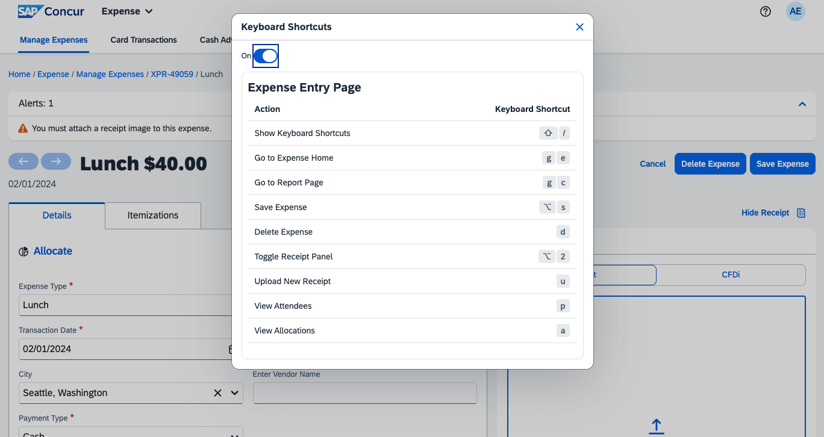

Configuration / Feature Activation
The change occurs automatically; there are no additional configuration steps.

Travel Allowance

New Features: Create a New Rate Bundle from a Statutory Base Rate Bundle and Enhanced Preview Mode

Overview
In March, two new features were released for clients using Travel Allowance. These features will be useful for clients who will be transitioning from the Legacy to the Service version of Travel Allowance.

Create a New Rate Bundle from a Statutory Base Rate Bundle
In March, a new feature for Travel Allowance Service (TAS) supports an option to create a new rate bundle from an existing statutory base rate bundle. This allows a client to change calculation rules while rates remain read-only, assign a user to the bundle, and test it.
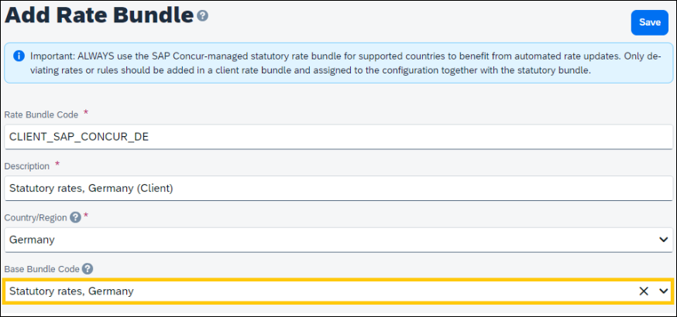
Testing can include changing the default Calculation Rules while still benefiting from automatic rate updates for the new bundle. For example, updating the default for Day of exchange rate to allow the default to be switched to first day of the itinerary, last day of the itinerary, or the start/end date of the expense report header. Or update the default Reimbursement interval to either Calendar Day or 24-hour interval.
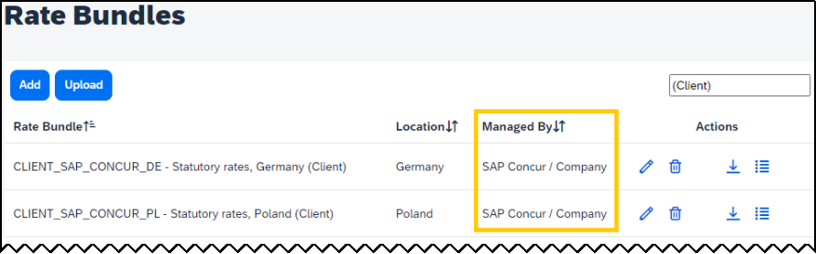
Note that, once created, the new rate bundle will display under Managed By as SAP Concur / Company.

Enhanced Preview Mode for Travel Allowance Service
In October of 2023 the Users for Preview Mode feature was released. This feature allows the Legacy client without access to a Production Sandbox environment to test the Travel Allowance Service (TAS) prior to transition. This is done by selecting the Users for Preview Mode option in Travel Allowance Configuration.
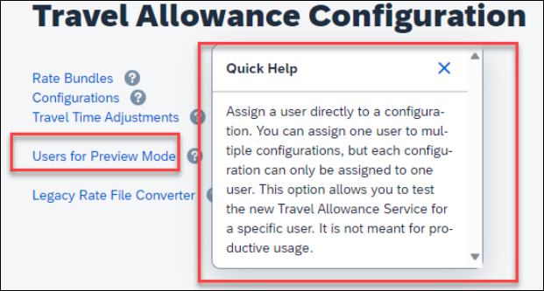
With the March 2024 release, several updates were made available to this feature:
- Preview Mode in Menu: The Users for Preview Mode menu is changed to Preview Mode and updated Quick Help text is included:
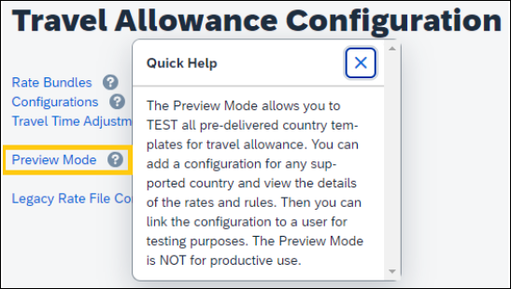
- Add Configuration: The Preview Mode page now displays the Add a Configuration button for the Expense Administrator (Restricted) role:
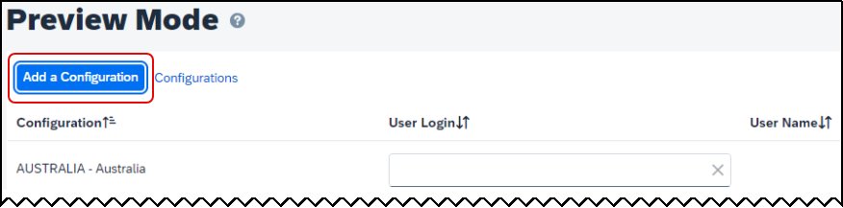
When adding the new configuration, the administrator may update only a restricted set of fields and may select only those rate bundles that are marked under Managed By as SAP Concur / Company.
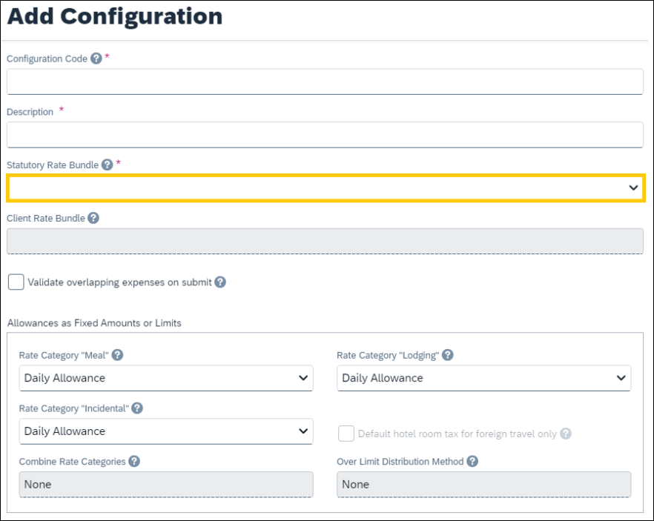

Configuration / Feature Activation
These features are automatically available; however, they can be configured by the Travel Allowance Configuration administrator or SAP Concur personnel as required.

Planned Changes
The items in this section are targeted for future releases. SAP Concur reserves the right to postpone implementation of – or completely remove – any enhancement/change mentioned here.
The planned changes listed in this document are specific to this product. For information about planned site-wide or shared changes that might impact your SAP Concur solutions, refer to the Shared Changes Release Notes.

Company Card

**Planned Changes** Enhancements to the Manage Transactions Screen

Information First Published | Information Last Modified | Feature Target Release Date
March 2024 | -- | Late May, 2024
Any changes since the previous monthly release are highlighted in yellow in this release note.

Overview
In late May, enhancements to the Manage Transactions screen will be available to the Company Card administrator for evaluation. These changes will be visible by default and the administrator may work with the new user interface and then decide to revert to the earlier version or continue with the newer version which will become the default user interface in an upcoming release.
More feature information will be available in an upcoming release note.
This feature improves the company card experience by automatically displaying search results from the previous 30 days with the ability to perform a more complex search that displays hidden, visible, duplicate, and expensed transactions in a column order view familiar to administrators working in a financial statement format.

Administrator Experience
The Company Card administrator will see the simple search format of employee transactions of the previous 30 days. Transactions that are both hidden and visible to employees (including transactions that are already on an expense report) will be returned.
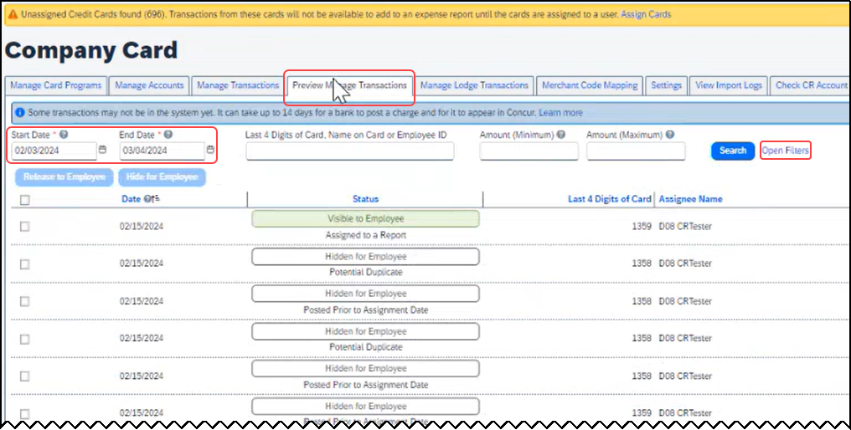
From this simple format, the administrator clicks Open Filters to refine the search:
The Last 4 Digits… search now combines the logic for all the potential typed values:
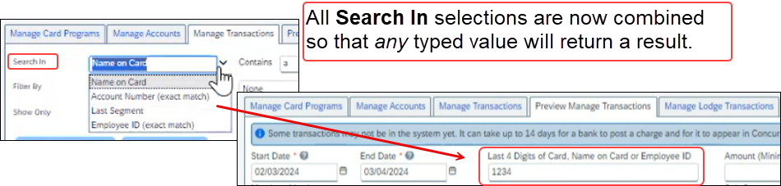
Duplicate transactions are displayed using the Potential Duplicate attribute, and the informational window includes a link to release the transaction to the employee:
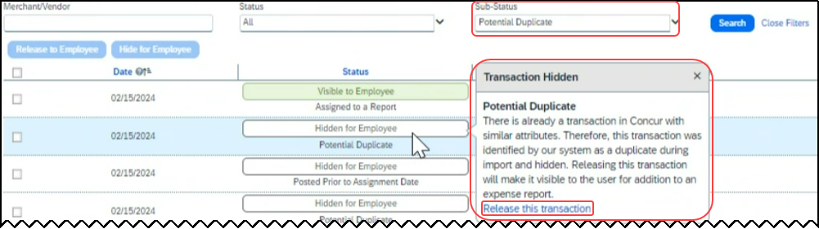
Transactions both already assigned to a report or posted prior to assignment date are clearly marked. For some status types, hovering a cursor opens an informational window describing the condition, action, and links to take action as needed:
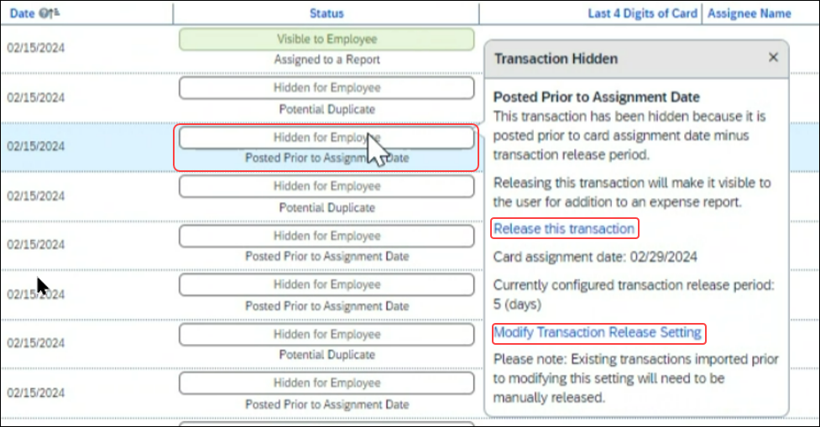

Moving Between the Two Manage Transactions Windows
In the figures above both the Manage Transactions and Preview Manage Transactions tabs are shown for clarity. Only a single tab will be displayed for the benefit of the administrator, who may move from the new user interface to the original interface using the Revert to prior experience link.

Configuration / Feature Activation
The change to the new user interface is visible by default and the administrator may revert to the original interface as needed. Note the new interface will display at any time the administrator moves from the screen and back again in a single session.

Receipts – ExpenseIt for Web

**Planned Changes** Single Combined Option to Select ExpenseIt for Email and Web Now Two Separate Options

Information First Published | Information Last Modified | Feature Target Release Date
April, 2024 | -- | May, 2024
Any changes since the previous monthly release are highlighted in yellow in this release note.

Overview
In May, users of ExpenseIt will have two separate options that let them control how ExpenseIt works for email and on the internet. With this change, an ExpenseIt user may open their expense preferences through their Profile Settings and work with the following options:
- Use ExpenseIt to create expenses from uploaded receipts on the web
- User ExpenseIt to create expenses from receipts mailed to receipts@concur.com

Default Behavior for New and Existing Users
Existing users who disabled the single, combined control will see both new, separate options disabled. New users will always see both options enabled by default.

Configuration / Feature Activation
No end-user action is required: ExpenseIt is automatically enabled the week of January 15, 2024, for all end-users on entities that have purchased ExpenseIt.

Reports

**Planned Changes** Enhancements to the Report Timeline

Information First Published | Information Last Modified | Feature Target Release Date
April 12, 2024 | -- | April 23, 2024
Any changes since the previous monthly release are highlighted in yellow in this release note.

Overview
The user interface for the Report Timeline feature in an expense report will be enhanced and will display updated icons and layout. Some additional details will also display when compared to what is currently displayed.
This feature will provide users with improved usability and will ensure report timeline user interface is easily accessible.

Phases
This feature will be released to specific verticals, vendors, and data centers in April 2024:

Phase | Date of Release
Phase 1: All customer test entities | April 16, 2024
Phase 2: All production entities | April 23, 2024

End-User Experience
Open an expense report and click Report Details > Report Timeline to see the new enhancements in the Report Timeline screen. You will see more information than was previously available, along with the status of the report and names of the approvers.
In the Approval Workflow section, the UI will be improved to display updated icons, approver names along with time and date of approval.
Example:
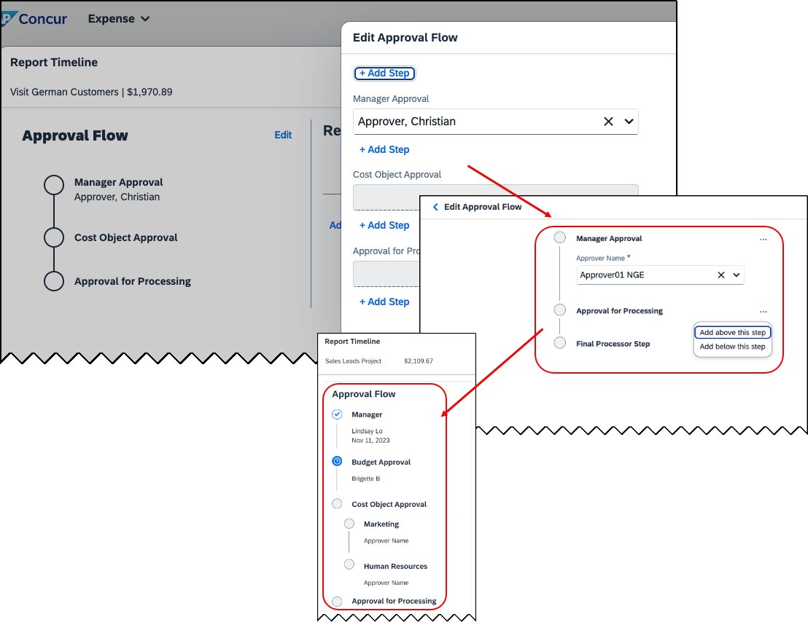

The view in the Report Summary section will also be enhanced to show updated icons and layout. New buttons Sort and Filter will be included in the UI. The comment section will no longer be hidden and will now display to all.
Example: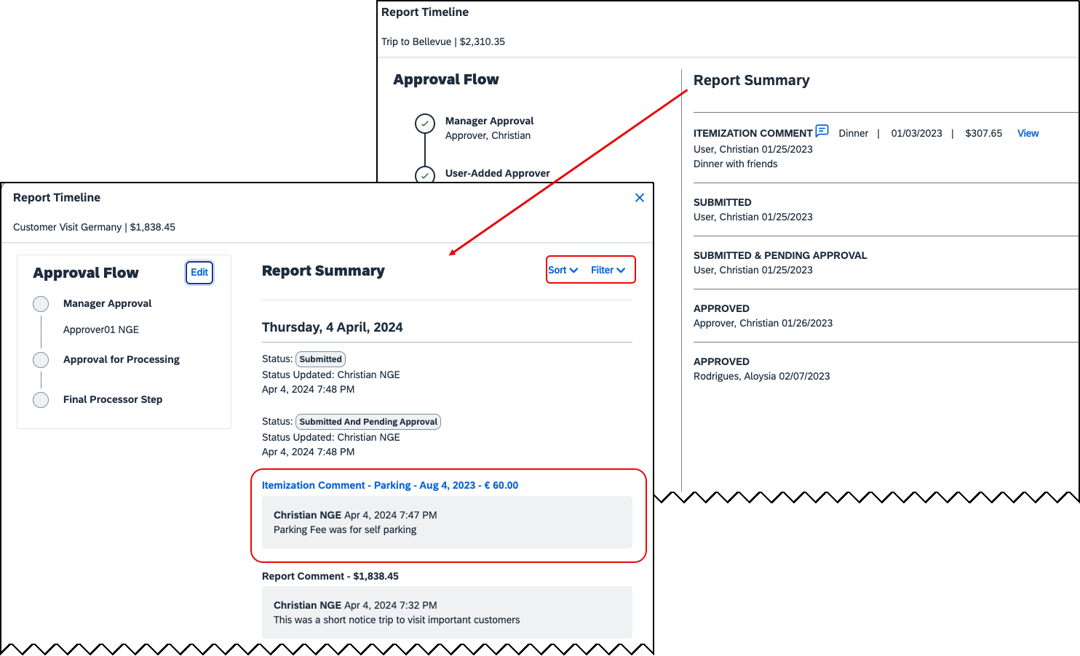

Configuration / Feature Activation
These changes will be automatically available; there are no configuration or activation steps.

**Planned Changes** Preferred Name for Expense Submitter
Information First Published | Information Last Modified | Feature Target Release Date
March 15, 2024 | April 12, 2024 | Q2, 2024
Any changes since the previous monthly release are highlighted in yellow in this release note.

Overview
Targeted for the second quarter of 2024, Concur Expense will support preferred names for users submitting expenses. The users will be able to view the preferred name that has been setup for approvers, company attendees, and other elements that display a name field, if the preferred name has been configured for the user.
Today, in Concur Expense, users can set a preferred name for themselves. In the second quarter of 2024, Concur will display the preferred name for approvers, company attendees, and other names that an expense submitter will see in the system.
For example, if a user with expense approver permissions has specified a preferred name, this preferred name will display to users submitting expenses, when selecting an approver, or when viewing the timeline for an expense report.
Similarly, if another user in the same company has specified a preferred name in Concur Expense, an expense submitter will see the preferred name when searching for an attendee, and when the user has been added as an attendee to an expense.
This update will offer users the flexibility to set up their own preferred names at work, compared to using their given first names and improves user satisfaction.

End-User Experience
The user who is an expense submitter will see the preferred names that is configured for other employees that they interact with in the system, if their locale supports preferred name. This preferred name will appear in places where the users may have seen the given name of the employee previously.

Configuration / Feature Activation
The change occurs automatically; there are no additional configuration steps.

User Interface Changes

**Planned Changes** Update to the Report Status Indicator

Information First Published | Information Last Modified | Feature Target Release Date
April 12, 2024 | -- | April 23, 2024
Any changes since the previous monthly release are highlighted in yellow in this release note.

Overview
Currently, end users can view the updated rectangular indicator that shows the status of an expense report. This indicator, at present, displays in bold colors. Targeted for April 23rd, 2024, this rectangular indicator will be further enhanced to display in more pleasing, mild colors.
With this change, this indicator will be easier on the eyes than the prior version.

End-User Experience
The end-user can now see, in selected screens, a solid color background and white text in the tiles that display the status of the expense report.

Configuration / Feature Activation
These changes are automatically available; there are no configuration or activation steps.

Client Notifications

Accessibility

Accessibility Updates
SAP implements changes to better meet current Web Content Accessibility Guidelines (WCAG). Information about accessibility-related changes made to SAP Concur solutions is published on a quarterly basis. You can review the quarterly updates on the Accessibility Updates page.

Gender Diversity

Gender Diversity Planned Features and Changes
SAP Concur is committed to supporting gender diversity. Over time we plan to implement product changes to help ensure that SAP Concur solutions support gender non-binary users. These changes will include but are not limited to support for preferred names, non-binary gender options in travel preferences, and non-binary titles.
These planned changes reflect SAP's commitment to supporting gender diversity and enable gender non-binary users to enter consistent information when making travel arrangements and entering personal information into SAP Concur solutions.
Timelines and details about these ongoing changes will be provided in the SAP Concur release notes.

In-Product User Assistance

Client Customized Content
If your company creates customized content for SAP Concur solutions through a user assistance tool such as SAP Enable Now or Concur User Assistant by WalkMe, the changes described in these release notes might affect your customized content. SAP Concur recommends reviewing the monthly release notes for all of your SAP Concur solutions as well as the Shared Changes Release Notes to confirm whether any of the planned or released changes might impact your internal, customized content.
If any changes in a release impact your content, work with your internal teams to update your content accordingly.

Subprocessors

SAP Concur Non-Affiliated Subprocessors
The list of non-affiliated subprocessors is available from the SAP Sub-processors / Data Transfer Factsheets page.
To access the SAP Concur Sub-processors List:
- Click the following link to navigate to the SAP Sub-processors / Data Transfer Factsheets page:
SAP Sub-processors / Data Transfer Factsheets
- Sign in to the SAP Support Portal using your Support User ID (S-user) and password.
SAP customers must sign in to the SAP Support Portal using their Support User ID (S-user) and password. For information about S-User IDs, refer to Your New Support User ID (S-user) and to the Learn All About S-User IDs blog post.
- On the SAP Sub-processors / Data Transfer Factsheets page, type "Concur" in the Search field.
- In the Title column, click SAP Concur Sub-processors List.
If you have questions or comments, please reach out to: Privacy-Request@Concur.com

Supported Browsers

Supported Browsers and Changes to Support
For information about supported browsers and planned changes to supported browsers, refer to the Concur Travel & Expense Supported Configurations guide.
When changes to browser support are planned, information about those changes will also appear in the Shared Changes Release Notes.

Additional Release Notes and Other Technical Documentation

Online Help
You can access release notes, setup guides, user guides, admin summaries, supported configurations, and other resources via the in-product Help menu or directly on the SAP Help Portal.
To access the full set of documentation for your product, use the links in the SAP Concur Help menu, or visit the SAP Concur solutions page.
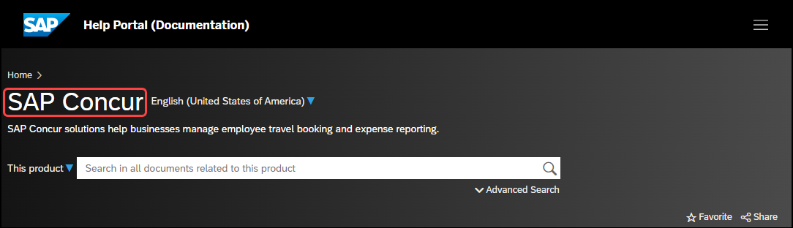

SAP Concur Support Portal – Selected Users
Access release notes, webinars, and other technical documentation on the SAP Concur support portal.
If you have the required permissions, Contact Support is available on the SAP Concur Help menu, and in the SAP Concur page footer.
Click Contact Support to access the SAP Concur support portal, then click Resources.
- Click Release/Tech Info for release notes, technical documents, etc.
- Click Webinars for recorded and live webinars.

Cases

Check Support Case Status
The steps in this procedure provide instructions for checking whether a case is resolved.
To check the status of a submitted case
- Log on to https://concursolutions.com/portal.asp.
- Click Help > Contact Support.
If you do not have the option to contact SAP Concur support under the Help menu, then your company has chosen to support the SAP Concur service internally. Please contact your internal support desk for assistance.
- Click Support > View Cases.
- In the table, view the desired type of cases based on the View list selection. Search results are limited to each company's own cases.

© 2024 SAP SE or an SAP affiliate company. All rights reserved.
No part of this publication may be reproduced or transmitted in any form or for any purpose without the express permission of SAP SE or an SAP affiliate company.
SAP and other SAP products and services mentioned herein as well as their respective logos are trademarks or registered trademarks of SAP SE (or an SAP affiliate company) in Germany and other countries. Please see http://global12.sap.com/corporate-en/legal/copyright/index.epx for additional trademark information and notices.
Some software products marketed by SAP SE and its distributors contain proprietary software components of other software vendors.
National product specifications may vary.
These materials are provided by SAP SE or an SAP affiliate company for informational purposes only, without representation or warranty of any kind, and SAP SE or its affiliated companies shall not be liable for errors or omissions with respect to the materials. The only warranties for SAP SE or SAP affiliate company products and services are those that are set forth in the express warranty statements accompanying such products and services, if any. Nothing herein should be construed as constituting an additional warranty.
In particular, SAP SE or its affiliated companies have no obligation to pursue any course of business outlined in this document or any related presentation, or to develop or release any functionality mentioned therein. This document, or any related presentation, and SAP SE’s or its affiliated companies’ strategy and possible future developments, products, and/or platform directions and functionality are all subject to change and may be changed by SAP SE or its affiliated companies at any time for any reason without notice. The information in this document is not a commitment, promise, or legal obligation to deliver any material, code, or functionality. All forward-looking statements are subject to various risks and uncertainties that could cause actual results to differ materially from expectations. Readers are cautioned not to place undue reliance on these forward-looking statements, which speak only as of their dates, and they should not be relied upon in making purchasing decisions.

