
Concur Invoice:
Purchase Request and Purchase Order
User Guide

Last Revised: May 22, 2023
Applies to these SAP Concur solutions:
 Concur Expense
 Professional/Premium edition
 Standard edition
 Concur Travel
 Professional/Premium edition
 Standard edition
 Concur Invoice
 Professional/Premium edition
 Standard edition
 Concur Request
 Professional/Premium edition
 Standard edition

Table of Contents
Section 1: Permissions 1
Section 2: Overview 1
Section 3: Access the Feature 1
Section 4: Purchase Request User Experience 2
Create the Purchase Request 3
Add Purchase Request Items 3
Select a Vendor 3
Complete the Purchase Request 6
Manage Images 9
Support Images and the PO Configuration Supporting Documents Feature 12
Search for a Ship-to or Bill-to Address 13
Change Ship-To or Bill-To Address 13
Create and Submit a PO Change Order 15
Edit an Existing Purchase Request 18
Delete an Existing Purchase Request 20
Cancel a Change Request 21
Copy an Existing Purchase Request 21
Change Purchase Request Policy 22
Auto-Assign PO-Based Invoices to Original Purchase Request Owner 23
Reassign PO-Based Invoices Created Within Invoice 23
Reassign PO-Based Invoices Created Outside of Invoice 25
Submit the Purchase Request 25
Notify Purchase Request Users When Purchase Order Transmitted 25
Purchase Request Owners Transmitting Their Purchase Orders 26
Purchase Request Owners Editing Their Purchase Orders 28
Search for a Purchase Request 28
Change View Search Option 29
Add a Comment to an Item 29
View Comments 30
View the Audit Trail 32
View Purchase Orders 33
Create Invoices From Purchase Orders 33
Recall a Purchase Request 34
Select for Different Vendors and Project- and Event-Based Requests 35
Distribute (Allocate) a Purchase Request 36
Import Distributions 39
Create and Manage Allocation Favorites 41
Act As a Proxy for a Purchase Request User 44
How It Works 44
Purchase Request Proxy Role Behavior is Limited to Purchase Request 44
Stop Acting as Proxy 45
Use Employee Import to Assign the Purchase Request Proxy Role 45
Configuration 45
View the Approval Flow 45
Email Notifications of Status Change and Required Approvals 47
Manage Receipts and Receipt Images 48
Section 5: Purchase Request Approver Experience 48
Search for a Purchase Request 49
Change View Search Option 49
Send Back a Purchase Request 49
Approve and Forward a Purchase Request 51
Approve a Change Request 51
Upload and View Images 53
View Comments 55
View the Audit Trail 57
View the Approval Flow 57
Add a Comment to an Item 59
Edit an Item of an Unapproved Purchase Request 60
View Purchase Order Contact and Email Address 60
Section 6: Purchase Request Processor Experience 61
Search for a Purchase Request 62
Change View Search Option 63
View Associated Images to a Purchase Request 63
Purchase Order Contact and Email Address 64
Clear Exceptions for a Purchase Request 64
Approve a Purchase Request 65
Approve and Forward a Purchase Request 66
Approve a Change Request 67
Upload, View, and Delete Images 68
View Comments 71
Review Audit Trail 72
View Approval Flow 73
Change Ship-To Address 75
Add a Comment to an Item 76
Delete an Item from a Purchase Request 78
Distribute (Allocate) a Purchase Request 78
Import Distributions 81
Create and Manage Allocation Favorites 83
Edit an Item of an Unprocessed Purchase Request 85
Delete an Item of an Unprocessed Purchase Request 86
Section 7: Purchase Order Processor Experience 86
Review or Change a Vendor 87
Change Ship-To or Bill-To Address 88
Edit Purchase Order Details 89
Upload, View, and Delete Images 90
Send Back a Purchase Order 93
Create Invoices From Transmitted Purchase Orders 95
Void a Purchase Order 96
Close a Purchase Order 97
Reopen a Closed Purchase Order 99
View Associated Images to the Purchase Order 100
Search for a Purchase Order 100
Change View Search Option 101
View Original Payment or Purchase Request Associated With a PO 101
Approval Flow Available to View Within Purchase Order 102
Review the Audit Trail 103
Filter the Approver and Processor Views 105
Additional Search Options 106
Preview a Purchase Order 106
Tip: Combined Processor Roles for a Single Back-Office Processor 108
Preview a PO Change Order 109
View PO Amount That Has Been Invoiced 110
Transmit Purchase Order to the Vendor 111
Automatically Transmit Purchase Orders 111
Transmit a Change Order 112
Manage Receipts and Receipt Images 113
Section 8: Create and Manage Queries 113
Understand Conditional Expressions 114
The Query Builder and the Condition Editor 116
Determine How to Create a Query 125
Access the Query Builder 126
Create New Queries in PR and PO Processor 126
Edit Queries in PR and PO Processor 128
Delete Queries in PR and PO Processor 129
Export Query Results in PR and PO Processor 129
Section 9: Configure Column and Fields Set View 130
Add, Delete, and Move Columns 130
Rearrange the Columns 131

Revision History
Date | Notes/Comments/Changes
May 22, 2023 | Updated to reflect changes to the Profile menu (Act As).
October 31, 2022 | Minor edits; cover date not updated.
January 21, 2022 | Updated the copyright year; no other changes; cover date not updated
December 2, 2021 | Updated screenshots and text on pages 102 and 103 to reflect new static suffix for the From line in PO preview.
March 4, 2021 | Updated the copyright year; no other changes; cover date not updated
October 21, 2020 | Added information about users with the Purchase Request User and Purchase Request Processors roles being able to delete images.
June 12, 2020 | Minor edit; no content change.
June 11, 2020 | Added information about reopening a closed purchase order.
May 21, 2020 | Added note that states that users who do not have access to the Distribution functionality will not see it.
April 20, 2020 | Renamed the Authorization Request check box to Request on the guide’s title page; cover date not updated
January 7, 2020 | Updated the copyright; no other changes; cover date not updated
October 8, 2019 | Minor edit; no content changes.
September 25, 2019 | Minor spelling correction; no content changes.
September 24, 2019 | Updated Select Invoice Owner link and image.
August 10, 2019 | Minor edits; no content changes.
May 17, 2019 | Updated the Create the PR and View Comments sections for May release new features (comments icon and View Details link.)
April 13, 2019 | Updated images as part of the new user experience for Concur Invoice.
March 14, 2019 | Renamed "SAP Concur Customer support" to "SAP Concur Support".
February 1, 2019 | Updated the copyright; no other changes; cover date not updated
November 27, 2018 | Renamed Concur to SAP Concur where applicable. Performed minor edits; updated some images with old Concur logo; renamed payment request to invoice; no other content changes.
April 14, 2018 | Updated the Edit an Existing Purchase Request section to reflect the addition of bulk editing the Expense Type list and Custom field(s).
April 11, 2018 | Changed the check boxes on the front cover; no other changes; cover date not updated
March 17, 2018 | Added information about bill-to address on PO Change Order editable when deleted on original purchase order.
March 17, 2018 | Added information about ship-to address on PO Change Order editable when deleted on original purchase order.
January 25, 2018 | Updated the copyright; no other changes; cover date not updated
October 14, 2017 | Added information about invoice and purchase request numbers being hyperlinked.
September 16, 2017 | Updated some images to show the now available hyperlinked purchase requests and purchase orders in some windows for purchase request users, purchase request processors, and purchase order processors. No content changes.
July 29, 2017 | Added information about transmitted PO PDF emails to vendors displaying all recipients.
July 8, 2017 | Added the following information:  - Change View menu option for purchase request and purchase order processors now available  - Purchase Request Creators can create invoice from their purchase orders.
June 3, 2017 | Added the following information:  - Search options for purchase request processors  - PO contact name and email address available in Vendor list and field for purchase request creators, purchase request approvers, and purchase request processors
April 22, 2017 | Added the following information:  - PO Change Order feature  - Users can change bill-to address on purchase requests  - Users cannot edit or delete a receipt that is associated to an invoice  In addition, performed restructuring of content, including adding more procedures.
March 18, 2017 | Added information about purchase request user being able to view the purchase orders resulting from their purchase requests.
December 13, 2016 | Changed copyright and cover; no other content changes.
December 5, 2016 | Updated the Permissions section and guide content to new corporate style; no content changes.
November 4, 2016 | Added information about the Concur Receiving feature.
September 9, 2016 | Added information about the following:  - Purchase request vendor search enhancements  - Ability to change purchase request policy
August 12, 2016 | Added information about warning message appearing for processor in Preview Purchase Order window and updated purchase order images.
July 8, 2016 | Added information about searching for a ship-to address.
March 18, 2016 | Updated with the following information:  - PO Processors being able to upload images to purchase order  - PO Processors being able to view PO amount that has been invoiced
February 19, 2016 | Added information about exporting query results.
January 15, 2016 | Added information about creating and managing queries for PR and PO Processors.
December 11, 2015 | Added information about purchase request owners being able to edit their own purchase orders.
September 18, 2015 | Added information about email notification to include transaction-specific URL.
 | Older revision history has been removed.

Purchase Request and Purchase Order
NOTE: Multiple SAP Concur product versions and UI themes are available, so this content might contain images or procedures that do not precisely match your implementation. For example, when SAP Fiori UI themes are implemented, home page navigation is consolidated under the SAP Concur Home menu.

Permissions
A company administrator may or may not have the correct permissions to use this feature. The administrator may have limited permissions, for example, they can affect only certain groups and/or use only certain options (view but not create or edit).
If a company administrator needs to use this feature and does not have the proper permissions, they should contact the company's SAP Concur administrator.
In addition, the administrator should be aware that some of the tasks described in this guide can be completed only by SAP Concur staff. In this case, the client must initiate a service request with SAP Concur support.

Overview
The Purchase Requests and Purchase Orders (PR and PO) feature allows clients to achieve internal spend authorization by using purchase requests. These requests are then turned into purchase orders, which are documents authorizing a supplier to provide goods or services, at specified prices and quantities, in return for payment. When coupled with existing Invoice, PO Matching and Pay functionality, these features provide an end-to-end spend authorization to pay lifecycle.
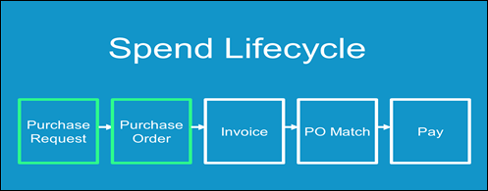

Access the Feature
To access the Purchase Request (PR) feature, first ensure that the feature is enabled.
- For more information, refer to the Concur Invoice: Purchase Request and Purchase Order Setup Guide.
To access the feature, click Requests.
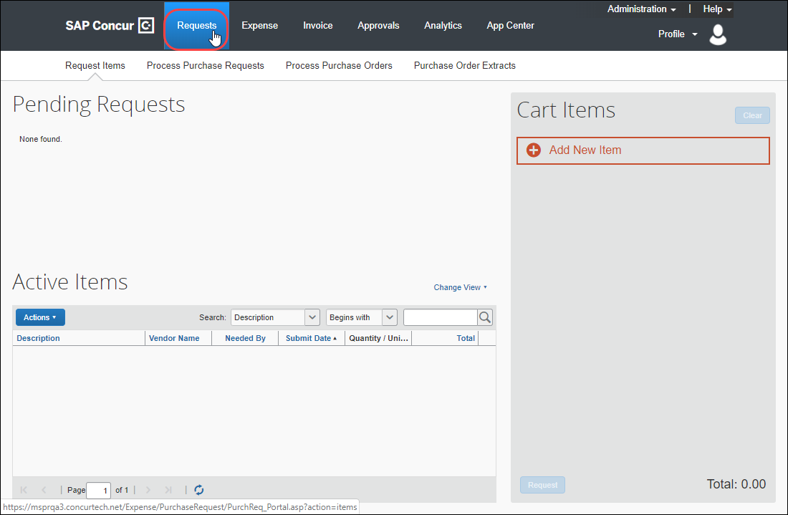
Users who work with purchase requests and purchase orders have a unique view designed to allow rapid entry and review. Additional options allow each user, depending on role, to submit, approve, and transmit or, as required, return a request to the requestor or even terminate the PO past its transmittal phase, after it is in the hands of the vendor.

Purchase Request User Experience
The user with the Purchase Request User role can create purchase requests (PR) on the Requests > Purchase Requests > Pending Requests page.
The user creates a purchase request by adding one or more items to the request, filling in the required purchase details, and then submitting the request for processing.
When creating a purchase request, the Purchase Request user can also request a new vendor be added to the system.

Create the Purchase Request

Add Purchase Request Items
To create a purchase request, the user adds PR items and then generates a purchase request that contains those items.
On the Pending Requests page, the user can create one or more PR items by clicking Add New Item, specifying the type of item (Goods or Services), selecting a vendor, and then filling in the remaining required fields.

Select a Vendor
If the user clicks in the Vendor field, a list of the five most recently used vendors appears.
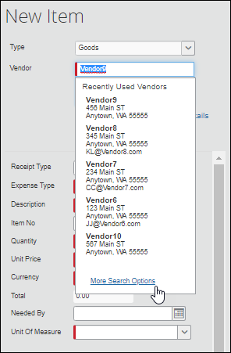
The user can choose a vendor from the recently used list, search for a vendor by typing the first few letters of the vendor's name in the Vendor field, or search for a vendor by clicking the More Search Options link and using the advanced search.
The user can also request a new vendor by clicking Request New Vendor.
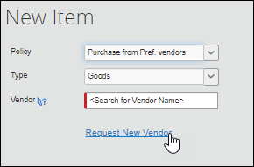
The Request New Vendor page appears.
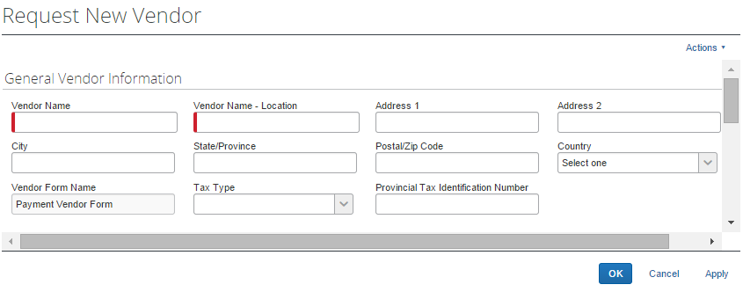
After the vendor information is entered and the user clicks OK, the user is returned to the New Item page.
The name of the requested vendor appears in the Vendor field and the vendor information is added to the system in Unapproved status. The vendor remains unapproved until the Vendor Manager reviews and validates the vendor.
For more information, refer to the Concur Invoice: Vendor Manager User Guide.
Until the vendor is approved or the request is submitted, the user will see an Edit link to the right of the Request New Vendor link. Clicking Edit opens the vendor information page so that the information can be reviewed and updated.
If the user selected an approved vendor, they will see a View Details link to the right of the Request New Vendor link.
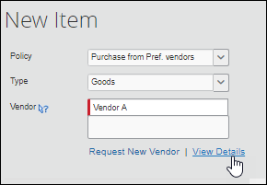
Clicking the View Details link opens the Vendor Information page in read-only mode.
Depending on the system configuration and what information about the selected vendor has been added to the system, the vendor address, contact name, or contact email address might appear below the Vendor field.
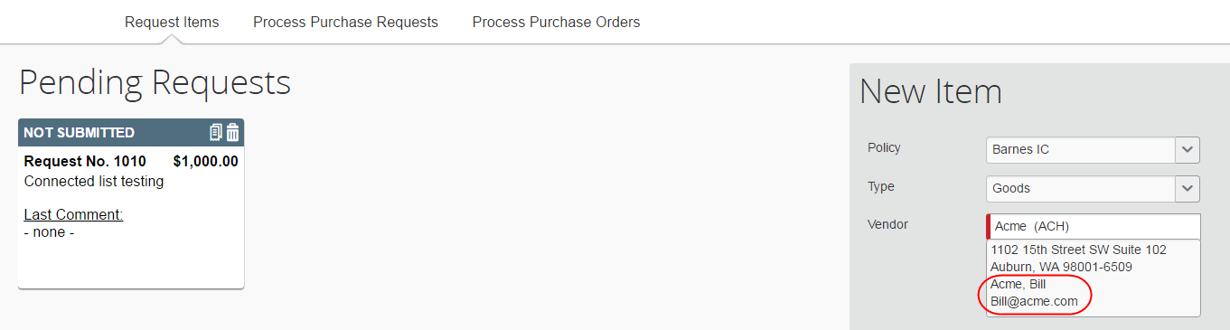
After selecting or requesting a vendor, the user can fill out the remaining required fields (denoted by a red bar) to complete the purchase request item and then click Save.
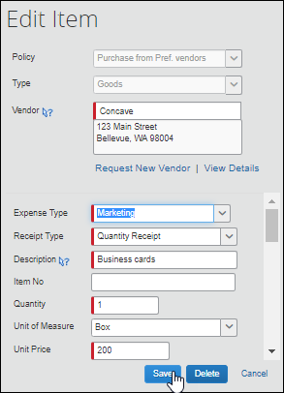

Complete the Purchase Request
Clicking Save returns the user to the cart. Saved items are listed in the cart. The user can continue to add PR items until all of the necessary PR items have been added to the purchase request.
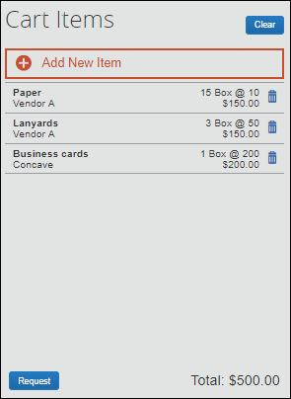
After all the request items have been added, the request is assembled by clicking Request. Clicking Request opens the Purchase Details page where the user can complete the request by entering the required header information in the Purchase Details section.
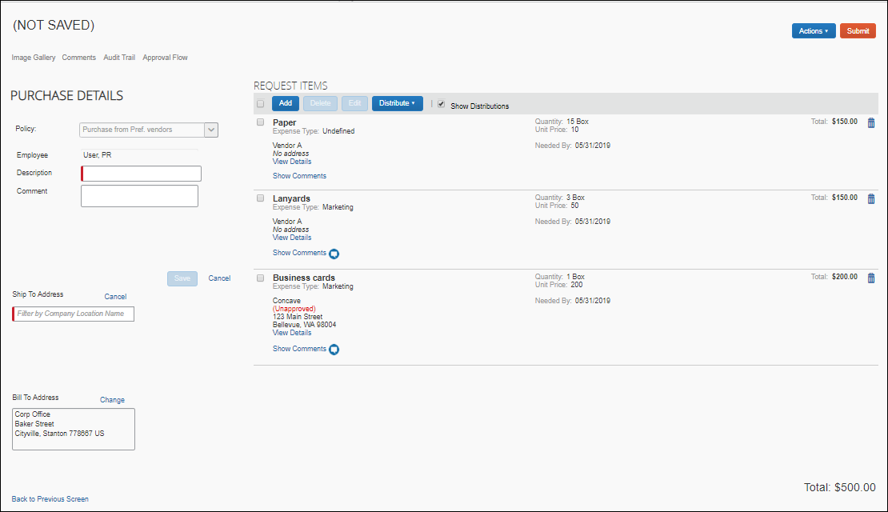
When the user clicks the Ship To Address or Bill To Address field, a list of the available addresses (previously configured by the Invoice Configuration Administrator) appears and the user must select an address from the list.
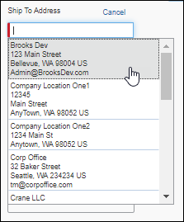
After selected a Ship To Address, the user can choose to make the selected address the default Ship To address for their purchase requests.
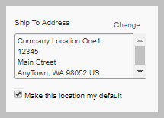
After setting the default Ship To Address, the Ship To Address field will be automatically populated with the selected address when new purchase requests are created. The default address can be changed as needed.
When all the required fields have been filled out, the user clicks Save. Once saved, the request can be submitted by clicking Submit, or the user can return to the Pending Requsts page by clicking Back to Previous Screen.
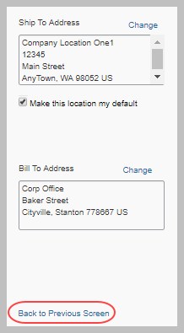
Purchase requests that have been saved but not yet submitted are listed at the top of the Pending Requests page. Purchase request that have been submitted and are in process are listed in the Active Items section.
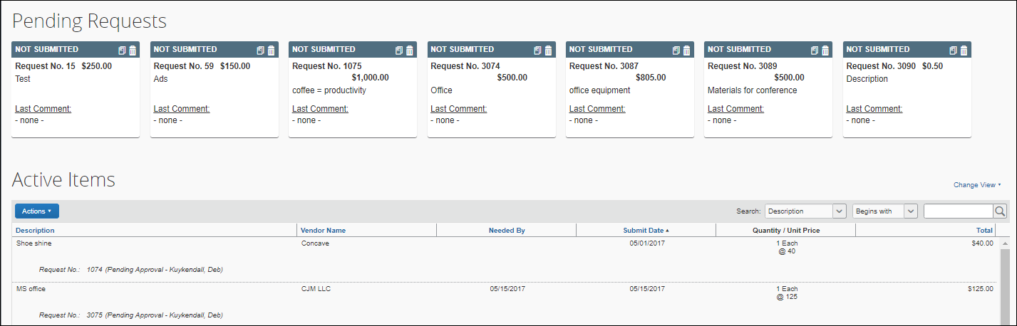

Manage Images
The user can upload, view, and delete images. In addition, the user can attach supporting documents to a purchase order that transmits to a vendor by selecting (enabling) the Include in PO Transmission check box in the Upload Image window. Further, the user can choose documents that are already available for a purchase request and attach these documents for the vendor.
To upload an image
- Click Actions > Upload Image.
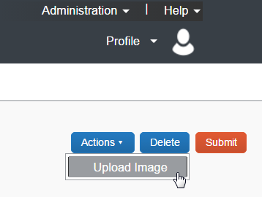
The Upload Image window appears.
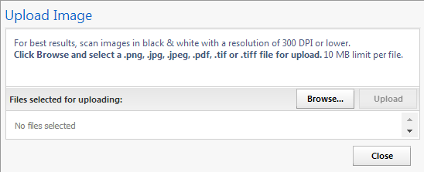
- Click Browse and select the desired image by double-clicking it, or by selecting it and clicking Open.
- (Optional) Select (enable) the Include in PO Transmission check box.
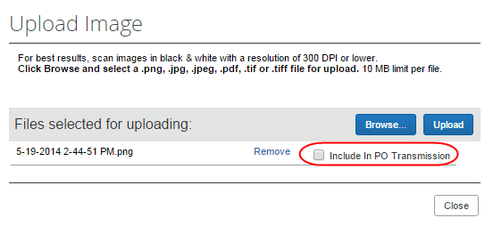
- Click Upload.
- Click Close.
To view an image:
- On the Request page, click Image Gallery.
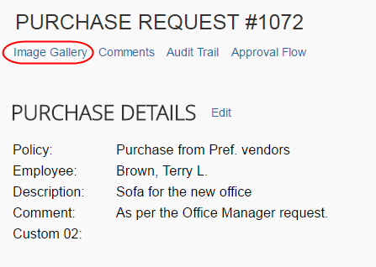
The Purchase Request Images window appears. If there are more than one image or supporting document, you can toggle between them by using the Next and Previous buttons.
You can also include supporting documents in the PO transmission from the Purchase Request Images window by selecting (enabling) the Include in PO Transmission check box.
The approver and processor can view images and include supporting documents in the PO transmission. The processor can also delete images, whereas approver cannot.
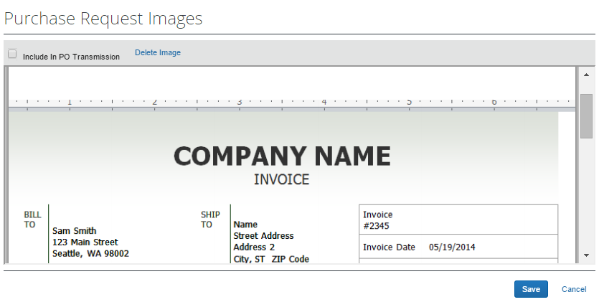
- Click Save or Cancel when you are done.
To delete an image:
- On the Request page, click Image Gallery.
- In the Purchase Request Images window, click Delete Image.
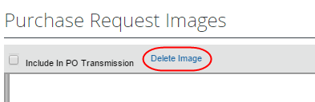
The Please Confirm window appears.
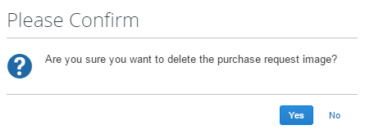
- Click Yes. Once you have deleted an image, the next image, if there is one, appears.

Support Images and the PO Configuration Supporting Documents Feature
The PO configuration associated with a Group may also include supporting documents. These documents apply to all PO transmissions performed by the PO Processor for that Group and are included alongside any documents added by the user.

Search for a Ship-to or Bill-to Address
To search for a ship-to or bill-to address, start entering the company name in the Ship To Address or Bill To Address field. The list that appears shows the company name and the full address details. In addition, the list shows the default address.
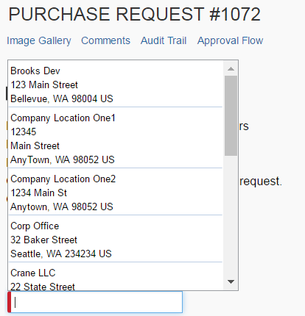

Change Ship-To or Bill-To Address
The purchase request user can change the ship-to or bill-to address on purchase requests, so that they can send the vendor the correct address to which to ship or bill the request. Users can switch to any ship-to or bill-to address available for their company.
The default ship-to or bill-to address that is used on policy level should be used for the purchase request. If the user changes the policy on the purchase request, the system does not change the ship-to or bill-to address on the purchase request since the user might have changed this previously from the former policy default.
To change the ship-to or bill-to address:
- Double-click the desired purchase request. The Purchase Request window appears.
- In the Ship To or Bill To section, click Change.
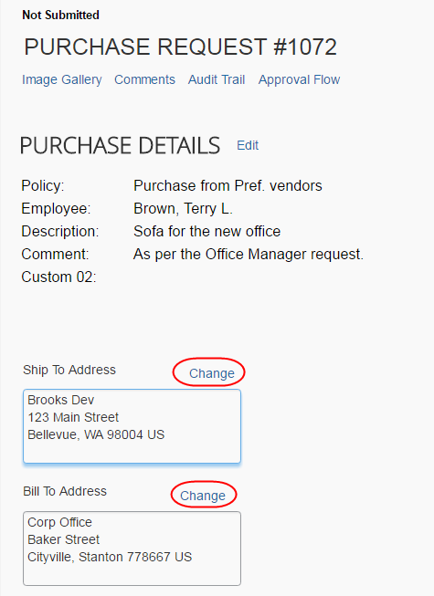
- In the Ship To or Bill To field, click the field to select a different ship-to or bill-to address. (Example of Bill To field below.)
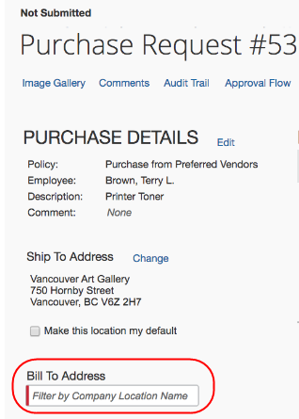
- Click Save.

Create and Submit a PO Change Order
Provided SAP Concur or the client admin has activated the PO Change Order feature, the purchase request user will be able to start creating PO change orders from their transmitted purchase orders. The purchase request user first locates the purchase order from which they would like to create a change order by clicking Requests > Purchase Requests > My Purchase Orders.
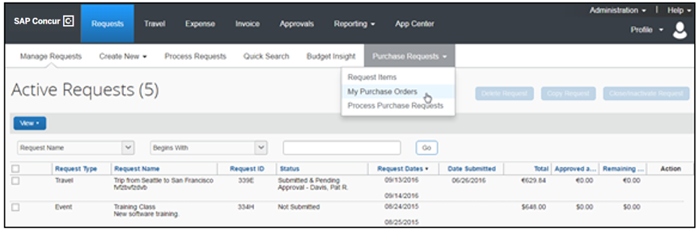
From the All Orders page, the purchase request user can view their purchase orders in read-only mode but will be able to select a transmitted purchase order, and then clicks Actions > Create Change Order.
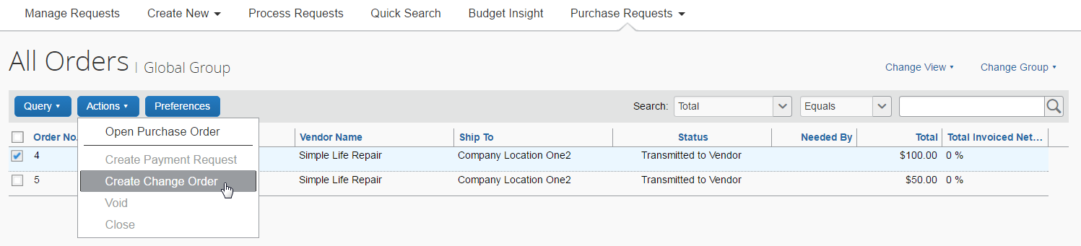
The purchase order will now return to the original purchase request, and an icon appears on the now unsubmitted purchase request. As a matter of fact, most users who work with a specific purchase request or purchase order that is in a PO Change Order mode will see this icon next to the purchase request/purchase order.
Once the purchase order is in a PO Change Order mode, additional changes cannot be requested for that purchase order until it has been approved.
The purchase request user can now add new line items to the purchase request by opening the purchase request and clicking Add.
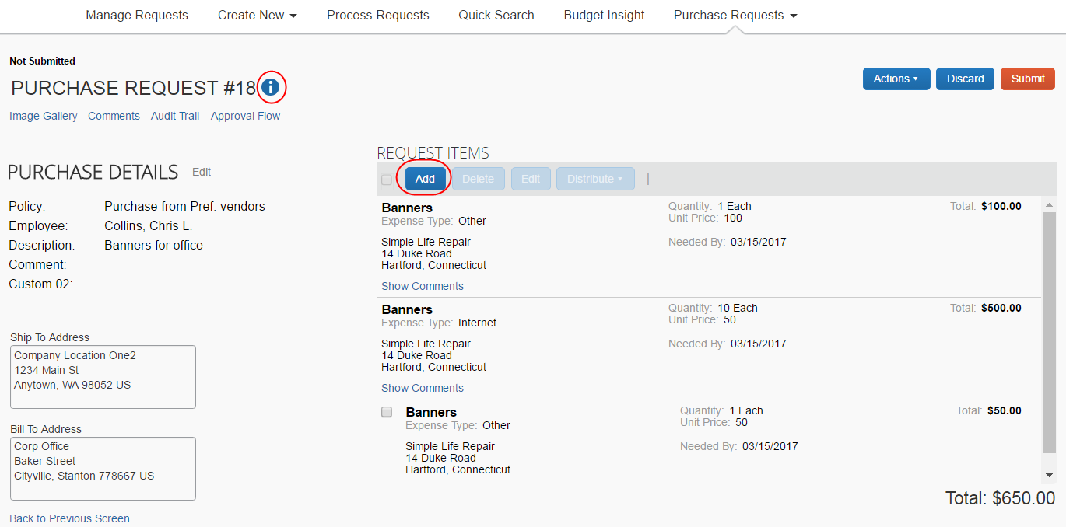
Apart from adding line items, the purchase request user can edit, delete, or distribute line(s) they they have just added. In addition, they can add or update the ship-to and bill-to addresses on the PO Change Order if the addresses were deleted on the original purchase order. All other fields will be read-only, such as vendor details. When the purchase request user has added the desired line items, they need to click Save.
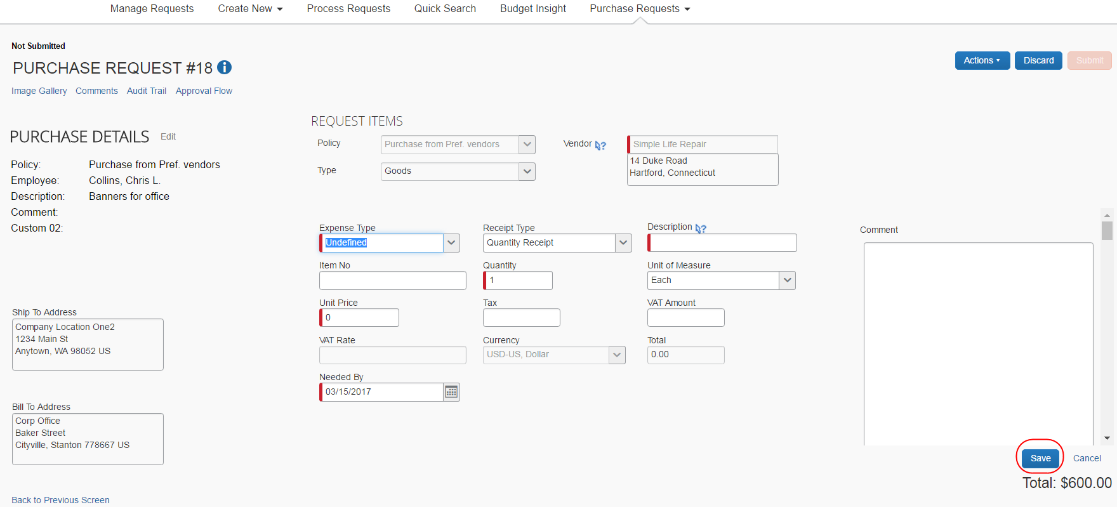
After saving the purchase request, the purchase request user is taken back to the purchase request details page from which they can click Submit to send the purchase request for approval. The purchase request will go through the same approval workflow as previously.
If the purchase request is part of a limit approval workflow, the approval workflow will be based on the new total purchase order amount.
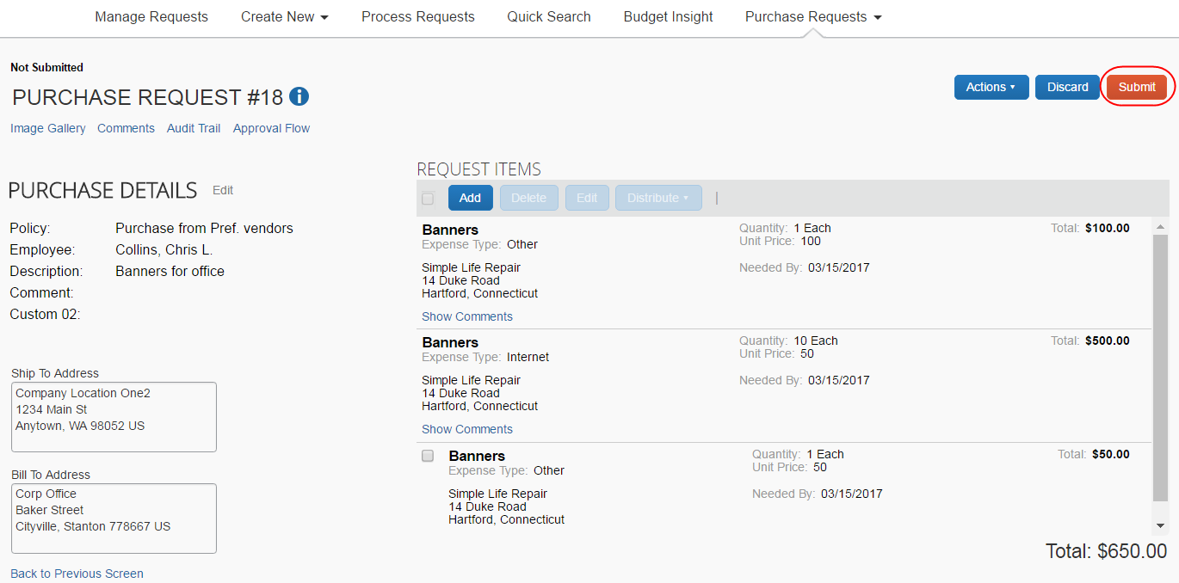

Edit an Existing Purchase Request
To edit a single purchase request, for example, to add line items, double-click the purchase request and use the instructions in the Create a Purchase Request section as a guide.
You can also simultaneously update the Expense Type list and Custom field(s) for multiple line items in a purchase request.
Purchase request users will only see custom fields in the Edit Multiple Fields window if the admin has added custom fields to the relevant form in the Forms and Fields tool.
To simultaneously update the Expense Type List and Custom field(s) for a line item:
- Double-click the desired purchase request to open it for editing.
- Select the line items you want to update and then click Edit.
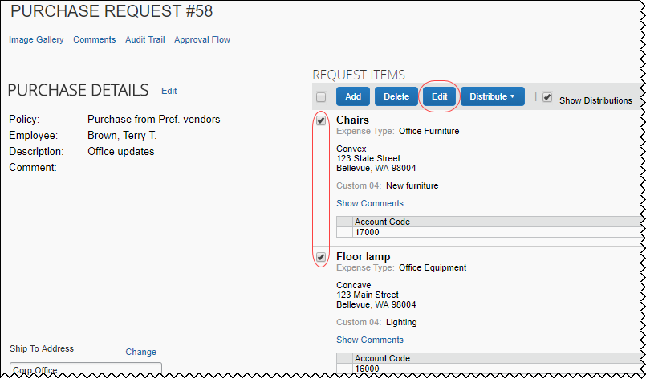
The Edit Multiple Fields window appears.
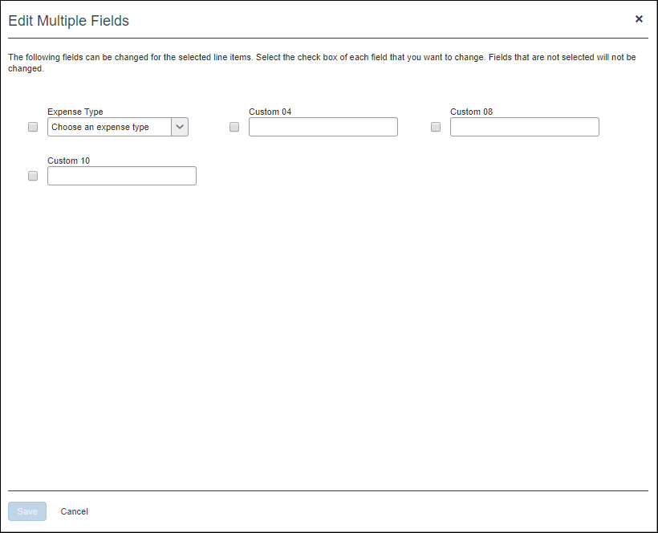
- Select the fields you want to edit and then update the fields.
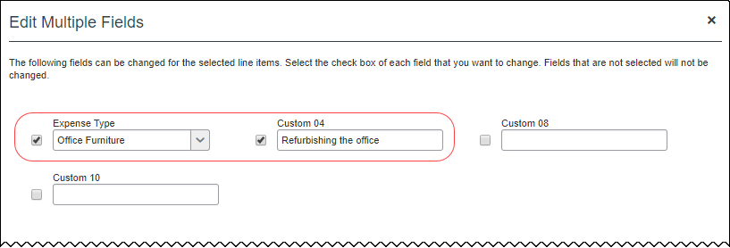
- Click Save.
In the preceding example, the Expense Type and Custom 04 fields were updated. After clicking Save, the fields in the line items that were selected in step 2 reflect the changes made in the Edit Multiple Fields window in step 3.
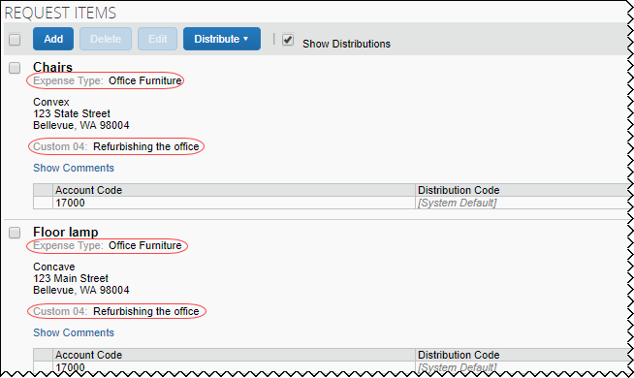

Delete an Existing Purchase Request
The user can delete a purchase request by clicking the Trash icon for the unsubmitted request on the Pending Requests page, or, by clicking Delete if the user has opened the request.
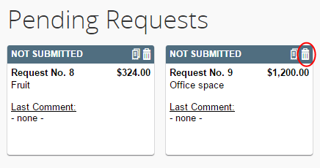

Cancel a Change Request
If the purchase request user wants to cancel any current unsubmitted change requests they are working on, for example, if a manager does not approve a change and sends the request back to the purchase request user, they can do so by clicking Discard.
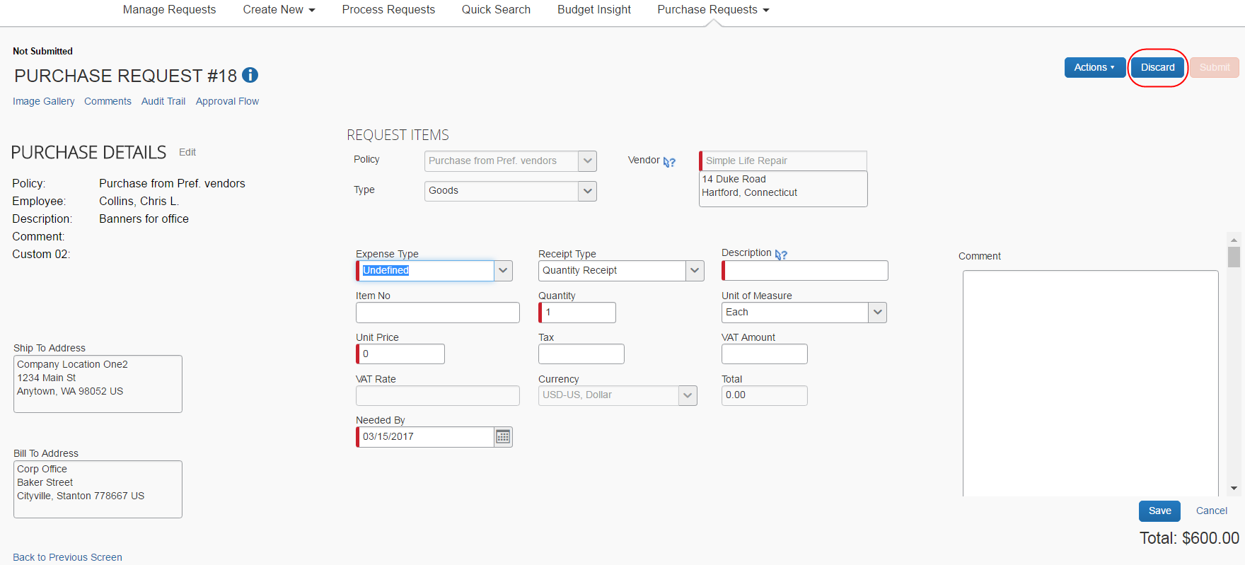

Copy an Existing Purchase Request
A purchase request can be copied in order to create a new request. Do this by either:
- Unsubmitted Request: Clicking the Copy icon for the unsubmitted request
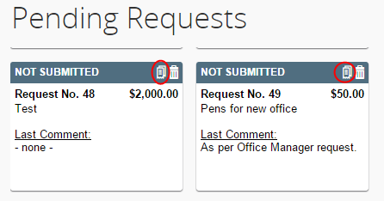
- Submitted Request: Clicking Copy Request from the Actions menu of the submitted request
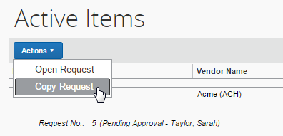
A user cannot copy a request that is associated with a closed purchase order.

Change Purchase Request Policy
Purchase request users can change policies of unsubmitted purchase requests, for example, if they have selected incorrect ones.
Concur Invoice will track the change of policy in the audit trail.
To change the policy, the user needs to open the purchase request and click the Edit link.
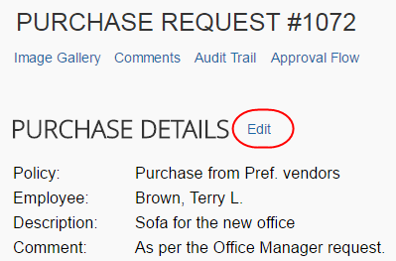
Then, in the Policy list, the user can change the policy and click Save.
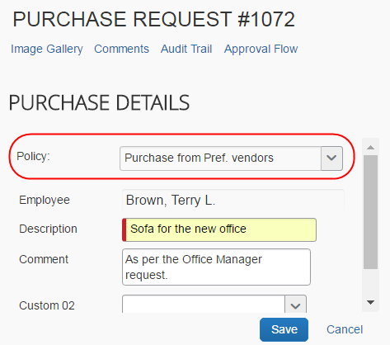

Auto-Assign PO-Based Invoices to Original Purchase Request Owner
Concur Invoice created or externally created PO-based invoices can be automatically assigned to the purchase request owner provided the Assign invoice to Purchase Request Owner option is selected (enabled) by the admin in Invoice Settings.
This means that Concur Invoice will try to find the purchase request owner of the PO-based invoices. When the PR owner is found, Concur Invoice will automatically assign the purchase request owner as the invoice owner of the PO-based invoices.

Reassign PO-Based Invoices Created Within Invoice
If the user wants to assign the unsubmitted PO-based invoice, where the PO is generated within Concur Invoice, they can do so from the Manage Request menu.
For example, Chris Collins needs to reassign a PO-based invoice that was incorrectly assigned to him. He opens the invoice, and then clicks the Assign button as is shown in the image.
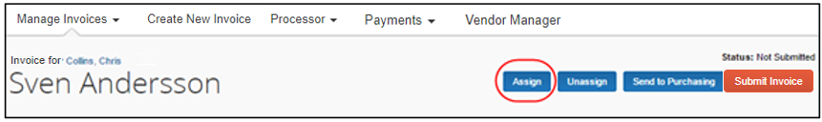
The Assign Requests window appears and Chris can select the purchase request owner.
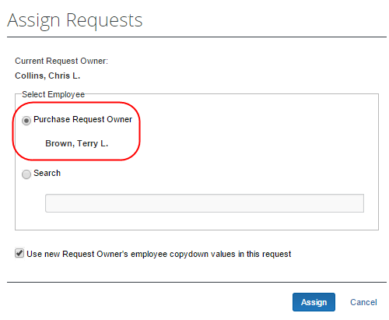
Once Chris has clicked Assign, the request will be assigned to the original purchase request owner, in this case, Terry Brown.

Reassign PO-Based Invoices Created Outside of Invoice
In cases where the AP user needs to assign the externally created PO-based invoice, they can do so by clicking the Assign button or the Select Invoice Owner link. In the window that appears, the AP user can see by whom the purchase order was requested and assign the PO-based invoice to that user.
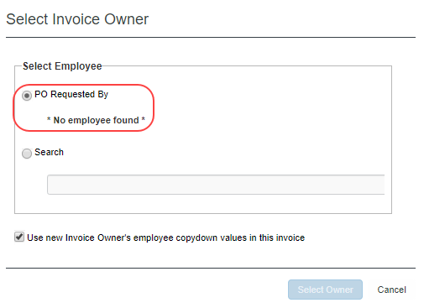

Submit the Purchase Request
Once submitted, the purchase request is moved to the Active Items section pending final approval and processing, and then order generation and transmittal to the supplier.

Notify Purchase Request Users When Purchase Order Transmitted
The purchase request user can receive email notifications every time the processor has transmitted a purchase order to the supplier. In addition, the purchase request user will receive the purchase order as a PDF attachment in the email notification.
To receive email notifications, the purchase request user must activate the feature in Profile.
To receive notification when the status of a purchase request changes:
- Click Profile > Profile Settings.
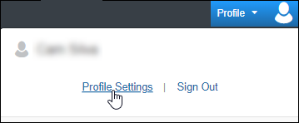
- Click Invoice Preferences (left menu). The Invoice Preferences page appears.
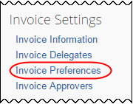
- Select (enable) The status of a purchase request changes option.
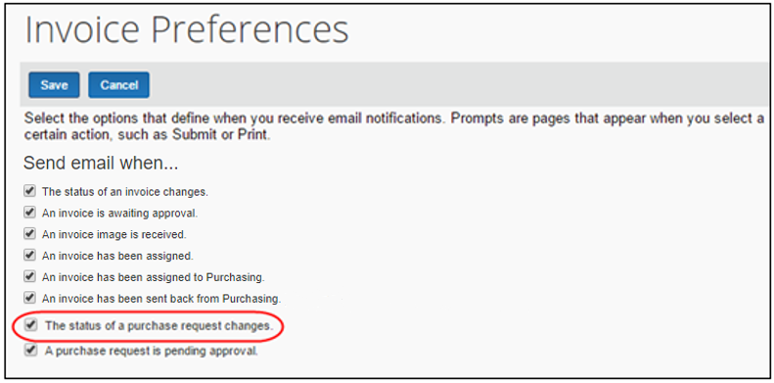
- Click Save.

Purchase Request Owners Transmitting Their Purchase Orders
A Purchase Request Owner may transmit his/her own purchase orders. Provided the administrator has activated this option in Invoice Settings, the Purchase Request Owner can request items, have their managers approve the request, and then they can transmit the purchase order. The Purchase Request Owner will have access to the Purchase Order page and perform the same tasks as the PO Processor. Apart from transmitting the purchase order, the Purchase Request Owner may also edit their own purchase orders and use the Send Back, Void, Close, and Upload Images options.
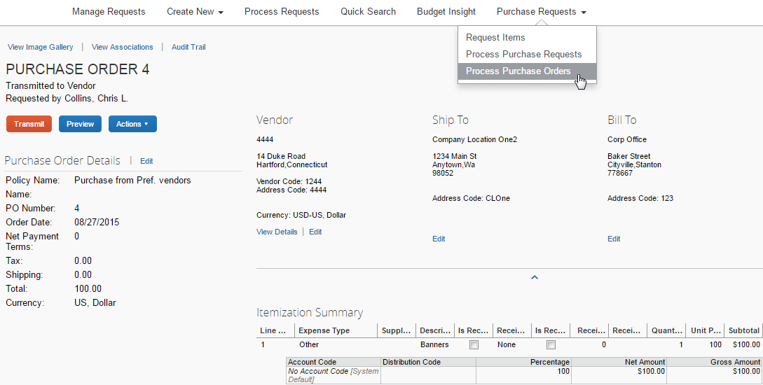
The Purchase Request Owner will only be able to see his/her own purchase orders.
- For more information, see the Concur nvoice: Purchase Request and Purchase Order Setup Guide and the Concur nvoice: Invoice Settings Setup Guide.

Purchase Request Owners Editing Their Purchase Orders
A Purchase Request Owner may edit his/her own purchase orders. Provided the administrator has activated this option in Invoice Settings, the Purchase Request Owner will be able to see the edit link so that they can edit their own purchase orders.
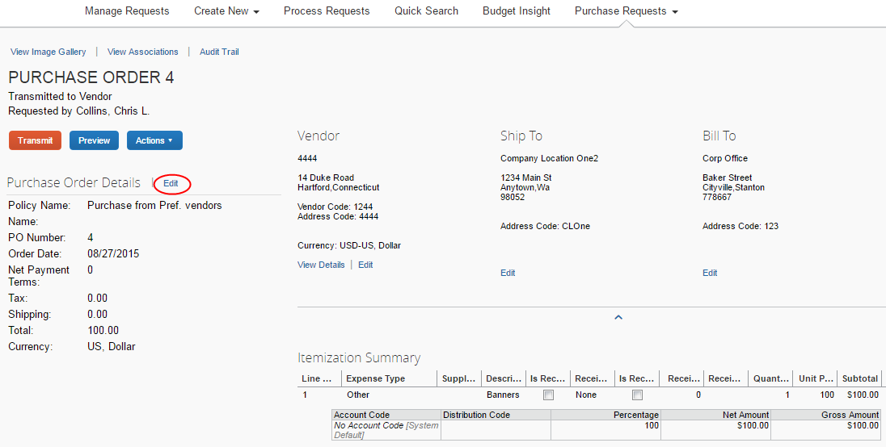
- For more information, see the Concur Invoice: Purchase Request and Purchase Order Setup Guide and the Concur Invoice: Invoice Settings Setup Guide.

Search for a Purchase Request
Purchase request users can search for their submitted purchase requests in the search area by selecting different search criteria, such as Vendor Name, Item Total, or Order No.
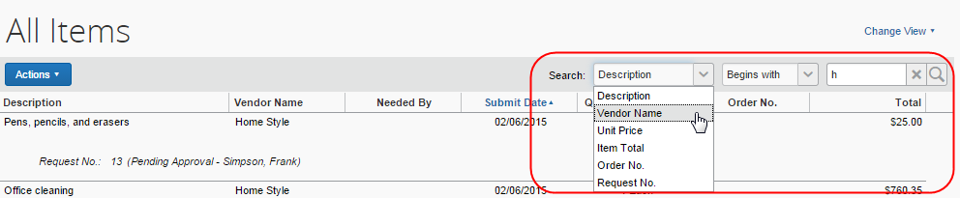

Change View Search Option
Purchase request users can also use the Change View menu to display active items or items submitted by date range. By changing the view, the result appears on the page.
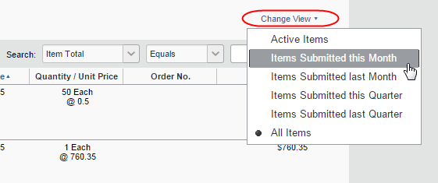

Add a Comment to an Item
Purchase request users can add comments to an item to clarify an item or to provide more information about an item.
To add a comment to an item:
- Open the desired purchase request.
- In the Items section, click Show Comments.
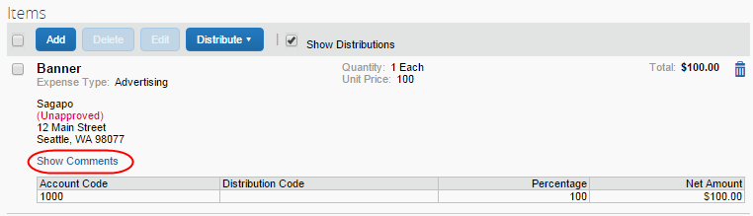
- Click the Add Comments link that appears.
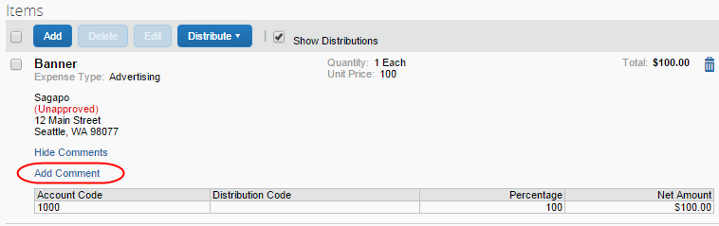
- In the comments field, type the comment, and then click Save.
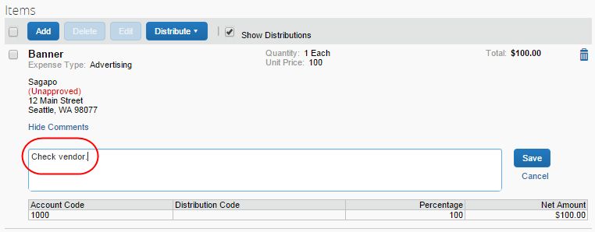

View Comments
The purchase request user can view comments that have been added to a purchase request at either the header or line item level.
To view comments:
- Open the desired purchase request.
- If comments have been added to the header of a purchase request, the Has Comments icon appears next to the Comments link.
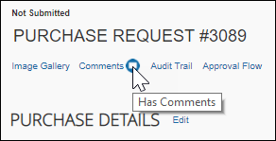
If comments have been added to a line item, the Has Comments icon appears next to the Show Comments link for the line item.
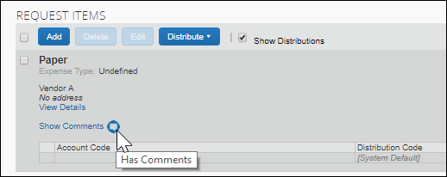
- To view the comments at the header level, click Comments.
The Comment History window appears.
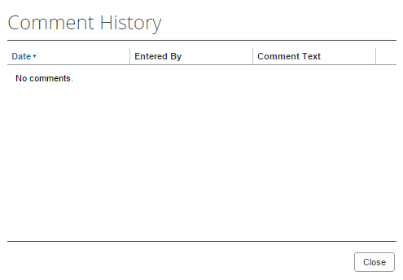
- To view comments that have been added to a line item, click Show Comments. The comments appear within the line item row.
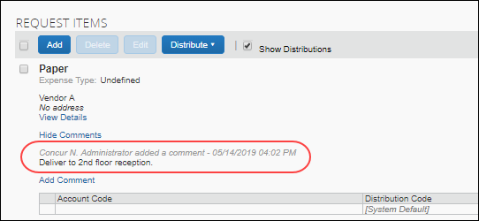

View the Audit Trail
To review the audit trail, open the purchase request, and then click Audit Trail.
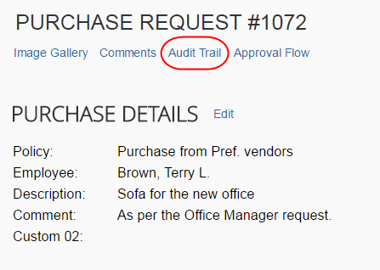
The Audit Trail window appears with information about actions that the purchase request user and the system have taken on the specific purchase request.
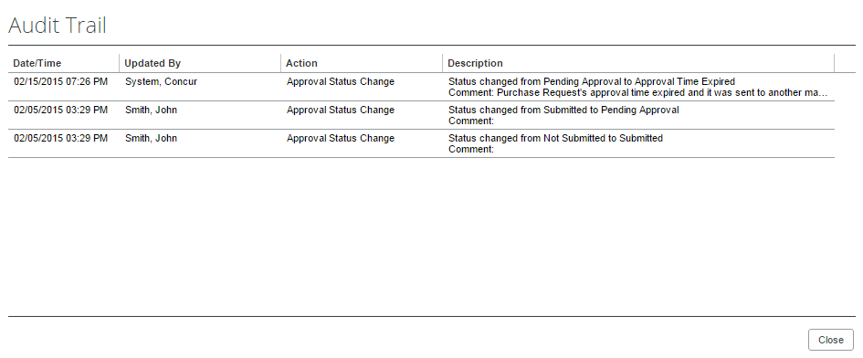
All users who have access to a PO change order transaction will be able to view the audit trail history of the PO Change Order.

View Purchase Orders
Purchase request users can view the purchase orders resulting from their created purchase requests. To do so, in the Purchase Request menu, click My Purchase Orders.
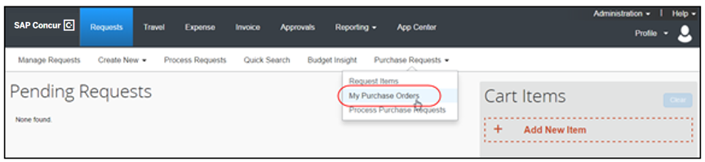
If you are both a purchase request user and a purchase request processor, you will not see the My Purchase Orders menu option.

Create Invoices From Purchase Orders
Purchase request creators can create invoices from their own transmitted purchase orders by selecting the Create Payment Request option in the Actions menu, either from the All Orders page or from an opened purchase order.
All Orders page:
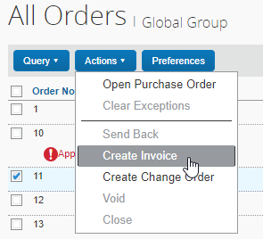
Purchase Order page:
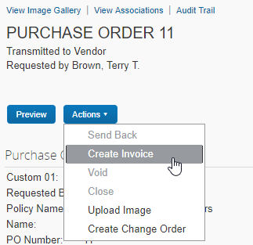

Recall a Purchase Request
The purchase request user can recall a purchase request that they have submitted but that the approver has not yet approved.
To recall a purchase request:
- On the Pending Requests page, double-click the submitted, but the not yet approved purchase request.
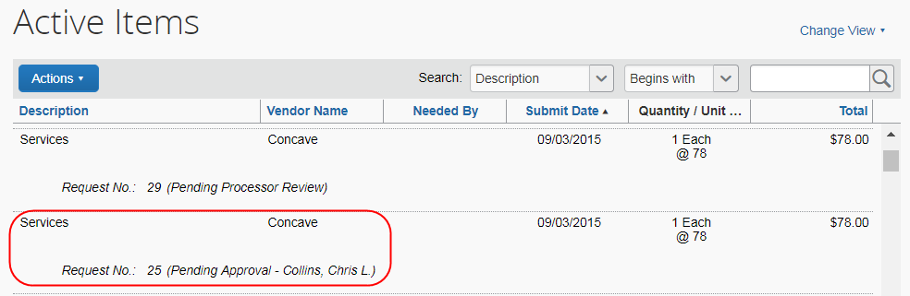
- On the Request page, in the Actions menu, click Recall Request.
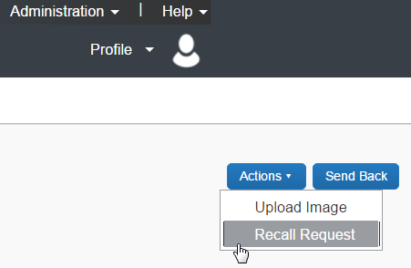
- In the Recall Request window that appears, click Yes.
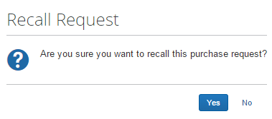

Select for Different Vendors and Project- and Event-Based Requests
When creating their purchase request, users may select a different vendor for each item within the overall purchase request. Associating a vendor at the item level adds more detail to the request and, combined with the ability to create project- or event-based requests, makes the process more efficient and budget appropriate.
For example, an office remodel project may combine goods (furniture) alongside services (cleaning), with different vendors as required.
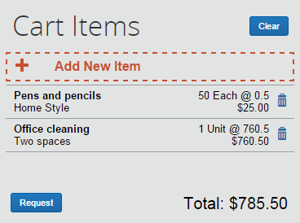
From this single request, multiple purchase orders are generated, each associated with the items contained in the original request. The unique PO number guides the system when an action, such as Send Back, requires that all POs be identified with the parent PR being returned to the requestor.

Distribute (Allocate) a Purchase Request
The purchase request user can specify distributions at the line item level, so that they can allocate the cost of the purchase accurately. In addition, if they want to apply the same distributions to all line items, they can specify the distributions once and apply it to all line items.
The processer can also create and manage distributions (allocations).
Only users with access to the Distribution functionality will see it. Users who need to access the Distribution functionality should contact their SAP Concur representative.
Distribute a purchase request:
- Open the desired purchase request.
- On the Request page, select one or more itemizations to that you want to distribute between departments.
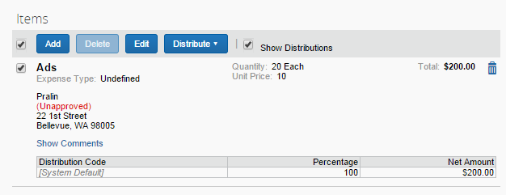
- Click Distribute > Distribute Selected Items.
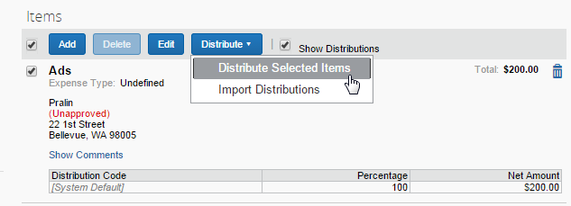
The Distribute Selected Items page appears.
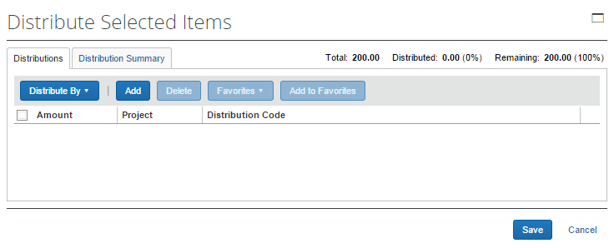
- Click Distribute By and select to distribute the allocation by amount or by percentage.
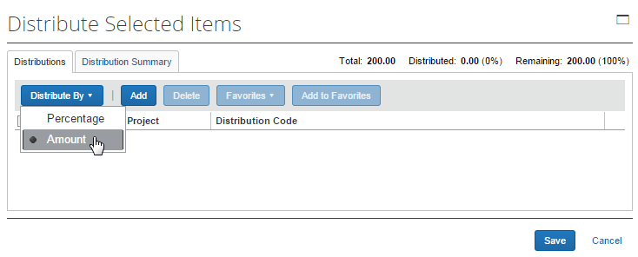
- Click Add. The total is now evenly spread between the number of allocations (you may adjust these manually, but the percent must equal 100 or the amount the overall total, excepting tax and shipping before you can proceed).
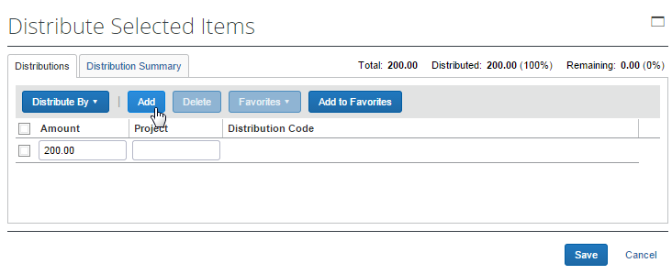
- Complete all required fields and the optional fields as directed by your company. (Your company defines the fields that appear on this page.)
- Click Save.
You can add or delete an item by clicking the Add or Delete button respectively.

Import Distributions
The purchase request user can import his/her distributions (allocations) by using the Import feature. This feature supports clients who need to distribute a single purchase request across many cost objects. For example, the corporate office may decide one purchase request should be shared by all the 400 company retail locations. Imported distributions can be:
- Specified to import as either percentage or amount, with restrictions based on the sign (negative or positive)
- Applied across multiple line items at once
To import distributions:
- Double-click the purchase request that you would like to open.
- On the Request page, in the Items section, select the item for which you want to import distributions.
- Click Distribute, and then Import Distributions.
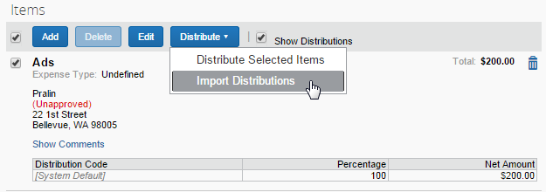
- In the Import Distributions window that appears, click Browse to select the file that you want to import. You may download a sample Excel file (.xls) template based off distribution (allocation) configuration fields by clicking Download Template.
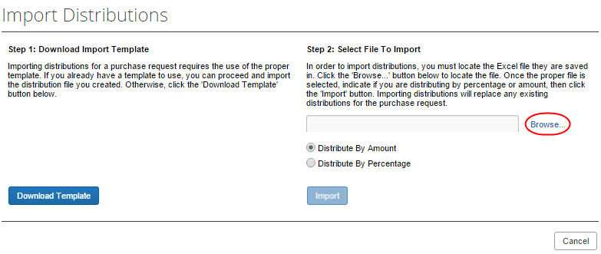
- Select the file to import, and then click Open.
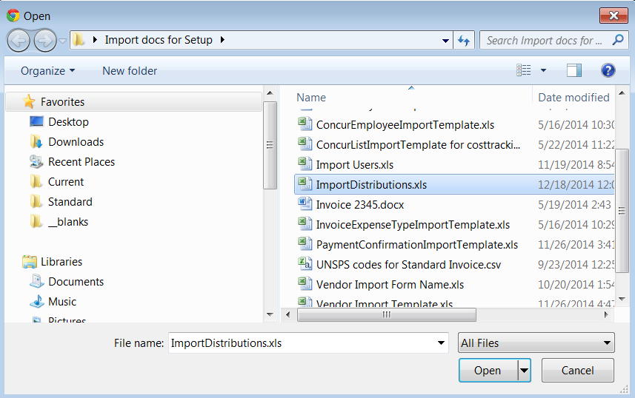
- Click Import.
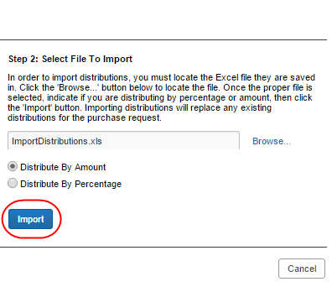
Concur Invoice imports the distributions and display them in Concur Invoice.
- Click Save.
While Invoice imports the distributions, error checking and validations are processed, and the results appear in the Import Errors window.

Create and Manage Allocation Favorites
Users often allocate many expenses in an identical manner. For example, they will allocate 20% of an expense to Cost Center A, and 80% to Cost Center B. The Allocation Favorites feature allows the user to save a group of allocations, to use on other expenses.
When the user applies these allocation favorite "sets" to another expense, the system validates the data in those stored allocation records to ensure any project codes or other list fields are still valid and alerts the user if the user needs to correct data. The user adds the allocation to the expense, and then the user can edit the allocation just like a manually entered allocation row.
To create an allocation favorite:
- Open the desired purchase request.
- On the Request page, in the Items section, select the item for which you want to create a favorite allocation.
- Click Distribute > Distribute Selected Items.
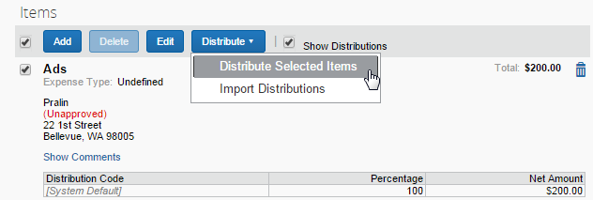
- In the Distribute By menu, select if you would like to distribute the allocation by amount or percentage.
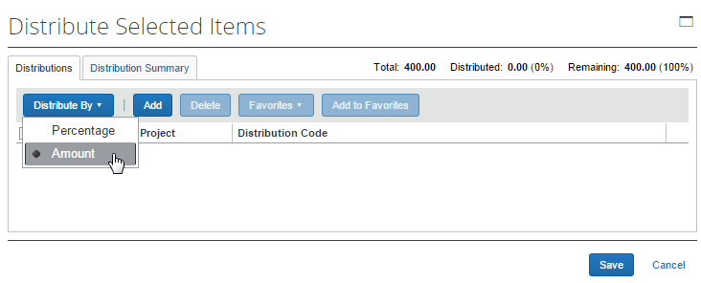
You can use the Add button to correctly identify and budget the expense to the accounting system. For example, use this if your need to spread your expenses across several projects or departments.
- Click Add to Favorites.
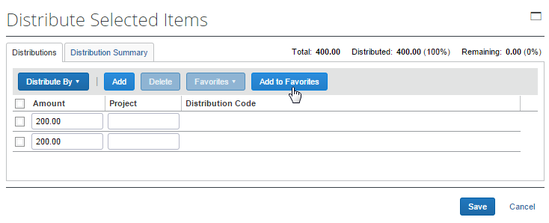
The Add to Favorites window opens.
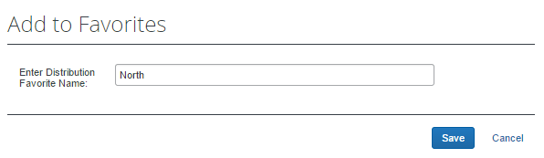
- Enter a name for the allocation favorite and then click Save. The system adds the allocation to your favorites, which you can see if you click Favorites.
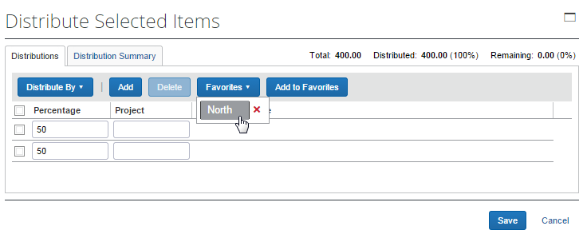
To assign your allocation favorite:
To assign your allocation favorites, follow the To create allocation favorite procedure that is described above. However, instead of clicking Add to Favorites, in the Favorites menu, select the favorite allocation that you would like to use.
To remove an allocation favorite:
Over time, allocation favorites will become incorrect or obsolete. The user can remove out-of-date allocation favorites by clicking on the red X icon next to the name as shown in the figure below.
To edit an allocation favorite:
The user can update the set by using it on an expense, making needed corrections, and then saving the resulting allocations to the same allocation favorite name. The system will confirm that the user wants to overwrite the existing set.
On the Distribution Summary page of the Distribute Selected Items window, the user may view a summary of a distribution they made of a line item.

Act As a Proxy for a Purchase Request User
A user can be assigned a proxy role that allows them to act on behalf of any other user granted the Purchase Request User role. This feature is identical to its implementation in Concur Invoice, and is designed specifically to work within Purchase Request, without changing the PR proxy user’s roles and access rights when they exit Purchase Request and begin work within Concur Invoice.

How It Works
The proxy feature works when the following role relationship is in effect:
- The Purchase Request Proxy role is assigned to the user who will proxy for others
- The Purchase Request User role is assigned to those users the Purchase Request Proxy role will proxy for
With this assignment in place, the PR Proxy role user will see the Proxy Search button in the Purchase Request tab, and now has rights to search for and proxy any user with the Purchase Request User role.

Purchase Request Proxy Role Behavior is Limited to Purchase Request
This functionality is designed for the stand-alone Purchase Request module and does not change the behavior of the user when they work within Concur Invoice. This means the user can leave the Purchase Request tab and continue work as a user of Invoice, an administrator for Invoice tools, or otherwise. However, once they return to the Purchase Request tab, they are again representing the selected PR user.

Stop Acting as Proxy
When an admin is done acting as a proxy for another user, they can end the proxy session by clicking Myself > Switch in the Act As section of the Profile menu.
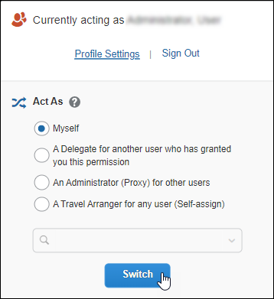

Use Employee Import to Assign the Purchase Request Proxy Role
You can assign the Purchase Request Proxy role using the overnight Employee Import job. This role is included in the 400-level Role Code set of roles.

Configuration
The client must have the Purchase Request module activated and have assigned the roles (as described above) to their users. If you intend to import this role using the overnight Employee Import job, the Import/Extract Administrator role is required. Contact SAP Concur support directly to set up this role for your import.

View the Approval Flow
The purchase request user can view the workflow to see all the approval steps that are part of the purchase request process. In addition, it is possible to submit the purchase request from the Approval Flow for Purchase Request window.
To view the approval flow:
- Open the desired purchase request.
- On the Request page, click Approval Flow.
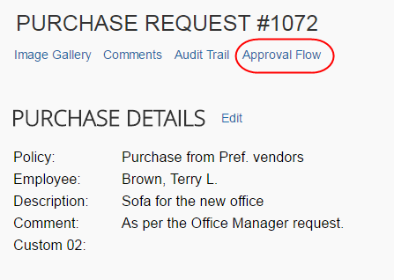
- In the Approval Flow for Purchase Request window, review the workflow, and then click Cancel, or click Submit to submit the request.
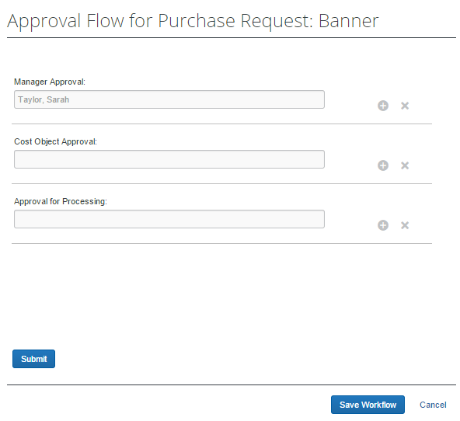

Email Notifications of Status Change and Required Approvals
If clients have set up to receive email notifications about status changes or approvals to be done of purchase requests, the notification email will contain a link that will take the client directly to the specific purchase request that has changed or that needs to be approved.
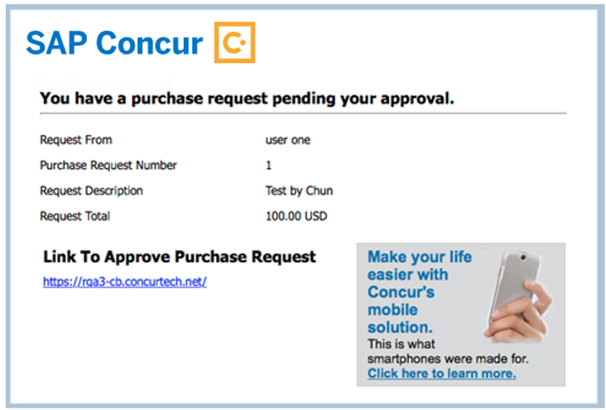
Note that to receive notification emails, the user must select the desired setting in Profile > Profile Settings> Invoice Preferences.
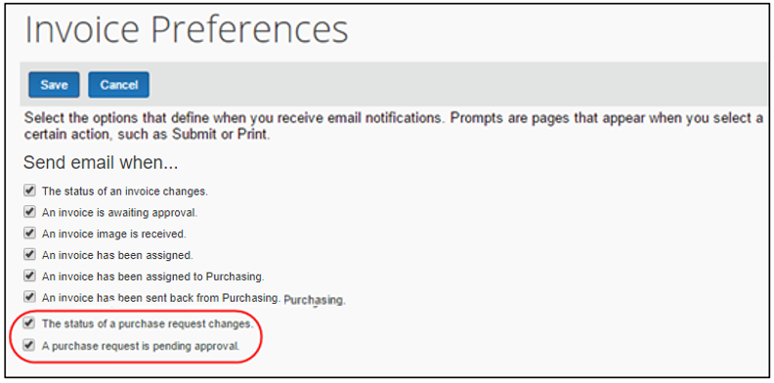

Manage Receipts and Receipt Images
Purchase Request Owners, who work with the Receiving feature, can add, edit, delete receipts and receipt images of the transmitted purchase order provided the Allow Purchase Request Owners to Edit their own Purchase Orders option is selected (enabled) in Invoice Settings.
If a receipt is associated with an invoice, a user will not be able to edit or delete the receipt and the Edit and Delete buttons will be disabled. If a user needs to make changes to an invoice, they need to first unassociated the receipt to the invoice.
- For more information, refer to the Concur Receiving section of the Concur Invoice: Purchase Order Matching User Guide.

Purchase Request Approver Experience
A user with the Purchase Request Approver role can click Purchase Request > Approve Requests to access purchase requests for processing.
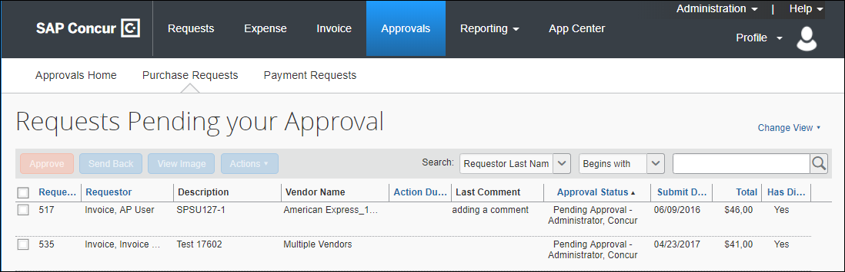
The purchase request approver can review images that are attached to purchase requests, approve purchase requests, and send purchase requests back to the requestor. The approver is limited in what they can change in the request, and so may elect to send a request back, or have the processor adjust the request as needed.

Search for a Purchase Request
Approvers can search for approved purchase requests or requests that are pending approval in the search area by selecting different search criteria, such as Requestor Last Name, Total, or Request No.
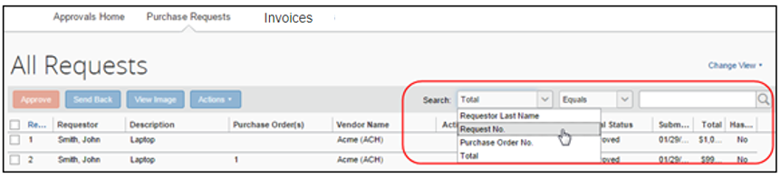

Change View Search Option
Approvers can also use the Change View menu to display requests pending their approval or requests approved by date range. By changing the view, the result appears in the page.
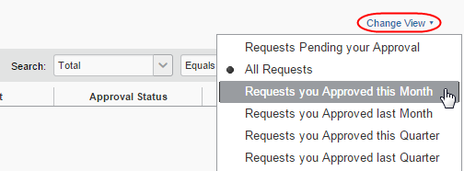

Send Back a Purchase Request
Approvers can send back a purchase request prior to transmittal to the vendor to remove a purchase request from its workflow for additional review, correction of the associated purchase request amount or cost object, or to amend some additional items to the purchase request.
When a purchase request is sent back to the requester, the assigned purchase request number is voided, the original associated request item(s) are made read-only, and a new, duplicate purchase request is created with a status of Sent Back to Employee that includes the original items and allocations that were part of the now-retired PR. An indicator is also added to the new PR to show it was generated based on a now-invalid PR.
Finally, an email notification is generated and sent based on the purchase request email notification settings for the requestor.
To send back a purchase request:
- On the Requests Pending your Approval page, select the purchase request you want to send back by clicking its check box.
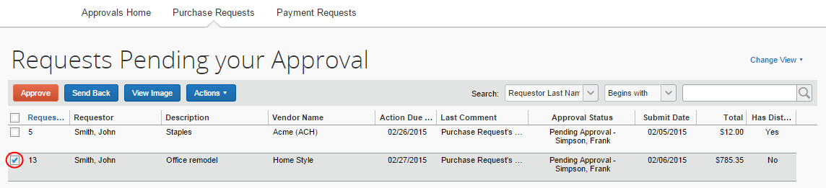
- Click Send Back.
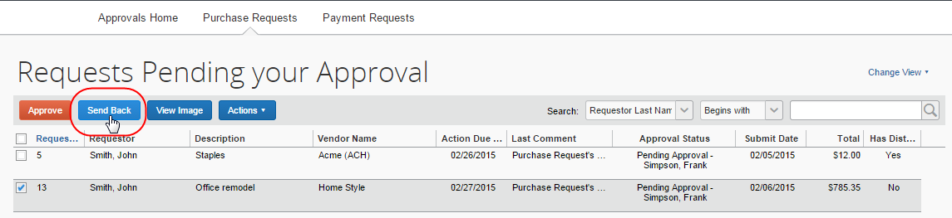
- In the Send Back Purchase Request window that appears, enter a comment about why you want to send back the purchase request, and then click OK.
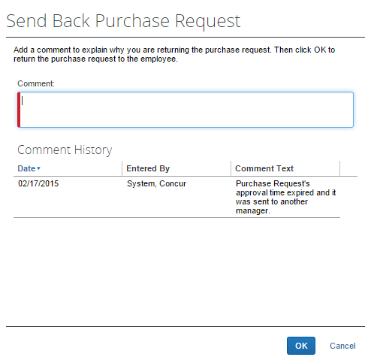

Approve and Forward a Purchase Request
If the approver wants to approve a purchase request but also add another approver, they can do this by opening the desired PR and clicking Approve & Forward.
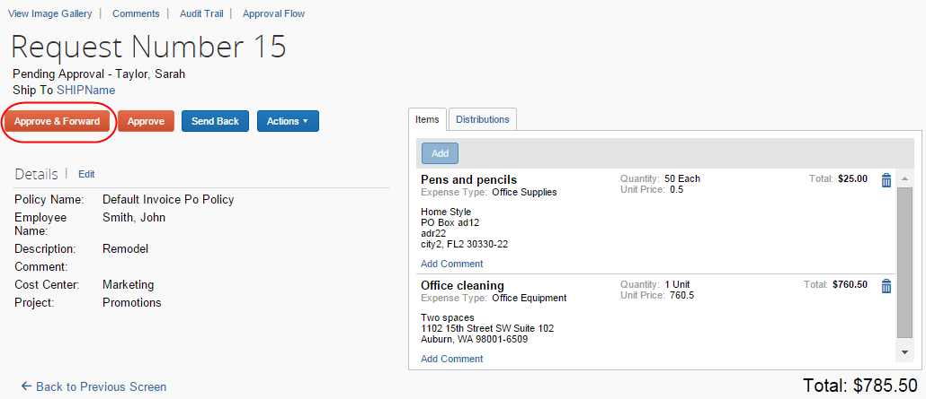
In the Approve & Forward Purchase Request window that appears, the approver can add another approver and a comment about why they would like to do this. Complete this step by clicking Approve & Forward.
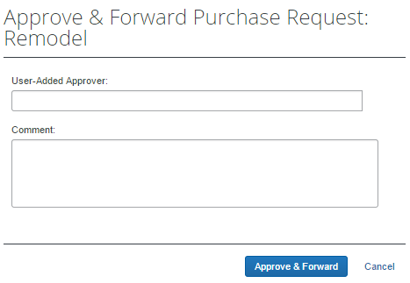

Approve a Change Request
When the approver logs in to approve the purchase request, they will see the icon, which indicates that this is a change request.
Apart from approving the purchase request, the approver will be able to edit the quantity of the purchase request. In addition, the approver can send the purchase request back to the purchase request user by clicking Send Back. The approver should include a send-back reason and the purchase request user is then notified by email that the purchase request is being sent back. Reminders, notifications, and escalations work the same way for change requests as they do for purchase requests.
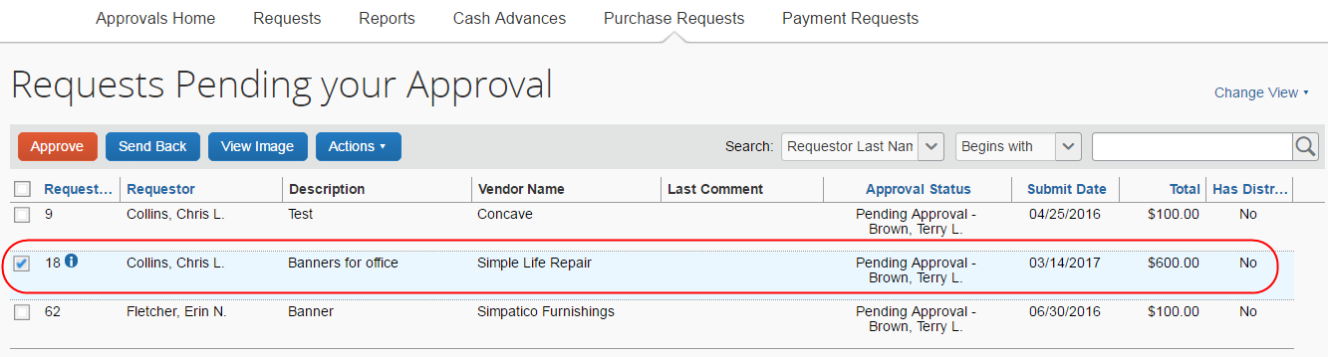
Once the approver clicks Approve, the purchase request will proceed to the purchase request processor for approval.
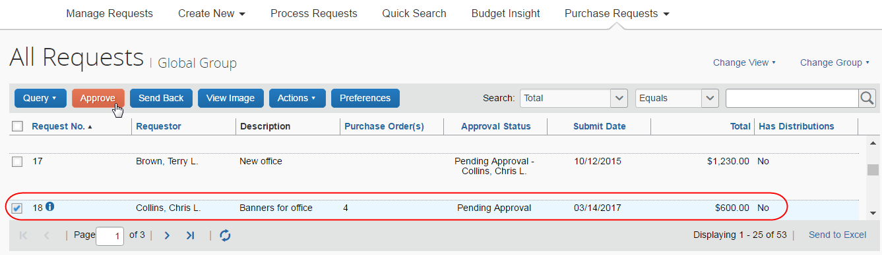

Upload and View Images
The approver can upload and view images to the purchase requests. However, approvers cannot delete images.
To upload an image:
- Open the desired purchase request.
- On the Request page, click Actions > Upload Image.
The Upload Image window appears.
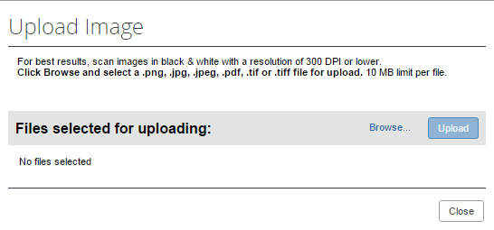
- Click Browse and select the desired image by double-clicking it, or by selecting it and clicking Open.
- (Optional) Select (enable) the Include in PO Transmission check box.
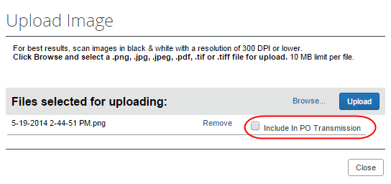
- Click Upload.
- Select the file that you want to upload by double-clicking it or selecting it and clicking Open.
- Click Close.
To view an image:
- Open the desired request.
- On the Request page, click View Image Gallery.
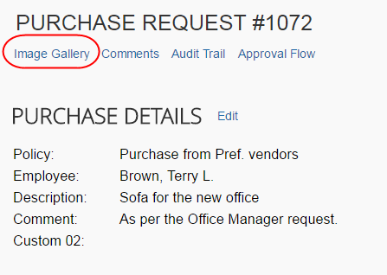
The Purchase Request Images window appears. If there are more than one image or supporting document, you can toggle between them by using the Next and Previous buttons.
You can also include supporting documents in the PO transmission from the Purchase Request Images window by selecting (enabling) the Include in PO Transmission check box.
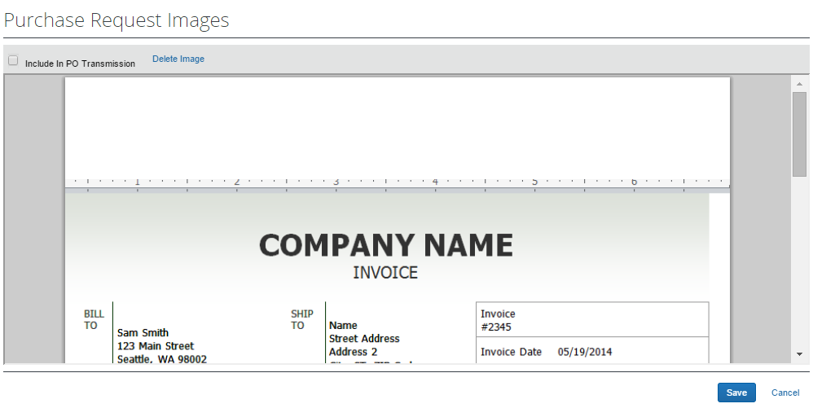
- Click Save or Cancel when you are done.

View Comments
The approver can view comments that have been added to a purchase request at either the header or line item level.
To view comments:
- Open the desired purchase request.
- If comments have been added to the header of a purchase request, the Has Comments icon appears next to the Comments link.
If comments have been added to a line item, the Has Comments icon appears next to the Show Comments link for the line item.
- To view the comments at the header level, click Comments. The Comment History window appears.
- To view comments that have been added to a line item, click Show Comments. The comments appear within the line item row.

View the Audit Trail
To review the audit trail, open the purchase request, and then click Audit Trail.
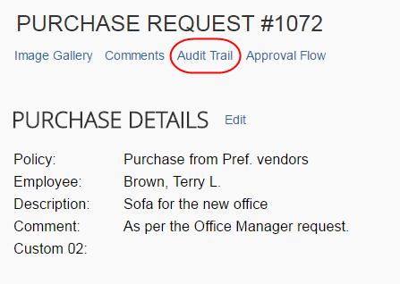
The Audit Trail window appears with information about actions that the approver and the system have taken on the specific purchase request.
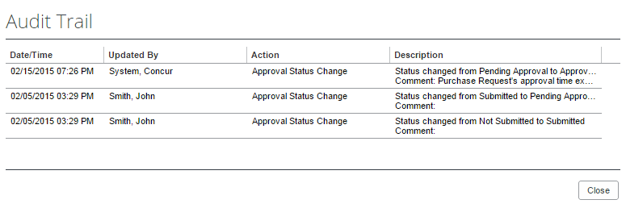
All users who have access to a PO change order transaction will be able to view the audit trail history of the PO Change Order.

View the Approval Flow
The approver can view the workflow to see all the approval steps that are part of the purchase request process. In addition, they can approve or send back the purchase request in the Approval Flow for Purchase Request window.
To view the approval flow:
- Open the desired purchase request.
- On the Request page, click Approval Flow.
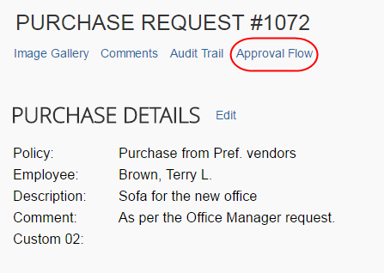
- In the Approval Flow for Purchase Request window, review the workflow, and click Cancel, or click Approve or Send Back to approve or send back the purchase request.
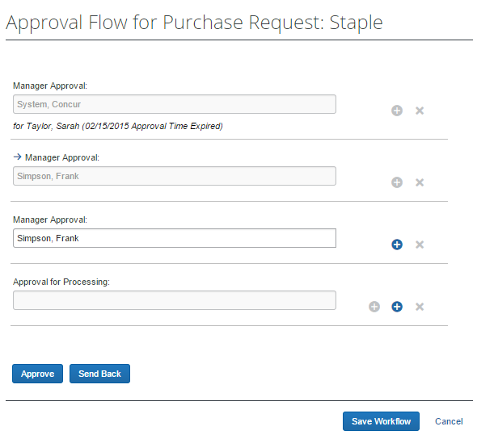

Add a Comment to an Item
Approvers can add comments to an item to make a clarification about an item, or to provide more information.
To add a comment to an item:
- Open the desired purchase request.
- In the Items section, click Show Comments.
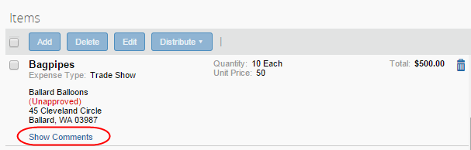
- Click the Add Comments link that appears.
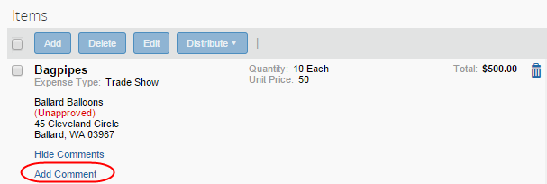
- In the comments field, type the comment, and then click Save.
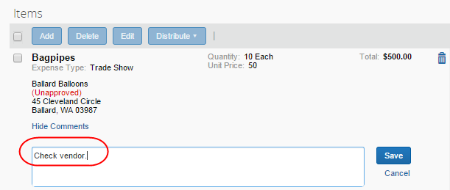

Edit an Item of an Unapproved Purchase Request
The approver can edit the vendor, URL, and comments fields.
To edit in item:
- Open the desired request.
- In the Items section, click Edit.
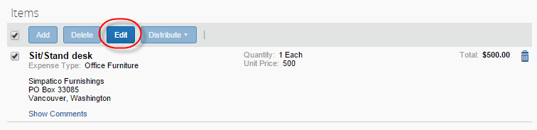
- Make your changes and then click Save.
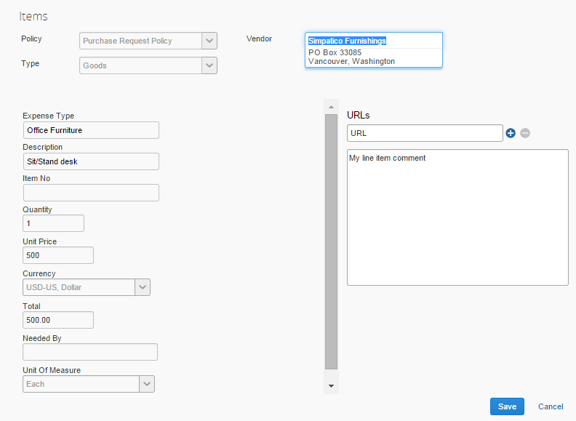

View Purchase Order Contact and Email Address
The purchase request approver will see the contact name and email address of the purchase order contact in the Vendor field of the Request Items section of the opened purchase request in edit mode, provided this information has been imported into Concur Invoice. This makes it easy to quickly find the relevant contact person of the purchase order.
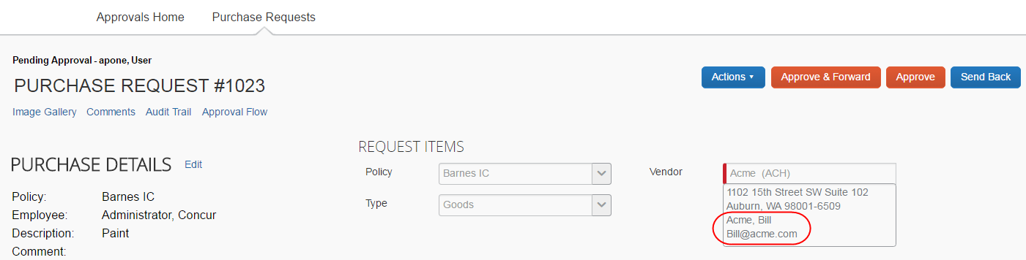

Purchase Request Processor Experience
The Purchase Request Processor role typically reviews a PR for completeness. This means reviewing that required field types are completed, exceptions are cleared, and other details to ensure the requestor has properly filled out the request.
The Purchase Request Processor role clicks Requests > Purchase Requests > Process Purchase Requests. Here, the processor can review purchase requests pending all approvers and perform processing tasks on the purchase request.
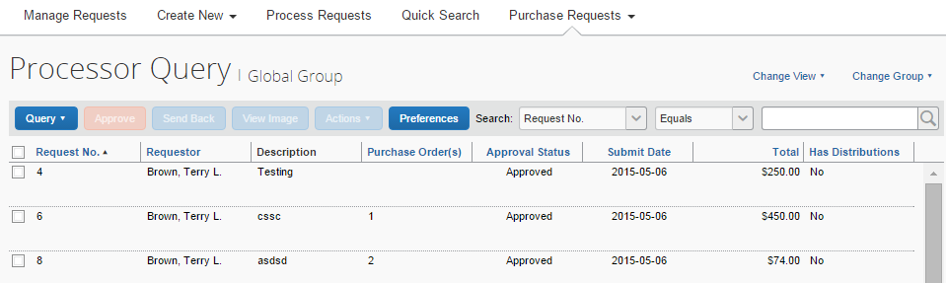
When opened, all functionality available to the original purchase requestor is available to the processor, plus the following actions:
- Approving the PR
- Send the request back to the requestor for corrections
- View the associated image(s) for the PR
- Clear exceptions on the selected PR
- Create queries to search for requests
Following approval, the purchase request is turned into one or more purchase orders, each PO generated from an item that makes up the parent request. For the PR shown in the figure below, three POs will be created, of which two will go to a single vendor, the last to a different vendor.
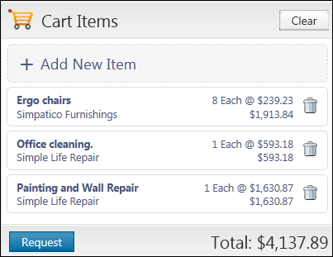

Search for a Purchase Request
Purchase request processors can search for purchase requests that are pending processor review by selecting different search criteria, such as Requestor Last Name, Total, or Vendor Name.
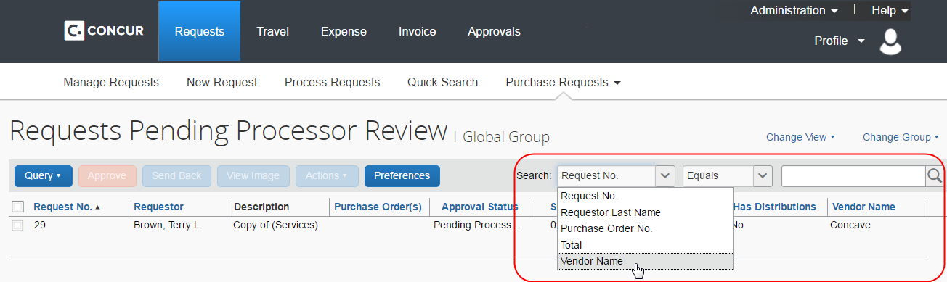

Change View Search Option
Purchase request processors can also use the Change View menu to display requests pending processor review, all requests, or change order requests pending processor review. By changing the view, the result appears on the Requests Pending Processor Review page, the All Requests page, or the Change Orders Requests Pending Processor Review.
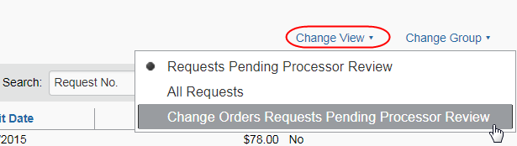

View Associated Images to a Purchase Request
To view associated images to the purchase request, click Image Gallery.
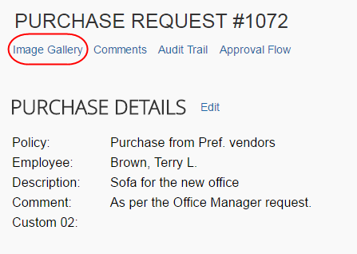

Purchase Order Contact and Email Address
The purchase request processor can see the contact name and email address of the purchase order contact in the Vendor field of the Request Items section of the opened purchase request in edit mode, provided this information has been imported into Concur Invoice. This makes it easy to quickly find the relevant contact person of the purchase order.
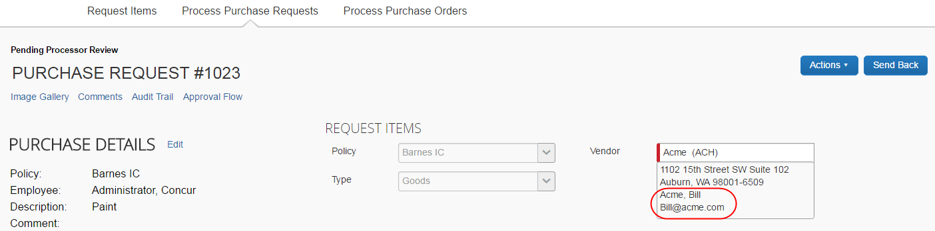

Clear Exceptions for a Purchase Request
To clear exceptions for a purchase request, read the exception message in the Exceptions section of the purchase request that you have opened and take the actions necessary to resolve the exception(s).
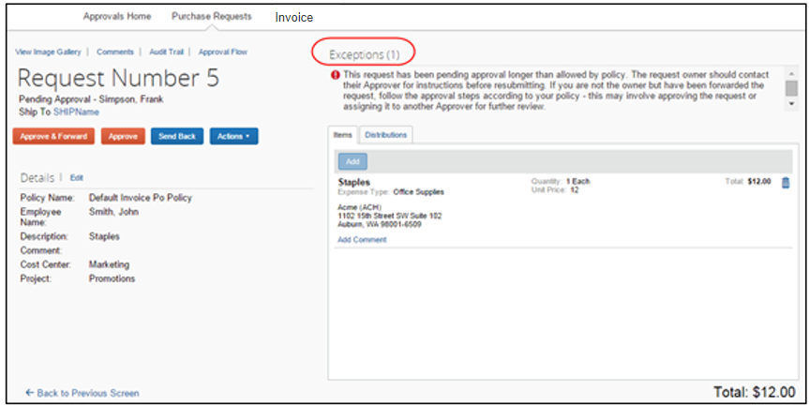

Approve a Purchase Request
To approve a purchase request, simply select the request and then click Approve.
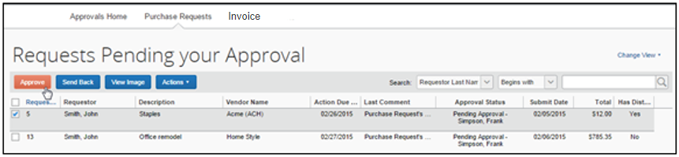
If you need to review the details of the purchase request, you may first open the request by double-clicking it.
Ensure that you clear any exceptions before you approve the purchase request.
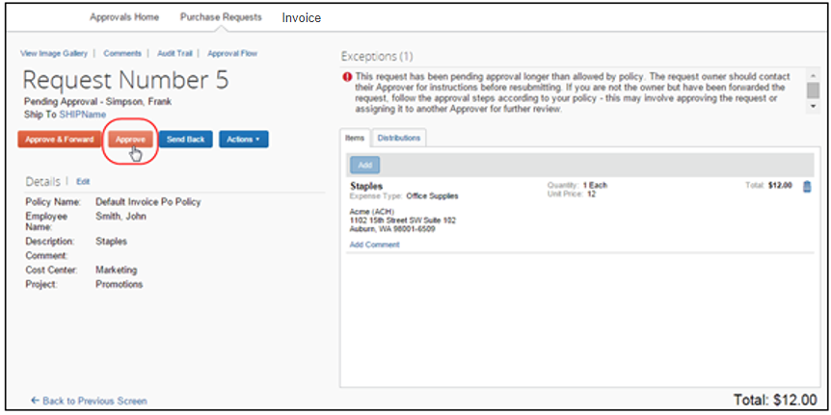
Following approval, the system turns the purchase request into one or more purchase orders, each PO generated from an item that makes up the parent request. For the PR shown in the figure below, the system creates two POs, which will go to two different vendors.

Approve and Forward a Purchase Request
If the purchase request processor wants to approve the purchase request but also add another approver, they can do this by opening the desired PR and clicking Approve & Forward.
In the Approve & Forward Purchase Request window that appears, the purchase request processor can add another approver and a comment about why they would like to do this. Complete this step by clicking Approve & Forward.

Approve a Change Request
Once the approver has approved the change request, the request will proceed to the purchase request processor for approval. The approver will see a icon, which indicates that this is a change request. The approver can filter the view to only see the change requests in the Change View menu.
To approve a change request:
- Open the desired purchase request.
- On the Request page, select the change request to approve and then click Approve.

Upload, View, and Delete Images
The purchase request processor can upload, view, and delete images to the purchase requests.
To upload an image:
- Open the desired purchase request.
- On the Request page, click Actions > Upload Image.
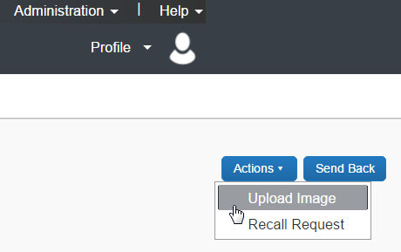
The Upload Image window appears.
- Click Browse and select the desired image by double-clicking it, or by selecting it and clicking Open.
- (Optional) Select (enable) the Include in PO Transmission check box.
- Click Upload.
- Click Close.
To view an image:
- On the Request page, click Image Gallery.
The Purchase Request Images window appears. If there are more than one image or supporting document, you can toggle between them by using the Next and Previous buttons.
You can also include supporting documents in the PO transmission from the Purchase Request Images window by selecting (enabling) the Include in PO Transmission check box.
- Click Save or Cancel when you are done.
To delete an image:
- On the Request page, click Image Gallery.
The Purchase Request Images window appears.
- Select the image you want to delete and click Delete Image.

View Comments
The purchase request processor can view comments that have been added to a purchase request at either the header or line item level.
To view comments:
- Open the desired purchase request.
- If comments have been added to the header of a purchase request, the Has Comments icon appears next to the Comments link.
If comments have been added to a line item, the Has Comments icon appears next to the Show Comments link for the line item.
- To view the comments at the header level, click Comments.
The Comment History window appears.
- To view comments that have been added to a line item, click Show Comments. The comments appear within the line item row.

Review Audit Trail
To review the audit trail, open the purchase request, and then click Audit Trail.
The Audit Trail window appears with information about actions that the purchase request processor and the system have taken on the specific purchase request.
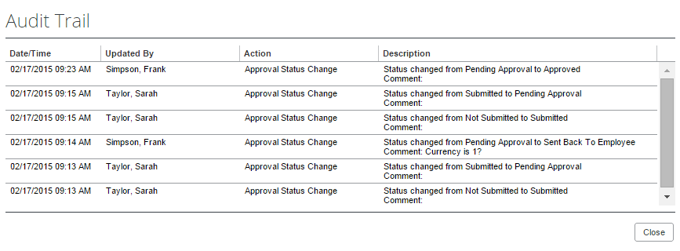
All users who have access to a PO change order transaction will be able to view the audit trail history of the PO Change Order.

View Approval Flow
The purchase request processor can view the workflow to see all the approval steps that are part of the purchase request process. In addition, it is possible to approve or send back the purchase request from the Approval Flow for Purchase Request window.
To view approval flow:
- Open the desired purchase request.
- On the Request page, click Approval Flow.
- In the Approval Flow for Purchase Request window, review the workflow, and click Cancel, or click Approve or Send Back to approve or send back the purchase request.
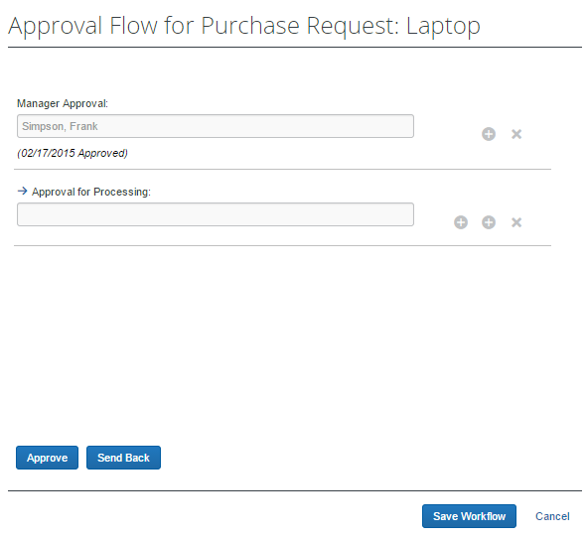

Change Ship-To Address
The purchase request processor can change the ship-to address.
To change the ship-to address:
- Open the desired purchase request.
- In the Ship To Address section, click the Change link.
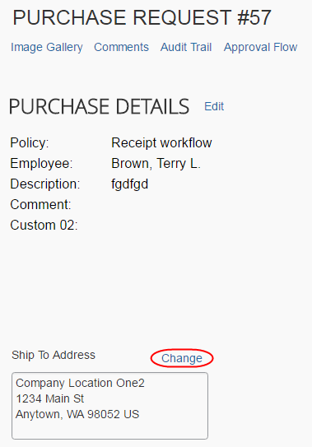
- Click in the field that appears and select the ship-to name.
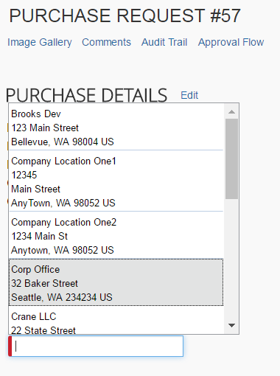
- Click Save.

Add a Comment to an Item
Purchase request processor can add comments to an item to clarify an item or to provide more information about the item.
To add a comment to an item:
- Open the desired purchase request.
- In the Items section, click Show Comments.
- Click the Add Comments link that appears.
- In the comments field, type the comment, and then click Save.
The comment appears in the Items section.
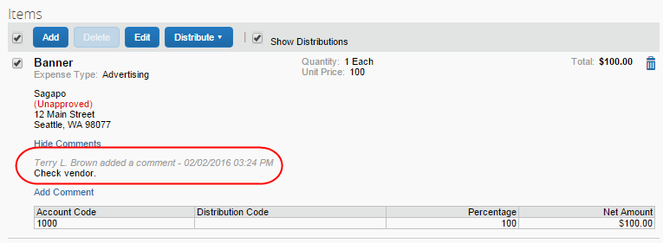

Delete an Item from a Purchase Request
The purchase request processor can delete an item from the purchase request.
To delete an item from a purchase request:
- Open the desired purchase request.
- In the Items section, select the item that you want to remove.
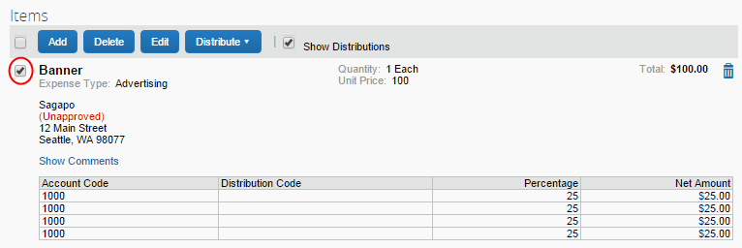
- Click the Trash icon.
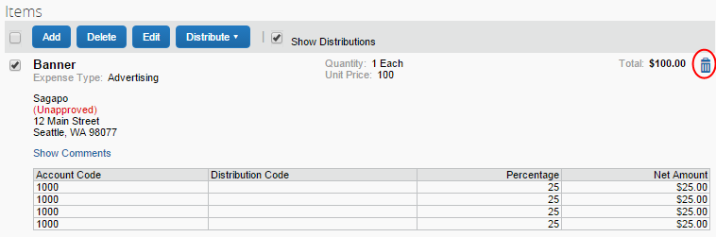
The system will remove the item from the purchase request.

Distribute (Allocate) a Purchase Request
The purchase request processor can specify distributions at the line item level, so that they can allocated the cost of the purchase accurately. In addition, if they want to apply the same distributions to all line items, they can specify the distributions once and apply it to all line items.
Both the purchase request user and the approver can also create and manage distributions (allocations).
Distribute a purchase request:
- Open the desired purchase request.
- On the Request page, select one or more itemizations to that you want to distribute between departments.
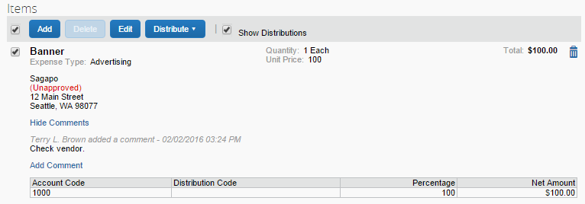
- Click Distribute > Distribute Selected Items.
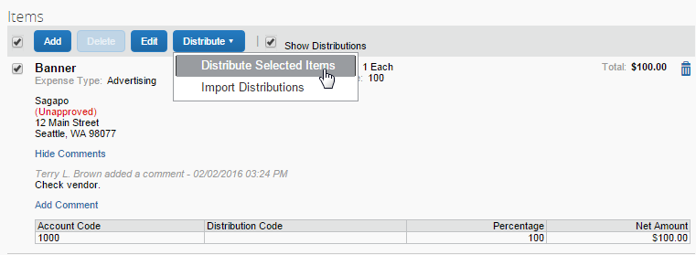
The Distribute Selected Items page appears.
- Click Distribute By and select to distribute the allocation by amount or by percentage.
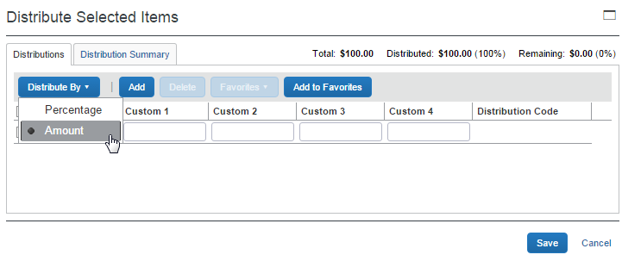
- Click Add. The total is now evenly spread between the number of allocations (you may adjust these manually, but the percent must equal 100 or the amount the overall total, excepting tax and shipping before you can proceed).
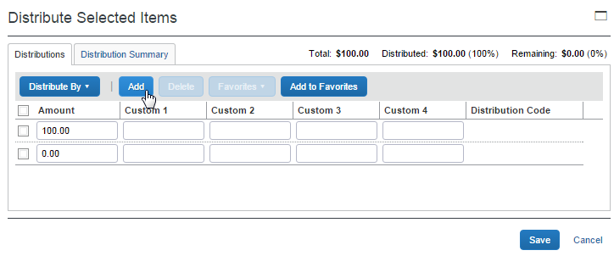
- Complete all required fields and the optional fields as directed by your company. (Your company defines the fields that appear on this page.)
- Click Save.
You can add or delete an item by clicking the Add or Delete button respectively.

Import Distributions
The purchase request processor can import their distributions (allocations) by using the Import feature. This feature supports clients who need to distribute a single purchase request across many cost objects. For example, the corporate office may decide one purchase request should be shared by all 400 company retail locations. Imported distributions can be:
- Specified to import as either percentage or amount, with restrictions based on the sign (negative or positive)
- Applied across multiple line items at once
To import distributions:
- Double-click the purchase request that you would like to open.
- On the Request page, in the Items section, select the item for which you want to import distributions.
- Click Distribute, and then Import Distributions.
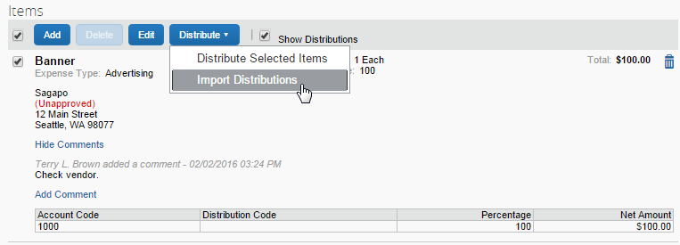
- In the Import Distributions window that appears, click Browse to select the file that you want to import. You may download a sample Excel file (.xls) template based off distribution (allocation) configuration fields by clicking Download Template.
- Select the file to import, and then click Open.
- Click Import.
Concur Invoice imports the distributions and display them in Concur Invoice.
- Click Save.
While Concur Invoice imports the distributions, error checking and validations are processed, and the results appear in the Import Errors window.

Create and Manage Allocation Favorites
The purchase request processor has the same ability as the purchase request user and approver to create and manage allocations.
To create an allocation favorite:
- Open the desired purchase request.
- On the Request page, in the Items section, select the item for which you want to create a favorite allocation.
- Click Distribute > Distribute Selected Items.
- In the Distribute By menu, select if you would like to distribute the allocation by amount or percentage.
You can use the Add button to correctly identify and budget the expense to the accounting system. For example, use this if your need to spread your expenses across several projects or departments.
- Click Add to Favorites.
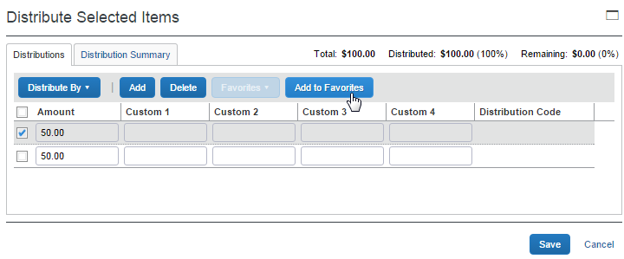
The Add to Favorites window opens.
- Enter a name for the allocation favorite and then click Save. The system adds the allocation to your favorites, which you can see if you click Favorites.
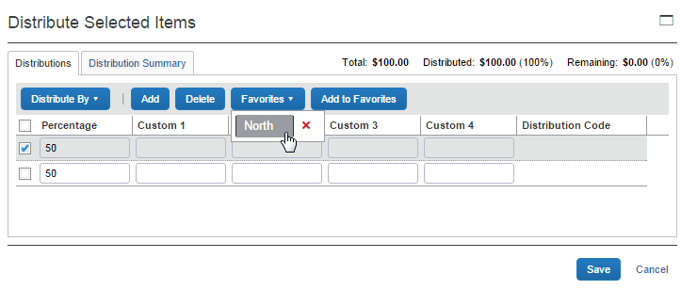

Edit an Item of an Unprocessed Purchase Request
The processor can edit several fields of a purchase request item, such as quantity, unit of measure, and unit price.
To edit an item:
- Open the desired request.
- In the Items section, click Edit.
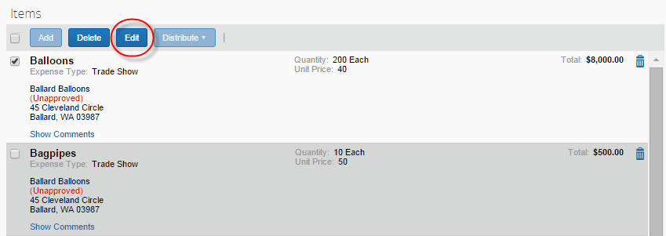
- Make your changes and then click Save.
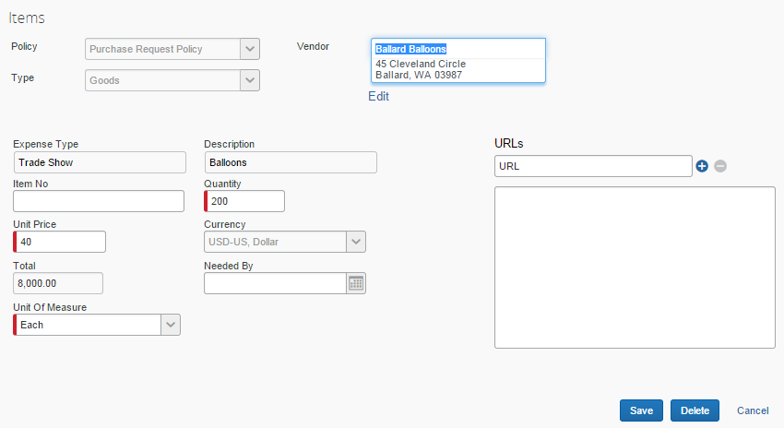

Delete an Item of an Unprocessed Purchase Request
The processor can delete an item of an unprocessed purchase request. To do so, the processor opens the desired purchase requests, and, in the Items section, selects the item to delete and clicks Delete.
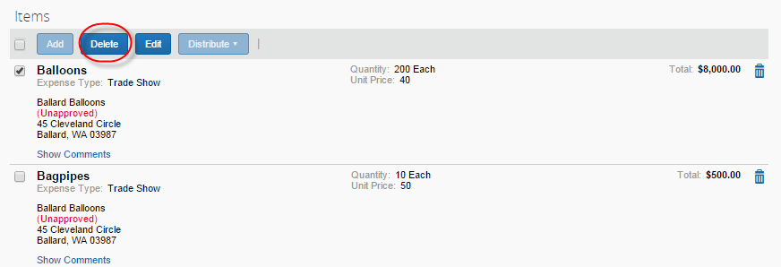

Purchase Order Processor Experience
The Purchase Order processor typically reviews a PO for buying details. This means reviewing the PO for correct shipping method and terms, reviewing the selected vendor to ensure it is a preferred supplier, and other details.
The Purchase Order Processor role clicks Requests > Purchase Requests > Process Purchase Orders. Here, the processor can review PO requests pending all approvers and perform processing tasks on the PO request.
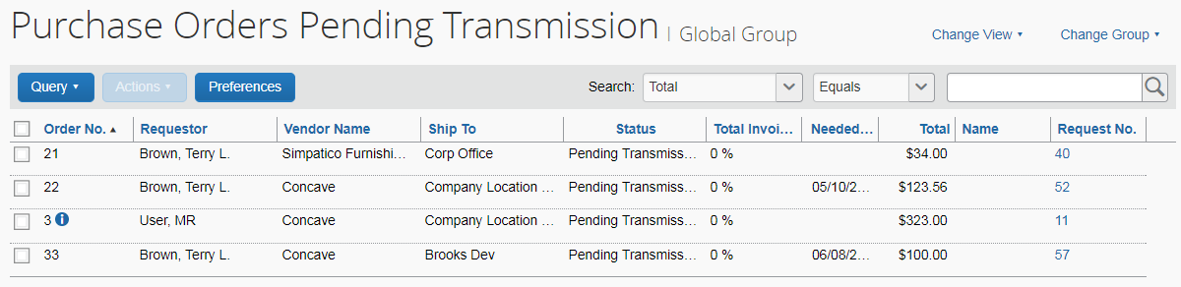

Purchase Order Configuration is Group-Aware
The PO configuration a PO Processor works with may be based on the Group the processor works in. This configuration may include region- or subsidiary-specific attributes, including supporting documents, logos, and email addresses.
- For more information, refer to the Using the Purchase Order Configuration Tool section in the Concur Invoice: Purchase Request and Purchase Order Setup Guide.

Review or Change a Vendor
To view or change a vendor:
- Double-click the desired purchase order. The Purchase Order window appears.
- In the Vendor section, click View Details or Edit depending on what you want to do.
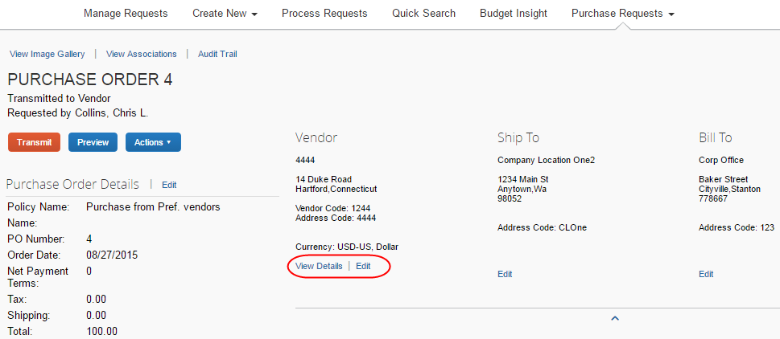

Change Ship-To or Bill-To Address
To change the ship-to or bill-to address:
- Double-click the desired purchase order. The Purchase Order window appears.
- In the Ship To or Bill To section, click Edit.
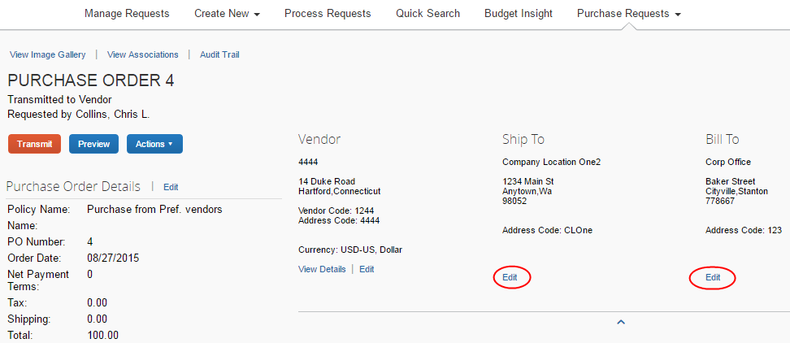
- In the Change Address window, select a different ship-to or bill-to address.
Change Address window (ship-to address):
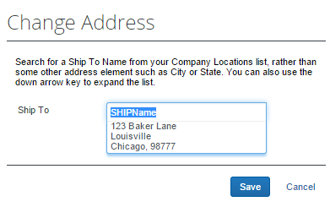
Change Address window (bill-to address):
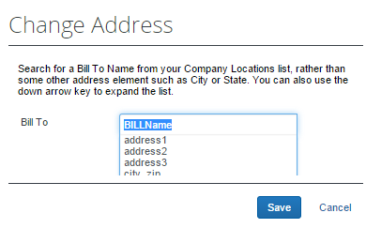
- Click Save.

Edit Purchase Order Details
PO processors can edit some of the details, for example, the description, need-by date, or shipping cost of the purchase order.
To edit purchase order details:
- Open the desired purchase order.
- Click Edit.
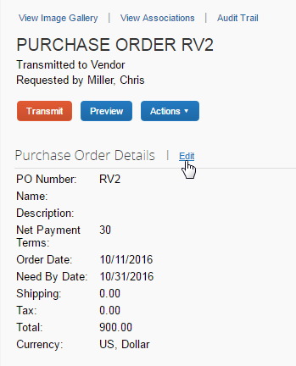
- In the Purchase Order Details window that appears, edit the fields and then click Save.
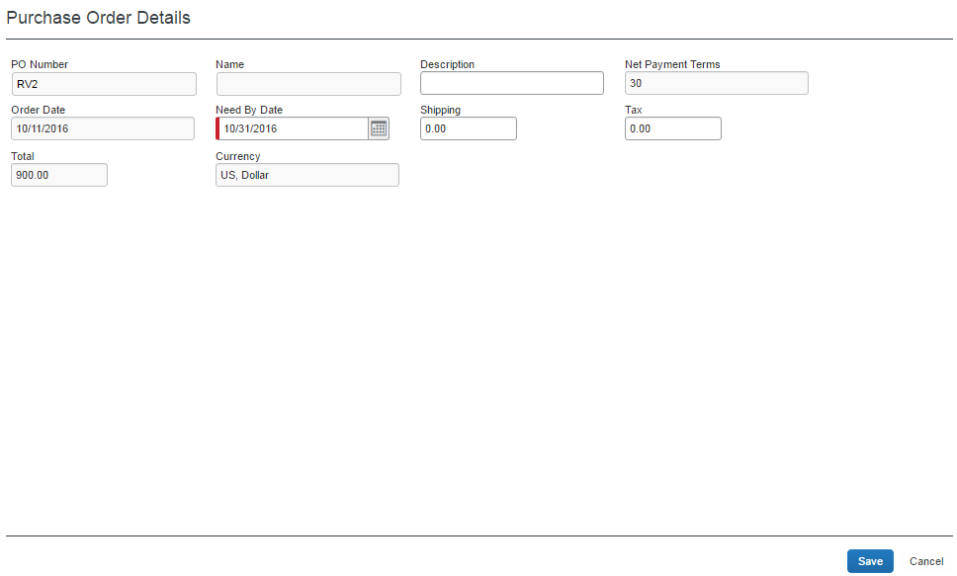

Upload, View, and Delete Images
The PO processors can upload, view and delete images of purchase orders.
To upload an image:
- Open the desired purchase order.
- On the Request page, click Actions > Upload Image.
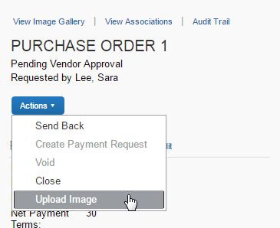
The Upload Image window appears.
- Click Browse and select the desired image by double-clicking it, or by selecting it and clicking Open.
- (Optional) Select (enable) the Include in PO Transmission check box.
- Click Upload.
- Click Close.

To view an image:
- On the Purchase Order page, click View Image Gallery.
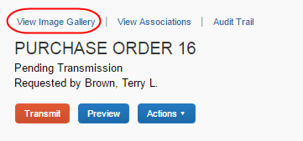
The Purchase Order Images window appears. If there are more than one image or supporting document, you can toggle between them by using the Next and Previous buttons.
You can also include supporting documents in the PO transmission from the Purchase Order Images window by selecting (enabling) the Include in PO Transmission check box.
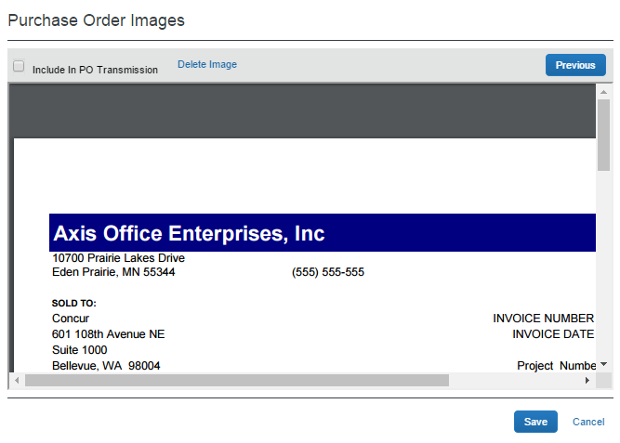
- Click Save or Cancel when you are done.
To delete an image:
- On the Purchase Order page, click View Image Gallery.
- In the Purchase Order Images window, click Delete Image.
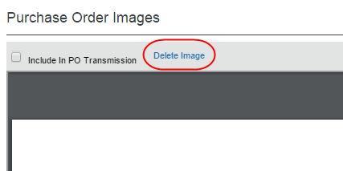
The Please Confirm window appears.
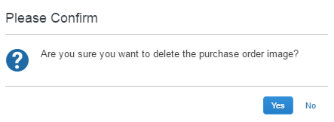
- Click Yes. Once you have deleted an image, the next image, if there is one, appears.

Send Back a Purchase Order
PO processors can send back a purchase order prior to transmittal to vendor to remove a purchase order from its workflow for the purpose of additional review, correction of the associated purchase request amount or cost object, or amend some additional items to the PR.
When a Send Back action is taken on the PO, the assigned PO number is voided, the purchase order is removed from the workflow, the original associated request item(s) are made read-only, and a new, duplicate PR is created with a status of Sent Back to Employee that includes the original items and allocations that were part of the now-retired PO. An indicator is also added to the new PR to show it was generated based on a now-invalid PR.
Finally, an email notification is generated and sent based on the purchase request email notification settings for the requestor. The following image shows a sample email body text.
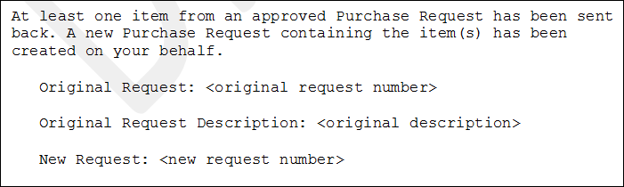
To send back a purchase order:
- On the Purchase Orders Pending Transmission page, select the purchase order you want to send back by clicking its check box.
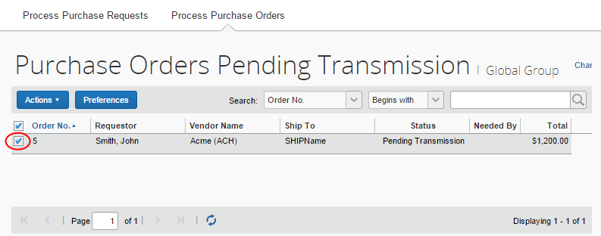
- On the Actions menu, click Send Back.
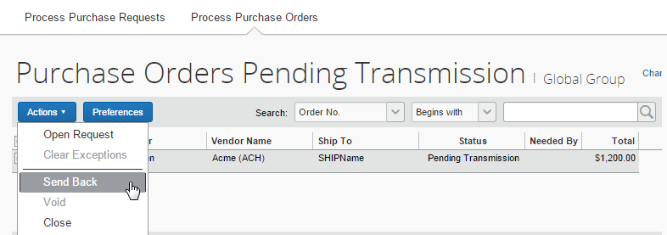
- In the Send Back Purchase Order window that appears, enter a comment about why you want to send back the purchase order, and then click OK.
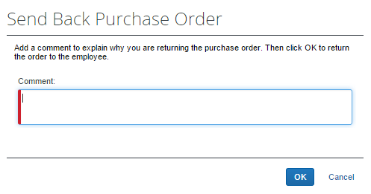

Create Invoices From Transmitted Purchase Orders
When PO processors view their list of purchase orders, they can create an invoice from a purchase order on this list. The option to create an invoice from the PO list is available only when the PO processor selects a single, transmitted PO that has not yet been closed.
This feature is useful when, for example, the supplier has sent a PO-based invoice, but not provided the purchase order number of that invoice.
The PO processor can create the invoice in the Actions menu on the All Orders page.
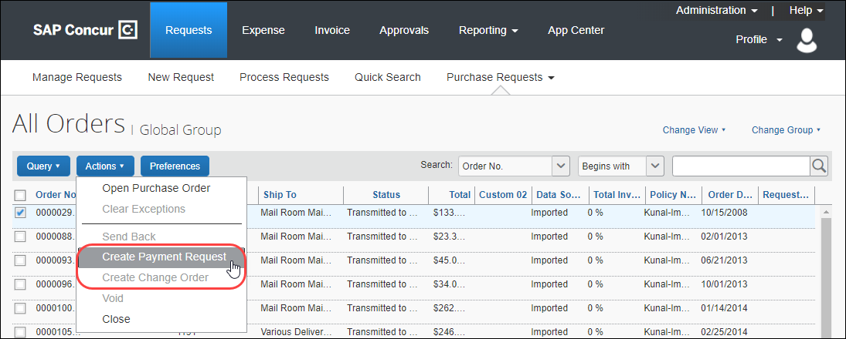

Void a Purchase Order
A PO processor may want to void a purchase order after transmittal to vendor if, for example, the order cannot be fulfilled due to a discontinued item, or if there are vendor issues or changes in the business environment that deems the PO invalid.
When a PO processor voids a purchase order, the system sets the PO to Voided and the purchase order is removed from the workflow. A record of the PO remains in the system, but the PO is not included in any listing or extract of general purchase orders. However, voided purchase orders can be included in search result lists by filtering the search where the status is equal to Voided.
Voiding the PO is a "housecleaning" measure used to ensure any associated invoices referencing this PO Number will be identified and handled appropriately.
Before the PO processor voids a purchase order, the system must first extract the PO.
To void a purchase order:
- On the All Orders page, select the purchase order you want to void by clicking its check box.
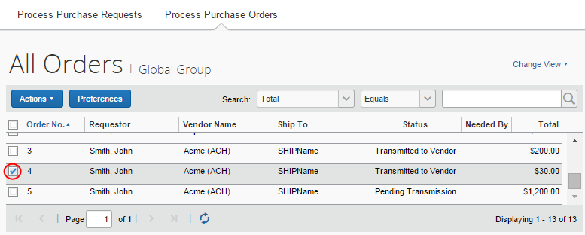
- On the Actions menu, click Void.
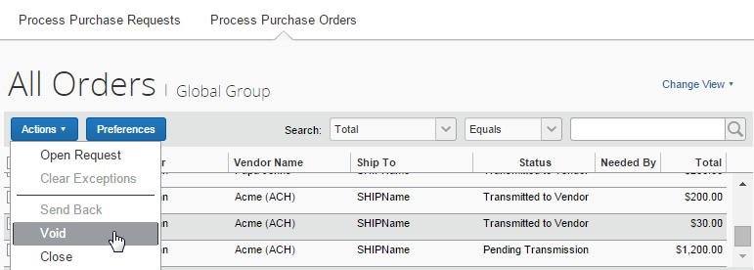
- In the Void Purchase Order window that appears, enter a comment about why you want to void the purchase order, and then click OK. The system updates the audit log and changes the status of the purchase order to Voided.
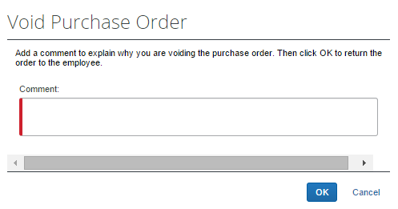

Close a Purchase Order
When a PO processor closes a purchase order after transmittal to vendor, the system removes the closed PO from the list of purchase orders pending actions. This helps the processor to manage their POs and their statuses more efficiently.
If the PO processor wants to search on closed POs, they can do so by selecting Status Equals Closed in the search area. The page will list all the closed POs.
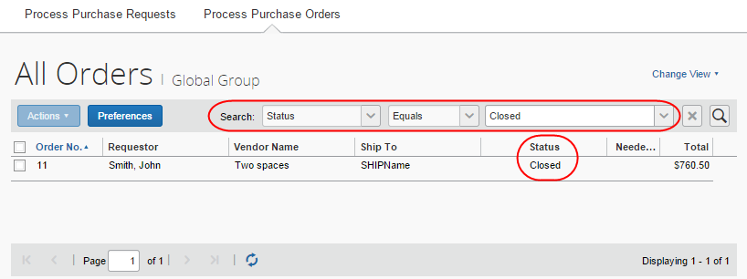
Please note that the PO processor cannot copy a request if it is associated with a closed PO.
If the client uses an external purchasing system, a standard PO import into Concur Invoice can update any PO with a Closed status.
To close a purchase order:
- On the All Orders page, select the purchase order you want to close by clicking its check box.
- On the Actions menu, click Close.
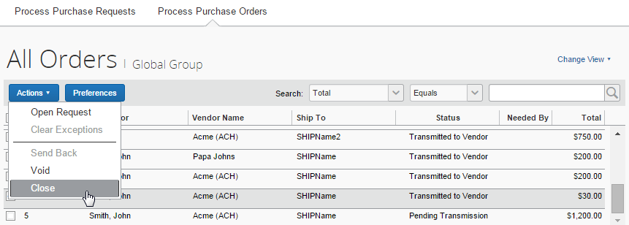
3. In the Close Purchase Order window that appears, enter a comment about why you want to close the purchase order, and then click OK. When the PO processor has closed the PO, it will no longer appear in the list of that page.
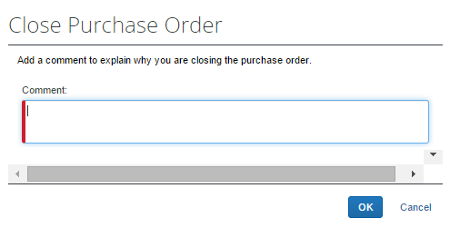
In addition, a closed PO will not be available in the list of active POs for matching invoices.

Reopen a Closed Purchase Order
Users with the Purchase Order Processor role can reopen closed purchase orders. This is useful when a PO has been incorrectly closed and needs to be reopened and processed correctly.
To reopen a closed purchase order:
- On the Closed purchase orders page or in an opened purchase order, in the Actions menu, select Reopen.
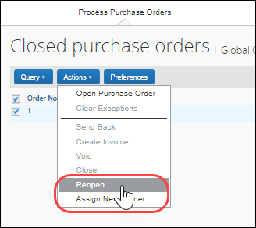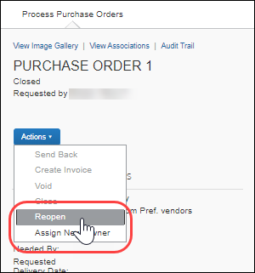
The Reopen Purchase Order window appears.
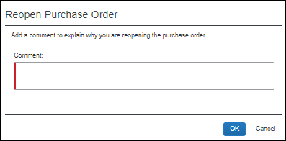
- In the Comments field, enter a comment and then click OK. The PO is reopened with the status it was in when it was closed. For example, if the status of the PO was Transmitted to Vendor when the PO was closed, the PO will be reopened with a status of Transmitted to Vendor.
The status changes are included in the audit trail for the PO.
INCLUDEPICTURE "C:\\..\\AppData\\Local\\Temp\\SNAGHTML19edd62.PNG" \* MERGEFORMATINET INCLUDEPICTURE "C:\\Users\\i866670\\AppData\\Local\\Temp\\SNAGHTML19edd62.PNG" \* MERGEFORMATINET INCLUDEPICTURE "C:\\Users\\i866670\\AppData\\Local\\Temp\\SNAGHTML19edd62.PNG" \* MERGEFORMATINET INCLUDEPICTURE "C:\\Users\\i866670\\AppData\\Local\\Temp\\SNAGHTML19edd62.PNG" \* MERGEFORMATINET INCLUDEPICTURE "C:\\Users\\i866670\\AppData\\Local\\Temp\\SNAGHTML19edd62.PNG" \* MERGEFORMATINET INCLUDEPICTURE "C:\\..\\AppData\\Local\\Temp\\SNAGHTML19edd62.PNG" \* MERGEFORMATINET INCLUDEPICTURE "C:\\Users\\i866670\\AppData\\Local\\Temp\\SNAGHTML19edd62.PNG" \* MERGEFORMATINET INCLUDEPICTURE "C:\\Users\\i866670\\AppData\\Local\\Temp\\SNAGHTML19edd62.PNG" \* MERGEFORMATINET INCLUDEPICTURE "C:\\Users\\i866670\\AppData\\Local\\Temp\\SNAGHTML19edd62.PNG" \* MERGEFORMATINET INCLUDEPICTURE "C:\\Users\\i866670\\AppData\\Local\\Temp\\SNAGHTML19edd62.PNG" \* MERGEFORMATINET INCLUDEPICTURE "C:\\Users\\i866670\\AppData\\Local\\Temp\\SNAGHTML19edd62.PNG" \* MERGEFORMATINET INCLUDEPICTURE "C:\\Users\\i866670\\AppData\\Local\\Temp\\SNAGHTML19edd62.PNG" \* MERGEFORMATINET INCLUDEPICTURE "C:\\Users\\i866670\\AppData\\Local\\Temp\\SNAGHTML19edd62.PNG" \* MERGEFORMATINET INCLUDEPICTURE "C:\\Users\\i866670\\AppData\\Local\\Temp\\SNAGHTML19edd62.PNG" \* MERGEFORMATINET INCLUDEPICTURE "C:\\..\\..\\..\\AppData\\Local\\Temp\\SNAGHTML19edd62.PNG" \* MERGEFORMATINET INCLUDEPICTURE "C:\\..\\..\\..\\AppData\\Local\\Temp\\SNAGHTML19edd62.PNG" \* MERGEFORMATINET INCLUDEPICTURE "C:\\..\\AppData\\Local\\Temp\\SNAGHTML19edd62.PNG" \* MERGEFORMATINET INCLUDEPICTURE "C:\\..\\..\\..\\..\\AppData\\Local\\Temp\\SNAGHTML19edd62.PNG" \* MERGEFORMATINET 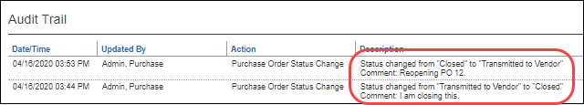

View Associated Images to the Purchase Order
To view associated images to the purchase order, click View Image.
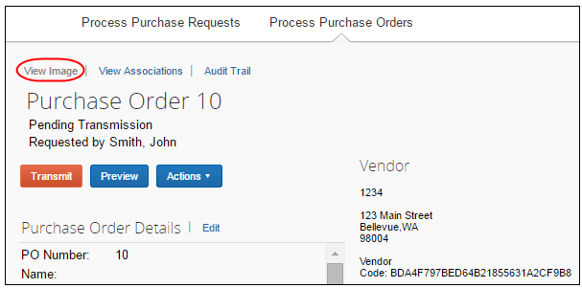

Search for a Purchase Order
PO processors can search for purchase orders that are pending transmission or all purchase orders in the search area by selecting different search criteria, such as Requestor Last Name, Total, or Vendor Name.
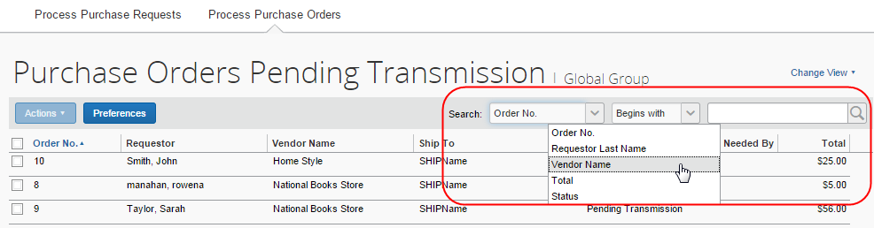

Change View Search Option
PO processors can also use the Change View menu to display purchase orders or change orders pending transmission or purchase orders pending vendor approval. By changing the view, the result appears on the page.
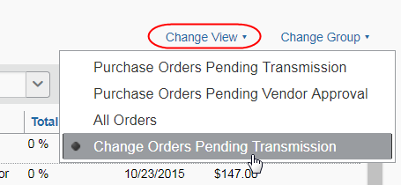

View Original Payment or Purchase Request Associated With a PO
To view the original payment or purchase request associated with a specific purchase order, click View Associations.
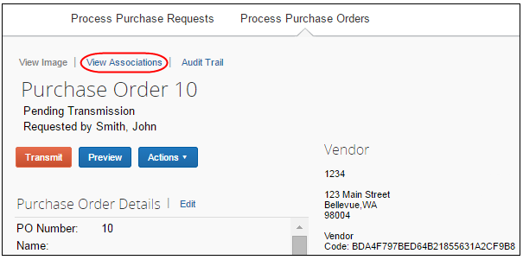
The Purchase Order Associations window appears with information about the associated payment and purchase order requests of the purchase order.
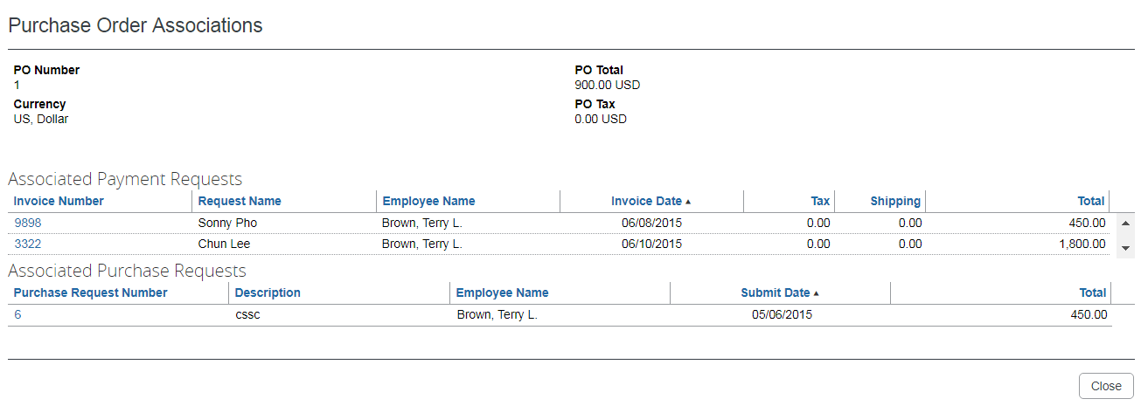
Depending on your user permission role, you might be able to click on the associated invoice and/or purchase request number to see the related record.

Approval Flow Available to View Within Purchase Order
The PO processor can double-click the purchase request in the Purchase Order Association window to view the approval flow of a purchase request within a purchase order.
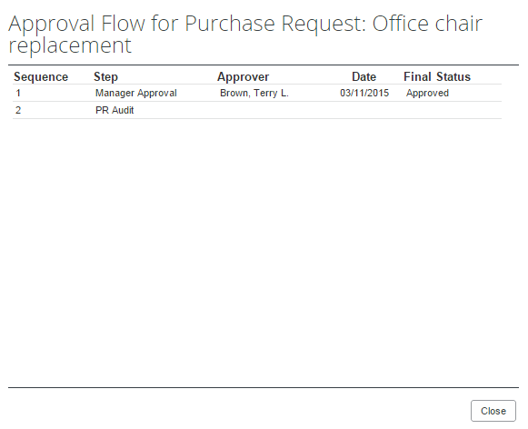

Create Invoices From Transmitted Purchase Orders.
When PO processors view their list of purchase orders, they can create an invoice from a purchase order on this list. The option to create an invoice from the PO list is available only when the PO processor selects a single, transmitted PO that has not yet been closed.
This feature is useful when, for example, the supplier has sent a PO-based invoice, but not provided the purchase order number of that invoice.
The PO processor can create the invoice in the Actions menu on the All Orders page or on the Purchase Order page.
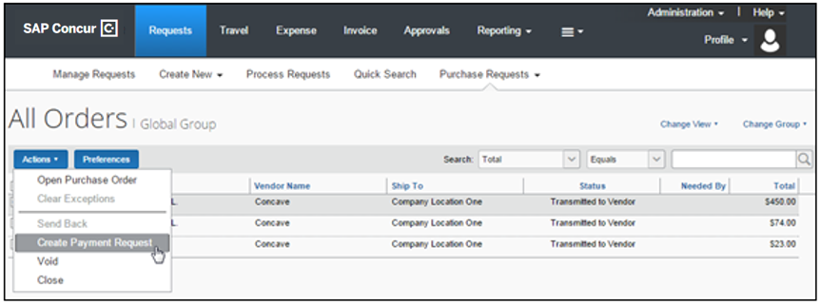

Review the Audit Trail
To review the audit trail, click Audit Trail.
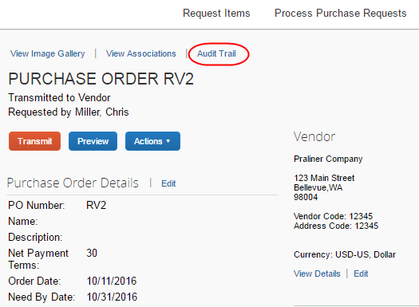
The Audit Trail window appears with information about actions that the PO processor has taken on the specific purchase order.
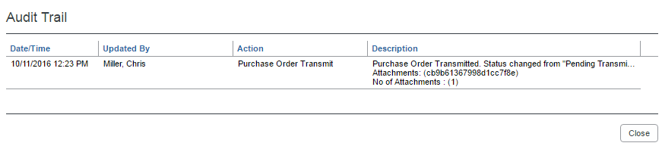
All users who have access to a PO change order transaction will be able to view the audit trail history of the PO Change Order.
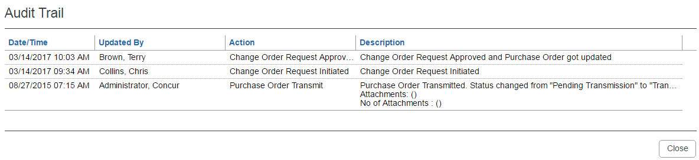

Filter the Approver and Processor Views
The approver and processor roles can draw on role-specific search criteria that lets them return a request set matching the type of requests they are working with. For example, the approver shares the processor Requestor Last Name and Total search criteria but lacks the Vendor Name search criteria reserved for the PO processor. Similarly, the PO processor can draw on Order No. but cannot use the Request No. criteria.
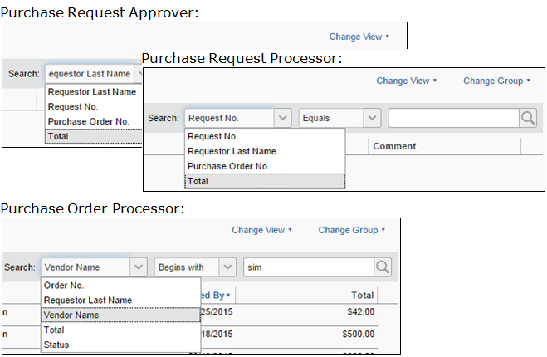
In use, the search is performed like any other in Concur Invoice. The PO processor options are shown in the example below, where the Vendor Name search criteria is selected for a match to any vendor beginning with "Sim."
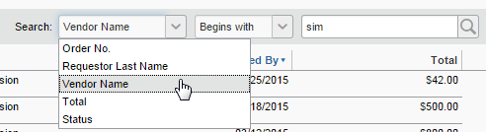

Additional Search Options
Depending on which role they have, users can use a Change View menu to view requests in various states. The PO processor selection are shown in the following figure.
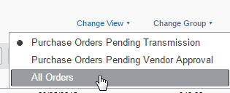
Each role has a different View set, based on the requests they work with. In addition, both Processor roles can elect to filter by the group they want to work with.
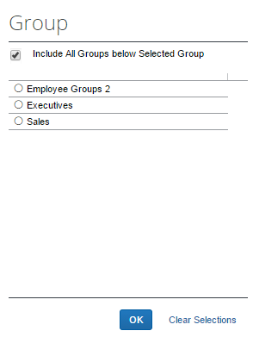

Preview a Purchase Order
The PO processor has a unique view of the overall PR to PO creation by being able to view a PDF of the purchase order, as it will appear to the vendor on receipt via email. This view allows the PO processor to verify information in a single view, including address, email, and comments to the vendor.
In addition, PO processors can view all documents that are associated with a specific purchase order, which gives them an overview of all documents that they transmit to a vendor.
This includes documents uploaded by:
- Administrators who configure purchase orders in PO Configuration
- Users who create purchase requests and select the Include in PO Transmission option
- Approvers who approve purchase requests and select the Include in PO Transmission option
- PO processors who process purchase requests and select the Include in PO Transmission option
To preview a purchase order in PDF format:
- On the All Orders page, double-click the purchase order that you want to view.
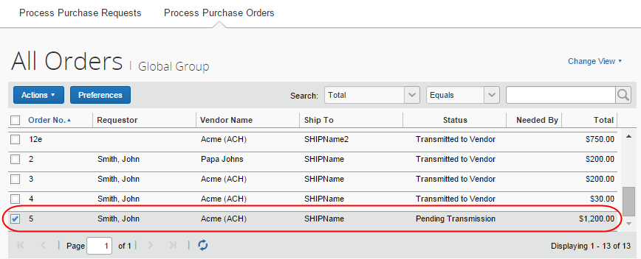
- Click Preview.
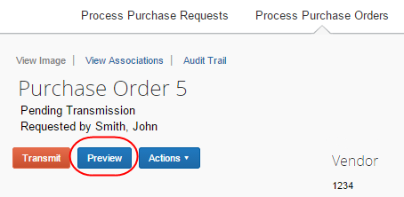
The Preview Purchase Order window appears.
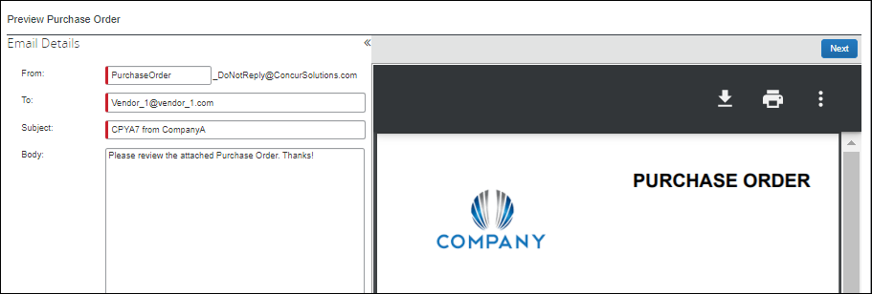
The PO processor can correct selected items in the Preview Purchase Order window, and add one or more additional email addresses as needed. If multiple email addresses exist, vendors will see all other contacts who received the email by looking at the To line of their email. This helps prevent multiple vendor contacts from fulfilling the same purchase order.
To change default text (Body text, address, Instructions, etc.) the Invoice Configuration administrator uses the Purchase Order Configuration tool (Administration > Invoice > Purchase Order Configuration). To change any PO data presented in the PDF, the PO Processor opens the actual PO and edits the fields.
The processor can also email the PO from this window by clicking Transmit.
The processor can change the prefix for the From address but cannot change the suffix of the address from "_DoNotReply@ConcurSolutions.com".
- For more information about the Purchase Order Configuration tool, refer to the Using the Purchase Order Configuration Tool section in this document.

Tip: Combined Processor Roles for a Single Back-Office Processor
If a company uses a single employee or set of employees to fulfill both the PR and PO Processor roles, they are best served to focus their review tasks within one processor "view", reserving the second processor tasks to simply bulk selecting and approving. For example, the PR processor can review all aspects, while the PO processor simply selects one or more POs and approves for transmission.

Preview a PO Change Order
Once a PO change order has gone through the workflow and has been fully approved, the PO processor will be able to open the Preview Purchase Order window view information about the revision number and revision date of the last revision, new line items, and updated amount of the PO change order.
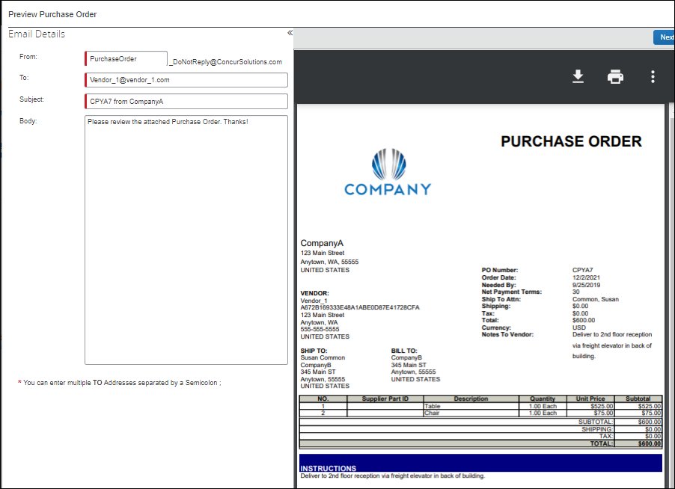
The PO processor can also view a Change Order Revision section of the purchase order PDF with revision information.
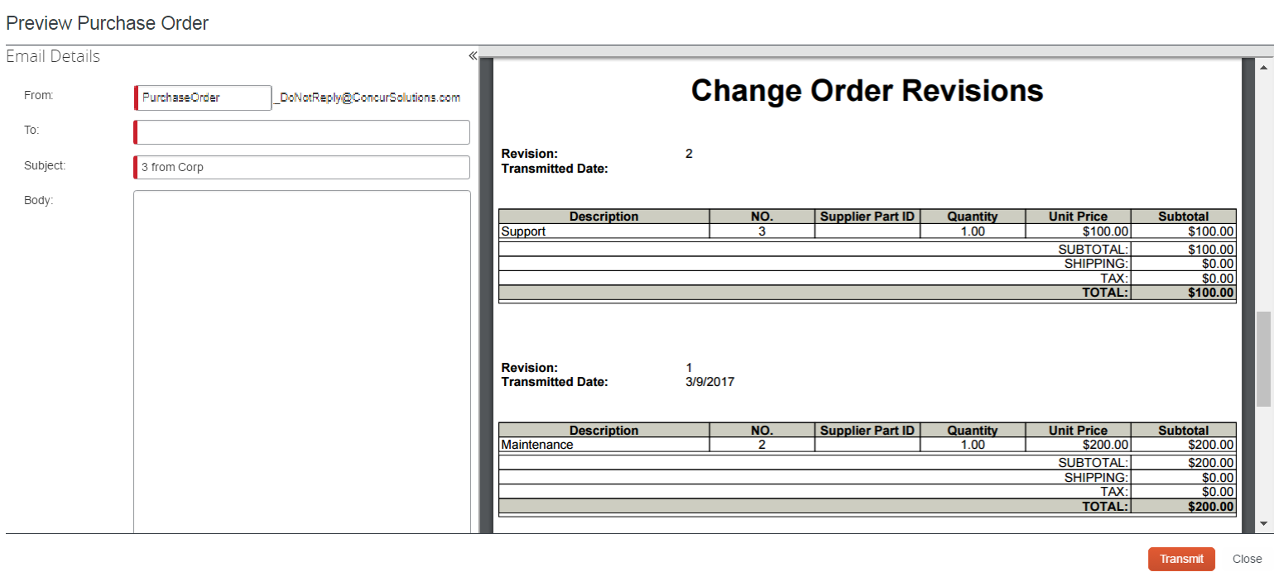

View PO Amount That Has Been Invoiced
PO Processor can see how much of the purchase order amount that has been invoiced. To do so, the PO Processor may create a query that defines if a purchase order has been fully or partially invoiced, or not invoiced at all. This information is important and lets the PO Processor take necessary actions, such as closing the purchase order, or contact the vendor regarding the outstanding invoices.
The query will be based on approved invoices.
In the example below, the system will query for purchase orders where 90 percent or more of the PO amount have been invoiced.
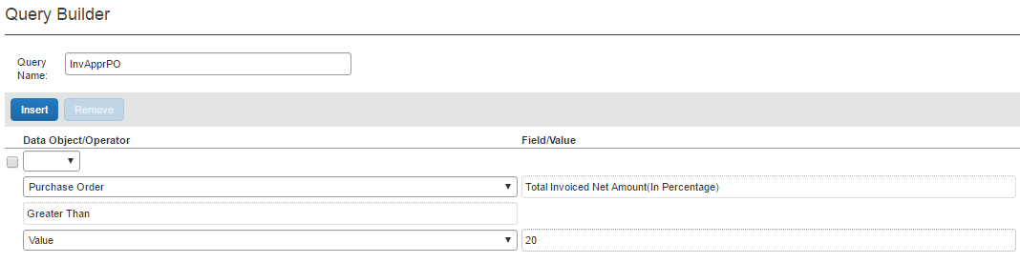
By clicking the Preferences button, the PO Processor can add the new column, Total Invoiced Net Amount (in Percentage) to the Purchase Orders page.
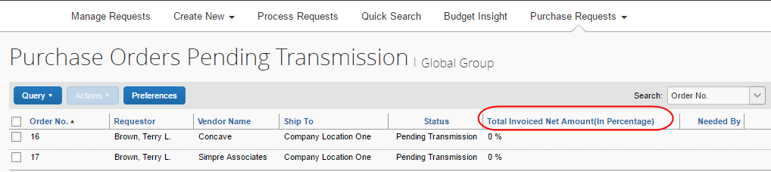
This feature is available to Purchase Request Users if they have access to transmitting or editing their own POs; settings that admins can activate in Invoice Settings.

Transmit Purchase Order to the Vendor
To transmit a purchase order to the vendor, click Transmit.
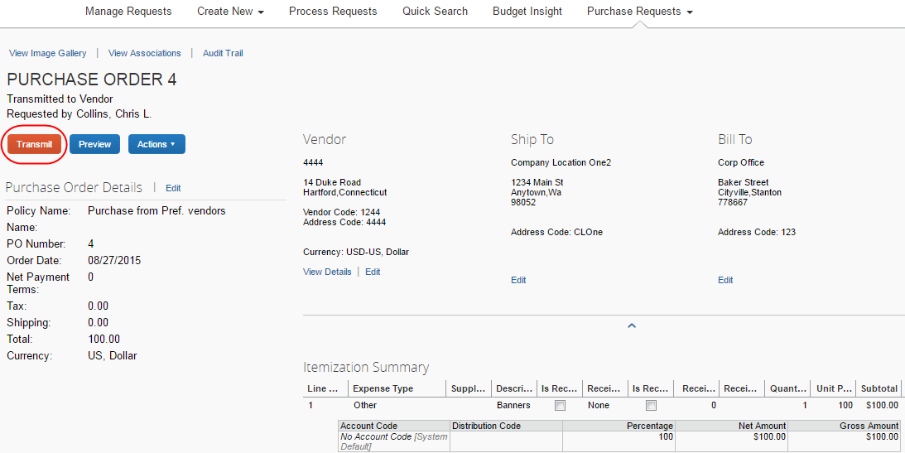

Retransmitting Purchase Orders
Users can transmit a purchase order multiple times. However, sometimes a user might transmit a purchase order inadvertently, and, to prevent this from happening, users who retransmit a purchase order will now see a confirmation window asking them if they want to retransmit the purchase order.

Automatically Transmit Purchase Orders
The administrator may enable (select) an option in Workflows, which removes a workflow step in the purchase order process. In this case, Concur Invoice will transmit purchase orders from the approved purchase request directly to the supplier.
If the purchase request contains incorrect data, such as an incorrect vendor email address, Invoice will not transmit the purchase request automatically, but instead it will require manual PO processing.
- For more information, refer to the Concur Invoice: Purchase Request and Purchase Order Setup Guide.

Transmit a Change Order
When the purchase request processor has approved the purchase request, the PO processor will be able to see an updated purchase order with a Pending Transmission status in the processor view. They will also be able to tell that the purchase order is a change order by the icon that is visible by the order number. The PO processor can filter the view to only see the change orders in the Change View menu.
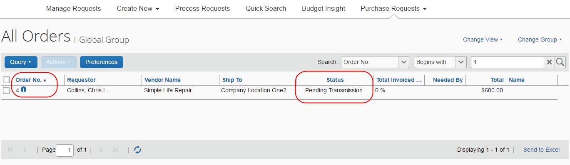
The PO processor can open the purchase order to see the newly added line item(s) and a notification that the purchase order has changed.
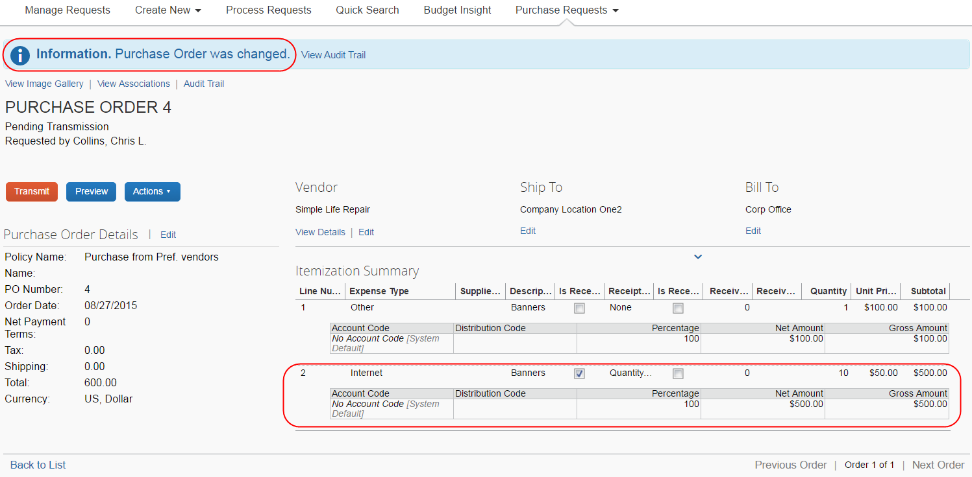
When the PO processor has reviewed the updates of the purchase order, they click Transmit. Once the purchase order has been transmitted, all the icons disappear that are associated with that specific purchase order.
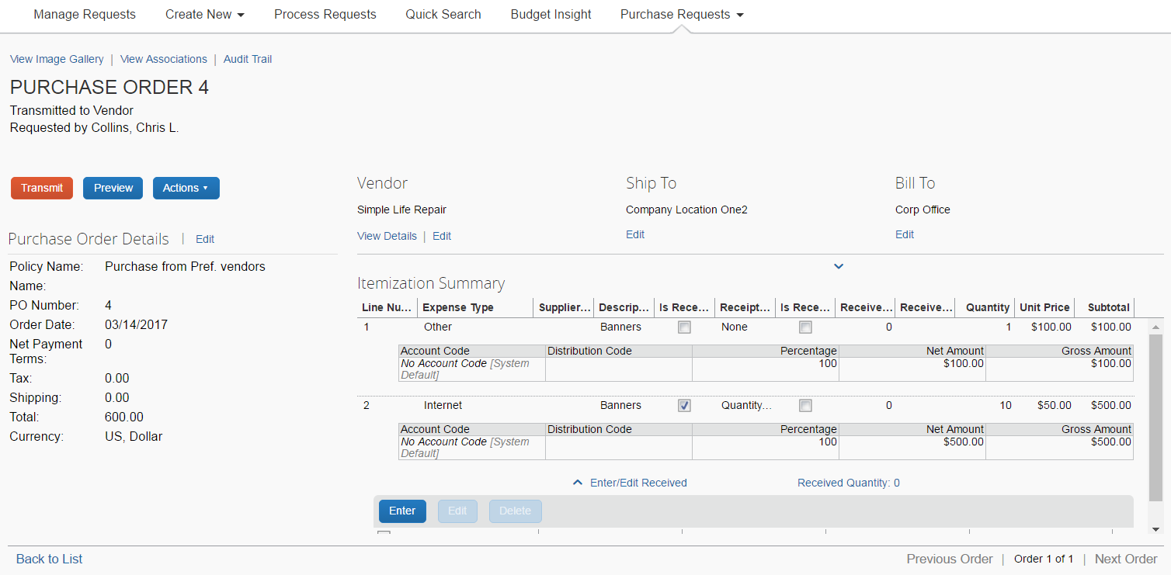

Manage Receipts and Receipt Images
PO Processors, who work with the Receiving feature, can add, edit, delete receipts and receipt images of the transmitted purchase order.
If a receipt is associated with an invoice, a user will not be able to edit or delete the receipt and the Edit and Delete buttons will be disabled. If a user needs to make changes to an invoice, they need to first unassociated the receipt to the invoice.
- For more information, refer to the Concur Receiving section of the Concur Invoice: Purchase Order Matching User Guide.

Create and Manage Queries
The PR and PO Processor can use the Query Builder to create new search queries and manage existing queries. The queries are if/then conditional statements. When the defined conditions are met, the purchase request is displayed to the PR Processor and the purchase order is displayed to the PO Processor when the query is run.
Queries you create by using Query Builder are your own and no one else can view, edit, delete, or use your queries. This means that, excepting default queries, you cannot share newly created queries as global queries.

Understand Conditional Expressions
When creating or editing conditional expressions, the PR or PO Processor should consider the following:
- There is no limit to the number of conditions that comprise a total expression. The conditional expression for "Office Max purchases, SJohnson" is:
(Vendor equals Office Max) and (Employee Last Name equals Johnson)
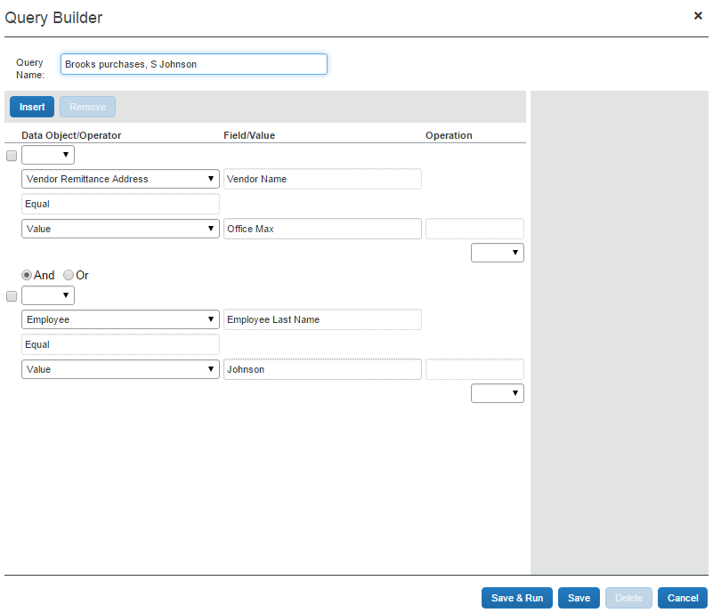
- Most conditions are comprised of a Field then an Operator then a Value. For example:
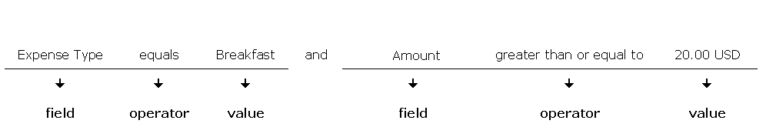
- A Field consists of a data object, which is essentially a database table, and a field, which is essentially a database column, located within the data object. The field that is selected defines the data type of the condition (number, text, date, etc.).
If a second condition is created, the field's data type must match that of the first field.
- An Operator is one of several pre-defined comparison operators (equals, not equals, is greater than, etc.). The list of operators will change depending on the type of data being compared.
- A Value is a constant, and like the field, can be of any data type; however, the data type of the value must match the data type of the field.
- When a conditional expression is composed of multiple conditions, each condition is separated by either And or Or.
- Parentheses are optional and are used to define order of operation for the And/Or operators. If the parentheses are omitted, And/Or operations are carried out left to right. There is no precedence of And over Or, the evaluation of the expression is simply left to right.
- If a conditional expression contains parentheses, the count of left parentheses must match the count of right parentheses. There can be up to three parentheses for both left and right sides.
Example of correct placement of parentheses and total left/right count:
(Condition 1) and (Condition 2)
Examples of incorrect parentheses even though the total left/right count matches:
Condition1) And (Condition2
Condition1) And (Condition2) Or (Condition3
(Condition1)) And (Condition2
Simple Condition Example
A condition is a simple Boolean comparison, like:
Purchase Request Is Greater Than 1000
The condition looks at the request total. If the request total is greater than 1000, then the system flags the request with an exception that appears to the PR or PO Processor. If the request does not exceed the conditions, the system does not display an exception.
Complex Condition Example
The conditional expression can be a single condition as in the above example, or it can be a complex expression involving multiple conditions connected by And/Or operators and parentheses, such as the following example that contains four conditions:
Request Total Is Greater Than 1000 and Request Approval Status is Equal to Pending Approval

The Query Builder and the Condition Editor
The Query Builder window in PR Processor and PO Processor are very similar to the Condition page within several of the other features in the Invoice Configuration administrator. The following is a sample of the Query Builder window, including the Condition Editor.
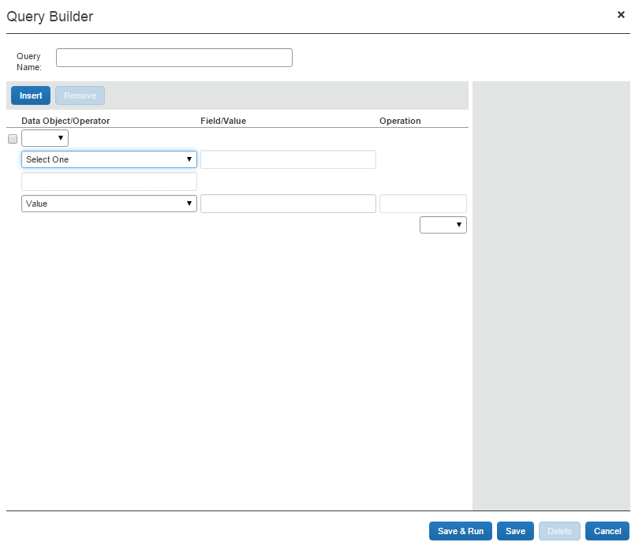
Each condition appears on two lines within the Query Builder window. The tables below provide a description of the Query Builder windows.
Field | Description
Left Parenthesis | Select zero to three parentheses, depending on the complexity of the condition.
Data Object | Select one of the following in the Query Builder window (for PR Processors):  Employee: To create an employee-based condition  Purchase Request: To create a request entry-based condition  Purchase Request Distribution: To create a distribution-based condition  Purchase Request Item: To create an item-based condition  Vendor Remittance Address: To create a vendor remittance-based condition  Select one of the following in the Condition Builder window (for PO Processors):  Bill To: To create an employee-based condition  Employee: To create a bill to-based condition  Purchase Order: To create a purchase order entry-based condition  Purchase Order Distribution: To create a distribution-based condition  Purchase Order Item: To create an item-based condition  Ship To: To create a ship to-based condition  Vendor Remittance Address: To create a vendor remittance-based condition
Field | Select an item from the helper pane that appears. The information that appears within this pane is based upon the selection within the Data Object list.
Operator | Select an item from the helper pane that appears. The information that appears within this pane is based upon previous choices.
Value | Select an item from the helper pane that appears. The information that appears within this pane is based upon the selection within the Data Object list.
Data Object | This field will always display as Value and you cannot change this.
Field | Select an item from the helper pane that appears. The information that appears within this pane is based upon the selection within the Data Object list.
Value | Select an item from the helper pane that appears. The information that appears within this pane is based upon the selection within the Data Object list.
Right Parenthesis | Select zero to three parentheses, depending on the complexity of the condition.
And/Or | Select either option to join the current condition to the next condition. Note: Appears only where two or more conditions are referenced.
The following table shows the options that appear for the Field/Value field, based on the selection made in the Data Object list for the PR Processor.
Selection from the Data Object list | Choices Displayed for Field/Value
Employee | - Active  - Choose Vendor Access Group  - Country of Residence  - Custom 01-07
Purchase Request | - Amount without VAT  - Approval Status  - Currency  - Custom 01-24  - Description  - First Submit Date  - Group  - Has Unapproved Vendor Address  - Image Available  - Is Exception Approved  - Is Limit Approved  - Notes to Supplier  - Org Unit 1-Org Unit 6  - Policy Name  - Provincial Tax Identification Number  - Shipping  - Submit Date  - Tax  - Total  - VAT Amount One  - VAT Amount Two  - VAT Rate One  - VAT Rate Two  - Vendor Tax Identification Number
Purchase Request Distribution | - Custom 01-20  - Percentage
Purchase Request Item | - Amount without VAT  - Currency  - Custom 01-20  - Description  - Discount Percentage  - Discount Terms  - Expense Type  - Item Number  - Needed By  - Net Payment Terms  - Policy  - Purchase Type  - Quantity  - Shipping  - Shipping Method  - Shipping Terms  - Tax  - Total  - Unit Price  - Unit of Measure  - VAT Amount  - VAT Rate
Vendor Remittance Address | - Account Number  - Address 1  - Address 2  - Address 3  - Address Accounting Code  - City  - Contact Email  - Contact First Name  - Contact Last Name  - Country  - Currency  - Custom 02-20  - Discount Percentage  - Discount Terms  - Image Avail  - Image Received  - Is Approved  - Net Payment Terms  - PO Contact Email  - PO Contact First Name  - PO Contact Last Name  - PO Contact Phone Number  - Postal Code  - Preferred Vendor  - Provincial Tax Identification Number  - Shipping Method  - Shipping Terms  - State or Province  - Tax ID  - Tax Type  - Telephone Number  - Vendor Code  - Vendor Name
The following table shows the options that appear for the Field/Value field, based on the selection made in the Data Object list for the PO Processor.
Selection from the Data Object list | Choices Displayed for Field/Value
Bill To | - Address 1  - Address 2  - Address 3  - Address Accounting Code  - Address Identifier  - City  - Country  - Postal Code  - State or Province
Employee | - Active  - Choose Vendor Access Group  - Country of Residence  - Custom 01-22  - Email Address  - Employee First Name  - Employee ID  - Employee Last Name  - Is a Test User?  - Ledger  - Locale  - Logon ID  - Middle Initial  - Number of Requests Pending for Employee  - Org Unit 1-Org Unit 6  - Password Changed Date  - Reimbursement Currency  - State/Province  - Sum o Totals for Requests Pending for Employees
Purchase Order | - Amount without VAT  - Authorized By  - Buyer Contact  - Creation Date  - Currency  - Custom 01-24  - Description  - Discount Percentage  - Discount Terms  - First Order Date  - Group  - Is Line Item Tax  - Is Test  - Name  - Needed By  - Net Payment Terms  - Notes To Supplier  - Order Date  - PO Number  - Policy Name  - Provincial Tax Identification Number  - Receipt Type  - Requested By  - Requested Delivery Date  - Ship To Attn  - Shipping  - Shipping Description  - Shipping Method  - Shipping Terms  - Status  - Tax  - Total  - VAT Amount One  - VAT Amount Two  - VAT Rate One  - VAT Rate Two  - Vendor Account Number  - Vendor Tax Id  - Vendor Tax Identification Number
Purchase Order Distribution | - Custom 01-20  - Is Hidden  - Percentage
Purchase Order Line Item | - Account Code  - Amount without VAT  - Creation Date  - Custom 01-20  - Description  - Expense Type  - External ID  - Line Number  - Notes To Vendor  - Quantity  - Requested By  - Requested Delivery Date  - Supplier Part ID  - Tax  - Total  - Unit Price  - Unit of Measure  - VAT Amount  - VAT Rate
Ship To | - Address 1  - Address 2  - Address 3  - Address Accounting Code  - Address Identifier  - City  - Country  - Postal Code  - State or Province
Vendor Remittance Address | - Account Number  - Address 1  - Address 2  - Address 3  - Address Accounting Code  - City  - Contact Email  - Contact First Name  - Contact Last Name  - Country  - Currency  - Custom 02-20  - Discount Percentage  - Discount Terms  - Image Avail  - Image Received  - Is Approved  - Net Payment Terms  - PO Contact Email  - PO Contact First Name  - PO Contact Last Name  - PO Contact Phone Number  - Postal Code  - Preferred Vendor  - Provincial Tax Identification Number  - Shipping Method  - Shipping Terms  - State or Province  - Tax ID  - Tax Type  - Telephone Number  - Vendor Code  - Vendor Name

Determine How to Create a Query
When creating or editing a query, the PR or PO Processor defines the conditional expression(s)—the if section of the query. The expression can contain one or more conditions separated by And or Or.
PR Processor Example
Assume the PR Processor wants to locate all purchase requests submitted by one employee. The condition for the employee-related query of "Review all of Terry Brown's payments" is:
(Employee First Name equals Terry) and (Employee Last Name equals Brown)
The Query Builder window displays as shown in the following image.
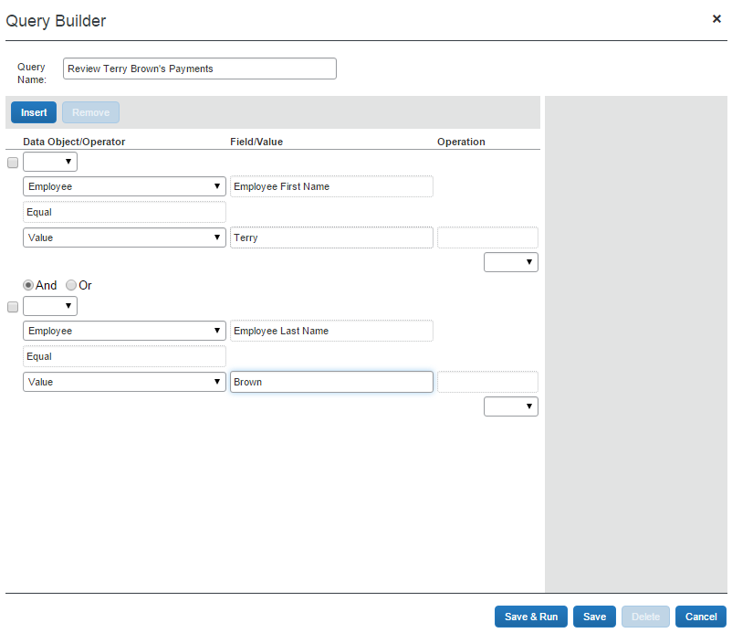
In each case, And is used between the two conditions, so both of the conditions must be met in order to locate the invoice.
- For more information about conditional expressions and the feature used for creating and editing conditional expressions, refer to the Understanding Conditional Expressions section in this chapter.

Access the Query Builder
You can use the Query Builder to create new search queries and manage existing queries. PR Processors access the Query Builder by clicking Requests > Purchase Requests > Process Purchase Requests. PO Processors access the Query Builder by clicking Requests > Purchase Requests > Process Purchase Orders.
The queries created within this area are specific to each PR or PO Processor; they are not global. Therefore, each PR or PO Processor will create and manage their own queries.

Create New Queries in PR and PO Processor
As a PR Processor, you can create a new query from the Processor Query page, and as a PO Processor, you can create a new query from the Purchase Orders Pending Transmission page. You may run queries against the group or groups of employees for whom you have administrative rights.
Queries you create are your own and no one else can view, edit, delete, or use these. This means that you cannot share newly created queries as global queries.
To create a new query:
- In the Query menu, click New Query. The Query Builder appears.
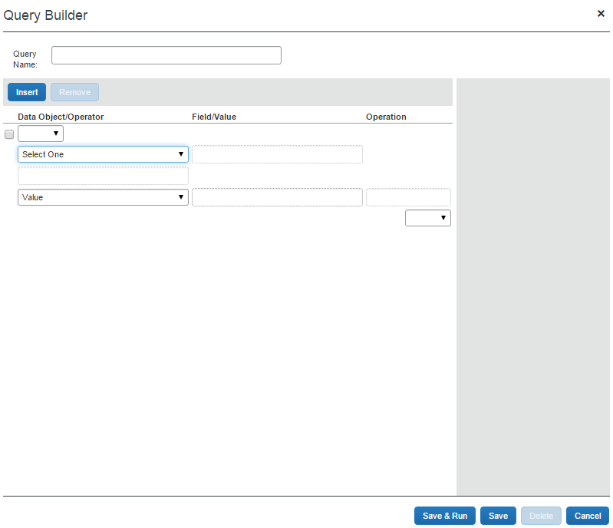
- Complete the following:
Field | Description
Query Name | Enter a name for the query. Once the query is saved, it will appear in the Query menu to be run.
Condition | Select the appropriate information from within the Condition Editor.
+ Button | Click to add conditions to the Condition Editor. The system always adds rows to the bottom of all currently existing rows. There is no limit to the number of rows that you can add.
- Button | Click the – button in the row that you want to delete. The condition is deleted. This is permanent; therefore, if you delete a condition in error, you will have to recreate it in its entirety.
- Click Save. You can find the query listed in the Query menu from where you can run the query.

Edit Queries in PR and PO Processor
You can edit all available queries from the Query menu.
Queries may only be edited by the by the Processor who created them.
To edit queries in PR processor:
- In the Query menu, click Edit Saved Query, and then click on the query that you want to edit.
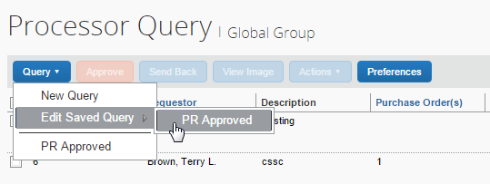
The Query Builder window appears.
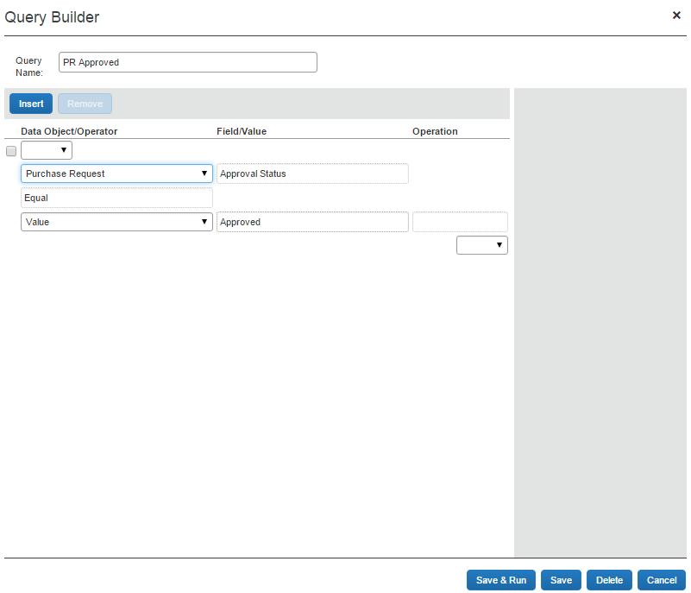
- In the Query Builder, edit the condition information by adding or deleting a condition row.
- Click Save once your changes are complete.

Delete Queries in PR and PO Processor
You can delete all queries from the Query Builder window. This deletion is permanent. Therefore, if you delete a query in error, it must be recreated in its entirety.
The Processor that created the queries is the only one who can delete the queries.
To delete a query in PR processor:
- In the Query Builder, open the query that you want to delete.
- Click Delete. A confirmation window appears.
- Click Yes. The system has deleted the query and it no longer appears in the Query menu.

Export Query Results in PR and PO Processor
You can export your query results into an Excel-based data template. This allows you to open Excel and load the results of your query for use in application.
To export the results of your query:
- Run the query for the results you are seeking.
- Click Send to Excel in the lower-right corner of the page.
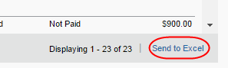
The data is loaded and automatically appears in Excel with each column representing a field within the purchase order.

Configure Column and Fields Set View
The approver and processor working with either purchase orders or purchase requests can arrange the column view to include and exclude fields and arrange the sequence in the order they want.

Add, Delete, and Move Columns
First, click Preferences to open the Preferences window, and then select or clear the check boxes next to those fields you want to add or remove:
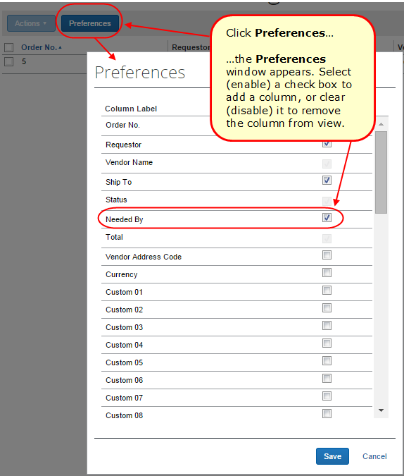

Rearrange the Columns
A simple drag-and-drop action lets you grab the column heading, and then move it to a new location in the list view.




