
Concur Invoice: Image Handling – Process Images
User Guide

Last Revised: April 13, 2019
Applies to these SAP Concur solutions:
 Concur Expense
 Professional/Premium edition
 Standard edition
 Concur Travel
 Professional/Premium edition
 Standard edition
 Concur Invoice
 Professional/Premium edition
 Standard edition
 Concur Request
 Professional/Premium edition
 Standard edition

Table of Contents
Section 1: Permissions 1
Section 2: Overview 1
Associate Images with an Invoice 1
Upload Images for an Invoice 1
Available Actions 2
Section 3: Required Roles 3
Section 4: Managing Invoice Images 4
Access the Process Images Tool 4
Scan an Invoice Image 4
Upload and Attach Images to an Invoice 7
View Images for an Invoice 10
Set Images Received 12

Revision History
Date | Notes/Comments/Changes
October 31, 2022 | Minor edits; cover date not updated
January 21, 2022 | Updated the copyright year; no other changes; cover date not updated
March 4, 2021 | Updated the copyright year; no other changes; cover date not updated
April 20, 2020 | Renamed the Authorization Request check box to Request on the guide’s title page; cover date not updated
January 7, 2020 | Updated the copyright; no other changes; cover date not updated
April 13, 2019 | Updated images and changed the term "request" to "invoice" where applicable as part of the new user experience for Concur Invoice.
March 5, 2019 | Changed the term "Concur" to "SAP Concur" and the term "payment request" to "invoice" where applicable; no other content changes.
February 1, 2019 | Updated the copyright; no other changes; cover date not updated
April 11, 2018 | Changed the check boxes on the front cover; no other changes; cover date not updated
January 25, 2018 | Updated the copyright; no other changes; cover date not updated
December 13, 2016 | Changed copyright and cover; no other content changes.
December 5, 2016 | Updated the Permissions section and guide content to new corporate style; no content changes.
June 12, 2015 | Updated with information about enhanced Process button behavior.
March 13, 2015 | New document.

Image Handling – Process Images
NOTE: Multiple SAP Concur product versions and UI themes are available, so this content might contain images or procedures that do not precisely match your implementation. For example, when SAP Fiori UI themes are implemented, home page navigation is consolidated under the SAP Concur Home menu.

Permissions
A company administrator may or may not have the correct permissions to use this feature. The administrator may have limited permissions, for example, they can affect only certain groups and/or use only certain options (view but not create or edit).
If a company administrator needs to use this feature and does not have the proper permissions, they should contact the company's SAP Concur administrator.
In addition, the administrator should be aware that some of the tasks described in this guide can be completed only by SAP Concur staff. In this case, the client must initiate a service request with SAP Concur Support.

Overview
The Process Invoice Documents tool allows any employee assigned the Invoice Image Processor role to mark paper images as received for an invoice, and to upload and view additional images to be associated with an invoice.

Associate Images with an Invoice
The system acknowledges the paper images as received for invoices by changing the Image Received setting (a flag in the database) from No to Yes for the invoice. The change occurs when:
- Employees enter the invoice ID from the printed image into the system either manually or by using a scanner to populate the Invoice ID field on the Image Received page by scanning the barcode on the invoice.
- Employees view images by using options on the Attach Images & View page.
Once the employee enters the value, the system updates the information appropriately, based on the policy of the invoice and the scan configuration.

Upload Images for an Invoice
The Process Invoice Documents tool allows the user to use options on the Attach Images & View page to attach additional images to an invoice. When doing this, the Image Upload window appears with instructions detailing how to upload one or more images for the invoice. The tool also allows the user with the Image Processor role to view images currently associated with the invoice by entering the invoice ID. The image processor may also set the image as received to speed up the processing of the invoice.
The configurable capabilities within Invoice Image Processor include:
- Inserting data that can be used for record management (Invoice Container ID)
- Conditional invoice image processor alerts to signal the need for special processing
- For more information about scan configurations or policies, refer to the Concur Invoice: Image Handling – Scan Configuration Setup Guide and Concur Invoice: Policies Setup Guide, or contact your Concur Invoice administrator.

Available Actions
Any employee granted the Invoice Image Processor role may perform the following actions:
- Update the image received information in the system by typing or scanning the invoice ID and by providing a unique invoice container ID
- Upload one or more additional images to append to the images currently associated with an invoice
- View all images associated with an invoice
- Set images as received for faster processing of an invoice

Required Roles
The Employee administrator must assign the Invoice Image Processor role to the employee. Any employee assigned this role can scan invoices for anyone within the company; there are no group restrictions.
The administrator must grant the Invoice Image Processor role to an employee before they can access the Process Invoice Documents tool. The Employee administrator grants this assignment in User Permissions.
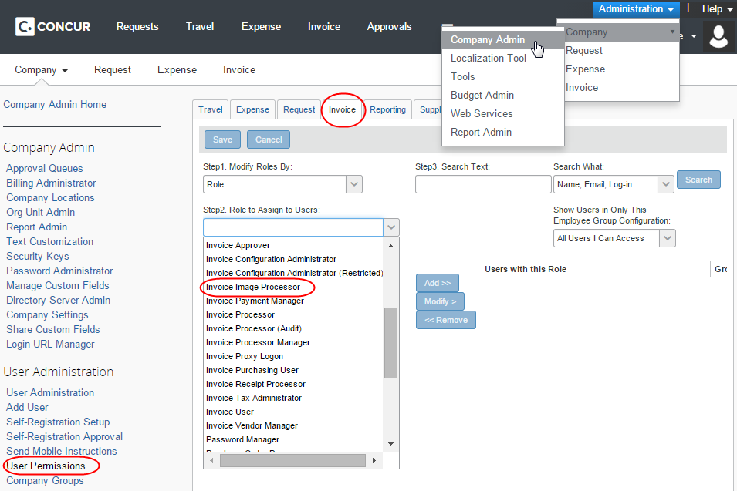
- For more information about adding, editing, or deleting user roles within the User Permissions tool, refer to the Shared: User Administration User Guide or contact your Invoice administrator.

Managing Invoice Images
The Employee administrator may assign the Invoice Image Processor role to multiple employees and can thus assign each invoice image processor to enter and update image information for invoices for all employees within the company.

Access the Process Images Tool
To access the Process Invoice Documents tool, click Invoice > Processor > Process Invoice Documents.
Depending on your permissions, the page may appear immediately after you click Invoice.
The Image Received page appears.
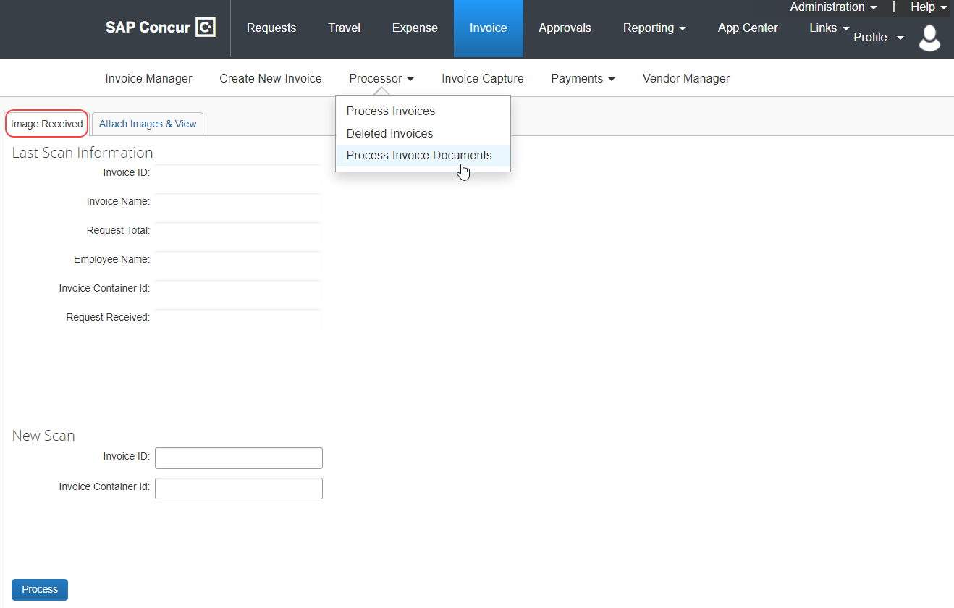

Scan an Invoice Image
You can provide the Invoice ID information by using either a barcode scanner to populate the Invoice ID field on the Image Received page, or by manually entering the Invoice ID code displayed on the invoice image into the field. After you have entered the data, the system updates the invoice information appropriately, based on the policy of the invoice and the scan configuration.
Depending on your configuration, you may not display the invoice ID on the invoice. Contact your Concur Invoice administrator to have the invoice ID added to the printed invoice.
- IMPORTANT: The barcode that appears on the invoice incorporates a large, wide font for a scanner to read it properly. You should verify that your barcode scanner works with the SAP Concur barcode specifications.
To scan an invoice:
- Click the Image Received tab.
- Scan the barcode at the top of the invoice into the Invoice ID field. This is a required field.
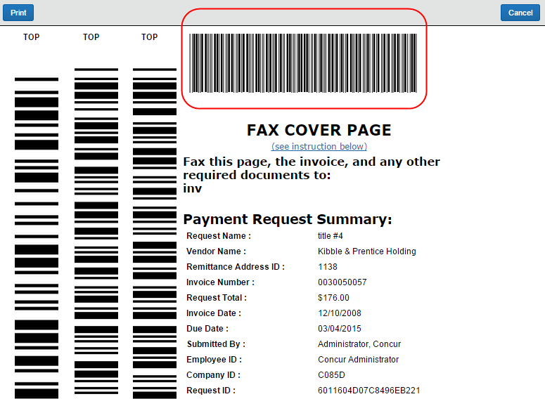
- Enter the invoice container ID information into the Invoice Container ID field. This field may or may not be required by the scan configuration.
You may use the Image Container ID for data management and tracking purposes. For example, if you use a numbered filing system, you will type the numerical value of the file or storage box that contained the images in this field.
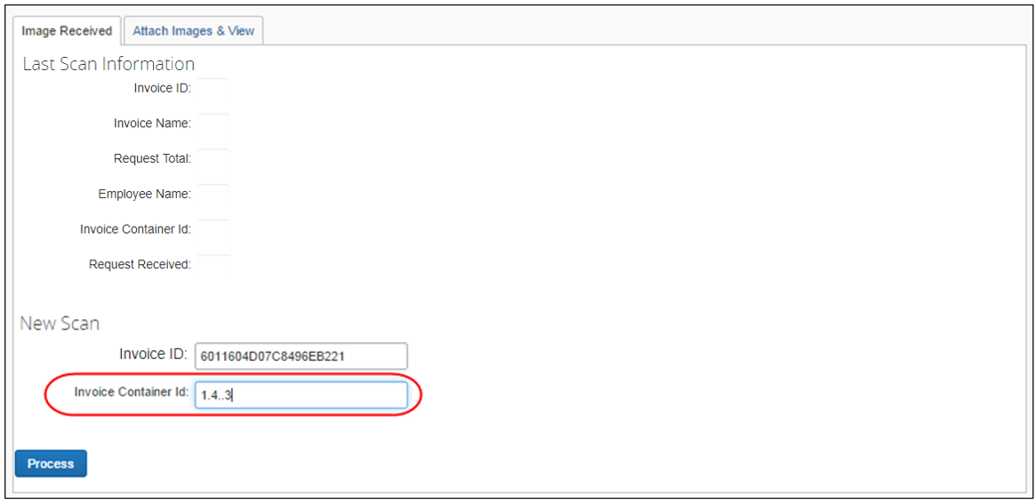
- Click Process. The system's Image Received flag for that invoice changes to reflect the new information. In addition, the system updates the Last Scan Information section to reflect the invoice that was most recently processed.
When you click the Process button, this action will also include the behavior of the Set Request Received button on the Attach Images & View page.
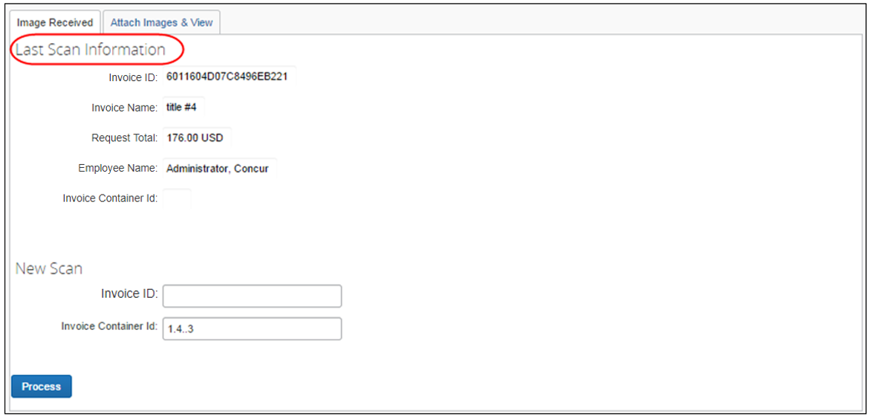
- Place the images into the designated image container, if applicable.

Upload and Attach Images to an Invoice
The image processor may use the Process Invoice Documents tool to upload images to associate them with an existing invoice. This procedure does not turn the Image Received flag in the system to Yes. To change the flag immediately, the image processor must view the images on the Attach Images & View page or enter the invoice ID on the Images Received page. If the image processor does not view the images, then the system will update the flag when the imaging job next executes.
To attach images to an invoice:
- Click the Attach Images & View tab.
- Enter the invoice identifier found on the invoice into the Invoice ID field.
If your company uses a handheld scanner to track images, you can use that scanner to populate the Invoice ID field.
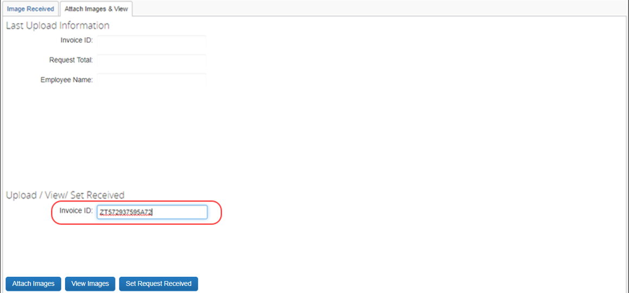
- Click Attach Images.
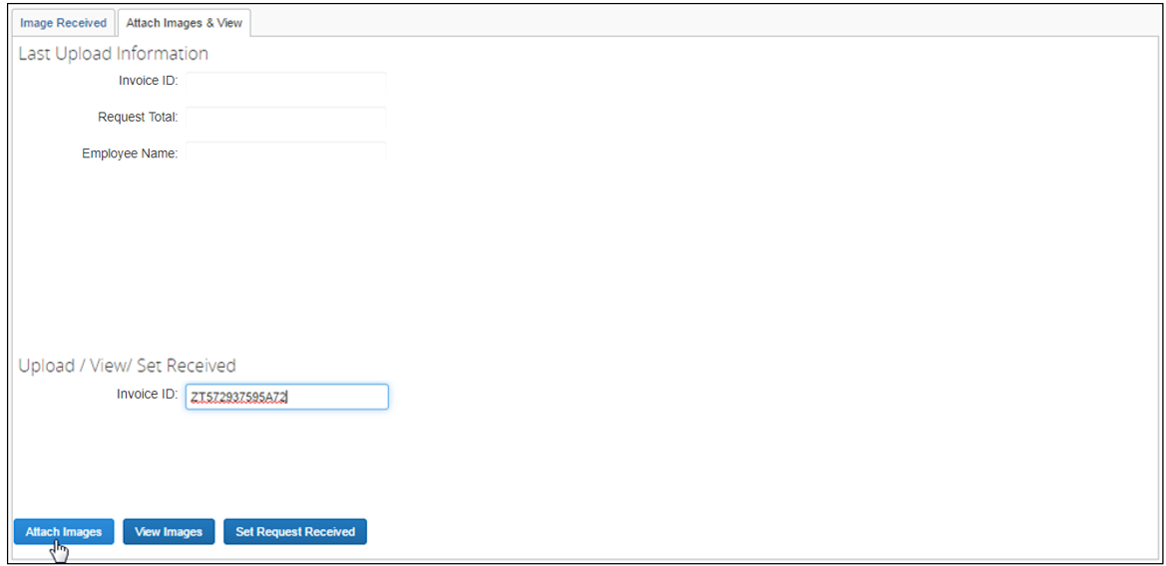
The Upload Image window appears.
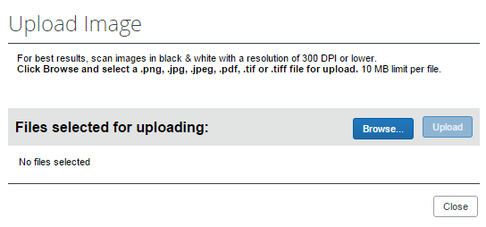
- Click Browse.
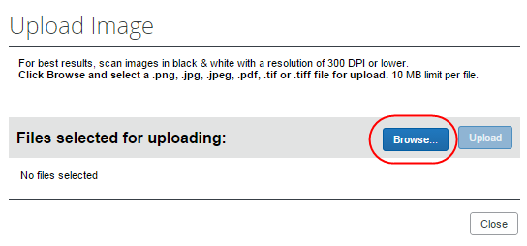
- Navigate to the image, and then click Open.
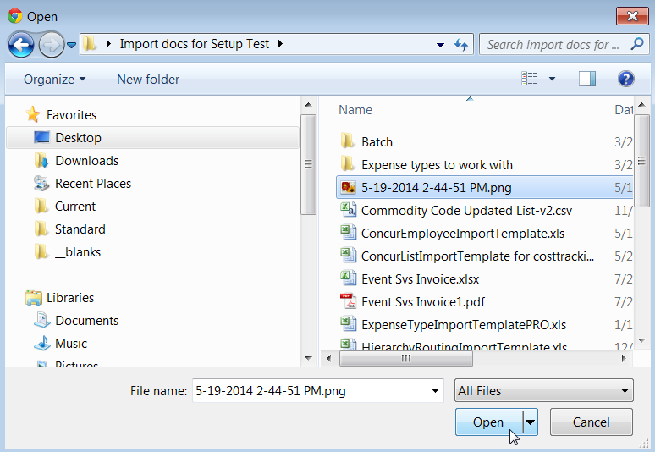
- Click Upload.
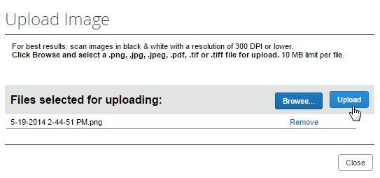
- (Optional) Repeat steps 3 - 6 until you have uploaded all images.
- Click Close.

View Images for an Invoice
The image processor may view the images of the invoices associated with an invoice by using options on the Attach Images & View page. The act of viewing an invoice image will update the Image Received flag to Yes.
To view images associated with an invoice:
- Click the Attach Images & View tab.
- On the Attach Images & View page, enter the invoice identifier found on the invoice into the Invoice ID field.
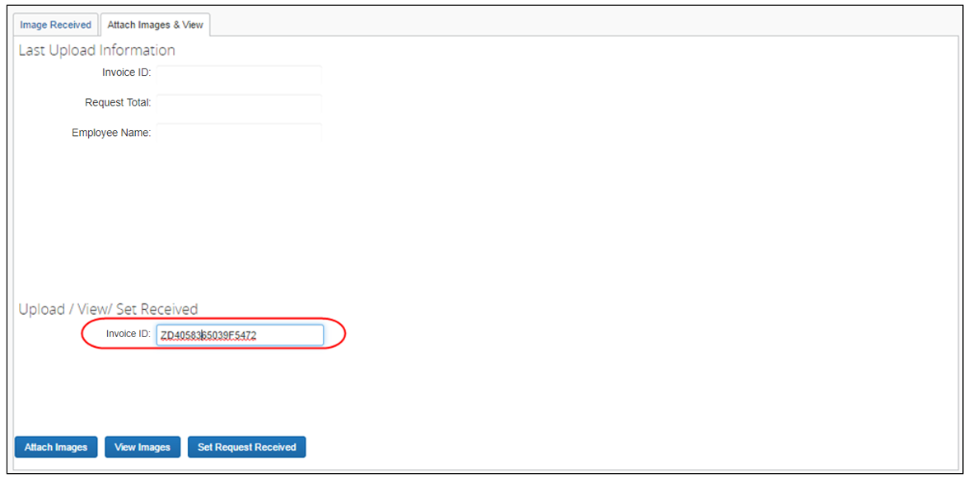
- Click View Images.
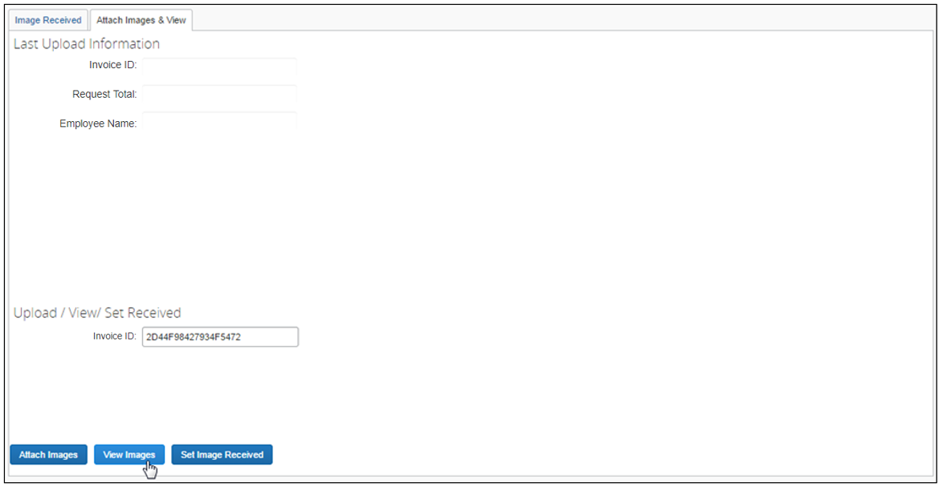
A viewer opens that allows you to scroll through all the images associated with the invoice.
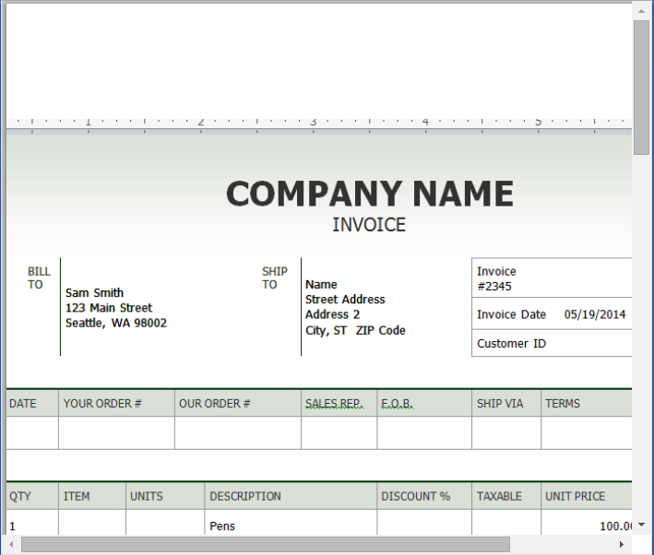
You will also see the image you last uploaded in the Last Upload Information section.
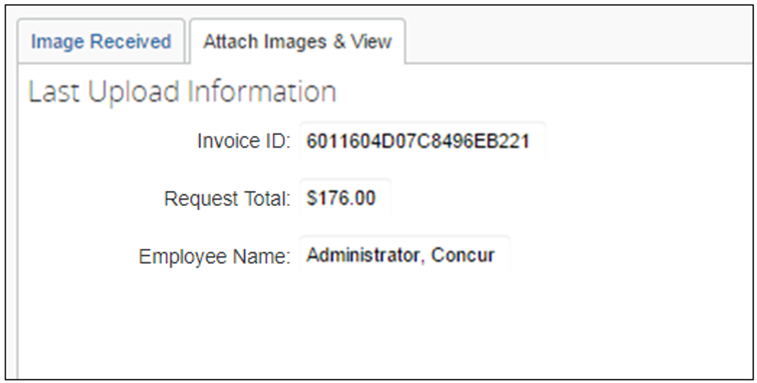

Set Images Received
The image processor may set an image as received to speed up the process in which an invoice goes through the system. This might be useful, for example, if no image is available and the processor needs to process an invoice quickly for a vendor waiting for payment. When the image processor clicks the Set Image Received button, the system updates a flag in the database that the image is available, although it is not, and sidesteps the process for faster processing of the invoice.
To set images received:
- Click the Attach Images & View tab.
- On the Attach Images & View page, enter the invoice ID from the invoice in the Invoice ID field.
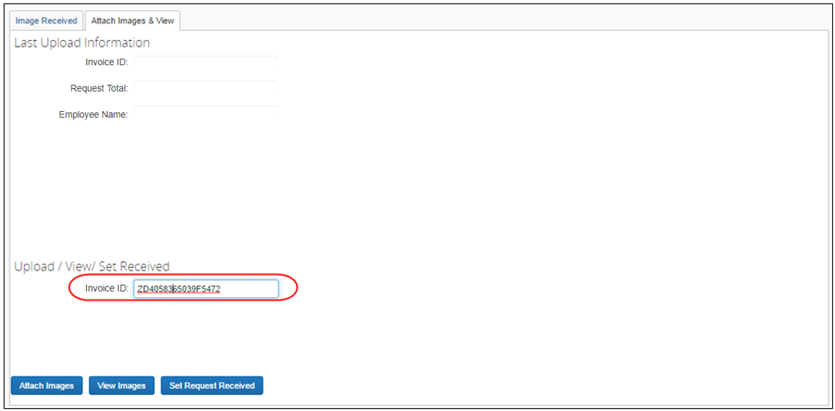
- Click Set Request Received.
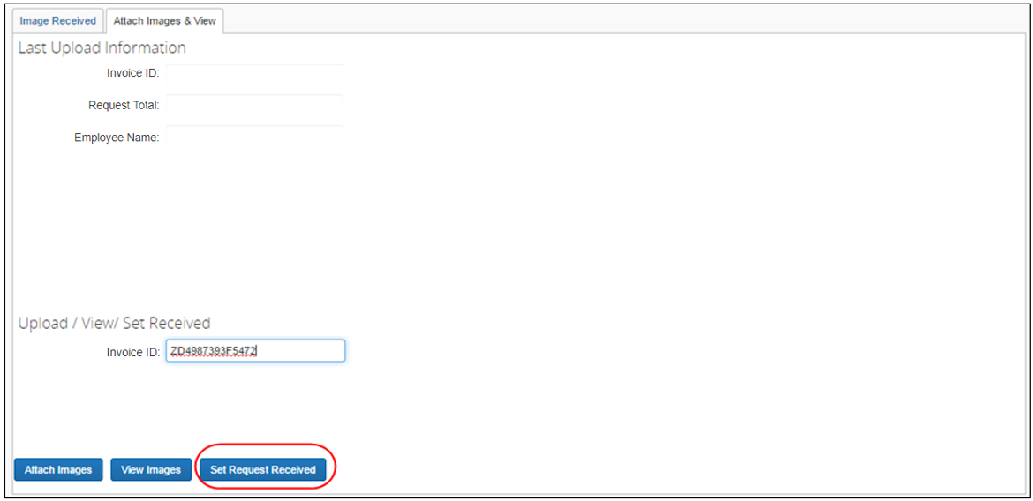
A window appears to inform you that the system has marked the invoice with an image received.
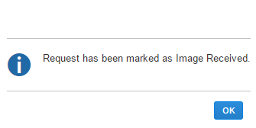
- Click OK.
☼

