
Concur Invoice: Capture Processing (Client-Managed)
User Guide
Last Revised: January 3, 2023

Applies to these SAP Concur solutions:
 Concur Expense
 Professional/Premium edition
 Standard edition
 Concur Travel
 Professional/Premium edition
 Standard edition
 Concur Invoice
 Professional/Premium edition
 Standard edition
 Concur Request
 Professional/Premium edition
 Standard edition

Table of Contents
Section 1: Exclusions 1
Section 2: Permissions 1
Section 3: Overview 1
Dual Support – Using Both Capture Processing Methods 2
Client-Managed Capture Processing: Key Benefits 2
Required Roles 3
Terminology and Concepts 3
Terminology Used for Batch/Document/Page Structure 4
Activating and Configuring Invoice Capture Processing 4
Section 4: Using Capture Processing 5
Steps to Self-Managing the Batch to Invoice Process 5
Process by Page Description 6
Planning for and Working With Capture Processing 9
Setting up an Exception Email Address 9
Setting Up a Default Policy for Emailed and Uploaded Invoices 9
Setting Up a Default Ledger in a Multi-Ledger Environment 10
Understanding Document Separation 10
Understanding the Task and Status States 15
Locked and Unlocked Status 15
Supported Image File Types 16
Excluding Vendor From Extraction 17
Filtering the Vendors Based on the Email Address 18
Section 5: Accessing and Working With Capture Processing 18
Using the Capture Batch List Page 18
Access by Roles 18
Manually Advancing a Batch 19
Large Batches Divided into Multiple Smaller Batches 20
Searching for Supplier or Upload Batches in the Capture Batch List Page 20
Opening a Batch for Review in Batch Details 23
Reviewing Batch Header and Attachment Information 25
Downloading and Viewing the Original Attachment(s) 26
Using Batch Details to Review Attachments Before Reprocessing 26
Additional Functions Available to the Client Managed Capture Verifier 27
When Should You Reprocess a Batch? 29
Using the Upload Feature to Add Batches 30
Using the Document Separation Page 36
Working With Batches and Invoice Pages: Options on the Button Bar 37
Working With Batches and Pages: Viewing Attachments 38
Working With Batches and Pages: Submitting and Other Options 38
Using the Verification Page 39
What Fields Are Extracted During the OCR Process? 41
Verifying the Captured Data OCR Extraction 42
Coding Fields Using the Copy and Paste Feature 42
Verification Using the Automatic Yellow Highlighting Feature 45
Adding and Moving Rows in the Itemization Summary 45
Working With Vendors 47
Moving Through the Batch Verification Workflow 49
Acting on the Verified Batch 50
Moving Between Opened Invoice and Batch Details 53
Viewing the Capture Email for an Invoice 54
Section 6: Appendix 55
Working With Tax and VAT Data 55
Canada 55
UK/US/Japan/Australia 56
Other Countries 56
Enabling CFDi Attachments for Reporting to Mexican Tax Authorities 56
Where to Download the Begin Separator Sheet 56
Supported Languages and Currencies 57
Understanding and Improving the OCR and Extraction Process 58
How Does OCR Extraction Work? 58
Factors Affecting Accuracy of OCR and Extraction 59
Examples of Good and Bad Images and Resulting Data Capture 60

Revision History
Date | Notes/Comments/Changes
April 22, 2023 | Minor edit in the Supported Languages and Currencies section; cover date not updated.
January 3, 2023 | Removed the note in the Overview regarding the Invoice Capture paper invoice processing service retirement that occurred on December 31, 2022.
November 2, 2022 | Minor edits to the Overview; cover date not updated.
August 20, 2022 | Minor edits; cover date not updated.
July 28,2022 | Clarified the note to the Overview to address the pending retirement of the paper invoice processing service of Invoice Capture on December 31, 2022.
July 16, 2022 | Added a note to the Overview to address the pending retirement of the paper processing service of Invoice Capture on December 31, 2022. Minor edits throughout.
January 4, 2022 | Removed references to Internet Explorer. IE is no longer supported.
January 2, 2022 | Updated the copyright year; no other changes; cover date not updated
March 4, 2021 | Updated the copyright year; no other changes; cover date not updated
November 14, 2020 | Updated images to show Open as PDF option as a button instead of an option in the Actions menu.
June 16, 2020 | Removed the “Increasing the Extraction Success Rate of the PO Number Field” section on page 53. It is obsolete.
April 20, 2020 | Renamed the Authorization Request check box to Request on the guide’s title page; cover date not updated
January 7, 2020 | Updated the copyright; no other changes; cover date not updated
August 17, 2019 | Added info about "View Capture Email" for August release.
June 12, 2019 | Updated a couple of references to the “Invoice Intelligent Capture Verifier” with “Client Managed Capture Verifier”.
May 10, 2019 | Removed Bulgarian, Greek, and Russian from the list of supported languages and currencies.
April 13, 2019 | Updated UI terms from "Request" to "Invoice". Updated images to reflect New UI and terminology.
March 27, 2019 | Updated supported language list to include Japanese and Chinese.
February 19, 2019 | Added info about changes to handling batches with 500 or greater pages. Replaced 'payment request' with 'invoice'. Updated screenshots with old logo. Updated 'Concur' to 'SAP Concur'. Addressed menu changes.
October 13, 2018 | Added information about the following:  - The original email will no longer be attached to the exception emails sent out to clients  - Large Batched divided into multiple smaller batches
April 11, 2018 | Changed the check boxes on the front cover; no other changes; cover date not updated
January 26, 2018 | Updated the copyright; no other changes; cover date not updated
November 4, 2107 | Purchase Order data is now used to auto-match a vendor systematically.
September 16, 2017 | Support for automatic attachment of CFDi tax documents for reporting to the Mexican tax authorities.
August 19, 2017 | Removal of the Locked Indicator column and addition of the Document Count column to the Batch List page columns.
July 8, 2017 | Updated with information about single-clicking now available to open a  batch on the All Batches page.
June 3, 2017 | The Capture Processing tool now calculates VAT based on field placement, and no longer uses the Policies tool to set the field's calculation behavior.
April 22, 2017 | Updated with information about:  - Automatic assignment of Vendor Owner to the Assign Request To field if a vendor is matched to an employee using the Vendor Mapping List options  - Support for calculations at the line item level for the VAT Amount 2-4 fields is included with this release
March 18, 2017 | Added information about working with VAT in different countries.
December 13, 2016 | Changed copyright and cover; no other content changes.
December 5, 2016 | Updated the guide content to new corporate style; no content changes.
November 4, 2016 | Updated with information about:  - Ability to rotate displayed invoice both clock- and counter-clockwise  - How to submit PO Number field examples to increase the effectiveness of the OCR system in extracting this data
June 17, 2016 | Updated with information about associating an email alias to a default policy and language.
May 13, 2016 | Updated with information about VAT Amount 1 – 4 field usage
April 15, 2016 | Updated with information about the reprocessing feature allowing change of Capture mode
February 19, 2016 | Updated with information about:  - A new error message that display recommended action if a batch fails during processing  - Ability to move itemizations above or below others by using a pair of new buttons, Move Up and Move Down
January 15, 2016 | Updated with information about what fields are extracted during the OCR process
 | Older revision history has been removed.

Capture Processing (Client-Managed) User Guide
NOTE: Multiple SAP Concur product versions and UI themes are available, so this content might contain images or procedures that do not precisely match your implementation. For example, when SAP Fiori UI themes are implemented, home page navigation is consolidated under the SAP Concur Home menu.

Exclusions
Please note the following exclusions when working with Capture Processing:
- Multiple file upload is supported using Chrome, Safari, FireFox, or Microsoft Edge.
- A currency format that includes a decimal is enforced for capturing amount fields (Shipping; Tax). This means the amount data must be in the format "1.23" for successful capture to these fields.
- Currently the only exception email that can be sent for a selected batch that has failed conversion is the Attachment Format Not Supported email in the Capture Batch List page. Additional exceptions will be added in upcoming releases.

Permissions
The Capture Processing (client-managed) functionality is available to selected users based on their role assignments. Those users with the Invoice AP User or Client Managed Capture Verifier roles can access the Capture Processing links and screen. However, certain admin tools, such as those that activate the feature, are limited to SAP Concur staff.
For this reason, the client might need to submit a Service Request to SAP Concur support to activate and configure some areas of the Capture Processing product.

Overview
Invoice Capture is an optional feature that supports capture processing and validation of invoice data and generation of an invoice by using Optical Character Recognition (OCR).
Invoice Capture offers three options for managing capture processing:
- Concur Managed – Managed, fee-based where SAP Concur staff performs the verification of OCR results on behalf of the client
- Client Managed – Free, client-managed feature of Invoice Management that lets the client self-manage the verification of OCR results
- Dual Support – When a client uses both Concur Managed and Client Managed options simultaneously
Options to work with both Concur Managed and Client Managed types of Invoice Capture are available in the user interface, which is designed to allow easy identification, set up, and management of either capture type, or for both management types simultaneously.
For each method, the client provides suppliers with a unique SAP Concur-issued email to which invoices can be sent. Alternatively, the invoices can be mailed, scanned, and uploaded. From there, OCR is performed by the system. Either the client or SAP Concur staff performs verification of OCR results, after which each invoice is saved and advanced to the beginning of the workflow process.
Clients who use Concur Managed or Dual Support (Concur-Managed and Client-Managed) can process their own invoice batches.

Dual Support – Using Both Capture Processing Methods
Dual Support lets a client process their emailed or uploaded batches using either capture method. When this feature is enabled, additional options appear that let the admin assign a capture type to one or more batches.
- For more information about this feature, refer to the Concur Invoice: Capture Processing – Dual Support User Guide.

Client-Managed Capture Processing: Key Benefits
This feature allows clients to manage captured data and verify the results. Key benefits include:
- Completely integrated user interface feature within Concur Invoice (does not require a separate tool or login)
- Straight-through email attachment (invoice) processing
- Suppliers email invoices to the address provided by SAP Concur. From there, the invoices (as attachments) can be easily separated and/or organized within the user interface in preparation for OCR data extraction. The results display in Concur Invoice ready for verification and additional coding. In addition, all email details are listed for easy review and traceability.
- Flexible Verification, Coding, and Auto-Routing experience
- Suppliers often provide information that can drive how an invoice should be coded, and even which employee it belongs to. These values can be mapped into custom fields, and validated in lists (common examples include Project, Account, or Store Number). The resulting data will pre-populate within the invoice in preparation for final coding.

Required Roles
The following roles are used to activate, configure, and use the Capture Processing features.
- Invoice Configuration administrator (Unrestricted): To use Invoice Admin tools, such as Capture Processing Admin, Routing Configuration and Forms & Fields
- Invoice AP User: To access, with read-only privileges, the supplier emails on the Batch List page
- Client Managed Capture Verifier: To access and work with document separation and verification, vendor selection, and final rejection or submission using options in the Document Separation and Verification tabs
- For more information about assigning roles to your users, refer to the Shared: User Admin User Guide.

Terminology and Concepts
The following terms are used throughout this document:
Batch: One or more invoice attachments either emailed or uploaded into the Capture Processing system.
Email: A Batch that has been emailed to the client’s view via their dedicated email address provided to the supplier for this purpose.
Upload: A Batch that was added to the list using the Upload button.
Locked, Unlocked: The state of a batch when the Verifier is working with a batch and it is unavailable to anyone else. This is because only a single person can have a session with a batch at one time.
Classic versus Current: There is a legacy Intelligent Capture product that is referred to as classic (DataCap), while the current iterations, both Client-Managed and SAP Concur service managed, are referred to as current (Capture Processing).
Document Separation: A step in the preparation process where the Client Managed Capture Verifier role reviews the batch for file and page grouping by separating, combining, or removing pages within files to create a single invoice, checking and correcting orientation in anticipation of the next step, processing via OCR prepare the batch of invoices for final the Verification step.
Verification: A step where the Client Managed Capture Verifier role reviews the post-processing capture results. This includes noting incorrect field capture and manually coding additional custom fields added onto the form by the client in effort to prepare the batch for the final invoice review step.

Terminology Used for Batch/Document/Page Structure
Batch: A collection of one or more Documents each with one or more Pages sent by the supplier. Taken together, each document’s pages form an invoice whose data will be processed into an invoice.
Document: A file of one or more pages. The file is converted by the system into PDF format and displays in a hierarchy above its associated pages (invoices).
A document is referred to as an "attachment" in the user interface. For example, you rename and select pages for an attachment when using Processing.
Page: A single Page (invoice) within a Document represents all or part of an invoice, and after processing results in an invoice.
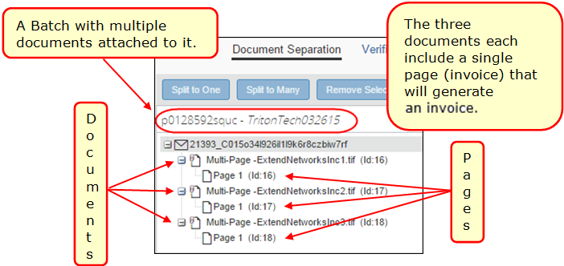
Split: To move an invoice from one document to a new document, either as the single invoice (Split to Many command), or one of several within the batch (Split to One command).

Activating and Configuring Invoice Capture Processing
Configuration of the product is performed by SAP Concur. SAP Concur support and implementation staff will use the Concur Admin and Concur Consultant roles to activate the product and configure the tool.
- For more information about activating and configuring the product for use at your organization, refer to the Concur Invoice: Capture Processing (Client-Managed) Setup Guide.

Using Capture Processing
Capture Processing lets a client self-manage the preparation, processing, and verification of supplier-emailed or locally uploaded invoices prior to submission as an invoice. The administrator reviews invoices for grouping, sequence, image quality and presentation prior to processing and invoice creation. Once processing is completed, the administrator confirms the output by verifying the data, and then submits the invoice to Concur Invoice workflow.
The following tabs and options are available by administrative role:
- Batch List: This view acts as a ‘landing page’ and shows all supplier emails, and all batches uploaded locally, all displayed in a list format alongside their processing states, and related information.
- Document Separation: This view shows a single batch (emailed or uploaded) with all documents and associated pages displayed in the user interface to allow the user to quickly organize and manage the batch with the goal of separating the attachments into individual invoices in preparation for submission to OCR extraction and final verification.
- Verification: This view shows the results of the OCR processing and the data that was captured into each supported field. Change the data as required, and manually fill out any additional field data for fields not supported for capture, in preparation for final submission to Concur Invoice.

Steps to Self-Managing the Batch to Invoice Process
The task of using Invoice Capture Processing to turn emailed or uploaded batches into invoices is a multi-step process. After role assignment and configuration of the forms, fields, and settings, the general steps are:
- Step 1: (System) Email/Uploaded Batch Received and Converted
Batches are received by email, or by upload, and display in Capture Batch List
- Step 2: (User) Batch Reviewed for Invoice Page Order and Submit
Batches are opened sequentially in Document Separation to confirm that document and page order is correct, and are then submitted for OCR extraction
- Step 3: (System) OCR Process and Display for Verification
Document page(s) are read and data captured into supported fields; the invoice is now ready for review and manual update in Verification
- Step 4: (User) Submit (Export) of New Invoice
The administrator readies the invoice for submission by verifying the captured data, and where relevant, by coding (manually adding values to custom fields added by the client and not populated by OCR capture)
Additional invoice coding might be required depending on the configuration setup for your organization.

Process by Page Description
The Capture Processing Batch List page provides a view into all received supplier emails and locally uploaded batches, and the status of each batch. This page also displays any errors or exceptions generated during the capture conversion process.
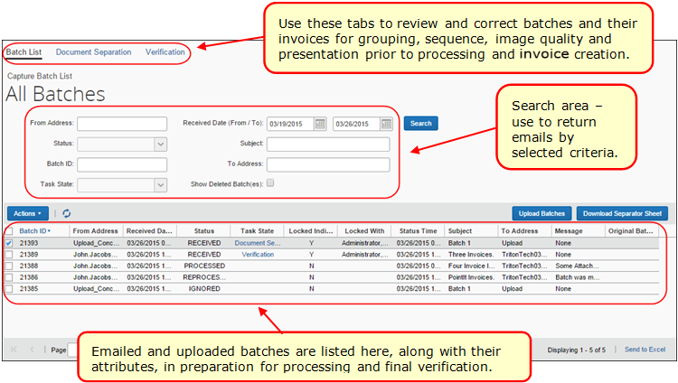
Options on the Document Separation page are used to review the page order and perform other tasks in preparation for the processing step. The figure below shows a single emailed batch (prefixed with the email list number 9167) opened to display three documents (converted to PDF format), each with one or more pages that will create three separate invoices after being processed.
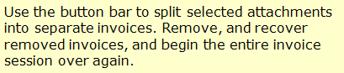
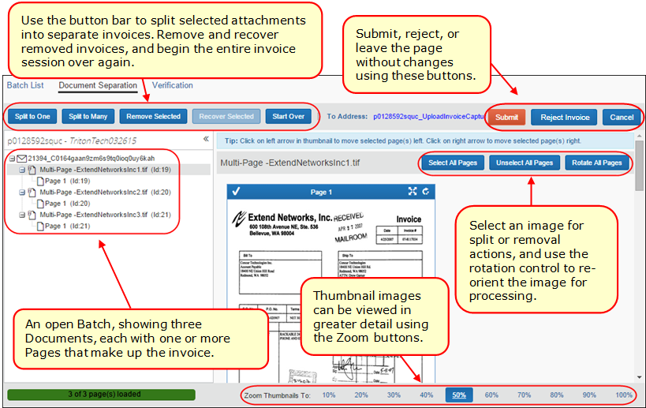

Options in the Verification page are used to review the captured data from the invoice (page) prior to submitting the new invoice to the beginning of workflow. Here the Verifier reviews vendor, header, and line item data, corrects any errors, and, if relevant, completes additional coding.
The Invoice Details section on the Verification page contains extracted data that auto-populates the invoice, while you can code the custom fields in the invoice image by using copy and paste actions, and clicking directly on the data to fill the invoice field.
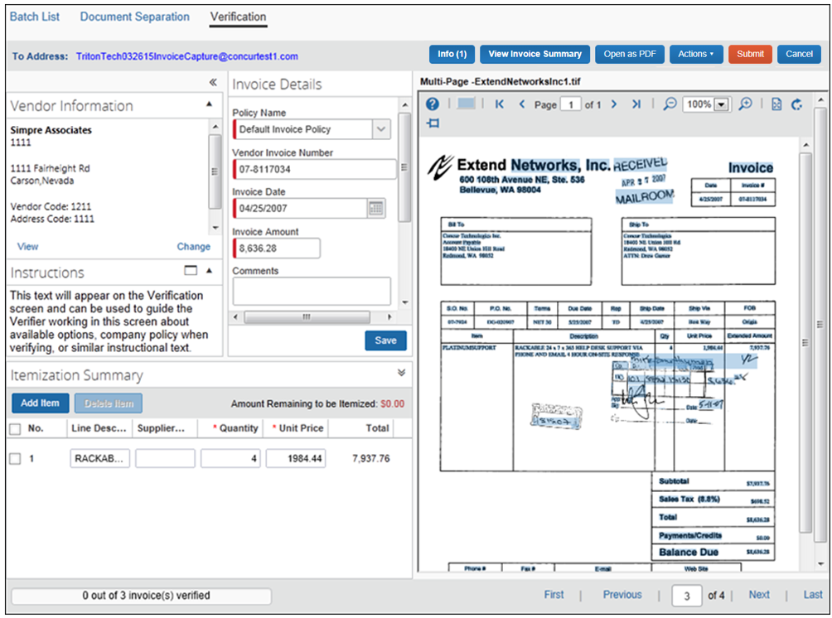

Planning for and Working With Capture Processing
Use the following information to plan for your approach to using Capture Processing at your company site.

Setting up an Exception Email Address
The Invoice Configuration administrator (Restricted) can access the Other Settings tab (Administration > Invoice > Capture Processing Admin) to configure the email address where alerts about processing exceptions can be sent.
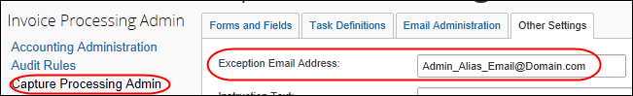
When an invoice cannot be generated, an email is sent to this address letting the client know about the exception that happened.
The original email will not be attached to the exception email.
TIP: Instead of a single recipient, create a dedicated email alias that includes all relevant AP department/Verifiers so that more than one person, who can act on it, receives the email.
- For more information, refer to the Configuring: Exception Email Address and Instruction Text Options section in the Concur Invoice: Capture Processing (Client-Managed) Setup Guide.

Setting Up a Default Policy for Emailed and Uploaded Invoices
The default policy options let the Invoice Configuration administrator (Restricted) set a default policy under which each of the batches, based on the sending method (upload and email), will inherit their policy attributes.
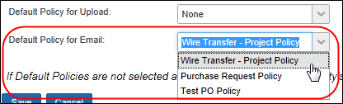
By setting the policy here (Administration > Invoice > Capture Processing Admin), this same policy will populate the Policy field for emailed and uploaded batches in the Verification page.
- For more information, refer to the Concur Invoice: Capture Processing (Client-Managed) Setup Guide.

Setting Up a Default Language and Policy to an Email Alias
An email alias can be configured with default policy and email attributes. Doing this sets an association that tells the system to use these defaults for batches sent using any email address associated with the email alias. These defaults can be manually re-set in the Verification page, or be overwritten by other settings, but are ideal for companies that want to use Capture Processing to assign different policies according to clearly defined geographical or business unit entities that can be assigned different email addresses for policy assignment.
- For more information, refer to the Appendix: Using the Email Address to Filter Vendor Availability in the Concur Invoice: Capture Processing (Client-Managed) Setup Guide.

Changing to the Purchase Order Policy Type
If the admin elects to change the policy to any Purchase Order (PO) policy type, the attributes of this policy take effect. Note that, if a PO policy is invoked, the PO Number field is a Required field type as this number is essential to processing a purchase order.
Conversely, if the system detects a PO number, it will change to a PO policy for that invoice.

Setting Up a Default Ledger in a Multi-Ledger Environment
To associate the correct account codes for the new invoices, the system refers to the ledger and its account code associations. To ensure that the correct ledger and account codes are being used at a multi-ledger company, the admin has the option of selecting the ledger they prefer.
This is done using the Default Ledger option on the Other Settings tab of the Capture Processing Admin tool (Administration > Invoice > Capture Processing Admin.
- For more information, refer to the Working with Options on the Other Settings Tab section in the Concur Invoice: Capture Processing (Client-Managed) Setup Guide.

Understanding Document Separation
Document Separation is an optional step used to review the batch file and invoice pages for grouping, order, and orientation to confirm the correct invoices are present and prepared for data processing to populate the invoice. Typically, the Verifier will perform this task manually since you cannot assume the supplier email does not contain dunning notices, illegible data, or similar.
Conversely, if you are confident of preparedness, the separation task within Capture Processing is not required, and you need only add a physical "Begin" separator sheet prior to each separate invoice. The bar code instructs the system that the page following is a single invoice so that Capture Processing automatically separates the invoices without manual intervention. Now the auto-separated pages are moved directly to the OCR Extraction step, discarding the separator page(s) in the process, and displaying the results in final verification. Note that single-page invoices are handled automatically in this manner.

When Should I Use Document Separation?
Even under the best conditions, vendors will often fax or scan items upside down or out of order, combine unrelated invoices, forget to group multi-page invoices, or include unneeded pages within the emailed batch. If allowed to proceed without review, the output would be worthless at best, and a waste of time at worst.
For this reason, a simple review by the Client Managed Capture Verifier role ensures the processing step will return valid invoices. Therefore, it is strongly recommended that the Verifier review every multi-invoice batch using options on the Document Separation tab. By using these options, you can resolve these separation questions:
- Is this an invoice?: Use the zoom and maximize options to view the page clearly:
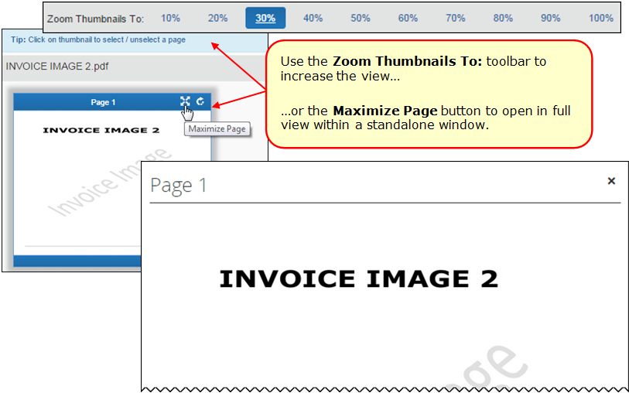
- Is each page oriented correctly?: Use the rotational controls to prepare the invoice for processing in its correct orientation:
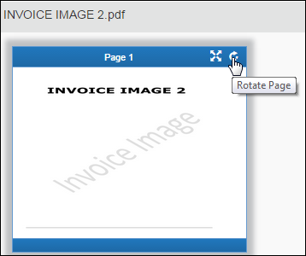
Are all pages split into the correct documents?: Often, a multi-page invoice needs to be split into one or more new documents, within which are grouped one or more invoice pages. To do this, select the pages to move, then, using the Split buttons:
- Split to One: All selected invoice pages are moved to a single document
- Split to Many: All selected invoice pages are moved to their own document, with new name and ability to rename the new document you have created.
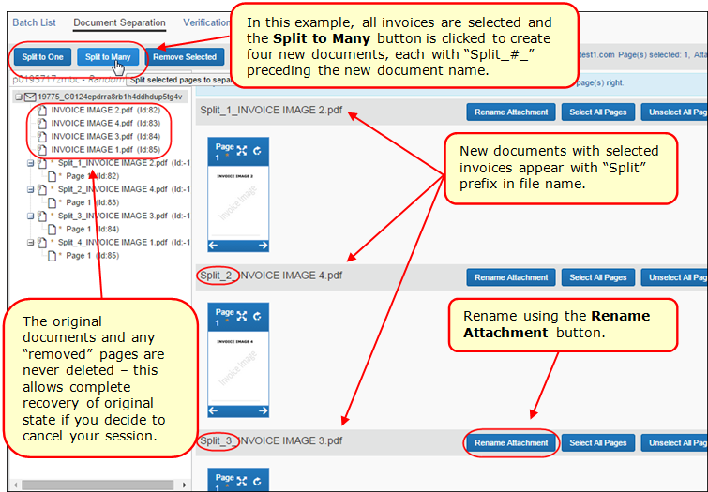
- Are the pages in the correct order within a single document?: Here, multi-page invoices might be out of order under a single document, or pages from one document need to be moved and then ordered under another, existing document. Use the green check marks and arrows to guide your placement of invoice pages in the multi-page document:
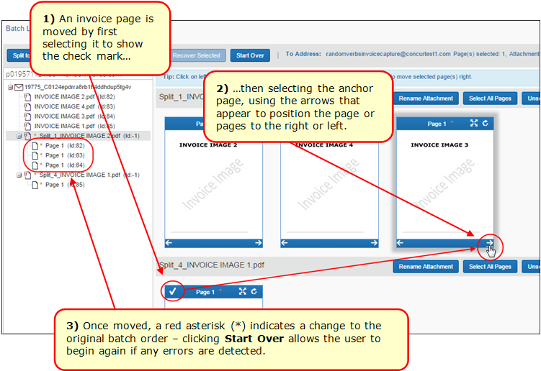

When Can I Bypass Document Separation?
Document separation is an optional step. You can submit a Service Request to SAP Concur support to configure Capture Processing to bypass this step entirely. However, you must be certain that, whether uploading or emailing the batch, there exists a one-to-one relationship of image file attachment and invoice page to create the single invoice.
You can decide based on how your suppliers provide their invoices, either educating them about how the invoices should be emailed or enforcing a policy of a one-to-one attachment to page as described above.
Using the Begin Separator Sheet to Scan and Auto-Separate Invoices
Scan a batch and let the system define each invoice by detecting the "Begin" separator sheet(s) you inserted between invoice pages in the scan job.
Scan Job Action | Invoice & Sheet Setup | Description
A single-page invoice. | Invoice (I) only; no separator sheet. | Scan the invoice without any separator sheet. The system interprets the single page invoice to be a single page invoice and proceeds directly to Verification.
I
Two or more single or multi-page invoices. | Document separator "Begin" sheet (B), then first invoice of single or multiple pages (I), then separator sheet (B), then second invoice of multiple pages. | The "Begin" sheet instructs the system that all succeeding invoice pages make up a single invoice. Then a new Begin sheet is encountered, and the system creates another new invoice.
B
B
I
I
You can request your vendor incorporate these sheets before emailing them in a batch to Capture Processing.
- For more information, refer to the Where to Download the Begin Separator Sheet section in the Appendix of this document.
Document Separation and the Single Page Invoice
Document separation is not required whenever a single page within an attachment file will render a single invoice. The system knows to send this combination directly to processing and verification where, if rotation or otherwise is an issue, the Client Managed Capture Verifier role can remedy the display using options in the Verification tab.

Understanding the Task and Status States
The Status and Task State columns provide the administrator with a view into the status of a batch. For more information about what these mean, refer to Searching for Supplier or Upload Batches in the Capture Batch List Page in this document.

Locked and Unlocked Status
A batch is "locked" once ownership is taken using either the Document Separation or Verification links. Once locked, the batch is released whenever a user’s behavior indicates the batch is finished. For example, if the owner uses the Submit button or the Cancel buttons with the batch, or any user clicks on another invoice in the same state. Alternatively, if a user accesses another batch in a different state (original = Verify, new one = Document Separation), the previous batch will unlock after a few minutes. Alternatively, the use of the search functionality will also release the batch.
Releasing the Locked Batch
A batch will remain locked for 30 minutes total if the user leaves the locked batch using any other option (Submit; exit the application; etc.). This tells the system the owner is not yet finished and provides enough time to allow them to return to the batch to finish their task. If they cannot return in that amount of time, the lock is released for the new potential owner.
Viewing the Status and Owner of a Locked Batch
If a batch is locked, the status of the batch, and the name of the owner, are displayed in the Locked Indicator and Locked With columns, respectively.
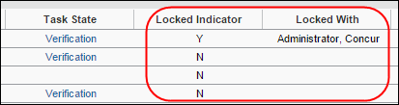

Supported Image File Types
The following file and image types are supported when uploading or emailing invoices:
- TIF, TIFF
- JPEG, JPG
- PNG
- PDF (with XFA; with embedded fonts)
- Word file (DOC; DOCX)
- Excel file (XLS; XLSX)
- EML (File saved using Microsoft Outlook)
- CSV
- CFDi (tax information with PDF)

Excluding Vendor From Extraction
The Vendor Manager role can use the Is Vendor Visible for Content Extraction field of the vendor import to prevent the vendor from being included on the invoice during extraction. This applies to both the on-demand and overnight vendor import methods.
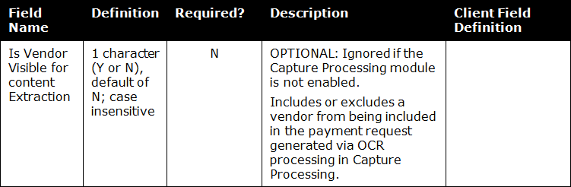
- For more information, refer to Chapter 4: Approved Vendor Import of the Concur Invoice V3 (Current) in the Import and Extract File Specifications guide, or the Concur Invoice: Vendor Manager Import User Guide.
This same functionality is available to the Vendor Manager by selecting an existing vendor and applying the attribute through the user interface.
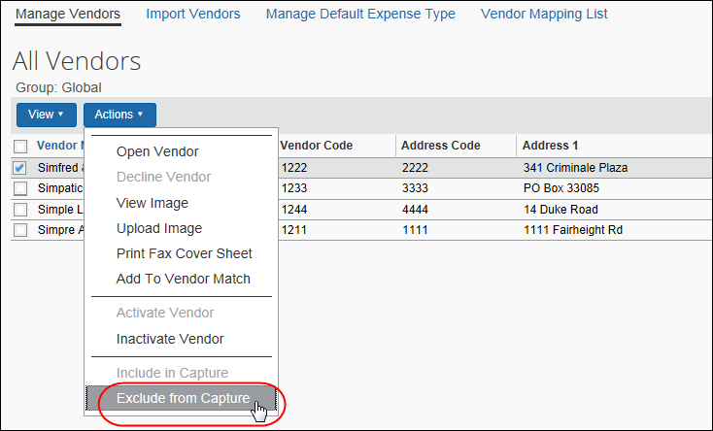
- For more information, refer to the Concur Invoice: Vendor Manager User Guide.

Filtering the Vendors Based on the Email Address
The list of vendors available for assignment to an invoice can be filtered based on the email used by the supplier when sending the invoice. This means that the "To" email address provided to the supplier can filter the list of vendors that the admin or system can work with, resulting in more accurate vendor assignment.
- For more information, refer to the Appendix of the Concur Invoice: Capture Processing (Client-Managed) Setup Guide.

Accessing and Working With Capture Processing
To display the page, click Invoice > Invoice Capture. The Capture Batch List page displays as shown in the following figure.
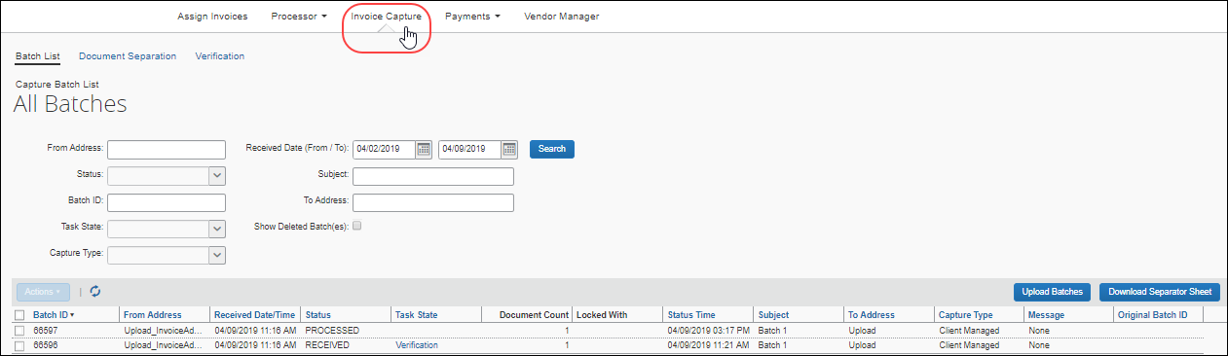

Using the Capture Batch List Page
This section details options available selectively to the AP User and the Client Managed Capture Verifier roles when working with batches emailed or uploaded to Invoice Capture Processing and displayed in the Capture Batch List page.

Access by Roles
Both the AP User and the Client Managed Capture Verifier roles can review a batch by opening it. However, the AP User is restricted to a read-only view, preventing them from making changes, and does not have access to the Upload button or any upload functionality. The Verifier role, however, has complete access to all functions.

Manually Advancing a Batch
If the Verifier wants to advance an emailed or uploaded batch directly to the Verification step, they can do so using the Advance to Verification that appears when the Verifier clicks the Actions menu or right-clicks a row to display the context menu (as shown in the figure below).
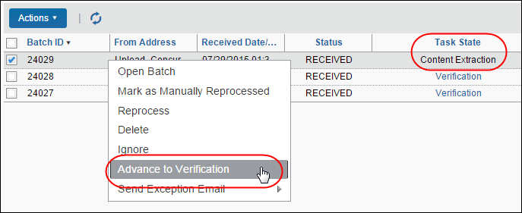
When using this feature the following applies:
- The batch must be in the Content Extraction task state
- OCR is bypassed, so the Verifier will need to manually code the invoice
- This action can only be performed in bulk if all batches are in the same task state

Large Batches Divided into Multiple Smaller Batches
Large batches of invoices (more than 100 batches) will automatically be divided into multiple smaller batches (100 at a time) for easier processing.
If this happens, users will receive an automatic batch separation message on the Capture Batch List page. In addition, they can determine which batches belong together by looking at the original batch number.
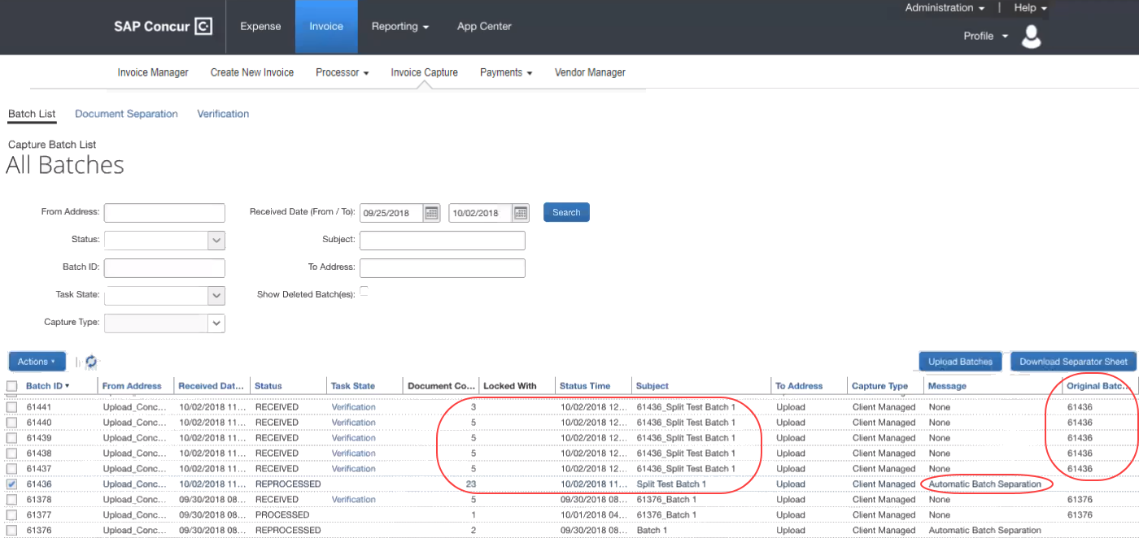

Searching for Supplier or Upload Batches in the Capture Batch List Page
The list of batches includes those sent by suppliers using the unique client email address, and those uploaded locally. Search options allow users to return a filtered list of batches.

Using the Search Criteria for an Effective Return
Both the AP User and the Client Managed Capture Verifier roles can draw on the search options listed below when using Search fields and criteria. This functionality is shown in the figure below of the Capture Batch List in its default display of All Batches.
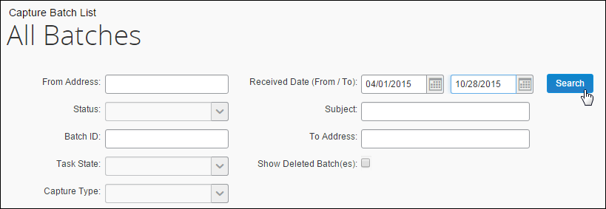
You can enter a partial search criteria ("contains") search element if you do not know the entire search string. For example, the December Invoice 12345 text in the subject line can be returned in a search by simply typing "12345" or "December" for the Subject search criteria. Similarly, typing "@domain" would return name@domain.com and any other similar email address in a search.
The fields include the following:
- From Address: The email address from the originator of the email, as name@domain.com.
- Received Date (From/To): The dates within which the batch was originally received, for example, between May 1st 2013 and July 1st 2013. The default is the last seven calendar days.
- Status: The status of the batch.
Field Name | Description
Any | Batch of any status type.
Converting | One or more attachments in the batch is being converted from an invalid to valid PDF format.
Processed | The batch has completed the processing step successfully and is ready for verification.
Processing | The batch is being processed.
Reprocessed | The failed or rejected batch has been sent for processing again.
Reprocessing | The client identified an issue and sent for reprocessing.
Ignored | The batch could not be identified or is clearly not an invoice or related to supporting an invoice.
Failed | The batch was identified by the system as not having attachments or is of a non-supported document type.  TIP: A batch marked as Failed will often include many invoices that were successfully processed. Use the Batch Details page to identify failed invoices that characteristically lack a link to a successfully created invoice.
Rejected | The client identified an issue with the batch and has rejected the batch. For example, unsupported file type, no attachments with email, or password protected email.
Received | The batch has been received and is pending OCR.
Receiving | The batch is being converted in preparation for the Verification or Document Separation step.
Exported | The batch has completed verification and is waiting for import into Concur Invoice.
Conversion Failed | The conversion of the batch has failed and the batch must be corrected for the issue and sent again.  TIP: A batch marked as Failed will often include many invoices that were successfully processed. Use the Batch Details page to identify failed invoices that characteristically lack a link to a successfully created invoice.
<blank> | The batch is imported and no further action can be taken.
Available only to SAP Concur support and Implementation
Deleted | The batch is hidden from client view
- Subject: The subject line from the batch in all or part.
- Batch ID: The unique ID assigned to the batch by Capture Processing.
- To Address: The email address to which the batch was sent (useful when multiple email addresses are employed at the client site), which doubles as a link opening the Batch Details window with details of the batch history.
- Task State: The task status. Note that selected task states provide a link to take the administrator directly to the task option:
Field Name | Description
Any | Batch of any status type.
<blank> | The batch is imported into the Invoice system and no further action can be taken.
Initialization | The batch is received and is being prepared for the Document Separation step.
Auto Document Separation | If configured for the entity, the system is determining if barcode separator pages are present. If present, automatic document separation is performed. If not present, the document is placed in the manual document separation queue.
Document Separation (links to page) | The batch is prepared for the manual review using options in the Document Separation tab.  The Verifier can click the link directly to move to the tab where the processed output is displayed for review purposes.
Content Extraction | The batch attachments (invoices, etc.) have completed document separation and are being prepared for Optical Character Recognition (OCR) processing.
Analyzer | OCR is complete and data is being assembled for verification.
Verification  (links to page) | The batch is now ready for manual review of processing output to determine if the correct data has been captured and mapped to the respective fields on the newly created invoice. Options in the Verification tab are used to confirm these mappings, and to manually update any additional, non-default fields the client might have added.  The Verifier can click the link directly to move to the tab where the invoice is displayed for review purposes.
Where the batch is uploaded, and not emailed
Upload | The batch is uploaded and pending initialization.
- Capture Type: The method used to process the batch, either via Concur Capture Services or Client-Managed Capture.
In display, each row includes the information in the table above, with the following additions:
Field Name | Description
Locked Indicator | Is (Y) or is not (N) locked for review by a Verifier.
Locked With | The Verifier who is currently working with the batch and locking it from use by another Verifier.  - For more information about locked batches, refer to the Locked and Unlocked Status section in this document.
Status Time | The time of the last status update.
Subject | Displays either the email Subject: line, or, if uploaded, the batch prefix (optional; added at configuration) and batch number.
To Address | Either uploaded, or email used to send the batch.
Capture Type | The method used to process the batch, either via SAP Concur Capture Services or Client-Managed Capture.
Message | Displays error messages for Failed and Ignored items; triggers an exception email to the address specified by the client using the Capture Processing configuration tool.
Original Batch ID | ID of the original batch, if the item was reprocessed.

Opening a Batch for Review in Batch Details
All the functionality described in the following sections applies to the Client Managed Capture Verifier role. The AP User role is restricted to a read-only review when opening a batch.
A batch is opened in the Batch Details page to review its details, and whenever a batch is reprocessed by the admin. The page appears by clicking the email directly or by using Actions > Open Batch (AP User view of the Actions menu is shown in the following image).
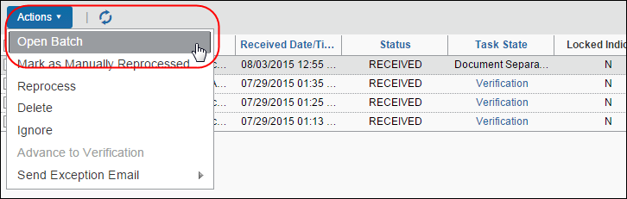
When opened, the batch file list displays directly under the batch’s header information in the Attachments list, with active links that, upon clicking, open the attachment, in PDF format, in the right-side pane.
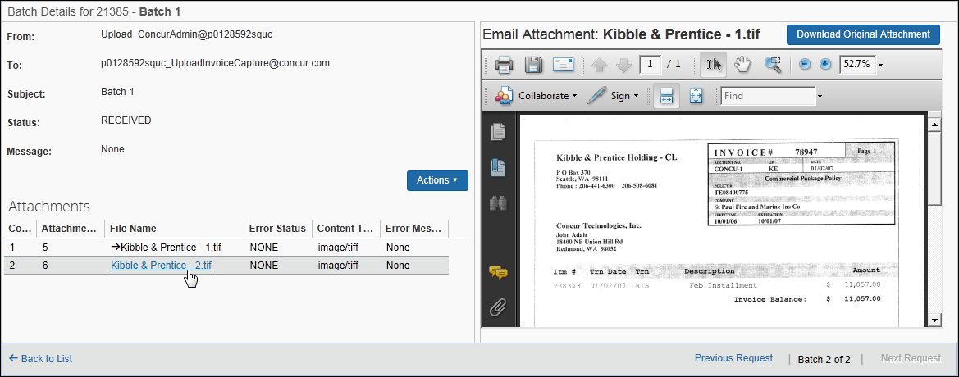
The list provides a quick reference to the file names, key number, and the error state (if any) associated with the attachment.

Reviewing Batch Header and Attachment Information
The batch header appears in the following figure. Reference the following table for information about each available read-only field.
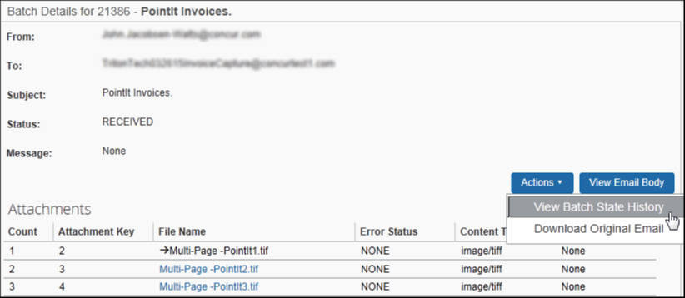
Field Name | Description
From Address | The email address from the originator of the email.
To Address | The email address that received the email.
Subject | Subject line from the email.
Status | The state of the invoice(s) set to be processed.
Message | Displays the error message for Failed and Ignored items.
Invoice Link | Opens the invoice for viewing.
(Optional) View Email Body button | Opens the original email, showing the email header information (From; Sent; Subject; etc.).  NOTE: This button does not appear for attachments uploaded to the system.
Actions > Download Original Email | Downloads the original email using the browser’s download and open / save functionality.
Available only to SAP Concur support and Implementation
Actions > View Batch State History button | Opens the Batch State History window where the admin can review the details of the task state, from initialization to verification (and troubleshoot the batch for any issues with the batch).

Downloading and Viewing the Original Attachment(s)
A Download Original Attachment button is available to the Client Managed Capture Verifier role to access the vendor’s image file in its original format. This is useful for auditing purposes, or any time the original must be referenced for data.
To download the image file, the Verifier role clicks Download Original Attachment. The file appears to save or open directly (browser might be different from what the figure shows below).
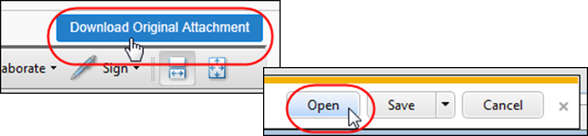

Using Batch Details to Review Attachments Before Reprocessing
If you elect to reprocess a batch selected in the Batch List page it will appear in the Batch Details window. By selecting one or more attachments in this window, the admin can draw on additional options to help work with the batch prior to reprocessing.
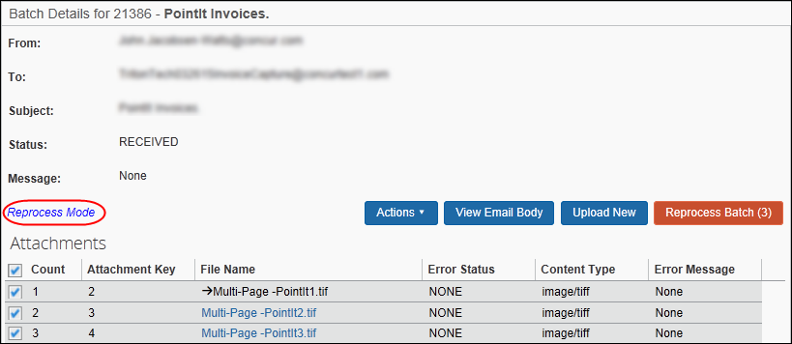
For example, to view the attachments in detail, decide to upload a new, replacement attachment, and to filter the attachments to be reprocessed selectively prior to the actual reprocessing step. In this way the batch and its attachments can be reviewed for accuracy, and only those attachments with issues reprocessed in this step.

Additional Functions Available to the Client Managed Capture Verifier
The Invoice Client Managed Capture Verifier role is granted additional rights that let them work with batches using commands available only to them from the Actions menu.
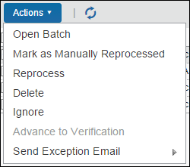
These include:
- Mark as Manually Reprocessed: Use to apply a status of Manually Reprocessed. This is done whenever the original invoice image quality is low, and an improved replacement invoice is emailed or uploaded for creation of the invoice. By marking the new invoice as reprocessed, all users understand there was an issue, and a new invoice was required to complete processing.
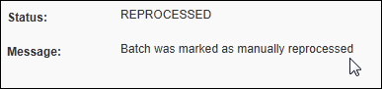
- Reprocess: Use to force the reprocessing of a batch that might not have correctly created an invoice, or any at all. The selected batch is reprocessed and appears in the Batch Details page for review. Multiple selections can be reprocessed but will not appear automatically in the Batch Details page. You must open them separately to review the invoices and attachments.
- For more information about reprocessing a batch, refer to Using Batch Details to Review Attachments Before Reprocessing section in this document.
- Reprocessing under the Dual Support Environment: If working with Capture Processing in a Dual Support environment, the admin can elect to change the processing method from Client Managed to Concur Managed or vice versa to accommodate batch handling.
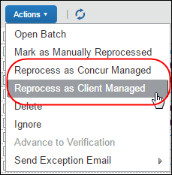
- For more information about changing the processing method, refer to Concur Invoice: Capture Processing - Dual Support User Guide.
- Delete: Use to remove a batch. The selected batch is deleted from Capture Processing (multiple deletion is permitted) when you do this.
- Ignore: Use to archive a batch, possibly in preparation for reprocessing later. Capture Processing will "soft" delete the batch. It will still appear in the list with a status of Ignored, but the system provides no functionality such as document separation for a batch with this status.
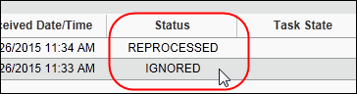
- Advance to Verification: Use to bypass OCR capture extraction and instead proceed directly to the Verification step from the Content Extraction step (only – otherwise the command is disabled). This is useful for those Verifiers who do not want to wait for OCR extraction and instead expedite the process directly to the Verification step.
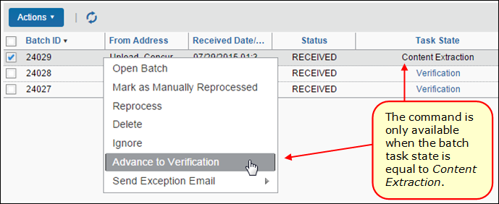
Since the batch is removed from the OCR step using this feature, manual verification is required to finish coding the new invoice.
- Send Exception Email: Use to send an email alerting your specified recipients that this batch has the specified exception (chosen from a list). This command augments the system’s automatic exception process by letting you do this when an issue is found with the batch that requires the recipient’s attention.
- For more information, refer to the Working with Options on the Other Settings Tab section in the Concur Invoice: Capture Processing (Client-Managed) Setup Guide.

When Should You Reprocess a Batch?
A batch might fail for several reasons, and if this happens, the system will display an error message to the administrator.
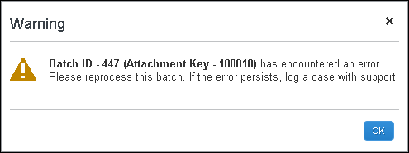
Reprocess a batch whenever the initial processing failed based on issues you can correct directly (as opposed to requesting a new batch from the supplier). This option simply allows for a second attempt at initial processing in order to use the batch as provided, with corrections applied at your site.

Changing the Capture Processing Mode
If working in the Capture Processing Dual Support environment, you can elect to change the capture method by performing the reprocessing step under a different capture mode (Client Managed to Concur Managed, or reverse). This is useful whenever the admin would like to move a batch based on who should perform the processing of the batch. A pair of commands appears in the Actions menu to perform this switch of ownership.

Partially Successful Batches
The system will always complete invoice creation for a batch even if a partial failure is encountered due to some unforeseen issue. This means you do not need to reprocess the entire batch from start to finish. Instead, note the Failed status and use the Batch Details page to identify those failed invoices that should be reprocessed (typically those that lack a link indicative of a successfully created invoice).

Using the Upload Feature to Add Batches
The Client Managed Capture Verifier role (only) can elect to upload a batch to the Capture Batch List directly from their desktop. This is useful whenever you want to use Capture Processing to process invoices that have not been emailed by your supplier (by mail, fax, scan, or otherwise as examples).
SAP Concur strongly recommends a minimum of 300 DPI when scanning invoices.
The Upload Batch window appears when you click Upload Batches in the Capture Batch List page (note the examples in the following figure).
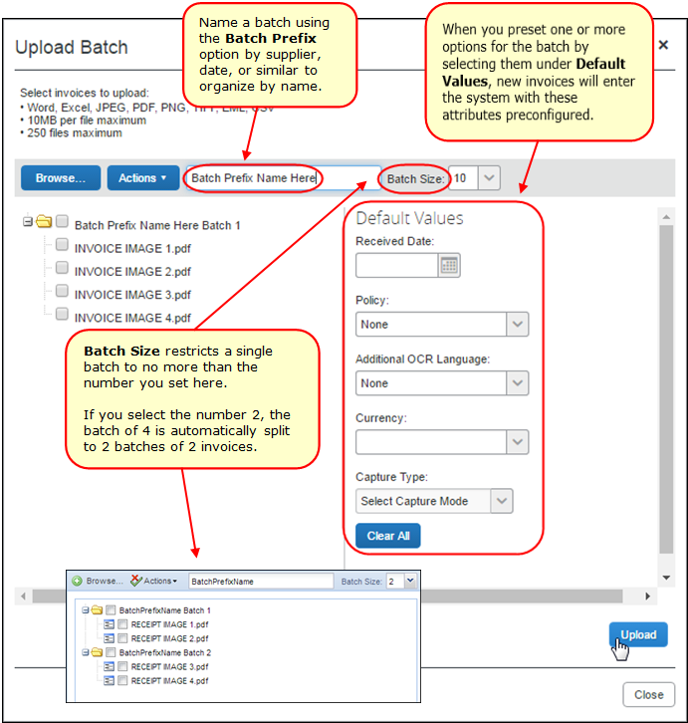
Multiple file upload is supported using Chrome, Safari, Firefox, or Microsoft Edge.

Preparing for Upload
When approaching the upload process, it is important to understand how to organize each batch and associated set of invoices. You can upload as many invoices as you want in a single upload session (that is, until you click Close and exit the session), but when grouping invoices within a batch, note that a limit of 25 invoices is enforced for each batch to keep the size reasonable.
This means best practice is to first set the Batch Size value (the default is 10), then browse and add your invoices. Now, upload the batch and go through this process again, resetting the size and uploading invoices either sequentially by supplier or similar, all within the same session. When you click Close, the session ends, and all settings revert to their defaults.
Determining Batch Sizes When Working With Multiple Verifiers
Keep in mind that as each Verifier works with a single batch, that batch is locked from others. This could mean that large batches might not make sense if multiple Verifiers are working in simultaneous sessions; the larger the batch, the fewer invoices available for work across the Verifiers. Conversely, if only a single Verifier is tasked with reviewing, they are not limited by these restrictions, and you might prefer creating large batches since there is no conflict of use across Verifiers.
The following options are available to help in organizing batches in the Upload Batch window:
- Batch Prefix: (Recommended) To add clarity and ownership to your view of batches, consider naming the batches by adding a prefix (Acme; etc.) or initial so that everyone knows what employee uploaded the batch or batches. The name is incremented for each new batch, creating Acme1, Acme2, Acme3, or Erin1, Erin2, Erin3, etc. as you group your invoices per batch.
- Batch Size: The number you select here tells the system to group by that amount, and no more, for each batch. If you select the number 2, and have staged 4 invoices for upload, the system will automatically take, in sequential order, the first 2 invoices for the first batch, and continue this process, creating 2 batches of 2 invoices each total.
Remember that you must set the attribute before uploading. The system cannot re-set batch size nor can you re-arrange them after the invoices are uploaded- you must reverse the work and begin again.
- Default Fields: Here you can elect to save coding time by pre-configuring invoice attributes in advance of the export into Invoice workflow. For example, have the system pre-select an invoice policy for uploaded invoices only, or associate a capture type with the uploaded batch.

Uploading the Invoices
Uploading the invoices is a straightforward process. The administrator (Client Managed Capture Verifier role) determines the order of invoice upload to match the attributes they have configured. For example, setting the name to Acme, and the batch level to 2 to match the supplier’s typical invoice set. Using the example above, these will all be sent to Concur Invoice workflow under the Wire Transfer policy that includes the selected employee, Erin Fletcher, who will be auto-assigned the invoices and become the Invoice Owner.
To upload invoices in the Upload Batch window:
- Click Upload Batches in the Capture Batch List page.
- (Optional) In the Upload Batch window, set the configuration attributes you want for the batch or batches as detailed above.
- Click Browse and select the invoices to upload (a maximum number of 25 invoices per batch is enforced).
- Click Upload to upload the batch and associated invoices; each batch and invoice is now marked with "uploaded" to verify receipt.
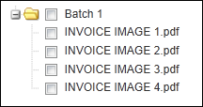
- Continue to upload additional invoices as required, then click Close to exit the window.
The batch is now listed in the Capture Processing Batch List page and can be managed just as any other batch using instructions in this document. Note that each uploaded batch is represented as a single row. If two batches are uploaded, two separate rows are created:
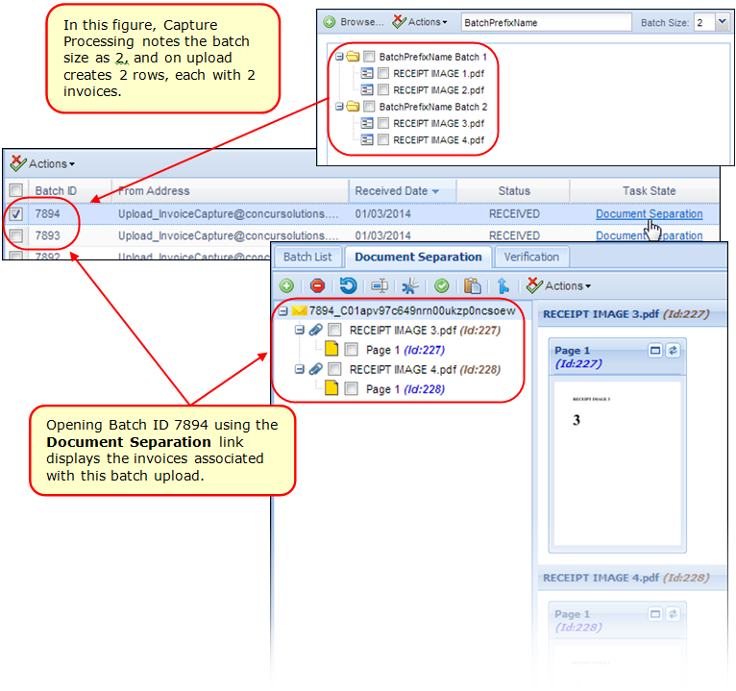

Working with Invoices in the Upload Batch Page
Several display and deletion options are available to the administrator when working in the Upload Batch page and are available by clicking the Actions menu.
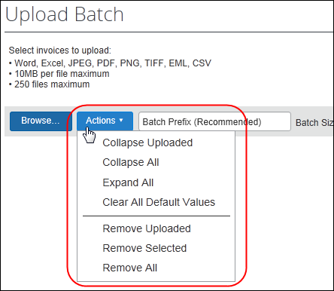
The commands perform the following actions:
- Collapse Uploaded/All: Use these commands to hide the list view of your invoices under their respective batches, either those that have been uploaded, or all that are listed
- Expand All: Open all batches and their invoices for view in list format
- Clear All Default Values: Reset all options under Default Fields to blank
- Remove Uploaded/Selected/All: Use these commands to remove a selected or uploaded batch or invoice, or all batches that appear in the list

Special Considerations When Uploading Batches
Note the following when working with this feature:
- A limit of 25 invoices is enforced for a single batch
- Configuration of attributes (size, naming, owner, etc.) must be set before uploading the invoices (batches)
- Attributes reset after a session (when you click Close)

Using the Document Separation Page
The Client Managed Capture Verifier role uses the Document Separation page to review the emailed or uploaded batch prior to submitting it for OCR extraction and verification. A session using the options on this page is recommended whenever confirmation is needed that invoice pages are in the correct order and associated with the correct batch, as examples.
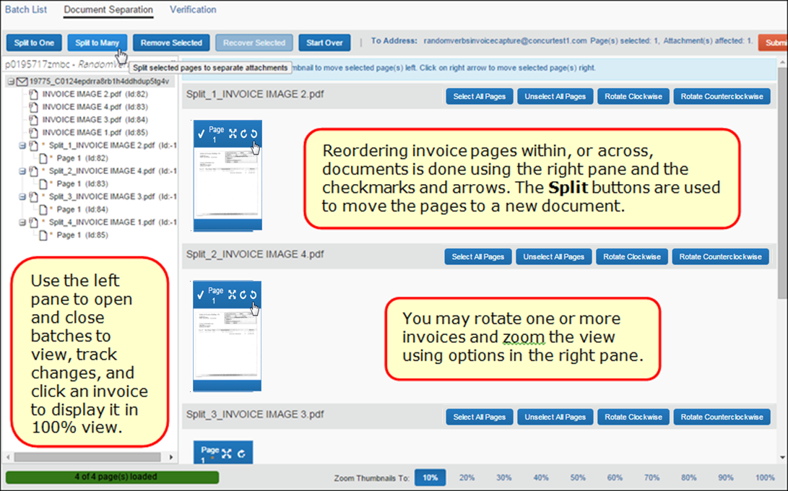
When you work with a batch, the Batch List page shows the batch as locked under the Locked Indicator column, with the name of the current "owner" listed under Locked With.
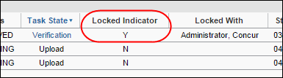
- For more information about the locked status, refer to the Locked and Unlocked Status section in this document.

Working With Invoices of Over 500 Pages
Attachments that include over 500 pages often fail due to the large number of pages and embedded fonts the system must decode. To prevent a failure in processing attachments of this size, the system handles 500+ page attachments as follows:
- If single attachment over 500 pages: The attachment will skip the Document Separation task, and instead display for coding on the Verification page.
- If multiple attachments with one attachment over 500 pages: Each attachment will route through Document Separation to the Verification step, but the attachment over 500 pages will trigger an informational message (below), and then proceed directly to the Verification step in read-only state.
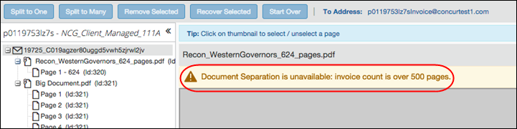

Working With Batches and Invoice Pages: Options on the Button Bar
The uppermost section of the Document Separation page features a button bar as shown in the following figure.
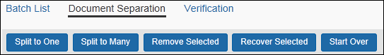
The buttons on this bar perform the following functions:
- Move all selected pages to a single new batch:
The Split to One button creates a single new batch in the left pane, and groups all selected invoice pages under that batch; this is a many to one relationship of invoice pages to a new batch respectively
- Move each selected page to its own new Invoice:
The Split to Many button creates one or more new individual invoices in the left pane, as part of the current batch
- Remove one or more invoice pages from a batch:
The Remove Selected button marks an invoice page with a status of Removed in the right pane, and places the same status (via an asterisk "*") on the page in the right pane as a temporary reference. This supports the ability to recover the change if the Verifier changes their mind about the deletion (once the session is concluded and the batch submitted, the invoice is deleted from the system.)
- Return a removed invoice page to its original batch:
The Recover Selected button reverses the Remove action, returning all selected invoice pages to their original state, in the batch

Working With Batches and Pages: Viewing Attachments
The right pane of the page can be used to manipulate the attached invoice images, in PDF format, to ensure they are properly prepared for the OCR step of processing. Each image must be legible, clear of streaks and smudges, and oriented in the correct, upright position.
To aid in this task, the page includes a set of percentage links under Zoom Thumbnails To that increase or decrease the size of the image for greater visibility. Alternatively, view an image in its own window by clicking the Maximize Page button. To correct the orientation, click the Rotate Page button until the image is upright.
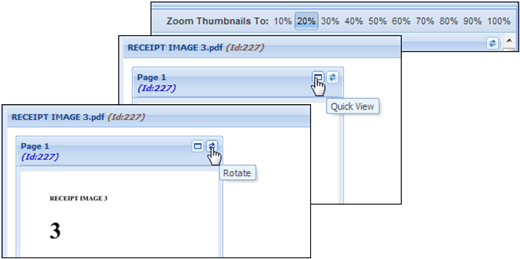

Working With Batches and Pages: Submitting and Other Options
Once the administrator has verified the batch, they can choose from the following options, available to them using the buttons on the Document Separation page:
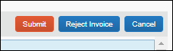
- Submit: This command places the batch in queue for the OCR step in processing. The results will be available in the Verification tab.
- Reject: This command strips the batch of all changes for this session. You must specify a reason so that an action can be taken by the system.
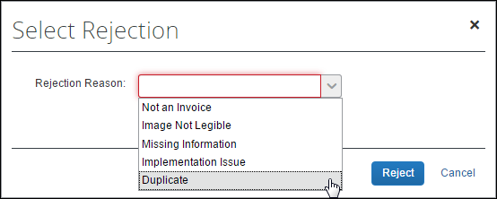
If you select Not an Invoice or Image Not Legible then the batch returns to queue.
- Cancel: This command places the batch, with changes intact, back into the batch list for future work in another session

Using the Verification Page
The Verification page is used by the Client Managed Capture Verifier role to work through each processed batch, reviewing the newly created invoice for accurate data capture.
The Verifier reviews and (if necessary) corrects fields captured by default during the OCR process, and fills out non-default (client-additional, such as Custom) fields. However, selected fields, such as Assign Request To, might be read-only to indicate who will be assigned the invoice. This role will also review the itemizations under Itemization Summary, adding and moving rows as needed.
There are two methods the Verifier can employ to perform the task of updating fields that the OCR process does not code automatically:
- Manually by Keyboard: The value in the source field of the invoice is manually added to the target field in either the header or line item sections of the new invoice using keystrokes
- Copy and Paste Feature: The invoice image features highlighting that, when clicked, can paste the value directly to a selected field (this is discussed in detail below)
Tools that the Verifier can draw on include the Unpin Image button and sizing options that support magnification for greater clarity and detail of the image text meant to be captured and coded. When finished, the administrator can proceed one after another, or review an invoice, then submit it before moving to the next using controls in the lower right of the page.

Coding Fields Manually on the Verification Page: Setup Options
Several configuration options are available in the Other Settings tab of the Capture Processing Admin tool that can speed manual coding of the new invoice. For example, if auto-assignment of policy is enabled, the current policy assignment can be changed by using the Policy Name field. Likewise, if the Select Ledger feature is active, all account codes associated with the ledger selected using this option will be used for each invoice.
Finally, if the Capture Attention To feature is enabled in Task Definitions, the invoice owner can be selected by using the search function in the Assign Request To field the system adds with this option. Note that this feature can also pre-set an owner in read-only format based on system defaults (vendor assignment, etc.) as set by a company.
- For more information about these options, see the Working with Options on the Other Settings Tab and Working with Options on the Task Definitions Tab sections of the Concur Invoice: Capture Processing (Client-Managed) Setup Guide.

What Fields Are Extracted During the OCR Process?
The fields in the following table are extracted during the OCR process.
Fields Supported for Capture by Invoice Client-Managed Capture Processing
Header Fields
Vendor Name | Invoice Date | Invoice Number
Currency | Total Amount | Shipping
Tax | PO Number | Invoice Owner is configured
Vat 1 (Primary Tax - Canada GST/HST, Australia GST, US Tax, VAT UK/Japan) ** | Vat 2 (Secondary Tax – Canada PST/QST) * | Vat Amount 1 - 4
Line-Item Fields
Part Number | Description | Total (calculated)
Quantity | Unit Price | PO Number
Vat 1 (Primary Tax - Canada GST/HST, Australia GST, US Tax, VAT UK/Japan) ** | Vat Amount 2 - 4
NOTE: Fields can be added to the form but will require manual entry and coding by the Client Managed Capture Verifier role.
* On page calculation behavior for these fields is dependent upon which form, the Header or Line Item, the VAT field is placed on. Once a VAT field is added, calculations are performed based on the location as follows:
- Request Total = Header Shipping + Header Tax (or line tax) + (Header VAT total (if exists and has non-zero value)) + Line item Total
- OR -
Line VAT total (if exists and has non-zero value)
- Amount Remaining to be itemized = Invoice Amount - (Header Shipping + Header Tax (or line tax) + (Header VAT total (if exists and has non-zero value)) - Line item Total
- OR -
Line VAT total (if exists and has non zero value)

Verifying the Captured Data OCR Extraction
The task of verification incorporates a side-by-side view of the original emailed invoice, for preparation for creating an invoice. This view lets the Verifier quickly compare and verify values auto populated into the default fields (captured data) during the processing step.
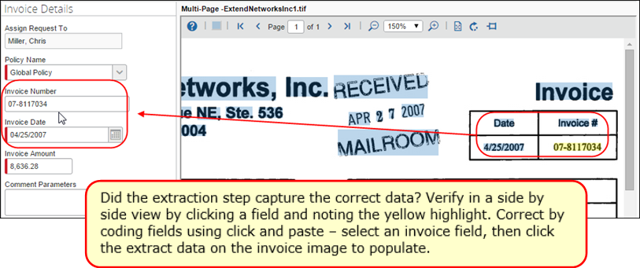
The Verifier also manually codes the remaining, client-added fields at this time, for example, if a custom field Store Number or similar was added to the form to satisfy the equivalent value provided by the supplier. Again, the Unpin and magnification features can help when coding the invoice.
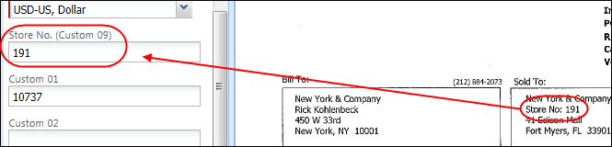

Coding Fields Using the Copy and Paste Feature
The Copy and Paste feature is used to quickly map data elements in the invoice image directly to a selected field in the new invoice using standard clicking and dragging techniques. By choosing the first uncoded field, the Verifier can quickly move from field to field as the system automatically fills and then moves to the next empty field in the invoice. In this way, Custom and other field types can be filled with a minimum of time and error.

How It Works
The Verifier working in the Verification tab sees the new invoice and the invoice image side by side. With this view, the Verifier has several options to perform the copy and paste.
They can first select one (or more) data items, then the field.
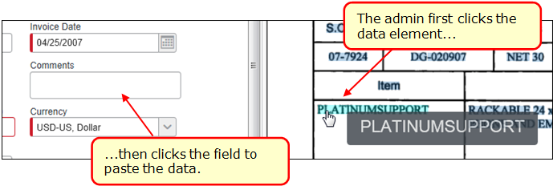
Or first select the invoice field, and then right-click the data element.
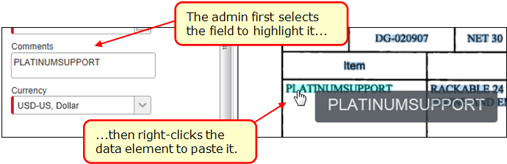
To capture several data elements, click several highlighted data elements, then click a field to paste. Or, click a non-highlighted area and a crosshair tool appears that can then dragged across the data and pasted by either clicking a field, or right-clicking to paste in an already-selected field.
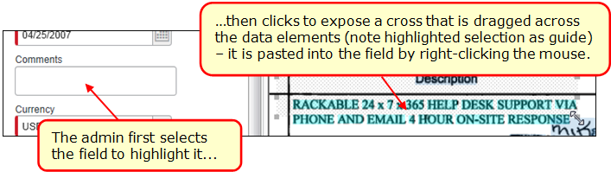
In all instances, the data is copied to the field and the system advances automatically to the next unfilled field in the invoice. To cancel the copy action, press the Escape key.
A drop-down Custom field type cannot be populated using this method and should be manually coded by the Verifier.

Tips and Best Practices When Working With This Feature
The most rapid data coding is performed by clicking in the first unfilled field of the form, then right-clicking a data element to fill it – the system auto-advances to the next empty field where the action is repeated, and so on until the form is completed.
When working with this feature the admin can change the highlighted color or elect to turn the highlighting off completely using options on the toolbar (the data can still be captured).
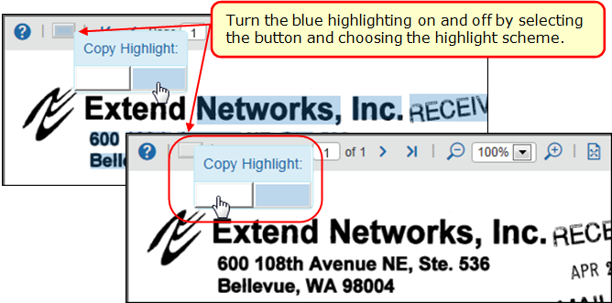
As always, it is critical that each field be reviewed for the correct value and placement of data. For example, the image quality of hazy, blurred, or non-standard font types might lead to typographical errors. A quick final review of the coded invoice will ensure it is successfully created.
- The process of producing clean invoice images is discussed in depth in the Understanding and Improving the OCR and Extraction Process section in this guide.

Verification Using the Automatic Yellow Highlighting Feature
If the Verifier clicks a field in the new invoice in the left pane, that data will automatically appear in yellow highlight in the invoice image in the right pane.
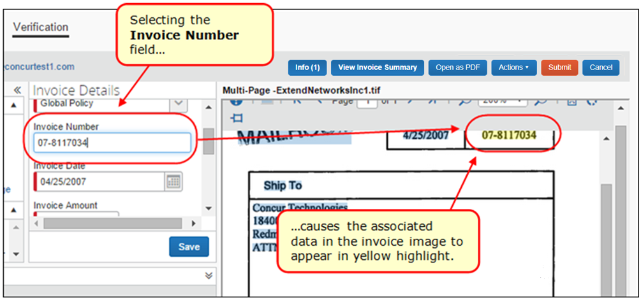
By auto-highlighting the image, the Verifier can quickly scan and recode the invoice if there are any mistakes. For example, "1234" might be an address that was incorrectly mapped to an invoice number field in the invoice.
Note the following when working with this feature:
- A single highlighted area on the invoice image might be mapped to more than one field on the new invoice – use this to recode if there is a mistake
- Only the currently displayed invoice image page shows the highlight – if another invoice page has highlighting it is not shown in the current page view
- This feature works when tabbing from field to field in the invoice
- If extracted data is changed, the invoice field (or fields) change as well
- The process of producing clean invoice images is discussed in depth in the section Understanding and Improving the OCR and Extraction Process in this guide.

Adding and Moving Rows in the Itemization Summary
The Verifier can add and move rows using the buttons in Itemization Summary. This is useful when verifying and correcting the extracted list of itemizations so that the order matches the invoice (or other criteria). For example, to remedy a missed itemization that should be added and moved within the existing list, or any itemization in the list that requires reordering so that it appears as the verifier expects post-processing.
This is done using the Add Item, Move Up, and Move Down buttons that add and move a single selected line to a new location within the overall list.
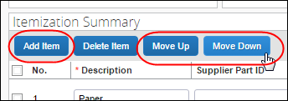

Behavior When Adding and Moving
When adding, and then moving, a new row, the system places the row:
- At bottom, if no row, or multiple rows, are selected
- Above, if a single row is selected
In the following example, the Pencils line item is added to the Itemization Summary line items using the Add Item button, and then moved to its correct location using the Move Up button.
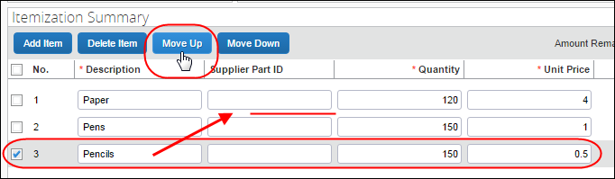

Working With Vendors
The Verifier is limited to either adding or changing a vendor under Vendor Information. They cannot request a new vendor. Issues with a missing vendor require the Vendor Manager role to resolve using the Vendor Manager tool in Concur Invoice.
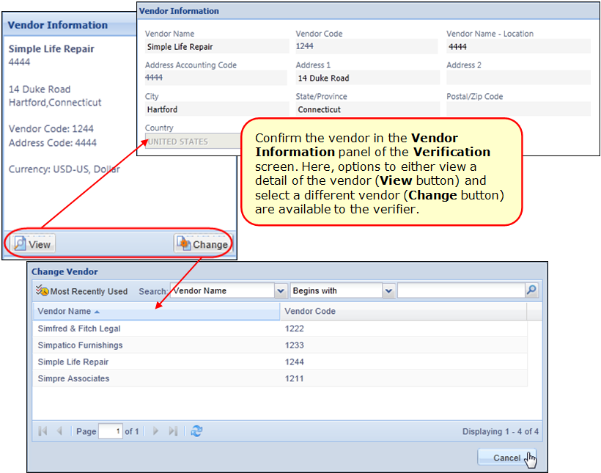
When changing the vendor, use the Search functionality and available attributes to filter the vendor master list to the vendor you want to use. Be aware that the available search criteria is dependent on the status (Hidden; Required; Optional) applied to the entry of banking information by roles using the Group Configurations tool.
If the Vendor Segregation feature is enabled, the list of available vendors will be limited to those associated with the email address as per the feature. For more information, refer to the Appendix of the Concur Invoice: Capture Processing (Client-Managed) Setup Guide.
- For more information about managing your vendors in Capture Processing, refer to the Concur Invoice: Vendor Manager User Guide.

Use Purchase Order Data to Match to Vendor
Capture Processing will attempt to match a Purchase Order (PO) to a vendor automatically, using data included in the PO and the original invoice. This systematic matching is performed whenever a PO:
- Is found to match the wrong vendor
- Is found to match no vendor at all
- Has its number, and thus its vendor match, changed in the system
This enhancement speeds the matching of the correct vendor to the purchase order. The automatic matching of vendor follows the pairing of an invoice containing a known PO number to an actual PO currently existing in Concur Invoice. Once this is completed, data in the PO is used to confirm the vendor in order to match to the best "known" vendor for that PO. If an incorrect match is found, the system displays a message asking if the admin would like to change the vendor assignment.
If no vendor can be found, Capture Processing uses existing matching features (copy down fields, Vendor Segregation email address, etc.) instead. Alternatively, inactive POs can be used for this data, but if the PO is invalid or has a status of Null, it will be ignored.

Filter Vendors Based on Email Address Used by Vendor
You can decide to filter the vendors that can be assigned to an invoice, thus increasing the accuracy of the vendor by reducing the number of available selections. By associating email addresses to a single email alias, then assigning the alias to a group of vendors, only those vendors are available during the OCR step, and when changing vendors manually during the verification step.
- For more information, refer to the Appendix: Using the Email Address to Filter Vendor Availability in the Concur Invoice: Capture Processing (Client-Managed) Setup Guide.

Moving Through the Batch Verification Workflow
The Verifier can display any invoice in the batch using buttons available on the button bar at the bottom of the Verification page. A status indicator provides information on the total amount of invoices in the verification queue and the exact invoice number you are verifying.
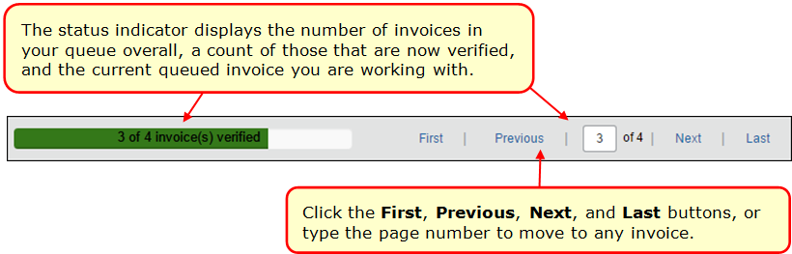
The Verifier will employ whatever method best applies to their work style and company requirements. That is, either moving through the invoices for verification only and leaving the final action to a different Verifier, or performing the verification and then acting on the invoice immediately.

Navigation Options and Informational Messages
The Verifier can draw on several navigational options and will see reminder messages when working with multi-invoice batches on the Verification page:
- Auto-return to last opened invoice: If you leave the Verification page, on return the last saved invoice of the multi-invoice batch is automatically displayed, allowing you to continue where you left off
- Access any invoice at any time: A set of buttons supports viewing the first, previous, next, and last, or any invoice by page number by the Verifier instead of a linear paging

- Review verification status in a summary view: A summary view of the status of all invoices, each with a link that opens the invoice, is available by clicking the View Invoice Summary button.
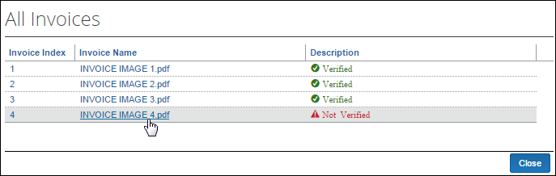
- Automatic warning for unverified work on a specific invoice: The system generates a warning message whenever the Verifier navigates away or attempts to submit a batch with invoices that have not been fully verified
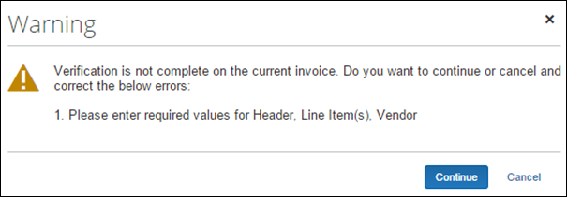
- Automatic warning for unverified invoice on submission: If any invoices in a batch remain unverified on submission, the system displays a warning message for the Verifier

Acting on the Verified Batch
Once the batch is verified as complete and ready for Concur Invoice workflow, the Verifier can elect to reject one or all invoices or submit the completed invoice. If there is an error preventing submission, or the invoice is invalid, additional action can be taken with the invoice.
The buttons and any error message appear at the top of the Verification page.
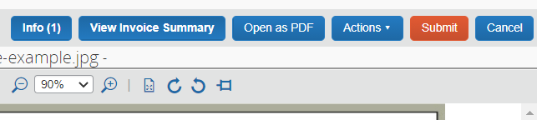

Rejecting, Recovering, and Reprocess Invoices
The Actions menu features a set of rejection commands that let you elect to reject one or all invoices. Click a command to perform this task. If you do this in error, use the Recover Invoice command to return the invoice to an active status.
You can also choose to reprocess all invoices or pin an invoice image.
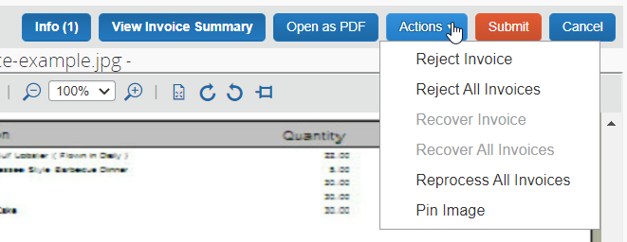

Retrieving Error Messages
If an error is detected, the system displays the Error button with an amount indicating the number of errors. When clicked, the Errors message box displays.
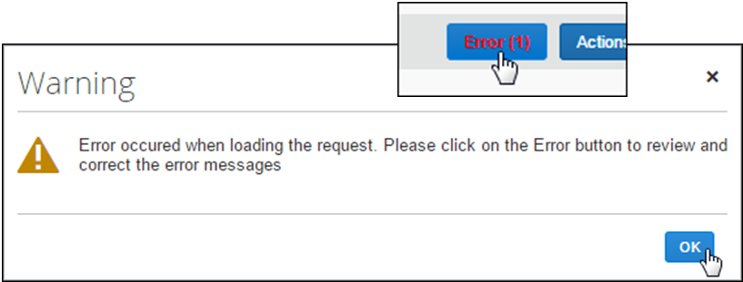
Review the error, and consult with your Concur Invoice administrator to resolve the issue.

Submitting an invoice
Click Submit to send the new invoice to the beginning of Concur Invoice workflow.
This is the most common action, resulting in generation of an invoice in Concur Invoice. The invoice might need to be assigned if not auto routed to the Invoice Owner, updated with additional coding, after which it proceeds to the beginning of its assigned workflow. From here, the invoice is treated just as any other invoice in the system, approved and processed to completion.

Rejecting an invoice
Whenever an invoice cannot be processed, it is a candidate for rejection. To reject one or more invoices, click Actions > Reject or Reject All Invoices and select a reason in the Select Rejection dialog.
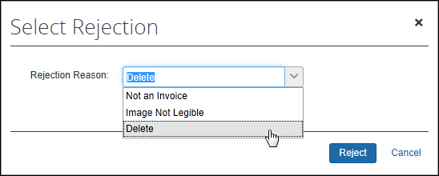
If you select Delete, then it will delete the entire batch. If you select Not an Invoice or Image Not Legible, then the batch is returned to queue. The system will mark the invoice with a watermark of REJECTED and add the Rejection Summary window to explain the status of the invoice.
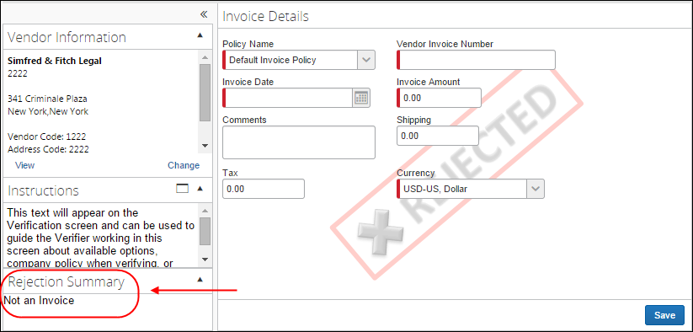

Canceling an invoice
Click Cancel to return the processed batch to the Capture Batch List page.
An issue might prevent submission of the invoice, and the Verifier might want to return the supporting documents included in the batch to the Capture Batch List page. Here, another Verifier can assume responsibility for the original batch to resolve the issue. Click Cancel to do this.

Moving Between Opened Invoice and Batch Details
When you view the details of an invoice that was created through Invoice Capture, the Actions menu on the Invoice Details page contains a command that is unique to invoices generated through Capture Processing. The View Capture Details command opens the invoice in the Batch Details view.
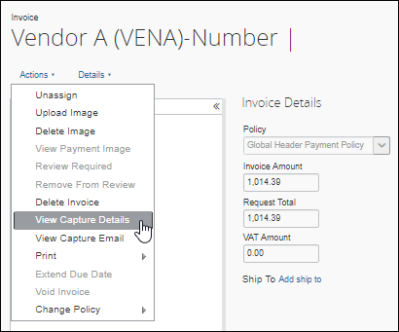
A link, Back to Invoice, returns the view to the Invoice Details page.
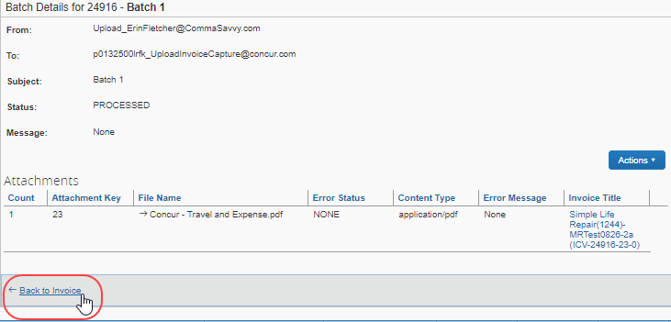

Viewing the Capture Email for an Invoice
When you view the details of an invoice that was created through Invoice Capture, the Actions menu on the Invoice Details page contains a command that is unique to invoices generated through Capture Processing, View Capture Email.
If the batch from which the invoice was created was generated from an email, the View Capture Email command email body for review in PDF format.
Information about the sender and receiver of the email is omitted from the PDF and attachments to the original email are not available when viewing the email through View Capture Email.
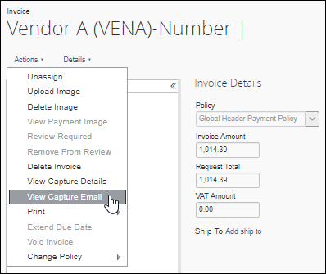
If the invoice was generated through Capture Processing but was not generated by an email, clicking View Capture Email results in the following message: This Invoice does not have any Email associated to it.
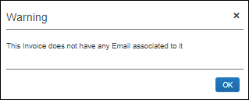

Appendix
This section provides configuration details, in-depth descriptions, upcoming feature, and additional data that might be helpful to the user of Capture Processing.

Working With Tax and VAT Data
If the admin elects to capture tax and VAT fields and has one or more tax authorities, the field data might change based on assigned owner, vendor, policy, or expense type assignment. This change is based on the associations created between these attributes and the tax authority to which they are assigned.
To prevent confusion and assist the admin, an audit trail entry is created whenever the tax and VAT data changes due to processing and final assignments as described above.
This section describes best practices for working with VAT in different countries.

Canada
There are different ways to implement VAT for a client in Canada. The following section describes how to implement four and two VAT tax fields respectively.
Implement four VAT tax fields:
Clients who, for example, do business in multiple provinces and prefer not to have to populate VAT Tax Codes to identify the type of tax that is applicable can implement four dedicated VAT Tax fields for this purpose.
Implementation of all four VAT fields should be labeled as follows:
- VAT Amount 1 – GST
- VAT Amount 2 – PST
- VAT Amount 3 – HST
- VAT Amount 4 – QST
If the client needs to modify VAT at the line, then VAT fields would also need to be added to the Payment Request Line Items Details form to activate the Specify Tax in Invoice Details or Itemization Summary feature.
All VAT fields can be added to Capture Processing forms. However, values for the VAT Amount 3 and VAT Amount 4 fields must be entered manually at this time.
Implement two VAT tax fields:
Clients who only do business in one province or prefer to use VAT Tax Code to distinguish between VAT Tax types in Canada might implement two VAT amount fields.
Implementation of two VAT fields should be labeled as follows:
- For GST/HST use VAT Amount 1
- For PST/QST use VAT Amount 2
Capture Processing will extract primary tax in the VAT Amount 1 field and provincial tax in the VAT Amount 2 field.
VAT Tax Code fields can also be implemented to allow the client to specify which type of VAT Tax that is applicable to each field.
It is important that clients use the correct VAT field to avoid having to manually correct the extracted data results in Capture Processing.

UK/US/Japan/Australia
For the UK, the US, Japan, and Australia, use the VAT Amount 1 field, which is for primary tax. This field is mapped to extract these specific taxes in Invoice Capture as well.
For Japanese clients (and potentially other markets), the invoice can identify vendors who include VAT in their unit price. This allows the client to populate the VAT fields without changing the amount to be paid to avoid over billing yet get the correct VAT amounts populated for their extract.

Other Countries
For other countries, contact you SAP Concur Account Manager for up-to-date information about which VAT fields to use.
- For more information about VAT handling in Capture Processing, refer to the Concur Invoice: Capture Processing (Client-Managed) Setup Guide and the Concur Invoice: VAT Setup Guide.

Enabling CFDi Attachments for Reporting to Mexican Tax Authorities
Regulations in Mexico require that a CFDi document in XML format be attached to every submitted invoice. By enabling this feature in Capture Processing, a user might add this document to their invoice and the system will automatically image both documents and create an invoice that includes all relevant tax data for submission.
- For more information, refer to the Appendix topic on this feature in the Concur Invoice: Capture Processing (Client-Managed) Setup Guide.

Where to Download the Begin Separator Sheet
The Capture Processing system uses the Begin separator sheet to instruct the system that an invoice follows. This manual method is used when multi-invoice batches are submitted after scanning. These sheets are available on the Batch List page, using the Download Separator Sheet button.
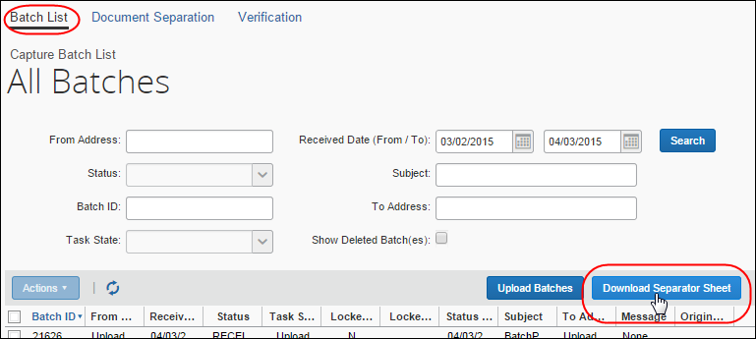

Supported Languages and Currencies
Invoice Capture Processing supports all currencies supported by the Concur Invoice product.
The Invoice Capture Processing feature can read, capture, and support invoices written in the following languages:
- Chinese
- Czech
- Danish
- Dutch
- English
- Estonian
- Finnish
- French
- German
- Hungarian
- Italian
- Japanese
- Latvian
- Lithuanian
- Norwegian
- Polish
- Portuguese
- Romanian
- Slovenian
- Spanish
- Swedish
- Turkish

Understanding and Improving the OCR and Extraction Process
The Optical Character Recognition (OCR) process in Capture Processing uses sophisticated extraction logic and algorithms to identify and convert predefined areas of an invoice image into text data. That text data is then mapped automatically into fields in an invoice.
No OCR technology can provide completely accurate results, but certain factors contribute to a more successful outcome. Specifically:
- Format of the processed document
- Location, position, and orientation of the data
- Use of color vs. a black and white in the processed image

The SAP Concur Imaging Service
The SAP Concur Imaging service employs multiple tools, rules sets, and constant re-analysis to direct a document to the correct process and best outcome. The challenge is supporting the requirements of many different formats while providing rules that ensure the highest success rate in return. For example, the document's embedded properties data is used to direct the document to the tool that will render the cleanest image result.
The client is encouraged to submit a ticket to SAP Concur support so that the Imaging service can learn from errors in its effort to improve the overall success rate.

How Does OCR Extraction Work?
The extraction process prepares the invoice page image for the OCR and Extraction steps by converting:
- The document into a 300 DPI image
- NEXT -
- Into Grey Scale
- THEN -
- Converts it into TIFF image format
The TIFF image is processed using OCR and the content extracted. Overall, the key here is that the document preparation process can add to degrading the readability of the invoice data.

Factors Affecting Accuracy of OCR and Extraction
The following factors affect the overall accuracy of the readability of the data by the system. Consider the following when working with your invoice images:
- Document Format: Use standard PDF documents with supported fonts
- Document Quality: The document should not be pixelated, smudged, or have fold or wrinkles
- Black and White vs. Color: Black & White documents are better for OCR.
- Contrast: Low Contrast documents result in poor OCR and extraction
- Script vs. Plain Text: A script type is more difficult to extract than a plain type
- Consistent Font Type: Multiple font types on a single document can cause bad readability
- Handwritten Text: Unless done in clear, large block-style writing, handwriting is always difficult to decipher and so is not recommended for capture; the results will not be usable
- Location of the Content: The system looks in the logical location for specific elements, such as the top third for the invoice number, and the tax amount at the bottom of the invoice
- Page Formats:
- Single Page Formats (ex - JPG/PNG): File size over 1mb will result in image compression resulting in reduced image quality
- Multiple Page Formats (ex – PDF/Word): A file size over 5mb might be compressed if the average page size is > 100k

Examples of Good and Bad Images and Resulting Data Capture

Excellent Invoice Image Whose Data Can be Completely Extracted
The following is an example of a well-laid out invoice that uses consistent font types, with logical locations for data elements (invoice number; tax), and displays no fold blemish lines or smudges.
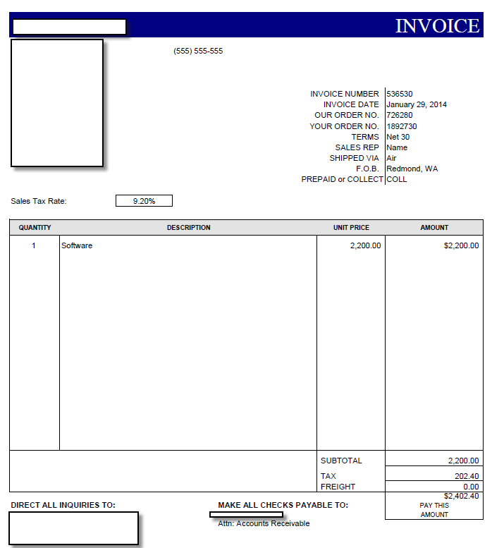

Problematic Invoice Images Whose Data Cannot be Completely Extracted
The following examples include problems to be avoided.
Pixelated Fonts
The preparation and processing of the following pixelated image resulted in data reading "51300". This is because the OCR processing was not able to differentiate between a $ and a 5:

Location of Content
In this document Sales Tax field is a part of the line item list, so extraction logic does not identity it as a header-specific tax value. Ideal placement is as part of the footer, where the system would expect to find it for extraction.
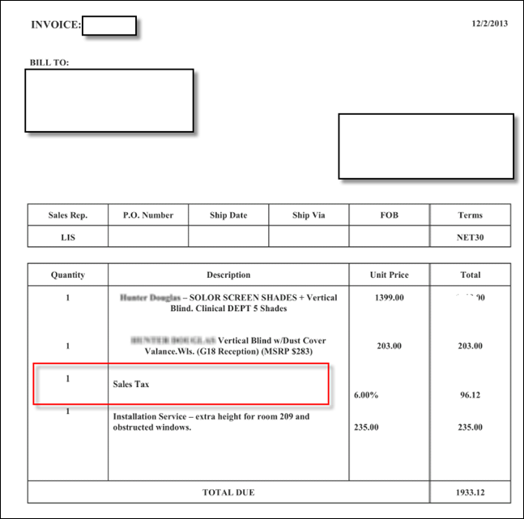
Additionally, the amount is rendered as a percent (%) that is out of alignment, resulting in low confidence in capture for this item and the other data somewhat aligned with the tax amount percentage.
Handwritten and Bad Contrast Invoices
The bad contrast and handwritten text, plus improper alignment of the image results in a very poor chance of data capture.
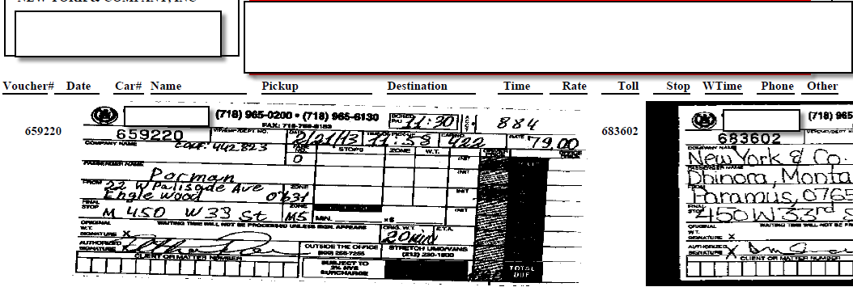
Bad Scan and Resolution
The original light contrast was degraded further by pre-processing, which resulted in a final image for processing that was far too light to render usable captured data.
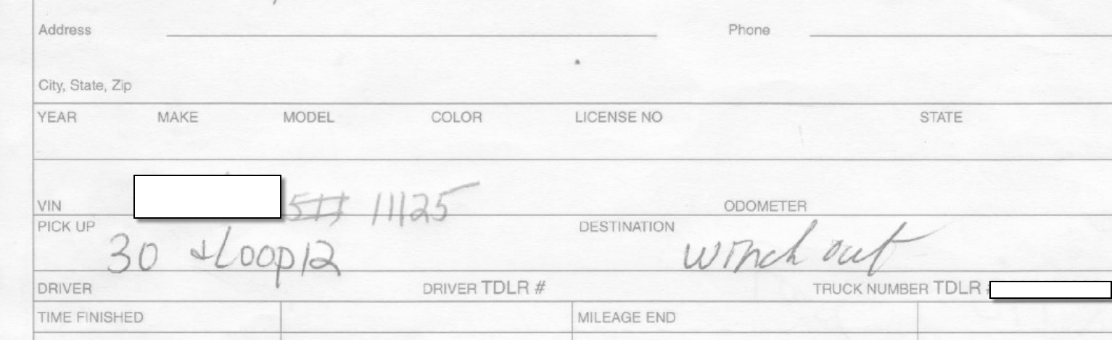
Custom Font Types
The following invoice image appears clear.
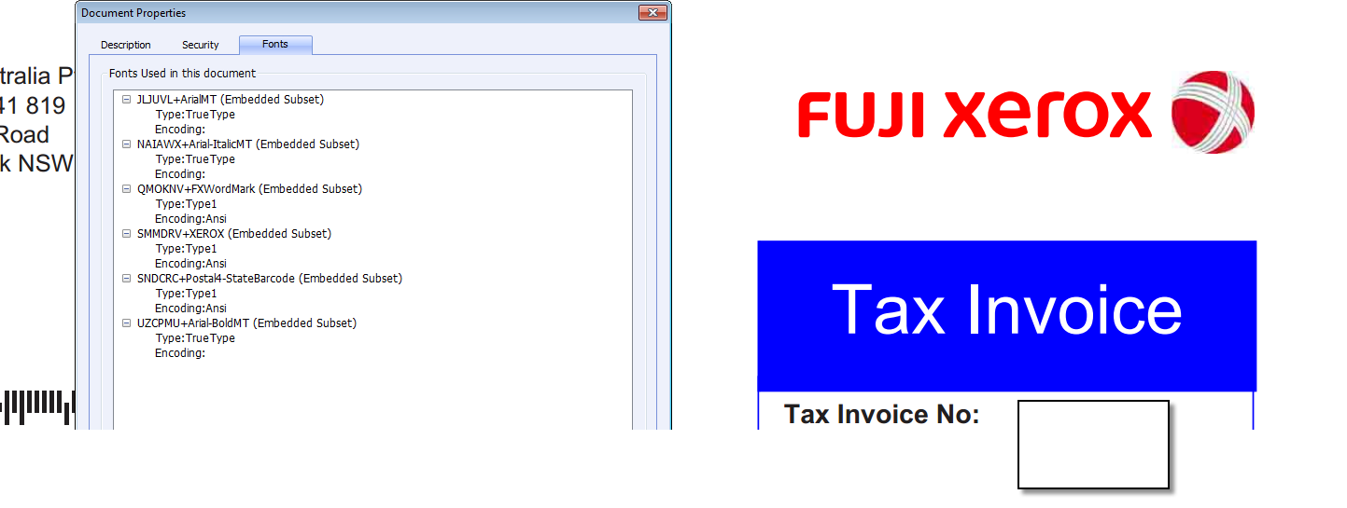
However, on inspection the image was found to incorporate several custom fonts with non-standard encoding.
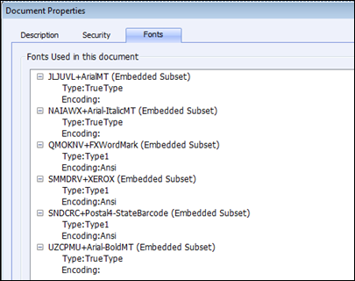
The extraction results for this image were fair, and the system incorporates many layers of document converters to handle these document types. However, the speed and quality of processing are compromised as several additional layers of conversion were used to render results that could be captured.
☼

