
Concur Invoice: Invoice Accounts Payable
User Guide

Last Revised: February 18, 2023
Applies to these SAP Concur solutions:
 Concur Expense
 Professional/Premium edition
 Standard edition
 Concur Travel
 Professional/Premium edition
 Standard edition
 Concur Invoice
 Professional/Premium edition
 Standard edition
 Concur Request
 Professional/Premium edition
 Standard edition

Table of Contents
Section 1: Permissions 5
Section 2: Overview 5
The Centralized Accounts Payable (AP) Environment 6
Combine Invoice Roles for Invoice Tasks 6
Section 3: Using the Invoice Manager Page 7
Section 4: Using the Unassigned Invoices Page 10
Customize Columns on the Unassigned Invoices Page 11
Search and Assign Management of Invoices 12
Search for Invoices 13
Search for Unassigned Invoice by Using the Search Functionality 13
Assign an Unassigned Invoice 14
Auto-Assign an Invoice Using Hierarchies 15
Unassign an Invoice 16
Delete an Invoice 17
Restore One or More Deleted Invoices 19
View Assigned Invoices 21
Work with Images 21
Upload an Image for an Invoice 21
View an Image for an Invoice 22
Delete an Image from an Invoice 23
Print an Invoice 24
View the Comment History of an Invoice 25
View the Audit Trail for an Invoice 26
View the Approval Workflow of an Invoice 27
Change Policy of an Unassigned Invoice 29
Best Practice: Ensure Policy Availability for the Administrator 29
How the Change Payment Policy Works 29
Change Policy for One or More Invoices 30
Change the Policy on an Assigned Invoice 31
What Form Field Data Is Removed on Policy Reassignment 31
Section 5: Using the My Invoices Page 33
Invoice Navigation 34
Customize Columns on the My Invoices Page 35
Download Data to Excel 37
Managing Recurring Invoices 38
Create a Recurring Invoice 40
Attach a Recurring Image 42
Set the Recurring Offset Value 42
Export Recurring Invoices 43
Edit a Single Recurring Invoice 44
Edit a Recurring Invoice Sequence 44
Delete a Single Recurring Invoice 44
End a Recurring Invoice Sequence 45
Delete a Recurring Invoice Sequence Created by Another Employee 45
View Deleted Invoices 46
View Deleted Invoices by Date 47
Search for Deleted Invoices 47
Section 6: Create, Submit, and Approve an Invoice in a Single Step 50
Overview 50
Before You Begin 50
Required Roles 50
How Single Step Approval Workflow Works 51
Section 7: Tracking Front-Office Invoice Changes 51
Overview 51
Before You Begin 52
Actions that Trigger a Change 52
How the Changes Are Tracked 52
Special Considerations 53
More Information 53
Read the Audit Trail for a Tracked Invoice 53
Section 8: Preventing Unauthorized Deletion of an Invoice 54
Overview 54
Before You Begin 54
Required Roles 55
Section 9: Assigning the AP User to a Vendor Group 55
User Admin Experience 55
Configuration 57

Revision History
Date | Notes/Comments/Changes
February 18, 2023 | Added an Export Recurring Invoices section to the Managing Recuring Invoices section. Added a Recurring Invoices bullet to the list in the Download Data to Excel section.
October 27, 2022 | Minor edits; cover date not updated,
June 18, 2022 | Added a note about AP User and Process role access by vendor group in the Overview and Using the Unassigned Invoices Page sections.
January 21, 2022 | Updated the copyright year; no other changes; cover date not updated
March 4, 2021 | Updated the copyright year; no other changes; cover date not updated
November 16, 2020 | Removed note about Unverified Capture link.
September 28, 2020 | Added information about duplicate invoices and removed in-product message information.
September 14, 2020 | Added information about customizing columns in the All My Invoices list view.
July 24, 2020 | Updated information about Download as Excel feature.
July 21, 2020 | Updated information about changing policy on invoices.
July 8, 2020 | Added information about Download as Excel feature.
April 20, 2020 | Renamed the Authorization Request check box to Request on the guide’s title page; cover date not updated
March 14, 2020 | Added information about customizing columns in the Unsubmitted Invoices and Unsubmitted Purchase Order list views.
February 3, 2020 | Minor formatting change; no other changes.
January 7, 2020 | Updated the copyright; no other changes; cover date not updated
December 16, 2019 | Added info about customizing columns on the Unassigned Invoices page.
August 5, 2019 | Added clarification about the Invoice Navigation window.
June 8, 2019 | Added information about viewing all assigned invoices.
May 11, 2019 | Updated sections describing assigning and unassigning invoices.
April 13, 2019 | Added new user experience enhancements, such as the new Invoice Manager page, the new Unassigned Invoices page, and the My Invoices page that replaces the My Request page. The sections describing assigning and unassigning invoices is targeted to be updated completely next week.
February 13, 2019 | Changed the term "Concur" to "SAP Concur" and the term "payment request" to "invoice" where applicable; no other content changes.
February 1, 2019 | Updated the copyright; no other changes; cover date not updated
April 11, 2018 | Changed the check boxes on the front cover; no other changes; cover date not updated
April 4, 2018 | Republished to add bookmarks.
January 31, 2018 | Added information about managing recurring payment requests.
January 13, 2018 | Updated copyright information and added content about the Request Navigation window and Previous Request and Next Request links.
July 29, 2017 | Added information about the search functionality on the All Unassigned Requests page.
July 8, 2017 | Removed references to double-clicking as customers only need to single-click to open payment requests. Added information about the Comment History window.
December 13, 2016 | Changed copyright and cover; no other content changes.
May 15, 2015 | Updated the images to the enhanced UI and made general updates to the content.
September 17, 2014 | Added information about the two user interfaces; no other content changes
July 11, 2014 | A new View menu filter, Unassigned Requests Created by Me, is now available
June 16, 2014 | The AP User role is now group aware and can be mapped to Vendor Access Groups as imported and created using the Vendor Manager tool
April 15, 2014 | Change copyright and cover; no other content changes
February 7, 2014 | Addition of recurring invoice feature
April 15, 2013 | If auto submit rules are configured via Policies, they are ignored when the AP User is auto-assigned (soft-assigned) a request on opening it in their Unassigned Requests queue
December 28, 2012 | Made rebranding and/or copyright changes; no content changes
January 20, 2012 | Update to reference auto-assign of Invoice Owner using the Routing Configuration and Import Hierarchy Mappings feature.
February 24, 2011 | Ability to restore ("undelete") a deleted payment request.
December 31, 2010 | Updated the copyright and made rebranding changes; no content changes.
July 16, 2010 | Convert document to new user interface.
December 2009 | Changed to stand-alone user guide; no content change
July 2008 (SU 33) | Added information about the two available user interfaces:  - Classic user interface  - Current user interface
 | Older revision history has been removed. Guide first created in September 2007 (SU23).

Invoice Accounts Payable
NOTE: Multiple SAP Concur product versions and UI themes are available, so this content might contain images or procedures that do not precisely match your implementation. For example, when SAP Fiori UI themes are implemented, home page navigation is consolidated under the SAP Concur Home menu.

Permissions
A company administrator may or may not have the correct permissions to use this feature. The administrator may have limited permissions, for example, they can affect only certain groups and/or use only certain options (view but not create or edit).
If a company administrator needs to use this feature and does not have the proper permissions, they should contact the company's SAP Concur administrator.
In addition, the administrator should be aware that some of the tasks described in this guide can be completed only by SAP Concur staff. In this case, the customer must initiate a service request with SAP Concur support.

Overview
Organizations that employ the centralized Accounts Payable (AP) process may use roles and features associated with Concur Invoice to streamline the process of creating, submitting, and approving invoices in this environment. This guide explains the roles and procedures required to perform the following tasks:
- Manage invoices, including assignment, unassignment, image upload, printing, viewing, audit trail review, and other tasks
- Create and submit an invoice in a single step
- Specify an invoice as automatically recurring
- Track changes made in an invoice by front-office employees
- Prevent unauthorized deletion of an invoice
- Be assigned to a Vendor Access Group to work with unassigned invoices associated with that vendor group (and no others)
Users with both the AP User and Processor roles can access the Unassigned Invoices page, based on their vendor group access. This ensures they will only view invoices relevant for their role.
The sections below describe how the Accounts Payable (AP) model can apply features in Concur Invoice to streamline tasks in this centralized environment. Specific configuration information is included in the various Concur Invoice setup guides.

The Centralized Accounts Payable (AP) Environment
In this organizational model, the back office receives an invoice from a vendor for a good or service that a front-office employee ordered on behalf of the organization. The back-office employee uses the vendor invoice information to create the invoice, attach the invoice image to the invoice, and then assign the invoice to the employee who ordered the good or service. The employee, in the Invoice User role, verifies the information and submits the invoice for approval by the Invoice Approver.

Combine Invoice Roles for Invoice Tasks
While many Concur Invoice tools require only a single role, the Invoice User role may be combined with other Concur Invoice roles for access to Concur Invoice pages to perform specific tasks. This means that privileges and rights for each role may overlap.
With the addition of another role (as specified), the Invoice User can:
- Change Purchase Order (PO) data in form fields (Invoice Purchasing User)
Cannot work with own PO-based invoices except in capacity of Purchasing role that prohibits creation or submission of PO-based invoices.
- Assign or unassign an invoice (Invoice AP User)
- Manage unassigned and assigned invoices pending approval (Invoice AP User)
- Create, submit, and approve an invoice in a single step (Invoice Approver role)
- Track changes by front-office employees (Invoice AP User)
- For more information, refer to the Shared: User Administration User Guide.

Using the Invoice Manager Page
The Invoice Manager page is intended to provide the Accounts Payable users the necessary visibility to monitor all active unpaid invoices as they flow through the system as well as providing short cuts and counts to tasks they do daily.
The user with the Invoice AP User role accesses the Invoice Manager page by clicking the Invoice menu in Concur Invoice.
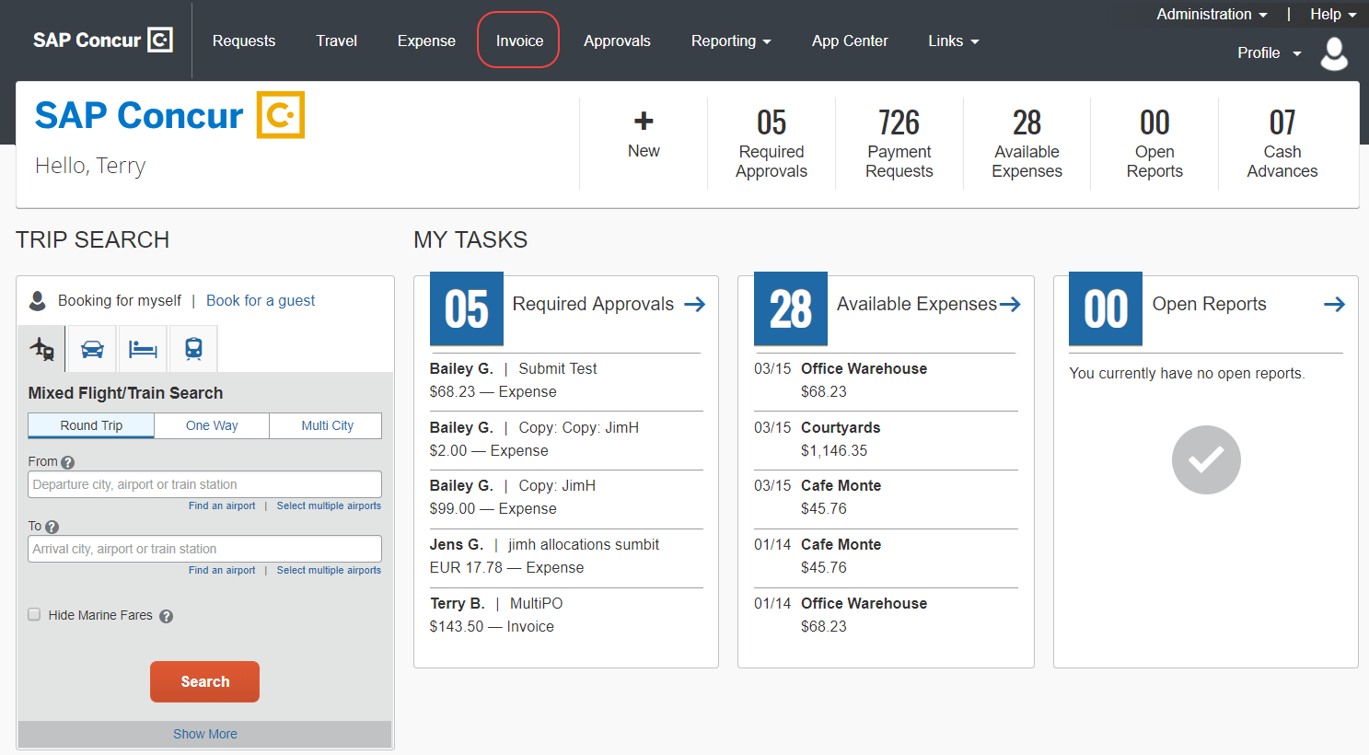
Non-AP users are directed to the My Invoices page when they click the Invoice tab. The Invoice Manager page is not accessible to them.
The Invoice Manager page appears with links to important tasks the AP user needs to perform daily, such as assign and submit invoices.
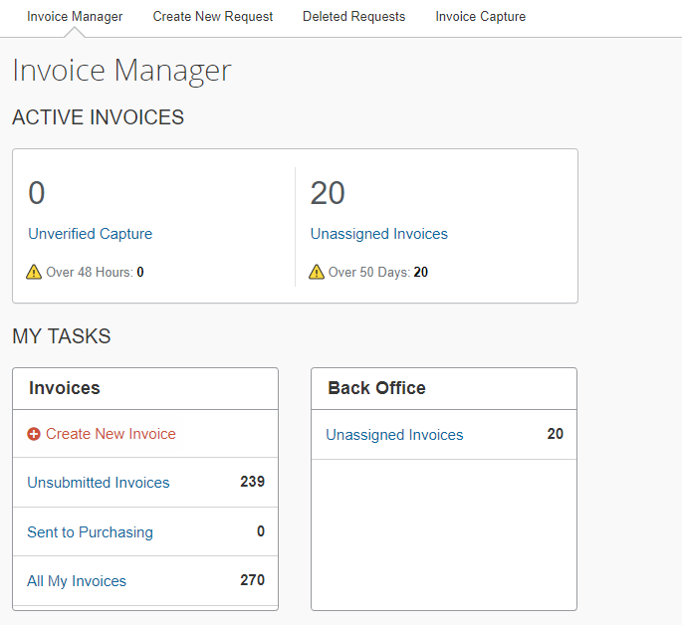
SAP Concur has used existing group and policy configuration in the legacy user interface when displaying counts and cards on the Invoice Manager page to ensure customers continue to see only what they are supposed to.
The Invoice Manager page is divided into two sections: Active Invoices and My Tasks. The goal of the Active Invoices section is to raise awareness of invoices that are aging more than expected, and therefore may need AP attention. An alert (yellow triangle) allows customers to gain visibility into the age of an invoice. For Capture Processing, the age is based on the received date and for all other invoice counts, the age is based on the date the invoice was created.
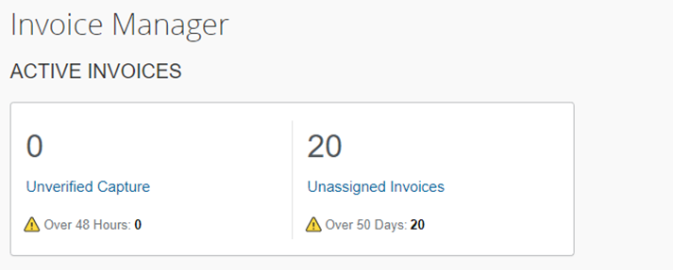
The My Tasks section is intended to provide AP users access points to their daily tasks, for example, checking invoices currently assigned to them or checking if actions are to be performed by an AP User (back office).
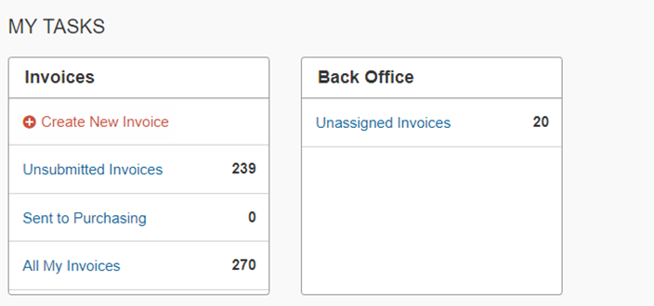
If an AP user also has the Vendor Manager role, an Unapproved Vendors link displays in the Back Office section. Clicking this link will take the user to the Unapproved Vendors page in Vendor Manager.

Using the Unassigned Invoices Page
This section describes how to use options on the Unassigned Invoices page to manage unassigned invoices that have not yet been submitted. Using these options, the Invoice AP user or Invoice Processor can search for both assigned and unassigned invoices by their assignment date. Once a list is returned by Concur Invoice, the user can then assign and unassign invoices singly, or in bulk, to a new invoice user. This is useful for organizations that use the centralized Accounts Payable (AP) back-office model, where a single employee may be responsible for assigning and monitoring invoices across an organization.
AP users who want to work with unassigned invoices can access the Unassigned Invoices page from the Invoice Manager page by clicking the Unassigned Invoices link in the Active Invoices or Back Office section.
Users with both the AP User and Processor roles can access the Unassigned Invoices page, based on their vendor group access. This ensures they will only view invoices relevant for their role.
The Unassigned Invoices page appears with a list of unassigned invoices.
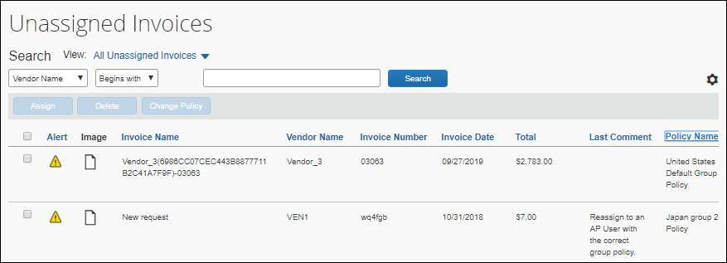
In the View list, the AP user can select to view all unassigned invoices or unassigned invoices created by themselves.
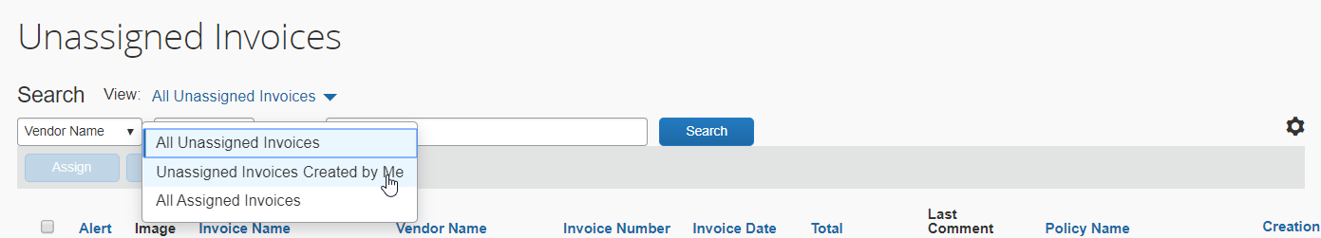
AP users can open and view unassigned invoices without having to assign them to themselves. To edit unassigned invoices, they must click the Edit button of an opened invoice. They do not need to assign the invoice to themself to edit it. After the editing is completed, AP users click Save, and then Assign to assign the invoice to the Invoice Owner.
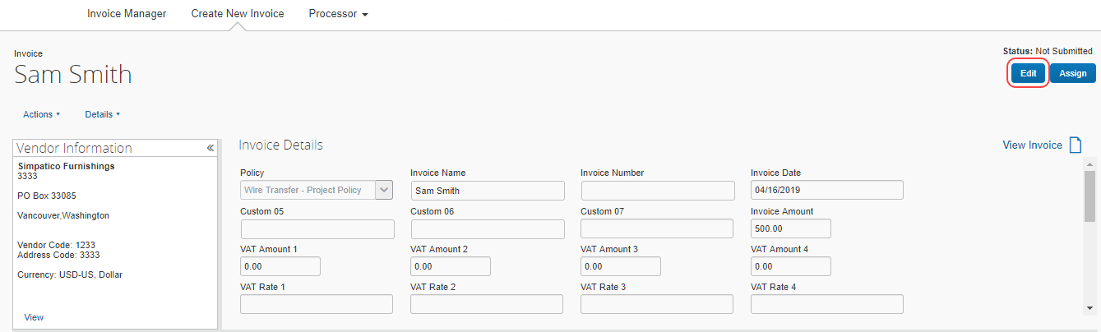
AP users will be able to see duplicate invoices on the Unassigned Invoices page before they open an invoice and they will also see a duplicate message immediately after they open an invoice.

Customize Columns on the Unassigned Invoices Page
AP users can manage and customize columns from the Unassigned Invoices list pages.
To customize columns:
- Click on the gear icon to access the Manage Columns window.
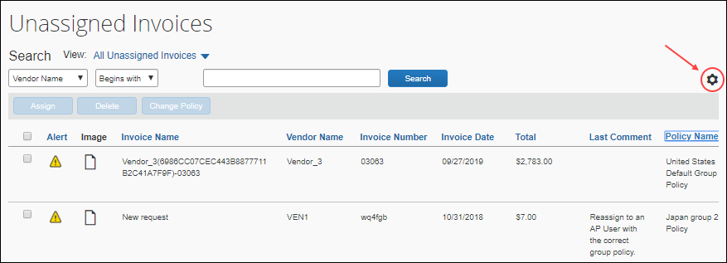
- In the Manage Columns window, drag and drop fields between the Hidden and the Visible lists depending on what you want to see on the Unassigned Invoices page.
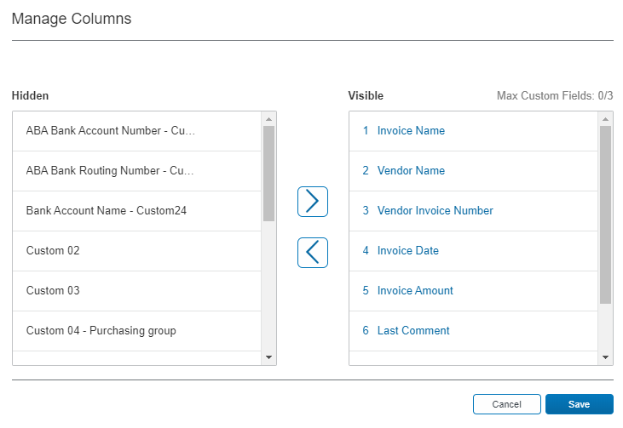
- Click Save.
Some of the columns cannot be removed (hidden). If you attempt to remove (hide) a required column, a warning message appears.
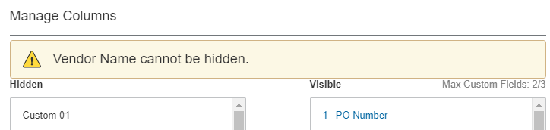
A maximum of three custom fields can be placed in the Visible list.

Search and Assign Management of Invoices
By using options on the Unassigned Invoices page, you can perform the following actions:
- Search for unassigned invoices
- Delete an invoice (may require change to settings)
- Change the policy associated with an invoice (may require change to settings)

Search for Invoices
By default, the system shows you all unassigned invoices when you first open the Unassigned Invoices page. You can search for all unassigned invoices and unassigned invoices created by you on this page.
You will only see invoices based on your user permission in the system.
To search for invoices
On the Unassigned Invoices page, in the View list, select the All Unassigned Invoices, Unassigned Invoices Created by Me, or All Assigned Invoices.
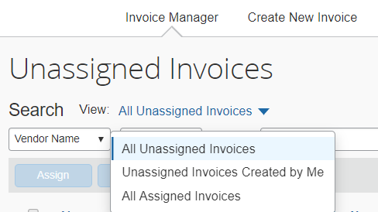

Search for Unassigned Invoice by Using the Search Functionality
You can search on certain types of unassigned invoices by using the search functionality on the Unassigned Invoices page.
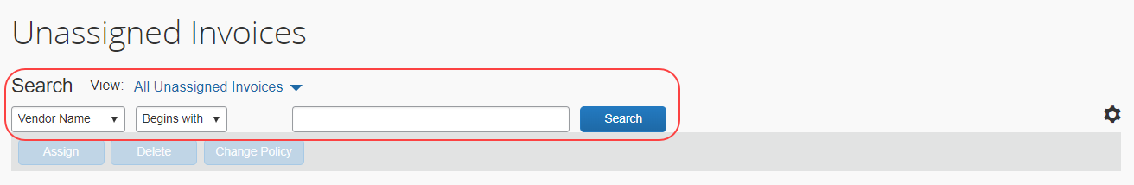
The search options include vendor name, invoice number, total, policy name and invoice name.
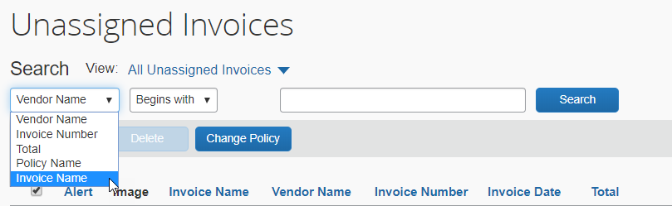

Assign an Unassigned Invoice
An unassigned invoice can be assigned to an employee using the procedure below. However, it is also possible to assign an already assigned invoice to a different employee. See the procedure below for information on reassigning an invoice.
To assign an unassigned invoice to an employee:
- On the Unassigned Invoices page, search for the unassigned invoice(s) you want to assign.
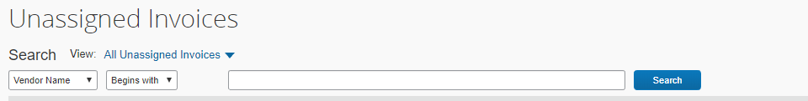
- Select the invoice(s) to be assigned by using the check box to the left of the row.
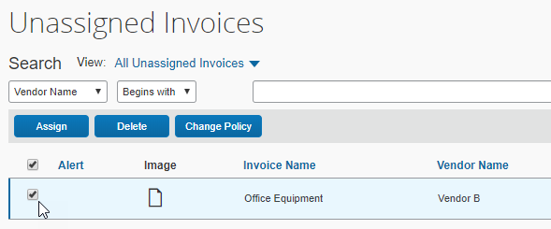
- Click Assign.
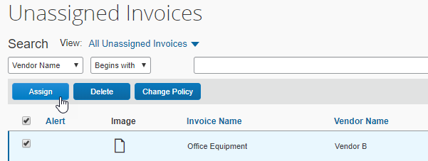
- In the Assign Invoices window, type the first three characters of the employee for whom you want to assign the invoice.
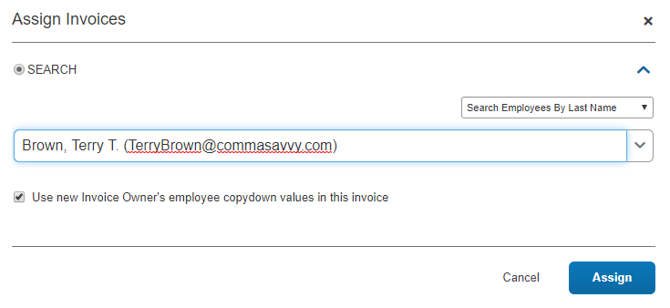
- (Optional) Select (enable) or clear (disable) the Use new Invoice Owner's employee values in this invoice to include the employee's information as pre-populated information on the invoice on assignment.
- Click Assign to assign the invoice to the employee. The Unassigned Invoices page appears.

Auto-Assign an Invoice Using Hierarchies
It is possible to import hierarchy segment mappings that are associated with a default user. When the AP user selects the fields mapped to a hierarchy, that hierarchy path auto-fills the remaining fields as the AP user moves to each field, resulting in the system identifying the default Invoice Owner and auto-assigning it to that employee.
This feature relies on the Routing Configuration and associated import, List Management, and Feature Hierarchy modules of Concur Invoice. Once configured, the default employee appears in the assignment, and no option to change this is allowed. If the specified user is not found (is promoted; transfers), the system will "walk" up the hierarchy to the very next logical employee and assign it to them.
- For more information on configuring this feature, refer to the Concur Invoice: Routing Configuration User Guide and the Concur Invoice: Hierarchy Mappings User Guide.

Unassign an Invoice
An invoice can be unassigned from the current owner of the invoice. This action is restricted to a single invoice at a time since the invoice must be opened to access the Unassign menu item.
To unassign an invoice:
- On the Invoice Manager page, click Unsubmitted Invoices. The My Invoices page appears showing the Unsubmitted Invoices view.
- Click the invoice to open it. The Invoice for <name> page appears.
- In the Actions menu, click Unassign.
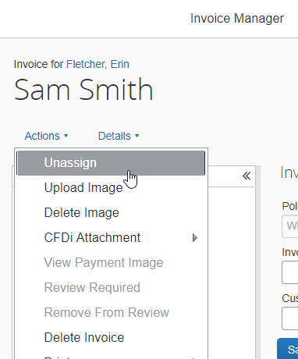
- In the Unassign Invoice window, provide a comment for why the invoice was unassigned from the employee.
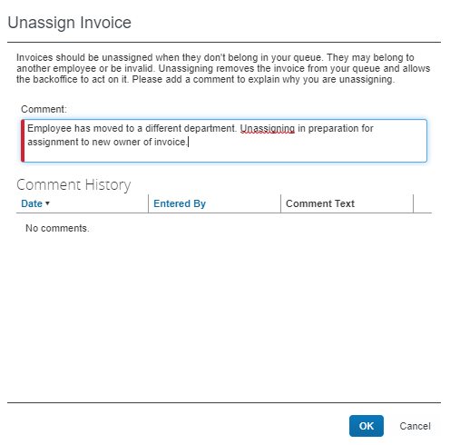
- Click OK.

Delete an Invoice
Only an unassigned invoice can be deleted using this option. This action is restricted to a single invoice at a time since the invoice must be opened to access the Delete option.
- Access by the Invoice User to this command can be restricted. For more information, refer to the Preventing Unauthorized Deletion of an Invoice section in this document.
To delete an invoice:
- On the Invoice Manager page, click Unassigned Invoices. The Unassigned Invoices page appears.
- In the View list, click All Unassigned Invoices to search for the unassigned invoice you want to delete.
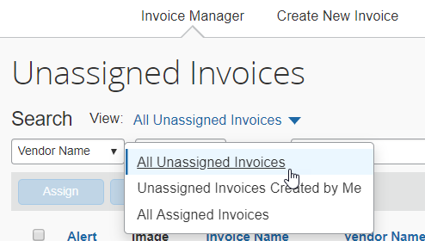
- Select the invoice you want to delete and click Delete.
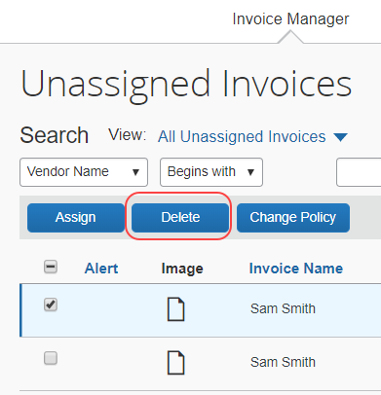
- In the Please Confirm window that appears, click Yes.
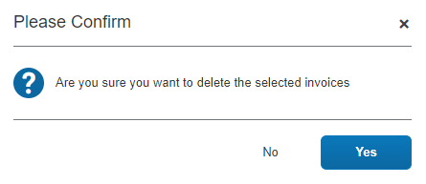

Restore One or More Deleted Invoices
If an invoice is deleted by mistake it can be restored to active status, assigned to the original invoice owner. This action can be taken with one or more invoices.
The AP user must have the Invoice Processor role to perform this procedure.
To restore a deleted invoice:
- Click Processor > Deleted Invoices.
- Select the invoice(s) you will restore.
- In the Actions menu, click Restore Invoice or click the Restore Invoice button in the upper-right corner of the page.
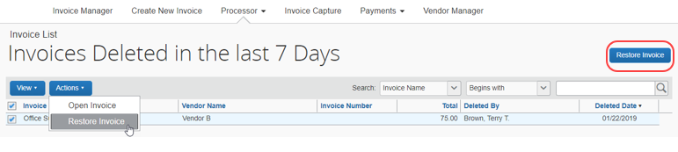
- In the Restore Invoice window, enter a comment. When restoring an invoice, a comment is required that is entered into the audit trail of the invoice, which also records the date and the user associated with the event.
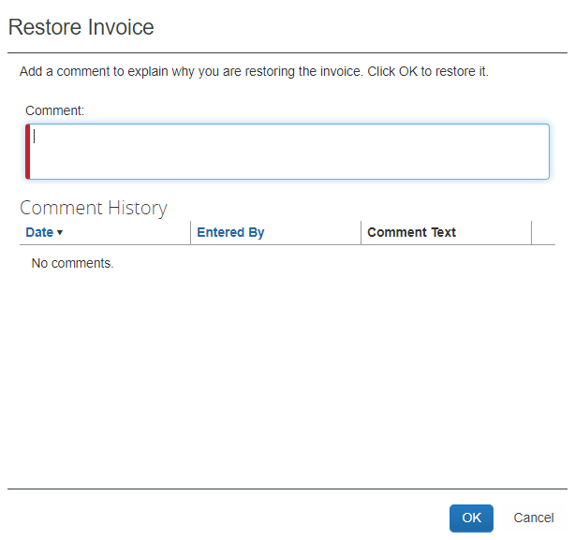
- Click OK. The invoice is now placed in the original invoice owner's queue.

View Assigned Invoices
You can view invoices that you have assigned if you need to keep track of them or if you need to reassign an invoice that you, for example, assigned to an incorrect invoice owner. To view assigned invoices, on the Unassigned Invoices page, in the View list, select All Assigned Invoices.
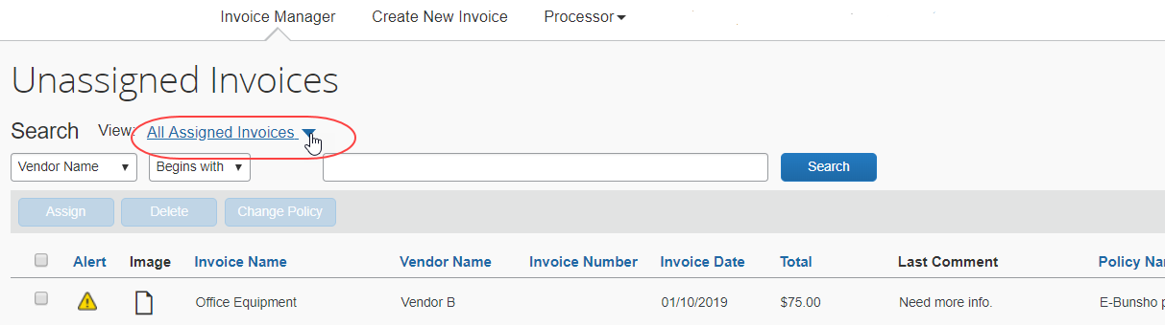
If you need to reassign an invoice, select the relevant invoice and click Assign.
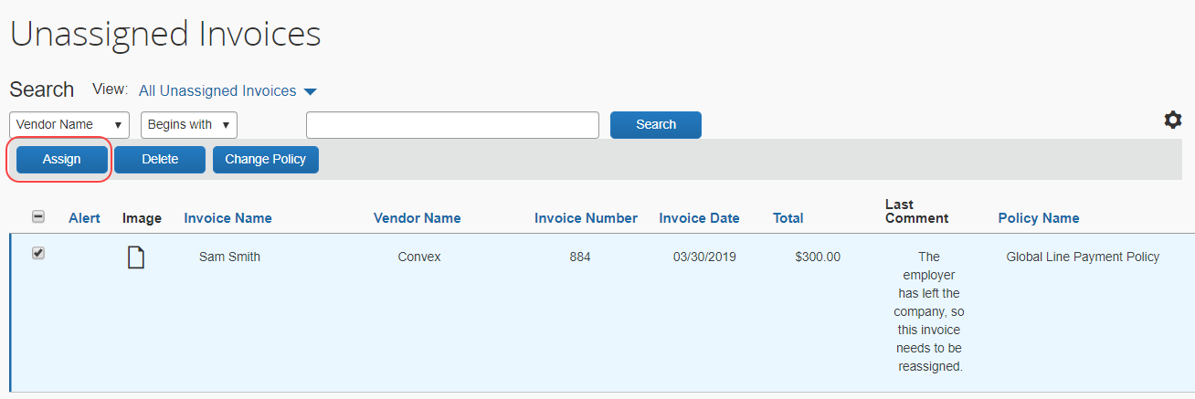
In addition, you can perform several tasks if you open the details of an invoice by clicking it. Some of these tasks include reassign, unassign, print, an delete an invoice.

Work with Images
This section describes how to upload, change, and delete images associated with an invoice.

Upload an Image for an Invoice
An image such as an invoice or W-9 form can be uploaded for a specified invoice. This action is restricted to a single invoice at a time since the invoice must be opened to access the Upload Image menu option.
To upload an image:
- On the Unassigned Invoices page, search for the invoice the image will be associated with.
- Open the invoice by clicking it. The Invoice page appears.
- In the Actions menu, click Upload Image.
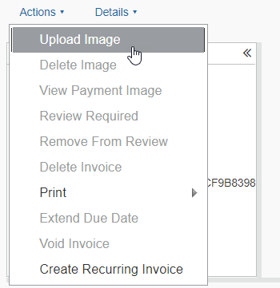
- In the Attach Files window, click Browse and navigate to the folder containing the images.
- Select the image file(s) and click Open. The file is added to a list under Files Selected for uploading.
- Click Attach to upload the files.
The process may take a few minutes. The amount of time required to upload the images depends both on the size of each file and the connection speed.

View an Image for an Invoice
Images associated with an invoice can be viewed with the invoice opened or closed, in listed format. The payment image, however, can only be viewed with the invoice in an opened state.
To view an image associated with an invoice:
- On the Unassigned Invoices page, search for the invoice the image is associated with.
- Open the invoice by clicking it directly.
- To view either image type, perform one of the following procedures with the invoice opened:
- Image:
- Click the View Image link.
- Payment Image:
- In the Actions menu, click View Payment Image.

Delete an Image from an Invoice
This action is restricted to a single invoice at a time since the invoice must be opened to access the Delete Image menu option.
- For information about disabling the ability to delete an image from an invoice, refer to the Concur Invoice: Invoice Settings Setup Guide.
To delete an image associated with an invoice:
- On the Unassigned Invoices page, search for the invoice the image is associated with.
- Open the invoice by clicking it directly.
- In the Actions menu, click Delete Image.
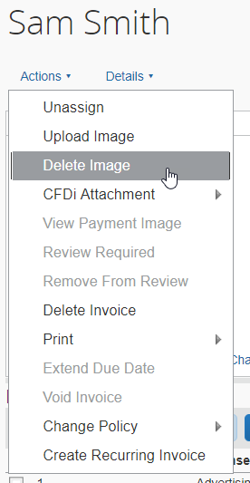
- In the Please Confirm window, click Yes to delete the image.
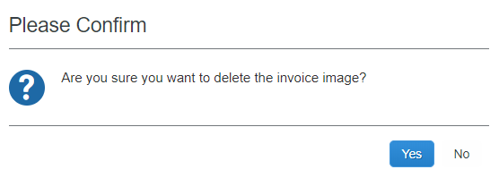

Print an Invoice
This action is restricted to a single invoice at a time since the invoice must be opened to access the Print menu item.
To print the invoice:
- On the Unassigned Invoices page, search for the invoice to be printed.
- Click the invoice to open it. The Invoice page appears.
- In the Actions menu, point to Print, and then click one of two options:
- Invoice Scan/Fax Cover Page: The invoice is displayed in a standalone Fax Cover Page window for printing with barcodes and other details
- Invoice: The invoice is displayed in a standalone Invoice window for printing
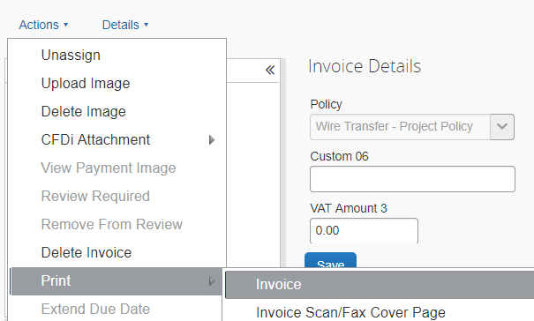
A browser window appears with the invoice type displayed.
- Click the Print button in the upper-left corner of the page.
- Close the window when the printing job is done.

View the Comment History of an Invoice
This action is restricted to a single invoice at a time since the invoice must be opened to access the Comments menu option.
To view the comment history of an invoice:
- On the Unassigned Invoices page, search for the invoice whose audit trail history you want to view.
- Click the invoice to open it. The Invoice page appears.
- In the Details menu, click Comments.
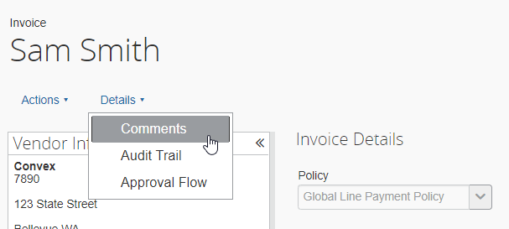
The Comments window appears with comments listed in rows from most recent on. The date reflects the users own time zone.
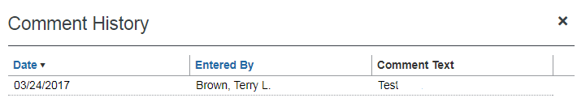
- Click Close.

View the Audit Trail for an Invoice
This action is restricted to a single invoice at a time since the invoice must be opened to access the Audit Trail option.
To view the audit trail history for an invoice:
- On the Unassigned Invoices page, search for the invoice whose audit trail history you want to view.
- Click the invoice to open it. The Invoice page appears.
- In the Details menu, click Audit Trail.
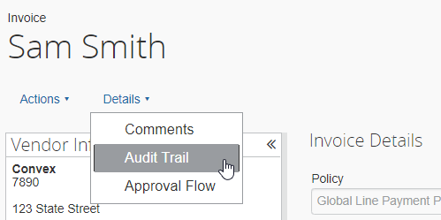
The Audit Trail window appears with comments listed in rows from most recent on.
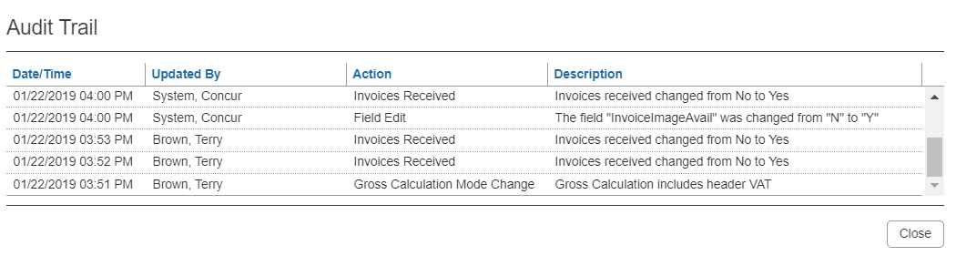
- When done reviewing the audit trail, click Close.

View the Approval Workflow of an Invoice
This action is restricted to a single invoice at a time since the invoice must be opened to access the Approval Flow option.
To view the approval workflow for an invoice:
- On the Unassigned Invoices page, search for the invoice whose audit trail history you want to view.
- Click the invoice to open it. The Invoice page appears.
- In the Details menu, click Approval Flow.
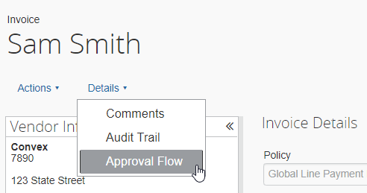
The Approval Flow for Invoice window appears.
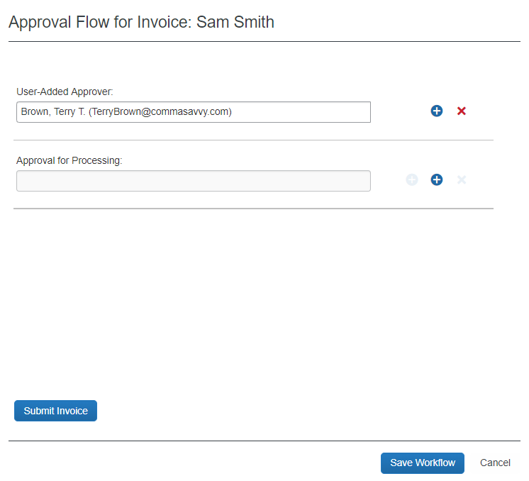
- Review and update the workflow as required, then perform one of the following actions:
- Submit Invoice: Click to submit the invoice
- Save Workflow: Save the changes you have made to the workflow (optionally, click Submit Invoice to now submit the invoice) – once this workflow is saved the invoice follows the workflow after submission
- Cancel: When done reviewing to dismiss the window, or use to clear any changes you have made that you do not want to save
A message appears to ask if you want to open the next invoice or go back to the list.
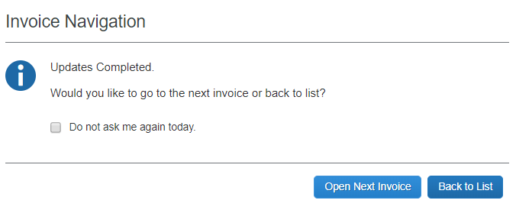

Change Policy of an Unassigned Invoice
The users with the Invoice AP User, Invoice Processor, and Invoice Processor Manager roles can reassign an invoice from one company invoice policy to another. This applies only to invoices without an invoice owner and where the status is unassigned.
This feature is used whenever:
- A site using electronic data capture imports an invoice under a default company policy and the invoice should be reassigned
- Multiple invoice policies require a reassignment when an error is made, or a policy becomes inactive, or a new policy is introduced

Best Practice: Ensure Policy Availability for the Administrator
It is possible for an employee to be working under a policy that is unavailable to the administrator assigning the invoice to that employee. To avoid this, be sure to make the superset of policies available to the administrator to ensure they can choose the policy the employee should work under for the specific invoice being assigned.

How the Change Payment Policy Works
The users with the Invoice AP User, Invoice Processor, or Invoice Processor Manager roles can select one or more unassigned invoices on the Unassigned Invoices page, click Change Policy to select a new policy for the invoice(s). On reassignment, selected fields are cleared of data and an audit trail is created that details what data was removed.
Note the following constraints and considerations:
- Only active policies are available for assignment
- Batch reassignment is supported only when all invoices share the same policy
- This feature may only be applied to invoices in which the status is unassigned
- Only those employees with access to the newly assigned policy may be assigned the invoice
- The new invoice owner will be required to fill out missing data in cleared fields prior to submitting the invoice (refer to the section What Form Field Data is Removed on Policy Reassignment in this document)

Change Policy for One or More Invoices
This feature is limited to only those invoices with a status of unassigned.
To change the policy of an unassigned invoice:
- On the Unassigned Invoices page, search for the unassigned invoice(s) that will have their current policy changed (they must all share the same policy prior to reassignment).
- Select the invoice(s) that will have their current policy changed.
- Click Change Policy.
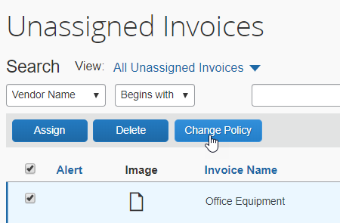
The Change Policy window appears.
- In the Choose a Policy list, select the policy you want to change to.
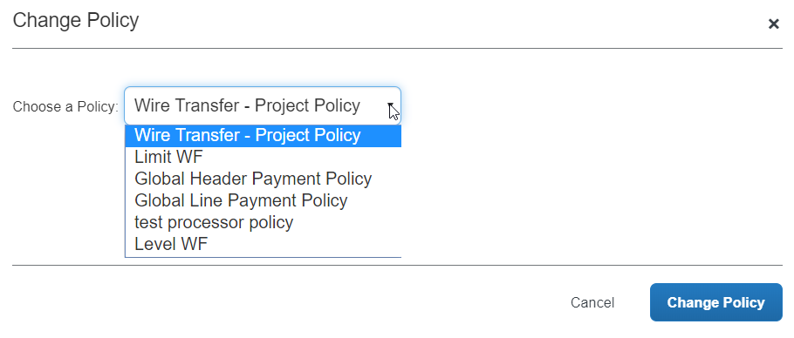
The new policy is now assigned to the invoice(s), and form field data is cleared as required based on the old and new policy field mapping (refer to the section What Form Field Data is Removed on Policy Reassignment in this document for additional information).

Change the Policy on an Assigned Invoice
You can change the policy of an invoice that is already assigned to an invoice owner if it has not been submitted. If the invoice has not yet been submitted, the invoice may be unassigned, the policy changed, and the invoice reassigned to those employees who have access to the newly assigned policy.

What Form Field Data Is Removed on Policy Reassignment
Selected field data is removed because, under the new policy, certain header, line item, or allocation field data may not logically be carried forward if the identical field does not exist on the new policy form. Generally, data is retained where a field exists on both forms. Where a field is not on the new form, the data is cleared, and the audit trail updated with that information. Certain fields are always cleared of data, regardless of the policy's form fields. Refer to Table 1 for this information.
Data in field types of List or Connected List that exist in both forms will have the data removed since, though the field may exist on both forms, the data within those respective fields may differ.
Table 1: Action Taken on Field Data on Policy Reassignment
Field Name or Type | Action Results In…
Header Field Name or Type:
Custom 01 - 24 | Retain if the field is on the form
Org Unit 01 - 06 | Retain if the field is on the form
Business Purpose | Retained only if same field exists on new form
Comment | Retained even if fields differ
Line Item Description | Retained only if same field exists on new form
Description | Retained only if same field exists on new form
Has Comments | Retained only if same field exists on new form
Invoice Date | Retained only if same field exists on new form
Is Emergency Check Run | Retained only if same field exists on new form  Note: If removed from new form, defaults to N
Notes to Approvers | Retained only if same field exists on new form
Notes to Vendor | Retained only if same field exists on new form
PO Number | Retained only if same field exists on new form
Payment Due Date | Retained only if same field exists on new form
Vendor Invoice Number | Retained only if same field exists on new form
Line Item Field Name or Type:
Custom 01 - 15 | Retain if the field is on the form
Description | Retained only if same field exists on new form
Ship From Zip | Retained only if same field exists on new form
Ship To Zip | Retained only if same field exists on new form
Quantity (line item) | If removed from new form, Quantity defaults to 1 and Unit Price is changed to equal the Line Item Total value.  Example: 2 items of $5.00 each totaling $10.00 on old form becomes 1 item of $10.00 totaling $10.00.
Allocation Field Name or Type:
Custom 01 - 20 | Retain if the field is on the form

Using the My Invoices Page
AP users who want to work with invoices can access the My Invoices page from the Invoice Manager page by clicking on the Unsubmitted Invoices link or the All My Invoices link in the Invoices tile in the My Tasks section.
The My Invoices page appears displaying unsubmitted invoices or all the AP user's invoices depending on which link they click on the Invoice Manager page.
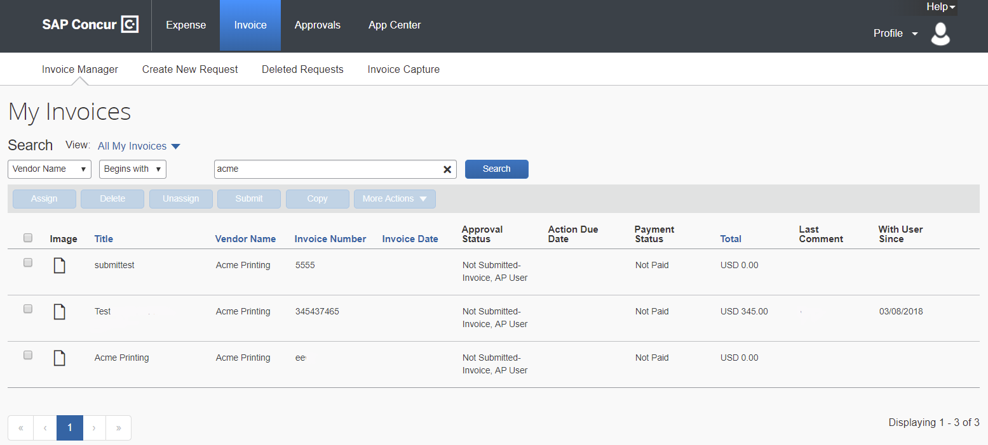
Alternatively, AP users can click the Invoice task on the Quick Task Bar to access the My Invoices page.
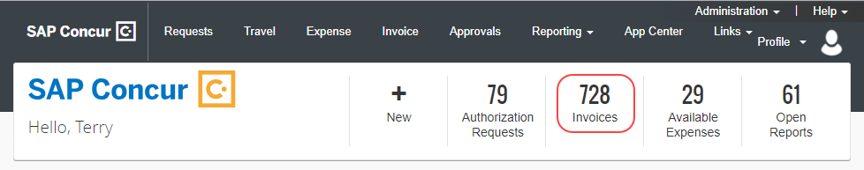
You can select several different views from the My Invoices page depending on your needs, for example, unsubmitted invoices, all your invoices, recurring invoices, and your deleted invoices.
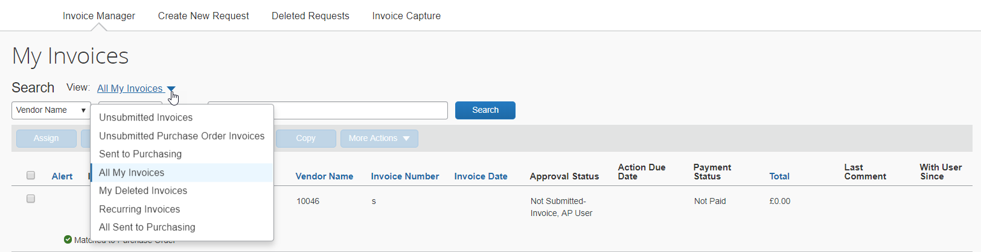
Depending on where in the process the invoice is, you can also select a number of actions by clicking the buttons for assigning, deleting, unassigning, submitting, or copying invoices, or by selecting options in the More Actions menu: Approval Flow, Change PO to NonPO, Recall, or Change Policy.

Invoice Navigation
Once you have opened an invoice, you can decide if you want to go to your next invoice directly by clicking the Next Invoice link instead of going back to the invoice list on the My Invoices page. The Previous Invoice will take you back to the previous invoice in your list.
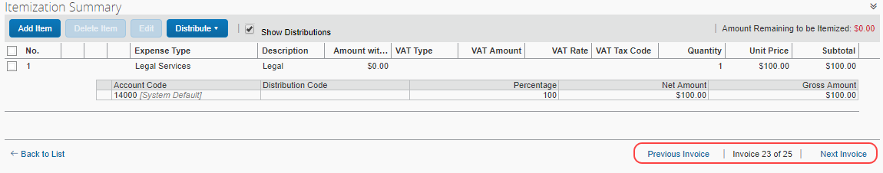
In addition, when you select an action (for example, assign) on a list page and select to whom to route the invoice, you can then choose if you want to go back to the invoice list or go to your next invoice directly by selecting either Open Next Invoice or Back to List in the Invoice Navigation window that appears.
The Invoice Navigation window only appears when users are working on the list pages.
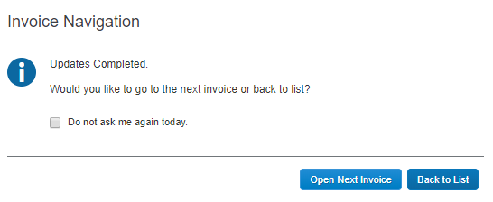
In addition, users can save their setting for 24 hours by selecting the Do not ask me again today option before clicking any of the buttons. This selection means that users will be directed to the next invoice automatically for the next 24 hours.

Customize Columns on the My Invoices Page
AP users can manage and customize columns from the following list views:
- Unsubmitted Invoices
- Unsubmitted Purchase Orders
- All My Invoices
To customize columns:
- Click on the gear icon to access the Manage Columns window.
The image shows the Unsubmitted Invoices list view.
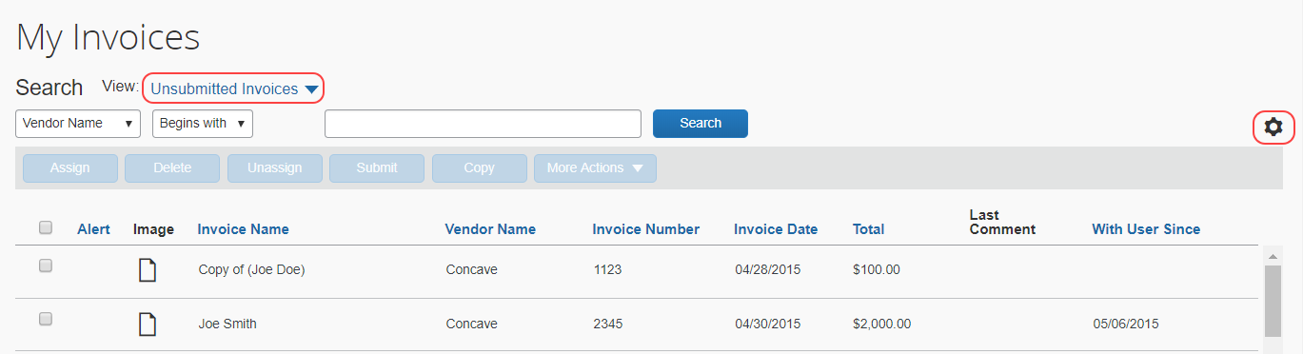
- In the Manage Columns window that appears, drag and drop fields between the Hidden and the Visible lists depending on what you want to see on the Unassigned Invoices page.
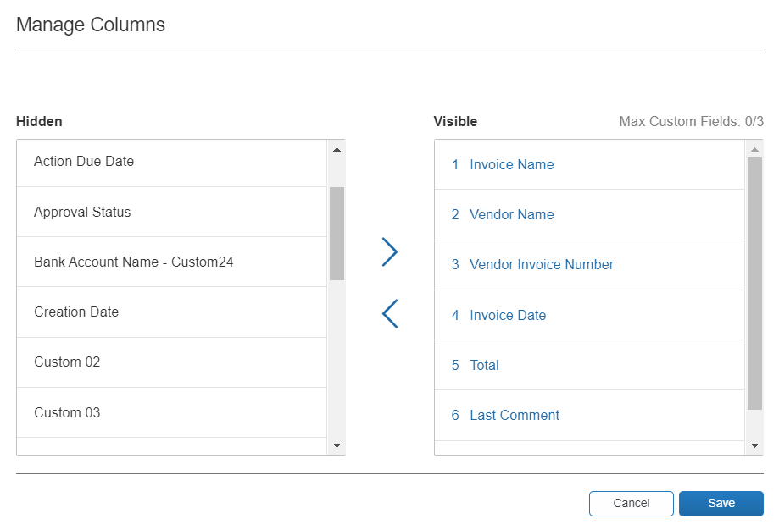
- Click Save.
The Vendor Name, Invoice Number, and Invoice Date fields cannot be removed (hidden). If you attempt to remove (hide) a required column, a warning message appears.
Default Columns:
- Invoice Name
- Vendor Name
- Invoice Number
- Invoice Date
- Total
- Last Comment
- With User Since
Additional Columns That Can Be Added/Removed:
- Action Due Date
- Payment Status
- Approval Status
- Custom 1-20
- PO Number
- Policy Name
- Is Emergency Check Run
- Invoice Received Date
- Payment Terms
- Payment Due Date (not applicable to the All My Invoices list view)
- Payment Method
- Description
- Org Unit 1-6
Searchable columns:
- Vendor Name
- Title
- PO Match Status (not applicable to the All My Invoices list view)
- Total
- Vendor Invoice Number
- PO Number (not applicable to the All My Invoices list view)
Any changes to columns in the Manage Columns window will be applied to the Unsubmitted Invoices, Unsubmitted Purchase Orders, and All My Invoices list views.
A maximum of three custom fields can be placed in the Visible list.
In addition, if you customize columns while acting as a proxy for another user, you are customizing the view for yourself only, not the user for whom you are acting as a proxy.
An In-Product Message (IPM) with information about this feature appears the first time you access the Unsubmitted Invoices, Unsubmitted Purchase Order Invoices, or the All My Invoices list view.
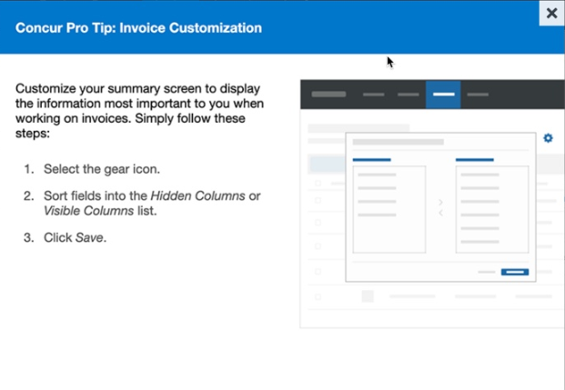

Download Data to Excel
You can download data to Excel from several list views on the My Invoices page. The Download as Excel link is available from the following list views:
- Unsubmitted Invoices
- Unsubmitted Purchase Orders
- All Unassigned Invoices
- Unassigned Invoices Created by Me
- All Assigned Invoices
- My Deleted Invoices
- All My Invoices
- Recurring Invoices
The maximum number of invoices that can be exported from the All My Invoices list view is 12,500. The other list views do not have this limit, but the export process might take some time if there are many items to be exported.
Example – Download as Excel From All My Invoices List View
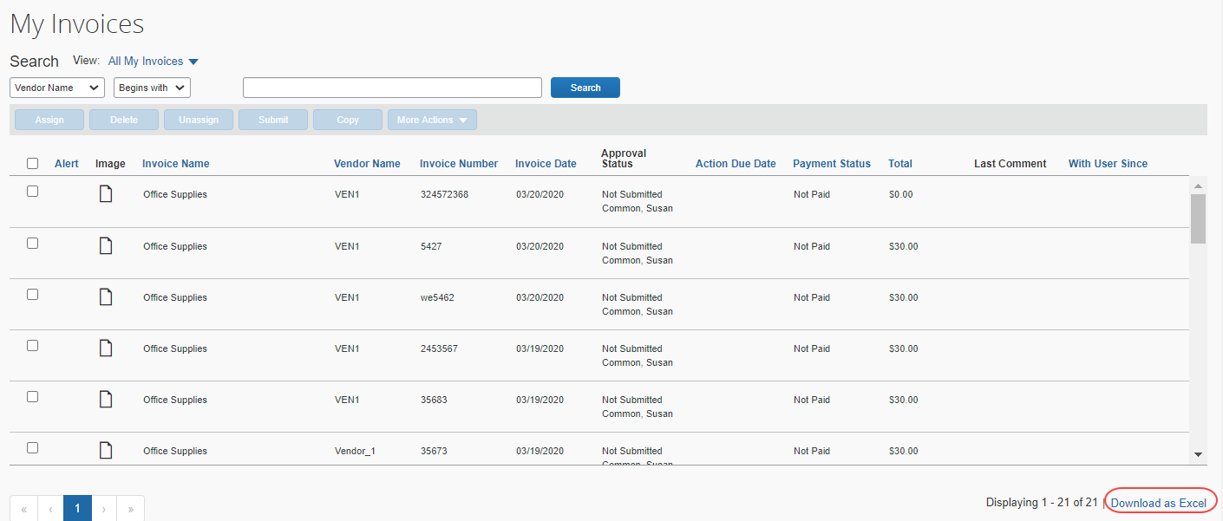
If the customer leaves the My Invoices page while the export process is in progress, the export will be canceled. However, customers will be able to open an invoice on the My Invoices page while the export is running.

Managing Recurring Invoices
An invoice can be specified as a recurring invoice type, to be generated and moved to workflow and payment automatically, as a repeating expense on a regular schedule as specified by the Invoice Owner. This feature is useful whenever payment is required on a service or good, such as rent, software licenses and subscriptions or similar, on a regular calendar schedule.
This feature does not apply to purchase orders (a PO-based invoice.) The command is unavailable if the invoice is of this type.
Once the invoice becomes a recurring invoice, it is duplicated on the My Invoices page on a regular basis specified by the offset value. The default is 14 days prior to the payment date.
- For more information about changing the offset value, refer to the Set the Recurring Offset Value section in this document.
Recurring invoices can be flagged for tracking, built into audit rules, or even built into a workflow approval skip step if only the first invoice needs to be approved.
- For audit rules, use the Request option as Data Object/Operator and Origin Source and Recurring Invoice options as Field/Value together with the Equal operator as shown in the following image.
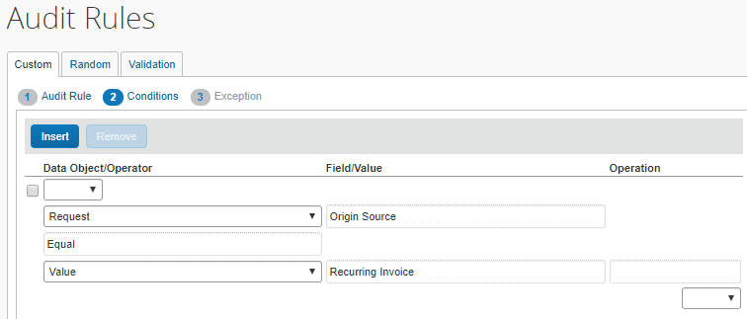
- For reporting, go to Invoice > Payment Request Header Information > Additional Details > Origin Source, and then filter to Recurring Invoice.
Perform "One-Off" Changes to Details of a Recurring Invoice
If, on any set recurrence interval, a single change must be made, the owner can open the submitted invoice, select Recall in the More Actions menu, make the change, and save and re-submit with the required change.
The next invoice that is generated will not reflect this change. It is a one-time change that is not retained in the template.

Create a Recurring Invoice
This feature is automatically on and available to the user and administrator.
To create a recurring invoice:
- On the My Invoices page, select the invoice that will become the recurring invoice. The Invoice for <name> page appears.
- Click Actions > Create Recurring Invoice.
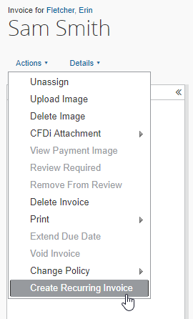
The Recurring Invoice Details window appears.
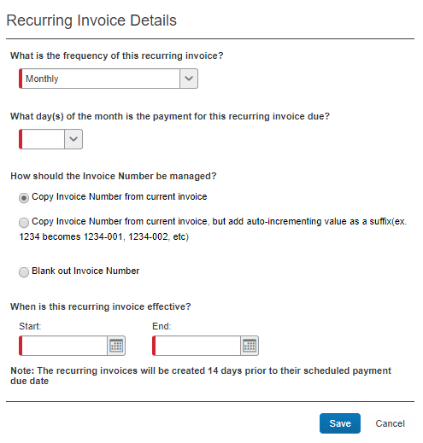
- Complete all required fields.
Field | Description/Action
What is the frequency of this recurring invoice? | In this list, select how often the system should create a recurring invoice. Select one of the following:  - Monthly  - Twice Per Month  - Quarterly
What day(s) of the month is the payment for this recurring invoice due? | In this list, select what day of each month the payment for this recurring invoice should be due.
How should the Invoice Number be managed | Depending on your company's configuration, you might see one or several of these options:  - Copy Invoice Number from current invoice: This is the current behavior and will be the default option.  - Copy Invoice Number from current invoice, but add auto-incrementing value as a suffix: SAP Concur maintains the invoice number, and then adds a hyphen and number to the end of the invoice number to make it unique. For example, if the invoice number is 1234, then the recurring invoice numbers that are created from that template will be 1234-01, 1234-02, and so on.  - Blank out Invoice Number: SAP Concur does not copy the invoice number from a current invoice, but instead blanks out the invoice number.
When is this recurring invoice effective? | Select between which dates the recurring invoice is in effect.
- Click Save.

Attach a Recurring Image
To attach a recurring image:
- After creating a recurring invoice, go back to the list and open the recurring invoice.
- Click on Actions > Upload Image.
The amount field cannot be updated by the processor if it is an invoice generated from a recurring invoice. The amount field can only be updated by the user that created the original recurring invoice.

Set the Recurring Offset Value
The AP User role is granted permissions to set the day on which the invoice should be created prior to the actual payment date (the default is 14 days):
To set the recurring offset value:
- Click Administration > Invoice.
- Click Invoice Settings (left menu). The Invoice Settings page appears.
- In the Default Recurring Invoice Generation Offset field, set a value by number of days that specifies when the invoice should be generated prior to the actual payment date.
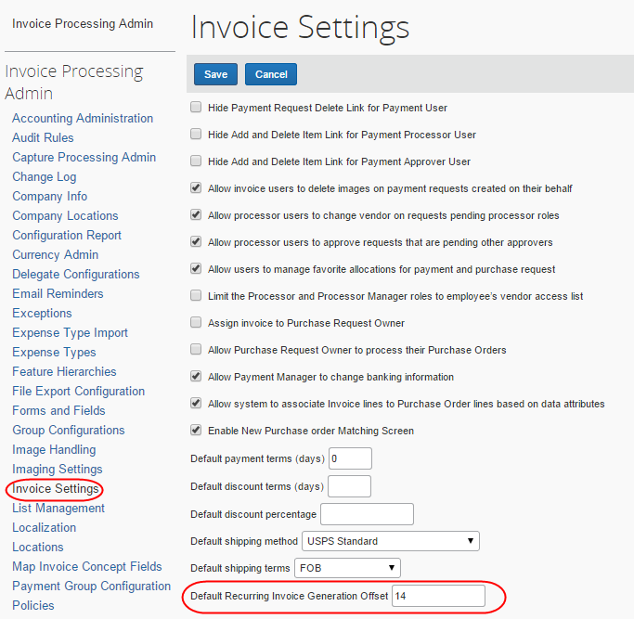
- Click Save.
- For more information, refer to Concur Invoice: Invoice Settings Setup Guide.

Export Recurring Invoices
The Recurring Invoices list page has a Download as Excel link that works the same as the Download as Excel link on the My Invoices page, but only exports recurring invoices.
Once Invoice Owners with the AP User role click the Download as Excel link, all recurring invoices are selected and exported to an Excel spreadsheet. The export file will be named, invoices_<date or time stamp>.xml. The spreadsheet will contain the same fields as displayed on the Recurring Invoices list page.
Reviewing the exported recurring invoices spreadsheet, helps users identify any that require adjustments made to recurring invoice templates.
- For more information, refer to the Download Data to Excel section in this guide.
To download recurring invoices to an Excel spreadsheet:
On the Recurring Invoices list page, click the Download as Excel link in the lower right corner of the page.

Edit a Single Recurring Invoice
To edit a single recurring invoice:
- On the My Invoices page, in the View list, click Recurring Invoices.
- Open the generated recurring invoice by clicking it.
- Make your desired changes.
Changes made to a generated recurring invoice (as opposed to the original sequence) will not apply to any new invoices in that sequence.
- Click Save.

Edit a Recurring Invoice Sequence
To edit a recurring invoice sequence:
- On the My Invoices page, in the View list, click Recurring Invoices.
- In the Recurring Invoices view that appears, select the check box of the invoice to edit.
- If you want to edit the invoice sequence details, open the invoice and edit as normal.
- If you want to edit the end date of the sequence or the invoice number generation configuration, open the invoice and click Edit Recurring Invoice. The Recurring Invoice Details window appears. Edit the sequence and then click Save.

Delete a Single Recurring Invoice
To delete a single recurring invoice:
- On the My Invoices page, in the View list, select Recurring Invoices.
- Open the recurring invoice by clicking it.
- Click Actions > Delete Recurring Invoice.
- In the Please Confirm window that appears, click Yes.

End a Recurring Invoice Sequence
To end a recurring invoice sequence:
- On the My Invoices page, in the View list, select Recurring Invoices.
- Open the recurring invoice by clicking it.
- Click Edit Recurring Invoice. The Recurring Invoice Details window appears.
- Select the end date to the date for when you want the recurring invoice sequence to end.
- Click Save.
When you end a recurring invoice sequence, Concur Invoice will not create more recurring invoices. However, the ones already in the system will remain. To remove these, follow the To delete a single recurring invoice procedure in this document.

Delete a Recurring Invoice Sequence Created by Another Employee
A user with the Invoice Proxy User role can proxy in as another employee and delete a recurring invoice sequence.
To delete a recurring invoice sequence created by another employee:
- Click Profile > Act as user in assigned group (Proxy) and select the user.
- Click Start Session.
- Click Invoice. The Invoice Manager page appears.
- Click the All My Invoices link. The My Invoices page appears.
- In the View list, click Recurring Invoices.
- Select the recurring invoice you want to delete, and then click Delete.
- In the Please Confirm window, click Yes to delete the invoice.
You will also need to follow the instructions for deleting any existing invoices by using the To delete a single recurring invoices procedure in this document.

View Deleted Invoices
Users with the Invoice Processor role can see all deleted invoices from anyone, whereas a user with the Invoice AP User role can only see their own deleted invoices, which they can access and manage through the My Invoices page.
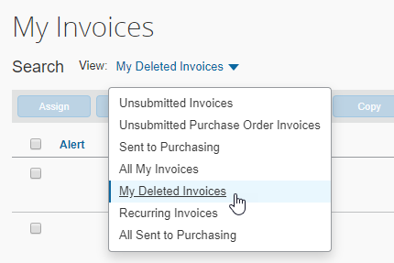
Users with both the Invoice AP User and Invoice Processor roles can view deleted invoices using the Deleted Invoices option in the Processor menu. This feature extends the user's invoice research capabilities by allowing them to determine after deletion if an invoice was deleted, by whom and when the deletion occurred.
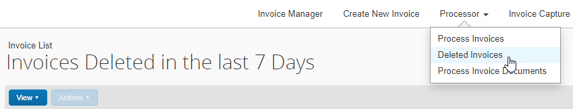
With this information, the user is provided greater visibility of the invoices they work with day to day. Note that the feature does not allow for the reactivation of an invoice, nor can the user edit the read-only invoice, they are restricted to viewing the invoice, its audit trail, image, and other attributes.

View Deleted Invoices by Date
The initial view of the invoice shows those deleted in the last week. The user can decide to change this view by clicking View and selecting an option:
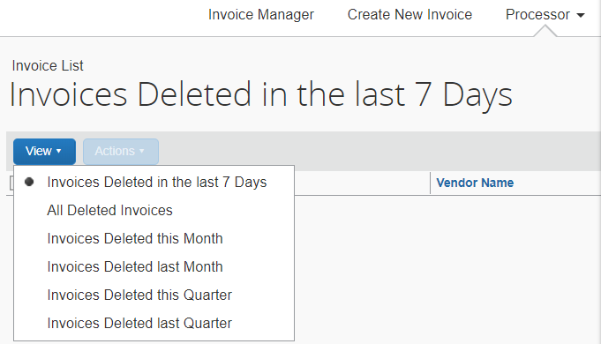

Search for Deleted Invoices
The user can decide to display specific invoices using the search functionality available in the Search area of the page. This is done by providing search criteria that match the selected filters.
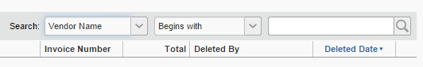
To view deleted invoices:
- Click Invoice > Processor > Deleted Invoices.
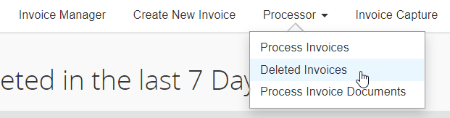
The Invoice List page appears with the default display of Invoices Deleted in the Past 7 Days filter.
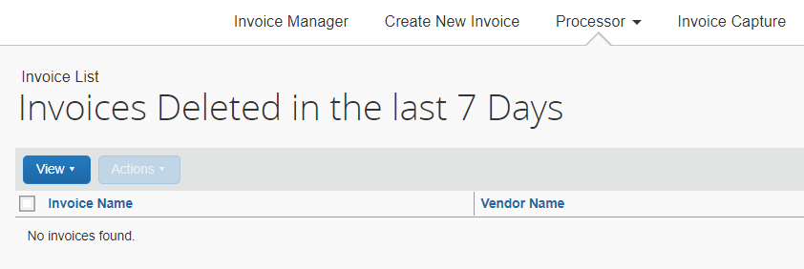
- Search for the invoice by using either of the following options:
- By Date: The initial view of the invoices shows those deleted in the last week. Open the View menu and select a menu item that matches the dates before, between, or beyond which the invoice was deleted.
For example, if the invoice was deleted early the previous week, you would select Invoices Deleted in the last 7 days.
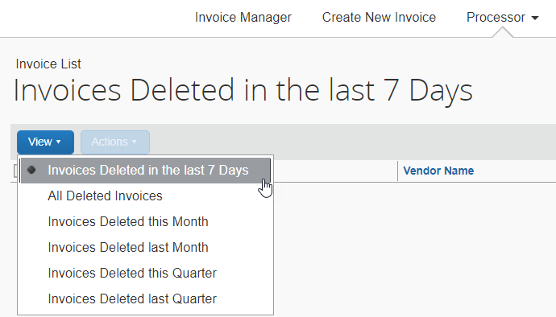
- By Invoice Name: The user can decide to display specific invoices using the search functionality available in the Search area of the page. This is done by providing search criteria that match the selected filters.
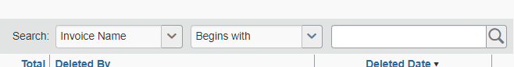
- Once the invoice is found, open the invoice on the Invoice List page by clicking it directly or by clicking Open Invoice in the Actions menu.
- Perform the review of the deleted invoice. The following options are available to the user:
- Print: Click Actions, then point to Print and click Invoice
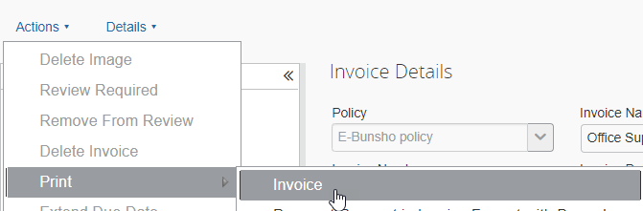
- View Audit Trail: Click Details, then click Audit Trail to display the Audit Trail window for this invoice
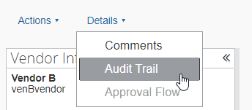
- View Images: Click View Image. The imaging service displays any associated images in a window of the same name
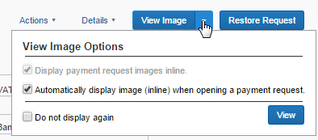
- When done reviewing the invoice, click Back to List to return to the Invoice List page.
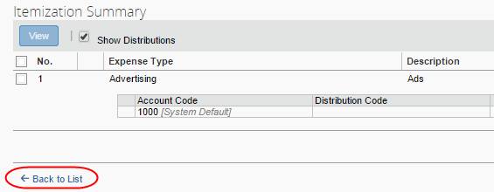

Create, Submit, and Approve an Invoice in a Single Step

Overview
Users assigned the Invoice User and Invoice Approver roles can consolidate the workflow steps required to bring an invoice from initial creation to the approval state. This allows the employee to create and submit an invoice and have the system automatically approve the invoice in preparation for processing. Using this feature addresses the scenario where the Accounts Payable (AP) back-office personnel receive an invoice from a vendor and wish to consolidate the tasks of creating, submitting, and approving the invoice associated with an invoice into a single action.

Before You Begin
The following conditions must be met to configure this feature:
- Applies only to the Invoice User who also has the Invoice Approver role
- The invoice cannot exceed the approver's limit approval
- A skip rule must be configured at the Manager Approval workflow step

Required Roles
The ability to submit and approve an invoice in a single step is available to the following roles:
- Invoice Approver role who is also an Invoice User
- (Optional) The Invoice Delegate or Invoice Proxy roles, who inherit the approval credentials of the invoice owner (delegator)

How Single Step Approval Workflow Works
To configure this feature, the Employee Administrator role will first assign the role of Invoice Approver to the Invoice User (employee) who is originating the invoice. The addition of this role allows the employee to be assigned an Approval Limit value, a figure up to which they can approve the invoice. To establish this amount (setting) the Invoice Configuration administrator uses the Authorized Approvers link from workflows in the classic interface to establish the amounts for the Invoice Approver. Then, a workflow rule is created that includes a skip step defined to skip the Manager Approver step if the employee submitting the invoice meets the conditions set in the rule.
In practice, the employee creates the invoice from the vendor invoice. As the invoice owner, the employee verifies the information and then submits the invoice. At that time the system verifies that the employee is an authorized approver whose approval limit exceeds the amount of the invoice. With the skip step for the Manager Approval workflow configured, the system bypasses this step and moves the invoice directly to the Approval for Processing step.
- For more information, refer to the guides listed below:
- Assigning the Invoice Approver role: Refer to the Shared: User Administration User Guide.
- Setting the Approver's Limit Authority: Refer to the Concur Invoice: Workflows – General Information Setup Guide.
- Creating a workflow rule that includes the skip step: Refer to the Concur Invoice: Workflows – General Information Setup Guide.

Tracking Front-Office Invoice Changes

Overview
The Accounts Payable (AP) back office can decide to create an audit trail of changes made to an invoice after it has been reassigned from the back-office originator to an employee and prior to the approval workflow step. This is useful whenever a company wishes to review changes to accounting-related fields in an invoice, especially where the combination of Invoice User and Invoice AP User roles allow an employee to modify field values usually locked to the Invoice User. Or the back office may simply want to track changes at those sites that reassign invoices multiple times to different invoice owners.

Before You Begin
The following conditions must be met to configure this feature:
- The Invoice Configuration administrator role adds the Has Tracked Change check box to the Request Header Form in a hidden or read-only state. The field cannot be modified.
- A workflow condition may be created that triggers based on the status of the Has Tracked Change status. Doing this allows the system to direct the invoice directly to a specific employee for review purposes.
- An audit rule can be configured to trigger when the Has Tracked Changes status changes from No to Yes. Doing this causes an alert to be displayed when the invoice is viewed in the header form.

Actions that Trigger a Change
Changes to accounting-related fields listed below are logged to the audit trail:
- Changes to the expense type
- Adding or removing a line item, or changing the line-item total amount
- Adding or removing an allocation line item
- Changes to the allocation code
- Changes to either the Invoice Number or Vendor Remittance Address fields

How the Changes Are Tracked
Tracking of changes begins at the first reassignment, where a "snapshot" of the invoice values is created for inclusion in the audit trail. At that time the date, time, and owner name are logged alongside invoice values (expense type, allocations) in the audit trail. These are stamped as Initial Request Value in the Action column on the Audit Trail page. This set of values becomes the baseline against which any changes are tracked.
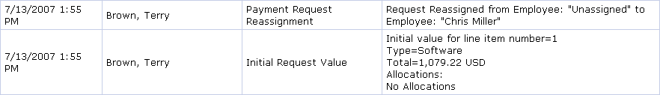
When the invoice owner makes a change at the entry or allocation level, the change in status is noted in the Action column as a Modified Request Value (but is not yet logged).
The system logs the changed values only when the employee submits the invoice. At that time the date, time, and owner name are logged alongside the specific changes to the invoice. In addition, the Has Tracked Change check box in the Payment Request Header form of the invoice is selected:
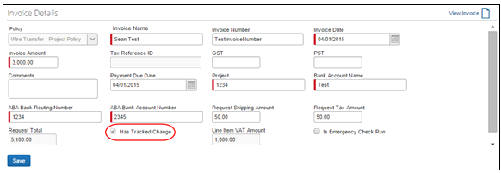
The actions described above hold true if an invoice is reassigned more than once. However, the system will always reset the Action column status to Initial Request Value to track any additional changes by the newly assigned employee.

Special Considerations
Note the following constraints and considerations:
- The Initial Request Value status is applied, and then reapplied, every time the invoice is reassigned. This allows a fresh baseline stamp for the new owner of the invoice. Careful reading of the audit trail from bottom to top will reveal the overall audit trail history.
- The invoice is considered changed and the change logged whenever the employee clicks the OK or Save link on the Distribute Selected Items page, even if no changes took place.
- The invoice is considered changed and a change logged if the employee changes a tracked field, then changes it back. The value is not compared, only the fact that it was edited.

More Information
For more information, refer to Track Processor Changes to Request Fields and Line Items in the Concur Invoice: Forms and Fields Setup Guide, and Track Processor Changes to a Request in the Concur Invoice: Audit Rules Setup Guide.

Read the Audit Trail for a Tracked Invoice
The Audit Trail page details the changes made to the invoice over the assignment cycle. In the example below, Stacey Johnson, the invoice originator, creates the invoice and unassigns it. Terry Brown, in the Invoice AP User role, assigns the invoice to Chris Miller. At this point, a baseline is created and the Has Tracked Change status is set to No. Chris Miller then changes both the expense type (from Software to Office Furniture) and the amount, and then unassigns the invoice.
Both changes are tracked in the audit trail, and the status of Payment Request Reassignment is given to the invoice. On reassignment to Stacey Johnson (by Terry Brown), the invoice is again given the status of Initial Request Value, ensuring that any changes by Stacey will automatically change the state of the Has Tracked Change check box from cleared (disabled) to selected (enabled). Finally, Stacey submits the invoice, which causes the Approval Status Change action, from Submitted to Pending Approval.

Preventing Unauthorized Deletion of an Invoice

Overview
The Hide Payment Request Delete Link for Invoice User settings feature allows the Invoice Admin role to restrict the appearance of the Delete Invoice link that appears in the Actions menu on the Invoice List page. This feature is useful in centralized organizations where a back-office employee (typically the AP User role) generates invoices from received invoices for assignment to front-office personnel. By restricting access to the Delete Invoice link, the back office may be certain that no unauthorized deletions of assigned invoice will occur.
The originator can always delete an invoice they have created themselves.
The table below outlines the state of this setting and what the user can do:
Setting State | Actions that can be performed by user role
Disabled  (Default state) | - Invoice User can delete an unsubmitted invoice assigned to them  - A Delegate or Proxy of the Invoice User can delete an unsubmitted invoice assigned to the user they are working on behalf of
Enabled | - Invoice User cannot delete an unsubmitted invoice assigned to them (unless they are the originator of the invoice)  - A Delegate or Proxy of the Invoice User cannot delete an unsubmitted invoice assigned to the user they are working on behalf of (unless that user is the originator of the invoice)

Before You Begin
Before this feature can be used it must first be enabled by either the Invoice Configuration administrator or Invoice Configuration administrator (Restricted) roles.
- For information about enabling this feature, refer to the Concur Invoice: Invoice Settings Setup Guide.
In addition, note the following constraints and considerations:
- Only unsubmitted, assigned invoices may have this restriction applied to them
- Only the originator of the invoice (or their Proxy or Delegate users) will see the Delete Invoice link, and only they can use the link to delete the invoice
- This setting does not affect the ability of the Invoice AP User, Invoice Processor, or Invoice Processor Manager from deleting an unassigned invoice, nor does it affect the Invoice Processor Manager from deleting an invoice in the pending approval state

Required Roles
Only the Invoice User role is affected by this feature since it primarily removes the option for this role for their submitted invoices.
- For more information, refer to the Shared: User Administration User Guide.

Assigning the AP User to a Vendor Group
The AP User role is a group-aware role. By making the AP User role group-aware, the users with this role assignment can be limited in what unassigned invoice they can assign, and to whom. For a large company, a strategy of matching Vendor Access groups to regions means unassigned invoices with regional attributes are managed and assigned by the AP User for that region, thus filtering the work and the view of unassigned invoices.

User Admin Experience
The User Admin role will see the Groups to be Assigned to the User(s) for the Selected Role(s) option when assigning the Invoice AP User role to a user. Note that the groups listed for selection are not traditional "Groups" as created using the Group Configurations tool, but instead the groups imported and managed using the Vendor Manager tool’s import functionality.
In the following figure, the XLS Vendor Import includes the hierarchies and the vendors assigned to one or more groups.
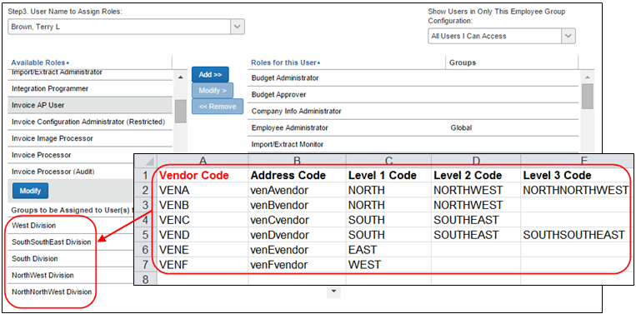
These groups represent the configured company hierarchy that drives what region (in the example above) a vendor is assigned to, and thus also what region the AP User is assigned to by association.
In the figure below, Terry Brown is an Invoice AP User assigned to the Groups to be Assigned to User(s) for the Selected Role(s) group and may now work with several vendors.
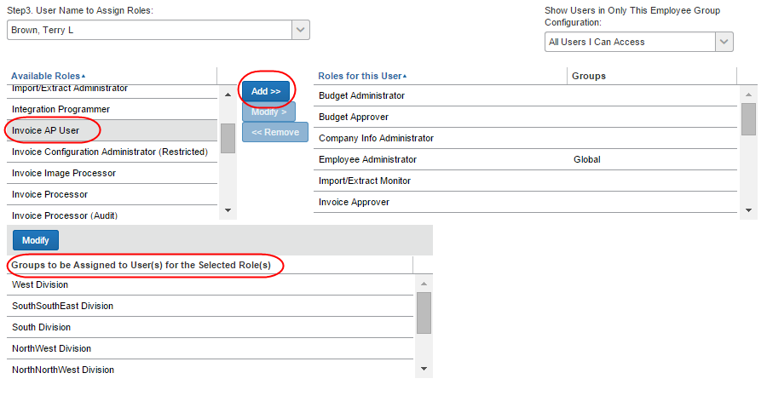

Configuration
The vendor group feature relies on the Vendor Access Mapping import that is used to create the groups to which AP Users are assigned. These groups, in turn, are those that this role is allowed or prevented from accessing.
The following steps are required to implement the vendor group feature:
- Vendor Admin creates the vendor hierarchy that reflects the vendor grouping and sub-grouping the company wants to put in place, and then imports this data
- The User Admin assigns the AP User role choosing one or more groups for the user
The customer may need to submit a Service Request ticket to SAP Concur support to configure certain areas of this feature.

The Vendor Access Group Feature Information
Since the AP User is now a group-aware role, you will need to configure your access groups to align with the business objective (that is regional or another attribute). This feature is described in the May 2014 Concur Invoice Professional release notes, and in the documents referenced below.
- For more information, refer to Concur Invoice: Vendor Manager User Guide and the Concur Invoice: Vendor Employee Access Import User Guide.

☼

