
Concur Expense: Payment Manager for Expense Pay Global
User Guide
for Concur Professional/Premium
Last Revised: December 8, 2022
Applies to these SAP Concur solutions:
 Expense
 Professional/Premium edition
 Standard edition
 Travel
 Professional/Premium edition
 Standard edition
 Invoice
 Professional/Premium edition
 Standard edition
 Request
 Professional/Premium edition
 Standard edition
Table of Contents
Section 1: Permissions 6
Section 2: Overview 6
Payment Manager 6
Definitions 7
The Payment Manager Pages 7
Section 3: Reimbursement Manager Role Procedures 9
Accessing Payment Manager 9
Managing Card Programs 10
Creating and Editing Card Programs 11
Validating Credit Card Account Numbers 14
Managing Batch Definitions 16
Creating and Editing Batch Definitions 17
Managing Batches 22
Monitoring Batches 22
Resending Card Batch Remittance File 29
Rescheduling Batches 31
Managing Expense Reports on the Reports Payees List 34
Report Payee Status 35
Managing Payment Demands 36
Section 4: Expense Pay Information and Procedures 38
Managing Funding Accounts 38
Creating a Funding Account 39
Verifying a Worldline Funding Account (€, £, $, or C$) 42
Editing a Funding Account 44
Setting a Funding Account 44
Replacing a Funding Account 44
Deleting a Funding Account 45
Viewing Funding 45
Funding Bank Account Fields by Country 47
Worldline 47
Convera 54
Section 5: Accounting Activity Reconciliation 61
Overview 61
Tracking payments through the process 61
Reconcile Bank Statements with Expense Pay Payments 62
Troubleshoot Reconciliation Discrepancies 63
Managing Expense Reports on the Reports Payees and Cash Advance Payees Lists 63
Report Payee Status 66
Manually Reimbursing Employees 68
Manually Creating a Payment Demand 69
Viewing Employee Banking 70
Expense User Procedures 72
Payment Status in the Report Payments Window 72
Section 6: Accounting Extract Reconciliation Tools 73
Payment Manager 73
Funding Accounts 74
Card Programs 75
Batch Definitions 75
Payees Lists 75
Batches 76
Payment Demands 76
Employee Banking Information 77
Methods 77
Administrator Email Notifications 77
Funding Amount Email Notification 77
Extract Reconciliation Tab 79
Access the Extract Reconciliation tab in Payment Manager 79
Extract Activity Reconciliation Process 79
Not Funded Report Payees 81
Correcting Accounting Entries 82

Revision History
Date | Notes / Comments / Changes
December 8, 2022 | Updated references to Bambora (now rebranding to Worldline) and Western Union (now rebranding to Convera)
April 13, 2022 | Updated the Managing Batches section with details on Resend Card Batch Remittance File feature.
March 30, 2022 | Updated the Manually Reimbursing Employees section to clarify how an employee can be reimbursed manually.
January 21, 2022 | Updated the copyright year; no other changes; cover date not updated
November 13, 2021 | Updated the Creating and Editing Card Programs section to reflect the following change:  - A new field, Arm ID, displays and is for future use only  Added a new procedure, To view batch data.
October 16, 2021 | Updated the Creating and Editing Card Programs section to reflect the following changes:  - The "Global" check box is renamed "Payment Provider"  - A new field, File ID, displays and is for future use only
August 27, 2021 | Updated instances of "payment-processing p…" to "payment provider"
January 8, 2021 | Updated the copyright; added Concur to the cover page title; cover date not updated
April 13, 2020 | Renamed the Authorization Request check box to Request on the guide’s title page.
January 2, 2020 | Updated the copyright; no other changes; cover date not updated
November 9, 2019 | Updated the Funding Account page to reflect the following changes:  - The Account Currency field has been renamed to Reimbursement Currency.  - The Funding Type drop-down has been removed from the screen.  - The Provider field has been added to a new section of the page, Provider Details. The field displays available payment processing providers. If only one provider is available for selected reimbursement currency, the provider is defaulted.  NOTE: The functionality of the page has not changed.
March 16, 2019 | Added the Verifying a Bambora Funding Account (€, £, $, or C$) section per the new functionality described in the March 2019 release notes.  Clarified the description of the Reopened funding account status.
January 16, 2019 | Added clarification about the Receive Daily Funding Email setting: "This setting is only used to stop sending daily funding emails when the daily funding amount is equal to 0 (currency)."
January 12, 2019 | Added information about new provider, Western Union Business Solutions (WUBS).
January 7, 2019 | Updated the copyright; no other changes; cover date not updated
November 17, 2018 | Added information about the Extract Reconciliation tab now available in Monitor Batches.
April 5, 2018 | Changed the check boxes on the front cover; no other changes; cover date not updated
February 20 2018 | Updated guide name in references to the Shared: Employee Import Specification guide.
February 10 2018 | Added note about the new conditionally displayed column, Warnings.
December 9 2017 | Edited the procedure, To create a new funding account, to show the new tabs (Account Information and P… Onboarding Application) on the Funding Account page.  Edited instances of "Bambora" and "Beanstream" replaced with the term " provider" where appropriate.
November 13 2017 | Clarified the Account Owner Name for funding accounts is the name shown on the account's bank statements.
September 16 2017 | Update the graphic (part 1) for adding a funding account to show the new contact fields.
August 19 2017 | Updated graphic of the window for adding a new Global funding account to show the new Bambora text.
July 29 2017 | Minor edits and updates to funding account field names
July 8 2017 | Updated graphic of window for adding new Global funding account to show Bambora text.
June 3 2017 | Clarified the description of Aborted in the table of Expense Pay Specific Statuses.
April 24 2017 | Corrected the description of Accepted in the table of Report Payee Statuses.
April 22 2017 | Updated a graphic in the procedure To review payment batch status to include an inactive funding account.  Added the possible statuses for Global funding accounts to the procedure To create a new funding account.
March 29 2017 | Changed the description of the Daily Funding Amount Email Notification by removing the reference to returns, which are not included.
March 18 2017 | Added the procedure "To inactivate an employee's bank account."  Updated graphic of Payment Demands tab to show new Send to Excel option.  Updated graphic of global account setup fields to show new section where documents can be uploaded to the payment p….
February 17 2017 | Added information about support for USD and CAD.  Added information about functionality for changing a funding account.
December 14 2016 | Changed copyright and cover; no other content changes.
July 11 2016 | New document just for clients who use the p… method for payment processing of Expense Pay transactions.

Payment Manager for Expense Pay Global
NOTE: Multiple SAP Concur product versions and UI themes are available, so this content might contain images or procedures that do not precisely match your implementation. For example, when SAP Fiori UI themes are implemented, home page navigation is consolidated under the SAP Concur Home menu.
This document describes the processes around Expense Pay Global for payment processing transactions.
Typically, Professional edition clients will only utilize this guide when they have Expense Pay Global enabled. Clients who upgraded from Standard edition and who did not purchase Expense Pay Global may have limited access to a subset of the features listed in this guide. This guide clearly indicates when information is specific to Expense Pay Global.
COMPANION GUIDE: Both the Expense: Expense Pay Global User Guide and the Expense: Payment Manager for Expense Pay Global User Guide are necessary to manage the Expense Pay Global service.
- If you are not using a provider, please refer to the Expense: Payment Manager for Expense Pay Classic User Guide.

Permissions
A company administrator may or may not have the correct permissions to use this feature. The administrator may have limited permissions, for example, they can affect only certain groups and/or use only certain options (view but not create or edit).
If a company administrator needs to use this feature and does not have the proper permissions, they should contact the company's Concur Expense administrator.
Also, the administrator should be aware that some of the tasks described in this guide can be completed only by SAP Concur. In this case, the client must initiate a service request with SAP Concur support.

Overview

Payment Manager
The Payment Manager page allows you to view and manage batches of expense reports that are ready for reimbursement. Each batch stays open until the closing date configured in the batch definition. Any expenses that are approved for payment will be listed in the currently open batch. You can view the list of all the expenses in the batch from the Payment Manager page.
Upgraded clients not using Expense Pay Global can download a transaction file listing after the batch is closed. The downloaded file facilitates a manual method to handle payments.
Expense Pay Global clients will have the system automatically execute the process once the batch is sent for payment.

Definitions
Batch: A collection of payment demands scheduled for payment. One payment demand is created per report. Each payment demand generates a transaction when the batch is processed.
Batch Close: The date the batch no longer accepts new payment demands.
Batch Open: The date the batch is created and begins accepting payment demands.
Batch Schedule: The defined close and send dates for the batch.
Batch Send: The date the system sends the payment demands for processing.
Funding System: Beginning in 2016, SAP Concur began moving to an enhanced system for managing payment execution and there temporarily a subset of clients who use one or both of these types of funding accounts:
- Classic is the legacy SAP Concur Expense Pay type of funding account that utilizes a direct relationship with a bank for moving funds.
- Global is the new SAP Concur Expense Pay type of funding account that utilizes a relationship with a provider for moving funds.
Payment Demand: A payment for a report payee. The payment demand will include all expense entries in the report for the payee. One payment demand is generated for each report in the batch.
Returned Payments: Payment demands returned by the banking system. Funds from returned payments are deposited directly back to the client’s funding account for direct debit funding accounts.
Report Payee: A payee on an expense report. A report payee can be either an employee or a card issuer.

The Payment Manager Pages
The Payment Manager page contains the Expense Pay Global functionality available in the current Administration interface.
- Monitor Batches page:
  - View Batches tab: Displays the list of open batches, by batch configuration. The Reimbursement Manager can search for historical batches, reschedule open batches, view payment demand details including audit trail, or view report summary information. This tab allows users to search for status and details on batches. This includes views by funding account, batch status or dates, allowing flexibility of monitoring tasks.
  - View Funding tab: Displays the details related to each funding account for the transactions processed by Expense Pay for that batch. Only Expense Pay clients use this tab.
  - Bank Statements tab: For Expense Pay (only), displays data related to pre-fund accounts in a format similar to a bank statement.
  - Extract Reconciliation tab: For Expense Pay (only), allows the Reimbursement Manager to view the extract entries associated with Expense Pay payments. The page lists one row for each Standard Accounting Extract job and reimbursement currency combination.
- Monitor Payees page:
  - Report Payees tab: Provides an expense report-centered view into expense report reimbursement. The Reimbursement Manager uses this page to see the status of expense reports processed by the system.
  - Cash Advance Payees tab: Provides the cash advance-centered view into Cash advance reimbursement. For Expense Pay (only), the Reimbursement Manager uses this page to see the status of cash advances processed by the system.
  - Employee Banking tab: For Expense Pay (only), displays a list of employee bank accounts with status, and allows the administrator to view account history and failed accounts.
- Configure Batches Page:
  - Funding Accounts tab: Displays the list of bank accounts that Expense Pay will draw funds from in order to pay employees or card issuers. The Reimbursement Manager uses this page to create funding accounts for payments. For Expense Pay (only), these accounts are associated with payees on the Batch Definitions page.
  - Card Programs tab: Displays the (list of card) programs that are currently configured as payees for Expense Pay. The Reimbursement Manager uses this page to create and manage card programs for payments. For Expense Pay (only), these programs are associated with funding accounts on the Batch Definitions page.
  - Batch Definitions tab: Displays the full details for each type of batch. The Reimbursement Manager uses this page to create and maintain the batch definitions that control the organization and timing of payment batches.
  - For Expense Pay pages and procedures, refer to the Expense Pay Global User Guide.

Reimbursement Manager Role Procedures
A person with the Reimbursement Manager role uses the Payment Manager page to process the expense reports ready for payment. The Reimbursement Manager performs the following tasks:
- Creates and maintains employee and card batch definitions, which tie together employee and card payment methods and batch schedules
- Creates and maintains card program definitions
- Confirms the status of payment batches as they are prepared for processing
- Closes payment batches for processing, if necessary
- Views the status of payment batches once they have been processed

Accessing Payment Manager
A link to the Payment Manager page appears on the Tools page to employees that have the Reimbursement Manager or Reimbursement Auditor role.
The Reimbursement Auditor role has a limited subset of the available functionality.
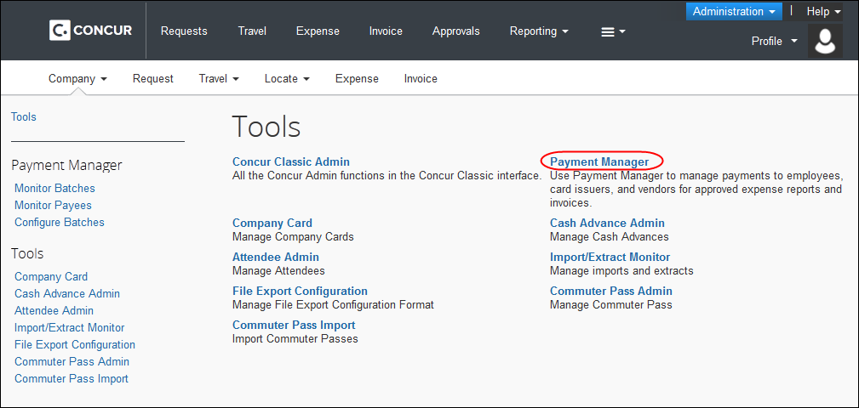
To access Payment Manager:
- Click Administration > Company > Tools. The Tools page appears.
- Click Payment Manager. The Payment Manager page appears, with the Monitor Batches page displayed.
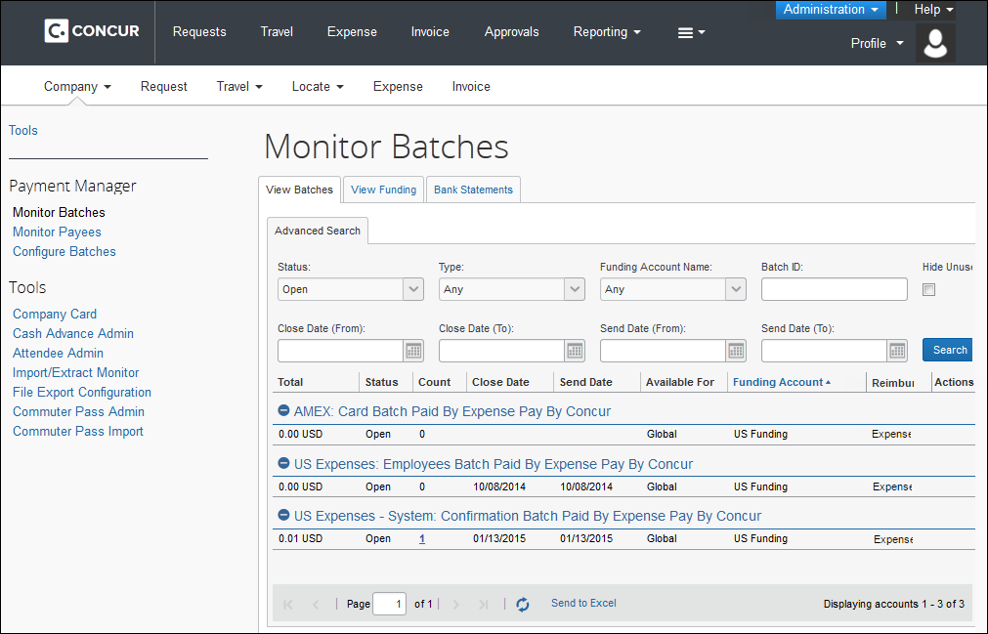

Managing Card Programs
Concur can generate remittance files for company card issuers, based on the payment batches in Payment Manager. The Reimbursement Manager uses the Card Programs page to enter the data required to correctly remit payment to the card issuer. Once the card programs have been entered, the Reimbursement Manager uses the batch definitions to link the card programs with their payment method and batch schedule.

Creating and Editing Card Programs
To add a new card program:
- Click Configure Batches (left menu) > Card Programs.
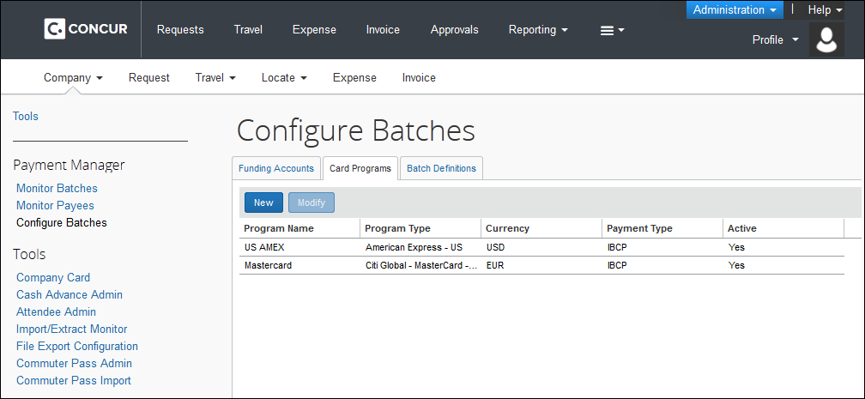
- Click New. The Add New Card Program page appears.
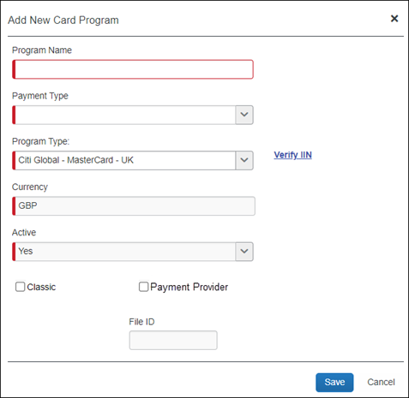
- Enter the necessary information. The fields that appear vary depending on the Program Type selected. Common fields are:
Field | Definition
Program Name | The name for the card program. Appears in Payment Manager as part of the batch name.
Payment Type | The method that the card is billed and paid. Possible options vary based on configuration and may include:  IBIP: Individual Bill/Individual Paid. The employee receives the bill for the card and must pay the card vendor directly. Expense Pay will reimburse the employee for expense associated with this card program.  IBCP: Individual Bill/Company Paid. The employee receives the bill for the card, and the company pays the card vendor directly. The employee must enter their card transactions into an expense report, then Expense Pay will reimburse the card vendor for the submitted expenses.  - For more information, refer to the Expense: Payment Types Setup Guide.
Program Type | The card issuer and card program information.
Currency | The currency of the card program.
Active? | Whether the card program is active.
Classic | Whether the card program uses the Classic funding system described in the Definitions section of this guide.
Payment Provider | Whether the card program uses the Global funding system described in the Definitions section of this guide.
File ID | For clients using Worldline as their payment partner, this optional field has been added to the Concur Expense user interface (UI) for some card programs.  This field is for future use only.  IMPORTANT: Entering incorrect data into the field can cause processing failures for batches which cannot be aborted.
Arm ID | For clients using Worldline as their payment partner, this optional field has been added to the Concur Expense user interface (UI) for some card programs.  This field is for future use only.  IMPORTANT: Entering incorrect data into the field can cause processing failures for batches which cannot be aborted.
Custom fields exist for cards that require additional data. Please contact your card vendor to obtain the necessary data. The details will be in your card welcome letter.
- Click Save.
To review or edit an existing card program:
- In Payment Manager, click Configure Batches > Card Programs.
- Select the name of the desired card program.
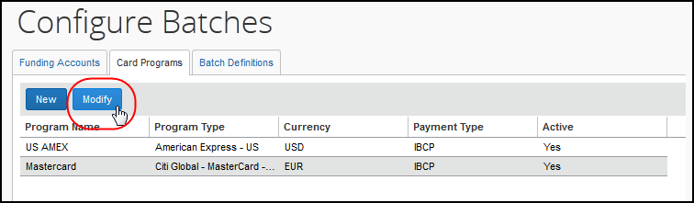
- Click Modify. The Edit Card Program window appears.
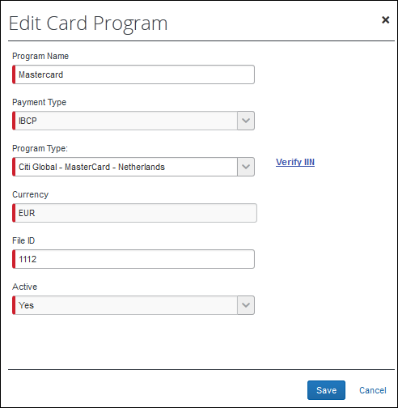
- Make changes to the fields as necessary.
- Click Save.

Validating Credit Card Account Numbers
Administrators can validate their card account number against the card issuer’s identification number.
To validate credit card account numbers:
- Create a new card program, or click Modify for an existing card program.
- Click the Verify IIN link.
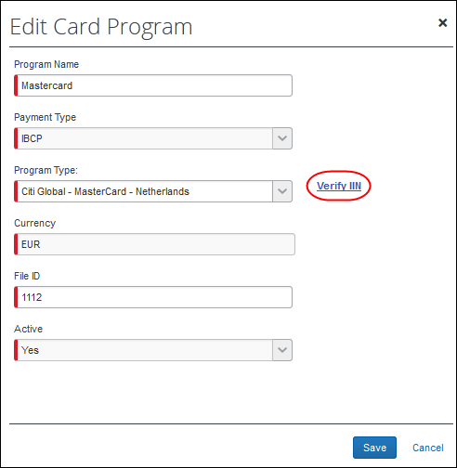
The Verify Issuer Identification Number screen displays. This screen contains the valid ranges for the card program.
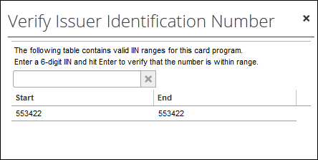
- To verify that the card's number is within the valid range of the card program, enter the 6-digit BIN number (the first six digits of the card number) into the field and press Enter.
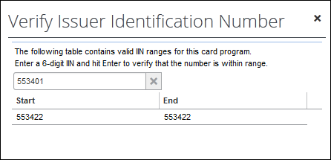
- You will receive a success or failure message. Click OK to dismiss the message.
If you confirm with your corporate card provider that your IIN range is correct, but the page does not accept it, please open a case with Client Support to request an update to the IIN, including the IIN range to add.
- Click X to return to the Card Program page.
- If you are satisfied with your card program, click Save.

Managing Batch Definitions
The Reimbursement Manager creates and updates batch definitions for the various employee and card payment methods. A batch definition consists of the country and currency combination, the groups that the batch definition will pay, the accounting information, the payment method, and the batch schedule. The Reimbursement Manager uses the Batch Definitions page of Payment Manager to view and edit existing batch definitions, and to create new definitions.
The funding accounts portion of the Batch Definitions tab has its own section in this guide, Manage Funding Accounts.
To review batch definitions:
- Click Configure Batches. The Funding Accounts tab appears.
- Click the Batch Definitions tab. The list of batch definitions appears.
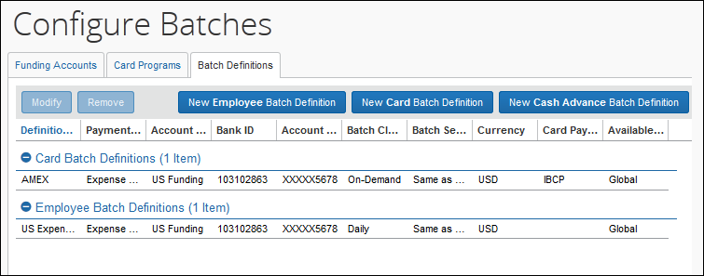
- On the Batch Definitions tab, you can create a new batch definition, edit an existing one, or delete a batch definition.

Creating and Editing Batch Definitions
The Reimbursement Manager can create Card or Employee batch definitions. The Card batch definition is used to pay company card issuers. The Employee batch definition is used to reimburse employees directly. The Reimbursement Manager defines a batch by providing the payment method or funding bank account (for Expense Pay), the Expense Groups that the batch pays, the batch schedule, and the card program to be paid (for Card batch definitions).
Expense Pay also supports the Cash Advance batch definition, which is used to send requested funds directly to the employee’s bank accounts.

Processes
To create a new batch definition:
- On the Batch Definitions tab, click New Employee Batch Definition, New Card Batch Definition, or New Cash Advance Batch Definition.
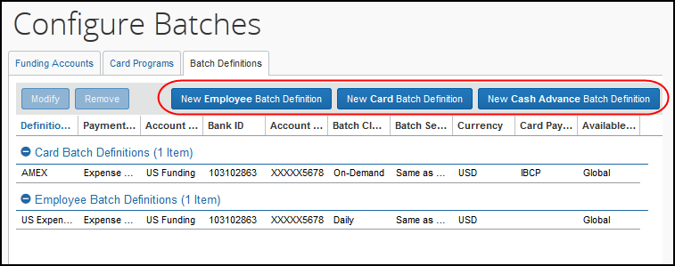
- Fill in the fields.
Field | Description
Batch Name | Type the display name for this batch definition. The display name appears on the View Batches page.
Payment/Reimbursement Method | Select the method you will use to reimburse expenses that are categorized in this batch.
Currency  (non-Expense Pay) | Select the currency of the batch definition.
Payment Type  (Card Only) | Select the payment type for the card program. This determines whether the payment goes to the user or directly to the card company.  NOTE: This field only appears if you choose to add a Card Program batch definition.  - Refer to Managing Card Programs for details.
Available For | Select the Expense Groups to which this batch definition applies.
Schedule | Select the desired schedule for the batch definition.  - Refer to Batch Definition Scheduling for details.
Card Program  (Card Only) | Select the card program that this batch represents. All transactions using this payment type will be contained in this batch.  NOTE: This field only appears if you choose to add a Card Program batch definition. This field may not appear for some card programs.  - Refer to Managing Card Programs for details.
Liability Account Code | This is the accounting code that will appear in the Expense Pay Accounting Extract or Standard Accounting Extract Liability Account Code field for payment made with this batch definition.
Cash Account Code | This is the accounting code that will appear in the Expense Pay Accounting Extract or Standard Accounting Extract Cash Account Code field for payments made with this batch definition.
Expense Pay Fields
Funding Account  (Expense Pay only) | This section provides the ability to select the live funding account for this batch. Funding accounts can be created, modified and assigned as the live account for the batch.
Allow Employee to Modify their Bank Information  (Employee or Cash Advance only) | Select (enable) this check box to allow employees in the selected group to modify their bank account information. The Bank Information page will appear in Profile, allowing the user to enter and update their bank information.
Allow Employee Import to Modify Bank Information  (Employee or Cash Advance only) | Select (enable) this check box to allow the employee import process to update the bank account information for the selected group.  NOTES:  - You can enable this check box and the Allow Employee to Modify their Bank Information check box together. The employee will still be able to update their bank information.  - If you have not previously set up the employee bank account import, contact Concur Client Services to begin the setup process.  - Refer to the Shared: Employee Import Specification guide..  Best Practice for Employee Bank Information:  - Use employee import to load the initial set of employee banking and then allow employees to update from that point forward. Both check boxes on this page must be selected (enabled) to use this option.  - Future employee import should only include new employee bank information and NOT existing employee bank information.
Send Date  (Expense Pay only) | This is the number of calendar days after the batch closes before it is processed.
- Click Save.
To modify a batch definition:
- In Payment Manager, click Configure Batches. The Funding Accounts tab appears.
- Click the Batch Definitions tab. The list of batch definitions appears.
- Select the desired batch definition:
- Employee for batches that will pay reimbursements to employees
- Card for batches that will pay personal or company credit cards
- Cash Advance for batches to pay cash advances to employees
Concur only pays cash advances to employees that are in both a Cash Advance batch and an Employee batch (cash batch).
- Click Modify.
- Make the necessary changes, including updating the batch to use a different funding account.
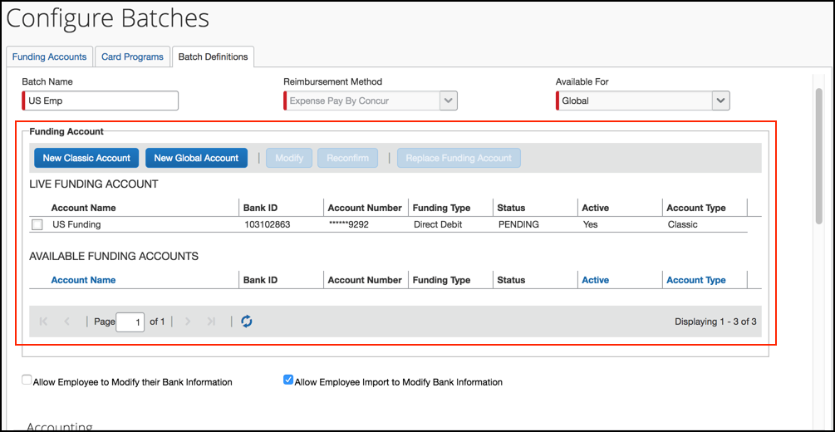
- Click Save. The change will be applied to the next batch once the current batch closes.

Deleting a batch definition
There are limited reasons to delete a batch definition and the best practice is to modify the existing batch definition when possible. When a batch definition is deleted, the existing payment demands will be processed using the old batch definition. When the system opens a new batch, provided you create a new batch definition, it will use the new batch definition to open this batch. This means you must create a new batch definition before the existing open batch closes; otherwise, the system will no longer create payment demands for the groups previously handled by the old batch definition.
To remove a batch definition:
- In Payment Manager, click Configure Batches. The Funding Accounts tab appears.
- Click the Batch Definitions tab. The list of batch definitions appears.
- Select the desired batch definition.
- Click Remove.

Batch Definition Scheduling
Batch definition scheduling sets the dates that a payment batch will close (preventing any new demands from being entered) and begin processing.
If you change the schedule once there is an open batch, the system waits until the current batch is completed (using the old schedule), then opens a new batch using the new schedule. Any reports that reach the Pending Payment status go into the current open batch. The possible schedules are:

Schedule | Description
On-Demand | The batch will remain open until you manually close it in Payment Manager.  NOTE: Expense Pay Japan clients can set the Value Date for On-Demand batches. For more information, refer to the Expense Pay: Value Date Setting section of this guide.
Daily | The batch closes daily at the end of the day.
Weekly | The batch closes at the end of the day on the selected day(s) of the week.
Every other week | The batch closes at the end of the day on the selected day of the week, every other week. The administrator selects the weekday, and the batch closes on the second occurrence of that day.  Example: On Monday, the administrator chooses the Every other week schedule and selects Thursday as the weekday. The next Thursday (3 days later) is the first occurrence of the weekday, and marks the end of the first week. The Thursday after that is when the batch closes for the first time.
Semi-Monthly – Days of Month | The batch closes at the end of the day on the two selected days of the month.
Monthly | The batch closes at the end of the day on the selected day of the month.  NOTE: You can account for banking holidays by setting the Monthly option to six calendar days prior to your payment due date. These six calendar days will account for three banking days for processing plus three non-banking days for the weekend plus a bank holiday. If you set the day of the month six calendar days out, you may pay your card prior to the due date. If you choose this option you will avoid the need to modify the batch close date around bank holidays.

Expense Pay: Impact of Batch Send Date Settings
The Batch Send Date field specifies the number of calendar days after the batch closes before Expense Pay sends the batch to the bank. This time interval provides time for the Reimbursement Manager to review the closed batch, determine the amount of funds required to pay the batch, and move funds into the funding bank account for this batch before the bank processes payment demands.
This setting also allows the Reimbursement Manager to review payment demands and set them to Place On Hold, Client Pay, or Assign to Next Batch. Because the batch is closed and sent during the overnight processing period (ONP), clients that wish to use the On Hold, Client Pay, or Assign to Next Batch functionality must either:
- Review their batches prior to the beginning of the ONP period on the day the batch is scheduled to close and send, or
- Set the Send Date to be at least one day after the close date for the batch
Clients who want to synchronize the schedules for their Standard Accounting Extract (SAE) job and their batch schedules will want to make the send date the same as the close date, so the extract contains the report payees and their associated payment demands sent for payment that day. This option makes reconciliation easiest.
The Reimbursement Manager must select either Same as Close Date, to send the batch as soon as it closes, or 1-5 Calendar Days, to delay the batch send by the specified number of days.
By adding a delay between the close and send date, the Reimbursement Manager can view the closed batch amount prior to receiving the Daily Funding Amount email. However, adding a day between batch close and send does not change the Daily Funding Amount email schedule. This notice goes out when the batch is communicated to the payment processor, generally the day before the funding is drawn down, but this can vary by currency.

Managing Batches

Monitoring Batches
The Reimbursement Manager uses the Monitor Batches page of Payment Manager to review batch status and payment demand details for all batches. The batches are grouped by batch definition. By default, the page displays the current batches for each definition. The Reimbursement Manager can search for a specific batch.
Based on configuration, the closed batches can generate an export file that can be downloaded from Payment Manager.
To review payment batch status:
- In Payment Manager, click Monitor Batches > View Batches. The page displays the current open batches.
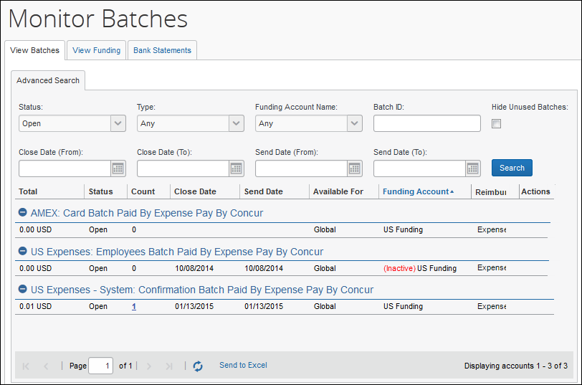
When applicable, the View Batches tab of the Monitor Batches page displays the column, Warnings, and the message, "Incomplete Banking Profile” to help prevent delays in successful processing of payments.
Not all batches have viewable data, but when applicable, the View Batch Data link displays the masked payment and remittance data that is transmitted to the payment and/or card provider.
- (Optional) Use the search fields to locate a particular batch. The search results display below:
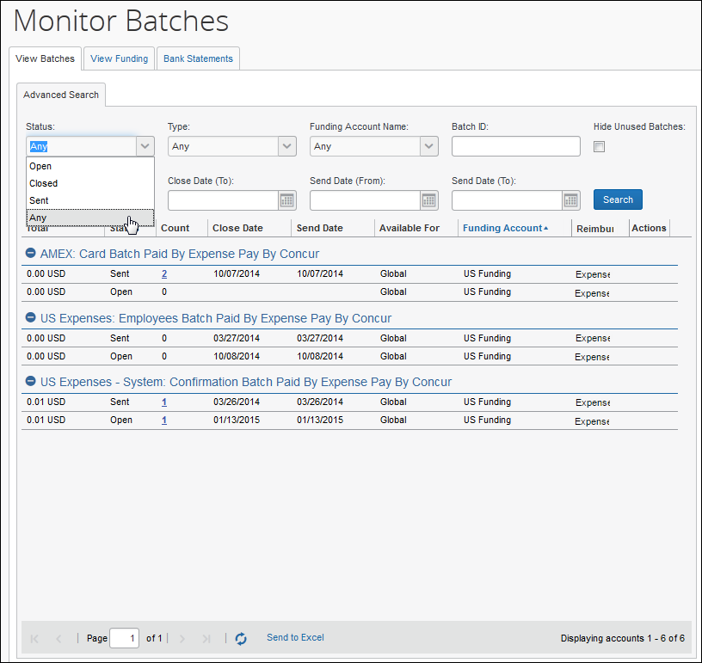
The Status column indicates whether a Reimbursement Manager can add more payment demands to the batch and other status information.
Status | Description
Open | Any expenses that are approved for payment will be added to the batch.
Closed | The batch no longer accepts approved expenses.  Expense Pay: Using the Report Payees List, the Reimbursement Manager can remove report payees from the batch.
Sent | The system successfully sent the batch to the payer's bank. The Reimbursement Manager can no longer add or remove report payees from this batch.
Processing | The batch is closed, but an error prevented it from sending. Click Close Now again to resend the batch.
Failed | The system is unable to process the batch. This could be due to network issues.  Expense Pay: This could be due to a failed funding account. The Reimbursement Manager should verify the funding account is set to Confirmed in the Funding Account List page. The system will attempt to resend the batch in 24 hours.
To view the payment demands in a batch:
On the View Batches tab, click the value in the Count column for the desired batch. The Payment Demands for Batch tab displays, listing the payment demands in the batch.
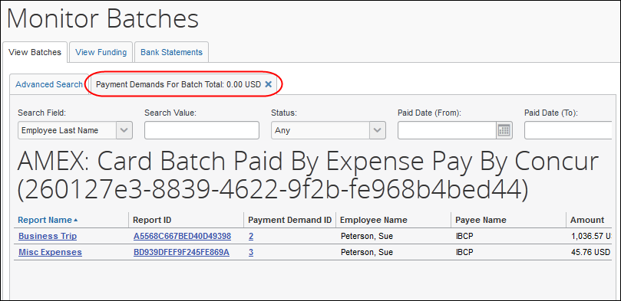
To export the batch list to an Excel spreadsheet:
- On the Monitor Batches page, select the View Batches tab.
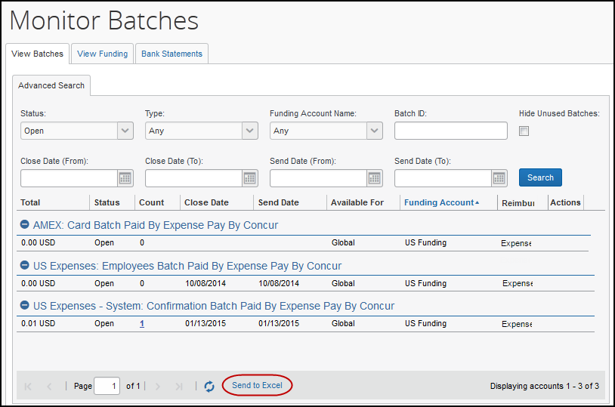
- Click Send to Excel. This opens an Excel spreadsheet containing the columns and data on the View Batches tab.
To close an on-demand batch:
- On the View Batches tab, find the desired batch.
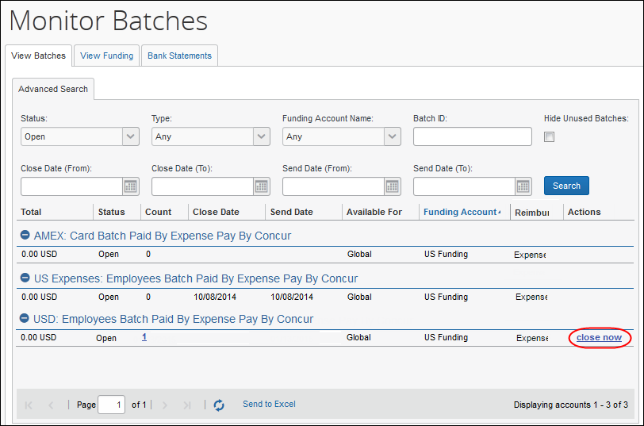
- Click close now. The batch closes and generates the export file. A new batch for that payment type is opened.
To download the export file for a batch:
This functionality may not be available, based on configuration.
- On the View Batches tab, search for the desired batch. The export file will be available once the batch has closed.
- Click download file to download the export file.
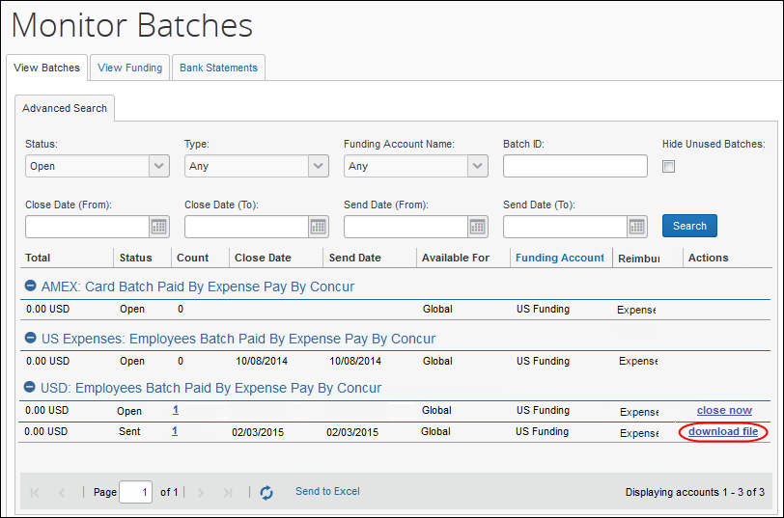
To view batch data:
Not all batches have viewable data, but when applicable, the View Batch Data link displays the masked payment and remittance data that is transmitted to the payment and/or card provider.
- Click View Batch Data to open the Batch Data tab.
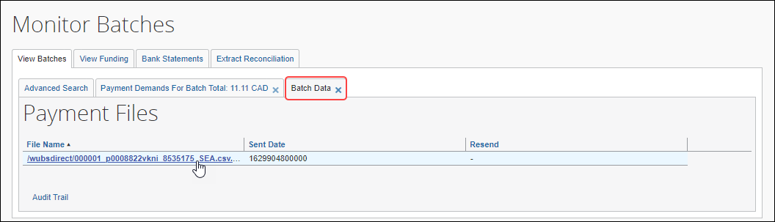
- Click a file name, if one is available, to display the masked data that was transmitted.
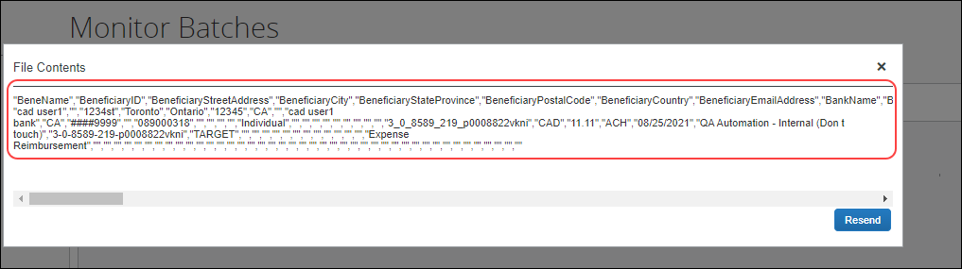
The Resend button is only available for some providers and you should only click it if directed to do so by your payment provider, card provider, or SAP Concur.

Resending Card Batch Remittance File
Client admins can resend a card batch remittance/allocation file to the card company.
Corporate card banks (for example, Citi, Amex, or Bank of America) can request that remittance/allocation details be re-sent for a received payment. With the resend button, the client can do this themselves when needed.
This feature is only available for the card companies listed previously. It is available for both Worldline and Convera payment providers when the card program supports it.
To resend remittance/allocation details to a requesting card bank:
- Go to Payment Manager > Monitor Batches.
- On the Monitor Batches page, search and open the affected card batch.
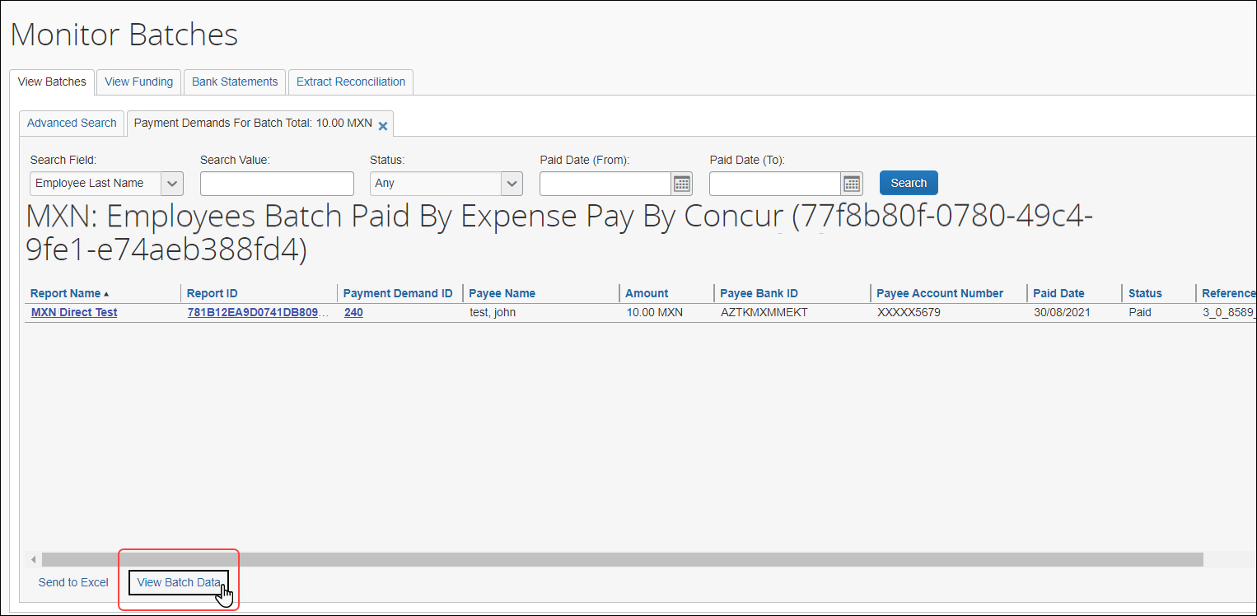
- Click View Batch Data.
If the admin receives a message stating no batch data is available, this indicates there is no separate remittance file for their card program configuration.
- On the Batch Data tab, in the File Name section, click the remittance transmission link.
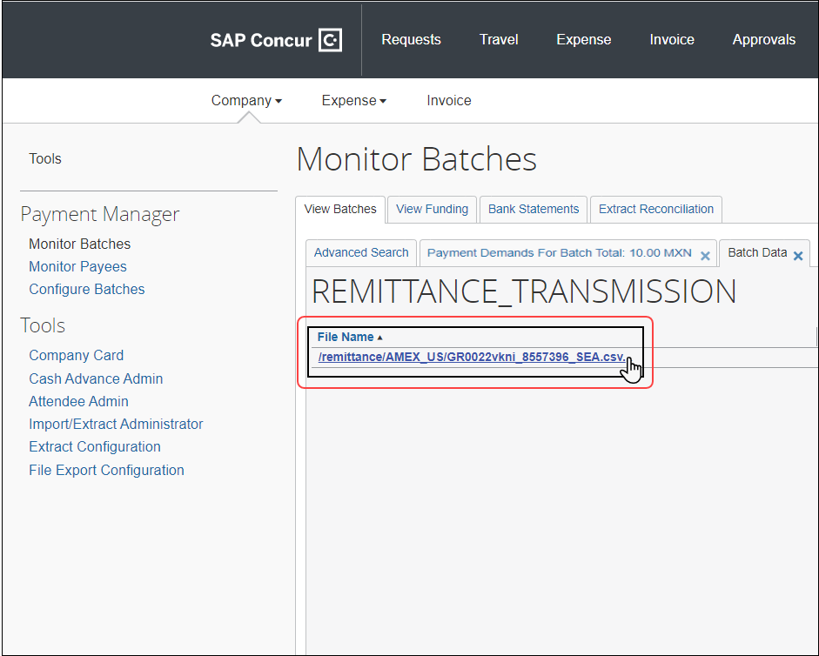
On the Batch Data tab, the remittance transmission link may appear on the bottom half of the page, depending on which payment provider the batch is using.
- On the File Contents window, click Resend.
The Resend button is only available if the card vendor allows it.
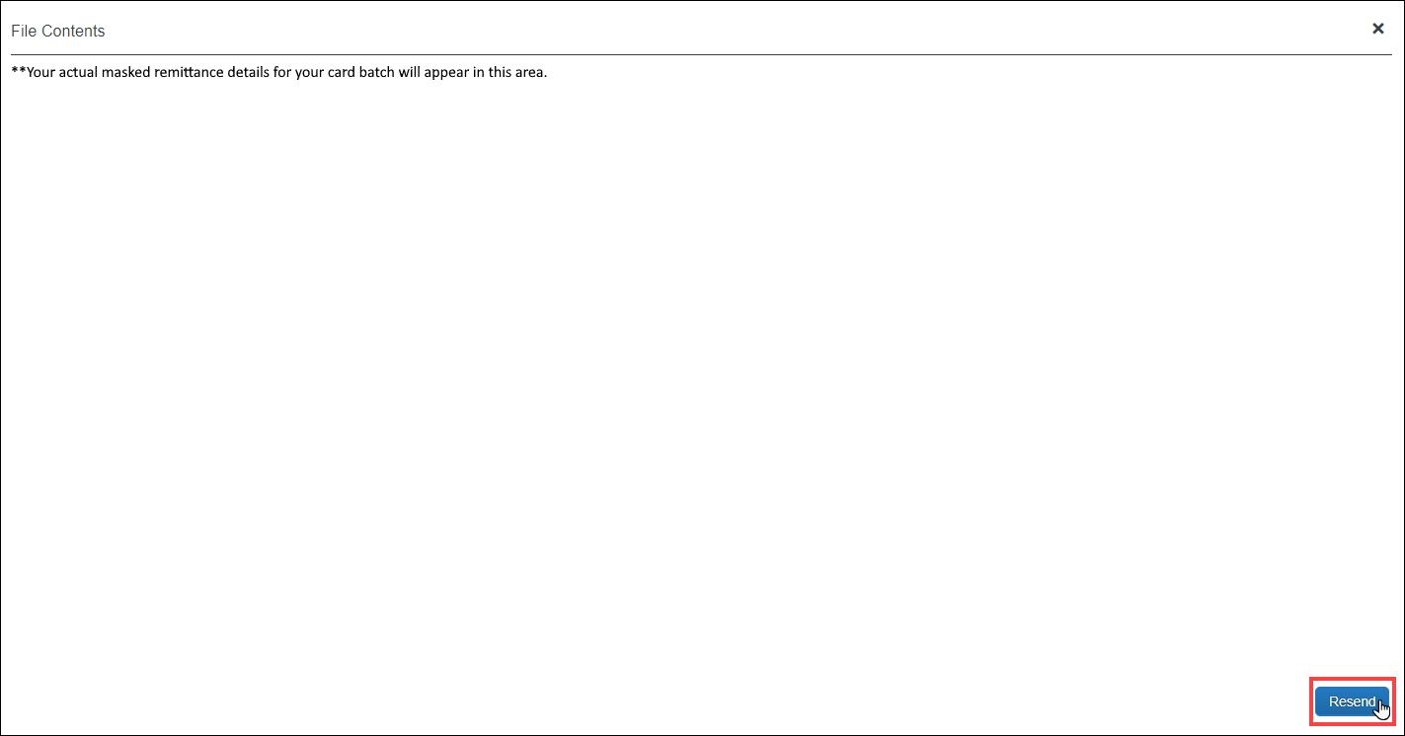
The file has now been resent to the card company and the payment will be allocated to the card holders' accounts (provided that the third-party payment provider has completed the payment).
Due to the variable timing of when the client sends the funds to the payment provider and when the card company receives them, the card company may request the allocation details be resent.

Rescheduling Batches
In some circumstances, the Reimbursement Manager may need to close or send a particular batch earlier or later than its regular schedule. For example, to ensure Expense Pay generates payments to employees before a banking holiday, the Reimbursement Manager may choose to pay the batch earlier than scheduled.
The Reimbursement Manager can use the Reschedule Batch link on the View Batches tab of Payment Manager to close and send the batch sooner or later than scheduled. In some cases, administrators may want to have some payment demands in the batch paid on an earlier schedule, and some paid on the original schedule.
To reschedule a batch:
- On the View Batches tab of the Monitor Batches page, search for the desired batch.
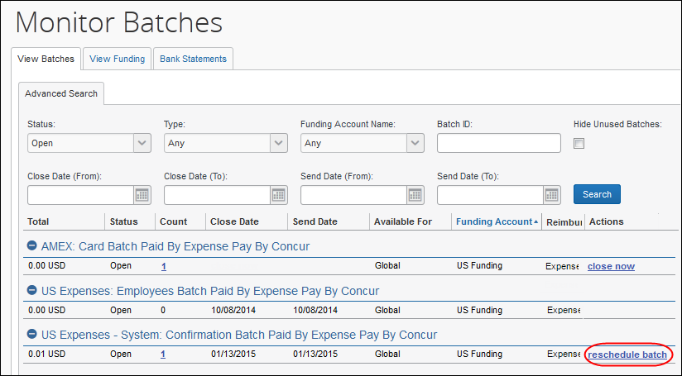
- Click reschedule batch. The Reschedule Batch Id window appears.
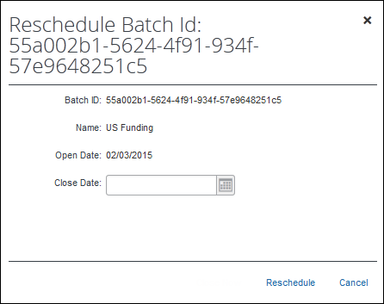
- Set a new Close Date and Send Date (Expense Pay only) for the batch.
- Click Reschedule.
If you close a batch early, the following batch is shorter in duration. For example, if a batch is scheduled to close on Tuesday, the system always looks for the next Tuesday to close. If a batch is opened on Tuesday, it will close the following Tuesday (seven days later). If the batch is opened on Wednesday, it will close the following Tuesday (six days later). If the batch is opened on Monday, it will close on Tuesday (one day later).

Rescheduling a Subset of Payment Demands in a Batch
If a subset of payment demands in a batch need to be rescheduled, the administrator must remove the payment demands that will be paid on the original schedule, reschedule the batch, then re-add the held payment demands to the new open batch.
To reschedule the payment demands:
- Click Monitor Batches. The View Batches page displays.
- Select Monitor Payees and select Assigned in the Status field and any additional search criteria.
- Click Search.
- Select the payment demands you wish to exclude from the current payment schedule.
- Click Place on Hold. The selected payment demands are now removed from the batch.
- Reschedule the batch using the instructions in the To reschedule a batch procedure above.
To add the held payment demands to the new batch:
This step can be completed once the rescheduled batch has closed and the open batch now reflects the new schedule.
- Select Monitor Payees > Report Payees. The Report Payees page displays.
- Select On Hold in the Status field and click Search.
- Select the payment demands to move into the new open batch.
- Click Change Batch > Assign to Next Batch. The subset of the payment demands are now in the desired batch schedule.

Managing Expense Reports on the Reports Payees List
A report payee and cash advance payee is a payee on an expense report. Report payees can be either employees or company card issuers. A payment demand consists of one or more report entries for the same payee. A payment demand for a card program will contain the total remittance amount for all card transactions for that card program included in the batch. A payment batch consists of one or more payment demands. NOTE: The Reimbursement Auditor user role cannot view the Employee Banking Status.
The Reimbursement Manager uses the Reports Payees list to investigate the payment status of a specific expense report or report payee and perform the following tasks:
- Place report payees on hold: Sometimes a Reimbursement Manager needs to remove a payee from a payment demand. By placing a payee on hold, the Reimbursement Manager removes the payee from its payment demand and its batch. The payee is not processed until the Reimbursement Manager reassigns the payee to an open batch.
- Assign report payees to an open batch: If a payee is in an Aborted or On Hold status, and the issue leading to this status has been resolved, the Reimbursement Manager can assign the payee to an open batch. The system adds the report payee to an existing payment demand for that payee or creates a new payment demand in the open batch.
To locate reports in Payment Manager:
- Click Monitor Payees. The Report Payees page displays.
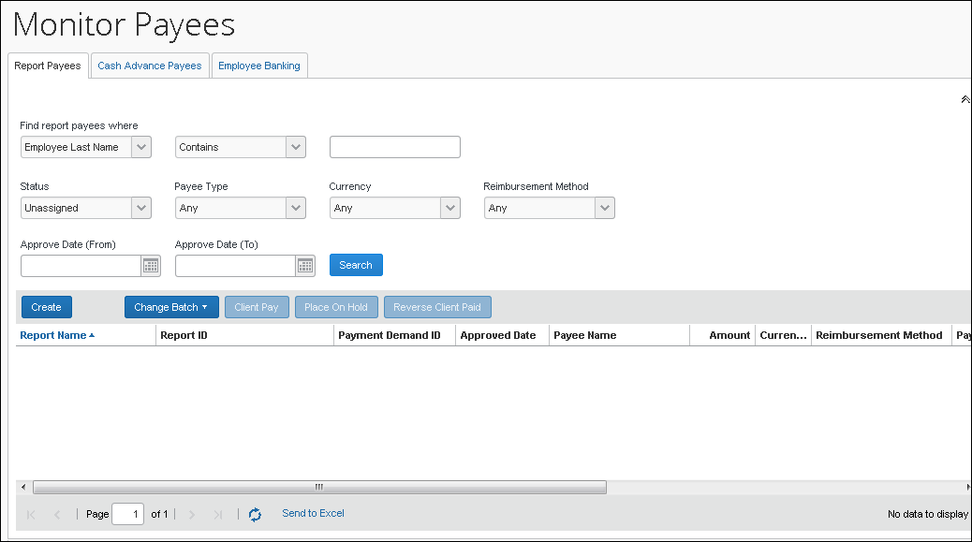
- To search for a specific expense report within the group, use the following fields:
- Find report payees where
- Status
- Payee Type
- Currency
- Reimbursement Method
The Status column always defaults to Unassigned.
To place a report payee on hold:
- Click Monitor Payees. The Report Payees page displays.
- Select the desired expense report.
Only report payees associated to batches that are not sent can be set to Place On Hold.
- Click Place On Hold. The report payee status changes to On Hold.
To assign a report to an open batch:
- Click Monitor Payees.
- Select the desired expense report.
- Click Change Batch > Assign to Next Batch. The report payee status changes to Assigned.
- For information on Expense Pay specific procedures, refer to the Expense Pay Information and Procedures section of this guide.

Report Payee Status
The Status column displays information about a report that guides what a Reimbursement Manager can do with a specific report.
Status | Description
Aborted | The payment demand has been returned by the Expense Pay Engine.
Any | This selects for any status.
Assigned | The payment demand is assigned to an open or closed batch that has not yet been sent for processing. Reports with a status of Assigned can be assigned to the next batch (if the batch it currently belongs to is closed), placed on hold, or marked as Client Pay.
Not Sent/Not Completed (only used in Search field) | This status includes all payment demands with a status of Aborted, Assigned, or On Hold.
On Hold | The Reimbursement Manager put this report payee on hold. No payment demand is associated with a report payee that is on hold. Reports in a Hold status can be assigned to the next batch or marked as Client Pay.
Sent/Completed | The payment demand is in a batch sent for processing.
Unassigned (only used in Search field) | This status includes all payment demands with status of On Hold, Aborted, and Client Pay.
Unpaid (only used in Search field) | This status includes all payment demands without a status code and those set to Not Paid.
- For information on Expense Pay specific report statuses, refer to the Expense Pay Information and Procedures section of this guide.

Managing Payment Demands
The Reimbursement Manager manages payment demands through the Payment Demands tab of the Monitor Batches page. This page displays the payment demands contained for the specified batch. The Reimbursement Manager selects the batch on the View Batches tab of the Monitor Batches page of Payment Manager, which opens the Payment Demands tab.
From the Payment Demands tab, you can open the Payment Demand Audit Trail window, where you can troubleshoot or audit a payment demand. You can also open the Report Summary window, where you can view the summary for the report associated with the payment demand.
- Refer to the Managing Batches section of this guide for more information.

Payment Demand Types
There are two kinds of payment demands, Cash and Card. A Cash payment demand contains one report payee, an employee. A Card payment demand contains one payee, a card issuer. These payment demands result from expense report submissions.
To review payment demands contained in a batch:
- On the View Batches tab of the Monitor Batches page, click the amount in the Count column of the desired batch. The Payment Demands for Batch tab appears.
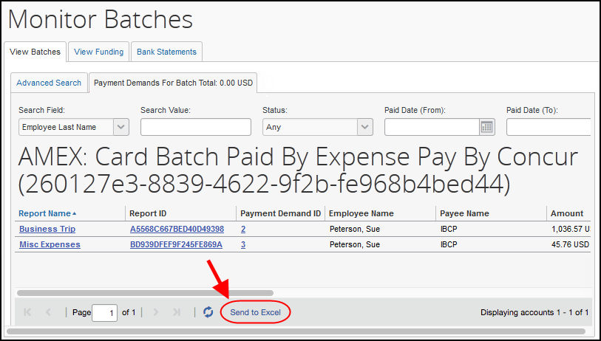
- Review the information for the desired demands.
- Click X to close the tab.
To view the payment demand audit trail:
- On the Payment Demands for Batch tab, click the Payment Demand ID. The Audit Trail for Payment Demand window appears:
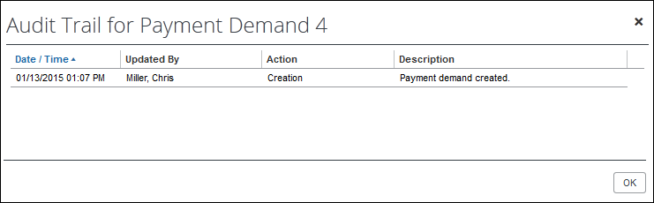
- Click OK.
To review the report summary for a payment demand:
On the Payment Demands tab, click the name in the Report Name column for the desired payment. The Expense Report Summary window appears:
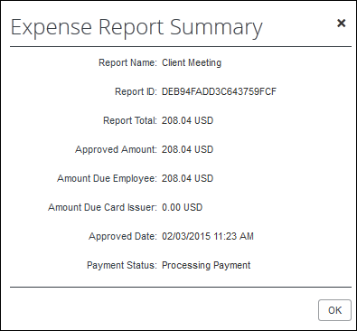

Expense Pay Information and Procedures

Managing Funding Accounts
Funding accounts are the bank accounts that Expense Pay draws funds from to fund payments to employees or card programs. The best practice is for the Reimbursement Manager to define these bank accounts on the Batch Definitions tab of the Configure Batches page of Payment Manager, within a specific Batch. Alternatively, the Reimbursement Manager can utilize the Funding Accounts tab to create, view, and modify funding accounts.
Debit Authorization Process
Each country has a unique process for authorizing SAP Concur to debit a funding account. SAP Concur’s providers must complete the debit authorization before you can begin making payments using your funding account in Payment Manager. Contact Concur Client Services to get a copy of the sample letter to send to your bank with this request.
- For more information, refer to the Expense Pay Global User Guide.
From the Batch Definitions page, create or modify a batch to access the funding account section.
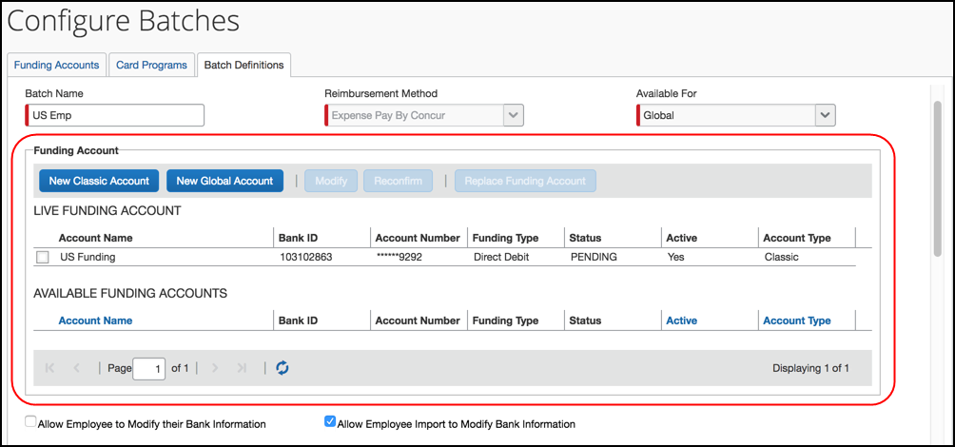

Creating a Funding Account
For a comprehensive view of funding accounts, refer to the Batch Definitions tab.
To create a new funding account:
- Click New Global Account. The Funding Account window appears. Fill in the required fields for the selected country/currency combination.
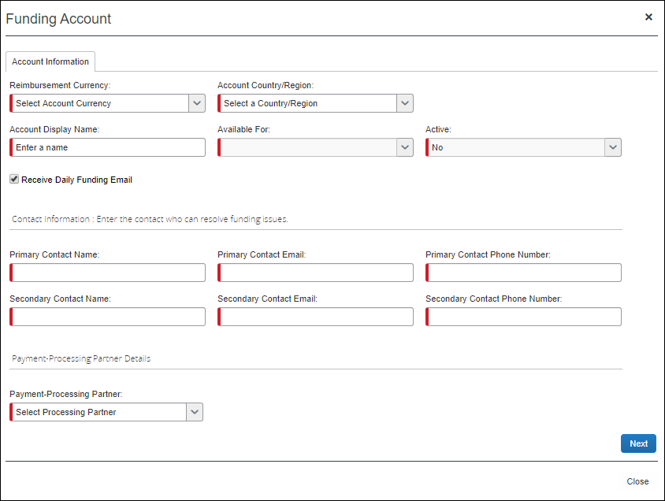
- Complete the following fields:
Field | Description
Account Country | The country where the bank account is located.
Reimbursement Currency | The available currency or currencies based on the selected Account Country.  NOTE: UK funding accounts can use either GBP or Euro.
Account Display Name | The name that will appear for the funding account on the Create/Edit Batch Definitions page and on the Monitor Batches > View Funding > Direct Debit page.  NOTE: The Reimbursement Auditor user role can view the funding account name but not the details. The funding account name should be clear and descriptive.
Available For | The group whose Reimbursement Managers will be able to access the funding account.
Active | The status of the account, either active or inactive.
Receive Daily Funding Email | The feature that sends a funding email out daily for this funding account. Selected to receive the email or cleared to not receive the email. This setting is only used to stop sending daily funding emails when the daily funding amount is equal to 0 (currency).  NOTE: The funding account email is not group-aware. The emails for all funding accounts will go to all users who have the Reimbursement Manager user role, regardless of group.
Primary Contact Name | The name of the primary contact who can resolve funding issues.
Primary Contact email | The email of the primary contact who can resolve funding issues.
Primary Contact phone number | The phone of the primary contact who can resolve funding issues.
Secondary Contact Name | The name of a secondary contact who can resolve funding issues.
Secondary Contact email | The email of the secondary contact who can resolve funding issues.
Secondary Contact phone number | The phone of the secondary contact who can resolve funding issues.
provider | The provider for this funding account.
- Click Save.
- On the Provider Onboarding Application tab, fill in the field required by the provider.
- IMPORTANT: Not all SAP Concur clients will utilize the same providers. Please refer to the Funding Bank Account Fields by Country section for onboarding requirements per currency and provider.
- Click Close. The status of the new account will be set to Unconfirmed while the provider verifies the account details.
- For field details, refer to the Funding Bank Account Fields by Country section of this guide.
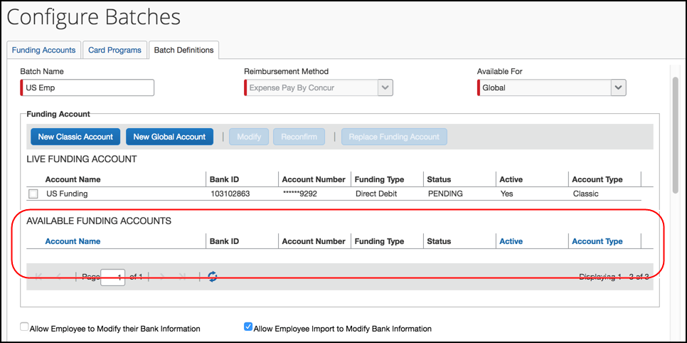
The newly created funding account appears in the available funding accounts section where the account can be selected as the live batch account or left as a possible future account.
The possible statuses for Global funding accounts are:
- In Progress – The client has started, but not finished entering funding account information.
- In Review – The client has finished entering funding account information and submitted it for verification to the provider.
- Reopened – The provider has reviewed the application and has requested additional information. The information is displayed on the top of the application form and can be viewed by clicking View All. Copy the information requested into a Word document, and provide answers, then upload this document along with any other documents that might have been requested into the Additional Relevant Documentation field. And then submit the application again.
- Accepted – The provider has verified and accepted the account information.

Verifying a Worldline Funding Account (€, £, $, or C$)
The debit test allows clients to confirm that the payment processer (Worldline) can debit their funding account and that the funding account is ready to be used to pay employees and company cards.
For Expense Pay – Global clients whose funding accounts use Worldline as the provider, it is possible to manually initiate a debit test (commonly known as a penny test) transaction for Accepted (status) Worldline funding accounts.
The test will debit the amount of 0.01 in funding account currency (Euro €, British Pound £, United States Dollar $, or Canadian Dollar $) from the funding account and credit it back to the funding account.
To use the new debit test button, the funding account must meet the following requirements:
- The provider must be Worldline.
- The funding account status must be Accepted.
- A funding account must not already be on a temporary hold due to a funding failure with Worldline.
Debit Test a Funding Account
- From the (Modify) Funding Account page, click Initiate Debit Test.
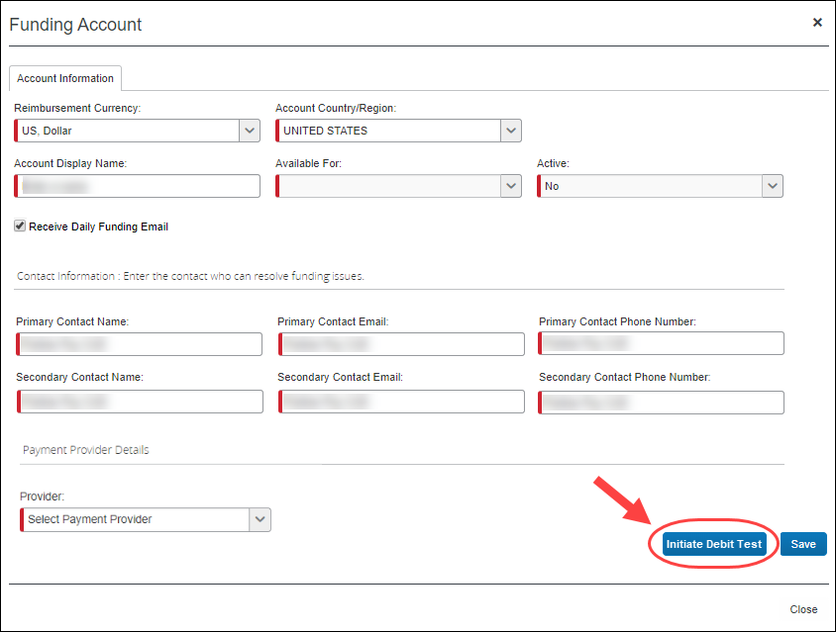
The test will debit the amount of 0.01 in funding account currency (€, £, $, or C$) from the funding account and credit it back to the funding account.
- Review your bank statement with your bank and confirm a debit for 0.01 from Worldline.
- After the debit test is complete, it is appropriate to assign a new funding account to an employee or card batch.

Editing a Funding Account
To edit an existing funding account:
- From within a batch (new or existing), select the desired account and click Modify. The Funding Account window appears.
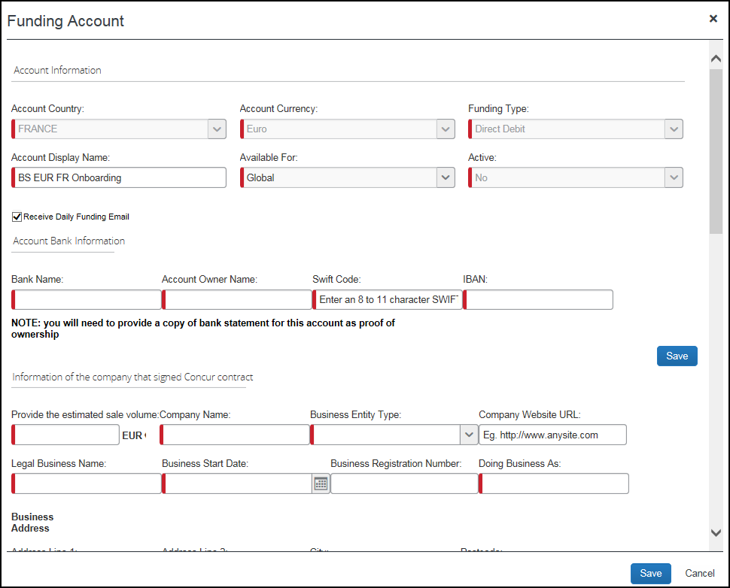
- Make the necessary changes in the available fields.
It is not possible to modify funding bank account information. If the funding bank account details change, create a new funding account.
- Click Save and Exit.

Setting a Funding Account
Each batch must have a funding account assigned as the live account, for a new batch, choose the desired available account and click Set Funding Account.

Replacing a Funding Account
If you need to replace a funding account, then follow this process:
Expense Pay account confirmation must complete with the payment provider before replacing the funding account. If you replace a funding account with an account that is not fully verified and live, there will be a delay in employee payments. Concur suggested best practice is to complete all necessary setup, including verification, prior to replacing a funding account.
- Create the new funding account or choose an existing funding account.
- Refer to the Creating and Editing Funding Accounts section of this guide for details.
- Set the new funding account to Live on the Batch Definitions tab of the Configure Batches page in Payment Manager.

Deleting a Funding Account
It is not possible to delete a funding account; however, it can be set to inactive.

Viewing Funding
The View Funding page displays the following tabs:
- Direct Debit: Only utilized for classic funding accounts.
- Pre Fund: Only utilized for classic funding accounts.
- Global Funding: This tab allows a Payment Manager to view accounts that are used for Expense Pay transactions that are processed by Concur Expense Pay providers. This tab displays a daily summary of account activity for all providers' funding accounts.
To view the View Funding page:
Click Monitor Batches > View Funding > Global Funding.
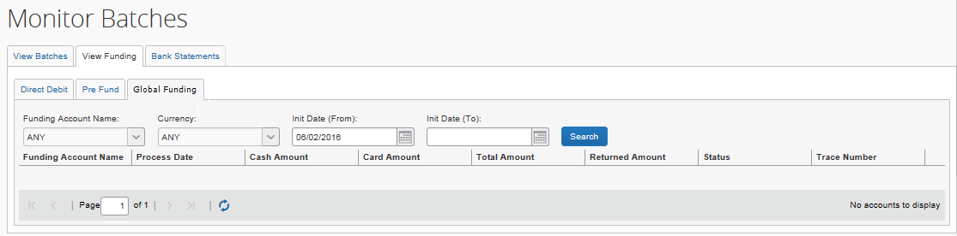
Cash Advance Funding Details may display with several blank columns.
For additional payment details, click View Batches > details.

The page displays the following columns:
Column | Description
Funding Account Name | Funding account name.
Process Date | The date the batch was processed or the return was processed
Cash Amount | The funding amount of all Cash Programs for this funding account.  NOTE: The amount in this column may vary from the amount on the batch list page due to rejected payment demands.
Card Amount | The funding amount of all Card Programs for this funding account.
Total Amount | The sum of cash, and card amounts.
Returned Amount | The sum of returned payments received.
Status | The status of each funding transaction.
Trace Number | A unique identifier that is sent on the debit into the banking system.
To search for a specific funding account on the Global Funding tab:
- On the View Funding page, select the desired account from the Funding Account Name list.
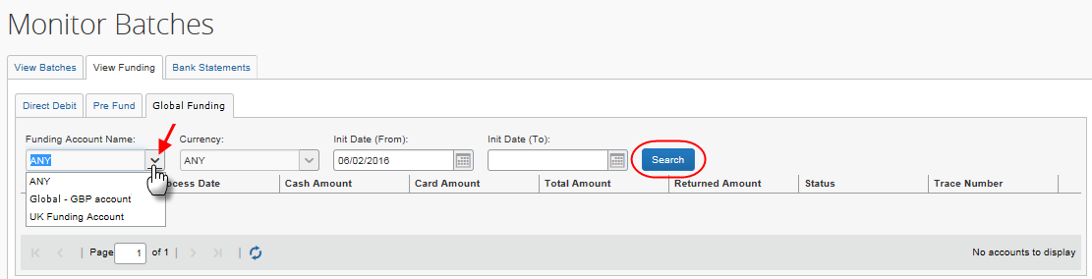
- Click Search. The search results display.
To search for funding account activity by date:
- In the date fields, select the desired dates. The view retains 90 days-worth of account activity.
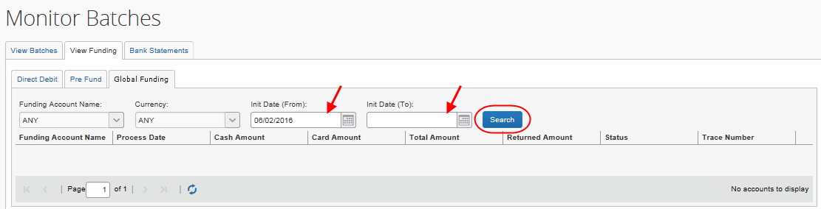
- Click Search. The search results display.

Funding Bank Account Fields by Country
The onboarding fields vary by country/currency and by provider requirements.

Worldline

Canada
Canada Bank Account Fields
Field | Description
Account Owner Name | Name of the account owner as shown on the bank statement of this funding account.
Transit Number | The account transit number.
Institution Number | The account institution number.
Account Number | The account number.
Provide the estimated sale volume | The estimated sale volume.
Company Name | The company name.
Business Entity Type | The business entity type.
Company Website URL | The company Web Site URL.
Legal Business Name | The legal business name of the company.
Business Start Date | The company’s first day of business.
Business Registration Number | The business registration number.
Doing Business As | The company “DBA” or doing business as name.
Address Line 1 | The physical address of the company.
Address Line 2 | (Optional) The physical address of the company.
City | The physical city of the company.
Postcode | The physical postcode of the company.
Province | The physical province of the company.
Country | The physical country of the company.
(Director #) First Name | The director’s first name.
(Director #) Last Name | The director’s last name.
(Director #) Date of Birth | The director’s birthday.
(Director #) % for Company | The ownership percent in the company held by this director.
(Director #) Date Current Ownership Started | The date current ownership began.
(Director #) Address Line 1 | The physical address of the director.
(Director #) Address Line 2 | (Optional) The physical address of the director.
(Director #) City | The physical city of the director.
(Director #) Postcode | The physical postcode of the director.
(Director #) Province | The physical province of the company.
(Director #) Country | The physical country of the director.
How often do you submit your batches? | The frequency of batches you have submitted in the past.
What is the average amount of each batch? | The average amount of your batches.
What do you expect the maximum amount of each batch to be? | The maximum amount that you expect for each batch.
First Name of Person Accepting | The first name of the person accepting these terms and conditions.
Last Name of Person Accepting | The last name of the person accepting these terms and conditions.
Email of Person Accepting | The email address of the person accepting these terms and conditions.
Phone Number of Person Accepting | The phone number of the person accepting these terms and conditions.

Eurozone
Eurozone Bank Account Fields
Field | Description
Bank Name | The name of the bank.
Account Owner Name | Name of the account owner as shown on the bank statement of this funding account. Pre-populated with the company’s entity name.  NOTE: Concur Customer support can change this value to match the sub-entity that holds the account (necessary in some cases).
Swift Code | Also known as SWIFT-BIC, BIC code and SWIFT ID, a SWIFT code is a standard format of Bank Identifier Codes. It is the unique identification code of a particular bank.  The SWIFT code is 8 or 11 characters, made up of:  4 characters - bank code (only letters)  2 characters - country code (only letters)  2 characters - location code (letters and digits)  3 characters - branch code, optional ('XXX' for primary office) (letters and digits)
IBAN | The two-character country code, followed by two check digits then the bank identifier and account number, typically derived from the domestic account number.  Format:  Austria: AT2!n5!n11!n  Length: 20  Belgium: BE2!n3!n7!n2!n  Length: 16  Denmark: DK2!n4!n9!n1!n  Length: 18  Finland: FI2!n6!n7!n1!n  Length: 18  France: FR2!n5!n5!n11!c2!n  Length: 27  Germany: DE2!n8!n10!n  Length: 22  Greece: GR2!n3!n4!n16!c  Length: 27  Ireland: IE2!n4!a6!n8!n  Length: 22  Italy: IT2!n1!a5!n5!n12!c  Length: 27  Luxembourg: LU2!n3!n13!c  Length: 20  Netherlands: NL2!n4!a10!n  Length: 18  Portugal: PT2!n4!n4!n11!n2!n  Length: 25  Spain: ES2!n4!n4!n1!n1!n10!n  Length: 24  Sweden: SE2!n3!n16!n1!n  Length: 24  Switzerland: CH2!n5!n12!c  Length: 21  United Kingdom: GB2!n4!a6!n8!n  Length: 22  ! = characters, a = alphabetic, c = alphanumeric, n = numeric.
Provide the estimated sale volume | The estimated sale volume.
Company Name | The company name.
Business Entity Type | The business entity type.
Company Website URL | The company Web Site URL.
Legal Business Name | The legal business name of the company.
Business Start Date | The company’s first day of business.
Business Registration Number | The business registration number.
Doing Business As | The company “DBA” or doing business as name.
Address Line 1 | The physical address of the company.
Address Line 2 | (Optional) The physical address of the company.
City | The physical city of the company.
Postcode | The physical postcode of the company.
Country | The physical country of the company.
(Director #) First Name | The director’s first name.
(Director #) Last Name | The director’s last name.
(Director #) Date of Birth | The director’s birthday.
(Director #) % for Company | The ownership percent in the company held by this director.
(Director #) Date Current Ownership Started | The date current ownership began.
(Director #) Address Line 1 | The physical address of the director.
(Director #) Address Line 2 | (Optional) The physical address of the director.
(Director #) City | The physical city of the director.
(Director #) Postcode | The physical postcode of the director.
(Director #) country | The physical country of the director.
How often do you submit your batches? | The frequency of batches you have submitted in the past.
What is the average amount of each batch? | The average amount of your batches.
What do you expect the maximum amount of each batch to be? | The maximum amount that you expect for each batch.
First Name of Person Accepting | The first name of the person accepting these terms and conditions.
Last Name of Person Accepting | The last name of the person accepting these terms and conditions.
Email of Person Accepting | The email address of the person accepting these terms and conditions.
Phone Number of Person Accepting | The phone number of the person accepting these terms and conditions.

United Kingdom
United Kingdom Bank Account Fields
Field | Description
Bank Name | The name of the bank.
Account Owner Name | Name of the account owner as shown on the bank statement of this funding account. Pre-populated with the company’s entity name.  NOTE: Concur Customer support can change this value to match the sub-entity that holds the account (necessary in some cases).
Sort Code | The sort code.
Account Number | The account number.
Provide the estimated sale volume | The estimated sale volume.
Company Name | The company name.
Business Entity Type | The business entity type.
Company Website URL | The company Web Site URL.
Legal Business Name | The legal business name of the company.
Business Start Date | The company’s first day of business.
Business Registration Number | The business registration number.
Doing Business As | The company “DBA” or doing business as name.
Address Line 1 | The physical address of the company.
Address Line 2 | (Optional) The physical address of the company.
City | The physical city of the company.
Postcode | The physical postcode of the company.
Country | The physical country of the company.
(Director #) First Name | The director’s first name.
(Director #) Last Name | The director’s last name.
(Director #) Date of Birth | The director’s birthday.
(Director #) % for Company | The ownership percent in the company held by this director.
(Director #) Date Current Ownership Started | The date current ownership began.
(Director #) Address Line 1 | The physical address of the director.
(Director #) Address Line 2 | (Optional) The physical address of the director.
(Director #) City | The physical city of the director.
(Director #) Postcode | The physical postcode of the director.
(Director #) country | The physical country of the director.
How often do you submit your batches? | The frequency of batches you have submitted in the past.
What is the average amount of each batch? | The average amount of your batches.
What do you expect the maximum amount of each batch to be? | The maximum amount that you expect for each batch.
First Name of Person Accepting | The first name of the person accepting these terms and conditions.
Last Name of Person Accepting | The last name of the person accepting these terms and conditions.
Email of Person Accepting | The email address of the person accepting these terms and conditions.
Phone Number of Person Accepting | The phone number of the person accepting these terms and conditions.

United States
United States Bank Account Fields
Field | Description
Bank Name | The name of the bank.
Account Owner Name | Name of the account owner as shown on the bank statement of this funding account.
Routing Number | The account routing number.
Account Number | The account number.
Provide the estimated sale volume | The estimated sale volume.
Company Name | The company name.
Business Entity Type | The business entity type.
Company Website URL | The company Web Site URL.
Legal Business Name | The legal business name of the company.
Business Start Date | The company’s first day of business.
Business Registration Number | The business registration number.
Doing Business As | The company “DBA” or doing business as name.
Address Line 1 | The physical address of the company.
Address Line 2 | (Optional) The physical address of the company.
City | The physical city of the company.
ZIP Code | The physical postal code of the company.
Country | The physical country of the company.
(Director #) First Name | The director’s first name.
(Director #) Last Name | The director’s last name.
(Director #) Date of Birth | The director’s birthday.
(Director #) % for Company | The ownership percent in the company held by this director.
(Director #) Date Current Ownership Started | The date current ownership began.
(Director #) Address Line 1 | The physical address of the director.
(Director #) Address Line 2 | (Optional) The physical address of the director.
(Director #) City | The physical city of the director.
(Director #) ZIP Code | The physical postal code of the director.
(Director #) country | The physical country of the director.
How often do you submit your batches? | The frequency of batches you have submitted in the past.
What is the average amount of each batch? | The average amount of your batches.
What do you expect the maximum amount of each batch to be? | The maximum amount that you expect for each batch.
First Name of Person Accepting | The first name of the person accepting these terms and conditions.
Last Name of Person Accepting | The last name of the person accepting these terms and conditions.
Email of Person Accepting | The email address of the person accepting these terms and conditions.
Phone Number of Person Accepting | The phone number of the person accepting these terms and conditions.

Example Form - Worldline
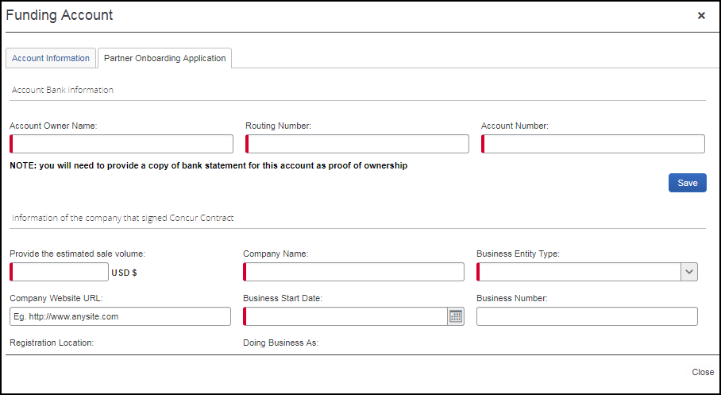

Convera
The SAP Concur user interface will display an imbedded Convera onboarding application form.
Obtain the following information in preparation of the on-boarding bank funding setup.
Information requested is based on regulatory requirements. Company information is related to the entity that signed the contract with Concur, not the subsidiary.
Note: Below are general requirements but every situation may be unique after documents are reviewed by Convera and additional follow up may be required.

United States

United States Bank Account Fields
Field | Description
Information About You
I wish to submit an application for a* | Either Corporation, Sole Proprietor, or Partnership from the list.  NOTE: Confirmation, based on selection, displays and is required.
First Name of Person Filling this application* | The first name of the person completing this application.
Middle Name of Person Filling this application | The middle name of the person completing this application.
Last Name of Person Filling this application* | The last name of the person completing this application.
Information about signing officer, where a signing officer is a representative with the powers to commit the authorizing of an organization to all binding agreements
First Name* | The first name of the signing officer.
Middle Name | The middle name of the signing officer.
Last Name* | The last name of the signing officer.
Date of Birth* | A date picker field that defaults to the current month, day, and year. The date of birth of the signing officer.
Your Residential Address* | The home street number/letter and name of the signing officer.
City* | The home city of the signing officer.
Residential Address Country* | The home country of the signing officer.
State / Province* | The home state or province of the signing officer.
Postal Code* | The home postal or zip code number of the signing officer.
Telephone* | The home telephone number of the signing officer.
Email Address* | The email address of the signing officer.
Business Name* | The name of the corporation, sole proprietorship, or partnership.
Business Occupation | The type of business provided by the corporation, sole proprietorship, or partnership.
Website Address | The Internet homepage of the corporation, sole proprietorship, or partnership.
Business Details by business type
- For more information, see the Business Details by Business Type section at the end of this table.
ID
Primary ID Type* | Either Passport or Driver's License of the signing officer
Country of Issuance* | The name of the country that issued the passport or driver's license.
Issuance Date* | A date picker field that defaults to the current month, day, and year. The date the passport or driver's license was issued.
Expiry Date* | A date picker field that defaults to the current month, day, and year. The date that the passport or driver's license expires.
ID Number* | The identification number of the passport or driver's license.
Image of ID* | A field that allows a photo of the passport or driver's license to be attached to this application via file upload.  NOTE: Consent to perform an electronic verification is required.
Secondary ID Type | Either Driver's License, Nationality Card, or Utility Bill.
Image of ID | A field that allows a photo of the driver's license (if not already provided as the primary ID), nationality card, or utility bill to be attached to this application via file upload.
Trade Requirements
What is your average expense and invoice payment amount?* | A number in United States dollars that is your average batch amount.
How often will you be submitting payments?* | Either daily, weekly, monthly, quarterly, or yearly. The calendar frequency of expected payments.
How many payments will you typically make in this time?* | The number of batches you intend to submit based on the calendar frequency selected.
Please indicate the anticipated date of your first payment* | A date picker field that defaults to the current month, day, and year. The date you would like to begin using this new funding account.
Size of your organization* | The total number of your employees.
Declarations
Declaration and Agreement* | A check box that must be selected.
Foreign Exchange Contracts* | A check box that must be selected.
Additional Documentation
Southwest Border Ultimate Beneficial Ownership Form | A field that allows a file to be attached to this application via file upload.
Additional Relevant Documentation | A field that allows files to be attached to this application via file upload.
Account Details
Bank Name* | The name of the bank.
Bank Branch* | The bank's name for the physical location that is your branch.
Bank Street Address* | The street number and street name of your bank's address.
Bank City* | The city of your bank.
Bank Country* | This field is a pick list of countries supported by Convera even if they are not supported by Expense Pay - Global. By default, United States of America is selected.
Bank State / Province* | This field is a pick list of states and provinces that are applicable to the previously selected Bank Country.
Bank Zip Code* | The postal or zip code number of your bank.
Bank Telephone Number | The phone number of your bank.
Account Manager Name | The name of your contact person at your bank.
Exact Name of the Account Holder* | The precise name of the account holder per your bank's records.
Bank routing/transit code* | The account routing number.
Bank Account Number* | The number of the account.
Account Type | Either Checking or Savings.
Account Open Date | A date picker field that defaults to the current month, day, and year. The date the checking or savings account was created.
Applicant agrees to the terms… | A check box that must be selected.
Bank Statement issued in the name of the business within the last 90 days* | A field that allows a file to be attached to this application via file upload.

Business Details by business type
Business type determines the information required by Convera when creating funding accounts. Convera uses the following five business types:
- Corporation (Non-Public) (privately held)
- Corporation (Public)
- Partnership (For example, law firms are often partnerships.)
- Sole Proprietorship
- NGO (Charity or Not-For-Profit-Corporation)
Based on your business type, have the following information ready to enter on your Convera registration onboarding form.
Corporation (Non-Public)
- Full registered legal name of the entity, and/or “doing business as” (dba) name
- Business registration number
- Registered address
- Address of principal place of business
- Date of incorporation
- Articles of Incorporation
- EIN from the IRS
- Original letter from the filing or a letter from the IRS confirming the TAX ID
If misplaced, call 1-800-829-4933 and request a 147C letter.
- Filing evidence from the appropriate state of filing
Evidence should show the date of incorporation or should have a seal from the state.
- Information about Controlling Persons
- Full Name
- Date of birth
- Residential Address
- Role
- Beneficial Owners Information (owning or controlling 25% or greater of the company)
- •Individuals or if applicable information about parent legal entity
- Full Name
- Date of birth
- Residential Address
- •Ownership Breakdown or Organization chat
Document should be signed and dated, and it should show ownership equal to 100%. It should be uploaded in the Additional Relevant Documentation section.
Corporation (Public)
- Full registered legal name of the entity, and/or “doing business as” (dba) name
- Registered address
- Address of principal place of business
- Date of incorporation
- Articles of Incorporation
- EIN from the IRS
- Original letter from the filing or a letter from the IRS confirming the TAX ID
If misplaced, call 1-800-829-4933 and request a 147C letter.
- Searchable symbol on the exchange (For example, Bloomberg, Yahoo, Google.)
- Authorized persons to act on behalf of the company
- Certificate of Incumbency
Meeting Minutes authorizing the opening are also acceptable.
- Filing evidence from a state
Evidence should show the date of incorporation or should have a seal from the state.
Partnership
- Full name of the entity/partnership and/or “doing business as” (dba) name (if applicable)
- Business address of the Partnership (if applicable)
- Business registration number (if applicable)
- Country and where applicable, the state/province of formation/registration
- Information about Partners
- Full Name
- Date of birth
- Residential Address
- Partnership agreement
- General Partnership -Limited and General partner must be disclosed on this document
- Limited Partnership agreement -all partners are indicated on this document with their ownership
- EIN from the IRS
- Original letter from the filing or a letter from the IRS confirming the TAX ID
If misplaced, call 1-800-829-4933 and request a 147C letter.
- Identification from all partners who act on behalf of the organization
Generally, a partnership has specific persons or a committee
- Front and back of the identification for each member who has signing authority (driver’s license or passport)
- A breakdown with ownership and percentages for all partners
- Limited and general
Convera must be able to reach all parties that equal 100%.
Some government websites will provide history and data for some of the information required. Refer to the corporation websites for the state in which the company registers.
Sole Proprietor
- Full registered legal name of the entity, and/or “doing business as” (dba) name
- Permanent residential address
- Date of birth
- Address of principal place of business, if different from the permanent residential address
- Business registration number or tax ID number
- Date of establishment
- Business License or Federal/State Tax ID Document
- EIN from the IRS
- Original letter from the filing or a letter from the IRS confirming the TAX ID
If misplaced, call 1-800-829-4933 and request a 147C letter.
NGO (Charity or Not-For-Profit-Corporation)
- Articles of Incorporation as a Not-For-Profit-Corporation
An association, or any other entity which has not filed, must provide minutes of a meeting identifying all board members.
- 501 © 3 Status from the IRS (only for not-for-profit corporations)
- Resolution or members of the board with their identification
Generally, an NGO has specific persons or a committee
- Front and back of the identification for each member who has signing authority (driver’s license or passport)
- EIN from the IRS
- Original letter from the filing or a letter from the IRS confirming the TAX ID
If misplaced, call 1-800-829-4933 and request a 147C letter.
Guidestar.org provides some information that may be helpful.

Accounting Activity Reconciliation

Overview
The Reimbursement Manager tool and Payment Manager tool each provides information that can be used to reconcile accounting extract information and funding account activity with Expense Pay payments.
- For more information on the Reimbursement Manager tool, refer to the Accounting Extract Reconciliation Tools section of this guide.
The View Funding page of Payment Manager is the reconciliation tool for the Bank Statement Centric process. The page:
- Makes it easy to ensure funded amounts have been extracted.
- Lists funded and returned amounts.
- Displays one row per funding account for each banking day.
- Has columns for:
- Funding Account Identification
- Total Funding Amount
- Returned Amount
- Trace Number

Tracking payments through the process
The Reimbursement Managers and the employees can track where a payment demand is in the payment process using the Payment Manager page and the Report Payments page.
The following is a description of how the payment process is displayed:
Day 1-2:
- Payment Manager: The payment demand audit trail shows that the payment demand was created
- Refer to the Managing Payment Demands section of this guide for more information on viewing the payment demand audit trail.
- Report Payments page: The Status displays Processing
Day 3:
- Payment Manager: The payment demand audit trail shows that the payment demand was paid
- Report Payments page: The Status displays Processed

Reconcile Bank Statements with Expense Pay Payments
Using the example of a funding amount of $78.15 USD, withdrawn 8/8/2012, the following procedure describes reconciling a bank statement amount with Expense Pay payments.
To reconcile a bank statement amount with Expense Pay payments:
- On the bank statement for the desired funding account, identify a withdrawal (for a funding amount) or deposit (for a returned amount) initiated by the provider. The transaction description will include the name of the provider.
- In Payment Manager, click View Funding < Global Funding.
- To select date for the bank statement that you want to search for, set your date range by selecting the Process Date (From) and Process Date (To).
- Click Search.
- Identify the funding account row and process date that corresponds to the desired funding or returned amount.
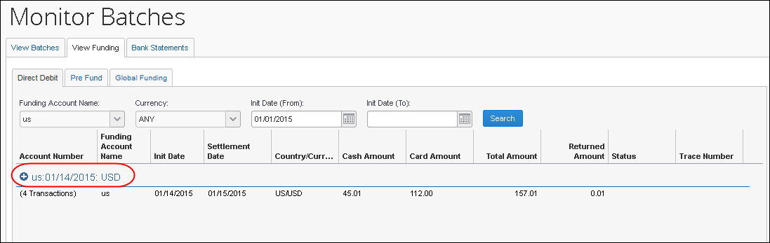
- Verify the Total Amount in the row matches the amount on the bank statement.
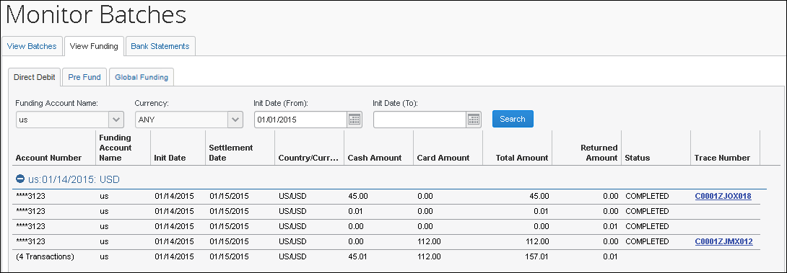
To view the details of the selected funding account and date, click the + sign to expand the view.
- To ensure that the amount extracted to your financial system through the Standard Accounting Extract matches the amount on the bank statement, click the Trace Number link and verify that the Extracted Amount matches the Total Amount or Returned Amount. If these match, your reconciliation is complete. You know that the amount on the bank statement matches the amount extracted in your financial system. If these do not match, there are two possible courses of action:
- If the batch schedule runs more frequently than the SAE schedule, this is expected on the days preceding the SAE. Revisit the View Funding page after the SAE job runs. The two amounts should then match.
- If the SAE job that should have included these report payees has run and the report payee is still not extracted, follow the troubleshooting process below.

Troubleshoot Reconciliation Discrepancies
SAE Discrepancies:
Funded amounts appearing on bank statements may not have their associated report payees extracted in the Standard Accounting Extract for two reasons:
- The SAE Job has yet to run
- The SAE Job has a filter that is excluding the report from extract

Managing Expense Reports on the Reports Payees and Cash Advance Payees Lists
A report payee and cash advance payee is a payee on an expense report. Report payees can be either employees or company card issuers. Cash advance payees can only be employees. A payment demand consists of one or more report entries for the same payee. A payment demand for a card program will contain the total remittance amount for all card transactions for that card program included in the batch. A payment batch consists of one or more payment demands.
The Reimbursement Manager uses the Reports Payees and/or Cash Advance Payees lists to investigate the payment status of a specific expense report or report payee and perform the following tasks:
- Place both report and/or cash advance payees on hold: Sometimes a Reimbursement Manager needs to remove a payee from a payment demand. By placing a payee on hold, the Reimbursement Manager removes the payee from its payment demand and its batch. The payee is not processed until the Reimbursement Manager reassigns the payee to an open batch.
- Assign both report and/or cash advance payees to an open batch: If a payee is in an Aborted or On Hold status, and the issue leading to this status has been resolved, the Reimbursement Manager can assign the payee to an open batch. The system adds the report payee to an existing payment demand for that payee or creates a new payment demand in the open batch.
- Manually create a payment demand: Under a few circumstances, the administrator may need to create a payment demand for payee.
- For more information, refer to the Manually Creating a Payment Demand section of this guide.
- Designate a particular report and/or cash advance payee to be client paid: The Reimbursement Manager can designate a payee to be "client paid," meaning that the client arranges to generate payment to the payee through their financial system instead of through Expense Pay. This action removes the payee from its payment demand and batch. It also sets the reimbursement method to Manual and the status to Client Pay.
- For more information, refer to the When the employee needs to be manually reimbursed section of this guide.
- Move a previously client paid report and/or cash advance payee to an open batch: The Reimbursement Manager can move a payee that was originally marked Client Pay to the current open batch. This functionality should be used when a payee was mistakenly marked Client Pay and the Reimbursement Manager has confirmed that the payee should be reimbursed using Expense Pay instead.
To locate reports in Payment Manager:
- Click Monitor Payees. The Report Payees page displays.
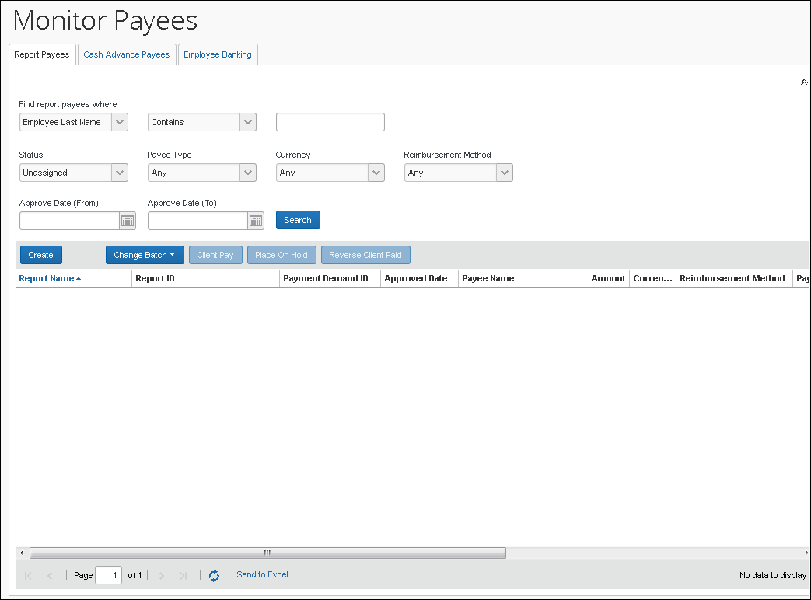
- To search for a specific expense report within the group, use the following fields:
- Find report payees where
- Status
- Payee Type
- Currency
- Reimbursement Method
The Status column always defaults to Unassigned.
To locate cash advance reports in Payment Manager:
- Click Monitor Payees. The Report Payees page displays. Click the Cash Advance Payees tab.
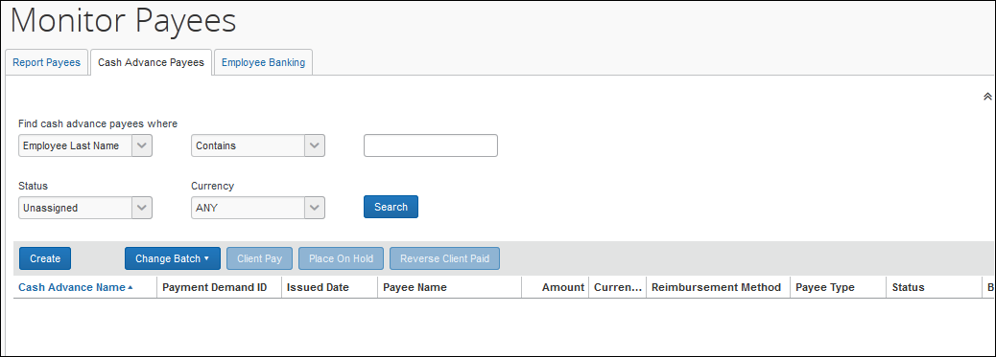
- To search for a specific expense report within the group, use the following fields:
- Find cash advance payees where
- Status
- Currency
The Status column always defaults to Unassigned.
To mark a report payee as Client Paid:
- Click Monitor Payees.
- Select the desired expense report.
Only report payees associated to batches that have not been sent can be set to Client Paid.
- Click Client Pay. The report payee status changes to Client Pay.
To move a report marked Client Pay to an open batch:
- Click Monitor Payees.
- Select the desired reports.
- Click Reverse Client Paid for each report.
This puts the payment demand on hold and moves the report into the open batch. The payment demand is then assigned to the next batch, which creates a new payment demand number in the current open batch.

Report Payee Status
The Status column displays information about a report that guides what a Reimbursement Manager can do with a specific report.
Status | Description
Any | This selects for any status.
Assigned | The payment demand is assigned to an open or closed batch that has not yet been sent for processing. Reports with a status of Assigned can be assigned to the next batch (if the batch it currently belongs to is closed), placed on hold, or marked as Client Pay.
Not Sent/Not Completed (only used in Search field) | This status includes all payment demands with a status of Aborted, Assigned, or On Hold,.
On Hold | The Reimbursement Manager put this report payee on hold. No payment demand is associated with a report payee that is on hold. Reports in a Hold status can be assigned to the next batch or marked as Client Pay.
Sent/Completed | The payment demand is in a batch sent for processing.
Unassigned (only used in Search field) | This status includes all payment demands with status of On Hold, Aborted, and Client Pay.
Unpaid (only used in Search field) | This status includes all payment demands without a status code and those set to Not Paid.
Expense Pay Specific Statuses
Aborted | The payment demand was in a batch sent to the payer's bank for payment. The EPE designated that the bank was unable to pay the payment demand. In most cases, the Reimbursement Manager does not need to take action for aborted payment demands. When a payment demand with an employee payee is aborted, that employee's bank account is marked as Failed and an email notification is sent to them. Once the employee updates their bank account information, the system will move any aborted payment demands for that employee into the next available batch.  The system will only automatically assign the report to the next batch if the user continues to update their bank information. If the user does not update their bank information, the Reimbursement Manager will need to manually assign the report to the open batch once the bank account has been updated.  NOTE: If necessary, reports with a status of Aborted can be assigned to the next batch, placed on hold, or marked as Client Pay.
Accepted | The payment demand has been accepted by the payment engine or provider. This is a normal step in the process that may be followed by funded and then paid or possibly aborted if the payment is returned.
Client Pay | The Reimbursement Manager changed the reimbursement method from Expense Pay (EFT) to Client Pay (AP).
Paid | The payment demand is in a batch sent to the payer's bank for payment. The EPE indicated that the payee’s bank accepted the payment demand and payment should occur within a few banking days. Note that the payee’s bank may subsequently reject the payment demand. If this occurs then the EPE will change the status to Aborted.
Payment Confirmed | The report has reached the Payment Confirmed workflow step and is considered paid.  - For more information, refer to Report Payment Confirmed Status below.
Payment Funded | Funding has been initiated and the funding dates for the payment demand have been set.
Failed Account | The employee’s bank account associated with this report payee has a status of Failed. The payment demand will remain in the status until the employee updates their bank account information.  - For more information, refer to Failed Account Statuses below.

Expense Pay: Report Payment Confirmed Status
Expense Pay will only change the report payment status to Payment Confirmed if the Payment Confirmation step is activated in the workflow. This feature is optional as it has an impact on reporting. Expense reports can only have one payment status; however, reports with both cash and card expenses can have two different payees- the employee and the card program. Once the payment engine has sent the Payment Confirmed status for either the cash or card payee, the report payment status is updated to Payment Confirmed. To begin using this workflow step, contact Concur Client Services.

Manually Reimbursing Employees
There are some occasions when an employee that is normally reimbursed through Expense Pay needs to be reimbursed manually. This can be done to any report payee and cash advance payee, up until the point when the payment demand associated with that payee has been sent to the payment engine for processing.
When paying an employee manually, you can do the following:
- Mark the report payee as Client Pay in Payment Manager: The Reimbursement Manager searches for the report payee on the Report Payees page or the cash advance payee on the Cash Advance Payees page. Once they find the report, they select it and click Client Pay. Expense Pay will not reimburse the report.
- IMPORTANT NOTE: If this process is done before the Standard Accounting Extract job runs, the report will have a blank value in column 128 (the Report Payment Reimbursement Type field), indicating that it was not paid using Expense Pay. If this process is done after the Standard Accounting Extract job runs, the report will have a “1” value in the Report Payment Reimbursement Type field. This indicates that it was paid by Expense Pay, as at the time the extract was run this was the scheduled method of payment.

Manually Creating a Payment Demand
On rare occasions, certain payment demands are not created for payees. The most typical case is when a user did not have banking entered at the time their report was approved. The administrator can use the Create Payment Demand feature to retroactively trigger a payment demand. The administrator can create payment demands for the reports that meet the following criteria:
- Reports that do not have a payment demand for cash or card payee or both types of demand
- The report must have one of the following payment statuses:
- Processing Payment
- Paid
- Payment Confirmed
- The reports can be pre-extract or already extracted in the Standard Accounting Extract
- For Cash payment demands, the user must have an active bank account in the system
You can only create a payment demand if there is a valid batch definition (cash or card) for creating this payment demand.
To manually create a payment demand
- Click Monitor Payees.
- Click Create. The Create Payment Demand window appears.
- Fill out the search fields with the report information.
- Click Search.
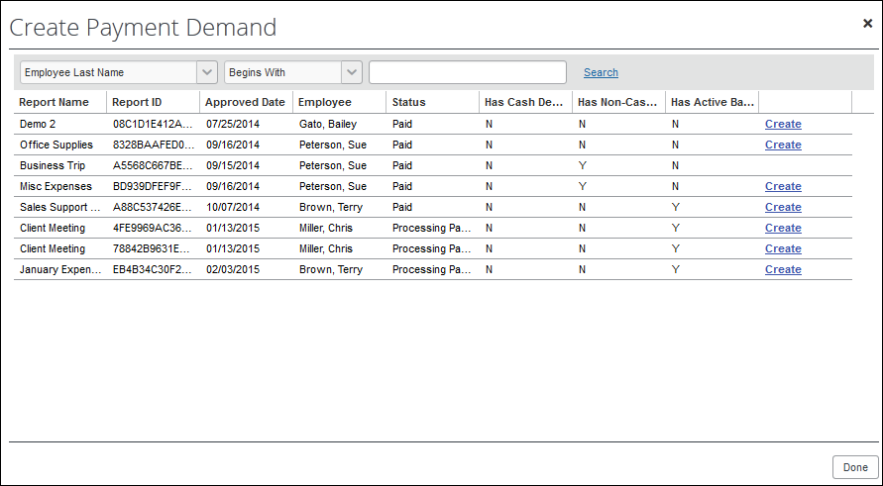
- Click Create for the desired payment demand(s). The report disappears from the list and appears in the Report Payees list.
- When finished, click Done.

Viewing Employee Banking
The Employee Banking page allows the administrator to view employee bank account information, including historical information.
The Reimbursement Auditor user role cannot view the Employee Banking Status.
The re-confirm Failed account function is not used by the Global Pay process.
In cases where there is incorrect banking, information the employee should correct the bank number, bank account number, or account type. There is no way for the Reimbursement Manager to enter employee bank account information.
To access the Employee Banking page:
In Payment Manager, click Monitor Payees > Employee Banking.
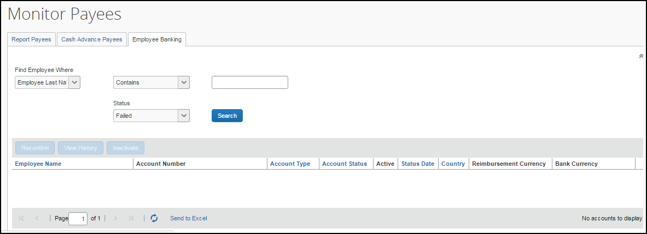
To search for an employee's bank information:
To search for a specific employee's bank information, use the Find Employee Where or Status fields in the Search area.
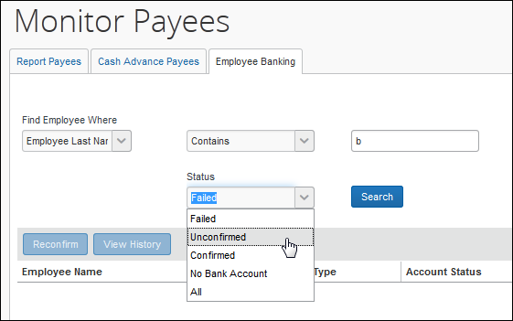
To view an employee's bank account history:
- Use the Find Employee Where or Status fields in the Search area to locate the desired employee.
- Select the desired employee.
- Click View History.
If Expense Pay is terminated, previous data is maintained and reporting is still available. Additionally, Expense users will see their banking information as read only information in their profile.
To inactivate an employee's bank account:
- Use the Find Employee Where or Status fields in the Search area to locate the desired employee.
- Select the desired employee.
- Click Inactivate.

Expense User Procedures
Expense users must have valid bank account information on the Profile > Profile Settings > Bank Information page before they can be reimbursed using Expense Pay.

Payment Status in the Report Payments Window
Users can view the status of payments made by Expense Pay in the Report Payments window.
To access the Report Payments window:
- Click Expense.
- Click the name of the desired report. The Expense List appears.
- Select Report Details > Payments.
- Review the information in the Report Payments window.
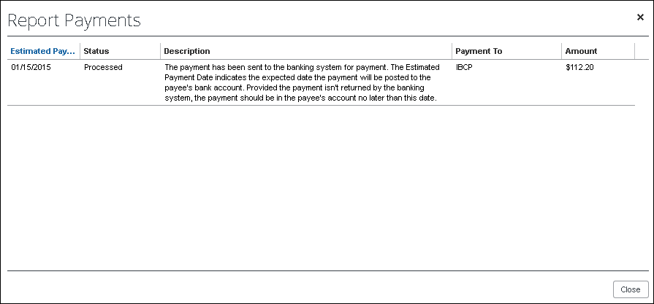
The possible statuses are:
Status | Description
Initiated | The payment was initiated but has yet to be released by your organization for processing. The Estimated Payment Date indicates three weekdays after the date your organization is scheduled to release the payment for processing.
Processing | Your organization has released the payment for processing, but it has yet to be sent to the banking system for payment. The Estimated Payment Date indicates the approximate date the payment will be posted to the payee’s bank account.
Processed | The payment has been sent to the banking system for payment. The Estimated Payment Date indicates the expected date the payment will be posted to the payee’s bank account. Provided the payment is not returned by the banking system, the payment should be in the payee’s account no later than this date.
Failed | The banking system has returned this payment. Before payment can be made you must update your bank account information in Profile > Profile Settings > Bank Information and the system must confirm this information.
Failed Account | The payment has not been initiated because your bank account has invalid information. Before payment can be initiated you must update your bank account information in Profile > Profile Settings > Bank Information and the system must confirm this information.
On Hold | The payment was initiated but has yet to be released by your organization for processing. The Estimated Payment Date is blank because your organization has not scheduled a release date yet. Contact the person who administers Expense for your organization.
Organization Paid | Concur will not reimburse this amount due. Instead, your organization will arrange payment for this amount due. Contact the person who administers Expense for your organization for details on this payment.

Accounting Extract Reconciliation Tools
This section describes tools that a Reimbursement Manager may use.

Payment Manager
A link to the Payment Manager page appears on the Tools page to employees that have the Reimbursement Manager or Reimbursement Auditor role.
The Reimbursement Auditor role has a limited subset of the available functionality.
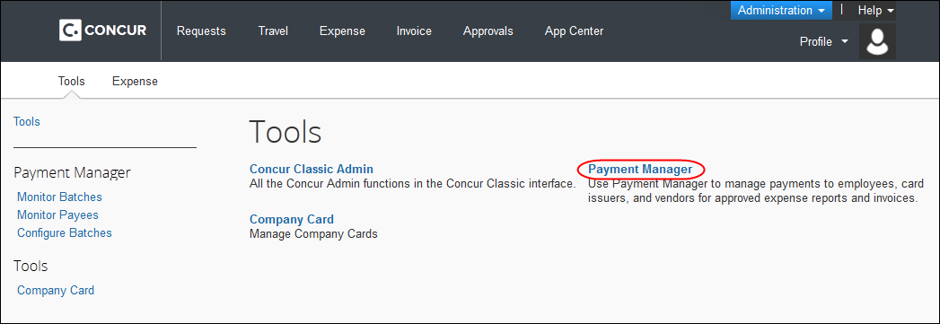
To access Payment Manager:
- Click Administration > Company > Tools. The Tools page appears.
- Click Payment Manager. The Payment Manager page appears, with the Monitor Batches page displayed.
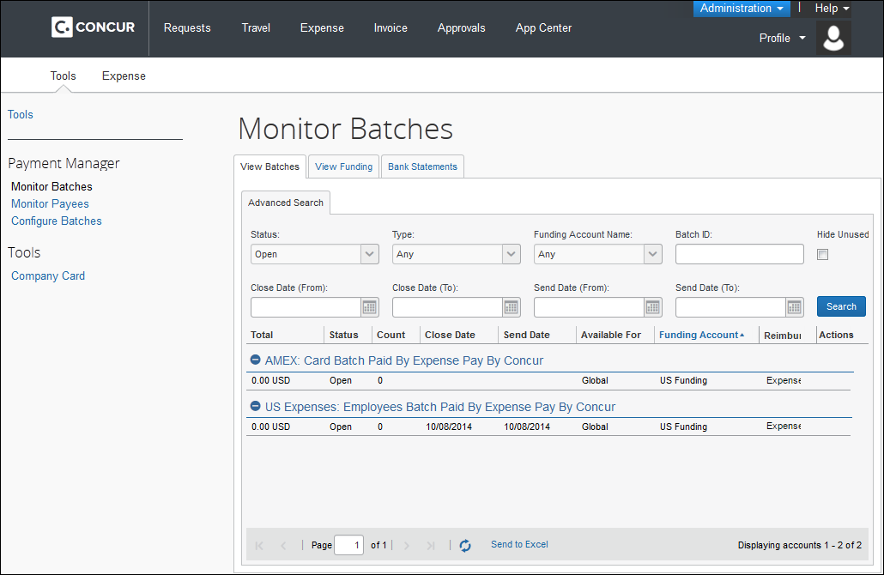

Funding Accounts
Funding accounts are the bank accounts that Concur Pay draws funds from to fund payments to employees or card programs. The Reimbursement Manager defines these bank accounts on the Funding Accounts tab of the Configure Batches page of Payment Manager.
The View Funding page displays the following tabs:
- (For use with Expense Pay Classic only) Direct Debit tab which displays a daily summary of account activity for all funding accounts used by Expense Pay. The Reimbursement manager or Reimbursement auditor can search for specific funding accounts or date ranges. The daily funding amounts will be updated at 12 PM CST in the US and Canada. The returned amounts are summarized on this page.
- (For use with Expense Pay Classic only) Pre Fund tab which allows a Payment manager to view accounts that are pre-funded and managed by the administrator. This tab displays a daily summary of account activity for all pre-funded funding accounts. Pre-funding means that the client determines the funding levels of accounts that are set up by Concur.
- (For use with Expense Pay Global only) Global Pay tab which allows a Payment Manager to view accounts that have a provider. This tab displays a daily summary of account activity for all providers' funding accounts.

Card Programs
The Concur Pay can generate payments to company card issuers, based on the payment batches in Payment Manager. The Reimbursement Manager uses the Card Programs page of Payment Manager to enter the data required to correctly remit payment to the card issuer. Once the Card Programs have been entered, the Reimbursement Manager uses the batch definitions to link a funding account with a card program.
Expense Pay does not generate payments to manually-entered card charges as there is no reliable way to ensure the card transaction is only paid once.

Batch Definitions
The Reimbursement Manager creates and updates batch definitions to be used by the Concur Pay. A batch definition consists of the attributes of the funding bank account, the Expense Groups that the batch definition will pay, the close and send date schedule, the status, and optionally the card program to be paid. The Reimbursement Manager uses the Batch Definitions page of Payment Manager to view and edit existing batch definitions, and to create new definitions.

Payees Lists
A report payee and cash advance payee is a payee on an expense report. Report payees can be either employees or company card issuers. Cash advance payees can only be employees. A payment demand consists of one or more report entries for the same payee. A payment demand for a card program will contain the total remittance amount for all card transactions for that card program included in the batch. A payment batch consists of one or more payment demands.
The Reimbursement Manager uses the Reports Payees and/or Cash Advance Payees lists to investigate the payment status of a specific expense report or report payee and perform the following tasks:
- Place both report and/or cash advance payees on hold: Sometimes a Reimbursement Manager needs to remove a payee from a payment demand. By placing a payee on hold, the Reimbursement Manager removes the payee from its payment demand and its batch. The payee is not processed until the Reimbursement Manager reassigns the payee to an open batch.
- Assign both report and/or cash advance payees to an open batch: If a payee is in an Aborted or On Hold status, and the issue leading to this status has been resolved, the Reimbursement Manager can assign the payee to an open batch. The system adds the report payee to an existing payment demand for that payee or creates a new payment demand in the open batch.
- Designate a particular report and/or cash advance payee to be client paid: The Reimbursement Manager can designate a payee to be "client paid," meaning that the client arranges to generate payment to the payee through their financial system instead of through Expense Pay. This action removes the payee from its payment demand and batch. It also sets the reimbursement method to Manual and the status to Client Pay.
- Move a previously client paid report and/or cash advance payee to an open batch: The Reimbursement Manager can move a payee that was originally marked Client Pay to the current open batch. This functionality should be used when a payee was mistakenly marked Client Pay and the Reimbursement Manager has confirmed that the payee should be reimbursed using Expense Pay instead.
- Manually create a payment demand: Under a few circumstances, the administrator may need to create a payment demand for payee.

Batches
The Reimbursement Manager uses the Monitor Batches page of Payment Manager to review batch status and payment demand details for all batches. The batches are grouped by batch definition. By default, the page displays the current batches for each definition. The Reimbursement Manager can search for a specific batch. The Reimbursement Manager can also use the Monitor Batches page to reschedule batches, closing them earlier or later than their batch schedule.

Payment Demands
The Reimbursement Manager manages payment demands through the Payment Demands tab of the Monitor Batches page. This page displays the payment demands contained in a specified batch listed on the View Batches tab. The Reimbursement Manager can access the Payment Demands tab from the View Batches tab of the Monitor Batches page of Payment Manager.
From the Payment Demands tab, you can open the Payment Demand Audit Trail window, where you can troubleshoot or audit a payment demand. You can also open the Report Summary window, where you can view the summary for the report associated with the payment demand.

Employee Banking Information

Methods
Organizations can bring employee bank account information into Expense Pay using two methods:
- Employee manages their own banking information using Profile: This method is the most popular and best practice way for organizations to manage this information.
- Organization imports employee banking information: Some organizations choose to use the Employee Import to import employee banking information from another system that manages this information.
Organizations select a method for each batch definition. If employees will be managing their own banking data, the administrator must update the batch definition to allow employees to see and edit their bank account information in Profile.
If the client will be importing employee bank information, they must update the batch definition to allow it.
To update the batch definitions:
- Click Administration > Company > Tools.
- Click Payment Manager (left menu) > Configure Batches > Batch Definitions.
- Select the desired batch.
- Click Modify.
- Select the Allow Employee to Modify their Bank Information check box to allow employees to manage their own banking information.
- Select the Allow Employee Import to Modify Bank Information check box to allow the import to update the user bank information.

Administrator Email Notifications

Funding Amount Email Notification
An email notification of the funding amounts by account is available to all users with the Reimbursement Manager or Reimbursement Auditor role. This feature is useful as a way to monitor activity abnormally large funding requests or for too many blank days that do not match the expected pattern. On days with no activity, such as bank holidays, the amounts listed in the email will be zero.
The email notification is not the preferred method for monitoring activity. Concur recommends regularly viewing the View Funding > Global Funding page for funding details.
If the funding amount is not available when the email is sent, the Reimbursement Manager will be directed to the View Funding > Global Funding page for funding details. Reimbursement Managers must make sure that the funding account is funded no later than the close of business on the settlement date for each batch. The Daily Funding Amount email is enabled on the New/Edit Funding Account page of Payment Manager.
The Funding Amount email is not group-aware. Every user with the Reimbursement Manager role will receive every funding amount email for all configured batches.

When funding activity information is available
This is the daily funding account notification for all active funding accounts for <MM/DD/YYYY>
---------------------------------------------------------------------------
Bank ID: <bankid>
Account Number: <accountnumber>
Cash Program Amount: 0.00 USD
Card Program Amount: 0.00 USD
Total Funding Amount: 0.00 USD
---------------------------------------------------------------------------
---------------------------------------------------------------------------
Bank ID: <bankid>
Account Number: <accountnumber>
Cash Program Amount: 268.34 CAD
Card Program Amount: 0.00 CAD
Total Funding Amount: 268.34 CAD
---------------------------------------------------------------------------
---------------------------------------------------------------------------
Bank ID: <bankid>
Account Number: <accountnumber>
Cash Program Amount: 0.00 USD
Card Program Amount: 0.00 USD
Total Funding Amount: 0.00 USD
---------------------------------------------------------------------------

When funding activity information is not available
Expense Pay is currently processing the daily funding and did not have a total amount available at the time this email was sent. The View Funding > Global Funding will display the funding total once Expense Pay has completed processing for this account. Please note that funding amounts will not be withdrawn on bank holidays. Any funding amount scheduled for a bank holiday will be processed the following banking day.

Extract Reconciliation Tab
The Extract Reconciliation tab allows the Reimbursement Manager to view the extract entries associated with Expense Pay Global payments. The page lists one row for each Standard Accounting Extract job and reimbursement currency combination. The Reimbursement Manager can drill down to a list of report payees included in the extract file.

Access the Extract Reconciliation tab in Payment Manager
To access the tab, click Administration > Company > Tools > Payment Manager > Monitor Batches > Accounting Extract Reconciliation.
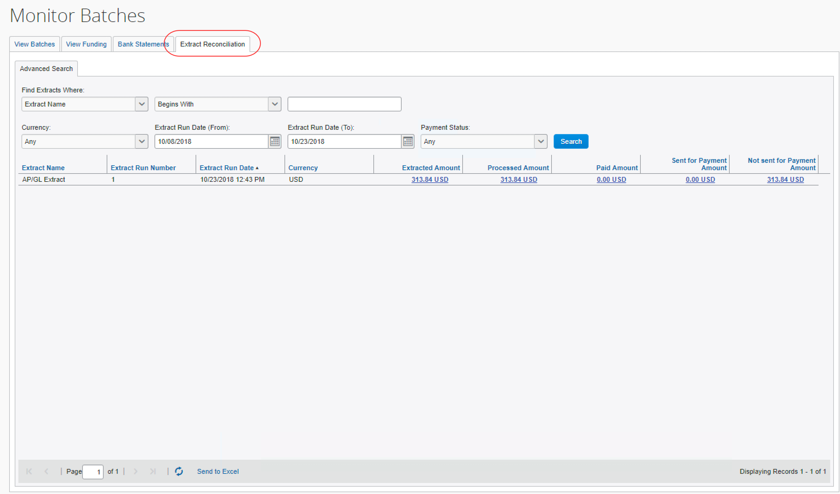

Extract Activity Reconciliation Process
- Determine the name and job run number of the Standard Accounting Extract you would like to reconcile.
- On the Monitor Batches page, click Extract Reconciliation.
- Use the fields in the Find area to locate the desired extract.
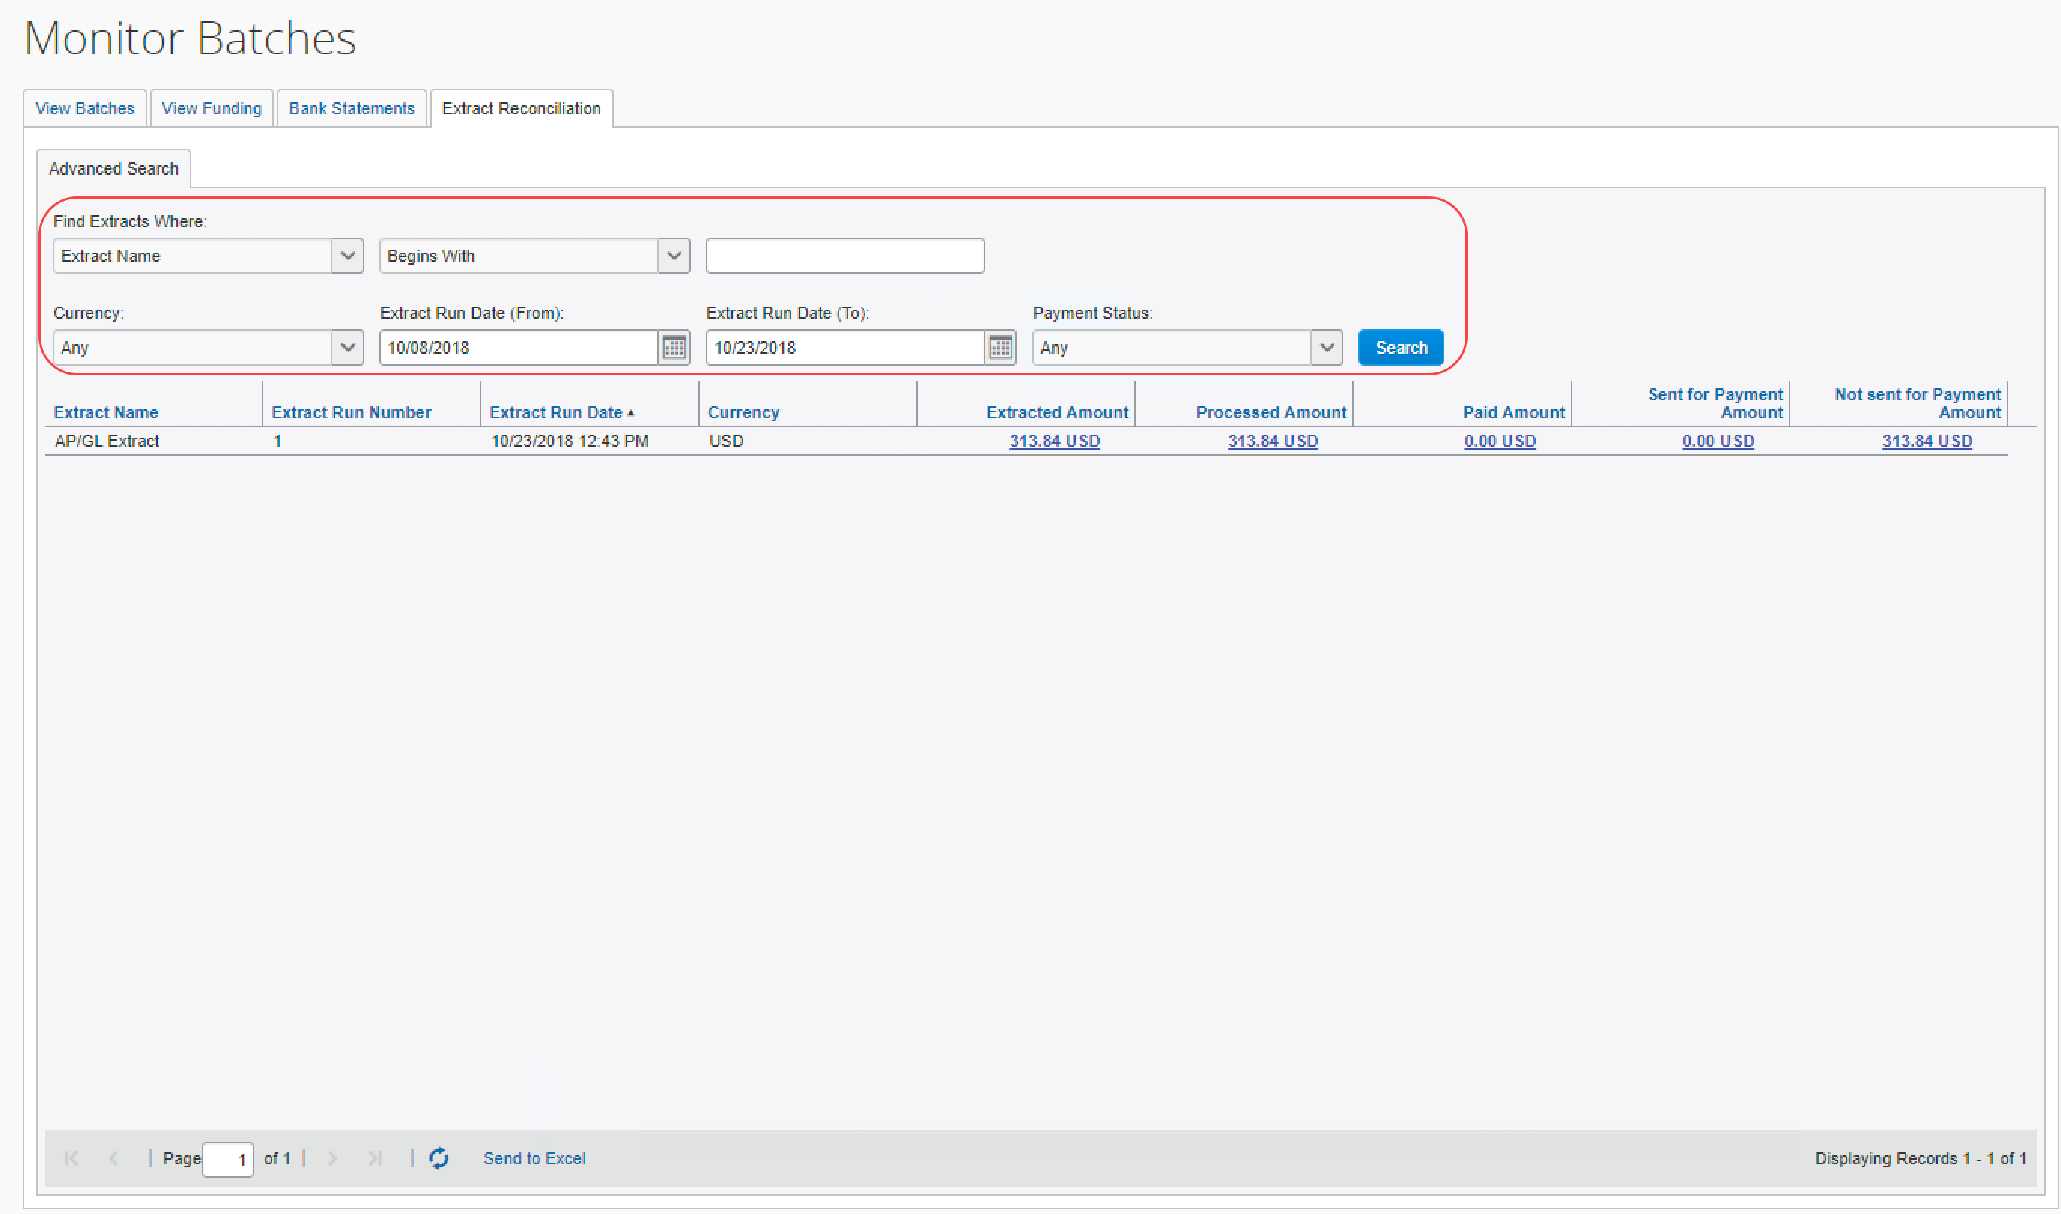
- Click the amount in the Processed Amount, Paid Amount, Sent for Payment Amount, or Not Sent for Payment Amount field to view the included report payees.
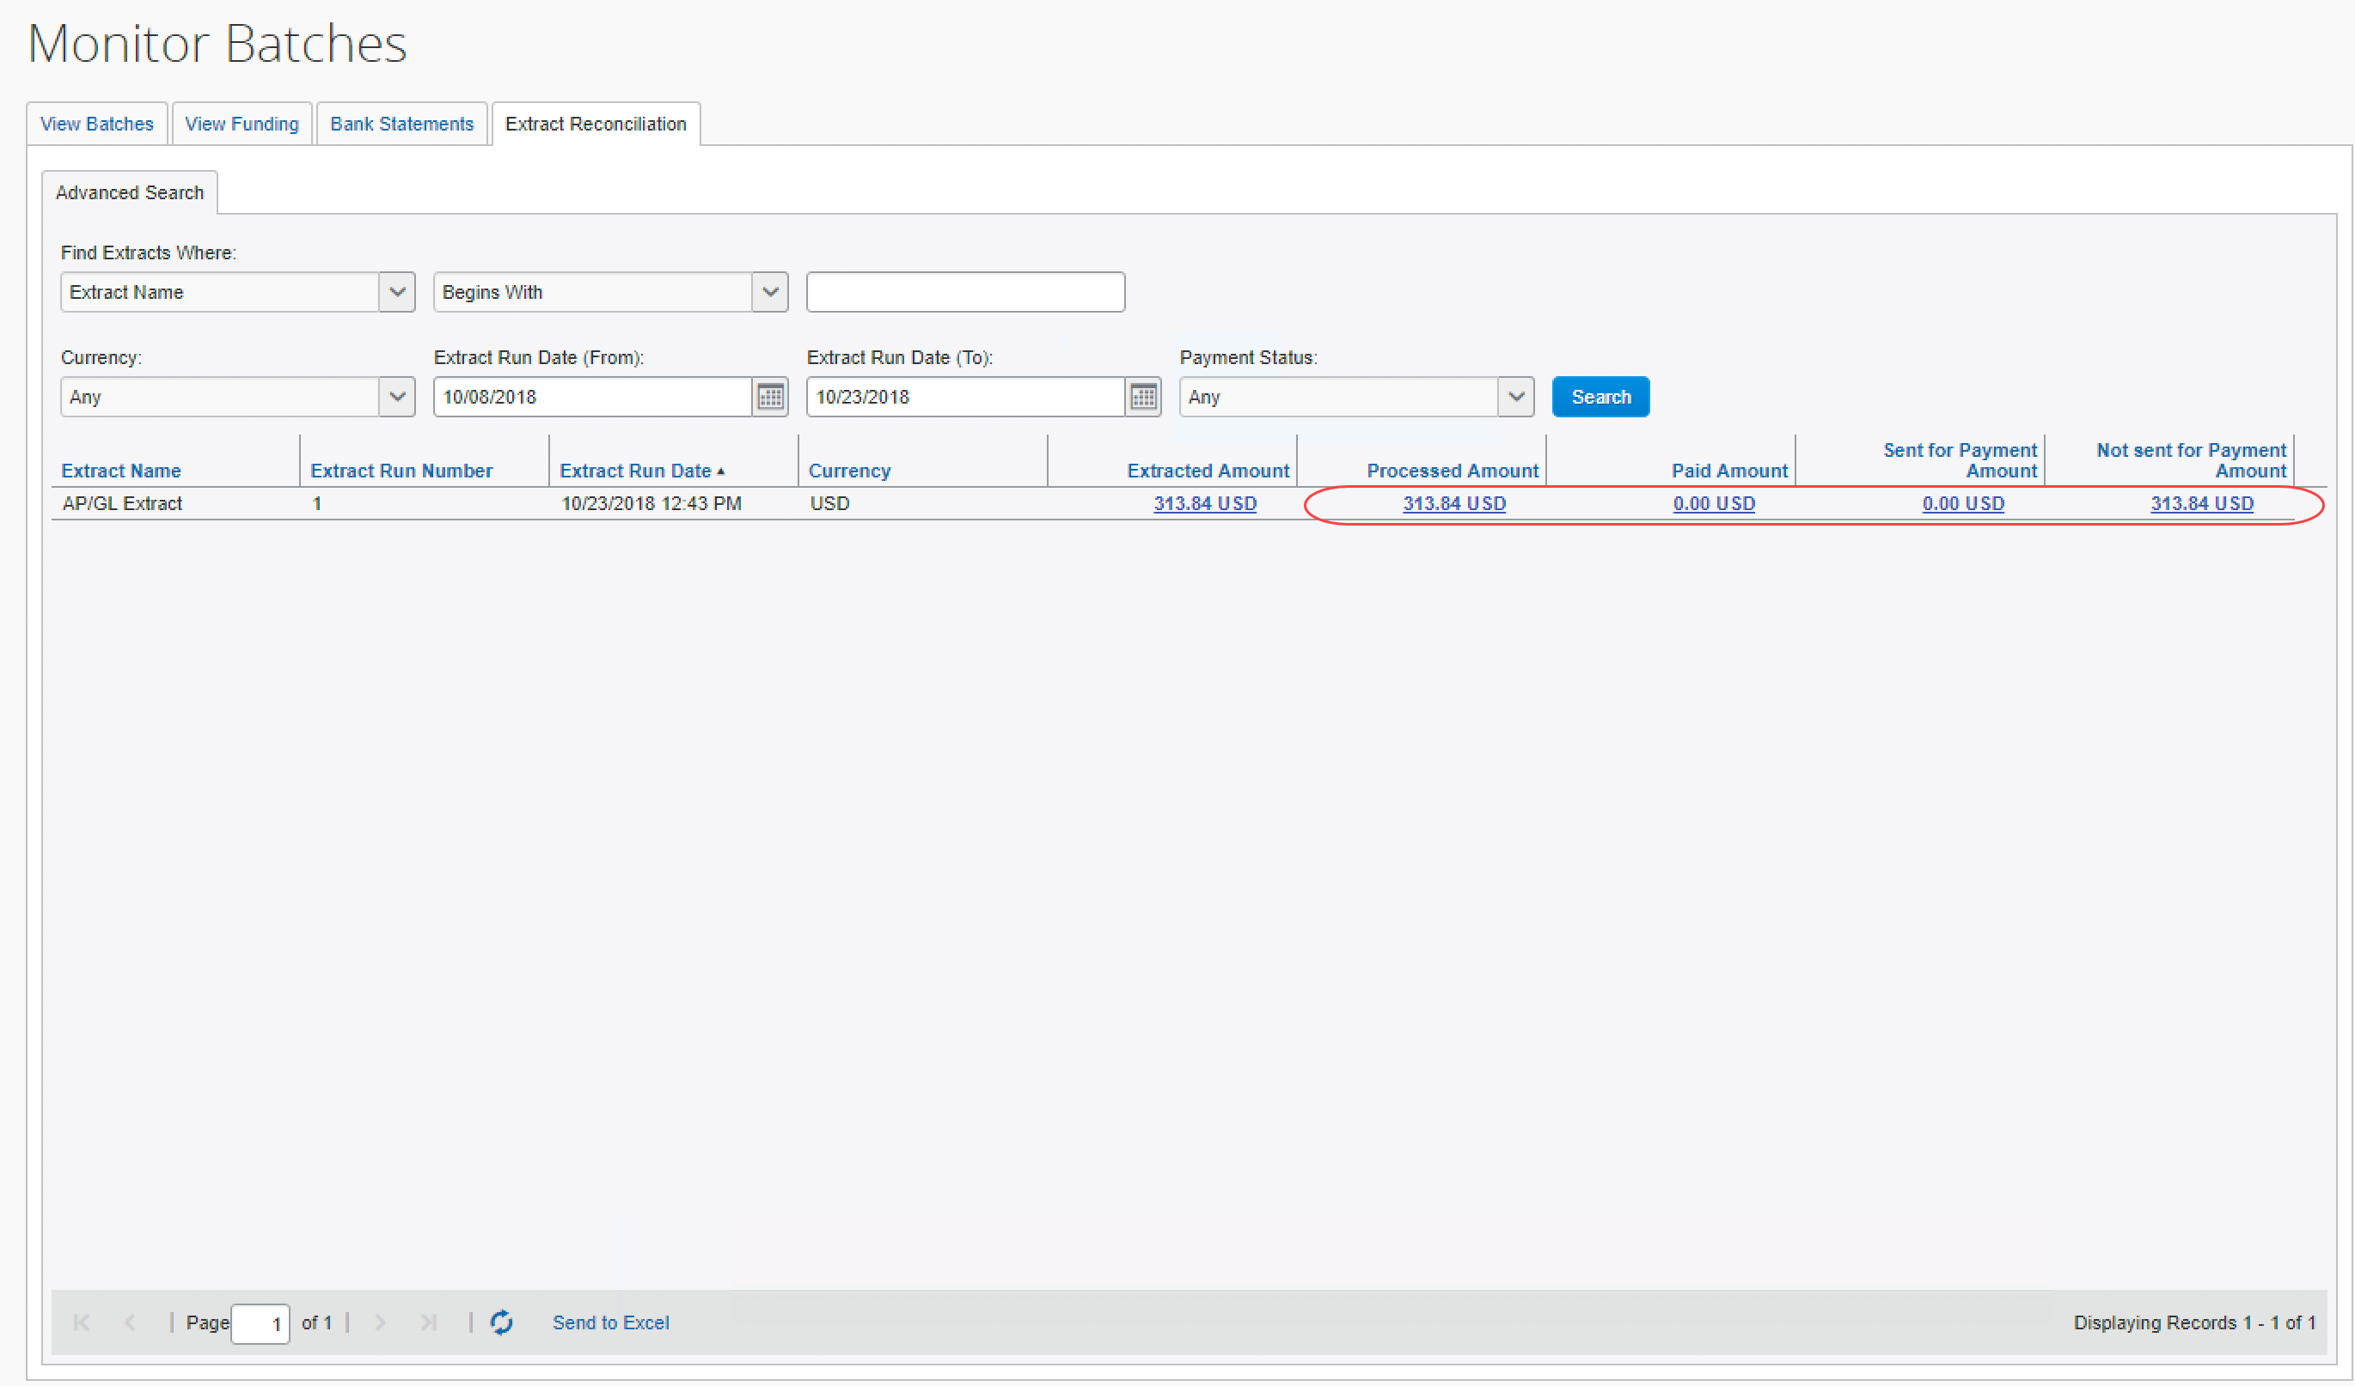
- View the detail tab that lists the report payees included in the selected amount.
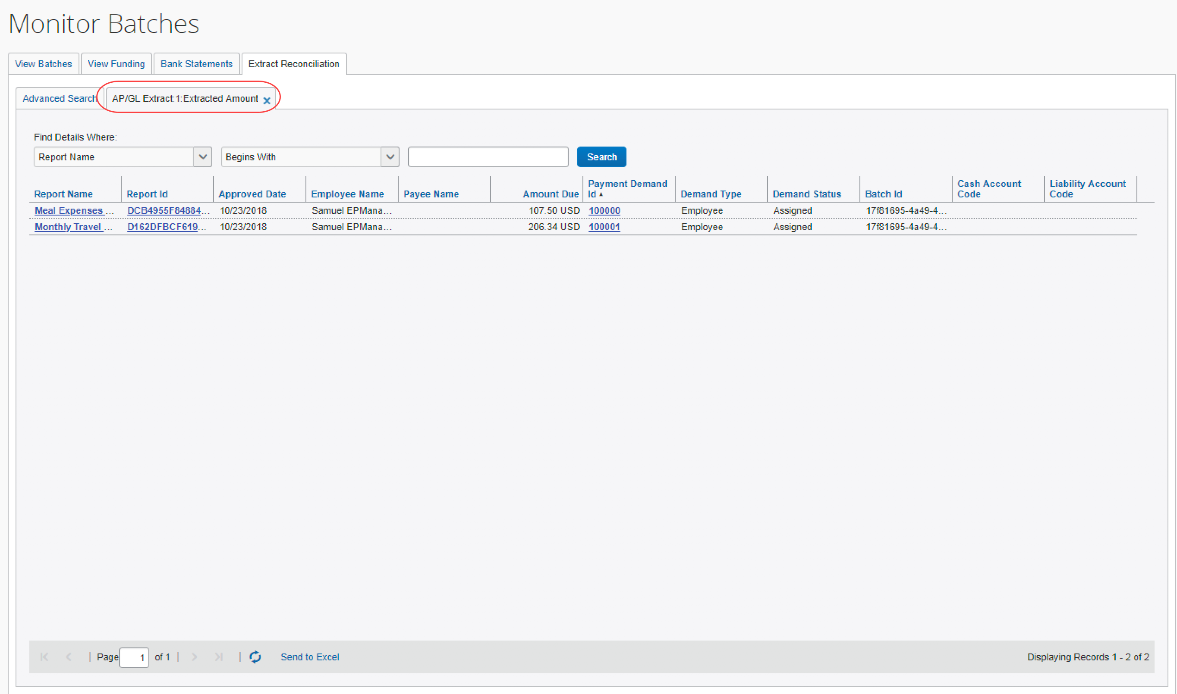
- Click a value from the Payment Demand ID column to view the payment demand details.

Report Payees
On the Extract Reconciliation tab, click the desired amount value:
- Processed Amount: The sum, in the indicated reimbursement currencies, of the report payees in the extract for which Concur Pay has created payment demands.
- Paid Amount: The sum, in the indicated reimbursement currencies, of the report payees in the extract for which Concur Pay has created payment demands that the Concur Payment Engine has confirmed as being paid.
- Sent for Payment Amount: The sum, in the indicated reimbursement currencies, of the report payees in the extract for which Concur Pay has created payment demands that have been sent to the Concur Payment Engine but not yet paid.
- Not Sent for Payment Amount: The sum, in the indicated reimbursement currencies, of the report payees in the extract for which Concur Pay has created payment demands that have not yet been sent to the Concur Payment Engine.

Not Funded Report Payees
When comparing processed amounts with paid amounts for an extract job there can be extracted report payees not yet paid.
These extracted but not yet paid report payees may need to be handled, depending on their status:
- Sent for Payment: These report payees should be marked Paid within two banking days from the Sent Date. No additional action is required.
- Not Sent for Payment: These may require additional action.

not sent for payment report payees
The report payees that were not sent for payment can be examined using the details page.
To view the report payee details:
- Click the Not Sent for Payment Amount to drill down to the list of report payees that constitute this amount
- Review the Status column and take the necessary action:
Status | Description | Action to Take
Pending Confirmation | Employee’s bank account is pending confirmation. | No additional action necessary. Once the account is confirmed, the payment demands will be automatically moved into the open batch.
Aborted or Failed Account | Employee bank account failed. | Remind employee to correct banking information.
On Hold | The report payee was marked On Hold by the Reimbursement manager. | Report payee should be moved to an open batch.
Client Pay | The report payee was marked Client Pay by the Reimbursement manager. | Make a correcting accounting entry.  - Refer to the Correcting Accounting Entries section of this document for details.
Assigned | Report payee is in a batch that has not yet been sent. | No action is necessary.

Correcting Accounting Entries
At the end of your accounting period you may need to make a correcting accounting entry for any journal entries the accounting reflects as Paid that have not been processed. The correcting entries can be created manually using the process listed below.
The Expense Pay Extract provides an automated way to do this accounting.
- For more information, refer to the Expense Pay: Expense Pay Extract Specification.
To create a correcting entry:
- On the details page, determine which Cash Accounts are impacted. Use the Cash Account filter to organize report payees by cash account.
- Make the necessary correcting entry for this cash account.
- Repeat this process for each affected cash account.
- At the next accounting period check if these were paid. If they were, you will need to do another correcting entry for the re-payment.

☼

