
Concur Expense: JPT on NextGen UI
User Guide

Last Revised: Dec 08, 2023
Applies to these SAP Concur solutions:
 Expense
 Professional/Premium edition
 Standard edition
 Travel
 Professional/Premium edition
 Standard edition
 Invoice
 Professional/Premium edition
 Standard edition
 Request
 Professional/Premium edition
 Standard edition
Table of Contents
Section 1: Permissions 1
Section 2: Overview 1
Who Should Use This Feature 1
Corporate Card Users and the Japan Public Transportation Expense Type 1
Required Roles 1
Section 3: Using the IC Card 2
Overview 2
How Expense Works With the IC Card 2
Network IC Card Reader to read IC Card routes 3
Associate an IC Card to an employee 3
Entering Route Information 4
Removing an IC Card Route from an Expense Report 4
Section 4: Accessing Japan Public Transport 5
Accessing the Japan Public Transport Feature 5
Section 5: Options 6
JPT Options Available When Creating an Expense Report 6
Creating a JPT on NextGen UI Expense Report Using Route Search 7
Entering JPT Route Information 35
JPT Commuter Pass Routes Option Available in Profile Settings 36
Commuter Pass - Entering Commuter Pass Routes 37

Revision History
Date |  | Notes / Comments / Changes
December 8, 2023 | Added the PASMO reference in the guide.
December 16, 2022 | Added the information on newly added icon for identifying round trips in favorite routes.  Added reference for Suica ICCI user guide.
April 23, 2022 | Updated the information on newly added via fields for commuter pass users
March 19, 2022 | General guide updates.
January 21, 2022 | Updated the copyright year; no other changes; cover date not updated
September 29, 2021 | Updated screenshots to reflect latest JPT on NextGen UI in the Entering Routes Using the Network IC Card Reader section.
September 23, 2021 | Removed reference to manual option for users typing in an entry in the Creating a JPT on NextGen UI Expense Report Using Route Search section.  Minor edit to the JPT Options Available When Creating an Expense Report section.
August 27, 2021 | Updated feature name from JPT 2.0 to JPT on NextGen UI.
June 30, 2021 | New guide.

Japan Public Transport
NOTE: Multiple SAP Concur product versions and UI themes are available, so this content might contain images or procedures that do not precisely match your implementation. For example, when SAP Fiori UI themes are implemented, home page navigation is consolidated under the SAP Concur Home menu.

Permissions
You may or may not have the correct permissions to use this functionality. You may have limited permissions, for example, you can affect only certain groups and/or use only certain options (view but not create or edit).
If you need to use this functionality and do not have the proper permissions, contact your company's Concur administrator.

Overview
The typical businessperson in Japan can have multiple train rides per day that they will track and process for reimbursement. To answer the need to expense this type of travel, Concur designed and integrated the Japan Public Transport (JPT) feature into the Expense product.
This feature allows users to quickly expense JPT in several ways:
- Route search (look up routes bases on a from/to station)
- Rail IC Card routes imported into Expense via the E-receipt service using the network IC Card reader

Who Should Use This Feature
The rail/bus content sourced is specific to the Japan marketplace. The feature cannot be used with any rail content outside of Japan.

Corporate Card Users and the Japan Public Transportation Expense Type
A corporate card cannot be used with the Japan Public Transportation expense type. Only Cash Out of Pocket payment types are supported.

Required Roles
There are no required roles to use the Japan Public Transport feature; you need only have the Expense User role.
If you do not see the Japan Public Transportation expense type when creating your expense report, contact your administrator.

Using the IC Card
The easiest, quickest, and most error-free way to add routes to an expense report is to import them into Expense from the employee's IC Card.
To import data from an IC Card into Concur Expense, use one network IC Card reader per office location.
A network IC Card reader enables users to import their IC Card data into Expense via the Internet. Client should contact a device vendor directly to purchase a network IC Card reader and run an implementation project.

Overview
An IC card is a preloaded commuter card used to enter and exit the rail station gates, thereby capturing the time, date, and route information within the intelligent chip of the IC card. There are approximately 16 different IC Cards in Japan, SUICA and PASMO being the most popular since they are primarily used by JR (Japan Rail Company) and within Tokyo by many millions of people. Each IC Card stores the last 20 transactions.

How Expense Works With the IC Card
IC Card routes are read using a network IC Card reader.

Partner Network IC Card Reader (Device)
- A device is installed at each Company location and a user swaps the IC Card on the device.
- Rail Routes stored on the IC card will be pulled into the Receipt Store and displayed in Available Expenses along with any other Smart Expenses.

Network IC Card Reader to read IC Card routes

Associate an IC Card to an employee
After you activate your user account, you need to associate your IC Card to your Concur account. The first time you tap your IC Card on the network IC Card device, the screen below is displayed. Enter your employee ID.
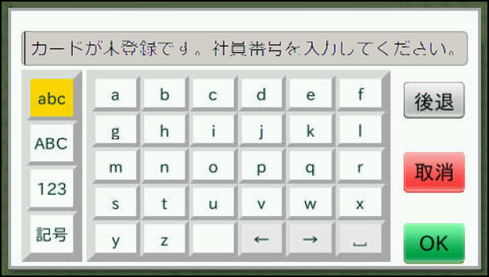

Your IC Card and your Concur account are associated.
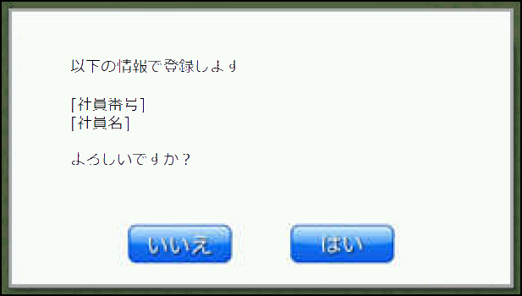
To know more about Suica/PASMO ICCI, please refer the Japan IC Card Integration Services User Guide

Entering Route Information
With the network IC Card reader, once the employee has swapped his IC Card on the device, the IC Card routes are displayed automatically in the Available Expense list along with all other Smart Expenses.
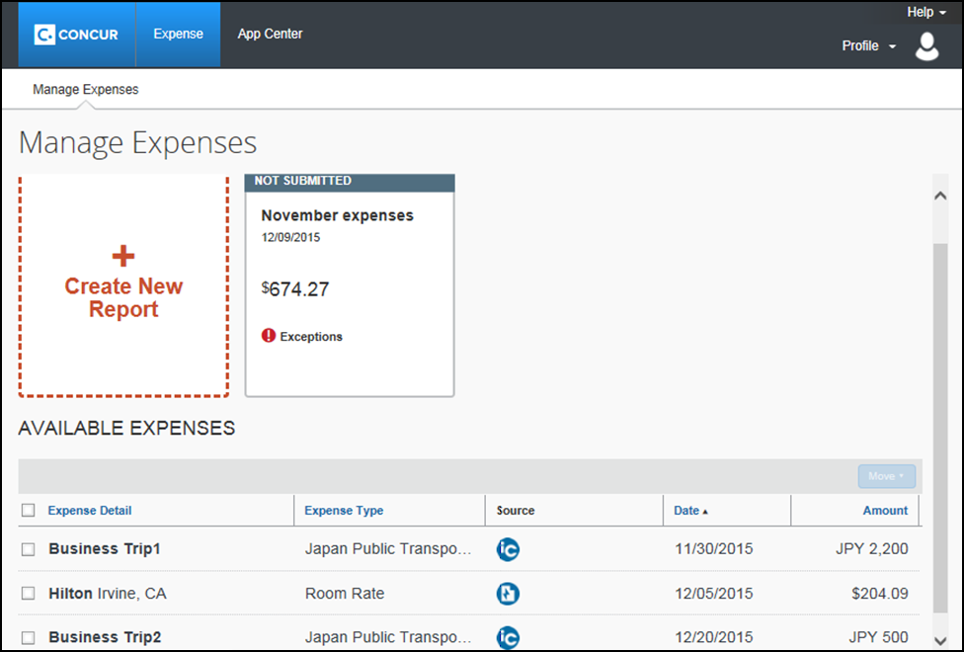
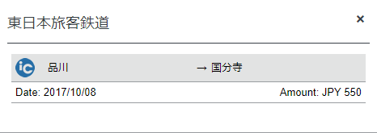

Removing an IC Card Route from an Expense Report
If you delete a JPT expense created from an IC Card e-receipt, the e-receipt will go back to the Available Expenses list.

Accessing Japan Public Transport
You can access this feature by selecting the Japan Public Transportation expense type when creating your expense report.
If you do not see the Japan Public Transportation expense type when creating your expense report, contact your administrator.

Accessing the Japan Public Transport Feature
To access the Japan Public Transport feature:
- Click Expense > Create New Expense Report.
- Fill out the Expense header fields, being sure to complete all required field types, then click Create Report. Users can create an expense report using the policy to which JPT expense type is activated when the client is configured with the JPT on NextGen UI feature.
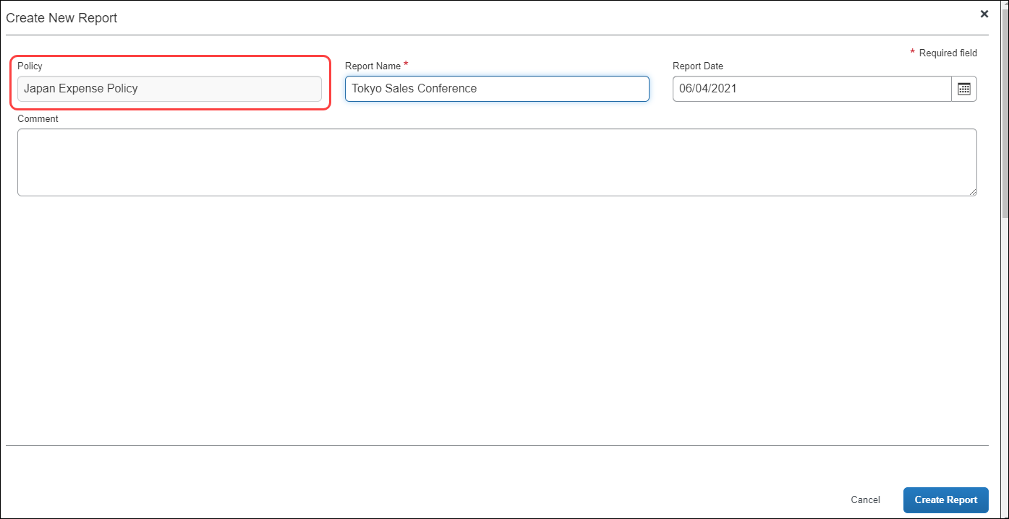
- Click Add Expense and then on the Create New Expense tab, click Japan Public Transportation expense type.
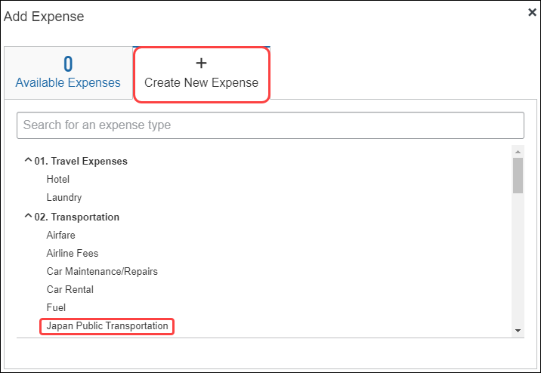

Options
You are granted access to the Japan Public Transport (JPT) feature and options in the following areas of Expense:

- When Creating the Expense Report: You select the Japan Public Transportation expense type to see options that let you add the routes you have travelled
- My Profile: Your Profile page includes a link that lets you add or delete commuter pass routes

JPT Options Available When Creating an Expense Report
To add JPT travel to an expense report:
- Create an expense report by completing the Expense header form including all Required field types
- For the expense type, select Japan Public Transportation and complete the fields that display
- Add the route(s), using the appropriate option:
- From Available Expenses if using the network IC Card device
- Using the Search Route function to populate the route
TIP: Traveled routes on the IC Card also include those pre-paid by a commuter card.
When using the Route search function, be sure to enter commuter routes in Profile - Ekispert services will automatically deduct expenses associated with commuter routes paid for by the commuter pass.

Creating a JPT on NextGen UI Expense Report Using Route Search
The JPT feature allows you to expense JPT using route searches to search for and select your applicable journeys for reimbursement and add a commuter pass to your profile.
You can create an expense report using the policy to which JPT expense type is activated when the client is configured with the JPT on NextGen UI feature.
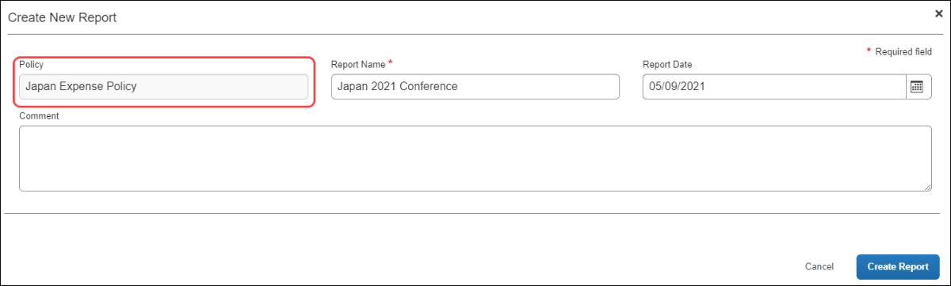
When the report is created, the report currency is displayed as configured for your reimbursement currency.
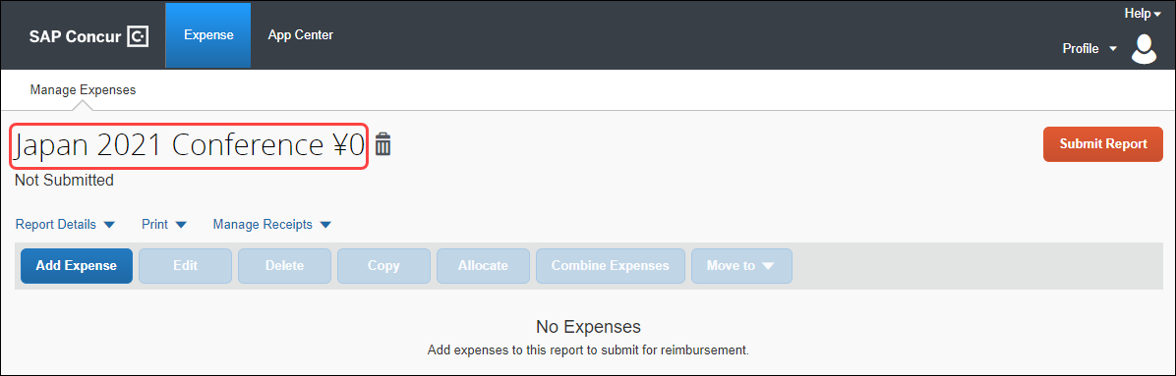
When you create a new JPT expense, you will select Japan Public Transportation.
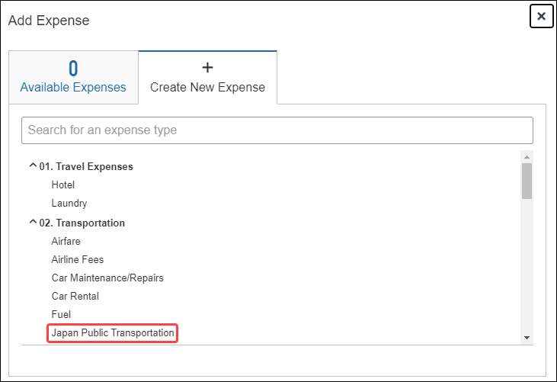
You will provide the required route search criteria:
- Trip Date: The date the trip occurred.
- Time: The time the trip occurred.
- Trip Type: The type of trip taken – One-way or Round Trip.
- Seat Type: You have three options: Non-reserved, Reserved, or Green (first class)
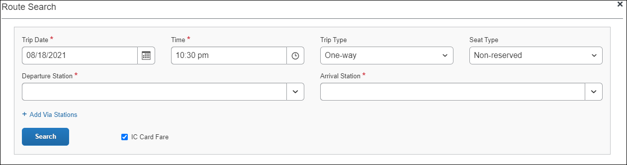
You can perform a route search by searching for and selecting both a Departure Station and Arrival Station.
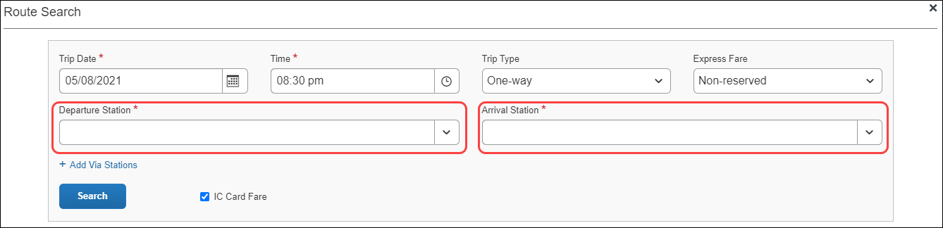
As you type, Concur Expense deploys a search and filter list, allowing you to select the appropriate departure station and arrival station as it appears in the list.
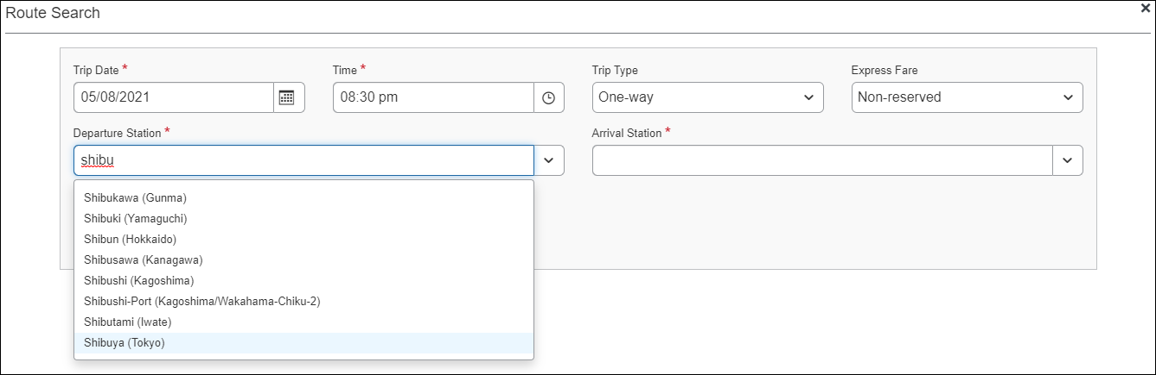
If necessary, you may add up to two via stations as part of your route search by clicking + Add Via Stations. As they type, you can use the search and filter list to select the appropriate via station(s) as they appear in the list.
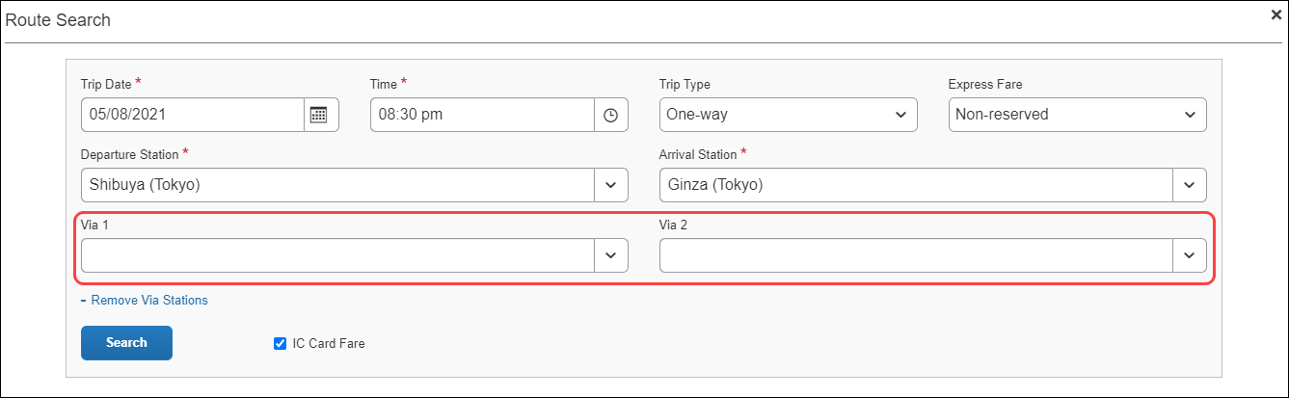
By default, the IC Card Fare checkbox is selected. Selecting IC Card Fare indicates whether you ("traveler") paid for their ticket using your travel card or if the ticket was purchased from the ticket counter. The prices may differ based on the payment method used.
Most of the time, you will select the IC Card Fare option. Therefore, IC Card Fare is selected by default.
When you click Search, Concur Expense returns a maximum of five route results. These routes ("journeys") will be classified as Fast, Easy, Cheap, or Commuter Pass OR none of the designations.
These designations are specified if a partner has provided that data to SAP Concur. Depending on the journey, the route can have multiple designations (for example, Fast and Cheap). A journey with a designation of Easy has the fewest number of stops.
These designations can also help approvers and processors when they review a JPT expense by allowing them to see if the route complies with their organization's travel policy.
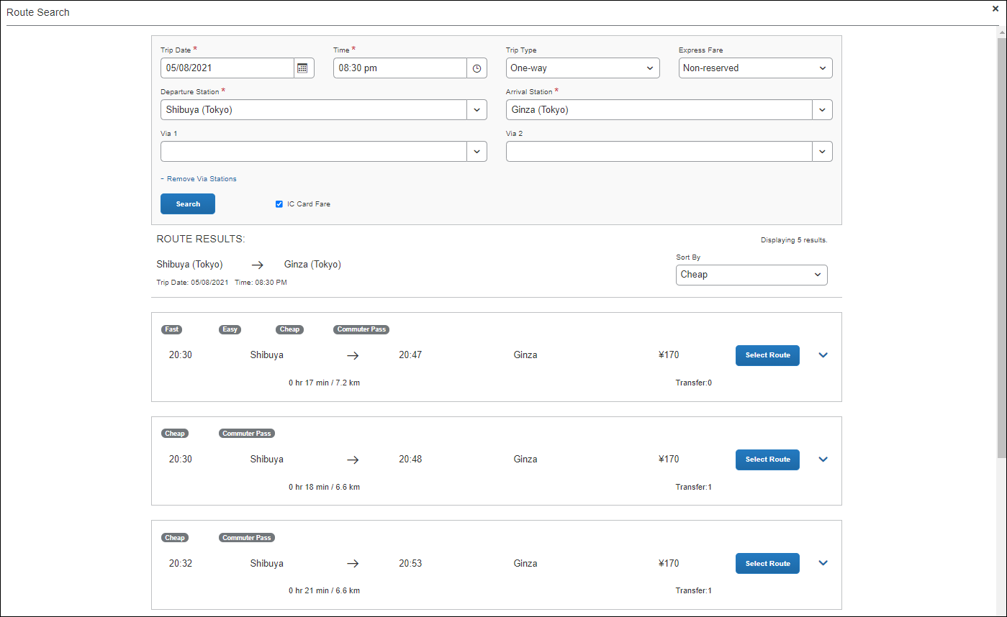
You can sort the route results using the Sort By list, which offers three sorting options: Cheap, Easy, and Fast. A route can have multiple designations or none at all. Therefore, if sorting by Cheap, the route results displayed may have other designations.
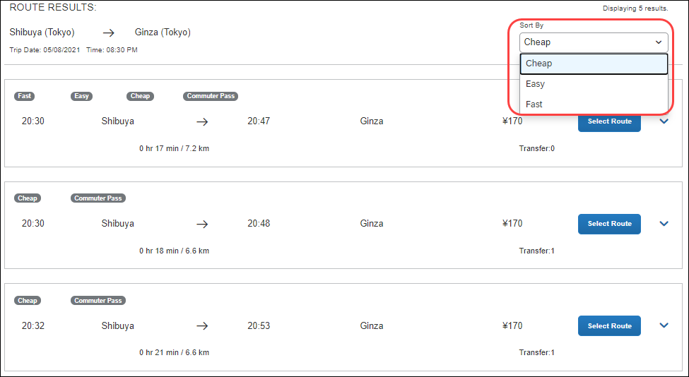
You click expand icon to expand the route details and see if additional transportation is required to get to the designated arrival station in the selected route. Icons, such as a bus or a walking person, indicate whether you need to take a bus or walk to a stop in the selected route.
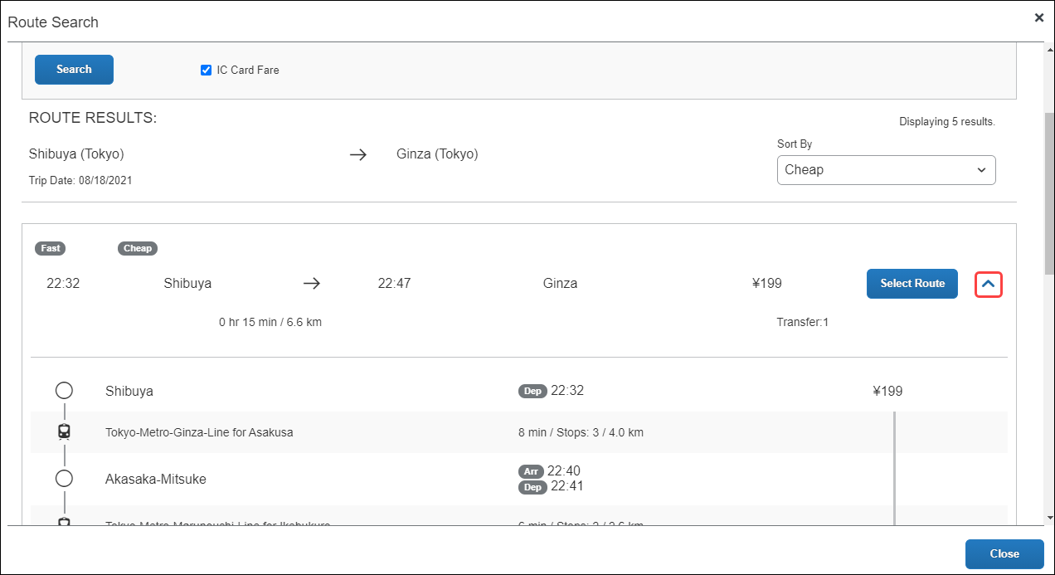
Once you select a route by clicking Select Route button, you will be able to save your JPT expense report by completing the required fields.
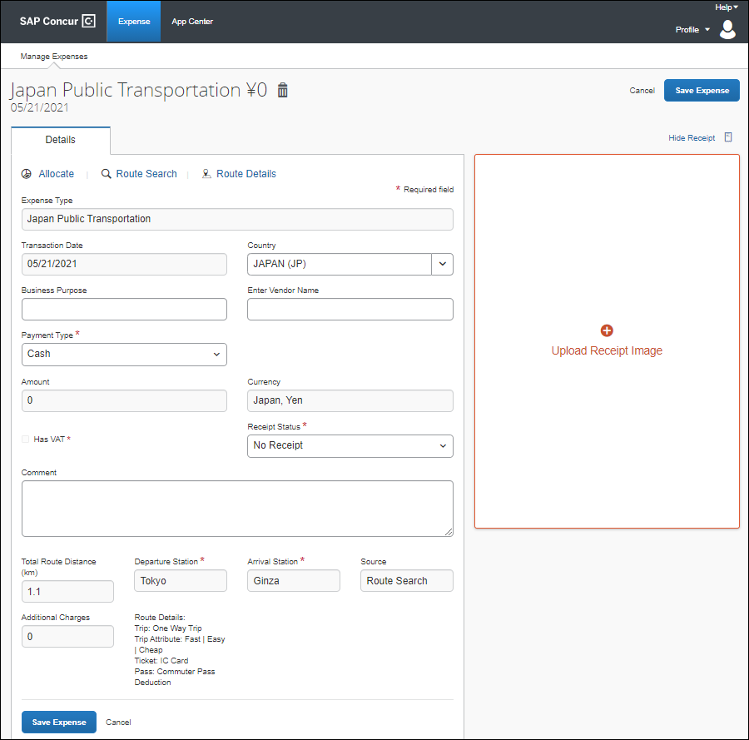
The Expense Type field will always be Japan Public Transportation; you cannot change it to another expense type. When you create an expense report and select Japan Public Transportation as the expense type, it is then hardcoded into the expense details.
For example, unlike other expense reports, you cannot change the Expense Type to another expense type such as Hotel or Dinner, when providing the details of the Japan Public Transportation expense.
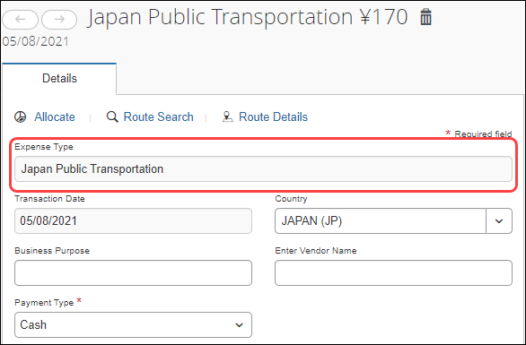
Additional information about JPT expense details page:
- You cannot edit the Transaction Date field, as the date is extracted from the route search.
- The Country field always defaults to JAPAN (JP) given the travel will always occur in Japan.
- The Currency field will always default to the reimbursement currency configuration that is mapped to that user (in this case, you, the traveler).
- The source of the expense will either be Route Search or IC Card Fare (through e-receipt).
- Additional charges, such as those assisted with first-class fare, display in the Additional Charges fields, if applicable.
- The Route Details area display the type of trip (One Way Trip or Round Trip) and the type of ticket used (Paper or IC Card Fare).

Adding a Favorite Route
You can configure a route you regularly use (for example, from home to work) and add it to your favorites. When you create a future JPT expense, you can then select the route from the Favorite Routes tab.
Currently, there is no limit to the number of routes you can add to the Favorite Routes tab.
From the Route Search window, you can create a route and mark it as a favorite from the Route Search tab.
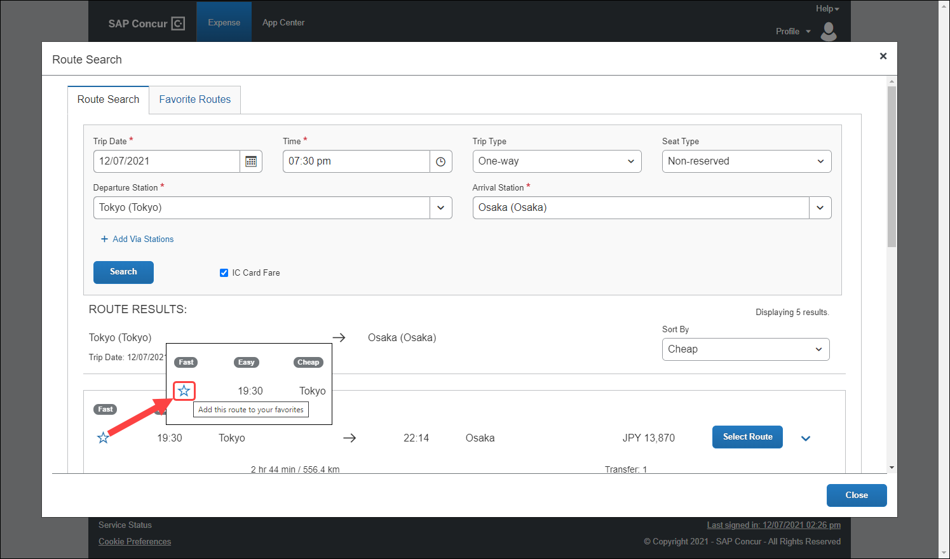
Once you click the star icon, the route is favorited (the star changes from clear to blue) and added to the Favorite Routes tab.
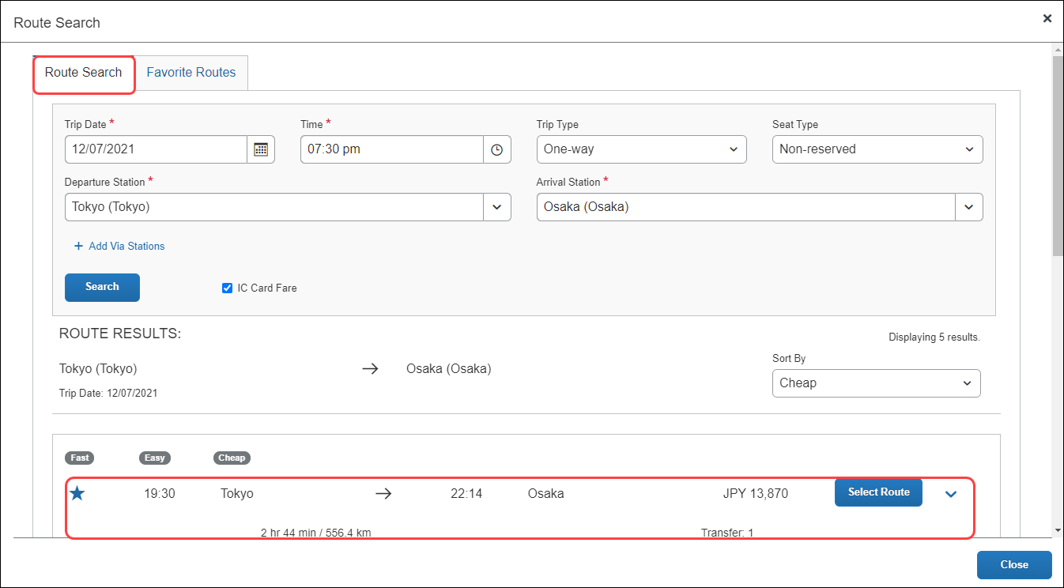
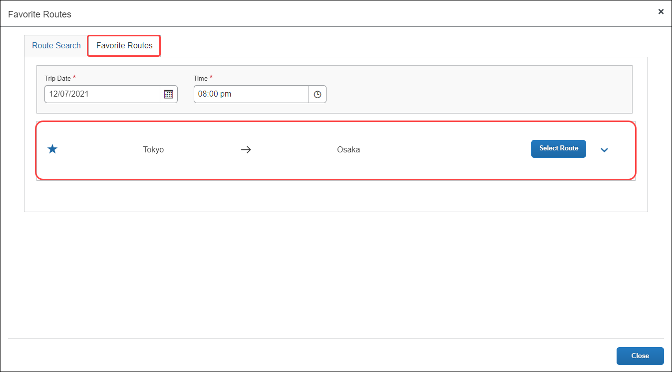
You can click the Show Details toggle button to display the favorite route’s details.
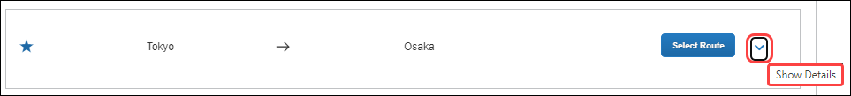
You can then click the Hide Details toggle button to hide the favorite route’s details.
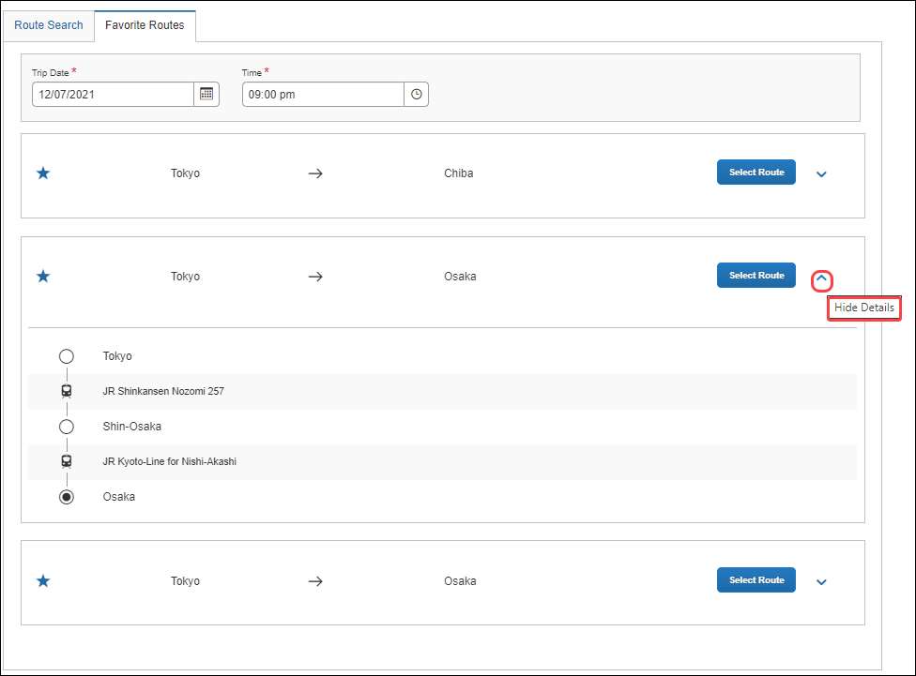
The 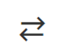 icon indicates that the favorite route is a round trip.
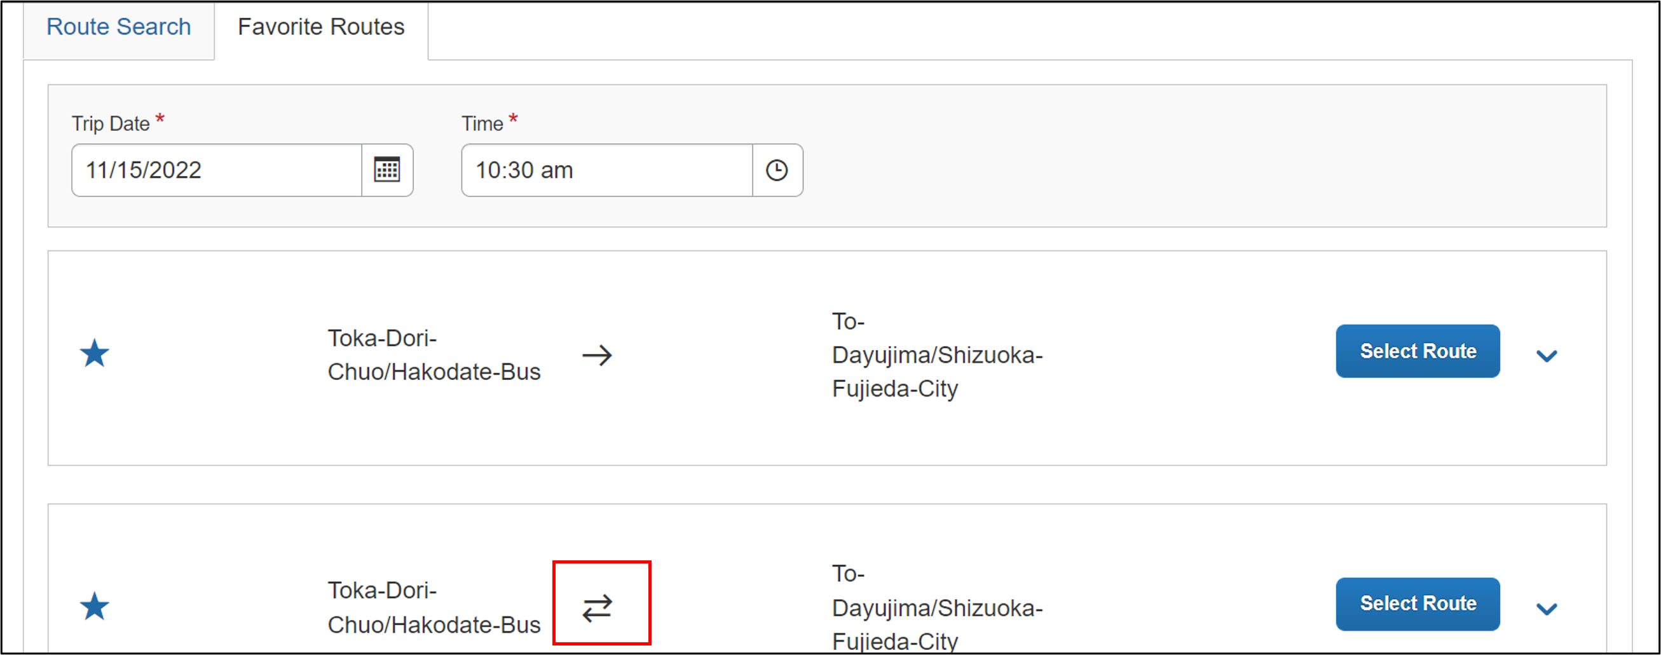

Adding a JPT Expense from a Favorite Route
You can create a JPT expense and select a favorite route (noted by the star icon).
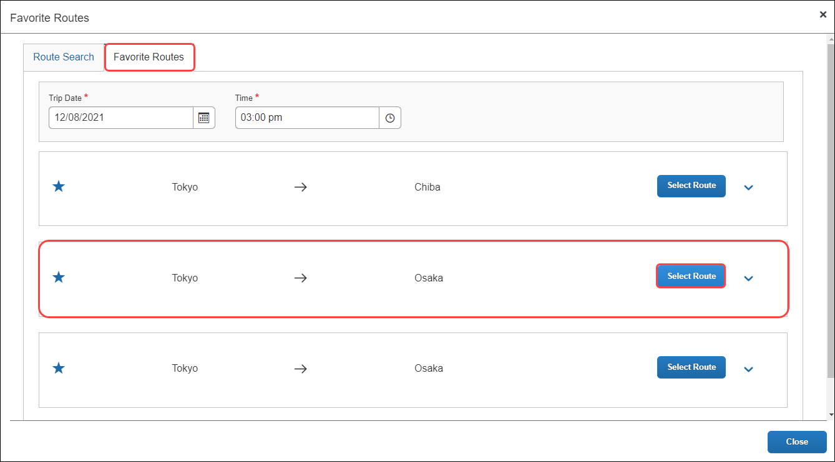
In the expense report, the departure station and arrival station will pre-populate with the data provided from the favorite route selected.
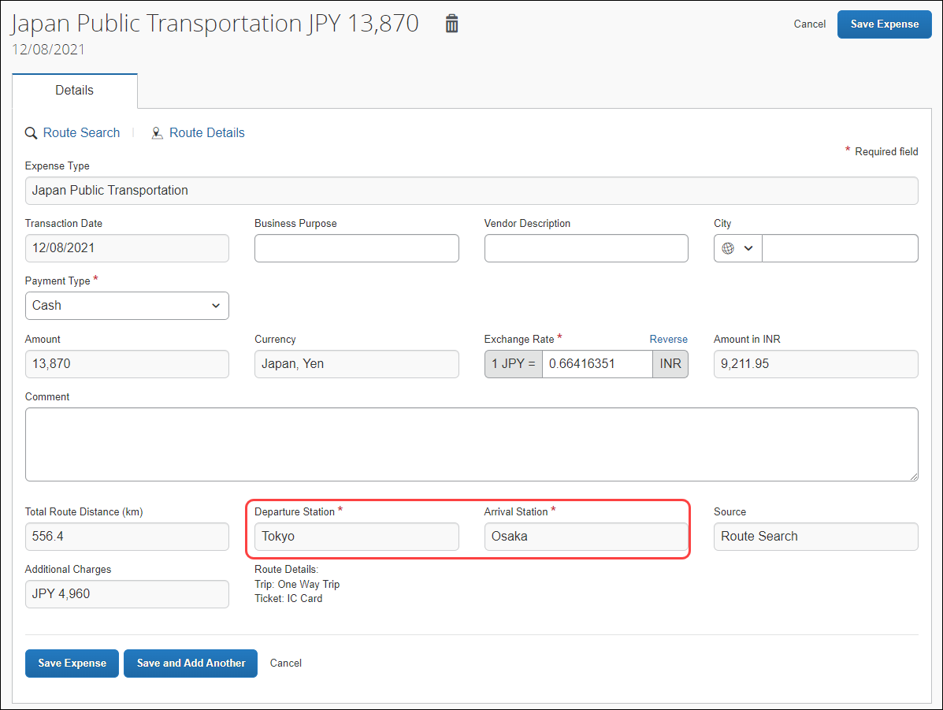
You can then save the expense or save the current JPT expense and add another JPT expense.

Saving and Adding Another JPT Expense
You can save a JPT expense and then add another JPT expense (to the same expense report) by clicking the Save and Add Another button.
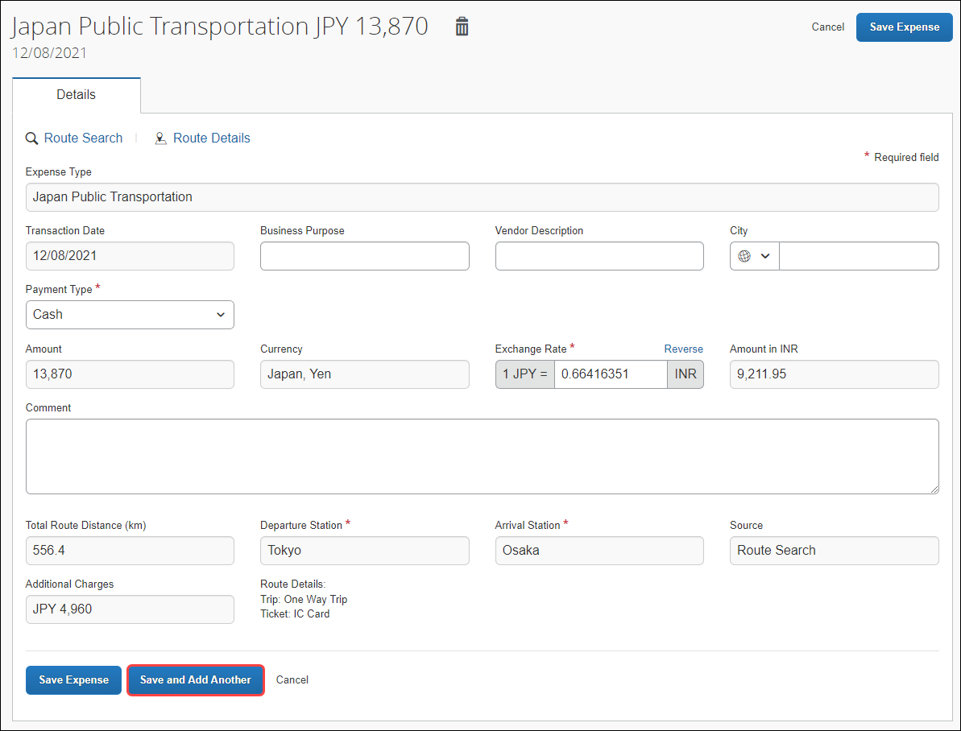
The JPT expense is saved and the New Expense window will open.
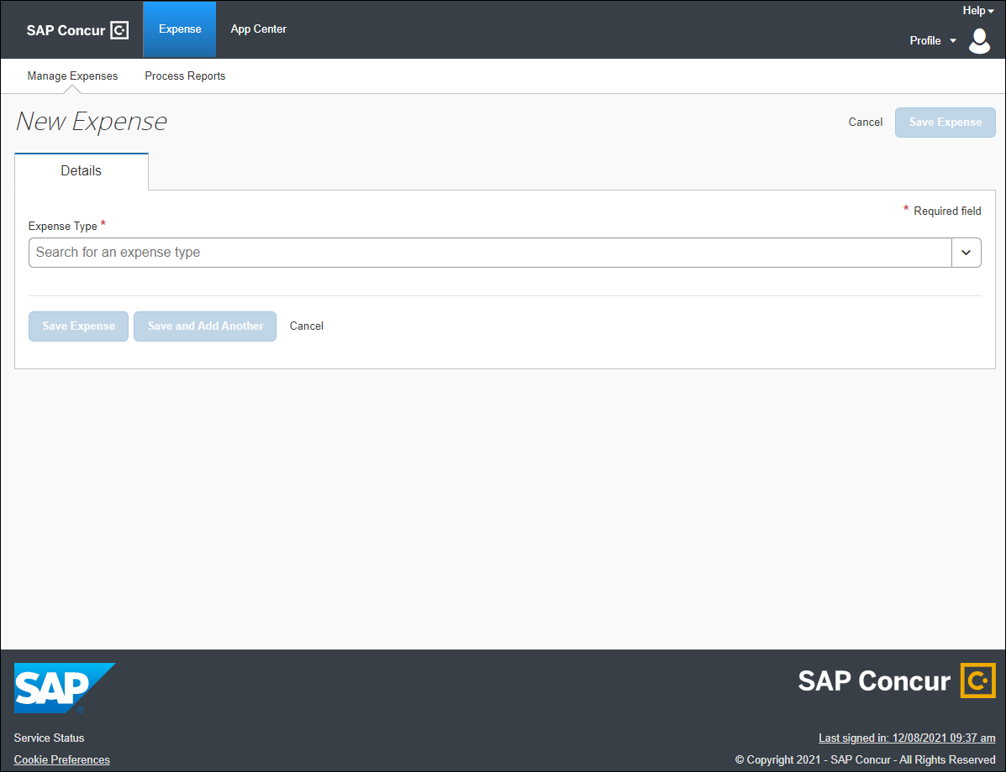
You can select any expense, but in this case, you can select Japan Public Transportation.
You can select a route using a route search OR select a favorite route on the Favorite Routes tab.
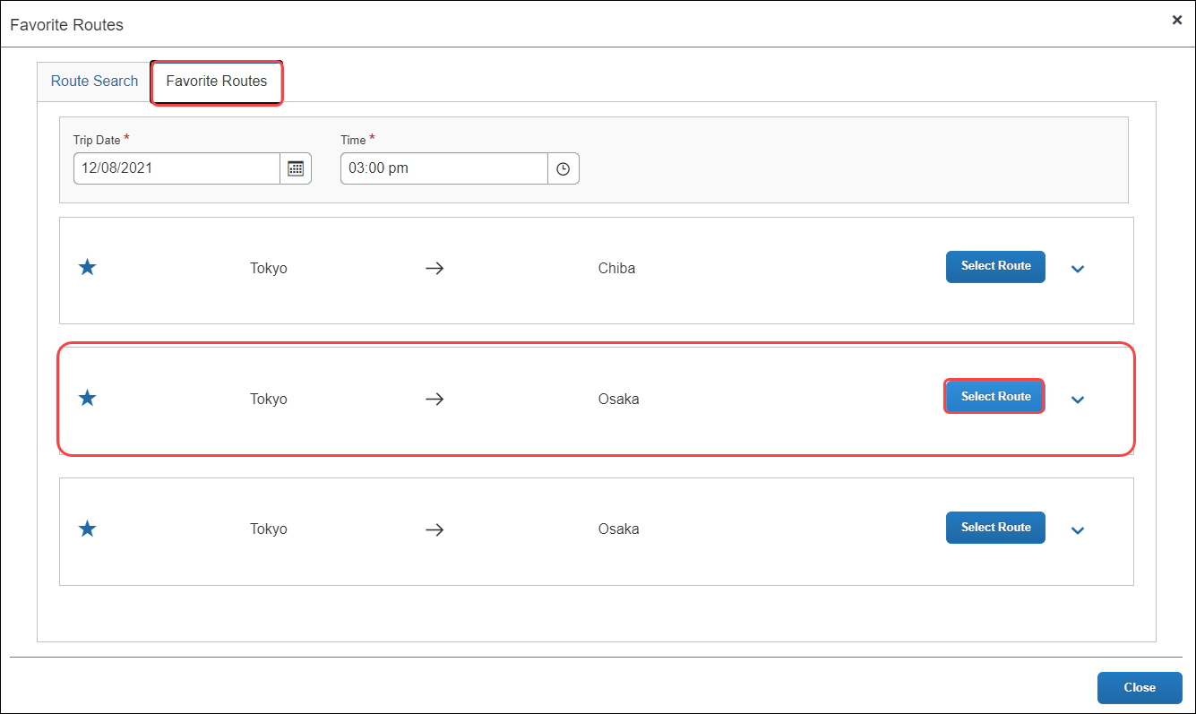
The JPT expense report reflects the newest JPT expense added using the Favorites Route tab.
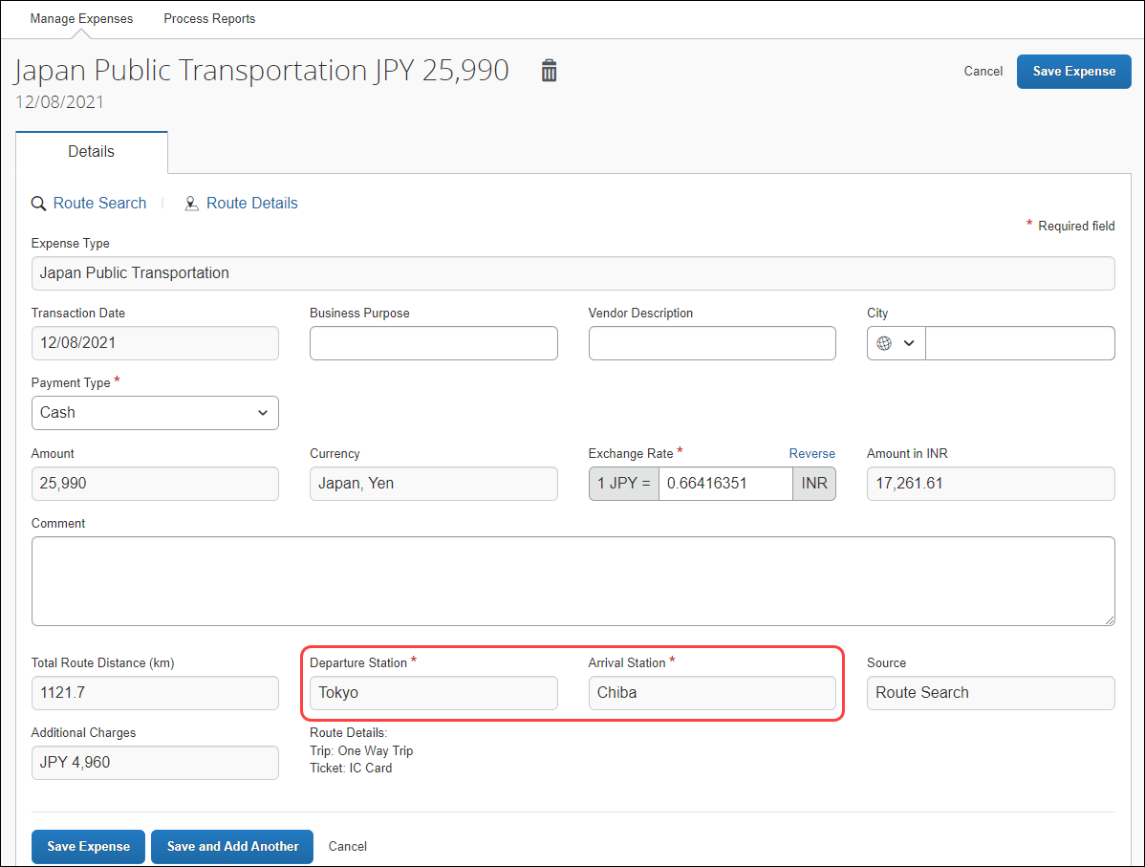
You can choose (again) whether to save the JPT expense or clicking Save and Add Another to save another expense to the expense report.
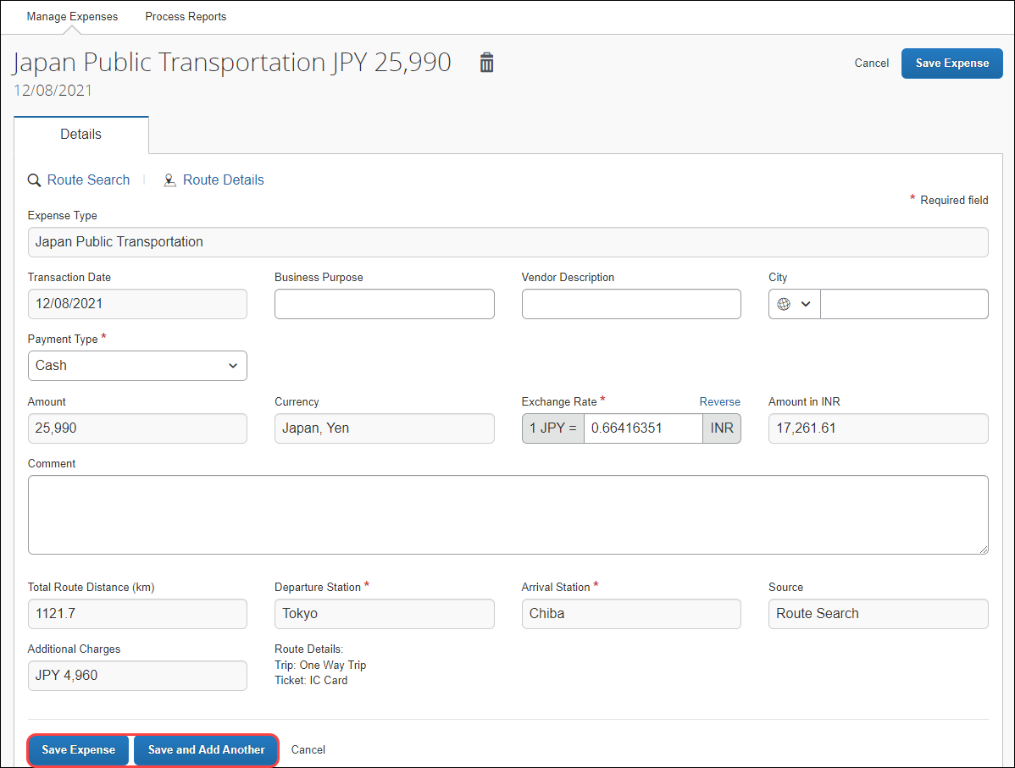

Deleting a Favorite Route From The Route Search
You can delete a favorite route from the Route Search tab by clicking the star icon to remove it as a favorite.
The favorite route will also be deleted from the Favorite Routes tab.
Deleting a favorite route does NOT affect any previous JPT expenses submitted using a favorite route.
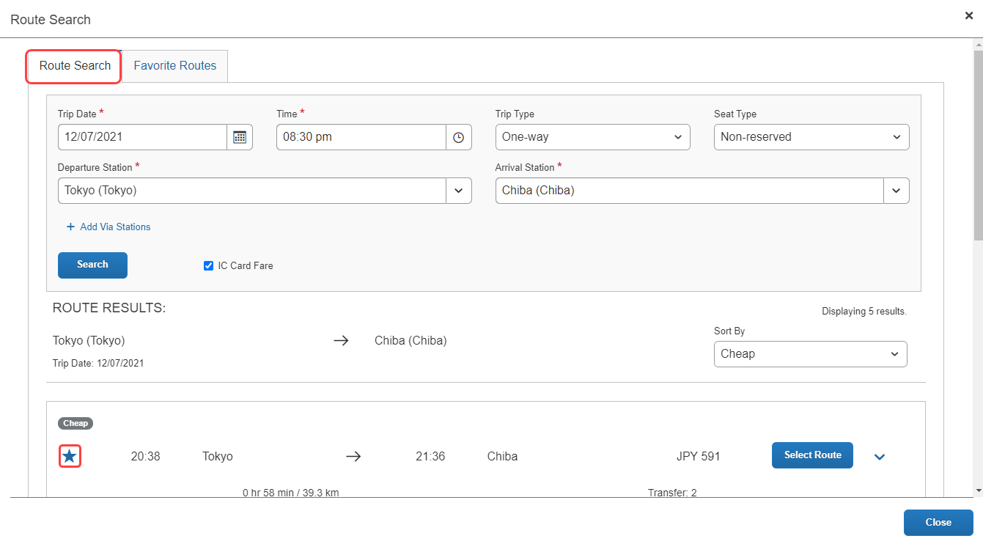

Deleting a Favorite Route From The Favorite Routes Tab
You can delete a favorite route from the Favorite Routes tab by clicking the star icon to remove it as a favorite.
Deleting a favorite route does NOT affect any previous JPT expenses submitted using a favorite route.
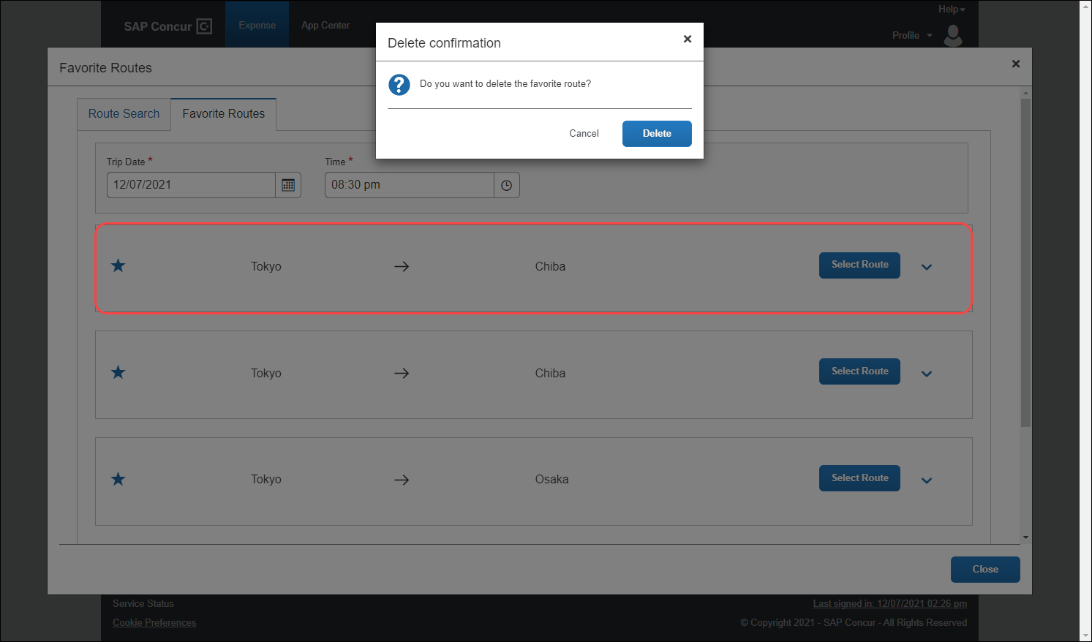
The route is removed, and the Favorite Routes list tab is updated.
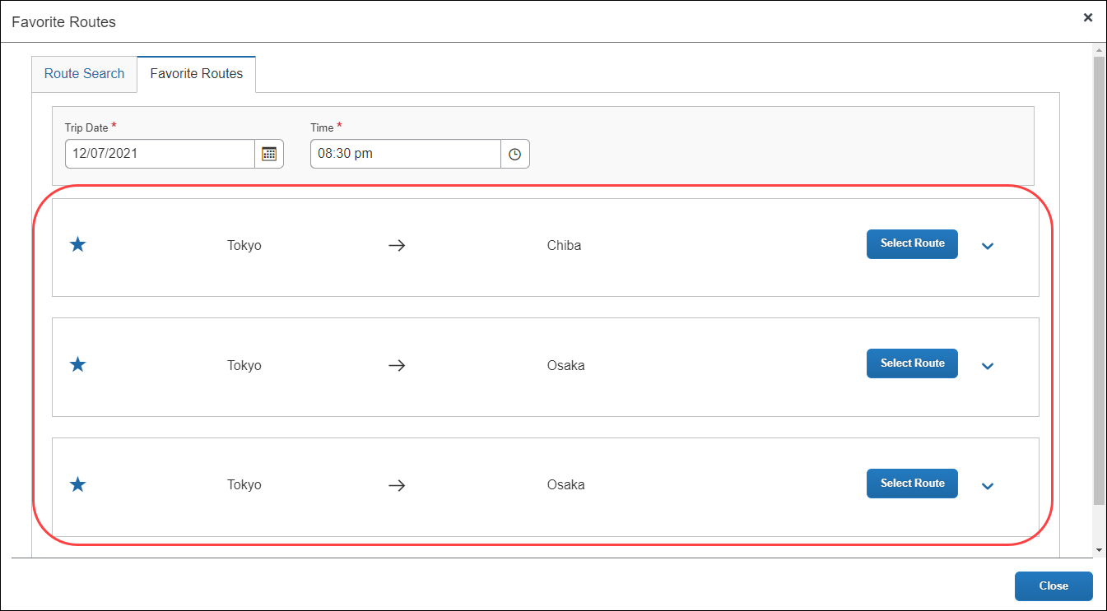

Deleting a Favorite Route From The Favorite Routes Tab
You can delete a favorite route from the Favorite Routes tab by clicking the star icon to remove it as a favorite.
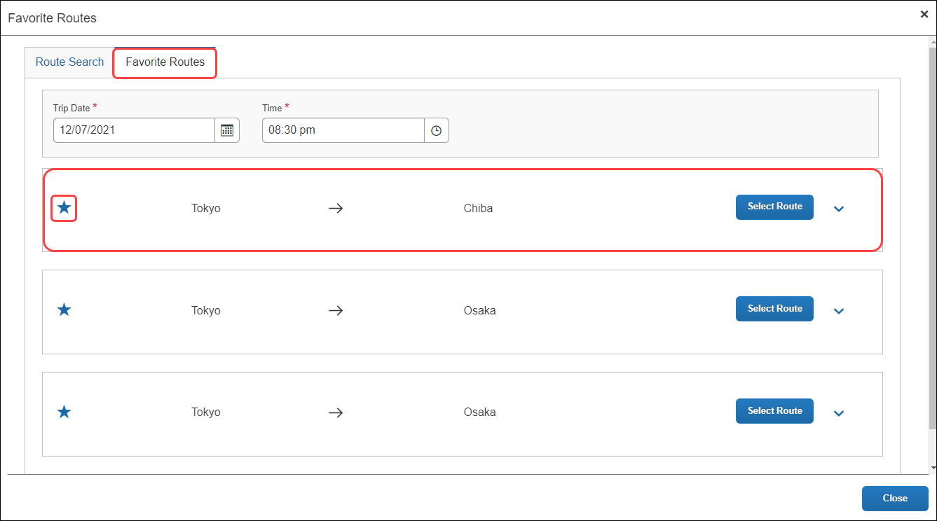
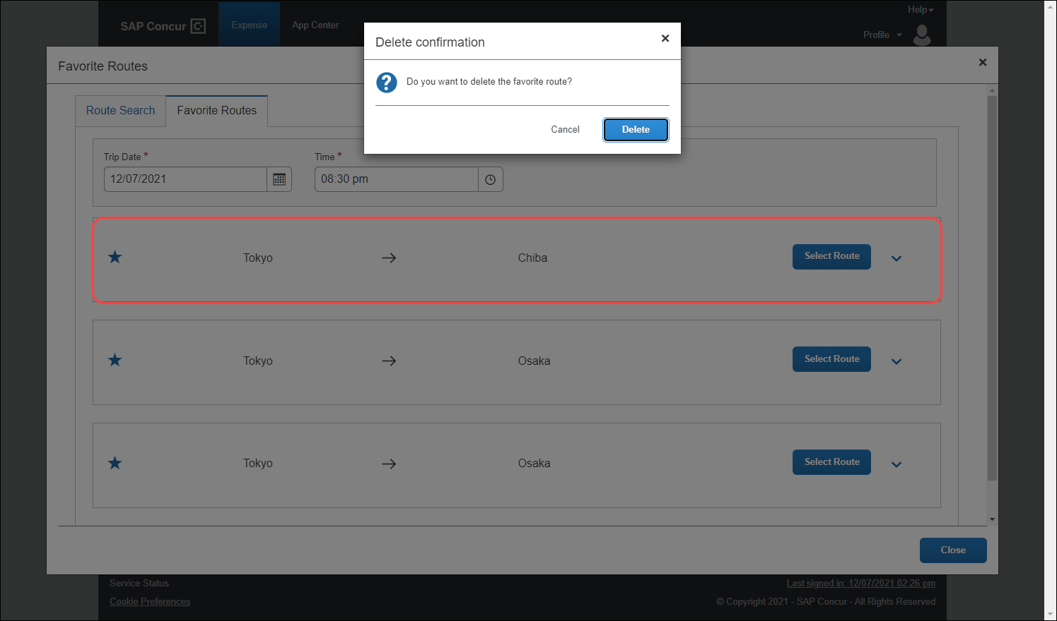
The Favorite Routes tab updates with the favorite route removed.
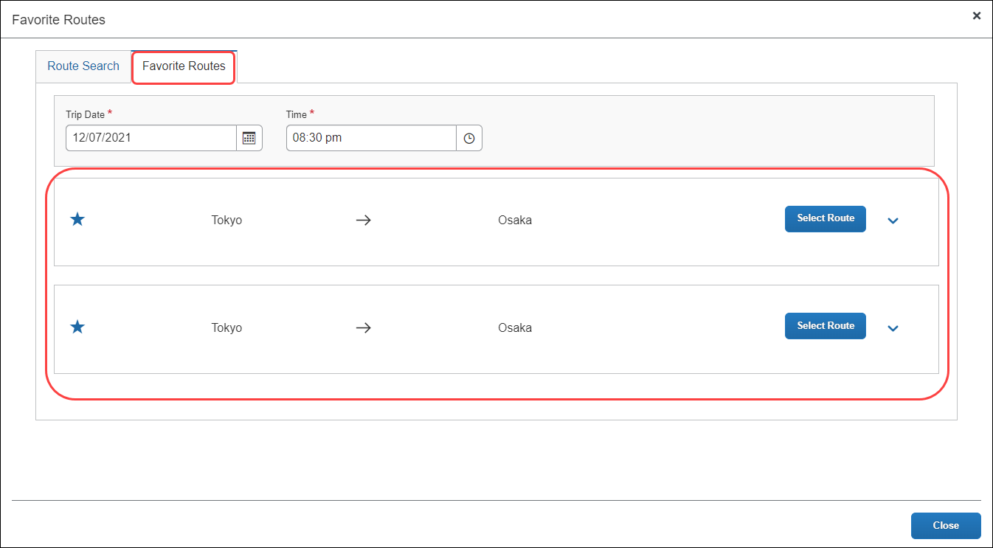

Adding An Expense From A Favorite Route For The Requested Trip Date and Time
You can create a JPT expense using the same route, but the route’s date and time changes based on the date and time traveled. You can save time by providing route stations and route search conditions (such as seat type), and then select the target route. You can also reuse these route search conditions and route (same departure and arrival stations and lines) to create a new JPT expense.
When providing the date and time, you may not know the precise time of the departure or arrival, for example. However, when adding a JPT expense from a favorite route for the requested trip date and time, Concur Expense will automatically update the expense report using your favorite route’s adjusted date and time.
On the Favorite Routes tab, you can configure the trip date and time. In this example, you select the date.
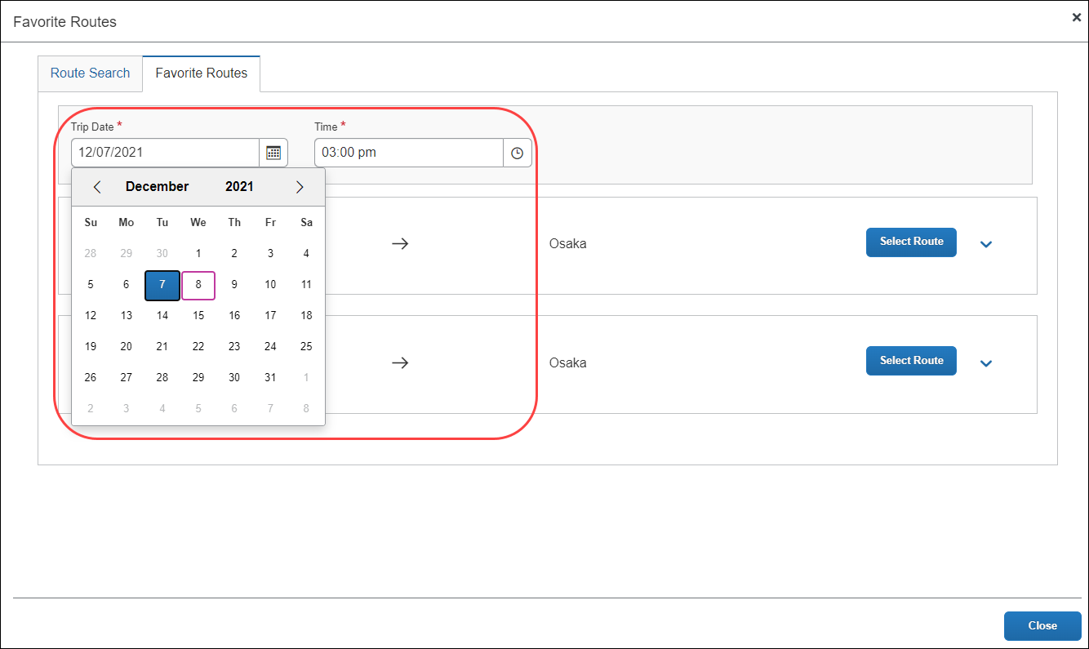
Once you select the date, you can then provide an approximate time for when you think you took the favorite route.
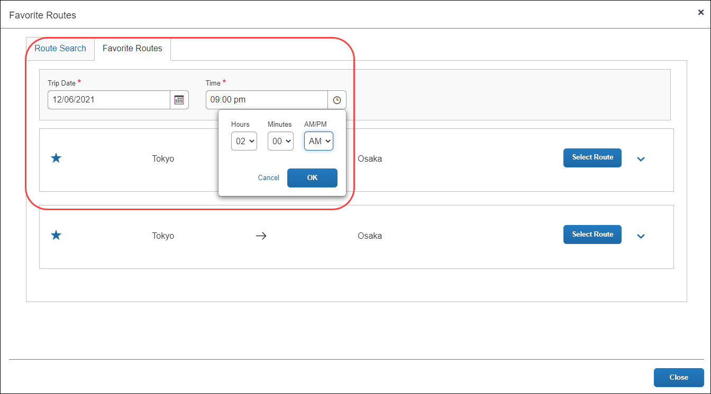
You select the route from the Favorite Routes tab, with the trip date and time (they provided) applied.
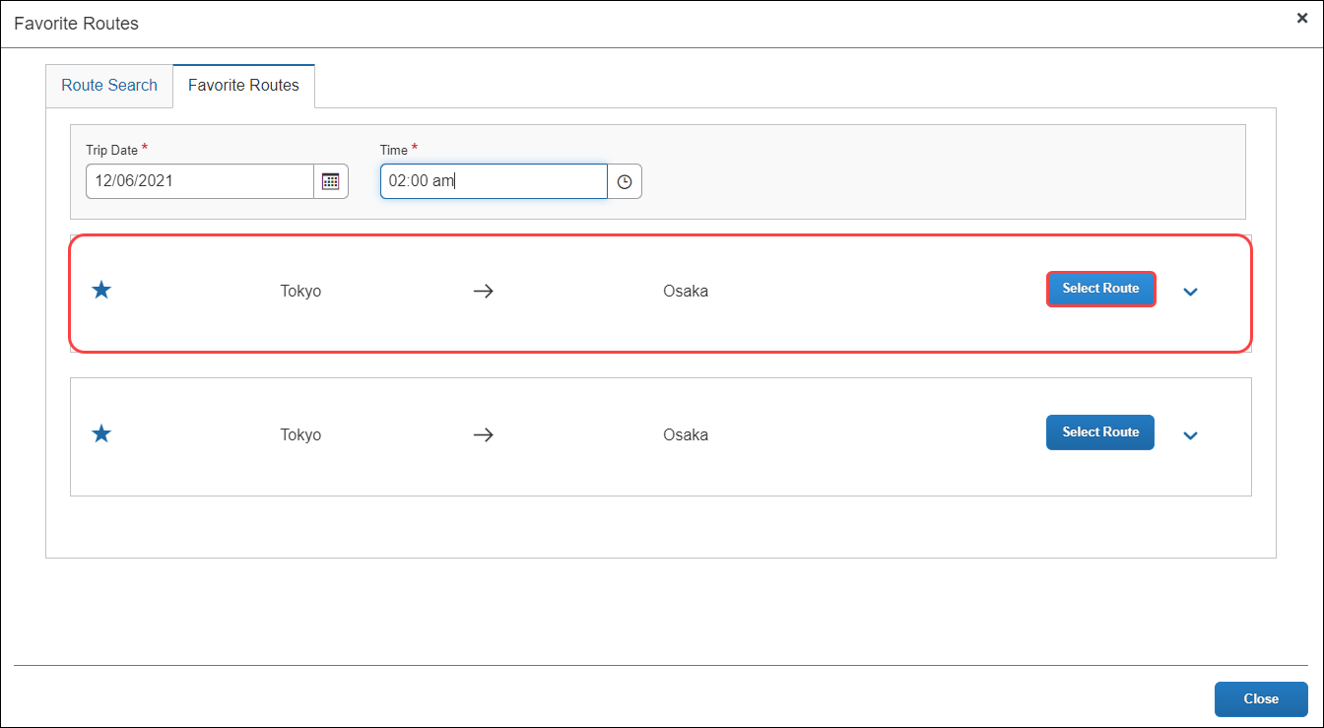
On the expense report page, you can view the route details that have been pre-populated from the route search then click Route Details at the top of the report to view the selected route’s details.
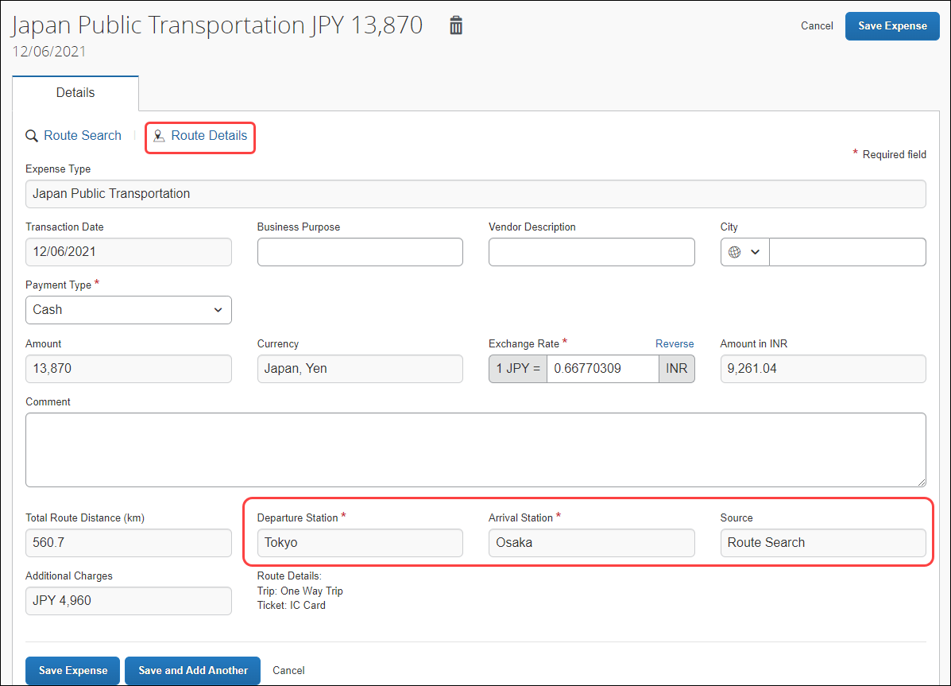
If the trip’s departure date and time are different than the favorite route’s date and time specified by you, Concur Expense will automatically adjust the time in the Route Details window. In the previous example, you had entered a 2:00 a.m. departure date, but Concur Expense updated the departure time to the correct time (of 4:55) from the actual route data.
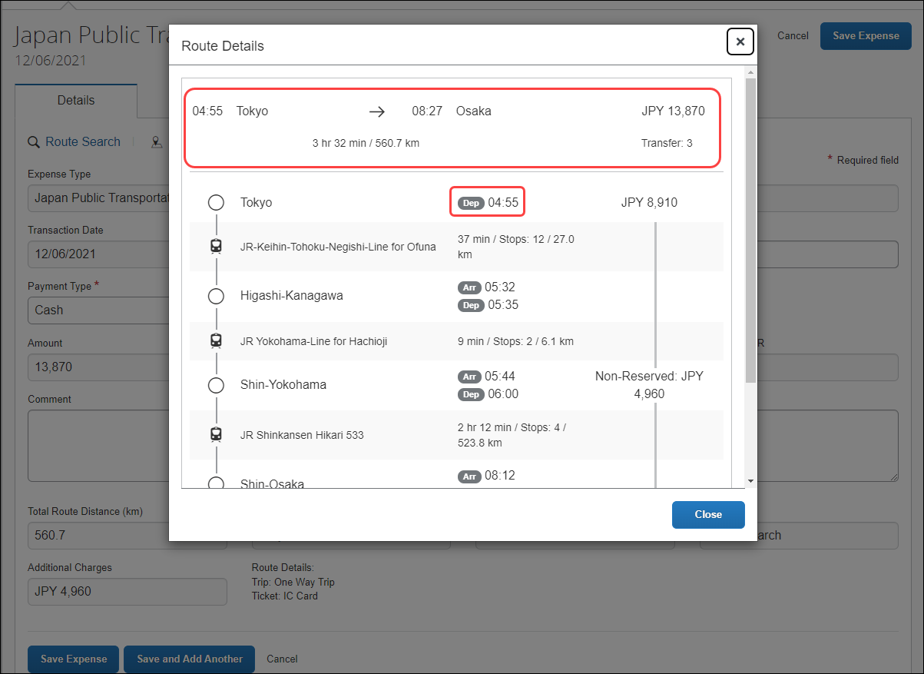
If the favorite route is associated with a commuter pass, you will see Commuter Pass Deduction for the Pass information.
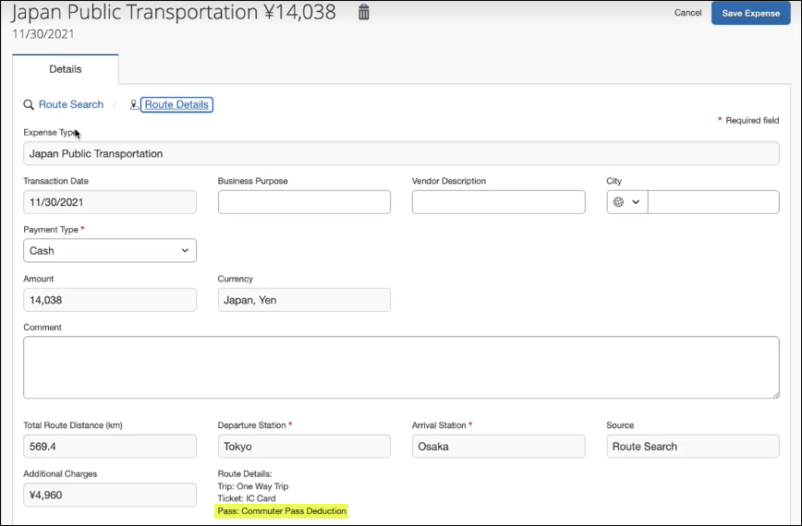

Adding a Favorite Via Station Route
You can add a favorite via station route using the same method for adding a favorite route by clicking the star icon.
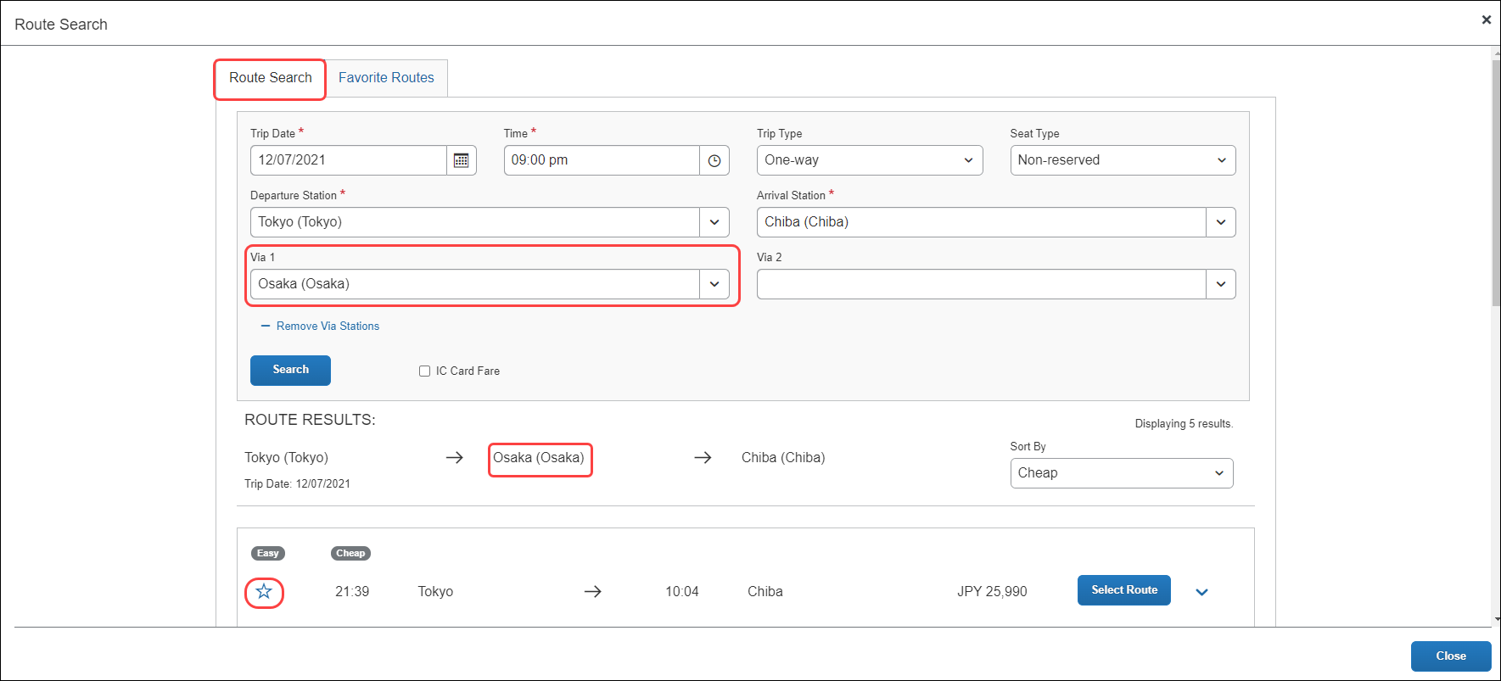
Once added, the favorite via station route will be added to the Favorite Routes tab. You can expand the route by clicking the Show Details button to display the route’s details, which contains the favorite via station.
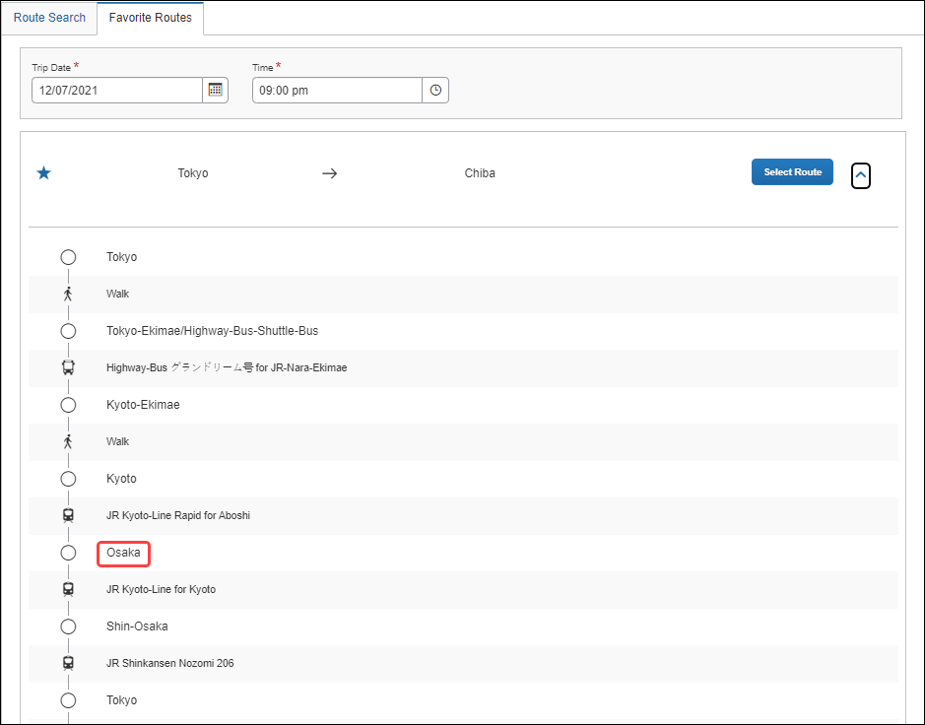

Registering a Commuter Pass
You can register a commuter pass. Once a commuter pass is registered, it can be used for JPT expense.
From the Profile Settings page, you can add a commuter pass if it is configured.
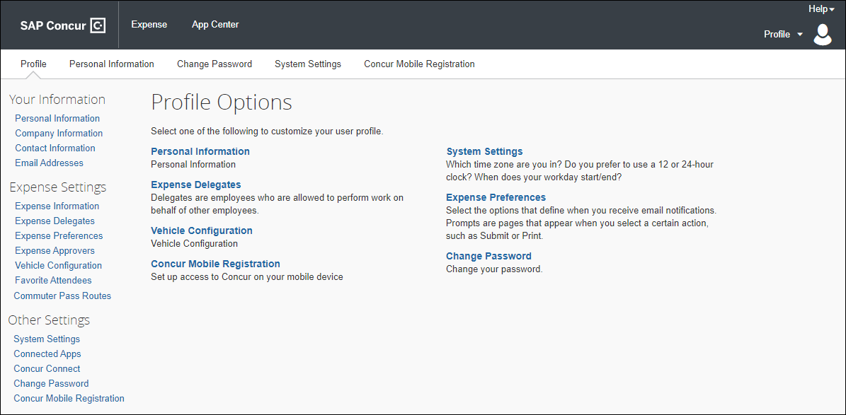
Users will only be able to store one commuter pass at a time.
Only one commuter pass is allowed in a date period; a user cannot use multiple commuter passes for the same period. For example, if they use one route on Monday, Wednesday, and Friday, but use another route on Tuesday and Thursday, they cannot use separate passes for the two unique routes.
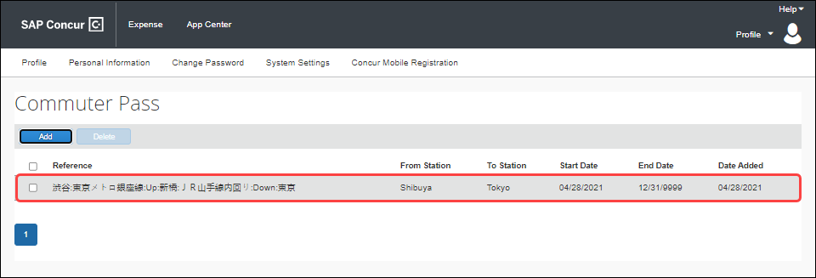
If the commuter pass is not valid, you will see this warning:
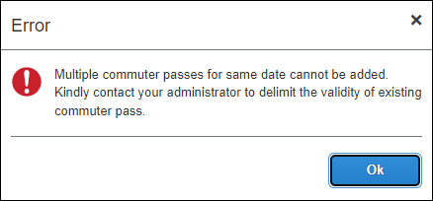

Registering a Commuter Pass Route Using Route Search
You will be able to register a route (for example, from home to work) that you can use regularly when creating a JPT expense. In addition, if you have a commuter pass registered to their profile, the route will be tied to that route.
You have to pay upfront for the commuter pass at the station and will be reimbursed outside of SAP Concur. The expense process is typically facilitated through their HR system via reimbursement in their paycheck. For SAP Concur, this ensures the user is not double-reimbursed in SAP Concur.
On the Commuter Pass Routes page of Profile Settings, you may add a commuter pass route. If an approver, processor, or user needs to change the end date of their commuter pass, they must contact Concur Admin to configure the end date of the commuter pass.
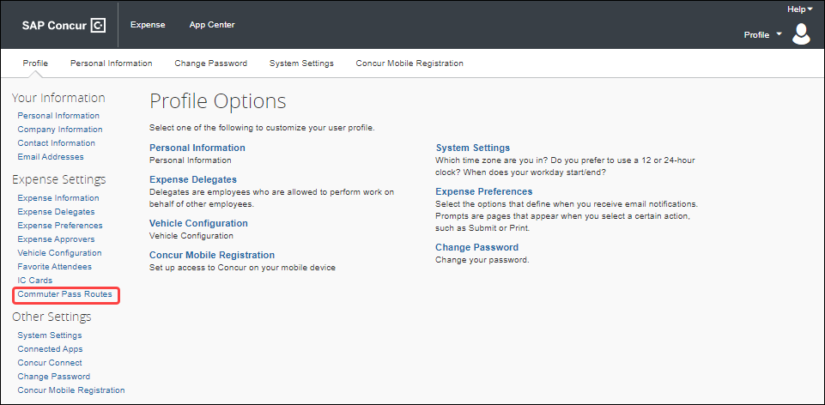
You will search for and add the commuter pass route. If necessary, they can also add four via stations.
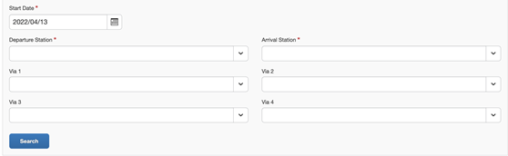
Concur Expense returns a maximum of five route results. Users can also click Select Route to expand the route to see if the stops on the route as well as whether walking is required to get to a designated stop on the route.
Once the route is selected, it is added to your Commuter Pass page.
Once a commuter pass route is added, the route search results will feature a Commuter Pass designation when the route meets the commuter pass route's criteria, including the precise transfer stops if applicable.
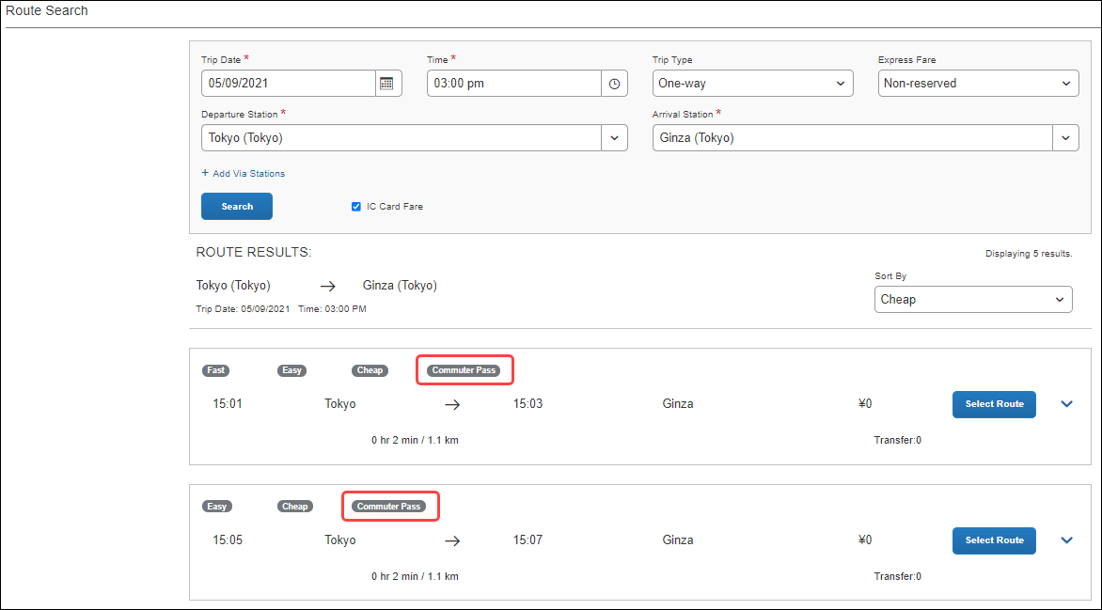
If you select a route not associated with their commuter pass, the Commuter Pass designation will not appear.
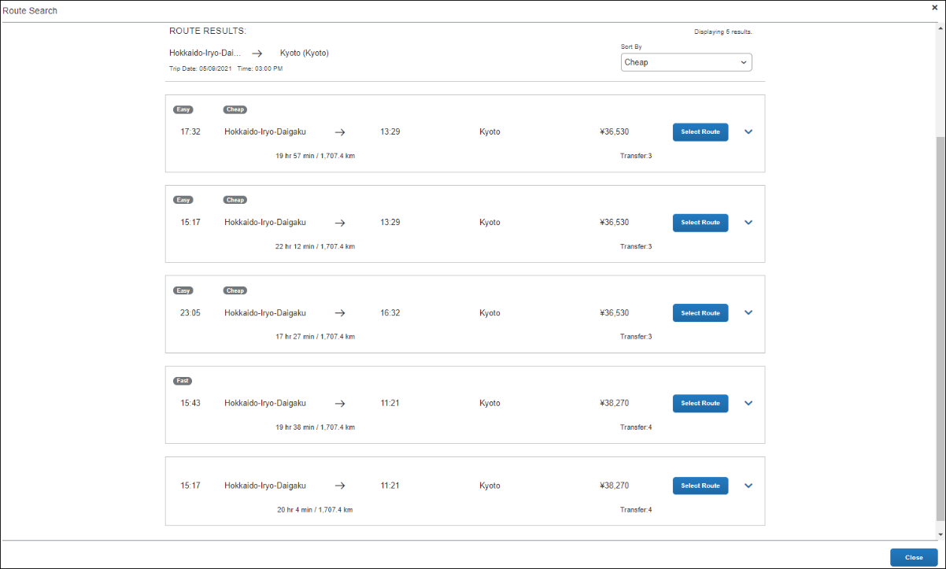
If the user selects a route that partially or entirely matches their registered commuter pass route, there will be a fare deduction. If the entire route matches their registered commuter pass, the total fare will be zero.
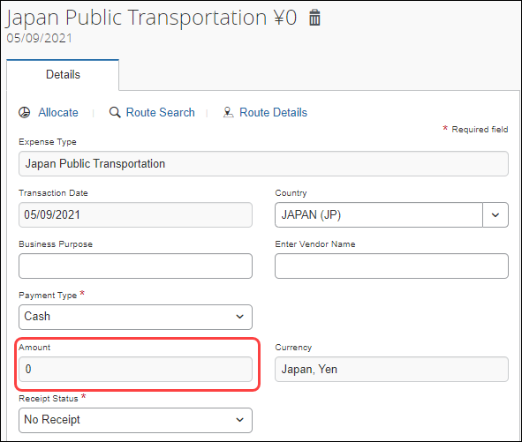

Entering JPT Route Information
Options that appear when you select the Japan Public Transportation expense type allow you to perform a route search to add a route and add routes directly from your IC Card transactions from Available Expenses.

Entering Routes Using the Network IC Card Reader
If your office has a network IC Card reader, you may add routes in Expense for use in your expense reports.
To enter routes using a network IC Card reader:
- In the office, tap your IC Card on the device.
- Log in and go to Available Expenses or within the Expense Report, click Add Expenses and see the Available Expenses tab.
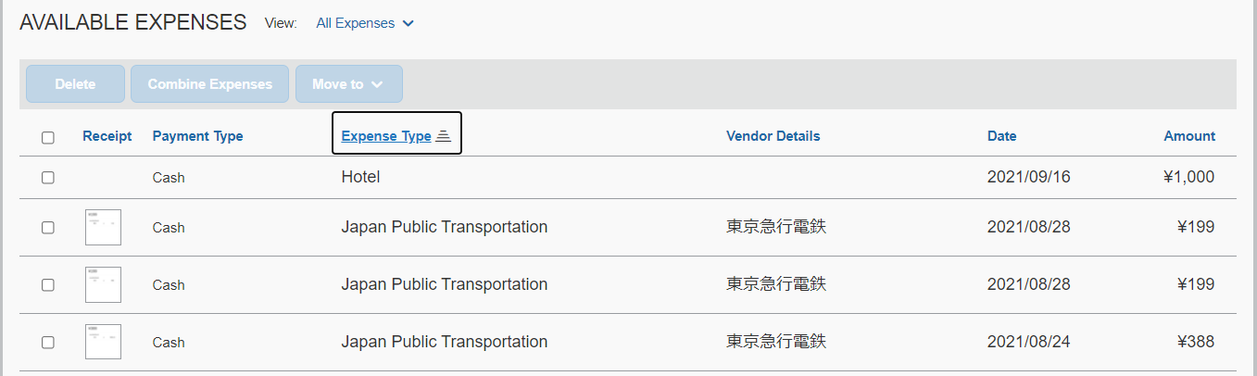
Each Smart Expense with the Expense Type is Japan Public Transportation, which corresponds to an IC Card route. Under Available Expenses section, click the Receipt image icon to see the detail of the Smart Expense route.
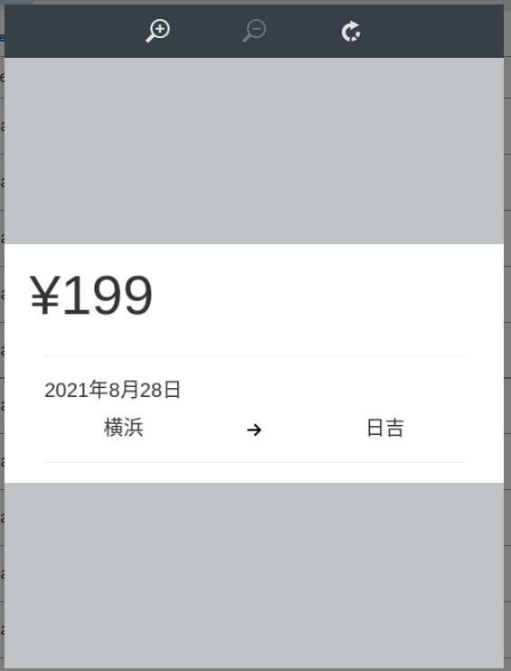
- Select one or more IC Smart Expenses and move them to an existing report or a new report.
Each Smart Expense will be automatically added as a report entry in the Expense Report.
- (Optional) Click the added JPT expense to open Expense Detail screen. Enter text in the Business Purpose and Comment sections as directed by your company policy.
- Click Save Expense.
For routes coming from the IC Card, the route distance is not managed.

JPT Commuter Pass Routes Option Available in Profile Settings
You are granted access to a link on your Profile page that let you work with commuter routes if it is configured. The link is:
- Commuter Pass Routes: Add and delete commuter pass routes you use to transit for business purposes.
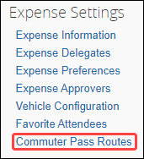
If you do not see the links, contact your administrator.
The user pays upfront for the commuter pass at the station and will be reimbursed outside of SAP Concur. The expense process is typically facilitated through their HR system via reimbursement in their paycheck. For SAP Concur, this ensures the user is not double-reimbursed in SAP Concur.

Commuter Pass - Entering Commuter Pass Routes
A commuter pass route may already have been entered for you by your administrator. To enter your own routes, use the Commuter Pass Routes link.
Users will only be able to store one commuter pass at a time.
Only one commuter pass is allowed in a date period; a user cannot use multiple commuter passes for the same period. For example, if they use one route on Monday, Wednesday, and Friday, but use another route on Tuesday and Thursday, they cannot use separate passes for the two unique routes.
For example, if you are using a commuter pass that pre-pays for travel from station to station, you should enter these routes on the Commuter Pass Routes page. Doing this allows Concur to deduct the amount already paid from station to station when a trip includes that leg when using the route search feature.
As another example, if you pre-paid for travel from station A to station B, and you travel by rail from station A to station B to station C, the actual cost you can expense is from station B to station C. The A > B leg of this trip is already paid.
To add commuter pass routes:
- Click Profile > Profile Settings > Commuter Pass Routes (under Expense Settings).
- In the Commuter Pass Routes page, click Add to open the Commuter Pass Route dialog box.
- Enter all information for the required (*) fields and then click Search.
You can add upto four stations between your departure and arrival destinations.

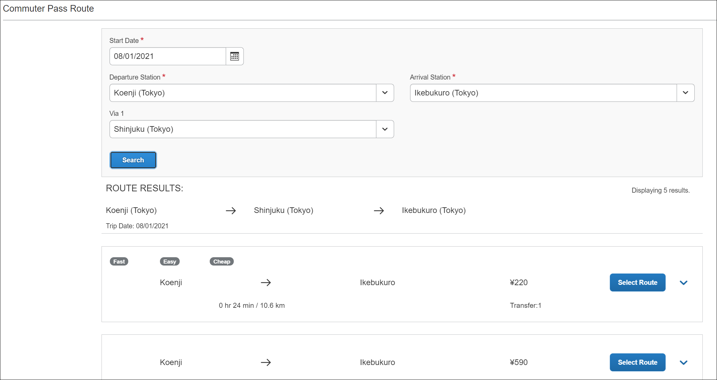
- One or more routes are returned by Ekispert for selection. Choose the route matched with your commuter pass, and then click Add Commuter Pass.
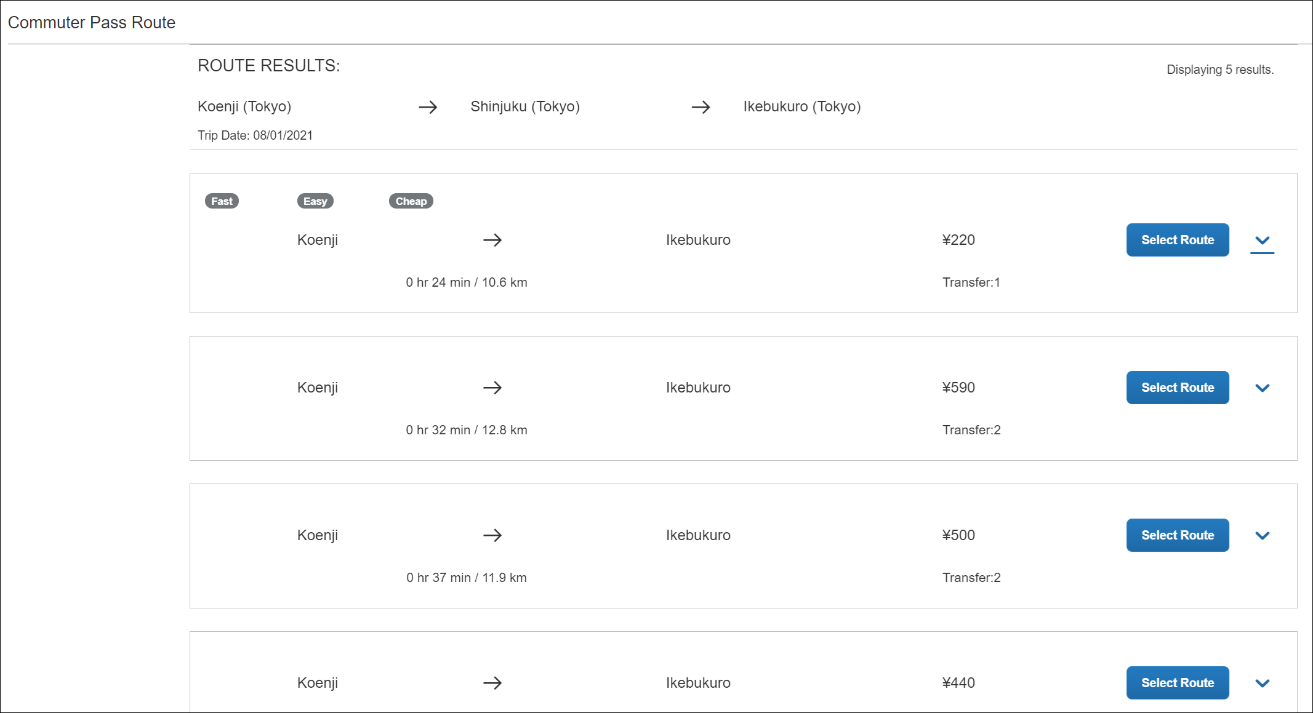
The route is added to the list of routes in the Commuter Pass Routes screen. If the route is not associated with a commuter pass subscription or by the date, no route is returned.
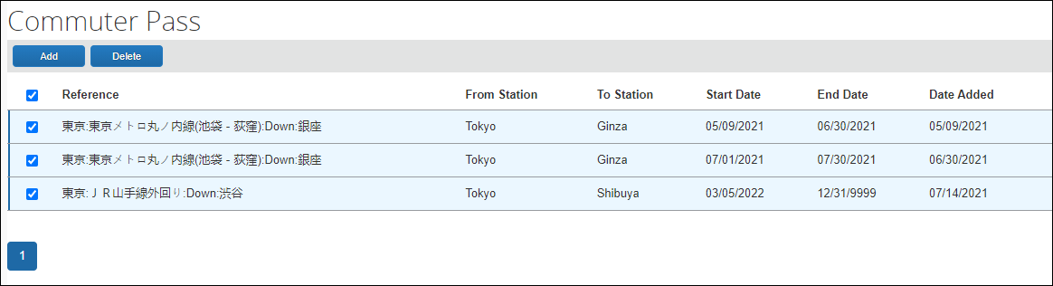
To delete commuter pass routes:
- Click Profile > Profile Settings > Commuter Pass Routes (under Expense Settings).
- On the Commuter Pass page, select the route or route(s) to delete and click Delete.
- In the Delete dialog box, click Yes to remove these routes from the list.

☼

