
Concur Expense: Company Card & Company Bill Statement Administrator
User Guide
Last Revised: December 20, 2019
Applies to these SAP Concur solutions:
 Expense
 Professional/Premium edition
 Standard edition
 Travel
 Professional/Premium edition
 Standard edition
 Invoice
 Professional/Premium edition
 Standard edition
 Request
 Professional/Premium edition
 Standard edition
Table of Contents
Section 1: Permissions 1
Section 2: Overview 1
The Company Billed Statements Feature 1
Available Actions and Required Roles 2
Roles and Role Access 2
Modules Within Company Card 3
Company Card Status Designations 4
Company Card Transactions in Other Currencies 4
Section 3: Accessing the Tool 4
Section 4: Manage Card Programs Page 5
Searching for a Card Program 5
Creating a New Card Program 6
Managing the Open Statement Period 9
Section 5: Manage Accounts Page 10
Searching for a Card Account 11
Creating a New Card Account 12
Modifying an Existing Card Account 16
Assigning a Card Account 17
Effective Date and Transaction Release Period settings and CBS Accounts 17
Unassigning a Card Account 19
Deleting a Card Account 20
Before You Begin 20
Restoring a Deleted Card Account 21
Best Practice - Assigned Accounts and Transaction Date Assignment 22
Before You Begin 22
Exporting to an Excel Worksheet 23
Section 6: Manage Transactions Page 23
Using the Manage Transactions Page to Manage Company Card Transactions 23
Accessing the Manage Transactions Page 24
Viewing Company Card 24
Search Example 26
Releasing the Transactions 27
Releasing Imported and Hidden Transactions of Cash Advance Type 27
Hiding the Transactions 28
Exporting to an Excel Worksheet 28
Section 7: Manage Lodge Accounts - Overview 28
Definitions 29
Before You Begin 29
Activating Lodge Card Accounts 29
Section 8: Manage Lodge Transactions Page 30
Using the Manage Lodge Transactions Page to Manage Transactions 30
What the User Sees 30
Accessing the Manage Lodge Transactions Page 30
Viewing Lodge Transactions 31
Arrange and Filter Transaction Rows 32
Identify an Orphaned Lodge Transaction 32
Searching for Lodge Transactions 33
Assigning Lodge Transactions 33
Select The Transactions to Assign 33
Assign the Transaction to a User 34
Reassigning Lodge Transactions 34
Select The Transactions to Reassign 35
Reassign the Transaction to a Different User 35
Unassigning Lodge Transactions 36
Select the Transactions to Unassign 36
Unassign the Transaction 36
Handling Orphaned Transactions 36
Exporting to an Excel Worksheet 37
Section 9: Manage Fleet/Fuel Transactions Page 37
Section 10: Merchant Code Mapping 37
About Merchant Code Mappings 38
Merchant Code Mapping Under Company Billed Statements 38
Viewing the Merchant Code Mapping for Specific Expense Types 39
Assigning a Merchant Code Mapping to an Expense Type 39
Editing Merchant Codes 40
Removing Merchant Code Mapping from Expense Types 42
Section 11: Settings Page 43
Section 12: View Import Logs 47
Section 13: Exporting Card Data to an Excel Worksheet 50
Viewing Import Log Transaction Data in View Import Logs 50
Section 14: Configurable Color Icons 51
Available Color Choices 51
Configuration 52
Section 15: Dependencies and Limitations 52
Section 16: Effective Date versus Transaction Release Period 52
About Effective Date and Transaction Release Period 52
Strategies for Deploying Company Card Transactions 53
Case Studies 55

Revision History
Date | Notes / Comments / Changes
September 17, 2022 | Removed pre-Next Gen UI screenshots
January 21, 2022 | Updated the copyright year; no other changes; cover date not updated
January 8, 2021 | Updated the copyright; added Concur to the cover page title; cover date not updated
April 13, 2020 | Renamed the Authorization Request check box to Request on the guide’s title page.
December 20, 2019 | Updated the copyright; removed the Scoring Explanation section
January 7, 2019 | Updated the copyright; no other changes; cover date not updated
June 14, 2018 | Changed copy-down to copydown; no other changes; cover date not updated
April 5, 2018 | Changed the check boxes on the front cover; no other changes; cover date not updated
March 7 2018 | Updated the copyright; no other changes; cover date not updated
June 28 2017 | Added information about configuring the Lodge card account type.
May 31 2017 | Clarified who can download transaction details: The Card Program Administrator role assigned to the Global group can view transaction data included in the import logs generated when importing account feeds.
April 22 2017 | Added information about new Download link that exports transaction data included in the log files for an account import.
March 18 2017 | Added content from now archived Concur Expense Company Card Deployment Strategies: Effective Date vs. Transaction Release Period Fact Sheet.
February 17 2017 | Added information on improved searches, including the new option, Last Segment, on the Manage Transactions page.
January 24 2017 | Added a note that depending on your settings, employee expense type preference based on the merchant name can override the default expense type based on the merchant code.
December 14 2016 | Changed copyright and cover; no other content changes.
November 4 2016 | Updated to include the Account Code field and explain how effective and transaction release dates work with a CBS account type.
October 28 2016 | Updated the guide content to new corporate style; no content changes.
September 9 2016 | Updated the Setting tab information to reflect that only global group admins can edit the Settings tab.
January 15 2016 | Addition of the Automatically set the default business purpose Statement Report for Period (DATE) option on the Settings tab
December 11 2015 | Added the Always take the VAT from the feed even for 0 amount, if retrieved from the transaction (AMEX TMKD only) setting.
November 20 2015 | The Add New button in Merchant Code Mapping is disabled if a Parent expense type is selected, preventing incorrect mapping of parent to expense type, and the Settings Page section is updated.
August 24 2015 | Added a note about the Manage Fleet/Fuel Transactions tab
April 10 2015 | A new setting option is added to Add/Modify Card Program
January 16 2015 | A new setting is now included in the General Settings section of Settings.
November 30 2014 | Integration Administrator has changed to Import/Extract Administrator; no other content changes
October 14 2014 | Added information about the two user interfaces; no other content changes
September 12 2014 | The admin can now customize the statement report name for their Purchasing Card setup to prevent confusion and manual renaming when using multiple accounts.
May 16 2014 | The admin can now:  - Create statement periods that extend into the year using the Create Future Periods button  - Filter for view, modify, and delete these future statement periods
September 20 2013 | Change to Company Bill Statements allowing you to specify a number of days either before or after the billing end date (instead of always before).
August 23 2013 | Additional countries now supported for the Purchasing Card program.
April 26 2013 | A new setting is now included in the Company Bill Statements section of Settings.
March 22 2013 | A new setting is now included in the Company Bill Statements section of Settings.
December 28 2012 | Made rebranding and/or copyright changes; no content changes
November 16 2012 | Addition of:  - Additional Company Billed Statement documentation  - New options in Manage Accounts page to support the Virtual Card Account (VCA) and other managed cards of this type.
August 17 2012 | A new search check box, Include Cancelled Accounts, lets the Company Card administrator include or exclude accounts of this type.
June 22 2012 | A new setting is now included in the General section of Settings.
May 18 2012 | Additions for the Company Bill Statement Reports feature, including the Manage Card Programs tab.  Addition of the Send to Excel functionality available from selected tabs in Company Card  New settings are now included in the General section of Settings
March 23 2012 | Remove information of bulk assignment on Manage Accounts page - assignment is now restricted to one account per user at a time.
February 2012 | Changed copyright; no content change
November 23 2011 | The Merchant Code Mapping tool is now moved to the new current interface.  The Company Card administrator role is now Group aware, and is limited to working with only those transactions and employees who fall into the same Group Hierarchy node. This means:  - Admin sees and can assign only to employees in their Group  - Admin edits only accounts & transactions linked to users in their Group
June 17 2011 | The administrator can now restore (reactivate) a deleted card account.  Remove setting Default employee setting to prompt for company card transactions from Settings tab (this was done in May of 2011).
March 18 2011 | Clarify that imported company card transactions mapped to cash advance will be hidden in Company Card > Manage Transactions if the user they are to be assigned to does not have a cash advance account code set up.
December 31 2010 | Updated the copyright and made rebranding changes; no content changes.
Nov 2010 (SU61) | Navigation to the Company Card page has changed - the link is now on the Expense Tools > Company Card menu.
July 2010 (SU57) | Add information about new Unassign a Lodge Transaction to document.
May 2010 (SU55) | Update the View Import Logs section.
Apr. 2010 (SU54) | This document now includes all information from the Expense: Company Card Administrator (Manage Transactions and Lodge Accounts) User Guide which is to be retired.
Mar. 2010 (SU53) | The Manage Accounts and Settings page functionality is now moved to the new interface for parity with CES. These two new pages are documented with this monthly release.
Feb. 2010 (SU52) | Added information about Delete button in the Available Company Card Charges section of My Concur.
December 2009 | Changed to stand-alone user guide; no content change
Apr. 2009 (SU42) | Settings page may be used to suppress display of Company Card page in My Concur, Travel & Expense.
Feb. 2009 (SU40) | Clarified that the Transaction Release Period setting applies only to imports using a configurable importer.
Jan. 2009 (SU39) | Added information about hiding card transactions on the Manage Transactions page.
Nov. 2008 (SU37) | Added information about Lodge Accounts.
Aug. 2008 (SU34) | Added information about Diversion Accounts.
Jul. 2008 (SU 33) | Added information about the two available user interfaces:  - Classic user interface  - Current user interface
May 2008 (SU31) | Added information about support for card member listing feed in this release.
Mar. 2008 (SU29) | Cleanup; no change to content
Nov. 2007 | Further updates to Transaction Management: determination of Prior to Effective Date status
Oct. 2007 | Company Card transaction management changes: New Manage Transactions page, new fields on Assign Card(s) to Employee and Company Card Settings pages.

Company Card Administrator
NOTE: Multiple SAP Concur product versions and UI themes are available, so this content might contain images or procedures that do not precisely match your implementation. For example, when SAP Fiori UI themes are implemented, home page navigation is consolidated under the SAP Concur Home menu.

Permissions
You may or may not have the correct permissions to use this tool. You may have limited permissions, for example, you can affect only certain groups and/or use only certain options (view but not create or edit). A Card Program administrator with the Company Card administrator role as well will be able to see additional functionality within this tool. For example, the Company Card administrator role is Group-aware, meaning the admin can only work with those users and accounts and transactions that are within a common Group.
If you need to use this tool and do not have the proper permissions, contact your company's Concur administrator.
Also, be aware that some of the tasks described in this guide can be completed only by Concur. In this case, your company must initiate a service request with Concur Client Support.

Overview
The Company Card page is used by Company Card administrators to manage imported company card transactions. This includes verifying correct assignment to the user, identifying those that are incorrectly assigned or lack assignment (are orphaned), rectifying these transaction types, and releasing held transactions to an employee.
Options in this module also allow a Card Program administrator to manage statement-based card programs, including creation of card programs and management of statement periods by the Company Bill Statement administrator.
The Expense Company Card administrator can assign, manage, and configure the company card information in the entire system. However, the Company Billed Statements feature must be enabled for this role to access and manage card programs.
The clients should work with their Expense representative to enable Company Billed Statements - a contract is required to activate the feature.

The Company Billed Statements Feature
The Company Billed Statements functionality provides the company better control over statement-based card programs, such as Purchasing Cards. The Card Program administrator creates the Purchasing Card (PCard) program, providing the Card Issuer and statement frequency with start date. With the first purchasing card transaction imported, the system creates the Statement Report and sets the statement period.
Each subsequent imported transaction is added to the statement report and automatically assigned the correct expense type and Merchant Code and, if data exists, automatically itemized as well. By default, the statement report will be held until the end of the statement period at which point it can be submitted.
- Refer to Expense: Company Bill Statement Reports Setup Guide for more information about the Company Billed Statements and Purchasing Card features.

Available Actions and Required Roles
The options available within Company Card are based on the roles assigned to the administrator. For example, the Expense Company Card administrator can assign, manage, and configure the company card information in the entire system, while the Expense Card Program administrator can create and manage card programs and statement periods.

Roles and Role Access
The following roles are available:
- Company Card administrator
- Company Bill Statement User
- Company Bill Statement Approver
- Company Bill Statement Processor (Manager); (Audit)
It is important to understand which features in the Company Card module are available for each role. The following table describes access at a high-level:
Tool Area | Company Card Administrator Role can Access | Card Program Administrator can Access | Access Granted Both Roles
Manage Card Programs | No access | Access | Access
Manage Accounts | Access, but not to Purchasing card management | Access | Access (all accounts)
Manage Transactions | Access, but not to Purchasing card transactions | Access (Purchasing Card only) | Access (all transactions)
Manage Lodge Transactions | Access | No access | Access
Merchant Code Mapping | Yes, including access to policy selection if the feature has been enabled (USE_STATEMENT_  REPORTS) | Access (includes Policy access) | Access (includes Policy access)
Settings | Access | Access | Access
View Import Logs | Access | Access | Access

Modules Within Company Card
The following modules and actions are available:
- Manage Card Programs: Enables the administrator to create statement-based card programs and manage statement periods. This includes assigning card accounts to card programs.
- Manage Accounts:
- Manage Cards: Enables the administrator to manage existing company cards and register new cards.
- Assign Cards: Enables the administrator to assign or delete any unassigned company cards.
- Manage Transactions: Enables the administrator to release to the employee transactions that are being held for some reason.
- Diversion and Lodge Accounts: Enables the administrator to configure diversion or lodge accounts.
- Manage Fleet/Fuel Transactions: Enables the administrator to assign fleet/fuel transactions
- For more information, refer to the Expense: Fleet/Fuel Card Setup Guide.
- Merchant Code Mapping: Enables the administrator to assign merchant codes to the appropriate expense types for company card transactions.
- Settings: Enables the administrator to select and edit the necessary site settings that affect the company card functionality.
- View Import Logs: Enables the administrator to review the company card import logs based on run.

Company Card Status Designations
The following status assignments are applied to cards and card accounts:
Cancelled: The card account is no longer active, and is cancelled by the card issuer, typically via the card feed depending on the issuer (not all support this). The administrator can use this status to filter out this card status type in Manage Accounts.
Active: The card account is current and active and may be assigned to a user.
Assigned: The card account is assigned to a user (the administrator has rights to assign if the user is within their Group)
Unassigned: The card account is unassigned and not associated with any user (the administrator has rights to delete the account if the user is within their Group)
Deleted: The account is removed from the system by the administrator

Company Card Transactions in Other Currencies
Company card transactions billed in a currency other than the employee's reimbursement currency will import. However, the system attempts to locate the appropriate exchange rate (from the billing currency to the reimbursement currency) for conversion purposes at the time the employee attempts to assign the transaction to an expense report.
- If the Exchange Rates feature is activated and the billing currency is included in the Exchange Rates import, converted to the employee's reimbursement currency, then the transaction can be assigned to an expense report.
- If the Exchange Rates feature is not activated or if the appropriate currency has not been imported, then the transaction cannot be assigned to the report. Once the Exchange Rates feature is activated and the correct currency exchange rate is imported, the assignment process can occur.
- Refer to Expense: Currency Admin Setup Guide for more information.

Accessing the Tool
The Company Card and Company Card administrators can access the Company Card page from Tools.
To access the Company Card page:
- Click Administration > Company > Tools.
- In the left menu, click Company Card.
- Has Card Program administrator and Company Card administrator roles:
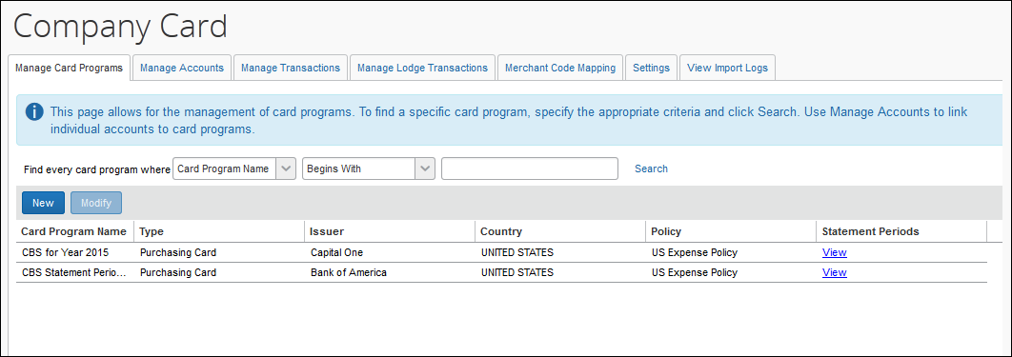
- Lacks the Card Program administrator role:
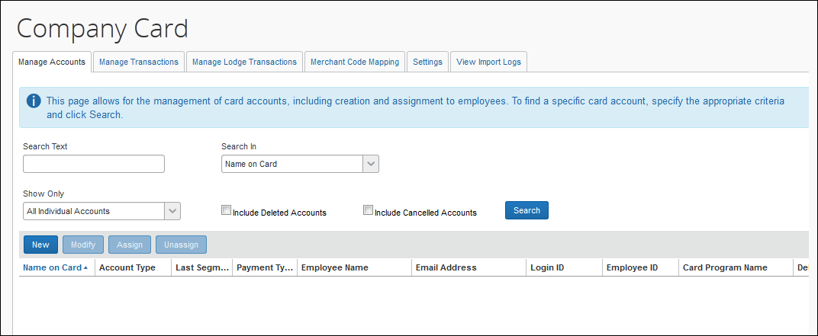

Manage Card Programs Page
The Manage Card Programs page is used to perform the following actions:
- Search for a card program
- Create a new card program or modify an existing card program
- Manage the open statement period for a card program
- Manage the date that assigns a transaction to a statement period
- Refer to Expense: Company Bill Statement Reports for more information about the Company Billed Statements and Purchasing Card features.

Searching for a Card Program
When searching for card programs, the Card Program administrator can input search criteria to return the result set.
To search for a card program:
- OPTIONAL: Refine the view by providing search criteria in the Find every card program where section:
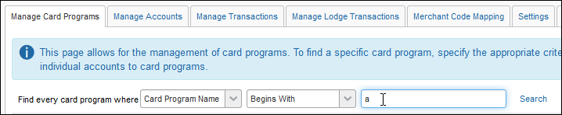
Input:
Search Field | Description/Action
Card Program Name | Enter the name of the Card Program
- Click Search, the results are listed in rows directly under the search area of the page.

Creating a New Card Program
The Card Program administrator can manually create new card programs.
To create a new card program:
- On the Manage Card Programs page, click New. The Create New Card Program dialog box appears.
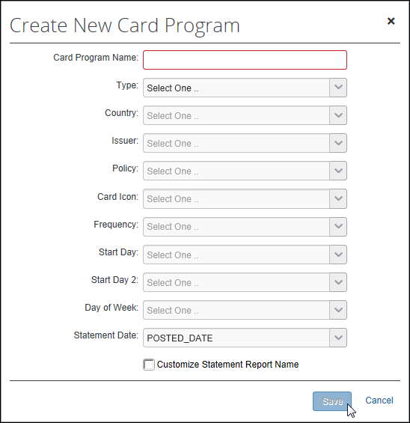
- Enter the criteria as described in the table below.
Field | Description & Notes
Card Program Name | Type the desired name of the card program
Type | Select the appropriate type
Country | Select the country in which the card program is issued.
Issuer | Select the name of the bank that issued the card program.
Policy | Select the policy that will be used for statement reports created for charges incurred with the card program.
Card Icon | Select a color that will be associated as a colored card icon to the card charges incurred with the card program. If no card color is selected, the system will default to the card icon selected for the card job definition.  - Refer to Configurable Color Icons in this document for more information about available icon colors.
Frequency | Select the frequency of the card program’s statement cycle.
Start Day | Select the day of the month on which the cycle starts. Applies to Monthly or Twice Monthly billed programs only.
Start Day 2 | Select the day of the month on which the second cycle (within the month) starts. Applies to Twice Monthly billed programs only.
Day of Week | Select the day of the week on which the cycle starts. Applies to Weekly billed programs only.
Statement Date | (Default = Posted) Select the date data type (Posted; Billing) that will be used to assign the CBS transactions to the corresponding Statement Report associated to a period.
Customize Statement Report Name | If selected, the four settings below will appear.  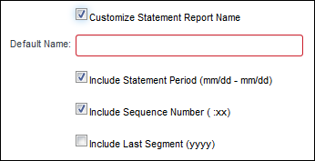
Default Name | The name, up to seventeen characters, that will be used for all statement reports generated under this account.
Include Statement Period | (Default = On) Include the start and end date of the statement report data ("mm/dd – mm/dd").
Include Sequence Number | (Default = On) Include a sequential incremental number in the name, such as ":02 or :03" to show the sequence if multiple reports are generated (for example, daily).
Include Last Segment | Include the last four numbers of the card account number.
- Click Save to save this new card program to the system.

Managing the Open Statement Period
The Card Program administrator can modify the End Date of the statement period that is currently open by clicking the View link in the statement row.
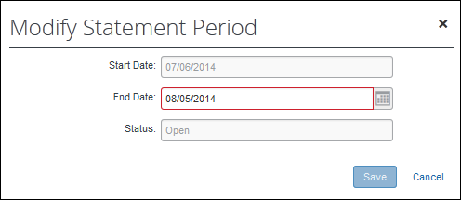
This option lets the administrator fine-tune the date in order to accommodate fluctuating statement periods due to banking holidays or other changes dictated by the Card issuer.
To modify a statement period:
- On the Manage Card Programs page, select the appropriate card program and click the View link.
- Select the open statement period and click Modify.
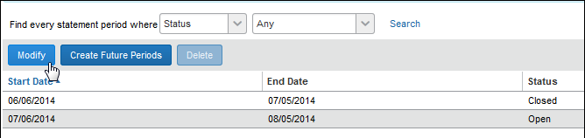
- Modify the value for End Date by choosing a new date.
- Click Save.
The next statement period will automatically start the following day.

Manage Accounts Page
Note that the user with the Card Program administrator role (only) has access to this tab, but is restricted to managing only those card accounts linked to Card Programs, and assigning only those users assigned the Statement User role.
- Refer to Roles and Role Access in this document for more information about the division of options among the available Company Card roles.
The Manage Accounts page is used to perform actions listed below:
- Search for an account, either Individual or Diversion and Lodge
- Create a new card account
- Modify an existing card account
- Assign a card account
- Unassign a card account
- Delete a card account (requires site setting for Delete button)
- Export data to an Excel Worksheet
All assign and edit actions of the Company Card admin are limited to those available within the Group hierarchy they are assigned to.

Searching for a Card Account
When searching for accounts, the Company Card administrator can input search criteria relative to either card accounts or employees to return the result set.
The administrator is limited to working with accounts tied to users within that administrator's Group hierarchy node.
To search for a card account:
- On the Company Card page, click the Manage Accounts tab.
- Enter the search criteria as described in the table below.
Search Field | Description/Action
Search Text | Type the search text that will return the card accounts you want to view, for example "Miller" for an employee name, or "1234" as the last segment of the account number.
Search In | Specify where the search should look for the search text you have entered.
Search By Card Program Type | Specify if the search should be for all card program types, or restrict the search to Purchasing Card programs only.
Show Only | Available Options
Show Only | All Individual and Managing Accounts: All accounts that meet the search criteria and are in the card admin's hierarchy (for assigned accounts).
Show Only | Assigned Individual Accounts: All accounts that meet the search criteria and are in the card admin's hierarchy.
Show Only | Unassigned Individual Accounts: All accounts that meet the search criteria -- these accounts have not yet been assigned to a user so there is no associated hierarchy.
Show Only | Diversion and Lodge Accounts: All accounts that meet the search criteria -- these accounts are never assigned to a user so there is no associated hierarchy.
Include Deleted Accounts | Prevent (clear; the default) or include (select) the display of card accounts with a system status of Deleted in the search results.
Include Cancelled Accounts | Prevent (clear; the default) or include (select) the display of card accounts with a system status of Cancelled in the search results.
- Click the Search button, the results are listed in rows directly under the search area of the page:
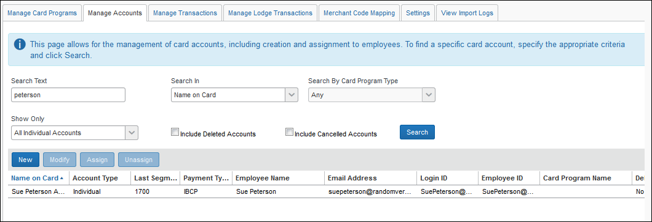

Creating a New Card Account
The Expense Company Card administrator can manually register new company cards to specific users within a shared Group from this area. When creating a new card account the administrator has the option of creating and assigning the account with a single action. This is described in the procedure below.
If the Expense Company Card administrator manually enters a company card that is subsequently imported during the company card import process, the imported card will overwrite the manually entered name. However, a card member listing feed will never override a card assignment. Instead, a warning message is generated noting current card assignment and other information.
To create a new card account:
- On the Manage Accounts page, click New. The Create New Card Account dialog box appears.
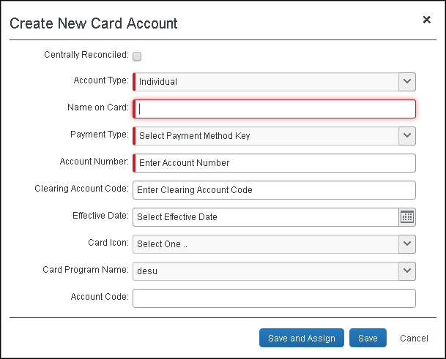
- Enter the criteria as described in the table below.
Field | Description/Action
Account Type | Choose the type of account.
Name on Card | Type the employee's name, exactly as it appears on the card.
Payment Type | Select the payment type for the new card from within the Payment Type dropdown list.  NOTE: The Payment Type list contains only payment types that have associated company card import feeds.  - For more information on adding and editing Payment Types, refer to the Expense: Payment Types Setup Guide.
Account Number | Enter the new company card number into the Account Number field, using only numeric characters (such as, 123445678975).  NOTE: Company card numbers are not validated within the Expense system to ensure that they are legitimate charge card numbers; however, they are verified to make sure they are between 14 and 16 characters in length.
Clearing Account Code | Enter a clearing account code number in the Clearing Account Code field. The clearing account code is used to book amounts in the companies ledger that the employee owes back to the company when they have charged amounts that are not going to be reimbursed on a company paid card.  NOTE: The Clearing Account Code field must be completed in order for an employee to submit a company card transaction expense in an expense report for an expense marked as a Company Billed/Company Paid (CBCP) expense. Otherwise, the employee will receive an error message stating that this field was not completed and will not be able to submit the expense report. However, if a clearing account code is already set up for the payment type, then this field does not need to be completed.
Effective Date | Enter the effective date of the card. The effective date is the date assigned by the corporate card vendor and establishes when the card is active and can be used by the card holder.  Either type the date in directly, using the MM/DD/YYYY format, or click the calendar and choose a date from the calendar image.
Card Icon | Select a color that will be associated as a colored card icon to the card account you create here. If no card color is selected, the system will default to the standard default color selections, for example Mint (AMEX), Sunset (MasterCard), and Sky (VISA) colors.  - Refer to Configurable Color Icons in this document for more information about available icon colors.
Card Program Name | Select the card program name.
Account Code | Enter the GL account code that will override any GL account assigned to any expense types. This must be done manually as there is no method to do this in the Journal Account Code field of the Standard Accounting Extract (SAE).
- Choose from two options to complete this procedure:
- Save: Click Save to save this new account to the system.
- Save and Assign: Click Save and Assign to save the account and then proceed to assign the new account to an employee within your Group.
When using this option, the Assign Account with Name on Card: dialog box appears.
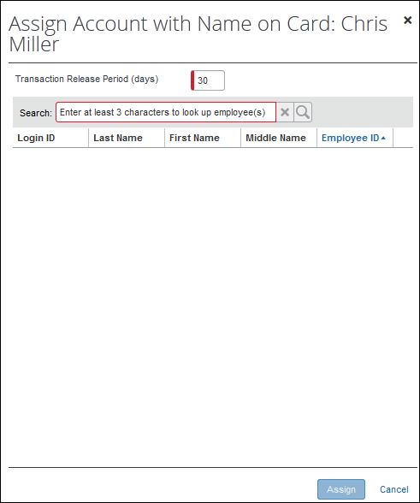
Fill out the information as required:
- Transaction Release Period (days): Enter a positive whole number from 1 to 999. This number, subtracted from the date of card assignment, specifies the beginning of the date range in which a transaction's post date must fall for the transaction to be released to the user at card assignment. The date of card assignment represents the end of that date range.
- The Transaction Release Period setting applies only to those transactions imported using a configurable importer. Refer to Settings in this guide for more information on the Transaction Release setting.
- Search: Enter a minimum of 3 characters of the last name of the employee you will assign the card account to. You are limited to those employees within your Group hierarchy.

Modifying an Existing Card Account
When modifications to an existing card account are required use the Modify button to open the selected account and perform the changes. Only card accounts assigned to users within the administrator's Group are available for edit.
To modify an existing card account:
- On the Manage Accounts page, enter the appropriate search criteria to locate an account, then click Search.
- Select the desired record.
- Click Modify.
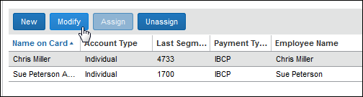
The Modify Card Account dialog box appears.
- Edit the values as needed to change the name on the account, payment type, clearing account code, or effective start date.
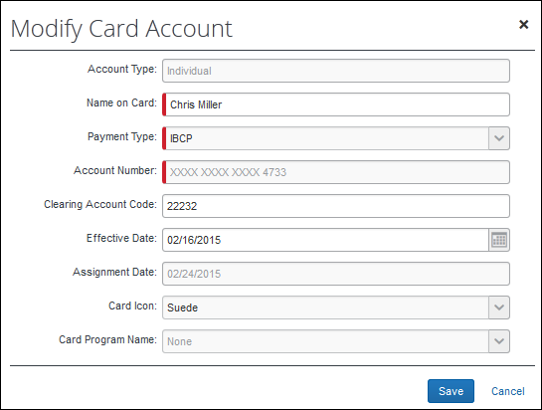
- Click Save.

Assigning a Card Account
The Expense Company Card administrator can view all unassigned card accounts, but can only assign unassigned cards one at a time to employees within their common Group assignment (admin, and user). The list of unassigned cards comes from company card import and card member listing feeds received from the credit card vendors and from new cards that have been registered but not yet assigned. These cards may already have the employee's name, but they are not associated with that employee in Expense. After the card is assigned to the employee, transaction information associated with that card appears in Expense.
- To learn how to create and assign a card account in a single step, refer to the Creating a New Card Account section in this document.

Effective Date and Transaction Release Period settings and CBS Accounts
The Effective Data and Transaction Release Period settings do not apply to the Company Bill Statements (CBS) account type, and transactions for a statement period prior to the current period are automatically hidden from the user.
- For examples and strategies related to effective date versus transaction release period, refer to the Effective Date versus Transaction Release Period section of this document.
To assign a card account:
- On the Manage Accounts page, enter the appropriate search criteria to return the card record(s), then click Search.
- Select a record from the rows that display.
You may assign only one card account at a time.
- Click Assign.
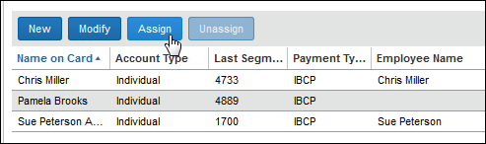
The Assign Account with Name on Card dialog box displays.
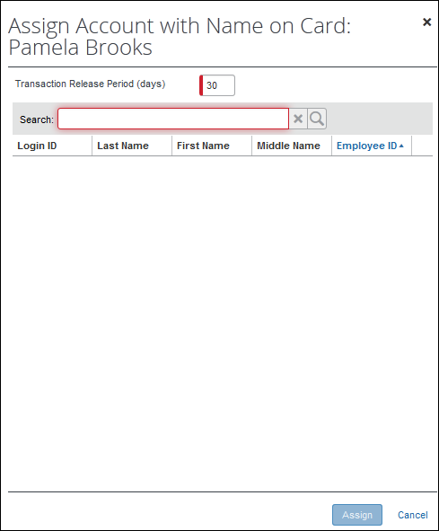
- Input the following information:
- Transaction Release Period (days): Enter a positive whole number from 1 to 999. This number, subtracted from the date of card assignment, specifies the beginning of the date range in which a transaction's post date must fall for the transaction to be released to the user at card assignment. The date of card assignment represents the end of that date range.
- The Transaction Release Period setting applies only to those transactions imported using a configurable importer. Refer to Settings in this guide for more information on the Transaction Release setting.
- Search: Enter a minimum of 3 characters of the last name of the employee you will assign the card account to - the result set is limited to those employees in the same Group as the administrator performing the search.
- Click Assign.

Unassigning a Card Account
The administrator has the ability to unassign a company card from a user and return it to the list of unassigned cards if the administrator and user share a common Group assignment. The administrator can remove a company card assignment from an employee within the Company Cards page. Once the card is unassigned, it can be reassigned to another employee if they also share the same Group assignment.
If a company card is unassigned from an employee and its transactions exist in an expense report, the transactions will remain assigned or associated with the report until the employee manually removes the entries. If the employee removes the transactions from the existing report, the transaction data will become available for the next employee assigned to that company card. Additionally, if a company card is unassigned from an employee, all transactions that have not been assigned or associated with a submitted report become unassigned.
To unassign an existing card:
- On the Manage Accounts page, enter the appropriate search criteria to locate an employee, then click Search.
- Select a record from the rows that display.
- Click Unassign.
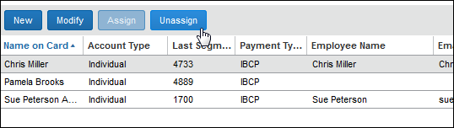
A verification dialog box displays.
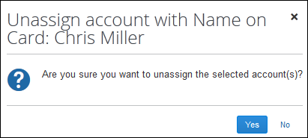
- Click Yes.

Deleting a Card Account
The administrator has the ability to delete any card accounts if they are no longer being used within the company and the assigned user shares the same Group assignment as the administrator. The card account status can be either assigned or unassigned.
The company card is soft deleted from the system. This means that the information remains in the system, but is removed from the employee's view. Additionally, it will not reappear even if the company card account appears in subsequent feeds.

Before You Begin
The Delete button is only available to the administrator if the setting Allow card accounts to be deleted has been selected on the Settings tab of Company Card.
- For more information, refer to the Settings Page, General Settings section of this guide.
To delete a card account:
- On the Manage Accounts page, enter the appropriate search criteria to locate a card account, then click Search.
- Select one or more records from the rows that display.
- Click Delete.
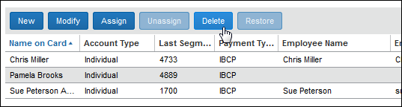
A confirmation dialog box displays.
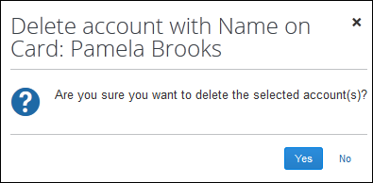
- Click Yes to delete the selected card account(s).

Restoring a Deleted Card Account
The administrator can elect to restore (reactivate) a card account that they have previously deleted. The account can be either assigned or unassigned. If assigned, the transaction dates set using Transaction Release Period remain in effect, and transactions, such as cash advances, are recreated and are visible or hidden to the assigned employee depending on the transaction release period date range. The user the account is assigned to must share the administrator's Group assignment.
The restore functionality only displays when the Allow card accounts to be deleted setting is enabled in Company Card > Settings tab.
TIP: Use the Include Deleted Accounts search criteria to display card accounts of this type.
As a reminder, the Transaction Release Period definition is repeated below:
Transaction Release Period (days): This number, subtracted from the date of card restoration, specifies the beginning of the date range in which a transaction's post date must fall for the transaction to be released to the user at card restoration. The date of card assignment represents the end of that date range.

Best Practice - Assigned Accounts and Transaction Date Assignment
To avoid inheriting existing card account transaction period dates that control what transactions will now appear to the assigned user, consider unassigning the deleted account prior to restoring it - this removes these date restrictions and associated (re)creation of cash advances, allowing the administrator to reset these dates on new assignment to another user in the same Group as the administrator.

Before You Begin
The Delete button is only available to the administrator if the setting Allow card accounts to be deleted has been selected on the Settings tab of Company Card. Refer to the section Settings Page > General Settings for more information.
To restore a card account:
- On the Manage Accounts page, enter the appropriate search criteria to locate a card account, being sure to select the Include Deleted Accounts check box, then click Search.
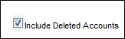
- Select one or more records from the rows that display.
TIP: The Deleted? column indicates what card accounts have been deleted with a Yes value.
- Click Restore.
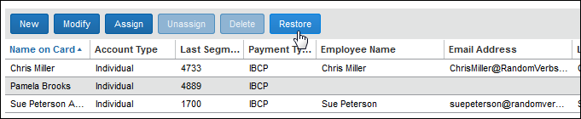
- Click Yes in the confirmation dialog box that appears.
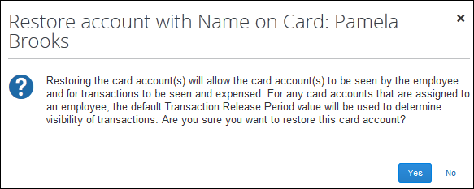
The account is now restored and is visible to either the assigned employee or as an unassigned account to the administrator for future assignment.
In addition:
- The existing values for Transaction Release Period are in effect if the card is assigned to a user
- Cash advance records (if applicable) are automatically created for cash advance transactions existing at the time of deletion

Exporting to an Excel Worksheet
You can export card account data displayed in rows following a search. Exported data is presented in an Excel worksheet format that can be worked with just as any other Excel worksheet.
- Refer to Exporting Card Data to an Excel Worksheet in this document.

Manage Transactions Page
Note that the user with the Card Program administrator role (only) has access to this tab, but is restricted to managing only those charges linked to Card Programs.
- Refer to Roles and Role Access in this document for more information about the division of options among the available Company Card roles.

Using the Manage Transactions Page to Manage Company Card Transactions
The Manage Transactions page allows you to work with transactions tied to users who share your Group assignment. You can use this page to:
- Search for and select company card transactions
- Release or hide one or more transactions from the employee
- Export data to an Excel Worksheet

Accessing the Manage Transactions Page
To access the Manage Transactions page:
On the Company Card page, click the Manage Transactions tab.
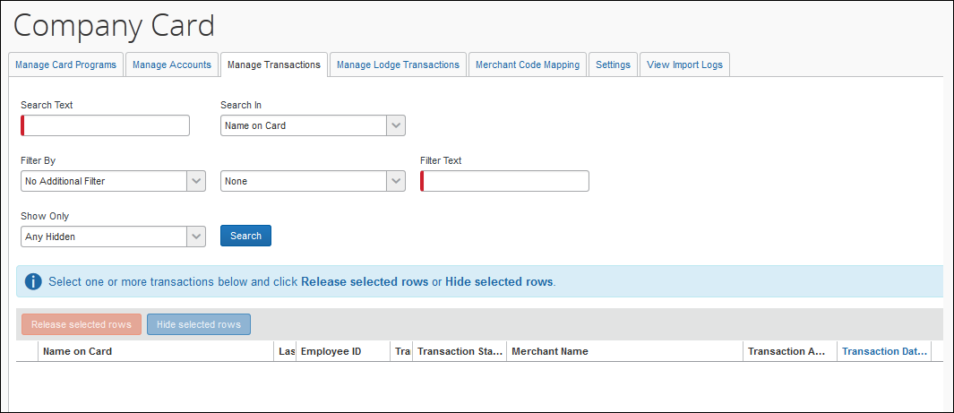

Viewing Company Card
Transactions that can be released to or hidden from an employee are displayed on the Manage Transactions page. To view the transactions, a group of search options are available to help the user specify the group of transactions they wish to work with. The default sort order is by the Name on Card value. Columns you can sort with include Cardholder Name, Last Segment, Employee ID, Transaction Type, Status, Date, and Amount, and others.
The Company Card administrator is prevented from searching for their own transactions, and can work only with transactions tied to users who share the same Group assignment.
To view one or more company card transactions:
- Click Manage Transactions.
- To search for one or more transactions, use the table below to fill out each field:
Field | Description/Action
Search Text | Required: Type the unique search string that will return the search results for company card transactions you wish to view. The result set is limited to users who share the same Group assignment as the administrator.
Search In | Choose the transaction record data that will be searched for the value entered in Search Text:  - Name on Card  Type a character to begin the search; refine by adding additional characters as a filter  - Account Number (exact match)  Note: The search string must exactly match the transaction record  - Last Segment  The "last segment" is the set of four digits at the end of the account number.  - Employee ID (exact match)  Note: The search string must exactly match the transaction record
Filter By | Depending on your choice you can instruct the system to refine the search results using the following options:  - No Additional Filter: Return all matches (that is, do not filter the returns)  - Transaction Amount: Choose this option, then specify if the numeric value you enter should equal, be less or greater than, or be less or greater and also equal to the value you enter.  - Merchant Name: Choose this option, then specify if the string value you enter should return search results that begin with, contain, end with, or exactly equal the search string.
Show Only | Restrict the search results to display only those results that fall into the following categories:  - Any Hidden: Any status except Unassigned to Report  - Configuration Hidden: The transaction is of any type that the client has elected to hide from the employee. These can be Payments, Cash Advances and Bank charges.  - Potential Duplicate: The transaction may be a duplicate of another transaction that has already been imported and released. A transaction is considered a potential duplicate if it is encountered multiple times within the same feed file. The transaction is imported but hidden. If the transaction duplicates a transaction imported previously during a different job run, it is considered a duplicate and is not imported.  - Prior to Card Assignment: The posted date of the transaction was outside of the transaction release time period (the date the card was assigned to an employee less the number of days specified for the Transaction Release Period setting). For example, if the card was assigned on October 30, and the Transaction Release Period is 20 days, then a transaction that takes place before October 10 is "Prior to card assignment." The transaction is imported but hidden.  - Prior to Effective Date: The posted date of the transaction was outside of the transaction release time period (the date the card was effective less the number of days specified for the Transaction Release Period setting).  - Unassigned to Report: The transaction is visible to the user and has not been assigned to an expense report.  - User Hidden: The user has hidden the transaction on the company card screen instead of adding it to a report.
- Click Search. The transactions that match the search criteria appear in rows on the Manage Transactions page.
When the Company Card administrator finds the relevant transaction or transactions, then the Company Card Administrator can release those transactions to the card holder or hide them. Since the result set is filtered to same-Group users and activity, all actions (release, hide) are available to the administrator from this result set.

Search Example
Assume you want to return results for an employee in your Group whose name includes User, and for this employee, only those hidden transactions associated with the merchant whose name is McDonalds.
The search section of the page is populated with values that return the search results you want:
Field Name | Value to Input
Search Text | User  Only a portion of the name is required when using Name on Card - wildcards are also permitted in this field.
Filter By | M  Selecting Merchant Name changes the search criteria - in this case to Begins With, Contains, etc. The value entered need only match the criteria you select.
Show Only | Any Hidden  Other choices include User Hidden, Potential Duplicate, etc.
The search section looks like this:
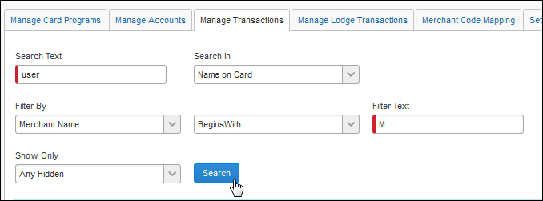
The search results appear in rows below the search area.

Releasing the Transactions
To release one or more company card transactions:
- Select the check box next to each transaction that is to be released to the card holder employee.
- Click Release Selected Rows. The selected transactions are released to the employee. The next time the employee logs on to Expense, the released transactions are available to add to a report.

Releasing Imported and Hidden Transactions of Cash Advance Type
The importer will detect if a transaction of type ATM Withdrawal is imported as a Cash Advance. However, if no cash advance account code is associated with the owner of the imported cash advance, the system allows the import, but automatically hides the transaction and allows assignment only after the account code is created for the user. At that time the administrator can search on and assign the transaction manually.

Assigning the Account Code for the Employee
The account code is assigned using options in the Administration > Company > Company Admin > User Administration page by searching for the user and providing a value for Cash Advance Account Code in Expense and Invoice Settings.
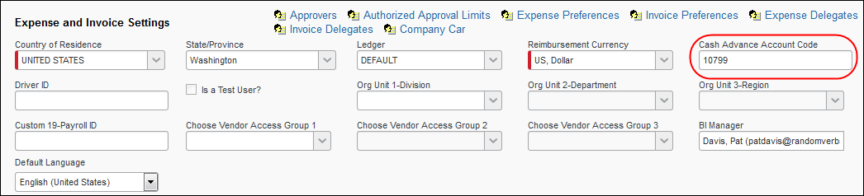

Hiding the Transactions
To hide one or more company card transactions:
- Select the check box next to each transaction that is to be hidden from the card holder employee.
- Click Hide Selected Rows. The selected transactions are hidden from the employee. The next time the employee logs on to Expense, the transactions will not appear.

Exporting to an Excel Worksheet
You can export card account data displayed in rows following a search. Exported data is presented in an Excel worksheet format that can be worked with just as any other Excel worksheet.
- Refer to Exporting Card Data to an Excel Worksheet in this document.

Manage Lodge Accounts - Overview
When a company decides to provide a single company card for travel instead of issuing multiple cards to their users they will "lodge" that card with a travel agent. In this scenario when a user requests a trip the agent includes that user's unique employee ID in the imported lodge transaction in order to link that trip to the user that requested it. This ID is carried through the lodge account import and provides the system a means to link the trip to the user.
Lodge transactions that the system cannot match and assign to an user are known as "orphaned" lodge transactions. The Manage Lodge Transactions page allows the administrator to search for and assign the orphaned transaction(s) to the correct user. They may also rectify incorrect matches by reassigning an assigned transaction to another user (where the transaction has not already been added to an expense report).

Definitions
Orphan: A lodge transaction that is imported but does not have an employee ID match. In this circumstance the transaction is considered "orphaned" and will require manual matching to a user.
Mismatched: A lodge transaction that is imported and assigned incorrectly to the wrong employee.

Before You Begin
The checklist below should be reviewed to ensure the lodge transaction feature is successful at a site:
- Be sure all lodge accounts with travel agents have a representation in the system.
- All employees drawing on a lodge account must be resident in the system.
- Employees must share a Group hierarchy assignment with the assigning administrator - review Group assignments to ensure this is so.
- Travel agents must use the correct employee ID - ensure any errors are corrected with the agent.
- The system will attempt to match an orphaned lodge transaction but may make mistakes - if an employee rejects the association determine if you can manually match the transaction and then determine where the "bad" employee ID is generated, then correct that.
- The system will notify the administrator about receiving orphaned transactions and failed jobs - this email or job status indicates a problem of either an incorrect or missing employee ID or a missing lodge account.

Activating Lodge Card Accounts
Implementation Consultants can enable the Lodge Card feature - submit a Service Request to have this done. Once enabled, the entity's CC import will identify lodge transactions in the feed and handle them appropriately. The Diversion and Lodge Accounts link will now be available via the Expense Company Card Administrator tool.
- For more information about activating Lodge card accounts, refer to the Expense: Lodge Card Setup Guide.

Manage Lodge Transactions Page

Using the Manage Lodge Transactions Page to Manage Transactions
The Manage Lodge Transactions page allows you to:
- View imported lodge account transactions not yet added to an expense report
- Search for and select orphaned and incorrectly-matched lodge transactions
- Search for users in your Group and assign the transaction to them
- Export data to an Excel Worksheet

What the User Sees
In Expense, the user adds lodge account transactions to their expense report using the same process they use for regular company card transactions.
Lodge account transactions appear in the Smart Expenses section. The user selects Add Card Charges.
The user selects the appropriate lodge account transaction and clicks Import > To Current Report or Import > To New Report:
The lodge account transactions appear on the expense report.
The user selects the lodge account transaction, and the Expense tab shows the lodge account payment type:
The employee will not be reimbursed for the charge as the payment type is that of the lodge account.

Accessing the Manage Lodge Transactions Page
The Manage Lodge Transactions tab is available only if the feature has been activated. Contact Concur directly to submit a service request to have this feature activated.
To access the Manage Lodge Transactions page:
On the Company Card page, click the Manage Lodge Transactions tab.
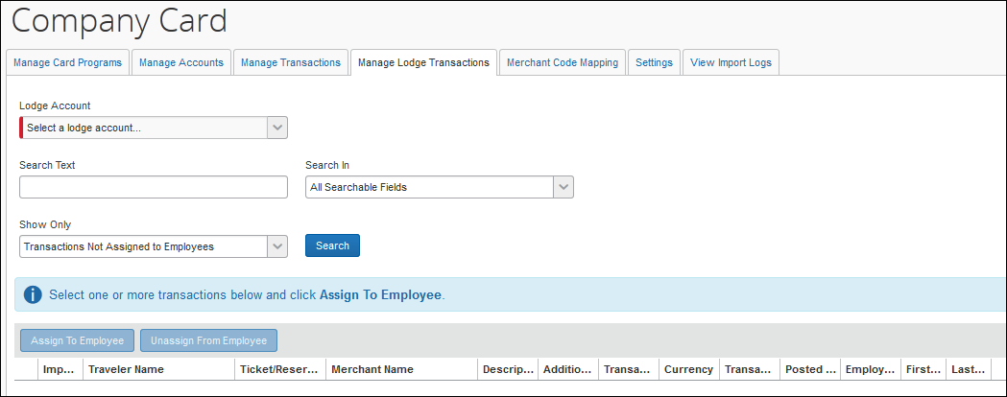

Viewing Lodge Transactions
Transactions not yet associated with an expense report are displayed on the Manage Lodge Transactions page. A lodge account is selected and rows display, each as a single lodge transaction with multiple column headings identifying traveler name, reservation number, dates, and employee identification among others.
To view a lodge account:
- Click Manage Lodge Transactions.
- Use the table below to fill out each field:
Field | Description
Lodge Account | Required: Select the imported account from this drop-down list.
Search Text | Type a unique search criteria string to filter the list to the desired transactions
Search In | Filter the string typed in Search for to search only the data included under the following columns:  - Import Run Number  - Passenger Name  - Ticket/Reservation Number  - Merchant Name  Or search all fields by selecting:  - All searchable fields (Default)
Show only | Filter the results to return:  - Transactions assigned to an employee  - Transactions not assigned to an employee (Default)
- Click Search. The transactions for the selected lodge account appear in rows directly beneath.
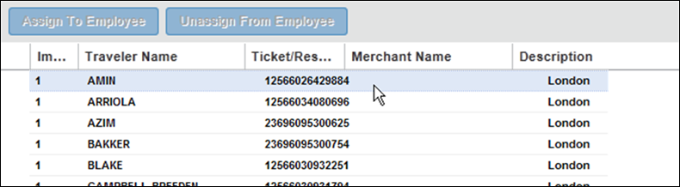
Transactions are sorted by Traveler Name by default, but may be organized by any of the available columns.
- Refer to the section Arrange and Filter Transaction Rows for more information on sorting the display of transactions.

Arrange and Filter Transaction Rows
By default transactions are arranged in alpha-order using the Traveler Name column. To order the transactions by any other column click the column and select Sort Ascending or Sort Descending - the rows will resort to match your selection. You may also add or remove columns by clicking the column and pointing to Columns. A list of available columns with check boxes appears. Select or clear a check box to display or hide the column respectively.
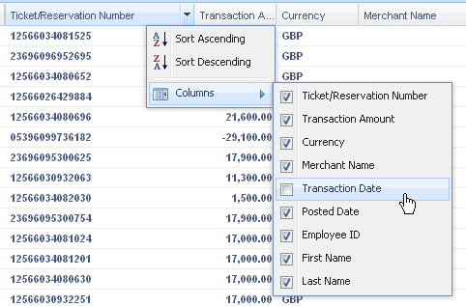

Identify an Orphaned Lodge Transaction
An orphaned transaction is identified by the lack of any value under Employee ID. This means that to identify an orphaned transaction, first look for all transactions that lack any value under Employee ID - you can use the sort order of this column to bring all unassigned transactions to the top of the row listing.

Searching for Lodge Transactions
To search for one or more lodge transactions:
- Enter one or more characters in Search. You can use any one of the following search criteria:
- Employee ID
- Employee Last Name
- Import Run Number
- Merchant Name
- Ticket/Reservation Number
- Traveler Name
- Click Search to begin the search
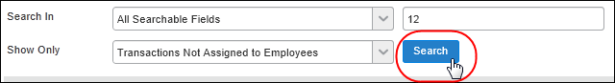
The rows are filtered to only show those transactions that match the search criteria.
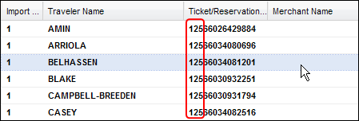

Assigning Lodge Transactions
Once the lodge transaction is identified as either orphaned or mis-assigned the transaction can be matched to the correct user within the administrator's Group. To do this, first select the transaction(s) to be assigned, then assign the transactions to a user.

Select The Transactions to Assign
To select one or more transactions:
Click one or more transactions directly - each transaction you select is highlighted to indicate it is ready for assignment (see next).
TIP: Use standard Windows Shift and Ctrl keystroke and mouse combinations to select groups of transactions.

Assign the Transaction to a User
To assign the selected transaction(s) to a user:
- Click Assign to Employee.
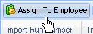
- In the Assign Selected Transactions To An Employee dialog box, type the first three characters of the employee in Search. Click the magnifying glass icon ( ) to begin the search. Click the X ( ) to clear the text box.
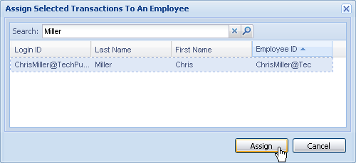
- In the search results rows, select an employee (only one may be selected) by clicking the row directly (this activates the Assign button).
TIP: Use the columns to sort the employee search result set in order to find an employee.
- Click Assign. The transaction is assigned and you are returned to the Manage Lodge Transactions page.

Reassigning Lodge Transactions
A Lodge transaction that is already assigned can be assigned to another employee who also shares the same Group assignment as the current user and assignor (administrator). To do this, first select the transaction(s) and then use the Assign to Employee function to reassign the transaction.

Select The Transactions to Reassign
To select one or more transactions:
Click one or more transactions directly - each transaction you select is highlighted to indicate it is ready for assignment (see next).
TIP: Use standard Windows Shift and Ctrl keystroke and mouse combinations to select groups of transactions.

Reassign the Transaction to a Different User
To reassign the selected transaction(s) to a user:
- Click Assign to Employee.
- In the Assign Selected Transactions To An Employee dialog box, type the first three characters of the employee in Search. Click the magnifying glass icon ( ) to begin the search. Click the X ( ) to clear the text box.
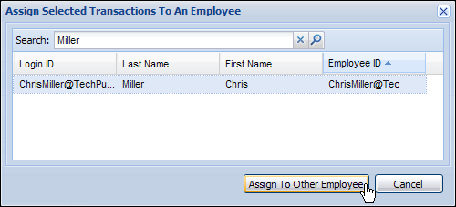
- In the search results rows, select an employee (only one may be selected) by clicking the row directly (this activates the Assign To Other Employee button).
TIP: Use the columns to sort the employee search result set in order to find an employee.
- Click Assign To Other Employee. The transaction is assigned and you are returned to the Manage Lodge Transactions page.

Unassigning Lodge Transactions
The following procedure allows an assigned transaction to be unassigned and placed into the orphaned transaction queue. This is useful whenever a mis-assigned transaction requires that the transaction be unassigned and put in a "standby" mode until the correct employee can be found to assign the transaction to. The administrator can only take action on those transactions associated with a user who shares the same Group assignment.

Select the Transactions to Unassign
To select one or more transactions:
Click one or more transactions directly - each transaction you select is highlighted to indicate it is ready for assignment (see next).
TIP: Use standard Windows Shift and Ctrl keystroke and mouse combinations to select groups of transactions.

Unassign the Transaction
To unassign the selected transaction(s) from a user:
- Click Unassign From Employee.
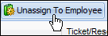
- In the confirmation dialog box that appears, click OK.
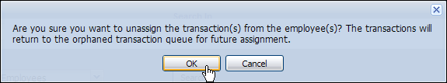

Handling Orphaned Transactions
If the employee ID in the imported lodge account transaction is either incorrect or missing, an orphaned transaction results. Under these circumstances the system will take the following action:
- The system attempts to match any employee information provided in the transaction with a "Name" field, such as Passenger Name. An exact match causes the transaction to be associated with that user and they are sent email that a transaction is now attributed to them.
- If no match can be made, the transaction is imported and dropped into a general account for orphaned transactions. Email is sent to the Company Card administrator that an orphaned lodge transaction has been received.
- If the system does not find the lodge account that the lodge transaction specifies, the transaction is not imported, a warning is entered in Job Details, and processing of the feed is continued. The job is marked as Failed to bring attention to the problem.

Exporting to an Excel Worksheet
You can export card account data displayed in rows following a search. Exported data is presented in an Excel worksheet format that can be worked with just as any other Excel worksheet.
- Refer to Exporting Card Data to an Excel Worksheet in this document.

Manage Fleet/Fuel Transactions Page
The Manage Fleet/Fuel Transactions tab appears only for clients using a specific type of fleet/fuel card feed.
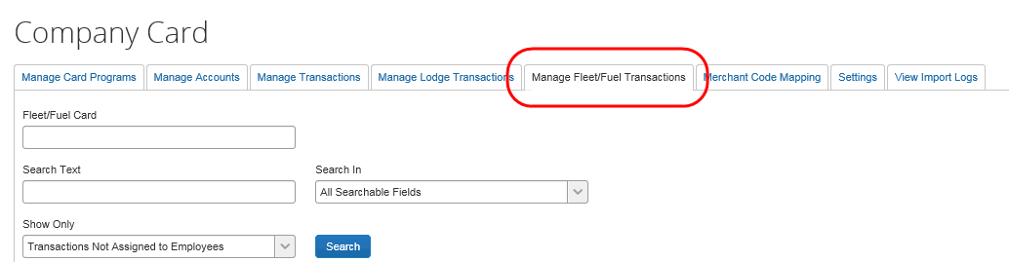
- For more information about the tab and fleet/fuel cards, refer to the Expense: Fleet/Fuel Card Setup Guide.

Merchant Code Mapping
Company card feeds use Merchant Category Codes (MCC), which are classification codes used to identify the type of business involved in the transaction. These codes are then used in the Expense Merchant Code to Expense Type Mapping table. This table is used to resolve assignment of expense types to company card transactions.
Merchant codes are not editable because they are defined by industry standards. These defined codes are preloaded into the system during the initialization process. If an unrecognized merchant code is provided in a feed, it is added to the system, and when used in an expense report, appears as "Undefined." This Undefined expense type code can be mapped like other merchant codes.

About Merchant Code Mappings
A merchant code can be assigned only to one expense type; however, an expense type may have multiple assigned merchant codes. If a company card transaction enters the system with a merchant code that is not assigned in the table, the expense type is labeled as "Undefined." The Undefined expense type is a system expense type that appears on the Add Expense page of Expense. The employee must assign the transaction to a valid expense type in the policy before the expense report can be submitted.
An employee cannot submit an expense report that contains undefined transactions.

Parent Expense Types are Prevented From Being Mapped to Merchant Codes
A merchant code is prevented by the system from being mapped to a parent expense type. While a parent expense type can be created using the Expense Types tool, no report (CBS or otherwise) can be submitted unless a valid expense type is associated with the transaction.
For this reason, the Map New button is disabled and the error message "Merchant codes cannot be associated to parent expense types or expense categories." appears if a parent expense type is selected for mapping.

Merchant Code Mapping Under Company Billed Statements
With Company Billed Statements enabled the Expense Company Card administrator can elect to further customize the mapping by the policy. For example, while all policies will honor mappings for a given merchant code, a subset of one or more policies can be selected and the merchant codes adjusted for the Expense Category and Expense Type values mapped to the merchant code.
To access the Merchant Code Mapping:
- On the Company Card page, click the Merchant Code Mapping tab. The Merchant Code Mapping to Expense Types page appears with a searchable list of all available expense types in the system.
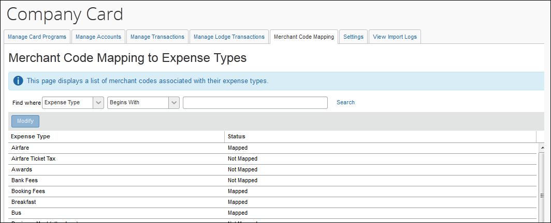
- Review the Status column to determine the expense types that are already mapped.
- Mapped: Contains mapping from a merchant code to an expense type.
- Not Mapped: Remains "Undefined" and requires mapping.

Viewing the Merchant Code Mapping for Specific Expense Types
The Expense Company Card and the Company Bill Statement administrators can review the complete list of active expense types and merchant code assignments in the system.
To view the merchant code mapping for specific expense types:
On the Merchant Code Mapping to Expense Types page, select the name of the expense in the Expense Type column, performing a search if necessary, then click Modify - the Assign Merchant Code to Expense Type page appears.
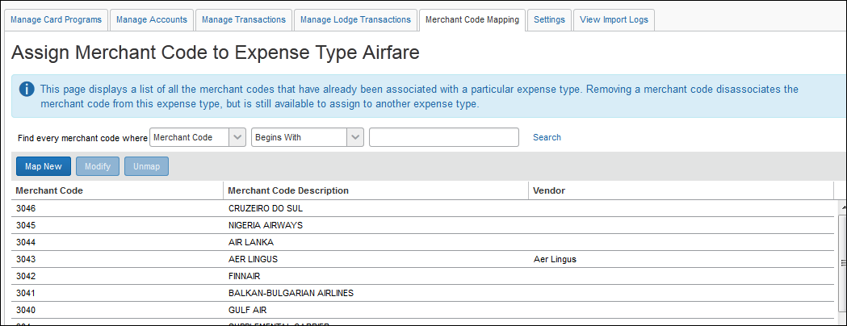

Assigning a Merchant Code Mapping to an Expense Type
A merchant code is prevented by the system from being mapped to a parent expense type. For this reason, the Map New button is disabled and the error message "Merchant codes cannot be associated to parent expense types or expense categories." appears if a parent expense type is selected for mapping.
Depending on your settings, employee expense type preference based on the merchant name can override the default expense type based on the merchant code. To review your purchasing card settings, refer to the Expense: Company Bill Statement Reports Setup Guide.
To assign a merchant code mapping to an expense type:
- On the Merchant Code Mapping to Expense Types page, select the desired expense type.
- Click Modify.
- Click Map New. The list of available Merchant Codes appears.
- Select the desired merchant code(s).
- Click Map. The Assign Merchant Code to Expense Type page appears.
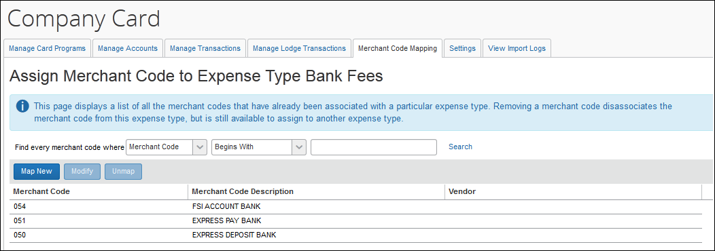

Editing Merchant Codes
To edit the merchant codes:
- On the Merchant Code Mapping to Expense Types page, select the name of the expense (Airfare, Lodging, etc.) in the Expense Type column, performing a search if necessary.
- Click Modify.
- Select a row under Merchant Code, performing a search if necessary, then click Modify.
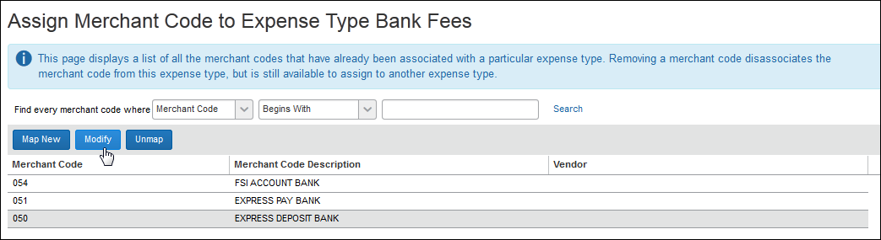
- On the Default Mapping All Policies step, make the appropriate changes - these are applied as default mapping for all active policies.
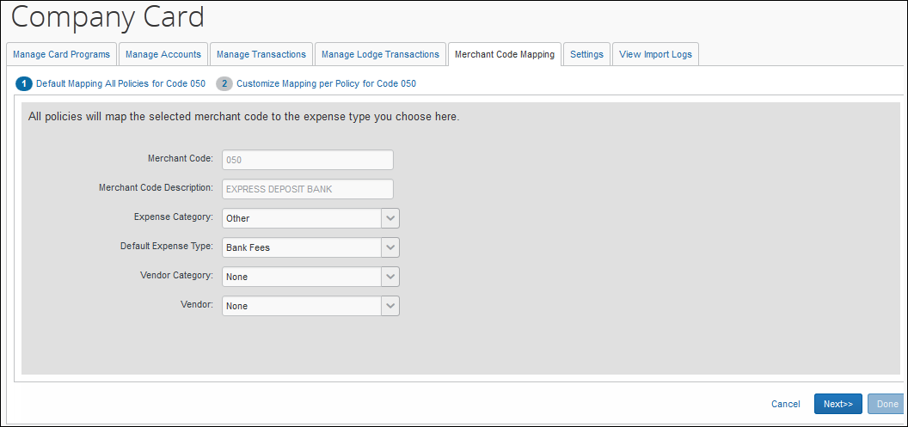
- Click Next. The Customize Mapping per Policy step appears.
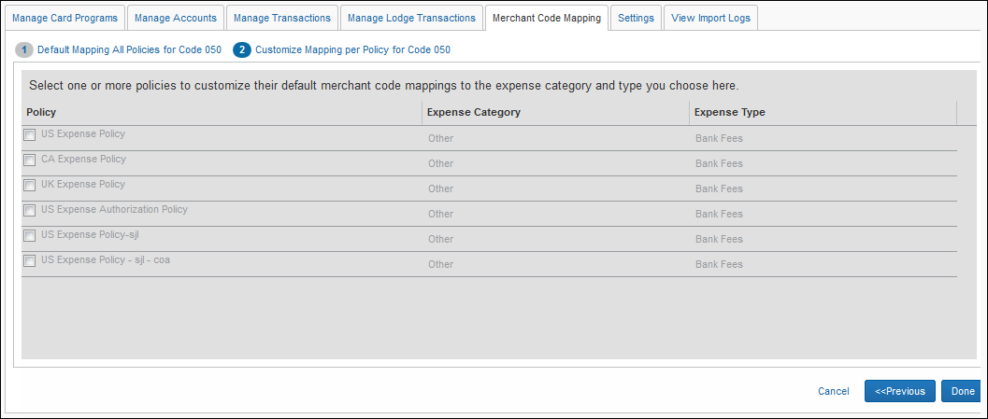
- Select a policy, then modify the default expense mappings for the merchant code using the table below:
Column | Description
Expense Category | The parent category to the expense type - when you choose a different category, the associated expense types then become available.
Expense Type | The expense type currently assigned to the expense category you have chosen above.
- Click Done to return to the Assign Merchant Code to Expense Type for <expensetype> page.
Any merchant code without an expense type assigned to it imports with an expense type of Undefined, and the employee must select the appropriate expense type.

Removing Merchant Code Mapping from Expense Types
To remove merchant code mapping from expense types:
- On the Merchant Code Mapping to Expense Types page, select desired expense type.
- Click Modify.
- Under Merchant Code, select a code.
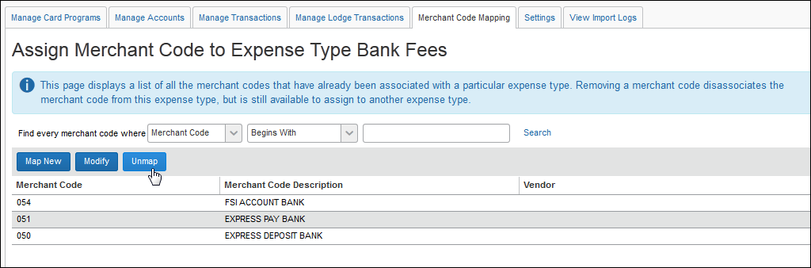
- Click Unmap; a confirmation dialog box appears.
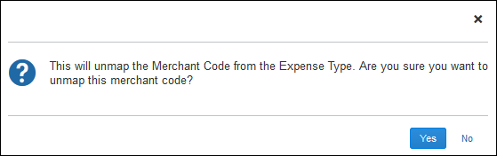
- Click Yes.
The merchant code is not deleted, but instead remains in the system for assignment to a different expense type.

Settings Page
Both the Expense Company Card and the Company Bill Statement administrators can configure and manage the site settings that affect the company card functionality by using options available on the Settings tab of Company Card Administrator.
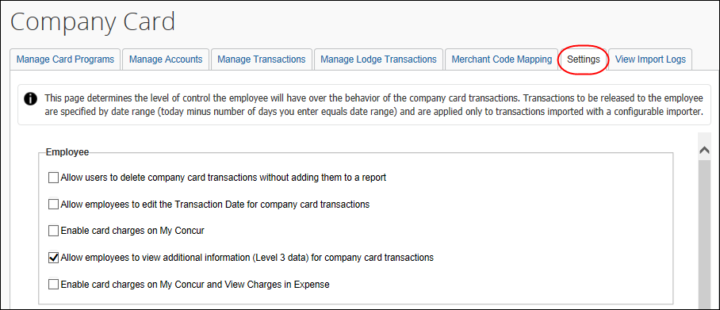
Only Expense Company Card Administrators who administer for the Global group can edit the Settings tab. Expense Company Card Administrators, who administer for one or more groups, but not for the Global group, will have read-only access to view the Settings tab.
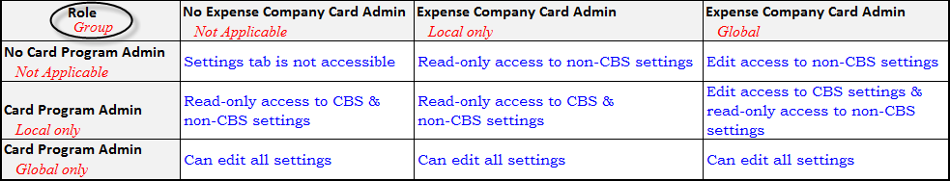
To access the company card settings:
- On the Company Card page, click the Settings tab.
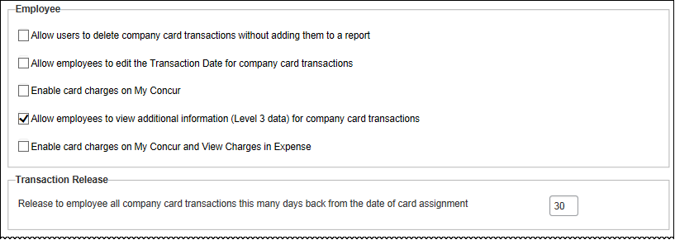
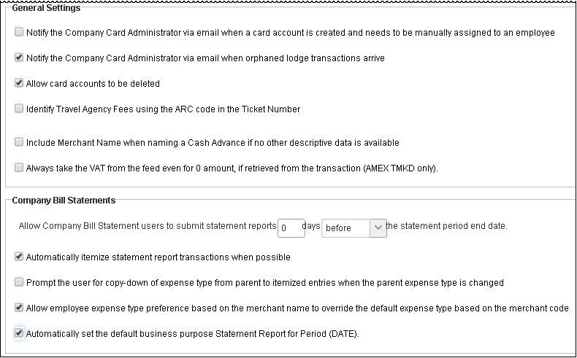
- Review the options to determine which settings apply.
Setting Name | Description/Action
Employee
Allow users to delete company card transactions without adding them to a report  Default = Enabled | When this setting is selected, a Delete link appears on the Expense Company Card Transactions page and in the Available Company Card Charges section on the Concur home page, enabling employees to delete company card transactions.  NOTES:  - Company card transactions are soft-deleted from the system. This means that the information remains in Expense, but is removed from the employee's view.  - Test users will be allowed to delete card transactions without regard to this setting, to ensure that test data may always be removed from the system as needed.
Allow employees to edit the Transaction Date for company card transactions  Default = Disabled | When this setting is selected, employees can edit the transaction date on a company card transaction. Once activated, the transaction date is displayed as an editable field on the Edit Expense page for an expense, which already contains the date provided by the card vendor. The Transaction Date, Vendor, Currency, Exchange Rate, and Amount fields are locked (an employee cannot edit them) by default on an incoming company card transaction. The Date field may be changed to be editable only by using this setting. This is useful for companies that use Travel Allowance where the date may have a one-day difference from a restaurant transaction.
Enable card changes on my Concur home page  Default = Enabled | This setting is not used in the enhanced UI.
Allow employee to view additional information (Level 3 data) for company card transactions  Default = Enabled | When this setting is selected, employees can view additional data through an information box that displays level 3 data, if it exists, for a company card transaction. This ability is available to the employee from the Company Card Transactions page, Expense List page, and Edit Entry page.  When this check box is cleared, only basic card transaction data is displayed in the pop-up window. For example, for airfare, the employee, delegate, approver, and processor can view ticket number, travel agency, seat class, and so on.
Enable card charges on my Concur home page and View Charges in Expense  Default = Enabled | This setting is not used in the enhanced UI.
Transaction Release
Release to employee all company card transactions this many days back from the date of card assignment  Default = Enabled | Enter a positive whole number from 1 to 999. Expense assigns to the employee all card account transactions falling within the date range specified by the date of card assignment less this number of days. Transactions that have a post date earlier than the first date in this range are not released to the employee, and are imported as Hidden transaction types.  NOTE: This setting applies only to those transactions imported using a configurable importer.  Example: if today is September 28, and you enter the number 20, the date range begins September 8 (September 28 minus 20 days equals September 8). All transactions that occur starting September 8 are released to the employee.  The default figure is 30.
General Settings
Notify the Company Card Administrator via email when a card account is created and needs to be manually assigned to an employee  Default = Enabled | When this setting is selected, all card administrators will receive email notification whenever a new card account is created through an import but is not yet assigned to a user (has a status of Unassigned).
Notify the Company Card Administrator via email when orphaned lodge transactions arrive  Default = Enabled | An orphaned lodge transaction is a transaction that for various reasons is not associated with a user. When you select this setting the system causes an email to be generated and sent to the Expense Company Card administrator when an orphaned transaction is imported.
Allow card accounts to be deleted  Default = Enabled | When this setting is selected the administrator is given the ability to delete a card account.
Identify Travel Agency fees using the ARC code in the ticket number  Default = Disabled | When this setting is selected the import will use logic to determine if the first 3 characters of the ARC code denote a Travel Agency fee transaction and, if so, will map this to the generic merchant code (MCC) used by Travel Agents. The MCC (4722) can be mapped to the client’s desired expense type for agency fees.
Include Merchant Name when naming a Cash Advance if no other descriptive data is available | If the imported data does not include a description of the advance, Expense will instead use the merchant name and transaction date.
Always take the VAT from the feed even for 0 amount, if retrieved from the transaction (AMEX TMKD only) | This setting only appears for clients with Central Reconciliation.  When this setting is selected, the card transactions from the AMEX TMKD feed will always use the VAT amount from the feed, without recalculating it.
Company Bill Statements
Allow Company Bill Statement users to submit statement reports “X” days <before; after> the statement period end date | Specify if statement reports should be submitted before or after the statement period end date - this allows a client to force the statement reports to be held until the end of the statement period to allow for the arrival of charges made late in the statement cycle.  As an example, if the period ends on January 30th, and you want all reports submitted for that period by the 25th, you would input the number “5” (30 – 25 = 5) and use the before parameter. To allow 5 days after, again input “5” and the after parameter.
Automatically itemize statement report transactions when possible | Select (the default) so that, on import, transactions are itemized within the statement report.
Prompt the user for copydown of expense type from parent to itemized entries when the parent expense type is changed. | Select to have the system prompt the user to copy down the changed parent expense type to the child entries. Disabled (the default), no prompt appears and no copydown action is performed when the parent expense type is changed.
Allow employee expense type preference based on the merchant name to override the default expense type based on the merchant code | Select (the default) and the system will always default to the user's preferred mapping of expense type to merchant code.
Automatically set the default business purpose Statement Report for Period (DATE) | Select (the default) to automatically fill the Business Purpose field (at Header, and via copy down) with the date period for the CBS report.  Disable this setting to prevent this behavior so that the report creator must instead provide a business purpose.  TIP: This feature is used in conjunction with the Business Purpose field which may be optionally added to forms.
- Make the necessary selections.
- Click OK.

View Import Logs
The Expense Company Card administrator can access and download the company card import logs for each company card import process, based on Run Date, Status, and Run Number, from Expense Tools.
To view the import logs:
- On the Company Cards page, click View Import Logs. The View Import Logs page appears.
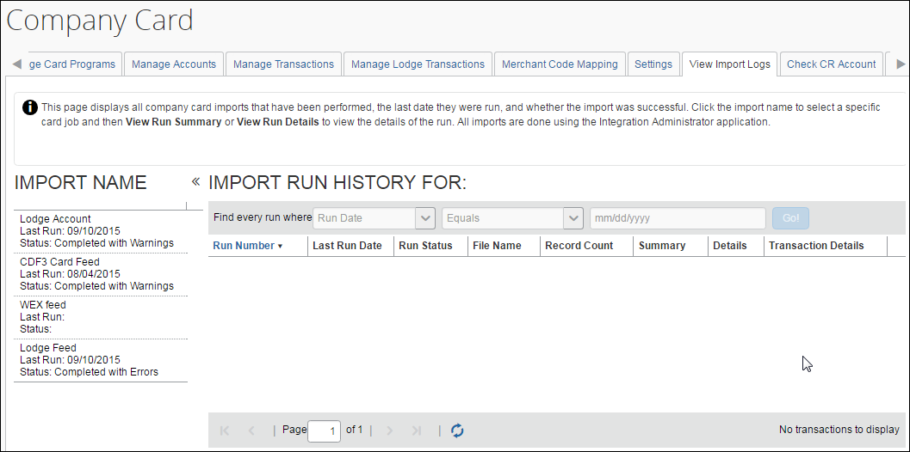
- Under Import Name, select an import job by clicking it.
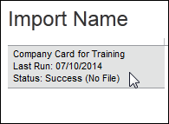
- The job appears under Import Run History For: <jobname>.
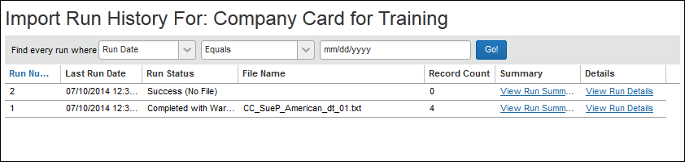
- OPTIONAL: Refine the view by providing search criteria in the Find every run where section as described in the table:
Field Name | Description
Run Date | Enter the date of the job run, then select the date filtering (Equals, Greater Than, etc.), and finally the date in mm/dd/yyyy format. Click Go.
Status | Select the run status type, then click Go.
Run Number | Enter the numbers that identify the set of job records to view, then select the number filtering (Equals, Greater Than, etc.), then finally the numbers of the job run. Click Go.
- From the search results, click an option to review the job run:
- View Run Summary: Displays the run configuration information in separate collapsible rows:
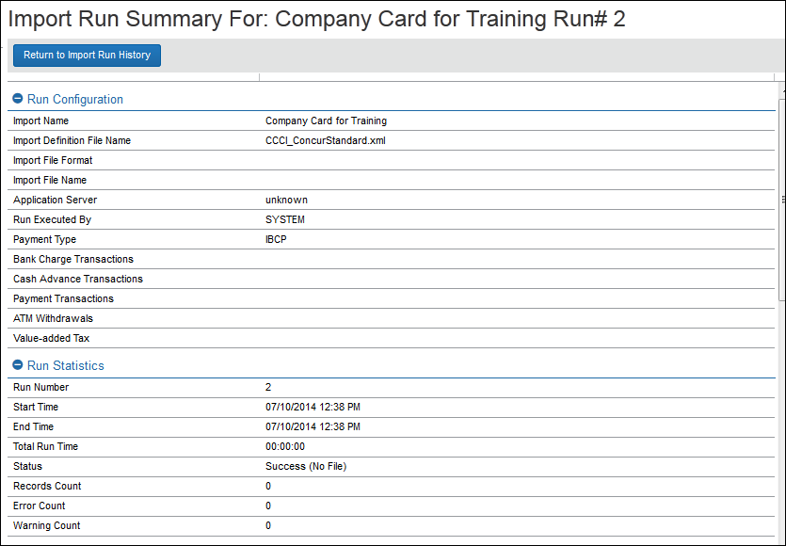
- View Run Details: Displays the logging messages generated where a job is completed with warnings:
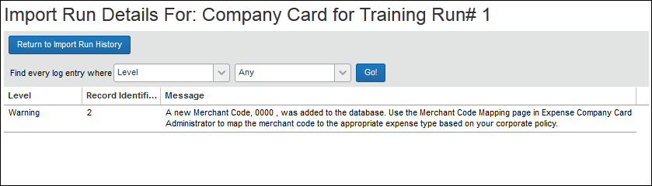
- Review the log information as needed.
- Click Return to Import Run History to return to the summary view.
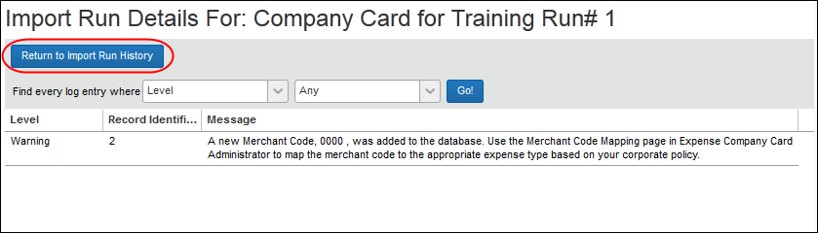

Exporting Card Data to an Excel Worksheet
You can elect to export card data displayed in rows into an Excel worksheet. Currently this functionality is supported on the Manage Accounts, Manage Transactions, Manage Lodge Transactions, and View Import Logs tabs.
To use the feature, the Company Card administrator accesses the tab and searches for the card account data they want to export to Excel. In the example below, the Company Card administrator is using this option on the Manage Lodge Transactions tab - the functionality in other tabs are virtually identical excepting the View Import Logs tab functionality (explained below).
To export card data to an Excel worksheet:
- Access the tab containing the data you want to export.
- Search for the data you want to export.
- At the bottom of the table rows, click Send to Excel.
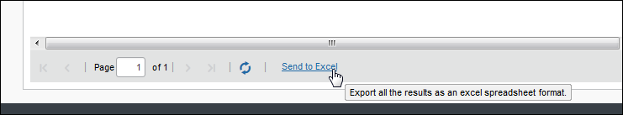
- The Save As dialog box appears; use this to specify the name of the file, and the location to which the Excel worksheet will be saved.
- Click Save to save the Excel file.

Viewing Import Log Transaction Data in View Import Logs
The Card Program Administrator role assigned to the Global group can view transaction data included in the import logs generated when importing account feeds.
To export import log transaction data to an Excel spreadsheet:
- Access the View Import Logs page.
- Under Import Name, click the import to export.
- Under Transaction Details, click Download.
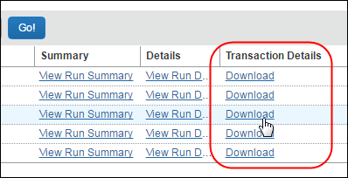
- The transaction data is now displayed in Protected View in Excel, in row format, by Transaction ID.

Configurable Color Icons
The Card administrator can assign a color to the card icon that displays when card charges appear in Available Expenses. This is helpful for users who employ multiple cards and want to know which card is responsible for the charges they are viewing.
For example, a user with both an American Express Corporate Card and a Purchasing Card (p-card) will not see any differentiation when viewing card charges in Available Expenses. With this configuration, an Iris color can be assigned to the Corporate Card and Slate for the p-card. Now, when they are displayed, the user can quickly discern which card generated the charges.

Available Color Choices
A sample of color choices are shown in the color palette below:
Name | Color | Name | Color
Sea |  | Grape | 
Iris |  | Suede | 
Peel |  | Blush | 
Slate |  | Teal | 
Sage |  | Rose | 
Standard Colors - Defaults for selected cards
Mint  (AMEX) |  | Sunset  (MasterCard) | 
Sky  VISA | 
If no card color is selected, the system will default to the card icon selected for the relevant card job definition. If the job definition did not auto-select a card icon, then the standard default color selections will be used, for example Mint (AMEX), Sunset (MasterCard), and Sky (VISA) colors.

Configuration
To configure this feature, the Import/Extract Administrator chooses the color choice when setting up the job definition. This is done by selecting a color from the Card Icon to Display drop down box.
- For more information, refer to the Shared: Import/Extract Administrator User Guide.

Dependencies and Limitations
The Expense Company Card administrator depends upon the Import/Extract Administrator to perform the company card imports. Depending on your company configuration, you may have to submit a case to Concur Client Services to have the import tasks done.

Effective Date versus Transaction Release Period

About Effective Date and Transaction Release Period
When working with the Company Card feature in Concur Expense there may be confusion regarding how the Effective Date and the Transaction Release period function. It is important to understand that the two are completely independent data points that have no direct relationship to one another in Expense. This is because the Effective Date check is performed during company card import while the Transaction Release Period setting is used at card assignment.
The Effective Date works in conjunction with the credit card feed import process and is dependent upon the running of the import process to perform its job of revealing or hiding transactions. It performs its work card feed by card feed. This is why an Effective Date cannot be retroactive to transactions loaded prior to the establishment (or modification) of the Effective Date.
EXAMPLE 1
If, on December 1st, you set an Effective Date of November 15 for a cardholder account, a card feed import on December 1st will compare the Effective Date of November 15 to the posting date of the transactions in the feed (typically November 30). Those transactions are then made visible to the cardholder. However, the visible or hidden status of transactions prior to December 1st remain unaffected: these transactions and their visibility are determined by the Transaction Release Period set at the time of card assignment (see Case 3, below).
This means that the visibility of transactions prior to the date that the card is assigned is determined solely by the setting of the Transaction Release Period, thus it is pointless to set the Effective Date for an assigned card prior to its actual assignment. If, on the other hand, you set an Effective Date that is later than the date of the card assignment, then the Effective Date will take precedence over the Transaction Release Period.
EXAMPLE 2
If, on December 1, you set an Effective Date of December 15 for a cardholder account, a card feed import on Dec 1 it will compare the Effective Date of December 15 to the posting date of the transactions in the feed (typically November 30). Those transactions will be hidden from the cardholder. This is because the Effective Date is in the future, and each card import process will evaluate the Effective Date and the Posting Date of the transaction, continuing to hide transactions until the dates of the Effective Date and Posting Date are identical. That is, the Transaction Release Period set at the time of card assignment will have no effect on the visibility of the card transactions (see Case 4, below).

Strategies for Deploying Company Card Transactions
The correct strategy for deploying company card transactions in Expense depends on the company's need to apply strict adherence to specific posting dates for cutoff/startup of card transactions.
Scenario 1
A group of new users must be assigned specific posting dates as the cutoff and startup of the card transactions
If a company requires strict adherence to specific posting dates as the cutoff/startup of card transactions for new groups of CES users, then use the Effective Date to drive the visibility of the card transactions. The one important prerequisite to using this strategy is that you be able to identify and assign card accounts to your users in advance of the Effective Date you have planned for them. When you assign the account the Effective Date must be at least one day in the future in order to ensure the first posting date is correct.
Scenario 2
Exact starting posting date not required, or you are unable to ensure cards will be assigned to cardholders in advance of Effective Date
If an exact starting posting date is not a requirement OR if you are not able to ensure that cards are assigned to all cardholders in advance of the assigned effective date, it is strongly recommended that you work with the Transaction Release Period and leave the Effective Date field empty. In practice, you can establish a "quasi- Effective Date" (plus or minus a day or two) by timing the delivery of the 600-level record and the setting of a Transaction Release Period. In this scenario, it is wise to err on the side of hiding, rather than exposing, too many transactions. This is because the Manage Transactions page in the Company Card Administrator tool allows fine tuning of transaction visibility by individual user - but only to expose transactions: the options in this page will not allow you to hide transactions that are currently visible to the user.

Case Studies
Case #1
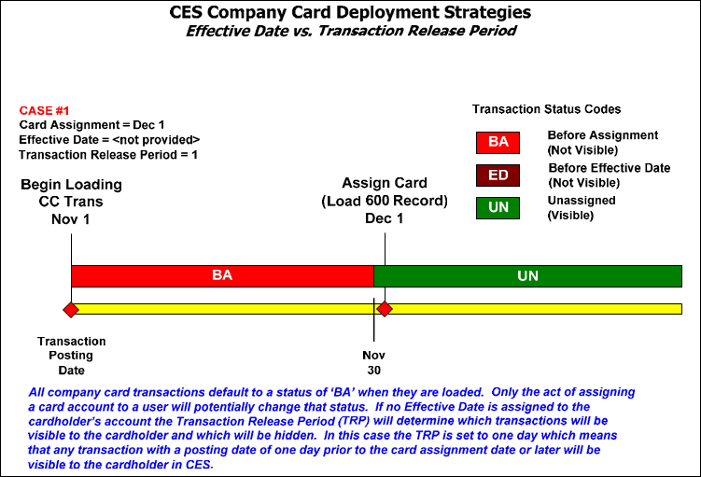
Case #2
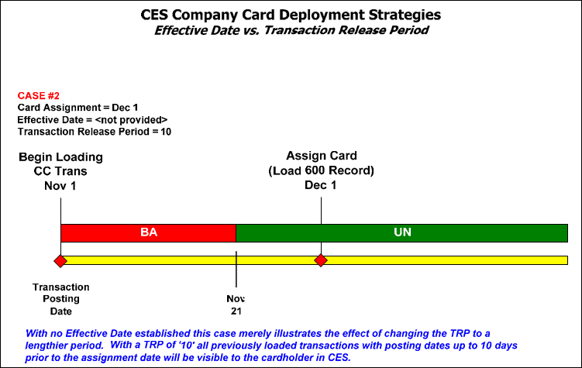
Case #3
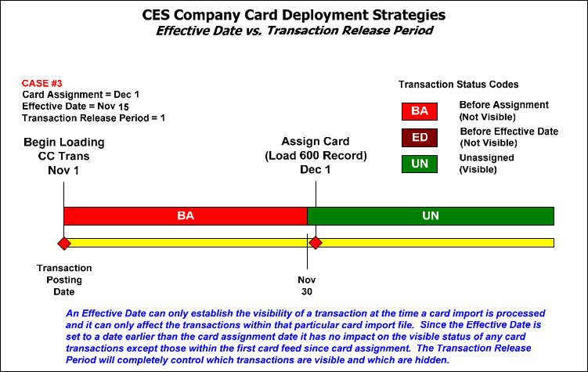
Case #4




