
Shared: Delegate Configuration
Setup Guide

Last Revised: July 18, 2023
Applies to these SAP Concur solutions:
 Expense
 Professional/Premium edition
 Standard edition
 Travel
 Professional/Premium edition
 Standard edition
 Invoice
 Professional/Premium edition
 Standard edition
 Request
 Professional/Premium edition
 Standard edition

Table of Contents
Section 1: Permissions 1
Section 2: Overview 1
Maximum Number of Assignments and Using the Expense Proxy Role 2
Terminology 2
Tracking Delegate Actions – Audit Trail 2
Section 3: Administrator Experience 2
Section 4: User Experience in Profile 4
Add a Delegate 6
Specify a Delegate Can Receive Expense Assistant Emails 7
Edit a Delegate 7
Delete a Delegate 7
View Users for Whom the User is a Delegate 7
Delete Users for Whom the User is a Delegate 8
Section 5: Delegate Experience 9
Submit or Notify 12
Not Ready For Review 13
Preview for the Approver 14
Mark As Not Reviewed 16
Email Notifications 16
Profile While Working as a Delegate 17
Manage Receipt Images 17
Section 6: Special Considerations for Delegate Configurations 17
Changing Groups 17
Important! - Manually Update Delegate Assignments for Changed Group 17
Authorized Approver Delegates 18
Changes in Limits 19
Analysis/Intelligence (formerly Concur Insight) Delegates 19
Section 7: Delegate Configuration 20
Default Configuration 20
Changing the Delegate Configuration and Delegate Assignments 20
Access Delegate Configurations 20
Create a New Delegate Configuration 21
Edit a Delegate Configuration 24
Delete a Delegate Configuration 25
Purge the System of Inactive Delegate Records 26

Revision History
Date | Notes/Comments/Changes
July 18, 2023 | Updated Section 5: Updated email Permanent approver delegates note, highlighting the Can Approve or Can Preview permissions settings.
June 16, 2023 | Updated Section 7: Delegate Configuration Creating a New Delegate Configuration with note detailing how to restrict creation and management of delegates to the User Administrator role only.
April 25, 2023 | Updated Section 5: Delegate Experience to reflect changes to the “Act As” section of the Profile menu.
September 17, 2022 | Removed Section 2: Two User Interfaces for Concur Expense End Users, Section 5: What the User Sees in Profile – Existing UI, and Section 7: What the Delegate Sees – Existing UI  Minor edits
January 21, 2022 | Updated the copyright year; no other changes; cover date not updated
April 15, 2021 | Updated the copyright year; no other changes; cover date not updated
December 3,2020 | Added a new subsection, Specify a Delegate Can Receive Expense Assistant Emails, to Section 5: What the User Sees in Profile – Existing UI.  Added a new subsection, Specify a Delegate Can Receive Expense Assistant Emails, to Section 6: What the User Sees in Profile – NextGen UI.
July 24, 2020 | Updated the Authorized Approver Delegates section to clarify the delegate role in both Concur Expense and Concur Request. A note was also added to further explain the delegate configuration option.
July 1, 2020 | Updated information about the existing UI and NextGen UI; made modifications throughout; cover revision date updated
April 27, 2020 | Renamed the Authorization Request check box to Request on the guide’s title page; cover date not updated
January 15, 2020 | Updated the copyright; no other changes; cover date not updated
December 16, 2019 | Removed reference to deprecated pause delegation feature
November 14, 2019 | Clarify that the Restrict delegate selection to user's group setting is ignored when using Add Delegate function – admin may assign any user without restriction
September 30, 2019 | Renamed the Expense: Receipt Handling – Uploaded and Emailed Images Setup Guide to Expense: Receipt Handling – Digital Receipts Setup Guide
April 23, 2019 | Updated the definition of the Restrict delegate selection to user's group setting in the Create a New Delegate Confirmation section.
April 22, 2019 | Added information about the existing UI and NextGen Expense; cover revision date updated
February 11, 2019 | Updated the copyright; no other changes; cover date not updated
April 16, 2018 | Changed the check boxes on the front cover; no other changes; cover date not updated
March 2 2018 | Updated the copyright; no other changes; cover date not updated
June 5 2017 | Clarify that a delegate inherits only those privileges allowed by the new delegate configuration associated with the user's new Employee group.
February 17 2016 | Added clarification that:  - Employees sharing a delegate configuration also share identical privileges  - If a change is made in how delegates are selected (search for eligible delegates to assign) then no change is made to existing delegates
December 14 2016 | Changed copyright and cover; no other content changes.
December 7 2016 | Updated the guide content to new corporate style; no content changes.
December 1 2016 | Added clarification regarding the need to select check boxes in addition to adding a delegate's name to the Delegates for tab.
October 27 2016 | Updated the guide content to new corporate style; no content changes.
July 13 2016 | Added a note that a single user may have a maximum of 250 delegates delegate on their behalf.
December 11 2015 | Added a Note to the information about deleting (in Profile) users for whom a user is a delegate stating that there is no email notification of this action.
November 20 2015 | Added information about deleting (in Profile) users for whom a user is a delegate.
October 16 2015 | Updated What the Delegate Sees section to match updated UI.
June 29 2015 | Clarify that Profile > Administer for… initial display shows last search return
April 29 2015 | Removed information about the old UI; no other content changes
April 17 2015 | Changed the name of Concur Insight to Analysis/Intelligence; no other content changes
January 16 2015 | Added note about the Can View Receipts option actually means view, add, delete, etc.  Added a reference to the receipt handling guides
October 3 2014 | Added information about the two user interfaces; no other content changes
March 5 2014 | Noted that the name of Analysis/Intelligence is now Concur Insight; no other content changes
January 23 2014 | Cover and copyright changes; no other content changes
April 3 3012 | Removed all references to the legacy Authorization Request feature in Concur Expense  Changed any references to Concur's Travel Request service to Request, Concur Request, or Authorization Request, depending on the situation  No other content changes
February 27 2013 | Name change from "Travel Request" to "Request" – no other content changes
December 28 2012 | Made rebranding and/or copyright changes; no content changes
November 16 2012 | Added information about enhancements for the Delegate Preview for Employee feature
September 14 2012 | Added information about:  - Delegate Preview for Approver  - Separate option for submitting travel requests
August 28 2012 | Additional general edits

Delegate Configuration
NOTE: Multiple SAP Concur product versions and UI themes are available, so this content might contain images or procedures that do not precisely match your implementation. For example, when SAP Fiori UI themes are implemented, home page navigation is consolidated under the SAP Concur Home menu.

Permissions
A company administrator may or may not have the correct permissions to use this feature. The administrator may have limited permissions, for example, they can affect only certain groups and/or use only certain options (view but not create or edit).
If a company administrator needs to use this feature and does not have the proper permissions, they should contact the company's SAP Concur administrator.
In addition, the administrator should be aware that some of the tasks described in this guide can be completed only by SAP. In this case, the client must initiate a service request with support.

Overview
- IMPORTANT: All delegates and delegate configurations are shared between Concur Expense and Concur Request.
Delegate configurations define the set of tasks (like preparing, submitting, etc.) that delegates can complete in Concur Expense and Concur Request while working on behalf of a designated user.
- In Concur Expense, these tasks apply to expense reports and cash advance requests.
- In Concur Request, these tasks apply to requests.
Delegate configurations are applied to employee group configurations in Concur Expense/ Request. A delegate configuration can be used by one or more employee group configurations, but each employee group configuration can use only one delegate configuration.
A User Administrator can assign delegates to users; users can choose their own delegates. Regardless of who assigns/chooses the delegate, they can assign only the tasks allowed by the delegate configuration for the delegate's group configuration. Finally, these tasks (privileges) are identical across all delegates working under that delegate configuration.

Maximum Number of Assignments and Using the Expense Proxy Role
Delegates are individuals acting on behalf of a named list of specific users. A reasonable maximum number of user assignments is 250 per delegate, and that is what is supported by SAP. Please use the Expense Proxy role when assigning access for shared service centers: the Expense Proxy role is designed to allow an individual user to support entire Expense groups within the system.

Terminology
Section | Description
Delegate | A Concur Expense/Concur Request user who has been granted permission to act on behalf of another Concur Expense/Concur Request user in preparing, submitting, approving, etc.
Temporary Approval Delegation | Allow a Concur Expense/Concur Request user to act as an approver for a specified period of time
Delegate Restriction to Group | Allow a Concur Expense/Concur Request user to select delegates outside of their own employee group configuration (does not apply to any delegate assigned using the Delegate For feature).

Tracking Delegate Actions – Audit Trail
While a delegate is acting on behalf of another SAP user, an audit trail is created, which tracks all of the actions performed. Details about field-level changes after the report or request is submitted are recorded and displayed.
The following actions are permanently recorded:
- Name of the person who last modified the expense report, cash advance request, request category, expense, or request
- Name of the person who submitted the report/request and the time it was submitted
- Name of the person who approved the report/request and the time it was approved

Administrator Experience
Delegates are shared between Concur Expense and Concur Request. Any additions, deletions, or changes the admin makes in Concur Expense will affect Concur Request, and vice versa.
To locate the delegate information for a user, the admin clicks Administration > Company > Company Admin, and then User Administration (left menu). Once the admin locates the desired user, the delegate information appears in the Expense and Invoice Settings section.
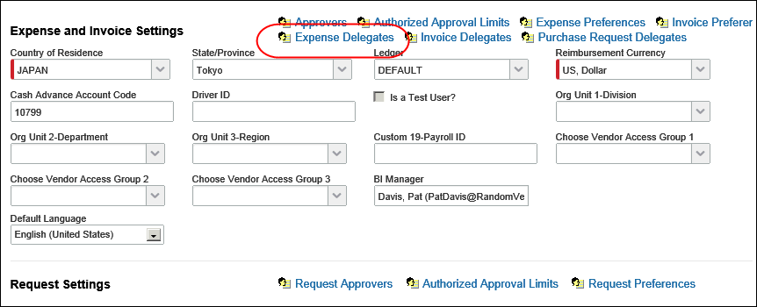
When the administrator clicks the Expense Delegates link, the Expense Delegates for <user> page appears.
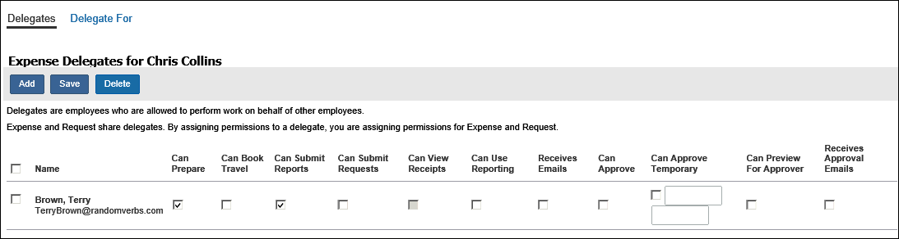
Users must grant specific permissions to their delegates by selecting the desired check boxes, such as Can Prepare. A delegate without check marks will not have sufficient access to perform delegate tasks.
Note the following:
- The page title is Expense Delegates for <user>, but it applies to Concur Expense and Concur Request.
- The columns (check boxes) that appear on this page are determined by the delegate configuration.
There are two links at the top of the page:
- Delegates: The admin uses this link to add, edit, or delete the delegates who will work on behalf of the selected employee.
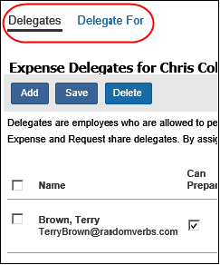
Delegate For: The admin uses this link to add, edit, or delete the users for whom the selected employee works as a delegate (note that Delegate For assignment precludes any user restrictions, for example, approval budget limiting, Group assignment, or other).
The two pages are very similar and work the same way.
- For more information about this page or for information on how to add, edit, or delete delegates within the User Administration tool, refer to the Shared: User Administration User Guide.

User Experience in Profile
If a delegate configuration exists for the employee's group configuration, in Profile:
- The Expense Delegates link appears for Concur Expense users.
- The Request Delegates link appears for Concur Request users.
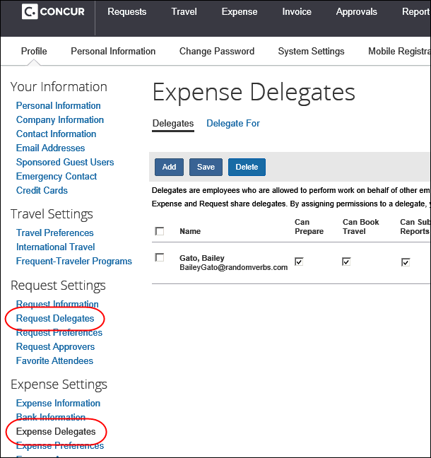
Note the following:
- If the user clicks the Expense Delegates link (left menu), the Expense Delegates page appears. If the user clicks the Request Delegates link (left menu), the Request Delegates page appears. Regardless, it is the same page.
- The columns (check boxes) that appear on this page are determined by the delegate configuration.
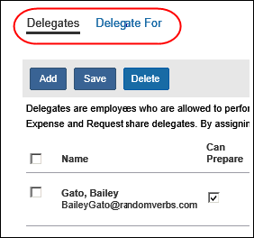
There are two links at the top of the page:
- Delegates: The employee uses this link to add, edit, or delete their delegates.
- Delegate For: The employee uses this link to view the users for whom they work for as a delegate and the assigned tasks.

Add a Delegate
On the Delegates page, the user clicks Add. The top of the page expands, providing a search field.
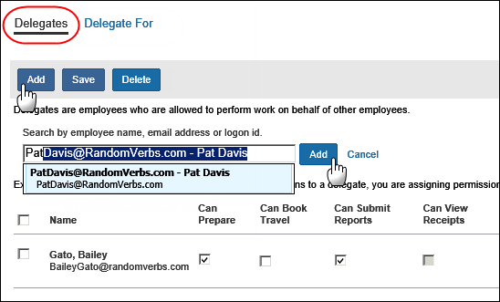
The user locates the desired delegate and clicks Add. The delegate then appears in the list of delegates.
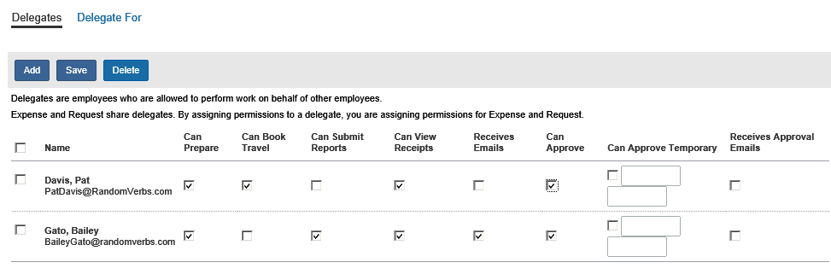
The user makes the desired selections and clicks Save. All additions are immediate after the user clicks Save.

Specify a Delegate Can Receive Expense Assistant Emails
On the Delegates page, you can specify that delegates receive the weekly Report Summary email. To add delegates to the CC line of the weekly Report Summary, Expense Assistant must be enabled.
On the Delegates page, the user must select the Receives Emails check box and then click Save. With this option selected, delegates are copied on the emails and users see those assigned delegates on the CC line of a Report Summary email.
If Expense Assistant is not enabled, the Receives Emails check box is still available for non-Expense Assistant emails.
Users will see the newly assigned delegates on the CC line of weekly Report Summary emails. Delegates also receive these emails.

Edit a Delegate
On the Delegates page, the user makes the desired changes and clicks Save. All changes are immediate after the user clicks Save.

Delete a Delegate
On the Delegates page, the user selects the desired delegate and clicks Delete. All deletions are immediate after the user confirms the deletion.

View Users for Whom the User is a Delegate
The user clicks the Delegate For link. The page displays the Concur Expense/Request users for whom they are a delegate. The check boxes (read-only) indicate the tasks the delegate can complete for the designated Concur Expense/Request user.
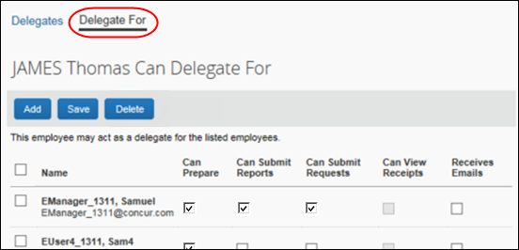
Delegate assignment precludes any restrictions, for example, approval budget limiting, Group assignment, or other.

Delete Users for Whom the User is a Delegate
On the Delegate For page, the user selects the desired delegate and clicks Delete. All deletions are immediate after the user confirms the deletion.
There is no email notification of this action.

Delegate Experience
Once a user has been assigned as a delegate, the user can immediately begin working as a delegate. The delegate clicks Profile and then, in the Act As section, selects A Delegate for another user who has granted you this permission.
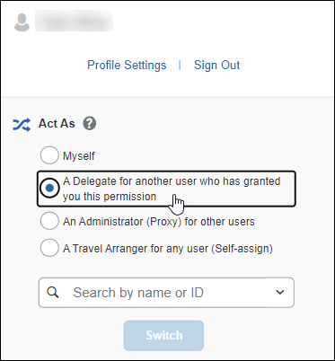
When the delegate clicks in the Search by name or ID field, if they previously acted as a delegate for any users, those users appear in the Most Recent Users list. The delegate can search for other names by entering one or more letters of the candidate's last name. The name search returns up to 80 results.
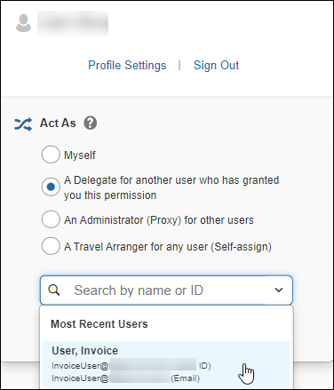
After they choose the user for whom they want to act as a delegate, the delegate clicks Switch.
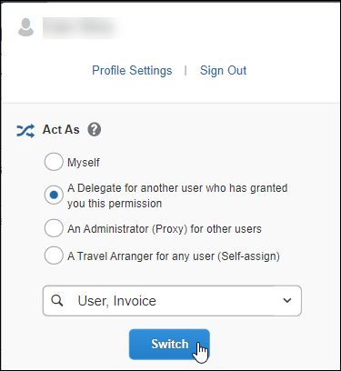
The Profile menu label then becomes Acting as <name> and the single user icon becomes a double user icon.
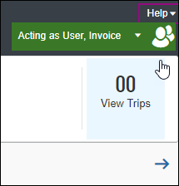
If the user has access to the Administration menu, they can perform administrative tasks without ending the delegate session. As soon as they select any Administration menu item, the delegate session is automatically paused:
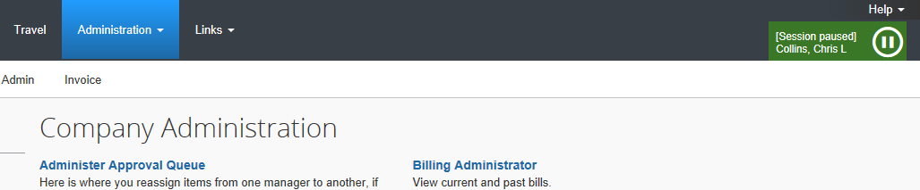
To begin working as the delegator again, the user hovers the mouse over the Pause icon, which becomes a Play icon, and clicks the Play icon.
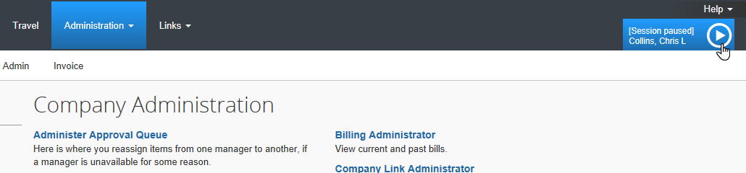
To return to working on their own behalf, the delegate clicks Myself and then clicks Switch.
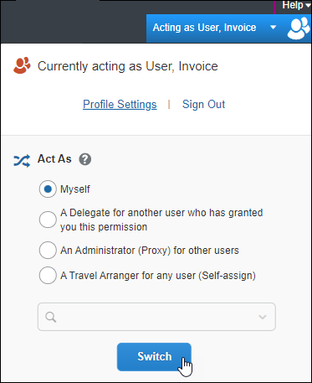

Submit or Notify
Depending on the permissions given to the delegate, they may or may not be allowed to submit a report/request after creating it.
- If allowed, the Submit Report button appears.
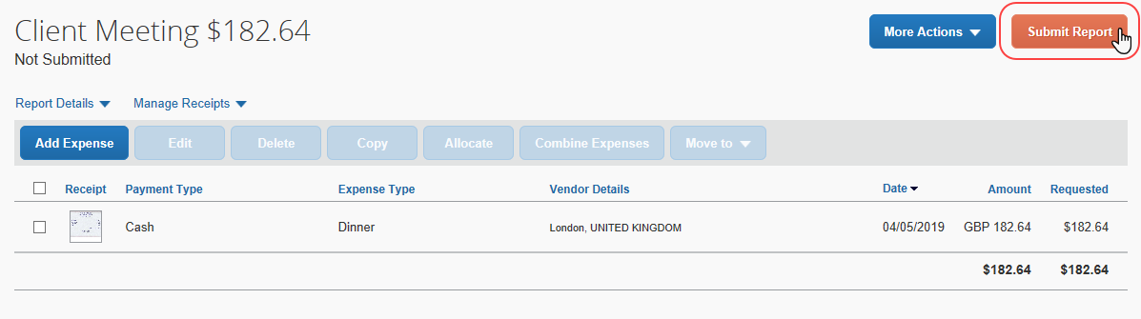
- If not allowed, the Ready for Review button appears.
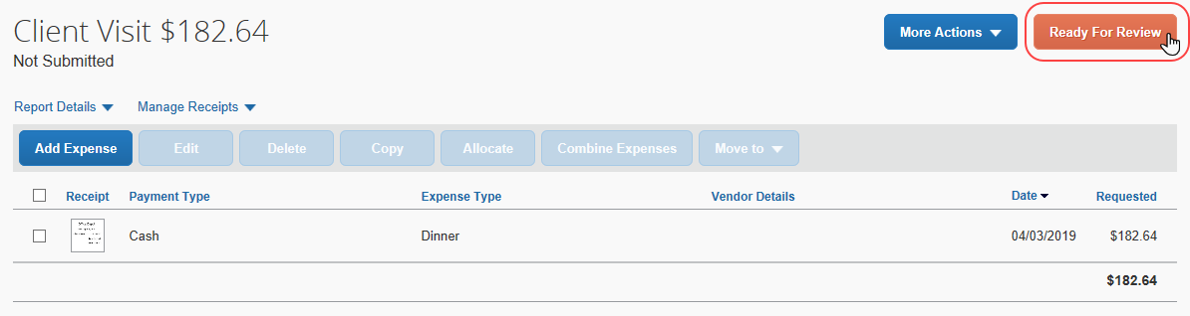
When the delegate clicks Ready for Review, the system:
- Displays a "Ready for Review" message for the user (report/request owner), wherever the report name displays, for example:
- In the My Tasks section of the home page:
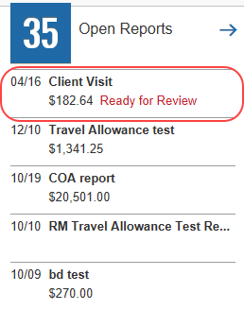
- On the report tile on the Concur Expense home page:
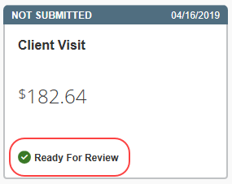
- Sends an email notification to the report/request owner indicating that the report/request is ready for review and submission
- Creates an audit trail entry
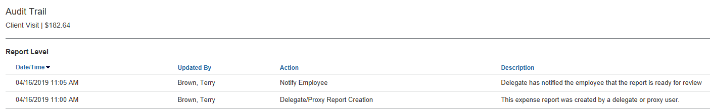

Not Ready For Review
A delegate can "undo" marking the report/request as ready for review. The delegate opens the report/request and clicks Not Ready For Review, which appears only for reports/requests in notification status.
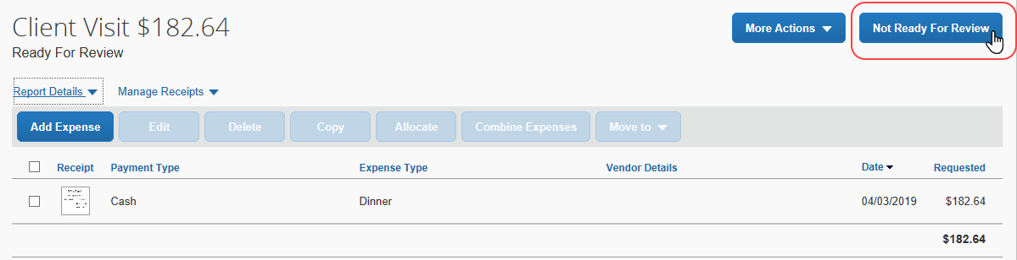
When the delegate clicks Not Ready For Review, the system:
- Removes the "Ready for Review" message wherever it displays
- Changes the Not Ready For Review button back to Ready For Review
The system does not:
- Recall the email notification to the employee, nor does it send an updated email to the employee
- Add an audit trail entry on reversal of notification

Preview for the Approver
An approver's delegate can be allowed to preview each report/request in the approver's approval queue. This delegate cannot approve the report/request – instead, the delegate's task is to ensure that the report/request is ready for the approver to review and approve.
The delegate reviews each report/request, checks for inconsistencies, verifies receipts, and – if necessary – sends back to the employee for corrections. When ready, the delegate notifies the approver that the report/request is ready for review.
A delegate who is assigned this "preview" option cannot also be allowed to approve reports/requests on behalf of the approver.
Once the delegate is assigned the proper rights, the delegate accesses the approver's approval queue as usual – on the SAP Concur home page or the Approvals page. The delegate opens the desired report/request and reviews the information, verifies receipts, etc.
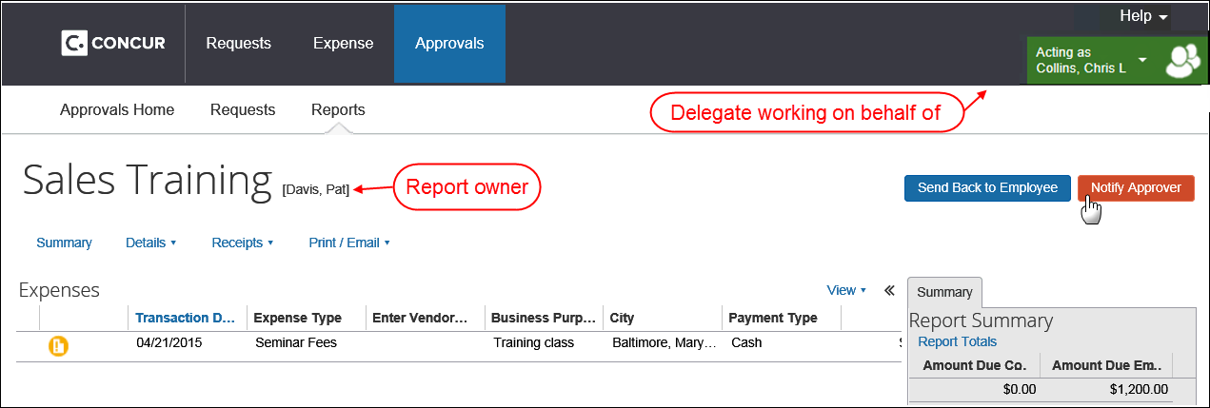
When ready, the delegate clicks Notify Approver.
When the delegate clicks Notify Approver, the system:
- Displays the "reviewed" icon appears on the Approvals page so the approver knows the report/request has been reviewed
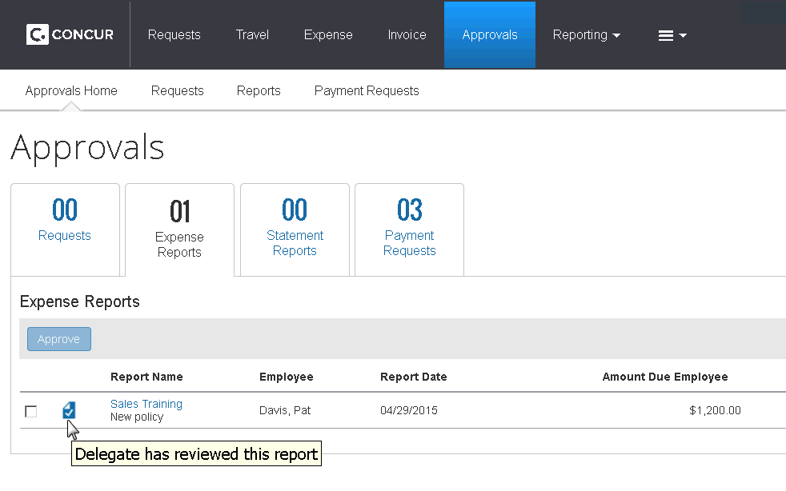
This icon is visible to all users who may view this queue, both delegates and the approver.
- Sends an email notification to the approver, indicating that the report/request has been reviewed by the delegate
- Creates an audit trail entry
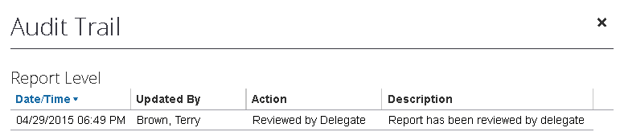

Mark As Not Reviewed
A delegate can "undo" the review. The delegate opens the report/request and clicks Mark As Not Reviewed.
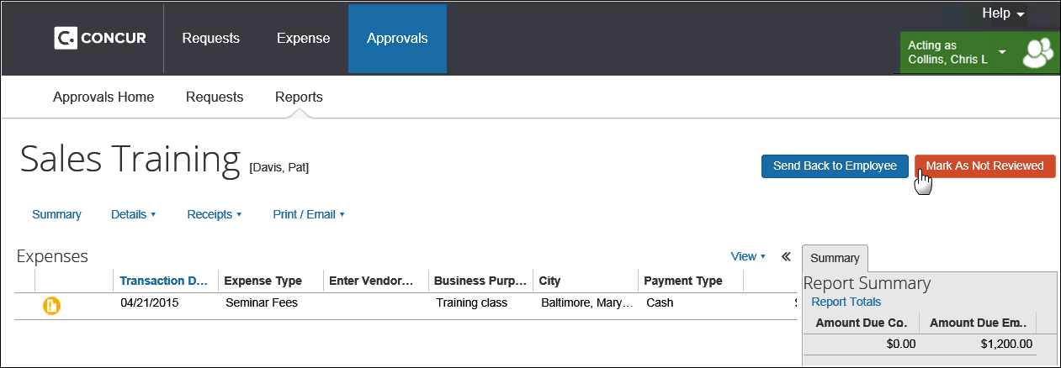
When the delegate clicks Mark As Not Reviewed, the system:
- Removes the "reviewed" icon is removed from the Approvals page so the approver knows the report/request is not ready
- Changes the Mark As Not Reviewed button back to Notify Approver
The system does not:
- Recall the email notification to the approver nor does it send an updated email to the approver
- Add an audit trail entry on reversal of notification

Email Notifications
If the delegate is allowed to receive emails, they receive the following:
- Workflow status change notifications
- Email reminders
- Image received notification
- New company card transactions notifications
- Sent Back notifications when the report was submitted by the delegate (cannot be turned off)
If the delegate is allowed to receive approval emails, they receive the following:
- New report/request pending your approval notifications
- Email reminders to the approver
Permanent approver delegates (Can Approve or Can Preview for Approver permissions) always receive these emails while temporary approver delegates receive emails only during the designated approval period.

Profile While Working as a Delegate
A delegate cannot select other delegates. If the user is currently working as a delegate and if the user clicks Profile > Profile Settings, the Expense Delegates link (left menu) and the Request Delegates link (left menu) will not be available.

Manage Receipt Images
The delegate can assist the user with uploaded images and the Available Receipts library (formerly Receipt Store).
- For more information, refer to the Concur Expense: Receipt Handling – Digital Receipts Setup Guide.

Special Considerations for Delegate Configurations

Changing Groups
If a user moves to a different employee group configuration, and the old group configuration and new group configuration have different delegate configurations, any new delegates that are assigned will use the new group configuration for that user.

Important! - Manually Update Delegate Assignments for Changed Group
When an employee acting as a delegate is moved to another employee group configuration, the system will not remove or update existing delegate assignments. Employees should be reminded to periodically review their delegation assignments to keep them up-to-date with current organizational changes.
In most cases, employees are motivated to keep these delegations accurate in order to ensure they have the right support for their duties, and no additional action is required. However, for some organizations it is very important to ensure only appropriate delegation is allowed.
To assist with this, the admin has two approaches available.
- The administrator may enable ONLY temporary approval delegation, ensuring that all approval delegations must be periodically updated by the employee to keep them in effect
- The administrator can manually remove the old delegate assignments to prevent confusion and, at that time, add the new delegate assignments (if any) to match the new employee group or remind users to update their own delegate assignments

Authorized Approver Delegates
By default, in both Concur Expense and Concur Request, if a delegate is working for an Authorized Approver, the delegate inherits the Authorized Approver's approval limits.
In Concur Expense, the delegate configuration can be designed to restrict approvers to those with an equal or higher authorized approver limit (as described in the configuration section of this guide). If so, the Authorized Approver will be able to delegate approvals only to other Authorized Approvers with equal or higher limit approvals. If the Authorized Approver selects a user with a lower limit, the Can Approve and Can Approve Temporary check boxes are displayed but are not available.
The delegate configuration option to restrict approvers to those with an equal or higher authorized approver limit only applies to Concur Expense. It does not apply to Concur Request.
Example: Authorized Approver Table
Authorized Approver | Level 1 | Level 2 | Limit | Exception Approval Authority
A | Acme | Sales | 2,000 USD | No
A | Widgets | Sales | 1,000 USD | No
B | Widgets | Sales | 2,000 USD | No
C | Acme |  | 10,000 USD | Yes
D | Widgets | Sales | 1,000 USD | No
D | Acme | Ops | 2,000 USD | Yes
E | Acme | Sales | 1,500 USD | No
F | Acme | Ops | 2,000 USD | No
G | Acme |  | 500 USD | No
Authorized Approver A has two different approval limits based on the authorized approver hierarchy. The following approvers are eligible to be approver delegates for Authorized Approver A:
B: This approver has a higher limit approval than A at the Widgets-Sales level of the hierarchy.
C: This approver has a higher limit approval than A at the Acme level of the hierarchy.
D: This approver has an equal limit approval than A at the Widgets-Sales level of the hierarchy.
The following approvers will not be eligible to be approver delegates for Approver A:
E: This approver has a lower limit approval than A at the Acme-Sales level of the hierarchy.
F: This approver does not have a limit approval at any of the hierarchy levels available to A.
G: This approver has a lower limit approval than A at the Acme level of the hierarchy.
- Refer to the Concur Expense: Workflow – Authorized Approvers Setup Guide for more information.

Changes in Limits
The Authorized Approver limits are evaluated only when the delegate is assigned. If an Authorized Approver has the same or higher limit and becomes a delegate and if the Authorized Approver delegate's limit is later lowered, SAP does not remove that delegate nor is the user or delegate notified.

Analysis/Intelligence (formerly Concur Insight) Delegates
The delegate configuration can be defined to allow delegates to run Analysis/ Intelligence (formerly Concur Insight) reports. If so, a user with Analysis/Intelligence access (either as a BI Manager or via a Cognos role) can assign up to two delegates to execute their reports.
Once a delegate has the proper reporting permissions, the Reporting tab becomes available so the delegate can access Analysis/Intelligence. When doing so, the delegate will have all the permissions of the user they are impersonating, including authoring permissions. The delegate will also have access to the My Folders directory and any reports stored in that location.
If the Reporting option is selected in the delegate configuration (as described in the configuration section of this guide), then the Can Use Reporting check boxes appear to the user and the User Administrator.
Note the following:
- If a user does not have Analysis/Intelligence permissions, the Can Use Reporting check boxes are displayed but are not available.
- A user with Analysis/Intelligence permissions can assign up to two reporting delegates. When the user attempts to assign a third delegate, an error message appears.

Delegate Configuration
The Expense Configuration administrator and/or the Request Configuration administrator can create and manage delegate configurations.

Default Configuration
Your system includes a default delegate configuration that applies settings as a collection of identical privileges to all employees working under this configuration. The configuration is provided as a guideline and can be changed. That is, you may use the default configuration "as is" or you can edit it to meet the needs of your organization. You can also create additional delegate configurations.
Remember: A delegate configuration can be used by one or more employee group configurations, but each employee group configuration can use only one delegate configuration. In addition, settings that grant privileges, such as submitting or approving, are granted or revoked for all employees sharing that delegate configuration.

Changing the Delegate Configuration and Delegate Assignments
Since a single delegate configuration applies to all employees sharing a group configuration, it follows that adding or removing privileges applies to all employees. So, if the ability to approve a report is removed by the admin, the immediate effect is the removal of that privilege from all employees working with that delegate configuration.
- Refer to Special Considerations for Delegate Configurations – Changing Groups for important information about updating and working with delegate configurations when changing employee groups.

Applying Different Delegate Privileges to Employees
The only way to apply different delegate privileges to an employee is to move them to a group configuration working with a delegate configuration reflecting the desired privileges.

Changing Delegate Search Selection
If a change is made by the admin in how delegates are selected (when searching for eligible delegates to assign) no changes are made to existing delegates or their configuration.

Access Delegate Configurations
To access the configuration page:
- Click Administration > Expense (or Request – on the sub-menu).
Depending on your permissions, the page may appear immediately after you click Administration.
- Click Delegate Configurations (left menu).
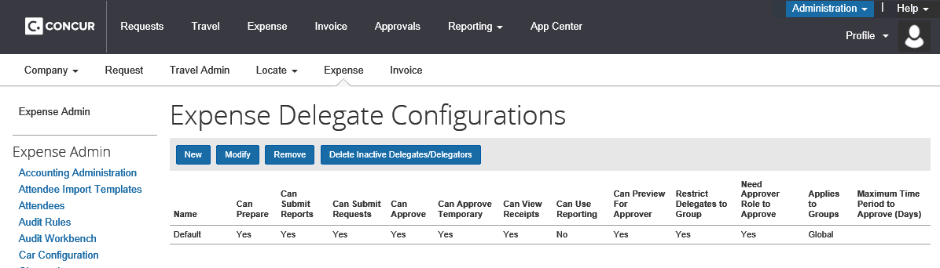
For Concur Expense, the Expense Delegate Configurations page appears.
For Request, the Delegate Configurations page appears.
The only difference between the Expense Delegate Configurations page and the Delegate Configurations page is the page name; this configuration is shared by both areas.

Create a New Delegate Configuration
To create a new delegate configuration:
- On the delegate configuration page, click New. The Add Delegate Configuration page appears.
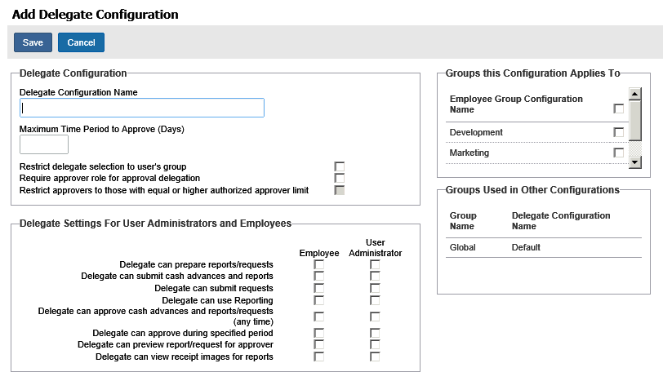
- Make the desired choices, keeping in mind that these settings apply as a group to all employees working under this delegate configuration.
Companies can restrict the creation and management of delegate assignments to the User Administrator role only by clearing (deselecting) all options under the Employee column. Now, only an admin with this role may create and manage assignments.

Name | Description
Delegate Configuration Name | Enter the name of the new delegate configuration.
Groups this Configuration Applies To | Select one or more employee group configurations that will use this delegate configuration.  NOTE: This list contains employee group configurations that are not associated with other delegate configurations.
Groups Used in Other Configurations | This list displays the employee group configurations that are associated with other delegate configurations and, thus, are not available.
Maximum Time Period to Approve (Days) | Enter the number of days for which an employee can approve reports/requests on behalf of another employee under the temporary approval delegation option Delegate can approve during specified period.  If this field is blank, no time limit is imposed.  NOTE: This field works in conjunction with the Date helper in the delegates area of both Profile and User Administration.  - For more information, refer to the Shared: User Administration User Guide.
Restrict delegate selection to user's group | If selected (enabled), the user selected to be a delegate must be from the same employee group configuration as the original user.  The system defines eligible delegates as persons who are one rung above the user in the user's hierarchy.  Note the following:  - This setting does not apply (is ignored) for any user assigned and acting as a delegate using the Delegate For feature.
Require approver role for approval delegation | If selected (enabled), the user selected to be a delegate for an approver must also be an approver.
Restrict approvers to those with equal or higher authorized approver limit | If selected (enabled), the user selected to be a delegate for an Authorized Approver must also be an Authorized Approver, with the same or higher approver limit.  Note the following:  - If the selected Authorized Approver has a lower limit, then the Can Approve and Can Approve Temporary check boxes are not available.  - The Authorized Approver limits are evaluated only when the delegate is assigned. If an Authorized Approver has the same or higher limit and becomes a delegate and if the Authorized Approver delegate's limit is later lowered, SAP Concur does not remove that delegate nor is the user or delegate notified.  - Refer to Authorized Approver Delegates in this guide.
Delegate Settings for User Administrators and Employees
Delegate can prepare reports/requests | If selected (enabled), the delegate can create expense reports and requests on behalf of another employee.
Delegate can submit cash advances and reports | If selected (enabled), the delegate can submit cash advances and expense reports on behalf of another employee.
Delegate can submit requests | If selected (enabled), the delegate can submit requests on behalf of another employee.  NOTE: This option appears only if Concur Request is implemented.
Delegate can use Reporting | If selected (enabled), the delegate can use Analysis/ Intelligence (formerly Concur Insight) on behalf of another employee.  - Refer to Analysis/Intelligence (formerly Concur Insight) Delegates in this guide.
Delegate can approve cash advances and reports/requests (any time) | If selected (enabled), the delegate can approve reports/requests on behalf of another employee. There is no time period associated with this action.  NOTE: When a delegate is acting on behalf of an authorized approver or cost object approver, then the delegate inherits all of the capabilities of that authorized approver, including the limits, currencies, and exception authority assigned to that approver.  - Refer to Authorized Approver Delegates in this guide.
Delegate can approve during specified period | If selected (enabled), the delegate can approve reports/requests on behalf of another employee for a specified period of time.  The user making the delegate assignment is required to enter the start and end dates for the delegation, and this may be constrained to a specified number of days based on the setting for Maximum Time Period to Approve (Days).
Delegate can preview report/request for approver | If selected (enabled), the delegate can preview expense reports and requests on behalf of another employee.  - Refer to Preview for the Approver in this guide.
Delegate can view receipt images for reports | If selected (enabled), the delegate can view receipt images on behalf of another employee.  NOTE: The setting says "view" but it includes view, add, delete, etc.
- Click Save.

Edit a Delegate Configuration
Delegate settings let the admin add or remove privileges, such as submitting or approving, for the delegate configuration they are working with. When doing this, remember that all delegates working with this configuration as a group share the identical set of privileges and gain or lose them as a group.
To edit a delegate configuration:
- On the delegate configuration page, select the desired configuration.
- Click Modify.
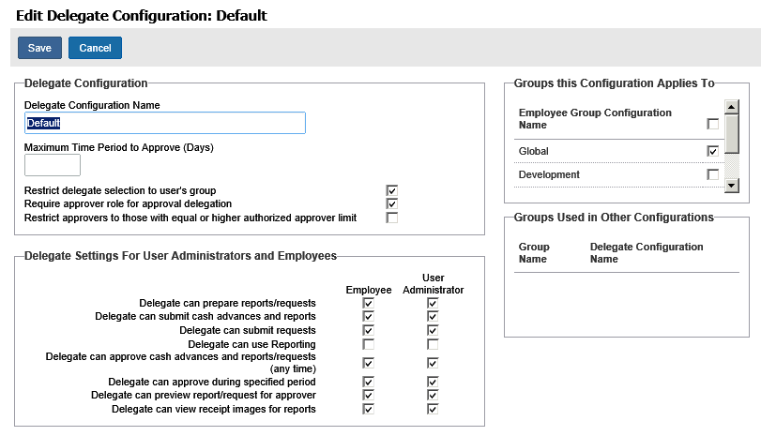
- Make the desired changes, as described in Creating a New Delegate Configuration in this guide.
- Click Save.

Delete a Delegate Configuration
The admin can delete a delegate configuration. Upon deletion, configurations are permanently removed from the system and all delegates for users who belong to the groups covered by that deleted configuration will be immediately removed.
- IMPORTANT: Please exercise caution in deleting a delegate configuration. There is no way to undo this action and recover the removed delegate assignments for the individual users.
To delete a delegate configuration:
- On the delegate configurations page, select the desired configuration.
- Click Remove.
- Click OK.

Purge the System of Inactive Delegate Records
The admin can delete all delegate records associated with inactive employees. Upon deletion, these records are permanently removed from the system and the inactive employee no longer appears in the delegate's list of users.
This option removes all records where:
- The employee (user for whom the delegate acts) is inactive.
- The delegate assigned to act for the employee is inactive.
- IMPORTANT: Please exercise caution in purging inactive records. There is no way to undo this action and recover the removed delegate assignments for the individual users.
To delete all delegate records associated with inactive employees:
On the delegate configurations page, click Delete inactive delegates/delegators.



