Shared: Sage 100 Integration
Setup Guide for SAP Concur

Last Revised: December 8, 2023
Applies to these SAP Concur solutions:
Concur Expense
Professional/Premium edition
Standard edition
Concur Travel
Professional/Premium edition
Standard edition
Concur Invoice
Professional/Premium edition
Standard edition
Concur Request
Professional/Premium edition
Standard edition

Table of Contents
Section 1: Overview 1
Data Flow Diagram 2
Important Timing Considerations 2
Connecting to and Disconnecting From Sage 100 2
Sending Expense/Invoice Data to Posting Financial Documents to Sage 100 3
Changing the Core Data in Sage 100 3
Features 4
Supported Versions of Sage 100 4
Supported Editions of Sage 100 4
Sage 100 Prerequisites 5
Sage 100 Exclusions 8
Definitions 9
Employee Core Data 9
Financial Posting 9
Supported Sage 100 Account Types 10
Section 2: Concur Expense End-User Experience 11
Expense Report Audit Trail 11
Process Reports Page 11
Financial Posting Failed Query 14
Section 3: Concur Invoice End-User Experience 15
Invoice Audit Trail 15
Process Invoices Page 15
Invoices Failing Financial Posting Query 17
Section 4: Configure Sage 100 Integration in SAP Concur 17
Step 1: Accounting 18
Standard Edition 18
Professional Edition 19
Step 2: Expense Types 19
Account Codes 20
Step: 3: Employee Reimbursements (Standard Expense Only) 22
Entering Account Codes for Reimbursement Methods 23
Step 4: Payment Types (Expense Only) 24
Standard Edition 24
Professional Edition 24
Step 6: Synchronize Vendors From Sage 100 (Invoice Only) 25
Step 7: Add Users From Sage 100 (Expense Only) 25
Standard Edition 25
Professional Edition 26
Section 5: Managing the Integration 26
Updating Employees (Vendor) Records 26
Updating the Synchronized Data 27
Disconnecting the Integration 27
Section 6: Frequently Asked Questions (FAQ) 27
About Sage 100 27
DataMap/Sage 100 Prerequisites 28
Accounts 28
Custom Fields (User defined field) 29
Vendors 30
Posting Transactions to Sage 100 32
Connecting and Disconnecting 38

Revision History
Date | Notes/Comments/Changes
December 8, 2023 | Initial publication

NOTE: Multiple SAP Concur product versions and UI themes are available, so this content might contain images or procedures that do not precisely match your implementation. For example, when SAP Fiori UI themes are implemented, home page navigation is consolidated under the SAP Concur Home menu.

Sage 100 Integration

Overview
SAP Concur and DataMap have partnered to make sharing accounting information between Sage 100 and SAP Concur easier. This partnership includes an integration that delivers bidirectional data flows between SAP Concur and Sage 100. This integration uses APIs from the SAP Concur Platform and from the DataMap Sage 100 extension ensuring fully automatic, near real-time data sharing.
The integration lets you load Sage 100 accounting data or “core data” into SAP Concur. This allows you to utilize this core data when entering expenses and/or invoices ensuing these include only valid, Sage 100 accounting data. SAP Concur regularly updates the core data to ensure SAP Concur always has the latest Sage 100accounting data. Data transmitted through Sage 100 Accounting during implementation and during subsequent synchronizations is purged from SAP Concur after 30-days.
The integration lets you post financial documents in Sage 100 that record financial activity found in approved expense reports or vendor invoices. The financial posting process sends expense reports and invoices that are ready to be posted from SAP Concur to Sage 100 Accounting, utilizing APIs from the SAP Concur Platform. The integration manages the transmission of expense and invoice data from SAP Concur to Sage 100, and the transmission of status information about these financial documents back to SAP Concur. The financial posting happens as soon as the expense or invoice processor or “processor” approves the report or invoice for payment. The processor will see financial posting status information in the audit trail of the expense report or invoice. The expense or invoice processor can confirm successful postings as well as view problems with a posting, allowing them to correct errors and re-send the information quickly.
- IMPORTANT: Account codes and vendor IDs will need to be mapped after connecting to the ERP and the contracted partner has sent the accounts to SAP Concur. Any existing account code and vendor ID mappings will be deleted.
The Sage 100 integration can synchronize the following types of information between SAP Concur and Sage 100:
- Accounting Dimensions (UDFs/UDTs): Sage 100 SAP Concur
- G/L Accounts: Sage 100 SAP Concur
- Employees/Users: Sage 100 SAP Concur
- Vendors: Sage 100 SAP Concur
- Purchase orders: Sage 100 SAP Concur
- Financial Documents for approved Expense Reports/Invoices: SAP Concur Sage 100
- Financial Documents Posting Status: Sage 100 SAP Concur
- Purchase Order Receipt: Sage 100 SAP Concur

Data Flow Diagram
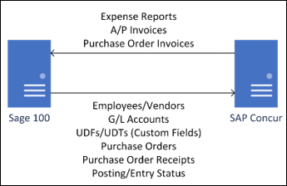
The following functionality is also available while using the integration:
- Expense Pay
- Invoice Pay (Only Check and ACH)
- Client Remittance of IBCP
The following functionality is not supported by the Sage 100 Integration:
- Payment Types with Offsets: Company Paid, IBCP with Offsets, CBCP with Offsets
If you would like to enable Sage 100 Accounting Integration for your company, contact SAP Concur support for more information.
While Concur Expense and Invoice Pay are supported, payment confirmation is not currently supported.

Important Timing Considerations

Connecting to and Disconnecting From Sage 100
The connection process can be self-instantiated through the App Center. After a contract is signed with DataMap, you can download the DataMap Financial Integration connector. Installing the DataMap Financial Integration connector will automatically connect your Sage 100 ERP to SAP Concur.
Contact DataMap for more information on connecting and disconnecting from Sage 100 Accounting. Prematurely clicking the Disconnect button on the SAP Concur App Center page may prevent you from posting expense reports or invoices. You must first verify that your users have no in-flight expense reports or invoices. In-flight refers to reports or invoices that are:
- Created and unsubmitted
- Submitted but not fully through the approval workflow

Sending Expense/Invoice Data to Posting Financial Documents to Sage 100
When the integration successfully posts in Sage 100, recording the financial activity in approved expense reports or invoices, SAP Concur locks these reports and invoices so that their data cannot change. This ensures the data in these posted financial documents aligns with the data in their associated reports or invoices.

Changing the Core Data in Sage 100
Any of the core data from Sage 100 loaded into SAP Concur that someone enters in expense reports or invoices becomes locked when someone submits these reports or invoices for approval. Any changes made in Sage 100 to the core data that occur after these reports or invoices are submitted are not reflected in these submitted reports or invoices. This preserves the record of the core data as it was entered into these reports or invoices at the time of submission. New reports or invoices can include the updated core data.
Because of this, the following changes in Sage 100 should be managed carefully:
- Removing G/L Account Numbers
- Modifying G/L Account Numbers
- Removing Vendor Numbers
- Modifying Vendor Numbers
- Removing a validation item for a User Defined Field (a list item for a custom field list in SAP Concur)
Prior to making these changes, the administrator should notify users to stop submitting expense reports and invoices and wait for all submitted reports to finish the approval/sync process. Then the administrator can make the change in Sage 100, and these changes will now update the synchronized data in SAP Concur.
Changes will need to be updated/remapped in the SAP Concur set up pages.
If the integration sends financial documents to Sage 100 while it contains core data that is no longer valid, the processor will learn of the error. To correct this error, the processor must send the report or invoice back to the employee, who can re-submit it with the latest Sage 100 information.
The following changes in Sage 100 Accounting should be managed carefully:
- Removing or modifying account codes
- Removing or modifying vendor/supplier records
- Removing or modifying User Defined Fields (custom fields lists)
Prior to making these changes, the administrator should notify users to stop submitting expense reports and invoices and wait for all submitted reports to finish the approval/sync process. Then the administrator can make the change in Sage 100 Accounting and update the synchronized data in SAP Concur.
The administrator can review which reports are submitted and not yet sent to Sage 100 using the Expense Processor and Invoice Processor tools.
For more information, refer to the Concur Expense End-User Experience and Concur Invoice End-User Experience sections of this guide.

Features
The integration resolves a common issue with the payment batch files—the inability to change reports or invoices once the batch has been closed. The payment batch process locks reports and invoices when it extracts them, making it impossible to make corrections in SAP Concur after the batch closes. The integration provides a more responsive system, adding the financial posting to the report and invoice workflow. The report or invoice is posted to the financial system but remains open in SAP Concur until posting is confirmed. Any problems with posting appear in SAP Concur, where they can be identified and corrected. Once the data is corrected, the reports and invoices can be posted successfully to Sage 100 Accounting.
The integration works with Concur Expense and Concur Invoice.
The integration allows clients to (via partner integration):
- Send employee (supplier/vendor) data from Sage 100 Accounting to SAP Concur, keeping SAP Concur up to date with the latest employee information.
- Pay expense reports and invoices using their Sage 100 Accounting financial system, without needing to send a batch file to Sage 100 Accounting.
- Send data from SAP Concur to Sage 100 Accounting and receive feedback from Sage 100 Accounting.
- View Sage 100 Accounting posting status in SAP Concur, including posting document numbers, and if a posting failed, a description of why that posting failed. This information appears in the audit trail of the expense report or invoice. Invoices will be entered into the Accounts Payable Invoice Data Entry, Expenses into Manual Check and Payment Entry, and Purchase Order Invoices into Receipt of Invoice Entry in Sage 100.
- The posting date used is only configurable within Sage 100 during data registration; the connector does not register data entry. All SAP Concur options relating to posting date are ignored.

Supported Versions of Sage 100
- Confirmed to run on Sage 100 2022 or higher. May be compatible with lower versions.

Supported Editions of Sage 100
- Sage 100 Standard
- Sage 100 Advanced
- Sage 100 Premium (SQL Server)

Sage 100 Prerequisites
The following prerequisites will prepare you to successfully connect your existing Sage 100 service with your SAP Concur service.
Have the following prepared:
- Employees set up as Vendors: for creating Concur Expense users, Expense Sage 100 sends employee specific information to SAP Concur as “employee vendors”. Employees must be set up as vendors in Sage 100 with first name, last name, and email address. Vendors without an email address will not be considered an employee vendor.
- Account Codes set for Expense, Invoice, and Purchase Order Line Items: Use the appropriate SAP Concur settings for each service to set the G/L accounts for each expense/invoice line type. If vendor synchronization is required, you may skip this step; however, purchase orders will not synchronize upon initial connection.
- Deploy and Configure the DataMap for Sage 100 Connector: Once the connector installer is downloaded, open it to begin the installation process. You will need an access key (provided after contract signing), as well as a valid set of Sage 100 credentials for the connector to work.
Images used in this document may depict a different version of the installer. However, the actions required will be identical.
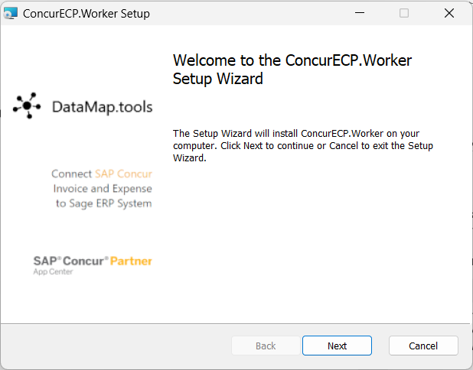
To accept the terms and conditions, select the I accept the terms in the License Agreement checkbox and then click Next.
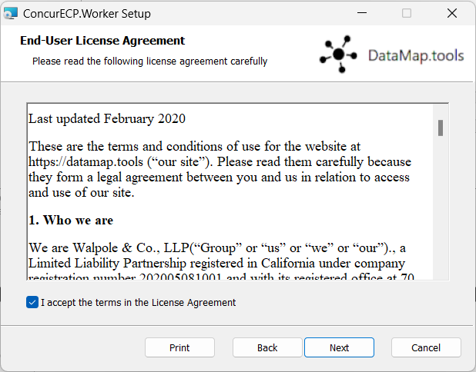
Enter your access key, without the prefix. An example access key is shown here:
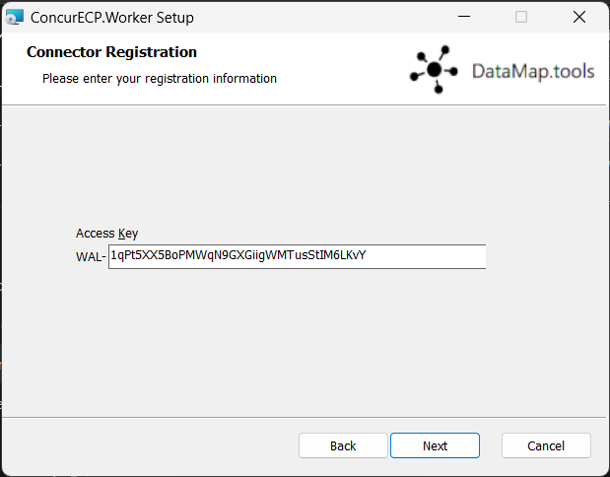
Configure your Sage 100 settings and credentials. Your input will be validated against the Sage 100 instance.
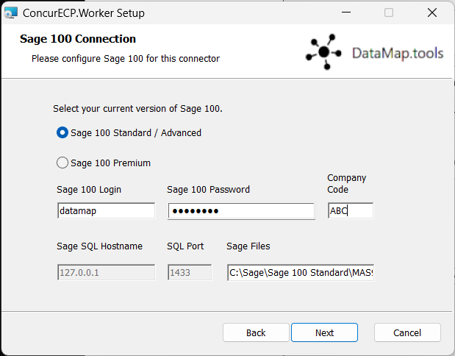
Configure any extra settings for the connector.
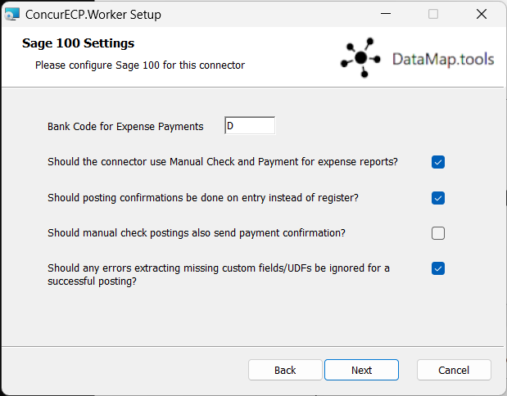
Finally, install to the default installation location. Once finished, you may close the installer, as the service runs in the background.
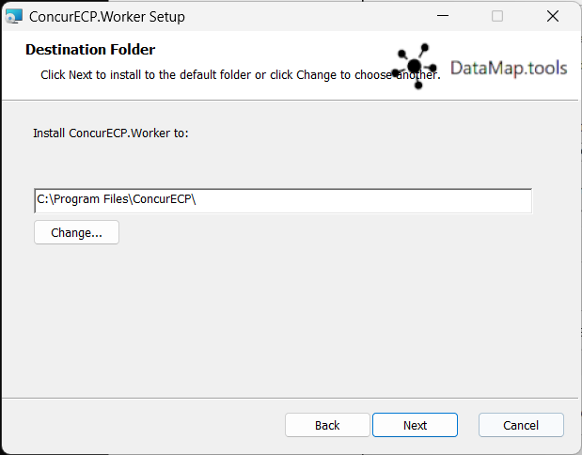
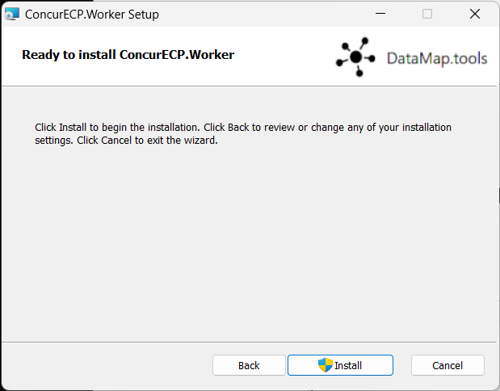
- Please refer to the DataMap Concur-Sage 100 Financial Integration User Guide for installation instructions.
The Sage 100 integration does not support multicurrency transactions. It also does not currently support VAT/GST.

Sage 100 Exclusions
The connector does not support any extensions which add extra functionality to Sage 100.

Definitions
User Defined Field (UDF/UDT): Sage 100 uses “user defined fields” or “user defined tables” to refer to what SAP Concur calls a “cost object list” or “custom field”. A User Defined Table (UDT) can also be used to generate list items, aside from the default validation list for a UDF.
Financial Documents: The integration converts SAP Concur expense reports and invoices into financial documents, which are then posted to Sage 100. A financial document corresponds to an invoice entry or a Manual Check and Payment entry, depending on the connector’s configuration settings. The integration assigns a Reference Number to a financial document so that this Reference Number can appear in SAP Concur for its associated report or invoice.
One expense report or invoice generally is represented by one financial document, while one expense report generally is represented by multiple financial documents, one for each payee on the report.
Core Data: The core data includes one or more user defined field, G/L Account, Employee vendors, and Vendor objects. The employee core data is the Vendor object that includes employee vendor information stored in Sage 100, combined with the employee information stored in SAP Concur.

Employee Core Data
SAP Concur uses employee core data to create users for Concur Expense. During Concur Expense implementation, the integration sends Sage 100 employee core data to SAP Concur. After loading the employee core data, whenever the administrator begins a user import using the Add Users from ERP button on the Users page of Expense Settings, using the employee core data, SAP Concur displays a list of employees. The administrator selects from this list the employees the administrator wants to add as a user in SAP Concur.
The employee core data is always sent from Sage 100 to SAP Concur. New Concur Expense users should always be added in Sage 100.
For more information, refer to the Configure Sage 100 Integration in SAP Concur > Step 7: Add Users from Sage 100 section of this guide.

Financial Posting
Once the financial posting is enabled, financial documents for approved expense reports and invoices are sent from SAP Concur to Sage 100. Next, posting feedback is sent from Sage 100 to SAP Concur.
When expense reports or invoices reach the status of Approved for Payment, they are converted to financial documents and added to the processing queue. Sage 100 requests the queued documents, and SAP Concur sends all the financial documents in the processing queue. Sage 100 returns an acknowledgement if the documents were all received successfully.
After receiving the successful receipt of documents message, SAP Concur marks the documents as paid for expense reports and marks as extracted for invoices and will not send them again. Sage 100 processes the financial postings and returns confirmations for each document. The confirmation includes success information or error codes for any financial documents that failed to post.
If the financial document failed to post, the expense report and/or invoice is updated with the error message and can be recalled by the processor. Failed reports can be found by running the Failing Financial Posting query on the Processor page. The processor can then modify the report/invoice to fix the issues, and mark it as Approved for Payment again. This allows the report and/or invoice to be sent to Sage 100 again.
For more information, refer to the Concur Expense End-User Experience and Concur Invoice User End-Experience sections of this guide.
All expense reports and invoices that posted successfully are updated in SAP Concur with the success message and are set to the approval status of Paid (reports) or Extracted (invoices). The expense reports/invoices are not allowed to be recalled by the processor once they have been successfully posted by Sage 100.

Supported Sage 100 Account Types
The integration supports the following Sage 100 account types:
- For mapping expense types in Concur Expense and/or Concur Invoice:
- All accounts
- Overheads
- Direct Costs
- Current Assets
- Other Current Assets
- Fixed Assets Cost of Goods Sold
- Expense
- For mapping credit card accounts:
- Credit card accounts must clearly have the name “credit card” (case-insensitive) included. This is an alternative to using a credit card vendor.
- For mapping clearing account codes
- Assets
- Accounts Receivables
  - Clearing account codes are unused by the connector.
- For mapping Journal Entry account codes:
- Assets
- Accounts Payable

Concur Expense End-User Experience
The integration functionality appears to the Concur Expense user in these places:
- Expense report audit trail
- Process Reports page

Expense Report Audit Trail
The report audit trail includes the posting status once the posting feedback has been returned from Business Central. The user clicks Details > Audit Trail to view the audit trail.
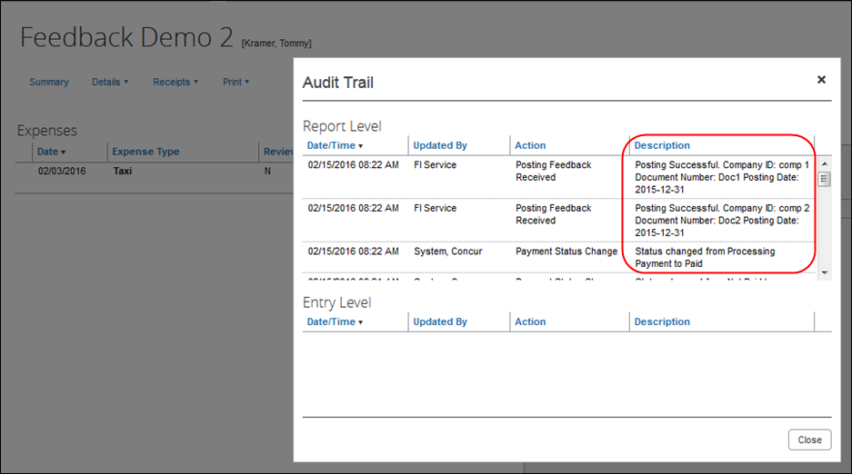

Process Reports Page
The Expense Processor approves the report for payment as usual. After approval, the expense report is placed in a financial posting queue for processing. The processing happens after the processor approves the report.
The financial integration marks expense reports for transfer to Sage 100 immediately once they are approved by the processor. Make sure the reports are ready to be sent before approving them in Process Reports.
Once the financial posting is complete, the processor will see the posting feedback on the Process Reports page.
Reports that posted successfully will show the payment status Paid and show the details of the financial posting in the audit trail. The audit trail message includes the Company ID, the Document ID, and the Posting Date.
Reports that failed to post will show an exception and the payment status Financial Posting Failed.
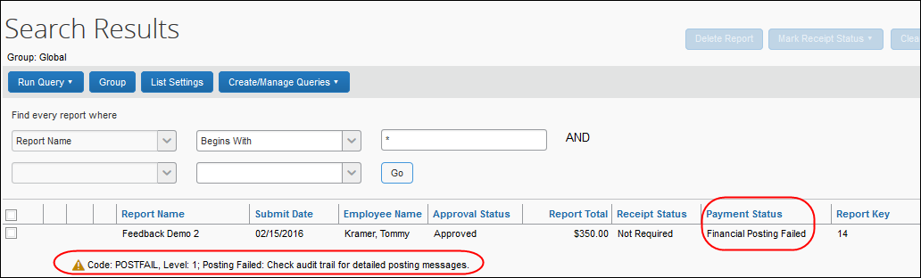
The processor can view the audit trail for the report to see the details of the posting failure. In this example, the report failed to post for two reasons. The audit trail message includes the Company ID, the Document ID, and the details of the failure.
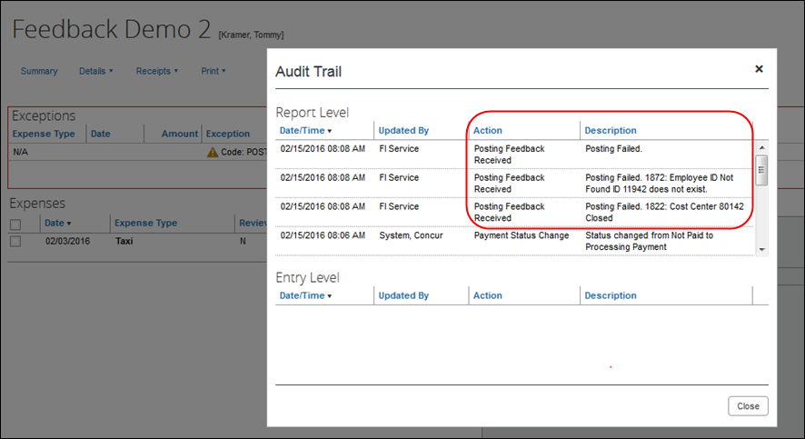
The processor recalls the report in order to make changes to it.
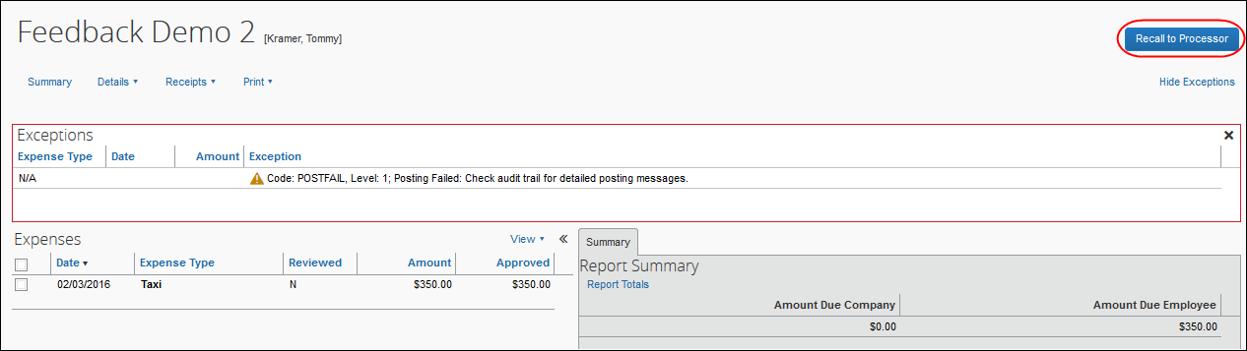
Then the processor works with the SAP Concur and Sage 100 administrators to resolve the issues. In this example, the SAP Concur administrator would update the user’s employee ID, while the Sage 100 administrator would confirm the correct cost center to select. Then the processor would select the correct Cost Center on the expense entry or report header. Once the processor has updated the report, they approve it for payment again.
When the report is successfully posted, the integration sets the report’s payment status to Paid.
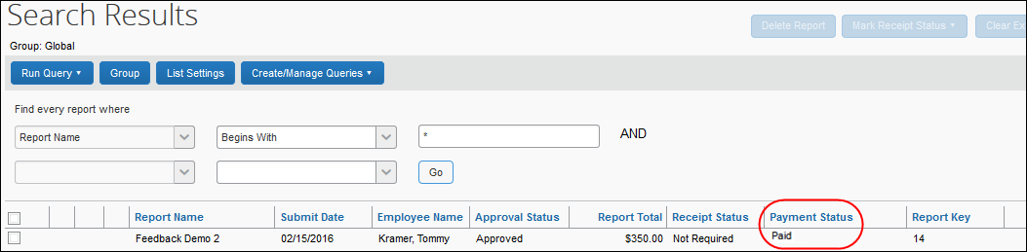

Financial Posting Failed Query
The processor can select the Reports Financial Posting Failed query on the Process Reports page to quickly locate all reports with the payment status of Financial Posting Failed.
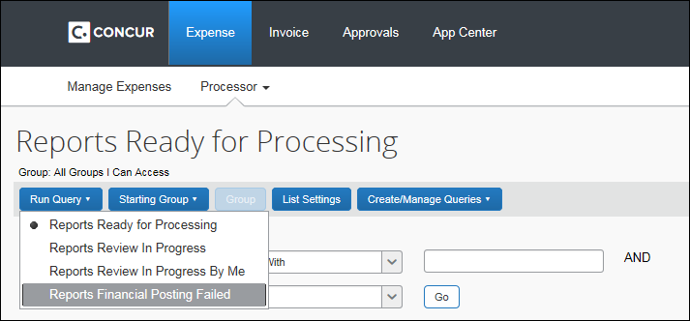

Concur Invoice End-User Experience
The integration functionality will appear to the Concur Invoice user in these places:
- Invoice audit trail
- Process Invoices pages

Invoice Audit Trail
The invoice audit trail includes the posting status once the posting feedback has been returned from Business Central. The user clicks Details > Audit Trail to view the audit trail.
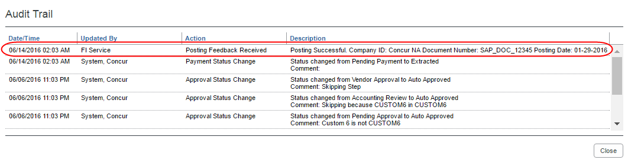

Process Invoices Page
The Invoice Processor approves the invoice for payment as usual. After approval, the invoice is placed in a financial posting queue for processing. The processing happens every time an invoice receives final processor approval.
The financial integration does not put invoices into batches—it marks them for transfer to Sage 100 immediately once they are approved by the processor. Make sure the invoices are ready to be sent before approving them on the Process Invoices page.
Once the financial posting is complete, the processor will see the posting feedback on the Process Invoices page.
If the process is successful, the invoice will show an Approval status of Extracted.
When the invoice is in transit to Sage 100, it might show a status of Sent to Financial ERP. This status appears briefly.
If the posting fails, the invoice shows a status of Financial Posting Failed.
The invoice processor can recall the invoice by clicking Recall Invoice to Processor.
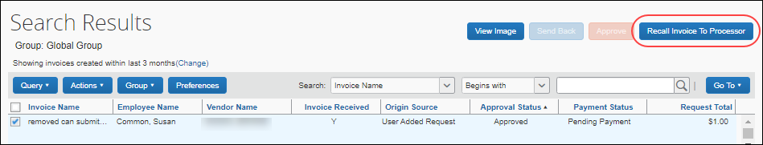
The Concur Invoice audit trail details the issue.
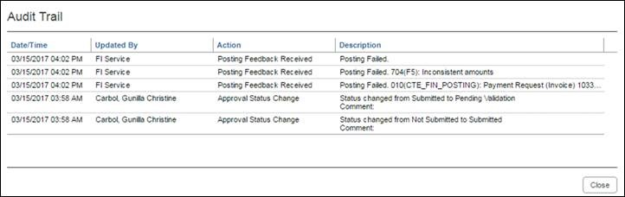
Once the invoice processor has corrected the information, the processor can mark the invoice for transfer to Sage 100 by clearing the exception, and then clicking Approve again.
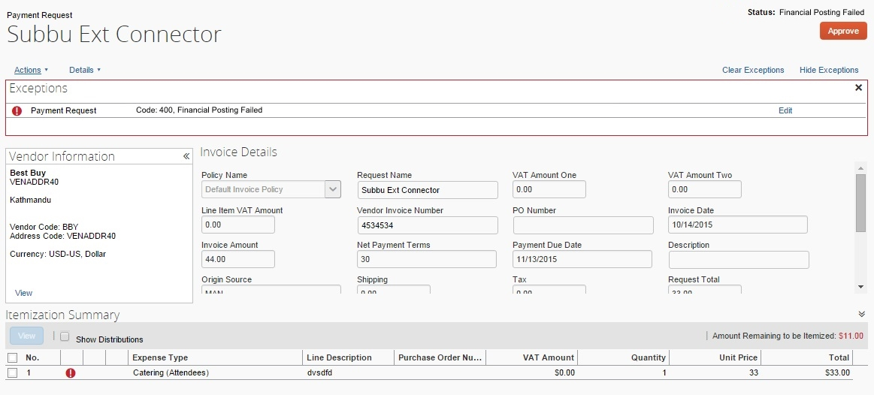

Invoices Failing Financial Posting Query
The processor can select the Invoices Failing Financial Posting query on the Process Invoices page to quickly locate all invoices with the Financial Posting Failed payment status.
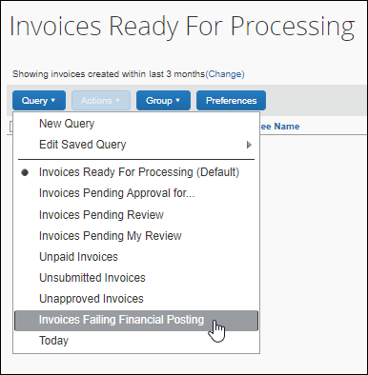

Configure Sage 100 Integration in SAP Concur
SAP Concur loads Sage 100 core data into your SAP Concur company. You will configure SAP Concur using this core data on the following administration pages.
Standard Edition
Administration pages for Standard Edition are in Product Settings.
- Accounting
- Expense Types
- Custom Fields
- Payment Types (Concur Expense only)
- Vendor Manager (Concur Invoice only)
- Users (Concur Expense only)
Professional Edition
- Accounting Integration Settings (View Imported Data)
- Accounting Administration
- List Management
- Payment Types (Concur Expense only)
- Vendor Manager (Concur Invoice only)
- Users/User Administration (Concur Expense only)
This setup guide provides a high-level view of the Sage 100-specific portions of administration settings. For general information about these administration pages, refer to the detailed set up and user guides for each product edition.

Step 1: Accounting
To ensure the integration will include financial documents in posts to Sage 100, perform the following accounting integration configuration.

Standard Edition
To configure accounting integration settings:
- In Product Settings, click the Accounting tile to access the Accounting page.
- Click the My ERP Data link to view Sage 100 core data the integration loaded into SAP Concur.
The ERP Company Details page provides a summary view of the Sage 100 data for the selected entity that is now integrated with SAP Concur, including GL Expense accounts and vendor/supplier information.
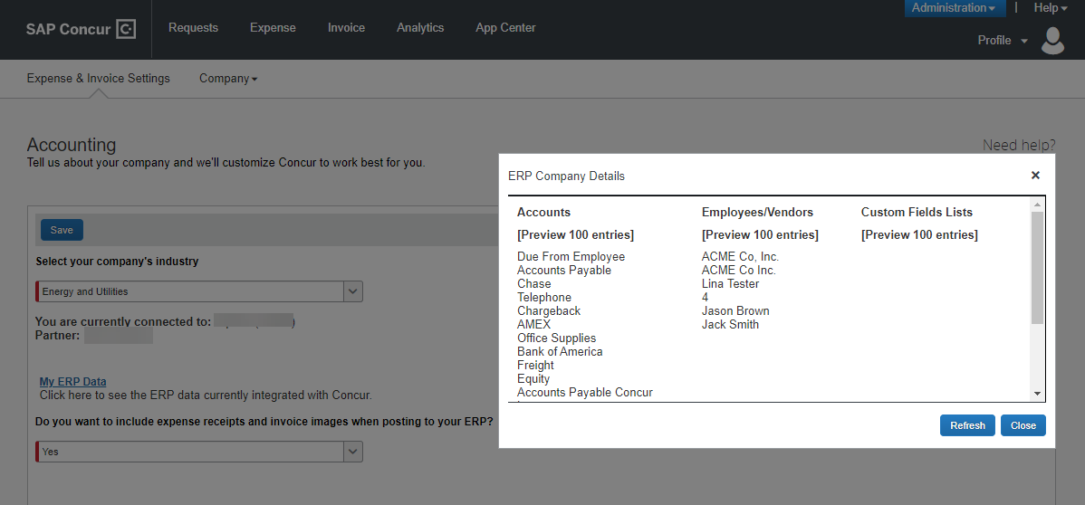

Professional Edition
To see accounting integration settings:
- Click Administration > Company > Tools > Accounting Integration Settings. The Account Integration Settings page appears.
The ERP that you are connected to and partner name displays.
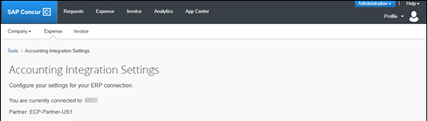

Step 2: Expense Types
Users select expense types when they create expenses or invoices in SAP Concur and can only choose from the configured list. Client administrators configure expense types on the following pages:
- Standard Edition: On the Account Codes tab of the Expense Types page in Product Settings.
- Professional Edition: On the Account Codes tab of the Accounting Administration page in Expense Admin.
You will configure the Sage 100 G/L Account Number to associate to each expense type. When the approved expense or invoice data is sent to Sage 100, the Sage 100 integration will convert the expense types in this data into G/L Account Numbers and include these in the financial documents it posts.

Account Codes
You will map the accounts to expense types for Concur Expense and/or Concur Invoice. The integration loads into SAP Concur the G/L Account Numbers for you to use when accounting for expenses and invoices.
For more information, refer to the Supported Sage 100 Account Types section of this guide.
G/L Account Numbers are imported from Sage 100. You may not use the SAP Concur import template.
If you have created policy groups, you can configure different expense types to Sage 100 product mappings for the individual policy groups.

Standard Edition
For more information about mapping expense types, refer to Concur Expense: Expense Types Setup Guide for Concur Standard Edition.
To enter account codes:
- In Product Settings, navigate to the Account Codes page:
- For Concur Expense, click Administration > Expense Settings > Expense Types for Expenses > Account Codes.
- For Concur Invoice, click Administration > Invoice Settings > Expense Types for Invoices > Account Codes.
- Click Account Codes (tab).
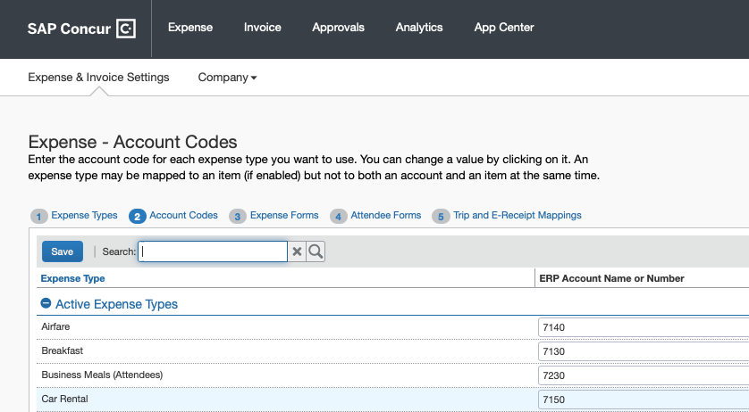
- Select the desired G/L Account Number in the ERP Account Name or Number field.
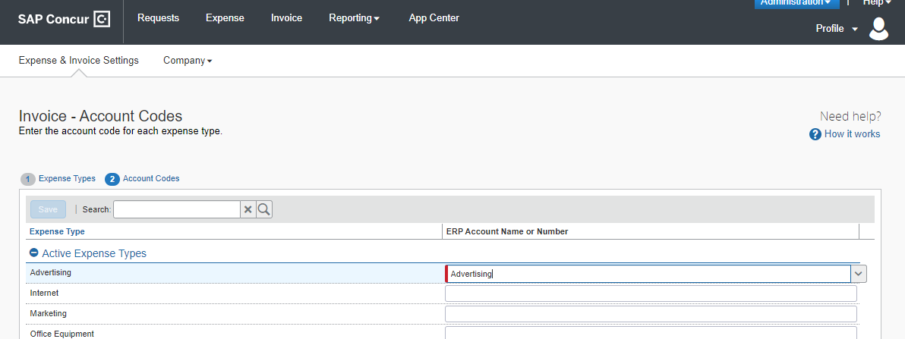
- Click Save.

Professional Edition
For more information about mapping expense types, refer to the Concur Expense: Account Codes Setup Guide.
To enter account codes in Professional Edition:
- Navigate to the Account Codes page:
- For Concur Expense, click Administration > Expense > Accounting Administration for Expenses > Account Codes.
- For Concur Invoice, click Administration > Invoice > Accounting Administration for Invoices > Account Codes.
- Click Account Codes (tab).
- Select the desired G/L Account Number in the ERP Account Name or Number field.
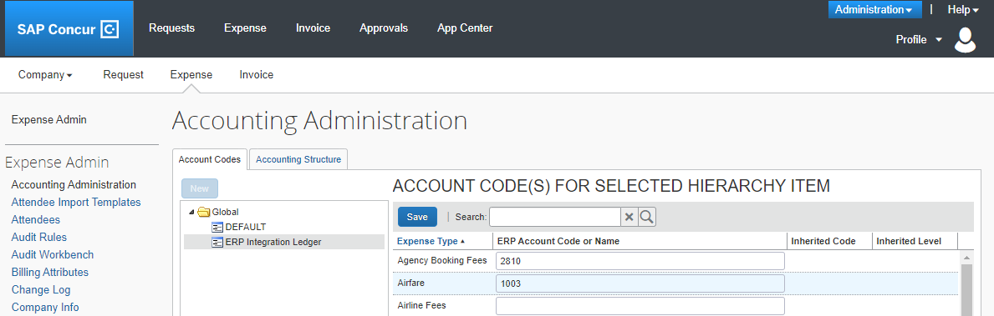
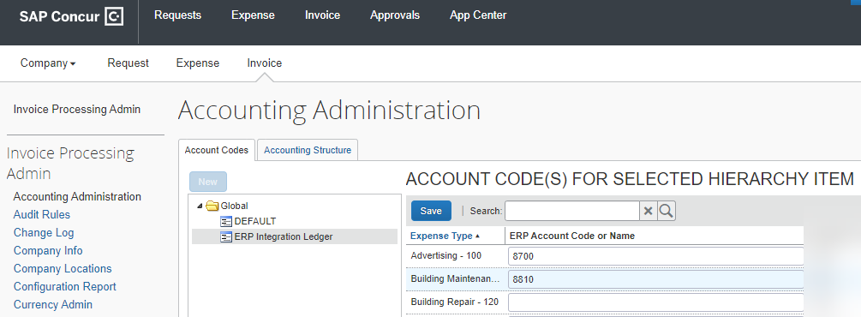
- Click Save.

Step: 3: Employee Reimbursements (Standard Expense Only)
There will be two posting options: Manual Check and Payment Entry or Invoice data entry. Most clients will use the Manual Check and Payment Entry option.
You have three options to select a posting date:
- Processor Approval Date (Default)
- Report create date
- Report submit date
If ADP file with Financial Integration is enabled, payment batches generate an ADP EPIP file. ADP file with Financial Integration is enabled by SAP Concur internal staff. If you require an EPIP file, contact SAP Concur support for assistance.

Entering Account Codes for Reimbursement Methods
After you have saved the employee reimbursement method, the Accounting tab appears.
To enter account codes for reimbursement methods:
- Click Administration > Expense Settings > Employee Reimbursements.
- Create or edit the desired reimbursement method.
- On the Accounting tab, enter the codes in the fields:
Field | Description
How do you want our transactions to appear in Sage 100? | There are two posting options to get data from SAP Concur to Sage 100. Select Manual Check and Payment Entry or Invoice data entry.
Cash Account Code | Cash account code is not used with Sage 100 integration.  NOTE: This field only appears for ADP and Expense Pay reimbursement methods.
- Click Save.
For more information, refer to the Concur Expense: Employee Reimbursement Setup Guide for Concur Standard Edition.

Step 4: Payment Types (Expense Only)

Standard Edition
Company card programs are configured on the Payment Types page in Product Settings. For each card program, the Accounting tab allows you to configure your accounting code and transaction settings for each card program.
To enter card program settings:
- Click Administration > Expense Settings or Expense & Invoice Settings > Payment Types.
- On the Payment Types page, create or edit the desired card program. You must create a card for credit card transactions.
- On the Accounting tab, complete the fields.
Field |  | Description
How do you want your transactions to appear in Sage 100? | Select Manual Check, Invoice Data Entry, or General Journal Entry, depending on your preference for entry. Manual Check is the recommended option with a Credit Card vendor configured.
Vendor Name for Card Program | Select your Credit Card vendor from this drop-down. This will be used for Manual Check and Invoice Data Entry posting.
- Click Save.
For more information, refer to the Concur Expense: Payment Types Setup Guide for Concur Standard Edition.

Professional Edition
To enter card program settings:
- Click Administration > Expense > Payment Types.
- Click the Payment Types box, then complete the fields.
Field |  | Description
How do you want your transactions to appear in Sage 100? | Select Manual Check, Invoice Data Entry, or General Journal Entry, depending on your preference for entry. Manual Check is the recommended option with a Credit Card vendor configured.
Vendor Name for Card Program | Select your Credit Card vendor from this drop-down. This will be used for Manual Check and Invoice Data Entry posting.

Step 6: Synchronize Vendors From Sage 100 (Invoice Only)
Sage 100 administrators will be able to create vendors in Sage 100 and then synchronize this data with Concur Invoice from the Vendor Manager page.
For Standard Edition, administrators can synchronize this data without having to use the vendor import functionality.
To synchronize Sage 100 vendors:
- On the Vendor Manager page, select Open Vendor > Add Vendors from ERP.
- Select the vendors to add from Sage 100.
- Click Add. The vendors are added to Concur Invoice.

Step 7: Add Users From Sage 100 (Expense Only)

Standard Edition
To import Sage 100 employee vendors:
- Click Administration > Invoice Settings or Expense & Invoice Settings.
- In the Product list, select Expense.
- Click User Accounts.
- On the Users page, in the Add Users list, click From ERP.
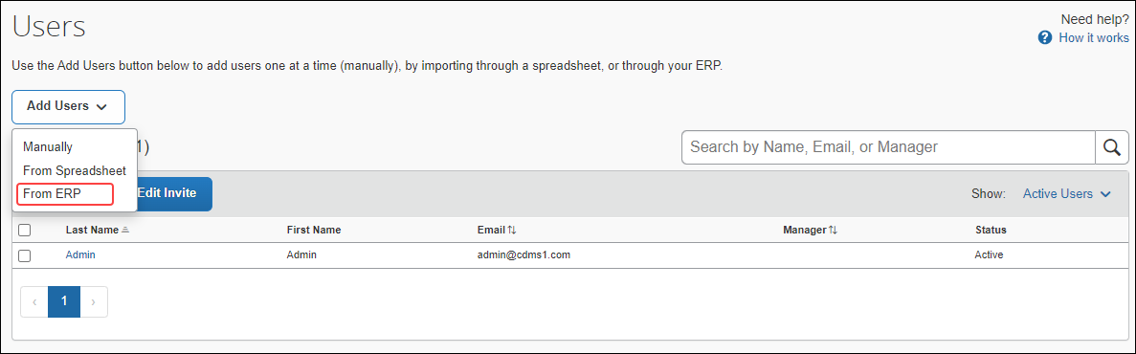
- In the Add Users from ERP window, select the desired users.
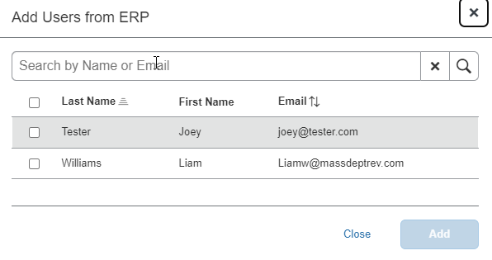
- Click Add.

Professional Edition
To import Sage 100 employee vendors:
- Click Administration > Company Admin > User Administration.
- Click Import Users from ERP.
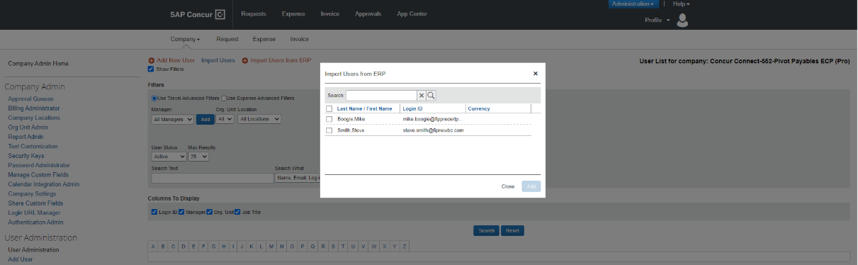
- In the Add Users from ERP window, select the desired users.
- Click Add.

Managing the Integration

Updating Employees (Vendor) Records
The integration will help add your Sage 100 employee vendors to SAP Concur. New Concur Expense users should always be added in Sage 100 first. After you add new employee vendors, follow the steps in the Configure Sage 100 Integration in SAP Concur > Step 7 – Add Users from Sage 100 section of this guide to add them to SAP Concur.

Updating the Synchronized Data
The accounting data in Sage 100 is synchronized with SAP Concur continuously. You do not need to run a manual sync update.
Data transmitted through Sage 100 during implementation and during subsequent synchronization, is purged from SAP Concur after 30-days.

Disconnecting the Integration
Disconnecting results in unregistering Sage 100. This disables most of the Sage 100 core data such as custom lists, account numbers, and users. Sage 100 will no longer be connected to SAP Concur.
Before disconnecting from Sage 100, all in-flight expense reports and invoices must be processed.
To disconnect a Sage 100 company from SAP Concur:
- Uninstall the DataMap Financial Integration Connector from the computer running Sage 100.
- Click Disconnect on the App Center for the DataMap integration.
- Contact DataMap to ensure that the disconnection process is successful.

Frequently Asked Questions (FAQ)

About Sage 100
Q: In what countries is Sage 100 integration with SAP Concur supported?
A: US only
The Sage 100connector does not support multicurrency transactions with VAT/GST.
Q: Which Sage 100 versions does the Sage 100 connector support?
A: All editions of Sage 100 are supported, including Standard, Advanced, and Premium. This must be configured during connector installation.
Q: What if I need to make changes to core data in Sage 100, for example, deleting an account?
A: Simply do so – the connector will automatically update SAP Concur upon a change. However, be mindful of potential data loss if existing invoices/expense reports use a deleted account number. This especially applies for in-flight financial documents.
Q: Can I connect multiple Sage 100 company files to one SAP Concur account?
A: No. The SAP Concur integration is a 1:1 ratio. You can connect one Sage 100 entity to one SAP Concur account.
Q: Does the integration sync data automatically from Sage 100 to SAP Concur?
A: Yes, the connector will pull and push data approximately every minute.
Q: Do the items listed in the PO update the inventory items in Sage 100 or do we just sync the expense amount?
A: This integration will be managed by Sage 100, so as long as Inventory Management is integrated with Purchase Order, POs invoices from Concur will update Sage 100. Note that purchase orders themselves can only be updated from Sage 100.

DataMap/Sage 100 Prerequisites
Q: What if I am upgrading Sage 100 Versions?
A: DataMap’s FIP connector works with all versions of Sage 100. This means when a customer upgrades their Sage 100 version, they will not need to upgrade the DataMap connector.
Q: What If I connected to the wrong Sage 100 entity via DataMap?
A: If changing company codes, use the configuration tool included with the installation of the Sage 100 connector. Otherwise, uninstall and reinstall the connector on an appropriate computer running Sage 100.
- For more information, refer to the DataMap FI Connector For Sage 100 Deployment and Setup Guide for SAP Concur Financial Integration Program.

Accounts
Q: How do I refresh accounts from Sage 100 to SAP Concur?
A: Simply wait for approximately a minute for the changes to propagate. If this does not work, try restarting the connector using the configuration tool.
Q: Are journal entry postings supported with the Sage 100 integration?
A: Yes. This will appear as a General Journal Entry in Sage 100.
Q: When I try to post transactions to Sage 100 I receive the following error: "BAD_DATA: ‘No payment type found for <expense group>’.” How do I resolve this error?
A: For expense reports posting into Manual Check, ensure that the payment type is set to post as a bill. It is possible that SAP Concur has reset payment types for ERP integration; try clicking save for each affected payment type in Concur’s settings.
Q: When I try to post transactions to Sage 100 I receive the following error: "BAD_DATA: ‘Missing account code for expense/invoice <name>!’.” How do I resolve this error?
A: There are unmapped account codes – check Expense Types for Expenses/Invoices in Concur and ensure that active expense types have an account code associated with them.

Custom Fields (User defined field)
Q: Does SAP Concur support Sage 100 UDF?
A: Yes. All UDFs created in Sage 100 will automatically be available to link to in SAP Concur. However, only Drop-Box or List-Box type UDFs can be used for list items using validation lists or tables.
Q: How do I refresh UDFs/UDTs/custom fields between Sage 100 and SAP Concur?
A: All integrations happen automatically. If this synchronization doesn’t happen within a few minutes, try restarting the worker using the configuration tool.
Q: Can I use one of my UDF’s custom fields/form fields to drive my alternate account codes?
A: No. You must create a new custom field in SAP Concur solutions to drive your alternate account codes. You cannot use an external list to define your alternate account code structure.
Q: The expense report or invoice fails with the Audit Log error “SAGE: Failed to set bank code: ErrNo CI_NOF.”
OR
Q: Custom fields are not being populated in SAP Concur.
A: Most likely, a custom field was mapped to a UDF that only exists on certain tables/properties (e.g., using a custom field for line items mapped to a UDF on AP_InvoiceHeader). Correct this by limiting the visibility of the custom field or leave it blank.

Vendors
Q: How do I add users from Sage 100 into SAP Concur?
A: Clients must set up their employees as vendors in Sage 100. In Vendor Maintenance, an employee vendor must have a first/last name and email attached. The name can be set up as “First, Last” or “Last, First”. The connector will try to interpret the names as best as it can.
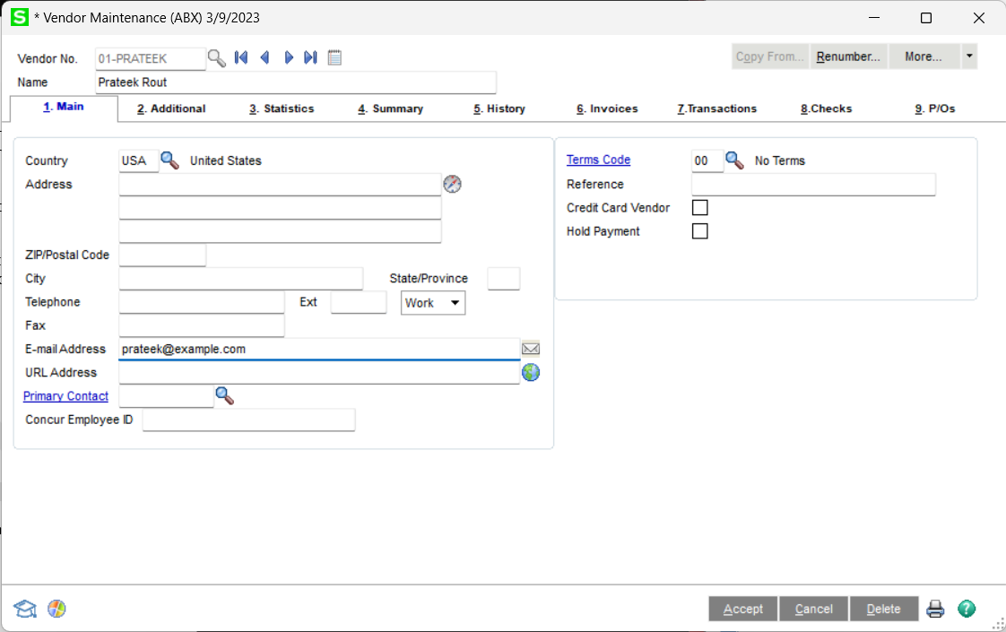
Note however, that there is no distinction between an employee vendor and a normal vendor. See the below screenshot of an example. As a result, when adding a user from ERP or adding a vendor from ERP, all vendors will be selectable. Ensure that you have selected the correct vendors before adding them to your SAP Concur instance.
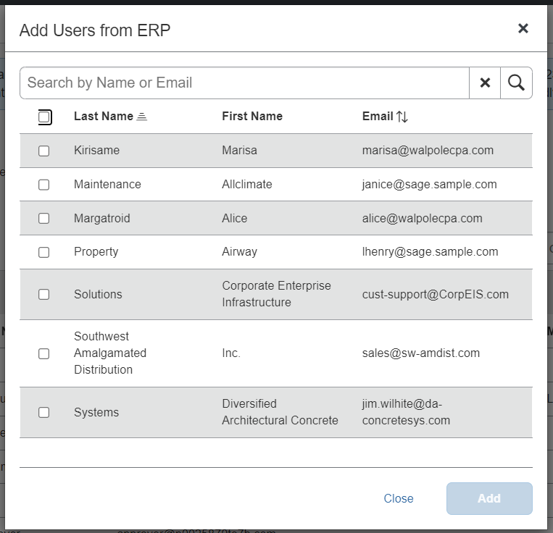
Q: How do I distinguish employee vendors from accounting vendors in Sage 100?
A: This is currently unsupported. Employees are indistinguishable from accounting vendors.
Q: How do I refresh employee or accounting vendor data from Sage 100?
A: Employees are automatically synchronized with all vendors. If synchronization does not occur automatically, you may need to restart the connector service.
Q: Why are ERP employees missing in User Accounts in Concur?
A: If you have Invoice enabled, you can check Vendor Manager to see if your employees are being synchronized correctly. Do not add them here.
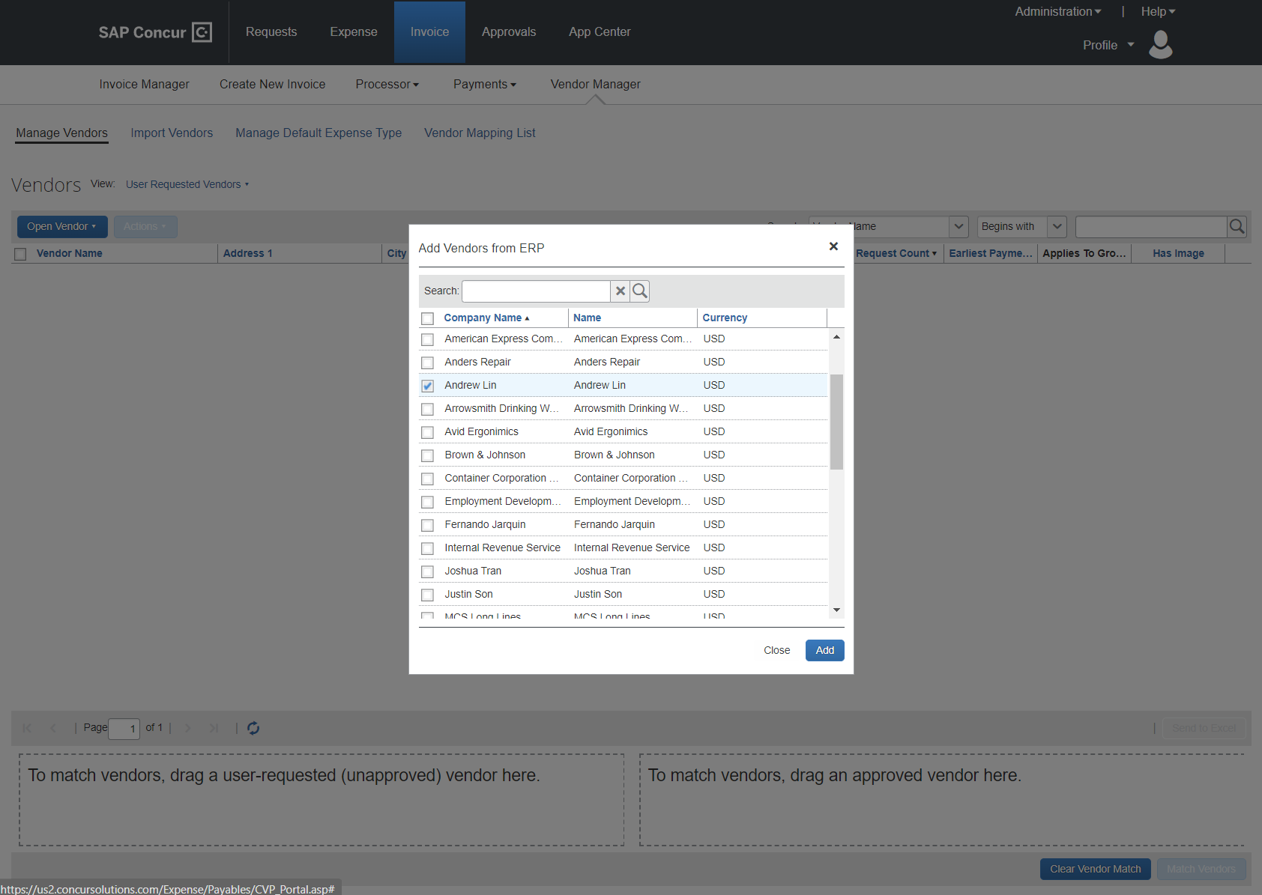
If they are visible, that most likely means you are missing an email on their vendor record. Regardless if you have expense or invoice enabled, ensure that all employees have a first/last name and a valid email in Sage 100. Names can be detected as “First (Middle) Last” or “Last, First (Middle)”.

Posting Transactions to Sage 100
Q: What happens if an expense report or invoice for a month (for example, February) contains transactions from a previous month (for example, January) and the previous month end (January Month End) is closed in Sage 100?
A: This will be left to Sage 100 administrators, because SAP Concur transactions are only entered, not registered. Therefore, the financial date is configured during registration of invoices/expenses, not upon submission. However, it is possible that Sage 100 will refuse a date depending on validation settings. This will cause the connector to respond with a failed posting and be returned to the invoice/expense processor.
Like all failed postings, the Expense/Invoice Processor will need to fix the date and then reprocess it.
Q: How will out of pocket expense transactions post to Sage 100?
A: This will appear as a Manual Check and Payment Entry or Invoice data entry under the employee vendor. A G/L distribution will be created, with the invoice number being the report ID in SAP Concur.
Provided is an example of an expense report with one Out-of-Pocket expense item. Screenshots are from SAP Concur Standard Edition and Sage 100 Standard but are applicable for all other version combinations.
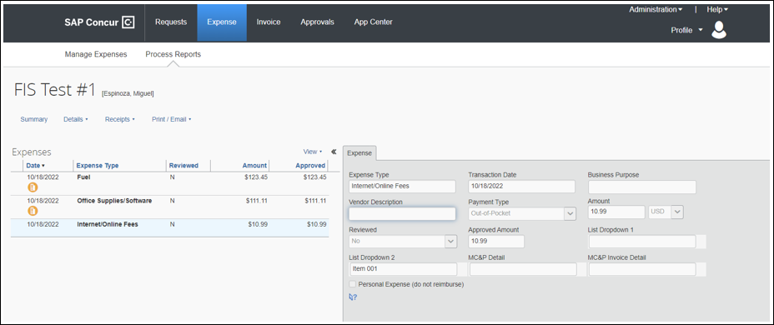
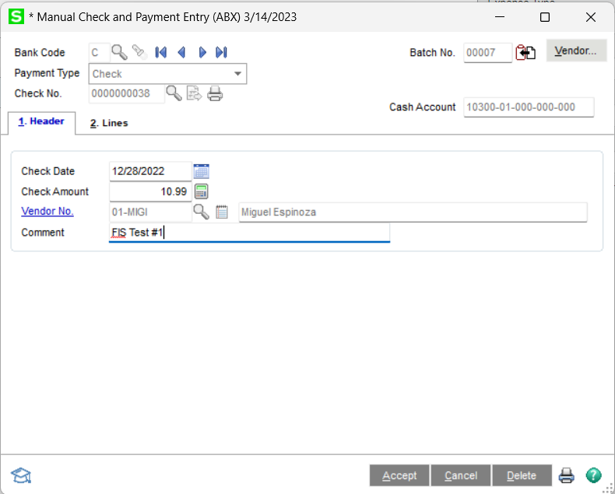
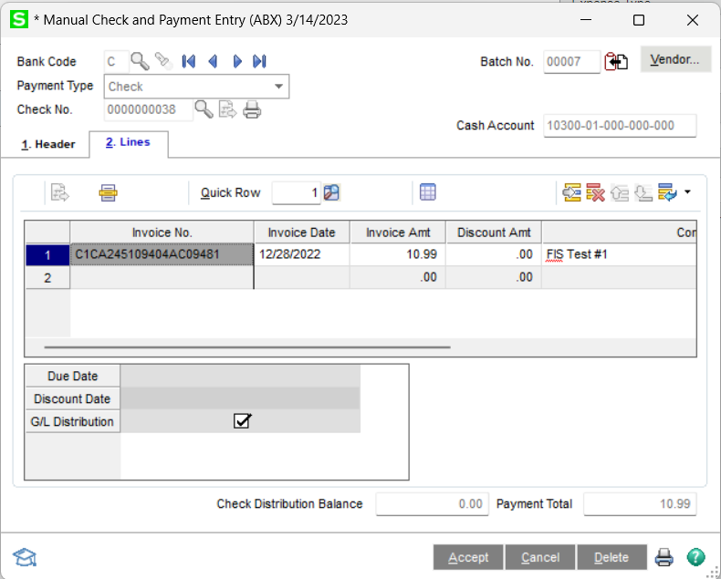
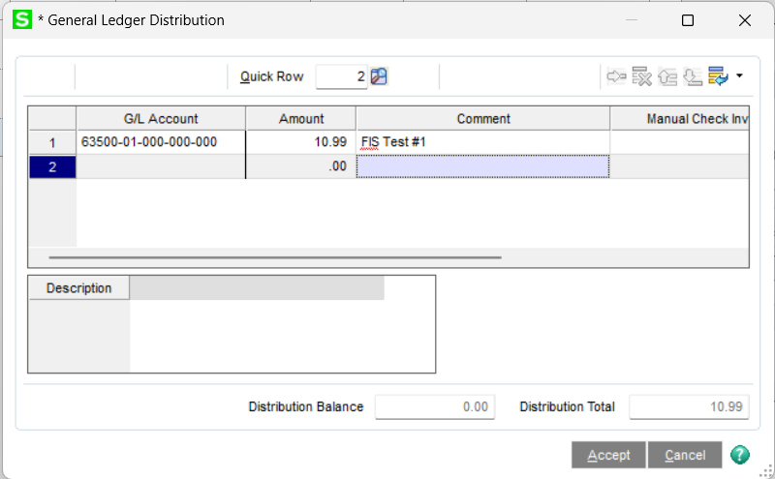
Q: How will A/P invoices post to Sage 100?
A: A/P invoices will be entered into A/P Invoice Data Entry.
Provided is an example of an expense report with one Out-of-Pocket expense item. Screenshots are from SAP Concur Professional Edition and Sage 100 Standard but are applicable for all other version combinations.
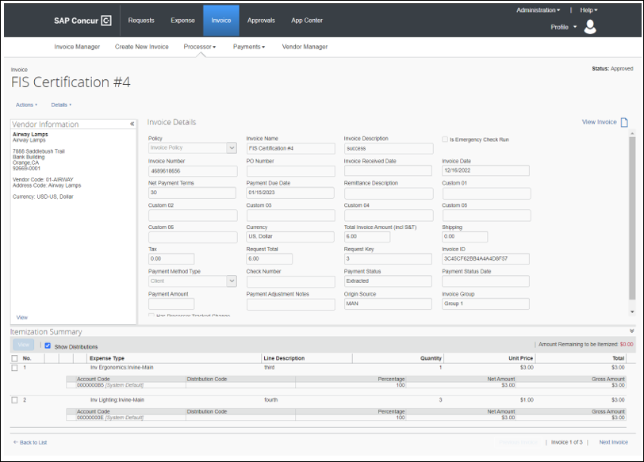
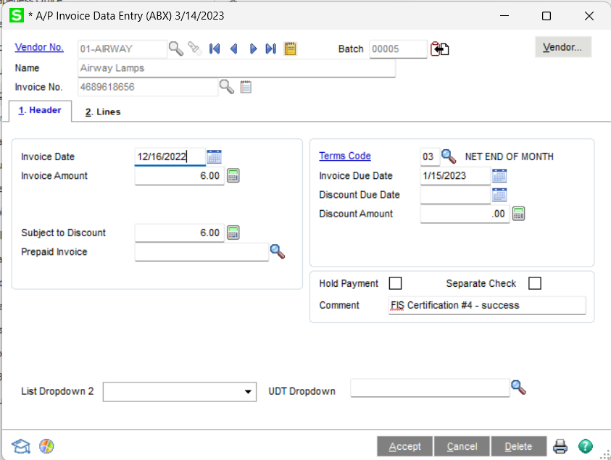
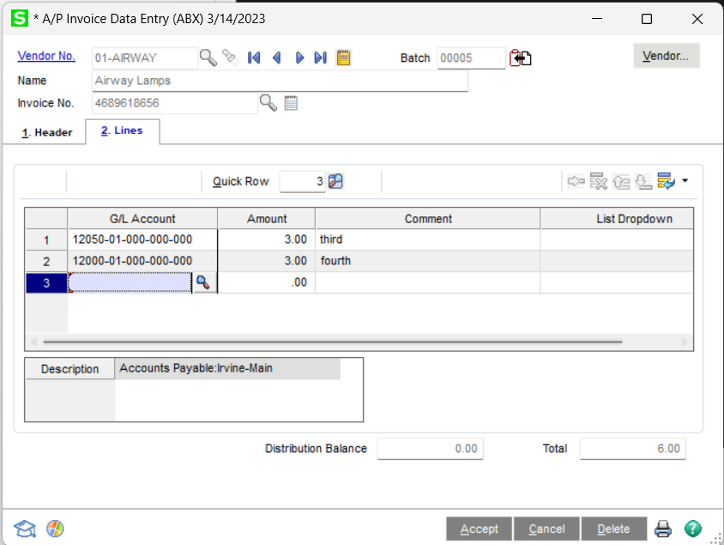
Q: When a credit card transaction posts as a Manual Check and Payment, on what date will it post?
A: Because the actual posting/registration is not handled by the connector, this cannot be answered as-is. However, the check date will be set to the report date.
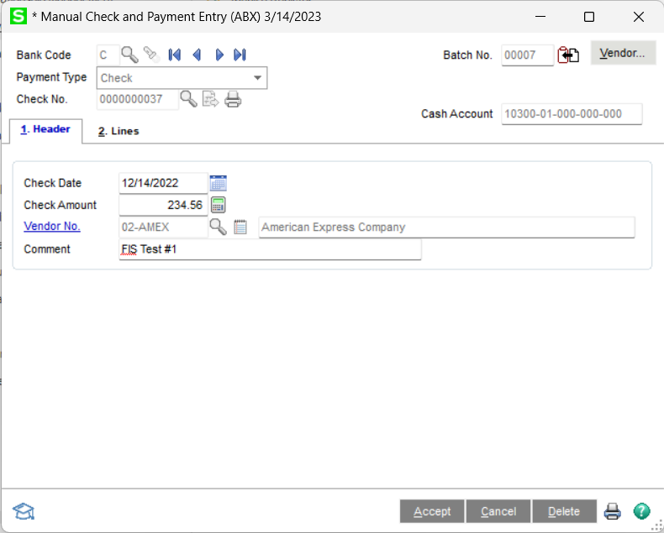
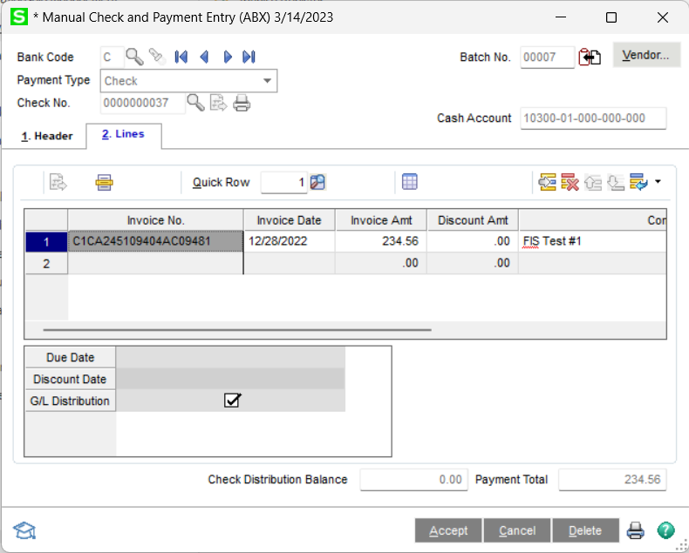
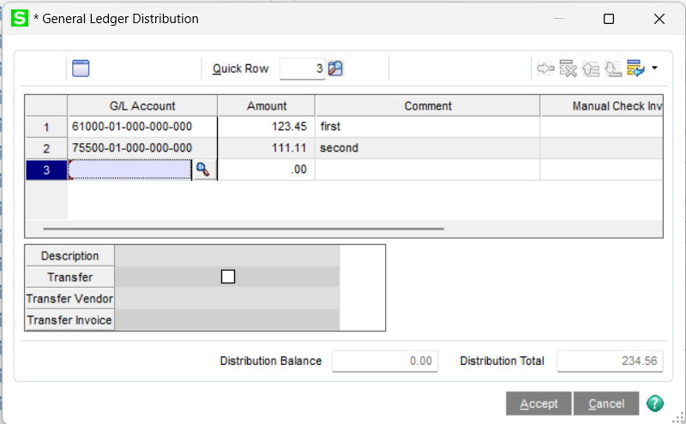
Q: Does the Sage 100 integration support multi-currency posting?
A: No, this is unsupported.
Q: I am getting an error when trying to post a purchase order invoice to Sage 100
A: If the error is prefixed with “SAGE:,” this is an error created when accessing Sage 100 through the connector. The business object error will also be logged, which may help with determining what is going wrong. This most likely is a result of permission issues.
If the error is prefixed with “BAD_DATA:,” this is an internal error created by the connector if there is not enough information. Ensure that the vendor you have selected for the purchase order invoice is mapped from Sage 100 via the FIP connector.
Q: The expense report fails with the Audit Log error “SAGE: Failed to set bank code: ErrNo CI_NOF.”
A: The bank code configured in the installer no longer exists in Common Information (C/I), or the connect does not have privileges to read it. Ensure that the user account for the connector can use the bank code, and that it exists. Use the connector configuration tool if necessary.
Q: Do images post back to Sage 100?
A: No, images are not synchronized between SAP Concur and Sage 100.

Connecting and Disconnecting
Q: How do I install the connector for the integration connector?
A: Use the installer provided from the landing page to install the DataMap Financial Integration connector. Instructions within the installer will help aid the installation process, as well as ensure the minimum requirements for setting up the connector.
Q: How can I confirm that I have connected Sage 100 to SAP Concur?
A: In SAP Concur, you will see what ERP you are connected to and your partner name of DataMap:
- Standard Edition: on the Accounting page in Product Settings
- Professional Edition: on the Administration > Company > Tools Accounting Integration Settings page.
Q: What happens if I need to disconnect from Sage 100?
A: Follow these steps to properly disconnect from Sage 100.
- Ensure there are no expense reports or invoices in-flight. This includes expense reports and invoices that have been created but have not yet been submitted.
- Uninstall the Financial Integration connector if you are not planning to reconnect immediately after.
- Use the DataMap Financial Integration App Center page and disconnect from the application. Contact DataMap if you have any questions about the disconnection process.

☼

