i
Applies to these SAP Concur solutions:
Expense
Professional/Premium edition
Standard edition
Travel
Professional/Premium edition
Standard edition
Invoice
Professional/Premium edition
Standard edition
Request
Professional/Premium edition
Standard edition

Shared: SAP Concur Password Policy Settings
Setup Guide
Last Updated: November 15, 2023
Table of Contents
Section 1: Overview 1
Section 2: Accessing the Sign-In Settings Page 2
Professional Edition 2
Standard Edition 3
Section 3: Configuring the Password Policy 4
Section 4: Default, Minimum, and Maximum Settings 6

Revision History
Date | Notes/Comments/Changes
November 15, 2023 | Removed phase 1 information.
November 9, 2023 | Added permissions information.
November 3, 2023 | New guide.
October 18, 2023 | New guide in DRAFT status.

NOTE: Multiple SAP Concur product versions and UI themes are available, so this content might contain images or procedures that do not precisely match your implementation. For example, when SAP Fiori UI themes are implemented, home page navigation is consolidated under the SAP Concur Home menu.

SAP Concur Password Policy Settings

Overview
A company administrator can define the password policy for SAP Concur solutions on the Sign-In Settings page. The Sign-In Settings page enables admins to configure the following requirements and parameters:
- Password length and character requirements
- Password expiration and reset requirements
- Account lockout parameters
- Inactive user session timeout parameters
- First sign in password change requirement
- Visibility of username reset link
- Email Address requirement for 2FA
Until the administrator manually changes the default policy settings through the Sign-In Settings page, the default password policy is in effect for their users.

Accessing the Sign-In Settings Page
A Concur Administrator with the required permissions can navigate to the Sign-In Settings page and configure the login policy for their SAP Concur solutions.

Professional Edition

Permissions
To access Sign-in Settings in Professional Edition, a user must have either the Company Administration permission or the Password Manager permission assigned to them. In Professional Edition, a user with the Permission Administrator or Company Administration permission can assign the Password Manager permission to a user who needs access to Sign-in Settings.

Accessing Sign-In Settings
On the on the Administration menu, click Authentication Admin, and then click Sign-In Settings.
The other options available on the Authentication Administration page vary depending on your company’s configuration.
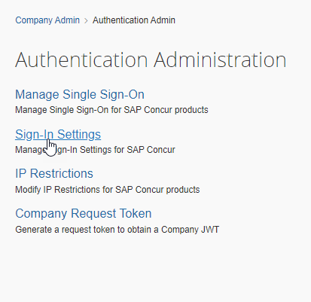

Standard Edition

Permissions
To access the Sign-In Settings page in Standard Edition, a user must have the Can administer, Travel-Only administrator, or Expense and Travel administrator check box selected on their user account page. In Standard edition, the client administrator can select Can administer, Travel-Only administrator, or Expense and Travel administrator on the desired user’s user account page to enable the user to access Sign-In Settings.
The other options available on the Authentication Administration page vary depending on your company’s configuration.

Accessing Sign-In Settings
To access the Sign-In Settings page in SAP Concur Standard Edition, on the Administration menu, click Company > Authentication Admin. On the Authentication Administration page, click Sign-In Settings.
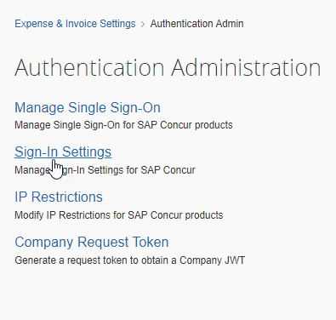

Configuring the Password Policy
The Sign-In Settings page enables the administrator to define policies for the following:
- Password Strength (required elements)
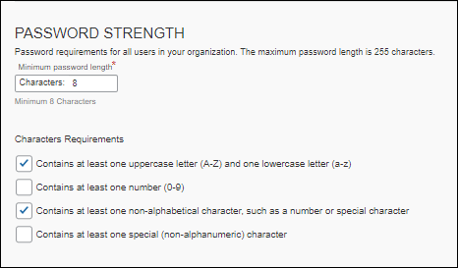
- Password Change (password reset and expiration)
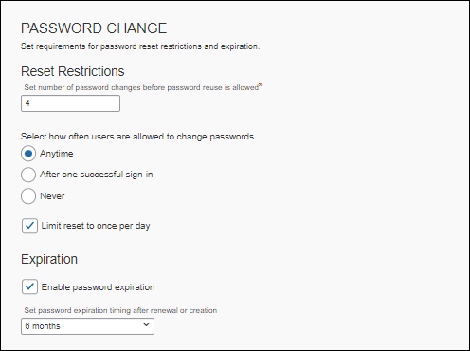
- Account Lockout (conditions for locking an account)
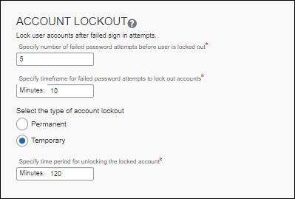
- Session Timeout (response to user inactivity)
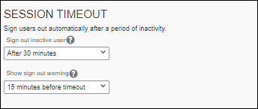
- Other Settings (username reset, change password, require email link for 2FA setup)
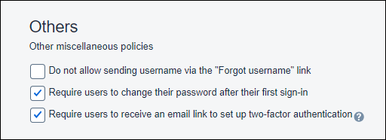

Default, Minimum, and Maximum Settings
To improve security for our clients, SAP Concur specifies default, minimum, and maximum password policy settings. If a company admin does not change these settings, the default settings are enforced.
For the default, minimum, and maximum values, refer to the following table:
Password Strength (required password elements) | Minimum | Maximum | Default
Password length | 8 | 255 | 8
Upper (A-Z) and lower (a-z) case letters required | True/False | True/False | True
Number (0-9) required | True/False | True/False | False
Number or special (non-alphabetic) character required | True/False | True/False | True
Special (non-alphanumeric) character required | True/False | True/False | False
Password Change (password reset and expiration) | Minimum | Maximum | Default
How often users are allowed to change their password | Never | Anytime | Anytime
Password reset allowed once per day | True/False | True/False | True
Number of password changes required before reusing a password | 4 | 20 | 4
Passwords expire | True/False | True/False | True
Period after which password expires | 1 month | 1 year | 6 months
Account Lockout (criteria for locking an account after failed attempt(s)) | Minimum | Maximum | Default
Number of failed sign-in attempts allowed before an account is locked | 3 | 20 | 5
Sign in failure window (elapsed time before restarting the failure count) | 10 min | 240 min | 10 min
Permanent lockout | True/False | True/False | False
Duration of account lockout | 30 min | 1440 min | 120 min
Session Timeout (sign users out after a period of inactivity) | Minimum | Maximum | Default
Display sign-out warning (display a warning x minutes before user is signed out due to inactivity) | 0 | 15 | 15
Sign out an idle user (number of minutes a user can be idle before being automatically signed out) | 10 | 120 | 30
Other settings | Minimum | Maximum | Default
Hide the "Forgot Username" link | True/False | True/False | False
User must change their password on first sign in | True/False | True/False | True
Require users to receive an email link to set up 2FA | Enabled/Disabled | Enabled/Disabled | Enabled

☼

