

Applies to these SAP Concur solutions:
 Expense
 Professional/Premium edition
 Standard edition
 Travel
 Professional/Premium edition
 Standard edition
 Invoice
 Professional/Premium edition
 Standard edition
 Request
 Professional/Premium edition
 Standard edition

Concur Request:
Overview of Request with Travel Allowance
Setup Guide

Last Revised: May 20, 2023
Table of Contents
Section 1: Permissions 1
Section 2: Overview of the Request Feature 1
Section 3: Request Configurations 1
Section 4: Overview 2
Travel Allowance Documentation 2
Concur Expense 2
Concur Request 2
Section 5: General Information 3
Daily Allowances 3
Fixed 3
Terminology 4
Intuitive User Interface (UI) Elements 5
Example 5
Section 6: What the User Sees 6
Creating a Request 6
Creating an Itinerary Based on Request Segments 18
Deleting a Travel Allowance Itinerary 20
Approving a Request 21
Creating an Expense Report 27
Modifying an Itinerary or Adjustments After a Trip 29
Section 7: Configuring Concur Request for Travel Allowances 31
Enable Daily Allowances for the Request Policy 32
Allow Employees to Recall Requests 33
Add the Request Field to the Expense Report Header Form 35
Configure Audit Rules for Travel Allowances in Concur Request 38
Supported Events 39
Available Fields 39

Revision History
Date | Notes / Comments / Changes
May 20, 2023 | Made the following updates:  - Replaced "travel allowance solution" with "Travel Allowance Service".  - Removed references to the NextGen UI and the NextGen UI Requirement section now that the NextGen UI is the current UI for Concur Request.  - In the Creating a Request section, replaced the image of the Create New Request tile with the new Create New Request button.  - Added the Configure Audit Rules for Travel Allowance in Concur Request section to the Configuring Concur Request for Travel Allowances section.
January 21, 2022 | Updated the copyright year; no other changes; cover date not updated
March 29, 2021 | Updated the copyright year; no other changes; cover date not updated
July 1, 2020 | Initial publication.

Travel Allowance
NOTE: Multiple SAP Concur product versions and UI themes are available, so this content might contain images or procedures that do not precisely match your implementation. For example, when SAP Fiori UI themes are implemented, home page navigation is consolidated under the SAP Concur Home menu.

Permissions
A company administrator may or may not have the correct permissions to use this feature. The administrator may have limited permissions, for example, they can affect only certain groups and/or use only certain options (view but not create or edit).
If a company administrator needs to use this feature and does not have the proper permissions, they should contact the company's SAP Concur administrator.
Also, the administrator should be aware that some of the tasks described in this guide can be completed only by SAP Concur. In this case, the client must initiate a service request with SAP Concur support.

Overview of the Request Feature
Refer to the Concur Request: Overview Guide for general information about requests, such as what the user sees, what the approver sees, workflow, settings, configuration basics, etc.

Request Configurations
Not all Request features are available for all Request configurations.
In order to use the Travel Allowance Service (TAS) in Concur Request, you must have Concur Expense and Concur Request.
Configuration | Is this feature available?
Stand-alone | No
Integrated with Concur Expense (but not Concur Travel) | Yes, Optional
Integrated with Concur Travel (but not Concur Expense) | No
Integrated with Concur Expense and Concur Travel | Yes, Optional

Overview
A company may reimburse its employees' travel expenses according to a schedule of set reimbursement rates, commonly known as "per diem" or "travel allowance" rates. Government and company policies determine rates. Rates may differ depending on location and length of travel as well as partial days of travel, seasonal travel, and so on. Travel allowances apply to meals (which usually includes incidentals) and lodging expenses.
Travel allowances do not apply to expenses such as car rentals, airline tickets, seminars, and so on.

Travel Allowance Documentation
The Travel Allowance Service uses configurable and/or statutory rate bundles to create configuration codes which are mapped to employees.

Concur Expense
The Travel Allowance Service is configured in Concur Expense. The following documents will be needed to configure the Travel Allowance Service for your company:
- Concur Expense: Travel Allowance Service Setup Guide – This document provides basic information about configuring travel allowance functionality and is needed by all clients.
- Concur Expense: Travel Allowance {Country} Statutory Bundle Guide – This document provides country-specific template information about SAP Concur-managed bundles.
- Concur Expense: Travel Allowance Generic Configurable Bundle Setup Guide – Where a country-specific guide is not available, or superseding rates are desired, this document provides information about creating client-managed bundles.
- Concur Expense: Travel Allowance Import (XML v 3) Specification – This document is used to efficiently populate employee User Administration accounts with a Country of Residence value (and any other client fields used in the travel allowance hierarchy) to provide the necessary mapping for travel allowance functionality.

Concur Request
To use the Travel Allowance Service with Concur Request, you will need the following document:
- Concur Request: Overview of Request with Travel Allowance Setup Guide (This guide) – This document provides basic information about configuring Concur Request for the Travel Allowance Service, and information about creating and approving requests with a travel allowance itinerary.

General Information
This section provides requirements and general information about the Travel Allowance Service.
This guide documents the Travel Allowance Service available to clients who use Concur Request. The Travel Allowance Service offers an SAP Concur managed rate service, where available, whereby statutory rate updates are maintained by SAP Concur.
If you will also be using the Travel Allowance Service with Concur Expense, such as creating expense reports from requests that have a travel allowance itinerary, you will need both Concur Request and Concur Expense.

Daily Allowances

Fixed
With a daily type of travel allowance, the employee is reimbursed the daily rate regardless of the actual amount of expenses. For example, assume that the daily rate for meals (including incidentals) is 55.00 EUR per day.
- If the employee spends less than 55.00 EUR per day, the employee keeps the difference.
- If the employee spends more than 55.00 EUR per day, the employee is responsible for paying the difference.
Since the system pays the employee the amount regardless of the actual expense, the employee does not enter actual expected expenses for meals and lodging into Concur Request or collect receipts. The system creates the daily-amount expenses based on the location and duration information that the employee provides in their trip itinerary.

Terminology
In the guides for this feature and in some of the configuration settings, you may see these travel allowance terms.
Term | Definition
Benefit-in-Kind (BIK) | A meal supplied by the company to employees that may create a tax obligation for the employee. For example:  - A meal supplied at a company canteen paid for by in-house currency or voucher  - A meal supplied as part of a training course, seminar, or conference arranged and paid for by the company  – or –  - Any meal arranged in advance  The amount paid to the employee is not reduced by the value of benefit-in-kind meals. The BIK amount is typically treated as a taxable benefit.  BIK may be configured in anticipation of further processing by a payroll system.
business trip | Work-related travel that may be eligible for travel allowance reimbursement.
configuration code | A collection of one or more rate bundles.
lodging | Where the employee sleeps the night such as a hotel, motel, or other traditional (likely commercial) accommodations.
managed rate service | A feature, such as travel allowance, whose statutory rate updates are maintained by SAP Concur.
overnight | A system alternative to the lodging allowance and a supplement to the meals allowance. Selecting a Lodging Type of Overnight increases the allowed amount.  While this may vary by country, this is typically used when the employee stays with friends, in a caravan, or any other lodging arrangement other than traditional hotel accommodations.  The overnight allowance, which is intended to be used by the employee to purchase a gift for the host, is a much lower amount than the lodging allowance.
rate | A unit of measure such as a currency amount (such as € 10,00) or period of time (such as daily).
rate type | A data set comprised of a code, description, and rate category.
rate bundle | A set of rates, deductions, and adjustments, either a statutory (SAP Concur-managed) set or a custom (company-created and managed) set.
rate category | A required element of each rate type.  Each rate type must have a rate category. The rate category maps the travel allowance rate type to the fixed travel allowance expense type category.  The system-provided choices are: Incidental, Lodging, and Meal.
statutory rates | The government defined amounts for reimbursable and tax-free travel allowance expenses. Statutory rates are also known as government rates or government allowances and are managed by SAP Concur.  NOTE: All rates are either statutory (SAP Concur-managed) or custom (company-created and managed).
template | A description of the expected or common usage of the travel allowance feature based on country, such as Germany or Spain. Each template has its own travel allowance setup guide.  NOTE: For countries without a country-specific travel allowance setup guide, the Expense: Travel Allowance Generic Configurable Bundle Setup Guide is needed in lieu of a country-specific guide.

Intuitive User Interface (UI) Elements
There are elements of the UI that display a simple form or not at all.

Example
On the Travel Allowance Adjustments page of a user's request, when a single lodging type is configured, such as "Overnight", then the name of the type displays as the name of the column with a checkbox for each row:
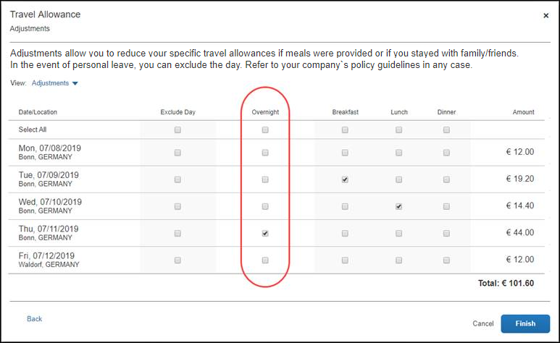
However, if more than one lodging type has been configured, then the name of the column is "Lodging Type" with a list for each row:
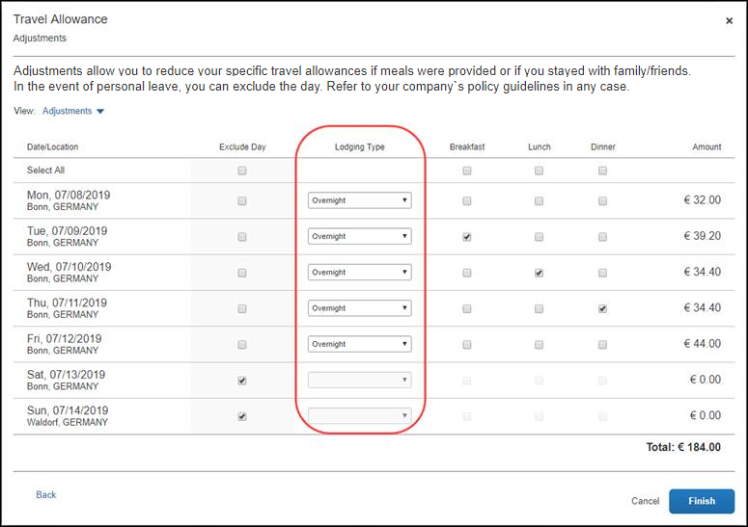

What the User Sees
This section uses a common method of reimbursement – daily allowances for meals and actual expenses for lodging.
Your company's travel allowance configuration and the country-specific statutory bundle or generic configurable bundle your company uses will determine which fields and values are available when creating a travel allowance itinerary in Concur Request.

Creating a Request
When the travel allowance feature is available to an employee, after the employee completes the header on a new request, they can add a travel allowance itinerary and define their travel allowance adjustment information to the request.
When you are creating a travel allowance itinerary on a request, you can manually enter the travel allowance itinerary information, or if you add your point-to-point transportation segments before adding the travel allowance itinerary, you can create the travel allowance itinerary with the locations, dates, and times automatically populated on the itinerary.
The following instructions provide steps for manually entering the travel allowance itinerary information.
- For more information about creating a travel allowance itinerary based on segments, refer to the Creating an Itinerary Based on Request Segments section in this guide.
To create a request with a travel allowance itinerary:
- From Concur Request, click Create New Request.
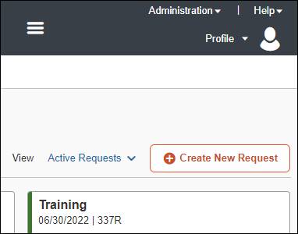
There are other valid paths to start a new request.
- On the Create New Request page, commonly referred to as the request header, complete all required fields. An asterisk indicates a required field.
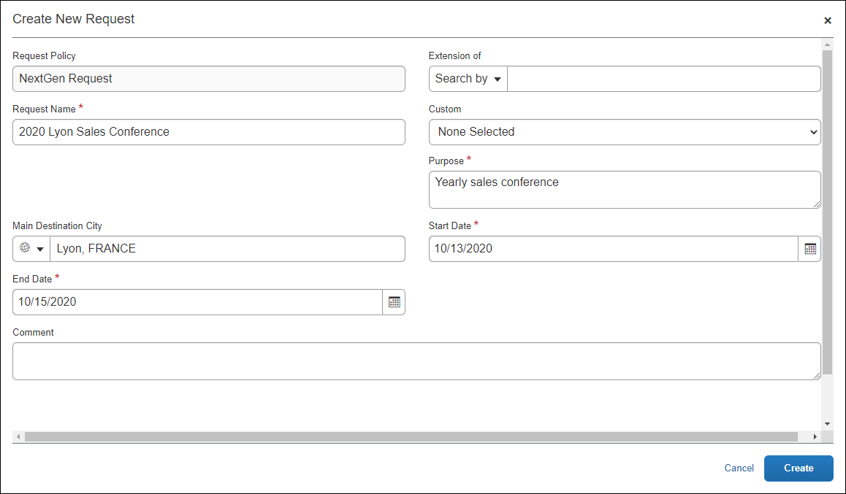
The policy selected may impact which fields display.
- Click Create to create the request.
- On the Expected Expenses page, click Manage Travel Allowance > Add Travel Allowance.
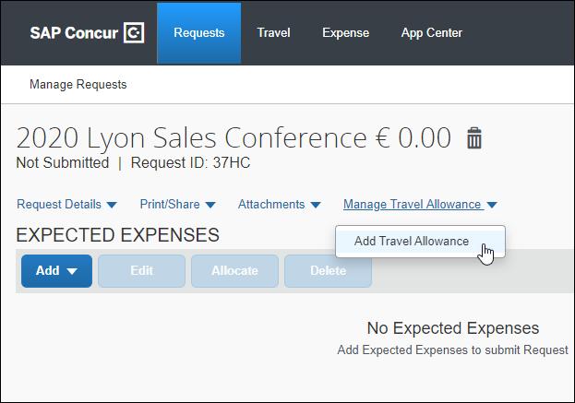
- On the Travel Allowance Itinerary page, complete all required fields. An asterisk indicates a required field. Fields vary by country.
Without the Detailed Itinerary check box selected:
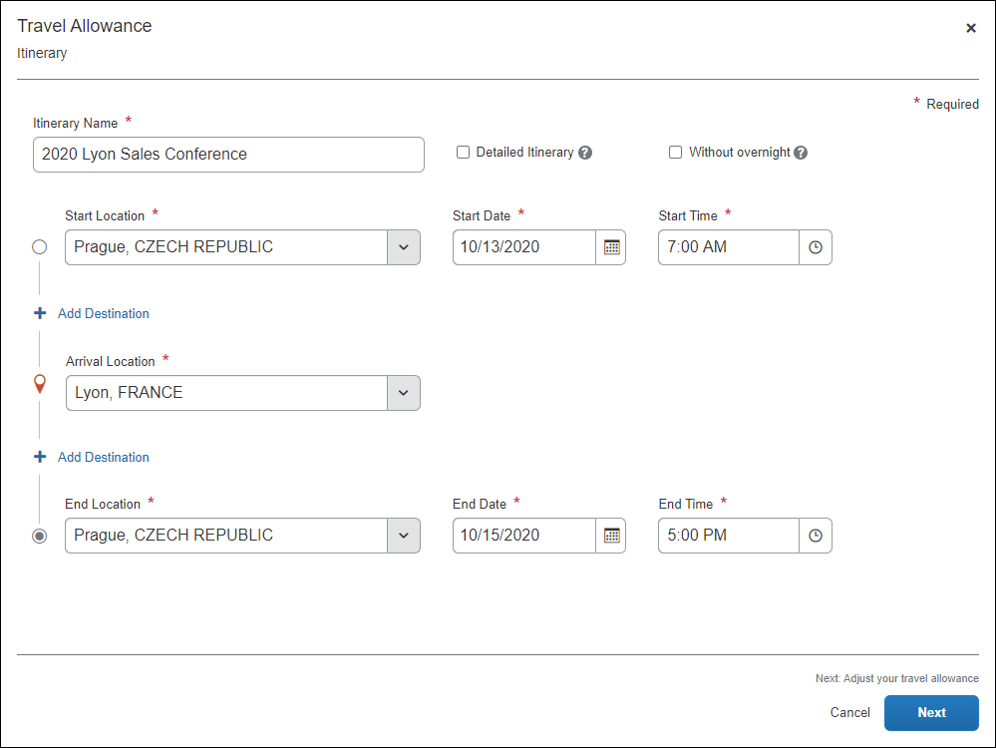
Additional required fields display when the Detailed Itinerary check box is selected:
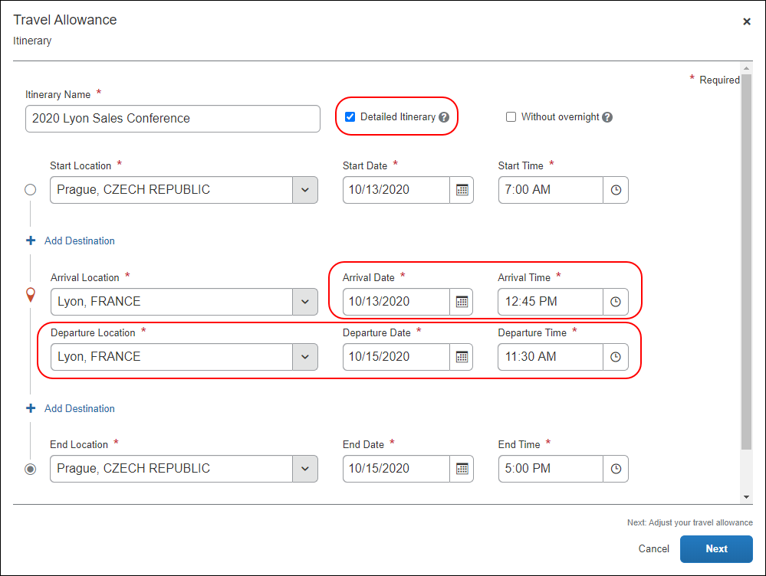
The following table shows the fields and their descriptions.
Field/Option | Description
Itinerary Name* | Enter an itinerary name or use the default name provided that matches the Request Name.
Detailed Itinerary | Select this option to display five additional fields:  - Arrival Date*  - Arrival Time*  - Departure Location*  - Departure Date*  - Departure Time*  NOTE: These fields are required when Detailed Itinerary is selected.
Without overnight | Select this option to indicate no accommodations will be used, for example a hotel. This option is typically selected by logistics employees who work through the night.  NOTE: Selecting Without overnight will prevent the Lodging Type choice(s) from displaying on the Travel Allowance Adjustments page.
Start Location* | Enter an origination city for this itinerary.
Start Date* | Enter a beginning month, day, and year for the time period covered by this itinerary.
Start Time* | Enter a beginning hour and minutes for the time period covered by this itinerary.
Add Destination | Click Add Destination to display another set of location fields to this itinerary. This option displays twice for convenience.
Arrival Location* | Select the first destination of your trip from the list of cities.
Arrival Date* | Enter the beginning month, day, and year of your time at this Arrival Location.
Arrival Time* | Enter the beginning hour and minutes of your time at this Arrival Location.
Departure Location* | Select the last location at this Arrival Location from the list of cities.
Departure Date* | Enter the month, day, and year that you will leave the Departure Location.
Departure Time* | Enter the hour and minutes that you will leave the Departure Location.
End Location* | Enter a final city for this itinerary.
End Date* | Enter the ending month, day, and year for the time period covered by this itinerary.
End Time* | Enter an ending hour and minutes for the time period covered by this itinerary.
- Click Next to save the itinerary and display the Travel Allowance Adjustments page.
Adjustments (view)
This is the default view where a user can see a row for each calculated daily allowance and select adjustments such as excluded days, provided meals, and others based on the configuration of the generic or statutory bundle your company is using.
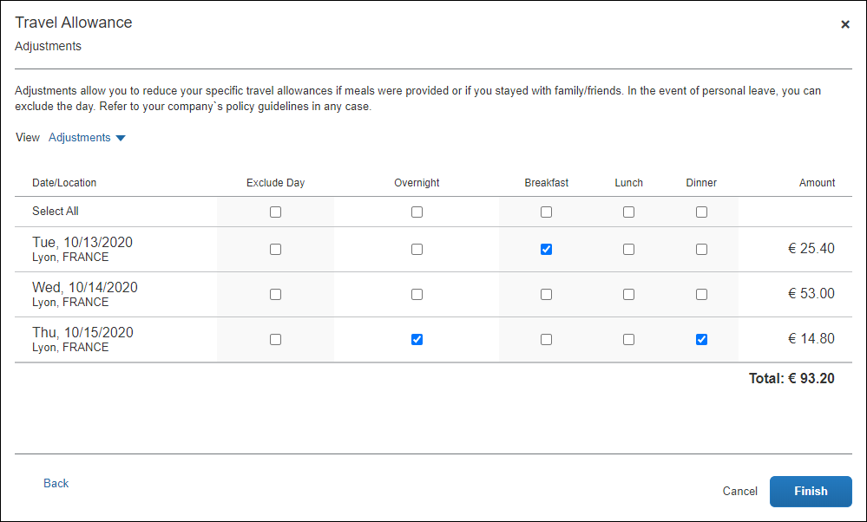
About Checkboxes versus Lists
If only one trip type, meal type, or lodging type is configured, it will appear to the user as a checkbox, such as the Overnight column and checkboxes in this example.
If more than one type is configured, a column will display a list of choices for the user:
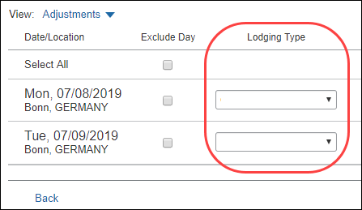
Reimbursement Details (view)
This view shows details for the adjustments based on what the user selected on the Travel Allowance Adjustments page together with original rate amounts, any deductions for the day, and total reimbursable amounts.
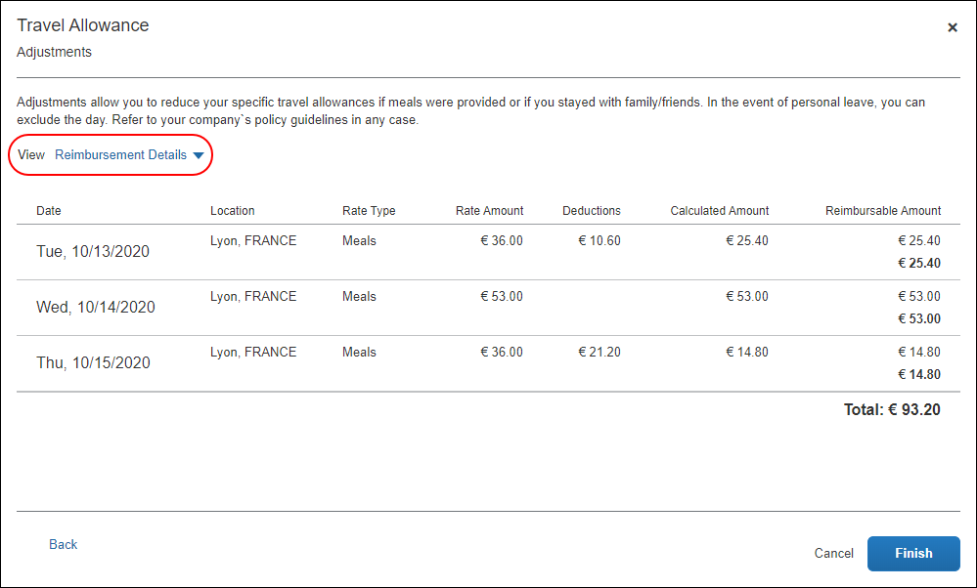
Tax-Exempt Amounts (view)
This view only displays for configurations that include both the statutory rate bundle and a configurable rate bundle where the amounts differ. The difference is tracked as taxable to the employee. Users can compare the amount on the Adjustments page with the tax-exempt amount on this page to know how much of their daily allowance is taxable.
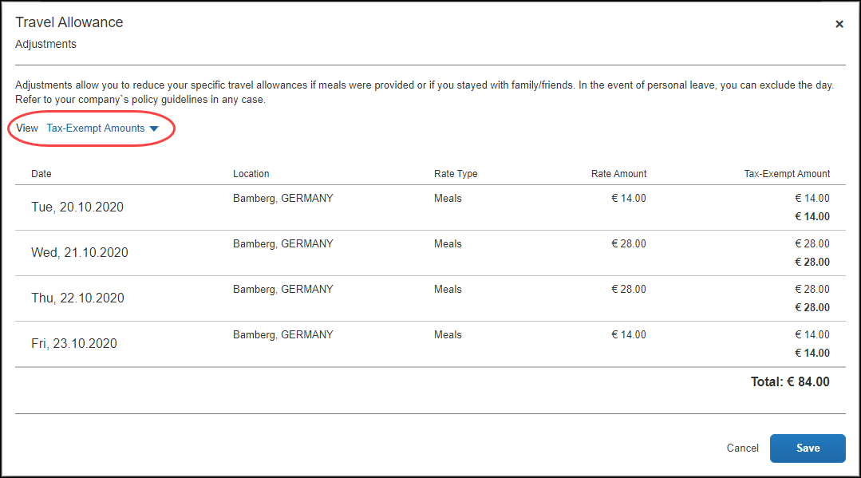

In this sample instance:
- For the first and last days, the amounts are automatically reduced because the employee did not spend full days at the location.
- The amount is reduced for the days when the employee indicated that meals were provided (for example, by the hotel and conference center).
- Selecting Overnight increases the allowed amount.
Any deduction can reduce the allowance amount to zero but never less than zero; it can never result in a charge to the employee.
The following table shows the fields and their descriptions:
Column | Description
Exclude Day | Select this check box to mark a date as personal time and therefore not eligible for travel allowance benefits.  NOTE: There is a Select All check box available for this column.
Overnight | If configured for your company, and selected, the system will add an amount to the calculated meals rate for the purpose of purchasing a gift for the host.  NOTE: There is a Select All check box available for this column.
Breakfast | Select this check box to mark the meal as provided and therefore not eligible for travel allowance benefits.  NOTE: Provided meals reduce the daily currency total shown in the Amount column.  NOTE: There is a Select All check box available for this column.
Lunch | Select this check box to mark the meal as provided and therefore not eligible for travel allowance benefits.  NOTE: Provided meals reduce the daily currency total shown in the Amount column.  NOTE: There is a Select All check box available for this column.
Dinner | Select this check box to mark the meal as provided and therefore not eligible for travel allowance benefits.  NOTE: Provided meals reduce the daily currency total shown in the Amount column.  NOTE: There is a Select All check box available for this column.
- (Optional) Click Back to edit the itinerary page.
- (Optional) Click Cancel to close the adjustments page without saving your selections.
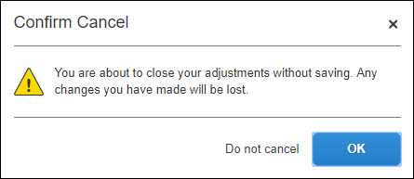
When Cancel is clicked, the request is not deleted and the itinerary and allowances can be edited later by selecting Manage Travel Allowance > Edit Travel Allowance or Edit Adjustments.
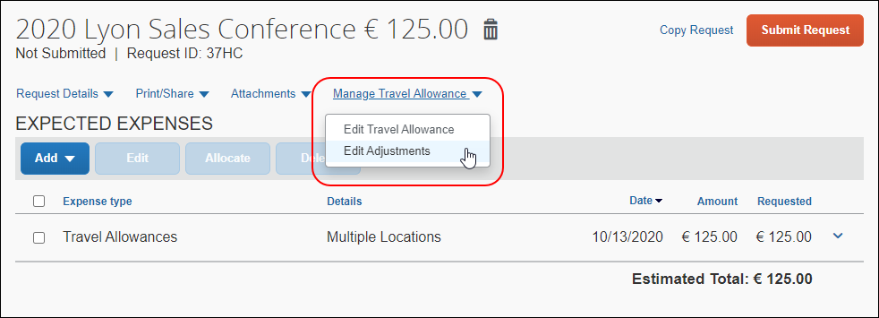
- Click Finish to create the travel allowance itinerary and daily allowances and display the request.
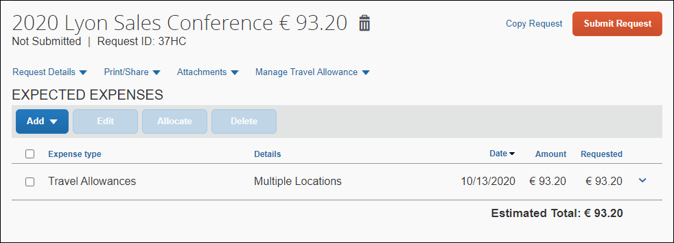
It is important to understand the following about system-created expected expenses:
- All of the daily allowance expected expenses are combined into one expected expense on the request, and the expected expense is assigned the default expense type of Travel Allowances.
This differs from daily allowance expenses on an expense report. In Concur Expense, when you add a travel allowance itinerary to an expense report, the individual daily allowance expenses are added to the expense report and they are assigned the Daily Allowance or Daily Allowance (Lodging) expense types.
- If rate information is changed after the Travel Allowances expected expense was created, the expected expense amount is not updated unless the user returns to the Travel Allowance Adjustments page and clicks Save.
You can view the Daily Allowance expense(s) contained within the Travel Allowances expected expense by clicking the down arrow next to the amount in the Requested column.
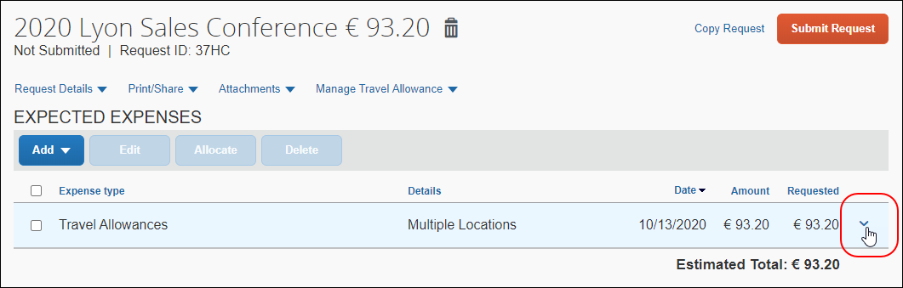
Clicking the down arrow expands the Travel Allowances expected expense.
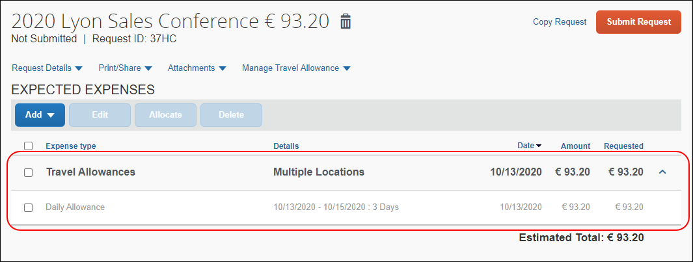
You can also view the Daily Allowance expense details by selecting (enabling) the check box for the Daily Allowance expense, and then clicking Edit on the Expected Expenses page. Most of the fields on the page are read-only for the Daily Allowance expense except for fields like the Description or Comment field.
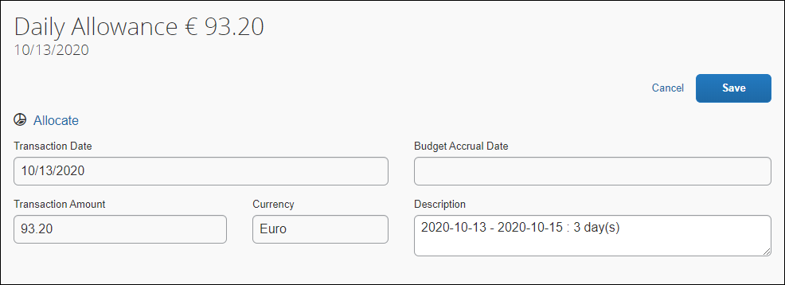
- To add additional expected expenses or segments to the request, click Add. This step is not specific to the travel allowance feature and is accomplished in the same manner that is used to add non-travel allowance expected expenses and segments to a request.
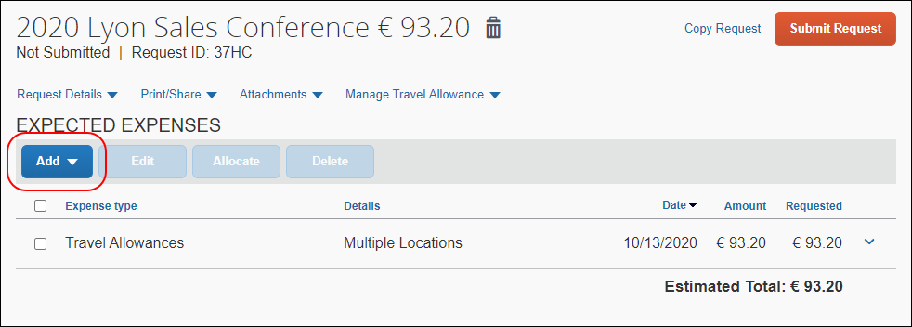
- When you are done creating the request, including the travel allowance itinerary and adjustments, and adding any additional expected expenses or segments to the request, click Submit Request to submit the request.

Creating an Itinerary Based on Request Segments
When you are creating a request with a travel allowance itinerary, if you create your point-to-point transportation segments before adding the travel allowance itinerary, the locations, dates, and times defined in the segments will automatically be populated in the travel allowance itinerary.
If a travel allowance itinerary is created before adding the transportation segment(s) to a request, the travel allowance itinerary will not be updated with the locations, dates, and times from the segment(s) you added after the travel allowance itinerary was created.
For example, you create a request, and before you add the travel allowance itinerary, you create an Air Ticket segment for your trip's flight.
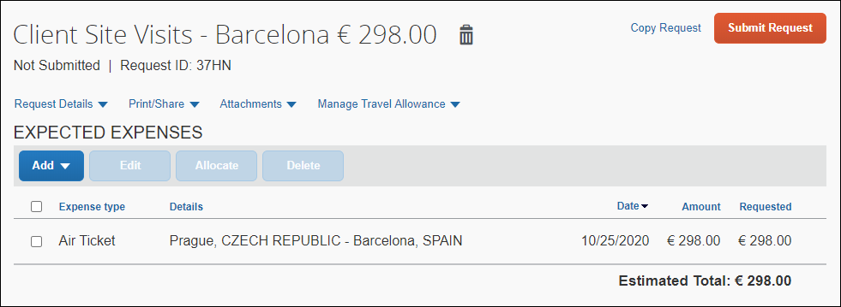
Air Ticket segment example:
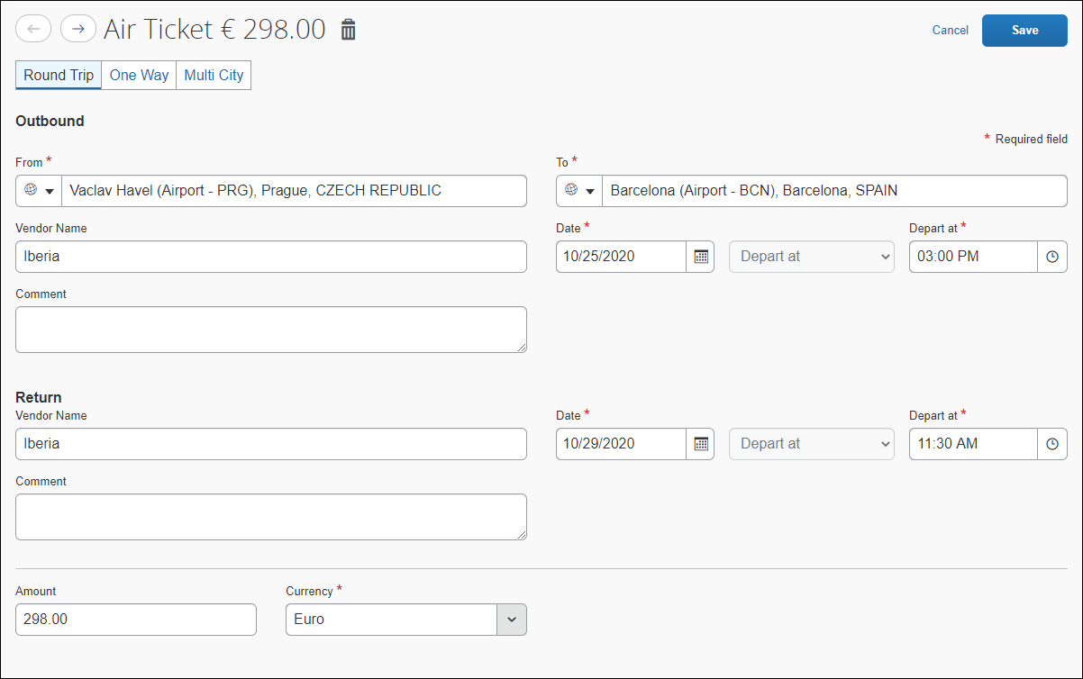
After creating the transportation segment, then click Manage Travel Allowance > Add Travel Allowance.
If the following information is populated in the transportation segment(s), the same information is automatically populated in the travel allowance itinerary:
- Start Location
Start Date
Start Time
- Arrival Location
Arrival Date
Arrival Time
- Departure Location
Departure Date
Departure Time
- End Location
End Date
End Time
In this example, the Arrival Date, Arrival Time, and End Time were not populated in the Air Ticket segment, so they were not populated in the travel allowance itinerary. If these fields were populated in the Air Ticket segment, then they would also be populated in the travel allowance itinerary.
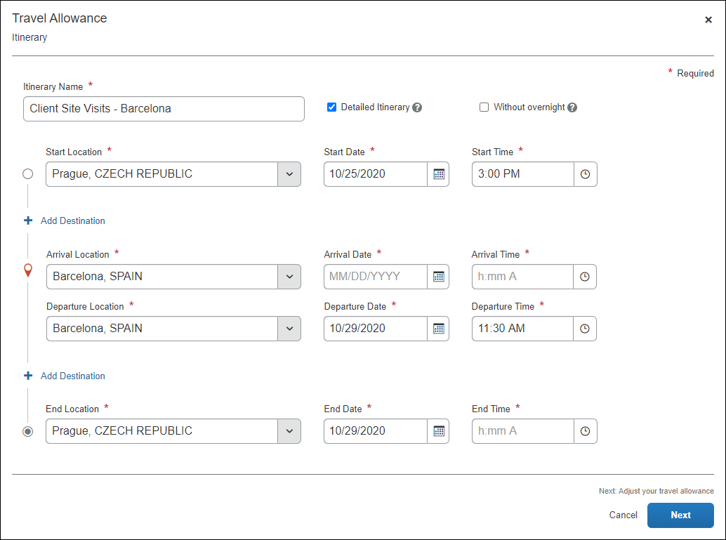

Deleting a Travel Allowance Itinerary
If your configuration allows it, you can delete a travel allowance itinerary before the request associated with the itinerary is submitted. Once the request is submitted, you cannot delete the travel allowance itinerary. A travel allowance itinerary can be deleted from the Travel Allowance Itinerary page.
To delete a travel allowance itinerary:
- Open the request containing the travel allowance itinerary you want to delete.
- On the Expected Expenses page, click Edit Travel Allowance in the Manage Travel Allowance menu.
Clicking Edit Travel Allowance opens the Travel Allowance Itinerary page.
- Click Delete Itinerary.
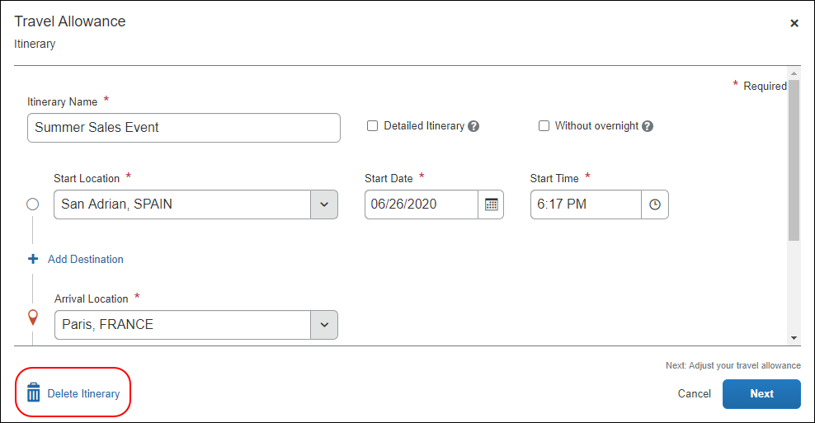
- Click Delete when asked, Are you sure you want to delete this itinerary? This action cannot be undone.
Clicking Delete permanently deletes the travel allowance itinerary from the request, including the Travel Allowances expected expense on the Expected Expenses page.

Approving a Request
After an employee submits a request with a travel allowance itinerary and adjustments, the approver can review the itinerary and adjustments before approving the request. The approver cannot edit the travel allowance itinerary or adjustments.
If the travel allowance itinerary or adjustments need to be modified before approving the request, send the request back to the employee with the reason entered in the Add Comment field in the Send Back to Employee dialog.
To approve a request with a travel allowance itinerary:
- Open the Approvals page.
To open the Approvals page either:
- Click Authorization Request under Required Approvals in the My Tasks section of the home page.
Or
- Click Approvals at the top of the page, and then click the Requests tab.
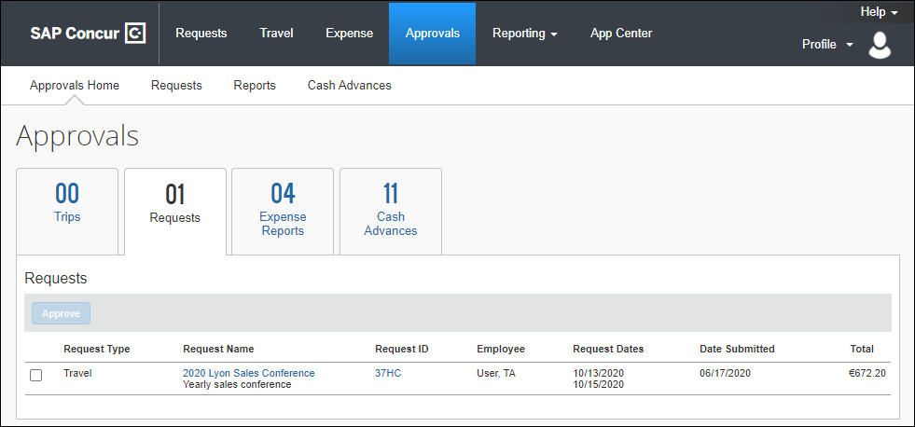
- Open the request containing the travel allowance itinerary.
- To expand the Travel Allowances expected expense on the Expected Expenses page, click the down arrow next to the amount in the Requested column.
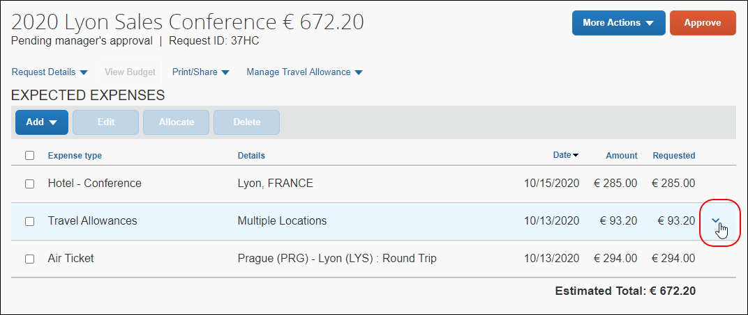
- To view the Daily Allowance expense details, on the Expected Expenses page, select (enable) the check box for the Daily Allowance expense, and then click Edit.
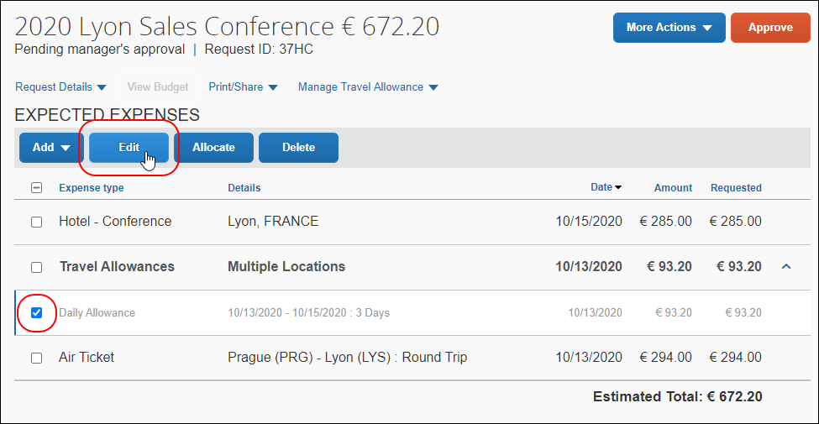
Clicking Edit opens the expected expense details page for the Daily Allowance expected expense. Most of the fields on the page are read-only for the Daily Allowance expense except for fields like the Comment field.
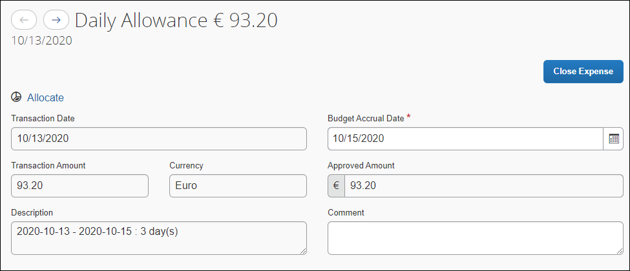
- Click Close Expense to return to the Expected Expenses page.
- To view the travel allowance itinerary and adjustments, on the Expected Expenses page, click Manage Travel Allowance > View Travel Allowance or View Adjustments.
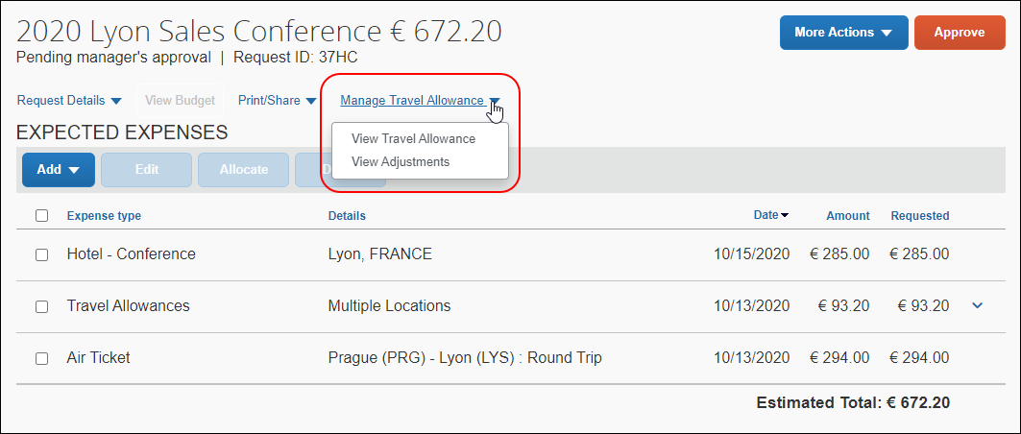
Clicking View Travel Allowance opens the Travel Allowance Itinerary page. This page is read-only for request approvers.
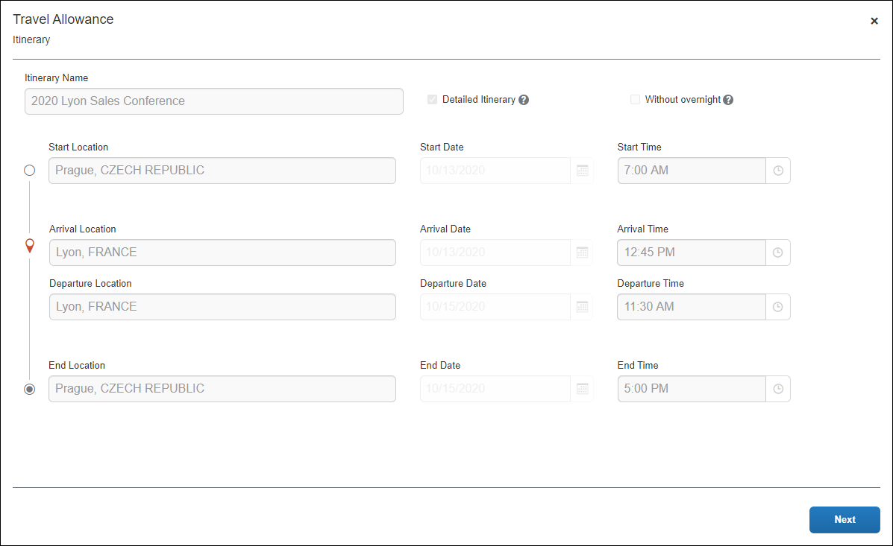
Clicking View Adjustments opens the Travel Allowance Adjustments page. This page is also read-only for request approvers.
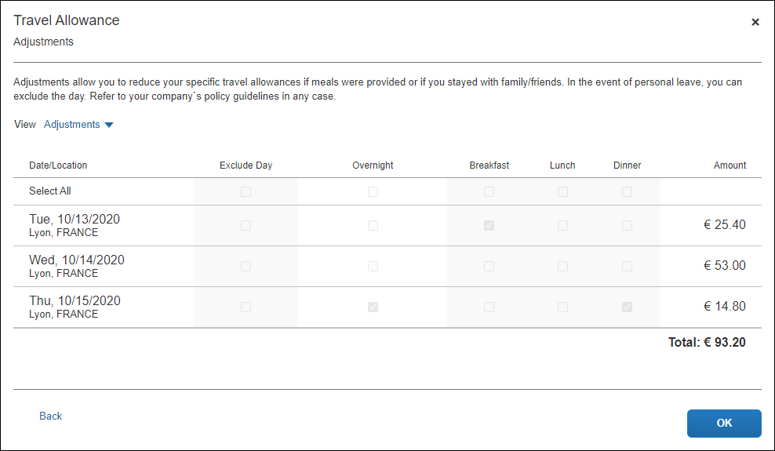
To view the reimbursement details for the travel allowance itinerary, on the Travel Allowance Adjustments page, click Reimbursement Details in the View list.
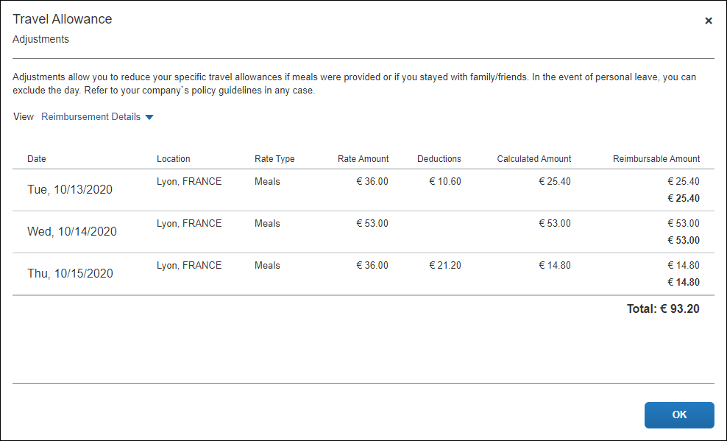
- When you are done reviewing the travel allowance itinerary for the request, review any additional expected expenses or segments on the request.
- On the Expected Expenses page, if the request is ready for approval, click Approve.
Click Yes when asked, Are you sure you want to approve this request?.
- If the request needs to be sent back to the request submitter, click More Actions > Send Back to Employee.
Clicking Send Back to Employee opens the Send Back to Employee dialog.
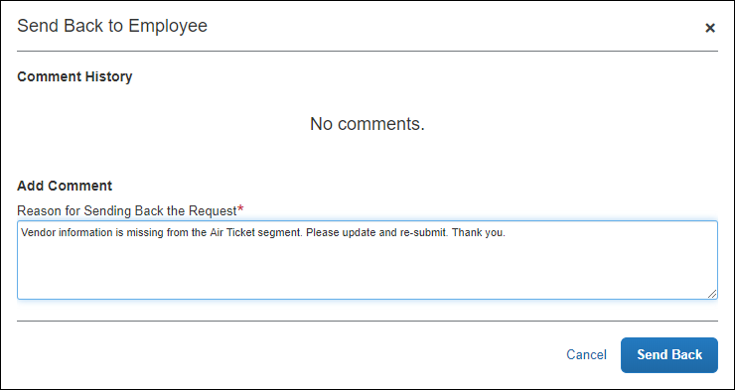
- In the Add Comment field, enter the reason for sending back the request and any additional information for the employee, and then click Send Back.

Creating an Expense Report
After the request has been approved and the employee has completed their trip associated with the travel allowance itinerary, the employee can create an expense report from the request with a travel allowance itinerary and adjustments.
To create an expense report from a request:
- In Concur Request, open the approved request from which you want to create an expense report.
- On the Expected Expenses page, click Create Expense Report.
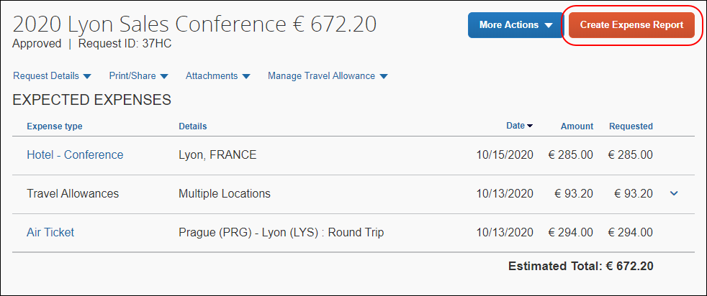
Clicking Create Expense Report opens the new expense report in Concur Expense.
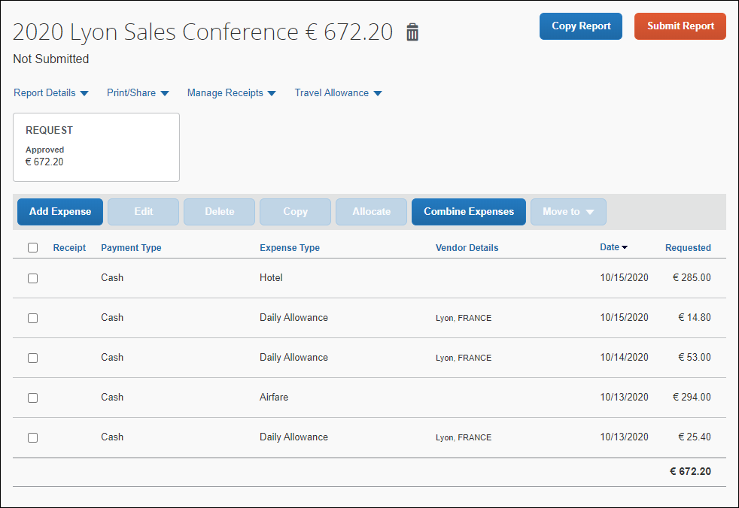
- The approved request is automatically associated with the expense report, and the Request box is displayed below the Report Details menu.
- The travel allowance itinerary is automatically associated with the expense report, and the itinerary can be viewed and edited by clicking Edit Travel Allowance from the Travel Allowance menu.
- Individual Daily Allowance expenses are automatically created on the expense report for each Daily Allowance expected expense associated with the travel allowance itinerary in the request.
- Expenses for any additional expected expenses or segments you added to the request are also automatically created on the new expense report.
It is important to understand the following about system-created expenses:
- As applicable, daily allowance expenses are assigned the default expense type of Daily Allowance or Daily Allowance (Lodging).
- If there are both meals and lodging allowances on the same day, an expense is created for each expense type for each day.
- If rate information is changed after the daily allowance expenses have been created, the amounts are not updated unless the user returns to the adjustments page and clicks Finish again.
- If the actual meal expenses are imported through the company card import but the employee was reimbursed with daily allowances, then the employee should mark the imported meal expenses as personal.
- For more information about expense reports and the Travel Allowance Service, refer to the Expense: Travel Allowance Generic Configurable Bundle Setup Guide or applicable Expense: Travel Allowance Statutory Bundle Setup Guide.

Modifying an Itinerary or Adjustments After a Trip
After an expense report is created from a request with a travel allowance itinerary, if the employee needs to update their travel allowance itinerary or adjustments after their trip, they can do so from the Travel Allowance menu on the expense report.
For example, if the trip was either shorter, longer, or the actual travel times differed from the dates on the request, the employee can make any required adjustments to their itinerary dates. Or the employee may need to adjust their allowances, such as marking free meals as provided to reduce the daily allowance amount.
Any changes made to the travel allowance itinerary or adjustments may recalculate the actual travel allowance entitlement.
- In some circumstances the resulting travel allowance entitlement could be higher - for example, if the trip was extended by a few days compared to the original request.
- In other circumstances the resulting travel allowance entitlement could be lower – for example, if the trip was shorter, or where the user had additional free or provided meal deductions.
To modify a travel allowance itinerary or adjustments on an expense report:
- In Concur Expense, open the expense report containing the travel allowance itinerary you want to modify.
- In the Travel Allowance menu, click Edit Travel Allowance or Edit Adjustments.
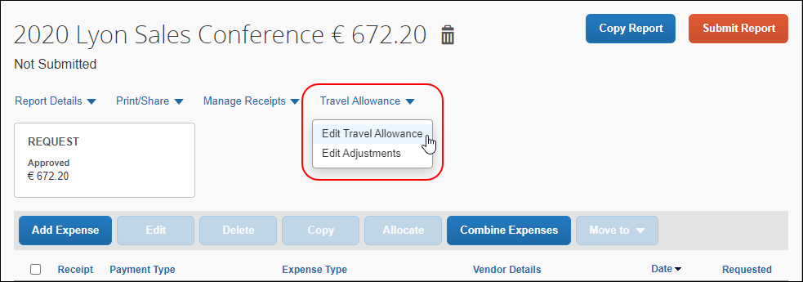
If you need to adjust the travel allowance itinerary, click Edit Travel Allowance. Clicking Edit Travel Allowance opens the Travel Allowance Itinerary page.
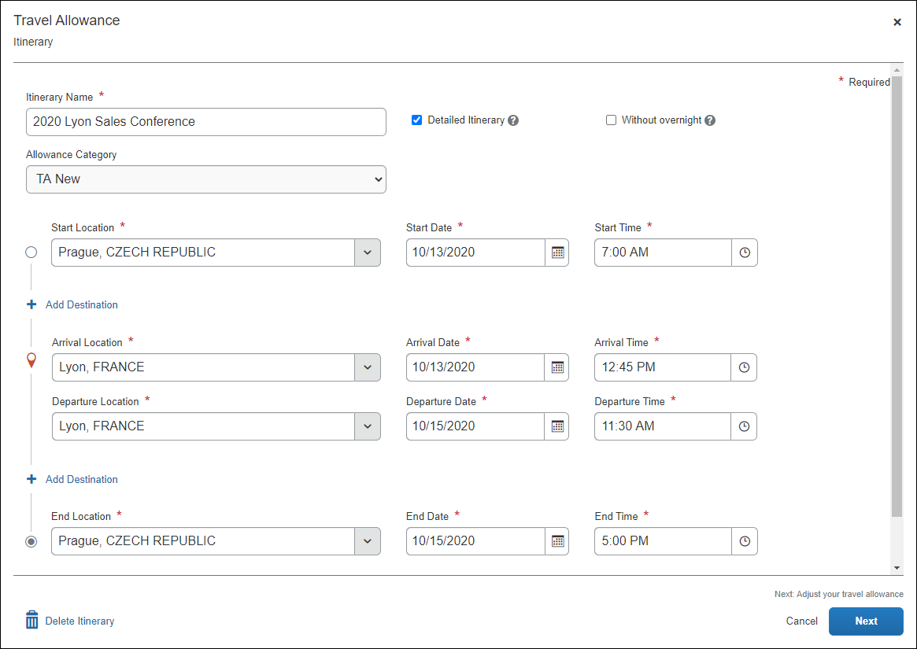
If you need to modify the travel allowance adjustments, click Edit Adjustments or on the Travel Allowance Itinerary page, click Next.
The Travel Allowance Adjustments page appears.
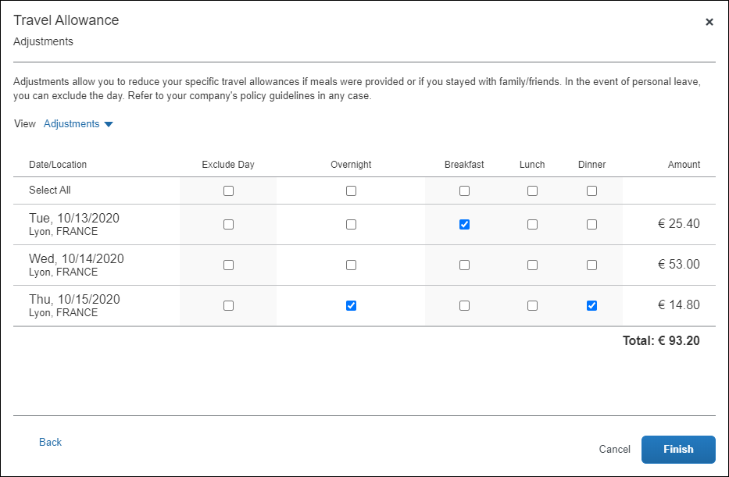
- To modify the travel allowance itinerary, on the Travel Allowance Itinerary page, make your changes, and then click Next to open the Travel Allowance Adjustments page.
- To modify the travel allowance adjustments, on the Travel Allowance Adjustments page, make your changes.
- If you want to view the reimbursement details, in the View list, click Reimbursement Details.
- Click Finish.
Clicking Finish saves your changes to the travel allowance itinerary and/or adjustments, recalculates your travel allowance entitlement, based on your changes, and closes the Travel Allowance Adjustments page.
- For more information about expense reports and the Travel Allowance Service, refer to the Expense: Travel Allowance Generic Configurable Bundle Setup Guide or applicable Expense: Travel Allowance Statutory Bundle Setup Guide.

Configuring Concur Request for Travel Allowances
While most of the configuration for the Travel Allowance Service is done in Concur Expense, in order to use the Travel Allowance Service in Concur Request, there is some additional configuration that needs to be done in Concur Request:
- Enable the Daily Allowance expense types for the request policy that will be used for requests that have a travel allowance itinerary
- Configure the request workflow to allow employees to recall requests, including recalling requests after approval
- Add the Authorization Requests/Travel Requests field to the Expense Report Header Form
- Configure audit rules for travel allowances in Concur Request

Enable Daily Allowances for the Request Policy
The Daily Allowance expense types need to be enabled for the request policy that will be used for creating requests with a travel allowance itinerary.
To enable the Daily Allowance expense types:
- Click Administration > Request > Request Administration > Request Policies.
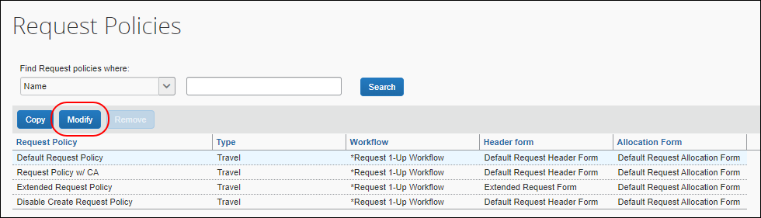
- On the Request Policies page, select the request policy that will be used to create requests with a travel allowance itinerary.
- Click Modify.
The Modify Request Policy page appears.
- Click the Expense Types tab.
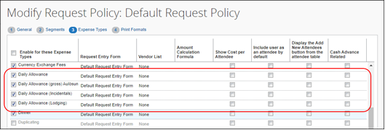
- In the Enable for these Expense Types column, select (enable) the check box for all the Daily Allowance expense types.
- Click Next.
- Click Done to save your changes to the request policy.
- For more information about request policies, refer to the Concur Request: Policies and Groups Setup Guide.

Allow Employees to Recall Requests
If you want to allow employees to recall submitted and approved requests in case their trip details change or if the employee needs to edit their travel allowance itinerary after a request has been submitted and approved, the request workflow that will be used for requests with a travel allowance itinerary needs to have the following recall settings enabled for the workflow:
- Allow employee to recall requests
- Allow employee to recall requests after approval
To enable the recall settings for a request workflow:
- Click Administration > Request > Request Administration > Workflows.
- On the Workflows page, select the request workflow that will be used to approve requests with a travel allowance itinerary.
- Click Modify.
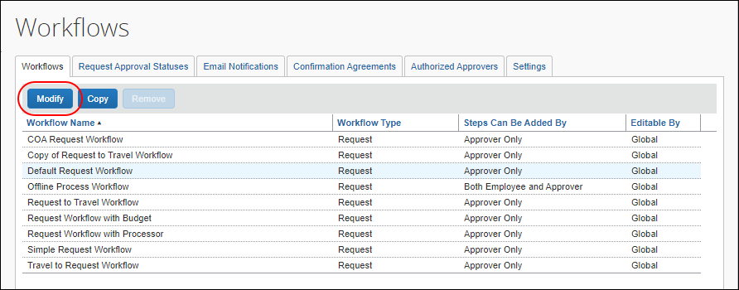
- On the Workflows tab, make sure the General tab is selected.
- Select (enable) the Allow employee to recall requests and Allow employees to recall requests after approval settings.
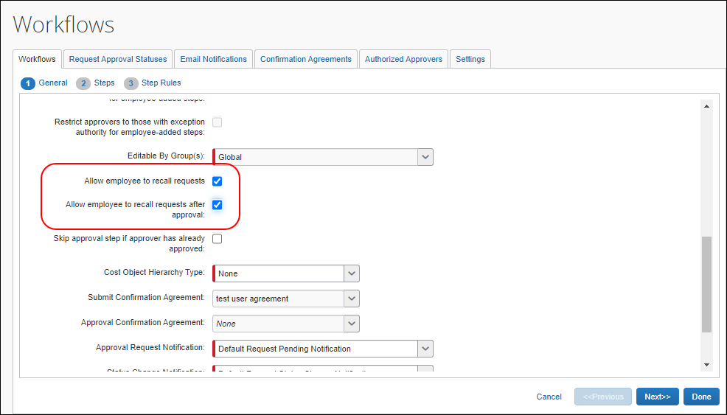
- Click Done to save your changes to the request workflow.
- For more information about request workflows, refer to the Concur Request: Workflow – General Information Setup Guide.

Add the Request Field to the Expense Report Header Form
In order to ensure the request information, including the travel allowance itinerary information, is added to an expense report when you create an expense report from a request that has a travel allowance itinerary, the Authorization Requests/Travel Requests field needs to be added to the Expense Report Header Form in Expense Admin.
To add the Authorization Requests/Travel Requests field to the Expense Report Header Form:
- Click Administration > Expense > Expense Admin > Forms and Fields.
The Forms and Fields page appears.
- In the Form Type list, select Expense Report Header.
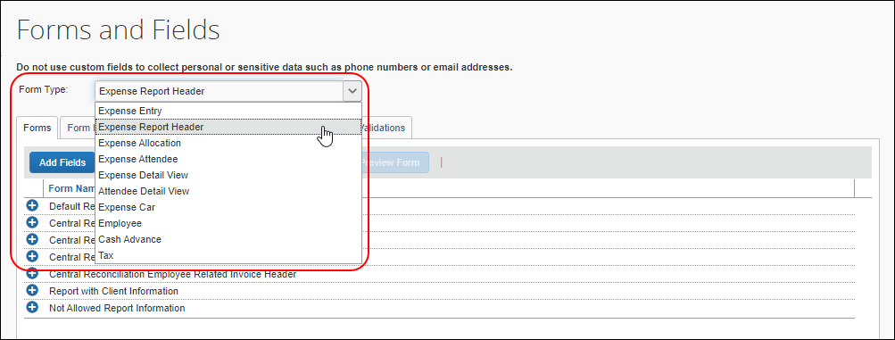
- On the Forms tab, click the plus sign, , next to the Default Report Information form name to expand the form.
- With the Default Report Information (Request) form selected, click Add Fields.
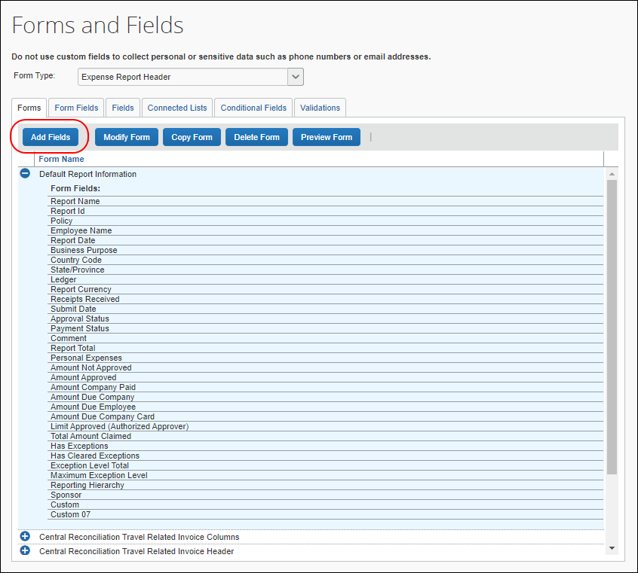
- The Add Fields to Forms dialog appears.
- Click the Authorization Requests/Travel Requests field, and then click Add Fields.
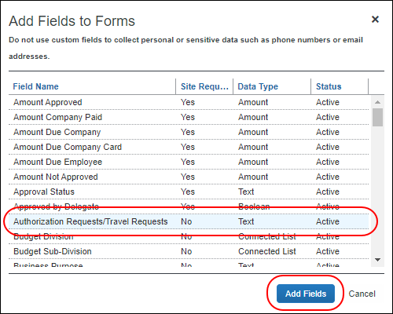
The Authorization Requests/Travel Requests field is added to the Default Report Information (Request) form.
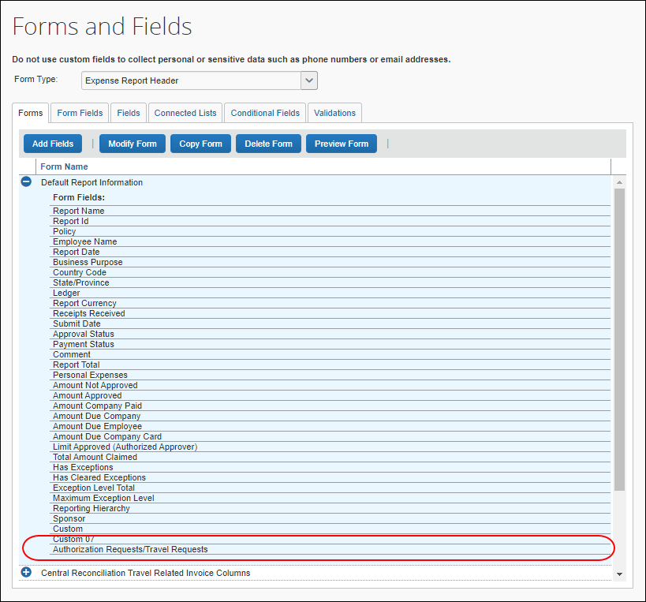
- For more information about configuring forms for Concur Expense, refer to the Expense: Forms and Fields Setup Guide.

Configure Audit Rules for Travel Allowances in Concur Request
Clients using the Travel Allowance Service (TAS) may configure audit rules using the Travel Allowance Service Adjustments and Travel Allowance Service Itinerary data objects. They are both available for selection on the Conditions page in Audit Rules (Administration > Request > Audit Rules).
The Travel Allowance Service Adjustments data object provides the ability to configure Concur Request audit rules for the Deduction Type, Lodging Type, and Meal Type adjustments.
The Travel Allowance Service Itinerary data object provides the ability to configure Concur Request audit rules associated with a travel allowance itinerary.

Supported Events
For the Travel Allowance Service Adjustments data object, the following events are supported:
- Request Entry Save
- Request Entry Submit
For the Travel Allowance Service Itinerary data object, the following events are supported:
- Request Entry Save
- Request Entry Submit
- Request Save
- Request Submit
- Post Request Submit

Available Fields
When selecting the Travel Allowance Service Adjustments data object in Audit Rules, the administrator can choose from three fields representing different values in the rate bundles:
- Deduction Type: Based on available Deduction Types in the rate bundle
- Lodging Type: Based on available Lodging Types in the rate bundle
- Meal Type: Based on available Meal Types in the rate bundle
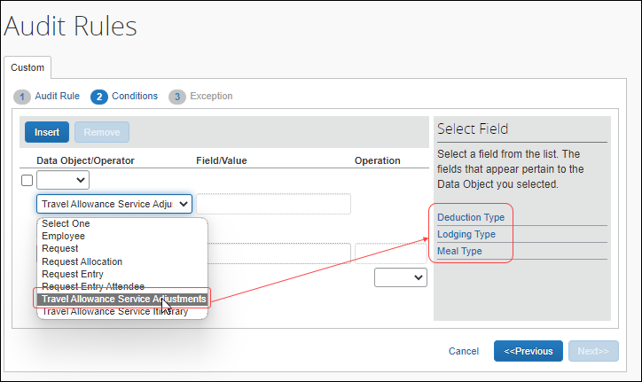
When selecting the Travel Allowance Service Itinerary data object in Audit Rules, the administrator can choose from the following fields:
- Is Domestic – This is true when the trip has only domestic destinations and no international destination. Conditions of ANY and EVERY are also available for use with this field.
- New TA Itinerary Exists – This is true when the trip uses the TAS rather than the classic Travel Allowance solution. This field was provided to give clients a way to isolate their rules/conditions that are meant for classic TA or only meant for TAS.
- Number of Days in Trip – This field represents the number of calendar or 24-hour days in the trip. When there are multiple itineraries in one request, the number of days is cumulative.
- Travel Allowance Configuration – With this field, an audit rule can be triggered for a specific configuration code. The TAS configuration codes display in a list.
- Trip End Date – For this field, the conditions of ANY and EVERY are available.
- Trip Start Date – For this field, the conditions of ANY and EVERY are available.
- Trip Type – The TAS trip types display in a list based on (filtered for) the configuration code.
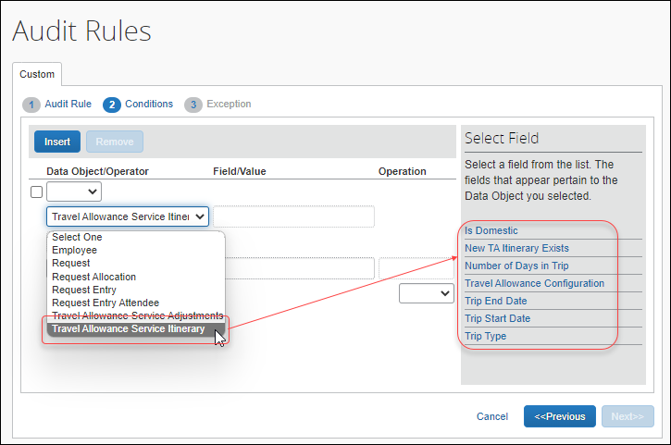

Example – Provided Breakfast Deduction Type
The Audit Rules administrator can select a specific configuration, deduction category code, and the deduction type to construct an audit rule when using the Deduction Type field. For example, an audit rule specifying a provided breakfast under a specified configuration might look like the rule below:
- Start by selecting the Travel Allowance Service Adjustments data object.
- Select a Deduction Type and the ANY,Equal operator.
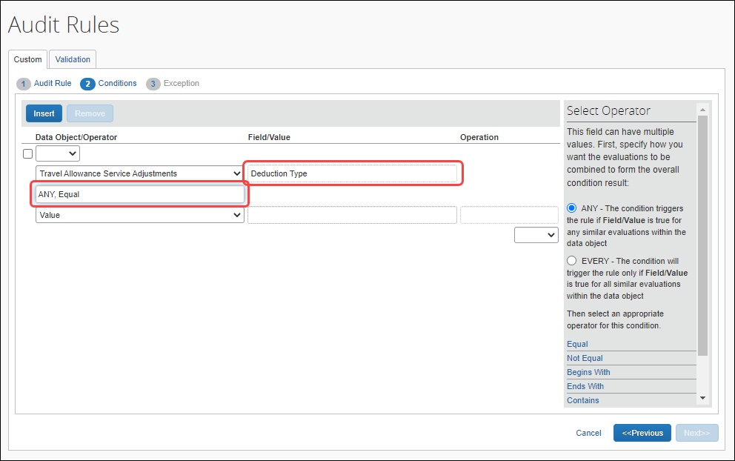
The selections of the Configuration, Deduction Category Code, and Deduction Type are made sequentially.
- Select the Configuration.
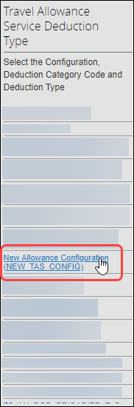
- Then select the Deduction Category Code.
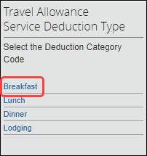
- And then select the Deduction Type.
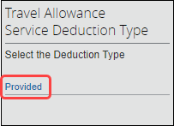
The result is the combination of these choices which will cause the rule to analyze and trigger based on a provided breakfast for the given configuration.
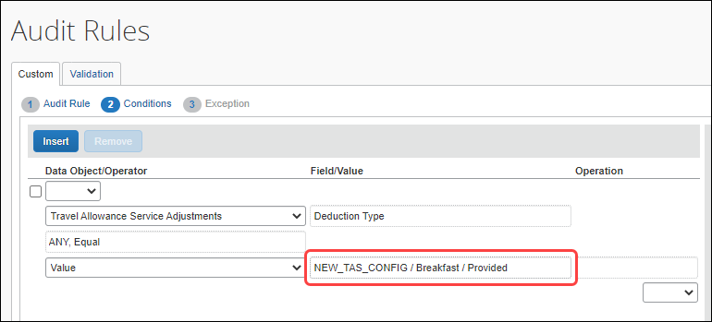

- For more information about audit rules, refer to the Concur Request: Audit Rules Setup Guide.

