
Concur Request:
Overview
Guide

Last Revised: May 4, 2023
Applies to these SAP Concur solutions:
 Concur Expense
 Professional/Premium edition
 Standard edition
 Concur Travel
 Professional/Premium edition
 Standard edition
 Concur Invoice
 Professional/Premium edition
 Standard edition
 Concur Request
 Professional/Premium edition
 Standard edition

Table of Content
Section 1: Permissions 1
Section 2: Overview 1
Additional Options 2
Roles/Permissions Use in Concur Request 2
Section 3: User Experience – Stand-Alone (Not Integrated with Concur Travel or Concur Expense) 3
Request Menu and Home Page 3
Typical Flow - Summary 5
Step 1: Creating the Request 6
Creating the Header 7
Creating the Expected Expenses 8
Allocations, Expected Expenses, Attendees, Cash Advance, Imaging, and Processor 14
Information About Requests without Expected Expenses or Segments Due to Policy 15
Step 2: Submitting the Request 16
Step 3: Approving the Request 16
Step 4: Finishing Up 16
Viewing, Editing, Printing, Deleting, Closing, Cancelling, Recalling, and Copying 16
Section 4: User Experience – Integrated with Concur Travel (Not Integrated with Concur Expense) 17
Request Menu and Home Page 17
Typical Flows - Summary 18
Process Flow – Approve then Book (starting in Request) 20
Step 1: Creating the Request; Step 2: Submitting the Request; Step 3: Approving the Request 20
Step 4: Booking the Trip in Concur Travel 20
Process Flow – Book then Approve (starting in Concur Travel) 24
Step 1: Booking in Concur Travel 24
Step 2: SAP Concur Creates the Request 26
Step 3: Submitting the Request 31
Step 4: Approving the Request 31
Step 5: Finishing Up 31
Viewing, Editing, Printing, Deleting, Closing, Cancelling, Recalling, and Copying 31
Section 5: User Experience – Integrated with Concur Expense (Not Integrated with Concur Travel) 31
Request Menu and Home Page 31
Typical Flow - Summary 33
Step 1: Creating the Request; Step 2: Submitting the Request; Step 3: Approving the Request 34
Step 4: Associating a Request with an Expense Report 34
From the Expense Report Header 35
From an Approved Request 37
Apply to an Existing Report 38
Viewing Request Values 39
Viewing, Editing, Printing, Deleting, Closing, Cancelling, Recalling, and Copying 39
Section 6: User Experience – Integrated with Concur Travel and Concur Expense 40
Request Menu and Home Page 40
Typical Flows - Summary 41
Process Flow – Approve then Book (starting in Concur Request) 42
Step 1: Creating the Request; Step 2: Submitting the Request; Step 3: Approving the Request; Step 4: Booking the Trip in Travel 42
Step 5: Associating a Request with an Expense Report 43
Process Flow – Book then Approve (starting in Concur Travel) 43
Step 1: Booking in Concur Travel; Step 2: SAP Concur Creates the Request; Step 3: Submitting the Request; Step 4: Approving the Request 43
Step 5: Associating a Request with an Expense Report 43
Viewing, Editing, Printing, Deleting, Closing, Cancelling, Recalling, and Copying 43
Section 7: Common Processes for All Implementation Types 44
All Implementation Types – Allocations, Expected Expenses, Attendees, Cash Advance, Imaging, and Processor 44
All Implementation Types – Submitting the Request 45
All Implementation Types – Approving the Request 47
All Implementation Types – View, Edit, Print, Delete, Close, Cancel, Recall, Copy 50
Viewing a Request 50
Editing/Changing/Updating Travel-Related Requests 51
Printing a Request 53
Deleting a Request 54
Closing/Inactivating a Request 55
Cancelling a Request 57
Recalling a Request 59
Copying a Request 61
Section 8: User Settings 64
Defining General Request Information 64
Selecting Delegates 65
Integrated with Concur Travel 65
Selecting Status Notifications 67
Selecting Approvers 68
Favorite Attendees 69
Section 9: Comparison of Features by Implementation 70
Section 10: Configuration 71
Roles Required for Configuration 71
Configuration Steps 72
Integrating with Concur Expense 75
Integrating with Concur Travel 75

Revision History
Date | Notes / Comments / Changes
May 4, 2023 | Made the following updates:  - In the User Experience – Stand-Alone (Not Integrated with Concur Travel or Concur Expense) > Step 1: Creating the Request section, replaced reference to the Create New Request tile with the Create New Request button and added note about event requests.  - Replaced the images of the Create New Request tile and View menu with the new Create New Request button and View menu throughout the guide.  - In the User Experience – Integrated with Concur Travel (Not Integrated with Concur Expense) > Process Flow – Approve then Book (starting in Request) > Booking the Trip in Concur Travel section, removed the outdated image of the Manage Requests page.
October 1, 2022 | Made the following updates:  - Updated screenshots and edited content for the new user experience  - Added the Information About Requests without Expected Expenses or Segments Due to Policy section under the Step 1: Creating the Request section  - Updated the Agency Proposals bullet in the Overview > Additional Options section.
January 21, 2022 | Updated the copyright year; no other changes; cover date not updated
March 29, 2021 | Updated the copyright year; no other changes; cover date not updated
July 20, 2020 | Removed the Request/Authorization Request/Concur Request section and changed "Authorization Request" reference to "Concur Request" in the Overview section to align with Concur Request product branding.
June 4, 2020 | Changed "Authorization Request" to "Concur Request" in Request guide references to align with Concur Request product branding.
June 3, 2020 | Changed "Authorization Request" to "Concur Request" in guide title to align with Concur Request product branding.
April 22, 2020 | Renamed the Authorization Request check box to Request on the guide’s title page; cover date not updated
January 10, 2020 | Updated the copyright; no other changes; cover date not updated
December 7, 2019 | Removed reference(s) to legacy Budget Insight feature. Clients who want to use budget functionality are recommended to implement the new Budget product that SAP Concur released last year.
January 18, 2019 | Updated the copyright; no other changes; cover date not updated
July 26, 2018 | Updated the Process Flow – Approve then Book (starting in Request) > Step 4: Booking the Trip in Travel section.
April 12, 2018 | Changed the check boxes on the front cover; no other changes; cover date not updated
February 8 2018 | Updated guide names in references to the Shared: Attendee Import, Version 2 Specification and Shared: Employee Import Specification guides.
January 31 2018 | Changed copyright and updated reference to Instant purchase, Travelfusion, and Direct Connects in the User Experience – Integrated With Concur Travel (Not Integrated with Concur Expense) section.
July 29 2017 | Updated the Closing/Inactivating a Request section.
December 14 2016 | Changed copyright and cover; no other content changes.
December 9 2016 | Updated the Recalling a Request section.
June 10 2016 | Added note to Associating a Request with an Expense Report section.
May 13 2016 | Updated the Permissions section and guide content to new corporate style; no content changes.
March 18 2016 | Updated the Process Flow – Book then Approve (starting in Travel) sections, and renamed the Process Flow –Approve then Book (starting in Request) sections.
January 25 2016 | Changed references to the import/extract guide; no other changes.
September 18 2015 | Added information about booking with an agent while using the Starting in Request process flow.
April 10 2015 | Updated the Process Flow – Starting in Request section.
December 12 2014 | Updated guide to enhanced user interface.
November 14 2014 | Expanded information about Starting in Request process flow.
September 17 2014 | Added information about two user interfaces; no other content changes.
September 12 2014 | Updated Editing/Changing/Updating Travel-Related Requests and Deleting a Request sections.
August 22 2014 | Updated Integrated with Travel information with new Starting in Request process flow.
May 16 2014 | Updated information on associating a request with an expense report from the View Request page.
January 20 2014 | Cover and copyright changes; no other content changes
July 1 2013 | General updates including:  - Cannot delete request if it is extended to another request (Extension of field)  - Event management  - Budget manager  - New roles  - Close Request button changed to Close/Inactivate Request
March 11 2013 | Added information about:  - Changed occurrences of "Travel Request" to "Request"  - Copy Request feature  - General edits
December 28 2012 | Made rebranding and/or copyright changes; no content changes
July 27 2012 | Added information about:  - Integration option - no travel request required  - Updates in agency-booked segments  - Additional edit/update information  - Moved Configuration Report to its own guide
March 30 2012 | Added information about:  - Attendees  - Close a travel request  - Recall a travel request after approval  - Relationship between travel arrangers and travel request delegates (integrated with Travel)  - Summary view (integrated with Expense)  - Configuration report
January 3 2012 | Rearranged the document to describe the experience if Travel Request is:  - Stand-alone (not integrated with Concur Travel or Concur Expense)  - Integrated with Concur Travel (but not Concur Expense)  - Integrated with Concur Expense (but not Concur Travel)  - Integrated with Concur Travel and Concur Expense  Added additional feature information
June 28 2011 | Incorporated information about:  - User profile  - Vendor field on the Segments tab
June 6 2011 | Clarification of the proxy role
June 3 2011 | Changed occurrences of "Request" to "Travel Request" - no other changes to content
May 20 2011 | Incorporated changes from the May release
March 24 2011 | Incorporated changes from the March release
January 21 2011 | Changes:  - Update to match current feature set  - Updated the copyright and made rebranding changes
October 18 2010 | Removed reference to proxies
October 15 2010 | Initial publication

Request – Overview
NOTE: Multiple SAP Concur product versions and UI themes are available, so this content might contain images or procedures that do not precisely match your implementation. For example, when SAP Fiori UI themes are implemented, home page navigation is consolidated under the SAP Concur Home menu.

Permissions
A company administrator may or may not have the correct permissions to use this feature. The administrator may have limited permissions, for example, they can affect only certain groups and/or use only certain options (view but not create or edit).
If a company administrator needs to use this feature and does not have the proper permissions, they should contact the company's SAP Concur administrator.
Also, the administrator should be aware that some of the tasks described in this guide can be completed only by SAP. In this case, the client must initiate a service request with SAP Concur support.

Overview
The Concur Request product is designed to help businesses control expenses by requiring employees to obtain approval before incurring expenses, for example, for travel, office equipment purchases, business meals and client entertainment, subscriptions, etc.
Concur Request is a robust and intricate feature. The options and features that are available to the user depend on the client's implementation of Concur Request. The implementation types are:
- Stand-alone (not integrated with Concur Travel or Concur Expense)
- Integrated with Concur Travel (but not Concur Expense)
- Integrated with Concur Expense (but not Concur Travel)
- Integrated with Concur Travel and Concur Expense
Each type of implementation is addressed separately in this guide. The individual sections of this guide discuss the user experience. At the end of this guide is a table that shows the Concur Request features that are available for each implementation type, along with the configuration information.

Additional Options
There are additional options that are not fully addressed in this guide:
- Budget: This option allows request approvers to view real-time budget details while evaluating and approving requests.
- For more information, refer to the Shared: Budget Setup Guide.
- Event Requests: This feature allows an assistant to create requests for a set of event attendees.
- For more information, refer to the Concur Request: Event Requests Setup Guide.
- Agency Proposals: This feature allows travel agents to provide proposed itineraries based on the request. The user can select a proposal, which goes through the workflow, then is booked by the agent.
This Agency Proposals feature is available from SAP Concur with the Agency Proposal via Concur Platform API. Available everywhere for any travel agency certified with this feature.
- For more information, refer to the Concur Request: Agency Proposals Setup Guide.

Roles/Permissions Use in Concur Request
The available user roles are:
- Request User
- Request Approver
- Request Authorized Approver
The available administrator roles are:
- Request Event Manager
- Request Proxy Logon
- Processors:
- Request Administrator (processor)
- Request Auditor (processor with read-only permissions)
- TMC Agent (travel agent/processor)
- Configuration:
- Request Configuration Administrator
- Request Configuration Administrator (restricted)
To assign roles/permissions and to access additional information:
Role | Refer to:
Processors: TMC Agent, Request Administrator, Request Auditor | Concur Request: Processor (Configuration) Setup Guide
Event Manager | Concur Request: Event Requests Setup Guide
Authorized Approver, Cost Object Approver | Concur Request: Workflow – Authorized Approvals Setup Guide  Concur Request: Workflow – Cost Object Approvals Setup Guide
All other roles – Assigned in User Permissions (Company Admin), Permissions Admin, or via the employee import | Shared: User Administration User Guide

User Experience – Stand-Alone (Not Integrated with Concur Travel or Concur Expense)
This section describes the user experience for the stand-alone – not integrated with Concur Travel or Concur Expense – implementation of Concur Request.
- The process described here is for the individual Request user. The Event Request feature allows an assistant to create one "master" request for multiple users. For more information, refer to the Concur Request: Event Requests Setup Guide.

Request Menu and Home Page
If the user has the Request User or Request Approver role:
- The Requests option appears on the menu.
– and –
- An Authorization Requests tile may appear in the Quick Task bar of the home page.
- Open Requests and Authorization Request approvals appear in the My Tasks area of the home page.
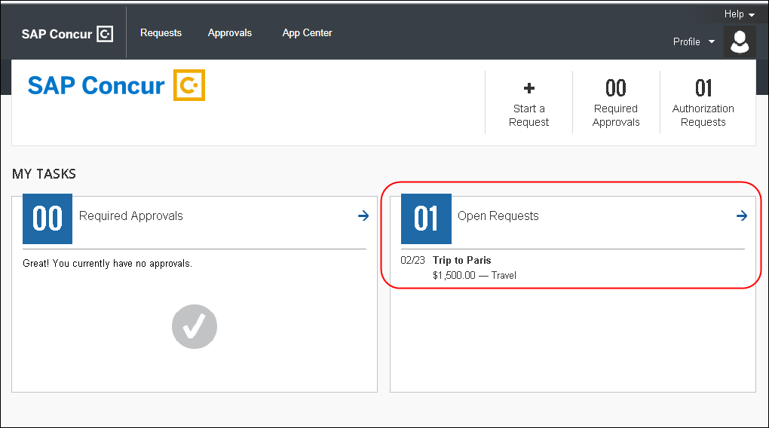
The user can:
- Click Start a Request or New > Start a Request to create a new request.
- Click the Requests menu to view all of their requests.
After clicking Requests, the user is taken to the Manage Requests page. The user can create a new request by clicking Create New Request. The user can use the View list to filter the list of requests.
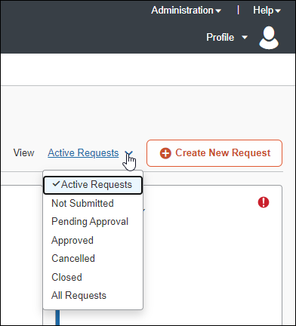

Typical Flow - Summary
These are the typical steps in the process; additional details are provided on the following pages.
- Step 1: Creating the request: The user completes the request.
There are many options available in the configuration of a request. The client can configure Request for the pre-approval of travel, cash advance, and/or general purchases. For example, a request that is designed for the pre-approval of travel will include fields about the mode of travel, the departure/arrival dates, hotel, etc. Cash advance requests will include fields for the amount and the type of currency. General requests will contain fields for the various expenses, such as subscriptions, seminar fees, etc.
The client decides how much or how little to include in any specific request.
- Step 2: Submitting the request: The user submits the request, which is routed to the user's request approver.
- Step 3: Approving the request: The approver reviews and approves the request.
- Step 4: Finishing up: The company uses its own internal processes to pay for the trip, manage the images, and provide the cash advance, etc.

Step 1: Creating the Request
To create a new request:
- Click Requests > Create New Request button.
If the Event Requests feature is enabled, you will need to click the Create New Request button and then click the Create New Request selection.
For more information about event requests, refer to the Concur Request: Event Requests Setup Guide.
- or –
- On the home page, click Start a Request or New > Start a Request.
A blank request appears.

Creating the Header
First, the Create New Request page appears. The fields on the Create New Request page are the request header fields. The user provides the general information about the requested trip or purchase. The user completes the required fields and optional fields as directed by their company. When done, the user clicks Create Request.
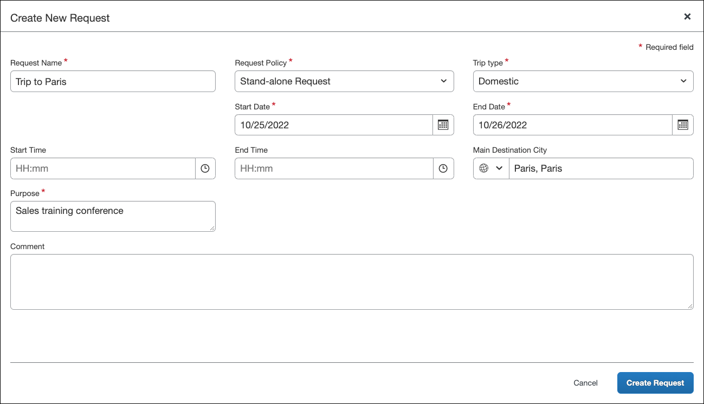
- The Create New Request page uses the Request Header form to determine which fields appear on the page. The Request Header form is configurable in Administration > Forms and Fields. For more information, refer to the Concur Request: Forms and Fields Setup Guide.
After clicking the Create Request button, the Expected Expenses page opens.
The request name, ID, and status are displayed at the top of the Expected Expenses page.
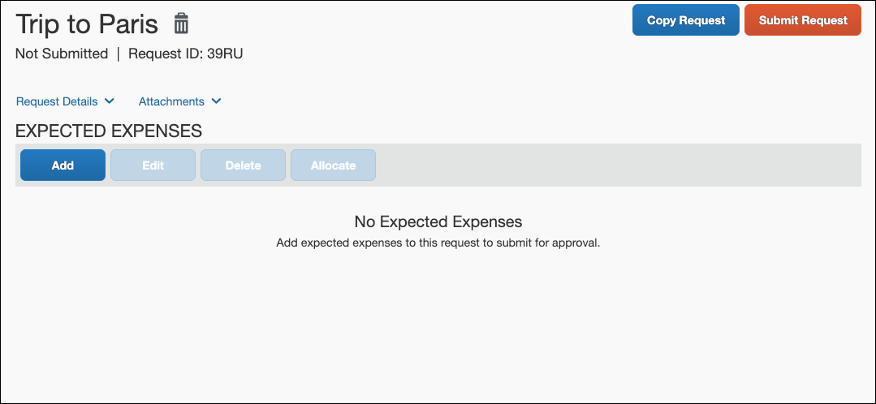

Creating the Expected Expenses
In Concur Request, expected expenses for a request include both expected expenses, such as fees or taxi fare, as well as travel segments, such as air or rail tickets, car rentals, or hotel stays.

To Create an Expected Expense
On the Expected Expenses page, click the Add button. Clicking the Add button opens the Add Expected Expenses dialog. The Add Expected Expenses dialog contains a list of all the expense types and segment types enabled for requests.
Select the applicable expense type.
In the search box at the top of the list, you can enter all of part of an expense type or segment type name. The list of available expense types and segment types shown will be filtered to show only those with matching text.
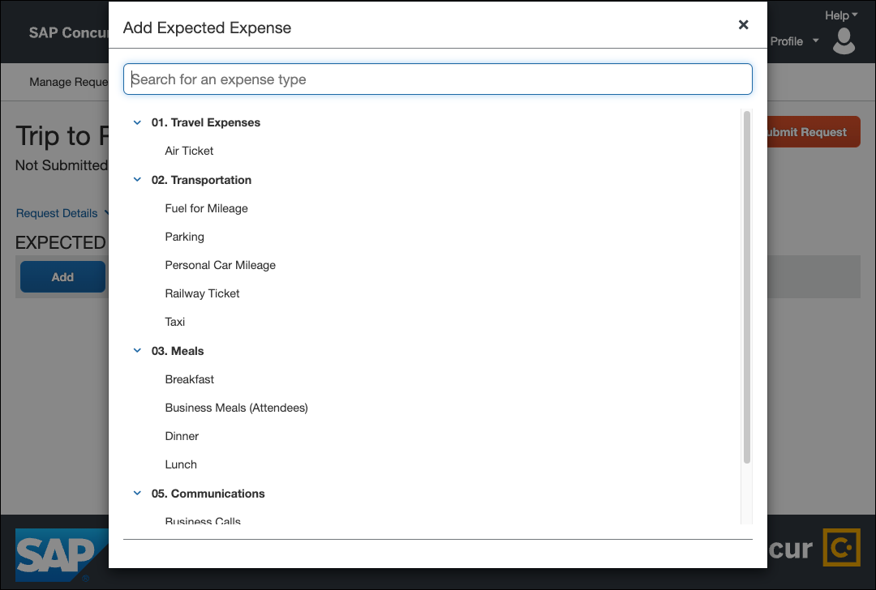
Clicking an expense type opens the expected expense details page for the selected expense type.
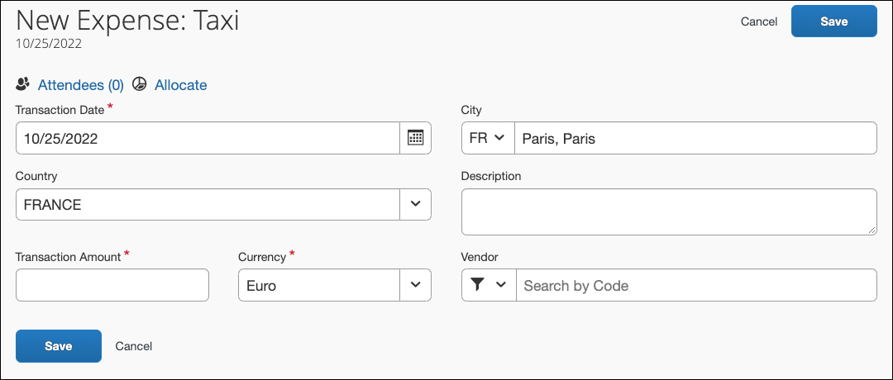
The fields that appear on this page are configurable by your company, so yours may be different from the one shown here.
Complete the fields and click Save. The expected expense is added to the Expected Expenses list.
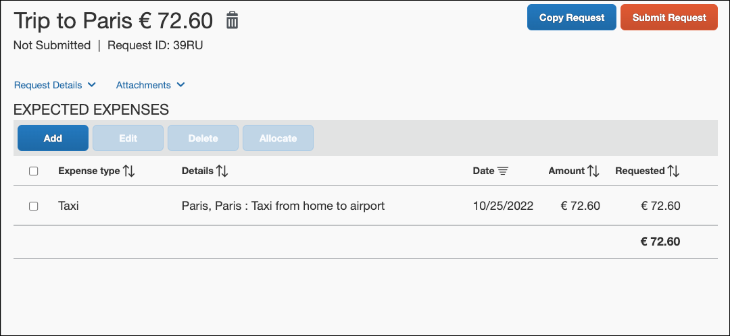

To Create a Segment
The steps for adding a segment to a request are the same as adding an expected expense. On the Expected Expenses page, click the Add button to open the Add Expected Expense dialog. In the Add Expected Expense dialog, you select the applicable segment type.
In the search box at the top of the list, you can enter all of part of an expense type or segment type name. The list of available expense types and segment types shown will be filtered to show only those with matching text.
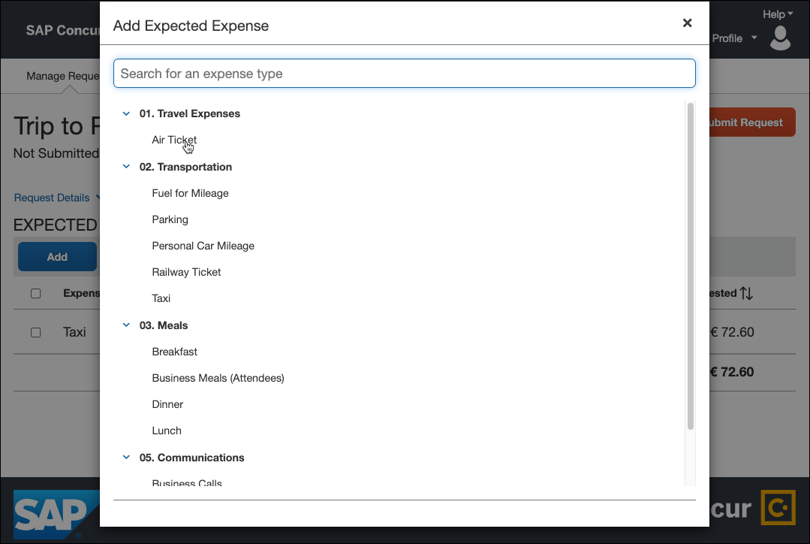
Clicking a segment type opens the sement details page for the selected segment type.
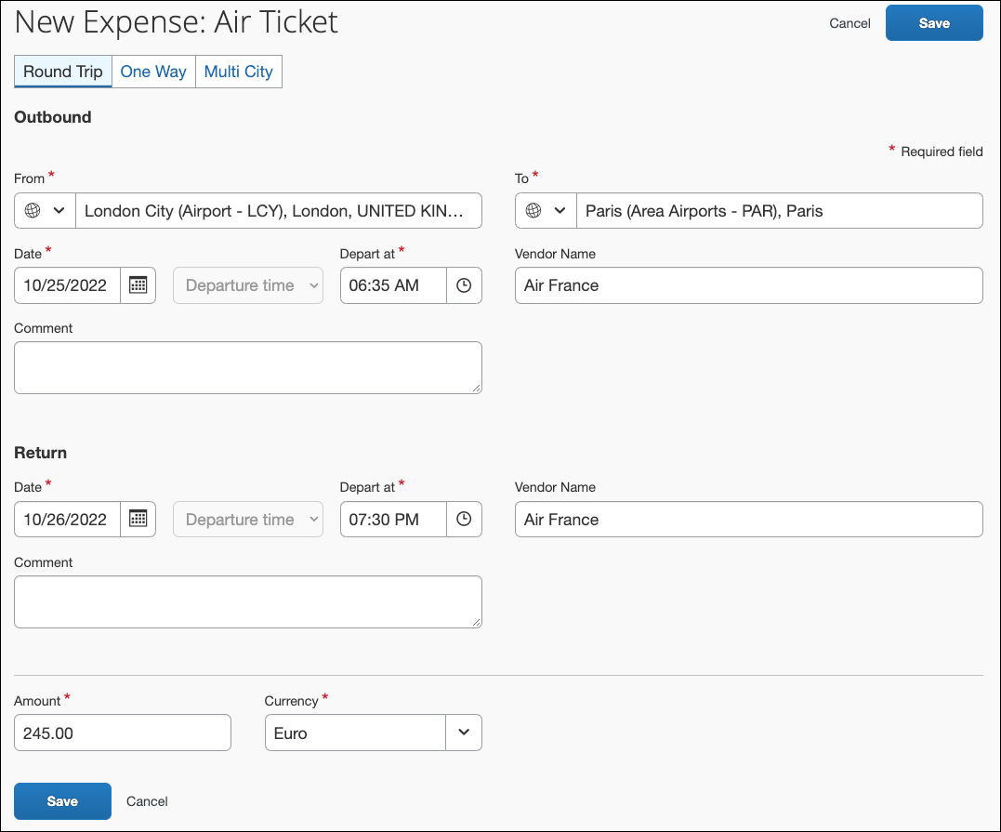
The fields that appear on this page are configurable by your company, so yours may be different from the one shown here.
Complete the fields and click Save. The segment is added to the Expected Expenses list.
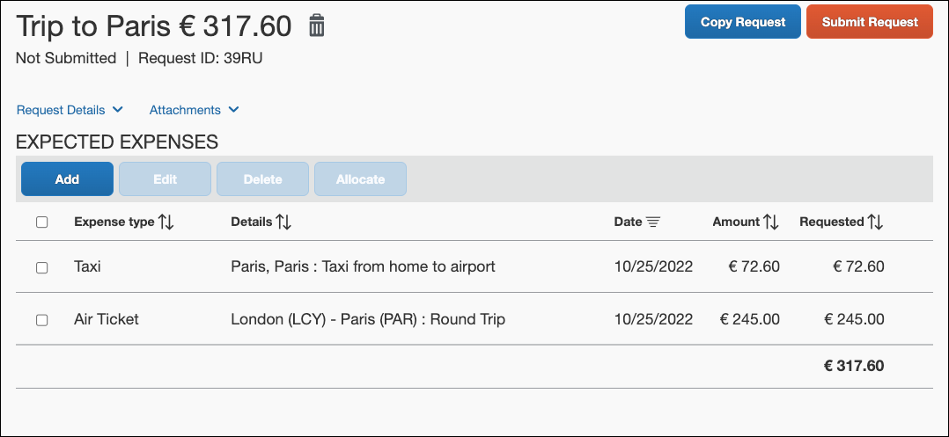
Note the following about these fields:
- Amount:
- For each segment, the user enters the total amount for the trip. Specifically, for car rental and hotel, the user enters the total amount – not the daily rate.
- The default is 0.00. The user can leave it as zero – even though the field is required.
- If any of the segments are entered in a currency other than the user's reimbursement currency and if the Expense Rates feature is properly configured, then:
- The total reflects the conversion to the user's reimbursement currency.
- The system uses the current exchange rate.
- The conversion is calculated when the segment is saved, and it is recalculated if the segment is reopened and saved.
- As the user saves segments and expected expenses, the running total for the request is displayed next to the request name at the top of the Expected Expenses page.
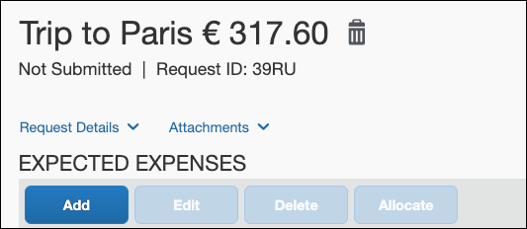
- Comment: The user enters any information that the travel agent needs to properly book the trip.
- Vendor / Vendor Name / Locations Per Supplier: In some cases (depending on the company's configuration), one of these fields may appear. If so, the user selects the desired option.
- The Vendor / Vendor Name / View Service Locations For fields are not standard fields. For more information, refer to the appendix in the Concur Request: Forms and Fields Setup Guide.
Note the following about the Detail fields (car rental and hotel):
- The user enters location information as instructions for the travel agency, such as "pick-up at airport" or "hotel near the waterfront."
- The user enters preference information as instructions for the travel agency, such as "automatic transmission, non-smoking" or "non-smoking room."
These are general guidelines. The company should ensure that its users understand exactly what is expected in these fields. The company can also include custom fields to collect additional information.
- The segments are configurable. For more information, refer to the Concur Request: Forms and Fields Setup Guide and the Concur Request: Segment Types Setup Guide.

Allocations, Expected Expenses, Attendees, Cash Advance, Imaging, and Processor
These features are the same for all implementation types.
- Refer to All Implementation Types – Allocations, Expected Expenses, Attendees, Cash Advance, Imaging, and Processor in this guide.

Information About Requests without Expected Expenses or Segments Due to Policy
When a user creates a request on the Create New Request page and selects a request policy that is not associated with any expense types or segment types, after the user clicks the Create button, the request opens with the request header fields displayed on the page instead of the Expected Expenses section.
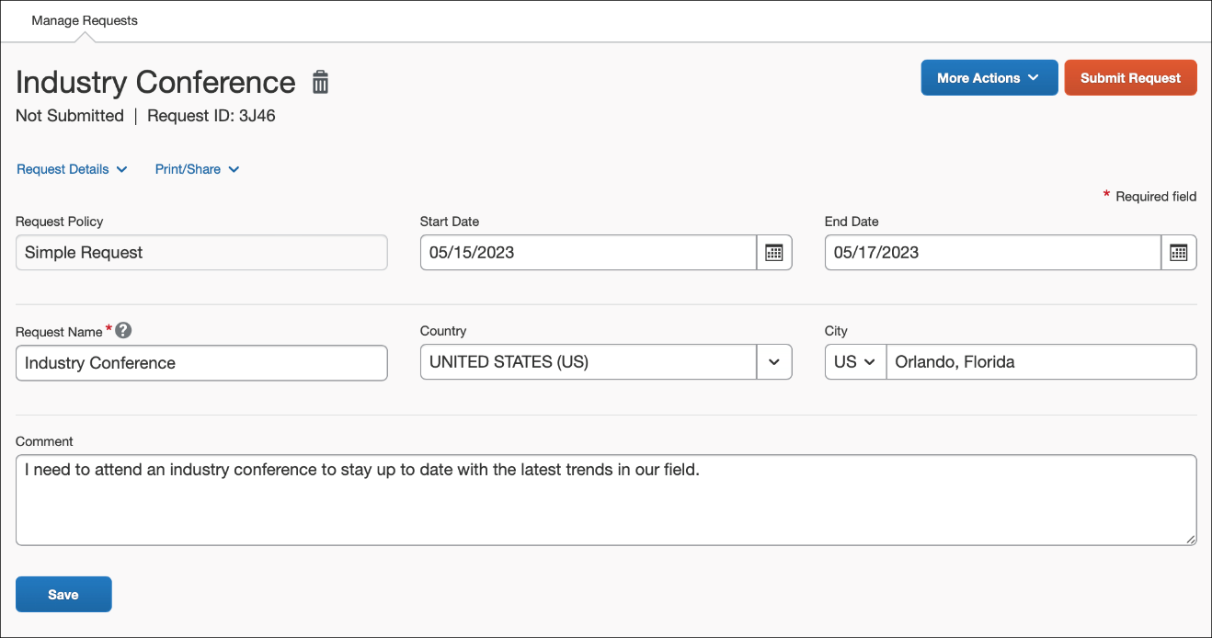
For this type of request, the request header fields are already displayed on the request, so the Edit Request Header selection will not be available on the Request Details menu.
Because no expected expenses or segments can be added to this type of request, no currency symbol or amount will be displayed to the right of the request name on the request, like they are for requests that can have expected expenses and segments.
On the Manage Requests page, the Requested and Approved columns will be blank for any request assigned a request policy that has no expense types or segment types enabled for the policy.
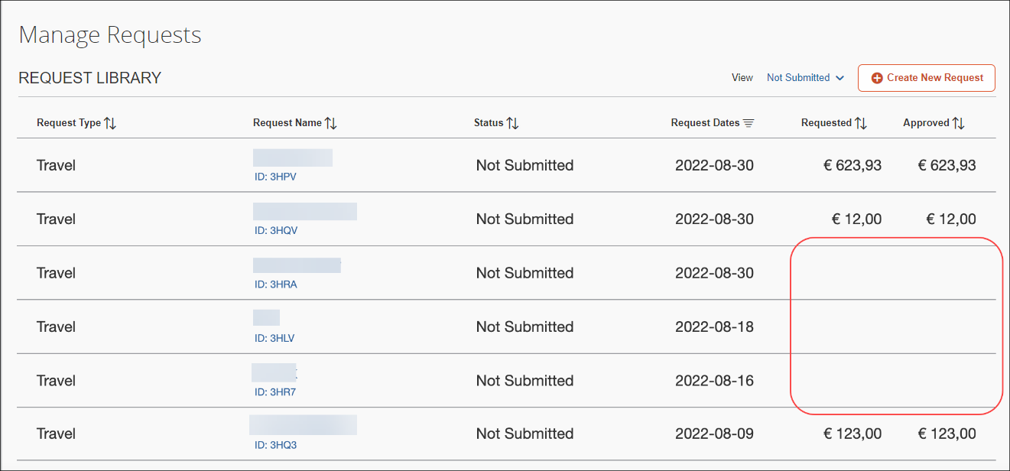
- For more information about Request policies, refer to the Concur Request: Policies and Groups Setup Guide.

Step 2: Submitting the Request
This step is the same for all implementation types.
- Refer to All Implementation Types – Submitting the Request in this guide.

Step 3: Approving the Request
This step is the same for all implementation types.
- Refer to All Implementation Types – Approving the Request in this guide.

Step 4: Finishing Up
The company uses its own internal processes to pay for the trip, manage the images, and provide the cash advance, etc.

Viewing, Editing, Printing, Deleting, Closing, Cancelling, Recalling, and Copying
These features are the same for all implementation types.
- Refer to All Implementation Types - View, Edit, Print, Delete, Close, Cancel, Recall, Copy in this guide.

User Experience – Integrated with Concur Travel (Not Integrated with Concur Expense)
This section describes the user experience for Concur Request integrated with Concur Travel.

Request Menu and Home Page
If the user has the Request User or Request Approver role and the Travel Wizard User role:
- The Request option appears on the menu.
– and –
- An Authorization Requests tile may appear in the Quick Task bar of the home page.
- and -
- Open Requests and Authorization Request approvals appear in the My Tasks area of the home page.
- and –
- The Travel wizard (Trip Search section) is available on the home page
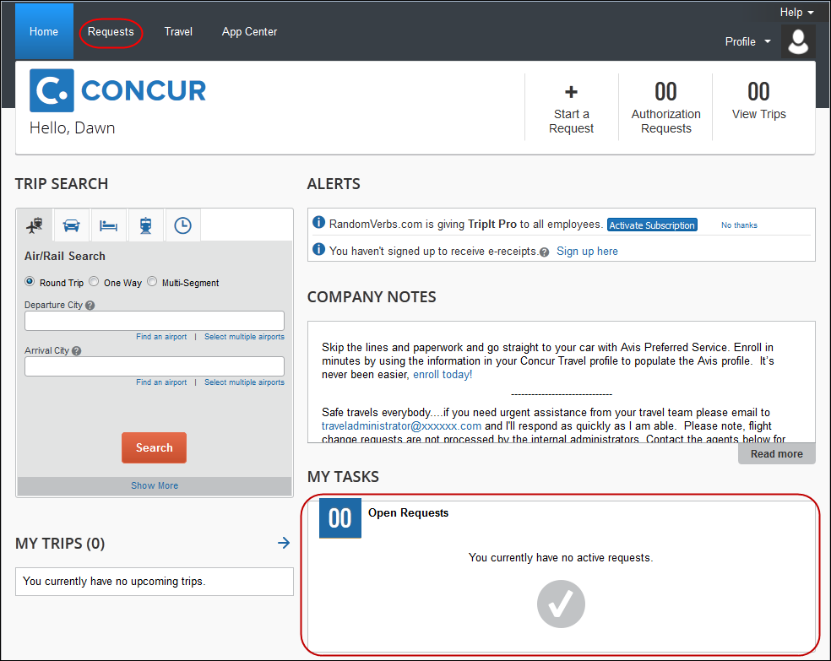
The user can:
- Click Start a Request or New > Start a Request to create a new request.
- Click the Request menu to view all of their requests.
After clicking Requests, the user is taken to the Manage Requests page. The user can create a new request by clicking Create New Request. The user can use the View list to filter the list of requests.

Typical Flows - Summary
There are two possible methods the clients can configure when using Request integrated with Concur Travel. The two methods can be used separately, or together, depending on client configuration. The processes have the following benefits:
- Approve then Book (starting in Concur Request): This process allows a seamless pre-approval and booking process with no constraint on short approval deadlines. It supports Immediate Purchase carriers, as the approval occurs before the booking.
- For more information, refer to the Concur Request: Workflow – General Information Setup Guide.
- Book then Approve (starting in Concur Travel): This process allows the request to contain actual booking information for the various travel segments. The segment amounts are not estimates, but actual values based on the available travel inventory. Users may pre-book a trip, and place it on hold if necessary.
These are the typical steps in the processes; details are provided on the following pages.
Approve then Book (starting in Concur Request):
- Step 1: Creating the request: The user completes the request.
There are many options available in the configuration of a request. The client can configure Request for the pre-approval of travel, cash advance, and/or general purchases. For example, a request that is designed for the pre-approval of travel will include fields about the mode of travel, the departure/arrival dates, hotel, etc. Cash advance requests will include fields for the amount and the type of currency. General requests will contain fields for the various expenses, such as subscriptions, seminar fees, etc.
The client decides how much or how little to include in any specific request.
- Step 2: Submitting the request: The user submits the request, which is routed to the user's request approver.
- Step 3: Approving the request: The approver reviews and approves the request.
- Step 4: Booking the Trip in Concur Travel: The user views the approved request, and clicks the Book link or button. The user is sent to the Travel Request Itinerary page, listing their itinerary with any required fields highlighted. After filling out required fields, the user is sent to the Concur Travel search results page. The user goes through the Concur Travel booking wizard for each segment in the request. The itinerary does not require any additional approvals, and is immediately booked and sent for ticketing.
Book then Approve (starting in Concur Travel):
- Step 1: Book in Concur Travel: Using the Trip Search panel (also known as the Travel Wizard), the user enters the trip information in the booking wizard. At the end of the booking, the user is directed to Request. The trip will be on hold until the request is approved.
This step may differ if the client is using the Booking Switch feature, as discussed below.
- Step 2: SAP Concur creates the request: SAP Concur automatically creates a request for the trip, based on the trip information.
- Step 3: Submitting the request: The user submits the request, which is routed to the user's request approver.
- Step 4: Approving the request: The approver reviews and approves the request. Once the request is approved, the trip is sent for ticketing.
- Step 5: Finishing up: The company uses its own internal processes to pay for the trip, manage the images, and provide the cash advance, etc.

Process Flow – Approve then Book (starting in Request)

Step 1: Creating the Request;
Step 2: Submitting the Request;
Step 3: Approving the Request
These three steps are exactly the same as the first three steps for the stand-alone implementation.
- Refer to User Experience – Stand-Alone (Not Integrated with Concur Travel or Concur Expense) in this guide.

Step 4: Booking the Trip in Concur Travel
After the approval step in the request workflow, the user’s request status is Approved-Pending Booking. On the Manage Requests page with Active Requests selected from the View list, request tile indicates the request is ready to book.
If the Approved-Pending Booking workflow step is not added to the workflow, the user will not see the Book link on the Manage Requests page.
The Book Travel button is displayed on the Expected Expenses page.
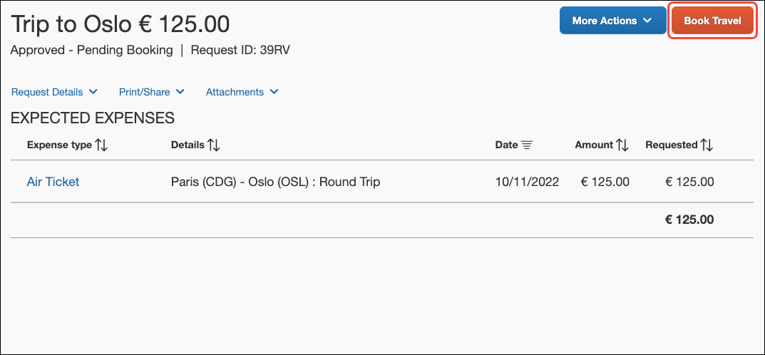
The user clicks Book/Book Travel, and is taken to the Travel Request Itinerary page.
The Booking Switch does not apply and the whole trip must be booked in Concur Travel.
The workflow can be configured to allow the user to select whether the trip should be self-booked or agent-booked. For more information, refer to the Integrated with Travel section of the Concur Request: Workflow- General Information Setup Guide.
The system can be configured to prevent the user from viewing the Travel tab, to force them to use the Book link or Book Travel button. This configuration should only be applied to users that do not need to directly access the Travel tab for any other reason. For more information, refer to the Integrated with Travel section of the Concur Request: Workflow- General Information Setup Guide.
A small box summarizes the Request main information on the left side. The itinerary segment information is listed on the page. If the user has no required fields to complete, they click Proceed to booking.
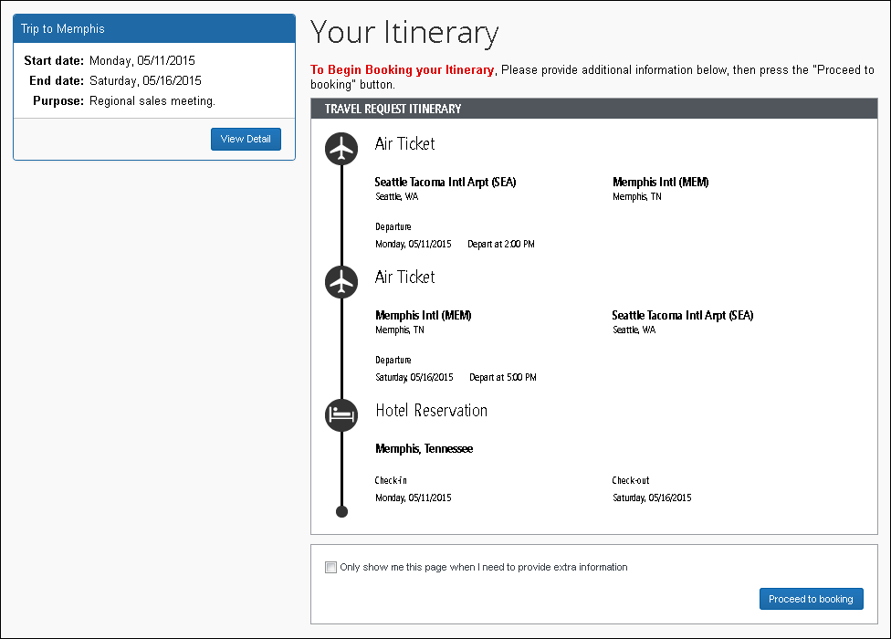
If the user does have required fields to fill in, the fields will be highlighted on the Travel Request Itinerary page:
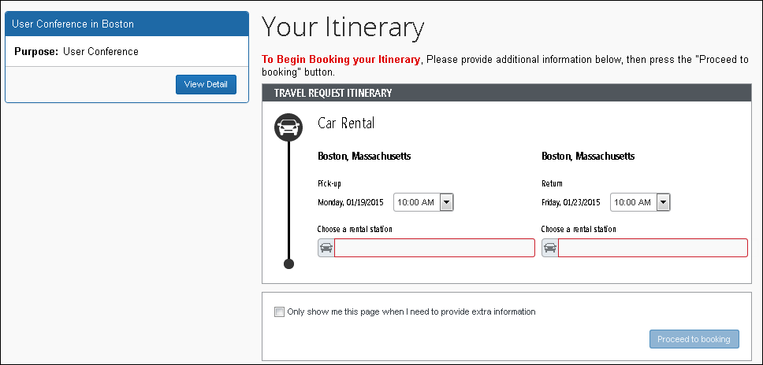
The user completes the fields and clicks Proceed to Booking. The Concur Travel search results page appears.
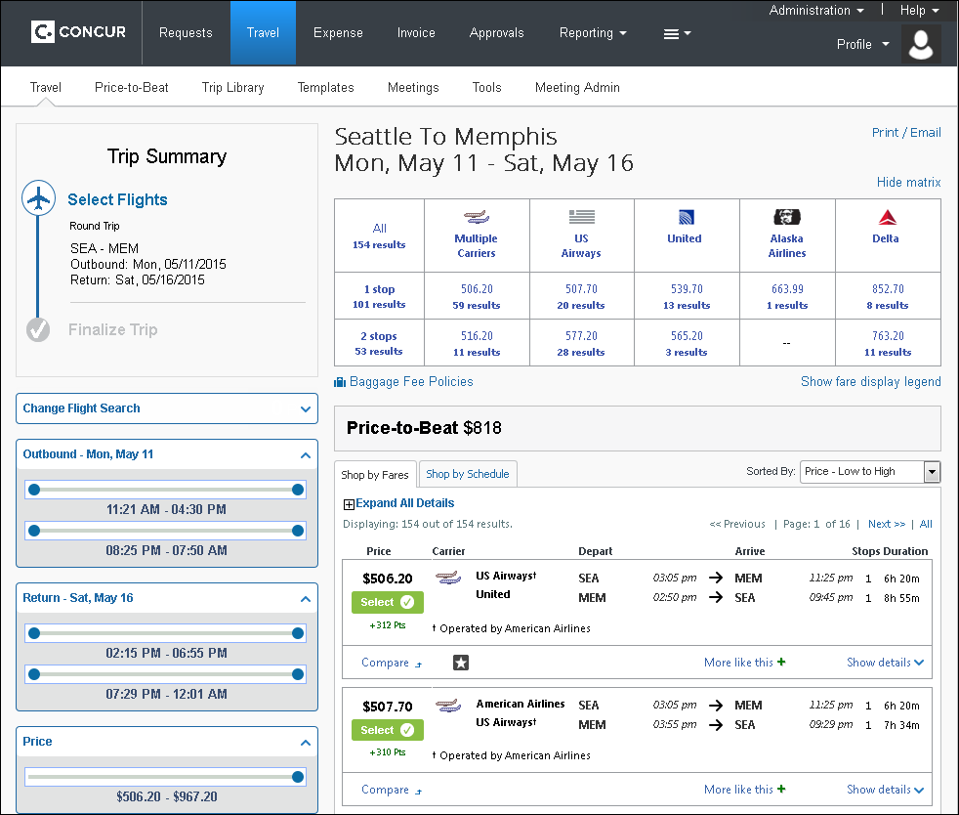
The user is taken through the booking process, picking up the services initially defined in the Request, one after the other.
The Approve then Book process does not support Flex Faring. Users who book from the approved request will only be able to book the lowest service class (Economy).
Once done, the user confirms their whole booking, which is marked as Approved. At this stage, the itinerary updates the Request and automatically completes the Approved – Pending Booking step. The request moves to the next workflow step, if any.

Process Flow – Book then Approve (starting in Concur Travel)

Step 1: Booking in Concur Travel
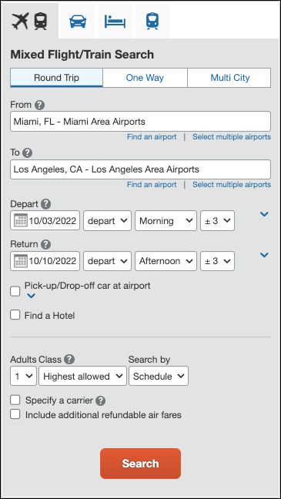
The user starts the booking process using the Travel Wizard.
At this point, if the client uses the Booking Switch feature, SAP Concur evaluates the selections the user made in the wizard and then determines – based on client-defined criteria – if the trip will be self-booked (booked by the user) or agency-booked.
- For more information about the switch and how it affects the request process, refer to the Concur Request: Booking Switch Setup Guide.
Assume for this example, either:
- The client does not use the Booking Switch.
– or –
- The client uses the Booking Switch and the switch has determined the trip is self-booked.
In either of these cases, the result is that after the user clicks Search, the next page of the wizard appears. The user books the trip as usual, making the appropriate selections for air, car, etc. The user verifies the trip information on the itinerary.
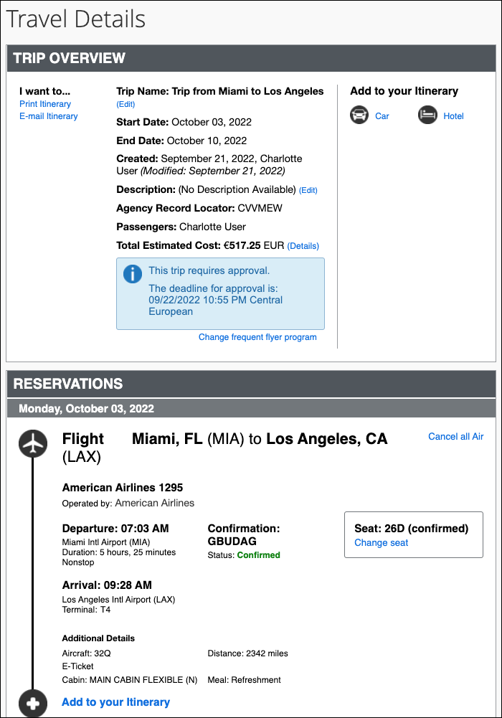
The user clicks through to the Trip Confirmation page, and after reviewing the trip details, clicks Confirm Booking. The user is redirected to Concur Request.

Important Information about Immediate Purchase Options
Instant purchase, Travelfusion, and Direct Connects require immediate purchase, so they are not recommended when using the Book then Approve (starting in Concur Travel) process. However, the client is not prevented from making immediate purchase bookings while using this process.
In some cases, clients may need to use immediate purchase options with the Book then Approve process. Most immediate purchase reservations can’t be cancelled or will incur a fee when cancelled. Some suppliers allow immediate purchase reservations to be cancelled automatically by Concur Travel after a timeout period.
- For more information, refer to the Concur Travel * Client Fact Sheet – Auto Cancel fact sheet.
If you want to use Instant purchase, Travelfusion, or Direct Connects, we recommend using the Approve then Book (starting in Request) process instead.

Step 2: SAP Concur Creates the Request
The system has created the request header and segments based on the itinerary information. Any missing required fields are highlighted.
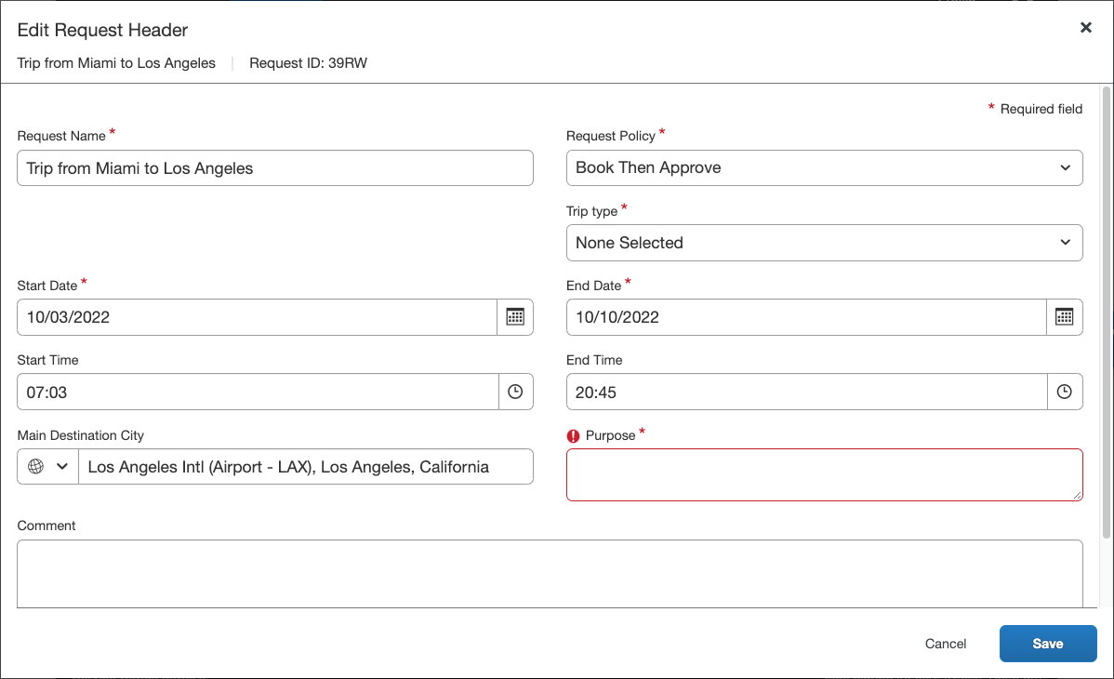
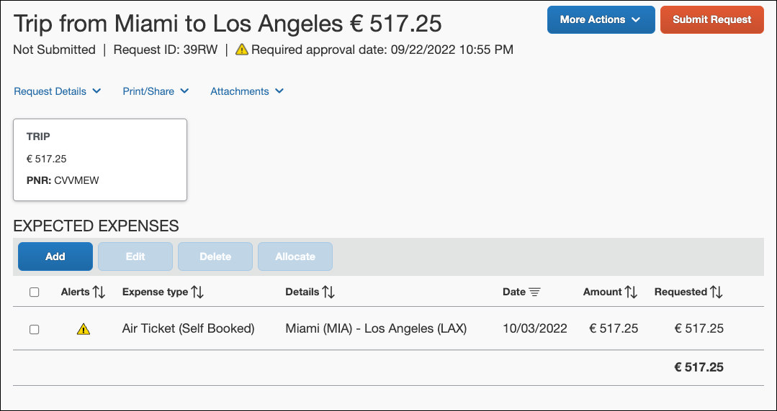
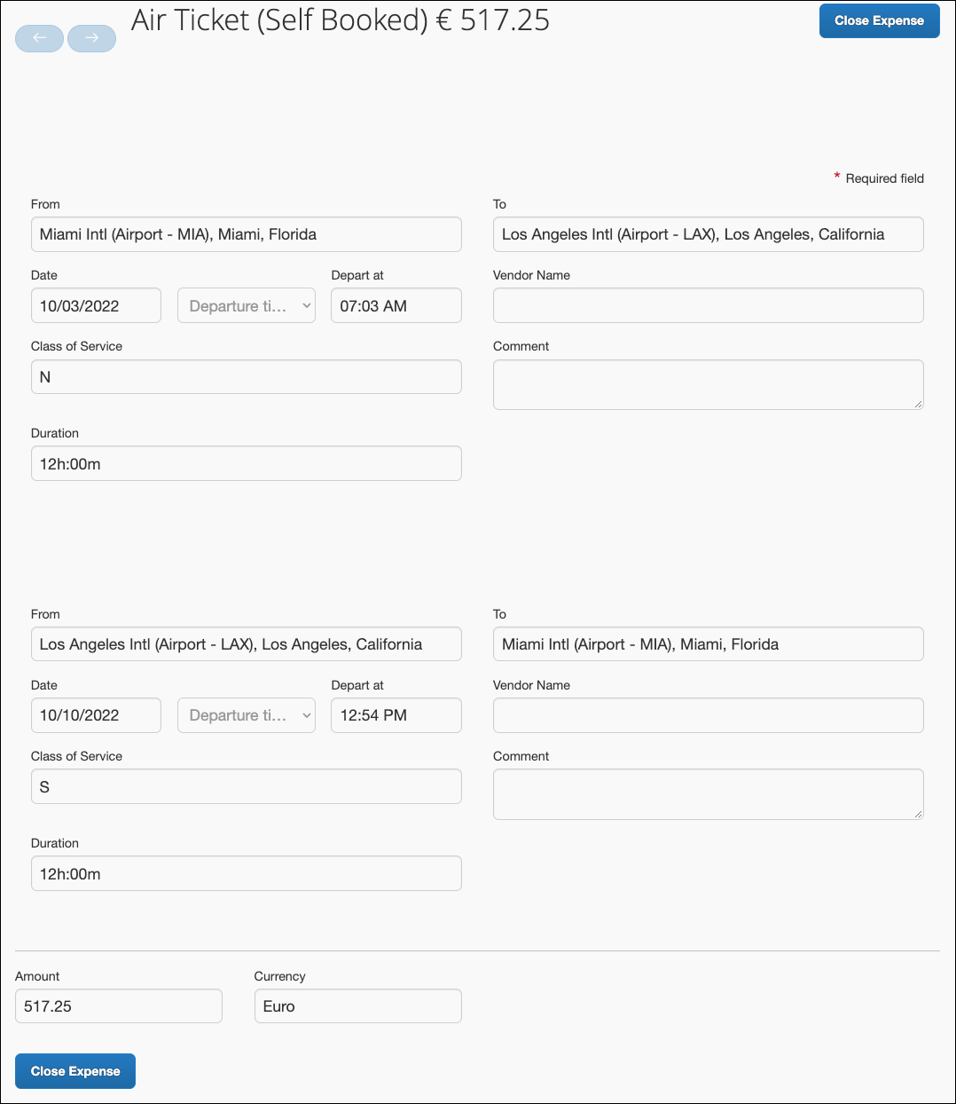
The user can edit the request, for example, select the appropriate policy and then add a cash advance request, expected expenses, attendees, segments that are not self-booked, allocations, or images.
If the request is not submitted, or has been returned to the user prior to approval, the user can modify the self-booked segments by clicking the TRIP section on the Expected Expenses page:
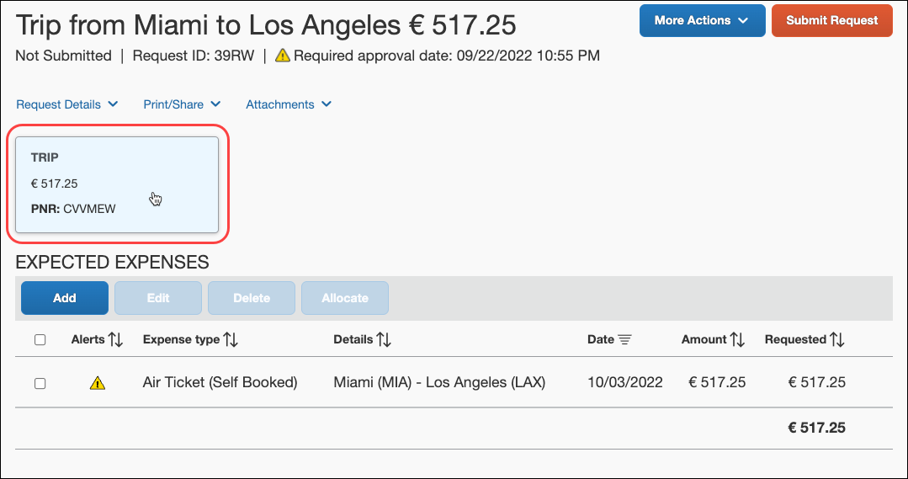
The travel itinerary dialog appears, and the user can make changes to the segment by clicking the Change Trip button.
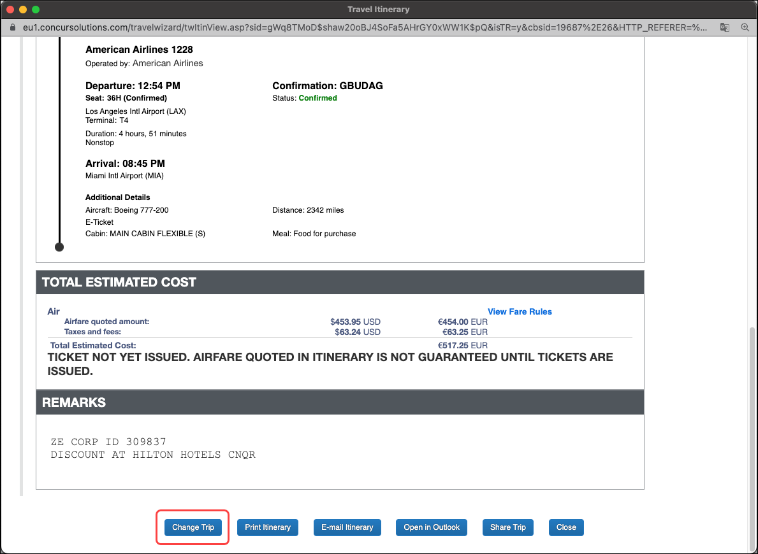

Allocations, Expected Expenses, Attendees, Cash Advance, Imaging, and Processor
These features are the same for all implementation types.
- Refer to All Implementation Types – Allocations, Expected Expenses, Attendees, Cash Advance, Imaging, and Processor in this guide.

Integration Option - No Request Required
As described previously, by default, a request is created at the end of each booking process. However, the administrator can define the Concur Travel integration so that a request is required only if a "Require Approval" travel rule is broken.
Note the following:
- This integration option affects only self-booked trips.
- This integration option can be used with or without the Booking Switch, which determines if the trip must be self-booked or agency-booked.
- If a self-booked trip breaks a "Require Approval" rule, then a request is required – the user is redirected to Concur Request.
- If no "Require Approval" rules are broken, then the trip is sent directly to ticketing. For example, if instant-purchase tickets are purchased, no request is required. Perhaps, short domestic trips would not require a request.
Any rules that are broken that use other levels of enforcement (Require Passive Approval, Notify Manager, etc.) will not redirect the user to Concur Request.
These examples demonstrate using the booking switch:
- Example 1:
- The Booking Switch determines the trip is agency-booked.
- The user creates the request and the trip is booked by the agency.
- The Concur Request approval flow applies.
- Example 2:
- The Booking Switch determines the trip is self-booked.
- The user books the trip in Concur Travel and breaks at least one Concur Travel rule that requires approval.
- The system creates a request at the end of the booking.
- The Concur Request approval flow applies.
- Example 3:
- The Booking Switch determines the trip is self-booked.
- The user books the trip in Concur Travel and breaks no Concur Travel rules that require approval.
- The trip is sent directly to ticketing queue. No request is created.

Step 3: Submitting the Request
This step is the same for all implementation types.
- Refer to All Implementation Types – Submitting the Request in this guide.

Step 4: Approving the Request
This step is the same for all implementation types.
- Refer to All Implementation Types – Approving the Request in this guide.

Step 5: Finishing Up
The company uses its own internal processes to pay for the trip, manage the images, and provide the cash advance, etc.

Viewing, Editing, Printing, Deleting, Closing, Cancelling, Recalling, and Copying
These features are the same for all implementation types.
- Refer to All Implementation Types - View, Edit, Print, Delete, Close, Cancel, Recall, Copy in this guide.

User Experience – Integrated with Concur Expense (Not Integrated with Concur Travel)
This section describes the user experience for Concur Request integrated with Concur Expense.
- The process described here is for the individual Request user. The Event Request feature allows an assistant to create one "master" request for multiple users. For more information, refer to the Concur Request: Event Requests Setup Guide.

Request Menu and Home Page
If the user has the Request User or Request Approver role and the Expense User role:
- The Request option appears on the menu.
– and –
- An Authorization Requests tile may appear in the Quick Task bar of the home page.
- Authorization Request approvals appear in the Required Approvals section of the My Tasks area of the home page.
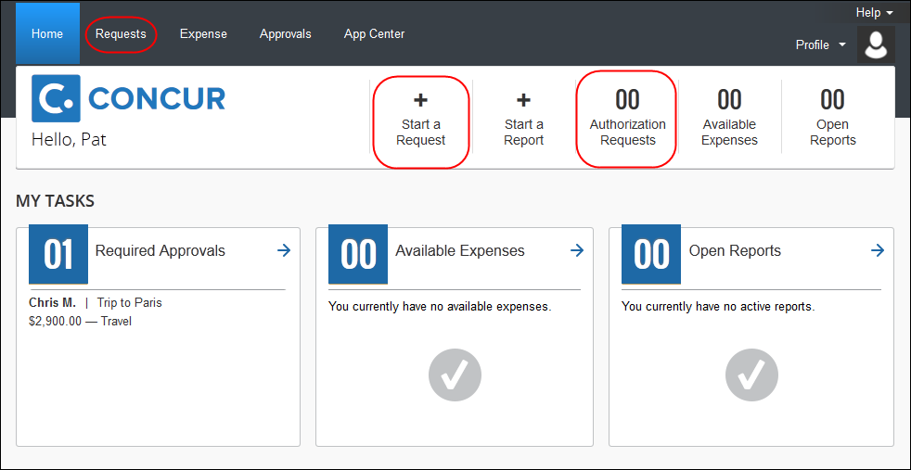
The user can:
- Click Start a Request or New > Start a Request to create a new request.
- Click the Request menu to view all of their requests.
After clicking Requests, the user is taken to the Manage Requests page. The user can create a new request by clicking Create New Request. The user can use the View list to filter the list of requests.

Typical Flow - Summary
These are the typical steps in the process; details are provided on the following pages.
- Step 1: Creating the request: The user completes the request.  - Step 2: Submitting the request: The user submits the request, which is routed to the user's request approver.  - Step 3: Approving the request: The approver reviews and approves the request. | These three steps  are the same  as the first three steps for the stand-alone implementation.
- Step 4: Associating a request with an expense report: The user associates the request with an expense report.

Step 1: Creating the Request;
Step 2: Submitting the Request;
Step 3: Approving the Request
These three steps are exactly the same as the first three steps for the stand-alone implementation.
- Refer to User Experience – Stand-Alone (Not Integrated with Concur Travel or Concur Expense) in this guide.

Step 4: Associating a Request with an Expense Report
Once the request has been approved, the user associates the request with an expense report in one of these ways:
- Create a new report and apply the request from the expense report header
- Create a new expense report from the request list
- Create a new expense report from an approved request
- Apply a request to an existing expense report
If the user’s reimbursement currency changes, the user must associate all requests in the old currency to expense reports, before their reimbursement currency is changed. Once the user has the new reimbursement currency, they will not be able to associate requests in their prior currency to expense reports.

From the Expense Report Header
The user creates a new expense report and completes the required and optional expense report header fields as directed by their company. To associate a request, the user clicks Create From an Approved Request link on the Create New Report page.
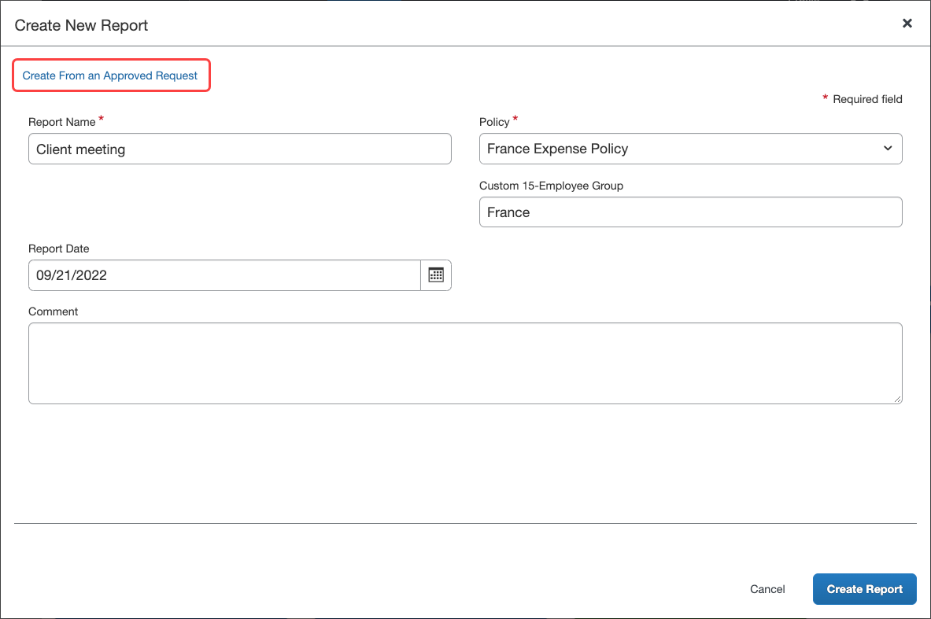
A list of approved (or cancelled after approval) requests appears. The user selects one or more requests and then clicks Create Report.
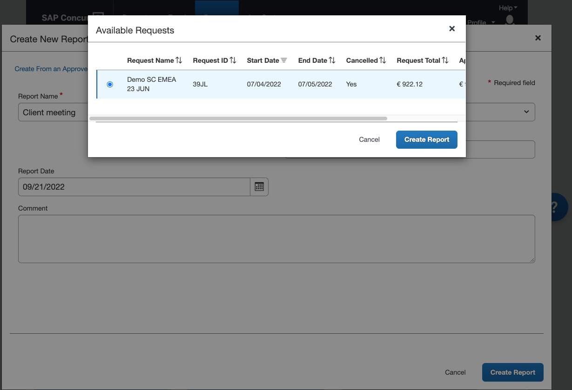
The selected request appears in the REQUEST section of the expense report.
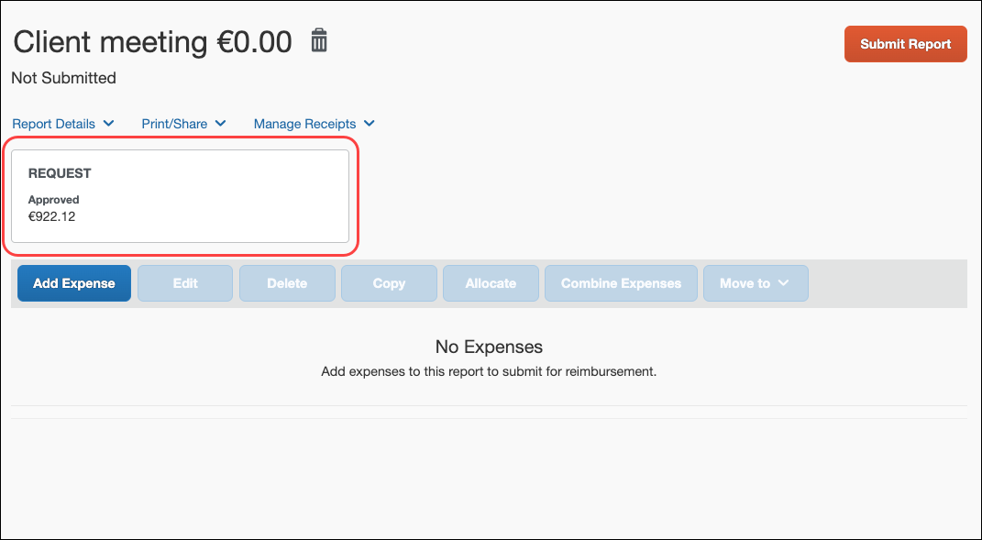

From an Approved Request
The user opens the approved request from the request list by clicking on the request name.
The Create Expense Report button appears on the request.
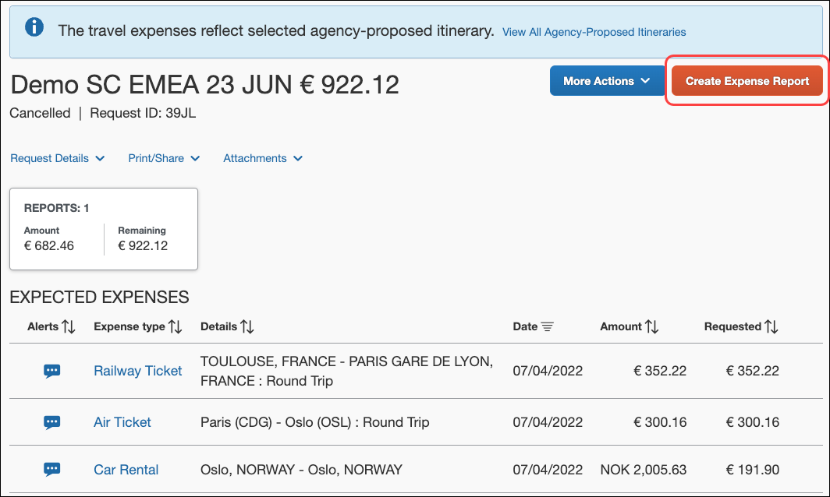
The user clicks the button. The new expense report appears, with the request already associated with the expense report.
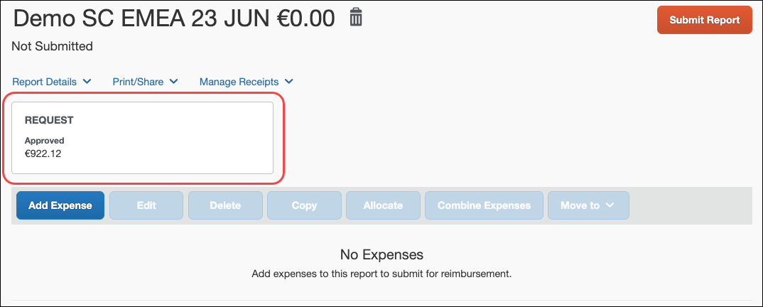
The user can access the Report Header page (Report Details > Report Header) to complete the required expense report header fields. When the header fields are complete, the user clicks Save and completes the rest of the expense report as usual.

Apply to an Existing Report
The user may assign an approved request to any unsubmitted expense report. To assign a request to an expense report, the user opens the expense report and then clicks Report Details > Manage Requests.
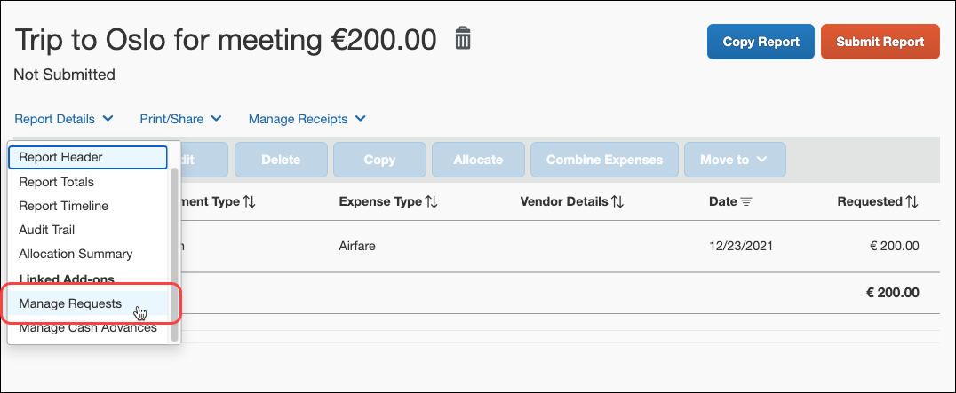
The Requests page appears.
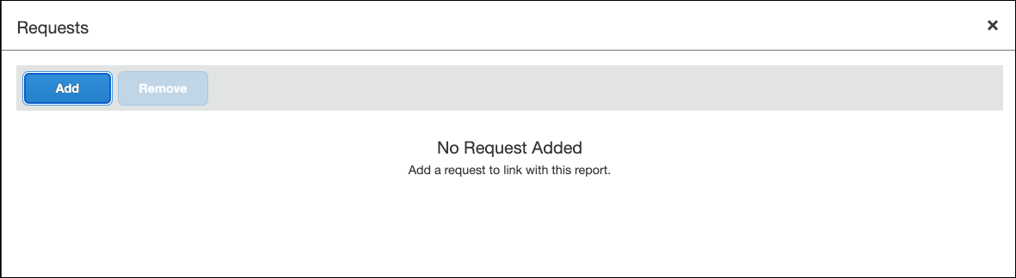
The user clicks Add and the Available Requests dialog appears. The user selects the desired request and clicks Add To Report, and then clicks Close.
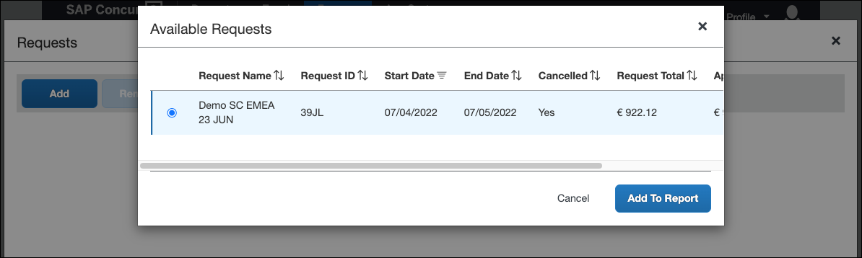

Viewing Request Values
Once a request is associated with an expense report, the user can create expense entries to indicate the exact amounts spent on the expenses. When the user selects an expense type that was used for expected expenses on the request, the Request field appears, listing the amount(s) of the estimated expenses in the request.
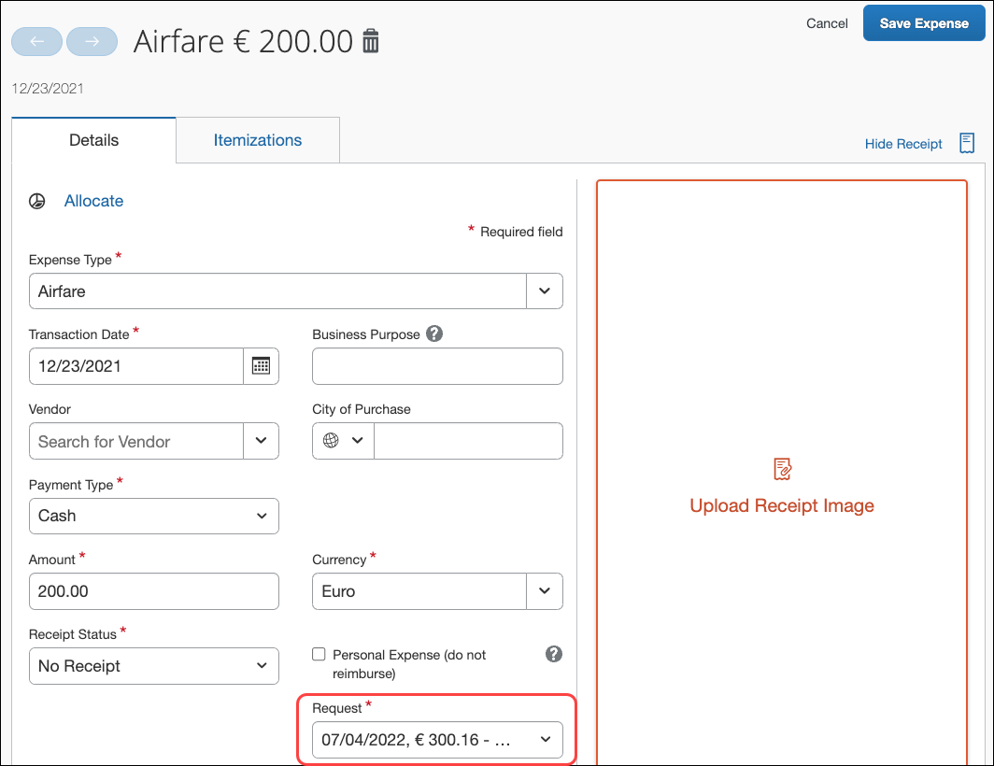

Viewing, Editing, Printing, Deleting, Closing, Cancelling, Recalling, and Copying
These features are the same for all implementation types.
- Refer to All Implementation Types - View, Edit, Print, Delete, Close, Cancel, Recall, Copy in this guide.

User Experience – Integrated with Concur Travel and Concur Expense
This section describes the user experience for Concur Request integrated with Concur Travel and Concur Expense.

Request Menu and Home Page
If the user has the Request User or Request Approver role and the Expense User role and the Travel Wizard User role:
- The Request option appears on the menu.
– and –
- An Authorization Requests tile may appear in the Quick Task bar of the home page.
- and -
- Open Requests and Authorization Request approvals may appear in the My Tasks area of the home page.
- and –
- The Travel wizard (Trip Search section) is available on the home page
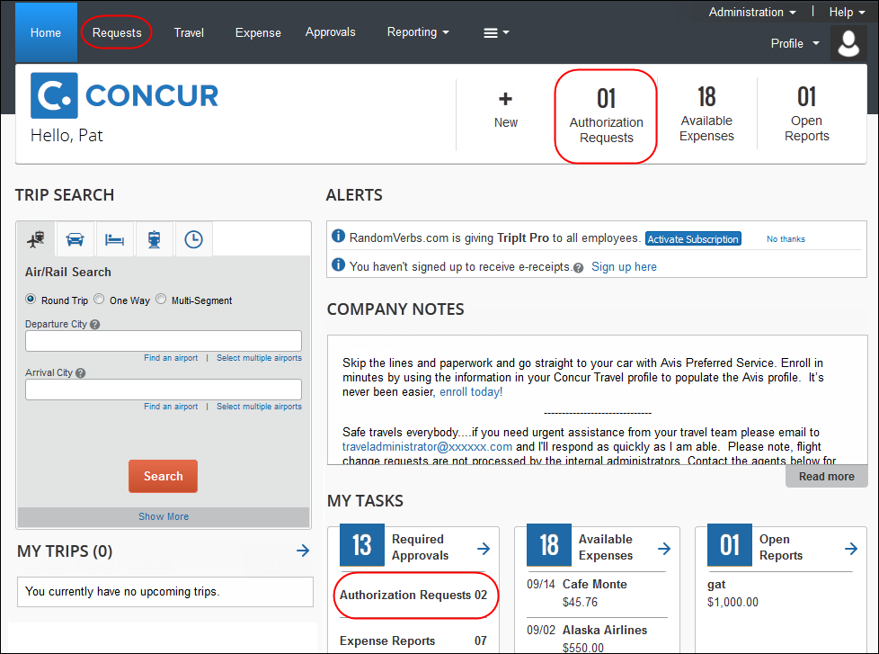
The user can:
- Click Requests to view all of their requests.
- Click Authorization Requests under Required Approvals to view the requests pending approval.
After clicking Requests, the user is taken to the Manage Requests page. The user can create a new request by clicking Create New Request. The user can use the View list to filter the list of requests.

Typical Flows - Summary
There are two possible methods the clients can configure when using Concur Request integrated with Concur Travel. The two methods can be used separately, or together, depending on client configuration.
These are the typical steps in the processes; details are provided on the following pages.
Approve then Book (starting in Request):
- Step 1: Creating the request: The user completes the request in Request.
- Step 2: Submitting the request: The user submits the request, which is routed to the user's request approver.
- Step 3: Approving the request: The approver reviews and approves the request.
- Step 4: Booking the Trip in Concur Travel: The user views the approved request, and clicks the Book link or button. The user is sent to the Travel Request Itinerary page, listing their itinerary with any required fields highlighted. After filling out required fields, the user is sent to the Concur Travel search results page. The user goes through the Concur Travel booking wizard for each segment in the request. The itinerary does not require any additional approvals, and is immediately booked.
Step 5: Associating a request with an expense report: The user associates the request with an expense report.
Book then Approve (starting in Concur Travel):
- Step 1: Book in Concur Travel: Using the Trip Search panel (also known as the Travel Wizard), the user enters the trip information in the booking wizard. At the end of the booking, the user is directed to Request.  - Step 2: SAP Concur creates the request: SAP Concur automatically creates the request, based on the trip information.  - Step 3: Submitting the request: The user submits the request, which is routed to the user's request approver.  - Step 4: Approving the request: The approver reviews and approves the request. | These three steps  are the same  as the first three steps  for Concur Request  integrated with  Concur Travel.
- Step 5: Associating a request with an expense report: The user associates the request with an expense report. | This step is the same as the final step for Concur Request integrated with Concur Expense.

Process Flow – Approve then Book (starting in Concur Request)

Step 1: Creating the Request;
Step 2: Submitting the Request;
Step 3: Approving the Request;
Step 4: Booking the Trip in Travel
These four steps are exactly the same as the first four steps for Concur Request integrated with Concur Travel, Approve then Book (starting in Request).
- Refer to User Experience – Integrated with Concur Travel (Not Integrated with Concur Expense) in this guide.

Step 5: Associating a Request with an Expense Report
This step is exactly the same as the final step for Concur Request integrated with Concur Expense.
- Refer to User Experience – Integrated with Concur Expense (Not Integrated with Concur Travel) in this guide.

Process Flow – Book then Approve (starting in Concur Travel)

Step 1: Booking in Concur Travel; Step 2: SAP Concur Creates the Request;
Step 3: Submitting the Request;
Step 4: Approving the Request
These three steps are exactly the same as the first three steps for Concur Request integrated with Concur Travel, Book then Approve (starting in Travel).
- Refer to User Experience – Integrated with Concur Travel (Not Integrated with Concur Expense) in this guide.

Step 5: Associating a Request with an Expense Report
This step is exactly the same as the final step for Concur Request integrated with Concur Expense.
- Refer to User Experience – Integrated with Concur Expense (Not Integrated with Concur Travel) in this guide.

Viewing, Editing, Printing, Deleting, Closing, Cancelling, Recalling, and Copying
These features are the same for all implementation types.
- Refer to All Implementation Types - View, Edit, Print, Delete, Close, Cancel, Recall, Copy in this guide.

Common Processes for All Implementation Types

All Implementation Types – Allocations, Expected Expenses, Attendees, Cash Advance, Imaging, and Processor
Allocations, Expected Expenses, Attendees, Cash Advance, Imaging, and Processor are optional features and can be used with all implementation types. These features are detailed in other Concur Request guides. Please refer to the guides listed below for general information, details of the user experience, and configuration of these features.
Feature | Description | For more information, refer to:
Allocations | Assign the cost of the trip or purchase to different departments or cost centers | Concur Request: Allocations Setup Guide
Expected Expenses | Include expenses not directly tied to a segment, such as meals, ground transportation, registration fees, etc. | Concur Request: Expected Expenses Setup Guide
Attendees | Identify other participants in the expected expense, such as Business Meals (used only with Expected Expenses) | Concur Request: Attendees Setup Guide
Cash Advances | Obtain cash for other expenses, such as taxi | Concur Request: Cash Advance Setup Guide
Imaging | Attach items, such as receipts, registration forms, etc. | Concur Request: Imaging Setup Guide
Processor | Process and display requests in real time | Concur Request: Processor (Configuration) Setup Guide  Concur Request: Processor User Guide

All Implementation Types – Submitting the Request
When ready, the user clicks Submit Request.
- If the user already has an assigned request approver, the user clicks Accept & Continue.
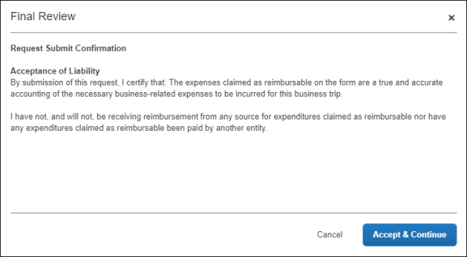
- If the user does not have an assigned request approver, the Edit Approval Flow dialog appears. The user selects an approver and then clicks Save.
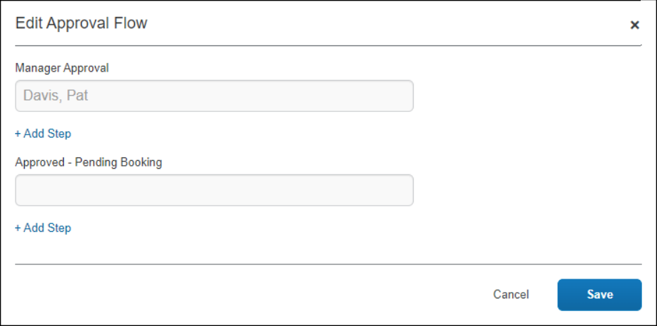
Then the user clicks Accept & Continue.
The request is sent to the approver and:
Action | For more information, refer to:
For travel-related requests:  - If the company has configured Concur Request to send an email to the travel agency when the user submits the request and if any segment is agency booked, then the email is sent now.  - If all segments are user-booked, no email will be sent to the agency. | Concur Request: Policies and Groups Setup Guide  Concur Request: Workflow - General Information Setup Guide
If confirmation agreements are configured, they will display on submit for the Request user. | Concur Request: Workflow - General Information Setup Guide

All Implementation Types – Approving the Request
If the user has the Request Approver role:
- The Request option appears on the menu.
– and –
- The Authorization Requests section appears in the Required Approvals area of My Tasks.
The user clicks the Authorization Requests section of My Tasks to see the requests waiting for approval.
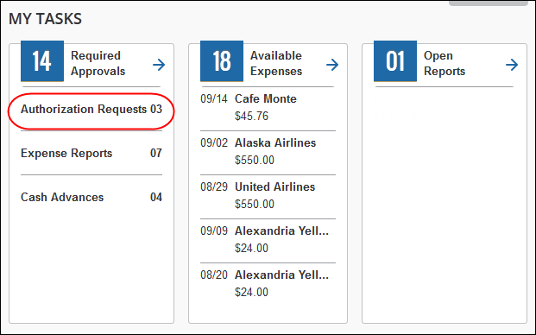
In the request list, the approver clicks the request name to view the request header, expected expenses, segments, approval flow, audit trail, amounts, images, and allocations.
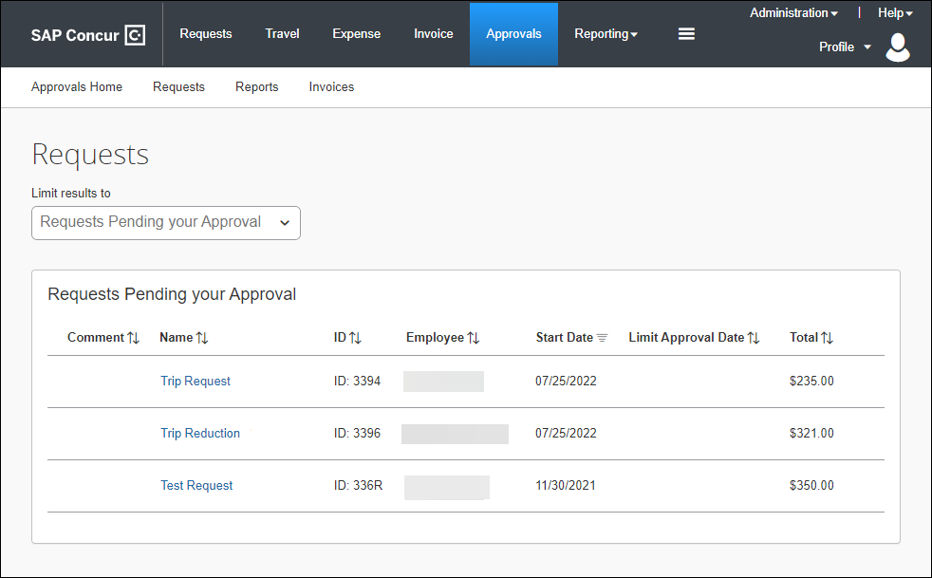
The approver can also use the Approvals menu option to view all the items pending approval.
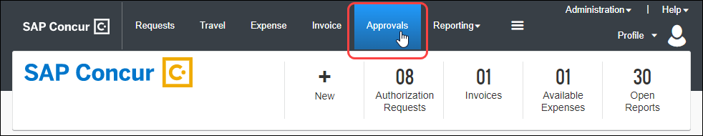
Users with the Request Approver role see the Approvals option regardless of whether their own group is configured to use requests. The approver role is not group-aware, so an approver may have to approve items for an employee in another group that has request privileges.
In the request list, the approver clicks the request name to view the request header, expected expenses, segments, approval flow, audit trail, amounts, images, and allocations.
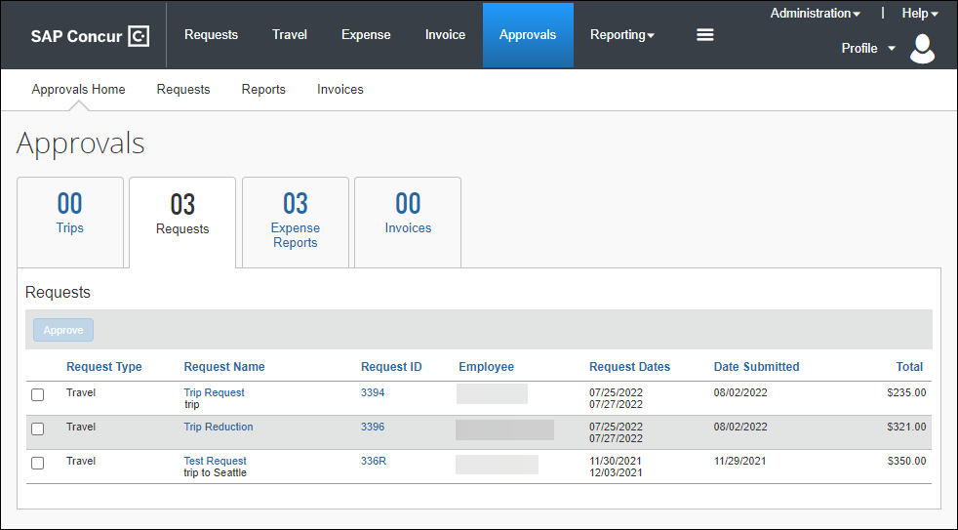
A request approver can then:
- Approve the request
- Approve the request and forward it to another approver (if the company is configured to use this workflow feature)
- Send the request back to the user with a comment to perhaps change and resubmit the request or to decline the request
Approvers cannot adjust amounts – even if the form field is configured to allow the approver to modify the field.
Note the following about request options:
Action | For more information, refer to:
Whether or not the Approve button appears on the Approvals page is configurable. | Concur Request: Workflow - General Information Setup Guide
If confirmation agreements are configured, they will display on approval for the approver. | Concur Request: Workflow - General Information Setup Guide
For travel-related requests:  - If the company configured Concur Request to send an email to the travel agency to finish the booking process and if any segment is agency booked, then the email is sent now.  - If all segments are user-booked, no email will be sent to the agency.  - There is one email sent at approval and one sent at final approval (used if the company allows ad-hoc approval). | Concur Request: Workflow - General Information Setup Guide  Concur Request: Policies and Groups Setup Guide

All Implementation Types – View, Edit, Print, Delete, Close, Cancel, Recall, Copy

Viewing a Request
The user can access requests several ways.
To access the entire list of requests:
The user clicks the Requests menu. The Manage Requests page appears with the active requests displayed. Each active request is displayed as an individual tile. The tiles are sorted by date of creation.
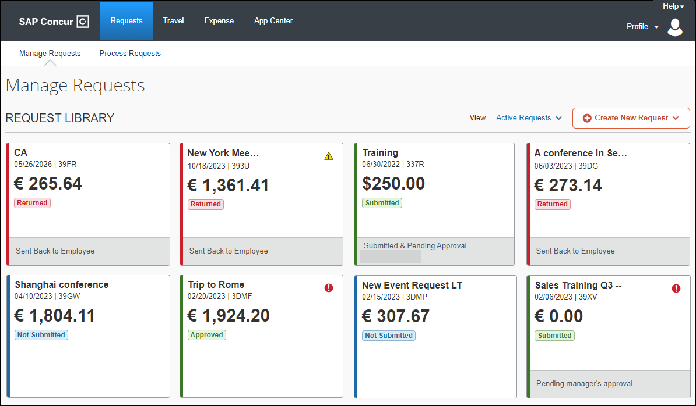
The user clicks a request tile to view and edit (if applicable) a request.
The user can also choose other request status views or all requests using the View list.
When viewing the other request status views or all requests, the requests are displayed in a list instead of individual requests tiles.

Editing/Changing/Updating Travel-Related Requests
Once a request is submitted, it cannot be modified. Prior to submission, the travel-related request can be modified by users or by TMCs.

User Updates in Self-Booked Segments
The user can make changes to self-booked segments under the following conditions:
- The request is unsubmitted
- The user has recalled the request
If the user makes changes to the trip in Concur Travel (such as changing the dates, locations, or prices of a segment), those changes are immediately reflected in the request. If segments are removed in Concur Travel, those segments are removed from the request.
If the user cancels the trip in Concur Travel, the request will keep its current status but all segments will be deleted.

Agency Updates in Agency-Booked Segments
The administrator can configure the system so that changes made by the travel agency automatically update the request. This feature is related to the travel agency.
- For details and configuration information, refer to the Concur Request: Travel Agency Offices Setup Guide.

User Updates in Agency-Booked Segments
Once a request email is sent to the agency, any follow-up to that email contains [NEW], [UPDATED], [DELETED], or [UNCHANGED] for each segment.
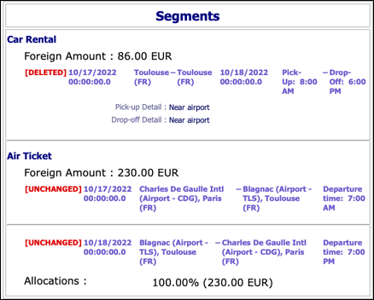
This way, the agency can easily monitor any changes to the request and update the trip accordingly.
The "tracking" text mentioned above does not appear in user emails or approver emails. However, if a user deletes an agency-booked segment, SAP Concur adds the deleted segment to the Deleted Expenses section on the Expected Expenses page (shown below) and notifies the user that the segment will not actually be deleted until SAP Concur sends a notification message to the agency.
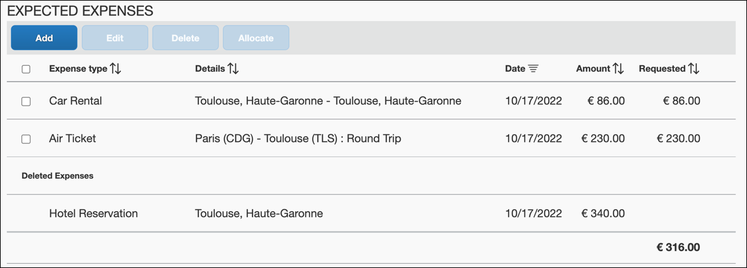
This way, the user can tell whether the agency has received notification about the deletion.

Printing a Request
Users can print a request using the Print or Print/Share menu on the request.
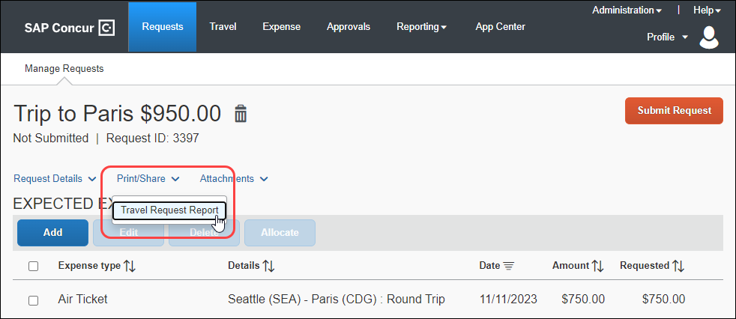
The number of options that appear in this list and the request information that prints is defined by the company.
- For details and configuration information, refer to the Concur Request: Printed Reports Configuration Setup Guide.

Deleting a Request
Whether or not a request can be deleted depends on the implementation and where the request is in the workflow:
- Stand-alone or integrated with Expense: A user can delete any unsubmitted request.
- Integrated with Concur Travel: If the client does not use the Booking Switch or if the client uses the Booking Switch but the trip is self-booked (booked by the user in Concur Travel), then the request cannot be deleted - even before it is submitted.
Also, a request cannot be deleted if it is extended on another request, using the Extension of field at the header level.
To delete a request, the user opens an unsubmitted request and then clicks the delete icon, , located next to the request name and amount.
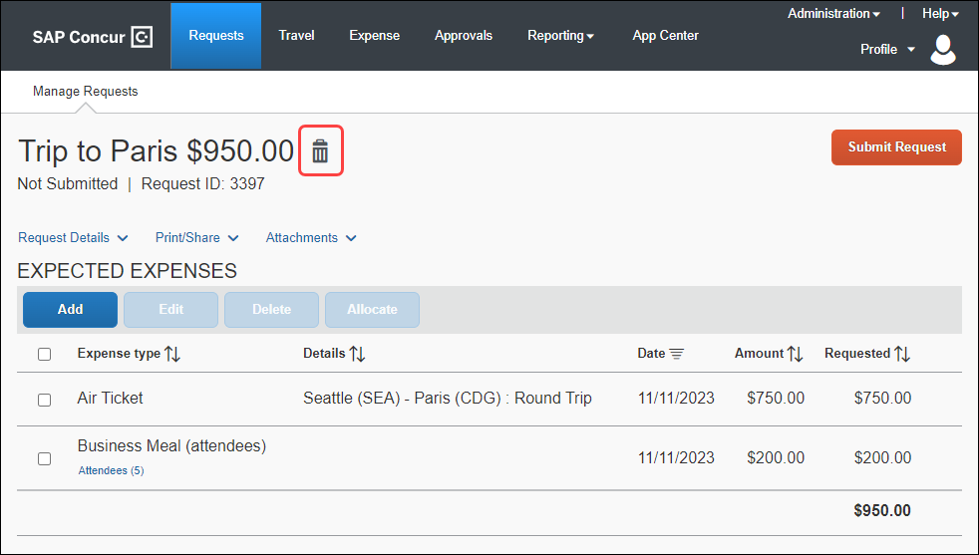
If a request cannot be deleted (for example, it has been submitted), the delete icon, , is not available.

Closing/Inactivating a Request
If your organization allows requests to be closed or inactivated and a request is eligible to be closed or inactivated, the Close/Inactivate Request option is available on the request.
This action removes the request from the user's list of requests. For example, a user may want to remove a cancelled or zero-balance request. The user can also close a request that still has a balance. For example, assume the request was approved for $800 for airfare but the airfare expense was actually $760. The user likely will not use the balance so the user can close the request.
To close or inactivate a request, the user opens the request, and then clicks Close/Inactivate Request on the More Actions menu.
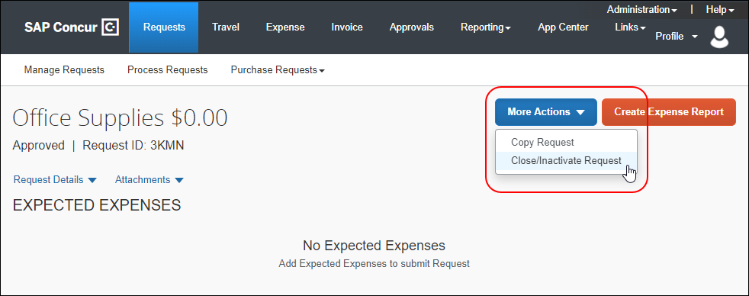
This message appears.
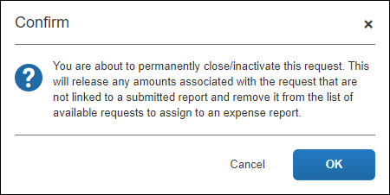
The user clicks OK. Clicking OK reduces the balance to zero and removes the request from the list.

View Closed Requests
The user can view closed requests by selecting Closed from the View list on the Manage Requests page.
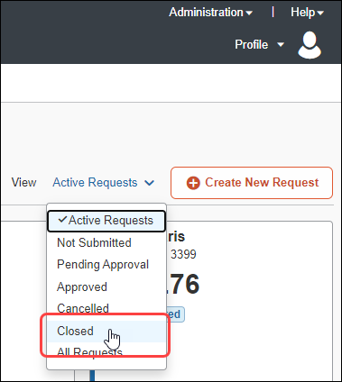

Integrated with Expense
If the user closes a request that is associated with a submitted expense report, the associated expense report is not affected. However, if the user closes a request that is associated with an unsubmitted expense report, the request is disassociated from the expense report, the authorized amounts are removed from the expense report, and the request balance is reduced to zero. Therefore, if a user wants to use and close a request, the user must be careful to submit all associated expense reports before closing. After the user closes a request, the request cannot be associated with any additional expense reports.
When the user attempts to close a request, the user is notified about the actions that will take place if an associated expense report is not yet submitted.

Reopen
The user cannot reopen a closed request.
There is a setting that allows the Request Administrator (Processor) to reopen a closed request.
- Refer to Concur Request: Site Settings Setup Guide.

Delegate, Proxy, and Request Administrator (Processor)
A user's delegate or proxy can close a request. The processor with the Request Administrator role can close a request. (The processor opens the request and clicks Close Request.)

Cancelling a Request
If your organization allows requests to be cancelled after submitting a request for approval, the Cancel Request button or the Cancel Request selection on the More Actions menu is available on the request.
The request's current status and the other actions available to the request determine whether the Cancel Request button, or the More Actions menu with the Cancel Request selection is displayed for the request.
To cancel a request, the user opens the request, and then clicks the Cancel Request button, or clicks Cancel Request from the More Actions menu.
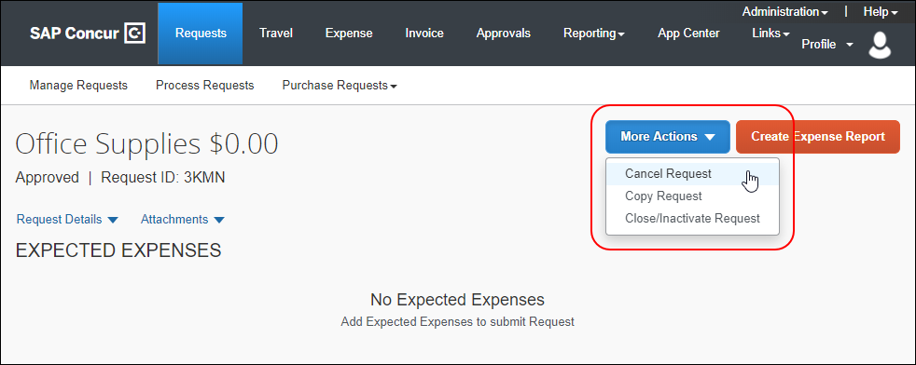
The Cancel Request dialog appears.
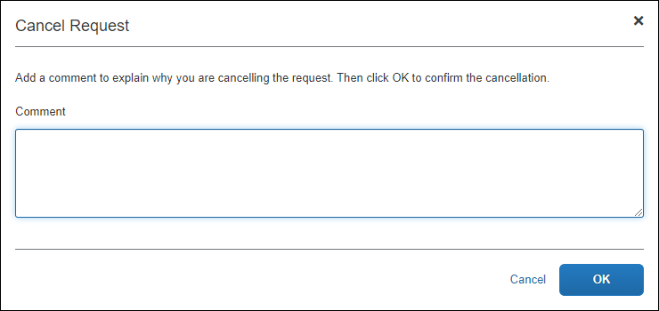
In the Comment field, the user enters the reason for cancelling the request and then clicks OK. Clicking OK changes the request status to Cancelled.
The following actions will happen when a user cancels a request.
Cancellation before approval:
- If the trip was booked using Concur Travel, the trip will be automatically cancelled.
- If the trip was booked using the agency and the agency was sent the notification when the user submitted the request or at any point of the approval flow, then a cancellation notification will be sent by email to the agency.
Cancellation after approval:
- If the trip was booked using Concur Travel, the trip will automatically be cancelled if tickets have not been issued yet and there is no instant purchase.
If auto cancellation fails, an email will be sent to the agency.
- If the request contains any agency-booked segments, the travel agency will be notified by email.

Recalling a Request
If your organization allows requests to be recalled after submitting a request for approval and/or after a request has been approved, and the request meets the criteria for being recalled, the Recall button or the Recall selection on the More Actions menu is available on the request.
The request's current status and the other actions available to the request determine whether the Recall button, or the More Actions menu with the Recall selection is displayed for the request.
To recall a request, the user opens the request, and then clicks the Recall button or clicks Recall from the More Actions menu.
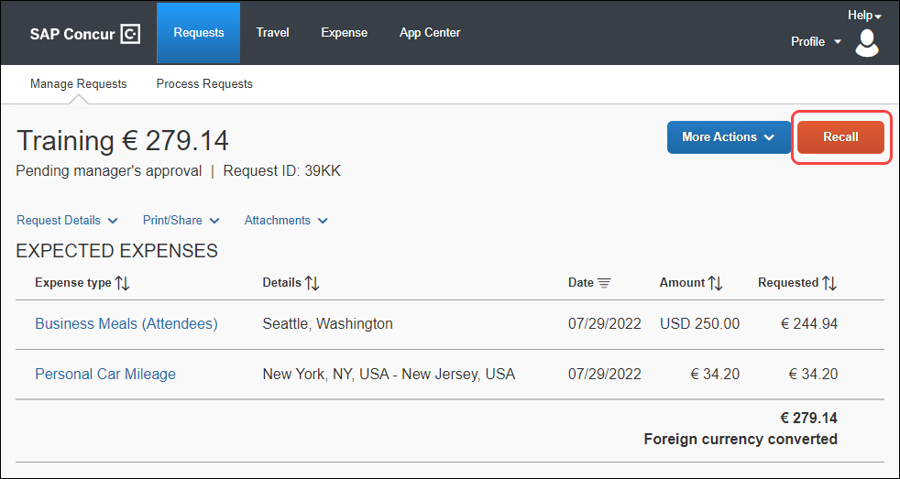
This message appears.
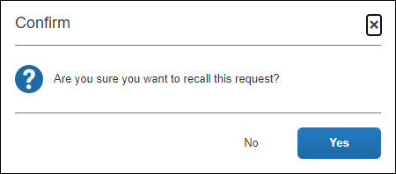
The user clicks Yes. Clicking Yes changes the request status to Returned.

Before Approval
A user can recall a request after it is submitted but before it is approved. If the workflow allows or requires more than one approver, then the user can recall the request until it is final approved.

After Approval
Users can recall a request after it has been approved – if the company uses this feature. If so, the Recall button appears after approval.
For example, assume that the user's request for sales training was approved and then the date of the sales training class changed. The user can recall the request, make the desired changes, and submit again. The request will then go through the approval workflow.
The user can recall a request if all of these are true:
- The Workflow setting allowing this feature is enabled.
- The request status is Approved.
- Both the start and end dates are in the future.
A "blank" date is considered to be "in the past" so the recall option is unavailable.
- There is no expense report (or an invoice from the SAP Concur Central Reconciliation service) associated with the request.
Then, the user can change dates, segments, amounts, etc.
The user cannot change a cash advance.
For clients using the workflow setting, the user has until the Start Date of the request to resubmit the request.
For clients using the Post Approval Trip Update feature: Once the user recalls the request, if it is already past the Last Approved Date, then the user has 24 hours from the time they recall the request to resubmit it, or the trip will be cancelled. If the request requires approval after re-submit, and does not receive that approval before the approval time limit, the trip is cancelled.
The user clicks Submit Request. The request goes through the current workflow.

Copying a Request
If your organization allows requests to be copied, the Copy Request button or the Copy Request selection on the More Actions menu is available on the request. The copy feature allows the user to create a copy and then edit the copy as desired.
The request's current status and the other actions available to the request determine whether the Copy Request button, or the More Actions menu with the Copy Request selection is displayed for the request.
To copy a request, the user opens the request they want to copy, and then and then clicks the Copy Request button or clicks Copy Request from the More Actions menu.
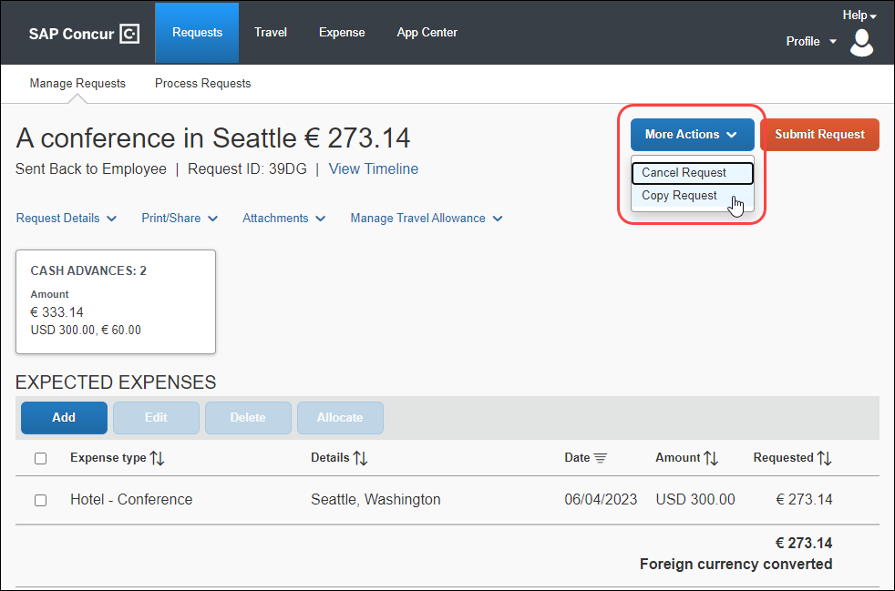
The Copy Request dialog appears.
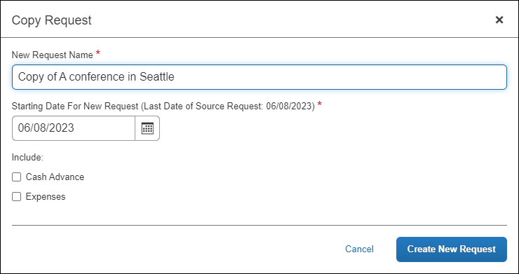
On this page:
- By default, the system provides a name for the copy. The user can edit it if desired.
- By default, the system sets the start date of the resulting request to be the source request end date plus one day. However, the user is provided the opportunity to set the start date.
- The user can elect whether or not to copy expected expenses, segments, and cash advances.
When the user clicks Create New Request, the system makes the copy of the request and opens the new request so the user can make the desired edits.
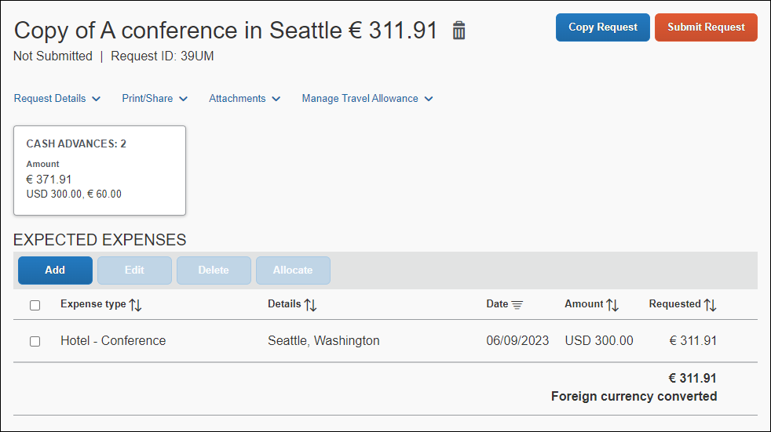

Request Status
Any request can be copied – regardless of status or whether it is open or closed – as long as the client's configuration allows users to create requests.
The Disable ability to create new Requests option in Request Policies forces users to start the process in Concur Travel. Requests created in this manner cannot be copied.

Information Copied
The following information is copied from the source request:
- Segments (if the Expenses check box is selected (enabled) in the Copy Request dialog): All agency-booked segments are copied. If the request contains self-booked segments, those segments become agency-booked; they are no longer self-booked.
- Expected expenses (if the Expenses check box is selected (enabled) in the Copy Request dialog)
- Attendees
- Allocations
- Latest comment
- Cash advances (if the Cash Advance check box is selected (enabled) in the Copy Request dialog)
- Other fields, like the Purpose, Start Date (based on the Copy Request dialog), custom fields, Travel Agency (the system first uses the agency from the source request; if not available, the system searches the Employee profile), etc.

Information NOT Copied
The following information is not copied from the source request:
- Attachments (images)
- Workflow
- Audit trail
- Any other information related to a policy that is no longer the user's current policy

Delegates and Proxies
Delegates (with "submit" rights) and proxies can copy requests.

User Settings

Defining General Request Information
The Request Information section in the Request Settings area of the Profile left menu contains the user's general information.
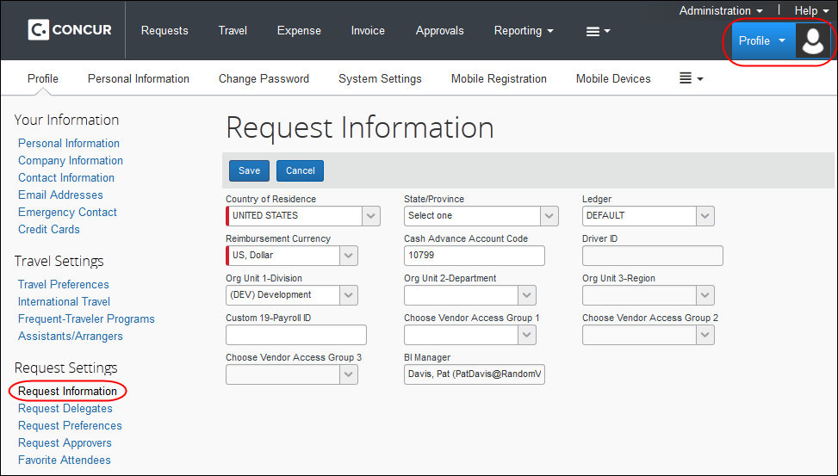

Selecting Delegates
Delegates are shared with Expense delegates. By assigning permissions to a delegate, the user assigns permissions for Expense and Request.
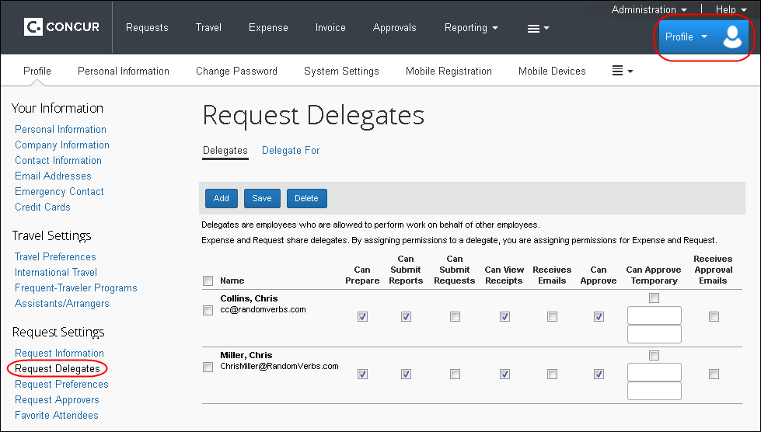

Integrated with Concur Travel
If Concur Request is integrated with Concur Travel and if travel arrangers are used in Concur Travel, then a user's travel arranger in Concur Travel must also be that user's Concur Request delegate.
If the company uses the Book then Approve (starting in Concur Travel) process flow, at the end of the booking process in Concur Travel, the user (or travel arranger, if applicable) is redirected to Concur Request. The travel arranger must also be the Concur Request delegate in order to finish the required request tasks.
If the company uses the Approve then Book (starting in Concur Request) process flow, the Concur Request delegate can create the request. After the request is approved, the Book link or Book Travel button allows the delegate to go into Concur Travel to book the segments. The delegate must also be a travel arranger in order to finish the required travel booking tasks.
Permissions in Profile > Profile Settings > Assistants/Arrangers (in the Travel Settings section of the left menu):
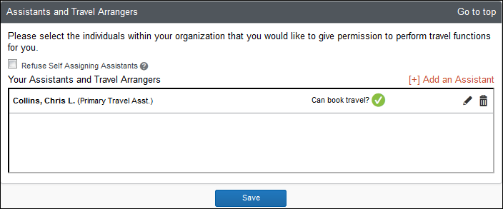
Permissions in Profile > Profile Settings > Request Delegates (in the Request Settings section of the left menu)
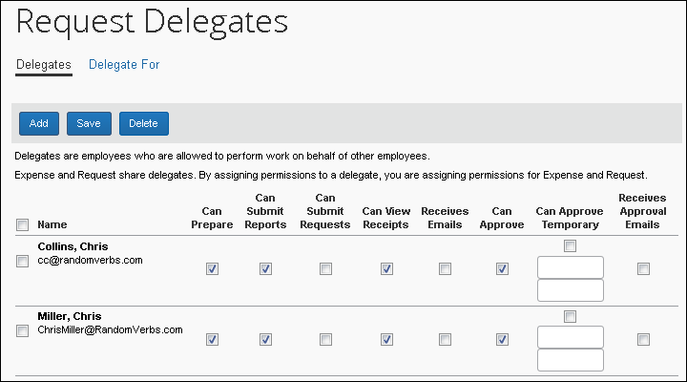

Selecting Status Notifications
Users and approvers can choose to have email sent to alert them when a request changes status, such as from pending authorization to authorized. This option appears in Profile > Profile Settings > Request Preferences (left menu).
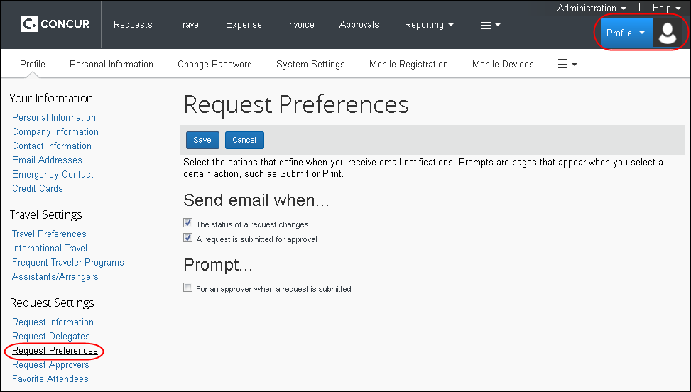

Selecting Approvers
A user's request approver is not necessarily the same as their expense report approver. The request approver is displayed in the Default approver for your Requests field in Profile > Profile Settings > Request Approvers (left menu).
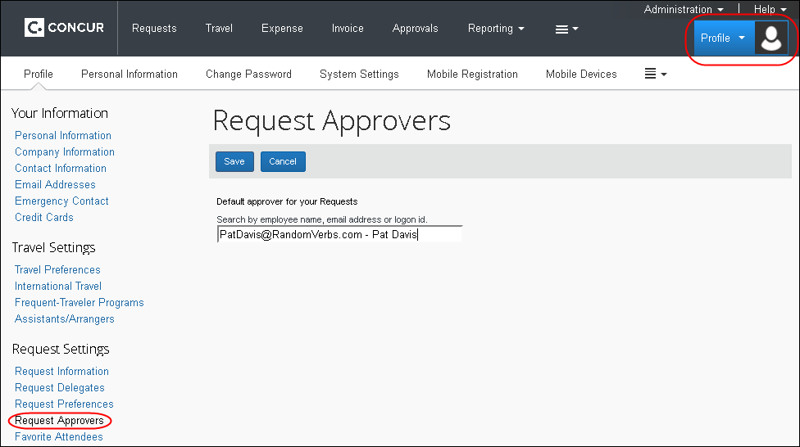
Note the following:
- If the employee is allowed to select their own approver, then the field is editable.
- If the employee is not allowed to select their own approver, then the field is read-only.
- A request approver can also be designated using the employee import.

Favorite Attendees
The user can also work with favorite attendees in the Request Settings section of Profile.
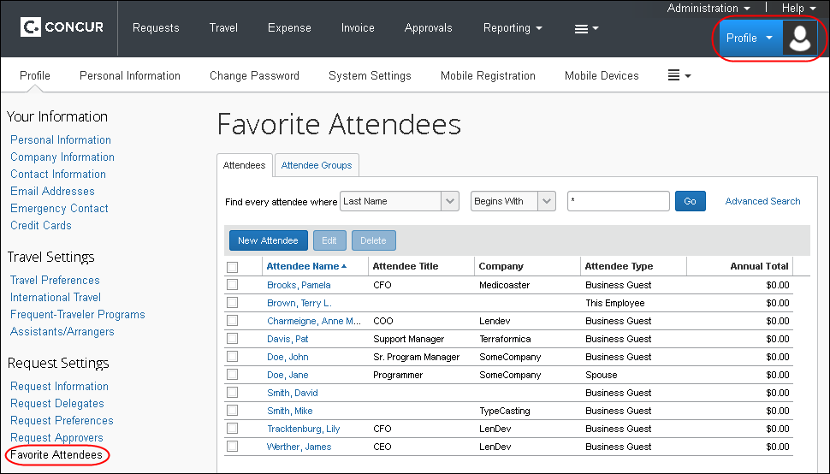
- For more information about request attendees, refer to the Concur Request: Attendees Setup Guide.

Comparison of Features by Implementation
Not all features are applicable for all implementations of Concur Request. In addition, some features are not appropriate for all types of requests, such as travel-only requests, cash-advance-only requests, purchase-only requests. Based on these factors, some features are optional, some are required, some are not allowed at all. The table below lists the Concur Request implementations and features.
Implementation   Feature   | Stand-Alone | Integrated w/ Expense – not Travel | Integrated w/ Travel – not Expense | Integrated w/ Expense and Travel
Allocations | Optional | Optional | Optional | Optional
Attendees | Optional w/ Expected Expenses | Optional w/ Expected Expenses | Optional w/ Expected Expenses | Optional w/ Expected Expenses
Audit Rules | Optional | Optional | Optional | Optional
Authorized Approvers | Optional | Optional | Optional | Optional
Booking Switch | No | No | Optional | Optional
Cash Advance | Optional | Optional | Optional | Optional
Country Groups | Optional | Optional | Optional | Optional
Email Reminders | Optional | Optional | Optional | Optional
Exceptions | Required w/ Audit Rules | Required w/ Audit Rules | Required w/ Audit Rules | Required w/ Audit Rules
Expected Expenses | Optional | Optional | Optional | Optional
Forms and Fields | Required | Required | Required | Required
Groups | Required | Required | Required | Required
Imaging | Optional | Optional | Optional | Optional
Policies | Required | Required | Required | Required
Printed Reports Configuration | Optional | Optional | Optional | Optional
Processor (Configuration) | Optional | Optional | Optional | Optional
Segment Types | Optional | Optional | Optional | Optional
Travel Agency | Optional | Optional | Optional | Optional
Workflows | Required | Required | Required | Required
Travel request required based on Concur Travel rules  (configured in Concur Travel) | No | No | Optional | Optional

Configuration

Roles Required for Configuration
There are two administrator roles:
- Request Configuration Administrator
– or –
- Request Configuration Administrator (restricted)
Some of the tasks listed on the following pages may also require the Expense Configuration Administrator role.

Configuration Steps
Most of these tasks are completed by SAP Concur implementation or support.
Some of these steps can be completed in a different order than listed here. For example, you must configure segments before forms and fields, but it does not matter if that is done before or after configuring the emails.

# | Step | Description | Refer to:
 | Feature activation | SAP Concur activates the feature using an internal site setting (HMC > Settings > Travel Request Enabled).  If Imaging is not yet on, on the Settings page, set Allow Image Upload to Yes. | HMC documentation
 | Hierarchies | If you are configuring Concur Expense and Concur Request, configure Expense first. The Request feature currently uses the Expense (Expense Reports) hierarchy, groups, expense types, an Expense policy, and an Expense Cash Advance workflow (if Cash Advance is used in Request).  The administrator can define a Request authorized approver hierarchy and/or Request cost object approver hierarchy if needed. | Shared: Feature Hierarchies Setup Guide
 | Lists and Locations | Lists and Locations are shared by several SAP Concur products. So, if you plan to use the same lists and locations as Expense, then the work is probably already done. If not, create any desired lists and make any desired location changes now. | Shared: List Management Setup Guide  Shared: Locations Setup Guide
 | Travel Agency | Configure the travel agency information, if the company plans to use either of the travel agency notifications for travel-related requests. | Concur Request: Travel Agency Offices Setup Guide
 | Segments Types | For travel-related requests, includes:  - Segment types configuration  - Policy | Concur Request: Segment Types Setup Guide
 | Forms and Fields | Configure the request forms and fields.  Configuration tip:  - If integrated with Expense, the administrator should add the Request field to the header form in Administration > Expense Admin > Forms and Fields.  - The Vendor field is not a traditional field. Refer to Vendor Field and Location Types below. | Concur Request: Forms and Fields Setup Guide
 | Country groups | Create country groups, if desired | Concur Request: Country Groups Setup Guide
 | Workflow | Configure the request workflow, workflow steps, rules, statuses, email notifications, settings, etc.  Also includes setting that allows user to recall a request  Configuration tip:  - If integrated with Travel, the administrator can add a workflow step to enable the Approve then Book (starting in Request) process flow. | Concur Request: Workflow - General Information Setup Guide
 | Authorized Approvers | Configure authorized approvers, if desired. | Concur Request: Workflow - Authorized Approvals Setup Guide
 | Cost object Approvers | Configure cost object approvers, if desired. | Concur Request: Workflow - Cost Object Approvals Setup Guide
 | Policy | Configure the request policies.  Also includes setting that allows user to cancel a request | Concur Request: Policies and Groups Setup Guide
 | Groups | Assign groups to request policies. | Concur Request: Policies and Groups Setup Guide
 | Audit Rules | Configure the desired audit rules. | Concur Request: Audit Rules Setup Guide
 | Exceptions | Required if using Audit Rules | Concur Request: Exceptions Setup Guide
 | Imaging | Includes:  - Imaging configuration  - Policy | Concur Request: Imaging Setup Guide
 | Allocations | Includes:  - Lists (optional)  - Forms and Fields  - Policy  - Audit Rules (optional) | Concur Request: Allocations Setup Guide
 | Cash Advance | Includes:  - Forms and Fields  - Policy  - Audit rules, workflow rules, and email reminders (optional) | Concur Request: Cash Advance Setup Guide
 | Expected Expenses | Includes:  - Forms and Fields  - Policy  - Audit rules, workflow rules, and email reminders (optional) | Concur Request: Expected Expenses Setup Guide
 | Attendees | Only used if using Expected Expenses  Includes:  - Forms and Fields (Request and Expense)  - Expense Types (Expense)  - Attendee Types and Settings (Expense)  - Attendee import (optional) | Concur Request: Attendees Setup Guide  Shared: Attendee Import, Version 2 Specification
 | Close/ Inactivate request | Allow user to close/inactivate a request  SAP Concur internal site setting ALLOW_CLOSE_AR_LINK set to Y.
 | Processor | Includes:  - Workflow  - Forms and Fields  - Audit rules, workflow rules, and email reminders (optional) | Concur Request: Processor (Configuration) Setup Guide
 | Site Settings | Additional settings, including:  - Allow users to copy requests  - Allow the Request Admin (processor) to reopen closed requests  - Allow multi-leg air segments | Concur Request: Site Settings Setup Guide
 | Printed Reports | Define how requests print | Concur Request: Printed Reports Configuration Setup Guide
 | Users | Assign the Request roles as needed using User Permissions (Company Admin), Permissions Admin, or via the employee import.  If using authorized approvers, assign the permissions for the approvers.  If using Event Requests, assign the proper roles. | Shared: User Administration User Guide  Shared: Employee Import Specification  Concur Request: Workflow - Authorized Approvals Setup Guide  Concur Request: Event Requests Setup Guide
 | Standard Request Extract | Configure and schedule the extract | Standard Request Extract Specification

Integrating with Concur Expense
Implement the desired Concur Expense features as described in the Concur Expense setup guides.

Integrating with Concur Travel
Integrate with Concur Travel, if desired.
- Click Administration > Travel > Travel System Admin.
- Click Wizard Options (on the travel configuration page for the company).
- Refer to the Concur Travel: Travel System Admin User Guide.
- Select Enable Request Integration.
- (Optional) Select Enable Travel Request Booking Switch.
- (Optional) Configure the Booking Switch.
- Refer to the Concur Request: Booking Switch Setup Guide.
- Configure the process flow:
- If using the Book then Approve (starting in Travel) process flow, select either:
- Create Request Based on Concur Travel Rules: Requests are created only if "Require Approval" Travel rules are broken.
- Always Create Request: A request is always created, regardless of Concur Travel rules.
- Refer to Integration Option - No Request Required in this guide for more information.
- If using the Approve then Book (starting in Request) process flow, verify that the Request workflow contains the Approved – Pending Booking step after the request approval steps.
- Refer to the Concur Request: Workflow - General Information Setup Guide.
☼

