
Concur Request:
Forms and Fields
Setup Guide

Last Revised: November 9, 2023
Applies to these SAP Concur solutions:
 Expense
 Professional/Premium edition
 Standard edition
 Travel
 Professional/Premium edition
 Standard edition
 Invoice
 Professional/Premium edition
 Standard edition
 Request
 Professional/Premium edition
 Standard edition

Table of Contents
Section 1: Permissions 1
Section 2: Overview of the Request Feature 1
Section 3: Request Configurations 1
Section 4: Terminology 1
Section 5: Overview of Forms and Fields 2
Forms – Overview 3
Request Header Form 3
Request Segment Form 4
Request Segment Custom Info Form 5
Request Entry Form 6
Request Allocation Form 7
Request Cash Advance Form 8
Request Risk Summary Form 8
Form Configuration Considerations 9
Fields – Overview 9
Data Types and Control Types 9
Default Values 10
Field Configuration Considerations 10
List Fields 11
Information about Specific Fields 12
Form Fields – Overview 12
Section 6: Basic Process for Request Forms and Fields 13
Additional Feature-Specific Documentation 13
IMPORTANT - Change to Expense Report Header Form 14
Section 7: Accessing Forms and Fields 15
Section 8: Procedures – Fields 16
Accessing Fields 16
Modifying Fields 17
Section 9: Procedures – Form Fields 20
Accessing Form Fields 21
Modifying Form Fields 21
Moving Form Fields 25
Adding Form Fields to a Form 25
Removing Form Fields 26
Previewing a Form 26
Section 10: Procedures – Forms 27
Additional Feature-Specific Documentation 28
Accessing Forms 28
Adding Fields to a Form 29
Copying a Form 30
Modifying the Form Name 30
Deleting a Form 31
Previewing a Form 31
Section 11: Procedures – Connected Lists 32
Accessing Connected Lists 32
Adding a New Connected List Definition 33
Select a List 33
Select Fields 35
Configure Fields 36
Preview 38
Assign to Forms 39
Modifying a Connected List Definition 40
Removing a Connected List Definition 40
Section 12: Appendix – Notes about Specific Fields / Forms 40
Additional Feature-Specific Documentation 40
Employee Form 41
Field: Default Travel Agency 41
Request Header Form 41
Field: Cash Advance Policy Fixed Limit Amount 41
Field: Extension of 42
Field: Duration (Days) 43
Fields: Main Destination Country, Main Destination City 44
Fields: Highest Location Risk Level, Main Destination Risk Level 46
Fields: Request Key, Approval Status 47
Field: Request Name 47
Request Segment Form 47
Field: Is Agency Booked 47
Field: View Service Locations For 48
Fields: Hotel Location Detail, Car Rental Location Detail 48
Request Segment or Request Entry Form 49
Fields: Vendor, Vendor Name 49
Request Entry Form 52
Fields: City, Country 52
Request Segment Custom Info Form 52
Fields: Segment Custom Fields 52

Revision History
Date | Notes / Comments / Changes
November 9, 2023 |  | In the Fields – Overview > Data Types and Control Types section, moved the following information from the List row to the Text row:  Launch URL (Single-line), Launch URL (Multi-line)  NOTE: The Launch URL control type is only used with the Launch External URL callout from Concur Connect.  - Refer to http://developer.concur.com for more information.  This information applies to the Text data type, not the List data type.
September 25, 2023 |  | In the following sections, added references to the new Launch URL (Single-line) and Launch URL (Multi-line) control types that are only used with the Launch External URL callout from Concur Connect:  - Fields – Overview > Data Types and Control Types  - Procedures – Fields > Modifying Fields  In the Procedures – Fields > Modifying Fields section, also added the following fields, which are only available when using the Launch URL control type:  - Application Connector  - Popup Width  - Popup Height
October 10, 2022 |  | Updated screenshots and edited content for the new user experience.
January 21, 2022 |  | Updated the copyright year; no other changes; cover date not updated
March 29, 2021 |  | Updated the copyright year; no other changes; cover date not updated
January 16, 2021 |  | Updated the information about line separators and segment forms in the note at the end of the Modifying Form Fields section.
July 20, 2020 |  | Removed the Request/Authorization Request/Concur Request section to align with Concur Request product branding.
June 4, 2020 |  | Changed "Authorization Request" to "Concur Request" in Request guide references to align with Concur Request product branding.
June 3, 2020 |  | Changed "Authorization Request" to "Concur Request" in guide title to align with Concur Request product branding.
April 22, 2020 |  | Renamed the Authorization Request check box to Request on the guide’s title page; cover date not updated
January 24, 2020 |  | Added the Field: Request Name section under the Section 13: Appendix – Notes about Specific Fields / Forms > Request Header Form section.
January 10, 2020 |  | Updated the copyright; no other changes; cover date not updated
February 21, 2019 |  | Added description of the Hidden if empty check box on the Modify Form Fields page to the Modifying Form Fields section.
January 18, 2019 |  | Updated the copyright; no other changes; cover date not updated
September 28, 2018 |  | Updated the definition of Field in in the Terminology section, including adding a note about fields that collect point-in-time data.
June 20, 2018 |  | Added information about the Max Length (chars) and Default Max Length fields to the Procedures – Fields > Modifying Fields section.
June 13, 2018 |  | Changed copy-down to copydown; no other changes; cover date not updated
May 7, 2018 |  | Add a caution note about copying down values in connected lists to the Default Value Type section.
April 6, 2018 | Changed the check boxes on the front cover; no other changes; cover date not updated
April 4, 2018 | Added a note to the Procedures – Form Fields > Removing Form Fields section.
February 27, 2018 | Changed copyright and added the following note:  Best practice is to not allow personal, sensitive, or uniquely identifying information in custom fields.
August 31 2017 | Added a note to the description of the Field Name about not using HTML.
December 21 2016 | Added the Request Header Form > Fields: Request Key, Approval Status section.
December 14 2016 | Changed copyright and cover; no other content changes.
May 13 2016 | Updated the Permissions section and guide content to new corporate style; no content changes.
November 17 2015 | Changed references for Authorization Request: Risk Management Integration Setup Guide to Authorization Request: Risk Management Setup Guide; no other content changes
August 14 2015 | Updated the screen shots to the enhanced UI; no other content changes
September 17 2014 | Added information about two user interfaces; no other content changes.
August 22 2014 | Added information about Hotel and Car Rental Location Detail fields.
May 15 2014 | Added a note about not deleting a request listed in the Extension of field
February 11 2014 | Added information about the form Preview
January 17 2014 | Added information about adding fields from the Form Fields tab
October 29 2013 | Added information about:  - Request Risk Summary Form  - Highest Location Risk Level, Main Destination Risk Level – which can be added to the header form
February 25 2013 | Name change from "Travel Request" to "Request" – no other content changes
January 18 2013 | Additional information about the Main Destination Country or Main Destination City fields when integrated with Concur Travel
December 28 2012 | Made rebranding and/or copyright changes; no content changes
December 14 2012 | Added information about the Main Destination Country or Main Destination City fields
November 21 2012 | Added information about the Cash Advance Policy Fixed Limit Amount field
July 13 2012 | Added information about the Duration (Days) field
May 18 2012 | Replaced the screen shots for custom fields in the appendix
April 24 2012 | Additional details about the City and Country fields (Appendix – Notes about Specific Fields / Forms)
April 20 2012 | Added information about:  - Vendor and the Vendor Name fields (Appendix – Notes about Specific Fields / Forms)  - City and Country fields (Appendix – Notes about Specific Fields / Forms)  - Change the existing Vendor field to Locations Per Supplier (Appendix – Notes about Specific Fields / Forms)
March 23 2012 | Added a note about Attendee forms and fields
March 6 2012 | Made rebranding and/or copyright changes; no content changes
December 16 2011 | Added a note about referring to the Processer Setup Guide for specific form information
November 22 2011 | Added information about Processor and Cash Advance
October 21 2011 | Added information about:  - Custom fields for segments (agency-booked trips only)  - Request entry form for expected expenses
September 23 2011 | Added separator line in the Modify Form Fields window
July 22 2011 | User interface changes - "Request" changed to "Travel Request" - updated menu options and screen shots  Added additional information about the Agency Office field
June 20 2011 | Added the appendix named Notes about Specific Fields / Forms
June 3 2011 | Changed occurrences of "Request" to "Travel Request" - no other changes to content
May 20 2011 | Added note for allocation information, refer to the Travel Request: Allocations Setup Guide.
March 18 2011 | Added information about Connected Lists
January 21 2011 | Changes:  - Update to match current feature set  - Updated the copyright and made rebranding changes
October 15 2010 | Initial publication

Forms and Fields
NOTE: Multiple SAP Concur product versions and UI themes are available, so this content might contain images or procedures that do not precisely match your implementation. For example, when SAP Fiori UI themes are implemented, home page navigation is consolidated under the SAP Concur Home menu.

Permissions
A company administrator may or may not have the correct permissions to use this feature. The administrator may have limited permissions, for example, they can affect only certain groups and/or use only certain options (view but not create or edit).
If a company administrator needs to use this feature and does not have the proper permissions, they should contact the company's SAP Concur administrator.
Also, the administrator should be aware that some of the tasks described in this guide can be completed only by SAP. In this case, the client must initiate a service request with SAP Concur support.

Overview of the Request Feature
Refer to the Concur Request: Overview Guide for general information about requests, such as what the user sees, what the approver sees, workflow, settings, configuration basics, etc.

Request Configurations
Not all Request features are available for all Request implementations.
Implementation | Is this feature available?
Stand-alone | Yes, Required
Integrated with Concur Expense (but not Concur Travel) | Yes, Required
Integrated with Concur Travel (but not Concur Expense) | Yes, Required
Integrated with Concur Expense and Concur Travel | Yes, Required

Terminology

The following terms and concepts are used with forms and fields.
Term | Definition
Form | A form is a configurable page for users to view or enter data. A form contains a set of fields – each used to display or enter one data item. The administrator can add, remove, or re-sequence fields to make a custom form.
Form Type | A form type is a specific type of form. For Concur Request, there is a request header form, an allocation form, several segment (air, car, etc.) forms, etc. as described on the following pages.
Field | A field is used to display or enter a single data item in a form. Each field has distinct properties such as control type, width, maximum characters, etc. There are three types of fields that can be used in any given form, including:  - System Required: These fields must appear on every form because they are required by Request.  - Concur Defined: These fields are created by Concur, based on common client usage; you can include them on a form, if you so choose.  - Custom: These fields are uniquely created by the administrator for use on any form as required, optional, or hidden.  NOTE: Best practice is to not allow personal, sensitive, or uniquely identifying information in custom fields.  NOTE: Fields that collect point-in-time data, such as the Comments field, will fulfill required field configuration when any comment has been entered by any person in the workflow. It is not possible to evaluate for individual steps.
Form Field | Once the administrator places a field on a form, it becomes a form field.  Each form field can have distinct properties that apply to the field only on that specific form. For example, if the administrator changes the width of the form field, only that form is affected. Neither that same field on other forms nor the default field are affected.
Data Type | Every field has a defined data type, such as date, amount, list, etc.
These items are discussed in detail on the following pages.

Overview of Forms and Fields
The Forms and Fields page consists of these sections:
- The Fields tab is used to define the default (general) attributes for all request-related fields.
- The Forms tab is used to define forms, by assigning and re-ordering fields.
- The Form Fields tab is used to define the attributes of the fields that are assigned to a form – if the administrator wants form-specific field attributes other than the default.
- The Connected Lists tab is used to manage connected list definitions.
- The Validations tab is used to create field-level validations to ensure correct data input.
- Refer to the Shared: Validations Setup Guide for more information.

Forms – Overview
In addition to the standard employee form, Concur Request uses the forms listed below.

Request Header Form
There is one default header form, which contains the general information about the request.
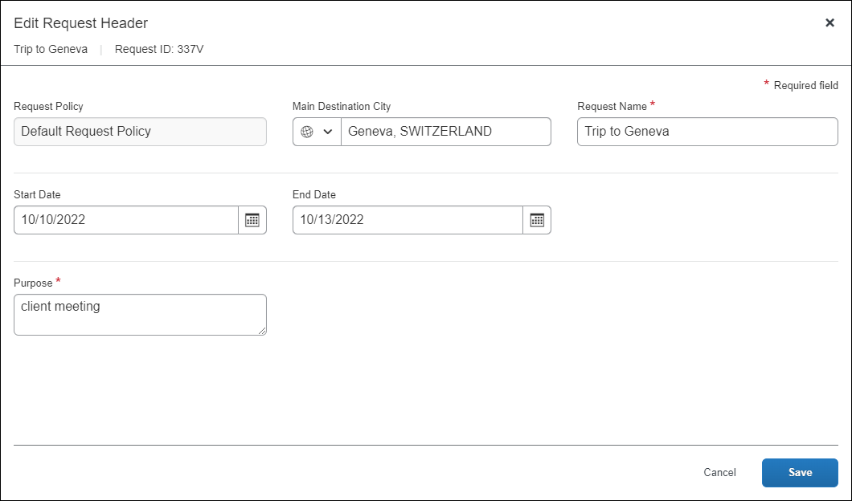

Request Segment Form
There are several default segment forms – one each for air, car rental, dining, event, hotel, limo, parking, rail, taxi, and an additional "miscellaneous" one for the administrator to create additional segment types. This is an example of a request segment form for air.
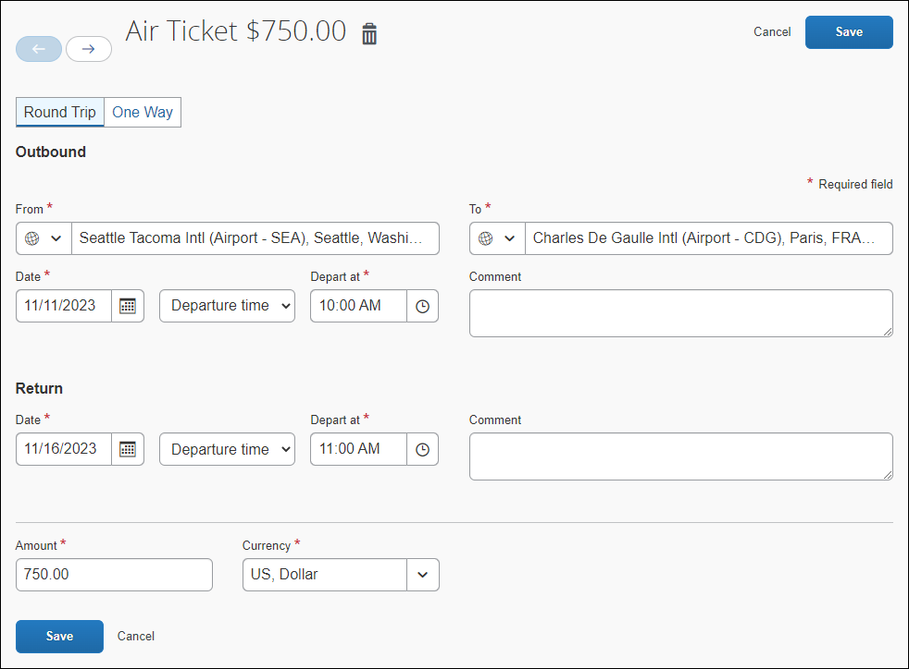
- For more information about defining segment types, refer to the Concur Request: Segment Types Setup Guide.

Request Segment Custom Info Form
There is one default custom info form, which contains custom fields that are used in conjunction with the segment forms.
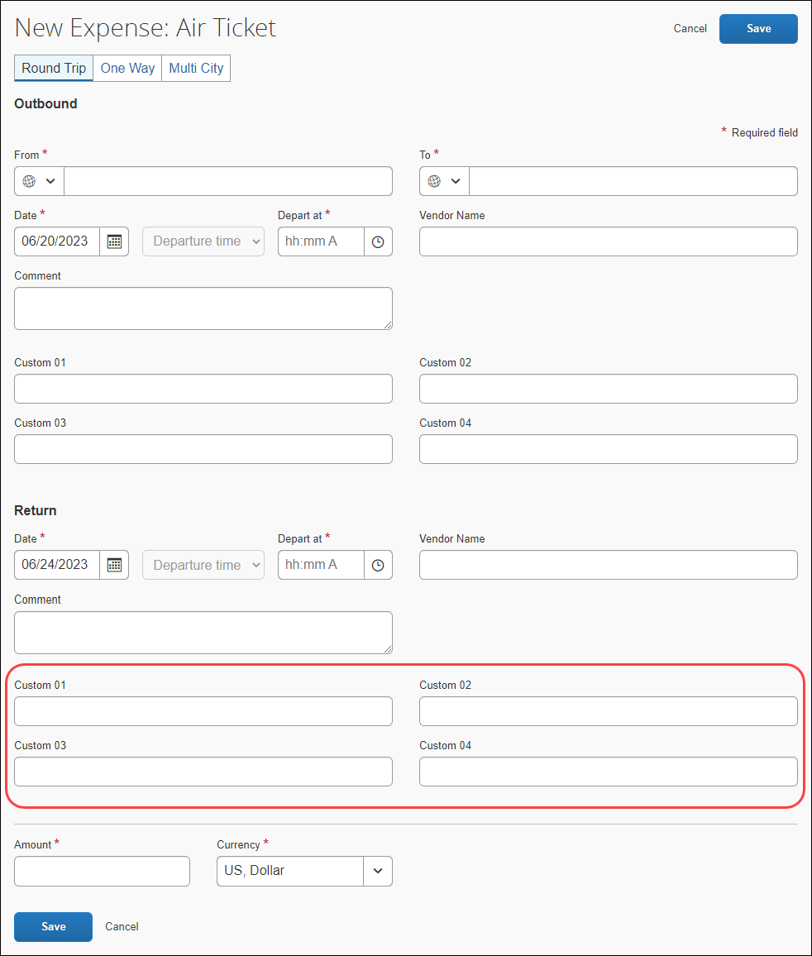
Best practice is to not allow personal, sensitive, or uniquely identifying information in custom fields.
- For additional information about segment custom fields and the segment custom info form, refer to the Appendix – Notes about Specific Fields / Forms at the end of this document.

Request Entry Form
There is one default request entry form, which is used to define the fields available for expected expenses on the expected expenses details page in the request.
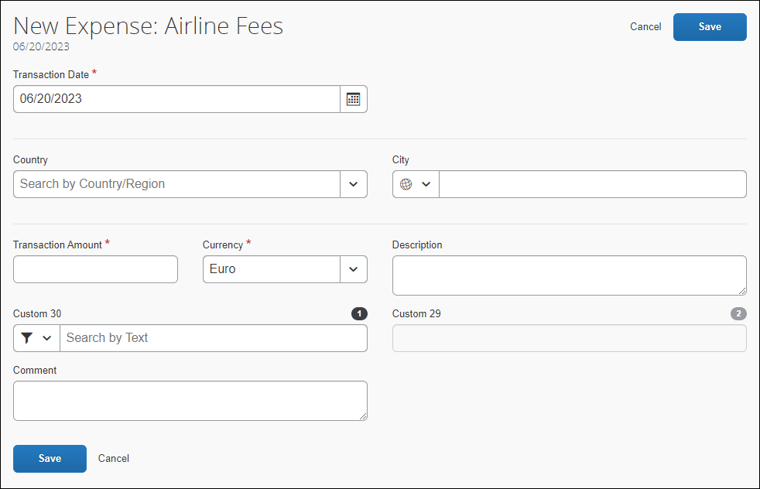
- For information about expected expenses, refer to the Concur Request: Expected Expenses Setup Guide.

Request Allocation Form
There is one default allocation form, which is used to define allocations.
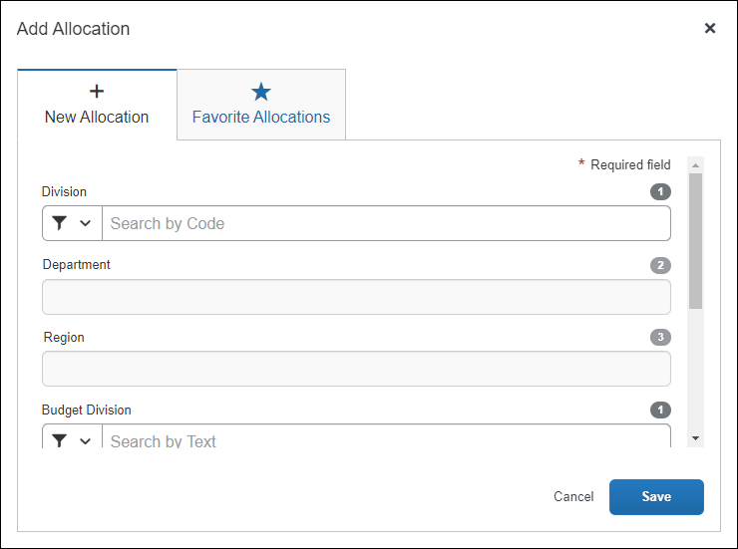
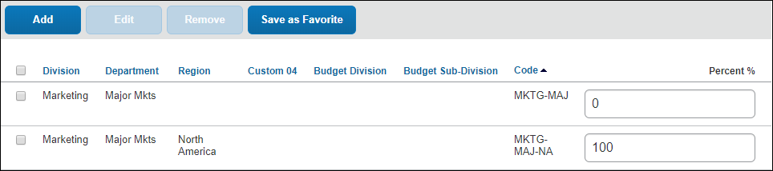
- For additional information about allocations, refer to the Concur Request: Allocations Setup Guide.

Request Cash Advance Form
There is one default cash advance form, which is used to define the cash advance fields.
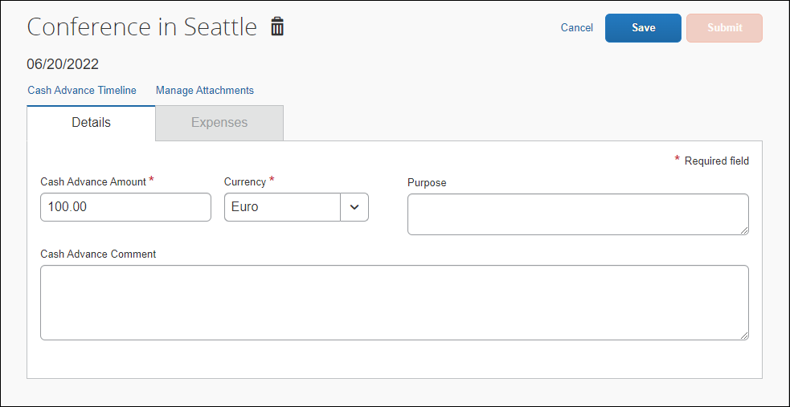
- For additional information about cash advances, refer to the Concur Request: Cash Advance Setup Guide.

Request Risk Summary Form
This form is used only if the Risk Management service is enabled for Concur Request.
There is one default risk summary form, which provides the information in the Travel Advisory dialog.
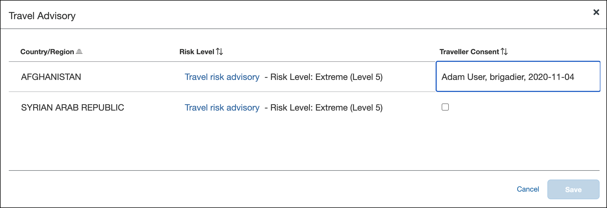
- For additional information about risk management, refer to the Concur Request: Risk Management Setup Guide.

Form Configuration Considerations
Note the following:
- There is no limit to the number of forms the administrator can deploy in the implementation.
- All forms are assigned to the request policy.
- Any form can be used with one or more policies.

Fields – Overview
Request fields may be:
- System Required: These fields must appear on every form because they are required by Concur.
- Concur Defined: These fields are created by Concur, based on common client usage – the administrator can include them on a form, if the client chooses.
- Custom: Custom fields are used by the administrator to collect additional data and can be defined as required, optional, or hidden.
- Custom fields on the request header form, the request allocation form, and the request entry form are configured and assigned to the respective form.
- Custom field for segments are configured and assigned to one or more segment custom info forms – essentially creating a "set" of custom fields. Then, each "set" (segment custom info form) is associated with the respective segment form via the policy.
Best practice is to not allow personal, sensitive, or uniquely identifying information in custom fields.
- For additional information about segment custom fields and the segment custom info form, refer to the Appendix – Notes about Specific Fields / Forms at the end of this document.

Data Types and Control Types
Each field has a defined data type (date, amount, etc.). The available types are listed in the table below.
Data types are related to the database column that holds the field value, so:
- Custom fields can have configurable data types. However, once an administrator has established a data type for a custom field, the same data type is set for every form in which the field is used.
- All other fields (other than custom fields) have specified data types that cannot be changed; they match the existing database column.
Each data type has a list of allowable control types that the administrator can use to configure the fields, as shown in the table below.
Field Data Type | Allowable Control Types
Any (Custom) | Edit, Multi-line Edit, Integer, Amount, Check Box, Edit (w/ Date Helper), Edit (w/ List Helper), and Drop-down List
Key | Neither visible nor selectable by the administrator; these are used by the system for foreign key columns
Text | Edit, Multi-line Edit, Launch URL (Single-line), and Launch URL (Multi-line)  NOTE: The Launch URL control type is only used with the Launch External URL callout from Concur Connect.  - Refer to http://developer.concur.com for more information.
Integer | Edit
Amount | Edit
Boolean | Check Box and Boolean Drop-down List
Date | Edit (w/ Date Helper)
List | Edit (w/ List Helper) and Drop-down List
Connected List | Edit (w/ Connected List Helper)
Numeric | Edit

Default Values
Fields can be configured to display default values. There are two sources for default values:
- Copy Down: The information in an employee-level field can be automatically copied into a request field.
- Constant: This value entered by the administrator while defining the field automatically appears in the request field.
This value is only a default; the employee can change it (if the employee is allowed edit rights).

Field Configuration Considerations
Note the following:
- While the data type is configurable for custom fields, the administrator cannot change the data type once they have used the field on a form.
- Best practice is to not allow personal, sensitive, or uniquely identifying information in custom fields.
- The administrator can use a field on multiple forms (for example, on several header forms, which will be used with different policies). If a field is to be used on multiple forms, its purpose should be consistent across all forms that utilize the field.
- IMPORTANT: This is a best practice recommendation – There is no system control to enforce this recommendation. Be aware that if the administrator allows a specific field to serve multiple purposes, extracting the data for business intelligence or integration will be cumbersome and complicated and likely result in unusable data.
- A field that serves the same purpose on multiple forms can be assigned a different label in each form.
- When the administrator uses a field on more than one form, it can have different Field Access properties on each form. For example, a field can be defined as read-only on one form but modifiable on another. This is a possible scenario when different groups have slightly different requirements.

List Fields
Most data types are self-explanatory – text, date, amount, etc. Lists, on the other hand, have several unique characteristics.

Simple Lists
Note the following:
- All list fields with the search helper support wildcard (*) searches.
- If a field is configured as a simple list with search helper, the field displays with a helper that allows the user to search either by the list item text or code:
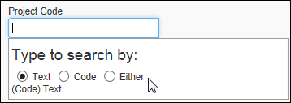
- If a field is configured as a simple list with dropdown, the field displays a maximum of 500 items in the dropdown:
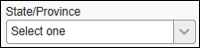
If the size is greater than 500, the field displays as a text field with the search helper (same as above).

Connected Lists
Note the following:
- If a field is defined as a connected list, it will display a maximum of 500 items in the connected list dropdown, and it will allow the user to search either by the list item text or code:
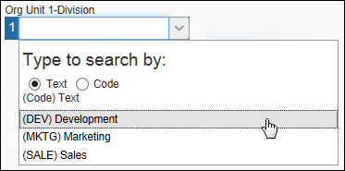
When the search results contain less than 500 items, any search refinement will be done within the browser, preventing any database access delay.
Example: Assume that the user is searching for Seattle. The user types in SE and the result set returned by the system is less than 500. The user adds A to search for SEA, and the previous result set is further refined, instead of contacting the system for a new result set.
- Connected lists - by definition - represent the association between two or more fields, so you must configure at least two fields to be associated connected list fields. Otherwise, the employee will receive errors when trying to use that field.
- If a connected list field is on a form, then at least one other associated connected list field must also be on that same form or a related form for copydown.
- If you define a field as a connected list field, you cannot mark any connected list fields below it as read-only.

Information about Specific Fields
Some fields are unique or unusual. Refer to the appendix named Notes about Specific Fields / Forms in this guide.

Form Fields – Overview
Note the following about form fields:
- A change made on the Form Fields tab affects only the selected field (or fields) on that form. The change does not affect the default field nor any field on another form.
- A change made on the Fields tab after a field has been added to a form may or not affect the form field.
- If the administrator has edited the form field, a change made to the default field (on the Fields tab) does not affect the form field.
- If the administrator has not edited the form field – is it still the same as the default field (on the Fields tab) – then a change made on the Fields tab will affect the form field.
- In order to reapply the default field settings, the administrator can remove the field from the form (using the Forms tab) and then re-add it.

Basic Process for Request Forms and Fields
The basic steps are listed here and described in detail on the following pages.
- On the Forms and Fields page:
- Set the field default settings (Fields tab).
- Create and configure each of the request forms (Forms tab).
- On the List Management page, identify and create the lists needed for the request forms, if any. Define the "levels" of any connected lists you will use. Provide the data for the lists either by entering the data manually or via import.
- For more information, refer to Shared: List Management Setup Guide.
- On the Forms and Fields page, add or modify any of the field properties to fit the forms (Form Fields tab). For example, the administrator may want to substitute a list for a text box or change the maximum number of characters allowed in a field.

Additional Feature-Specific Documentation
The documents listed below provide specific information about forms/fields as they relate to the associated feature.
For information about…. | Refer to….
Allocation forms/fields | Concur Request: Allocations Setup Guide
Attendee forms/fields | Concur Request: Attendees Setup Guide
Cash Advance forms/fields | Concur Request: Cash Advance Setup Guide
Request Entry forms/fields | Concur Request: Expected Expenses Setup Guide
Processor configuration requirements | Concur Request: Processor (Configuration) Setup Guide
Risk management forms/fields | Concur Request: Risk Management Setup Guide

IMPORTANT - Change to Expense Report Header Form
You can allow users to associate approved requests with new expense reports using the report header.
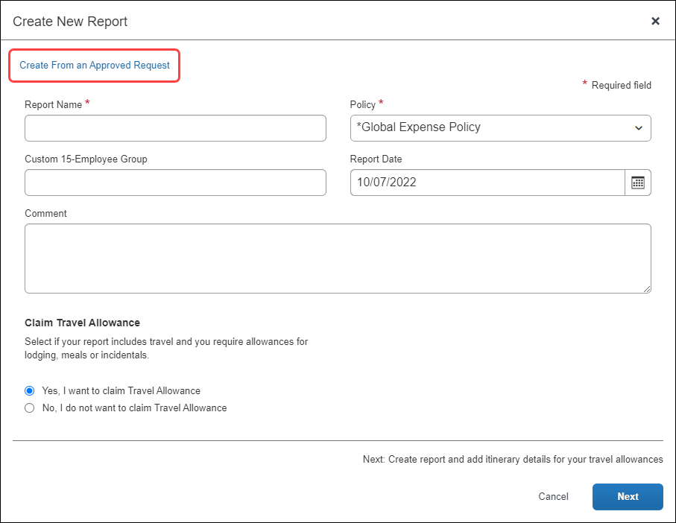
To do so, access Administration > Expense > Forms and Fields. Then, add the Authorization Request field to the expense report header form.

Accessing Forms and Fields
To access Forms and Fields:
Click Administration > Request > Forms and Fields.
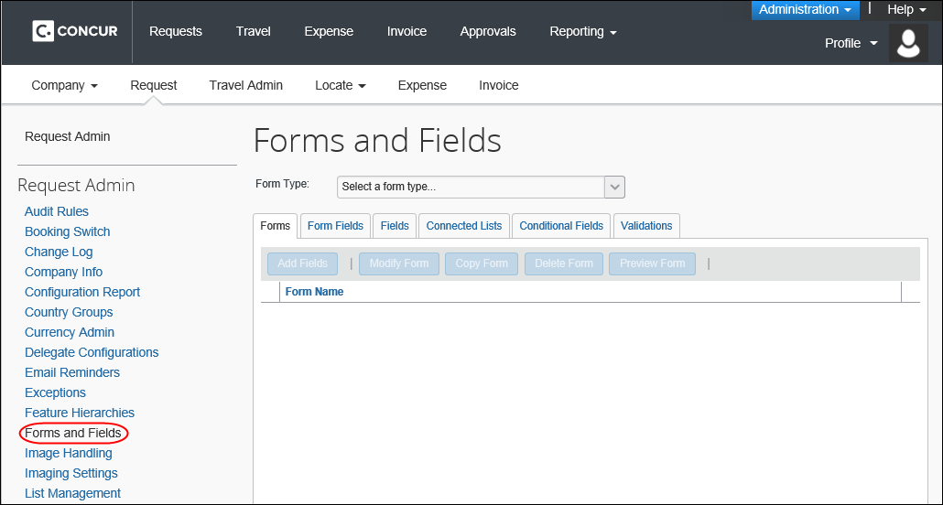

Procedures – Fields
Use the Fields tab to modify default field attributes.

Accessing Fields
To access the Fields tab:
- On Forms and Fields page, in the Form Type list, click the desired form type.
- Click the Fields tab.
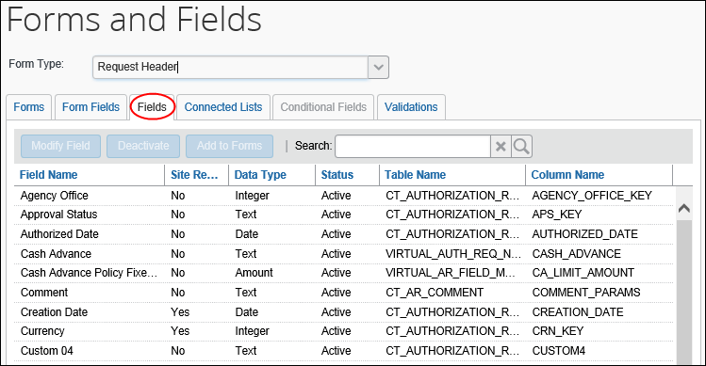

Modifying Fields
To modify fields:
- On the Fields tab, either:
- Click the desired field and click Modify Field.
– or –
- Double-click the field (anywhere on the line - not just the name).
The Modify Fields window appears.
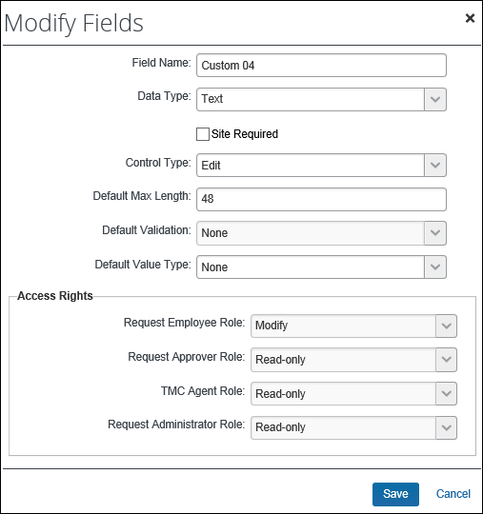
- Make the appropriate choices:
Field | Description
Field Name | Underlying name of the field – the default form field label  Edit as desired. The name entered here becomes the default (but editable) label on each form that contains this field.  IMPORTANT: While the administrative user interface does not prevent the entry of HTML (Hypertext Markup Language) into text labels in all cases, this is not a supported option within Concur. If you elect to take this path, there is no guarantee that it will work, and if it does work, this may be a temporary situation. Concur is always increasing the security code present to prevent vulnerabilities, which could break such usage at any time. Concur will not fix any reported issue regarding the use of HTML formatting in text fields.
Data Type | Data type for the field  Available data types are:  - Amount (currency)  - Boolean  - Date  - Integer  - List  - Connected lists  - If working with connected lists, refer to Procedures - Connected Lists in this guide.  - Numeric (floating point)  - Text  The data type is configurable only for custom fields. All other fields have fixed data types associated with the database column that holds the field value.  Note that when you select from the Data Type list, the window refreshes and provides other applicable fields. For example:  - When you choose Text, you are asked to provide the maximum length of the field.  - When you choose Connected List, you are asked to provide the name of the connected list definition.  - and so on
Site Required | Determines whether the field is required in the form  Select (enable) the check box to make the field required.
Control Type | Defines the control type associated with each data type  The options that appear here are determined by the option selected in the Data Type field.  NOTE: The Launch URL control type will only appear if the following conditions are true:  - The Form Type is Request Header, Request Entry, or Request Allocation  - The Data Type is Text  - There is at least one application connector configured and enabled
  Data Type | Control Type Options
  Amount | Edit
  Boolean | Check Box, Boolean drop-down List
  Date | Edit (w/ Date Helper)
  Integer | Edit
  List | Drop-down List, Edit (w/ List Helper)
  Numeric | Edit
  Connected list | Edit (w/ Connected List Helper)
  Text | Edit, Multi-line Edit, Launch URL (Single-line), Launch URL (multi-line)
Default Max Length (Modify Fields page)  Max Length (chars) (Modify Form Fields page) | Allows you to set the maximum length of the field value.  The maximum length, including spaces, must be equal to or less than the maximum number of characters allowed for the field.  - For more information about maximum field lengths for fields, refer to the Max Length column for the field in the Standard Request Extract Specification.  NOTE: This field may or may not appear - depending the option selected in the Data Type field.
Application Connector (Only appears when using the Launch URL control type) | Select the application connector to use with this field. Only application connectors for the Launch External URL callout will display.
Popup Width (Only appears when using the Launch URL control type) | Enter the width, in pixels, of the popup window that will display when the user launches the External URL window by clicking the list arrow button.
Popup Height (Only appears when using the Launch URL control type) | Enter the height, in pixels, of the popup window that will display when the user launches the External URL window by clicking the list arrow button.
Default Validation | Choose a validation routine to run against the field, if desired; not used by most clients  NOTE: This field may or may not appear - depending on the option selected in the Data Type field.  - For more information, refer to the Shared: Validations Setup Guide.
Default Value Type | Fields can be configured to display default values. There are two sources for default values:  - Copy Down: The information in an employee-level field can be automatically copied to this field.  - Constant: This value entered here automatically appears to the user.  This value is only a default; the employee can change it (if the employee has edit rights).
Access Rights | Choose the level of access granted to each role that uses a form with this field  It can be Modify, Read-only, or Hidden.  NOTE: If a field is required, you should not mark it Hidden.  - For information about the Processor (TMC Agent and Request Administrator) field access rights, refer to the Concur Request: Processor (Configuration) Setup Guide.
- Click Save.

Procedures – Form Fields
The Form Fields tab contains the fields that are currently assigned to each form. Form fields can be modified, added to, or removed from forms using the Form Fields tab.
Form fields for air and rail: For air and rail form types, the date fields are not required on the form but they are required when the user completes the form. Either the depart date or the arrival date is saved in the database.

Accessing Form Fields
To access the Form Fields tab:
- On Forms and Fields page, click the form type.
- Click the Form Fields tab.
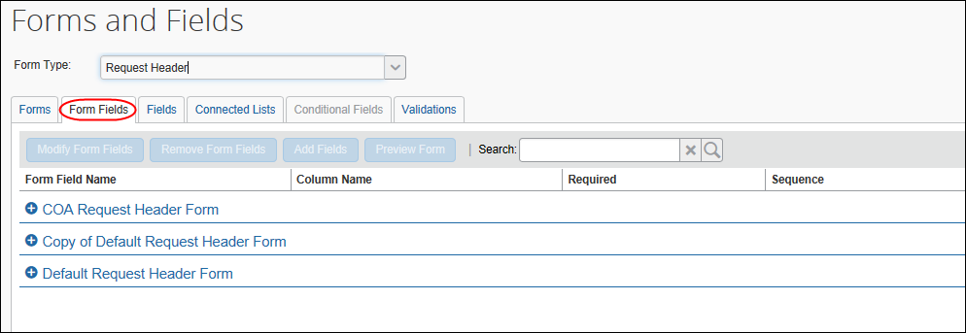
- Click the form name to see all fields on the form.

Modifying Form Fields
To modify form fields:
- Either:
- To select multiple fields, use Shift+click or Ctrl+click. Click Modify Form Fields.
– or –
- To modify a single form field, double-click the form field name.
The Modify Form Fields window appears. The information that is presented differs based on whether you selected a single field or multiple fields.
With a single field selected, all fields appear:
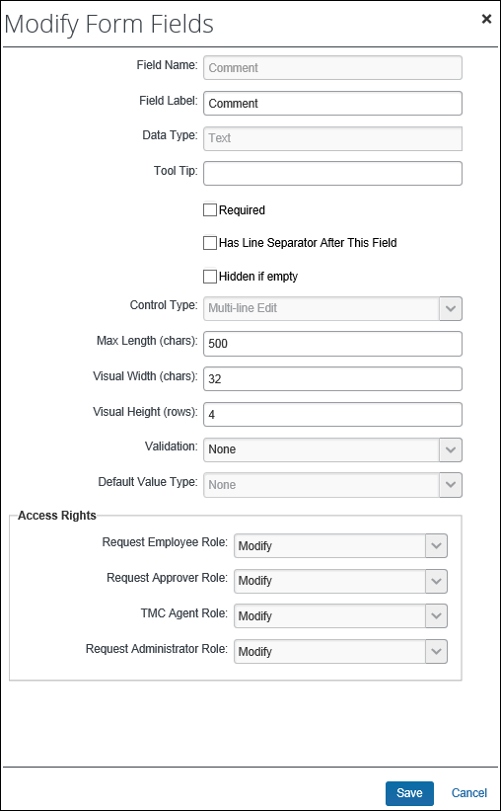
Note the following:
- Just like the Modify Fields window, the fields that appear here differ depending on the field selected (custom vs date vs comment, and so on).
- The Has Line Separator After This Field check box appears on all Request forms, including segment forms.
For segment forms, in the NextGen UI for Concur Request, the Date (DEPARTURE_DATE) and Depart at (DEPARTURE_TIME) / Arrive at (ARRIVAL_TIME) fields are considered one single field group, and the Date (ARRIVAL_DATE) and Depart at (DEPARTURE_TIME) / Arrive at (ARRIVAL_TIME) fields are considered one single field group.
Therefore, if the Has Line Separator After This Field check box is selected (enabled) for one or more of the fields in the group, only one line separator will be applied to the group, and it will be displayed after the group on the segment form.
- The Hidden if empty check box determines whether the field will be hidden on the form if the field does not contain a value. This check box is commonly used when a field is populated by a third party and is read-only, such as a field for a seat number or confirmation number, to prevent empty, read-only fields from displaying on a form.
With multiple fields selected, only the common fields appear:
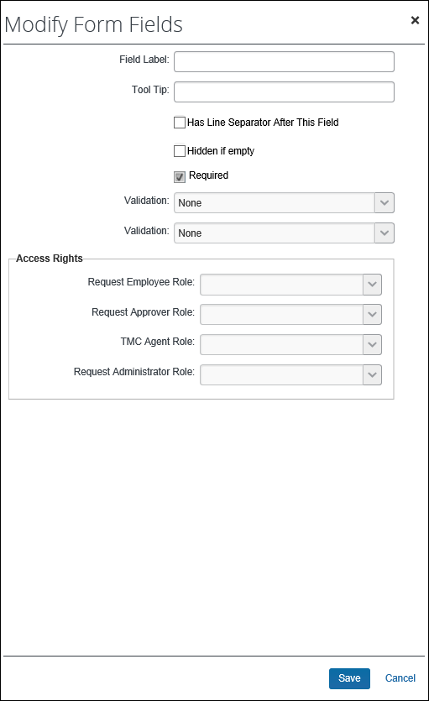
- Make any necessary changes.
- Refer to Modifying Fields in this guide for information about the various fields that appear.
- Click Save.

Moving Form Fields
To rearrange or re-order form fields:
- On the Form Fields tab, click one or more fields.
- Drag-and-drop to the new location.
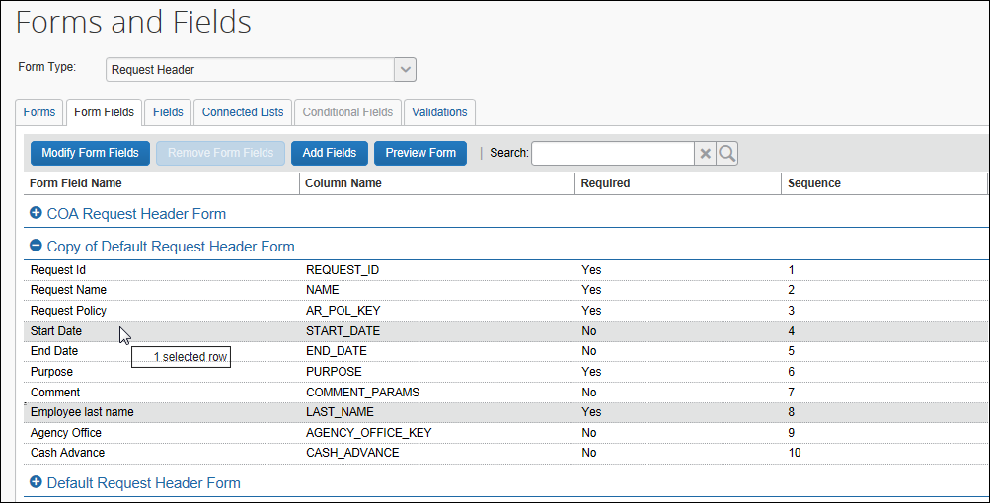

Adding Form Fields to a Form
You can add form fields to a form using the Form Fields tab or the Forms tab.
To add fields from the Form Fields tab:
- Click Administration > Request > Forms and Fields.
- Click the to expand the fields on the desired form.
- Click any field on the form. (This makes the Add Fields button active.)
Note the following:
- The field you add will appear just below the field you selected on the Form Fields tab.
You can also add fields using the Forms tab. If so, the newly added field(s) appears at the bottom of the field list.
- You can add multiple fields but only to one form (at a time) using the Form Fields tab. If you select more than one field on the Form Fields tab, the Add Fields button becomes unavailable.
You can add one or more fields to one or more forms (at the same time) using the Forms tab.
- Click Add Fields. The Add Fields to Forms window appears.
- In the Add Fields to Forms window, click one or more fields.
- Click Add Fields. The selected field(s) appears on the Form Fields tab just below the field you originally selected.

Removing Form Fields
Fields that are required by the system and fields that are marked as required cannot be removed. If you need to remove a field that has been marked are required, the Site Required check box on the Modify Fields dialog must be cleared for the field before the field can be removed on the Form Fields tab.
To remove form fields:
- On the Form Fields tab, click one or more fields.
- Click Remove Form Fields.

Previewing a Form
This preview provides the basic form details.
The feature is not intended to fully replicate the experience of the user when entering a request, but rather to convey enough information to ensure the admin has selected the correct form.
- On the Form Fields tab, expand the desired form.
- Click a field.
- Click Preview Form.
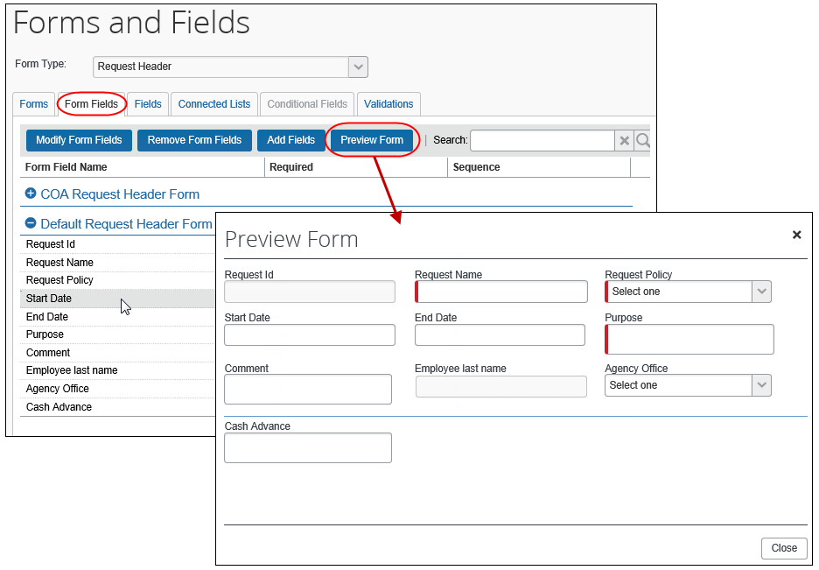
- Click Close.
You can also preview a form using the Forms tab.

Procedures – Forms
Use the Forms tab to:
- Add fields to one or more forms
- Copy a form to create the basis for a new form; the form fields are copied to the new form
- Modify the form name
- Delete a form
You cannot delete a form that in use or is a standard Request form.

Additional Feature-Specific Documentation
The documents listed below provide specific information about forms/fields as they relate to the associated feature.
For information about…. | Refer to….
Allocation forms/fields | Concur Request: Allocations Setup Guide
Attendee forms/fields | Concur Request: Attendees Setup Guide
Cash Advance forms/fields | Concur Request: Cash Advance Setup Guide
Request Entry forms/fields | Concur Request: Expected Expenses Setup Guide
Processor configuration requirements | Concur Request: Processor (Configuration) Setup Guide
Risk management forms/fields | Concur Request: Risk Management Setup Guide

Accessing Forms
To access the Forms tab:
- On Forms and Fields page, click the form type.
- Click the Forms tab.
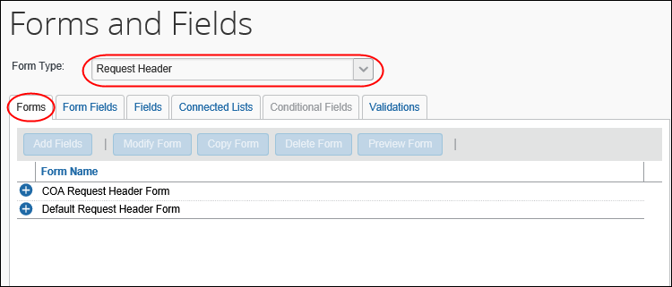
- Click the plus sign next to the form name to see all fields on the form.

Adding Fields to a Form
To add fields to a form:
- On the Forms tab, click the desired form. To select multiple forms, use Shift+click or Ctrl+click.
- Click Add Fields. The Add Fields to Forms window appears.
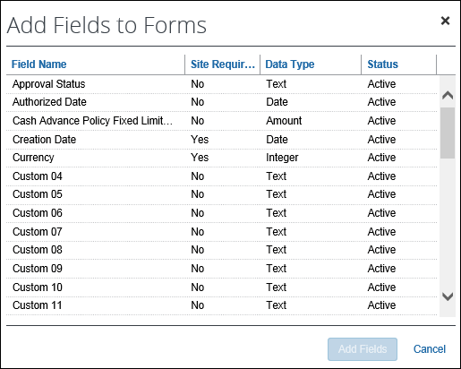
- Click the fields to add to the form. Use Shift+click or Ctrl+click for multiple fields.
- Click Add Fields. The Forms and Fields page appears.

Copying a Form
To copy a form:
- On the Forms tab, click the desired form.
- Click Copy Form. The copy appears in the list.
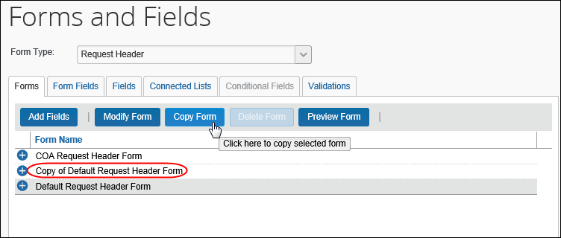

Modifying the Form Name
To modify the form name:
- On the Forms tab, click the desired form.
- Click Modify Form. The Modify Form window appears.
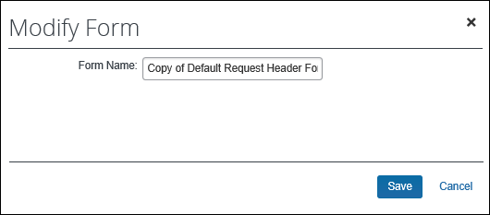
- Change the name of the form.
- Click Save.

Deleting a Form
You can delete a form only if it is not in use or is not a default Request form.
To delete a form:
- On the Forms tab, click the desired form.
- Click Delete Form.

Previewing a Form
This preview provides the basic form details.
The feature is not intended to fully replicate the experience of the user when entering a request, but rather to convey enough information to ensure the admin has selected the correct form.
- On the Forms tab, click the desired form.
- Click Preview Form.
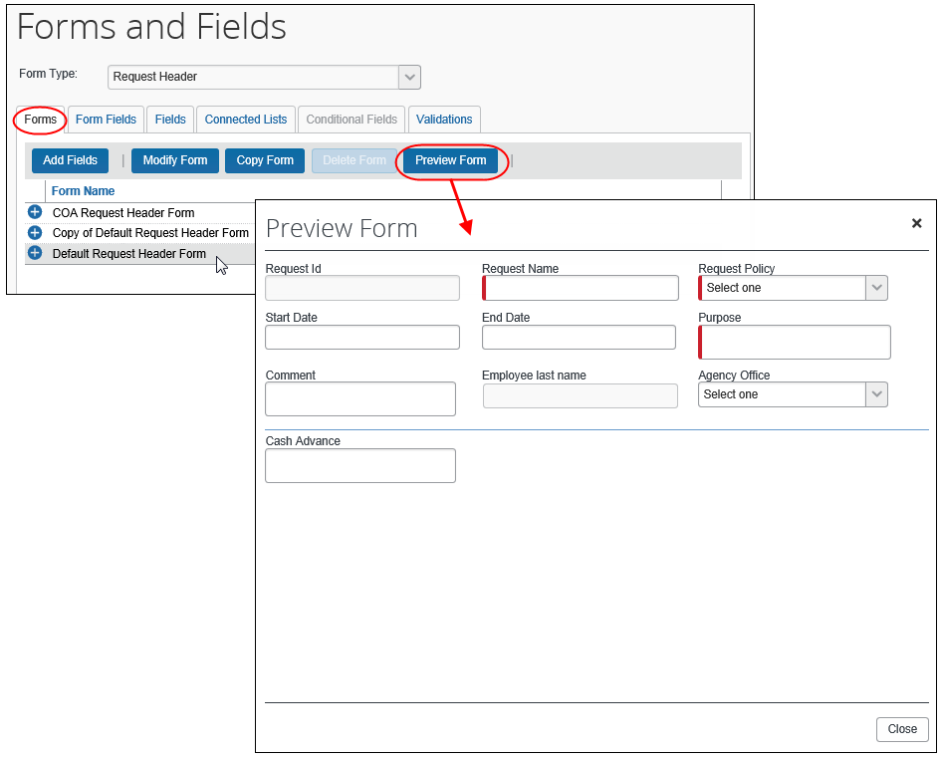
- Click Close.
You can also preview a form using the Form Fields tab.

Procedures – Connected Lists
The Connected Lists tab has the following functionality:
- New: The administrator can add new connected list definitions.
- Modify: The administrator can change list structure, attributes, and the forms the list appears on.
- Remove: The administrator can remove connected list definitions.

Accessing Connected Lists
To access Connected Lists:
- Click Administration > Request > Forms and Fields.
The Forms and Fields page appears.
- Click the desired form type from the Form Type list. The list of matching forms appears.
- Click the Connected Lists tab.
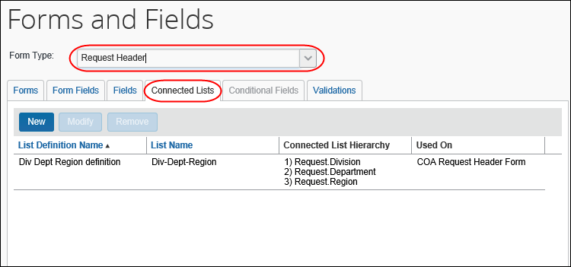

Adding a New Connected List Definition
Adding a new connected list definition is a five-step process:
- Select a List: Select the list to use, and set the connected list definition name.
- Select Fields: Select the fields included in the connected list definition.
- Configure Fields: Configure the field properties for the fields.
- Preview: Preview the fields with the list definition changes.
- Assign to Forms: Select the forms to assign the new connected list to.

Select a List
To select a list:
- Click New. The Select a List page appears, displaying all available lists.
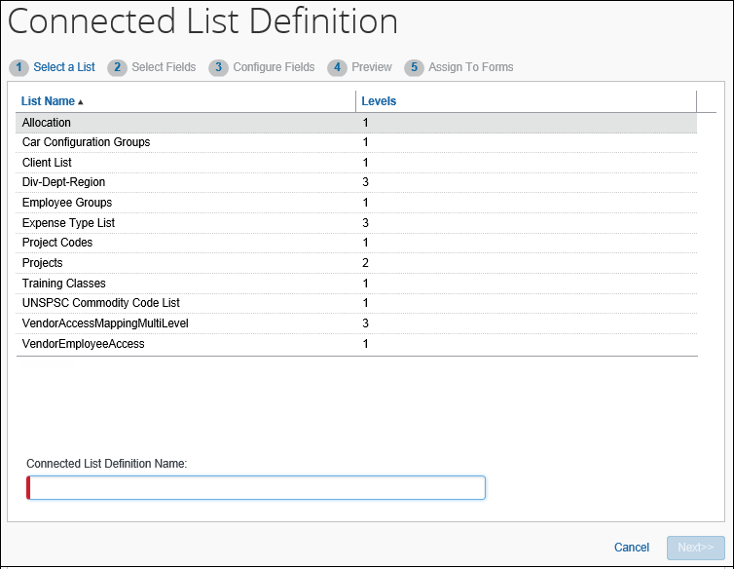
- Click the desired list.
- In the Connected List Definition Name field, enter the name.
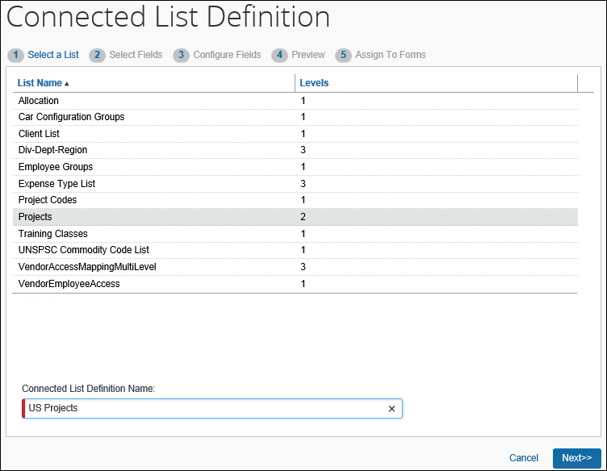
- Click Next.

Select Fields
The available fields appear on the left side of the Select Fields page.
To select fields for a new connected list definition:
- In the left pane, click the desired fields.
- The number of fields selected must equal the number of levels in the list.
- To select multiple fields, use Shift+click or Ctrl+click.
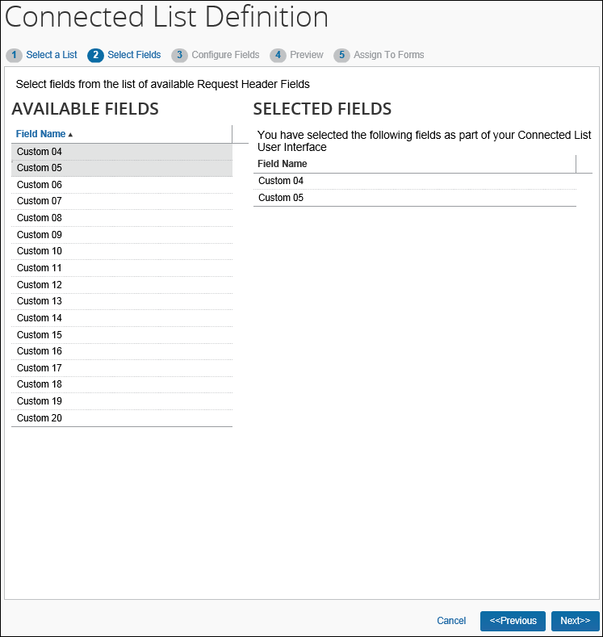
The selected fields will appear in the right pane.
- Click Next.

Configure Fields
The selected fields appear on the left side of the Configure Fields page.
To configure the fields:
- In the left pane, click the first field to configure. The attributes available for editing appear in the right pane.
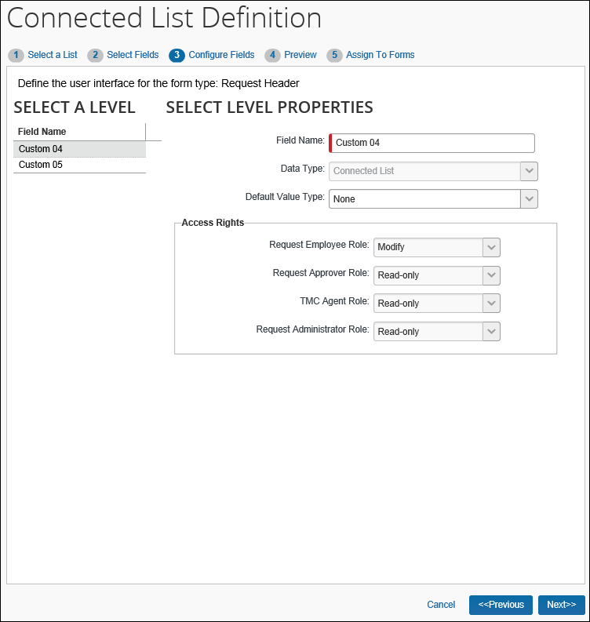
- Complete the appropriate fields.
Field | Description
Field Name | Field label displayed on the form  Change if desired.
Data Type | Data type of the selected field - connected list; read only
Default Value Type | Choose whether the copydown functionality automatically populates the field.  - Copy Down: Copydown allows the information entered into a field by an employee to be automatically entered into duplicate fields on other pages. This option takes precedence over other methods of pre-populating fields such as the Exchange Rates feature.  If you select this option, you must also select the copydown source. This tells Request which form type to use for the duplicate field. For example, if you want to copy down the Country Code, the copydown source will be Employee. Therefore, Request will look to the Country Code field on the employee form type and duplicate the entered information automatically.  - WARNING: Use caution when copying down connected list fields. The field values that are copied down are then subsequently validated upon save of the item. If the validation on one field fails, then that field and all fields at lower levels in that same connected list will be saved as blank. Copydown is executed upon creation of the item and may also be executed upon change of the copydown source. For example, a field that is copied from the report header to the expense entry would potentially be overwritten when the report header source field is edited.  - None: Indicates this field does not use copydown functionality.  - Constant: The first field in the connected list can also be configured as a constant. It allows you to enter a default value that will always be entered for the employee when that selected field appears.
Field Default Value | Appears only when Constant is selected in the Default Value Type field  Enter the constant that appears.
Copy Down Source | Appears only when Copy Down is selected in the Default Value Type field  Select the source of the copieddown data.
Field | Appears only when Copy Down is selected in the Default Value Type field  Select the field the data will be copied down from.
Access Rights | Select the access rights to the field for different user roles.  - For information about the Processor (TMC Agent and Request Administrator) field access rights, refer to the Concur Request: Processor (Configuration) Setup Guide.
- In the left pane, click the next field to configure and make the desired changes.
- When done with all fields, click Next.

Preview
The connected list preview is displayed on the Preview page. The set of connected list fields function as they will on the form they are assigned to. Use this page to validate that the connected fields appear in the correct order and include the expected list item values.
To preview the connected list:
- Practice with the fields to ensure that they work as intended.
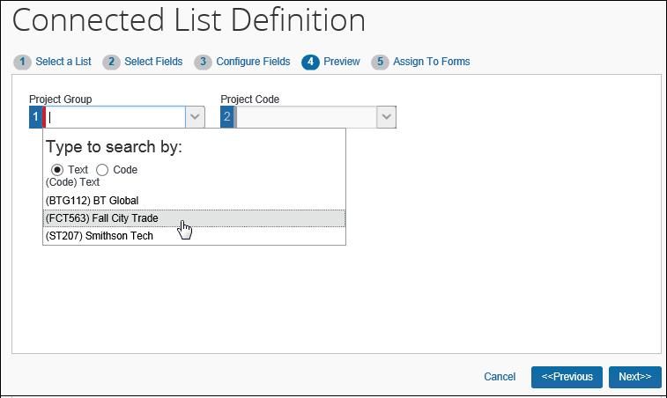
- If the fields work correctly, click Next. Otherwise, click Previous to return to a previous step and make required changes.

Assign to Forms
The Assign to Forms page displays a list of all forms for the selected form type.
To assign the connected list to a form:
- Click the desired form.
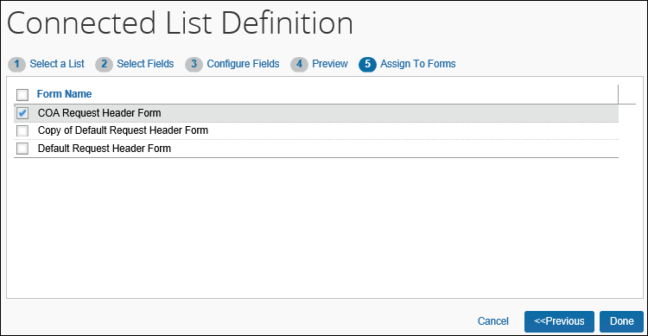
- Click Done. The definition appears.
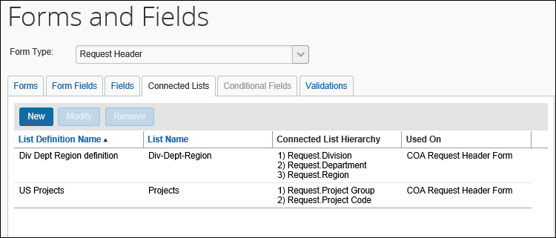
Consider accessing the Form Fields tab for this form to ensure that the new fields are in the desired location.

Modifying a Connected List Definition
To modify a connected list definition:
- On the Connected Lists tab, click the desired list.
- Click Modify.
- Use the Next and Previous buttons to navigate to the settings to modify. Make any necessary changes, as described in Adding a New Connected List Definition in this guide.
- Click Done.

Removing a Connected List Definition
To remove a connected list definition:
- On the Connected Lists tab, click the desired list.
- Click Remove.

Appendix – Notes about Specific Fields / Forms

Additional Feature-Specific Documentation
The documents listed below provide specific information about forms/fields as they relate to the associated feature.
For information about…. | Refer to….
Allocation forms/fields | Concur Request: Allocations Setup Guide
Attendee forms/fields | Concur Request: Attendees Setup Guide
Cash Advance forms/fields | Concur Request: Cash Advance Setup Guide
Request Entry forms/fields | Concur Request: Expected Expenses Setup Guide
Processor configuration requirements | Concur Request: Processor (Configuration) Setup Guide
Risk management forms/fields | Concur Request: Risk Management Setup Guide

Employee Form

Field: Default Travel Agency
The administrator can add the Default Travel Agency field to the employee form. If it is configured to be modified by the user, the field will appear in the Request Information section in Profile and the employee can then select their default travel agency.
By default:
- The Agency Office field is present in the default Request Header form.
- It is set to hidden for both employee and approvers.
- The information from the Default Travel Agency field in Profile is copied down to the Agency Office field in the Request Header form.
The Default Travel Agency field also appears in the Expense Information and Invoice Information sections of Profile if the Expense/Invoice user also has the Request User role.

Request Header Form

Field: Cash Advance Policy Fixed Limit Amount
This field is used as part of the Cash Advance limit calculation. The Cash Advance Limit feature is fully explained in the Concur Request: Cash Advance Setup Guide.

Field: Extension of
Often times, trips must be extended. The Extension of header field can be added to the header so a user can reference the existing request that needs to be extended.
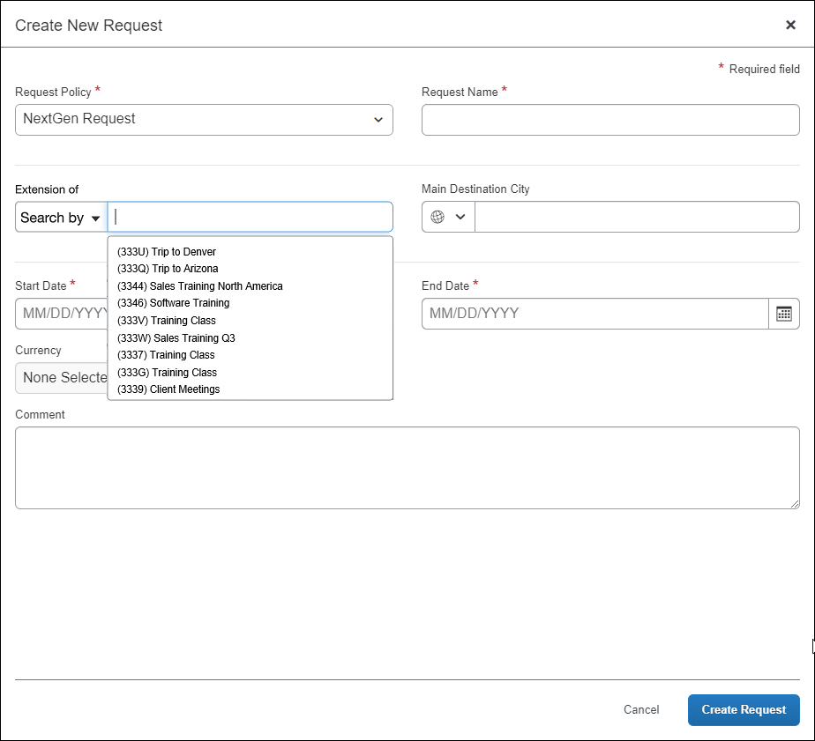
For example, assume that the trip was extended by two weeks. The user would now create a request for the remaining two weeks.
Note the following:
- The Extension of field is simply a reference for the user and approver. It does not pre-populate fields (like the date) nor does it restrict any of the user's choices.
- A request that is linked to (the original request) in the Extension Of field cannot be deleted from the system. The system generates an error saying the request cannot be deleted. For example, if you create Request B and link it to Request A in the Extension Of field, you cannot later delete Request A.

Field: Duration (Days)
The Duration (Days) field is available for the Request Header form. It is a calculated field that displays the length of the trip (end date minus start date plus 1) and is used, for example:
- To estimate travel allowance amounts for a trip
– or –
- To monitor for compliance, such as, if a laundry expense is not allowed if the trip lasts less than seven days
Note the following about the Duration (Days) field:
- This field calculates the trip duration using the start and end dates on the header. If either date field on the header is blank, then the Duration (Days) field displays zero.
- Since this is a calculated field, it is always read-only – even if the administrator changes the access to Modify in Forms and Fields.
- By default, the field is hidden from all users, approvers, etc. The administrator can make it visible, if desired, in Forms and Fields.
- This field has not been added to the default Request Header form. If the administrator wants the field to be visible, the administrator can add it to the Request Header form in Forms and Fields.
- The information in the Duration (Days) field can be copied down to the request entry custom fields and/or segment custom fields.
- The administrator can use the Duration (Days) field in audit rules, workflow rules, validation rules, calculation formulas, and printed reports.
- For more information about calculations for travel allowance, refer to the Concur Request: Expected Expenses Setup Guide. For more information about monitoring for compliance, refer to the Concur Request: Audit Rules Setup Guide.

Fields: Main Destination Country, Main Destination City
The admin can add the Main Destination Country or Main Destination City field to the request header.
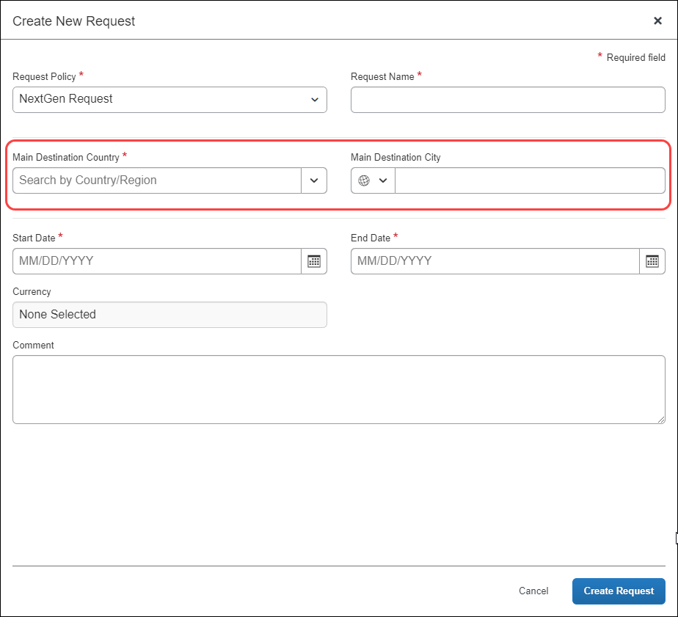
The user can then use these fields for those cases where the "final" destination is not on the itinerary. For example, the user may fly into the nearest airport but then take a cab, helicopter, or other private transportation to the final destination.

Integrated with Concur Travel
Clients who have Request integrated with Travel have the option of using one of these two process flows:
- Starting in Request: The user starts their process by creating a request. Once the request is approved, the user sees a link to book their travel segments in Travel.
- Starting in Travel: The user starts their process by pre-booking a trip in Travel. Depending on configuration, the system creates a request for the trip. Once the request is approved, the user can finalize the booking.
- For more information about these two process flows, refer to the Concur Request: Overview Guide.
If the client is using the Starting in Travel process flow, and if the destination fields are configured on the request header to be editable by the user, then Concur will populate the destination fields for the user.
- For self-booked air and rail segments, the city and country fields will be populated with information obtained from Concur Travel.
- For other self-booked segments, the country field will be populated with information obtained from Concur Travel.
The information provided by Concur Travel appears in the fields but the user can edit the information if desired.
If the destination fields are not on the header or are not editable by the user, then Concur will not attempt to populate the fields.

Fields: Highest Location Risk Level, Main Destination Risk Level
These fields are used only if Request is integrated with Concur Risk Management.
You can add either or both of these fields to the header – to collect data for audit rules and printed reports. They are read-only fields and can be hidden, if desired.
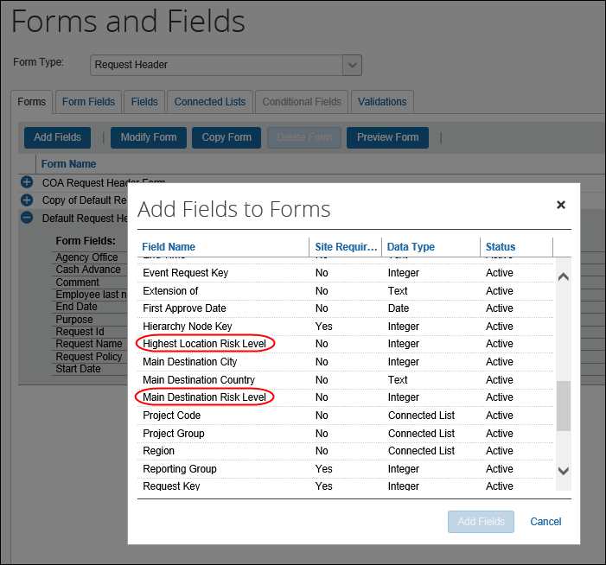
- For more information about Risk Management, refer to the Concur Request: Risk Management Setup Guide.

Fields: Request Key, Approval Status
By default, these fields are not included in the request Header form. If they are added to the form, their configuration can hide some details from the request audit trail.
If the Approval Status field is added and configured as hidden for the user: The audit trail entries regarding the approval status changes will not be visible to the user.
If the Request Key field is added and configured as hidden for the user: The user won’t be able to see the audit trail entries regarding the emails sent to the TMC.

Field: Request Name
It is best practice for the Request Name field on the Request Header form to be populated even if the field is hidden. If the Request Name field is displayed, the field should be required and populated by the employee. If the Request Name field is hidden, the field should be required and automatically populated with a default value.
When Request is integrated with Expense, if the Request Name field on the Request Header form is not designated as required and is not populated, the empty Request Name field will prevent creating an expense report on the approved request. The Request Name field on the Request Header form must be populated when Request is integrated with Expense.

Request Segment Form

Field: Is Agency Booked
In the Request Policies tool, the administrator can define a segment as managed by the travel agency, which means the agent must book this segment. However, there are some cases where sometimes a segment is managed by the agency and sometimes it is not.
In this case, for each segment that may or may not require agent management, add the Is Agency Booked field (check box) and make it editable by the employee. This will allow the employee (traveler) to change the agency visibility for each segment.

Field: View Service Locations For
The View Service Locations For field may appear on a segment form but it is not assigned to a form like other fields.
When defining the location type on the Segments tab in Request Policies (Administration > Request > Request Policies), the administrator can select more than one location type for a segment type. If so, then the View Service Locations For field appears automatically to the user on the request details page. As the user creates the segment, the user selects from the View Service Locations For list.
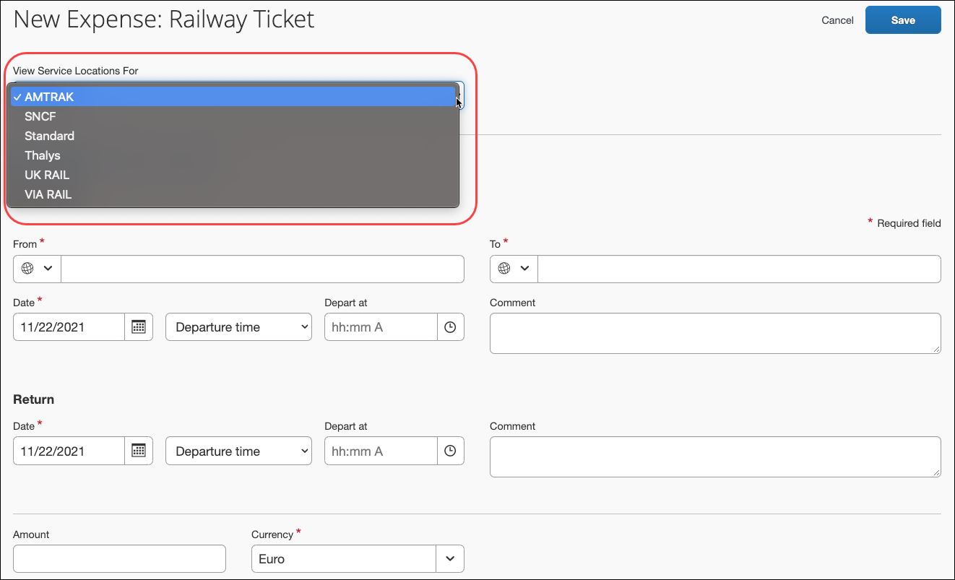
If there is only one location type configured for the segment type, then that location type is used for the segment; the View Service Locations For field does not appear for the user on the request details page.
When configuring for the processor, if the To, From, or City fields are set to Modify, then the View Service Locations For field will be as well.

Fields: Hotel Location Detail, Car Rental Location Detail
When the Hotel Location Detail or Car Rental Location Detail value does not match an existing location, the Hotel Location Detail or Car Rental Location Detail field will be set to the first 100 characters of the following field concatenation:
StartAddress/StartAddress2/StartCity/StartPostalCode/StartState/StartCountry

Request Segment or Request Entry Form

Fields: Vendor, Vendor Name
The Vendor and the Vendor Name fields can be used with segments and/or expected expenses.
- The Vendor field is associated with a single-level vendor list and is generally used for Air, Hotel, Car Rental, etc. – where the client has a defined list of vendors.
The user can type text in the Vendor field to filter the list values, but if a user types text that does not correspond to an existing value in the list, that text will not be saved for the field.
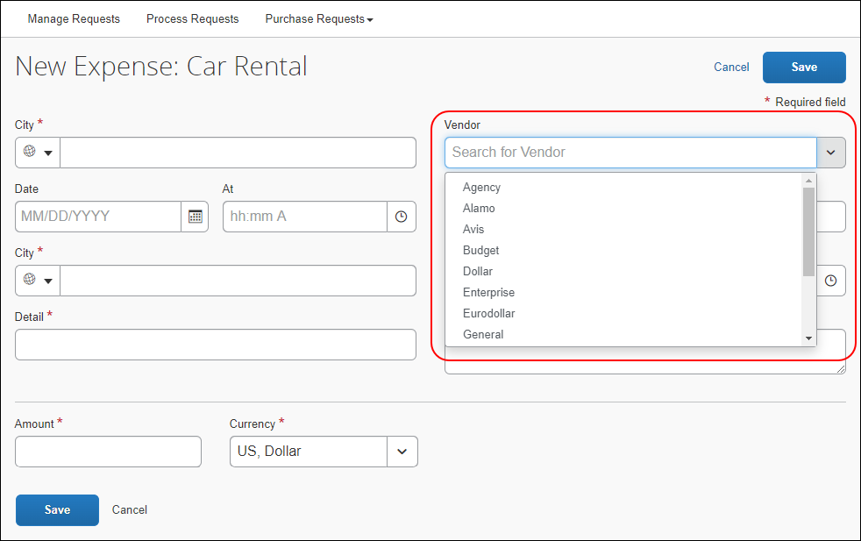
- The Vendor Name field is a simple text field. When the Vendor Name field is added to a segment form or to the request entry form, the user can type in a vendor name.
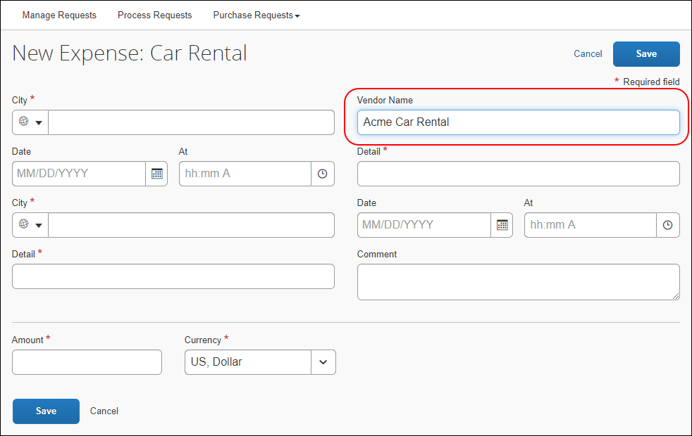
The client can add either field or both fields to a form.
How it works:
- If only the Vendor field is on the form, then:
- The Vendor field is a list.
- The user can only select from the list; the user cannot type in field.
- If only the Vendor Name field is on the form, then:
- The Vendor Name field is a text field.
- The user types the vendor name in the field; there is no list.
- If both Vendor and Vendor Name are on the form, then:
- Only the Vendor field (list) appears; the Vendor Name field is hidden.
- The Vendor field is a list and text field.
- The user can select from the list.
- If the desired vendor is not in the list, the user can type in the field. (The typed information is actually saved to the hidden Vendor Name field.)

Configuration
The client creates the vendor list (Administration > Request > List Management) or uses an existing list.
Expense and Request can use the same lists. If Request is integrated with Expense, this task may already be done.
The client contacts Concur Support for assistance with the remaining steps.
Concur completes these steps:
- Click Administration > Request > Request Policies.
- On the Segments and/or Expense Types steps, choose the appropriate vendor list for the segment type and/or expense type.
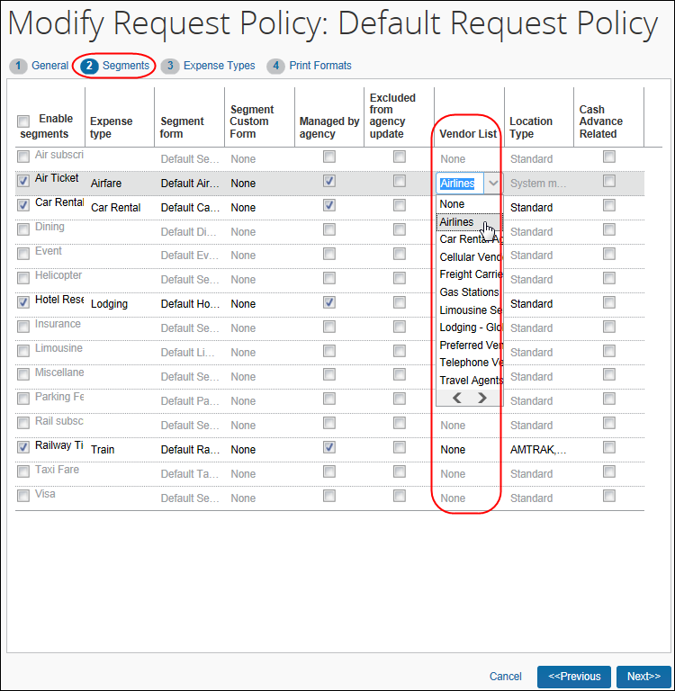
- For more information, refer to the Concur Request: Policies and Groups Setup Guide.
- Click Administration > Request > Forms and Fields.
- Add the Vendor field and/or the Vendor Name field to the appropriate segment and/or request entry forms.

Request Entry Form

Fields: City, Country
It will be possible to display the city or the country, or neither, or both on the form.
If both are displayed, the city and the country must be compatible.
- When the user selects a city, the system provides the country.
- If the user selects a country that is not associated with the selected city, the system clears the City field.

Validation Rules and Calculation Formulas
Using the City and Country fields, the client can use validation rules and a calculation formula to calculate simple per diem.
Example: Assume that the client pays a simple per diem amount for each day of travel, based on the location. The user enters the number of days in custom 4 (for example) and the location in the City field. The system then looks up the rate from the validation table and then calculates the expense amount.
Formula: result_t = C4 * (V_A1)
(which means - Calculate and set the entry transaction amount
as CUSTOM4 times AMOUNT1 returned by validation rules)
- For more information about calculations, refer to the Concur Request: Expected Expenses Setup Guide.

Request Segment Custom Info Form

Fields: Segment Custom Fields
Custom fields are available for segments.
The custom fields for car and hotel appear below the other segment fields. They cannot be moved or placed among the other segment fields.
Best practice is to not allow personal, sensitive, or uniquely identifying information in custom fields.
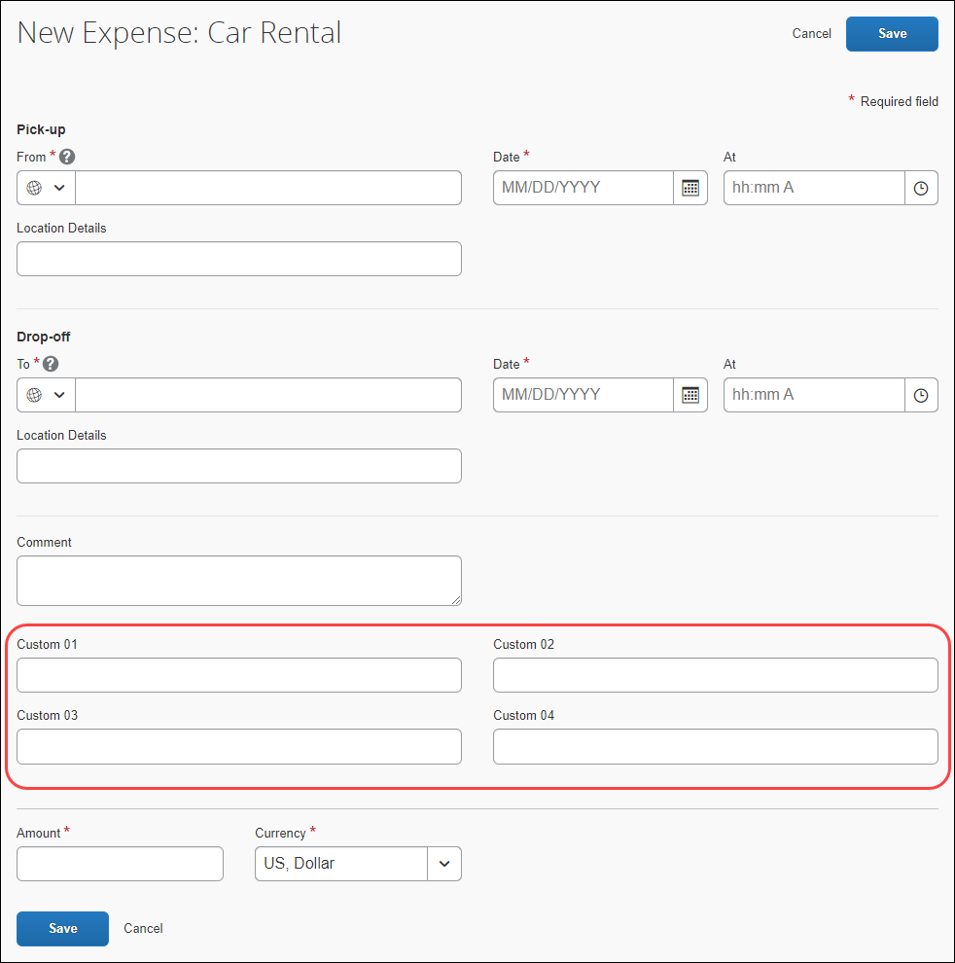
The custom fields for air and rail appear for both outbound and return. They cannot be moved or placed among the other segment fields.
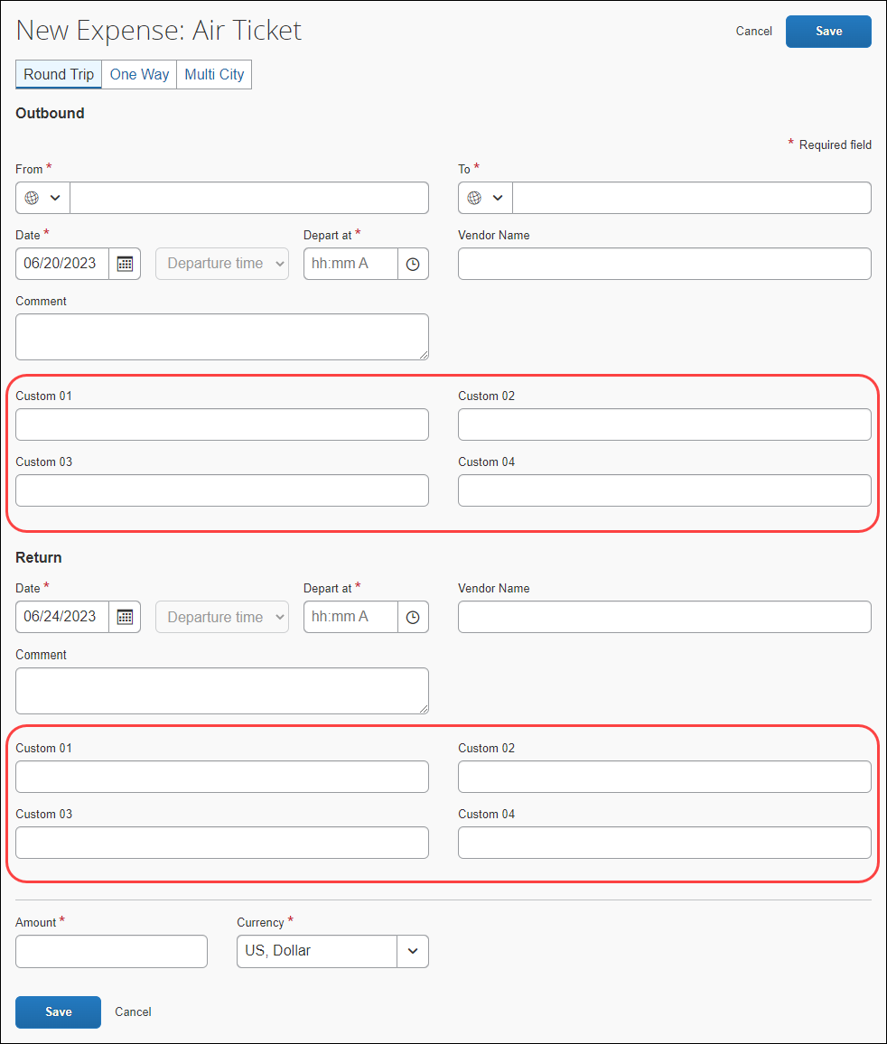
Segment custom fields are not added directly to the existing segment forms; instead, the administrator configures one or more Request Segment Custom Info forms, for example, one for air, one for car, one for hotel segments – essentially defining "sets" of custom fields. Then, the administrator associates the different custom info forms with the appropriate segment forms in Request Policies.
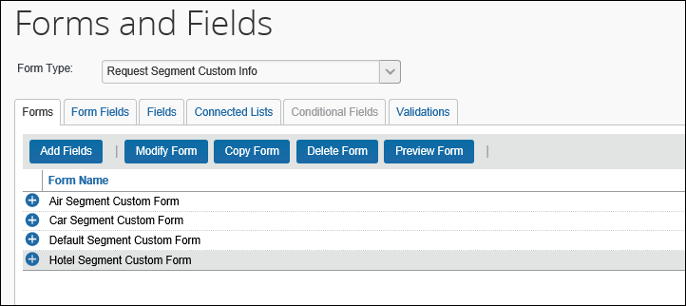
Note the following:
- By default, the Request Segment Custom Info form contains four custom fields but any of the 40 custom fields can be used.
- This form – like all other forms – can be copied as many times as necessary. In this case, perhaps to create a special set of custom fields for each segment type.
- Like other custom fields, the segment custom fields can be configured to use connected (multi-level) lists.

Important: Agency-Booked Trips ONLY
These custom fields are available only for agency-booked segments – not for user-booked segments. Remember: User-booked segments only occur when Concur Request is integrated with Concur Travel. If the client is using the Starting in Travel process flow, the user initiates the trip in Concur Travel and the request is created automatically, based on the trip details collected from the Travel wizard.
- For more information about the possible process flows, refer to the Concur Request: Overview Guide.
If the user later makes any changes to any segment, the request is automatically updated. The way this is done is by deleting the original segment and replacing it with the new segment. All custom fields would be deleted – with no way to recapture the information in those fields. So, custom fields are not available for user-booked segments.
Best Practice:
- For companies that are configured with integrated Concur Request and Concur Travel: Add custom fields only for those segments (if any) that are agency-defined. Use the custom fields to provide additional information for the travel agency – preferred vendor, type of room, special options, smoking preference, etc. – to ensure proper booking.
- For companies that are not configured with integrated Concur Request and Concur Travel: The intent is to use the custom fields to provide additional information for the travel agency – preferred vendor, type of room, special options, smoking preference, etc. – to ensure proper booking but, in fact, they can be used to collect any type of information.

Configuration
To use custom fields with segments (as described on the following pages):
- First, copy and edit the default custom info form.
You do not have to make a copy of the default form – you can simply use it "as is" or edit it. However, it is generally considered best practice to make a copy especially in this case where you may want several forms – one each for air, rental car, hotel, and rail.
Best practice is to not allow personal, sensitive, or uniquely identifying information in custom fields.
- Then, assign the custom info form to the appropriate segment form (in Request Policies).
- Optionally, you can:
- Create audit rules, email reminder rules, and/or workflow rules based on the custom fields.
- Add the custom fields to the printed reports.

Configure the Custom Info Form
- Click Administration > Request > Forms and Fields.
- In the Form Type list, click Request Segment Custom Info. The Default Segment Custom Form appears.
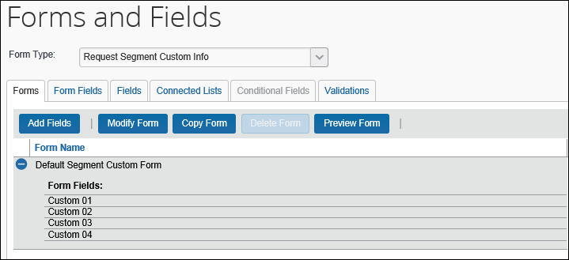
- On the Forms tab, click the Default Segment Custom Form and click Copy Form.
- Create the desired number of forms, edit the custom fields as usual, and configure connected (multi-level) lists as usual.
In this sample, we created one form each for air, car, and hotel segments.

Additional Configuration Steps
Required: Assign the custom info forms to segments in Request Policies.
- Refer to the Concur Request: Policies and Groups Setup Guide.
Optional: Create audit rules, workflow rules, and email reminders
- Refer to the Concur Request: Audit Rules Setup Guide, the Concur Request: Workflow – General Information Setup Guide, and the Concur Request: Email Reminders Setup Guide.
Optional: Add to printed reports
☼

