
Concur Request: Attendees
Setup Guide

Last Revised: February 23, 2024
Applies to these SAP Concur solutions:
 Concur Expense
 Professional/Premium edition
 Standard edition
 Concur Travel
 Professional/Premium edition
 Standard edition
 Concur Invoice
 Professional/Premium edition
 Standard edition
 Concur Request
 Professional/Premium edition
 Standard edition

Table of Contents
Section 1: Permissions 1
Section 2: Overview 1
Attendee Features Available to All Concur Request Users 1
Attendee Functionality Specific to Concur Request 1
How Concur Request Attendees Functionality Differs from Concur Expense 2
Section 3: Concur Request Configurations 2
Section 4: User Experience – Expected Expenses 2
Integrated with Concur Expense 4
Adding Attendees to an Expected Expense 4
Adding Recent Attendees 6
Adding a Favorite Attendee 8
Adding an Attendee Group 9
Searching for an Attendee 11
Other Search Functionality 13
Editing or Viewing Attendee Details 14
Integrated with Concur Expense 14
Viewing Amounts 15
Understanding How SAP Concur Distributes and Redistributes Amounts 16
Creating a New Attendee 16
Removing an Attendee from an Expected Expense 21
Creating an Attendee Group 22
View Attendee Summary from an Expected Expense 22
Additional Attendee Information - Attendee Detail View 23
Change Columns 23
Example - Add a Field 24
Using the Personal Attendee Import 25
Section 5: User Experience - in Profile 29
Attendees Tab 29
Creating a New Attendee 31
Editing Attendee Information 31
Deleting / Hiding Attendees 32
Finding Attendees 32
Attendee Groups Tab 32
Create a Group of Favorite Attendees 32
Edit a Group 34
Delete a Group 35
Send a Copy of a Group to Another User 35
Attendee Detail View 37
Section 6: Delegates, Proxies, Approvers, and Processors 37
Delegates and Proxies 37
Attendee Types Restricted by Groups 37
Approvers and Processors 37
Section 7: Configuration – Overview and Procedures 37
Different Processes for Different Options 38
The Basic Configuration Process 39
Step 1: Defining the Attendee Forms and Fields (Concur Expense) 39
Overview: Attendee Forms and Fields 39
Procedure: Configuring Attendee Forms and Fields (Concur Expense) 44
Step 2: Configuring the Attendee Detail View (Concur Expense) 49
Overview: Attendee Detail View 49
Procedure: Configure the View 49
Step 3: Add the Attendees field to the Request Entry Form (Concur Request) 52
Step 4: Adding Additional Attendee Types and Working with Other Attendee Settings (Concur Expense) 53
Overview: Attendee Types 53
Procedure: Configuring Attendee Types 54
Overview: Settings 58
Procedure: Configuring Settings 60
Overview: Attendee Types by User Groups 62
Procedure: Configuring Attendee Types by User Groups 63
Step 5: Configure the Concur Request Policy/Expense Type Options (Concur Request) 65
Step 6: Configure for the Personal Attendee Import 66
Integrated With Concur Expense 66
Not Integrated with Concur Expense 66
Step 7: Import a List of Attendees 66
IMPORTANT! Using the Attendee Import on an Existing System 66
External ID - Required for Imported Changes and Deletions 67
Section 8: Retain Attendee History with the Associated Expected Expense Entry 68
Section 9: Implementing the Attendee Import on an Existing System - Tips and Hints 68
Changing from a User-Entered List to a Managed List of Attendees 68
Changing Employees as Attendees to a Managed List of Attendees 69

Revision History
Date | Notes / Comments / Changes
February 23, 2024 | Updated screenshots and descriptions in the Searching for Attendees section.
January 19, 2024 | Updated the copyright year; no other changes; cover date updated
July 25, 2022 | Updated screenshots for the new user experience throughout.
January 21, 2022 | Updated the copyright year; no other changes; cover date not updated
February 20, 2021 | Updated the copyright date, and clarified text and added a note regarding the attendee import in the Using the Personal Attendee Import Feature section. It is recommended that no more than 500 attendees be included in a single import.
July 20, 2020 | Removed the Request/Authorization Request/Concur Request section to align with Concur Request product branding.
June 3, 2020 | Changed "Authorization Request" to "Concur Request" in guide title to align with Concur Request product branding.
May 27, 2020 | Added a new field, Default Search for Attendees, to the Configuring Attendee Types section, and updated images of the Attendee Type dialog to include the new Default Search for Attendees field.
April 22, 2020 | Renamed the Authorization Request check box to Request on the guide’s title page; cover date not updated
January 10, 2020 | Updated the copyright; no other changes; cover date not updated
June 20, 2019 | Added note about attendee search limits to the Searching for an Attendee section.
January 17, 2019 | Updated the copyright; no other changes; cover date not updated
June 13, 2018 | Changed copy-down to copydown; no other changes; cover date not updated
May 12, 2018 | Added information about the Fetch Attendee web service, and updated the Retain Attendee History with the Associated Expected Expense Entry section.
April 12, 2018 | Changed the check boxes on the front cover; no other changes; cover date not updated
February 8 2018 | Changed copyright and updated guide names in references to the Shared: Attendee Import, Version 2 Specification and Expense: Standard Attendee Detail Extract, Version 2 Specification guides.
December 14 2016 | Changed copyright and cover; no other content changes.
December 8 2016 | Updated the Permissions section and guide content to new corporate style; no content changes.
June 21 2016 | Added information about support for the Company Category and Employee Category fields.
May 13 2016 | Updated the Permissions section and guide content to new corporate style; no content changes.
January 25 2016 | Changed references to the import/extract guide; no other changes.
August 14 2015 | Added information about the Personal Attendee Import language, updated the screen shots to the enhanced UI.
September 16 2014 | Added information about two user interfaces; no other content changes.
January 17 2014 | Note about reactivating a deactivated attendee type
July 19 2013 | Added information about new attendee fields added in Expense, which affect Request
March 29 2013 | Added information about the attendee summary
February 24 2013 | Name change from "Travel Request" to "Request" – no other content changes
December 28 2012 | Made rebranding and/or copyright changes; no content changes
November 16 2012 | Added information about the personal attendee import
May 18 2012 | General formatting changes
April 20 2012 | Additional information about attendee options
March 30 2012 | Initial publication
March 23 2012 | Initial publication - draft

Attendees

Permissions
A company administrator may or may not have the correct permissions to use this feature. The administrator may have limited permissions, for example, they can affect only certain groups and/or use only certain options (view but not create or edit).
If a company administrator needs to use this feature and does not have the proper permissions, they should contact the company's SAP Concur administrator.
Also, the administrator should be aware that some of the tasks described in this guide can be completed only by SAP. In this case, the client must initiate a service request with SAP Concur support.

Overview
For some types of expenses, such as business meals or entertainment, users may be required to identify all attendees associated with the expense. The Concur Request user can include attendee information in order to obtain preapproval of travel costs as well as the associated attendees.
This guide describes how Concur Request users, approvers, delegates, and proxies use the Attendees feature. It also describes how the administrator configures the feature.

Attendee Features Available to All Concur Request Users
In the basic attendee feature, a Concur Request user can add, edit, view, and remove attendees.
Attendees are added to expected expenses and managed on the Attendees page. Attendees are available only for expected expenses that require attendees.

Attendee Functionality Specific to Concur Request
The Attendees feature is available only for expected expense – not for segments.

How Concur Request Attendees Functionality Differs from Concur Expense
The Attendees feature in Concur Request is very similar to the Attendees feature in Concur Expense, in fact, they share several pages and settings. However, in Concur Request, the Attendee feature does not have the same range of options because some are not applicable to requests – like accounting for "no shows."
- For more information, refer to the Concur Expense: Attendees Setup Guide.

Concur Request Configurations
When configuring the Attendees feature, much of the configuration is completed in Concur Expense, regardless of whether Concur Request is integrated with Concur Expense.
Not all Concur Request features are available for all Concur Request configurations.
Configuration | Is this feature available?
Stand-alone | Yes, but only if using expected expenses
Integrated with Concur Expense (but not Concur Travel) | Yes, but only if using expected expenses
Integrated with Concur Travel (but not Concur Expense) | Yes, but only if using expected expenses
Integrated with Concur Expense and Concur Travel | Yes, but only if using expected expenses

User Experience – Expected Expenses
This section describes the tasks the user can complete on the expected expense page of the request. Many of the same tasks can be completed on the user's Profile page. The information about the Profile page is described in User Experience - in Profile in this document.
Attendees are added and managed on the Attendees page. Users can access the Attendees page by clicking the Attendees link on the New Expense, expected expense details, and Expected Expenses pages.
The Attendees link only appears for expense types that your company has defined as requiring attendees.
When creating a new expected expense, the user clicks the Attendees link on the expected expense to add attendees on the New Expense page.
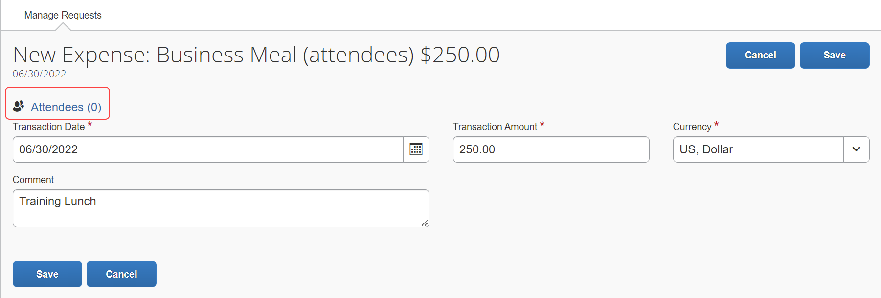
The Attendees page appears.
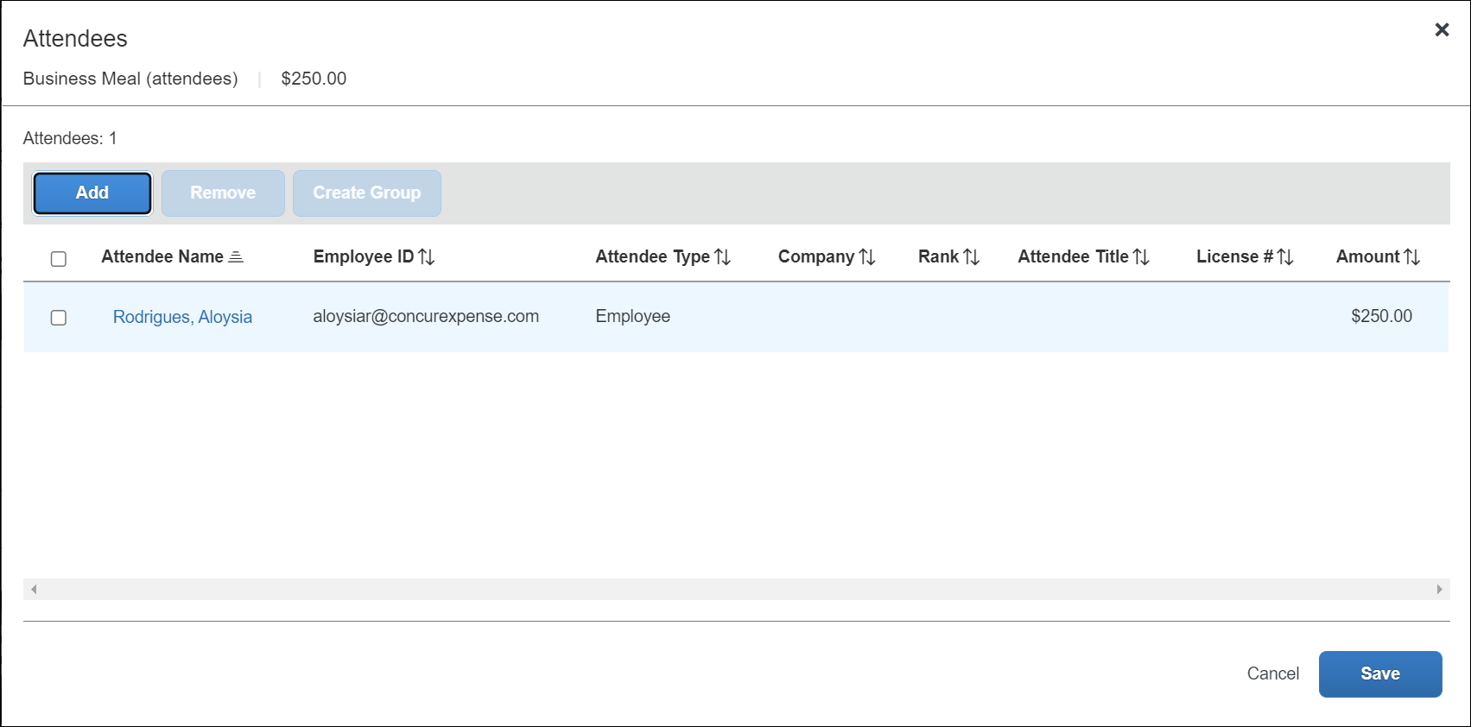
From the Attendees page, a user can:
- Add an existing attendee or attendee group to an expected expense
- Search for an existing attendee or attendee group
- Sort attendees by clicking the sort arrow next to the Attendee Name column
- Edit or view attendee information
- Create a new attendee (configurable)
- Create an attendee group
- Remove an attendee from an expected expense
- Import attendees (using an Excel worksheet) into an expected expense (configurable)
- Search for and import attendees from an external source (configurable)
- Refer to the Fetch Attendee Web Service information on http://developer.concur.com.
The Attendees section is configurable, for example:
- The client can add or remove columns.
- The client can allow or not allow the user to see the portion of the expected expense that is allotted to each attendee (in the Amount column).
- The client can elect to include or not include the user automatically as an attendee.
- The client can elect to show or not show the Attendee link in the expected expense. Without the Attendee link, the user must look first in Favorites before adding a new attendee.
- The administrator can also restrict – by attendee type – the attendees that a user can create, edit, view, or search for, as described in the configuration portion in this guide.
All of these options are described in the configuration section of this guide.

Integrated with Concur Expense
If Concur Request is integrated with Concur Expense, attendees are shared between the two services. That is, the user's favorite attendees in Concur Expense are the same as their favorite attendees in Concur Request.

Adding Attendees to an Expected Expense
From the Add Attendees page, users can add, sort, and remove attendees from the expected expense, and they can create reusable groups of attendees.
To access the Add Attendees page, users click the Attendees link on the New Expense page or expected expense details page. The Attendees dialog appears.
On the Attendees dialog, users can click the Add button.
The Add Attendees dialog appears.
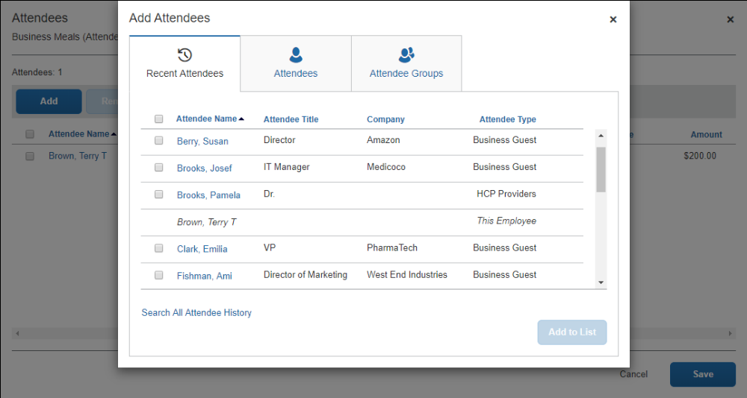
All options for adding attendees to the expected expense are available in the Add Attendees dialog. Users can choose from recent attendees, add a new attendee, or choose from attendee groups or favorites.
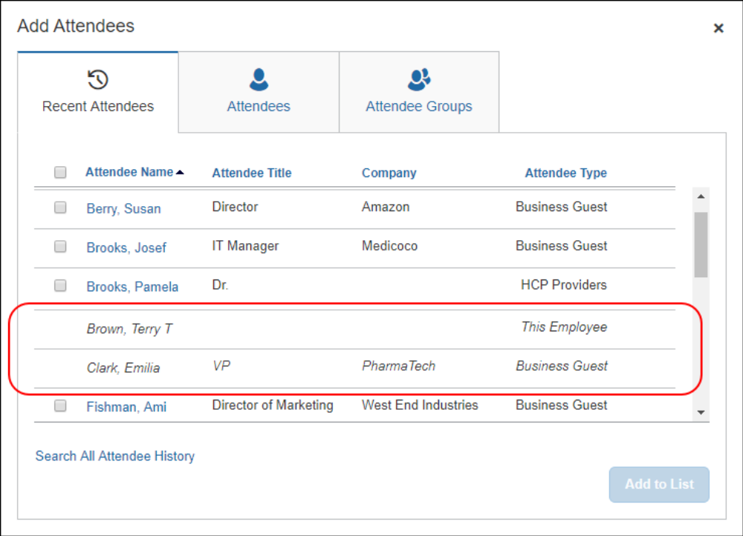
To prevent duplicate attendees from being added to an expected expense, attendees who are already added to the expected expense are read-only with italicized text and cannot be selected (checked) from the attendee list.

Adding Recent Attendees
The Recent Attendees tab lists attendees recently added to an expected expense. Users select a check box for the desired attendee(s), then the click Add to the List button. The selected attendees are added to the expected expense.
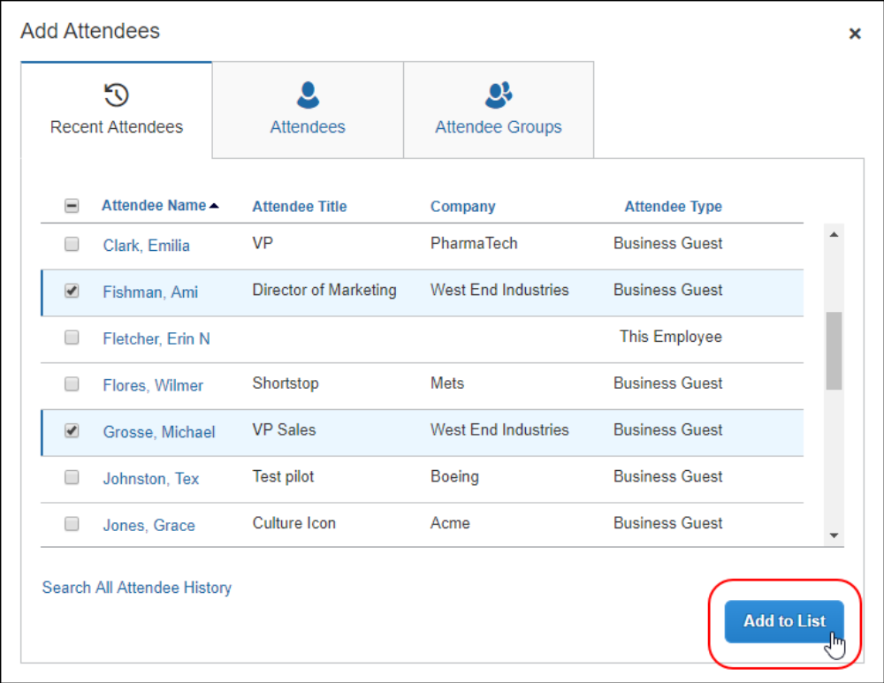

Sort Attendees
Users can sort the attendees on the Attendees page by clicking the sort arrow next to the Attendee Name column.
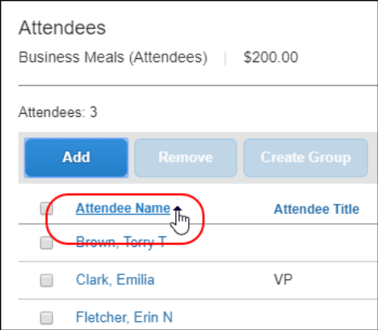

Search All Attendee History
At the bottom of the Recent Attendees tab is the Search All Attendee History link. Users can click the link to see all attendees ever used - regardless of whether they are in their Favorite Attendees list.
If a desired attendee is not listed for recent attendees, the user can search the Attendees tab to find the desired attendee. Refer to the Searching for an Attendee section in this guide.

Adding a Favorite Attendee
To add an attendee that a user has selected as a favorite (in Profile) but who is not available on the Recent Attendees tab, users can click Attendee Groups. The first group listed is Favorites. Users can click the Favorites link to access the Favorites dialog.
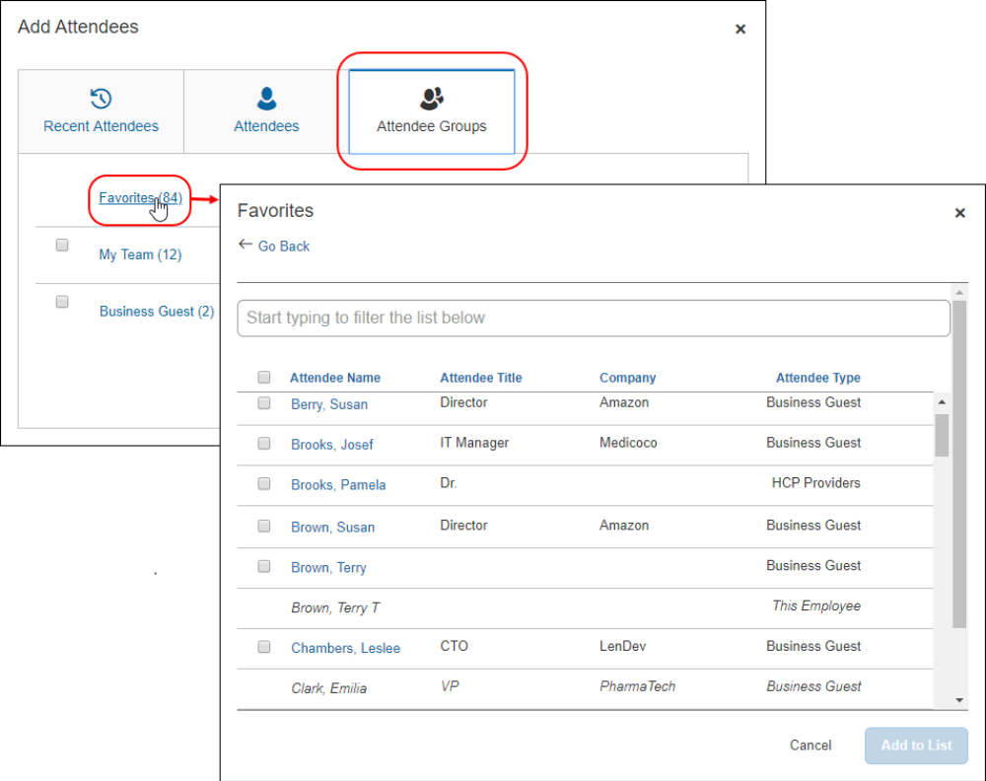
Next, the user selects the check box for the desired attendee(s) and then clicks the Add to List button.

Search for a Favorite Attendee
In the Favorites dialog, in the Search field, users can search by typing one or more letters of an attendee's name. They can select an attendee and click Add to List to add them to the attendee list for the expense.

Adding an Attendee Group
From the Attendee Groups tab, users can search for an attendee in an attendee group or add all attendees from a group. Attendee groups are listed below the Favorites attendee group, such as the My Team group.
To add all the attendees from a group, users select the check box next to the attendee group, and then clicks Add to List.
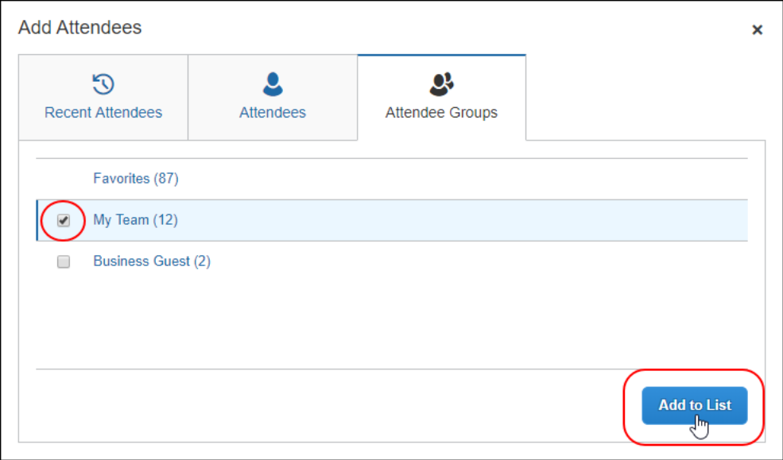
To add one or more attendees from a group, users click the attendee group name. The attendee group dialog appears with the name of the group at the top of the dialog.
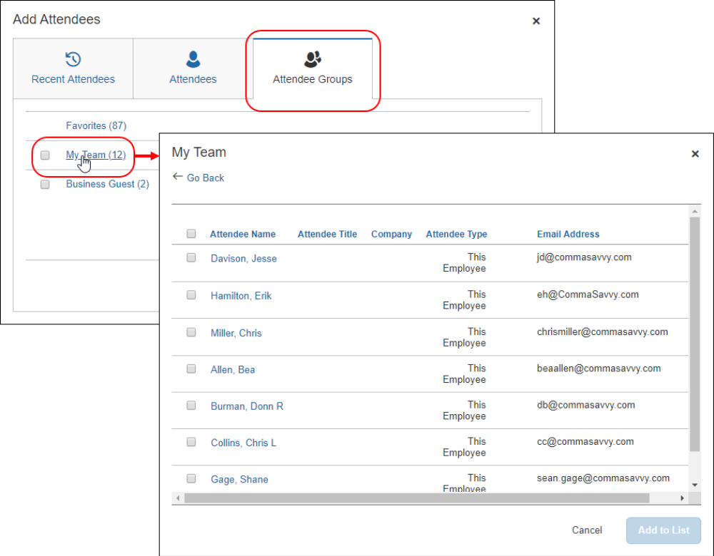
Users select the check box for the desired attendee(s) and then click Add to List.

Search Employees on My Team
The system can be configured to display the My Team link on the Attendee Groups tab. My Team displays a list of employees that are related to the current user in the following ways:
- The employees share the direct approver with the user.
- The employees report directly to the user.
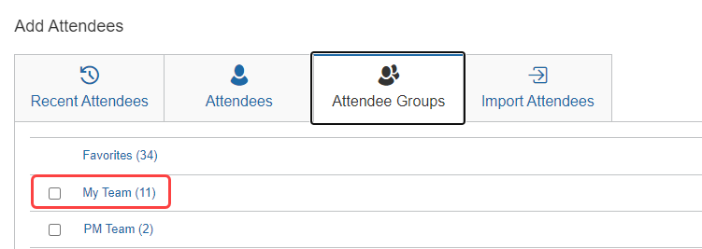
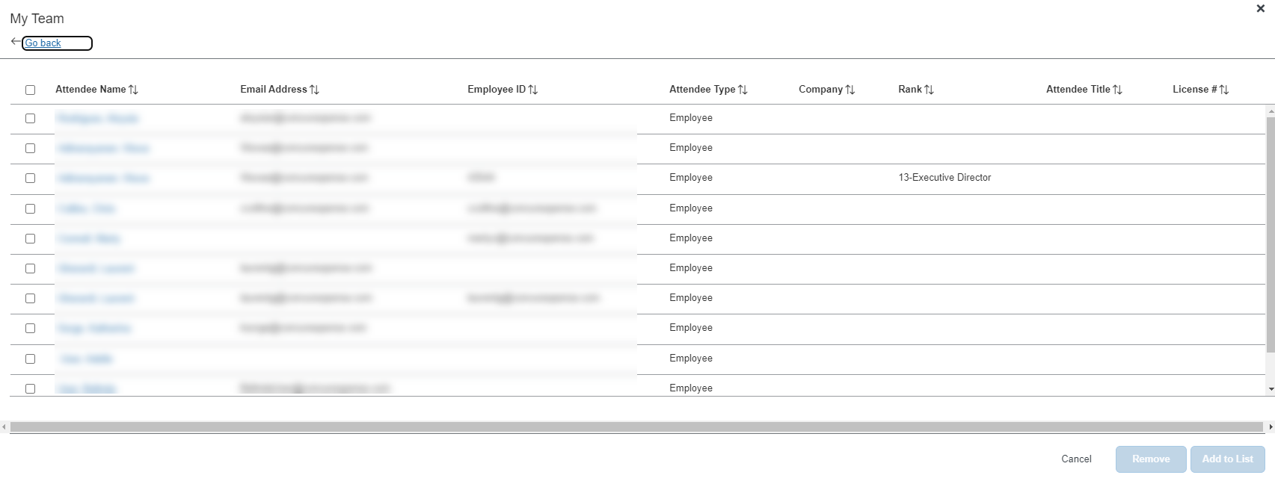
This feature requires that the Employee attendee type (SYSEMP) be configured as a shared list. For more information, refer to the Including All Employees in a Company in the Attendee Search section of this guide.
The system uses the configured approval hierarchy to determine the team structure. Delegates will see the My Team employees for the users that they are delegating for, not their own team.

Searching for an Attendee
Users who want to search for attendees they are not listed on the Recent Attendees tab or in Favorites, can search for desired attendees on the Attendees tab.
Attendee search is based on attendee type configuration for your organization and determines whether users see advanced or simple search options on the Attendees tab.
When searching for attendees in Concur Request, the search results has a limit of approximately 5,000 attendees, so the search results will be limited to the first 5,000 attendees returned by the search.
Users can also search an external source for attendees and import them into Concur Request. If you are searching an external source for attendees using the Fetch Attendee Web Service, the attendee search results for the Fetch Attendee Web Service has a limit of 100 attendees. In this scenario, the search results will be limited to the first 100 attendees returned by the search. For more information, refer to Fetch Attendee Web Service on http://developer.concur.com.
When the user clicks Add to add attendees, from the Add Attendees dialog, they access a search by Attendee Type and Attendee Name. Users can enter additional criteria to refine their search results.
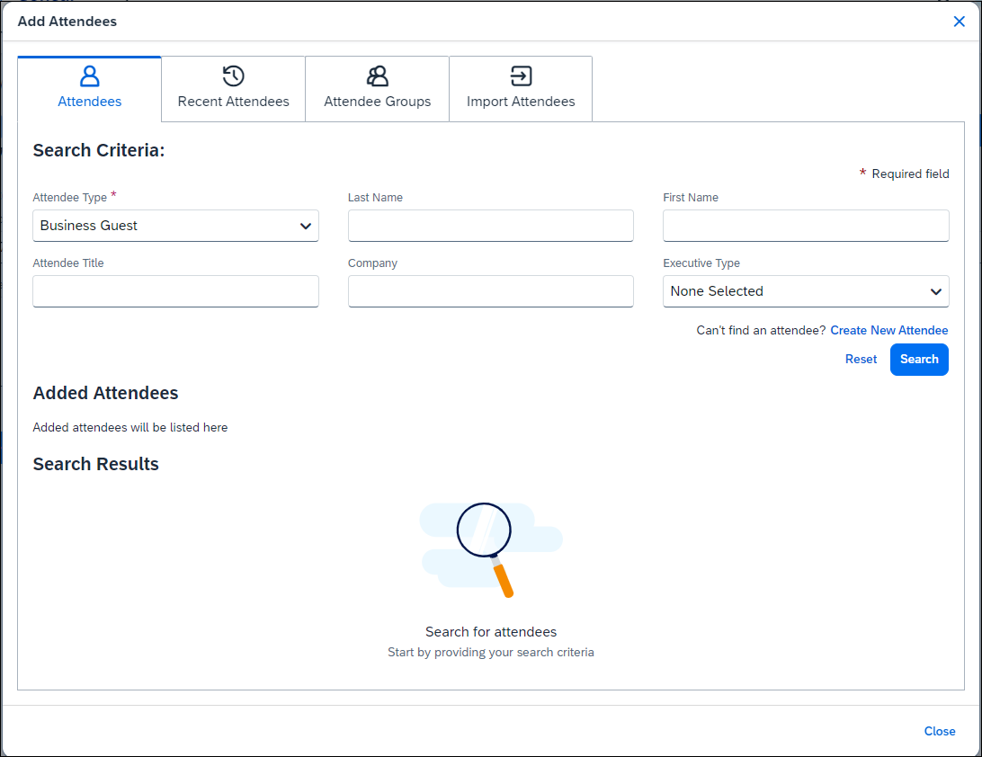
When a user performs a search, the attendee type is associated with the SYSEMP Attendee Type Code, such as Employee, and users will need to complete the First Name and Last Name fields on the search dialog. Also, for this attendee type, users can choose to include inactive employees in the attendee search results.
The search results appear. Users can select the attendee(s) and then click Add to add them to the list of attendees for the expected expense.
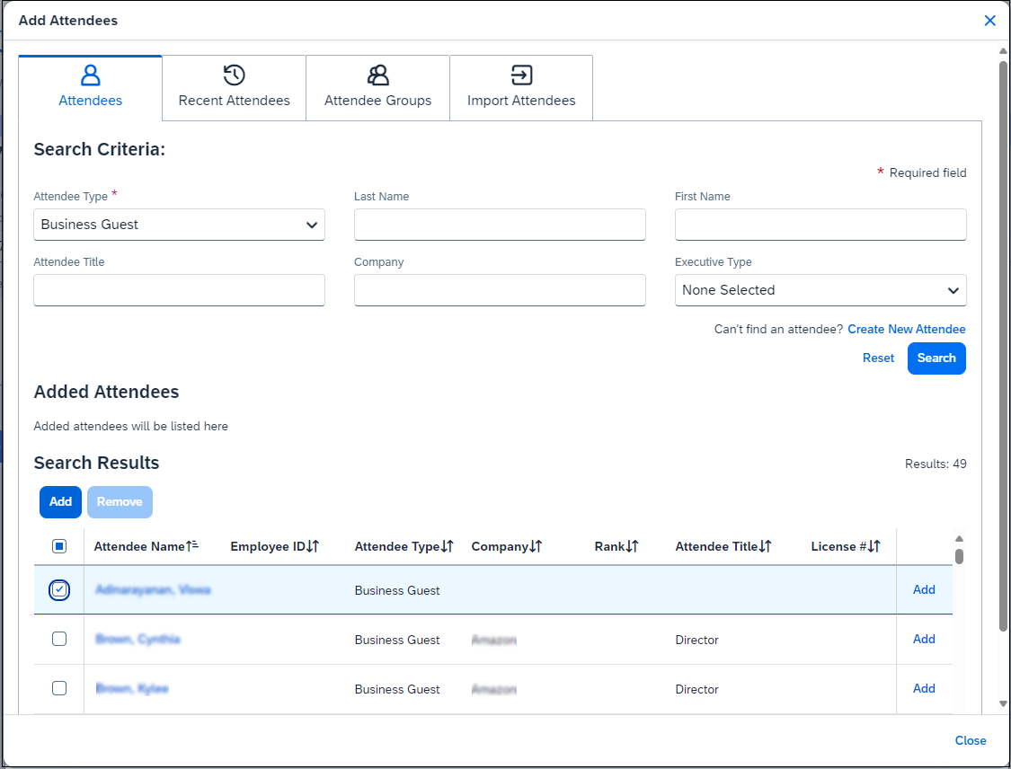
To prevent duplicate attendees from being added to an expected expense, attendees who are already added to the expected expense are read-only with italicized text and cannot be selected (checked) from the attendee list.

Other Search Functionality
Users can also search for attendees by using the following search functionality:
- Search recent attendees by clicking the Search All Attendee History link on the Recent Attendees tab
- Search for a favorite attendee by clicking the Favorites link on the Attendee Groups tab
- Search for employees by team by clicking the My Team link on the Attendee Groups tab (configurable)
- Refer to the Adding Attendees to an Expected Expense section for details on each search function for the specified tabs.

Editing or Viewing Attendee Details
A user can edit attendee information only if the user originally added the attendee to Concur Expense. Otherwise, the user can view – but not edit – attendee information.
In the Attendees section, the user clicks the desired attendee's name. The Attendee Details dialog appears.
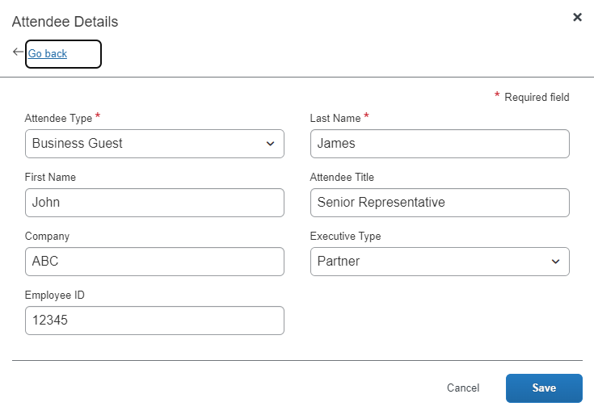
When done, the user clicks Save.

Integrated with Concur Expense
If Concur Request is integrated with Concur Expense, the following information can be configured to display (read-only) on this page (not shown in the sample above):
- Audit rule exception message: If an audit rule exception has been generated for this attendee
- Totals related to the associated expenses – not the request (including, but not limited to):
- Total amount YTD (total spend on this attendee by the entire company year-to-date)
- Total Amount Previous Year (total spend on this attendee by the entire company last year)
- Employee Amount YTD (total spend on this attendee by the current user year-to-date)
- Employee Amount Previous Year (total spend on this attendee by the current user last year)
Note the following:
- This total per attendee will begin to aggregate at the point the option is configured; it will not retroactively include expenses submitted prior to its activation. However, for those importing managed lists of attendees, a starting year-to-date total may be imported when creating a new attendee record.
- For more information about importing attendees, refer to Import a List of Attendees in the configuration section in this guide.
- Whether any or all these totals are visible to users is configurable, as described in configuration portion of this guide.
- The attendee types that are visible to users (by groups) is configurable, as described in configuration portion of this guide.
- Viewing and editing attendee information can also be completed by the user in Profile. Refer to User Experience - in Profile in this guide.

Viewing Amounts
Users can view the total amount of the expected expense divided among the attendees. Whether the Amount column appears is configurable.
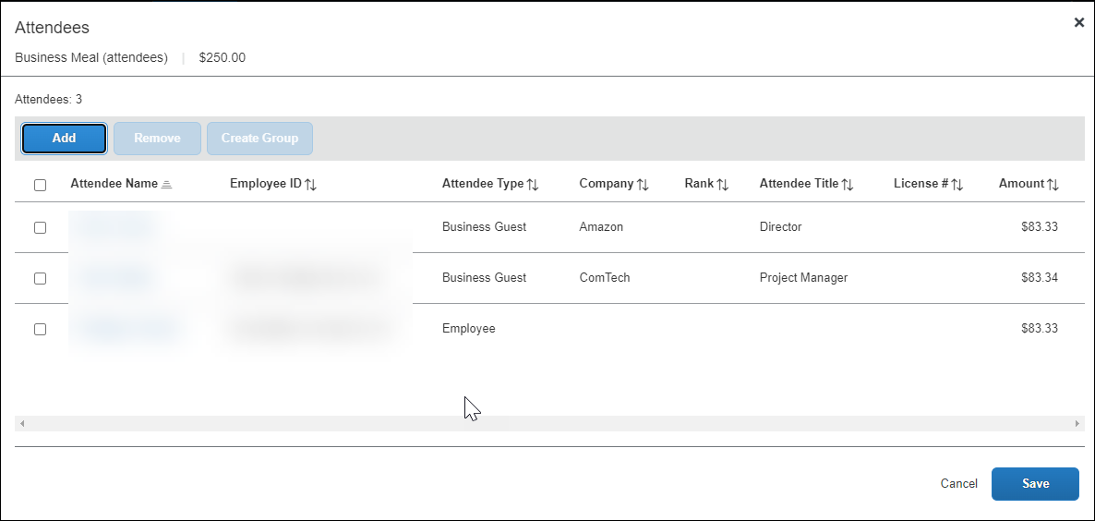
If you add a number of additional fields to this display, move the Attendee Count column to the left for easier viewing on laptop or netbook devices - use the Form Fields tab (in Forms and Fields) to do this.

Understanding How SAP Concur Distributes and Redistributes Amounts
SAP Concur initially distributes the amount of the expected expense equally across attendees. That is, if the amount is 100 USD and there are two attendees, the system allots 50 to each attendee.
If a user adds or removes an attendee, SAP Concur redistributes the amounts. If the expected expense has two attendees at 50 each and then the user removes one attendee, then the remaining attendee is allotted the full 100. If the user adds another attendee (so now there are two again), SAP Concur redistributes again, allotting 50 to each.

Creating a New Attendee
Creating a new attendee is configurable. If this feature is not enabled, users must select from a list of existing attendees.
From the Add Attendees tab, the user can create an attendee manually using the Create New Attendee link.
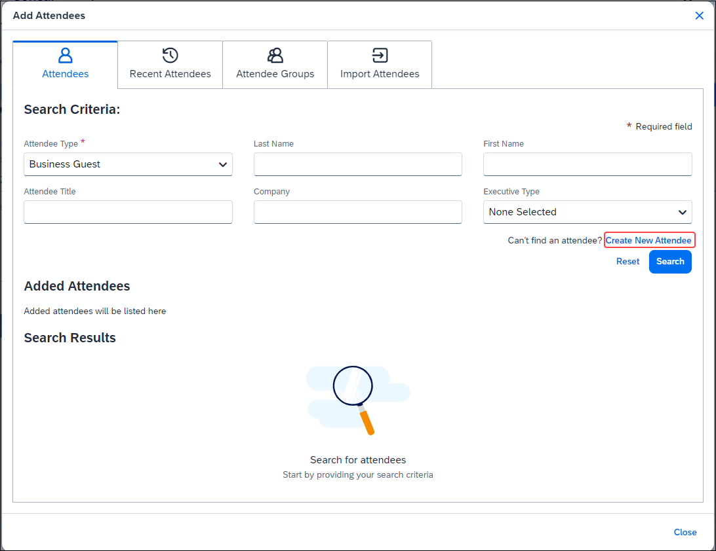
The Create New Attendee link is also located in the Search field when no results are found.

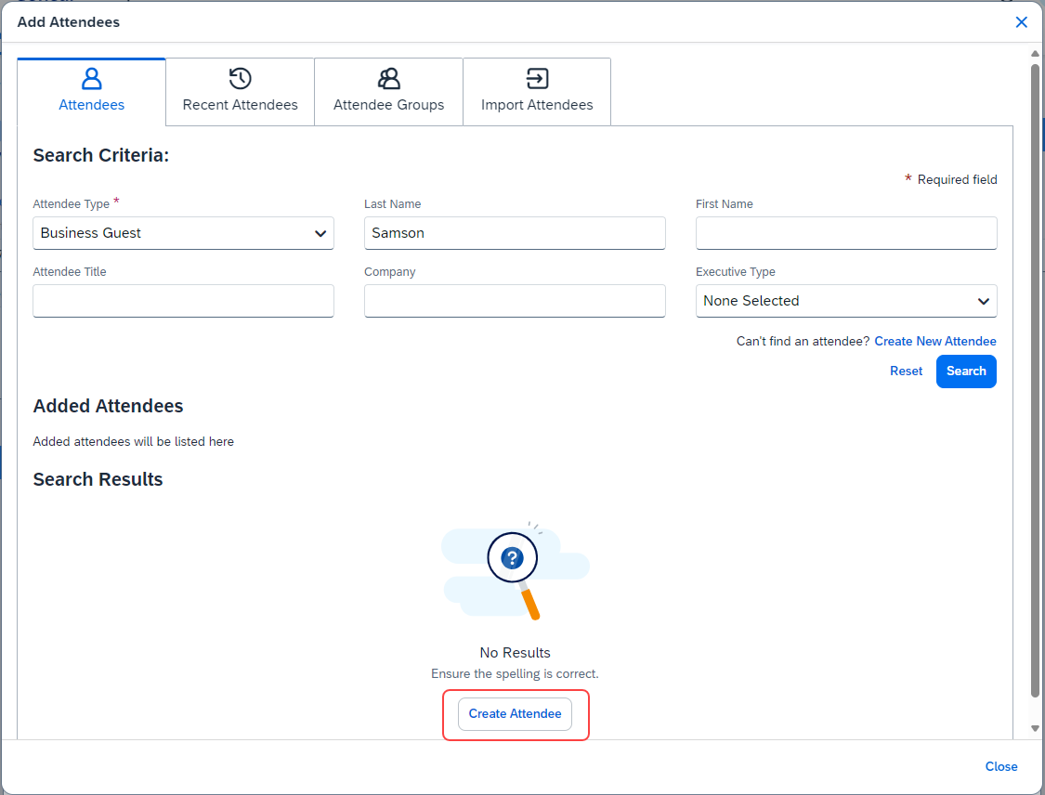
When users click the Create New Attendee link, the Create New Attendee dialog appears.
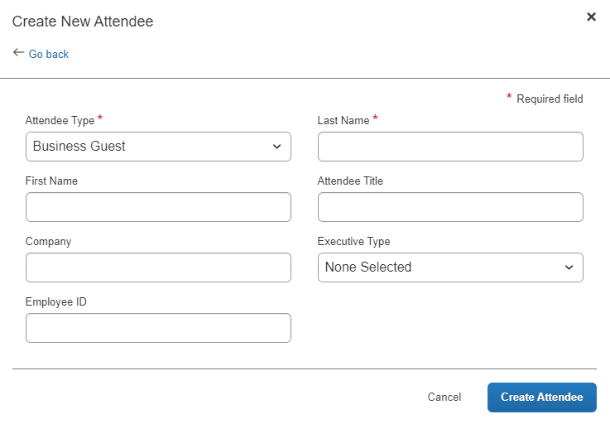
The user completes the fields in the Create New Attendee dialog, then clicks the Create Attendee button. The attendees appear on the Attendees page, and the user clicks Save to add the attendees to the expected expense and return to the expected expense page.
If users click Cancel, a message appears, and they can click Continue Without Saving. Any newly added or updated attendees on this page will not be saved to the expected expense.
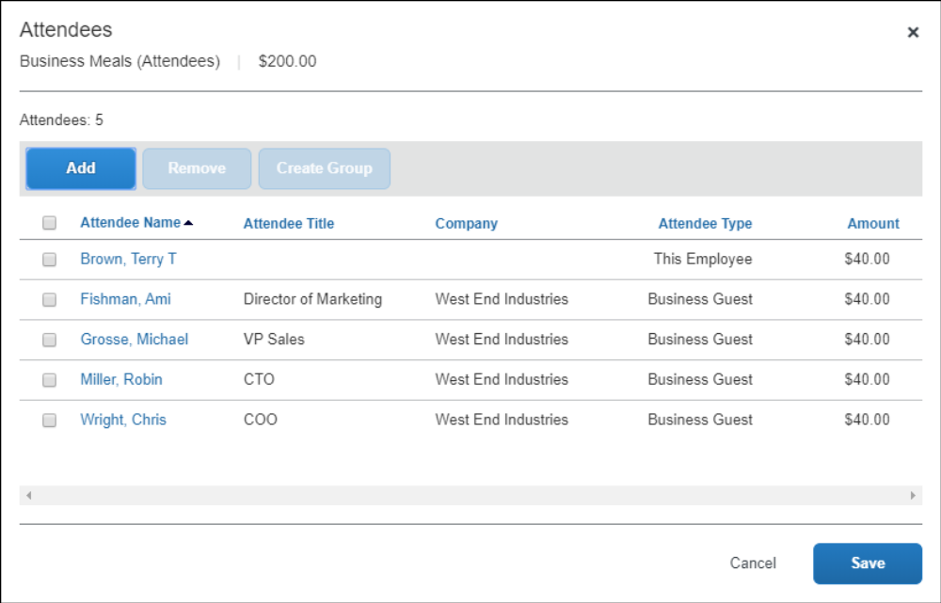
The system then checks for duplicate attendees. If it finds one or more potential duplicates, the user is prompted to use the existing attendee information (if the attendee that the user is adding and the duplicate are, in fact, the same person) or to continue adding the attendee (if the attendee that the user is adding and the duplicate are not the same person).
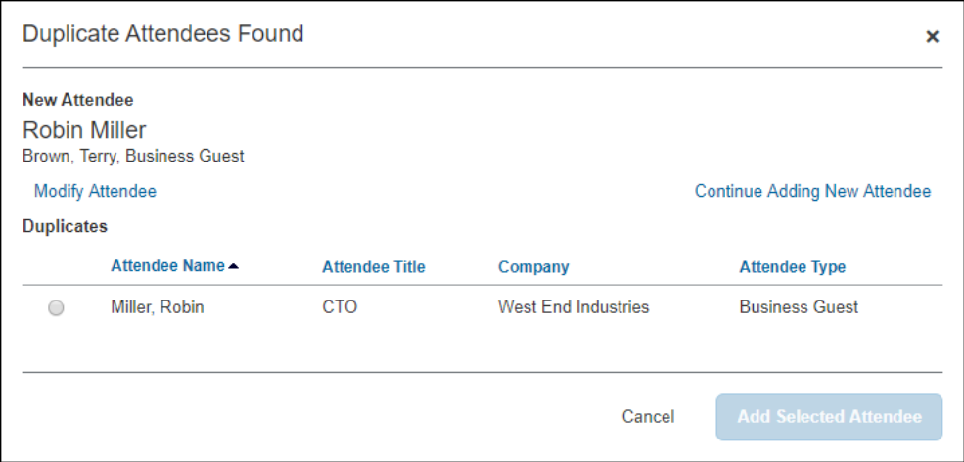
The new attendee is added to the expected expense and is added to the user's favorites list.
On the expected expense page, the number in the Attendees link is updated to match the number of attendees associated with the expected expense.
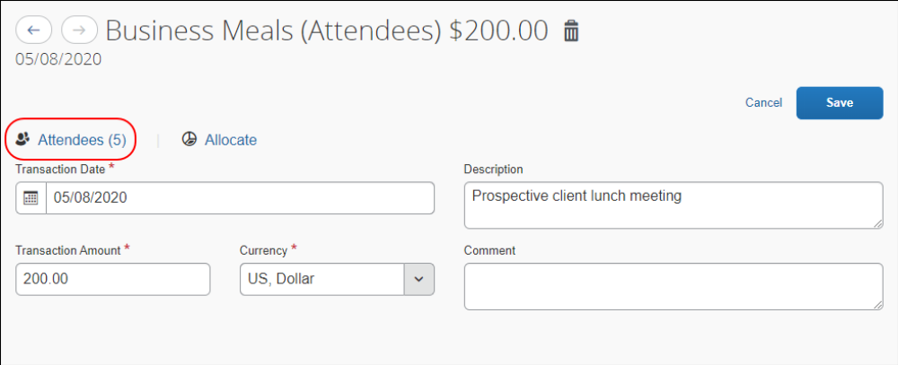
Note the following:
- The user can change the Attendee Type value for an attendee added to a report or request up to the point at which the report or request is submitted, after which this value is locked down by the system.
- The attendee duplicate type check by default is limited to attendees of the same type, however it can be expanded to all attendee types on the Settings tab of the Attendees page in Expense Admin.
- The company can also decide whether to implement "carry-forward." It is similar to copy down but it copies data from one attendee to another (for example, company name) when the user is adding attendees, as described in the configuration portion of this guide.
- Whether users can add new attendees is configurable, as described in the configuration portion of this guide.
By default, the Create New Attendee link appears to the user. The administrator can suppress this link in the Attendees section to prevent a user from adding an attendee – forcing the user to search for the attendee first, ensuring the attendee is not already in the system.
This option affects only the Attendees section of the New Expense – not the other attendee "grids" (like Profile favorites) that contain a Create New Attendee button.

Removing an Attendee from an Expected Expense
Attendees can be removed from an expected expense in the Attendees dialog and on the Attendees tab in the Add Attendees dialog.
To remove an attendee from the Attendees dialog:
- In the Attendees section of the Expenses tab, select the check box of the desired attendee.
- Click Remove. The attendee is removed from the expected expense.
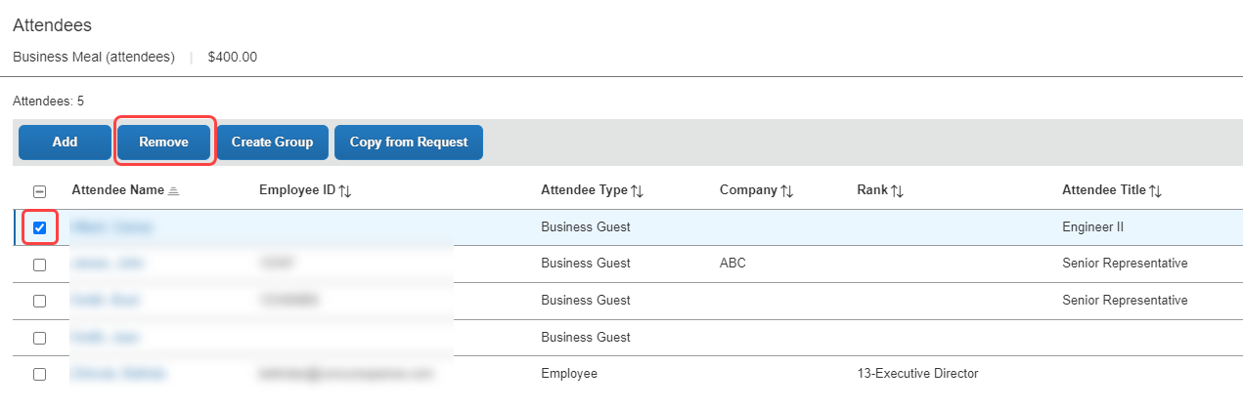
Removing the attendee from the expected expense does not remove the attendee from the user's favorites list. Amounts are redistributed, as described in Understanding How Concur Expense Distributes and Redistributes Amounts in this guide.
To remove an attendee from the Attendees tab in the Add Attendees dialog, do one of the following:
- In the Added Attendees section, click the X next to the attendee name.
- In the Search Results section of the Attendees tab, select the check box of the desired attendee, and then click Remove.
- In the Search Results section of the Attendees tab, click Remove in the Actions column for the desired attendee.
The attendee is removed from the expected expense.

Creating an Attendee Group
Users can create an attendee group using the attendees on an expected expense. To do so, the user selects the desired attendees and clicks Create Group.
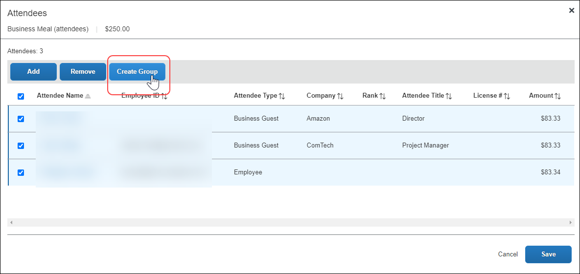
In the Create Group window, the user enters a group name and clicks Save.
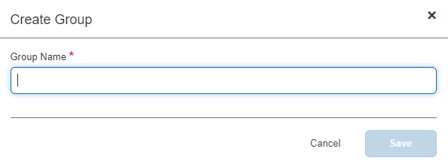
The group names do not have to be unique.
- Creating an attendee group can also be completed by the user in Profile. Refer to User Experience - in Profile in this guide.

View Attendee Summary from an Expected Expense
When there are attendees associated with an expected expense, the Attendees link displays below the expense type name in the Expected Expenses list.
Users can view attendee information on the expected expense by clicking the Attendees link to view the Attendees summary dialog.
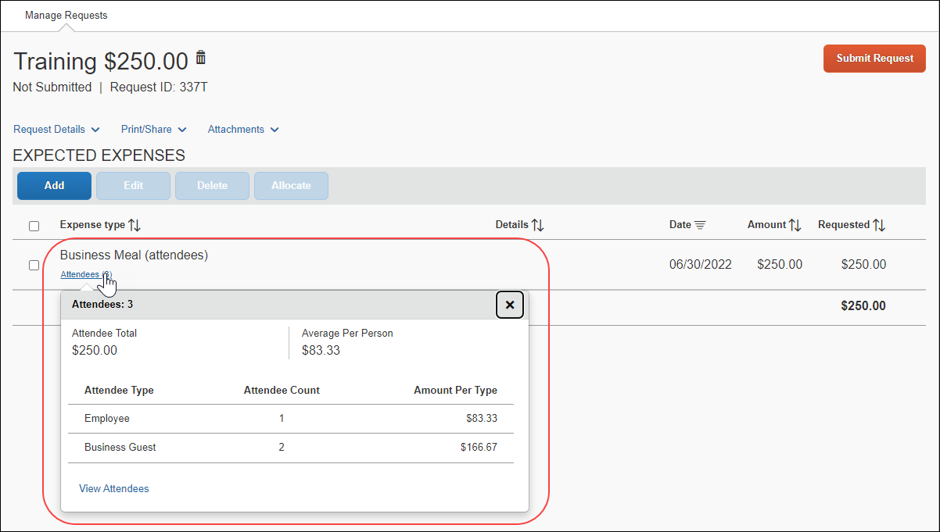
When users click the View Attendees link, they can view a detailed list of attendees.
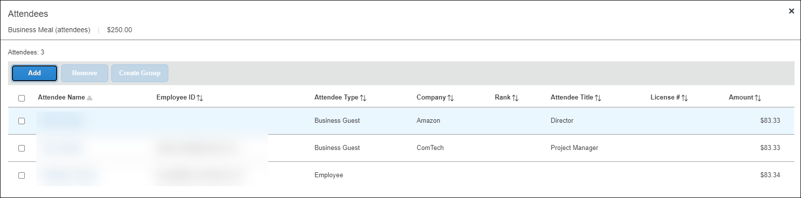

Additional Attendee Information - Attendee Detail View

Change Columns
There are several places in Concur Request where attendee information is presented in tables, such as the Attendees section of an expected expense.
By default, the information that the user sees in these tables includes the attendee name, type, company, and title. The administrator can customize this information.
The administrator can:
- Remove any of the following:
- Existing information (cannot remove Attendee Type)
- Add any of the following (including but not limited to):
- First Name
- Last Name
- Custom 1-25
- Total Amount Previous Year
- Total Amount YTD
Once the new "view" configuration is created, it is implemented by assigning it to one or more Concur Expense groups, as described in the configuration portion of this guide.

Example - Add a Field
For example, by default, the Attendees page of the expected expense contains the Attendee Name, Attendee Title, Company, and Attendee Type columns. Visibility of the Amount column is configurable.
Assume that a company is in the pharmaceutical industry where it is important for the user to know the state in which the attendee (doctor) practices. Further assume that the administrator added a custom field (renamed State) to the attendee form. Using the Attendee Detail View feature, the administrator can also easily add that same field to this display.
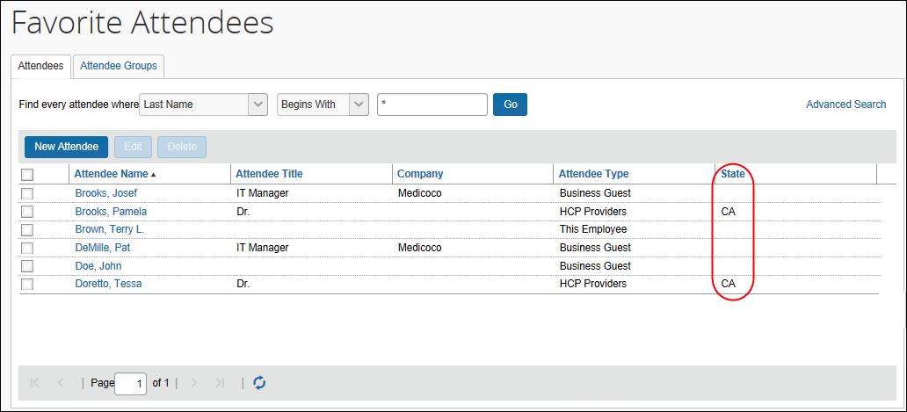
When the administrator adds or removes a column, the change appears in the profile settings and all grids where attendees are listed for an expected expense.
- For more information, refer to the Configuring the Attendee Detail View (Concur Expense) section of this guide.

Using the Personal Attendee Import
The personal attendee import benefits users who must list a large number of attendees for events such as seminars or department functions. The attendee import uses a Microsoft Excel spreadsheet to import attendees. It is recommended that no more than 500 attendees be included in a single import.
Concur Request supports up to 500 attendees per expected expense. This limit is due to a combination of configuration elements for the expected expense detail form, the attendee type, and related attendee form. Because of the constraints of these configuration elements, expected expenses with more than 500 attendees may or may not function correctly. SAP cannot guarantee that any list of attendees greater than 500 will import successfully to Concur Request. Attempting to import more than 500 attendees could result in issues opening the request or an individual expected expense.
Your company may allow you to use the import. When Concur Request is configured to use the attendee import feature, the Import Attendees tab appears on the Add Attendees dialog.
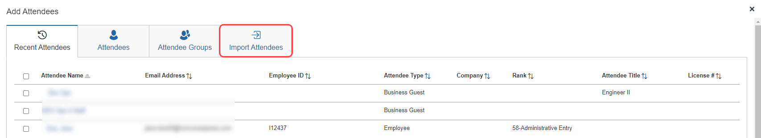
The user clicks the Import Attendees tab. The Attendee Import dialog appears.
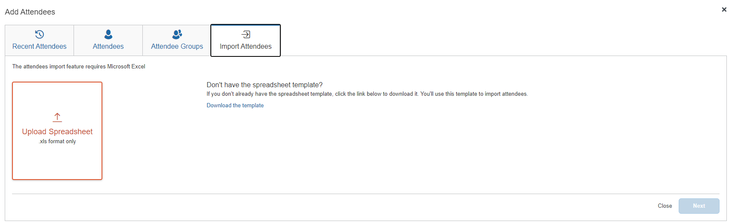
Using this dialog, the user accesses an Excel worksheet (formatted with the attendee fields) and saves it to their computer or network. The import only supports the Excel .xls file format.
The import file template is language specific. The user must download the template while logged in using the same language in which it will uploaded.
The user opens the worksheet in Excel, enters the attendee records (up to and not over 500 per import), and saves.
The user then imports the completed worksheet into Concur Expense. Once imported, Concur Request displays the attendee information. The user reviews the information for accuracy:
- If the information is correct, the user clicks Next.
- If the information is not correct (and the user notices the error), the user clicks Cancel, corrects the worksheet, and imports again.
When ready, the user clicks Next. The system checks for required fields. If it finds missing required fields, a message appears, indicating that the listed attendee will not be imported. The user can click the red circle to view the reason for the attendee error.
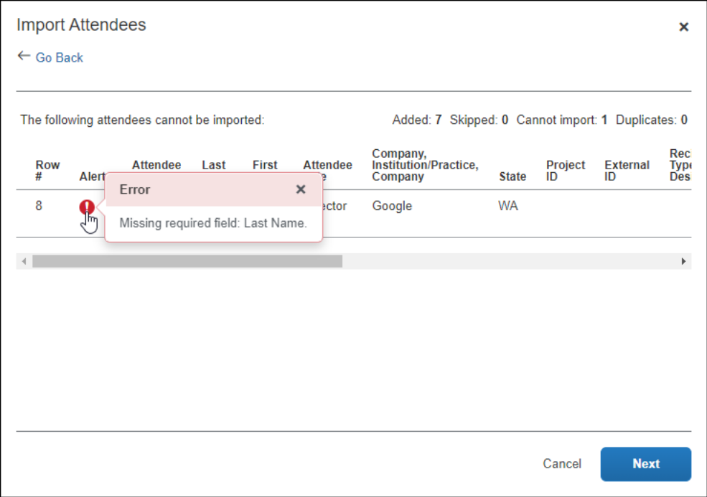
In the next step, the system checks for possible duplicates by comparing the attendees on the worksheet to attendees already in the system. If the import identifies possible duplicate attendees, a list of possible duplicate attendees is displayed in the Import Attendees section of the dialog. Duplicate attendees in the attendee import are resolved one attendee at a time.
Then:
- If a possible duplicate (from the worksheet) truly is an existing attendee, the user selects the attendee in the Import Attendees list, clicks View Duplicates, selects the existing attendee in the Duplicates section, and then clicks Use Selected Attendee.
- If the possible duplicate (from the worksheet) is not an existing attendee, the user selects the attendee in the Imported Attendee list, and then clicks Use Selected Attendee.
Note the following:
- Attendees that are missing required fields can be imported. The attendees must have at least the Last Name and Attendee Type field completed. The user can add all other required fields to the attendee record after import.
- Attendees that are in your Favorites are not treated as duplicates, providing that the attendee record appears once, and only once, in your favorite attendees.
- When the system checks for possible duplicates, it is first looking for an exact match on the External ID. The External ID is unique to each attendee. It is generally the attendee ID obtained from the client's HR or CRM system and is not likely to be included in the worksheet. It then looks for duplicates based on the fields configured for duplicate check for that attendee type.
- For more information about the External ID, refer to External ID - Required for Imported Changes and Deletions in the configuration section in this guide.
- If Concur Expense finds more than one possible duplicate (so that several names are listed in the Import Attendees list), the user deals with each one individually.
- Attendees of type SYSEMP (Employee), where the user is not allowed to create a new attendee record, can now be imported, and will be matched to one existing employee record.
- Attendee types where the user may not create a new attendee record but may search for attendees from a company-managed list may be included in the import file. The system will attempt to find a match with existing attendees in the system and will fail the record if no match is found.
- The attendee duplicate type check by default is limited to attendees of the same type, however it can be expanded to all attendee types on the Settings tab of the Attendees page in Expense Admin.
When done, the user clicks Next. The final Import Attendees page appears.
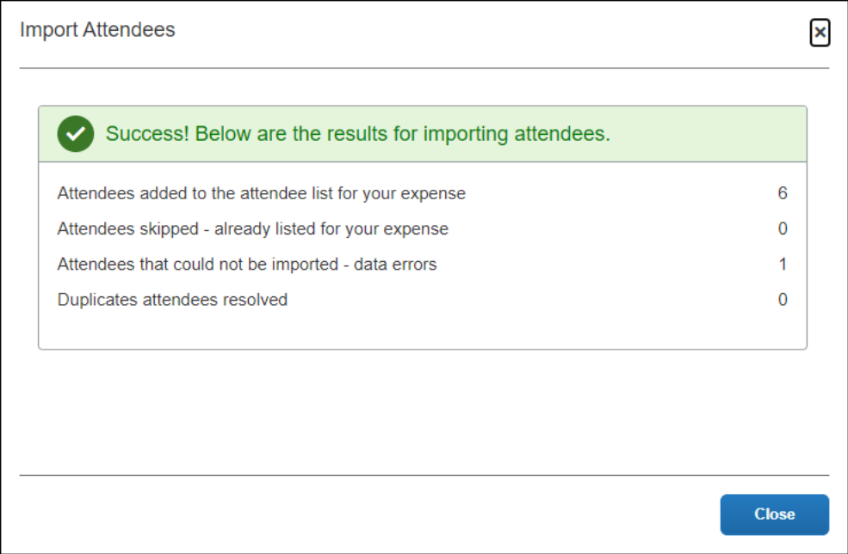
On this page, note the following definitions:
- Attendees added to the attendee list for your expense: A total count of the number of attendees successfully added from your imported list.
- Attendees skipped - already listed for your expense: A skip occurs if an attendee is added to an expense and then the user imports the same worksheet with the same attendee to the same expense.
- Attendees that could not be imported - data errors: The system detected that at least one required field was missing and the user elected to not import that attendee.
- Duplicate attendees resolved: As described previously, the system compares information from the attendees on the worksheet to the attendees already in the system. If the External IDs are not an exact match, the user is asked to indicate if the imported attendee truly is a duplicate.
- For more information about the External ID, refer to External ID - Required for Imported Changes and Deletions in the configuration section in this guide.
When the user clicks Close, the attendees are imported into the expected expense.

User Experience - in Profile
As mentioned previously, for clients with integrated Concur Expense and Concur Request, attendees are shared between the two services. That is, the user's favorite attendees in Concur Expense are the same as their favorite attendees in Concur Request.

Attendees Tab
When users view the Favorite Attendees page in Profile, they can manage their favorites list on the Attendees tab.
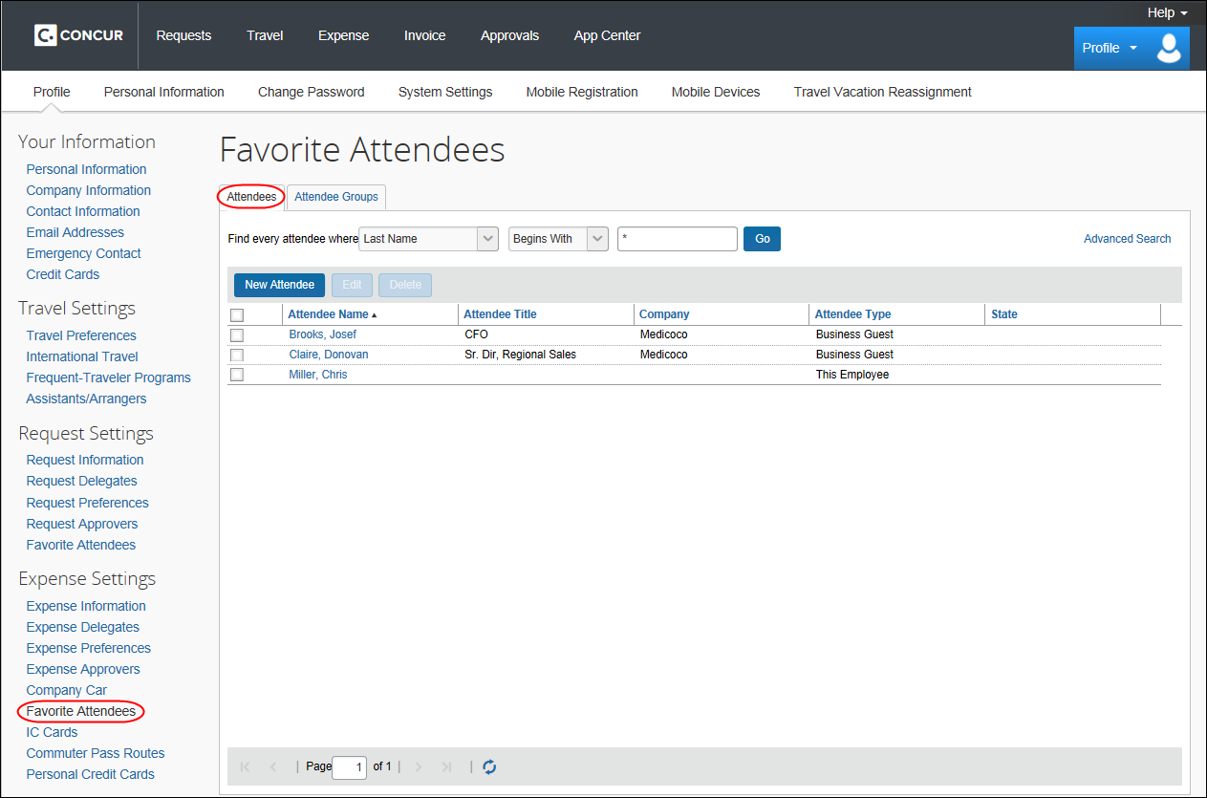
This list is not necessarily all of the user's available attendees; it includes only the user's favorites.
The attendee types that are visible to users (by groups) are configurable, as described in the configuration portion of this guide.
The user can use this tab to:
- Create a new attendee
- Edit or view attendee information
- Delete / Hide an attendee
- Find an attendee
Note the following about the information that appears on this page:
Information | Description
User Name  (attendee type of This Employee) | The user's name appears automatically in this list (depending on the configuration).
Annual Total | On this page, the attendee's name, title, company, and attendee type always appears. The Annual Total column appears only if Concur Request is integrated with Concur Expense and if Expense is configured to display this column.  If so, the amount comes from Concur Expense and does not include any requests:  - The amount shown is the total amount spent company-wide in the current calendar year for that attendee (not only from the current user)  – and –  - The currency used is:  - The currency that is set in the import record, if the attendee was imported  – or –  - The same as the user's reimbursement currency, if the attendee was added by a user  NOTE: There are two ways to add the total column to the Attendees tab (both described in the configuration section of this guide).  - One involves the attendee Settings page (in Expense Admin); that setting adds the Annual Total column to the Attendees tab.  - The other option involves using the Attendee Detail View form (in Expense Admin). Adding the Attendee Total YTD field to the view will provide the same result but will also add this information to several other places, like the Attendees section of the Expenses tab), the Search Attendees page, etc.  - Refer to Additional Attendee Information - Attendee Detail View in this guide.

Creating a New Attendee
To add a new attendee to the user's attendee favorites list, the user clicks New Attendee, completes the Add Attendee page, and then clicks Save or Save & Add Another.
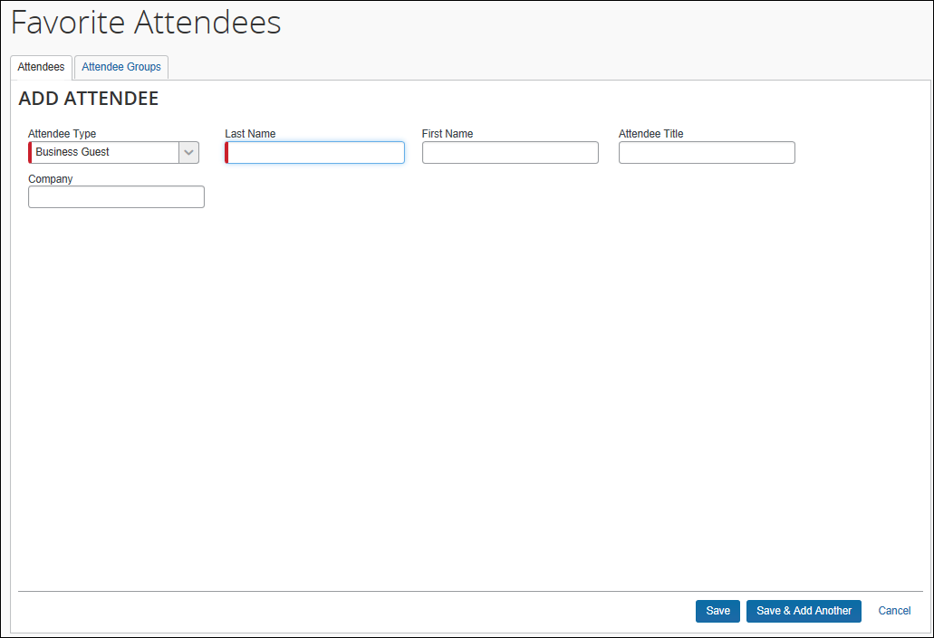
The company can also decide whether to implement "carry-forward." It is similar to copy down but it copies data from one attendee to another (for example, company name) when the user is adding attendees, as described in the configuration portion of this guide.

Editing Attendee Information
A user can edit attendee information only if the user originally added the attendee to the system. To do so, on the Attendees tab, the user selects either:
- The attendee's name (link)
– or –
- The check box to the left of the attendee's name and clicks Edit
The user edits the desired information and clicks Save.

Deleting / Hiding Attendees
When using this feature, the attendee is actually deleted from the system only:
- If the user originally added the attendee to the system
– and –
- If the attendee has not already been associated with a request (or an expense if integrated with Concur Expense)
In all other cases, the attendee information is simply removed (hidden) from the user's attendee favorites list and can be located using the search function.
To delete, the user selects the check box associated with the attendee and clicks Delete.
The attendee can also be deleted from the Favorites list on the Attendees Groups tab of the New Expense for the expected expense.

Finding Attendees
The user can search their favorites list using the Find every attendee where area. The user completes the fields and clicks Go. The search results appear.
Be aware that this "find" option is searching the attendees in the favorites list. To locate attendees that the user has deleted (removed), the user uses the search function.

Attendee Groups Tab
In Profile, users can manage their groups of favorite attendees. Users can create, edit, and delete groups

Create a Group of Favorite Attendees
Note the following:
- Attendees that a user adds to a group must first be in the user's favorites list.
- Each group can have as many as 500 individual members.
- A user can create an unlimited number of groups.
- An attendee can belong to more than one group.
To create a group, the user clicks Profile > Profile Settings > Favorite Attendees and then clicks the Attendee Groups tab. The user clicks Add New.
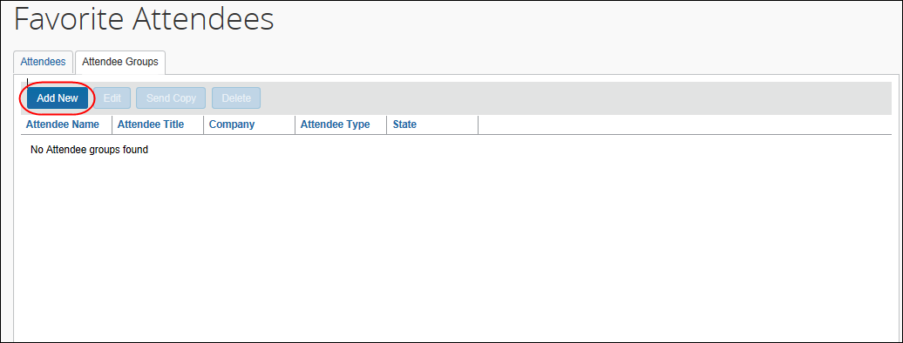
The user's list of favorite attendees appears.
The user selects the check box for each attendee to be included in the group and types a name for the group in the Group Name field.
The name does not have to be unique, but it is a best practice to have unique group names.
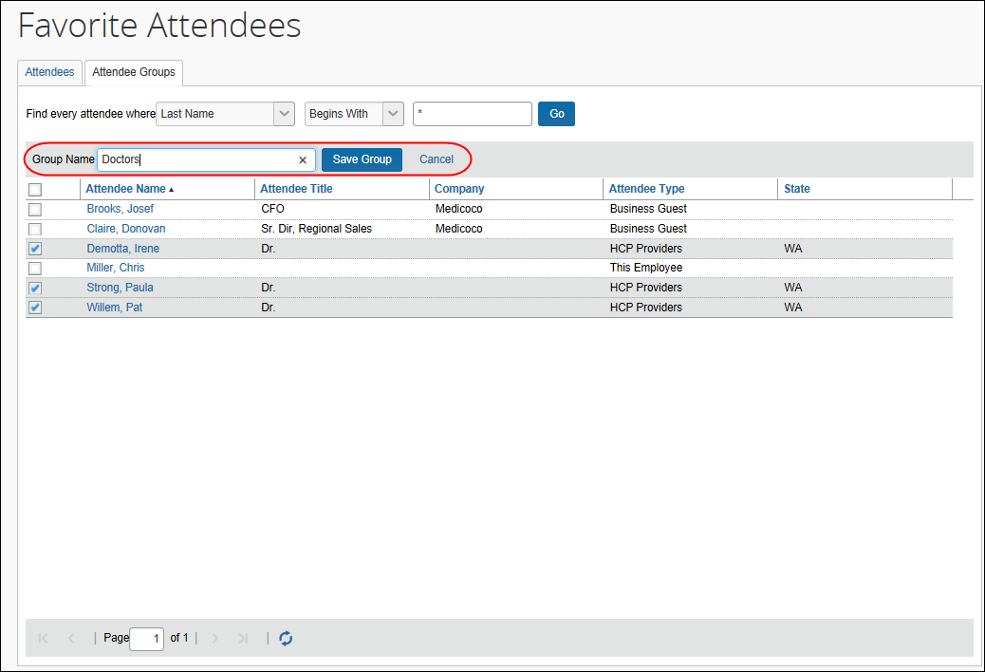
The user clicks Save Group. The selected attendees now appear in a group.
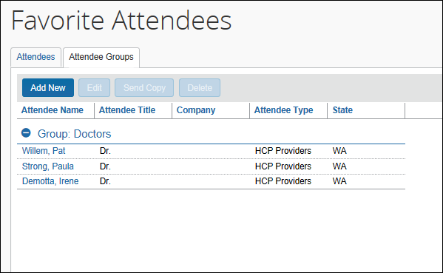

Edit a Group
The user uses the edit feature to:
- Add more attendees to an existing group
– or –
- Remove attendees from an existing group
On the Attendee Groups tab, the user clicks the group and clicks Edit.
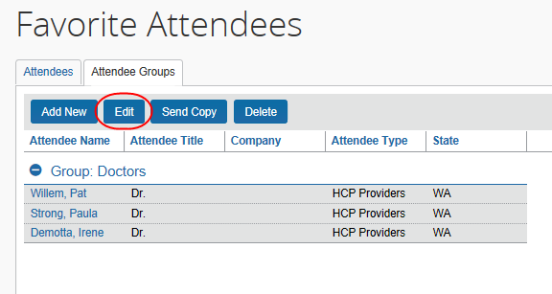
The user makes the desired changes and clicks Save Group.

Delete a Group
When a user deletes a group, the group is dissolved; the individual attendees are still available in the user's favorites list. If a user deletes an attendee from the favorites list and that attendee is in one or more groups, a confirmation message appears.
To delete, on the Attendee Groups tab, the user selects one or more groups and clicks Delete.

Send a Copy of a Group to Another User
A user can send a copy of one or more groups to another user. The group then appears immediately on the recipient's Attendee Groups tab; all individual attendees in the group also appear on the recipient's Attendees and Favorites tabs.
To send a copy to another user, on the Attendee Groups tab, the user clicks one or more groups and clicks Send Copy.
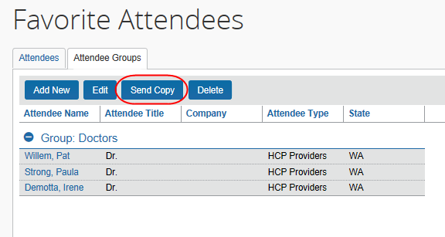
In the Send a copy of the selected group(s) window, the user finds the desired recipient and clicks Send.
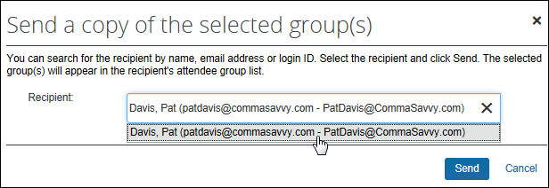
The selected group(s) can be sent to only one recipient at a time.
Note the following:
- Remember - this is a copy. Any modifications that the original owner makes to the group will not affect the recipient; any modifications that the recipient makes to their copy will not affect the original owner's group.
- Since the group names do not have to be unique, the copy cannot overwrite or otherwise destroy data in the recipient's group list.
- If the recipient does not have access to an attendee type, any attendees of that type will not be included in their copy of the group.

Attendee Detail View
You can add additional information to the attendee grids (tables) in Profile as described in Additional Attendee Information - Attendee Detail View in this guide.

Delegates, Proxies, Approvers, and Processors

Delegates and Proxies
All of the features described here for Concur Request users are also available to delegates and proxies.

Attendee Types Restricted by Groups
If the administrator has defined attendee types by groups, when a delegate or proxy accesses attendee information on behalf of a report owner, the attendee types available are based on the types defined for the report owner's group.

Approvers and Processors
Like most forms and fields, the attendee forms and fields can be configured so that it is either read-only or editable (modify) for the approver and/or processor. If so, modify means the approver and/or processor can add attendees to and remove attendees from an expense but cannot change amounts.
- Refer to Understanding How Concur Expense Distributes and Redistributes Amounts in this guide to understand the relationship between manual changes to amounts and Concur Expense's automatic redistribution of amounts among attendees.

Configuration – Overview and Procedures
Most of the configuration for this feature is completed in Expense Admin – whether or not Concur Request is integrated with Concur Expense. This portion of the process requires the role of Expense Configuration Administrator and Request Configuration Administrator.
Also, be aware that if Concur Request is integrated with Concur Expense and if the Attendee feature is already configured for Concur Expense:
- You do not have to configure again for Concur Request. It means that portion of the configuration process is already done.
– and –
- If you change an existing configuration, you will affect Concur Expense and Concur Request.

Different Processes for Different Options
Clients wanting to take advantage of the extended attendee functionality may opt in to the following features. The option features are applied in these ways:
- Global: Applies to all expected expenses that require attendees
- By attendee type: Set based on the attendee type
- By group: Applies to one or more Concur Expense/Concur Request groups
- By Request policy/Expense Type: Applies to the expense type within the Concur Request policy
The attendee features are listed in the table below and are described in detail on the following pages.
Configured by Feature | Global | Attendee Type | Group | Request policy
25 custom fields available specifically for attendees | X
Ability to track year-to-date attendee totals (if integrated with Concur Expense; includes expense totals – does not include any request amounts) | X
Separate attendee forms for each attendee type |  | X
Allow attendee lists to be shared or private |  | X
Allow or prevent users to enter new attendees into the system |  | X
Have system check for duplicates when users add new attendees |  | X
Duplicate checks are performed across all attendee types | X
Define the fields that the system uses to perform the duplicate check |  | X
Import of attendee lists by administrator | X
Allow the automatic creation of an attendee record for the current employee (SYSEMP attendee type) | X
Create audit rules relating to attendee totals and frequency of attendance |  |  | X
Auto-generate the External ID, used if importing lists of attendees | X
Restrict attendee types by user group |  |  | X
Configure the Attendee Detail View (form) |  |  | X
Allow the user to view the portion of the expense allotted to each attendee |  |  |  | X
Include the user by default as an attendee |  |  |  | X
Show the New Attendee button in the Attendees area of the Expenses tab |  |  |  | X
Allow users to import attendees | X
Search for and import attendees from an external source  NOTE: This option requires additional configuration. The external source is:  Fetch Attendee Web Service: Refer to the Fetch Attendee Web Service information on http://developer.concur.com. |  | X

The Basic Configuration Process
These steps are described briefly here and described in detail on the following pages:
Step 1: Define the attendee forms and fields (Concur Expense)
Step 2: Configure the Attendee Detail View (optional; Concur Expense)
Step 3: Add the Attendees field to the Request Entry form (Concur Request)
Step 4: Add additional attendee types and select attendee settings (Concur Expense)
Step 5: Configure the Concur Request policy/expense type options (Concur Request)
Step 6: Configure the Excel worksheet to be used for personal attendee imports (optional).
Step 7: Import a list of attendees (optional)

Step 1: Defining the Attendee Forms and Fields (Concur Expense)

Overview: Attendee Forms and Fields
Concur Request has only one Attendee field. It is a virtual field that is a copy of an Attendee Detail View form (default or customized) in Concur Expense, which is assigned to an Expense Group. If you want to edit the Concur Request Attendee field, then you must edit the Attendee Detail View form in Concur Expense.
Since attendees in Concur Request apply only to expected expenses and since expected expenses use the Request Entry form, you can assign the Attendee field to any Request Entry form (default or customized) but to no other type of form. Adding the Attendees field to any Request Entry form effectively "activates" the Attendees feature in Concur Request.
Note the following:
- Consider creating a custom Request Entry form that includes the Attendees field. This way, you can assign that form to specific expense types, while another Request Entry form can be used for the expense types that do not require attendees.
When adding the field to the form, define the access rights, whether the field is required, etc.
- To define the expense types that require attendee information, access Request Policies. On the Expense Types tab, select the appropriate Request Entry form for each expense type available.

General Notes about Attendee Forms in Concur Expense
- Concur Expense provides a default attendee form. To create new forms, make a copy of the default form and then edit the copy.
- Concur Expense also provides company-specific forms, such as the Health Care Professional (HCP) attendee form.
- An administrator can create as many attendee forms as needed.
- Attendee forms are administered at Administration > Expense > Forms and Fields (left menu).
- Once the Expense Attendee form type is selected, the list of forms is displayed. The forms can be expanded to display the currently configured fields.
- Use the Attendee Detail View form type to provide additional information in the most common attendee grids (tables) as described in Additional Attendee Information - Attendee Detail View in this guide.

Attendee Fields in Concur Expense
The attendee fields are:
Field Name | Description
Attendee Name | Attendee's name
Attendee Title | Attendee's work title
Attendee Type | Business Guest, Spouse, and so on
Company | Attendee's company
Company Category 1 Authorized Amount Previous YTD | Total pre-authorized spend on this attendee on selected expense types by the entire company last year
Company Category 1 Authorized Amount YTD | Total pre-authorized spend on this attendee on selected expense types by the entire company year-to-date
Company Category 1 Submitted Amount Previous YTD | Total spend on this attendee on selected expense types by the entire company last year
Company Category 1 Submitted Amount YTD | Total spend on this attendee on selected expense types by the entire company year-to-date
Company Category 2 Authorized Amount Previous YTD | Total pre-authorized spend on this attendee on selected expense types by the entire company last year
Company Category 2 Authorized Amount YTD | Total pre-authorized spend on this attendee on selected expense types by the entire company year-to-date
Company Category 2 Submitted Amount Previous YTD | Total spend on this attendee on selected expense types by the entire company last year
Company Category 2 Submitted Amount YTD | Total spend on this attendee on selected expense types by the entire company year-to-date
Created By (Private List) | Defines the "owner" of the attendee information  - For more information, refer to Private vs Shared Attendee Lists on the following pages.
Currency Key | As defined in the import, if imported; or same as the user's reimbursement currency, if the attendee was added by a user
Custom 1-25 | Custom fields as defined by the company
Employee Amount Previous Year | Total spend on this attendee by the current user last year  NOTE: An amount appears in this field only if Request is integrated with Expense. Be aware that it is an Expense total and does not include Request amounts.
Employee Amount YTD | Total spend on this attendee by the current user year-to-date  NOTE: An amount appears in this field only if Request is integrated with Expense. Be aware that it is an Expense total and does not include Request amounts.
Employee Category 1 Authorized Amount Previous YTD | Total pre-authorized spend on this attendee on selected expense types by the current user last year
Employee Category 1 Authorized Amount YTD | Total pre-authorized spend on this attendee on selected expense types by the current user year-to-date
Employee Category 1 Submitted Amount Previous YTD | Total spend on this attendee on selected expense types by the current user last year
Employee Category 1 Submitted Amount YTD | Total spend on this attendee on selected expense types by the current user year-to-date
Employee Category 2 Authorized Amount Previous YTD | Total pre-authorized spend on this attendee on selected expense types by the current user last year
Employee Category 2 Authorized Amount YTD | Total pre-authorized spend on this attendee on selected expense types by the current user last year
Employee Category 2 Submitted Amount Previous YTD | Total spend on this attendee on selected expense types by the current user last year
Employee Category 2 Submitted Amount YTD | Total spend on this attendee on selected expense types by the current user year-to-date
External ID | Required for imported attendee records  - For more information about the External ID, refer to External ID - Required for Imported Changes and Deletions in the configuration section in this guide.
First Name | Attendee's first name
Last Name | Attendee's last name
Middle Initial | Attendee's middle initial
Suffix | Suffix for the attendee name
Total Amount Previous Year | Total spend on this attendee by all users company-wide last year  NOTE: An amount appears in this field only if Concur Request is integrated with Concur Expense. Be aware that it is an expense total and does not include request amounts.
Total Amount YTD | Total spend on this attendee by all users company-wide year-to-date  NOTE: An amount appears in this field only if Concur Request is integrated with Concur Expense. Be aware that it is an expense total and does not include request amounts.

Private vs. Shared Attendee Lists
If an attendee list is private, then:
- Only the current user can use attendees from this list
- Only the current user can search this list
- If the user is allowed to add attendees to the list, then the system will search only this user's attendees for duplicates
If an attendee list is shared, then:
- Any user can use attendees from this list
- Any user can search this list
- If users are allowed to add attendees to the list, then the system will search all users' attendees for duplicates
The Created By (Private List) field, which is not visible to the user, has two functions. It is used by Concur Expense:
- To identify the "owner" of the attendee for editing or deleting; for example, in order for a user to edit attendee information or delete an attendee, the user must be the owner
- To identify if an attendee list is private or shared
Whether or not you include this field as one of the search fields and the duplicate search fields ultimately defines whether the attendees list is private or shared.
Further explanation: Remember, the Created By (Private List) field is always hidden and is always populated with the user's user ID (cannot be changed; cannot be deleted). So, if you add the Created By (Private List) field to the search fields or the duplicate search fields, the field is always part of the search or duplicate search.
- In the case of the search fields, the system will find only those attendees who have that same user ID in the Created By (Private List) field. In other words, the system will not search outside of the user's attendees. So, to keep a list private, add the Created By (Private List) field – users will not find each other's attendees.
- In the case of duplicate search fields, the system will match only attendees who have that same user ID in the Created By (Private List) field. In other words, the system will not search outside of the user's attendees for duplicates.
Include "Created By (Private List)" when defining… | Private List | Shared List | How?
Search fields on the attendees window | YES | NO | When defining forms, on the Forms tab  - Refer to Configuring Attendee Forms and Fields below.
Fields used to search for duplicate attendees | YES | NO | When defining attendee types, on the Add Attendee Type or Edit Attendee Type page  - Refer to Adding Additional Attendee Types and Working with Other Attendee Settings in this guide.

Amount Fields (Edit Attendee Details) - if Integrated with Expense
The amount fields that appear on the Fields tab provide the accumulated totals (in profile and in the Edit Attendee Details window in Concur Expense) if you add these fields to the desired attendee form.
This example shows the Employee Amount YTD and Total Amount YTD fields added to the attendee form for the Business Guest attendee type.
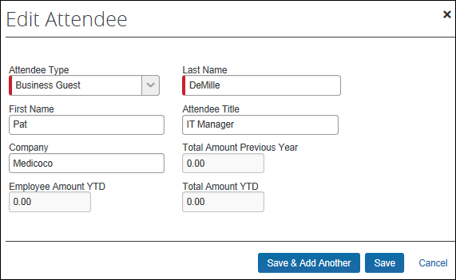

Procedure: Configuring Attendee Forms and Fields (Concur Expense)

Access Forms and Fields
To access the attendee forms and fields:
- Click Administration > Expense > Forms and Fields.
- In the Form Type list, click Expense Attendee.

Use the Forms Tab - General
To make general changes on the Forms tab:
- To view the fields on the form, click the to the left of the form name.
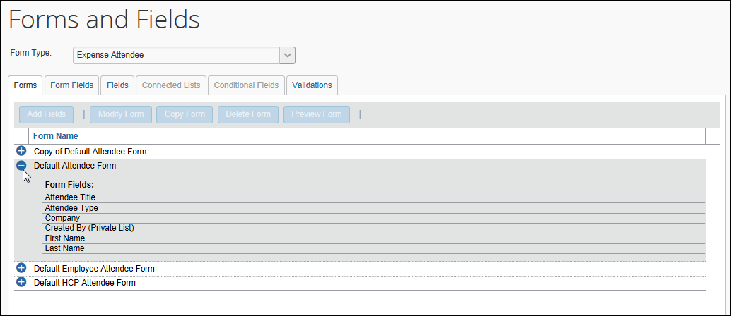
- To create another form, click an existing form and click Copy Form.
- To add additional fields to the form:
- Click the form.
- Click Add Fields.
- Click the desired fields.
- Click Add Fields.
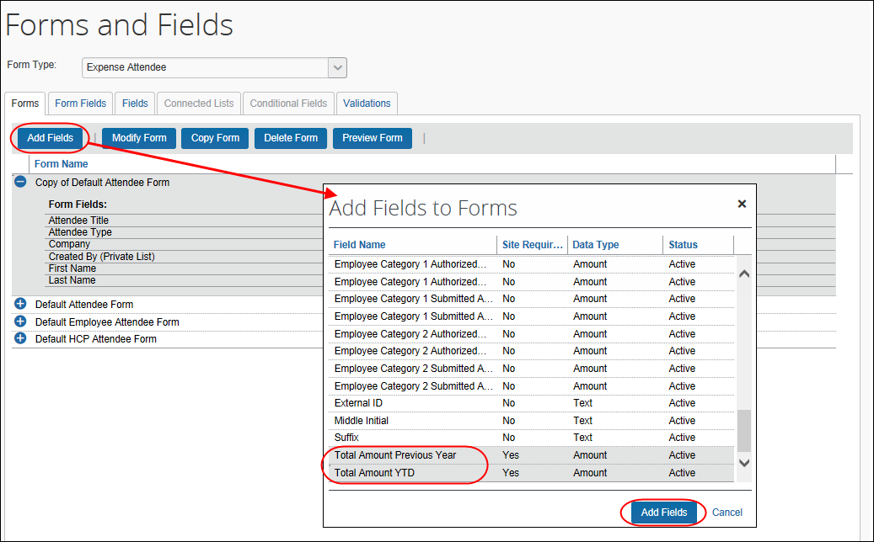

Use the Forms Tab - Search Fields
To Define the Search Fields:
- To define the search fields (the fields that appear on the Search Attendees window), on the Forms tab, click the form.
- Click Modify Form. The Modify Form dialog appears.
- Select the desired fields.
- Click Save.
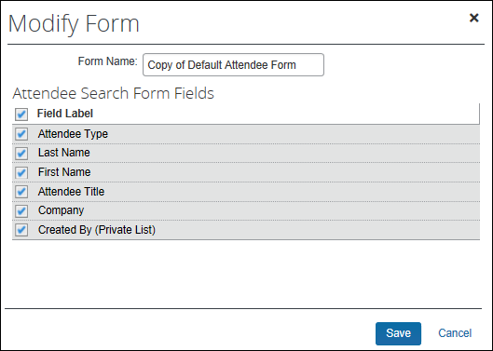

Use the Form Fields Tab - General
To make general changes on the Form Fields tab:
- To change the characteristics of a field:
- Either:
- Double-click the desired field.
– or
- Click the desired field and click Modify Form Fields.
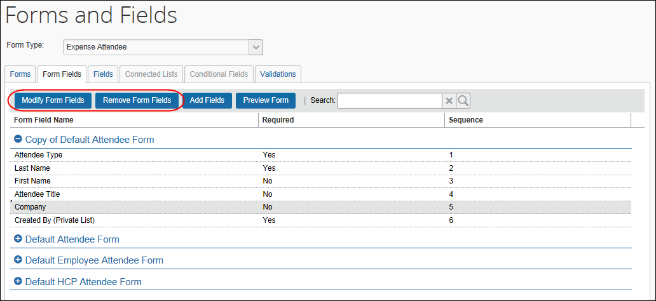
- Make the desired changes.
- Click Save.
- To remove a field:
- Click the field.
- Click Remove Form Fields.
- To change the sequence of the fields, drag-and-drop a field to the new location.

Use the Form Fields Tab - Configure Carry-Forward
When a user manually enters attendee information (name, company, job title, etc.) and the attendees are (for example) from the same company, the user must repeat the company name for each attendee. However, you can configure the system so the attendee information is automatically copied (carried forward) from one manual entry to the next.
First, the company decides which attendee fields, if any, use the carry-forward feature.
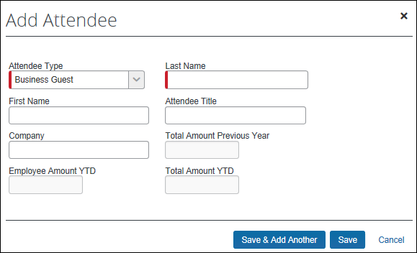
Typically, a company would have attendee type, company, and any custom fields carry forward.
This feature works when the user adds attendees in Profile > Profile Settings > Favorite Attendees or from the expense. However, the information is carried forward only when the user clicks Save & Add Another; it does not carry-forward on Save.
To configure carry-forward:
The feature is implemented like copy down.
- Either:
- Double-click the desired field.
– or
- Click the desired field and click Modify Form Fields.
- In the Default Value Type field, click Copy Down.
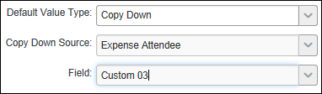
- In the Copy Down Source field, click Expense Attendee.
- In the Field field, click the name of the source field (which would be the same name as the field you are currently editing).
- Click Save.

Step 2: Configuring the Attendee Detail View (Concur Expense)

Overview: Attendee Detail View
Use these steps to provide additional information or suppress display of elements in the most common attendee grids (tables) as described in Additional Attendee Information - Attendee Detail View in this guide.
The configuration steps are:
- Configure the view (form)
- Assign the form to one or more Concur Expense groups

Procedure: Configure the View
In the examples below we will add as custom field (Custom 01 renamed State) to the view.
To configure the view to add a new field:
- Click Administration > Expense > Expense Admin.
- Click Forms and Fields (left menu). The Forms and Fields page appears.
- In the Form Type list, click Attendee Detail View.
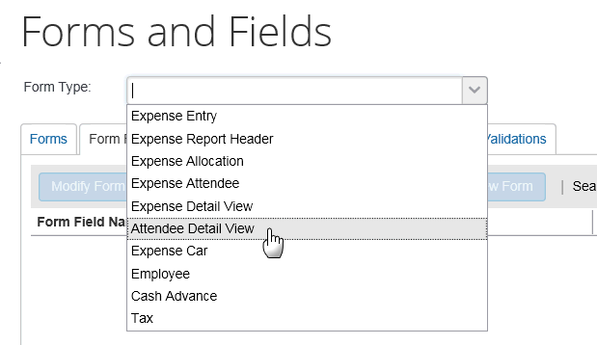
- IMPORTANT: This view will be assigned to one or more groups. Unless the changes will be assigned to all groups, consider making a copy of the form so you still have the original with the original configuration.
- Then, on the Forms tab (for the desired form or copy), click Add Fields.
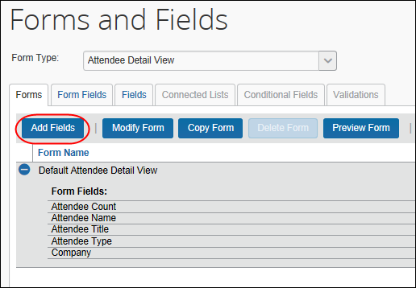
- Click the desired field and click Add Fields. The new field is added.
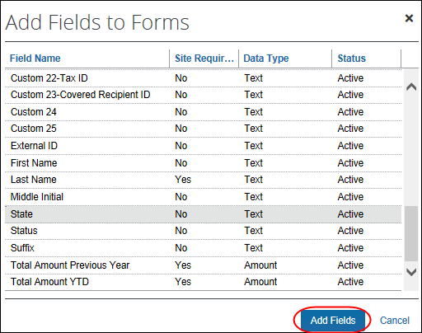
Note the following:
- Like any other form, you can use the Forms Fields tab to modify field properties, change the sequence, and remove fields.
- The Fields, Connected Lists, and Validations tabs are not available since they do not apply to "view" forms.
To assign to a Concur Expense group:
- Click Administration > Expense > Expense Admin > Group Configurations. The Group Configurations page appears.
- Click the desired group and click Modify.
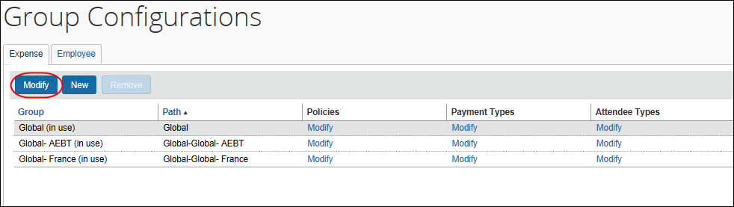
- In the Attendee List Form field, click the desired view form.
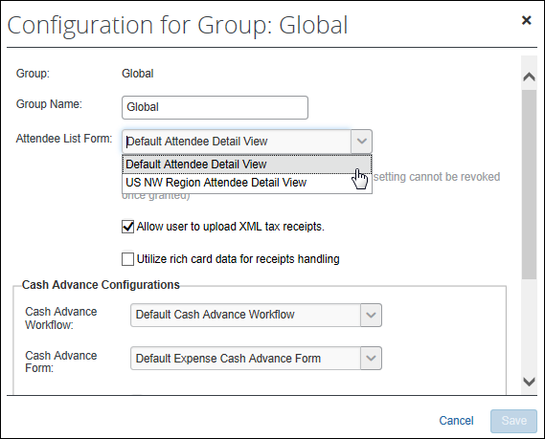
- Click Save.

Step 3: Add the Attendees field to the Request Entry Form (Concur Request)
To add the Attendees field to a Request Entry form:
- Click Administration > Request > Forms and Fields.
- In the Form Type field, click Request Entry.
- Click the desired request entry form.
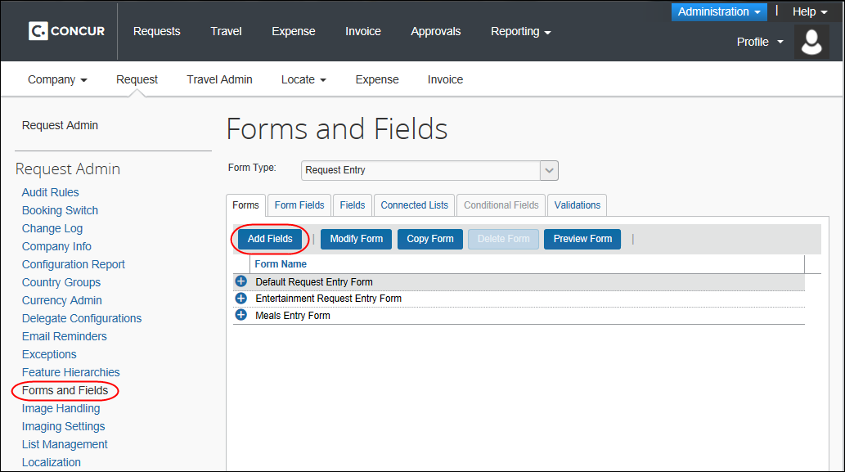
- Click Add Fields to add the Attendees field to the form.

Step 4: Adding Additional Attendee Types and Working with Other Attendee Settings (Concur Expense)
There are two pages: Attendee Types and Settings

Overview: Attendee Types
On the Attendee Types page, you can:
- While adding or editing attendee types:
- Define the fields that are used in "duplicate" searches
- Define whether to allow users to add attendees of this type
- Define the data source to search for that attendee type
- Inactivate attendee types

"This Employee" Attendee Type
Concur Expense uses this attendee type when it automatically adds Concur Expense and Concur Request users as attendees. This is a system attendee type, so it cannot be inactivated.
The automatic creation feature can be turned off; however, it is recommended that it remains on. Refer to the information about the attendee Settings tab.
On the Edit Attendee Type page:
Field | Description
Attendee Type | This Employee
Attendee Type Code | SYSEMP; cannot be edited
Expense Attendee Form | Default Attendee Form
Fields for duplicate search | External ID and Created By (Private List)
Allow users to add attendees of this type | No; cannot be edited
Allow users to edit the count for this type | No; cannot be edited

Procedure: Configuring Attendee Types
To access the attendee types:
Click Administration > Expense > Expense Admin > Attendees. The Attendees page appears.
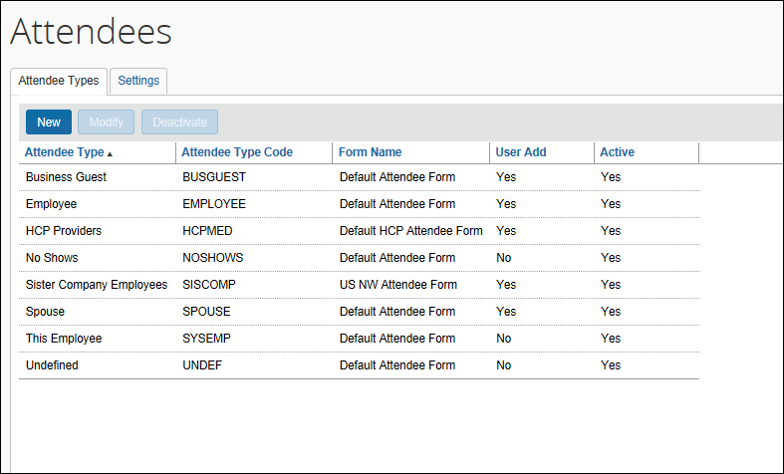
To modify an attendee type:
- On the Attendee Types tab, either:
- Double-click the desired attendee type.
– or –
- Click the desired attendee type and click Modify.
The Attendee Type dialog appears.
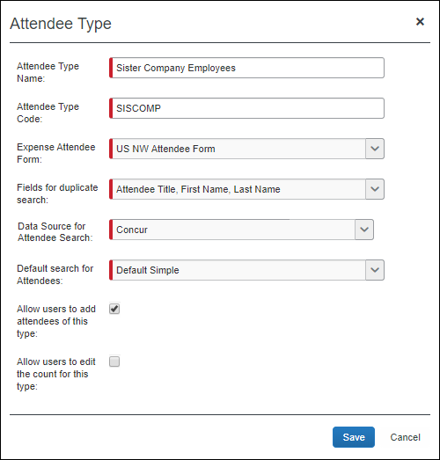
- Complete the appropriate fields.
Field | Description
Attendee Type Name | Change the name as desired.
Attendee Type Code | Change the code as desired. The code can be 1 to 8 alphanumeric characters, all uppercase, no spaces.
Expense Attendee Form | Click the desired attendee form.
Fields for duplicate search | Click the field(s) that will be used to check for duplicates.  NOTES:  - If the intent is for your users to have private attendee lists, then include the Created By (Private List) field as a duplicate search field for this attendee type.  - If you plan to have the system check for duplicates across attendee types, note that the system will successfully check for duplicates across attendee types only if the duplicate check fields are the same on all attendee types.
Data Source for Attendee Search | Click the data source used when searching for attendees of this type.  NOTE: This field is used by the Fetch Attendee Callout. If you are using this callout, select the system that you configured in the Register Application Connectors page of Web Services Admin.  Refer to the Fetch Attendee Callout information on http://developer.concur.com.
Default Search for Attendees | Select the default search when searching for this attendee type to optimize the experience:  Default Simple – This choice prompts the user with the type-ahead field where the user can enter first or last name of the attendee and provides access to the advanced search.  Default Advanced –This choice prompts the user with the advanced search options and provides access to the simple search.  Advanced Only – This choice provides the user with the advanced search and does not provide access to the simple search. This option is required for external attendee searches (API), or when the company has a very large number of attendees and the simple search responds very slowly or cannot be used.  NOTE: While the setting is available to all expense admins, the effects of this setting are only visible in the NextGen UI. End users in the existing legacy UI will continue to see Quick Search as the default regardless of what the admin sets as the default search per attendee type.
Allow users to add attendees of this type | Select (enable) this check box to allow users to add attendees with this attendee type.  NOTE: If you are using the Fetch Attendee Callout, this check box will be cleared and not editable.
Allow users to edit the count for this type | Do not use.
- Click Save.
To add a new attendee type:
- On the Attendee Types tab, click New. The Attendee Type dialog appears.
- Complete the fields as described in the previous section about editing existing attendee types.
- Click Save.
To deactivate an attendee type:
Note the following about deactivating an attendee type:
- When you deactivate an attendee type, all attendees with that attendee type are also marked as inactive and are no longer available for users to include on an expense.
- An attendee type that has been deactivated cannot later be made active.
- If you deactivate an attendee type and then later want to use it again, create a new attendee type. You cannot use the same name as the original. You can, however, modify the original and rename it. Then, you can create the new attendee type using the original name of the deactivated attendee type.
Deactivating an attendee type will also deactivate every attendee of that type so that they may no longer be selected for use on an expense. Deactivating an attendee type containing a massive number of attendees may require assistance from SAP Concur support due to the large number of records that must be altered. Please contact support if deactivation of an attendee type is not successful.
- On the Attendee Types tab, select the desired attendee type(s).
- Click Deactivate.
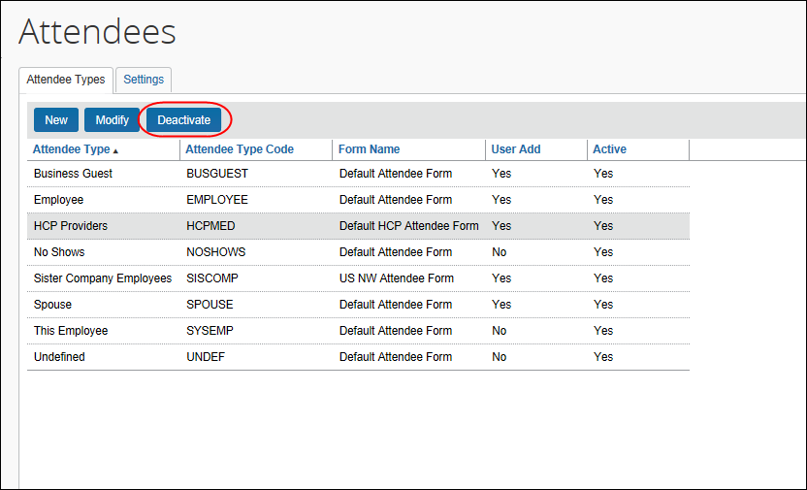

Overview: Settings
On the Settings tab, you can:
- Define the expense types that will be included when calculating attendee totals (if integrated with Concur Expense)
- Define whether the Annual Total column displays in Profile (if integrated with Concur Expense)
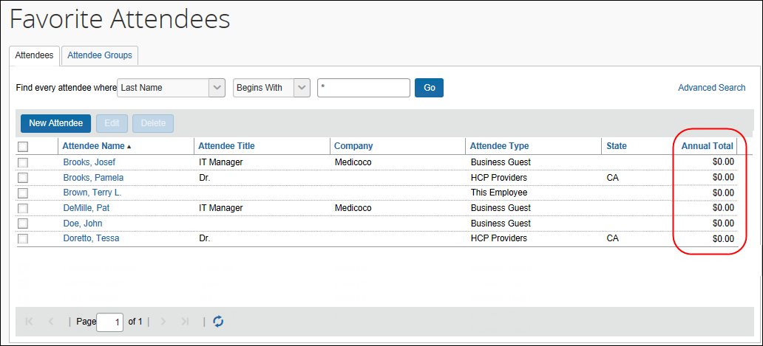
- Define whether attendee types are restricted by user groups
- Define whether duplicate attendee searches happen across attendee types
- Define whether to allow Concur Expense to automatically create an attendee record (SYSEMP attendee type) for the current user
- Define whether to have the system generate an External ID for attendees manually added by users
- For more information about the External ID, refer to External ID - Required for Imported Changes and Deletions in this guide.

Annual Total Column
If you choose to display the Annual Total column in Profile, be aware that:
- The totals apply to Concur Expense totals and do not include request amounts.
- The amount shown is the total amount spent company-wide for that attendee (not only from the current user) for the selected expense type(s)
– and –
- The currency used is:
- The currency that is set in the import record, if the attendee was imported
– or –
- The same as the user's reimbursement currency, if the attendee was added by a user
- There is another way to add this column to this page. Refer to Additional Attendee Information - Attendee Detail View in this guide.

Exchange Rates Required
In order for the system to maintain totals for attendees, currency conversion may be required. The amount allotted to each attendee is calculated in the user's reimbursement currency. If the attendee currency is different from the user's reimbursement currency, then the system must convert the amount (in the user's reimbursement currency) to the amount in the attendee currency. In order for that conversion to be successful, the appropriate exchange rates must be imported.
- If the Exchange Rates feature is activated and the user's reimbursement currency is included in the Exchange Rates import – converted to the attendee currency – then conversion takes place and the attendee totals are adjusted accordingly.
- If the Exchange Rates feature is not activated or if the appropriate currency has not been imported, then the user sees a message that briefly explains the issue and refers the user to your company's Concur Expense administrator.
- For more information, refer to the Concur Expense: Currency Admin Setup Guide.

Procedure: Configuring Settings
To change settings:
- On the Attendees page, click the Settings tab.
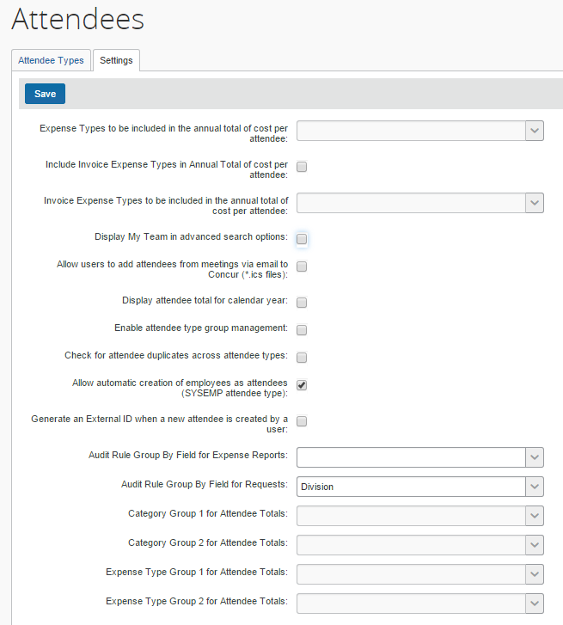
- Complete the appropriate fields.
Field | Description
Expense Types to be included in the annual total of cost per attendee | Click the expense types that will be included when calculating annual totals for attendees.  NOTE: If you do not select any expense types, the annual total will not be calculated.
Include Invoice Expense Types in Annual Total of cost per attendee | INVOICE ONLY: When the administrator selects this setting, all the expense types selected in the setting below will be included in the annual total of cost per attendee. This setting is cleared (disabled) by default.
Invoice Expense Types to be included in the annual total of cost per attendee | INVOICE ONLY: This setting contains a list of all the expense types that the administrator can select. When the administrator selects one or several expense types in this list, the amount from these expense types will be included in the total for a given attendee.
Display My Team in advanced search options | Select to display the My Team tab to the users when searching for attendees. The My Team tab contains the following employees:  - Employees with the same direct approver.  - Employees that are direct reports of the user.  - Refer to Searching Employees on My Team in this guide.  NOTES:  - This feature may be confusing to users if your default Expense approver assignments are not aligned with your team structure.  - This feature requires two additional attendee settings:  - Allow automatic creation of employees as attendees (SYSEMP attendee type) must be enabled. Refer to below in this table for more details.  Employee attendees are a shared list under the SYSEMP attendee type.
Allow users to add attendees from meetings via email to Concur (*.ics files) | Not used in Concur Request
Display attendee total for calendar year | Select (enable) if desired.
Enable attendee type group management | Select (enable) to define the attendee types available to different user groups.  - Refer to Attendee Types by User Groups in this guide.
Check for attendee duplicates across attendee types | Select (enable) to expand the attendee duplicate check to all attendee types. Clear to keep the duplicate check limited to attendees of the same type.  NOTE: The system will successfully check for duplicates across attendee types only if the duplicate check fields are the same on all attendee types.
Allow automatic creation of employees as attendees (SYSEMP attendee type) | ON by default; clear (disable) if desired.  NOTE: The system will automatically generate a record for each user but only once the user takes one of these actions:  - The user opens a new form where the user is required to be added by default.  - The user completes a 'This employee' attendee type search from the Attendee section of the New Expense (or Expense) tab or from profile.  - The user completes a quick search or a favorite search from the Attendee section of the New Expense (or Expense) tab.  At the same time the user is added to the attendee list, the External ID field is populated with the user's Employee ID.
Generate an External ID when a new attendee is created by a user | Select (enable) to have the system create an external ID.  - For more information about the External ID, refer to External ID - Required for Imported Changes and Deletions in the configuration section in this guide.
Audit Rule Group By Field for Expense Reports  Audit Rule Group By Field for Authorization Requests | Not used in Concur Request
Category Group 1 for Attendee Totals  Category Group 2 for Attendee Totals | Not available for Concur Request
- Click Save.

Overview: Attendee Types by User Groups
The administrator can define (or restrict) attendee types to specific groups. So, when a user adds, edits, views, or searches for an attendee, only the specified attendee types for that user's group will be available. For example, perhaps users in a Sales group can select and manage client attendees where non-Sales users cannot.
This way, different groups of employees can see a restricted - and more appropriate - set of attendee types.
One case may occur rarely - If an attendee is added to an entry and if that specific attendee type is later made inactive for the user's group and if the user later opens the entry, that attendee's information will no longer be editable by the user.

Procedure: Configuring Attendee Types by User Groups
The configuration includes two parts:
- Attendee setting: One-time process to turn on the feature
- Group configuration: Completed for each group
To set the Attendee Setting option:
- On the Settings tab, select (enable) Enable attendee type group management.
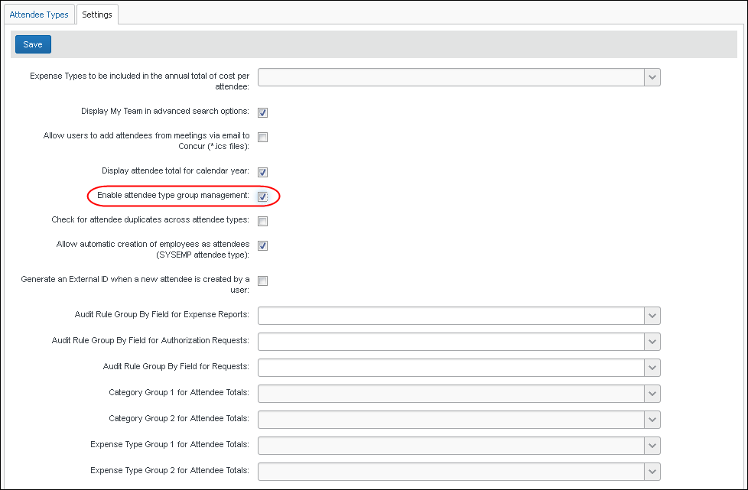
- Click Save. Now a new column - Attendee Types - appears on the Group Configurations page.
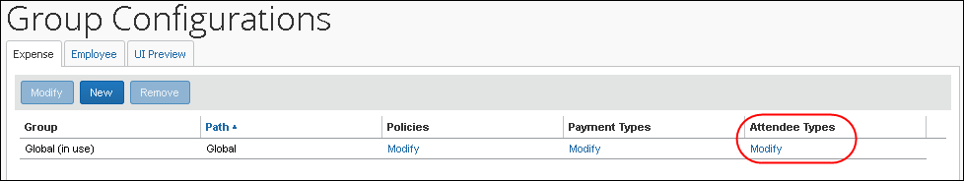
To assign attendee types to groups:
- On the Group Configurations page, click the Modify link in the Attendee Types column for the desired group. The Configuration for group window appears.
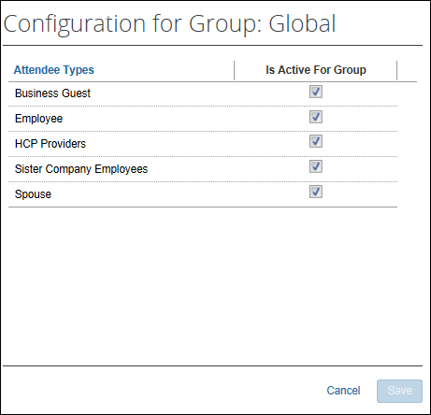
All attendee types appear except No Shows and This Employee, since they are system attendee types and cannot be inactive.
- Select (enable) the check box for all attendee types that should be active for the group.
Note the following - not all types can be activated/inactivated:
- If an attendee type is set to Active at the parent group level, it will remain active at the child group level and cannot be changed to Inactive.
- If the attendee type is set to Inactive at the parent group level, it can be overridden at the child group level and set to Active.
- Click Save.

Step 5: Configure the Concur Request Policy/Expense Type Options (Concur Request)
The available options are:
- Show cost per attendee
- Include user as an attendee by default
- Display the Add New Attendee button from the attendee table
To set any of these options:
- Click Administration > Request > Request Policies.
- On the Expense Types step, make the desired selections.
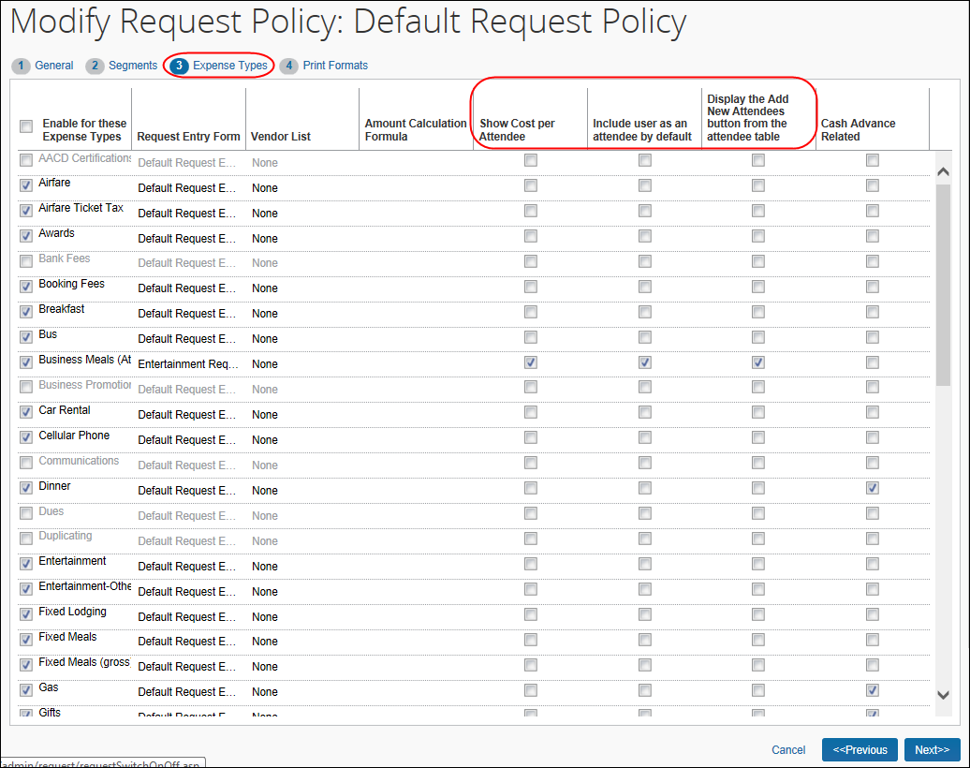

Option | Description
Show Cost Per Attendee | Select (enable) this check box to allow the user to see the portion of the expense that is allotted to each attendee.  If selected, the Amount column appears in the Attendees section of the expected expense.
Include user as an attendee by default | Select (enable) this check box to automatically add the user as an attendee (before other attendees are assigned to the entry).  Once attendees are assigned or if the user removes their names from the attendee list, the system does not attempt to add the user again.
Display the Add New Attendee button from the attendee table | Select (enable) the check box to disable the New Attendee button in the Attendees section. This will prevent the user from adding an attendee – forcing the user to search for the attendee first, ensuring the attendee is not already in the system.

Step 6: Configure for the Personal Attendee Import

Integrated With Concur Expense
For clients with Concur Request integrated with Concur Expense, if the Personal Attendee Import feature is configured in Concur Expense, then the feature is available in Concur Request, too. No additional configuration is required in Concur Request.
The import file template is language specific. The administrator must create a template for each language that is in use by the company.

Not Integrated with Concur Expense
The Personal Attendee Import is configured in Concur Expense.
- Refer to the Concur Expense: Attendee Setup Guide for more information.

Step 7: Import a List of Attendees
You can import a list of attendees for your company, for example, your company's client list or list of employees. This way, they appear in the Attendees list so users do not have to enter them manually (and perhaps inconsistently). You can also use the import feature to change attendee information or delete attendees.
- To import a list of attendees, refer to the Shared: Attendee Import, Version 2 Specification.

IMPORTANT! Using the Attendee Import on an Existing System
If you are planning to use the attendee import on an existing system (already has attendees), refer to Implementing the Attendee Import on an Existing System - Tips and Hints in this guide.

External ID - Required for Imported Changes and Deletions
The External ID is required in order to make changes to attendees (edit or delete) via the import. In most cases, the External ID is a company-generated unique identifier, which is imported with the initial import of attendees. However, for attendees who are manually entered by Concur Expense users, there likely is no External ID. Without that information, you cannot change or remove those attendees via the import.
To solve this problem, you can have the system auto-generate an External ID for each attendee so that the External ID will never be blank.

Configuration
To activate this feature, select (enable) the Generate an External ID when a new attendee is created by a user check box on the Settings tab of the Attendees page.
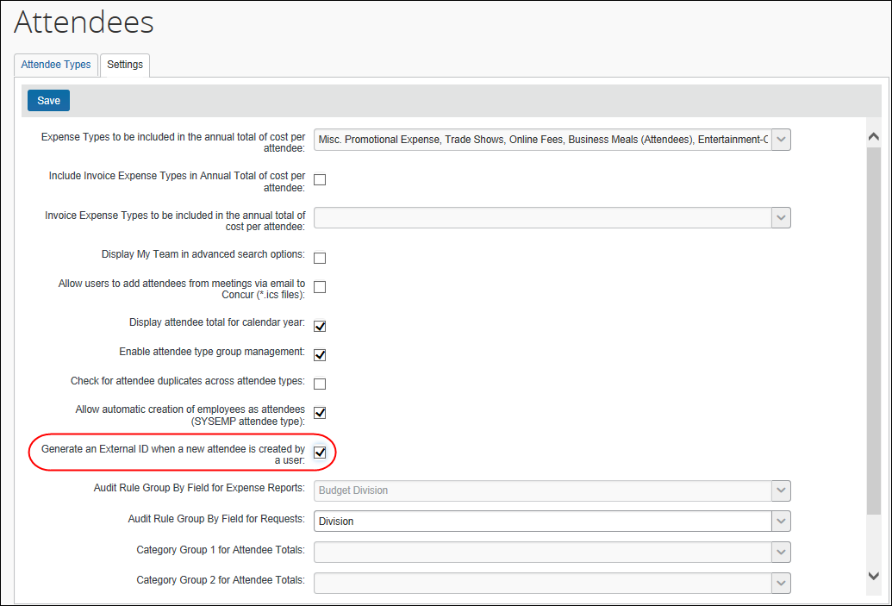

Extract the External IDs
Then, to obtain the External IDs for all attendees (so you can use them in an import), collect them from the Standard Attendee Detail Extract:
- If the Standard Attendee Detail Extract is already turned on for your company, the file will be available with your other extract files.
- If not, contact SAP Concur support to have it turned on.
- Refer to the Concur Expense: Standard Attendee Detail Extract, Version 2 Specification.

Retain Attendee History with the Associated Expected Expense Entry
By default, historical attendee information is not captured; only the current attendee information (master record) is available. If this feature is enabled, the point-in-time attendee information can be saved with the associated expected expense entry.
Attendee information (such as name or title) can change over time. With this feature, once the attendee is attached to an expense entry, that attendee information is stored and not allowed to be changed when the master record changes.
Contact SAP Concur support to have this feature activated.
SAP Concur internal staff will enable the Enable attendee history setting in the Hosted Management Console.

Implementing the Attendee Import on an Existing System - Tips and Hints

Changing from a User-Entered List to a Managed List of Attendees
In existing systems (not yet using the import), it is likely that each Concur Expense or Concur Request user entered a record for every attendee the user wanted to use, including the user. This means that it is highly likely that many of the attendees you want to import from another application already exist within the system – and many will exist multiple times.
To start fresh with a new list of attendees from the imported list, follow these steps:
Step # | Description | Where to find more information
1 | Define the name of the attendee type for this list. Attendee type names must be unique.  Tip: If you want the same name as the existing attendee type, we recommend that you rename the existing attendee type and then create a new attendee type with the desired name. | Procedure: Configuring Attendee Types in this guide
2 | Determine if users will be allowed to add new attendees to the attendee type list. If you want to control this list, you may wish to turn off the users' ability to add new attendees. | Procedure: Configuring Attendee Types in this guide
3 | Create the import file and import the list of attendees. | Shared: Attendee Import, Version 2 Specification
4 | Inactivate the old attendee type. This will remove all attendees of this type from all users' lists of attendees, though the information will still be viewable on expenses using those attendees. | Procedure: Configuring Attendee Types in this guide

Changing Employees as Attendees to a Managed List of Attendees
There are two employee-related attendee types:
- Employee: In older versions, each Concur Expense or Concur Request user had to enter a record for every employee attendee the user wanted to use, including the user. This means that it is highly likely that many of the employee attendees already exist multiple times within the system.
To make this list a comprehensive and usable list of employees that can be shared by all for use on expenses, follow these steps:
Step # | Description | Where to find more information
1 | Create an import file containing data for the employee attendee records and import the list. This will provide records for those employees who have not yet accessed the Attendee section as well as provide additional details in each employee attendee record.  When creating the import file:  - The External ID for these records must be the Employee ID that appears in Expense.  - The Attendee Type Code must be SYSEMP.  NOTE: Consider importing all employees who will be used as attendees – not only those who use Concur Expense or Concur Request. This will provide a comprehensive list of employee attendees for your Concur Expense/Concur Request users to search and select from. Then, if the imported employees who are not yet Concur Expense/Concur Request users become users in the future, the Employee ID will be used to link the attendee-related information to the correct user. | Shared: Attendee Import, Version 2 Specification
2 | Configure the This Employee attendee type:
2 | - Change the name if desired.  Attendee type names must be unique. If you want the same name as the existing Employee attendee type, then you must rename the existing Employee attendee type first and then change This Employee to Employee. | Procedure: Configuring Attendee Types in this guide
2 | - Configure the This Employee attendee type as a shared list by removing the Created By field in the duplicate check field. | Private vs. Shared Attendee Lists and Procedure: Configuring Forms and Fields in this guide
3 | Inactivate the old Employee attendee type. This will remove all attendees of this type from all users’ lists of attendees, though the information will still be viewable on expenses using those attendees. Users creating new expenses will search for and use employee attendee records under the new This Employee attendee type. | Procedure: Configuring Attendee Types in this guide
4 | Change the new Employee attendee type to a shared list.  - Change the form fields for search - clear the Created By (Private List) check box  - Edit the duplicate check - clear the Created By (Private list) check box | Private vs. Shared Attendee Lists in this guide

☼

