
Concur Invoice: Workflow – Cost Object Approval
Setup Guide

Last Revised: March 7, 2022
Applies to these SAP Concur solutions:
 Concur Expense
 Professional/Premium edition
 Standard edition
 Concur Travel
 Professional/Premium edition
 Standard edition
 Concur Invoice
 Professional/Premium edition
 Standard edition
 Concur Request
 Professional/Premium edition
 Standard edition
Table of Contents
Section 1: Permissions 1
Section 2: Workflow Guides 1
Section 3: Overview 1
Benefits of Using Cost Object Approval 2
Level-Based Approvals and Limit-Based Approvals 2
Example of Level-Based Approval 3
Example of Limit-Based Approval 3
Section 4: How Level-Based Cost Object Approvals Work 4
Approver Action: Approved 4
Approver Action: Return to the Employee 5
Approver Action: Changes that DO NOT Affect the Cost Object 5
Approver Action: Changes for Cost Objects or Amount 5
Section 5: How Limit-Based Cost Object Approvals Work 6
Approver Action: Approved 6
Approver Action: Approved Using Cost Object Direct Approval 7
Approver Action: Return to the Employee 7
Approver Action: Changes that DO NOT Affect the Cost Object 7
Approver Action: Changes that Affect the Cost Object, the Cost Object Amount, or the Report Total 7
Section 6: Configuration 7
Step 1: Define the Cost Object Approver Hierarchy 8
Step 2: Activate the Feature 8
Step 3: Edit the Workflow Steps 9
Step 4: Assign the Proper Rights to Users 10
Employee Import 10
User Administration 11
Section 7: Approver User Interface 12
Section 8: Additional Scenarios and Conditions 13
Direct Approval Under Limit-Based Cost Object Approval 13
Delegates 13
Self-Approval of Cost Object-Based Workflows 13
Additional Approver Situations 14
Additional Error Handling 17
Section 9: Cost Object Approval Differences Between Concur Invoice and Concur Expense 18

Revision History
Date | Notes/Comments/Changes
October 27, 2022 | Minor edits; cover date not updated.
March 7, 2022 | Added a note in the Additional Approver Situations section for Additional Error Handling for Cost Object not approved.
January 21, 2022 | Updated the copyright year; no other changes; cover date not updated
February 17, 2021 | Updated the copyright year; no other changes; cover date not updated
April 17, 2020 | Renamed the Authorization Request check box to Request on the guide’s title page; cover date not updated
January 6, 2020 | Updated the copyright; no other changes; cover date not updated
February 12, 2019 | Changed the term "Concur" to "SAP Concur" and the term "payment request" to "invoice" where applicable; no other content changes.
January 29, 2019 | Updated the copyright; no other changes; cover date not updated.
April 6, 2018 | Changed the check boxes on the front cover; no other changes; cover date not updated.
January 10, 2018 | Updated the copyright; no other changes; cover date not updated.
April 22, 2017 | Added a note about unlimited approval amount in the To assign the proper rights procedure.
December 14, 2016 | Changed copyright and cover; no other content changes.
December 5, 2016 | Updated the Permissions section and guide content to new corporate style; no content changes.
June 12, 2015 | Added information about self-approval for cost objects. In addition, updated the images to the enhanced UI and made general updates to the content.
September 16, 2014 | Added information about the two user interfaces; no other content changes.
April 16, 2014 | Changed copyright and cover; no other content changes.
March 22, 2013 | Include notes reminding that a time out action will always result in moving to the next step in COA workflow – there is no support any other action under time out.
December 28, 2012 | Made rebranding and/or copyright changes; no content changes.
November 16, 2012 | Added notes to explain that the Vendor Approval step cannot precede the Cost Object Approver step.
August 17, 2012 | Limit-based Cost Object Workflow now supports direct routing to approver with correct limit amount for the cost object being approved.  A new standalone window appears listing both the cost objects the approver is responsible for, and a list from which they can choose other cost objects they are authorized to approve.
May 18, 2012 | Tool now available from within Invoice Admin user interface.
December 31, 2010 | Updated the copyright and made rebranding changes; no content changes.
February 19, 2010 | Added section at end of document detailing differences in COA between the Concur Expense and the Concur Invoice products.
December 2009 | Changed to stand-alone setup guide; no content change.
September 18, 2009 | Added note - Approver may receive several invoices to approve Cost Objects within the same invoice.
April 17, 2009 | Initial publication.

NOTE: Multiple SAP Concur product versions and UI themes are available, so this content might contain images or procedures that do not precisely match your implementation. For example, when SAP Fiori UI themes are implemented, home page navigation is consolidated under the SAP Concur Home menu.

Workflow – Cost Object Approval

Permissions
A company administrator may or may not have the correct permissions to use this feature. The administrator may have limited permissions, for example, they can affect only certain groups and/or use only certain options (view but not create or edit).
If a company administrator needs to use this feature and does not have the proper permissions, they should contact the company's SAP Concur administrator.
In addition, the administrator should be aware that some of the tasks described in this guide can be completed only by SAP Concur staff. In this case, the client must initiate a service request with SAP Concur support.

Workflow Guides
Refer to these guides when configuring and maintaining workflows.
Setup Guide | Description
Concur Invoice: Workflow – General Information | Read this guide for general information about invoice workflows.
Concur Invoice: Workflow – Authorized Approvers | Read this guide if the company uses authorized approvers but only after reading the Concur Invoice: Workflow – General Information Setup Guide.
Concur Invoice: Workflow – Cost Object Approvals | Read this guide if the company uses cost object approvals but only after reading the Concur Invoice: Workflow – General Information Setup Guide.
Concur Invoice: Workflow – Email Notifications | Read this guide if the company uses email notifications for status changes and approval notification but only after reading the Concur Invoice: Workflow – General Information Setup Guide.

Overview
A cost object is any accounting-related data (cost center, department, product, project code, etc.) for which a separate cost measurement should be recorded. For example, in the current environment, an invoice moves through a defined (generally hierarchical) workflow process. With the Cost Object Approval feature, the invoice can move through separate client-defined workflows simultaneously.
For example, assume that the client defines the cost center to be the cost object. Further, assume that an invoice contains expenses that are assigned to two different cost centers – Sales and Training. When the invoice is submitted, it goes through a Training workflow and a Sales workflow at the same time. On the invoice, the expenses that apply to Training are highlighted for Training approvers; the expenses that apply to Sales are highlighted for Sales approvers.

Benefits of Using Cost Object Approval
The benefits of using the Cost Object Approval feature include:
- Budget ownership: The approval process specifically aligns with the affected budget. In the example described above, each affected cost center has the opportunity to review the entire invoice and approve or reject the portion allocated to its budget.
- Parallel processing: Each affected cost object is reviewing the invoice at the same time. This can save a tremendous amount of time, resulting in faster cycle time and faster reimbursement for the vendor.
Certain changes made by any of the approvers (described in detail later in this document) cause the invoice to go through the approval process again. This way, all approvers can review any changes ensuring control, compliance, and visibility for all affected cost objects.

Level-Based Approvals and Limit-Based Approvals
A cost object approval step can be based on either:
- Level: This type of approval is defined by each approver's sequential position in the approval process. The cost object moves from one level to the next to the next – all the way to the end of the process. For example, it moves from a junior manager to a senior manager to the company CFO.
- Limit: This type of approval is based on the amount that an approver is authorized to approve (also known as signing authority). The cost object moves only as far as the first approver with an approval limit (signing authority) equal to or greater than the cost object amount.
In the examples on the following pages, assume that the Cost Center field has been defined by the client as the cost object.

Example of Level-Based Approval
Simple level-based cost object approval step:
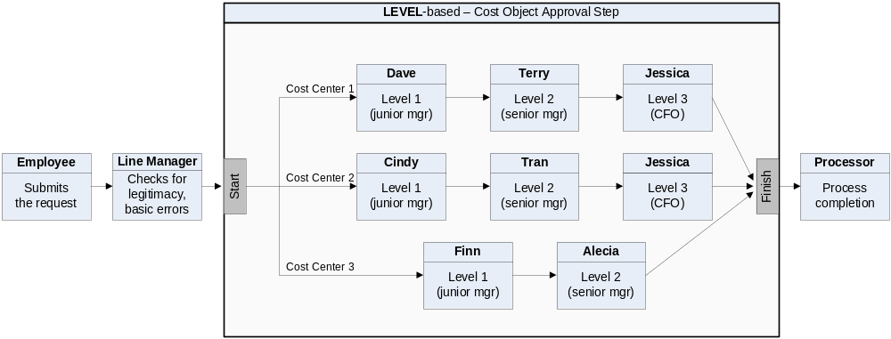
This example shows a simple workflow – from employee to the line manager to the cost object approval step to the processor.
A client can have only one cost object approval step in a workflow; however, the following are client-configurable:
- The number and placement of steps before and after the cost object approval step.
- The levels within the cost object approval step, which can even differ by cost center. In this example, Cost Center 1 and 2 have three levels of approvals; Cost Center 3 has two.

Example of Limit-Based Approval
Simple limit-based cost object approval step:
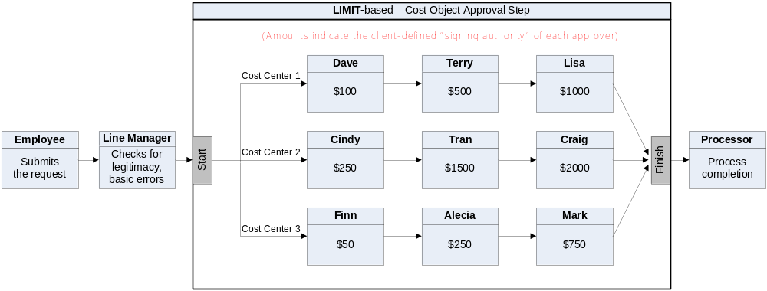
In this example, all cost centers have three approvers. Just like level-based approvals, there can be only one cost object approval step; the steps before and after are client-configurable; the limits and number of approvers within the cost object approval step are client-configurable.

How Level-Based Cost Object Approvals Work
The following set of examples is based on this level-based cost object approval step.
The table below lists the expenses on an invoice. The expenses are assigned to three cost centers.

Approver Action: Approved
The last column shows the flow through the cost object approval step if all approvers approve the expenses without changes.
Cost Center | Amount (USD) |  | Flow in the cost object approval step...
Cost Center | Expenses | Total | Flow in the cost object approval step...
1 | 75.00 | 975.00 | Dave  Terry  Jessica  finish
1 | 200.00 | 975.00 | Dave  Terry  Jessica  finish
1 | 700.00 | 975.00 | Dave  Terry  Jessica  finish
2 | 150.00 | 150.00 | Cindy  Tran  Jessica  finish
3 | 100.00 | 215.00 | Finn  Alecia  finish
3 | 115.00 | 215.00 | Finn  Alecia  finish

Approver Action: Return to the Employee
If any of the approvers return the invoice (Send Back to Employee), then:
- All workflow instances are terminated (even though the other cost centers may not actually be affected).
- The approver who initiated the action is required to provide a comment, which is visible to all other approvers.
- The action is logged in the Audit Trail.
- The invoice is returned to the employee (invoice owner).
- The process starts again – starting with the employee (invoice owner).

Approver Action: Changes that DO NOT Affect the Cost Object
If any of the approvers make any other changes to the invoice but those changes do not affect the cost object, then the approver clicks Approve and the invoice proceeds to the next step in the process (same as Approver Action: Approved). An example is changing the value for the Description field.

Approver Action: Changes for Cost Objects or Amount
Approvers are not allowed to directly make changes to the cost object or any assigned amounts. If such a change is desired, the approver should use the Send Back option and return the invoice, specifying the recommended change(s) (see Approver Action: Return to the Employee section above). The employee can then make the appropriate changes and resubmit the invoice, which in turn is routed through the workflow of the affected cost object.

How Limit-Based Cost Object Approvals Work
The following set of examples is based on this limit-based cost object approval step.
The table below lists the expenses on an invoice. The expenses are assigned to three cost centers.

Approver Action: Approved
The last column describes the flow through the cost object approval step if all approvers approve the expenses without changes.
Cost Center | Amount (USD) |  | Flow in the cost object approval step...
Cost Center | Expenses | Total | Flow in the cost object approval step...
1 | 75.00 | 975.00 | Dave  Terry  Lisa  finish
1 | 200.00 | 975.00 | Dave  Terry  Lisa  finish
1 | 700.00 | 975.00 | Dave  Terry  Lisa  finish
2 | 150.00 | 150.00 | Cindy  finish (Tran and Craig are bypassed)
3 | 100.00 | 215.00 | Finn  Alecia  finish (Mark is bypassed)
3 | 115.00 | 215.00 | Finn  Alecia  finish (Mark is bypassed)

Approver Action: Approved Using Cost Object Direct Approval
The last column describes the flow through the cost object approval step if all approvers approve the expenses without changes and the Cost Object Direct Approval option is configured.
Cost Center | Amount (USD) |  | Flow in the cost object approval step...
Cost Center | Expenses | Total | Flow in the cost object approval step...
1 | 75.00 | 975.00 | Lisa  finish (Dave and Terry are bypassed)
1 | 200.00 | 975.00 | Lisa  finish (Dave and Terry are bypassed)
1 | 700.00 | 975.00 | Lisa  finish (Dave and Terry are bypassed)
2 | 150.00 | 150.00 | Cindy  finish (Tran and Craig are not assigned)
3 | 100.00 | 215.00 | Alecia  finish (Finn is bypassed, and Mark is not assigned)

Approver Action: Return to the Employee
The result is the same as for the level-based approval. Refer to that section of this guide.

Approver Action: Changes that DO NOT Affect the Cost Object
The result is the same as for the level-based approval. Refer to that section of this guide.

Approver Action: Changes that Affect the Cost Object, the Cost Object Amount, or the Report Total
The result is the same as for the level-based approval. Refer to that section of this guide.

Configuration
Each client can have only one cost object approval step in an invoice workflow and only one invoice workflow in a policy.
The basic steps are listed below (and described in detail in the following pages):
Step 1: Define the Concur Invoice Cost Object Approver hierarchy:
- Set up the hierarchy.
- Create a connected (multi-level) list of the hierarchy levels.
Step 2: Activate the Cost Object Approver feature.
Step 3: Edit workflow steps if desired.
Step 4: Assign the proper rights to users.

Step 1: Define the Cost Object Approver Hierarchy
This portion of the configuration requires permissions for the Feature Hierarchies section in Administration.
Set up the Cost Object Hierarchy just like any other hierarchy.
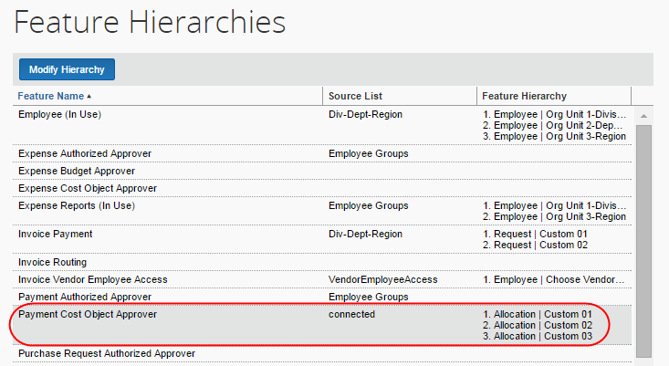
- For more information about hierarchies, refer to the Shared: Feature Hierarchies Setup Guide. For more information about lists, refer to the Shared: List Management Setup Guide.

Step 2: Activate the Feature
This portion of the configuration requires permissions for the Workflows section of Invoice Admin.
To activate the feature:
- Click Administration > Invoice > Workflows (left menu). The Workflows page appears.
- To create or modify a workflow, on the Workflows tab, either:
- Create a new workflow by selecting an existing one and clicking Copy.
- Modify an existing workflow by selecting it and clicking Modify (or double-click the desired workflow).
The General page appears.
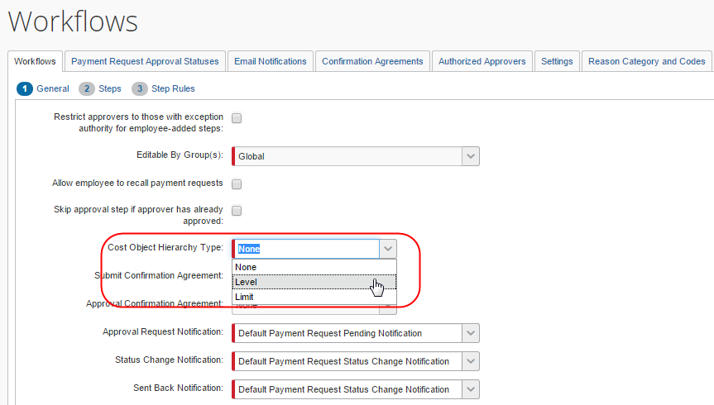
- In the Cost Object Hierarchy Type field, select the desired type: Level or Limit.
- (Optional) If Limit is selected, you can also select Cost Object Direct Approval to route the cost object directly to that approver with the required approval limit amount.

- Click Next. The Steps page appears (see next).

Step 3: Edit the Workflow Steps
This portion of the configuration requires permissions for the Workflows section of Invoice Admin.
By default, the new workflow step appears in the workflow just prior to the Prepayment Validation step. You can reorder the steps, if necessary, using the arrows at the left side of the window.
The Vendor Approval system step cannot precede the Cost Object Approval step.
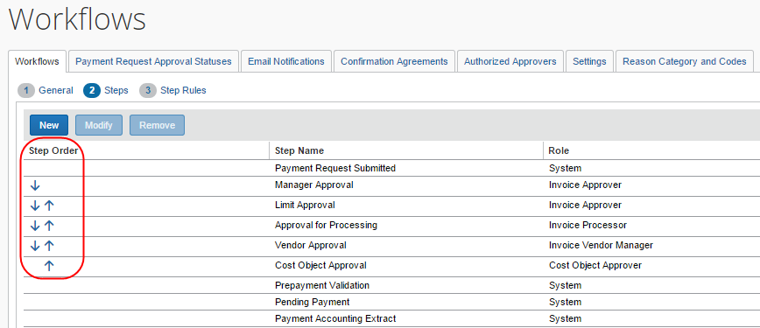
- For more information about editing workflows, refer to the Concur Invoice: Workflow – General Information Setup Guide.

Step 4: Assign the Proper Rights to Users
The company adds the proper authorized approver rights to users using:
- The employee import
- User Admin
– or –
- The Authorized Approvers tab in Workflows

Employee Import
For the Limit hierarchy type, you will use the 710 Cost Object Approver record set to import the approval limit and the currency. The Level hierarchy incorporates a numeric indicator also imported using this same record set.
# | Name | Definition | Req? | Description
15 | Approval Limit | Numeric | N | Specified in the approval limit currency.  If used, then Approval Limit Currency Code below is required.
16 | Approval Limit Currency Code | 3 characters | Dependency: See Approval Limit Description | If Approval Limit is used, then this is required.  Can be either three-digit or three-letter currency code; must be a valid currency in the list of system (reimbursement) currencies
- For information about the employee import, refer to the Shared: Employee Import Specification.

User Administration
When the Cost Object Approver feature is activated, the Authorized Approval Limits link appears in the Expense and Invoices Setting section in User Administration.
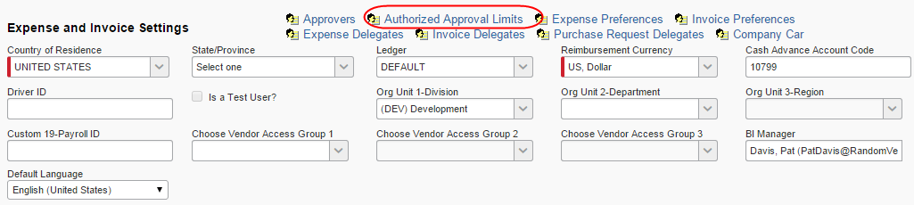
To see the Authorized Approval Limits link, you need to have activated the Authorized Approver feature and the company’s Authorized Approver hierarchy needs to have at least on level (in addition to Global).
To assign the proper rights:
- In the Expense and Invoices Setting section of User Administration, click the Authorized Approval Limits link. The Authorized Approval Limits window appears.
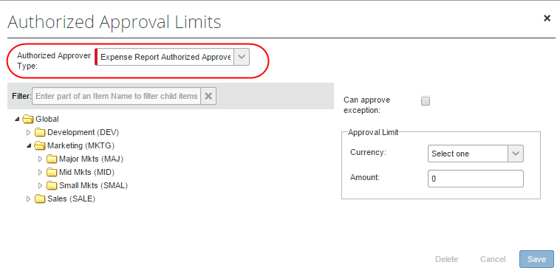
- On the left side, select the appropriate level in the hierarchy.
- On the right side:
- For limit-based cost object approval, select a currency and enter an amount.
For an unlimited approval amount, leave blank (null). To include an approver in the COA approval chain so users can see/approve an invoice, but not have signing authority for any amount in the cost center, enter zero (0).
- For level-based cost object approval, select a level.
The cost object configuration defines the type—either limit or level. If you complete both areas in this window—the Approval Limit area and the Level field—Concur Invoice will use the one that applies to your configuration and ignore the other.

Approver User Interface
The Invoice approver can view all invoices pending approval arranged row by row in the Requests Pending your Approval page. Those invoices incorporating the cost object approval step use a value in the Approval Status column to designate this workflow step. The amount that this user is responsible for displays to the right, in the Total column.
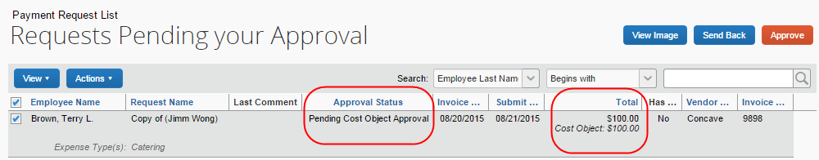
Clicking an invoice in the Requests Pending Your Approval page opens the invoice in Itemization Summary. This view lets the user see both the amount(s) they are responsible for approving as well as the other amounts contributing to the overall total for the invoice, that is, the cost object total appears at the top, while the amounts for each itemization appear beneath.
In addition, an icon identifies the invoice as a COA step in workflow.
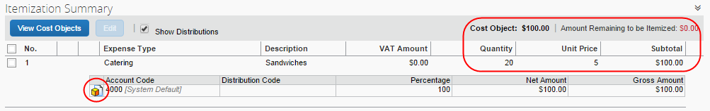
The rows the user is responsible for reviewing and approving are clearly designated by the COA icon, while the remaining informational entries appear for information only. Clicking Show Distributions "collapses" the view.
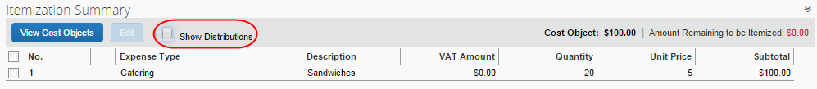
Clicking View Cost Objects opens the Cost Object Summary window. Within this window, the amounts requiring approval by the approver are listed, along with the total of all cost objects the approver is responsible for.
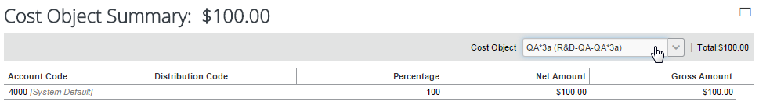

Additional Scenarios and Conditions

Direct Approval Under Limit-Based Cost Object Approval
When configuring Limit-based COA, the Cost Object Direct Approval option in the General step of workflow configuration tells Concur Expense to send the cost object approval directly to the approver with the correct amount limit. This bypasses all other approvers "preceding" the correct approver.

Delegates
The delegate approver acting on behalf of the assigned approver will use the level or limit rights assigned to the original approver rather than their own values.

Self-Approval of Cost Object-Based Workflows
Invoice Owners who are also approvers within the workflow chain for a given Cost Object can approve invoices and purchase requests if they were the ones who submitted the invoice. To configure this, the admin needs to activate this feature in the Workflows tool.
For example, if Jack submits an invoice for Cost Center A, and is an approver for Cost Center A, the invoice approval sequence will let Jack approve the invoice, regardless of whether Jack is first, second, or last in the workflow.
To allow self-approval of cost objects:
- Click Administration > Invoice > Workflows (left menu). The Workflows page appears/
- On the Workflows tab, select the desired workflow, and then click Modify.
- In the General step, select the Allow Self Cost Object Approval option.
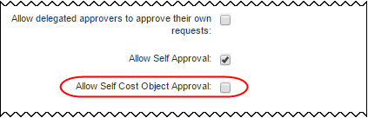
- Click Done.

Additional Approver Situations
Note the following:
- If an approver is responsible for approving more than one Cost Object in an invoice, they may be prompted more than once, and at different times, to complete the overall approval of the invoice. An icon next to the Cost Object aids the approver in determining the object they are responsible for approving.
- Any settings configured at the workflow level apply for the entire workflow, so you must make the same choices for approval time out, email notifications etc. when both a default workflow and cost object workflow is used.
- If approval time-out is ON, then it applies to all steps within the workflow, including cost object approval steps (of which there may be many). In practice, if a COA step times out, the cost object moves to the next step within the COA step – this is the only action COA supports.
- The prompt for approver setting has no affect within the cost object approval step.
- Email notifications and reminders work per usual.
- The Approval Flow page shows a single cost object step followed by a line for each cost object on the invoice, showing the viewer:
- Who the invoice is currently pending (one or more employees)
- Who the invoice is scheduled to be routed to
When the cost object workflow is concluded, it shows the final approver for that workflow.
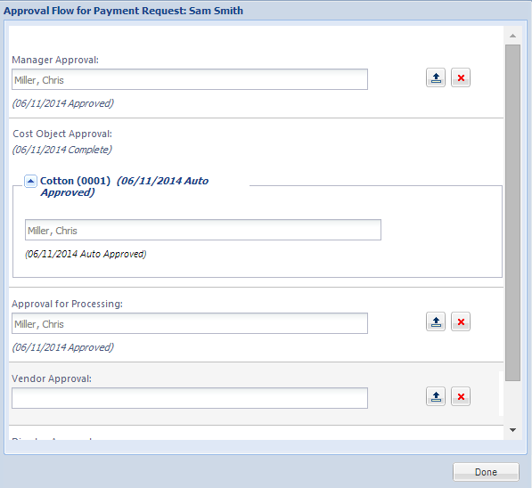
Each cost object can be expanded to show the details of that child cost object workflow.
- If a cost object field (for example, Cost Center) is not required and is left blank by the employee, then this expense moves through the workflow as if there was no cost object approval step.
- If all the expenses on an invoice are assigned to the same cost object, the process still applies but there is only one path within the cost object approval step. For example, if all expenses on an invoice are assigned to Cost Center 2, the workflow would look like this:
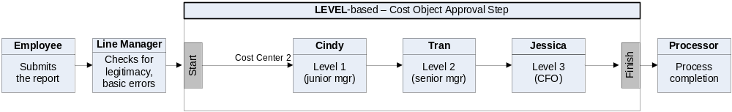
- If there are multiple approvers with the same approval limit/levels in the approver definition, Concur Invoice uses the first approver found.
- For limit-based approvals, if the highest approver limit within the cost object approval step cannot achieve limit approval for the object, then Concur Invoice will add additional approver steps by "walking up" the hierarchy to find the next available approver with a limit higher than the previous approver.
If the next level up has approvers but none have adequate limits, then Concur Invoice continues up until it finds an approver with the required limit.
Row | Approver | Limit | Department | Division | Cost Center
1 | A | 100 | R&D | DEV | EXP
2 | B | 900 | R&D | DEV | EXP
3 | C | 500 | R&D | DEV
4 | D | 750 | R&D | DEV
5 | E | 1000 | R&D
6 | F | 5000 | R&D
Example #1: Cost object of $1000 with Cost Object R&D-DEV-EXP:
- Concur Invoice first looks at the R&D-DEV-EXP node. It finds two approvers (A and B) and attempts to use them.
- When all available approvers in that node have been used and the object is still not approved, Concur Invoice moves up to the next node. No approvers at R&D-DEV (C and D) have a limit higher than our last approver (B in R&D-DEV-EXP has $900), so Concur Invoice does not use any approvers from this node.
- The object is not approved, so Concur Invoice moves up to the next node. The first approver found (approver E) for $1000 is used. Since Concur Invoice is now able to get the object approved, Concur Invoice does not add any more approvers from this node.
- Summary: Concur Invoice uses these approvers:
A ($100)
B ($900)
E ($1000)
Example #2: Cost object of $4000 with Cost Object R&D-DEV-EXP:
- Concur Invoice first looks at the R&D-DEV-EXP node. It finds two approvers (A and B) and attempts to uses them.
- When all available approvers in that node have been used and the object is still not approved, Concur Invoice moves up to the next node. No approvers at R&D-DEV (C and D) have a limit higher than our last approver (B in R&D-DEV-EXP has $900), so Concur Invoice does not use any approvers from this node.
- The object is not approved, so Concur Invoice moves up to the next node. The first approver found (approver E) for $1000 is used. Since the object is not yet approved, Concur Invoice uses the next approver (approver E). Now the object is approved so we do not add further steps.
- Summary: Concur Invoice uses these approvers:
A ($100)
B ($900)
E ($1000)
F ($5000)

Additional Error Handling
Note the following:
- Invalid approver: If an approver is designated for a step at workflow creation, it is possible that approver is no longer an appropriate choice when the invoice reaches that step. If the approver is no longer a valid approver at that point and if approver time-out is ON, the invoice will eventually time out and move to the next approver in the workflow (the only timeout action supported in COA).
- Approver limit has changed: If the limit (signing authority) of an approver changes, the invoice is marked as limit-approved based on the current limit in effect when the invoice is approved by that approver. The workflow step is not modified dynamically to find a different approver for the step.
- Level approvers are not sequential: If any gaps in the numerical level sequence for approvers at a specific cost object are found, an exception is created that a level has been skipped.
- Example #1: Approvers are found with levels 1, 3, 4. Since the level 2 approver was not found, an exception is generated.
- Example #2: For cost object A, approvers for levels 1, 2 and 3 exist. For cost object B, approvers for levels 1, 2, 3 and 4 exist. No exception is generated for either of these as there are no gaps in the sequence.
- No approver found for level: If no approver exists for a level in the hierarchy, there will be no step created in the cost object approval step for that level.
- No approvers found for cost object: If no approvers at all are found for a cost object, then no cost object approval step is created for that cost object and an exception is generated.
- Cost object not approved: If, for any reason, a cost object does not achieve approved status at the conclusion of the cost object approval workflow, a system exception is created during the termination step for cost object approval. This exception lists each cost object that did not meet approval requirements.
- Limits: The exception is generated if, at the conclusion of the cost object workflow, the invoice has not been approved by any approver with limit authority.
- Levels: The exception is generated if any level in the cost object approval step has been skipped due to time-out, missing approver, or any other reason.
The exception is not applied when an invoice/request is pending cost object approval and is approved by a Processor.

Cost Object Approval Differences Between Concur Invoice and Concur Expense
Cost Object Approval concepts, configuration, and functions are very similar between Concur Invoice and Concur Expense. However, there are a few differences:
- Changing Cost Object and Amounts: In Concur Expense, an approver may be allowed to change the values for Cost Object or Amount fields, and the expense report will then return to the start of the cost object step. In Concur Invoice, approvers cannot change the values for Cost Object or Amount.
For Invoice Processors, the Cost Object and Amount are locked down while the invoice is in "Pending Cost Object Approval" status. When not in that status, those fields may be editable, as specified by client configuration.
- Ad-hoc approval steps: In Concur Expense, an approver can add an ad-hoc approver step to a report in the cost object step. In Concur Invoice, an approver cannot add the ad-hoc step.
☼

