
Concur Invoice: Valued Added Tax (VAT)
Setup Guide
Last Revised: August 20, 2022
Applies to these SAP Concur solutions:
 Expense
 Professional/Premium edition
 Standard edition
 Travel
 Professional/Premium edition
 Standard edition
 Invoice
 Professional/Premium edition
 Standard edition
 Request
 Professional/Premium edition
 Standard edition
Table of Contents
Section 1: Overview 1
Section 2: VAT at Header and Line Item Level 1
VAT at the Header Level (Invoice Details) Only 1
VAT at Both the Header and Line Item Level 2
VAT at the Line Item Level (Itemization Summary) Only 2
Section 3: Available VAT Fields 2
Section 4: Configuration 4
Configure the Specify Tax in Invoice Details or Itemization Summary Feature 4
Configure VAT Labels 5
Configure Predefined Tax Codes 7
Configure and Calculate VAT for Capture Processing 8
Calculation of VAT is Form Dependent 9
Vendor Information for VAT Included in the Unit Price 10
Section 5: End-User Experience 12
VAT Fields at the Header Level (Invoice Details) Only 12
Specify Tax in Invoice Details or Itemization Summary 12
VAT Fields at the Line Item Level (Itemization Summary) Only 14
Vendor Information for VAT Included in the Unit Price 14
Section 6: Extract VAT Data 15
Prorated VAT Fields 17
Section 7: Implementation Best Practices 18
Canada 18
UK/US/Japan/Australia 19
Other Countries 19

Revision History
Date | Notes / Comments / Changes
August 20, 2022 | This guide is new to Concur Invoice Professional Edition and contains information formerly published in the VAT in Concur Invoice Fact Sheet.

Value Added Tax (VAT)
NOTE: Multiple SAP Concur product versions and UI themes are available, so this content might contain images or procedures that do not precisely match your implementation. For example, when SAP Fiori UI themes are implemented, home page navigation is consolidated under the SAP Concur Home menu.

Overview
Value-added tax (VAT) is a tax imposed on businesses at all levels of the manufacture and production of a good or service and is based on the increase in price, or value, provided by each level.
SAP Concur supports VAT in Concur Invoice by providing clients with a number of VAT fields to calculate VAT and store and extract VAT data. VAT fields are available both at the header level (in the Invoice Details section) and at the line item level (in the Itemization Summary section) of the invoice, and clients may choose to use VAT fields on both levels or only the header or line item level.
This document describes the VAT functionality in Concur Invoice in detail, including available fields, functional interaction with the invoice, impact on the Payment Request Accounting Extract (PRAE) file, and implementation best practices and key notes.

VAT at Header and Line Item Level
VAT fields at the header level stores the total invoice VAT information, and VAT at the line item level allows a client to modify the VAT at the line item level when VAT rates vary at this level.

VAT at the Header Level (Invoice Details) Only
Most invoices contain a total including tax and VAT and specifically call out the grand total for the tax or VAT. The purpose of the VAT fields at the header level is to store the overall total tax or VAT amounts represented on the invoice image. Assuming the VAT rate is identical for all line items, the system will auto-distribute the VAT to the gross amount for each line item based on the cost (weight) of the goods/services. This data is easily accessible in the Payment Request Accounting Extract file at both the header level and line item level. For more information, refer to the Extract VAT Data section in this document.
Even though not visible in the UI, the VAT Rate and VAT Tax Code entered at the header level will be stored for each line item and will also be available in the extract at both the header and line item level.
On 95% of invoices, VAT rates are identical for all line items, so header level storage and auto distribution of VAT to line item level will meet business needs. In cases where the client needs to manipulate the distributions of VAT at the line item level (for example where some of the items have differing VAT or Tax rates), refer to the VAT at Both the Header and Line Item Level section for details.

VAT at Both the Header and Line Item Level
Clients occasionally need to manually enter VAT at the line item level for invoices that have items with different VAT rates. This requires that VAT fields are available on both the Payment Request Header and the Payment Request Line Item Details forms, activating a feature to determine how VAT should be applied, which allows the client to expose the line item VAT columns when they change the mode. In addition, the client can take advantage of auto distribution from header level efficiencies for the majority of the time yet benefit from the flexibility to manually override data at the line item level when needed.
- For more information, refer to the Configure the Specify Tax in Invoice Details or Itemization Summary Feature and the Specify Tax in Invoice Details or Itemization Summary sections in this document.

VAT at the Line Item Level (Itemization Summary) Only
If clients must modify VAT 100% of the time at the line item level (less common scenario), they can implement VAT at the line item level only. However, the client will lose some of the efficiencies of auto distribution to the line item that is achieved if they implement VAT at the header level or both header and line item level. The amounts entered at the line item level will be reflected in the Gross Amount for that line item, but the user must enter these values manually. It is important to pressure test this with customers. In addition, SAP Concur expects future enhancements to come that compares VAT entered at the header level to where the client is with their itemizations ensuring they can work to zero and get the invoice balanced.
The Budget feature is a purchased service. If clients need to modify VAT 100% of the time at the line item level, they should consider using the Tax Authority functionality. For more information, see the Concur Invoice: Tax Authority Setup Guide.

Available VAT Fields
The following fields are available when working with VAT at the header and line item level.
Field Name | Description
VAT Amount 1 | This is the VAT amount.
VAT Amount 2 | This is the VAT amount.  NOTE: Some countries will have two VAT amount fields because clients have two types of tax assessed and both the VAT amounts need to be stored.
VAT Amount 3 | This is the VAT amount.  NOTE: Some countries will have three VAT amount fields because clients have more than one type of tax assessed, and all the VAT amounts need to be stored.
VAT Amount 4 | This is the VAT amount.  NOTE: Some countries will have four VAT amount fields because clients have more than one type of tax assessed, and all the VAT amounts need to be stored.
VAT Rate 1 | This is the tax rate associated with the VAT Amount 1 field. There is one tax rate for each tax amount field.
VAT Rate 2 | This is the tax rate associated with the VAT Amount 2 field. There is one tax rate for each tax amount field.
VAT Rate 3 | This is the tax rate associated with the VAT Amount 3 field. There is one tax rate for each tax amount field.
VAT Rate 4 | This is the tax rate associated with the VAT Amount 4 field. There is one tax rate for each tax amount field.
VAT Tax Code 1 | You can associate this VAT tax code to the VAT Amount 1 field. This can be entered via text or configured to support a list.  NOTE: Tax codes are applicable to invoices only.  - For more information, refer to the Configure Predefined Tax Code section in this document.
VAT Tax Code 2 | You can associate this VAT tax code to the VAT Amount 2 field. This can be entered via text or configured to support a list.  NOTE: Tax codes are applicable to invoices only.  - For more information, refer to the Configure Predefined Tax Code section in this document.
VAT Tax Code 3 | You can associate this VAT tax code to the VAT Amount 3 field. This can be entered via text or configured to support a list.  NOTE: Tax codes are applicable to invoices only.  - For more information, refer to the Configure Predefined Tax Code section in this document.
VAT Tax Code 4 | You can associate this VAT/Tax Code to the VAT Amount 4 field. This can be entered via text or configured to support a list.  NOTE: Tax codes are applicable to invoices only.  - For more information, refer to the Configure Predefined Tax Code section in this document.
Request Line Item VAT Amount | This field shows the sum (grand total) of all VAT amounts from all line items at the line item level and ensures that employees follow company directives by accounting for all VAT amounts.
Request Amount Without VAT | This is the net amount of the good/service without the tax applied at the header level.
Line Item VAT Amount 1 | This is the VAT amount associated with any given line item.
Line Item VAT Amount 2 | This is the VAT amount associated with any given line item.  NOTE: Some countries will have two VAT amount fields because clients have two types of tax assessed and both the VAT amounts need to be stored.
Line Item VAT Amount 3 | This is the VAT amount associated with any given line item.  NOTE: Some countries will have three VAT amount fields because clients have two types of tax assessed and both the VAT amounts need to be stored.
Line Item VAT Amount 4 | This is the VAT amount associated with any given line item.  NOTE: Some countries will have four VAT amount fields because clients have two types of tax assessed and both the VAT amounts need to be stored.
Line Item VAT Rate 1 | This is the tax rate associated with the VAT Amount 1 field. There is one tax rate for each tax amount field.
Line Item VAT Rate 2 | This is the tax rate associated with the VAT Amount 2 field. There is one tax rate for each tax amount field.
Line Item VAT Rate 3 | This is the tax rate associated with the VAT Amount 3 field. There is one tax rate for each tax amount field.
Line Item VAT Rate 4 | This is the tax rate associated with the VAT Amount 4 field. There is one tax rate for each tax amount field.
Line Item Amount without VAT | This is the net amount of the good/service without the tax applied at the line item level.
Line Item VAT Tax Code 1 | You can associate this VAT tax code to the VAT Amount 1 field. This can be entered via text or configured to support a list.
Line Item VAT Tax Code 2 | You can associate this VAT tax code to the VAT Amount 2 field. This can be entered via text or configured to support a list.
Line Item VAT Tax Code 3 | You can associate this VAT tax code to the VAT Amount 3 field. This can be entered via text or configured to support a list.
Line Item VAT Tax Code 4 | You can associate this VAT tax code to the VAT Amount 4 field. This can be entered via text or configured to support a list.

Configuration

Configure the Specify Tax in Invoice Details or Itemization Summary Feature
The administrator needs to go to the Forms and Fields tool to activate the Specify Tax in Invoice Details or Itemization Summary feature. This feature gives users the ability to manage and apply VAT on the invoice and, for example, change the VAT information when it differs between different items. The admin must add at least one VAT field at the header and at the line item level for the Specify Tax in Invoice Details or Itemization Summary feature to show on the Payment Request Header form of the invoice.
The Specify Tax in Invoice Details or Itemization Summary feature will not appear if the admin has only selected one VAT field, either at the header or at the line item level.
To activate the feature:
- Select Administration > Invoice > Forms and Fields (left menu). The Forms and Fields page appears.
- In the Form Type list, select Payment Request Header.
- Click the Forms tab.
- Select the form to which you want to add a VAT field.
- Click Add Fields. The Add Fields to Forms window appears.
- Select the field you want to add and then click Add Fields.
You can add the Line Item VAT Amount field (read only), which is an optional field, to the Payment Request Header form to see the rollup of all line item VAT amounts.
- In the Form Type list, select Payment Request Line Item Details.
- Click the Forms tab.
- Select the form to which you want to add a VAT field.
- Click Add Fields. The Add Fields to Forms window appears.
- Select the field you want to add and then click Add Fields.

Configure VAT Labels
The admin will be able to add four labels to the Payment Request Line Item Details form if users work with more than one VAT field at the line item level. The labels group VAT information together, and thereby give users a better user experience and overview of VAT at the line item level. In addition, admins can also rename these labels.
The following image shows the four labels available for VAT.
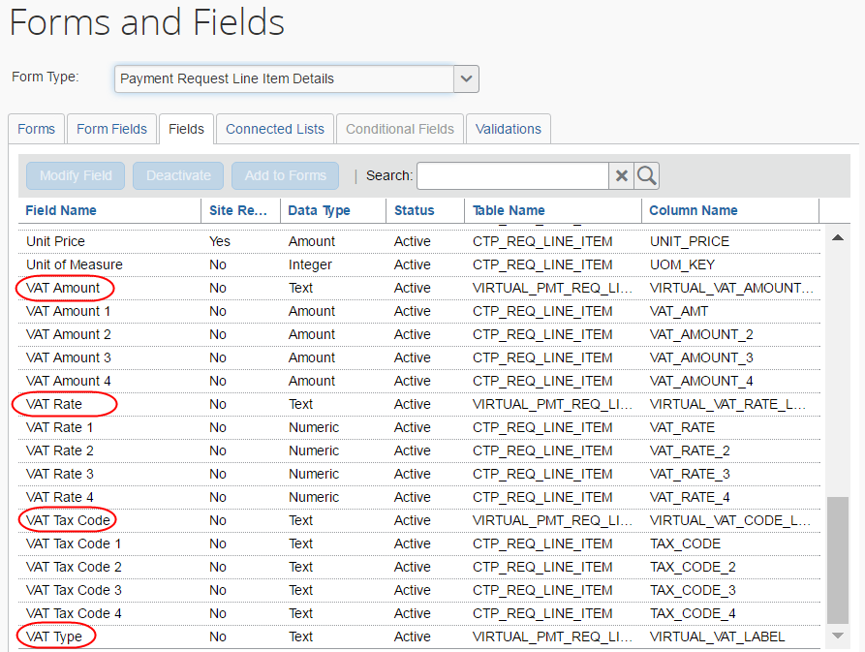
This table describes the four new labels.
Label/Field | Description
VAT Amount | This label includes information about the VAT amount of the invoice.
VAT Rate | This label includes information about the tax rate associated with the tax amount field of the invoice.
VAT Tax Code | This label includes information about the VAT tax code that is associated to a relevant set of vendors.
VAT Type | This label includes which type of VAT that is used. The values in this label are the VAT amount fields 1-4 of the line item level amounts, so the user understands what each row represents. For Canada, for example, it might be Goods and Services Tax (GST) or Provincial Sales Tax (PST).
To add VAT labels:
- Click Administration > Invoice > Forms and Fields (left menu). The Forms and Fields page appears.
- In the Form Type list, select Payment Request Line Item Details.
- Click the Forms tab and select the form to which you want to add the labels.
- Click Add Fields. The Add Fields to Forms window appears.
- Select the labels you want to add and then click Add Fields. The labels will be added to the form.
The admin must add the VAT Type field as part of this configuration.

Configure Predefined Tax Codes
The administrator needs to go to the Tax Administration tool to predefine tax codes. This will simplify entry of VAT tax codes for the end user and, at the same time, provide consistency when working with VAT tax codes for invoices and within Tax Authority.
If the admin does not predefine tax codes, the user will see the tax codes in read-only fields and not in lists.
To predefine tax codes:
- Select Administration > Invoice > Tax Administration (left menu).
- Click the Tax Code tab.
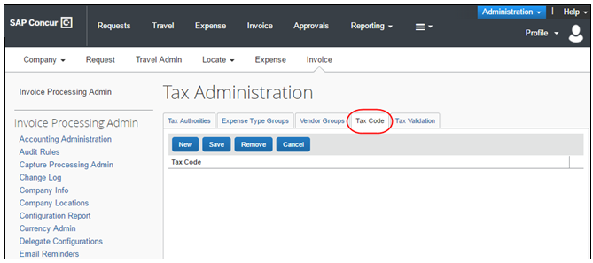
- Click New.
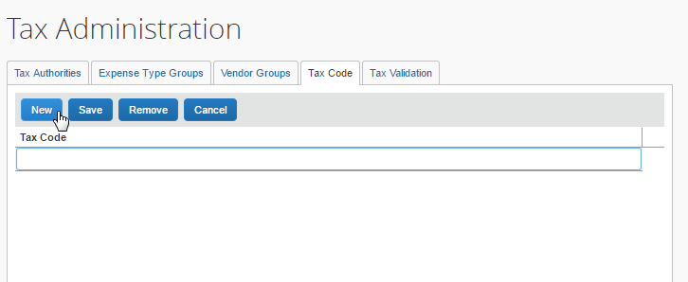
- Type the name of the code and then click Save.
The user will now see the tax code fields (1-4) as a list in the Invoice Details and Itemization Summary sections of the invoice.
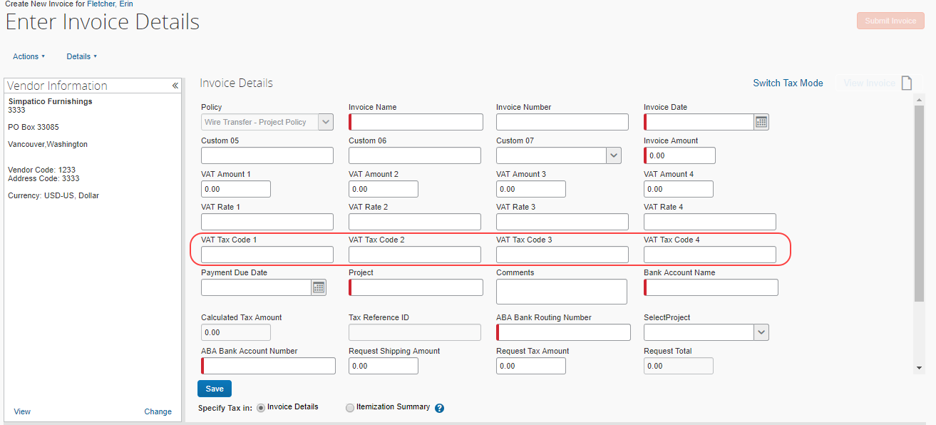
To edit the VAT tax code fields, the admin needs to ensure the user has been given modify rights of these fields in the Forms and Fields tool.

Configure and Calculate VAT for Capture Processing
For Capture Processing, VAT fields are added to forms using options in the Capture Processing Admin > Forms and Fields tab. However, to specify how VAT is calculated is different in Capture Processing and Concur Invoice. Whereas Concur Invoice can use the Specify Tax in Invoice Details or Itemization Summary feature, Capture Processing specifies how VAT is calculated based on the placement of the VAT field.

Calculation of VAT is Form Dependent
For Capture Processing, VAT calculations are dependent on the placement of the field on the form. Fields are added to a form using the Administration > Invoice > Capture Processing Admin tool, either on the Header or Line Item form.
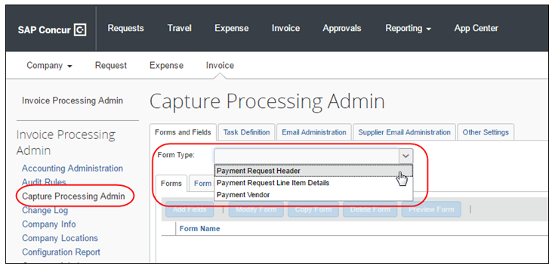
Once a VAT field is added, calculations are performed based on the location as follows:
- Request Total = Header Shipping + Header Tax (or line tax) + (Header VAT total (if exists and has non-zero value)) + Line Item Total
- OR -
Line VAT total (if exists and has non-zero value)
- Amount Remaining to be itemized = Invoice Amount - (Header Shipping + Header Tax (or line tax) + (Header VAT total (if exists and has non-zero value)) - Line Item Total
- OR -
Line VAT total (if exists and has non-zero value)
Please note the following when using the VAT feature:
- If both the header and line item VAT fields have non-zero values, then the line item VAT placement has precedence and that will be considered for calculation, (header VAT values will be ignored in that case).
- Tooltips are now added on the field Amount remaining to be itemized. This will help the user by providing the calculation details and the values for each field involved in that calculation.
- For information about which VAT fields to use in Capture Processing, refer to the Implementation Best Practices section in this document.

Vendor Information for VAT Included in the Unit Price
Most invoices do not account for VAT in the line item or header. However, in some markets, vendors will submit invoices with VAT already included in the header or in the line item (that is, within the unit price). SAP Concur will now be able to identify these vendors, so that the system can properly calculate the VAT (when using Tax Authority) and/or request total, gross amount, and amount remaining to be itemized, when the VAT is specified at the line item level (Itemization Summary) or at the header level (Invoice Details).
The benefit of this feature is to ensure that VAT is accounted for and present on the invoice, so clients can extract their data while, at the same time, ensuring that the invoice is not overinflating by adding VAT a second time in the unit price and thus overpaying vendors.
To add the Vendor includes VAT in the Unit Price field to the Payment Vendor form
- Click Administration > Invoice > Forms and Fields (left menu).
- In the Form Type list, select Payment Vendor.
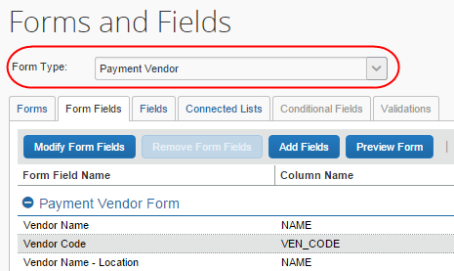
- In the Forms tab, select the form to which you want to add the field and click Add Fields.
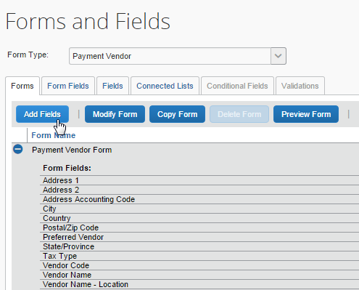
- In the Add Fields to Forms window that appears, select the Vendor includes VAT in the Unit Price field and then click Add Fields.
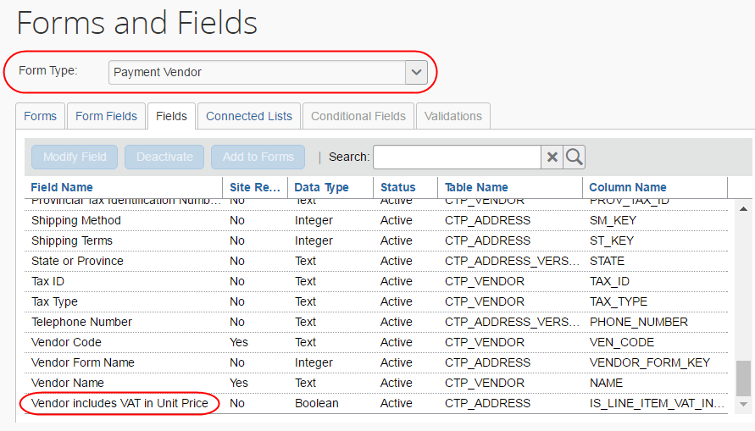
Invoice has now added the field to the form, which will appear as a check box in the Vendor Information window in Vendor Manager.
- For more information, refer to the Concur Invoice: Vendor Manager User Guide and the Concur Invoice: Vendor Import User Guide.

End-User Experience

VAT Fields at the Header Level (Invoice Details) Only
If the client has selected to use VAT only at the header level, the invoice VAT amount will be distributed to the gross amount for each line item based on the cost (weight) of the goods/services.
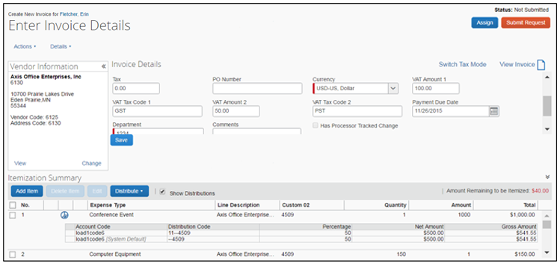

Specify Tax in Invoice Details or Itemization Summary
The possibility to specify VAT in the Invoice Details or the Itemization Summary section gives users the ability to change the VAT rates or amounts when it differs between different items.
By default, the Invoice Details option button is selected (enabled) and the invoice will auto-distribute VAT to all lines at the line item level based on the total at the header level. If the user needs to manipulate the distributions, they can click the Itemization Summary option button in the Specify Tax in setting. The total at the header level will be maintained and in read-only mode, and the existing distributed VAT to Gross Amount will no longer apply, as the VAT fields will become visible at the line item level where they can also be edited. This is beneficial for clients who work with items that have different VAT rates. For example, a client might have five items that are taxable and five other items that are exempt from tax. This feature enables client to easily change the VAT rate for items at the line item level. The amounts entered at line item level will be reflected in the Gross Amount for that line item.
Provided the administrator has added at least one VAT field at the header and at the line item level, the Specify Tax in setting appears in the Invoice Details section of the invoice with two options buttons, Invoice Details and Itemization Summary.
Example of when the Specify Tax in Invoice Details option is selected:
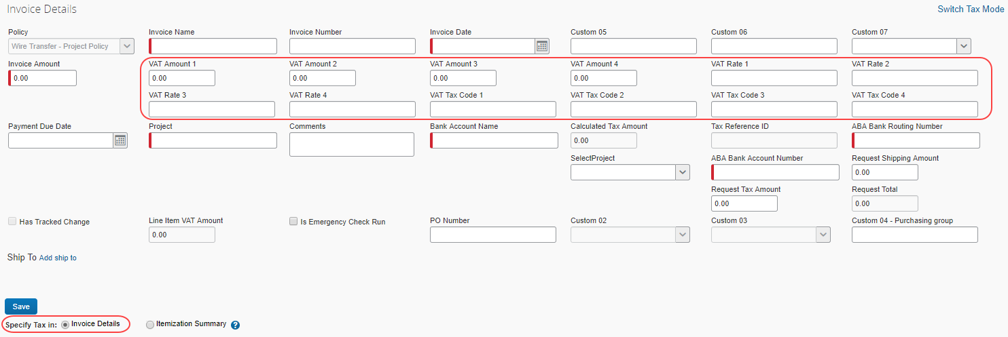
Example of when the Specify Tax in Itemization Summary option is selected and the VAT labels are used:
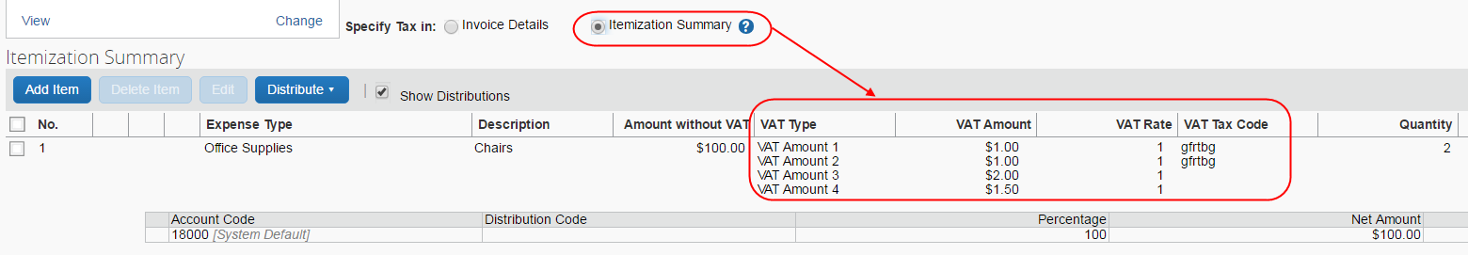
Clients, who have added more than one VAT amount field at the line item level, will see VAT information grouped by column (VAT Type, VAT Amount, VAT Rate, and VAT Tax Code) if VAT labels are used.
Admins may rename these columns (labels), so they might show with different names than what is shown in the image above.
These columns will not appear if the client is only using one VAT amount field.

VAT Fields at the Line Item Level (Itemization Summary) Only
If the client has selected to use VAT only at the line item level, the invoice VAT amounts entered at the line item level will be reflected in the gross amount for that line item, but the user must enter these values manually.
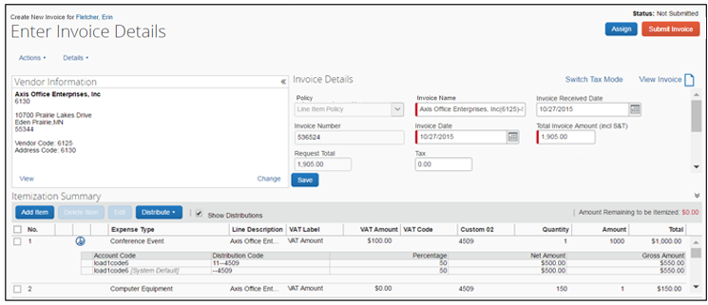
However, clients can use the Tax Authority feature to avoid having to populate these values manually. For more information, refer to the Concur Invoice: Tax Authority Setup Guide.

Vendor Information for VAT Included in the Unit Price
The Vendor Manager will see the Vendor includes VAT in Unit Price option in the Vendor Information window when they double-click on a vendor in Vendor Manager. This option indicates if VAT is included in the unit price. When this option is selected (enabled), the net amount and gross amount will be the same (regardless of whether the client uses Tax Authority or not). This setting is available through the Vendor Import or manually.
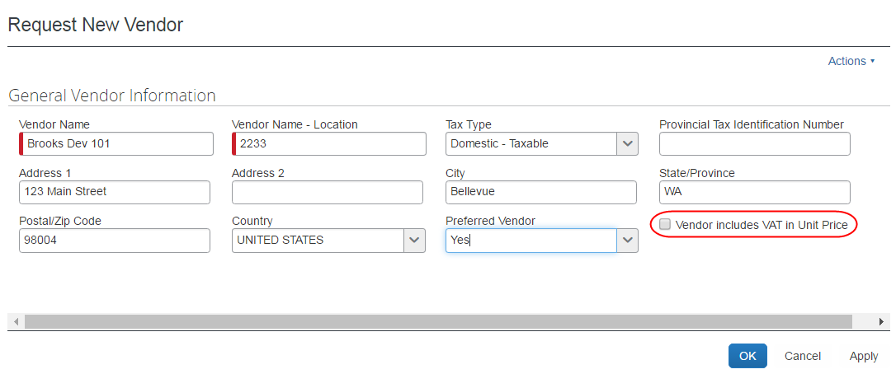

Extract VAT Data
Clients can extract the VAT fields that Concur Invoice provides through the Payment Request Account Extract (PRAE).
Clients can extract VAT data in the following ways:
- In line with the line item row: The expense account code row will have one line and VAT is available in multiple columns
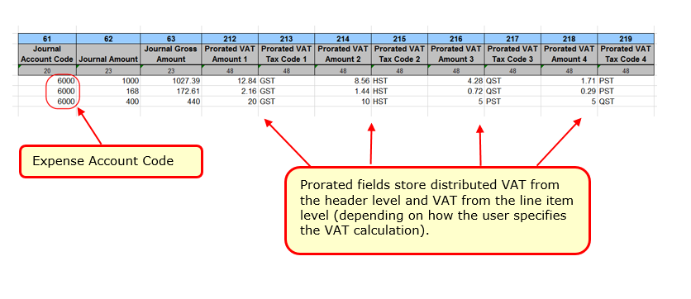
- As a separate row: VAT as a separate row to the expense account code row, each VAT field appears in a separate row with up to four rows (unless the client uses allocations)
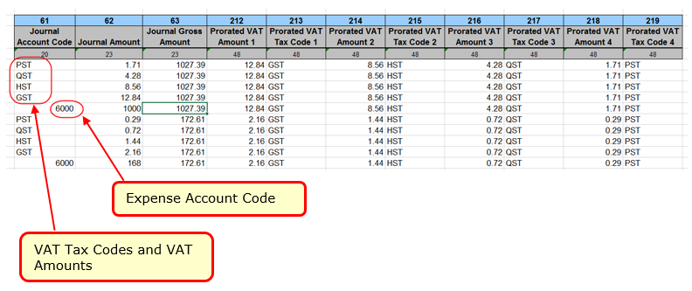
Clients need to be familiar with how VAT data appears in the PRAE depending not only on if they have selected to extract VAT data in line with the line item row or as a separate row, but also if the data comes from the header level, line item level, or the Specify Tax in setting with the Invoice Details or Itemization Summary option selected.
Extracting VAT data in line with the line item row
- If the client has VAT on the header level only, the Journal Amount column in the extract reflects the Net Invoice Amount (minus distributed header VAT and Shipping)
- If the client has VAT on the line item level only, the Journal Amount column in the extract reflects the Net Invoice Amount (minus line item VAT and Shipping)
- If the client uses the Specify Tax in setting, the Journal Amount column in the extract reflects the Net Invoice Amount (minus either header or line item VAT and Shipping depending on if the Invoice Details or Itemization Summary option is selected)
The Journal Code column in the extract reflects the Expense Type Code regardless of whether VAT is coming from the header or line item level.
Extracting VAT data as a separate row
- If the client has VAT on the header level only, the VAT tax code fields at the header level shows in the Journal Code column of the extract and the VAT amount fields at the header level shows the distributed amount in the Journal Amount column of the extract
- If the client has VAT on the line item level only, the VAT tax code at the line item level shows in the VAT Tax Code column of the extract and the line item VAT amount shows in the Journal Amount column of the extract
- If the client uses the Specify Tax in setting, the Journal Amount and Journal Code columns in the extract will show VAT data differently depending on if the Invoice Details or Itemization Summary option is selected)
Prorated VAT fields display the distributed values in each prorated column equating to the line item row (or allocation if multiple) depending on if the client is using the Invoice Details or Itemization Summary option of the Specify Tax in setting.
Prorated VAT field distribution depends on which VAT level that is used:
- VAT from the header level will reflect the distributed VAT from the header level including VAT Tax Code/VAT Rate/VAT Amount
- VAT from the line item level will reflect VAT data from the line item level (Line Item VAT Amounts, Line Item VAT Codes, and Line Item VAT Rates)
- VAT from the Specify Tax in setting, will reflect VAT data from either the header or line item level depending on which option (Invoice Details or Itemization Summary is selected)
Prorated fields add more value for the In line with the line item row option, which allow clients to access VAT information at the line item level depending on the option selected above. In this scenario, the client’s system can pull one value per allocation.
If clients use the As a Separate row option, the fields will be populated as described above. However, the rows will duplicate the amounts for each allocation per line item.

Prorated VAT Fields
The prorated VAT fields are populated based on which VAT mode (header or line item level) clients use for an invoice. This is a significant benefit that reduces extract file complexities.
The following table describes the prorated VAT fields.
Field Name | Description
Prorated VAT Amount 1 | This is the prorated VAT tax, calculated either from the VAT amount from the header level distribution or from the line item level. This calculation also depends on which Specify Tax in setting is selected.
Prorated VAT Amount 2 | This is the prorated VAT tax amount.  NOTE: Some countries will have two VAT amount fields because clients have more than one type of tax assessed, and all the VAT amounts need to be stored.
Prorated VAT Amount 3 | This is the prorated VAT tax amount.  NOTE: Some countries will have three VAT amount fields because clients have more than one type of tax assessed, and all the VAT amounts need to be stored.
Prorated VAT Amount 4 | This is the prorated VAT tax amount.  NOTE: Some countries will have four VAT amount fields because clients have more than one type of tax assessed, and all the VAT amounts need to be stored.
Prorated VAT Tax Code 1 | This is the prorated VAT tax code.  NOTE: Tax codes are applicable to invoices only.
Prorated VAT Tax Code 2 | This is the prorated VAT tax code.  NOTE: Tax codes are applicable to invoices only.
Prorated VAT Tax Code 3 | This is the prorated VAT tax code.  NOTE: Tax codes are applicable to invoices only.
Prorated VAT Tax Code 4 | This is the prorated VAT tax code.  NOTE: Tax codes are applicable to invoices only.
Prorated VAT Rate 1 | This is the prorated tax rate associated with the VAT Amount 1 field. There is one prorated tax rate for each tax amount field.
Prorated VAT Rate 2 | This is the prorated tax rate associated with the VAT Amount 2 field. There is one prorated tax rate for each tax amount field.
Prorated VAT Rate 3 | This is the prorated tax rate associated with the VAT Amount 3 field. There is one prorated tax rate for each tax amount field.
Prorated VAT Rate 4 | This is the prorated tax rate associated with the VAT Amount 4 field. There is one prorated tax rate for each tax amount field.
- For more information about the VAT fields, refer to the Concur Invoice: Payment Request Accounting Extract V2 (Current) Specifications.

Implementation Best Practices
This section describes the implementation best practices for working with VAT in different countries.

Canada
There are different ways to implement VAT for a client in Canada. The following section describes how to implement four and two VAT tax fields respectively.
Implement four VAT tax fields
Clients who, for example, do business in multiple provinces and prefer to not have to populate VAT tax codes to identify the type of tax that is applicable may implement four dedicated VAT tax fields for this purpose.
Implementation of all four VAT fields should be labeled as follows:
- VAT Amount 1 – GST
- VAT Amount 2 – PST
- VAT Amount 3 – HST
- VAT Amount 4 – QST
If the client needs to modify VAT at the line, then VAT fields would also need to be added to the Payment Request Line Items Details form to activate the Specify Tax in Invoice Details or Itemization Summary feature.
All VAT fields may be added to Capture Processing forms. However, values for the VAT Amount 3 and VAT Amount 4 fields must be entered manually at this time.
Implement two VAT tax fields
Clients who only do business in one province or prefer to use VAT tax codes to distinguish between VAT tax types in Canada may implement two VAT amount fields.
Implementation of two VAT fields should be labeled as follows:
- For GST/HST use VAT Amount 1
- For PST/QST use VAT Amount 2
Capture Processing will extract primary tax in the VAT Amount 1 field and provincial tax in the VAT Amount 2 field.
VAT tax code fields can also be implemented to allow the client to specify which type of VAT tax that is applicable to each field.
It is important that clients use the correct VAT field to avoid having to manually correct the extracted data results in Capture Processing.

UK/US/Japan/Australia
For the UK, the US, Japan, and Australia, use the VAT Amount 1 field, which is for primary tax. This field is mapped to extract these specific taxes in Capture Processing as well.
For Japanese clients (and potentially other markets), the invoice can identify vendors who include VAT in their unit price. This allows the client to populate the VAT fields without changing the amount to be paid to avoid over billing yet get the correct VAT amounts populated for their extract.

Other Countries
For other countries, contact you Concur Account Manager for up-to-date information about which VAT fields to use.

☼

