
Concur Invoice: Tax Authority
Setup Guide

Last Revised: August 27, 2021
Applies to these SAP Concur solutions:
 Concur Expense
 Professional/Premium edition
 Standard edition
 Concur Travel
 Professional/Premium edition
 Standard edition
 Concur Invoice
 Professional/Premium edition
 Standard edition
 Concur Request
 Professional/Premium edition
 Standard edition
Table of Contents
Section 1: Permissions 1
Required Roles 1
Section 2: Overview 1
Section 3: Supported Countries for VAT 2
Section 4: Value-Added Tax 2
Track VAT 2
Sources of VAT Amounts 3
Special Cases 3
Requirements to Calculate VAT 4
Section 5: End-User Experience 4
Copy Down 5
Section 6: Processor Experience 6
Section 7: Configuration Overview 6
Tax Administration Tool 6
Client Responsibility Regarding VAT 6
Calculate VAT and Required Criteria 7
Understand and Use the Effective Date and the End Date 7
Understand and Use Company Locations 8
Apply VAT to Expense Type Groups 8
Availability of Expense Types Based on Location of Tax Authority 9
Apply VAT to Vendor Groups 9
Forms and Fields: Ensure Employees Account for All Tax Amounts 9
Control Tax Amount Handling 10
Configure and Calculate VAT for Capture Processing 10
Calculation of VAT is Form Dependent 10
Audit Rules 11
Audit Trail 11
Section 8: Configure Tax Authorities 11
The Basic Process 11
Step 1: Add VAT Fields to Forms 12
Step 2: Assign the Tax Administrator Role 13
Step 3: Access Tax Authorities 14
Step 4: Add a New Tax Authority 14
Step 5: (Optional) Add a New Expense Type Group to a Tax Authority 18
Step 6: (Optional) Add a New Vendor Group to a Tax Authority 22
Step 7: (Optional) Configure Predefined Tax Codes 25
Section 9: Imports and Extracts 27
Section 10: Reporting 27
Section 11: Appendix A - Tax Amount Calculation 28
UK Example (Applicable to All Single-Level VAT Countries) 29

Revision History
Date | Notes/Comments/Changes
October 13, 2022 | Minor edits, cover date not updated
August 20, 2022 | Minor cross-reference edit, cover date not updated
January 21, 2022 | Updated the copyright year; no other changes; cover date not updated
August 27, 2021 | Updated image what the Processor sees. No content changes.
February 17, 2021 | Updated the copyright year; no other changes; cover date not updated
April 17, 2020 | Renamed the Authorization Request check box to Request on the guide’s title page; cover date not updated
January 6, 2020 | Updated the copyright; no other changes; cover date not updated
April 13, 2019 | Changed the term "payment request" to "invoice" as part of the new user experience for Concur Invoice including images.
March 28, 2019 | Removed content referring to Canada, because Canada is not supported for VAT in Concur Invoice.
February 11, 2019 | Changed the term "Concur" to "SAP Concur" and the term "payment request" to "invoice" where applicable; no other content changes.
January 29, 2019 | Updated the copyright; no other changes; cover date not updated
April 6, 2018 | Changed the check boxes on the front cover; no other changes; cover date not updated
January 10, 2018 | Updated the copyright; no other changes; cover date not updated
October 10, 2017 | Updated images, VAT calculations, and updated information about Tax Authority supporting one VAT amount field.
June 23, 2017 | Added VAT fields and new Specify Tax in setting for calculating VAT.
December 14, 2016 | Changed copyright and cover; no other content changes.
April 15, 2016 | Updated with information about changed company location configuration.
February 19, 2016 | New guide.

Tax Authority
NOTE: Multiple SAP Concur product versions and UI themes are available, so this content might contain images or procedures that do not precisely match your implementation. For example, when SAP Fiori UI themes are implemented, home page navigation is consolidated under the SAP Concur Home menu.

Permissions
A company administrator may or may not have the correct permissions to use this feature. The administrator may have limited permissions, for example, they can affect only certain groups and/or use only certain options (view but not create or edit).
If a company administrator needs to use this feature and does not have the proper permissions, they should contact the company's SAP Concur administrator.
In addition, the administrator should be aware that some of the tasks described in this guide can be completed only by SAP Concur staff. In this case, the client must initiate a service request with SAP Concur support.

Required Roles
To add and manage tax authorities, the user needs to have the Tax Administrator role.

Overview
A tax authority is the government body that levies Value-Added Tax (VAT). In most tax jurisdictions, this is the country. However, in some countries, such as the UK, the tax authority includes the country as well as specific states/provinces. Most European countries levy VAT; the United States does not.
In most cases, clients create country-specific tax authority configurations, each configuration matched by tax type and percentage rate to the country originating the service or good detailed in the invoice.
For example, a client located in the United States might configure a tax authority for Australia that incorporates a Goods and Services Tax (GST) rate type with a percent-based calculation method of 10%. Now, when an invoice arrives from Australia, the system processes the rate calculation and displays a value in the Rate, Amount, and Tax Code fields added to the Header or Line Item forms for this purpose.
Most companies define only those tax authorities for locations with domestic employees or those that are likely to provide a return. That is, a company pays enough VAT in that tax authority so that the reclaim available is greater than the cost of requesting the reclamation. This information is generally gathered from the company's tax accounting department.
To use the Tax Authority feature, clients need to have configured the relevant VAT fields first.
- For more information about configuring VAT fields, refer to the Concur Invoice: Value Added Tax (VAT) Setup Guide.

Supported Countries for VAT
The primary countries supported for VAT in Concur Invoice are United Kingdom, Japan, and Australia.
The secondary countries supported for VAT in Concur Invoice are countries that have one tax type that levy tax. However, these countries might not be fully supported under certain global or national laws.
Countries that are not supported for VAT in Concur Invoice are the US, Canada, India, and other multi-tax countries.

Value-Added Tax
Value-added tax (VAT) is a tax imposed on businesses at all levels of the manufacture and production of a good or service and is based on the increase in price, or value, provided by each level. In the case of manufacturing clothing, raw materials (for example cotton) are not taxed. However, the value of the cotton is increased by turning it into fabric, so the fabric is taxed as it is sold to the clothing maker. Then, the value of the fabric is increased by turning it into clothing, so the clothing is taxed again as it is sold to the consumer.
Though VAT is levied at each level, it is generally offset with tax credits at each level, so the end consumer ultimately pays the VAT when the consumer purchases the good or service.
A company that pays VAT on behalf of its employees may be able to reclaim the VAT paid. Typically, some or all the VAT can be reclaimed for service-related expenses as well as general business supplies.
In this document, the term VAT is used, though most countries use terms other than VAT. For example, the French term is Taxe sur la Valeur Ajoutée (TVA), the German term is Mehrwertsteuer (MwST), and the Italian term is Imposta sul Valore Aggiunto (IVA).

Track VAT
The need to track VAT depends on the location of the company:
- Domestic: For a company operating in a VAT-levying country (for example, a company based in Germany), tracking VAT is a domestic issue and is critical to day-to-day operations, just as tracking and reporting sales tax is critical for companies operating in the United States. Reporting is mandatory; these companies must report VAT data to their government on a periodic basis, most often monthly.
The company can use the VAT data provided by SAP Concur (which can be transferred to the company's financial systems) to develop the required reports for reclamation.
- International: For a company with employees traveling to VAT-levying countries (for example, a company based in the United States with employees who travel to Europe), the company pays VAT but does not have to track VAT unless the company is interested in reclaiming. The amount available for reclamation may be substantial but – since the process is so complex – the cost for reclaiming VAT may be prohibitive. In addition, because of the complexity, companies tend to hire companies that specialize in the reclamation of VAT. This, too, adds to the cost of reclaiming.
The company can use the VAT data provided by SAP Concur (which can be transferred to the company's financial systems) to evaluate whether or not to reclaim. If the company decides to reclaim, it can use SAP Concur to assist in gathering the detailed information necessary for the reclamation process.

Sources of VAT Amounts
The actual VAT amounts are obtained from several different sources:
- Concur Invoice calculates the amounts based on the amount of the invoice and current tax rates (as defined by the VAT configuration)
- The user or processor enters or edits the amount manually

Special Cases
In some cases, it is hard to calculate the right tax amount for an itemized line item expense based on the information captured in Concur Invoice and the information available to the user on the invoice. The data entry burden on the user to enter the information in exactly the manner needed for the calculation to work correctly is too great.

User Edit of Tax Amount
SAP Concur allows configuration of the VAT amount to allow edits by the user. This lets the user compare the VAT amount to the invoice, and make corrections as needed.
An example of where this may be appropriate is a country where the mobile phone usage is taxed differently for domestic versus international calls. It would be unreasonable to ask the user to sum up the data to enter one itemization for domestic calls and a separate itemization for international calls. With this option, the user may simply edit the calculated VAT amount to match the amount stated on the invoice.
- For more information, refer to the Configure Tax Authorities section in this guide.

Capture Processing Change to Tax Amount Logged in Audit Trail
Whenever the Capture Processing VAT Amount 1 (header or line item) field, entered during Invoice Capture, is auto-updated by Tax Authority-based changes, the system will log a value in the Audit Trail of the invoice, so the client can understand what caused the change to the VAT values.
- For more information, refer to the Concur Invoice: Capture Processing (Client-Managed) Setup Guide and the Concur Invoice: Capture Processing (Client-Managed) User Guide.

Requirements to Calculate VAT
The system needs this information in order to properly calculate VAT and reclaim:
- Tax Authority: The unique tax authority configuration for the country in which it will be deployed
- Expense type: VAT applies to some—but not all—expense types
- Date: The date the expense was incurred, though VAT rates do not change often; they are subject to change
- Location: The location where the expense was incurred. The system compares the origination of the invoice to the employee's home country to determine whether the transaction is domestic or foreign and then uses that information to determine the applicable tax authority and rates
- Vendor: Vendor information is needed when vendor groups are configured for Tax Authority
The system gathers all of this information from the invoice. The invoice may include all the costs (gross amount total) or parse the taxes from the base amount and display these in their respective VAT fields using the associated tax authority.

End-User Experience
Once the administrator has added the VAT-related fields to the forms, the user will see these on the Payment Request Header and Payment Request Line Item Details forms, as well as on the Payment Vendor form. The VAT fields help clients store detailed tax information and ensure that they are compliant with relevant tax laws.
Concur Invoice only supports the VAT Amount 1, VAT Rate 1, and VAT Tax Code 1 fields in Tax Authority.
- For more information about the fields, see the table in the Forms and Fields: Ensure Employees Account for All Tax Amounts section of this document.
Example of VAT fields in the Invoice Details (Header) Section
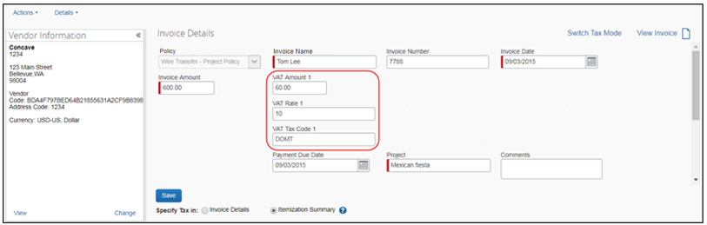
Example of VAT fields in the Itemization Summary (Line Item) section
Example of VAT fields in the Vendor Information (Vendor) window
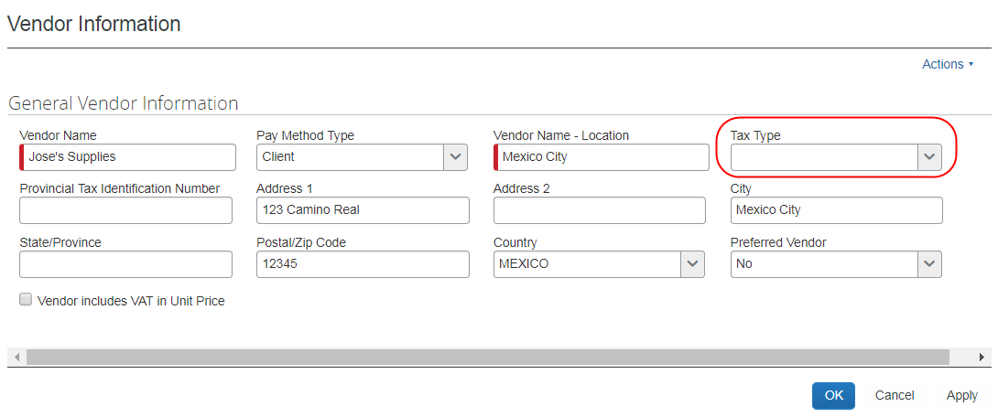
- For more information about fields and forms, refer to the Concur Invoice: Forms and Fields Setup Guide.

Copy Down
Copy down works the same as any other field.

Processor Experience
Back-office processors can view and edit all tax information to ensure it complies with tax regulations. The processor can review the invoice and edit the VAT amount as necessary. The Invoice Details section in Concur Invoice displays the tax amounts in the currency in which the transaction was incurred.
In some countries, there may be up to four fields VAT amount fields, although the Tax Authority feature currently only supports one field (VAT Amount 1).
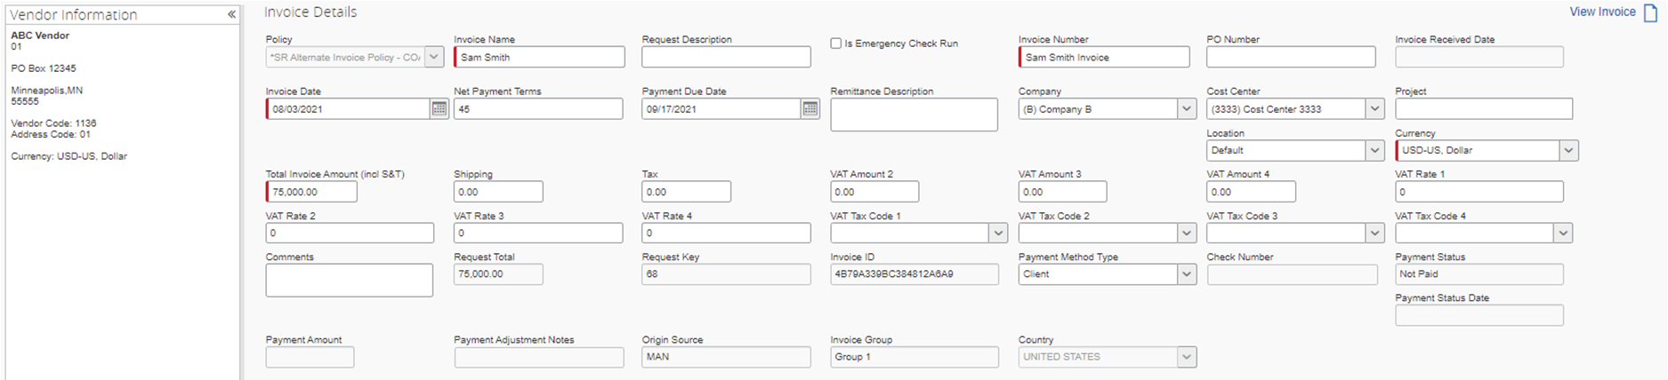

Configuration Overview

Tax Administration Tool
The Tax Administration tool is used to configure and maintain the tax authorities for each country, including the type of tax rate (for example, exempt, standard, or reduced), and the date and percent that will be in effect.
Optionally, expense types and vendors that share the same tax attributes can be grouped and associated to a tax authority to simplify the deployment of each tax authority configuration.

Client Responsibility Regarding VAT
It is the company's responsibility to understand the complexities and liabilities associated with VAT as well as the terms and requirements of reclaiming VAT.
If the company enlists SAP Concur for assistance, it is the company's responsibility to provide SAP Concur with the desired configuration information during the configuration process, for example, the names of tax authorities and VAT rates. Though SAP Concur can provide some general guidance about VAT, SAP Concur takes no responsibility in defining the company's VAT reporting requirements or reclamation strategy.
It is also the company's responsibility to remain informed of changes in VAT requirements as they apply to the company.

Calculate VAT and Required Criteria
The calculation that Concur Invoice will perform is based on three criteria:
Tax Authority + Company Location (Ship To) + Expense Type (or Vendor) = Calculation
The Tax Authority component incorporates the country and tax rate type and actual rate to be applied to the good or service. The Company Location component identifies a domestic or international location, and any additional state or provincial criteria for the calculation. Finally, the expense type or vendor define the good or service which may need to be handled per the type of purchase performed by the company.

Understand and Use the Effective Date and the End Date
When creating an expense type or vendor group you are required to enter an effective date during configuration. The required effective date is the start date on which the system should begin using the group, and the optional end date is the date on which the system will stop using the group configuration.
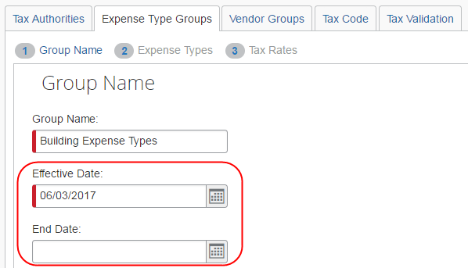
In use, these dates define the span during which the group is in effect. If no end date is specified, the system uses the date of 12/31/9999, but the admin can decide, based on changes to tax rates, to enforce an end date.
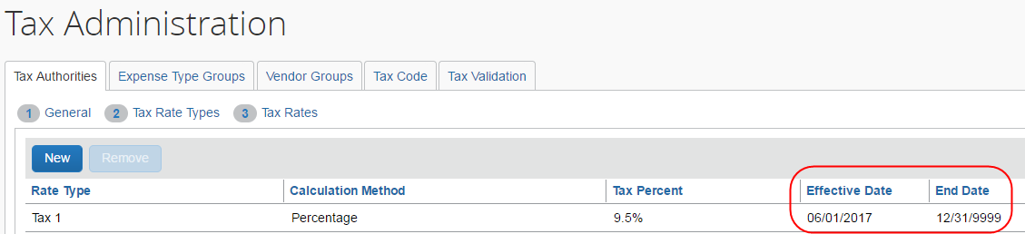
This is typically done when new rates will take effect and the date for the new and expiring groups coincide such that no calendar gap exists between the two. For example, a new VAT rate from 10% to 12% to be enforced on January 1 means the admin would create a group using 10% up to December 31, and then begin use of the 12% group on the January 1 of the new year.

Understand and Use Company Locations
The location of the company receiving a good or service dictates how VAT tax is applied. The country of origin and destination, if different, let Concur Invoice calculate VAT based on international rates, while domestic transactions can be calculated on a different rate. In addition, the specific state or province may alter the calculation as well.
Setting the ship-to location is done by using the Company Locations tool, which is accessed by clicking Administration > Invoice > Company Locations.
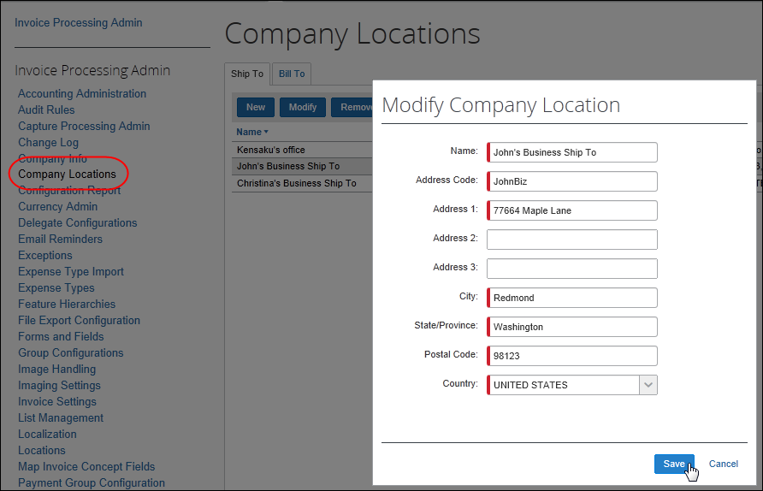
- For more information, refer to the Concur Invoice: Company Locations Setup Guide.

Apply VAT to Expense Type Groups
Clients can apply tax rates per expense type but note that not all expense types are subject to VAT calculation by all tax authorities. When defining the expense types for which VAT applies, there is at least one tax rate. In addition, the rate that is selected may depend on certain logical conditions.
For example, in Australia the standard tax rate is 10%. However, there are some exceptions where goods and services are exempt from VAT. In this case, clients can create two Expense Type Groups, one for goods and services that have a 10% tax rate and one that have no tax rate. Then clients can list the expense types that should belong to each of these groups.
Applying VAT to expense type groups is optional. Doing this will simplify the deployment of the tax authority, but it is not required to implement tax authorities.

Availability of Expense Types Based on Location of Tax Authority
The unique combination of tax authority, company location, and expense type is used to calculate the tax. This means that if you intend to create several expense type groups for a single authority, those you select for one group are logically unavailable for any other group only within the tax authority with which you are working.
- For more information about applying VAT to expense type groups, refer to the Configure Tax Authorities section in this guide.

Apply VAT to Vendor Groups
Vendor groups may share common tax-related attributes, just as with expense types. Clients can decide to group vendors just as they do with expense types, and, in fact, group vendors who are largely related by their common expense types. For example, office- or legal-related expense types where the vendor who fulfills these goods or services is never specified for any other expense type.
Applying VAT to vendor groups is optional. Doing this will simplify the deployment of the tax authority, but it is not required to implement tax authorities.
- For more information about applying VAT to vendor groups, refer to the Configure Tax Authorities section in this guide.

Forms and Fields: Ensure Employees Account for All Tax Amounts
The administrator can add relevant VAT fields to the forms in the Forms and Fields tool. Currently, in Tax Authority, Invoice only supports one VAT amount field (VAT Amount 1/VAT Rate 1/VAT Tax Code 1).
- For more information about forms and fields, refer to the Concur Invoice: Forms and Fields Setup Guide, and for more information about VAT fields, refer to the VAT Fact Sheet.

Control Tax Amount Handling
To provide clients with better control of how tax amounts are handled at a given location, or in an office or a country, administrators can go to the Forms and Fields tool to activate the Specify Tax in Invoice Details or Itemization Summary feature by adding VAT fields to the Payment Request Header and/or Payment Request Line Item Details forms. This feature gives users the ability to manage and apply VAT on the invoice and, for example, change the VAT information when it differs between different items. The admin must add at least one VAT field at the header and at the line item level for the Specify Tax in Invoice Details or Itemization Summary feature to show on the Payment Request Header form of the invoice.
The Specify Tax in Invoice Details or Itemization Summary feature will not appear if the admin has only selected one VAT field, either at the header or at the line item level.

Configure and Calculate VAT for Capture Processing
For Capture Processing, VAT fields are added to forms using options in the Capture Processing Admin > Forms and Fields tab. However, to specify how VAT is calculated is different in Capture Processing and Invoice. Whereas Invoice can use the Specify Tax in Invoice Details or Itemization Summary feature, Capture Processing specifies how VAT is calculated based on the placement of the VAT field.

Calculation of VAT is Form Dependent
For Capture Processing, VAT calculations are dependent on the placement of the field on the form. Fields are added to a form using the Administration > Invoice > Capture Processing Admin tool, either on the Header or Line Item form.
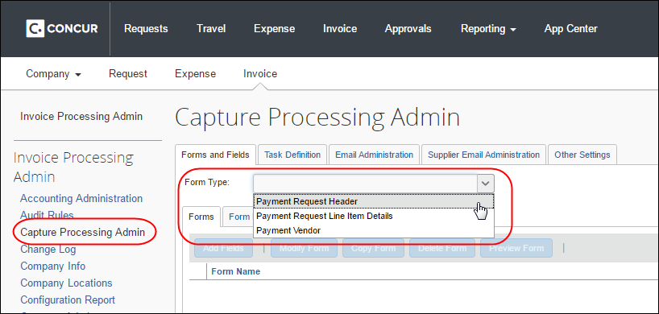
Once a VAT field is added, calculations are performed based on the location as follows:
- Request Total = Header Shipping + Header Tax (or line tax) + (Header VAT total (if exists and has non-zero value)) + Line item Total
- OR -
Line VAT total (if exists and has non-zero value)
- Amount Remaining to be itemized = Invoice Amount - (Header Shipping + Header Tax (or line tax) + (Header VAT total (if exists and has non-zero value)) - Line item Total
- OR -
Line VAT total (if exists and has non-zero value)
Please note the following when using the VAT feature:
- If both the header and line item VAT fields have non-zero values, then the line item VAT placement has precedence and that will be considered for calculation, (header VAT values will be ignored in that case).
- Tooltips are now added on the field Amount remaining to be itemized. This will help the user by providing the calculation details and the values for each field involved in that calculation.

Audit Rules
The administrator can use any of the VAT fields to set up an audit rule at the Header level. For a list of the VAT fields, see the Forms and Fields: Ensure Employees Account for All Tax Amounts section in this guide.
- For more information about audit rules, refer to the Concur Invoice: Audit Rules Setup Guide.

Audit Trail
If a change to a VAT rate field is caused by a Tax Authority change, that event is logged by the system to the Audit Trail and may be referenced by the user to determine how the change occurred.

Configure Tax Authorities
This section describes how to enable, access, and configure tax authorities.

The Basic Process
Implementing this feature requires some preparation and configuration prior to start using the feature. The client and SAP Concur staff will perform the following actions to configure and activate the feature:
- Client adds VAT fields to forms: Clients need to add VAT fields to the relevant forms before they start configuring the Tax Authority feature.
- Concur enables the Tax Authority feature: SAP Concur staff enable the feature.
- Client configures tax authorities: Once the feature is available in Concur Invoice, the client:
- Assign the Tax Administrator role: The Tax Administrator role is assigned to an employee by using options in User Permissions, which allows this user to access the Tax Administration tool.
- Add a new tax authority: The tax administrator defines each tax authority (usually a country) for which the company wants to track VAT. For each tax authority, the administrator defines the location, tax rate types (standard, reduced, and so on), the calculation method (percent by default), the rate, and the effective date in Administration > Invoice > Tax Administration > Tax Authorities tab.
- (Optional) Add a new expense type group to a tax authority: The tax administrator sets tax and reclaim properties for groups of expense types that share the same tax and reclaim properties in the Administration > Invoice > Tax Administration > Expense Type Groups tab.
Not all expense types are eligible for VAT or reclaim.
- (Optional) Add a new vendor group to a tax authority: The tax administrator sets tax and reclaim properties for groups of vendors that share the same tax and reclaim properties in the Administration > Invoice > Tax Administration > Vendor Groups tab.
- (Optional) Configure Predefined Tax Codes: The administrator can predefine tax codes for the user.

Step 1: Add VAT Fields to Forms
The administrator must add VAT fields to the forms, so that users can work and manage VAT.
Currently, in Tax Authority, Invoice only supports one VAT amount field (VAT Amount 1/VAT Rate 1/VAT Tax Code 1).
To add VAT fields to forms:
- Click Administration > Invoice.
- Click Forms and Fields (left menu).
- In the Form Type list, select the relevant type of form to which you want to add VAT fields.
- Click the Forms tab. The Add Fields to Forms window appears.
- Select the VAT fields you want to add, and then click Add Fields.
- For more information about forms and fields, refer to the Concur Invoice: Forms and Fields Setup Guide.

Step 2: Assign the Tax Administrator Role
The Invoice Tax Administrator role is available once SAP Concur staff have enabled the Tax Administration feature. Assign this role so that the user can see and work with tax authorities
To assign the Invoice Tax Administrator role;
- Click Administration > Company > Company Admin.
- Click User Permissions (left menu) and then click the Invoice tab.
- Enter the name of the user to which to assign the role, and then click Search.
- In the Available Roles list, select Invoice Tax Administrator, and then click Add.
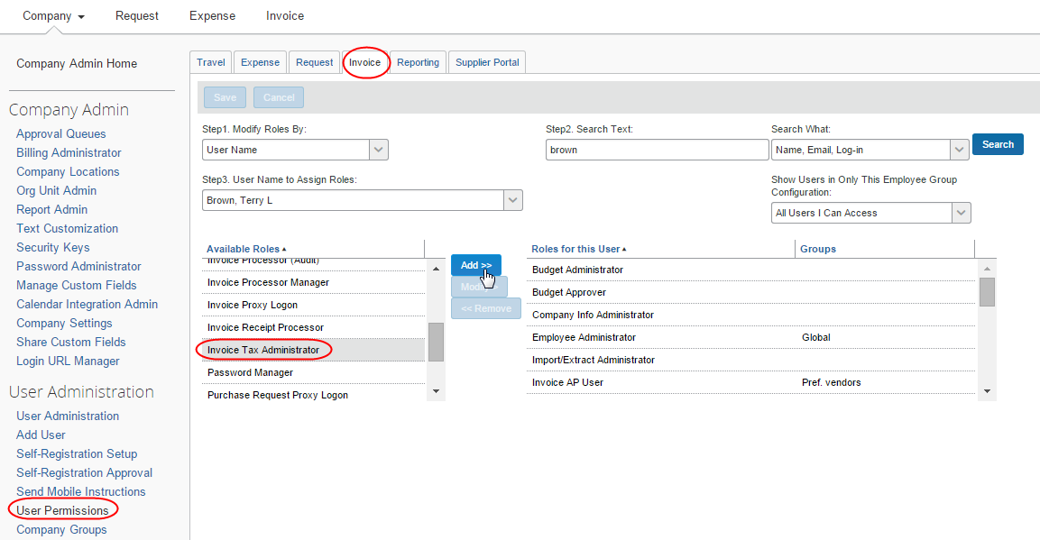
- Click Save.

Step 3: Access Tax Authorities
The administrator needs to use the Tax Administration tool to access the Tax Authorities feature.
To access the Tax Authorities page:
- Click Administration > Invoice
- Click Tax Administration left menu. The Tax Administration page appears.
- Click the Tax Authorities tab.
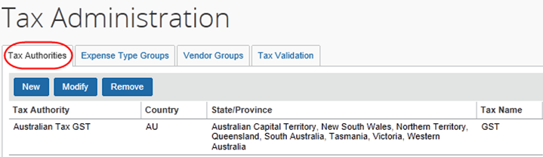
The following information appears for any existing tax authorities.
Column | Description
Tax Authority | This is the name of the tax authority (usually a country name), as defined by the company.
Country | This is the country associated with the tax authority.  NOTE: The tax authority and country will likely be the same.
State/Province | This is the states/province associated with the tax authority. If the tax applies to an entire country, then no states/provinces are designated.  NOTE: The column will likely be blank.
Tax Name | This is the name of the tax authority, as defined by the company. Examples of typical tax names are GST, MwST, and VAT.

Step 4: Add a New Tax Authority
Adding a new tax authority is a three-step process:
- Define the general settings: Complete the General step of the wizard
- Define the tax rates types: Complete the Tax Rate Types step of the wizard
- Define the tax rates: Complete the Tax Rates step of the wizard
To complete the General step:
- On the Tax Authorities page, click New. The General step appears.
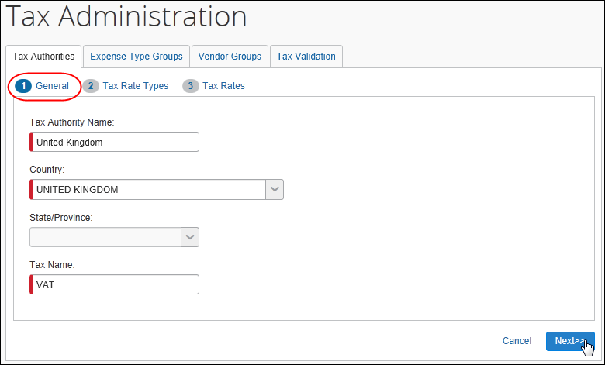
- Complete the appropriate fields:
Field | Description/Action
Tax Authority Name | Type a unique name (generally the country name) for the tax authority.
Country | Select the associated country.
State/Province | Select the associated states/provinces in the list.  If the tax authority applies to the entire country, do not select any states/provinces. This action applies the attributes to all entities within the specified country.
Tax Name | Type a tax name, up to five characters maximum.  NOTE: The tax name is the name that the Invoice user and processor see in the Concur Invoice user interface. The company should ensure that the name entered here is a term that is familiar to its users.
When the admin selects Country and State/Province in the Tax Authorities tab, Invoice will pull the ship-to information from the Company Locations page in Administration to know where the expense incurred or the location to which the vendor will ship the goods or services. The system compares the origination of the invoice to the employee's home country to determine whether the transaction is domestic or foreign and then uses that information to determine the applicable tax authority and rates.
- Click Next. The Tax Rate Types step appears.
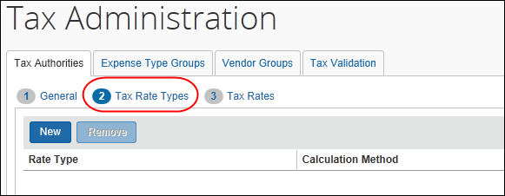
To complete the Tax Rate Types step:
Tax rate types define the name of the tax rate for reference in the system and on any requests generated in the business intelligence tools in the system. It is recommended (but not required) that these names match the name published by the tax authority.
- On the Tax Rate Types step, click New. The Add Tax Rate Types Configuration window appears.
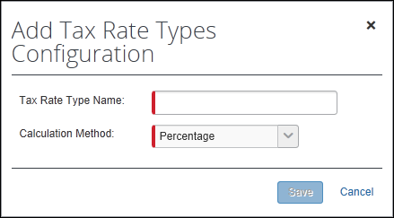
- Complete the appropriate fields.
Field | Description
Tax Rate Type Name | Type the name of the rate, for example, Standard or Reduced.  NOTE: It is recommended (but not required) that these names match the name published by the tax authority.
Calculation Method | Select Percentage. This is the default choice.
- Click Save.
- Add as many tax rate types as needed.
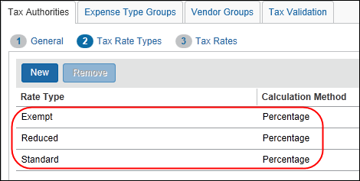
- When done, click Next. The Tax Rates step appears.
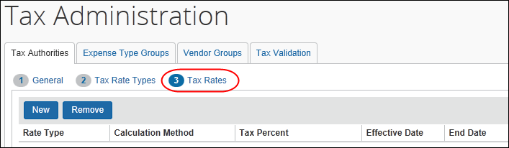
To complete the Tax Rates step:
- On the Tax Rates step, click New. The Add Tax Rate Configuration window appears.
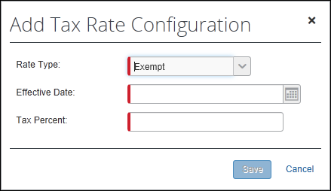
- Complete the appropriate fields.
Field | Description
Rate Type | Select the rate type.  Once you select the type, the Tax Percent field appears.
Effective Date | Enter the start date for the rate.
Tax Percent | This field appears by default and is based on the Percentage calculation method. Enter the percentage here.
- Click Save.
- Add as many rates as needed.
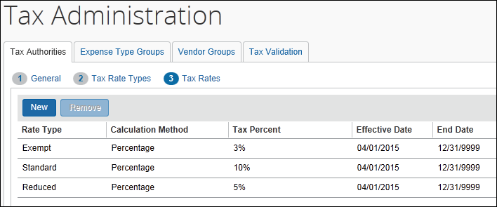
- Click Done. The new tax authority appears on the Tax Authorities page.

Step 5: (Optional) Add a New Expense Type Group to a Tax Authority
Adding an expense type group is a three-step process:
- Define the group settings: Complete the Group Name step of the wizard
- Select the affected expense types: Complete the Expense Types step of the wizard
- Define the tax rates: Complete the Tax Rates step of the wizard
Ensure that you are consistent if you configure expense type groups or vendor groups and define the VAT calculation mode. For example, if you select line item in the expense type group configuration, you should also select line item as a VAT calculation mode.
To complete the Group Name step:
- On the Expense Types Group tab, select from the Tax Authority list.
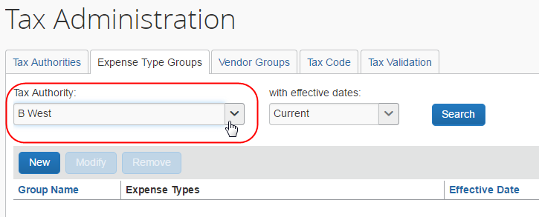
- (Optional) Select the desired date range (all currently active, or all tax authorities) in the with effective dates list, then click Search. The existing groups for the selected tax authority, if any, appear.
- Click New. The Group Name step appears.
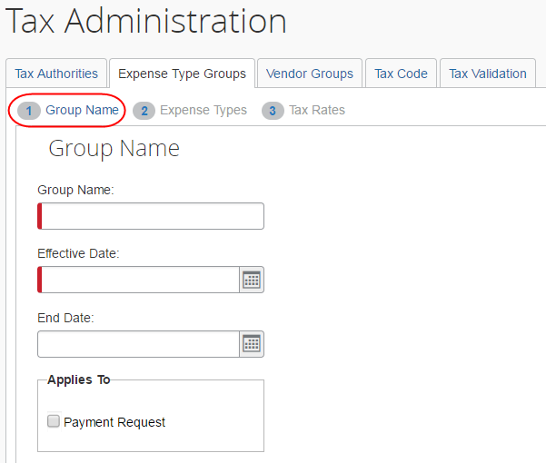
- Enter the desired values for the group.
Field | Description/Action
Group Name | Enter the display name for the group.
Effective Date | Select the effective date of the group.
End Date | (Optional) Select the end date for the group's effective date range.  Typically, the system will set this date when it is time to retire this group. Leave this blank unless there is a specific end date you want to enforce.
Applies To | Select the Payment Request document type for which to calculate VAT for expense type groups.  The Applies To setting also appears as a column on the Expense Type Groups page.
Tax Code | You can associate a tax code to a relevant set of expense types. This information will then feed into your financial system to make it easier for your company to handle tax.  The tax code can contain up to 20 characters. The Tax Code field is an arbitrary field and will be a read-only field for the user.  NOTE: VAT tax codes are applicable to invoices only.
Disable VAT calculation | In countries where vendors already provide VAT amounts, for example in the UK, there might not be a need to perform VAT calculation. If this is the case, select the check box to disable VAT calculation.  NOTE: You can only disable VAT calculation for invoices.
- Click Next. The Expense Types step displays.
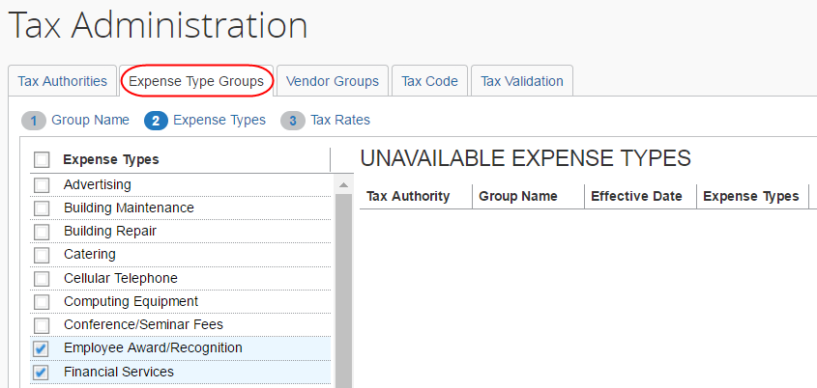
To complete the Expense Types step:
- On the Expense Types step, select the desired expense types in the Expense Types column.
Any expense types that are already used for this tax authority appear in the Unavailable Expense Types pane with the name of the group.
- Click Next. The Tax Rates step displays.
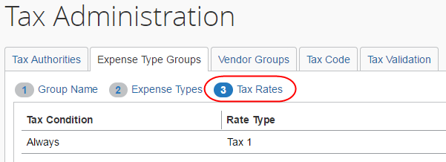
To complete the Tax Rates step:
The Tax Rates step shows the default tax condition of Always which means that this tax rate will always apply.
- To change the rate type, click the field in the Rate Type column to select from the list, which displays the rate types available for the selected tax authority.
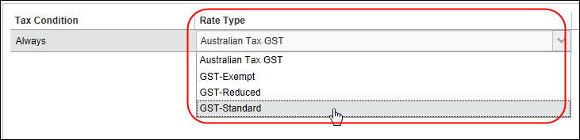
- Click Done to exit the wizard. You will now see the expense type groups that you created in the list.
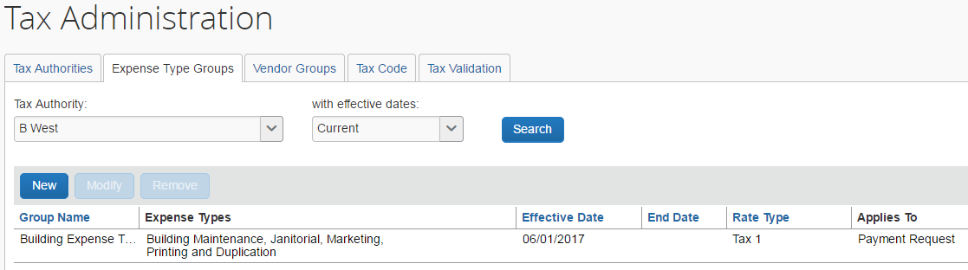

Step 6: (Optional) Add a New Vendor Group to a Tax Authority
Adding a vendor group is a three-step process:
- Define the group settings: Complete the Group Name step of the wizard
- Select the affected vendors: Complete the Vendor Name step of the wizard
- Define the tax rates: Complete the Tax Rates step of the wizard
Ensure that you are consistent if you configure expense type groups or vendor groups and define the VAT calculation mode. For example, if you select line item in the expense type group configuration, you should also select line item as a VAT calculation mode.
To complete the Group Name step:
- On the Vendor Groups tab, select from the Tax Authority list.
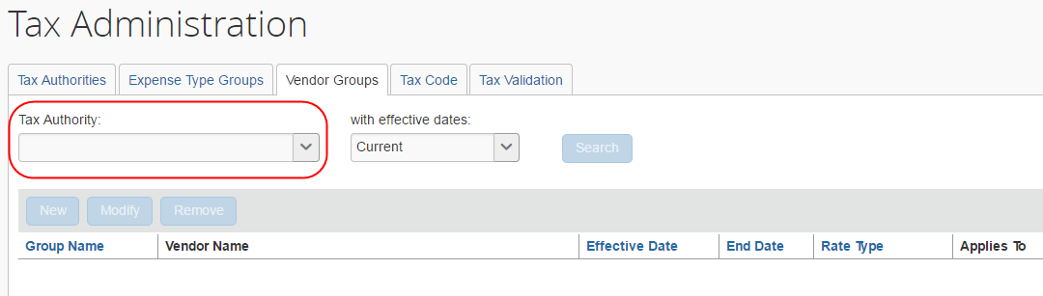
- (Optional) Select the desired date range (all currently active, or all tax authorities) in the with effective dates list, and then click Search. The existing groups for the selected tax authority, if any, appear.
- Click New. The Group Name step appears.
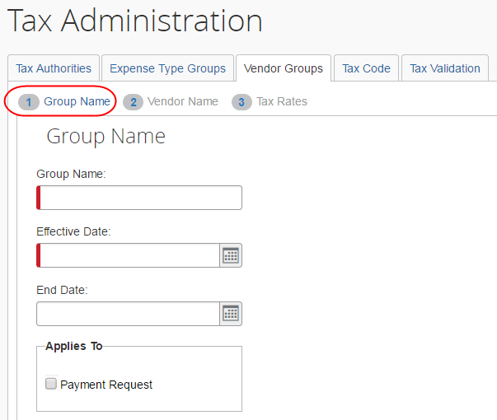
- Enter the desired values for the group.
Field | Description/Action
Group Name | Enter the display name for the group.
Effective Date | Select the effective date of the group.
End Date | (Optional) Select the end date for the group's effective date range.  Typically, the system will set this date when it is time to retire this group. Leave this blank unless there is a specific end date you want to enforce.
Applies To | Select the Payment request document type for which to calculate VAT for vendor groups.  The Applies To setting also appears as a column on the Expense Type Groups page.
Tax Code | You can associate a tax code to a relevant set of vendors. This information will then feed into your financial system to make it easier for your company to handle tax.  The tax code can contain up to 20 characters. The Tax Code field is an arbitrary field and will be a read-only field for the user.  NOTE: VAT tax codes are applicable to invoices only.
Disable VAT calculation | In countries where vendors already provide VAT amounts, for example in the UK, there might not be a need to perform VAT calculation. If this is the case, select the check box to disable VAT calculation.  NOTE: You can only disable VAT calculation for invoices.
- Click Next. The Vendor Name step displays.
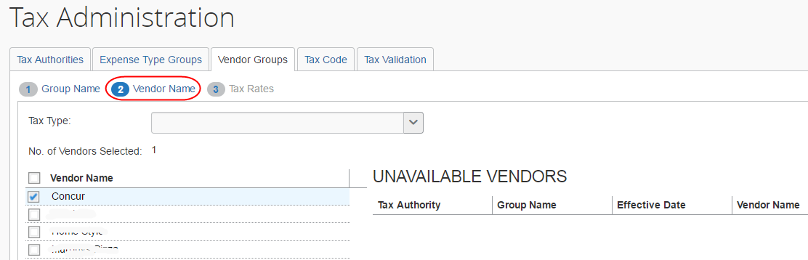
To complete the Vendor Name step:
- (Optional) On the Vendor Name step, select a type of tax, international, domestic, taxable, etc., for this optional step, from the Tax Type list.
Any vendors that are already used for this tax authority appear in the Unavailable Vendors pane with the name of the group.
- Click Next. The Tax Rates step displays.
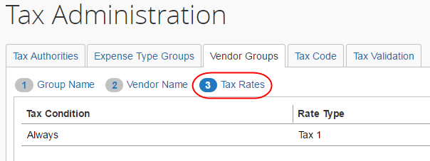
To complete the Tax Rates step:
The Tax Rates step shows the default tax condition of Always – meaning this tax rate will always apply.
- To change the rate type, click the field in the Rate Type column to select from the list, which displays the rate types available for the selected tax authority.
- Click Done to exit the wizard. You will now see the vendor groups that you created in the list.
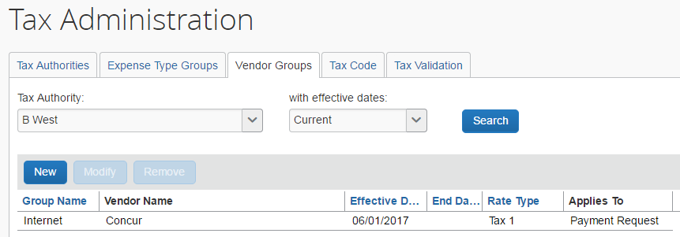

Step 7: (Optional) Configure Predefined Tax Codes
The administrator can predefine tax codes. This will simplify entry of VAT tax codes for the end user and, at the same time, provide consistency when working with VAT tax codes for invoices and within Tax Authority.
If the admin does not predefine tax codes, the user will see the tax codes in read-only fields and not in lists.
To configure predefined tax codes:
- Click Administration > Invoice > Tax Administration (left menu).
- Click the Tax Code tab.
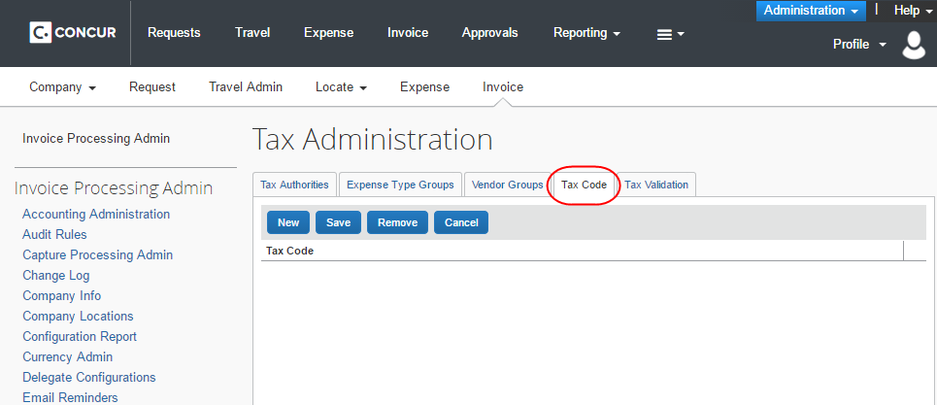
- Click New.
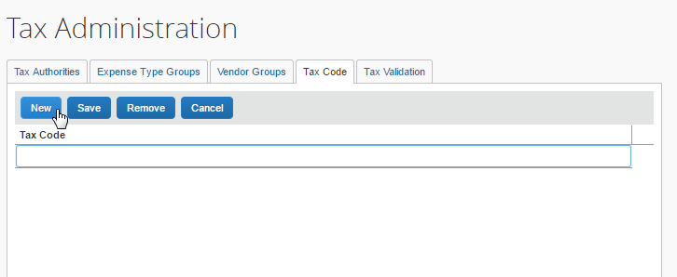
- Type the name of the code and then click Save.
The user will now see the VAT Tax Code 1 field as a list in the Invoice Details and Itemization Summary sections of the invoice.
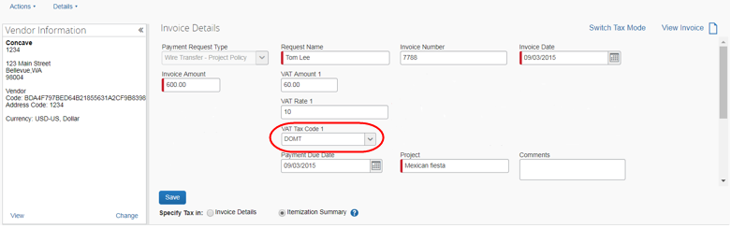
- To edit the VAT Tax Code 1 field, the admin needs to ensure the user has been given modify rights of these fields in the Forms and Fields tool.

Imports and Extracts

Imports
The VAT fields are available in the import.

Extracts
The Payment Request Accounting extract and Employee Requested Vendor extract will have the same fields as the imports. These fields will all be optional.
With the ability to include Header level and Line Item level VAT amount taxes in the Payment Request Accounting Extract, SAP Concur has added a new option, On a Separate Line, in the Tax Details list of the Payment Request Accounting Extract. This option provides a new tax line with tax information instead of including tax on the invoice line. This means that there will be one line with tax information and one line without tax information, and, thus, every other line goes into separate extracts.
SAP Concur creates extracts after the release and the information will then be added to the specification guide.
- For more information, refer to the following documents:
- Concur Invoice: Vendor Import User Guide
- Concur Invoice: Approved Vendor Import V3 (Current) Specification
- Concur Invoice: Payment Request Accounting Extract V2 (Current) Specification
- Concur Invoice: Standard Employee Requested Vendor Extract Specification
- Concur Invoice: Payment Request Import V2 Specification

Reporting
The VAT fields will be available for clients who use Analysis/Intelligence.
- For more information, refer to the Analysis/Intelligence user guides.

Appendix A - Tax Amount Calculation
VAT is calculated at the time the expense is saved. VAT is recalculated when the employee, approver, or processor edits the invoice date, invoice amount, policy, vendor, system tax, shipping, VAT amount 1, location, expense type, location, line quantity, or line item unit price.
The system tracks the source of the tax amount (calculated by the system when the employee saves the invoice) or if the VAT amount was adjusted by a back-office processor. The system does not recalculate and overwrite the processor's edits to the tax amount.
Concur Invoice calculates the Net amount first and then applies the VAT rate to receive the correct VAT tax.
Concur Invoice calculates VAT tax as follows if tax is set to header:
Net=Line Item Amount/1+Tax Rate
VAT=Net*VAT Rate
Concur Invoice calculates VAT tax as follows if tax is set to line item:
VAT Rate*Line Item Amount=Line Item VAT Amount
Example:
Let us assume that we have the following invoice information:
Invoice Amount = 100
Shipping = 10
VAT Rate on vendor = 10 %
The calculation will then be as follows:
100-10 = 90/1.10 = 81.81 (NET)
81.81 * .10 = 8.18 (VAT1)
This update only applies to Tax Authority at the header level (vendor). Line item VAT Tax Authority remains as is with percentage applied to the Total for the line item row.
Once the system has the net, the system can calculate each of the individual taxes. For most countries, this is really a simple calculation, because tax is levied only at the country level. For other countries, this calculation should still arrive at the correct amounts for the various levels of tax.
- For more information on VAT, refer to the Concur Invoice: Value Added Tax (VAT) Setup Guide.

UK Example (Applicable to All Single-Level VAT Countries)
From the point of sale:
NET expense = 125.32 (pre-tax sales total)
VAT rate = 17.5%
VAT = 125.32 * 0.175 = 21.931 rounded to 21.93
GROSS = NET + SumOfTaxes
GROSS = 125.32 + (21.93)
GROSS = 147.25
The transaction is entered into the application with the gross amount. The VAT tax rate already exists in the system as part of the UK tax configuration.
So, from the application:
GROSS expense = 147.25
VAT rate = 17.5%
NET = GROSS/ (1 + SumOfTaxRates)
NET = 147.25 / (1 + 0.175)
NET = 147.25 / 1.175
NET = 125.31914 rounded to 125.32

☼

